Developing a standard set of outcome domains and associated patient reported outcome measures for patients with neck pain in Dutch primary care exercise therapist practice

Master thesis
Physiotherapy Science
Program in Clinical Health Sciences
Utrecht University

Name student: G.P.A. (Gijs) van Gils
Student number: 6439160
Date: 25 June 2021
Internship supervisor(s): Koen (AC) Verburg MSc., Prof. Dr. Philip van der Wees
Internship institute: Radboud University Medical Center, Radboud Institute for Health Sciences, IQ Healthcare, Nijmegen, The Netherlands
Lecturer/supervisor Utrecht University: Dr. M.A. Timmer

“ONDERGETEKENDE

Gijs Peter Antoon van Gils

bevestigt hierbij dat de onderhavige verhandeling mag worden geraadpleegd en vrij mag worden gefotokopieerd. Bij het citeren moet steeds de titel en de auteur van de verhandeling worden vermeld.”

Examiner
Dr. M.F. Pisters

Assessors:
Prof. Dr. P. van der Wees PhD
Prof. Dr. C. Veenhof PhD

Masterthesis, Physical Therapy Sciences, Program in Clinical Health Sciences, Utrecht University, Utrecht, 2021

ABSTRACT
Background Neck pain is, with a prevalence of 42 to 65%, one of the most common musculoskeletal disorders worldwide, and the second most treated condition in Dutch primary care exercise therapist practice. In order to evaluate the healthcare quality provided by exercise therapists in daily practice, there is a need for measures that could be used to compare treatment outcomes. Specifically, standardized outcome domains (i.e. ‘what’ to measure) with associated questionnaires can aid in the decision-making process for treatment of individual patients, and facilitate comparisons of quality of interventions for professionals.
Aim To develop a clinical standard set of outcome domains and associated patient reported outcome measures (PROMs) for patients with neck pain in Dutch exercise therapy.
Methods A four round consensus-driven modified RAND-UCLA Delphi procedure was performed including 1) literature/guideline search of recommended and currently used PROMs, 2) add of missing PROMs by an expert panel consisting of patients, exercise therapists and policy makers, 3) online survey where a group of Dutch exercise therapists scored the relevance and feasibility of PROMs, and 4) a consensus meeting by experts to determine the PROMs included in the standard set.
Results Search of literature/guideline and currently used PROMs in five different patient reported outcomes resulted in twenty-six identified PROMs. After application of exclusion criteria, twenty PROMs were scored on a 9-point Likert scale by exercise therapists in a survey. Ten of the PROMs had a median score of 6 or higher for relevance and feasibility. These were discussed by experts in the consensus meeting, resulting in a standard set of three primary PROMs for four outcome domains and three optional PROMs for three outcome domains. Primary PROMs were the Numeric Pain Rating Scale to measure pain intensity, Patient Specific Complaints for physical functioning and Pain Disability Index for use in both pain behaviour and the social functioning domain.
Conclusion and key findings This study presents a standard set of four outcome domains with three PROMs, including a measurement protocol with time points for moments of use in treatment, for Dutch exercise therapists treating patients with neck pain.

Keywords: Neck pain – exercise therapy – outcome measures – PROMs – Delphi – questionnaire
Trefwoorden: Nekpijn – oefentherapie – uitkomstmetingen – Patiënt Gerapporteerde Uitkomstmaten – Delphi – vragenlijsten
INTRODUCTION
Modern-day Neck pain is, with a prevalence of 42 to 65%, one of the most common musculoskeletal disorders worldwide (1). It is defined as an uncomfortable sensory and emotional experience that is associated with actual or potential tissue damage in the cervical spine area, possibly accompanied by a headache, shoulder- and/or arm pain (2). Currently, neck pain is the second most treated condition in Dutch primary care exercise therapist practice (3). Exercise therapy is a body-oriented therapy developing body awareness, posture, and movement in functional daily activities. Exercise therapy is a small profession (2000 therapists) in the Netherlands and scientific evidence in quality of their care is essential (4). Nevertheless, only limited evidence of quality of healthcare by exercise therapists exists in daily practice, so there is a need to establish measures that could be used to compare treatment outcomes (4).

Improving quality of care should be routine practice for healthcare professionals. The Institute of Medicine has defined quality of healthcare as “the degree to which health services for individuals and populations increase the likelihood of desired health outcomes and are consistent with current professional knowledge” (5). Measuring health outcomes of treatment is fundamental for improving quality of healthcare (6). Moreover, standardized measures enable the evaluation of quality by comparing healthcare outcomes at an aggregated level (7). Health outcomes can be monitored through patient-reported outcomes (PROs) i.e. ‘what’ to measure, measured with patient-reported outcome measures (PROMs) i.e. ‘how’ to measure (8). PROMs are questionnaires measuring patients’ views on the impact of a condition and its treatment on their health (9). The use of PROMs has become more common in clinical practice for evaluating and improving quality of care (9).

Standardized outcome domains with associated PROMs in a standard set are important for two main reasons. First, they provide insight into the healthcare outcomes at the individual patient level, which can result in better decision-making in treatment. Secondly, standardized outcome domains are important at the professional level, as they allow for the comparison of quality of healthcare. Currently, there is no standard set of outcome measures to evaluate quality of treatment in exercise therapy in patients with neck pain. Thus, there is a need for a standard set of outcome domains and associated PROMs in clinical Dutch exercise therapy in patients with neck pain. Importantly, the selected PROMs need to be considered relevant and feasible by stakeholders, allowing them to be useful for the evaluation of exercise therapist practice in primary Dutch healthcare.

Therefore, the aim of this study was to employ a consensus-driven modified RAND-UCLA Delphi procedure to develop a clinical standard set of outcome domains and associated PROMs for patients with neck pain. This set can be used by Dutch exercise therapists to measure the health status as reported by individual patients and to measure the quality in exercise therapist practice.
METHODS
Design
This study used a mixed method design in Dutch primary healthcare of exercise therapists. A consensus-driven modified RAND-UCLA Delphi method was used to reach consensus. This method was conducted in four consecutive steps, as described in table 1. The study was performed between January 2021 and July 2021.
Table 1 steps during the consensus-driven modified RAND-UCLA Delphi method
Step | Participants | Goal | (aimed) Results
- Literature search and current use of PROMs | Author (GvG) | To identify PROMs that are described in (1) scientific literature, (2) clinical guidelines, and (3) healthcare registrations. | List of generic and specific PROMs in neck pain for potential use in exercise therapist practice.
- Expert check | 7 experts (two patients with neck pain, one member of the patient association in neck pin (RSI-vereniging), two exercise therapists both exercise therapy lecturers as well, one researcher, one member of the Dutch exercise therapy association) | To confirm the comprehensiveness of identified PROMs and obtain suggestions for additional PROMs | Addition of few PROMs not found in the first step but suggested by the experts.
- Online survey | 40 exercise therapists | To score PROMs on a 9-point Likert scale for relevance and feasibility. | Relevance scores and feasibility scores of each PROM as evaluated by exercise therapists.
- Consensus meeting and follow-up | 6 experts of step 2, three authors (GvG, AV, PvdW) | Discuss and deliberate outcome domains and relevance and feasibility of PROMs for inclusion in the standard set. | Standard set of outcome domains with associated PROMs, including a measurement protocol.

Step 1: Literature search and current use of measurements
In step one we used an explorative approach, since the aim was not to conduct a systematic review of the literature. Firstly, we identified recommended PROMs in scientific literature and guidelines about neck pain in six main PROs: pain, physical functioning, social functioning, mental functioning, quality of life, and perceived health. Three literature databases (PubMed, PEDro, Scopus) were searched between February and March 2021, see appendix A for the search string. The guideline search was conducted using the Guideline International Network (GIN), VvOCM guideline database, KNGF guideline database Kennisplatform, and the Dutch Guideline Database (10) (11) (12) (13). This search was restricted to Dutch or English guidelines related to neck pain.
To identify the actual use of PROMs in Dutch primary healthcare by exercise therapists in patients with neck pain, the Dutch exercise therapy association (VvOCM) was requested by email to share treatment details from their national data registry exercise therapy. Their healthcare registration for 2020 revealed 821 treatment episodes (23.441 in total) related to neck pain based on diagnose code (DCSHP 30XX) in 810 different patients (22.892 in total). Potential PROMs were only included if they were available in Dutch language.
Step 2: Expert check
Stakeholders with expertise in exercise therapy and neck pain were selected via purposive sampling and invited to participate in an expert panel. This resulted in a diverse expert panel of stakeholders with healthcare perspectives: (therapist, researcher, delegate of the Dutch exercise therapy association (VvOCM), educator) and stakeholders with patient perspectives (delegate of the neck pain patient association (RSI-vereniging), patient with neck pain). The PROMs generated in step 1 were presented to the expert panel with the use of an introduction, characteristics (including number of items, subdomains), and psychometric properties (overall validity and reliability). The experts were individually asked for comprehensiveness of the list of PROMs generated in step 1, and were asked for suggestions regarding additional PROMs used by exercise therapists for patients with neck pain.
Step 3: Online survey
The online survey contained the PROMs generated in step 1 and 2, and needed to be ranked on relevance and feasibility by Dutch exercise therapists. Exercise therapists were eligible for participation in the survey if they had treated at least one patient with neck pain in the last six months. The request to complete the survey was placed in the newsletter of the Dutch exercise therapy association and on social media of the main researcher. In addition, purposive sampling was done by contacting five exercise therapy practices in each of the twelve Dutch provinces via email and telephone. The survey was conducted online using the program Qualtrics. The survey was distributed by email to the selected therapists with an identical link to the survey. After five days, the selected and emailed therapists were randomly called for a reminder to complete the survey.
The relevance and feasibility of each PROM were separately rated on a 9-point Likert scale, by asking ‘Is this PROM relevant/feasible to use in patients with neck complaints?’. An impression of these questions in the survey can be found in appendix B. The 9-point Likert scale ranged from 1 (totally not relevant/feasible) to 9 (totally relevant/feasible). We then calculated the median scores for relevance and feasibility per PROM, allowing the PROMs to be classified into three categories based on the median score: 1) inappropriate, if the median score ranged between 1-3, 2) uncertain, if the median score ranged between 4-6, and 3) appropriate, if the median score was equal to or higher than 7 (14).
Step 4: Consensus meeting
The experts of step 2 were invited for a two-hour online consensus meeting. Results of the survey were sent to the experts as preparation for the consensus meeting. The preparation document consisted of a reproduction of each PROM with an introduction, characteristics (including number of items, subdomains), psychometric properties (overall validity and reliability) and the median scores for relevance and feasibility of each PROM. The meeting was structured using the Nominal Group Technique (NGT) to warrant equivalent voice by each expert in the consensus process (15). As such, the potential PROMs for measuring the corresponding outcome domain were first presented, followed by discussion of the eligibility of the PROMs, and finally voting on inclusion of each PROM in the standard set for the outcome domain. These steps were repeated for each outcome domain. The online consensus meeting was held using Microsoft Teams. We used a web-based program (Mentimeter) which generated a personal code to participate in voting for inclusion of a PROM. Each expert logged on to Mentimeter individually to receive the question: ‘Which one PROM is most relevant and feasible in this outcome domain?’ with the suggested PROMs as potential answers. Each expert selected one PROM, which they considered most relevant and feasible in the concerning outcome domain. Finally, the PROM with the most votes was included in the standardized set. The meeting was video recorded with consent of the participants.
Follow-up after the consensus meeting
After the consensus meeting, we aimed to seek final approval and acceptance of the standard set including a measurement protocol for each included PROM. Acceptance for each PROM in the standard set was obtained in each group by asking; ‘Do you agree with the following PROMs in the standard set?’ and ‘Do you agree to use the following PROMs as optional?’, for an impression see appendix C. Options for answering these questions were ‘agree’ and ‘not agree’, with the possibility to explain a ‘not agree’ answer. The goal was to confirm acceptability of the included PROMs in the standard set and optional set by each expert. In addition to the agreement of the standard set, we asked the experts to vote on a proposed measurement protocol for each PROM (i.e. at which moment in treatment should the PROM be used). For each of the included PROMs we asked for ‘At which moment in treatment would you use this questionnaire?’. Answer options were 1) at the beginning of the treatment (intake) 2) every six weeks 3) other timeframe, namely… 4) at the end of the treatment. An impression is presented in appendix D. In order to accept a measurement moment in the protocol, a majority of the experts had to agree on the preferred moment. The follow up approval process was conducted using an online survey with the program Qualtrics.

RESULTS
Participants
In this study, two groups of participants participated. First group of participants was an expert panel for conducting the consensus process. The expert panel included seven stakeholders of interest: two patients with neck pain, one member of the patient association in neck pain (RSI-vereniging), two exercise therapists who both are exercise therapy lecturers as well, one researcher with expertise in neck pain and one member of the Dutch exercise therapy association (VvOCM). Second group of participants were 40 Dutch primary care exercise therapists who completed the survey. 85% were women. The average age was 43 years with a range from 23 to 60. However, characteristics of this sample (85% woman, av. age 43) turned out represent to the total population (n=2000) of exercise therapists in the Netherlands (73% woman, av. age 42).
Step 1: Literature search and current use of measurements
The first step identified twenty-six PROMs in scientific literature, guidelines and national data registry exercise therapy, see appendix E (black and green). These PROMs measure six different PROs: pain, physical functioning, social functioning, mental functioning, quality of life, and perceived health. The search in the scientific literature generated ten PROMs, identified guidelines recommended sixteen PROMs, and the national data registry exercise therapy showed five PROMs used in exercise therapist practice. Investigation of the actual use of these PROMs in daily practice in 2020, revealed that five different PROMs were used 453 times in 245 different patients: Numeric Pain Rating Scale (NPRS), Visual Analog Scale (VAS), Patient Specific Complaints (PSC), Neck Disability Index (NDI), Global Perceived Effect-Dutch Version (GPE-DV). In the total search, five PROMs were repeatedly recommended. Seven PROMs were excluded because they were not available in Dutch language. One PROM, Short Form-12 items (SF-12), was excluded because the PROM was a short version of another PROM, Short Form-36 items (SF-36). Also, one PROM, Patient Specific Functional Scale (PSFS) was excluded because of the similarity with the PSC. In total, step one resulted in 17 PROMs for potential inclusion in the standard set, as listed as the green measurements in appendix E.
Step 2: Expert check
A member of the expert group suggested additional PROMs to be included to the list of potential PROMs. This expert added three PROMs to the list, resulting in a total list of 20 PROMs, see appendix E (green plus blue). The added PROMs were related to participation in work: the ‘Work Limitations Questionnaire (WLQ)’, ‘Blue Flags’ and ‘Stanford Presenteeism Scale (SPS-6)’.

Step 3: Online survey
Forty exercise therapists scored the twenty outcome measures, see table 2. Six outcome measures were scored with a median of 7 or higher on both relevance and feasibility, and were thus classified as appropriate. Four PROMs had a median score of 6 and ten measures scored a 5 or lower. In contrast to what we initially had proposed (score of 4 or higher), we included PROMs with a score of 6 or higher in the consensus meeting. Since no PROM had a median score of 3 or lower, we changed our prioritization for inclusion in the consensus meeting. We displaced our median inclusion score from 4 to 6. We classified PROMs with a median score range 1-5: low, a median score of 6 as medium and a median score of 7 or higher as high in case of relevance and feasibility.
Table 2 median relevance and median feasibility of each PROM scored by exercise therapists.
PROM | Median score relevance | Median score feasibility
Visual Analog Scale (VAS) | 8 | 8
Patient Specific Complaints (PSK) | 8 | 8
Neck Disability Index (NDI) | 8 | 7
Numeric Pain Rating Scale (NPRS) | 7 | 8
Pain Disability Index (PDI) | 7 | 7
Neck Pain and Disability Scale (NPDS) | 7 | 7
Short Form 36 items (SF-36) | 6 | 6
Four-Dimensional Complaints list (4DKL) | 6 | 6
Global Perceived Effect (GPE-DV) | 6 | 6
Bournemouth Neck Questionnaire (BNQ) | 6 | 6
Work Limitations Questionnaire (WLQ) | 6 | 5
McGill Pain Questionnaire (MPQ) | 5 | 5
Multidimensional Pain Inventory (MPI) | 5 | 5
Health Assessment Questionnaire (HAQ) | 5 | 5
Tampa scale for Kinesiophobia (TSK) | 5 | 5
Short Questionnaire to Assess Health-enhancing physical activity (SQUASH) | 5 | 5
Blue Flags Questionnaire (BFQ) | 5 | 5
EuroQoL (EQ-5D) | 5 | 4
Fear Avoidance Believes Questionnaire (FABQ) | 4 | 4
Stanfort Presenteeism Scale (SPS-6) | 4 | 4
Median score range 1-5: low, median score 6: medium, median score of 7 or higher: high

Step 4: Consensus meeting
The goal of this step was to determine the standard set of outcome domains with associated PROMs, based on input of the median scores of the previous step. The experts discussed and voted on PROMs for the six outcome domains: pain, physical functioning, social functioning, mental functioning, quality of life, and perceived health. The outcome domain pain was divided in two sub domains: pain intensity and influence of pain on behaviour. For each outcome domain the expert panel voted on including one PROM, see table 3. The Numeric Pain Ranking Scale (NPRS), the Patient Specific Complaints (PSC) and Pain Disability Index (PDI) were included PROMs in de standard set because these PROMs measure the most important outcome domains according to the experts; pain intensity with NPRS, physical functioning with PSC and pain behaviour plus social functioning with PDI. Considerations were made based on length, time of use and number of items in each PROM to reduce administration time in exercise therapy. The experts suggested to select optional PROMs in less important outcome domains that are nevertheless useful, depending on patient specific intake. Three optional PROMs were included, Fear Avoidance Believe Questionnaire (FABQ) and Short Form 36 items (SF-36) were selected for measuring the outcome domains mental activity and Quality of Life, respectively. Experts stated to include the Neck Disability Index (NDI) as an extra, optional PROM in the outcome domain physical functioning. For the outcome domain perceived health, no measure was deemed relevant by the experts.
Follow-up after the consensus meeting
The follow-up process for final approval resulted in overall acceptance of the included standard set and optional set by the experts. One expert suggested to use the same standard set in different healthcare professions, to compare and interpret the same PROMs between different professions. Besides the accepted standard and optional set, the follow-up resulted in a measurement protocol for each included PROM in both sets, see table 4. All of the PROMs: NPRS, PDI and PSK were suggested to be used in the beginning of the treatment by 4 or more experts (majority based on six experts). For use of the PROMs every six weeks there was a minority, no PROM was suggested to be used repeatedly every six weeks. Only NPRS, PSC and SF-36 should be used at the end of the treatment according to the experts.
Table 3 outcome domains with associated PROMs by consensus of the expert panel

DISCUSSION
The main goal of this study was to determine a clinical standard set of outcome domains and associated PROMs for patients with neck pain, to be used for clinical practice of Dutch exercise therapists. In this consensus study, we developed a standard set with three outcome domains: pain (intensity and behaviour), functional activity and social activity. The standard set contains three PROMs: the Numeric Pain Ranking Scale (NPRS) for measuring pain intensity, the Patient Specific Complaints (PSC) for measuring functional activity and the Pain Disability Index (PDI) for measuring social activity and pain behaviour. Three PROMs were included for use in an optional setting depending on patient specific intake goals; Fear Avoidance Believes Questionnaire (FABQ) to measure mental functioning, Short Form 36 items (SF-36) which measures Quality of Life and the Neck Disability Index (NDI) as an extra, optional PROM in the outcome domain physical functioning. All six standard and optional PROMs should be used at the beginning of the treatment. Experts indicated only three PROMs (NPRS, PSC, SF-36) that should be used at the end of the treatment.
This is the first study that has developed a standard set of outcome measures for Dutch exercise therapy. However, a standard set of outcome domains and PROMs have been developed for other professions, such as physiotherapy (16) (17) (18) (19). Similar to a standard set developed for low back pain in physiotherapy, we propose using NPRS to measure pain. Thus, there are similarities in the usage of PROMs between physiotherapy and exercise therapy and suggests that shared standard outcome sets with PROMs can be developed for these two professions. Indeed, this was also suggested by one of the participants of the expert panel. Since the main PROMs are generic, and not specific for neck pain, we believe there is an opportunity for cooperation between healthcare professionals to develop generic standard sets.
A strength of this study is the mixed method approach of the consensus-driven modified RAND-UCLA Delphi method with multiple rounds to reach consensus. This method is commonly used to reach consensus among expert opinions (14). Consequently, the developed standard set is well supported by experts in the field, increasing its potential to be valuable in the clinic. Another important asset of this study was the participation of patients with neck pain and a delegate of the patient federation (RSI-vereniging) in the expert panel, which allowed us to receive input from a patients’ perspective as well. This variation of experts and stakeholders is important for quality improvement initiatives (20).
One of the limitations of this study was the low response rate for the survey. Given that there are 1800 members of the exercise therapy association (VvOCM), we had expected more than 40 responses to the survey. However, this was anticipated by the exercise therapist association (VvOCM) based on low response rates in the past. Therefore, we changed our sampling strategy after the first week of survey distribution to purposive sampling, by systematically asking five exercise therapist practices in each province to answer the survey. Feedback from survey respondents revealed another limitation: the lack of an option to select ‘don’t know or don’t use’ as an outcome measure. Consequently, they were forced to provide a score of 1 for relevance and feasibility on the 9-point Likert scale. Additionally, this may have contributed to respondents leaving the survey unfinished. Therefore, the median score results for relevance and feasibility might be lower than the aimed valid median scores. Regardless, we expect that respondents who do not use an outcome measure, likely do not find it relevant or feasible. Finally, while the development of the measurement protocol was based on the opinion of experts, not all possessed in-depth knowledge on the use of PROMs for quality improvement. The measurement protocol therefore has to be examined by stakeholders in measuring healthcare quality to develop the best customized measurement protocol to improve quality, because not all experts in the panel possessed in-depth knowledge on the use of PROMs for quality improvement (21).
The current study included feedback from practicing exercise therapists on their choice for used outcome measures for individual patients. However, to improve quality in the future, it would be useful to combine outcome sets with stratified patient subgroups (22). Allocating patients in subgroups increases the potential to compare quality and effectivity between patients (23). Recently, a screening tool has been evaluated for risk stratification in musculoskeletal complaints, which can categorize patients and can be used to combine the stratification and the standard set of outcome domains and PROMs (23) (24). In the future, this screening tool with subgroups can be combined with outcome sets for a more targeted way of comparing quality and effectivity of the provided care.
Implementation of the standard set in daily practice has to be done in a protocollary framework. The PROM-cycle is a framework that supports and provides guidance in the implementation of PROMs (25) (26). Implementation for exercise therapy practice consists of inserting the PROMs in the standard set in the Electronic Health Record (EHR). This system is used daily by exercise therapists for clinical record keeping (27). The PROMs could then automatically be shown at the moments that are noted in the measurement protocol.
CONCLUSION
Overall, this study developed a standard set of three PROMs for measuring four outcome domains in Dutch primary exercise therapy for patients with neck pain. An optional set with three PROMs for three outcome domains is included as well. For each PROM an accessory measurement protocol is adopted for Dutch primary exercise therapists to use in daily practice for patients with neck pain. We recommend that this protocol be implemented by exercise therapists nation-wide to monitor, standardize and improve the quality of care provided.
REFERENCES
(1) Jahre H, Grotle M, Smedbråten K, Dunn KM, Øiestad BE. Risk factors for non-specific neck pain in young adults. A systematic review. BMC Musculoskelet Disord 2020 Jun 9;21(1):366-y.
(2) Bier J.D., Scholten-Peeters G.G.M., Staal J.B., Pool J., van Tulder M., Beekman E., Meerhoff G.M., Knoop J., Verhagen A.P. KNGF-richtlijn Nekpijn. 2016.
(3) Dool Jvd, Schermer T. Zorg door de oefentherapeut: jaarcijfers 2017 en trendcijfers 2013-2017. 2018.
(4) Post M.H.T., de Witte G. VvOCM Kennisagenda Verandering in beweeggedrag en onderzoek. 2018.
(5) Campbell SM, Roland MO, Buetow SA. Defining quality of care. Soc Sci Med 2000 Dec;51(11):1611-1625.
(6) Hanefeld J, Powell-Jackson T, Balabanova D. Understanding and measuring quality of care: dealing with complexity. Bull World Health Organ 2017 May 1;95(5):368-374.
(7) Foust-Wright C, Wissig S, Stowell C, Olson E, Anderson A, Anger J, et al. Development of a core set of outcome measures for OAB treatment. Int Urogynecol J 2017 Dec;28(12):1785-1793.
(8) Chen YT, Tan YZ, Cheen M, Wee HL. Patient-Reported Outcome Measures in Registry-Based Studies of Type 2 Diabetes Mellitus: a Systematic Review. Curr Diab Rep 2019 Nov 20;19(11):135-8.
(9) van der Wees, P. J., Verkerk EW, Verbiest MEA, Zuidgeest M, Bakker C, Braspenning J, et al. Development of a framework with tools to support the selection and implementation of patient-reported outcome measures. J Patient Rep Outcomes 2019 Dec 30;3(1):75-9.
(10) Guideline International Network (GIN) database. Available at: https://g-i-n.net. Accessed 19 february, 2021.
(11) Vereniging voor Oefentherapeuten Cesar en Mensendieck. VvOCM guidelines and protocols. Available at: https://www.vvocm.nl/Kwaliteit/Richtlijnen-en-protocollen. Accessed 20 february, 2021.
(12) Koninklijk Nederlands Genootschap voor Fysiotherapie. KNGF kennisplatform. Available at: https://kngf2.nl/kennisplatform. Accessed 20 february, 2021.
(13) Federatie Medisch Specialisten. FMS Guideline database. Available at: https://richtlijnendatabase.nl. Accessed 21 february, 2021.
(14) Fitch, K. Bernstein, S.J. Aguilar, M.D. Burnand, B. LaCalle, J.R. Lazaro, P. van het Loo, M. McDonnell, J. Vader, J.P. Kahan, J.P. The RAND/UCLA Appropriateness Method User's Manual. New York [u.a.]: Routledge; 2001.
(15) McMillan SS, King M, Tully MP. How to use the nominal group and Delphi techniques. Int J Clin Pharm 2016 Jun;38(3):655-662.
(16) Verburg AC, van Dulmen SA, Kiers H, Nijhuis-van der Sanden, M. W. G., van der Wees, P. J. Development of a standard set of outcome measures for non-specific low back pain in Dutch primary care physiotherapy practices: a Delphi study. Eur Spine J 2019 Jul;28(7):1550-1564.
(17) Verburg AC, van Dulmen SA, Kiers H, Ypinga JH, Nijhuis-van der Sanden, M. W., van der Wees, P. J. Development of a Standard Set of Outcome Domains and Proposed Measures for Chronic Obstructive Pulmonary Disease in Primary Care Physical Therapy Practice in the Netherlands: a Modified RAND/UCLA Appropriateness Method. Int J Chron Obstruct Pulmon Dis 2019 Nov 28;14:2649-2661.
(18) Akpan A, Roberts C, Bandeen-Roche K, Batty B, Bausewein C, Bell D, et al. Standard set of health outcome measures for older persons. BMC Geriatr 2018 Feb 2;18(1):36-3.
(19) McNamara RL, Spatz ES, Kelley TA, Stowell CJ, Beltrame J, Heidenreich P, et al. Standardized Outcome Measurement for Patients With Coronary Artery Disease: Consensus From the International Consortium for Health Outcomes Measurement (ICHOM). J Am Heart Assoc 2015 May 19;4(5):e001767. doi: 10.1161/JAHA.115.001767.
(20) Hamilton AB, Yano EM. The importance of symbolic and engaged participation in evidence-based quality improvement in a complex integrated healthcare system: response to "The science of stakeholder engagement in research". Transl Behav Med 2017 Sep;7(3):492-494.
(21) Goodman MS, Sanders Thompson VL. The science of stakeholder engagement in research: classification, implementation, and evaluation. Transl Behav Med 2017 Sep;7(3):486-491.
(22) Campbell SM, Braspenning J, Hutchinson A, Marshall MN. Research methods used in developing and applying quality indicators in primary care. BMJ 2003 Apr 12;326(7393):816-819.
(23) Bier JD, Sandee-Geurts JJW, Ostelo, R. W. J. G., Koes BW, Verhagen AP. Can Primary Care for Back and/or Neck Pain in the Netherlands Benefit From Stratification for Risk Groups According to the STarT Back Tool Classification? Arch Phys Med Rehabil 2018 Jan;99(1):65-71.
(24) van den Broek, A. G., Kloek CJJ, Pisters MF, Veenhof C. Validity and reliability of the Dutch STarT MSK tool in patients with musculoskeletal pain in primary care physiotherapy. PLoS One 2021 Mar 18;16(3):e0248616.
(25) van der Wees, P. J., Verkerk EW, Verbiest MEA, Zuidgeest M, Bakker C, Braspenning J, et al. Development of a framework with tools to support the selection and implementation of patient-reported outcome measures. J Patient Rep Outcomes 2019 Dec 30;3(1):75-9.
(26) van der Wees P, Vajda I. Patiëntenparticipatie bij Patient Reported Outcome Measures
(PROMs). Patiëntenfederatie NPCF 2015, 24 april.
(27) Meerhoff GA, van Dulmen SA, Maas MJM, Heijblom K, Nijhuis-van der Sanden, M. W. G., Van der Wees, P. J. Development and Evaluation of an Implementation Strategy for Collecting Data in a National Registry and the Use of Patient-Reported Outcome Measures in Physical Therapist Practices: Quality Improvement Study. Phys Ther 2017 Aug 1;97(8):837-851.

APPENDIX A
(((((((neck pain) OR (Cervical pain)) OR (Neckache)) OR (Neck ache)) OR (Neckaches)) OR (Neck aches)) AND (((exercise therapy) OR (primary health care)) OR (primary healthcare))) AND ((((((((Patient reported outcome measure) OR (Patient reported outcome measurement)) OR (patient reported outcome)) OR (Patient reported outcome)) OR (Patient reported outcome questionnaire)) OR (outcome questionnaire)) OR (PROM)) OR (PROMs)) Filters: Systematic Review, in the last 10 years

APPENDIX B
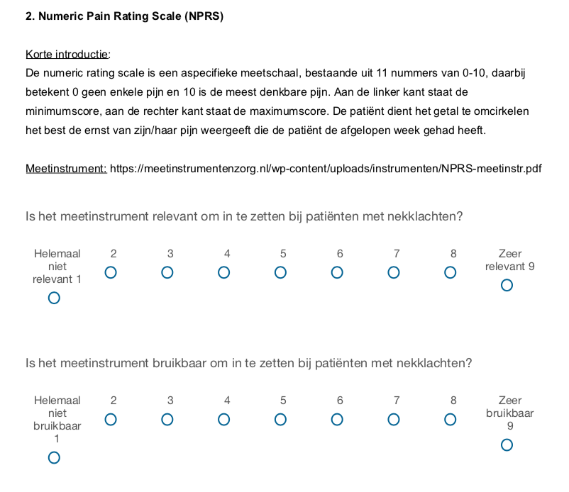
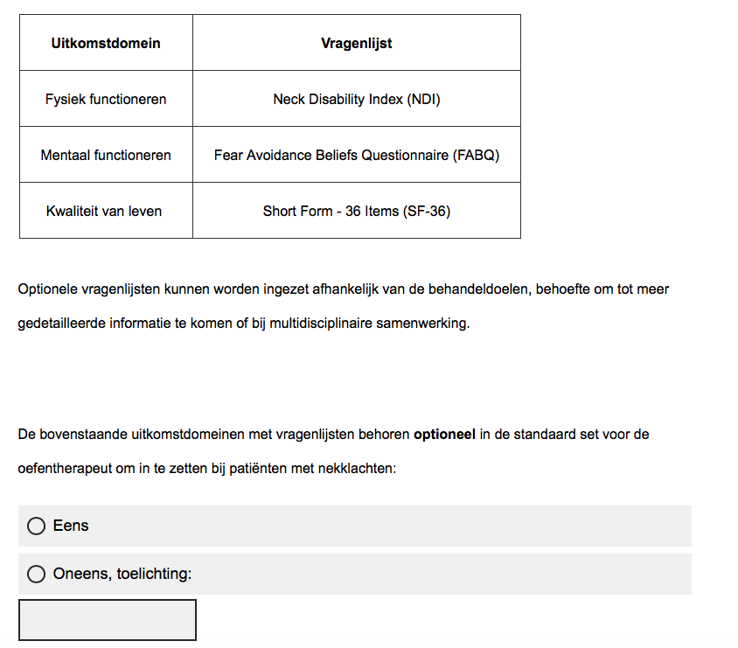
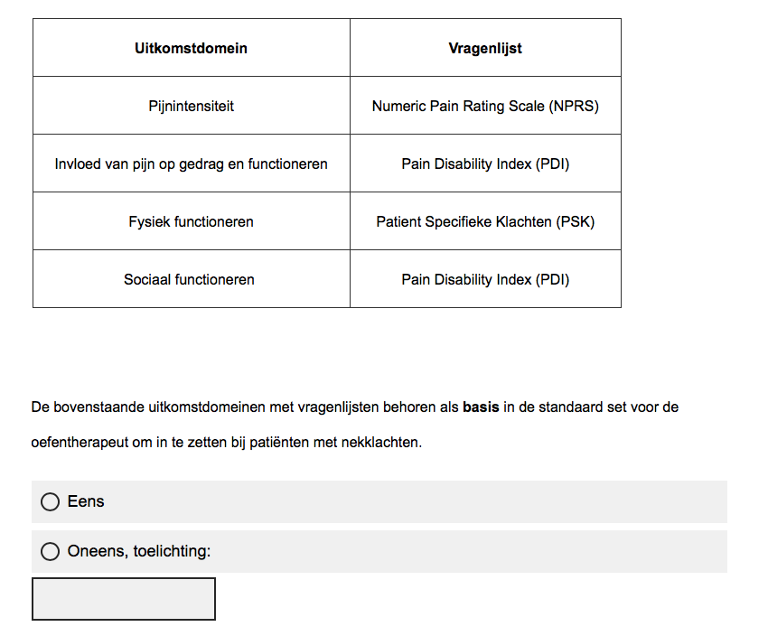
APPENDIX C
APPENDIX D
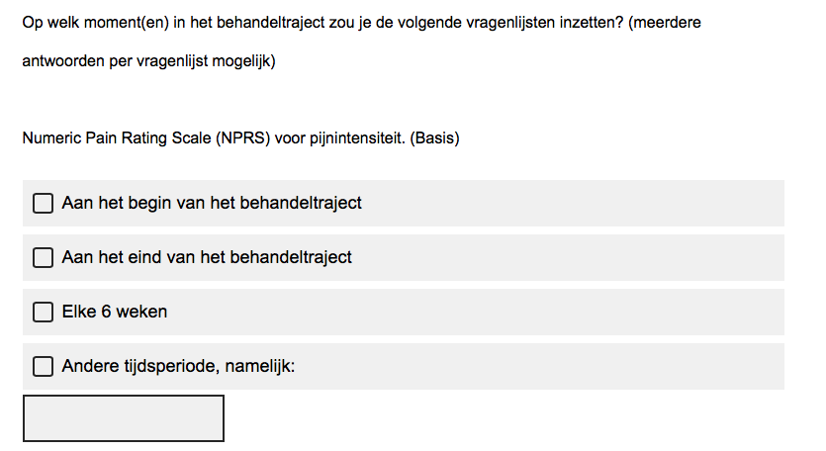

APPENDIX E
- Visuele Analoge Schaal (VAS)
- Numeric Pain Ranking Scale (NPRS)
- Pain Disability Index (PDI)
- McGill Pain Questionnaire (MPQ)
- West Haven-Yale Multidimensional Pain Inventory (WHYMPI)
- Short Form 36 items (SF-36)
- Short Form 12 items (SF-12)
- Vier Dimensionale Klachten Lijst (4DKL)
- Health Assessment Questionnaire (HAQ)
- Fear Avoidance Believes Questionnaire (FABQ)
- Tampaschaal voor Kinesiofobie (TSK)
- Short Questionnaire to Assess Health-enhancing physical activity (SQUASH)
- EuroQoL (EQ-5D)
- Patiënt Specifieke Klachten (PSK)
- Patient-Specific Functional Scale (PSFS)
- Work Limitations Questionnaire (WLQ)
- Blue Flags Questionnaire
- Stanfort Presenteeism Scale (SPS-6)
- Global Perceived Effect-Dutch Version (GPE-DV)
- Neck Disability Index (NDI)
- Neck Pain and Disability Scale (NPDS)
- Neck Bournemouth Questionnaire (NBQ)
- Northwick Park Neck Pain Questionnaire (NPQ)
- Whiplash Disability Questionnaire (WDQ)
- Copenhagen Neck Functional Disability Scale (CNFDS)
- Core Neck Questionnaire (CNQ)
- Core Whiplash Outcome Measure (CWOM)
- Core Neck pain Questionnaire (CNPQ)
- Core Outcome Measures Index for neck pain (COMI)

