Feeding behavior of captive juvenile Crocodillus porosus

Abstract
In the crocodile farming industry certain juvenile crocodiles stay behind in growth. Previous research has shown that although temperature, type of food, feeding frequency, stocking density and animal size are of influence on growth, they do not contribute to differences in animals within a group.
In this study a start was made to investigate the ethological aspects of fitness in captive juvenile crocodillus porosus. On an Australian crocodile farm two groups of juvenile crocodiles were monitored 24 hours per day for seven days, ethograms of the groups were composed. Their fitness was determined using three measures: Head length, Body length and weight.
The time in which the animals finished their food was assessed. The amount of mouthfuls of food taken was monitored during the trial and showed an increase every day. Interesting piecks in feeding behavior during the day were seen and different kinds of feeding behavior were monitored. Other interesting behaviors were observed. A small trial was performed to determine the best marking method for juvenile crocodiles, no suitable method was found.
The results of this study pose interesting questions for further research and most of all show the possibilities and challenges of performing research on juvenile Saltwater crocodiles.

Introduction
The crocodile farming industry is relatively young . It was only in 1971 that Saltwater crocodiles in Australia became a protected species and killing wild animals for their skins became illegal. As a response to this crocodile farming grew and established itself as a licensed industry.
The aim for crocodile farms is to have fast growing crocodiles with intact skins. In the current farming system size differences occur in the populations, starting at very young ages.
This poses problems for farms in multiple ways: The slowest growing animals take more time to achieve the length at which they leave the farm. They occupy space and eat food over a longer period and hence cost the farm more money than the faster growing individuals. It is also known that in the group of individuals that stay a great deal behind in development , called runts, mortality is higher and constitutes 48% of total deaths on Australian crocodile farms (Isberg, unpublished) Previous studies show that crocodile growth depends on many factors including temperature, type of food, feeding frequency, stocking density, size of the animals and social competition (Morpurgo et al 1993; Huchzermeyer 2003). The first 4 parameters are the same for all animals in a population under farming conditions. Many possibilities for the occurrence of size differences have been suggested including genetic causes, environmental causes which are the same for farm animals, and management (Buenviaje et al, 2008).
From experience crocodile farmers know that runts grow faster when selected and put in pens with only other runt individuals, suggesting a social competition component to the fitness of these animals. So far, there are no reports concerning crocodile behavior in captivity and the effect of crocodile behavior on growth rates and the occurrence of size differences in groups of captive individuals.
The aim of this research was to make a start in investigating the ethological aspects of fitness in captive crocodiles. Are growth and fitness in juvenile saltwater crocodiles related to dominance and can they be affected by a possibility to hide for each other?
The hypothesis was that dominant individuals eat more, experience less stress and therefore grow more. A possibility for the subordinate individuals to hide for the dominant ones will reduce stress, increase feeding behavior and improve growth rates and fitness.
Due to multiple problems during the study, further explained in the discussion, the original plan had to be revised and the choice was made to test possibilities to design a new research to test the original hypothesis. The study performed focuses on the relationship between group feeding behavior and group fitness, the feeding pattern is also studied.
Since both groups consist of randomly assigned crocodiles out of the same nests, no deviations are expected.

Materials and methods
In order to test the hypothesis the study was designed as follows: The animals used for this research would be measured using the three variables as described later in this chapter. Each individual animal would be marked ensuring identification during the development of the ethogram.
The first trial of 8 Days the animals would be observed 24/7 with cameras and the marked individuals would be followed during this period. Their behaviors would be recorded in an ethogram.
During the second trial, the effect of a partly cage division would be tested. For this an opaque Perspex plate would be placed in one of the pens. In this way, the animals would be provided with a way to hide from other crocodiles in the pen, while still being able to reach food and access both water and dry parts of the pen.
During this second 8 day trial ethograms would be made of the individually marked animals in both the control pen and the pen with hiding option.
After these trials the individual animal behavior would be linked to the individual animal fitness.
Due to multiple problems during the research, further explained in the discussion, the original plan had to be revised and the choice was made to test possibilities to design a new research to test the original hypothesis.
Prior to the actual trial, a couple of small trials were executed to determine the best marking method for the juvenile crocodiles.
In the first trial, a couple of methods were compared: reflective paint on the crocodiles cranium, reflective nail polish on the cranium, reflective tape on the cranium and reflective fabric attached with superglue (Selleys Quick Fix Supa Glue Liquid Gel Liquid) to the cranium. In the next trial, only the two longest lasting methods from trial one were tested. The spots of application during this trial were the cranium, the back and the tail. On half of the test subjects the markings were covered in superglue to strengthen the bond.
The marking of the animals was achieved by washing and drying the animals on the spots of application, after which the markers were applied . The animals were put in two separate pens without water to let the markers dry. After two hours the animals were taken out of the drying pens and a layer of superglue was applied over the markings in half of the cases. All the animals were put back in the drying pen for another two hours and after this put back in their original pens.
The marking method that stayed on longest was used in the study.
Executed research
Animals of 7-10 days old were selected randomly out of a group of hatchlings consisting of a couple of nests put together and randomly put in two research pens each containing 20 individuals. These groups were put together four weeks before the measurement started to create a stable established group.
The pen sizes were 117x239cm of which approximately 60% was covered with water. During the research period the water temperature was constantly kept at 32° Celsius and the environmental temperature was monitored daily. In each pen, 2 cameras were installed for 24/7 monitoring of the animals. The pens where lit overnight using infrared lights to ensure sight.
The animals were fed 4 times a week with fresh red meat (buffalo) fortified with 2% vitamins/minerals (Monsoon Crocodile Premix, Adissco Australia Pty Ltd, Qld) and 1,5% Calcium carbonate in the afternoon. The pens were cleaned in the morning after a feeding day. The amounts of food were raised every weekend, which means one time halfway through this trial.
Measuring fitness
As a measure of fitness, growth was recorded during the study in three ways: head length, body weight and total body length. Measurements were taken four days before the start of the trial and directly after the trial. The time of four days was taken to minimize the effect of handling stress on the trial results. The assumption is that after four days the stress caused by handling the animals is reduced to a minimum.
Developing an ethogram
After a two day period of observing the animals a trait list concerning their feeding behavior was composed.
Short | Behavior | description
FW | Feed in water | Grab mouthful of food and eat in the water staying close to the food source
FL | Feed on land | Grab mouthful of food and eat on land staying close to the food source
FR | Feed and run | Grab mouthful of food and move away from the food source to the other half side of the pen

During an seven day trial, including four feeding sessions, an ethogram was constituted using this trait list. The observations were made from the time of feeding until all the food was gone, this could either be because of consumption, or because of cleaning of the pens the day after.
The observations were made by counting the amount of times each of the behaviors was executed by the individuals in one of the research groups every five minutes of the day as long as food was present. This was repeated for the second research group using the same film material.

Results
Marking methods
During the first trial, reflective paint, reflective nail polish, reflective tape and reflective fabric were applied on the cranium of different juvenile crocodiles. Only the paint and the nail polish were still present on the test subjects after two days.
These two methods were further tested in a second trial. In this trial, more spots of application were tested and superglue was applied over the marking material in half of the animals. After a testing period of four days all the reflective paint was gone and just some of the uncovered nail polish was still present on the cranium. In the animals with superglue on top of the markings all the paint was gone, the nail polish was still present on the cranium but not on the tails or backs of the animals.
Feeding behavior
During the trial period the mean feeding time was 15:36 (± 32 min). The crocodiles kept eating the food until all of the meat was gone. This could be either because they consumed all the available food, or because the food was removed during cleaning the next day. The mean cleaning time during this trial was 7:53(± 29 min) which results in an average availability of food during 16,03 (± 1,03) hours. An exception to this was when the crocodiles finished the food before cleaning. This occurred for pen R on the 17th and for both pen L and pen R on the 18th. Due to this the actual mean availability of food was 11,21 (± 5,81) hours.
Food consumption increased every day. On the 18th the graphics don’t show an increase in feeding behavior. The cause of this is that the same amount of food was supplied as the day before. This time however the crocodiles finished the food within two hours. The previous day the same amount of food was consumed in approximately four hours in case of pen R and not finished at all in case of pen L. Taking this in account the events on the 18th can still be considered as an increase in feeding behavior.

Total feeding behaviors during the day
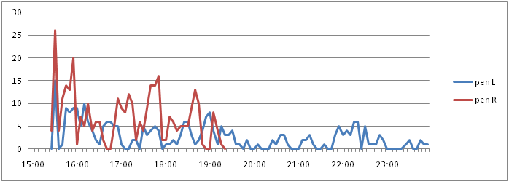17-02-2010
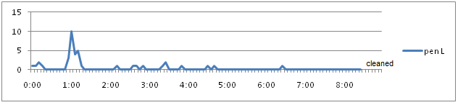
18-02-2010
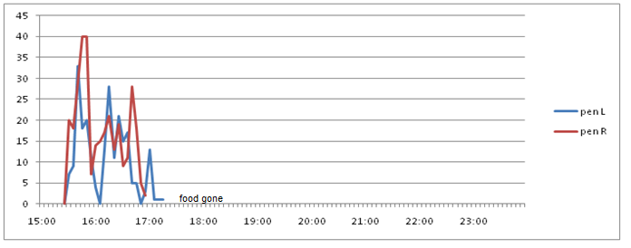18-02-2010
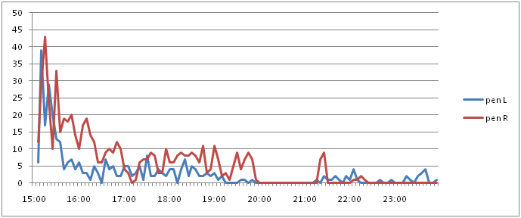21-02-2010
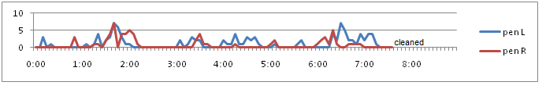
22-02-2010
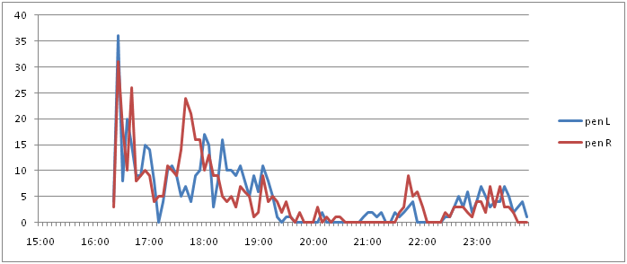22-02-2010
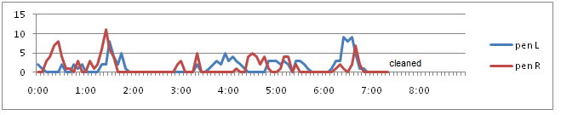
23-02-2010
During the trial pen L took les mouthfuls of food every day than pen R which proved not to be significant (P=0,23). The amount of feeding behaviors of both pens increased during the trial and was almost the same on the first and last day of the trial.
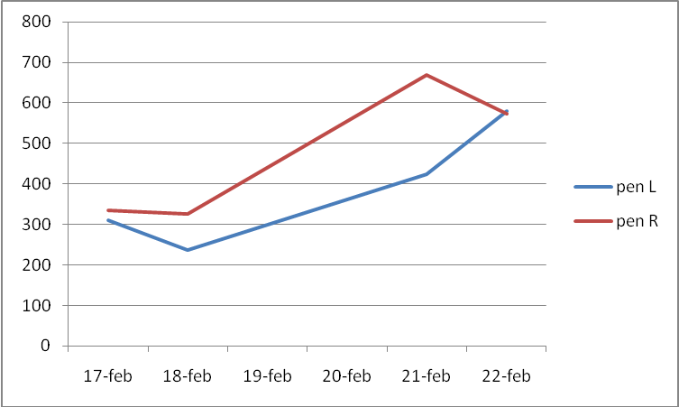
Total feeding behaviors per feeding session

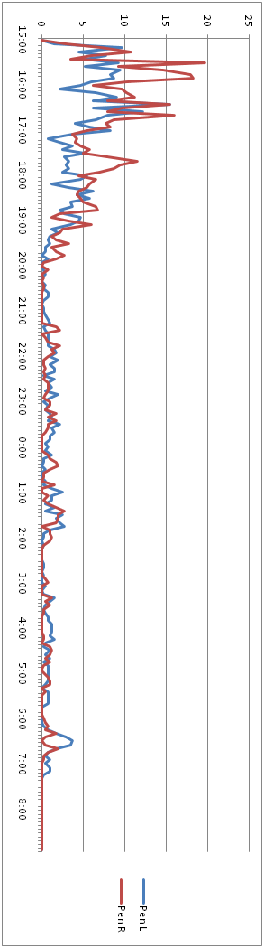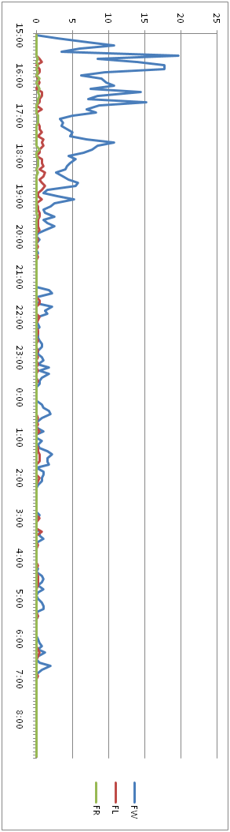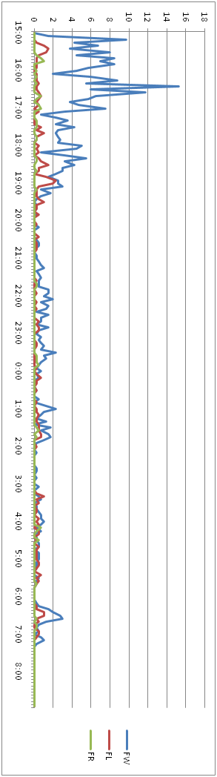

On average 50% of the food was gone within 1,77 (± 0,84)hours. To finish 75% of the food the crocodiles took an average of 4,68 (± 3,03) hours and after 7,27 (±4,92) hours they finished 90% of the food. The large standard deviations are the result of the shortage of food on the 17th in pen R and on the 18th in both pens. These values are highly different from the rest. To get a reliable image of the situation when there is food present until cleaning, these values have to be left out. Resulting in 50% of the food being finished in 2,22 (+-0,60) hours, 75% being finished in 6,60 (+- 1,80)hours and 90% being finished in 10,48 (+-2,69).
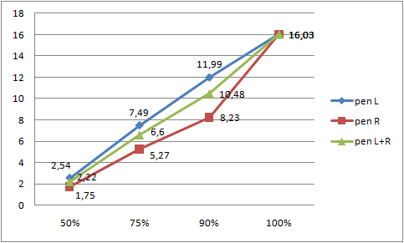
time to finish certain percentage of food
The large peak of mouthfuls taken generally ended around 20:00 after which a basic level of a couple of mouthfuls per hour occurred. A small significant (P=0,04) peak took place every day between 1:00 and 2:00 in both of the pens. A small peak also seemed to occur in the hour before cleaning. This was only recorded in two of the three days that food was still present in the morning.

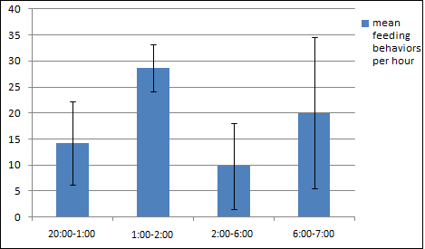
mean feeding bahaviors per hour
The feeding behavior that both groups showed the most was feeding in the water. With 74,8% - 98,2% of the feeding actions it was the most preferred way to ingest food. Feeding on land occurred in 1,96%-22,6% of the occasions and feeding and running away was least popular with only 0%-4,1% of the feeding behaviors.
From the second day of the trial on the relative occurrence of feeding on land increased in both of the pens. Feeding in water decreased during this period and feeding and running away stayed reasonably constant.
Pen L
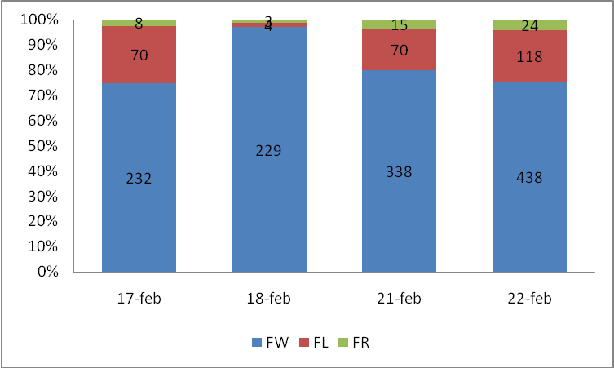
Destribution feeding behaviors per feeding session
Pen R
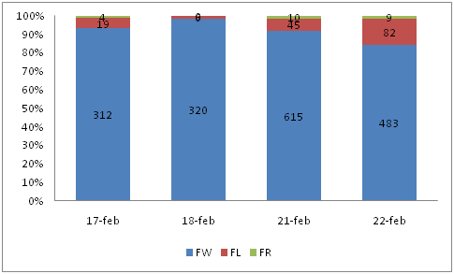
Destribution feeding behaviors per feeding session
Fitness
Before and after the trial the fitness of the animals was measured using three variables: weight, head length and total body length. The increase during this trial of all three variables was largest in pen L.
 |  | measurement 1 | measurement 2 | increase | Percentage increase
head length pen L (mm) |  | 52,91 | 56,52 | 3,612 | 6,82
head length pen R (mm) |  | 54,19 | 56,26 | 2,07 | 3,81
total length pen L (cm) |  | 33,92 | 35,51 | 1,59 | 4,68
total length pen R (cm) |  | 34,18 | 34,99 | 0,82 | 2,38
weight pen L (g) |  | 77.00 | 108,10 | 31,10 | 40,38
weight pen R (g) |  | 82,75 | 98,80 | 16,05 | 19,39
Animal fitness measurements
During the first measurements all the values of fitness were lower in pen L than in pen R, during the second measurements all values are greater than in pen R. All the differences were not significant ( P ranging from 0,24 till 0,48).
The mean head length in pen L increased with 6,8% compared to 3,8% in pen R, total length increased with 4,6% in pen L and 2,4% in pen R and the mean weight in pen L increased with 40,4% while the increase was just 19,4% in pen R.
Other interesting behavior
During the study the focus was put on feeding behavior. While analyzing this feeding behavior other typical behavior of the animals became noticed. An interesting group behavior that took place through the whole day was piling of the animals in the corners of the pen. The piles often consisted of over ten animals, but smaller piles were also seen.
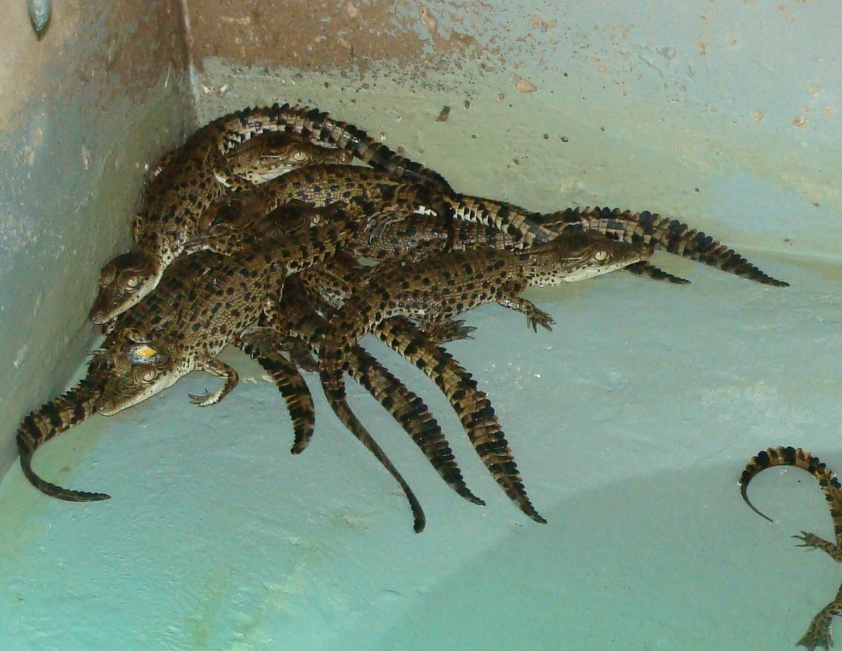
Piling crocodiles in a corner of the pen
Remarkable behavior shown by an individual animal was that this crocodile in pen L sat at the spot where the feeding started every time the caretaker entered the area around the pens around feeding time. The animal was facing the side at which the food would appear first every time.

Discussion
In order to answer the hypothesis, the initial research was designed as described earlier. During the execution of this design multiple things did not turn out as expected.
The most important problem was marking the animals. Multiple options were thought of, for example labels like used with chickens, paint as used with pigs and paint on the cranium as used on larger crocodiles. Prior to the actual trial, a couple of small trials concerning marking methods were done. The result of these trials was that the nail polish plus superglue stayed on longest on the cranium, the least motile part of the body. This method was used during the research.
During the actual research trials the individual marking came off after half a week. It was not possible to reapply since this would cause new stress and would bias the results. It was tried to follow individual animals on the video footage from a certain time without markings. This method showed to be unusable since it was impossible to keep track of a single animal without losing it within a couple of hours due to piling of the animals.
The consequence of these problems was that it became impossible to make ethograms of the individual animals and link the results with the individual rates of fitness. The choice was made to compare group behavior with group fitness.
To obtain more valuable information, it would be useful to find better ways of marking juvenile crocodiles. Methods as applying ties and ribbons are useless since the crocodiles interact in a rough way and tear off all applications including paint. Another problem in marking the animals is that the juvenile crocodiles spend most of their time either in the water or piled up on land.
In the first case, the durability of the marking is important, it should not be bleached or washed off by water. This is worsened by the fact that the crocodile pens are cleaned four times a week using chlorine based products while the animals are still in the pens.
Piling up poses the problem of visibility. The juvenile crocodiles make piles of over ten animals which makes it easy to lose track of individuals. It also contributes to the wearing of individual marking methods since the animals rub against each other with their rough skins.
The ideal marker would be a long lasting, visible marking method which does not permanently damage the parts of the crocodile skin that have to be sold. New techniques have to be thought of.
Another problem that occurred during this study was the visibility of the animals on camera. The surveillance cameras were situated on a bar hanging over the pens. This way the animals were only visible from the top which meant that a lot of types of behavior weren’t clearly visible. It is for example difficult to observe behaviors like changing head height and opening of the mouth, which are more clearly visible from the side. The current camera position is good for monitoring the place of the animals in the pens and observing the animals taking mouthfuls of meat. In order to be able to make a more extensive ethogram it would be useful to add camera’s with a side view.
Visibility of the animals was also compromised by the provision of light during nighttime. In order to be able to record the animal behavior on camera the pens were moderately lit overnight using infrared lights situated about 15 centimeters above water level in the front and the back of the pen. There were also small infrared lights placed in a circle around the camera lens. This was necessary in order to ensure visibility and a previous trial by S. Isberg showed that using only the lights situated around the cameras was insufficient.
Every light however created a glary spot on the water surface that resulted in a small area of lesser visibility. The visibility was mostly sufficient to monitor the different feeding behaviors in this study but has to be looked at in order to monitor various other behaviors.
Feeding behavior
In this study the time in which the animals ate a certain percentage of their food was measured. In the first calculations all gathered results were taken and the outcome gave very high standard deviations. The reason for this was that the animals finished their food a long time before cleaning of the pens on the 17th in pen R and on the 18th in both pens. To get a reliable image of the time spans in a situation in which food is present during the whole night until cleaning the next morning, the results of the 17th in pen R and the 18th in both pens had to be left out.
Knowing in which time span juvenile crocodiles of this age finish a certain percentage of food is relevant for further studies. Certain deviations due to differences in animal size, group size, etc. are expected when using these data on other groups of animals, but it provides a guideline to determine the hours of observation during a new research.
It can also be used in solving questions about the presence of food related dominance. During the executed trials food related aggression was present. Aggression provides stress for the subordinate animals and therefore possibly a reduction in growth rates. It is very useful to find out if the aggressive behavior of the animals is worse with the presence of food, like it is in juvenile Nile crocodiles (Morpurgo et al 1993). A possibility is to provide smaller portions of food in a higher frequency during the day to see if the constant presence of food effects the aggressive behavior of the animals.
The food consumption increased every day in this study. On the 18th the graphics don’t show an increase in the amount of feeding behaviors, but this is due to the fact that the amount of meat fed that day was the same as the day before. In order to get a better image of the amount of feeding behaviors the animals actually execute per feeding session it is better to adjust the feeding amounts every day. This way the results are clearer, but also the effect of being more hungry than usual on the next session is prevented. In this study, the animals were more hungry than usual on the third feeding day because of the deprivation of food for two days due to their normal feeding regime. This was also the first feeding session after the session on the 18th on which the animals finished the food within a few hours. This may have contributed to their eagerness to eat during the feeding session on 21st .
Another result in this study was that the animals in pen L ate less that the animals in pen R at the start of the trial. At the end of the trial both groups took the same amount of mouthfuls. An explanation for this could be that the animals in pen L were smaller than the animals in pen R at the start of the trial and grew substantially during the trial, a growth that the animals in pen R experienced before the start of the measurements due to difference in genetics or age.
This is, however, very unlikely since both groups consist of randomly assigned crocodiles out of the same nests. The environmental factors were also the same for both pens so no deviations were expected.

Another possibility is that pen L experienced higher stress rates at the start of the trial, which withheld the animals from eating. This could be due to the presence of a dominant animal monopolizing the food. Environmental factors can be excluded since they were the same for both groups.

The third explanation has to do with the size of the mouthfuls taken. During this study the feeding behavior is monitored by counting the amount of mouthfuls taken by the animals. The size of these mouthfuls was not measured and could have differed between the animals. The assumption is however, that this could not have been the reason for the differences between the groups, since the animals were randomly assigned. Due to stress within the group the size of the mouthfuls taken could have differed. This is an interesting topic for further research.

Using statistics the amount of mouthfuls taken by pen R was not significantly greater than the amount taken by pen L. An explanation for this can be that the trial only consisted of four measuring days. Because of this the results could have been random and a new study has to be executed including more feeding days to prove whether or not one of the pens consumes more food.
A small significant peak in the amount of feeding behaviors was seen around 1 pm every session during this study. A possible cause for this is that the crocodiles are nocturnal. There a no further signs in this study of the crocodiles being nocturnal animals since the feeding behavior is very low during most of the night hours. Cloudsley-Thompson (1964) reported that Nile crocodiles are slightly nocturnal with a peak in the early evening, but tend to be diurnal depending on environmental temperature. Smith (1979) discovered that crocodilians switch from diurnal to nocturnal depending on season. Most research conducted about feeding of crocodylus porosus focused on stomach contents rather than when the crocodiles took the food (Taylor et al 1979; Sah et al 1996). More research has to be done to see if juvenile individuals of crocodylus porosus show nocturnal behavior in captivity.
Another small peak occurred two hours before cleaning .This peak occurred two out of the three times when food was still present at that time of the day. The question rises if these observations are just random since the trial was very short and it only occurred twice. The results proved to be not significant in statistics.
There are two possible explanations for the occurrence of this peak. It could be a sign of conditioning. In this case the animals learned that the available food will be taken away within two hours and this will be the last opportunity to eat for several hours, which makes them more willing to eat the food.
Another explanation could be that the increased feeding activities are a consequence of the rising of the sun just before the increase starts. This can be a trigger in the learning process as described above, or natural behavior. In the last case the rise of activity when daylight commences could be a sign of the animals not being nocturnal feeders but that they prefer to feed during daytime.
A fairly larger peak in feeding behavior is seen right after the provision of food. This peak can easily be explained by the animals being hungry and the food being fresh. The high frequency of feeding doesn’t start until some minutes after supplying the food. This can be explained by the fact that most of the animals are shy of humans, unfamiliar movement and sudden noises. During the first minutes after feeding the humans are still present and moving around the pens to feed other animals. After the humans leave the area around the animal pens most of the animals start feeding.
An exception to this are a few individual animals who start grabbing mouthfuls while the supplying of food goes on. Some of them assume a position closest to and facing the side at which the caretaker starts providing food on every feeding day, a sign of conditioning.
This observation is very interesting and poses the question how big the learning component is in crocodiles compared to the congenital component of behavior. The observations during this research show both learning behavior like the anticipation on food, and congenital behavior. An example of congenital behavior in this study was that the animals in 74,8-98,2% of the times dragged their food under water and shook it like they would do to kill their prey in the wild. In captivity they get fed minced meat and the behavior is not necessary to be able to consume the food. Still they execute this behavior right at the first time they feed, without being exposed to another crocodile executing this behavior first.

During this study the animals preferred to grab a mouthful of food and take this into the water. In the wild situation this is a useful behavior to kill the captured prey. During the trial the amount of mouthfuls taken on land relatively decreased and feeding on land increased. A possible explanation could be that the animals gradually get used to the minced meat, that they do not have to kill. In order to save energy they consume the food on land near the food source without dragging the meat to other places like the water and having to come back for another mouthful. This could be described as a learning experience.

Another reason for the increase of feeding on land is that the crocodiles gained more confidence during the trial. During feeding on land their body exposure is larger than during feeding in water, in which at least half their body is covered by water. That they stay exposed for a longer period could be caused by lower stress levels.
However, another explanation could be that the animals feed on land because they do not want to enter the water. The reason for this can be a dominant animal monopolizing the water. The increase in feeding on land occurs in both pens at the same time, making this less likely, but the presence of a dominant animal in both pens is not impossible.

Fitness
In this study three measures of fitness were used: head length, body length and weight.
Head length is the method with the smallest error, since it is a bone to bone measurement and human error can be minimized compared to total length. Weight is a valuable measure since it includes gain of muscle, although it can be biased by when the animal was last fed, how much it ate and when it last defecated. However, the assumption is that the faster growing animals are consuming more and converting more efficiently. Hence bodyweight was considered to be an appropriate measure of fitness.

Before and after the trial measurements of fitness were taken. Before the trial the animals in pen L were smaller than the animals in pen R. After the trial the animals in pen L were larger than the crocodiles in pen R. The difference in animal size was insignificant in this study.
During the trial Pen L took less mouthfuls than Pen R which suggest a larger growth in Pen R since the crocodiles in this pen consume more food. Therefore, the intake of food doesn’t seem a valid explanation for the larger growth in Pen L.

A different explanation could lie in social interactions in the pens. A larger growth suggest more positive social interactions which lead to smaller amounts of stress and less energy wasted by stress mechanisms. This could lead to having more energy to grow and thus more growth. In this study no recordings were made of stress behavior. The only marker that could be explained as stress, being feed and run, was constant between the pens and therefore can’t explain the difference in growth. To measure the influence of social behavior on growth more social interactions have to measured.

The most likely explanation for the measured larger growth in pen L in this study is human error. During the first measurement, taken before the start of the trial, the assumption was made that the animals would be assessed individually. A small group of animals was randomly taken out of both of the pens and measurements were taken after marking the animals. Because the markings didn’t last the crocodile behavior was monitored for the group instead of for every individual. Another consequence of the disappearing markings was that it was not possible to take measurements of fitness of the exact same animals as before the trial. To compensate for this the decision was made to take measurements of a larger sample of animals. This possible difference in sampled animals could be the cause for measuring larger animals during the second measurement. It could be that a larger selection of bigger animals was made during the second measuring than during the first one. Because the sample during the first measurement was smaller than during the second one a non reliable image of the group could have been created.

Both the growth of the animals and the feeding of the animals appeared to be non significant in statistics.
Linking behavior and fitness
In order to either confirm or reject the hypothesis it is necessary to try to find a link between behavior and fitness of the animals. In the executed study only feeding behavior was monitored so the only possibility is to link this feeding behavior to the group fitness.
During this study pen R showed more feeding behavior than pen L giving the assumption that the animals in pen R consumed more food.
Pen L showed the highest increase in fitness during this trial. As described earlier there are multiple explanations for this outcome and the trial was too short to get significant results. It is very plausible that the results are not reliable.
Furthermore, many behaviors were not described during this study and these behaviors were very likely to be a great influence on the animals stress levels and feeding behaviors.
Therefore, it is not possible to make a reliable link between crocodile behavior and fitness in this study.

Conclusion
Due to multiple problems occurring during this study it was neither possible to proof nor to reject the posed hypothesis. The study did give insight in what is possible and even more what the obstacles are in conducting behavioral research on juvenile crocodiles in a captive situation.
Most of all, this study provides a basis for further research and poses multiple questions to be solved in new studies.

References
Buenviaje, G.N., Ladds, P.W., Melville,L., Manolis,S.C. (2008) “Disease-husbandry associations in farmed crocodiles in Queensland and the Northern Territory” Australian Veterinary Journal 71(6): 165 – 173
Cloudsley-Thompson, J. L. (1964) “Diurnal rhythm of activity in the Nile crocodile” Animal Behaviour 12(1): 98-100

Fis, F.E., Bosti, S.A., Nicastr, A.J., Beneski, J.T. (2007)“Death roll of the alligator: mechanics of twist feeding in water” Journal of Experimental Biology 210: 2811-2818
Huchzermeyer (2003) “Important aspects of crocodile farming” in Crocodiles: biology, husbandry and diseases, CABI Publishing Cambridge: 98-104
Medley, C (1970) "One Way to Halt Poaching-Gator Farming" The New York Times January 18
Morpurgo, B., G Gvaryahu, G., Robinzon, B.(1993) “Aggressive behaviour in immature captive Nile crocodiles, Crocodylus niloticus, in relation to feeding” Physiology & behavior 53(6): 1157-1161
Norbert Smith, E.(1979) “Behavioral and Physiological Thermoregulation of Crocodilians” American Zoologist 19(1):239-247
Sah S.A.M., Stuebing, R.B (1996) “Diet, growth and movements of juvenile crocodiles Crocodylus porosus Schneider in the Klias River, Sabah, Malaysia” 12 : 651-662
Taylor, J.A. (1979) “The Foods and Feeding Habits of Subadult Crocodylus Porosus Schneider in Northern Australia” Australian Wildlife Research publish.csiro.au
Verbal references and help:
Dr. S.R. Isberg
Dr. A. Britton

