Elucidating the molecular basis of exodermis development to create a Zea mays variety with a multiseriate exodermis
Research proposal writing assignment, Douwe Rietveld, 6001106
Summary: 291 words
Global atmospheric CO₂ concentrations are rising rapidly due to human activities and an increasing world population. This puts increasing pressure on crops we rely on for food and other necessities. Plants capture CO₂ in order to assimilate biomolecules like sugar for energy. Suberin is one of these biomolecules, and it is a hydrophobic polymer deposited in barrier cell types, like root endodermis and exodermis, where it forms a barrier. Some plants are known to possess multiple of these exodermis layers; a multiseriate exodermis (MEX). Molecularly, the exodermis is poorly characterized compared to the endodermis, because the model plant species Arabidopsis thaliana has none. However, the exodermis increases plant drought resistance by increasing water retainage of roots and even has the potential of alleviating the rising atmospheric CO₂ levels by storing suberin in soils. The more suberin a plant deposits in its root system, the more atmospheric CO₂ becomes sequestered underground. This means that plants with a MEX generally have a larger potential of storing CO₂. If crops like maize, Zea mays, which has a single exodermis layer, can obtain multiple exodermis layers this might increase carbon sequestration and drought resistance. Maize is suitable for this approach, since maize roots are typically left underground after harvest. In this proposed work, we aim to generate a new maize variety that possess a MEX. By investigating the molecular mechanisms behind (multiseriate) exodermis development we aim to elucidate what (transcription) factors influence development of the exodermis. Using paired-end deep RNA sequencing and genome walking of (dry- and hydroponically grown) maize roots and Chrysopogon zizanioides, a maize relative with a MEX, we will generate transcriptomic data of both species. Lastly, we aim to find genes we can use to introduce a MEX in transgenic maize.
Overall aim:
Identifying molecular regulators of multiseriate exodermis and designing a new Zea mays crop variety that has a suberized multiseriate exodermis, which sequesters more atmospheric carbon and is more drought tolerant.
Key objectives:
1: Identify a plant species that has a suberized multiseriate exodermis and thrives in typical Zea mays environmental conditions.
2: Generate novel transcriptomic data from Zea mays and related species.
3: Identify genetic factors responsible for (multiseriate-) exodermal development.
4: Transform Zea mays to create a new variety with a multiseriate exodermis, increasing carbon sequestration and drought resistance.
Keywords: exodermis, Zea mays, suberin, drought tolerance, carbon sequestration
Introduction
The exodermis and suberin
In 2021, Earth’s northern hemisphere temperatures reached 1,5 degrees Celsius above pre-industrial temperatures which is largely caused by human CO₂ emissions (‘Climate Change 2021, the physical science basis’, IPCC, 2021). With the global human population almost reaching 8 billion, both greenhouse gas emissions and food demands are expected to increase in the future. This puts increasing pressure on plant crop performance, which is depending on plant energy use. Plants sequester carbon (C) to assimilate it into biomolecules like sucrose and cellulose for energy storage and/or structure. One of the most persistent and slow-degrading of these molecules is suberin (Figure 1A), a hydrophobic biopolymer consisting of fatty acid chains linked via phenolic structures (Graça, 2015). Suberin is mostly found in cell walls of adapted cells that serve as protective barriers, in leaves aboveground and the endodermis and exodermis in roots (Graça, 2015). Both the exodermis and endodermis are lignified and suberized, but the endodermis to a smaller extent than the exodermis in some plants (Kajala et al., 2021). The exodermis is the outermost cortex cell layer of the roots, while the endodermis layer is located just inside the cortex layer(s). Exodermis is involved in retaining water during drought or inhibiting Radial Oxygen Loss (ROL) during floods (Ma and Peterson, 2003). In both exodermis and endodermis, lignin is deposited around cells to form a sealed barrier known as Casparian Bands (Hose et al., 2001), whereas suberin is found as coating around individual cell walls (Meyer et al., 2009).
A B
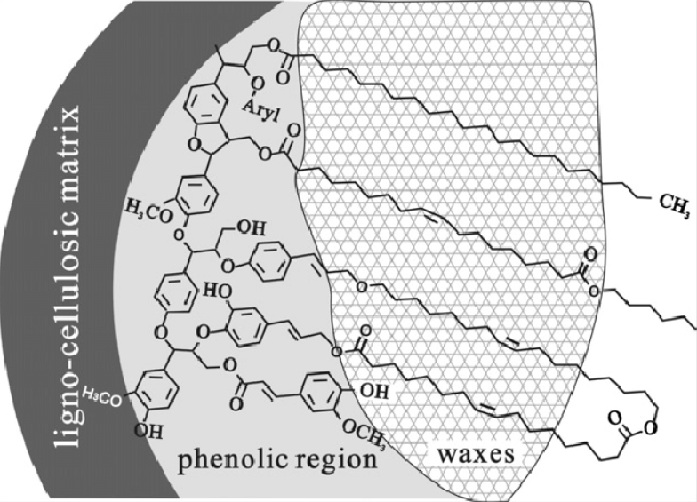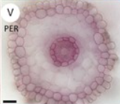
C
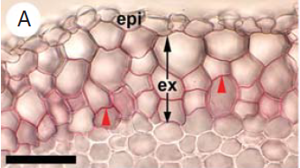
Figure 1: Suberin structure and distribution in root cross-sections of single- and multi-layered exodermis layers.
A: Schematic representation of chemical structure of suberin. (Yao et al., 2012)
B: Cross-section of Zea mays roots grown in perlite and sand mixture (PER) with Sudan Red 7B staining of suberin, visible in endodermis-, epidermis- and exodermis cell layers. (Tylova et al., 2017)
C: Cross-section close-up of the MEX in Iris pumila with Sudan Red 7B staining of suberin. Red arrowheads indicate suberin lamellae. Epi=epidermis, ex=exodermis (Meyer et al., 2009).
The potential of a multiseriate exodermis
93% of all flowering plants have an exodermis layer in roots (Peterson and Perumalla., 1990) but the model plant species Arabidopsis thaliana has not, which is why the exodermis has not been studied as thoroughly. The exodermal rate of maturation is highly responsible to environmental cues (Meyer et al., 2009), meaning that when plant roots experience drought, the exodermis matures faster. Some monocot plant species are known to have multiple exodermal cell layers in their roots (a multiseriate exodermis, MEX). Plants with MEX have greater suberin content than plants with a uniseriate exodermis, because deposition of suberin lamellae is not restricted to the outermost exodermis layer (Meyer et al., 2009). Given that suberin is stored in roots and decomposes slowly, roots with a MEX sequester more atmospheric carbon in soils than roots with a single or no exodermis. After a plant has died, the suberin molecules in the roots can remain in the soil for a long time, since it degrades slower than most other biopolymers (Harman-Ware et al., 2021). In this way, atmospheric CO₂ can be stored in the soil via deposition of suberin, which could help decreasing the rising atmospheric CO₂ levels that cause climate change. Using this potential of the (multiseriate) exodermis could be advantageous when applied widely, such as on agricultural crops. Therefore, expanding our knowledge of molecular mechanisms that underlie exodermis differentiation and -development is key in developing crops that help tackling climate change. Next to that, more frequent drought events are expected to take place in the future (Sheffield and Wood, 2007), which increases pressure on crop performance. By introducing a MEX to widely used crops in dry areas, these extra root barriers can increase plant drought tolerance by reducing the transmembrane water transport of roots (Ma and Peterson, 2003), which helps increase water retainage during drought. Another possibility is to use this principle to fertilize soils. When suberin eventually breaks down, it can be used for agriculture by fertilizing soils with organic matter, although this reduces the effect of atmospheric carbon sequestration.

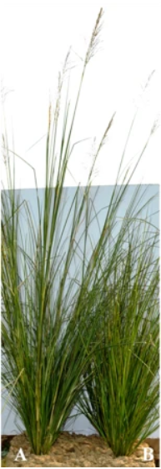
Applying a MEX to a crop
Some important considerations of applying a MEX to a crop is that the plant roots must remain in the soil after harvest and the crop is preferably annual for better results. Maize (Zea mays) is an annual food- and biofuel crop which is cultivated mostly in dry areas. During harvest, shoot material is removed, with roots staying behind in the soil. Like the majority of flowering plants, maize has an exodermis layer in roots which contains suberin lamellae (Peterson and Perumalla, 1990, Meyer et al., 2009). By introducing MEX to maize, this can help increase carbon capture from the atmosphere, while increasing crop performance during drought stress.
Like in the (single-layered) uniseriate exodermis, molecular foundations of MEX-development are unknown. Chrysopogon zizanioides, or vetiver, is a grass species closely related to maize which possesses a MEX, which makes it a useful candidate for studying MEX-anatomy. Another uniseriate exodermis monocot crop that could benefit from multiple exodermal layers in roots is rice (Oryza sativa). Maize seems more favorable however, because maize can be cultivated alternately with other crops like beans and other legumes. These could benefit from the soil fertilizing potential of extra carbon sequestration. However, the molecular factors responsible for development of single- or multilayered exodermal cells is largely unknown to date (Kajala et al., 2021). In this work, we propose to investigate the molecular mechanisms of exodermis development. Factors involved in these mechanisms could act in different ways on exodermis development. Genes that increase suberin deposition in outer cortex cells, increase cell division in the root meristem or protein gradients are all examples of how gene expression could establish different exodermal anatomies across plant species. Also, we aim to apply these newly found factors to Zea mays by Agrobacterium tumefaciens mediated transformation in order to obtain a maize variety with a MEX.
Hypotheses:
1: performing assays and studying suberin content of Zea mays related plant roots will bring forward a candidate species (for RNA-seq) with a multiseriate exodermis.
2: We can identify molecular regulators of multiseriate exodermal development, like SHORTROOT (SHR) and SCARECROW (SCR) regulate endodermal development.
3: When Zea mays obtains multiple exodermal cell layers with suberin, it will capture more carbon and becomes more drought resistant.
Originality
In this work, development of the multiseriate exodermis will for the first time be molecularly characterized by performing RNA sequencing. The focus lies on genes that express in the exodermis- and cortex cells during exodermal development. If new molecular (multiseriate) exodermis markers or transcription factors are found, they will be applied to maize by transformation in order to create a newly designed maize variety that has MEX (multiseriate exodermis) or more suberin in the native uniseriate exodermis. If this succeeds, the new maize crop variety will capture more atmospheric carbon and will be more resistant to drought at the same time. Also, new transcriptome- and cell type-specific gene expression data of the species Chrysopogon zizanioides will be generated, next to identifying new promoters in both C. zizanioides and Zea mays. C. zizanioides is of interest for many industries. It be used to extract oil, livestock feed or erosion control in soils prone to degradation. Generating a novel reference transcriptome for C. zizanioides is of value for research with these applications in mind.
Methods and techniques
Work package 1: Finding Zea mays relatives with MEX
The first work package (WP) aims to find the best candidate plant species for RNA-seq experiments. The maize variety we will be using is A188, because this inbred line shows the highest transformation efficiency when using Agrobacterium tumefaciens (around 50%, Ishida et al., 2007). Since maize is a member of the Poaceae order of plants, the focus of WP 1 will lie on plants around this group. We will take the following criteria into account when selecting species:
- does the plant species have a multiseriate exodermis?
- is the plant species (closely) related to Zea mays?
- does the plant live in similar conditions as Zea mays?
- data and resource availability of the species
Aims and methods
1 Grow species of interest in typical Zea mays growth conditions
Maize is a member of the Poaceae family of grasses, which contains species living in different environments where abiotic factors like temperature and water availability can differ greatly. A MEX is found in several species closely related to maize, as is shown in figure 2. Because exodermal development is responsive to the environment (Meyer et al., 2009), all species of interest in figure 2 will be grown in conditions similar to those in typical maize fields. This will take place in the greenhouse cabinets in the Botanical Gardens at Utrecht University. Temperatures are kept close to 25 degrees Celsius, with 16- and 35 degrees Celsius as lower and upper limits. Plants will grow in long day conditions (sowing in March, with growing lights supplying extra light when needed). Water will be supplied twice, since plants will grow for only 4 weeks. At least 20 individuals per species will be grown to collect sufficient amount of material for further experiments, preferably more. We will grow plants on patches or trays of 1m² to resemble agricultural light competition. All plants will be grown on vermiculite soil.
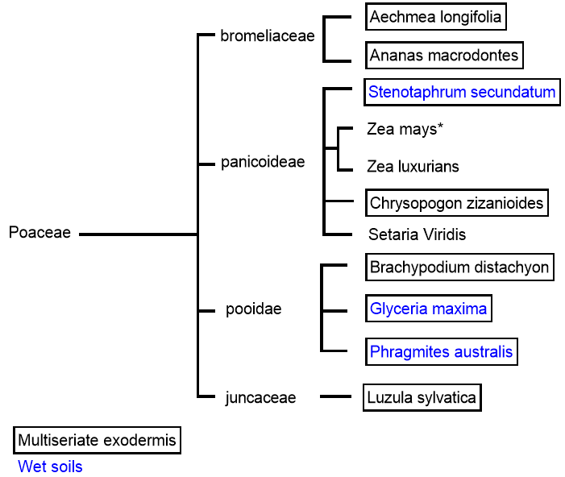
Figure 2: Phylogenetic tree of species of interest of the Poaceae family (grasses). All stated species have an exodermis, with barred species having multiple exodermis layers (MEX). Black colored species inhabit well-drained soils, blue colored species inhabit wet soils. *=Zea mays. Derived from Meyer et al., 2009; Soukup et al. (2007); Kroemer, 1903; Shiskoff, 1986
2 Drought assays
When maize plants are 4 weeks old, they are fit for experiments. We will perform dry treatments in combination with drought assays. Plants will be only watered once to simulate dry periods in which maize should be able to survive. As well as monitoring survival rate, we will measure relative water content of plants by using leaf samples we harvest after the dry period (Hao et al., 2011). In this way, we will select the plants that match best with Zea mays in terms of water requirements for further experiments.
3 Study exodermal anatomy
Candidate species of which the majority of plants survived the drought assays will be used for further research. We will study exodermal pattern (uniform or dimorphic, Meyer et al., 2009) and number of layers. We will harvest samples for microscopy from roots where the exodermis has fully matured, around 30 mm distal from the root tip (Hose et al., 2001). We will fix, section and stain the samples for suberin using Sudan Red 7B. To study the different exodermal anatomies of the species, we will generate microscopic fluorescence images of the exodermis using Confocal Fluorescence Microscopy with the Carl Zeiss Airyscan microscope in the Kruyt building.
4 Quantification of microscopic data
We will perform quantification of fluorescent signal intensities using Image-J software to determine suberin content in the different species, as the intensities of the suberin stains are linearly correlated with suberin quantity. The species that show high suberin content will be investigated in WP2.
Figure 4 (side): two Chrysopogon zizanioides varieties. A: South Indian variant, B: Northern Indian variant.
Hypothesis: Chrysopogon zizanioides (Vetiver) is the best candidate species for RNAseq, since it is the closest C₄ Zea mays relative with a suberized multiseriate exodermis (Meyer et al., 2009). It is also a hardy plant that can tolerate many abiotic stresses. Although perennial, C. zizanioides grows fast, with the South Indian type (A) reaching up to 2,5m. (Chakrabarty et al., 2015)
Work package 2: transcriptome analysis of exodermis
In WP 2 we will generate transcriptome data of Chrysopogon zizanioides and Zea mays. We divide maize plants into two groups: one that is grown in vermiculite soil like in WP1, and another group that is hydroponically grown (no exodermis suberization). When the three groups have grown for 4 weeks, we again divide them; one half of each group will be used for RNA-seq, the other for gene walking. By comparing transcript profiles of these three groups with different exodermal anatomies, chances are greatest of finding genetic factors that regulate exodermal development. For hydroponically grown maize we will use the outermost cortex layer for transcript profiling. Eventual transcription factors and promoters found here can be used for transformation in WP 3.
Aims and methods
1 Creating reference transcriptomes
Chrysopogon zizanioides and other MEX candidates in WP1 have little genomic- and transcriptomic data available, while maize has abundant transcriptome data available (Chakrabarty et al., 2015, Martin et al., 2014, Hirsch et al., 2014, Wang et al., 2015), although parts of the maize transcriptome remain unclear. Therefore we will perform De novo transcriptome assembly using root tissues of Chrysopogon zizanioides.
2 LCM
To separate cell types, we will use laser capture microdissection with the Pix-Cell II LCM system (Kerk et al., 2003) to separate cell types. After we isolate RNA and construct RNAseq libraries (Townsley et al 2015 / Kajala 2021), samples will be sent to USeq for high-throughput deep RNA sequencing with HiSeq.
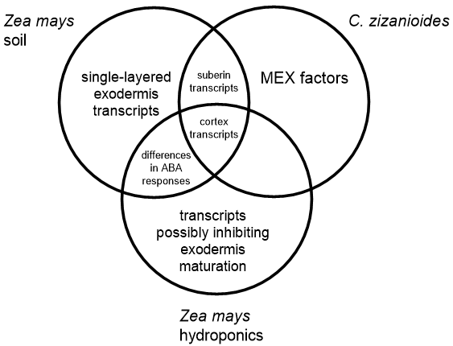
Figure 5: Transcript categories. Diagram showing expected categories of relevant root transcripts from the three groups.
Figure 5 shows categories of transcripts we expect to find in the samples. The transcripts where chances of finding a MEX development regulator are greatest in Chrysopogon zizanioides. Between the two maize groups, we expect to find differentially expressed ABA-related transcripts (abscisic acid), since ABA is involved in drought stress responses in roots (Vallabhaneni et al., 2010). Cortical identity-transcripts are expected to be found in every plant group.
3 Promoter identification
To identify promoters of the genes of interest, we will use genome walking with PCR on C. zizanioides and both maize groups. By using the exonic RNA sequences of transcripts found in WP2, we aim to find the corresponding coding sequences in the plant genomes to find flanking promoter sequences with PCR and sequence specific primers.
Table 1: example list of genes and -promoters
Promoters | Predicted target genes
‘novel MEX’ TF promoter | ‘novel MEX’ TF
‘novel uniseriate exodermis’ TF promoter | ‘novel uniseriate exodermis’ TF
monocot PEP homolog promoter | Maize OsMYB93 homolog
Maize OsLSI1 homolog promoter
Table 1 states a number of genes and promoters our RNA-sequencing and genome walking experiments might identify. The ‘novel (multiseriate) exodermis’ genes we hope to find are regulators of exodermal development, like SHORTROOT and SCARECROW control endodermis development (Koizumi et al., 2012).
4 Transcript data analysis
We will use Trans-ABySS to assemble paired-end sequencing data. When RNA-sequence data of the three groups and different tissues is collected, we will compare transcript abundances in a cell type specific manner, as well as between the different plant groups.
– cell type-specific transcript comparison
First, we will gather data of total root RNA as a reference. After that we will look for transcripts that are more abundant in exodermis- or cortex cells compared to other root cell types. Comparing transcriptome data of exodermal cells and outer cortex cells will provide new insights in the genetic basis of exodermis differentiation.
–transcript comparison across species
Next, we will compare cortex- and exodermis transcript abundances in a species-species way. Transcript profiles of soil grown maize exodermis will be compared to C. zizanioides-exodermis transcript abundances.
Hypothesis: (multiseriate) exodermis development is regulated by transcription factors, like the endodermis is regulated by SCR and SHR.
Work package 3: creating a maize variety with a MEX
The final WP aims to transform maize plants to create MEX-gain-of-function mutants. We will use Agrobacterium tumefaciens to transform maize plants with constructs expressing the MEX factors. Successfully transformed plants will be grown and tested for favorable characteristics like drought tolerance and suberin content like in WP 1 to determine effects of the newly obtained MEX on carbon sequestration and drought resistance.
Aims and methods
1 Generating transformed maize plants
We will use RNA obtained in WP2 to create strands of complementary DNA. The coding sequences of putative MEX genes will be cloned into maize expression vectors under selected promoters, and then into the T-DNA sequence of binary vector pSB131. We will transform maize plants using the Agrobacterium tumefaciens transformation protocol described by Ishida et al. (2007), who showed transformation frequency of around 50 % in maize. The bacterial strain we use is LBA4404. The selection agent will be Basta herbicide (Bayer Crop Science), which contains phosphinothricin (PPT). Transformed tissues will be redifferentiated to generate new plants. simlutaneously, a new set of non-transformed A-188 maize plants will be grown to use as control group in part (2) and (3) of this WP.
2 Investigating exodermal anatomy of new maize varieties
We will grow transformed (T2) plants in typical maize field conditions in the Botanical Gardens at Utrecht, similar to conditions and protocols in WP1. We will survey transformed plant roots for the presence of multiple exodermis layers. We will take samples from older root parts, where the exodermis is expected to have fully matured (Graça, 2015). We will use Sudan Red7B to stain suberin and generate microscopic images using Confocal fluorescence microscopy as described in WP1. We will quantify microscopic data using Image-J and/or ICY. Suberin amounts and exodermal layer numbers of transformed maize roots will be compared to non-transgenic roots. Also, we will determine total root biomass by weighing dried roots, same as we measure dry leaf mass in WP 1 (Hao et al., 2011).
3 Evaluation of characteristics of new maize variety
We will also test and compare crop yield and drought resistance of the transformed plants to the original A188 variety. Plants will be grown fully mature and produce maize kernels. Crop yield will be tested by weighing the total amount of kernels per plant after removing them from the ears. Drought tolerance will be tested like in WP1 (2).
A B
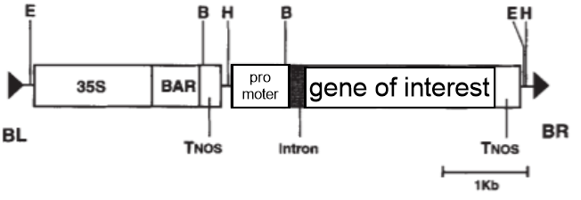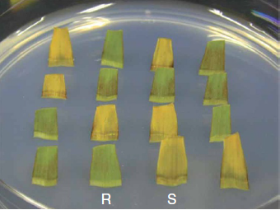
Figure 6: Transformation strategy (Ishida et al., 1996):
6A: T-DNA of the pSB131 vector. BR=right border, BL=left border, BAR=PPT resistance gene (phosphinothricin, selection agent), 35S=35SCaMV promoter, TNOS=nopaline synthase terminator. Restriction sites: B=BamHI, E=EcoRI, H=HindIII. ‘Gene of interest’ is where DNA coding sequence will be cloned and ‘promoter’ is where the selected promoter will be cloned.
6B: selection of maize leaves on medium containing Basta herbicide (phosphinothricin). R=an example of a successful transformation (Resistant), S=non-transgenic leaf (Susceptible).
Hypothesis: if transformation succeeds, the new maize variety captures more atmospheric carbon and is more drought tolerant, thanks to obtaining a multiseriate exodermis.
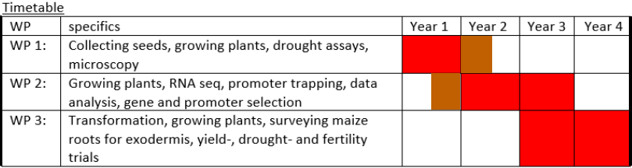
Risk assessment
If a regulator of multiseriate exodermal development cannot be found using the described experiments, there is another possibility to increase suberin content in maize roots without the multiseriate approach. In 2016, an exodermis- and endodermis specific promoter was found in rice (Oryza sativa); the LSI1 promoter (Mitani-Ueno et al., 2016). By transforming maize with a construct containing the LSI1 promoter in combination with a gene that can increase suberin deposition, suberin content of Zea mays roots can be increased. An example of a gene likely involved in regulating suberin synthesis in rice is OsMYB93. OsMYB93 is chosen because rice is monocot like maize. This option is saved as risk assessment experiment because adding extra exodermis layers to roots probably yields more gain of suberin than a uniseriate exodermis with increased suberin content. Next to that, OsMYB93 function is not yet explored specifically (Lashbrooke et al., 2016). Nevertheless, this option could also yield a maize variety with increased suberin content in roots, which sequesters more atmospheric carbon in soils and increases drought resistance.
Scientific and societal impact
The exodermis serves as a protective cell layer in plant roots. While the exodermis makes up the outermost cortex layer in 93% of all flowering plant roots, Arabidopsis thaliana roots possess none. This has caused molecular knowledge of the exodermis and its establishment to lag behind. By creating a new reference transcriptome for roots of monocot grasses like Chrysopogon zizanioides, we collect new data about an important crop relative. By comparing transcriptome data of the different species, this proposed work will be useful for evolutionary studies of grasses. Next to that, transcriptome data from WP2 could offer insights in the evolutionary paths of exodermis- and cortex development. Examples of new findings include transcripts of transcription factors, regulators and/or genes that influence suberin synthesis or cell divisions creating the exodermis. Also, gene walking in both species can yield unidentified promoters.
On top of that, this proposed work applies the newly gathered knowledge on a crop (maize) to help fighting climate change while improving crop resilience and soil-fertilizing potential. In numerous plants, the exodermis contains substances like suberin and lignin, of which suberin has the most potential in terms of increasing drought tolerance, since it is hydrophobic (Graça, 2015). This potential is a welcome addition when climate change causes more drought. Suberin of harvested crop roots can remain in the soil for longer periods of time, storing carbon. Another option is to use this carbon to fertilize soils. If suberin is in fact decomposed, it can help enrich carbon content in soils. Soils that fall short in terms of organic matter requirements can be improved to sustain more nutrient-demanding crops by first growing crops which enrich soils. Maize is often cultivated alternately with other crops such as legumes which may benefit from the enriched soil organic matter left behind by the new maize variety. This is why creating a maize variety with a MEX can be extra useful compared to other crop species that could benefit from extra exodermis layers like rice (Oryza sativa).
References
Chakrabarty, Debasis, Puneet Singh Chauhan, Abhishek Singh Chauhan, Yuvraj Indoliya, Umesh Chandra Lavania, en Chandra Shekhar Nautiyal. ‘De Novo Assembly and Characterization of Root Transcriptome in Two Distinct Morphotypes of Vetiver, Chrysopogon Zizaniodes (L.) Roberty’. Scientific Reports 5, nr. 1 (18 december 2015): 18630. https://doi.org/10.1038/srep18630.
Graça, José. ‘Suberin: the biopolyester at the frontier of plants’. Frontiers in Chemistry 3 (2015): 62. https://doi.org/10.3389/fchem.2015.00062.
Hao, Zhuan-Fang, Xin-Hai Li, Zhi-Jun Su, Chuan-Xiao Xie, Ming-Shun Li, Xiao-Ling Liang, Jian-Feng Weng, De-Gui Zhang, Liang Li, en Shi-Huang Zhang. ‘A Proposed Selection Criterion for Drought Resistance across Multiple Environments in Maize’. Breeding Science 61, nr. 2 (2011): 101–8. https://doi.org/10.1270/jsbbs.61.101.
Harman-Ware, Anne E., Samuel Sparks, Bennett Addison, en Udaya C. Kalluri. ‘Importance of suberin biopolymer in plant function, contributions to soil organic carbon and in the production of bio-derived energy and materials’. Biotechnology for Biofuels 14, nr. 1 (20 maart 2021): 75. https://doi.org/10.1186/s13068-021-01892-3.
Hose, E., D.T. Clarkson, E. Steudle, L. Schreiber, en W. Hartung. ‘The exodermis: a variable apoplastic barrier’. Journal of Experimental Botany 52, nr. 365 (1 december 2001): 2245–64. https://doi.org/10.1093/jexbot/52.365.2245.
‘Climate Change 2021: the physical science basis’. Intergovernmental Panel on Climate Change (IPCC), 06 august 2021
Hirsch, Candice N., Jillian M. Foerster, James M. Johnson, Rajandeep S. Sekhon, German Muttoni, Brieanne Vaillancourt, Francisco Peñagaricano, e.a. ‘Insights into the Maize Pan-Genome and Pan-Transcriptome’. The Plant Cell 26, nr. 1 (1 januari 2014): 121–35. https://doi.org/10.1105/tpc.113.119982.
Ishida, Yuji, Yukoh Hiei, en Toshihiko Komari. ‘Agrobacterium-Mediated Transformation of Maize’. Nature Protocols 2, nr. 7 (juli 2007): 1614–21. https://doi.org/10.1038/nprot.2007.241.
Kerk, Nancy M., Teresa Ceserani, S. Lorraine Tausta, Ian M. Sussex, en Timothy M. Nelson. ‘Laser Capture Microdissection of Cells from Plant Tissues’. Plant Physiology 132, nr. 1 (1 mei 2003): 27–35. https://doi.org/10.1104/pp.102.018127.
Koizumi, Koji, Tomomi Hayashi, en Kimberly L. Gallagher. ‘SCARECROW reinforces SHORT-ROOT signaling and inhibits periclinal cell divisions in the ground tissue by maintaining SHR at high levels in the endodermis’. Plant Signaling & Behavior 7, nr. 12 (1 december 2012): 1573–77. https://doi.org/10.4161/psb.22437.
Lashbrooke, Justin, Hagai Cohen, Dorit Levy-Samocha, Oren Tzfadia, Irina Panizel, Viktoria Zeisler, Hassan Massalha, e.a. ‘MYB107 and MYB9 Homologs Regulate Suberin Deposition in Angiosperms’. The Plant Cell 28, nr. 9 (september 2016): 2097–2116. https://doi.org/10.1105/tpc.16.00490.
Ma, Fengshan, and Carol A Peterson. ‘Current insights into the development, structure, and chemistry of the endodermis and exodermis of roots’. Canadian Journal of Botany 81, nr. 5 (1 mei 2003): 405–21. https://doi.org/10.1139/b03-042.
Martin, Jeffrey A., Nicole V. Johnson, Stephen M. Gross, James Schnable, Xiandong Meng, Mei Wang, Devin Coleman-Derr, e.a. ‘A near complete snapshot of the Zea mays seedling transcriptome revealed from ultra-deep sequencing’. Scientific Reports 4 (31 maart 2014): 4519. https://doi.org/10.1038/srep04519.
Meyer, Chris J., James L. Seago Jr, en Carol A. Peterson. ‘Environmental effects on the maturation of the endodermis and multiseriate exodermis of Iris germanica roots’. Annals of Botany 103, nr. 5 (1 maart 2009): 687–702. https://doi.org/10.1093/aob/mcn255.
Mitani-Ueno, Namiki, Naoki Yamaji, en Jian Feng Ma. ‘High Silicon Accumulation in the Shoot Is Required for Down-Regulating the Expression of Si Transporter Genes in Rice’. Plant and Cell Physiology 57, nr. 12 (december 2016): 2510–18. https://doi.org/10.1093/pcp/pcw163.
PETERSON, CAROL A., en CHRISTOPHER J. PERUMALLA. ‘A survey of angiosperm species to detect hypodermal Casparian bands. II. Roots with a multiseriate hypodermis or epidermis’. Botanical Journal of the Linnean Society 103, nr. 2 (1 juni 1990): 113–25. https://doi.org/10.1111/j.1095-8339.1990.tb00177.x.
Sheffield, Justin, and Eric F. Wood. ‘Projected Changes in Drought Occurrence under Future Global Warming from Multi-Model, Multi-Scenario, IPCC AR4 Simulations’. Climate Dynamics 31, nr. 1 (1 juli 2008): 79–105. https://doi.org/10.1007/s00382-007-0340-z.
SHISHKOFF, NINA. ‘Distribution of the Dimorphic Hypodermis of Roots in Angiosperm Families’. Annals of Botany 60, nr. 1 (1987): 1–16.
Soukup, Aleš, William Armstrong, Lukas Schreiber, Rochus Franke, en Olga Votrubová. ‘Apoplastic Barriers to Radial Oxygen Loss and Solute Penetration: A Chemical and Functional Comparison of the Exodermis of Two Wetland Species, Phragmites Australis and Glyceria Maxima’. New Phytologist 173, nr. 2 (2007): 264–78. https://doi.org/10.1111/j.1469-8137.2006.01907.x.
Shapter, Frances M., en Daniel L. E. Waters. ‘Genome Walking’. In Cereal Genomics: Methods and Protocols, onder redactie van Robert J. Henry en Agnelo Furtado, 133–46. Methods in Molecular Biology. Totowa, NJ: Humana Press, 2014. https://doi.org/10.1007/978-1-62703-715-0_12.

Tylová, Edita, Eva Pecková, Zuzana Blascheová, en Aleš Soukup. ‘Casparian bands and suberin lamellae in exodermis of lateral roots: an important trait of roots system response to abiotic stress factors’. Annals of Botany 120, nr. 1 (1 juli 2017): 71–85. https://doi.org/10.1093/aob/mcx047.
Vallabhaneni, Ratnakar, en Eleanore T. Wurtzel. ‘From Epoxycarotenoids to ABA: The Role of ABA 8′-Hydroxylases in Drought-Stressed Maize Roots’. Archives of Biochemistry and Biophysics, Carotenoids, 504, nr. 1 (1 december 2010): 112–17. https://doi.org/10.1016/j.abb.2010.07.005.
Wang, Bo, Elizabeth Tseng, Michael Regulski, Tyson A Clark, Ting Hon, Yinping Jiao, Zhenyuan Lu, Andrew Olson, Joshua C. Stein, en Doreen Ware. ‘Unveiling the Complexity of the Maize Transcriptome by Single-Molecule Long-Read Sequencing’. Nature Communications 7, nr. 1 (september 2016): 11708. https://doi.org/10.1038/ncomms11708.
Yao, Suping, Jian Cao, Ke Zhang, Kun Jiao, Hai Ding, en Wenxuan Hu. ‘Artificial Bacterial Degradation and Hydrous Pyrolysis of Suberin: Implications for Hydrocarbon Generation of Suberinite’. Organic Geochemistry 47 (1 juni 2012): 22–33. https://doi.org/10.1016/j.orggeochem.2012.03.005.
Yoo, Yo-Han, Yu-Jin Kim, Sunok Moon, Yun-Shil Gho, Woo-Jong Hong, Eui-Jung Kim, Xu Jiang, en Ki-Hong Jung. ‘Fast Track to Discover Novel Promoters in Rice’. Plants 9, nr. 1 (18 januari 2020): 125. https://doi.org/10.3390/plants9010125.
Number of words without references: 3999

