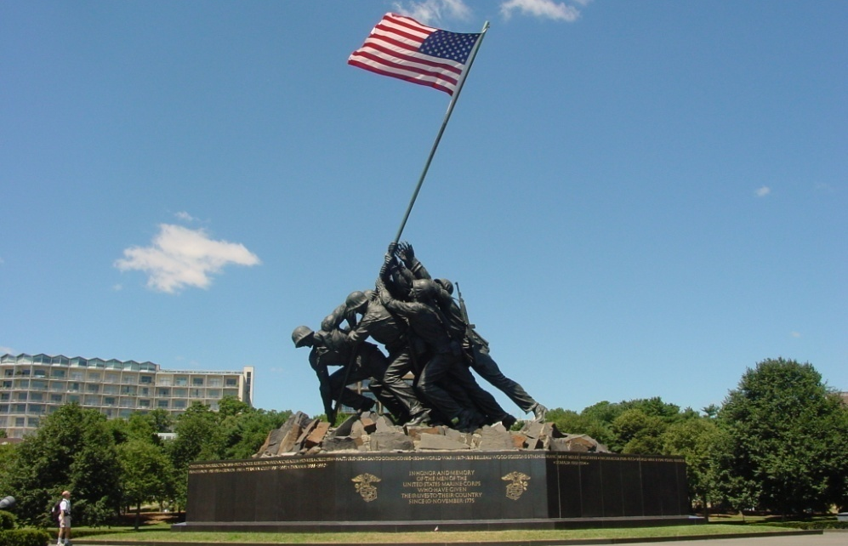

FIGURE 1: “U.S. Marine Corps War Memorial (Iwo Jima Monument) near Washington D.C.”
July 2, 2001 by Christopher Hollis for Wdwic Pictures. Accessed via Wikipedia, the free
encyclopedia on May 13, 2010.

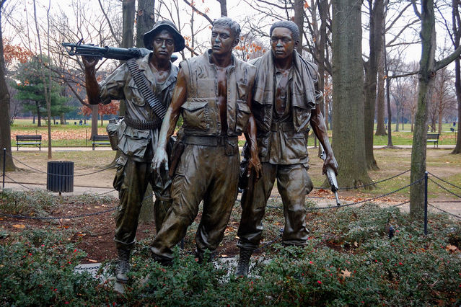

FIGURE 2: “The Three Soldiers.” Date and photographer unknown.
Accessed via Wunderground.com on June 16, 2008.
FIGURE 3: “World War II Memorial panorama, Washington D.C.” September 4, 2005 by Gabor Eszes.
Accessed via Wikipedia, the free encyclopedia on May 13, 2010.

