Pain assessment and management in hospitalised cats at Utrecht University Veterinary Teaching Hospital (UKG).
By
Stijn Boogers

6668445
Master thesis
Faculty of Veterinary Medicine
Utrecht University

Under the supervision of Prof. Dr. H. A. N. Calero Rodriguez
July 2025

Abstract
Background: Pain assessment tools in cats form the foundation for adequate analgesic treatment and improvement of animal welfare. Awareness of the importance of these tools has increased over the last decade with multiple validated pain scales being available. However, routine implementation in veterinary clinics is limited.
Objectives: This study aimed to evaluate the assessment and management of pain at the Utrecht University Veterinary Teaching Hospital (UKG) using the Glasgow Feline Composite Measure Pain Scale (CMPS-F) and by monitoring analgesic administration.
Methods: A cross-sectional observational study design was conducted in a timeframe of 5 weeks. All cats admitted to the veterinary hospital through the emergency clinic, surgery department or consultation were assessed using the CMPS-F and considered painful when reaching a score of ≥ 5/20. Analgesia administration was reported as well. All obtained data was statistically analysed through Excel and R. studio.
Results: A total of 340 paired pain score observations were recorded during measurements, showing high interobserver agreement (ICC=0.94, p<0.001). Pain score evaluation was conducted on 45 cats. Of these, 33.3% (15/45) were considered painful at some point during hospitalisation and 66,7% (30/45) were observed as comfortable. The population consisted of 34 cats hospitalised in the ward for internal medicine reasons with 32.4% (11/34) regarded as painful, whereas 11 cats underwent surgery from which 36.4% (4/11) were observed as painful. Furthermore, analgesic administration was not significantly associated with a faster recovery compared to those who did not receive analgesia (p=0.1972).
Conclusions: A substantial proportion of hospitalised cats were considered painful, with elevated frequencies in both the internal medicine and surgery group. Analgesic treatment was administered often, but not associated with a faster decline in pain, possibly due to indication bias. These findings underscore the need for further developments of education courses and training regarding pain alongside a pain protocol for every new feline individual administered to the UKG.

Table of contents
Abbreviations 4
Introduction 5
Materials and Methods 6
Study design 6
Study population 6
Pain scoring 6
Statistical analysis 6
Results 7
Total cat population 7
Interobserver agreement 7
Pain assessments 7
Discussion 11
Pain in the hospitalisation 11
Interobserver agreement (ICC) 11
Internal medicine vs. surgery patients 12
Analgesic management 12
CMPS-Feline 13
Conclusion 14
References 14

Abbreviations
IASP: International Association for the Study of Pain
CMPS-Feline: Glasgow Composite Measure Pain Scale Feline
FGS: Feline Grimas Scale
UKG: University Utrecht Veterinary Teaching Hospital
SU: Surgery
IM: Internal medicine
SD: Standard deviation
IQR: Interquartile range
Hd: Hospitalisation day
PSA: Pain score observer A
PSB: Pain score observer B
ICC: Intraclass Correlation Coefficient
IRR: Incident rate ratios
LRT: Likelihood ratio test
OVHX: Ovariohysterectomy
MCPS: Multidimensional composite pain scale

Introduction
The International Association for the Study of Pain (IASP) defines pain as “An unpleasant sensory and emotional experience associated with, or resembling that associated with, actual or potential tissue damage”¹. As a consequence of pain, tissue repair can potentially delay, or worsen disease and even chronic pain may occur². In human medicine (chronic) pain is recognized as a global issue and alongside body temperature, blood pressure, respiratory rate, and heart rate even mentioned as the “Fifth Vital Sign”³⁻⁵.
Similarly, pain is acknowledged as a fundamental aspect of animal welfare and animal health by the veterinary community. This awareness has grown significantly over the last decade⁶. Challenges occur when recognizing pain in animals due to their incapability to talk, fine-drawn behavioural changes, and behavioural differences between individuals and breeds. Especially in cats pain is difficult to assess. When housed in the clinical setting, cats are sensitive to multiple stimuli causing stress and anxiety which might be misinterpreted when assessing pain^{7,8}. To get a hold of these challenges and prevent the underrecognition of feline pain, many validated pain assessment methods have been developed for use in the clinical setting^{6,9}. Among others, these methods include the Feline Grimace Scale (FGS)¹⁰, the Glasgow Feline Composite Measure Pain Scale (CMPS-Feline)¹¹, and the UNESP-Botucatu scale¹². Alongside six behavioural aspects, the CMPS-Feline uses the evaluation of facial expression as a valid indicator of pain. Therefore, the positioning of the ears and the muzzle tension are assessed^{11,13}. Consequently, pain recognition is less challenging.
Despite the availability of these scales, several studies have shown that a substantial amount of companion animal practitioners do not utilize these pain scales to evaluate the pain of the individual^{2,9,14-17}. One Spanish study² showed only 28% (n=292) of the surveyed veterinarians used validated pain scales to assess pain, whereas a Canadian study reported only a 10% usage (n= 474)¹⁸. Instead, many veterinarians rely on non-behavioural signs and physiological parameters to assess pain¹⁴. Practices not using these scales had problems with making the pain assessment a routine part of care and mentioned lack of staff, training, and time as additional motives^{2,16}. This approach towards pain causes suboptimal pain assessment and inadequate analgesic management, leaving animals in distress during their hospitalisation period.
To evaluate the utilization of these scales, internal audits can be conducted or surveys distributed. Few audits regarding pain assessment have been carried out at veterinary teaching hospitals. Results of these audits showed that prevalences of painful canine patients were assessed at 22% (n=230)¹⁹ and 38% (n=95)²⁰. Thus, it was concluded that a suboptimal analgesic regime was present and more attention towards pain assessment was advised ^{19,20}.
Therefore, the goal of this cross-sectional observational study is to get an understanding of the proportion of cats in pain, the current situation regarding feline pain assessment, and pain management in the facilities of the Utrecht University Veterinary Teaching Hospital (UKG) through an internal audit. Several hypotheses were tested during statistical analysis:
(1) Of all the hospitalised cats less than 5% are in pain according to the CMPS-Feline
(2) Internal medicine and surgery patients will have the same proportion of cats in pain
(3) All hospitalised cats in pain get adequate analgesia to lower the pain score over time
Based on these findings, recommendations on pain assessment and analgesic treatment could be made for the UKG, whereby potentially improving current pain protocols, education, and awareness concerning pain.

Materials and Methods
Study design
This cross-sectional observational study was carried out in the facilities of the UKG. No institutional ethical approval was required by the MOCO department coordinator of companion animals.
Study population
All cats enrolled in this study through scheduled surgeries, the emergency clinic or consultations leading to hospitalisation. All cats hospitalised in the facilities of the UKG were observed in this study, regardless of their duration of stay. The study lasted for 5 weeks, from Monday until Friday and from May until June 2025. Aggressive or completely paralysed cats, cats with loss of consciousness (e.g. comatose and stupor or sedated), or housed in the oxygen cage were excluded from this study.
Pain scoring
During the timeframe of 5 weeks, pain assessments were conducted in the facilities of the UKG. These facilities include the intensive care, internal medicine, and the surgery department. Measurements were performed by two observers with the use of the validated CMPS-Feline (range of 0-20, pain threshold ≥5)¹¹. Both observers had previous experience with feline pain recognition. Measurements happened every two hours from 8 AM until 16 PM during the whole hospitalisation period. Both observers were blinded for data gathered by the other observer until the end of the data collection to prevent confirmation bias. Definitive pain scores were an average of both the observer’s assessments. Cats were scored in their housing units to diminish the cat handling. When cats were not present during timepoints because of diagnostics or other circumstances, the timepoint was omitted from the study until the cats returned to their housing. Veterinarians and veterinary technicians were blinded for the results of the pain assessment, thereby preventing influence on decision-making for analgesic intervention and pain relief. Additionally, observers were blinded for whether cats received analgesia. Information about analgesia administration, dosage, and type of analgesia used was collected by the veterinarians and handed over to the observers after data collection was completed. To track pain over time, patient-IDs and the day of hospitalisation were gathered. The following information was also collected for every cat included in the study: gender, reproduction state, breed, age, body mass, and reason of hospitalisation (internal medicine (IM) and surgery (SU)).
Statistical analysis
Data was documented in an Excel spreadsheet (version 2503, 16.0) and analysis was performed with the use of R. studio (version 4.5.0). Evaluating if data collection was consistent between the two observers, the interobserver agreement was determined at the hand of the Intraclass Correlation Coefficient (ICC). Its significance was evaluated with the F-test.
An exact one-sided binominal test helped calculate the proportion of animals in pain by creating a binominal value of the CMPS-F with a pain threshold value of ≥5 to distinguish between painful or comfortable. Descriptive statistics and figures include a 95% confidence interval and bar chart. Comparing the proportion of animals in pain within the IM and SU group a Fisher test was conducted to evaluate significance and visualized within the same bar chart mentioned above.
Reflecting upon the interaction of analgesia (meds) and time (hospitalisation days (Hd) and fixed timepoints (Time)) with the pain score, a linear mixed model with a Poisson distribution was applied. Hence, analgesia administration was converted into a binary variable: 1 for receiving analgesia and 0 for no analgesia. Pain scores were used as ordinal variables ranging from 0-20. Pain scores were described at the hand of the median, mean, inter-quartile range (IQR), and standard deviation (SD). Line plots were used to display the changes in pain scores over time between the group receiving analgesia and the group without analgesic intervention. Results were judged significant if P-values were <0.05.
Results:

Total cat population
During the 5 weeks of measurements, 45 cats were observed in the hospitalisation that met the inclusion criteria for pain assessment. The majority of this study population was hospitalised for internal medicine reasons (IM, n=34). A smaller population was found in the surgery group (SU, n=11). Pain assessments were conducted with the use of the CMPS-Feline and animals were considered painful when reaching a score of ≥ 5/20.
Interobserver agreement:
The interobserver agreement was evaluated using an Intraclass Correlation Coefficient (ICC (3,k)) to see if observations (n=340) from observers A (PSA) and B (PSB) corresponded with each other. The ICC (0.94) was determined based on average ratings from the two observers with a 95% CI [0.925–0.951]. The data showed to be statistically significant (F(339,339) = 16.6, p < 0.001), indicating observations between observer A and observer B were consistent.
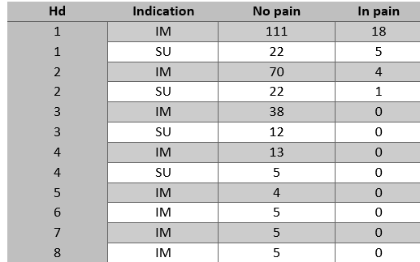
Pain assessments:
To determine the proportion of cats (n=45) in pain at a certain time during hospitalisation, the average of the highest pain score assessed by both observers was used. In case of scores with decimals, values were rounded to the nearest whole number. Of all cats, 15/45 (33.3%) were regarded as painful at a certain point during hospitalisation as shown in Figure 2. The results were statistically significant (p <0.001), showing that a proportion far greater than 5% (0.333, 95% CI [0.218–1.00]) of all hospitalised cats were in pain at some point during their stay. Hence, the null hypothesis – of all the hospitalised cats less than 5% are in pain according to the CMPS-Feline – was rejected.
Table 1. Distribution of all paired observations divided by hospitalisation day (Hd) and indication.
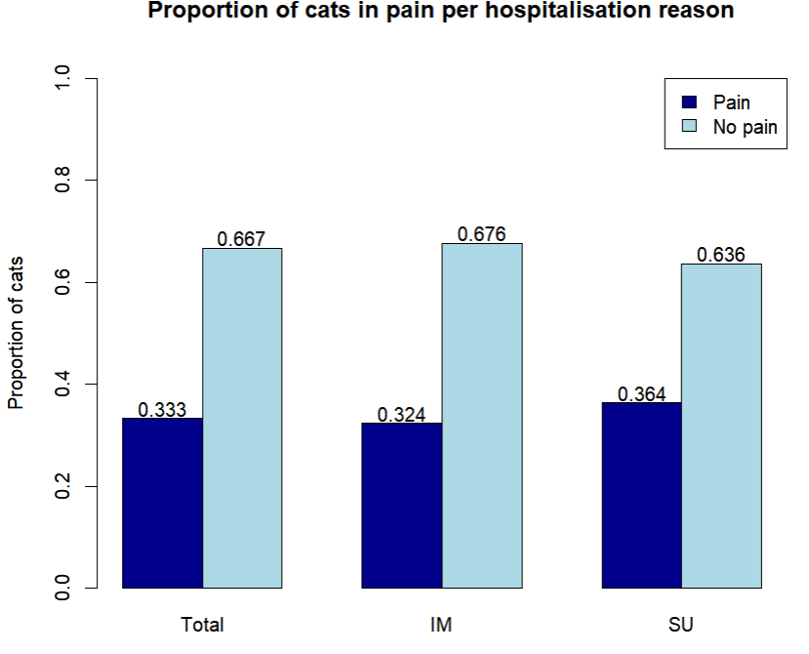
Pain in the overall population was further explored by assessing the proportion of painful cats within the IM and SU groups. A distribution of paired observations of all hospitalisation days (Hd) was made per clinical indication, as shown in Table 1. Most painful observations occurred on day 1 (IM=18, SU=5). On subsequent days, the amount dropped rapidly with no reports of painful cats beyond day 2. However, there was a drop in the amount of observations beyond day 2. Among IM patients, one-third were considered painful (0.324, 95% CI [0.174–0.505]). Patients administered at the UKG for post-SU hospitalisation, reached equal or higher proportions (0.364, 95% CI [0.109–0.692]) of cats in pain compared to the IM group (Figure 2). No statistically significant differences (p=1.00) were discovered in the proportions of cats in pain between groups. Thus, the proportion of painful cats does not significantly differ across hospitalisation reasons.

Figure 2. Proportions of cats considered painful in the overall population (n=45), IM (n=24), and SU (n=11) group, based on the CMPS-Feline (≥5/20). The total feline population showed that 33.3% (95% CI [0.218–1.00]) was in pain with 32.4% (95% CI [0.174–0.505]) of the IM group and 36.4% (95% CI [0.109–0.692]) of the SU was assessed painful. The light-blue bars represent the proportion of cats free of pain.

Analgesic management
A total of 340 pain score observations were made during the data gathering at fixed timepoints (08:00h, 10:00h, 12:00h, 14:00h, 16:00h). At each timepoint, besides the pain score, analgesic intervention hours prior to the measurements were recorded as well (no analgesia=0, analgesia administered=1).
To check if there was adequate analgesic management over the hospitalisation period, pain scores (mean=2.03, median= 2.0, IQR= 1.0-3.0, SD= 1.6) were evaluated as a function of analgesic treatment (meds=0 or 1), time and Hd. During all timepoints the mean pain score varied slightly (1.91-2.12). Furthermore, cats receiving analgesia prior to measurements (1) had a mean pain score of 2.30 (SD= 1.87) compared to a mean of 1.95 (SD= 1.50) for cats who did not receive analgesia (0). In addition, 73.7% (n=33/45) of all patients received analgesia at least once during hospitalisation.
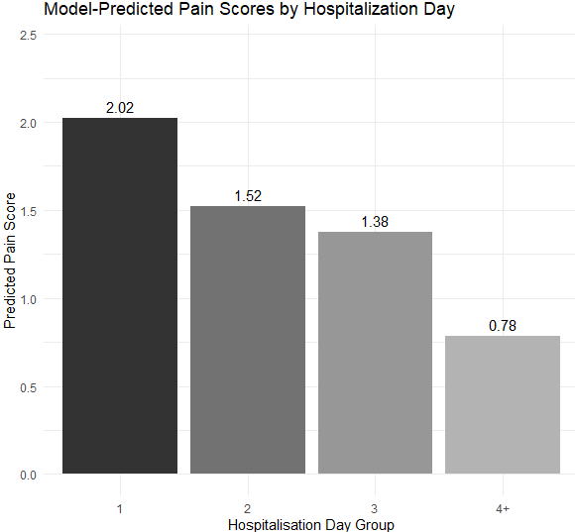
A simplified linear mixed model with a Poisson distribution was utilized to assess the individual effect of Hd, time, and analgesic administration on pain scores in cats without the interaction of all variables together. The incident rate ratios (IRRs) following this model showed a statistically significant (likelihood ratio test (LRT) χ²(3)= 26.61, p <0.01) decrease in pain scores as Hd progressed. On hospitalisation day 2 the IRR was 0.752 (95% CI [0.613–0.923]) and for days 4 and beyond the IRR dropped to 0.386 (95% CI [0.257–0.582]), showing an expected decrease in the pain score. In Figure 3 the mean predicted pain score per hospitalisation day group based on the Poisson regression is plotted out, which shows a steady drop (2.02-0.78) in the pain score over time corresponding with the IRR. The fixed timepoints showed no significant differences (LRT χ²(4)= 1.11, p=0.893) regarding the effect on pain scores. Furthermore, patients receiving analgesia tended to have higher pain scores with an IRR of 1.237 (95% CI [0.976–1.567]), but was not considered statistically significant (LRT χ²(1) = 3.02, p=0.078).

Figure 3. Poisson model-predicted pain scores per hospitalisation day (Hd) group, adjusted for analgesic administration and time. The y-axis shows the predicted mean pain score and the x-axis shows the Hd groups. The mean pain score shows an expected drop when Hd progressed. This decline in pain score due to Hd was statistically significant (LRT) χ²(3)= 26.61, p <0.01), suggesting a decrease in pain when hospitalisation progressed.

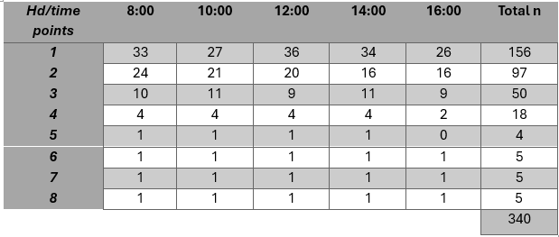
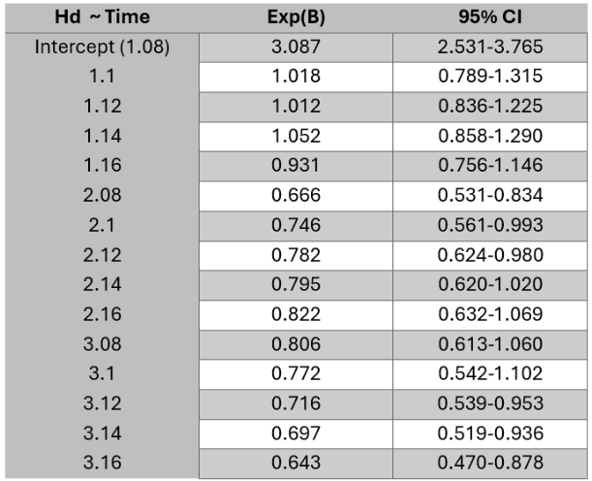
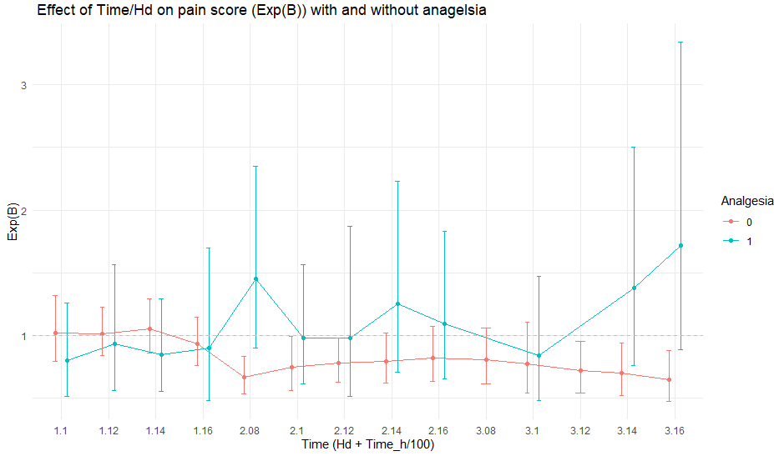
An adapted linear mixed model with a Poisson distribution was used for evaluating the overall interaction of time (Hd + timepoints) and analgesic administration (meds) with the pain score. Concerning Hd, observations from day 1 until day 3 have been included in the model since measurements beyond day 3 were limited as shown in Table 2. Employing this change to the variable Hd gave a more reliable outcome of the overall interaction. The analysis of the variables Hd, timepoints, Meds, and pain score was conducted on 303 observations. However, no statistical significance was calculated as demonstrated by an LRT of 15.871 (χ²(4), p=0.1972), with no overdispersion evident (≈0.10, p=1.00). Therefore, the interaction between time and meds and its effect on the pain score was not significant (p>0.05). In conclusion, cats with analgesic intervention do not show a faster decline in the pain score over time compared to cats without analgesia.
Table 2. The distribution of all observations (n=340) was categorized by Hd and fixed timepoints (8:00; 10:00; etc.). The first three hospitalisation days include the gross measurements with a greater number of study subjects compared to the days 3+.
Figure 4. Estimated expanded odds ratio (Exp(B)) regarding pain scores over timepoints (Time= .08, .10, .12, etc.) and hospitalisation days (Hd= 1., 2., 3.), subdivided by whether analgesia was administered (1, blue) or not (0, red). Values are retrieved from Tables 2 and 3 below. Exp(B)s from group 0 are compared to the intercept (1.08= 3.087). Exp(B)s regarding group 1 are compared to the Exp(B)s of group 0 at the exact same timepoints and Hd. 95% CI ais displayed with bars.
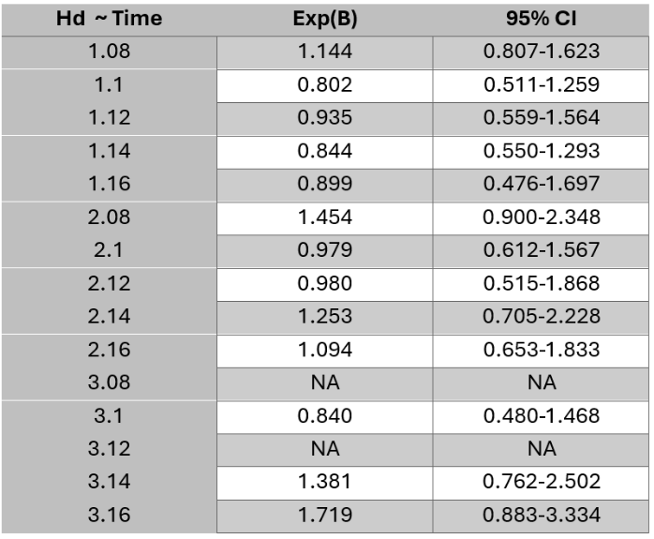
This model and its interaction subdivided by cats receiving analgesia (1) and those who did not (0), was visualized in Figure 4. It displays the pain score comparison (Exp(B)) per day and timepoint (Hd + Time, for example, Hd 1 at 12:00= 1.12) between cats receiving analgesia (1) and those without intervention (0). In Table 3, pain scores of cats without analgesia were compared to the mean pain score on Hd 1 at 8:00 (intercept=3.087; 95% CI [2.531–3.765]). For example, Hd 2 at 8:00 had a mean pain score 33.3% (2.08, Exp(B)= 0.666) lower as the intercept, being statistically significant (95% CI [0.531–0.834]). Furthermore, values on 2.10 (0.746; 95% CI [0.561–0.993]), and 2.12 (0.782; 95% CI[0.624–0.980]), 3.12 (0.716; 95% CI [0.539–0.953]), 3.14 (0.697; 95% CI [0.519–0.936]), and 3.16 (0.643; 95% CI [0.470–0.878]) showed to be statistically significant as well when compared to the intercept. Therefore a significantly lower pain score was observed during those timepoints for cats without analgesia. Table 3 demonstrates a decline in pain score over time on days 1 and 3 during intra-day timepoints (Exp(B)<1), whereas on day 2 all timepoints had an Exp(B)<1. In Table 4, the pain scores of cats receiving analgesia were compared to values of the group who did not receive analgesia at the exact same timepoints and Hd. Results showed an inclination towards a lower pain score on Hd 1 and its intra-day timepoints. For example, cats receiving analgesia on 1.10 had a pain score 19.8% (0.802) lower on average than group 0. This was not statistically significant since 1.00 is included in the 95% CI [0.511–1.259]. However, the following days display mainly pain scores higher than the group without analgesia (Exp(B)>1). Overall, cats receiving analgesia showed higher pain scores during most intra-day timepoints compared to the group without analgesic intervention. Values corresponding with the line plots in Figure 4 and the additional 95% CI can be found in Tables 4 and 3.
Table 3. The difference in pain scores (Exp(B)) compared to the intercept (=3.087; hospitalisation day 1 at 08:00 h) derived from patients with no analgesic intervention subdivided by Hd and fixed timepoints (Time) at which measurements were performed. Cats at 2.14 had a 20.5% (Exp(B)=0.795) lower pain score compared to the intercept. Nevertheless, this was not statistically significant since the 95% CI included 1.00 [0.620–1.020].

Table 4. The difference in pain scores (Exp(B)) compared to the values at the same fixed timepoints and Hd. Cats at 2.14 had a 25.3% (Exp(B)=1.253) higher mean pain score than cats without analgesia on the Hd at the exact same timepoint. However, this was not statistically significant since the 95% CI includes 1.00 [0.705-2.228]. No cats received analgesia at timepoints 3.08 and 3.12, therefore those are referred to as NA.

Discussion:

Pain in the hospitalisation
This study at the UKG highlights that one-third (33.3%) of all cats in its facilities were classified as painful at a certain point of time during hospitalisation, based on the use of the CMPS-Feline (≥5/20), supported by an excellent ICC as described in the next paragraph. Therefore, pain is more present in the facilities of the UKG as previously assumed. Unlike dogs^{19,20}, no recent study has been conducted regarding pain in hospitalised cats inside practices. However, a study was conducted concerning pain in a post-operative setting for cats (n=45) undergoing ovariohysterectomy (OVHX). These cats were randomly assigned to groups receiving either saline solution, bupivacaine hydrochloride, or meloxicam intraperitoneal peri-surgery. Assessments were followed at the hand of the UNESP-Botecatu multidimensional composite pain scale (MCPS) and showed that 40% of the cats by observer 1 (experienced) and 44% by observer 2 (student) were classified as painful²¹. Although the population was observed at the hand of the MCPS and was limited to surgical patients – whereas this study population was assessed with the CMPS-Feline and existed of both surgical and internal medicine patients – the comparable proportion of cats identified painfully suggests difficulty recognizing pain in feline patients in diverse settings. Because of this issue, pain in cats is often underrecognized. Cats’ fine-drawn behavioural changes of pain and alterations in behaviour in the hospitalised setting, complicate pain recognition even further^{7,8}.

Interobserver agreement (ICC)
Enhancement of rescue analgesia intervention for painful cats can be achieved using pain scales. As of today, several validated pain scales are available, but utilisation for both canine and feline patients takes practice, education, training, and experience to get familiar with them. Paired observations (n=340) of both observers in this study showed (ICC=0.94) excellent compliance using the CMPS-Feline. However, both observers had limited experience in assessing feline pain. Experience concerning feline (or canine) pain, alters the interpretation of these scales as in the previously cited study. The results of observer 2 in Benito et al. (2017), showed significantly lower scores compared to the experienced observer 1, with the ICC being 0.707. Nevertheless, the proportion of intervention with rescue analgesia did not differ significantly, thereby not changing the course of the analgesic management²¹. Another study examining the agreement between staff with diverse levels of training and the involvement of students showed a poor overall ICC (0.494). However, Interobserver agreement between nurses and surgeons, and nurses ECVAA diplomates were high, with respectively ICCs of 0.951 in both cases. Furthermore, students tended to judge that analgesic intervention was necessary in more cases²². Again, experience played a part in the consideration of both the interpretation of pain and analgesic intervention.
Routine and everyday use of validated pain scales like the CMPS-Feline on all patients is suggested based on showing results, giving structure to pain recognition, gaining experience with feline pain, and foremost reducing the proportion of cats in pain. Furthermore, the underrecognition of pain might decline and early detection increase, subsequently enhancing analgesic intervention management. All can be accompanied by training courses for veterinary master students to get acquainted with feline pain and analgesic intervention. A study regarding final-year veterinary students undergoing evaluation of their clinical-based training, showed that due to training their assessment of pain improved. Pre-training, 55.3% of the students felt competent in their ability to assess pain, compared to 89.4% post-training²³. Hence, this study supports the idea of early-on training regarding pain scales and pain assessment. Instructions towards a routine mutual pain assessment approach composed by veterinarians and veterinary technicians might be beneficial.

Internal medicine vs. surgery patients
In the present study, no differences were found in the proportions of cats in pain between the IM and SU groups. To date, no study has explicitly investigated the differences in pain between cats undergoing surgery or those hospitalised for internal medicine conditions. The study by Wiese et al. (2005) suggested the majority of cats presented at the emergency clinic, which were diagnosed as painful via a survey filled in by veterinarians (n=60), were coping with visceral pain (43%)²⁴. Although these results do not give a better understanding of pain proportions within feline IM and SU patients, it does show the importance of visceral pain in non-surgical feline patients. Consequently, it might partially explain the high proportion of painful cats within the IM group. Examples of visceral sources that promptly evoke pain in cats include lower urinary tract obstructions, saddle thrombus, and pancreatitis²⁵⁻²⁷. Benito et al. (2017) showed that 40-44% of cats undergoing OVHX were considered painful, supporting the comparable results from this study when it comes to SU (0.364)²¹. Intuitive thoughts will say surgical patients tend to be more painful. However, awareness towards pain arising in the internal medicine group might be necessary based on these findings. Note that no previous study has examined this difference directly, highlighting the importance of future studies aiming to further analyse pain distribution across both groups.

Analgesic management
It is considered good practice when veterinary teaching hospitals or clinics aim to have animals as free of pain as possible or intervene with analgesia when needed through proactive pain management, thereby improving animal welfare^{6,28}. In this study, pain scores declined over the course of hospitalisation, suggesting an improvement in the cats’ comfort. However, this reduction was not significantly influenced by analgesic administration or at specific intra-day timepoints. Additionally, cats receiving analgesia showed no faster decline in pain scores over time compared to those that did not. The high variability of data might cause different outcomes, by showing an diverse individual response to pain and analgesia.
These findings were in contrast with general expectations towards analgesia, reducing pain and thereby displaying a decline in pain. A study conducted on pain post-OVHX (n=29) at the hand of the MCPS showed that cats receiving analgesia showed accelerated pain reduction compared to the group without analgesia, most often needing rescue analgesia as well²⁹. Visualised in Figure 5, cats on analgesia tend to have higher pain scores during most of the intra-day timepoints. This analgesia paradox might be explained by the fact that cats receiving analgesia started with higher baseline pain scores, for which they received analgesia during clinical decision-making. Hence, this indication bias possibly does not reflect the true effect of analgesia. To analyse the influence of analgesia on the pain score in time, a greater power of the study with more cats is advised, resulting in more measurements per timepoint. Furthermore, both analgesic administration and pain score observations were made at fixed timepoints matching the follow-up of analgesic administration which occurred right before scoring. These measurements were limited, because data gathering was only conducted throughout the week, excluding weekends, evenings, and nights. When diagnostics or therapy such as surgery was performed, data was missing as well. Besides that, the type of medication used, its duration of action, and a complete timepoint interval for both observations and analgesic administration covering a 24-hour period would give more information about the analgesic management itself. Unfortunately, this is out of the scope of this research.
It was notable that almost three-quarters (73.7%) of all cats received analgesia at least once during their hospitalisation. Therefore, pain was assessed adequate or possibly assumed to be present based on previous experiences with certain conditions or clinical evaluation rather than using pain scales, leading to analgesic treatment^{2,14}. The high proportion might indicate proactive analgesic management by clinicians. However, no data was gathered regarding whether pain assessment tools were utilized on a routine basis for every patient or even used at all. Cats are distinguished from dogs when it comes to pain-related behaviour, making it hard to recognize it and form an objective evaluation. A protocol regarding routine pain assessment for all feline patients brought into the clinic is considered necessary at the hand of validated pain scales. It might enhance analgesic decision-making on a scientific basis.
CMPS-Feline
The use of a validated pain scale with both behavioural aspects and facial expression helps objectify feline pain assessment due to its challenging nature. However, some aspects of the CMPS-Feline showed to be observer or cat-dependent. For instance, applying ‘gentle’ pressure to a painful area as asked, depends on the interpretation of the observer of what was considered gentle. For some patients, it was observer-dependent which response was elicited. This might be sex and/or experience related^{21,30}. Moreover, behaviour has a large share in the overall score. Cats being more aggressive or stressed based on their character tend to score higher without being in pain, for which they were excluded from the study. The study by Buisman et al. (2017) showed comparable problems regarding the CMPS-Feline with pain-free clinically healthy cats that were hissing, crying, or lacking any response to stroking, thereby resulting in higher pain scores³¹. While the CMPS-Feline provides a structural approach with pain assessment, clinical evaluation should play a pivotal role as well when assessing pain of the individual.

Conclusion
In conclusion, the proportion of painful cats at the UKG exceeds the expected proportion, with comparable proportions in both surgery and internal medicine patients, highlighting the presence of pain in the latter. The interobserver agreement was high using validated pain scales in this study, but experience, routine use, and development of education programs with validated pain scales like the CMPS-Feline are necessary for proactive pain management. Cats receiving analgesic treatment did not show faster recovery, but this was potentially caused by an indication bias. With a considerable amount of cats receiving analgesia at least once during hospitalisation and the challenging nature of assessing feline pain, a protocol for pain assessment for every new patient should be considered.
This study has several limitations, with assessments being limited to weekdays and daytime hours, thereby not including nights and weekends. The five-week duration of this study may have limited the variance and caseload of the data collection. An underestimation of the overall pain prevalence may result from this. Feline pain is difficult to recognize for which experience is considered necessary, which the observers did not fully possess.
Future studies could incorporate the type, duration of action, and dosage of analgesia as well as more timepoints to give more insight into analgesic management than the current results. Research regarding pain prevalence among internal medicine or surgery patients and progression of pain can be expanded by including nights and weekends in the assessments. This would strengthening current findings with a greater study power, or giving new insights into pain prevalence and pain progression during the hospitalisation course.

References
1. Raja SN, Carr DB, Cohen M, et al. The revised international association for the study of pain definition of pain: Concepts, challenges, and compromises. Pain. 2020;161(9):1976–1982. doi: 10.1097/j.pain.0000000000001939.
2. Menéndez S, Cabezas MA, Gomez de Segura IA. Attitudes to acute pain and the use of pain assessment scales among spanish small animal veterinarians. Front Vet Sci. 2023;10:1302528. doi: 10.3389/fvets.2023.1302528.
3. Tompkins DA, Hobelmann JG, Compton P. Providing chronic pain management in the "fifth vital sign" era: Historical and treatment perspectives on a modern-day medical dilemma. Drug Alcohol Depend. 2017;173 Suppl 1(Suppl 1):S11–S21. doi: 10.1016/j.drugalcdep.2016.12.002.
4. Mellor DJ, Cook CJ, Stafford KJ. Quantifying some responses to pain as a stressor. In: The biology of animal stress: Basic principles and implications for animal welfare. ; 2000:171–198. https://doi.org/10.1079/9780851993591.0171. 10.1079/9780851993591.0171.
5. Goldberg DS, McGee SJ. Pain as a global public health priority. BMC Public Health. 2011;11:770–770. doi: 10.1186/1471-2458-11-770.
6. Gruen ME, Lascelles BDX, Colleran E, et al. 2022 AAHA pain management guidelines for dogs and cats*. J Am Anim Hosp Assoc. 2022;58(2):55–76. https://doi.org/10.5326/JAAHA-MS-7292. Accessed 4/29/2025. doi: 10.5326/JAAHA-MS-7292.
7. Steagall PV. Analgesia: What makes cats different/challenging and what is critical for cats? Vet Clin N Am : Small Anim Pract. 2020;50(4):749–767. https://www.sciencedirect.com/science/article/pii/S0195561620300048. doi: 10.1016/j.cvsm.2020.02.002.
8. Steagall PV, Robertson S, Simon B, Warne LN, Shilo-Benjamini Y, Taylor S. 2022 ISFM consensus guidelines on the management of acute pain in cats. J Feline Med Surg. 2022;24(1):4–30. doi: 10.1177/1098612X211066268.
9. Monteiro BP, Lee NH, Steagall PV. Can cat caregivers reliably assess acute pain in cats using the feline grimace scale? A large bilingual global survey. J Feline Med Surg. 2023;25(1):1098612X221145499. doi: 10.1177/1098612X221145499.
10. Evangelista MC, Watanabe R, Leung VSY, et al. Facial expressions of pain in cats: The development and validation of a feline grimace scale. Sci Rep. 2019;9(1):19128–8. doi: 10.1038/s41598-019-55693-8.
11. Reid J, Scott EM, Calvo G, Nolan AM. Definitive glasgow acute pain scale for cats: Validation and intervention level. Vet Rec. 2017;180(18):449. doi: 10.1136/vr.104208.
12. Belli M, de Oliveira AR, de Lima MT, Trindade PHE, Steagall PV, Luna SPL. Clinical validation of the short and long UNESP-botucatu scales for feline pain assessment. PeerJ. 2021;9:e11225. doi: 10.7717/peerj.11225.
13. Holden E, Calvo G, Collins M, et al. Evaluation of facial expression in acute pain in cats. J Small Anim Pract. 2014;55(12):615–621. doi: 10.1111/jsap.12283.
14. Catanzaro A, Di Salvo A, Steagall PV, Zampini D, Polisca A, della Rocca G. Preliminary study on attitudes, opinions and knowledge of italian veterinarians with regard to abdominal visceral pain in dogs. Veterinary Anaesthesia and Analgesia. 2016;43(4):361–370. https://www.sciencedirect.com/science/article/pii/S1467298716301039. doi: 10.1111/vaa.12326.
15. Weber GH, Morton JM, Keates H. Postoperative pain and perioperative analgesic administration in dogs: Practices, attitudes and beliefs of queensland veterinarians. Aust Vet J. 2012;90(5):186–193. https://doi.org/10.1111/j.1751-0813.2012.00901.x. doi: 10.1111/j.1751-0813.2012.00901.x.
16. Costa RS, Hassur RL, Jones T, Stein A. The use of pain scales in small animal veterinary practices in the USA. J Small Anim Pract. 2023;64(4):265–269. https://doi.org/10.1111/jsap.13581. doi: 10.1111/jsap.13581.
17. Buisman M, Hasiuk MMM, Gunn M, Pang DSJ. The influence of demeanor on scores from two validated feline pain assessment scales during the perioperative period. Vet Anaesth Analg. 2017;44(3):646–655. doi: 10.1016/j.vaa.2016.09.001.
18. Dawson LC, Dewey CE, Stone EA, Mosley CI, Guerin MT, Niel L. Evaluation of a welfare assessment tool to examine practices for preventing, recognizing, and managing pain at companion-animal veterinary clinics. Can J Vet Res. 2017;81(4):270–279.
19. Moran CE, Hofmeister EH. Prevalence of pain in a university veterinary intensive care unit. J Vet Emerg Crit Care (San Antonio). 2013;23(1):29–36. doi: 10.1111/vec.12010.
20. Rousseau-Blass F, O'Toole E, Marcoux J, Pang DSJ. Prevalence and management of pain in dogs in the emergency service of a veterinary teaching hospital. Can Vet J. 2020;61(3):294–300.
21. Benito J, Monteiro BP, Beauchamp G, Lascelles BDX, Steagall PV. Evaluation of interobserver agreement for postoperative pain and sedation assessment in cats. J Am Vet Med Assoc. 2017;251(5):544–551. doi: 10.2460/javma.251.5.544.
22. Marco-Martorell M, Duffy N, Martinez M, Maddox T, Robson K. Agreement of pain assessment using the short form of the canine glasgow composite measure pain scale between veterinary students, veterinary nurses, veterinary surgeons, and ECVAA-diplomates. Animals. 2024;14(16). doi: 10.3390/ani14162310.
23. Schull DN, Morton JM, Coleman GT, Mills PC. Veterinary students' perceptions of their day-one abilities before and after final-year clinical practice-based training. Journal of Veterinary Medical Education. 2011;38(3):251–261. https://doi.org/10.3138/jvme.38.3.251. doi: 10.3138/jvme.38.3.251.
24. Wiese AJ, Muir WW3, Wittum TE. Characteristics of pain and response to analgesic treatment in dogs and cats examined at a veterinary teaching hospital emergency service. J Am Vet Med Assoc. 2005;226(12):2004–2009. doi: 10.2460/javma.2005.226.2004.
25. Guillaumin J. Feline aortic thromboembolism: Recent advances and future prospects. J Feline Med Surg. 2024;26(6):1098612X241257878. doi: 10.1177/1098612X241257878.
26. Forman MA, Steiner JM, Armstrong PJ, et al. ACVIM consensus statement on pancreatitis in cats. J Vet Intern Med. 2021;35(2):703–723. doi: 10.1111/jvim.16053.
27. Segev G, Livne H, Ranen E, Lavy E. Urethral obstruction in cats: Predisposing factors, clinical, clinicopathological characteristics and prognosis. J Feline Med Surg. 2011;13(2):101–108. doi: 10.1016/j.jfms.2010.10.006.
28. Monteiro BP, Steagall PV. Chronic pain in cats: Recent advances in clinical assessment. J Feline Med Surg. 2019;21(7):601–614. doi: 10.1177/1098612X19856179.
29. Malo A, Cheng AJ, Ruel HL, et al. Randomised, prospective, blinded, clinical trial of opioid-free injectable anaesthesia with or without multimodal analgesia in kittens undergoing ovariohysterectomy. J Feline Med Surg. 2023;25(3):1098612X231158582. doi: 10.1177/1098612X231158582.
30. Doodnaught GM, Benito J, Monteiro BP, Beauchamp G, Grasso SC, Steagall PV. Agreement among undergraduate and graduate veterinary students and veterinary anesthesiologists on pain assessment in cats and dogs: A preliminary study. Can Vet J. 2017;58(8):805–808.
31. Buisman M, Hasiuk MMM, Gunn M, Pang DSJ. The influence of demeanor on scores from two validated feline pain assessment scales during the perioperative period. Veterinary Anaesthesia and Analgesia. 2017;44(3):646–655. https://doi.org/10.1016/j.vaa.2016.09.001. doi: 10.1016/j.vaa.2016.09.001.

