The effect of bacteria on biomass production, schizophyllan production and material properties of Schizophyllum commune

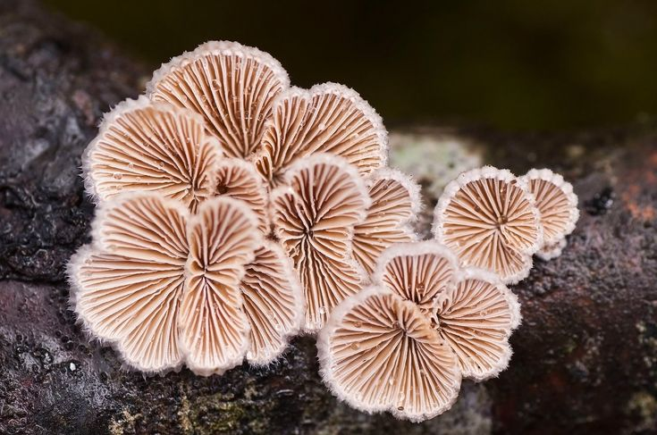
(Healing-Mushrooms.net, 2021)

  - Winyse van den Abeele | 6536379

  - Daily supervisor: Dr. F.E.L. Kleijburg | Departement Microbiologie, Universiteit Utrecht
  - Examiner: Prof. dr. H.A.B. Wösten | Departement Microbiologie, Universiteit Utrecht
  - 2nd examiner: Dr. L.G. Lugones | Departement Microbiologie, Universiteit Utrecht

Layman summary

Schizophyllum commune is a fungus that normally lives on dead wood but it can also infect plants and in some case humans. S. commune is known for a vast genetic variety between strains. The fungus makes a polysaccharide called schizophyllan which can be found in the cell wall but also around the hyphae. A previous study reported that schizophyllan can protect fungal spores against freeze / thraw cycles, heat shock and bacteria. Additionally, mycelium of S. commune is used to make materials like artificial leather. Characteristics of these materials are known to be influenced by environmental factors like light and CO₂. This study focussed on the effect of bacteria (Escherichia coli and a Paraburkholderia species) on biomass, schizophyllan production and material properties of S. commune. In the first experiment twenty-seven S. commune strains were grown on Schizophyllum commune minimal medium (SCMM) with E. coli on plate. Twelve strains had a decreased biomass production, while two strains had a higher biomass production in presence of the bacteria. Four strains had an increased schizophyllan production while two strains had a decreased schizophyllan production when grown together with E. coli. Next, four selected strains were grown in SCMM liquid shaking cultures with excess thiamine (vitamin B1) to assess if additional thiamine excreted by E. coli into the medium influenced biomass production by S. commune. Results showed that excess thiamine does not always have an effect on biomass production by the fungus. Additionally, two selected S. commune strains were grown on Lysogeny Broth (LB) with E. coli or a Paraburkholderia species to determine the production of biomass and schizophyllan on a different medium or with a different bacteria. Strains produced less biomass when grown with Paraburkholderia compared to when grown without the bacteria, while schizophyllan production was not significantly affected. For the last experiment materials were made from two selected S. commune strains by either growing them with or without E. coli. Density was higher for both strains when the fungus was grown with E. coli and one strain showed a significant increase in maximum strain and maximum stress. Together results show that individual S. commune strains react differently when grown together with bacteria and that environmental factors also play a role, which can be possibly be explained by the vast genetic differences between each S. commune strain.

Layman summary (Dutch)

Schizophyllum commune is een schimmel die normaalgesproken op dood hout leeft, maar ook planten en in enkele gevallen mensen kan infecteren. S. commune staat bekend om zijn grote genetische variëteit tussen stammen. De schimmel maakt een polysacharide genaamd schizophyllan dat in de celwand zit, maar zich ook rond de hyfen bevindt. Eerder onderzoek vond dat schizophyllan sporen van de schimmel kan beschermen tegen vries / dooi cycli, hitte én bacteriën. Daarnaast wordt het mycelium gebruikt om materialen zoals nep leer van te maken. Karaktereigenschappen van deze materialen worden beïnvloed door omgevingsfactoren zoals licht en CO₂. In deze studie is gekeken naar het effect dat bacteriën (Escherichia coli en een Paraburkholderia soort) hebben op de biomassa, schizophyllan productie en materiaal karaktereigenschappen van S. commune. In het eerste experiment zijn zevenentwintig S. commune stammen gegroeid op Schizophyllum commune minimaal medium (SCMM) met E. coli op plaat. Twaalf stammen hadden een verlaagde biomassa en twee stammen een verhoogde biomassa bij de aanwezigheid van E. coli. Vier stammen hadden een verhoogde schizophyllan productie en twee stammen een verlaagde schizophyllan productie wanneer ze met E. coli waren gegroeid. Vervolgens zijn vier stammen gegroeid in SCMM vloeibare schudcultures met overmaat aan thiamine (vitamine B1) om te kijken of additioneel thiamine uitgescheiden door E. coli in het medium de biomassa van S. commune beïnvloed. Uit de resultaten bleek dat overmaat aan thiamine niet altijd de biomassa van S. commune beïnvloed. Daarna zijn twee S. commune stammen gegroeid op Lysogeny Broth (LB) samen met E. coli of een Paraburkholderia soort om te zien of biomassa of schizophyllan productie anders is wanneer de schimmel op een ander medium of met een andere bacterie groeit. Stammen produceerde minder biomassa wanneer ze met Paraburkholderia waren gegroeid, maar schizophyllan productie was niet significant anders. In het laatste experiment is materiaal gemaakt van twee S. commune stammen waarbij de schimmel wel of niet samen gegroeid was met E. coli. Beide stammen hadden een hogere dichtheid wanneer ze waren gegroeid met E. coli en een stam had significant een hogere maximum spanning en een hogere maximum rek. Alles samen genomen laten de resultaten zien dat elke S. commune stam anders reageert wanneer hij samengroeit met bacteriën, maar dat ook omgevingsfactoren invloed hebben, waarschijnlijk doordat de schimmel tussen stammen zo genetisch divers is.

Abstract

Twenty-seven Schizophyllum commune strains were grown with or without E. coli on SCMM agar, in liquid shaken SCMM cultures or pre-grown on SCMM agar and then placed on LB agar to assess the effect of E. coli on biomass and schizophyllan production in S. commune. Individual S. commune strains reacted differently to E. coli and either increased, decreased or showed no significant change in biomass or schizophyllan production. Selected strains were grown in liquid shaken SCMM cultures either with or without E. coli or a tenfold excess of thiamine to assess if additional thiamine excreted by E. coli increased biomass and schizophyllan production in S. commune. Addition of tenfold excess thiamine increased biomass in one strain and increased schizophyllan production in another strain indicating that thiamine is not the deciding factor in most cases. Two S. commune strains were grown with or without a Paraburkholderia species (L480) on LB agar. S. commune grown with L480 resulted in a lower biomass production. Mycelium sheets were made of S. commune grown with or without E. coli to assess change in material properties. Density, maximum stress and maximum strain were higher in mycelium sheets made from S. commune strains grown with E. coli. Together results show that individual S. commune strains are differently affected when grown together with bacteria in different conditions.

Introduction

Schizophyllum commune
Schizophyllum commune, commonly known as the Split-gill mushroom, is an edible basidiomycete (Boonthatui et al., 2021) found all over the world (Ohm et al., 2010). S. commune was first known as a saprophyte generally living on dead wood and causing white rot (Ohm et al., 2010) however more recently it is recognised as a plant pathogen were the fungus takes advantage of environmental induced damage like pruning wounds, freeze injuries and sunscald lesions to infect plants (Takemoto et al., 2010). The fungus is normally not pathogenic to humans but it can infect both immunocompromised and immunocompetent individuals (Sigler et al., 1999). S. commune is often used as a model organism because of its short life cycle of approximately 10 days and because of the genetic tools available (Mooibroek et al., 1990; Ohm et al., 2010; Vonk et al., 2019). S. commune is also of interest to several industries like the medical field and agriculture in for example production of secondary metabolites that show potential in preventing Alzheimer’s Disease (Mišković et al., 2021). Additionally, an article by Kim et al., 2020 discusses the potential of S. commune in biodegradation of complex substances.
Schizophyllum commune strains are genetically and morphologically hypervariable (Marian et al., 2024). The hypervariability can be explained by nucleotide diversity π (the fraction of nucleotides that are different between two randomly chosen alleles) found between synonymous sites. In most fungal species this is π < 0.05 while Baranova et al., 2015 found that S. commune populations from the United States and Russia had a π of 0.20 and 0.13 respectively. Individual nucleotide mutation rate per generation in S. commune is 2.0 x 10⁻⁸ (Baranova et al., 2015). This is among the highest mutation rates reported in fungi and exceeded only by Neurospora crassa which has a mutation rate of 3.38 x 10⁻⁶ (Wang et al., 2020).

Lifecycle of Schizophyllum commune
The lifecycle of S. commune starts with the germination of a haploid basidiospore (Kleijburg & Wösten, 2025). Two haploid monokaryons with compatible mating types fuse together to form a fertile heterokaryon. Blue light (Ohm et al., 2013), amiable CO₂ levels (Kleijburg & Wösten, 2025) and a minimum concentration of 6 ng/ml of growth factor thiamine (Niederpruem & Wessels, 1969) are necessary to induce fructification. The fruiting bodies contain cells called basidia in which the process of karyogamy, meiosis, sporulation, and then mitosis respectively take place to produce new haploid basidiospores (Kleijburg & Wösten, 2025).

Schizophyllan
S. commune produces and excretes an exopolysaccharide called schizophyllan (Prokop et al., 1992). Schizophyllan is a β-1,3 glucan chain with single β-1,6 glucan branching at every third residue and is found in the hyphal cell wall and as layer around the hyphae (Kleijburg & Wösten, 2025). In liquid shaking culture schizophyllan can also be found in the supernatant (Komatsu et al., 1969) and in water the polysaccharide forms a rod-like triple helix structure (Kashiwagi et al., 1981). Extracellular production of schizophyllan is related to fungal growth (Prokop et al., 1992). The optimal temperature for schizophyllan production by S. commune is around 28 °C while the optimal pH is around 5 (Gou et al., 2023).
S. commune is of interest to several industries. This is in part due to the high thermal stability of schizophyllan which denatures only at 135 °C (Zentz et al., 1992), as well as high viscosity of the polysaccharide (Yanaki et al., 1980). Research in our lab showed that schizophyllan protects S. commune spores against cold stress and also suggested schizophyllan as a protector against heat stress and bacterial attack (personal communication). Additionally, antitumor effects were found in mice where schizophyllan instigates a host-mediated immune response (Zhang et al., 2013). Schizophyllan is already applied in the medical field and other known applications are usage in cosmetic products, food preservation, and in oil recovery fields (Kleijburg & Wösten, 2025).

Interactions of S. commune in nature
In nature organisms can have beneficial, neutral, or antagonistic interactions with each other. S. commune can secrete volatile organic compounds to prevent growth and/or motility of competing fungi and bacteria (Wirth et al., 2021). The quantity and type of volatiles excreted are dependent on the environment and growth stage of S. commune (Freihorst et al., 2018). An example is 1-octen-3-ol, a volatile with antibacterial, antifungal, and herbicidal function (Hummadi et al., 2022), which makes up 11% of the volatile profile of S. commune in dikaryotic stage while barely present in the monokaryotic stage (Freihorst et al., 2018). On the other hand, other fungal species and bacteria have been found to stimulate or inhibit growth, fruiting body production, and pigment production in S. commune by inducing stress- or defence responses (Krause et al., 2020).
S. commune is an endophyte in plants (Zhai et al., 2017). In this relationship the fungus stimulates beneficial processes in the plant like inhibiting and reducing presence of free radicals, enhancing production of certain phytochemicals, and enabling an increase in nutrient- and mineral uptake (Sharma et al., 2024). It can protect the host plant from certain pathogens and insects by secreting antifeedants, insecticides and antimicrobials (Wang et al., 2022).

Materials from Schizophyllum commune
Materials made from fungi show a potential as alternatives for products like leather, textiles, plastics, meat and even construction materials (Kleijburg & Wösten, 2025). Currently there are already some examples on the market like acoustic boards (mogu.bio) and clothing made of fungal mycelium (www.stellamccartney.com).
Over the years S. commune has become a model system for fungal materials (Kleijburg & Wösten, 2025). Genes and environmental conditions effect material properties of S. commune. Appels et al., 2018 reported that deletion of hydrophobin gene sc3 increased the Young’s Modulus by 3-fold and the maximum tensile strength by 4-fold compared to the wildtype. Moreover, when grown in light combined with high CO₂ levels both Young’s Modulus and maximum tensile strength are higher compared to grown in dark or light with low levels of CO₂. Additionally, treatment with glycerol after cultivation increases the elasticity of fungal material from 1,5% to 29,6 % (Appels et al., 2020).

This thesis focussed on the production of schizophyllan by S. commune in presence of bacteria. This was done by growing strains from the Utrecht University Collection with E. coli. To our knowledge there are no reports of S. commune and Escherichia coli having a direct relationship in nature, however E. coli K12 (Clifton, 1933) was used for the experiments in this study as it is a model organism and is generally easy to cultivate. A Paraburkholderia species (species unknown) was used in one of the experiments.
Selected strains were used to assess if additional thiamine excreted by E. coli influences biomass or schizophyllan production of S. commune. Lastly, S. commune was grown with E. coli or a Paraburkholderia species to asses if different bacteria affect biomass or schizophyllan production of S. commune differently. The last part of this thesis focussed on material properties of materials made from S. commune when grown with bacteria. Floating mats were made of S. commune strains grown either with or without E. coli and tensile testing was performed to determine the Young’s modulus and stress/strain curve.

Materials and Methods

Strains and culture conditions
Monokaryon S. commune strain H4-8A (matA43matB41; FGSC no. 9210) (Ohm et al., 2010) and dikaryon S. commune strains from the Utrecht University collection (table 1) were grown at 30°C in the dark on Schizophyllum commune minimal medium (SCMM; Dons et al., 1979) either or not with 15 g l⁻¹ agar. Liquid shaking cultures were grown at 200 rpm. In one experiment 1.2 mg additional thiamine was added to the SCMM. In another experiment Lysogeny Broth (LB) medium (Bertani, 1951) with 15 g l⁻¹ agar was used.
E. coli strain K12 (Clifton, 1933) was grown overnight at 200 rpm in either 10 ml SCMM or 10 ml LB in a 100 ml Erlenmeyer at 37°C at 200 rpm in a VWR Professional 3500 Incubating Orbital Shaker (Avantor, www.avantorsciences.com). OD₆₀₀ was measured with a spectrophotometer.
Paraburkholderia sp. (L480) was grown overnight at 200 rpm in 10 ml LB in a 100 ml Erlenmeyer at 37°C at 200 rpm in a VWR Professional 3500 Incubating Orbital Shaker (Avantor, www.avantorsciences.com). L480 was counted with a Bürker-Türk counting chamber.

Production of schizophyllan by S. commune with and without presence of E. coli
An agar plug taken from the periphery of a 7-day old SCMM agar S. commune culture was grown for four days on a 76 mm 0.1 µm Polycarbonate Track Etched (PCTE) membrane (Gvs, www.gvs.com) placed over SCMM agar. Additionally, 2 x 10⁸ E. coli cells were spread over SCMM agar in a 9x9 cm Petri dish using a spreader and grown overnight at 30°C in the dark. The PCTE membranes with S. commune were transferred either to fresh SCMM agar or placed on top of the overnight grown E. coli. Plates were grown for three days.
Mycelium was transferred into a 15 ml tube and washed thrice with 7 ml demi water (first time overnight at 25 rpm on a L 29 Labinco Test-Tube Rotator (Labinco BV, www.labinco-bv.com). Supernatant from the overnight wash was filtered through a Filtropur S 0,45 (Sarstedt, www.sarstedt.com) filter and schizophyllan was precipitated by addition of 30% v/v ethanol, manual shaking for 10 seconds and incubation overnight at 4°C. Schizophyllan was harvested by centrifuging in a 5804 R Eppendorf Centrifuge at 3234 rpm for 5 minutes (Eppendorf, www.eppendorf.com). Mycelium and schizophyllan were dried in a Scala Scientific IlShinBioBase Freeze Dryer (Scala Scientific, www.scala-scientific.com) for 2 days.

Production of schizophyllan by S. commune with and without presence of E. coli or L480
An agar plug taken from the periphery of a 7-day old SCMM agar S. commune culture was grown for three days on a 76 mm 0.1 µm PCTE membrane (Gvs, www.gvs.com) placed over SCMM agar. Additionally, 2 x 10⁸ E. coli or L480 cells were spread over LB agar in a 9x9 cm Petri dish using a spreader and grown for 1 hour at 30°C in the dark. The PCTE membranes with S. commune were transferred either to fresh LB agar or placed on top of the E. coli or L480. Plates were grown for three days.
Mycelium was transferred into a 15 ml tube and washed thrice with 5 ml demi water (first time overnight at 25 rpm on a L 29 Labinco Test-Tube Rotator (Labinco BV, www.labinco-bv.com). Supernatant from the overnight wash was filtered from the mycelium through a Miracloth (Merck, www.sigmaaldrich.com). Schizophyllan was precipitated and harvested like described above. Mycelium and schizophyllan were freeze-dried for 1 week (see above).

Production of schizophyllan by S. commune with and without presence of E. coli or additional thiamine
E. coli cultures grown in SCMM were harvested by centrifugation in a 5804 R Eppendorf Centrifuge at 3234 rpm for 2 minutes (Eppendorf, www.eppendorf.com), washed twice with miliQ, and concentrated until 2 x 10⁸ E. coli cells per 100 µl miliQ.
A 7-day old SCMM agar S. commune culture from a 6x6 cm Petri dish was macerated with 10 ml SCMM in a Monel Cup for 30 seconds at low speed with a Two Speed Waring commercial blender (Waring Laboratory, www.waringlab.com). The macerate was transferred to a 50 ml Erlenmeyer and 100 µl miliQ, 2 x 10⁸ E. coli cells suspended in 100 µl miliQ, or 1,2 mg thiamine dissolved in 100 µl miliQ was added. Cultures were grown for 7 days and mycelium was harvested into Miracloth (Merck, www.sigmaaldrich.com). Schizophyllan from the supernatant was precipitated and harvested like described above. Mycelium and schizophyllan were freeze-dried for 2 days (see above).

Materials, floating mats
A 7-day old SCMM agar S. commune culture from a 9x9 cm Petri dish was macerated with 50 ml SCMM as described above and grown for 5 days in a 250 ml Erlenmeyer. The culture was macerated again and 2 g wet weight was taken up in 6 ml SCMM. The suspension was spread into a 9x9 cm Petri dish and grown for three days. 30 ml SCMM was pipetted underneath the mycelial mat and growth was prolonged for 5 days. The mat was harvested and dried with aerial hyphae down on the lid of the Petri dishes.

Materials, tensile test
Dried mycelium mat was cut into a dog bone shape with a THS265-CW4x25 mold (Grip-Engineering Thümler GmbH, www.grip.de THS265_Datasheet) in a Fontijne Presses manual hydraulic press (Fontijne Presses, www.fontijnepresses.com) and incubated for 5 days at 25°C with 50% humidity in the dark. Tensile measurements were conducted with a Universal Test Machine with a 50N load cell (LS5, Lloyd Instruments/Ametek, www.cscforce.com, www.ametektest.com). Machine configurations were set to 0.1 N preload/stress, 10 mm/min preload/stress speed, and extension rate of 2mm/min. Clamps the dog bone shape was secured between from each end started 55 mm apart. Sample thickness was measured at both sides and in the middle of the dog bone shape with a digital Metro MT 1200 length gauge device (Heidenhain, www.heidenhain.com). The test was conducted at room temperature. Stress (MPa) was calculated by Load (N) / surface area (mm²) where 1N/mm² = 1 MPa. Strain was calculated by dividing the Extension from Preload through the length where length = length between the clamps (55 mm). Young’s Modulus was calculated with the slope of a stress/strain curve.

Statistics
Students t-test’s (p ≤ 0.05) with the Levene test to determine equal variance were conducted for the production of schizophyllan and material properties. Biological triplicates were used for the schizophyllan screenings, while the material testing used biological sextuplicates.

Results

Biomass and schizophyllan production of S. commune strains grown with E. coli
Twenty-seven S. commune strains (UU-collection, table 1) were grown on a PCTE membrane over SCMM with or without E. coli. Twelve strains had lower biomass production when grown together with E. coli (ranging from 39.6 mg to 135.0 mg) compared to when grown alone (ranging from 66.7 to 190.8 mg). Strains UU-373 and UU-354 had increased biomass production when grown with E. coli (120.7 and 13.8 mg respectively) than when grown without E. coli (69.5 and 3.4 mg respectively). Four strains had a higher schizophyllan production when grown with E. coli (ranging from 5.3 mg to 12.5 mg) compared to when grown alone (ranging from 3.9 mg to 7.9 mg). Strains UU-371 and UU-439 had decreased schizophyllan production when with E. coli (4.5 mg and 3.9 mg respectively) compared to when grown without the bacteria (9.0 mg and 10.4 mg respectively). Five strains had higher schizophyllan production per mg biomass when grown with E. coli (ranging from 0.057 mg/mg to 0.190 mg/mg) compared to when grown without the bacteria (0.024 mg/mg to 0.079 mg/mg). Four strains had lower schizophyllan production per mg biomass when grown with E. coli (ranging from 0.041 mg/mg to 0.152 mg/mg) compared to when grown alone (0.068 mg/mg to 0.452 mg/mg). Together, data show that individual S. commune strains react differently to the presence of E. coli with regards to biomass production, schizophyllan production and schizophyllan production per biomass.

Table 1. Average and SEM of biomass, schizophyllan and schizophyllan produced per mg biomass of S. commune strains grown with (+EC) or without E. coli. Significance between the conditions per strain is indicated with a * (p≤0.05).

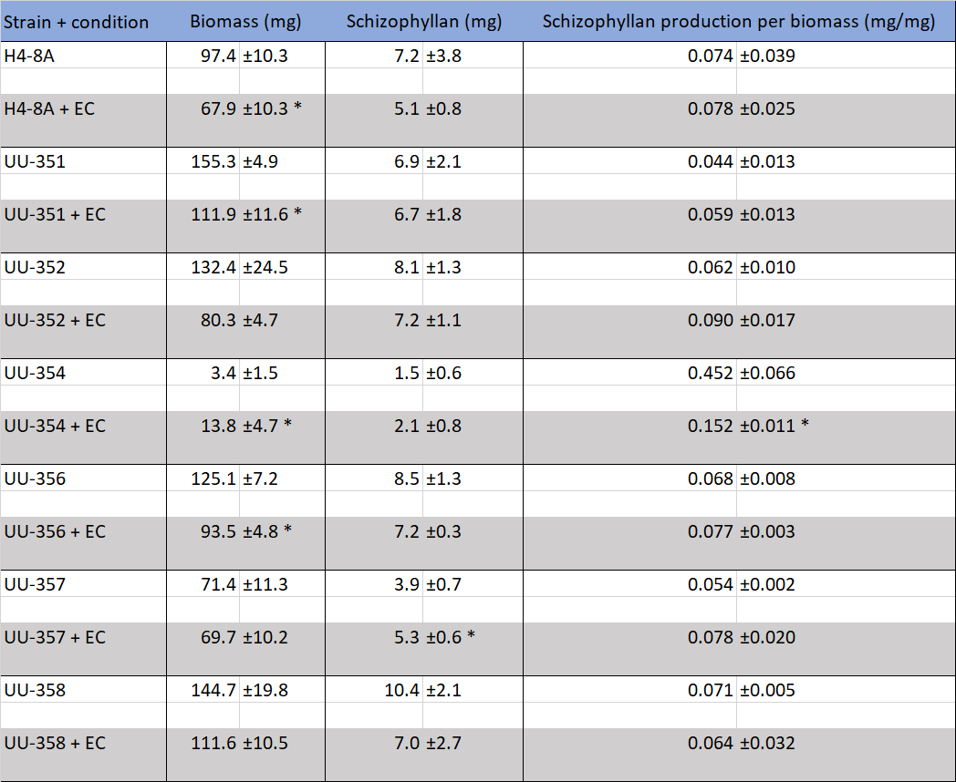
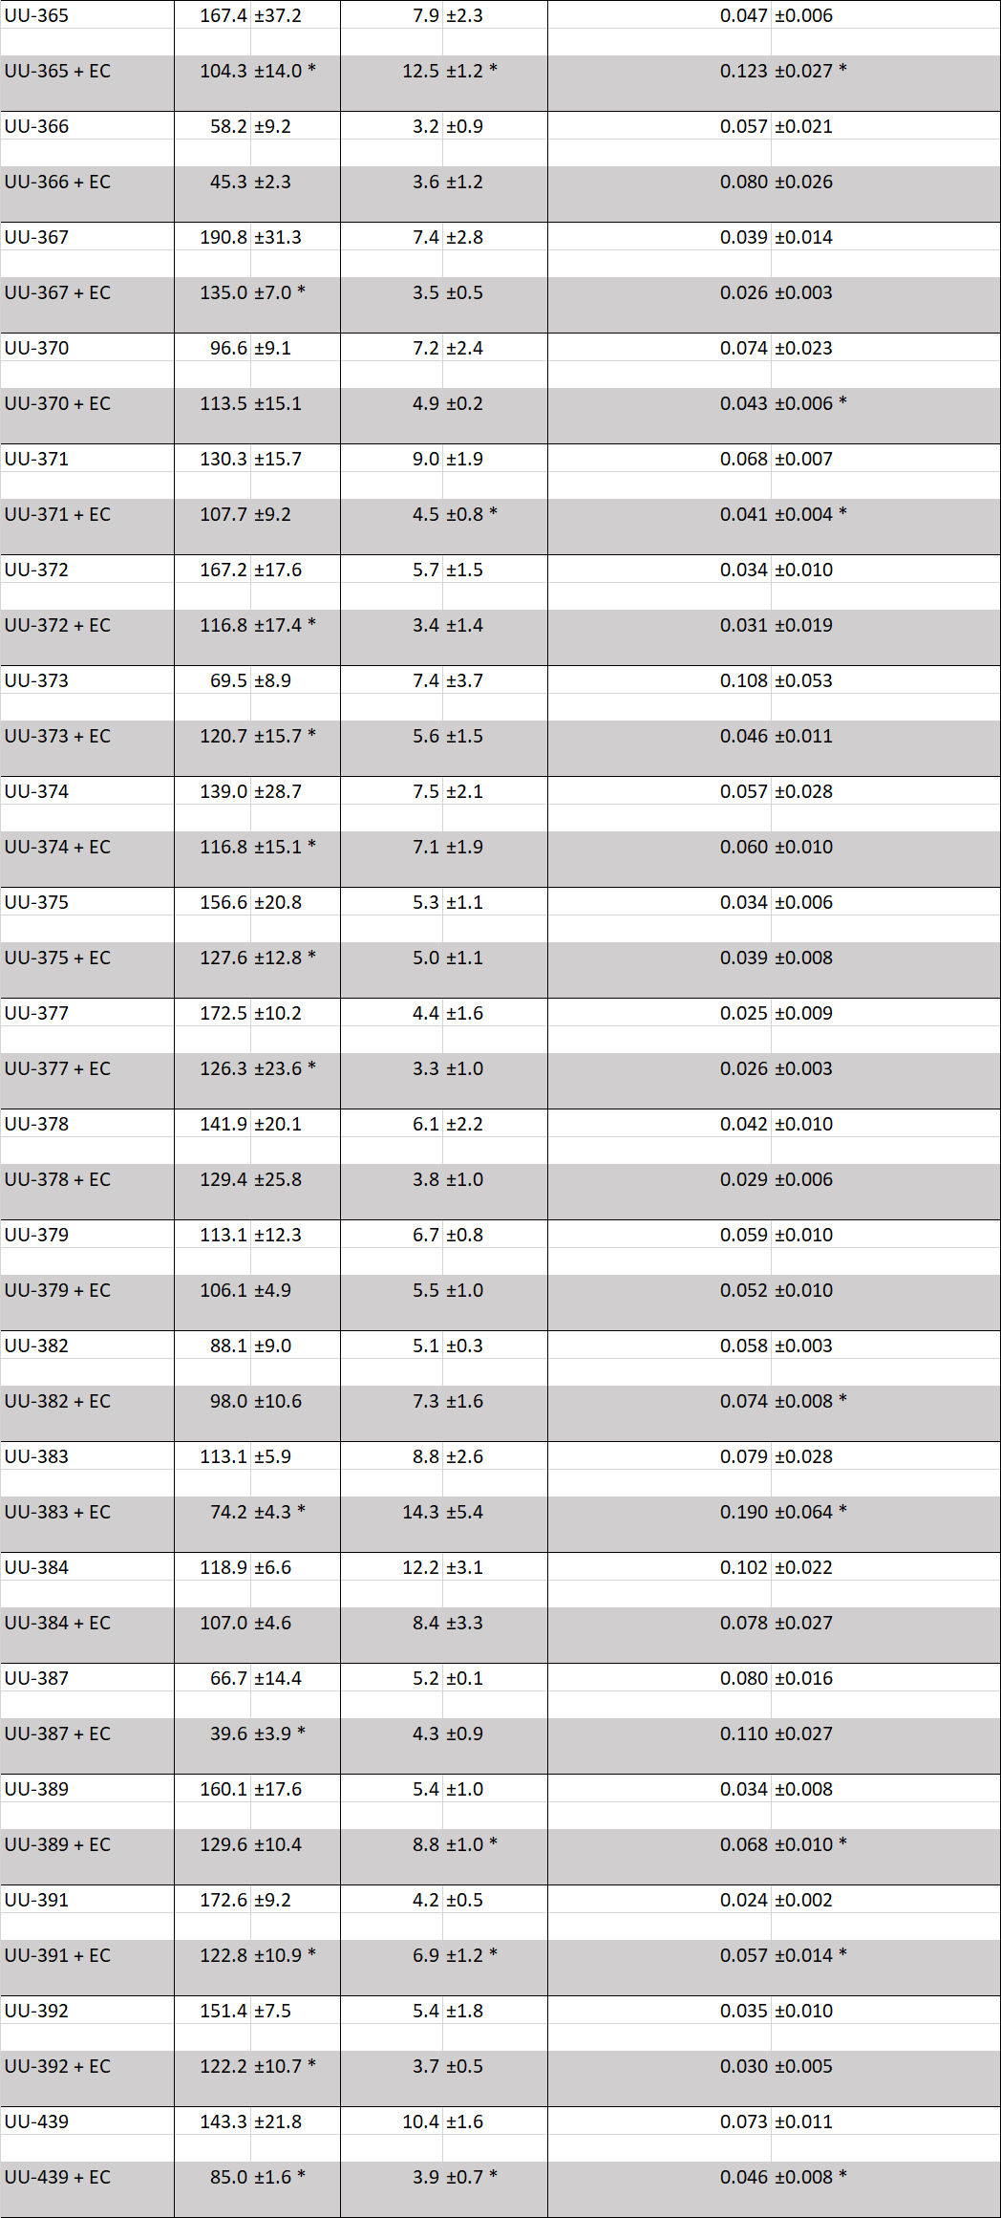

Biomass and schizophyllan production by S. commune strains grown with E. coli or extra thiamine
S. commune strains UU-354, UU-373, and UU-389 were selected for further experiments because they showed increase in biomass production (UU-354 and UU-373) or increase in schizophyllan production (UU-389) when grown together with E. coli. These strains were grown in liquid shaken SCMM cultures either with or without E. coli or a tenfold excess thiamine (table 3) to test if the additional thiamine secreted by E. coli into the medium could influence biomass production. Biomass production decreased for strain H4-8A and UU-389 when grown with E. coli (75.87 mg and 56.53 mg respectively) compared to grown without (103.27 mg and 76.80 mg respectively). Biomass production increased in strain UU-354 and UU-373 when grown with E. coli (40.17 mg and 52.20 mg respectively) compared to grown alone (22.03 mg and 30.40 mg respectively). Schizophyllan production decreased in UU-373 (9.10 mg to 13.97 mg). Schizophyllan production per biomass increased in strain H4-8A and UU-389 when grown with E. coli (0.27 mg/mg and 0.60 mg/mg) compared to grown alone (0.18 mg/mg and 0.30 mg/mg respectively). Strain UU-354 and UU-373 had lower schizophyllan production per biomass when grown with E. coli (0.46 mg/mg and 0.67 mg/mg respectively) compared to grown without E. coli (0.17 mg/mg and 0.29 mg/mg respectively). Biomass production in UU-389 was higher when grown with tenfold excess thiamine (89.30 mg) compared to when grown without excess thiamine (76.80 mg). Schizophyllan production was higher in UU-354 when grown with tenfold excess thiamine (0.91 mg) compared to when grown without excess thiamine (0.67 mg). Schizophyllan production per biomass in all four strains neither increased or decreased significantly when grown with tenfold excess thiamine compared to when grown without it. Together, data show that biomass production, schizophyllan production and schizophyllan production per mg biomass in S. commune strains are either higher, lower or not significantly changed when grown together with E. coli; and that addition of tenfold excess thiamine only increased biomass in one strain and increased schizophyllan production in another strain, indicating that thiamine excreted by E. coli is not the driving factor for biomass production in S. commune.

Table 2. Average and SEM of biomass, schizophyllan and schizophyllan produced per biomass of S. commune strains grown with (+EC) or without E. coli, or grown with (+10x Thiamine) or without tenfold excess thiamine. Significance between the conditions per strain is indicated with a * (p≤0.05).

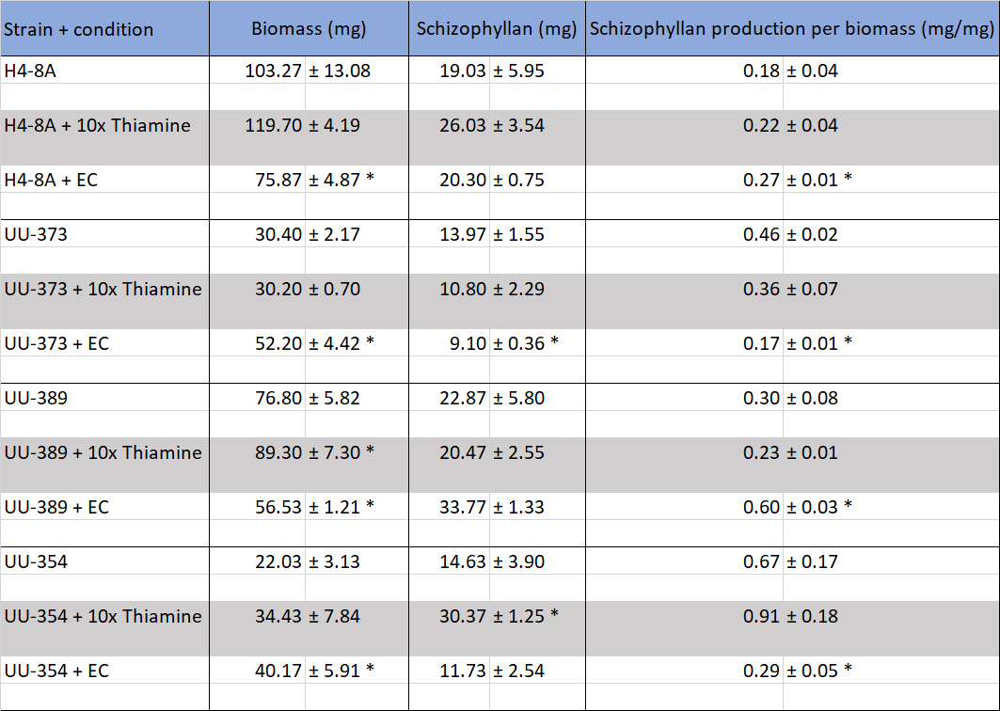

Biomass and schizophyllan production of S. commune strains grown with E. coli or L480
S. commune strains H4-8A and UU-373 were pre-grown on SCMM on a PCTE membrane and transferred to LB plates with or without E. coli or a Paraburkholderia species (L480) (table 2). H4-8A and UU-373 had a decrease in biomass production when grown with E. coli (5.73 mg and 2.87 mg respectively) or L480 (5.10 mg and 2.60 mg respectively) compared to when grown without bacteria (11.40 mg and 7.37 mg respectively). Schizophyllan production for neither strain was significantly different when grown with or without E. coli or L480. Strain H4-8A had higher schizophyllan production per biomass when grown with E. coli (0.178 mg/mg) compared to when grown alone (0.084 mg/mg). Together, data show that S. commune grown with either E. coli or L480 results in a lower biomass, Schizophyllan production is not significantly different and schizophyllan production per biomass is higher for H4-8A when grown with E. coli compared to grown without.

Table 3. Average and SEM of biomass, schizophyllan and schizophyllan produced per biomass of S. commune strains grown with (+EC) or without E. coli, or grown with (+L480) or without L480. Significance between the conditions per strain is indicated with a * (p≤0.05).

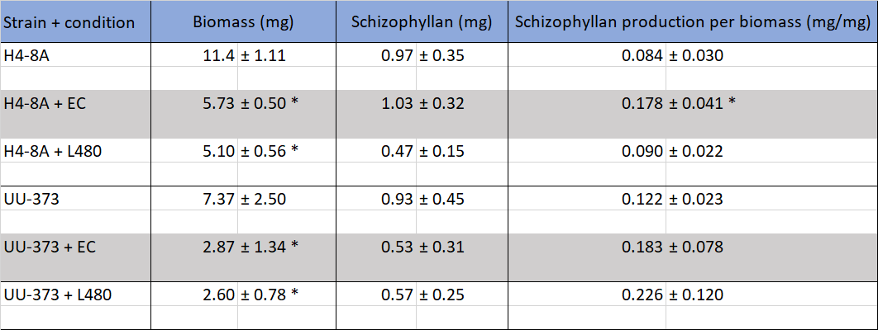

Material properties of S. commune when grown with or without E. coli
Floating mats were made from S. commune strains UU-373 and UU-389 grown either with or without E. coli. The density of UU-373 and UU-389 was higher when mycelium was grown with E. coli (3.471 mg/cm³ and 3.171 mg/cm³ respectively) than when mycelium was grown without E. coli (2.108 mg/cm³ and 2.213 mg/cm³ respectively) (table 4). Material properties were assessed through tensile measuring (table 4). The maximum tensile stress was higher for UU-373 when grown with E. coli (9.43 MPa) than when grown without E. coli (3.12 MPa). Similarly, the maximum tensile stress was higher for UU-389 when grown with E. coli (7.26 MPa) compared to grown alone (4.90 MPa), although this difference was not significant. The maximum strain was higher for UU-373 when grown with E. coli (4.9%) compared to grown without E. coli (1.6%). Likewise, the maximum strain was higher for UU-389 when grown with E. coli (3.4%) compared to grown without (2.5%) although this difference was not significant. There seemed to be a trend that data from samples grown with E. coli are further apart from each other than samples grown without E. coli (figure S1). There was no significant difference in Young’s Modulus for UU-373 or UU-389 when gown with or without E. coli (table 4). Together, these data indicate that growing S. commune strains with E. coli impacts density, maximum stress, and maximum strain but does not impact Young’s Modulus.

Table 4. Average and SEM of maximum stress, maximum strain, Young’s Modulus and density of strains grown with (+EC) or without E. coli. Significance between the conditions per strain is indicated with a * (p≤0.05).

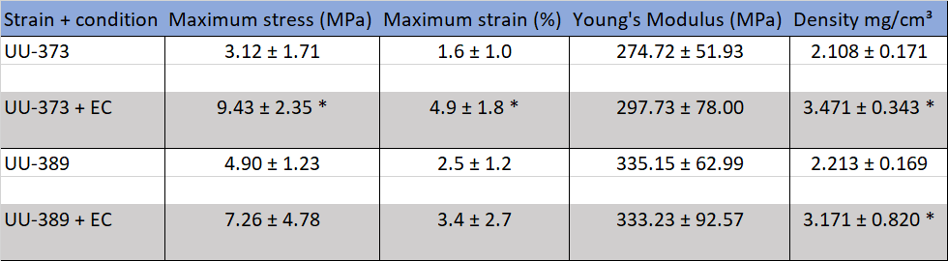

Discussion

In this study S. commune strains were grown with or without E. coli either on SCMM agar, in liquid shaken SCMM or pre-grown on SCMM agar and then placed on LB agar. Results showed that individual S. commune strains reacted differently to the bacteria. Production of biomass and schizophyllan was either higher, lower or not significantly different when strains were grown with E. coli compared to when grown alone. Notably biomass and schizophyllan production was highly varied between strains. There was also high variation in schizophyllan production per biomass between strains, suggesting that there is no relationship between biomass and schizophyllan production across the S. commune species. This is in line with a previous study from Sutivisedsak et al., 2013 who reported that biomass and schizophyllan production differs between S. commune strains. Interestingly, one strain showed a decrease in biomass when grown on LB agar with E. coli while when grown with E. coli on SCMM agar biomass increased. The differences in production of biomass and schizophyllan between strains of S. commune and between conditions found might be explained by nutrient uptake efficiency of S. commune strains. They have previously been reported to have different nutrient uptake efficiencies per type of carbon and nitrogen source (Imtiaj et al., 2008). Resource competition for nutrients like carbon, which both S. commune and E. coli need to grow (Niederpruem et al., 1964; Lozano Terol et al., 2019), could also play a role as these have limited availability for S. commune in LB the medium.
To test whether biomass production of S. commune was affected by thiamine which is secreted by E. coli, liquid shaken SCMM cultures were made with addition of tenfold excess thiamine. Addition of excess thiamine to S. commune cultures only increased production of biomass in one strain and increased schizophyllan production in another strain. This suggests that additional thiamine provided by E. coli during co-culturing does not cause the changes in biomass or schizophyllan production found when S. commune was grown with E. coli in either liquid shaken SCMM culture or on SCMM agar. Excess of thiamine had no negative effect on either biomass or schizophyllan production which implicates that similar to humans excessive amounts of thiamine are not toxic for S. commune (Martel et al., 2024).
To investigate if S. commune reacts differently when grown together with bacteria other than E. coli, S. commune strains were grown with a Paraburkholderia species (L480) on LB agar with S. commune pre-grown on SCMM agar. Results showed a decrease in S. commune biomass when grown with this bacteria. In a preliminary version of this experiment (data not shown), S. commune was pre-grown on LB agar because the Paraburkholderia species was not able to grow on SCMM liquid or agar. However, S. commune showed extremely slow growth on LB agar and when put together with bacteria did not seem to grow further. This was presumably because the fungus is not able to compete with bacteria for resources in LB medium. Although the Paraburkholderia species we used is unknown, Haq et al., 2014 reported a Paraburkholderia species found in the mycosphere of Laccaria proxima. They suggested that Paraburkholderia terrae (BS001) formed a biofilm around the hyphae to possibly protect the fungus against antifungals. The bacteria also used its host to increase its own motility as well as caused the host fungi to secrete glycerol to use as carbon source. It would be interesting to investigate if this is also a feasible interaction between S. commune and Paraburkholderia species when medium is optimised for both fungus and bacteria. Moreover, experiments with bacteria or even fungi that occur together with S. commune in nature could provide more insight on effects and functions of symbiosis as they are likely more synergised in their interaction with each other.
Mycelium sheets were made of S. commune grown with or without E. coli. One strain (UU-373) showed a significant increase in maximum tensile strength and maximum elongation when grown with E. coli. Possibly, E. coli may influence the structure of UU-373 leading to stronger and more ductile mycelium. Interestingly, materials made from S. commune grown with E. coli were observed to have high differences in maximum stress-strain between samples. This implies that making materials from S. commune and E. coli leads to variation in the material. More research is needed to determine if these differences are drastic enough to impact production stability as an increase in durability of materials can be of interest to companies and investors. Finally, density of material increased when S. commune was grown together with E. coli. Previous studies found that different substrates and environmental factors affected density in materials made from fungal mycelium by influencing mycelial network and mycelial crosslinking (Aiduang et al., 2022; Olivero et al., 2023), suggesting that E. coli affects the mycelium of S. commune on a similar level when grown together into a mycelium sheet. Further research could focus on what effect one or multiple naturally occurring bacteria have on material properties of S. commune materials and if changes in environmental factors or a potential after treatment, like glycerol used in Appels et al., 2020, affects the material properties of different S. commune strains.
Altogether, results from this study found that individual S. commune strains react differently to different environmental conditions and hypothesises that this is likely caused by the hypervariability between S. commune strains.

Supplementary figures
Figure S1. Stress/strain curves of strains grown with (+EC) or without E. coli.
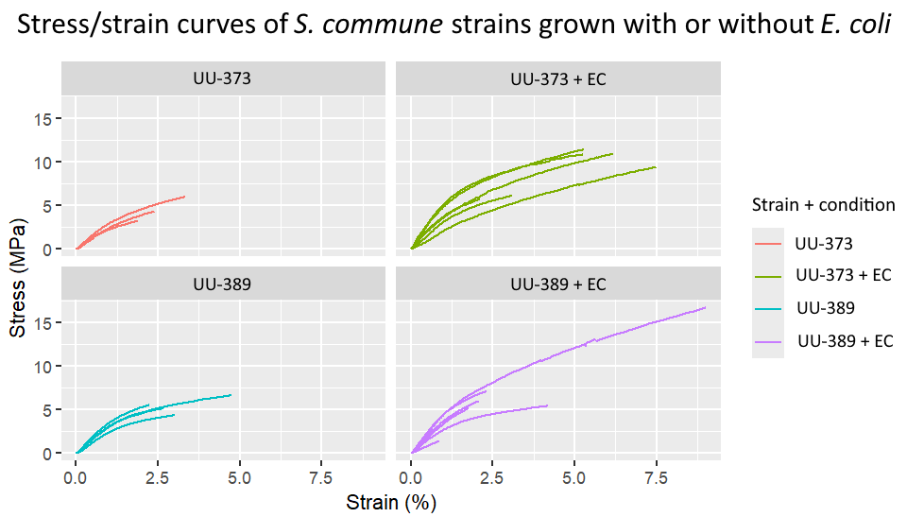

Generative AI statement
During the writing process ChatGPT (Open AI Chat-GPT-4o, September 2025) was solely used to suggest articles. No information was copied from ChatGPT.

References

Aiduang, W., Kumla, J., Srinuanpan, S., Thamjaree, W., Lumyong, S., & Suwannarach, N. (2022). Mechanical, Physical, and Chemical Properties of Mycelium-Based Composites Produced from Various Lignocellulosic Residues and Fungal Species. Journal of Fungi, 8, 1125. https://doi.org/10.3390/jof8111125
Appels, F. V. W., Dijksterhuis, J., Lukasiewicz, C. E., Jansen, K. M. B., Wösten, H. A. B., & Krijgsheld, P. (2018). Hydrophobin gene deletion and environmental growth conditions impact mechanical properties of mycelium by affecting the density of the material. Scientific Reports, 8, 4703. https://doi.org/10.1038/s41598-018-23171-2
Appels, F. V. W., van den Brandhof, J. G., Dijksterhuis, J., de Kort, G. W., & Wösten, H. A. B. (2020). Fungal mycelium classified in different material families based on glycerol treatment. Communications Biology, 3, 334. https://doi.org/10.1038/s42003-020-1064-4
Baranova, M. A., Logacheva, M. D., Penin, A. A., Seplyarskiy, V. B., Safonova, Y. Y., Naumenko, S. A., Klepikova, A. V., Gerasimov, E. S., Bazykin, G. A., James, T. Y., & Kondrashov, A. S. (2015). Extraordinary Genetic Diversity in a Wood Decay Mushroom. Molecular Biology and Evolution, 32, 2775–2783. https://doi.org/10.1093/molbev/msv153
Bertani, G. (1951). Studies on lysogenesis i. Journal of Bacteriology, 62, 293–300. https://doi.org/10.1128/jb.62.3.293-300.1951
Boonthatui, Y., Chongsuwat, R., & Kittisakulnam, S. (2021). Production of Antioxidant Bioactive Compounds during Mycelium Growth of Schizophyllum commune on Different Cereal Media. Chiang Mai University Journal of Natural Sciences, 20. https://doi.org/10.12982/CMUJNS.2021.032
Clifton, C. E. (1933). Factors Influencing Rate of Reduction of Potassium Ferricyanide by “Resting” Escherischia coli. Proceedings of the Society for Experimental Biology and Medicine, 31, 109–110. https://doi.org/10.3181/00379727-31-7017P
Dons, J. J. M., De Vries, O. M. H., & Wessels, J. G. H. (1979). Characterization of the genome of the basidiomycete Schizophyllum commune. Biochimica et Biophysica Acta (BBA) - Nucleic Acids and Protein Synthesis, 563, 100–112. https://doi.org/10.1016/0005-2787(79)90011-X
Freihorst, D., Brunsch, M., Wirth, S., Krause, K., Kniemeyer, O., Linde, J., Kunert, M., Boland, W., & Kothe, E. (2018). Smelling the difference: Transcriptome, proteome and volatilome changes after mating. Fungal Genetics and Biology, 112, 2–11. https://doi.org/10.1016/j.fgb.2016.08.007
Gou, Z., Peng, Z., Wang, S., Chen, L., Ma, Z., Kang, Y., Sun, L., Wang, R., Xu, H., Gu, Y., Sun, D., & Lei, P. (2023). Efficient production and skincare activity evaluation of schizophyllan, a β-glucan derived from Schizophyllum commune NTU-1. International Journal of Biological Macromolecules, 241, 124504. https://doi.org/10.1016/j.ijbiomac.2023.124504
Haq, I. U., Graupner, K., Nazir, R., & van Elsas, J. D. (2014). The Genome of the Fungal-Interactive Soil Bacterium Burkholderia terrae BS001—A Plethora of Outstanding Interactive Capabilities Unveiled. Genome Biology and Evolution, 6, 1652–1668. https://doi.org/10.1093/gbe/evu126
Healing-Mushrooms.net. (2021, April 28). [Schizophyllum commune (split-gill mushroom)] [Photograph]. Healing-Mushrooms.net. https://healing-mushrooms.net/schizophyllum-commune#_ednref7
Hummadi, E. H., Cetin, Y., Demirbek, M., Kardar, N. M., Khan, S., Coates, C. J., Eastwood, D. C., Dudley, E., Maffeis, T., Loveridge, J., & Butt, T. M. (2022). Antimicrobial Volatiles of the Insect Pathogen Metarhizium brunneum. Journal of Fungi, 8, 326. https://doi.org/10.3390/jof8040326
Imtiaj, A., Jayasinghe, C., Lee, G. W., Kim, H. Y., Shim, M. J., Rho, H.-S., Lee, H. S., Hur, H., Lee, M. W., Lee, U.-Y., & Lee, T.-S. (2008). Physicochemical Requirement for the Vegetative Growth of Schizophyllum commune Collected from Different Ecological Origins. Mycobiology, 36, 34–39. https://doi.org/10.4489/MYCO.2008.36.1.034
Vonk, P. J., Escobar, N., Wösten, H. A. B., Lugones, L. G., & Ohm, R. A. (2019). High-throughput targeted gene deletion in the model mushroom Schizophyllum commune using pre-assembled Cas9 ribonucleoproteins. Scientific Reports, 9, 7632. https://doi.org/10.1038/s41598-019-44133-2
Kashiwagi, Y., Norisuye, T., & Fujita, H. (2002, May 1). Triple helix of Schizophyllum commune polysaccharide in dilute solution. 4. Light scattering and viscosity in dilute aqueous sodium hydroxide. Macromolecules, 14, 1220-1225. https://doi.org/10.1021/ma50006a016
Keightley, P. D., Ness, R. W., Halligan, D. L., & Haddrill, P. R. (2014). Estimation of the Spontaneous Mutation Rate per Nucleotide Site in a Drosophila melanogaster Full-Sib Family. Genetics, 196, 313–320. https://doi.org/10.1534/genetics.113.158758
Kim, D.-W., Nam, J., Nguyen, H. T. K., Lee, J., Choi, Y., & Choi, J. (2020). Draft Genome Sequence of the White-Rot Fungus Schizophyllum Commune IUM1114-SS01. Mycobiology, 49, 86–88. https://doi.org/10.1080/12298093.2020.1843222
Kleijburg, F. E. L., & Wösten, H. A. B. (2025). The versatility of Schizophyllum commune in nature and application. Fungal Biology Reviews, 53, 100431. https://doi.org/10.1016/j.fbr.2025.100431
Komatsu, N., Okubo, S., Kikumoto, S., Kimura, K., & Saito, G. (1969). Host-mediated antitumor action of schizophyllan, a glucan produced by Schizophyllum commune. Gan, 60, 137–144.
Krause, K., Jung, E.-M., Lindner, J., Hardiman, I., Poetschner, J., Madhavan, S., Matthäus, C., Kai, M., Menezes, R. C., Popp, J., Svatoš, A., & Kothe, E. (2020). Response of the wood-decay fungus Schizophyllum commune to co-occurring microorganisms. PLoS ONE, 15, e0232145. https://doi.org/10.1371/journal.pone.0232145
Lozano Terol, G., Gallego-Jara, J., Sola Martínez, R. A., Cánovas Díaz, M., & de Diego Puente, T. (2019). Engineering protein production by rationally choosing a carbon and nitrogen source using E. coli BL21 acetate metabolism knockout strains. Microbial Cell Factories, 18, 151. https://doi.org/10.1186/s12934-019-1202-1
Marian, I. M., Valdes, I. D., Hayes, R. D., LaButti, K., Duffy, K., Chovatia, M., Johnson, J., Ng, V., Lugones, L. G., Wösten, H. A. B., Grigoriev, I. V., & Ohm, R. A. (2024). High phenotypic and genotypic plasticity among strains of the mushroom-forming fungus Schizophyllum commune. Fungal Genetics and Biology, 173, 103913. https://doi.org/10.1016/j.fgb.2024.103913
Martel, J. L., Doshi, H., Sina, R. E., & Franklin, D. S. (2024). Vitamin B1 (Thiamine). In StatPearls [Internet]. StatPearls Publishing. https://www.ncbi.nlm.nih.gov/sites/books/NBK482360/
Mišković, J., Karaman, M., Rašeta, M., Krsmanović, N., Berežni, S., Jakovljević, D., Piattoni, F., Zambonelli, A., Gargano, M. L., & Venturella, G. (2021). Comparison of Two Schizophyllum commune Strains in Production of Acetylcholinesterase Inhibitors and Antioxidants from Submerged Cultivation. Journal of Fungi, 7, 115. https://doi.org/10.3390/jof7020115
Mohammadi, A., Shojaosadati, S. A., Tehrani, H. J., Mousavi, S. M., Saleh, T., & Khorasani, A. C. (2018). Schizophyllan production by newly isolated fungus Schizophyllum commune IBRC-M 30213: Optimization of culture medium using response surface methodology. Annals of Microbiology, 68, 47–62. https://doi.org/10.1007/s13213-017-1316-9
Mooibroek, H., Kuipers, A. G., Sietsma, J. H., Punt, P. J., & Wessels, J. G. (1990). Introduction of hygromycin B resistance into Schizophyllum commune: Preferential methylation of donor DNA. Molecular & General Genetics: MGG, 222, 41–48. https://doi.org/10.1007/BF00283021
Mogu. (n.d.). Mogu. https://mogu.bio/
Niederpruem, D. J., Hobbs, H., & Henry, L. (1964). NUTRITIONAL STUDIES OF DEVELOPMENT IN SCHIZOPHYLLUM COMMUNE. Journal of Bacteriology, 88, 1721–1729. https://doi.org/10.1128/jb.88.6.1721-1729.1964
Niederpruem, D. J., & Wessels, J. G. (1969). Cytodifferentiation and morphogenesis in Schizophyllum commune. Bacteriological Reviews, 33, 505–535. https://doi.org/10.1128/br.33.4.505-535.1969
Ohm, R. A., Aerts, D., Wösten, H. A. B., & Lugones, L. G. (2013). The blue light receptor complex WC-1/2 of Schizophyllum commune is involved in mushroom formation and protection against phototoxicity. Environmental Microbiology, 15, 943–955. https://doi.org/10.1111/j.1462-2920.2012.02878.x
Ohm, R. A., de Jong, J. F., Lugones, L. G., Aerts, A., Kothe, E., Stajich, J. E., de Vries, R. P., Record, E., Levasseur, A., Baker, S. E., Bartholomew, K. A., Coutinho, P. M., Erdmann, S., Fowler, T. J., Gathman, A. C., Lombard, V., Henrissat, B., Knabe, N., Kües, U., Lily, W. W., Lindquist, E., Lucas, S., Magnuson, J. K., Piumi, F., Raudaskoski, M., Salamov. A., Schmutz, J., Schwarze, F. W., vanKuyk, P. A., Horton, J. S., Grigoriev, I. V., Wösten, H. A. B. (2010). Genome sequence of the model mushroom Schizophyllum commune. Nature Biotechnology, 28, 957–963. https://doi.org/10.1038/nbt.1643
Olivero, E., Gawronska, E., Manimuda, P., Jivani, D., Chaggan, F. Z., Corey, Z., de Almeida, T. S., Kaplan-Bie, J., McIntyre, G., Wodo, O., & Nalam, P. C. (2023). Gradient porous structures of mycelium: A quantitative structure–mechanical property analysis. Scientific Reports, 13, 19285. https://doi.org/10.1038/s41598-023-45842-5
Prokop, A., Rapp, P., & Wagner, F. (1992). Production of extracellular β-1,3-/β-1,6-glucan by mono- and dikaryons of Schizophyllum commune. Experimental Mycology, 16, 197–206. https://doi.org/10.1016/0147-5975(92)90028-P
Sharma, K., Verma, R., Kumar, D., & Kumar, V. (2024). Impact of Irpex lenis and Schizophyllum commune endophytic fungi on Perilla frutescens: Enhancing nutritional uptake, phytochemicals, and antioxidant potential. Microbial Cell Factories, 23, 226. https://doi.org/10.1186/s12934-024-02491-1
Sigler, L., Bartley, J. R., Parr, D. H., & Morris, A. J. (1999). Maxillary Sinusitis Caused by Medusoid Form of Schizophyllum commune. Journal of Clinical Microbiology, 37, 3395–3398. https://doi.org/10.1128/jcm.37.10.3395-3398.1999
Stella McCartney. (2021, March 18). The world’s first Mylo™ garments created from vegan mushroom leather. Stella McCartney. https://www.stellamccartney.com/gb/en/stellas-world/the-worlds-first-mylo-garments-created-from-vegan-mushroom-leather.html
Sutivisedsak, N., Leathers, T. D., & Price, N. P. (2013). Production of schizophyllan from distiller’s dried grains with solubles by diverse strains of Schizophyllum commune. SpringerPlus, 2, 476. https://doi.org/10.1186/2193-1801-2-476
Takemoto, S., Nakamura, H., Erwin, Imamura, Y., & Shimane, T. (2010). Schizophyllum commune as a Ubiquitous Plant Parasite. Japan Agricultural Research Quarterly: JARQ, 44, 357–364. https://doi.org/10.6090/jarq.44.357
Wang, C.-F., Yang, X.-Q., Sun, J., Wang, T., Cui, H.-R., Yang, Y.-B., & Ding, Z.-T. (2022). New Metabolites, Antifeedant, Insecticidal Activities, and Reciprocal Relationship Between Insect and Fungus from Endophyte Schizophyllum commune. Chemistry & Biodiversity, 19, e202200130. https://doi.org/10.1002/cbdv.202200130
Wang, L., Sun, Y., Sun, X., Yu, L., Xue, L., He, Z., Huang, J., Tian, D., Hurst, L. D., & Yang, S. (2020). Repeat-induced point mutation in Neurospora crassa causes the highest known mutation rate and mutational burden of any cellular life. Genome Biology, 21, 142. https://doi.org/10.1186/s13059-020-02060-w
Wirth, S., Krause, K., Kunert, M., Broska, S., Paetz, C., Boland, W., & Kothe, E. (2021). Function of sesquiterpenes from Schizophyllum commune in interspecific interactions. PLoS One, 16, e0245623. https://doi.org/10.1371/journal.pone.0245623
Yanaki, T., Norisuye, T., & Fujita, H. (1980). Triple Helix of Schizophyllum commune Polysaccharide in Dilute Solution. 3. Hydrodynamic Properties in Water. Macromolecules, 13, 1462–1466. https://doi.org/10.1021/ma60078a019
Zentz, F., Verchère, J.-F., & Muller, G. (1992). Thermal denaturation and degradation of schizophyllan. Carbohydrate Polymers, 17, 289–297. https://doi.org/10.1016/0144-8617(92)90172-M
Zhai, X., Chen, L., Jia, M., Li, C., Shen, H., Ye, B., Qin, L., & Han, T. (2017). A stable beneficial symbiotic relationship between endophytic fungus Schizophyllum commune and host plant Panax ginseng. bioRxiv, 175885. https://doi.org/10.1101/175885
Zhang, Y., Kong, H., Fang, Y., Nishinari, K., & Phillips, G. O. (2013). Schizophyllan: A review on its structure, properties, bioactivities and recent developments. Bioactive Carbohydrates and Dietary Fibre, 1, 53–71. https://doi.org/10.1016/j.bcdf.2013.01.002

