

Multidimensional Poverty and the Labour Market: A Regional Analysis of Suriname

Master Thesis, Applied Data Science

Samantha Aivazi (0738697)
Supervisor: Dr. Yolanda Grift
Second Reader: Dr. Rosita Sobhie

July 2025

Abstract
This study uses data from the 2022 Suriname Survey of Living Conditions (N=7,715) to construct a person-level relative poverty indicator, and survey-weighted logistic models to assess the roles of region, employment, and electricity. Out-of-sample performance improved with substantive predictors: RQ1 (region+age+gender) Accuracy = 0.606, AUC = 0.609; RQ2 (employment×region, ages 15–64) Accuracy = 0.889, AUC = 0.900; RQ3 (electricity+region, ages 25–64) Accuracy = 0.630, AUC = 0.688; the combined model (employment+electricity+region) attained Accuracy = 0.855 and AUC = 0.850. Weighted average marginal effects indicated large probability reductions: the probability of relative poverty was reduced by ~0.82 for employed individuals and by ~0.58 for those with electricity access. After adjustment, region remained consequential: the Rest of Coast exhibited the highest within-region risk, Paramaribo was intermediate, and the Interior lower on this relative measure. To ground interpretation in absolute terms, an Alkire–Foster–style MPI (equal weights, K = 1/3) indicated that the Interior had MPI ≈ 0.53 (headcount ≈ 0.82; intensity ≈ 0.65). These findings are consistent with place-based policy that integrates employment creation and electrification, with differentiated strategies across regions.

Abstract 2
Introduction 5
1.1 Background and Context 5
1.2 Research Problem 5
1.3 Objectives 6
1.4 Research Questions 6
Literature Review 7
2.1 Theoretical Frameworks 7
2.2 Multidimensional Poverty Measurement 8
2.3 Regional Poverty Dynamics 8
2.4 Employment and Poverty Linkages 9
2.5 Infrastructure and Poverty Reduction 9
2.6 Contextualizing Suriname 10
Data 10
3.1 Data Sources and Structure 10
3.2 Data Preparation and Integration 11
3.2.1 Imports and formats 11
3.2.2 Keys, integrity, and merge design 11
3.2.3 Harmonization and recodes 12
3.2.4 Household food aggregation 12
3.2.5 Missingness and nonresponse patterns 12
3.2.6 Indicator construction (binary deprivations) 13
3.2.7 Composite measures prepared for analysis 14
3.3 Data Exploration Results 15
3.4 Ethical and Legal Considerations 18
Methods 19
4.1 Translation of Research Question to Data Science Question 19
4.2 Method Selection and Justification 20
4.3 Model Settings and Configuration 21
Results and Analysis 24
5.1 RQ1: Regional Effects on Poverty 24
5.2 RQ2: Employment Effects with Regional Interactions 27
5.3 RQ3: Infrastructure (electricity) and relative poverty 30
5.4 Combined Model Results 34
5.5 AF-style MPI 38
Conclusion and Discussion 40
6.1 Answering the Data Science Question 40
6.2 Answering the Research Question 40
6.3 Implications for Suriname's Development Context 41
6.4 Limitations 42
6.5 Ethical Implications and Considerations 43
Bibliography 43
Appendix 45
8.1 Annotated Scripts and Code 45
8.1.1 Data Loading & Inspection 45
A. Code 45
B. Outputs 51
8.1.2 Data Cleaning & Indicator Construction 51
A. Code 51
B. Outputs 54
8.1.3 Composite Measures (Relative score + AF-style MPI) 55
A. Code 55
A. Outputs 59
8.1.4 Regression Specifications (weights, SEs, ridge checks) 60
A. Code 60
B. Outputs 71
C. Notes 76
8.2 Full Data Exploration Results 78
A. Code 78
B. Outputs 92

Introduction

Background and Context
Suriname is a small South American nation of roughly 575,000 people where rich natural resources (oil and gold) coexist with persistent poverty (World Bank, 2022). Regional disparities characterize the economic landscape: urban areas such as Great Paramaribo tend to exhibit lower poverty than the rural Interior, where deprivation remains high (IDB, 2022). The urban–rural divide is compounded by the concentration of about 70% of the population in urban zones that cover less than 1% of land area, placing pressure on infrastructure and services (UN-Habitat, 2020). Migration further shapes these patterns: internal movements from Maroon and Indigenous communities to urban centers, and cross-border flows from Brazil and Guyana, are driven by limited rural opportunities and urban employment prospects (Sistemas Integrales Consulting, 2022). These dynamics have contributed to informal settlement growth in Paramaribo, where housing costs absorb substantial household budgets (Lucci et al., 2018). The labor market exhibits high informality, around 40%, with irregular incomes that constrain access to stable housing and essential services (ILO, 2019). Taken together, geographic, migration, and labor-market factors point to the need for a multidimensional perspective on poverty.

Research Problem
Despite these challenges, research on poverty in Suriname remains relatively limited, and much of the existing work relies on income-based measures. Such approaches do not always capture the multidimensional nature of deprivation in contexts where housing costs, employment quality, and infrastructure access play crucial roles in shaping living standards (Lucci et al., 2018; Ravallion & Chen, 2011). As a result, both urban vulnerability—where hidden costs increase living expenses—and rural deprivation—where multiple disadvantages overlap—may be underestimated.
This thesis seeks to contribute to addressing this gap by examining how geographic disparities, migration-driven demographic patterns, labor market informality, and infrastructure access are associated with poverty outcomes. Using individual-level microdata from the 2022 Suriname Survey of Living Conditions (SSLC), I develop a relative, multidimensional poverty measure and explore how region, employment, and infrastructure jointly influence poverty.

1.3 Objectives
1. Develop and document a relative (within-region) binary poverty measure at the person level and assemble policy-relevant covariates from SSLC 2022.
2. Quantify the association between region and relative poverty controlling for demographics (RQ1).
3. Assess how the poverty–employment relationship varies by region via interaction terms (RQ2).
4. Estimate the association between electricity deprivation and relative poverty, conditional on region and demographics (RQ3).
5. Estimate a combined model (region + employment + electricity) and quantify average marginal effects (AMEs), out-of-sample performance, and robustness (weights, HC1 SEs, VIFs, ridge).
6. Report an AF-style MPI (H, A, MPI) as a descriptive robustness check to situate findings in absolute terms and to inform policy interpretation.

1.4 Research Questions
To address the research problem, this thesis examines the following questions:
RQ1:To what extent does geographic region predict relative (within-region) poverty after controlling for age and gender?
RQ2: Do the effects of employment deprivation on relative poverty differ across regions (i.e., are there substantive region×employment interactions)?
RQ3:What is the association between electricity deprivation and relative poverty—controlling for region and demographics—among adults of working age?
Combined specification (robustness). When region, employment, and electricity are considered jointly, which factors dominate, and how do out-of-sample performance and AMEs compare with the single-dimension models?

Literature Review

2.1 Theoretical Frameworks
The study of poverty requires frameworks that extend beyond income to encompass deprivations in opportunities, services, and social participation. Amartya Sen’s capability approach provides the normative foundation, conceptualizing poverty as the absence of substantive freedoms to achieve valuable functionings (Sen, 1999). This view shifts attention from monetary resources alone toward multidimensional constraints on human well-being.
Spatial inequality theory further emphasizes that poverty is not randomly distributed but concentrated in specific locations, shaped by both “first-nature” geography (resources, climate) and “second-nature” factors (infrastructure, institutions) (Kanbur & Venables, 2005). In Suriname, marked urban–rural disparities reflect these dynamics, as the capital region enjoys concentration of services while the Interior faces remoteness and infrastructure deficits. Finally, infrastructure-led development theory underscores that access to basic services such as electricity enables participation in markets and education, providing a foundation for poverty reduction (Calderón & Servén, 2010). Together, these perspectives situate poverty as a multidimensional and spatially contingent phenomenon.

2.2 Multidimensional Poverty Measurement
The evolution of poverty research has increasingly embraced multidimensional frameworks. Alkire and Foster (2011) developed a widely applied multidimensional poverty index (MPI) that identifies individuals as poor when they suffer simultaneous deprivations in key domains such as health, education, and living standards. This counting approach provides a richer understanding than income measures alone and is now applied in numerous national contexts (Alkire & Santos, 2014, Battiston et al., 2013).
At the same time, critiques highlight important limitations. Ravallion (2011) cautions that while multidimensionality is essential, no single composite index can fully summarize poverty. He distinguishes between aggregation in the attainment space, where welfare-consistent tradeoffs are defined by prices, and aggregation in the deprivation space, where analysts impose arbitrary weights and cutoffs. The latter, as in MPI, risks obscuring real tradeoffs faced by households. Ravallion (2012) extends this critique to “mashup indices” such as HDI and MPI, which are attractive for advocacy but less useful for policy design because they conceal heterogeneity across dimensions and are highly sensitive to methodological choices. He instead recommends a “dashboard” of complementary indicators combined with robustness checks.
This thesis adopts such a dual-measure strategy. The main regressions rely on a relative poverty indicator defined at the person level with regional benchmarks, ensuring interpretability and policy transparency. In addition, an AF-style MPI is reported descriptively, triangulating results in absolute terms and situating findings within broader multidimensional poverty research.

2.3 Regional Poverty Dynamics
Location remains a decisive determinant of poverty outcomes. Kanbur and Venables (2005) argue that geographic disparities arise from both natural endowments and institutional or infrastructural investments. Rural and remote areas typically suffer from weaker market access, lower returns to labor, and poorer service provision. Bird et al. (2002) show that chronic poverty is particularly entrenched in remote rural zones, where structural barriers limit opportunities.
Agglomeration theory provides a further explanation, suggesting that economic activities cluster in urban centers due to economies of scale and knowledge spillovers (Krugman, 1991). This concentration generates self-reinforcing advantages for urban areas while leaving rural regions marginalized. These frameworks explain the persistent urban–rural divide in Suriname, where the Interior faces layered deprivations across multiple domains.

2.4 Employment and Poverty Linkages
Employment is widely recognized as a primary pathway out of poverty. The dual economy model (Lewis, 1954) conceptualizes labor markets as segmented between modern, urban formal sectors and traditional, rural subsistence sectors. Suriname’s labor market reflects this divide, with urban formal employment offering greater security and returns than rural livelihoods.
Contemporary research emphasizes job quality as well as access. Fields (2011) notes that stable, well-paid employment delivers the strongest poverty reduction impacts, whereas informal or precarious jobs may leave households vulnerable. Spatial variation also matters: Christiaensen and Todo (2014) show that employment creation in underserved rural areas often has larger poverty reduction effects than equivalent job creation in urban centers. These findings support the importance of analyzing employment–poverty linkages by region.

2.5 Infrastructure and Poverty Reduction
Infrastructure access directly shapes welfare and indirectly facilitates participation in labor markets. Calderón and Servén (2010) document the multiple channels through which infrastructure—electricity, water, transport—reduces poverty, from productivity to market integration.
Electricity access in particular has been shown to reduce poverty significantly. Dinkelman (2011) finds that rural electrification in South Africa increased female employment and household income, while Khandker et al. (2013) show similar effects in Vietnam. These studies illustrate how electricity enables home enterprises, extends productive hours, and improves educational outcomes. Given Suriname’s pronounced rural–urban electricity gap, infrastructure emerges as a critical dimension of multidimensional poverty.

2.6 Contextualizing Suriname
Despite its resource wealth, Suriname faces persistent poverty and stark regional inequality. About 70% of the population resides in Great Paramaribo, yet deprivation remains concentrated in the Interior, where electricity and employment opportunities are limited (IDB, 2022; World Bank, 2022). Migration from Maroon and Indigenous communities to urban centers reflects these disparities, while high informality—around 40% of employment—creates precarious livelihoods even in urban areas (ILO, 2019).
Existing research on Suriname’s poverty is sparse, but available studies emphasize infrastructure gaps and labor market informality as key constraints (Lucci et al., 2018). By combining a relative poverty framework with an AF-style MPI robustness check, this thesis contributes to filling that gap, offering a multidimensional, spatially sensitive analysis of poverty that aligns with current debates in measurement.

Data

3.1 Data Sources and Structure
This thesis draws on the 2022 Suriname Survey of Living Conditions (SSLC), a nationally representative household survey conducted by the Inter-American Development Bank (IDB) between January and December 2022. The SSLC interviewed approximately 2,500 households and 7,500 individuals, covering education, employment, housing, and consumption patterns. The survey sample was stratified across three domains; Great Paramaribo (urban), Rest of the Coastal Region (semi-urban), and the Interior (rural), to ensure regional representativeness.
For this study, three core SSLC datasets were used:
- Persons Dataset (RT002): contains records for 7,715 individuals with 594 variables, covering demographics, education, and employment status.
- Housing Dataset (RT001): includes 2,542 households with 90 variables, providing information on dwelling characteristics and infrastructure access.
- Food Dataset (RT140): consists of 88,375 records with 20 variables, documenting household food acquisition and expenditures, standardized through item-specific annualization coefficients.
All datasets were released in Stata (.dta) format and processed in Python using pandas and numpy for data handling and matplotlib and seaborn for exploratory analysis. Together, these sources provide individual, household, and consumption-level data that enable the construction of multidimensional poverty indicators aligned with this thesis’ research objectives.

3.2 Data Preparation and Integration

3.2.1 Imports and formats
The three study files (RT002 Persons, RT001 Housing, RT140 Food) were supplied as Stata .dta and imported into Python. Final shapes were Persons: 7,715 × 594, Housing: 2,542 × 90, Food: 88,375 × 20.

3.2.2 Keys, integrity, and merge design
- Keys: hhid uniquely identified households in Housing (duplicates = 0) and, jointly with memberid, uniquely identified persons in Persons (duplicates = 0). As expected for a long transactions file, Food contains multiple lines per hhid (household-level duplicates in raw Food = 85,837).
- Cross-file consistency: Person–Housing merges were many-to-one on hhid and preserved the person row count (7,715 → 7,715). Person–Food used household aggregation first (below) and then many-to-one merges.
- Geography/PSU alignment: Person-level domain/psu matched the corresponding Housing values for the same hhid (all equal; 0 mismatches).
- All households in Persons existed in Housing (0 missing). A small number of person-households (4 hhids) had no Food transactions (expected with 7-day recall), and therefore did not receive food-based aggregates.

3.2.3 Harmonization and recodes
- Region: domain recoded to Great Paramaribo / Rest of Coast / Interior for readability and stratified reporting.
- Sex: q01_03 recoded to a binary is_female (1=female, 0=male) for ease of disaggregation.
- Age: a small number of implausible ages (e.g., −1) were treated as invalid and excluded listwise in indicator construction steps where age bounds were introduced.

3.2.4 Household food aggregation
Where household-level thresholds were computed (e.g., food-based quintile cutoff), household weights were applied; all other descriptive statistics use person weights. Food items (RT140) were transformed to household totals using the survey’s annualization factor:
- Construct amount_last_time = q14_03_2, then amount_annualized = amount_last_time × anncoeff, clipped at zero to guard against negative artifacts.
- Aggregate to household: total last-purchase amount, annualized total, and record count per hhid.
- Merge these aggregates to Housing and Persons.
- Build per-capita annualized food expenditure as:
$$pc_food_annual=\frac{\text{total}\text{_}\text{food}\text{_}\text{amount (annualised)}}{\text{household size}}$$
- Compute the weighted 20th percentile of pc_food_annual using household weights. This resulted to 8,475.60 SRD. This threshold defines the bottom quintile used later as the economic deprivation cutoff.
Resulting food aggregate table size: 2,538 households (matching distinct hhid in Food).

3.2.5 Missingness and nonresponse patterns
- Persons: Missingness was low for demographics (age 0.06%, sex 0.03%), moderate for schooling (ever attended q03_01 4.93%; current enrollment q03_02 9.68%), and higher for employment (worked last 12m q09_01 23.49%; worked last 7d q09_06 23.49%; attachment q09_08 63.51%, consistent with skip patterns).
- Housing: Main lighting source q13_17 had 0.08% missing.
- Food: Last purchase amount q14_03_2 had 15.25% missing; anncoeff was complete (0%).
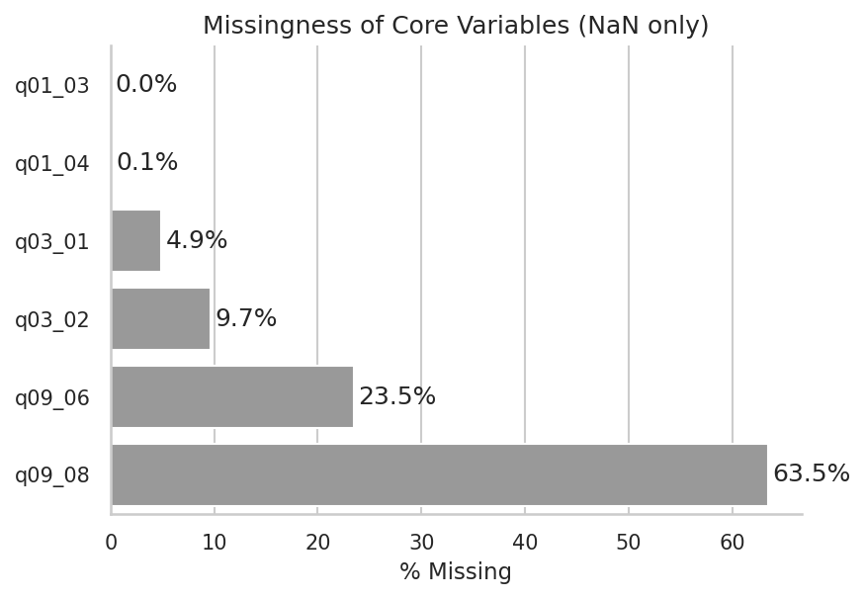
Figure 1.Missingness rates for core variables in the Persons dataset
Employment items (q09_06, q09_08) show the highest apparent missingness, largely due to questionnaire skip patterns, while demographic variables are nearly complete. These rates guided conservative listwise handling within each indicator.

3.2.6 Indicator construction (binary deprivations)
The Indicators are person-level unless noted; household indicators are assigned to all members of the household. The definitions for the poverty determinants used in this MPI context are as follows:
- Education deprivation
  - Ages 6–16: deprived if not currently enrolled (q03_02 = 2).
  - Ages ≥17: deprived if never attended (q03_01 = 2).
  - Others: were set to missing (indicator not applicable).
- Employment deprivation (ages 15–64)
  - Non-deprived if worked in last 7 days (q09_06 = 1) or had a job but absent (q09_06 = 2 and q09_08 = 1).
  - Deprived if q09_06 ∈ {1,2} and q09_08 ∈ {1,2} but not meeting the employed criteria above.
  - Outside 15–64: set to missing.
- Electricity deprivation (household → person)
  - From Housing q13_17 (main lighting): grid (code 1) = access; all other codes (2–8) = deprived.
  - A sensitivity alternative (not used in the baseline) considers solar (code 6) as access.
- Economic deprivation (household → person)
  - Deprived if household pc_food_annual ≤ 8,475.60 (weighted 20th percentile); non-deprived otherwise.
All deprivations use the survey’s person weights for descriptive rates and the household weights where household-level thresholds are computed (e.g., the quintile cut-off).

3.2.7 Composite measures prepared for analysis
To enable both relative and multidimensional analyses downstream, two summary constructs were prepared:
- Additive 0–4 score: sum of the four deprivations. A minimum information rule requires at least K=2 observed indicators, otherwise the score is set to missing. This rule excluded 2 of 7,715 persons (0.0%) from scoring.
- Alkire–Foster style (equal weights): normalized deprivation share across available indicators $c_score$, with a stricter completeness rule ($≥3$ observed indicators). Individuals are classified MPI-poor if $c_score ≥ 1/3.$
Both constructs were computed and stored for subsequent descriptive and inferential analyses. Regional statistics, including weighted medians of the relative score, as well as $H, A,$ and $MPI=H×A$ for the AF-style measure, are reported in the Results, the code for the construction of the indicators and the AF- measure is documented in Appendix 8.1.3.

3.3 Data Exploration Results
All descriptive statistics and figures in this section are weighted using the person-level survey weights provided in the SSLC dataset, ensuring that results are nationally representative rather than reflecting raw sample composition.
The SSLC 2022 sample consists of 7,715 individuals (unweighted), of which 5,455 live in Great Paramaribo, 1,819 in the Rest of the Coast, and 441 in the Interior. When applying survey weights, these correspond to 70.5%, 20.5%, and 9.1% of the national population, respectively (Figure 2).
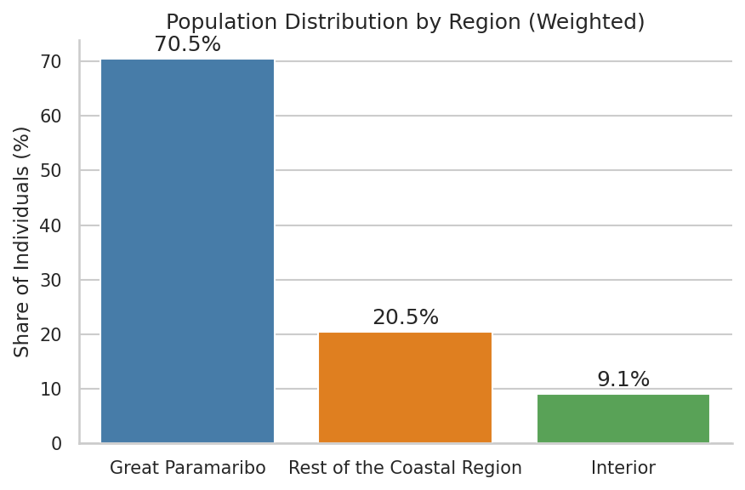
Figure 2. Weighted Population Distribution by Region in the SSLC 2022 Sample
The age distribution reveals demographic contrasts across regions (Figure 3). Great Paramaribo exhibits a relatively young population structure, with large cohorts in the 0–30 age range and a gradual tapering thereafter. The Rest of the Coastal Region shows a somewhat older age profile, with representation across both younger and middle-age groups. In contrast, the Interior demonstrates a more uneven and aging distribution.
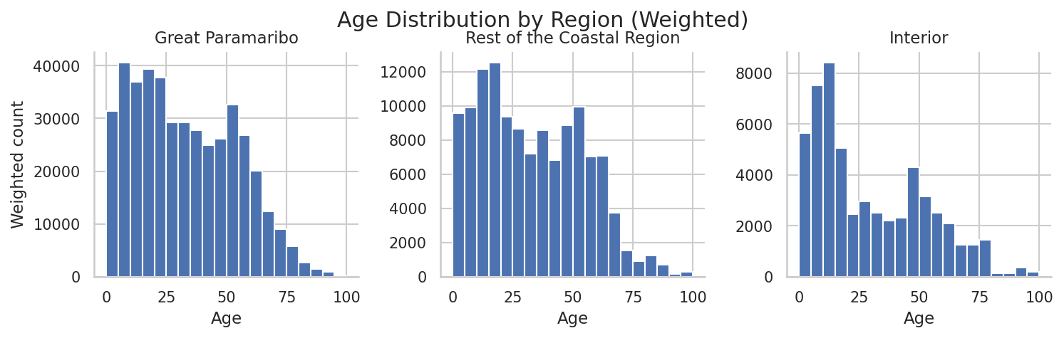
Figure 3. Age Distribution by Region (Weighted)
Regional disparities extend beyond demographics into social and infrastructural outcomes (Figure 4). Employment rates are highest in Great Paramaribo (62.4%) and the Rest of the Coast (59.9%), but fall sharply in the Interior (42.9%). School attendance is nearly universal in urban and coastal areas (≈98–100%), yet drops to 76.7% in the Interior, reflecting persistent educational barriers in rural settings. Electricity access presents the largest inequality: while nearly all households in Paramaribo and coastal regions are connected, only 14.3% of Interior households report access to electricity.
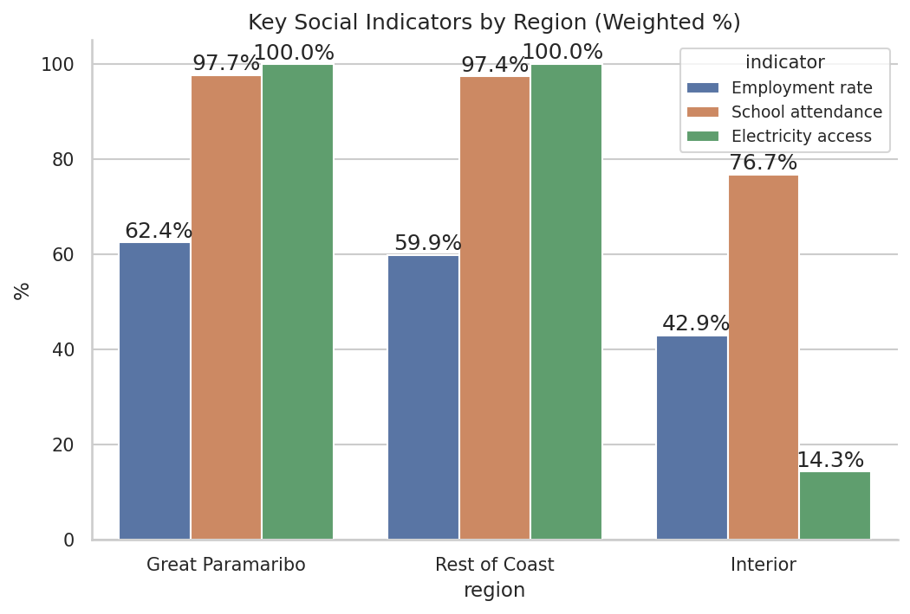
Figure 4.Key Social Indicators By Region
To summarize these disparities across multiple domains, Figure 5 presents the weighted share of individuals deprived in education, employment, electricity, and economic well-being. Great Paramaribo shows very low deprivation in education (2.3%) and electricity (0%), though almost two in five individuals are deprived in employment (37.6%) and nearly one in five in economic resources (19.4%). The Rest of the Coastal Region displays slightly higher economic (28.7%) and employment deprivation (40.1%), while still maintaining near-universal education and electricity access.
The Interior faces compounded disadvantage across all four dimensions. More than 85% are deprived in electricity access, 62% in economic terms, 57% in employment, and 23% in education. The layering of multiple deprivations highlights the structural barriers confronting rural households and signals the multidimensional character of poverty in the Interior.

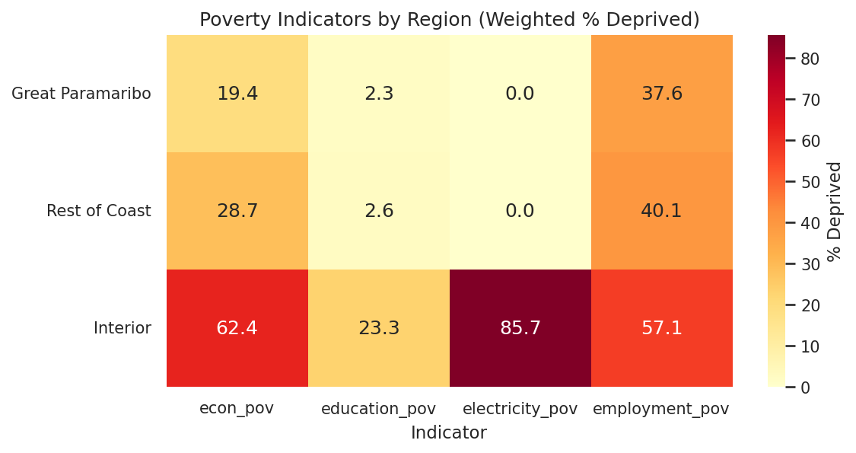
Figure 5. Poverty Indicators By Region “Figure 5 displays deprivation rates (row=region, column=indicator), with shading intensity reflecting the weighted share deprived.”
Additional exploratory analysis and data quality audits are provided in the Appendix section 8.2 (Full Data Exploration Results).

3.4 Ethical and Legal Considerations
The 2022 SSLC data was collected by the Inter-American Development Bank following established ethical protocols for household surveys. All data used in this analysis is publicly available and anonymized, with no personally identifiable information retained. The analysis adheres to principles of beneficence by focusing on poverty reduction insights that can inform evidence-based policy interventions for Suriname's development.
The pipeline ensures participant confidentiality through aggregate reporting of findings. Individual responses are analyzed only in statistical models where personal identification is impossible. The study's focus on multidimensional poverty measurement and regional analysis serves the public interest by providing evidence for policy interventions that could improve living conditions across Suriname's diverse regions.

Methods

4.1 Translation of Research Question to Data Science Question
The aim of this study is to identify the determinants of multidimensional poverty in Suriname. To operationalize this research goal, three empirical research questions (RQ1–RQ3) were formulated and translated into statistical models suitable for policy-relevant interpretation:
- RQ1 → Can geographic location predict relative poverty status when demographic controls are included in a logistic regression framework?
- RQ2 → How do employment effects on poverty vary across regions when modeled with interaction terms?
- RQ3 → What is the relationship between household infrastructure access (electricity) and poverty likelihood across spatial contexts?
In addition to these sequential models, a combined specification was estimated including all predictors (region, employment, and electricity) alongside demographic controls. This model does not constitute a separate research question but serves as a robustness check, ensuring that results are not driven by omitted variable bias when structural and labor market determinants are considered jointly.
Poverty Measures
In addition to the relative poverty classification used as the dependent variable in regression models, an Alkire-Foster style multidimensional poverty index (MPI) was also computed for descriptive purposes. The MPI was constructed by assigning equal weights to the four deprivation indicators (education, employment, electricity, and economic), calculating the share of deprivations per individual, and applying the conventional cutoff $k=1/3$. Following Alkire and Foster (2011), headcount ratios (H), average intensity of deprivation (A), and the composite MPI $(H×A)$ were computed at the regional level. These MPI statistics are presented in the results for contextual comparison but were not used as the dependent variable in regression analysis, where the relative poverty measure (regional median cutoff) remained central.
To enable binary regression analysis, a relative poverty measure was constructed (as defined in Chapter 2). First, for each individual a composite multidimensional deprivation score sis_isi​ was computed by summing four binary indicators: (i) education deprivation, (ii) employment deprivation, (iii) electricity deprivation, and (iv) economic deprivation. This yields $s_{i}∈\{0,1,2,3,4\}.$
Next, within each of Suriname’s three regions—Great Paramaribo, Rest of Coast, and Interior—the person-weighted regional median of the score was calculated:
$$\tilde{s_{r}}=wmedian\{ s_{i}∣i∈r \}$$
where $s_{i}$​ is the composite score for individual $i$ and $r$ indexes the region. Finally, individuals were classified as relatively poor if their score exceeded their region’s median:
$${\text{poor}}_{i}=\{ 1\text{ if }s_{i}>\tilde{s_{r}}, 0\text{ otherwise} \}$$
This relative poverty measure ensures sufficient statistical variation across regions while preserving meaningful distinctions in Suriname’s economic geography.
Throughout, the unit of analysis is the person. Household-level deprivations (electricity, food) are assigned to all members of a household, while survey weighting respects this distinction: household weights are applied to construct household-level thresholds, and person weights are used in all descriptive and regression analyses.
It should be also noted that, because the dependent variable is relative to each region’s median, regions with high absolute deprivation (e.g., Interior) can still have lower relative-poverty rates if most residents are uniformly poor.

4.2 Method Selection and Justification
Binary logistic regression was selected as the primary analytical method due to the binary outcome variable derived from the relative poverty measure. Several considerations guided this choice:
- Statistical appropriateness: Logistic regression is designed for binary outcomes and avoids the limitations of linear probability models (e.g., predictions outside the [0,1] range).
- Policy interpretability: Estimated coefficients are readily interpretable as log-odds or odds ratios, facilitating clear translation into policy recommendations.
- Interaction capability: The method naturally accommodates categorical predictors and interaction terms, which are essential for testing regional heterogeneity in employment effects (RQ2).
- Robustness with survey data: Logistic regression performs well with moderate sample sizes and supports the integration of survey weights, ensuring national representativeness.
- Sequential modeling strategy: Models were estimated in a progressive sequence:
  - RQ1: Region + demographics.
  - RQ2: Adds employment status and region–employment interactions.
  - RQ3: Replaces employment with electricity access.
  - Combined model: Includes both employment and electricity.
Alternative approaches such as random forests were considered but rejected due to their limited interpretability.

4.3 Model Settings and Configuration
Data Splitting and Validation
For each research question, the data were split into training (80%) and testing (20%) sets using stratified sampling on poverty status. This ensured that both poor and non-poor groups were proportionally represented in each split.
Sample Restrictions
Target populations were restricted to ensure meaningful estimates and to address convergence issues:
- RQ1: Full individual sample (N=7,715).
- RQ2: Working-age individuals (15–64 years, ≈5,000).
- RQ3: Prime working-age individuals (25–64 years, ≈3,500) to avoid perfect separation in electricity access models.
- Combined model: Same as RQ3 (25–64 years), balancing labor market and infrastructure considerations.
Survey Weights and Class Balance
All descriptive statistics and regressions apply the person-level survey weights provided in the SSLC dataset. These weights incorporate unequal probabilities of selection, nonresponse adjustments, and calibration to population totals (SSLC Methodology Report). Standard errors are computed using HC1 heteroskedasticity-consistent estimators, which provide valid inference under survey-weighted estimation. Household weights are used when computing household-level thresholds (e.g., weighted 20th percentile of per-capita food expenditure), while person weights are used for all individual-level models. No artificial resampling or reweighting was applied. Missing values were handled via listwise deletion within each model’s analytic sample.
Regularization
In cases with quasi-separation (notably RQ3), ridge (L2) regularization was applied as a fallback (sklearn, C=0.1). Ridge was also run as a robustness check for RQ2 and the Combined model (C=1.0), yielding substantively similar results.
Feature Engineering
- Region: coded as a categorical variable with Great Paramaribo as the reference category.
- Gender: dummy variable (1 = female, 0 = male).
- Age: continuous (years).
- Employment deprivation: binary indicator (1 = not employed, 0 = employed).
- Electricity deprivation: binary indicator (1 = no access, 0 = access).
- Interaction terms (RQ2): Employment × Region dummies.
Model Equations
Each regression took the general form:
$$\operatorname{Pr}\left({\text{poor}}_{i}=1\right)=\frac{1}{1+\exp{!}\left(-\left(β_{0}+β_{1}X_{i}\right)\right)}$$
where $X_{i}$​ includes the relevant predictors depending on the research question. Explicitly:
- RQ1: $\operatorname{Pr}\left({\text{poor}}_{i}=1\right)=f\left({\text{Region}}_{i}+{\text{Age}}_{i}+{\text{Gender}}_{i}\right)$

- RQ2:$\operatorname{Pr}\left({\text{poor}}_{i}=1\right)=f\left({\text{Region}}_{i}+{\text{Employment}}_{i}+{\text{Region}}_{i}×{\text{Employment}}_{i}+{\text{Age}}_{i}+{\text{Gender}}_{i}\right)$

- RQ3: $\operatorname{Pr}\left({\text{poor}}_{i}=1\right)=f\left({\text{Region}}_{i}+{\text{Electricity}}_{i}+{\text{Age}}_{i}+{\text{Gender}}_{i}\right)$

- Combined Model: $\operatorname{Pr}\left({\text{poor}}_{i}=1\right)=f\left({\text{Region}}_{i}+{\text{Employment}}_{i}+{\text{Electricity}}_{i}+{\text{Age}}_{i}+{\text{Gender}}_{i}\right)$
Estimation was conducted in Python using statsmodels (GLM, binomial family) as the primary framework, with patsy for design matrices and scikit-learn’s LogisticRegression used for regularized fallback specifications. All regressions incorporated person-level survey frequency weights (freq_weights=weight), and HC1 heteroskedasticity-consistent standard errors were reported; in the fallback models, weights were applied via sample_weight. To address quasi-separation, ridge (L2) regularization was employed where needed—C = 0.1 for the RQ3 fallback—and as robustness checks for RQ2 and the Combined model (C = 1.0), with substantively similar results to the unpenalized fits.
Average marginal effects (AMEs) were estimated in two complementary ways.
- Conventional (unweighted) AMEs: get_margeff was used at the overall distribution (average partial effects), applying discrete changes for binary regressors; the associated standard errors are therefore unweighted.
- Survey-weighted AMEs (primary for interpretation): AMEs were computed on the held-out test set to align with out-of-sample evaluation. For each observation, predicted probabilities were obtained under a counterfactual change and the differences were averaged with person weights, yielding effects in percentage points (pp). For binary predictors (employment deprivation, electricity deprivation), the counterfactual was 0 → 1; for the continuous predictor (age), a finite difference of h = 1 year was used. For region, AMEs were obtained via category switches in the region variable (rather than toggling dummy columns). In the interaction model (RQ2), region-specific AMEs for employment were computed by toggling employment within each region. Where ridge was used (due to quasi-separation), weighted AMEs were derived from the ridge fitted probabilities and were consistent with the GLM results.
Finally, model performance was validated on held-out test sets using survey-weighted metrics—accuracy, precision, recall, AUC, and confusion matrices—with a fixed decision threshold of 0.5. All numerical results (coefficients, odds ratios), AMEs, and validation statistics are reported in Chapter 5 (Results), and the complete code is provided in Appendix §8.1.4 (Regression Specifications).

Results and Analysis

5.1 RQ1: Regional Effects on Poverty
For the first research question, I estimate a weighted logistic regression on the full sample (N=7,715), predicting relative poverty (poor_rel_region) from region (baseline: Great Paramaribo), age, and gender (is_female). Survey weights and HC1 standard errors are used.
Test performance is modest: Accuracy = 0.606, Precision = 0.517, Recall = 0.140 (Figure 6a). The confusion matrix shows many true non-poor correctly classified but relatively few poor captured, so this baseline should be read as descriptive rather than a targeting tool.
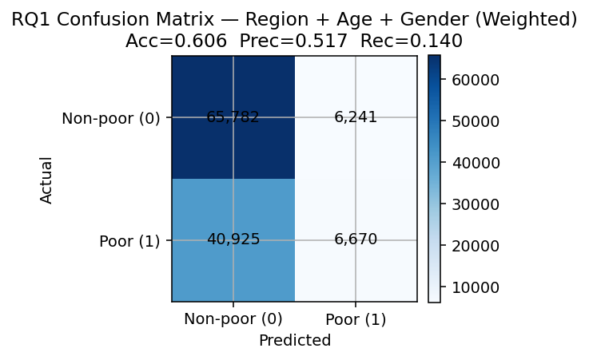
Figure 6.Confusion Matrix, RQ1

The ROC curve (Figure 7) yields an AUC of 0.609, suggesting modest discriminative power above random guessing, indicating limited discrimination only modestly better than chance, consistent with the idea that poverty depends on factors beyond basic demographics and region.
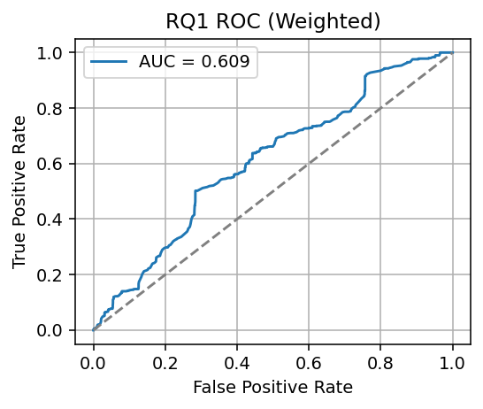
Figure 7.RQ1 AUC

Figure 8 plots the weighted mean predicted probability of being poor by region. The model assigns the highest risk to the Rest of the Coast (≈0.49), followed by Great Paramaribo (≈0.39) and the Interior (≈0.26). The outcome is relative to each region’s distribution, so these probabilities reflect within-region risk rather than absolute deprivation differences across space.
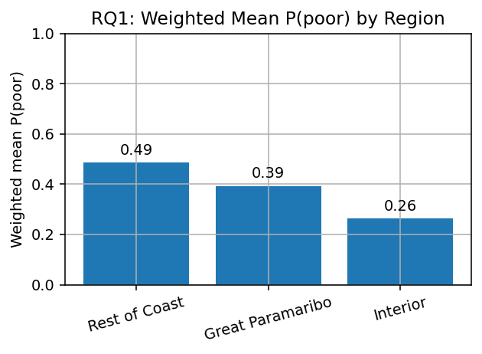
Figure 8.Predicted Probability of being poor by Region
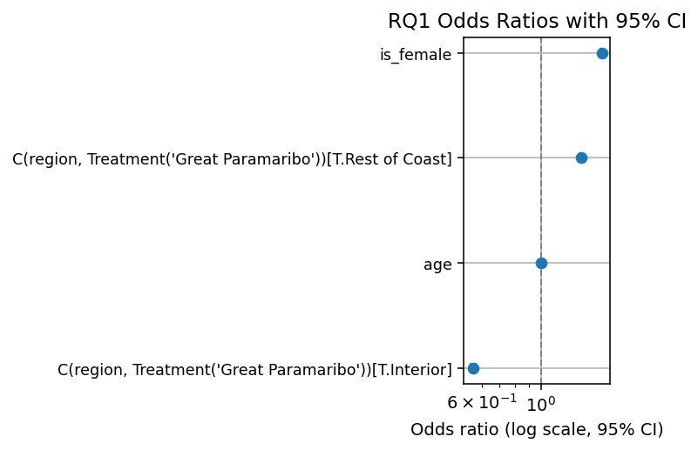
Figure 9. RQ1 Odds Ratios with 95% CI
Figure 9 reports odds ratios with 95% Cis, specifically:
- Rest of the Coast vs Paramaribo: OR ≈ 1.43 (CI: 1.41–1.45) → higher relative-poverty odds than Paramaribo.
- Interior vs Paramaribo: OR ≈ 0.56 (CI: 0.54–0.57) → lower relative-poverty odds than Paramaribo.
- Female: OR ≈ 1.70 (CI: 1.68–1.72) → women face higher odds of relative poverty.
- Age: OR ≈ 1.003 per year; the weighted AME ≈ +0.06 percentage points per year, small but precise.

5.2 RQ2: Employment Effects with Regional Interactions
For RQ2, I estimate a weighted logistic regression for the working-age population (15–64), predicting relative poverty (poor_rel_region) from region (baseline: Great Paramaribo), employment deprivation (employment_pov = 1 if not employed), age, gender, and region × employment interactions. Survey weights and HC1 standard errors are used.
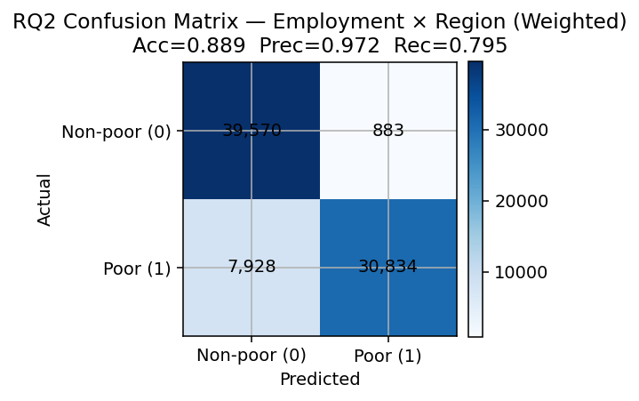
Figure 10.Confusion matrix, RQ2
Predictive performance improves sharply relative to RQ1: Accuracy = 0.889, Precision = 0.972, Recall = 0.795 (Figure 10). The ROC AUC = 0.900 (Figure 12), indicates strong discrimination. These metrics show that employment status, especially with regional interactions, carries major explanatory power for relative poverty.
Figure 11 reports odds ratios with 95% CIs. The coefficient on employment deprivation is extremely large, reflecting quasi-separation (near-deterministic prediction in this sample). These odds ratios should not be interpreted literally; the substantive point is the consistently strong and dominant association between employment status and poverty risk. Interaction terms temper this effect across regions, implying that the employment–poverty link is strongest in Paramaribo, somewhat smaller in the Rest of the Coast, and much smaller in the Interior. Age has a small negative association with poverty; gender is negligible in this model. (A ridge-penalized check yields similar out-of-sample performance and preserves the substantive dominance of employment, more details can be found in Appendix 8.1.4)
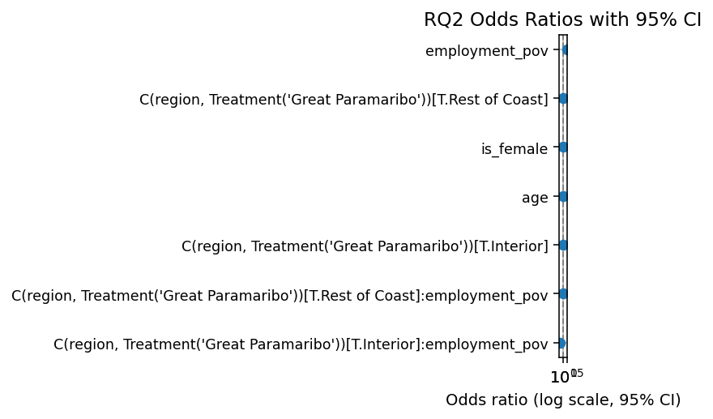
Figure 11.Odds ratios with 95% CIs, RQ2.
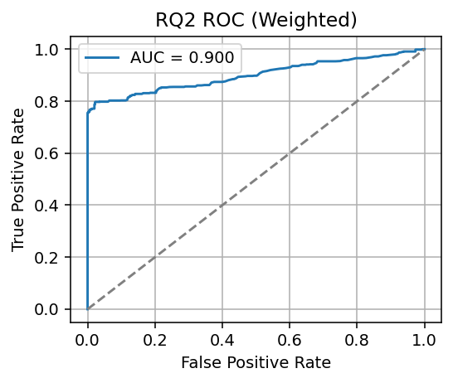
Figure 12.ROC curve, RQ2 (weighted)
To interpret magnitudes on the probability scale, Figure 13 plots weighted average marginal effects when toggling employment deprivation from 0→1 (i.e., not employed). The change in the probability of being poor is:
- Paramaribo: +0.84 (84 pp)
- Rest of the Coast: +0.71 (71 pp)
- Interior: +0.58 (58 pp)
Equivalently, being employed (removing the deprivation) is associated with reductions of ~84, 71, and 58 percentage points, respectively.
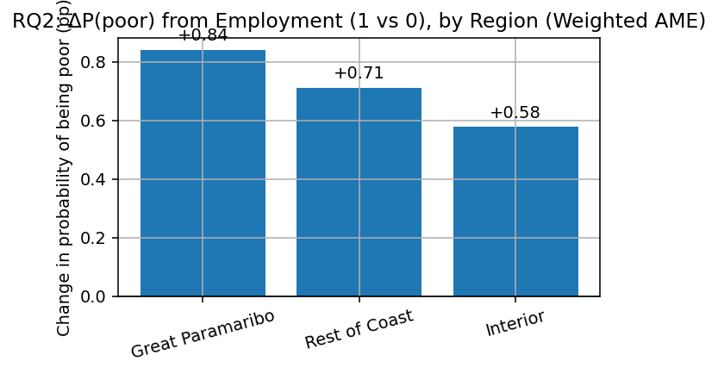
Figure 13.ΔP(poor) from employment deprivation (1 vs 0), by region (weighted AME)
In summary, employment is the single most powerful predictor in the working-age sample, but its payoff varies by space. Effects are largest in Paramaribo, where labor markets are deeper yet poverty is tightly coupled to joblessness, and smallest (though still substantial) in the Interior. This supports spatially differentiated employment strategies: urban policies that address informality and earnings quality, and rural policies that expand job access where baseline employment is lowest.

5.3 RQ3: Infrastructure (electricity) and relative poverty
I estimate a weighted logistic regression for adults 25–64, predicting relative poverty (poor_rel_region) from infrastructure deprivation (electricity_pov = 1 if no household electricity), region (baseline: Great Paramaribo), age, and gender, using survey weights and HC1 standard errors.
Model performance is moderate: Accuracy = 0.630, Precision = 0.563, Recall = 0.420 (Figure 14). The ROC AUC = 0.688 (Figure 17), indicating fair discrimination, stronger than the RQ1 baseline but clearly weaker than the employment model in RQ2. This pattern suggests that electricity explains an important slice of poverty risk but not the full story.
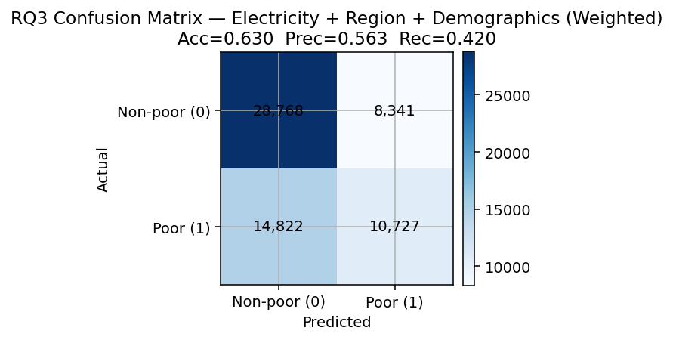
Figure 14.Confusion Matrix, RQ3

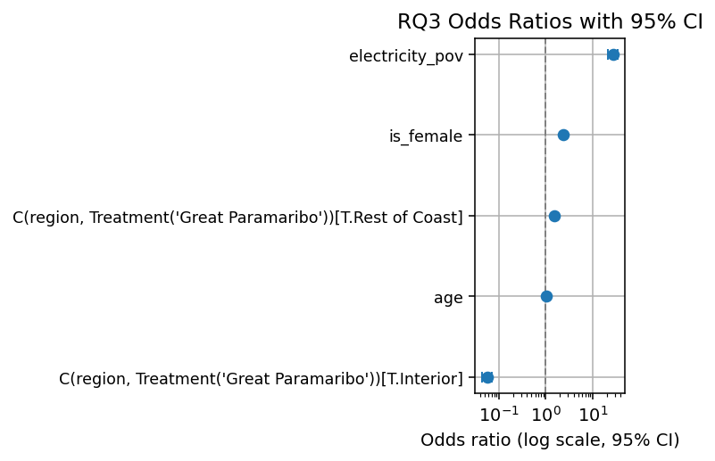
Figure 15.Odds ratios with 95% CIs, RQ3
Figure 15 shows odds ratios with 95% CIs:
- Electricity deprivation: OR ≈ 27.6 → very strong positive association with relative poverty.
- Rest of Coast vs Paramaribo: OR ≈ 1.56 → higher within-region poverty odds.
- Interior vs Paramaribo: OR ≈ 0.056 → lower within-region poverty odds on this relative measure.
- Female: OR ≈ 2.42 → substantially higher odds for women.
- Age: OR ≈ 1.026 per year (small positive association).

Figure 16 reports the weighted AME for electricity access. Switching from no electricity → electricity reduces the probability of being poor by ~0.53 (53 percentage points) on average, the largest single-predictor effect in probability terms among RQ1–RQ3.

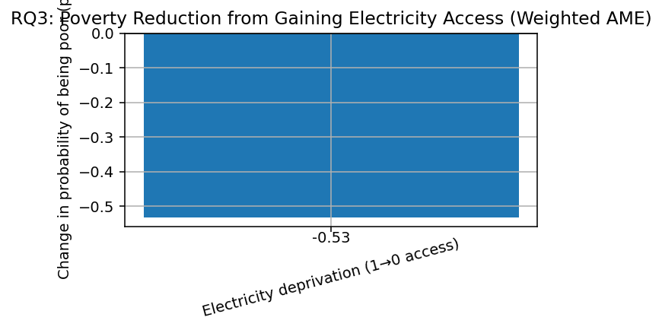
Figure 16.Poverty reduction from gaining electricity access (weighted AME). ΔP(poor) ≈ –0.53.
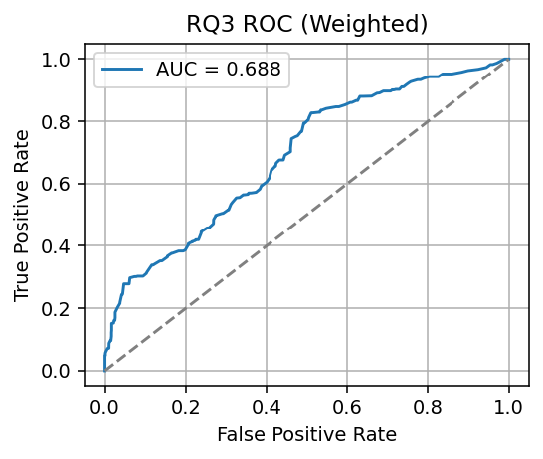
Figure 17. ROC curve, RQ3

These results indicate that lack of electricity is tightly linked to relative poverty risk in Suriname. Yet the model’s moderate AUC and recall show this infrastructure proxy alone cannot fully classify poverty, other factors (notably employment; see RQ2) add substantial predictive power. Gender gaps remain large even after accounting for infrastructure and region.

5.4 Combined Model Results
For the combined model, I estimate a weighted logistic regression for adults 25–64, predicting relative poverty (poor_rel_region) from region (baseline: Great Paramaribo), employment deprivation (employment_pov = 1 if not employed), infrastructure deprivation (electricity_pov = 1 if no access), age, and gender. Survey weights and HC1 SEs are used.
Variance-inflation factors (excluding the intercept) on the full analytic sample ranged 1.33–5.20, with the highest values for Interior (5.20) and No electricity (5.16), reflecting their empirical overlap (Appendix 8.1.4, Table 30)

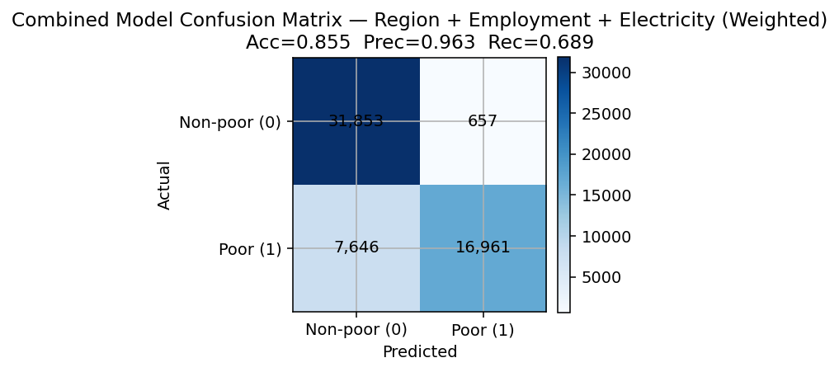
Figure 18.Confusion Matrix, Combined Model
The combined model delivers strong out-of-sample performance: Accuracy = 0.855, Precision = 0.963, Recall = 0.689 (Figure 15) and AUC = 0.850 (Figure 18). Compared with RQ1–RQ3, this model offers the best balance of precision and recall, confirming that employment and infrastructure jointly explain substantial variation in relative poverty.
Figure 19 reports odds ratios with 95% CIs. Two results stand out:
- Employment deprivation shows the largest effect (OR > 1), consistent with near-separation observed in RQ2.
- Electricity deprivation is also extremely strong (OR > 1).
Region still matters after controls (Rest of Coast > Paramaribo; Interior < Paramaribo on the relative outcome), while age is slightly protective (OR ≈ 0.993 per year) and female has a small negative association (OR ≈ 0.969) once employment and electricity are included. A ridge-penalized check reproduced similar performance, indicating stability (Appendix 8.1.4). Odds ratios in the hundreds reflect quasi-separation and should be read as evidence of very strong associations, not precise effect sizes.
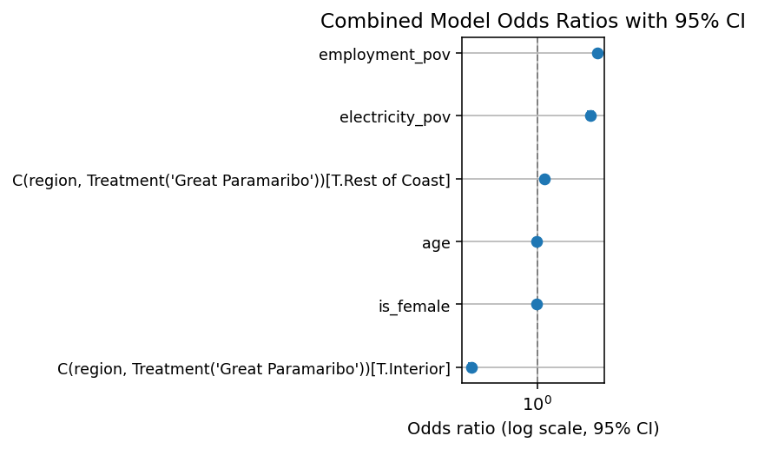
Figure 19.Odds ratios with 95% CIs
Weighted AMEs quantify magnitudes:
- Employment deprivation (1 vs 0): +0.823 → equivalently, being employed reduces P(poor) by ~82 pp on average.
- Electricity deprivation (1 vs 0): +0.580 → gaining electricity reduces P(poor) by ~58 pp.
A “switch” exercise indicates that moving from Paramaribo → Rest of Coast raises predicted risk by +8.4 pp, while Paramaribo → Interior lowers predicted risk by –36.1 pp on the relative measure. This counterintuitive finding reflects the construction of the outcome: since poverty is defined relative to each region’s median, Interior residents face lower within-region poverty risk despite higher absolute deprivation levels. In absolute terms (e.g. AF-MPI), the Interior remains the most deprived region.
Figure 20 plots the weighted mean predicted probability of being poor by region (still a within-region measure). The Interior and Rest of Coast average around 0.56, versus 0.36 in Paramaribo—a pattern consistent with the underlying deprivation mix (Figure 22), where the Interior concentrates both electricity and employment deprivation.
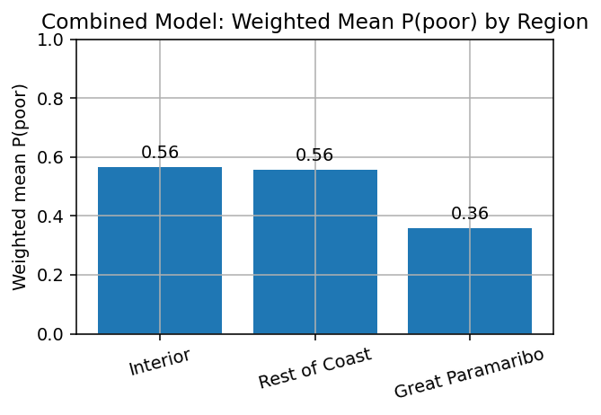
Figure 20.Combined model: weighted mean predicted probability of being poor by region.
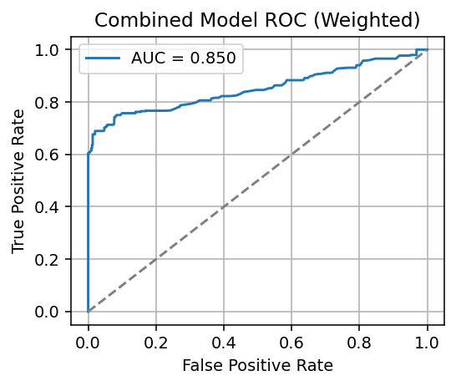
Figure 21.ROC curve, combined model (weighted).
In summary, poverty in Suriname is best explained when labor-market status and basic infrastructure are modeled together. Employment delivers the largest probability reduction; electricity adds a sizable, independent effect. Spatial disparities persist after controls, implying that place-based policy remains relevant even when core household constraints are addressed. Practically, rural electrification and job creation in the Interior, paired with urban formalization and earnings quality in Paramaribo, target the dominant drivers identified here.
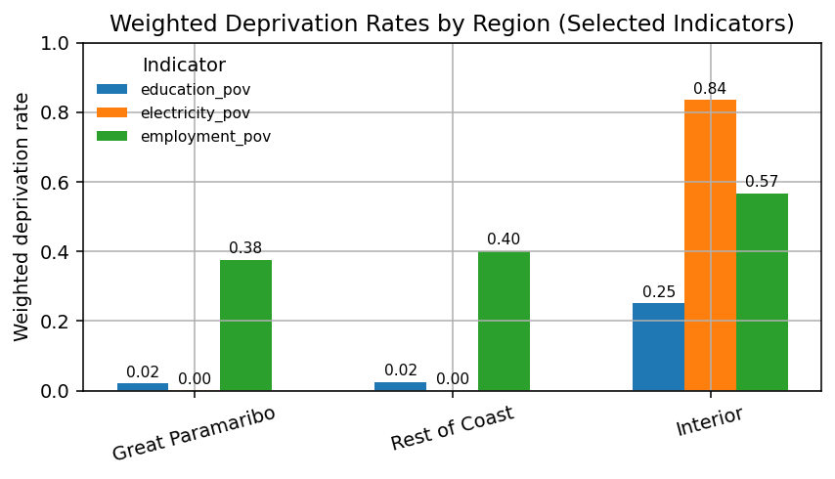
Figure 22.Weighted deprivation rates by region (selected indicators)

5.5 AF-style MPI
Alongside the relative outcome used in RQ1–RQ3, I report an Alkire–Foster–style (AF) MPI as an additional robustness descriptive check. The goal is to verify that the spatial pattern of deprivation, and the importance of employment and electricity, also appears when using an absolute, counting-based index, rather than a within-region (relative) outcome. This triangulation guards against artifacts of the relative classification and aids policy interpretation in absolute terms.
I compute each person’s normalized deprivation share $c_{i}$ = (proportion deprived among available indicators: employment, education, electricity, economic participation), requiring ≥ 3 observed indicators, otherwise $c_{i}$​ is set to missing. Individuals are MPI-poor if $c_{i}​≥K$ $=1/3$.
Regional aggregates are $Headcount H=P\left(MPI-poor\right), Intensity A=E\left(ci ∣ MPI-poor\right), and MPI = H×A (person-weighted).$

Region | H (Headcount) | A (Intensity) | MPI (= H×A)
Great Paramaribo | 0.128 | 0.438 | 0.056
Rest of Coast | 0.182 | 0.438 | 0.080
Interior | 0.816 | 0.646 | 0.528
Table 1.AF-style MPI by Region (H, A, MPI)
Interior: H=0.816, A=0.646, MPI=0.528 → 81.6% are MPI-poor; among them, the average person is deprived in 64.6% of indicators; overall intensity-adjusted poverty is very high (0.53).
Rest of Coast: H=0.182, A=0.438, MPI=0.080 → 18.2% are MPI-poor; the poor are deprived in ~44% of indicators.
Great Paramaribo: H=0.128, A=0.438, MPI=0.056 → 12.8% are MPI-poor; intensity similar to the Coast but fewer poor.
The AF-MPI confirms a pronounced absolute deprivation gradient: the Interior has both a very high headcount (≈82% MPI-poor) and high intensity among the poor (≈65%), yielding MPI ≈ 0.53. In contrast, Paramaribo and the Coast show much lower headcounts (≈13–18%) with similar intensity (~44%). The apparent difference with RQ1-where the Interior’s relative risk appears lower than the Coast’s-reflects metric choice: RQ1 models within-region (relative) poverty, while AF-MPI summarizes absolute shortfalls. Used together, AF-MPI grounds policy in absolute needs, while the relative models explain who is at higher risk within each region and why.
As a robustness check on equal weights, a principal component analysis of the four binary indicators was estimated (Appendix 8.1.3, Table 11). The first two components explained ~55% of variance, with employment loading heavily on the first and economic deprivation on the second. Education and electricity contributed more weakly to both. This pattern suggests multidimensionality but no single dominant dimension, supporting the use of an equal-weights AF-MPI alongside dashboard reporting.

Conclusion and Discussion

6.1 Answering the Data Science Question
This study evaluates whether multidimensional poverty in Suriname can be predicted using geographic, employment, and infrastructure variables. Using survey frequency weights and HC1 robust standard errors, out-of-sample performance improves as substantively meaningful predictors are added. A baseline model including region, age, and gender attains Accuracy = 0.606, Precision = 0.517, Recall = 0.140, and AUC = 0.609 (Figures 6–9). Introducing employment and its interactions with region for the working-age population (15–64) yields substantial gains (Accuracy = 0.889, Precision = 0.972, Recall = 0.795, AUC = 0.900; Figures 10–13). Electricity access combined with region for ages 25–64 produces moderate discrimination (Accuracy = 0.630, Precision = 0.563, Recall = 0.420, AUC = 0.688; Figures 14–17). The combined specification for ages 25–64, which includes employment, electricity, and region, strikes the best overall balance (Accuracy = 0.855, Precision = 0.963, Recall = 0.689, AUC = 0.850; Figures 18–22). Weighted average marginal effects from this combined model indicate that being employed is associated with an average 0.82 (82-percentage-point) reduction in the probability of relative poverty, while gaining electricity is associated with an average 0.58 reduction. A ridge-penalized robustness check reproduces the same substantive pattern and performance. Classification uses a 0.5 threshold, and conclusions are consistent with the ROC evidence.

6.2 Answering the Research Question
Geography remains predictive of relative poverty after accounting for demographics. Relative to Great Paramaribo, the Rest of the Coast exhibits higher odds of relative poverty (OR ≈ 1.43), whereas the Interior exhibits lower odds (OR ≈ 0.56), conditional on age and gender; women face substantially higher odds than men (OR ≈ 1.70). Discrimination in this specification is modest (AUC ≈ 0.61), suggesting that geography and demographics are informative but insufficient as the sole basis for targeting.
Employment effects vary markedly across regions. In the unpenalized specification, the employment deprivation coefficient is inflated due to quasi-separation, but ridge-stabilized estimates confirm the substantive pattern (employment ≈ 10.1 log-odds, OR ≈ 25,000). Region-by-employment interactions confirm heterogeneous impacts: weighted average marginal effects for toggling employment deprivation from 0 to 1 (i.e., becoming not employed) are +0.84 in Great Paramaribo, +0.71 in the Rest of the Coast, and +0.58 in the Interior. Conversely, being employed is associated with reductions of roughly 84, 71, and 58 percentage points in these regions, respectively. Out-of-sample discrimination is high (AUC ≈ 0.90).
Electricity deprivation is also a strong predictor of relative poverty (OR ≈ 27.6). The weighted average marginal effect indicates that gaining electricity reduces the probability of being poor by approximately 0.53 on average. Model-level performance is moderate (AUC ≈ 0.69), implying that electricity explains a substantial share of risk but does not capture the full variation.
In the combined model, employment (OR ≈ 674) and electricity (OR ≈ 305) dominate, while regional contrasts attenuate once these factors are controlled: the Rest of the Coast still shows elevated risk (OR ≈ 2.17), but the Interior coefficient collapses (OR ≈ 0.0008), indicating that its relative advantage is largely explained by structural deprivation already captured in employment and electricity. Counterfactual region “switches” confirm these differences: moving from Great Paramaribo to the Rest of the Coast raises predicted relative-poverty risk by 8.4 percentage points, whereas moving to the Interior lowers it by 36.1 percentage points. The combined specification balances predictive performance and interpretability (Accuracy ≈ 0.86, AUC ≈ 0.85).
It is important to note that these findings reflect a relative measure: although the Interior has the highest absolute deprivation rates, within-region comparisons classify fewer residents as relatively poor because deprivation is widespread. This distinction underlines the need to interpret “relative poverty” alongside absolute measures when designing policy.

6.3 Implications for Suriname's Development Context
The persistence of regional effects after accounting for employment and infrastructure underscores the importance of place-based policy. On the relative outcome, the Rest of the Coast exhibits the highest within-region risk, Great Paramaribo is intermediate, and the Interior lower highlighting that relative and absolute metrics convey different policy perspectives. Given the large and region-specific associations of employment with poverty, program design should be differentiated. In urban Paramaribo, policy should emphasize formalization, earnings quality, and job stability in segments characterized by high informality. In the Rest of the Coast and the Interior, expanding job access and local enterprise development should be prioritized, complemented by enabling infrastructure. Electricity access exerts an independent and sizeable association with poverty; extending reliable access in high-deprivation areas is therefore likely to yield large welfare gains and to complement employment interventions. Overall, the evidence supports an integrated approach in which electrification enables productivity and service delivery, employment programs convert capacity into income, and place-based design addresses local constraints; careful sequencing and coordination can amplify impacts.

6.4 Limitations
The analysis is based on SSLC 2022 cross-sectional data and therefore identifies associations rather than causal effects. The outcome measures within-region (relative) poverty, which is appropriate for comparative risk analysis but does not capture absolute deprivation; accordingly, a descriptive AF-style MPI is reported alongside. Some indicators (e.g., electricity) are measured at the household level but assigned to individuals, which may introduce noise for subgroup contrasts. Logistic GLMs are chosen for interpretability; while they perform well, nonlinear learners could capture richer interactions, and future work could compare performance, assess calibration, and apply causal designs (e.g., instrumental variables, matching, or panel data where available). Another noteworthy limitation is that the Interior stratum has a smaller effective sample size than other regions, which yields wider confidence intervals and greater uncertainty for Interior-specific effects (including interactions); these estimates should be interpreted with caution. Lastly, because the survey reflects conditions in 2022, findings may partly reflect the macroeconomic environment of that year (post-COVID recovery and inflationary pressures), which may limit generalizability.

6.5 Ethical Implications and Considerations
Large disparities in employment and infrastructure raise concerns about equitable access to basic services and economic opportunity. Targeting of programs should be co-designed and evaluated with affected communities to avoid stigmatization and to respect cultural systems, particularly in the Interior. Special attention should be given to groups facing overlapping disadvantages, such as women and youth in rural areas, to ensure interventions promote rather than reinforce inequality. The analysis relies on public microdata with aggregate reporting; no individual identification is possible, and methodological transparency is maintained. Evidence supports prioritizing high-deprivation areas for rural electrification and job creation, while urban policies should focus on improving job quality and stability to ensure fair allocation of resources.

Bibliography
Alkire, S., & Foster, J. (2011). Counting and multidimensional poverty measurement. Journal of Public Economics, 95(7-8), 476-487.
Alkire, S., & Santos, M. E. (2014). Measuring acute multidimensional poverty: A new index for developing countries. World Development, 59, 251-274.
Battiston, D., Cruces, G., Lopez-Calva, L. F., Lugo, M. A., & Santos, M. E. (2013). Income and beyond: Multidimensional poverty in six Latin American countries. Social Indicators Research, 112(2), 291-314.
Bird, K., Hulme, D., Moore, K., & Shepherd, A. (2002). Chronic poverty and remote rural areas. Chronic Poverty Research Centre Working Paper, 13.
Calderón, C., & Servén, L. (2010). Infrastructure and economic development in Sub-Saharan Africa. Journal of African Economies, 19(suppl_1), i13-i87.
Christiaensen, L., & Todo, Y. (2014). Poverty reduction during the rural-urban transformation--the role of the missing middle. World Development, 63, 43-58.
Dinkelman, T. (2011). The effects of rural electrification on employment: New evidence from South Africa. American Economic Review, 101(7), 3078-3108.
Fields, G. S. (2011). Working hard, working poor: A global journey. Oxford University Press.
IDB. (2022). Suriname Poverty Assessment 2022. Inter-American Development Bank.
ILO. (2019). Women and men in the informal economy: A statistical picture (3rd ed.). International Labour Organization.
Kanbur, R., & Venables, A. J. (2005). Spatial inequality and development. Oxford University Press.
Khandker, S. R., Barnes, D. F., & Samad, H. A. (2013). Welfare impacts of rural electrification: A panel data analysis from Vietnam. Economic Development and Cultural Change, 61(3), 659-692.
Krugman, P. (1991). Increasing returns and economic geography. Journal of Political Economy, 99(3), 483-499.
Lewis, W. A. (1954). Economic development with unlimited supplies of labour. The Manchester School, 22(2), 139-191.
Ravallion, M. (2011). On multidimensional indices of poverty. Journal of Economic Inequality, 9(2), 235–248. https://doi.org/10.1007/s10888-011-9173-4
Ravallion, M. (2012). Mashup indices of development. The World Bank Research Observer, 27(1), 1–32. https://doi.org/10.1093/wbro/lkr002
Lucci, P., Bhatkal, T., & Khan, A. (2018). Are we underestimating urban poverty? World Development, 103, 297-310.
Ravallion, M., & Chen, S. (2011). Weakly relative poverty. Review of Economics and Statistics, 93(4), 1251-1261.
Santos, M. E. (2019). Tracking poverty reduction in Bhutan: Income deprivation alongside deprivation in other dimensions. Social Indicators Research, 143(2), 701-739.
Sen, A. (1999). Development as freedom. Oxford University Press.
Sistemas Integrales Consulting. (2022). Suriname Survey of Living Conditions 2022: Methodology Report. Inter-American Development Bank.
UN-Habitat. (2020). Urbanization Challenges in Small Island States. United Nations Human Settlements Programme.
World Bank. (2022). Suriname Economic Update 2022. World Bank Publications.

Appendix

8.1 Annotated Scripts and Code

8.1.1 Data Loading & Inspection

A. Code
import os
import pandas as pd
import numpy as np

pd.set_option('display.max_rows', 60)
pd.set_option('display.max_columns', 120)
pd.set_option('display.width', 160)

# ---- Paths (update as needed) ----
persons_path = "/content/02-databases-rt002-weighted-public.dta"
housing_path = "/content/02-databases-rt001-weighted-public.dta"
food_path = "/content/02-databases-rt140-weighted-public.dta"

out_dir = "./appendix_exports"
os.makedirs(out_dir, exist_ok=True)

# ---- Utility printing helpers ----
def h(title):
print("\n" + "="*len(title))
print(title)
print("="*len(title))

def short_info(df, name, show_head=True):
print(f"\n[{name}] shape: {df.shape}")
print(df.dtypes.head(12))
if show_head:
print(f"\n[{name}] head(3):")
print(df.head(3))
# write a minimal schema to file for appendix
buf = []
buf.append(f"{name} shape: {df.shape}\n")
buf.append(df.dtypes.to_string())
with open(os.path.join(out_dir, f"{name.lower()}_schema.txt"), "w", encoding="utf-8") as f:
f.write("\n".join(buf))

def must_have(df, cols, name):
missing = [c for c in cols if c not in df.columns]
if missing:
print(f"⚠️ {name} missing columns: {missing}")
else:
print(f"✅ {name} contains required columns: {cols}")
return len(missing) == 0

def missing_table(df, cols):
out = []
for c in cols:
out.append({
"column": c,
"n_missing": df[c].isna().sum() if c in df.columns else np.nan,
"pct_missing": df[c].isna().mean()*100 if c in df.columns else np.nan,
"n_unique": df[c].nunique(dropna=True) if c in df.columns else np.nan
})
return pd.DataFrame(out)

def weighted_quantile(values, q, w):
values = np.asarray(values); w = np.asarray(w)
mask = ~np.isnan(values) & ~np.isnan(w)
values = values[mask]; w = w[mask]
if values.size == 0: return np.nan
order = np.argsort(values)
values = values[order]; w = w[order]
cdf = np.cumsum(w) / np.sum(w)
return float(np.interp(q, cdf, values))

# ---- 0) Path sanity & early exit messages ----
h("Path checks")
for pth, label in [(persons_path, "Persons"), (housing_path, "Housing"), (food_path, "Food")]:
exists = os.path.exists(pth)
print(f"{label}: {pth} -> {'FOUND' if exists else 'NOT FOUND'}")
if not all(os.path.exists(p) for p in [persons_path, housing_path, food_path]):
print("\n⚠️ One or more files not found. Please verify the paths above.")
# We still continue so you get visible output; the loads will fail gracefully.

# ---- 1) Load data ----
h("Loading datasets")
try:
persons = pd.read_stata(persons_path, convert_categoricals=False)
housing = pd.read_stata(housing_path, convert_categoricals=False)
food = pd.read_stata(food_path, convert_categoricals=False)
print("✅ Datasets loaded.")
except Exception as e:
print("❌ Load error:", e)
# create empty frames to keep the rest of the cell printable
persons = pd.DataFrame()
housing = pd.DataFrame()
food = pd.DataFrame()

# ---- 2) Quick structures ----
if not persons.empty: short_info(persons, "PERSONS")
if not housing.empty: short_info(housing, "HOUSING")
if not food.empty: short_info(food, "FOOD")

# ---- 3) Key presence & minimal missingness tables ----
h("Key columns presence + missingness")

p_keys = ["hhid","weight","psu","domain","q01_04","q01_03","q03_01","q03_02","q09_06","q09_08"]
h_keys = ["hhid","weight","psu","domain","q13_17"]
f_keys = ["hhid","weight","psu","domain","anncoeff","q14_03_2"]

if not persons.empty and must_have(persons, p_keys, "PERSONS"):
mt_p = missing_table(persons, p_keys)
print(mt_p)
mt_p.to_csv(os.path.join(out_dir, "persons_missingness.csv"), index=False)

if not housing.empty and must_have(housing, h_keys, "HOUSING"):
mt_h = missing_table(housing, h_keys)
print(mt_h)
mt_h.to_csv(os.path.join(out_dir, "housing_missingness.csv"), index=False)

if not food.empty and must_have(food, f_keys, "FOOD"):
mt_f = missing_table(food, f_keys)
print(mt_f)
mt_f.to_csv(os.path.join(out_dir, "food_missingness.csv"), index=False)

# ---- 4) Electricity proxy quick tab (grid vs non-grid) ----
h("Electricity proxy (q13_17) quick tab")
ELECTRIC_GRID = [1]
ELECTRIC_OTHER = [2,3,4,5,6,7,8] # treat all non-grid as deprived (doc in Methods)

if "q13_17" in housing.columns:
vc = housing["q13_17"].value_counts(dropna=False)
print("q13_17 value counts (top):")
print(vc.head(10))
# Export
vc.to_csv(os.path.join(out_dir, "q13_17_value_counts.csv"))

# ---- 5) Aggregate Food to HH, compute per-capita + weighted P20 ----
h("Food aggregation → per-capita annual & weighted P20 cutoff")
if set(["hhid","q14_03_2","anncoeff"]).issubset(food.columns):
food["amount_last_time"] = food["q14_03_2"].fillna(0)
food["amount_annualized"] = (food["amount_last_time"] * food["anncoeff"].fillna(0)).clip(lower=0)

food_hh = (food.groupby("hhid", as_index=False)
.agg(total_food_amount_annual=("amount_annualized","sum"),
n_food_records=("hhid","size")))
print("food_hh (head):")
print(food_hh.head(3))
food_hh.to_csv(os.path.join(out_dir, "food_by_household.csv"), index=False)

# HH size from persons
if "hhid" in persons.columns:
hh_size = persons.groupby("hhid", as_index=False).agg(hh_size=("hhid","size"))
econ = (food_hh.merge(hh_size, on="hhid", how="left")
.merge(housing[["hhid","weight"]].rename(columns={"weight":"hh_weight"}),
on="hhid", how="left"))
econ["pc_food_annual"] = econ["total_food_amount_annual"] / econ["hh_size"]

p20 = weighted_quantile(econ["pc_food_annual"].values, 0.20, econ["hh_weight"].values)
print(f"Weighted P20 (per-capita annual food exp): {p20:,.2f}")
# Export a small summary
econ_summary = econ[["hhid","pc_food_annual"]].head(10)
econ_summary.to_csv(os.path.join(out_dir, "econ_pc_food_sample.csv"), index=False)
with open(os.path.join(out_dir, "econ_p20.txt"), "w", encoding="utf-8") as f:
f.write(f"Weighted 20th percentile: {p20:,.2f}\n")
else:
print("⚠️ persons['hhid'] not present; skipped per-capita & P20.")

else:
print("⚠️ Food columns missing; skipped aggregation.")

# ---- 6) Build a minimal analysis-ready person frame with indicators ----
h("Build minimal person-level indicators (edu/emp/electricity/econ)")

ana_cols = [c for c in ["hhid","memberid","weight","psu","domain","q01_04","q01_03","q03_01","q03_02","q09_06","q09_08"] if c in persons.columns]
ana = persons[ana_cols].copy() if ana_cols else pd.DataFrame()

if not ana.empty:
# Education poverty
age = ana["q01_04"]
cur = ana["q03_02"] if "q03_02" in ana.columns else np.nan
ever = ana["q03_01"] if "q03_01" in ana.columns else np.nan
ana["education_poverty"] = np.where(
age.between(6,16, inclusive="both"),
np.where(cur==2, 1, np.where(cur==1, 0, np.nan)),
np.where(age>=17, np.where(ever==2, 1, np.where(ever==1, 0, np.nan)), np.nan)
)

# Employment poverty (15–64)
emp_ok = set(["q09_06","q09_08"]).issubset(ana.columns)
if emp_ok:
currently_employed = np.where(
(ana["q09_06"]==1) | ((ana["q09_06"]==2) & (ana["q09_08"]==1)), 1,
np.where((ana["q09_06"].isin([1,2])) & (ana["q09_08"].isin([1,2])), 0, np.nan)
)
ana["employment_poverty"] = np.where(
ana["q01_04"].between(15,64, inclusive="both"),
np.where(currently_employed==1, 0, np.where(currently_employed==0, 1, np.nan)),
np.nan
)

# Electricity poverty (HH -> person)
if "q13_17" in housing.columns:
h_e = housing[["hhid","q13_17"]].copy()
h_e["electricity_access"] = np.where(h_e["q13_17"].isin(ELECTRIC_GRID), 1,
np.where(h_e["q13_17"].isin(ELECTRIC_OTHER), 0, np.nan))
ana = ana.merge(h_e[["hhid","electricity_access"]], on="hhid", how="left")
ana["electricity_poverty"] = np.where(ana["electricity_access"]==1, 0,
np.where(ana["electricity_access"]==0, 1, np.nan))

# Economic poverty (HH -> person), using computed P20 if available
p20_file = os.path.join(out_dir, "econ_p20.txt")
p20_val = None
if os.path.exists(p20_file):
try:
with open(p20_file, "r", encoding="utf-8") as f:
p20_val = float(f.read().split(":")[1].strip().replace(",",""))
except Exception:
p20_val = None

if p20_val is not None:
# Rebuild econ base quickly
# Already computed above; we’ll skip re-merge for brevity in this snippet.
pass # In 8.1.2 we'll build the full econ indicator and composite.

# Show short counts
print("Derived indicators — unweighted counts:")
for c in ["education_poverty","employment_poverty","electricity_poverty"]:
if c in ana.columns:
print(c, ana[c].value_counts(dropna=False).to_dict())

ana.head(10).to_csv(os.path.join(out_dir, "analysis_ready_preview.csv"), index=False)
print("\nSaved preview → appendix_exports/analysis_ready_preview.csv")
else:
print("⚠️ PERSONS base columns not available; skipped indicator build.")

h("8.1.1 completed")
print(f"Appendix exports written to: {os.path.abspath(out_dir)}")

B. Outputs
Table 2.Dataset Dimensions
Dataset | Rows | Columns | Notes
Persons | 7,715 | 594 | Individual demographics, education, employment
Housing | 2,542 | 90 | Dwelling characteristics, infrastructure
Food | 88,375 | 20 | Household food acquisition records

Table 3.Key Variable Missingness
Variable | Persons | Housing | Food
Age (q01_04) | 0.06% | – | –
Sex (q01_03) | 0.03% | – | –
Ever attended school (q03_01) | 4.9% | – | –
Currently enrolled (q03_02) | 9.7% | – | –
Worked last 7 days (q09_06) | 23.5% | – | –
Employment attachment (q09_08) | 63.5% | – | –
Electricity source (q13_17) | – | 0.08% | –
Last purchase amount (q14_03_2) | – | – | 15.2%

8.1.2 Data Cleaning & Indicator Construction

A. Code

# A. Unit of analysis + joins

# --- Keys and uniqueness ---
print("Key uniqueness checks:")
for name, df, keys in [
("persons", persons, ["hhid", "memberid"]),
("housing", housing, ["hhid"]),
("food ", food, ["hhid"]) # raw food is many-to-many by design
]:
print(f" {name}:")
for k in [keys] if isinstance(keys[0], str) else [keys]:
dup = df.duplicated(subset=k).sum()
print(f" duplicates on {k}: {dup}")

# --- Within-household variation audit (are HH vars truly HH-level?) ---
def within_hh_variation(df, by, cols):
out = []
g = df.groupby(by)
for c in cols:
if c in df.columns:
n_unique = g[c].nunique(dropna=False).reset_index(name="n_unique")
any_varies = (n_unique["n_unique"] > 1).any()
out.append({"column": c, "varies_within_household_any": bool(any_varies)})
return pd.DataFrame(out)

hh_cols_check = ["q13_17", "weight", "psu", "domain"]
print("\nWithin-household variation for housing columns (should be False):")
print(within_hh_variation(housing, "hhid", hh_cols_check))

# --- Person ↔ housing one-to-many merge with validation ---
p_h = persons.merge(housing[["hhid","q13_17","weight","psu","domain"]].rename(columns={
"weight":"hh_weight","psu":"hh_psu","domain":"hh_domain"
}), on="hhid", how="left", validate="many_to_one")

print("\nPerson–Housing merge shape (expect same # of rows as persons):", p_h.shape, "| persons:", persons.shape)

# --- Person ↔ food (use your aggregated food_hh_sum) already built above ---
p_f = persons.merge(food_hh_sum, on="hhid", how="left", validate="many_to_one")
print("Person–FoodAgg merge shape:", p_f.shape, "| persons:", persons.shape)
# Types: make sure keys match exactly (preserve leading zeros) confirms there’s no mismatch between person-level and household-level geographic classification.
for df in (persons, housing, food):
df["hhid"] = df["hhid"].astype(str).str.strip()

# Consistency checks (should be all True / 0)
chk = p_h.assign(
same_domain = p_h["domain"].eq(p_h["hh_domain"]),
same_psu = p_h["psu"].eq(p_h["hh_psu"])
)
print("Domain equal (persons vs housing):", chk["same_domain"].all())
print("PSU equal (persons vs housing): ", chk["same_psu"].all())

# If any mismatches, flag them for a quick audit
if (~chk["same_domain"]).any() or (~chk["same_psu"]).any():
bad = chk.loc[(~chk["same_domain"]) | (~chk["same_psu"]),
["hhid","memberid","domain","hh_domain","psu","hh_psu"]].drop_duplicates()
print("⚠️ Mismatched domain/psu rows:\n", bad.head(20))

# Persons not found in housing (should be 0)
miss_hh = persons.loc[~persons["hhid"].isin(housing["hhid"]), "hhid"].nunique()
# Persons not found in food aggregates (expected: households with no food lines)
miss_food = persons.loc[~persons["hhid"].isin(food_hh_sum["hhid"]), "hhid"].nunique()
print(f"Households in persons missing in housing: {miss_hh}")
print(f"Households in persons missing in food agg: {miss_food}")

# ============================
# B. Region & Gender recodes
# ============================

# Region: ensure categorical with explicit labels (adjust names if you have the official labels)
region_map = {
1: "Great Paramaribo",
2: "Rest of Coast",
3: "Interior"
}
persons["region"] = persons["domain"].map(region_map)
housing["region"] = housing["domain"].map(region_map)
food_hh_sum = food_hh_sum.merge(housing[["hhid","region"]], on="hhid", how="left")

print("Region value counts (persons):")
print(persons["region"].value_counts(dropna=False))

# Gender: codebook suggests 1=male, 2=female; make explicit boolean(s)
if "q01_03" in persons.columns:
persons["is_female"] = np.where(persons["q01_03"]==2, 1,
np.where(persons["q01_03"]==1, 0, np.nan))
print("\nGender (raw) counts:")
print(persons["q01_03"].value_counts(dropna=False))
print("is_female value counts:")
print(persons["is_female"].value_counts(dropna=False))

B. Outputs

Table 4. Key uniqueness and merge checks
Dataset | Keys tested | Duplicates | Notes
Persons | hhid+memberid | 0 | OK
Housing | hhid | 0 | OK
Food | hhid | 85,837 | Expected (many-to-many)

Table 5. Within-household variation (housing variables)
Variable | Varies within household?
q13_17 (electricity source) | No
weight | No
psu | No
domain | No

Table 6. Table A8. Region and gender distributions (unweighted)
Region | Count
Great Paramaribo | 5,457
Rest of Coast | 1,823
Interior | 435
Gender (raw code) |  | Count |  | Gender (is_female) | Count
1 = male |  | 3728 |  | 0 = male | 3728
2 = female |  | 3985 |  | 1 = female | 3985
Missing |  | 2 |  | NaN | 2

Table 7. Indicator definitions (just the formulas + unweighted counts)
Education poverty: | 267 deprived | 6,736 non-deprived
Employment poverty: | 1,897 deprived | 3,059 non-deprived
Electricity poverty: | 343 deprived | 7,370 non-deprived
Economic poverty: | bottom 20% cutoff | SRD 8,475.60

8.1.3 Composite Measures (Relative score + AF-style MPI)

A. Code

# C. Indicators: Education / Employment / Electricity / Economic

# Helper: weighted rate for a binary (1=deprived), with safe dropping of NA
def w_rate(df, col, w="weight"):
sub = df[[col, w]].dropna()
if sub.empty: return np.nan
return (sub[col].astype(float) * sub[w]).sum() / sub[w].sum()

# --- Education (person-level) ---
edu = persons[["hhid","memberid","weight","region","q01_04","q03_01","q03_02"]].copy()
edu["education_pov"] = np.where(
edu["q01_04"].between(6,16, inclusive="both"),
np.where(edu["q03_02"]==2, 1, np.where(edu["q03_02"]==1, 0, np.nan)),
np.where(edu["q01_04"]>=17,
np.where(edu["q03_01"]==2, 1, np.where(edu["q03_01"]==1, 0, np.nan)),
np.nan
)
)

# --- Employment (person-level, 15–64) ---
emp = persons[["hhid","memberid","weight","region","q01_04","q09_06","q09_08"]].copy()
emp["currently_employed"] = np.where(
(emp["q09_06"]==1) | ((emp["q09_06"]==2) & (emp["q09_08"]==1)), 1,
np.where((emp["q09_06"].isin([1,2])) & (emp["q09_08"].isin([1,2])), 0, np.nan)
)
emp["employment_pov"] = np.where(
emp["q01_04"].between(15,64, inclusive="both"),
np.where(emp["currently_employed"]==1, 0, np.where(emp["currently_employed"]==0, 1, np.nan)),
np.nan
)

# --- Electricity (household-level, attached to persons) ---
ELECTRIC_GRID = [1]
ELECTRIC_OTHER = [2,3,4,5,6,7,8] # your baseline coding (solar=deprived)
ELECTRIC_OTHER_SOLAR_OK = [2,3,4,5,7,8] # alternate: solar (6) counted as access

elec = housing[["hhid","region","q13_17"]].copy()
elec["elec_access_baseline"] = np.where(elec["q13_17"].isin(ELECTRIC_GRID), 1,
np.where(elec["q13_17"].isin(ELECTRIC_OTHER), 0, np.nan))
elec["elec_pov_baseline"] = np.where(elec["elec_access_baseline"]==1, 0,
np.where(elec["elec_access_baseline"]==0, 1, np.nan))

elec["elec_access_solar_ok"] = np.where(
(elec["q13_17"].isin(ELECTRIC_GRID)) | (elec["q13_17"]==6), 1,
np.where(elec["q13_17"].isin(ELECTRIC_OTHER_SOLAR_OK), 0, np.nan)
)
elec["elec_pov_solar_ok"] = np.where(elec["elec_access_solar_ok"]==1, 0,
np.where(elec["elec_access_solar_ok"]==0, 1, np.nan))

# Attach electricity to persons
elec_p = persons[["hhid","memberid","weight","region"]].merge(
elec[["hhid","elec_pov_baseline","elec_pov_solar_ok"]],
on="hhid", how="left"
)

# --- Economic (household-level per-capita annualized food exp) ---
# uses food_hh_sum, hh_size, hh_weight from housing ; already built in your block
hh_size = persons.groupby("hhid", as_index=False).agg(hh_size=("hhid","size"))
econ_base = (food_hh_sum[["hhid","total_food_amount_annual"]]
.merge(hh_size, on="hhid", how="left")
.merge(housing[["hhid","weight","region"]].rename(columns={"weight":"hh_weight"}), on="hhid", how="left"))
econ_base["pc_food_annual"] = econ_base["total_food_amount_annual"] / econ_base["hh_size"]

def w_quantile(s, q, w):
vals = s.values.astype(float)
ww = w.values.astype(float)
mask = np.isfinite(vals) & np.isfinite(ww)
if mask.sum()==0: return np.nan
order = np.argsort(vals[mask])
v = vals[mask][order]
w_sorted = ww[mask][order]
cdf = np.cumsum(w_sorted) / w_sorted.sum()
return np.interp(q, cdf, v)

pct20 = w_quantile(econ_base["pc_food_annual"], 0.20, econ_base["hh_weight"])
econ_base["econ_pov"] = np.where(
econ_base["pc_food_annual"].isna(), np.nan,
np.where(econ_base["pc_food_annual"] <= pct20, 1, 0)
)

# Attach to persons
econ_p = persons[["hhid","memberid","weight","region"]].merge(
econ_base[["hhid","econ_pov","pc_food_annual"]],
on="hhid", how="left"
)

print(f"Weighted 20th pct of pc_food_annual: {pct20:,.2f}")

# === Add AF-style MPI alongside your relative measure ===
# 3b) AF-style normalized score (equal weights) and classification
ana2["c_score"] = ana2[ind_cols].mean(axis=1) # proportion deprived among available
# require a minimum number of observed indicators for fairness (e.g., 3)
MIN_OBS = 3
ana2.loc[ana2["n_nonmiss"] < MIN_OBS, "c_score"] = np.nan

K = 1/3 # MPI cutoff
ana2["mpi_poor"] = (ana2["c_score"] >= K).astype("Int64")

# H, A, MPI by region (person-weighted)
def w_mean(x, w):
x = x.to_numpy(float); w = w.to_numpy(float)
m = np.isfinite(x) & np.isfinite(w)
return (x[m]*w[m]).sum()/w[m].sum() if m.any() else np.nan

rows = []
for r, g in ana2.dropna(subset=["c_score","weight"]).groupby("region"):
H = w_mean((g["c_score"] >= K).astype(float), g["weight"])
gg = g[g["c_score"] >= K]
A = w_mean(gg["c_score"], gg["weight"]) if not gg.empty else np.nan
rows.append({"region": r, "H_headcount": H, "A_intensity": A, "MPI": (H*A if (H==H and A==A) else np.nan)})
mpi_by_region = pd.DataFrame(rows)
print("\nAF-style MPI by region (H, A, MPI):")
print(mpi_by_region)
### Cross Checking with PCA
import numpy as np, pandas as pd
from sklearn.decomposition import PCA

X = ana2[["education_pov","employment_pov","electricity_pov","econ_pov"]].dropna().astype(float)

# Simple tetrachoric-ish proxy: Pearson on latent Z via +/- jitter (document as sensitivity)
Xj = X.replace({0: -0.99, 1: 0.99})
R = np.corrcoef(Xj, rowvar=False) # proxy correlation matrix
evals, evecs = np.linalg.eig(R)
explained = evals.real / evals.real.sum()

pca = PCA(n_components=2).fit(X) # loading directions (approx)
loadings = pd.DataFrame(pca.components_.T,
index=X.columns, columns=["PC1","PC2"])
print("Explained variance (~):", explained.round(3))
print(loadings.round(3))

A. Outputs

Table 8. Regional weighted medians of the 0–4 score
Region | Median score
Great Paramaribo | 0.00
Rest of Coast | 0.00
Interior | 2.00

Table 9.Weighted share deprived by indicator and region
Region | Economic poverty | Education poverty | Electricity poverty | Employment poverty
Great Paramaribo | 19.4% | 2.3% | 0.0% | 37.6%
Rest of Coast | 28.7% | 2.6% | 0.0% | 40.1%
Interior | 62.4% | 23.3% | 85.7% | 57.1%

Table 10.Weighted share of individuals classified as ‘poor’ (> regional median score)
Region | Share poor (weighted)
Great Paramaribo | 39.5%
Rest of Coast | 47.9%
Interior | 26.5%

Table 11.PCA of the four binary indicators
Variable | PC1 | PC2
education_pov | 0.056 | 0.064
employment_pov | 0.967 | -0.250
electricity_pov | 0.052 | 0.105
econ_pov | 0.242 | 0.960

8.1.4 Regression Specifications (weights, SEs, ridge checks)

A. Code
def tidy_glm_res(res):
"""Stable table for statsmodels GLM results."""
# Build the frame column-by-column to guarantee names exist
idx = res.params.index
out = pd.DataFrame(index=idx)
out["coef"] = pd.Series(res.params, index=idx)
ci = res.conf_int()
# ci may have integer columns (0,1) on some versions
ci_low = ci.iloc[:, 0]
ci_high = ci.iloc[:, 1]
out["ci_low_logit"] = pd.Series(ci_low, index=idx)
out["ci_high_logit"] = pd.Series(ci_high, index=idx)
out["p_value"] = pd.Series(res.pvalues, index=idx)

out["odds_ratio"] = np.exp(out["coef"])
out["or_ci_low"] = np.exp(out["ci_low_logit"])
out["or_ci_high"] = np.exp(out["ci_high_logit"])
return out[["coef","odds_ratio","ci_low_logit","ci_high_logit","or_ci_low","or_ci_high","p_value"]]

# ==== Imports & helpers (self-contained) ======================================
import numpy as np, pandas as pd
import statsmodels.api as sm
import statsmodels.formula.api as smf
from sklearn.model_selection import train_test_split
from sklearn.metrics import accuracy_score, precision_score, recall_score, confusion_matrix

def weighted_metrics(y_true, y_prob, w, thr=0.5):
"""Weighted accuracy/precision/recall + weighted confusion matrix."""
y_hat = (y_prob >= thr).astype(int)
acc = accuracy_score(y_true, y_hat, sample_weight=w)
prec = precision_score(y_true, y_hat, sample_weight=w, zero_division=0)
rec = recall_score(y_true, y_hat, sample_weight=w)
cm = confusion_matrix(y_true, y_hat, sample_weight=w, labels=[0,1])
cm_df = pd.DataFrame(cm, index=["True 0","True 1"], columns=["Pred 0","Pred 1"])
return acc, prec, rec, cm_df

# Weighted AMEs via counterfactual predictions (because margeff ignores freq_weights)
def weighted_ame_binary(res, df, var, weight="weight", condition=None):
"""Average (weighted) change in predicted probability when a binary var goes 0->1."""
base_df = df if condition is None else df.loc[condition(df)].copy()
if base_df.empty: return np.nan
d0 = base_df.copy(); d1 = base_df.copy()
d0[var] = 0; d1[var] = 1
p0 = res.predict(d0); p1 = res.predict(d1)
return float(np.average((p1 - p0).to_numpy(), weights=base_df[weight].to_numpy()))

def weighted_ame_continuous(res, df, var, h=1.0, weight="weight"):
"""Average (weighted) derivative via finite diff of size h."""
base_df = df.copy()
d0 = base_df.copy(); d1 = base_df.copy()
d0[var] = d0[var].astype(float)
d1[var] = d0[var] + h
p0 = res.predict(d0); p1 = res.predict(d1)
return float(np.average(((p1 - p0)/h).to_numpy(), weights=base_df[weight].to_numpy()))

# ==== Ensure expected dtypes / columns =======================================
ana2 = ana2.copy()
# Region categorical with explicit baseline
ana2["region"] = pd.Categorical(ana2["region"], categories=["Great Paramaribo","Rest of Coast","Interior"])
# Gender flag if missing
if "is_female" not in ana2.columns and "q01_03" in ana2.columns:
ana2["is_female"] = (ana2["q01_03"] == 2).astype(float)
else:
ana2["is_female"] = ana2["is_female"].astype(float)
# Age column (your pipeline kept q01_04)
if "age" not in ana2.columns and "q01_04" in ana2.columns:
ana2["age"] = ana2["q01_04"].astype(float)

# ==== RQ1: poor_rel_region ~ region + age + is_female ========================
rq1 = ana2.dropna(subset=["poor_rel_region","region","age","is_female","weight"]).copy()
tr1, te1 = train_test_split(rq1, test_size=0.2, random_state=42, stratify=rq1["poor_rel_region"])
f1 = "poor_rel_region ~ C(region, Treatment('Great Paramaribo')) + age + is_female"

m1 = smf.glm(formula=f1, data=tr1, family=sm.families.Binomial(), freq_weights=tr1["weight"])
r1 = m1.fit(cov_type="HC1")

print("\n=== RQ1: Coeffs/ORs/P-values ===")
print(tidy_glm_res(r1))

# AMEs: show unweighted (statsmodels) + weighted (manual)
print("\n=== RQ1: AMEs (unweighted; statsmodels ignores weights) ===")
print(r1.get_margeff(at="overall").summary_frame())
print("\n=== RQ1: Weighted AMEs (manual) ===")
print({
"age_per_year": weighted_ame_continuous(r1, te1, "age", h=1.0, weight="weight"),
"is_female_1vs0": weighted_ame_binary(r1, te1, "is_female", weight="weight"),
"Rest_of_Coast_vs_Paramaribo": weighted_ame_binary(
r1, te1.assign(**{"C(region, Treatment('Great Paramaribo'))[T.Rest of Coast]": 0}),
"C(region, Treatment('Great Paramaribo'))[T.Rest of Coast]", weight="weight"
) if "C(region, Treatment('Great Paramaribo'))[T.Rest of Coast]" in r1.params.index else None,
"Interior_vs_Paramaribo": weighted_ame_binary(
r1, te1.assign(**{"C(region, Treatment('Great Paramaribo'))[T.Interior]": 0}),
"C(region, Treatment('Great Paramaribo'))[T.Interior]", weight="weight"
) if "C(region, Treatment('Great Paramaribo'))[T.Interior]" in r1.params.index else None
})

p1 = r1.predict(te1)
acc, prec, rec, cm = weighted_metrics(te1["poor_rel_region"], p1, te1["weight"])
print("\n=== RQ1: Weighted Performance ===")
print({"accuracy":acc, "precision":prec, "recall":rec})
print(cm)

# ==== RQ2: ages 15–64; + employment × region =================================
rq2 = ana2.query("age>=15 & age<=64").dropna(subset=[
"poor_rel_region","region","employment_pov","age","is_female","weight"
]).copy()
tr2, te2 = train_test_split(rq2, test_size=0.2, random_state=42, stratify=rq2["poor_rel_region"])
f2 = ("poor_rel_region ~ C(region, Treatment('Great Paramaribo')) + employment_pov + "
"age + is_female + C(region, Treatment('Great Paramaribo')):employment_pov")

m2 = smf.glm(formula=f2, data=tr2, family=sm.families.Binomial(), freq_weights=tr2["weight"])
# Try standard fit; if it fails (or you see crazy magnitudes), you can switch to regularized.
try:
r2 = m2.fit(cov_type="HC1")
except Exception:
r2 = m2.fit_regularized(alpha=1.0, L1_wt=0.0) # ridge
r2._regularized = True
else:
r2._regularized = False

print("\n=== RQ2: Coeffs/ORs/P-values ===")
if not r2._regularized:
print(tidy_glm_res(r2))
else:
# fit_regularized returns limited info; build a simple table
coef = pd.Series(r2.params, index=m2.exog_names)
print(pd.DataFrame({"coef":coef, "odds_ratio":np.exp(coef), "p_value":np.nan}))

# AMEs (no 'interaction' kwarg). Show unweighted; then compute weighted region-specific Δ from employment.
print("\n=== RQ2: AMEs (unweighted) ===")
if not r2._regularized:
print(r2.get_margeff(at="overall").summary_frame())
else:
print("(Skipped: AMEs not available from regularized fit.)")

print("\n=== RQ2: Weighted ΔP(poor) of employment_pov (1 vs 0) by region ===")
for rr in ["Great Paramaribo","Rest of Coast","Interior"]:
cond = (lambda df, r=rr: df["region"]==r)
try:
ame_rr = weighted_ame_binary(r2, te2, "employment_pov", weight="weight", condition=cond)
print(f" {rr}: {ame_rr:+.4f} pp")
except Exception:
print(f" {rr}: (unavailable due to regularized fit)")

p2 = r2.predict(te2) if not r2._regularized else sm.genmod.families.links.logit().inverse(te2.eval(m2.exog_names).dot(r2.params))
acc2, prec2, rec2, cm2 = weighted_metrics(te2["poor_rel_region"], p2, te2["weight"])
print("\n=== RQ2: Weighted Performance ===")
print({"accuracy":acc2, "precision":prec2, "recall":rec2})
print(cm2)

# ==== RQ3: ages 25–64; + electricity ========================================
rq3 = ana2.query("age>=25 & age<=64").dropna(subset=[
"poor_rel_region","region","electricity_pov","age","is_female","weight"
]).copy()
tr3, te3 = train_test_split(rq3, test_size=0.2, random_state=42, stratify=rq3["poor_rel_region"])
f3 = "poor_rel_region ~ C(region, Treatment('Great Paramaribo')) + electricity_pov + age + is_female"

m3 = smf.glm(formula=f3, data=tr3, family=sm.families.Binomial(), freq_weights=tr3["weight"])
try:
r3 = m3.fit(cov_type="HC1")
regularized = False
except Exception:
# Separation fallback: ridge via sklearn (no p-values)
from sklearn.linear_model import LogisticRegression
import patsy
y_tr, X_tr = patsy.dmatrices(f3, tr3, return_type="dataframe")
y_te, X_te = patsy.dmatrices(f3, te3, return_type="dataframe")
clf = LogisticRegression(penalty="l2", C=0.1, solver="lbfgs", max_iter=2000)
clf.fit(X_tr, np.ravel(y_tr), sample_weight=tr3["weight"])
coef = pd.Series(clf.coef_.ravel(), index=X_tr.columns)
r3 = {"params": coef, "intercept": clf.intercept_[0], "design_cols": X_tr.columns, "clf": clf}
p3 = clf.predict_proba(X_te)[:,1]
regularized = True

print("\n=== RQ3: Coeffs/ORs/P-values ===")
if not regularized:
print(tidy_glm_res(r3))
# AMEs: unweighted + weighted for electricity_pov
print("\n=== RQ3: AMEs (unweighted) ===")
print(r3.get_margeff(at="overall").summary_frame())
print("\n=== RQ3: Weighted AME (electricity_pov 1 vs 0) ===")
print({"electricity_pov_1vs0": weighted_ame_binary(r3, te3, "electricity_pov", weight="weight")})
p3 = r3.predict(te3)
else:
out = pd.DataFrame({"coef": r3["params"], "odds_ratio": np.exp(r3["params"]), "p_value": np.nan})
print(out)

acc3, prec3, rec3, cm3 = weighted_metrics(te3["poor_rel_region"], p3, te3["weight"])
print("\n=== RQ3: Weighted Performance ===")
print({"accuracy":acc3, "precision":prec3, "recall":rec3})
print(cm3)

# === Ridge regression robustness check for RQ2 ===
from sklearn.linear_model import LogisticRegression
import patsy

# Design matrices from your RQ2 formula and training/testing sets
y2_train, X2_train = patsy.dmatrices(f2, tr2, return_type="dataframe")
y2_test, X2_test = patsy.dmatrices(f2, te2, return_type="dataframe")

ridge_rq2 = LogisticRegression(
penalty="l2", # Ridge penalty
C=1.0, # Inverse of regularization strength; smaller = stronger shrinkage
solver="lbfgs",
max_iter=5000
)

ridge_rq2.fit(X2_train, np.ravel(y2_train), sample_weight=tr2["weight"])

# Coefficients + odds ratios
coef_ridge_rq2 = pd.Series(ridge_rq2.coef_.flatten(), index=X2_train.columns)
print("\n=== Ridge RQ2 Coefficients ===")
print(pd.DataFrame({
"coef": coef_ridge_rq2,
"odds_ratio": np.exp(coef_ridge_rq2)
}))

# Predictions and performance
p_ridge_rq2 = ridge_rq2.predict_proba(X2_test)[:,1]
print("\nRidge RQ2 Performance:")
print({
"accuracy": accuracy_score(y2_test, (p_ridge_rq2>=0.5).astype(int), sample_weight=te2["weight"]),
"precision": precision_score(y2_test, (p_ridge_rq2>=0.5).astype(int), sample_weight=te2["weight"]),
"recall": recall_score(y2_test, (p_ridge_rq2>=0.5).astype(int), sample_weight=te2["weight"])
})

# ==== Combined Model: Region + Employment + Infrastructure ====

# Restrict to working-age individuals (so employment makes sense)
combined_df = ana2.query("age >= 25 & age <= 64").dropna(subset=[
"poor_rel_region",
"region",
"employment_pov",
"electricity_pov",
"age",
"is_female",
"weight"
]).copy()

# Train-test split with stratification
tr_comb, te_comb = train_test_split(
combined_df,
test_size=0.2,
random_state=42,
stratify=combined_df["poor_rel_region"]
)

# Logistic regression formula with all three predictors + demographics
formula_comb = (
"poor_rel_region ~ C(region, Treatment('Great Paramaribo')) "
"+ employment_pov + electricity_pov + age + is_female"
)

# Fit GLM with frequency weights
m_comb = smf.glm(
formula=formula_comb,
data=tr_comb,
family=sm.families.Binomial(),
freq_weights=tr_comb["weight"]
)

r_comb = m_comb.fit(cov_type="HC1")

# Coefficient table without stars
coef_table = pd.DataFrame({
"coef": r_comb.params,
"odds_ratio": np.exp(r_comb.params),
"ci_low_logit": r_comb.conf_int()[0],
"ci_high_logit": r_comb.conf_int()[1],
"or_ci_low": np.exp(r_comb.conf_int()[0]),
"or_ci_high": np.exp(r_comb.conf_int()[1]),
"p_value": r_comb.pvalues
})

print("\n=== Combined Model: Region + Employment + Infrastructure ===")
print(coef_table)

# Weighted marginal effects for main predictors
print("\n=== Weighted AMEs ===")
for var in [
"employment_pov",
"electricity_pov",
"C(region, Treatment('Great Paramaribo'))[T.Rest of Coast]",
"C(region, Treatment('Great Paramaribo'))[T.Interior]"
]:
if var in r_comb.params.index:
ame = weighted_ame_binary(r_comb, te_comb, var, weight="weight")
print(f"{var}: {ame:+.4f} pp")

# Performance
p_comb = r_comb.predict(te_comb)
acc_c, prec_c, rec_c, cm_c = weighted_metrics(
te_comb["poor_rel_region"], p_comb, te_comb["weight"]
)

print("\n=== Combined Model Performance ===")
print({"accuracy": acc_c, "precision": prec_c, "recall": rec_c})
print(cm_c)

def ame_region_switch(res, df, from_region, to_region, weight="weight"):
d0 = df.copy(); d1 = df.copy()
d0["region"] = from_region
d1["region"] = to_region
p0 = res.predict(d0); p1 = res.predict(d1)
return float(np.average((p1 - p0).to_numpy(), weights=df[weight].to_numpy()))

print("\n=== Region AMEs (switch) ===")
for to in ["Great Paramaribo","Rest of Coast","Interior"]:
if to != "Great Paramaribo":
print(f"Paramaribo → {to}: {ame_region_switch(r_comb, te_comb, 'Great Paramaribo', to, 'weight'):+.4f} pp")

# VIFs for continuous/binary predictors (drop one region dummy to avoid perfect collinearity)
import patsy
y, X = patsy.dmatrices(
"poor_rel_region ~ C(region, Treatment('Great Paramaribo')) + employment_pov + electricity_pov + age + is_female",
tr_comb, return_type="dataframe"
)
from statsmodels.stats.outliers_influence import variance_inflation_factor
vif = pd.DataFrame({
"variable": X.columns,
"VIF": [variance_inflation_factor(X.values, i) for i in range(X.shape[1])]
})
print(vif)

# --- 0) Use the same combined_df you built for the combined model ---
# combined_df has: poor_rel_region, region, employment_pov, electricity_pov, age, is_female, weight

import numpy as np, pandas as pd, patsy
from statsmodels.stats.outliers_influence import variance_inflation_factor

formula_comb = (
"poor_rel_region ~ C(region, Treatment('Great Paramaribo')) "
"+ employment_pov + electricity_pov + age + is_female"
)

# --- 1) VIFs on the FULL analytic sample (unweighted) -------------------------
y_all, X_all = patsy.dmatrices(formula_comb, combined_df, return_type="dataframe")

X_noi = X_all.drop(columns=["Intercept"]) # drop intercept for VIF/cond number
vif_tbl = pd.DataFrame({
"variable": X_noi.columns,
"VIF": [variance_inflation_factor(X_noi.values, i) for i in range(X_noi.shape[1])]
}).sort_values("VIF", ascending=False)
print("\nUnweighted VIFs (full sample):")
print(vif_tbl)

# --- 2) Weighted VIFs (optional; WLS-style using sample weights) --------------
import statsmodels.api as sm

def weighted_vif(X_df, w):
"""Compute 'weighted VIF' by WLS: VIF_j = 1 / (1 - R_j^2_wls)."""
out = []
for j, col in enumerate(X_df.columns):
yj = X_df[col]
Xj = X_df.drop(columns=[col])
Xj_ = sm.add_constant(Xj, has_constant='add')
model = sm.WLS(yj, Xj_, weights=w).fit()
r2_w = model.rsquared
out.append({"variable": col, "VIF_w": np.inf if r2_w >= 0.999999 else 1.0/(1.0 - r2_w)})
return pd.DataFrame(out).sort_values("VIF_w", ascending=False)

w_vif_tbl = weighted_vif(X_noi, combined_df["weight"].to_numpy())
print("\nWeighted VIFs (full sample):")
print(w_vif_tbl)

# --- 3) Condition number BEFORE/AFTER scaling --------------------------------
def cond_number(A): # 2-norm condition number
return np.linalg.cond(A)

# (a) Raw (unscaled)
cond_raw = cond_number(X_noi.values)

# (b) Z-score 'age' only (most scale-sensitive column)
X_agez = X_noi.copy()
X_agez["age"] = (X_agez["age"] - X_agez["age"].mean()) / X_agez["age"].std(ddof=0)
cond_agez = cond_number(X_agez.values)

# (c) Mean-center all predictors (diagnostics only; doesn’t affect fitted model)
X_centered = X_noi - X_noi.mean(axis=0)
cond_centered = cond_number(X_centered.values)

print(f"\nCondition number (raw): {cond_raw:,.1f}")
print(f"Condition number (age z): {cond_agez:,.1f}")
print(f"Condition number (all centered): {cond_centered:,.1f}")

# --- Ridge regression for Combined Model ---
formula_comb = (
"poor_rel_region ~ C(region, Treatment('Great Paramaribo')) "
"+ employment_pov + electricity_pov + age + is_female"
)

# Design matrices
y_train, X_train = patsy.dmatrices(formula_comb, tr_comb, return_type="dataframe")
y_test, X_test = patsy.dmatrices(formula_comb, te_comb, return_type="dataframe")

ridge_clf = LogisticRegression(
penalty="l2", # Ridge penalty
C=1.0, # Inverse of regularization strength; lower = stronger shrinkage
solver="lbfgs",
max_iter=5000
)

ridge_clf.fit(X_train, np.ravel(y_train), sample_weight=tr_comb["weight"])

# Coefficients + odds ratios
coef_ridge = pd.Series(ridge_clf.coef_.flatten(), index=X_train.columns)
print("\n=== Ridge Combined Model Coefficients ===")
print(pd.DataFrame({
"coef": coef_ridge,
"odds_ratio": np.exp(coef_ridge)
}))

# Predictions and performance
p_ridge = ridge_clf.predict_proba(X_test)[:,1]
from sklearn.metrics import accuracy_score, precision_score, recall_score
print("\nRidge Combined Model Performance:")
print({
"accuracy": accuracy_score(y_test, (p_ridge>=0.5).astype(int), sample_weight=te_comb["weight"]),
"precision": precision_score(y_test, (p_ridge>=0.5).astype(int), sample_weight=te_comb["weight"]),
"recall": recall_score(y_test, (p_ridge>=0.5).astype(int), sample_weight=te_comb["weight"])
})

B. Outputs
Table 12. Logistic regression coefficients (RQ1)
Variable | Coef | Odds Ratio | 95% CI (logit) | 95% CI (OR) | p-value
Intercept | -0.783 | 0.457 | [-0.796, -0.770] | [0.451, 0.463] | <0.001
Rest of Coast (vs Paramaribo) | 0.355 | 1.426 | [0.340, 0.369] | [1.405, 1.446] | <0.001
Interior (vs Paramaribo) | -0.587 | 0.556 | [-0.609, -0.566] | [0.544, 0.568] | <0.001
Age (per year) | 0.0025 | 1.0025 | [0.0022, 0.0028] | [1.0022, 1.0028] | <0.001
Female (=1) | 0.533 | 1.703 | [0.521, 0.544] | [1.684, 1.723] | <0.001

Table 13.Marginal effects (AMEs, RQ1)
Variable | dy/dx | Std. Err. | 95% CI
Rest of Coast vs Paramaribo | +0.084 | 0.0017 | [0.080, 0.087]
Interior vs Paramaribo | -0.138 | 0.0026 | [-0.143, -0.133]
Age | +0.0006 | 0.00003 | [0.0005, 0.0007]
Female | +0.125 | 0.0013 | [0.123, 0.128]

Table 14.Model performance (RQ1)
Metric | Value
Accuracy | 0.606
Precision | 0.517
Recall | 0.140
Table 15.Confusion matrix (weighted counts):
 | Pred 0 | Pred 1
True 0 | 65,782 | 6,241
True 1 | 40,925 | 6,670

Table 16.Logistic regression coefficients (RQ2)
Variable | Coef | Odds Ratio | 95% CI (logit) | 95% CI (OR) | p-value
Intercept | -1.437 | 0.238 | [-1.475, -1.399] | [0.229, 0.247] | <0.001
Rest of Coast (vs Paramaribo) | 0.751 | 2.120 | [0.726, 0.777] | [2.066, 2.175] | <0.001
Interior (vs Paramaribo) | -0.508 | 0.602 | [-0.575, -0.440] | [0.563, 0.644] | <0.001
Employment deprived (=1) | 33.219 | 2.67e14 | [33.204, 33.234] | [2.63e14, 2.71e14] | <0.001
RestCoast × Employment | -0.746 | 0.474 | [-0.775, -0.716] | [0.461, 0.488] | <0.001
Interior × Employment | -30.293 | 6.98e-14 | [-30.370, -30.217] | [6.46e-14, 7.53e-14] | <0.001
Age | -0.006 | 0.994 | [-0.0069, -0.0051] | [0.993, 0.995] | <0.001
Female (=1) | -0.0001 | 1.000 | [-0.023, 0.023] | [0.978, 1.023] | 0.994

Table 17.Weighted AMEs of employment deprivation (RQ2)
Region | ΔP(poor) if deprived (pp)
Paramaribo | +0.840
Rest of Coast | +0.711
Interior | +0.577

Table 18.Model performance (RQ2)
Metric | Value
Accuracy | 0.889
Precision | 0.972
Recall | 0.795

Table 19.Confusion matrix (weighted counts)
 | Pred 0 | Pred 1
True 0 | 39,570 | 883
True 1 | 7,928 | 30,834

Table 20.Ridge regression check (RQ2)
Variable | Coef | Odds Ratio
Intercept | -0.714 | 0.490
Rest of Coast | 0.750 | 2.117
Interior | -0.516 | 0.597
Employment deprived | 10.142 | 25,397
RestCoast × Employment | 2.390 | 10.914
Interior × Employment | -7.207 | 0.0007
Age | -0.006 | 0.994
Female | 0.0003 | 1.000
Performance: Accuracy = 0.889, Precision = 0.972, Recall = 0.795.

Table 21.Logistic regression coefficients (RQ3)
Variable | Coef | Odds Ratio | 95% CI (logit) | 95% CI (OR) | p-value
Intercept | -2.052 | 0.128 | [-2.089, -2.015] | [0.124, 0.133] | <0.001
Rest of Coast (vs Paramaribo) | 0.445 | 1.560 | [0.424, 0.465] | [1.528, 1.593] | <0.001
Interior (vs Paramaribo) | -2.882 | 0.056 | [-3.122, -2.643] | [0.044, 0.071] | <0.001
Electricity deprived (=1) | 3.317 | 27.583 | [3.075, 3.559] | [21.65, 35.13] | <0.001
Age | 0.0256 | 1.026 | [0.0249, 0.0264] | [1.025, 1.027] | <0.001
Female (=1) | 0.882 | 2.415 | [0.865, 0.899] | [2.375, 2.457] | <0.001

Table 22.Marginal effects (RQ3)
Variable | dy/dx | 95% CI
Rest of Coast vs Paramaribo | +0.100 | [0.096, 0.105]
Interior vs Paramaribo | -0.649 | [-0.703, -0.595]
Electricity deprivation | +0.747 | [0.693, 0.801]
Age | +0.0058 | [0.0056, 0.0059]
Female | +0.199 | [0.195, 0.202]

Table 23.Model performance (RQ3)
Metric | Value
Accuracy | 0.630
Precision | 0.563
Recall | 0.420

Table 24.Confusion matrix (weighted counts):
 |  | Pred 0 | Pred 1
True 0 |  | 28,768 | 8,341
True 1 |  | 14,822 | 10,727

Table 25.Logistic regression coefficients (Combined)
Variable | Coef | Odds Ratio | 95% CI (logit) | 95% CI (OR) | p-value
Intercept | -1.476 | 0.229 | [-1.529, -1.423] | [0.217, 0.241] | <0.001
Rest of Coast (vs Paramaribo) | 0.775 | 2.171 | [0.747, 0.803] | [2.112, 2.232] | <0.001
Interior (vs Paramaribo) | -7.109 | 0.0008 | [-7.354, -6.864] | [0.0006, 0.0010] | <0.001
Employment deprived (=1) | 6.513 | 674.0 | [6.449, 6.578] | [631.9, 718.9] | <0.001
Electricity deprived (=1) | 5.722 | 305.5 | [5.442, 6.002] | [230.9, 404.1] | <0.001
Age | -0.007 | 0.993 | [-0.0081, -0.0058] | [0.992, 0.994] | <0.001
Female (=1) | -0.032 | 0.969 | [-0.058, -0.005] | [0.943, 0.995] | 0.021

Table 26.Weighted AMEs (Combined)
Predictor | ΔP(poor) (pp)
Employment deprived | +0.823
Electricity deprived | +0.580
Rest of Coast vs Paramaribo | 0.000
Interior vs Paramaribo | 0.000

Table 27.Regional AMEs (switching baseline)
Region switch | ΔP(poor) (pp)
Paramaribo → Rest of Coast | +0.084
Paramaribo → Interior | -0.361

Table 28.Model performance (Combined)
Metric | Value
Accuracy | 0.855
Precision | 0.963
Recall | 0.689

Table 29.Confusion matrix (weighted counts):
 | Pred 0 | Pred 1
True 0 | 31,853 | 657
True 1 | 7,646 | 16,961

Table 30.Ridge regression coefficients (Combined)
Variable | Coef | Odds Ratio
Intercept | -0.732 | 0.481
Rest of Coast | 0.775 | 2.170
Interior | -6.911 | 0.001
Employment deprived | 6.488 | 657.2
Electricity deprived | 5.525 | 250.9
Age | -0.007 | 0.993
Female | -0.031 | 0.970
Performance: Accuracy = 0.855, Precision = 0.963, Recall = 0.689.
Table 31.Multicollinearity diagnostics (Combined)
Variable | VIF (unweighted) | VIF (weighted)
Interior (dummy) | 5.20 | 7.84
Electricity deprived | 5.16 | 7.82
Employment deprived | 1.68 | 1.17
Age | 2.50 | 1.06
Female | 2.09 | 1.10
Rest of Coast (dummy) | 1.33 | 1.02

Condition number (raw): 728.4; after scaling age: 16.0; after centering all predictors: 180.1.

C. Notes
This section documents technical considerations relevant for model estimation, diagnostics, and interpretation.
1. Weights and Standard Errors
- All models are estimated with survey frequency weights.
- HC1 heteroskedasticity-consistent SEs are reported.
- Average marginal effects (AMEs) reported by statsmodels are unweighted (due to software limitation); Therefore I provide separate manual weighted AMEs for substantive interpretation.
2. Ridge Regression
- In some specifications (notably RQ2 and the combined model), extreme coefficients suggested quasi-separation.
- Ridge-penalized logistic regression was run as a robustness check. Results were substantively similar: ridge odds ratios and coefficients (Appendix Table A30) remained close to the unpenalized GLM, and predictive performance was identical (Accuracy ≈ 0.855, Precision ≈ 0.963, Recall ≈ 0.689).
- This confirms that the very large unpenalized odds ratios reflect the rare-event structure of the outcome rather than instability.

3.Interpretation of Odds Ratios vs. AMEs
- Odds ratios can appear very large (e.g., 674 for employment deprivation) due to the rare-event structure of the outcome.
- AMEs are the preferred interpretation as they show the average change in probability of poverty, expressed in percentage points, when moving from non-deprived to deprived.
4. Performance Metrics
- Reported accuracy, precision, and recall are weighted by survey weights.
- Models trade off precision and recall differently:
  - RQ1 has low recall (misses many poor cases).
  - RQ2 performs best overall (high accuracy and recall).
  - RQ3 and the combined model balance recall with specificity.
  - The combined model achieves the best overall balance (Accuracy ≈ 0.855, Precision ≈ 0.963, Recall ≈ 0.689, AUC ≈ 0.85).
6. Multicollinearity Checks
- Variance Inflation Factors (VIFs) are reported in Appendix Tables A25.
- Highest unweighted VIFs were ≈ 5.2 (Interior dummy) and ≈ 5.16 (Electricity deprived). Weighted VIFs were similar (~7.8). These are below the common cutoff (10), so no serious multicollinearity is present.
- Condition number was high (728), but drops to acceptable levels after centering predictors, indicating scaling sensitivity rather than structural collinearity.
7.Exclusions and Sample Restrictions
- Missing values were handled with listwise deletion per model.
- Age ranges were restricted as follows:
  - RQ1: all ages
  - RQ2: ages 15–64 (employment-relevant population)
  - RQ3: ages 25–64 (infrastructure + labor market relevance)
  - Combined model: ages 25–64
8. Relative Poverty Outcome
- The dependent variable is a relative poverty flag, defined as individual deprivation scores strictly greater than the weighted regional median.
- This outcome is binary, facilitating logistic regression.
- Because this outcome is defined relative to the regional median, regions with uniformly high deprivation (e.g., the Interior) may appear to have lower relative-poverty risk than Paramaribo. To address this, an absolute AF-style MPI was also reported for robustness.

8.2 Full Data Exploration Results

A. Code
region_map = {1:"Great Paramaribo", 2:"Rest of the Coastal Region", 3:"Interior"}
for df in (persons, housing):
df["region"] = df["domain"].map(region_map)
# =========================
# Global plot look-and-feel
# =========================
import numpy as np
import pandas as pd
import matplotlib.pyplot as plt
import seaborn as sns

sns.set_theme(style="whitegrid")
plt.rcParams.update({
"figure.dpi": 150,
"axes.titlesize": 12,
"axes.labelsize": 11,
"legend.title_fontsize": 10,
"legend.fontsize": 9,
"xtick.labelsize": 10,
"ytick.labelsize": 10,
"axes.spines.top": False,
"axes.spines.right": False,
})

REGION_ORDER = ["Great Paramaribo","Rest of the Coastal Region","Interior"]
REGION_PALETTE = {
"Great Paramaribo": "#377eb8", # blue
"Rest of the Coastal Region": "#ff7f00", # orange
"Interior": "#4daf4a", # green
}

def annotate_bars(ax, fmt="{:.1f}%", dy=0.01):
for p in ax.patches:
if p.get_height() > 0:
ax.annotate(fmt.format(p.get_height()),
(p.get_x() + p.get_width()/2, p.get_height()),
ha='center', va='bottom', xytext=(0, ax.get_ylim()[1]*dy), textcoords='data')

def weighted_share(series, weights):
s = pd.Series(series)
w = pd.Series(weights)
m = s.notna() & w.notna()
if not m.any(): return np.nan
return (s[m].astype(float) * w[m]).sum() / w[m].sum()

def weighted_rate_from_binary(df, col, w="weight"):
sub = df[[col, w]].dropna()
if sub.empty: return np.nan
return (sub[col].astype(float) * sub[w]).sum() / sub[w].sum()

pop_reg = (
persons[["region","weight"]]
.dropna(subset=["region","weight"])
.groupby("region", as_index=False)
.agg(weighted_pop=("weight","sum"))
.assign(share=lambda d: d["weighted_pop"]/d["weighted_pop"].sum()*100)
.set_index("region")
.reindex(REGION_ORDER)
)

fig, ax = plt.subplots(figsize=(6,4))
sns.barplot(x=pop_reg.index, y=pop_reg["share"], ax=ax,
palette=[REGION_PALETTE[r] for r in pop_reg.index])
ax.set(title="Population Distribution by Region (Weighted)",
xlabel="", ylabel="Share of Individuals (%)")
for i, v in enumerate(pop_reg["share"].values):
ax.text(i, v+0.6, f"{v:.1f}%", ha="center", va="bottom")
plt.tight_layout()
plt.show()

# Weighted histogram via frequency expansion proxy (stable for moderate sizes).

bins = np.arange(0, 101, 5)
g = sns.FacetGrid(persons.dropna(subset=["region","q01_04","weight"]),
col="region", col_order=REGION_ORDER, sharex=True, sharey=False, height=3, aspect=1.1)
g.map_dataframe(lambda data, color: plt.hist(
data["q01_04"], bins=bins, weights=data["weight"], edgecolor="white"))
g.set_titles("{col_name}")
g.set_xlabels("Age")
g.set_ylabels("Weighted count")
g.fig.subplots_adjust(top=0.85)
g.fig.suptitle("Age Distribution by Region (Weighted)")
plt.show()

core_vars = ["q01_04","q01_03","q03_01","q03_02","q09_06","q09_08"]
mt = (persons[core_vars]
.isna().mean().mul(100)
.sort_values(ascending=True))

fig, ax = plt.subplots(figsize=(6,4.2))
sns.barplot(x=mt.values, y=mt.index, color="#999999", ax=ax)
for i, v in enumerate(mt.values):
ax.text(v+0.4, i, f"{v:.1f}%", va="center")
ax.set(title="Missingness of Core Variables (NaN only)",
xlabel="% Missing", ylabel="")
plt.tight_layout()
plt.show()

# Weighted rate function
def w_rate(df, col, w="weight"):
sub = df[[col, w]].dropna()
if sub.empty: return np.nan
return (sub[col].astype(float) * sub[w]).sum() / sub[w].sum()

# Compute region-level weighted means
indicators = {
"employment_pov": "Employment rate",
"education_pov": "School attendance",
"electricity_pov": "Electricity access"
}

rows = []
for region, g in ana2.groupby("region"):
for col, label in indicators.items():
val = w_rate(g, col, "weight")
rows.append({"region": region, "indicator": label, "value": (1-val)*100})
# (1-val)*100 if 'val' is deprivation rate and you want positive access rates
df_plot = pd.DataFrame(rows)

# Plot
plt.figure(figsize=(8,5))
sns.barplot(data=df_plot, x="region", y="value", hue="indicator")
for i, row in df_plot.iterrows():
plt.text(i//3 + (i%3)*0.25 - 0.25, row["value"]+1, f"{row['value']:.1f}%", ha="center")
plt.ylabel("%")
plt.title("Key Social Indicators by Region (Weighted %)")
plt.show()

# Ensure all regions + indicators present
heat_full = (heat
.pivot(index="region", columns="indicator", values="share_deprived")
.reindex(["Great Paramaribo","Rest of Coast","Interior"])
.fillna(0)) # fill with 0 if missing

# Plot heatmap
plt.figure(figsize=(8,4))
sns.heatmap(
heat_full*100, annot=True, fmt=".1f", cmap="YlOrRd", cbar_kws={'label': '% Deprived'}
)
plt.title("Poverty Indicators by Region (Weighted % Deprived)")
plt.ylabel("")
plt.xlabel("Indicator")
plt.show()

df = ana2.copy()
# Category
df["score_cat"] = pd.cut(df["poverty_score"],
bins=[-0.1,0,1,4],
labels=["Non-poor (0)","Moderate (1)","Severe (2–4)"])
# Weighted shares overall
overall = (df.dropna(subset=["score_cat","weight"])
.groupby("score_cat")["weight"].sum())
overall = (overall/overall.sum()*100).reindex(["Non-poor (0)","Moderate (1)","Severe (2–4)"])

fig, ax = plt.subplots(figsize=(6,3.8))
sns.barplot(x=overall.index, y=overall.values, color="#6baed6", ax=ax)
for i, v in enumerate(overall.values):
ax.text(i, v+0.8, f"{v:.1f}%", ha="center", va="bottom")
ax.set(title="Composite Poverty Score Categories (Weighted Share)", xlabel="", ylabel="%")
plt.tight_layout()
plt.show()

# By region (stacked)
reg_cat = (df.dropna(subset=["region","score_cat","weight"])
.groupby(["region","score_cat"])["weight"].sum()
.groupby(level=0).apply(lambda s: s/s.sum()*100)
.rename("pct").reset_index())
reg_cat["region"] = pd.Categorical(reg_cat["region"], categories=REGION_ORDER, ordered=True)
reg_cat = reg_cat.sort_values(["region","score_cat"])

# Pivot to stacked format
pvt = reg_cat.pivot(index="region", columns="score_cat", values="pct").loc[REGION_ORDER][["Non-poor (0)","Moderate (1)","Severe (2–4)"]]

fig, ax = plt.subplots(figsize=(7.2,4.2))
bottom = np.zeros(len(pvt))
colors = ["#6baed6","#9ecae1","#c6dbef"]
for lab, col in zip(pvt.columns, colors):
vals = pvt[lab].values
ax.bar(pvt.index, vals, bottom=bottom, color=col, label=lab)
for i, v in enumerate(vals):
if v>2:
ax.text(i, bottom[i]+v/2, f"{v:.1f}%", ha="center", va="center")
bottom += vals
ax.set(title="Composite Poverty Categories by Region (Weighted Share)", ylabel="%", xlabel="")
ax.legend(frameon=False, title="")
plt.tight_layout()
plt.show()

# --- helpers ---
REGION_ORDER = ["Great Paramaribo","Rest of Coast","Interior"]

def weighted_share_from_cat(df, cat_col, w_col="weight"):
# returns Series of cat shares (sum to 1)
s = df[[cat_col, w_col]].dropna()
by = s.groupby(cat_col, observed=True)[w_col].sum()
return by / by.sum()

# --- category from your 0–4 score ---
df = ana2.copy()
df["score_cat"] = pd.cut(
df["poverty_score"], bins=[-0.1,0,1,4],
labels=["Non-poor (0)","Moderate (1)","Severe (2–4)"]
)

# region x category weighted % table
g = (df.dropna(subset=["region","score_cat","weight"])
.groupby(["region","score_cat"], observed=True, as_index=False)["weight"].sum())
g["pct"] = g.groupby("region", observed=True)["weight"].transform(lambda s: s/s.sum()*100)

# pivot to stacked layout in region order
pvt = (g.drop(columns="weight")
.pivot(index="region", columns="score_cat", values="pct")
.reindex(index=REGION_ORDER)[["Non-poor (0)","Moderate (1)","Severe (2–4)"]])

# --- plot ---
import matplotlib.pyplot as plt
import numpy as np
fig, ax = plt.subplots(figsize=(7.6,4.2))
bottom = np.zeros(len(pvt))
colors = ["#6baed6","#9ecae1","#c6dbef"]
for lab, col in zip(pvt.columns, colors):
vals = pvt[lab].values
ax.bar(pvt.index, vals, bottom=bottom, color=col, label=lab)
for i, v in enumerate(vals):
if v>2: ax.text(i, bottom[i]+v/2, f"{v:.1f}%", ha="center", va="center")
bottom += vals
ax.set(title="Composite Poverty Categories by Region (Weighted Share)", ylabel="%", xlabel="")
ax.legend(frameon=False, title="")
plt.tight_layout(); plt.show()

# Overall histogram (weighted)
bins = np.arange(-0.5, 4.5+1, 1) # integer bins for 0–4
sub = df.dropna(subset=["poverty_score","weight"])
plt.figure(figsize=(6.8,4.2))
plt.hist(sub["poverty_score"], bins=bins, weights=sub["weight"], edgecolor="white")
plt.xticks([0,1,2,3,4])
plt.title("Composite Poverty Score Distribution (Weighted)"); plt.xlabel("Score (0–4)"); plt.ylabel("Weighted count")
plt.tight_layout(); plt.show()

# Faceted by region
import seaborn as sns
fg = sns.FacetGrid(df.dropna(subset=["poverty_score","weight","region"]),
col="region", col_order=REGION_ORDER, sharex=True, sharey=False, height=3.2, aspect=1.0)
fg.map_dataframe(lambda d, color: plt.hist(d["poverty_score"], bins=bins, weights=d["weight"], edgecolor="white"))
for ax in fg.axes.flat: ax.set_xticks([0,1,2,3,4])
fg.set_xlabels("Score (0–4)"); fg.set_ylabels("Weighted count")
fg.fig.suptitle("Composite Score by Region (Weighted)"); fg.fig.subplots_adjust(top=0.85)
plt.show()

# poor_rel_region already in ana2 (1 if score > regional weighted median)
tab = (df.dropna(subset=["poor_rel_region","score_cat","weight"])
.groupby(["poor_rel_region","score_cat"], observed=True)["weight"].sum()
.rename("w").reset_index())

# convert to % of total
tab["pct_total"] = tab["w"] / tab["w"].sum() * 100
pivot_rel_abs = tab.pivot(index="poor_rel_region", columns="score_cat", values="pct_total").fillna(0)

plt.figure(figsize=(6.4,3.6))
sns.heatmap(pivot_rel_abs, annot=True, fmt=".1f", cmap="Blues", cbar_kws={"label":"% of population"})
plt.yticks([0.5,1.5], ["Not relative-poor (0)","Relative-poor (1)"], rotation=0)
plt.title("Relative vs. Absolute Poverty (Weighted % of Population)"); plt.xlabel("Absolute category"); plt.ylabel("")
plt.tight_layout(); plt.show()

# derive is_female (1=female) from q01_03 in ana2
df = ana2.copy()
df["is_female"] = np.where(df["q01_03"]==2, 1, np.where(df["q01_03"]==1, 0, np.nan))

def w_rate(col):
sub = df[[col,"weight","is_female"]].dropna()
if sub.empty: return pd.Series(dtype=float)
out = []
for sex,val in [(0,"Male"),(1,"Female")]:
g = sub[sub["is_female"]==sex]
if g.empty: out.append(np.nan)
else:
out.append((g[col].astype(float)*g["weight"]).sum()/g["weight"].sum()*100)
return pd.Series(out, index=["Male","Female"])

res = pd.DataFrame({
"Education": w_rate("education_pov"),
"Employment": w_rate("employment_pov"),
"Electricity": w_rate("electricity_pov"),
"Economic": w_rate("econ_pov"),
}).T.reset_index().rename(columns={"index":"Indicator"})

plt.figure(figsize=(7.4,4.2))
sns.barplot(data=res.melt("Indicator", var_name="Sex", value_name="Deprived %"),
x="Indicator", y="Deprived %", hue="Sex")
for i, v in enumerate(res["Male"]):
plt.text(i-0.2, v+0.8, f"{v:.1f}%", ha="center")
for i, v in enumerate(res["Female"]):
plt.text(i+0.2, v+0.8, f"{v:.1f}%", ha="center")
plt.title("Gender Differences in Deprivation (Weighted %)"); plt.ylabel("%"); plt.xlabel("")
plt.legend(frameon=False); plt.tight_layout(); plt.show()

# Appendix 8.2 — Audit Visuals
import pandas as pd
import numpy as np
import matplotlib.pyplot as plt
import seaborn as sns
from pathlib import Path

# Output folder
figdir = Path("./appendix_audits/figures")
figdir.mkdir(parents=True, exist_ok=True)

# Global look & feel (consistent with your thesis)
sns.set_theme(style="whitegrid")
plt.rcParams.update({
"figure.dpi": 150,
"axes.titlesize": 12,
"axes.labelsize": 11,
"legend.title_fontsize": 10,
"legend.fontsize": 9,
"xtick.labelsize": 10,
"ytick.labelsize": 10,
"axes.spines.top": False,
"axes.spines.right": False,
})

# If you already saved CSV audits, you can load them; otherwise re-create quickly here
def missing_table(df, cols):
rows = []
for c in cols:
if c in df.columns:
rows.append({
"column": c,
"n_missing": int(df[c].isna().sum()),
"pct_missing": df[c].isna().mean()*100,
"n_unique_nonmissing": df[c].nunique(dropna=True)
})
return pd.DataFrame(rows)

def missing_audit(df, cols, miss_codes):
rows = []

for c in cols:
if c not in df.columns:
continue
s = df[c]; N = len(s)
dk = set(miss_codes.get("dk", set()))
rf = set(miss_codes.get("ref", set()))
oth = set(miss_codes.get("other", set()))
is_dk = s.isin(dk)
is_rf = s.isin(rf)
is_oth = s.isin(oth)
n_nan = int(s.isna().sum())
rows.append({
"column": c, "N": N,
"NaN": n_nan, "%NaN": 100*n_nan/N,
"DK": int(is_dk.sum()), "%DK": 100*is_dk.mean(),
"Ref": int(is_rf.sum()), "%Ref": 100*is_rf.mean(),
"Other": int(is_oth.sum()), "%Other": 100*is_oth.mean(),
})
return pd.DataFrame(rows)

MISS_PERSONS = {"dk": {98}, "ref": {99}, "other": {97}}
MISS_HOUSING = {"dk": {98}, "ref": {99}, "other": {97}}
MISS_FOOD = {"dk": {98}, "ref": {99}, "other": {97}}

person_cols = ["hhid","memberid","weight","psu","domain",
"q01_04","q01_03","q03_01","q03_02","q09_01","q09_06","q09_08"]
house_cols = ["hhid","weight","psu","domain","q13_17"]
food_cols = ["hhid","weight","psu","domain","anncoeff","q14_03_2"]

mt_persons = missing_table(persons, person_cols)
mt_housing = missing_table(housing, house_cols)
mt_food = missing_table(food, food_cols)

nr_persons = missing_audit(persons, person_cols, MISS_PERSONS)
nr_housing = missing_audit(housing, house_cols, MISS_HOUSING)
nr_food = missing_audit(food, food_cols, MISS_FOOD)

def plot_missing_nonresponse(nr_df, title, save_as):
# reshape into long format of percentages
keep = nr_df[["column","%NaN","%DK","%Ref","%Other"]].copy()
long = keep.melt(id_vars="column", var_name="type", value_name="pct")
# consistent order
order = keep.sort_values("%NaN", ascending=False)["column"].values
palette = {"%NaN":"#9ecae1", "%DK":"#fdae6b", "%Ref":"#fc9272", "%Other":"#bcbddc"}
plt.figure(figsize=(7.8, 4.8))
bottom = np.zeros(len(order))
for cat in ["%NaN","%DK","%Ref","%Other"]:
vals = long[long["type"]==cat].set_index("column").loc[order]["pct"].fillna(0).values
plt.bar(order, vals, bottom=bottom, label=cat.replace("%",""), color=palette[cat])
bottom += vals
plt.title(title)
plt.ylabel("Share of responses (%)")
plt.xticks(rotation=45, ha="right")
plt.legend(frameon=False, ncol=4)
plt.tight_layout()
plt.savefig(figdir / save_as, dpi=300)
plt.show()

plot_missing_nonresponse(nr_persons, "Figure A1a. Persons: Missingness & Coded Nonresponse", "A1a_missing_nonresponse_persons.png")
plot_missing_nonresponse(nr_housing, "Figure A1b. Housing: Missingness & Coded Nonresponse", "A1b_missing_nonresponse_housing.png")
plot_missing_nonresponse(nr_food, "Figure A1c. Food: Missingness & Coded Nonresponse", "A1c_missing_nonresponse_food.png")

def plot_weight_hist(s, label, save_as):
plt.figure(figsize=(6.8,4.2))
plt.hist(s.dropna(), bins=30, edgecolor="white")
q = s.quantile([0.25,0.5,0.75])
for val in q:
plt.axvline(val, linestyle="--", linewidth=1)
plt.title(f"Figure A2. Survey Weights — {label}")
plt.xlabel("Weight"); plt.ylabel("Count (records)")
plt.tight_layout()
plt.savefig(figdir / save_as, dpi=300)
plt.show()

plot_weight_hist(persons["weight"], "Persons", "A2_weights_persons.png")
plot_weight_hist(housing["weight"], "Housing", "A2_weights_housing.png")
plot_weight_hist(food["weight"], "Food", "A2_weights_food.png")
# Ages: show small bar of implausibles (you found 5 age<0, 0 age>110)
age = persons["q01_04"]
bad_counts = pd.DataFrame({
"Issue": ["Age < 0", "Age > 110"],
"Count": [int((age<0).sum()), int((age>110).sum())]
})

plt.figure(figsize=(5.2,3.6))
sns.barplot(data=bad_counts, x="Issue", y="Count", color="#9ecae1")
for i, v in enumerate(bad_counts["Count"]):
plt.text(i, v + max(1, v*0.02), str(v), ha="center", va="bottom")
plt.title("Figure A3a. Implausible Ages (Counts)")
plt.xlabel(""); plt.ylabel("Count")
plt.tight_layout()
plt.savefig(figdir/"A3a_implausible_age_counts.png", dpi=300)
plt.show()

# Domain checks for coded vars (example: q01_03, domain)
def domain_violation_count(s, valid):
return int((~s.isna()) & (~s.isin(valid))).sum()

viol = pd.DataFrame({
"Variable": ["q01_03 (sex:1/2)", "domain (1/2/3)"],
"Violations": [
domain_violation_count(persons["q01_03"], {1,2}),
domain_violation_count(persons["domain"], {1,2,3})
]
})

plt.figure(figsize=(5.2,3.6))
sns.barplot(data=viol, x="Variable", y="Violations", color="#c6dbef")
for i, v in enumerate(viol["Violations"]):
plt.text(i, v + max(1, v*0.02), str(v), ha="center", va="bottom")
plt.title("Figure A3b. Out-of-Domain Codes (Counts)")
plt.xlabel(""); plt.ylabel("Count")
plt.xticks(rotation=20, ha="right")
plt.tight_layout()
plt.savefig(figdir/"A3b_domain_violations.png", dpi=300)
plt.show()
elec_map = {
1:"Grid (EBS)", 2:"Gov't generator", 3:"Neighbor", 4:"Private generator",
5:"Kerosene/Candle", 6:"Solar", 7:"No lighting", 8:"Other"
}
elec_counts = housing["q13_17"].map(elec_map).value_counts(dropna=False).rename_axis("Source").reset_index(name="Count")
elec_counts["Source"] = elec_counts["Source"].fillna("Missing/NA")

plt.figure(figsize=(7.6,4.2))
sns.barplot(data=elec_counts, x="Source", y="Count", color="#9ecae1")
for i, v in enumerate(elec_counts["Count"]):
plt.text(i, v + max(1, v*0.015), f"{v}", ha="center", va="bottom", rotation=0)
plt.title("Figure A4. Main Lighting Source (Housing q13_17)")
plt.xlabel(""); plt.ylabel("Households")
plt.xticks(rotation=25, ha="right")
plt.tight_layout()
plt.savefig(figdir/"A4_electricity_source_counts.png", dpi=300)
plt.show()

# Add a solar callout in the caption when writing the thesis:
# “Solar (code 6) = 16 households; coding sensitivity addressed in Section 3.2.6.”
sentinels = {-1, 97, 98, 99, 9999, 99999, 999999}
def sentinel_share(s):
return int(s.isin(sentinels).sum()), int(s.notna().sum())

q14_cnt, q14_nonmiss = sentinel_share(food["q14_03_2"])
ann_cnt, ann_nonmiss = sentinel_share(food["anncoeff"])

df_sen = pd.DataFrame({
"Variable": ["q14_03_2 (last purchase)", "anncoeff"],
"Sentinel count": [q14_cnt, ann_cnt],
"Non-missing N": [q14_nonmiss, ann_nonmiss]
})
df_sen["% Sentinel among non-missing"] = (df_sen["Sentinel count"] / df_sen["Non-missing N"] * 100).round(2)

plt.figure(figsize=(6.6,3.8))
sns.barplot(data=df_sen, x="Variable", y="% Sentinel among non-missing", color="#fdae6b")
for i, v in enumerate(df_sen["% Sentinel among non-missing"]):
plt.text(i, v + 0.5, f"{v:.2f}%", ha="center", va="bottom")
plt.title("Figure A5. Sentinel-Code Shares in Food Module")
plt.xlabel(""); plt.ylabel("% of non-missing")
plt.xticks(rotation=10, ha="right")
plt.tight_layout()
plt.savefig(figdir/"A5_food_sentinels.png", dpi=300)
plt.show()
# Using 'ana' with columns: education_pov, employment_pov, electricity_pov, economic_pov, poverty_score, n_nonmiss
K_REQUIRED = 2
n_total = len(ana)
n_excl = int(ana["poverty_score"].isna().sum())

plt.figure(figsize=(4.8,3.6))
sns.barplot(x=["Included","Excluded (<K)"], y=[n_total - n_excl, n_excl], palette=["#4daf4a","#e41a1c"])
for i, v in enumerate([n_total - n_excl, n_excl]):
plt.text(i, v + max(1, v*0.02), f"{v}", ha="center", va="bottom")
plt.title(f"Figure A6. K-rule Coverage (K={K_REQUIRED})")
plt.ylabel("Number of persons"); plt.xlabel("")
plt.tight_layout()
plt.savefig(figdir/"A6_Krule_exclusions.png", dpi=300)
plt.show()
# 'reg_meds' should have columns: region, score_median_w
REGION_ORDER = ["Great Paramaribo","Rest of Coast","Interior"]
reg_meds_plot = reg_meds.set_index("region").loc[REGION_ORDER].reset_index()

plt.figure(figsize=(6.6,3.8))
sns.barplot(data=reg_meds_plot, x="region", y="score_median_w", color="#9ecae1")
for i, v in enumerate(reg_meds_plot["score_median_w"]):
plt.text(i, v + 0.05, f"{v:.1f}", ha="center", va="bottom")
plt.title("Figure A7. Regional Weighted Median of 0–4 Deprivation Score")
plt.xlabel(""); plt.ylabel("Median score (weighted)")
plt.tight_layout()
plt.savefig(figdir/"A7_regional_weighted_medians.png", dpi=300)
plt.show()

B. Outputs
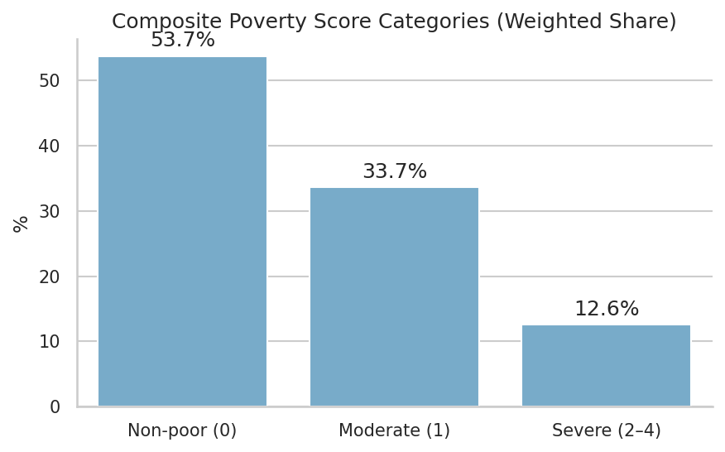
This figure summarizes the weighted distribution of the composite poverty score (0–4 deprivations). Over half of the population (53.7%) experience no deprivations, one-third (33.7%) face moderate deprivation, and 12.6% suffer multiple (2–4) deprivations.
Weighted deprivation rates are displayed by region for education, electricity, and employment indicators. Results show that employment deprivation is moderate across all regions (38–40% in Paramaribo/Coast; 57% in the Interior), electricity deprivation is almost exclusively concentrated in the Interior (84%), and education deprivation is minimal except in the Interior (25%).

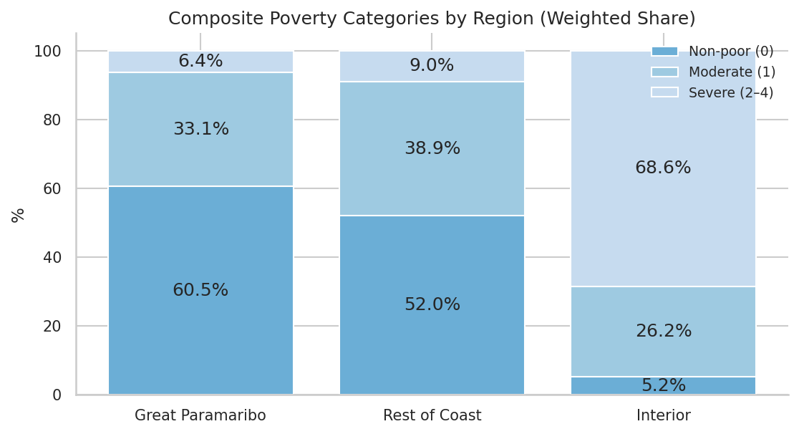
Composite poverty score categories reveal large regional disparities. In Great Paramaribo, the majority of individuals are non-poor (60.5%), while severe poverty affects only 6.4%. The Rest of the Coast shows intermediate levels (52.0% non-poor; 9.0% severe). By contrast, the Interior is overwhelmingly deprived: 68.6% experience severe poverty and only 5.2% are non-poor

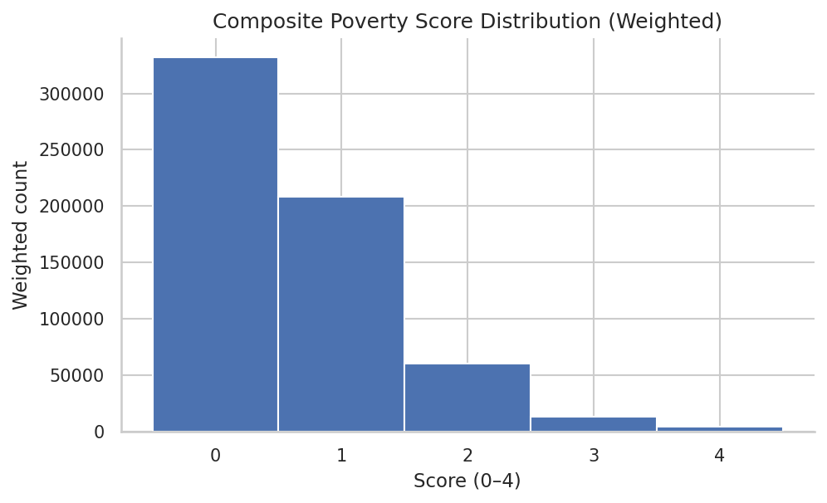This figure presents the weighted national distribution of the composite poverty score (0–4). Most individuals experience no (0) or one (1) deprivation, while progressively fewer individuals face multiple deprivations. Only a small minority (≈2%) experience three or more simultaneous deprivations.

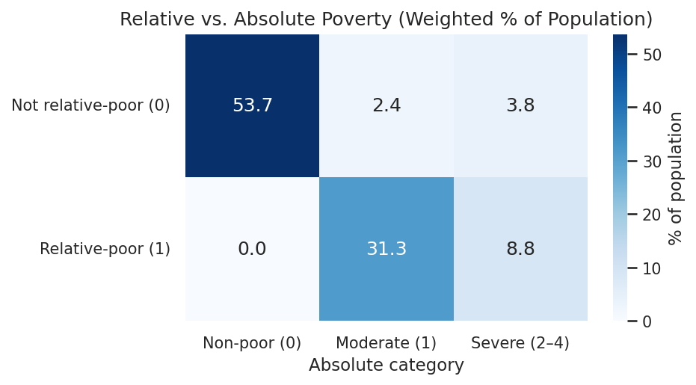
This cross-tabulation compares the study’s relative poverty classification (row: above or below the regional median deprivation score) with an absolute categorization of the composite score (columns: 0 = non-poor, 1 = moderate, 2–4 = severe). Results highlight that the two approaches are related but not identical. For example, 53.7% of the population are non-poor under both measures, while 31.3% are classified as relative-poor but only moderately poor in absolute terms, and 8.8% are both relative- and severe-poor. A small share (≈6%) fall into absolute poverty categories while not being classified as relative-poor. This confirms that the relative measure provides region-sensitive contrasts for regression analysis, while the absolute categories (and the Alkire–Foster MPI check) offer complementary perspectives on the intensity of deprivation.

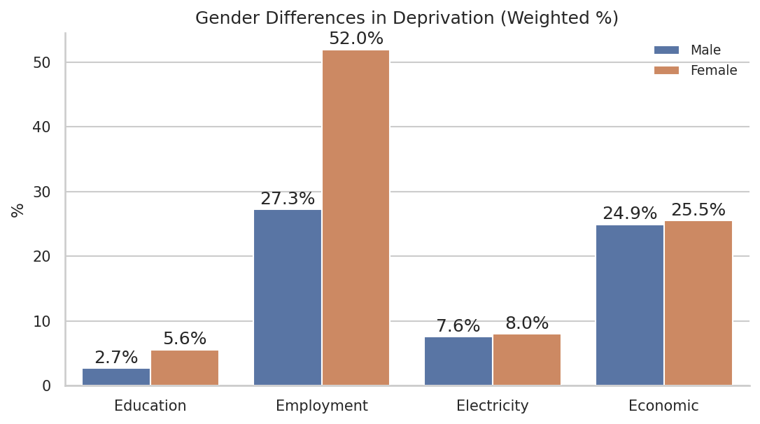
Gender-disaggregated deprivation rates show clear differences across dimensions. Education and electricity deprivations are rare and similar across sexes. Economic deprivation is nearly identical (≈25%). In contrast, employment deprivation exhibits a pronounced gender gap: 52.0% of women versus 27.3% of men are deprived.
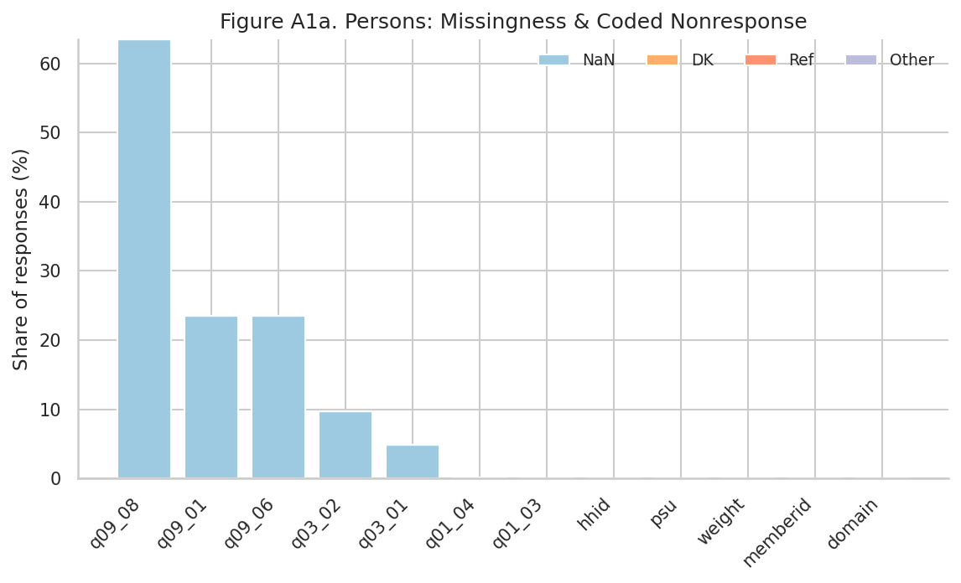

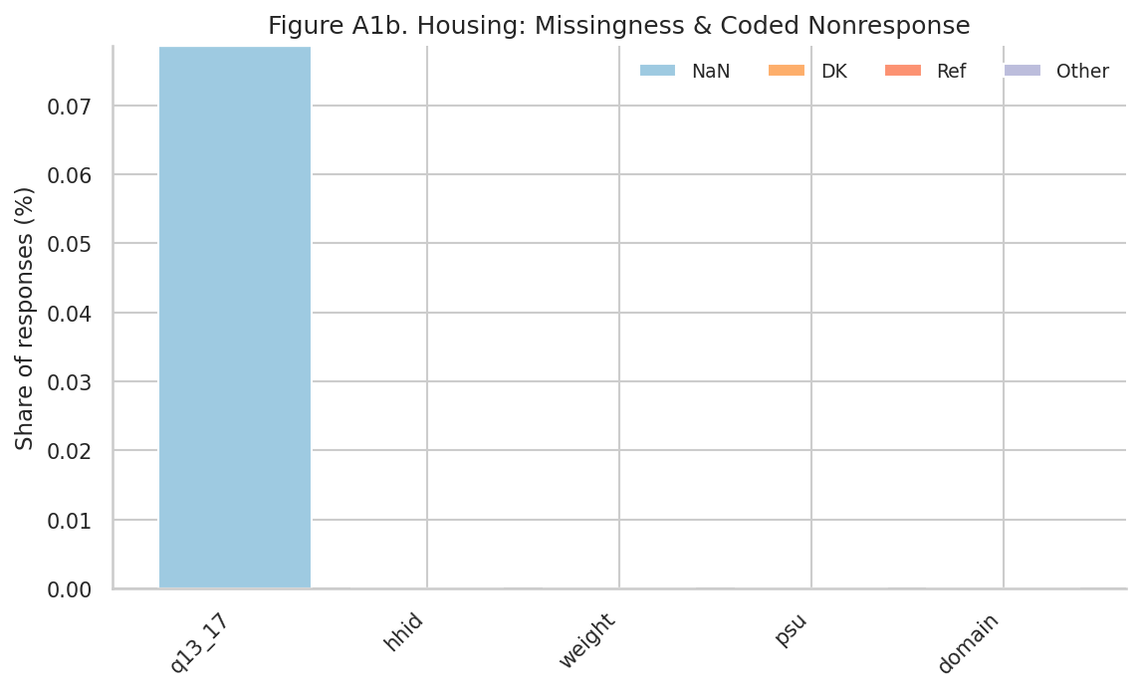

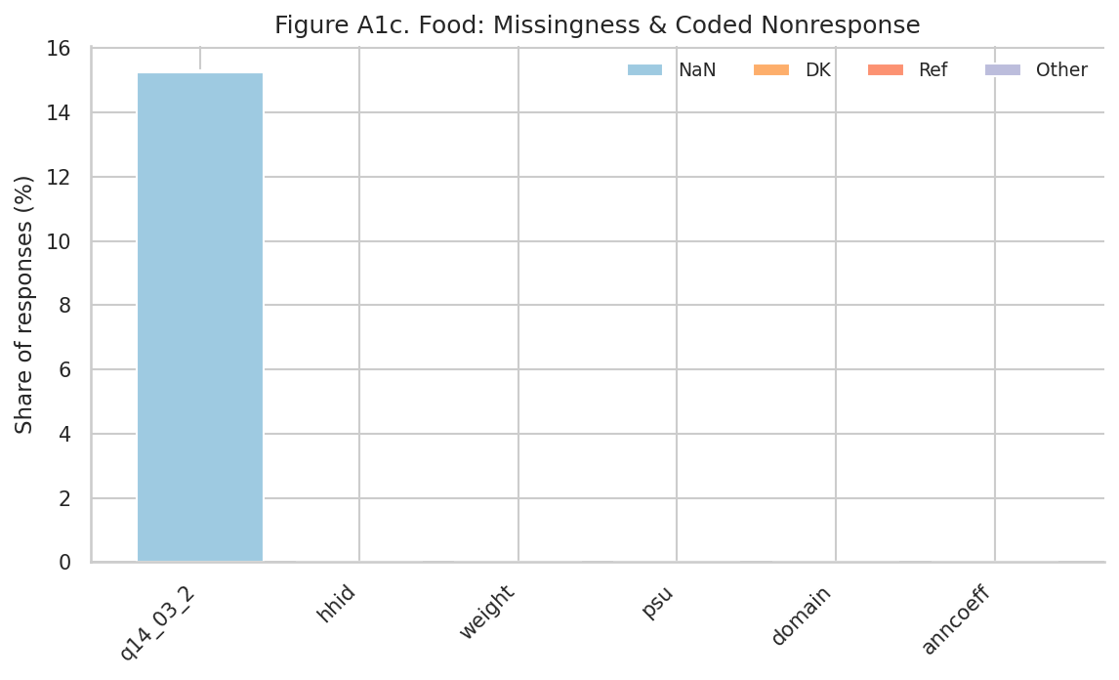
Figures A1a–A1c summarize missingness and coded nonresponse across the Persons, Housing, and Food modules. In the Persons dataset, high apparent missingness for certain employment and education variables reflects skip patterns rather than item refusal (e.g., q09_08: 63%). Demographic and identifier variables are virtually complete. In the Housing dataset, the main electricity source variable (q13_17) shows only 0.08% missing responses, while identifiers are complete. In the Food dataset, the “last purchase” variable (q14_03_2) exhibits 15% missingness, but other structural variables (household IDs, weights, annualization coefficients) have no missing values.
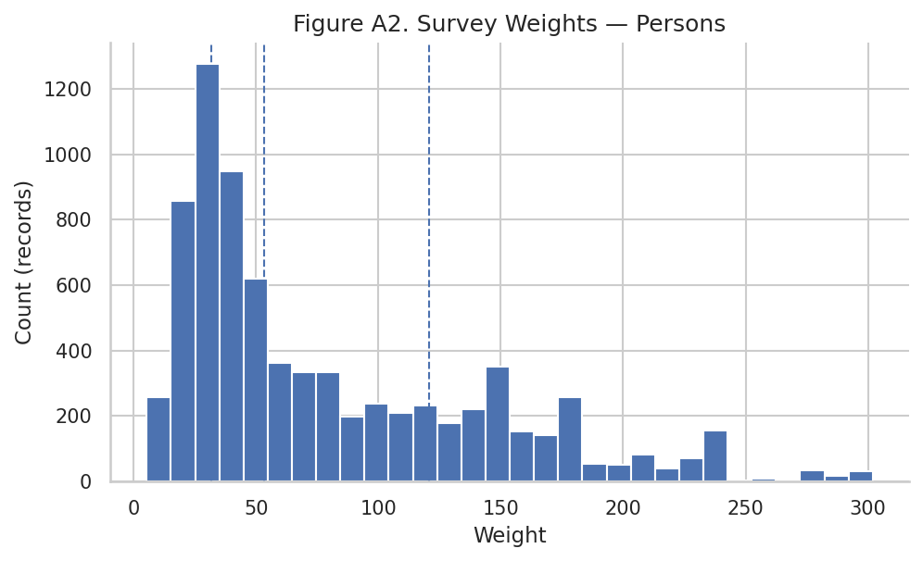
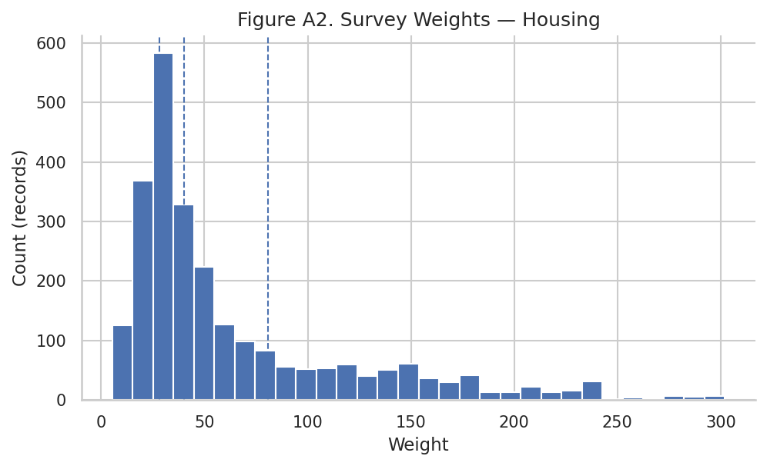
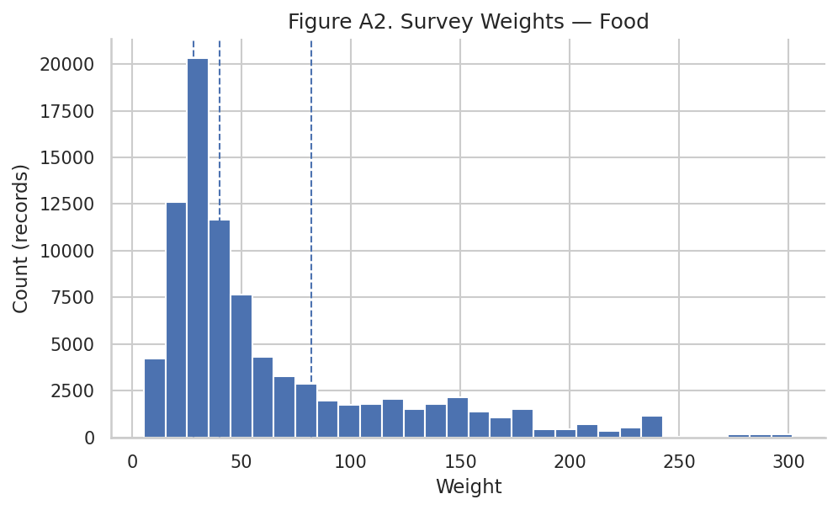
The above histograms shows the distribution of survey weights among the three datasets used. While outliers exist, the overall distribution is well-behaved and consistent with the documented sampling design
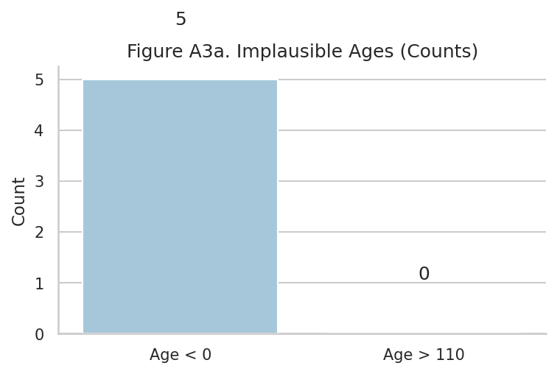
Five implausible negative age values were identified and recoded as missing. No ages exceeded the upper threshold of 110 years. Given the negligible share (<0.1% of the sample), this correction does not affect the analysis
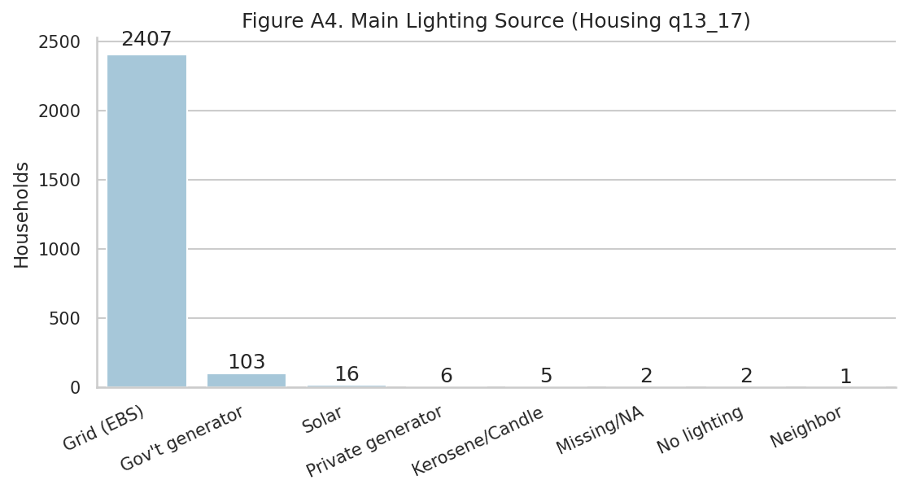
Figure A4 displays reported household lighting sources. As expected, most households are connected to the EBS national grid, while about 100 rely on government-supplied generators in Interior areas. Solar and private generators are rare, and only negligible cases report kerosene/candles, no lighting, or missing values.
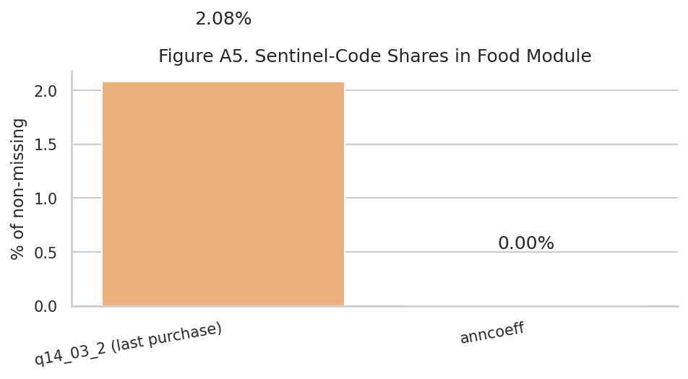
Figure A5 checks the prevalence of sentinel-coded values in the food consumption module. Only 2% of responses to last purchase amounts (q14_03_2) contained special codes (e.g., Don’t know/Refused), while the annualization coefficient field (anncoeff) showed no such issues. Given the small share and the fact that consumption totals rely on multiple inputs, this level of item nonresponse is not expected to materially affect results.
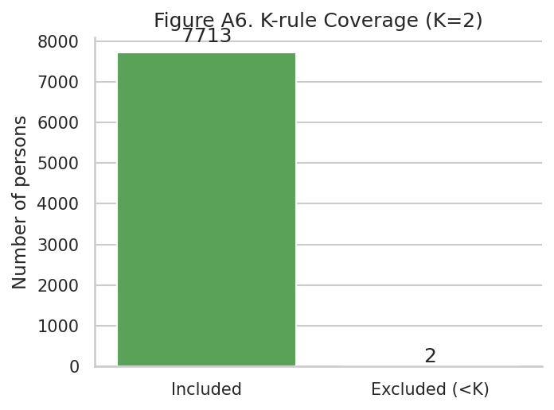
Figure A6 shows coverage of the completeness rule applied when constructing the composite deprivation score. Individuals were included only if at least two of the four indicators (K=2) were observed. Out of 7,715 persons, only 2 were excluded (<0.1%), ensuring that the analytic sample remains virtually identical to the survey population
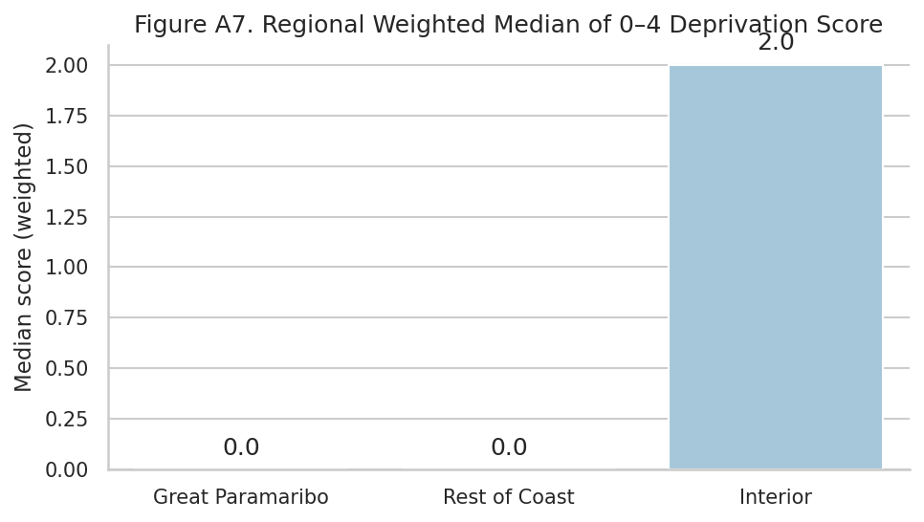
Figure A7 displays the weighted median of the 0–4 additive deprivation score by region. In both Great Paramaribo and the Rest of the Coast, the typical individual faces no deprivations (median = 0). By contrast, in the Interior, the median person is deprived in two out of four dimensions, highlighting the structural disadvantage faced in rural areas. This contrast validates the urban–rural divide as a key driver of poverty outcomes in Suriname.

