Anthropogenic factors explain the most spatial variation of plant beta-diversity in the Netherlands
V.A.M. van Doorn
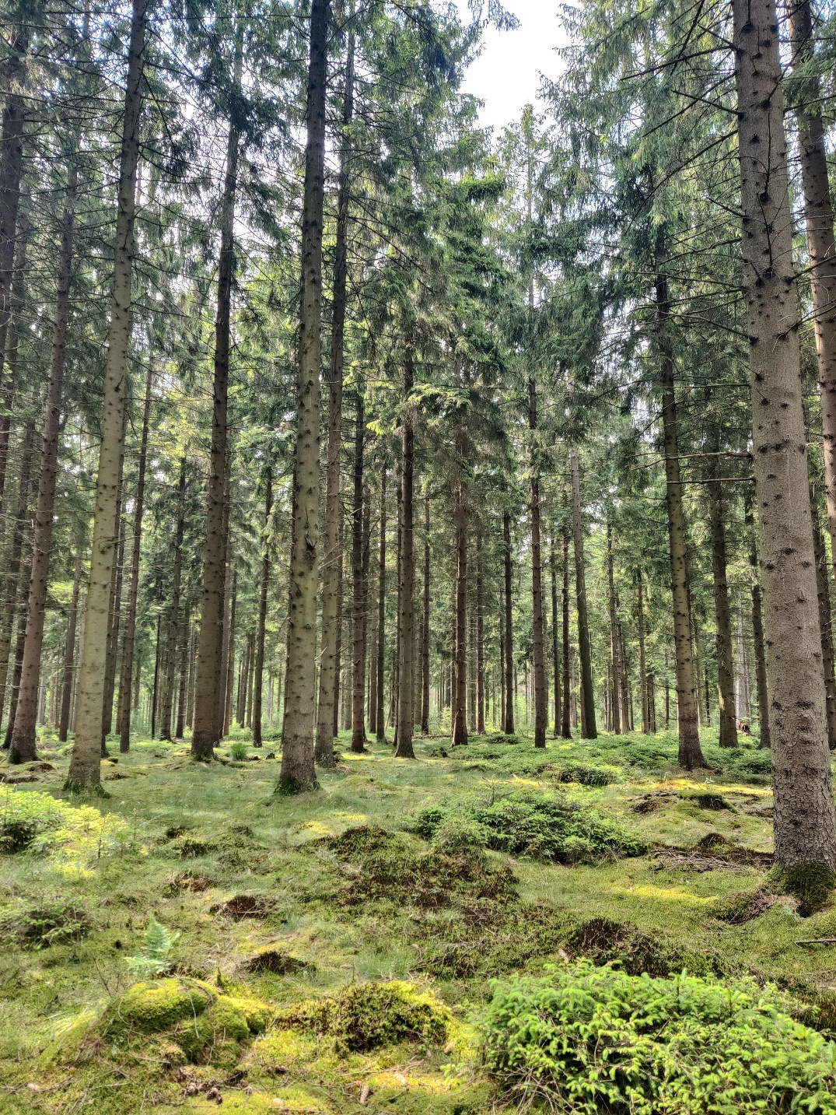

Utrecht University
Environmental Biology – Ecology and Natural Resource Management
Faculty of Science, Department of Biology
Supervisor: Dr. J.J Lembrechts
Examiner: Dr. Y. Hautier
Table of content
1
Abstract 3
Introduction 4
Methods 7
Study Area 7
Sampling design 8
Vegetation Surveys 9
Microclimate measurements 9
Anthropogenic and environmental predictors 10
Statistical analysis 12
Results 13
Data exploration 13
Relationship between anthropogenic heterogeneity, natural heterogeneity and spatial variation in surface temperature 15
Relationship between Anthropogenic, Natural factors and the spatial variation in beta-diversity 18
Discussion 23
Conclusion 25
Bibliography 26
Appendix 34

Abstract
We researched the relationships between anthropogenic and natural landscape heterogeneity and spatial beta-diversity in a forest, peatland and urban environment in the Netherlands. Plot-level vegetation surveys were done and using TOMST TMS4 sensors temperature was measured. Land use and management were given a value based on the intensity. pH, elevation and soil type data was collected via online databases. Using a Generalized Linear Mixed Model with random effects it was found that difference in tree cover explained the most variance in surface temperature, while differences in anthropogenic factors explained the most variance in beta diversity across landscapes. Variation in land use, management and natural factors increase landscape heterogeneity, and therefore increase beta-diversity. These findings underscore the ecological importance of human-driven heterogeneity, particularly for biodiversity conservation in multifunctional landscapes with little natural heterogeneity like the Netherlands.

Introduction
Worldwide biodiversity is declining, in the sense that it can be called the 6th mass extinction (Ekinci, 2024). This decline is mainly due to human actions, such as climate change, land use change as well as overpopulation (Cafaro et al., 2022; Harrison, 2020; Prof. Dr. Deniz Ekinci, 2024). Warming induced losses in plant species may lead to functional, phylogenetic diversity and species richness decline (Harrison, 2020). Land use change becomes more intensive as the human population and economy grows (Cafaro et al., 2022; Marques et al., 2019). Land use change can have positive or negative effects on biodiversity, with the negative outcomes coming from the most intense land use (Sharma et al., 2022).
In the Netherlands, loss of biodiversity is present at a particularly high pace (CLO, 2016). Being a small country with one of the highest population density on Earth, there is little space left for nature (Centraal Bureau voor de Statistiek, 2024; Van Dijk, 2019). The largest part of the land surface has an urban or agricultural land use, with 12% of land surface still being natural and forested. Those ecosystems are under management to protect them from external disturbances (Van Dijk, 2019; Ministerie van Algemene Zaken, 2020). Remarkably, Dutch authors have published more studies in the field of biodiversity management than authors from other regions, suggesting that this is an important topic for the county (‘Biodiversity Management’, 2022).
The importance of conserving biodiversity is being recognized progressively by a large public (de Oliveira Caetano et al., 2023), as biodiversity has benefits for all. Biodiversity can be explained and studied in several ways. The amount of species present in one defined area is called the alpha diversity, when this is compared to the alpha diversity of another area, this is called the beta-diversity. Gamma diversity is the total diversity found in a research area. One of the most important functions of biodiversity is ecosystem stability. For example, having a composition of different plant species leads to asynchrony, which translates to different responses of species on environmental change (Schnabel et al., 2021). Having this variety of responses, the chances increase that of all the species, a part will subsist. This is also known as redundancy, the ability of being replaced by another species that has comparable functional traits (Oliver et al., 2015). Ecosystem stability makes ecosystems more resistant and resilient for climate change (Oliver et al., 2015). These different biodiversity quantification results in there being no unequivocal method of measuring biodiversity (Socolar et al., 2016), which makes it difficult to compare biodiversity values across the world. This is where beta-diversity provides insight, as it provides a link between the local and regional diversity.
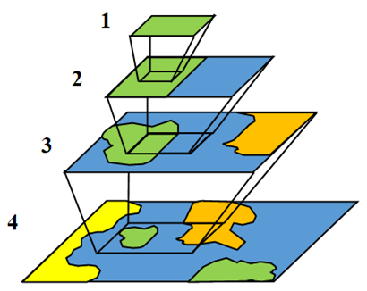
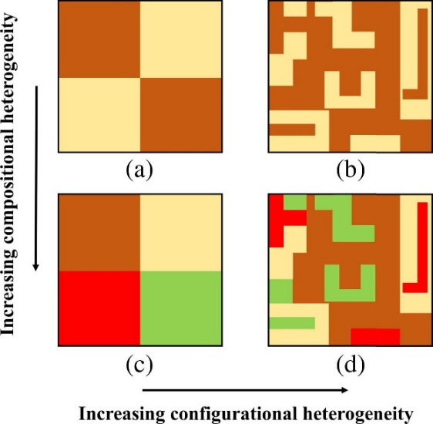
A high beta-diversity suggests that a landscape has a high heterogeneity. Even though research has been done on the effect of landscape heterogeneity, the majority of studies do not provide definition for heterogeneity (Tonetti et al., 2023). Landscape heterogeneity can be seen as patches in the landscape (configurational heterogeneity), composing of 2 land uses or multiple (compositional heterogeneity) (Chen et al., 2016) (fig. 1). Configurational heterogeneity increases with an increase in the complexity of the spatial patterns, like borders and fragmentation and compositional heterogeneity increases with the increase in the number of cover types (Chen et al., 2016). Landscape heterogeneity can also be seen as a continuous factor. Those factors can be anything that varies in a landscape, like natural factors or anthropogenic factors. The anthropogenic and natural heterogeneity and its interplay is therefore thought to affect plant diversity in urban environments (Guo et al., 2024). Anthropogenic factors can be split up in land use/disturbance and management. Land use is the purpose that the land has, such as recreation, agriculture or an urban environment. Nature management is the manner in which people manage nature, this is done on different intensities. For example logging 1 hectare of a forest compared to selecting specific trees that are to be logged (Staatsbosbeheer n.d.). In grasslands, difference in management intensity can be mowing the whole grassland or just the verges.
Figure 1. Compositional and configurational heterogeneity. The x-axis shows an increase in the configurational heterogeneity, shown as an increase in cover types. The y-axis shows an increase in the compositional heterogeneity, shown as an increase in spatial complexity. Figure from Chen et al., 2016.
Figure 2. How measuring at different scales influences heterogeneity. The larger the scale, the more heterogeneity is captured when doing measurements. Figure from Plant and Soil Sciences eLibrary 2025

Scale is an interesting factor in landscape heterogeneity, firstly because it has an effect how much of the heterogeneity is captured when quantifying it (fig. 2). For instance, if we would show only a quarter (so a smaller scale) of each of the panels (a. b. c. d.), the compositional heterogeneity would look different. Secondly, with increasing spatial heterogeneity, patches lose area and become isolated, which constrains species establishment and therefore species richness (Tamme et al., 2010). Therefore, some research suggests that an intermediate heterogeneity is best for optimizing biodiversity (Fahrig et al., 2011; Redon et al., 2014). This adds to the idea that including scale in measuring beta-diversity can increase the reflections’ accuracy of the heterogeneity of the ecosystem. The interpretation of the term scale, is therefore a key aspect in measuring beta-biodiversity. Scaling can be interpreted as sampling extent (field plot size) (Clarke et al., 2025), or as the distance between plots. While measuring diversity at small distances, species richness increases fast with an increasing distance, because of variation in habitats or landscape heterogeneity (Barton et al., 2013). At intermediate scales, diversity differentiates less between areas, as less species are different from the regional pool. At very large scales, species richness increases again due to changes in the landscape, climatic differences and evolutionary histories (Barton et al., 2013). It is not clear what the effect of the scale of heterogeneity is on beta diversity in the Netherlands.
Landscape heterogeneity has an effect on microclimate heterogeneity (Londe et al., 2020). That is, spatial variety of the local climatic conditions that organisms are exposed to, which is different from the macroclimate in a region (Kemppinen et al., 2024). Microclimate heterogeneity can increase the amount of microrefugia, which are microsites that can increase a species’ resilience to extinction (Keppel et al., 2015), by creating fine-scale environmental gradients that buffer organisms from climate extremes (Dobrowski, 2011). Previous studies suggest that management and land use can shape microclimate variability, by increasing or decreasing landscape heterogeneity, for instance by the formation of urban heat islands (Landsberg, 1981; Menge et al., 2023; Mokhtari et al., 2022). By increasing urban land use, which can increase or decrease landscape heterogeneity dependent on its intensity and the configurational and compositional heterogeneity (fig. 1), urban heat islands can be formed, which in its turn can lead to an increase or decrease in microclimate variability. To what degree the heterogeneity of anthropogenic and natural factors can affect microclimate in different areas of the Netherlands, maintains a knowledge gap.
Previous research has shown that landscape and microclimate heterogeneity have an effect on the species richness in an area (Alahuhta et al., 2017; J. Liu et al., 2018), based on niche theory (Lundholm, 2009). Each species is adapted to a specific range of abiotic factors, and when the area has broad range of those factors, multiple species can co-exist in the area (Redon et al., 2014). As landscape and microclimate heterogeneity increase the amount of niches in an area (Jiang et al., 2021), and niche variability increases beta-diversity (Jiang et al., 2021), we hypothesize that landscape and microclimate heterogeneity increase beta-diversity. Beta diversity is particularly relevant in heterogeneous or fragmented landscapes, where turnover in species composition can signal ecological filtering, dispersal limitations, or habitat specialization; factors that are key to understanding biodiversity patterns under anthropogenic pressure. Beta-diversity values need to be interpreted with care, as the significance of a change in beta-diversity is not straight forward in conservation science (Socolar et al., 2016) An increase in beta-diversity is not always desirable, as strong fragmentation of a landscape leads to a high dissimilarity between plots, which reflects in a high beta-diversity (Socolar et al., 2016). This is why understanding the drivers of landscape heterogeneity is important, especially in systems with low natural and topographic variation like the Netherlands. Despite growing recognition of the importance of fine scale heterogeneity, few studies have looked at the varying drivers of landscape and microclimate heterogeneity, and how it impacts beta-diversity. This study addresses that gap by measuring anthropogenic, natural and distance related heterogeneity and plant beta-diversity in different landscapes.
Research aims and questions
- To what extent does anthropogenic and natural heterogeneity influence microclimate variability (temperature) across landscapes?
Hypothesis: Greater variation in land use and management will increase landscape heterogeneity and thus temperature dissimilarity. Due to the relatively flat topography of the Netherlands, anthropogenic factors are expected to have a stronger effect on microclimate than natural factors, especially in urban or agricultural areas. However, in strictly protected natural areas, natural variation may be more influential.
- What is the impact of this anthropogenic and natural heterogeneity on spatial vascular plant beta-diversity across landscapes?
Hypothesis: Minimal land use and management may promote higher alpha diversity, as limited disturbance can create intermediate conditions favorable for multiple species (Marull et al., 2015). This intermediate disturbance by minimal land use and management may look like people walking on footpaths, mowing and grazing.
Conversely, intense land use and management can homogenize environmental conditions, reducing alpha diversity through both direct effects (e.g., nitrogen enrichment, pavement) and indirect effects (e.g., increased temperature due to paved surfaces).
Regarding beta diversity, we hypothesize that landscapes with the greatest variation in land use and management will exhibit the highest heterogeneity, and thus the highest beta diversity (fig. 1d). It is expected that in protected areas natural factors will be most correlated with beta-diversity, and that in more urban areas anthropogenic factors are the most correlated with beta-diversity. With greater distances, we generally expect higher dissimilarities between plant communities because of changing local natural factors like topography and soil type.

Methods
This research is a part of the MicroFracNet, an addition to the Ecological Fractal Network (EcoFracNet n.d.). The latter is an international network, established with the aim to measure biodiversity across different scales, in different landscapes.

Study Area
This research uses several study sites to study anthropogenic and natural heterogeneity in different types of ecosystems. The study sites were selected based on availability in combination with other research projects. The variation in these sites gives us the opportunity to answer the research questions in different landscapes, providing a broader perspective
Austerlitz is part of the Utrechtse Heuvelrug and is a planted broad leaf and coniferous forested on a sandy moraine. It is a nitrogen polluted forest, with some heathland. It is managed by Staatsbosbeheer, who are in charge of selective logging in the forest. In addition they set up the current tree planting using a combination of management styles. In some areas fences are placed to exclude roe deer (Capreolus capreolus), in other areas the planted trees are treated with several growth inducing substances. The forest is accessible for walkers and mountain bikers.
Fochteloërveen is a resting raised bog in the north of the Netherlands. It is a nature reserve managed by Natuurmonumenten and Staatsbosbeheer. The southern part of the bog has a short history of grazing by sheep. Public access is restricted in the largest part of the bog, acting as a protection against disturbance. Other management practices are in the form of large grazers, and changing their grazing area, and controlling the water table.
Utrecht Science Park is the campus of Utrecht University and Hogeschool Utrecht. It is composed of buildings, sport fields and (ecological) pastures.

Sampling design
To answer the research questions, the design of the MicroFracNet was used. This design is a triangle with multiple triangles nested in it, which allows us to capture landscape heterogeneity and ecological variation on different scales in a location. The largest scale being 900 meters, and the smallest scale being 11 meters (fig 3a.). The largest triangle consists of 3 plots that are 900 meters apart. By adding plots into this triangle, 3 smaller triangles that are 300 meters apart (9 plots that are 300 meters apart) are formed, which are then arranged into more triangles that consist of 27 plots that are 100 meters apart. Plots are added to a part of the bottom triangle (100 meter scale), which created the 33 meter scale (9 plots that are 33 meters apart). Lastly plots are added to the former scale to create the 11 meter scale (9 plots that are 11 meters apart). Using this design each MicroFractNet design consists of 39 plots.
This plot design was used in all our locations, using QGIS version 3.34 (QGIS Development Team, 2024) to determine the plot coordinates (fig. 3a). The triangular nested plot design was constructed using AutoCAD (Autodesk, 2024) and overlaid onto study sites in QGIS version 3.34 (QGIS Development Team, 2024). Due to the spatial constraints of Dutch nature reserves, the polygon was rotated and adjusted within each site to maximize the number of plots falling within the target habitat. In Austerlitz, five peripheral plots were excluded because they fell outside the forest boundary (fig. 3b).
In the field, the plot coordinates were found by using a Garmin GPS with the saved coordinates. For the 33 and 11 meter scale, measuring tape was used to find the plots, as the GPS was not accurate enough for the smaller distances.
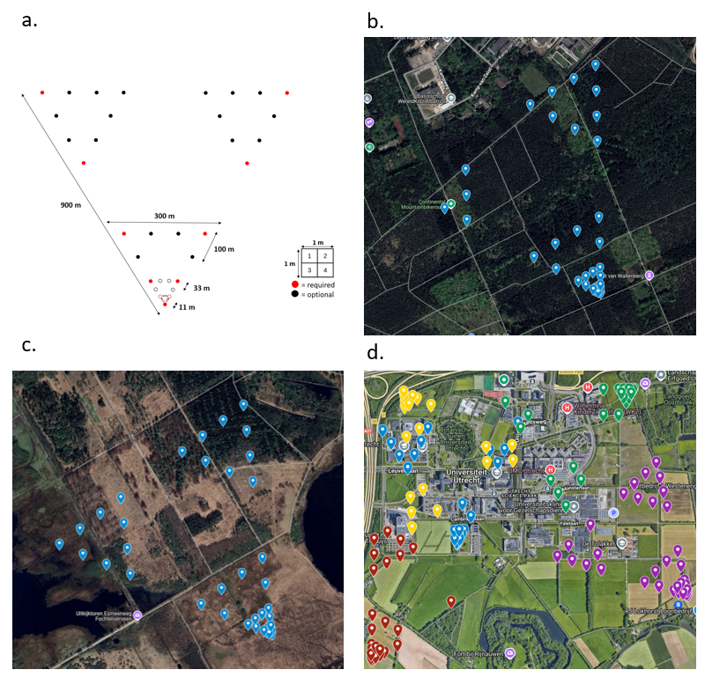
Figure 3. MicroFracNet designs in the field. a. Original MicroFracNet design, with the triangle distances of 900, 300, 100, 33 and 11 meters. Each dot is a 1 m² plot, composed of four 0,25 m² quadrants. The red dots are required plots, the black ones are optional; b. MicroFracNet design in Austerlitz, in which some plots are missing; c. MicroFracNet design in Fochteloërveen; d. Multiple MicroFracNet designs at Utrecht Science Park. Only the surveyed plots are showed.

Vegetation Surveys
The 1 m² plots were set up by surveying 4 quadrants. Per quadrant a 50x50 cm grid was laid out on top of the vegetation. The grid was divided into 25 cells of 10x10 cm (fig. 4). During fieldwork, all plant species present in, or overhanging the quadrant were noted down, which allows the cover percentage to become higher than 100%. Further, other biological (moss, animal faeces), non-biological (bare soil) and metadata (longitude and latitude). After this, the cover percentage of all species and categories per quadrant were estimated by estimating how many grid cells a species or category would cover. 1 grid cell accounts for 1 % of the 1 m² plot cover. Additionally, cover percentage was split into herb cover and tree cover. When a plant species was impossible to identify in the field, a specimen was collected and labelled, which was dried for later identification.
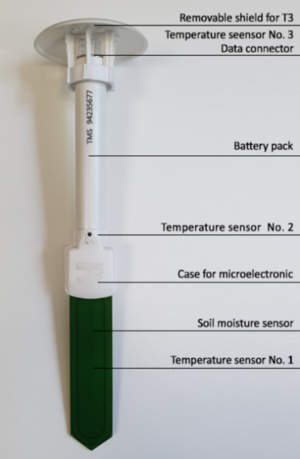
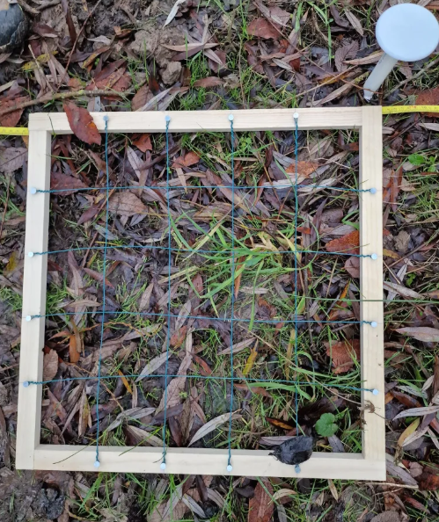

Figure 4. Plot set up. 50x50 cm quadrant grid (left) with a TOMST TMS4 in the corner. Details of the TOMST TMS4 sensor.

Microclimate measurements
In each plot, a TOMST TMS4 microclimate ((Wild et al., 2019), (TOMST, 2024) sensor was installed at the centre of each plot if possible (fig 4,). These sensor measures soil moisture and temperature at 3 depths ( -6, +2 and +15 cm) and soil moisture at 15 minute intervals. Due to logistical constraints and risk of theft, sensors were not deployed in plots located within the Utrecht Science Park.
In Austerlitz, 34 plots were established; however, only 33 were equipped with sensors because one plot was located on a footpath. To minimize visibility and reduce theft risk, sensors were buried slightly deeper than recommended, requiring correction for altered measurement depths. In Fochteloërveen, sensors were initially installed in all 39 plots, but data were ultimately obtained from 33 plots due to sensor loss. At the Utrecht Science Park, 135 plots were surveyed, but no microclimate sensors were installed for the reasons noted above.
Temperature and soil moisture were recorded in a time period from halfway March 2025 to the end of May 2025, in Austerlitz. For Fochteloërveen the time period was the end of April 2025 until the beginning of June 2025. In both locations the time period is around 6 weeks.

Anthropogenic and environmental predictors
To investigate the anthropogenic factors regarding management scale and land use, categories were made to annotate values to the different intensities. Management is labelled on a gradient from 0-8, with an area in category 0 being completely natural and an area in category 8 being intensely managed (table 1). The land use is labelled on a gradient from 0-10, with an area being in category 0 being nature and an area being in category 10 being completely paved (table 2).

Table 1. Categories of nature management intensity: Each site was assigned a management value (0-8) based on the level of human intervention, ranging from pristine (0) to ecological engineering (8). The middle column defined each category, and the right column describes typical landscape examples or practices associated with each.
Value | Category | Explanation
0 | Pristine | Completely natural areas with no discernible human management, rarely encountered in highly developed regions.
1 | Minimal intervention | Sites where only occasional or very limited monitoring occurs, with negligible active management.
2 | Light monitoring | Areas subject to basic, infrequent observations or minimal management efforts.
3 | Passive restoration | Zones where natural processes are subtly aided by occasional human interventions (e.g., infrequent weeding or thinning or minor site maintenance).
4 | Targeted management | Sites where focused actions are implemented to benefit specific species or ecosystem functions.
5 | Moderately managed | Areas where a balanced approach is adopted, applying interventions on a moderate scale to sustain or enhance ecosystem functions.
6 | Active restoration | Sites that receive direct restoration efforts, such as planting native species or selective thinning and removal of problematic vegetation.
7 | Intensive management | Areas undergoing frequent and diverse interventions—including controlled burns, systematic rewilding, extensive cutting or mowing—to manage large-scale processes.
8 | Ecological engineering | Sites subject to large-scale, comprehensive modifications designed to restore or maintain ecosystem functions (for example, through river reconfigurations or major landscape reconfigurations)

Table 2. Categories of land use/disturbance intensity. Each site was assigned a disturbance value (0–10) based on the level of human disturbance, ranging from pristine (0) to fully artificial landscapes (10). The middle column defines each category, and the right column describes typical landscape examples or land uses associated with each.
Value | Category | Explanation
0 | Pristine | Areas that are completely undisturbed, typically strict nature reserves or protected regions with minimal human presence.
1 | Minimal disturbance | Sites such as nature reserves where human activity is very limited (e.g., occasional walkers), leaving the environment largely intact.
2 | Low disturbance | Landscapes experiencing light recreational use—for example, forests frequented by mountain bikers or hikers—where human impact remains relatively low.
3 | Managed natural areas | Regions where human influence is evident through practices such as forestry, structured hedgerows, or ecologically managed grasslands aimed at maintaining biodiversity.
4 | Ecologically integrated agriculture | Areas that merge sustainable agricultural practices (e.g., ecological farming, wildlife-friendly meadow bird areas, food forests, or large-scale natural gardens) with significant natural elements.
5 | Traditional agricultural landscapes | Small-scale, culturally maintained agricultural settings where ecological enhancement is not the primary focus, but natural features persist alongside farming activities.
6 | Peri-urban and roadside greenery | Small-scale, culturally maintained agricultural settings where ecological enhancement is not the primary focus, but natural features persist alongside farming activities.
7 | Neglected urban fringe | Urban edges or transitional areas (such as vacant lots, old rail corridors, or forgotten urban spaces) that have become overgrown with spontaneous vegetation due to inconsistent maintenance.
8 | Intensive agricultural landscapes / greenhouses | Regions dominated by industrial practices—such as monoculture farming, large-scale greenhouses, or intensive agriculture—where production replaces most natural habitat features.
9 | Heavily managed urban greenery | Urban green spaces that are extensively engineered (e.g., city parks, meticulously maintained gardens, or “tile nature” areas) where human design and control are paramount.
10 | Fully artificial landscapes | Completely transformed environments like large parking lots, supermarket complexes, or fully paved surfaces where natural elements are virtually absent.

Soil type was expressed as a code provided by Bodemkaart Nederland. They are compared as being the same or not, in a binary way. pH data from 0-5cm was retrieved from Bodemkaart Nederland, with a resolution of 25 meters (Bodemdata, n.d.; Helfenstein et al., 2022). To fill missing datapoints the resolution of the map was lowered. The same was done in regards of elevation, which was retrieved from AHN (Algemene Hoogtekaart Nederland) (AHN, 2020) using the AHN4 maps with a resolution of 5 meters.
The variables named above enable us to measure heterogeneity in the landscape (table 3). There are 4 categories, anthropogenic, natural, microclimate and scale. The dissimilarities of 2 plots values in a plot combination will be taken. For disturbance mean and management mean the mean of the 2 plot values will be taken, to show what correlation the intensity of the disturbance and management has.
Table 3. Overview of measured variables. In the left column the variable category is defined, with in the right column the variables that fit into that category.
Variable category | Variable
Anthropogenic | Management
 | Disturbance
 | Management mean
 | Disturbance mean
Natural | pH
 | Soil type
 | Elevation
 | Herb cover
 | Tree cover
Microclimate | Surface temperature
Scale | Distance

Statistical analysis
Statistical analyses were done in R version 4.2.3 (R Core Team, 2025). The analyses focused on testing the effects of anthropogenic and natural heterogeneity on (1) landscape temperature variation and (2) plant community beta-diversity.
- Landscape Temperature Variation (Austerlitz and Fochteloërveen)
Austerlitz and Fochteloërveen: The aim is to test the correlation of management differences, land use/disturbance differences and the difference in environmental variables (pH, elevation, distance, soil type, tree cover and herb cover) on temperature (landscape heterogeneity). First a Principal Component Analysis is done to visualize the different predictors of temperature. Then, per location all the absolute dissimilarities (differences between plots) of the variables were calculated for every possible plot combination. Duplicate pairs and same plot combinations were removed. The temperature time series of the TOMST TMS4 sensors were split into a mean, minimum and maximum temperature per temperature sensor per plot. This provided 9 temperature dissimilarities per plot. It was chosen to use the surface minimum and maximum temperature. For Austerlitz this was the T3 sensor as the sensors were buried in the ground, in Fochteloërveen this was the T2 sensor. Using this data, a Generalized Linear Mixed Model (GLMM) with a Gaussian distribution was made with the use of the glmmTMB package (Brooks et al., 2017) in R (R Core Team, 2024). The management dissimilarities, disturbance dissimilarities and natural factors’ dissimilarities acted as predictors and the temperatures as a response variable. The collinearity was evaluated to ensure that the predictors would not be correlated. A random effect was added to one or both of the plots in the combination to account for the fact that the pairwise data did not consist of independent observations. That is because the same plot occurs in multiple combinations, but every combination only occurs once. The model was ran with one or two random effects, and depending on which one had the lowest AIC that model was selected. Variance partitioning for specific predictors was done by making a model without that predictor and calculating the difference between that R² and the R² or the full model.

- Plant community beta-diversity (Austerlitz, Fochteloërveen and Utrecht Science Park)
Austerlitz, Fochteloërveen and Utrecht Science Park: A Bray-Curtis index was calculated for every possible plot combination. This index is selected as it takes abundance of species into account, instead of only species richness (Schroeder & Jenkins, 2018). A generalized linear mixed model (GLMM) with a beta-error distribution and logit-link was used to analyse the relationship of the anthropogenic and environmental dissimilarities with the Bray-Curtis dissimilarities (between 0-1, the 0 and 1 values were adjusted with 0.001 to make them fall in that range). Again a random effect was added in the plot 1 identity of the combination. Models were fitted using the glmmTMB package in R. For Utrecht Science Park the initial plan was to have 5 triangle designs, however due to time constrains the vegetation surveys were not complete. For this reason it was chosen to analyse the already surveyed plots of these 5 triangles in this location all together. Another reason for this is that the 5 triangles are so close together that it is more appropriate for them to be seen as 1 location than as 5 separate.

Results

Data exploration
Across the three study locations, species richness varied substantially. The highest diversity was observed at Utrecht Science Park, where 210 plant species were recorded, including 15 tree species and 195 herbs and shrubs. The plots at Fochteloërveen hosted a total of 47 species, with a relatively low number of trees (7) and 39 herbs and shrubs. In Austerlitz, we found the lowest total richness, with 33 species; of which 15 trees and 28 herbs and shrubs.
Apparent are the larger variation in land use values in Utrecht Science Park than in the other locations, as well as the distance (fig. 5). Additionally, Austerlitz’ surface temperature has a wider range than Fochteloërveen.
Regarding beta-diversity, Fochteloërveen has the highest mean beta-diversity, as well as the highest amount of beta-diversity values being 0 and 1. This infers that from the three locations, Fochteloërveen has the most plots that are completely different, and also has the most plots that are identical (fig. 6).
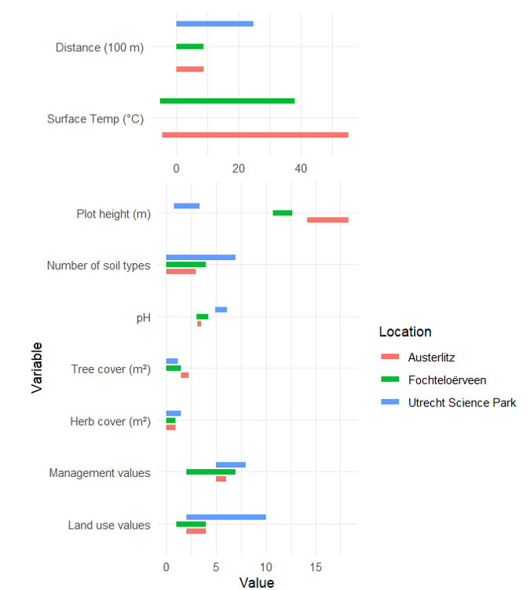
Figure 5. Variable ranges per location. Ranges of variables across Austerlitz, Fochteloërveen and Utrecht Science Park. Note that distance and surface temperature are plotted on different x-axis scales to accommodate their larger ranges.

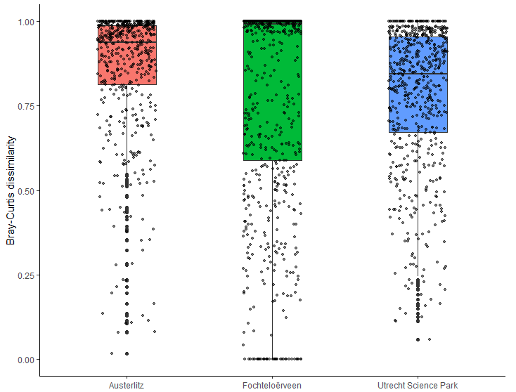
Figure 6. Beta-diversity per location. Boxplot of the ranges of Bray-Curtis dissimilarity across Austerlitz, Fochteloërveen and Utrecht Science Park. The value 0 signifying that two plant communities are identical, 1 signifying that the plant communities in a combination are completely different. Each point is the dissimilarity of a pairwise comparison of 2 plots.

Relationship between anthropogenic heterogeneity, natural heterogeneity and spatial variation in surface temperature
Principal Component Analyses were performed to visualize the direction of different predictors of Surface Temperature. In Austerlitz’ PCA, the first principal component accounted for 37.1% of the total variance in the data, and the second principal component explained an additional 19.2%, resulting in a combined total of 56.3% of explained variance. In the Fochteloërveen PCA, the first PC accounted for 36.2% of the variation, the second PC for 25.4%, resulting in the total variance explained being 61.6%.
Notable in the biplot of Austerlitz most of the arrows point in opposing directions, for instance in disturbance an management and surface temperature and vegetation cover, which suggest that there is a strong negative correlation between those predictor variables and that they may influence surface temperature through different ecological mechanisms (fig. 7a). Herb cover and maximum surface temperature do point in the same direction and are positively correlated (fig. 7a). In the biplot of Fochteloërveen, Management, and pH are pointing in the same direction, as well as Disturbance, which shows that these variables are positively correlated (fig. 7b). In both biplots, herb cover and tree cover are in opposing directions, indicating that these variables are negatively correlated (fig. 7ab).
a | b
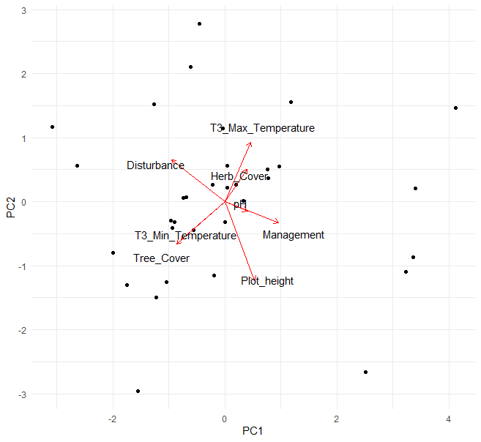 | 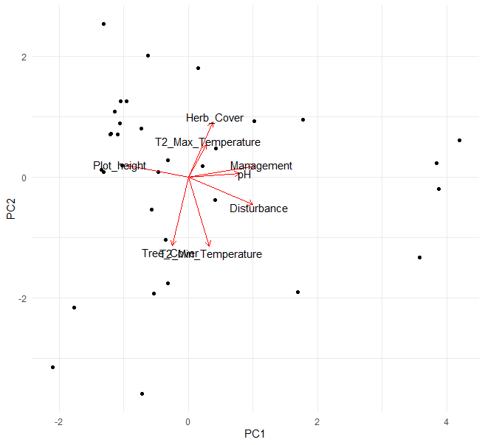
Figure 7. PCA biplot of surface temperature predictors in Austerlitz (a) and Fochteloërveen (b). Note that these are the raw values, not the dissimilarities

In Austerlitz, differences in minimum surface level temperature were mostly strongly and positively associated with differences in tree cover (SE = 0.0007, p < 0.001, Marginal R² = 0.076, n = 528; table 4, fig. 8). For differences in maximum surface temperature, tree cover again emerged as a significant positive predictor (SE = 1.062e-02, p < 0.01, Marginal R² = 0.026; n = 528; table 5, fig. 8). These results suggest that natural factors, rather than anthropogenic variables influence surface level temperature differences in Austerlitz.
In Fochteloërveen, minimum surface level temperature differences were again strongly correlated with tree cover (SE = 0.0026819, p < 0.05, Marginal R² = 0.065, n = 528; table 4, fig. 8). The differences in maximum surface level were strongly correlated with differences in the management mean (SE = 0.4079186, p < 0.001, R² = 0.130, n = 528; table 5, fig. 8). These outcomes show that in Fochteloërveen, variation in minimum surface temperature is mainly explained by natural factors, while variation in maximum surface temperature is mostly explained by anthropogenic variables.
Variance partitioning showed that in Austerlitz the variance in minimum and maximum surface temperature differences were mostly explained by differences in natural factors, while in Fochteloërveen the maximum surface temperature difference was mostly explained by anthropogenic factors differences (table 6).
Table 4: Summary table of predictors of Minimum Surface Temperature in Austerlitz and Fochteloërveen.
 | Austerlitz |  |  | Fochteloërveen
 | Estimate | P value | Significance | Estimate | P value | Significance
(Intercept) | -2.048 | 0.432 |  | 1.929 | 0.003 | **
Disturbance mean | 0.247 | 0.313 |  | -0.647 | 0.197
Disturbance | 0.129 | 0.203 |  | 0.387 | 0.167
Management mean | 0.395 | 0.316 |  | 0.208 | 0.466
Management | -0.090 | 0.544 |  | -0.092 | 0.351
Herb cover | -0.0008 | 0.438 |  | -0.002 | 0.589
Tree cover | 0.005 | p < 0.001 | *** | 0.006 | 0.018 | *
Soil type | -0.099 | 0.206 |  | 0.291 | 0.435
pH | 0.279 | 0.377 |  | -0.040 | 0.805
Elevation | -0.014 | 0.782 |  | 0.175 | 0.538
Distance | -0.0002 | 0.375 |  | 0.0003 | 0.573
N. of observations | 528 |  |  | 528
R² | 0.076 |  |  | 0.065

Table 5: Summary table of predictors of Maximum Surface Temperature in Austerlitz and Fochteloërveen.
 | Austerlitz |  |  |  |  | Fochteloërveen
 | Estimate | P value |  |  | Significance |  | Estimate | P value | Significance
(Intercept) | -16.31 | 0.280 |  |  |  |  | 1.826 | 0.058
Disturbance mean | 1.719 | 0.213 |  |  |  |  | -1.306 | 0.077
Disturbance | -0.426 | 0.432 |  |  |  |  | -0.267 | 0.613
Management mean | 3.091 | 0.178 |  |  |  |  | 1.453 | p < 0.001 | ***
Management | 0.619 | 0.433 |  |  |  |  | 0.272 | 0.187
Herb cover | -0.006 | 0.244 |  |  |  |  | 0.003 | 0.752
Tree cover | 0.011 | 0.004 |  |  | ** |  | -0.002 | 0.666
Soil type | -0.358 | 0.383 |  |  |  |  | -0.548 | 0.214
pH | -0.533 | 0.749 |  |  |  |  | 0.028 | 0.944
Elevation | -0.299 | 0.247 |  |  |  |  | 0.157 | 0.769
Distance | 0.0002 | 0.849 |  |  |  |  | 0.0002 | 0.849
N. of observations | 528 |  |  |  |  | 528
R² | 0.026 |  |  |  |  | 0.130
Austerlitz |  |  | Fochteloërveen
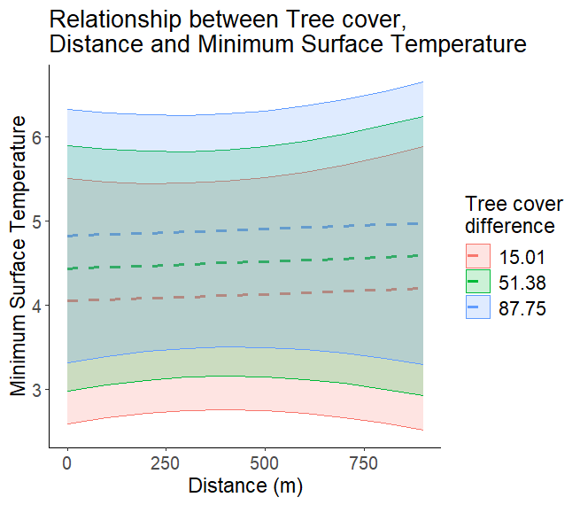 |  |  | 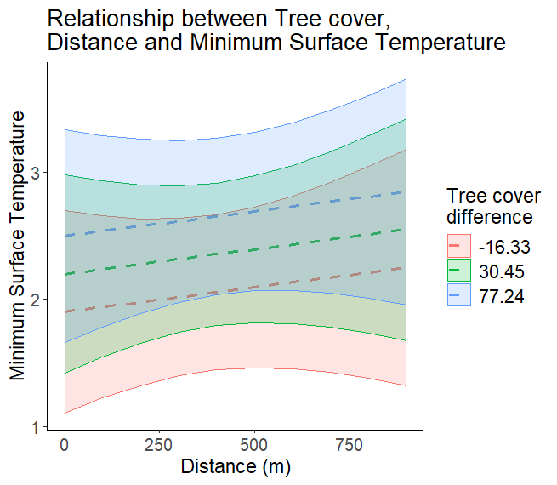
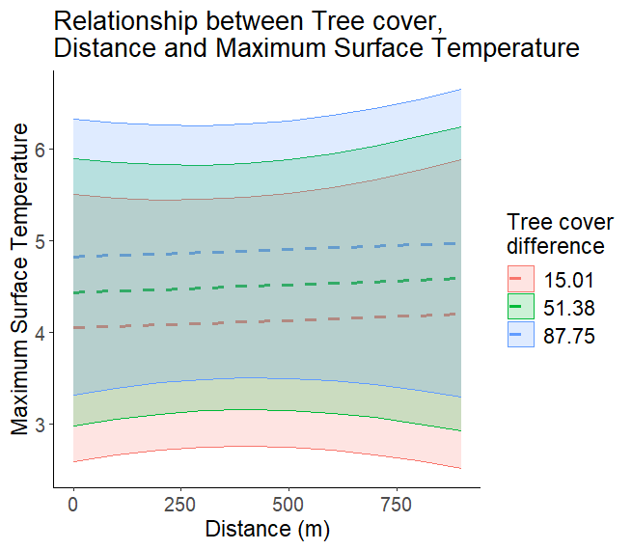 |  |  | 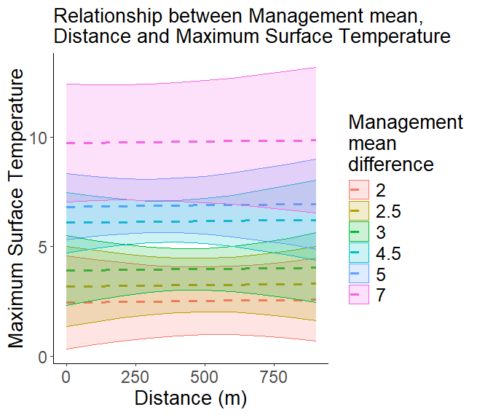
Figure 8. Significant relationships of heterogeneity and surface temperature difference. Relationship between tree cover and Minimum (upper) and Maximum (lower) Surface Temperature differences in Austerlitz (left) and Fochteloërveen (right). Dashed lines signify that distance is not significant. Other figures in appendix fig. 1

Table 6: Variance explained by the predictors of Surface Temperature difference. The different variable groups are found in the rows. Anthropogenic factors being land use/disturbance and management. Natural factors being pH, soil type and plot elevation. Temperature being minimum and maximum surface temperature. with the Austerlitz in the columns on the left and Fochteloërveen on the right. Per variable group the explained variance is stated, as well as the percentage compared to the total variance explained. The highest percentage of variance explained is bold.
 | Austerlitz |  | Fochteloërveen
 | Minimal surface temperature | Maximal surface temperature | Minimal surface temperature | Maximal surface temperature
Full model | 0.076 | 0.026 | 0.065 | 0.127
Anthropogenic factors | 0.023 (30.2%) | 0.010 (38.5%) | 0.014 (21.5%) | 0.111 (87.4%)
Natural factors | 0.055 (72.4%) | 0.015 (57.7%) | 0.020 (30.8%) | 0.007 (0.006%)
Distance | 0.003 (3.9%) | 0 (0%) | 0.001 (1.5%) | 0 (0%)

Relationship between Anthropogenic, Natural factors and the spatial variation in beta-diversity
It was found that differences in pH (SE = 0.461, p = 0.002) and differences in minimum surface temperature (SE = 0.060, p = 0. 01220) had a positive significant influence on the Bray-Curtis dissimilarity (table 7, fig 9). Compared to the other locations, there was a low amount of significant predictors. The largest part of the variance was explained by human influences (table 8).
In Fochteloërveen, Bray-Curtis dissimilarity was positively associated with differences in Disturbance mean (SE = 0.275, p < 0.001), Management mean (SE = 0. 154, p < 0.001), pH (SE = 0. 141, p < 0.001), Soil type (SE = 0. 177, p < 0.05), Minimum Surface temperature (SE = 0.028, p < 0.05), and Distance (SE = 0.0005, p < 0.01)(table 7, figure 9). The R² showed that the largest part of the variance was explained by human influence (table 8). These results did not support our hypothesis that in a protected area, differences in natural factors are more correlated with beta-diversity.
In Utrecht Science Park, differences in Disturbance (SE = 0.021, p < 0.001) , pH (SE = 0.086, p < 0.001), Soil type (SE = 0.039, p < 0.001), Elevation (SE = 0.0578, p < 0.001), and Distance (SE = 0.00004, p < 0.001) were positively significant on the Bray-Curtis dissimilarity (table 7, figure 10). These results were partially supported by our hypothesis that in more urban systems, anthropogenic variables are more correlated with beta-diversity.
In the graphs of Fochteloërveen and Utrecht Science Park, the increase in beta-diversity shows a noticeable decline in slope (fig. 9).
Interestingly the full model of Fochteloërveen explained more of the variance than the models of the other locations (table 8). This suggests that in Austerlitz and Utrecht Science Park other predictors that were not included in our models have a strong relationship with beta-diversity. It could also be caused by a low heterogeneity and low beta-diversity in the other locations, especially in Austerlitz, in which the variation in beta-diversity can be caused by random noise.

Table 7: Summary table of the GLMM of predictors on Bray-Curtis dissimilarity in Austerlitz Fochteloërveen and Utrecht Science Park.
 | Austerlitz |  |  | Fochteloërveen |  |  | Utrecht Science Park
 | Estimate | P value | Sig | Estimate | P value | Sig |  | Estimate | P value | Sig
(Intercept) | 1.751 | 0.498 |  | 0.205 | 0.580 |  |  | 3.430 | 0.045 | *
Disturbance mean | 0.266 | 0.275 |  | 2.220 | < 0.001 | *** |  | 0.193 | 0.085
Management mean | -0.372 | 0.349 |  | -0.865 | < 0.001 | *** |  | -0.495 | 0. 089
Disturbance | 0.036 | 0.785 |  | -0.179 | 0.366 |  |  | 0.194 | < 0.001 | ***
Management | 0.151 | 0.451 |  | -0.035 | 0.625 |  |  | -0.034 | 0.626
pH | 1.429 | 0.002 | ** | 1.533 | < 0.001 | *** |  | 0.385 | < 0.001 | ***
Soil type | -0.033 | 0.763 |  | 0.3716 | 0.036 | * |  | 0.210 | < 0.001 | ***
Elevation | 0.015 | 0.813 |  | -0.165 | 0.381 |  |  | 0.293 | < 0.001 | ***
Min Surface Temp | 0.149 | 0.012 | * | 0.059 | 0.035 | * |  | x | x | x
Max Surface Temp | 0.010 | 0.365 |  | -0.008 | 0.535 |  |  | x | x | x
Distance | 0.0003 | 0.115 |  | 0.001 | 0.009 | ** |  | 0.007 | < 0.001 | ***
N. of observations | 528 |  |  | 528 |  |  |  | 5251
R² | 0.382 |  |  | 0.746 |  |  |  | 0.264

Table 8. Variance explained by grouped predictors in Austerlitz, Fochteloërveen and Utrecht Science Park.
Anthropogenic factors being land use/disturbance and management. Natural factors being pH, soil type and plot elevation. Temperature being minimum and maximum surface temperature. Per variable group the explained variance is stated, as well as the percentage compared to the total variance explained. The highest percentage of variance explained is bold.
Variance partitioning | Austerlitz | Fochteloërveen | Utrecht Science Park
Full model | 0.382 | 0.746 | 0.264
Anthropogenic factors | 0.133 (34,8%) | 0.475 (63,7%) | 0.088 (33,3%)
Natural factors | 0.035 (9,2%) | 0.167 (22,4%) | 0.032 (12,1%)
Temperature | 0.062 (16,2%) | 0.043 (5,7%) | X
Distance | 0.041 (10,7%) | 0.032 (4,3%) | 0

Figure 9: Relationships between predictors, distance and Bray-Curtis dissimilarity per location.
The x-axis is the distance, the y-axis the Bray-Curtis dissimilarity. The legend shows the predictor, which is the same in every row. The left column shows the graphs for Austerlitz, the middle column for Fochteloërveen, the right column for Utrecht Science Park. The shaded areas show the 95% interval, the line being the predicted mean for the predictor and Bray-Curtis dissimilarity at that distance. A single line means that the predictor in the legend was not significant. A dashed line means that distance was not significant. These figures are based on predictions of the GLMM of the predictors on Bray-Curtis dissimilarity.
Austerlitz | Fochteloërveen | Utrecht Science Park
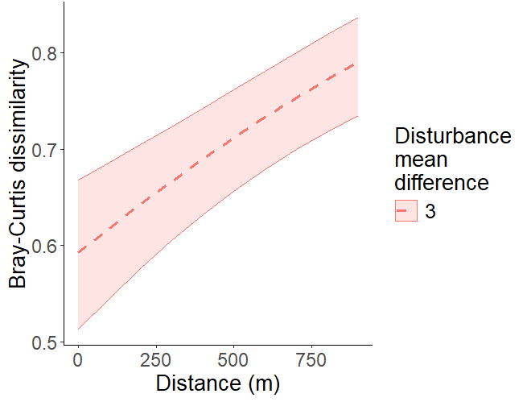 | 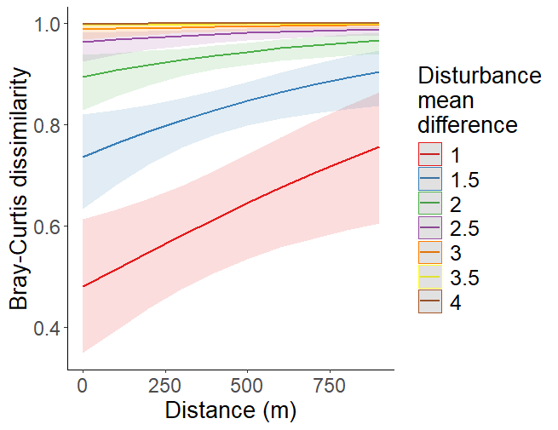 | 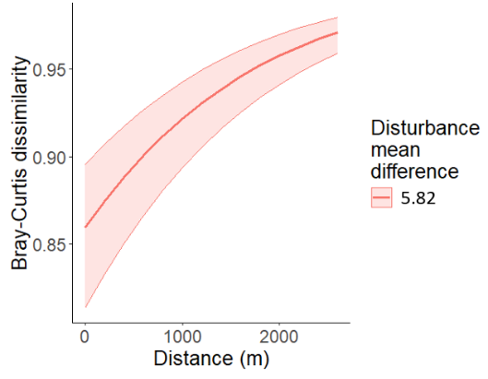
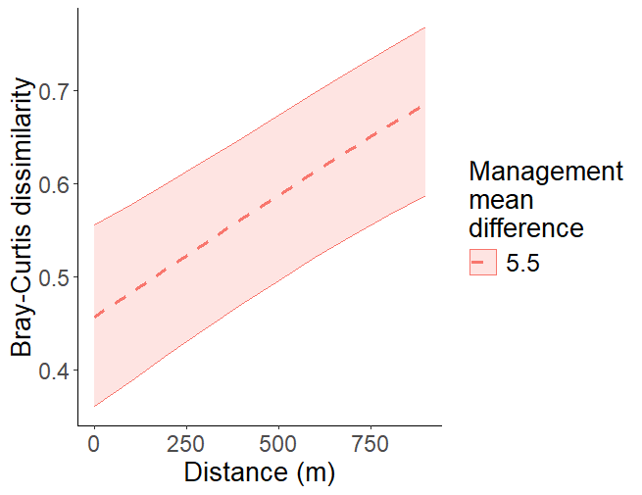 | 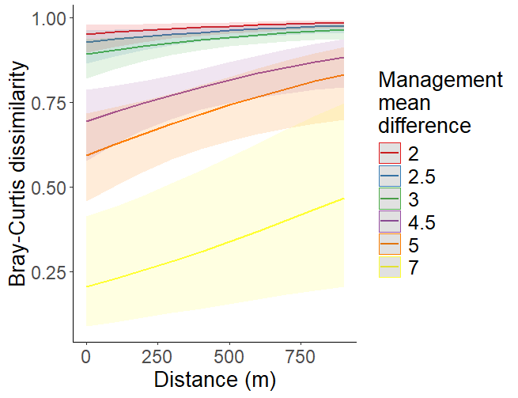 | 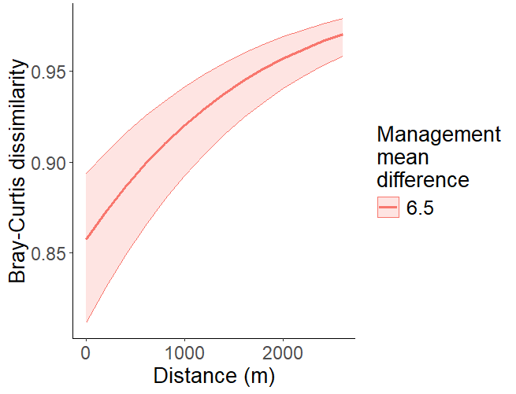
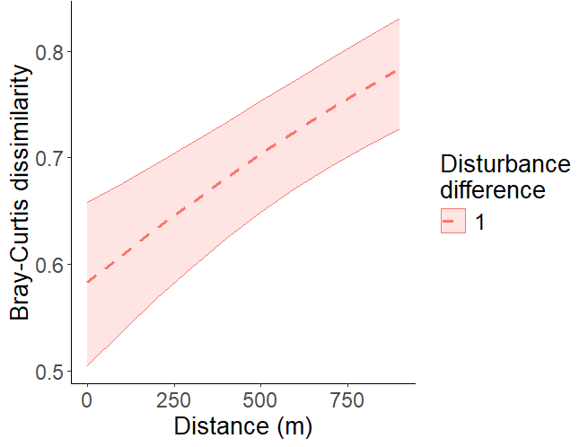 | 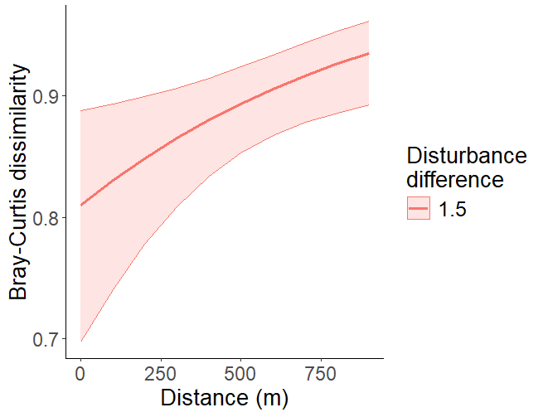 | 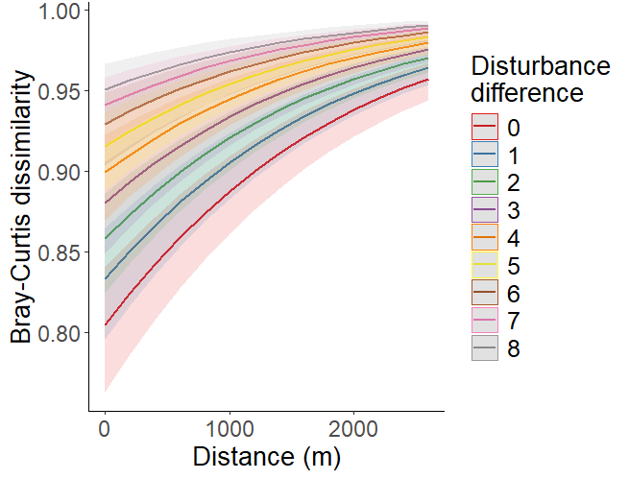
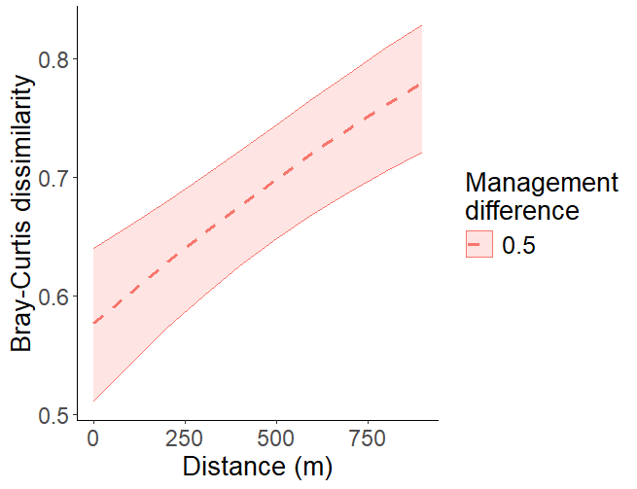 | 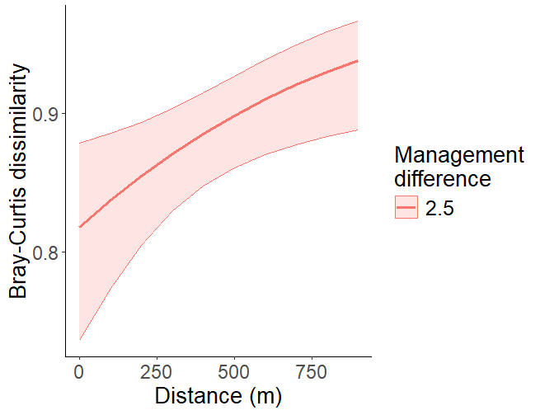 | 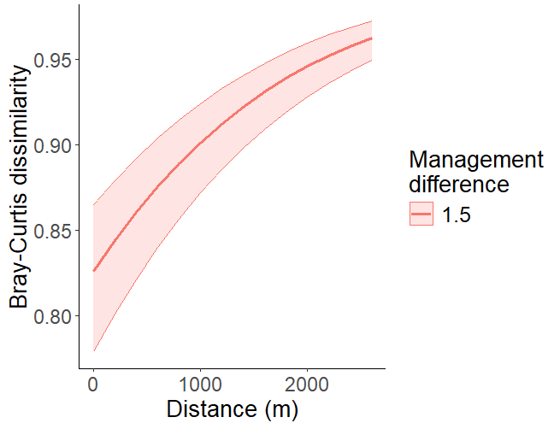

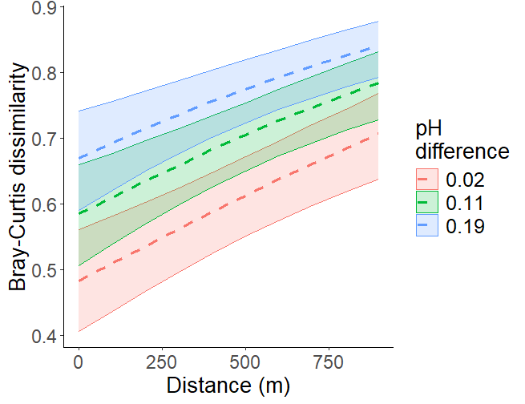 | 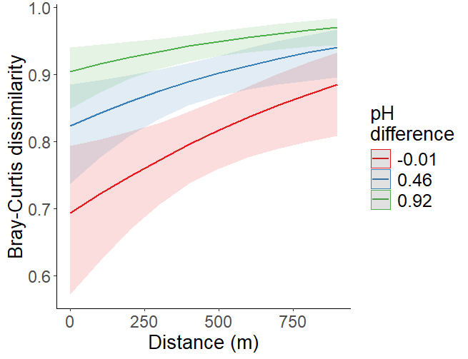 | 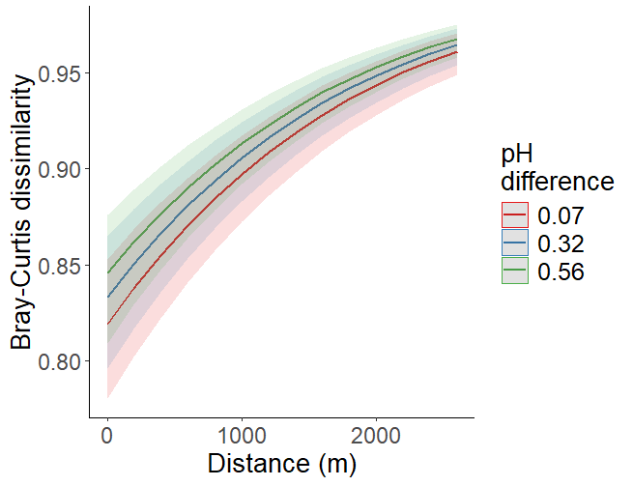
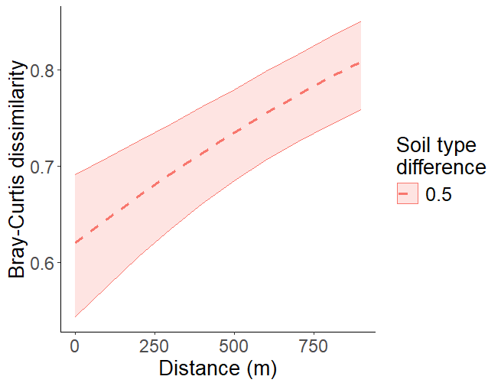 | 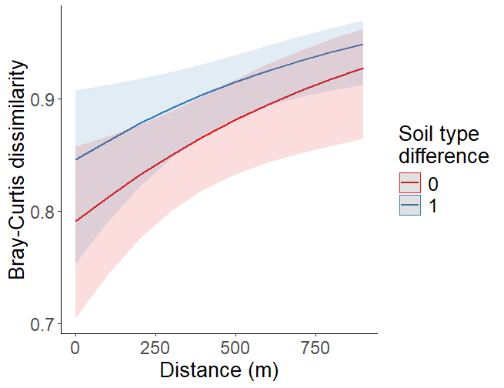 | 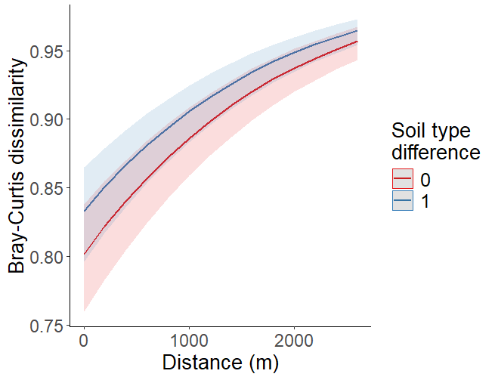
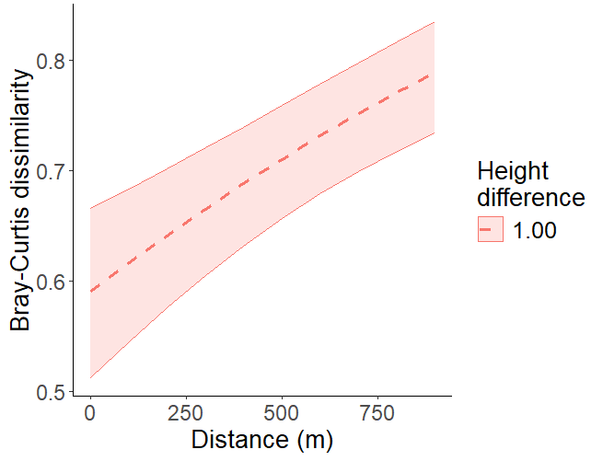 | 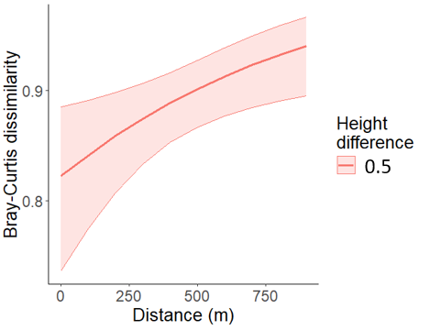 | 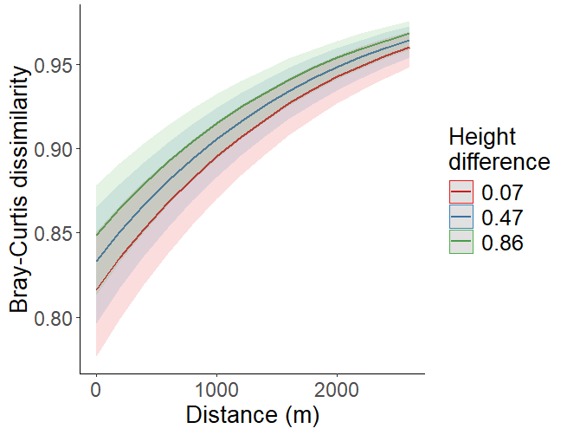
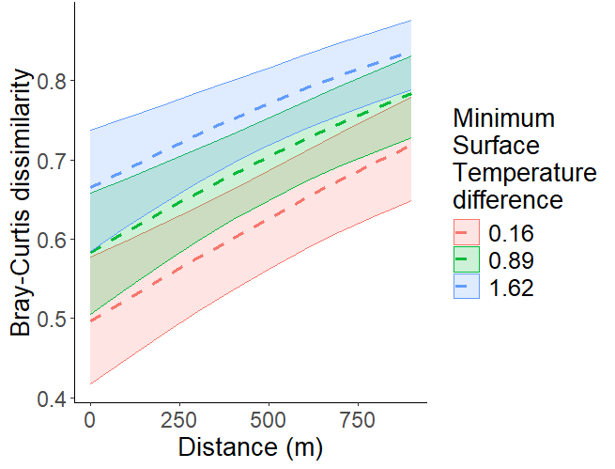 | 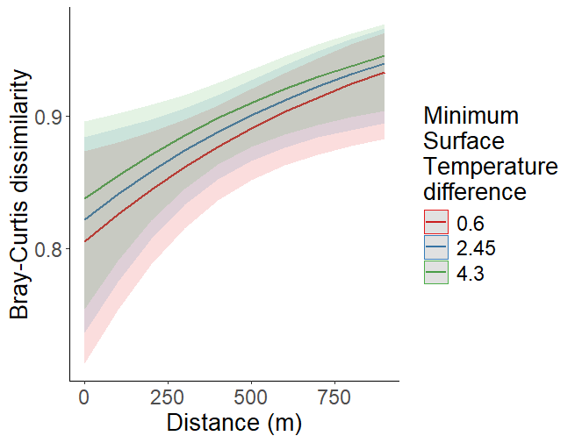

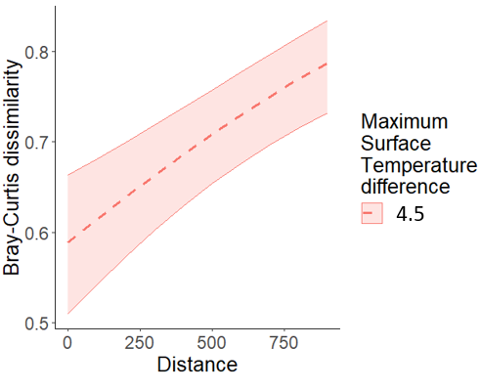 | 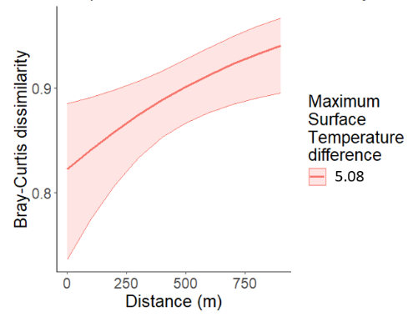

Discussion
To what extent does anthropogenic and natural heterogeneity influence microclimate variability (temperature) across landscapes?
In Austerlitz, microclimate surface temperature had a range of -4.4 °C to 55.2 °C. It was found that this variation in microclimate was explained mainly by natural factors. We found that tree cover was significantly correlated with minimum and maximum surface temperature in Austerlitz. This result is not surprising as tree cover inhibits solar radiation (Sandholt et al., 2002), causing shade, which is the largest direct driver of surface temperature in this model. Contrary to expectations, anthropogenic factors such as management did not significantly explain variation in temperature. It was expected that management would impact vegetation cover and therefore be correlated with it, which would result in management also being a significant predictor for minimum and maximum surface temperature. A possible explanation for why we did not find this relationship can be that the tree planting and herbivore exclusion management in this location has not taken place for long enough to induce a significant difference on the tree cover, as this management has only been introduced for less than 6 months. A gap phase may be present between the start of the management and when the management has an effect on the landscape (Angelstam, 1998). The relatively low explanatory power of the models may also reflect omitted variables, such as soil moisture, which is known to strongly mediate microclimate buffering (Greiser et al., 2024; Xing et al., 2018), soil moisture may explain some variance. In forests, dry, sun-exposed sites are more sensitive to changes in soil moisture, and this is where temperature buffering is most prevalent (Greiser et al., 2024). Finally, the limited variance explained may simply reflect the low heterogeneity of this system, which constrains detectable patterns and increases the influence of random noise at fine spatial scales.
In Fochteloërveen we again found that tree cover had a significant relationship with the minimum surface temperature (range -5.3 °C to 38 °C), and additionally that the management mean had significant relationship with the maximum temperature. Once more, the significant tree cover is an expected result. Management mean was significantly associated with the maximum temperature, which can be explained by there being different management styles in Fochteloërveen, that are performed for multiple years or decades, which is likely long enough to show differences in the landscape (Angelstam, 1998). Just like in Austerlitz, this model explained little variance, which suggests that other predictors may be of importance. The exclusion of the soil moisture predictor may have an even larger influence on the results in Fochteloërveen than in Austerlitz, as this research area is a peat bog with some very wet patches in the landscape, which would have shown in the data as a large range of soil moisture dissimilarity.

What is the impact of this anthropogenic and natural heterogeneity on the spatial plant beta-diversity across landscapes?
In Austerlitz we found that variation in plant beta-diversity was mainly explained by anthropogenic heterogeneity, while the 2 significant predictors in the model belonged in the natural factors category. The apparent inconsistency in these results can be explained by the distinction between statistical significance and variance explained: although 2 the natural factors were significant, their effect sizes only accounted for a minor part of the total variation. In contrast, anthropogenic heterogeneity contributed more substantially to the beta-diversity, even if their individual predictors did not reach statistical significance. This pattern suggests that, in this relatively flat, managed forest, broad-scale differences in land use and management drive overall beta-diversity, while natural factors exert more localized and subtle influences. Further, we found that pH and minimum temperature had a positive significant relationship with the beta-diversity. As pH was very low in this area, it was expected that it has a strong relationship with alfa-diversity (Yadav et al., 2020). Even though the pH range was small (3.16-3.51), this still consisted of a doubling of hydrogen ions in the soil. We expected to find a significant result with the management variables, as there was new management being performed in this area. Again, the fact that there was no significant relationship with management can be because not enough time has passed since the beginning of this management, to pick up any differences in the landscape (Angelstam, 1998) and the species composition, which can take decades (Kuuluvainen et al., 2021). The variance partitioning showed that around 40 percent of the variance was explained by the model, and a third of that by anthropogenic variables. The latter we expected to be more as Austerlitz is a highly managed forest, with several types of intense management. The lack of explained variance by anthropogenic factors can be because one major driver of plant community was missing in the model of this location, which is nitrogen pollution (Onderzoeks- & Onderwijshub Utrechtse Heuvelrug - Universiteit Utrecht, 2025). Nitrogen pollution acts through soil acidification, which may explain why we did find a significant result with pH (Nitrogen deposition as a threat to European Terrestrial Biodiversity, Nancy B Dise, z.d.), regardless of the small range. Another reason for the low amount of variance explained by anthropogenic variables can be because pH is in the natural variables group, and it could be argued that it belongs in the anthropogenic group. A trend was found in regards of distance (p = 0.11), however with only 33 species found in the forest, the plant diversity heterogeneity was so low that we did not expect distance to have a strong relationship with beta-diversity.
In Fochteloërveen it was found that anthropogenic heterogeneity explain most of the plant beta-diversity. We found that disturbance mean, management mean, pH, soil type, minimum surface temperature and distance were significant positive predictors of with beta-diversity. The management and land use/disturbance practices in Fochteloërveen have been in place for one or multiple decade(s). Compared to Austerlitz, this is a long enough time to pick up heterogeneity that was caused by this disturbance and management (Angelstam, 1998). Again, pH (range 3.06-4.23) has a positive significant relationship with beta-diversity. Minimum surface temperature and soil type were found to have significant relationships with beta-diversity, in the literature both are proposed to have an interacting relationship with plant diversity, meaning that surface temperature and soil type affect plant diversity and vice versa (Hamberg et al., 2020; Moujahid et al., 2017). The ranges of the significant factors in the model show that the landscape in Fochteloërveen was quite heterogenous, therefore it was expected that distance would also be significantly correlated with beta-diversity. The model explained about 75% of the variance, which shows that most of the predictors of beta-diversity in Fochteloërveen were included in this model. It is to be expected that moisture measurements would increase the explained variance even more, as Fochteloërveen had a large range of water table levels that were seen in the field (Zelnik & Čarni, 2008). A large part of the variance was explained by anthropogenic variables, which was not expected in our hypothesis. This suggests that even in a protected area, anthropogenic heterogeneity is still the main driver of beta-diversity, mainly due to the variation in management intensity in the forms of large grazers, changing their grazing area, and controlling the water table.
In Utrecht Science Park it was once more found that mostly anthropogenic heterogeneity explained the plant beta-diversity. Disturbance, pH, soil type, height and distance were significantly correlated with beta-diversity. We expected the significance of anthropogenic variables, as the range of the different land use values was wide, causing the disturbance dissimilarities to be high, which provided a highly heterogenous landscape. Disturbance mean and management mean were borderline significant (p = 0.09), supporting this hypothesis. In such a heterogeneous landscape as Utrecht Science Park, many variables and their interactions are needed to predict the heterogeneity, which makes it complex to create a fitted model (Mokhtari et al., 2022). That is a possible explanation for the fact that our model explained little variance, which suggests that one or multiple predictors are missing from it. One of these is thought to be temperature, as in an urban environment temperature can reach high levels, called urban heat islands (Landsberg, 1981). Next to urban heat islands, the presence of urban cool islands lead to a wide range of temperature in an urban environment, causing a large heterogeneity in temperature (Mokhtari et al., 2021). We have been proposing that large landscape heterogeneity is thought to increase beta-diversity. In urban settings, there is some debate in the literature about what the exact effect of the anthropogenic factors on plant diversity is (Deutschewitz et al., 2003; Kühn et al., 2004; X. Liu et al., 2022).
Our research shows that the variability in intensity of anthropogenic and natural factors increase landscape heterogeneity the most, which increases beta-diversity the most. In a country with low natural heterogeneity due to low topographical variety, anthropogenic factors can increase that heterogeneity by management and disturbance. This can act in a beneficial way, increasing the amount of species in the landscape. However, in urban areas, beta diversity can become high, but this is mainly due to a low amount of plant species and does not necessarily reflect a healthy divers ecosystem.
In the future, research should be done on the part that nitrogen pollution plays in the spatial variation of beta-diversity. Further, research could be done on standards in how we use the terms ‘large scale’ and ‘small scale’, as this can differ greatly in different landscapes. The ‘large scale’ in the Netherlands would be ‘small scale’ for another country. Next, it would be interesting to study if the landscape heterogeneity, microclimate heterogeneity and spatial beta-diversity does in fact increase the amount of microrefugia in a landscape, by looking at rare plant species.

Conclusion
Our results show that in various places in the Netherlands, beta-diversity is mainly correlated with anthropogenic heterogeneity, in the form of management and disturbance. In a country with low natural heterogeneity, anthropogenic disturbance may increase that heterogeneity. In moderation, this can increase plant diversity. If a high beta diversity is desired, a variation of land uses and management is needed in a landscape to induce high landscape heterogeneity.
Acknowledgements
I am grateful for the supervision of Jonas Lembrechts and Janna Barel, and the collaboration with fellow students Louise Jochems, George Papaisidorou and Alexander Boas, as well as to my second examiner Yann Hautier.

Bibliography
ChatGPT Open AI was used for the generation of parts of the R code in this thesis.
AutoCAD [Computer software]. (2024). Autodesk.
R Core Team (2024). *R: A language and environment for statistical computing*. R Foundation for Statistical Computing, Vienna, Austria. URL: https://www.R-project.org/
QGIS Development Team (2024). *QGIS Geographic Information System*. Open Source Geospatial Foundation Project. URL: https://www.qgis.org/
TOMST. (2024). *TMS-4 datalogger*. TOMST. https://tomst.com/
AHN. (2020, februari 4). Dataroom [Pagina]. AHN; AHN. https://www.ahn.nl/dataroom
Alahuhta, J., Kosten, S., Akasaka, M., Auderset, D., Azzella, M. M., Bolpagni, R., Bove, C. P., Chambers, P. A., Chappuis, E., Clayton, J., de Winton, M., Ecke, F., Gacia, E., Gecheva, G., Grillas, P., Hauxwell, J., Hellsten, S., Hjort, J., Hoyer, M. V., … Heino, J. (2017). Global variation in the beta diversity of lake macrophytes is driven by environmental heterogeneity rather than latitude. Journal of Biogeography, 44(8), 1758-1769. https://doi.org/10.1111/jbi.12978
Angelstam, P. K. (1998). Maintaining and Restoring Biodiversity in European Boreal Forests by Developing Natural Disturbance Regimes. Journal of Vegetation Science, 9(4), 593-602. https://doi.org/10.2307/3237275
Barton, P. S., Cunningham, S. A., Manning, A. D., Gibb, H., Lindenmayer, D. B., & Didham, R. K. (2013). The spatial scaling of beta diversity. Global Ecology and Biogeography, 22(6), 639-647. https://doi.org/10.1111/geb.12031
Biodiversity Management: A Bibliometric Analysis of Scopus Database Publications. (2022). Asian Journal of Fundamental and Applied Sciences. https://doi.org/10.55057/ajfas.2022.3.3.5
Bodemdata. (z.d.). Geraadpleegd 17 juli 2025, van https://bodemdata.nl/themakaarten
Brooks, M., Kristensen, K., Benthem, K. van, Magnusson, A., Berg, C., Nielsen, A., Skaug, H., Mächler, M., & Bolker, B. (2017). glmmTMB Balances Speed and Flexibility Among Packages for Zero-inflated Generalized Linear Mixed Modeling. The R Journal. https://digitalcommons.unl.edu/r-journal/675
Cafaro, P., Hansson, P., & Götmark, F. (2022). Overpopulation is a major cause of biodiversity loss and smaller human populations are necessary to preserve what is left. Biological Conservation, 272, 109646. https://doi.org/10.1016/j.biocon.2022.109646
Centraal Bureau voor de Statistiek. (2024, May 2). Minder natuur- en bosgebied in Nederland. https://www.cbs.nl/nl-nl/nieuws/2024/18/minder-natuur-en-bosgebied-in-nederland
Centraal Planbureau / CLO. (2016, June 10). Verlies natuurlijkheid in Nederland, Europa en de wereld. https://www.clo.nl/indicatoren/nl144003-verlies-natuurlijkheid-in-nederland-europa-en-de-wereld
Chen, Y., Song, X., Wang, S., Huang, J., & Mansaray, L. R. (2016). Impacts of spatial heterogeneity on crop area mapping in Canada using MODIS data. ISPRS Journal of Photogrammetry and Remote Sensing, 119, 451-461. https://doi.org/10.1016/j.isprsjprs.2016.07.007
Clarke, M., Heim, A., & Lundholm, J. (2025). Prediction of coastal barren plant species richness and functional diversity by environmental variability across scales. Journal of Vegetation Science, 36(1), e70004. https://doi.org/10.1111/jvs.70004
de Oliveira Caetano, G. H., Vardi, R., Jarić, I., Correia, R. A., Roll, U., & Veríssimo, D. (2023). Evaluating global interest in biodiversity and conservation. Conservation Biology, 37(5), e14100. https://doi.org/10.1111/cobi.14100
Deutschewitz, K., Lausch, A., Kühn, I., & Klotz, S. (2003). Native and alien plant species richness in relation to spatial heterogeneity on a regional scale in Germany. Global Ecology and Biogeography, 12(4), 299-311. https://doi.org/10.1046/j.1466-822X.2003.00025.x
Dobrowski, S. Z. (2011). A climatic basis for microrefugia: The influence of terrain on climate. Global Change Biology, 17(2), 1022-1035. https://doi.org/10.1111/j.1365-2486.2010.02263.x
Ecological Fractal Network. (z.d.). Ecological Fractal Network. Geraadpleegd op 29 augustus 2025, van https://ecofracnetwork.github.io/
Fahrig, L., Baudry, J., Brotons, L., Burel, F. G., Crist, T. O., Fuller, R. J., Sirami, C., Siriwardena, G. M., & Martin, J.-L. (2011). Functional landscape heterogeneity and animal biodiversity in agricultural landscapes. Ecology Letters, 14(2), 101-112. https://doi.org/10.1111/j.1461-0248.2010.01559.x
Greiser, C., Hederová, L., Vico, G., Wild, J., Macek, M., & Kopecký, M. (2024). Higher soil moisture increases microclimate temperature buffering in temperate broadleaf forests. Agricultural and Forest Meteorology, 345, 109828. https://doi.org/10.1016/j.agrformet.2023.109828
Guo, L.-Y., Nizamani, M. M., Harris, A., Padullés Cubino, J., Johnson, J. B., Cui, J.-P., Zhang, H.-L., Zhou, J.-J., Zhu, Z.-X., & Wang, H.-F. (2024). Anthropogenic factors explain urban plant diversity across three tropical cities in China. Urban Forestry & Urban Greening, 95, 128323. https://doi.org/10.1016/j.ufug.2024.128323
Hamberg, L. J., Fraser, R. A., Robinson, D. T., Trant, A. J., & Murphy, S. D. (2020). Surface temperature as an indicator of plant species diversity and restoration in oak woodland. Ecological Indicators, 113, 106249. https://doi.org/10.1016/j.ecolind.2020.106249
Harrison, S. (2020). Plant community diversity will decline more than increase under climatic warming. Philosophical Transactions of the Royal Society B: Biological Sciences, 375(1794), 20190106. https://doi.org/10.1098/rstb.2019.0106
Helfenstein, A., Mulder, V. L., Heuvelink, G. B. M., & Okx, J. P. (2022). Tier 4 maps of soil pH at 25 m resolution for the Netherlands. Geoderma, 410, 115659. https://doi.org/10.1016/j.geoderma.2021.115659
Jiang, L., Lv, G., Gong, Y., Li, Y., Wang, H., & Wu, D. (2021). Characteristics and driving mechanisms of species beta diversity in desert plant communities. PLOS ONE, 16(1), e0245249. https://doi.org/10.1371/journal.pone.0245249
Kemppinen, J., Lembrechts, J. J., Van Meerbeek, K., Carnicer, J., Chardon, N. I., Kardol, P., Lenoir, J., Liu, D., Maclean, I., Pergl, J., Saccone, P., Senior, R. A., Shen, T., Słowińska, S., Vandvik, V., von Oppen, J., Aalto, J., Ayalew, B., Bates, O., … De Frenne, P. (2024). Microclimate, an important part of ecology and biogeography. Global Ecology and Biogeography, 33(6), e13834. https://doi.org/10.1111/geb.13834
Keppel, G., Mokany, K., Wardell-Johnson, G. W., Phillips, B. L., Welbergen, J. A., & Reside, A. E. (2015). The capacity of refugia for conservation planning under climate change. Frontiers in Ecology and the Environment, 13(2), 106-112. https://doi.org/10.1890/140055
Kühn, I., Brandl, * Roland, & Klotz, S. (2004). The flora of German cities is naturally species rich. Evolutionary Ecology Research, 6(5), 749-764.
Kuuluvainen, T., Angelstam, P., Frelich, L., Jõgiste, K., Koivula, M., Kubota, Y., Lafleur, B., & Macdonald, E. (2021). Natural Disturbance-Based Forest Management: Moving Beyond Retention and Continuous-Cover Forestry. Frontiers in Forests and Global Change, 4. https://doi.org/10.3389/ffgc.2021.629020
Landsberg, H. E. (1981). The Urban Climate. Academic Press.
Liu, J., Vellend, M., Wang, Z., & Yu, M. (2018). High beta diversity among small islands is due to environmental heterogeneity rather than ecological drift. Journal of Biogeography, 45(10), 2252-2261. https://doi.org/10.1111/jbi.13404
Liu, X., Yang, G., Que, Q., Wang, Q., Zhang, Z., & Huang, L. (2022). How Do Landscape Heterogeneity, Community Structure, and Topographical Factors Contribute to the Plant Diversity of Urban Remnant Vegetation at Different Scales? International Journal of Environmental Research and Public Health, 19(21), Article 21. https://doi.org/10.3390/ijerph192114302
Londe, D. W., Dwayne Elmore, R., Davis, C. A., Fuhlendorf, S. D., Luttbeg, B., & Hovick, T. J. (2020). Structural and compositional heterogeneity influences the thermal environment across multiple scales. Ecosphere, 11(11), e03290. https://doi.org/10.1002/ecs2.3290
Lundholm, J. T. (2009). Plant species diversity and environmental heterogeneity: Spatial scale and competing hypotheses. Journal of Vegetation Science, 20(3), 377-391. https://doi.org/10.1111/j.1654-1103.2009.05577.x
Marques, A., Martins, I. S., Kastner, T., Plutzar, C., Theurl, M. C., Eisenmenger, N., Huijbregts, M. A. J., Wood, R., Stadler, K., Bruckner, M., Canelas, J., Hilbers, J. P., Tukker, A., Erb, K., & Pereira, H. M. (2019). Increasing impacts of land use on biodiversity and carbon sequestration driven by population and economic growth. Nature Ecology & Evolution, 3(4), 628-637. https://doi.org/10.1038/s41559-019-0824-3
Marull, J., Tello, E., Fullana, N., Murray, I., Jover, G., Font, C., Coll, F., Domene, E., Leoni, V., & Decolli, T. (2015). Long-term bio-cultural heritage: Exploring the intermediate disturbance hypothesis in agro-ecological landscapes (Mallorca, c. 1850–2012). Biodiversity and Conservation, 24(13), 3217-3251. https://doi.org/10.1007/s10531-015-0955-z
Menge, J. H., Magdon, P., Wöllauer, S., & Ehbrecht, M. (2023). Impacts of forest management on stand and landscape-level microclimate heterogeneity of European beech forests. Landscape Ecology, 38(4), 903-917. https://doi.org/10.1007/s10980-023-01596-z
Ministerie van Algemene Zaken. (2020, 19 maart). Beleid voor natuur en biodiversiteit. Rijksoverheid. https://www.rijksoverheid.nl/onderwerpen/natuur-en-biodiversiteit/beleid-voor-natuur-en-biodiversiteit
Mokhtari, Z., ‌Barghjelveh, S., & Sayahnia, R. (2021). Heterogeneity of the thermal environment and its ecological evaluation in the urban region of Karaj. Geography and Environmental Sustainability, 11(4), 37-58. https://doi.org/10.22126/ges.2021.6654.2418
Mokhtari, Z., Barghjelveh, S., Sayahnia, R., Qureshi, S., & Russo, A. (2022). Dynamic and Heterogeneity of Urban Heat Island: A Theoretical Framework in the Context of Urban Ecology. Land, 11(8), Article 8. https://doi.org/10.3390/land11081155
Moujahid, L. E., Roux, X. L., Michalet, S., Bellvert, F., Weigelt, A., & Poly, F. (2017). Effect of plant diversity on the diversity of soil organic compounds. PLOS ONE, 12(2), e0170494. https://doi.org/10.1371/journal.pone.0170494
Nitrogen deposition as a threat to European Terrestrial Biodiversity, Nancy B Dise. (z.d.). Geraadpleegd 14 juli 2025, van https://www.researchgate.net/profile/Roland-Bobbink/publication/236268651_Nitrogen_deposition_as_a_threat_to_European_Terrestrial_Biodiversity/links/573f050a08ae9ace841337cd/Nitrogen-deposition-as-a-threat-to-European-Terrestrial-Biodiversity.pdf
Oliver, T. H., Heard, M. S., Isaac, N. J. B., Roy, D. B., Procter, D., Eigenbrod, F., Freckleton, R., Hector, A., Orme, C. D. L., Petchey, O. L., Proença, V., Raffaelli, D., Suttle, K. B., Mace, G. M., Martín-López, B., Woodcock, B. A., & Bullock, J. M. (2015). Biodiversity and Resilience of Ecosystem Functions. Trends in Ecology & Evolution, 30(11), 673-684. https://doi.org/10.1016/j.tree.2015.08.009
Onderzoeks- & Onderwijshub Utrechtse Heuvelrug—Universiteit Utrecht. (2025, juli 10). https://www.uu.nl/onderzoek/onderzoeks-onderwijshub-utrechtse-heuvelrug
Prof. Dr. Deniz Ekinci. (2024). HUMAN ROLE IN THE 6th. MASS EXTINCTION PROCESS. EPRA International Journal of Research & Development (IJRD), 530-541. https://doi.org/10.36713/epra17544
Redon, M., Bergès, L., Cordonnier, T., & Luque, S. (2014). Effects of increasing landscape heterogeneity on local plant species richness: How much is enough? Landscape Ecology, 29(5), 773-787. https://doi.org/10.1007/s10980-014-0027-x
Sandholt, I., Rasmussen, K., & Andersen, J. (2002). A simple interpretation of the surface temperature/vegetation index space for assessment of surface moisture status. Remote Sensing of Environment, 79(2), 213-224. https://doi.org/10.1016/S0034-4257(01)00274-7
Schnabel, F., Liu, X., Kunz, M., Barry, K. E., Bongers, F. J., Bruelheide, H., Fichtner, A., Härdtle, W., Li, S., Pfaff, C.-T., Schmid, B., Schwarz, J. A., Tang, Z., Yang, B., Bauhus, J., von Oheimb, G., Ma, K., & Wirth, C. (2021). Species richness stabilizes productivity via asynchrony and drought-tolerance diversity in a large-scale tree biodiversity experiment. Science Advances, 7(51), eabk1643. https://doi.org/10.1126/sciadv.abk1643
Schroeder, P. J., & Jenkins, D. G. (2018). How robust are popular beta diversity indices to sampling error? Ecosphere, 9(2), e02100. https://doi.org/10.1002/ecs2.2100
Sharma, A. K., Sharma, A. K., Sharma, M., & Sharma, M. (2022). Assessment of Land Use Change and Climate Change Impact on Biodiversity and Environment. In K. D. Bahukhandi, N. Kamboj, & V. Kamboj (Red.), Environmental Pollution and Natural Resource Management (pp. 73-89). Springer International Publishing. https://doi.org/10.1007/978-3-031-05335-1_5
Socolar, J. B., Gilroy, J. J., Kunin, W. E., & Edwards, D. P. (2016). How Should Beta-Diversity Inform Biodiversity Conservation? Trends in Ecology & Evolution, 31(1), 67-80. https://doi.org/10.1016/j.tree.2015.11.005
Staatsbosbeheer. (n.d.). Hoeveel kapt Staatsbosbeheer eigenlijk? Geraadpleegd 21 januari 2025, van https://www.staatsbosbeheer.nl/wat-we-doen/bos-beheren/zorgen-voor-bos/hoeveel-kapt-staatsbosbeheer-eigenlijk
Tamme, R., Hiiesalu, I., Laanisto, L., Szava-Kovats, R., & Pärtel, M. (2010). Environmental heterogeneity, species diversity and co-existence at different spatial scales. Journal of Vegetation Science, 21(4), 796-801. https://doi.org/10.1111/j.1654-1103.2010.01185.x
Tonetti, V., Pena, J. C., Scarpelli, M. D., Sugai, L. S., Barros, F. M., Anunciação, P. R., Santos, P. M., Tavares, A. L., & Ribeiro, M. C. (2023). Landscape heterogeneity: Concepts, quantification, challenges and future perspectives. Environmental Conservation, 50(2), 83-92. https://doi.org/10.1017/S0376892923000097
Van Dijk, J. (2019). Biodiversity and Nature. In E. F. J. De Mulder, B. C. De Pater, & J. C. Droogleever Fortuijn (Red.), The Netherlands and the Dutch: A Physical and Human Geography (pp. 81-104). Springer International Publishing. https://doi.org/10.1007/978-3-319-75073-6_5
Wild, J., Kopecký, M., Macek, M., Šanda, M., Jankovec, J., & Haase, T. (2019). Climate at ecologically relevant scales: A new temperature and soil moisture logger for long-term microclimate measurement. Agricultural and Forest Meteorology, 268, 40-47. https://doi.org/10.1016/j.agrformet.2018.12.018
Xing, L., Li, L., Gong, J., Ren, C., Liu, J., & Chen, H. (2018). Daily soil temperatures predictions for various climates in United States using data-driven model. Energy, 160, 430-440. https://doi.org/10.1016/j.energy.2018.07.004
Yadav, D. S., Jaiswal, B., Gautam, M., & Agrawal, M. (2020). Soil Acidification and its Impact on Plants. In P. Singh, S. K. Singh, & S. M. Prasad (Red.), Plant Responses to Soil Pollution (pp. 1-26). Springer. https://doi.org/10.1007/978-981-15-4964-9_1
Zelnik, I., & Čarni, A. (2008). Distribution of plant communities, ecological strategy types and diversity along a moisture gradient. https://doi.org/10.1556/comec.9.2008.1.1

Appendix
Figure 1: Relationship between anthropogenic and natural heterogeneity and surface temperature. The x-axis is the distance, the y-axis the Bray-Curtis dissimilarity. The legend shows the predictor, which is the same in every row. The left column shows the graphs for Austerlitz, the middle column for Fochteloërveen, the right column for Utrecht Science Park. The shaded areas show the 95% interval, the line being the predicted mean for the predictor and Bray-Curtis dissimilarity at that distance. A single line means that the predictor in the legend was not significant. A dashed line means that distance was not significant. Based on predictions of the GLMM of the predictors on Bray-Curtis dissimilarity.
Aus min | Aus max | Foch min | Foch max
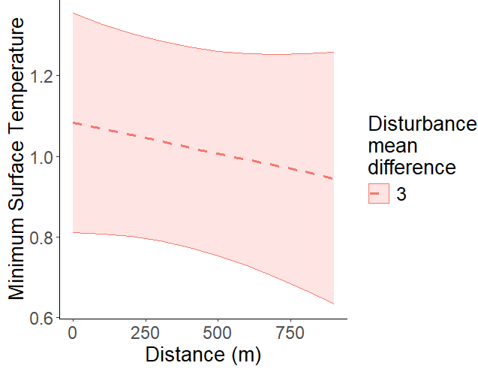 | 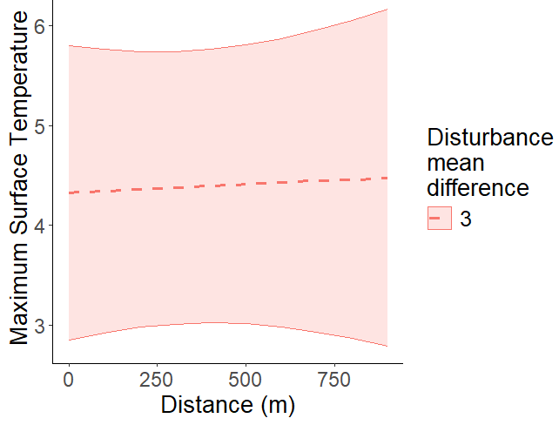 | 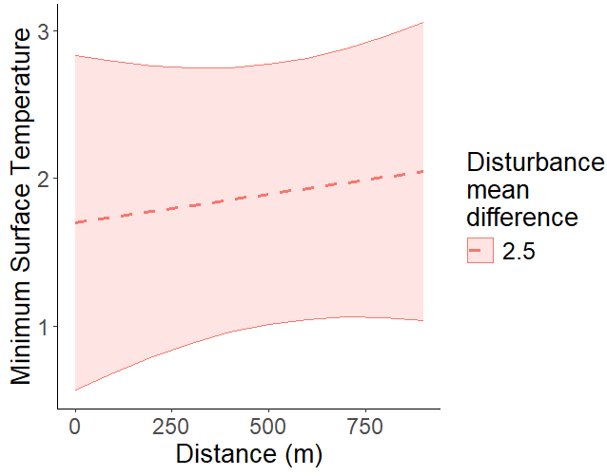 | 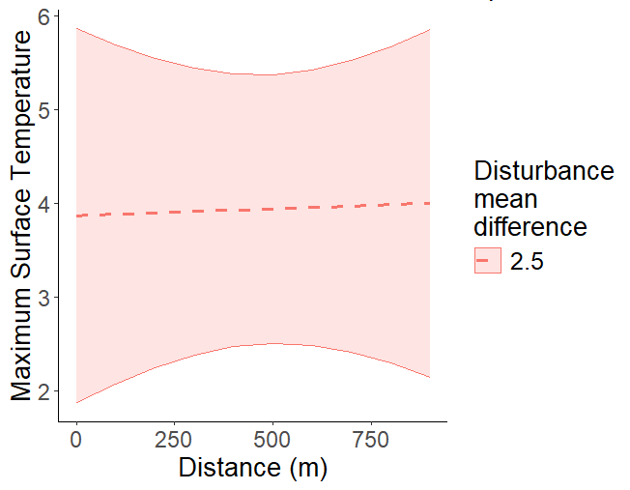
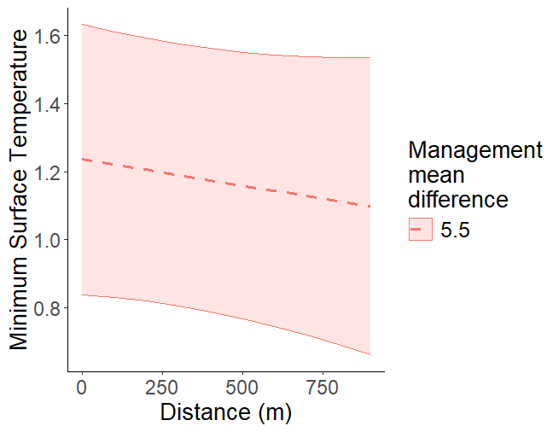 | 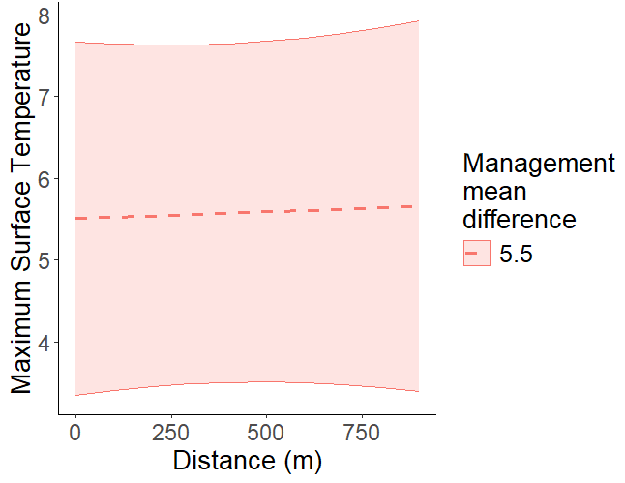 | 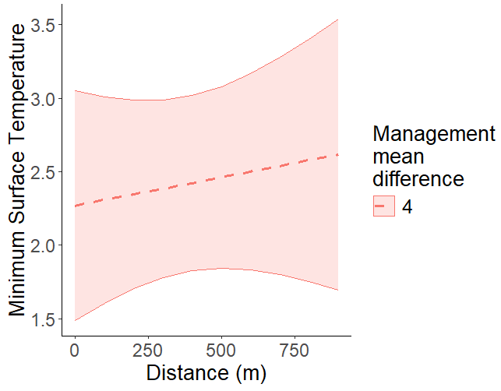
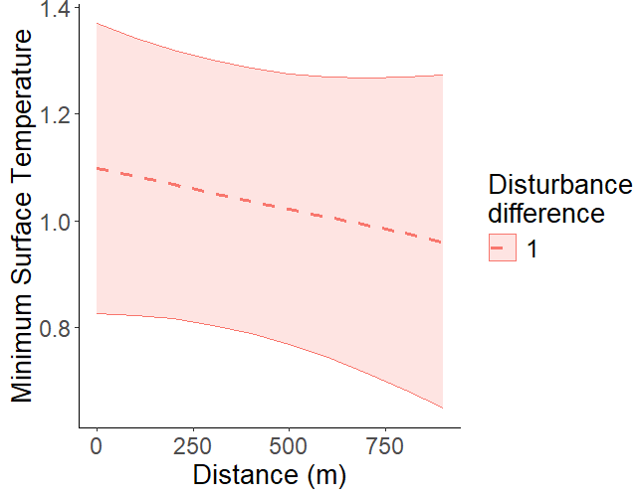 | 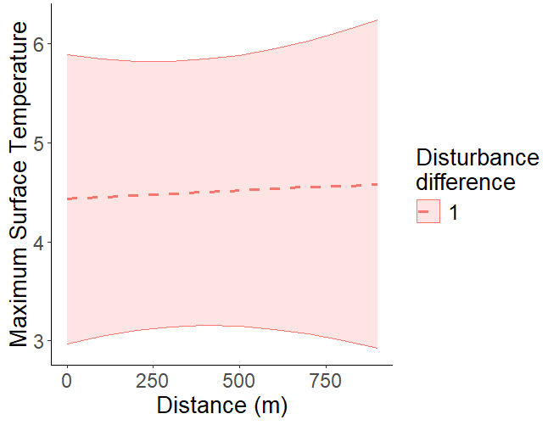 | 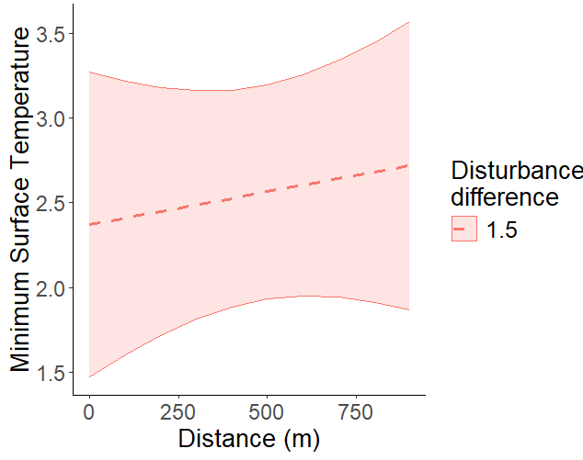 | 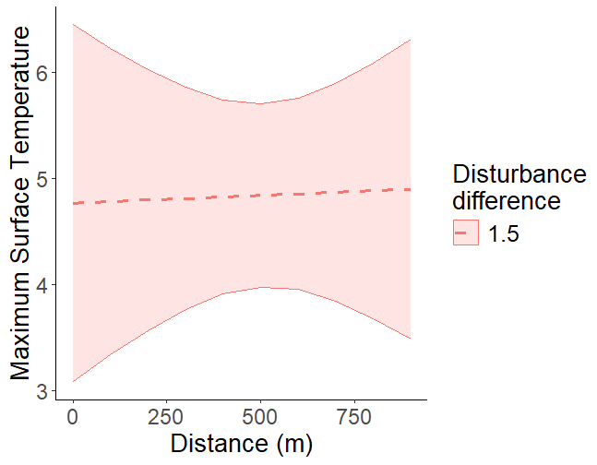
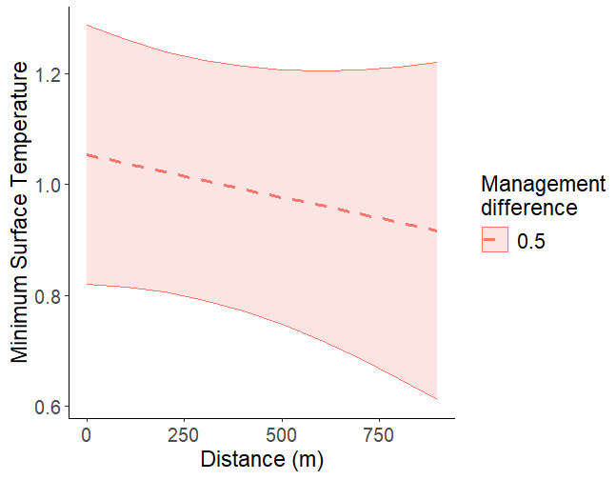 | 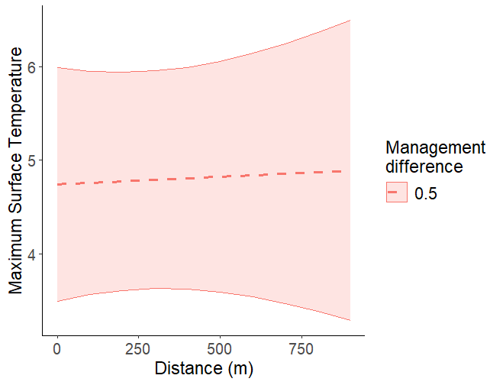 | 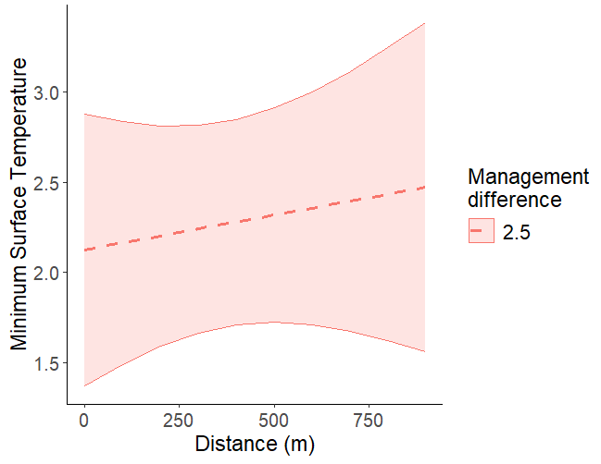 | 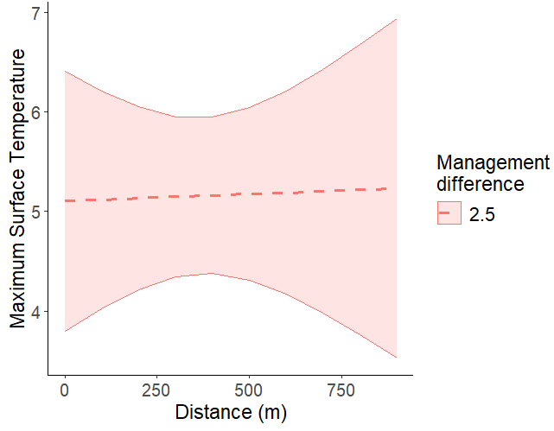
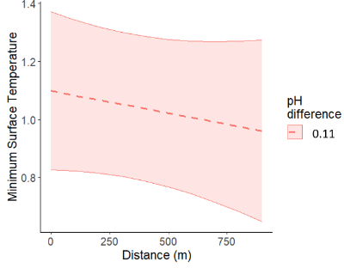 | 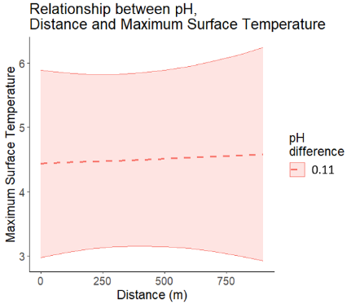 | 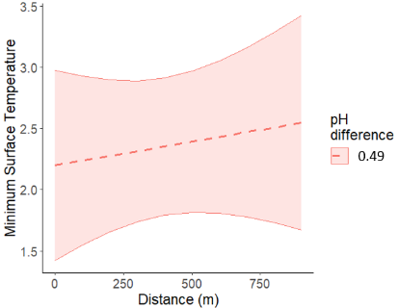 | 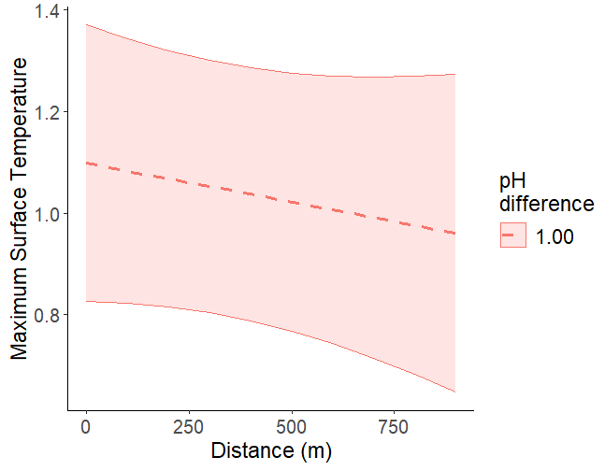
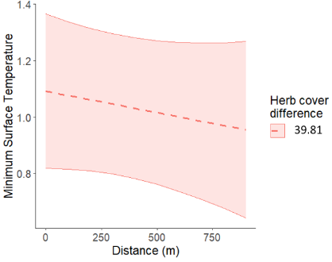 | 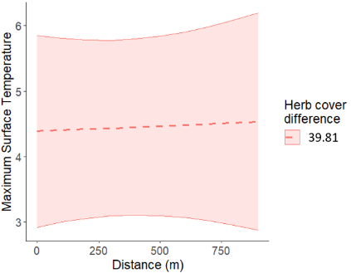 | 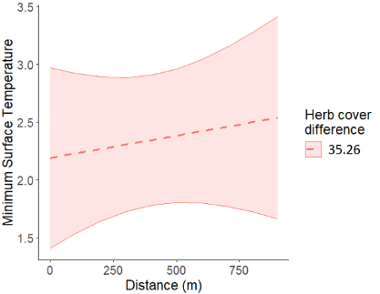 | 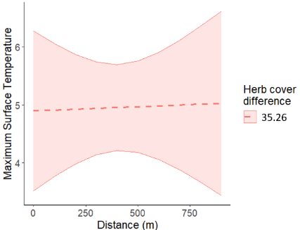
 |  |  | 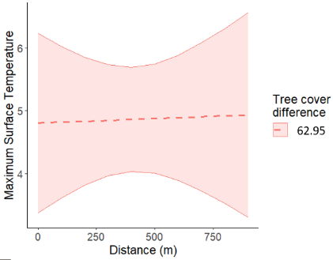
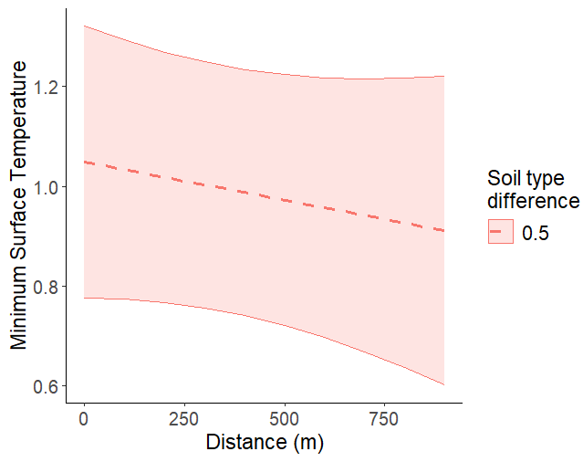 | 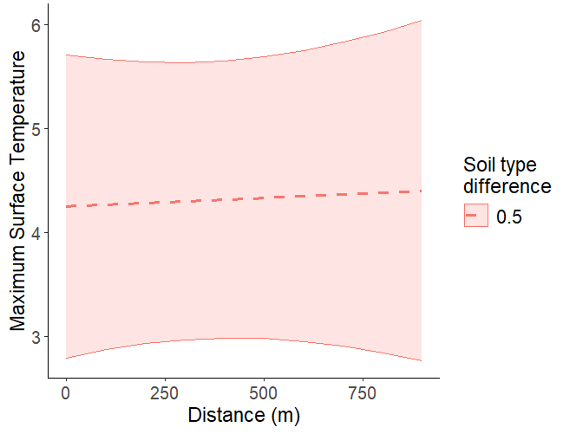 | 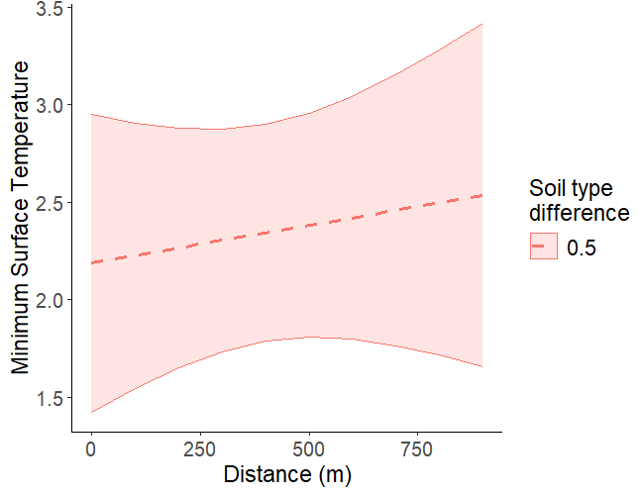 | 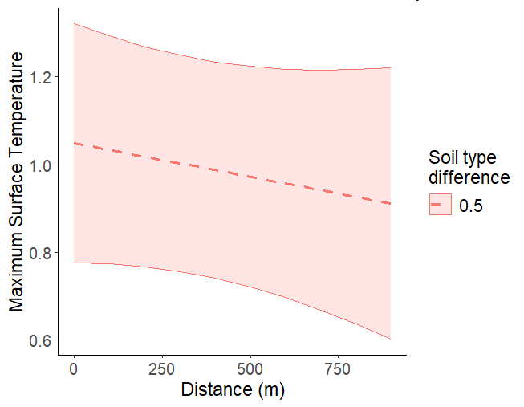
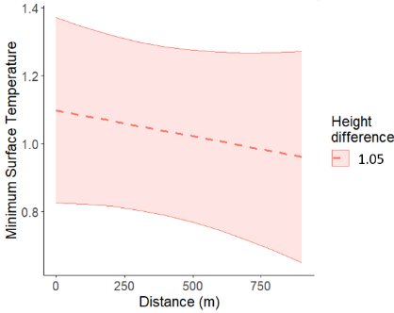 | 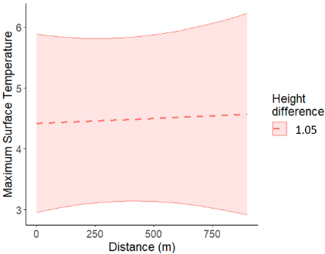 | 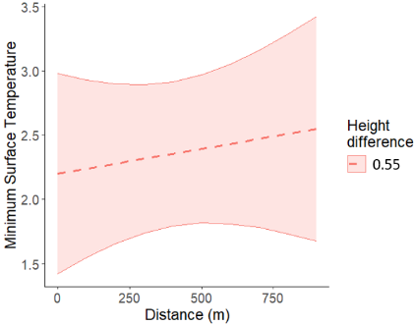 | 