3D modelling of the synovium in Psoriatic Arthritis

Hannah Rhodé van der Kooij
0497274
Molecular and Cellular Life Sciences (MCLS),
Utrecht University

Supervisor | Assessor | Examiner
Bennie van Heeswijk (MSc.) | Dr. Erik Lubberts | Dr. Theo van den Broek
Department of Rheumatology,
Erasmus University Medical Center
July 2025

Table of Contents
Table of Contents 1
Abstract 2
Methods 7
Results 12
Discussion 22
Layman’s summary 26
Acknowledgements 27
AI statement 27
References 27

Abstract
Psoriatic arthritis (PsA) is a chronic inflammatory joint disease affecting approximately one third of patients with psoriasis. Joint inflammation is characterized by synovial hyperplasia and immune cell infiltration, including monocytes that differentiate into macrophages upon tissue entry. Despite growing insights into its pathogenesis, there is still no cure for PsA, highlighting the continued need for translational research to improve treatment strategies. However, current two dimensional (2D) in vitro models often fail to recapitulate the complex architecture and cell-cell interactions of the synovial tissue.
To address this, we developed a three dimensional (3D) in vitro model that mimics key features of the inflamed PsA synovium. PsA derived synovial fibroblasts were cultured in Matrigel, forming a synovial-like lining within 7 days. CD14⁺ monocytes were added to mimic immune cell infiltration, and a flow cytometry panel was designed to assess monocyte-to-macrophage differentiation after 3D co-culture. Upon co culture, the model showed increased production of IL-6, IL-8, MMP3, and CCL20. These inflammatory mediators are involved in immune activation, cartilage degradation, and immune cell recruitment. This 3D synovial model offers a relevant and accessible platform for studying PsA pathogenesis and immune infiltration in vitro.

Introduction
Psoriatic arthritis (PsA) is a chronic autoimmune disease characterized by inflammation of the synovial tissue, a specialized tissue lining the joints such as in the knees, shoulders, and hands. This tissue plays a crucial role in joint health by producing synovial fluid, which lubricates the joint and improves movement. The synovium itself consists of two distinct layers: the lining layer, which is in direct contact with the joint cavity and contains synovial fibroblasts and synovial macrophages responsible for maintaining the homeostasis of cartilage and the synovial fluid. Underneath the lining is the sub lining layer, which is rich with blood vessels, immune cells, and additional fibroblast subsets that contribute to immune regulation and extracellular matrix remodeling. Synovial fibroblasts are specialized stromal cells that play a central role in maintaining joint homeostasis and mediating inflammatory responses. They are broadly classified into two anatomically and functionally distinct subsets: lining fibroblasts and sub lining fibroblasts. These subsets can be distinguished using specific cellular markers. Synovial fibroblasts typically express Podoplanin (PDPN), but sub lining and lining fibroblasts differ in co-marker expression. While sub lining fibroblasts are often marked by THY1+ (CD90) expression, lining fibroblasts are generally THY1-. General fibroblast markers, such as CD34 and fibroblast activation protein (FAP), are also commonly used to identify fibroblast populations across both compartments¹. Another key component of synovial tissue are synovial macrophages, a specific type of tissue-resident macrophages (TRMs). These cells are permanently present in the synovial membrane and originate from embryonic progenitors. Their developmental origin is established early during embryogenesis. Synovial macrophages play a crucial role in maintaining tissue homeostasis by clearing cellular debris and promoting tolerance to non-toxic stimuli. Notably, these macrophages possess the ability to self-renew, ensuring the long-term maintenance of their population². In PsA, inflammation within the synovium leads to structural and cellular changes, including increased proliferation of synovial fibroblasts. These changes in cellular composition will lead to disruption of the synovial lining. Besides that, the synovial lining becomes infiltrated by immune cells, like monocyte-derived macrophages (MDMs)³. Unlike TRMs, MDMs originate from circulating CD14⁺ monocytes of hematopoietic origin and differentiate upon entering the synovial tissue into macrophages. These macrophages are broadly classified into two subsets: pro-inflammatory M1 macrophages, which are involved in pathogen clearance and amplification of inflammation. M1 macrophages mainly express surface markers CD80 and CD86. Both CD86 and CD80 can bind to the co-stimulatory receptor CD28 on T cells, providing essential signals that lead to T-cell activation. The second subset involves anti-inflammatory M2 macrophages, which aid in tissue repair, resolution of inflammation, and homeostasis. M2 macrophages are characterized by the markers CD206 and CD163, both of which play roles in pathogen scavenging and immune regulation. During active inflammation, M1 macrophages dominate, while in resolving or less active phases, the environment shifts toward M2 macrophage polarization to support healing and tissue remodeling⁴. In the context of PsA, infiltration of monocytes that differentiate into macrophages plays a key role in driving inflammation. These immune cells produce pro-inflammatory cytokines such as TNF α, IL 1β, and IL 6, which amplify inflammation and promote further recruitment of immune cells. The cytokines also activate synovial fibroblasts, stimulating them to release additional cytokines, matrix-degrading enzymes including matrix metalloproteinases (MMPs), and chemokines such as CCL20. This cascade leads to cartilage damage and the release of Damage Associated Molecular Patterns (DAMPs), which drive the cycle of inflammation and tissue destruction. Collectively, these processes result in persistent synovitis, characterized by joint pain, dysfunction, and progressive tissue damage⁵. Although various therapies are available for the treatment of PsA, a definitive cure remains elusive. This underscores the importance of gaining a precise understanding of the underlying mechanisms of this disease. Gaining deeper insight into the disease is crucial for developing therapies. In this context, translational research continues to play a key role in understanding the mechanisms that drive disease progression. To study PsA, laboratory research often relies on simplified two-dimensional (2D) culture models, typically involving synovial fibroblasts co-cultured with key immune cell types such as T cells or monocytes. These models provide a valuable and controlled platform for looking into cellular interactions and inflammatory pathways. However, conventional 2D cultures fall short in mimicking the complex and dynamic cell–cell and cell–matrix interactions that occur within inflamed joint tissues, limiting their clinical relevance. Mice models have been used for studying more complex immune cell interactions and testing new therapies in diseases such as rheumatoid arthritis⁶. Yet, direct translation of findings from mouse models to humans is challenging due to fundamental differences in immune system function. Therefore, it is essential that results obtained in animal studies are validated using human-based systems. To address the limitations of both simple 2D cultures and animal models, the research field is increasingly shifting toward the development of advanced in vitro systems that better replicate human biology. Three-dimensional (3D) models are being developed to more accurately reflect the cellular composition and extracellular matrix of human tissues. These include self-renewing organoids containing stem cells, as well as spheroid models composed of one or more cell types. Such models offer broad applicability across various research fields, including oncology, gastroenterology, and neurology. Within rheumatology, similar efforts are now gaining momentum, with the goal of enabling human-relevant insights into the pathogenesis and treatment of PsA⁷. Several models have been developed to recapitulate synovial tissue architecture, including the behavior of synovial fibroblasts. The synovial lining is characterized by a condensed cell layer in which cells are embedded within a meshwork of the extracellular matrix ⁸. When synovial fibroblasts are embedded in a 3D matrix such as Matrigel, they self-organize into a layered structure that resembles native synovial lining ⁹. Adding CD14+ monocytes isolated from peripheral blood mononuclear cells (PBMCs) to mimic the immune cell infiltration that occurs during inflammation. In these models, a reduction in CD14+ surface maker expression was observed, which could reflect monocyte-to-macrophage differentiation within the 3D environment ¹⁰. Upon exposure to therapeutic agents, these 3D cultures reproduce synovial inflammation by secretion of cytokines and tissue remodeling, demonstrating their functional relevance¹¹. The inclusion of endothelial cells has been shown to further enhance the formation of a functional synovial lining within such 3D cultures and can support the study of angiogenesis in the context of RA¹².
In this study, we present a novel 3D model for PsA, which, to our knowledge, is the first to utilize fibroblasts derived from PsA patients. It is important to note that previous models have predominantly employed fibroblasts from RA patients, and that RA and PsA are distinct diseases with differing pathophysiological features. We demonstrate that PsA fibroblasts embedded in a 3D Matrigel matrix self-organize into a synovial lining-like structure. Unlike other models that require large numbers of fibroblasts, our approach is designed to be more practical and improve throughput. We show that as few as 50,000 fibroblasts are sufficient to form a synovial lining within the 3D matrix and confirmed these observations with histology staining. To mimic immune cell infiltration observed in the synovium, we incorporated CD14⁺ monocytes into the 3D model. To characterize whether monocyte-macrophage differentiation happens in the model, we developed a flow cytometry panel targeting a broad range of macrophage surface markers. We are the first to use flowcytometry after 3D culture within a Matrigel. Our data confirms the presence of CD68⁺ cells within the 3D co-culture. This provides new opportunities to investigate the changes in cell composition in 3D culture. Besides looking into the cellular profiles upon 3D culture, we explored the inflammatory landscape of the model by analyzing cytokine secretion profiles in 3D co-cultures and monocultures. We show that co-culture of fibroblasts and monocytes within a 3D model induces the production of pro-inflammatory stimuli including IL-6, IL-8, MMP3, and CCL20. Upon stimulation with pro-inflammatory cytokines such as TNF-α, C- reactive protein (CRP), or IL-6, we observed changes in the secretion of the 3D cultures.
This 3D PsA model offers a relevant platform for studying synovial inflammation and immune cell interactions, providing valuable insights into the underlying mechanisms of PsA. Furthermore, it holds potential as an ex vivo system for investigating drug responses and immune cell interactions with synovial fibroblasts within a tissue-like environment.

Methods
Cell culture
Synovial fibroblasts were isolated from synovial biopsies obtained from patients diagnosed with psoriatic arthritis (PsA). Cells were cultured in Dulbecco’s Modified Eagle Medium (DMEM) supplemented with 10% fetal calf serum (FCS) and penicillin/streptomycin (P/S) in T75 culture flasks. The culture medium was refreshed twice weekly, and cells were passed upon reaching confluence. For experimental use, cells were utilized up to passage 8.
Magnetic associated cell sorting (MACS)
Classical monocytes (CD14+) were isolated from peripheral blood mononuclear cells (PBMCs) using CD14+ MicroBeads (Miltenyi Biotec, Cat. No. 130-050-201) in combination with magnetic-activated cell sorting (MACS). The isolation procedure was carried out according to the manufacturer’s instructions. Following initial preparation, the cell suspension was processed using the autoMACS® NEO Separator (Miltenyi Biotec), following the automated protocol provided by the manufacturer.
Coating with Poly-HEMA
24-well culture plates were coated with poly(2-hydroxyethyl methacrylate) (Poly-HEMA; Sigma-Aldrich, Cat. No. 1003355348). The required amount of Poly-HEMA was dissolved in ethanol preheated to 60 °C. Once fully dissolved, 1 mL of the solution was added to each well. Plates were then air-dried overnight in a sterile culture hood to allow complete evaporation of ethanol.
3D Synovial culture generation
Preparations
Prior to 3D generation the Matrigel was allowed to thaw on ice O/N. On the day of culture, PBS, Trypsin, and EGM-Plus media were heated to 37°C. Poly-HEMA coated plates were brought to 37°C. Fibroblast cultures were checked for health and a confluency of around 80% using an inverted light microscope.
Cell harvesting
The media was aspirated from the culture flasks and gently rinsed with approximately 10 ml of 1X PBS. PBS was aspirated, and 2 ml Trypsin was added to each T75 flask. Cells were allowed to detach for 2-4 minutes in a 37°C incubator, while tapping to improve detachment. Preheated DMEM (1% P/S, 10% FCS) (8 ml) was added to stop trypsinization. The cell suspension was centrifuged, and the pellet was resuspended in preheated DMEM (1% P/S, 10% FCS). The cell suspension was transferred through 70 µm strainer, and the culture flask/thawing tube was rinsed with an additional DMEM (1% P/S, 10% FCS), which was also added through the strainer. The cell suspension was centrifuged again, and the pellet was suspended in 1 ml DMEM (1% P/S, 10% FCS). Cell viability and count were determined with Tryptan Blue.
Preparation of Matrigel/Cell-Suspension Master Mix for co-cultures or monocultures.
The correct number of cells was pooled into a pre-chilled 15 ml tube. For monoculture plating, 5.0x10^4 fibroblasts were used. For co-culture plating, fibroblasts and monocytes were combined at a 1:1 ratio. An optimal concentration of 5.0x10^4 cells per 3D culture was maintained for co-cultures.
The cell suspension was centrifuged at 300x g for 10 minutes at 4°C. The supernatant was aspirated, leaving approximately 50-100 µl without disturbing the cell pellet. The cell pellet was centrifuged 300x g for 10 minutes at 4°C. As much supernatant as possible was carefully removed without disturbing the pellet. The pellet was loosened by firmly tapping the bottom of the tube on the bench and stored on ice. The cells were gently re-suspended in the required volume of Matrigel and kept on ice, allowing microscopic air bubbles to rise to the surface and be eliminated over 15-20 minutes.

Plating of Matrigel/Cell-Suspension and subsequent culturing
3D cultures of 25 µl of Matrigel/cell-suspension were pipetted into the center of the wells in poly-HEMA coated culture plates. The plate was carefully placed into a 5% CO2, 85% relative humidity, 37°C incubator for one hour to allow the Matrigel to polymerize. Once the Matrigel was polymerized, pre-warmed DMEM (1% P/S, 10% FCS) was added dropwise directly onto the culture plate. The plates were carefully returned to the 37°C, 5% CO2, 85% relative humidity incubator. The media was routinely changed twice per week, by carefully removing 50% of the medium and replacing it with fresh, warm DMEM (1% P/S, 10% FCS).
The 3D’s were cultured up to 21 days and were harvested for downstream analysis by histology or flow cytometry.
Cytokine stimulation
The well-formed 3D model was stimulated with pro-inflammatory stimuli from D14 until D21. The stimuli included TNF-α (10 ng/mL), IL-6 (10 ng/mL) or C-reactive protein (25 µg/ml). Treatment was refreshed by removing 50% of the culture supernatant and adding twice the concentration to get the mentioned concentration in the culture plate. For experiments with CRP or TNF-α, the culture supernatant was completely removed at D14 before stimulation (Fig. 5).

Flow cytometry
For flow cytometry staining, PBMCs or SFMCs were thawed and plated. For staining of 3D cultures, a pre-incubation with Corning® Cell Recovery Solution (CLS354270, Corning) was used for the depolymerization of gelled Matrigel matrix for 30-60 min at 4°C.
Next, the sample pellets were washed with PBS and incubated for 15 min with monoclonal antibodies of the following cell surface markers: CD14 (monocyte marker), CD16 (monocyte marker), CD11c (monocytes and macrophages), CD86 (M1 macrophage), CD80 (M1 macrophage), CD163 (M2 macrophage), CD206 (M2 macrophage), or PDPN (fibroblasts marker). Internal staining for CD68 (macrophage marker) was performed with the eBioscience™ Foxp3 / Transcription Factor Staining Buffer Set (00-5523-00, Invitrogen™) following the manufacturers protocol. Further details are provided in Table 1.
Samples were measured by Cytek® Aurora (Cytek), and data were analyzed with SpectroFlo® software (Cytek) and FlowJo (BD Biosciences).

Table 1. Flow cytometry panel
Marker | Fluor chrome | Target cells | Dilution | Clone | Company | Catalogue number | Channel (Aurora)
CD14 | Brilliant Ultraviolet 615 | Monocytes | 1:125 | M5E2 | BD Biosciences | 751150 | UV10
CD16 | Pacific Blue | Monocytes | 1:1280 | 3G8 | Sony | 2110160 | V3
CD68 | RealBlue 705 | Macrophages | 1:20 | Y1/82a | BD Biosciences | 570646 | B10
CD11c | Alexa Fluor 488 | Macrophages | 1:640 | Bu15 | Biolegend | 337236 | B2
CD163 | PE-Cy7 | M2 macrophage | 1:20 | GHI/61 | Biolegend | 333614 | YG3
CD206 | Brilliant Violet 711 | M2 macrophage | 1:20 | 19.2 | Invitrogen | 407-2069-42 | V13
CD86 | Red 718 | M1 macrophage | 1:80 | 2331 (FUN-1) | BD Biosciences | 567071 | R4
CD80 | Brilliant Violet 786 | M1 macrophage | 1:20 | L307.4 | BD Biosciences | 564159 | V15
LD | Ghost Dye Red 780 | Live dead stain | 1:8000 | N/A | Cytekbio | 13-0865-T100 | R7
PDPN | PerCP-eFluor 710 | Fibroblasts | 1:40 | NZ-1.3 | Invitrogen | 46-9381-42 | B10

Enzyme-Linked Immunosorbent Assay
Culture supernatants were analyzed using Enzyme-Linked Immunosorbent Assay (ELISA) kits according to the manufacturer’s instructions. Further details of the ELISA kits are provided in Table 2.
Table 2. ELISA kits
Target | Company
Human Total MMP-3 | R&D Systems (DY513)
Duoset Human CCL20/MIP-3α | R&D Systems (DY360)
Duoset Human IL-6 | R&D Systems (DY206)
Human TNF alpha Uncoated ELISA kit | Invitrogen by Thermofisher Scientific (REF: 88-7346-88)
Human IL-8 Uncoated ELISA kit | Invitrogen by Thermofisher Scientific (REF: 88-8086-880
Human IL-1β Uncoated ELISA kit | Invitrogen by Thermofisher Scientific (REF: 88-7261-88)

Histology
After culturing the 3D for 14-21 days, samples were fixed in 10% formalin for 15 minutes to preserve cellular architecture. Fixed cultures were embedded in 2% agarose to provide structural support during processing. Subsequent histological procedures, including dehydration and paraffin embedding, were performed by the Pathology Research and Trial Service (PARTS) facility at Erasmus MC. Formalin-fixed, paraffin-embedded (FFPE) sections were deparaffinized using xylene and rehydrated through a graded ethanol series. Sections were stained with Mayer’s hemalum solution (Sigma-Aldrich, Cat. No. 1.09249.2500) followed by eosin staining (Polysciences, Cat. No. 09859-1000). Finally, stained sections were mounted using DPX mounting medium (Scharlau, Cat. No. DP00500100). The complete staining protocol is provided in Table 3.
Table 3.
Solution | Time
Xylene | 5 min
Xylene | 5 min
100% Ethanol | 2 min
100% Ethanol | 2 min
95% Ethanol | 2 min
70% Ethanol | 2 min
Water wash | 2 min
Hematoxylin | 3 min
Water wash (under running tap water) | ~10 min (check color)
95% Ethanol | 1 min
Eosin | 30-45 sec
95% Ethanol | 2 min
100% Ethanol | 2 min
100% Ethanol | 2 min
Xylene | 2 min
Xylene | 2 min
Mounting + Coverslip | End

Results
Development and modulation of the PsA 3D synovial model
We developed a 3D model using PsA-derived synovial fibroblasts embedded in Matrigel. Within 7 days, fibroblasts form a 3D structure in Matrigel. The structure is characterized by cell–cell interactions and spontaneous contraction of the matrix (Fig. 1A). We initially cultured 200,000 fibroblasts per well this established protocol is based on existing literature. The 3D model robustly formed a synovial-like lining, which we confirmed by histological staining (Fig. 1B).
To improve the model’s scalability and increase experimental throughput, the system was optimized by reducing the required number of synovial fibroblasts to 50,000 cells. Remarkably, even at lower seeding densities, fibroblasts could form clear cell–cell interactions and lining structures, indicating that fewer cells suffice for synovial architecture formation (Fig.1C&E).
To mimic monocyte infiltration during synovial inflammation, CD14⁺ monocytes isolated from buffy coats were co-cultured with synovial fibroblasts in the 3D model. After 7 days of culture, fibroblast monocultures formed well-organized 3D structures with clear cell–cell interactions and distinct lining formation. In contrast, co-cultures showed less pronounced 3D organization, reduced cell–cell contacts, and diminished lining formation (Fig. C&D). These findings suggest that monocyte integration disrupts early tissue organization within the first 7 days. While fibroblast monocultures reach a stable structure within this period, co-cultures require more time to establish comparable 3D architecture. Therefore, an extended culture period of up to 14 days was applied prior to stimulation or flow cytometry processing to allow further structural development of the co-culture.
To study the effects of inflammation on 3D formation, cultures were treated with TNF-α. Early TNF-α exposure (day 0–3) inhibited cell–cell interactions, contraction and organization of the 3D matrix as observed in untreated controls (Fig. 2A). Furthermore, TNF-α treatment of established 3D structures from day 7 to day 14 led to a breakdown and impaired further maturation of the 3D structure (Fig. 2B). In contrast, untreated controls continued to develop into a well-defined, rounded 3D structure with increased complexity (Fig. 2C).

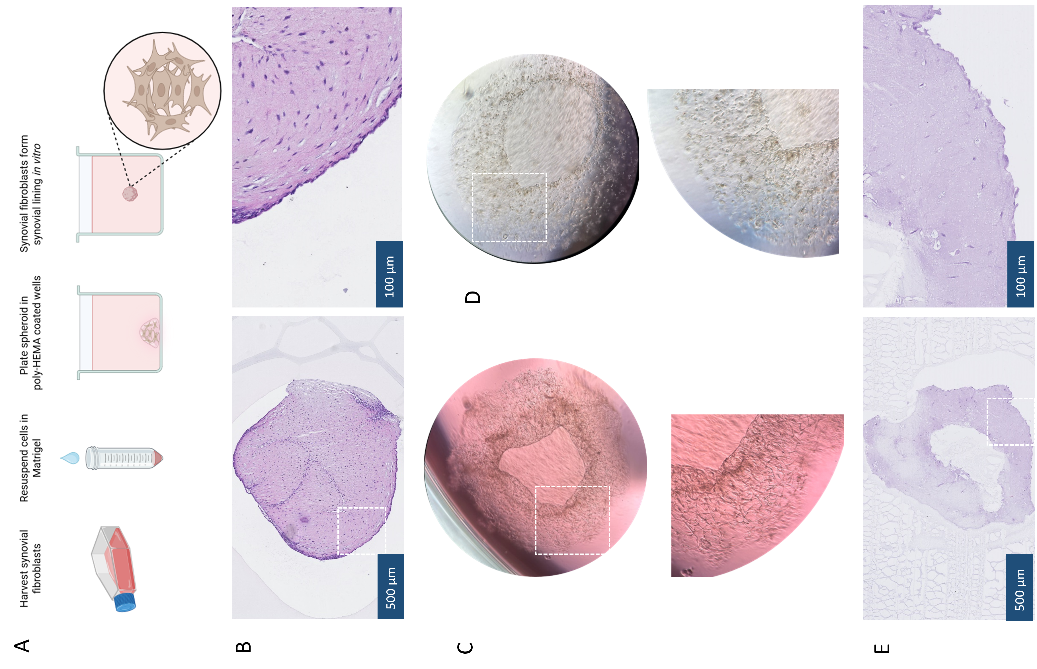
Fig. 1 - Development of an in vitro 3D model for studying Psoriatic arthritis
a) Schematic overview of the protocol used to establish 3D cultures of synovial fibroblasts; b) Histological section of a 7-day-old 3D culture containing 200,000 synovial fibroblasts; c) 3D structure of a culture with 50,000 synovial fibroblasts at day 7; d) 3D co-culture of 50,000 synovial fibroblasts and 50,000 monocytes (1:1 ratio) at day 7; e) Histological section of a 7-day-old 3D culture with 50,000 synovial fibroblasts. Histological sections were stained with Hematoxylin (purple) and Eosin (pink) according to the protocol described in Table 3. Images were acquired at 5× magnification (scale bars: 500 μm); zoom-in images were taken at 20× magnification (scale bars: 100 μm) (B & E).

100
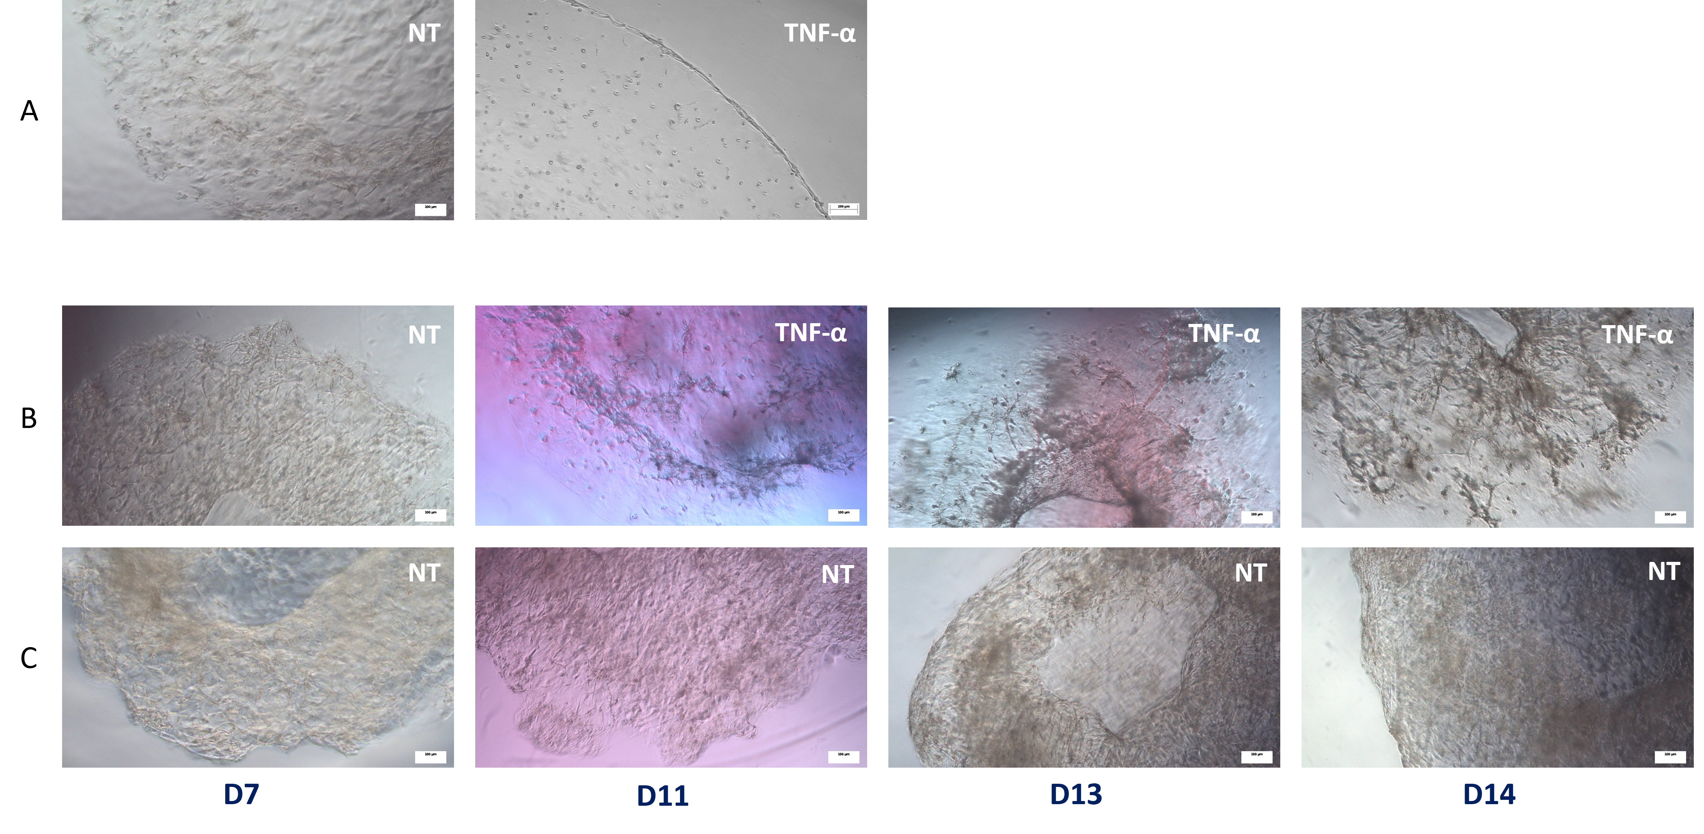
Fig. 2 - Effects of TNF-α on 3D formation in early and later stages of culture
a) Treatment with TNF-α (10 ng/mL) during the first 3 days of culture compared to non-treated (NT) control; b) Treatment with TNF-α (10 ng/mL) applied from day 7 to day 14 of 3D culture. Scale bars represent 100 μm.

Cytokine secretion upon co-culture and cytokine stimulation
To further explore the functionality of our 3D model, we investigated its cytokine environment, particularly in response to the addition of monocytes. Previous results indicated that monocytes influence lining formation within the model, suggesting potential crosstalk with fibroblasts. To assess whether such interactions induce cytokine secretion, we performed ELISA on supernatants collected during the first 14 days of culture. Samples were derived from monocultures of fibroblasts (F) or monocytes (M), as well as from fibroblast–monocyte co-cultures (F+M).
Supernatants of monocytes monocultures did not contain Il-6, IL-8, or MMP (Fig. 3A-C). CCL20 is secreted in low amounts of monocyte cultures (Fig. 3D). In fibroblasts monocultures we observed an increase for IL-6 and IL-8 secretion from day 4 till day 14 (Fig. 3A-B). For MMP3 we observe that it is present on day 4 and day 7, but at later time points there is no MMP3 present anymore (Fig. 3C). On day 10 the secretion of CCL20 is at its peak, after which the levels decrease again (Fig. 3 D). For co-cultures we see the same trend for the CCL20. Even though the trend is the same for both fibroblast monocultures and co-cultures, the levels of CCL20 are higher in co-culture (Fig. 3 D).
Co-cultures showed high levels of pro-inflammatory cytokines IL-6 and IL-8 at all measured time points (Fig. 3 A-B). For IL-6 and IL-8, the levels of co-culture supernatants reached the detection limit. Therefore, the differences between cultures could not be detected. Therefore, we would have to repeat these ELISA’s with different dilutions for these cytokines. For MMP3, we observed variability between buffy coats and culture days, but it is clear that the co-culture induces the production of MMP3. We observe that monocultures of monocytes do not secrete MMP3. For fibroblasts monocultures we observe low secretion for MMP3 at day 4 and day 7 but at later time points it is no longer present (Fig. 3C).
Overall, we observe that co-culture induces the production of pro-inflammatory mediators in higher levels than monocultures (Fig. 3). Other factors, including IL-1β, GM-CSF, and TNF-α, were also assessed but were not detected in the supernatants of either co-cultures or monocultures (data not shown).

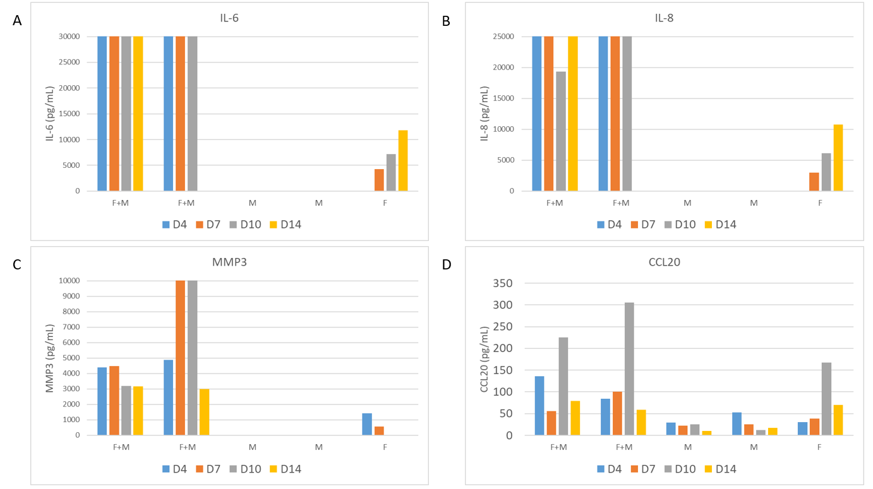
Fig. 3 - Cytokine secretion by 3D co-cultures (F+M) and monocultures (fibroblasts (F) or monocytes (M))
a–d) Cytokine secretion levels of IL-6, IL-8, MMP3, and CCL20 (pg/mL) measured with ELISA in 3D co-cultures of synovial fibroblasts and monocytes, as well as in monocultures (fibroblasts or monocytes), during the first 14 days of culture. ELISAs for MMP3, IL-6, and IL-8 reached detectable levels in fibroblast–monocyte (F+M) co-cultures.

Differential Effects of TNF-α, IL-6 and CRP on Cytokine Secretion in a 3D Synovial Model
We investigated the effect of different pro-inflammatory stimuli and assessed the cytokine secretion of the 3D model. We stimulated the cultures with TNF-α, IL-6, or CRP. TNF-α and IL-6 are both important cytokines in the pathogenesis of PsA. These cytokines play roles in immune activation and contribute to inflammation¹³. Treatment with C-reactive protein (CRP), an acute-phase protein produced during inflammation, has been shown to promote inflammatory responses by stimulating immune cells to produce pro-inflammatory mediators. In monocytes, CRP specifically induces the production of cytokines such as IL-1β, TNF-α IL-23, and IL-6¹⁴.
Well-formed 3D structures were treated with IL-6, TNF-a, or CRP from day 14 to day 21. We investigated the cytokine response upon stimulation with these pro-inflammatory mediators (Fig. 4 and Fig 5). First, we compared the effects of TNF-α or IL-6 treatments on cytokine secretion. Secretion of MMP3 and CCL20 was low in untreated conditions, particularly in fibroblast monocultures, with only a modest increase observed upon co-culture with monocytes (Fig. 4A). Stimulation with TNF-α resulted in higher MMP3 and CCL20 secretion in the co-cultures, and a smaller but noticeable increase in fibroblast monocultures. In both co-cultures and fibroblasts monocultures that were treated with TNF-α, the peak of CCL20 and MMP3 secretion is at D18 (Fig. 4B & E).
Stimulation with IL-6 did not induce a noticeable difference in cytokine secretion of CCL20 compared to untreated controls (Fig. 4 D&F). For MMP3 secretion there is a difference between buffy coats; one co-culture shows an induction of MMP3 upon treatment with IL-6, while the other one is not induced upon treatment (Fig. 4F).

Next, we mimicked early synovial inflammation within the synovium with CRP treatment. 3D mono- and co-cultures were treated with either CRP or TNF-α treatment (Fig. 5). IL-8 secretion showed a modestly altered pattern: while untreated cultures displayed an increase in IL-8 from day 18 to day 21, this increase was less pronounced in CRP-treated cultures (Fig. 5 A&C). In contrast, treatment with TNF-α altered cytokine secretion profiles (Fig. 5B). Focusing on IL-6 secretion levels, the CRP-treated cultures remained comparable to untreated conditions, suggesting a limited effect of CRP (Fig. 5 D&F). IL-6 secretion was strongly induced by TNF-α at day 18 and day 21 in both fibroblast monocultures and co-cultures, approximately a twofold increase compared to untreated conditions (Fig. 5E). In this case, it looks like the presence of monocytes does not further induce IL-6 secretion. Notably, treatment with either CRP or TNF-a did not induce secretion of TNF-α, IL-1β, IL-23, or GM-CSF (data not shown).

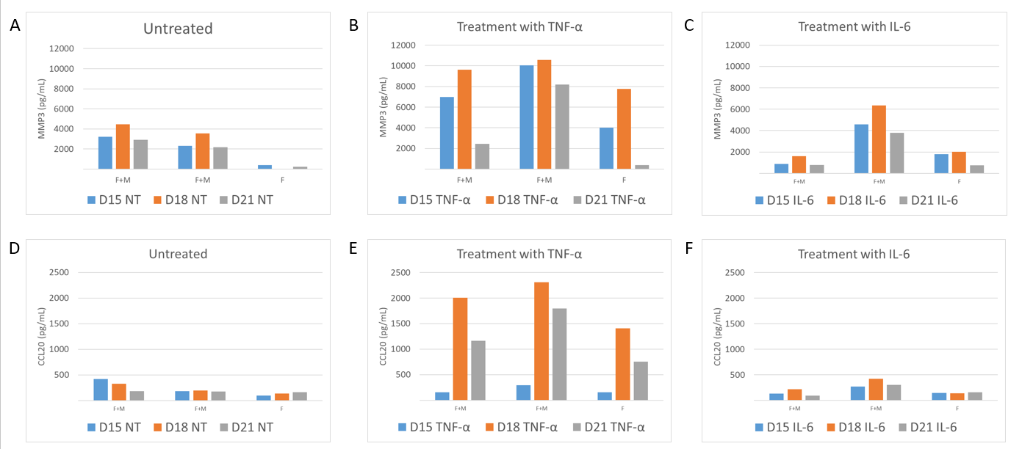
Fig. 4 - Pro-inflammatory stimulation of established co-cultures and fibroblasts monocultures
a-c) MMP3 (pg/mL) secretion in culture supernatants of co-cultures vs. fibroblast monocultures at D15, D18 and D21; d-f) CCL20 (pg/mL) secretion in culture supernatants of co-cultures vs. fibroblast monocultures at D15, D18 and D21. Cultures were either left untreated (NT) or stimulated with TNF-α (10 ng/mL) or IL-6 (10 ng/mL).

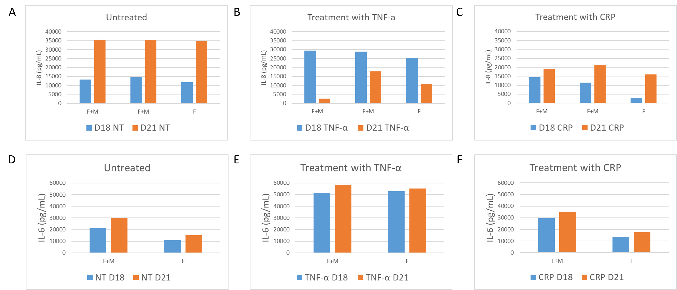
Fig. 5 - CRP treatment to mimic early inflammatory responses in the synovium.
a–c) IL-8 secretion (pg/mL) in culture supernatants of fibroblast–monocyte co-cultures versus fibroblast monocultures at days 15, 18, and 21; d–f) IL-6 secretion (pg/mL) in culture supernatants of the same conditions at days 18 and 21. Cultures were either left untreated (negative control) or stimulated with TNF-α (10 ng/mL) or C-reactive protein (CRP, 25 µg/mL).

Development of a flowcytometry panel for Macrophage subset identification within a 3D culture model for PsA
To assess the differentiation of monocytes to macrophages ex-vivo, we developed a flow cytometry panel. Each antibody was first titrated to determine its optimal staining concentration. Before building the flow cytometry panel, spectral compatibility was assessed to minimize spectral overlap between the fluorophores (Table 1). The panel was tested on buffy coats of PBMCs or synovial fluid mononuclear cells (SFMCs) from PsA. The gating started with selection of the cells, followed by selection of single cells and next live cells gating using live/dead staining. Next, we selected the CD14+ monocytes within the samples (Fig. 6A).
We see positive staining for the markers CD68, CD163, CD206, CD11c, and CD86 (Fig. 6B-F). CD80 was the only marker that showed no detectable signal in either PBMC or SFMC samples (data not shown). We visualized the staining using a histogram and for each marker we determined the Mean Fluorescence Intensity (MFI). Calculation of the MFI provides an indication of the expression level per marker within the CD14+ population. We observed that for each marker, the MFI is higher in SFMCs compared to PBMCs. These findings suggested that all cells within both sample types were positive for monocyte, macrophage, and specific M1/M2 markers, indicating that this panel could be used to track differentiation in our 3D cultures.
We tested staining of CD14, PDPN, and CD68 after 3D co-culturing of 14 days (Fig. 7A). The marker PDPN is highly specific for fibroblasts and CD14 specific for monocytes. We can use these markers to distinguish these cell populations after growth within the 3D model. We plotted CD14+ against CD68+ and we observe that all CD14+ are also positive for CD68. This could mean that monocyte-to-macrophage differentiation happened in our 3D model; however, additional staining is required to fully confirm this (Fig. 7A). The additional markers within the panel showed no positive staining after 3D culture. To further characterize the cells in our 3D model, we also examined their auto fluorescent profiles. We showed the auto fluorescent pattern of monocytes derived from PBMCs (Fig. 7B). As shown, the pattern of unstained monocytes had only two peaks in the UV and violet channels, and a small peak in the blue channel. The left part of the spectral pattern included channels for yellow-green and red, where the auto fluorescent signal was low. We compared this pattern to that of unstained monocytes after 3D culture and observed higher signals across the entire spectrum (Fig. 7C). From these findings we concluded that auto fluorescent emission changed upon 3D culture in Matrigel.
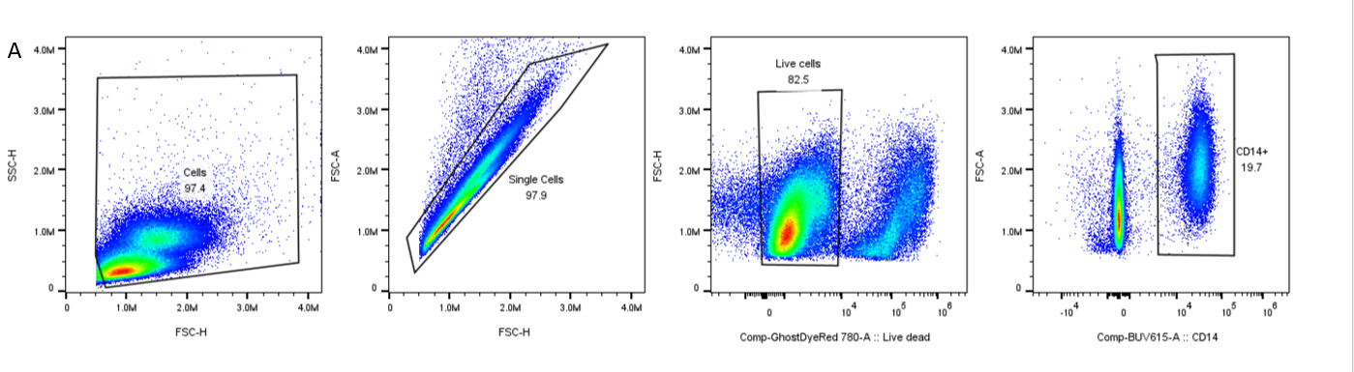
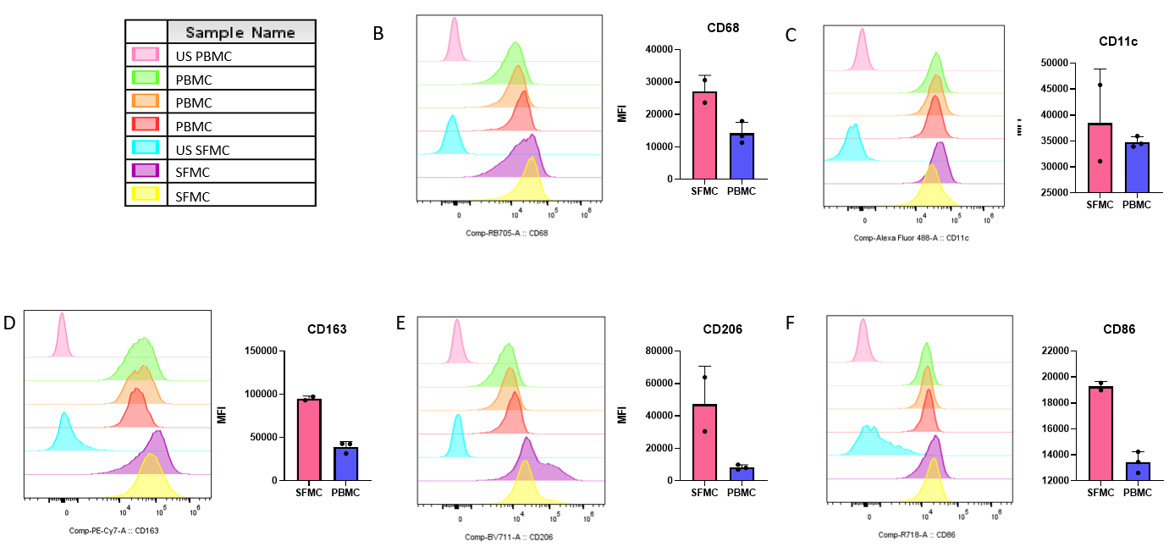
Fig. 6 - Ex-vivo staining of PBMCs and SFMCs derived from PsA patients
a) Gating strategy for selection of CD14+ monocytes from PBMCs or SFMCs; b-f) Histogram and calculated MFI (Mean Fluorescence Intensity) for each marker in the macrophage panel including CD68, CD11c, CD163, CD206, and CD86. Legend represents the sample names of the colors in the histogram.

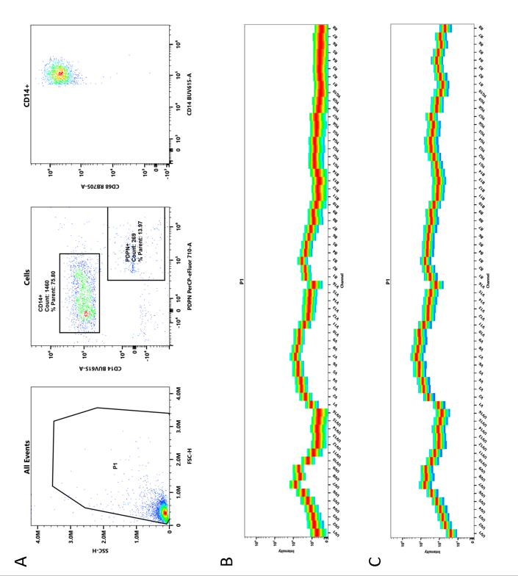
Fig. 7- Flow cytometry analysis of 3D cultures.
a) Gating strategy for identifying monocytes (CD14⁺), synovial fibroblasts (PDPN⁺), and CD68⁺ cells (CD68⁺CD14⁺); b) Autofluorescence profile of freshly isolated PBMC-derived monocytes; c) Autofluorescence profile of monocytes after 5 days of culture within the 3D model. Flow cytometry data were analyzed using the Spectro Flow software.

Discussion In this study, we presented a 3D model for studying PsA in vitro. We demonstrated that fibroblasts organize into a synovial-lining like structure within 7 – 14 days of culture. The fibroblasts form a well-formed 3D structure that is characterized by lining formation and cell-cell interactions. Our 3D model is practical and requires lower cell amounts than 3D models that were published for RA^{9,10}. The infiltration of immune cells during active disease was mimicked by adding CD14+ monocytes to our 3D culture model. The addition of these monocytes changed the speed of development and induced cytokine secretion by the 3D model. In this study, we developed a flow cytometry panel to investigate the potential of the 3D model to support monocyte-to-macrophage differentiation. This panel involves markers to select different cell populations including fibroblast, monocytes, and subsets of macrophages.
This is the first study that provides flow cytometry data after 3D culture. Publications on 3D culturing of the synovium only gave insight into the cell populations that were put into a 3D model but did not provide any data after 3D culturing ¹⁰. To build and optimize the panel, we used PBMC and SFMC samples from PsA patients. We provided evidence that most of the markers can be positively stained on PBMC and SFMCs. Only CD80 staining did not show positive staining in monocytes from PBMC or SFMC, while the titration did work (data not shown). This may be due to the need for a higher antibody concentration than initially titrated. In this study, we showed CD14+/CD68+/PDPN+ to distinguish key cell populations after 3D culture and investigate differentiation of monocytes after co-culture. We show evidence of CD68+ cells upon co-culture within our 3D model. Even though we tested the complete panel in 3D cultures, it has not yet performed optimally in 3D cultures. Therefore, staining with additional markers including CD80, CD86, CD206, and CD163 have not been confirmed on 3D cultures within this report. Here we discuss some reasons why these staining's are not working after 3D culture. First, we titrated all the antibodies of the panel on PBMCs or THP-1 cells. While these titrations give a good insight into the optimal staining concentrations, it is advisable to do titrations directly on 3D-cultured samples rather than on PBMCs or THP-1 cells. It might be possible that the titrations will give other optimal concentrations and in addition this control could improve the unmixing analysis. Second, we observe that the background signal after 3D culture changes compared to unstained monocytes from PBMCs (Fig. 7B&C). Change in autofluorescence influences staining with our flow cytometry panel. Possibly requiring stronger fluorophores for markers whose positive signal of the staining is surpassed by the increase in autofluorescence. Another, less fortunate possibility is that alle the monocyte cells die in our model, this could lead to an unspecific binding, false positive results and more autofluorescence (background signal). Therefore, we propose to further investigate cell survival within the 3D model, by performing viability assays at different time points during 3D culture. Once the panel is fully optimized, it will be possible to incorporate additional markers. For example, CD64 and Folate Receptor Beta (Frβ) could be included to further characterize myeloid cell populations ^{15,16}. Adding HLA-DR as a marker could provide valuable insights into the activation states of monocytes during co-culture experiments. To identify specific subsets of synovial fibroblasts within the 3D culture, markers that distinguish between the lining (THY1-) and the sub lining layer (THY1+) could be added in the future. Finally, assessing the activation state of fibroblasts is also possible when adding the Fibroblast Activation Protein (FAP) as a marker into this flow cytometry panel¹⁷. We showed that synovial fibroblasts form a lining in the 3D model and confirmed this with HE staining. The addition of CD14⁺ monocytes changed the 3D architecture and formation, and this was observed by brightfield imaging. Unfortunately, due to these structural changes, these co-cultures could not be processed for histological staining. The structural integrity of the 3D constructs was insufficient to undergo harvesting from the culture plate, embedding in agarose, and subsequent FFPE processing. This might be a consequence of less lining formation within the co-cultures. Furthermore, exposure to pro-inflammatory stimuli (TNF-α) disrupted the formation of compact 3D structures. These cultures were also insufficient for further histological processing. Optimization of the protocol could be useful to enable reliable histological analysis of co-cultures and stimulated cultures to confirm the observed morphological changes. Here, we use HE staining to confirm the lining formation; however, the field offers more advanced staining methods that could add even more insights into the complexity and characterization of the model. For example, staining of Cadherin-11 showed how this protein mediates lining formation by synovial fibroblasts ^{18,19}. In addition, the staining of MMPs’ using immunohistochemistry (IHC) could show where these mediators are formed within the 3D culture²⁰. We have shown ELISA data on MMP3 secretion by the 3D model but combining this with IHC staining could give information on where it is formed and by which cell type.
We assessed the cytokine secretion by our 3D model, and we demonstrated that co-culturing monocytes with fibroblasts induced the secretion of several pro-inflammatory cytokines, including IL-6, IL-8, MMP3, and CCL20. In contrast, these cytokines were either absent or, in the case of CCL20, present at only minimal levels in monocyte-only cultures. This indicated that the interaction between monocytes and fibroblasts played a key role in promoting inflammatory mediator release within the 3D co-culture model. Interestingly, we did not observe secretion of IL-1β or TNF-α in the co-culture system. This is in contrast to what we expected and what is known from literature based on 2D culture systems^{21,22}. We tried to determine how we can induce IL-1β and TNF-α production within the 3D model. Therefore, we tested whether treatment with IL-6 or CRP could induce this production. CRP was included because it has been reported to trigger dose-dependent production of IL-23, IL-1β, TNF-α, and IL-6 in monocyte-derived PBMCs¹⁴. Although we used the same concentration as reported (25 μg/mL), this did not yield similar effects in our 3D cultures. IL-6 was tested as a potential activator since it is highly secreted upon co-culture (Fig. 3A). We hypothesized that treatment with IL-6 might drive a more complete inflammatory feedback loop, but this cytokine could also not induce IL-1β and TNF-α secretion. These findings suggested that while the co-culture model captures certain inflammatory features relevant to PsA, it does not fully reproduce the expected cytokine profile associated with the disease. Identifying the missing triggers required to induce a more complete inflammatory profile is essential to enhance the clinical relevance of our 3D model. For instance, stimulation with LPS could be tested to assess whether it enhances cytokine secretion and could be a useful positive control for the activation of CD14+ monocytes and their production of IL-1β, TNF-α ^{23,24}. Another consideration are the current cell culture conditions. We used a general culture medium (DMEM+10%FCS+1%Pen/Strep) for our 3D cultures; it might be useful to supplement culture media with factors such as GM-CSF which are known to support cytokine secretion by and differentiation of macrophages¹⁵. Another important consideration is the origin of the monocytes used in the co-culture model. In our setup, monocytes are derived from PBMCs that were obtained from buffy coats. While the synovial fibroblasts are patient-derived from PsA patients. This mismatch in donor origin introduces the possibility of HLA mismatch, which may influence the observed cellular interactions. It is conceivable that some of its current responses are driven by allogeneic reactions rather than disease-specific mechanisms. Ideally, monocytes and fibroblasts from the same PsA patient would be used to better reflect the in vivo situation. However, this is challenging due to the limited availability of synovial fibroblast and PBMCs from the same origin. Balancing biological relevance with practical feasibility remains a key challenge in optimizing and developing in vitro culture models. While recent advances in 3D synovium models have enabled the co-culture of synovial fibroblast, endothelial cells, and monocyte-derived macrophages, a key limitation remains: the absence of TRMs. These resident macrophages are a crucial component of healthy synovium, where they contribute to tissue homeostasis, immune surveillance, and the maintenance of the synovial tissue ⁵. Currently, robust protocols for the isolation and long-term culture of human synovial tissue-resident macrophages are lacking. This technical barrier limits our ability to recapitulate the full complexity of the synovial microenvironment in vitro. Other fields have recently made significant progress by successfully deriving functional tissue-resident-like macrophages from human pluripotent stem cells (hPSCs) and adding them within human intestinal organoids ²⁵. These macrophages closely mimic the transcriptional and functional profiles of tissue-resident macrophages, offering a promising approach for synovial tissue engineering. Incorporating TRMs into 3D synovium cultures would be a major advance and enabling their roles in inflammation and homeostasis. Here, we focus on mimicking immune cell infiltration, but the addition of this type macrophages could further improve the modelling of the synovium.
To conclude, we presented a novel and valuable 3D model for studying PsA, based on synovial fibroblasts derived from human tissue. This model provides a controlled and physiologically relevant environment for investigating disease mechanisms in vitro. To mimic immune cell infiltration during active inflammation, we integrated CD14⁺ monocytes into the 3D matrix, establishing a system that enables the study of cellular interactions involved in PsA pathogenesis. We are the first to provide a flow cytometry panel to examine monocyte-to-macrophage differentiation after 3D modeling. This is, to our knowledge, the first 3D culture system specifically designed to investigate the interplay between synovial fibroblasts and monocytes in the context of PsA.

Layman’s summary
Psoriatic arthritis (PsA) is a chronic disease that causes inflammation in the joints, especially in the synovium. The synovium is a thin layer of tissue that helps keep joints healthy and moving smoothly. It consists of different cell types, including synovial fibroblasts and synovial macrophages. In PsA, immune cells from the blood enter the synovium and release inflammatory signals called cytokines. These signals affect the local cells and cause inflammation in the joint, leading to pain, stiffness, and damage.
To better understand how PsA works, researchers use lab-based models made of synovial fibroblasts and immune cells like monocytes or T cells. Traditional 2D cell cultures are simple and easy to use but do not accurately mimic the complexity of the human joint. On the other hand, animal models are more complex and commonly used in research, but they come with high costs, ethical concerns, and are biologically different from humans. As a result, findings from animal studies do not always translate well to human studies. That is why there is a growing need for lab models that closely resemble human joint tissue without the use of animals. Scientists are developing 3D models that better mimic synovial tissue using human-derived synovial fibroblasts. Some of these models have already been used to study rheumatoid arthritis (RA) and include not only fibroblasts but also endothelial cells and immune cells. By combining these cell types, researchers can gain better insight into what happens during joint inflammation.
In this project, we developed a new 3D model using synovial fibroblasts from PsA patients. These cells formed tissue-like structures in the lab, and we confirmed this using histology staining. To mimic immune cell infiltration, we added CD14⁺ monocytes that are known to enter the synovium during inflammation. In inflamed joints, these monocytes often differentiate into macrophages, which can either worsen inflammation (M1 macrophages) or help repair the tissue (M2 macrophages).
We found that when monocytes and fibroblasts were cultured together, they recreated part of the inflammatory environment seen in PsA. The co-cultures produced inflammatory molecules such as IL-8, IL-6, MMP3, and CCL20. These are known to play roles in attracting more immune cells, damaging cartilage, and maintaining inflammation. This suggests that the cells in our model interact in a similar way to how they would in an inflamed PsA joint. We also wanted to see whether the monocytes in our model differentiate into macrophages. We developed a flow cytometry panel with specific cel markers. We included markers for monocytes (CD14), macrophages in general (CD68), and specific macrophage types: M1 (CD80/CD86) and M2 (CD163/CD206). This allows us to follow how monocytes changed over time in 3D culture with fibroblasts (PDPN).
In summary, this research presents a new 3D model that mimics PsA in humans. It offers a useful tool to study how PsA develops and progresses and could help in the testing of new treatments. This model could enhance the translational relevance of in vitro research in psoriatic arthritis.

Acknowledgements
I would like to express my gratitude to Dr. Erik Lubberts for providing me with the opportunity to undertake my internship in this research group and for his support throughout the project. I thank Bennie van Heeswijk for his daily supervision and guidance. I also wish to thank the members of the research group for their collaboration and insightful discussions during my internship. Finally, I thank Dr. Theo van den Broek for the review of my report and final presentation.

AI statement
For this project, a GenAI tool (OpenAI, 2025/Microsoft Copilot) was used to enhance writing by providing grammar corrections and rewriting suggestions.

References
1. Mizoguchi F, Slowikowski K, Wei K, et al. Functionally distinct disease-associated fibroblast subsets in rheumatoid arthritis. Nat Commun. 2018;9(1):789–11. https://link.springer.com/article/10.1038/s41467-018-02892-y. doi: 10.1038/s41467-018-02892-y.
2. Wu Y, Hirschi KK. Tissue-resident macrophage development and function. Frontiers in Cell and Developmental Biology. 2021;8:617879. https://www.ncbi.nlm.nih.gov/pubmed/33490082. doi: 10.3389/fcell.2020.617879.
3. Knab K, Chambers D, Krönke G. Synovial macrophage and fibroblast heterogeneity in joint homeostasis and inflammation. Front Med. 2022;9. doi: 10.3389/fmed.2022.862161.
4. Cutolo M, Campitiello R, Gotelli E, Soldano S. The role of M1/M2 macrophage polarization in rheumatoid arthritis synovitis. Frontiers in Immunology. 2022;13:867260. https://www.ncbi.nlm.nih.gov/pubmed/35663975. doi: 10.3389/fimmu.2022.867260.
5. Saeki N, Imai Y. Crosstalk between synovial macrophages and fibroblasts in rheumatoid arthritis. Histology and histopathology. 2023;38(11):18628–1238. https://www.ncbi.nlm.nih.gov/pubmed/37219031. doi: 10.14670/HH-18-628.
6. Lubberts E, Koenders MI, Oppers‐Walgreen B, et al. Treatment with a neutralizing anti‐murine interleukin‐17 antibody after the onset of collagen‐induced arthritis reduces joint inflammation, cartilage destruction, and bone erosion. Arthritis and rheumatism. 2004;50(2):650–659. https://onlinelibrary.wiley.com/doi/abs/10.1002%2Fart.20001. doi: 10.1002/art.20001.
7. Mishra AP, Kumar R, Harilal S, Nigam M, Datta D, Singh S. Emerging landscape of in vitro models for assessing rheumatoid arthritis management. ACS pharmacology & translational science. 2024;7(8):2280–2305. http://dx.doi.org/10.1021/acsptsci.4c00260. doi: 10.1021/acsptsci.4c00260.
8. Smith MD. The normal synovium. The open rheumatology journal. 2011;5(1):100–106. https://www.ncbi.nlm.nih.gov/pubmed/22279508. doi: 10.2174/1874312901105010100.
9. Kiener HP, Watts GFM, Cui Y, et al. Synovial fibroblasts self‐direct multicellular lining architecture and synthetic function in three‐dimensional organ culture. Arthritis &amp; Rheumatism. 2010;62(3):742. doi: 10.1002/art.27285.
10. Broeren M. A three-dimensional model to study human synovial pathology. ALTEX, alternatives to animal experimentation. 2019;36(1):18–28. https://www.ncbi.nlm.nih.gov/pubmed/30303512. doi: 10.14573/altex.1804161.
11. Broeren MGA, De Vries M, Bennink MB, et al. Suppression of the inflammatory response by disease-inducible interleukin-10 gene therapy in a three-dimensional micromass model of the human synovial membrane. Arthritis Res Ther. 2016;18(1). doi: 10.1186/s13075-016-1083-1.
12. Wei K, Korsunsky I, Marshall JL, et al. Notch signalling drives synovial fibroblast identity and arthritis pathology. Nature. 2020;582(7811):259–264. https://link.springer.com/article/10.1038/s41586-020-2222-z. doi: 10.1038/s41586-020-2222-z.
13. Azuaga AB, Ramírez J, Cañete JD. Psoriatic arthritis: Pathogenesis and targeted therapies. International Journal of Molecular Sciences. 2023;24(5):4901. https://www.ncbi.nlm.nih.gov/pubmed/36902329. doi: 10.3390/ijms24054901.
14. Geyer CE, Newling M, Sritharan L, et al. C-reactive protein controls IL-23 production by human monocytes. International journal of molecular sciences. 2021;22(21):11638. https://www.ncbi.nlm.nih.gov/pubmed/34769069. doi: 10.3390/ijms222111638.
15. Jiemy WF, Zhang A, Abdulahad WH, et al. GM-CSF drives IL-6 production by macrophages in polymyalgia rheumatica. Annals of the rheumatic diseases. 2025;84(5):833–843. https://dx.doi.org/10.1016/j.ard.2025.01.004. doi: 10.1016/j.ard.2025.01.004.
16. Warmink K, Siebelt M, Low PS, et al. Folate receptor expression by human Monocyte–Derived macrophage subtypes and effects of corticosteroids. Cartilage. 2022;13(1):19476035221081469. https://journals.sagepub.com/doi/full/10.1177/19476035221081469. doi: 10.1177/19476035221081469.
17. Croft AP, Campos J, Jansen K, et al. Distinct fibroblast subsets drive inflammation and damage in arthritis. Nature. 2019;570(7760):246–251. https://link.springer.com/article/10.1038/s41586-019-1263-7. doi: 10.1038/s41586-019-1263-7.
18. Lee DM, Kiener HP, Agarwal SK, et al. Cadherin-11 in synovial lining formation and pathology in arthritis. Science. 2007;315(5814):1006–1010. http://www.sciencemag.org/cgi/content/abstract/315/5814/1006. doi: 10.1126/science.1137306.
19. Valencia X, Higgins JMG, Kiener HP, et al. Cadherin-11 provides specific cellular adhesion between fibroblast-like synoviocytes. The Journal of Experimental Medicine. 2004;200(12):1673–1679. https://www.ncbi.nlm.nih.gov/pubmed/15611293. doi: 10.1084/jem.20041545.
20. GATTORNO M, GERLONI V, MORANDO A, et al. Synovial membrane expression of matrix metalloproteinases and tissue inhibitor 1 in juvenile idiopathic arthritides. Journal of rheumatology. 2002;29(8):1774–1779. http://www.jrheum.org/content/29/8/1774.abstract.
21. Dan-in Jang, A-Hyeon Lee, Hye-Yoon Shin, et al. The role of tumor necrosis factor alpha (TNF-α) in autoimmune disease and current TNF-α inhibitors in therapeutics. International Journal of Molecular Sciences. 2021;22(5):2719. doi: 10.3390/ijms22052719.
22. Larid G, Delwail A, Dalle T, et al. Ex vivo cytokine production in psoriatic disease: Towards specific signatures in cutaneous psoriasis and peripheral psoriatic arthritis. Frontiers in immunology. 2022;13:993363. https://search.proquest.com/docview/2740512177. doi: 10.3389/fimmu.2022.993363.
23. Matic M, Simon SR. Tumor necrosis factor release from lipopolysaccharide-stimulated human monocytes: Lipopolysaccharide tolerance in vitro. Cytokine. 1991;3(6):576–583. https://dx.doi.org/10.1016/1043-4666(91)90484-U. doi: 10.1016/1043-4666(91)90484-U.
24. Lee JY, Sullivan KE. Gamma interferon and lipopolysaccharide interact at the level of transcription to induce tumor necrosis factor alpha expression. Infection and Immunity. 2001;69(5):2847–2852. http://iai.asm.org/content/69/5/2847.abstract. doi: 10.1128/IAI.69.5.2847-2852.2001.
25. Tominaga K, Kechele DO, Sanchez JG, et al. Deriving human intestinal organoids with functional tissue-resident macrophages all from pluripotent stem cells. Cellular and molecular gastroenterology and hepatology. 2025;19(4):101444. https://www.clinicalkey.es/playcontent/1-s2.0-S2352345X24001991. doi: 10.1016/j.jcmgh.2024.101444.

