The potential added values of high-quality, digitized plastinated specimens in veterinary anatomy education: a small-scale usability study.

MSc Thesis, Companion Animal Medicine, Utrecht University
22-08-2025

Disclaimer: this document serves as a ‘link’ between multiple files. The digitization technique described in this thesis has been formulated into a manuscript (appendix 1), which has been submitted for publication. It was deemed more appropriate to expand upon the unedited manuscript with external documents, instead of rewriting it to make it fit the scope of this thesis.

Abstract
With anatomical dissections being included decreasingly in medical curricula, contextual anatomical knowledge of students may diminish. On top of that, accessibility of some currently used anatomical studying materials, such as plastinated specimens, can be limited. However, both dissections and plastinated specimens provide much-needed interactions with three-dimensional (3D) structures, that are required to obtain spatial anatomical, and later clinical anatomical knowledge. In order to increase accessibility therefore, the specimens can be digitized. Though, with a broad range of studying materials already available, added value of new materials should be assessed before introduction. This is especially true for digital 3D models, since an individual’s visual-spatial ability (VSA) plays a major role in their reception and usability for studying. This mixed-method study describes the evaluation process of two high-quality digitized plastinated specimens that were created in the context of the veterinary medicine master research program. A small-scale pilot study (n = 5), online surveys (n = 3) and semi-structured interviews (n = 4) were executed to form an objective and subjective indication of digitized plastinated specimen usability for spatial knowledge acquisition. Moreover, general reception of the models by stakeholders was analyzed and feasibility of this study was assessed with a larger-scale future study in mind. No significant results could be produced that either confirm or deny objective usability of the digital models compared to available two-dimensional (2D) and physical 3D materials. Thematic analysis showed the models were received very positively, with a broad range of applications envisioned. Participants agreed that the models improve accessibility of physical plastinated specimens. Moreover, there was a clear preference for the presented digital models over anatomical images when studying anatomy. No influence of VSA on study results could be detected in this study, but its relevance in anatomy education is large and therefore discussed nonetheless.

Introduction
Anatomy lectures and anatomical dissections take up increasingly less time in medical curricula (Azer & Eizenberg, 2007; Drake et al., 2009; Pais et al., 2017, McBride & Drake, 2018, Gummery et al., 2024), as mentioned in the manuscript (appendix 1), which may lead to decreased contextual anatomical knowledge (McKeown et al., 2003). Meanwhile, students nowadays have a broad range of available studying materials to choose from, such as books, plastinated specimens and cadavers, but also digital three-dimensional (3D) models (Azer & Eizenberg, 2007). Hence, when new studying materials are added they should fit a purpose, for example by improving on limitations of other materials. For instance, widely used formalin-fixed cadavers allow for physical interactions with 3D structures. These interactions are key factors in building up spatial knowledge (Bülthoff et al., 1995) such as structure location, size and orientation (Dickson et al., 2024). Unfortunately, formalin, or formaldehyde, is a carcinogenic substance (Committee to Review the Formaldehyde Assessment in the National Toxicology Program, 2014) and its use is strictly regulated by the European Union (European Commission, 2023). Therefore, the plastination of formalin-fixed cadavers can circumvent this limitation, as formalin removal is part of the plastination process (von Hagens, 1979; von Hagens et al., 1987). The resulting plastinated specimens are dry, odorless and firm and can be handled without the use of gloves (von Hagens et al., 1987).
As plastinated specimens are created from animal tissues, however, they are not as available as textbooks, or (online) digital 3D models. A way to enhance their availability is through digitization, thereby turning them into digital 3D models. A 2015 meta-analysis on 3D visualization techniques – including digital 3D models – shows their effectiveness in anatomical knowledge gain, compared to two-dimensional (2D) learning materials, such as images (Yammine & Violato, 2015). However, some debate still remains whether this effectiveness has been correctly established, due to the high variety of controls and study outcomes in the included studies and because no distinction is made in the presentation of the 3D materials (Wainman et al., 2018). This distinction is important as presentation influences the way the brain registers and stores information; digital 3D models presented on a flat 2D screen are still registered as being 2D (Bülthoff et al., 1995). Consequently, an individual with a lower visual-spatial ability (VSA) may struggle when using digital 3D structures presented on 2D media to study spatial anatomy (Rochford, 1985; Bogomolova et al., 2020a; van Leeuwen et al., 2023). This can negatively impact their studying results and increase cognitive load during studying (Huk, 2006). Yet, even though a material might be less useful for certain individuals, they still perceive the materials as being useful (van Leeuwen et al., 2023).
A possible circumvention for the influence of VSA exists in the form of head-mounted displays making use of augmented reality (AR) or virtual reality (VR) technology, often combined under the term ‘extended reality’ (XR). Digital 3D models presented stereoscopically through these head-mounted displays create a visual sense of depth and are therefore perceived by the brain as being 3D, which seems to eliminate the negative impact of lower VSA (Wainman et al., 2018; Bogomolova et al., 2020a). Nevertheless, while presentation influences the efficacy of using digital 3D models to gain anatomical knowledge, it also defines their availability. Since one of the goals of plastinated specimen digitization is increasing availability of the specimen and a website is more easily accessible than a head-mounted display, online display seems to present the best option to reach that goal. Other than in terms of accessibility, added value of studying materials for knowledge gain can also be determined in terms of ease of use (how easy a material is to use) and general usability. Furthermore, interactions with materials could increase self-efficacy; a person’s belief in their ability to perform, or achieve a certain goal. In this case, so-called ‘enactive mastery experience’, i.e., actually using the materials to study, could improve self-efficacy (Bandura, 1997). The combination of knowledge and high self-efficacy seems to be a predictor for academic motivation and achievement (Artino, 2012). Moreover, if a studying material is inherently motivating it promotes engagement and higher student engagement leads to better learning outcomes (Russell et al., 2016; Ma et al., 2022).
Therefore, this mixed-method study aims to evaluate the specific added values of using digitized plastinated specimens as a learning tool. To start, two plastinated specimens were digitized, one of the canine hindlimb musculature and one of the deep equine stifle. After digitization, they were edited, annotated and uploaded onto an online viewer, where they could be interacted with on computers and mobile devices. Since the digital models are 3D based, but presented on a 2D medium, they are referred to as being ‘two-and-a-half-dimensional’ (2.5D) in this thesis. However, as to not confuse participants, the models were referred to as being digital 3D models during the study. Perceived added value was assessed by getting insight into the general opinion of stakeholders (students and members of staff) on the use of digitized plastinated specimens in veterinary anatomical education. Because of the time constraints of the master degree research project, recruitment was limited. Nevertheless, a small-scale pilot study and online survey were set up to get an insight into the opinions of veterinary medicine students on digitized plastinated specimen use. Moreover, a number of semi-structured interviews were performed to get insight into the opinion of faculty staff. Quantitative data collected during the pilot study aimed to give an objective indication of general usability of 2.5D materials for spatial knowledge gain, while also serving as the basis for a power analysis for a possible future study. Selection of spatial knowledge level as the pilot study outcome is in accordance to Bloom’s taxonomy, which describes that cognitive levels build on one another (Bloom, 1956). In this sense, spatial anatomical knowledge builds on factual knowledge and in turn forms the basis for clinical anatomical knowledge (Leonard, 1996; Thompson & Giffin, 2021). Therefore, spatial anatomical knowledge forms an important stepping stone in becoming a competent clinician.

Research questions and hypotheses
The primary research question (PRQ) for this study is as follows: “What is the added value of digitized plastinated specimens as an anatomical studying material?”. As mentioned previously, added value can be determined in terms of accessibility, ease of use, motivation and general usability. Therefore, 3 secondary research questions (SRQ) were formulated to investigate these factors.

SRQ 1: “What is the influence of studying with 2.5D materials on the level of spatial knowledge, compared to 2D and 3D studying materials?”
The hypothesis for this research question was that 2.5D studying materials are effective for the acquisition of spatial knowledge, comparable with 2D and 3D materials.

SRQ 2: “Do visual-spatial abilities influence ease of use and spatial knowledge levels in students when studying with 2.5D materials, compared to 2D and 3D studying materials?”
The hypothesis was that individuals with below average VSAs will display a lower level of spatial knowledge after using either 2D or 2.5D studying materials compared to 3D studying materials. Yet, in accordance with the study by van Leeuwen et al. (2023), ease of use of 2.5D materials will be comparable to 2D and 3D materials for these individuals. Additionally, the expectation was that individuals with above average VSAs will display a spatial knowledge level that is equal for all three material types. Moreover, ease of use of 2.5D materials will be comparable to 2D and 3D materials.

SRQ 3: “Do students perceive their knowledge, motivation and self-efficacy to be improved after studying with 2.5D materials, compared to 2D and 3D studying materials?”
It was hypothesized that a studying session would increase participants’ perceived knowledge, motivation and self-efficacy, regardless of which studying material was used.

Materials & methods

Digitization protocol
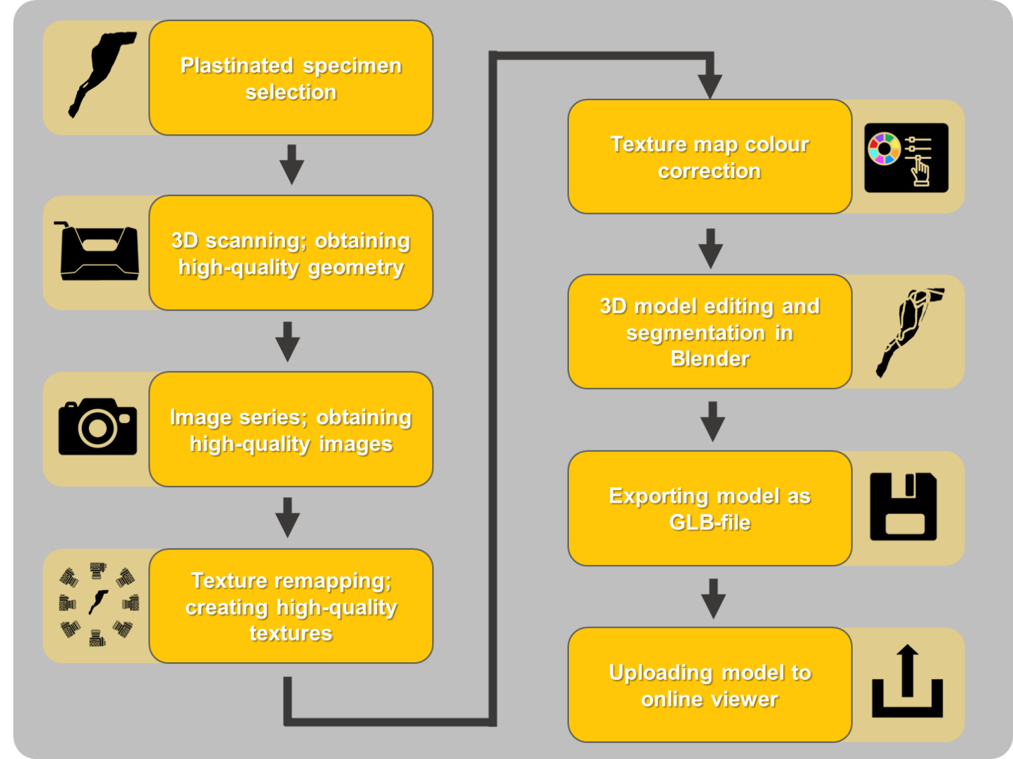
Digitization of two plastinated specimens, one of the canine hindlimb musculature and one of the deep equine stifle, was performed for this research project. The digitization process has been recorded in the manuscript (appendix 1), the full protocol is described in detail in appendix 2 and the workflow is shown in Figure 1. It consists of plastinated specimen selection, 3D scanning for high-quality geometry and an image series with high-resolution images, which was then turned into high-resolution texture maps. Resulting texture maps were color-corrected and combined with the 3D models. Afterwards, the resulting 3D models were edited, segmented and annotated in Blender (v3.6.17 LTS) and uploaded onto an online viewer that allows zooming, rotating, panning and selection of all segmented structures.
Figure 1. Digitization protocol as described in the manuscript. Plastinated specimens were selected and scanned, had their textures improved through an image series and color correction, followed by editing in Blender. Finally, they were uploaded onto an online viewer.

Data collection and study population
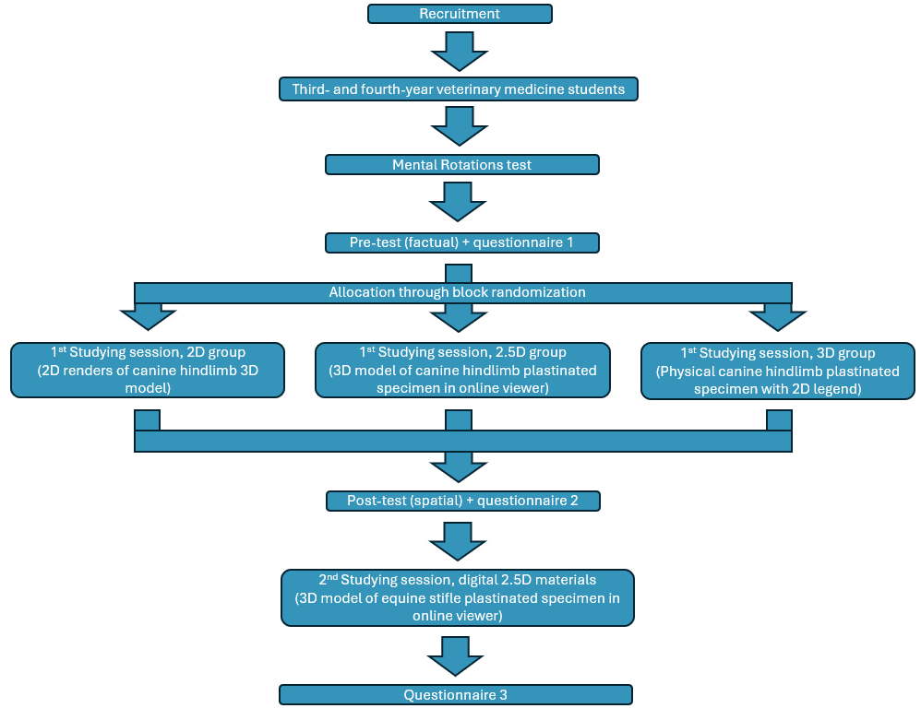
This usability study consisted of three elements, namely a randomized crossover pilot study (Figure 2 & appendices 3 through 9), an online survey and stakeholder interviews, all three were conducted at the veterinary medicine faculty of Utrecht University. Participants could partake on a voluntary basis. Participants in the pilot study consented to the collection of personal data. Personal data of all collection methods was pseudonymized and could not be traced back to original participants. For the pilot study, veterinary medicine students who were either in the final year of the bachelor’s degree (generally ‘third year’), or in the first year of the master’s degree (generally ‘fourth year’) were recruited. This selection allowed students to have sufficient knowledge of anatomical terms from the bachelor’s program, without the interference of clinical experience from the master’s program. For the online survey, veterinary medicine students were invited to respond, regardless of study progress. However, participants of the pilot study were not invited to respond as the goal was obtaining more feedback on general 3D model usability. For the stakeholder interviews, teachers and prosectors at the Anatomy & Physiology department of the veterinary medicine faculty were invited personally, based on their occupation.
Figure 2. Full pilot study setup. 2D, two-dimensional; 2.5D, two-and-a-half dimensional; 3D, three-dimensional.

Recruitment & group allocation
Inherent time constraints of the master degree research project complicated large-scale recruitment, therefore the decision was made to have this research project serve as a pilot study, rather than a large-scale study. Recruitment was executed over a period of 2 months and experiments were held in this period based on participant availability. This was done to allow as many participants as possible to partake in the experiments. One observer supervised all experiments.
Participants for the pilot study were allocated to one of three intervention groups: images (2D group), digital model on a laptop (2.5D group), or physical plastinated specimen (3D group). To make sure group sizes remained balanced over time, block randomization with a block size of 3 was used. Every block of three participants was assigned using a randomized group allocator in Excel (version 2506). The first participant was allocated to one of three groups, the second to one of two remaining groups and the third to the last remaining group. To minimize the influence of possible selection bias that can follow from block randomization (Lim & In, 2019), group allocation was executed before assessing a participant’s VSA. Moreover, to minimize the influence of possible observation bias that can follow from block randomization (Lim & In, 2019), no observer information was collected. Rather, an objective assessment of participant capabilities was made by using written tests. Blinding of participants and observer was impossible, as the used studying materials implied the assigned group.

Studying materials
All studying materials for the first studying session were derived from the same canine hindlimb plastinated specimen and its digital 3D model. In this way, the influence of anatomical variation between specimens and therefore between groups was removed and the main difference between groups was the method of presentation. This allowed for the influence of presentation on the different research goals to be studied.
The 2D group was provided with printed 2D renders from the canine hindlimb 3D model (appendix 4). The renders were created in Blender, from the cranial, medial, caudal and lateral views of the 3D model. The different structures of the model were highlighted and annotated after rendering using GIMP (version 2.8.14). The 2.5D group was provided with the digital 3D model of the canine hindlimb (appendix 5), presented in an online viewer on the participants’ own laptops. The models were fully functional: participants could zoom, rotate, pan and select all the annotated structures. The 3D group was provided with the exact physical canine hindlimb plastinated specimen that was digitized during this research project. They were also given printed 2D renders from the 3D model as a legend (appendix 6), however images were limited to the medial and lateral view of the 3D model to promote plastinated specimen usage for studying, instead of image use.
The 2.5D studying materials for the second studying session consisted of the digital 3D model of the equine stifle (appendix 9), presented in an online viewer on the participants’ own laptops. The models were fully functional, participants could zoom, rotate, pan and select all the annotated structures. No control group was implemented, as this section of the experiment was designed predominantly for obtaining qualitative data on 2.5D studying material usability.

Pilot study setup
The pilot study allowed for an indication of the quantitative data and qualitative data that could be collected with a larger-scale study and the obtained data was used for a power analysis for a possible future larger-scale study. The pilot study consisted of 8 items.

1) Mental Rotations Test (MRT)
A 24-point Mental Rotations Test (MRT, appendix 7) as presented by Shepard & Metzler (1971), validated by Vandenberg & Kuse (1978) and subsequently redrawn by Peters et al. (1995) was used to assess VSA of each participant. According to instructions, there was a time limit of 10 minutes and the MRT was scored on a scale from 0 to 24 points. There seems to be a testing effect, where repetition of the test leads to a higher outcome on the second test (Vorstenbosch et al., 2013). Therefore, having done an MRT before was an exclusion criterium.

2) Pre-test
The pre-test consisted of 7 extended matching questions (Case & Swanson, 1998), 2 open questions and 1 matching question. For the extended matching questions, a list of all 28 possible answers (i.e., muscle names) was provided to prevent spelling errors and blank responses. The pre-test was centered around the canine hindlimb and assessed current factual anatomical knowledge of muscle and bone names, anatomical terms of location and joint movements. There was a time limit of 15 minutes and tests were graded on a scale from 0 to 10 points.

3) Questionnaire 1
Questionnaire 1 obtained demographics and base characteristics. It also featured 7 questions on a 7-point Likert scale, assessing perceived anatomical knowledge, as well as self-efficacy in the form of motivation and participants’ belief in their ability to obtain specific anatomical knowledge (Artino, 2012). Furthermore, participants reported general preference for studying with the different materials (text & images, digital models, plastinated specimens) on a ranking of 1 to 3, with 1 being “most preferred” and 3 being “least preferred”. Open space was provided to clarify responses, or for any additional feedback.

4) First studying session
The first studying session was introduced through an on-paper instruction with background information on the studying session, learning goals and tips. Also, an explanation on how to use the online viewer, if relevant for that participant, was provided. As the focus of the post-test was assessing spatial knowledge level, the learning goals were centered around anatomical structure locations and functionality in the (upper) canine hindlimb. The learning goals were equal for all groups and were defined as follows: the relative location of muscles, which muscles were in contact with one another, which muscles were visible from purely cranial, caudal, medial or lateral views and the function of muscles based on their path from origin to insertion. To compensate for a possible lack in factual knowledge which may interfere with the acquisition of spatial knowledge, participants were granted a ‘cheat sheet’ during the studying session and post-test, containing the names of all relevant structures, a visual representation of the different anatomical terms of locations of a dog and the correct names for the possible joint movements of the hip and knee joints. Participants were then granted 15 minutes to study with their assigned studying material and the cheat sheet. After these 15 minutes, the studying material was removed, but they were allowed to keep the cheat sheet during the post-test as it did not contain spatial information.

5) Post-test
The post-test consisted of 10 spatial knowledge-assessing questions, in line with the learning goals given beforehand. There was 1 matching question and there were 9 extended matching questions, of which 6 asked for multiple answers, so called “pick ‘n’ items” extended matching questions (Case & Swanson, 1998). By removing the studying material and having questions based on the specified learning goals, students were encouraged to use visuospatial knowledge such as muscle size, shape, location and path (Nguyen et al., 2012; Dickson et al., 2024) instead of factual knowledge. After each question, participants were asked to estimate how much of their reply came from the studying session, as opposed to prior knowledge. This estimate was placed on a scale ranging from ‘100% studying session’ to ‘100% prior knowledge’. There was a time limit of 15 minutes. A grading form based on partial credit scoring was generated before the start of the experiment. For questions asking which muscles have a specific function (e.g. knee extension, hip abduction) based on the path of the muscles in the assigned studying material, some otherwise correct answers were classified as being ‘neutral’. Neutral answers were classified based on minimal muscle contribution to a specific function according to Evans & de Lahunta (2013) and/ or Dyce et al. (2010), or based on subjective assessment that the visible muscle path alone was insufficient for determining its function. Tests were graded on a scale of 0 to 10 points.

6) Questionnaire 2
The second questionnaire included the same 7-point Likert scale questions as the first questionnaire, with the addition of an eighth question assessing participants’ ease of use with their assigned studying material. Open space was provided to clarify responses, or for any additional feedback.

7) Second studying session
The second studying session was introduced similarly to the first one, where background information of the experiment and instructions for the online viewer were given, together with learning goals and tips. This session was focused on the equine stifle 2.5D model. Learning goals were centered around naming of ligaments and tendons, the functions of ligaments based on their path, the location of the patella and the function behind the shape of the bones present in the model, thus aiming to obtain both factual and spatial knowledge. Participants were informed that this session was purely qualitative, therefore they would not be studying for the best test results. Rather, it would assess perceived usability and ease of use of the digital model in the online viewer when studying. They were given a manual with questions based on the learning goals, they were encouraged to use it to study in conjunction with the digital model. The answers were not graded afterwards and there was a time limit of 15 minutes.

8) Questionnaire 3
The third questionnaire included 11 questions on a 7-point Likert scale. The first 3 questions assessed perceived usability and ease of use of the equine stifle 2.5D model in learning anatomy, the remaining 8 questions focused on assessing participant preference in using digital 3D models compared to text & images (4 questions) and compared to plastinated specimens (4 questions) when studying anatomy. Again, participants reported general preference for studying with the different materials (text & images, digital models, plastinated specimens) on a ranking of 1 to 3, with 1 being “most preferred” and 3 being “least preferred”. Lastly, they were asked which of the studying materials (text & images, digital 3D models, plastinated specimens, or other) they prefer to use in 5 distinct situations. The 5 situations were (1) while preparing for an anatomical practical class, (2) during an anatomical practical class, (3) while preparing for an exam, (4) while preparing for a clinical case, (5) while refreshing anatomical knowledge. Per questions, they were allowed to give either one answer, or multiple answers if they wanted to report a ranked preference. After every question in questionnaire 3, open space was provided to clarify responses, or for any additional feedback.

Online survey setup
An online survey was made which, similar to questionnaire 3, asked participants to report general preference for studying with the different materials (text & images, digital models, plastinated specimens) on a ranking of 1 to 3, with 1 being “most preferred” and 3 being “least preferred”. After reporting their ranking, participants were allowed to look at and use both digital 3D models in the online viewer on their own computers for an unlimited amount of time. Afterwards, they were again asked to rank studying material preference, similar to before this viewing session. Moreover, they were asked to respond to 9 questions on a 7-point Likert scale extracted from questionnaire 3. The first question assessed ease of use of the models, the remaining 8 questions focused on assessing participant preference in using digital 3D models compared to text & images (4 questions) and compared to plastinated specimens (4 questions) when studying anatomy. Lastly, participants were asked in which situations they would see themselves using the digital 3D models. Open space was provided to clarify any responses, or for additional feedback.

Interviews with faculty staff
Short 15-30 minute semi-structured interviews were performed with various staff members of the Anatomy & Physiology department. Hyperlinks to the online viewer with both digital 3D models were shared beforehand, allowing participants to view and interact with the models on their own computers. During the interviews, participants were prompted by asking for perceived upsides, downsides, limits, possibilities and general usability/ applicability of both digital 3D models, or of digitized plastinated specimen models in general, in anatomy studying and education. Data was transcribed during the interview, or transcribed based on audio recording, which was obtained with consent of the interviewed participant.

Statistical analyses
Obtained data was analyzed using R (version 4.5.1) and its coding environment, RStudio (version 2025.05.1+513). Since the sample size of the pilot study is small, finding normality for variables and reaching statistical significance were not the main goals. However, trends may be detected and the collected data serves as a basis for a power analysis. For training purposes, however, data analysis was performed nonetheless. Moreover, on multiple occasions analysis was also performed as if the sample size was much larger. Normality of variables was assessed with the Shapiro-Wilk test and Q-Q plots.
Equality of characteristics between groups was analyzed using descriptive statistics (mean ± standard deviation (SD)) and with statistical tests. The parametric one-way ANOVA and non-parametric Kruskal-Wallis tests were used for numerical variables. The Kruskal-Wallis test is a non-parametric alternative to the one-way ANOVA, it uses ranking instead of scores. This makes it less power-efficient than the ANOVA, but it also makes less assumptions about data distribution, therefore it is more appropriate in case normality cannot be assumed (Petrie & Watson, 2013). The Chi-squared test would normally be used for categorical variables with ‘large’ sample sizes (>5 samples/ group) and Fisher’s exact test for categorical variables with ‘small’ sample sizes (Petrie & Watson, 2013). Again, for training purposes, both parametric and non-parametric tests, and both the Chi-squared and Fisher’s exact tests were used. In case of normality for MRT and/ or pre-test score, group means for the result of that test were analyzed using the one-way ANOVA to evaluate equal distribution between groups. In case of significant results, post-hoc analysis between pairs of groups was performed using Tukey’s range test. In case normality could not be assumed for one or both test results, the Kruskal-Wallis test was performed for those analyses, with Dunn’s test being used for post-hoc analysis between pairs of groups in case of significance.

Internal test consistency and grading
Using RStudio, Cronbach’s alpha and its confidence intervals using Feldt’s method (1965) were calculated post-hoc in order to evaluate the internal consistency of the MRT and the pre- and post-test. Multiple scoring scenarios were evaluated for the latter to see if it resulted in a high variance of alpha values. The scenario resulting in the highest alpha and the smallest confidence interval would be selected for final post-test scoring. In all scenarios, participant scoring was based on final total score, adjusted to fit a continuous scale of 0 to 10. The scenarios were as follows:
- Scoring as described in the post-test, appendix 3. For every question, all correct answers are worth an x amount of points, where x = 1 ÷ “total number of correct answers for that question”. Incorrect answers are worth -x points, with a score of 0 as a minimum. Neutral answers, as defined in the post-test section (ambiguous answers based on literature, or subjective interpretation), do not influence score.
- Scoring of questions 1 and 3 to 6 is similar to scenario 1. The other questions were extended matching questions without an indicated number of expected answers, they are scored based on “total number of given correct answers” ÷ “total number of available correct answers” for each question.
- Scoring of questions 1 and 3 to 6 is similar to scenario 1. The other questions were extended matching questions without an indicated number of expected answers, they are scored based on “total number of given correct answers ÷ “total number of given answers (except for neutral answers)” for each question.

SRQ 1: “What is the influence of studying with 2.5D materials on the level of spatial knowledge, compared to 2D and 3D studying materials?”
First, the general presence of prior knowledge was assessed using the results of the pre-test, which assessed current factual anatomical knowledge. Afterwards, the result of the post-test, measuring spatial knowledge, was analyzed. This difference in knowledge measurement (factual versus spatial) was done to reduce the influence of the testing effect; an increase in scoring that happens when similar subjects are examined repeatedly, even without feedback in between (Roediger & Butler, 2011; Jensen et al., 2014). However, since both tests assess different types of knowledge, a direct comparison between tests is not likely to give a representative indication of spatial knowledge gain due to the intervention alone. Rather, with a future study in mind, the pre-test result will serve as an indicator for presence of prior factual knowledge, therefore indicating whether the chosen student pool was fitting for the experiment. The post-test result will in turn be used as a study outcome. An analysis of correlation between the two will serve to shed light on the relationship between the two tests.
Influence of assigned group on post-test score was analyzed similarly to MRT and pre-test scores. I.e., group means were analyzed using the one-way ANOVA with post-hoc Tukey’s range test in case of normality, or the Kruskal-Wallis test with post-hoc Dunn’s test in case normality could not be assumed. Doing this, an indication could be given of the effect of assigned group on level of spatial knowledge. In case of normality of pre-and post-test scores, correlation between the two tests was measured using Pearson’s correlation coefficient. Otherwise, it was measured using Spearman’s rank correlation coefficient, its non-parametric equivalent. Both aim to see if, and to what degree, a higher score on one test leads to a higher score on the other.

SRQ 2: “Do visual-spatial abilities influence ease of use and spatial knowledge levels in students when studying with 2.5D materials, compared to 2D and 3D studying materials?”
After the study, mean MRT score was calculated. Individual MRT scores were classified as being either above, or below average and participants were grouped accordingly. In case of normality for post-test results, the two sample t-test was used to analyze the influence of MRT group on post-test results. In case normality could not be assumed, the Mann-Whitney U test, the non-parametric alternative to the two sample t-test, was used (Petrie & Watson, 2013).
Moreover, in case of normality of post-test results, the influence of MRT group, assigned intervention group and the interaction term of “MRT group x intervention group” on post-test results was analyzed using the two-way ANOVA. In case normality could not be assumed, the Aligned Rank Transform (ART) ANOVA, the non-parametric alternative to a factorial (e.g., two-way) ANOVA, was used (Wobbrock et al., 2011). In case significance was found with the two-way ANOVA, post-hoc analysis between pairings of group and MRT score was performed using Tukey’s range test. In case significance was found with the ART ANOVA, post-hoc analysis was performed using Dunn’s test.
Perceived ease of use of assigned studying material during the first studying session was assessed on a 7-point Likert scale, with questionnaire 2. Though there is discussion about the best way to analyze Likert scale data (Bishop & Herron, 2015), treating it as ordinal data seems to be most fitting. Therefore, ordinal logistic regression was used for analysis (Petrie & Watson, 2013). The influence of MRT group, assigned intervention group, and the interaction term of “MRT group X intervention group” on perceived ease of use was analyzed. The odds ratios produced by this regression assess to what degree MRT group and/ or intervention group and/ or specific combinations of MRT group and intervention group are more likely to result in a higher reported ease of use.

SRQ 3: “Do students perceive their knowledge, motivation and self-efficacy to be improved after studying with 2.5D materials, compared to 2D and 3D studying materials?”
To answer this research question, the difference between questionnaires 1 (before intervention) and 2 (after intervention) was analyzed. Questions 1 through 4 investigated perceived knowledge, question 6 investigated motivation to study and questions 5 and 7 investigated self-efficacy. When multiple questions served to investigate the same goal, p-values were adjusted using the false discovery rate-setting in RStudio, to compensate for multiple comparisons and lower the odds of a type I error. The Wilcoxon signed rank test was used to analyze the difference between questionnaires 1 and 2. The Wilcoxon signed rank test is the non-parametric alternative to the paired t-test and tests if there is a significant difference between two paired rankings (Petrie & Watson, 2013).
Per question, the Kruskal-Wallis test was used to analyze the influence of assigned intervention group on this difference. If the Kruskal-Wallis test produced a significant result, that would mean that assigned group influenced the difference between questionnaires 1 and 2 for that specific question. It was followed by a post-hoc analysis using a pairwise Mann-Whitney U test to see which specific groups differed from one another.
After every post-test question, participants made an estimation of how much they used knowledge acquired during the studying session, as opposed to prior knowledge. These estimations were quantified based on the indicated location on the scales. A total mean, as well as individual means for ‘studying session knowledge used’ were calculated. Individual means were analyzed using the Wilcoxon signed rank test. The influence of assigned intervention group on individual means was analyzed using the Kruskal-Wallis test. Since this is based on participants’ own estimates, it indicated whether they perceived their knowledge as having increased.

General studying material preference
General preferences for studying material use (2D vs 2.5D vs 3D) in the form of rankings were obtained during questionnaires 1 and 3 of the pilot study, and during the start and end of the online survey. The differences in ranking before and after ‘intervention’ per studying materials were analyzed using the pairwise Wilcoxon signed rank test with Bonferroni p-value adjustment. To test if there was a difference in ranking between any studying materials, a Friedman rank sum test was used for the ‘before intervention’ ranking and for the ‘after intervention’ rankings. Post-hoc analysis was done for both the ‘before intervention’ and the ‘after intervention’ rankings, between pairs of studying materials. The pairwise Wilcoxon signed rank test with Bonferroni p-value adjustment was used for this.

Power analysis for future large-scale study
Effect size (η²) was calculated for the effects of intervention group on post-test results and MRT group on post-test result, based on the results obtained from the two-way ANOVA investigating these relationships (Tomczak & Tomczak, 2014). Effect size η² was then translated into Cohen’s f, using the formula from Cohen (1988):
$$f=\sqrt{\frac{η^{2}}{1-η^{2}}}$$
As a form of control, Cohen’s d as found by Yammine & Violato (2015) for difference in spatial knowledge gain between 2D and 3D visualization technologies (d = 0.50) was also included. This could then be translated into Cohen’s f using the formula from Cohen (1988):
$$f=\frac{1}{2}d$$
Three post-hoc power analyses were done based on an ANOVA test using these three values for Cohen’s f, using a significance level of 0.05 and desired power of 0.8. For this study, a p-value < 0.05 was deemed to be significant.

Thematic analysis
Lastly, thematic analysis was performed using qualitative results and any (additional) feedback. Methodology as described by Braun & Clarke (2006) was utilized. After familiarization with the obtained data, it is analyzed by starting the process of ‘coding’. Coding involves extracting a certain element, or certain elements from the raw data, so that expressions, sentences, or responses to questions are turned into sortable units. For example, the sentence: “I imagine myself using these models in preparation for practical classes and exams.”, can be turned into the elements ‘preparation practical classes and ‘preparation exams’. Following coding of all collected data, it was visualized in PowerPoint (version 2507), allowing overarching themes to be identified by sorting the obtained elements. Themes were then reviewed and refined further and a final report was created. This report was obtained by quantifying all identified elements based on their occurrences in the data collection methods, with a maximum of 1 occurrence per participant.
The goal was to analyze and structure this complete collection of qualitative data, to get a representation of how the digital 3D models were received, both positively and negatively. Moreover, it aimed to investigate how participants visualized the implementation of the digital 3D models in (anatomical) curricula in veterinary medicine.

Results

Digitization & study material creation
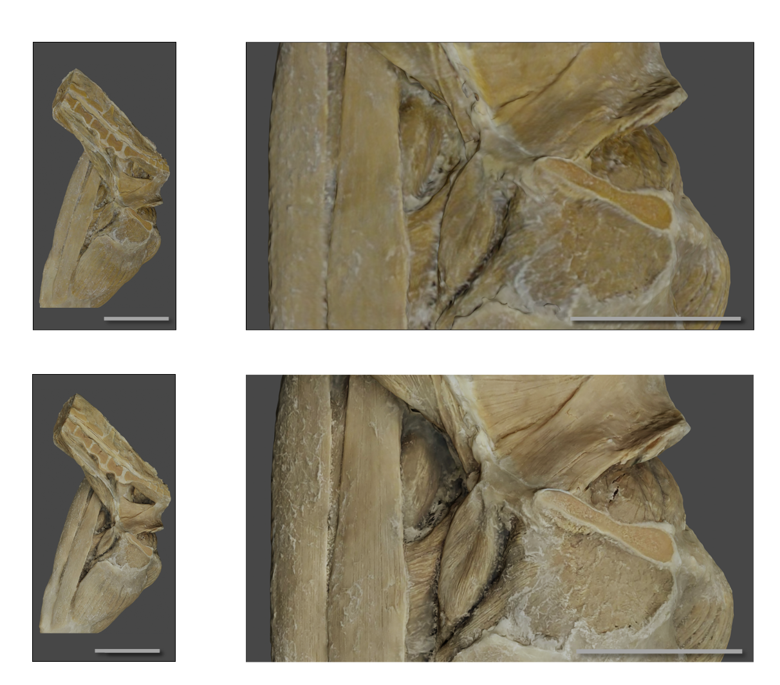
Both plastinated specimens were successfully digitized into 3D models and their low quality textures were replaced with the photogrammetry-style image series. Afterwards, both models were segmented and annotated in Blender and uploaded onto an online viewer. Results from digitization and texture improvement are shown in Figure 3 for the canine hindlimb plastinated specimen and in Figure 4 for the equine stifle plastinated specimen.
d
b
a
c
Figure 3. Result of canine hindlimb plastinated specimen digitization, with magnification. a + b, old textures; c + d, new textures. Scale bars represent 3 cm.

2D renders were successfully created based on the canine hindlimb digital 3D model (Figure 5). They were annotated and printed on A4 format paper, with 2 images per page to maintain readability.

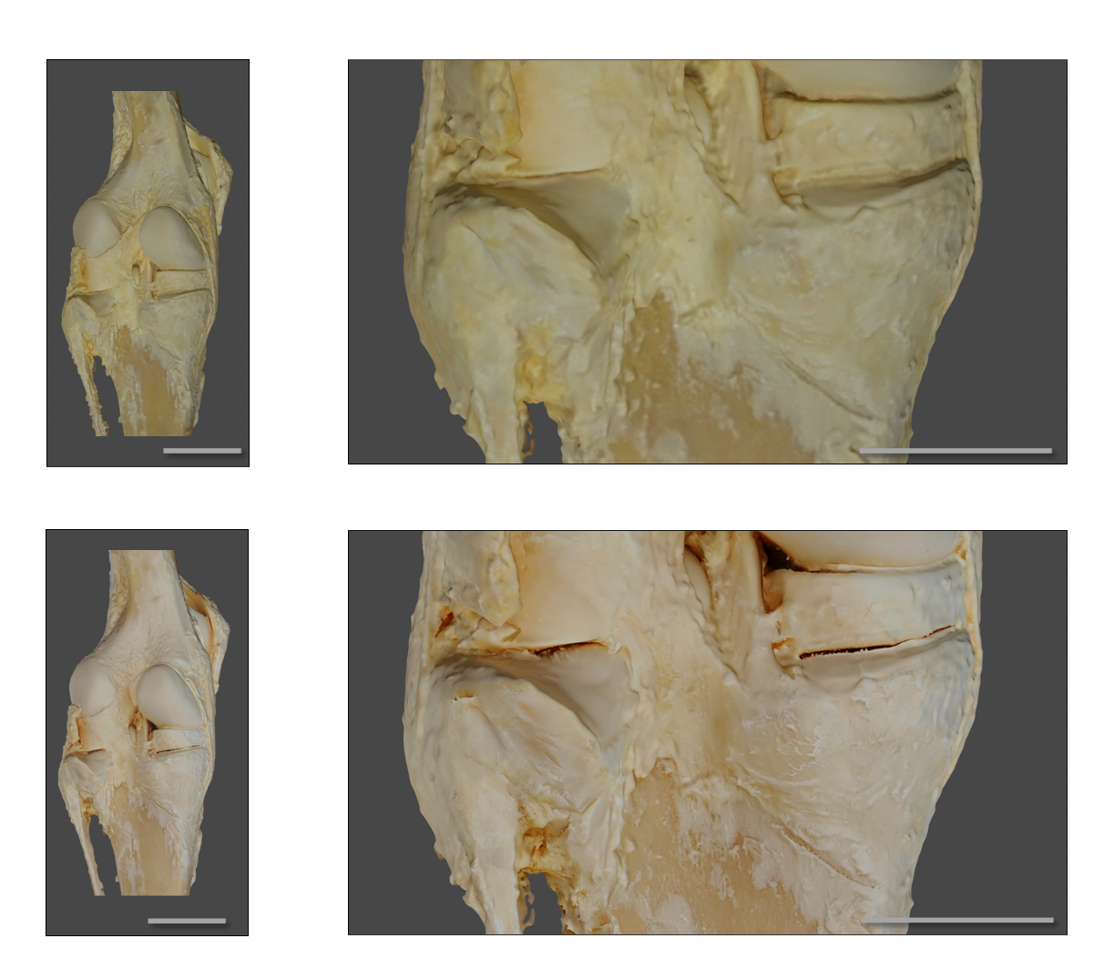
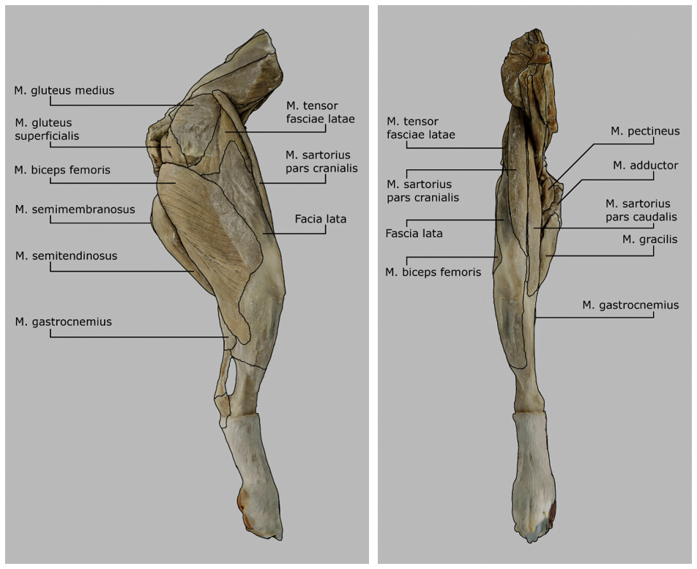
Figure 4. Result of equine stifle plastinated specimen digitization, with magnification. a + b, old textures; c + d, new textures. Scale bars represent 7 cm.
a
c
b
d
b
a
Figure 5. Two-dimensional renders of canine hindlimb model, annotated. a, lateral view; b, cranial view.

Participation & characteristics
A total of 5 students enrolled in the pilot study. They were allocated to group 2D (n = 1), group 2.5D (n = 2) or group 3D (n = 2). One participant in the 2.5D group was not able to finish the last two questions of the post-test due to time constraints and they missed one question of questionnaire 1. For the 2 blank responses, 0 points were awarded as described by the grading form. The resulting test score was included in statistical analysis. For the questionnaire, analysis was performed with the one response missing. The rest of the experiment was completed by all participants. Further, a total of 3 students took part in the online survey. Characteristics of participants for the pilot study and online survey are shown in Table 1. Lastly, a total of 4 members of faculty staff was interviewed, of whom two are teachers and two are prosectors.

Table 1. Characteristics of pilot study and online survey participants. p-values are given for (1) pilot study alone, and for (2) pilot study + online survey. 2D, two-dimensional; 2.5D, two-and-a-half-dimensional; 3D, three-dimensional; PM, parametric test; NPM, non-parametric test; OS, online survey; N/O, no outcome; BSc, Bachelor of Science; MSc, Master of Science.
Characteristic | 2D group  n = 1 | 2.5D group  n = 2 | 3D group  n = 2 | p-value (1)  PM (NPM) | OS  n = 3 | p-value (2)  PM (NPM)
Gender
Female, n (%) | 0 (0%) | 1 (50%) | 2 (100%) | 0.233 (0.6) | 1 (33,3%) | 0.343 (0.657)
Male, n (%) | 1 (100%) | 1 (50%) | 0 (0%) | 0.233 (0.6) | 2 (66,7%) | 0.343 (0.657)
Age, mean (±SD) | 22 (0) | 24.5 (0.71) | 22.5 (0.71) | N/O (0.190) | 28 (1) | N/O (0.0941)
Currently studying
BSc, n (%) | 1 (100%) | 1 (50%) | 0 (0%) | 0.233 (0.6) | 0 (0%) | 0.149 (0.214)
MSc, n (%) | 0 (0%) | 1 (50%) | 2 (100%) | 0.233 (0.6) | 3 (100% | 0.149 (0.214)

Internal consistencies
Internal consistencies (Cronbach’s alpha) with 95% confidence intervals are shown in Table 2 for the MRT, the pre-test and the 3 post-test scoring scenarios (scoring based on: 1, points for correct answers, negative points for incorrect answers; 2, given correct answers ÷ available correct answers; 3, given correct answers ÷ total given answers). Post-test scenario 3 had a higher alpha value (0.76) than scenario 1 (0.73) and scenario 2 (0.72), as well as a smaller confidence interval. It was therefore used as the sole scoring method for the post-test.

Table 2. Study tests and their internal consistency. CI, 95% confidence interval. Scenario 1, points for correct answers, negative points for incorrect answers; 2, given correct answers ÷ available correct answers; 3, given correct answers ÷ total given answers.
Test (scenario) | Cronbach’s alpha (CI, Feldt)
Mental Rotations Test | 0.96 (0.88 – 1.00)
Pre-test | 0.89 (0.65 – 0.99)
Post-test (scenario 1) | 0.73 (0.16 – 0.97)
Post-test (scenario 2) | 0.72 (0.13 – 0.97)
Post-test (scenario 3) | 0.76 (0.24 – 0.97)

Test scores & ease of use
Mean MRT score was 16.0 (±6.12) for the current study population (n = 5). In order to get a more representative mean MRT score for the population of veterinary medicine students, MRT scores from a study at Utrecht University by colleagues (n =42, mean MRT score = 18.6 ±3.66) were obtained and combined with the current study. Their study population consisted of 1st and 2nd year veterinary medicine students. The combined mean MRT score (n = 47) was 18.3 (±3.98). Grouped mean MRT, pre-test and post-test scores from the current study are shown in Table 3, including p-values of group mean analyses. The difference between the pre- and post-test is also calculated, 4/5 participants showed an increase in score.
No significant differences were found between group means for the three tests, nor for group mean differences between the pre- and post-test scores. Individual MRT scores, with both means (current study and combined), are shown in Figure 6a. Individual scores for the pre-test are visualized in Figure 6b and individual scores for the post-test are visualized in Figure 6c. Using the combined mean MRT score, participants from the current study were divided into either an “above average” (n = 2), or a “below average” (n = 3) MRT score group. Post-test results stratified by MRT group are visualized in Figure 6d. Analysis of the influence of assigned intervention group, MRT group and the interaction term of “MRT group x intervention group” on post-test score is summarized in Table 4. No significant influence of MRT group on post-test result was detected. Moreover, no interaction terms could be generated for the two-way ANOVA, and the ART ANOVA failed to generate any output.

Table 3. Test results of pilot study. 2D, two-dimensional; 2.5D, two-and-a-half-dimensional; 3D, three-dimensional; PM, parametric test; NPM, non-parametric test; MRT, Mental Rotations Test; SD, standard deviation; N/O, no outcome.
Test | 2D group  n = 1 | 2.5D group  n = 2 | 3D group  n = 2 | p-value  PM (NPM)
MRT score (current study), mean (±SD) | 24 (0) | 11.5 (2.12) | 16.5 (6.36) | N/O (0.301)
Pre-test score, mean (±SD) | 5 (0) | 5.09 (2.71) | 4.21 (1.82) | N/O (0.819)
Post-test score (scenario 3), mean (±SD) | 7.77 (0) | 6.08 (3.66) | 4.73 (0.276) | 0.68 (0.741)
Difference in pre- and post-test score, mean (±SD) | 2.77 (0) | 1 (0.95) | 0.52 (2.1) | N/O (0.368)

Table 4. Analysis of Mental Rotations Test group & intervention group and their interaction terms on post-test outcome. MRT, Mental Rotations Test; ANOVA, analysis of variance; ART, aligned rank transform.
Test | Variable | p-value
Two sample t-test | MRT group | 0.740
Mann-Whitney U test | MRT group | 0.8
Two-way ANOVA | MRT group | 0.952
Two-way ANOVA | Intervention group | 0.824
Two-way ANOVA | “MRT group x intervention group” | N/O
ART ANOVA | MRT group | N/O
ART ANOVA | Intervention group | N/O
ART ANOVA | “MRT group x intervention group” | N/O

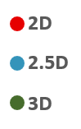
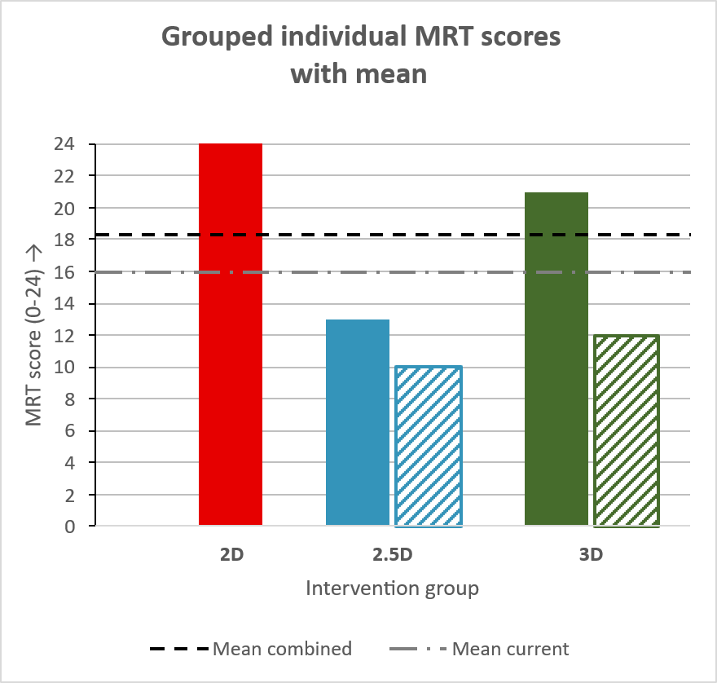
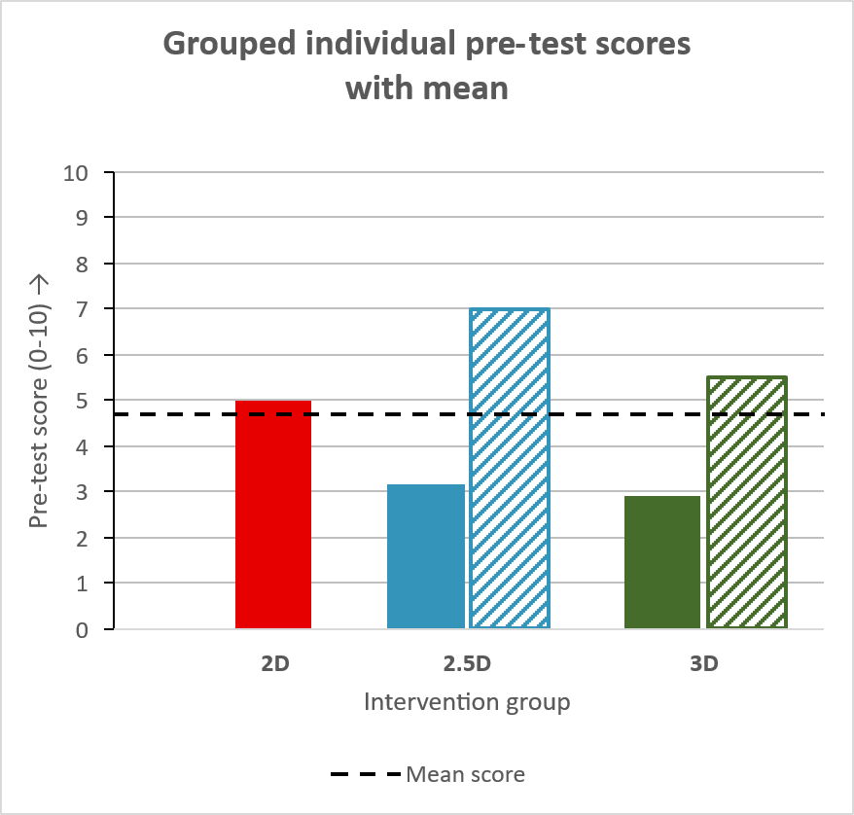
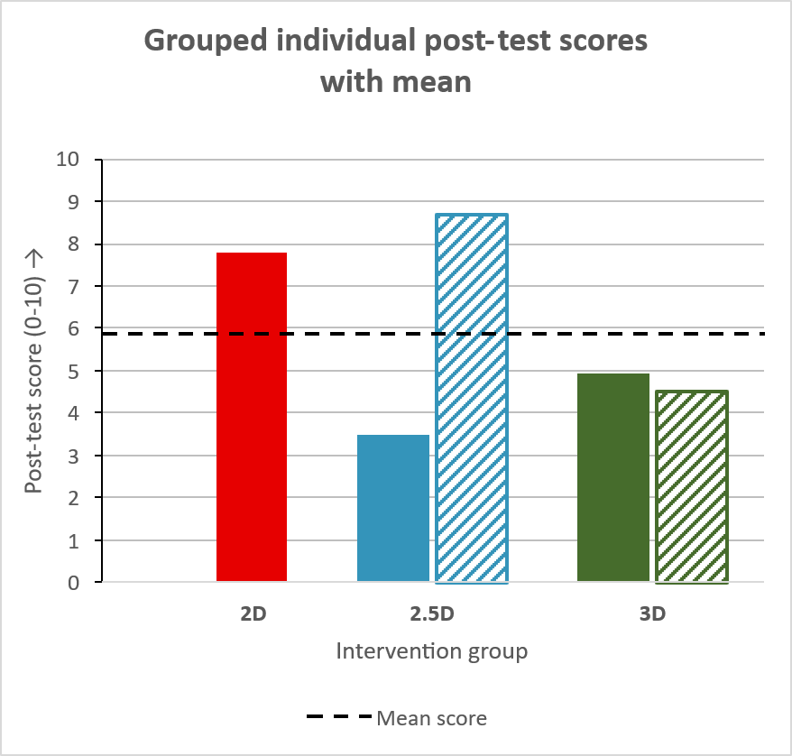
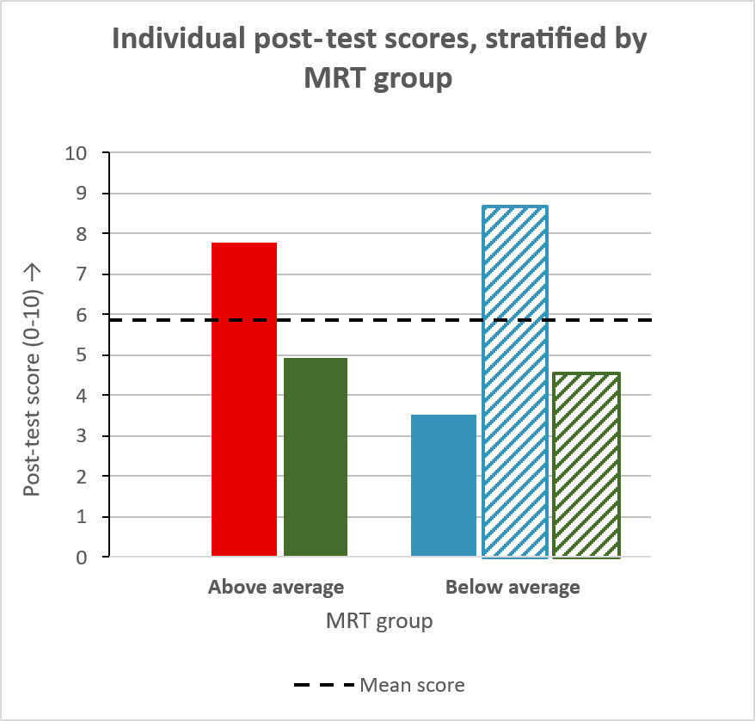
Figure 6. Pilot study test results. a, individual MRT scores with means from combined and current population; b, individual pre-test scores with mean; c, individual post-test scores with mean; d, individual post-test scores, stratified by MRT group (above, or below average of combined population). Full color bars correspond to the first participant of an intervention group, striped bars correspond to the second participant of an intervention group. Therefore, individuals are equally colored between Figures 6 & 7.
b
d
c
a

Furthermore, ease of use of assigned studying material, as assessed in questionnaire 2, is reported in Table 5. Results from logistic ordinal regression are reported in Table 6. Ease of use as reported by the 2D group (4) was reportedly lower than the 2.5D group (6 & 7), which was in turn lower than the 3D group (7 & 7). This is reflected in the coefficients and odds ratios between groups, but no significance was detected. Moreover, no interaction terms could be generated for the combination of MRT group & intervention group.

Table 5. Reported ease of use of studying material per group. 2D, two-dimensional; 2.5D, two-and-a-half-dimensional; 3D, three-dimensional.
Group | Score(s) (7-point Likert scale)
2D (n = 1) | 4
2.5D (n = 2) | 6, 7
3D (n = 2) | 7, 7

Table 6. Logistic ordinal regression outcome on ease of use. OR, odds ratio; CI, 95% confidence interval.
Predictor | Reference | Coefficient | OR | 95% CI | p-value
Group 2D | Group 2.5D | -13.38 | 1.55 x 10^-6 | 0 – 10^44 | 0.822
Group 3D | Group 2.5D | 12.13 | 1.86 x 10^5 | 10^-41 – 10^51 | 0.822
MRT (above average) | MRT (below average) | -3.677 | 0.025 | 10^-33 – 10^29 | 0.920
“Intervention Group x MRT group” | - | N/O | N/O | N/O | N/O

Lastly, Spearman’s rho (ρ) for the relationship between the pre- and post-test scores was 0.5 (p-value = 0.45). The relationship between the two tests is visualized in Figure 7.
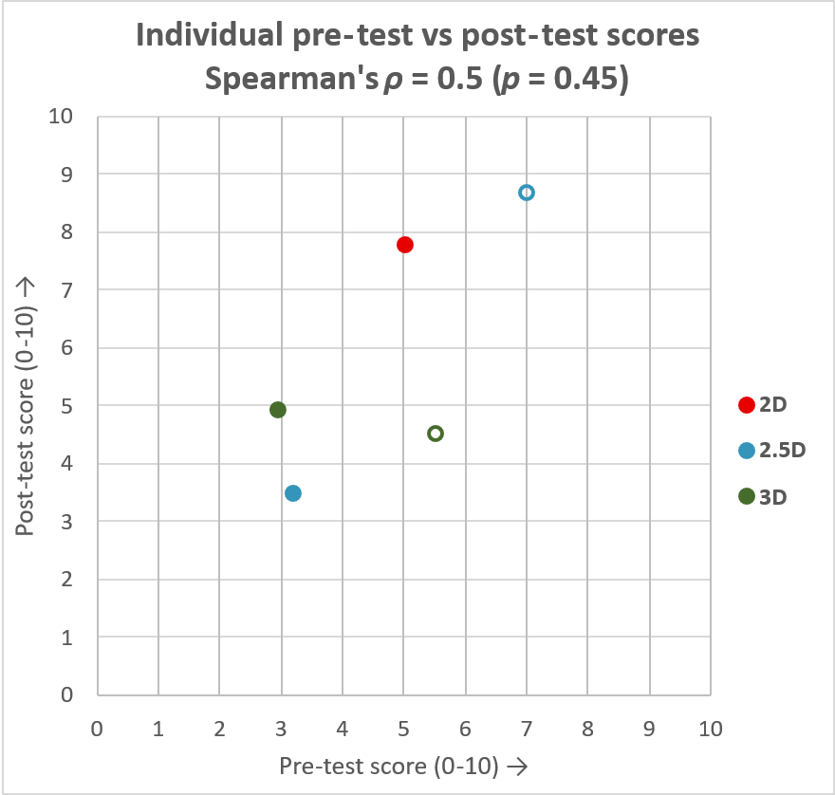

Figure 7. Relationship between pre-test and post-test scores. Full color dots correspond to the first participant of an intervention group, empty dots correspond to the second participant of an intervention group. Therefore, individuals are equally colored between Figures 6 & 7.

Motivation, self-efficacy and perceived & obtained knowledge
Results from questionnaires 1 (before intervention) and 2 (after intervention) are visualized in Figure 8. Questions were aimed at perceived knowledge (questions 1 through 4), motivation to study (question 6) and self-efficacy (questions 5 & 7). The p-values for the analysis of difference in result per question are shown in Table 7. No significance was detected in the difference in knowledge, motivation and self-efficacy between questionnaires 1 and 2, nor for the effect of assigned intervention group on these differences.
Additionally, individual means of knowledge used (obtained versus prior) in the post-test, are summarized in Table 8, sorted by group. A mean percentage of ~77.4% (± 15.5) of obtained knowledge being used to answer the questions was reported, as opposed to 22.6% of prior knowledge being used. This difference was significant (p = 0.0312). Group mean for obtained knowledge used in the 2D group (59.4%) was lower than the 2.5D group mean (70.9% ± 7.51), which was in turn lower than 3D group mean (92.8% ± 4.86). However, the effect of assigned intervention group on mean obtained knowledge use was not significant (p = 0.165).
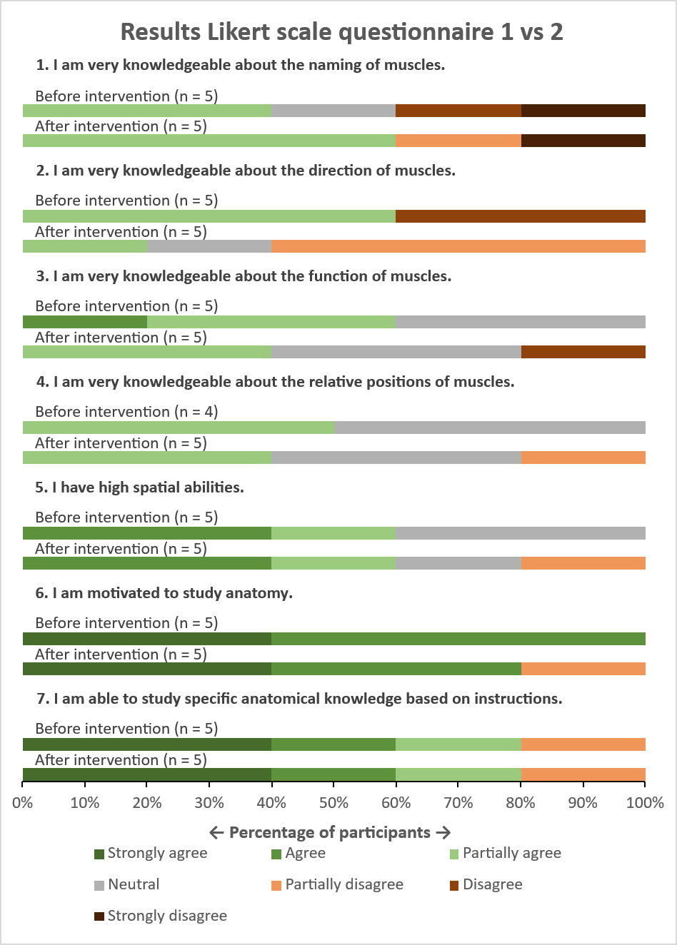
Table 7. Analyses of differences between questionnaires 1 and 2. Nr., question number; WCX, Wilcoxon signed rank test p-value; fdr, false rate discovery-adjustment; KWT, Kruskal-Wallis test p-value.
Nr. | Subject | WCX (fdr) | KWT  (fdr)
1 | Knowledge | 0.461 | 0.623
2 | Knowledge | 0.850 | 0.623
3 | Knowledge | 0.461 | 0.623
4 | Knowledge | 0.461 | 0.623
5 | Self-efficacy | 1 | 0.472
6 | Motivation | 1 | 0.4724
7 | Self-efficacy | 1 | 0.446

Participant | Group | Mean OKU (%)
1 | 2D | 59.4
2 | 2.5D | 65.6
3 | 2.5D | 76.3
4 | 3D | 89.4
5 | 3D | 96.3
Total |  | 77.4 ± 15.5
Table 8. Individual mean ‘obtained knowledge’ used for answering post-test. OKU, “Obtained knowledge used”.

Figure 8. Likert scale results of questionnaires 1 and 2 (before and after intervention).

Usability of digital 3D & studying preference
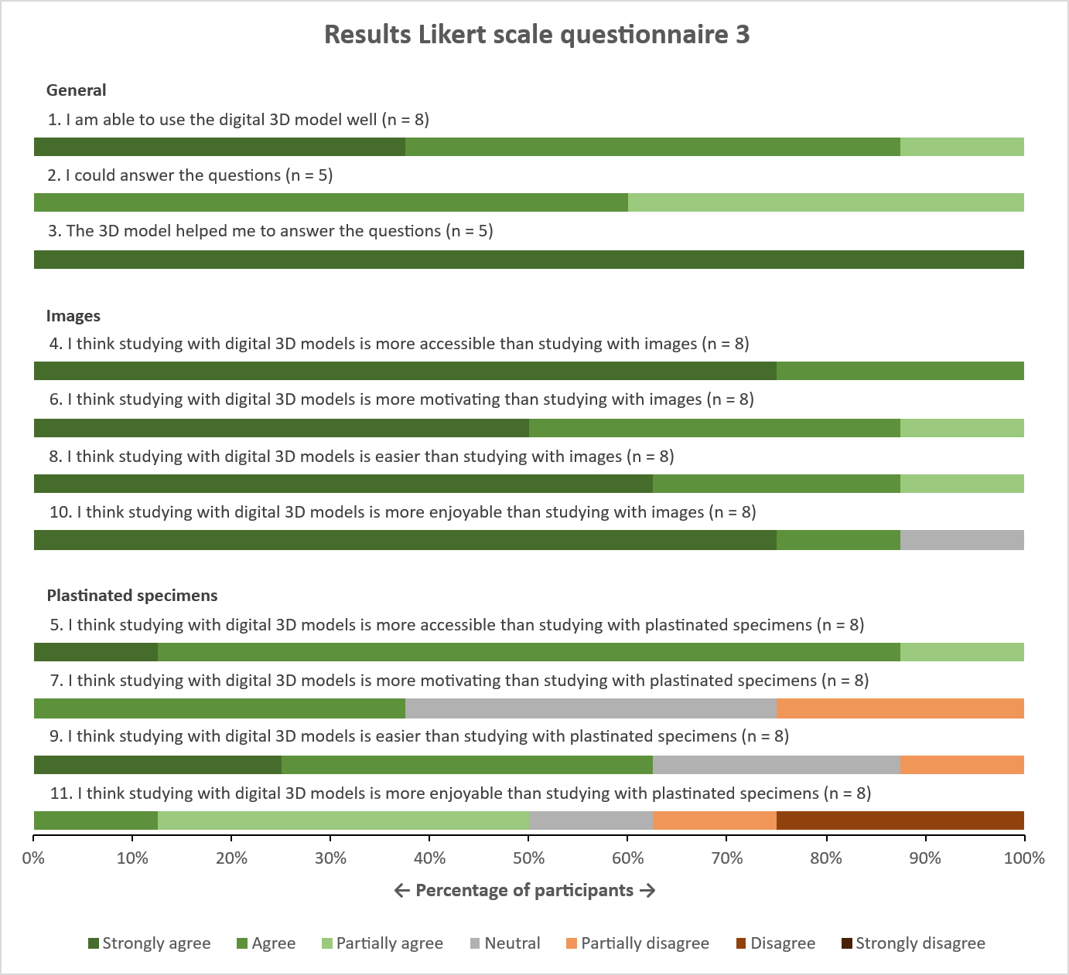
Likert scale data regarding digital 3D model usability and relative preference was obtained during questionnaire 3 of the pilot study (n = 5) and during the online survey (n = 3) and is visualized in Figure 9. Questions are sorted, based on theme/ studying material.

Figure 9. Results of questionnaire 3 and online survey, questions are sorted on theme/ studying material.
Combined results of general studying material preference between questionnaires 1 and 3 from the pilot study (n = 5) and between the start and finish of the online survey (n = 3) are visualized in Figure 10. Before intervention, plastinated specimens were most preferred (6/8 on 1st rank and 2/8 on 2nd rank), followed by digital 3D models (2/8 on 1st rank and 6/8 on 2nd rank), and text & images were least preferred (8/8 on 3rd rank). After intervention, digital 3D models were most preferred (5/8 on 1st rank and 3/8 on 2nd rank), followed by plastinated specimens (3/8 on 1st rank, 5/8 on 2nd rank) and text & images were least preferred (8/8 on 3rd rank).
Analysis showed no significant difference in ranking before and after intervention (Table 9) for plastinated specimens (p = 0.298) and digital 3D models (p = 0.298) and could not be calculated for text & images since nothing had changed. However, there was a significant difference between preferences for studying materials. Specifically, before intervention, a significant difference in ranking was found between plastinated specimens and text & images (p = 0.0308), and between 3D models and text & images (p = 0.0308). Additionally, after intervention, a significant difference in ranking was found between plastinated specimens and text & images (p = 0.0308), and between 3D models and text & images (p = 0.0308).
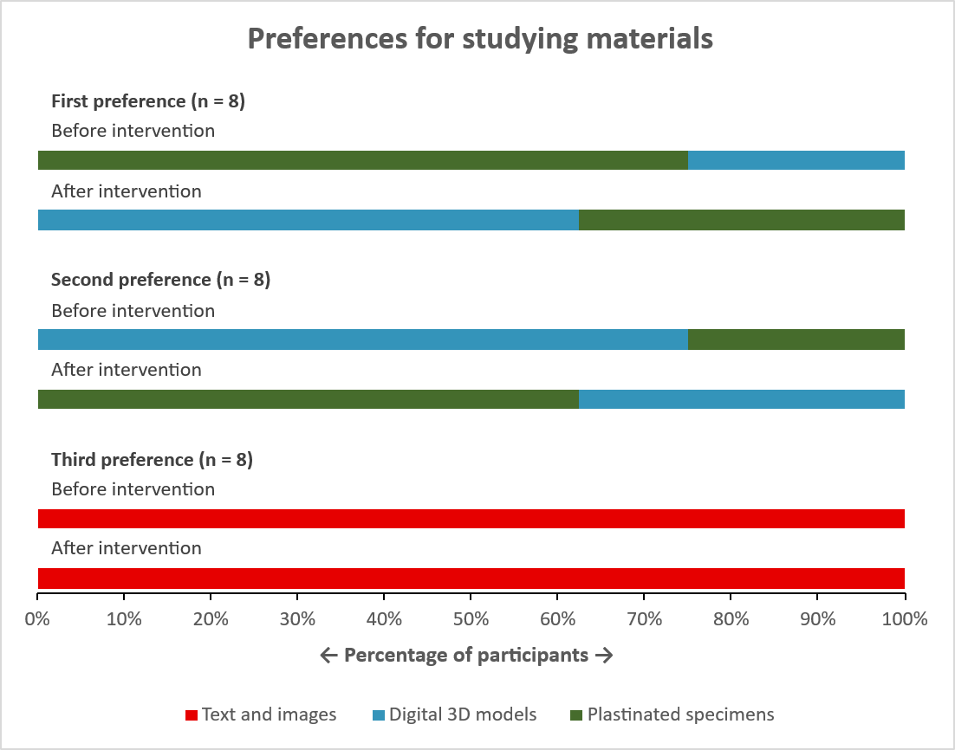

Figure 10. Results of general studying material preferences based on rankings of 1st to 3rd preference, before and after intervention.

Table 9. Statistical test results between studying materials, before and after intervention.
Moment | Test used | Comparison | p-value
Before intervention | Friedman rank sum | All three materials | 0.00150
Before intervention | Wilcoxon signed rank | Plastinated specimen vs 3D model | 0.545
Before intervention | Wilcoxon signed rank | Plastinated specimen vs text & images | 0.0308
Before intervention | Wilcoxon signed rank | 3D model vs text & images | 0.0308
After intervention | Friedman rank sum | All three materials | 0.00219
After intervention | Wilcoxon signed rank | Plastinated specimen vs 3D model | 1
After intervention | Wilcoxon signed rank | Plastinated specimen vs text & images | 0.0346
After intervention | Wilcoxon signed rank | 3D model vs text & images | 0.0346

Results from questionnaire 3 (n = 5) on preferred studying materials in specific situations (1 – 5) are summarized in Figure 11. The situations were (1) while preparing for an anatomical practical classes, (2) during an anatomical practical class, (3) while preparing for an exam, (4) while preparing for a clinical case, (5) while refreshing anatomical knowledge. Participants could rank plastinated specimens, digital 3D models, text & images, and any ‘other’, self-defined studying materials they wished to rank. A ranking of preferred studying materials could be entered without a minimum and maximum amount of answers.
No question had more than 3 materials as an answer, therefore the maximum score for a material per question was 3. Number of occurrences of the different materials was multiplied by score based on its ranking, where rank 1 equaled 3 points, rank 2 equaled 2 points and rank 3 equaled 1 point. Only one participant included the ‘other’ option, defining it as ‘self-drawn images’. Overall, participants preferred to use physical plastinated specimens during practical classes (situation 2) and they preferred 3D models during all other situations.
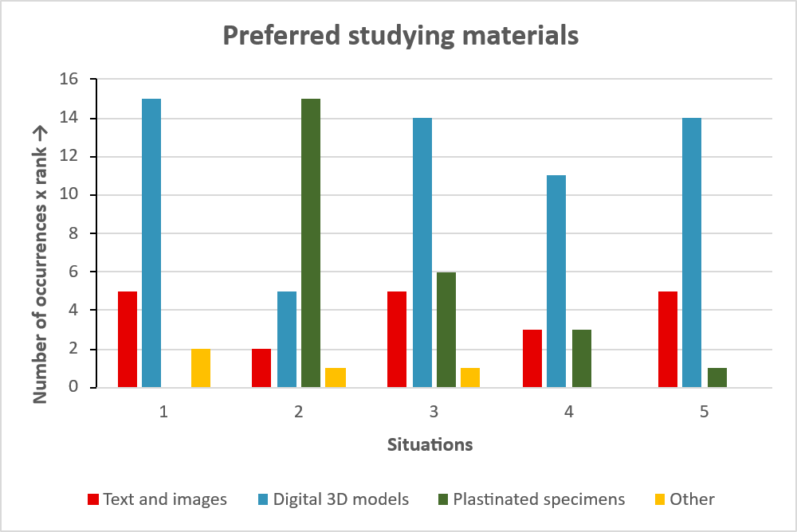

Figure 11. Preferred studying materials during: (1) preparation of an anatomy practical class, (2) an anatomy practical class, (3) preparation for an exam, (4) preparation for a clinical case, (5) refreshing of knowledge. Data obtained from questionnaire 3 (n = 5). Number of occurrences for each material is multiplied by its ranking position (1st rank = 3 points, 2nd rank = 2 points, 3rd rank = 1 point). ‘Other’ was defined as ‘self-drawn images’ by one participant. 3D, three-dimensional.

Power analyses
As described, effect sizes obtained during this study could be used for a power analysis that would give an indication for the number of required participants in a future, large-scale study. Hence, ANOVA power analyses were performed, results are shown in Table 10. Two analyses were based on the effect sizes found for the two-way ANOVA of intervention group and MRT group on post-test result. The third analysis was based on Cohen’s d of 0.5 as found by Yammine & Violato (2015) as a form of control, for difference in spatial knowledge gain between 2D and 3D visualization technologies.
Table 10. Results of ANOVA-based power analyses, from two-way ANOVA-derived effect sizes, including control from Yammine & Violato (2015). ANOVA, analysis of variance; MRT, Mental Rotations Test; η², eta squared, a measure of effect size.
Source | η² | Cohen’s f | n per group | Groups | Total size
Two-way ANOVA (intervention group vs post-test score) | 0.320 | 0.685 | ~8 | 3 | ~24
Two-way ANOVA (MRT group vs post-test score) | 0.00384 | 0.0621 | >1000 | 2 | >2000
Yammine & Violato (2015) | 0.058 | 0.25 | ~52 | 3 | ~156

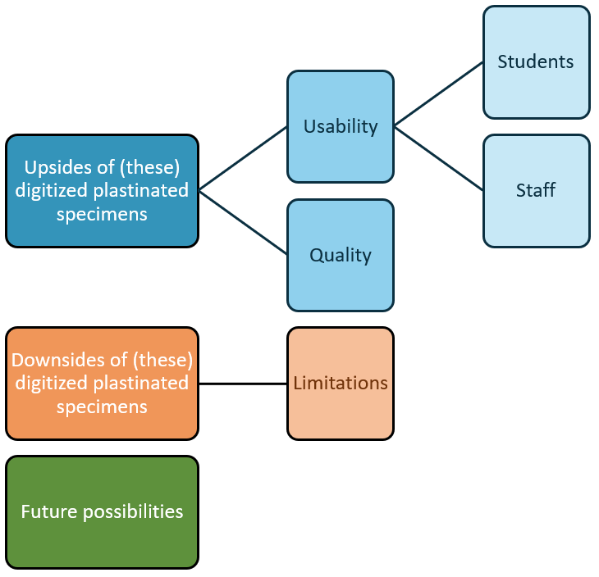
Thematic analysis
Qualitative data was collected from the pilot study (n = 5), the online survey (n = 3) and the semi-structured interviews with faculty staff (n = 4). Data was collected through scripted questions and through blank spaces, left for additional feedback. All collected data was read through and analyzed, and all relevant elements were coded. Afterwards, all elements were visualized in PowerPoint and sorted under primary themes, similar to the prompts of the semi-structured interview: ‘Quality, ‘Usability’, ‘Advantages’, ‘Limitations’ and ‘Possibilities’. These primary themes were further refined and converted into the overarching themes of ‘Upsides of (these) digitized plastinated specimens’, ‘Downsides of (these) digitized plastinated specimens’ and ‘Future possibilities’. The first two themes were also divided into sub-themes, as shown in Figure 12. General upsides, downsides and future possibilities were sorted under their respective overarching themes. ‘Usability’ refers to forms of usability as reported by the participants and was sub-divided further into ‘usability for students’ and ‘usability for staff’. ‘Quality’ refers to received feedback regarding the quality of the digitized plastinated specimens. ‘Limitations’ refers to downsides that are inherent to the presentation method and creation of digital models based on plastinated specimens, as opposed to general downsides that could be resolved. Moreover, whether a piece of feedback was sorted under ‘general downside’ or ‘future possibilities’ depended on the context as given by the participant. For example, the sentence: “There are no layers to peel back”, would be interpreted as a general downside, while the sentence: “Can you add layers in the future?”, would be interpreted as a future possibility. Finally, all feedback elements were quantified, with single occurrences being left out. Results are shown in Table 11.
Figure 12. Identified themes and sub-themes

Table 11. Results of thematic analysis of qualitative data from all participants (n = 12). Single occurrences were left out. n, number of occurrences.
Theme | n | Statement
Upsides of (these) digitized plastinated specimens
Usability – for students | Digitized plastinated specimens can be used to prepare for:
Usability – for students | 8 | Examination
Usability – for students | 7 | Practical classes
Usability – for students | 6 | Clinics & orthopedic rotations
Usability – for students | 2 | Surgeries
Usability – for students | Digitized plastinated specimens can be used:
Usability – for students | 8 | To refresh knowledge
Usability – for students | 5 | As a digital tutor
Usability – for students | 3 | As an addition to physical plastinated specimens
Usability – for students | 2 | As a self-assessment tool
Usability – for students | 2 | As an addition to studying materials
Usability – for students | 2 | For visualization of difficult anatomical structures
Usability – for staff | Digitized plastinated specimens can be used
Usability – for staff | 2 | During lectures
Usability – for staff | 2 | To safeguard physical plastinated specimens
Usability – for staff | 2 | As an assessment tool
Quality | 6 | The digital models look nice/ good/ pretty
Quality | 4 | The digital models are high-quality, with well-defined textures
General | 8 | The annotations and menu function were useful/ easy/ clear
General | 8 | I prefer the digital models over images (as a learning tool)
General | 7 | The digital models are accessible
General | 5 | I prefer the digital models over physical plastinated specimens (as a learning tool)
General | 5 | Digitized plastinated specimens give more insight than books
General | 4 | The digitized plastinated specimens are easy to use
General | 4 | Digitized plastinated specimens give 3D insight
General | 3 | Digitized plastinated specimens are efficient studying tools
General | 2 | When digitized, multiple people can view the same specimen at once
Downsides of (these) digitized plastinated specimens
Limitations | 5 | The digitized plastinated specimens don’t offer haptic feedback
Limitations | 3 | The digitized plastinated specimens are not a replacement of currently available materials
Limitations | 2 | Learning from a screen, or with digital models, is less motivating than learning with physical plastinated specimens
General | 3 | There is no movement in the digital models  - Therefore it seems less fitting for soft plastination (n = 1)
General | 2 | The digitized plastinated specimens don’t offer background information
General | 2 | Time is necessary to learn anatomy, even if you can look at spatial information more quickly
General | 2 | Plastination causes loss of quality of the specimen, this is translated into the digitized 3D model
Future possibilities
General | 4 | Layers could be added to the models, to simulate digital dissection
General | 3 | A larger collection of digitized plastinated specimens should be created
General | 2 | The digitized plastinated specimens can be inserted into an E-learning module
General | 2 | (Patho-)physiological processes can be explained/ visualized through the use of digitized plastinated specimens

Discussion
This thesis aimed to investigate the added value of high-quality, digitized plastinated specimens as studying materials through mixed methods. The creation of digital plastinated specimens was described in a manuscript, currently under review at a scientific journal. Applicability of the created models was investigated by describing their reception by multiple stakeholders and by analyzing pilot data on general usability. Due to the small scale of the pilot study (n = 5), pilot data was used to provide an objective indication of the usability of 2.5D learning materials for obtaining spatial knowledge. It was also used as a feasibility study, to see whether included tests and protocols are fitting and accurate. Generally, reception by all stakeholders was found to be very positive, as showcased by the results of thematic analysis. Positive reception is further confirmed by participants’ rankings of studying materials, which show a clear preference for studying with 2.5D materials over 2D materials, together with a partial preference for studying with 2.5D materials over physical plastinated specimens. Hence, subjectively, the usability of 2.5D materials seems high. In terms of objective usability, no significant differences were found, but participants in all groups did report to use more obtained knowledge than prior knowledge to answer post-test questions. These findings suggest that the objective functionality of 2.5D learning materials as studying tools is comparable with 2D and 3D materials. In order to confirm these findings on a larger scale and get an insight into the exact added value of digitized plastinated specimens in veterinary anatomical education, future research is required.

Research questions

SRQ 1: “What is the influence of studying with 2.5D materials on the level of spatial knowledge, compared to 2D and 3D studying materials?”

&

SRQ 2: “Do visual-spatial abilities influence ease of use and spatial knowledge levels in students when studying with 2.5D materials, compared to 2D and 3D studying materials?”
The study was unable to detect differences in mean spatial knowledge levels between studying materials, or between MRT groups. Ideally, influence of MRT scores on studying result would be measured via linear regression (Cui et al., 2017), instead of the influence of being in the ‘above average’ or ‘below average’ group. This group division allows the analysis of relationships between VSA and spatial knowledge levels when linear regression may not be able to, for example due to small sample size. Division, or stratification, by MRT score has been described with 2 groups (Cui et al., 2017; Bogomolova et al., 2020a) and with 3 groups (van Leeuwen et al., 2023). When dividing the study population by a mean score, it is important to base grouping on a representative mean. To achieve this, MRT scores of a different study’s student population at Utrecht University were added to this study’s scores, to calculate a more representative mean. It is important to note that this added population consisted of 1st and 2nd year veterinary medicine students, whereas the population of the current study consisted of 3rd and 4th year veterinary medicine students. As VSA generally increases over time and with more interactions with spatial anatomy (Hoyek et al., 2009; Vorstenbosch et al., 2013; Bogomolova et al., 2020b), introduction of the second student population might decrease the combined mean. The inverse was true, as the total mean increased with the introduction of the second population. Presumably, the small sample size of the current study has led to a result in MRT scores that is not fully representative for the bigger population. Nevertheless, this difference in means had no effect on MRT group assignment, both means lead to the same allocation. Since a difference is expected to exist between the 2D and 3D group when stratifying post-test scores by MRT group (Rochford, 1985; Wainman et al., 2018; Bogomolova et al., 2020a; van Leeuwen et al., 2023), the comparison of 2D vs 3D could serve as a positive control. Presumably due to small sample size, no difference between 2D and 3D material use was detected.
Furthermore, it was hypothesized that ease of use of 2.5D materials would be comparable to 2D and 3D materials, regardless of VSA. A difference in reported ease of use could be explained by individuals with lower VSAs reporting an increased cognitive load when learning spatial knowledge from 2D presented materials (Huk, 2006). This theory was analyzed using logistic ordinal regression, for reported ease of use of the studying materials. Outcomes matched Likert data, showing that the 2D group was associated with a lower ease of use than the 2.5D group, which was in turn associated with a slightly lower ease of use than the 3D group. The difference between 2.5D and 3D ease of use was relatively small, whereas the difference between 2D and 2.5D was relatively large. However, presumably due to small sample size, no significance was detected between any groups and the size of the confidence intervals makes the exact odds ratios undeterminable. Another possibility is that there is a difference in ease of use, but participants are not aware of it. This phenomenon is described by van Leeuwen et al., (2023), where students with lower VSAs underperformed compared to students with higher VSAs when using a monoscopic 3D visualization tool for anatomy learning. Yet, these students reported that the model helped them and they described it as a positive experience. Concluding, 2.5D materials seem effective in spatial knowledge gain, comparable with 2D and 3D materials. Moreover, VSA plays an important role in usability of different studying materials, however this influence could not be demonstrated with the current data.

SRQ 3: “Do students perceive their knowledge, motivation and self-efficacy to be improved after studying with 2.5D materials, compared to 2D and 3D studying materials?”
While a significant difference was detected between obtained knowledge versus prior knowledge used in the post-test, analysis of the questionnaires was not able to detect any differences. Participants using 3D materials estimated having used the most obtained knowledge, followed by the participants using 2.5D materials. The participant using 2D materials reported to have used the least obtained knowledge. However, this difference was not found to be significant and a larger study will be required to confirm this perception of knowledge gain. Nevertheless, these findings showcase the subjective usability of 2.5D materials compared to 2D and 3D materials and they might suggest a trend of knowledge perception being bound to specific studying material use.
Through the questionnaires, this study also investigated the role of 2.5D materials in increasing self-efficacy through ‘enactive mastery experience’. As described in Social Cognitive Theory (Bandura, 1997), the level of self-efficacy of an individual influences their motivation, behavior and cognition. A study by Ouweneel et al. (2013) provides evidence for this theory by showing that, over time, an increase of self-efficacy in students was related to an increase of engagement and performance. Subsequently, they provide evidence that the inverse is also true; a decrease in self-efficacy was related to a decrease in engagement and performance. Moreover, the combination of knowledge and high self-efficacy seems to be a predictor for academic motivation and achievement (Artino, 2012). Therefore, in education it is important to not only assess and aim to increase students’ capabilities, but also their belief in their own capabilities. Whether 2.5D studying materials are effective tools for this goal, will have to be investigated further in a larger study.

PRQ: “What is the added value of digitized plastinated specimens as an anatomical studying material?”
By combining the answers of the secondary research questions and the qualitative aspects of this thesis, the primary research question can be answered. No clear evidence is found of the objective usability of 2.5D learning materials in obtaining spatial knowledge, other than it performing similar to 2D and 3D materials in the context of this small-scale study. The qualitative aspects show that general feedback on the digitized plastinated specimens is positive and that participants enjoyed using the models. Furthermore, participants in all sections of this study reported a broad range of possible envisioned applications. It is important to note that between participants of the pilot study and participants of the online survey, the ‘intervention’ phase differed in intensity. Pilot study participants based perceived usability on an actual studying session with one of the models, while online survey participants based it on a simple viewing session of both models. This might make pilot study participants’ opinion more based on usability experience, compared to the online survey group. Nevertheless, all participants agreed at least partially that digitization increases accessibility of plastinated specimens, even though specific opinions on ease of use, inherent motivation and enjoyability of digital models compared to plastinated specimens differed. Moreover, no participants disagreed with the statement that digitized plastinated specimens form an improvement on all four of these factors when compared to 2D learning materials. This is also reflected in their preferences for different studying material use, where images as a learning material are ranked consistently lower than both 2.5D and 3D materials.
In contrast, only few downsides and limitations were reported by participants. As discussed before, limitations were defined as downsides that are inherent to the presentation method. For example, there is no haptic feedback with digital models, as discussed in the manuscript. Also, three participants of the interviews reported that the digital models are not likely to replace physical specimens. Both of these limitations confirm why it is important to look at ‘added’ value of a studying material; materials might have drawbacks but these need to be less severe than the upsides they offer. Replacing physical plastinated specimens was not the goal, rather the goal was to enhance their availability, so students could use the plastinated specimens more efficiently. Furthermore, reported downsides were often linked to reported future possibilities. For example, a reported downside was that the digital models do not allow movement, while another participant mentioned the possibility of animating the models. A single participant framed the inability to remove layers in the models as a downside, four others framed this as a future possibility. Further, the digital models (currently) do not provide factual background information on included structures other than names, but by including background information or implementing the models as part of an E-learning module, this can be changed. This might also increase the time users will spend with the models, thereby promoting longer interactions with the spatial information. Lastly, the loss of quality and clarity that is caused by plastination is transferred to the digital models as well. While this is not something that the currently described methodology can prevent, digital post-processing could improve this, or a different methodology for plastination which improves color retention of tissues could be implemented (Durrani et al., 2025).
When combining all information, this study shows that the added value of digitized plastinated specimens as anatomical learning materials seems to stem from its presentation of spatial information. It seems to be more enjoyable, easy to use and motivating than images and text books, and more accessible than images & text books and physical plastinated specimens. Usability of 2.5D materials for knowledge gain seems on par with 2D and 3D materials, though future studies are required to show whether this holds true in a bigger study population. The number of reported upsides and possibilities of the created digital models was higher and more extensive than the amount of limitations and downsides reported, highlighting the perceived added value of digitized plastinated specimens as an anatomical studying material.

Study methodology improvement
With the goal of setting up a future, large-scale study, the pilot study methodology is analyzed by interpreting the discovered internal consistencies of tests and discussing the current setup. Concerning the questionnaires, few issues were detected, other than one participant not filling in one question in questionnaire 1. A decision was made not to exclude this participant or this question from further analysis. Next, when determining the accuracy of both the pre-test and post-test in estimating knowledge levels, both validity and reliability are important factors. Validity describes to what extent a test measures what it should measure, reliability describes to what extent a test measures consistently (Tavakol & Dennick, 2011). Hence, internal consistencies were measured using Cronbach’s alpha, which is effectively a measurement of reliability of a test (Tavakol & Dennick, 2011). Reliability of the MRT would serve as a control for the effect of small sample size on all tests, as its reliability has been described in larger study populations (Vandenberg & Kuse, 1978; Bogomolova et al., 2020a). All three tests seem to reach alpha levels that are deemed satisfactory (>0.7) for early stages of research (Nunnally & Bernstein, 1994). However, there is variation in the exact value per test and the accompanying confidence interval. The MRT shows a small confidence interval and a high alpha value of 0.96, comparable to the 0.88 found by Bogomolova et al. (2020a). The pre-test shows a high alpha value with a larger confidence interval and all post-test scoring scenarios show an acceptable alpha value of >0.7. However, confidence intervals for all scenarios are large, with scenario 3 (given correct answers ÷ total given answers) having the smallest interval. Since the MRT, the pre-test and the post-test were completed by the same group of participants and confidence intervals differ greatly between tests, it is unlikely that solely small sample size is the cause. Rather, reliability of the pre- and especially the post-test might simply be low. Further, the variation may be due to the difference in number of questions between the MRT (24), the pre-test (10) and the post-test (10), as a higher number of questions can inflate Cronbach’s alpha value (Tavakol & Dennick, 2011). Nonetheless, with a larger study in mind, attempts should be made to increase validity and reliability of these knowledge tests. For example, through expert validation and by decreasing the influence of errors and ambiguities in the current tests, as several problems were identified.
Ideally, the post-test would be used to measure an increase in spatial knowledge. Results from the currently used post-test cannot be directly compared to the pre-test, though. This is due to the difference in assessed knowledge between pre- and post-test (factual and spatial, respectively). The difference was implemented to decrease the testing effect, where subsequent testing of similar subjects increases test results (Roediger & Butler, 2011; Jensen et al., 2014). According to Bloom’s taxonomy (Bloom, 1956), spatial knowledge should build on factual knowledge (Leonard, 1996; Thompson & Giffin, 2021). However, a number of variables influences the translation of factual to spatial knowledge, such as VSA and an intervention as described in this thesis. Therefore, pre-test results were used as an indicator of prior factual knowledge distribution among the intervention groups and using the post-test, level of spatial knowledge was assessed. With this, the assumption was made that little prior spatial knowledge would be present due to participants not having completed their clinical rotations. Pre-test results did not differ significantly between groups and all participants reported to have used significantly more obtained knowledge than prior knowledge. However, demographics showed that 2 participants had followed education on the locomotory system a month before. This should be avoided in future studies, as this could lead to an increase of prior knowledge (both factual and spatial), thereby influencing spatial knowledge results. In order to get an indication of how factual and spatial knowledge translate to one another, correlation between the two tests was measured and the difference between the two test scores was analyzed. No significance was detected for difference between groups, but 4/5 participants did show a higher post-test score compared to their pre-test score, visualizing the relationship between prior factual knowledge and spatial knowledge level after studying. Hence, for a future study, prior knowledge should be assessed before measuring spatial knowledge level.
A few problems were identified for the post-test specifically. First, most of the post-test questions were written in the “pick n items” extended matching format. With this format the question is framed, a list of possible responses is given and the number of required or expected answers is specified. By using this specification, the question is transformed from a ‘true/ false’ task, to a ‘best-answer’ task. Best-answer questions are generally believed to be less ambiguous, as the cut-off point between true and false in true/ false tasks can be open to interpretation (Case & Swanson, 1998). However, there were 5 extended matching questions where an expected number of answers was not specified. As participants were not aware of the grading system, this might cause uncertainty while answering, possibly decreasing the number of responses given. Therefore, multiple scoring scenarios were created and analyzed on reliability, of which scenario 3 resulted in the highest and seemingly most accurate alpha value. For these questions, scenario 3 calculated a score based on given correct answers, divided by all given answers (minus neutral answers). As defined in the Materials & Methods section, neutral answers were answers that were classified as being ambiguous, based on literature or subjective interpretation. Assuming uncertainty of participants was mostly centered around these ambiguous answers, whether participants did or did not write down these answers, would not affect their final score. On the contrary, inclusion of an expected number of answers might encourage participants to write down answers they are less sure of. By not providing a limit, they presumably wrote down answers they were most sure about. A second identified problem was question 3, asking which muscles of the upper hindlimb were visible from a strictly caudal point of view. All 5 participants listed the musculus gastrocnemius, while this is generally seen as a muscle that is part of the lower hindlimb (Evans & De Lahunta, 2013). Participants might not have read the specification of ‘upper’ hindlimb. Also, confusion might stem from the fact that it was the only annotated muscle of the lower hindlimb, due to the way the plastinated specimen was prepared. Third, 1 participant in the 2.5D group was unable to complete the post-test within the time limit. This would normally lead to their exclusion from analysis. Due to already small sample size, the decision was made to grade the unfinished questions with 0 points and not to exclude this participant. Fourth, all three intervention groups were given the same amount of time to study for the post-test. Participants in the 2.5D group might require more time, as they have to study the models, but also get familiar with the controls of the online viewer. Participants should be granted time to familiarize themselves with the online viewer by using an unrelated model, before starting the studying session. To achieve this, the second studying session could have been executed first. The decision was made to not do this, as interacting with a 3D model is generally seen as the more ‘exciting’ part of the study. Since engagement during the first studying session was necessary to obtain reliable data, it seemed more appropriate to follow the order as described in this study. Nevertheless, to compensate for this learning curve, an explanation of the different functionalities and controls of the viewer was given beforehand, as part of the on-paper instructions. Fifth, simple muscle function could be seen as factual, non-spatial knowledge. Participants could ‘store’ muscle function as factual knowledge during the studying session, even if this knowledge is based on spatial information (Dickson et al., 2024). In this case, questions asking for muscle function would require recall and not the translation of spatial knowledge. To counteract this, spatial knowledge acquisition during the studying session was encouraged by informing participants that the studying materials would be removed during the post-test. For a future study, questions such as these should be validated by experts more extensively, or replaced by other methods of examination that are more clearly linked to VSA. Possible methods include practical examinations, drawing of views and cross-section-based questions (Langlois et al., 2017).
Also, gathered data was used to perform a power analysis. With a small sample size, it is possible that a found effect size is not representative for the effect size of a larger population. This is reflected in power analysis results from the 2 found effect sizes, compared to the power analysis based on the effect size as determined by Yammine & Violato (2015). As indicated, the effect of studying material and VSA on spatial knowledge level would require group sizes of 8 and >1000, respectively, to reach significance. Compared to the required group size of 52 for studying material influence, based on the effect size as found by Yammine & Violato (2015), these results do not seem representative. Though, their analysis is based on ‘general’ 3D visualization techniques and not specifically 3D models. The study by Bogomolova et al. (2020a), using a specific 3D visualization technique, was able to detect significance of the effect of VSA on spatial knowledge level at group sizes of 20. Therefore, accuracy of the current study seems moderate for the effect of studying material, and small for the effect of VSA on spatial knowledge level. A number of problems and issues have been identified with the current methodology and should be resolved before a larger-scale study is performed, to ensure significant results can be found. Most issues seemed to be related to the post-test, which should be resolved by requesting more extensive validation by experts.

Implications
The subjective assessment of added value resulted in a diverse range of responses and a very positive reception, even though the reliability of the objective assessment of 2.5D material usability might be lower than preferred,. This brings forth the question, is increased enjoyability and accessibility of a studying material enough to justify its implementation in a full anatomical curriculum? It seems true that by allowing students interactions with their preferred studying material, engagement is increased, which in turn leads to better learning outcomes (Russell et al., 2016; Ma et al., 2022). Adding more studying materials to students’ learning arsenal is in agreement with Ward & Walker (2008), who report that a diverse range of learning methods promotes deep learning, thereby improving studying outcomes and retention of information. Moreover, Wood et al. (2025) suggests a hybrid approach of physical and digital resource integration in anatomical education, to cater to different learning preferences and to increase accessibility and engagement.
Contrarily, evidence also shows that students’ subjective perceptions of studying material usefulness does not equal its objective usefulness (Kirschner & van Merriënboer; 2013, van Leeuwen et al., 2023). For instance, being presented with high-realism visualizations is associated with higher cognitive load (Scheiter et al., 2009; Skulmowski & Rey, 2018). Furthermore, as shown by Huk (2006), higher cognitive load is reported when students with low VSAs interact with digital 3D models. According to cognitive load theory (Sweller et al., 1998), higher cognitive load during studying reduces the amount of available working memory. In order to store information in the long-term memory however, processing through working memory is required. Therefore, limiting the availability of working memory by including ‘seductive details’, as described by Rey (2012), or by learning material mismatch, may lead to reduced study result. This effect is shown by Scheiter et al., (2009), who reported decreased studying outcomes and more problems when students used realistic visualizations, compared to schematic ones. Paradoxically, presenting students with high-realism visualizations has also been linked to increased studying outcomes (Skulmowski & Rey, 2020a) and high realism may be preferred by students, compared to moderate, or low realism, depending on the context (Erolin, 2023). In order to help students navigate this increase in details, visual cues may be required (Skulmowski & Rey, 2018). Also, these seem to decrease cognitive load (Koh et al., 2023). With the models developed in the context of this thesis, visual cues are provided in the form of annotation. Users can select structures in the model, which are then highlighted and a name is provided. In line with this, annotation was the general upside of the digitized plastinated specimens that was reported most frequently.
Clearly, the relationship between spatial information presentation and cognitive load is complicated, with VSA also playing an important role. A multitude of studies showcase the influence of gender on VSA, where women tend to score significantly lower on tests like the MRT, compared to men (Guillot et al., 2007; Hoyek et al., 2009; Vorstenbosch et al., 2013 Gonzales et al., 2020; Koh et al., 2023; van Leeuwen et al., 2023). Moreover, veterinary medicine has undergone rapid feminization (Koolmees, 2000). Nowadays, a vast majority of veterinary medicine students and veterinarians in the western world are female (Irvine & Vermilya, 2010; Federation of Veterinarians in Europe, 2019, 2023). With an increase of women in the field of study, who generally showcase lower levels of VSA, VSA as part of the veterinary medicine curriculum can be an important point of focus. Research has shown that VSA can be improved (Hoyek et al., 2009; Vorstenbosch et al., 2013; Bogomolova et al., 2020b) and that a lower baseline score leads to more improvement overall when VSA is trained (Bogomolova et al., 2020b). Consequently, an increase in VSA can lead to more improved anatomical knowledge (Guillot et al., 2007). For example, by using modern 3D visualization techniques, which seem to become more usable with higher VSA (Bogomolova et al., 2020a; van Leeuwen et al., 2023). However, even when VSA levels are low, head-mounted displays using XR technology can offer an alternative. Because these displays present 3D information stereoscopically, allowing a sense of depth, the negative influence of VSA seems to be circumvented. This allows students with lower VSAs to obtain spatial knowledge more rapidly, presumably without cognitive overload (Bogomolova et al., 2020a).
Another important aspect of assessing anatomical knowledge level, is testing methodology. According to the theory of transfer-appropriate processing (Morris et al., 1977), knowledge can be more easily transferred from learning to testing when they involve similar characteristics. This would mean that learning with 3D-presented, instead of 2D-presented materials would present an advantage if the test involved physical 3D materials. Whether this influences anatomy learning significantly is unclear, Wainman et al. (2018) were not able to prove this effect. A similar effect seems to exist in the form of realism of the test materials. When studying with realistic renders, as opposed to schematic renders, students performed better on test materials with an equal amount of realism (Skulmowski & Rey, 2020b).
In conclusion, the added value of digitized plastinated specimens as a studying material stems from the fact that it presents an accessible method of spatial knowledge gain. They are received very positively and stakeholders envision a broad range of application and future possibilities. Furthermore, using the digital models is seen as easier, more enjoyable and more motivational than using 2D images. This promotes student engagement with the material, which may lead to improved self-efficacy and studying outcomes. Nevertheless, the influence of testing methodology and VSA on this outcome cannot be underestimated. Therefore, the type of studying materials offered during a course should influence the types of testing used, and vice versa. Moreover, identifying low VSA individuals and encouraging them to improve their abilities should be a part of the anatomical curriculum of the future. In the meantime, XR technology may present these individuals an opportunity to obtain spatial knowledge while preventing cognitive overload. Assessing whether digitized plastinated specimens will form a usable studying material for knowledge gain, either with or without XR, requires a future, larger-scale usability study. To that end, this thesis has presented the key issues with the current study setup. Validation of study procedures and tests by experts are hypothesized to improve on these issues.

Limitations
The methodology of this study presented some limitations. Due to the time constraints of the master research project, it was deemed more fitting to organize a pilot study. Even then, the small scale meant actual statistical analysis could rarely be performed, therefore even trends could hardly be detected. Due to the small scale, the issues found with the post-test may have influenced reliability as shown with the large confidence intervals around the internal consistency of the post-test. While detection of influences such as these is of course the purpose of a pilot/ feasibility study, it can influence power analysis results which were indeed found to be unreliable. The approximated length of the pilot study (~2 hours) was presumably a factor for low participation. Also, the method of recruitment is likely to lead to nonresponse bias, as people who dislike working with digital models are not likely to partake in a long experiment. Furthermore, subjective usability, as reported by pilot study and online survey participants, was not assessed on the same basis. As described, the pilot study included an intervention in the form of a studying session, whereas the online survey only had a viewing session, with no minimum or maximum amount of time spent. Letting participants view the digital models through their own devices could impact reception due to hardware issues. However, no issues were reported in this study.

References
Artino, A. R. (2012). Academic self-efficacy: From educational theory to instructional practice. Perspectives on Medical Education, 1(2), 76–85. https://doi.org/10.1007/s40037-012-0012-5
Azer, S. A., & Eizenberg, N. (2007). Do we need dissection in an integrated problem-based learning medical course? Perceptions of first- and second-year students. Surgical and Radiologic Anatomy, 29(2), 173–180. https://doi.org/10.1007/s00276-007-0180-x
Bandura, A. (1997). Self-efficacy: The exercise of control (pp. ix, 604). W H Freeman/Times Books/ Henry Holt & Co.
Bishop, P. A., & Herron, R. L. (2015). Use and Misuse of the Likert Item Responses and Other Ordinal Measures. International Journal of Exercise Science, 8(3), 297–302. https://doi.org/10.70252/LANZ1453
Bloom, B. (1956). Taxonomy of Educational Objectives (1st Ed.). David McKay Company Inc.
Bogomolova, K., Hierck, B. P., van der Hage, J. A., & Hovius, S. E. R. (2020b). Anatomy Dissection Course Improves the Initially Lower Levels of Visual-Spatial Abilities of Medical Undergraduates. Anatomical Sciences Education, 13(3), 333–342. https://doi.org/10.1002/ase.1913
Bogomolova, K., van der Ham, I. J. M., Dankbaar, M. E. W., van den Broek, W. W., Hovius, S. E. R., van der Hage, J. A., & Hierck, B. P. (2020a). The Effect of Stereoscopic Augmented Reality Visualization on Learning Anatomy and the Modifying Effect of Visual-Spatial Abilities: A Double-Center Randomized Controlled Trial. Anatomical Sciences Education, 13(5), 558–567. https://doi.org/10.1002/ase.1941
Braun, V., & Clarke, V. (2006). Using thematic analysis in psychology. Qualitative Research in Psychology, 3(2), 77–101. https://doi.org/10.1191/1478088706qp063oa
Bülthoff, H. H., Edelman, S. Y., & Tarr, M. J. (1995). How are three-dimensional objects represented in the brain? Cerebral Cortex (New York, N.Y.: 1991), 5(3), 247–260. https://doi.org/10.1093/cercor/5.3.247
Case, S. M., & Swanson, D. B. (1998). Constructing written test questions for the basic and clinical sciences (3rd ed.). National Board of Medical Examiners.
Cohen, J. (1988). Statistical power analysis for the behavioral sciences (2. ed., reprint). Psychology Press.
Committee to Review the Formaldehyde Assessment in the National Toxicology Program 12th Report on Carcinogens, Board on Environmental Studies and Toxicology, Division on Earth and Life Sciences, & National Research Council. (2014). Review of the Formaldehyde Assessment in the National Toxicology Program 12th Report on Carcinogens. National Academies Press (US). http://www.ncbi.nlm.nih.gov/books/NBK248276/
Cui, D., Wilson, T. D., Rockhold, R. W., Lehman, M. N., & Lynch, J. C. (2017). Evaluation of the effectiveness of 3D vascular stereoscopic models in anatomy instruction for first year medical students. Anatomical Sciences Education, 10(1), 34–45. https://doi.org/10.1002/ase.1626
Dickson, J., Shaw, D. J., Gardiner, A., & Rhind, S. (2024). Testing anatomy: Dissecting spatial and non-spatial knowledge in multiple-choice question assessment. Anatomical Sciences Education, 17(1), 102–113. https://doi.org/10.1002/ase.2323
Drake, R. L., McBride, J. M., Lachman, N., & Pawlina, W. (2009). Medical education in the anatomical sciences: The winds of change continue to blow. Anatomical Sciences Education, 2(6), 253–259. https://doi.org/10.1002/ase.117
Durrani, Z., Penrose, F., Anderson, J., Ricci, E., Carr, S., & Ressel, L. (2025). A complete workflow from embalmed specimens to life-like 3D virtual models for veterinary anatomy teaching. Journal of Anatomy, 246(5), 857–868. https://doi.org/10.1111/joa.14192
Dyce, K. M., Sack, W. O., & Wensing, C. J. G. (2010). Textbook of veterinary anatomy (4th ed.). Elsevier.
Erolin, C. (2023). Preference for realism in 3D anatomical scans. Journal of Visual Communication in Medicine, 46(2), 85–96. https://doi.org/10.1080/17453054.2023.2226690
European Commission. (2023). Commission Regulation (EU) 2023/1464 amending Annex XVII to Regulation (EC) No 1907/2006 of the European Parliament and of the Council as regards formaldehyde and formaldehyde releasers.
Evans, H. E., & De Lahunta, A. (2013). Miller’s anatomy of the dog (4th ed.). Elsevier.
Federation of Veterinarians in Europe. (2019). Survey of the veterinary profession in Europe.
Federation of Veterinarians in Europe. (2023). VETSurvey 2023.
Feldt, L. S. (1965). The approximate sampling distribution of Kuder-Richardson reliability coefficient twenty. Psychometrika, 30(3), 357–370. https://doi.org/10.1007/BF02289499
Gonzales, R. A., Ferns, G., Vorstenbosch, M. A. T. M., & Smith, C. F. (2020). Does spatial awareness training affect anatomy learning in medical students? Anatomical Sciences Education, 13(6), 707–720. https://doi.org/10.1002/ase.1949
Guillot, A., Champely, S., Batier, C., Thiriet, P., & Collet, C. (2007). Relationship between spatial abilities, mental rotation and functional anatomy learning. Advances in Health Sciences Education: Theory and Practice, 12(4), 491–507. https://doi.org/10.1007/s10459-006-9021-7
Gummery, E., Singh, M., & Channon, S. B. (2024). Establishing a veterinary anatomy core syllabus through a modified Delphi process. Journal of Anatomy, 244(1), 184–201. https://doi.org/10.1111/joa.13948
Hoyek, N., Collet, C., Rastello, O., Fargier, P., Thiriet, P., & Guillot, A. (2009). Enhancement of mental rotation abilities and its effect on anatomy learning. Teaching and Learning in Medicine, 21(3), 201–206. https://doi.org/10.1080/10401330903014178
Huk, T. (2006). Who benefits from learning with 3D models? The case of spatial ability. Journal of Computer Assisted Learning, 22(6), 392–404. https://doi.org/10.1111/j.1365-2729.2006.00180.x
Irvine, L., & Vermilya, J. R. (2010). Gender Work in a Feminized Profession: The Case of Veterinary Medicine. Gender & Society, 24(1), 56–82. https://doi.org/10.1177/0891243209355978
Jensen, J. L., McDaniel, M. A., Woodard, S. M., & Kummer, T. A. (2014). Teaching to the Test…or Testing to Teach: Exams Requiring Higher Order Thinking Skills Encourage Greater Conceptual Understanding. Educational Psychology Review, 26(2), 307–329. https://doi.org/10.1007/s10648-013-9248-9
Kirschner, P. A., & van Merriënboer, J. J. G. (2013). Do Learners Really Know Best? Urban Legends in Education. Educational Psychologist, 48(3), 169–183. https://doi.org/10.1080/00461520.2013.804395
Koh, M. Y., Tan, G. J. S., & Mogali, S. R. (2023). Spatial ability and 3D model colour-coding affect anatomy performance: A cross-sectional and randomized trial. Scientific Reports, 13, 7879. https://doi.org/10.1038/s41598-023-35046-2
Koolmees, P. A. (2000). De feminisering van de diergeneeskunde in Nederland, 1925-2000/ Feminization of veterinary medicine in the Netherlands 1925-2000. Argos (Utrecht, Netherlands), 23, 125–131.
Langlois, J., Bellemare, C., Toulouse, J., & Wells, G. A. (2017). Spatial abilities and anatomy knowledge assessment: A systematic review. Anatomical Sciences Education, 10(3), 235–241. https://doi.org/10.1002/ase.1655
Leonard, R. J. (1996). A clinical anatomy curriculum for the medical student of the 21st century: Gross anatomy. Clinical Anatomy (New York, N.Y.), 9(2), 71–99. https://doi.org/10.1002/(SICI)1098-2353(1996)9:2<71::AID-CA1>3.0.CO;2-2
Lim, C.-Y., & In, J. (2019). Randomization in clinical studies. Korean Journal of Anesthesiology, 72(3), 221–232. https://doi.org/10.4097/kja.19049
Ma, J., Sun, C., & Wang, Y. (2022). The Mediating Role of Learning Engagement on Learning Gains of International Students in Chinese Higher Education Institutions—Based on a Multi-Cohort Analysis. Sustainability, 14(21), Article 21. https://doi.org/10.3390/su142114052
McBride, J. M., & Drake, R. L. (2018). National survey on anatomical sciences in medical education. Anatomical Sciences Education, 11(1), 7–14. https://doi.org/10.1002/ase.1760
McKeown, P. P., Heylings, D. J. A., Stevenson, M., McKelvey, K. J., Nixon, J. R., & McCluskey, D. R. (2003). The impact of curricular change on medical students’ knowledge of anatomy. Medical Education, 37(11), 954–961. https://doi.org/10.1046/j.1365-2923.2003.01670.x
Morris, C. D., Bransford, J. D., & Franks, J. J. (1977). Levels of processing versus transfer appropriate processing. Journal of Verbal Learning and Verbal Behavior, 16(5), 519–533. https://doi.org/10.1016/S0022-5371(77)80016-9
Nguyen, N., Nelson, A. J., & Wilson, T. D. (2012). Computer visualizations: Factors that influence spatial anatomy comprehension. Anatomical Sciences Education, 5(2), 98–108. https://doi.org/10.1002/ase.1258
Nunnally, J., & Bernstein, I. H. (1994). Psychometric Theory (3rd Ed.). McGraw-Hill.
Ouweneel, E., Schaufeli, W. B., & Le Blanc, P. M. (2013). Believe, and you will achieve: Changes over time in self-efficacy, engagement, and performance. Applied Psychology. Health and Well-Being, 5(2), 225–247. https://doi.org/10.1111/aphw.12008
Pais, D., Casal, D., Mascarenhas-Lemos, L., Barata, P., Moxham, B. J., & Goyri-O’Neill, J. (2017). Outcomes and satisfaction of two optional cadaveric dissection courses: A 3-year prospective study. Anatomical Sciences Education, 10(2), 127–136. https://doi.org/10.1002/ase.1638
Peters, M., Laeng, B., Latham, K., Jackson, M., Zaiyouna, R., & Richardson, C. (1995). A Redrawn Vandenberg and Kuse Mental Rotations Test—Different Versions and Factors That Affect Performance. Brain and Cognition, 28(1), 39–58. https://doi.org/10.1006/brcg.1995.1032
Petrie, A., & Watson, P. F. (2013). Statistics for Veterinary and Animal Science (3rd ed.). Wiley-Blackwell, a John Wiley Sons, Ltd., publication.
Posit team. (2025). RStudio: Integrated Development Environment for R. (Version 2025.06.1+513) [Computer software]. Posit Software, PBC. https://www.posit.co/
R Core Team. (2025). R: A Language and Environment for Statistical Computing (Version 4.5.1) [Computer software]. R Foundation for Statistical Computing. https://www.r-project.org/
Rey, G. D. (2012). A review of research and a meta-analysis of the seductive detail effect. Educational Research Review, 7(3), 216–237. https://doi.org/10.1016/j.edurev.2012.05.003
Rochford, K. (1985). Spatial learning disabilities and underachievement among university anatomy students. Medical Education, 19(1), 13–26. https://doi.org/10.1111/j.1365-2923.1985.tb01134.x
Roediger, H. L., & Butler, A. C. (2011). The critical role of retrieval practice in long-term retention. Trends in Cognitive Sciences, 15(1), 20–27. https://doi.org/10.1016/j.tics.2010.09.003
Russell, J., Van Horne, S., Ward, A. S., Bettis, E. A., Sipola, M., Colombo, M., & Rocheford, M. K. (2016). Large Lecture Transformation: Adopting Evidence-Based Practices to Increase Student Engagement and Performance in an Introductory Science Course. Journal of Geoscience Education, 64(1), 37–51. https://doi.org/10.5408/15-084.1
Scheiter, K., Gerjets, P., Huk, T., Imhof, B., & Kammerer, Y. (2009). The effects of realism in learning with dynamic visualizations. Learning and Instruction, 19(6), 481–494. https://doi.org/10.1016/j.learninstruc.2008.08.001
Shepard, R. N., & Metzler, J. (1971). Mental rotation of three-dimensional objects. Science (New York, N.Y.), 171(3972), 701–703. https://doi.org/10.1126/science.171.3972.701
Skulmowski, A., & Rey, G. D. (2018). Realistic details in visualizations require color cues to foster retention. Computers & Education, 122, 23–31. https://doi.org/10.1016/j.compedu.2018.03.012
Skulmowski, A., & Rey, G. D. (2020b). Realism as a retrieval cue: Evidence for concreteness-specific effects of realistic, schematic, and verbal components of visualizations on learning and testing. Human Behavior and Emerging Technologies, 3(2), 283–295. https://doi.org/10.1002/hbe2.209
Skulmowski, A., & Rey, G. D. (2020a). The realism paradox: Realism can act as a form of signaling despite being associated with cognitive load. Human Behavior and Emerging Technologies, 2(3), 251–258. https://doi.org/10.1002/hbe2.190
Sweller, J., Van Merrienboer, J. J. G., & Paas, F. G. W. C. (1998). Cognitive Architecture and Instructional Design. Educational Psychology Review, 10(3), 251–296. https://doi.org/10.1023/A:1022193728205
Tavakol, M., & Dennick, R. (2011). Making sense of Cronbach’s alpha. International Journal of Medical Education, 2, 53–55. https://doi.org/10.5116/ijme.4dfb.8dfd
The GIMP Development Team. (2014). GNU Image Manipulation Program (GIMP) (Version 2.8.14) [Computer software]. Community, Free Software (license GPLv3). https://gimp.org/
Thompson, A. R., & Giffin, B. F. (2021). Higher-Order Assessment in Gross Anatomy: A Comparison of Performance on Higher- Versus Lower-Order Anatomy Questions between Undergraduate and First-Year Medical Students. Anatomical Sciences Education, 14(3), 306–316. https://doi.org/10.1002/ase.2028
Tomczak, E., & Tomczak, M. (2014). The need to report effect size estimates revisited. An overview of some recommended measures of effect size. TRENDS in Sport Sciences, 21(1). https://tss.awf.poznan.pl/The-need-to-report-effect-size-estimates-revisited-An-overview-of-some-recommended,188960,0,2.html
Vandenberg, S. G., & Kuse, A. R. (1978). Mental rotations, a group test of three-dimensional spatial visualization. Perceptual and Motor Skills, 47(2), 599–604. https://doi.org/10.2466/pms.1978.47.2.599
van Leeuwen, B. S., Dollé, A. E. D., Vernooij, J. C. M., Hierck, B. P., & Salvatori, D. C. F. (2023). Rotation of 3D Anatomy Models Is Associated with Underperformance of Students with Low Visual-Spatial Abilities: A Two-Center Randomized Crossover Trial. Education Sciences, 13(10), Article 10. https://doi.org/10.3390/educsci13100992
von Hagens, G. (1979). Impregnation of soft biological specimens with thermosetting resins and elastomers. The Anatomical Record, 194(2), 247–255. https://doi.org/10.1002/ar.1091940206
von Hagens, G., Tiedemann, K., & Kriz, W. (1987). The current potential of plastination. Anatomy and Embryology, 175(4), 411–421. https://doi.org/10.1007/BF00309677
Vorstenbosch, M. A. T. M., Klaassen, T. P. F. M., Donders, A. R. T. (Rogier), Kooloos, J. G. M., Bolhuis, S. M., & Laan, R. F. J. M. (2013). Learning anatomy enhances spatial ability. Anatomical Sciences Education, 6(4), 257–262. https://doi.org/10.1002/ase.1346
Wainman, B., Wolak, L., Pukas, G., Zheng, E., & Norman, G. R. (2018). The superiority of three-dimensional physical models to two-dimensional computer presentations in anatomy learning. Medical Education, 52(11), 1138–1146. https://doi.org/10.1111/medu.13683
Ward, P. J., & Walker, J. J. (2008). The influence of study methods and knowledge processing on academic success and long-term recall of anatomy learning by first-year veterinary students. Anatomical Sciences Education, 1(2), 68–74. https://doi.org/10.1002/ase.12
Wobbrock, J. O., Findlater, L., Gergle, D., & Higgins, J. J. (2011). The aligned rank transform for nonparametric factorial analyses using only anova procedures. Proceedings of the SIGCHI Conference on Human Factors in Computing Systems, 143–146. https://doi.org/10.1145/1978942.1978963
Wood, K. N., McWatt, S., Risha, N., & Mensink, P. (2025). Analyzing the use of digital and physical anatomical teaching models in anatomy training. Advances in Physiology Education, 49(2), 572–581. https://doi.org/10.1152/advan.00030.2025
Yammine, K., & Violato, C. (2015). A meta-analysis of the educational effectiveness of three-dimensional visualization technologies in teaching anatomy. Anatomical Sciences Education, 8(6), 525–538. https://doi.org/10.1002/ase.1510

Appendices
List of appendices:
- Appendix 1, submitted manuscript on plastinated specimen digitization technique
- Appendix 2, digitization protocol
- Appendix 3, pilot study protocol
- Appendix 4, 2D image renders for studying session 1
- Appendix 5, online viewer with canine hindlimb digital model for studying session 1
- Appendix 6, 2D image renders as legend for studying sessions 1
- Appendix 7, Mental Rotations Test, Vandenberg & Kuse (1978), redrawn by Peters et al. (1995)
- Appendix 8, ‘cheat sheet’ post-test
- Appendix 9, online viewer with equine stifle digital model for studying session 2

