Brain Volume and Cognition at School Age after
Perinatal Arterial Ischemic Stroke (PAIS)

Karlijn Herijgers (6779840)
Thesis Major Research Project (51 EC)
MSc Neuroscience and Cognition, Utrecht University

Wilhelmina Children’s Hospital, University Medical Center Utrecht (UMCU)
Division Woman & Baby, Neonatology Department
05-09-2024

Examinator: Niek van der Aa
Daily supervisor: Lisanne Baak

Abstract
Background: Perinatal arterial ischemic stroke (PAIS) can lead to severe neurodevelopmental issues, including cognitive deficits. The extent of impairment varies widely due to differences in stroke volume and location. Larger stroke volumes may disrupt brain development and lead to greater cognitive deficits. Consequences of PAIS are mostly assessed in pre-schoolers, despite the indications that cognitive deficits may not appear until school age. Therefore, this study aimed to explore how PAIS impacts brain development and cognitive function at school age. It is hypothesised that PAIS volume would negatively impact brain volume at school age and cognitive outcomes, and that stroke location would also be significantly associated with these outcomes.
Methods: 44 children were selected from the Neonatal Stroke Registry Utrecht. Eligible children had unilateral PAIS, were diagnosed neonatally, and were between 8 and 14 years old at the time of testing. Neonatal T2 and diffusion-weighted images were used to extract stroke volume and location. A follow-up MRI at school age was performed to assess brain development. Cognitive outcomes were evaluated using the Wechsler Intelligence Scale for Children (WISC-V-NL).
Results: Neonatal stroke volume negatively correlated to total brain volume and ipsilesional hemisphere volume, but not to contralesional hemisphere volume. Stroke volume was also negatively associated with FSIQ scores and all primary indices. Stroke location was associated with brain volumes and cognition, with the main branch MCA group having the most adverse outcomes. Total brain volume and ipsilesional brain volumes at school age were positively associated with all cognitive index scores, except for the Working Memory Index.
Conclusion: Stroke volume and location significantly are associated with ipsilesional hemisphere volumes and cognitive functioning at school age. Neonatal imaging, particularly PAIS volume, may be an early predictor of brain development and long-term IQ. Improving our understanding of neurodevelopmental outcomes after PAIS at school age can help identifying children at risk for cognitive impairment and providing them with better support, necessitating an extended follow-up for children affected by PAIS.

Layman’s Summary
Perinatal arterial ischemic stroke (PAIS) is a type of stroke that happens around the time of birth. This happens when a blood clot blocks a vessel in the brain, which leads to a lack of oxygen, and this causes brain damage. It can have serious consequences, including difficulties with cognitive processes like memory or problem-solving. The extent of these problems varies between children as it is influenced by the size (volume) of the stroke and its location. If the stroke is bigger or in a crucial location, the child experiences greater cognitive difficulties.
Prior studies mainly investigated the consequences of PAIS in pre-school children, but the extent of cognitive problems may change over time. Because of this delay, it is important to examine the consequences of PAIS at a later age too. Therefore, this study explored how PAIS impacts the development of the brain and cognitive functioning at school age.
The children who participated in this study were diagnosed with PAIS close after birth and were between 8 and 14 years old on the day of testing. To determine the volume and location of the stroke, we used an MRI scan that was taken shortly after birth. To investigate the development of the brain, we administered a follow-up MRI when the children were at school age. Lastly, we examined cognitive functions with the Wechsler Intelligence Scale for Children (WISC-V-NL), which consists of a series of tests that measure understanding language, solving visual puzzles, problem-solving, working memory, and processing speed.
We found that children with larger strokes had smaller brain volumes, especially on the side of the stroke. The volume of the healthy side of the brain at school age did not relate to the stroke volume. Children with larger strokes also had lower scores on the cognitive tests. The location of the stroke was also associated with the development of the brain and the cognition scores. Children who had a stroke affecting the main branch of the middle cerebral artery, which is an important blood vessel in the brain, had smaller brain volumes and lower IQ scores than children with strokes at a different location.
In conclusion, this study investigated how PAIS is related to long-term outcomes, namely brain development and cognition at school age. We found that larger strokes are related to smaller brain volumes and lower cognition scores. The findings of this study show that it is important to extend the follow-up of children with PAIS. Understanding the long-term consequences of PAIS will help to indicate children at risk for cognitive difficulties so they can be provided with support and interventions.

1 Introduction
With the improvement in the detection of perinatal arterial ischemic stroke (PAIS), the incidence is now estimated to be around 1:5000 live births (Sorg et al., 2021), though this varies between study populations. PAIS can be the cause of various serious neurodevelopmental disabilities, such as cerebral palsy, cognitive deficit, epilepsy, behavioural problems, language delay, or visual field defects (Mineyko & Kirton, 2019; Wagenaar et al., 2018). The motor outcome is most often studied in this population, but various studies found that children with PAIS regularly experience cognitive problems (Dunbar & Kirton, 2018; McLinden et al., 2007; Ricci et al., 2008; Van Buuren et al., 2013; Westmacott et al., 2009). As much as 46% of the 160 PAIS patients have cognitive deficits (Wagenaar et al., 2018) and another study found a prevalence of 69% in their population (Westmacott et al., 2009).
The extent of impairment after PAIS varies widely, which could partly be explained by the variation in stroke location and volume. Larger stroke volumes in particular can disrupt brain development, specifically of the ipsilesional hemisphere (Ilves et al., 2022; Pretzel et al., 2022). This could potentially lead to more pronounced cognitive deficits as the child ages, as brain volume has previously been associated with cognitive outcomes (Lange et al., 2010; Pietschnig et al., 2015; Shaw et al., 2006). Confirmatory, cognitive function has been linked to both stroke volume (Bosenbark et al., 2016; Lõo et al., 2018; Long et al., 2011; Westmacott, 2010) as well as location (López-Espejo & Hernández‐Chávez, 2017; Wagenaar et al., 2018).
Although cognitive deficits are relatively commonly seen after PAIS, some studies reported no significant effect of PAIS on cognition (Ballantyne et al., 2008; Ricci et al., 2008). A possible explanation for these conflicting results is a delayed decline in cognitive performance due to increasing task demands as the children get older. Some studies found cognitive outcomes in children with PAIS worsen over time (Chabrier et al., 2016; Westmacott et al., 2009). More specifically, studies show that pre-schoolers with PAIS do not diverge from typically developing children, but their cognitive performance was significantly declined when they got older (Banich et al., 1990; Levine et al., 2005). Unfortunately, outcome following PAIS is usually studied in children up to 5 years of age and the knowledge about cognitive outcome at school age is scarce. Consequently, predicting the long-term effects of PAIS on cognition is difficult and the extent of cognitive deficits later in life could be underestimated.
Therefore, we aimed to investigate the associations between stroke volume and location, brain development, and cognition after PAIS at school age. It is hypothesised that neonatal stroke volume will be negatively associated with ipsilesional brain volumes at school age (Ilves et al., 2022; Pretzel et al., 2022) as well as cognitive functioning (Bosenbark et al., 2016; Lõo et al., 2018; Long et al., 2011; Westmacott, 2010). Additionally, stroke location is also expected to be associated with these outcomes (López-Espejo & Hernández‐Chávez, 2017; Wagenaar et al., 2018). Lastly, we expect a positive association between ipsilesional brain volumes at school age and cognition (Haebich et al., 2020; Levine et al., 2005).
A prospective study was established to conduct extensive testing on children with confirmed PAIS, exploring the associations between stroke characteristics on neonatal magnetic resonance imaging (MRI), brain development on MRI data obtained at school age, and cognitive outcomes assessed with a neuropsychologic assessment at school age.

2 Methods
2.1 Study design and participants
The participants in this study were identified from the Neonatal Stroke Registry Utrecht (NSRU), consisting of infants who were admitted to the neonatal intensive care unit at the Wilhelmina Children’s Hospital (WCH) in Utrecht between 1990 and 2023. Children were eligible for inclusion in this study if they were diagnosed with primarily unilateral PAIS. Only children who were diagnosed during the neonatal period were eligible for inclusion as there are methodological issues with including retrospectively diagnosed children since they are usually the more severe cases and therefore not representative of the whole population. Four children with presumed perinatal ischemic stroke (PPIS) were eligible for inclusion, as they were diagnosed shortly after birth, minimising the risk of bias while increasing our sample size. Further inclusion criteria were a gestational age of ≥34 weeks, being between 8 and 14 years old on the day of testing, and the availability of a neonatal MRI scan, including structural (T1 and T2-weighted) and diffusion-weighted imaging sequences. Participants were excluded if they were preterm born (<34 weeks of gestational age), had previously diagnosed severe structural brain damage, or congenital brain abnormalities and other metabolic or chromosomal abnormalities.
The study was approved by the local medical ethics committee (NedMec, 23-156) and written informed consent was acquired from both parents as well as from the child if they were 12 years or older.

2.2 Materials
2.2.1 Neonatal Data and MRI
Clinical neonatal characteristics were obtained from the NSRU, as well as the neonatal MRI data. The scans were performed for clinical purposes on a 1.5T or 3T Philips MRI scanner (Philips Medical Systems, Best, Netherlands). The MRI protocol included at least axial T1-weighted imaging (2 mm slice thickness), T2-weighted imaging (2 mm slice thickness), and diffusion-weighted imaging (3 mm slice thickness). Details regarding the scan protocol and procedure have been disclosed previously (Kersbergen et al., 2014; Niwa et al., 2010).
To determine the stroke location, the MRI scans were assessed by neonatologists with expertise in neonatal neurology, and the involved arterial territory was classified based on Govaert (2009). In the case of multiple lesions, the most prominent territory was used. In addition to the arterial territory and lesion laterality, the involvement of the basal ganglia, thalamus, corticospinal tract, and mammillary bodies were also scored.
Stroke volume was determined by segmenting the stroke using an automatic method employing convolutional neural networks (Zoetmulder et al., 2023). The stroke segmentations were visually checked on quality and manually corrected in ITK-SNAP version 3.8.0 (Yushkevich et al., 2006) if needed. Stroke volume was then calculated relative to the neonatal total brain volume.

2.2.2 MRI at school age
To investigate brain development after PAIS, a follow-up MRI scan was performed at school age. The assessed volumes included the total brain volume (TBV), ipsilesional hemisphere volume (IHV) and contralesional hemisphere volumes (CHV), as well as the cortical grey matter, white matter, and subcortical grey matter volumes of both hemispheres. The scans were performed on a 3T Philips MRI scanner (Philips Medical Systems, Best, Netherlands), using a 32-channel SENSE head-coil, and operated using software version R530. The MRI protocol included among others structural T1-weighted imaging. The scans were visually checked for motion artefacts during acquisition and in the case of severe motion, the disrupted sequence was administered again.
The T1-weighted images were automatically segmented and parcellated with FreeSurfer version 7.2. To ensure the largest reduction in relative unexplained variance and the highest reliability of quality control, a manual strategy was used (Monereo-Sánchez et al., 2021). First, the acquired output was visually inspected for common errors (skull strip, intensity normalisation, and white matter errors), which were resolved when possible. Subsequently, the quality of the segmentation was rated based on the accuracy of the grey matter and white matter surfaces, and the segmentation. The segmentations were rated into four categories: 0 (perfect), 1 (sufficient), 2 (insufficient), and 3 (unusable). Segmentations placed in category 2 were manually adjusted in FreeSurfer and, depending on its success, were either accepted as accurate or excluded along with scans from category 3. Subsequently, the cortical grey matter, subcortical grey matter, and white matter brain volumes of both hemispheres were extracted from the final data.
The TBV and IHV, and CHV acquired at school age were corrected for age at scanning and sex, and the cortical grey matter, white matter, and subcortical grey matter volumes per hemisphere were calculated relative to hemispheric volume. To avoid distorted ratios caused by the stroke's impact on the IHV, the CHV was used as the reference for both hemispheres, based on the assumption that the hemispheric volumes would have been similar without PAIS.

2.2.3 Cognition
Cognitive outcomes at school age were assessed using the Dutch version of the Wechsler Intelligence Scale for Children (WISC-V-NL, Wechsler, 2018). The five primary indices – Verbal Comprehension Index (VCI), Visual Spatial Index (VSI), Fluid Reasoning Index (FRI), Working Memory Index (WMI), and Processing Speed (PSI)– were assessed with the ten core subtests (Table 2). The 10 subtests together form the Full-Scale IQ (FSIQ) score. All converted (sub)scales have a mean score of 100 and a standard deviation (SD) of 15.

2.2.4 Maternal education
Maternal education served as a proxy for socio-economic status, as determined by a questionnaire where the parent reported the highest level of education obtained. To classify maternal education level, the Dutch Verhage scale was used (Verhage, 1964), which ranges from incomplete elementary school to a university degree. Levels 1 to 4 indicate a low educational level, level 5 represents a middle educational level, and levels 6 and 7 denote a high educational level.

Table 2. Overview of the ten WISC-V subtests per primary index
Verbal Comprehension Index | Similarities, Vocabulary
Visual Spatial Index | Block design, Visual Puzzles
Fluid Reasoning Index | Matrix Reasoning, Figure Weights
Working Memory Index | Digit Span, Picture Span
Processing Speed Index | Symbol Search, Coding

2.3 Procedure
Prior to the testing day, the participants and parents were provided with study information after which they gave verbal consent to participate. Upon arrival at the WCH, they were provided with the same information and a brief overview of the program before written informed consent was obtained. Firstly, study participants participated in a neuropsychological examination, executed by a trained neuropsychologist. The WISC-V-NL was used to assess general cognitive intelligence (FSIQ), as well as its primary indices (VCI, FRI, WMI, PSI, and VSI). The test took about 90 minutes, including small breaks. If the participant already completed the WISC-V-NL in a clinical setting in the year prior to the testing day, the healthcare professional was contacted and the raw test scores were requested after permission of the participant’s parents. At the end of the day, the follow-up MRI scan of 30 minutes was conducted during which the structural T1-weighted was made. Following the study day, the parents of the participants were sent a screenshot of the MRI, a gift card, and a brief report containing the results of the tests.

2.4 Statistical analysis
Statistical analyses were executed in SPSS version 27 (IBM Corp., Armonk New York, United States). We handled missing data by pairwise deletion to avoid bias and increase statistical power). To reach a power level of 80% and an effect size of 0.5 with a significance level of 0.05, 19 participants were required per linear regression and 25 per ANOVA/Kruskal-Wallis test, which was met for all analyses of the final sample.
For the association between stroke location with brain volumes at school age and cognitive functioning at school age, a one-way independent ANOVA or Kruskal Wallis test was used, depending on whether the assumptions were met. A multivariate regression analysis was used to correlate stroke volume to brain volumes at school age and cognition, as well as brain volumes at school age to cognition. The analyses including brain volumes at school age were corrected for age of scanning and sex, and the analyses investigating the associations between stroke characteristics and cognition were corrected for maternal education. The analysis regarding the relationship between brain volumes and cognition at school age was only corrected for age of testing and sex, not maternal education, due to the small sample size that limited the number of covariates that we were able to include.
Since it was expected that the main branch MCA group would diverge strongly from the other arterial territory groups and have more adverse outcomes (Wagenaar, 2018), the analyses were repeated on data without this group to inspect whether the effects also persisted without this subgroup.
For the ANOVA or Kruskal-Wallis analyses, normality of continuous variables was inspected with a Shapiro-Wilk test, and homogeneity of variance was assessed with Levene’s test. For the multivariate regression analyses, data was checked for multicollinearity by checking the strength of the correlation (<±0.8) (Field, 2013) as well as tolerance (>0.1) and VIF (<10), while normality of residuals, linearity, and homoscedasticity were visually checked.

3 Results
3.1 Population
For this study, we identified 81 children in the correct age range. Twenty-two children did not adhere to the inclusion and exclusion criteria, resulting in 59 eligible children who were contacted for study participation. We were unable to contact five children, nine declined to participate, and one was unable to partake in the study due to the inability to follow instructions, resulting in a final study population of 44 children (23 female; mean [SD] age = 12.2 [2.0]; range = 8.3-14.8). Clinical neonatal characteristics are displayed in Table 1. Characteristics of the participants at school age are shown in Table 2.
For the neonatal MRI, all stroke territories were represented, while the stroke volumes of four children could not be obtained due to PPIS with cystic evaluation of the stroke area instead of diffusion restriction on the neonatal MRI. Regarding the MRI at school age, the scans of 10 children could not be analysed due to scan artefacts, segmentation errors, or the decline of MRI administration. Lastly, one participant declined to participate in the neuropsychological assessment (Figure 1).

Table 1. Neonatal clinical and stroke characteristics of the study population
Number of participants, n | 44
Female, n (%) | 23 (52)
Gestational age at birth in weeks, median (IQR) | 39⁺⁴ (37.9 - 40.7)
Birth weight, median (IQR) | 3295 (2934 - 3615)
Apgar score, median (IQR)  At 1 min  At 5 min  At 10 min | 9 (7 - 9)  9 (8 - 10)  10 (9 - 10)
Seizures, n (%) | 31 (70)
Postnatal day at neonatal MRI, median (IQR) | 5 (4 - 6)
Stroke volume, % of TBV | 7.91 (9.55)
Lesion laterality, n (%)  Right  Left  Bilateral | 15 (34)  26 (59)  3 (7)
Lesion subtype (artery territory), n (%)  Main MCA  Anterior branch MCA  Middle branch MCA  Posterior branch MCA  Cortical branch MCA  Perforator branch  PCA | 8 (18)  1 (2)  5 (11)  8 (18)  4 (9)  15 (34)  3 (7)
Corticospinal tract involvement, n (%) | 22 (50)
Basal ganglia involvement, n (%) | 10 (23)
Thalamus involvement, n (%) | 4 (9)
Mammillary bodies involvement, n (%) | 10 (23)
TBV = total brain volume, MCA = middle cerebral artery, PCA = posterior cerebral artery

Table 2. Clinical, neurodevelopmental, and MRI characteristics of the study population at school age
Age in years, mean (SD; range) | 12.2 (2.0; 8.3 - 14.8)
Epilepsy, n (%) | 5 (11)
Cerebral palsy, n (%) | 13 (29)
Maternal education*, median (IQR) | 7 (5 - 7)
Paternal education*, median (IQR) | 7 (5 - 7)
Brain volume at school age, mean (SD)  Total brain volume in cm³  Contralesional hemisphere volume (CHV) in cm³  Cortical grey matter as % of CHV  White matter as % of CHV  Subcortical grey matter as % of CHV  Ipsilesional hemisphere volume in cm³  Cortical grey matter as % of CHV  White matter as % of CHV  Subcortical grey matter as % of CHV | 1096.7 (132.9)  577.4 (51.0)  47.6 (1.7)  35.7 (1.8)  4.3 (0.3)  522.1 (91.2)  43.1 (6.3)  31.5 (5.4)  3.8 (0.8)
WISC scores, mean (SD; range)  FSIQ  VCI  VSI  FRI  WMI  PSI | 96 (16; 54 - 128)  99 (15; 65 - 130)  93 (16; 61 - 129)  97 (15; 61 - 123)  96 (16; 59 - 120)  97 (16; 66 - 132)
Cognitive outcomes, n (%)  FSIQ ≤70  FSIQ ≤ 85  FSIQ ≥ 115 | 4 (9)  12 (28)  5 (12)
CHV = contralesional hemisphere volume, FSIQ = Full Scale Intelligence Quotient, VCI = Verbal Comprehension Index, VSI = Visual Spatial Index, FRI = Fluid Reasoning Index, WMI = Working Memory Index, PSI: Processing Speed Index
*Social economic status according to Verhage classification (levels 1-4: low educational level, level 5: middle educational level, level 6-7: high educational level)

Figure 1. Flowchart of subject inclusion and study design
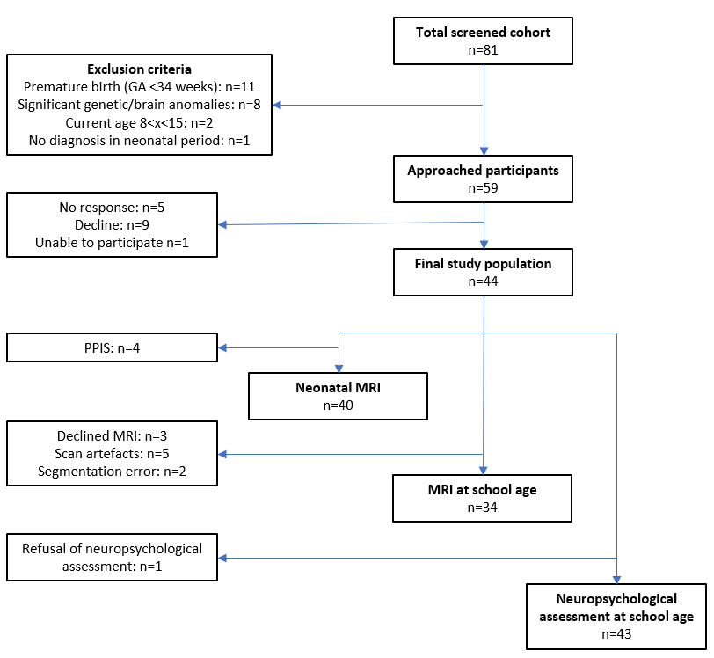

3.2 Neonatal stroke characteristics and brain volume at school age
3.2.1 Stroke volume
As expected, stroke location and stroke volume were significantly associated (r(40)=.476, p=.002). This relationship is displayed visually in supplementary Figure A.
To examine the relationship between neonatal stroke volume and brain volume at school age, a multivariate linear regression was used. All assumptions were met, except for homoscedasticity for all brain volumes and multicollinearity for ipsilesional cortical grey matter and white matter volume, which might influence the reliability of the analyses.
Neonatal stroke volume negatively correlated significantly with the TBV at school age (p<.001) as well as with the IHV (p<.001), but not with the CHV (Figure 2, Table 3). Neonatal stroke volume was also negatively correlated to ipsilesional cortical grey matter volume (p<.001), white matter volume (p<.001), and subcortical grey matter volume (p<.001) at school age (Figure 2, Table 3). In the contralesional hemisphere, only subcortical grey matter volume was significantly negatively associated with stroke volume (p=.039) (Figure 2, Table 3). These correlations persisted when investigating the data without the main branch MCA group, except for subcortical grey matter in the ipsilesional hemisphere.

Table 3. Multivariate linear associations between relative neonatal stroke volume and brain volume at school age
 | Predictors | df | Adj. R² | Standardised β | 95% CI | p-value
Total brain volume | Stroke volume  Age  Sex | 3,26 | .576 | -.764  -.021  .328 | -14925.98 – -7487.69  -17571.42 – 14881.59  18685.09 – 143472.22 | <.001*  .866  .013*
Contralesional hemisphere | Stroke volume  Age  Sex | 3,26 | .223 | -.207  -.089  .518 | -3192.44 – 829.65  -10603.97 – 6349.13  15365.09 – 82280.34 | .237  .609  .006
Cortical grey matter | Stroke volume | 1,28 | -.033 | .051 | -.001 – .001 | .788
White matter | Stroke volume | 1,28 | -.032 | .062 | -.001 – .001 | .746
Subcortical grey matter | Stroke volume | 1,28 | .113 | -.378 | -.0002 – -.0001 | <.001*
Ipsilesional hemisphere | Stroke volume  Age  Sex | 3,24 | .766 | -.899  .066  .249 | -11233.67 – -7345.72  -5484.395 – 11478.61  10649.71 – 75875.25 | <.001*  .474  .011*
Cortical grey matter | Stroke volume | 1,28 | .816 | -.907 | -.008 – -.006 | <.001*
White matter | Stroke volume | 1,28 | .816 | -.907 | -.007 – -.005 | <.001*
Subcortical grey matter | Stroke volume | 1,28 | .601 | -.784 | -.001 – .001 | <.001*
*p < .05

3.2.2 Stroke location
The descriptives of brain volume at school age per arterial territory are displayed in supplementary Table A. Significant differences between the stroke territories were found for the TBV (p=.012) and the IHV (p<.001), but not for the CHV (supplementary Table B). Significant intergroup differences were also found for relative cortical grey matter volume (p=.003), white matter volume (p=.006) and subcortical grey matter volume (p=.004) in the ipsilesional hemisphere, but not in the contralesional hemisphere (supplementary Table C). Post-hoc analyses revealed that the effect was primarily driven by the main branch MCA group, which had significantly smaller brain volumes compared to the other arterial territory groups. However, even when the main branch MCA group was excluded, the significant differences persisted for most volumes, except the TBV and IHV. Additionally, the difference between the territories became significant for subcortical grey matter volume in the contralesional hemisphere (χ2(5)=11.418, p=.044).

Figure 2. The relationship between stroke characteristics (relative neonatal stroke volume and arterial territory) and brain volume at school age
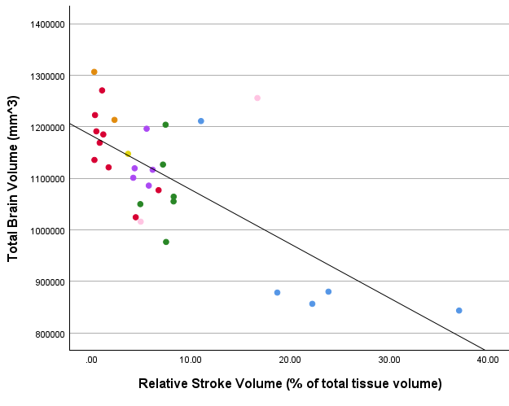a. 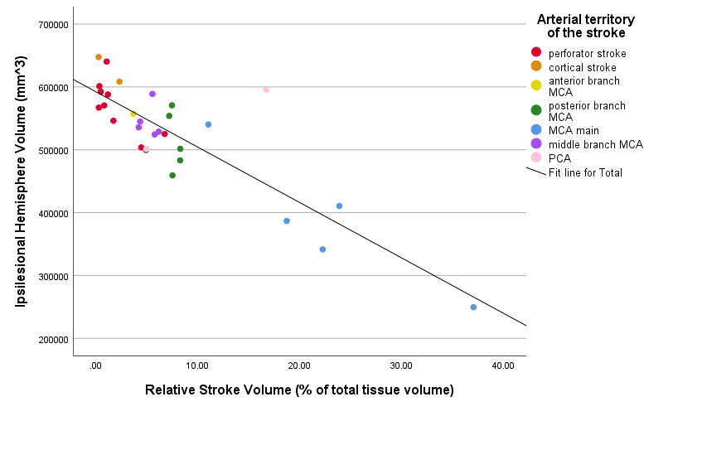
b.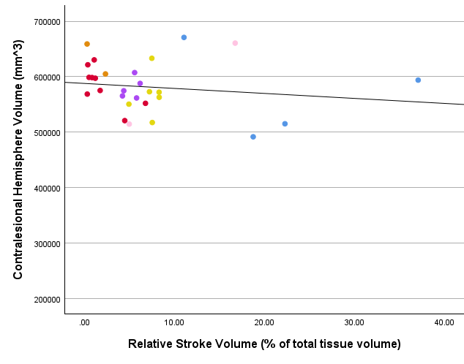c.
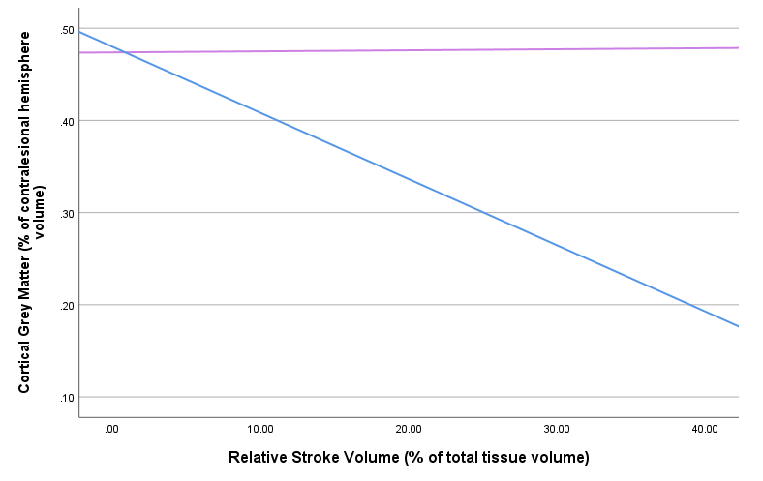d. 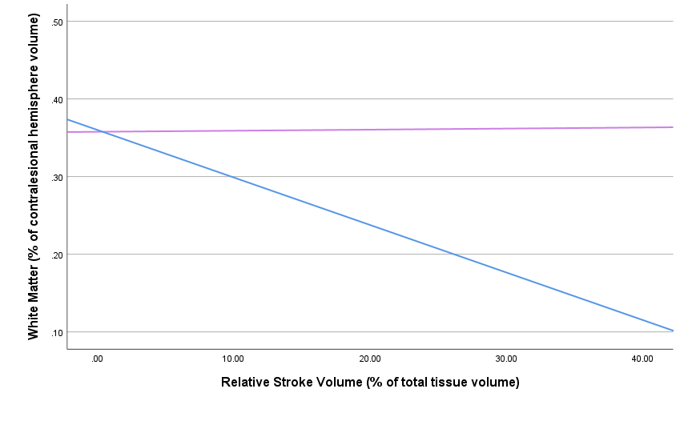e. 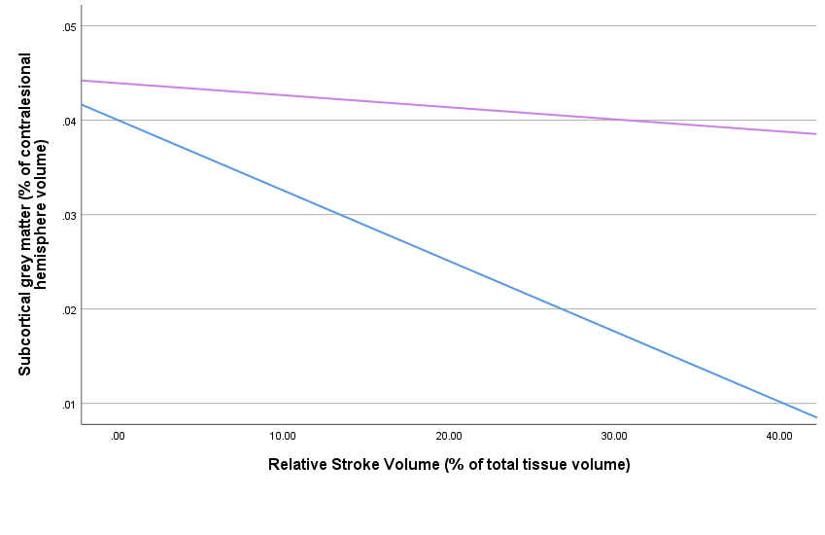f. 
The stroke location is shown in colour for total brain volume (a), ipsilesional hemisphere volume (b), and contralesional hemisphere volume (c) at school age. Relative ipsilesional (blue) and contralesional (purple) volumes are shown for cortical grey matter (d), white matter (e), and subcortical grey matter (f) at school age.

3.3 Neonatal stroke characteristics and cognition at school age
3.3.1 Stroke volume
To investigate the relationship between neonatal stroke characteristics and cognitive outcomes at school age, multivariate linear regressions were used. All assumptions were met, with an exception for homoscedasticity.
Neonatal stroke volume negatively correlated significantly with the scores on the FSIQ (p<.001), VCI (p=.001), VSI (p<.001), FRI (p<.001), WMI (p=.003), and PSI (p=.013) (Figure 3, Table 4). When the data was investigated without the main branch MCA group, these effects only persisted for the FSIQ (adj. R²=.137, F(2,29)=3.451, p=.045, β=-.436) and FRI (adj. R²=.161, F(2,29)=3.979, p=.030, β=-.406).

3.3.2 Stroke location
The descriptives of cognition at school age per arterial territory are displayed in supplementary Table D. For this analysis, a one-way independent ANOVA was used as all assumptions were met. Significant differences were found for FSIQ (p<.001), VCI (p=.004), VSI (p<.001), FRI (p<.001), and WMI (p=.014), but not for PSI (Figure 3, supplementary Table E). A post-hoc analysis revealed that mainly the main branch MCA group scored lower than other territories. When the analysis was repeated without the main branch MCA group, there was only a significant intergroup difference in FSIQ scores (F(6,28)=3.140, p=.023).

Table 4. Multivariate linear associations between relative neonatal stroke volume and cognitive outcomes at school age
 | Predictors | df | Adj. R² | Standardised β | 95% CI | p-value
FSIQ | Stroke volume  Maternal education | 2,36 | .508 | -.702  .110 | -20.661 – -10.724  -3.449 – 4.147 | <.001*  .348
VCI | Stroke volume  Maternal education | 2,36 | .343 | -.553  -.005 | -18.199 – -7.224  -4.256 – 4.134 | <.001*  .971
VSI | Stroke volume  Maternal education | 2,35 | .397 | -.668  .115 | -19.784 – -8.646  -4.167 – 4.309 | <.001*  .193
FRI | Stroke volume  Maternal education | 2,35 | .389 | -.609  .226 | -17.911 – -7.307  -2.216 – 5.762 | <.001*  .081
WMI | Stroke volume  Maternal education | 2,34 | .207 | -.538  -.051 | -17.157 – -4.620  -6.449 – 3.254 | <.001*  .732
PSI | Stroke volume  Maternal education | 2,34 | .182 | -.402  .168 | -15.933 – -2.402  -2.964 – 7.081 | .014*  .289
FSIQ = Full Scale Intelligence Quotient, VCI = Verbal Comprehension Index, VSI = Visual Spatial Index, FRI = Fluid Reasoning Index, WMI = Working Memory Index, PSI = Processing Speed Index
*p < .05
Figure 3. The relationship between stroke characteristics (relative neonatal stroke volume and arterial territory) and cognitive outcomes at school age
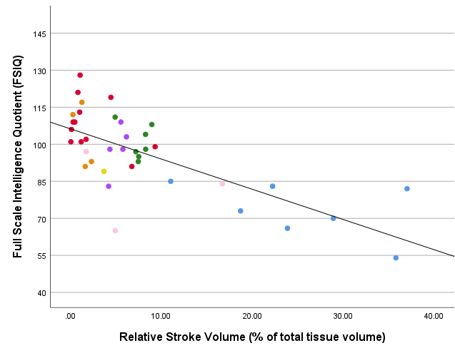 a. 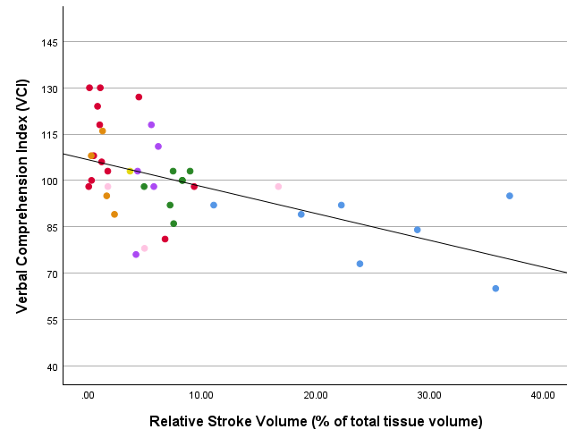b.
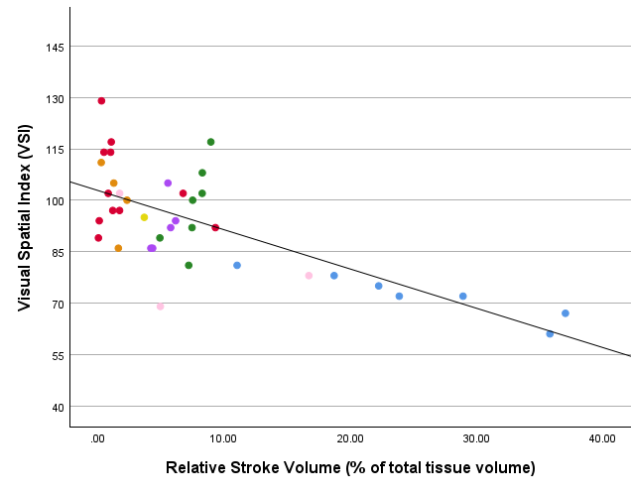 c. 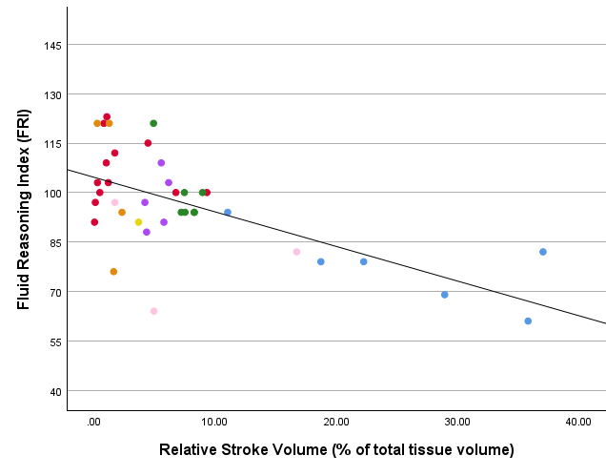d.
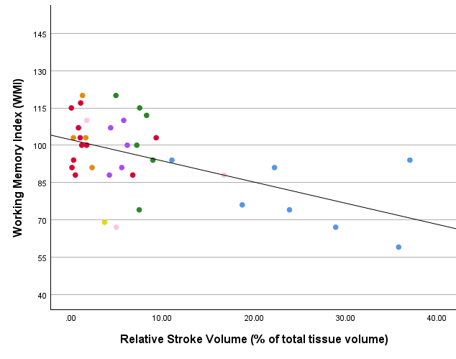e.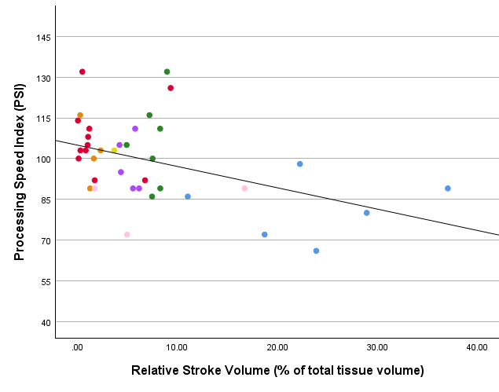 f.
The stroke location is shown in colour for Full Scale Intelligence Quotient (FSIQ) (a), Verbal Comprehension Index (VCI) (b), Visual Spatial Index (VSI) (c), Fluid Reasoning Index (FRI) (d), Working Memory Index (WMI) (e), and Processing Speed Index (PSI) (f).
3.4 Brain volume and cognition at school age
To investigate the relationship between brain volume and cognitive outcomes at school age, multivariate linear regressions were used. The assumptions were met for most analyses, except for homoscedasticity when investigating the relationship between the IHV and the VRI index, the ipsilesional tissues and all indices, and the contralesional tissues and the FRI index.
The TBV was positively associated with the scores on the FSIQ (p<.001), VCI (p=.031), VSI (p<.001), FRI (p=.018), and PSI (p<.001), but not WMI (Figure 4a, Table 5). When this relationship was investigated without the main branch MCA group, the effect persisted for the FSIQ (p=.041), VSI (p=.021), and PSI (p=.001).
Similarly, IHV also positively correlated to the scores on the FSIQ (p<.001), VCI (p=.034), VSI (p<.001), FRI (p=.013), and PSI (p<.001), but not to WMI (Figure 4b, Table 5). Ipsilesional cortical grey matter volume was positively correlated to the scores on the FSIQ (p=.004), VCI (p=.035), VSI (p=.002), and FRI (p=.016) (Table 5). Ipsilesional white matter volume was positively associated with the scores on the FSIQ (p=.005), VSI (p=.001), and FRI (p=.005), but not with VCI, WMI, or PSI (Table 5). Ipsilesional subcortical grey matter volume was also positively associated with the scores on the FSIQ (p=.032) and VSI (p=.005), but not with VCI, FRI, WMI, or PSI (Table 5). When these relationships were investigated without the main branch MCA group, IHV still positively correlated to the FSIQ (p=.019), VSI (p=.015), and PSI (p<.001) scores, but no longer to VCI and FRI. Ipsilesional cortical grey matter volume still correlated positively to the FSIQ (p=.036) and VCI (p=.015) scores, but no longer to VSI and FRI. Ipsilesional white matter volume and subcortical grey matter volume no longer correlated to any of the indices.
For the contralesional hemisphere, CHV positively correlated to the scores on the PSI (p=.004) but not to the other indices (Figure 4c, Table 5). Contralesional cortical grey matter volume, white matter volume, and subcortical grey matter volume were not associated significantly with the cognitive indices. When investigating the relationships without the main branch MCA group, the CHV was still positively associated with the PSI index (p=.009) and no significant relationships were found for contralesional cortical grey matter, white matter, or subcortical grey matter volumes.
All associations between the brain volumes at school age and cognitive indices are reported in supplementary Table F.

Table 5. Multivariate linear associations between brain volumes at school age and cognitive indices. Of the nine segmented brain volumes and cognition outcomes, only the associations with p-value <.05 are shown in this table.
 |  | Predictors | df | Adj. R² | Standardised β | 95% CI | p-value
Total brain volume | FSIQ | Brain volume  Age  Sex | 3,28 | .415 | .641  -.280  -.247 | .00004 - .00011  -4.471 - .017  -16.559 - 1.340 | <.001  .052  .093
 | VCI | Brain volume  Age  Sex | 3,28 | .188 | .457  -.242  -.012 | .00001 - .00008  -4.284 - .676  -10.246 - 9.533 | .010  .147  .942
 | VSI | Brain volume  Age  Sex | 3,27 | .441 | .674  -.216  -.306 | .00004 - .00012  -4.117 - .536  -19.150 - -.598 | <.001  .126  .038
 | FRI | Brain volume  Age  Sex | 3,27 | .229 | .565  -.181  -.121 | .00002 - .00009  -3.774 - 1.121  -13.383 - 6.535 | .003  .267  .487
 | PSI | Brain volume  Age  Sex | 3,27 | .459 | .611  -.336  -.378 | .00003 - .00010  -4.894 - -.479  -20.575 - -2.972 | <.001  .019  .011
Contralesional hemisphere volume | PSI | Brain volume  Age  Sex | 3,25 | .339 | .606  -.309  -.479 | .00007 - .00028  -4.832 -.071  -25.148 - -3.714 | .001  .056  .010
Ipsilesional hemisphere volume | FSIQ | Brain volume  Age  Sex | 3,28 | .420 | .635  -.308  -.196 | .00005 - .00015  -4.688 - -.213  -14.827 - 2.724 | <.001  .033  .169
 | VCI | Brain volume  Age  Sex | 3,28 | .183 | .444  -.261  .026 | .00001 - .00012  -4.442 - 541  -9.049 - 10.496 | .012  .120  .880
 | VSI | Brain volume  Age  Sex | 3,27 | .467 | .683  -.242  -.260 | .00007 - .00017  -4.283 - .266  -17.308 - .565 | <.001  .081  .065
 | FRI | Brain volume  Age  Sex | 3,27 | .249 | .567  -.192  -.062 | .00003 - .00013  -3.830 - 1.008  -11.275 - 7.777 | .002  .242  .709
 | PSI | Brain volume  Age  Sex | 3,27 | .396 | .553  -.356  -.326 | .00004 - .00014  -5.187 - -.516  -19.326 - -.976 | <.001  .019  .031
Cortical grey matter | FSIQ | Brain volume | 1,30 | .217 | .493 | 38.886 - 189.087 | .004
 | VCI | Brain volume | 1,30 | .112 | .375 | 6.277 - 156.893 | .035
 | VSI | Brain volume | 1,29 | .252 | .527 | 49.728 - 207.278 | .002
 | FRI | Brain volume | 1,30 | .177 | .421 | 18.624 - 171.246 | .016
White matter | FSIQ | Brain volume | 1,30 | .212 | .488 | 44.015 - 220.798 | .005
 | VSI | Brain volume | 1,29 | .292 | .561 | 71.588 - 253.684 | .001
 | FRI | Brain volume | 1,30 | .230 | .480 | 40.325 - 213.541 | .005
Subcortical grey matter | FSIQ | Brain volume | 1,30 | .115 | .379 | 66.856 - 1404.650 | .032
 | VSI | Brain volume | 1,29 | .220 | .496 | 339.639 - 1688.596 | .005
FSIQ = Full Scale Intelligence Quotient, VCI = Verbal Comprehension Index, VSI = Visual Spatial Index, FRI = Fluid Reasoning Index, WMI = Working Memory Index, PSI = Processing Speed Index

Figure 4. The relationship between total brain volume (a), ipsilesional hemisphere volume (b), and contralesional hemisphere volume (c) and the FSIQ and five cognitive indices (shown in colour)
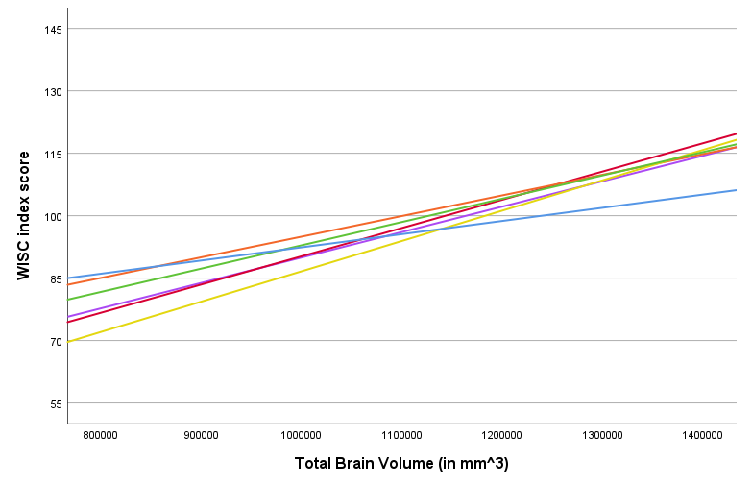 a. 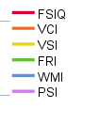
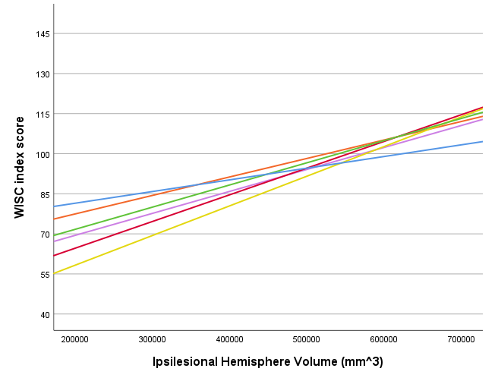b. 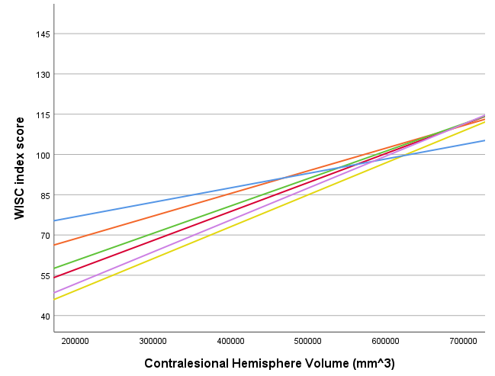c.
FSIQ = Full Scale Intelligence Quotient, VCI = Verbal Comprehension Index, VSI = Visual Spatial Index, FRI = Fluid Reasoning Index, WMI = Working Memory Index, PSI = Processing Speed Index

4 Discussion
This study aimed to get a better insight into the effect of PAIS on brain development and cognitive outcome at school age. Overall, we found that the WISC index scores of most children fell within the normal range, though 28% suffered from cognitive impairment, while 12% performed above average. We found that neonatal stroke volume correlated negatively with the TBV and ipsilesional hemisphere volumes at school age, but not with the contralesional hemisphere volumes. Moreover, neonatal stroke volume correlated negatively with FSIQ and all indices. The arterial territory subgroups differed significantly in the TBV and ipsilesional brain volumes at school age and the cognitive indices and followed the same pattern as stroke volume. Additionally, we found that the TBV and ipsilesional brain volumes at school age were positively associated with the FSIQ and all indices, except WMI.
As expected, we found that neonatal stroke volume strongly correlates negatively to the TBV and the ipsilesional hemisphere volumes but not to contralesional hemisphere volumes (Ilves et al., 2022; Pretzel et al., 2022; Shinde et al., 2023). Exceptionally, contralesional subcortical grey matter volume did correlate negatively to stroke volume. This unexpected finding could be due to the nature of subcortical structures, which serve as relay centre, and therefore it could be argued that its volume would decrease when there is less input and output due to a large stroke.
Moreover, neonatal stroke volume also correlated negatively to the scores on FSIQ and all indices, confirming the previously published findings in children with PAIS that stroke volume correlated negatively to cognitive outcomes (Bosenbark et al., 2016; Lõo et al., 2018; Long et al., 2011; Westmacott, 2010). This aligns with our hypothesis, as we expect that stroke volume influences the extent of disruption of brain development, which subsequently affects cognitive functioning.
Stroke location had a significant influence on both brain volume at school age as well as cognition, which also corresponds with prior research (Long et al., 2010; López-Espejo et al., 2017; Wagenaar et al., 2018), though the relationship between stroke location and cognition is not always found (Bosenbark et al., 2016; Dunbar et al., 2018). However, it must be noted that the effect we found of stroke location on the outcomes was mainly caused by the main branch MCA subgroup as it had much smaller brain volumes and cognitive index scores than the other arterial territory groups. The effect of stroke location on the outcomes became less prominent when the main branch MCA was excluded, which is why neonatal stroke volume is a considerably better predictor for neurodevelopmental outcomes at school age. Nevertheless, the arterial territory was strongly associated with neonatal stroke volume and could therefore be useful in a clinical setting to predict the long-term consequences of PAIS.
In line with prior research, our study showed a positive correlation between brain volume at school age and cognitive functioning, as the TBV and IHV were positively correlated to all cognitive indices, except WMI. Additionally, although the correlations of the ipsilesional volumes and cognitive indices all had the same positive trend, some associations were unexpectedly insignificant. We hypothesise that the discrepancies arose as cognitive functioning depends more on the integrity of widespread neural networks rather than brain volume. Therefore, future research could investigate the association between brain development and cognition after PAIS by focussing on connectivity instead of brain volume.
This study has several limitations. First, while the number of participants is one of this study’s strengths due to the rarity of PAIS, our sample size is simultaneously statistically a limitation, especially for analyses involving stroke location as some subgroups consisted of only a few children. Additionally, the small sample size limited the number of covariates that we were able to include and therefore we were unable to correct the analyses involving both brain volumes and cognition for maternal education. However, when investigating the data, maternal education rarely was a significant covariate and added very limited explained variance.
Second, the selection of participants was done as randomly as possible, but there were many uncontrollable factors, such as willingness/ableness to participate and geographical location (the NSRU only includes children admitted to the WCH), thereby possibly introducing sampling bias. Moreover, various factors could influence how inclined parents and children were to participate, such as parental education level, younger age of the child, or disease burden.
Third, a methodological limitation that should be discussed is the MRI segmentation quality at school age. We used a method that was trained on healthy, symmetrical brains, while our participants often had significant brain lesions, leading to segmentation inaccuracies. The cortex adjacent to the stroke lesion was sometimes not segmented correctly and was excluded from the volume measurements. Although it is arguable that this part of the cortex might not function properly (Marín-Padilla, 1996), this limitation reduced the accuracy of our ipsilesional brain volumes assessment and led to the exclusion of scans of two participants in the main branch MCA group. Therefore, the improvement of brain segmentation methods that can process MRI scans of brains with lesions is needed to perform more precise studies on brain development.
In conclusion, this study found that stroke volume and certain stroke locations (main branch MCA) are significantly associated with smaller ipsilesional hemisphere volumes as well as lower IQ scores at school age. Prior research has found varying results regarding the neurodevelopmental consequences after PAIS and has mostly been limited to a young population (<7 years), which makes it difficult to predict the long-term consequences of PAIS. As cognitive deficit may not become apparent until the school years, the follow-up of children with PAIS should be extended, also when there is no apparent cognitive impairment as pre-schoolers. By obtaining a better understanding of the neurodevelopmental outcomes after PAIS, we can indicate children at risk for cognitive impairment and offer support more effectively.

Acknowledgements
For this project, OpenAI Chat-GPT 3.5 (August 2024) was used to provide feedback on my writing style and refine sentences.
Supplementary Information

Figure A. Relative neonatal stroke volume (% of neonatal total brain volume) per arterial territory

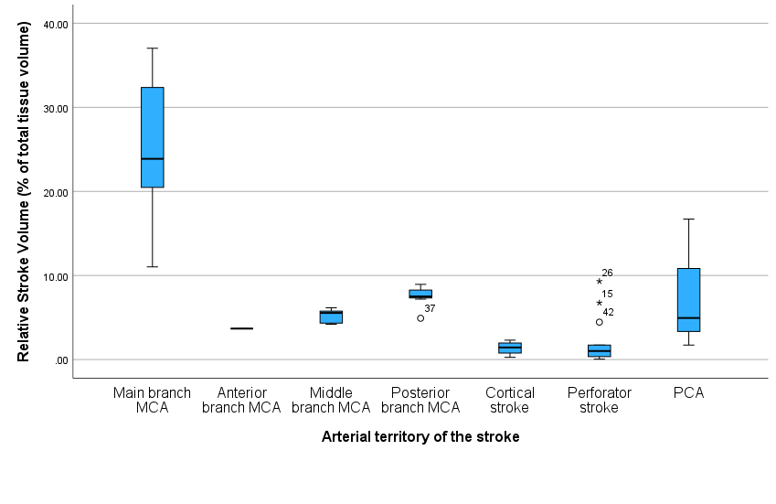
MCA = middle cerebral artery, PCA = posterior cerebral artery

Table A. Brain volumes at school age per arterial territory
 | Total  (n=31) | Main MCA (n=4) | Anterior MCA (n=1) | Middle MCA (n=5) | Posterior MCA (n=7) | Cortical stroke (n=2) | Perforator stroke (n=11) | PCA (n=2)
Total brain volume in cm³, mean (SD) | 1096691.11 (132931.89) | 947230.17 (176459.48) | 1147427.63 (N/A) | 1123761.75 (42651.84) | 1040421.45 (124978.64) | 1259884.36 (65871.98) | 1152856.00 (90662.12) | 1135776.06 (169640.64)
Contralesional hemisphere in cm³, mean (SD) | 577438.02 (50967.62) | 567747.31 (81429.50) | N/A | 579283.47 (18660.28) | 554117.64 (50544.44) | 631914.79 (38221.73) | 583235.24 (42997.30) | 587465.61 (103261.94)
Cortical grey matter as % of CHV, mean (SD) | 47.59 (1.74) | 46.93 (1.38) | 49.85 (N/A) | 48.62 (1.65) | 48.14 (2.03) | 46.43 (1.63) | 47.36 (1.71) | 46.48 (1.18)
White matter as % of CHV, mean (SD) | 35.66 (1.83) | 36.39 (1.83) | 33.90 (N/A) | 34.51 (1.77) | 35.72 (2.10) | 37.3 (1.10) | 35.71 (1.97) | 35.75 (0.56)
Subcortical grey  Matter as % of CHV, mean (SD) | 4.31 (0.26) | 4.25 (0.50) | 4.14 (N/A) | 4.25 (0.16) | 4.12 (0.16) | 4.4 (0.00) | 4.4 (0.16) | 4.48 (0.43)
Ipsilesional hemisphere in cm³, mean (SD) | 522136.29 (91169.19) | 379482.85 (121430.39) | 557105.55 (N/A) | 544478.28 (25992.33) | 486303.81 (76806.30) | 627969.57 (27650.24) | 569620.76 (48314.37) | 548310.45 (66378.70)
Cortical grey matter,  as % of CHV, mean (SD) | 43.14 (6.28) | 30.88 (9.64) | 46.26 (N/A) | 45.41 (2.41) | 41.47 (3.36) | 46.04 (2.82) | 46.86 (2.38) | 43.46 (1.59)
White matter as % of CHV, mean (SD) | 31.51 (5.41) | 21.34 (7.33) | 32.38 (N/A) | 32.17 (2.21) | 30.24 (4.70) | 37.19 (1.21) | 34.17 (1.97) | 32.63 (1.89)
Subcortical grey  matter as % of CHV, mean (SD) | 3.82 (0.75) | 2.23 (0.71) | 3.96 (N/A) | 4.05 (0.28) | 3.72 (0.55) | 4.42 (0.02) | 4.03 (0.31) | 4.48 (0.39)
MCA = middle cerebral artery, PCA = posterior cerebral artery, CHV = Contralesional hemisphere volume
Table B. Relationship between stroke location (arterial territory) and brain volume at school age (ANCOVA)
 | Predictors | Adj. R² | df | F | η_{p}² | p-value
Total brain volume | Stroke location  Age  Sex | .340 | 8,24 | 3.548  .296  2.881 | .470  .012  .107 | .012*  .592  .103
Contralesional hemisphere volume | Stroke location  Age  Sex | .081 | 7,23 | .563  .039  4.843 | .109  .002  .174 | .727  .846  .038
Ipsilesional hemisphere volume | Stroke location  Age  Sex | .503 | 8,24 | 6.373 | .614  .054  .091 | <.001*  .252  .133
*p < .05

Table C. Relationship between stroke location (arterial territory) and brain volume at school age
 | Statistical test used | df | Distribution (F or X²) | p-value
Contralesional hemisphere volume
Cortical grey matter volume | Kruskal-Wallis | 6 | 7.439 | .282
White matter volume | ANOVA | 8,24 | .775 | .596
Subcortical grey matter volume | ANOVA | 8,24 | 1.602 | .186
Ipsilesional hemisphere volume
Cortical grey matter volume | Kruskal-Wallis | 6 | 19.839 | .003*
White matter volume | Kruskal-Wallis | 6 | 18.057 | .006*
Subcortical grey matter volume | Kruskal-Wallis | 6 | 18.865 | .004*
*p < .05
Table D. Cognitive index scores at school age per arterial territory
 | Total  (n=43) | Main MCA (n=8) | Anterior MCA (n=1) | Middle MCA (n=5) | Posterior MCA (n=8) | Cortical MCA (n=4) | Perforator (n=14) | PCA (n=3)
FSIQ, mean (SD) | 96 (16.3) | 74 (10.4) | 89 (N/A) | 98 (9.6) | 98 (10.6) | 103 (13.2) | 108 (10.3) | 82 (16.1)
VCI, mean (SD) | 99 (15.6) | 83 (11.1) | 103 (N/A) | 101 (16.0) | 95 (8.2) | 102 (12.2) | 111 (14.7) | 91 (11.5)
VSI, mean (SD) | 93 (16.4) | 73 (6.3) | 95 (N/A) | 93 (7.8) | 97 (12.4) | 101 (10.7)* | 103 (16.0) | 83 (17.1)
FRI, mean (SD) | 97 (15.2) | 78 (10.5) | 91 (N/A) | 98 (8.6) | 99 (9.6) | 103 (22.0) | 106 (9.6) | 81 (16.5)
WMI, mean (SD) | 96 (16.0) | 82 (14.9) | 69 (N/A) | 99 (9.6) | 98 (18.9)* | 104 (11.9)* | 103 (10.8) | 88 (21.5)
PSI, mean (SD) | 97 (16.2) | 82 (10.7)* | 103 (N/A) | 98 (9.9) | 101 (18.9) | 102 (11.1)* | 104 (16.3) | 83 (9.8)
MCA = middle cerebral artery, PCA = posterior cerebral artery, FSIQ = Full Scale Intelligence Quotient, VCI = Verbal Comprehension Index, VSI = Visual Spatial Index, FRI = Fluid Reasoning Index, WMI = Working Memory Index, PSI = Processing Speed Index
*mean score and SD are based on n-1 due to a single missing value

Table E. Relationship between stroke location (arterial territory) and cognitive indices at school age (ANCOVA)
 | Predictors | df | Adj. R² | F | η_{p}² | p-value
FSIQ | Stroke location  Maternal education | 7,35 | .535 | 8.386  .008 | .590  .000 | <.001*  .929
VCI | Stroke location  Maternal education | 7,35 | .307 | 3.947  .070 | .404  .002 | .004*  .792
VSI | Stroke location  Maternal education | 7,34 | .386 | 5.071  .010 | .472  .000 | <.001*  .992
FRI | Stroke location  Maternal education | 7,34 | .406 | 4.985  .796 | .468  .023 | <.001*  .379
WMI | Stroke location  Maternal education | 7,33 | .233 | 3.177  1.477 | .366  .043 | .014*  .233
PSI | Stroke location  Maternal education | 7,33 | .168 | 1.960  .623 | .263  .019 | .100  .435
FSIQ = Full Scale Intelligence Quotient, VCI = Verbal Comprehension Index, VSI = Visual Spatial Index, FRI = Fluid Reasoning Index, WMI = Working Memory Index, PSI = Processing Speed Index
*p < .05
Table F. Multivariate linear associations between brain volumes and cognitive indices at school age
 |  | Predictors | df | Adj. R² | Standardised β | 95% CI | p-value
Total brain volume | FSIQ | Brain volume  Age  Sex | 3,28 | .415 | .641  -.280  -.247 | .00004 - .00011  -4.471 - .017  -16.559 - 1.340 | <.001*  .052  .093
 | VCI | Brain volume  Age  Sex | 3,28 | .188 | .457  -.242  -.012 | .00001 - .00008  -4.284 - .676  -10.246 - 9.533 | .010*  .147  .942
 | VSI | Brain volume  Age  Sex | 3,27 | .441 | .674  -.216  -.306 | .00004 - .00012  -4.117 - .536  -19.150 - -.598 | <.001*  .126  .038
 | FRI | Brain volume  Age  Sex | 3,27 | .229 | .565  -.181  -.121 | .00002 - .00009  -3.774 - 1.121  -13.383 - 6.535 | .003*  .267  .487
 | WMI | Brain volume  Age  Sex | 3,26 | .129 | .321  -.343  -.153 | -.00001 - .00001  -5.519 - .103  -15.659 - 6.429 | .082  .058  .398
 | PSI | Brain volume  Age  Sex | 3,27 | .459 | .611  -.336  -.378 | .00003 - .00010  -4.894 - -.479  -20.575 - -2.972 | <.001*  .019  .011
Contralesional hemisphere volume | FSIQ | Brain volume  Age  Sex | 3,26 | .127 | .461  -.233  -.202 | .00001 - .00025  -4.491 - .960  -18.106 - 5.930 | .025  .195  .307
 | VCI | Brain volume  Age  Sex | 3,26 | .028 | .281  -.173  .054 | -.00003 - .00014  -3.998 - 1.488  -10.556 - 13.636 | .179  .356  .796
 | VSI | Brain volume  Age  Sex | 3,25 | .170 | .521  -.193  -.341 | .00004 - .00029  -4.555 - 1.364  -24.135 - 1.740 | .011  .277  087
 | FRI | Brain volume  Age  Sex | 3.26 | .062 | .403  -.145  -.086 | -.00001 - .00024  -3.784 - 1.668  -14.514 - 9.521 | .055  .432  .673
 | WMI | Brain volume  Age  Sex | 3,24 | .047 | .229  -.340  -.056 | -.00001 - .0001  -5.375 - .363  -13.884 - 10.697 | .279  .084  .791
 | PSI | Brain volume  Age  Sex | 3,25 | .339 | .606  -.309  -.479 | .00007 - .00028  -4.832 -.071  -25.148 - -3.714 | .001*  .056  .010
Cortical grey  matter volume | FSIQ | Brain volume | 1,30 | -.028 | .069 | -258.539 - 375.800 | .708
 | VCI | Brain volume | 1,30 | -.002 | .174 | -155.410 - 433.974 | .342
 | VSI | Brain volume | 1,29 | -.032 | .047 | -302.498 - 388.181 | .801
 | FRI | Brain volume | 1,30 | -.026 | -.084 | -378.964 - 238.668 | .646
 | WMI | Brain volume | 1,28 | .024 | .155 | -197.968 - 466.471 | .415
 | PSI | Brain volume | 1,29 | -.030 | .066 | -264.395 - 376.339 | .723
White matter  volume | FSIQ | Brain volume | 1,30 | -.033 | .023 | -287.827 - 324.914 | .902
 | VCI | Brain volume | 1,30 | -.019 | -.118 | -378.060 - 194.744 | .518
 | VSI | Brain volume | 1,29 | -.032 | .045 | -297.979 - 377.606 | .811
 | FRI | Brain volume | 1,30 | -.022 | .106 | -212.199 - 381.914 | .564
 | WMI | Brain volume | 1,28 | -.023 | -.110 | -423.982 - 235.425 | .563
 | PSI | Brain volume | 1,29 | -.027 | .084 | -243.307 - 382.506 | .653
Subcortical  grey matter  volume | FSIQ | Brain volume | 1,30 | -.033 | .023 | -1993.357 - 2255.384 | .901
 | VCI | Brain volume | 1,30 | -.033 | -.023 | -2122.455 - 1876.526 | .901
 | VSI | Brain volume | 1,29 | -.013 | .143 | -1400.471 - 3111.918 | .444
 | FRI | Brain volume | 1,30 | -.030 | .055 | -1762.511 - 2374.121 | .765
 | WMI | Brain volume | 1,28 | -.032 | -.056 | -2597.559 - 1935.456 | .767
 | PSI | Brain volume | 1,29 | -.017 | -.128 | -2814.508 - 1384.408 | .492
Ipsilesional hemisphere volume | FSIQ | Brain volume  Age  Sex | 3,28 | .420 | .635  -.308  -.196 | .00005 - .00015  -4.688 - -.213  -14.827 - 2.724 | <.001*  .033  .169
 | VCI | Brain volume  Age  Sex | 3,28 | .183 | .444  -.261  .026 | .00001 - .00012  -4.442 - 541  -9.049 - 10.496 | .012*  .120  .880
 | VSI | Brain volume  Age  Sex | 3,27 | .467 | .683  -.242  -.260 | .00007 - .00017  -4.283 - .266  -17.308 - .565 | <.001*  .081  .065
 | FRI | Brain volume  Age  Sex | 3,27 | .249 | .567  -.192  -.062 | .00003 - .00013  -3.830 - 1.008  -11.275 - 7.777 | .002*  .242  .709
 | WMI | Brain volume  Age  Sex | 3,26 | .122 | .307  -.356  -.127 | -.00001 - .00001  -5.631 - .021  -14.788 - 7.089 | .093  .052  .476
 | PSI | Brain volume  Age  Sex | 3,27 | .396 | .553  -.356  -.326 | .00004 - .00014  -5.187 - -.516  -19.326 - -.976 | <.001*  .019  .031
Cortical  grey matter  volume | FSIQ | Brain volume | 1,30 | .217 | .493 | 38.886 - 189.087 | .004*
 | VCI | Brain volume | 1,30 | .112 | .375 | 6.277 - 156.893 | .035*
 | VSI | Brain volume | 1,29 | .252 | .527 | 49.728 - 207.278 | .002*
 | FRI | Brain volume | 1,30 | .177 | .421 | 18.624 - 171.246 | .016*
 | WMI | Brain volume | 1,28 | .014 | .220 | -36.757 - 139.243 | .243
 | PSI | Brain volume | 1,29 | .070 | .317 | -9.681 - 153.538 | .082
White matter  volume | FSIQ | Brain volume | 1,30 | .212 | .488 | 44.015 - 220.798 | .005*
 | VCI | Brain volume | 1,30 | .036 | .260 | -25.705 - 158.350 | .151
 | VSI | Brain volume | 1,29 | .292 | .561 | 71.588 - 253.684 | .001*
 | FRI | Brain volume | 1,30 | .230 | .480 | 40.325 - 213.541 | .005*
 | WMI | Brain volume | 1,28 | -.001 | .182 | -54.903 - 155.619 | .335
 | PSI | Brain volume | 1,29 | .091 | .349 | -1.970 - 189.563 | .055
Subcortical  grey matter  volume | FSIQ | Brain volume | 1,30 | .115 | .379 | 66.856 - 1404.650 | .032*
 | VCI | Brain volume | 1,30 | .007 | .199 | -304.508 – 1029.325 | .276
 | VSI | Brain volume | 1,29 | .220 | .496 | 339.639 - 1688.596 | .005*
 | FRI | Brain volume | 1,30 | .056 | .293 | -119.091 - 1228.406 | .103
 | WMI | Brain volume | 1,28 | -.008 | .165 | -423.634 - 1066.586 | .384
 | PSI | Brain volume | 1,29 | .033 | .255 | -212.239 - 1182.539 | .165
FSIQ = Full Scale Intelligence Quotient, VCI = Verbal Comprehension Index, VSI = Visual Spatial Index, FRI = Fluid Reasoning Index, WMI = Working Memory Index, PSI = Processing Speed Index
*p < .05

References
Ballantyne, A. O., Spilkin, A. M., Hesselink, J. R., & Trauner, D. A. (2008). Plasticity in the developing brain: intellectual, language and academic functions in children with ischaemic perinatal stroke. Brain, 131(11), 2975–2985. https://doi.org/10.1093/brain/awn176
Banich, M. T., Levine, S. C., Kim, H., & Huttenlocher, P. R. (1990). The effects of developmental factors on IQ in hemiplegic children. Neuropsychologia, 28(1), 35–47. https://doi.org/10.1016/0028-3932(90)90084-2
Bosenbark, D. D., Krivitzky, L., Ichord, R., Jastrzab, L., & Billinghurst, L. (2016). Attention and executive functioning profiles in children following perinatal arterial ischemic stroke. Child Neuropsychology, 24(1), 106 123. https://doi.org/10.1080/09297049.2016.1225708
Chabrier, S., Peyric, É., Drutel, L., Deron, J., Kossorotoff, M., Dinomais, M., Lazaro, L., Lefranc, J., Thébault, G., Dray, G., Fluss, J. V., Renaud, C., Tich, S. N., Darteyre, S., Dégano, C., Delion, M., Groeschel, S., Hertz‐Pannier, L., Husson, B., . . . Vuillerot, C. (2016). Multimodal Outcome at 7 Years of Age after Neonatal Arterial Ischemic Stroke. The Journal of Pediatrics, 172, 156-161.e3. https://doi.org/10.1016/j.jpeds.2016.01.069
Dunbar, M., & Kirton, A. (2018). Perinatal stroke: mechanisms, management, and outcomes of early cerebrovascular brain injury. The Lancet Child & Adolescent Health, 2(9), 666–676. https://doi.org/10.1016/s2352-4642(18)30173-1
Field, A. (2013). Discovering statistics using IBM SPSS Statistics (4th ed.). Sage Publications.
Giraud, A., Stephens, C., Fluss, J. V., Kossorotoff, M., Walsh, B. H., & Chabrier, S. (2023). Long-term developmental condition following neonatal arterial ischemic stroke: A systematic review. Archives De Pédiatrie, 30(8), 600–606. https://doi.org/10.1016/j.arcped.2023.07.007
Goodman, R., & Yude, C. (2008). IQ AND ITS PREDICTORS IN CHILDHOOD HEMIPLEGIA. Developmental Medicine & Child Neurology, 38(10), 881–890. https://doi.org/10.1111/j.1469-8749.1996.tb15045.x
Govaert, P. (2009). Sonographic stroke templates. Seminars in Fetal and Neonatal Medicine, 14(5), 284–298. https://doi.org/10.1016/j.siny.2009.07.006
Haebich, K. M., Willmott, C., Scratch, S. E., Pascoe, L., Lee, K. J., Spencer-Smith, M. M., Cheong, J. L. Y., Inder, T. E., Doyle, L. W., Thompson, D. K., & Anderson, P. J. (2019). Neonatal brain abnormalities and brain volumes associated with goal setting outcomes in very preterm 13-year-olds. Brain Imaging And Behavior, 14(4), 1062–1073. https://doi.org/10.1007/s11682-019-00039-1
Ilves, N., Lõo, S., Ilves, N., Laugesaar, R., Loorits, D., Kool, P., Talvik, T., & Ilves, P. (2022). Ipsilesional volume loss of basal ganglia and thalamus is associated with poor hand function after ischemic perinatal stroke. BMC Neurology, 22(1). https://doi.org/10.1186/s12883-022-02550-3
Kersbergen, K.J., Leemans, A., & Groenendaal, F. (2014). Microstructural Brain Development between 30 and 40 Weeks Corrected Age in a Longitudinal Cohort of Extremely Preterm Infants. NeuroImage, 103, 214-224.
Lange, N., Froimowitz, M. P., Bigler, E. D., & Lainhart, J. E. (2010). Associations Between IQ, Total and Regional Brain Volumes, and Demography in a Large Normative Sample of Healthy Children and Adolescents. Developmental Neuropsychology, 35(3), 296–317. https://doi.org/10.1080/87565641003696833
Levine, S. C., Kraus, R., Alexander, E., Suriyakham, L. W., & Huttenlocher, P. R. (2005). IQ decline following early unilateral brain injury: A longitudinal study. Brain and Cognition, 59(2), 114–123. https://doi.org/10.1016/j.bandc.2005.05.008
Long, B., Spencer-Smith, M. M., Jacobs, R., Mackay, M., Leventer, R., Barnes, C., & Anderson, V. (2010). Executive Function Following Child Stroke: The Impact of Lesion Location. Journal Of Child Neurology, 26(3), 279–287. https://doi.org/10.1177/0883073810380049
Long, B., Anderson, V., Jacobs, R., Mackay, M., Leventer, R., Barnes, C., & Spencer-Smith, M. (2011). Executive Function Following Child Stroke: The Impact of Lesion Size. Developmental Neuropsychology, 36(8), 971–987. https://doi.org/10.1080/87565641.2011.581537
Lõo, S., Ilves, P., Männamaa, M., Laugesaar, R., Loorits, D., Tomberg, T., Kolk, A., Talvik, I., Talvik, T., & Haataja, L. (2018). Long-term neurodevelopmental outcome after perinatal arterial ischemic stroke and periventricular venous infarction. European Journal Of Paediatric Neurology, 22(6), 1006–1015. https://doi.org/10.1016/j.ejpn.2018.07.005
López-Espejo, M., & Hernández‐Chávez, M. (2017). Could infarct location predict the long-term functional outcome in childhood arterial ischemic stroke? Arquivos De Neuro-psiquiatria, 75(10), 692–696. https://doi.org/10.1590/0004-282x20170124
Marín-Padilla, M. (1996). Developmental Neuropathology and Impact of Perinatal Brain Damage. I. Journal Of Neuropathology & Experimental Neurology, 55(7), 758–773. https://doi.org/10.1097/00005072-199607000-00002
McLinden, A., Baird, A., Westmacott, R., Anderson, P., & deVeber, G. (2007). Early cognitive outcome after neonatal stroke. Journal of Child Neurology, 22(9), 1111–1116. https://doi.org/10.1177/0883073807305784
Mineyko, A., & Kirton, A. (2019). Long-Term outcome after bilateral perinatal arterial ischemic stroke. Pediatric Neurology, 101, 39–42. https://doi.org/10.1016/j.pediatrneurol.2019.07.013
Monereo-Sánchez, J., De Jong, J. J., Drenthen, G. S., Beran, M., Backes, W. H., Stehouwer, C. D., Schram, M. T., Linden, D. E., & Jansen, J. F. (2021). Quality control strategies for brain MRI segmentation and parcellation: Practical approaches and recommendations - insights from the Maastricht study. NeuroImage, 237, 118174. https://doi.org/10.1016/j.neuroimage.2021.118174
Niwa, T., De Vries, L.S., Benders, M.J.N.L., Takahara, T., Nikkels, P.G.J., & Groenendaal, F. (2011). Punctuate White Matter Lesions in Infants: New Insights Using Susceptibility-Weighted Imaging. Neuroradiology, 53(9), 669-679.
Pietschnig, J., Penke, L., Wicherts, J. M., Zeiler, M., & Voracek, M. (2015). Meta-analysis of associations between human brain volume and intelligence differences: How strong are they and what do they mean? Neuroscience & Biobehavioral Reviews, 57, 411–432. https://doi.org/10.1016/j.neubiorev.2015.09.017
Pretzel, P., Dhollander, T., Chabrier, S., Al-Harrach, M., Hertz-Pannier, L., Dinomais, M., & Groeschel, S. (2022). Structural brain connectivity in children after neonatal stroke: A whole-brain fixel-based analysis. NeuroImage Clinical, 34, 103035. https://doi.org/10.1016/j.nicl.2022.103035
Riva, D., & Cazzaniga, L. (1986). Late effects of unilateral brain lesions sustained before and after age one. Neuropsychologia, 24(3), 423–428. https://doi.org/10.1016/0028-3932(86)90029-1
Ricci, D., Mercuri, E., Barnett, A., Rathbone, R. R., Cota, F., Haataja, L., Rutherford, M., Dubowitz, L., & Cowan, F. (2008). Cognitive outcome at early school age in Term-Born children with perinatally acquired middle cerebral artery territory infarction. Stroke, 39(2), 403–410. https://doi.org/10.1161/strokeaha.107.489831
Shaw, P., Greenstein, D., Lerch, J., Clasen, L., Lenroot, R., Gogtay, N., Evans, A., Rapoport, J., & Giedd, J. (2006). Intellectual ability and cortical development in children and adolescents. Nature, 440(7084), 676–679. https://doi.org/10.1038/nature04513
Sorg, A., Von Kries, R., Klemme, M., Gerstl, L., Felderhoff‐Müser, U., & Dzietko, M. (2021). Incidence Estimates of perinatal Arterial ischemic stroke in Preterm- and Term-Born infants: A National Capture-Recapture Calculation Corrected Surveillance study. Neonatology, 118(6), 727–733. https://doi.org/10.1159/000514922
Van Buuren, L. M., Van Der Aa, N. E., Dekker, H. C., Vermeulen, R. J., Van Nieuwenhuizen, O., Van Schooneveld, M. M. J., & De Vries, L. S. (2013). Cognitive outcome in childhood after unilateral perinatal brain injury. Developmental Medicine & Child Neurology, 55(10), 934–940. https://doi.org/10.1111/dmcn.12187
Verhage, F., Intelligentie en leeftijd onderzoek bij Nederlanders van twaalf tot zevenzeventig jaar. [Intelligence and age: Research study in Dutch individuals aged twelve to seventy-seven]. Assen, The Netherlands: Van Gorcum/Prakke & Prakke; 1964
Wagenaar, N., Martinez-Biarge, M., Van Der Aa, N. E., Van Haastert, I. C., Groenendaal, F., Benders, M. J., Cowan, F. M., & De Vries, L. S. (2018). Neurodevelopment after perinatal arterial ischemic stroke. PEDIATRICS, 142(3). https://doi.org/10.1542/peds.2017-4164
Westmacott, R., Askalan, R., MacGregor, D., Anderson, P. J., & deVeber, G. (2010). Cognitive outcome following unilateral arterial ischaemic stroke in childhood: effects of age at stroke and lesion location. Developmental Medicine & Child Neurology, 52(4), 386–393. https://doi.org/10.1111/j.1469-8749.2009.03403.x
Westmacott, R., MacGregor, D., Askalan, R., & deVeber, G. (2009). Late emergence of cognitive deficits after unilateral neonatal stroke. Stroke, 40(6), 2012–2019. https://doi.org/10.1161/strokeaha.108.533976
Zoetmulder, R., Baak, L., Khalili, N., Marquering, H. A., Wagenaar, N., Benders, M., Van Der Aa, N. E., & Išgum, I. (2023). Brain segmentation in patients with perinatal arterial ischemic stroke. NeuroImage Clinical, 38, 103381. https://doi.org/10.1016/j.nicl.2023.103381

