Unbiased quantification of spliced and unspliced reads for RNA velocity analysis
1-8-2023
Thijs Benschop
Supervised by: Valérie Marot-Lassauzaie and Laleh Haghverdi at MDC in Berlin and Onur Basak at UMC Utrecht
Abstract
To predict the future state of single cells, RNA velocity can be used to infer a temporal dimension in single-cell RNA data. RNA velocity uses the abundances of spliced and unspliced RNA in a cell for each gene to predict the direction of change in the transcriptional space of the cells. Inaccuracies and biases in the quantification of spliced and unspliced reads have been shown and suggested in several papers ^{6 & 8}. For reliable velocity calculations, it is crucial that reads are quantified without bias towards either spliced or unspliced. This work introduces a counting method that quantifies spliced and unspliced reads in an unbiased way. The method is tested on a 10x dataset, and on a full-length sequencing technique called Vasa sequencing. The difficulties of using RNA velocities with the current sequencing technologies are shown and the importance of filtering transcript models before the analysis is highlighted. Lastly, some potential future steps are suggested.
Laypersons summary
Studying single biological cells has become an important research method for understanding how cells work and how genetic factors influence the cell. Ideally, we would be able to study a single cell over its entire lifespan, obtain all possible information, and study how a cell changes over time. Sadly, when a cell is studied, it has to be destroyed. A method has been developed to still obtain temporal information about single cells, this method is called RNA velocity. It uses the delay between the activation of a gene and the protein production of the same gene to study where the cell could be on a time scale. If the cell only just became active, this can be seen in the RNA of the cell, the RNA still needs to be cut by the cell to be used, this is called splicing. When the amount of RNA that needs to be spliced and the amount of RNA that is already spliced is measured in a cell, we can infer for each cell where it is on a timescale. The measurement of spliced and unspliced RNA has been a problematic point in the RNA velocity analysis, without a reliable way of doing it. This work suggests a better method to quantify spliced and unspliced RNA and tests it on different relevant datasets.
Introduction
All cells change over time. The temporal behaviour of cells could be informative in processes such as development or cell cycling. Single-cell sequencing can be used to analyze these dynamical processes. However, during sequencing the cells are destroyed. For this reason, we can not follow and sequence cells over time. The asynchronicity of cells through a certain process causes different cells to represent different time points in the life of a cell. To still obtain information about the future states of single cells, La Manno et al. introduced RNA velocity for single cells in 2018 ⁴. This method uses the abundances of spliced and unspliced RNA in cells for each gene to predict the direction of change in the transcriptional space. The method relies on the temporal delay between the creation of unspliced RNA molecules and the splicing of these molecules, and thus the creation of spliced RNA molecules. By measuring the spliced and unspliced counts for each gene, the speed of transcription, splicing and degradation of RNA can be estimated. These parameters are denoted with parameters α, β and γ. When these three parameters are known, the velocity of a cell can be obtained and the future state can be predicted. One example application of RNA velocity is adding a direction of cells to a low dimensional embedding such as a UMAP ¹² or a t-SNE ⁵.
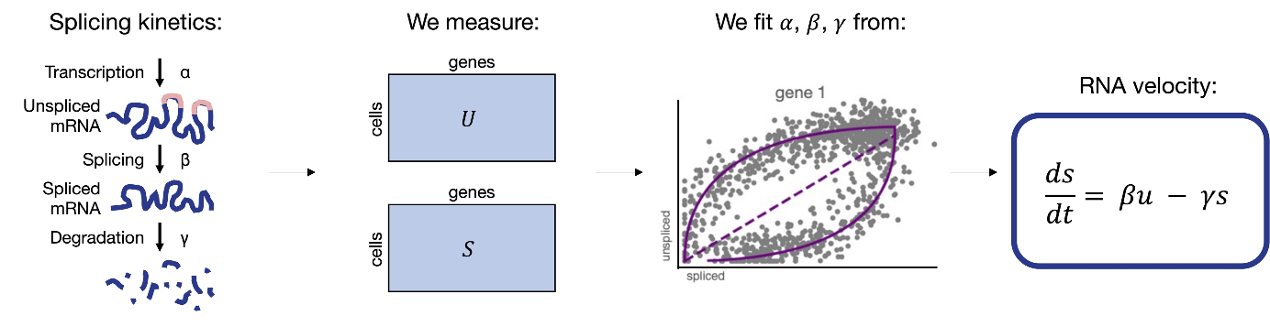
Figure 1. Overview of RNA velocity analysis
Overview of the different steps in RNA velocity analysis. The first picture shows the splicing kinetics that the model is based on. The parameters α, β and γ are shown. The second picture shows the matrices of unspliced and spliced counts for each cell for each gene that needs to be created. The third picture shows a phase portrait of spliced vs unspliced counts for a single gene. An elliptical shape is fitted to the phase portrait, out of which the velocity parameters can be extracted. The last picture shows the eventual formula for calculating the velocity for a cell.
La Manno et al. also introduced a package to do RNA velocity analysis with, called Velocyto ⁴. The package starts its analysis by counting spliced and unspliced RNA for each gene in each cell, based on a reference database of transcript models. In Velocyto, a read is seen as spliced when it only aligns to exons in the gene annotation. When a read aligns to introns, or to an exon-intron border, the read is counted as unspliced. When different transcript models for the same gene give different quantification results for a read, the read is seen as ambiguous and is not used anymore.
After the counting of spliced and unspliced reads, the velocity parameters α, β and γ can be fitted to the data for each gene. The parameters are fitted by plotting the spliced and unspliced counts for each cell for a gene in a phase portrait. When the phase portrait represents an up and downregulation of a gene, showing an elliptical shape, the parameters can be fitted well. The elliptical shape is seen when cells are observed at different time points throughout the up and downregulation. The upper right part of the phase portrait represents a steady state where transcription and splicing occur at the maximum speed. The values of the parameters depend on the location of the steady state, the slope of the elliptical shape and the width of the elliptical shape.
Because the shape of the phase portrait is used for fitting the parameters, accurate measurements of spliced and unspliced RNA molecules are important. When the shape of the phase portrait is changed because of technical issues, the entire analysis is affected. Theoretically, the depth of the sequencing should not matter. When both spliced and unspliced are multiplied by the same factor, the shape of the portrait will remain the same, resulting in the same velocity parameters. A problem will arise, however, when only one of the two quantities is affected by some technical issue. In this case, the shape of the phase portrait will be warped, and the extracted parameters will have different values. Because of this, there must be no bias towards spliced or unspliced RNA being counted, when there is no bias, the phase portrait will remain suited to extract parameters from. Similar problems in the current RNA velocity analysis are suggested by multiple papers. Soneson et al. show that preprocessing choices have a large effect on the outcome of RNA velocity ⁸. Marot-Lassauzaie and Bouman et al. outline the same quantification issue as discussed in this work in their supplementary information note A, and form the basis of this research project ⁶.
In this work I will examine the problems in the current spliced unspliced quantification rules, after which we will suggest new rules for quantifying spliced and unspliced RNA. The newly suggested counting rules are tested on two different single-cell sequencing datasets. The effect of the new rules on the recovery of the velocity parameters will be examined.
Results & Discussion
First, we examined the old counting rules for quantifying spliced and unspliced reads. Multiple problems have been suggested already. First off, in Velocyto, reads that only align to an exon are seen as spliced. However, since unspliced reads also contain exons, it is not possible to know if these reads actually come from a spliced or unspliced molecule. To clearly recognize a read as spliced we need to observe a border between an exon and an exon. To clearly observe a read as unspliced, we need to observe a border between an exon and an intron. With the current rules, some reads are counted as spliced, even when we do not clearly know whether they are spliced. This can lead to a bias towards spliced counts.
There is another problem with the current rules. Reads that align only to introns are currently counted as unspliced. This is correct, these reads do indeed come from unspliced molecules. However, a different problem arises here. Many single-cell sequencing techniques, like 10x sequencing, use the poly-A tail of a gene to start their transcription for sequencing ¹. If there is a poly-A motif present in the exons or introns of a gene, it could happen that transcription for sequencing also starts there, instead of only at the poly-A tail. This is called internal priming (Fig 2C). When this happens in an intron of a gene, more reads are created that only align to an intron. With the current counting rules, this can lead to a bias towards counting unspliced reads. When internal priming happens, there are two locations where RNA can be sequenced and two locations where reads are quantified for one gene. The transcription for the internal priming likely happens at a different rate than for the poly-A tail. Possibly leading to biases in the sequencing. Internal priming is also more likely to occur in the introns of genes, leading to a potential bias in unspliced reads ⁹.
In this work, we suggest new quantification rules for spliced and unspliced counts. The goal of the new rules is to quantify spliced and unspliced counts in an unbiased way, to recover velocity parameters more accurately. The new rules quantify reads as (Fig 2b):
- Unspliced, if the read algins to an exon and an intron at the same time.
- Spliced, if the read aligns to exons only, and skips over at least one intron
- Ambiguous, in all other cases
The new rules make sure that spliced and unspliced reads are measured at the same rate. The same location is looked at for both spliced and unspliced reads, being the end of an exon, and what happens after, checking if an exon-exon or an exon-intron border is seen. This ensures there is no bias towards counting either spliced or unspliced reads. The rules eliminate the bias towards spliced reads that previously existed and the bias towards unspliced reads that internal priming creates.
10x sequencing is a common method for single-cell RNA sequencing. The new rules require an exon-exon or an exon-intron border to be seen for an RNA molecule to be counted. 10x sequencing is 3’ prime biased and produces reads of around 150 base pairs long ¹. We did a preliminary analysis of the transcription models to investigate how likely these short reads are to pick up non-ambiguous exon-exon and exon-intron borders. An exon border is seen as ambiguous when the exact border is not found in every single transcript model for a gene. For the counting rules to work, the reads must cover a non-ambiguous exon border. The mm10 mouse Gencode database for comprehensive gene annotation was examined here ³. In this dataset, 11,2% of genes have a transcripts model that has a non-ambiguous exon border within 150 base pairs of the end of the transcript. This means that around 11% of genes in the database could be suited for RNA velocity analysis with 10x sequencing data. The analysis also showed that 86,3% of exon borders in the dataset are ambiguous borders. The Gencode database has on average 3,7 transcript models per gene, with a maximum of 82 transcript models for a single gene (fig 2.). The source of the different transcript models is very often unclear. The Gencode database includes an annotation for the support level of the transcript, however, very often this is incomplete or unclear.
The high number of transcript models per gene and the high percentage of ambiguous exon borders make it so that not all transcript models can be used for our analysis. In the ideal situation, we would have no ambiguous exon borders. Filtering of transcript models could therefore be an important step in RNA velocity. To minimize the number of ambiguous regions in the transcript models, we created a filtering method. The method looks at the exon-exon borders of the transcript models and compares these with the spliced reads in the current dataset. When a read is spliced, we can see to which transcript model the read aligns when skipping over introns. When a transcript model is supported by at least 5% of the spliced reads in the dataset, we keep the transcript model in the filtered database. All other transcript models are deleted. We argue that the deleted transcript models most likely play a part in alternative splicing events that do not take place in the cell types that are currently being studied and can therefore be ignored. The filtering in the 10x dataset leads to the percentage of exon borders that are ambiguous decreasing by around 20%. Many genes are also filtered out, because of lack of coverage in the dataset. The number of transcripts per gene stays similar. (Fig 2.)
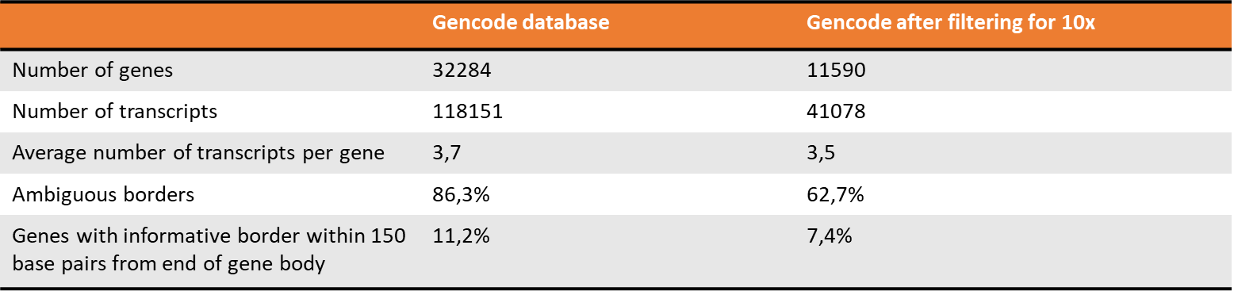
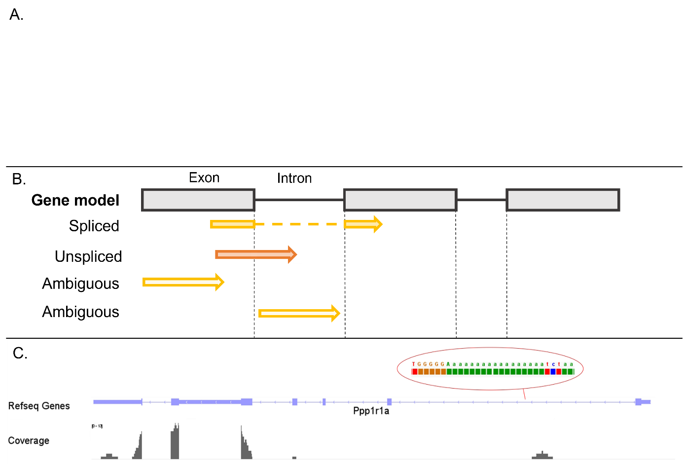
Figure 2. Summary statistics and visualization of problems in quantifying spliced and unspliced.
A. summary statistics of the Gencode database, before and after filtering for the 10x dataset. B. Visualization of the suggested quantification rules for spliced, unspliced and ambiguous counts. A transcript model is shown, and how the different possible reads will be quantified. C. Example of internal priming. The transcript model and the coverage found in the 10x dataset are shown. The poly-A motif in the middle of the intron is shown, as well as the coverage that is found in that location.
We first tested the new counting rules on a 10x sequencing dataset of developing mouse pancreas ² (Fig 3.). See the method section for the preprocessing steps and further analysis steps. The output that used the unfiltered Gencode database for the counting ended up with 16 genes that had a minimum of 2 spliced and unspliced counts for at least one cell. This result is increased to 42 genes when the filtered gene annotation database is used for the counting (Fig. 3). The phase portraits were created for these 42 genes, and the elliptical shapes were fitted to them. The genes with the best likelihood score for the fit of the elliptical shape to the phase portrait are shown here. The likelihood scores of the best genes are also plotted. Considering that the genes with the highest likelihood of fit are shown here, the phase portraits do not look as promising as expected. The elliptical shape can only be observed sometimes and the temporal order of cell types is also only clear sometimes. The phase portraits are too noisy to show a clear signal most of the time and therefore can not give clear velocity parameters.
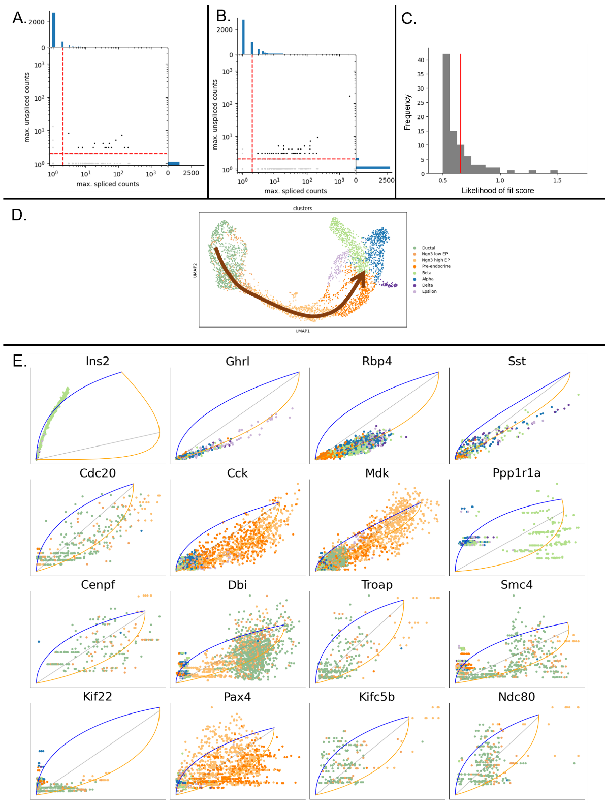
Figure 3. Results of the counting of the 10x sequencing dataset
A. Maximum spliced and unspliced counts found for each gene with the unfiltered transcription model database. Red lines indicate a minimum of 2 spliced and unspliced counts. B. Same graph for the filtered transcription model database. C. Distribution of the likelihood of fit scores for the elliptical shape on the phase portraits of all genes. The red line indicates the average score of 0.657. D. UMAP of the dataset. Cell types are coloured based on the annotation given by the original dataset. Arrows indicate the suggested direction of cell change. E. Phase portraits with the elliptical shape fitted for the 16 genes with the highest likelihood of fit scores from the dataset. Sorted by likelihood score.
10x sequencing is a 3’ biased method, as shown before, this leads to certain genes being impossible to study with this sequencing technique, as their exon borders can not be sequenced. Because of this problem, the use of another sequence technique for RNA velocity analysis was investigated. Vasa sequencing is a full-length sequencing technology, which means that in theory all exon borders of a gene could be observed ⁷. The Vasa sequencing paper shows that the coverage has a wider range than 10x sequencing has. However, this technique produces a lower coverage on the parts where sequencing is active. The reads that are produced by Vasa sequencing are on average 250 base pairs long. The reads from 10x sequencing are 150 base pairs long. The Vasa sequencing dataset has 6.616.560 reads in chromosome 11, spanning over 250 base pairs on average, summing up to 1.654.140.000 covered bases. The 10x dataset has 45.566.500 reads on chromosome 11 of on average 150 base pair long, summing up to 6.834.975.000 covered bases. In this example chromosome, 10x sequencing has a 4 times higher coverage. This higher coverage of 10x is spread over a way smaller part of the gene bodies compared to Vasa sequencing.
Vasa sequencing also uses cell barcodes and UMI’s, just like 10x sequencing. A dataset of developing mouse embryo at timepoint 8.5 was used ⁷. See the method section for preprocessing steps and further analysis. The output that used the entire Gencode database had 57 genes with a minimum of 2 spliced and unspliced counts for a single cell, whereas the filtered gene annotation database version of the analysis had 214 suitable genes (Fig 4.). Phase portraits were again created for the best genes and the elliptical shapes were fitted. The phase portraits with the highest likelihood of fit scores are shown. The dataset was clustered with a Louvain clustering to show a UMAP and the potential different cell types in different colours. The phase portraits here again barely represent the elliptical shape that we hoped to see. Often the portraits are too noisy to fit the ellipse, meaning that here the velocity parameters can also not be extracted reliably.

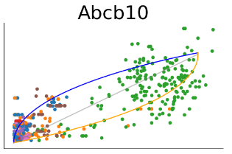
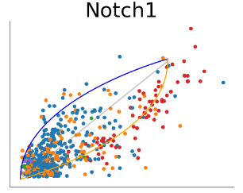
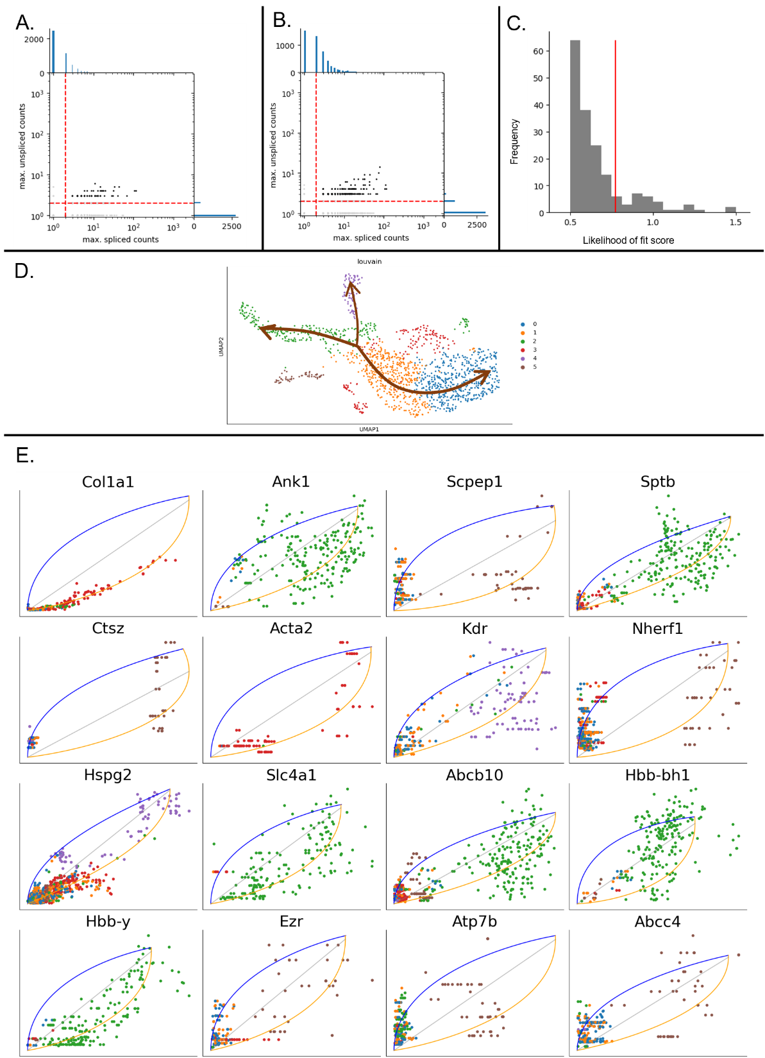
Figure 4. Results of the counting of the Vasa sequencing dataset.
A. Maximum spliced and unspliced counts found for each gene with the unfiltered transcription model database. Red lines indicate a minimum of 2 spliced and unspliced counts. B. Same graph for the filtered transcription model database. C. Distribution of the likelihood of fit scores for the elliptical shape on the phase portraits of all genes. The red line indicates the average score of 0,775. D. UMAP of the dataset. Louvain clusters are shown with different colours. Arrows indicate the suggested direction of cell change. E. Phase portraits with the elliptical shape fitted for the 16 genes with the highest likelihood of fit scores from the dataset. Sorted by likelihood score.

Conclusion & Outlook
We suggested new rules for the quantification of spliced and unspliced reads to eliminate bias in the recovery of parameters for RNA velocity analysis. We tested the rules on two different datasets. The 10x dataset did not show results that are in line with the expectation of an RNA velocity analysis. The best phase portraits from the analysis only sometimes showed the shape and the order of cell types that were expected. However, only a small amount of genes were able to be studied in this dataset in the first place. According to the preliminary analysis that was done, only 11% of genes have an informative exon border in a location that can be studied by RNA velocity when 10x sequencing data is used. Only a small part of this 11% of genes has high enough coverage in this dataset to show a phase portrait. This small number of genes suitable for analysis was more than doubled after filtering the transcript models, but the results were still not good enough for reliable RNA velocity.
The Vasa seq dataset showed a higher number of genes with at least 2 spliced and unspliced counts for a single cell than the 10x dataset showed. This number almost quadrupled when the transcript models were filtered. This result shows that a full-length sequencing method increases the number of genes that can be studied in RNA velocity. In theory, all exon borders can be picked up by full-length sequencing, putting fewer requirements on where the exon borders have to be in the gene body to be studied. When comparing the best phase portraits of the 10x dataset to the best phase portraits of the Vasa sequencing dataset to each other, The results look similar. The likelihood of fit scores for the two datasets are also highly similar. This shows that the higher coverage over a small part of the gene body that 10x sequencing does performs just as well as the lower coverage over the entire gene body that Vasa sequencing does. This is probably the case because the wider coverage of Vasa sequencing can pick up most of the exon borders throughout the gene body, and therefore has a higher chance to find an informative exon border for quantifying a read as spliced or unspliced. The shallow coverage of 10x sequencing should lead to higher likelihood of fit scores when an informative exon border is observed, however, the chance of observing a suitable and informative border is lower, and most likely only a small number of borders can be found per gene. However, for both sequencing technologies, the phase portraits are not suited to extract velocity parameters. The phase portraits do not represent the elliptical shape enough for reliable analysis and further velocity prediction steps.
Higher coverage could lead to phase portraits displaying the elliptical shape more clearly. More data points in the phase portraits could lead to a clearer shape being observed. With the current sequencing technologies, this is not yet possible. The full-length sequencing of Vasa Seq shows promise by including more genes in the analysis, however, we believe the coverage would have to be higher. In Figure 5 the correlation between the coverage of a gene is compared with the likelihood of fit score for a gene. There is a positive correlation between the two, but what is most clear is that the outliers with very high coverage have a way better likelihood of fit score. Especially in the 10x dataset, this effect is clearly visible. This shows that high coverage does influence the reliable extraction of velocity parameters positively.
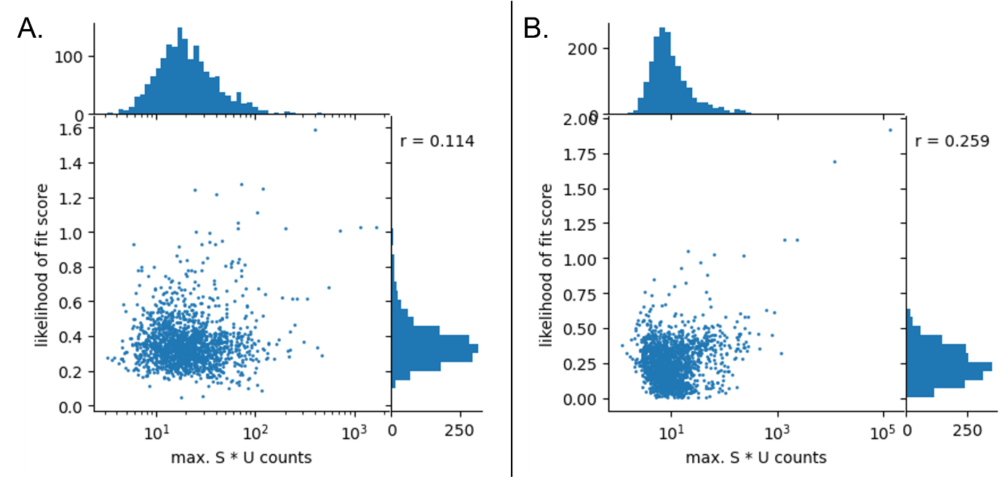
Figure 5. Correlation between coverage and likelihood of fit score of the elliptical shape for a gene.
The correlation is shown between the maximum count for spliced times the maximum count for unspliced reads for a single gene and the likelihood of fit score for that gene. The correlation coefficient is shown in the graph. A. for the Vasa seq dataset B. For the 10X dataset
Some methods are in development that look promising for obtaining higher coverage for more genes. One of these methods is 10x gene expression flex sequencing. Unlike regular 10x sequencing, this method does not use poly A motifs to start sequencing. Instead, this method uses gene-specific probes to sequence. 10x genomics shows that this method can pick up more genes than their older method, they say it is twice as sensitive ¹¹. However, not many papers using this method are available yet. This could be something to look into for RNA velocity analysis.
Another methodology suggested by Volden & Volmers (2022) uses the 10x sequencing library preparation steps to prepare the cDNA for the sequencing of the cells, however, after this step, they use Illumina sequencing and the R2C2 pipeline to obtain full-length transcripts of the RNA ¹⁰. This method should obtain just as many reads as the normal 10x sequencing technology but then extends the reads to the full length. A dataset like this would be very suited for RNA velocity analysis, as more exon borders can be studied this way, and the coverage for 10x sequencing looked high enough for good analysis in our results. However, this method has also not been used and tested extensively yet. When this is done, it could be a promising solution for RNA velocity analysis and a hopeful sight for the prediction of future states of single cells.

Methods
Scripts and notebooks can be found on Git Hub: https://github.com/ValerieMarot/u-s-quantification/tree/main
Preprocessing of 10x dataset
The 10x dataset was retrieved from the Gene Expression Omnibus with accession number GSE132188. The sample from timepoint 15.5 was used, with accession number GSM2852755. The fastq files were aligned using cellranger version 7.1.0. the command cellranger count was used to obtain the aligned bam file. Default parameters were used. The refdata-gex-mm10-2020-A reference genome and transcript models were used, this reference was obtained from the 10x website.
Preprocessing of the VasaSeq dataset
The vasa-seq dataset was retrieved from the Gene Expression Omnibus with accession number GSE176588. A sample from timepoint 8.5 was used, with accession number GSM5369513. The fastq files were aligned with STAR version 2.7.10b. first, an index for the reference genome was created with STAR with the parameter –runmode GenomeGenerate, for the same reference genome as for the 10x dataset. Then STAR was run with parameters ‘’–soloType CB_UMI_simple --readFilesCommand zcat --outFilterMultimapNmax 20 --outSAMunmapped Within --outSAMattributes NH HI nM AS CR UR CB UB --soloCBstart 7 --soloCBlen 16 --soloUMIstart 1 --soloUMIlen 6’’ to obtain the aligned bam file.
Quantification of reads
For the quantification of spliced and unspliced reads a python script was created. The script is available on Git Hub. The script takes as an input a bam file or multiple bam files containing the reads, a gtf file containing the reference transcript models and a list of barcodes when working with a sequencing technology that uses cell barcodes. The output of the script is three expression matrices for spliced, unspliced and ambiguous counts, containing counts for each gene for each cell. The script was run with a reference transcript models file from the gencode database, containing the comprehensive gene annotation for mm10. The file is available on the website of the gencode database ³.
Filtering of transcript models
The script for the filtering of the transcript models is available on Git Hub. The filtering was run with the gencode mm10 comprehensive gene annotation file, and the bam file for the method that the filtering was performed for. The script was run in mode ‘simple’, where all transcripts are kept that are supported by at least 5% of the spliced reads in the dataset. See Figure 6 for an example.
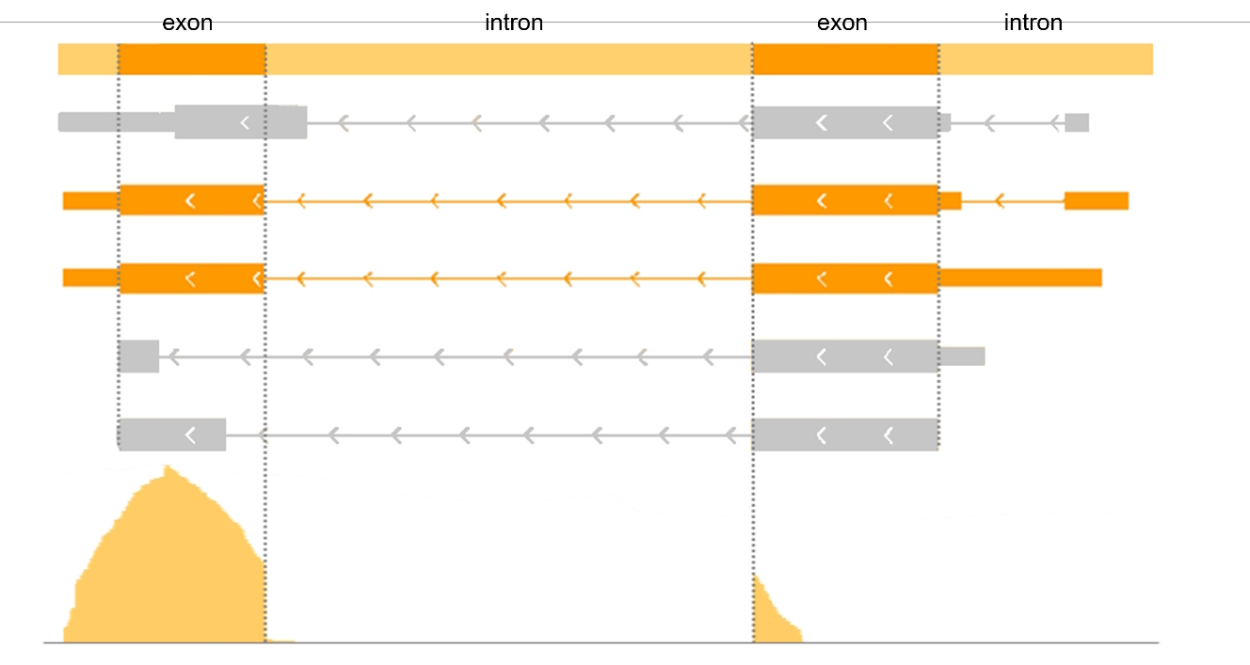
Figure 6. Example of transcript models filtered out.
Example of a gene where transcript models are filtered out based on the coverage found in the dataset for this gene. The transcript models in orange are kept, and the grey transcript models are filtered out. Below the coverage is shown.
Creation of phase portraits for genes.
For the creation of the phase portraits, the count matrices were first normalized over the three layers combined, so over spliced, unspliced and ambiguous counts. After this the reads were imputed, and the input data was first reduced to 5 dimensions using PCA, then for each cell, the 15 nearest neighbours were found, after which the counts for each gene were averaged over the 25 nearest neighbours. These counts were then plotted. To fit the elliptical shape to the phase portraits, the fit.py script from the Python package of Marot-Lassauzaie & Bouman et al. was used ⁶. These elliptical shapes were then plotted over the phase portraits. For the 10x dataset, the clusters that were annotated in the dataset were used for the UMAP and the plotting. For the VasaSeq dataset, a UMAP was first created, after which a Louvain clustering was done on the dataset, leading to 6 Louvain clusters. This was done with the Scanpy package with version 1.9.3. The likelihood of fit scores for the elliptical shape of the phase portraits were also calculated with the package of Marot-Lassauzaie & Bouman et al ⁶.
References
- 10x genomics. What types of RNA can be detected? 10X Genomics. Retrieved from https://kb.10xgenomics.com/hc/en-us/articles/217261666-What-types-of-RNA-can-be-detected-
- Bastidas-Ponce. Comprehensive single cell mRNA profiling reveals a detailed roadmap for pancreatic endocrinogenesis | Development | The Company of Biologists. Retrieved from https://journals-biologists-com.proxy.library.uu.nl/dev/article/146/12/dev173849/19483/Comprehensive-single-cell-mRNA-profiling-reveals-a
- Frankish, A., Diekhans, M., Jungreis, I., Lagarde, J., Loveland, J. E., Mudge, J. M., Sisu, C., Wright, J. C., Armstrong, J., Barnes, I., Berry, A., Bignell, A., Boix, C., Carbonell Sala, S., Cunningham, F., Di Domenico, T., Donaldson, S., Fiddes, I. T., García Girón, C., … Flicek, P. (2021). GENCODE 2021. Nucleic Acids Research, 49(D1), D916–D923. https://doi.org/10.1093/nar/gkaa1087
- La Manno, G., Soldatov, R., Zeisel, A., Braun, E., Hochgerner, H., Petukhov, V., Lidschreiber, K., Kastriti, M. E., Lönnerberg, P., Furlan, A., Fan, J., Borm, L. E., Liu, Z., van Bruggen, D., Guo, J., He, X., Barker, R., Sundström, E., Castelo-Branco, G., … Kharchenko, P. V. (2018). RNA velocity of single cells. Nature, 560(7719), Article 7719. https://doi.org/10.1038/s41586-018-0414-6
- Maaten, L. van der, & Hinton, G. (2008). Visualizing Data using t-SNE. Journal of Machine Learning Research, 9(86), 2579–2605.
- Marot-Lassauzaie, V., Bouman, B. J., Donaghy, F. D., Demerdash, Y., Essers, M. A. G., & Haghverdi, L. (2022). Towards reliable quantification of cell state velocities. PLOS Computational Biology, 18(9), e1010031. https://doi.org/10.1371/journal.pcbi.1010031
- Salmen, F., De Jonghe, J., Kaminski, T. S., Alemany, A., Parada, G. E., Verity-Legg, J., Yanagida, A., Kohler, T. N., Battich, N., van den Brekel, F., Ellermann, A. L., Arias, A. M., Nichols, J., Hemberg, M., Hollfelder, F., & van Oudenaarden, A. (2022). High-throughput total RNA sequencing in single cells using VASA-seq. Nature Biotechnology, 40(12), Article 12. https://doi.org/10.1038/s41587-022-01361-8
- Soneson, C., Srivastava, A., Patro, R., & Stadler, M. B. (2021). Preprocessing choices affect RNA velocity results for droplet scRNA-seq data. PLOS Computational Biology, 17(1), e1008585. https://doi.org/10.1371/journal.pcbi.1008585
- Svoboda, M., Frost, H. R., & Bosco, G. (2022). Internal oligo(dT) priming introduces systematic bias in bulk and single-cell RNA sequencing count data. NAR Genomics and Bioinformatics, 4(2), lqac035. https://doi.org/10.1093/nargab/lqac035
- Volden, R., & Vollmers, C. (2022). Single-cell isoform analysis in human immune cells. Genome Biology, 23(1), 47. https://doi.org/10.1186/s13059-022-02615-z
- Wallace, A. (n.d.). The gold standard, transformed: Taking single cell RNA-seq further than ever before. 10x Genomics. Retrieved 19 July 2023, from https://www.10xgenomics.com/blog/the-gold-standard-transformed-taking-single-cell-rna-seq-further-than-ever-before
- Dalmia, A., & Sia, S. (2021). Clustering with UMAP: Why and How Connectivity Matters (arXiv:2108.05525). arXiv. https://doi.org/10.48550/arXiv.2108.05525

Thanks
Thanks to Valérie for having unlimited patience in answering all my questions :)

