

Investigating the Neurophysiological Precursor of Sustained Attention in the context of Impulsivity

Minor Internship Report (33 EC)
MSc Neuroscience and Cognition
Graduate School of Life Sciences
Utrecht University

9th September 2025

Author Note
For full disclosure, this report was not written using Generative AI at any given writing stage.

Student: Janice Trudy Halim
Student number: 7003498
Supervisor: prof. dr. J. L. Kenemans
Second reader: dr. Daan van Rooij
Abstract
Lapses in sustained attention may interfere with daily functioning and have been implicated in disorders such as ADHD. Previous research has linked attenuated P3 amplitude with lapses of sustained attention upon utilizing the visual continuous temporal expectancy task (CTET). Furthermore, the potential relationship between sustained attention and impulsivity may address what happens in the brain prior to a lapse in attention. The present study sought to determine whether P3 predicted target detection in the context of auditory sustained attention and whether P3 was related to impulsivity. However, the results did not provide evidence that P3 exhibits predictive characteristics of auditory sustained attention, unlike previous research in visual modality. Additionally, there is no evidence that auditory sustained attention, reflected in P3 activity, has a relationship with impulsiveness. The same is true when analyzing subgroups divided based on impulsivity. Performance results however show that high impulsive individuals exhibit more false alarms rates than low impulsive individuals, suggesting a potential role of arousal. However, it may also point to a stronger relationship between impulsivity and response inhibition. Future research should improve the present study’s methodology by a more comprehensive P3 analysis, and should consider examining other potential neural precursors of lapses of auditory sustained attention such as CNV component.
Keywords: CTET, sustained attention, event-related potential (ERP), impulsivity.
Layman Summary
For some professions, such as truck drivers and surgeons, being able to stay alert for long periods of time is important to do their jobs well. This ability is defined as capability to sustain attention. Errors in sustaining attention can have hazardous consequences, such as getting into accidents at work or while driving. Furthermore, individuals with disorders such as ADHD and schizophrenia often display errors in maintaining attention. From previous studies that measure electrical activities in the brain using electroencephalography (EEG), it was found that after averaging all of the brain activities, a brain signal known as the event-related potential (P3) shows a consistent pattern before an error in attention. P3 was shown to be smaller before you miss a target while trying to sustain attention, while it was much larger before you successfully identify the target. In the current study, we measured errors in attention between groups of people with low and high levels of impulsivity using the auditory version of continuous temporal expectancy task (CTET), to see if P3 is indeed smaller before errors in attention and to see if P3 amplitude, which measures sustaining attention capabilities, is related to impulsivity levels.
Our results, however, did not support findings from previous studies, and we also did not see a relationship between sustaining attention and impulsivity levels. Although, we found that those with high impulsivity are more likely to identify the wrong targets than those with low impulsivity. This suggests that highly impulsive individuals may become less alert throughout the task and so become less cautious in their responses, indicating the role of arousal. However, this may also mean that those with high impulsivity cannot easily restrain their responses when identifying targets, therefore linking impulsivity with response inhibition. That being so, the present study is the first to study the relationship between auditory sustained attention, P3, and impulsivity. Future studies should consider a more thorough method in analyzing P3, and perhaps they should analyze another brain signal such as CNV alongside. Further insights into this relationship have potential in improving workplace safety as well as improving understanding of what happens in the brain for those with attention-related disorders.

Introduction
Sustaining attention is an aspect of cognitive control, which enables us to navigate the world in a goal-directed manner. Sustained attention can be defined as the maintenance of a vigilant or alert state especially to process critical signals (Posner & Petersen, 1990). Such a mechanism is important in daily life functioning, and lapses in sustaining attention over long periods of time are especially consequential for occupations such as truck drivers, pilots, and astronauts (Maki et al., 2022). Furthermore, maladaptive lapses in attention are central to several psychopathologies such as attention deficit/hyperactivity disorder (ADHD; American Psychiatric Association, 2013) and schizophrenia (Chidharom et al., 2021). Given these considerations, improving our understanding of sustained attention, especially what may precede lapses of attention, has important implications in preventing accidents in professional workplaces that require sustained vigilance and in advancing our understanding of one of the possible mechanisms underlying clinical attentional deficits.

Auditory sustained attention
Research on sustained attention has long been done utilizing the Continuous Temporal Expectation Task (CTET) paradigm, in conjunction with target detection. First devised and introduced by O’Connell and colleagues (2009), the paradigm entailed monitoring a stream of continuous stimuli in order to correctly distinguish rare targets from the standard stimuli, by demanding participants to deploy continuous attention. Lapses of sustained attention, defined by O’Connell and colleagues (2009) as the failure to detect a target stimulus while undergoing the task, may be caused by the repetitive nature of the task, and has been suggested to be influenced by the type of stimulus modality utilized in the paradigm (Berry et al., 2014).
Behavioral results from Berry and colleagues (2014) have demonstrated this modal influence by being the only study to date to have adapted the originally visual-oriented CTET paradigm for the auditory domain. Their findings suggested that lapses of attention in visual modality might be driven by distractibility, whereas attentional difficulties might be driven by boredom in auditory modality instead. Furthermore, Berry and colleagues (2014) have contributed to the notion that auditory stimuli captured and held attention more automatically than their visual counterpart, as they found performance to be better for temporal judgments that utilize auditory stimuli than visual stimuli.

Event-related potential fP3 as index of sustained attention
Lack of research in auditory sustained attention in comparison to visual sustained attention makes further investigation into the subject imperative, given that attention has been implicated specifically in the context of auditory signals while driving (Van Der Heiden et al., 2018). While Berry and colleagues (2014) have mostly focused on behavioral results, measuring electrocortical activity with electroencephalography (EEG) prior to an error might provide further insights into auditory sustained attention. Therefore, the present study intends to extend Berry and colleagues’ (2014) study by implementing EEG to capture neurophysiological precursor of lapses of auditory sustained attention.
Studies on visual sustained attention have also utilized EEG in tandem with the CTET paradigm to observe electrophysiological changes both prior to and upon attentional error. A key event-related potential (ERP) component, the frontal (f)P3, has been involved in relation to visual sustained attention (Chidharom et al., 2021; Dockree et al., 2017; O’Connell et al., 2009). Frontal P3 has been found to exhibit significantly larger amplitudes during successful target detection compared to misses, and this signal is likewise augmented even 3-4 seconds prior to detection. These findings have been further supported and extended by Dockree and colleagues (2017) in their study involving methylphenidate (MPH), a drug often prescribed for ADHD symptoms treatment in basis of its ability to enhance attention. Dockree and colleagues (2017) demonstrated that MPH usage leads to linear increase in fP3 amplitude 4 seconds before target detection. Furthermore, a group comparisons study saw differential frontal P3 activity prior to a lapse of visual sustained attention in patients with schizophrenia, whose symptoms include attentional errors, compared to healthy controls (Chidharom et al., 2021). This error precursor was observed at a later period in schizophrenia patients at two trials before target, while it occurred earlier at four trials prior in healthy controls. Based on this body of evidence, it seems conceivable that lapses of sustained attention could be predicted by fP3 activity.

Sustained attention in high impulsive individuals
Individual differences such as impulsivity may also induce susceptibility to lapse of sustained attention. Impulsivity has been defined as a tendency to act without forethought, or to make decisions without due consideration (Bari & Robbins, 2013). While attention and impulsivity may seem two distinct processes, impulsiveness and inattention manifest in parallel as key symptoms in individuals with ADHD (American Psychiatric Association, 2013), thus suggesting a possible relationship between impulsivity and attention. Furthermore, Nigg (2016) postulates that these concepts are intertwined especially in the context of ADHD, as attention may facilitate regulation of impulse control and that impulsivity is implicated in attentional problems. Thus, improving our understanding of attention and impulsivity has important implications in improving our understanding of atypical brain function.
While the relationship between attention and impulsivity in ADHD has been well given thought (for review, see Nigg, 2016), less research has examined impaired sustained attention in a healthy population with heightened impulsivity. On one hand, various studies in this field have presented only behavioural results (Leshem, 2016; Leshem & Yefet, 2019). Indeed, participants with higher impulsivity have been shown to exhibit more misses in trials involving attention maintenance, thereby presenting more lapses in sustaining attention in comparison to low impulsivity individuals (Leshem & Yefet, 2019). It was even suggested, however, that impulsivity may be compensated during tasks involving attention maintenance due to its relatively lower cognitive load, whereas trait impulsivity may present more difficulties upon attention switching instead (Leshem, 2016). On the other hand, research on impulsivity in ADHD cohort that accounted for electrophysiological signals, such as fP3, has mostly focused on response inhibition (i.e., suppression of pre-potent response to critical stimuli; Bekker et al., 2005). Furthermore, inhibitory deficits may not necessarily manifest in individuals with heightened impulsivity (Lansbergen et al., 2007). Even so, it is still possible that individuals with higher self-reported impulsivity present similar lapses in sustained attention as those with clinical impulsivity. Given the potential role of fP3 in predicting these lapses, as well as the potential relationship between attention and impulsivity, an avenue of possible research can be explored by investigating fP3-indexed sustained attention in relation to impulsivity.

Current study
Considering all of the previous points, this study aims to unravel the relationship between auditory sustained attention, impulsivity, and the ERP component frontal P3 through the following research questions: First, does P3 predict target detection? Drawing from previous research in visual domain (Chidharom et al., 2021; Dockree et al., 2017; O’Connell et al., 2009), we hypothesized that P3 would predict target detection by replicating evidence found in sustained attention to auditory domain. Specifically, we expected that fP3 would foreshadow failure in auditory sustained attention prior to actual lapse, by exhibiting attenuated P3 amplitude for misses in comparison to hits trials during pre-target period (800ms prior to target detection).
Second, is there a correlation between P3 amplitude and impulsivity? Given findings by Leshem and Yefet (2019), we hypothesized that P3 amplitude, as index of sustained attention, would be negatively correlated with impulsivity score as measured by BIS. Therefore, the higher P3 amplitude preceding target detection, the lower levels of impulsivity participants would exhibit. Conversely, lower P3 amplitude preceding target detecting would be related to higher scores of impulsivity. Extending from the first hypothesis, this study expected to demonstrate a more negative correlation coefficient value for the relationship between P3 Hits and impulsivity, as compared to the relationship between P3 Misses and impulsivity.
Methods

Participants
The study was approved by the Ethical Review Board of the Faculty of Social and Behavioural Sciences of Utrecht University. The study adhered to the Declaration of Helsinki 2013. 54 participants were recruited through the SONA system, Cal.com, and WhatsApp, leading to the establishment of a convenience sample. However, the final dataset comprised only of 38 participants (N males = 13, N females = 25), due to dropouts or missing data (see Appendix B). The average age of 38 participants was 24.03 (SD = 4.880). The participants were eligible to participate in the study if they were over 18 years old, had normal to corrected-to-normal vision, did not drink coffee or use any drugs/stimulants starting at 22:00 the night before the experiment, and had no current neurological/psychiatric disorders. All participants were paid a total of 20 euros or 2.5 PPU credits for taking part in the study. In a situation when the data collection exceeded 120 minutes, the subjects were compensated with 5 euros per additional 30 minutes.

Materials
Qualtrics
Prior to the EEG data collection session, the participants were provided with a link to a set of questionnaires hosted by Qualtrics software (Qualtrics, Provo, UT). This set consisted of questionnaires about demographics, impulsivity, stress. The whole survey completion time was approximately 15 minutes. The only questionnaires from this list used in the current study were the demographics survey and the revised Barratt Impulsiveness Scale (BIS) measuring impulsivity.
Revised Barratt Impulsiveness Scale. To measure impulsivity, the revised BIS was administered (Chen, 2013). It is a validated questionnaire, consisting of 30 items rated on 4-point Likert scale that ranges from 1 (“Rarely/Never) to 4 (“Almost Always/Always”). Reversed items were 2, 4, 19, 20, 21, 22, 23, 24, 26, 27, 30, and were reverse-scored during analysis. The items were summed together, with higher scores indicating greater self-reported impulsiveness. To measure the BIS’ internal reliability, a Cronbach’s alpha was computed by calculating the pairwise correlations between 30 items. It has good internal reliability in the present study (α = .821).

Procedure
Each participant received an information letter about the study before coming to the lab once to complete a two-hour-long data collection session. At the beginning of the session, the subject signed the informed consent form. The researchers then placed the EEG cap on the participant’s head and adjusted the chin rest, ensuring that each subject sat in a centered position, 60 cm away from the computer screen. After providing instructions, the researchers moved to the adjacent room and then the participants performed the auditory continuous temporal expectancy task (CTET) and another task in a balanced order. Resting state EEG, as well as self-reported subjective drowsiness, were acquired before and after completion of the task. However, only EEG and performance results from the auditory CTET were used in the current study.
Auditory CTET
The auditory version of CTET was first introduced by Berry et al. (2014). The task required participants to monitor a continuous stream of auditory tones with four randomly alternating pitches (non-target frames) for the duration of 800ms. The participants must detect the target frame which had a longer duration and were instructed to press the spacebar upon detection. The present study employed a duration of 950ms for the target frame. Responses, or spacebar button presses within two non-target frames (1600ms) following the target, were recorded as hits. Non-responses after a target was presented were recorded as misses.
Due to programming limitations, the task was split into two parts. The first part comprised of four blocks, whereas the second part comprised of three blocks. Each block contained approximately an average of 246 non-target tones and 22 target tones.
Before beginning the auditory CTET, participants completed two practice blocks that contained three target tones. Each participant had to display 100% accuracy during the practice blocks to confirm that the participant could perceptually distinguish between target and non-target trials.
EEG data acquisition
The EEG signal was recorded using a 64-channel ActiveTwo system (Biosemi, Amsterdam, The Netherlands). The following electrode positions were utilized: Fpz, AFz, Fz, FCz, Cz, CPz, Pz, POz, Oz, FP1/2, AF3/4/7/8, F1/2/3/4/5/6/7/8, FC1/2/3/4/5/6; FT7/8; C1/2/3/4/5/6; T7/8; CP1/2/3/4/5/6; TP7/8; P1/2/3/4/5/6/7/8; PO3/45/6/7/8; O1/2. Two electrodes were positioned on the mastoids behind both ears for offline re-referencing during EEG pre-processing. Two facial electrodes were positioned above the left eye (EXG1) and on the outer corner of the participant’s left eye (EXG2) to record electrooculogram (EOG). Additionally, four electrodes were medially and laterally positioned relative to the index finger on both arms of the participant to record electromyography (EMG). Data was recorded at a sampling rate of 2048Hz with online low pass filtering at 417Hz, while referencing to the Common Mode Sense/Driven Right Leg electrodes.
EEG pre-processing
The EEG signal data were analyzed with the Brain Vision Analyzer 2.1 software (Brain Products GmbH, Gilching, Germany). During pre-processing, data was re-referenced to the mastoid electrodes, with the sampling rate set to 250Hz, and filtered with the following settings: 0.5Hz low cut-off filter, 40Hz high cut-off filter, and 50Hz notch filter. The signal was segmented into 7000ms epochs ranging from -4000ms pre-onset to 3000ms post-onset to allow for a broader time to perform artifact rejection. Only FCz and Fz electrodes were subjected to artifact rejection, with trials rejected upon containing a voltage step that exceeded 50μV/ms, amplitude that that exceeded $±$200μV, or when the lowest activity within an interval of 100ms was lower than 0.5μV. A Gratton & Coles ocular correction was performed to eliminate the effect of eyeblinks. A second artifact rejection was performed, in which EXG1 activity that exceeded 200μV interval difference within a time period of -500ms to 1200ms relative to target interval onset was rejected.
Short-term pre-target processing
To analyze the pre-target P3 component, data was segmented into epochs of -80ms to 500ms relative to target frame onset, thus examining only one pre-target frame. Data was moreover separated between hits and misses. Baseline correction was performed to the time period -80ms to 0ms relative to frame onset. P3 was extracted from the FCz electrode throughout 163-213ms post-frame onset. The component amplitudes were assessed by subtracting the amplitude of negative pre-component onset from the peak amplitude. Thus, component onset was set at 92-124ms post-frame onset.
Planned statistical analysis
Preliminary assumption checks, descriptive statistics, correlational tests, paired samples t-test, and 2x2 mixed ANOVA were analyzed with R Statistical Software (v4.3.3; R Core Team 2024). Assumptions were tested with Shapiro-Wilk’s Test to examine normality of distribution, as well as Levene’s Test to examine homogeneity of variance. The significance level for all statistical analyses was set at 0.05.
To compare whether there is a difference of P3 amplitude between successful and failed signal detection, a paired samples t-test was conducted with the following measures: P3 amplitude for Hits and P3 amplitude for Misses.
To examine whether there is a relationship between P3 amplitude and impulsiveness, two separate correlational analyses were conducted for P3 Hits amplitude and P3 Misses amplitude with impulsivity scores.
Exploratory statistical analysis
To investigate whether there is a difference in P3 amplitude between failed and successful signal detection for individuals with differences in self-reported impulsivity, a mixed model ANOVA was conducted. This analysis incorporated P3 amplitude as the dependent variable, Detection (hits, misses) as the within-subject factor, and self-reported impulsiveness (high impulsivity, low impulsivity) as the between-subject factor. Interaction between Detection and Impulsivity was furthermore examined.
The average amplitudes of P3 Hits and P3 Misses were computed into the variable P3 Average, and the difference of amplitudes between P3 Hits and P3 Misses was computed into the variable P3 Difference. To further examine the relationship between P3 with impulsiveness, two separate correlational analyses were conducted for P3 Average and P3 Difference with impulsivity scores. Moreover, two separate independent samples t-tests were conducted to compare respectively the group average of P3 Average and P3 Difference between high and low impulsive samples.
To compare whether there is a difference of task performance between high and low impulsivity groups, two separate independent samples t-tests were conducted to examine the hit rates and false alarm rates of each group.
Results
Overall Data
Participants reached a slightly higher amplitude on average for successful signal detection (M_{Hits} = 4.40, SD = 4.32) compared to failed signal detection (M_{Misses} = 3.78, SD = 2.71). However, upon conducting a paired samples t-test, the difference between the average overall P3 amplitude for Hits trials and the average overall P3 amplitude for Misses trials is not significant, t(37) = 1.44, p = .159. This finding does not replicate previous research (O’Connell et al., 2009), thus indicating that P3 amplitude does not seem to predict successful signal detection. To note, however, that the hits and misses seem to peak at different electrodes (see Figure 2).
Figure 1
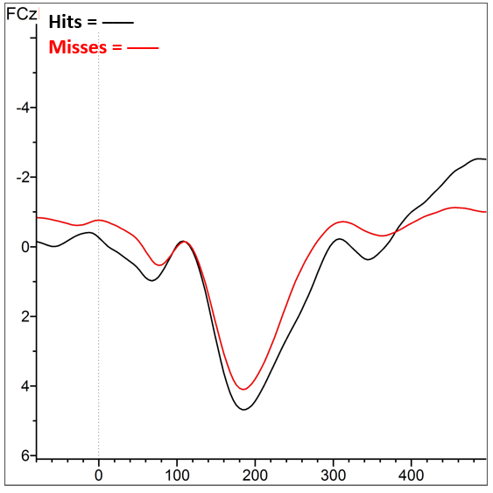
Overall grand average P3 waveform at FCz electrode of the pre-target frame

Figure 2
Topographical view for overall amplitudes of P3 hits (A) and misses (B)
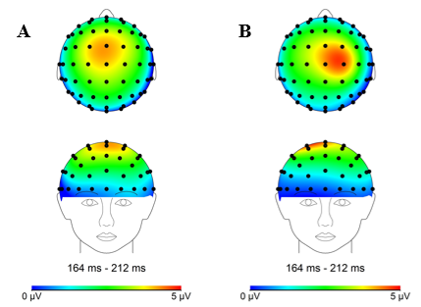
A Pearson’s correlation analysis conducted between the P3 amplitude for Hits and impulsivity scores showed that there is no relationship between P3 Hits and impulsivity, r(36) = 0.00, p = .995. The assumption for normality of distribution was not met for P3 amplitude for Misses, hence a Spearman’s correlation was conducted instead. Likewise, the analysis did not show that P3 Misses has a relationship with levels of impulsivity, r = -0.13, p = .446. Visualizations can be seen on Figure 3.
Figure 3
Scatterplots of P3 Hits and Impulsivity (A) and of P3 Misses and Impulsivity (B)
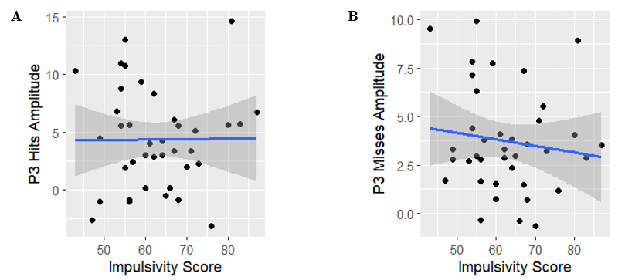
Grouped by Impulsivity
The average BIS score is 62.61 (SD = 10.33) in the present sample. The present study additionally utilized the present sample’s median (61.50) as a cut-off score for groups with High Impulsivity (N = 19) and Low Impulsivity (N = 19). Observed average score and standard deviations of P3 amplitude for hits and misses, average score and range of BIS impulsivity score, hit rate, and false alarm rate, separated by high and low impulsivity group can be seen in Table 1.
Table 1
Descriptive Statistics of P3 Amplitude, BIS Score, Hit Rate, and False Alarm Rate for High and Low Impulsivity Groups
 | Average P3 amplitude (SD) |  | Average BIS score (SD; range) | Average Hit rate (SD; range) | Average False Alarm rate (SD; range)
Impulsivity | Hits | Misses | Average BIS score (SD; range) | Average Hit rate (SD; range) | Average False Alarm rate (SD; range)
Low | 4.88 (4.76) | 4.32 (2.97) | 54.37 (4.65; 43-61) | 66.81% (0.25; 24.67-98.67%) | 2.42% (0.03; 0.05-6.69%)
High | 3.91 (3.92) | 3.25 (2.37) | 70.84 (7.38; 62-87) | 60.10% (0.21; 19.48-96.69%) | 6.06% (0.07; 0.00-21.85%)

Figure 4
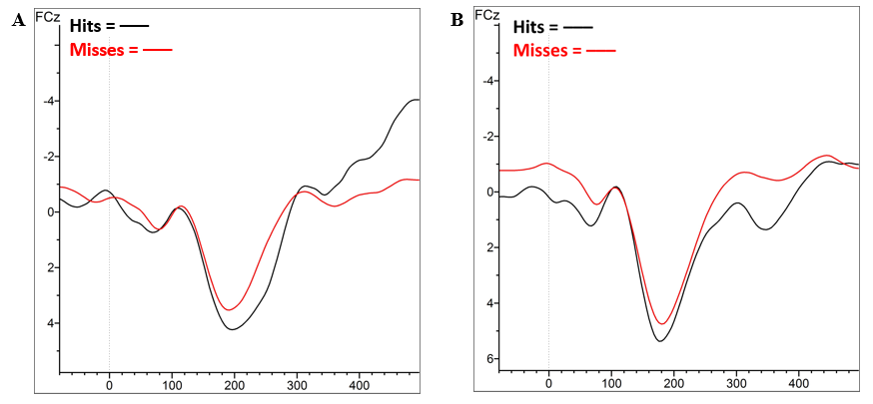
Grand averages of P3 waveform of high (A) and low (B) impulsivity groups at FCz electrode of the pre-target frame

Figure 5
Topographical view for P3 hits and misses separated by impulsivity
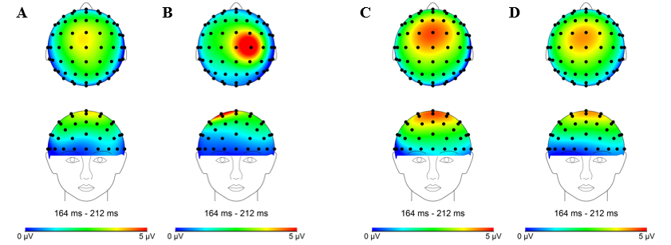
Note. A and B concerned P3 amplitude for respectively Hits and Misses for High Impulsive group. C and D concerned P3 amplitude for respectively Hits and Misses for Low Impulsive group.
Assumption for homogeneity of variance was not met for Detection, hence, a robust mixed ANOVA was utilized using 20% trimmed means instead of 2x2 mixed model ANOVA. A robust mixed ANOVA using the package ‘WRS2’ is a viable statistical analysis when data violates assumption checks (Mair & Wilcox, 2020; Wilcox, 2021). However, the robust mixed ANOVA yielded no difference between low and high impulsivity compared upon P3 amplitude, F(1, 17.84) = 0.68, p = .421. The results also showed no main effect of detection on P3 amplitude, F(1, 20.70) = 1.92, p = .181. The interaction effect was also not present, F(1, 20.70) = 0.02, p = .904. There was no indication that different impulsivity levels, hits and misses, and interaction between impulsivity levels and trial detection vary in terms of auditory CTET P3 amplitude measured at FCz electrode.
Figure 6
Boxplots of P3 amplitude for Detection and Impulsivity Score
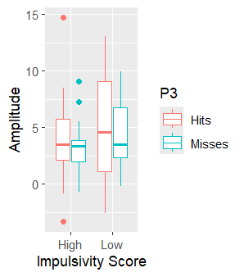
Pearson’s correlation revealed that there is no correlation between P3 Average and impulsivity scores, r(36) = -0.06, p = .737, and likewise, no correlation between P3 Difference and impulsivity scores, r(36) = 0.14, p = .389. Present results indicated that the P3 amplitude averaged over hits and misses does not have a relationship with impulsiveness levels, nor does the difference between P3 amplitude for hits and misses with impulsiveness levels. Visualizations of the correlational analyses can be seen in Appendix C7.
Independent samples t-test further revealed that there is not a significant difference of P3 Average for low and high impulsiveness groups, t(36) = -0.94, p = .355. Furthermore, the P3 Difference did not vary for low and impulsiveness groups, t(36) = 0.09, p = .925. Boxplots of the independent samples t-tests can be seen in Appendix C8.
Task Performance Grouped by Impulsivity
Independent samples t-test revealed that there is no significant difference between the hit rates for low and high impulsiveness groups, t(36), -0.90, p = .375. Assumption for homogeneity of variance was not met for false alarm rate. Hence, a Welch two sample t-test was conducted, revealing that the difference of false alarm rate between low and high impulsiveness groups is significant, t(23.22) = 2.11, p = .045. Present results suggested that, while one group is not necessarily more precise than the other in identifying target tones, high impulsive group seems more likely than low impulsive group to misidentify non-target tones as the target.
Discussion
The present study investigated whether the CTET P3 amplitude predicts target detection in an attempt to replicate earlier findings in the visual domain of sustained attention (Chidharom et al., 2021; Dockree et al., 2017; O’Connell et al., 2009). The study furthermore investigated whether P3 amplitude, which indexes auditory sustained attention, has a relationship with impulsivity levels. However, the planned analysis results did not demonstrate support for any of our hypotheses. Likewise, exploratory analyses results failed to show comparative differences of P3 amplitude when accounting for different levels of impulsivity. Interestingly, however, performance analyses revealed that high impulsivity group demonstrates significantly higher false alarm rates than low impulsivity group, while there is no comparative difference of hit rates for both groups.
This study did not replicate previous research findings in the visual modality showing an increase in P3 amplitude during the preceding non-target frame prior to successful signal detection as compared to failed signal detection (Chidharom et al., 2021; Dockree et al., 2017; O’Connell et al., 2009). This is contrary to descriptive statistics of overall data that exhibited larger P3 amplitude for hits than misses trials during preceding non-target frame. Moreover, 21 out of 38 participants showed pattern in the expected direction, with 10 highly impulsive participants and 11 participants with low impulsivity. Perhaps this lack of replication could be explained by a difference in preceding non-target frame analyses between previous research and the current study. The current study examined only one pre-target frame in comparison to previous studies that examined P3 amplitude throughout five pre-target frames within an epoch (Chidharom et al., 2021; Dockree et al., 2017; O’Connell et al., 2009). Observation across five instead of one pre-target frame would give a clearer insight into P3 activity in the auditory domain.
Lack of P3 predictive characteristics could perhaps also be driven by the single electrode analysis approach the current study takes, unlike previous research which utilized a cluster electrode approach. By focusing on P3 amplitude on FCz electrode, we neglect information provided by electrodes surrounding FCz and the possibility of the peak occurring elsewhere for different conditions. Indeed, visual inspection of Figure 2 revealed that peaks for overall hits and misses occurred at different electrodes, and it even seemed that P3 is stronger prior to failed target detection. When separated by impulsivity levels, while visual inspection of low impulsivity group seemed to be in the expected direction (see Figure 5), high impulsivity group seemed to exhibit stronger P3 amplitude for misses than hits at C2 electrode. This unexpected activity might be the reason that P3 for overall misses seemed to peak at a different electrode in Figure 2. Therefore, utilizing a cluster electrode approach might be more beneficial and comprehensive in understanding P3 activity prior to lapses of sustained attention.
This study further expected that P3 amplitude has a negative relationship with impulsiveness. Contrary to expectations, both Pearson’s and Spearman’s correlational analyses did not provide statistical evidence that P3 amplitude for hits and misses are related to impulsivity scores. Given that the revised BIS has three subscales, such as motor, attention, and planning (Chen, 2013), perhaps only one of the subscales is correlated with the amplitude of CTET P3 component, which reflects capacity for sustained attention. Results in the present study, however, suggest that P3-indexed auditory sustained attention does not seem to be related to impulsivity.
While other exploratory analyses did not show promising results, this study found evidence that individuals with higher impulsivity have more tendency to falsely classify non-target stimuli as target relative to those with lower impulsivity. Perhaps this is owed to the repetitive and continuous nature of the CTET task which, according to Berry and colleagues (2014), may lead to boredom and thus failure in maintaining attention to the task conditions, specifically in the auditory domain. While the number of misses in high impulsivity group does not differ from low impulsivity group, it is conceivable that higher false alarm rates in high impulsivity group reflects a lowered capability to inhibit responses to non-target tones due to lack of engagement to the task, or in other words, being in a state of under-arousal. This corresponds to a study by Leshem and Yefet (2019), who utilized two variants of go/no-go tasks to disentangle the relationship between impulsivity and inhibitory control. Leshem and Yefet’s (2019) findings suggested that highly impulsive participants in a low arousal environment seem to exhibit impaired response inhibition, manifest in the tendency for rapid and frequent responses. In a similar vein, high impulsivity group has been found to demonstrate poor performance in association with a state of low (tense) arousal, which is attributed to lacking cautiousness and thereby increases the likelihood of responding (Dickman, 2000). To note, however, that Dickman (2000) observed such relationship between arousal and performance only in high functional impulsivity group, known to act with little forethought when this approach is beneficial, which suggests that high impulsivity participants in the present study is likewise of the functional subtype. Hence, as CTET has low task demands by only requiring participants to provide responses upon detecting target, high impulsivity group might become less cautious in inhibiting their responses because rapid and frequent responses compensated for higher false alarm rates with hits rate relatively comparable to low impulsivity group. This may also account for lack of comparative differences between high and low impulsivity for lapses of sustained attention.
It would be remiss to exclude the possibility that impulsivity is indeed not related to auditory sustained attention, but with response inhibition instead. While current results correspond with previous findings by Leshem and Yefet (2019), with high impulsivity participants exhibiting more false alarms, the conceptualization of false alarms being the difficulty to suppress prepotent responses points to a stronger relationship between impulsivity and inhibitory control. However, given that CTET does not specifically measure response inhibition, and that this is contrary to the results demonstrated by Lansbergen and colleagues (2007), this interpretation should perhaps be taken with due consideration.
Lack of sufficient difference in the predictive relations for high and low impulsive groups can also possibly be attributed to impulsivity levels being a self-reported measure. Participants in this study are healthy students that did/have not received a diagnosis for neurological/psychiatric disorders, which makes it conceivable that high self-reported impulsivity might not be necessarily indicative of clinical significance. Indeed, a phenomenon of initial elevation on self-reports, in which participants rated themselves higher when they took the survey for the first time compared to subsequent times, has been observed in samples of U.S. college students (Anvari et al., 2023).
Despite its limitations, the present study contributes to the growing body of literature pertaining to the relationship between sustained attention, impulsivity, and the P3 ERP component. This study was the first to examine the neural precursor of sustained attention utilizing the auditory version of CTET paradigm, furthermore in the context of impulsivity. To date, only Berry and colleagues (2014) have examined sustained attention in the auditory domain. While present results did not replicate previous findings of the predictive characteristics of P3 on visual sustained attention, this only proves that further work is needed to disentangle the relationship between P3, auditory sustained attention, and impulsivity.
Future directions
Several improvements could be carried out in future studies in terms of methods. As previously mentioned, it would be beneficial to examine five pre-target frames instead of only one to gain a clearer understanding of the P3 activity for sustained attention. In addition, analyzing the electrodes in a cluster instead of the present study’s single-electrode approach, may present a more comprehensive P3 amplitude analysis. Exploring the BIS subscales in future studies as well may elucidate the aspects of impulsivity that might underlie lapses of sustained attention. In a similar vein, investigating functional and dysfunctional aspects in high impulsivity participants as done in Dickman’s (2000) study might be just as worthwhile. Moreover, given current results about false alarm rates that note the possible role of arousal in mediating impulsivity and sustained attention, further examination into arousal could be considered, such as measuring pre- and post-state arousal by utilizing the self-reported subjective drowsiness in the study.
Furthermore, analyzing another ERP component such as the contingent negative variation (CNV) in conjunction with P3 could give a clearer picture of the mechanisms underlying auditory sustained attention. Braver (2012) proposed via the framework Dual Mechanisms of Control (DMC), that cognitive control can operate in two mechanisms: proactive mode and reactive mode. CNV is a slow, negative event-related potential thought to reflect anticipatory attention for target stimulus (Brunia & Van Boxtel, 2001), and has been explored with the CTET paradigm to study proactivity in sustained attention (Chidharom et al., 2021; O’Connell et al., 2009). CNV amplitude, similarly to fP3, has been found to be significantly larger during hits than misses upon target detection (Chidharom et al., 2021; O’Connell et al., 2009). However, this augmented CNV effect was only present in Chidharom and colleagues' (2021) study at 4 trials prior to target, suggesting that the potential for CNV as an index of proactive sustained attention still remains to be seen. That being so, it may still be beneficial to analyze CNV in conjunction with P3, which has been thought to represent reactive control in sustained attention (Chidharom et al., 2021), to explore further the potential dissociable domains of cognitive mechanisms behind sustained attention.
Conclusion
This study aimed to disentangle the relationship between auditory sustained attention, P3, and impulsivity. While this study did not extend previous work’s results on fP3-indexed sustained attention to auditory domain and did not prove that high impulsive individuals differ than their low impulsive counterparts in terms of brain states during lapses of sustained attention, performance results suggested potential mediating role of arousal. As of now, higher false alarm rates in high impulsive individuals points to stronger relationship of impulsivity with response inhibition. Methodology in the present study could use further improvements, especially with a more comprehensive fP3 analysis, in conjunction with CNV. Nonetheless, this study is an important starting point to examine the potential of fP3 as a neurophysiological precursor of lapse of sustained attention in different levels of impulsivity.

References
American Psychiatric Association. (2013). Diagnostic and Statistical Manual of Mental Disorders (Fifth Edition). American Psychiatric Association. https://doi.org/10.1176/appi.books.9780890425596
Anvari, F., Efendić, E., Olsen, J., Arslan, R. C., Elson, M., & Schneider, I. K. (2023). Bias in Self-Reports: An Initial Elevation Phenomenon. Social Psychological and Personality Science, 14(6), 727–737. https://doi.org/10.1177/19485506221129160
Bari, A., & Robbins, T. W. (2013). Inhibition and impulsivity: Behavioral and neural basis of response control. Progress in Neurobiology, 108, 44–79. https://doi.org/10.1016/j.pneurobio.2013.06.005
Bekker, E. M., Kenemans, J. L., Hoeksma, M. R., Talsma, D., & Verbaten, M. N. (2005). The pure electrophysiology of stopping. International Journal of Psychophysiology, 55(2), 191–198. https://doi.org/10.1016/j.ijpsycho.2004.07.005
Berry, A. S., Li, X., Lin, Z., & Lustig, C. (2014). Shared and distinct factors driving attention and temporal processing across modalities. Acta Psychologica, 147, 42–50. https://doi.org/10.1016/j.actpsy.2013.07.020
Braver, T. S. (2012). The variable nature of cognitive control: A dual mechanisms framework. Trends in Cognitive Sciences, 16(2), 106–113. https://doi.org/10.1016/j.tics.2011.12.010
Brunia, C. H. M., & Van Boxtel, G. J. M. (2001). Wait and see. International Journal of Psychophysiology, 43(1), 59–75. https://doi.org/10.1016/S0167-8760(01)00179-9
Chen, W. (2013). NeuroInvesting: Build a New Investing Brain (1st ed.). Wiley. https://doi.org/10.1002/9781118638279
Chidharom, M., Krieg, J., Marques-Carneiro, E., Pham, B.-T., & Bonnefond, A. (2021). Investigation of electrophysiological precursors of attentional errors in schizophrenia: Toward a better understanding of abnormal proactive control engagement. Journal of Psychiatric Research, 140, 235–242. https://doi.org/10.1016/j.jpsychires.2021.05.079
Dickman, S. J. (2000). Impulsivity, arousal and attention. Personality and Individual Differences, 28(3), 563–581. https://doi.org/10.1016/S0191-8869(99)00120-8
Dockree, P. M., Barnes, J. J., Matthews, N., Dean, A. J., Abe, R., Nandam, L. S., Kelly, S. P., Bellgrove, M. A., & O’Connell, R. G. (2017). The Effects of Methylphenidate on the Neural Signatures of Sustained Attention. Biological Psychiatry, 82(9), 687–694. https://doi.org/10.1016/j.biopsych.2017.04.016
Lansbergen, M. M., Böcker, K. B. E., Bekker, E. M., & Kenemans, J. L. (2007). Neural correlates of stopping and self-reported impulsivity. Clinical Neurophysiology, 118(9), 2089–2103. https://doi.org/10.1016/j.clinph.2007.06.011
Leshem, R. (2016). Relationships between trait impulsivity and cognitive control: The effect of attention switching on response inhibition and conflict resolution. Cognitive Processing, 17(1), 89–103. https://doi.org/10.1007/s10339-015-0733-6
Leshem, R., & Yefet, M. (2019). Does impulsivity converge distinctively with inhibitory control? Disentangling the cold and hot aspects of inhibitory control. Personality and Individual Differences, 145, 44–51. https://doi.org/10.1016/j.paid.2019.03.003
Mair, P., & Wilcox, R. (2020). Robust statistical methods in R using the WRS2 package. Behavior Research Methods, 52(2), 464–488. https://doi.org/10.3758/s13428-019-01246-w
Maki, K. A., Fink, A. M., & Weaver, T. E. (2022). Sleep, time, and space—Fatigue and performance deficits in pilots, commercial truck drivers, and astronauts. SLEEP Advances, 3(1), zpac033. https://doi.org/10.1093/sleepadvances/zpac033
Nigg, J. T. (2016). Attention and Impulsivity. In D. Cicchetti (Ed.), Developmental Psychopathology (1st ed., pp. 1–56). Wiley. https://doi.org/10.1002/9781119125556.devpsy314
O’Connell, R. G., Dockree, P. M., Robertson, I. H., Bellgrove, M. A., Foxe, J. J., & Kelly, S. P. (2009). Uncovering the Neural Signature of Lapsing Attention: Electrophysiological Signals Predict Errors up to 20 s before They Occur. Journal of Neuroscience, 29(26), 8604–8611. https://doi.org/10.1523/JNEUROSCI.5967-08.2009
Posner, M. I., & Petersen, S. E. (1990). The Attention System of the Human Brain. Annual Review of Neuroscience, 13(1), 25–42. https://doi.org/10.1146/annurev.ne.13.030190.000325
Van Der Heiden, R. M. A., Janssen, C. P., Donker, S. F., Hardeman, L. E. S., Mans, K., & Kenemans, J. L. (2018). Susceptibility to audio signals during autonomous driving. PLOS ONE, 13(8), e0201963. https://doi.org/10.1371/journal.pone.0201963
Wilcox, R. R. (2021). Introduction to robust estimation and hypothesis testing (5th ed.). Elsevier, Inc.

Appendix A
Pre-processing template of task-related EEG data in Brain Vision Analyzer
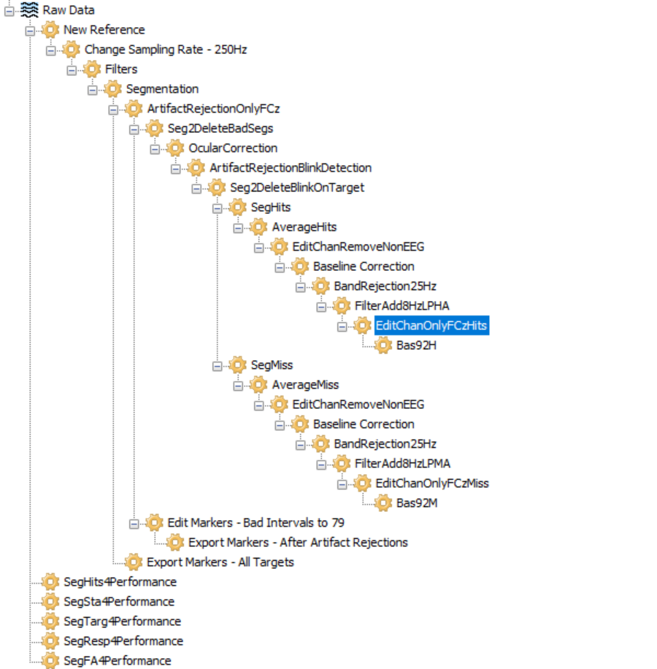

Note. Explanation of abbreviations: SegHits/SegMiss (Segmentation for hit/miss trials), EditChanRemoveNonEEG (Edit channels to remove non-EEG electrodes, such as external electrodes), Bas92 (Baseline correction to 92-124ms). The final four nodes are used to extract task performance from each participant: SegHits4Performance (Segmentation for number of hits), SegSta4Performance (Segmentation for number of standard/non-target stimuli), SegTarg4Performance (Segmentation for number of target stimuli), SegResp4Performance (Segmentation for number of participant responses), SegFA4Performance (Segmentation for number of false alarm, but this node is not used in favor of a different approach).
Appendix B
List of excluded participants
Participants excluded due to drop-outs/incomplete questionnaire data:
PP08, PP21, PP26, PP37, PP44, PP52.
Participants excluded from EEG analysis:
PP03, PP07 did not partake in auditory CTET due to time constraints.
PP20 did not have data after ArtifactRejectionBlinkDetection, perhaps due to loose right mastoid external electrode.
PP03 did not have segmentation for Hits.
PP39 did not have segmentation for Hits, and measurement of CTET data had to be halted early on due to technical problems with ActiView program.
PP23, PP31, and PP45 had technical problems.
Appendix C
Additional figures
Figure 7
Scatterplots of P3 Average and Impulsivity (A) and of P3 Difference and Impulsivity (B)
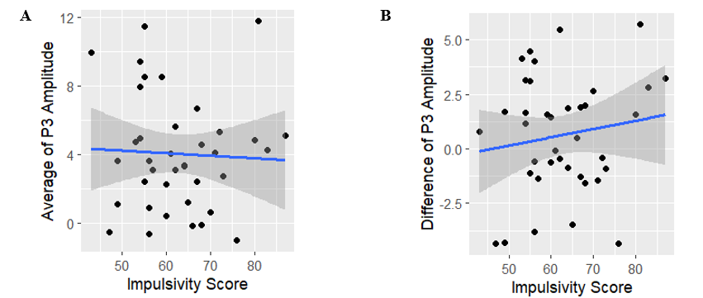

Figure 8
Boxplots of P3 Average (A) and P3 Difference (B) separated by Impulsivity
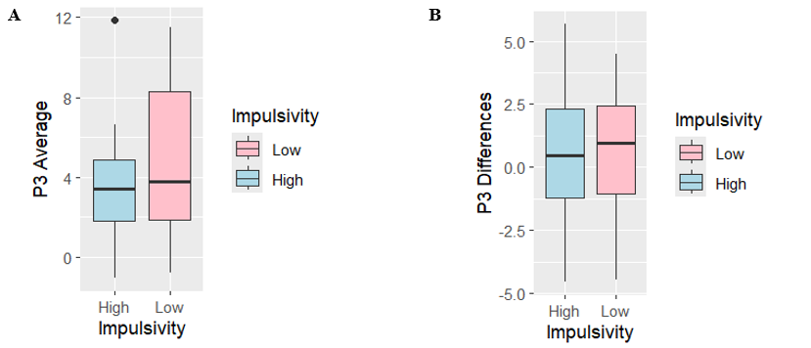

Figure 9
Boxplots of P3 Hits and Misses separated by Impulsivity with connected data points
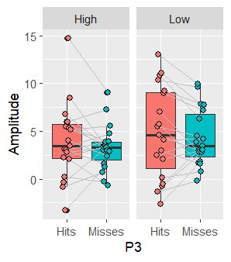
Note. High refers to High Impulsivity group and Low refers to Low Impulsivity group. Connected data points are the Hits and Misses of the (same) participant.

