Comparison of air pollution exposure assessment methods in relation to children’s respiratory health effects

Femke Bouma - Student number: 3948951

Abstract
Introduction
Long-term exposure to air pollution has been associated with asthma incidence and decreased lung function in children. However, the application of a wide variety of exposure assessment methods has potentially contributed to the substantial heterogeneity in effect estimates. The aim of this study was to compare different exposure assessment methods in their effect estimation of asthma incidence and lung function.

Methods
Eight different exposure assessment methods, differing in modelling (dispersion, empirical with different algorithms) and monitoring strategy (fixed site, mobile), were applied to calculate annual average air pollution exposure at the residential addresses of a Dutch birth cohort of nearly 4,000 participants. Health effect estimates of air pollution and asthma incidence from birth to 20 years and lung function at 16 years were assessed and compared. Random-effects meta-analyses were applied to assess heterogeneity of the association estimates.

Results
The correlation between exposure concentrations from the different methods was generally moderate to high, mostly ranging from 0.5 to 0.9. The association estimates for the different exposure assessment methods were largely similar in direction but differed in size (e.g. asthma incidence OR ranged from 1.09 to 2.56 for BC). The heterogeneity of association estimates differed between pollutants and outcome measures, and was largest for BC with asthma (I² 64.2%). Null to moderate correlations were found between model performance and association estimates.

Conclusion
Different exposure assessment methods generally resulted in similar conclusions about the direction of association with asthma incidence and lung function in children, but differed in magnitude of association estimates. Heterogeneity of these association estimates might be partially driven by the application of various exposure assessment methods.

Plain language summary
Outdoor air pollution negatively impacts human health. It consists of gases and particles that are harmful to health when they are inhaled. In order to investigate the health effects of air pollution, large-scale studies are needed. It is currently not possible to measure the individual long-term exposure for such large groups of people because of practical and financial constraints. Therefore, researchers have developed many different models to approximate the exposure as accurately as possible. The application of different models in health research may affect the conclusions that can be drawn from this research.
Many studies have found that children living at addresses with higher exposure to air can increase the risk of asthma and decrease lung function in children. However, different studies have reported varying quantitative estimates of these associations. This may be because these studies have used different methods to estimate the long-term exposure to air pollution, but this has not been extensively researched. In the current study we compared associations with asthma and lung function for eight such models in nearly 4,000 children in the Netherlands.
We found that the different models estimated the exposure levels of air pollution quite differently, but that the exposures were nonetheless quite highly correlated, meaning that if one model estimated a higher level of pollution at a particular address, the other models also tended to estimate higher levels for that same area, and vice versa. This indicates that the different models are generally in agreement about where pollution levels are higher or lower, even if they do not provide exactly the same values. With regards to the risk estimates for asthma and lung function, the models generally agreed on whether there was an increased risk or not, but varied in the level of risk they identified. In other words, most models showed that air pollution increased the risk of asthma and decreased lung function, but the level of increased risk differed between the models.
Our findings suggest that the method of assessing air pollution exposure can influence the size of the health effect estimates reported. This indicates that the application of different exposure assessment methods plays a role in the variation of effect estimates found in previous studies. However, most methods consistently indicated an increased risk of asthma and decreased lung function, which reinforces previous research conclusions.

Introduction
The association between long-term exposure to air pollution and asthma and lung function in children has been extensively researched (Anderson et al., 2013; Barone-Adesi et al., 2015; Han et al., 2021; HEI, 2022; Khreis et al., 2017; Zhang et al., 2022). However, one of the major challenges that remains in this research is characterizing long-term exposure for individuals. Since the feasibility of personal exposure measurements in large cohort studies is currently very low, many studies have applied different exposure assessment methods. Air pollution exposure assessment methods differ in the monitoring data, e.g. routine monitoring, mobile monitoring and satellite remote sensing data, as well the modeling approach, e.g. land-use regression (LUR) modeling, dispersion modeling and the combination thereof, that is applied (Hoek, 2017). It is speculated that the use of different exposure assessment methods likely contributes to the heterogeneity in health effect estimates (Khreis et al., 2017). However, the extent of this contribution is difficult to extrapolate from systematic reviews that include studies that additionally differ in other methodological aspects such as population, outcome measures, and statistical methods. The application of different methods for air pollution exposure assessment in these studies complicates the comparison of association estimates and potentially affects the conclusions that can be drawn from epidemiological studies of health effects of air pollution.
In addition to the monitoring data used for modelling, different model development algorithms have been applied in empirical modeling methods. Some studies have investigated the relative performance of different methods, mostly focusing on different model development algorithms (Chen et al., 2019; Kerckhoffs et al., 2019; Weichenthal et al., 2016). Few studies have applied and compared multiple exposure assessment methods and/or model development algorithms in epidemiological analyses (Bouma et al., 2022; Jerrett et al., 2017; Klompmaker et al., 2021; Wang et al., 2015).
In order to investigate differences in estimates of exposure-outcome relationships between different exposure assessment methods, health outcomes that have previously been found to be associated with air pollution exposure can best be examined. This specific challenge can be addressed through comparing the associations between air pollution exposure and health outcomes using different exposure assessment methods within the same cohort. Long-term exposure to outdoor air pollution has been linked to adverse respiratory health outcomes such as asthma development and lower lung function in children (Khreis et al., 2017; Lee, 2020; Zhang et al., 2022). In the Prevention and Incidence of Asthma and Mite Allergy (PIAMA) birth cohort, air pollution, including nitrogen dioxide (NO₂), particulate matter <2.5 µm (PM_{2.5}) and PM_{2.5} absorbance, have been associated with asthma development and decreased lung function (Gehring et al., 2020; Milanzi et al., 2018). Recent analyses of ultrafine particles (UFP) found no associations with these health outcomes (Yu et al., 2021, 2022).
The aim of this study was to compare different exposure assessment methods in effect estimation of long-term exposure to outdoor air pollution and asthma and lung function in children.

Materials and methods

2.1 Study design
In this study we compared eight different exposure assessment methods. Table 1 provides an overview of the methods, most of which were developed in the framework of previous projects and covered multiple pollutants. The variety of methods was larger than in most previous comparison studies. We additionally included multiple development algorithms or developed these models if they were not yet available. For the health analyses, we followed the methods as applied in earlier analyses assessing associations of UFP with asthma incidence using the observations from age one to 20 years (Yu et al., 2022) lung function at age 16 (Yu et al., 2021). We compared the association estimates and confidence intervals for the different exposure assessment methods. We also investigated the correlation between model performance (defined as the R² of the model applied to various external validation datasets) and the health effect estimate. Additionally, we performed meta-analyses to assess the heterogeneity of effect estimates between the different methods.

2.2 Study population
The PIAMA birth cohort is an ongoing Dutch prospective cohort study with prenatal inclusion that started with 3963 newborns born in 1996-1997 (Wijga et al., 2014). The original aims of the cohort were to investigate mite-allergen avoidance for the prevention of asthma and allergy, and to assess the influence of lifestyle, environmental and genetic factors on childhood asthma. Parents completed questionnaires during pregnancy, when the child was three months old, and yearly from age one to eight. At ages 11, 14 and 16/17, both parents and the participants themselves completed questionnaires. Participants additionally completed questionnaires at age 20. Data were obtained on child and family characteristics, a wide range of environmental and lifestyle exposures and on asthma and other allergic and respiratory outcomes. Clinical examinations were performed in sub-groups of participants at ages one, four, eight, 12, and 16 years. These included, amongst others, measurements of lung function. Primary health outcomes evaluated in this study were lung function at age 16 (Milanzi 2019) and asthma incidence from birth until age 20 (Gehring, 2020).

2.3 Air pollution exposure assessment
We estimated annual average air pollution exposure for black carbon (BC), NO₂, UFP and PM_{2.5} using eight different exposure assessment methods. A more detailed description can be found in [ref. exposure paper (in development)]. The methods differed in modelling approach (empirical versus deterministic) and in the monitoring data used (mobile, fixed site routine and study specific monitoring). The mobile models for PM_{2.5} (MUSIC, Exposomics, and RUN) were found to have a very poor predictive performance and were therefore excluded from this analysis. The methods additionally differed in the domain in which they were developed (e.g. Amsterdam, major cities, The Netherlands, Europe-wide) and the time period for which they were available (from 2009 to 2021-2022). Two methods assessed a different metric for BC, namely the ESCAPE models assessed PM_{2.5} absorbance and the dispersion models assessed elemental carbon (EC). For ease of interpretation, these are all deemed “BC” when discussing all models generally and the model-specific metric is used when discussing these models specifically. In the case of the empirical models, we included models using three commonly applied algorithms selected from distinct families: Supervised Linear Regression (SLR), Lasso and Random Forest (RF) (Kerckhoffs, 2019; Chen, 2019). For conciseness, only the SLR models are presented in the main results, as this is the most commonly applied algorithm.
Air pollution concentrations were assigned to the residential histories of the participants of the PIAMA cohort. For the asthma analysis, concentrations were applied to both the birth address and the address at the time of outcome measurements (deemed the “current address”). For the lung function analysis, the concentrations were applied to the address at the clinical examination at the age of 16.
The predictive performance of the models on external validation datasets was assessed previously [ref. exposure paper (in development)]. For the analysis of the correlation between performance R² and association estimates, the most appropriate validation dataset(s) was determined for each pollutant.

Table 1. Exposure assessment methods
Exposure assessment method | Pollutants | Monitoring data | Modeling method | Domain | Time period
Low cost sensors | NO₂ | Long-term (6 months) monitoring at 100 sites across the Netherlands. | LUR | Netherlands | 2021-2022
Google Airview | UFP, BC, NO₂ | Mobile monitoring | LUR | Amsterdam | 2019-2020
MUSIC | UFP, BC | Mobile monitoring | LUR | Major cities: Amsterdam and Rotterdam | 2013
Exposomics | UFP, BC | Mobile monitoring | LUR | Major cities: Utrecht, Amsterdam, Maastricht | 2014-2015
RUN | UFP, BC | Mobile monitoring | LUR | Netherlands | June 2016 – November 2017
ESCAPE | PM_{2.5}, PM_{2.5} abs, NO₂ | Long-term study-specific monitoring | LUR | Netherlands | 2009: three seasons
ELAPSE/EXPANSE | PM_{2.5}, BC, NO₂ | Long-term routine monitoring | LUR (only SLR and RF) | Europe | 2010 to 2019
Dispersion model | PM_{2.5}, EC, NO₂ | Not applicable | Dispersion modeling | Netherlands | 2010 to 2019

2.4 Outcome assessment
Asthma
Data on asthma were collected from participants by questionnaires that were completed by the parents and/or the participant repeatedly from birth until age 20 years. The definition of asthma followed the definition developed by experts within the Mechanisms of the Development of Allergy (MeDALL) consortium and was a positive answer to at least two of the three following questions: 1) “Has a doctor ever diagnosed asthma in your child?”2) “Has your child had wheezing or whistling in the chest in the last 12 months?”,3) “Has your child been prescribed asthma medication during the last 12 months?”. At age 20 years, these questions were posed to the participants themselves. Incident asthma was defined as positive when the participant fulfilled the criteria for the first time and had non-missing data for all previous follow-ups.

Lung function
Lung function was measured with forced expiratory volume in one second (FEV₁) and forced vital capacity (FVC) at age 16. The measurements were performed in two centers using different devices, the Jaeger Masterscreen pneumotachographs (CareFusion, Yoba Linda, CA, USA) and EasyOne spirometers, and corrections were applied for systematic differences between devices (Milanzi et al., 2018).

2.5 Data analysis
Discrete time hazard models were used to analyze associations with asthma incidence. Associations between air pollution exposure and lung function were assessed cross-sectionally using linear regression. We adjusted associations with asthma for sex, maternal and paternal asthma and hay fever, native nationality, parental education, breastfeeding, older siblings, day-care attendance, maternal smoking during pregnancy, parental smoking at home, mold or dampness at home, pets, use of gas for cooking and active smoking (from age 14 years). Associations with lung function with adjustment for sex, log-transformation of age, weight and height, parental education, maternal atopy, paternal atopy, breastfeeding, respiratory infections in the last 3 weeks (prior to the medical examination), Dutch nationality, indoor tobacco smoke exposure in the home, maternal smoking in pregnancy, furry pets in the home, mold in the home, gas cooking and average air pollution concentrations for the 7 days preceding the lung function measurement for lung function.
One of the limitations of our analysis is that the models we assessed were developed in different years. Therefore, we assessed the associations of the multiyear models (ELAPSE/EXPANSE and dispersion) in 2010 (if available), 2013, 2016 and 2019 and compared these associations over time. In the main analysis, we expressed association estimates for the fixed exposure increments of 1 µg/m³ for BC, 10 µg/m³ for NO₂, 5,000 particles/cm³ for UFP and 5 µg/m³ for PM_{2.5}. Additionally, we compared effect estimates expressed per interquartile range (IQR) for each method to investigate how much differences in exposure contrast contribute to differences in effect estimates. Methods may differ in the correlation between predicted exposures and confounders. We therefore compared effect estimates from different methods in the unadjusted model 1 and the fully adjusted model 2 to judge how sensitive differences between methods were to adjustment for confounders. Lastly we analyzed the heterogeneity of the association estimates in random effect meta-analyses with I², both for the set of methods including only the SLR models, as well as for the set including the RF and LASSO models. In these analyses, the models for the earliest available were included for the multiyear methods.

Results

3.1 Population characteristics
Population characteristics for the population for the asthma analysis are presented in table 2. Lung function was assessed in a subset of PIAMA participants, hence the smaller population for this analysis than for the asthma analysis (table S1). Both populations included a majority of participants with highly educated parents.

Table 2 Population characteristics of the population for the asthma analysis, ages 1 – 20 years
Characteristics | n/N (%)
Female | 1780/3687 (48.3)
Maternal asthma and/or hay fever | 881/3652 (24.1)
Paternal asthma and/or hay fever | 911/3658 (24.9)
Dutch nationality | 3190/3521 (90.6)
High maternal education | 1298/3678 (35.3)
High paternal education | 1458/3637 (40.1))
Breastfeeding (≥12 weeks) | 1627/3463 (47.0)
Older siblings | 1860/3678 (50.6)
Daycare center attendanceª | 2040/3538 (57.7)
Mother smoked during pregnancy | 626/3652 (17.1)
Smoking at child's home^{b}
Early life^{c} | 912/3686 (24.7)
Age 20 years | 186/2127 (8.7)
Active smoking at least once a week^{d}
Age 14 years | 119/2431 (4.9)
Age 20 years | 426/2127 (20.0)
Use of natural gas for cooking
Early life^{c} | 3028/3674 (82.4)
Age 20 years | 1564/2127 (73.5)
Mold/damp spots in participant's home
Early life^{c} | 300/3643 (8.2)
Age 20 years | 242/2127 (11.4)
Furry pets in participant's home
Early life^{c} | 1720/3677 (46.8)
Age 20 years | 877/2127 (41.2)
ª During second year of life.
^{b} Defined as parental smoking until and including age 17 years and any smoking at age 20 years.
^{c} During first year of life.
^{d} At age ≥14 years.

Air pollution exposure
The distribution of air pollution exposure estimates differed substantially between methods (figure 1 and table S2). Only the distributions at the birth address for the asthma population are reported. Methods differed in predicted mean concentrations, ranging from 0.49 to 2.90 for BC, from 15.21 to 30.89 for NO₂, from 8192 to 17329 for UFP and from 9.82 to 18.02 for PM_{2.5}, as well as in their predicted exposure contrasts, with IQRs ranging from 0.06 to 1.10 for BC, from 1.02 to 12.19 for NO₂, from 1223 to 4979 for UFP and from 0.14 to 4.19 for PM_{2.5}. The MUSIC SLR model predicted a substantial amount of negative concentrations for BC. As the concentrations of this model correlate highly with the Lasso model as well as with models from other methods, this is likely due to a downward shift of the entire distribution of the predicted concentrations (table 3).
The IQRs for all models and all exposures at the birth and current addresses can be found in table S3. The empirical mobile monitoring models generally predicted larger exposure contrasts than the stationary LUR and dispersion models, especially the major city models of Exposomics and MUSIC. For the multiyear models (ELAPSE/EXPANSE and the dispersion models), a downward trend in predicted mean concentrations was found, but exposure contrasts remained mostly stable over the years. No clear pattern was seen for differences in predicted exposure distributions between the different model development algorithms.

Figure 1. Distribution of air pollution exposures at the birth address for the participants included in the asthma analysis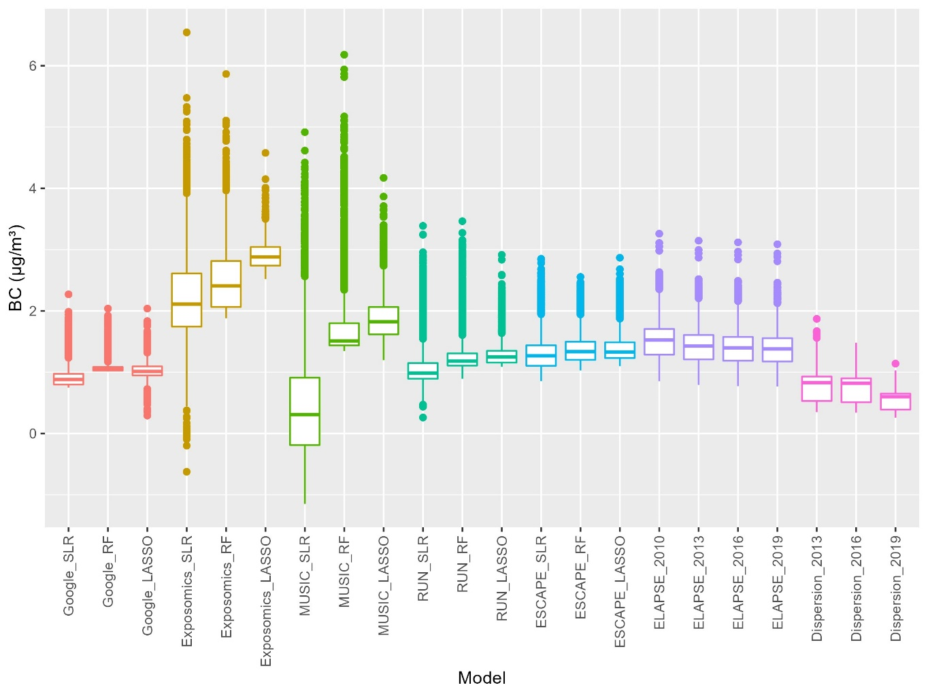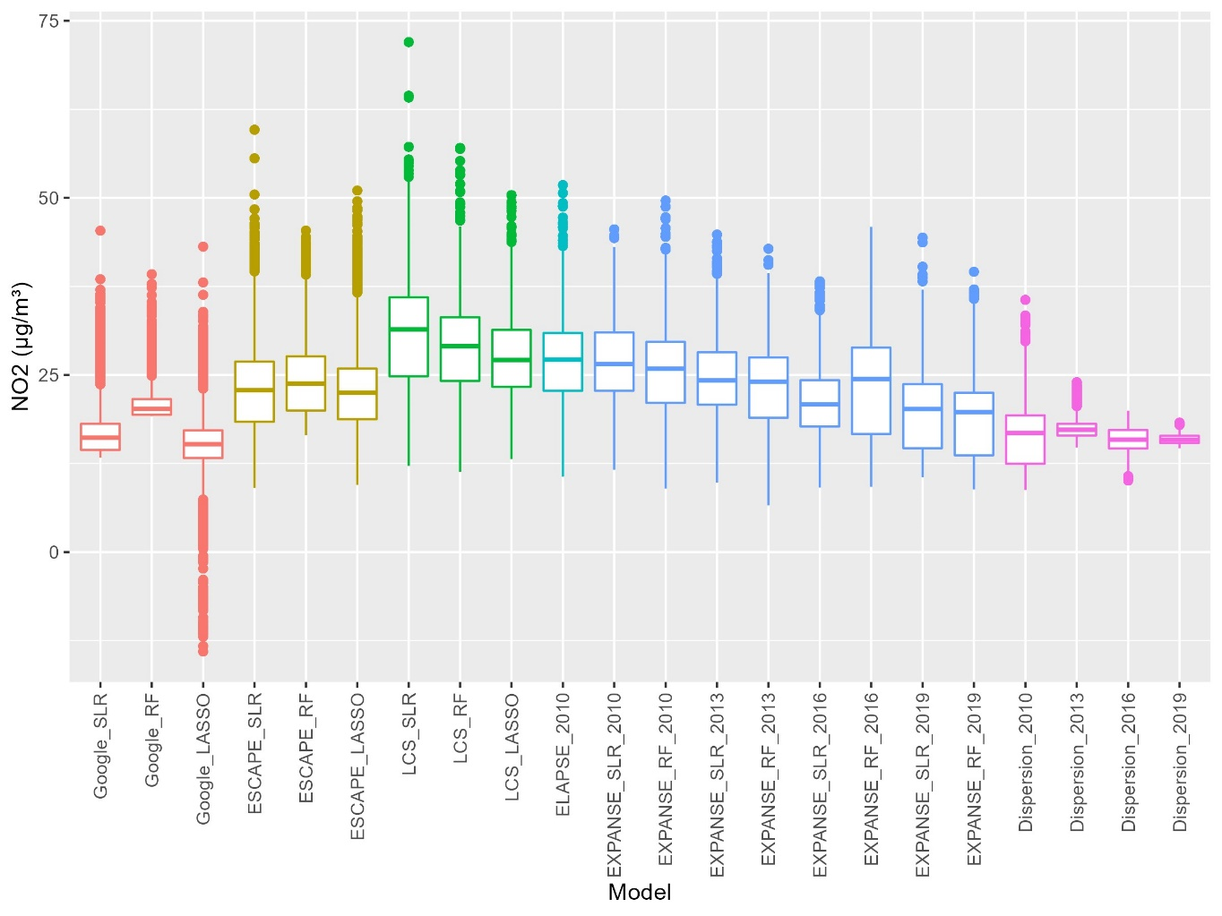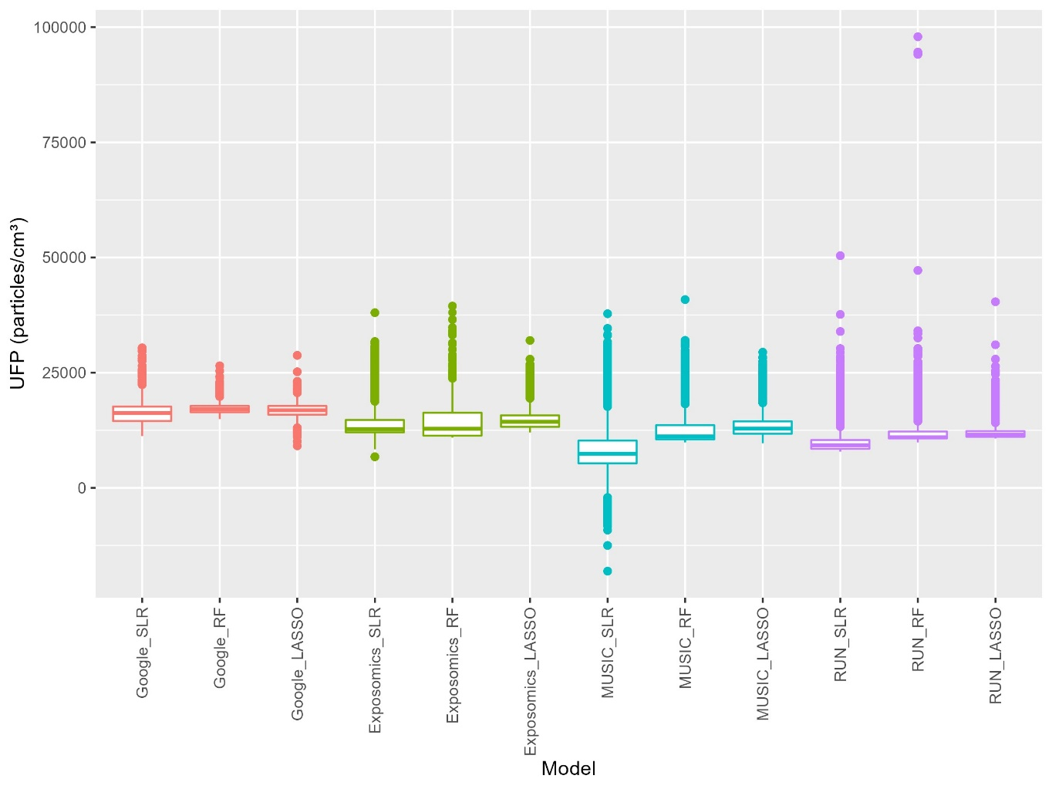 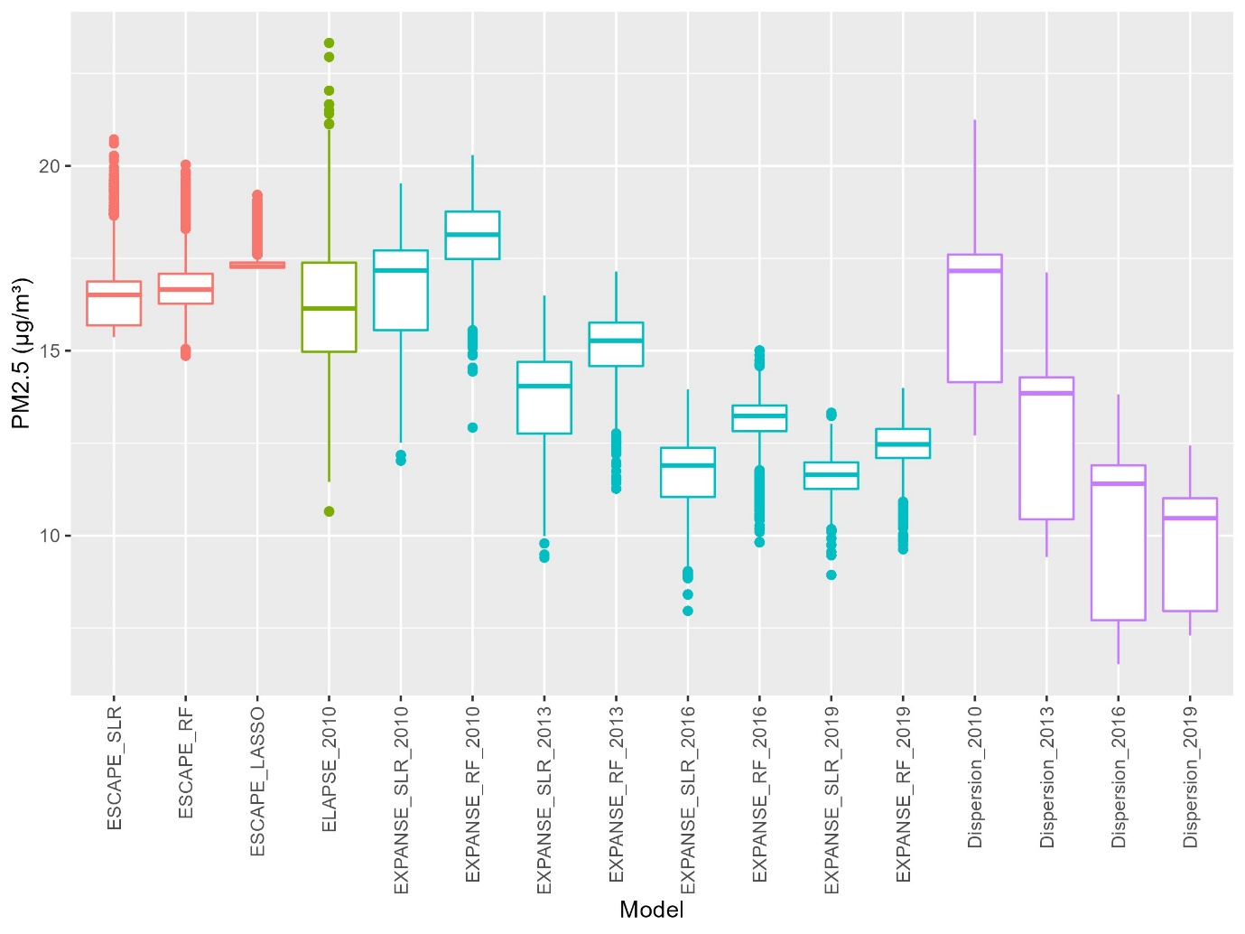

Correlations between predicted concentrations of most models were moderate to high, ranging from 0.5 to 0.9 (tables 3, 4, and S4 to S9) for predictions at the birth and current address for asthma as well as at the address at 16 years for lung function. Correlations lower than 0.5 occurred mostly for the mobile models (Google, MUSIC, Exposomics, RUN) and the low-cost sensor models.

Table 3 Correlations (Pearson) between BC exposures at birth (red) and current (green) address for participants included in the asthma analysis.
 |  | Google |  |  | MUSIC |  |  | Exposomics |  |  | RUN |  |  | ESCAPE |  |  | ELAPSE | Dispersion
 |  | SLR | RF | LASSO | SLR | RF | LASSO | SLR | RF | LASSO | SLR | RF | LASSO | SLR | RF | LASSO | 2010 | 2013
Google | SLR |  | 0.69 | 0.83 | 0.83 | 0.31 | 0.80 | 0.77 | 0.82 | 0.76 | 0.77 | 0.76 | 0.85 | 0.89 | 0.85 | 0.86 | 0.70 | 0.67
Google | RF | 0.72 |  | 0.64 | 0.47 | 0.50 | 0.48 | 0.46 | 0.58 | 0.38 | 0.50 | 0.61 | 0.52 | 0.63 | 0.73 | 0.64 | 0.37 | 0.34
Google | LASSO | 0.85 | 0.67 |  | 0.66 | 0.33 | 0.64 | 0.65 | 0.65 | 0.64 | 0.61 | 0.59 | 0.68 | 0.70 | 0.70 | 0.67 | 0.56 | 0.52
MUSIC | SLR | 0.85 | 0.52 | 0.69 |  | 0.19 | 0.99 | 0.82 | 0.87 | 0.83 | 0.69 | 0.75 | 0.79 | 0.86 | 0.83 | 0.85 | 0.85 | 0.73
MUSIC | RF | 0.42 | 0.57 | 0.40 | 0.33 |  | 0.21 | 0.21 | 0.34 | 0.15 | 0.28 | 0.38 | 0.28 | 0.24 | 0.30 | 0.28 | 0.12 | 0.08
MUSIC | LASSO | 0.82 | 0.53 | 0.67 | 0.99 | 0.37 |  | 0.79 | 0.88 | 0.80 | 0.65 | 0.75 | 0.76 | 0.84 | 0.83 | 0.85 | 0.86 | 0.71
Exposomics | SLR | 0.80 | 0.52 | 0.69 | 0.84 | 0.32 | 0.82 |  | 0.78 | 0.86 | 0.63 | 0.68 | 0.74 | 0.77 | 0.74 | 0.71 | 0.80 | 0.69
Exposomics | RF | 0.83 | 0.63 | 0.68 | 0.88 | 0.47 | 0.89 | 0.80 |  | 0.77 | 0.64 | 0.77 | 0.75 | 0.84 | 0.86 | 0.83 | 0.77 | 0.67
Exposomics | LASSO | 0.77 | 0.44 | 0.67 | 0.84 | 0.27 | 0.82 | 0.87 | 0.78 |  | 0.69 | 0.67 | 0.76 | 0.74 | 0.69 | 0.68 | 0.80 | 0.68
RUN | SLR | 0.80 | 0.52 | 0.65 | 0.73 | 0.38 | 0.70 | 0.68 | 0.67 | 0.71 |  | 0.80 | 0.92 | 0.61 | 0.64 | 0.60 | 0.59 | 0.46
RUN | RF | 0.79 | 0.63 | 0.63 | 0.77 | 0.49 | 0.77 | 0.72 | 0.78 | 0.69 | 0.84 |  | 0.84 | 0.73 | 0.77 | 0.73 | 0.69 | 0.61
RUN | LASSO | 0.86 | 0.55 | 0.71 | 0.81 | 0.38 | 0.78 | 0.76 | 0.76 | 0.77 | 0.94 | 0.86 |  | 0.76 | 0.76 | 0.72 | 0.72 | 0.66
ESCAPE | SLR | 0.91 | 0.68 | 0.73 | 0.87 | 0.37 | 0.85 | 0.78 | 0.86 | 0.75 | 0.66 | 0.75 | 0.78 |  | 0.92 | 0.97 | 0.78 | 0.80
ESCAPE | RF | 0.87 | 0.76 | 0.73 | 0.85 | 0.44 | 0.85 | 0.77 | 0.87 | 0.72 | 0.68 | 0.79 | 0.77 | 0.93 |  | 0.91 | 0.75 | 0.72
ESCAPE | LASSO | 0.88 | 0.68 | 0.69 | 0.86 | 0.41 | 0.86 | 0.73 | 0.84 | 0.69 | 0.65 | 0.75 | 0.74 | 0.97 | 0.92 |  | 0.74 | 0.73
ELAPSE | 2010 | 0.73 | 0.42 | 0.59 | 0.87 | 0.26 | 0.87 | 0.81 | 0.78 | 0.81 | 0.64 | 0.71 | 0.74 | 0.79 | 0.77 | 0.75 |  | 0.82
Dispersion | 2013 | 0.69 | 0.41 | 0.55 | 0.74 | 0.19 | 0.73 | 0.70 | 0.69 | 0.70 | 0.52 | 0.64 | 0.69 | 0.81 | 0.74 | 0.74 | 0.82

Table 4 Correlations (Pearson) between NO₂ exposures at birth (red) and current (green) address for participants included in the asthma analysis.
 |  | Google |  |  | Low cost sensors |  |  | ESCAPE |  |  | ELAPSE | EXPANSE |  | Dispersion
 |  | SLR | RF | LASSO | SLR | RF | LASSO | SLR | RF | LASSO | 2010 | SLR_  2010 | RF_  2010 | 2010
Google | SLR |  | 0.82 | 0.66 | 0.68 | 0.64 | 0.73 | 0.83 | 0.87 | 0.84 | 0.73 | 0.67 | 0.72 | 0.74
Google | RF | 0.84 |  | 0.52 | 0.46 | 0.45 | 0.49 | 0.70 | 0.84 | 0.72 | 0.60 | 0.56 | 0.56 | 0.61
Google | LASSO | 0.70 | 0.57 |  | 0.58 | 0.35 | 0.43 | 0.46 | 0.52 | 0.47 | 0.38 | 0.39 | 0.47 | 0.39
Low cost sensors | SLR | 0.71 | 0.52 | 0.60 |  | 0.40 | 0.58 | 0.50 | 0.49 | 0.46 | 0.40 | 0.35 | 0.37 | 0.49
Low cost sensors | RF | 0.62 | 0.43 | 0.38 | 0.42 |  | 0.87 | 0.82 | 0.73 | 0.73 | 0.83 | 0.81 | 0.87 | 0.73
Low cost sensors | LASSO | 0.73 | 0.52 | 0.48 | 0.62 | 0.86 |  | 0.79 | 0.73 | 0.72 | 0.75 | 0.72 | 0.81 | 0.67
ESCAPE | SLR | 0.85 | 0.73 | 0.51 | 0.56 | 0.80 | 0.80 |  | 0.88 | 0.94 | 0.89 | 0.84 | 0.84 | 0.90
ESCAPE | RF | 0.88 | 0.85 | 0.57 | 0.54 | 0.72 | 0.74 | 0.89 |  | 0.87 | 0.81 | 0.76 | 0.78 | 0.78
ESCAPE | LASSO | 0.86 | 0.74 | 0.52 | 0.53 | 0.72 | 0.74 | 0.94 | 0.88 |  | 0.83 | 0.76 | 0.77 | 0.86
ELAPSE | 2010 | 0.75 | 0.62 | 0.44 | 0.47 | 0.82 | 0.77 | 0.89 | 0.82 | 0.83 |  | 0.87 | 0.86 | 0.86
EXPANSE | SLR_  2010 | 0.70 | 0.58 | 0.45 | 0.42 | 0.81 | 0.74 | 0.84 | 0.77 | 0.77 | 0.88 |  | 0.91 | 0.81
EXPANSE | RF_  2010 | 0.74 | 0.58 | 0.54 | 0.45 | 0.87 | 0.83 | 0.85 | 0.79 | 0.77 | 0.87 | 0.92 |  | 0.73
Dispersion | 2010 | 0.76 | 0.64 | 0.44 | 0.55 | 0.72 | 0.69 | 0.90 | 0.80 | 0.86 | 0.87 | 0.80 | 0.74

Health effects estimates

Asthma incidence
Fully adjusted associations between air pollution and asthma incidence are shown in figure 2. For the majority of the models for BC, NO₂ and PM_{2.5} estimated exposures were significantly positively associated with asthma incidence. For BC, this was only the case for the exposure at the birth address. The associations with NO₂ and PM_{2.5} exposure at both the birth address and at the current address were significantly associated with asthma incidence. For UFP, only with the Exposomics model significant associations were observed. The other methods showed mostly positive, though non-significant, associations.
Though the direction of the association was largely consistent between exposure assessment methods for all pollutants, the magnitude of the association differed substantially. With the exposure at the birth address, the associations ranged from 1.09 to 2.56 for BC, from 1.21 to 1.58 for NO₂, from 1.04 to 1.13 for UFP and from 1.48 to 4.10 for PM_{2.5}. These differences were generally slightly smaller for exposure at the current address, apart from UFP. The precision of the estimates also differed substantially between methods. The larger association estimates mostly corresponded to larger confidence intervals.

Figure 2 Associations of air pollution exposure at the birth and current address with incident asthma at age 1 to 20 years, fully adjusted model. ORs are expressed per 1 µg/m³ for BC, 10 µg/m³ for NO₂, 5,000 p/cm³ for UFP and 5 µg/m³ for PM_{2.5}. Adjusted for sex, maternal and paternal asthma and hay fever, native nationality, parental education, breastfeeding, older siblings, day-care attendance, maternal smoking during pregnancy, parental smoking at home, mold or dampness at home, pets, use of gas for cooking and active smoking (from age 14 years)
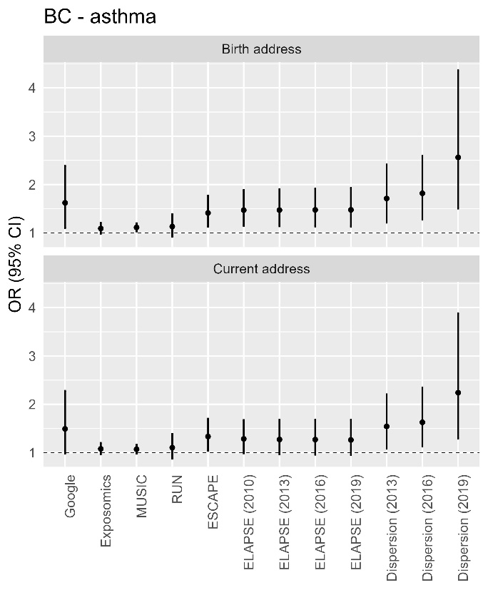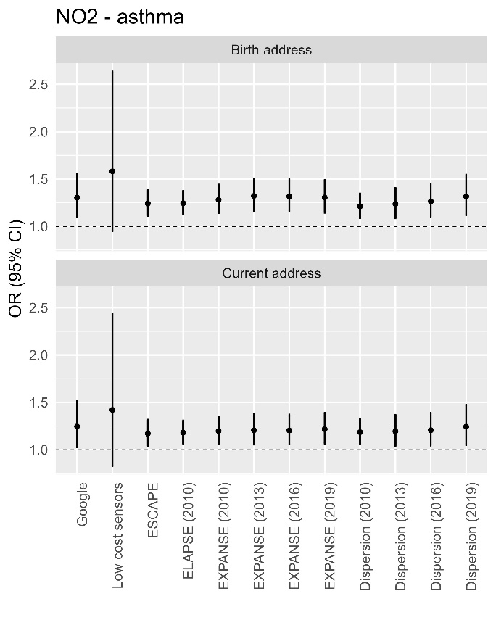
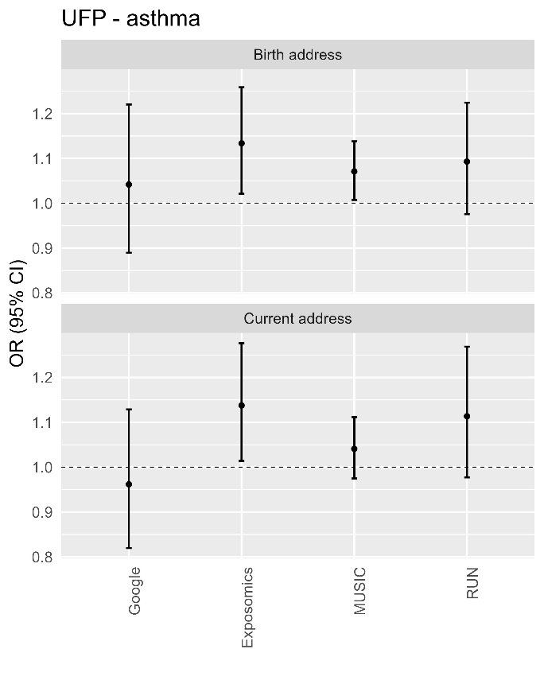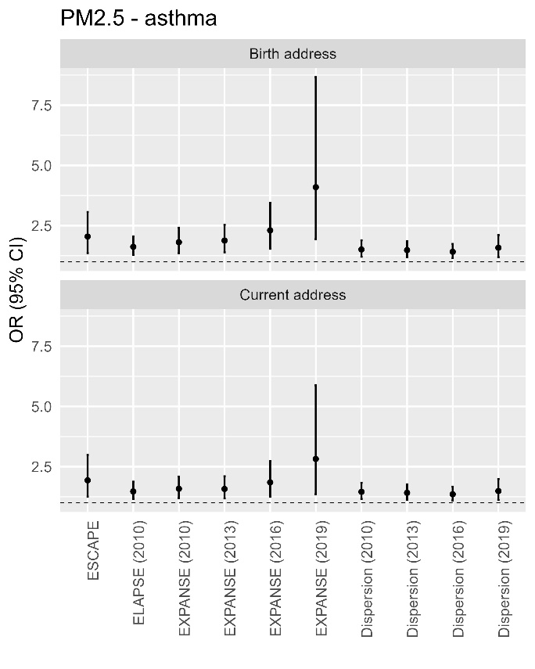

Table S10 presents both the minimally adjusted (model 1) and fully adjusted (model 2) associations for all exposure models with asthma incidence, including the RF and LASSO models, expressed both per set and IQR increment. The adjusted models showed generally associations similar to or stronger than the associations from the unadjusted models. No major differences between exposure methods were found in the change in the estimate between the unadjusted and adjusted models. Only for PM_{2.5}, the EXPANSE RF models and the low-cost sensors model showed higher odds ratios (ORs) in the unadjusted model than in the adjusted models. Effect estimates expressed per IQR increment were smaller, less variable and had smaller confidence intervals than estimates expressed per set increment. Similar to the effect estimates of the different methods, the effect estimates of different model development algorithms within the same empirical methods showed largely similar significance and directions of effect with sometimes substantial differences in the magnitude of the effect, which were more variable in the estimates expressed per set increment.

Lung function
NO₂ had a consistently significant negative association with FEV1, except for the low-cost sensors model, but not with FVC (figure 3). BC and PM_{2.5} also showed mostly negative (nearly) significant associations with only FEV1. None of the UFP models had a significant association with either of the lung function metrics. For nearly all models with a non-significant association, the direction of the association was negative. The largest differences in association estimates for FEV1 were found for BC (ranging from 0.75 to -9.46 percent difference) and PM_{2.5} (ranging from -1.29 to -8.96 percent difference).

Figure 3 Associations between air pollution exposure at the current address and lung function (FVC and FEV1) at age 16 year, fully adjusted model. Expressed as % difference for fixed increments: 5 µg/m³ for PM_{2.5}, 10 µg/m³ for NO₂, 1 µg/m³ for BC and 5,000 p/cm³ for UFP. Adjusted for sex, log-transformation of age, weight and height; parental education, maternal atopy, paternal atopy, breastfeeding, respiratory infections in the last 3 weeks (prior to the medical examination), Dutch nationality, indoor tobacco smoke exposure in the home, maternal smoking in pregnancy, furry pets in the home, mold in the home, gas cooking and average air pollution concentrations for the 7 days preceding the lung function measurement
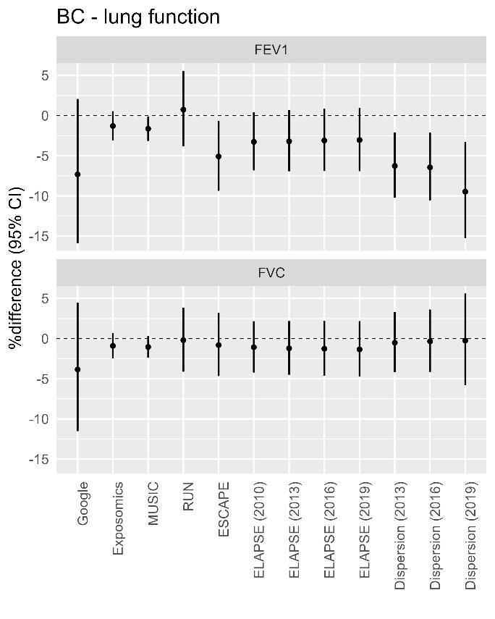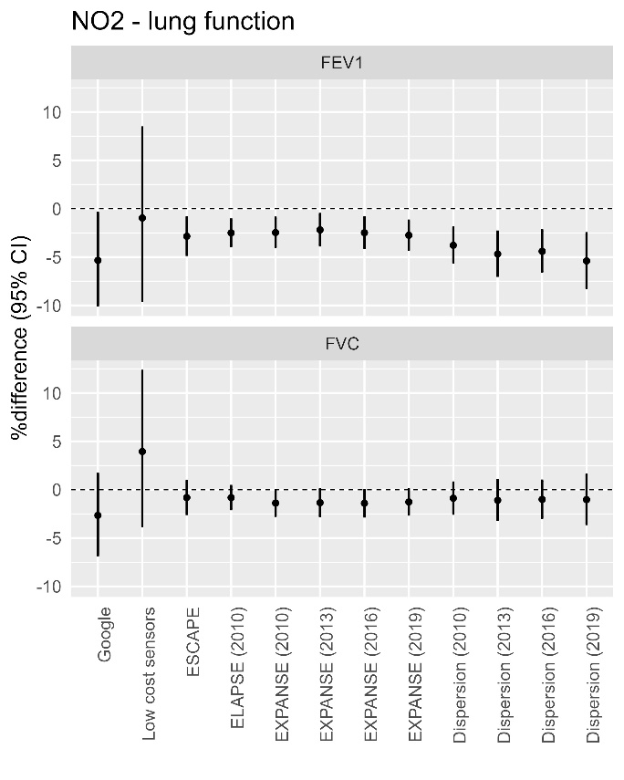
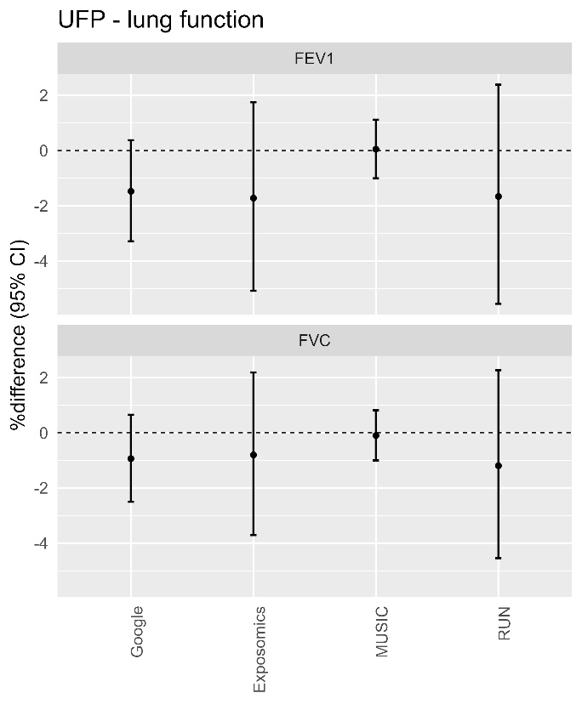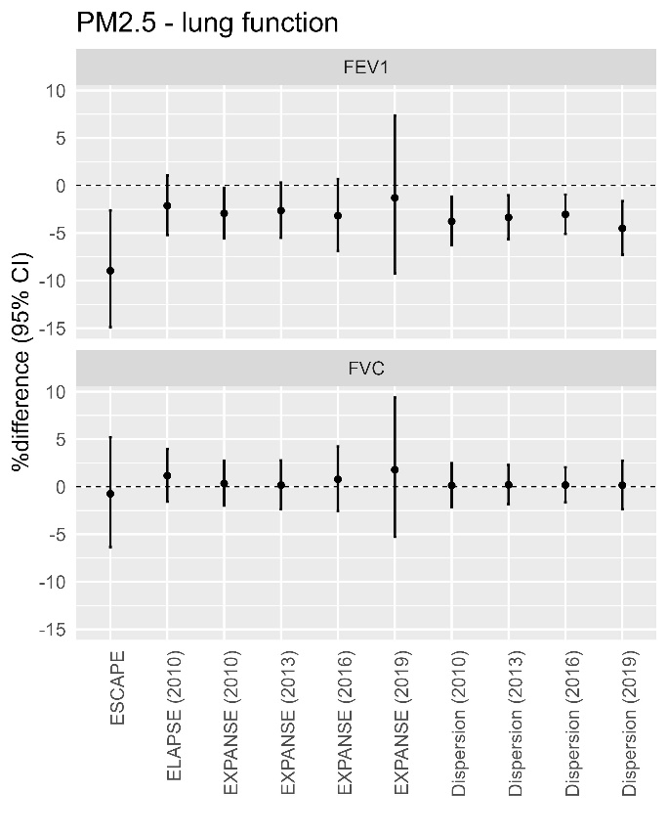

Similar to asthma, most of the significant associations were stronger in the fully adjusted model than in the minimally adjusted model (table S11). Effect estimates expressed per IQR increment were also smaller, less variable and had smaller confidence intervals compared to the estimates expressed per set increment. More differences were found in the significance and/or the direction of effect between different model development algorithms within the same method. For instance, the ESCAPE SLR model for BC and PM_{2.5} showed a significant negative association with FEV1 where none of the other models were significantly associated with FEV1. Similarly for NO₂, only the SLR model from Google Airview was significantly associated with FEV1.

Comparison of effect estimates

Correlation with predictive performance
When comparing the odds ratios for the associations between air pollution exposure and asthma per fixed increment with the corresponding external validation R², we generally found a slight positive (meaning a higher R² corresponded to a higher OR) or null relationship between the two measures (figure S1). The correlation was strongest for UFP (R² 0.39 at the birth address), slightly positive for BC (R² 0.14 at the birth address) and close to null or negative for NO₂ and PM_{2.5}. This analysis had similar results for the lung function estimates (figure S2). Here slightly negative (meaning a higher R² corresponded to a stronger negative percent difference in lung function estimate) relationships were found for BC, NO_{2,} and UFP with FEV₁ (highest R² for NO₂ (0.44)), but not for PM_{2.5} which showed no clear correlation. For FVC, only UFP showed a clear correlation between the two measures (R² 0.32).

Figure 4 Comparison between asthma ORs and external validation R²s for BC, NO₂ and UFP (NAQMN = national air quality monitoring network)
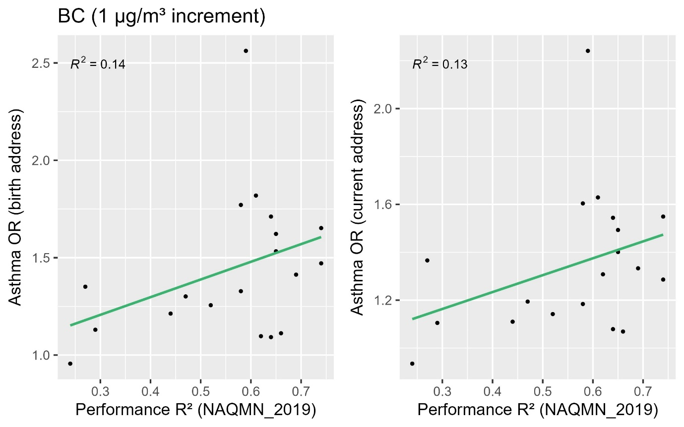
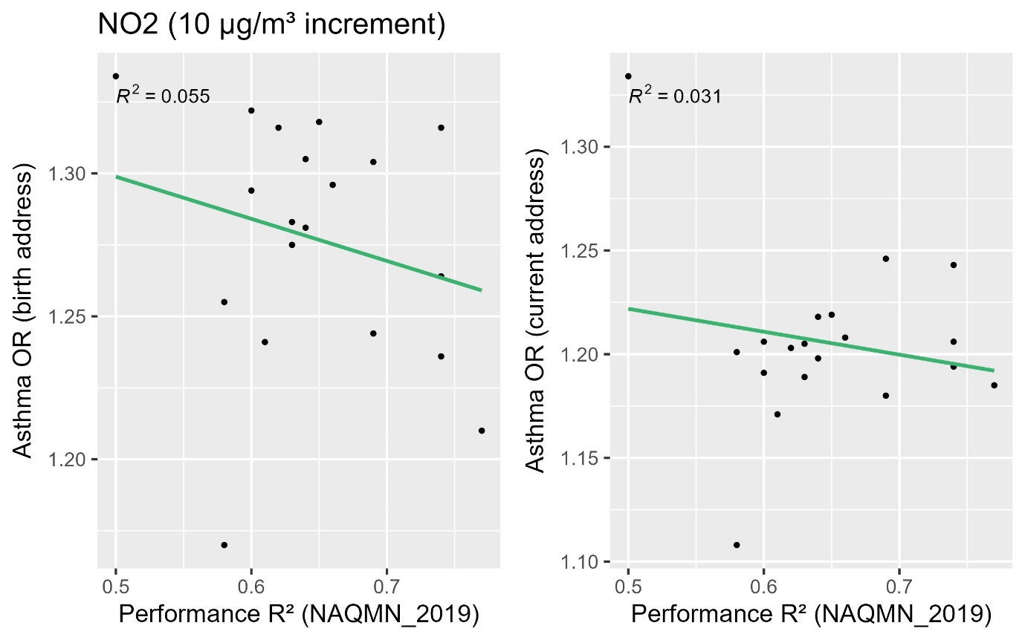
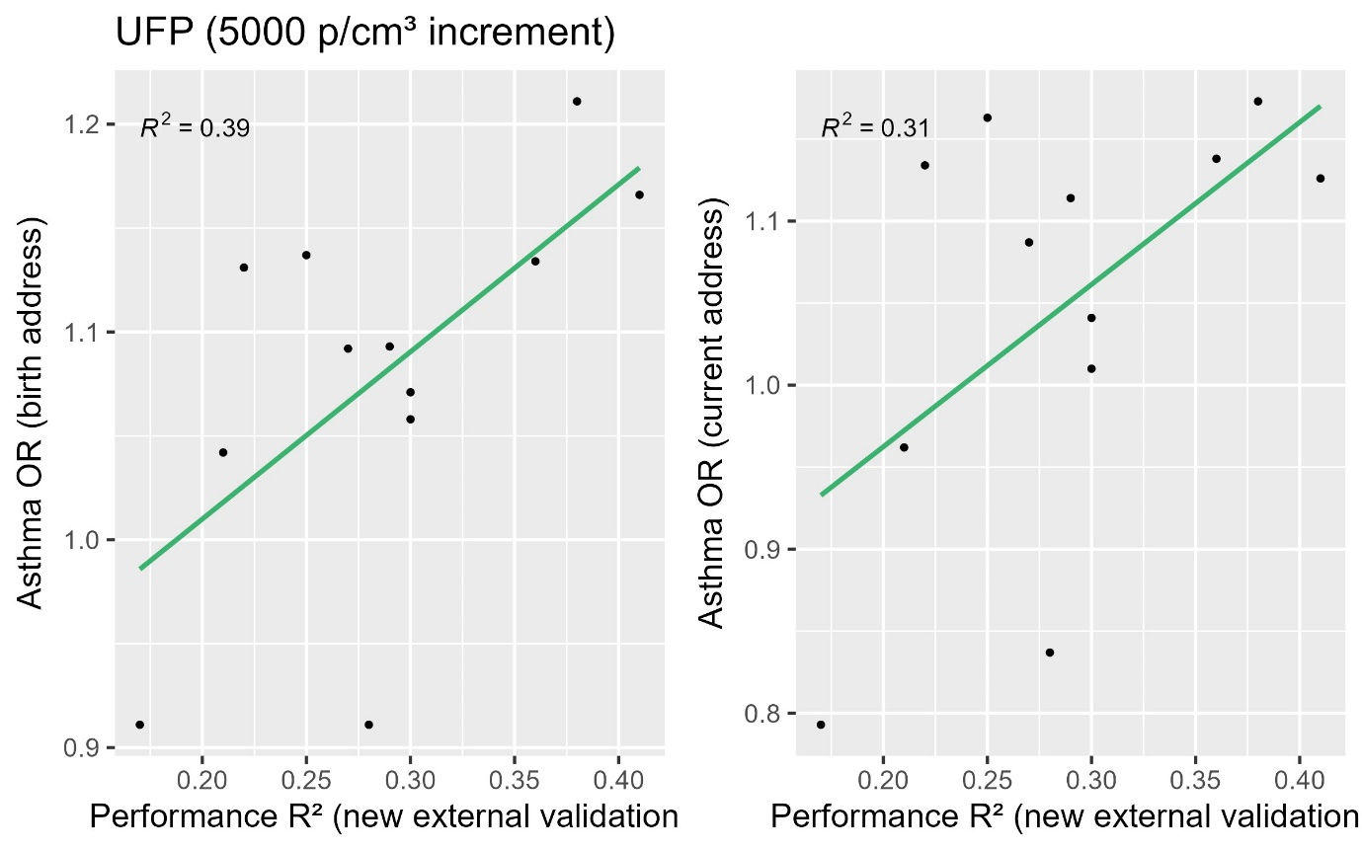

Heterogeneity of associations
In the meta-analyses of the associations of the different pollutants with asthma incidence across the different methods, substantial heterogeneity was found for BC (I² 64.2% and 37.0% for exposure at birth address and current address respectively), whereas no to minor heterogeneity was found for NO₂, UFP, and PM_{2.5} with I²’s close to 0% (table 3). All pollutants showed a statistically significant positive pooled OR. In the meta-analyses for lung function, some heterogeneity was found for BC and PM_{2.5} with FEV₁ (I² 42.3% and 33.3% respectively), whereas no heterogeneity was found for the other pollutants or with FVC. The pooled estimates for FEV₁ were all statistically significant and negative apart from UFP. For FVC, only BC and NO₂ showed a significant pooled estimate.
Including the models developed with the RF and Lasso algorithms in the meta-analyses increased the I² for NO₂ with asthma (exposure at the birth address) and FEV₁, for UFP with asthma (exposure at the current address), and for PM_{2.5} and asthma (both exposure metrics). The I² for the other pollutants as well as all pooled effect estimates remained similar to the analyses including only the SLR algorithm.

Table 3. Meta-analysis for asthma incidence until age 20 and lung function at age 16
Pollutant | Number of models* | Asthma incidence |  |  |  | Lung function
Pollutant | Number of models* | Birth address |  | Current address |  | FEV1 |  | FVC
Pollutant | Number of models* | Random effects OR (95% CI) | I² | Random effects OR (95% CI) | I² | Random effects %difference (95% CI) | I² | Random effects %difference (95% CI) | I²
Only SLR models for empirical methods
BC | 7 | 1.27 (1.12; 1.45) | 64.2% | 1.17 (1.05; 1.29) | 37.0% | -2.66 (-2.96; -1.06) | 42.3% | -0.95 (-1.77; -0.12) | 0.0%
NO₂ | 5 | 1.25 (1.18; 1.33) | 0.0% | 1.19 (1.12; 1.27) | 0.0% | -3.04 (-4.00; -2.06) | 0.0% | -1.09 (-1.93; -0.23) | 0.0%
UFP | 4 | 1.08 (1.04; 1.13) | 0.0% | 1.06 (1.00; 1.13) | 18.8% | -0.48 (-1.34; 0.39) | 0.0% | -0.38 (-1.12; 0.36) | 0.0%
PM_{2.5} | 3 | 1.68 (1.43; 1.98) | 1.6% | 1.56 (1.33; 1.84) | 0.0% | -4.25 (-7.16; -1.24) | 33.3% | 0.17 (-1.40; 1.77) | 0.0%
Including available SLR, RF and Lasso models for empirical methods
BC | 17 | 1.27 (1.17; 1.38) | 62.3% | 1.17 (1.09; 1.25) | 39.5% | -2.02 (-3.08; -0.96) | 38.8% | -0.78 (-1.40; -0.16) | 0.0%
NO₂ | 12 | 1.28 (1.20; 1.37) | 17.8% | 1.20 (1.14; 1.25) | 0.0% | -2.53 (-3.45; -1.60) | 28.9% | -1.08 (-1.68; -0.47) | 0.0%
UFP | 12 | 1.09 (1.06; 1.13) | 0.0% | 1.07 (1.01; 1.12) | 33.3% | -0.56 (-1.06; -0.06) | 0.7% | -0.48 (-0.91; -0.05) | 0.0%
PM_{2.5} | 6 | 1.84 (1.56; 2.18) | 19.6% | 1.68 (1.44; 1.97) | 8.6% | -3.72 (-5.30; -2.12) | 0.0% | 0.21 (-1.21; 1.64) | 0.0%
*For the multi-year methods, only the earliest available year is included (2013 for the BC dispersion model, 2010 for the rest). If both the ELAPSE and EXPANSE models for 2010 were available, only the EXPANSE model was included.

Discussion
In this study, we compared a large selection of air pollution exposure assessment models and their associations with asthma incidence from age 1 to 20 and lung function at age 16 in the PIAMA birth cohort. Correlations between estimates of exposure models were moderate to high. We found that the significance of the associations and the effect sizes differed substantially when applying the different methods for BC and PM_{2.5}, though the direction of the association was generally similar. In the meta-analysis, relatively substantial heterogeneity in effect estimates was found for these pollutants. For NO₂ and UFP, the analyses resulted in largely similar conclusions about the presence and direction of an association (significantly positive for NO₂ and asthma, significantly negative for NO₂ and FEV₁, null associations for NO₂ and FVC and UFP with both asthma and lung function). In the meta-analysis, minimal to moderate heterogeneity was found in the effect estimates for these pollutants. Exposure predictions from the three algorithms SLR, RF and Lasso generally resulted in similar associations with asthma and lung function. Correlations between model performance (based on external validation R²) and effect size were null to moderate.

4.1 Comparison of exposure assessment methods

4.1.1 Comparison with previous studies
Our findings correspond to previous analyses in the PIAMA cohort, in which associations with asthma incidence and decreased lung function were found for BC, NO₂ and PM_{2.5} (Gehring et al., 2020; Milanzi et al., 2018) but not for UFP (Yu et al., 2021, 2022). A previous study within this cohort found that lung function health effects did not differ substantially between LUR and dispersion model exposure assessment of NO₂, PM_{2.5}, and BC (Wang et al., 2015). Similarly, in the analysis of UFP and allergic sensitization in children, no differences were found in the associations between different model development algorithms (Bouma et al., 2022). Other studies on method comparisons, mainly focusing on the comparison of mortality estimates, similarly found similar directions of the association with small differences in association estimates when applying different exposure assessment methods (Jerrett et al., 2017; Klompmaker et al., 2021).

4.1.2 Heterogeneity of effect estimates
Previously conducted systematic reviews and meta-analyses report different findings with regard to the heterogeneity of effect estimates. For asthma incidence, one study found no heterogeneity for NO₂ and large heterogeneity for PM_{2.5} (I²: 72.7%) (Gasana et al., 2012). However, most other meta-analyses of asthma in children had different findings, namely larger heterogeneity for NO₂ than for PM_{2.5} (Anderson et al., 2013; Han et al., 2021; Khreis et al., 2017). Another meta-analysis only investigated NO₂ and found substantial heterogeneity with asthma symptom prevalence (I²: 32.8%) (Favarato et al., 2014). This study additionally attempted to analyze the heterogeneity due to the method of exposure assessment by stratifying the meta-analysis by different methods, such as dispersion modelling and land-use regression modelling. No evidence of heterogeneity was found in these stratified meta-analyses, possibly due to low power. Only one of the meta-analyses included an analysis of BC and found no heterogeneity (I²: 0%) (Khreis et al., 2017). No systematic reviews have been conducted on UFP and asthma and lung function in children to date due to the limited number of studies. In our analyses, we found the most substantial heterogeneity for BC, potentially due to the inclusion of a wider variety of methods for this pollutant than for the other pollutants. For NO₂ and PM_{2.5} we found close to 0% heterogeneity when including only the SLR models, which increased to nearly 20% for both pollutants when including the RF and Lasso models.
Only two systematic reviews and meta-analyses have been conducted on air pollution and lung function in children, one on PM_{2.5} and one on NO₂. Large heterogeneity was found for PM_{2.5} (I² for FEV1: 93%, for FVC: 94%) (Zhang et al., 2022). Less substantial heterogeneity was found for NO₂ with FEV1 (I²: 32% for linear health models, <1% for log-linear models) (Barone-Adesi et al., 2015). In the current study, moderate heterogeneity was found for PM_{2.5}, which disappeared when including the RF and Lasso algorithms in the analysis. For NO₂, moderate heterogeneity was found, but only when all algorithms were included in the analysis. Similar to the meta-analysis for asthma incidence, the most substantial heterogeneity was found for BC.
Though systematic reviews have different findings on the heterogeneity of effect estimates between air pollution exposure and asthma and lung function in children, our findings indicate that this heterogeneity is likely driven in part by the method of exposure assessment, including the model development algorithm.

4.1.3 Exposure contrast and model validity
Differences in association estimates might be driven by differences in predicted exposure contrasts. In the current study, association estimates were found to be less variable when expressed per IQR increment than when expressed per fixed increment. The major cities mobile models generally predicted the highest IQR in exposure concentrations for BC, providing low association estimates with small confidence intervals when expressed per fixed increment. When expressed per IQR increment, the exposure estimates remained mostly similar as the predicted IQR was close to the fixed increment of 1 µg/m³. However, the distribution of the predicted concentrations of these models also contained unrealistic (negative or extremely high) values, complicating the interpretation of their association estimates. Conversely, a limited contrast in exposure concentrations corresponded to high association estimates with large confidence intervals when expressed per fixed increment, as seen for the Dispersion_2019 model for BC. This estimates and its confidence interval decreased when expressed per IQR increment, as the IQR increment was much smaller than the fixed increment of 1 µg/m³. Mobile models developed in major cities might be better at capturing the small-scale spatial variation of traffic pollutants but worse at capturing regional variation than nation-wide or Europe-wide models. In the PIAMA cohort, with participants residing in large cities as well as different regional areas, capturing both types of variation is important for accurate exposure estimation.
Another reason for the heterogeneity in association estimates might be differences in measurement error between the different exposure assessment methods. Exposure misclassification due to measurement error can result in attenuation of the association estimates. However, simulation studies have found that more accurate exposure assessment does not necessarily correspond to improved health effect estimation (Szpiro et al., 2011). In the current study, we found null to moderate correlations between model performance based on external validity and association estimates, which remained after correction for IQR, indicating that model performance might partly explain heterogeneity in association estimates of air pollution exposure with asthma and lung function.

4.2 Temporal variation of effect estimates
Another important issue in air pollution epidemiology is the temporal misalignment of exposure and outcome measurement. Air pollution models are used to assess exposure in different time periods, with the assumption that exposure contrasts remain similar over longer periods of time. In the current study, two exposure methods were able to assess exposure over multiple years, namely the Europe-wide LUR models and the dispersion models. We found generally consistent associations with asthma incidence and lung function with exposures estimated in 2010 (NO₂ and PM_{2.5}), 2013, 2016, and 2019 (BC, NO₂, PM_{2.5}). These models were not available for UFP. Our results are in line with previous findings of stable associations of NO₂ with mortality over multiple years (Cesaroni et al., 2012) as well as with reported stable exposure contrasts in the Netherlands (Eeftens et al., 2011). This supports the application of exposure models to assess exposure outside of the time period in which the measurements were conducted.

4.3 Strengths and limitations
Strengths of this study include the large selection of exposure assessment methods, varying in the applied monitoring as well as modelling approach. Additionally, we were able to apply different model development algorithms to most empirical models to assess differences between these algorithms in a variety of models.
A limitation of this study was that most models investigated were developed in different years. For this reason, the associations were assessed for multiple years with the multiyear ELAPSE/EXPANSE and dispersion models. Though differences in the effect estimates between different years were generally small, it cannot be ruled out that temporal variation in air pollution concentrations and contrasts played a role in any differences that were found. Additionally, not all methods were available for all pollutants. This was especially an issue for UFP, for which only mobile models were available.

Conclusion
The application of different air pollution exposure assessment methods in the analysis of associations with asthma and lung function in the PIAMA birth cohort resulted in similar findings on the significance and directions of the associations, but differences in the magnitude of the effect estimates. The selection of exposure assessment method might contribute to the heterogeneity of effect estimates found in meta-analyses of associations between air pollution and these outcomes.

References
Anderson, H. R., Favarato, G., & Atkinson, R. W. (2013). Long-term exposure to air pollution and the incidence of asthma: Meta-analysis of cohort studies. Air Quality, Atmosphere and Health, 6(1), 47–56. https://doi.org/10.1007/S11869-011-0144-5
Barone-Adesi, F., Dent, J. E., Dajnak, D., Beevers, S., Anderson, H. R., Kelly, F. J., Cook, D. G., & Whincup, P. H. (2015). Long-Term Exposure to Primary Traffic Pollutants and Lung Function in Children: Cross-Sectional Study and Meta-Analysis. PLoS ONE, 10(11). https://doi.org/10.1371/JOURNAL.PONE.0142565
Bouma, F., Hoek, G., Koppelman, G. H., Vonk, J. M., Kerckhoffs, J., Vermeulen, R., & Gehring, U. (2022). Exposure to ambient ultrafine particles and allergic sensitization in children up to 16 years. https://doi.org/10.1016/j.envres.2022.115102
Cesaroni, G., Porta, D., Badaloni, C., Stafoggia, M., Eeftens, M., Meliefste, K., & Forastiere, F. (2012). Nitrogen dioxide levels estimated from land use regression models several years apart and association with mortality in a large cohort study. Environmental Health 2012 11:1, 11(1), 1–10. https://doi.org/10.1186/1476-069X-11-48
Chen, J., de Hoogh, K., Gulliver, J., Hoffmann, B., Hertel, O., Ketzel, M., Bauwelinck, M., van Donkelaar, A., Hvidtfeldt, U. A., Katsouyanni, K., Janssen, N. A. H., Martin, R. V., Samoli, E., Schwartz, P. E., Stafoggia, M., Bellander, T., Strak, M., Wolf, K., Vienneau, D., … Hoek, G. (2019). A comparison of linear regression, regularization, and machine learning algorithms to develop Europe-wide spatial models of fine particles and nitrogen dioxide. Environment International, 130, 104934. https://doi.org/10.1016/J.ENVINT.2019.104934
Eeftens, M., Beelen, R., Fischer, P., Brunekreef, B., Meliefste, K., & Hoek, G. (2011). Stability of measured and modelled spatial contrasts in NO2 over time. Occupational and Environmental Medicine, 68(10), 765–770. https://doi.org/10.1136/OEM.2010.061135
Favarato, G., Anderson, H. R., Atkinson, R., Fuller, G., Mills, I., & Walton, H. (2014). Traffic-related pollution and asthma prevalence in children. Quantification of associations with nitrogen dioxide. Air Quality, Atmosphere and Health, 7(4), 459–466. https://doi.org/10.1007/S11869-014-0265-8/FIGURES/2
Gasana, J., Dillikar, D., Mendy, A., Forno, E., & Ramos Vieira, E. (2012). Motor vehicle air pollution and asthma in children: A meta-analysis. Environmental Research, 117, 36–45. https://doi.org/10.1016/J.ENVRES.2012.05.001
Gehring, U., Wijga, A. H., Koppelman, G. H., Vonk, J. M., Smit, H. A., & Brunekreef, B. (2020). Air pollution and the development of asthma from birth until young adulthood. European Respiratory Journal, 56(1). https://doi.org/10.1183/13993003.00147-2020
Han, K., Ran, Z., Wang, X., Wu, Q., Zhan, N., Yi, Z., & Jin, T. (2021). Traffic-related organic and inorganic air pollution and risk of development of childhood asthma: A meta-analysis. Environmental Research, 194, 110493. https://doi.org/10.1016/J.ENVRES.2020.110493
HEI. (2022). Special Report 23: Systematic Review and Meta-analysis of Selected Health Effects of Long-Term Exposure to Traffic-Related Air Pollution. https://www.healtheffects.org/system/files/hei-special-report-23_4.pdf
Hoek, G. (2017). Methods for Assessing Long-Term Exposures to Outdoor Air Pollutants. Current Environmental Health Reports, 4(4), 450. https://doi.org/10.1007/S40572-017-0169-5
Jerrett, M., Turner, M. C., Beckerman, B. S., Pope, C. A., van Donkelaar, A., Martin, R. V., Serre, M., Crouse, D., Gapstur, S. M., Krewski, D., Diver, W. R., Coogan, P. F., Thurston, G. D., & Burnett, R. T. (2017). Comparing the health effects of ambient particulate matter estimated using ground-based versus remote sensing exposure estimates. Environmental Health Perspectives, 125(4), 552–559. https://doi.org/10.1289/EHP575/SUPPL_FILE/EHP575.S001.ACCO.PDF
Kerckhoffs, J., Hoek, G., Portengen, L., Brunekreef, B., & Vermeulen, R. C. H. (2019). Performance of Prediction Algorithms for Modeling Outdoor Air Pollution Spatial Surfaces. Environmental Science and Technology, 53(3), 1413–1421. https://doi.org/10.1021/ACS.EST.8B06038/ASSET/IMAGES/LARGE/ES-2018-06038S_0003.JPEG
Khreis, H., Kelly, C., Tate, J., Parslow, R., Lucas, K., & Nieuwenhuijsen, M. (2017). Exposure to traffic-related air pollution and risk of development of childhood asthma: A systematic review and meta-analysis. Environment International, 100, 1–31. https://doi.org/10.1016/J.ENVINT.2016.11.012
Klompmaker, J. O., Janssen, N., Andersen, Z. J., Atkinson, R., Bauwelinck, M., Chen, J., de Hoogh, K., Houthuijs, D., Katsouyanni, K., Marra, M., Oftedal, B., Rodopoulou, S., Samoli, E., Stafoggia, M., Strak, M., Swart, W., Wesseling, J., Vienneau, D., Brunekreef, B., & Hoek, G. (2021). Comparison of associations between mortality and air pollution exposure estimated with a hybrid, a land-use regression and a dispersion model. Environment International, 146, 106306. https://doi.org/10.1016/J.ENVINT.2020.106306
Lee, J. T. (2020). Review of epidemiological studies on air pollution and health effects in children. Clinical and Experimental Pediatrics, 64(1), 3–11. https://doi.org/10.3345/CEP.2019.00843
Milanzi, E. B., Koppelman, G. H., Smit, H. A., Wijga, A. H., Oldenwening, M., Vonk, J. M., Brunekreef, B., & Gehring, U. (2018). Air pollution exposure and lung function until age 16 years: The PIAMA birth cohort study. European Respiratory Journal, 52(3), 1800218. https://doi.org/10.1183/13993003.00218-2018
Szpiro, A. A., Paciorek, C. J., & Sheppard, L. (2011). Does more accurate exposure prediction necessarily improve health effect estimates? Epidemiology, 22(5), 680–685. https://doi.org/10.1097/EDE.0b013e3182254cc6
Wang, M., Gehring, U., Hoek, G., Keuken, M., Jonkers, S., Beelen, R., Eeftens, M., Postma, D. S., & Brunekreef, B. (2015). Air pollution and lung function in dutch children: A comparison of exposure estimates and associations based on land use regression and dispersion exposure modeling approaches. Environmental Health Perspectives, 123(8), 847–851. https://doi.org/10.1289/EHP.1408541/SUPPL_FILE/EHP.1408541.S001.ACCO.PDF
Weichenthal, S., Ryswyk, K. Van, Goldstein, A., Bagg, S., Shekkarizfard, M., & Hatzopoulou, M. (2016). A land use regression model for ambient ultrafine particles in Montreal, Canada: A comparison of linear regression and a machine learning approach. Environmental Research, 146, 65–72. https://doi.org/10.1016/J.ENVRES.2015.12.016
Wijga, A. H., Kerkhof, M., Gehring, U., De jongste, J. C., Postma, D. S., Aalberse, R. C., Wolse, A. P. H., Koppelman, G. H., Van rossem, L., Oldenwening, M., Brunekreef, B., & Smit, H. A. (2014). Cohort profile: The Prevention and Incidence of Asthma and Mite Allergy (PIAMA) birth cohort. International Journal of Epidemiology, 43(2), 527–535. https://doi.org/10.1093/IJE/DYS231
Yu, Z., Koppelman, G. H., Boer, J. M. A., Hoek, G., Kerckhoffs, J., Vonk, J. M., Vermeulen, R., & Gehring, U. (2022). Ambient ultrafine particles and asthma onset until age 20: The PIAMA birth cohort. Environmental Research, 214, 113770. https://doi.org/10.1016/J.ENVRES.2022.113770
Yu, Z., Koppelman, G. H., Hoek, G., Kerckhoffs, J., Vonk, J. M., Vermeulen, R., & Gehring, U. (2021). Ultrafine particles, particle components and lung function at age 16 years: The PIAMA birth cohort study. Environment International, 157, 106792. https://doi.org/10.1016/J.ENVINT.2021.106792
Zhang, W., Ma, R., Wang, Y., Jiang, N., Zhang, Y., & Li, T. (2022). The relationship between particulate matter and lung function of children: A systematic review and meta-analysis. Environmental Pollution, 309, 119735. https://doi.org/10.1016/J.ENVPOL.2022.119735

Appendix
Table S1 Characteristics of participants included in the lung function analysis, age 16 (N=625)
Characteristic
Boys, n (%) | 292 (46.7)
Age [years], mean ± std | 16.4 ± 0.2
Weight [kg], mean ± std | 64.2 ± 10.1
Height [cm], mean ± std | 175.6 ± 8.9
Parental atopy
Atopic mother, n (%) | 195 (31.2)
Atopic father, n (%) | 210 (33.6)
Presence of pets at age 16, n (%) | 363 (58.1)
Presence of molds at age 16, n (%) | 62 (9.9)
Breastfeeding more than 12 weeks, n (%) | 343 (54.9)
Gas cooking at age 16, n (%) | 491 (78.6)
Maternal smoking during pregnancy, n (%) | 83 (13.3)
Indoor tobacco smoke exposure at age 16, n (%) | 42 (6.7)
Parental education, n (%)
Low | 50 (8.0)
Intermediate | 187 (29.9)
High | 388 (62.1)
Dutch nationality, n (%) | 606 (97.0)
Recent respiratory infections ª, n (%) | 263 (42.1)
Lung function
FEV₁ [L], mean ± std | 3.94 ± 0.72
FVC [L], mean ± std | 4.70 ± 0.87
ª Respiratory infections in the 3 weeks before lung function measurement.

Table S2 Distribution of air pollution exposure at the birth address for participants included in the asthma analysis. Concentrations in µg/m³, except UFP in particles/cm³.

BC
Model | Mean | SD | Min | P5 | P25 | P50 | P75 | P95 | Max | IQR
Google_SLR | 0.934 | 0.189 | 0.748 | 0.763 | 0.800 | 0.880 | 0.974 | 1.342 | 2.270 | 0.174
Google_RF | 1.087 | 0.113 | 1.011 | 1.016 | 1.026 | 1.054 | 1.084 | 1.344 | 2.038 | 0.058
Google_LASSO | 1.035 | 0.153 | 0.293 | 0.856 | 0.948 | 1.012 | 1.095 | 1.319 | 2.038 | 0.147
MUSIC_ SLR | 0.487 | 1.000 | -1.147 | -0.829 | -0.189 | 0.308 | 0.910 | 2.555 | 4.916 | 1.099
MUSIC_ RF | 1.784 | 0.648 | 1.345 | 1.381 | 1.437 | 1.509 | 1.798 | 3.263 | 6.179 | 0.361
MUSIC_ LASSO | 1.887 | 0.404 | 1.197 | 1.339 | 1.618 | 1.823 | 2.063 | 2.679 | 4.170 | 0.445
Exposomics_ SLR | 2.226 | 0.753 | -0.624 | 1.27 | 1.743 | 2.111 | 2.612 | 3.732 | 6.543 | 0.869
Exposomics _ RF | 2.509 | 0.533 | 1.881 | 1.883 | 2.064 | 2.409 | 2.815 | 3.490 | 5.864 | 0.751
Exposomics_ LASSO | 2.902 | 0.221 | 2.519 | 2.591 | 2.739 | 2.879 | 3.042 | 3.302 | 4.577 | 0.303
RUN_ SLR | 1.093 | 0.376 | 0.261 | 0.709 | 0.893 | 0.985 | 1.150 | 1.970 | 3.387 | 0.257
RUN_ RF | 1.280 | 0.330 | 0.893 | 0.954 | 1.108 | 1.181 | 1.307 | 1.983 | 3.463 | 0.199
RUN_ LASSO | 1.312 | 0.235 | 1.089 | 1.11 | 1.156 | 1.249 | 1.348 | 1.895 | 2.915 | 0.192
ESCAPE_SLR | 1.322 | 0.327 | 0.855 | 0.923 | 1.105 | 1.268 | 1.439 | 1.991 | 2.850 | 0.334
ESCAPE_RF | 1.381 | 0.244 | 1.028 | 1.08 | 1.201 | 1.335 | 1.497 | 1.864 | 2.554 | 0.296
ESCAPE_LASSO | 1.405 | 0.265 | 1.097 | 1.13 | 1.231 | 1.329 | 1.488 | 1.970 | 2.867 | 0.257
ELAPSE_2010 | 1.521 | 0.309 | 0.852 | 1.057 | 1.286 | 1.525 | 1.706 | 2.062 | 3.259 | 0.420
ELAPSE_2013 | 1.431 | 0.296 | 0.792 | 0.993 | 1.21 | 1.428 | 1.607 | 1.948 | 3.145 | 0.397
ELAPSE_2016 | 1.403 | 0.291 | 0.773 | 0.978 | 1.187 | 1.398 | 1.576 | 1.906 | 3.118 | 0.389
ELAPSE_2019 | 1.386 | 0.286 | 0.768 | 0.97 | 1.175 | 1.38 | 1.554 | 1.877 | 3.087 | 0.379
Dispersion_13 | 0.781 | 0.231 | 0.350 | 0.43 | 0.530 | 0.830 | 0.930 | 1.140 | 1.870 | 0.400
Dispersion_16 | 0.759 | 0.227 | 0.340 | 0.41 | 0.510 | 0.820 | 0.900 | 1.110 | 1.480 | 0.390
Dispersion_19 | 0.554 | 0.151 | 0.260 | 0.31 | 0.390 | 0.600 | 0.650 | 0.770 | 1.140 | 0.260

NO₂
Model | Mean | SD | Min | P5 | P25 | P50 | P75 | P95 | Max | IQR
Google_SLR | 17.32 | 4.15 | 13.34 | 13.54 | 14.40 | 16.15 | 18.11 | 26.54 | 45.36 | 3.71
Google_RF | 20.93 | 2.36 | 19.20 | 19.22 | 19.38 | 20.20 | 21.59 | 25.39 | 39.22 | 2.21
Google_LASSO | 15.21 | 5.21 | -14.04 | 7.10 | 13.28 | 15.22 | 17.18 | 24.52 | 43.12 | 3.91
ESCAPE_SLR | 23.28 | 6.86 | 9.05 | 13.00 | 18.39 | 22.85 | 26.88 | 36.23 | 59.62 | 8.49
ESCAPE_RF | 24.53 | 5.54 | 16.50 | 17.49 | 19.98 | 23.78 | 27.64 | 35.02 | 45.39 | 7.65
ESCAPE_LASSO | 23.15 | 6.17 | 9.49 | 14.87 | 18.75 | 22.50 | 25.89 | 34.70 | 51.04 | 7.14
ELAPSE_2010 | 30.89 | 7.92 | 12.17 | 17.89 | 24.82 | 31.44 | 35.97 | 44.50 | 72.00 | 11.16
EXPANSE_2010 | 28.55 | 6.81 | 11.34 | 16.16 | 24.16 | 29.05 | 33.15 | 39.27 | 57.07 | 8.99
EXPANSE_RF_2010 | 27.13 | 6.41 | 13.14 | 15.69 | 23.33 | 27.12 | 31.36 | 39.18 | 50.38 | 8.03
EXPANSE_2013 | 26.67 | 6.14 | 10.65 | 15.55 | 22.77 | 27.17 | 30.93 | 35.89 | 51.81 | 8.16
EXPANSE_RF_2013 | 26.55 | 6.54 | 11.63 | 14.01 | 22.78 | 26.53 | 31.01 | 37.78 | 45.55 | 8.23
EXPANSE_2016 | 25.22 | 6.31 | 8.97 | 13.70 | 21.05 | 25.88 | 29.68 | 34.64 | 49.63 | 8.63
EXPANSE_RF_2016 | 24.18 | 6.13 | 9.83 | 12.59 | 20.81 | 24.23 | 28.20 | 35.53 | 44.82 | 7.39
EXPANSE_2019 | 22.98 | 6.22 | 6.58 | 11.18 | 18.97 | 24.04 | 27.48 | 31.68 | 42.81 | 8.52
EXPANSE_RF_2019 | 20.90 | 5.40 | 9.10 | 11.10 | 17.72 | 20.85 | 24.26 | 31.57 | 38.20 | 6.54
DISPERSION_10 | 23.78 | 7.34 | 9.21 | 12.80 | 16.67 | 24.42 | 28.86 | 36.30 | 45.91 | 12.19
DISPERSION_13 | 20.11 | 5.94 | 10.55 | 11.63 | 14.66 | 20.19 | 23.70 | 31.68 | 44.39 | 9.04
DISPERSION_16 | 19.13 | 5.72 | 8.85 | 10.62 | 13.66 | 19.75 | 22.49 | 29.46 | 39.57 | 8.83
DISPERSION_19 | 16.70 | 4.77 | 8.75 | 9.98 | 12.47 | 16.81 | 19.30 | 25.95 | 35.61 | 6.83
LCS_SLR | 17.49 | 1.50 | 14.75 | 15.58 | 16.45 | 17.26 | 18.11 | 20.60 | 23.99 | 1.66
LCS_RF | 15.73 | 1.89 | 10.09 | 11.96 | 14.63 | 15.87 | 17.22 | 18.38 | 19.95 | 2.60
LCS_LASSO | 15.92 | 0.70 | 14.66 | 14.90 | 15.39 | 15.85 | 16.41 | 17.18 | 18.28 | 1.02

UFP
Model | Mean | SD | Min | P5 | P25 | P50 | P75 | P95 | Max | IQR
Google_SLR | 16267 | 2456 | 11250 | 12754 | 14496 | 16230 | 17645 | 20203 | 30404 | 3149
Google_RF | 17329 | 1356 | 14915 | 15684 | 16415 | 17074 | 17781 | 20095 | 26497 | 1367
Google_LASSO | 16862 | 1461 | 9123 | 14582 | 15895 | 16842 | 17770 | 19237 | 28760 | 1875
MUSIC _SLR | 8192 | 6264 | -18082 | -2116 | 5333 | 7388 | 10259 | 20461 | 37794 | 4926
MUSIC__RF | 12912 | 3961 | 9857 | 9989 | 10518 | 11158 | 13596 | 22503 | 40863 | 3078
MUSIC _LASSO | 13583 | 2901 | 9693 | 10354 | 11754 | 12859 | 14430 | 19635 | 29446 | 2677
EXPO _SLR | 14128 | 3526 | 6735 | 11585 | 12039 | 12729 | 14731 | 21946 | 38021 | 2692
EXPO _RF | 14318 | 3744 | 10902 | 11044 | 11327 | 12836 | 16306 | 22117 | 39467 | 4979
EXPO _LASSO | 15016 | 2556 | 12014 | 12389 | 13261 | 14346 | 15735 | 20690 | 31999 | 2474
RUN _SLR | 10286 | 3226 | 7851 | 8020 | 8469 | 9243 | 10396 | 17311 | 50395 | 1926
RUN_RF | 12177 | 3826 | 9847 | 10009 | 10733 | 10964 | 12225 | 18643 | 97926 | 1492
RUN _LASSO | 12169 | 1962 | 10708 | 10808 | 11087 | 11549 | 12310 | 16296 | 40396 | 1223

PM_{2.5}
Model | Mean | SD | Min | P5 | P25 | P50 | P75 | P95 | Max | IQR
ESCAPE_SLR | 16.53 | 0.92 | 15.37 | 15.41 | 15.69 | 16.51 | 16.87 | 18.52 | 20.72 | 1.19
ESCAPE_RF | 16.76 | 0.73 | 14.86 | 15.81 | 16.27 | 16.66 | 17.08 | 18.24 | 20.03 | 0.81
ESCAPE_LASSO | 17.42 | 0.32 | 17.25 | 17.25 | 17.25 | 17.28 | 17.39 | 18.24 | 19.22 | 0.14
ELAPSE_2010 | 16.27 | 1.66 | 10.65 | 13.94 | 14.97 | 16.14 | 17.38 | 19.09 | 23.33 | 2.41
EXPANSE_2010 | 16.64 | 1.46 | 12.03 | 13.75 | 15.56 | 17.17 | 17.72 | 18.39 | 19.53 | 2.16
EXPANSE_RF_2010 | 18.02 | 0.97 | 12.92 | 16.18 | 17.48 | 18.14 | 18.76 | 19.41 | 20.30 | 1.28
EXPANSE_2013 | 13.59 | 1.40 | 9.41 | 10.73 | 12.76 | 14.04 | 14.70 | 15.22 | 16.50 | 1.94
EXPANSE_RF_2013 | 15.16 | 0.84 | 11.27 | 13.73 | 14.59 | 15.27 | 15.76 | 16.41 | 17.14 | 1.17
EXPANSE_2016 | 11.62 | 1.02 | 7.96 | 9.55 | 11.05 | 11.90 | 12.38 | 12.95 | 13.96 | 1.33
EXPANSE_RF_2016 | 13.14 | 0.66 | 9.82 | 11.91 | 12.83 | 13.24 | 13.52 | 14.12 | 15.01 | 0.69
EXPANSE_2019 | 11.62 | 0.52 | 8.94 | 10.77 | 11.26 | 11.65 | 11.98 | 12.46 | 13.32 | 0.72
EXPANSE_RF_2019 | 12.44 | 0.59 | 9.63 | 11.47 | 12.10 | 12.47 | 12.88 | 13.28 | 14.00 | 0.79
DISPERSION_10 | 16.43 | 1.84 | 12.71 | 13.61 | 14.15 | 17.16 | 17.60 | 19.05 | 21.25 | 3.45
DISPERSION_13 | 12.94 | 1.87 | 9.42 | 10.14 | 10.44 | 13.85 | 14.28 | 15.08 | 17.12 | 3.84
DISPERSION_16 | 10.37 | 2.02 | 6.52 | 7.26 | 7.71 | 11.40 | 11.90 | 12.65 | 13.82 | 4.19
DISPERSION_19 | 9.82 | 1.43 | 7.30 | 7.67 | 7.96 | 10.47 | 11.01 | 11.47 | 12.44 | 3.05

Table S3 Predicted IQR for all models at the current address for the asthma population and at the address at age 16 for the lung function population

 | ASTHMA (CURRENT ADDRESS) |  |  |  | Lung function
 | BC (µg/m³) | NO₂ (µg/m³) | UFP (p/cm³) | PM_{2.5} (µg/m³) | BC (µg/m³) | NO₂ (µg/m³) | UFP (p/cm³) | PM_{2.5} (µg/m³)
Google_SLR | 0.169 | 3.56 | 3097 |  | 0.111 | 2.43 | 2925
Google_RF | 0.055 | 1.61 | 1408 |  | 0.047 | 0.93 | 1465
Google_LASSO | 0.140 | 3.87 | 1886 |  | 0.114 | 3.76 | 1847
MUSIC_ SLR | 1.069 |  | 4523 |  | 0.921 |  | 3594
MUSIC_ RF | 0.320 |  | 2406 |  | 0.233 |  | 956
MUSIC_ LASSO | 0.434 |  | 2534 |  | 0.381 |  | 1854
EXPOSOMICS_ SLR | 0.844 |  | 2211 |  | 0.760 |  | 1110
Exposomics _ RF | 0.689 |  | 4382 |  | 0.436 |  | 1937
Exposomics_ LASSO | 0.286 |  | 2263 |  | 0.248 |  | 1572
RUN_ SLR | 0.251 |  | 1698 |  | 0.206 |  | 1155
RUN_ RF | 0.177 |  | 1176 |  | 0.121 |  | 631
RUN_ LASSO | 0.175 |  | 1013 |  | 0.130 |  | 671
ESCAPE_SLR | 0.323 | 8.42 |  | 1.16 | 0.293 | 6.91 |  | 1.08
ESCAPE_RF | 0.287 | 7.16 |  | 0.73 | 0.229 | 6.10 |  | 0.67
ESCAPE_LASSO | 0.231 | 7.08 |  | 0.11 | 0.176 | 5.85 |  | 0.04
ELAPSE_2010 | 0.391 | 11.09 |  | 2.47 | 0.385 | 11.38 |  | 1.89
ELAPSE_2013 | 0.376 |  |  |  | 0.369
ELAPSE_2016 | 0.368 |  |  |  | 0.354
ELAPSE_2019 | 0.361 |  |  |  | 0.347
EXPANSE_2010 |  | 8.85 |  | 2.21 |  | 8.90 |  | 2.83
EXPANSE_RF_2010 |  | 7.93 |  | 1.34 |  | 8.02 |  | 1.39
EXPANSE_2013 |  | 8.14 |  | 2.12 |  | 8.12 |  | 2.50
EXPANSE_RF_2013 |  | 7.85 |  | 1.26 |  | 8.30 |  | 1.33
EXPANSE_2016 |  | 8.49 |  | 1.46 |  | 8.72 |  | 1.84
EXPANSE_RF_2016 |  | 7.15 |  | 0.77 |  | 7.15 |  | 0.90
EXPANSE_2019 |  | 8.43 |  | 0.75 |  | 9.93 |  | 0.68
EXPANSE_RF_2019 |  | 6.32 |  | 0.83 |  | 6.61 |  | 0.88
DISPERSION_10 |  | 11.64 |  | 3.44 |  | 9.67 |  | 3.33
Dispersion_13 | 0.390 | 8.97 |  | 3.79 | 0.395 | 7.52 |  | 3.81
Dispersion_16 | 0.380 | 8.76 |  | 4.16 | 0.390 | 8.17 |  | 4.26
Dispersion_19 | 0.270 | 6.69 |  | 2.98 | 0.270 | 5.89 |  | 3.05
LCS_SLR |  | 1.63 |  |  |  | 1.31
LCS_RF |  | 2.61 |  |  |  | 2.66
LCS_LASSO |  | 0.97 |  |  |  | 0.87

Table S4 Correlations (Pearson) between UFP exposures at birth (red) and current (green) address for participants included in the asthma analysis.
 |  | Google |  |  | MUSIC |  |  | Exposomics |  |  | RUN
 |  | SLR | RF | LASSO | SLR | RF | LASSO | SLR | RF | LASSO | SLR | RF | LASSO
Google | SLR |  | 0.52 | 0.78 | 0.38 | 0.29 | 0.45 | 0.30 | 0.36 | 0.46 | 0.37 | 0.21 | 0.39
Google | RF | 0.53 |  | 0.53 | 0.32 | 0.42 | 0.34 | 0.36 | 0.40 | 0.37 | 0.36 | 0.25 | 0.39
Google | LASSO | 0.76 | 0.53 |  | 0.43 | 0.24 | 0.35 | 0.19 | 0.26 | 0.35 | 0.25 | 0.18 | 0.28
MUSIC | SLR | 0.39 | 0.36 | 0.43 |  | 0.75 | 0.82 | 0.73 | 0.68 | 0.79 | 0.70 | 0.36 | 0.69
MUSIC | RF | 0.31 | 0.44 | 0.25 | 0.80 |  | 0.85 | 0.88 | 0.88 | 0.87 | 0.78 | 0.48 | 0.80
MUSIC | LASSO | 0.45 | 0.38 | 0.36 | 0.85 | 0.88 |  | 0.85 | 0.81 | 0.93 | 0.80 | 0.40 | 0.81
Exposomics | SLR | 0.31 | 0.39 | 0.21 | 0.78 | 0.90 | 0.88 |  | 0.86 | 0.94 | 0.89 | 0.44 | 0.87
Exposomics | RF | 0.37 | 0.43 | 0.27 | 0.72 | 0.89 | 0.83 | 0.87 |  | 0.89 | 0.74 | 0.43 | 0.75
Exposomics | LASSO | 0.46 | 0.41 | 0.35 | 0.83 | 0.89 | 0.94 | 0.95 | 0.90 |  | 0.86 | 0.44 | 0.86
RUN | SLR | 0.40 | 0.41 | 0.29 | 0.74 | 0.82 | 0.82 | 0.90 | 0.76 | 0.87 |  | 0.46 | 0.99
RUN | RF | 0.30 | 0.35 | 0.24 | 0.51 | 0.64 | 0.57 | 0.61 | 0.58 | 0.61 | 0.63 |  | 0.48
RUN | LASSO | 0.42 | 0.45 | 0.32 | 0.73 | 0.82 | 0.82 | 0.88 | 0.76 | 0.87 | 0.99 | 0.65

Table S5 Correlations (Pearson) between PM_{2.5} exposures at birth (red) and current (green) address for participants included in the asthma analysis.
 |  | ESCAPE |  |  | ELAPSE | EXPANSE |  | Dispersion | Low cost sensors
 |  | SLR | RF | LASSO | 2010 | SLR  2010 | RF  2010 | 2010 | SLR
ESCAPE | SLR |  | 0.76 | 0.82 | 0.68 | 0.67 | 0.41 | 0.81 | -0.18
ESCAPE | RF | 0.78 |  | 0.74 | 0.59 | 0.47 | 0.31 | 0.61 | -0.07
ESCAPE | LASSO | 0.85 | 0.77 |  | 0.44 | 0.27 | 0.14 | 0.44 | -0.18
ELAPSE | 2010 | 0.71 | 0.63 | 0.50 |  | 0.71 | 0.60 | 0.79 | -0.28
EXPANSE | SLR 2010 | 0.66 | 0.48 | 0.29 | 0.71 |  | 0.66 | 0.87 | -0.03
EXPANSE | RF 2010 | 0.40 | 0.29 | 0.15 | 0.56 | 0.67 |  | 0.59 | -0.04
Dispersion | 2010 | 0.81 | 0.62 | 0.47 | 0.80 | 0.87 | 0.58 |  | -0.20
Low cost sensors | SLR | -0.20 | -0.08 | -0.19 | -0.33 | -0.06 | -0.07 | -0.24

Table S6 Correlation (Pearson) between BC exposures at the address at the time of the16-year lung function measurements
 |  | Google |  |  | MUSIC |  |  | Exposomics |  |  | RUN |  |  | ESCAPE |  |  | ELAPSE
 |  | SLR | RF | LASSO | SLR | RF | LASSO | SLR | RF | LASSO | SLR | RF | LASSO | SLR | RF | LASSO | 2010
Google | RF | 0.54
Google | LASSO | 0.69 | 0.43
MUSIC | SLR | 0.70 | 0.13 | 0.47
MUSIC | RF | 0.10 | 0.37 | 0.14 | -0.18
MUSIC | LASSO | 0.68 | 0.14 | 0.45 | 0.99 | -0.18
Exposomics | SLR | 0.74 | 0.23 | 0.52 | 0.75 | 0.00 | 0.73
Exposomics | RF | 0.76 | 0.40 | 0.51 | 0.83 | 0.07 | 0.83 | 0.72
Exposomics | LASSO | 0.75 | 0.17 | 0.54 | 0.79 | -0.04 | 0.75 | 0.86 | 0.71
RUN | SLR | 0.59 | 0.44 | 0.37 | 0.42 | 0.16 | 0.40 | 0.52 | 0.54 | 0.65
RUN | RF | 0.64 | 0.53 | 0.34 | 0.55 | 0.13 | 0.57 | 0.55 | 0.71 | 0.54 | 0.59
RUN | LASSO | 0.80 | 0.50 | 0.58 | 0.62 | 0.14 | 0.60 | 0.71 | 0.69 | 0.77 | 0.79 | 0.65
ESCAPE | SLR | 0.82 | 0.40 | 0.54 | 0.77 | -0.04 | 0.76 | 0.72 | 0.76 | 0.69 | 0.41 | 0.67 | 0.73
ESCAPE | RF | 0.80 | 0.59 | 0.57 | 0.70 | 0.05 | 0.71 | 0.65 | 0.78 | 0.61 | 0.50 | 0.71 | 0.75 | 0.87
ESCAPE | LASSO | 0.76 | 0.42 | 0.50 | 0.74 | 0.00 | 0.75 | 0.63 | 0.77 | 0.59 | 0.39 | 0.67 | 0.65 | 0.94 | 0.87
ELAPSE | 2010 | 0.67 | 0.14 | 0.45 | 0.82 | -0.15 | 0.82 | 0.74 | 0.71 | 0.73 | 0.36 | 0.58 | 0.62 | 0.83 | 0.70 | 0.74
Dispersion | 2013 | 0.62 | 0.12 | 0.41 | 0.65 | -0.12 | 0.63 | 0.60 | 0.56 | 0.56 | 0.18 | 0.49 | 0.56 | 0.85 | 0.64 | 0.72 | 0.80

Table S7 Correlation (Pearson) between NO₂ exposures at the address at the time of the 16-year lung function measurements
 |  | Google |  |  | ESCAPE |  |  | ELAPSE | EXPANSE |  | Dispersion | Low cost sensors
 |  | SLR | RF | LASSO | SLR | RF | LASSO | 2010 | SLR_2010 | RF_2010 | 2010 | SLR | RF | LASSO
Google | SLR
Google | RF | 0.69
Google | LASSO | 0.30 | 0.19
ESCAPE | SLR | 0.81 | 0.49 | 0.10
ESCAPE | RF | 0.85 | 0.72 | 0.19 | 0.82
ESCAPE | LASSO | 0.78 | 0.48 | 0.08 | 0.92 | 0.79
ELAPSE | 2010 | 0.69 | 0.37 | 0.03 | 0.88 | 0.74 | 0.84
EXPANSE | SLR_2010 | 0.62 | 0.34 | 0.09 | 0.80 | 0.69 | 0.74 | 0.84
EXPANSE | RF_2010 | 0.64 | 0.31 | 0.16 | 0.82 | 0.71 | 0.74 | 0.82 | 0.89
Dispersion | 2010 | 0.66 | 0.41 | -0.03 | 0.87 | 0.70 | 0.82 | 0.88 | 0.75 | 0.66
Low cost sensors | SLR | 0.32 | 0.08 | 0.36 | 0.07 | 0.11 | 0.01 | -0.03 | -0.06 | -0.12 | 0.07
Low cost sensors | RF | 0.77 | 0.35 | 0.16 | 0.85 | 0.77 | 0.80 | 0.83 | 0.80 | 0.89 | 0.73 | 0.11
Low cost sensors | LASSO | 0.71 | 0.25 | 0.13 | 0.72 | 0.65 | 0.65 | 0.66 | 0.68 | 0.79 | 0.57 | 0.27 | 0.89

Table S8 Correlation (Pearson) between UFP exposures at the address at the time of the 16-year lung function measurements
 |  | Google |  |  | MUSIC |  |  | Exposomics |  |  | RUN
 |  | SLR | RF | LASSO | SLR | RF | LASSO | SLR | RF | LASSO | SLR | RF | LASSO
Google | SLR
Google | RF | 0.44
Google | LASSO | 0.76 | 0.50
MUSIC | SLR | 0.36 | 0.16 | 0.52
MUSIC | RF | 0.12 | 0.33 | 0.17 | 0.28
MUSIC | LASSO | 0.54 | 0.05 | 0.39 | 0.48 | 0.46
Exposomics | SLR | 0.31 | 0.27 | 0.29 | 0.33 | 0.72 | 0.63
Exposomics | RF | 0.34 | 0.33 | 0.28 | 0.27 | 0.79 | 0.62 | 0.84
Exposomics | LASSO | 0.57 | 0.21 | 0.49 | 0.45 | 0.58 | 0.86 | 0.81 | 0.79
RUN | SLR | 0.43 | 0.28 | 0.45 | 0.41 | 0.54 | 0.67 | 0.78 | 0.69 | 0.83
RUN | RF | 0.02 | 0.01 | 0.06 | 0.10 | 0.21 | 0.05 | 0.17 | 0.17 | 0.10 | 0.14
RUN | LASSO | 0.45 | 0.28 | 0.44 | 0.40 | 0.57 | 0.71 | 0.77 | 0.73 | 0.85 | 0.97 | 0.13

Table S9 Correlation (Pearson) between PM_{2.5} exposures at the address at the time of the 16-year lung function measurements
 |  | ESCAPE |  |  | ELAPSE | EXPANSE |  | Dispersion
 |  | SLR | RF | LASSO | 2010 | SLR  2010 | RF  2010 | 2010
ESCAPE | SLR
ESCAPE | RF | 0.57
ESCAPE | LASSO | 0.57 | 0.60
ELAPSE | 2010 | 0.60 | 0.44 | 0.20
EXPANSE | SLR_2010 | 0.77 | 0.44 | 0.23 | 0.69
EXPANSE | RF_2010 | 0.46 | 0.31 | 0.06 | 0.68 | 0.64
Dispersion | 2010 | 0.90 | 0.49 | 0.31 | 0.69 | 0.89 | 0.60
Low cost sensors | SLR | 0.09 | 0.19 | 0.00 | 0.18 | 0.29 | 0.25 | 0.17

Table S10 Associations (OR (95% CI)) between air pollution exposure and asthma at age 1 to 20 years at the birth and current address, different adjustment models, for method-specific IQR (Table S2) and fixed increments. Model 1 adjusted for sex only. Model 2 adjusted for sex, maternal and paternal asthma and hay fever, native nationality, parental education, breastfeeding, older siblings, day-care attendance, maternal smoking during pregnancy, parental smoking at home, mold or dampness at home, pets, use of gas for cooking and active smoking (from age 14 years)
BC
 | Model 1 |  |  |  | Model 2
 | Birth address |  | Current address |  | Birth address |  | Current address
 | Per 1 µg/m³ | Per IQR | Per 1 µg/m³ | Per IQR | Per 1 µg/m³ | Per IQR | Per 1 µg/m³ | Per IQR
Google_SLR | 1.497  (1.052; 2.131) | 1.073  (1.009; 1.141) | 1.317  (0.896; 1.936) | 1.048  (0.982; 1.118) | 1.622  (1.103; 2.386) | 1.088  (1.017; 1.163) | 1.493  (0.978; 2.279) | 1.070  (0.996; 1.149)
Google_RF | 1.082  (0.581; 2.014) | 1.005  (0.969; 1.041) | 1.106  (0.557; 2.196) | 1.006  (0.968; 1.044) | 1.097  (0.564; 2.134) | 1.005  (0.967; 1.045) | 1.308  (0.633; 2.700) | 1.015  (0.975; 1.056)
Google_LASSO | 1.621  (1.035; 2.538) | 1.074  (1.005; 1.147) | 1.405  (0.873; 2.26) | 1.048  (0.981; 1.12) | 1.771  (1.087; 2.885) | 1.088  (1.012; 1.169) | 1.604  (0.950; 2.710) | 1.068  (0.993; 1.149)
Exposomics_SLR | 1.064  (0.97; 1.168) | 1.055  (0.974; 1.144) | 1.046  (0.949; 1.153) | 1.039  (0.957; 1.128) | 1.092  (0.985; 1.211) | 1.079  (0.987; 1.180) | 1.079  (0.969; 1.202) | 1.067  (0.974; 1.169)
Exposomics_RF | 1.188  (1.046; 1.35) | 1.135  (1.034; 1.246) | 1.099  (0.959; 1.258) | 1.066  (0.972; 1.17) | 1.213  (1.053; 1.396) | 1.152  (1.039; 1.277) | 1.110  (0.955; 1.291) | 1.074  (0.969; 1.190)
Exposomics_LASSO | 1.153  (0.841; 1.581) | 1.044  (0.949; 1.149) | 1.079  (0.775; 1.501) | 1.022  (0.929; 1.124) | 1.256  (0.884; 1.784) | 1.071  (0.963; 1.192) | 1.142  (0.787; 1.656) | 1.039  (0.933; 1.156)
MUSIC_SLR | 1.089  (1.017; 1.166) | 1.098  (1.019; 1.183) | 1.050  (0.975; 1.13) | 1.053  (0.974; 1.139) | 1.112  (1.031; 1.199) | 1.124  (1.034; 1.22) | 1.069  (0.985; 1.161) | 1.074  (0.984; 1.172)
MUSIC_RF | 0.955  (0.852; 1.071) | 0.984  (0.944; 1.025) | 0.909  (0.804; 1.028) | 0.97  (0.932; 1.009) | 0.956  (0.844; 1.082) | 0.984  (0.941; 1.029) | 0.935  (0.819; 1.067) | 0.979  (0.938; 1.021)
MUSIC_LASSO | 1.260  (1.065; 1.49) | 1.108  (1.028; 1.194) | 1.135  (0.946; 1.362) | 1.057  (0.976; 1.144) | 1.328  (1.103; 1.600) | 1.134  (1.044; 1.232) | 1.184  (0.966; 1.451) | 1.076  (0.985; 1.176)
RUN_SLR | 1.050  (0.873; 1.264) | 1.013  (0.965; 1.062) | 0.996  (0.811; 1.222) | 0.999  (0.949; 1.051) | 1.130  (0.920; 1.388) | 1.032  (0.979; 1.089) | 1.105  (0.880; 1.387) | 1.025  (0.969; 1.085)
RUN_RF | 1.194  (0.977; 1.461) | 1.036  (0.995; 1.079) | 1.081  (0.858; 1.362) | 1.014  (0.973; 1.057) | 1.301  (1.040; 1.627) | 1.054  (1.008; 1.102) | 1.194  (0.923; 1.543) | 1.032  (0.986; 1.081)
RUN_LASSO | 1.216  (0.912; 1.62) | 1.038  (0.982; 1.097) | 1.171  (0.851; 1.611) | 1.028  (0.972; 1.088) | 1.351  (0.983; 1.857) | 1.060  (0.997; 1.126) | 1.366  (0.958; 1.948) | 1.056  (0.992; 1.125)
ESCAPE_SLR | 1.347  (1.096; 1.656) | 1.104  (1.031; 1.183) | 1.257  (1.008; 1.568) | 1.077  (1.002; 1.156) | 1.413  (1.126; 1.773) | 1.122  (1.040; 1.21) | 1.333  (1.044; 1.703) | 1.097  (1.014; 1.188)
ESCAPE_RF | 1.551  (1.179; 2.042) | 1.137  (1.049; 1.233) | 1.412  (1.052; 1.895) | 1.103  (1.014; 1.198) | 1.652  (1.222; 2.233) | 1.158  (1.061; 1.265) | 1.549  (1.12; 2.142) | 1.132  (1.033; 1.241)
ESCAPE_LASSO | 1.457  (1.133; 1.872) | 1.099  (1.032; 1.171) | 1.306  (0.995; 1.713) | 1.062  (0.999; 1.13) | 1.533  (1.164; 2.018) | 1.114  (1.039; 1.193) | 1.401  (1.040; 1.889) | 1.080  (1.009; 1.155)
ELAPSE (2010) | 1.374  (1.097; 1.719) | 1.144  (1.040; 1.257) | 1.197  (0.944; 1.517) | 1.073  (0.978; 1.178) | 1.471  (1.148; 1.885) | 1.177  (1.060; 1.307) | 1.286  (0.988; 1.674) | 1.104  (0.995; 1.225)
ELAPSE (2013) | 1.369  (1.083; 1.73) | 1.133  (1.032; 1.244) | 1.178  (0.919; 1.51) | 1.064  (0.968; 1.17) | 1.472  (1.137; 1.907) | 1.166  (1.052; 1.293) | 1.273  (0.966; 1.677) | 1.096  (0.987; 1.218)
ELAPSE (2016) | 1.369  (1.080; 1.737) | 1.130  (1.030; 1.240) | 1.173  (0.910; 1.512) | 1.061  (0.966; 1.166) | 1.476  (1.135; 1.92) | 1.164  (1.051; 1.29) | 1.270  (0.959; 1.684) | 1.093  (0.984; 1.214)
ELAPSE (2019) | 1.367  (1.073; 1.741) | 1.128  (1.028; 1.238) | 1.165  (0.900; 1.509) | 1.058  (0.962; 1.163) | 1.476  (1.130; 1.929) | 1.162  (1.048; 1.288) | 1.264  (0.949; 1.683) | 1.090  (0.981; 1.211)
Dispersion (2013) | 1.593  (1.169; 2.17) | 1.205  (1.065; 1.363) | 1.425  (1.037; 1.958) | 1.148  (1.014; 1.3) | 1.711  (1.212; 2.415) | 1.240  (1.080; 1.423) | 1.544  (1.080; 2.207) | 1.185  (1.030; 1.362)
Dispersion (2016) | 1.685  (1.229; 2.31) | 1.232  (1.086; 1.398) | 1.507  (1.090; 2.085) | 1.169  (1.033; 1.322) | 1.819  (1.277; 2.593) | 1.270  (1.103; 1.464) | 1.629  (1.129; 2.349) | 1.204  (1.047; 1.383)
Dispersion (2019) | 2.352  (1.463; 3.784) | 1.260  (1.108; 1.432) | 2.034  (1.249; 3.314) | 1.211  (1.062; 1.382) | 2.562  (1.504; 4.362) | 1.289  (1.117; 1.488) | 2.241  (1.292; 3.884) | 1.243  (1.072; 1.442)

NO₂
 | Model 1 |  |  |  | Model 2
 | Birth address |  | Current address |  | Birth address |  | Current address
 | Per 10 µg/m³ | Per IQR | Per 10 µg/m³ | Per IQR | Per 10 µg/m³ | Per IQR | Per 10 µg/m³ | Per IQR
Google_SLR | 1.246  (1.062; 1.462) | 1.084  (1.022; 1.148) | 1.166  (0.978; 1.389) | 1.055  (0.992; 1.123) | 1.304  (1.095; 1.553) | 1.102  (1.034; 1.174) | 1.246  (1.027; 1.511) | 1.080  (1.010; 1.156)
Google_RF | 1.306  (0.986; 1.73) | 1.058  (0.997; 1.124) | 1.247  (0.914; 1.701) | 1.035  (0.986; 1.086) | 1.334  (0.984; 1.809) | 1.063  (0.996; 1.134) | 1.334  (0.952; 1.868) | 1.046  (0.992; 1.102)
Google_LASSO | 1.133  (0.987; 1.3) | 1.050  (0.995; 1.108) | 1.070  (0.927; 1.234) | 1.026  (0.972; 1.084) | 1.170  (1.006; 1.361) | 1.063  (1.002; 1.128) | 1.108  (0.945; 1.300) | 1.040  (0.979; 1.105)
Low cost sensors_SLR | 1.250  (0.781; 1.999) | 1.038  (0.960; 1.121) | 1.046  (0.638; 1.715) | 1.007  (0.930; 1.092) | 1.581  (0.948; 2.635) | 1.079  (0.991; 1.174) | 1.421  (0.828; 2.437) | 1.059  (0.970; 1.156)
Low cost sensors_RF | 2.095  (1.419; 3.093) | 1.214  (1.096; 1.345) | 1.648  (1.124; 2.416) | 1.140  (1.031; 1.261) | 2.341  (1.520; 3.605) | 1.250  (1.116; 1.401) | 1.745  (1.142; 2.666) | 1.158  (1.036; 1.294)
Low cost sensors_LASSO | 2.267  (0.826; 6.222) | 1.086  (0.981; 1.202) | 1.553  (0.555; 4.348) | 1.043  (0.945; 1.152) | 3.258  (1.055; 10.059) | 1.126  (1.005; 1.261) | 1.974  (0.624; 6.238) | 1.068  (0.956; 1.193)
ESCAPE_SLR | 1.215  (1.099; 1.343) | 1.179  (1.083; 1.284) | 1.152  (1.037; 1.28) | 1.127  (1.031; 1.232) | 1.241  (1.111; 1.386) | 1.201  (1.093; 1.319) | 1.171  (1.041; 1.317) | 1.143  (1.035; 1.262)
ESCAPE_RF | 1.248  (1.103; 1.411) | 1.183  (1.077; 1.299) | 1.168  (1.024; 1.332) | 1.117  (1.017; 1.226) | 1.283  (1.12; 1.469) | 1.208  (1.090; 1.339) | 1.205  (1.042; 1.393) | 1.142  (1.030; 1.266)
ESCAPE_LASSO | 1.230  (1.101; 1.373) | 1.160  (1.072; 1.255) | 1.179  (1.05; 1.324) | 1.124  (1.035; 1.219) | 1.255  (1.111; 1.416) | 1.176  (1.079; 1.283) | 1.201  (1.057; 1.364) | 1.138  (1.040; 1.246)
ELAPSE (2010) | 1.200  (1.097; 1.312) | 1.228  (1.111; 1.358) | 1.142  (1.041; 1.251) | 1.159  (1.046; 1.283) | 1.244  (1.127; 1.374) | 1.280  (1.144; 1.432) | 1.180  (1.065; 1.308) | 1.203  (1.072; 1.348)
EXPANSE_SLR (2010) | 1.248  (1.123; 1.387) | 1.223  (1.112; 1.346) | 1.180  (1.058; 1.315) | 1.159  (1.052; 1.277) | 1.281  (1.139; 1.44) | 1.252  (1.126; 1.392) | 1.198  (1.061; 1.352) | 1.175  (1.054; 1.309)
EXPANSE_SLR (2013) | 1.292  (1.149; 1.454) | 1.235  (1.121; 1.362) | 1.199  (1.063; 1.352) | 1.163  (1.052; 1.286) | 1.322  (1.160; 1.505) | 1.259  (1.130; 1.402) | 1.206  (1.055; 1.378) | 1.169  (1.046; 1.307)
EXPANSE_SLR (2016) | 1.284  (1.144; 1.44) | 1.243  (1.125; 1.374) | 1.193  (1.061; 1.341) | 1.164  (1.052; 1.288) | 1.316  (1.159; 1.495) | 1.271  (1.137; 1.42) | 1.203  (1.056; 1.371) | 1.173  (1.048; 1.313)
EXPANSE_SLR (2019) | 1.277  (1.134; 1.438) | 1.236  (1.115; 1.37) | 1.205  (1.070; 1.359) | 1.175  (1.060; 1.303) | 1.305  (1.144; 1.489) | 1.260  (1.124; 1.412) | 1.218  (1.066; 1.391) | 1.185  (1.057; 1.33)
EXPANSE_RF (2010) | 1.228  (1.100; 1.371) | 1.185  (1.082; 1.298) | 1.161  (1.037; 1.301) | 1.128  (1.029; 1.237) | 1.275  (1.127; 1.441) | 1.222  (1.104; 1.352) | 1.189  (1.047; 1.35) | 1.150  (1.038; 1.274)
EXPANSE_RF (2013) | 1.244  (1.115; 1.389) | 1.199  (1.094; 1.313) | 1.163  (1.039; 1.301) | 1.126  (1.030; 1.23) | 1.294  (1.144; 1.463) | 1.238  (1.118; 1.371) | 1.191  (1.050; 1.35) | 1.147  (1.039; 1.267)
EXPANSE_RF (2016) | 1.251  (1.113; 1.405) | 1.182  (1.084; 1.289) | 1.182  (1.049; 1.331) | 1.127  (1.035; 1.227) | 1.296  (1.138; 1.474) | 1.213  (1.102; 1.336) | 1.208  (1.058; 1.379) | 1.144  (1.041; 1.258)
EXPANSE_RF (2019) | 1.265  (1.110; 1.442) | 1.169  (1.072; 1.275) | 1.188  (1.038; 1.358) | 1.116  (1.024; 1.216) | 1.318  (1.139; 1.524) | 1.201  (1.090; 1.323) | 1.219  (1.049; 1.416) | 1.135  (1.031; 1.248)
Dispersion (2010) | 1.191  (1.082; 1.312) | 1.234  (1.099; 1.386) | 1.167  (1.057; 1.288) | 1.197  (1.067; 1.342) | 1.210  (1.088; 1.347) | 1.258  (1.106; 1.43) | 1.185  (1.061; 1.323) | 1.218  (1.072; 1.385)
Dispersion (2013) | 1.209  (1.075; 1.36) | 1.190  (1.068; 1.325) | 1.166  (1.032; 1.318) | 1.150  (1.029; 1.285) | 1.236  (1.085; 1.407) | 1.214  (1.078; 1.367) | 1.194  (1.042; 1.368) | 1.175  (1.038; 1.329)
Dispersion (2016) | 1.234  (1.091; 1.396) | 1.205  (1.081; 1.345) | 1.179  (1.037; 1.34) | 1.155  (1.032; 1.293) | 1.264  (1.102; 1.45) | 1.231  (1.090; 1.391) | 1.206  (1.045; 1.392) | 1.179  (1.039; 1.337)
Dispersion (2019) | 1.273  (1.101; 1.472) | 1.180  (1.068; 1.303) | 1.206  (1.035; 1.404) | 1.133  (1.023; 1.255) | 1.316  (1.120; 1.546) | 1.207  (1.080; 1.348) | 1.243  (1.049; 1.474) | 1.157  (1.032; 1.296)

UFP
 | Model 1 |  |  |  | Model 2
 | Birth address |  | Current address |  | Birth address |  | Current address
 | Per 5000 particles/cm³ | Per IQR | Per 5000 particles/cm³ | Per IQR | Per 5000 particles/cm³ | Per IQR | Per 5000 particles/cm³ | Per IQR
Google_SLR | 0.993  (0.859; 1.149) | 0.996  (0.908; 1.092) | 0.921  (0.796; 1.067) | 0.950  (0.867; 1.041) | 1.042  (0.890; 1.22) | 1.026  (0.928; 1.135) | 0.962  (0.820; 1.129) | 0.976  (0.883; 1.078)
Google_RF | 0.877  (0.670; 1.147) | 0.964  (0.895; 1.039) | 0.793  (0.603; 1.043) | 0.936  (0.866; 1.012) | 0.911  (0.680; 1.22) | 0.974  (0.898; 1.057) | 0.837  (0.622; 1.126) | 0.950  (0.873; 1.034)
Google_LASSO | 0.850  (0.666; 1.085) | 0.940  (0.858; 1.031) | 0.753  (0.590; 0.961) | 0.897  (0.818; 0.985) | 0.911  (0.700; 1.185) | 0.965  (0.874; 1.066) | 0.793  (0.608; 1.035) | 0.915  (0.827; 1.013)
Exposomics_SLR | 1.099  (1.000; 1.209) | 1.051  (1.000; 1.105) | 1.087  (0.979; 1.206) | 1.036  (0.991; 1.084) | 1.134  (1.021; 1.259) | 1.068  (1.011; 1.129) | 1.138  (1.014; 1.277) | 1.057  (1.006; 1.111)
Exposomics_RF | 1.110  (1.014; 1.214) | 1.108  (1.014; 1.211) | 1.100  (1.000; 1.210) | 1.085  (1.000; 1.177) | 1.131  (1.024; 1.251) | 1.130  (1.023; 1.247) | 1.134  (1.020; 1.261) | 1.114  (1.017; 1.219)
Exposomics_LASSO | 1.154  (1.012; 1.317) | 1.072  (1.006; 1.144) | 1.112  (0.963; 1.283) | 1.048  (0.983; 1.118) | 1.211  (1.046; 1.401) | 1.098  (1.022; 1.178) | 1.173  (0.999; 1.376) | 1.074  (1.000; 1.154)
MUSIC_SLR | 1.052  (0.995; 1.112) | 1.051  (0.995; 1.109) | 1.026  (0.967; 1.089) | 1.023  (0.971; 1.078) | 1.071  (1.007; 1.138) | 1.069  (1.007; 1.134) | 1.041  (0.975; 1.112) | 1.036  (0.978; 1.099)
MUSIC_RF | 1.072  (0.984; 1.168) | 1.043  (0.990; 1.098) | 1.047  (0.952; 1.152) | 1.022 (0.977; 1.069) | 1.092  (0.993; 1.201) | 1.054  (0.996; 1.116) | 1.087  (0.978; 1.209) | 1.040  (0.989; 1.094)
MUSIC_LASSO | 1.127  (1.004; 1.266) | 1.066  (1.002; 1.134) | 1.083  (0.953; 1.230) | 1.041  (0.976; 1.111) | 1.166  (1.026; 1.327) | 1.085  (1.014; 1.162) | 1.126  (0.977; 1.298) | 1.062  (0.988; 1.141)
RUN_SLR | 1.060  (0.954; 1.176) | 1.022  (0.982; 1.064) | 1.057  (0.939; 1.190) | 1.019  (0.979; 1.06) | 1.093  (0.976; 1.224) | 1.035  (0.991; 1.080) | 1.114  (0.977; 1.269) | 1.036  (0.992; 1.082)
RUN_RF | 1.031  (0.951; 1.117) | 1.009  (0.986; 1.032) | 0.985  (0.901; 1.076) | 0.996  (0.976; 1.018) | 1.058  (0.970; 1.154) | 1.016  (0.991; 1.042) | 1.010  (0.926; 1.102) | 1.002  (0.982; 1.023)
RUN_LASSO | 1.081  (0.910; 1.285) | 1.019  (0.977; 1.063) | 1.065  (0.871; 1.301) | 1.013  (0.972; 1.055) | 1.137  (0.945; 1.368) | 1.031  (0.986; 1.079) | 1.163  (0.934; 1.448) | 1.031  (0.986; 1.078)

PM_{2.5}
 | Model 1 |  |  |  | Model 2
 | Birth address |  | Current address |  | Birth address |  | Current address
 | Per 5 µg/m³ | Per IQR | Per 5 µg/m³ | Per IQR | Per 5 µg/m³ | Per IQR | Per 5 µg/m³ | Per IQR
ESCAPE_SLR | 1.984  (1.373; 2.867) | 1.177  (1.078; 1.284) | 1.792  (1.211; 2.651) | 1.144  (1.045; 1.253) | 2.047  (1.366; 3.07) | 1.186  (1.077; 1.305) | 1.936  (1.256; 2.983) | 1.165  (1.054; 1.287)
ESCAPE_RF | 2.226  (1.394; 3.557) | 1.132  (1.053; 1.217) | 2.034  (1.239; 3.339) | 1.107  (1.031; 1.189) | 2.432  (1.454; 4.069) | 1.148  (1.060; 1.243) | 2.322  (1.346; 4.004) | 1.129  (1.044; 1.22)
ESCAPE_LASSO | 3.552  (1.291; 9.775) | 1.035  (1.007; 1.063) | 3.155  (1.049; 9.484) | 1.025  (1.001; 1.05) | 3.774  (1.262; 11.290) | 1.037  (1.006; 1.068) | 3.820  (1.166; 12.509) | 1.030  (1.003; 1.057)
ELAPSE (2010) | 1.569  (1.270; 1.939) | 1.237  (1.120; 1.367) | 1.462  (1.181; 1.811) | 1.201  (1.084; 1.331) | 1.624  (1.281; 2.058) | 1.258  (1.124; 1.407) | 1.473  (1.158; 1.874) | 1.205  (1.073; 1.354)
EXPANSE_SLR (2010) | 1.737  (1.339; 2.252) | 1.276  (1.138; 1.431) | 1.532  (1.191; 1.97) | 1.209  (1.081; 1.353) | 1.812  (1.359; 2.414) | 1.300  (1.145; 1.476) | 1.584  (1.198; 2.094) | 1.227  (1.084; 1.390)
EXPANSE_RF (2010) | 2.132  (1.455; 3.125) | 1.218  (1.103; 1.346) | 2.023  (1.391; 2.942) | 1.211  (1.094; 1.341) | 2.065  (1.364; 3.126) | 1.208  (1.084; 1.346) | 1.855  (1.233; 2.789) | 1.183  (1.059; 1.322)
EXPANSE_SLR (2013) | 1.776  (1.353; 2.332) | 1.255  (1.127; 1.398) | 1.541  (1.187; 2.000) | 1.206  (1.077; 1.35) | 1.881  (1.395; 2.535) | 1.284  (1.141; 1.445) | 1.576  (1.182; 2.100) | 1.217  (1.075; 1.378)
EXPANSE_RF (2013) | 2.383  (1.534; 3.703) | 1.230  (1.107; 1.366) | 2.008  (1.323; 3.047) | 1.195  (1.074; 1.329) | 2.369  (1.474; 3.807) | 1.228  (1.097; 1.375) | 1.834  (1.167; 2.883) | 1.167  (1.040; 1.310)
EXPANSE_SLR (2016) | 2.133  (1.474; 3.087) | 1.232  (1.113; 1.364) | 1.759  (1.233; 2.51) | 1.183  (1.064; 1.316) | 2.307  (1.539; 3.456) | 1.259  (1.126; 1.407) | 1.849  (1.251; 2.733) | 1.201  (1.069; 1.35)
EXPANSE_RF (2016) | 3.455  (1.926; 6.196) | 1.190  (1.096; 1.291) | 2.789  (1.612; 4.824) | 1.171  (1.076; 1.273) | 3.278  (1.756; 6.116) | 1.181  (1.082; 1.289) | 2.315  (1.289; 4.159) | 1.138  (1.040; 1.245)
EXPANSE_SLR (2019) | 3.660  (1.826; 7.338) | 1.207  (1.091; 1.336) | 2.649  (1.347; 5.209) | 1.157  (1.046; 1.28) | 4.097  (1.938; 8.665) | 1.227  (1.101; 1.368) | 2.821  (1.356; 5.871) | 1.168  (1.047; 1.303)
EXPANSE_RF (2019) | 3.225  (1.708; 6.09) | 1.206  (1.089; 1.335) | 3.675  (1.986; 6.802) | 1.241  (1.120; 1.374) | 2.494  (1.263; 4.922) | 1.157  (1.038; 1.29) | 2.726  (1.408; 5.278) | 1.181  (1.058; 1.317)
Dispersion (2010) | 1.455  (1.191; 1.776) | 1.296  (1.129; 1.488) | 1.394  (1.138; 1.709) | 1.257  (1.093; 1.446) | 1.512  (1.21; 1.891) | 1.331  (1.141; 1.554) | 1.457  (1.159; 1.832) | 1.296  (1.107; 1.517)
Dispersion (2013) | 1.438  (1.178; 1.756) | 1.322  (1.134; 1.541) | 1.363  (1.114; 1.666) | 1.264  (1.085; 1.473) | 1.481  (1.186; 1.849) | 1.352  (1.140; 1.603) | 1.413  (1.128; 1.770) | 1.300  (1.096; 1.542)
Dispersion (2019) | 1.552  (1.199; 2.009) | 1.307  (1.117; 1.531) | 1.442  (1.112; 1.869) | 1.246  (1.066; 1.456) | 1.583  (1.190; 2.108) | 1.324  (1.112; 1.576) | 1.489  (1.115; 1.988) | 1.270  (1.068; 1.510)

Table S11 Associations between air pollution exposure and lung function at age 16 years at the current address, different adjustment models, expressed as % difference for method-specific IQR (Table S20) and fixed increments. BC, NO₂, UFP and PM2.5. Model 1 adjusted for sex, log-transformation of age, weight and height. Model 2 adjusted for sex, log-transformation of age, weight and height, parental education, maternal atopy, paternal atopy, breastfeeding, respiratory infections in the last 3 weeks (prior to the medical examination), Dutch nationality, indoor tobacco smoke exposure in the home, maternal smoking in pregnancy, furry pets in the home, mold in the home, gas cooking and average air pollution concentrations for the 7 days preceding the lung function measurement.

BC
 | Model 1 |  |  |  | Model 2
 | FEV1 |  | FVC |  | FEV1 |  | FVC
Model | Per 1 µg/m³ | Per IQR | Per 1 µg/m³ | Per IQR | Per 1 µg/m³ | Per IQR | Per 1 µg/m³ | Per IQR
Google_SLR | -6.479  (-14.842; 2.706) | -0.781  (-1.862; 0.313) | -2.562  (-10.083; 5.588) | -0.303  (-1.236; 0.638) | -7.324  (-15.763; 1.961) | -0.886  (-1.987; 0.227) | -3.842  (-11.404; 4.365) | -0.457  (-1.407; 0.501)
Google_RF | 4.589  (-6.630; 17.156) | 0.211  (-0.322; 0.747) | 0.138  (-9.139; 10.362) | 0.006  (-0.449; 0.464) | 4.621  (-6.643; 17.243) | 0.213  (-0.323; 0.75) | 0.122  (-9.192; 10.39) | 0.006  (-0.452; 0.466)
Google_LASSO | -2.305  (-9.904; 5.934) | -0.270  (-1.203; 0.671) | 1.266  (-5.519; 8.538) | 0.146  (-0.656; 0.955) | -3.523  (-11.162; 4.772) | -0.415  (-1.364; 0.542) | -0.411  (-7.209; 6.886) | -0.048  (-0.864; 0.775)
MUSIC_SLR | -1.573  (-2.935; -0.192) | -1.485  (-2.773; -0.181) | -0.909  (-2.087; 0.283) | -0.858  (-1.971; 0.267) | -1.638  (-3.036; -0.220) | -1.547  (-2.869; -0.208) | -1.036  (-2.245; 0.187) | -0.979  (-2.121; 0.177)
MUSIC_RF | 0.793  (-0.767; 2.378) | 0.180  (-0.175; 0.536) | 0.184  (-1.146; 1.532) | 0.042  (-0.262; 0.347) | 0.663  (-0.898; 2.248) | 0.150  (-0.205; 0.507) | 0.146  (-1.186; 1.496) | 0.033  (-0.271; 0.338)
MUSIC_LASSO | -3.572  (-6.723; -0.314) | -1.378  (-2.62; -0.12) | -2.122  (-4.873; 0.709) | -0.815  (-1.888; 0.27) | -3.637  (-6.865; -0.298) | -1.403  (-2.677; -0.114) | -2.317  (-5.132; 0.581) | -0.890  (-1.990; 0.221)
Exposomics_SLR | -1.122  (-2.782; 0.565) | -0.844  (-2.096; 0.424) | -0.709  (-2.138; 0.741) | -0.533  (-1.610; 0.556) | -1.292  (-2.991; 0.436) | -0.972  (-2.254; 0.327) | -0.899  (-2.362; 0.587) | -0.676  (-1.779; 0.440)
Exposomics_RF | -1.122  (-3.673; 1.496) | -0.498  (-1.642; 0.659) | -0.795  (-2.991; 1.450) | -0.353  (-1.335; 0.639) | -1.278  (-3.874; 1.388) | -0.567  (-1.733; 0.612) | -1.092  (-3.325; 1.192) | -0.485  (-1.485; 0.526)
Exposomics_LASSO | -3.601  (-8.422; 1.472) | -0.875  (-2.085; 0.351) | -1.940  (-6.159; 2.468) | -0.468  (-1.511; 0.586) | -4.423  (-9.376; 0.800) | -1.078  (-2.330; 0.191) | -2.963  (-7.291; 1.567) | -0.718  (-1.797; 0.373)
RUN_SLR | 0.950  (-3.469; 5.570) | 0.197  (-0.733; 1.137) | 0.314  (-3.459; 4.234) | 0.065  (-0.731; 0.868) | 0.748  (-3.724; 5.428) | 0.155  (-0.788; 1.108) | -0.200  (-4.007; 3.759) | -0.042  (-0.849; 0.772)
RUN_RF | 1.304  (-4.318; 7.256) | 0.158  (-0.537; 0.858) | 0.874  (-3.940; 5.929) | 0.106  (-0.489; 0.705) | 0.866  (-4.787; 6.855) | 0.105  (-0.597; 0.812) | 0.243  (-4.591; 5.321) | 0.030  (-0.572; 0.634)
RUN_LASSO | -2.177  (-9.498; 5.736) | -0.292  (-1.319; 0.745) | 0.740  (-5.754; 7.681) | 0.098  (-0.785; 0.989) | -2.947  (-10.307; 5.017) | -0.397  (-1.436; 0.653) | -0.131  (-6.659; 6.853) | -0.017  (-0.912; 0.885)
ESCAPE_SLR | -4.702  (-8.802; -0.418) | -1.366  (-2.596; -0.120) | -0.557  (-4.245; 3.274) | -0.159  (-1.231; 0.924) | -5.093  (-9.245; -0.751) | -1.481  (-2.732; -0.215) | -0.805  (-4.550; 3.087) | -0.230  (-1.321; 0.872)
ESCAPE_RF | -3.166  (-7.897; 1.809) | -0.720  (-1.830; 0.403) | -0.879  (-5.047; 3.471) | -0.198  (-1.156; 0.769) | -3.264  (-8.057; 1.779) | -0.742  (-1.868; 0.397) | -1.211  (-5.425; 3.190) | -0.273  (-1.244; 0.707)
ESCAPE_LASSO | -5.162  (-10.288; 0.257) | -0.939  (-1.914; 0.046) | -0.221  (-4.87; 4.656) | -0.039  (-0.885; 0.813) | -5.198  (-10.391; 0.296) | -0.946  (-1.934; 0.053) | -0.238  (-4.952; 4.709) | -0.042  (-0.900; 0.822)
ELAPSE (2010) | -3.027  (-6.411; 0.48) | -1.163  (-2.490; 0.182) | -0.693  (-3.675; 2.382) | -0.264  (-1.414; 0.9) | -3.269  (-6.719; 0.309) | -1.257  (-2.612; 0.117) | -1.076  (-4.113; 2.057) | -0.411  (-1.586; 0.778)
ELAPSE (2013) | -2.993  (-6.536; 0.686) | -1.094  (-2.417; 0.248) | -0.807  (-3.924; 2.411) | -0.293  (-1.439; 0.866) | -3.197  (-6.814; 0.559) | -1.169  (-2.522; 0.202) | -1.205  (-4.381; 2.077) | -0.438  (-1.609; 0.747)
ELAPSE (2016) | -2.937  (-6.552; 0.818) | -1.037  (-2.341; 0.285) | -0.865  (-4.041; 2.416) | -0.303  (-1.431; 0.838) | -3.106  (-6.798; 0.731) | -1.097  (-2.43; 0.255) | -1.264  (-4.500; 2.083) | -0.443  (-1.597; 0.723)
ELAPSE (2019) | -2.894  (-6.575; 0.932) | -0.996  (-2.292; 0.317) | -0.933  (-4.163; 2.406) | -0.319  (-1.439; 0.814) | -3.046  (-6.806; 0.865) | -1.049  (-2.375; 0.294) | -1.342  (-4.634; 2.063) | -0.460  (-1.605; 0.699)
Dispersion (2013) | -5.608  (-9.454; -1.597) | -2.282  (-3.895; -0.642) | -0.112  (-3.630; 3.533) | -0.045  (-1.468; 1.398) | -6.260  (-10.13; -2.223) | -2.553  (-4.182; -0.895) | -0.509  (-4.064; 3.178) | -0.204  (-1.646; 1.259)
Dispersion (2016) | -5.769  (-9.763; -1.598) | -2.320  (-3.977; -0.634) | 0.053  (-3.612; 3.856) | 0.021  (-1.443; 1.506) | -6.440  (-10.459; -2.241) | -2.595  (-4.270; -0.891) | -0.338  (-4.044; 3.510) | -0.134  (-1.617; 1.372)
Dispersion (2019) | -8.549  (-14.232; -2.489) | -2.384  (-4.060; -0.678) | 0.241  (-5.149; 5.938) | 0.065  (-1.417; 1.57) | -9.462  (-15.159; -3.383) | -2.648  (-4.341; -0.925) | -0.251  (-5.691; 5.504) | -0.068  (-1.570; 1.457)

NO₂
 | Model 1 |  |  |  | Model 2
 | FEV1 |  | FVC |  | FEV1 |  | FVC
Model | Per 10 µg/m³ | Per IQR | Per 10 µg/m³ | Per IQR | Per 10 µg/m³ | Per IQR | Per 10 µg/m³ | Per IQR
Google_SLR | -3.445  (-7.822; 1.140) | -0.899  (-2.077; 0.292) | -0.868  (-4.734; 3.156) | -0.224  (-1.242; 0.804) | -5.337  (-9.983; -0.452) | -1.403  (-2.673; -0.117) | -2.656  (-6.762; 1.631) | -0.691  (-1.788; 0.418)
Google_RF | -2.009  (-8.057; 4.437) | -0.191  (-0.789; 0.41) | -0.863  (-6.127; 4.696) | -0.082  (-0.594; 0.433) | -2.587  (-8.715; 3.953) | -0.247  (-0.856; 0.366) | -1.417  (-6.741; 4.212) | -0.134  (-0.656; 0.390)
Google_LASSO | 0.376  (-1.736; 2.534) | 0.146  (-0.677; 0.975) | 0.516  (-1.297; 2.363) | 0.200  (-0.505; 0.910) | 0.526  (-1.610; 2.708) | 0.204  (-0.628; 1.042) | 0.454  (-1.372; 2.314) | 0.176  (-0.534; 0.892)
ESCAPE_SLR | -1.913  (-3.676; -0.117) | -1.345  (-2.591; -0.082) | -0.147  (-1.691; 1.422) | -0.103  (-1.188; 0.995) | -2.853  (-4.772; -0.896) | -2.009  (-3.370; -0.629) | -0.813  (-2.499; 0.903) | -0.570  (-1.758; 0.632)
ESCAPE_RF | -1.333  (-3.564; 0.950) | -0.810  (-2.176; 0.575) | -0.303  (-2.238; 1.671) | -0.184  (-1.363; 1.010) | -2.160  (-4.531; 0.270) | -1.315  (-2.772; 0.163) | -1.119  (-3.172; 0.979) | -0.680  (-1.936; 0.592)
ESCAPE_LASSO | -2.119  (-4.171; -0.023) | -1.244  (-2.460; -0.014) | -0.179  (-1.979; 1.653) | -0.105  (-1.162; 0.963) | -3.028  (-5.234; -0.772) | -1.782  (-3.094; -0.452) | -0.857  (-2.796; 1.121) | -0.502  (-1.644; 0.654)
ELAPSE (2010) | -1.677  (-2.911; -0.428) | -1.894  (-3.285; -0.483) | -0.245  (-1.324; 0.845) | -0.278  (-1.496; 0.956) | -2.493  (-3.844; -1.124) | -2.815  (-4.335; -1.270) | -0.817  (-2.002; 0.382) | -0.923  (-2.261; 0.433)
EXPANSE_SLR (2010) | -1.989  (-3.401; -0.547) | -1.753  (-3.009; -0.482) | -0.963  (-2.198; 0.289) | -0.848  (-1.938; 0.254) | -2.467  (-3.977; -0.932) | -2.175  (-3.511; -0.821) | -1.383  (-2.696; -0.053) | -1.219  (-2.378; -0.047)
EXPANSE_SLR (2013) | -1.883  (-3.410; -0.331) | -1.523  (-2.763; -0.267) | -1.028  (-2.353; 0.314) | -0.831  (-1.904; 0.253) | -2.190  (-3.795; -0.559) | -1.772  (-3.075; -0.452) | -1.340  (-2.728; 0.068) | -1.084  (-2.209; 0.055)
EXPANSE_SLR (2016) | -2.019  (-3.494; -0.521) | -1.754  (-3.038; -0.452) | -1.000  (-2.282; 0.299) | -0.868  (-1.982; 0.26) | -2.481  (-4.046; -0.891) | -2.156  (-3.519; -0.774) | -1.410  (-2.769; -0.032) | -1.224  (-2.406; -0.028)
EXPANSE_SLR (2019) | -2.140  (-3.535; -0.724) | -2.132  (-3.522; -0.721) | -0.829  (-2.048; 0.405) | -0.826  (-2.040; 0.403) | -2.747  (-4.238; -1.233) | -2.737  (-4.222; -1.228) | -1.266  (-2.570; 0.056) | -1.261  (-2.560; 0.055)
EXPANSE_RF (2010) | -1.679  (-3.240; -0.092) | -1.336  (-2.583; -0.073) | -1.201  (-2.548; 0.164) | -0.956  (-2.030; 0.130) | -2.130  (-3.794; -0.437) | -1.696  (-3.026; -0.347) | -1.730  (-3.160; -0.279) | -1.377  (-2.519; -0.222)
EXPANSE_RF (2013) | -1.591  (-3.024; -0.137) | -1.295  (-2.464; -0.111) | -1.195  (-2.429; 0.055) | -0.972  (-1.978; 0.045) | -1.920  (-3.438; -0.377) | -1.563  (-2.803; -0.307) | -1.597  (-2.900; -0.276) | -1.299  (-2.363; -0.224)
EXPANSE_RF (2016) | -1.702  (-3.310; -0.067) | -1.204  (-2.349; -0.047) | -1.134  (-2.522; 0.274) | -0.802  (-1.788; 0.194) | -2.286  (-4.014; -0.526) | -1.619  (-2.851; -0.372) | -1.763  (-3.250; -0.252) | -1.248  (-2.306; -0.178)
EXPANSE_RF (2019) | -1.964  (-3.849; -0.042) | -1.254  (-2.466; -0.026) | -1.255  (-2.885; 0.403) | -0.800  (-1.845; 0.256) | -2.572  (-4.586; -0.515) | -1.644  (-2.943; -0.328) | -1.908  (-3.645; -0.139) | -1.218  (-2.334; -0.089)
Dispersion (2010) | -2.320  (-3.941; -0.672) | -2.267  (-3.851; -0.656) | -0.071  (-1.501; 1.380) | -0.069  (-1.466; 1.348) | -3.784  (-5.576; -1.958) | -3.697  (-5.449; -1.912) | -0.883  (-2.482; 0.742) | -0.862  (-2.424; 0.724)
Dispersion (2013) | -3.063  (-5.127; -0.953) | -2.298  (-3.858; -0.713) | -0.175  (-2.010; 1.694) | -0.131  (-1.506; 1.263) | -4.680  (-6.932; -2.373) | -3.519  (-5.228; -1.779) | -1.086  (-3.110; 0.979) | -0.813  (-2.334; 0.731)
Dispersion (2016) | -2.803  (-4.726; -0.841) | -2.274  (-3.841; -0.681) | -0.088  (-1.794; 1.647) | -0.072  (-1.454; 1.330) | -4.404  (-6.525; -2.235) | -3.578  (-5.312; -1.812) | -1.000  (-2.901; 0.938) | -0.810  (-2.354; 0.759)
Dispersion (2019) | -3.538  (-6.092; -0.914) | -2.066  (-3.577; -0.530) | 0.076  (-2.210; 2.416) | 0.044  (-1.287; 1.393) | -5.405  (-8.188; -2.538) | -3.169  (-4.830; -1.479) | -1.023  (-3.541; 1.561) | -0.594  (-2.068; 0.902)
Low cost sensors_SLR | 0.191  (-8.301; 9.470) | 0.025  (-1.112; 1.174) | 5.782  (-1.930; 14.100) | 0.728  (-0.251; 1.716) | -0.958  (-9.512; 8.404) | -0.124  (-1.281; 1.046) | 3.949  (-3.764; 12.281) | 0.501  (-0.494; 1.505)
Low cost sensors_RF | -2.915  (-7.207; 1.575) | -0.778  (-1.955; 0.413) | -1.342  (-5.091; 2.556) | -0.356  (-1.370; 0.668) | -4.786  (-9.397; 0.059) | -1.286  (-2.571; 0.016) | -3.281  (-7.301; 0.913) | -0.877  (-1.981; 0.240)
Low cost sensors_LASSO | -10.238  (-23.337; 5.099) | -0.946  (-2.312; 0.439) | -5.321  (-17.293; 8.384) | -0.480  (-1.657; 0.711) | -15.903  (-29.143; -0.189) | -1.513  (-2.986; -0.017) | -11.615  (-23.659; 2.330) | -1.081  (-2.348; 0.203)

UFP
 | Model 1 |  |  |  | Model 2
 | FEV1 |  | FVC |  | FEV1 |  | FVC
Model | Per 5000 particles/cm³ | Per IQR | Per 5000 particles/cm³ | Per IQR | Per 5000 particles/cm³ | Per IQR | Per 5000 particles/cm³ | Per IQR
Google_SLR | -1.470  (-3.247; 0.340) | -0.858  (-1.903; 0.198) | -0.808  (-2.344; 0.752) | -0.471  (-1.371; 0.437) | -1.473  (-3.288; 0.376) | -0.860  (-1.928; 0.219) | -0.941  (-2.503; 0.646) | -0.549  (-1.465; 0.376)
Google_RF | -0.720  (-3.909; 2.574) | -0.210  (-1.155; 0.744) | -0.866  (-3.598; 1.944) | -0.253  (-1.063; 0.563) | -0.397  (-3.607; 2.920) | -0.116  (-1.065; 0.843) | -0.706  (-3.446; 2.111) | -0.206  (-1.017; 0.611)
Google_LASSO | -0.072  (-3.032; 2.980) | -0.027  (-1.141; 1.100) | 0.767  (-1.795; 3.395) | 0.285  (-0.673; 1.252) | -0.088  (-3.089; 3.006) | -0.033  (-1.162; 1.11) | 0.429  (-2.153; 3.079) | 0.160  (-0.808; 1.137)
MUSIC_SLR | -0.019  (-1.055; 1.028) | -0.014  (-0.784; 0.762) | -0.119  (-1.006; 0.776) | -0.088  (-0.748; 0.576) | 0.049  (-1.006; 1.116) | 0.037  (-0.748; 0.827) | -0.101  (-1.002; 0.808) | -0.075  (-0.744; 0.599)
MUSIC_RF | 0.120  (-2.413; 2.719) | 0.023  (-0.474; 0.523) | 0.710  (-1.475; 2.945) | 0.138  (-0.288; 0.566) | -0.141  (-2.683; 2.467) | -0.027  (-0.527; 0.475) | 0.562  (-1.627; 2.801) | 0.109  (-0.318; 0.538)
MUSIC_LASSO | -2.738  (-5.719; 0.337) | -1.034  (-2.180; 0.126) | -1.810  (-4.395; 0.846) | -0.681  (-1.669; 0.316) | -3.804  (-6.964; -0.537) | -1.442  (-2.666; -0.201) | -2.937  (-5.669; -0.126) | -1.110  (-2.161; -0.047)
Exposomics_SLR | -1.100  (-4.386; 2.299) | -0.239  (-0.967; 0.493) | -0.186  (-3.034; 2.745) | -0.040  (-0.665; 0.588) | -1.723  (-5.079; 1.752) | -0.376  (-1.122; 0.377) | -0.805  (-3.707; 2.185) | -0.175  (-0.815; 0.469)
Exposomics_RF | -0.992  (-3.011; 1.069) | -0.393  (-1.199; 0.421) | -0.404  (-2.147; 1.370) | -0.160  (-0.853; 0.539) | -1.336  (-3.396; 0.767) | -0.530  (-1.354; 0.302) | -0.805  (-2.577; 0.999) | -0.319  (-1.025; 0.393)
Exposomics_LASSO | -2.483  (-5.973; 1.137) | -0.791  (-1.927; 0.358) | -0.904  (-3.953; 2.241) | -0.287  (-1.266; 0.703) | -3.682  (-7.347; 0.129) | -1.178  (-2.382; 0.041) | -2.157  (-5.351; 1.145) | -0.686  (-1.723; 0.361)
RUN_SLR | -0.819  (-4.629; 3.144) | -0.187  (-1.076; 0.709) | -0.346  (-3.634; 3.055) | -0.079  (-0.841; 0.689) | -1.663  (-5.550; 2.385) | -0.382  (-1.295; 0.539) | -1.197  (-4.543; 2.267) | -0.274  (-1.056; 0.513)
RUN_RF | -0.279  (-1.004; 0.450) | -0.036  (-0.131; 0.058) | -0.423  (-1.042; 0.200) | -0.055  (-0.136; 0.026) | -0.292  (-1.019; 0.440) | -0.038  (-0.133; 0.057) | -0.430  (-1.050; 0.194) | -0.056  (-0.137; 0.025)
RUN_LASSO | -1.598  (-7.433; 4.605) | -0.213  (-1.016; 0.597) | -1.036  (-6.084; 4.284) | -0.138  (-0.827; 0.556) | -2.761  (-8.681; 3.543) | -0.370  (-1.194; 0.462) | -2.351  (-7.452; 3.031) | -0.314  (-1.019; 0.396)

PM_{2.5}
 | Model 1 |  |  |  | Model 2
 | FEV1 |  | FVC |  | FEV1 |  | FVC
Model | Per 5 µg/m³ | Per IQR | Per 5 µg/m³ | Per IQR | Per 5 µg/m³ | Per IQR | Per 5 µg/m³ | Per IQR
ESCAPE_SLR | -8.173  (-14.104; -1.833) | -1.863  (-3.298; -0.407) | -0.336  (-5.913; 5.571) | -0.074  (-1.336; 1.203) | -8.962  (-14.894; -2.616) | -2.050  (-3.495; -0.583) | -0.741  (-6.351; 5.205) | -0.164  (-1.437; 1.126)
ESCAPE_RF | -3.310  (-10.561; 4.529) | -0.451  (-1.487; 0.596) | -0.425  (-6.871; 6.468) | -0.057  (-0.951; 0.845) | -3.654  (-10.927; 4.212) | -0.498  (-1.541; 0.555) | -0.831  (-7.295; 6.083) | -0.112  (-1.011; 0.796)
ESCAPE_LASSO | -18.061  (-40.453; 12.753) | -0.199  (-0.517; 0.120) | -3.461  (-26.616; 26.998) | -0.035  (-0.309; 0.239) | -15.622  (-38.867; 16.461) | -0.170  (-0.491; 0.153) | -2.013  (-25.704; 29.233) | -0.020  (-0.297; 0.257)
ELAPSE (2010) | -2.037  (-5.069; 1.092) | -0.778  (-1.955; 0.413) | 1.326  (-1.373; 4.099) | 0.501  (-0.523; 1.537) | -2.119  (-5.197; 1.059) | -0.810  (-2.006; 0.401) | 1.165  (-1.574; 3.980) | 0.441  (-0.600; 1.492)
EXPANSE_SLR (2010) | -2.424  (-5.033; 0.257) | -1.330  (-2.778; 0.14) | 0.598  (-1.72; 2.971) | 0.326  (-0.942; 1.61) | -2.918  (-5.541; -0.223) | -1.603  (-3.062; -0.122) | 0.349  (-1.990; 2.744) | 0.190  (-1.091; 1.488)
EXPANSE_SLR (2013) | -2.076  (-4.918; 0.852) | -1.028  (-2.455; 0.419) | 0.510  (-2.002; 3.086) | 0.251  (-0.992; 1.509) | -2.633  (-5.493; 0.314) | -1.306  (-2.746; 0.154) | 0.169  (-2.367; 2.772) | 0.083  (-1.174; 1.356)
EXPANSE_SLR (2016) | -2.372  (-6.078; 1.481) | -0.856  (-2.221; 0.528) | 1.346  (-1.967; 4.771) | 0.480  (-0.709; 1.684) | -3.173  (-6.890; 0.691) | -1.148  (-2.525; 0.247) | 0.777  (-2.558; 4.226) | 0.278  (-0.924; 1.494)
EXPANSE_SLR (2019) | 0.029  (-7.925; 8.670) | 0.004  (-1.133; 1.154) | 2.776  (-4.274; 10.345) | 0.379  (-0.601; 1.368) | -1.286  (-9.223; 7.347) | -0.178  (-1.327; 0.983) | 1.787  (-5.277; 9.379) | 0.245  (-0.745; 1.245)
EXPANSE_RF (2010) | -3.018  (-7.057; 1.196) | -0.869  (-2.063; 0.339) | 0.869  (-2.751; 4.625) | 0.247  (-0.791; 1.296) | -3.217  (-7.282; 1.026) | -0.927  (-2.130; 0.291) | 0.746  (-2.902; 4.532) | 0.212  (-0.835; 1.270)
EXPANSE_RF (2013) | -2.664  (-7.009; 1.883) | -0.737  (-1.970; 0.512) | 0.922  (-2.959; 4.958) | 0.252  (-0.819; 1.334) | -2.751  (-7.179; 1.889) | -0.761  (-2.019; 0.514) | 1.000  (-2.964; 5.125) | 0.273  (-0.820; 1.378)
EXPANSE_RF (2016) | -3.107  (-8.374; 2.462) | -0.561  (-1.546; 0.434) | -0.325  (-4.996; 4.577) | -0.058  (-0.909; 0.801) | -2.833  (-8.194; 2.842) | -0.511  (-1.512; 0.501) | -0.016  (-4.773; 4.979) | -0.003  (-0.868; 0.87)
EXPANSE_RF (2019) | -5.154  (-11.028; 1.109) | -0.945  (-2.075; 0.198) | -1.634  (-6.894; 3.925) | -0.295  (-1.273; 0.693) | -5.114  (-11.067; 1.237) | -0.937  (-2.082; 0.221) | -1.385  (-6.728; 4.265) | -0.250  (-1.242; 0.752)
Dispersion (2010) | -3.264  (-5.78; -0.682) | -2.205  (-3.922; -0.459) | 0.348  (-1.906; 2.654) | 0.234  (-1.285; 1.776) | -3.759  (-6.291; -1.159) | -2.542  (-4.272; -0.780) | 0.145  (-2.135; 2.478) | 0.097  (-1.439; 1.658)
Dispersion (2013) | -2.918  (-5.17; -0.611) | -2.219  (-3.944; -0.464) | 0.382  (-1.630; 2.435) | 0.289  (-1.238; 1.84) | -3.351  (-5.619; -1.028) | -2.550  (-4.289; -0.780) | 0.204  (-1.831; 2.281) | 0.155  (-1.391; 1.724)
Dispersion (2019) | -4.002  (-6.766; -1.156) | -2.469  (-4.197; -0.709) | 0.330  (-2.168; 2.893) | 0.202  (-1.333; 1.761) | -4.503  (-7.278; -1.644) | -2.780  (-4.519; -1.009) | 0.157  (-2.366; 2.744) | 0.096  (-1.455; 1.671)

Figure S1. Comparison between asthma ORs and external validation R²s.
NO₂ (10 µg/m³ increment)
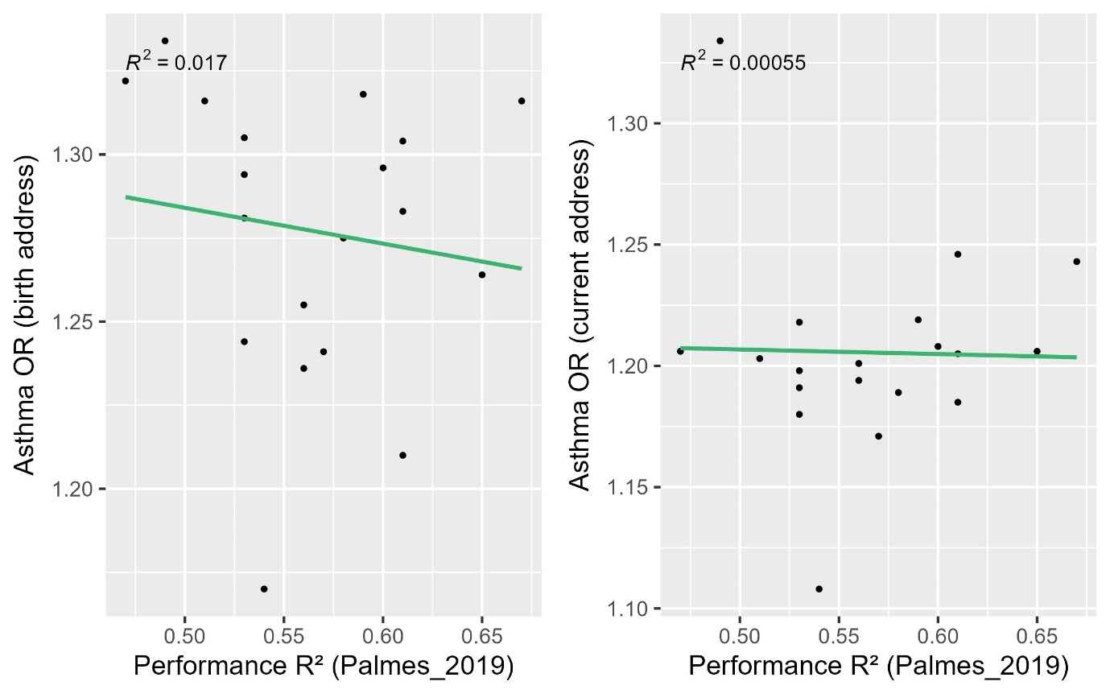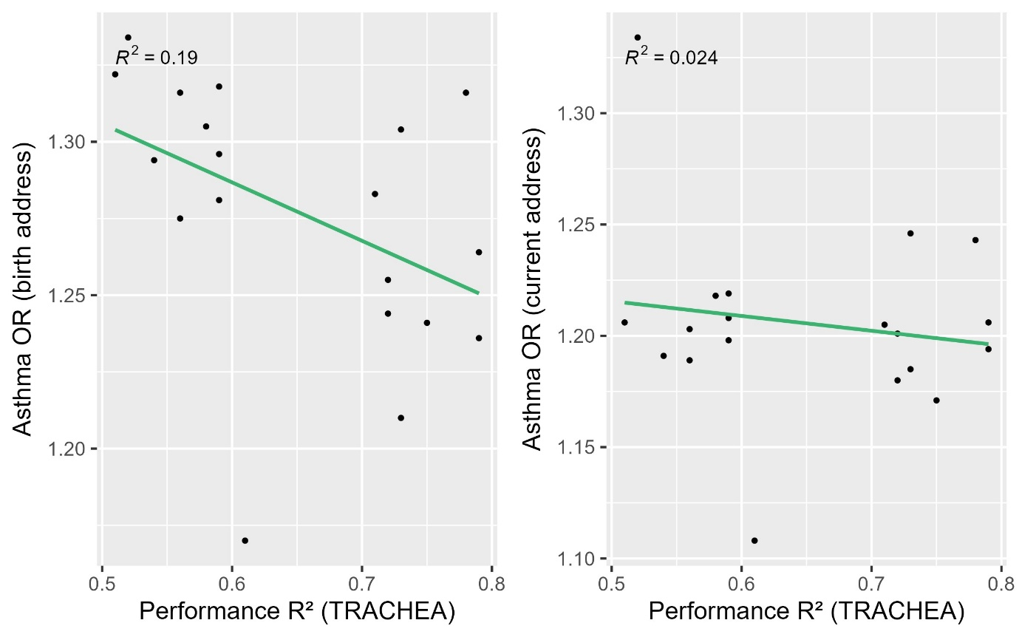

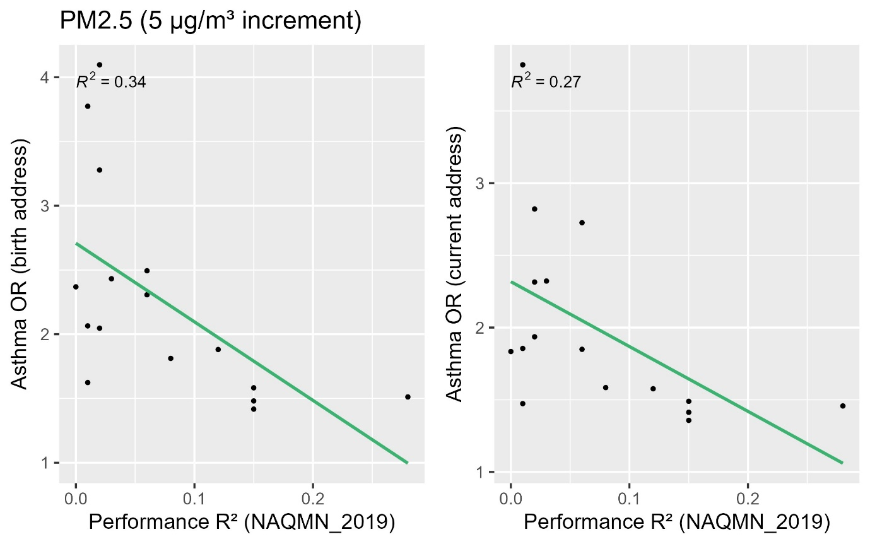

Figure S2. Comparison between lung function effect estimates and external validation R²s.
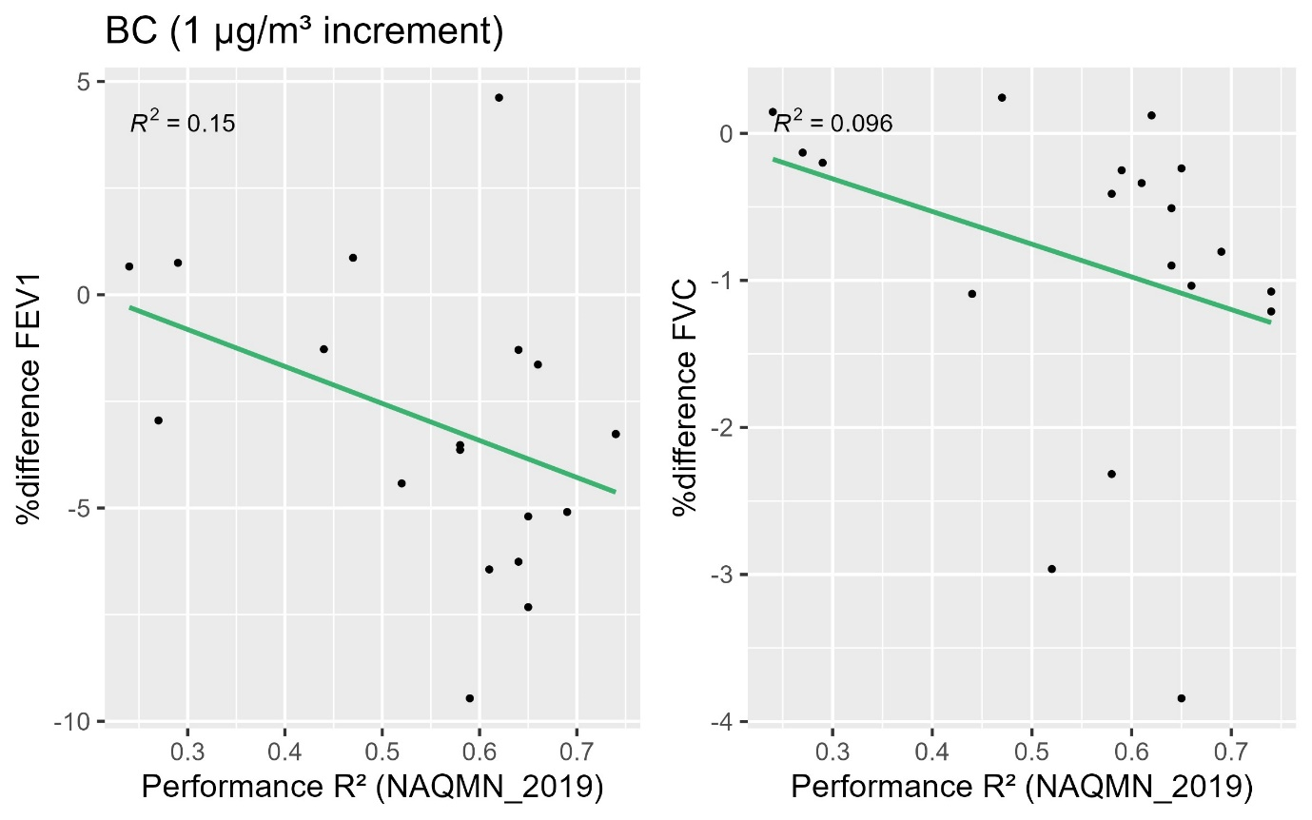
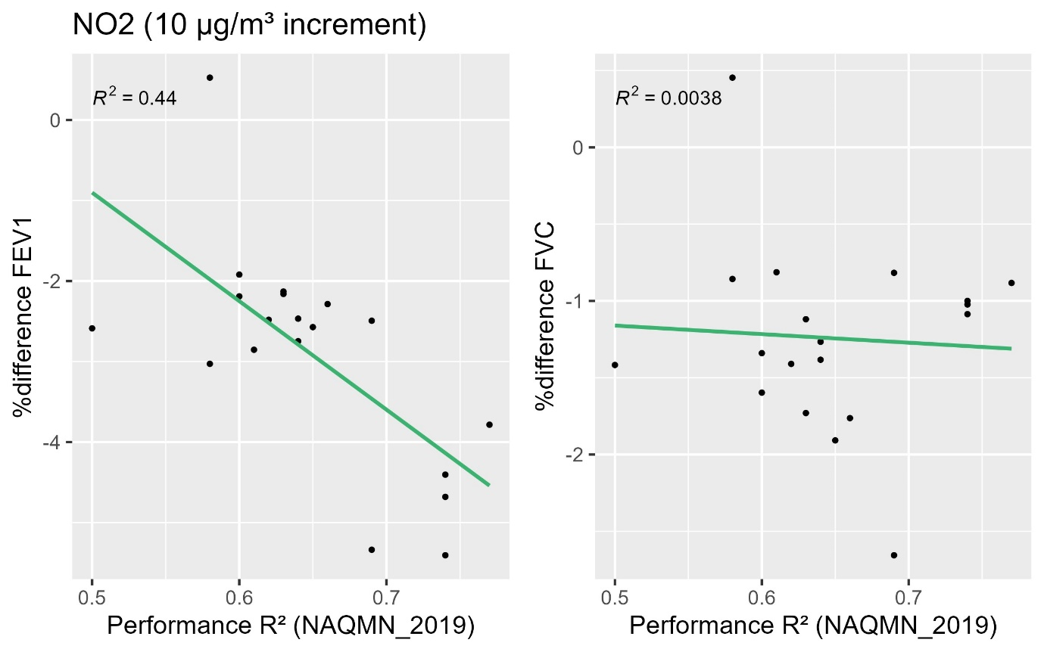
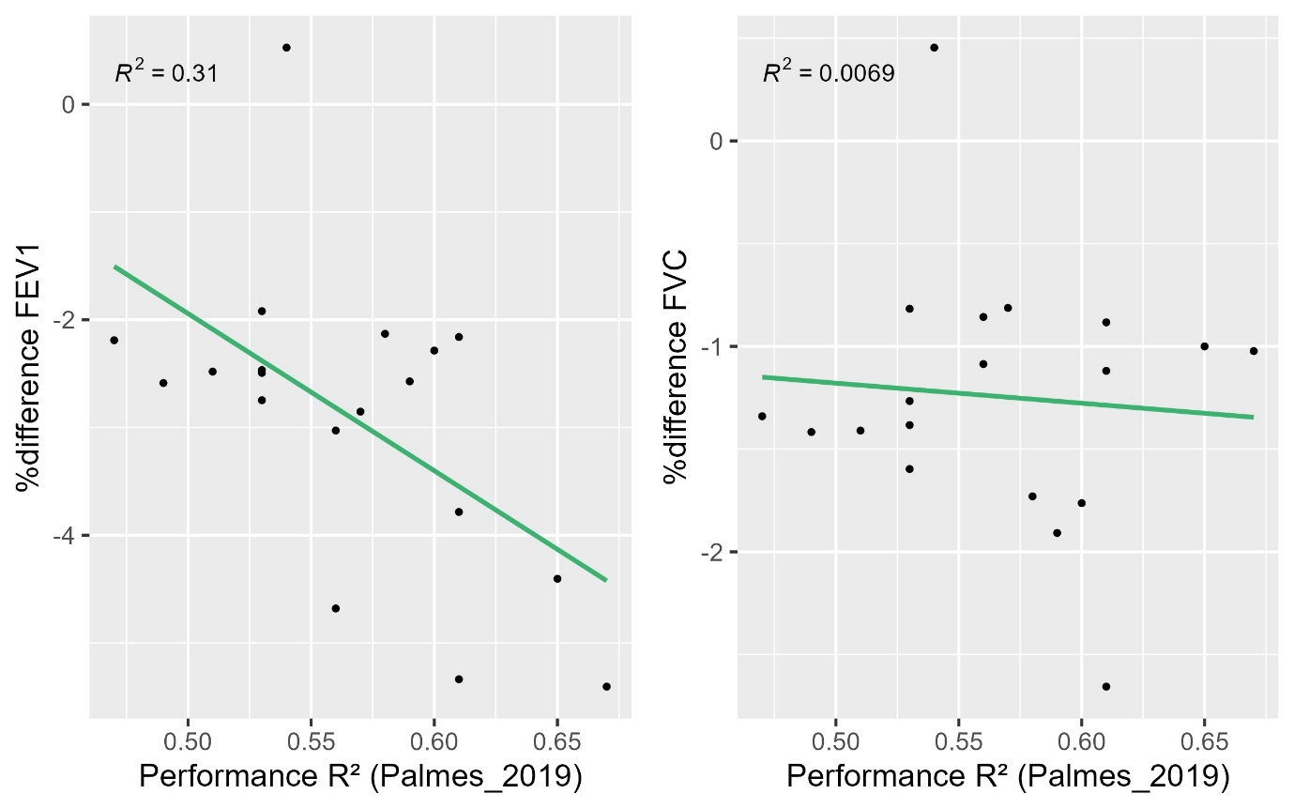
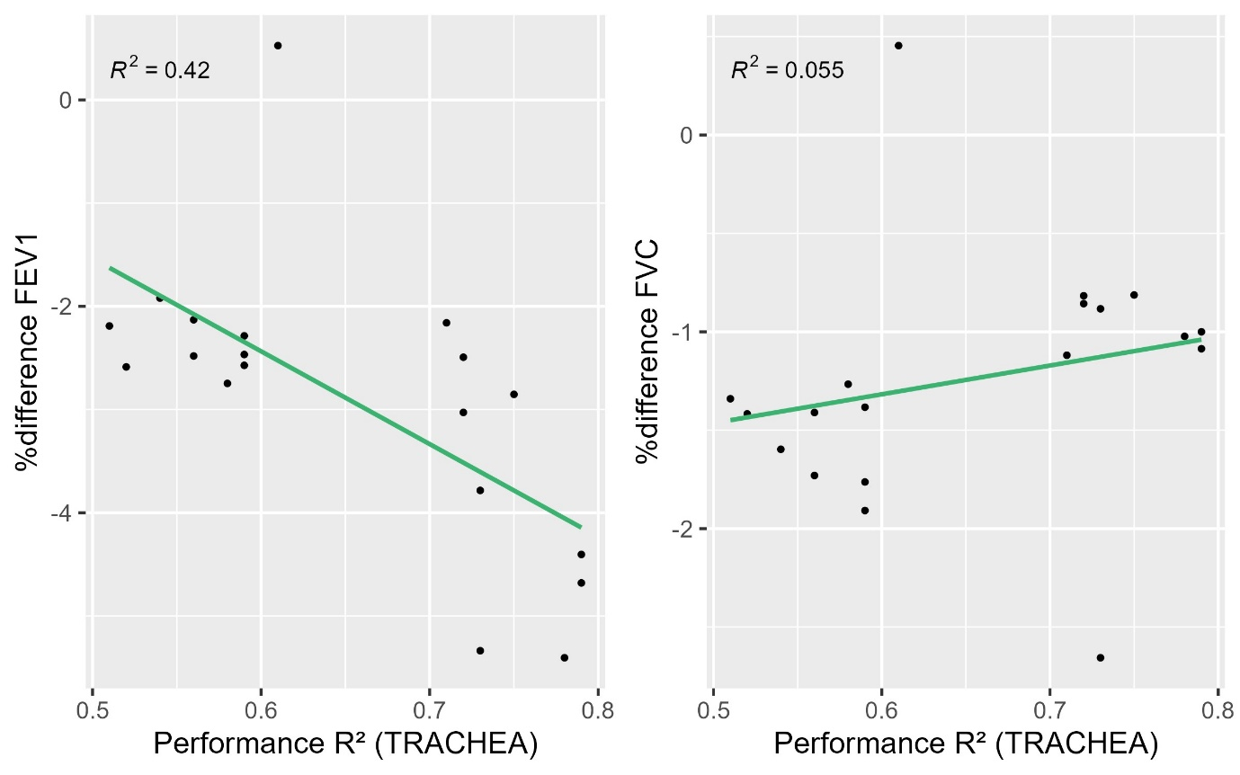
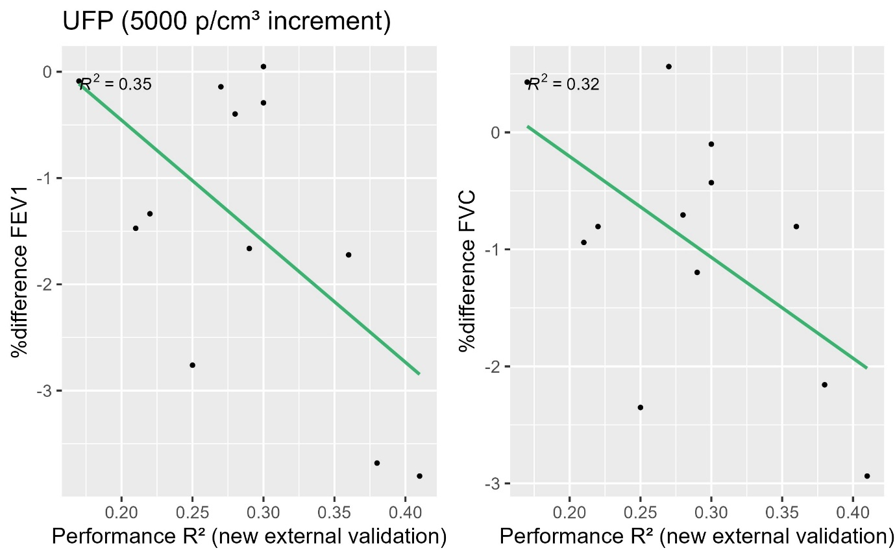
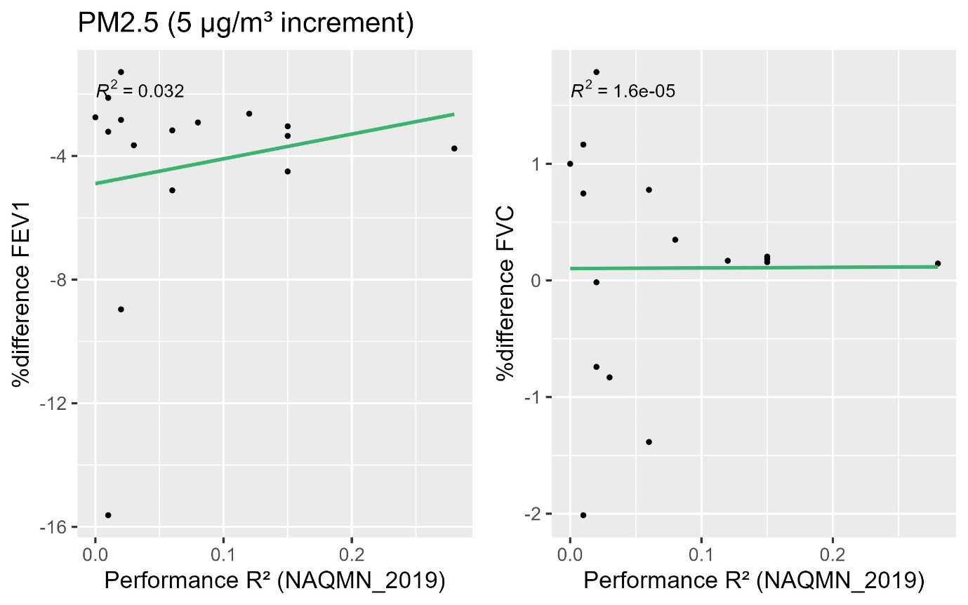

Table S12 Results of the regression of the model performance R² and the predicted exposure IQR on the OR for asthma incidence
Pollutant (external validation set) |  | Performance R² |  | IQR
Pollutant (external validation set) |  | Beta (SE) | p-value | Beta (SE) IQR | p-value IQR
BC (NAQMN_2019) | Performance R² | 0.91 (0.55) | 0.12
BC (NAQMN_2019) | Performance R² + IQR | 1.06 (0.53) | 0.06 | -0.54 (0.30) | 0.09
NO₂ (NAQMN_2019) | Performance R² | -0.15 (0.15) | 0.34
NO₂ (NAQMN_2019) | Performance R² + IQR | -0.07 (0.18) | 0.70 | -0.00 (0.01) | 0.47
NO₂ (Palmes) | Performance R² | -0.11 (0.20) | 0.59
NO₂ (Palmes) | Performance R² + IQR | -0.09 (0.19) | 0.66 | -0.00 (0.00) | 0.28
NO₂ (Trachea) | Performance R² | -0.19 (0.09) | 0.06
NO₂ (Trachea) | Performance R² + IQR | -0.17 (0.10) | 0.11 | -0.00 (0.00) | 0.46
UFP (new external validation) | Performance R² | 0.81 (0.32) | 0.03
UFP (new external validation) | Performance R² + IQR | 0.82 (0.31) | 0.03 | 0.00 (0.00) | 0.24
PM_{2.5} (NAQMN_2019) | Performance R² | -6.11 (2.28) | 0.02
PM_{2.5} (NAQMN_2019) | Performance R² + IQR | 1.40 (2.80) | 0.63 | -0.60 (0.18) | 0.00

Table S13 Heterogeneity I² (number of models/studies) of current study and previous meta-analyses
Pollutant | Asthma |  | Lung function
 | Current study | Previous studies | Current study | Previous studies
BC | 62.3% (17) | 0% (8) (Khreis et al., 2017) | FEV₁: 38.8% (17), FVC: 0.0% (17) | NA
NO₂ | 17.8% (12) | 0.0% (3) (Gasana et al., 2012)  32.8% (18) (Favarato et al., 2014)  64.1% (13) (Anderson et al., 2013)  47% (22) (Han et al., 2021)  65% (20) (Khreis et al., 2017) | FEV₁ 28.9% (12), FVC: 0.0% (12) | FEV₁: <1% (9) (Barone-Adesi et al., 2015)
UFP | 0.0% (12) | NA | FEV₁ 0.7% (12), FVC: 0.0% (12) | NA
PM_{2.5} | 19.6% (6) | 72.7% (2) (Gasana et al., 2012)  7.4% (5) (Anderson et al., 2013)  29% (13) (Han et al., 2021)  28% (10) (Khreis et al., 2017) | FEV₁ and FVC: 0.0% (6) | FEV₁: 93% (9), FVC: 94% (10) (Zhang et al., 2022)

