Utrecht University
Department of Media and Culture Studies
Research Master in Musicology

(Un)familiar Structuring: Relearning Analysis through the Sampled Music of Kolo Gana

Anna Nikolozišvili
Student ID: 7651279
June 16, 2025

Supervisor: Dr Annelies Andries
Second reader: Dr Judith Lochhead

Abstract

Music analysis is an established, yet continuously evolving aspect of music research and study. However, with its focus on well-established theories and analytical concepts, music scholarship often leaves little room for developing the skills needed to approach any music—familiar or unfamiliar—tending to prioritise specialisation over holistic understanding. While ideas promoting global perspectives on music and its study have contributed to a broader understanding of musicology, long-lasting practical solutions for overcoming the narrowing of repertoire according to subfield divisions remain underexplored.
In this thesis, I question how familiarity influences analysis of sampled music, which—though often associated with hip-hop—draws on music from a wide range of forms, genres, and cultures. The concepts of familiarity and unfamiliarity in relation to musical perception, as understood by Henry Stobart, guide the selection of case studies in the form of three hip-hop tracks: ‘Worldwide’, ‘She Don’t Mean It’, and ‘Infinity Bars III’. These pieces, created by a Nigerian producer, Kolo Gana, sample music by Georgian, Slovak, and Nigerian artists, and respectively align with my three levels of (un)familiarity, as analytical starting points: 1. cultural and academic familiarity, 2. cultural familiarity and academic unfamiliarity, 3. cultural and academic unfamiliarity. To analyse these case studies, I draw upon Judith Lochhead’s approach to music analysis as the structuring of musical time, applying the three steps she outlines: beginning with an investigation of micro- and macroperceptions, followed by their mapping and visualisation, and concluding with interpretative speculations.
As digital music practices continue to develop the relevance of genre-specific analytical models diminishes in relation to the growing number of culturally varied musics and their new combinations. In this thesis, I offer an analytical approach that supports engagement with musics, regardless of their expected categorisation within musicological subfields. By examining how varying levels of familiarity with certain musics and their associated scholarship influence and shape analytical processes, I aim to highlight the critical role subjective perception plays in music analysis as a form of creative activity. This mindset seeks to encourage both individual and collective growth as specialised, yet broadly informed music scholars who are equipped to approach any music, whether familiar or unfamiliar to them.

Acknowledgements

I am most grateful to Annelies Andries for her tireless supervision and guidance. It is thanks to her continuous encouragement that I found myself experiencing the thesis writing process as more enjoyable than stressful. I am honoured and thankful to Judith Lochhead for kindly agreeing to be the second reader of my thesis. Many thanks to Michiel Kamp for his insightful comments on my first pieces of writing that turned out to be foundational for the thesis, as well as to Sebastian Wedler for his useful feedback on the thesis proposal.
I thank my big group of family and friends for their care. I am especially grateful to my parents, Andrea and Niko, for never failing to model curiosity, and for somehow managing to crack the code and give us a childhood where choice, rather than survival, was the norm. While they may have sometimes regretted asking about my thesis (listening to my rants takes some patience), I am lucky to have parents who make sure to stay aware of my interests. I am always thankful to Giorgi, the best support system I could wish for.
I dedicate this thesis to my three built-in best friends: Mariam (Marinečka), Alexi (Akinko)
and Giorgi (Goško).

Table of Contents

Abstract 2
Acknowledgements 3
List of figures 6
Introduction 7
Finding the Ball Before We Can Keep Our Eye on It 8
Sampling as a Source of Three Forms of (Un)familiarity 9
Inevitable Globalisation through Curiosity 10
1. Framing Gana 13
But First, Let’s Address Sampling 14
Unfamiliar Music and Mother Tongues 16
Analysis Defined and Loosened Up 17
Analysis as Structuring 19
(Un)familiar Music and Structuring 20
2. One Track, Two Georgias: Trio Mandili’s ‘Kakhuri’ in Gana’s ‘Worldwide’ 25
Investigating and Speculating on Macroperceptions 26
Investigating and Speculating on Microperceptions 29
Mapping and Speculating 32
Conclusion 35
3. Layering Music, Layering History: Slovak ‘Karička’ in Gana’s ‘She Don’t Mean It’ 36
From Field Recording to Revival 37
The Part with Chopping & Looping 40
Conclusion 44
4. Same Weapon, Different Bullets: Fela Kuti and Africa 70’s ‘Water No Get Enemy’ in Gana’s ‘Infinity Bars III’ 46
‘Infinity Bars III’ For the First Time 47
Fela Kuti and ‘Water No Got Enemy’ 50
‘Infinity Bars III’ For the Second Time 53
Conclusion 57
Conclusions 59
Analysis and Analyses Intertwined 60
Methodology Rediscussed 61
Analysis as a Reflection of (In)effective Dialogue with the Next Generation 62
From Mother Tongues to Adoptive Tongues 63
Bibliography 65
Appendices 69
Appendix A 69
Appendix B 70
Appendix C 71
Appendix D 72
Appendix E 73
Appendix F 76
Appendix G 78
Appendix H 79
Appendix I 80
Appendix J 81

List of figures

Figure1.1 Gana’s Instagram post introducing all tracks in What It Means to See It All (Expanded Edition). 13
Figure 2.1 Reddit comment in a thread about Trio Mandili’s ‘Kakhuri’. 25
Figure 2.2 Excerpt from my transcription of ‘Kakhuri’ by Trio Mandili. 31
Figure 2.3 The first two verses of ‘Kakhuri’ with the chorus.___________________________ 33
Figure 2.4 Fragments of looped ‘Kakhuri’ in ‘Worldwide’. 33
Figure 2.5 Excerpt from the merged map of ‘Worldwide’._____________________________ 34
Figure 2.6 Misaligned layers on the merged map of ‘Worldwide’. 34
Figure 2.7 Transcription of four bass layer patterns.__________________________________ 34
Figure 2.8 Bass layer pattern combinations. 34
Figure 3.1 Beginning of Map 1. 42
Figure 3.2 Beginning of Map 2. 42
Figure 3.3 Two bass layer patterns. 43
Figure 3.4 Bass layer in ‘She Don’t Mean It’. 44
Figure 4.1 Beginning of Map 1 – ‘Infinity Bars III’ For the First Time. 49
Figure 4.2 ‘Water No Get Enemy’ scheme. 53
Figure 4.3 Transcription of the patterns W, X, Y and Z. 53
Figure 4.4 ‘Water No Get Enemy’ with Gana’s sampled parts in red. 55
Figure 4.5 Beginning of Map 2 – ‘Infinity Bars III’ For the Second Time. 55

Introduction

Music analysis is an activity music scholars engage with in different contexts and under various circumstances. Recent music analysis debates include the questioning of the meaning the practice has acquired over the years. While some argue that the term music often implies art music originating from or inspired by the European art music tradition (Zagorski-Thomas 2023, 20), others have been advocating for the expansion of music studies, including its analysis in stylistic, historical and geographical terms. Although the activity is an inseparable part of music theory scholarship, the knowledge analytical enquiry provides has proven to be significant across musicological subdisciplines. For example, when defining music analysis, Ian Bent (2001, 341) acknowledges that ‘analytical techniques can be applied to aurally perceived material, in any tradition (whether ethnomusicology or that of Western performance)’. Three years later, Kofi Agawu describes American theorists’ growing interest in ‘non-Western and non-canonical repertoires’ (Agawu 2004, 267-8). Recently, Alexandra Monchick (2023, 7) reiterates this statement, underlining the way American musicology has embraced the analysis of popular and non-Western music.
Although most music scholars would agree that analysis may grant insight into all music, the efficiency it brings in generating knowledge about pieces often depends on specific analytical techniques, their ties to concrete repertoires, and our (researchers’/analysts’/listeners’) cultural and educational backgrounds. Just as the study of music takes different forms across countries, the emphasis placed on analysis varies according to context. Nevertheless, it is often possible to categorise analytical scholarship into one of the following categories: Western music analysis, popular music analysis, as well as non-Western music analysis—all three offering respective theories and methodologies. The development of these branches has allowed for greater specialisation and more effective communication among scholars with shared interests—through journals such as Analytical Approaches to World Musics and study groups like the SMT Popular Music Interest Group. And while this has also enabled many music analysis curricula to extend beyond Western art music, incorporating ‘world’ or ‘global’ music and popular music themes, not many analytical approaches offer the toolbox applicable to any music. Sometimes, specialisations in concrete bodies of music tie the understanding of analysis with specific theories and approaches so closely that attempting to analyse music unfamiliar to us (both culturally or academically) leaves us feeling unequipped and unprepared. Overcoming the challenge of such situations often requires unlearning and relearning what music analysis means.

Finding the Ball Before We Can Keep Our Eye on It
One such story of unlearning is told by Allan Moore (2003, 1-6) in the introduction of one of the first popular music analysis books. Here he describes the process through which the study of popular music gained the honour of being considered academic. He recalls how some musicologists, courageous enough to work on ‘unserious’ music, had to rethink how to approach a repertoire of music that did not coincide with the expected materials conventionally used to study the theory and analysis of music. Before the time came to actively engage in research activities and propose frameworks, the group of scholars must have been confronted by the realisation that the concepts of music theory and music analysis—as they knew them—did not actually include all music theory and all music analysis. In other words, before offering a methodology fit to study popular music, these musicologists went through the awkward moment of recognising the non-existence of an appropriate methodology.
Falling into a situation similar to that of the first popular music scholars—having the expectation to analyse a type of music you have not been taught to analyse—may sound intriguing but is often quite uncomfortable. In my final year of undergraduate studies in musicology, I was surprised to find out how lost I was when my supervisor asked me to figure out a way to analyse medieval hymns from Georgia. What made it worse was that I am partly Georgian myself, and what made it even worse was that I already had a few years of chanting experience in an amateur choir. The circumstances were distressing because I had an unconscious expectation that after three years of higher education in music and many more years of sight singing, writing dictations and harmonising, I should not have had such trouble when faced with a Georgian chant for the first time as an analyst.
To gain more clarity, I asked my teacher what steps she expected me to follow to analyse the pieces. The panic and terror, the feeling of ‘what did I even learn all these years’ ceased when she clarified that this was exactly what we were going to figure out. This was the first time I was forced to realise that the analysis of music does not always consist of reading a theory and following its instructions to point out some elements in the score. Looking for the exposition and the development or the main theme and the second theme in a Georgian chant obviously did not make sense, but nor did the search for a tonic, modulations, a twelve-tone row and other concepts I had been focused on learning up until then. I found myself in a position where, in order to look for something in that music, I had to find what to look for in the first place, or as Moore (2003, 6) puts it, I had to ‘decid[e] which differences do make a difference, which carry any interpretive weight’.
My undergraduate degree had a happy ending—not only did I gain more confidence in approaching Georgian chants, but I also even ended up comparing them to Georgian traditional songs and pointing out that the two are not the same from an analytical perspective. However, as I finished working on the project, I was left wondering just how much music was out there, which, if trying to analyse for the first time, would make me feel clueless and incompetent as a musicology graduate. Additionally, I finished my studies as a musicology student following a music theory track, specialising in the theoretical aspects of Georgian chants, which although referred to as the ‘academic’ or ‘classical’ type of music, are usually researched in the ethnomusicology department. The disorientation I felt after starting a master’s program in musicology and constantly deciding whether I should regret not pursuing an ethnomusicology or a music theory degree instead was frustrating. Ironically, as I make peace with my choice, in this thesis, I present my research on popular music.

Sampling as a Source of Three Forms of (Un)familiarity
While Philip Tagg (1982, 39) remembers playing Scarlatti and soul, studying Palestrina and spending time at a pop club in the middle of the twentieth century, the ways through which we experience music nowadays, and especially popular music, have since changed significantly. Not only have technological advances influenced the way we create music, but they have also drastically changed the way we listen to it, encounter it and familiarise ourselves with it. Although, more than fifty years later after Tagg, having also studied Scarlatti and Palestrina, my ties to popular music are predominantly connected to social media use. If Tagg had to walk to the ‘Palais’ to listen to the newest hits of his time, the way our generation often gets exposed to some of the digitally produced music is by scrolling through Instagram and opening reels sent by friends.
One year ago, one such reel, repeatedly finding its way to my screen, introduced me to a Nigerian producer, Kolo Gana. While the way he sampled Slovak traditional music caught my attention, the ‘serious’ music theorist in me would never have thought of analysing Gana’s tracks in an academic context. It was only when I had to pick a topic to work on in a Digital Music Cultures course, when I took on the challenge of writing about a case study related to popular music. Although outside my comfort zone, Gana’s hip-hop track sampling Slovak traditional dance music sparked my interest because of my sense of familiarity with the culture it referenced. It is through this project that I started to wonder how my previous encounters influence the way I analyse.
Realising that my understanding of Slovak music is rooted more in personal experiences than in academic training prompts further questioning. Examining how the circumstances of my cultural upbringing and music education determine the way I formalise my listening experiences motivates me to question: how does (un)familiarity influence the process of sampled music analysis? Although a more general question may not include the word ‘sampled’ in it, the choice to focus on this type of repertoire is deliberate. Gana’s musical compositions, which are always produced through sampling, present three types of musical sources: 1. ones I have never listened to before (Afrobeat, Fela Kuti and Africa 70), 2. ones I have grown up dancing and singing to as a child (Slovak traditional music, Karička dance), and 3. ones I have learnt, performed, analysed and researched about (Georgian polyphonic music). Thus, these sources represent three starting points for analysis: the first one being unfamiliarity, the second—cultural familiarity, and the third one—cultural, as well as academic familiarity. Therefore, while the goal of my thesis is to debate how familiarity guides analysis, it also demonstrates the variety and combination of sources sampled and digitally produced music offers.

Inevitable Globalisation through Curiosity
As each of my three analyses starts with a premise dependent on my personal relation to the source of the sample, through this approach, I aim to bring more awareness to the inevitability of subjectivity in music analysis. Debating the potential death of music analysis, Bhogal (2023, 5) describes how students often question the broader implications of this phenomenon. Advocating for a contextual approach to music analysis, she states that ‘as long as [she] can continue to appreciate the act of music analysis […] as an activity where their whole selves as global and globalised musicians are valued and validated, students will remain curious’ (Bhogal 2023, 5, italics original). Achieving this, what appears to be an enriching perspective on music analysis, requires analytical methodologies allowing room for subjectivity and vulnerability for all parties involved, including students, as well as scholars and teachers.
In the (American) context of the decolonisation of music theory and analysis, Kofi Agawu (2023, 28) describes contemporary theorists’ need for ‘a delinking from European theorists (like Schenker)’. However, without seeing adequate approaches to music analysis that could allow for curriculums that dispose of colonial traces, he questions the aftermath of such procedures. Similarly, thinking about an alternative future, Julian Horton (2023, 29, 33), acknowledging the strong politicisation of recent music theoretical discourse, argues in favour of a new textbook, which would ‘expose students to the discipline’s full diversity and make[s] a case for its curricular and intellectual relevance’. The inescapable shift the discipline of music theory has experienced since Philip Ewell’s (2021) contributions about its white racial frame has made some scholars more hopeful for a change, while leaving others overwhelmed by it.
Although my experiences with Anglo-American music theory discourse and its motivations to contribute to anti-colonialism and equality are fairly recent, the perspective I offer with the analysis of various musics also strives for a balanced and global approach to music studies. While I have already explained that this thesis revolves around sampled hip-hop and popular music, it is just as involved with musics with differing contexts. The first case study presented in the second chapter focuses on vocal-instrumental polyphonic music from Georgia (Caucasus region at the intersections of Europe and Asia). Here Gana samples the song ‘Kakhuri’ from a YouTube video by the well-known group Trio Mandili and creates a track called ‘Worldwide’ (Gana 2024d). The next case study from chapter 3 comes from a recording of Slovak (Central European) traditional dance music, arranged in 2001 for educational purposes. Gana’s full track, using this music, is titled ‘She Don’t Mean It’ and was inspired by the widespread attention the idea of sampling Slovak music received on his social media. The last case study, discussed in chapter 4, is centred on Fela Kuti and Africa 70’s Afrobeat—a blend of West African and American musics, such as funk, jazz, soul, highlife and Yoruba. While the analysis of the track ‘Infinity Bars III’ sampling Kuti’s ‘Water No Get Enemy’ starts from the position of my unfamiliarity, the interpretation acknowledges Gana and Kuti’s mutual Nigerian origins. Overall, as the variety of these examples show, the most important factor in this research is that it simply revolves around music.
My approach to these culturally, geographically and historically differing musics does not depend on finding ‘indigenous music theories’ for each of them (Agawu 2023, 28). Instead, I draw upon Judith Lochhead’s (2016, 68) understanding of analysis as a mode of ‘producing knowledge, an ongoing process that recognizes our own historical, social, and cultural embeddedness’. Lochhead’s three-step idea of structuring perceptions, discussed in the first chapter of this thesis, tries to demonstrate an analytical procedure applicable to any type of music based on the acknowledgement of the researcher’s/analyst’s/listener’s own (un)familiarity. Not only is this approach freeing in terms of material choices for analysis, but it is also non-discriminative of the origins of the sources, and non-exclusionist in terms of the researcher’s/analyst’s/listener’s previous music-educational background. Therefore, while the impulse for my research is motivated by curiosity about music and interest in the process of music analysis, it simultaneously and inadvertently offers an anti-racist and a decolonial approach to the activity.
That being said, the freedom provided in music analysis through the concept of (un)familiarity must not act as an excuse for incompetent and uninformed scholarship. While previous academic and music-educational experiences often guide the way we listen, perceive and analyse, acknowledging our starting point in analysis does not imply full rejection of accumulated scholarship and sole dependence on our own hearing abilities. As Henry Stobart (2013, 126) states, (un)familiar music should be approached by investigating its origins and the context of its creation, while taking on the challenges that come with trying to perceive and understand geographically, historically, culturally or ideologically differing musics. Through my analysis of Kolo Gana’s music, I argue that stepping out of our musicological comfort zones creates space to broaden our knowledge and experience by valuing our own perceptions of music, while remaining informed by those of our colleagues.

Framing Gana

Kolo Gana, a Nigerian music producer, can be considered as an example of a growing number of DIY musicians. Having grown up in various countries, including Japan, Nigeria, Belgium, and the US, he is now based in Atlanta, Georgia (Robinson 2023, 12:20). Since 2017, Gana—a health inspector by day—has been creating hip-hop music and sharing it via social media platforms such as YouTube, Instagram and TikTok, as well as streaming services like Spotify and Apple Music, apparently without affiliation to a music label (Robinson 2023, 2:55).
Throughout the last two years, Gana has developed a music production style, which is based on sampling and reproducing music from different cultures. As the artist claims, he has been engaged with sampling ‘musical legends from countries all across the world’ in order to broaden his musical knowledge and experience (Gana 2023b). Encouraged by respective audiences’ positive reactions to his use of the music they identify with, in 2023, Gana produced an album titled What It Means to See It All. The album includes fifteen tracks, all based on samples from different countries. One year later, Gana re-released the album, expanding it by doubling the amount of tracks and dividing them into two discs (figure 1.1).
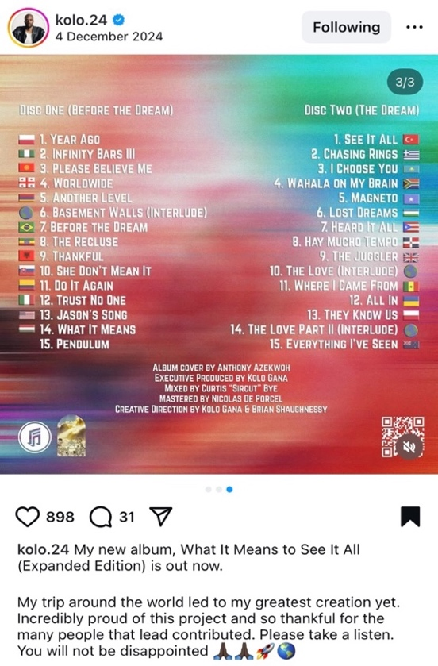
Figure1.1 Gana’s (2024h) Instagram post introducing all tracks in What It Means to See It All (Expanded Edition).
And while it appears that Gana has not yet been part of musicological discourse, I argue that his music can significantly shift our perspective on the way we approach familiar and unfamiliar music and its analysis in the context of sampling. To demonstrate what analysis of sample-based tracks might entail, and how it can shift our understanding of music analysis as a practice, I turn to this album for all three case studies. As already mentioned in the introduction, the case studies include ‘Worldwide’, ‘She Don’t Mean It’, and ‘Infinity Bars III’—the 4th, 10th, and 2nd tracks of the album, respectively.
In this chapter of the thesis, I consider the meaning of analysis as a creative and performative activity, and a way of producing knowledge. This is done by a historiographical discussion on the topic by authors such as Ian Bent (2001), Kofi Agawu (2004), David Lewin (2006), and Judith Lochhead (2016), and informed by the concept of global musicology, as defined by Daniel Chua (2022). I further explain how my analysis of the three tracks draws upon Lochhead’s concept of structuring, while describing the specific methods by which I conduct the analysis. I also explain how my analysis is grounded in Henry Stobart’s (2013) notion of (un)familiarity, and why this concept serves as the starting point for the analytical process. Additionally, I consider popular music discourse on sampling, as well as the analysis of hip-hop music.

But First, Let’s Address Sampling
The digital compositional technique of sampling is explained by Mark Katz (2010, 159) as a ‘quotation that recreates all the details of timbre and timing that evoke and identify a unique sound event’. This type of a ‘quotation’—in this thesis directly referred to as a sample—can, on the one hand, recreate the sampled track and produce a remix, and on the other hand, act as just one of the layers for an original composition seen as independent of the sample’s source, which only serves as an inspiration for the new track. The latter seems to be true for Gana’s music production. The producer frequently shows gratitude towards specific cultures for inspiration, yet he characterises his music practice as sampling, viewing it as just one of the necessary steps in creating a new track.
And while the producer’s use of samples in his music is of secondary importance to my research focusing on the analysis of music, it must be noted that the primary interest towards sampling has often been rooted in addressing topics, such as cultural inequality and appropriation, exploitation, and copyright. The discussion of black artists’ exploitation is highlighted by Mark Katz (2010) in his chapter on sampling and politics, as well as by David Hesmondhalgh (2006) in his article ‘Digital Sampling and Cultural Inequality’. Katz’s (2010, 142-6) case study describes the transition from Camille Yarbrough’s political song ‘Take Yo’ Praise’ into Norman Cook’s (also known as Fatboy Slim) ‘Praise You’ while questioning the ethics of Cook’s use of the piece where both of Yarbrough’s original meanings, that is, a personal message to a man and a political message against racism towards Africans, are disposed of. Similarly, as Hesmondhalgh discusses Richard Melville Hall’s (better known as Moby) album Play, he pays attention to the easiness, and more importantly, the directness of sampling, which contributes to prevailing ignorance and failure to acknowledge and legally protect the culture of less influential communities (2006, 56-7).
While sampling may just be a compositional tool for some hip-hop musicians, enhancing their final tracks, for Gana, an artist gaining listeners online, it functions not only as a creative step, but also as the primary marketing strategy. Although samples ‘merely’ serve as the background of his music, they are fundamental, not only for the tracks, but also for targeting and acquiring an audience. This is why, during my analysis of the case studies, I also consider Gana’s choice and use of the samples with respect to the target audiences. Although Gana, a Black artist of Nigerian origin residing in the US, presents an interesting case for studying both the ethics and racial imbalance in sampling, the brief perspectives on misrepresentation I offer on his sample use are grounded in my perception-based investigations.
Therefore, while Gana’s tracks contribute to the ‘celebration of different cultures’ and the ‘celebration of the power that music has to bring us together’ (Gana 2023), from a musicological point of view, this artistic experiment raises several questions. Most importantly, it leads us to ask how the dominating phenomenon of digital music creation may change the way we approach the analysis of music from various cultures depending on our familiarity with them. We may expect that through a higher familiarity level with the sampled repertoire, it is impossible to overlook the aspect of exploitation in sampling. It is due to this that the analysis of my perceptions in chapter one touches upon political aspects of current Georgian history. In chapter two, I examine the backgrounds of the Slovak ‘revivalist’ musicians sampled by Gana and attempt to find the roots of the music’s hidden origins. In the last chapter, I act as an outsider, whose entitlement to an opinion on the way Gana uses politically motivated music from his own home country is limited.

Unfamiliar Music and Mother Tongues
Twenty years ago, Kofi Agawu (2004, 278) stated: ‘If music is a form of language, then we might expect analysts to speak that language. […] An analyst who is detached from the nature of the musical language and lacks recreative ability within it may well promote views of musical structure that are at variance with the conventions upon which the repertoire in question was composed in the first place. […] the ability to speak music as a mother tongue should be a requirement for proper and insightful analysis’. But what if the music we analyse does not fit only one single repertoire? How many mother tongues are music scholars expected to have? The music Kolo Gana samples varies significantly. Can we simply apply a theory from pop-music studies to analyse his hip-hop tracks, potentially overlooking the music his samples are sourced from?
Speaking of mother tongues and becoming a competent music scholar, Henry Stobart (2013, 126-8) discusses Mantle Hood’s (1960) concept of bi-musicality. In light of ethnomusicologists’ tendency to fully immerse themselves in the musical traditions they study by learning to listen to and perform the music, Hood sees this approach as a challenge, noting the limited possibility of achieving complete fluency in a musical system later acquired as a second. For John Baily (2008, 132), the idea of intermusability overcomes the limitations of Hood’s concept. By shifting the focus to musical ability and acquired performance skills, rather than inherent musical knowledge, Baily proposes to shift away from the term bi-musicality to avoid limiting the number of musical traditions in which a person can develop proficiency. As Stobart (2013, 128) writes, Baily’s approach to learning unfamiliar musics possibly suggests ‘a more flexible attitude to intercultural engagement and participation, and a move away from discourses of cultural exclusivity’. Nevertheless, Stobart, Baily, and Hood all direct their attention to unfamiliar music due to their experiences with research, but most importantly with performance, in the context of their ethnomusicological fieldwork and respective specialisations.
While all three of these authors propose their perspective on widening musical horizons, Daniel Chua (2022) goes even further by promoting the concept of global musicology as another way of defeating cultural exclusivity in music scholarship, broadly speaking. Claiming that musicology is ‘broken’ and unwilling to catch up with the changes in the world, the author offers two solutions to the problem of overcoming scholarship based on and grounded in ‘discriminating taste’ (Chua 2022, 117, 122). Firstly, he encourages his colleagues to attend conference presentations they might not typically choose, as a way of challenging their comfort zones (122). Secondly, he believes that in order to support communication and mutual understanding between scholars, it is crucial to engage in collaborative research and move away from individually written monographs.
And while these suggestions may be important, it is worth considering whether adopting a more practical stance earlier in music education could significantly influence the future development of the field. Teaching the ability to listen to unfamiliar music alongside familiar music would help overcome the individualised, and, according to Chua (2022, 122), relationally embedded forms of criticism and judgment present in musicological environments from an earlier stage. To do this, I propose a practical solution by turning to and relearning music analysis. But what does it actually mean to have the practical ability to analytically engage with (un)familiar music? Before addressing analysis as an activity of (un)familiar structuring, I propose to discuss how analysis has been defined in the past.

Analysis Defined and Loosened Up
According to Bent (2001, 340-2), analysis is a process of dismantling the structure of a musical composition into smaller elements and observing their relations and functions. While this definition is kept quite general, what follows is a detailed description of analytical work, creating an extremely specific image of ‘the analyst’ together with its ‘do’s and don’ts’. Bent defines the analyst through the opposition to ‘the aesthetician’, ‘the historian’ and ‘the critic’. Here, the analyst is only concerned with musical structure and its elements, and unlike the aesthetician, does not examine how the structure and its elements relate to humans and their realities. For the analyst, historical information is used only as a tool throughout the analytical process, and vice versa—the historian uses analytical methods to inform their historically-oriented research. Finally, for the sake of objectivity, the analyst’s primary work is to describe music through various means, while the critic judges it in speech or writing. Thus, although Bent acknowledges the close ties and dependencies between various musicology representatives, the border between their specialisations is perfectly clear.
Perhaps the acceptability of Bent’s analyst persona depends on each music researcher’s background, education, and interests. As the author himself states: ‘In reality the analyst works with the preconceptions of his culture, age and personality’ (Bent 2001, 420). However, to what extent does he take into consideration the practicalities of the analysts’ differing realities? Although Bent’s definition of analysis may be applicable to working with all music, the definition of ‘the analyst’ does not account for the universal element of the phenomenon, overlooking the blurring of roles depending on the analysed music, its environment and the analyst’s relation to it.
Based on this, just as Chua (2022, 115) feels the need to ‘undefine’ musicology when looked at through the global dimension of music studies, it may as well be needed and beneficial to take a more flexible stance on the over-defined role of ‘the analyst’ to support all and any music analysis. As a result, I choose not to frame my research of Gana’s compositions as a study grounded in a specific sub-discipline. In other words, due to the cross-cultural (or global) circumstances which determine Gana’s musical pieces, the methodology used to study them is guided by the music and the process of its perception, instead of methodological pre-restrictions based on existing musicological subfields and my positioning within them.
The parts of Bent’s (2001, 341) definition which do, however, guide my research, are his statements that present analysis as ‘that part of the study of music which takes as its starting point the music itself, rather than external factors’ and understand it as a ‘procedure for discovering’. Kofi Agawu (2004, 270-1) follows up on this by observing that ‘analysis is ideally permanently open, that it is dynamic and on-going […]. In an ideal world, analysis would go on always and forever’ and that ‘[t]here is however, no final state to hearing, only the latest state’. Both authors, therefore, refer to analysis as an active process of perceiving music without a definable or a necessary endpoint. This is relevant not only to all three of my case studies in general, where relistening and reanalysing form a continuous process, but also to the second case study in particular, where my analyses of ‘Karička’ and Gana’s track ‘She Don’t Mean It’ are revisited after a year-long break.
Agawu’s approach to analysis as a mode of performance and recomposition further informs my understanding of the activity as a creative form of presentation aiming to capture the reader’s or listener’s attention and interest, and to challenge them to view the analysed pieces from a different angle. Additionally, it is productive to think about the ‘recomposition’ of the music analysed, as a way of verbalising our perceptions, which inevitably differ from, and may even alter, others’ perceptions of the same piece. But what does the analytical process and its performance entail, and how does this align with the idea of defining structures, as proposed by Bent (2001)?

Analysis as Structuring
When providing a general overview of analytical approaches to hip-hop music, Kyle Adams (2015, 121) states that ‘there is not yet a universal analytical method for hip-hop music’. In his opinion, it is due to hip-hop’s cyclical nature, harmonic simplicity, and the contextual fluidity of samples, whose meanings change depending on their usage, that cause most existing analytical approaches to fall short of doing justice to hip-hop tracks (119-21). At the same time, the author argues that these elements of hip-hop music are only challenging when analysed using pre-existing methodologies that are incompatible with this type of repertoire. And while Adams (2015, 132) strives toward ‘a unified analytical approach to hip-hop music’, I turn to the concept of analysis as a form of structuring, which allows for a flexible examination of musics both sampled and composed by sampling.
Before addressing the idea of structuring, Judith Lochhead refers to listening as a process of ‘human knowing’ and to analysis as ‘producing knowledge’, while acknowledging that ‘listening as a culturally, socially, and historically generated activity of musical experience affects how one approaches musical works analytically’ (Lochhead 2016, 77). Instead of using common analytical terminology, Lochhead (79) speaks about a ‘musical thing’, while David Lewin (2006, 60) speaks about a ‘sonic event’. Both of their texts shift our perspective on music analysis through their understanding of it as the phenomenon of musical perception, while sharing the idea of structuring. Instead of focusing on musical structure, Lochhead calls the process of analysis the ‘structuring of musical time’, or the process of how a musical event comes to be (79). According to her—similarly to Agawu (2004)—music analysis, that is, ‘the reconception of musical structuring’, entails a ‘dynamic and reflexive process of listening, creating, and performing’ (Lochhead 2016, 85). Lochhead’s and Lewin’s understanding of analysis as an active process of structuring helps avoid the loose concept of ‘structure’ as a single undeniable phenomenon. The active attitude not only views analysis as a form of creativity, but also leads us to think of the activity as a mode of categorising and organising our own perceptions based on our bodily reactions and socio-cultural positioning.
For Lewin (2006, 66), ‘perception-structuring’ is the process of organising musical perceptions and examining how they change based on various contexts of the same events. Considering the interest he shows in understanding the mechanisms of musical perception, although I do not intend to use his Basic Formula, Lewin’s perception-structuring holds significance given the relevance of changing contexts of musical events when speaking about the act of sampling in contemporary music practices. Moreover, by zooming into the same musical event within various contexts, Lewin, to a certain extent, manages to overcome the issue of hierarchy apparent in most analytical work (83). He does this by rejecting the singularity of a musical event and instead, and by understanding it as a set of phenomena, which autonomously exist in different places at different times under various circumstances. Therefore, Lewin (2006, 80) claims his model is ‘sensitive to the way in which perception-structures [pi] can occupy different mental and/or clock times’. From a practical perspective, this means that, for Lewin, the ‘correctness’ of analysis is not a relevant factor and that he does not refrain from exploring the psychoacoustic and sociocultural mechanisms behind ‘incorrect’ interpretations of certain sonic events.
Lewin’s analysis stands far from linear interpretations of musical events. Instead, it tries to make sense of these events by creating a web of perceptions and their contexts according to specific times and circumstances. At the same time, he speaks about competence involved in the process of listening and the influence our past activities have on current perception-making processes (2006, 66). He also points out the cultural and theoretical components that come with the connection of past knowledge to present experiences of perception. How, then, does the acknowledgement of extra-musical influences on perception and listening, along with the assessment of the analyst’s/researcher’s/listener’s level of familiarity, align with the practical aims of music analysis?

(Un)familiar Music and Structuring
My analysis of Kolo Gana’s music—familiar at times and unfamiliar in others—requires a flexible set of interpretative tools, benefitting from a step by step approach described by Lochhead (2016). While the scholar distances herself from offering a definite analytical methodology, she proposes a three-step guide for the activity, including: investigating, mapping and speculating. She grounds the investigative process in the concepts of ‘microperceptions’ and ‘macroperceptions’ as suggested by Ihde (1990, 29), concentrating on the human corporeal and sensory experiences with music on the one hand, and on their social and cultural contexts on the other (Lochhead 2016, 86).
As she puts it: ‘Macroperceptions stand in a reflexive relation to microperceptions, each affecting the other in a dynamic process of knowing’ (Lochhead 2016, 87). Due to the combination of micro- and macro- levels of perception, Lochhead (2016 88, 93) speaks about ‘hermeneutical hearing’, considering the act of hearing as a socio-culturally underpinned process of interpretation, or as a ‘sensory-hermeneutical experience[s]’. Nevertheless, attention to the two types of perceptions is only possible by acknowledging the level of familiarity we (analysts/researchers/listeners) start our analysis with.
Henry Stobart (2013, 109) starts the conversation on the role of familiarity and music by exposing the duality behind the ‘familiar’ and ‘unfamiliar’, both carrying positive and negative connotations; the former related to sharing, cultural identity, but also to boredom; and the latter connected to both exciting, as well as frightening limits of a comfort zone. When using the concept of (un)familiarity, Stobart (2013, 110) takes into consideration the flexibility and changeability it comes with, noting that ‘musics are rarely, if ever, entirely familiar or unfamiliar’. He further underlines the fact that although all music can have a large number of interpretations, depending on the degree of familiarity, we tend to interpret certain musics in certain ways. The author underlines the hardships that come with culturally determined perceptions and finds the reason behind various degrees of perception of the same music in the differing corporeal responses. Although Stobart does not explicitly connect the concept of familiarity to analysis, using it as the starting point for my examination of Gana’s three tracks enables me to begin by acknowledging my own background. At the same time, it also raises my awareness of the origins of both my micro- and macroperceptions during the investigative stage of analysis and helps avoid the search for ‘correct’ interpretations.
It is important to note, however, that all three of my analyses begin with recordings, which positions my approach within an ethnomusicological framework (Stobart 2023, 24). It is only after the first encounter with a recording that I am able to evaluate my level of familiarity with the specific piece of music, which then determines the premise I open my analysis with. In all cases, the macroperceptive dimension of the analysis is informed by historical research, drawing on both scholarly contributions and primary sources, such as documentaries and news articles, relating to the artists Gana samples, and the musical traditions they represent. This aspect of my investigation not only informs my analysis by providing historical, cultural, and socio-political context, but is also crucial in shaping my ongoing listening and perceptual engagement with the musics.
In the meantime, my microperceptive investigations rely heavily on repeated close listening; in some cases, slowing down the recording allows for greater attention to detail. While most of my listening takes place at a desk (through a microphone), in silence and accompanied by note-taking, I have also listened in noisier external environments, such as on public transport or while walking through the streets (using earphones). It is during these continuous listening experiences that the basic awareness of the tracks’ layers becomes apparent, noticing the instrumentation, the rhythm and meter, the timbre and articulation, and overall harmonic and melodic developments.
For Lochhead (2016, 95), musical mapping, informed by cartography, is a creative but descriptive action, serving as an embodiment of the analyst’s perceptions and aiming to direct others’ experience of the analysed musical example. For Gana’s three tracks, as well as their sample sources, my mapping procedures use the lyrics of the pieces as their starting points. In all three chapters, I offer multiple maps that serve both to present my perceptions and to help me effectively communicate my understanding of the pieces. Not only do the lyrics prompt a comparative examination of the meanings in the sources of the samples and Gana’s tracks, but they also act as anchors for orientation when describing various sonic events. It is possible to do this by adding time stamps to the lyrics. Every case study presents a final map where both the sample and Gana’s track are represented. The choice of which element serves as the map’s base depends on the prior analysis. This analysis is influenced by my initial perceptions and my level of familiarity with the sample, factors that instinctively guide my prioritisation.
Colour coding is an important part of my maps, supporting the visualisation of music. I incorporated this aspect to clarify my own perceptions when verbalising and visualising them. The colour coding not only helps differentiate musical elements, but also simplifies their transfer between maps, proving especially valuable when merging sample source maps with Gana’s tracks. While I have never used this mapping method before, it feels like a natural outcome of the freedom gained when not relying on pre-existing theories, allowing me to find the best way to communicate my perceptions.
Additionally, except from colour coding and mapping through lyrics, my analysis includes transcriptions in Western-style notation. In Chapter 2, I attach a transcription of the Georgian song ‘Kakhuri’, helping the reader familiarise themselves with this type of music while becoming aware of the song’s harmonic simplicity. In Chapters 2 and 3, transcriptions are used to notate Gana’s bass lines. This not only directs the reader’s attention to these layers but also highlights the short, cyclical nature of the layer that provides the harmonic foundation. In Chapter 4, I present a transcription that visualises four distinct sonic events from Fela Kuti and Africa 70’s piece ‘Water No Get Enemy’. Overall, all these transcriptions serve as listening and interpretative aids.
It is through these methods of micro- and macroperceptive investigation and mapping that I interpret Gana’s three tracks alongside the sources of their samples. Not only do the following three chapters guide the reader through the activities of investigation and mapping, but they also engage with the speculative dimension of analysis, what Lochhead (2016, 97) describes as the point at which ‘the analyst presents an accounting of emergent structurings of the musical work’. My analyses of these case studies seek to generate knowledge about Gana's sampled music, all while remaining self-reflective on how my perceptions influence the final interpretations. The intention behind this anthropology-inspired autoethnographic element of the research, as understood by Heewon Chang (2008), is to help situate our own selves as analysts/researchers/listeners within a broader socio-cultural perspective, while avoiding an overemphasis on personal experience or a privileging of narrative at the expense of analysis.
While the overall goal of this chapter was to frame Gana, his music, and my analysis of it in theoretical and methodological terms, it also aimed to introduce (un)familiar structuring as an analytical approach—one that shifts the question from whether we are competent enough to analyse a given music to examining the premises from which our analysis begins.

One Track, Two Georgias:

Trio Mandili’s ‘Kakhuri’ in Gana’s ‘Worldwide’


Figure 2.1 Reddit comment in a thread about Trio Mandili’s ‘Kakhuri’ (Wittler420_69 2021 in MusicRANg).

Kolo Gana has reached for Georgian music on multiple occasions during the past few years of his online musicking career. His recent track ‘Worldwide’, published on December 4, 2024, as the fourth track of the What It Means to See It All (Expanded Edition) album samples one of the most viewed YouTube videos related to Georgian music (Gana 2024d). Although Gana’s piece was published only a few months ago, his references to the source of the sample can be found dating back to June 2023. The song titled ‘Kakhuri’, performed by Trio Mandili and posted on their YouTube channel, is a modern vocal-instrumental representation of Georgian polyphony. While the Trio is not typically fussed over among locals, it is well-known and well-appreciated by foreigner listeners and fans of Georgian culture. Despite this, Gana’s videos introducing ‘Worldwide’ on his social media and streaming platforms have received positive attention from Georgian audiences (Gana 2024g).
‘Worldwide’ as an autonomous musical work may be classified as a hip-hop track. Its typical analysis would include the discussion of the beat, Gana’s rap flow, as well as identification of layered samples and instrumental sounds, and overall observations on its form. However, how can the perceptions of this track from a Georgian listener’s point of view further inform the general understanding of it? In this chapter, I argue that a perspective shaped by familiarity with Georgian music inevitably accords the sample layer a higher position in my perception hierarchy of the overall hip-hop track. While neither Trio Mandili nor the song ‘Kakhuri’ were officially part of my studies, Georgian music courses focusing on performance, transcription, and analysis have shaped my overall familiarity with this type of repertoire. Therefore, my interpretation of ‘Worldwide’ not only draws on my linguistic and cultural familiarity with the source of the sample, but also reflects my prior experience with the analysis of Georgian music.
The perception-structuring of ‘Worldwide’ in this chapter offers a first practical look at Lochhead’s (2016) approach to analysis in the context of sampled hip-hop music. The first part of the chapter focuses on the interpretation of my macroperceptions of the track, while the second part discusses microperceptions as well as the song’s mapping processes.

Investigating and Speculating on Macroperceptions
The introductory reel through which we encounter ‘Worldwide’ on social media platforms briefly introduces Gana’s sampling process and serves as a promotional video for the full track. The reel starts with the performer’s usual catchphrase presenting the sample according to its country of origine: ‘If you want to make a great rap song, sample music from Georgia. I’m telling you. Watch’ (Gana 2024g). Then he proceeds to share his creative process by providing descriptions of the steps he takes to create the final piece. As the first step, he records the sample from YouTube showing its title and original performers, followed by the looping of the sample. The third step is titled ‘full beat’, and the fourth ‘bars’ (Gana 2024g). While this information is minimal and insufficient from an analytical perspective, the concrete references the short reel introduces already activate macroperceptive investigation. At this point, investigation includes researching the source of the sample and its performers, trying to make sense of the lyrics, exploring reactions on social media, and debating the level of familiarity needed to recognise the source.
The source of the sample, published on March 21, 2021 by Trio Mandili on their official YouTube channel, is one of the first videos to pop up on YouTube under the keyword ‘Georgian music’. As of today, the view count of this ‘Kakhuri’ recording has close to 59 million views, while the channel counts 1.73 million subscribers. This data represents the fandom the group has acquired over more than ten years from their formation. Their first YouTube video, posted in 2014, determined their local and international success and instant popularity. Despite this, among Georgians, the band’s name is often met with an eye-roll today, for multiple reasons. Teona Lomsadze (2019, 394, 390) classifies Trio Mandili as performers of Pop-Folk—which she describes as ‘contemporary composed music with a folk flavor’. While the 2014 video mentioned above is indeed a cover of the contemporary song ‘Apareka’, the trio’s repertoire is not limited to modern Georgian pieces; it also includes traditional songs as well as non-Georgian music.
Nevertheless, the music performed by Trio Mandili is criticised by many for deviating from what some consider to be ‘authentic’ folklore. As Lomsadze (2019, 396) notes, ‘majority of traditional music performers […] mention that the musical content of pop-folk music is less aggravating to them than the fact that these musicians […] are using the name of Georgian traditional polyphony “for their own profit”’. While Lomsadze describes the dismissive attitude apparent among traditional music performers and researchers protective of Georgian traditional music, the general public’s negative view of Trio Mandili is largely rooted in political reasons. As Matthew Knight (2019, 136) states, ‘a major part of the backlash derives from an inability to police international understandings of Georgian traditions’. This is particularly relevant when considering Trio Mandili’s tours in Russia and their collaborations with Russian artists, despite the 2008 invasion of Georgia and the ongoing occupation of its territories.
Notwithstanding the predominantly unsupportive opinion of the trio among locals, these musicians’ careers continue to flourish, driven by positive responses from international listeners— ‘many of them from men apparently smitten by the beauty of the singers’, as Knight (2019, 136) puts it. According to Lomsadze (2019, 396), what makes the girls’ especially attractive to international audiences is the way they ‘break with the stereotype that Georgian traditional music is only performed by a group of men, who stand on stage dressed in traditional chokhas, eyebrows raised, dour-faced and not moving except when the song calls for clapping’. Additionally, Stobart’s (2013, 122) observation that music from around the world, though widely available, is often presented in curated forms that avoid offending or challenging mainstream sensibilities helps explain why Trio Mandili’s romanticised portrayal of Georgia dominates the online sphere. Gana’s decision to sample this particular video reinforces the illusion of full accessibility often associated with digital media.
How, then, did Kolo Gana’s strategy of targeting local audiences prove successful, reaching over 500,000 views on the previously discussed introductory reel, and attracting patriotic responses from Georgian viewers, likely including some of those usually critical of Trio Mandili? But more importantly, what does this artistic choice to sample Trio Mandili reveal about Gana’s broader creative intentions? The answer to the first question is simple. While some viewers respond critically, perceiving the sampling of traditional music as cultural appropriation, most of the audience expresses enthusiasm about their country’s presence in an international context—perceiving it as the attention it rightfully deserves. This explains then, why Gana’s appreciation of the culture they identify with is met with feelings of pride and patriotism, even if most viewers would not usually consider Trio Mandili a fitting embodiment of their country’s identity.
While the ethical dimensions of sampling have been widely discussed by scholars mentioned in the first chapter of this thesis, and although my project focuses on the process of analysis, it is impossible to avoid addressing the political implications of Gana’s choice to sample Trio Mandili. It is especially inevitable given that Gana’s strategy for acquiring an audience relies heavily on introducing the samples as representative of their respective countries. It should be noted here that Gana’s use of Trio Mandili—a group considered by many Georgians as misrepresentative of their culture—hints at the producer’s limited research on his sources. In the case of sampling ‘Kakhuri’, this looks like an accidental—and perhaps innocent—miscalculation on his part, which did not provoke any politically oriented discussion among viewers of the reel.
However, the same cannot be said about Gana’s previous sampling project, where he claims to have ‘made a hit by sampling beautiful music from Abkhazia’ (Gana 2023a). As a result of what appears to be Gana’s utter unawareness, the implication that Abkhazia—a Georgian region currently occupied by Russia—is a separate nation, sparked debate in the comment section. While most viewers attempt to clarify this misunderstanding, some express a more defensive view, supporting the region’s autonomy. Due to this conflict among listeners, the music and the sampling process in Gana’s piece appear largely insignificant—seemingly the result of the producer’s ignorance.
Through his music production, Gana appears to be attempting to bridge cultures by means of sampling and hip-hop, potentially fostering mutual understanding and interest in unfamiliar traditions. Although his music is not explicitly political, his position as a cultural mediator could be more impactful if informed by deeper engagement with the origins of the sampled material. As Stobart (2013, 109) points out, the balance between the familiar and the unfamiliar is the key to a successful form of musical communication. While the scholar argues that most creative ideas arise through the misperception of other music, a failure to connect with the target audience on a macroperceptive level makes it unlikely that such ‘creative misperception’ will be fully recognised or appreciated from the listeners’ microperceptive standpoint (Stobart 2013, 129–30). In other words, political unfamiliarity and ambivalence toward cultural sensitivities may likely overshadow the interest and courage Gana shows in exploring music unfamiliar to him. While I regret beginning my analysis on a political note, my high level of familiarity with the sampled source makes it impossible to overlook cultural missteps and, consequently, to fully trust the artist’s genuine interest in the culture he references.

Investigating and Speculating on Microperceptions
While the reel I discussed in the first part of the analysis introduces the creative process from Gana’s perspective, the deliberate microperceptive investigation begins with active listening of the full track. The investigative part of microperceptive analysis, in practice consisting of continuous listening at different times and under varying circumstances, allows for general observations and makes the layers comprising the overall sound of the song more apparent. Although hearing a hip-hop piece with an obvious rap part, I most of all hear Georgian music as the foundation of the track. Except from the ‘Kakhuri’ sample, identifiable layers include Gana’s rap layer, sometimes exchanged by his vocal part, the bass sound, the organ sound, percussion instruments, and various sound effects. The conscious distinction of these musical things or sonic events is accompanied by the identification of the time signature and the rap flow. An additional observation can be made regarding the changes in Gana’s voice; his rap parts sound strict and dry, while his singing voice is soft and flowy.
While the track is supposed to catch Georgian listeners’ attention through the sample that underpins it, the very few seconds of the recording offer another element directed at triggering the locals’ familiarity radar. Worldwide’ opens with a descending major third (C sharp to A), followed by what sounds like a young woman speaking through a megaphone, making an announcement in Georgian: ‘მზად ხარ შეხვდე ოცნებას? ვფიქრობ ახლოვდება’ (‘Are you ready to meet your dream? I think it’s coming’, my translation). My investigation into the source of this announcement lasted several weeks and involved asking friends if they recognised the voice, as well as searching through Georgian media—assuming that, not knowing the language, Gana could not have gone too far to find this sample. It was only while searching for a third case study for this thesis that I realised a dream-related announcement in the respective language functions as a kind of leitmotif throughout Gana’s album What It Means to See It All (Expanded Edition), which he divides into Disc One (Before the Dream) and Disc Two (The Dream), with ‘Worldwide’ falling into the first part. This shows Gana’s careful consideration of the tracks and the two discs as a unified work, and highlights how placing the case study in its broader context helps resolve questions that would otherwise remain unanswered.
While the mysterious opening seconds of the recording certainly captured my attention, my initial instinct in the analytical process led me to first revisit and refine my understanding of the sample’s source before attempting to map out Gana’s ‘Worldwide’. This layer of the track uses Trio Mandili’s recording of ‘Kakhuri’—a song in three voices and a plucked string instrument, panduri. Although the song, as well as the instrument, are traditional, the musicians make an untypical choice in the way they distribute the lines among each other. In traditional singing, solo lines are usually sung in the top two voices alongside a bass voice, which primarily carries a harmonic function. This is especially relevant in songs from the Kakheti region, where the bass typically functions as a drone and often remains static (Aslanishvili 2009). In this particular song, in each verse, two solo lines are exchanged by two singers—traditionally between the two top voices. But in Trio Mandili’s version, the first line is sung by the first or the second voice interchangeably, while the second line of each verse is always performed by the bass voice singer. This flexible approach to line distribution reflects the trio’s contemporary take on traditional musical forms.
The song ‘Kakhuri’ is built upon a simple harmony. My transcription (Appendix A) of the three voices singing the first verse and the chorus includes descriptions of the harmonic movement in Roman numerals marked in red (figure 2.2). The song starts with a panduri introduction part (not included in the transcription), which already presents the harmonic base on C sharp. This foundation is continuously present throughout the first verse (Gana 2024d, 00:15). It moves down to B in the middle of the chorus (00:28, bar 7), only to come back to the centre at the end of the chorus. The harmonies present during the song and marked in green on the score, such as the stable fifths and octaves, as well as the 1-5-7 chord (C sharp – G sharp – B) are typical of Georgian polyphony (figure 2.2). As for the melodic material of the piece, the scale built upon the melodic motives moves between a Dorian in C sharp to an Aeolian with the same centre. This difference, marked in yellow (A sharp in circles, A in squares), is, however, only noticeable in the highest voice (figure 2.2). Overall, these observations raise questions for future consideration—namely, whether the harmony is preserved in Gana’s track and if all voices and the instrument remain audible in the sampled version.
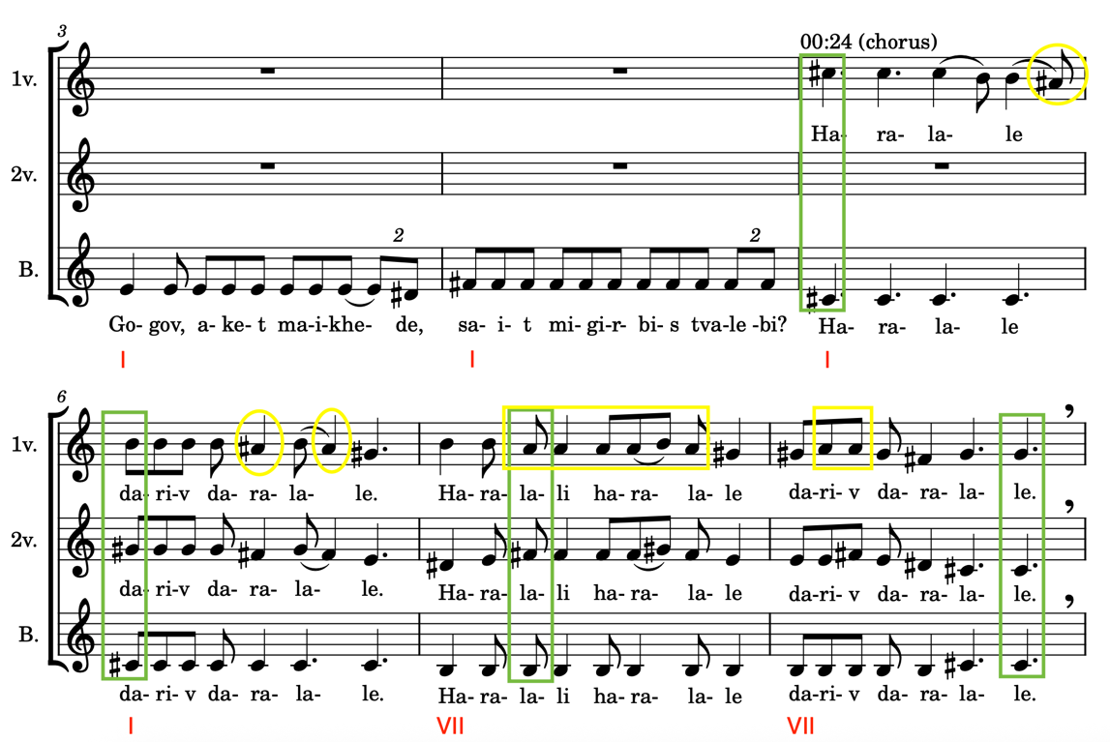
Figure 2.2 Excerpt from my transcription of ‘Kakhuri’ by Trio Mandili.
Reaching for the lyrics of the song as the next step not only helps us understand the lyrics, but also provides the basis for further mapping (lyrics in Georgian in Appendix B, and in English in Appendix C). While Georgian traditional song titles usually include two components—the region where the song originates from, but more importantly, its social function—Trio Mandili’s video is simply titled ‘Kakhuri’, literally translated as Kakhetian. The vagueness of the title—initially leaving us to guess the function of the song from one of the country’s most musically developed regions—is clarified upon closer consideration of the lyrics. The song presents a dialogue between a boy interested in a girl who makes fun of her admirer by pointing out his big nose and jokingly explaining she could not care less about his existence. Based on the story, it is safe to classify the piece falling into the genre of ‘humorous’ songs, often coming from the shairi tradition, where singers improvise in a joking manner.
The mood established by the original lyrics is certainly not mirrored in Gana’s text, which shifts between reflections on the struggles of his rap career and his love life. In one of the lines, the producer makes a reference to the culture he samples from by including the word ‘madloba’ (Georgian for ‘thank you’) (Gana 2024d, 00:28). Aside from this element, what makes Gana’s lyrics particularly interesting is the vocal line that appears twice, referencing ‘motion[ing] out in Georgia’ at 00:59 and 2:10. While this appears to be another allusion to the country of Georgia, the mention of the ‘north side’ in the following line raises doubt, given that locals typically divide the country into western and eastern regions. Considering Gana’s place of residence, it is more likely that the ‘Georgia’ in his lyrics refers to the U.S. state rather than the country. This may be interpreted as a form of wordplay, in which Gana invites listeners to interpret according to their own preferences and levels of familiarity.

Mapping and Speculating
Following macro- and microperceptive analysis of both ‘Worldwide’ and ‘Kakhuri’, the structuring stage begins, progressively developing into a final map of Gana’s track. The first mapping (apart from the earlier transcription, which may also be considered a map) starts by focusing on the way Gana chops and loops the sample in time. This is practically visualised by two maps in parallel—the first one showing the original ‘Kakhuri’ lyrics colour coded according to separate parts Gana samples (2.3, Appendix B), and the second one demonstrating the way the chopped parts of ‘Kakhuri’ are structured in time in the context of ‘Worldwide’ (Figure 2.4, Appendix D). This second map then includes the timestamps of the track and offers a way of sectioning certain events in groups according to their repetitions. Visualising the things on the first map titled ‘old lyrics’ and transforming them into the ‘new lyrics’ on the second map using various colours and highlights not only illustrates how Gana reproduces the sample’s verbal text but also represents the full sonic event behind each of these verbal signs.
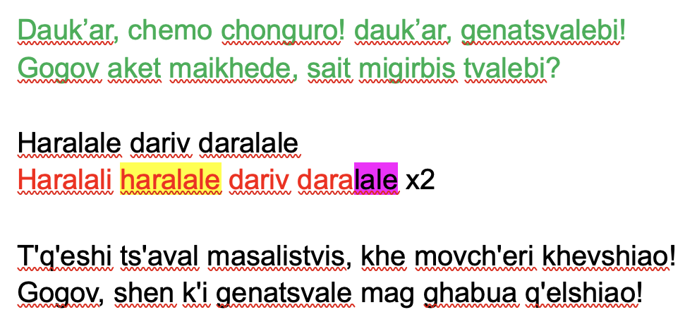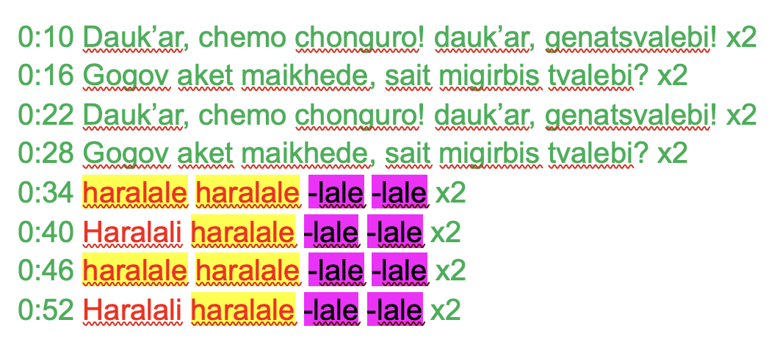
Figure 2.3 The first two verses of ‘Kakhuri’ with the chorus. Figure 2.4 Fragments of looped ‘Kakhuri’ in ‘Worldwide’.
Having completed the mapping of ‘Kakhuri’s’ new lyrics, I shift my focus to ‘Worldwide’, where I place timestamps every fourth or second line to better understand how they function as Gana’s background sample. This is best visible on the final map (Figure 2.5, Appendix E), where the new lyrics are merged with Gana’s lyrics. The final map shows how the beginnings of verses from the new lyrics match with Gana’s lyrics in his rap parts, but not in the vocal parts (Gana 2024d, 00:58 and 2:10). There, the new lyrics part seems to be ahead by one or two seconds than Gana’s verses. This mismatch is indicated on the map by yellow highlights corresponding to relevant timestamps. The new lyric parts are then placed in the middle of their respective verses. It may be speculated that the misalignment of the layers stems from Gana’s improvisatory approach to the vocal part, which, unlike the stable rap lines mostly in triplets, does not strictly follow the beat but instead flows more freely (Figure 2.6).
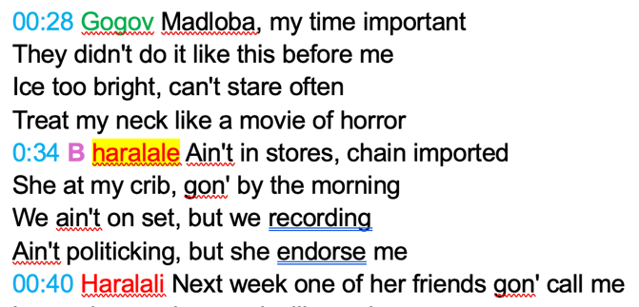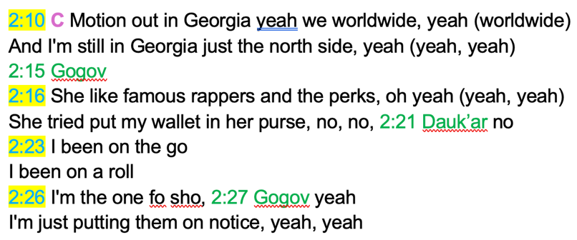
Figure 2.5 Excerpt from the merged map of ‘Worldwide’ . Figure 2.6 Misaligned layers on the merged map of ‘Worldwide’.
Apart from the structuring of the new lyrics with Gana’s lyrics, the final part also includes the bass layer providing ‘Worldwide’ its harmonic foundation with a consistent rhythmic pattern. Transcribing the bass layer into a staff system helps recognise four different patterns (figure 2.7). The combinations of these patterns are grouped under A, B and C and assigned a purple colour on the map (Figure 2.8). After including the bass layer in the map, it becomes clear that it closely follows the chopped segments of the Georgian song—raised both in speed and pitch in the sampling process—rather than Gana’s rap layer. And even though the sample and Gana’s bass layers go hand in hand, in terms of the track’s harmonic foundation, the bass layer dominates the sample layer starting on the sixth degree on C, gradually working its way up to the central tone E. Additionally, while ‘Kakhuri’ shifts between two modes, ‘Worldwide’—as suggested by its vocal line (Gana 2024d, 00:58 and 2:10)—remains within E Dorian, featuring a stable C as its VI degree and preserving the major second interval between the VII and I scale degrees. Overall, Gana’s track may appear simple in terms of its harmonic and melodic material, yet it nonetheless offers complexity through the richness of its layered sonic events.
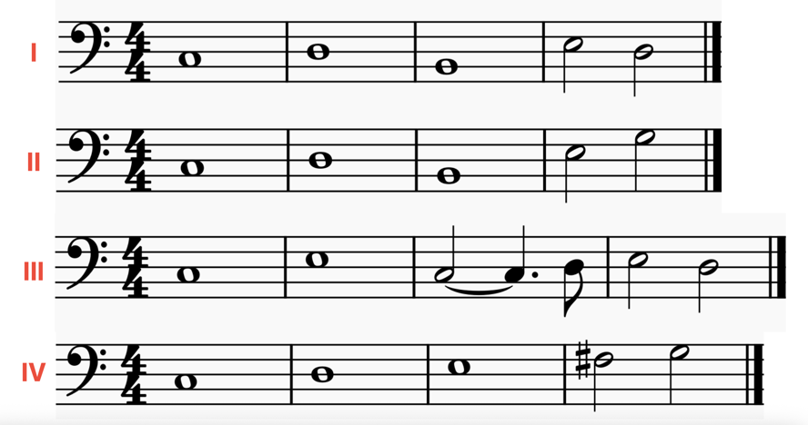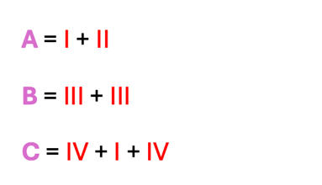
Figure 2.7 Transcription of four bass layer patterns. Figure 2.8 Bass layer pattern combinations.

Conclusion
Having listened to the source of the sample a few times during my analysis of ‘Worldwide’, due to my cultural and educational background, I found that I had to make a conscious effort to listen to the other layers in Gana’s track instead of only following the sample. This let me observe how difficult it is to listen to multiple layers at the same time and how inevitable it is to create an unconscious hierarchy of musical things, or sonic events. If, for me, ‘Worldwide’ clearly exemplifies a blending of musics, as I have aimed to demonstrate through my final map, I wonder to what extent it remains simply a hip-hop track to an unfamiliar ear, even after reading my analysis. By the means of visualisation and colour coding, the final map treats layers, such as the new lyrics and Gana’s lyrics, with equal importance, allowing the listener to follow either, according to their preference.
Through my linguistic and cultural familiarity, I offer an interpretation of the track from a ‘local’ perspective. While this provides a basis for observing the socio-political implications of Gana’s use of Georgian music, it is my academic knowledge of this music that supports my microperceptive analysis. Due to my high level of familiarity with the music, I may have a hard time ‘unhearing’ the sample and end up inevitably ranking it as the number one sonic event of this track. While a biased perspective might seem disadvantageous or even unprofessional, it can also enable me to offer an interpretation unlikely to emerge from an analyst with limited familiarity with the sample. This way, I invite an unfamiliar listener to allow this layer to appear in their own conscious or unconscious ranking of musical perceptions.
Not only does this chapter describe and explain the processes accompanying familiar music structuring, but it also shows the way the three steps of analysis—investigating, mapping, speculating—interact. Roughly dividing the analysis into macro- and microperceptive discussions proved a more flexible understanding of the three steps. While mapping was practically applied during the microperceptive analysis, the examination of ‘Worldwide’ revealed how both the investigative and mapping stages inherently invite speculation, highlighting the simultaneity of these analytical procedures.

Layering Music, Layering History: Slovak ‘Karička’ in Gana’s ‘She Don’t Mean It’

In January 2024, Kolo Gana published a reel on his social media platforms sampling music from the Central European country of Slovakia (Gana 2024a). The video went viral among Slovak audiences, gaining attention from various news outlets and securing Gana interviews with local media. The reel’s success on Instagram and Tik-Tok motivated Gana to create a full version of the track, which led him to release the song under the title ‘She Don’t Mean It’, alongside an instrumental version (Gana 2024b, 2024c). The track eventually landed on Gana’s album What It Means to See It All (Expanded Edition), and as I mentioned earlier, it also popped up on my screen, marking my first encounter with the artist. Not only did this result in my first attempt to analyse hip-hop music, but although I grew up hearing it, it was also my first time analysing Slovak traditional music. One year later after my first encounter with the track, I am revisiting and reanalysing ‘She Don’t Mean It’, which, apart from being comparable to my other two case studies in terms of differing levels of familiarity, also allows reflections on analysis—in Agawu’s (2004, 270) terms—as an ongoing process.
Therefore, in this chapter, I aim to explore how my cultural but non-academic familiarity with this type of music influences the interpretation and the process of analysis of Gana’s piece. Starting the investigation by concentrating on the source of the sample itself determines two directions of analysis. The first one views ‘Karička’ which Gana samples, as a representation of historical layering, demonstrating how sampling adds another layer to music production and dissemination, following forms such as ethnomusicological field recordings, CD releases, and YouTube videos. This part of the investigation emerges through the motivation to orient myself in the repertoire and the ways it has been historically presented. Researching the music’s adaptability to technological change, this part of the analysis examines the background and origins of the track ‘Karička’, which is credited to ĽH Samka Smetanu (Folk Music by Samko Smetana) and sampled by Kolo Gana over twenty years later (DokuDoki 2015).
The second analytical path, less concerned with the sample’s history, focuses instead on its musical structuring within the hip-hop context. By concentrating on ‘She Don't Mean It’, this analysis examines the ‘Karička’ track’s role as one of the foundational layers of the hip-hop track. This comprises a micro- and macroperceptional analysis that revolves around the compositional changes the initial sample recording underwent through digital editing and the layering of additional elements, ultimately reflecting the originality of Gana’s style in the final track.

From Field Recording to Revival
In his short video posted on January 15, 2024, Gana starts with his usual introduction modified to a specific country: ‘If you want to make a great rap beat, sample music from Slovakia. I’m telling you, watch’ (Gana 2024a). The clip reached over 2.5 million views on Instagram and 1.1 million views on Tik-Tok, surpassing Gana’s usual audience number. Similarly to the introductory reel for the sampling of Trio Mandili’s ‘Kakhuri’, Gana breaks down the composition process in four steps, the first one being ‘Recording the sample straight from YouTube’ including the video title; and the second one called ‘Chop & Loop’, where he marks the key of the sample as C sharp minor and the BPM as 188. The third and fourth steps provide the ‘full beat’ and ‘bars’ (Gana 2024a).
My investigation of ‘She Don’t Mean It’ starts by asking: what exactly does Gana sample? Too curious to find out what attracted the producer to Slovak music, my analysis, similarly to the previous case study in Chapter 2, begins by reaching for the source of the sample. After his viral video, when asked about his relation to Slovakia in an interview with a local radio station, Gana states that he found the country by searching through a map for a new music source for his next sampling project (Imrichová 2024). He came across a YouTube video uploaded by a channel named DokuDoki (2015). In its caption, this video, published in October 2015, provides a full title of the CD and bilingual titles for three of the songs combined in the dance track ‘Karička’: ‘[1] Hey Dvorianky, Such A Village – [2] Hey, Boyfriend Of Mine – [3] Wait For Me, Dear Girl’ (DokuDoki 2015).
While finding a YouTube reference is not a difficulty, tracing the origins of the previous layer—the CD titled Svet ľudových tancov I. (World of Folk Dances I.), from which Gana sourced the original piece for his music—proves to be more challenging. Apart from minimal online information available, a source discussing the CD is Barbara Rose Lange’s (2018, 75-96) chapter on Slovak folk revival, which provides crucial details regarding its creation and background. Lange describes the changing and conflicting relationship between institutionalisation and the ‘revival’ of ‘authentic’ folk culture. The urge to overcome the phenomenon of scenic folklore, also referred to as ‘folklorism’, was evident in Slovakia during the nineties, aligning with similar initiatives seen internationally (Lange 2018, 76). That being said, some forms of Slovak scenic folklore have not been overthrown and to this day serve to represent the culture of the country. Nevertheless, during the past three decades, multiple bands opposing the idea of scenic folklore tied to the period of communism have been formed. Lange refers to these musicians as ‘revivalists’ who rejected the ‘Soviet style’ folklore and preferred to represent the culture in an ‘authentic’ manner based on their education and family backgrounds (86).
The two CDs titled Svet ľudových tancov I. and II. produced under contract in 2001 were a result of a collaborative project between SĽUK (Slovak Folk Art Ensemble), a state institution established in 1949, and future members of the group Banda, including the violinist, Samko Smetana. As Lange (2018, 90) states, ‘Varga recruited Samo Smetana to put together music for the dances that he wanted to teach. The project had many contradictions, but it also provided the impetus for Banda to polish some village styles and then move toward world-music fusion’. The main purpose behind their creation was educational, serving as dance practice CDs, which also determined minimal effort in marketing and promotion strategies. Ultimately, the project combined musicians with different artistic aspirations: future Banda members known as ‘revivalists’, scenic folklore musicians, as well as singers from the countryside (90). The complexity of the project and the number of parties involved raises questions regarding copyright. As Lange states, ‘ĽH Samka Smetanu (Folk Music by Samo Smetana) is the group with the main performer credit, but on these CDs, it is a fluid set of players’ (Lange 2018, 90).
While we might not be able to acquire more detailed information on the compensation and copyright issues of these recordings, it also becomes important to question the origins of the songs presented through them. The dance ‘Karička’, sampled by Kolo Gana, belongs to the first CD, a compilation of dances from the regions of Šariš, Spiš and Zemplín. Due to the practical aim behind the CDs serving as music for dance classes, rather than offering a listening experience, the names of individual tracks often refer to a dance genre instead of a name of a concrete folk song. This is also true of the track labelled as ‘Karička’, a round dance performed by women, made up of three parts: ‘Ej, Dvorianky, to valal’, ‘Ej, frajir muj, frajir muj’ and ‘Počekaj me dzifče’. In a recent interview with Samo Smetana, he clarifies that this particular track, which originated from a village Dvorianky in Zemplín region, was sung by a group of girls from Bratislava, the capital of the country, accompanied by Smetana’s group (Smeláková 2024).
One more factor worth considering when it comes to the process of ‘revival’ of Slovak folk music by musicians such as Banda members is their process of tracing sources they perceive as original and authentic. As Lange writes, one of the band members, Alžbeta Lukáčová, ‘saw Svet ľudových tancov as an experiment in which Banda’s musicians had been trying to play like the 1950s Slovak Radio field recordings’ (Lange 2018, 93). What further explains this statement is the fact that the above-mentioned musician, Samo Smetana, was an employee of the Slovak Radio in Bratislava, where he ‘had unusual access to the collection of archival recordings there’ (Lange 2018, 78). After the formation of the band Banda in 2003 as an experimental world music group, their music creation process, although fully acoustic, was based on arranging musical information derived ‘from their own family backgrounds, as well as from the Slovak Radio field recordings (…). They often chose just a melody and discarded the text, or did the reverse’ (Lange 2018, 94). In this way, Lange clarifies the process and circumstances that enabled Banda to engage with the process of ‘revival’.
And while finding the authors and performers of recordings produced as a result of ethnomusicological fieldwork requires archival research, it is evident that they served as a source of inspiration for the two CDs from 2001, including the ‘Karička’ track from Svet ľudových tancov I., later sampled by Gana. Although this historical deep dive may seem irrelevant to the analysis of the track ‘She Don’t Mean It’, as someone who views Slovak traditional music as representative of one of my cultures but also lacks basic information on its production processes, I find it crucial to familiarise myself with how the ‘Karička’ track comes to be before attempting to verbalise my microperceptive analysis of the music.

The Part with Chopping & Looping
But how exactly does Gana use the ‘Karička’ track? The examination of the journey the ‘Karička’ from Dvorianky made until it was found by the producer leads to a more focused micro- and macroperceptive analysis of both the original source on its own, as well as Gana’s sampled version. The investigation, mapping and speculation are based on my first analysis of these two pieces one year ago, as well as my listening experiences of a wider Slovak repertoire throughout the months, inspired by the first analysis of ‘Karička’ and ‘She Don’t Mean It’.
As mentioned above, the original ‘Karička’ track recorded by Smetana combines three songs performed by a vocal-instrumental ensemble. According to Radochová (2016, 34), different versions of ‘Karička’ were traditionally danced and sung by women during social events, such as weddings, without instrumental accompaniment. In this case, with the future members of the group Banda arranging the piece for the CD, this particular ‘Karička’ features a background ensemble consisting of string instruments such as violin, viola, and double bass, along with what appears to sound like the regionally traditional cimbal. While it is difficult to separate the cimbal from the double bass during the majority of the piece, the sound is clearly hearable twice during the third section of the recording (DokuDoki 2015, 3:13 and 3:57).
At first glance, the transition between the three songs of the dance is seamless, however, further musical and textual analysis clearly highlights the individuality of the three different parts. These are numbered on the first map based on the lyrics of the three songs (map 1 in Appendix F, English translation of the lyrics in Appendix G). The first song, ‘Ej, Dvorianky, to valal’, is sung by a girl, who seems to have a love interest in the Dvorianky village but ultimately does not find a match in any neighbouring places. It consists of three verses, with the violin and viola parts acting as solo instruments intermittently throughout the song. After the second verse, a short modulation from the subdominant key of E minor is introduced in the instrumental part (Gana 2024b, 2024c, 1:03), with the third verse returning to the tonic key of B minor (1:31). This return, however, turns out to be short, as after the third verse, the harmony shifts to the key of E minor as a new tonic for the full duration of the second song, ‘Ej, frajir muj, frajir muj’ (2:03).
The second song presents a three-verse dialogue between lovers. Compared to the two neighbouring songs, the verses in this one contain three lines instead of four, further proving the songs’ independent nature. The third song, ‘Počekaj me dzifče’, speaks about a broken promise from a lover to a girl (3:13). The song comprises two verses in the initial key of B minor. While each song consists of its own melodic and rhythmic material, the consistency in simple meter and fast tempo, as well as the compatibility of the harmonic progressions, contribute to the unity and continuous character of the full dance piece.
Analysing this piece for the second time after a few-month break, results in two things: it allows me to critically reassess my initial perceptions of the recording through the first mapping, while also enabling me to focus on nuances I had previously overlooked. One such element is the doubling of the voices throughout the three ‘Karička’ sections, which, having just analysed the previous case study on Georgian polyphony, I immediately recognised as a significant detail worth including on the map. The sharp and defined timbre of the main vocalists, and the accompanying ensemble, along with what was likely a differing distance between the singers and the microphone, made it difficult to exactly distinguish the two-voiced parts. Listening to the recording with the intention of identifying the two-voiced parts, I found myself questioning the reliability of my perceptions. At times, I wondered whether the faintly audible second voice in the background was truly present or merely an invention of my own imagination. Despite this, the instances where a second voice—usually at the interval of a third—is audible are marked on the map in bold letters.
This first map aims to visualise the temporal development of the ‘Karička’ track, including its harmonic progressions and the interactions between vocalists and key instrumental parts. However, the most important element for the analysis of Gana’s ‘She Don’t Mean It’ is the set of lyrics he chooses to use, highlighted in yellow (figure 3.1). The lyrics highlighted in yellow, although chopped in ways that depart from the original, serve as the foundation of the producer’s track. Gana uses the audio of ‘Karička’ published as a YouTube video, as original material for sampling. According to his description of the creative process, he digitally edits the audio in computer software, the results of which appear in the instrumental version uploaded on his platforms. The editing process involves changes in the harmony and additional rhythmic and harmonic layers. To understand this in more detail, we first need to shift the focus to Gana’s sample looping and examine the yellow parts of the original audio he chooses to extract.
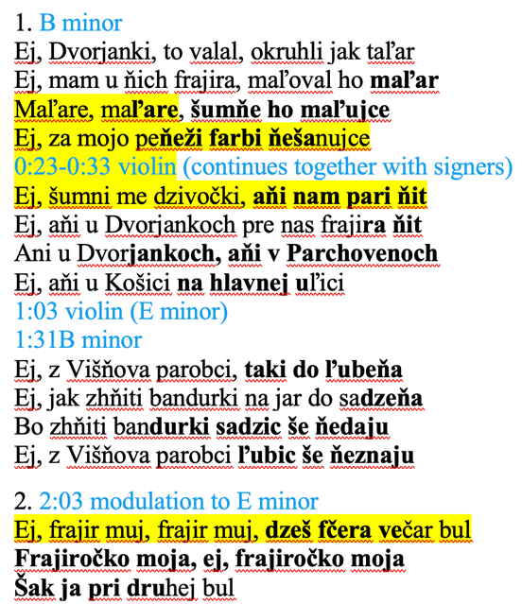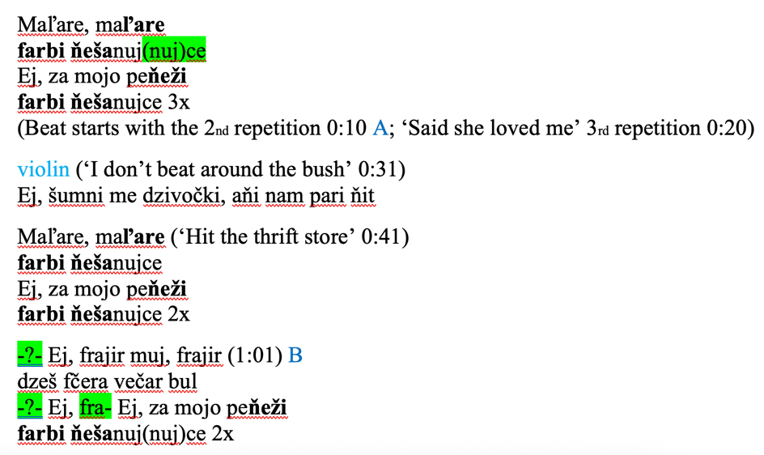
Figure 3.1 Beginning of Map 1. Figure 3.2 Beginning of Map 2.
As it turns out, Gana’s version of ‘Karička’ uses only three and a half out of thirty lines of the original lyrics. The producer reorders some of the half-lines from the first verse of ‘Ej, Dvorianky, to valal’ to create a base for his track. He further includes a line from the second verse of the same song together with its solo violin part, as well as the first line of the second song ‘Ej, frajir muj, frajir muj’. Creating a second map by ordering these lines helps us understand better the way Gana creates his track’s foundation (Appendix H). Therefore, the second map, outlining Gana’s ‘She Don’t Mean It’, visualises the piece based on its sampling of the Slovak dance music (figure 3.2). Due to Gana’s sampling, which is based on sound rather than a linguistic or meaning-based perception of ‘Karička’, he not only reorganises the lyrics in a unique way but also segments some words so that they become unidentifiable within the original text. These parts, which appear only sporadically, are highlighted in green on the second map.
While Gana puts an emphasis on lyric repetition, instead of diversity, as a result of chopping, his newly formed pattern mixes different phrases in Slovak with extracted individual syllables. Despite the distorted meaning that this approach produces, the original lyrics and their ordering become insignificant in Gana’s final version of the song, where they provide a background to his rap part, which then determines both the meaning and the form of the new song.
Moreover, the producer shifts the key to C sharp minor, excluding previously hearable modulations. Together with the first repetition of his chopped and looped ‘Karička’ verse (0:10), he introduces a beat, which is shortly followed by a newly recorded rap part (figure 3.2). Gana’s original lyrics, provided in the caption of his YouTube video, consist of two repeating verses (‘Said she loved me’ and ‘I don’t beat around the bush’) and two individual middle verses (Gana 2024b). His rap, including several colloquial expressions, is written in a contemporary casual English language style, which is a significant contrast to the previous lyrics in a Slovak dialect. While, similarly to the original Slovak songs, the rapper refers to a love interest, he puts more emphasis on the theme of success and ambition. This is further confirmed by the line ‘now I’m poppin tags, I’m Bratislava known’, referring to his short video’s fame among Slovak audience.
While the instrumental part of Gana’s song becomes harmonically unchallenged, he supports the original ensemble with an additional bass sample stabilising the present key. This is achieved through the frequent repetition of the tonic note C sharp in the bass layer, which aligns with the steady background tonic line in crotchets found in the original source of the sample. From this perspective, the bass line in ‘She Don’t Mean It’, which mostly alternates between the upper and lower tonic and the dominant, is somewhat more mobile than that of the original sample. To gain a better understanding of this element and how it supports the rest of the musical material, I provide a transcription of the layer, accompanied by timestamps indicating the exact moments of repetition and change between the two consistent patterns, labelled A and B (figure 3.3, 3.4). The written-out timestamps not only show the way the two patterns interact, but clarify the first pattern’s (A) dominance over the second one (B).
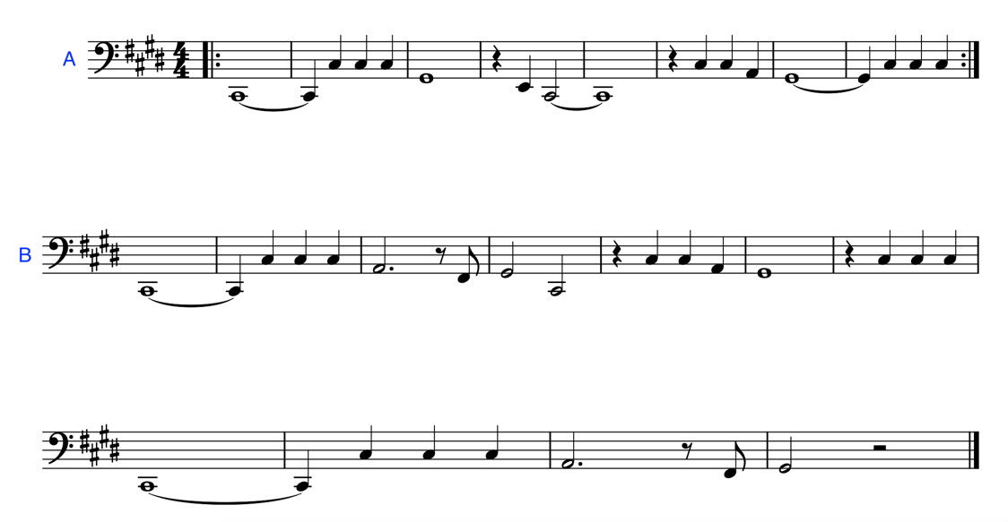
Figure 3.3 Two bass layer patterns.
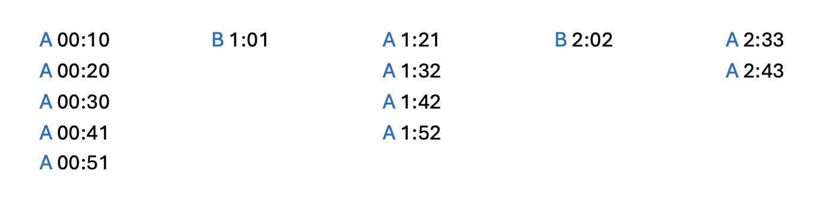
Figure 3.4 Bass layer in ‘She Don’t Mean It’.
Additionally, this layer is represented on the second map, where pattern B reappears alongside the line sampled from the second section of ‘Karička’. Meanwhile, pattern A, of which only the first loop is marked each time it reappears (at 00:10, 1:21 and 2:33), accompanies the rest of the recording. Gana appears to link the bass layer to the sample, similarly to the approach taken in the previously discussed ‘Worldwide’ (Gana 2024d). In practice, this means that it is the rap layer that is adjusted to fit the bass layer accompanying the sample, rather than the bass being adapted to the rap. Although it is the transcription and mapping that visualises this aspect of the track, this corelation of the layers may already be assumed through the introductory reel, where ‘bars’—that is, the rap layer—are only added after the full beat is ready (Gana 2024a).

Conclusion
The analysis of Gana’s ‘She Don’t Mean It’ took me on two different paths. One of them, led by the motivation to find out more about the music I instinctively identify with. This historical research on the source of the sample used by Gana not only highlighted the role of technology in the way Slovak traditional music has been recorded and disseminated over the years, but also underlined the political implications causing the ‘revival’ wave in the country. While Gana sampled ‘Karička’ from a YouTube video he randomly found online after randomly picking a country to sample from, my historical and cultural analysis of the source aimed to reveal the complexity of the journey that the three combined songs from Eastern Slovakia undertook before appearing in a hip-hop track.
The second part of my analysis moves away from historical analysis triggered by the initial macroperceptive listening and seeks to analyse both ‘Karička’ and ‘She Don’t Mean It’. Although concentrating on Gana’s track, looking back at the maps I started creating one year ago, the primary focus of the analysis remains to be the ‘Karička’ piece recorded by ĽH Samka Smetanu and serving as the starting point for mapping the overall hip-hop track. While the historical search in the first part of the chapter may have been influenced by the attempt to fill in the gaps in my familiarity with Slovak traditional repertoire, it is due to my cultural familiarity that ‘Karička’ became the dominant musical thing perceived in Gana’s ‘She Don’t Mean It’. Thus, a similar experience to the previously analysed ‘Worldwide’ track—where paying attention to layers other than the sample became a challenge—demonstrates how easily familiar musics take over my instincts and determine the perception of Gana’s music.
From a group of Slovak villagers, songs in ‘Karička’ travelled in the form of an ethnomusicological field recording, a staged performance on a CD recording, a freely accessible YouTube video, and back into the online world through a Nigerian artist’s home studio. Ultimately, this long journey reveals that not only does the analysis of Gana’s ‘She Don’t Mean It’ highlight the complexity of traditional music’s role in the contemporary context of musicking, but the reanalysis of this music after a year-long break also justifies understanding analysis as a continuous process.

Same Weapon, Different Bullets: Fela Kuti and Africa 70’s ‘Water No Get Enemy’ in Gana’s ‘Infinity Bars III’

Having analysed Gana’s two tracks sampling music familiar to me, for the third case study, I went through the producer’s reels looking for an unfamiliar example. At first, I thought I would pick a track, which gained Gana the most views on social media. Some of these were either missing the rap layer, only offering an instrumental version of the full track, or they sampled music that did not feel unfamiliar enough. Thanks to my supervisor asking if Gana has ever reached for music from his home country, I landed on his 2024 track ‘Infinity Bars III’ (Gana 2024e), sampling the Nigerian musician Fela Kuti’s (1938-1997) ‘Water No Get Enemy’ (1975, 2016).
In this final chapter of the thesis, I explore in what ways may unfamiliar music be approached. Focusing on two artists sharing a home country who view music as a weapon, I first analyse their tracks individually, then examine their relationship and the way they come together in Gana’s sampled track. Additionally, what makes this analysis particularly interesting is the awareness that, in this case, it can be assumed that Gana approaches the sample with a high level of familiarity, whereas my analysis begins from a position of cultural and academic unfamiliarity. Inevitably, during the analysis, I question what makes Nigerian music sound Nigerian, and whether that is apparent in both Kuti’s and Gana’s music. As a result, my analysis of ‘Infinity Bars III’ and ‘Water No Get Enemy’ is guided by intuition and grounded in my general knowledge of music and analysis on the one hand, and in a process of navigating my own perception-based assumptions on the other.
Additionally, during this analysis I explore the philosophies guiding both Kuti and Gana’s understanding of music as a weapon. Ultimately, while both Nigerian musicians create music grounded in a belief in its transformative power, I argue that the kind of power it embodies differs significantly between the two, carrying a strong political message for Kuti, and a more personal one for Gana. These speculations are based on both a macroperceptive analysis of their individual tracks—including commentary from All About Jazz editor Chris May in the ‘Water No Get Enemy’ YouTube video—and historical and cultural analysis supported by documentaries and existing research on Kuti as the inventor of Afrobeat (Kuti 2016).

‘Infinity Bars III’ For the First Time
Kolo Gana’s ‘Infinity Bars III’ is a track released on December 4, 2024, as part of his album What It Means to See It All (Expanded Edition). In the introductory reel, Gana encourages viewers to ‘sample legendary music from Nigeria, referencing a YouTube video titled ‘Fela Kuti - Water No Get Enemy’ (Gana 2024f). Given Gana’s Nigerian background, his choice and use of Nigerian music is particularly intriguing for music analysis. While he often includes brief references to the cultures or languages of the countries he samples from, when it comes to music from his home country, there is an expectation that these references might be more meaningful than in other cases.
Using the privilege of not knowing the source of the sample, my analysis starts with Gana’s final track. The first and the second time listening to the track are enough to gain basic understanding of the music before engaging with the procedure of close listening and mapping of the aural perceptions. The first listening allows for the registering of the initial microperceptions. The most distinct sound is a keyboard in low register providing the harmonic background for the whole track alongside—what seems to be—a lively, high-register piano sample. This is accompanied by an acoustic drum sound, and after the introduction, a full drum set alongside Gana’s rap layer. An obvious element of the track is a big band sound, interchanged with solo saxophone episodes.
Apart from the microperceptions, the first listening offers more insight into possible cultural underpinnings of the track. Most importantly, in the introduction, we hear what appears to be an interview excerpt between a woman and a man speaking English with African accents. The woman asks the man about his sources of inspiration, to which he replies: ‘the environment. The world of an artist is the environment. And it is not for entertainment. It is for listening and thinking’ (Gana 2024e, 0:08 – 0:21).
After the first listening experience, initial questions about the track arise. The most obvious being—the determining of what is sampled and what is not. It is inevitable to avoid making assumptions and speculations about this before reaching for the source of the sample referenced by Gana in his reel. My assumptions on which sounds come from foreign sources and which ones are created by Gana are based on the expectations connected to hip-hop music, as well as the familiarity with previously analysed Gana’s repertoire. The elements that appear to be sampled are the drum, heard in conjunction with the piano, and the saxophone and big-band sounds. While the drum set, joining after the introduction, seems to be a key part of any hip-hop track, the percussion instrument apparent from the beginning of the ‘Infinity Bars III’ has an acoustic, conga like sound. In other words, it sounds too ‘ethnic’ to be part of the usual hip-hop drum set.
The second question posed after the first listening of the track refers to the relation between the rap layer and the instrumentation, and the way they both contribute to the structuring of the music. This question arises because of the apparent absence of longer rests in Gana’s rap part. Whether the rap part can be divided into sections, or if the music comes to be time-framed through the changes and layering within the instrumental part, is an inquiry guiding not only the second listening experience, but also the rest of the analysis.
The second listening includes shifting the attention to the lyrics of the rap part. What stands out in Gana’s text are his religious references to figures such as Jesus Christ, God and devil. Apart from quoting the bible, ‘Infinity Bars III’ lyrics revolve around themes common for rap songs. Gana speaks about women, money problems and his rap career, but he also includes topics such as the AI, war and premature labour. These first impressions of the rap part allow for time signature confirmation of 4/4 and Gana’s flow executed predominantly in semiquavers. While his rap, as already mentioned, sounds continuous and leaves no room for pauses or section markers, it gives no indication of where the music is in time. The fact that without the background layers or an understanding of the lyrics it would be difficult to tell whether the song is at the beginning, middle, or end, hints at the meaning of the song’s title.
While the ‘Infinity’ part of this song is clarified through the unending rap flow, it must be noted that this particular track is the third one of its kind, preceded by ‘Infinity Bars’ (Gana 2021b) and ‘Infinity Bars II’ (Gana 2021c) where Gana’s rap continues without significant breaks. The lyrics of all three track somewhat relate to global issues, some referencing the COVID pandemic, others political conflicts and the rise of artificial intelligence. Nevertheless, in all of them Gana also addresses his music career and romantic relationships, which show to be reoccurring themes in his repertoire. Musically, the three ‘Infinity’ tracks share a time signature, similar tempo, as well as saxophone solo sounds in the background. While ‘Infinity Bars III’ seem to be a continuation of a certain hip-hop style Gana incorporates into his repertoire, the cultural and musical connection to the country of Nigeria appears to be exclusive only to the last version of the track.
To gain a clearer understanding of the track and the layering of its elements, I propose mapping out the sonic events in relation to their timing, based on close listening after the first two hearings (Appendix I). This procedure consists of listing, colour coding and visually layering the aural elements of the song including: the low register piano (LP1, LP2), high register piano (HP), the acoustic drum sample (AD), the electronic drum set (ED), the big band sound (BB), the orchestral sound (O), the solo saxophone sounds (S1, S2), the rap layer (R) and an interview recording (figure 4.1). This analytical process allows for observations in relation to the elements and their interaction through layering. Although the rap part is characterised by the absence of rests, and therefore not actively participating in the sectioning of the song, making all background elements visible on the map contributes to opening a discussion on the structuring, and overall form of the track.
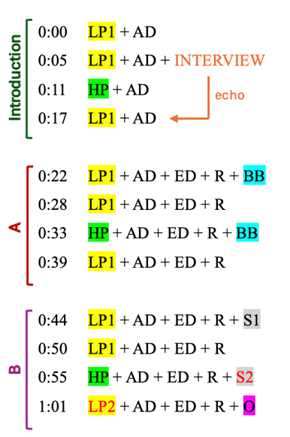
Figure 4.1 Beginning of Map 1 – ‘Infinity Bars III’ For the First Time.
The layout of the track comprises of sheer and coloured elements. The sheer elements, including the acoustic drum, electronic drum set, and the rap layer do not have an assigned colour due to their continuous presence throughout the track (for the ED and R excluding the introduction and the outro parts). The colour coded visualisation of the rest of the elements makes the understanding of their interchangeability and repetition accessible more quickly. The map, serving as a type of a score, makes it apparent that the song, comprises of the introduction, the outro, as well as two equal parts, indicated as A and B, and their four-time repetition. While the coupling of the two repetitive parts may be seen as too simple and lacking originality, they appear to be sufficiently capturing the listener’s attention throughout Gana’s rap part—as the background sounds to the song’s primary layer.
While this analysis, based on close listening and the acknowledgement of both micro- and macroperceptions, allows for speculation on the musical features of the ‘Infinity Bars III’, as well as on the characteristics of Gana’s compositional style, the issue about its cultural meaning remains. Being aware of Gana’s reference in the introductory reel to music originating from Nigeria, following questions arise: What is Nigerian about this music? What does Nigerian music sound like? How can we distinguish ‘Nigerianness’ in this song? Considering my unfamiliarity with Nigerian music and culture, the only way to identify sounds originating from this country is to point out all the elements that do sound familiar. That is, grounding the preliminary analysis in perceptions of familiar sounds, instead of seeking out the unfamiliar. However, finishing the first overall analysis of the track, the only elements standing out as unfamiliar appear to be the interview recording in the introduction part, and possibly the acoustic drum sound (AD). Therefore, at this point of the analysis, the questions articulated above stay unanswered and require engagement with the source of the sample.

Fela Kuti and ‘Water No Got Enemy’
The process of familiarising myself with the source of the sample—Fela Kuti (2016) and Africa 70’s ‘Water No Get Enemy’—starts by looking up the video referenced by Gana (2024f) in his reel. It is then guided primarily by its extra-musical elements before conducting more detailed analysis of the piece. It is approached with the goal of learning about the source both musically and culturally in order to relate it to Gana’s track and ultimately gain a better understanding of it. The research and analysis of the sample source consists of going through primary sources, such as other songs by the same artist, magazine articles, available video materials including documentary films, as well as academic research.
The video Gana used for his track was published online by the artist’s official YouTube channel on January fifteenth, 2016. The description directs the listener to the original source—LP Expensive Shit—released in 1999, while dating the song to 1975. Considering that the track is eleven minutes long, out of which the first 5 minutes and 36 seconds are mainly instrumental before the vocals join in, the images and commentary appearing on the screen compete with the musical element of the video for the viewer’s direct attention. As referenced in the description, the video is part of a series of songs on the channel featuring a historical commentary, that is, an informative text by the senior editor of the All About Jazz platform, Chris May.
The YouTube video and May’s commentary introduces the track ‘Water No Get Enemy’ and the circumstances of its composition and release. It explains the meaning behind the title of the song—a Yoruba proverb emphasising the power of nature (in Kuti 2016, 1:15)—a statement, which Kuti subscribes to and promotes. According to Chris May (2:19), Kuti connects the symbiosis between nature and humans to Nigerian political environment implying its victory in case the government decides to follow the statement voiced in the proverb. The video also provides context for the album Expensive Shit, presenting it as an expression of resistance against Nigerian authorities, who repeatedly assaulted, arrested, and accused the musician of various crimes, even raiding and setting his residence, the Kalakuta Republic, on fire and throwing him and his mother out of a window.
While the video offers a glimpse into Kuti and the character of his music, publications across various fields—such as African studies, literary criticism, linguistics, communication and musicology—provide a more detailed analysis of his work and its cultural context. For example, Meghan Langley (2010) examines Kuti as a human rights activist through the lens of African idealism; in Research in African Literatures, Tejumola Olaniyan (2001, 85), discusses Kuti’s nativism, its roots and its place in postcolonial cultural production and as his ‘quest for authentic subjectivity’. For the American Studies journal, musicologist Alexander Stewart (2013, 100), describes Kuti’s life journey as a ‘transformation from British-trained Nigerian jazz trumpeter to black-nationalist countercultural dissident icon’. According to Stewart’s belief, Kuti’s road to securing the role of the father of Afrobeat was determined by Africa’s postcolonial music market’s need for a new type of popular music, which would appeal to all social and ethnic representatives and promote an African identity (101).
Comparing Kuti’s musicianship to James Brown’s, Stewart (2013, 102) explains the former’s educational background mentioning his studies at Trinity College. The author constructs a comprehensive image of Kuti by highlighting key biographical events—such as his trip to the US, his ideological shift from nationalism to Pan-Africanism and blackism, reflected in the evolution of his band’s names from the Koola Lobitos to Nigeria 70, Africa 70, and finally Egypt 80—as well as his aspiration to become the Black President and an African messiah (113–15). Despite Kuti’s political wishes and visions of a better future in Africa, he remains a controversial figure—a hero for some and a misogynist for others, as discussed by Adebukunola Oluwayemisi Babalola (2018).
Shifting focus from the philosophical underpinnings of Kuti’s work to its musical features, Stewart (2013, 114) defines Afrobeat as a mixture of at least three genres: highlife, including its Latin and Caribbean influences, funk, and most importantly—jazz. Fela’s Afrobeat relies on several key elements, including Yoruba chants and vocal dialogues between the soloist and the choir; trumpet and saxophone solos; two distinct guitar parts; rhythmic patterns and percussion instrument choices influenced by Caribbean and traditional West African music, such as congas, along with a Funk-inspired duplet subdivision of the beat; and the absence of tonal shifts and advanced chord progressions, with harmonies drawing inspiration from modal jazz (104–12). Other instruments commonly used by Kuti and characterising Afrobeat include a jazz organ, claves, shekere and maracas.
Most of these elements, if not all, are present in the song ‘Water No Get Enemy’, later sampled by Gana. By examining the song closely, its constant alteration between solo (jazz organ, saxophone, vocal part) and collective parts (wind instruments, choir) proves to be another crucial feature of Kuti’s music. The scheme, which maps out the parts consists of four collective motives marked as W, X, Y and Z, out of which X appears to be the main building block—continuously returning, while also serving as improvisatory material for saxophone and vocal solos (figure 4.2 and 4.3). The piece remains in the key of E flat Dorian throughout it. The lyrics of the song are written in Pidgin English—a mixture of English and indigenous languages—which Kuti, enabling him to reach a wider audience, came to prefer over ‘educated English’ or Yoruba (Stewart 2013, 112; Olaniyan 2001, 81).
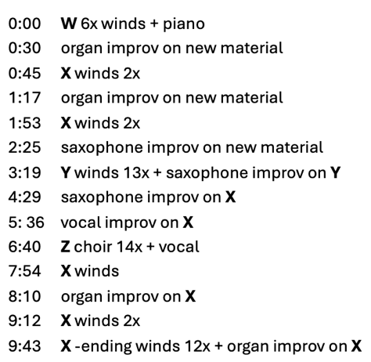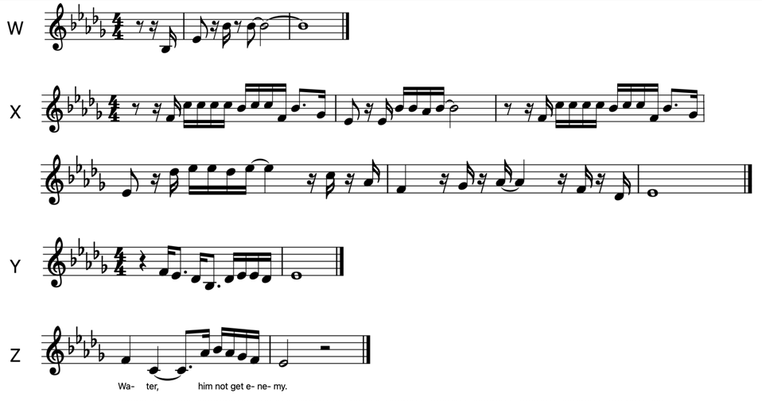
Figure 4.3 Transcription of the patterns W, X, Y and Z.
Figure 4.2 ‘Water No Get Enemy’ scheme.
My analysis of ‘Water No Get Enemy’ begun with a more extensive exploration of Fela Kuti as a historical and cultural figure within his socio-political context. My unfamiliarity with his music, combined with the awareness of shared cultural heritage between Gana and Kuti, caused the urge to fill in the gap in my knowledge to be able to further reexamine the placement of this song in ‘Infinity Bars III’, both in musical and extra-musical terms. While my analysis of ‘Water No Get Enemy’ focuses on a partial and unexhaustive mapping of my micro-perceptions, the briefness of this procedure is explained by the map’s aim to serve as a reference for identifying Gana’s use of this song.

‘Infinity Bars III’ For the Second Time
The second part of this chapter ended with a few unanswered questions asking what exactly made Kolo Gana’s ‘Infinity Bars III’ sound Nigerian. In this part, I try to answer this question by revisiting the track and analysing it again by identifying parts sampled from Fela Kuti’s ‘Water No Get Enemy’. A second analysis of Gana’s track not only invites a reassessment of how we perceive certain sonic elements, but also opens the door to a more culturally oriented discussion of the two artists’ approaches to composition and its purpose.
Already in 2001—only four years after Fela’s death—Olaniyan (2001, 77) speaks about ‘one-dimensional appropriations’ and ‘opportunistic compilations designed to cash in on the renewed popular interest in the musician since his death’. Until today Kuti’s music continues to be sampled by musicians, such as Fatboy Slim, The Roots, Coldplay, Beyoncé and Jay-Z. For Kolo Gana, Kuti is the only Nigerian artist he has sampled and included in his album. As already mentioned in previous chapters, Gana’s primary reason for advertising his sampling practises in connection to certain nations is to gain an audience who will get attracted to a track due to their perception of a familiar sound they identify as culturally ‘theirs’. While this tactic sometimes results in Gana receiving several hundred thousand—or even millions—of views on his reels, it seems to have failed in the case of sampling Kuti’s music: the introductory reel reached only 57,000 views on Instagram and did not appear to gain special attention among Nigerian viewers. In the previous two chapters, I have speculated on the local viewers’ reactions to Gana sampling ‘Kakhuri’ and ‘Karička’. Does the relatively low view count on the sampling of ‘Water No Get Enemy’ reflect Nigerian audience not finding Kuti as representational of their country? Or perhaps, Nigerians are less patriotic than Slovaks and Georgians, and therefore do not simply care for being mentioned online? Despite familiarising myself with the music of Gana and Kuti and acquiring some academic insight into the origins of Afrobeat, my cultural understanding of Nigerian audiences remains limited, leaving me unable to addressing some of the questions raised.
While social media view-count does not necessarily offer an accurate reflection of certain societies, we may still speculate on why a Nigerian artist referencing another Nigerian artist does not receive as much engagement on his work, as when he references music from countries he himself is unfamiliar with. In his article, Stewart (2013, 104) sheds light on Kuti’s invention of the term Afrobeat and the musician’s intention to capture an African sound. As mentioned earlier, Kuti’s political and philosophical ideas of Pan-Africanism led him to change the band name from referencing his country name to the name of the whole continent, thus emphasising the aim to spread his voice to the whole Africa, as opposed to local Nigerian communities. Therefore, although only a hypothesis, Gana’s success with ‘Infinity Bars III’ may have depended more on demographics drawn to the Afrobeat genre and the idea of Pan-Africanism, rather than on Nigerian communities finding their voices online—as was the case with Slovak and Georgian viewers discussed in previous two chapters.
Having gained some knowledge on Kuti’s music, at this point of research, returning to Gana’s track for the second time allows for further re-examination of musical perceptions and a reflection on their effect on the previously constructed map (Appendix J). The way Gana captures Kuti’s sound in his track is by sampling, what appear to be, three short excerpts from ‘Water No Get Enemy’ (figure 4.4). The first one is the very first motive of the piece dominated by saxophones and trumpets previously marked as W on the second map, and as the Big Band sound BB in the initial ‘Infinity Bars III’ map (figure 4.5). The other two samples are identified as the two saxophone solo parts in Gana’s B sections, where the first one (S1) comes from an excerpt from Kuti’s first saxophone improvisation part marked as SI (Gana 2024e, 2:44-2:48); and the second one (S2) originating from Kuti’s Y section (3:19-3:24). Although Gana uses only a few seconds of Kuti and Africa 70’s music, he nevertheless manages to reproduce their characteristic sound in a recognisable way.
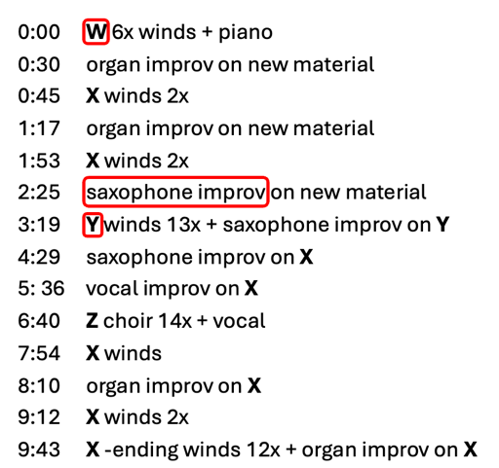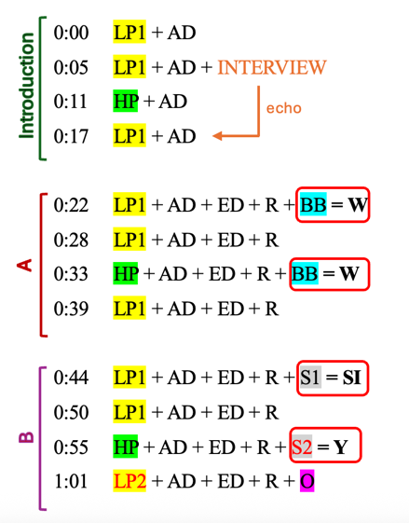
Figure 4.4 ‘Water No Get Enemy’ with Gana’s sampled parts in red.
Figure 4.5 Beginning of Map 2 – ‘Infinity Bars III’ For the Second Time.
As for the other elements of ‘Infinity Bars III’, a direct reference to Fela appears in the introduction part in form of the interview; this does not originate from the sampled song but from a different, as yet unidentified, source. Interestingly, while Gana does not sample any organ sounds from Kuti, the piano plays a significant role in his track, providing a harmonic foundation (moving from the subtonic to tonic in LP1, and staying on the dominant in HP). In this regard, both Gana’s and Kuti’s tracks remain within the chosen key and are characterised by harmonic simplicity.
Additionally, regarding the previously discussed role of what sound like congas (AD) in Gana’s track: although Africa 70 consistently featured this instrument, ‘Water No Get Enemy’ —with its dense layering of percussion and guitars used mainly as background voices—does not appear to contain a distinct conga episode that could have served as an obvious sample. While it is difficult to determine with certainty, it is more likely that the conga-like sounds in Gana’s track do not originate from Kuti’s music. Nonetheless, through their inclusion, Gana makes a clear reference to the culture he seeks to represent in the track.
While Gana introduces his sample as Nigerian and attempts to connect to this culture in various ways, it is the only one out of my three case studies, in which the link cannot be made through the vocal parts and the lyrics of the source song. It is worth considering whether the decision to omit the vocal parts of ‘Water No Get Enemy’ was driven purely by musical choices, or whether the use of Pidgin English in the original song, which could conflict with Gana’s English rap, played a role. While Kuti’s lyrics are more repetitive and centred on the song’s main message, Gana’s lyrics, by contrast, address a range of themes, mostly personal but also socially oriented. Moreover, although somewhat out of context, Gana directly addresses his sample source in the lyrics, stating: ‘But we keep it gracious, tryna be one with nature, Water no get enemy, Fela’s greatest statement’ (Gana 2024e). Whether in this way Gana does justice to Kuti’s political message embedded in his song remains debatable.
However, whether Gana shares Kuti’s worldview remains an open question—one that may help explain the differences in the messages their respective pieces carry. A few points need to be considered in relation to this—the first one being the obvious historical difference between the times the two publish their work. Another important factor is that although Kuti received his education in UK and the US tour had a massive impact on his life, he spent most of his life in Nigeria, while Gana grew up moving around the world as a child before settling down in the US. According to Kuti, the mistake Americans made in Africa was to bring arms, Western knowledge and, Christianity and divide African people as a result (Flori and Tchalgadjieff 1982, 48:35). Although he grew up Christian, he decided to turn to Africa spirituality, which would better suit his African origins. This approach seems in opposition to Gana’s repetitive religious and Christian implications in ‘Infinity Bars III’, as well as his other work.
Finally, and most importantly, the biggest similarity, as well as difference is Gana’s and Kuti’s understanding of music. In a documentary interview from 1982, Kuti states that musicianship is given by the higher forces, and it must be used for the good of humanity. He believed that by ‘using it for your own self by deceiving people […], you will die young’ (Flori and Tchalgadjieff 1982, 25:10). He famously declared that music ‘is the weapon of the future’, which he used to spread his political messages and unite African people as a result (Flori and Tchalgadjieff 1982, 51:19). This attitude helps explain the conversation included in the introduction of ‘Infinity Bars III’, in which Kuti rejects the idea of music as entertainment and instead frames it strictly as a vehicle for political change.
Similarly, Gana has been comparing music to a weapon even before the sampling of Kuti’s music. However, the weapon he speaks about seems to have a drastically different purpose. In a video documenting the creation of his first album (including the first ‘Infinity Bars’) published by Gana on his channel in 2021, he speaks about ‘[his] journey of self-discovery, a journey of manifesting desires, all through music, what [he] believe[s] to be one of the world’s most powerful weapons for good’ (Gana 2021a, 13:15). Gana describes music to be an individualistic, therapeutic and celestial experience serving as a gateway from the burdens of everyday life, which he intends on sharing with a similarly minded audience. And while his lyrics often describe the negative aspects and experiences of life, his music does not provoke or call for change, instead, it aims to be relatable—a means of personal expression and emotional release. Therefore, the didactic and informational aspect of Fela’s music does not coincide with Gana’s attitude towards musical composition and performance.

Conclusion
Structuring Gana’s music where the sample he uses is unfamiliar to me, proves to be a thought-provoking analytical experience. While in the previous two chapters where my analysis always started by examining the source of the music Gana sampled, not knowing Fela Kuti and Africa 70’s music determined the fact that my analysis opened by investigating Gana’s ‘Infinity Bars III’. Analysing this track on micro- and macroperceptive levels included detailed attention to the layers present in the song, without having one of them dominate my perception of the complete track. In contrast to the previous two case studies, my mapping of ‘Infinity Bars III’ relied entirely on the timestamped layers of the track and their combinations, without incorporating any material from the lyrics. Revisiting the first map created upon the first analysis of Gana’s track after having analysed Kuti’s ‘Water No Get Enemy’, allowed identifying parts sampled by the producer and linking them to previously marked perceptions, resulting in an alternative map of ‘Infinity Bars III’.
Reflecting on the intuitional way I approached the structuring of Gana’s track, which samples music unfamiliar to me, it may be assumed that I began the analysis by reaching for what did feel familiar in this scenario—Gana’s music. As I closely analysed the producer’s two tracks, as shown in previous two chapters, and became more familiar with his broader work during the research process, Gana’s compositional choices—as well as his layering and combination of layers—became increasingly perceptible over time. Therefore, approaching ‘Infinity Bars III’ was already shaped by my prior analytical and non-analytical encounters with the artist’s music. Considering this, I find that my general approach to analysis is unconsciously guided by a tendency to start by seeking out the familiar in music.
While my perspectives on the way Gana’s sampling of Kuti was received are limited by my cultural unfamiliarity, this analytical experience broadened my awareness of a new musical repertoire—especially the Afrobeat genre—while allowing me to remain productive in my research and deliver a thorough analysis of Gana’s music. Additionally, analysing ‘Infinity Bars III’ twice, with the analysis of ‘Water No Get Enemy’ in between, inevitably leads me to again recognise the process of analysis as an ongoing, potentially never-ending activity.

Conclusions

I began the introduction to this thesis by discussing how music-analytical procedures are often shaped by specific musicological subdisciplines or areas of specialisation. I grounded this argument in both scholarly accounts—such as Allan Moore’s (2003) reflections on early academic encounters with popular music—and in my own personal feelings of disorientation when first analysing Georgian chants. This has led me to question contemporary understanding of analysis as an activity aimed at gaining knowledge of music, while orienting my research around the nature in which subjectivity, personal experiences and academic backgrounds affect the way we approach the activity.
Choosing to focus my research on the music of Atlanta-based Nigerian producer Kolo Gana allowed me to identify three forms of (un)familiarity and to demonstrate how each one influences my analysis of his sampled tracks. In Chapter 2. I demonstrated not only how my high level of familiarity with Georgian music and culture prompted a separate analysis of Trio Mandili’s ‘Kakhuri,’ but also how this familiarity shaped my interpretation of Gana’s ‘Worldwide,’ which samples that song. In Chapter 3. I showed the way my cultural, but non-academic familiarity with Slovak music guided how I heard and structured the producer’s track ‘She Don’t Mean It’ sampling the dance recording ‘Karička’ by ĽH Samka Smetanu. Finally, in Chapter 4. I aimed to describe how my unfamiliarity with Fela Kuti, Africa 70, and Afrobeat determined the way I learnt about, verbalised and visualised my perceptions of Gana’s ‘Infinity Bars III’.
While my research on familiarity as an analytical pre-requisite was modest in size, gaining deeper insight into how familiarity shapes analytical procedures would require a larger-scale project capable of revealing broader patterns among a more diverse range of analysts/researchers/listeners. Having experienced the process of analysis three times—each initiated by active listening to Gana’s music and an awareness of my varying levels of familiarity with the repertoire he samples—I now draw my conclusions. These not only aim to answer the research question posed in the early stages of the project, but also offer findings that were not anticipated, and suggest possible directions for future research.

Analysis and Analyses Intertwined
My analysis of Gana’s music, which I have been referring to as the process of (un)familiar structuring, has been underpinned by analytical approaches discussed in the first chapter of the thesis. Understanding analysis as a continuous, creative process of structuring music in time according to our perceptions—both based on sensory, as well as culturally and socially oriented experiences—I have decided to follow David Lewin’s (2006) attitude by rejecting the notion of ‘incorrect’ analysis. Moreover, in my analysis, informed by Lewin and aware of the impossibility of fully avoiding hierarchies, I addressed this issue by explicitly acknowledging the sonic events I prioritise and by tracing the roots of my perceptions of them. Building on this perspective and seeking an analytical approach that avoids discrediting the full range of musical and extra-musical perceptions that inevitably shape listening, while remaining adaptable to any kind of music, I turned to Judith Lochhead’s (2016) three-step guide to analysis: investigating, mapping, and speculating.
And although Lochhead (2016) describes these three steps as separate, yet mutually informative notions, in my analysis of the three case studies, I have found speculation to be an inevitable process accompanying both the investigative and mapping stages. Therefore, in practice, interpretations were built up in parallel to the first two steps of analysis. In retrospect, I relate this to Agawu’s (2004) idea of analysis as a form of performance, one that privileges the oral over the written. Viewing written analysis as merely descriptive—and incapable of fully capturing the performative and creative nature of the analytical act—may explain why speculation is inherent to analysis from the beginning, even if it only becomes formalised as the final step in written form.
Additionally, an unexpected outcome of my three analyses has been the way they informed one another, letting me observe how analysis of specific pieces benefits from our interest in other musical materials. I came to realise, by accident, that certain mysterious or overlooked aspects of the pieces I was analysing often remained unresolved until my intense focus on the track in question had passed. This may be noticed in Chapter 2. with the search for the source of the announcement in Georgian that Gana started his track ‘Worldwide’ with. It was only while searching for a third case study and listening to other tracks on Gana’s latest album—long after I had given up tracing that announcement both online and offline—that I realised it must have been made by the producer specifically for ‘Worldwide’. Moreover, it was through the analysis of Georgian polyphony in the same chapter that I was able to revisit and update my analysis of ‘Karička’ in Chapter 3., by drawing attention to the voice doubling the main vocal line. While these are more explicit ways in which my work on the three case studies complemented one another, the analyses were also intertwined in more subtle ways, often prompting me to revisit and mark certain details I had initially overlooked.
While the tendency to revisit analysis described above already shows analysis as a continuous process, all three of my case studies have hinted at the concept of ongoing analysis. The obvious example of continued analysis is shown through the discussion of Gana’s ‘She Don’t Mean It’, which inspired this project one year ago. The revisiting of this track alongside the source of its sample led to an additional layering of my microperceptions, specifically, the doubled voice in ‘Karička’, and the bass layer in ‘She Don’t Mean It’. Although this case study involved revisiting familiar material after a longer break, during my first encounter with Gana’s ‘Infinity Bars III’ and Kuti’s ‘Water No Get Enemy’, the notion of ongoing analysis, or what Agawu (2004, 275) calls the ‘reinvention of the wheel’, is apparent right away. Here, having familiarised myself with Kuti’s music after the first analysis of Gana’s track, all three stages of analysis are shortly repeated, providing a new layer of information as shown through the second map of ‘Infinity Bars III’.
In this way, this constant reinterpretation of music and recomposition of previous analyses is a result of a growing level of familiarity. We may further speculate that with each newly acquired piece of musical or extra-musical knowledge, we enter a new stage of analysis—one that allows us to perceive previously analysed pieces in new ways.

Methodology Rediscussed
Although Lochhead’s (2016) guide functions as a methodological framework in my analysis, it is complemented by specific methods tailored to support the investigation, mapping, and speculation of both the sampled material and Gana’s original production. These modes of analysis are not selected in advance but are instead shaped by the need to express, verbalise, and formalise my perceptions in response to each individual example. As demonstrated in Chapters 2, 3, and 4, my mapping procedures are heavily dependent on colour coding and verbal cues that correspond to specific aural experiences. While the maps in the first two case studies—where the discussion begins with an analysis of the sources Gana samples—rely on the lyrics of those pieces, the maps in the final chapter consist entirely of signs with respective meanings. Here, this difference in mapping strategies stems not only from my intuitive tendency to approach Gana’s tracks through music familiar to me, but also by the fact that, in the final case study, the material he samples from ‘Water No Get Enemy’ is fully instrumental and contains no lyrics.
As described in the first chapter, the decision to use colour coding as a way of representing individual sonic events is a spontaneous result of mapping my perceptions. Even though this analytical method remains untheorised at this stage of my project, its significance as a visualisation tool—both in music-related research and other disciplines—suggests that grounding it more firmly as a mapping strategy would be a valuable future endeavour.
Alongside colour coding, I have used transcriptions in Western-style notation to make clear distinctions of certain layers. These transcriptions serve as a descriptive tool and, unlike colour coding, may not be as accessible considering not every reader may be familiar with this notation style. Nevertheless, they are used to represent certain parts of the analysed music to communicate more effectively with readers who do share my music-educational background. While both colour coding and transcription are used to visualise my perception-based understanding of the analysed music, incorporating these tools directly into the text proves the most effective way to communicate with the reader—allowing for quicker reference and reducing abstraction in verbal descriptions. Nevertheless, verbal explanations remain essential for the reader’s comprehension of the maps.

Analysis as a Reflection of (In)effective Dialogue with the Next Generation
In 1982, Tagg (40) speaks of music as a form of communication between humans. He insists popular music analysis starts to be taken seriously by explaining that the experiences of this music must be understood both emotionally, as well as intellectually. He also underlines the need for ‘being able to face pupils whose music outlook has been crippled by those who present ‘serious music’ as if it could never be ‘fun’ and ‘fun music’ as though it could never have any serious implications’ (Tagg 1982, 39). Therefore, Tagg is aware of the responsibility musicologists and music teachers have in enabling students to understand and think about music they encounter on a daily basis—be it in a concert hall or in a supermarket. Instead of discriminating according to genre, style or class, Tagg highlights the importance of learning about music according to our experiences.
And although Tagg wrote his thoughts on musicologists’ responsibility to adapt with time more than forty years ago, the same argument resurfaces in recent discussions on the relevance of music analysis. In the collection of responses to Julian Horton’s 2020 article ‘On the Musicological Necessity of Music Analysis’, ten Anglo-American scholars pose thought-provoking questions and offer their opinions on the future of music analysis (2023). Consequently, two important counterarguments reappear throughout the collection. Although both speak about responsibility, some lean towards adopting a similar stance to Tagg’s, where the students’ wishes receive priority when learning how to analyse (Bhogal, Cavett, Zagorski-Thomas, Stobart); and others emphasise the responsibility ‘to the discipline’ itself (Horton 2023, 30), where grounding knowledge in Western music theory, perhaps due to its primary role in the field’s initial establishment, is a non-negotiable (Monchick).
Both of these groups of scholars wish to communicate with students and share their knowledge, but they differ in the ways they try to make the initial connection. The first group tries to open up to whatever repertoire might be unfamiliar to them but is well-known to their students, while the other group tries to connect by teaching whatever they are familiar with and perceive as the foundation of their musical comprehension before learning about students’ individual interests in music. Therefore, the starting point for teaching analysis happens to be familiarity, although whose familiarity should take priority remains arguable.
While approaching analysis through the concept of (un)familiarity requires a level of vulnerability that not everyone is comfortable expressing publicly or in the classroom, the recent discussions about analysis as a practice within educational institutions highlight the relevance of understanding how we learn about music through this lens. Although my research does not offer the kind of textbook proposed by Cavett (2023, 33), it provides an example of how approaching music analysis as a form of perception-structuring can serve as an effective method for analysing and communicating about music, whether familiar or unfamiliar. Most importantly, my research centred on developing the skill to analyse any music, a skill I wish had been part of my own music education, aims to serve as a type of recommendation within academic environments concerned with music pedagogy.

From Mother Tongues to Adoptive Tongues
Finally, I revisit the question of analytical competence. As Agawu (2004) argued for professionalism and ‘fluency’ in the repertoire analysed, while Lewin (2006) deliberately welcomed the exploration of ‘incorrect’ perceptions, I have adopted the notion of familiarity as the anchor for each analysis, aiming to demonstrate that unfamiliarity does not necessarily imply incompetence. Living in a reality where musics continuously blend into one another makes it impossible for music scholars to be familiar with all repertoires, even at a surface level. My goal with this analysis was not simply to show that unfamiliar music can be approached (something ethnomusicologists have successfully done for many years), but to highlight that such analysis can also take place beyond the context of specialisation. Gaining the courage to overcome the obstacles and challenges posed by unfamiliar music is presented here as a skill—one that not only demonstrates the effectiveness of analysis as a learning method, but that can also be taught to promote a non-discriminative and open music scholarship, as advocated by Chua (2022).
Therefore, based on my belief and the short but valuable learning experience gained through this research project, I suggest that while musicology—as a broadly defined field encompassing all music scholarship—may appear to be ‘broken’ (Chua 2022, 117), it is repairable through approaches such as the one presented here. Over a decade ago, Stobart (2013, 116) observed that the reasons behind musical unfamiliarity pointed to political, economic and cultural issues, also finding unfamiliarity’s roots in ‘a lack of motivation to engage with [music], sometimes in turn reflecting the ascription of low or undesirable cultural values’. Taking this statement into consideration, whether the search for approaches that not only promote analysis but also strive for mutual understanding and curiosity becomes a widely accepted reality or remains an aspiration, depends on each scholar’s willingness to reflect on their own cultural values.

Bibliography
Literature
Adams, Kyle. 2015. ‘The Musical Analysis of Hip-Hop’. In The Cambridge Companion to Hip-Hop, edited by Justin A. Williams, 118–34. Cambridge University Press.
Agawu, Kofi. 2004. ‘How We Got out of Analysis, and How to Get Back in Again’. Music Analysis 23, no. 2–3 (July): 267–86. https://doi.org/10.1111/j.0262-5245.2004.00204.x.
———, Gurminder K. Bhogal, Esther Cavett, Jonathan Dunsby, Julian Horton, Alexandra Monchick, Ian Pace, Henry Stobart, and Simon Zagorski-Thomas. 2023. ‘Valuing the Surplus: Perspectives on Julian Horton’s Article “On the Musicological Necessity of Music Analysis”’. Musical Quarterly 3, no. i–ii: 62–104. In Music Analysis 42: 412–71. https://doi.org/10.1111/musa.12221.
Aslanishvili, Shalva. 2009. ‘Forms of Multipart Singing in Georgian Folk Songs’. In Echoes from Georgia: Seventeen Arguments on Georgian Polyphony, edited by Rusudan Tsurtsumia and Joseph Jordania. Nova Science Publishers.
Babalola, Adekunola Oluwayemisi. 2018. ‘Overlooking Misogyny: A Critical Examination of Fela Anikulapo-Kuti’s Music, Lifestyle and Legacy’. Master’s thesis, Texas A&M University-Corpus Christi.
Baily, John. 2008. ‘Ethnomusicology, Intermusability, and Performance Practice’. In The New (Ethno)musicologies, edited by Henry Stobart, 117–34. Scarecrow.
Bent, Ian D. 2001. ‘Analysis’. Edited by Anthony Pople. Oxford Music Online. https://doi.org/10.1093/gmo/9781561592630.article.41862.
Chang, Heewon. 2008. Autoethnography as Method. Left Coast Press.
Chua, Daniel K. L. 2022. ‘Global Musicology: A Keynote without a Key’. Acta Musicologica 94, no. 1: 109-126. https://muse.jhu.edu/article/857072.
Ewell, Philip. 2021 ‘Music Theory’s White Racial Frame’. Music Theory Spectrum 43, no. 2: 324-329.
Hesmondhalgh, David. 2006. ‘Digital Sampling and Cultural Inequality’. Social & Legal Studies 15 (1): 53–75. https://doi.org/10.1177/0964663906060973.
Hood, Mantle. 1960. ‘The Challenge of ‘Bi-Musicality’’. Ethnomusicology 4, no. 2: 55–59.
Ihde, Don. 1990. Technology and the Lifeworld. Indiana University Press.
Katz, Mark. 2010. Capturing Sound: How Technology Has Changed Music. Berkeley: University Of California Press.
Knight, Matthew E. 2019. ‘Folk Polyphony Goes Viral: Televised Singing Competitions and the Play of Authenticity in the Republic of Georgia’. MUSICultures 46, no. 1: 128–52.
Lange, Barbara Rose. 2018. Local Fusions: Folk Music Experiments in Central Europe at the Millennium. Oxford University Press.
Langley, Meghan. 2010. ‘PEACE PROFILE: Fela Kuti, An “African Man Original”’. Peace Review 22, no. 2: 199–204. https://doi.org/10.1080/10402651003751511.
Lewin, David. 2006. ‘Music Theory, Phenomenology, and Modes of Perception’. In Studies in Music with Text. Oxford Studies in Music Theory. Oxford Academic, online edition, 3 October 2011. https://doi-org.utrechtuniversity.idm.oclc.org/10.1093/acprof:oso/9780195182088.003.0004.
Lochhead, Judith. 2016. Reconceiving Structure in Contemporary Music: New Tools in Music Theory and Analysis. 1st ed. Routledge. https://doi.org/10.4324/9781315740744.
Lomsadze, Teona. 2019. ‘Contemporary Female Singer-Songwriters in the Context of the Georgian Folk Music Revival’. In Women’s Role in UNESCO-Recognized European Traditional Singing Practices, edited by Rusudan Tsurtsumia and Joseph Jordania. Nova Science Publishers.
Moore, Allan. 2003. ‘Introduction’. In Analyzing Popular Music, edited by Allan F. Moore, 1–12. Cambridge University Press. https://doi.org/10.1017/CBO9780511482014.002.
Olaniyan, Tejumola. 2001. ‘The Cosmopolitan Nativist: Fela Anikulapo-Kuti and the Antinomies of Postcolonial Modernity’. Research in African Literatures 32, no. 2 (Summer): 76–89. https://www.jstor.org/stable/3820905.
Radochová, Kristýna. 2016. ‘Folklorní soubor Dunajec a jeho vliv na hudební kulturu města Olomouce’. Bachelor’s thesis. https://theses.cz/id/6y8q4a/Bakal_sk_prce_-_Radochov.pdf.
Stewart, Alexander. 2013. ‘Make It Funky: Fela Kuti, James Brown and the Invention of Afrobeat’. American Studies 52, no. 4: 99–118. https://doi.org/10.1353/ams.2013.0124.
Stobart, Henry. 2013. ‘Unfamiliar Sounds? Approaches to Intercultural Interaction in the World’s Musics’. In Music and Familiarity, edited by Elaine King and Helen M. Prior, 109–36. Routledge.
Tagg, Philip. 1982. ‘Analysing Popular Music: Theory, Method and Practice’. Popular Music 2: 37–67. https://www.jstor.org/stable/852975.

Audiovisual Sources
DokuDoki. 2015. ‘ĽH Samka Smetanu - Karička (Slovak Folk Songs)’. October 23, YouTube video, 4:24. https://www.youtube.com/watch?v=5f0Iyde0BJA.
Flori, Jacques and Stephanie Tchalgadjieff, dir. 1982. Fela Kuti: Music Is The Weapon. France 2 (FR2), K.I.C.S., Ministère de la Culture. Prime Video.
Gana, Kolo. 2021a. ‘Kolo - MANIFESTED (Documentary)’. January 21, YouTube video, 20:15. https://www.youtube.com/watch?v=iDqLLu8mQ5I&t=795s.
———. 2021b. ‘Kolo - Infinity Bars (Official Video)’. January 27, YouTube video, 4:28. https://www.youtube.com/watch?v=PDP3jL2n6r8.
———. 2021c. ‘Kolo - Infinity Bars II (Video)’. December 23, YouTube video, 3:51. https://www.youtube.com/watch?v=QPjFDAKVHhw.
———. 2023a. ‘Abkhazia, thank you for the inspiration 🙏🏿🙏🏿’. February 27, TikTok video, 00:43. https://www.tiktok.com/@kolo.24/video/7204873804961647918.
———. 2023b. ‘The story of how I traveled the world through music’. September 27, Instagram video. https://www.instagram.com/p/CxtBxRgLhAY/.
———. 2024a. ‘Slovakia, thank you for the inspiration 🙏🏿🙏🏿🇸🇰🇸🇰’. January 15, Instagram video. https://www.instagram.com/p/C2IJk5trQIA/.
———. 2024b. ‘Kolo - She Don't Mean It (Official Audio)’. January 31, YouTube video, 2:47. https://www.youtube.com/watch?v=px25MxxnhOk.
———. 2024c. ‘She Don't Mean It (Instrumental)’. November 11, YouTube video, 2:47. https://www.youtube.com/watch?v=SkrozTXgsiA.
———. 2024d. ‘Kolo - Worldwide (Official Audio)’. December 4, YouTube video, 3:12. https://www.youtube.com/watch?v=N7ahykCKn3M.
———. 2024e. ‘Kolo - Infinity Bars III (Official Audio)’. December 4, YouTube video, 3:39. https://www.youtube.com/watch?v=vUyS2fcIoag.
———. 2024f. ‘Sampled legendary music from Nigeria to make this rap song on my new album 🇳🇬🇳🇬. Had to go home for this one. That bars on this >>>>>’. December 6, Instagram video. https://www.instagram.com/reel/DDPjZbYRM1K/?igsh=d2tuYjJ1aXVibnV3.
———. 2024g. ‘I sampled music from Georgia 🇬🇪🇬🇪. A banger was made 🔥🔥’. December 23, Instagram video. https://www.instagram.com/reel/DD7WaVLR2pH/?igsh=OTJvcDM4cmUxN3kx.
Imrichová, Andrea, host. 2024. ‘Keď chceš mať hit, ktorý všetci milujú, rapuj do slovenskej ľudovky ako tuto raper z Nigérie’. FUN RÁDIO Slovensko, February 19, Instagram video. https://www.instagram.com/jasomfunradio/reel/C3iTWJqNWMY/.
Kuti, Fela. 2016. ‘Fela Kuti - Water No Get Enemy’. January 15, YouTube video, 11:00. https://www.youtube.com/watch?v=kisTH3SFegc.
Robinson, Luke, host. 2023. ‘What It Takes To Be Great - Kolo Gana’. Amalgamation of Minds, episode #20. March 1, Podcast, 01:22:58. https://www.listennotes.com/podcasts/amalgamation-of/episode-20-what-it-takes-to-REIPcnu_Gz6/?srsltid=AfmBOooLSNcxVg3eZK9Gd8Ekhma1VGl_lN5zZ5BIN_Vb9YjNSgB8OBjD.
Trio Mandili. 2014. ‘Trio Mandili - Apareka’. September 9, YouTube video, 2:34. https://www.youtube.com/watch?v=IbsQJBxICN0.
———. 2021. ‘Trio Mandili - Kakhuri’. March 21, YouTube video, 2:01. https://www.youtube.com/watch?v=EDK9KOfknTw.

Internet Resources: News Articles and Social Media Posts
Gana, Kolo (@kolo.24). 2024h. ‘My new album, What It Means to See It All (Expanded Edition) is out now. My trip around the world led to my greatest creation yet. Incredibly proud of this project and so thankful for the many people that lead contributed. Please take a listen. You will not be disappointed 🙏🏿🙏🏿🚀🌎’. Instagram, December 4, 2024. https://www.instagram.com/p/DDKPR_eRoFl/?igsh=MXBtYWJtdml2bzc3aw%3D%3D.
Smeláková, Karin. 2024. ‘VIDEO: Nigérijský producent pretvoril slovenskú ľudovku do hip-hopu, Slováci šalejú’. Bratislavak, January 25. https://www.bratislavak.sk/clanky/994/video-nigerijsky-producent-pretvoril-slovensku-ludovku-do-hip-hopu-slovaci-saleju.
MusicRANg. 2021. ‘Trio Mandili - Kakhuri [Georgian folk]’. Reddit thread. https://www.reddit.com/r/Music/comments/meg0zw/comment/gsi128q/.

Appendices

Appendix A
Transcription of ‘Kakhuri’ by Trio Mandili
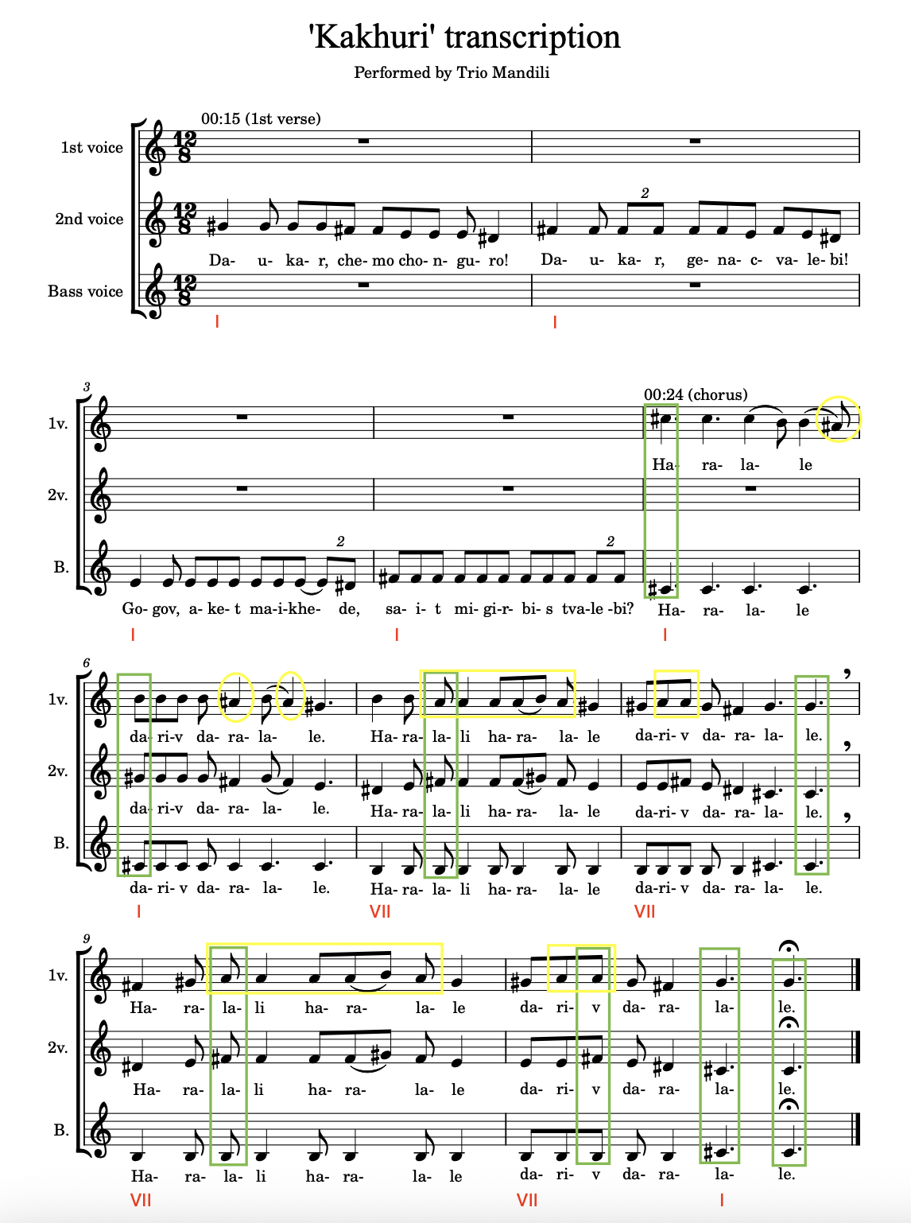

Appendix B
MAP 1 – OLD LYRICS

Panduri intro (centre – C sharp)
Dauk’ar, chemo chonguro! dauk’ar, genatsvalebi!
Gogov aket maikhede, sait migirbis tvalebi?
Haralale dariv daralale
Haralali haralale dariv daralale x2
T'q'eshi ts'aval masalistvis, khe movch'eri khevshiao!
Gogov, shen k'i genatsvale mag ghabua q'elshiao!
Haralale dariv daralale
Haralali haralale dariv daralale x2
Bich’o ras gadamek’ide ch’irata da lkhinatao?
Sheni tskhviri gamodgeba shakriani khidatao!
Haralale dariv daralale
Haralali haralale dariv daralale x2
Izarde mts’vane jejilo, dap’urdi, gakhdi q’anao!
Babuasheni rom mok’vda, rat’om ar ts’agiq’vanao?
Haralale dariv daralale
Haralali haralale dariv daralale x2
Haralale dariv daralale
Haralali haralale dariv daralale x2

Appendix C
‘Kakhuri’ Translation from Georgian to English

Girl: Play, my chonguri! Play, my dear!
Boy: Girl, look here, where do your eyes run?

Haralale dariv daralale
Haralali haralale dariv daralale x2 [glossolalia]

Girl: I go to the forest for materials, I cut the tree in a ravine,
Boy: Girl, I darling that jowl of yours!

Haralale dariv daralale
Haralali haralale dariv daralale x2 [glossolalia]

Girl: Boy why do you nag me in good times and bad,
Girl: Your nose could be good enough as a bridge in Shakriani!

Haralale dariv daralale
Haralali haralale dariv daralale x2 [glossolalia]

Girl: Grow green spikelet, feed, turn into a field!
Girl: When your grandmother died, why didn’t she take you?

Haralale dariv daralale
Haralali haralale dariv daralale x2 [glossolalia]

Haralale dariv daralale
Haralali haralale dariv daralale x2 [glossolalia]

Appendix D
MAP 2 – NEW LYRICS

0:04 Dauk’ar, chemo chonguro! dauk’ar, genatsvalebi! x2

0:10 Dauk’ar, chemo chonguro! dauk’ar, genatsvalebi! x2
0:16 Gogov aket maikhede, sait migirbis tvalebi? x2
0:22 Dauk’ar, chemo chonguro! dauk’ar, genatsvalebi! x2
0:28 Gogov aket maikhede, sait migirbis tvalebi? x2
0:34 haralale haralale -lale -lale x2
0:40 Haralali haralale -lale -lale x2
0:46 haralale haralale -lale -lale x2
0:52 Haralali haralale -lale -lale x2

0:58 Dauk’ar, chemo chonguro! dauk’ar, genatsvalebi! x2
1:04 Gogov aket maikhede, sait migirbis tvalebi? x2
1:10 Dauk’ar, chemo chonguro! dauk’ar, genatsvalebi! x2
1:16 Gogov aket maikhede, sait migirbis tvalebi? x2

1:22 Dauk’ar, chemo chonguro! dauk’ar, genatsvalebi! x2
1:28 Gogov aket maikhede, sait migirbis tvalebi? x2
1:34 Dauk’ar, chemo chonguro! dauk’ar, genatsvalebi! x2
1:40 Gogov aket maikhede, sait migirbis tvalebi? x2
1:46 haralale haralale -lale -lale x2
0:52 Haralali haralale -lale -lale x2
0:58 haralale haralale -lale -lale x2
2:04 Haralali haralale -lale -lale x2

2:09 Dauk’ar, chemo chonguro! dauk’ar, genatsvalebi! x2
2:15 Gogov aket maikhede, sait migirbis tvalebi? x2
2:21 Dauk’ar, chemo chonguro! dauk’ar, genatsvalebi! x2
2:27 Gogov aket maikhede, sait migirbis tvalebi? x2

2:33 Dauk’ar, chemo chonguro! dauk’ar, genatsvalebi! x2
2:39 Gogov aket maikhede, sait migirbis tvalebi? x2
2:45 Dauk’ar, chemo chonguro! dauk’ar, genatsvalebi! x2
2:51 Gogov aket maikhede, sait migirbis tvalebi? x2
2:57 Haralale dariv daralale
3:03 Haralali haralale dariv daralale x2 [T'q'eshi ts'aval masalistvis…]

Appendix E
MAP 4 – FINAL MAP

Cis-A
["მზად ხარ შეხვდე ოცნებას? ვფიქრობ ახლოვდება"
Are you ready to meet your dream? I think it's coming]
0:04 Dauk’ar

0:10 A Dauk’ar N****s tell me, I can do what you doing
If you could do it, why didn't you do it
Look at the map, you'll see my influence
Look at the stats, no stopping the movement
0:16 Gogov If it's a race then trust I'm a shoo-in
If they want smoke, I light up the cuban
We talking rap, these n****s ain't fluent
You don't write your shit, career in ruins
0:22 A Dauk’ar I love the pressure more than the glory
I love the pain more than the trophies
I made a mil' telling my story
I didn't miss out she wasn't for me
00:28 Gogov Madloba, my time important
They didn't do it like this before me
Ice too bright, can't stare often
Treat my neck like a movie of horror
0:34 B haralale Ain't in stores, chain imported
She at my crib, gon' by the morning
We ain't on set, but we recording
Ain't politicking, but she endorse me
00:40 Haralali Next week one of her friends gon' call me
Love when a plan, works like a charm
And they know they'll never be staying for long
When they wake up, they smelling the coffee
00:46 B haralale Making a killing 'til they off me
My ambition way too gaudy
Even my loft is way too lofty
Even my heart is way too haughty
00:52 Haralali Off these samples, labels calling
Shock with these flips like Jeff Hardy
Show 'em the steps, so they all watch me
Trying to copy, but they not me, uh

0:58 Dauk’ar [no bass sound]
00:59 Motion out in Georgia yeah we worldwide, yeah
And I'm still in Georgia just the north side, yeah
1:04 C Gogov She like famous rappers and the perks, oh yeah
She tried put my wallet in her purse, no, 1:10 Dauk’ar no, no
1:12 I been on the go
I been on a roll
1:14 I'm the one fo sho, 1:16 Gogov yeah
I'm just putting them on notice, yeah, yeah

1:22 A Dauk’ar They used to sleep on the team and the movement
They saw me pop, now they gon' rue it
Come back around cause your streams are not boomin'
You should have blown up, n***a you blew it
1:28 Gogov Rowland's like Kelly be loving my humor
Jennifer's showing me love like a Hewitt
Priyanka's love all the beats that I'm brewing
I don't got a type, she cute then I'm choosing
1:34 A Dauk’ar Music is spreading, quicker that's rumors
Out of this world, that's how they view me
Alien status, shout out to Future
Pay for my pen, I'll be your booster
1:40 Gogov All of my opps are in collusion
All of my brothers, move as a unit
She love me down, but it ain't mutual
Having a wifey simply ain't crucial
1:46 B haralale All I can do in this life is go harder
The alternatives tame like Impala
There's more in the chamber, revolvers
So many hits I need 10 day with Dodgers
1:52 Haralali The trauma he got make him light up
Fill up a bowl like he working at Cava
I told him our days gon' be brighter
Sun and my stock are in unison rising
1:58 B haralale The socials are boomin' and lively
My reach is starting to rival Verizon
I know that they shocked by my climbing
If you ask me, it's not really surprising
2:04 Haralali I studied the game to a science
They should have probably name me Macgyver
You rappers should quit with the trying
When you go quiet's when you excite us, 2:09 Dauk’ar n***a

2:10 C Motion out in Georgia yeah we worldwide, yeah (worldwide)
And I'm still in Georgia just the north side, yeah (yeah, yeah)
2:15 Gogov
2:16 She like famous rappers and the perks, oh yeah (yeah, yeah)
She tried put my wallet in her purse, no, no, 2:21 Dauk’ar no
2:23 I been on the go
I been on a roll
2:26 I'm the one fo sho, 2:27 Gogov yeah
I'm just putting them on notice, yeah, yeah

2:33 Dauk’ar
2:34 I IV I IV Motion out in Georgia yeah we worldwide, yeah
And I'm still in Georgia just the north side, yeah

2:39 Gogov
2:45 Dauk’ar
2:51 Gogov
2:57 Haralale dariv daralale
3:03 Haralali haralale dariv daralale x2 [T'q'eshi ts'aval masalistvis…]

Appendix F
MAP 1 – Analysis of ‘Karička’ by ĽH Samka Smetanu

1. B minor
Ej, Dvorjanki, to valal, okruhli jak taľar
Ej, mam u ňich frajira, maľoval ho maľar
Maľare, maľare, šumňe ho maľujce
Ej, za mojo peňeži farbi ňešanujce
0:23-0:33 violin (continues together with signers)
Ej, šumni me dzivočki, aňi nam pari ňit
Ej, aňi u Dvorjankoch pre nas frajira ňit
Ani u Dvorjankoch, aňi v Parchovenoch
Ej, aňi u Košici na hlavnej uľici
1:03 violin (E minor)
1:31B minor
Ej, z Višňova parobci, taki do ľubeňa
Ej, jak zhňiti bandurki na jar do sadzeňa
Bo zhňiti bandurki sadzic še ňedaju
Ej, z Višňova parobci ľubic še ňeznaju

2. 2:03 modulation to E minor
Ej, frajir muj, frajir muj, dzeš fčera večar bul
Frajiročko moja, ej, frajiročko moja
Šak ja pri druhej bul
2:19-2:27 violin
Ej, kec ši pri druhej bul, co ci povedala
Frajiročko moja, ej, frajiročko moja
Tebe ohvarjala
2:42-2:50 violin
Ej, tebe ohvarjala, že ši ňerobotna
Ľem či ši mojomu, ej, ľem či ši mojomu
Šerdečku prijomna

3. 3:13 modulation back to B minor, cimbal
Počekaj me dzifče na dvorjonskim mosce
Pošľem ci pišemko na ribovim chvosce
Ňejedna ribočka popot mostok prešla
Aľe aňi jedna pišemko ňeňesla
3:38 -3:43 violin
Ňesla ona, ňesla drobnu rozmariju
Už še rozejdzeme muj ľubi frajiru
3:57 cimbal
Rozmarija drobna, šidzem konarova
A osmi še zlamal, jak me frajir sklamal
Trimaj trimaj naj še ňeše, naj še na ňej sukeň treše Ujuju, ujuju

Appendix G
‘Karička’ English translation

1.
Hey, Dvorianky, it’s a village, round as a coin
Hey, my boyfriend is there, looking as if painted by a painter
Painters, painters, paint him well
Hey, do not save my money for the paint
Hey, pretty girls, there’s no one to match up to us
Hey, there is no boyfriend for us in Dvorianky
Not in Dvorianky, nor in Parchovany
Hey, not even on the main street of Košice
Hey, bachelors from Višňov are as lovable
Hey, as rotten potatoes for spring planting
Because rotten potatoes cannot be planted
Hey, bachelors from Višňov do not know how to love
2.
Hey, boyfriend of mine, boyfriend of mine, where were you yesterday
My girlfriend, hey, my girlfriend
Well, I was with another one
Hey, when you were with another one, what did she tell you
My girlfriend, hey, my girlfriend
She gossiped about you
Hey, she gossiped, that you don’t work
But you are so, hey, but you are so
Pleasant to my heart
3.
Wait for me girl on the bridge in Dvorianky
I will send you a letter on a fish’s tail
More than one fish passed under the bridge
But none of them brought a letter
It didn’t come, it brough little rosemary
We will already break up my lovely boyfriend
Little rosemary, with seven branches
And the eight broke, as my boyfriend disappointed me
Hold it hold it, let it be carried, let the skirt be shaken on it [Ujuju, ujuju]

Appendix H
MAP 2 – Analysis of Gana’s ‘She Don’t Mean It’

Maľare, maľare
farbi ňešanuj(nuj)ce
Ej, za mojo peňeži
farbi ňešanujce 3x
(Beat starts with the 2nd repetition 0:10 A; ‘Said she loved me’ 3rd repetition 0:20)
violin (‘I don’t beat around the bush’ 0:31)
Ej, šumni me dzivočki, aňi nam pari ňit
Maľare, maľare (‘Hit the thrift store’ 0:41)
farbi ňešanujce
Ej, za mojo peňeži
farbi ňešanujce 2x
-?- Ej, frajir muj, frajir (1:01) B
dzeš fčera večar bul
-?- Ej, fra- Ej, za mojo peňeži
farbi ňešanuj(nuj)ce 2x
Maľare, maľare (‘Said she loved me’ 1:21 A)
farbi ňešanujce
Ej, za mojo peňeži
farbi ňešanujce
violin (‘I don’t beat around the bush’ 1:32)
Ej, šumni me dzivočki, aňi nam pari ňit
Maľare, maľare (‘Been a sharpshooter’ 1:42)
farbi ňešanujce
Ej, za mojo peňeži
farbi ňešanujce 2x
-?- Ej, frajir muj, frajir (2:02) B
dzeš fčera večar bul
-?- Ej, fra- Ej, za mojo peňeži
farbi ňešanuj(nuj)ce 2x
Maľare, maľare (‘Said she loved me’ 2:22)
farbi ňešanujce
Ej, za mojo peňeži
farbi ňešanujce
violin (‘I don’t beat around the bush’ 2:33 A)
Ej, šumni me dzivočki, aňi nam pari ňit.

Appendix I
MAP 1 – ‘Infinity Bars III’ For the First Time

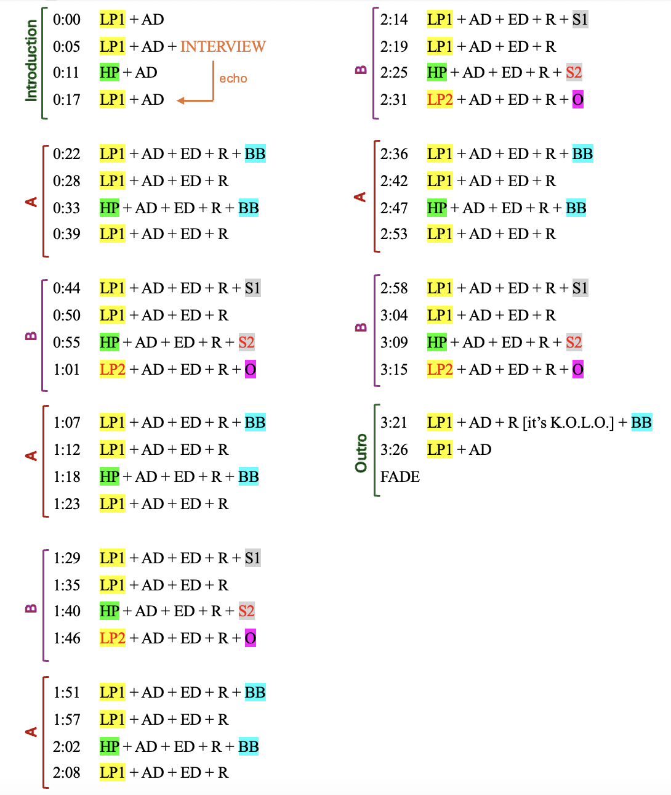

Appendix J
MAP 2 – ‘Infinity Bars III’ For the Second Time

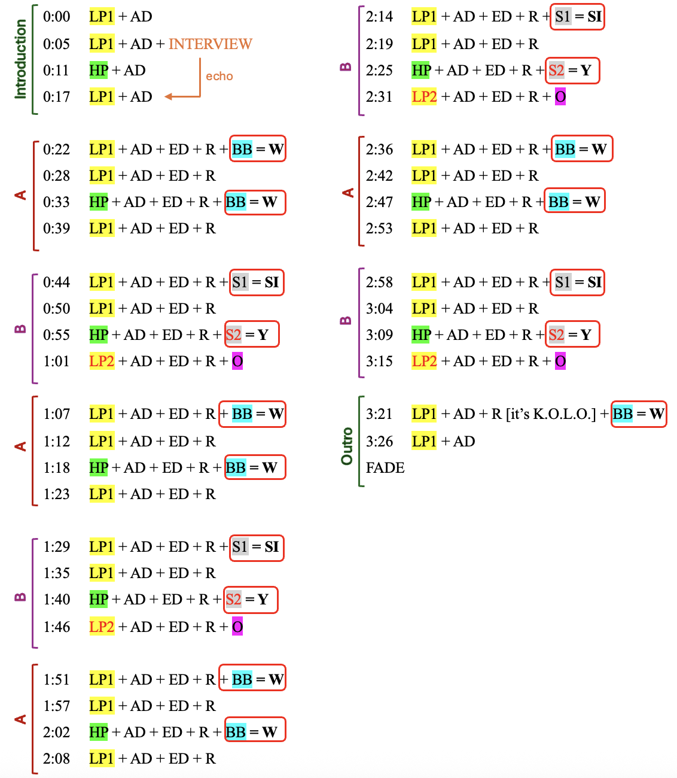

Not because I found the music uninteresting, but because, unfortunately, popular music was never part of my academic education.
A substantial part of the paper written in April 2024 for the Digital Music Cultures course is included in Chapter 3.
That being said, colonialism is not a new concept for me, considering its inevitable role in Georgian musicology and music theory, given the country’s unfortunate experiences with Russian imperialism.
This research may be understood as ethnomusicological, just because it focuses on samples from ‘traditional’ or ‘non-Western’ repertoire. It may also be classified as a popular music study due to the hip-hop element. It could also be called a music-theoretical work, considering its emphasis on music examples and the process of their perception and analysis. This research could also fit well into the cultural musicology domain since it studies cross-cultural relations in composition and analysis. However, determining which one of these labels ‘works better’ in this case does not serve the overall research process.
During analysis I use these two terms, together with the word ‘element’, interchangeably.
Here, I differentiate between an approach and a methodology by viewing the former as a mindset or attitude towards analysis, and the latter as a set of practical strategies for engaging in analytical activity. In this context, Lochhead’s three-step guide functions as an overarching, yet flexible methodology for analysis.
Due to the time and size limitations of this thesis, I have refrained from using other analytical methods to gain further insight into the music by Gana and the artists he samples. Potentially, these musical pieces could benefit from analysis with digital tools like spectral analysis, which might offer greater clarity, reveal finer details, or simply confirm human perceptions. In the future, this study may also be enriched by interviews with Gana and some of the artists he samples, deepening the human aspect in music-creation processes, and therefore rooting the research in ethnomusicological methodology.
As it appears from the two reels linked below, Gana published an instrumental version of the beat using this sample in June 2023, titling it ‘Madloba’ (Georgian for ‘thank you’). This recording seems to have been taken down since then. https://www.instagram.com/reel/Ctb0Yd5rBVj/?igsh=MjU2MGNiZG5md3h1 and https://www.instagram.com/reel/CthBhD_rBVI/?igsh=NnA2NGhjYTRzMWJr
The YouTube search accessible at: https://www.youtube.com/results?search_query=georgian+music.
The channel accessible at: https://www.youtube.com/watch?v=EDK9KOfknTw.
Members of Trio Mandili have changed over the years, with only one original member remaining active since 2014. The current ensemble including Tatuli Mgeladze (middle voice), Tako Tsiklauri (upper voice), and Mariam Kurasbediani (bass voice and panduri), has been active since 2018.
It must be noted, however, that on another occasion, Gana sampled the male choir Basiani, performing the traditional song ‘Khintskala’. This reel, despite the choir’s much lower online presence, reached one million views on Instagram—twice as many as the one featuring ‘Kakhuri’—perhaps confirming a stronger local interest in what is perceived as ‘authentic folklore’. The reel is accessible at: https://www.instagram.com/reel/CxnhlENMve8/?igsh=MWhmZGpiOWQ0YnI0NA%3D%3D.
This particular song is not exceptionally popular, and its digitally available recordings are scarce. There is a noteworthy version of the song recorded in the 1050s released in 2020 by the Folklore State Centre of Georgia, accessible at: https://audiomack.com/folkcentre/song/track-23.
The transcription serves as a visual aid for listening and analysis rather than as a performance guide. It does not include ornamentation, a crucial element that largely defines the characteristic sound of Georgian music.
Words in the repeating part of the lyrics, such as ‘haralale’, do not have a meaning and are usually referred to in Georgian musicology as glossolalia. I am grateful to my Kakhetian father for his help in understanding the dialect used in the song’s verses.
Shairi, in the modern context, is to some extent comparable to rap battles, it is now not commonly practiced in Georgia anymore.
‘Worldwide’ lyrics are part of map 4 in Appendix E.
In order to save space and make the map more cohesive, the green elements from the new lyrics are presented only by their first words.
Some of the articles available at: https://spectator.sme.sk/culture-and-lifestyle/c/weekend-nigerian-rapper-makes-beat-out-of-slovak-folk-song-drops-a-hit, https://obkec.azet.sk/clanok/neiScPv/nigerijskeho-rapera-ocarili-slovenske-ludovky-jeho-uspesny-remix-poculo-viac-ako-milion-ludi/, https://standard.sk/552234/video-ludovky-z-vychodu-ocarili-producenta-z-nigerie-netradicne-spojenie-folkloru-a-rapu-puta-pozornost/?source=rssfeed.
This chapter presents a portion of the paper originally written for the Digital Music Cultures course in April 2024.
While Karička is a well-known Slovak dance, the version recorded by ĽH Samka Smetanu is not widely known to the general public.
Interestingly, while Gana references the YouTube video title as a part of his reel, he does not do the same with his two full versions of the song ‘She Don’t Mean It’: the ‘Official Audio’ and the ‘Instrumental’. Similarly to the short video, he simply captions them: ‘Thank you for the inspiration, Slovakia. Ďakujem, Slovensko!!’, thus, emphasising the originality of his new track.
Referring to SĽUK choreographer Ervín Varga (1955-2013).
The cimbal (cimbalom in Hungarian) is a stringed instrument played by striking the strings with mallets, and should not be confused with the cymbal, a percussion instrument made of metal discs.
I am grateful to my mother for helping me understand the lyrics written in a strong Eastern dialect.
This time, they lyrics do not appear on my maps anymore. They are available to read at: https://www.shazam.com/song/1778069027/infinity-bars-iii.
Except for the vocals accompanying the band in the background, for example between 0:45 – 1:15 (Kuti 2016).
The English translation of ‘Water No Get Enemy’ accessible at: https://www.musixmatch.com/lyrics/Fela-Kuti/Water-No-Get-Enemy/translation/english.
More information on this is accessible at: https://www.whosampled.com/Fela-Kuti/?sp=3.
My transcription.
The lyrics are based on the Latin transcription of Georgian by natiin56 on the platform Genius accessible at: https://genius.com/Trio-mandili-kakhuri-lyrics. I reach for a Latin version to make the lyrics directly accessible to non-Georgian readers.
My translation.
Gana’s lyrics are sourced from Shazam, accessible at: https://www.shazam.com/song/1778069184/worldwide.
Lyrics provided by the author of the YouTube video (DokuDoki 2015).
My translation.

