Gratitude Journaling and Stress: The Role of Psychological Flexibility in the Daily Life of Students and Young Professionals

Ramin-Alexander Rente
S2805715
Department of Clinical Psychology, Utrecht University
Supervisor: Dr. Michaela Schok, Department of Psychology, Utrecht University
Second Supervisor: Sara Laureen Bartels, Postdoctoral Researcher, Department of Psychiatry and Neuropsychology and Alzheimer Centrum Limburg, Mental Health and Neuroscience Research Institute, Maastricht University, Netherlands
February 17, 2025
Abstract
Stress is an inevitable reality for the daily life of students and young professionals, with severe consequences for their mental health. Gratitude journaling emerged as an effective intervention for reducing stress. Yet its effectiveness may be contingent upon the level of psychological flexibility which may induce a more receptive psychological state for benefiting from gratitude practices. Consequently, this study investigated whether psychological flexibility (PF) moderates the relationship between gratitude journaling (GJ) and perceived stress (PS) using an Ecological Momentary Assessment approach. Assigned to either a gratitude journaling or digital diary condition for 10 days, participants (N = 76) completed twice daily assessments measuring PF and PS including a gratitude journaling task for respective condition. A linear mixed-effects model showed that GJ alone did not significantly reduce stress compared to the digital diary condition. However, higher PF was a strong predictor of lower PS independent from the condition. Additionally, a significant interaction showed that GJ was more beneficial for reducing PS for individuals with high PF. These findings suggest that PF can amplify the effectiveness of gratitude interventions, emphasizing the need for personalized stress management approaches. Future research should explore interventions that integrate PF training to maximize the benefits of gratitude-based exercises and help students and young professionals to manage daily stress.
Keywords: Stress, Gratitude Journaling, Psychological Flexibility, Ecological Momentary Assessment, Mixed-Effects Model
Gratitude Journaling and Stress: The Role of Psychological Flexibility in the Daily Life of Students and Young Professionals
With over 60% of young adults experiencing moderate to severe distress (Vankar, 2024), stress has become an inevitable reality for students and young professionals (SYP). Defined as a set of emotional, behavioural, and physiological responses to events that disrupt normal functioning and coping (American Psychological Association, 2018; Liu & Zhang, 2024), stress is a key predictor of severe, negative mental health outcomes for SYP (Acharya et al., 2018; Asif et al., 2020; Compton et al., 2008; Zhou & Zheng, 2022). Gratitude journaling (GJ) has emerged as a potent approach in reducing stress for SYP (Emmons & McCullough, 2003; Tolcher et al., 2024). Yet, gratitude alone may not address the complex, fluctuating nature of perceived stress (PS) (Fekete & Deichert, 2022). Psychological flexibility (PF), “the ability to be aware of internal and external stimuli while acting and thinking in alignment with one’s own values” (Hayes et al., 2012), might complement GJ by enabling SYP with a broader cognitive framework to adapt to stressors (Cyniak-Cieciura, 2021; Kashdan, 2010; Landi et al., 2020). Hence, understanding the interplay between GJ, PF and PS can provide more nuanced, context-sensitive insights to help SYP navigate the challenges of daily stress. Specifically, the study aims to examine the moderating role of PF between GJ and PS. To capture the dynamic, time-sensitive interplay, this study employs Ecological Momentary Assessment (EMA) which offers a unique, well-established method to collect data in real time within the dynamic and fluctuating environment of SYP (Bai et al., 2020; Myin-Germeys et al., 2018; Verhagen et al., 2016; Villanueva et al., 2024).

Prevalence and Implications of Perceived Stress among SYP
SYP are individuals between the age of 18-35, who are in the early stages of their academic or professional careers. They are required to navigate a transitional, fast-paced period in their life characterized by increasing self-sufficiency, academic or career pressures, and constant adaption to shifting responsibilities and deadlines (Krogh & Madsen, 2024; Martel & Fuchs, 2017). Consequently, SYP are exposed to a variety of fluctuating and dynamic stressors (Acharya et al., 2018; Zhao et al., 2023), contributing to elevated stress levels worldwide (Vankar, 2024). In the U.S., SYP report significantly higher stress levels than older adults (American Psychological Association, 2023), with over half experiencing weekly burnout-like symptoms (Ames et al., 2023). Similar trends are observed in Europe and APAC regions, showing high stress vulnerability among SYP (Asif et al., 2020; Benatov et al., 2022; Brenneisen Mayer et al., 2016; Centraal Bureau voor de Statistiek, 2022; Zhou & Zheng, 2022).
While moderate stress can enhance academic performance (Toews et al., 1997), excessive PS among SYP is associated with depression (Stecker, 2004), burnout (Dyrbye et al., 2010; Santen et al., 2010), somatic complaints (Mosley et al., 1994), decreases in empathy (Neumann et al., 2011), serious thoughts about dropping out (Dyrbye et al., 2011), suicidal ideation (Compton et al., 2008; Dyrbye et al., 2011), poor academic performance (Yamada et al., 2014), decreased quality of life (Ribeiro et al., 2018) and low labour market participation (Winding et al., 2023). Given the risks associated with high levels of PS, identifying effective coping mechanisms tailored to the elevated and fluctuating stressors of SYP is essential.

Gratitude Interventions: Benefits and Limitations
Gratitude, defined as the practice of recognizing and appreciating positive aspects of life (Wood et al., 2010), has been linked to numerous psychological (Datu et al., 2022; Kong et al., 2015; Sisson et al., 2024) and physiological benefits (Kyeong et al., 2017; O’Leary et al., 2016; Sisson et al., 2024; Thadani, 2024). In particular, GJ interventions have been shown to reduce stress: Tolcher et al. (2024) found that participants practicing “Three Good Things” journaling reported significant stress reduction, whereas a free journaling control group showed no improvement, aligning with prior findings by Watkins et al. (2015). Similarly, Fuller et al. (2025) demonstrated that a GJ intervention application significantly reduced symptoms of depression, anxiety, and stress among students. Additionally, more frequent gratitude practices correlate with lower stress (Tolcher et al., 2024), as supported by Tran et al. (2022), who found daily but not weekly GJ to be effective.
While GJ offers benefits, its positive effects may be limited in addressing the full spectrum of stressors (Davis et al., 2016; Fekete & Deichert, 2022). When confronted with persistent and dynamic challenges, SYP often rely on ineffective avoidance coping (Alkhawaldeh et al., 2023) which increases stress vulnerability (Mašková, 2023). Additionally, the aforementioned studies (Fuller et al., 2025; Tolcher et al., 2024; Tran et al., 2022) mainly focus solely on GJ, ignoring potential moderating factors and their temporal precedence. This gap highlights the need to explore additional psychological mechanisms, such as psychological flexibility (PF), which may enhance the effectiveness of GJ in managing stress (Freire et al., 2020).

Psychological Flexibility and Its Mitigating Potential.
Psychological Flexibility and Stress-Reducing Benefits
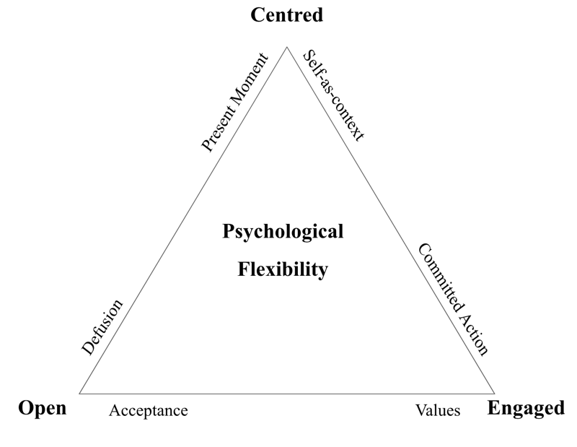
PF is the ability to remain open to experiences, stay present, and take value-driven action even in challenging situations (Hayes et al., 2012). The Triflex model (Harris, 2019; see Figure 1) organizes PF into three core response styles: open (acceptance of experiences and detachment from unhelpful thoughts), centred (mindful awareness and a stable sense of self), and engaged (acting in accordance with personal values).
Figure 1
Triflex Model of Psychological Flexibility
Empirical evidence has linked PF to lower symptoms of psychopathology, better functioning and well-being (Cyniak-Cieciura, 2021; Kashdan, 2010; Landi et al., 2020). In particular, higher PF correlates with lower PS as it enables individuals to modify thoughts and behaviours to align with situational demands rather than reacting rigidly (Kashdan & Rottenberg, 2010). This aligns with Cyniak-Cieciura’s (2021) finding that individuals with higher PF report lower stress levels, suggesting that PF may act as a buffer against PS.

The Moderating Role of Psychological Flexibility
Building upon its general effectiveness in reducing stress, PF can also play a significant role in mitigating the effects of daily stressors. Gloster et al. (2017) reported that PF regularly moderated physical and mental health outcomes, while Chong et al. (2023) found PF to partially mediate the effects of burnout on mental well-being. PF’s ability to foster a range of adaptive coping strategies, from emotional regulation to acceptance (Hayes et al., 2012), suggests it may complement GJ by enhancing its stress-reducing effects, particularly in the SYP demographic. For example, those with higher PF may experience greater benefits from GJ, as they are adept at integrating gratitude into their broader coping responses. In contrast, individuals with lower PF may experience diminished effects of GJ, as they might lack the PF to fully utilize gratitude in stressful situations. Investigating this dynamic, especially within the natural environment of SYP, will provide a more nuanced understanding of the relationship between GJ, PF, and PS.
Hence, this study employs EMA which offers a well-established method for capturing real-time data (Mengelkoch et al, 2023; Murray et al., 2023). EMA provides critical advantages over retrospective measures by reducing the memory-experience gap and offering ecologically valid insights into how these variables fluctuate throughout the day (Myin-Germeys et al., 2018). This real-time approach is especially relevant for SYP, whose stressors and coping mechanisms are dynamic and context-dependent (Bai et al., 2020). By leveraging EMA, this study aims to better understand how GJ and PF interact to influence daily levels of stress.
Hypothesis 1 (H1): Participants in the GJ condition will report significantly lower levels of PS compared to individuals in the digital diary (DD) condition.
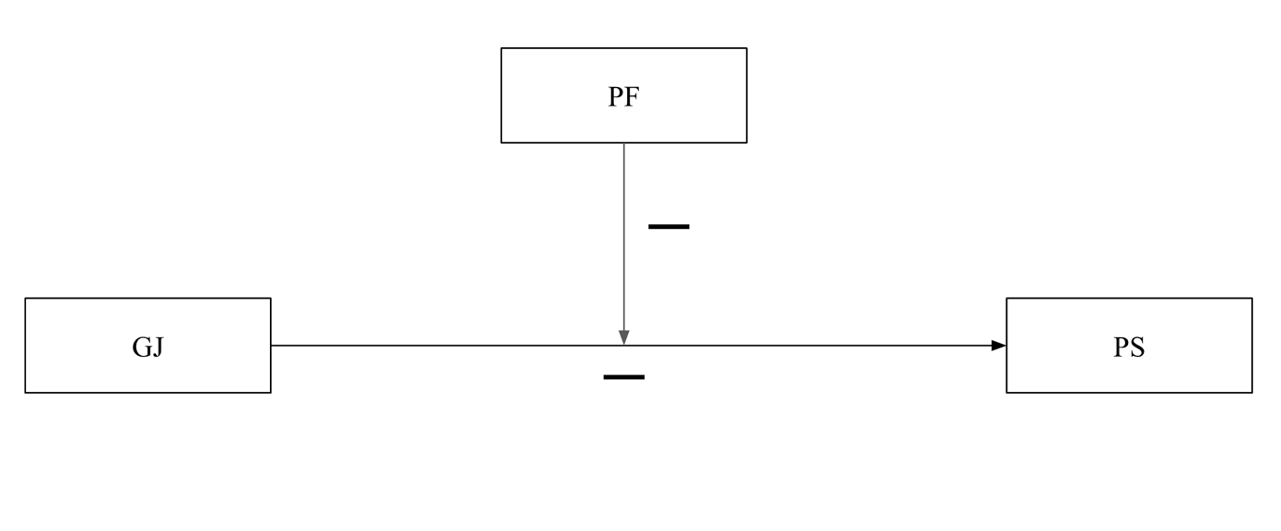
Hypothesis 2 (H2): The relationship between the conditions (GJ vs. DD) and PS will be moderated by PF. Specifically, the stress-reducing effect of GJ will be significantly stronger for individuals with higher PF.
Figure 2
H2: Moderation Model of Psychological Flexibility

Method

Procedure
The study was part of an overarching Master Thesis Project and promoted via social networks and messenger tools, with study details provided in an introductory text and flyer (Appendix A). The overall project comprised three phases: pre-assessment, intervention, and post-measurement. Pre-measurement data was collected via an online Qualtrics questionnaire (Qualtrics, 2024). After completion participants were randomly assigned to either the GJ or DD condition using the randomizer functionality of Qualtrics. The present study specifically focused on the intervention phase, which involved a 10-day Ecological Momentary Assessment (EMA) protocol conducted by using the m-Path platform (Mestdagh et al., 2025, Version 1.0.1.). Following pre-assessment, participants scheduled an online meeting during which they were instructed on how to use m-Path. To ensure consistency across all meetings, a standardized script and presentation tailored to group conditions were used (Appendix B). Participation was voluntary, and withdrawal was allowed at any time without consequences. An informed consent form was provided, and participants could ask questions via email or messenger tools (Appendix B). A 100€ voucher lottery was offered as an incentive for participation. It was emphasized that participant’s results had no influence on winning the reward. The Ethics Review Board of the Faculty of Social & Behavioural Sciences of Utrecht University approved the study (Appendix B).
Participants
Participants were recruited through convenience sampling. Eligibility criteria included being 18–35 years old, identifying as a student, young worker, or working student, speaking English, and having mobile phone access. A total of 231 participants were initially recruited. The final convenience sample consisted of 76 participants. Respective subsample size of the DD condition was 41 (54%), and of GJ condition was 35 (46%) (see Figure 3). Participants were asked to provide demographic information, including age, gender, and ethnicity and prior journaling experience (no, former or currently practicing).

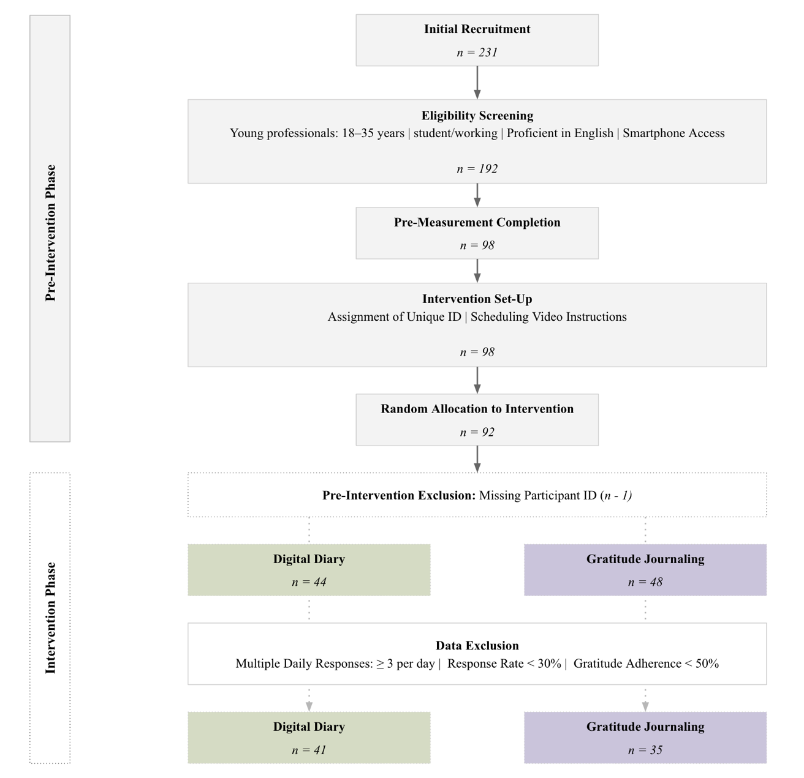
Intervention
Figure 3
Participant Flowchart
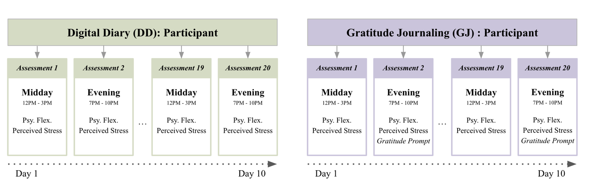
The 10-day intervention included two daily assessments with respective time frames from 12 PM–3 PM and 7 PM–10 PM (see Figure 4). For each time interval three reminders were scheduled. This semi-random sampling scheme was chosen based on empirical evidence supporting high compliance rates (83%), strong ecological validity, and reduced participant burden (Rintala et al., 2019; Vachon et al., 2019). To maximize compliance, assessments were designed to take no more than three minutes (Kimhy et al., 2012; Ono et al., 2019). Assessments measured PF (six items), PS (one item), including an additional gratitude journaling prompt (“Name three things you are grateful for today.”) between 7 PM–10 PM for the GJ condition (see Figure 4). During the initial online meeting, examples were provided to encourage reflection.
Figure 4
Study Design and Assessment by Condition

Measures
Psychological Flexibility
PF was assessed using Psy-Flex, a six-item self-report questionnaire adjusted to high temporal specificity (“Reflect on the last two hours…”). It was assessed twice daily (12–3 PM, 7–10 PM) for both groups. Psy-Flex has demonstrated high internal consistency (Cronbach’s α > 0.85) and strong construct validity across diverse populations (Benoy et al., 2019; Gloster et al., 2021). Responses were recorded on a 10-point Likert scale (1 = “not at all” to 10 = “very much”) to capture daily fluctuations in PF (Appendix C).
To assess the stability of PF over time, intraclass correlation coefficients (ICC) were calculated. PF demonstrated moderate stability, ICC = 0.535, indicating that 53.5% of its variance was attributable to stable differences between participants (between-person variability), while 46.5% of its variance reflected within-person fluctuations across days. This suggests that PF is partially trait-like but still subject to daily variability, aligning with ICC scores from prior research (Cunha et al., 2023; Lavefjord et al., 2025).
Perceived Stress
PS was measured using a single-item scale: “To what extent have you felt stressed over the last two hours?”. Participants responded on a 10-point Likert scale (1 = “not at all” to 10 = “very much”) (Appendix C). This scale was chosen to enhance variability in responses and align with real-time EMA. Answering options were standardized across all measures to improve response accuracy. Single-item scales have been validated as reliable tools assessing stress in EMA studies (Murray et al., 2023).
PS exhibited a lower ICC of 0.28, meaning that 28.0% of the variance was due to stable between-person differences, whereas 72% (0.72) of the variance was due to within-person fluctuations. These ICC values align with findings by Murray et al. (2023) who demonstrated substantial within-person variability (>70%). This suggests that PS levels were highly dynamic and influenced by momentary experiences rather than being a stable individual trait. These values justify the use of a multilevel modelling approach, as both PF and PS varied significantly within individuals over time.

Data Analysis
A linear mixed-effects model (LMM) was employed using the lmer function from the lme4 package. All analyses were conducted in R (v4.2.2) and RStudio (v2023.03.0+ Build 386). LMMs were chosen to account for the hierarchical nature of the data. The model included fixed effects, and their interaction with a random intercept for participants to account for between-subject variability.
Power Analysis
Power analysis for multilevel, mixed-effects models lack a universally accepted standard (Kumle, 2023; Murayama et al., 2022). Since this study relies on hierarchical data structures where repeated measures are nested within participants, the simr package which integrates with lme4 is recommended (Bates et al., 2015; Green & MacLeod, 2016). As no prior studies have examined a similar research design using an EMA, correct estimation of key parameters was not possible. However, a longitudinal pre-post study by Fuller et al. (2025) served as a general guideline. The analysis was based on a planned sample size of 100 participants (50 per condition) with 20 repeated measures per participant. An ICC of 0.2-0.3 was assumed based on initial variance estimates. A small-to-medium effect size (d = 0.25) was chosen in line with previous research. Power analysis revealed that the study design provides sufficient power for detecting the main effect of condition (H1). However, the analysis showed that power for detecting the interaction effect (H2) is insufficient.

Assumption Testing
Hypothesis 1. A Q-Q plot was examined to visually assess normality of residuals. While the plot indicated a linear pattern, minor deviations in the tails were observed (see Figure 11, Appendix F). To further evaluate normality, skewness (0.48) and kurtosis (2.85) were computed. These values fell within acceptable limits, suggesting that the residuals were approximately normally distributed (Scott et al., 2013). Autocorrelation diagnostics showed no significant issues beyond lag 1 and no influential outliers were detected (see Figure 12-13, Appendix F). Regarding the homoscedasticity assumption, a residual vs. fitted values plot and density plot suggested possible heteroscedasticity, with greater variance in the DD condition (see Figure 14-15, Appendix F). Levene’s Test (p = 0.008) confirmed significant variance differences, violating the homoscedasticity assumption (see Appendix F).
Hypothesis 2. To test assumption for Hypothesis 2, the interaction term (GJ × PF) was included in the model. PF was mean centred before testing the moderation effect to ensure that the intercept represented the expected stress level when PF was at its average level in the sample, rather than an arbitrary value of zero. Centring also reduced multicollinearity in the interaction term, improving the interpretability of the results (see Figure 17-18, Appendix G). Autocorrelation diagnostics showed no significant issues beyond lag 1 (see Figure 20, Appendix H) and no influential outliers (Cook’s Distance < 0.3) were detected (see Figure 21, Appendix H). A Q-Q plot was examined to visually assess normality of residuals, indicating a linear pattern with slightly heavier tails (see Figure 22, Appendix H). The normality of residuals was confirmed with skewness (0.48) and kurtosis (3.334) values within acceptable limits (Scott et al., 2013). To assess the assumption of homoscedasticity, a residual vs. fitted values plot was examined (see Figure 23, Appendix H), along with Levene’s Test (p = 0.510), confirming no violation of equal variation among both conditions.

Results
Participant Characteristics
82% were White/Caucasian (n = 62), 11% had multiple ethnicities (n = 8) and 8% (n = 7) indicated other. 29 were males (38%), 46 females (60%), and 1 nonbinary or other (1%). The average age of participants was M = 24.8 (SD = 2.71, Mdn = 25). Age distributions were similar across conditions (see Figure 8, Appendix E). The overall response rate was high, with a mean of M = 87.9 (SD = 16.3, Mdn = 95) (see Figure 6, Appendix D). Response rates were slightly higher in the GJ condition (M = 90.3, SD = 14.3, Mdn = 100) compared to the DD condition (M = 85.6, SD = 17.7, Mdn = 90). In the GJ condition, adherence to the journaling task was high, with a mean adherence score of M = 89.2 (SD = 16.4, Mdn = 100), indicating that most participants engaged consistently with the intervention. Occupational categories (student, worker, or both) were equally represented (see Figure 10, Appendix E). Prior journaling experience of participants (none, current, or former) similarly distributed across conditions (see Figure 9, Appendix E). However, 2 participants (5.1%) in the DD condition were currently practicing gratitude journaling.
Hypothesis 1: The Effect of Gratitude Journaling on Perceived Stress
The homoscedasticity assumption was violated, as confirmed by Levene’s (p = 0.008) (see Figure 11-12, Appendix F). To account for this, the model was fitted using lme(), which allows for heteroscedasticity modeling via varIdent(). While AIC suggests a slightly better fit (ΔAIC = 2.254), the fixed effects remain nearly identical across models. Thus, while heteroscedasticity modelling slightly improves the model fit, it does not alter the substantive conclusion.
GJ did not significantly reduce PS compared to the DD condition, b = 0.01, SE = 0.33, t(74.17) = 0.03, p = 0.98. The effect size was minimal, Cohen’s d = -0.00282, 95% CI [-0.11, 0.11], further supporting the conclusion that GJ did not meaningfully impact PS (see Table 1). Descriptive statistics reinforced this finding, with mean PS nearly identical between conditions, M = 4.47, SD = 2.61 for GJ, and M = 4.46, SD = 2.44 for DD (see Figure 16, Appendix F). These results provided no support for H1, indicating that GJ, in its current form, was not significantly more effective in reducing PS than the DD condition.
Table 1
Fixed and Random Effects for Hypothesis 1
Effect | Estimates | SE | 95%CI |  | p
 |  |  | LL | UL
Fixed effects
(Intercept) | 4.519*** | .232 | 4.072 | 4.978 | < .001***
condition [Gratitude Journal] | .010 | .335 | -.642 | -.662 | .975
Random Effects
Within-Person Variability | 1.344 | .120 | 1.100 | 1.560
Between-Person Variability | 2.139 | .095 | 1.900 | 2.400
Note. Number of participants = 76, number of observations = 1,268. CI = confidence interval; LL = lower limit; UL = upper limit.; ***p < .001. SE for random effects is estimated via bootstrapping

Post-Hoc Analysis: Examining High-Adherence Participants
Given that some participants engaged more consistently in GJ (see Figure 6, Appendix D), a post-hoc analysis was conducted to examine whether GJ might have been more effective for individuals with high adherence (80–100% completion). The model fit improved in this subset, with a lower REML criterion at convergence (5024.3). Despite a slight reduction in PS levels among high-adherence participants, the effect of GJ on PS remained non-significant (p = 0.51) (see Table 3, Appendix F).
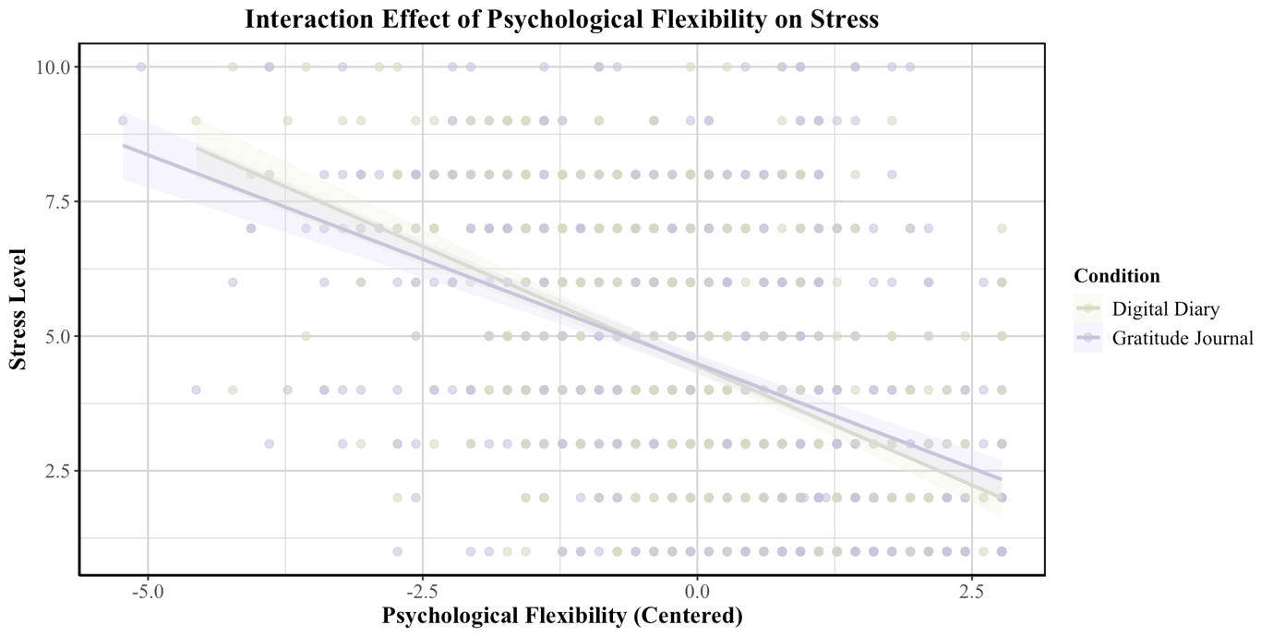
Hypothesis 2: The Moderating Role of Psychological Flexibility
To test whether PF moderated the relationship between GJ and PS, an interaction term (GJ × PF) was included in the model.
Figure 5
Interaction Effect of Psychological Flexibility on Stress by Condition
PF scores were not significantly different across both condition, t(1211.7) = -0.4299, p = 0.6673 with M = 7.25, SD = 1.59 for GJ, and M = 7.21, SD = 1.38 for DD, confirming that differences in moderation effects were not due to baseline group differences. Median for GJ (Mdn = 7.5) was slightly higher than for DD (Mdn = 7.17) (see Figure 19, Appendix G). The model results revealed significant effects (see Table 2). Higher PF was associated with lower stress levels, b = -1.029, SE = 0.198, t(74.17) = -5.19, p < 0.001. More importantly, the interaction between GJ and PF was significant, b = 0.354, SE = 0.089, t(74.17) = 3.98, p < 0.001, indicating that GJ was more effective in reducing stress for individuals with higher PF. However, at the mean level of PF, the main effect of GJ remained non-significant, b = 0.104, SE = 0.333, t(74.17) = 0.031, p = 0.704. This suggests that GJ, on its own, did not significantly reduce PS compared to the DD condition when PF was average. This aligns the prior findings from H1, where the overall effect of GJ on PS was also not significant. Conditional R² was 0.422, meaning that 42.2% of the variance in stress was explained by both fixed and random effects. The marginal R² was 0.244, indicating that 24.4% of the variance was explained by the fixed effects alone (condition, PF, and their interaction), while 17.8% of the variance remained attributable to individual differences.
Table 2
Fixed and Random Effects for Hypothesis 2
Effect | Estimates | SE | 95%CI |  | p
 |  |  | LL | UL
Fixed effects
Intercept [Digital Diary, Mean PF] | 4.433 | .186 | 4.068 | 4.799 | < .001***
condition [Gratitude Journal] | .104 | .273 | -.431 | .639 | .704
Psychological Flexibilityª | -1.029 | .074 | -1.174 | -.884 | < .001***
Condition x Psychological Flexibilityª | .354 | .102 | .152 | .555 | < .001***
Random Effects
Within-Person Variability | 3.795 | 1.948 | .755 | 1.689
Between-Person Variability | 1.167 | 1.080 | 3.500 | 4.092
Note. Number of participants = 76, number of observations = 1,268. CI = confidence interval; LL = lower limit; UL = upper limit; ***p < .001. SE for random effects is estimated via bootstrapping;
ª Psychological Flexibility was mean centred

Discussion
This study explored the relationship between GJ and PS, moderated by PF among SYP. Results indicate that contrary to expectations, GJ alone did not significantly reduce stress (H1) and, on its own, did not reduce stress when accounting for PF. However, PF was a strong predictor of lower PS, and its interaction revealed that GJ has been beneficial for participants with high PF (H2). This suggests that PF can play a fundamental role in the effectiveness of gratitude interventions and stress reduction.
Interpretation of the Findings.

Limited Effectiveness of Gratitude Journaling on Stress Reduction.
The finding that GJ alone did not significantly reduce PS (H1), and, on its own, did not reduce stress when accounting for PF (H2, condition effect), contradicts previous research (Emmons & McCullough, 2003; Tran et al., 2022). Even among participants with high adherence rates, who may have benefited the most from the gratitude exercise (see Table 3, Appendix F), the effect remained non-significant. The discrepancy may stem from several factors. First, effective gratitude interventions from Fuller et al. (2025) and Tolcher et al. (2024) lasted 6-8 weeks. This study was limited to 10 days to ensure a trade-off between a demanding study design for participants and maintaining high compliance rates. Consequently, a relatively short duration of the gratitude intervention may have been insufficient to induce substantial changes in stress perception. Second, studies that reported significant effects emphasize guidance and education about gratitude interventions (Tolcher et al., 2024; Watkins et al., 2015). Although instructions were provided during the initial video briefing and guidance for inquiries was offered via e-mail contact, they may have been inadequate. More personalized guidance may be helpful for SYP to leverage more benefits from the gratitude intervention. For example, an additional video session mid-intervention could help participants to discuss their experiences and address any surfacing challenges.
Another possible explanation for the lack of a significant effect is that participants in the DD condition might have engaged in a mild form of daily self-reflection through the assessment of PF. This could have had its own stress-reducing effects (Del Palacio‐González et al., 2017), minimizing potential differences between the conditions. Additionally, three participants in the DD condition indicated that they were currently practicing gratitude which may have contributed to dilute effects. Including a neutral control condition that passively tracks stress levels could isolate gratitude-related effects.
Central Role of Psychological Flexibility in Stress Reduction.
While GJ alone had no significant effects on PS, results present significant and condition-independent stress-reducing effects of PF, consistent with previous research (Cyniak-Cieciura, 2021; Gloster et al., 2017). Aligning with Hayes et al.'s (2012) claim that greater PF enables individuals to reframe negative experiences and engage in adaptive coping strategies, findings of the present study suggest that SYP with high PF likely perceive daily stressors as less impactful and can accept and adjust better to PS. Importantly, the moderate ICC (0.535) of PF suggests that while partly stable, PF also fluctuates within individuals across time, aligning with prior research (Cunha et al., 2023; Lavefjord et al., 2025). This within-person variability indicates that certain aspects of PF are susceptible to change, highlighting the potential for targeted interventions. Specifically, SYP with lower PF who might struggle with daily stress regulation could benefit from interventions targeting core response style (i.e. cognitive defusion exercises or acceptance strategies) to enhance PF. Future studies may investigate what response styles of the Triflex model are particularly helpful in managing and reducing stress. This is highly relevant to the population given that SYP are subjected to elevated and fluctuating stress levels, which necessitates a tailored set of stress-reducing activities (Acharya et al., 2018; Alkhawaldeh et al., 2023; Winding et al., 2023).
However, it is important to emphasize that uncentered, average PF scores were high with a right-skewed distribution and had low variability (see Figure 17, Appendix G). While centring normalized the PF distribution, a lack of variability remained, ultimately minimizing potential differences between GJ and DD conditions (see Figure 18, Appendix G). Future studies should prioritize recruiting heterogeneous samples with greater PF variance, particularly populations with greater variance in low to moderate PF scores. This could help to elucidate more robust insights into potential differential effects between conditions.

Gratitude and Psychological Flexibility as Synergistic Mechanisms.
The significant interaction indicates that the effect of the GJ condition on PS depends on the level of PF. Specifically, as PF increases, the difference between GJ and DD in reducing stress becomes more pronounced, supporting the notion that GJ and PF may work synergistically. High PF may induce a more receptive psychological state for benefiting from gratitude practices. Conversely, SYP with lower PF may engage in more rigid thought patterns as a response to daily stressors which could reduce their ability to effectively engage with GJ. This tendency aligns with a prior finding that found specifically higher levels of PF significantly moderated the relationship between daily stressors and well-being (Gloster et al., 2017).
Limitations
A key limitation of this study is the underpowered sample size. This may have limited the ability to detect more robust effects, particularly for the interaction between GJ and PF. Given the relatively small sample, findings should be interpreted with caution, as they do not capture the variability present in larger, more diverse populations. Additionally, it was not possible to control for whether participants in the DD condition were privately engaging in gratitude practices outside the study, potentially diluting the contrast between conditions. Duration and frequency of data collection also pose constraints. While aiming for a balance of participant workload and compliance rate, this approach may have missed critical fluctuations in stress responses throughout the day. Furthermore, reactivity to repeated assessments could have influenced participants’ answers, potentially altering natural stress patterns (Van Berkel et al., 2018).
Implications and Future Research
Given these limitations, this study might stimulate future research designs. To gain more insights into fine-grained temporal variations, assessment scales could be shortened, higher assessment frequency (i.e. Morning, Midday, Afternoon, Evening) (Myin-Germeys et al., 2018) established and duration extended to 14-21 days (Emmons & McCullough, 2003. To counterbalance the reactivity of responses, EMA designs could be used in conjunction with passive data collection. For example, smartwatches could passively track physiological markers of stress such as heart rate variability which has been shown to be a reliable predictor of daily stress (Peabody et al., 2023).
To gain deeper insights into the nuances of GJ, future research could analyse the content of gratitude entries rather than focusing on adherence rates as an indication of a successful intervention. Specifically, journal entries could be evaluated based on word count, richness of expression, and thematic diversity to assess engagement levels. This approach could serve two purposes: (a) detecting repetition of gratitude items, which may indicate reduced cognitive engagement with the practice, and (b) identifying richer expression and greater thematic diversity, which could reflect deeper involvement in GJ condition. Higher engagement levels may, in turn, enhance the effectiveness of the intervention, providing a more nuanced understanding of the contingencies of effective GJ interventions.
Finally, findings point in the direction of personalized intervention strategies. Given that individuals with higher PF benefit more from GJ, interventions may benefit from screening participants for their baseline level of PF and tailoring approaches accordingly. For example, Acceptance Commitment Therapy (ACT) trainings could precede gratitude exercises for individuals with lower PF. This need for personalization is reflected in evidence from transdiagnostic interventions, which focus on addressing shared psychological mechanisms rather than rigid diagnostic categories (Vogel et al., 2024). By providing a dynamic, transdiagnostic framework, intervention could be tailored to individual differences in PF. This might support participants in developing the required PF to engage more effectively with gratitude journaling practices. A subsequent shift from a one-size-fits-all approach to a personalized framework holds benefits for workplace and university training as well. As GJ may not be equally beneficial for everyone, institutions could consider implementing PF workshops alongside GJ, creating scalable yet tailored interventions. For example, student support services or corporate well-being programs could offer ACT-inspired training sessions before introducing gratitude journaling ensuring that participants have the adaptive cognitive skills needed to fully benefit from gratitude-based exercises. This integrated approach could lead to more effective stress reduction strategies, ultimately improving mental health outcomes in both academic and professional settings of SYP.

References
Acharya, L., Jin, L., & Collins, W. (2018). College life is stressful today – Emerging stressors and depressive symptoms in college students. Journal of American College Health, 66(7), 655–664. https://doi.org/10.1080/07448481.2018.1451869
Alkhawaldeh, A., Al Omari, O., Al Aldawi, S., Al Hashmi, I., Ann Ballad, C., Ibrahim, A., Al Sabei, S., Alsaraireh, A., Al Qadire, M., & ALBashtawy, M. (2023). Stress Factors, Stress Levels, and Coping Mechanisms among University Students. The Scientific World Journal, 2023, 2026971. https://doi.org/10.1155/2023/2026971
American Psychological Association. (2018, April 19). APA Dictionary of Psychology. https://dictionary.apa.org/
American Psychological Association. (2023, November 1). Stress in AmericaTM 2023: A nation grappling with psychological impacts of collective trauma. https://www.apa.org/news/press/releases/2023/11/psychological-impacts-collective-trauma
Ames, M., Choudaha, R., Finley, A., Gatta, M., Humphrey, D., Lipson, S., & Malpiede, M. (2023). The Mental Health and Wellbeing of Young Professionals. In 2023 (p. 19). https://marychristieinstitute.org/wp-content/uploads/2023/01/The-Mental-Health-and-Wellbeing-of-Young-Professionals-Survey.pdf
Asif, S., Mudassar, A., Shahzad, T. Z., Raouf, M., & Pervaiz, T. (2020). Frequency of depression, anxiety and stress among university students. Pakistan Journal of Medical Sciences, 36(5), 971–976. https://doi.org/10.12669/pjms.36.5.1873
Bai, S., Elavsky, S., Kishida, M., Dvořáková, K., & Greenberg, M. T. (2020). Effects of Mindfulness Training on Daily Stress Response in College Students: Ecological Momentary Assessment of a Randomized Controlled Trial. Mindfulness, 11(6), 1433–1445. https://doi.org/10.1007/s12671-020-01358-x
Bates, D., Maechler, M., Bolker, B. M., & Walker, S. C. (2015). Fitting Linear Mixed-Effects Models Using lme4. JOURNAL OF STATISTICAL SOFTWARE, 67(1), 1–48. https://doi.org/10.18637/jss.v067.i01
Benatov, J., Ochnik, D., Rogowska, A. M., Arzenšek, A., & Mars Bitenc, U. (2022). Prevalence and Sociodemographic Predictors of Mental Health in a Representative Sample of Young Adults from Germany, Israel, Poland, and Slovenia: A Longitudinal Study during the COVID-19 Pandemic. International Journal of Environmental Research and Public Health, 19(3), Article 3. https://doi.org/10.3390/ijerph19031334
Brenneisen Mayer, F., Souza Santos, I., Silveira, P. S. P., Itaqui Lopes, M. H., de Souza, A. R. N. D., Campos, E. P., de Abreu, B. A. L., Hoffman Ii, I., Magalhães, C. R., Lima, M. C. P., Almeida, R., Spinardi, M., & Tempski, P. (2016). Factors associated to depression and anxiety in medical students: A multicenter study. BMC Medical Education, 16(1), 282. https://doi.org/10.1186/s12909-016-0791-1
Centraal Bureau voor de Statistiek. (2022, April 29). 1 in 5 young workers experience work-related stress | Jeugdmonitor. Jeugdmonitor. https://jeugdmonitor-acc.cbs.nl/en/publications/1-in-5-young-workers-experience-work-related-stress
Chong, Y. Y., Frey, E., Chien, W. T., Cheng, H. Y., & Gloster, A. T. (2023). The role of psychological flexibility in the relationships between burnout, job satisfaction, and mental health among nurses in combatting COVID-19: A two-region survey. Journal of Nursing Scholarship: An Official Publication of Sigma Theta Tau International Honor Society of Nursing, 55(5), 1068–1081. https://doi.org/10.1111/jnu.12874
Compton, M. T., Carrera, J., & Frank, E. (2008). Stress and Depressive Symptoms/Dysphoria Among US Medical Students: Results From a Large, Nationally Representative Survey. Journal of Nervous & Mental Disease, 196(12), 891–897. https://doi.org/10.1097/NMD.0b013e3181924d03
Cunha, M., Pereira, C. R., & Galhardo, A. (2023). Assessing psychological flexibility by the Psy-Flex and its relationship with mental health [Poster presentation]. 31st European Congress of Psychiatry, Paris, France. https://doi.org/10.13140/RG.2.2.11358.82242
Cyniak-Cieciura, M. (2021). Psychological flexibility, temperament, and perceived stress. Current Issues in Personality Psychology, 9(4), 306–315. https://doi.org/10.5114/cipp.2021.108685
Datu, J. A. D., Valdez, J. P. M., McInerney, D. M., & Cayubit, R. F. (2022). The effects of gratitude and kindness on life satisfaction, positive emotions, negative emotions, and COVID-19 anxiety: An online pilot experimental study. Applied Psychology: Health and Well-Being, 14(2), 347–361. https://doi.org/10.1111/aphw.12306
Davis, D. E., Choe, E., Meyers, J., Wade, N., Varjas, K., Gifford, A., Quinn, A., Hook, J. N., Van Tongeren, D. R., Griffin, B. J., & Worthington, E. L. (2016). Thankful for the little things: A meta-analysis of gratitude interventions. Journal of Counseling Psychology, 63(1), 20–31. https://doi.org/10.1037/cou0000107
Del Palacio‐González, A. , Clark, D. A. , & O’Sullivan, L. F. (2017). Cognitive processing in the aftermath of relationship dissolution: Associations with concurrent and prospective distress and posttraumatic growth. Stress and Health, 33(5), 540–548. 10.1002/smi.2738 https://doi.org/10.1002/smi.2738
Dyrbye, L. N., Harper, W., Durning, S. J., Moutier, C., Thomas, M. R., Massie, F. S., Eacker, A., Power, D. V., Szydlo, D. W., Sloan, J. A., & Shanafelt, T. D. (2011). Patterns of distress in US medical students. Medical Teacher, 33(10), 834–839. https://doi.org/10.3109/0142159X.2010.531158
Dyrbye, L. N., Power, D. V., Massie, F. S., Eacker, A., Harper, W., Thomas, M. R., Szydlo, D. W., Sloan, J. A., & Shanafelt, T. D. (2010). Factors associated with resilience to and recovery from burnout: A prospective, multi-institutional study of US medical students. Medical Education, 44(10), 1016–1026. https://doi.org/10.1111/j.1365-2923.2010.03754.x
Emmons, R. A., & McCullough, M. E. (2003). Counting blessings versus burdens: An experimental investigation of gratitude and subjective well-being in daily life. Journal of Personality and Social Psychology, 84(2), 377–389. https://doi.org/10.1037/0022-3514.84.2.377
Freire, C., Ferradás, M. del M., Regueiro, B., Rodríguez, S., Valle, A., & Núñez, J. C. (2020). Coping Strategies and Self-Efficacy in University Students: A Person-Centered Approach. Frontiers in Psychology, 11. https://doi.org/10.3389/fpsyg.2020.00841
Fuller, C., Marin-Dragu, S., Iyer, R. S., & Meier, S. M. (2025). A Mobile App–Based Gratitude Intervention’s Effect on Mental Well-Being in University Students: Randomized Controlled Trial. JMIR mHealth and uHealth, 13(1), e53850. https://doi.org/10.2196/53850
Gloster, A. T., Meyer, A. H., & Lieb, R. (2017). Psychological flexibility as a malleable public health target: Evidence from a representative sample. Journal of Contextual Behavioral Science, 6(2), 166–171. https://doi.org/10.1016/j.jcbs.2017.02.003
Green, P., & MacLeod, C. J. (2016). SIMR: An R package for power analysis of generalized linear mixed models by simulation. Methods in Ecology and Evolution, 7(4), 493–498. https://doi.org/10.1111/2041-210X.12504
Harris, R. (2019). ACT made simple: An easy-to-read primer on acceptance and commitment therapy (2nd ed.). New Harbinger Publications.
Hayes, S. C., Strosahl, K. D., & Wilson, K. G. (2012). Acceptance and commitment therapy: The process and practice of mindful change, 2nd ed (pp. xiv, 402). Guilford Press.
Kashdan, T. B. (2010). Psychological Flexibility as a Fundamental Aspect of Health. Clinical Psychology Review, 30(7), 865–878. https://doi.org/10.1016/j.cpr.2010.03.001
Kashdan, T. B., & Rottenberg, J. (2010). Psychological flexibility as a fundamental aspect of health. Clinical Psychology Review, 30(7), 865–878. https://doi.org/10.1016/j.cpr.2010.03.001
Kong, F., Ding, K., & Zhao, J. (2015). The Relationships Among Gratitude, Self-esteem, Social Support and Life Satisfaction Among Undergraduate Students. Journal of Happiness Studies, 16(2), 477–489. https://doi.org/10.1007/s10902-014-9519-2
Krogh, S. C., & Madsen, O. J. (2024). Dissecting the achievement generation: How different groups of early adolescents experience and navigate contemporary achievement demands. Journal of Youth Studies, 27(5), 706–722. https://doi.org/10.1080/13676261.2022.2162812
Kumle, L. (2023). Simulation-Based Power Analysis in (Generalized) Linear Mixed Models. https://www.psycharchives.org/en/item/1761d29f-4a60-41bb-a2b7-aafeb230bf59
Kyeong, S., Kim, J., Kim, D. J., Kim, H. E., & Kim, J.-J. (2017). Effects of gratitude meditation on neural network functional connectivity and brain-heart coupling. Scientific Reports, 7(1), 5058. https://doi.org/10.1038/s41598-017-05520-9
Landi, G., Pakenham, K. I., Boccolini, G., Grandi, S., & Tossani, E. (2020). Health Anxiety and Mental Health Outcome During COVID-19 Lockdown in Italy: The Mediating and Moderating Roles of Psychological Flexibility. Frontiers in Psychology, 11, 2195. https://doi.org/10.3389/fpsyg.2020.02195
Lavefjord, A., Sundström, F. T. A., Chia, D., Tabrizi, F., Buhrman, M., & McCracken, L. M. (2025). Comprehensive and efficient assessment of psychological flexibility in the context of chronic pain. European Journal of Pain, 29(2), e4781. https://doi.org/10.1002/ejp.4781
Liu, X., & Zhang, J. (2024). Continuous Glucose Monitoring: A Transformative Approach to the Detection of Prediabetes. Journal of Multidisciplinary Healthcare, 17, 5513–5519. https://doi.org/10.2147/JMDH.S493128
Martel, A., & Fuchs, D. C. (2017). Transitional Age Youth and Mental Illness – Influences on Young Adult Outcomes. Child and Adolescent Psychiatric Clinics of North America, 26(2), xiii–xvii. https://doi.org/10.1016/j.chc.2017.01.001
Mašková, I. (2023). Work-related coping behaviour and experience patterns in university students: A review of 20 years of research. Frontiers in Psychology, 14. https://doi.org/10.3389/fpsyg.2023.1062749
Mengelkoch, S., Moriarity, D. P., Novak, A. M., Snyder, M. P., Slavich, G. M., & Lev-Ari, S. (2023). Using ecological momentary assessments to study how daily fluctuations in psychological states impact stress, well-being, and health. Journal of Clinical Medicine, 13(1), Article 24. https://doi.org/10.3390/jcm13010024
Mestdagh, M., Verdonck, S., Piot, M., Dejonckheere, E., Meers, K., Niemeijer, K., Van Daele, T., Cloos, L., Kuppens, P., & Tuerlinckx, F. (2025). M-Path (Version 1.0.1.) [Computer software]. KU Leuven. https://m-path.io/landing/
Mosley, T. H., Perrin, S. G., Neral, S. M., Dubbert, P. M., Grothues, C. A., & Pinto, B. M. (1994). Stress, coping, and well-being among third-year medical students. Academic Medicine: Journal of the Association of American Medical Colleges, 69(9), 765–767. https://doi.org/10.1097/00001888-199409000-00024
Murayama, K., Usami, S., & Sakaki, M. (2022). Summary-statistics-based power analysis: A new and practical method to determine sample size for mixed-effects modeling. Psychological Methods, 27(6), 1014–1038. https://doi.org/10.1037/met0000330
Murray, A. L., Xiao, Z., Zhu, X., Speyer, L. G., Yang, Y., Brown, R. H., Katus, L., Eisner, M., & Ribeaud, D. (2023). Psychometric evaluation of an adapted version of the perceived stress scale for ecological momentary assessment research. Stress and Health, 39(4), 841–853. https://doi.org/10.1002/smi.3229
Myin-Germeys, I., Kasanova, Z., Vaessen, T., Vachon, H., Kirtley, O., Viechtbauer, W., & Reininghaus, U. (2018). Experience sampling methodology in mental health research: New insights and technical developments. World Psychiatry, 17(2), 123–132. https://doi.org/10.1002/wps.20513
Neumann, M., Edelhäuser, F., Tauschel, D., Fischer, M. R., Wirtz, M., Woopen, C., Haramati, A., & Scheffer, C. (2011). Empathy decline and its reasons: A systematic review of studies with medical students and residents. Academic Medicine: Journal of the Association of American Medical Colleges, 86(8), 996–1009. https://doi.org/10.1097/ACM.0b013e318221e615
O’Leary, K., O’Neill, S., & Dockray, S. (2016). A systematic review of the effects of mindfulness interventions on cortisol. Journal of Health Psychology, 21(9), 2108–2121. https://doi.org/10.1177/1359105315569095
Peabody, J. E., Ryznar, R., Ziesmann, M. T., & Gillman, L. (2023). A systematic review of heart rate variability as a measure of stress in medical professionals. Cureus, 15(1), e34345. https://doi.org/10.7759/cureus.34345
Ribeiro, Í., Pereira, R., Freire, I., Oliveira, B. de, Casotti, C., & Boery, E. (2018). Stress and Quality of Life Among University Students: A Systematic Literature Review. Health Professions Education, 4(2), 70–77. https://doi.org/10.1016/j.hpe.2017.03.002
Rosal, M. C., Ockene, I. S., Ockene, J. K., Barrett, S. V., Ma, Y., & Hebert, J. R. (1997). A longitudinal study of students’ depression at one medical school. Academic Medicine: Journal of the Association of American Medical Colleges, 72(6), 542–546. https://doi.org/10.1097/00001888-199706000-00022
Santen, S. A., Holt, D. B., Kemp, J. D., & Hemphill, R. R. (2010). Burnout in medical students: Examining the prevalence and associated factors. Southern Medical Journal, 103(8), 758–763. https://doi.org/10.1097/SMJ.0b013e3181e6d6d4
Scott, M. A., Marx, B. D., & Simonoff, J. S. (2013). The SAGE Handbook of Multilevel Modeling. 1–696. https://doi.org/10.4135/9781446247600
Sisson, N. M., Park, Y., Overall, N. C., Park, H. G., Johnson, M. D., Stellar, J. E., Le, B. M., & Impett, E. A. (2024). Thank You for Changing: Gratitude Promotes Autonomous Motivation and Successful Partner Regulation. Personality and Social Psychology Bulletin, 01461672241246211. https://doi.org/10.1177/01461672241246211
Stecker, T. (2004). Well-being in an academic environment. Medical Education, 38(5), 465–478. https://doi.org/10.1046/j.1365-2929.2004.01812.
Thadani, K. (2024). Examining the Influence of Gratitude on Sleep Quality Among Young Adult Population: A Scientific Exploration. INTERANTIONAL JOURNAL OF SCIENTIFIC RESEARCH IN ENGINEERING AND MANAGEMENT, 08, 1–5. https://doi.org/10.55041/IJSREM33487
Toews, J. A., Lockyer, J. M., Dobson, D. J., Simpson, E., Brownell, A. K., Brenneis, F., MacPherson, K. M., & Cohen, G. S. (1997). Analysis of stress levels among medical students, residents, and graduate students at four Canadian schools of medicine. Academic Medicine: Journal of the Association of American Medical Colleges, 72(11), 997–1002. https://doi.org/10.1097/00001888-199711000-00019
Tolcher, K., Cauble, M., & Downs, A. (2024). Evaluating the effects of gratitude interventions on college student well-being. Journal of American College Health, 72(5), 1321–1325. https://doi.org/10.1080/07448481.2022.2076096
Tran, E., Huang, L., Craig, M., & Sharmin, S. (2022). The Impact of Gratitude Journaling on CS1 Students. 52–52. https://doi.org/10.1145/3501709.3544287
Van Berkel, N., Ferreira, D., & Kostakos, V. (2018). The experience sampling method on mobile devices: Gaps and opportunities. ACM Computing Surveys, 50(6), 1–40. https://doi.org/10.1145/3123988
Vankar, P. (2024, September 26). People experiencing stress, depression, and anxiety symptoms by age group worldwide 2022. Statista. https://www.statista.com/statistics/1400861/percentage-of-individuals-reporting-symptoms-of-stress-depression-anxiety-by-age-group-worldwide/
Verhagen, S. J. W., Hasmi, L., Drukker, M., Os, J. van, & Delespaul, P. A. E. G. (2016). Use of the experience sampling method in the context of clinical trials. BMJ Ment Health, 19(3), 86–89. https://doi.org/10.1136/ebmental-2016-102418
Villanueva, J., Meyer, A. H., Block, V. J., Benoy, C., Bader, K., Brogli, S., Karekla, M., Walter, M., Haller, E., Lang, U. E., & Gloster, A. T. (2024). How mood is affected by environment and upsetting events: The moderating role of psychological flexibility. Psychotherapy Research, 34(4), 490–502. https://doi.org/10.1080/10503307.2023.2215392
Watkins, P. C., Uhder, J., & Pichinevskiy, S. (2015). Grateful recounting enhances subjective well-being: The importance of grateful processing. The Journal of Positive Psychology, 10(2), 91–98. https://doi.org/10.1080/17439760.2014.927909
Winding, T. N., Nielsen, M. L., & Grytnes, R. (2023). Perceived stress in adolescence and labour market participation in young adulthood—A prospective cohort study. BMC Public Health, 23, 186. https://doi.org/10.1186/s12889-023-15120-0
Wood, A., Froh, J., & Geraghty, A. (2010). Gratitude and well-being: A review and theoretical integration. Clinical Psychology Review, 30, 890–905. https://doi.org/10.1016/j.cpr.2010.03.005
Yamada, Y., Klugar, M., Ivanova, K., & Oborna, I. (2014). Psychological distress and academic self-perception among international medical students: The role of peer social support. BMC Medical Education, 14, 256. https://doi.org/10.1186/s12909-014-0256-3
Zhao, S., Zhang, Y., Yu, C., Zhang, H., Xie, M., Chen, P., & Lin, D. (2023). Trajectories of perceived stress among students in transition to college: Mindset antecedents and adjustment outcomes. Journal of Youth and Adolescence, 52(9), 1873–1886. https://doi.org/10.1007/s10964-023-01788-5
Zhou, H., & Zheng, Q. (2022). Work Stressors and Occupational Health of Young Employees: The Moderating Role of Work Adaptability. Frontiers in Psychology, 13. https://doi.org/10.3389/fpsyg.2022.796710

Appendix A

Materials for Participant Sampling

Introduction Text:
“Join Our Study & Win a €100 Amazon Gift Card!
Are you a student or young professional?
We’re inviting you to be part of our study “Tracking Psychological Flexibility in Daily Life”.
This research is about understanding how we navigate stress and maintain well-being in everyday life. Your participation would mean a lot to us and contribute to important mental health research.
What’s Involved?
- Quick initial questionnaire (~7 minutes)
- ⁠15 min online onboarding with one of us
- ⁠⁠10-day digital diary study via the m-Path app (~5 minutes daily)
- ⁠⁠Brief follow-up survey
Complete the study for a chance to win a €100 Amazon gift card!
To get started, simply scan the QR code or click the link below to complete the initial questionnaire and schedule a quick online meeting with one of us.
https://survey.uu.nl/jfe/form/SV_3ruz6WhC5cxnuES
Thank you so much, and we’re looking forward to have you join us!”

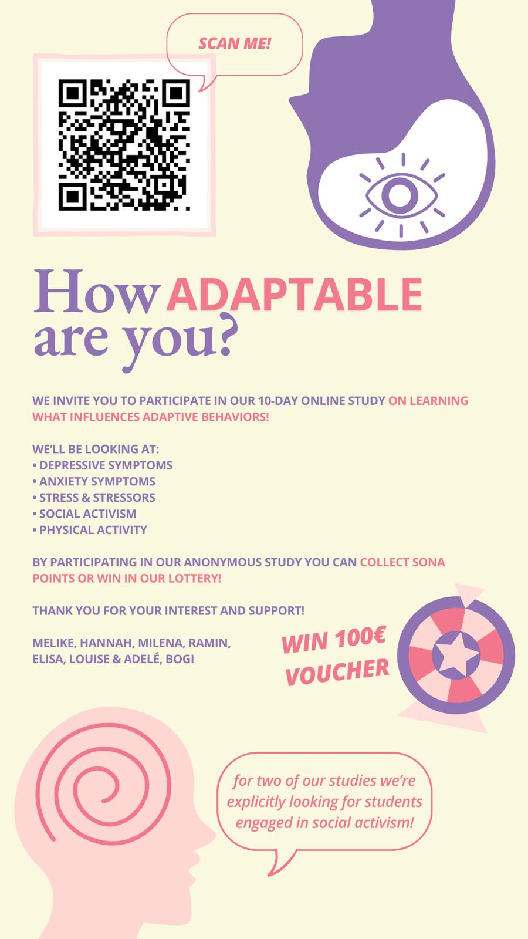
Flyer shared alongside the introduction text

Appendix B

Materials for Online Instruction Meetings

Script for Online Instruction Meetings for Digital Diary
“Welcome, and thank you for joining me today for this video briefing. We’re excited to have you as part of our study and appreciate your willingness to contribute to our research. In this session, I’ll guide you through setting up the tools you’ll need to participate fully. If at any point you have questions, feel free to ask—I am here to help!
First, we’ll need you to download the m-path app, which is central to the study. You can find this application both on GooglePlay and AppStore under the name “m-path”. If you prefer, I’ll also send a link ( m-path on GooglePlay, m-path on AppStore) that you can click directly. Take a moment to install it, and let me know once you’re ready.
Once the app is downloaded, you should open it to make sure it works. You’ll see a few prompts as part of the setup process. It’s important to follow these steps carefully:
First, please allow notifications and try to avoid having your phone in “do not disturb” mode for the sake of the study! This will help ensure you receive reminders and updates throughout the study.
Then you should be able to enter Your Participant ID. You’ll enter this as your nickname within the app. If you’re unsure of your ID, let me know, and I can assist.
Secondly, accept the Terms and Conditions. If you feel like it, take your time and read through the Terms and Conditions and Privacy Policy, then confirm your agreement. This step ensures your data is handled safely and ethically.
The app may also ask if you’d like to enable optional tracking features. You’re welcome to opt-in, but this is entirely voluntary and won’t affect your participation in the study.
The app will generate a recovery code during setup. Please save this code in a safe place, such as your notes app or take a screenshot of it. This code is important for recovering your account if needed.
Lastly, use my unique code as “the researcher” to join the study. Enter the code into the designated field in the app, and you’ll officially be enrolled.
Once you’ve completed these steps, let me know, and I’ll confirm that everything is set up correctly. If you encounter any issues, don’t hesitate to ask for help.
//providing a test notification to see whether the set up works//
During the 10-day study period, which will start on the 12th of December, you will receive notifications twice each day (in the midday and evening) from the m-Path app to complete a short questionnaire within a 3-hour window. During this period, you will receive a few reminders to ensure you fill out the responses on time. In the daily diary, you will be asked to reflect on your stress level, how you dealt with a challenging situation if you encountered one, and your physical activity (in the morning and evening).”

Script for Online Instruction Meetings for Gratitude Journal
“Welcome, and thank you for joining me today for this video briefing. We’re excited to have you as part of our study and appreciate your willingness to contribute to our research. In this session, I’ll guide you through setting up the tools you’ll need to participate fully. If at any point you have questions, feel free to ask—I am here to help!
First, we’ll need you to download the m-path app, which is central to the study. You can find this application both on GooglePlay and AppStore under the name “m-path”. If you prefer, I’ll also send a link (m-path on GooglePlay, m-path on AppStore) that you can click directly. Take a moment to install it and let me know once you’re ready.
Once the app is downloaded, you should open it to make sure it works. You’ll see a few prompts as part of the setup process. It’s important to follow these steps carefully:
First, please allow notifications and try to avoid having your phone in “do not disturb” mode for the sake of the study! This will help ensure you receive reminders and updates throughout the study.
Then you should be able to enter Your Participant ID. You’ll enter this as your nickname within the app. If you’re unsure of your ID, let me know, and I can assist.
Secondly, accept the Terms and Conditions. If you feel like it, take your time and read through the Terms and Conditions and Privacy Policy, then confirm your agreement. This step ensures your data is handled safely and ethically.
The app may also ask if you’d like to enable optional tracking features. You’re welcome to opt-in, but this is entirely voluntary and won’t affect your participation in the study.
The app will generate a recovery code during setup. Please save this code in a safe place, such as your notes app or take a screenshot of it. This code is important for recovering your account if needed.
Lastly, use my unique code: as “the researcher” to join the study. Enter the code into the designated field in the app, and you’ll officially be enrolled.
Once you’ve completed these steps, let me know, and I’ll confirm that everything is set up correctly. If you encounter any issues, don’t hesitate to ask for help.
//providing a test notification to see whether the set up works
During the 10-day study period, which will start on the 12th of December, you will receive notifications twice each day (in the midday and evening) from the m-Path app to complete a short questionnaire within a 3-hour window. During this period, you will receive a few reminders to ensure you fill out the responses on time. In the daily diary, you will be asked to reflect on your stress level, how you dealt with a challenging situation if you encountered one, and your physical activity (in the morning and evening).”

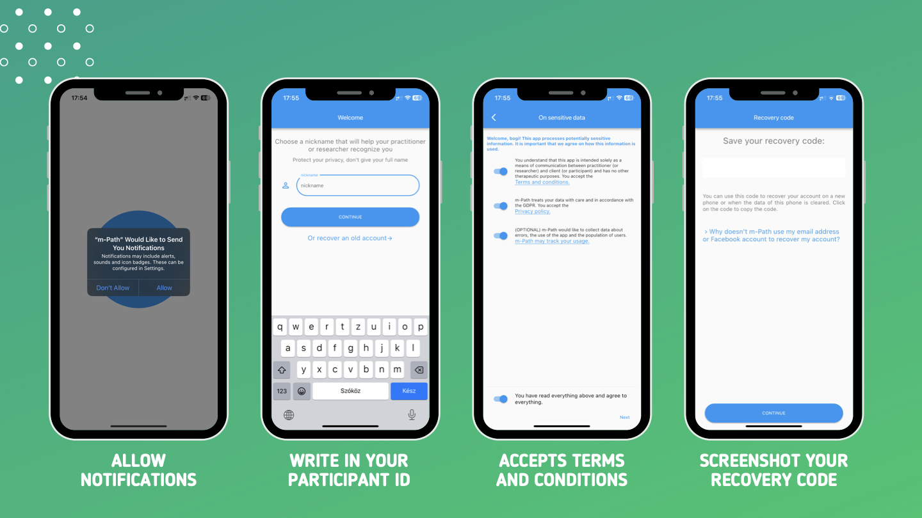



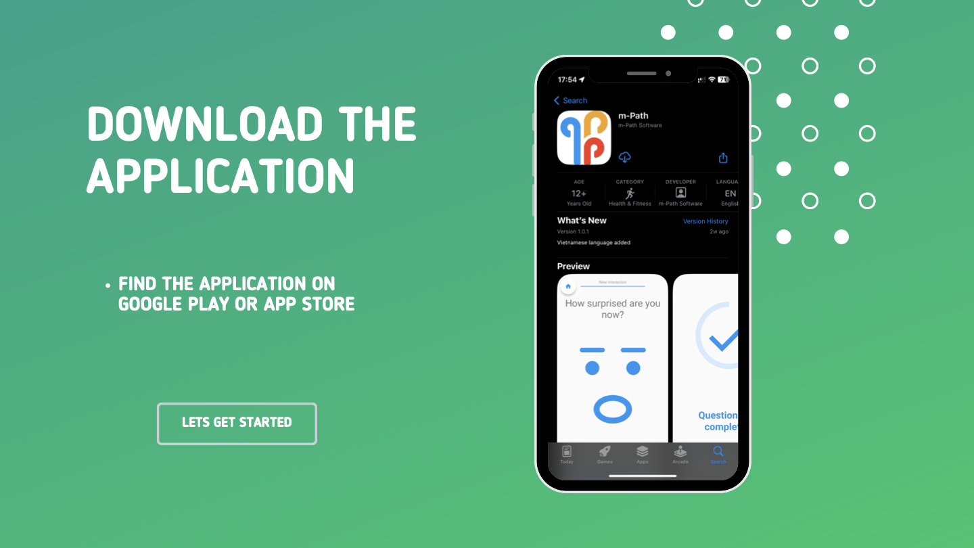
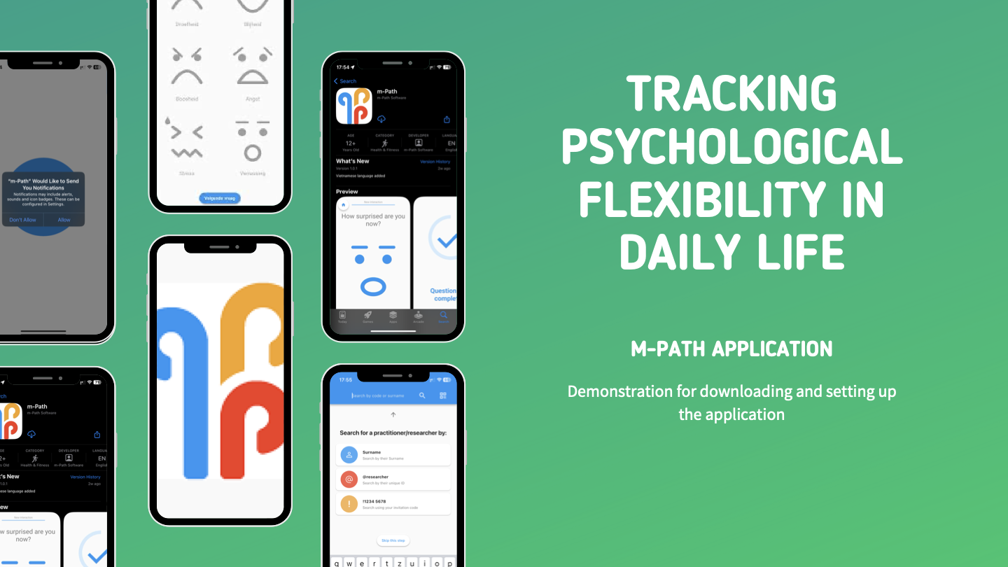
Presentation for Online Instructions

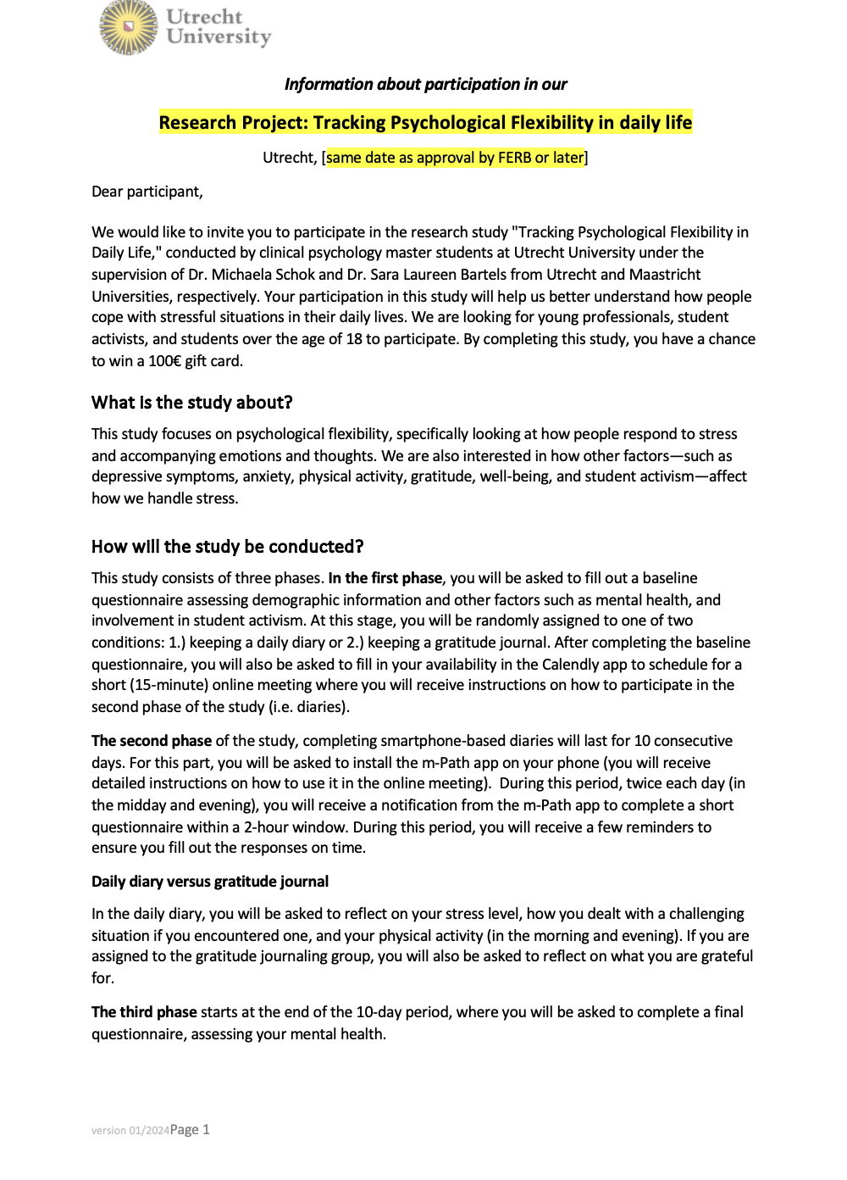
Informed Consent

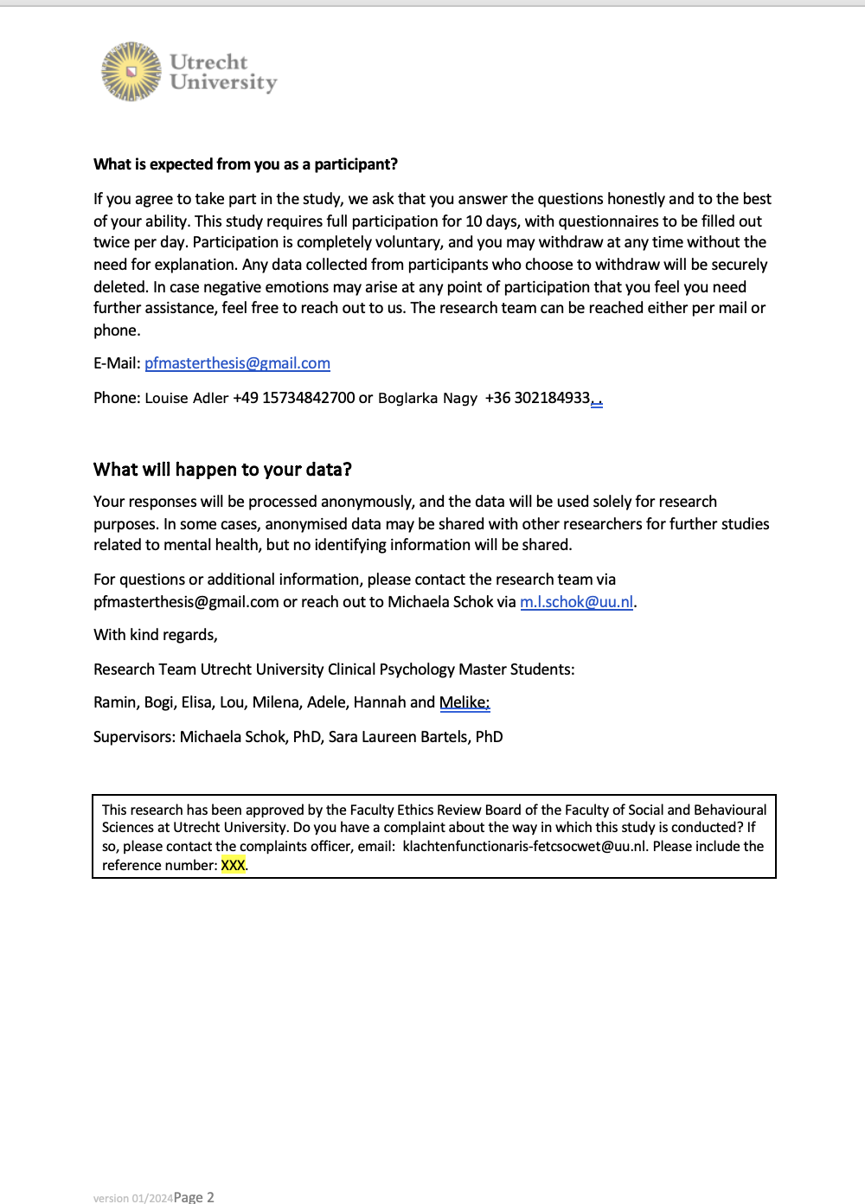

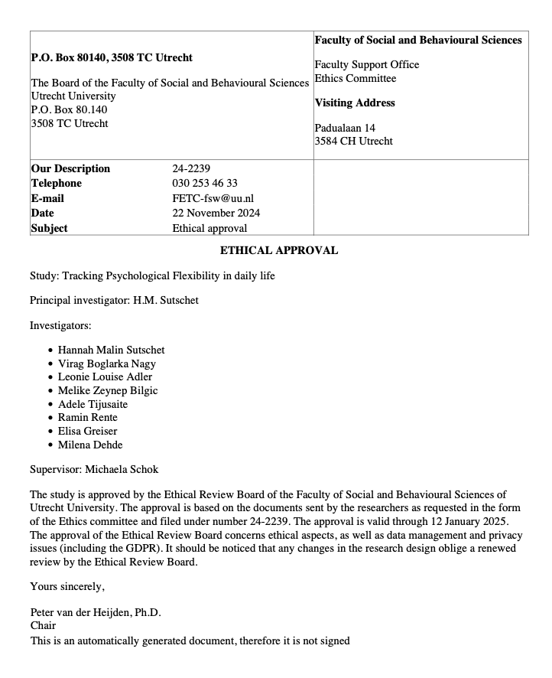
Approval of Ethics Review Board of the Faculty of Social & Behavioural Sciences, Utrecht University

Appendix C

Administered Scales

Psychological Flexibility
1. Not at all | 2. Very little | 3. A little bit | 4. Somewhat | 5. Fairly | 6. Moderately | 7. Quite a bit | 8. Considerably | 9. Extremely | 10. Very much
The following questions refer to your experiences in the last two hours.
- Centered_Present Moment: Even if I am somewhere else with my thoughts, I can focus on what’s going on in important moments.
- Open_Acceptance: If need be, I can let unpleasant thoughts and experiences happen without having to get rid of them immediately.
- Open_Defusion: ⁠I can look at hindering thoughts from a distance without letting them control me.
- Centered_Self-as-Context: Even if thoughts and experiences are confusing me I can notice something like a steady core inside of me.
- Engaged_Values: I determine what’s important for me and decide what I want to use my energy for.
- Engaged_Committed Action: I engage thoroughly in things that are important, useful, or meaningful to me.

Perceived Level of Stress
1. Not at all | 2. Very little | 3. A little bit | 4. Somewhat | 5. Fairly | 6. Moderately | 7. Quite a bit | 8. Considerably | 9. Extremely | 10. Very much

- To what extent have you felt stressed over the last two hours?

Gratitude Journaling Prompt
Open answer
- "Name three things you are grateful for.”

Appendix D

Data Exclusion based on Response Rates and Gratitude Adherence

Distribution of Response Rate

The overall response rate was high, with a mean of M = 87.9 (SD = 16.3) and a Mdn = 95. Response rates were slightly higher in the GJ condition (M = 90.3, SD = 14.3, Mdn = 100) compared to the DD condition (M = 85.6, SD = 17.7, Mdn = 90).
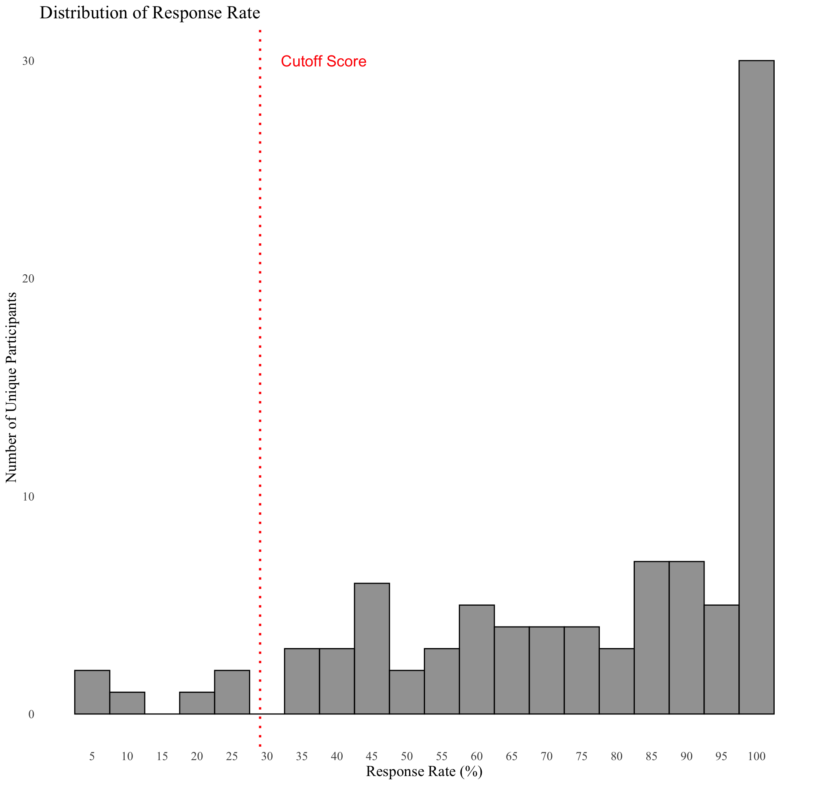
Figure 6
Distribution of Response Rate for both Conditions

Distribution of Gratitude Adherence

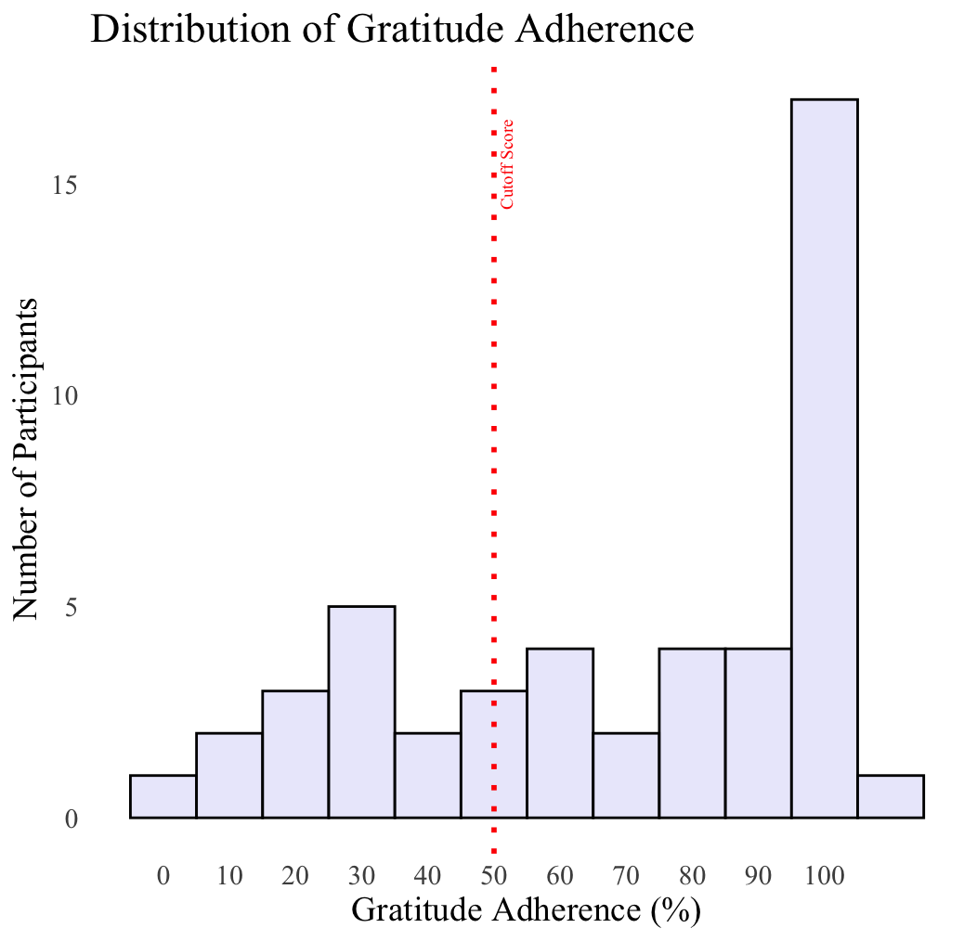
Gratitude adherence was calculated by taking the actual gratitude items along the 10-day study and divide them by the total amount of possible gratitude items (3 per day x 10 days).
Figure 7
Distribution of Gratitude Adherence for Gratitude Journaling Condition

Code Prompt for Multiple Response and differences in sample size
Self-initiated multiple responses. Unclear if the app prompted participants again or if participants just went into the app again and completed the diary on their own initiative.
# Cleaning for multiple responses
# Convert the "time" column to a Date-Time format
dailydata_final <- dailydata_final %>%
mutate(time = as.POSIXct(time, format="%a, %d %b %Y %H:%M:%S", tz="UTC"),
date = as.Date(time)) # Extract only the date
# Select the first response for each participant per day in the midday period (12:00-18:59)
midday_responses <- dailydata_final %>%
filter(hour >= 12 & hour < 19) %>%
group_by(participant_id, date) %>%
slice_min(time, n = 1) %>%
ungroup()

# Select the first response for each participant per day in the evening period (19:00-24:00)
evening_responses <- dailydata_final %>%
filter(hour >= 19 & hour < 24) %>%
group_by(participant_id, date) %>%
slice_min(time, n = 1) %>%
ungroup()

# Combine the selected responses
dailydata_cleaned_mr <- bind_rows(midday_responses, evening_responses)

Appendix E

Demographic Distributions by Condition

Age Distribution by Condition
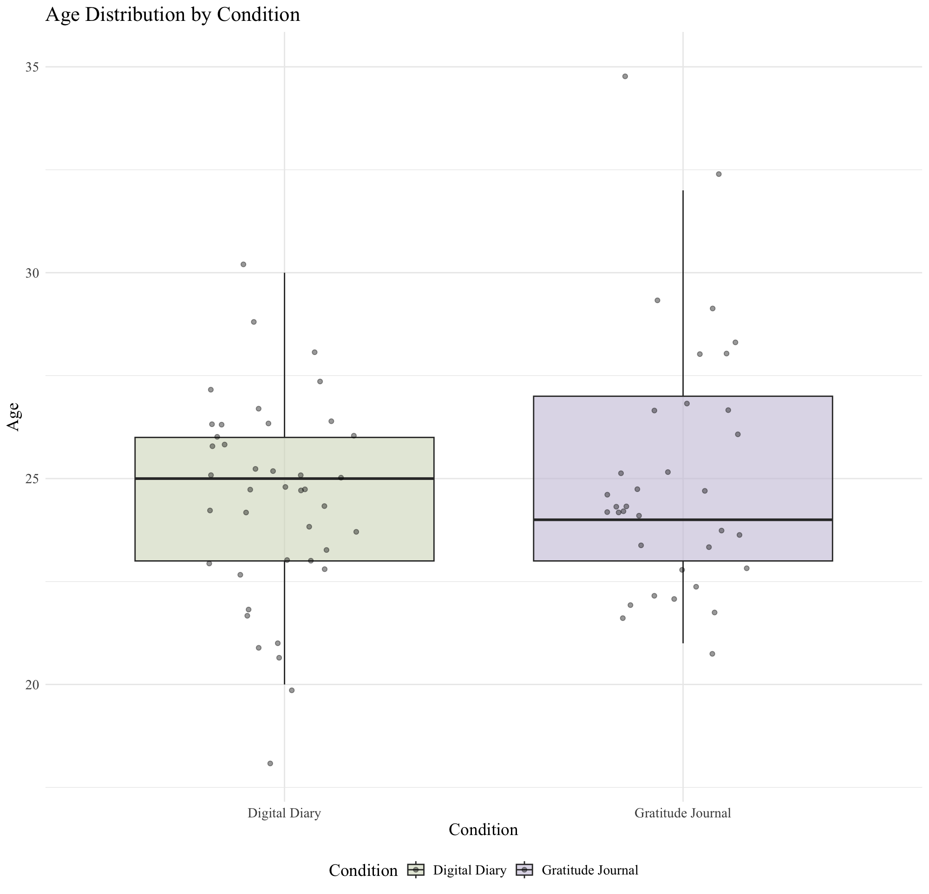
This boxplot illustrates the age distribution across the DD and GJ conditions. Age distributions were similar, though the GJ group showed slightly more variability (M = 25.1, SD = 3.04, Mdn = 24) compared to the DD group (M = 24.5, SD = 2.39, Mdn = 25).
Figure 8
Age Distribution by Condition

Journaling Experience by Condition

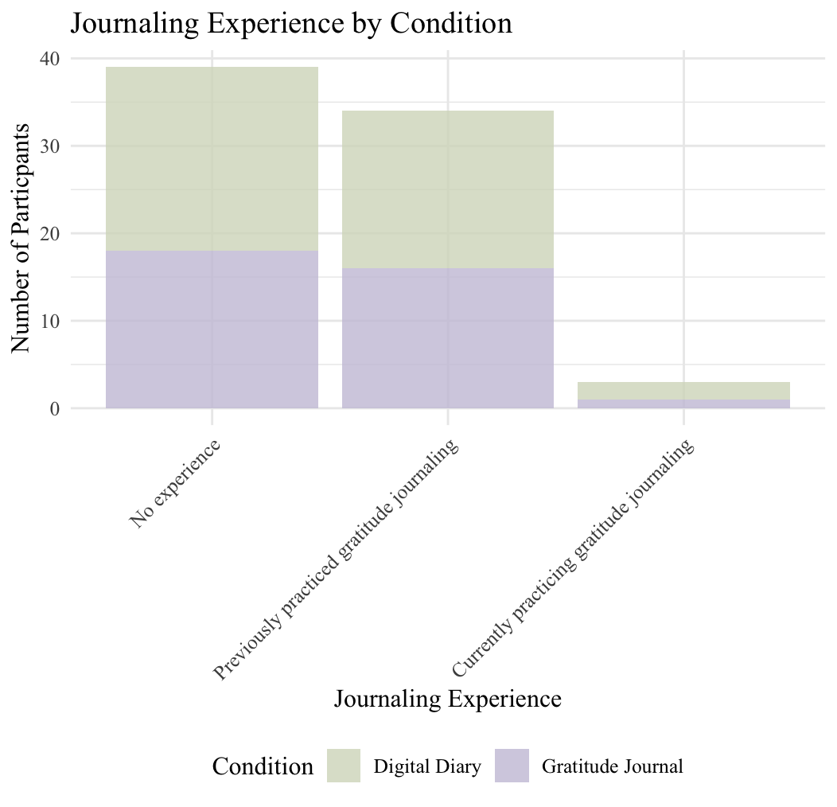
Most participants reported no prior experience with gratitude journaling (n = 39, 51.3%), while 34 participants (44.7%) had previously practiced and only 3 participants (3.95%) were currently practicing gratitude journaling. Conditions were similarly distributed. In the DD condition, 21 participants (53.8%) had no experience while in the GJ condition 18 participants (48.6%) had no experience. 18 (46.2%) of the DD condition had previously practiced, compared to 16 (43.2%) of the GJ condition. 2 participants (5.1%) in the DD condition were currently practicing gratitude journaling while 1 (2.7%) in the GJ condition was currently practicing as well.
Figure 9
Journaling Experience by Condition

Occupation by Condition
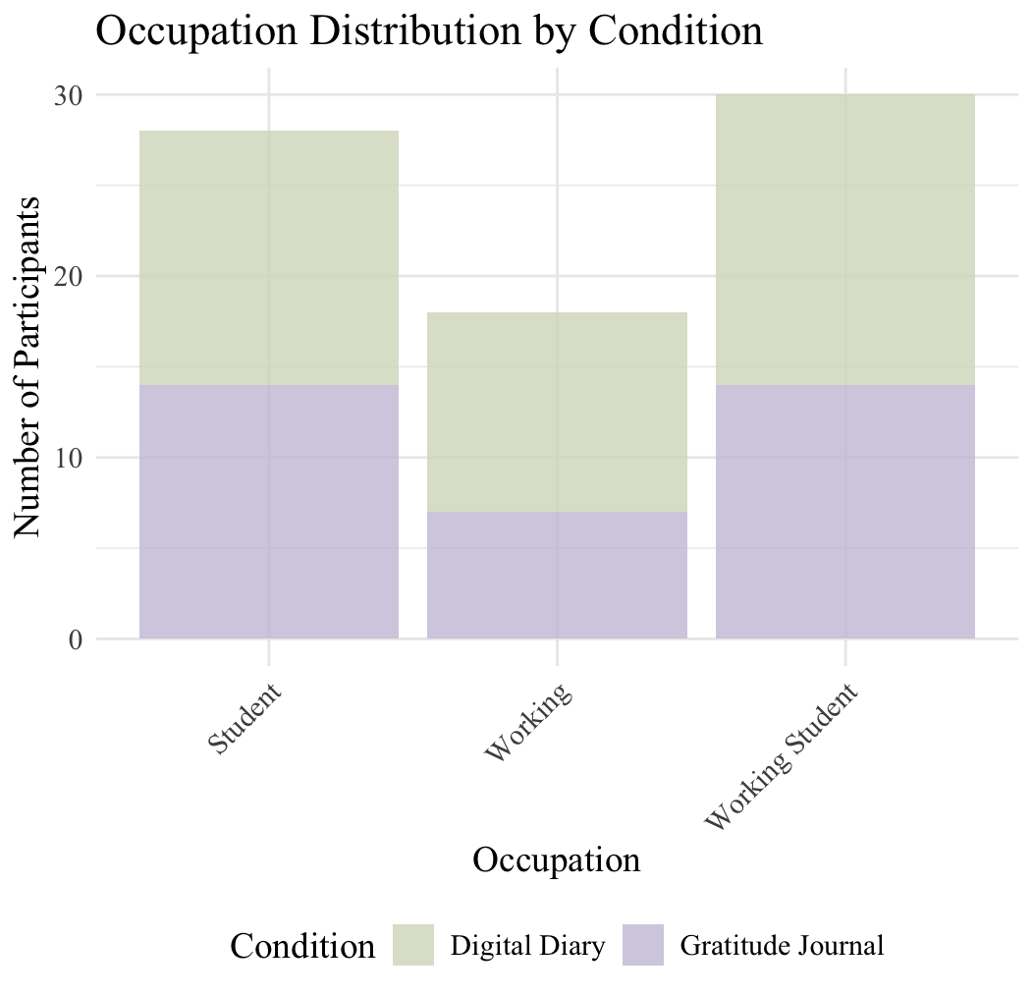
The distributions of the boxplot suggest balanced representation across all occupational categories. Participants were categorized in three occupations: working students made up the largest group (n = 30, 39.5%), followed by students (n = 28, 36.8%) and working professionals (n = 18, 23.7%). The distribution was similar across conditions. In the DD condition, 14 participants (35.0%) were students, 11 (27.5%) were working, and 16 (40.0%) were working students. In the GJ condition, 14 participants (35.0%) were students, 7 (17.5%) were working, and 14 (35.0%) were working students.
Figure 10
Occupation by Condition

Appendix F

Testing of Assumptions: Hypothesis 1

Normality of Residuals
Figure 11
QQ-Plot for Normality of Residuals

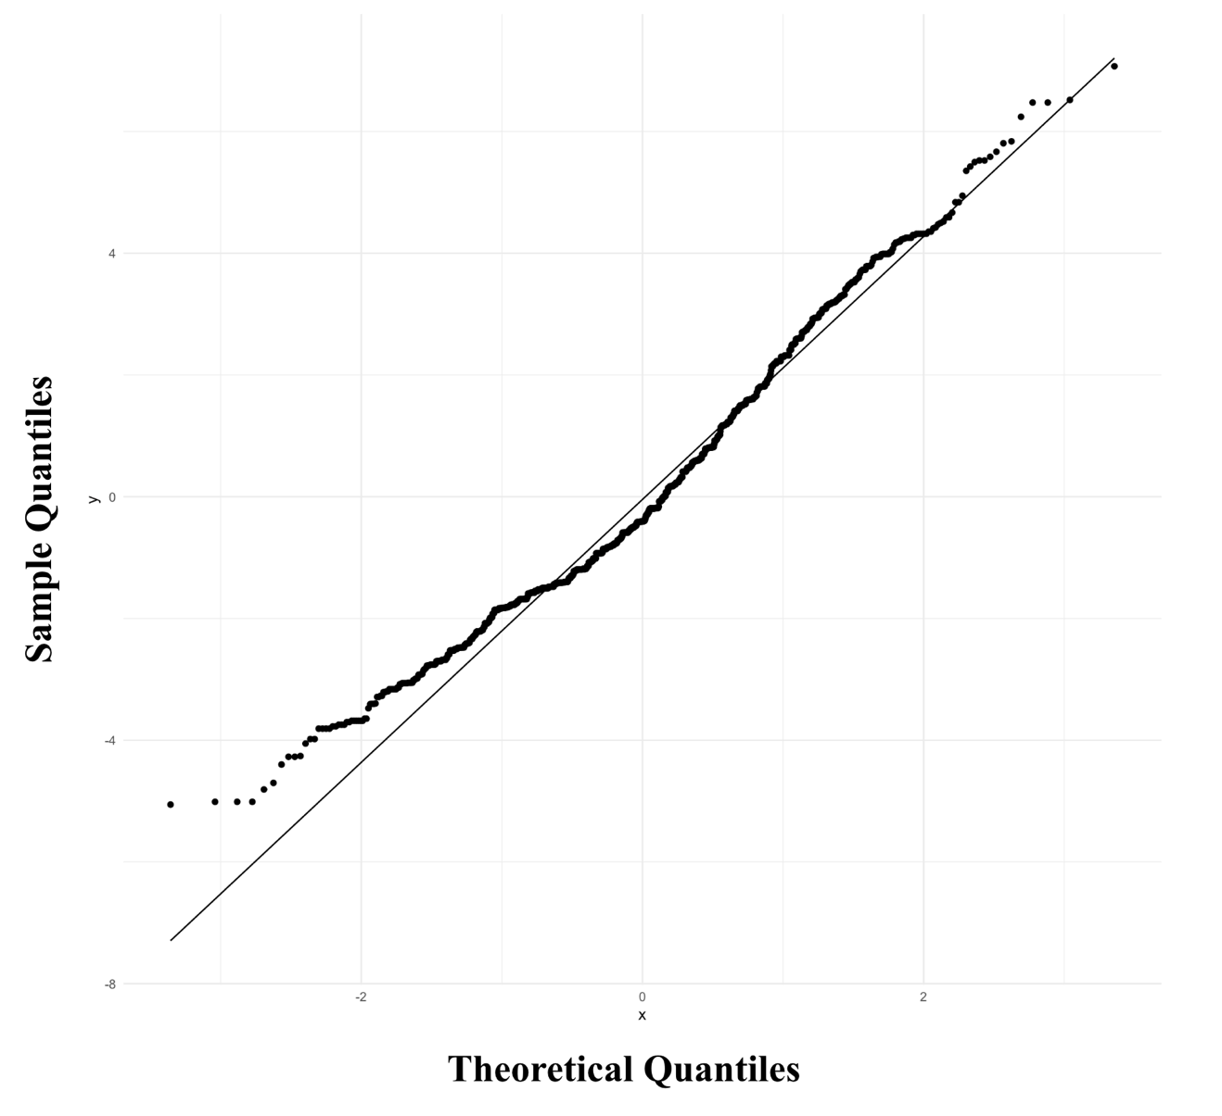
A generally linear pattern, with minor deviations in the tails, suggesting residuals were approximately normally distributed. The normality of residuals was confirmed with skewness (0.48) and kurtosis (2.85) values within acceptable limits.

Independence of Residuals for Hypothesis 1
Autocorrelation diagnostics showed no significant issues beyond lag 1.
Figure 12
Autocorrelation Diagnostic for Hypothesis 1

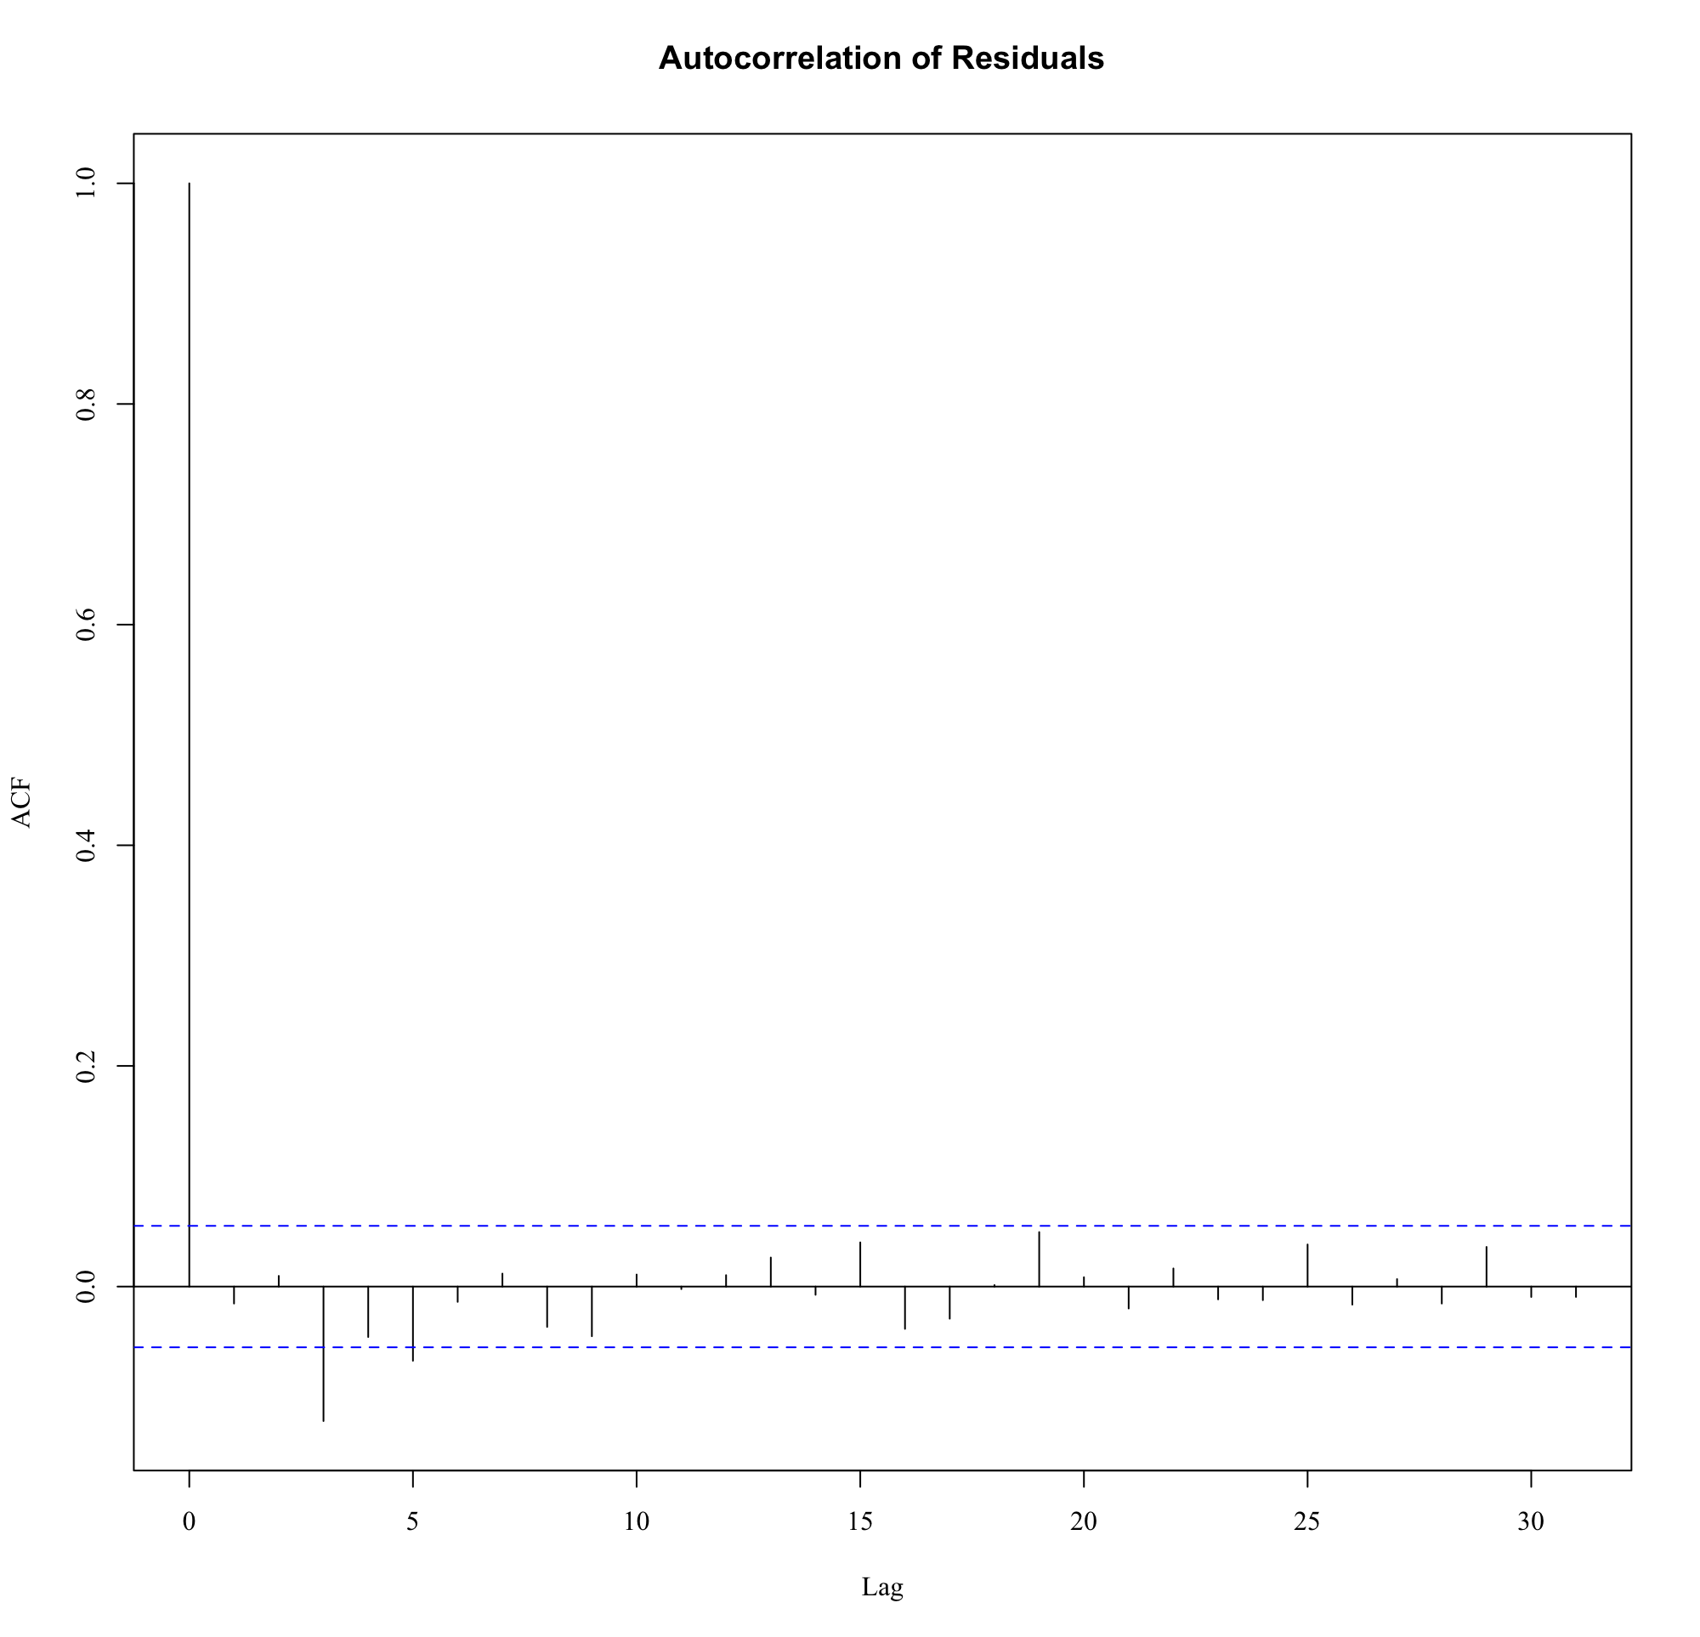
Cook’s Distance for Hypothesis 1
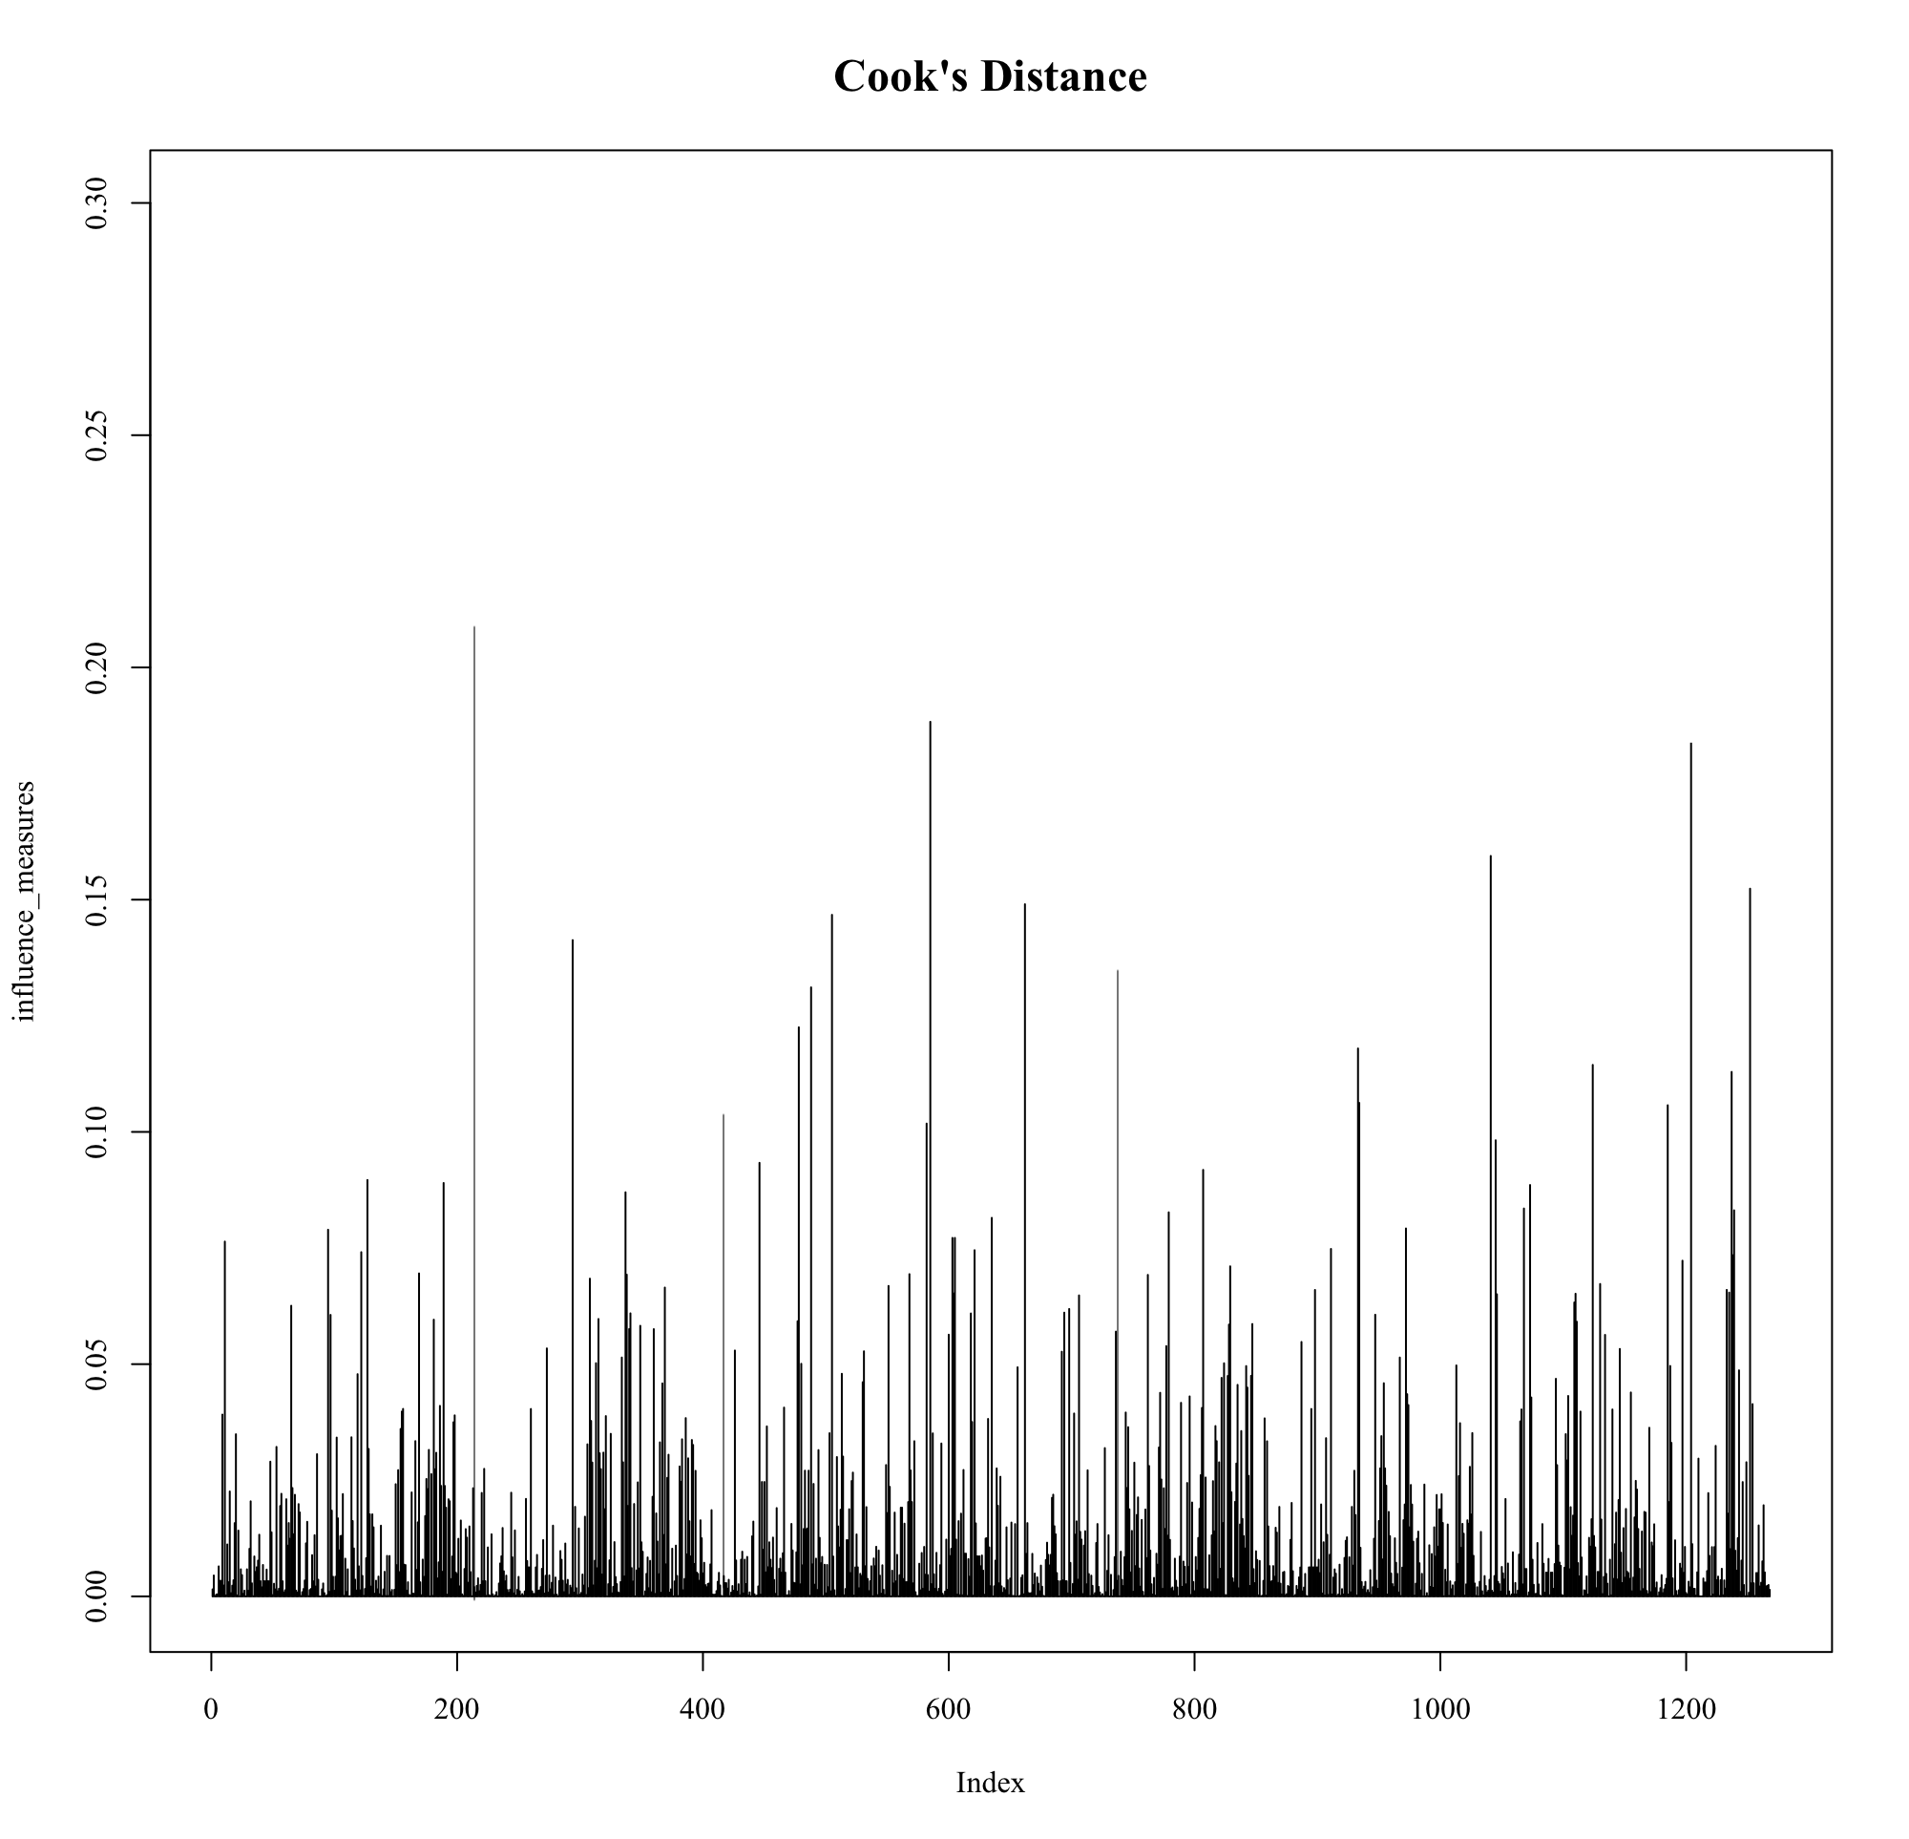
No influential outliers were detected.
Figure 13
Cook’s Distance for Potential Outliers

Homoscedasticity Assumption for Hypothesis 1

Residuals vs. Fitted Values
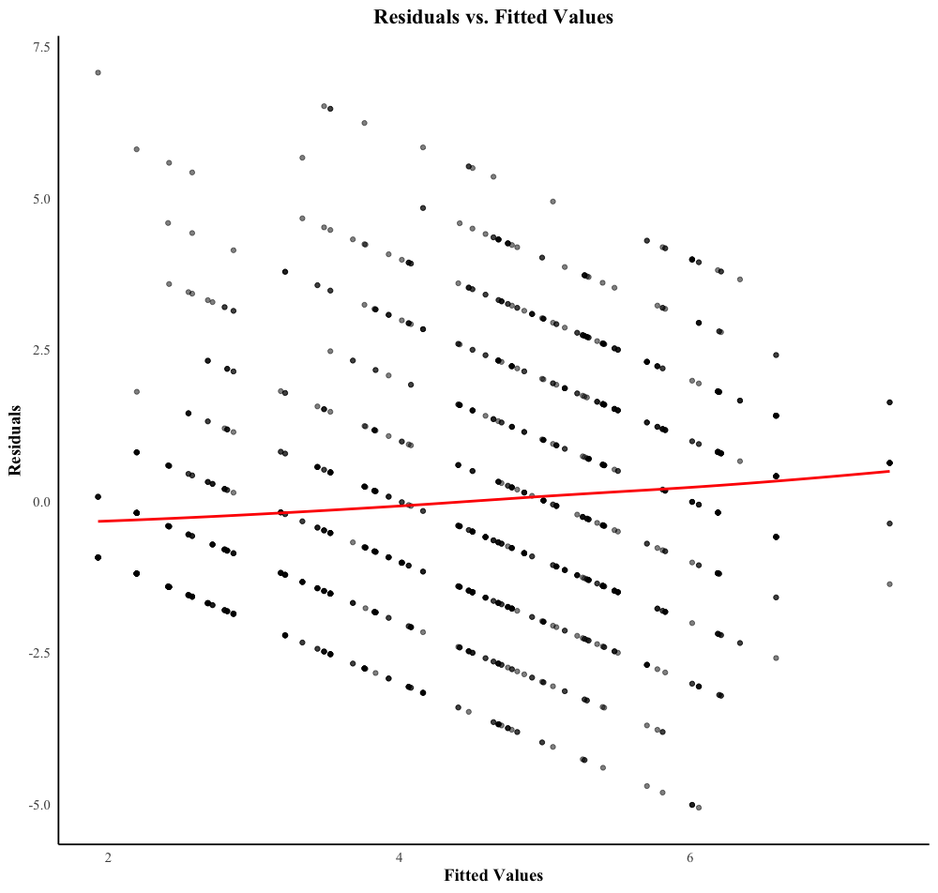
A residual vs. fitted values plot was examined. The plot revealed a structured pattern, likely due to the categorical nature of the independent variable (Condition: Gratitude Journal vs. Digital Diary). While no strong funnel shape was observed, the presence of a structured pattern suggested possible heteroscedasticity.
Figure 14
Residual vs. Fitted Values Plot

Density Plot
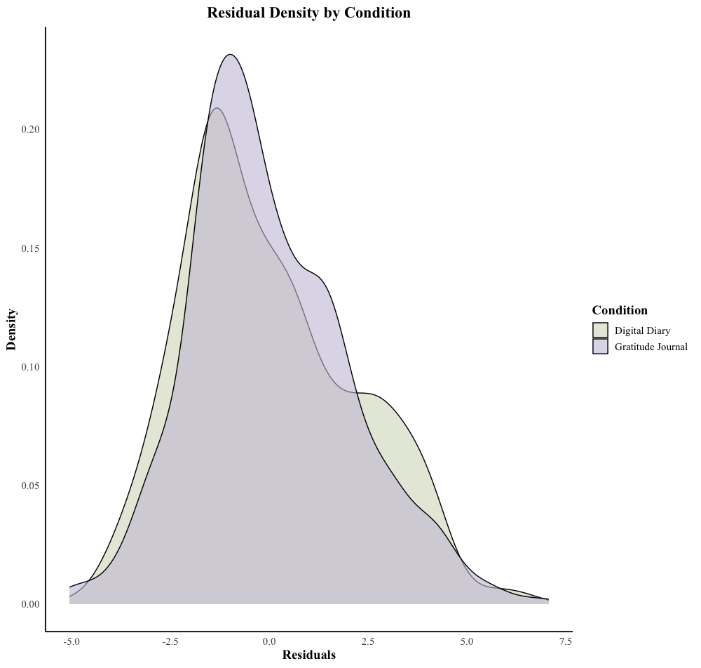
A density plot of residuals further supported the presence of variance differences between conditions. The Gratitude Journal condition exhibited a narrower, more peaked distribution, while the Digital Diary condition showed a flatter, more spread-out residual distribution, suggesting greater variance in the Digital Diary group. This visual evidence aligns with Levene’s Test (p = 0.008) confirming significant differences in variance across both conditions.
Figure 15
Residual Density by Condition

Results of Post-Hoc Analysis for Gratitude Adherence
Table 3
Fixed and Random Effects for Post-Hoc Analysis of Hypothesis 1
Effect | Estimates | SE | 95%CI |  | p
 |  |  | LL | UL
Fixed effects
(Intercept) | 4.519*** | .150 | 4.072 | 4.978 | < .001***
condition [Gratitude Journal] | .010 | .105 | -.642 | .662 | .910
Random Effects
Within-Person Variability | 1.349 | .120 | 1.100 | 1.560
Between-Person Variability | 2.223 | .095 | 1.900 | 2.400
Note. Number of participants = 76, number of observations = 1,268. CI = confidence interval; LL = lower limit; UL = upper limit; ***p < .001. SE for random effects is estimated via bootstrapping

Visual Investigation of Perceived Stress by Condition
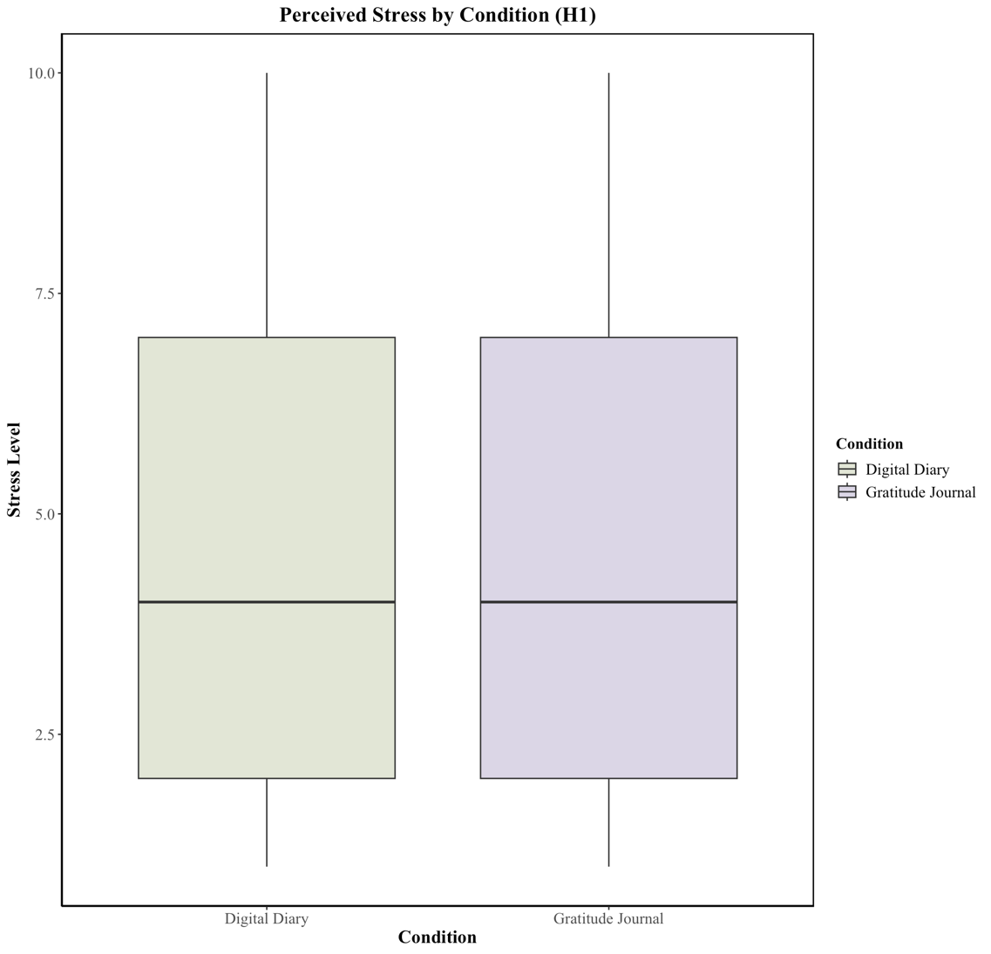
The boxplot illustrates the distribution of PS across the DD and GJ conditions, displaying nearly identical median values. The interquartile range (IQR) and whiskers indicate similar variability between groups. These findings are in alignment with the statistical results, indicating that GJ did not significantly reduce perceived stress compared to the digital diary condition.
Figure 16
Boxplot for Perceived Stress Scores by Condition

Appendix G

Mean centring of Psychological Flexibility
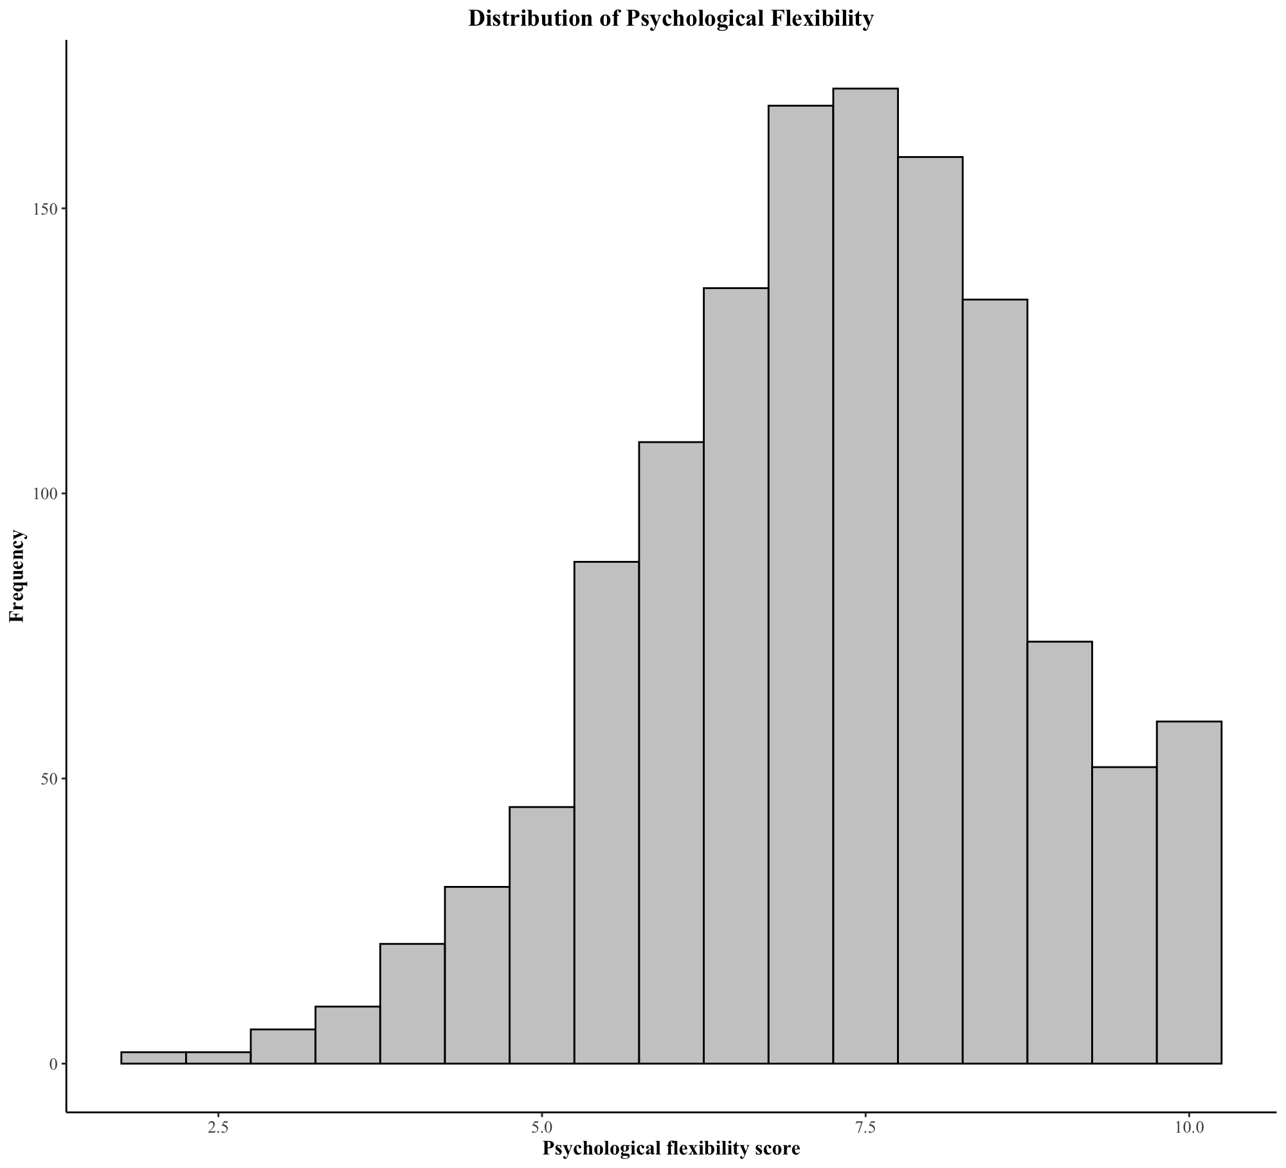
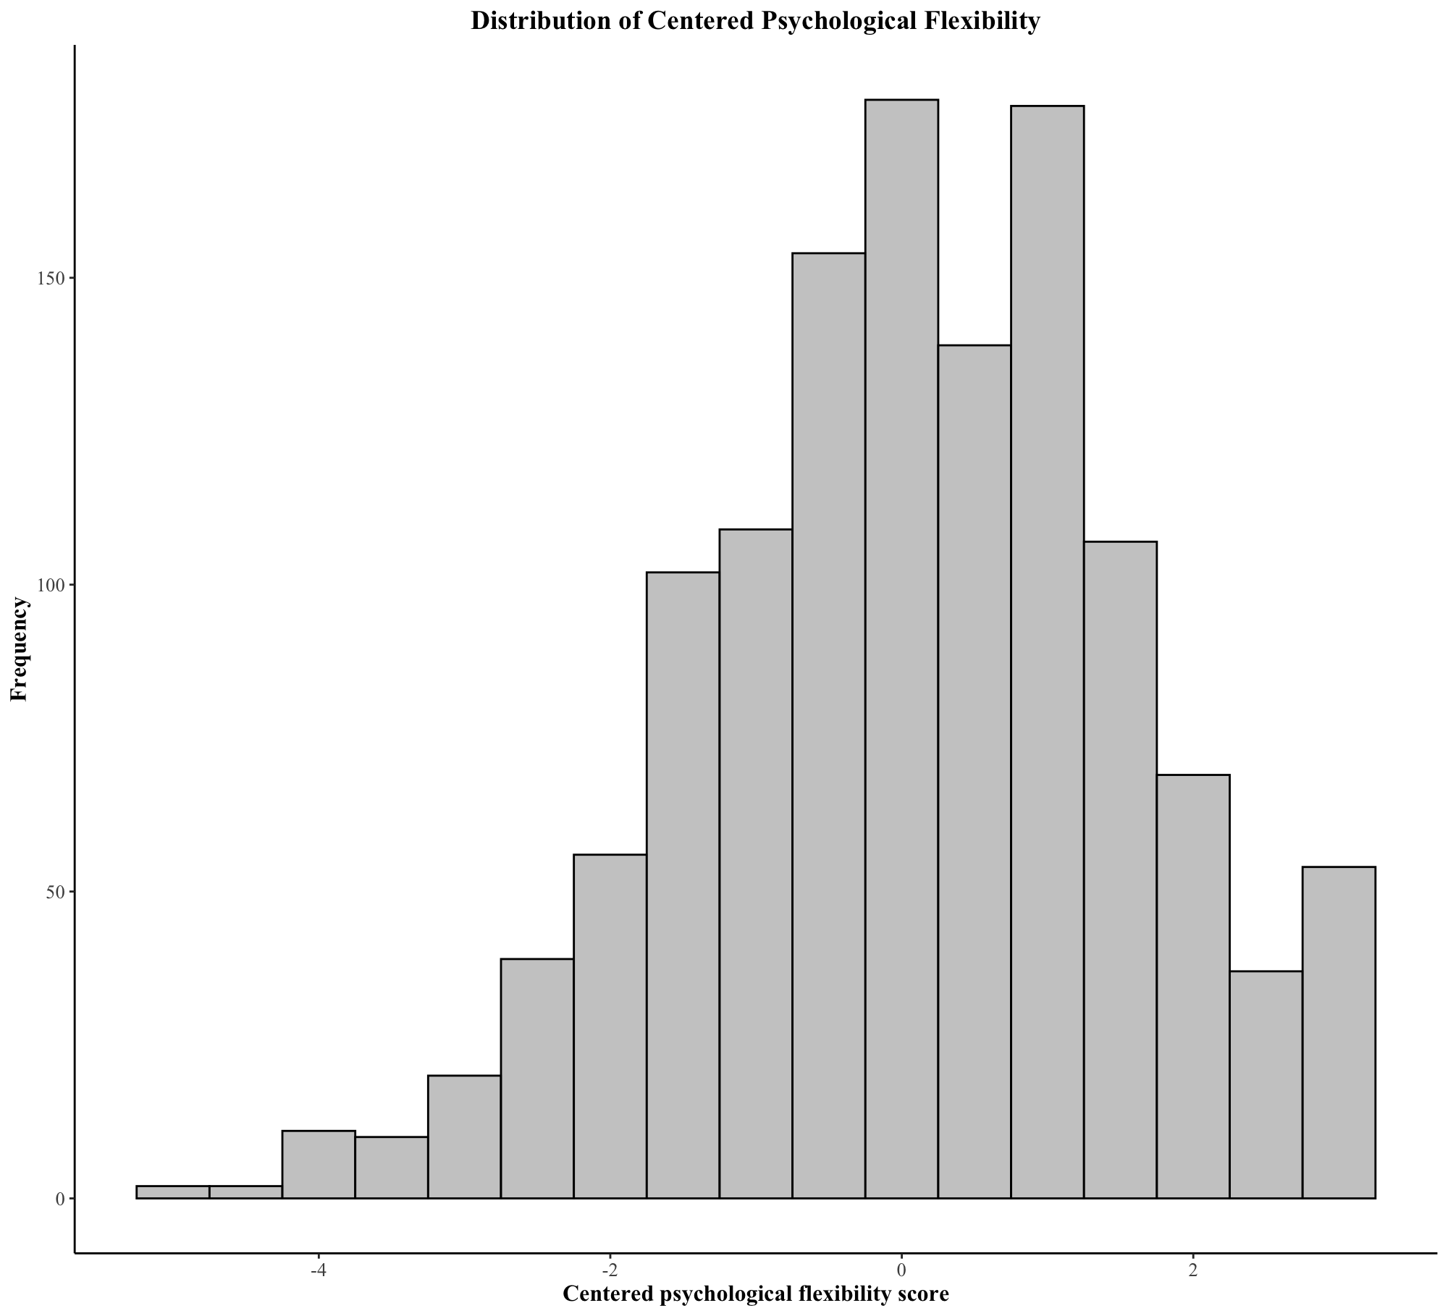
PF was mean centred before testing the moderation effect to ensure that the intercept represented the expected stress level when PF was at its average level in the sample, rather than an arbitrary value of zero. Centring also reduced multicollinearity in the interaction term, improving the interpretability of the results. Specifically, the link between condition and PF decreased from 0.672 to -0.022, and the link between condition and the interaction term dropped from -0.712 to 0.013 after centring, showing a significant reduction in multicollinearity.
Figure 18
Distribution of PF Centred

Figure 17
Distribution of PF Uncentered

Distribution of Psychological Flexibility by Condition
The boxplot illustrates the distribution of PF across conditions, showing similar overall levels. The median PF is slightly higher in the GJ condition, and the interquartile range (IQR) is more spread out. Individual data points indicate variability within both conditions, reinforcing that PF levels were relatively similar across conditions.
Figure 19
Boxplot of Distribution of Psychological Flexibility by Condition
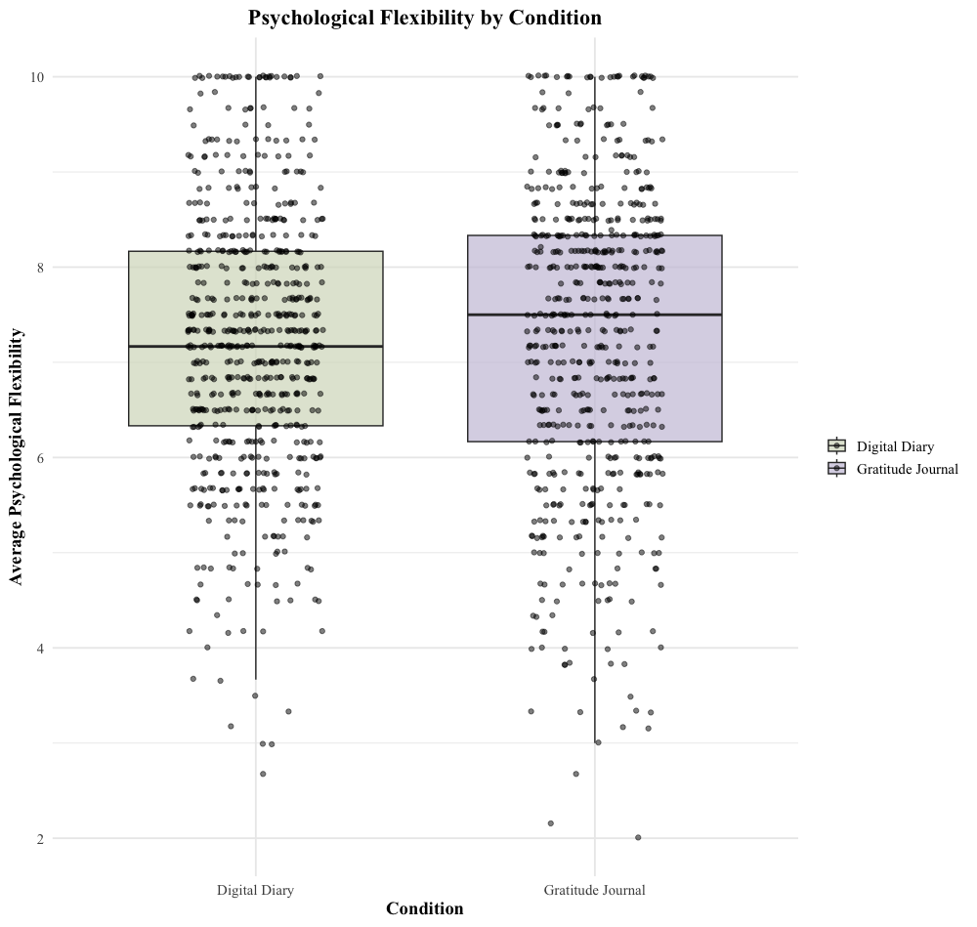

Appendix H

Testing of Assumptions: Hypothesis 2

Independence of Residuals for Hypothesis 2
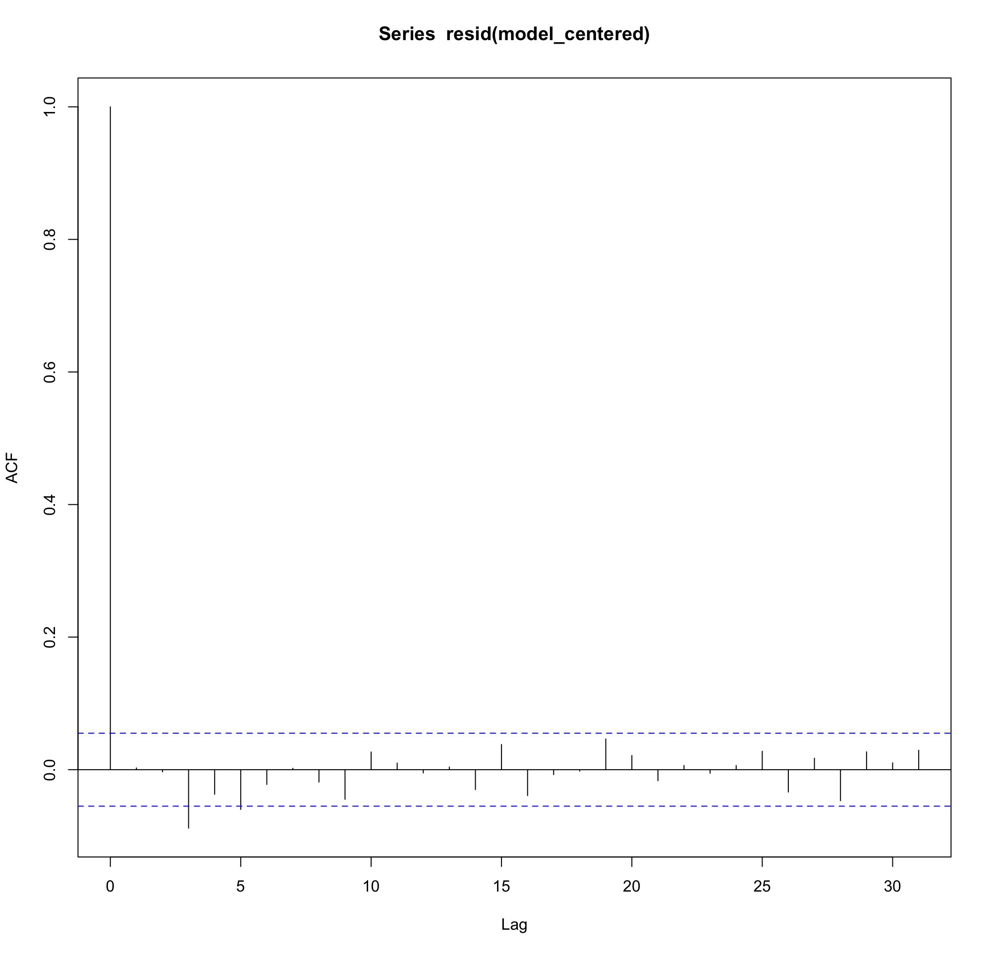
Autocorrelation diagnostics showed no significant issues beyond lag 1.
Figure 20
Autocorrelation Diagnostic for Hypothesis 2

Cook’s Distance for Hypothesis 2
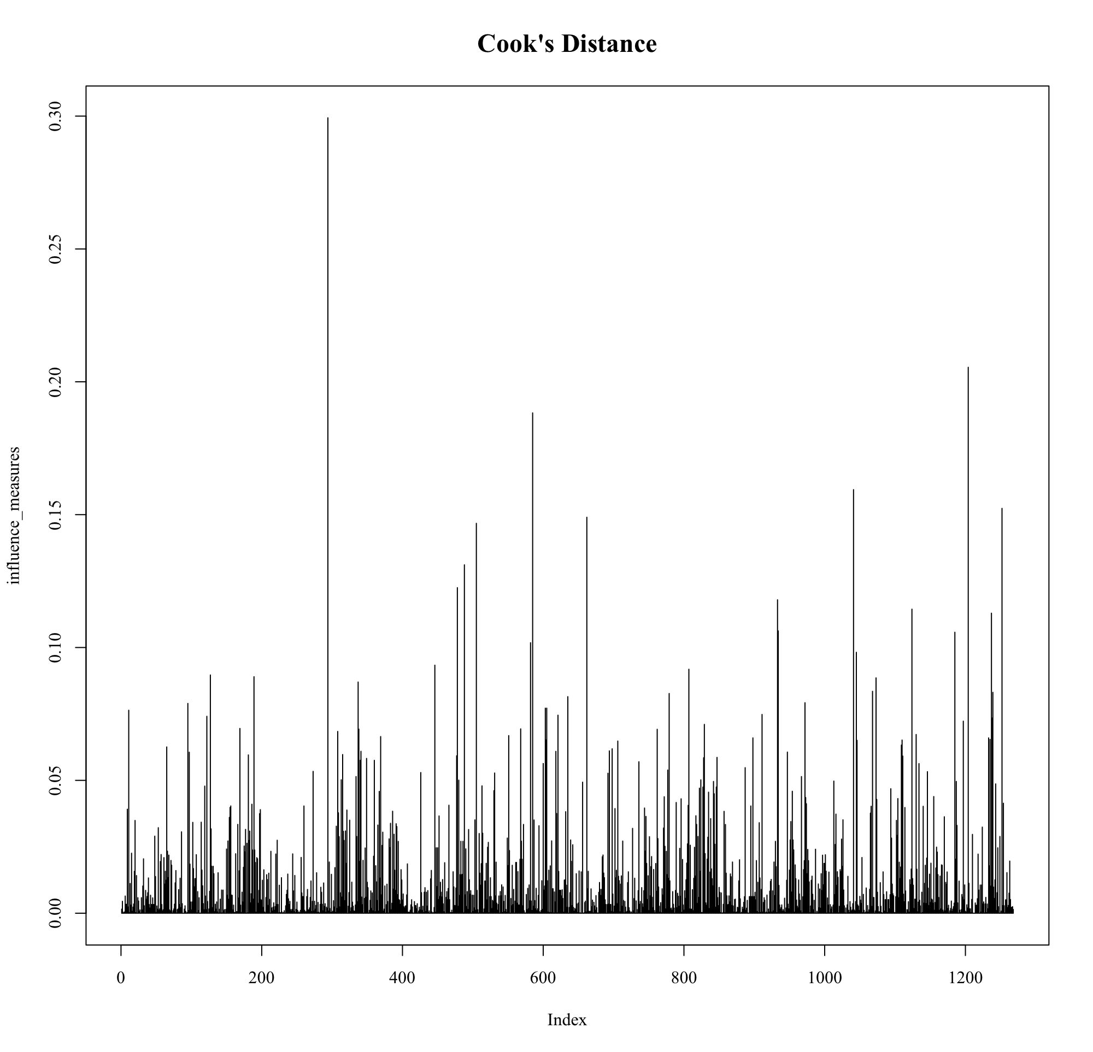
No influential outliers were detected.
Figure 21

Cook’s Distance for Hypothesis 2

Normality of Residuals
Figure 22
Q-Q Plot of Residuals for Hypothesis 2

A generally linear pattern, with minor deviations in both tails and upper quantile, suggesting residuals were approximately normally distributed. The normality of residuals was confirmed with skewness (0.48) and kurtosis (3.33) values within acceptable limits.
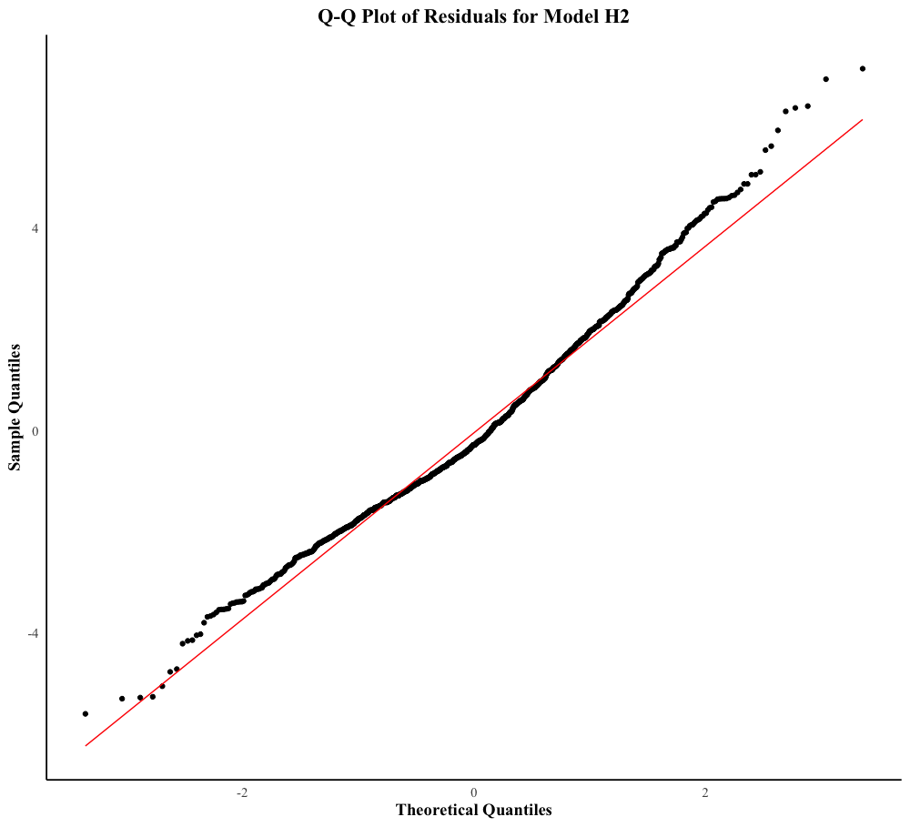

Homoscedasticity Assumption for Hypothesis 2

Residuals vs. Fitted Values
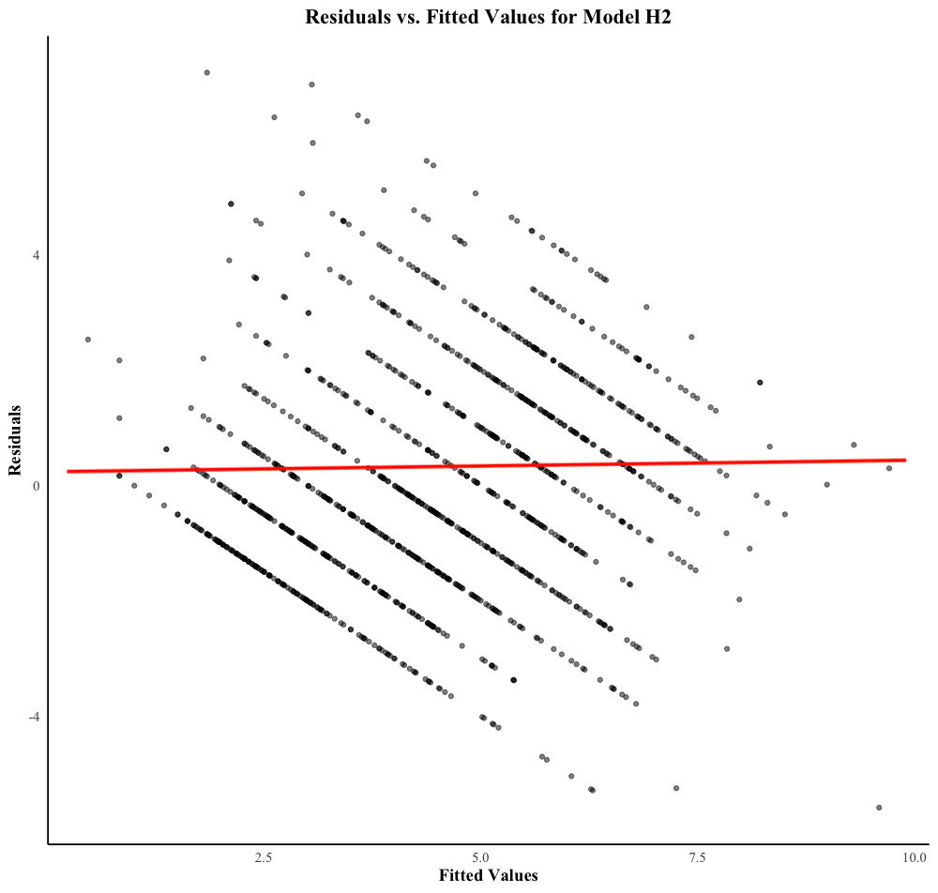
The plot of residuals vs. fitted values shows a random distribution of residuals around zero, with no visible funnel shape or systematic pattern.
Figure 23
Residuals vs. Fitted Values for Hypothesis 2

Appendix I
Data Collection
Data collection involved a three-phase process: pre-assessment, briefing and intervention. Participants were recruited via personal networks using WhatsApp and social media platforms. An introductory text and flyer (Appendix A) were distributed to outline key details of the study. Eligibility criteria were 18–35 years old, identifying as a student, young worker, or working student, speaking English, and having mobile phone access. Those who met criteria have been randomly assigned to either the Gratitude or Digital Diary condition using Qualtrics’ randomizer functionality. Upon assignment, participant scheduled an online video instruction meeting via the platform Calendly. This meeting served to instruct participants on how to use m-Path for the 10-day intervention. Standardized scripts and slides have been used to ensure consistency across all meetings (Appendix B). The m-Path was set up prior to the intervention and has been underwent a two-day testing phase to confirm its functionality.

Appendix J
Code Prompts in R
# Load necessary libraries
> library(readxl)
> library(dplyr)
> library(lubridate)
> library(lme4)
> library(ggplot2)
> library(performance)
> library(simr)
# Load the dataset
dailydata_final <- read_excel("~/Library/CloudStorage/GoogleDrive-raminrente@gmail.com/Meine Ablage/01_Master/00_Master Thesis/05_Analysis/Final/dailydata_final.xlsx")
> View(dailydata_final)
> dailydata_final <- dailydata_final[-1527, ]

# Create new variable: pre_sample_size (sample size per condition)
pre_sample_size <- dailydata_final %>%
group_by(condition) %>%
summarise(sample_size = n_distinct(participant_id))
# Cleaning for multiple responses
# Convert the "time" column to a Date-Time format
dailydata_final <- dailydata_final %>%
mutate(time = as.POSIXct(time, format="%a, %d %b %Y %H:%M:%S", tz="UTC"),
date = as.Date(time)) # Extract only the date
# Select the first response for each participant per day in the midday period (12:00-18:59)
midday_responses <- dailydata_final %>%
filter(hour >= 12 & hour < 19) %>%
group_by(participant_id, date) %>%
slice_min(time, n = 1) %>%
ungroup()

# Select the first response for each participant per day in the evening period (19:00-24:00)
evening_responses <- dailydata_final %>%
filter(hour >= 19 & hour < 24) %>%
group_by(participant_id, date) %>%
slice_min(time, n = 1) %>%
ungroup()

# Combine the selected responses
dailydata_cleaned_mr <- bind_rows(midday_responses, evening_responses)

# Calculate response rate per participant response_rate <- dailydata_cleaned_mr %>% group_by(participant_id) %>% summarise(total_responses = n(), response_rate = (total_responses / 20) * 100) %>% ungroup()
# Calculate overall mean, standard deviation, and median for response_rate
overall_response_stats <- dd_final %>%
summarise(
mean_response = mean(response_rate, na.rm = TRUE),
sd_response = sd(response_rate, na.rm = TRUE),
median_response = median(response_rate, na.rm = TRUE)
)

# Print overall results
print(overall_response_stats)

# Calculate mean, standard deviation, and median for response_rate by condition
response_by_condition <- dd_final %>%
group_by(condition) %>%
summarise(
mean_response = mean(response_rate, na.rm = TRUE),
sd_response = sd(response_rate, na.rm = TRUE),
median_response = median(response_rate, na.rm = TRUE)
)

# Print results by condition
print(response_by_condition)

# Calculate gratitude adherence for "Gratitude Journal" condition
gratitude_adherence <- dailydata_cleaned_mr %>%
filter(condition == "Gratitude Journal") %>%
group_by(participant_id) %>%
summarise(gratitude_adherence = (sum(gratitudeitems_perday, na.rm = TRUE) / 30) * 100) %>%
ungroup()
# Filter for Gratitude Journal condition and calculate statistics
gratitude_adherence_stats <- dd_final %>%
filter(condition == "Gratitude Journal") %>%
summarise(
mean_adherence = mean(gratitude_adherence, na.rm = TRUE),
sd_adherence = sd(gratitude_adherence, na.rm = TRUE),
median_adherence = median(gratitude_adherence, na.rm = TRUE)
)

# Print the results
print(gratitude_adherence_stats)
# Create final dataset
# Merge response rate and gratitude adherence with the main dataset
dailydata_cleaned_mr <- dailydata_cleaned_mr %>%
left_join(response_rate, by = "participant_id") %>%
left_join(gratitude_adherence, by = "participant_id")
# Create final dataset dd_final

dd_final <- dailydata_cleaned_mr %>%
filter((condition == "Digital Diary" & response_rate >= 30) |
(condition == "Gratitude Journal" & response_rate >= 30 & gratitude_adherence >= 50))

#RENAMING FINAL DATASET
dd_final <- dd_final %>%
+ rename(
+ centered_present_moment = `Centered_Present Moment`,
+ open_acceptance = `Open_Acceptance`,
+ open_defusion = `Open_Defusion`,
+ centered_self_as_context = `Centered_Self-as-Context`,
+ engaged_values = `Engaged_Values`,
+ engaged_committed_action = `Engaged_Committed Action`
+ )

# Calculate average psychological flexibility
dd_final <- dd_final %>%
mutate(average_pf = rowMeans(select(., centered_present_moment, open_acceptance, open_defusion,
centered_self_as_context, engaged_values, engaged_committed_action),
na.rm = TRUE))
# Calculate mean and standard deviation overall psychological flexibility
> average_pf_overall <- dd_final %>%
+ summarise(
+ mean_pf = mean(average_pf, na.rm = TRUE),
+ sd_pf = sd(average_pf, na.rm = TRUE)
+ )
> print("Overall Psychological Flexibility Stats:")
> print(average_pf_overall)
# Calculate mean and standard deviation of psychological flexibility by condition
> condition_pf <- dd_final %>%
+ group_by(condition) %>% # Assuming "condition" column contains 'Digital Diary' and 'Gratitude Journal'
+ summarise(
+ mean_pf = mean(average_pf, na.rm = TRUE),
+ sd_pf = sd(average_pf, na.rm = TRUE)
+ )
>
> print("Psychological Flexibility Stats by Condition:")
> print(condition_pf)

#CALCULATE DESCRIPTIVES
# Create a new dataset with unique participants from dd_final
unique_participants <- dd_final %>%
select(participant_id, condition) %>%
distinct()
# Create a separate dataset for descriptives
all_descriptives <- unique_participants %>%
left_join(all_descriptives, by = "participant_id")

# Calculate gender distribution overall
gender_distribution <- all_descriptives %>%
count(gender)
# Calculate gender distribution per condition
gender_distribution_condition <- all_descriptives %>%
group_by(condition, gender) %>%
summarise(n = n(), .groups = "drop")
# Calculate ethnicity distribution overall ethnicity_distribution <- all_descriptives %>% count(ethnicity)
# Calculate mean and standard deviation for age
# Calculate overall mean, standard deviation, and median for age
overall_age_stats <- all_descriptives %>%
summarise(
mean_age = mean(age, na.rm = TRUE),
sd_age = sd(age, na.rm = TRUE),
median_age = median(age, na.rm = TRUE)
)

# Print overall results
print(overall_age_stats)

# Calculate mean, standard deviation, and median for age by condition
age_by_condition <- all_descriptives %>%
group_by(condition) %>%
summarise(
mean_age = mean(age, na.rm = TRUE),
sd_age = sd(age, na.rm = TRUE),
median_age = median(age, na.rm = TRUE)
)

# Print results by condition
print(age_by_condition)
# Create an APA-style boxplot for age per condition
age_boxplot <- ggplot(all_descriptives, aes(x = condition, y = age, fill = condition)) +
geom_boxplot(outlier.shape = NA, alpha = 0.6) +
geom_jitter(width = 0.2, alpha = 0.4) +
scale_fill_manual(values = c("Gratitude Journal" = "#CAC4DB", "Digital Diary" = "#D5DBC4")) +
theme_minimal() +
labs(title = "Age Distribution by Condition",
x = "Condition",
y = "Age",
fill = "Condition") +
theme(text = element_text(size = 14, family = "Times New Roman"),
legend.position = "bottom")

# Display the plot
print(age_boxplot)

# Calculate counts and percentages including split by condition for occupation
# Calculate overall counts and percentages for occupation
occupation_summary <- all_descriptives %>%
group_by(occupation) %>%
summarise(
count = n(),
percentage = (n() / nrow(all_descriptives)) * 100 # Relative percentage
) %>%
ungroup()
# Calculate counts and percentages split by condition
occupation_by_condition <- all_descriptives %>%
group_by(condition, occupation) %>%
summarise(
count = n(),
percentage_within_condition = (n() / sum(n())) * 100 # Relative % within each condition
) %>%
ungroup()

# Print results
print(occupation_by_condition)

# Create an APA-style stacked bar plot for occupation with each occupation split by condition
occupation_boxplot <- ggplot(all_descriptives, aes(x = occupation, fill = condition)) +
geom_bar(position = "stack", alpha = 0.8) +
scale_fill_manual(values = c("Gratitude Journal" = "#CAC4DB", "Digital Diary" = "#D5DBC4")) +
theme_minimal() +
labs(title = "Occupation Distribution by Condition",
x = "Occupation",
y = "Number of Participants",
fill = "Condition") +
theme(text = element_text(size = 14, family = "Times New Roman"),
legend.position = "bottom",
axis.text.x = element_text(angle = 45, hjust = 1))

# Display the plot
print(occupation_boxplot)
#Boxplot for Journaling Experience
all_descriptives <- all_descriptives %>%
mutate(journaling_exp = recode(journaling_exp,
"Yes, I did gratitude journaling in the past." = "Previously practiced gratitude journaling",
"Yes, I am currently regularly doing gratitude journaling." = "Currently practicing gratitude journaling",
"No" = "No experience"
))
# Calculate counts and percentages including split by condition for journaling_exp
journaling_exp_summary <- all_descriptives %>%
group_by(journaling_exp) %>%
summarise(
count = n(), # Absolute count
percentage = (n() / nrow(all_descriptives)) * 100 # Relative percentage
)
journaling_exp_by_condition <- all_descriptives %>%
group_by(condition, journaling_exp) %>%
summarise(
count = n(), # Absolute count
percentage = (n() / sum(n())) * 100 # Relative percentage within each condition
) %>%
ungroup()
# Create an APA-style stacked bar plot for journaling experience with each subcategory split by condition
journaling_exp_boxplot <- ggplot(all_descriptives %>% mutate(journaling_exp = factor(journaling_exp, levels = c("No experience", "Previously practiced gratitude journaling", "Currently practicing gratitude journaling"))), aes(x = journaling_exp, fill = condition)) +
geom_bar(position = "stack", alpha = 0.8) +
scale_fill_manual(values = c("Gratitude Journal" = "#CAC4DB", "Digital Diary" = "#D5DBC4")) +
theme_minimal() +
labs(title = "Journaling Experience by Condition",
x = "Journaling Experience",
y = "Number of Participants",
fill = "Condition") +
theme(text = element_text(size = 12, family = "Times New Roman"),
legend.position = "bottom",
axis.text.x = element_text(angle = 45, hjust = 1))

# Display the plot
print(journaling_exp_boxplot)
#PSYCHOMETRIC PROPERTIES
# Calculate min, max, mean, and standard deviation for gratitude adherence (50-100)
gratitude_stats <- gratitude_adherence %>%
filter(gratitude_adherence >= 50 & gratitude_adherence <= 100) %>%
summarise(
min_value = min(gratitude_adherence, na.rm = TRUE),
max_value = max(gratitude_adherence, na.rm = TRUE),
mean_value = mean(gratitude_adherence, na.rm = TRUE),
sd_value = sd(gratitude_adherence, na.rm = TRUE)
)
# Compute ICC for the average psychological flexibility score
icc_model <- lmer(average_pf ~ 1 + (1 | participant_id), data = dd_final)
icc_result <- icc(icc_model)

# Print ICC result
print(icc_result)

# Compute ICC for stress_level
icc_stress_model <- lmer(stress_level ~ 1 + (1 | participant_id), data = dd_final)
icc_stress_result <- icc(icc_stress_model)

# Print ICC result
print(icc_stress_result)

# Calculate mean and standard deviation of stress level for each condition
stress_summary <- dd_final %>%
group_by(condition) %>%
summarise(
mean_stress_level = mean(stress_level, na.rm = TRUE),
sd_stress_level = sd(stress_level, na.rm = TRUE)
)

# Print the results
print(stress_summary)

#Power Calculation
library(simr)

# Fit the initial mixed model (H1)
model_H1 <- lmer(stress_level ~ condition + (1 | participant_id), data = dd_final)

# Extend the model to simulate power analysis
model_H1_sim <- extend(model_H1, along = "participant_id", n = 100) # Adjust n as needed

# Specify effect size (adjust based on prior research)
fixef(model_H1_sim)["conditionGratitude"] <- 0.25 # Assuming small-to-medium effect size

# Run power simulation
power_H1 <- powerSim(model_H1_sim, nsim = 1000) # Conduct 1000 simulations

# Print power results
print(power_H1)

# Visualize power across different sample sizes
power_curve_H1 <- powerCurve(model_H1_sim, along = "participant_id")
plot(power_curve_H1)

# Fit the initial mixed model (H1)
model_H1 <- lmer(stress_level ~ condition + (1 | participant_id), data = dd_final)

# Extend the model to simulate power analysis
model_H1_sim <- extend(model_H1, along = "participant_id", n = 100) # Adjust n as needed

# Specify effect size (adjust based on prior research)
fixef(model_H1_sim)["conditionGratitude"] <- 0.25 # Assuming small-to-medium effect size

# Run power simulation
power_H1 <- powerSim(model_H1_sim, nsim = 1000) # Conduct 1000 simulations

# Print power results
print(power_H1)

# Visualize power across different sample sizes
power_curve_H1 <- powerCurve(model_H1_sim, along = "participant_id")
plot(power_curve_H1)

#Assumptions for HYPOTHESIS 1
#Normality
# Q-Q Plot
ggplot(data.frame(residuals = residuals_h1), aes(sample = residuals)) +
stat_qq() +
stat_qq_line() +
theme_minimal() +
labs(title = "Q-Q Plot of Residuals")
# Skewness and Kurtosis
skewness_value <- skewness(residuals_h1, na.rm = TRUE)
kurtosis_value <- kurtosis(residuals_h1, na.rm = TRUE)
print(paste("Skewness:", skewness_value))
print(paste("Kurtosis:", kurtosis_value))
#Homoscedasticity
> ggplot(data.frame(Residuals = residuals_H1, Condition = dd_final$condition), aes(x = Residuals, fill = Condition)) +
+ geom_density(alpha = 0.5) +
+ labs(title = "Residual Density by Condition", x = "Residuals", y = "Density") +
+ theme_minimal()
# Create APA-style Residuals vs. Fitted Plot with Times New Roman
> ggplot(data.frame(Fitted = fitted_values_H1, Residuals = residuals_H1), aes(x = Fitted, y = Residuals)) +
+ geom_point(alpha = 0.5, color = "black", size = 1.5) + # Adjust opacity & point size
+ geom_smooth(method = "loess", color = "red", se = FALSE, linetype = "solid", size = 1) + # APA red line
+ labs(title = "Residuals vs. Fitted Values",
+ x = "Fitted Values",
+ y = "Residuals") +
+ theme_minimal(base_size = 14) +
+ theme(text = element_text(family = "Times New Roman"), # Set font to Times New Roman
+ panel.grid.major = element_blank(),
+ panel.grid.minor = element_blank(),
+ axis.line = element_line(color = "black"),
+ plot.title = element_text(hjust = 0.5, face = "bold"),
+ axis.title = element_text(face = "bold"))
# Create APA-style Residual Density Plot with specified colors and font
> ggplot(data.frame(Residuals = residuals_H1, Condition = dd_final$condition),
+ aes(x = Residuals, fill = Condition)) +
+ geom_density(alpha = 0.6) + # Transparency for overlapping visualization
+ scale_fill_manual(values = c("Gratitude Journal" = "#CAC4DB", "Digital Diary" = "#D5DBC4")) + # Custom colors
+ labs(title = "Residual Density by Condition",
+ x = "Residuals",
+ y = "Density") +
+ theme_minimal(base_size = 14) +
+ theme(text = element_text(family = "Times New Roman"), # Set font
+ panel.grid.major = element_blank(),
+ panel.grid.minor = element_blank(),
+ axis.line = element_line(color = "black"),
+ plot.title = element_text(hjust = 0.5, face = "bold"),
+ axis.title = element_text(face = "bold"),
+ legend.title = element_text(face = "bold"))
# Perform Levene’s Test for equal variance
> leveneTest(residuals_h1 ~ dd_final$condition)
# Perform Fligner-Killeen Test for equal variance
fligner.test(residuals_H1 ~ dd_final$condition)

#Testing Standard LME model with heteroscedasticity correction
Fit LME model with heteroscedasticity correction
> model_H1_hetero <- lme(stress_level ~ condition,
+ random = ~1 | participant_id, # Random intercept for each participant
+ weights = varIdent(form = ~1 | condition), # Allows different variance for each condition
+ data = dd_final)

# Compare models using AIC
> AIC(model_H1_hetero, model_H1_standard)

#Testing
# Mixed-effects model: Stress level as a function of condition, accounting for individual differences
model_H1 <- lmer(stress_level ~ condition + (1 | participant_id), data = dd_final)

# Model summary
summary_results <- summary(model_H1)

# Filter data for post-hoc analysis
posthoc_data <- dd_final %>%
filter((condition == "Gratitude Journal" & gratitude_adherence >= 80 & gratitude_adherence <= 100) |
condition == "Digital Diary")

# Ensure variables are factors
posthoc_data$condition <- factor(posthoc_data$condition, levels = c("Digital Diary", "Gratitude Journal"))

# Mixed-effects model: Stress Level by Condition (High-Adherence vs. Digital Diary)
posthoc_model <- lmer(stress_level ~ condition + (1 | participant_id), data = posthoc_data)

# Model summary
summary(posthoc_model)

#HYPOTHESIS 2
# Center psychological flexibility variable for interaction
dd_final$average_pf_centered <- scale(dd_final$average_pf, center = TRUE, scale = FALSE)

#Assumption for H2
#Normality
library(ggplot2)
# Extract residuals and fitted values
residuals_H2 <- resid(model_H2_centered)
fitted_values_H2 <- fitted(model_H2_centered)

# Generate Q-Q Plot with Times New Roman font
ggplot(data.frame(residuals = residuals_H2), aes(sample = residuals)) +
stat_qq() +
stat_qq_line(color = "red") + # Add reference line for normality
theme_minimal(base_size = 14) +
labs(title = "Q-Q Plot of Residuals for Model H2",
x = "Theoretical Quantiles",
y = "Sample Quantiles") +
theme(text = element_text(family = "Times New Roman"),
panel.grid.major = element_blank(),
panel.grid.minor = element_blank(),
axis.line = element_line(color = "black"),
plot.title = element_text(hjust = 0.5, face = "bold"),
axis.title = element_text(face = "bold"))
#Homoscedasticity
# Create APA-style Residuals vs. Fitted Plot
ggplot(data.frame(Fitted = fitted_values_H2, Residuals = residuals_H2), aes(x = Fitted, y = Residuals)) +
geom_point(alpha = 0.5, color = "black", size = 1.5) +
geom_smooth(method = "loess", color = "red", se = FALSE, linetype = "solid", size = 1) +
labs(title = "Residuals vs. Fitted Values for Model H2",
x = "Fitted Values",
y = "Residuals") +
theme_minimal(base_size = 14) +
theme(text = element_text(family = "Times New Roman"),
panel.grid.major = element_blank(),
panel.grid.minor = element_blank(),
axis.line = element_line(color = "black"),
plot.title = element_text(hjust = 0.5, face = "bold"),
axis.title = element_text(face = "bold"))
#Autocorrelation
acf(resid(model_H2_centered))

#Model Fit
library(performance)
r2_model_H2 <- r2(model_H2_centered)
print(r2_model_H2)

# Mixed-effects model with interaction term (Uncentered)
model_H2_uncentered <- lmer(stress_level ~ condition * average_pf + (1 | participant_id), data = dd_final)

# Mixed-effects model with interaction term (Centered)
model_H2_centered <- lmer(stress_level ~ condition * average_pf_centered + (1 | participant_id), data = dd_final)

# Model summaries
summary(model_H2_uncentered)
summary(model_H2_centered)

# Create moderation plot (Uncentered)
ggplot(dd_final, aes(x = average_pf, y = stress_level, color = condition)) +
geom_point(alpha = 0.5) +
geom_smooth(method = "lm", se = TRUE) +
scale_color_manual(values = c("Gratitude Journal" = "#CAC4DB", "Digital Diary" = "#D5DBC4")) +
theme_minimal() +
labs(title = "Moderation Analysis (Uncentered): Psychological Flexibility & Journaling Condition",
x = "Psychological Flexibility (Uncentered)",
y = "Stress Level",
color = "Condition")

# Create moderation plot (Centered)
ggplot(dd_final, aes(x = average_pf_centered, y = stress_level, color = condition)) +
geom_point(alpha = 0.5) +
geom_smooth(method = "lm", se = TRUE) +
scale_color_manual(values = c("Gratitude Journal" = "#CAC4DB", "Digital Diary" = "#D5DBC4")) +
theme_minimal() +
labs(title = "Moderation Analysis (Centered): Psychological Flexibility & Journaling Condition",
x = "Psychological Flexibility (Centered)",
y = "Stress Level",
color = "Condition")

#Interaction plot (centered)
# Create interaction plot with APA-style formatting
ggplot(dd_final, aes(x = average_pf_centered, y = stress_level, color = condition, fill = condition)) +
geom_point(alpha = 0.6, size = 2) + # Add data points
geom_smooth(method = "lm", se = TRUE, alpha = 0.3) + # Lighter shade for confidence intervals
scale_color_manual(values = c("Gratitude Journal" = "#CAC4DB", "Digital Diary" = "#D5DBC4")) +
scale_fill_manual(values = c("Gratitude Journal" = "#E0DAF5", "Digital Diary" = "#E8EED5")) +
theme_classic() + # APA-style theme
theme(
text = element_text(family = "Times New Roman"),
axis.title = element_text(size = 14, face = "bold"),
axis.text = element_text(size = 12),
legend.title = element_text(size = 12, face = "bold"),
legend.text = element_text(size = 12),
plot.title = element_text(size = 16, face = "bold", hjust = 0.5),
panel.border = element_rect(color = "black", fill = NA, size = 1),
panel.grid.major = element_line(color = "lightgrey", size = 0.5),
panel.grid.minor = element_line(color = "lightgrey", size = 0.25)
) +
labs(title = "Interaction Effect of Psychological Flexibility on Stress",
x = "Psychological Flexibility (Centered)",
y = "Stress Level",
color = "Condition",
fill = "Condition")
#Creating mean values of average_pf and investigating whether sig. differences
# Overall mean of psychological flexibility overall_mean_pf <- mean(dd_final$average_pf, na.rm = TRUE) print(paste("Overall Mean Psychological Flexibility:", round(overall_mean_pf, 2)))
# Mean psychological flexibility per condition mean_pf_per_condition <- dd_final %>% group_by(condition) %>% summarise(mean_pf = mean(average_pf, na.rm = TRUE)) print(mean_pf_per_condition)
#t_test_pf <- t.test(average_pf ~ condition, data = dd_final)
print(t_test_pf)

A technical error caused excess responses (>2 per day), leading to further exclusions (see Appendix D.)

