

Well-Being Intervention Recommendations: the Influence of Gender Representation within a Company.
Publicly accessible

Anne-Julia Stolp (8940037)

Master Thesis Work & Organisational Psychology
UU-SER 24-0432
Lianne Aarntzen
Utrecht University
06-24-2025
Word count: 7446

Summary

Background: Gender inequality is a problem around the world, with gender pay gaps and unequal division of domestic labour. The goal of this research was to see if people suggest different interventions to the same workplace problem depending on whether the problem occurs in a male- or female-dominated company. There are two types of interventions, work-directed and person-directed. Therefore the research question was as follows: “To what extent does gender representation within a company influence the preference of specific types of well-being intervention recommendations?”. An exploratory research question was also posed: “Do people generally perceive work-directed interventions as better compared to person-directed strategies when addressing workplace issues?”. Methods: An online survey was done in Qualtrics, using a sample of Dutch participants in the network of the researcher (N=234). In a 2×2 repeated measures design, participants evaluated four vignettes that varied in gender dominance and intervention type. Results: Findings indicated a strong preference for work-directed interventions, regardless of gender composition. Contrary to expectations, gender representation in the workplace did not influence ratings, nor did it interact with intervention type. However, individuals with more traditional gender attitudes rated all interventions more favorably in male-dominated groups, suggesting that gender stereotypes affect organisational problem perception and solution tacitly. Discussion: These results echo a positive trend towards a structural rather than individual solution preference. For HR professionals and policymakers, the findings point to broad support for work-directed interventions, presenting an opportunity to implement long-term, equitable well-being programs in the workplace.
Keywords: gender stereotypes, workplace interventions, mental health, person-directed intervention, work-directed interventions, gender composition, system justification, inequality

Introduction
Imagine the following scenario: Technovations is a male-dominated technology company, with very few women working there. They work long days on computers and phones, having to pay attention to and staring at the screens in front of them. This has led to many workers starting to experience headaches and sleeping problems, and these complaints have reached the Chief Executive Officer and Human Resource Management. The CEO and HRM are acknowledging this problem and have started to work on an intervention for the workers. The intervention consists of putting timers on the computers, so that there are obligatory breaks after a certain amount of time. To support autonomy, employees have the option to postpone the reminder, for example, by 10 minutes, if they are in the middle of a task and prefer to
finish it first. Additionally, the company can offer blue light blocking glasses to help reduce eye strain and support healthy screen use throughout the day. But would the same intervention be proposed if it were a company that is female dominated?
Gender inequality is a problem all around the world, which leads to even more dramatic problems, such as the gender pay gap. Inequality in income is one of the factors that keeps the gender gap from closing. The gender gap is based on four dimensions; economic opportunities, education, health and political leadership, on which men score higher than women, which leads to inequality. The global gender gap is only closed for 68.4% over 146 countries, and in the Netherlands, the gender gap is closed for 77.7% (World Economic Forum, 2023). The gender pay gap in the Netherlands consisted of 6.9% less wage for women than for men in the private sector in 2022 and shows that gender-based discrimination and injustice are still a problem in the Netherlands and other countries over the world (Centraal Bureau voor de Statistiek, 2023; Moyser, 2019). The underpayment for female-dominated jobs, even when the necessary skill-level is the same as that for male-dominated jobs shows this even better (Levanon et al., 2009; Moyser, 2017). This gender pay gap means that a lot of women are missing out on money, which can also lead to more unequal division of labour in families. When men earn more money than women, it is more economically rewarding to let women do more unpaid work, such as cooking and cleaning (also known as domestic labour) (Moyser, 2019). This will however create a vicious circle of women making less money and not having an equal division of doing domestic labour.
This unequal division of domestic labour is also shown in statistics. The World Bank Open Data (z.d.) has shown that men in the Netherlands spend 9% of a 24 hour day on domestic labour, such as care giving, childrearing and other unpaid housework (Moyser, 2019). Women however spend over 15% of a 24 hour day on domestic labour, which is almost double the time that men spend on it, which often leads to a reduction of paid labour for women and prioritisation of paid work for men (Moyser, 2019; World Bank Open Data, z.d.). This makes women more prone to disadvantages, such as low income and disadvantages in cases like divorce and retirement (Leopold, 2018; Moyser, 2019). This unequal burden can cause burnout and work-life conflict, especially in female-dominated sectors. So far, the literature has explained this largely in terms of gender norms: women work part-time more often, take long leaves, and are perceived as primary caregivers. However, this paper considers a potential additional explanation. Do people suggest different interventions to the same workplace problem depending on whether the problem occurs in a male- or female-dominated company?
Because there is a distinction that can be made in well-being interventions, they can be divided in person/work interface-directed interventions, person-directed interventions, work-directed interventions (DeFrank & Cooper, 1987; Giga et al., 2003, as cited in Taris et al., 2003; Schaufeli and Enzmann 1998). Person-directed interventions attempt to strengthen employees' individual coping skills or psychological resilience, for example by mindfulness training, cognitive-behavioral approaches, or time-management courses. On the other hand, work-directed interventions, seek to reduce stressors that are inherent in the work situation itself, for example reducing workload, staffing up, job redesign, or improving supervisory support. Person/work interface-designed interventions target the enhancement of the match between the employee and the demands of the job, for instance through the provision of flexible work arrangements or job crafting possibilities. Men and women may receive different interventions, men might be more likely to receive work-directed interventions, while women might be more likely to receive person-directed interventions. This could be due to system justifications, role prioritisations and attribution errors (Jost & Banaji, 1994; Haines & Stroessner, 2019; Pettigrew, 1979; Ross, 1977).
In this paper, we investigate whether in female-dominated sectors, person-directed interventions are more likely to be offered while in male-dominated sectors, work-directed interventions may be more likely to be offered.

Theoretical framework
Work- and person-directed interventions
According to Dawis & Lofquist in 1984 (as cited in Taris et al., 2003) person/work interface interventions can be defined as “interventions that focus on the working individual in the context of the organisation, aiming to improve the match between the person and his or her work environment”. Person/work interface interventions are often used to improve the resistance of employees to stressors at the job. These interventions aim to change personal characteristics, in order to improve the functioning of employees at work. An example of such an intervention is improving employee’s coping by giving feedback (Taris et al., 2003). Person-directed interventions are aimed at changing personal characteristics of employees, but not with the target of improving their functioning at work. Examples of this type of intervention are relaxation training or fewer working hours (Taris et al., 2003). In this paper, person/work interface-directed interventions and person-directed interventions are both put under person-directed interventions, since every intervention that targets the employees themselves rather than the work environment, will be seen as a person-directed intervention. A work-directed intervention aims to make changes in the work environment, such as content and relations at work. These interventions target stressors in the work situation itself, for example job redesigns and ergonomic improvements, in order to improve employee functioning and well-being (Taris, et al., 2003). This makes their work easier and does not lead to a reduction in working hours.

System Justification
According to the system justification theory (Jost, Banaji & Nosek, 2004), people live in certain social, economic, and political systems. They are familiar with these systems, since they provide order, stability and security. The systems make sense of their world and people therefore tend to justify them. So certain systems that sustain or create gender norms, stereotypes and gender inequality due to pay gaps are also justified and seen as fair and inevitable, thus taking away feelings of discomfort. System justification can explain why workplace problems in female-dominated sectors are more often attributed to women themselves. When women experience stress or burnout, the system (workplace) is not questioned. Instead, the intervention is framed as something the individual must fix: more rest, more balance, or personal coping. In male-dominated workplaces, the opposite may occur: the structure is seen as failing the worker, prompting changes in the environment. This distinction links directly to the type of intervention prescribed: person- versus work-directed. System justification serves to preserve the status quo, reinforcing existing gendered workplace dynamics by guiding how we interpret and respond to problems.
As far as gender is concerned, it implies that some people, including women, may come to accept and even support traditional stereotypes and gender roles. For example, the belief that women are more suited for nurturing roles while men naturally assume positions of leadership, could explain the organisational gender gaps (Jost & Kay, 2005). Such things contribute towards making inequality (for example in the form of wages, career advancement opportunities, or other forms of gender discrimination) appear inevitable or natural and thus reducing the cognitive dissonance or discomfort one experiences. Additional studies also highlight that members belonging to understudied groups perpetrate system justification. Such behavior is predominantly motivated by the need to reconcile the gap between personal experience and the evidence supporting the belief in a just world (Jost & Banaji, 1994).
These stereotypes subjugate individuals to a certain level of expectation due to their stereotypical identity which accelerates them to fit into boxes intentionally designed for them which shapes rigid social structures. They serve the system by creating separate guidelines towards how men and women “should” behave (Jost et al., 2003) For instance, the expectations attached to female gender stereotypes identify women as more communal and men as more agentic, which affects choices regarding hiring and promotion and most often undermines women.
Other ideologies, such as the myth of motherhood, can equally strengthen gender discrimination. Especially the belief that mothers are less career oriented than their male counterparts can justify their exclusion from these positions (Verniers & Vala, 2018). There are more patronising beliefs regarding women, classified as benevolent sexism, which strengthens existing gender to power relations. These beliefs that are often expressed in a way that sounds kind, are nonetheless dangerous as they foster subordination of women, suggesting they should to be looked after instead of encouraged (Glick & Fiske, 1996).

Role prioritisation model
In addition, the role prioritisation model (Haines & Stroessner, 2019) shows that men and women are associated with breadwinning and caregiving roles respectively. When men and women give low priority to their ‘expected’ gender role, so when women give low priority to caregiving and men to breadwinning, this is frowned upon and harsh judgements are often given. Due to widespread societal beliefs about gender roles, it is expected that participants will assume men and women should behave according to traditional gender norms and will base their opinions on which intervention is preferable accordingly. Men are expected to prioritise work, excel in their careers, and desire full-time employment (Eagly & Karau, 2002). When workplace problems arise that affect a large portion of men, they are more likely to be attributed to inherent workplace factors. But it is important to note that few people explicitly consent to differential standards for men and women. Instead, gender norms are implicit and unconscious and shape judgments and decisions without deliberate awareness. Therefore, gender manipulation in this research is 'covert', people are not explicitly asked about gender norms but are influenced by them covertly, allowing observation of their impacts more naturally and avoid social desirability bias.
Consequently, interventions will focus on workplace modifications, such as providing ergonomic chairs, lighter lifting loads, and additional paid breaks. In contrast, women are more often perceived as treating work as secondary, preferring fewer work hours, and struggling to handle paid employment (Ridgeway & Correll, 2004). When women experience workplace issues, interventions are more likely to focus on skills they need to develop or personal adjustments they should make. This stems from the expectation that the problem lies more with the woman than with the workplace. Thus, interventions may include solutions such as increased part-time work or training in workplace planning and prioritisation (Williams, 2020).
This shows that these role expectations can shape the type of interventions society finds acceptable or logical. It is important to note that while individual men may be seen as personally failing if they struggle (as they are not living up to masculine norms), groups of failing men are not similarly pathologised. The sector itself is then framed as needing to improve. Conversely, even when significant numbers of women fail, the reason may still be addressed on grounds of individual or gendered limitation, and in stereotypically reinforcing ways.
This also pertains to broader theories of attribution. What is interesting about this, since work is historically a masculine domain, problems faced by women may be attributed to personal weakness, while men’s challenges are seen as rooted in external conditions (Swim & Sanna, 1996). Human beings’ inclination towards overattribution of internal causes to others’ problems, particularly for members of oppressed groups, and underattributing situational causes is a classic example of the fundamental attribution error (Pettigrew, 1979; Ross, 1977). A recent article shows that Latina youth (minority group), ofteddefined as 'at risk,' are being subtly indoctrinated with distorted concepts of responsibility. This conditioning implies to them that they, not the inherent systemic flaws or deep-seated societal biases, are the principal responsibility bearers for the school and societal disparities they face (Ye, 2024; based on Garcia, 2009) This distortion may be especially pronounced when accounting for women’s problems in the workplace, thereby further justifying the use of person-directed interventions over structural ones (Swim & Sanna, 1996). Therefore, male dominated sectors may more often get a work-directed intervention and female dominated sectors may more often get a person-directed intervention.
Workplace issues that are common, such as burnout, are also gendered. Empirical literature shows that burnout is disproportionately associated with women and female-dominated occupations such as teaching and nursing (Purvanova & Muros, 2010; Maslach & Leiter, 2016). This reinforces the stereotype that women are inherently less robust and more vulnerable to stress, resulting in recommendations such as working fewer hours or stepping back. When looking at role prioritisation and system justification theory again, female-dominated companies will likely receive person-directed interventions, focusing on improving women’s skills or encouraging women to work part-time (more based on priority to caregiving). Male-dominated companies will in turn likely receive work-directed interventions, focusing on fixing the workplace, in order that male employees can sustain their breadwinning role.
The above-named gender models and system justification theory will be applied in a new context in this study. This can give new and interesting insights into this topic. This paper can contribute to seeing whether specific interventions are indeed tied to gender representation in the sector.
What is also interesting to research is if a certain intervention type, work-directed versus person-directed, is preferred. Since occupational and organisational health research suggests that employees and managers find interventions that target the work environment, such as control over schedules, job redesign, or ergonomic improvements, to be more acceptable or effective than interventions that are individually targeted, such as resilience training or meditation. For example, randomised trials of schedule-control interventions in IT and retail companies showed that increasing structural flexibility (such as self-rostering, autonomy) not only improved health but also engagement and retention (Tafvelin et al., 2019). Meta-analyses have also concluded that bottom-up or participatory, work-directed interventions produce small but reliable changes in engagement and reductions in absenteeism, often outperforming individual-level counselling interventions (Björk et al., 2021; Tarro et al., 2020).
Therefore, the research question will be as follows: “To what extent does gender representation within a company influence the preference of specific types of well-being intervention recommendations?”.
Based on the previous literature, it is expected that participants will rate person directed interventions as better for a company that is female dominated. It is also expected that participants will rate work-directed interventions as better for a company that is male dominated. These expectations are shown in Figure 1. It is also expected that when participants have either a higher gender stereotyping score or a higher system justification score, they will rate work-directed interventions as better for a company that is male dominated, and person directed interventions as better for a company that is female dominated.
Lastly, an exploratory question will be researched; “Do people generally perceive work-directed interventions as better compared to person-directed strategies when addressing workplace issues?”.

Figure 1
Hypothesis 1 &2
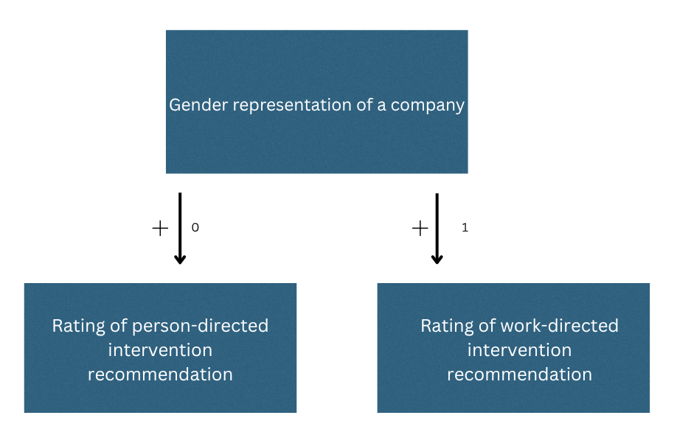
Note. 0 = female dominated gender representation, 1 = male dominated gender representation.

Methods
Participants and recruitment
For the sample, workers or students with a paid job were recruited. This was done by social media, such as LinkedIn & Instagram, and group chats on WhatsApp, from the researcher's network. This is also known as convenience sampling. The snowballing method has also been used, which means that the participants who have filled out the survey, were also asked to forward the survey to people in their network, to get a bigger sample size. They were asked to fill out the survey when they worked for at least four hours.
Participants knew that their answers were anonymous and confidential, and that no personal data was collected. To determine the sample size for the main hypotheses, a G*Power analysis was conducted. As a test-type, the ANOVA with Repeated Measures, Within Factors, was chosen, selecting a priori to calculate the sample size. The effect size was specified at 0.15, which is a small effect size according to Cohen’s guidelines for ANOVA effect sizes (Kotrlik et al., 2011). The alpha level is 0.05, and the power is set at 0.80 to ensure a high chance of finding an effect if there is one. For the number of groups, I put 4 because a 2 gender representation vignette (male-, female-dominated) x 2 intervention type (person-, work-directed) within subjects design has 4 groups. For the number of measurements, I put 4 measurements (as each participant will receive 4 vignettes). For the correlation among repeated measures, I put 0.2 as we expect weak correlations. For the non-sphericity correction, I put 0.75 as a default. With these numbers, G*Power suggests the total sample size should be 120. A total of 234 participants took part in this research, therefore this number of participants was reached. Of the participants, the gender division was almost 50/50 (Table 2).
Descriptive Statistics
Table 1
Work hours and age statistics
 |  | Work hours |  | Age
Valid |  | 188 |  | 234
Mean |  | 30.386 |  | 35.692
Std. Deviation |  | 13.364 |  | 15.071
Minimum |  | 0.000 |  | 18.000
Maximum |  | 80.000 |  | 77.000

Table 2
Gender frequencies
Variable |  | Level |  | Counts |  | Total |  | Proportion
Gender |  | Male |  | 118 |  | 234 |  | 0.504
 |  | Female |  | 115 |  | 234 |  | 0.491
 |  | I would rather not say |  | 1 |  | 234 |  | 0.004

Design & Procedure
The design is a 2x2 repeated measures ANOVA, two independent variables were manipulated within-subjects in a 2 gender representation company (male or female dominated company) X 2 type of intervention proposed (person-directed or work-directed) design. See Table 3 for an overview. The vignettes can be found in Appendix A, which consists of 2 gender representations (male-dominated, female-dominated workforce) with 2 intervention options. Both independent variables were manipulated within-subjects in vignettes by writing the same scenario but changing the gender representation in the company (either male dominated, or female dominated) and by changing the type of intervention that was proposed (either work-directed or person-directed). Therefor a total of 4 vignettes were evaluated with “person-directed” and “work-directed” interventions, being randomly allocated. Each participant was shown every situation just once and therefore the participants could not see the same situation twice. In Table 3, all possible combinations are shown.
The independent variables were manipulated through short textual primes in each vignette: gender composition was manipulated by having the company named male- or female-dominated, and intervention type was manipulated by introducing a person-directed intervention (such as individual training or stress management) or a work-directed intervention(such as structural or organistional changes). Each vignette featured a unique kind of workplace issue (burnout, headaches, loneliness, or back problems), and this helped to create diversity in content between conditions.
To present all conditions evenly and in a controlled manner, participants were randomly assigned to one of four blocks of vignettes in Qualtrics. Each block consisted of four distinct vignettes, so that each of the four possible combinations of the two independent variables (male/person-directed, male/work-directed, female/person-directed, female/work-directed) was covered once for each participant, but no condition was repeated more than once. This guaranteed each participant viewed each of the four possible types of conditions exactly once and that no scenario or intervention was repeated within a participant's questionnaire. The order of vignettes within every block was also randomisd to minimise order effects. A different block would also have each of the four possible combinations, but presented in another situation. So for example, participant one gets assigned to the first block, in which the male/person directed combination was presented in the back problem situation and then participant two would get assigned in the second block, in which this combination would be in the burnout situation, and so on. Full condition assignment is presented in Table 3, and full vignette texts are presented in Appendix A. The randomisation in Qualtrics can be found in Appendix D.
Participants were asked to rate on a 7-point Likert scale the approval ((1 = "Not at all fitting" to 7 = "Fits perfectly") and likelihood of recommending this intervention themselves ((1 = Not at all likely, 7 = Very likely) of every one of the recommended interventions.
Upon finishing the vignettes, participants completed two more questionnaires, which included the Gender System Justification Scale (Jost & Kay, 2005) and a self-developed scale measuring perceptions of gender stereotypes within an organisation.
The research was an online survey, researching the influence of gender representation within a company on well-being intervention recommendations. The survey could be filled out once by each participant on Qualtrics, both on computers and telephones. The survey took around 5 to 10 minutes to fill out, was anonymised and the participants were informed that their answers would be used for research. Average time was checked, and no participants were deleted based on this information.
Therefore, the first survey question was informed consent, where the participants could give permission for the data collection and that this data would be used for scientific research and would be stored for at least ten years. They are informed that they can stop at any time with the survey. Only if permission was given, could the participants start the survey.
This research has been registered and has been ethically tested by the Ethical Review Board of the Faculty of Social and Behavioural Sciences of Utrecht University [UU-SER 24-0432].

Table 3

Gender representation | Person-directed  intervention | Work-directed intervention
Male dominated | Male X person directed | Male X work directed
Female dominated | Female X person directed | Female X work directed

Measurements
There were two dependent variables in this study. The first dependent variable was the degree of appropriateness of the proposed intervention(person-directed or work-directed). The second dependent variable was the likelihood that the participant would recommend the intervention. Both variables were measured on a 7-point Likert scale. For each vignette, participants rated how well they think the provided intervention fits the situation using a Likert scale (1 = "Not at all fitting" to 7 = "Fits perfectly"), and how likely they would be to suggest the interventions themselves (1 = Not at all likely, 7 = Very likely). The appropriateness and likelihood of recommendation of the intervention were taken together, due to high correlation (r = .86, p < .01). The variable name of both the appropriateness and likelihood of recommendation taken together is intervention evaluation.
To assess participants’ endorsement of existing gender-based societal arrangements, the Gender System Justification Scale (Jost & Kay, 2005; based on Kay & Jost, 2003) was measured with 6 items, each of which is answered on a 7-point Likert scale (1 = strongly disagree, 7 = strongly agree). An example item is: “In most situations, women are treated fairly in society.” Higher scores reflect greater justification of gender-based social arrangements, indicating that the participant sees current gender relations as fair and legitimate.
The self-developed scale consisted of items that assess the extent to which certain organisational values or behaviors are believed by the respondents to be stereotypically associated with males or females. This rests on existing frameworks of descriptive stereotypes of gender (e.g., agentic vs. communal traits). In this self-assessment, participants expressed their views to provide statements at a 7-point Likert scale which is used to capture individual differences in assumptions and perception of gender stereotypes which arguably influence participants' evaluations of the interventions offered in the vignettes. It consists out of 4 items. An example item is: “Most women are happy to take on the bulk of the caregiving duties at home.”
Data-analysis plan
The data was analysed by using 2x2 repeated measures ANOVA. The analysis was done in JASP. The (α) will be 0.05 or lower. The analysis will be run for both main effects and an interaction effect. The data were analysed using a 2×2 repeated measures ANOVA in JASP, with an alpha level (α) of .05. This analysis tested both main effects (intervention type and gender representation) and the interaction effect between these factors. When significant effects were found, pairwise comparisons with Bonferroni correction were conducted to examine simple effects, that is, to test which specific conditions differed from each other (comparing intervention ratings between person-directed and work-directed interventions within male- vs. female-dominated vignettes). These comparisons help to clarify the direction and nature of significant effects observed in the ANOVA.

Results
Descriptive statistics
To give an overview of the dataset, the correlations of the variables are presented in Table 4, and the descriptive statistics are presented in Table 5. The data shows several significant correlations, and it shows that participants rated all interventions above the midpoint. The means per situation can be found in Appendix B.

Table 4
Correlations of the Variables
Variable |  |  | TotalEvaluation | Gender | TotalSJB |  | TotalStereo
1. TotalEvaluation |  | Pearson's r | —
2. Gender |  | Pearson's r | 0.117 | —
3. TotalSJB |  | Pearson's r | 0.062 | ***-0.435 | —
4. TotalStereo |  | Pearson's r | *0.141 | -0.019 | ***0.248 |  | —
Note. Pearson correlations between all main study variables. Gender is coded as 0 = male, 1 = female. *** p < .001, ** p < .01, * p < .05.

Table 5
Descriptive Statistics of the Variables
 |  | Male dominated company  Evaluation person directed intervention |  | Male dominated company  Evaluation work directed intervention |  | Female dominated company  Evaluation work directed intervention |  | Female dominated company  Evaluation person directed intervention
Mean |  | 4.692 |  | 5.500 |  | 5.515 |  | 4.894
Std. Deviation |  | 1.453 |  | 1.139 |  | 1.107 |  | 1.327
Minimum |  | 1.000 |  | 1.000 |  | 1.500 |  | 1.000
Maximum |  | 7.000 |  | 7.000 |  | 7.000 |  | 7.000
Note. Evaluation = score of appropriateness and likelihood taken together. N total = 234. Valid N = 234, 233, 233, and 232 respectively.

Assumptions
Before conducting the 2x2 ANOVA repeated measures analysis in JASP, the assumptions were checked. Normality was checked by creating a Q-Q plot of residuals, which showed that the assumption of normality was not violated. Sphericity is not necessary to check, because the factors do not have more than two levels. Outliers were checked by creating a boxplot, which showed that there are a few outliers (between 0 and 4). The box plots can be seen in Appendix C.

Results
Main effects
The main effect of gender composition on intervention evaluation was not significant (p = .151). Therefore, the participants did not rate men or women significantly differently, in contrast to what was hypothesised.
However, the main effect of the intervention type, person- or work-directed intervention, was significant. Work-directed interventions were rated better than person-directed interventions (M = .709, SE = .080, t = -8.847, Pbonf< .001, η²p = .255). This shows a medium to large effect size.

Interaction effect
There is no significant interaction effect of gender composition and intervention type (p = .231) on intervention evaluation, in contrast to what was expected for hypotheses.

Gender Stereotypes effect
A covariate, gender stereotyping, was also added to the repeated measures ANOVA, to see whether there is a three-way interaction of gender stereotyping, intervention type and gender representation. The analysis revealed a significant interaction between gender representation and gender stereotyping (F(1, 228) = 5.80, p = .017, η²ₚ = .025), in that the level of stereotyping influenced participants' judgments based on whether the vignette concerned a male or female protagonist. But the three-way interaction of intervention type, gender representation, and gender stereotyping was not significant (p = .473), which contrasts with the hypothesis on gender stereotyping. Because there was not a significant three-way interaction, post hoc comparisons or simple effects analyses were not conducted.

System Justification Beliefs effect The same analysis with system justification as a covariate also yielded no significant interactions. The interaction between gender composition and intervention type was not significant, (p = .642), nor was the interaction between gender composition and system justification, (p = .209). The three-way interaction between intervention type, gender composition, and system justification was also not significant (p = .436), which contrasts with the hypothesis on system justification beliefs. Since no significant interaction effects were found, no follow-up tests were conducted.
Discussion
In this research, it was examined if gender domination of a fictional workplace influences perceptions of the appropriateness of different types of mental health interventions. Specifically, we examined whether participants found person-directed interventions, such as training in resilience, more appropriate for female dominated workplaces and work-directed interventions, such as reducing workload, more appropriate for male dominated workplaces. This research drew on system justification theory, role prioritisation theory and fundamental attribution error which both suggest that individuals may implicitly favor status-quo preservation explanations and policies, especially in evaluating gendered organisational environments (Jost & Banaji, 1994; Haines & Stroessner, 2019; Pettigrew, 1979; Ross, 1977). It was also investigated whether variation within persons in perceptions of gender stereotypes at work, and variation within persons in system justification beliefs, influenced these judgments.
The results showed that, contrary to expectations, the gender structure of the work environment (male- vs. female-dominated) had no significant influence on participants' intervention ratings. There was no interaction of gender structure and intervention type either, suggesting that gender context of the workplace, when subtly manipulated, is not a strong influence on intervention attitudes. One likely explanation is that the gender representation manipulation was too subtle to activate gendered expectations in the minds of participants. It is known that when cues are subtle or not strongly linked to gendered norms or roles, individuals do not consciously process them in an applicable context to their judgments (Eagly & Karau, 2002). Since participants were merely told that a company was male- or female-dominated without clarification of what that gender balance implied, they may not have considered it to be relevant to their evaluation of interventions. Eagly and Karau's (2002) role congruity theory also argues that individuals employ gendered expectations specifically when gender norms are salient. When they are not cued explicitly, individuals may revert to neutral or non-gendered meanings. Finally, there is still the fact that social desirability might have influenced the answers given.
Other than that, it was found that participants preferred work-directed interventions more than person-directed interventions, regardless of gender composition in the workplace. This aligns with broader societal shifts toward recognising structural contributors to workplace well-being and previously found results in literature (Wong et al., 2024).
Although gender representation did not directly impact the evaluation of the interventions, it was found that participants who had more traditional gender stereotypes favored both more work- and person directed interventions in male-dominated environments. So, gender stereotype endorsement did moderate judgments, but only in the male-dominated work environment context. This significant interaction between gender composition and stereotype endorsement indicated that individuals who had stronger gender stereotype beliefs were more vulnerable to the impact of a male-dominated environment. These findings suggest that people of traditional inclination may regard issues of male workers as more justifiable or more urgent to intervene upon, whether the intervention be addressed at the individual or at the system. On the other hand, they could regard issues of women as less needing structural or individual intervention, possibly tacitly expecting women to adapt or presuming their issues to be less justified. This aligns with the research on the fundamental attribution error and gendered perceptions of agency. Under stress for women, others will more likely attribute it to internal deficits, while similar stress in men is more likely attributed to external pressure or situational unfairness (Swim & Sanna, 1996; Ye, 2024). This way, structural problems which occur to women can be attributed as personal failures, while the same problems that occur to men bring about action to be taken. This prejudice can inadvertently perpetuate variable workplace standards, justifying only structural change when favoring men. It can also mean that gendered occupation norms activate different attributional frameworks depending on the context. This is consistent with theories of cognitive accessibility, where gender role expectations shape perceptions and intervention selections (Rudman & Glick, 2001). The results also imply that activation of stereotypes may be mediated by variation between people rather than automatic for all because there was no gender composition effect at the aggregate level.
System justification beliefs did not significantly moderate intervention preferences in any condition. The three-way interaction with system justification was non-significant, offering no support for the role of system-justifying ideologies in shaping mental health intervention preferences.
Theoretical Implications
Participants who supported higher degrees of gender stereotyping in their work environments rated interventions more favorably in male-typed environments. This supports the idea of cognitive accessibility in which occupational gender standards guide judgments out of awareness. Although the gender manipulation was subtle, what these findings show is that even subtle cues can produce stereotype-consistent judgments, particularly those inclined to favor gender role stereotypes.
Unexpectedly, the respondents reported a greater preference for work-based interventions across all conditions. This reflected a growing realisation that organistion or structural issues are driving workplace well-being issues most, independent of gender composition. There was traditionally less support for work-directed interventions, since interventions mainly focused on improving personal resilience (Schaufeli & Enzmann, 1998). It also points to the fact that even though perception is stereotypically biased, general sentiment is more in favor of interventions that target structural causes rather than focusing only on coping strategies.
More generally, these results indicate that gender stereotypes can influence how people evaluate the interventions, yet the general trend is towards systemic, work-directed interventions. This points to the importance of examining not only individual attitudes but also broader organisational contexts to facilitate fair and effective mental health approaches in diverse workplaces.

Practical Implications
The results of this study have important implications for organisational policy, interventions for well-being, and DEI (Diversity, Equity, and Inclusion) practice. Participants in all conditions strongly preferred person-focused interventions over work-focused interventions. This suggests greater awareness among employees that structural and systemic factors, such as workload, staffing, and job design, are at the heart of many workplace well-being issues. This is good news for HR professionals and employers: it suggests that interventions at the organisational level as opposed to interventions targeting individuals will receive broad support among employees. This evidence is in accordance with existing literature showing that structural methods are more likely to secure long-term benefits in job satisfaction and employee well-being compared to individual-coping interventions (Bond & Bunce, 2001; Bambra et al., 2007; Richardson & Rothstein, 2008). For senior leadership and HR managers, this information brings assurance that systems interventions, while sometimes more challenging to implement, are not only more effective in the long run but increasingly accepted by employees.
However, stereotyping still happens and can unintentionally perpetuate inequality. Therefore, organisations should consider incorporating bias awareness and implicit stereotype education into mental health policy development to ensure balanced and equitable intervention strategies.
Limitations
There are a few limitations to this research that need to be considered. First, the sample was obtained largely from a convenient population and therefore likely biased in favor of university-educated, younger people. This could have impacted the overall preference for work-directed interventions, given that this group tends to support more liberal attitudes regarding workplace equity and mental health. Their strong interest in systemic-level interventions might not extend to more conservative or older groups.
Second, gender representation manipulation was relatively small, as it was just a brief description in a vignette for a business. While this was used to avoid explicit priming, it may have been too subtle to cause high stereotype activation in most participants. It is possible for future studies to make this manipulation more potent by adding industry hints (e.g., nursing vs construction), leader gender, or more descriptive context descriptions.
Finally, all the measures were self-report, and social desirability bias could influence these. Participants may have scored work-directed interventions more positively not necessarily because they believed them but because these answers are becoming more and more accepted as the "right" or socially desirable answer. Adding implicit measures or behavior tasks could provide a more complete picture of what lies beneath beliefs.
Future Research Directions
There are a number of directions on which future research could be built based on these findings. First of all, the participant samples should be expanded. More varied or professional samples across industries, ages, or levels of education would determine if findings can be generalised to a bigger part of the population, since the current sample consists mainly of highly educated and young people. Also cross-cultural comparisons could be made, since it would be valuable to investigate how cultural context affects these processes. In more gender-traditional or collectivist cultures, the impact of gender stereotypes and system justification may be very different.
Another direction for future research is to manipulate gender context more explicitly. Future research needs to try stronger gendered cues, such as leader gender, industry type, or visual stimuli, to see if more salient gender framing yields different results, since this research mainly focused on very subtle cues.
Lastly, future research should use alternatives to self-report. The use of methods such as implicit association tests (IATs), behavioral vignettes, or decision-making simulations would reduce bias and more validly measure underlying attitudes. This current research could still be influenced by social desirability in the answers that have been given by the participants.
Conclusion
In this study, the effect of hypothetical workplace gender composition and individuals' belief systems on ratings of the appropriateness of different mental health interventions was tested. Unexpectedly, the workplace's gender majority did not have a measurable effect on these ratings.
There was, however, a detectable and repeatable pattern: work-focused interventions were rated more appropriate than person-focused interventions regardless of workplace gender composition. It reflects an increasing recognition that structural factors, such as workload, job design, and organisational culture, play a primary role in affecting the mental health of employees.
Despite some indications of stereotype-based moderation in masculine contexts, it did not affect overall outcomes. Instead, the dominant message from participants was that organisational change is needed to improve workplace well-being. This is an encouraging sign for HR leaders and policymakers, as it tips the favor towards the imposition of structural interventions as effective and popular.
Future research needs to build on this by determining the generalisability of these preferences over industries, cultures, and demographics. Second, more powerful manipulations and more diverse measurement strategies may help further delineate active mechanisms accounting for intervention preferences. Despite these limitations, the findings unmistakably yield one implication: to be successful in generating mental well-being in the workplace, especially for women to reduce inequality, the focus must increasingly move away from modifying the employee and towards modifying the system.

Reference list
Bambra, C., Egan, M., Thomas, S., Petticrew, M., & Whitehead, M. (2007). The
psychosocial and health effects of workplace reorganisation: 2. A systematic review of task restructuring interventions. Journal of Epidemiology & Community Health, 61(12), 1028–1037. https://doi.org/10.1136/jech.2006.054999
Bond, F. W., & Bunce, D. (2001). Job control mediates change in a work reorganization
intervention for stress reduction. Journal of Occupational Health Psychology, 6(4), 290–302. https://doi.org/10.1037/1076-8998.6.4.290
Björk, J. M., Bolander, P., & Forsman, A. K. (2021). Bottom-up interventions effective in promoting work engagement: A systematic review and meta-analysis. Frontiers in Psychology, 12, 730421. https://doi.org/10.3389/fpsyg.2021.730421
Centraal Bureau voor de Statistiek. (2023, 6 december). Loonvers​​chil tussen mannen en
vrouwen in 2022 iets afgenomen. Centraal Bureau Voor de Statistiek. https://www.cbs.nl/nl-nl/nieuws/2023/49/loonverschil-tussen-mannen-en-vrouwen-in-2022-iets-afgenomen
DeFrank, R. S., & Cooper, C. L. (1987). Worksite stress Management interventions: Journal Of Managerial Psychology, 2(1), 4–10. https://doi.org/10.1108/eb043385
Eagly, A. H., & Karau, S. J. (2002). Role congruity theory of prejudice toward female
leaders. Psychological Review, 109(3), 573–598. https://doi.org/10.1037/0033-295x.109.3.573
Glick, P., & Fiske, S. T. (1996). The ambivalent sexism inventory: Differentiating hostile
and benevolent sexism. Journal of Personality and Social Psychology, 70(3), 491–512. https://doi.org/10.1037/0022-3514.70.3.491
Haines, E. L., & Stroessner, S. J. (2019). The role prioritization model: How communal men and agentic women can (sometimes) have it all. Social And Personality Psychology Compass, 13(12). https://doi.org/10.1111/spc3.12504
Jost, J. T., & Banaji, M. R. (1994). The role of stereotyping in system-justification and the production of false consciousness. British Journal of Social Psychology, 33(1), 1–27. https://doi.org/10.1111/j.2044-8309.1994.tb01008.x
Jost, J. T., Banaji, M. R., & Nosek, B. A. (2004). A Decade of System Justification Theory: Accumulated Evidence of Conscious and Unconscious Bolstering of the Status Quo. Political Psychology, 25(6), 881–919. https://doi.org/10.1111/j.1467-
9221.2004.00402.x
Jost, J. T., & Kay, A. C. (2005). Exposure to benevolent sexism and complementary gender
stereotypes: Consequences for specific and diffuse forms of system justification. Journal of Personality and Social Psychology, 88(3), 498–509. https://doi.org/10.1037/0022-3514.88.3.498
Jost, J. T., Kay, A. C., & Thorisdottir, H. (2009). Social and psychological bases of
ideology and system justification. Oxford University Press. https://doi.org/10.1093/acprof:oso/9780195320916.001.0001
Jost, J. T., Pelham, B. W., Sheldon, O., & Sullivan, B. N. (2003). Social inequality and
the reduction of ideological dissonance on behalf of the system: Evidence of enhanced system justification among the disadvantaged. European Journal of Social Psychology, 33(1), 13–36. https://doi.org/10.1002/ejsp.127
Kay, A. C., & Jost, J. T. (2003). Complementary justice: Effects of “poor but happy” and
“poor but honest” stereotype exemplars on system justification and implicit activation of the justice motive. Journal of Personality and Social Psychology, 85(5), 823–837. https://doi.org/10.1037/0022-3514.85.5.823
Leopold, T. (2018). Gender Differences in the Consequences of Divorce: A Study of
Multiple Outcomes. Demography, 55(3), 769–797. https://doi.org/10.1007/s13524-018-0667-6
Levanon, A., England, P., & Allison, P. (2009). Occupational Feminization and Pay:
Assessing Causal Dynamics Using 1950-2000 U.S. Census Data. Social Forces, 88(2), 865–891. https://doi.org/10.1353/sof.0.0264
Maslach, C., & Leiter, M. P. (2016). Burnout. In G. Fink (Ed.), Stress: Concepts, Cognition,
Emotion, and Behavior (pp. 351–357). Academic Press. https://doi.org/10.1016/B978-0-12-800951-2.00044-3
Moyser, M. (2017). Women in Canada: a gender-based statistical report.
https://www150.statcan.gc.ca/n1/pub/89-503-x/2015001/article/14694-eng.pdf
Moyser, M. (2019). Measuring and Analyzing the Gender Pay Gap: A Conceptual and
Methodological Overview. https://epe.lac-bac.gc.ca/100/201/301/weekly_acquisitions_list-ef/2019/19-35/publications.gc.ca/collections/collection_2019/statcan/452000022019001-eng.pdf
Pettigrew, T. F. (1979). The ultimate attribution error: Extending Allport’s cognitive analysis
of prejudice. Personality and Social Psychology Bulletin, 5(4), 461–476. https://doi.org/10.1177/014616727900500407
Purvanova, R. K., & Muros, J. P. (2010). Gender differences in burnout: A meta-analysis.
Journal of Vocational Behavior, 77(2), 168–185. https://doi.org/10.1016/j.jvb.2010.04.006
Richardson, K. M., & Rothstein, H. R. (2008). Effects of occupational stress management
intervention programs: A meta-analysis. Journal of Occupational Health Psychology, 13(1), 69–93. https://doi.org/10.1037/1076-8998.13.1.69
Ridgeway, C. L., & Correll, S. J. (2004). Unpacking the gender system: A theoretical
perspective on gender beliefs and social relations. Gender & Society, 18(4), 510-531. https://doi.org/10.1177/0891243204265269
Ross, L. (1977). The intuitive psychologist and his shortcomings: Distortions in the
attribution process. In L. Berkowitz (Ed.), Advances in Experimental Social Psychology (Vol. 10, pp. 173–220). Academic Press. https://doi.org/10.1016/S0065-2601(08)60357-3
Schaufeli, W., & Enzmann, D. (1998). The Burnout Companion to Study and Practice: A
Critical Analysis. In CRC Press eBooks. https://doi.org/10.1201/9781003062745
Swim, J. K., & Sanna, L. J. (1996). He’s skilled, she’s lucky: A meta-analysis of observers’
attributions for women’s and men’s successes and failures. Personality and Social Psychology Bulletin, 22(5), 507–519. https://doi.org/10.1177/0146167296225008
Tafvelin, S., Stenling, A., Lundmark, R., & Westerberg, K. (2019). Aligning job redesign
with leadership training to improve supervisor support: A quasi-experimental study. European Journal of Work and Organizational Psychology, 28(1) https://doi.org/10.1080/1359432X.2018.1541887
Taris, T. W., Kompier, M. A. J., Geurts, S. A. E., Schreurs, P. J. G., Schaufeli, W. B., De
Boer, E., Sepmeijer, K. J., & Watterz, C. (2003). Stress management interventions in the Dutch domiciliary care sector: Findings from 81 organizations. International Journal Of Stress Management, 10(4), 297–325. https://doi.org/10.1037/1072-5245.10.4.297
Tarro, L., Llauradó, E., Ulldemolins, G., Hermoso, P., & Solà, R. (2020). Effectiveness of
Workplace Interventions for Improving Absenteeism, Productivity, and Work Ability of Employees: A Systematic Review and Meta-Analysis of Randomized Controlled Trials. International Journal Of Environmental Research And Public Health, 17(6), 1901. https://doi.org/10.3390/ijerph17061901
Verniers, C., & Vala, J. (2018). Justifying gender discrimination in the workplace: The
mediating role of motherhood myths. PLoS ONE, 13(1), e0190657. https://doi.org/10.1371/journal.pone.0190657
Williams, J. C. (2020). Bias interrupted: Creating inclusion for real and for good. Harvard
Business Review Press.
Wong, C. Y. E., Kirby, T. A., Ryan, M. K., & Rink, F. (2024). Overcoming or Removing Gendered Barriers? Support for Individualistic Diversity, Equity, and Inclusion Interventions Among Those in Power. Journal Of Applied Social Psychology, 55(1), 22–37. https://doi.org/10.1111/jasp.13075
World Economic Forum. (June 20, 2023) Global Gender Gap Report 2023. WEForum.
Retrieved March 12, 2025, from https://www.weforum.org/publications/global-gender-gap-report-2023/in-full/benchmarking-gender-gaps-2023/#:~:text=The%20Global%20Gender%20Gap%20score,compared%20to%20last%20year's%20edition.
World Bank Open Data. (z.d.). World Bank Open Data.
https://data.worldbank.org/indicator/SG.TIM.UWRK.MA?locations=NL
Ye, S. (2024). Fundamental Attribution Error in the Classroom: Why and How Bias Hurts? Lecture Notes in Education Psychology And Public Media, 61(1), 27–34. https://doi.org/10.54254/2753-7048/61/20240427

Appendix A

Vignette 1
LandEscape is a female/male-dominated gardening company, with very few men/women working there. The gardeners perform hard physical labour, often carrying around heavy bags of potting soil and tools. This is taking its toll on the workers and more and more people are filing complaints, having back problems and starting to take days off. However, the CEO and HRM are acknowledging this problem and start to work on an intervention for the gardeners.

Person directed intervention: Provide training on how to carry the bags correctly and to improve posture

Work directed intervention: Invest in forklifts and dollies.

Vignette 2
LawIn is a female/male-dominated law firm, with very few men/women working there. The lawyers have very busy days, with mental challenges. They have to be focused and can barely rest. This is taking its toll on the lawyers and they are starting to file complaints, because more people are getting burned out. The CEO and HRM are acknowledging this problem and have started to work on an intervention for the lawyers.

Person directed intervention: Provide access to professionally guided peer support groups focused on stress management and mental resilience. These group sessions will be facilitated by a trained psychologist and provide a confidential space for lawyers to share experiences, reflect, and learn coping strategies.

Work directed intervention: Hire more people to assist during a big case so that it becomes mentally less challenging.

Vignette 3
EcoFash is a female/male-dominated sustainable fashion company, with very few men/women working there. The workers mostly work individually. Working a lot of time from home or in their own office rooms. As their work is individual oriented they rarely have interaction with their colleagues. An increasing number of workers feels lonely and depressed and some even are filing complaints. HRM acknowledges this problem and has started to work on an intervention for the workers.

Person directed intervention: Start workshops and training to provide insights in mental health and well-being.

Work directed intervention: Create at least one shared break, where everyone can come together and chat, and instead of individual offices (share offices) to promote interaction.

Vignette 3
EcoFash is a female/male-dominated sustainable fashion company, with very few men/women working there. Most employees work independently, often from home or in individual office spaces. Due to the solitary nature of the work, there is little day-to-day interaction among colleagues. As a result, a growing number of employees report feelings of loneliness and decreased well-being, and some have even filed formal complaints.
The HR department acknowledges these concerns and has begun developing interventions to support employees’ mental health and foster a greater sense of connection.

Person-directed intervention:
Organize workshops and training sessions focused on mental health awareness and personal well-being. These sessions aim to equip employees with tools to recognize early signs of stress and loneliness, and to develop strategies to enhance their emotional resilience.

Work-directed intervention:
Introduce structured opportunities for social interaction by implementing a work-at-the-office day with a long lunch, allowing employees to connect informally. In addition, move from individual offices to shared workspaces to encourage spontaneous communication and foster a sense of community in the workplace.

Vignette 4
Technovations is a female/male-dominated technology company, with very few men/women working there. They work long days on computers and phones, having to pay attention to and staring at the screens in front of them. . This has led to many workers starting to experience headaches and sleeping problems, and these complaints have reached the CEO and HRM. The CEO and HRM are acknowledging this problem and have started to work on an intervention for the workers.

Person directed intervention: Raise awareness among employees about the negative effects of prolonged screen time—such as headaches and sleep disturbances—and encourage healthy work habits. Through a company email, employees can be reminded to take regular short breaks, for example by getting a coffee or going for a brief walk.

Work directed intervention: Put timers on the computers, so that there are obligatory breaks after a certain time. To support autonomy, employees have the option to postpone the reminder—for example, by 10 minutes—if they are in the middle of a task and prefer to finish it first. Additionally, the company can offer blue light blocking glasses to help reduce eye strain and support healthy screen use throughout the day.

**Vignet 1**
LandEscape is een vrouwelijke/mannelijke gedomineerd tuinbedrijf, met zeer weinig mannen/vrouwen die daar werken. De tuinmannen verrichten zwaar fysiek werk, waarbij ze vaak zware zakken potgrond en gereedschap moeten dragen. Dit heeft zijn tol geëist op de werknemers en steeds meer mensen dienen klachten in, zoals rugproblemen en nemen dagen vrij. De CEO en HRM erkennen dit probleem en zijn begonnen met het ontwikkelen van een interventie voor de tuinmannen.

Persoonsgerichte oplossing: Bied training aan over hoe de zakken correct te dragen en de houding te verbeteren. Deze trainingen kunnen bestaan uit praktische sessies waarin ergonomische tiltechnieken worden aangeleerd, ondersteund door visuele instructies en regelmatige herhaling, zodat medewerkers zich deze vaardigheden eigen kunnen maken en fysiek ongemak kunnen voorkomen.
Werkgerichte oplossing: Investeer in heftrucks en dollies om fysieke belasting bij het tillen te verminderen. Door deze hulpmiddelen beschikbaar te stellen op de werkvloer, wordt het werk lichter, efficiënter en veiliger uitgevoerd. Dit draagt bij aan het welzijn van medewerkers en verlaagt het risico op fysieke klachten op de lange termijn.

---

**Vignet 2**
LawIn is een vrouwelijke/mannelijke gedomineerd advocatenkantoor, met zeer weinig mannen/vrouwen die daar werken. De advocaten hebben zeer drukke dagen met mentale uitdagingen. Ze moeten zich concentreren en hebben nauwelijks rust. Dit heeft zijn tol geëist op de advocaten en ze beginnen klachten in te dienen, omdat steeds meer mensen opgebrand raken. De CEO en HRM erkennen dit probleem en zijn begonnen met het ontwikkelen van een interventie voor de advocaten.

Persoonsgerichte oplossing: Bied toegang tot professioneel geleide peer supportgroepen die gericht zijn op stressmanagement en mentale veerkracht. Deze groepssessies worden gefaciliteerd door een getrainde psycholoog en bieden een vertrouwelijke ruimte voor advocaten om ervaringen te delen, te reflecteren en copingstrategieën te leren voor een betere balans.
Werkgerichte oplossing: Huur meer mensen in om te helpen tijdens een grote zaak, zodat het mentaal minder uitdagend wordt voor het bestaande team. Door de werkdruk te spreiden over meerdere professionals kunnen medewerkers zich beter concentreren op hun kerntaken, wat leidt tot hogere kwaliteit en minder stress.

---

**Vignet 3**
EcoFash is een vrouwelijke/mannelijke gedomineerd duurzame modebedrijf, met zeer weinig mannen/vrouwen die daar werken. De werknemers werken voornamelijk individueel, vaak vanuit huis of in individuele kantoorruimten. Door de solitaire aard van het werk is er weinig dagelijkse interactie tussen collega's. Als resultaat melden steeds meer werknemers gevoelens van eenzaamheid en een verminderde welzijn, en sommigen hebben zelfs formele klachten ingediend.

De HR-afdeling erkent deze zorgen en is begonnen met het ontwikkelen van interventies ter ondersteuning van de mentale gezondheid van werknemers en om een groter gevoel van verbinding te bevorderen.
Persoonsgerichte oplossing: Organiseer workshops en trainingssessies gericht op bewustzijn van mentale gezondheid en persoonlijk welzijn. Deze sessies geven werknemers inzicht in het herkennen van stresssignalen, leren hen praktische technieken voor zelfzorg en dragen bij aan een cultuur waarin mentale gezondheid bespreekbaar is.
Werkgerichte oplossing: Introduceer gestructureerde mogelijkheden voor sociale interactie door een vaste werkdag op kantoor in te voeren met een lange lunchpauze. Hierdoor kunnen werknemers informeel met elkaar verbinden. Vervang individuele kantoren door gedeelde werkruimtes om spontane communicatie te stimuleren en een sterkere teamgeest op te bouwen.

---

**Vignet 4**
Technovations is een vrouwelijke/mannelijke gedomineerd technologiebedrijf, met zeer weinig mannen/vrouwen die daar werken. Ze werken lange dagen op computers en telefoons, waarbij ze aandacht moeten besteden aan en naar de schermen voor hen moeten staren. Dit heeft geleid tot het begin van hoofdpijn en slaapproblemen bij veel werknemers, en deze klachten hebben de CEO en HRM bereikt. De CEO en HRM erkennen dit probleem en zijn begonnen met het ontwikkelen van een interventie voor de werknemers.

Persoonsgerichte oplossing: Verhoog het bewustzijn bij werknemers over de negatieve effecten van langdurig schermgebruik, zoals hoofdpijn en slaapstoornissen, en moedig gezonde werkgewoonten aan. Gebruik interne communicatiekanalen, zoals e-mail, om regelmatig te herinneren aan het nemen van korte, herstellende pauzes.
Werkgerichte oplossing: Plaats timers op de computers, zodat er verplichte pauzes zijn na een bepaalde tijd. Werknemers behouden autonomie door de mogelijkheid de herinnering uit te stellen met bijvoorbeeld 10 minuten. Bied daarnaast blauw licht blokkerende brillen aan ter ondersteuning van gezond schermgebruik gedurende de werkdag.

Appendix B

Descriptive Statistics
 |  | ManPersonTotal
Valid |  | 234
Missing |  | 0
Mean |  | 4.692
Std. Deviation |  | 1.453
95% CI Std. Dev. Upper |  | 1.598
95% CI Std. Dev. Lower |  | 1.332
Minimum |  | 1.000
Maximum |  | 7.000

Descriptive Statistics
 |  | ManWorkTotal
Valid |  | 233
Missing |  | 1
Mean |  | 5.500
Std. Deviation |  | 1.139
95% CI Std. Dev. Upper |  | 1.253
95% CI Std. Dev. Lower |  | 1.044
Minimum |  | 1.000
Maximum |  | 7.000

Descriptive Statistics
 |  | WomanWorkTotal
Valid |  | 233
Missing |  | 1
Mean |  | 5.515
Std. Deviation |  | 1.107
95% CI Std. Dev. Upper |  | 1.218
95% CI Std. Dev. Lower |  | 1.015
Minimum |  | 1.500
Maximum |  | 7.000

Descriptive Statistics
 |  | WomanPersonTotal
Valid |  | 232
Missing |  | 2
Mean |  | 4.894
Std. Deviation |  | 1.327
95% CI Std. Dev. Upper |  | 1.460
95% CI Std. Dev. Lower |  | 1.216
Minimum |  | 1.000
Maximum |  | 7.000

Appendix C
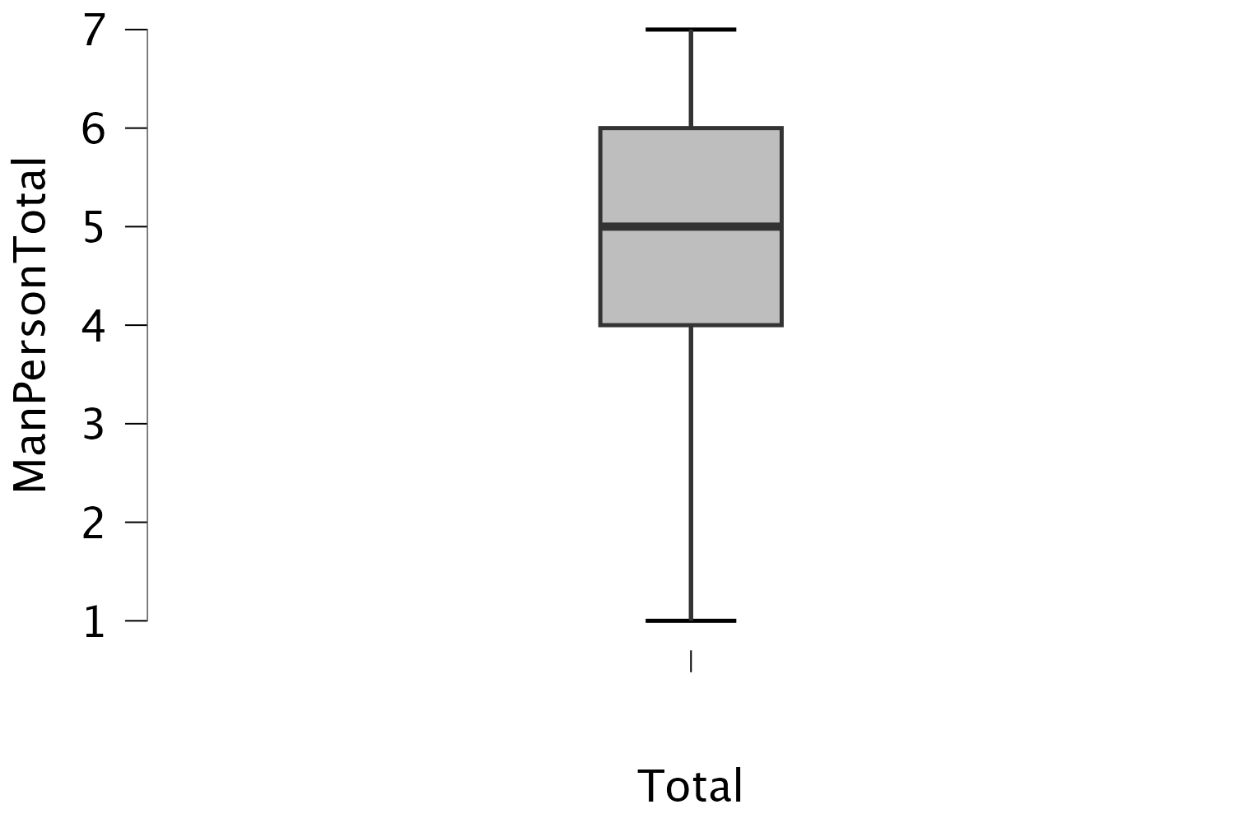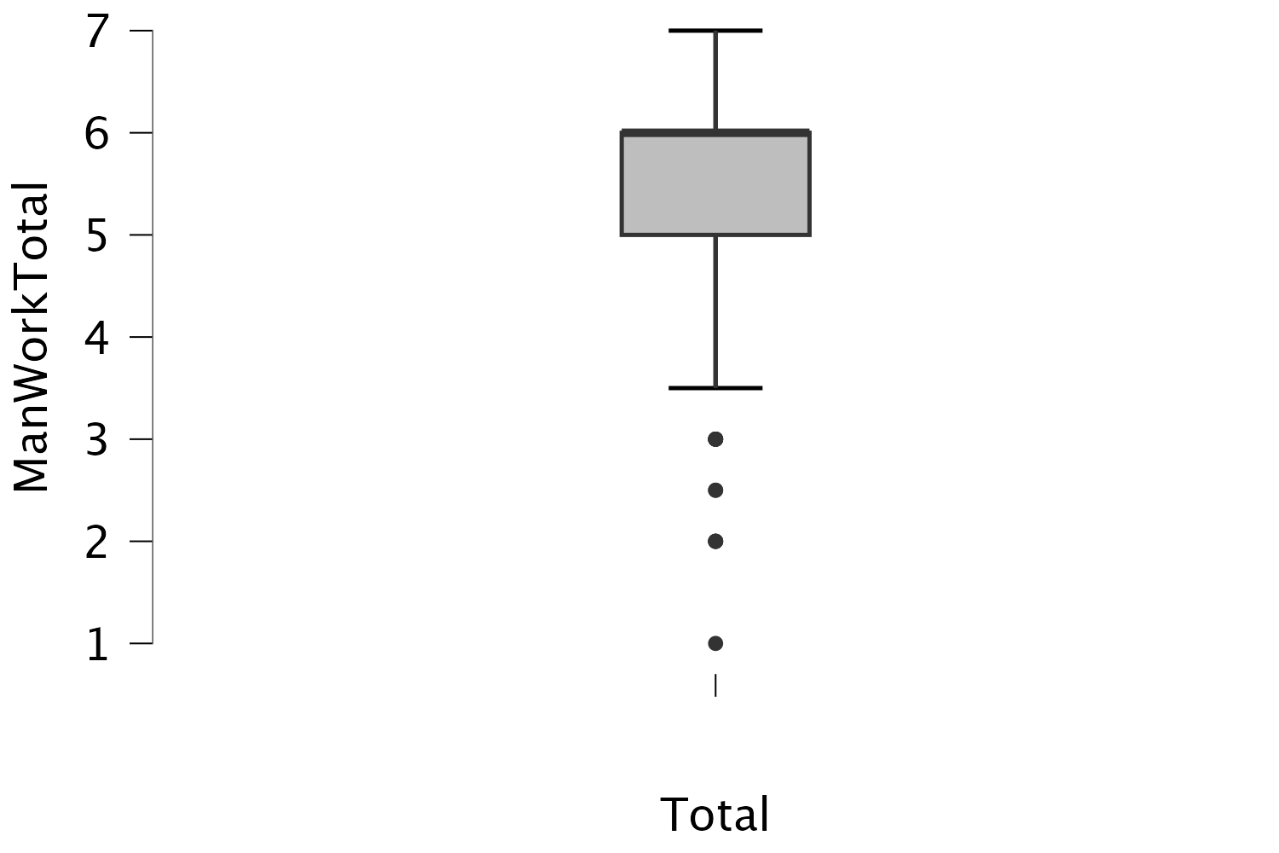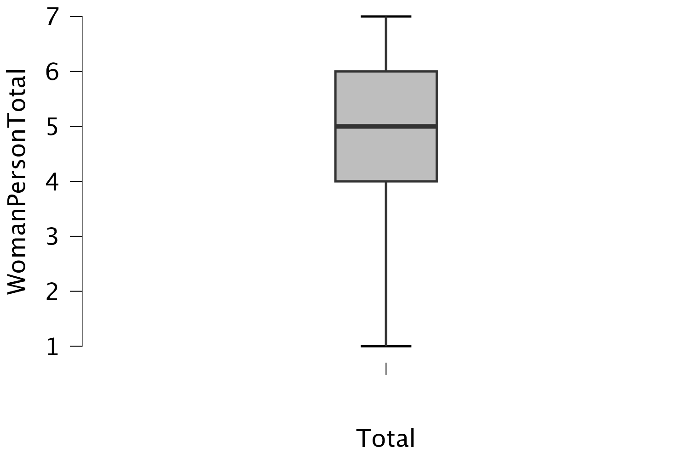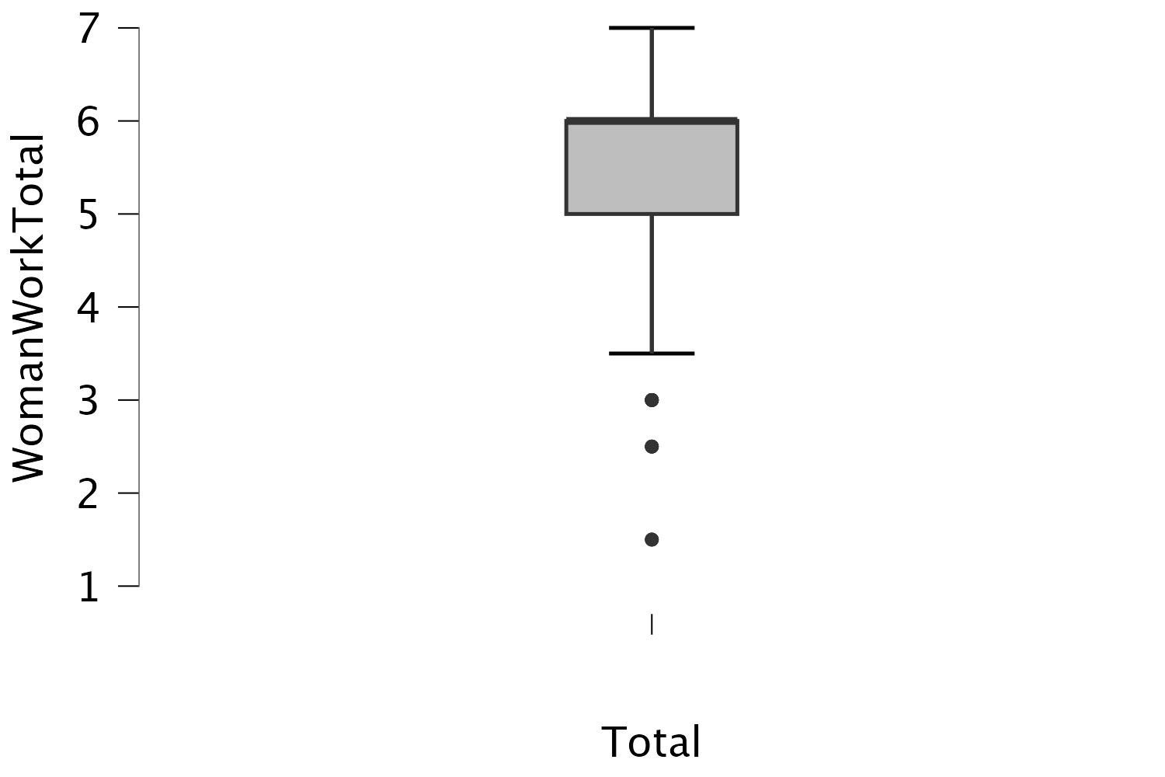

Appendix D

Randomizer
Randomly present
of the following elements
^{Evenly Present Elements}
Edit Count
Add BelowMoveDuplicateCollapseDelete
Group: Order 1
Add BelowMoveDuplicateCollapseDelete
Show Block: VIG1_Woman_Person (4 Questions)Toggle Questions
Add BelowMoveDuplicateDelete
Show Block: VIG2_Woman_Work (4 Questions)Toggle Questions
Add BelowMoveDuplicateDelete
Show Block: VIG3_Man_Person (4 Questions)Toggle Questions
Add BelowMoveDuplicateDelete
Show Block: VIG4_Man_Work (4 Questions)Toggle Questions
Add BelowMoveDuplicateDelete
+Add a New Element Here
Group: Order 2
Add BelowMoveDuplicateCollapseDelete
Show Block: VIG1_Woman_Work (4 Questions)Toggle Questions
Add BelowMoveDuplicateDelete
Show Block: VIG2_Woman_Person (4 Questions)Toggle Questions
Add BelowMoveDuplicateDelete
Show Block: VIG3_Man_Work (4 Questions)Toggle Questions
Add BelowMoveDuplicateDelete
Show Block: VIG4_Man_Person (4 Questions)Toggle Questions
Add BelowMoveDuplicateDelete
+Add a New Element Here
Group: Order 3
Add BelowMoveDuplicateCollapseDelete
Show Block: VIG1_Man_Person o3 (4 Questions)Toggle Questions
Add BelowMoveDuplicateDelete
Show Block: VIG2_Man_Work 03 (4 Questions)Toggle Questions
Add BelowMoveDuplicateDelete
Show Block: VIG3_Woman_Person 03 (4 Questions)Toggle Questions
Add BelowMoveDuplicateDelete
Show Block: VIG4_Woman_Work (4 Questions)Toggle Questions
Add BelowMoveDuplicateDelete
+Add a New Element Here
Group: Order 4
Add BelowMoveDuplicateCollapseDelete
Show Block: VIG1_Man_Work 4 (4 Questions)Toggle Questions
Add BelowMoveDuplicateDelete
Show Block: VIG2_Man_Person 4 (4 Questions)Toggle Questions
Add BelowMoveDuplicateDelete
Show Block: VIG3_Woman_Work 4 (4 Questions)Toggle Questions
Add BelowMoveDuplicateDelete
Show Block: VIG4_Woman_Person 4 (4 Questions)Toggle Questions

