
Arousal-indexed differences in nonverbal behavior and prosody between protophones and fixed signals in non- and minimally verbal autism

Jiaying Zhang
0597252
Master Thesis Research Master Linguistics
Utrecht University
30 ECTS

Supervisor: Dr. Laura Smorenburg
Second Reader: Prof. Dr. Aoju Chen

June 18th, 2025
Table of content
1. Introduction 4
2. Theoretical background 6
2.1. Prosody and nonverbal behavior 6
2.1.1. Prosody production in typically developing people 6
2.1.2. Prosody production in people with autism spectrum disorder 8
2.1.3. Nonverbal behavior in typically developing people 11
2.1.4. Nonverbal behavior in people with autism spectrum disorder 12
2.1.5. The relationship between prosody and nonverbal behavior 14
2.2. Nonverbal behavior and its related models 17
2.2.1. Summary of nonverbal behavior classifications 17
2.2.2. Theories of nonverbal immediacy exchange 21
2.3. Summary 24
3. Methodology 25
3.1. Research question 25
3.2. Hypothesis and prediction 25
3.3. Dataset 25
3.4. Annotation scheme design 26
3.5. Coding procedure and reliabilities 28
4. Statistical analysis 32
4.1. The relationship between vocalization types, arousal intensity and valence 33
4.2. Reanalysis excluding participants without negative valence or fixed signals 35
4.3. The relationship between pitch-related acoustic features, arousal intensity and valence 37
4.3.1. The relationship between arousal intensity and pitch features in protophones 37
4.3.2. The relationship between valence and pitch features in protophones 39
4.3.3. The relationship between arousal intensity and pitch features in fixed signals 41
4.3.4. The relationship between valence and pitch features in fixed signals 43
5. Discussion 46
5.1. Lack of association between vocalization types and intensity 47
5.2. Fixed signals are more strongly associated with negative valence 48
5.3. Lower pitch associated with higher intensity 49
5.4. Pitch as an index of emotional valence 51
5.5. Limitations and future directions 52
6. Conclusion 54
7. References 55
Appendices 68
Appendix A: GEE Results 68
Appendix B: Bayesian multilevel multinomial logistic regression model results 69

Introduction
Autism spectrum disorder (ASD) is a neurodevelopmental disorder characterized by early-onset impairments in reciprocal social interaction and communication (Chiang et al., 2008; American Psychiatric Association, 2013; Ousley & Cermak, 2014). The communication difficulties faced by children with ASD encompass two main aspects: verbal behavior and nonverbal behavior (Sari, 2018; Febriantini et al., 2021). Successful communication requires all participants to accurately perceive and interpret both verbal and nonverbal cues and effectively use them to convey meaning. However, communication skills in ASD are highly heterogeneous. In the current study, the study specifically focuses on individuals with non or minimally verbal autism (hereafter referred to as NMVA), who do not develop language or acquire only a few functional words or signs (Boucher et al., 2008), i.e. their verbal skills are highly impaired. Less is known about their nonverbal communication abilities.
In a larger project on prosody in individuals with NMVA (Smorenburg et al., 2024), which re-uses a dataset gathered in Barcelona, Spain (Slušná et al., 2021), we found that the individuals with NMVA exhibit significantly different pitch characteristics in two vocalization types—fixed signals (such as cries and laughs) and protophones (which are more speech-like due to the presence of some segmental information). To gain deeper insight into their communication patterns, findings from the author’s previous internship suggested that prosody should be examined together with other nonverbal, nonvocal behaviors (hereafter referred to as nonverbal behavior). To date, even though some NMVA studies have included both verbal and nonverbal aspects in their measurements, no research has explored the relationship between the prosody of individuals with NMVA and their nonverbal behavior. This means the current study is exploratory.
Building upon the prosodic pilot analysis of nonverbal vocalizations in non or minimally verbal autism, this study investigated how different vocalization types, specifically protophones and fixed signals, are associated with variations in nonverbal behavior in children and adolescents with non- or minimally verbal autism. Using a coding scheme based on arousal indices, the study examined whether these vocalizations systematically differ in the nonverbal behaviors they co-occur with, and whether pitch-related acoustic features (mean F0, median F0, F0 range, and F0 standard deviation) are predictive of these behavioral patterns.

Theoretical background
This section will first provide an overview of research on prosody and nonverbal behavior in both typically developing (TD) individuals and individuals with autism spectrum disorder (ASD), as well as their interrelationship between prosody and nonverbal behavior. Next, it will introduce existing models related to nonverbal behavior and identify the most suitable model as the foundational reference for this study. Finally, it will present a comprehensive summary, highlight the gaps in existing research and explain how the selected model will be applied to coding and analysis in this study.

Prosody and nonverbal behavior
This section will first introduce the prosody production abilities of TD individuals and those with ASD, and explain how they use prosody for communication and the characteristics of their prosody. Next, it will examine how these two groups use nonverbal behavior in communication and highlight the distinctive features of their nonverbal behavior. Finally, it will explore the relationship between prosody and nonverbal behavior, which leads to the research questions that this study aims to address.

Prosody production in typically developing people
Prosody, which is suprasegmental features of speech such as intonation, rhythm, stress, and pitch, plays a vital role in communication at affective, pragmatic, and syntactic levels, enhancing or altering the meaning of spoken content (Couper-Kuhlen, 1986; Bormann-Kischkel et al., 1995; Golan et al., 2007). Before acquiring language, infants rely on nonlinguistic means such as body movements and various vocalizations to communicate. Early infant vocalizations (protophones), believed to be precursors to speech, occur in the first month and are functionally different from non-speech-like signals (e.g., cries and laughs) (Jhang & Oller, 2017). Jhang & Oller (2017) also found that as early as the first month, infant protophones were already accompanied by variable facial affect valences and continued to be affectively flexible at the later ages. As for the non-speech-like signals (fixed signals), research has shown that in the first six months of life, infants produce vocalizations that mothers classify as cries, discomfort, calmness, pleasure, or surprise, each exhibiting distinct acoustic patterns (Papoušek & Papoušek, 1989; Trainor & Desjardins, 2002; Oller et al., 2021). As they develop intentional communication skills, older infants use vocalizations not only to express emotions but also to convey communicative intentions (Bates et al., 1975; Trevarthen, 1979; Marcos, 1987). Through these vocal expressions, infants become more effective in regulating social interactions. Emotions help define the quality of communication, while communicative functions clarify its direction and purpose (Trevarthen, 1990). Around 15 months of age, infants begin to rely more on the content of speech rather than its tone to guide their behavior (Friend, 2000). Research suggests that this ability continues to develop into primary school years (Aguert et al., 2013). For instance, 4- and 5-year-olds begin using prosodic cues in expressive speech, but they still prioritize word meaning over prosody (Aguert et al., 2010). As they continue to develop, typically developing children gradually refine their speech production, approaching adult-like proficiency. Eventually, they can effectively apply prosody to convey meaning, emotions, and pragmatic functions in language.
In terms of how TD people use prosody to convey communicative functions, research has shown that pitch, duration, and intensity are systematically manipulated to signal speech acts such as questioning, requesting, or emphasizing (Cruttenden, 1997; Cutler et al., 1997). For instance, they use stress to signal an important or contrastive word, as in the utterance (Halliday, 2015). Rising intonation often marks yes/no questions, while pitch accentuation can indicate contrastive focus (McCann & Peppe, 2003). Prosody also serves grammatical functions, such as segmenting utterances into phrases through the use of pauses, stress, intonation, and final syllable lengthening (Cruttenden, 1997). Even in infancy, prosodic cues embedded in infant-directed speech facilitate the expression and interpretation of intentions such as comfort or attention-getting (Fernald, 1992). As for the use of prosody to express emotion, both children and adults are able to produce affective prosody. In studies based on Russell’s two-dimensional circumplex model, emotions characterized by high arousal levels are often linked to acoustic indicators such as elevated mean fundamental frequency, a wider pitch range, faster speech rate, and greater vocal intensity (Lieberman, 1968; Laukka et al., 2005; Pereira, 2000). It is worth noting, however, that variations in emotional expression can result from a combination of inherent biological differences, socialization processes, the influence of the current social environment, and cultural expectations (Chaplin, 2015; Lin et al., 2021; Ertürk et al., 2024). This suggests that while TD individuals are capable of producing affective prosody, there is no single acoustic value (e.g., pitch, intensity, duration) that can serve as a universal parameter to represent prosodic patterns across different emotional states.
In summary, typically developing individuals initially use prosody to express emotions. As they grow, prosody not only conveys emotions but also serves important communicative functions. Whether in its pragmatic, grammatical, or affective roles, prosody is governed by relatively systematic patterns in typically developing individuals.

Prosody production in people with autism spectrum disorder
Regarding prosody production in verbal autism, findings suggest that individuals with ASD may exhibit prosody that differs from that of their typically developing peers. These differences are observed in three domains: grammatical, pragmatic, and affective prosody. For grammatical and pragmatic prosody, studies indicate that producing appropriate stress patterns can be challenging for speakers with ASD (McCann & Peppé, 2003; Paul et al., 2005). As for affective prosody, findings suggest that individuals with ASD may display prosody that is either overly monotone or exaggerated. However, research has also shown that individuals with ASD can perform as well as controls in producing prosody across grammatical, pragmatic, and affective domains (Boucher et al., 2000; Wolk et al., 2016; Grice et al., 2023). These conflicting findings may be attributed to heterogeneity within the ASD population and methodological differences across studies (McCann & Peppé, 2003; Grice et al., 2023).
As for non- and minimally verbal autism, it refers to individuals with ASD who experience severe language delays and either lack functional speech (a characteristic of nonverbal autism) or do not use vocalizations consistently (a characteristic of minimally verbal autism) (Esch et al., 2009; Franco et al., 2013; Koegel et al., 2019). Research on their prosody production is even more limited. The existing studies can be broadly summarized as follows.
Most studies on individuals with NMVA focus on the frequency of vocalizations in infants and their later impact on expressive language abilities. A longitudinal home-based study by DeVeney et al. (2021) found no significant differences at six months of age between infants at high and low risk for ASD in terms of vocalization frequency, speech-like vocalization frequency, consonant inventory, non-speech-like vocalizations, or the percentage of canonical syllables. However, by 12 months, the low-risk group exhibited a higher vocalization rate, though no substantial differences were observed in other measures. Patten et al. (2014) found that infants later diagnosed with ASD demonstrated lower rates of canonical babbling and overall vocalization compared to their typically developing peers. Additionally, babbling in both typically developing infants and those with ASD has been shown to predict expressive language abilities, vocabulary size at 18, 24, and 30 months, and receptive vocabulary at 12 and 18 months (Oller, 1999; Sheinkopf et al., 2000; Mitchell et al., 2006).
For older individuals with NMVA, Yoder et al. (2015) examined consonant inventory and intentional communication and found that these factors were predictors of expressive language growth in minimally verbal children aged 2 to 4 years. In a slightly older group of minimally verbal children, aged 2 to 5 years, consonant inventory was also found to be associated with later expressive language levels, but not receptive language (Saul & Norbury, 2020).
Thorson et al. (2016) investigated how minimally verbal school-aged children with ASD convey prosodic information acoustically in spontaneous speech. They focused on pitch, specifically the mean and standard deviation of the fundamental frequency (F0). The results indicated that the minimally verbal group had the highest F0 variance and mean pitch, while the control group showed the lowest. However, their analysis was limited to words, excluding participants’ nonverbal vocalizations and non-word utterances. Therefore, statistical tests were not conducted due to the limited data.
In a pilot analysis in the author’s internship on the NMVA data from Barcelona (henceforth referred to as the Barcelona-NMVA data), pitch variables were measured and compared between fixed signals (e.g., crying, laughter) and protophones (more speech-like vocalizations) for the first time. The findings revealed that protophones exhibited significantly lower values for mean F0, median F0, F0 standard deviation, and F0 range compared to fixed signals. This suggests that these two vocalization categories have significantly different characteristics. Additionally, the findings align with Papaeliou et al. (2002) on infants’ vocalizations, which concluded that, compared to vocalizations expressing emotions, those conveying communicative functions exhibit lower fundamental frequency values. Based on this, the author can speculate that if the vocalizations of individuals with NMVA are compared to those of infants, their fixed signals are more likely to convey emotions, whereas protophones tend to serve communicative functions. This research suggests that further research is needed to explore how they use nonverbal behaviors for communication, i.e. focusing on their communicative abilities instead of trying to identify markers for earlier diagnosis, as well as the relationship between prosody and corresponding nonverbal behaviors.
In summary, research findings on verbal autism present conflicting conclusions. Some studies suggest that the prosody production of individuals with verbal autism does not significantly differ from that of TD peers, while others indicate that it does. Regarding individuals with NMVA, studies show that their vocalization frequency is lower, and a pilot analysis on the current data showed that the prosodic characteristics differ significantly across vocalization types. Additionally, previous research has found that their consonant inventory and intentional communication differ significantly from those of TD peers. In terms of prosodic measures, their average pitch and pitch range are greater compared to both verbal autism and TD controls.

Nonverbal behavior in typically developing people
From birth, mothers and infants interact through unique nonverbal patterns using smell, touch, sound, sight, and movement. As children start to develop verbal skills, these early nonverbal experiences become connected with language. At the same time, the nonverbal communication skills that emerge in infancy keep evolving and shaping how adults interact nonverbally with one another (Pally, 2001).
While not as yet readily applicable to analytic work with adults, smell and touch are the earliest modalities of nonverbal communication and deserve comment. The odor of her breast milk is perhaps the most fundamental nonverbal communication a mother directs to her infant (Leon, 1992). By 6 weeks of age, breast milk odor stimulates the infant to orient toward the breast and make sucking movements. Communication through odor ensures that the baby will be able to find the breast even in the dark. In addition, touch serves as an integral ingredient of physiologic regulation of the infant (Barnard & Brazelton, 1990). Skin to skin touch increases feeding and weight gain in premature infants and prevents the profound physiologic and behavioral changes which accompany maternal separation.
By 2 months of age, infants focus on the face and voice of the mother and reacts in a give­and­take, ‘listen’ and ‘reply’ manner (Trevarthen & Aitken, 2001). The baby’s body movements, hand gestures, facial expression, and vocalization communicate its inner state to the mother.
By 6 - 9 months of age, the mother mirrors her infant’s nonverbal expressions within the same modality: vocalization to vocalization, facial expression to facial expression, gesture to gesture (Beebe & Lachmann, 2015). Instead of just copying the baby, they build on and expand the infant’s expressions to show understanding.
Subsequently, vocalization gradually assumes a dominant role in communication, while nonverbal expressions take on a supplementary function. For instance, 3-year-old American English-speaking children initially rely more on prosody than lexical cues to express uncertainty in speech (Hübscher et al., 2016). By the ages of 7-8 years old, they begin to signal uncertainty through facial expressions, such as eyebrow raising, furrowing, or making funny faces, as well as prosodic cues like fillers, pauses, and rising intonation (Swerts & Krahmer, 2005; Visser et al., 2014). As they continue to develop, they gradually shift toward using lexical markers to comprehend and convey beliefs and attitudes in language.

Nonverbal behavior in people with autism spectrum disorder
People with ASD typically demonstrate a disordered pattern of communication development that includes deficits in the use and understanding of nonverbal forms of communication (American Psychiatric Association, 2013). Previous research comparing groups of children with ASD to developmentally matched controls has revealed that children with ASD communicate for different reasons and use different nonverbal behaviors to communicate. For example, although they exhibit similar rates of communication for the purpose of requesting objects or actions, children with ASD communicate less often for the purpose of establishing joint attention, or commenting (i.e., directing another person’s attention toward an object or event to indicate interest) (Mundy et al., 1986; Wetherby et al., 1989; McEvoy et al., 1993).
People with ASD also have been found to demonstrate a limited range of nonverbal behaviors. In particular, less frequent use of eye contact, pointing, and showing objects has been reported (Baron-Cohen, 1989; Landry & Loveland, 1989; Mundy et al., 1994). Moreover, the use of certain nonverbal behaviors appears to be associated with specific communicative functions (Stone & Caro-Martinez, 1990). For example, children with ASD have been reported to be more likely to use pointing for the purpose of requesting than for indicating interest (Baron-Cohen, 1989). Likewise, Mundy et al. (1986) found that ASD children and matched controls used similar rates of eye contact while requesting, but the ASD group was less likely than the control group to use eye contact to coordinate attention between an adult and a toy.
Finally, there is some evidence that children with ASD use fewer complex combinations of nonverbal behaviors to communicate. The ability to coordinate gestures with vocalizations increases with age in typically developing children (Wetherby et al., 1988). This aspect of communication can have important social implications. Specifically, the ability to coordinate multiple nonverbal cues within communicative acts has been shown to increase the salience and interpretability of the communication, as well as increase the probability of maternal responsiveness to the communication (Yoder & Warren, 1998). However, the communicative acts of children with ASD involved a higher proportion of isolated gestural acts and a lower proportion of gestures combined with vocalizations relative to typically developing prelinguistic children (Wetherby et al., 1989).
In summary, people with ASD show different patterns of nonverbal communication relative to non-autistic people. First, people with ASD communicate less often. Second, when they communicate, people with ASD are more likely to request objects or actions and less likely to direct the others’ attention to an object or activity of interest relative to TD controls. Third, the two groups use different forms of nonverbal behavior to communicate. People with ASD demonstrate a lower rate of and proportionally fewer gestures associated with commenting (i.e., pointing and showing objects), a lower rate of and proportionally fewer acts involving eye gaze, and proportionally fewer acts showing the highest level of complexity (i.e., combining gestures, eye gaze, and vocalizations). These conclusions provide a reference for designing the annotation scheme and coding behaviors. Since individuals with ASD tend to use nonverbal behavior less during communication and often rely on single movements rather than combining multiple actions, the study prioritizes coding behaviors when a single form of body movement occurs, rather than focusing on the coordination of different forms.

The relationship between prosody and nonverbal behavior
Human language is multimodal, including both verbal and visual information. In face-to-face interactions, the whole body is involved and may serve informative purposes (Kelly et al., 2002; Kendon, 2004). People around the world produce spontaneous nonverbal behavior while talking. Research indicates that there are developmental links between speech and body movements, such as hand and head gestures, as well as facial expressions, particularly in relation to one specific linguistic aspect: prosody. Prosodic properties of speech encode prominence, phrasal organization, speech act types, emotions, attitudes, and beliefs (e.g., Byrd & Saltzman, 2003; Mello et al., 2012; Cutler & Ladd, 2013). There is a growing body of research showing that prosody is not only expressed through the tonal and temporal properties of speech, but also by means of body movements produced with the hand, head, or face, i.e. visual prosody (e.g., Krahmer & Swerts, 2007; Cvejic et al., 2012; Guellaï et al., 2014). The speech and gesture dimensions of prosody are found to be tightly intertwined at the temporal, semantic, and pragmatic levels, and this is true not only in adult speech but also in language development. In the multimodal expression of prosody, the nonverbal behavior dimension can consist of movements of the hand or head, facial expressions, or body postures. Traditionally, different types of body movements have been studied independently (for instance, facial expressions have received more attention in the literature on emotions, while hand movements have been the focus of studies on the way gestures convey specific meanings related to language and communication).
On the production side, newborns bring their hands and objects to their mouth, and explore them orally. These behaviors are considered to be the earliest signs of the oral-manual link in language development (Iverson & Thelen, 1999). Around 6-7 months of age, infants start to babble, a rhythmic close-open movement of the jaw that results in the production of syllables (Oller, 2000; Vihman et al., 2009). At the same age, infants start producing rhythmic arm movements that are temporally aligned with the vocal babbling (Ejiri, 1998; Iverson & Fagan, 2004). Interestingly, the acoustic quality of the infants’ babbles improves when infants combine these vocalizations with rhythmic arm movements, as syllables become shorter and display shorter formant-frequency transitions (Ejiri & Masataka, 2001).
The time-aligned coordination of gesture and speech is also present at later stages of language development. At the onset of word production, infants start combining vocalizations with pointing gestures signaling referents in space, and these gestural and speech dimensions are time-aligned in an adult-like way: The accented syllable in speech coincides with the apex of the pointing gesture (Butcher & Goldin-Meadow, 2000; Esteve-Gibert & Prieto, 2014). Later, at 4-5 years of age, researchers observe the emergence of bi-phasic body movements that have no referential meaning and that are timed with pitch accents that children use to emphasize specific information in the sentence (Nicoladis et al., 1999; Capone & McGregor, 2004; Mathew et al., 2017). These movements are typically produced with the hand, arm, or head, and are called beats in the gesture literature (Kendon, 2004; McNeill, 2005; Wagner et al., 2014). Beats provide clear evidence of the rhythmic entrainment between the acoustic and visual dimensions of language, because speakers are found to necessarily modify the acoustic properties of speech when they produce these body movements (Krahmer & Swerts, 2007). Thus, prosodic structure seems to be observed at the speech and at the gestural levels, both dimensions being temporally aligned in a precise way from early stages of language development.
Impairments in nonverbal communication among individuals with ASD were first documented in clinical studies by Asperger (1944) and Kanner (1943), who observed that such impairments persist regardless of whether verbal communication is present. Later, diagnostic tools such as ADOS-2 and ADI-R include gesture assessment as part of their evaluation of ASD symptom severity. Smith et al. (2007) found that difficulties in nonverbal communication predict delayed verbal communication development in infants diagnosed with ASD, suggesting a correlation between prosody and nonverbal behavior in this population. For individuals with verbal autism, research indicates that school-aged children and adolescents with ASD struggle with the spontaneous coordination of speech and gestures (Silverman et al., 2010; Salowitz et al., 2013). Wiklund (2016) was the first to investigate the role of prosodic and nonverbal features in understanding difficulties in ASD interactions. The study found that avoidance of direct eye contact and certain deviant prosodic features in speech disrupt interaction fluidity and contribute to misunderstandings. The above studies all indicate that both the verbal and nonverbal behavior of individuals with ASD are affected and that there is some internal connection between the two. Some research has attempted to apply these findings in practice and found that training one aspect can benefit the development of the other. For example, from an educational perspective, multiple studies have demonstrated that incorporating nonverbal communication into language learning facilitates ASD children’s vocabulary acquisition over time (Buck & VanLear, 2002; Drew et al., 2002; Niederer, 2013). This underscores the interdependence of verbal and nonverbal communication in the development of communication skills among ASD individuals.
Although many studies have demonstrated significant differences between individuals with ASD and their TD peers in both verbal and nonverbal behaviors, no research to date has specifically examined the relationship between prosody and body movement in ASD individuals’ production across interactive versus non-interactive contexts. Moreover, research on this topic is entirely lacking in the case of nonverbal autism. This study aims to address this gap in the literature.

Nonverbal behavior and its related models
To investigate the relationship between nonverbal behavior and prosody, it is necessary not only to categorize NMVA’s vocalization based on communicative functions but also to decode nonverbal behavior accordingly. However, there is little consensus on a definitive set of behaviors that serve communicative functions. The existing literature presents a fragmented and unsystematic collection of reports. This inconsistency comes from variations in the theoretical frameworks or models adopted by different studies, as well as differences in participant characteristics across research settings. Therefore, identifying the most suitable models for studying nonverbal behavior in individuals with non or minimally verbal autism is a crucial step in this study.

Summary of nonverbal behavior classifications
The nonverbal behavior classification is not unified within a single theoretical framework. To explore the relationship between nonverbal behavior and prosody and to identify a suitable coding system for this study, the literature review in this section will focus on decoding models related to communicative forms. Theories of nonverbal behavior span multiple perspectives, including biological (Ekman, 2017; Puts et al., 2014), social (Fridlund, 2017), sociopolitical (Burgoon & Dunbar, 2006), functional (Patterson, 1982), and process-Oriented (Patterson, 2019). Besides, nonverbal behavior is studied in relation to its diverse functions, including displaying affect (e.g., anxiety, happiness), revealing attitudes (e.g., interest, prejudice), regulating interaction (e.g., turn-taking, directing attention), managing impressions (e.g., presenting competence or confidence), revealing physical and mental conditions (e.g., pain, mental disorders), and exerting interpersonal control (e.g., dominance cues). This section will narrow the focus to decoding models that categorize nonverbal behaviors based on communicative forms, which will help establish a structured framework for analyzing communication patterns in NMVA.
Ekman & Friesen (1969) proposed one of the earliest classification methods of nonverbal behavior. They believed that nonverbal behavior involves analyzing both broad categories of activity, such as facial expressions, hand movements, and posture, as well as specific types of actions, including mutual eye glances, brow raising, hand rubbing, and foot tapping. Additionally, they emphasized that both the subject’s encoding (production) of behavior and their decoding (interpretation) of behavior should be considered.
Ekman & Friesen’s research (1969) was followed by numerous studies proposing classification methods for specific aspects of nonverbal behavior. For example, regarding gestures, Levy & McNeill (1992) classified gesture movements into four major categories based on metanarrative and narrative functions: iconic, metaphoric, deictic (pointing), and beat gestures. Kendon (2004) suggested that gestures contribute to comprehension in different ways depending on the context. He argued that gestures exist along a continuum of communicative actions, including both manual and vocal behaviors, and emphasized the fluid relationship between nonverbal behavior and verbal communication. Goldin-Meadow (2005) further found that when gesture is produced independently, it assumes the full communicative burden and adopts a language-like structure, exhibiting sentence-level ordering, word-level paradigms, and grammatical categories. Beyond gestures, classification methods have also been developed for facial expressions. These classifications are primarily found in automated facial expression analysis within computer vision and machine learning research. By applying feature detection, tracking, and representation, machines are trained to recognize facial expressions, and provide cues about emotion, intention, alertness, pain, personality, and so on.
As Ekman & Friesen (1969) emphasized, when classifying nonverbal behavior, it is crucial to consider both the encoding and decoding. To unify these two aspects, researchers have explored various approaches and found that emotional displays are a fundamental component of nonverbal behavior, which deserves special attention. This has led to the development of numerous affect-driven models. In these models, an individual’s behavioral adjustments are primarily influenced by the emotional valence of their interaction partner’s behavior. For example, several interpersonal interaction theories adopt this perspective, including: Andersen’s (1985) arousal-valence model, Burgoon’s (1978, 1983) nonverbal expectancy violations model (Burgoon & Hale, 1988), Cappella and Greene’s (1982) discrepancy-arousal model, and Patterson’s (1976) arousal labeling model. These models identify nonverbal immediacy behaviors, such as close proxemic distancing, touch, gaze, direct body orientation, and forward lean, as key factors in interpersonal interactions (Andersen, 1985; Burgoon et al., 1989; Andersen et al., 1998). Affect cues like smiling and vocal pleasantness play an important role in signaling availability, warmth, and intimacy during communication.
In research on communication in people with ASD, one of the most common classification methods is based on communication assessments. Researchers design specific assessment tasks to elicit participants’ behaviors and categorize them into three main communicative functions: behavior regulation, social interaction, and joint attention. To determine which communicative function a behavior belongs to, researchers observe different forms of communication, such as gestures, vocalizations/verbalizations, and eye gaze. If a specific form of communication appears during the elicitation task, it is taken as evidence that the individual has successfully expressed the targeted communicative function. Conversely, if no relevant behaviors are observed, it suggests that the individual did not express the intended function. Studies using this classification method typically analyze the duration of behaviors and the proportion of different functions, and compare these measures with those of a typically developing group to draw conclusions. An example of the coding scheme used in such studies is shown in Figure 1.

Figure 1 An example of the coding scheme used in research on communication in the ASD group, adapted from Maljaars et al. (2011)
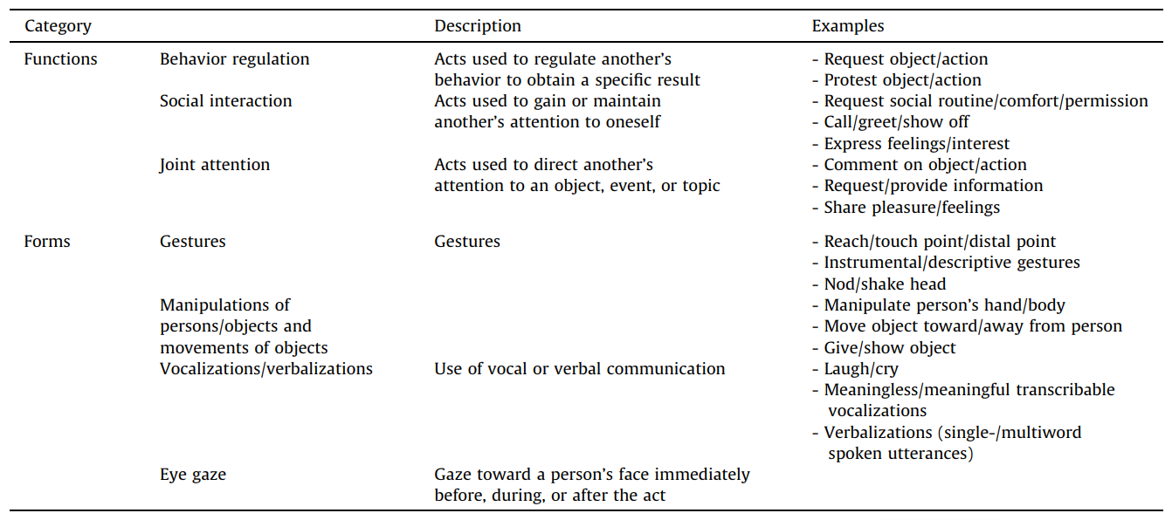

This study will utilize the Barcelona-NMVA dataset, which consists of video recordings of children and adolescents with autism and severe language delays and the absence of functional speech. For detailed information about the dataset, please refer to Section 3.3. Previous studies have highlighted the importance of considering both broad categories of activity and specific types of actions when classifying nonverbal behavior. However, since the participants in this study can be highly active (e.g., walking around), video recordings do not always capture their facial expressions. In some cases, only parts of their bodies are visible, and in moments of intense movement, even those may be obscured. As a result, focusing solely on specific body parts, such as gestures or facial expressions, would be impractical. The commonly used approach in ASD communication research, which classifies nonverbal behavior into three main communicative functions, examines participants from a cognitive ability’s perspective. In contrast, the current study emphasizes communicative forms and shifts the focus from cognitive abilities to communication behavior. Therefore, categorizing behaviors based on communicative functions is not the most appropriate method for addressing this study’s research questions. Instead, the most appropriate framework for this study is interpersonal interaction theories. These theories propose that nonverbal behavior serves multiple simultaneous functions, broadly categorized into social functions and affective functions. This framework is particularly suited for analyzing nonverbal immediacy exchanges of short duration, which is more effective for investigating nonverbal behavior occurring alongside prosodic vocalizations in this study. The following section will provide a detailed overview of these theories and their approach to decoding nonverbal behavior.

Theories of nonverbal immediacy exchange
Overall, communication theories of immediacy exchange are fundamentally arousal-valence theory. Unlike sequential functional models, such as the classification approach based on three main communicative functions commonly used in ASD communication research, theories of nonverbal immediacy exchange focus specifically on particular forms of arousal and enable predictions about responses to both moderate and high levels of immediacy change. To fully understand these theories, it is important to first define arousal and examine how it relates to communication.
Many authors who incorporate arousal in their theorizing have not defined it specifically (e.g., Schachter & Singer, 1962; Andersen, 1985). Others hold varying views of it. Although most definitions emphasize a state of activation, they differ in the extent to which such activation is a physiological, psychological, or behavioral variable and in the degree to which emphasis is placed on receptivity to incoming stimuli or effects on behavioral output. In physiology, arousal includes activation of the sympathetic division of the autonomic nervous system (Buchwald & Brown, 1973; Grings & Dawson, 1978; Lynn, 2013). In psychology, particularly within the emotion literature, arousal is considered one dimension of emotional experience (Dittmann, 1972; Mandler, 1975; Christ, 1985). From a communication standpoint, arousal encompasses both subjective experiences and accompanying behaviors. Physical arousal can occur without registering as an emotional experience. For instance, an increase in blood pressure or stomach acid production may not necessarily be accompanied by a conscious emotional response. Also, psychological arousal can occur without any observable physical signs. Recognizing these nuances, Burgoon et al. (1989) propose a two-dimensional framework that better captures the characteristics of arousal in communication.
In Burgoon et al. (1989), arousal is defined not only as a physiological event but also as a behavioral variable. They propose that arousal can be conceptualized as two-dimensional, involving both intensity and valence. Arousal intensity refers to the degree of physiological, psychological, and behavioral activation or excitement in an individual. In other words, intensity refers to the degree of one’s willingness to engage in communication, which can range from low to high. For instance, when a person shows a change in behavioral patterns during interaction like responding physically to another’s presence, speech, or actions, this kind of physiological activation may signal high communicative intent and can thus be interpreted as high arousal intensity. While behavioral changes can indicate high intensity, the absence of such changes does not necessarily imply low intensity. For example, in a conversation, if a person consistently maintains eye contact and attentively listens to the other speaker, despite the lack of obvious movement, this sustained engagement can still be considered high intensity due to the strong communicative intent being displayed. Arousal valence, on the other hand, reflects the extent to which exhibited behaviors indicate that the experienced arousal is pleasant or unpleasant. It ranges from negative to positive. Notably, in Burgoon et al.’s framework, research on anxiety, deception, unpleasant emotional expressions, and spatial invasion is expected to reveal negatively valenced arousal, whereas research on attraction, relaxation, and communicator styles involving attentiveness and animation pertains to positively valenced arousal. That is, positive valence includes not only explicitly positive emotions such as happiness and excitement but also relatively neutral states like calmness and relaxation. Negative valence, by contrast, refers to the experience of negative emotional states.
Burgoon et al.’s arousal intensity and valence theory, also referred to as arousal indices, provides the methodological foundation for this study, and guides the classification of nonverbal behavior. Unlike many studies on ASD that categorize nonverbal behavior based on communicative functions, such as behavior regulation, social interaction, and joint attention. This study adopts a classification approach based on arousal indices, and divides nonverbal behavior into two dimensions: intensity and valence. If a participant shows no high communicative intent during vocalization through nonverbal behaviors, it is classified as low arousal intensity. Conversely, if there is a clear communicative intent as indicated by nonverbal behaviors, it is classified as high arousal intensity. Regarding arousal valence, if the participant’s behavior during vocalization conveys negative emotions, it is categorized as negative valence. If it conveys neutral or positive emotions, it is categorized as positive valence. This approach differs from many dimensional emotion models, which classify emotions into positive, negative, and neutral. The decision not to include a neutral category is based on two considerations. First, in the Burgoon et al.’s theory, emotions were categorized as negative and non-negative. Second, among all emotional states in ASD, distinguishing negative emotions from non-negative emotions are most relevant to well-being, whereas distinguishing between positive and neutral emotions is less relevant. By focusing on negative versus non-negative emotion, this study aims to provide insights that could inform therapeutic interventions. Third, distinguishing between positive and neutral emotions is particularly challenging. However, not making this distinction allows us to simplify the experimental procedure without compromising the study’s validity, and it also enhances the feasibility of future replication.

Summary
In summary, while previous studies have established a link between verbal and nonverbal communication in perception, no research has explored how these two modalities are connected in production, let alone in NMVA. This study aims to address this gap. To ensure the feasibility of the research, selecting an appropriate model for coding nonverbal behavior is crucial. Given the need for a framework that effectively integrates prosody, nonverbal behavior, and communication, this study adopts Burgoon et al.’s arousal indices as the foundation for developing its coding scheme. Since some studies suggest that infants use vocalizations to express different emotions or communicative functions (Delack & Fowlow, 1978; D’Odorico & Franco, 1991; Hsu et al., 2000), and vocalizations conveying communicative functions tend to have significantly lower F0 than those expressing emotions (Papaeliou et al., 2002), this study can further connect this to the findings from the author’s internship. Specifically, protophones showed significantly lower values than fixed signals in mean F0, median F0, F0 standard deviation, and F0 range. Based on this, the author infers that speech-like protophones are more likely to serve communicative functions compared to fixed signals, and offer deeper insight into the communication patterns of individuals with NMVA. Therefore, this research will examine the relationship between the pitch characteristics of the fixed signals and protophones measured during the author’s internship and the arousal indices in the nonverbal behavior of individuals with NMVA. The findings will contribute to a clearer understanding of the prosody-nonverbal behavior relationship in this population, facilitate better communication strategies, and improve the ability to infer communicative intent from prosodic and nonverbal cues in nonverbal autism.

Methodology

Research question
The study aims to answer the following research questions:
- Do protophones and fixed signals differ in the arousal intensity and valence of accompanying nonverbal behavior in individuals with non- or minimally verbal autism?
- Are pitch-related acoustic features of protophones and fixed signals associated with the arousal intensity and valence of nonverbal behavior?

Hypothesis and prediction
Although previous studies on the perception of verbal and nonverbal behavior in ASD have shown their interrelation in communication, no research has investigated whether prosody and body movement exhibit a significant correlation within the framework of arousal indices in individuals with NMVA. Therefore, all findings of this study are exploratory, making it impossible to establish a hypothesis or prediction before conducting the research.

Dataset
This study was based on the Barcelona-NMVA dataset, which includes video recordings and corresponding audio recordings of participants’ communication behaviors while a therapist used the (adapted) Autism Diagnostic Observation Schedule to interact with them. The subjects consisted of 16 children and 9 adolescents with non- or minimally verbal autism from Barcelona, Spain (20 males and 5 females, average age = 11.4 years, SD = 4.0). All participants met the following criteria: (a) a previous parent- or center-reported ASD diagnosis; (b) absence of functional speech, defined as no words, single words, or simple fixed phrases as determined by parental, school, or center reports, in line with professional ASD classification; and (c) no compensation for the lack of speech using written or sign language modalities. The speech status and diagnosis of all participants were reassessed following recruitment, with evaluations based on Module 1 of the Autism Diagnostic Observation Schedule (ADOS) and, for school-aged participants, supplemented by the Autism Diagnostic Interview-Revised (ADI-R). Due to excessive background noise, three recordings were excluded from the final analysis, which results in a dataset of 22 recordings from 22 participants. However, the videos from the excluded recordings will be used to assess the feasibility of the coding scheme.

Annotation scheme design
The annotation scheme employed in this study is based on the arousal indices (Burgoon et al., 1989). In determining each category, coders follow the principle proposed by Ekman and Friesen (1969), and take into account both broad categories of activity and specific types of actions. This approach involves interpreting participants’ mental states while also relying on the coders’ own perceptions during annotation. The specific types of actions are primarily informed by previous studies on nonverbal communication in individuals with ASD. The author selects the most commonly used movements within this population.
The annotation scheme consists of several hierarchical tiers. The first tier is Facial Expression, which serves as the sole indicator for determining arousal valence. If the participant’s facial expression reflects positive or neutral emotion, it is labeled as P (positive). If it reflects negative emotion, it is labeled as N (negative). The second tier is Movement. If the participant is alone and not interacting with the therapist, the arousal intensity is directly labeled as L (low intensity). Otherwise, annotation proceeds to the third tier. The third tier is Specific Actions, which includes behaviors commonly used by individuals with ASD to communicate, such as initiating physical contact with the therapist, pointing, directing eye gaze at the therapist, or reaching/giving objects to the therapist. If any of these behaviors occur, the intensity is labeled as H (high intensity). If not, annotation proceeds to the fourth tier. Behavior Discontinuity is annotated in the fourth tier, which examines whether specific body movements occur before, during, or after a vocalization. To determine the presence of behavior in the before and after phases, the author typically inspects a time window of approximately one second. This choice is motivated by reaction time studies, which suggest that response times for simple, choice, and complex tasks generally do not exceed one second (Sternberg, 1969; Posner, 1978; Luce, 1986). Thus, a one-second interval is considered sufficient to capture relevant bodily responses. However, in some cases, this window may be extended beyond one second when necessary, in order to more clearly assess the continuity or progression of the observed action. If no relevant behavior is observed in either time window, the intensity is labeled as L. Otherwise, it is labeled as H. Based on these tiers, coders ultimately assign arousal intensity (H or L) and arousal valence (P or N).
It is important to note that participants occasionally move out of the camera frame. Even when they remain within view, their full body is not always visible due to positioning constraints. Furthermore, in some cases, coders might encounter uncertainty when determining arousal intensity or valence. To account for these challenges, an additional annotation category, U (Unclear), is introduced alongside existing codes such as Y, N, L, H, and others. This category is used to mark instances where coders are unable to confidently assign a specific classification.
In summary, the annotation scheme in this study was designed based on the arousal indices (Burgoon et al., 1989). When assessing participants’ specific actions, coders take into account the broad categories of activity, such as movements of the head, trunk, and arms, to determine whether the participant exhibits behaviors commonly used by individuals with ASD (see Table 1). These behaviors serve as cues for inferring communicative intentionality and emotional states. This approach reflects adherence to the principle proposed by Ekman and Friesen (1969).

Table 1 Annotation Scheme for Nonverbal Behavior Classification
Tier | Description | Labels
Facial Expression | Used to determine arousal valence. | P/N/U
Movement | Used to determine if the participant is alone or interacting with the therapist. | L/ NA (proceed to Tier 3)
Specific Actions | Checks for ASD-typical communicative behaviors: initiating physical contact, pointing, directing eye gaze toward the therapist, turning the body toward the therapist, and reaching for or giving objects. | H/ NA (proceed to Tier 4)
Behavior Discontinuity | Checks for presence of specific actions before, during or after vocalization. | L/H/U
Arousal Intensity | Whether communicative intent is present. | H/L/U
Arousal Valence | Whether the emotion is negative or non-negative. | P/N/U

Coding procedure and reliabilities
Each participant’s recordings were individually annotated using ELAN (2024). Video and audio recordings were imported alongside pre-existing TextGrid files, which had been created during the author’s internship for the classification of vocalizations. This process resulted in a total of 22 annotation files.
During annotation, coders first muted the audio recordings. The author then created hierarchical tiers based on the annotation scheme. Although the imported TextGrid files contained multiple vocalization types, coders focused exclusively on protophones and fixed signals. Additionally, to prevent the labels of protophones or fixed signals from influencing the coders’ annotations, these labels were hidden during the whole process. Coders only knew that the segment contains a target vocalization but were not aware of whether it was a protophone or a fixed signal.
The first round of annotation was conducted by the author, and a second round was carried out by second trained coder involved in this project. The first round covered all videos in the dataset, while the second round focused on the first four videos that the author had initially annotated. These early annotations were selected because they were made at a time when the author was still becoming familiar with the annotation scheme and were therefore more likely to contain inconsistencies. To assess inter-annotator reliability, the author reports Gwet’s AC1 (Agreement Coefficient 1) using the irrCAC package in R (Gwet, 2019). If annotations from the least experienced phase show strong agreement with those of the second coder, it is likely that the overall annotation quality is robust. Conversely, if differences are found, this provides a valuable opportunity for the two coders to jointly discuss the sources of disagreement and to re-annotate the relevant data, which contributes to enhance the overall reliability of the dataset.
After computing Gwet’s AC1 on the four videos annotated by both coders, the study found high agreement in the categorization of different behaviors. For arousal intensity, the observed agreement (pₐ) was 0.822, while the agreement expected by chance (pₑ) was 0.259. The resulting AC1 coefficient was 0.759 (SE = 0.0204), with a 95% confidence interval of [0.719, 0.799], which indicated substantial agreement between coders across the three intensity categories: High, Low, and Unclear. For arousal valence, the observed agreement was even higher (pₐ = 0.924), with an expected agreement of 0.277. The AC1 coefficient was 0.895 (SE = 0.0142), with a 95% confidence interval of [0.867, 0.923]. However, Gwet’s AC1 is a robust, chance-corrected agreement coefficient, and does not account for individual differences between participants. To address this limitation, the author conducted additional significance testing. Specifically, this study used Generalized Estimating Equations (GEE) with a logit link to examine whether the two coders’ annotations differed significantly when individual variation among participants was taken into account. The author also fitted a Bayesian multilevel multinomial logistic regression model to evaluate coder differences at the level of individual data points. The results showed that for the intensity categories L and H (which were included in the main analysis), as well as the valence categories P and N, the GEE analysis indicated no significant differences between coders (see Appendix A). However, the Bayesian logistic regression model revealed significant differences in these same categories (see Appendix B).
These results suggest that there was a high level of agreement between the two annotators on the behaviors coded, and that such agreement persisted even when individual differences between participants were not accounted for. However, when variation at the level of individual data points was taken into consideration, significant differences emerged between the annotations. To ensure the robustness of the data, the author manually re-annotated the same four videos, and repeated the inter-rater reliability tests using the same procedures. This time, higher agreement scores were achieved: pₐ = 0.873 for arousal intensity, and pₐ = 0.930 for valence. The GEE analysis again showed no significant differences between coders for all data points except those labeled as ‘Unclear’, after accounting for participant-level variation (see Appendix A). In contrast, the Bayesian logistic regression still revealed significant coder differences when modeling annotation variation at the level of individual data points (see Appendix B). These findings indicate that the annotation scheme used in this study is capable of achieving a high degree of consistency between coders at the level of individual participants, but may not fully ensure item-by-item consistency across all annotations.
Ultimately, the author replaced the initially selected four files with the re-annotated data, removed all vocalizations labeled as “U,” and got the final dataset used for statistical analysis. In this dataset, the number of fixed signals was 282, accounting for approximately 12.15% of all vocalization types, while protophones totaled 2039, making up about 87.85%. Regarding arousal intensity, high-intensity vocalizations numbered 829 (approximately 38.1%), whereas low-intensity vocalizations amounted to 1347 (61.9%). As for arousal valence, there were 127 instances of negative valence (7.74%) and 1513 instances of positive valence (92.26%).

Statistical analysis
All analyses were carried out in R version 4.2.3 (R Core Team, 2023). To address the first research goal, this study examined the relationship between vocalization type and both arousal intensity and valence. Section 4.1 presents all statistical analyses conducted for this purpose. The author employed binomial generalized linear mixed-effects models (GLMMs) using the lme4 package (Bates et al., 2015) in combination with broom.mixed (Bolker & Robinson, 2025). These models were used to investigate: the relationship between vocalization type and arousal intensity, the relationship between vocalization type and arousal valence, and the interaction between arousal intensity and valence in relation to vocalization type.
However, considering that some participants did not produce any negative valence nonverbal behaviors or fixed signals during the elicitation procedure, this imbalance may have affected the statistical analysis. To address this issue, this study conducted a follow-up analysis by excluding participants who did not produce any instances of negative valence or fixed signals. The data were reorganized following the same procedure described in Section 4.1, and the updated results are presented in Section 4.2.
The second aim of this study was to investigate whether pitch-related acoustic features: mean F0, median F0, F0 range, and F0 standard deviation, which were measured during the author’s internship, were associated with arousal intensity and valence within individual vocalization types. To address this, the author used the lme4 package (Bates et al., 2015) to fit a series of logistic mixed-effects models, each including a random intercept for subjects. In the first set of models, the data were restricted to protophones. Here, arousal intensity was entered as the predictor variable, and each of the four pitch-related measures was treated as a dependent variable. In the second set of models, the data remained limited to protophones, but valence was used as the predictor variable instead, with the same pitch-related features as outcome variables. Then, this study focused on fixed signals, and applied similar models to examine the effects of arousal intensity and valence on the pitch-related acoustic features within this vocalization type.
All models passed checks for residual normality and distribution adequacy. Therefore, subsequent sections directly report model results without repeatedly describing residual diagnostics.

The relationship between vocalization types, arousal intensity and valence
To investigate how both arousal intensity and valence relate to vocalization types, the author fitted a binomial generalized linear mixed-effects model using a subset of the data that included only protophones and fixed signals as vocalization types (N = 1631). To investigate how communicative functions differ across vocalization types, this study fitted two separate GLMMs to examine whether vocalization type (protophone vs. fixed signal) could predict variation in nonverbal behavior along the arousal intensity and arousal valence. Vocalisation type was entered as the fixed effect, arousal valence and arousal intensity was entered as outcome variables, respectively, and participant file was included as a random intercept to account for between-subject variation. The model predicting arousal intensity (High vs. Low) showed that vocalisation type was not a significant predictor of arousal intensity (Estimate = -0.108, p = .518). This suggests that the probability of a vocalisation being high or low in arousal intensity did not differ significantly between protophones and fixed signals. Besides, the mode conducted to predict arousal valence (Positive vs. Negative) revealed that vocalisation type was a significant predictor of valence (Estimate = 2.415, p < .001). Specifically, fixed signals were more likely to be associated with positive valence compared to protophones. These results suggest that while vocalisation type does not differentiate arousal intensity, it is strongly associated with arousal valence, with fixed signals tending to co-occur with more positively valenced nonverbal behaviours.
Additionally, to explore potential interactions between arousal and valence in predicting vocalization type, the author conducted an exploratory analysis using an alternative model treating vocalization type as the outcome. Although this direction is less intuitive given the annotation procedure, it allowed for examining whether complex arousal indices might influence the likelihood of specific vocal behavior.
As for the model treating vocalization type as the outcome, the dependent variable was vocalization type (reference level: protophone), and the fixed effects were arousal intensity (High vs. Low) and arousal valence (Negative vs. Positive), including their interaction. A random intercept for participant (file) was included to account for inter-subject variability (n = 22 participants).
The model revealed a significant main effect of valence, which indicated that vocalizations annotated as negative in valence were significantly more likely to be categorized as fixed signals rather than protophones. In contrast, the main effect of arousal intensity was not significant, which suggested that arousal intensity alone did not significantly distinguish vocalization types. Similarly, the interaction between arousal intensity and valence was not significant. Detailed results are presented in Table 2.

Table 2 Results of the Binomial GLMM Predicting Vocalization Type (Reference Level = PRO)
Fixed effects | Estimate (β) | Std. Error | z value | p value | Significance
(Intercept) | -3.939 | 0.528 | -7.458 | < .001 | ***
Intensity (H vs. L) | -0.060 | 0.247 | -0.241 | .810
Valence (N vs. P) | 2.506 | 0.335 | 7.486 | < .001 | ***
Intensity × Valence | -0.128 | 0.563 | -0.228 | .820

Overall, the results suggest that valence significantly predicts vocalization type in this dataset (see Figure 2), while arousal intensity and its interaction with arousal valence do not make significant contributions to the model.

Figure 2 Predicted Probabilities of Vocalization Type by Arousal Intensity and Valence
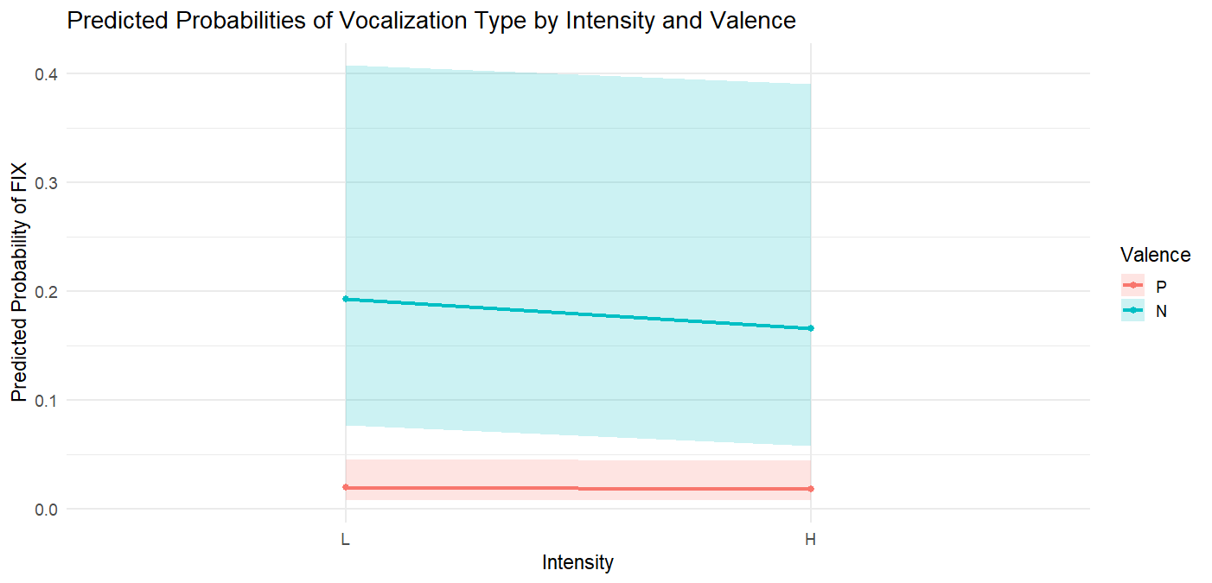

Reanalysis excluding participants without negative valence or fixed signals
To control for the potential imbalance introduced by participants who did not produce any negative valence or fixed signals, the study conducted a reanalysis by excluding these cases (N = 1041 across 11 participants). Two mixed-effects logistic regression models were constructed with vocalization type as the fixed effect and participants as a random intercept to account for individual differences. For arousal intensity, the model included 1,352 vocalizations from 11 participants. The model did not reveal a significant difference between protophones and fixed signals in terms of arousal intensity (Estimate = 0.048, p = 0.792). This indicates that vocalization type (protophone vs. fixed signal) was not a reliable predictor of arousal intensity. The predicted probability of high arousal did not significantly differ between the two types. In contrast, the model predicting arousal valence (positive vs. negative) showed a highly significant effect of vocalization type (Estimate = 2.377, p < .001). This suggests that fixed signals were significantly more likely to be associated with positive arousal valence than protophones.
Regarding the interaction, a binomial generalized linear mixed-effects model was fitted with vocalization type (PRO vs. FIX) as the outcome variable, and arousal intensity, arousal valence, and their interaction as fixed effects. A random intercept was included for file to account for subject-level variability.
Results showed a significant main effect of valence, which indicated that negative valence was associated with a higher likelihood of producing fixed signals. However, arousal intensity and the interaction between intensity and valence were not statistically significant (see Table 3).

Table 3 Results of the Binomial GLMM Predicting Vocalization Type (Only Participants Who Produced Both FIX and Negative Valence Included)
Fixed Effect | Estimate (β) | Std. Error | z value | p value |  | Significance
(Intercept) | -2.80 | 0.42 | -6.64 | < .001 |  | ***
Intensity (H vs. L) | -0.06 | 0.25 | -0.22 | .824
Valence (N vs. P) | 2.50 | 0.33 | 7.47 | < .001 |  | ***
Intensity × Valence | -0.23 | 0.55 | -0.42 | .677

These findings are largely consistent with those reported in Section 4.1, which suggests that the observed effect of valence on vocalization type is robust even when controlling for participant-level balance (see Figure 3).

Figure 3 Predicted Probabilities of Vocalization Type by Arousal Intensity and Valence After Excluding Participants Without Negative Valence or FIX Signals
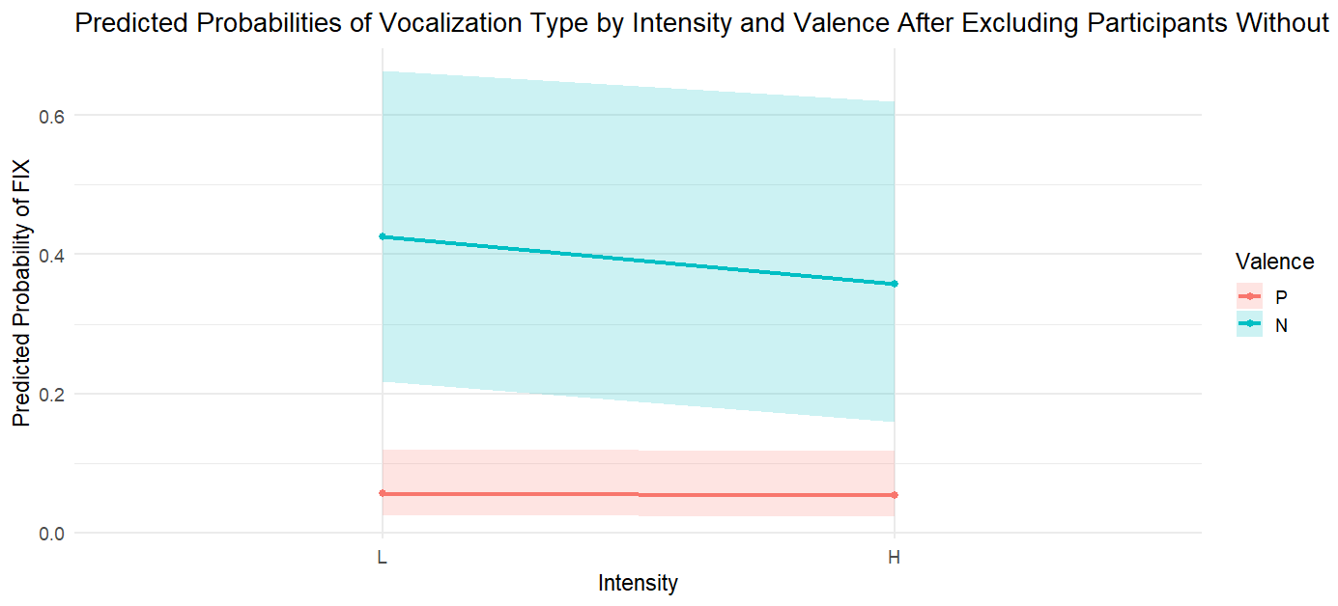

The relationship between pitch-related acoustic features, arousal intensity and valence

The relationship between arousal intensity and pitch features in protophones
To examine whether pitch-related features varied as a function of arousal intensity within protophones, four linear mixed-effects models were fitted, each predicting a different pitch-related measure (mean F0, median F0, F0 range, and F0 standard deviation) from arousal intensity, with a random intercept for subjects.
Results revealed that median F0 were significantly lower in high-intensity protophones compared to low-intensity ones. However, neither F0 range nor F0 standard deviation showed significant effects of intensity (see Table 4).

Table 4 Summary of Linear Mixed-Effects Models Predicting Pitch-Related Acoustic Features by Intensity in Protophones
Acoustic Feature | Fixed Effect | Estimate | Std. Error | df | t value | p value | Significance
Mean F0 | Intercept | 311.63 | 14.89 | 23.01 | 20.93 | < .001 | ***
 | Intensity (High) | –10.84 | 4.29 | 1849.61 | –2.53 | .0116 | *
Median F0 | Intercept | 311.29 | 15.20 | 23.06 | 20.49 | < .001 | ***
 | Intensity (High) | –11.74 | 4.44 | 1835.66 | –2.65 | .0083 | **
F0 Range | Intercept | 156.82 | 10.59 | 23.40 | 14.80 | < .001 | ***
 | Intensity (High) | –3.53 | 6.82 | 1869.43 | –0.52 | .605
F0 Standard Deviation | Intercept | 43.92 | 3.12 | 23.23 | 14.08 | < .001 | ***
 | Intensity (High) | –0.75 | 1.90 | 1854.61 | –0.39 | .694

These results suggest that, while overall pitch height decreased under high-intensity conditions, pitch variation was not significantly influenced by intensity. See Figure 4 for visualization of model outputs.

Figure 4 Pitch-Related Acoustic Features by Arousal Intensity in Protophones
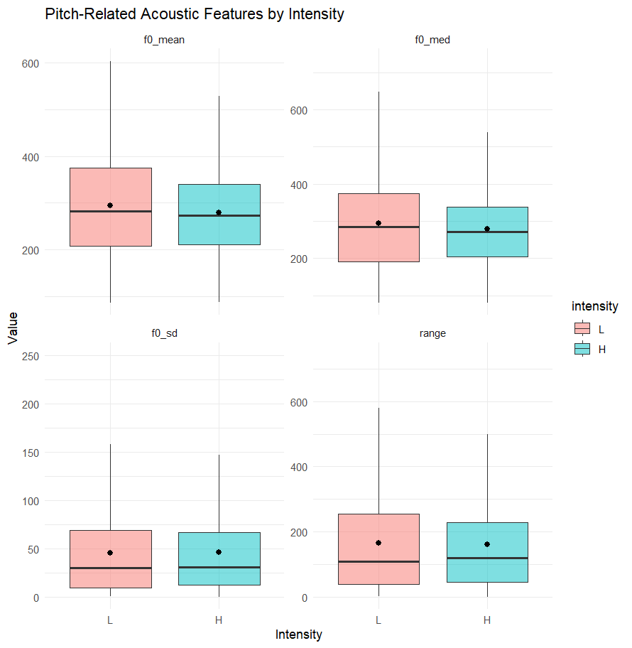

The relationship between valence and pitch features in protophones
To examine how valence affects pitch-related acoustic features, linear mixed-effects models were fitted with valence as a fixed effect and file (participants) as a random intercept.
The results revealed that valence had a significant effect on median F0. Specifically, negative valence was associated with a significantly higher median F0 compared to positive one. In contrast, the effects of valence on F0 range were less clear. For F0 range, a marginally significant trend was observed, with negative valence showing a wider pitch range. However, no significant difference was found in F0 standard deviation. See Table 5 for detailed outputs.

Table 5 Summary of Linear Mixed-Effects Models Predicting Pitch-Related Acoustic Features by Valence in Protophones
Acoustic Feature | Fixed Effect | Estimate | Std. Error | df | t value | p value | Significance
Mean F0 | Intercept | 298.45 | 14.75 | 22.72 | 20.24 | < .001 | ***
 | Valence (Negative) | 57.41 | 13.57 | 1417.05 | 4.23 | <.001 | ***
Median F0 | Intercept | 298.91 | 15.16 | 22.80 | 19.71 | < .001 | ***
 | Valence (Negative) | 61.34 | 14.23 | 1412.35 | 4.31 | <.001 | ***
F0 Range | Intercept | 150.99 | 10.83 | 17.80 | 13.95 | < .001 | ***
 | Valence (Negative) | 40.73 | 21.92 | 1420.88 | 1.86 | .063 | .
F0 Standard Deviation | Intercept | 42.51 | 3.15 | 17.32 | 13.49 | < .001 | ***
 | Valence (Negative) | 7.90 | 6.09 | 1409.44 | 1.30 | .195

In sum, these findings suggest that valence is strongly associated with pitch height but not with pitch variation, with negative valence showing higher mean and median pitch values than positive one (see Figure 5).

Figure 5 Pitch-Related Acoustic Features by Valence in Protophones
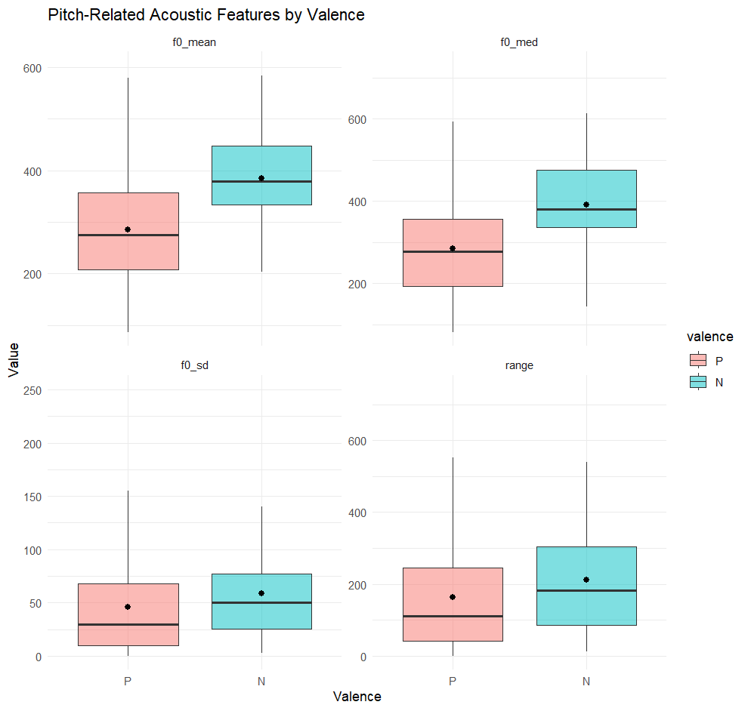

The relationship between arousal intensity and pitch features in fixed signals
To examine whether arousal intensity modulates acoustic characteristics of pitch, linear mixed-effects models were fitted separately for each pitch-related variable (mean, median, standard deviation, and range of F0). Arousal intensity was included as a fixed effect, and random intercepts by speaker file were included to account for within-speaker variation.
The results revealed a significant effect of arousal intensity on median F0. High intensity tended to have lower median F0 values compared to low intensity. However, no significant effects of arousal intensity were found for F0 range or F0 standard deviation. See Table 6 for detailed outputs.

Table 6 Summary of Linear Mixed-Effects Models Predicting Pitch-Related Acoustic Features by Arousal Intensity in Fixed Signals
Acoustic Feature | Fixed Effect | Estimate | Std. Error | df | t value | p value | Significance
Mean F0 | Intercept | 386.01 | 32.37 | 17.00 | 11.92 | < .001 | ***
 | Intensity (High) | –21.07 | 11.94 | 261.04 | –1.77 | .0787 | .
Median F0 | Intercept | 393.69 | 35.31 | 16.75 | 11.15 | < .001 | ***
 | Intensity (High) | –26.88 | 13.45 | 261.33 | –2.00 | .0468 | *
F0 Range | Intercept | 224.60 | 26.63 | 15.76 | 8.44 | < .001 | ***
 | Intensity (High) | 18.72 | 24.12 | 266.97 | 0.78 | .438
F0 Standard Deviation | Intercept | 61.62 | 6.58 | 13.25 | 9.37 | < .001 | ***
 | Intensity (High) | 5.38 | 6.84 | 261.29 | 0.79 | .432

These results suggest that while higher intensity may be associated with lower pitch height, it does not significantly alter pitch variation (see Figure 6).

Figure 6 Pitch-Related Acoustic Features by Arousal Intensity in Fixed Signals
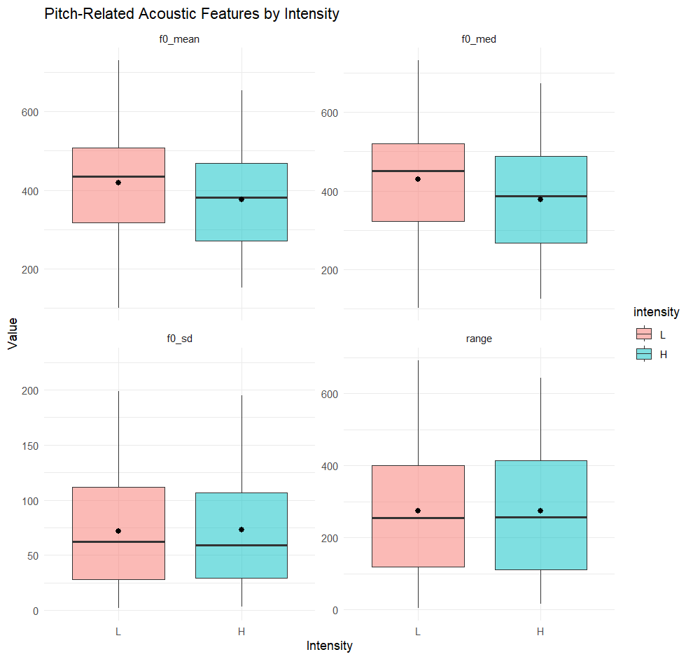

The relationship between valence and pitch features in fixed signals
To examine the effect of valence on prosodic features, four linear mixed-effects models were fitted using valence as a fixed effect and file (participant) as a random intercept.
Results showed that median F0 was significantly higher in negative valence than in positive ones. Additionally, F0 range was significantly wider under negative valence, and F0 standard deviation also increased significantly. See Table 7 for detailed outputs.

Table 7 Summary of Linear Mixed-Effects Models Predicting Pitch-Related Acoustic Features by Valence in Fixed Signals
Acoustic Feature | Fixed Effect | Estimate | Std. Error | df | t value | p value | Significance
Mean F0 | Intercept | 336.62 | 27.47 | 11.27 | 12.25 | < .001 | ***
 | Valence (Negative) | 33.77 | 15.28 | 175.61 | 2.21 | .0284 | *
Median F0 | Intercept | 338.75 | 31.39 | 10.64 | 10.79 | < .001 | ***
 | Valence (Negative) | 39.92 | 17.21 | 175.01 | 2.32 | .0215 | *
F0 Range | Intercept | 234.25 | 22.68 | 8.70 | 10.33 | < .001 | ***
 | Valence (Negative) | 81.63 | 32.01 | 43.07 | 2.55 | .0144 | *
F0 Standard Deviation | Intercept | 63.99 | 6.29 | 5.53 | 10.17 | < .001 | ***
 | Valence (Negative) | 21.83 | 9.18 | 18.18 | 2.38 | .0285 | *

Together, these results suggest that negative valence is associated with higher and more variable pitch in speech production (see Figure 7).

Figure 7 Pitch-Related Acoustic Features by Valence in Fixed Signals
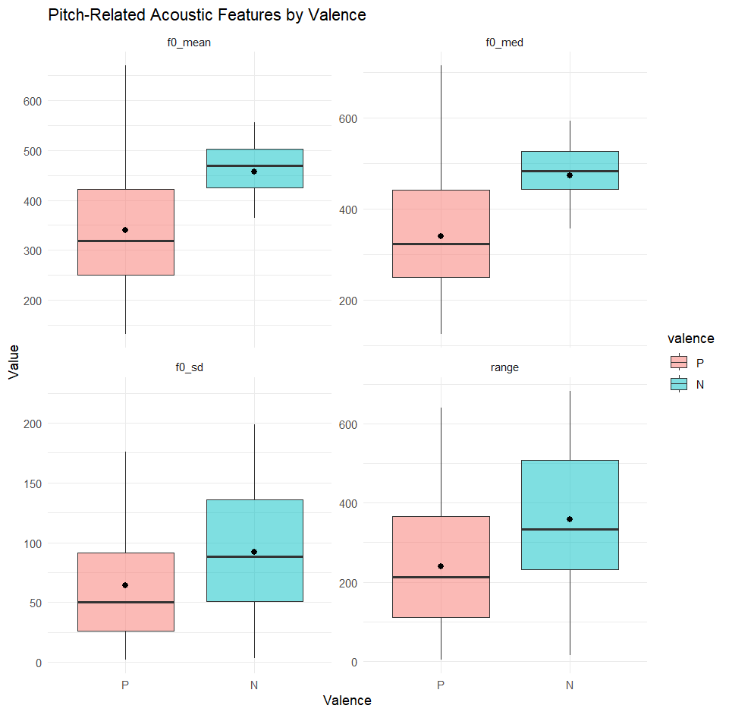

Discussion
This study explored whether there is a relationship between the pitch characteristics of protophone and fixed signal vocalizations and the corresponding nonverbal behavior in children and adolescents with non- and minimally verbal autism. The prosodic values of the participants’ vocalizations (previously measured during the author’s internship) were analyzed, and their nonverbal, nonvocal behaviors were coded along two dimensions: intensity and valence. To address the research question, the analysis was carried out in two steps. First, the study examined whether vocalization types were associated with the two dimensions of nonverbal behavior. Second, it investigated whether the pitch characteristics within each vocalization type were related to intensity and valence. As this was an exploratory study, no specific hypotheses or predictions were formulated in advance.
To summarize, four key findings emerged from the analysis. First, there was no significant association between vocalization types and intensity. This suggests that when NMVA individuals produce either protophones or fixed signal vocalizations, they may exhibit both high and low willingness to communicate. In other words, no particular vocalization type consistently indicates a greater desire to engage with others. Second, vocalization type was significantly associated with valence. Compared to protophones, fixed signals were more likely to be associated with negative valence. Third, across both vocalization types, low-intensity behaviors tended to be associated with higher pitch, whereas high-intensity behaviors were associated with lower pitch. This indicates that when NMVA individuals are more willing to interact, regardless of vocalization type, they tend to vocalize with lower pitch. Lastly, negative valence was generally associated with higher pitch, and positive valence with lower pitch. While the pitch variation between positive and negative valence was not significant for protophones, it was significant for fixed signals.
The following subsections will discuss the four main findings and the limitations of the study in greater depth.

Lack of association between vocalization types and intensity
The current study revealed no significant relationship between vocalization types and the intensity dimension of nonverbal behavior. This finding suggests that both protophones and fixed signals can occur in contexts characterized by either high or low intensity. In the present study, intensity served as a proxy for the individual’s willingness to communicate with others. The absence of a reliable association implies that neither vocalization type consistently reflects a greater or lesser communicative intent. In other words, an NMVA individual producing a protophone may be just as likely to exhibit high communicative engagement as when producing a fixed signal, and vice versa. These findings suggest that individuals with NMVA use vocalizations in a highly flexible way. Depending on the accompanying nonverbal behavior, the same type of vocalization can express different intentions, and different vocalization types may sometimes reflect similar communicative goals.
Although previous studies have noted that, as infants develop intentional communication skills, they begin to use vocalizations not only to express emotions but also to convey communicative intentions (Bates et al., 1975; Trevarthen, 1979; Marcos, 1987), and that individuals with NMVA differ significantly from their TD peers in terms of consonant inventory and intentional communicative behaviors, no research to date has directly examined the relationship between different vocalization types and communicative intentions. As a result, it remains unclear whether the observed lack of association between vocalization type and nonverbal indicators of willingness to communicate in NMVA individuals reflects a neurodivergent pattern. Without empirical evidence directly linking vocalization types to communicative intent, it is also difficult to speculate on the underlying reasons for this dissociation.

Fixed signals are more strongly associated with negative valence
The data collected by the present study showed that, in contrast to intensity, valence was found to be a significant predictor of vocalization type. Specifically, fixed signal vocalizations were significantly more likely than protophones to be associated with negative valence. This suggests a tendency for NMVA individuals to use fixed signals more frequently in emotionally negative contexts. The result underscores a meaningful behavioral pattern: fixed signals appear to reflect affective states more consistently than protophones.
This finding aligns with previous research by Oller et al. (2013) on infant vocalizations, which distinguished between protophones and fixed signals. Their study found that infant protophones are produced across a broad range of affective contexts, including positive, neutral, and negative, whereas cries and laughter are more rigidly tied to negative and positive emotions, respectively. Specifically, cries and laughs were judged to be associated with neutral facial affect in only about 4% of cases, whereas protophones showed predominant neutrality, with 64% rated as neutral in facial affect. This flexibility allows protophones to serve a variety of communicative functions, such as requesting, solitary vocal play, or designating objects or events, which are generally consistent with a neutral valence.
Jhang and Oller (2017) interpreted protophones as foundational for speech development, functioning not only to support linguistic growth but also to signal an infant’s affective state or general well-being (Oller & Griebel, 2006). Facial affect is coordinated in time with vocalization in infancy (Yale et al., 1999), so ptotophones can also serve to draw attention to the expression of affect through the visual modality. Importantly, while both cries and protophones can communicate distress, only protophones allow infants to vocally express neutrality. This functional role of protophones in signaling non-distress could explain their lower association with negative valence.
Drawing a parallel to the present study, it is plausible that a similar mechanism underlies the vocal behaviors of individuals with NMVA. Just as infants predominantly use protophones to convey neutral or non-distressed states, NMVA individuals may similarly rely on protophone-like vocalizations in emotionally neutral contexts, thereby leading to a lower frequency of negative valence in protophones compared to fixed signals. This interpretation suggests a potential developmental continuity between the vocal behavior of infants and that of individuals with NMVA, particularly in terms of how vocalizations function within the dimension of emotional valence.

Lower pitch associated with higher intensity
The results revealed a consistent pattern across both protophones and fixed signals. Vocalizations produced in high-intensity contexts, which were interpreted here as reflecting a stronger willingness to communicate, tended to exhibit lower pitch, as measured by both mean and median F0. Specifically, for protophones, both mean and median F0 were significantly lower when intensity was high, whereas for fixed signals, a significant reduction in median F0 and a marginal reduction in mean F0 were observed under high-intensity conditions. Notably, pitch variation (as indicated by F0 range and standard deviation) was not significantly affected by intensity in either vocalization type.
In emotion research, emotions are often described along the dimensions of arousal and valence, where arousal refers to the intensity of physical activation associated with emotional states, and valence describes the positivity or negativity of an emotion, as well as liking or disliking (Osgood et al., 1957; Russell & Mehrabian, 1977). This conceptualization of arousal more or less aligns with Burgoon et al.’s (1989) definition of arousal indices as “a state of physiological, psychological, and behavioral activation.” Therefore, although few studies have directly explored the relationship between prosody and individuals’ willingness to communicate, relevant insights can be drawn from research on the relationship between prosody and emotion. As discussed in the literature review, emotions characterised by high arousal are frequently associated with acoustic features such as elevated mean fundamental frequency, wider pitch variation, faster speech rate, and increased vocal intensity (Lieberman, 1968; Laukka et al., 2005; Pereira, 2000). These findings have led to conventional assumptions which are based on studies of neurotypical speech, that greater arousal or engagement typically corresponds to higher pitch. However, the present findings challenge this assumption. In the NMVA sample, higher communicative intensity was associated with lower pitch, regardless of whether the vocalization was a protophone or a fixed signal. This result contradicts typical arousal-pitch associations drawn from emotional speech in neurotypical populations. However, it is important to note that the arousal measured in emotion research typically refers to emotional arousal, which involves physiological changes that affect respiration, phonation, and articulation, which lead to emotion-specific acoustic patterns (see Wallbott & Scherer, 1986). In contrast, the arousal or intensity in the current study reflects the individual’s motivation or willingness to communicate, as inferred from nonverbal behavior. From this perspective, the present findings offer a novel contribution, which suggests that the prosodic correlates of communicative engagement in NMVA individuals may diverge from emotion-based acoustic patterns observed in typical development.
One possible reason for the lower pitch in high-intensity situations might be that it is used as a kind of social signal in the vocal patterns of people with NMVA. Instead of raising their pitch to grab attention, they might actually lower it (consciously or not) as a way of signaling that they are trying to connect or engage with someone. In social situations, when people realize others are around, they often adjust how they speak, such as volume and pitch, to appropriate conversational levels. The same may be true for individuals with NMVA. Similarly, individuals with NMVA might lower their pitch when motivated to communicate with others, which is significantly different from vocalizations from self-directed or solitary vocal play. This adjustment could serve as a signal that the individual is entering a communicative exchange. Alternatively, the observed pattern may reflect a physiological constraint or a developmental characteristic unique to this population. When they try to communicate, it changes how they use their voice or breath, which ends up lowering their pitch. Another possible explanation is that individuals with NMVA spend much of their time vocalizing in solitary contexts and only occasionally show communicative intent toward others. In the present study, this is reflected in the distribution of intensity levels, with high-intensity vocalizations comprising approximately 38.1% of the dataset, while low-intensity vocalizations accounted for 61.9%. Prior research has also demonstrated that one of the core characteristics of autism is impairment in reciprocal social interaction and communication (Chiang et al., 2008; American Psychiatric Association, 2013; Ousley & Cermak, 2014). As a result, compared to their TD peers, individuals with NMVA may have been less motivated to practice vocalizations in interactive context, especially when those interactions involved social partners. Because of this limited experience, they might not have developed strong control over adjusting their pitch in social situations, which could help explain why their pitch tends to be lower when they do try to communicate However, these interpretations remain speculative, since we did not include a TD control group in this study. Whether these explanations are valid requires further investigation with similar methods on TD participants.

Pitch as an index of emotional valence
Lastly, the present findings indicate a general association between emotional valence and pitch characteristics. Across both vocalization types, vocalizations associated with negative valence tended to exhibit higher pitch, while those linked to positive valence were produced with lower pitch. This pattern was especially evident in fixed signals, where all four pitch-related measures (mean F0, median F0, F0 range, and F0 standard deviation) showed significantly higher values under negative valence conditions. In contrast, for protophones, the difference in pitch height (mean and median F0) between negative and positive valence was statistically significant, but pitch variation (range and standard deviation) did not differ significantly. These findings are broadly consistent with prior research on affective prosody, which has demonstrated that emotions with higher arousal, such as anger or distress, are often accompanied by elevated mean pitch and greater pitch variability (Lieberman, 1968; Pereira, 2000; Laukka et al., 2005).
Interestingly, fixed signals show a clearer difference in pitch between valence conditions than protophones do. This may reflect that fixed signals are more emotionally transparent or that people have less control over in the production of fixed signals. Fixed signals, such as cries or laughter, are typically more reflexive and tightly coupled with emotional states (Oller et al., 2013), whereas protophones are known to occur in a wider range of affective and motivational contexts, often including emotionally neutral states (Jhang & Oller, 2017). This functional flexibility might explain the weaker association between pitch variation and valence in protophones.
In sum, negative valence was reliably associated with higher pitch, particularly in fixed signals. This finding aligns with existing literature suggesting that pitch modulation remains a robust cue to emotional state across different vocal forms. The observed differences in pitch variation likely stem from the distinct communicative functions of fixed signals and protophones. These results contribute to a more detailed understanding of how prosody may serve as an index of affect in individuals with NMVA.

Limitations and future directions
Several limitations of the current study should be acknowledged. First, the absence of a control group of TD individuals makes it harder to interpret whether the patterns observed in the NMVA group, such as decreased pitch in high-intensity contexts, are truly atypical or just part of the normal range of communicative variation.
Second, although the study revealed interesting associations between vocalization types, affective valence, and communicative intensity, the coding of intensity was based on external behavioral cues, which may not fully capture the speaker’s internal communicative motivation. Additionally, the valence distribution in the dataset was heavily skewed toward positive affect, which potentially reduced the power to detect more subtle or complex effects of negative emotional states.
Third, while the study incorporated both protophones and fixed signals, it did not further differentiate between subtypes of fixed signals. In both the author’s internship and the present study, protophones were defined as speech-like (marginal) syllables, whereas fixed signals encompassed a wide range of non-speech-like vocalizations, such as cries, laughs, grunts, moans, and yells. However, it remains uncertain whether these varied vocalizations within the fixed signal category truly share similar communicative functions and are meaningfully distinct from protophones. Without a more detailed categorization, it is hard to generalize the findings across such a wide range of vocalizations that may differ in sound and function. This also makes it harder to interpret the results clearly and limits how well they reflect real-world social interactions.
Future research would benefit from including a TD comparison group to determine whether the acoustic patterns observed here are unique to the NMVA population. It would also be helpful to adopt a more balanced dataset in terms of emotional valence. In addition, integrating physiological or neurophysiological measures (e.g., heart rate, skin conductance, EEG) could provide a fuller picture of how individuals with NMVA coordinate multiple modalities to express intention. Finally, further categorization of fixed signals and examination of their distinct pitch characteristics alongside corresponding nonverbal and nonvocal behaviors will help us clarify whether certain fixed signals are better suited for social interaction or more effective at conveying communicative intent than others, and offer deeper insights into the more detailed ways individuals with NMVA engage with their environment.

Conclusion
This study represents an initial step toward understanding how prosody and nonverbal nonvocal behavior are linked in individuals with nonverbal or minimally verbal autism. Building on the arousal indices proposed by Burgoon et al. (1989), a novel coding scheme was developed to investigate how pitch features vary in relation to perceived arousal intensity and valence across two vocalization types: protophones and fixed signals.
The findings revealed four major patterns: (1) there was no significant association between vocalization type and intensity; (2) fixed signals were more frequently associated with negative valence; (3) lower pitch was linked to higher communicative intensity; and (4) pitch emerged as a consistent index of emotional valence, especially within fixed signals.
In sum, this study offers a foundational understanding of how prosodic and nonverbal cues work together to signal affective and communicative states in individuals with NMVA. By shedding light on the structure behind seemingly idiosyncratic vocal and nonvocal behaviors, the findings contribute both a concrete, quantifiable methodology based on Burgoon et al.’s (1989) theoretical framework of communication and offer potential practical approaches for supporting interaction and interpretation of communicative intent in this population.

References
Aguert, M., Laval, V., Le Bigot, L., & Bernicot, J. (2010). Understanding expressive speech acts: The role of prosody and situational context in French-speaking 5-to 9-year-olds.
Aguert, M., Laval, V., Lacroix, A., Gil, S., & Le Bigot, L. (2013). Inferring emotions from speech prosody: Not so easy at age five. PLoS One, 8(12), e83657.
American Psychiatric Association. (2013). Diagnostic and statistical manual of mental disorders (5th ed.). Washington, DC: American Psychiatric Association.
Andersen, P. A. (1985). Nonverbal immediacy in interpersonal communication. In A. W. Siegman & S. Feldstein (Eds.), Multichannel integrations of nonverbal behavior (pp. 1-36). Hillsdale, NJ: Lawrence Erlbaum.
Andersen, P. A., Guerrero, L. K., Buller, D. B., & Jorgensen, P. F. (1998). An empirical comparison of three theories of nonverbal immediacy exchange. Human Communication Research, 24(4), 501-535.
Asperger, H. (1944). Die “Autistischen psychopathen” im kindesalter. Archiv für psychiatrie und nervenkrankheiten, 117(1), 76-136.
Balazia, M., Müller, P., Tánczos, Á. L., Liechtenstein, A. V., & Bremond, F. (2022, October). Bodily behaviors in social interaction: Novel annotations and state-of-the-art evaluation. In Proceedings of the 30th ACM International Conference on Multimedia (pp. 70-79).
Barnard, K. E., & Brazelton, T. (1990). Touch: The foundation of experience: Full revised and expanded proceedings of Johnson & Johnson Pediatric Round Table X. International Universities Press, Inc.
Baron‐Cohen, S. (1989). Perceptual role taking and protodeclarative pointing in autism. British Journal of developmental psychology, 7(2), 113-127.
Bates, E., Camaioni, L., & Volterra, V. (1975). The acquisition of performatives prior to speech. Merrill-Palmer quarterly of behavior and development, 21(3), 205-226.
Bates D, Mächler M, Bolker B, Walker S (2015). Fitting Linear Mixed-Effects Models Using lme4. Journal of Statistical Software, 67(1), 1–48. doi:10.18637/jss.v067.i01.
Beebe, B., & Lachmann, F. M. (2015). The contribution of mother-infant mutual influence to the origins of self-and object representations. In Relational perspectives in psychoanalysis (pp. 83-117). Routledge.
Bolker B, Robinson D (2025). broom.mixed: Tidying Methods for Mixed Models. R package version 0.2.9.7, https://github.com/bbolker/broom.mixed.
Bormann‐Kischkel, C., Vilsmeier, M., & Baude, B. (1995). The development of emotional concepts in autism. Journal of child psychology and psychiatry, 36(7), 1243-1259.
Boucher, J., Lewis, V., & Collis, G. M. (2000). Voice processing abilities in children with autism, children with specific language impairments, and young typically developing children. The Journal of Child Psychology and Psychiatry and Allied Disciplines, 41(7), 847-857.
Boucher, J., Bigham, S., Mayes, A., & Muskett, T. (2008). Recognition and language in low functioning autism. Journal of Autism and Developmental Disorders, 38, 1259-1269.
Buchwald, J. S., & Brown, K. A. (1973). Subcortical mechanisms of behavioral plasticity.
Buck, R., & VanLear, C. A. (2002). Verbal and nonverbal communication: Distinguishing symbolic, spontaneous, and pseudo-spontaneous nonverbal behavior. Journal of communication, 52(3), 522-541.
Burgoon, J. K. (1978). A communication model of personal space violations: Explication and an initial test. Human communication research, 4(2), 129-142.
Burgoon, J. K., Wiemann, J. M., & Harrison, R. P. (1983). Nonverbal violations of expectations. Nonverbal interaction, 11, 11-77.
Burgoon, J. K., & Hale, J. L. (1988). Nonverbal expectancy violations: Model elaboration and application to immediacy behaviors. Communications Monographs, 55(1), 58-79.
Burgoon, J. K., Kelley, D. L., Newton, D. A., & KEELEY‐DYRESON, M. P. (1989). The nature of arousal and nonverbal indices. Human Communication Research, 16(2), 217-255.
Burgoon, J. K., & Dunbar, N. E. (2006). Nonverbal expressions of dominance and power in human relationships. In The Sage handbook of nonverbal communication (pp. 279-298). SAGE Publications, Inc..
Burgoon, J. K., Guerrero, L. K., & Manusov, V. (2011). Nonverbal signals. Handbook of interpersonal communication, 239-280.
Butcher, C., & Goldin-Meadow, S. (2000). 12 Gesture and the transition from one-to two-word speech: when hand and mouth come together. Lang Gest, 2, 235.
Byrd, D., & Saltzman, E. (2003). The elastic phrase: Modeling the dynamics of boundary-adjacent lengthening. Journal of Phonetics, 31(2), 149-180.
Capone, N. C., and McGregor, K. K. (2004). Gesture development: a review for clinical and research practices. J. Speech Lang. Hear. Res. 47, 173-186. doi: 10.1044/1092-4388(2004/015)
Cappella, J. N., & Greene, J. O. (1982). A discrepancy‐arousal explanation of mutual influence in expressive behavior for adult and infant-adult interaction. Communications Monographs, 49(2), 89-114.
Chaplin, T. M. (2015). Gender and emotion expression: A developmental contextual perspective. Emotion Review, 7(1), 14-21.
Chiang, C. H., Soong, W. T., Lin, T. L., & Rogers, S. J. (2008). Nonverbal communication skills in young children with autism. Journal of autism and developmental disorders, 38, 1898-1906.
Chippendale, P. (2006, April). Towards automatic body language annotation. In 7th International Conference on Automatic Face and Gesture Recognition (FGR06) (pp. 487-492). IEEE.
Christ, W. G. (1985). The construct of arousal in communication research. Human Communication Research, 11(4), 575-592.
Couper-Kuhlen, E. (1986). An Introduction to English Prosody. London and Tuebingen: Edward Arnold and Niemeyer.
Cruttenden, A. (1997). Intonation. Cambridge University Press.
Cutler, A., Dahan, D., & Van Donselaar, W. (1997). Prosody in the comprehension of spoken language: A literature review. Language and speech, 40(2), 141-201.
Cutler, A., & Ladd, D. R. (Eds.). (2013). Prosody: Models and measurements (Vol. 14). Springer Science & Business Media.
Cvejic, E., Kim, J., & Davis, C. (2012). Recognizing prosody across modalities, face areas and speakers: Examining perceivers’ sensitivity to variable realizations of visual prosody. Cognition, 122(3), 442-453.
Delack, J. B., & Fowlow, P. J. (1978). The ontogenesis of differential vocalization: Development of prosodic contrastivity during the first year of life. In N. Waterson & C. Snow (Eds.), The development of communication. Wiley.
D’Odorico, L., & Franco, F. (1991). Selective production of vocalization types in different communication contexts. Journal of child language, 18(3), 475-499.
DeVeney, S. L., Kyvelidou, A., & Mather, P. (2021). A home-based longitudinal study of vocalization behaviors across infants at low and elevated risk of autism. Autism & Developmental Language Impairments, 6, 23969415211057658.
Dittmann, A. T. (1972). The body movement-speech rhythm relationship as a cue to speech encoding. In Studies in dyadic communication (pp. 135-151). Pergamon.
Drew, A., Baird, G., Baron-Cohen, S., Cox, A., Slonims, V., Wheelwright, S., ... & Charman, T. (2002). A pilot randomised control trial of a parent training intervention for pre-school children with autism: Preliminary findings and methodological challenges. European child & adolescent psychiatry, 11, 266-272.
Ejiri, K. (1998). Relationship between rhythmic behavior and canonical babbling in infant vocal development. Phonetica, 55(4), 226-237.
Ejiri, K., & Masataka, N. (2001). Co-occurences of preverbal vocal behavior and motor action in early infancy. Developmental Science, 4(1), 40-48.
Ekman, P., & Friesen, W. V. (1969). The repertoire of nonverbal behavior: Categories, origins, usage, and coding. semiotica, 1(1), 49-98.
Ekman P. 2017. Facial expressions. In Fernandez-Dols & Russell 2017, pp. 39-56.
ELAN (Version 6.9) [Computer software]. (2024). Nijmegen: Max Planck Institute for Psycholinguistics, The Language Archive. Retrieved from https://archive.mpi.nl/tla/elan
Ertürk, A., Gürses, E., & Kulak Kayıkcı, M. E. (2024). Sex related differences in the perception and production of emotional prosody in adults. Psychological Research, 88(2), 449-457.
Esch, B. E., Carr, J. E., & Grow, L. L. (2009). Evaluation of an enhanced stimulus-stimulus pairing procedure to increase early vocalizations of children with autism. Journal of Applied Behavior Analysis, 42(2), 225-241.
Esteve-Gibert, N., & Prieto, P. (2014). Infants temporally coordinate gesture-speech combinations before they produce their first words. Speech Communication, 57, 301-316.
Febriantini, W. A., Fitriati, R., & Oktaviani, L. (2021). An analysis of verbal and non-verbal communication in autistic children. J. Res. Lang. Educ, 2(1), 53-56.
Fernald, A. (1992). Human maternal vocalizations to infants as biologically relevant signals: An evolutionary perspective. The adapted mind, 391-428.
Franco, J. H., Davis, B. L., & Davis, J. L. (2013). Increasing social interaction using prelinguistic milieu teaching with nonverbal school-age children with autism.
Fridlund, A. J. (2017). The behavioral ecology view of facial displays, 25 years later. The science of facial expression, 77-92.
Friend, M. (2000). Developmental changes in sensitivity to vocal paralanguage. Developmental science, 3(2), 148-162.
Golan, O., Baron-Cohen, S., Hill, J. J., & Rutherford, M. (2007). The ‘Reading the Mind in the Voice’test-revised: a study of complex emotion recognition in adults with and without autism spectrum conditions. Journal of autism and developmental disorders, 37, 1096-1106.
Goldin-Meadow, S. (2005). The two faces of gesture: Language and thought. Gesture, 5(1-2), 241-257.
Grice, M., Wehrle, S., Krüger, M., Spaniol, M., Cangemi, F., & Vogeley, K. (2023). Linguistic prosody in autism spectrum disorder—An overview. Language and Linguistics Compass, 17(5), e12498.
Griggs, W. W., & Dawson, M. E. (1978). Emotions and Bodily Responses.
Guellaï, B., Langus, A., & Nespor, M. (2014). Prosody in the hands of the speaker. Frontiers in Psychology, 5, 700.
Gwet KL, Ph.D. (2019). irrCAC: Computing Chance-Corrected Agreement Coefficients (CAC). R package version 1.0, https://CRAN.R-project.org/package=irrCAC.
Halliday, M. A. K. (2015). Intonation and grammar in British English (Vol. 48). Walter de Gruyter GmbH & Co KG.
Hsu, H. C., Fogel, A., & Cooper, R. B. (2000). Infant vocal development during the first 6 months: Speech quality and melodic complexity. Infant and Child Development: An International Journal of Research and Practice, 9(1), 1-16.
Hübscher, I., Wagner, L., & Prieto, P. (2016). Young children’s sensitivity to polite stance expressed through audiovisual prosody in requests. In Proceedings of Speech Prosody (pp. 897-901).
Iverson, J. M., & Thelen, E. (1999). Hand, mouth and brain. The dynamic emergence of speech and gesture. Journal of Consciousness studies, 6(11-12), 19-40.
Iverson, J. M., & Fagan, M. K. (2004). Infant vocal-motor coordination: precursor to the gesture–speech system?. Child development, 75(4), 1053-1066.
Laukka, P., Juslin, P., & Bresin, R. (2005). A dimensional approach to vocal expression of emotion. Cognition & Emotion, 19(5), 633-653.
Lin, Y., Ding, H., & Zhang, Y. (2021). Gender differences in identifying facial, prosodic, and semantic emotions show category-and channel-specific effects mediated by encoder's gender. Journal of Speech, Language, and Hearing Research, 64(8), 2941-2955.
Liu, Z., Xu, A., Guo, Y., Mahmud, J. U., Liu, H., & Akkiraju, R. (2018, April). Seemo: A computational approach to see emotions. In Proceedings of the 2018 CHI Conference on Human Factors in Computing Systems (pp. 1-12).
Jhang, Y., & Oller, D. K. (2017). Emergence of functional flexibility in infant vocalizations of the first 3 months. Frontiers in Psychology, 8, 300.
Kanner, L. (1943). Autistic disturbances of affective contact. Nervous child, 2(3), 217-250.
Kelly, S. D., Iverson, J. M., Terranova, J., Niego, J., Hopkins, M., & Goldsmith, L. (2002). Putting language back in the body: Speech and gesture on three time frames. Developmental neuropsychology, 22(1), 323-349.
Kendon, A. (2004). Gesture: Visible action as utterance. Cambridge University Press.
Krahmer, E., & Swerts, M. (2007). Perceiving focus. Topic and Focus, 121-137.
Landry, S. H., & Loveland, K. A. (1989). The effect of social context on the functional communication skills of autistic children. Journal of Autism and Developmental Disorders, 19(2), 283-299.
Leon, M. (1992). The neurobiology of filial learning. Annual review of psychology, 43, 377-398.
Levy, E. T., & McNeill, D. (1992). Speech, gesture, and discourse. Discourse processes, 15(3), 277-301.
Lieberman, P. (1968). On the acoustic analysis of primate vocalizations. Behavior Research Methods & Instrumentation, 1, 169-174.
Luce, P. A. (1986). A computational analysis of uniqueness points in auditory word recognition. Perception & Psychophysics, 39(3), 155-158.
Lynn, R. (2013). Attention, arousal and the orientation reaction: International series of monographs in experimental psychology (Vol. 3). Elsevier.
Maljaars, J., Noens, I., Jansen, R., Scholte, E., & van Berckelaer-Onnes, I. (2011). Intentional communication in nonverbal and verbal low-functioning children with autism. Journal of Communication Disorders, 44(6), 601-614.
Mandler, G. (1975). Mind and emotion. New York Wiley.
Marcos, H. (1987). Communicative functions of pitch range and pitch direction in infants. Journal of child Language, 14(2), 255-268.
Mathew, M., Yuen, I., & Demuth, K. (2018). Talking to the beat: Six-year-olds’ use of stroke-defined non-referential gestures. First Language, 38(2), 111-128.
McCann, J., & Peppé, S. (2003). Prosody in autism spectrum disorders: a critical review. International Journal of Language & Communication Disorders, 38(4), 325-350.
McEvoy, R. E., Rogers, S. J., & Pennington, B. F. (1993). Executive function and social communication deficits in young autistic children. Journal of child psychology and psychiatry, 34(4), 563-578.
McNeill, D. (2005). Gesture and Thought. Chicago: Univ.
Mello, H., Panunzi, A., & Raso, T. (2012). Pragmatics and prosody: illocution, modality, attitude, information patterning and speech annotation (p. 200). Firenze University Press.
Mitchell, S., Brian, J., Zwaigenbaum, L., Roberts, W., Szatmari, P., Smith, I., & Bryson, S. (2006). Early language and communication development of infants later diagnosed with autism spectrum disorder. Journal of Developmental & Behavioral Pediatrics, 27(2), S69-S78.
Mundy, P., Sigman, M., Ungerer, J., & Sherman, T. (1986). Defining the social deficits of autism: The contribution of non‐verbal communication measures. Journal of child psychology and psychiatry, 27(5), 657-669.
Mundy, P., Sigman, M., & Kasari, C. (1994). Joint attention, developmental level, and symptom presentation in autism. Development and Psychopathology, 6(3), 389-401.
Nicoladis, E., Mayberry, R. I., & Genesee, F. (1999). Gesture and early bilingual development. Developmental psychology, 35(2), 514.
Niederer, E. (2013). Improving Language Acquisition of Autistic Children Through Implementing Non-Verbal Communication in Teaching Methods. Collection of Abstract Research Results of the University of Tilburg in 2013. Tilburg University.
Oller, D. K., Eilers, R. E., Neal, A. R., & Schwartz, H. K. (1999). Precursors to speech in infancy: The prediction of speech and language disorders. Journal of communication disorders, 32(4), 223-245.
Oller, D. K. (2000). The emergence of the speech capacity. Psychology Press.
Oller, D. K., & Griebel, U. (2006). How the language capacity was naturally selected: altriciality and long immaturity. Behavioral and Brain Sciences, 29(3), 293-294.
Oller, D. K., Buder, E. H., Ramsdell, H. L., Warlaumont, A. S., Chorna, L., & Bakeman, R. (2013). Functional flexibility of infant vocalization and the emergence of language. Proceedings of the National Academy of Sciences, 110(16), 6318-6323.
Oller, D. K., Ramsay, G., Bene, E., Long, H. L., & Griebel, U. (2021). Protophones, the precursors to speech, dominate the human infant vocal landscape. Philosophical Transactions of the Royal Society B, 376(1836), 20200255.
Osgood, C. E. (1957). The measurement of meaning. Urbana: University of Illinois Press.
Ousley, O., & Cermak, T. (2014). Autism spectrum disorder: defining dimensions and subgroups. Current developmental disorders reports, 1, 20-28.
Pally, R. (2001). A primary role for nonverbal communication in psychoanalysis. Psychoanalytic inquiry, 21(1), 71-93.
Papaeliou, C., Minadakis, G., & Cavouras, D. (2002). Acoustic patterns of infant vocalizations expressing emotions and communicative functions. Journal of Speech, Language, and Hearing Research, 45(2), 311-317.
Papoušek, M., & Papoušek, H. (1989). Forms and functions of vocal matching in interactions between mothers and their precanonical infants. First language, 9(6), 137-157.
Patten, E., Belardi, K., Baranek, G. T., Watson, L. R., Labban, J. D., & Oller, D. K. (2014). Vocal patterns in infants with autism spectrum disorder: Canonical babbling status and vocalization frequency. Journal of autism and developmental disorders, 44, 2413-2428.
Patterson, M. L. (1982). A sequential functional model of nonverbal exchange. Psychological review, 89(3), 231.
Patterson, M. L. (2019). A systems model of dyadic nonverbal interaction. Journal of Nonverbal Behavior, 43(2), 111-132.
Paul, R., Augustyn, A., Klin, A., & Volkmar, F. R. (2005). Perception and production of prosody by speakers with autism spectrum disorders. Journal of autism and developmental disorders, 35, 205-220.
Pereira, C. (2000). Dimensions of emotional meaning in speech. In ISCA Tutorial and Research Workshop (ITRW) on Speech and Emotion.
Posner, M. I. (1978). Chronometric explorations of mind. Lawrence Erlbaum.
Puts, D. A., Doll, L. M., & Hill, A. K. (2014). Sexual selection on human voices. Evolutionary perspectives on human sexual psychology and behavior, 69-86.
R Core Team (2023) R: A Language and Environment for Statistical Computing. R Foundation for Statistical Computing, Vienna.
Russell, J. A., & Mehrabian, A. (1977). Evidence for a three-factor theory of emotions. Journal of research in Personality, 11(3), 273-294.
Salowitz, N. M., Eccarius, P., Karst, J., Carson, A., Schohl, K., Stevens, S., ... & Scheidt, R. A. (2013). Brief report: visuo-spatial guidance of movement during gesture imitation and mirror drawing in children with autism spectrum disorders. Journal of autism and developmental disorders, 43, 985-995.
Sari, F. M. (2018). Patterns of teaching-learning interaction in the EFL classroom. Teknosastik, 16(2), 41-48.
Saul, J., & Norbury, C. (2020). Does phonetic repertoire in minimally verbal autistic preschoolers predict the severity of later expressive language impairment?. Autism, 24(5), 1217-1231.
Schachter, S., & Singer, J. (1962). Cognitive, social, and physiological determinants of emotional state. Psychological review, 69(5), 379.
Sheinkopf, S. J., Mundy, P., Oller, D. K., & Steffens, M. (2000). Vocal atypicalities of preverbal autistic children. Journal of autism and developmental disorders, 30, 345-354.
Silverman, L. B., Bennetto, L., Campana, E., & Tanenhaus, M. K. (2010). Speech-and-gesture integration in high functioning autism. Cognition, 115(3), 380-393.
Slušná, D., Rodríguez, A., Salvadó, B., Vicente, A., & Hinzen, W. (2021). Relations between language, non-verbal cognition, and conceptualization in non-or minimally verbal individuals with ASD across the lifespan. Autism & Developmental Language Impairments, 6, 23969415211053264.
Smith, V., Mirenda, P., & Zaidman-Zait, A. (2007). Predictors of expressive vocabulary growth in children with autism. Journal of Speech, Language, and Hearing Research, 50(1), 149-160.
Smorenburg, L., van Niekerk, E., Achterberg, M. Chen, A., Hinzen, W. (2024). Beyond words: The use of prosody by children and adolescents with non or minimally verbal autism. Invigoration grant, Dynamics of Youth, Utrecht University.
Sternberg, S. (1969). Memory-scanning: Mental processes revealed by reaction-time experiments. American scientist, 57(4), 421-457.
Stone, W. L., & Caro-Martinez, L. M. (1990). Naturalistic observations of spontaneous communication in autistic children. Journal of autism and developmental disorders, 20(4), 437-453.
Swerts, M., & Krahmer, E. (2005). Audiovisual prosody and feeling of knowing. Journal of Memory and Language, 53(1), 81-94.
Thorson, J. C., Usher, N., Patel, R., & Tager-Flusberg, H. (2016). Acoustic analysis of prosody in spontaneous productions of minimally verbal children and adolescents with autism. Teoksessa Proceedings of Speech Prosody, 8.
Trainor, L. J., & Desjardins, R. N. (2002). Pitch characteristics of infant-directed speech affect infants’ ability to discriminate vowels. Psychonomic bulletin & review, 9(2), 335-340.
Trevarthen, C. (1979). Communication and cooperation in early infancy: A description of primary intersubjectivity. Before speech: The beginning of interpersonal communication, 1, 530-571.
Trevarthen, C. (1990). Signs before speech. The Semiotic Web. Amsterdam: Mouton de Gruyter.
Trevarthen, C., & Aitken, K. J. (2001). Infant intersubjectivity: Research, theory, and clinical applications. The Journal of Child Psychology and Psychiatry and Allied Disciplines, 42(1), 3-48.
Vihman, M., DePaolis, R. A., & Keren-Portnoy, T. (2009). A dynamic systems approach to babbling and words.
Visser, M., Postma, M., Krahmer, E., & Swerts, M. (2014). Nonverbal cues of meta-memory awareness in older adults. In Proceedings of the Annual Meeting of the Cognitive Science Society (Vol. 36, No. 36).
Wagner, P., Malisz, Z., & Kopp, S. (2014). Gesture and speech in interaction: An overview. Speech communication, 57, 209-232.
Wallbott, H. G., & Scherer, K. R. (1986). Cues and channels in emotion recognition. Journal of personality and social psychology, 51(4), 690.
Wetherby, A. M., Cain, D. H., Yonclas, D. G., & Walker, V. G. (1988). Analysis of intentional communication of normal children from the prelinguistic to the multiword stage. Journal of Speech, Language, and Hearing Research, 31(2), 240-252.
Wetherby, A. M., Yonclas, D. G., & Bryan, A. A. (1989). Communicative profiles of preschool children with handicaps: Implications for early identification. Journal of Speech and Hearing Disorders, 54(2), 148-158.
Wiklund, M. (2016). Interactional challenges in conversations with autistic preadolescents: The role of prosody and non-verbal communication in other-initiated repairs. Journal of Pragmatics, 94, 76-97.
Wolk, L., Edwards, M. L., & Brennan, C. (2016). Phonological difficulties in children with autism: an overview. Speech, Language and Hearing, 19(2), 121-129.
Yale, M. E., Messinger, D. S., Cobo-Lewis, A. B., Oller, D. K., and Eilers, R. E. (1999). An event-based analysis of the coordination of early infant vocalizations and facial actions. Dev. Psychol. 35, 505–513. doi: 10.1037/0012-1649.35.2.505
Yoder, P. J., & Warren, S. F. (1998). Maternal responsivity predicts the prelinguistic communication intervention that facilitates generalized intentional communication. Journal of Speech, Language, and Hearing Research, 41(5), 1207-1219.
Yoder, P., Watson, L. R., & Lambert, W. (2015). Value-added predictors of expressive and receptive language growth in initially nonverbal preschoolers with autism spectrum disorders. Journal of autism and developmental disorders, 45, 1254-1270.

Appendices

Appendix A: GEE Results
Table 2 GEE Results on Intensity Before Re-annotation
Intensity Type | Coefficient (β) | SE | Wald χ² | p-value | Significance
Low | –0.302 | 0.325 | 0.87 | 0.352
High | –0.004 | 0.394 | 0.00 | 0.992
Unclear | 1.010 | 0.421 | 5.75 | 0.016 | *

Table 3 GEE Results on Intensity After Re-annotation
Intensity Type | Coefficient (β) | SE | Wald χ² | p-value | Significance
Low | –0.355 | 0.249 | 2.03 | 0.154
High | 0.032 | 0.308 | 0.01 | 0.917
Unclear | 1.066 | 0.417 | 6.53 | 0.011 | *

Table 4 GEE Results on Valence Before Re-annotation
Valence Type | Coefficient (β) | SE | Wald χ² | p-value | Significance
Positive | 0.195 | 0.374 | 0.27 | 0.602
Unclear | –0.243 | 0.302 | 0.65 | 0.42
Negative | 0.0148 | 1.1464 | 0.00 | 0.990

Table 5 GEE Results on Valence After Re-annotation
Valence Type | Coefficient (β) | SE | Wald χ² | p-value | Significance
Positive | 0.177 | 0.368 | 0.23 | 0.631
Unclear | –0.247 | 0.295 | 0.7 | 0.4
Negative | 0.0669 | 1.1391 | 0.00 | 0.9532

Appendix B: Bayesian multilevel multinomial logistic regression model results
Table 6 Fixed Effects from Bayesian Multilevel Multinomial Logistic Regression Predicting Intensity Before Re-annotation
Contrast (Outcome vs. Reference) | Predictor | Estimate (β) | 95% Credible Interval | Rhat | Bulk ESS | Tail ESS
H vs. L | Intercept | -4.07 | [-5.24, -3.10] | 1.00 | 1631 | 2456
 | Rater (Laura) | 0.75 | [0.23, 1.28] | 1.00 | 6903 | 2777
U vs. L | Intercept | -9.64 | [-14.09, -6.63] | 1.00 | 803 | 1526
 | Rater (Laura) | 3.71 | [2.44, 5.42] | 1.00 | 1236 | 1619

Table 7 Random Effects: SD of Intercepts by Index on Intensity Before Re-annotation
Contrast (Outcome vs. Reference) | Grouping Factor | SD (Intercept) | 95% Credible Interval
H vs. L | Index (item) | 6.60 | [5.21, 8.28]
U vs. L | Index (item) | 6.01 | [4.00, 8.96]

Table 8 Fixed Effects from Bayesian Multilevel Multinomial Logistic Regression Predicting Intensity After Re-annotation
Contrast (Outcome vs. Reference) | Predictor | Estimate (β) | 95% Credible Interval | Rhat | Bulk ESS | Tail ESS
H vs. L | Intercept | -8.42 | [-11.87, -5.77] | 1.00 | 612 | 998
 | Rater (Laura) | 1.25 | [0.45, 2.11] | 1.00 | 1905 | 2429
U vs. L | Intercept | -12.89 | [-20.47, -8.14] | 1.02 | 446 | 660
 | Rater (Laura) | 5.14 | [3.25, 8.10] | 1.01 | 561 | 836

Table 9 Random Effects: SD of Intercepts by Index on Intensity After Re-annotation
Contrast (Outcome vs. Reference) | Grouping Factor | SD (Intercept) | 95% Credible Interval
H vs. L | Index (item) | 14.35 | [10.12, 20.00]
U vs. L | Index (item) | 8.24 | [5.16, 13.25]

Table 10 Fixed Effects from Bayesian Multilevel Multinomial Logistic Regression Predicting Valence Before Re-annotation
Contrast (Outcome vs. Reference) | Predictor | Estimate (β) | 95% Credible Interval | Rhat | Bulk ESS | Tail ESS
U vs. P | Intercept | -5.09 | [-6.95, -3.55] | 1.00 | 1159 | 2281
 | Rater (Laura) | -1.02 | [-1.72, -0.38] | 1.00 | 5275 | 2850
N vs. P | Intercept | -18.41 | [-29.44, -11.42] | 1.00 | 1173 | 1218
 | Rater (Laura) | -0.73 | [-1.81, 0.27] | 1.00 | 5296 | 2471

Table 11 Random Effects: SD of Intercepts by Index on Valence Before Re-annotation
Contrast (Outcome vs. Reference) | Grouping Factor | SD (Intercept) | 95% Credible Interval
U vs. P | Index (item) | 9.57 | [7.27, 12.59]
N vs. P | Index (item) | 19.68 | [12.76, 30.42]

Table 12 Fixed Effects from Bayesian Multilevel Multinomial Logistic Regression Predicting Valence After Re-annotation
Contrast (Outcome vs. Reference) | Predictor | Estimate (β) | 95% Credible Interval | Rhat | Bulk ESS | Tail ESS
U vs. P | Intercept | -5.30 | [-7.43, -3.66] | 1.01 | 559 | 1400
 | Rater (Laura) | -1.02 | [-1.74, -0.35] | 1.00 | 2824 | 2495
N vs. P | Intercept | -23.85 | [-39.64, -13.94] | 1.01 | 945 | 1270
 | Rater (Laura) | 0.01 | [-1.16, 1.22] | 1.00 | 3851 | 2670

Table 13 Random Effects: SD of Intercepts by Index on Valence Before Re-annotation
Contrast (Outcome vs. Reference) | Grouping Factor | SD (Intercept) | 95% Credible Interval
U vs. P | Index (item) | 9.88 | [7.38, 13.29]
N vs. P | Index (item) | 24.27 | [14.60, 39.44]

For detailed information on the Barcelona-NMVA dataset, please refer to Section 3.3, Dataset.
Arousal refers to the intensity of physical activation associated with emotional states, and valence describes the positivity or negativity of an emotion, as well as liking or disliking (Osgood et al., 1957; Russell & Mehrabian, 1977).
The author uses the term “ASD” instead of “NMVA” in the description because infants at this stage, whether typically developing or autistic, do not yet have verbal abilities. Therefore, it is difficult to define autism at this age strictly as NMVA. However, since the prosody production performance of these ASD infants is similar to that of individuals with NMVA, the author includes them in the theoretical background for consideration.
Immediacy cues refer to approach behaviors that signal availability, increase sensory stimulation, and reduce both physical and psychological distance between interactants (Andersen, 1985). Commonly cited nonverbal immediacy behaviors include close interpersonal distance, physical touch, sustained gaze, direct body orientation, and forward lean (Andersen, 1985; Burgoon et al., 1989).
Each TextGrid contained two tiers. Tier 1 displayed the segmentations required for analysis in this study and indicated whether the pitch of each segment was usable, while Tier 2 recorded the vocalization type. The vocalization types included six categories: FIX (fixed signals, such as cries, laughs, grunts, moans, yells, etc.), VEG (vegetative sounds, such as burps, sneezes, coughs, hiccups, and breathing sounds), PRO (protophones, which are considered speech-like and may include vowel-like sounds), ECH (echolalia, referring to the inappropriate repetition of another speaker’s utterance), SIN (singing or melodic humming), and UN (unclear).
To be thorough, the author analyzed both mean and median F0 and included results for both in the tables and figures. However, due to their strong correlation, only median F0 is reported in the text, as it better captures the core characteristics of pitch.

