Finding novel host receptors for Rabies virus

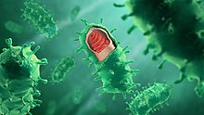

Gwynedd Kagenaar (6245579)
Daily supervisor: Matti pronker
Principal Investigator: Joost Pronker

Abstract
The rabies virus (RABV) is an enveloped neurotropic virus and is the causative agent of rabies disease (Fooks et al., 2014). The rabies virion is able to infect the host cell through the endocytic pathway by host cell receptor recognition through its transmembrane glycoprotein which forms a spike on the surface of the virion (Gaudin et al., 1993). To date, five proteinaceous host receptors have been identified: Nicotinic acetylcholine receptor (nAchR) (Lentz et al., 1982), neural cell adhesion molecule 1 (NCAM1) (Thoulouze et al., 1998), neurotrophin receptor p75 (Tuffereau et al., 1998), metabotropic glutamate receptor subtype 2 (mGluR2) (Wang et al., 2018a) and Integrin β-1 (Shua et al., 2020). However, none of these receptors appear to be essential for Rabies infection with viral entry still being observed in receptor knock-out lines. RABV most likely uses a combination of host receptors and other molecules such as carbohydrates, gangliosides and lipids to facilitate viral entry. To better understand Rabies host cell entry, we used co-immunoprecipitation using the Rabies glycoprotein as a bait in combination with liquid chromatography coupled to tandem mass spectrometry. This approach was unable to validate the previously found host receptors, however two potential novel host receptors have been identified in VGF nerve growth factor inducible and γ-enolase.

Layman’s summary
The rabies virus (RABV) is a neurotropic virus that causes rabies disease (Fooks et al., 2014). Neuronal cell infection happens through an interaction of the rabies glycoprotein present on the virus surface, with receptor proteins present on the surface of human neuronal cells. To date, five such human neuronal receptor proteins have been identified. However, none of these receptors appear to be essential for infection as infection can still occur in their absence. RABV most likely uses a combination of host receptors and other molecules such as carbohydrates, gangliosides and lipids to facilitate infection. To better understand Rabies infection, we studied which proteins from lysed rat cortex material interacted with the glycoprotein using mass-spectrometry. This approach was unable to validate the previously found host receptors, however two potential novel host receptors have been identified in VGF nerve growth factor inducible and γ-enolase.

Introduction
The rabies virus (RABV) is an enveloped neurotropic virus with a single-and-negative-stranded RNA genome, and is the causative agent of rabies disease (Fooks et al., 2014). RABV is a zoonotic disease, with 99% of infections in humans stemming from infected dog bites (Fooks et al., 2014). In the infected muscle tissue, the virus spreads retrogradely through the motor neurons of the peripheral nervous system into the central nervous system, resulting in an encephalitis with a nearly 100% fatality rate (MacGibeny, 2018). Current post-exposure prophylaxis (PEP) treatment consists of an initial vaccination and a dose of rabies immune globulin (RIG) administered within 12-24 hours after exposure, with a further three vaccinations administered within 2-4 weeks. Approximately 59,000 deaths each year can be attributed to the viral Rabies disease (World Health topics: Rabies, 2022). 95% of cases occur in Asia and the African continent, comparative, the United States has only 25 reported rabies fatalities between 2009 and 2018 (CDC, 2021). Furthermore, 40-50% of fatalities are children under the age of 15, resulting in a larger socio-economic pressure on these countries. The financial cost alone of rabies is estimated to be US$4 billion per year (Knobel et al., 2005). The discrepancy in morbidity and mortality rates between continents can in part be attributed to the difference in availability of PEP and presence of large RABV reservoirs. Currently, rabies virus is combatted through reducing reservoirs by vaccinating dog populations, lowering the risk of zoonotic transfer and administering pre-exposure prophylaxis (two vaccinations) to at risk individuals (CDC, 2019). The CDC recommends those living in or travelling to areas with high exposure risk, who might come in contact with wild or domesticated dogs, to get the vaccine. This multi-step approach is costly, with the US spending $245 to $510 million annually on rabies prevention and control. The average cost of a PEP treatment is $3,800 which contributes to the ongoing difficulty of controlling the RABV reservoirs.
The Rabies virus is part of the Lyssa genus and Rhabdoviridiae family and causes human rabies (Amarasinghe et al., 2018). RABV has five conserved proteins: nucleoprotein (N), phosphoprotein (P), matrix protein (M), glycoprotein (G), and RNA-dependent RNA polymerase (L) (Lyles et al., 2013). The rabies virions have a bullet-like shape (Figure 1), with a size of approximately 180 nm long and 75 nm wide. The inner nucleocapsid is formed by nucleoprotein and single-strand RNA, with one nucleoprotein protomer associating with nine nucleotides (Ge et al., 2010). The phosphoprotein and RNA-dependent RNA polymerase interact with the nucleocapsid to form the ribonucleoprotein (RNP). The RNP complex, responsible for transcription and translation, is encapsulated by a lipid bilayer derived from the host cell membrane and anchored to it through the matrix protein. The remaining glycoprotein is a transmembrane protein forming a ‘’spike’’ on the surface of the virion. As the only surface-exposed protein encoded by the viral genome, it is of paramount importance for host cell receptor recognition and infection (Gaudin et al., 1993).
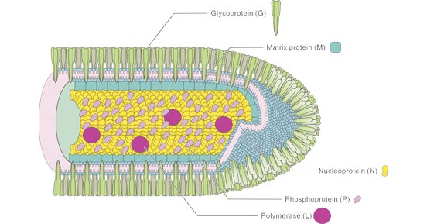
Figure 1. Rabies virus structure. The bullet shaped virion contains translation and replication machinery (RNP) within a host derived lipid bilayer. The membrane is covered in spike-shaped glycoprotein (G), the RNP complex is attached to the membrane through matrix proteins (M).
After the glycoprotein binds to the host receptor, the virus enters the cell through the endocytic pathway. A structural change in the glycoprotein is induced after being subjected to a lower pH in the endosomes. This conformation change enables the fusion of the viral envelope with the cell membrane, and the release of the RNP complex in the cytoplasm of the host cell (Gaudin et al., 1993). A Negri body is then formed, an inclusion in the cell containing the RNP where the transcription and virion assembly occurs, often an early pathological sign of rabies disease (Lahaye et al., 2009). The virions are then released from the infected muscle cell into the synaptic cleft of neuromuscular junctions (NMJs) through budding with the host cell membrane. Here it is internalized by the neuron through receptor interaction. It is then transported retrogradely along the axon to the neuronal cell body, where it replicates and assembles virions that travel to the dendrites where they are released from the dendritic side of the synapse. Once present in the central nervous system, RABV is able to evade the immune response through downregulation of the interferon (IFN) innate immune response (Rieder & Conzelmann, 2011). RABV phosphoprotein is able to bind and inhibit Interferon Regulatory Factor 3 (IRF3) which activates the production of interferons, and STAT1/2, which upregulates interferon-stimulated genes (Vidy, Chelbi-Alix & Blondel, 2005).
RABV’s spread through the neuronal network can be inhibited by disrupting the viral life cycle and thus the production of virions. Earlier research has indicated that glycoprotein deficient rabies strains are unable to infect cell cultures and in vivo model systems, indicating the importance of glycoprotein spikes for RABV infection and making it a possible target for drug development (Etessami et al., 2000; Mebatsion et al., 1996). Multiple studies have been conducted to elucidate possible host receptor proteins that interact with RABV glycoprotein (RABVG) and mediate RABV cell entry. To date, five host receptors have been identified (Figure 2): Nicotinic acetylcholine receptor (nAchR) is a pentameric ligand-gated ion channel that serves as the first discovered host receptor for rabies virus (Lentz et al., 1982). They are mostly present in the postsynaptic membrane of the neuromuscular junctions, connections between the terminal end of a motor nerve and a muscle, where they mediate communication with motor neurons. Neural cell adhesion molecule 1 (NCAM1) is a cell adhesion glycoprotein from the immunoglobulin superfamily with an ectodomain consisting out of five immunoglobulin-like domains and two fibronectin-like domains (Thoulouze et al., 1998). Like NAchR, NCAM1 is also present in the neuromuscular junctions, mainly on the presynaptic membrane, but also in the junctional folds of the postsynaptic membrane where it is involved in synaptogenesis (Lafon, 2005). Neurotrophin receptor p75 is a type 1 transmembrane protein from the tumour necrosis factor receptor superfamily with an ectodomain consisting out of four cysteine-rich domains (Tuffereau et al., 1998). P75^{NTR} is mainly expressed during development, though has been observed on the surface of axons in the adult rat brain (Lafon, 2005). Metabotropic glutamate receptor subtype 2 (mGluR2) is a G-protein coupled receptor present in the presynaptic membrane of the neuromuscular junctions (Wang et al., 2018a). Recently Integrin β-1 (ITB1) has been discovered as possible host receptor for RABV. Integrins are heterodimers consisting of an α- and β-subunit (Shua et al., 2020). Unlike the other host receptors, ITB1 is expressed in the skeletal muscle. Recent findings indicate that these host receptors are not exclusively responsible for rabies virus infection. For example, RABV was still able to infect a p75^{NTR} knockout neuronal cell line, indicating that individual host receptors are not essential for RABV infection (Tuffereau et al., 2007). RABV most likely uses a combination of host receptors and other molecules such as carbohydrates, gangliosides and lipids to facilitate viral entry (Davis, Rall & Schnell, 2015; Superti et al., 1986). To understand Rabies virus host cell recognition, tropism and cell entry mechanisms, it is crucial to identify bona fide host receptors in the mammalian nervous system. The goal of this internship is thus to validate previously found host receptors and find novel host receptor candidates to deepen the understanding of rabies virus cell-attachment and entry processes by using co-immunoprecipitation and high-resolution tandem mass spectrometry.
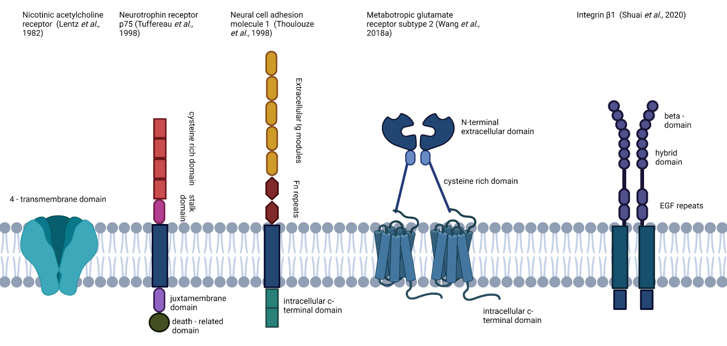
Figure 2. Known host receptors. The structures of the nicotinic acetylcholine receptor, neurotrophin receptor p75, neural cell adhesion molecule 1, metabotropic glutamate subtype 2 and integrin beta-1 are displayed.
To specifically study RABVG, a recombinant protein bait consisting of the extracellular domain of Rabies Glycoprotein with a C-terminal Gcn4 trimerization tag and a thrombin-cleavable Strep-II-His8 tandem affinity tag has been designed and a FLAG tandem affinity tag. This will be produced through transient overexpression in HEK293 cells, and purified from the cell supernatant by Nickel-affinity chromatography. These recombinant proteins will serve as ''bait'' for the novel host receptors (prey). Prey proteins will be extracted from both SH-SY5Y cell cultures and rat neuronal tissue. Prey proteins from the neuronal tissue or cell culture will be incubated with flag-tagged magnetic beads pre-bound with the bait protein, washed and obtained through acid elution. These proteins will be trypsinized and the peptides are then analysed through shotgun proteomics (LC-MS/MS). In parallel, unbound beads will be used as our negative control. Data obtained through this proteomics approach will be processed to identify significantly enriched cell surface proteins, which will be further studied. Potential host receptors will be validated through western blot analysis.
Methods
RABVG constructs
Rabies virus glycoprotein (GLYCO_RABVP) ectodomain of the Pasteur vaccine strain (K25 – N455), preceded by a CD5 signal peptide and followed by a GCN4 trimerization tag, NotI cleavage site and Strep-II-His8 tandem affinity tag at the C-terminal end was cloned into a pRK5 mammalian expression vector. The construct contains four fusion loop mutations (hydrophobic to serine; F93S, V94S, W140S, L141S). For the second and third round the Strep-II tag was replaced with a FLAG-tag.
RABVG expression and purification
2 Litres of HEK293E (Ebstein-Barr Nuclear antigen expressing) cells were transiently transfected with RABV-G ectodomain constructs) using polyethyleneimine. After 6 days, cell supernatant was harvested and filtered through 0.22 μm Steritop™ Filter Units (Millipore). A 5 ml HisTrap column was pre-equilibrated with 5 column volumes of Imac A (500 mM NaCl, 25 mM HEPES, 2mM CaCl2 and pH 7) using a peristaltic pump. The column was then loaded with the RABVG filtrate at 5 ml/min, 4 °C . The loaded column was connected to the the Äkta Go fast pressurized liquid chromatography (FPLC) system and washed with 40 column volumes of Imac A with 10 % Imac B. Elution was performed using Imac B (500 mM NaCl, 500mM Imidazole, 25 mM HEPES, 2 mM CaCl2, and pH 7), after 5 column volumes, the flow was paused for 1 hour to allow for incubation with imidazole, after which the flow was continued until a baseline was reached. IMAC elution was loaded onto a gravity flow column with Streptactin beads, protein was eluted in 8 steps using SEC buffer (150 mM NaCl, 20 mM MES, 2 mM CaCl2, 10 mM Desthiobiotin and pH 5.8).
SH-SY5Y cell culture
SH-SY5Y cells were grown in a T175 flask, in full-growth medium (DMEM-F12, 10 % FBS and 100 ug/ml penicillin) at 37 °C, 5 % CO2. After reaching 80 % confluency, medium was aspirated and cells washed with PBS. Cells were released from the plate mechanically through repeated pipetting with PBS. Cells were spun down 5 min at 300 g, 4 °C. Precipitate was incubated on ice for 30 min with 3 ml of NP-40 lysis buffer (20mM Iodoacetamide, 1 % NP-40, 1x protease inhibitor tablet in PBS). After which the suspension was spun down for 15 min at 13,000 g.
Rat brain lysis
Brains from mature, female Wistar rats were used. After decapitation, the cortex and midbrain were excised from the remaining brain tissue in halves and frozen at -20 °C. 6 ml of homogenization buffer (50 mM HEPES, 100 mM NaCl, 0.32 M sucrose, 2 mM CaCl2, and 1x Roche Complete EDTA-free protease inhibitor cocktail) was added to each tissue sample. The sample was then homogenized on ice using a Dounce homogenizer. Homogenate was spun at 1500 g for 15 minutes at 4 °C. Supernatant was then spun at 18000 g for 20 min, at 4 °C. The membrane pellet was resuspended in 3 ml homogenization buffer and incubated at 4 °C for 5 min. The suspension was incubated for 2 hours with 300 µl of 10x Triton X-100 (10 % in homogenization buffer), and spun at 100,000 g for 1 hour at 4 °C.
Co-immunoprecipitation
RABVG elution was diluted 10x with PBS and combined with 40 ul of pre-washed (PBS) anti-FLAG M2 magnetic beads per replicate, and incubated overnight at 4 °C. Control consists out of anti-FLAG M2 magnetic beads incubated with PBS, instead of RABVG elution. After 3 washing steps, 200 ul of SH-SY5Y cell lysate was combined with the RABVG bound beads or the control and incubated overnight at 4 °C. The crosslinking condition was incubated for 45 min at room temperature with 1 mM DSSO (dissuccinimydyl sulfoxide) in DMSO (dimethylsulfoxide). The crosslinking reaction was quenched with 20 mM Tris-HCL for 30 min at room temperature. Bound protein complexes were eluted with 28 µl acid elution buffer (0.1 M Glycine, pH 2.5), beads were spun down and removed using a magnet. 2 µl of neutralization buffer (1 M Tris-HCl, pH 9.0) was added to the supernatant to neutralize the samples.
S-trap trypsinization
Protein concentration was determined by bicinchoninic acid assay (BCA). Elution was solubilized using 2x SDS protein solubilisation buffer (10 % SDS, 100 M triethylammonium bicarbonate and pH 7.55) to sample at 1:1 ratio (mass/volume). To achieve disulfide reduction and cysteine alkylation, dithiothreitol (DTT) (20 mM) and iodoacetamide (40 mM) were added respectively. 12 % phosphoric acid was added at a ratio of 1:10 (volume/volume) and 6 times the current volume of S-trap buffer (90 % aqueous methanol, 100 mM triethylammonium bicarbonate and pH 7.1). The solution was loaded on the S-trap micro column, the loaded micro-column was washed using S-trap buffer. 20 µl of digestion buffer containing trypsin at a 1:10 ratio to the protein amount in the sample was added to the micro column, the column was incubated overnight at 37 °C. The tryspsinized peptides were eluted with 40 ul of 50 mM triethylammonium bicarbonate and 40 µl of 0.2 % aqueous formic acid. Eluted proteins were dried down in the speedvac and frozen at -20 °C.
Mass-spectrometry
Sample was resuspended in 12 % formic acid and spun down at max speed for 20 min. 50-200 ng of protein was loaded per sample on the Orbitrap Exploris, for high resolution liquid-chromatography mass-spectrometry (LC-MS). Samples were run with a gradient of 120 min. Mass-spectrometry data were analysed using MaxQuant version 2.1 and Perseus.
Western blot
7 µl of 4x XT sample buffer was added to 0.5-4 ug of protein sample and heated for 5 min at 95 °C. 10 µl of sample was loaded on a Biorad 12 % Bis-tris gel with the Precision Plus Protein Dual Color Standard marker and run at 160 volt for two hours. The gel transfer was performed using the Trans-Blot Turbo Transfer System onto a PVDF (or nitrocellulose?) membrane. The transfer was blocked in PBS-T (0.1 % TWEEN-20) with 3% Rapilait. The membrane was then incubated with primary γ-enolase polyclonal antibody produced in rabbit diluted in blocking buffer (Elabscience, #E-AB-70256, 1:1000). The blot was incubated for 1 hour at room temperature. The membrane was washed twice for 10 min with PBS-T. The membrane was then incubated with secondary antibody anti-rabbit IgG HRP-linked antibody (Cell Signaling, #7074, 1:10 000) for 1 hour at room temperature. The membrane was washed twice with PBS-T for 10 min and once with PBS for 10 min. The membrane was incubated for 5 min with Pierce ECL Plus substrate working solution and imaged using the Ammersham 600 chemiluminescence imager.

Results
RABV glycoprotein construct purification and co-immunoprecipitation of the RABV-G construct with SH-SY5Y cell line.
To validate previously found and find novel host receptors, a co-immunoprecipitation was performed using the ectodomain of the rabies glycoprotein to capture possible host receptors (Figure 3). The construct contains a C-terminal Strep-II-His8 tag which enables it to associate with the nickel charged agarose beads in the HisTrap column of the IMAC (immobilized metal affinity chromatography) and the streptactin beads used in the co-immunoprecipitation. The construct was produced using HEK-293 cells and purified using IMAC on the Äkta Go fast pressurized liquid chromatography (FPLC) system, after which it was concentrated five times and loaded onto streptactin beads for step-wise elution (Figure 4A). SH-SY5Y neuronal cells were lysed using a NP-40 buffer. The construct-bound beads were incubated with the SH-SY5Y cell lysate after which interacting proteins were eluted from the beads using desthiobiotin which displaces the strep-tag on the beads. The elution was trypsinized and analysed using liquid-chromatography mass-spectrometry. After loading 2 L of HEK293 cell supernatant on a Ni-excel HisTrap column and washing with 500 mM imidazole until baseline, 0.7 mg of protein was eluted. Concentrating the elution using a centrifugal concentrator resulted in 2.2 ml of concentrated elution with 0.214 mg protein per ml, approximately half the protein was lost (Figure 4B). For elution 3 and 7 a band is observed at the height of the construct, for each elution a thick band is present at the height of the streptactin protein that was bound to the beads. This suggests leakage of the streptactin from the beads, possibly due to the presence of a high concentration of detergent (NP40). Mass-spectrometry proteomics data is based on peptide sequences, proteins with shared peptide sequences are stored in one protein group, with the protein with the highest sequence coverage becoming the master of the protein group. No protein groups with a significant positive fold change were observed in the treatment group (Figure 4C).

Figure 3. Rabies glycoprotein construct. Visual representation of the glycoprotein construct.
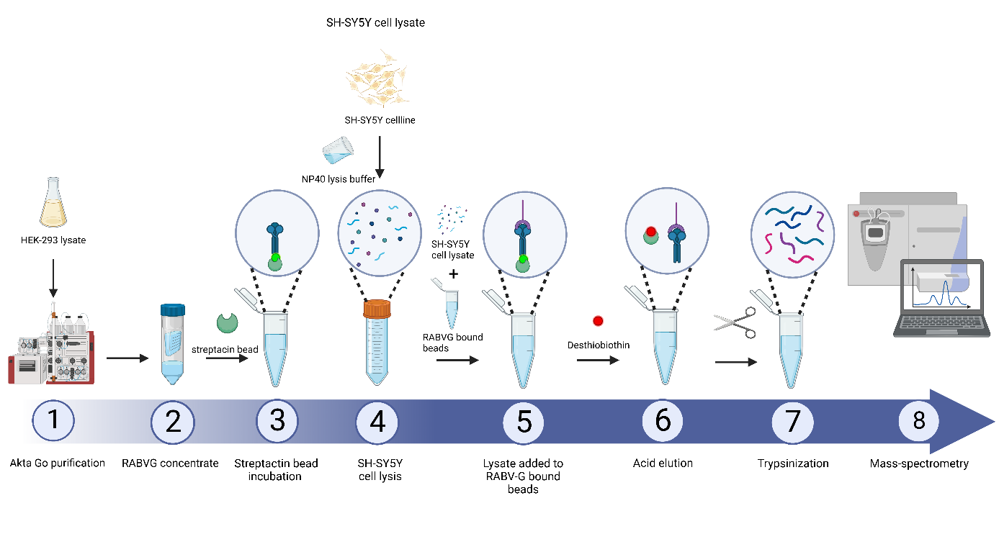
A

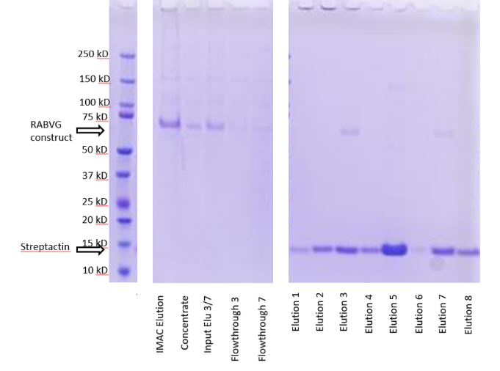
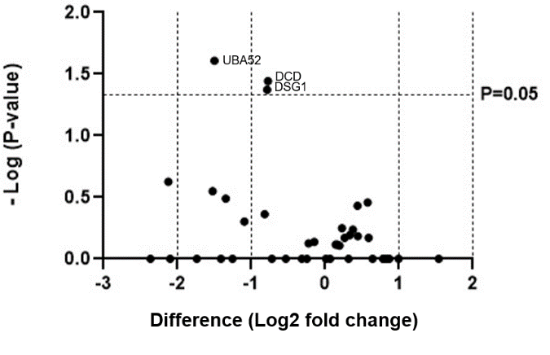
B C

Figure 4. Co-immunoprecipitation of the RABV-G construct with SH-SY5Y cell line. (A) Timeline of the co-immunoprecipitation protocol. (B) SDS-gel of the RABVG construct purification using immobilized metal affinity chromatography (IMAC) showing the IMAC elution and concentrated IMAC elution with the subsequent step-wise Streptactin column elution of the glycoprotein construct. The glycoprotein construct has an approximate size of 66 kD and Streptactin of 13 kD. (C) Volcanoplot indicating whether protein groups in the treatment group are upregulated (right-hand side) or down-regulated (left-hand side) compared to the control group. Horizontal P=0.05 cut-off line indicates significance of protein groups. Dashed vertical lines indicate a two-fold change and a four-fold change in upregulation or downregulation of the protein groups.

Co-immunoprecipitation of the RABVG construct using flag-tagged magnetic beads.
To increase the protein yield of the construct used in the co-immunoprecipitation, the elution was not subjected to the centrifugal concentrator to minimalize protein loss. The high amount of streptactin detected in the blot (figure 4B) indicates leakage of the streptactin beads, thus we switched to anti-FLAG M2 magnetic beads (Figure 5A). Furthermore, the desthiobiotin was replaced with a glycine acid elution (pH 2.5) to ensure complete elution of all bound proteins. These changes resulted in significant protein groups with a positive fold change being observed (Figure 5B). As we were specifically searching for a possible rabies host receptor, using the UniProt database, information on the neuronal specificity of the protein groups and literature on possible receptor functioning or membrane association was investigated (Table 1). Only one of the protein groups with a significant, positive fold change was both specific to neuronal tissue and was possibly membrane associated: the neurosecretory protein VGF. This protein has a 488-fold enrichment compared to the control. There are multiple proteolytic derivatives of VGF, however the mass-spectrometry data indicates that the full, unprocessed protein is present in the sample since peptides from all these parts were identified.

A

B
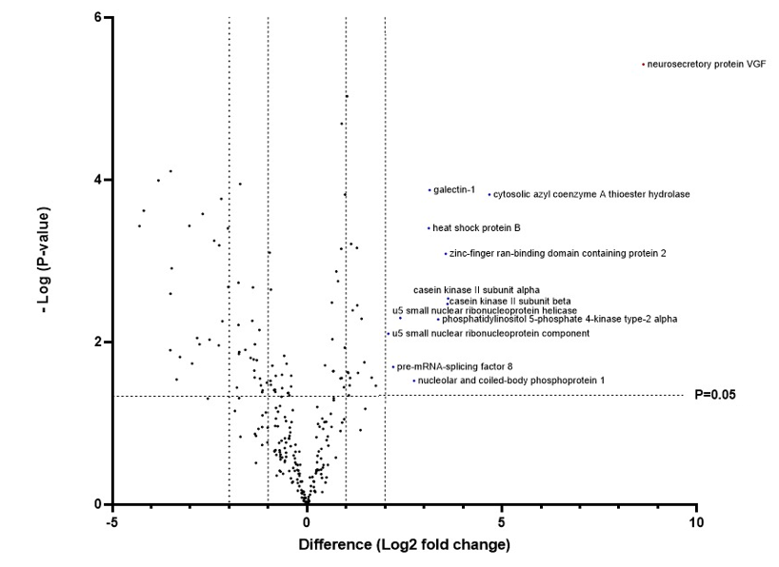

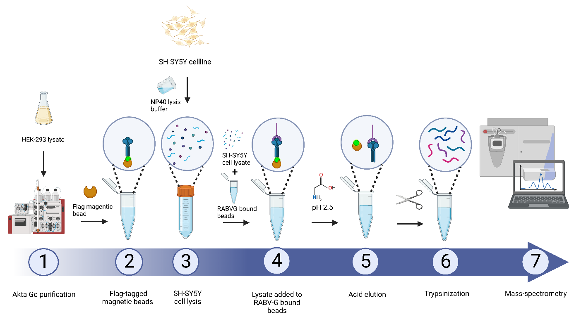

Figure 5. Co-immunoprecipitation of the RABV-G construct using flag-tagged magnetic beads. (A) Experimental setup of the co-immunoprecipitation protocol using anti-FLAG M2 magnetic beads, SH-SY5Y cell line and acid elution. (B) Volcanoplot indicating whether protein groups in the treatment group are upregulated (right-hand side) or down-regulated (left-hand side) compared to the control group. Horizontal P=0.05 cut-off line indicates significance of protein groups. Dashed vertical lines indicate a two-fold change and a four-fold change in upregulation or downregulation of the protein groups. Blue coloured protein groups indicate protein groups that are significantly upregulated with a minimum four-fold change compared to control.
Table 1. Protein groups with a positive fold change present in the treatment group. The table lists all protein groups from the volcanoplot (figure 5B) with a significant, positive fold change present in the treatment group, with a minimum four-fold change. Information on their respective function, and whether they are specific to neuronal tissue or are known to be membrane associated is described in the table. Data is obtained from the UniProt database.
Protein | Function | Neuronal tissue specific | Membrane associated | Significance  (-log) | Difference  (Log2 fold change)
Neurosecretory protein VGF | Vasopressin regulation | Yes | Yes | 5.60 | 488
Galectin 1 | Apoptosis, cell proliferation and differentiation regulation through carbohydrate binding | No | Yes | 3.98 | 18.25
Cytosolic acyl coenzyme A thioester hydrolase | Acyl-CoA hydrolysis | No | No | 3.92 | 9.12
Heat shock protein B | Proteome protection | No | No | 3.48 | 9.00
Zinc-finger ran-binding domain containing protein 2 | Alternative splicing of TRA2B/SFRS10 | No | No | 3.16 | 12.29
Casein kinase II subunit alpha | Serine/threonine-protein kinase complex | No | No | 2.58 | 12.73
Casein kinase II subunit beta | Regulatory subunit of casein kinase II/CK2 | No | No | 2.51 | 12.73
U5 small nuclear ribonucleoprotein helicase | Pre-mRNA splicing | No | No | 2.33 | 5.28
Phosphatidylinositol 5-phosphate 4-kinase 2 type-2 alpha | Phosphorylation of phosphatidylinositol 4-phosphate | No | No | 2.31 | 10.70
U5 small nuclear ribonucleoprotein component | Pre-mRNA splicing | No | No | 2.13 | 4.23
Pre-mRNA-splicing factor 8 | Pre-mRNA splicing | No | No | 1.70 | 4.63
Nucleolar and coiled-body phosphoprotein 1 | Regulator of RNA polymerase I | No | No | 1.52 | 6.82

Co-immunoprecipitation of the RABVG construct using flag-tagged magnetic beads and rat cortex.
In order to obtain a more accurate and native-like representation of proteins able to interact with the RABVG construct, Wistar rat cortex material from two different rats was used instead of the SH-SY5Y neuronal cell line to capture prey proteins from. This material was flash frozen and homogenised using a HEPES based buffer before being incubated with the RABVG construct bound anti-FLAG M2 magnetic beads (Figure 6A). Again, significant protein groups with a positive fold change were still observed (Figure 6B). As we were specifically searching for a possible rabies host receptor, using the UniProt database, information on the neuronal specificity of the proteins and literature on possible receptor functioning or membrane association was investigated (Table 2). Two proteins have a significant, positive fold change that are specific to neuronal tissue: γ-enolase and synapsin-2. There are also four membrane associated protein groups present: γ-enolase, fibrinogen-related protein 1, α-enolase and calmodulin. Of the known host receptors, only NCAM1 was found in the treatment samples, with an insignificant but positive fold-change of 1.49 (P= 0.20228). As γ-enolase is the only protein specific to both neuronal tissue and has a possible membrane association, a western blot was performed using γ-enolase antibody (Figure 6C). No bands are observed in the control samples, two bands at the height of the γ-enolase protein are observed for samples 1 and 2 from the cortex of the second rat. No bands are observed for the cortex material from the first rat. When looking at the samples from rat 1 and 2 separately the significance for γ-enolase changes. There is only a 2.41-fold positive fold change observed which is not significant (P=0.0654) for rat 1. For samples from rat 2, there is a significant, 10-fold positive fold change observed (P=0.0009).

A
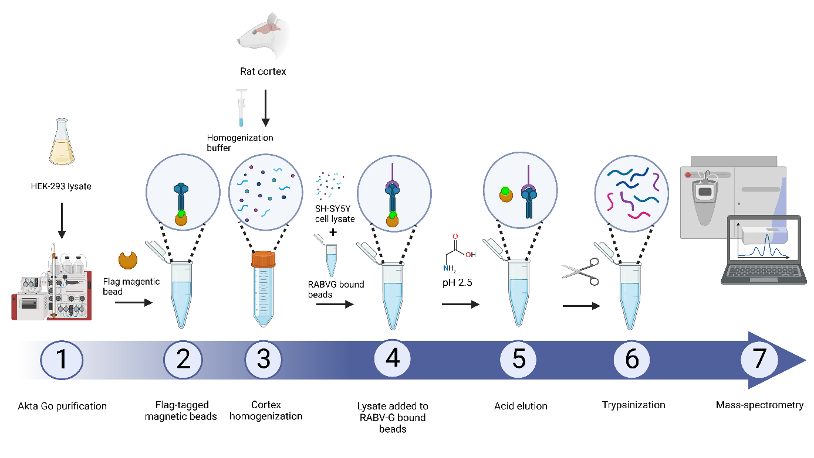

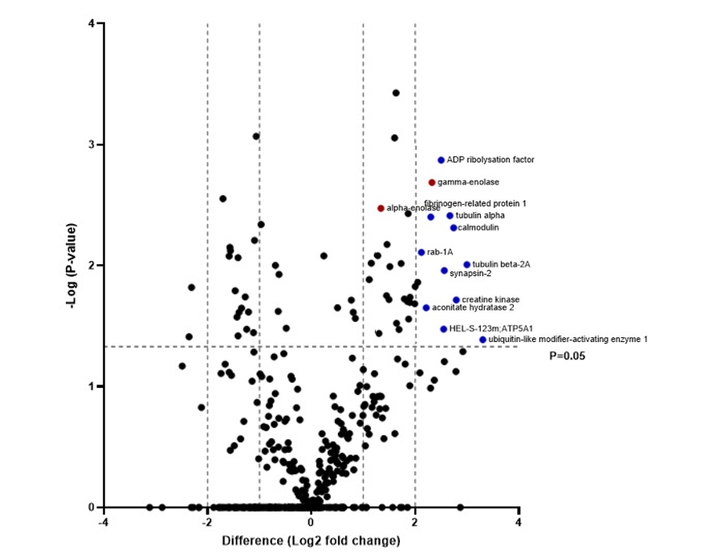
B

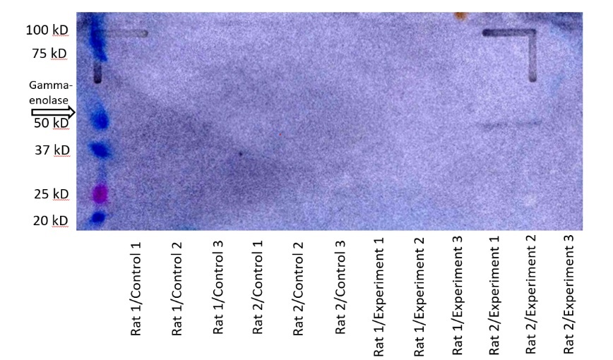
C

Figure 6. Co-immunoprecipitation of the RABV-G construct using flag-tagged magnetic beads and rat cortex lysate. (A) Experimental setup of the co-immunoprecipitation protocol using flag-tagged magnetic beads, acid elution and rat cortex lysate. (B) Volcano plot indicating whether protein groups in the treatment group are upregulated (right-hand side) or down-regulated (left-hand side) compared to the control group. Horizontal P=0.05 cut-off line indicates significance of protein groups. Dashed vertical lines indicate a two-fold change and a four-fold change in upregulation or downregulation of the protein groups. Blue coloured protein groups indicate protein groups that are significantly upregulated with a minimum four-fold change compared to control. Red coloured groups indicate the enolases. (C) Western blot indicating whether gamma-enolase is present in the control and treatment samples. Gamma-enolase has a size of approximately 52 kD.
Table 2. Protein groups with a positive fold change present in the treatment group. The table lists all protein groups from the volcanoplot (figure 6B) with a significant, positive fold change present in the treatment group, with a minimum four-fold change. Information on their respective function, and whether they are specific to neuronal tissue or are known to be membrane associated is described in the table. Data is obtained from the UniProt database.
Protein | Function | Neuronal tissue specific | Membrane associated | Significance  (-log) | Difference  (Log2 fold change)
ADP ribosylation factor | Protein trafficking | No | No | 2.86 | 5.58
γ-enolase | Catalyzes the conversion of 2-phosphoglycerate to phosphoenolpyruvate | Yes | Yes | 2.68 | 4.92
Fibrinogen-related protein 1 | Inhibits antigen-specific T-cell activation | No | Yes | 2.40 | 4.86
α-enolase | Catalyzes the conversion of 2-phosphoglycerate to phosphoenolpyruvate | No | Yes | 2.47 | 2.51
Tubulin-alpha | Microtubule  structural  component | Yes | No | 2.41 | 6.28
Calmodulin | Calcium binding | No | Yes | 2.31 | 6.59
Rab-1A | GTPase | No | No | 2.11 | 4.28
Tubulin-beta 2A | Microtubule  structural  component | Yes | No | 2.01 | 7.84
Synapsin-2 | Regulation of neurotransmitter release | Yes | No | 1.96 | 5.82
Creatine kinase | Reverse catalysation of phosphatase | No | No | 1.73 | 6.82
Aconitate hydratase 2 | Catalyzes the isomerization of citrate | No | No | 1.66 | 4.56
E3 ubiquitin-protein ligase RNF8 (HEL-S-123) | Catalysing Lys-63 and Lys-48 linked ubiquitination | No | No | 1.49 | 5.78
Ubiquitin-like modifier-activating enzyme 1 | Ubiquitination | No | No | 1.40 | 9.65

Discussion
The main findings of this study are that we were able to find a significant and 5-fold enriched protein in the treatment samples of the rat cortex material, that was both neuronal tissue specific and possible membrane associated; γ-enolase. Enolases are enzymes that catalyse the dehydration of 2-phospho-D-glycerate to phosphoenolpyruvate in glycolysis; the metabolic pathway in which glucose is converted to pyruvate (Vizin & Kos, 2015). There are three iso-enzymes: α-, β- and γ-enolase. α-enolase is present throughout the body, β-enolase in skeletal and heart muscle and γ-enolase mainly in neuronal cells. Enolase, is a 433 amino acid long acidic dimeric protein with a PDZ-binding motif on its C-terminal used for interaction with several proteins involved in intracellular redistribution of molecules and signalling pathway events (Vizin & Kos, 2015). We were also able to validate γ-enolase using western blot. These results indicate that γ-enolase could be a possible host receptor for rabies virus, which is supported by previous research. Enolases have been earmarked as possible plasminogen receptors suggesting that they could function as a receptor for rabies as well (Nakajima et al., 1994). This is supported by recent electron microscopic images indicating that γ-enolase is distributed in the synaptic membrane of neuronal rat cells (Ueta et al, 2004). Furthermore, research by Zhang et al (2020) into the proteome of rabies virions found that α-enolase is associated with these virions. Proteins found in virions often play essential roles in the infection cycle of the virus. However, we were not able to validate γ-enolase in the samples from rat 1. As it is still positively enriched in rat 1 cortex material, albeit it not significant, this could be a result of small sample size. As we were able to validate it for half the experimental samples, it would be beneficial to perform follow-up experiments. The protocol could be repeated with a larger sample size, but it is also possible to view the direct interaction between the glycoprotein construct and γ-enolase using direct binding assays such as surface plasmon resonance. It is also possible to visualize the interaction between γ-enolase and rabies glycoprotein in the cell, by using a split fluorescent probe system, in which fluorescence is only observed after interaction. This could also indicate the location of γ-enolase in the cell.
It might also be interesting to perform these experiments using VGF, the neuronal polypeptide found in the co-immunoprecipitation of the RABVG construct using FLAG-tagged magnetic bead and a SH-SY5Y cell line. Though this protein was not detected in the rat cortex material, because of its high significance (P< 0.001) and large difference between the control and treatment (488-fold change) it could still be a hit. VGF nerve growth factor inducer is a polypeptide precursor that can be processed into numerous proteins: NAPP129, NERP-3, NERP-1, NERP-2, NERP-4, TLQP-62, QQET-30, TPGH, TLQP-30, TLQP-21. HHPD-41, TLQP-11, AQEE-30, AQEE-11, and LQEQ-19 (Wang et al., 2022). They are expressed throughout the central and peripheral nervous system, with highest levels of expression in α-and γ-motor neurons in the anterior horn and in neurons of the posterior horn of the adult spinal cord, and the primary sensory neurons of dorsal root ganglion (Wang et al., 2022). These proteins have a role in a host of processes mostly control of vasopressin release. They also bind multiple membrane receptors; complement component C1q receptor, complement component 3a receptor 1 and the NTRK2/TRKB receptor (tropomysosin) (Wang et al., 2022). Affinity for these receptors differs between the different processed proteins, with TlQP-21 having a higher affinity for complement component 3a receptor 1 than TLQP-62 and LQEQ-19 (Cassina et al., 2013). This suggests that different derivatives may bind different receptors, it could very well be that one of the derivatives of VGF associates with a receptor that could also function as a receptor for rabies glycoprotein. A fluorescent binding assay could indicate a possible tentative relation between the glycoprotein construct, VGF derivative and possible host receptor.
Besides trying to identify new host receptors, this paper also aimed to validate the previous found host receptors: Nicotinic acetylcholine receptor (nAchR) (Lentz et al., 1982), neural cell adhesion molecule 1 (NCAM1) (Thoulouze et al., 1998), neurotrophin receptor p75 (Tuffereau et al., 1998), metabotropic glutamate receptor subtype 2 (mGluR2) (Wang et al., 2018a) and Integrin β-1 (Shua et al., 2020). However, only NCAM1 was found in the dataset of rat cortex prey proteins, where it had an insignificant but positive 4-fold enrichment compared to the control. As ITGB1 is only present in muscle cell it is logical that we were not able to validate this host receptor using exclusively rat cortex materials. Similarly, Shua et al (2020) were not able to validate ITGB1 as a receptor using cortex material. The other four host proteins are each present in the neuromuscular junctions of the peripheral nervous system. A possible explanation for their absence in the dataset could be the involvement of other proteins and residues in their interaction with rabies glycoprotein. Tuffereau et al. (2007) found that rabies is still able to infect p75^{NTR} knockout lines, furthermore, upon infection they found that small-diameter, capsaicin-sensitive, p75^{NTR} expressing neurons were resistant to rabies infection as they were unable to bind the glycoprotein. This could indicate that there are other factors that mediate p75^{NTR} and RABVG binding and presence of the receptor alone is not enough to facilitate cell entry An improvement upon the current protocol would be to reduce the concentration of NP-40 in the lysis buffer to ensure that large membrane parts are still available in the lysate during incubation with construct-bound anti-FLAG M2 magnetic beads. This increases the chance of interacting proteins in the membrane being in close proximity.
To summarize, the approach described in this paper is sufficient to elucidate membrane-associated neuronal proteins from both neuronal cell lines and tissue. However, lysing of the prey material is not an adequate enough simulation of the native environment. Possible interacting proteins within close proximity of each other on the cell membrane are diffused throughout the whole sample. This decreases the chance at an interaction between rabies glycoprotein and previously found host receptors when multiple factors are involved. Future research should focus on a whole cell approach, where glycoprotein is able to interact with host receptors in a more native environment.

Supplementary figures
Table 1. Protein groups with a significant hit in the first experiment round. The table lists all significant protein groups from the co-immunoprecipitation of the RABV-G construct with SH-SY5Y cell line (figure 4C). Information on their respective function, and whether they are specific to neuronal tissue or are known to be membrane associated is described in the table. Data is obtained from the UniProt database.
Protein | Function | Neuronal tissue specific | Membrane associated | Significance (-log) | Difference (log2 fold change)
Ubiquitin-60S ribosomal protein L40 | Endoplasmic reticulum-associated degradation through lys11 | No | No | 1.61 | -1.33
Dermcidin | Anion channel formation in bacterial membranes through homohexameric complex insertion | No | Yes | 1.44 | -2.60
Desmoglein 1 | Component of intercellular desmosome junctions | No | Yes | 1.37 | -2.56

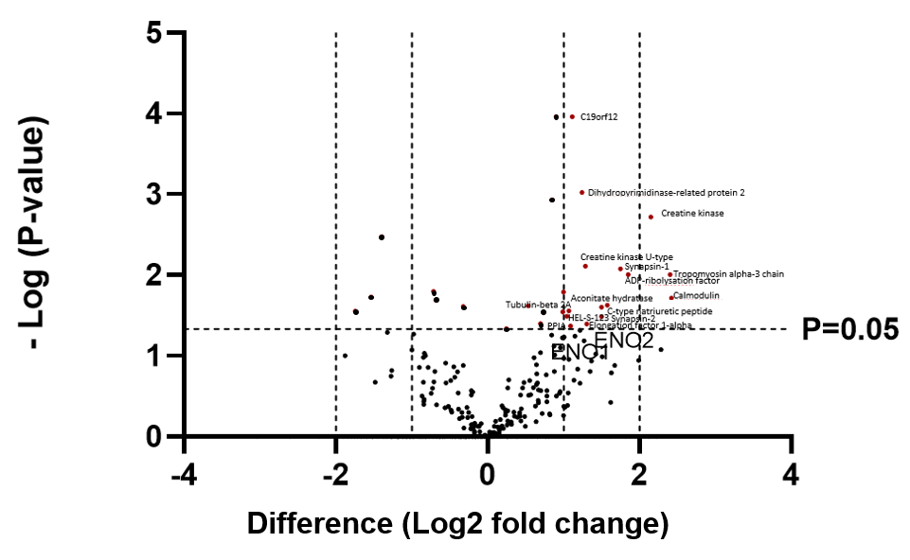

Figure 1. Co-immunoprecipitation of the RABV-G construct using flag-tagged magnetic beads and rat 1 cortex lysate. Volcano plot indicating whether protein groups in the treatment group are upregulated (right-hand side) or down-regulated (left-hand side) compared to the control group. Horizontal P=0.05 cut-off line indicates significance of protein groups. Dashed vertical lines indicate a two-fold change and a four-fold change in upregulation or downregulation of the protein groups. Red coloured protein groups indicate protein groups that are significantly upregulated with a positive fold-change compared to control. Bold lettering indicates γ-enolase (ENO2) and α-enolase (ENO1).

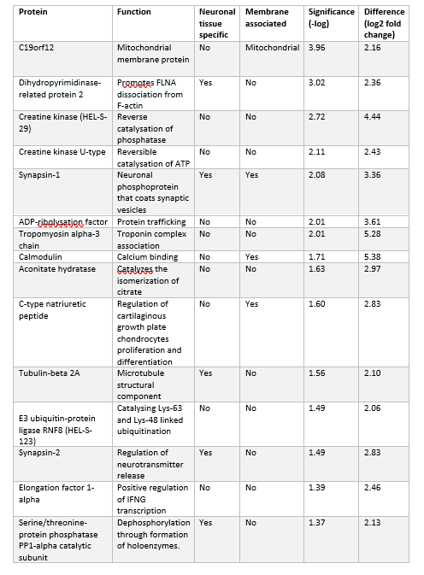
Table 2. Protein groups with a positive fold change present in the rat 1 treatment group. The table lists all protein groups from rat 1 cortex samples with a significant, positive fold change present in the treatment group (Figure 1). Information on their respective function, and whether they are specific to neuronal tissue or are known to be membrane associated is described in the table. Data is obtained from the UniProt database.

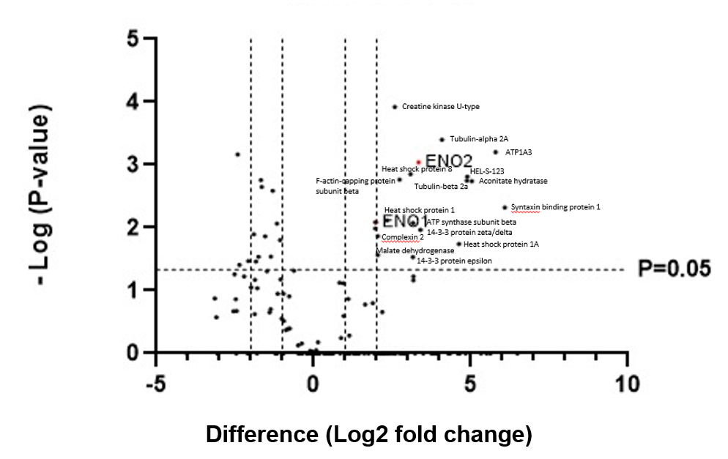 Figure 2. Co-immunoprecipitation of the RABV-G construct using flag-tagged magnetic beads and rat 2 cortex lysate. Volcano plot indicating whether protein groups in the treatment group are upregulated (right-hand side) or down-regulated (left-hand side) compared to the control group. Horizontal P=0.05 cut-off line indicates significance of protein groups. Dashed vertical lines indicate a two-fold change and a four-fold change in upregulation or downregulation of the protein groups. Red coloured protein groups with bold lettering indicate γ-enolase (ENO2) and α-enolase (ENO1).

Table 3. Protein groups with a positive fold change present in the rat 2 treatment group. The table lists all protein groups from rat 2 cortex samples with a significant, positive fold change present in the treatment group, with a minimum four-fold change (Figure 2). Information on their respective function, and whether they are specific to neuronal tissue or are known to be membrane associated is described in the table. Data is obtained from the UniProt database.
Protein | Function | Neuronal tissue specific | Membrane associated | Significance (-log) | Difference (log2 fold change)
Creatine kinase U-type | Reversible catalysation of ATP | No | No | 3.92 | 5.98
Tubulin-alpha 2A | Microtubule  structural  component | Yes | No | 3.40 | 16.8
Sodium/potassium-transporting ATPase subunit alpha-3 | Exchange of sodium and potassium ions across plasma membrane | No | Yes | 3.21 | 55.3
Gamma-enolase | Catalyzes the conversion of 2-phosphoglycerate to phosphoenolpyruvate | Yes | Yes | 3.04 | 10.06
Heat shock protein 8 | Proteome protection | No | No | 2.86 | 8.46
E3 ubiquitin-protein ligase RNF8 (HEL-S-123) | Catalysing Lys-63 and Lys-48 linked ubiquitination | No | No | 2.81 | 29.04
Tubulin-beta 2a | Microtubule  structural  component | Yes | No | 2.75 | 29.24
Aconitate hydratase | Catalyzes the isomerization of citrate | No | No | 2.71 | 32.44
F-actin-capping protein subunit beta | Cap forming on actin filaments | Yes | No | 2.77 | 6.63
Syntaxin binding protein 1 | Translocation of transport vesicles | No | No | 2.32 | 67.65
Heat shock protein 1 | Proteome protection | No | No | 2.12 | 5.03
ATP synthase subunit beta | Mitochondrial membrane ATP synthase | No | No | 2.08 | 8.94
14-3-3 protein zeta/delta | Activation modulation through phosphoserine or phosphothreonine motif binding | No | No | 1.97 | 10.56
Complexin 2 | Negative regulation of synaptic vesicle formation | Yes | No | 1.87 | 4.08
Heat shock protein 1A | Proteome protection | No | No | 1.74 | 24.59
Malate dehydrogenase | Reverse catalyzation of malate oxidation | No | No | 1.57 | 4.11
14-3-3 protein epsilon | Activation modulation through phosphoserine or phosphothreonine motif binding | No | No | 1.53 | 8.94

