Master Thesis U.S.E.

How consumers perceive products that are both sustainable and competitively priced

Tom Eleveld
t.r.j.eleveld@students.uu.nl
5755662

Supervisor: Timo van Balen

Co-reader: Jeroen Content

Abstract
Major environmental problems are causing sustainable products to become more salient, and this trend is expected to continue. To ensure mainstream adoption of sustainable products, prices need to drop to competitive levels. However, many consumers already doubt the truth of claims regarding sustainable products, and since these commodities are expected to come with a price premium, they might be distrusted if they are priced at a competitive level. This thesis examines how consumers perceive products that are both sustainable and competitively priced. The perceived credibility of sustainable products was found to be a critical factor in increasing a consumer’s purchase intention.
- Introduction
The climate is changing and global resources are diminishing, resulting in an unprecedented level of environmental challenges. The social, health and economic aspects of these problems are immense (McMichael & Lindgren, 2011; Kaufman, 2012; Watts et al., 2019; Clayton, 2020; IPCC, 2022). These challenges have resulted in the substantial growth of public concern over the past decades. In recent years, increasing weight has been placed on the consumption perspective (Liobikienėa Bernatonienėb, 2017). This is understandable since high levels of unsustainable consumption are a threat to the quality of the environment. With the rise in public concern, a significant increase in the purchase of sustainable products (Moisander, 2007; Shen, 2019), those that promise little to no impact on the environment (Shen, 2019), has occurred. The increased popularity of these products can be explained by the green consumerism trend, in which consumers are increasingly inclined to buy sustainable products and act as activists. Some consumers have stopped buying specific brands or company stock to punish companies that are demonstrating irresponsible behavior toward the environment, thereby forcing them to implement more sustainable practices (Chan & Lau 2000; Webb et al. 2008; Jaiswal, 2012). This is an encouraging trend since one of the ways to overcome climate-related problems is to ensure a global shift from non-sustainable to sustainable products (Ülku & Hsuan, 2016; Liobikienėa Bernatonienėb, 2017; Cerri et al., 2018).

However, the consumption of sustainable products is still limited in absolute terms and is faced with obstacles (Joshi & Rahman). It has been well established that consumers, particularly those who are environmentally aware, are willing to pay more for the sustainable version of a product, (Pickett-Baker & Ozaki, 2008; Shen et al., 2019; Sana, 2020). Nevertheless, the functional capabilities of non-sustainable and sustainable products are similar. Thus, it is evitable that they compete with each other (Conrad, 2004; Choi, 2017). As a consequence, non-environmentally aware consumers are inclined to choose the less expensive product, which is likely the non-sustainable option. However, to reach the social optimum of exclusively sustainable products (Conrad, 2005; Ülku & Hsuan, 2016), retailers must change the buying behavior of the non-environmentally aware consumer. This consumer is concerned with other product attributes, especially the price (Liobikienėa Bernatonienėb, 2017), and high prices negatively influence the purchases of sustainable products (Joshi & Rahman, 2015). If a product is to successfully move from a niche market to a mainstream market, its price should generally decrease. Given that this is likely to happen as the markets for sustainable products grow, economies of scale will reduce production costs and, therefore, create an opening for lower prices and the possibility of penetrating mass markets (Yenipazarli, 2015). For this reason, it is important to know how consumers perceive such products.

The sustainable product market is already viewed with significant skepticism (Webb et al., 2008, Yenipazarli, 2015). Environmental issues have uncovered a new sales market, where companies with sincere sustainable ambitions and companies with primarily financial motivations operate in the same space (Liobikienėa & Bernatonienėb, 2017). A practice called greenwashing, in which companies convince consumers to buy their products with misleading information (De Freitas Netto et al., 2020), is especially effective for sustainable products. Since such products are so-called credence products, for which the truthfulness of the claims made cannot be ascertained. How would a consumer know whether their eggs are truly organic or whether the cacao farmer in Africa actually received a fair share of revenue? Consequently, sustainable products are more inclined to suffer from consumer skepticism (Brouhle & Khanna, 2012), a concerning observation, considering the fact that trust is regarded as a prerequisite for the development of such products (Krittinee Nuttavuthisit & John Thøgersen, 2017). Apart from trust, price is also an important factor in this space. Price is a key marketing mix variable and a major barrier to buying sustainable products (Joshi & Rahman, 2015; Shen, 2019). Furthermore, price is a complex stimulus, it serves as a quality cue for utility, where a higher price signals a higher quality (Völckner & Sattler, 2005, 2007) and also a better sustainable quality (Brécard, 2008). Finally, price fairness perceptions are crucial in satisfying consumers’ needs and consumers expect sustainable products to have a price premium due to the extra costs involved (Cătoiu et al., 2010).

These three findings can be combined. First, price fairness perception is essential in satisfying customers’ needs. Second, consumers expect sustainable products to have a price premium. Third, the prices of sustainable products must drop to competitive levels before mainstream markets are reached. Here, a contradictory point is reached: How can competitively priced sustainable products be perceived as fair or credible when sustainable products are expected to come with a higher price because of the additional utility? This is especially true under the present circumstances in which sustainable products are already viewed with significant skepticism. This is troubling since trust is a prerequisite for further sustainable development. Research into predicting the consumer perception of competitively priced and sustainable products is limited, therefore, we don’t know how consumers would respond. To make a theoretical prediction, several models have to be combined. The multi-attribute utility (Rokka, 2008) theory is accommodating in conceptualizing this case. For sustainable products, attributes can consist of brand name, convenience, and price (Maheshwari & Malhotra, 2011). When analyzing the perceived product attributes of a sustainable product when it is perceived as non-credible, the perceived product attributes would have a negative effect on the perceived quality, thereby lowering the perceived value and, finally, lowering the purchase intention. Which is an undesirable outcome. In addition to the multi-attribute utility theory, two other theories are used to analyze the relationships in this environment. First, is the theory of planned behavior (TPB), since this is a widely used model for determining the motivation of behavior (Azjen, 1991; Rokka, 2008; Maichum, 2016). TPB is helpful in integrating beliefs and attitudes into the theoretical model. Consumer beliefs and attitudes assist in further defining and differentiating the perception of the products in question. It is theorized that consumers who are environmentally concerned are more prone to responding negatively to competitive prices. Which could mean that non-environmentally aware consumers do not respond to competitive prices, and therefore, still keep a partial opening to reaching mainstream markets. Having a lower purchase intention for non-sustainable products hinders a society’s efforts to regard sustainable products as the norm (Conrad, 2005). Therefore, it is necessary to examine evidence regarding this expectation. Second, because price and quality perceptions are also subject to examination, the purchase intention model by Chang and Wildt (1994) is used.

The main research question is: do (and to what extent) competitive prices reduce the sustainable credibility of products? Furthermore, the first sub-question is: Does this reduction in credibility lead to a reduction in buying intention? Finally, the second sub-question: Are competitively priced products perceived differently by environmentally conscious consumers than by non-environmentally conscious consumers?

The basis of this study is a literature review that resulted in a theoretical framework from which four different hypotheses were drawn. These hypotheses are based on crucial questions regarding sustainable development that were thus far insufficiently explained by previous research. Due to limited previous research, this thesis aims at adding knowledge to both pricing and consumer behavior literature by providing a sustainability component. The introduction is followed by the theory section, where all hypotheses are thoroughly explained, after which the methodology is discussed. This research made use of a questionnaire design to retrieve experimental laboratory data. The data is analyzed in the results section to see the influence of proposed relationships. The thesis is concluded with a discussion that examines the weaknesses in the study and suggestions for future research.

2. Theory section
The aim of this thesis is to examine how consumers perceive products that are both sustainable and competitively priced. More specifically, this research studies how the independent variables (sustainable label, competitively priced) influence the dependent variable (purchase intention). Perceived credibility is expected to act as a mediator and environmental awareness as a moderator on the moderated relationship between a competitive price and a sustainable label.

1. Model
Figure 1 is designed as a graphical representation of this research. The arrows represent the relationships that are subject to examination.

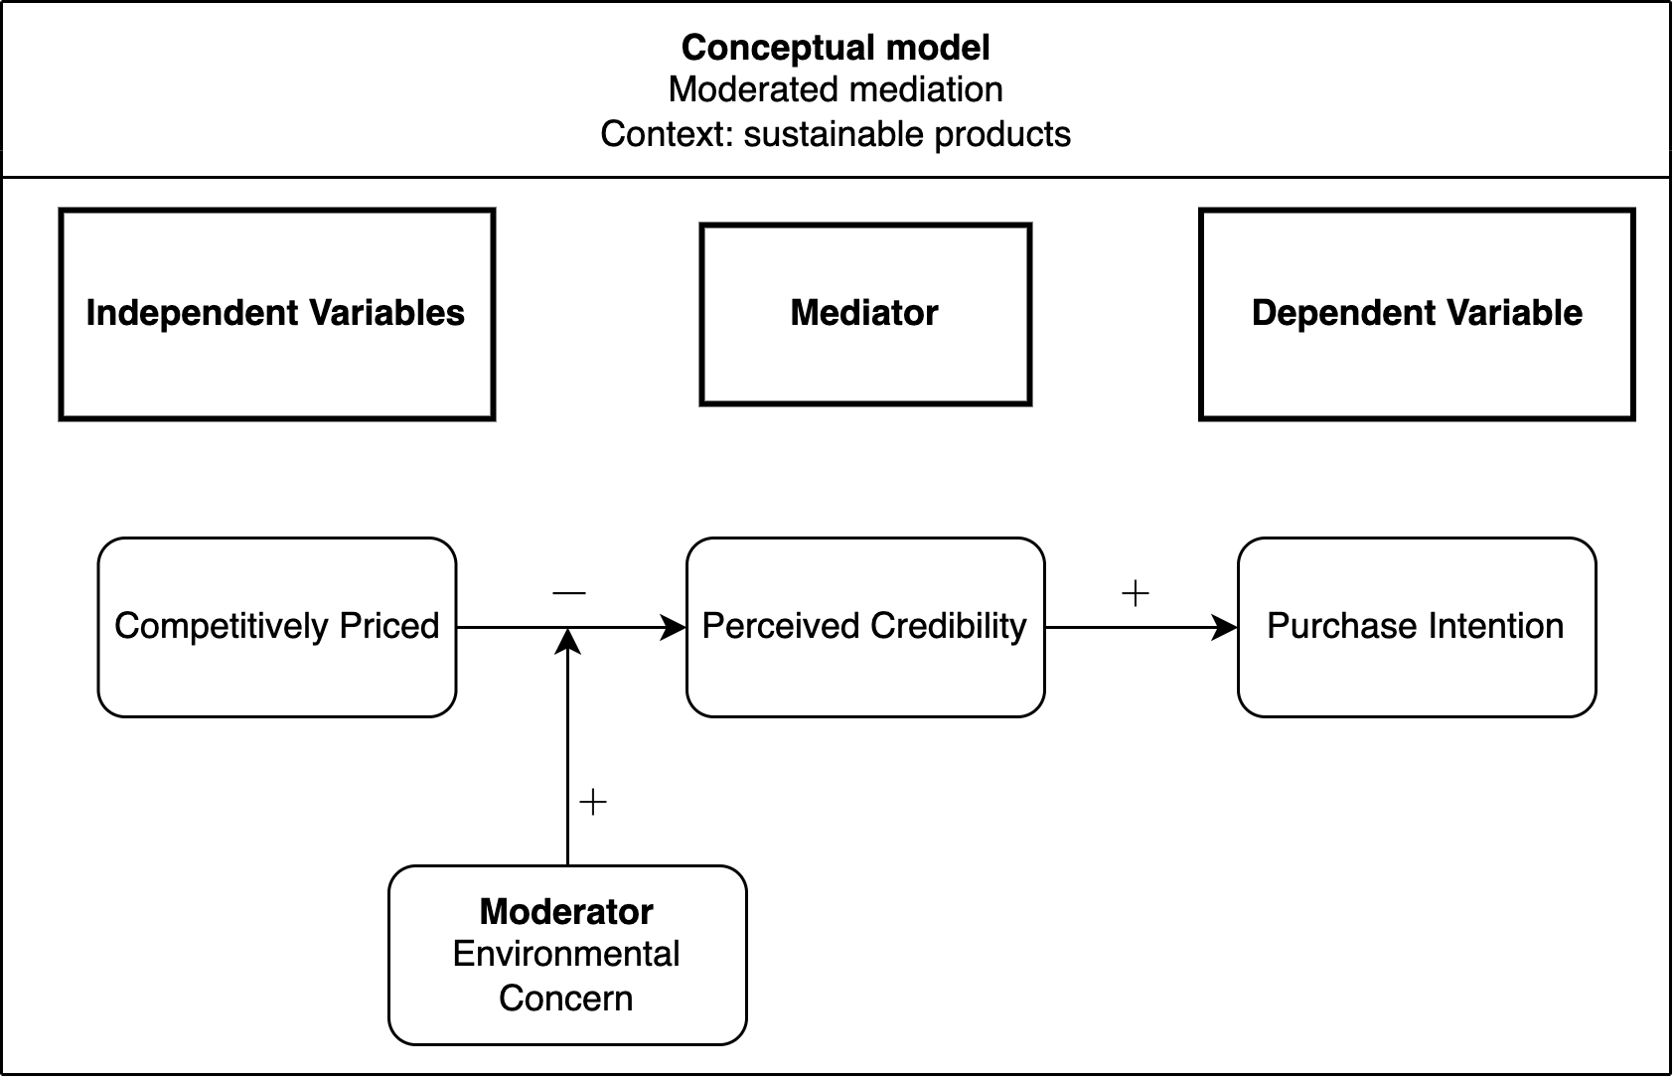
Figure 1. Conceptual model

Considering that markets for sustainable products are rapidly growing, it is expected that economies of scale will reduce production costs. The reduction in costs will open the possibility for lower retail prices and, therefore, open the door to mainstream markets (Yenipazarli, 2015). However, lower prices are no panacea; sustainable products also must command consumers’ trust (Joshi & Rahman, 2015; Krittinee Nuttavuthisit & John Thøgersen, 2017). For an accurate understanding of how price influences sustainable buying behavior, the trust issue should first be discussed. Sustainable or “green” companies with environmentally beneficial propositions are now assertively overtaking “brown” companies, with significant profits as a result. Potentially green-oriented sales and fear of falling behind are prompting these brown companies to introduce sustainable products of their own (Yenipazarli, 2015). Green consumerism, with its potentially vast profits, has resulted in large-scale environmentally oriented marketing strategies. Thus, environmental issues have become a competitive advantage in the marketplace (Liobikienėa & Bernatonienėb, 2017). However, having companies with sincere environmental ambitions and companies with primarily financial motivations in the same space has created distrust for sustainable products (Webb et al., 2008). Trust has been undermined by business scandals, unsubstantiated “green” claims (i.e., greenwashing), and inconsistent standards. Therefore, consumers fear being cheated when they buy products with sustainable claims (Krittinee Nuttavuthisit & John Thøgersen, 2017). This skepticism among consumers seems to be based on the perception that corporate policies will not tolerate lower profits when companies implement sustainable product initiatives (D’Souza, 2006).

Encouraging environmental awareness and changing subjective norms regarding the environment are major drivers of efforts to increase purchases of sustainable products. In addition to consumers’ trust issues, high prices are a major barrier to reaching this goal (Joshi & Rahman, 2015). Price is one of the key marketing mix variables to influence sustainable development (Shen, 2019). It has been well established that the price of a product is an important marketplace cue as well as a complex stimulus. At its core, the price is the amount of money that consumers must sacrifice for their consumption needs. When considering price this way, price represents an economic cost, and higher prices reduce purchase probabilities (Erickson & Johansson, 1985). Nonetheless, the price of a product is more complicated than that: Consumers view it in a broader sense. On the one hand, they use it as a quality cue, where a lower price is a negative signal regarding quality (Völckner & Sattler, 2005, 2007); on the other hand, a higher price signals a better environmental quality (Brécard, 2008).

Price is an important factor in sustainable development, as it must assure a fair exchange between what the customer is willing to sacrifice and what the seller has to offer (Shen, 2019). In general, price fairness perceptions play a major role in satisfying customers’ needs or sustaining a firm’s reputation (Cătoiu et al., 2010). In this setting, sustainable marketing is a new way of thinking in which all stakeholders need to be accounted for, now and in the future. Sustainability is a concept that has evolved, and the definition of sustainability has broadened. The classic definition of sustainable development is “a development that meets the needs of the present generation without compromising the ability of the future generation to meet its own needs (Brundtland et al., 1987)”. This new approach focuses on long-term societal and environmental interests, thereby requiring adjustments in the classic marketing mix variables. As a result, sustainable products often must cover additional costs, so they usually sell for a premium compared to their non-sustainable alternatives Brécard (2008). Consumers say they are willing to pay this premium owing to the additional utility these products possess (Hong, 2018; Ingenbeek. 2015).

How price works for sustainable products specifically is a necessary part of the discussion as well. Pickett-Baker and Ozaki (2008) argue that sustainable products essentially remain a niche market; if such products aim to join mainstream markets, they state that it is essential to identify and explore the factors that determine consumer purchase intentions. In fact, pricing is an essential tool in realizing market penetration, especially for sustainable products (Shen et al., 2019). Price is still chosen as the most relevant determinant in purchase decisions, and it is considered the main barrier in terms of sustainable purchase behavior (Liobikienėa & Bernatonienėb, 2017). In a meta-analysis paper by Joshi and Rahman (2015), there were 10 studies with results stating that price outweighs ethical beliefs. Specifically, because of the credence nature of sustainable products, where consumers are not able to determine the real sustainable value, the price is often adjusted upward to signal an honest product (Mahenc, 2008). In an environmental labeling survey, two products with identical seals were presented to consumers; the product with the higher price was assumed to have better environmental characteristics (Teisl, 2003).

2.2 The theory of planned behavior
To combine the different variables influencing this study, existing models concerning consumption are integrated. First, consumer behavior models are discussed, and explanations are offered for why they are applicable to sustainable products as well. Subsequently, purchasing as a multi-attribute decision process is examined in this setting. Finally, an integration of the crucial variables of price and credibility completes the theoretical framework for this study.

“In economic and cognitive psychology traditions, it is assumed that consumer behavior is rational in the sense that consumers act consistently according to their preferences and beliefs” (Rokka, 2008). The majority of research on sustainable consumer behavior is based on this assumption. Different variations are used, such as the theory of reasoned action (Ajzen and Fishbein, 1980) or the theory of planned behavior (TPB; Ajzen, 1991). Rational choice and self-interest are the basis of these models. Often, the TPB is used to determine the motivation of individual behavior and intention. It is popular because it is suitable for explaining antecedents and determinants of purchase intention, making it ideal for acting as a base model for this study. The TPB framework has been praised for being the most suitable model to predict intentions. Intention is a conscious action plan that requires behavior and motivation. Essentially, it is a person’s readiness to behave a particular way (Liobikienė et al., 2016). Many studies describe intentions, and researchers generally agree that intentions are the best predictors of behavior, mediating the impact of attitudes, subjective norms, and perceived behavioral control. More explicitly, intention is considered the best available predictor of human behavior, and the TPB framework is built around it (Han et al., 2009; Maichum, 2016).

The TPB framework has been used to examine sustainable product consumption in various studies (Maichum, 2016; Liobikienė et al., 2016; Cerri et al., 2018). The TPB is accommodating because consumer beliefs can be incorporated. For example, environmental concerns and knowledge are essential factors and can be integrated into the model (Paul et al., 2016; Yadav & Pathak, 2016). Nevertheless, predictions remain uncertain and have resulted in attitude-behavior gaps where consumers say they will do something but, in the end, act differently (Liobikienėa & Bernatonienėb, 2017; Burgin, 2021). Despite the TPB framework being the best for describing sustainable behavior, it is not without its caveats.

Generally, consumer attitude is regarded as having a transparent relationship with purchase intention. Attitude is an interaction in one’s memory between a given object and a summary evaluation of this object (Fazio, 1995). Accordingly, a consumer’s attitude reveals their psychological assessment of a product. Considering this study specifically, it is helpful to be aware that environmental attitudes influence consumers’ purchasing intentions. Environmental concern, for example, has a significant positive influence on the purchase intention of sustainable products (Pagiaslis & Krontalis, 2014; Joshi & Rahman (2015). Environmental concern is defined as the extent to which people are aware of environmental issues and their willingness to solve environmental problems (Alibeli & Johnson, 2009). To conclude, the TPB is most suitable for explaining the consumer purchase intentions of sustainable products, and environmental concern is a significant factor in this space.

The TPB framework with environmental concern as a factor offers a base model to examine the purchase intention of sustainable products further. However, this research proposes a specific exploration of consumer perception regarding competitive prices and how such prices potentially jeopardize the environmental credibility of sustainable products. Accordingly, a model is needed that incorporates the price of a product and the quality perception that comes with it. To examine the implications of price on purchase intention, the realization is needed that products are of a multi-attribute nature. Both the fields of psychology (Fishbein 1967) and economics (Lancaster 1966) suggest that products are defined as bundles of attributes (qualities), and consumers may have heterogeneous preferences regarding these attributes.

Product attribute information is an elemental or disaggregate form of information, whereas perceived quality can be considered a summarization of this information (Olson & Jacoby 1972; Myers & Shocker 1981; Zeithaml 1988). Product attribute information is either extrinsic or intrinsic, price is extrinsic, all of which influence quality perceptions. A large number of papers have agreed that price and perceived quality are highly related (Peterson, 1970; Rao & Monroe 1988; Zeithaml 1988)

2.3 How psychological benefits function as utility
Product attributes and price are major decision variables used by marketers to influence the product evaluations and purchase behaviors of potential customers (Chang & Wildt, 1994). However, these relationships are not straightforward, they are affected by various intervening constructs (Olson & Jacoby, 1972; Zeithaml, 1988), such as perceived price, perceived quality, and perceived value. In attempting to integrate consumer behavior with price and purchase intention, an understanding of the intervening constructs (price mechanisms) provides useful insights. First, perceived price is positively related to perceived quality, while perceived price is negatively influenced by reference price (the price of a similar product) and positively influenced by objective price. The fact that the reference price has an influence is important for this study. The higher the reference price the lower the perceived price, which subsequently means that the perceived quality goes down and the perceived value goes up. Finally, a positive perceived value leads to a positive purchase intention (Dodds & Monroe 1985; Monroe & Chapman 1987; Zeithaml 1988). Additionally, product attribute information is also an essential factor in determining purchase intention.
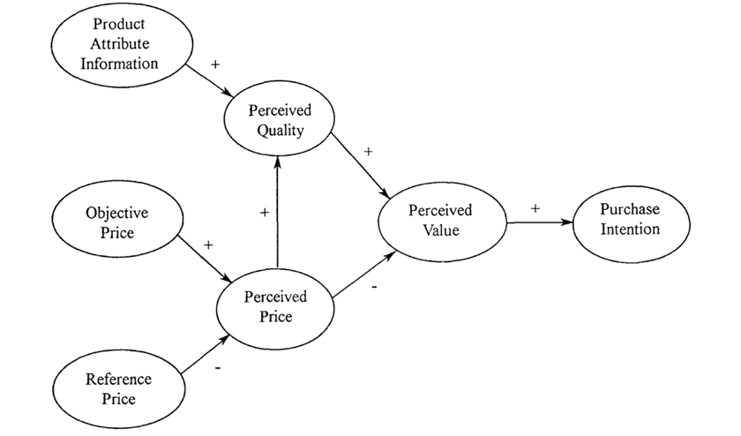
Figure 2. Purchase intention model (Chang & Wildt, 1994)

Extrinsic product attributes are non-tangible features that do not have a direct influence on the performance of a product, for example, the brand name (Chang & Wildt, 1994). It could be argued that sustainable product characteristics are also extrinsic product attributes since sustainable product characteristics offer a “warm glow” effect (Andreoni, 1990). This effect stems from the perception of utility by providing a small amount of public value and a more future-oriented outcome (Kaufmann, 2012). A consumer’s psychological benefits from the purchase can be added as utility (Bei & Simpson, 1995)

2.3 The multi-attribute nature of products
Some consumers even regard the sustainable attributes of a product as the most important factor. Sustainable products usually do not offer performance improvements; still, the warm glow effect is considered an essential factor behind the willingness to pay for sustainable quality. Nonetheless, Rokka (2008) argues that even the most sustainably oriented consumers do not choose products solely on the basis of their sustainable aspects. Instead, product choice depends on the multi-attribute nature, where a trade-off is made between various product attributes. Intrinsic and extrinsic attributes offer a consumer utility and consumers exert utility-maximizing behavior. Both tangible and intangible attributes of a product provide arguments for and against a potential purchase (Conrad, 2004). These attributes are provided by marketers, who know that the major decision variables are the product attributes and price. To optimize the product attributes and thereby maximize purchase intention, marketers seek knowledge about how consumers use product attributes and price information in the evaluations of products.

Compared to non-sustainable products, sustainable products appear to be more complex. Consumers continue to be focused on maximizing their utility; however, with sustainable products, there is a trade-off between utility derived from preferred characteristics and the moral behavior of buying such products. Moral behavior can originate because environmental behavior is expected from the consumer; this attitude is influenced by friends, partners, parents, or the media. However, the expected environmental behavior is not strong enough to drive the market share of sustainable products to one and that of non-sustainable products to zero. One reason is that marketers are aware of the conflict that consumers face as they balance preferred product characteristics and sustainability. Thus, consumers gain utility from the product attributes and disutility when the product is not sustainable. To raise the utility level, in addition to offering more attributes, producers can reduce the price when a product is not sustainable; this is an effective approach when the attributes of a product are similar. At the same time, some consumers are willing to accept the higher prices of sustainable products because they are usually costlier to produce (Conrad, 2005).

2.4 Price
The other component that influences the perceived value of a product is the price. In the most basic sense, the price is what consumers pay for a product, resulting in a reduction of their wealth (Erickson et al., 1985). This follows the “price as a constraint” view common in economics (Lancaster, 1971), where the price is a constraint on how much funds are available for spending on other goods and services. The classical economic model dictates that a consumer maximizes its utility by allocating a limited budget for alternative goods and services (e.g., Lilien and Kotler 1983, p. 390). However, price as a concept can be understood as much more than simply a “constraint.” Consumers use it as a quality cue, where a lower price is a negative signal for quality (Völckner & Sattler, 2005, 2007). However, the role and functioning of price can be extended even further, since perceptions of price are subjective, and these beliefs are intertwined with other attribute beliefs. It is the context and the history that a consumer has with a product or category that enables a “price range” in the consumer’s mind (Chang & Wildt, 1994). Consequently, perceptions regarding various attributes of the products might well bias the perceptions of prices away from the actual prices, just as price beliefs influence perceptions of quality attributes in the price-quality relationship.

The purpose of the present study is to empirically investigate the various roles that price can play in the multi-attribute product evaluation process. To propose the first hypothesis, the following elements are considered. First, a lower price is a negative signal for quality (Völckner & Sattler, 2005, 2007), and a higher price is a major barrier to the purchase of sustainable products (Joshi & Rahman, 2015). Second, consumers expect a price premium for sustainable products (Conrad, 2005). Resulting in a lower purchase intention for sustainable products that are competitively priced. Consequently, the following hypothesis is proposed:

H1: A consumer is likely to have a lower purchase intention for sustainable products that are competitively priced than for sustainable products bearing a higher price.

If a consumer is likely to have a lower purchase intention when a sustainable product is competitively priced, it is interesting to determine the mechanism behind this relationship. It is known that trust is regarded as a prerequisite for the development of sustainable products (Krittinee Nuttavuthisit & John Thøgersen, 2017) and that consumers need to trust sustainable products (Joshi & Rahman, 2015). Perceived credibility and trust are related factors (Tunçer, 2001), perceived credibility can be described as whether someone believes or trusts information (Cable, 2006; Freeman & Spyridakis, 2004). Resulting in the following hypothesis:

H2: A consumer is likely to have a higher purchase intention for a sustainable product with high perceived credibility than for a product with low perceived credibility.

For the third hypothesis, both variables are examined together through mediation. Sustainable products are thought to come with a price premium, while trust and price fairness are important factors in the buying process of sustainable products (Cătoiu, 2010). It is theorized that consumers will not trust the sustainable information on a product when the product is sold for a competitive price, causing them to not buy the product. Resulting in the following hypothesis:

H3: Sustainable products that are competitively priced have a lower perceived credibility than sustainable products that are priced at a premium.

A 2005 paper by Mazumdar et al. reports that consumers who are highly involved with the purchase of a product are more inclined to change their reference price. Additionally, environmental concern is mentioned as a major driver of the purchasing of sustainable products (Joshi & Rahman, 2015). It is proposed that environmentally concerned consumers are more conscious when purchasing environmental goods and, therefore, are more likely to notice that a sustainable product is sold for a competitive price. These consumers are aware that such products usually come with a price premium; therefore, they may distrust these products, which causes environmental concern to act as a moderator in the relationship between competitive price and perceived credibility. This leads to the following hypothesis:

H4: Environmentally concerned consumers perceive lower credibility of competitively priced products than non-environmentally concerned consumers do.

Finally, a mediation relationship where the relationship between competitively priced and purchase intention is mediated by perceived credibility:

H5: The effect of competitive pricing of sustainable products on purchase intention is mediated by perceived credibility.

3. Methodology
3.1 Research design
This study was conducted to examine the impact of price effects on consumer behavior toward sustainable products. A laboratory experiment employing a 2 (brand) x 3 (type of product) x 6 (price combination) design was constructed. Similar to research by Chang and Wildt (1994), the product was used as a within-subject factor, and the remaining factors were also used as within-subject factors. Despite its limitations, a within-subject design has the advantage of enjoying more statistical power than between-subject designs, and it is easier to find a sufficient number of participants. All respondents were examined using a questionnaire, and such a tool can be suitable for determining consumer perception (Viglia & Dolnicar, 2020). Gathered data were analyzed using the SPSS statistical program. A laboratory setting was chosen rather than a field experiment; while field experiments are appreciated for testing “true” purchasing actions, they also come with serious difficulties. As Rode et al. (2006) point out, “Consumer information about the label is difficult to assure in a field setting,” and “Field studies cannot control for sample selection since customers may seek or avoid the choice between the labeled and non-labeled versions of a product.” Fundamentally, the advantages are that when trade-offs between values and monetary incentives are measured in controlled settings, all participants make these choices with sufficient and equal information. Nonetheless, despite the manipulation advantages, a laboratory experiment will always lack real-life elements and be artificial as a result, thereby reducing the external validity (Viglia & Dolnicar, 2020). To minimize such risks, this research was designed to create a situation as close to real life as possible, given the constraints of such a study. The experiment began with an introduction, instructing the respondent to imagine themselves being in front of a supermarket shelf with two products on it. The experiment was intentionally constructed with real household products found in grocery stores in Australia. Using products from Australian supermarkets ensured that respondents could read the packaging on the product, resulting in a believable setting, but they were primed as little as possible.

For the design of the questionnaire, conjoint analysis was chosen, since this is one of the most suitable methodologies for consumer preferences (Green and Srinivasan, 1990; Carroll and Green, 1995). Conjoint analysis is a method that estimates consumers’ preferences, given their overall assessment of a set of alternatives that are prespecified in terms of different attributes (Green & Srinivasan, 1990). Conjoint analysis is usually done on the individual level when it comes to consumer preferences, as consumer preferences can vary widely. Additionally, price is typically included as an attribute when doing conjoint analyses. These elements combined make a conjoint analysis highly suitable for this research, since this study also seeks to examine the influence of price as an attribute and to evaluate consumer preferences at the individual level.

3.2 Respondents
Respondents for this study were found through direct and indirect relationships. Chan (2001) argues that minors have difficulty understanding an environmental context because of the complexity it creates for decision-making. Additionally, many researchers have suggested that people with little education have substantially more difficulty understanding decisions in an environmental context (Hedlund, 2011; Maichum et al., 2016). Consequently, the aim of this study was to find respondents age 18 and older who were enrolled in at least some form of educational program after high school. Two demographic questions were included in the questionnaire to ensure that respondents who did not meet these criteria could be eliminated. A power analysis revealed that 119 respondents is the minimum sample number to ensure a medium effect size and a low error probability (0.05). Appendix C presents the power analysis input and graph.

3.3 Data collection and quality control
The survey link was open for seven days. Respondents were excluded from the survey for three reasons: 1) completing the survey in less than the two minutes established as a minimum time to properly fill it in, 2) providing the wrong answer (television) to the simulation check question, and 3) failing to fully complete the survey, thereby creating missing data. This resulted in 133 usable respondents. The design chosen for this research was a within-subject design. However, if Products 2 and 3 (bags of potatoes and laundry powder) are excluded from the data, the design changes. The type of product is still a within-subject factor, but price is then a between-subject factor. This removes the potential learning problem that comes with within-subject designs when respondents are faced with sequential conditions (Charness et al., 2012) and opens up the possibility of affirming results achieved with the within-subject design by using the between-subject design. Obviously, this creates the disadvantage of having only one product (avocados) to assess, therefore running the risk that the product itself primes respondents in a specific way.
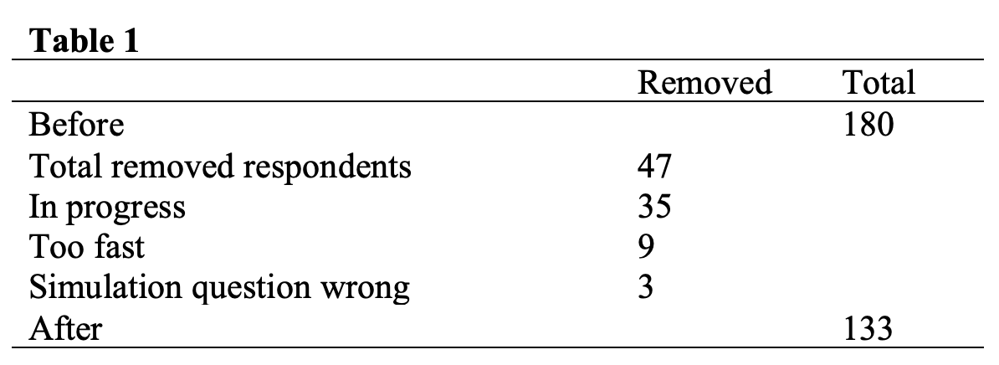

3.4 The experiment
Conjoint analysis was also used in the study by Rokka and Uusitalo (2008), where respondents—similar to those in this study—were shown product alternatives having different attribute compositions, including price and environmental labeling. The conjoint analysis allows harmonization of the theoretical basis on which this study relies and the laboratory experiment questionnaire design. As described in the theory section, extrinsic product attributes, such as sustainability features, can have a warm flow effect, which stems from the perception of utility (Chang & Wildt, 1994; Andreoni, 1990). One of the aims of this thesis is to consider sustainability as a product attribute and, therefore, a potential form of utility. The conjoint analysis allows the estimation of individual utility while dealing with consumer preferences in a controlled setting. Additionally, this results in the possibility of being able to cluster respondents into segments (Allenby & Ginter, 1995).

Moreover, this experiment used a variety of dual product combinations, with every combination revealing a different composition of attributes. The participants were asked to respond to statements on an overall level (not attribute-specific), so as not to compromise the conjoint analysis design. A graphical image (Figure 3) was presented to the respondents, with Product A always including a sustainability label and Product B never including one. This specific label was chosen since it is considered a general and comprehensible sustainability label for two reasons: First, it is green, a color associated with sustainability (De Long & Goncu-Berk, 2012), and the color stands out next to the product, making it easy to notice; second, the text in the label “100% Eco,” meaning 100% ecological, presents a clear message. While 100% ecological could mean a number of things within the sustainability spectrum, this ambiguity is, in fact, desired, since the goal of this research is not to examine the effect of a specific form of sustainability such as organic, but sustainability in general. Nevertheless, the risk of a social desirability bias is also present. This could occur when answers participants provide answers that differ from their actual attitudes because they want to feel good about themselves and seek to define their identity in a positive manner (Larson, 2018). The social desirability bias is combatted by providing one further information attribute and thereby adding more realism, in addition to making it less obvious what is being manipulated in the experiment. For example, for avocados, this additional information attribute was “sustainably farmed,” since unsustainable farming has been a negative news item recently, which creates a realistic setting (Serrano & Brooks, 2019).

The products used were avocados, bags of potatoes, and laundry powder, all being low-involvement, low-cost, and familiar products. These characteristics were chosen for the following reasons. Low involvement is considered important because consumers who are more involved with the environment are more inclined to purchase sustainable products, regardless of the type of appeal used, thereby eliminating a potential bias. Second, involvement tends to increase as products become more expensive, so low cost was a requirement. Third, products had to be relevant and familiar, so as to gain sincere cooperation and provide a realistic setting (Chang & Wildt, 1994; Schuhwerk & Lefkoff-Hagius (1995). The second independent variable was price: Product B’s price was constant for each product type, while Product A’s price would be low one time, the same another time, and higher still another time. All price differences were 25% below or above the constant price of Product B, resulting in a significant difference that is subject to examination. Moreover, price differences were randomly assigned. The number of attributes attached to a product was kept to a minimum, according to the theory behind conjoint analyses. The attributes and their quantity is crucial because too many attributes or results can become misleading. Moreover, restricting attributes and their levels makes the evaluation task simpler and is a better resemblance to the real choice situation (Rokka & Uusitalo, 2008).

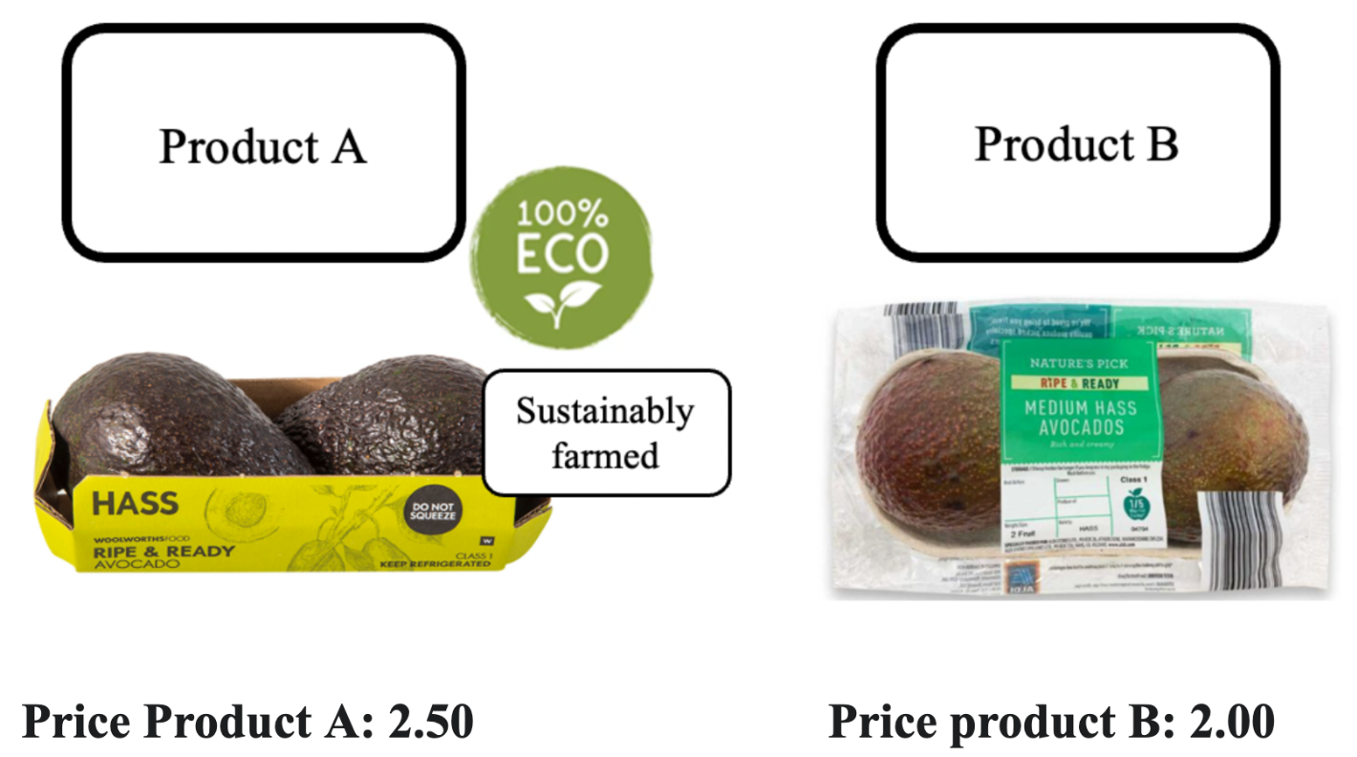
Figure 3. Example of first treatment (the higher price condition)

Environmental concern is theorized as being a moderator in the mediated relationship of competitive pricing on sustainable labeling to perceived credibility. This means that the more environmentally aware someone is, the more distrust they have for competitively priced products that are also sustainable. To examine the truthfulness of this hypothesis, each correspondent was examined with the environmental concern construct to keep the involvement per product low and to minimize the learning bias during the experiment. It was decided that the environmental concern would be measured after each participant was finished with the experiment. A common way to examine belief strength as defined in TPB is by using 7-point Likert scales (Azjen, 1991). This research took four statements from the environmental concern construct in the paper by Schuhwerk and Lefkoff-Hagius (1995): “I am concerned about the environment,” “The condition of the environment affects the quality of my life,” “I am willing to make sacrifices to protect the environment,” and “My actions impact the environment.” The construct had a Cronbach’s alpha of 0.9, and the average of the four statements was taken and used in the analysis.

The questionnaire was estimated to take approximately five minutes, and a graphical representation is provided in Figure 4.
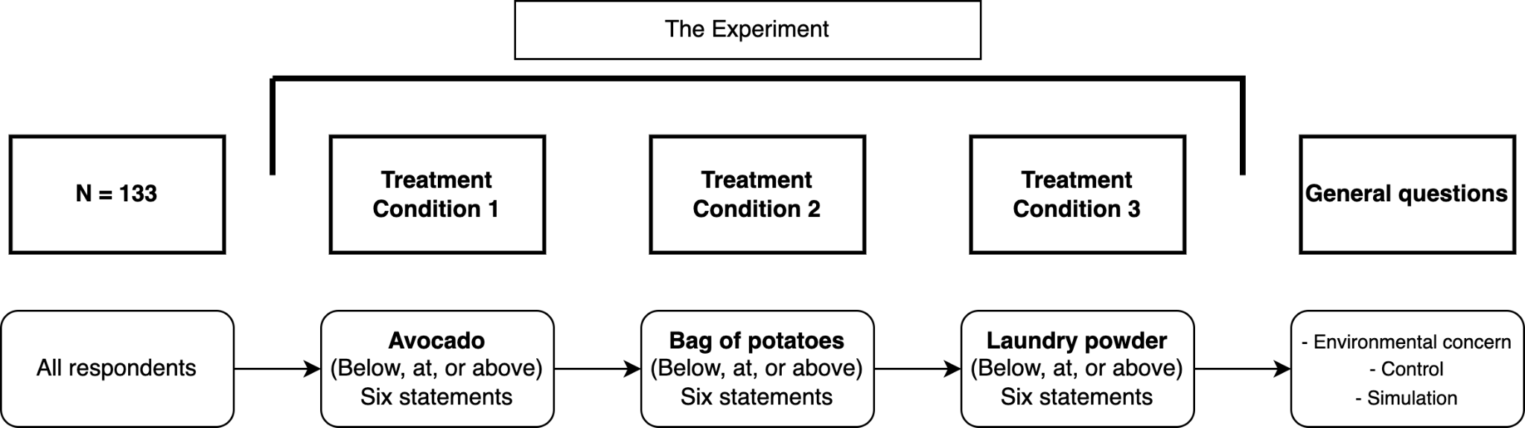
Figure 4. Graphical representation of the experiment

3.5 Dependent variables
Along with the conjoint analysis structure, the statements about quality and purchase intention were non-specific. However, due to the manipulation of treatments, the participants’ perceptions can be deduced from their responses to the statements. It is a way of deducing part-worth utilities for different product attributes from consumer choices. This technique creates a simulated real-life consumer choice in which the trade-off between specific product attributes takes place unconsciously. All used scales were found to be internally reliable (Cronbach’s alpha > 0.70). The perceived credibility construct was assessed using three items. The first two items were taken from Johnson and Kaye’s 2002 paper using media credibility. (“The information presented [on Vault.com; on Product A] was: believable; fair”). The Cronbach’s alpha was 0.84. The statements were evaluated on a 5-point Likert scale that ranged from not at all believable or fair to very believable or fair (Johnson, 1998) (Cable Yang, 2006). Perceived credibility is a determining factor in establishing trust between supplier and customer (Tunçer, 2001) and whether an audience believes or trusts information from a given medium (Cable, 2006; Freeman & Spyridakis, 2004). Consequently, a specific item for establishing the trustworthiness of the sustainable product (Product A) was deemed as an effective addition. The item was taken from Everard and Galletta’s 2006 paper on customer perception of online stores: “[This online store; Product A] is trustworthy.” The construct from which it was taken had a Cronbach’s alpha of 0.814 and was measured on a 7-point Likert scale (1 = strongly disagree, 7 = strongly agree).

It was theorized that value is an antecedent, and value is preceded by product quality. Attempting to examine antecedents, quality was chosen as a measurement. This item was also taken from Everard and Galletta’s 2006 paper: “[This website; Product A] is of high quality.” The construct from which it was taken had a Cronbach’s alpha of 0.896 and was measured on a 7-point Likert scale (1 = strongly disagree, 7 = strongly agree). Furthermore, purchase intention was also measured on its own. This item was taken from a paper by J.G. Maxham III (1999): “How likely are you to purchase [your next haircut from ABC haircut service; product A]?”. The statement had a Cronbach’s alpha of 0.96 and was measured on a 7-point Likert scale (1 = very unlikely, 7 = very likely).

3.6 Description data analysis
To assess how much of the variation in buying intention is caused by the individual, an ANOVA test was executed. Correspondent ID was used as a grouping factor and product type as weight.

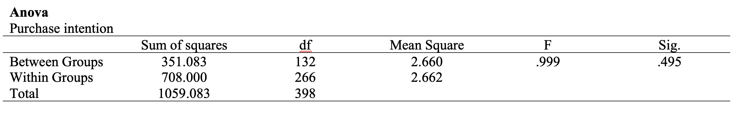

Considering that the test is insignificant, it was decided to use a clustering correction for the regression analysis. Data was first clustered and then used using: Complex samples, General Linear Model in SPSS.

4. Results
A moderated mediation model was constructed to test the five hypotheses, allowing an examination of the effect of price on purchase intention with perceived credibility as a mediator and environmental concern as a moderator (Figure 5). The model was tested using the process macro plugin by Hayes (2012) in SPSS, which is a widely used program for statistically analyzing behavioral data retrieved from surveys (Hayes, 2012).

4.1 The sample
Three demographic questions were included and are discussed here. The average age of the sample is 38, with a minimum age of 21 and a maximum of 76. This resulted in a diverse age range that is skewed toward the younger side, with a median age of 31 (Table 2). The respondents were predominantly male and Dutch at 69% and 81%, respectively (Table X) (Table X).
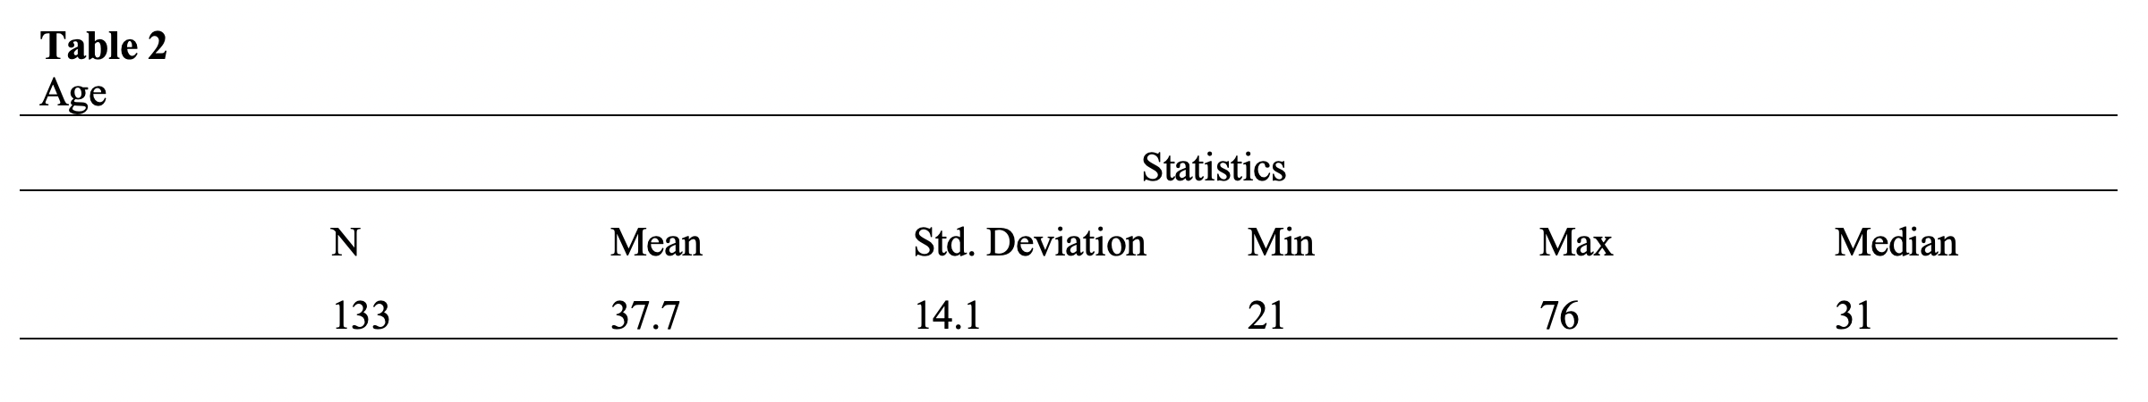
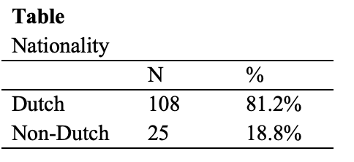
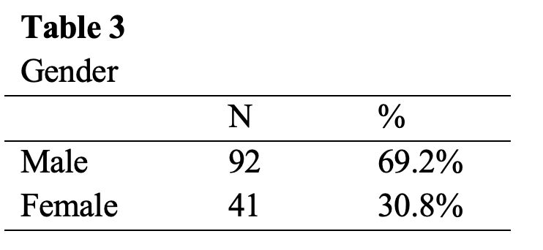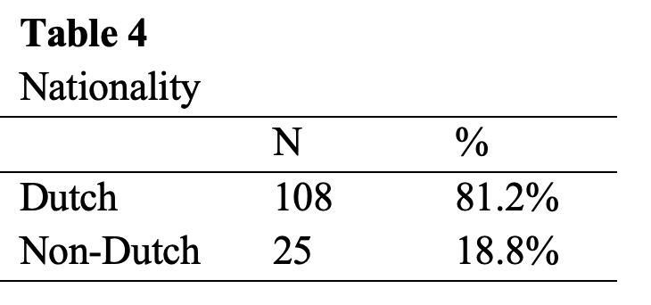

4.2 Validity and reliability
To derive internal reliability scores, the questions can be divided into two sections. First were the five questions about the product and second were the four questions about the respondent’s environmental concern. Both constructs were tested for their validity and reliability. A Cronbach’s alpha reliability score is the most widely used for survey research (Bonett & Wright, 2014). The internal consistency of a construct is associated with the homogeneity of the items within the construct and is important for valid research (Henson, 2001). A value of 0.7 or higher for Cronbach’s alpha is considered to be reliable.

The Cronbach’s alpha for the product questions was 0.837 (Appendix D). The purchase intention item could increase the overall internal validity to 0.854 when deleted. The process test was redone without this item, and the results remained the same. The Cronbach’s alpha for the environmental concern construct was 0.740 (Appendix E), and it was observed that when the fourth question was removed, the Cronbach’s alpha rose to 0.775. The process test was redone without this item, and the results remained the same. Considering that both Cronbach’s alphas are above the 0.7 threshold for reliable measures, the constructs were not adjusted.

4.3 model
For this model, the following variables were used. Purchase intention was the dependent variable, competitively priced was the independent variable, environmental concern was a moderator, and perceived credibility was the mediator (Figure 5). The model is constructed for sustainable products.

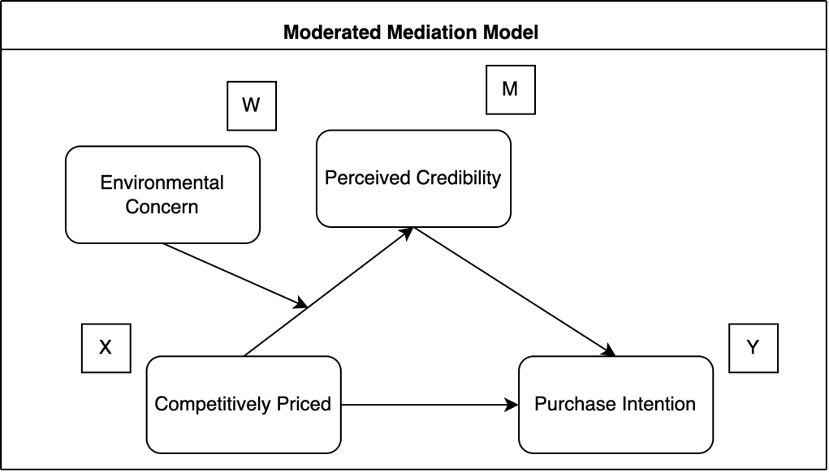
Figure 5. Moderated mediation model

4.4 Results
Results with outcome variable purchase intention are presented in table 5 (Appendix B). Considering model 7, there is no significant relationship (direct effect) between price and purchase intention (p=.427). Thus, H1 is rejected. Considering model 7, there is a highly significant relationship (direct effect) between perceived credibility and purchase intention, with a slope of .749 (p=.000). Thus, H2 is accepted.
Considering model 4, there is an insignificant relationship between price and perceived credibility, with a slope of .216 (p=.659). Thus, H3 is rejected. Assessing the 5th hypothesis regarding mediation, this was found to be insignificant. When considering model 2, there is no significance between competitive pricing and purchase intention, and in model 4 price is also insignificant, since both parameters are insignificant there can’t be mediation.

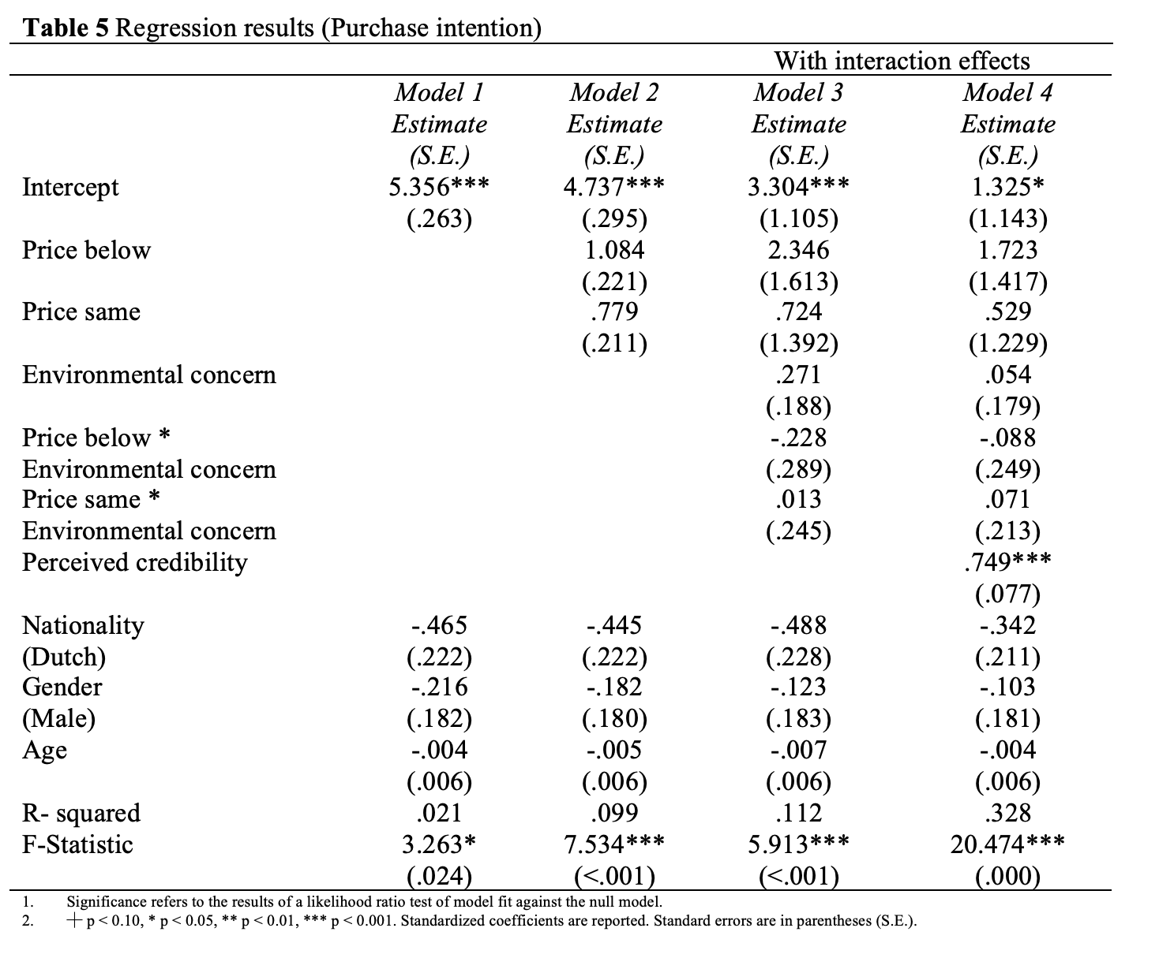

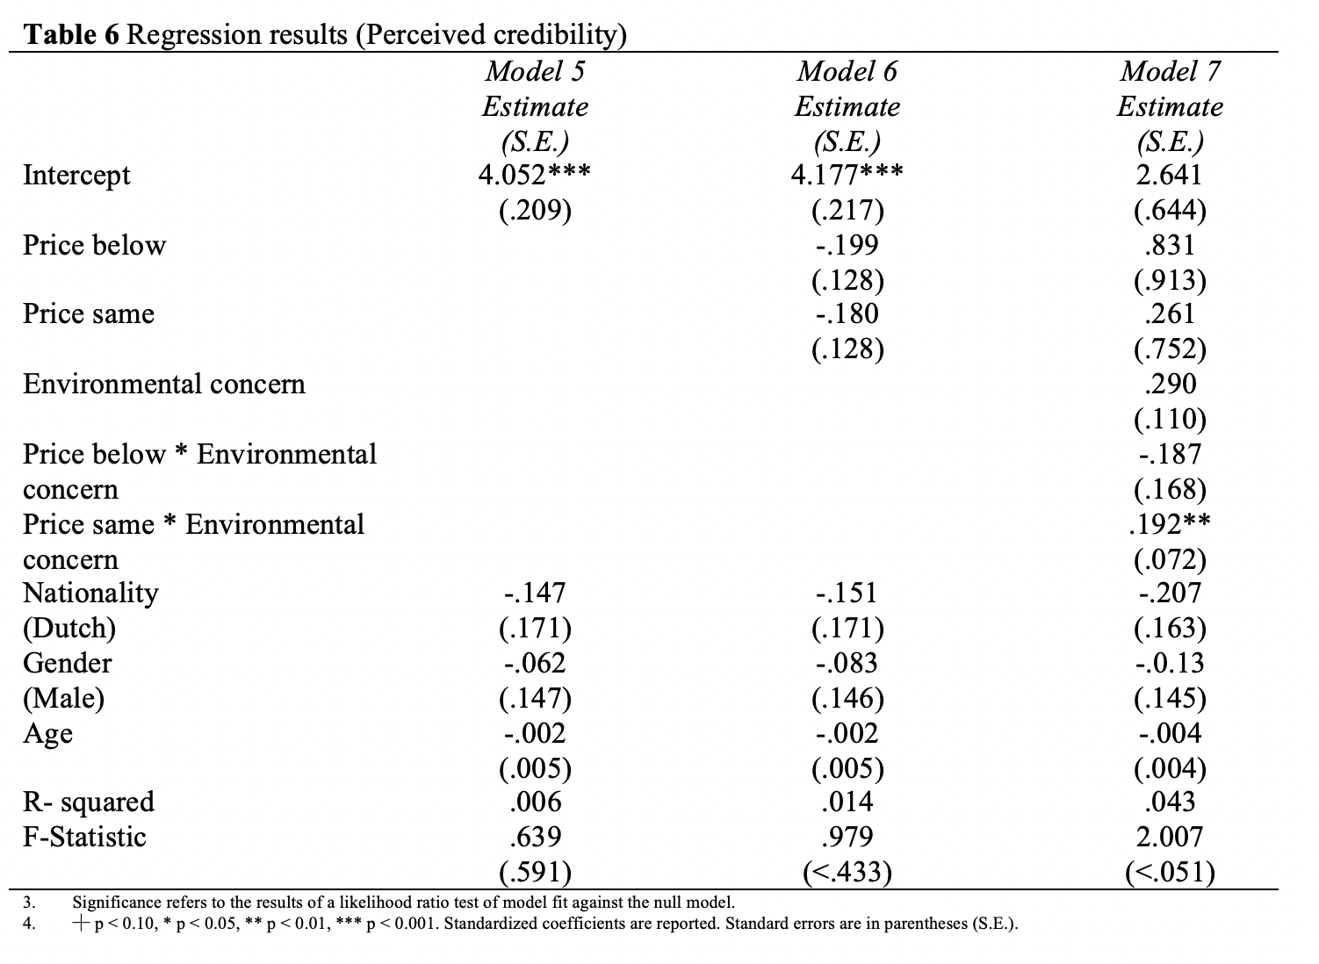

4.5 Summary

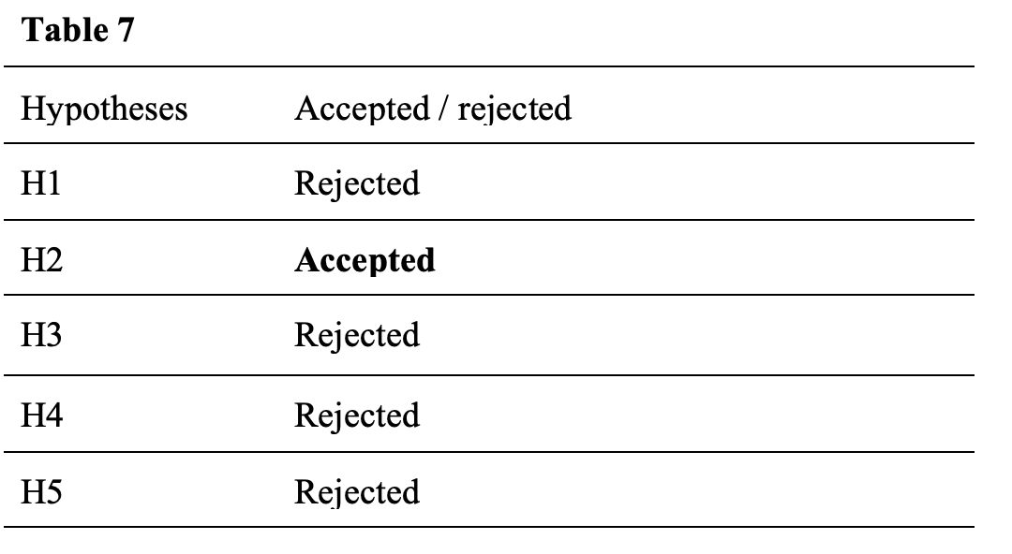
5. Discussion
This study sheds light on the consumer perception of sustainable products given their relative price, and several hypotheses were tested. First, the effect of perceived credibility on purchase intention was found to be significant, with higher perceived credibility of a sustainable product having a positive effect on purchase intention. This was theorized since perceived credibility is a construct of trust between supplier and customer and reveals how truthful the consumer thinks the proposition is (Tunçer, 2001; Eisdend, 2006). Furthermore, in the purchase intention model (Figure 2) by Chang and Wildt (1994), they argue that value and quality are antecedents of purchase intention (Monroe & Chapman, 1987; Zeithaml 1988). This study posits that perceived credibility concerning sustainable products can be considered as an addition to that model. If consumers do not trust a product or regard the information to be untruthful, the quality decreases and, finally, the purchase intention. Second, price has an insignificant effect on purchase intention

The third hypothesis was that sustainable products that are competitively priced have a lower perceived credibility than sustainable products that are priced at a premium. Essentially, the reasoning was that the perceived credibility of a sustainable product is a mediating factor in the relationship of price on purchase intention. This effect was found to be insignificant. Thus, the data reveals that the perceived credibility of a sustainable product does have a direct effect on purchase intention (H2), but it does not have an indirect effect on purchase intention. The final hypothesis states that environmentally concerned consumers have a lower perceived credibility for competitively priced products than non-environmentally concerned consumers, and the effect was found to be insignificant. The effect of price on perceived credibility was not influenced by the level of environmental concern of the consumer. The hypothesis was originally presented because consumers who are highly involved with the purchase of a product are more inclined to change their reference price (Mazumdar et al., 2005), while environmental concern is also noted as being a major driver for the purchase of sustainable products. Consequently, it was deduced that environmentally concerned consumers are more aware and thoughtful in the buying process and more inclined to notice that a sustainable product is being sold for a competitive price, which leads them to distrust the product. Nonetheless, the effect was insignificant. It must be noted that the environmental concern questions were vulnerable to socially desirable answers, despite the fact that the respondents were assured of anonymity. This bias potentially influenced the results. On average, respondents said they considered themselves very involved with the environment. However, it is known that beliefs often do not lead to corresponding actions (Rokka, 2008; Burgin, 2021; Pickett-Baker & Ozaki, 2008). Assessing the 5th hypothesis regarding mediation, this was found to be insignificant.

As with all research, this study was also subject to limitations. The first concerns the experimental design that was chosen. Within-subject designs have several disadvantages, which stem from the fact that they rely on repeated measures of the same respondent (Keppel, 1991). Respondents might notice the pattern and begin attempting to provide answers that satisfy their perception of the experimenter’s expectations. Such effects are known as “demand effects,” and these are likely stronger for within-subject designs and could lead to spurious effects (​​Charness, 2011). Second, the scenario approach used might be too simplistic, as it excludes realistic details that consumers are confronted with in actual stores (Okazaki & Hirose, 2009). The scenario approach used a laboratory setting, forced exposure to the products and required an immediate response. These elements limit the generalizability of this study (Schuhwerk & Lefkoff-Hagius, 1995). Third, this study was performed in the Dutch context. Although no culture-related variables were used in the experiment, such an process can produce different results in different countries. Trust, for example, is an attitude that differs substantially between countries (Hofstede et al., 2006), and knowing that trust is an important factor in this study, the results cannot easily be externally validated (Okazaki & Hirose, 2009).

A final and major element that must be noted is the attitude–behavior gap. In the search for ways to improve the market acceptance of sustainable products, it is necessary to understand consumers’ beliefs and actions (Ingenbeek, 2015; Yenipazarli, 2015; Cerri et al., 2017). The fundamental consumer behavior models (Fishbein, 1980; Azjen, 1985) rely on the assumption that consumers act consistently according to their preferences and beliefs. However, the consistency between attitudes and behavior is rather low (Rokka, 2008). There is a substantial estrangement between having a sustainable attitude and acting on those beliefs in the supermarket (D’Souza, 2006; Ingenbeek, 2015; Liobikienėa & Bernatonienėb, 2017). Ultimately, the objective is to increase the purchases of sustainable products, not to change attitudes, which is often ineffective. It should also be understood that, when conducting research, scholars seek to know the motivations of particular real-life actions, so theory and practice act in harmony instead of isolation. A first step was taken in this research by presenting respondents with a choice situation including the crucial variable of price and their corresponding intentions; only afterward were the participants asked about their beliefs. However, experimental intentions are still far different from real-world actions. As a final note, the words “green,” “environmental,” and “sustainable” were used as synonyms in this study, since the definitions largely overlap and generally have the same meaning. It was the aim of this thesis to provide insight into the sustainable product space. Thus, all results should be treated as general results that could also be applicable to subcategories of sustainability (e.g., organic, recyclable, etc.). However, that would require more specific research.

The following suggestions are made for future research. First, field experiments could be conducted instead of laboratory experiments. Engaging in a field experiment in addition to a laboratory experiment can result in enriched and complementary insights (Viglia & Dolnicar, 2020), such as the attitude-behavior gap that was a specific focus of this study. Field experiments would measure true actions in a real-world environment, thereby providing additional and valuable information regarding this space. Second, a similar experiment could be done, substituting the within-subject design with a between-subject design. Between-subject designs can provide greater confidence because they eliminate the learning effects that accompany within-subject designs (Viglia & Dolnicar, 2020). Finally, it is suggested to replicate this study in different countries to nullify the cultural factors per country. These suggestions for future research should counteract the limitations of this study and provide external validity. Note, this study was set as an exploratory analysis in examining the influence of the relative price levels of a sustainable product compared to a non-sustainable reference product. However, the literature suggests that other factors (e.g. subjective norm) are also influential. Future research should be aware of this.

It is not only reasonable but essential to expect that more and more sustainable products will reach the mainstream market with prices set at competitive levels; this is due to increasing environmental awareness and growing cost advantages thanks to economies of scale. A vast amount of literature has described the attitude–behavior gap and explains the inconsistency between beliefs and actions. Most people say they care about the environment, but this is often not seen in their environmental actions (e.g., recycling) or buying behavior (Rokka, 2008; Burgin, 2021; Pickett-Baker & Ozaki, 2008). As stated earlier, price remains a crucial determinant for people to buy a particular product (D’Souza, 2006; Liobikienėa & Bernatonienėb, 2017). Thus, when conceptualizing environmental purchasing behavior, the focus should be shifted to choices rather than attitudes (Rokka, 2008).

Additionally, the consumer perception that sustainable products always come with a price premium is not true. Sustainable products often are more expensive, but there are also instances where the sustainable approach leads to more efficient practices (Omer 2008; Kularatne, 2019; Ghoreishi & Happonen, 2020), thereby creating an opportunity for more competitive pricing. If consumers still distrust these products and buy fewer of them, this would create an additional barrier to reaching the social optimum of sustainable products becoming the norm. Accordingly, this research was constructed to examine the consumer perception of such products.

As Kotler states in his 2011 paper, price management is a difficult job for managers, requiring a balance of many factors, such as consumer perception, competitors’ reactions, and costs. Critically, literature in this area is lacking for sustainable products. Kotler states that “the marketing literature still assumes a world in which resources are infinitely available.” This paper aimed to deepen the price literature for sustainable products. How products are perceived is important for marketers, since perception affects consumer attitude, intentions, and behavior. Credibility perceptions are crucial for companies, as green products are constantly emerging, and companies need to identify the optimal pricing strategy and make the appropriate advertising decisions to ensure a healthy business model in the future (Cătoiu, 2010; Hong, 2018; Shen, 2019). In a meta-study by Joshi and Rahman (2015), they suggest that sustainable labeling might not have any effect on consumer behavior if consumers do not trust the information that is provided. This can be confirmed by the results of this study because the perceived credibility of sustainable products is a significant factor in determining purchase intention. Therefore, a managerial implication is that companies aiming to sell more sustainable products should also focus on convincing consumers of the truthfulness of their products. However, this tactic opens the door to green-washing by non-sustainable producers who seek to convince consumers that their products are sustainable. Therefore, governments are advised to further pursue nationally recognized sustainable labeling programs to help consumers identify credible sustainability schemes (Nilson et al., 2004).

A considerable amount of research confirms the notion that the sustainable product market is clouded with distrust for sustainability claims. While this study does provide answers by uncovering the functions of price and credibility in the sustainable product space, it also results in more questions.

Reference list

Alibeli, M. (n.d.). Environmental Concern: A Cross National Analysis. Retrieved June 1, 2022, from https://www.academia.edu/7041035/Environmental_Concern_A_Cross_National_Analysis
Allenby, & Ginter. (1995). Using Extremes to Design Products and Segment Markets.
Azjen, I. (1991). The Theory of Planned Behavior. https://www.sciencedirect.com/science/article/abs/pii/074959789190020T?fr=RR-2&ref=pdf_download&rr=71dcb64eff34b825
Bonett, D. G., & Wright, T. A. (2015). Cronbach’s alpha reliability: Interval estimation, hypothesis testing, and sample size planning. Journal of Organizational Behavior, 36(1), 3–15. https://doi.org/10.1002/job.1960
Brécard, D., Hlaimi, B., Lucas, S., Perraudeau, Y., & Salladarré, F. (2009). Determinants of demand for green products: An application to eco-label demand for fish in Europe. Ecological Economics, 69(1), 115–125. https://doi.org/10.1016/j.ecolecon.2009.07.017
Cătoiu, I., Vrânceanu, D. M., & Filip, A. (2010). Setting Fair Prices – Fundamental Principle Of Sustainable Marketing. Amfiteatru Economic Journal, 12(27), 115–128.
Chan, R. Y. K. (2001). Determinants of Chinese consumers’ green purchase behavior. Psychology & Marketing, 18(4), 389–413. https://doi.org/10.1002/mar.1013
Chang, T.-Z., & Wildt, A. R. (1994). Price, Product Information, and Purchase Intention: An Empirical Study. Journal of the Academy of Marketing Science, 22(1), 16–27. https://doi.org/10.1177/0092070394221002
Charness, G., Gneezy, U., & Kuhn, M. A. (2012). Experimental methods: Between-subject and within-subject design. Journal of Economic Behavior & Organization, 81(1), 1–8. https://doi.org/10.1016/j.jebo.2011.08.009
Chen, C. (2001). Design for the Environment: A Quality-Based Model for Green Product Development. Management Science, 47(2), 250–263.
Clayton, S. (2020). Climate anxiety: Psychological responses to climate change. Journal of Anxiety Disorders, 74, 102263. https://doi.org/10.1016/j.janxdis.2020.102263
Conrad, K. (n.d.). Price Competition and Product Differentiation When Consumers Care for the Environment. 19.
de Freitas Netto, S. V., Sobral, M. F. F., Ribeiro, A. R. B., & Soares, G. R. da L. (2020). Concepts and forms of greenwashing: A systematic review. Environmental Sciences Europe, 32(1), 19. https://doi.org/10.1186/s12302-020-0300-3
DeLong, M., & Martinson, B. (2013). Color and Design. A&C Black.
Eisend, M. (2006). Source Credibility Dimensions in Marketing Communication – A Generalized Solution. 33.
EMPGENS | Source Credibility Dimensions in Marketing Communication – A Generalized Solution. (n.d.). Retrieved April 4, 2022, from https://www.empgens.com/article/source-credibility-dimensions-in-marketing-communication-a-generalized-solution/
Erickson, G. M., & Johansson, J. K. (1985). The Role of Price in Multi-Attribute Product Evaluations. Journal of Consumer Research, 12(2), 195–199.
Everard, A., & Galletta, D. F. (2005). How Presentation Flaws Affect Perceived Site Quality, Trust, and Intention to Purchase from an Online Store. Journal of Management Information Systems, 22(3), 55–95.
Factors Affecting Green Purchase Behaviour and Future Research Directions | Elsevier Enhanced Reader. (n.d.). https://doi.org/10.1016/j.ism.2015.04.001
Fazio, R. (2022). Attitudes as object-evaluation associations: Determinants, consequences, and correlates of attitude accessibility.
Ghoreishi, M., & Happonen, A. (2020). Key enablers for deploying artificial intelligence for circular economy embracing sustainable product design: Three case studies. AIP Conference Proceedings, 2233(1), 050008. https://doi.org/10.1063/5.0001339
Green, P., & Srinivasan, V. (1990). Conjoint Analysis in Marketing: New Developments with Implications for Research and Practice.
Han, H., Hsu, L.-T. (Jane), & Sheu, C. (2010). Application of the Theory of Planned Behavior to green hotel choice: Testing the effect of environmental friendly activities. Tourism Management, 31(3), 325–334. https://doi.org/10.1016/j.tourman.2009.03.013
Hayes, A. F. (2012). PROCESS: A versatile computational tool for observed variable mediation, moderation, and conditional process modeling. http://www.afhayes.com/ public/process2012.pdf
Hedlund. (n.d.). The impact of values, environmental concern, and willingness to accept economic sacrifices to protect the environment on tourists’ intentions to buy ecologically sustainable tourism alternatives—Therese Hedlund, 2011. Retrieved June 15, 2022, from https://journals.sagepub.com/doi/10.1177/1467358411423330
Henson, R. K. (2001). Understanding Internal Consistency Reliability Estimates: A Conceptual Primer on Coefficient Alpha. Measurement and Evaluation in Counseling and Development, 34(3), 177–189. https://doi.org/10.1080/07481756.2002.12069034
Hong, Z., Wang, H., & Yu, Y. (2018). Green product pricing with non-green product reference. Transportation Research Part E: Logistics and Transportation Review, 115, 1–15. https://doi.org/10.1016/j.tre.2018.03.013
Jacoby. (1977). Consumer Response to Price: An Attitudinal, Information Processing Perspective.
Jaiswal, N. (2012). Green products: Availability, awareness and preference of use by the families. Indian Journal of Environmental Education, 12, 21–25.
Keppel, G. (1991). Design and analysis: A researcher’s handbook.
Kotler, P. (2011). Reinventing Marketing to Manage the Environmental Imperative. Journal of Marketing, 75(4), 132–135. https://doi.org/10.1509/jmkg.75.4.132
Kularatne, T., Wilson, C., Månsson, J., Hoang, V., & Lee, B. (2019). Do environmentally sustainable practices make hotels more efficient? A study of major hotels in Sri Lanka. Tourism Management, 71, 213–225. https://doi.org/10.1016/j.tourman.2018.09.009
Lancaster, K. (1971). Consumer Demand: A New Approach, New York:
Larson. (2018). Controlling social desirability bias.
Liobikienė, G., & Bernatonienė, J. (2017). Why determinants of green purchase cannot be treated equally? The case of green cosmetics: Literature review. Journal of Cleaner Production, 162, 109–120. https://doi.org/10.1016/j.jclepro.2017.05.204
Liu, X., Vedlitz, A., & Shi, L. (2014). Examining the determinants of public environmental concern: Evidence from national public surveys. Environmental Science & Policy, 39, 77–94. https://doi.org/10.1016/j.envsci.2014.02.006
Lu, L.-C., Chang, H.-H., & Chang, A. (2015). Consumer Personality and Green Buying Intention: The Mediate Role of Consumer Ethical Beliefs. Journal of Business Ethics, 127(1), 205–219.
Mahenc, P. (2008). Signaling the environmental performance of polluting products to green consumers. International Journal of Industrial Organization, 26(1), 59–68.
Maichum, K., Parichatnon, S., & Peng, K.-C. (2016). Application of the Extended Theory of Planned Behavior Model to Investigate Purchase Intention of Green Products among Thai Consumers.
Maxham, J. G. (2001). Service recovery’s influence on consumer satisfaction, positive word-of-mouth, and purchase intentions. Journal of Business Research, 54(1), 11–24. https://doi.org/10.1016/S0148-2963(00)00114-4
McMichael, A. J., & Lindgren, E. (2011). Climate change: Present and future risks to health, and necessary responses. Journal of Internal Medicine, 270(5), 401–413. https://doi.org/10.1111/j.1365-2796.2011.02415.x
Miller, D. (2001). Consumption: Disciplinary approaches to consumption. Taylor & Francis.
Monroe, K. B., & Chapman, J. D. (1987). Framing Effects on Buyers’ Subjective Product Evaluations. ACR North American Advances, NA-14. https://www.acrwebsite.org/volumes/6684/volumes/v14/NA-14/full
Nilsson, H., Tunçer, B., & Thidell, Å. (2004). The use of eco-labeling like initiatives on food products to promote quality assurance—Is there enough credibility? Journal of Cleaner Production, 12(5), 517–526. https://doi.org/10.1016/S0959-6526(03)00114-8
Nuttavuthisit, K., & Thøgersen, J. (2017). The Importance of Consumer Trust for the Emergence of a Market for Green Products: The Case of Organic Food. Journal of Business Ethics, 140(2), 323–337. https://doi.org/10.1007/s10551-015-2690-5
Omer, A. M. (2008). Energy, environment and sustainable development. Renewable and Sustainable Energy Reviews, 12(9), 2265–2300. https://doi.org/10.1016/j.rser.2007.05.001
Pagiaslis, A., & Krontalis, A. K. (2014). Green Consumption Behavior Antecedents: Environmental Concern, Knowledge, and Beliefs. Psychology & Marketing, 31(5), 335–348. https://doi.org/10.1002/mar.20698
Paul, J., Modi, A., & Patel, J. (2016). Predicting green product consumption using theory of planned behavior and reasoned action. Journal of Retailing and Consumer Services, 29, 123–134. https://doi.org/10.1016/j.jretconser.2015.11.006
Peterson, R. A. (1970). The Price-Perceived Quality Relationship: Experimental Evidence. Journal of Marketing Research, 7(4), 525–528. https://doi.org/10.1177/002224377000700415
Pickett‐Baker, J., & Ozaki, R. (2008). Pro‐environmental products: Marketing influence on consumer purchase decision. Journal of Consumer Marketing, 25(5), 281–293. https://doi.org/10.1108/07363760810890516
Rode, J., Hogarth, R. M., & Le Menestrel, M. (2008a). Ethical differentiation and market behavior: An experimental approach. Journal of Economic Behavior & Organization, 66(2), 265–280. https://doi.org/10.1016/j.jebo.2006.12.003
Rode, J., Hogarth, R. M., & Le Menestrel, M. (2008b). Ethical differentiation and market behavior: An experimental approach. Journal of Economic Behavior & Organization, 66(2), 265–280. https://doi.org/10.1016/j.jebo.2006.12.003
Rokka, J., & Uusitalo, L. (2008). Preference for green packaging in consumer product choices – Do consumers care? International Journal of Consumer Studies, 32(5), 516–525. https://doi.org/10.1111/j.1470-6431.2008.00710.x
Sana, S. S. (2020). Price competition between green and non green products under corporate social responsible firm. Journal of Retailing and Consumer Services, 55, 102118. https://doi.org/10.1016/j.jretconser.2020.102118
Schuhwerk, M. E., & Lefkoff-Hagius, R. (1995). Green or Non-Green? Does Type of Appeal Matter When Advertising a Green Product? Journal of Advertising, 24(2), 45–54. https://doi.org/10.1080/00913367.1995.10673475
Serrano, A., & Brooks, A. (2019). Who is left behind in global food systems? Local farmers failed by Colombia’s avocado boom. Environment and Planning E: Nature and Space, 2(2), 348–367. https://doi.org/10.1177/2514848619838195
Shen, B., Liu, S., Zhang, T., & Choi, T.-M. (2019). Optimal advertising and pricing for new green products in the circular economy. Journal of Cleaner Production, 233, 314–327. https://doi.org/10.1016/j.jclepro.2019.06.022
Teisl, M. F. (2003). What We May Have Is a Failure to Communicate*: Labeling Environmentally Certified Forest Products. Forest Science, 49(5), 668–680. https://doi.org/10.1093/forestscience/49.5.668
Ülkü, M. A., & Hsuan, J. (2017). Towards sustainable consumption and production: Competitive pricing of modular products for green consumers. Journal of Cleaner Production, 142, 4230–4242. https://doi.org/10.1016/j.jclepro.2016.11.050
Viglia, G., & Dolnicar, S. (2020). A review of experiments in tourism and hospitality. Annals of Tourism Research, 80, 102858. https://doi.org/10.1016/j.annals.2020.102858
Watts, N., Amann, M., Arnell, N., Ayeb-Karlsson, S., Belesova, K., Boykoff, M., Byass, P., Cai, W., Campbell-Lendrum, D., Capstick, S., Chambers, J., Dalin, C., Daly, M., Dasandi, N., Davies, M., Drummond, P., Dubrow, R., Ebi, K. L., Eckelman, M., … Montgomery, H. (2019). The 2019 report of The Lancet Countdown on health and climate change: Ensuring that the health of a child born today is not defined by a changing climate. The Lancet, 394(10211), 1836–1878. https://doi.org/10.1016/S0140-6736(19)32596-6
Yadav, R., & Pathak, G. S. (2016). Young consumers’ intention towards buying green products in a developing nation: Extending the theory of planned behavior. Journal of Cleaner Production, 135, 732–739. https://doi.org/10.1016/j.jclepro.2016.06.120
Zarazua de Rubens, G. (2019). Who will buy electric vehicles after early adopters? Using machine learning to identify the electric vehicle mainstream market. Energy, 172, 243–254. https://doi.org/10.1016/j.energy.2019.01.114

Appendix A

Example experiment

Dear participant,

Thank you for taking part in this master's thesis research by Tom Eleveld on consumer buying intentions. In this questionnaire, you will be presented with three household products and statements regarding these products. You are asked to respond to these statements.

All the information that you provide will be treated confidentially and kept anonymous.

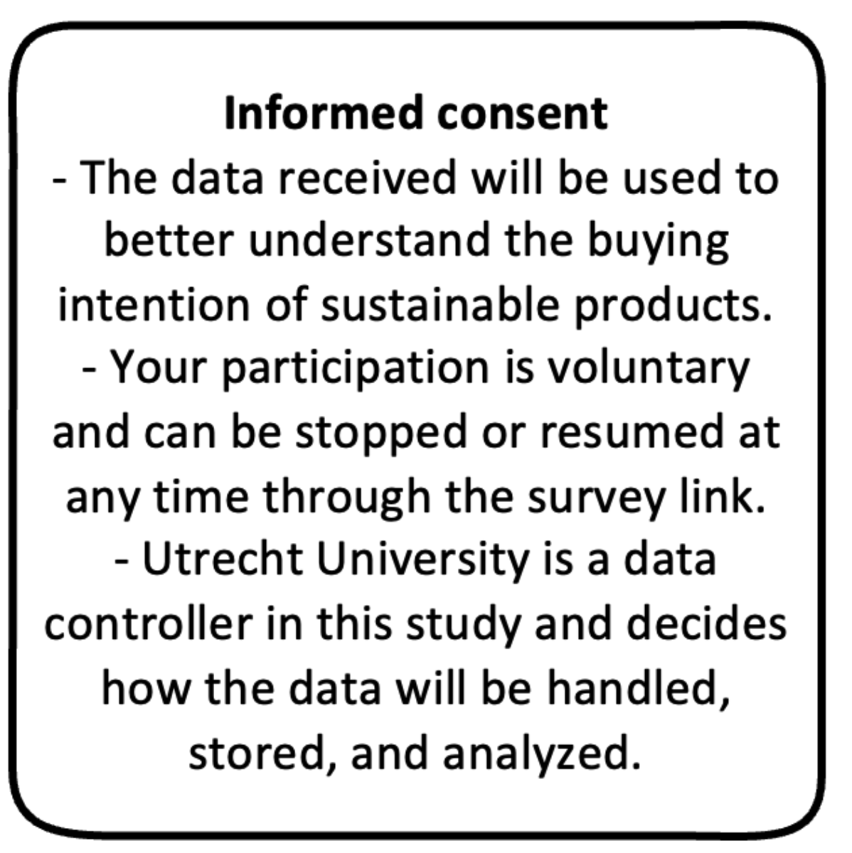

You’ve read the informed consent and agree to the use of your responses

[ ] I AGREE
[ } I DO NOT AGREE

Treatment 1 (Example)

Imagine yourself being in a supermarket, you are presented with a shelf that has two products (avocados) on it. After reviewing the products, respond to the statements below.

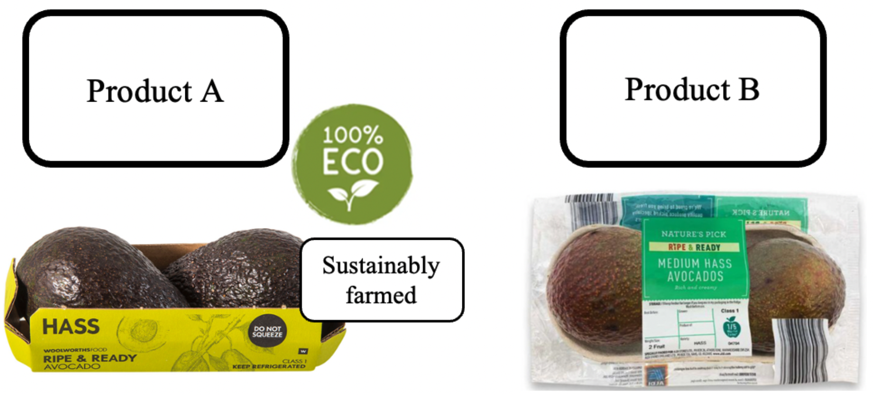

Price Product A: 2.50 Price product B: 2.00

The information on Product A was believable. (Johnson & Kaye’s, 2002)
1-2-3-4-5 (Not all believable – very believable)

The information on Product A was fair. (Johnson & Kaye’s, 2002)
1-2-3-4-5 (Not all fair – very fair)

Product A is trustworthy. (Everard & Galletta, 2006)
1-2-3-4-5-6-7 ( 1 = strongly disagree and 7 = strongly agree)

Product A is of high quality. (Everard & Galletta, 2006)
1-2-3-4-5-6-7 ( 1 = strongly disagree and 7 = strongly agree)

How likely are you to purchase product A? (J.G. Maxham III, 1999)
1-2-3-4-5-6-7 (Unlikely – likely)

Which product would you most likely buy? (J. Rokka & L. Uusitalo, 2008)
Product A
Reference product

Treatment 2 (Example)

Imagine yourself being in a supermarket, you are presented with a shelf that has two products (bags of potatoes) on it. After reviewing the products, please respond to the statements below.

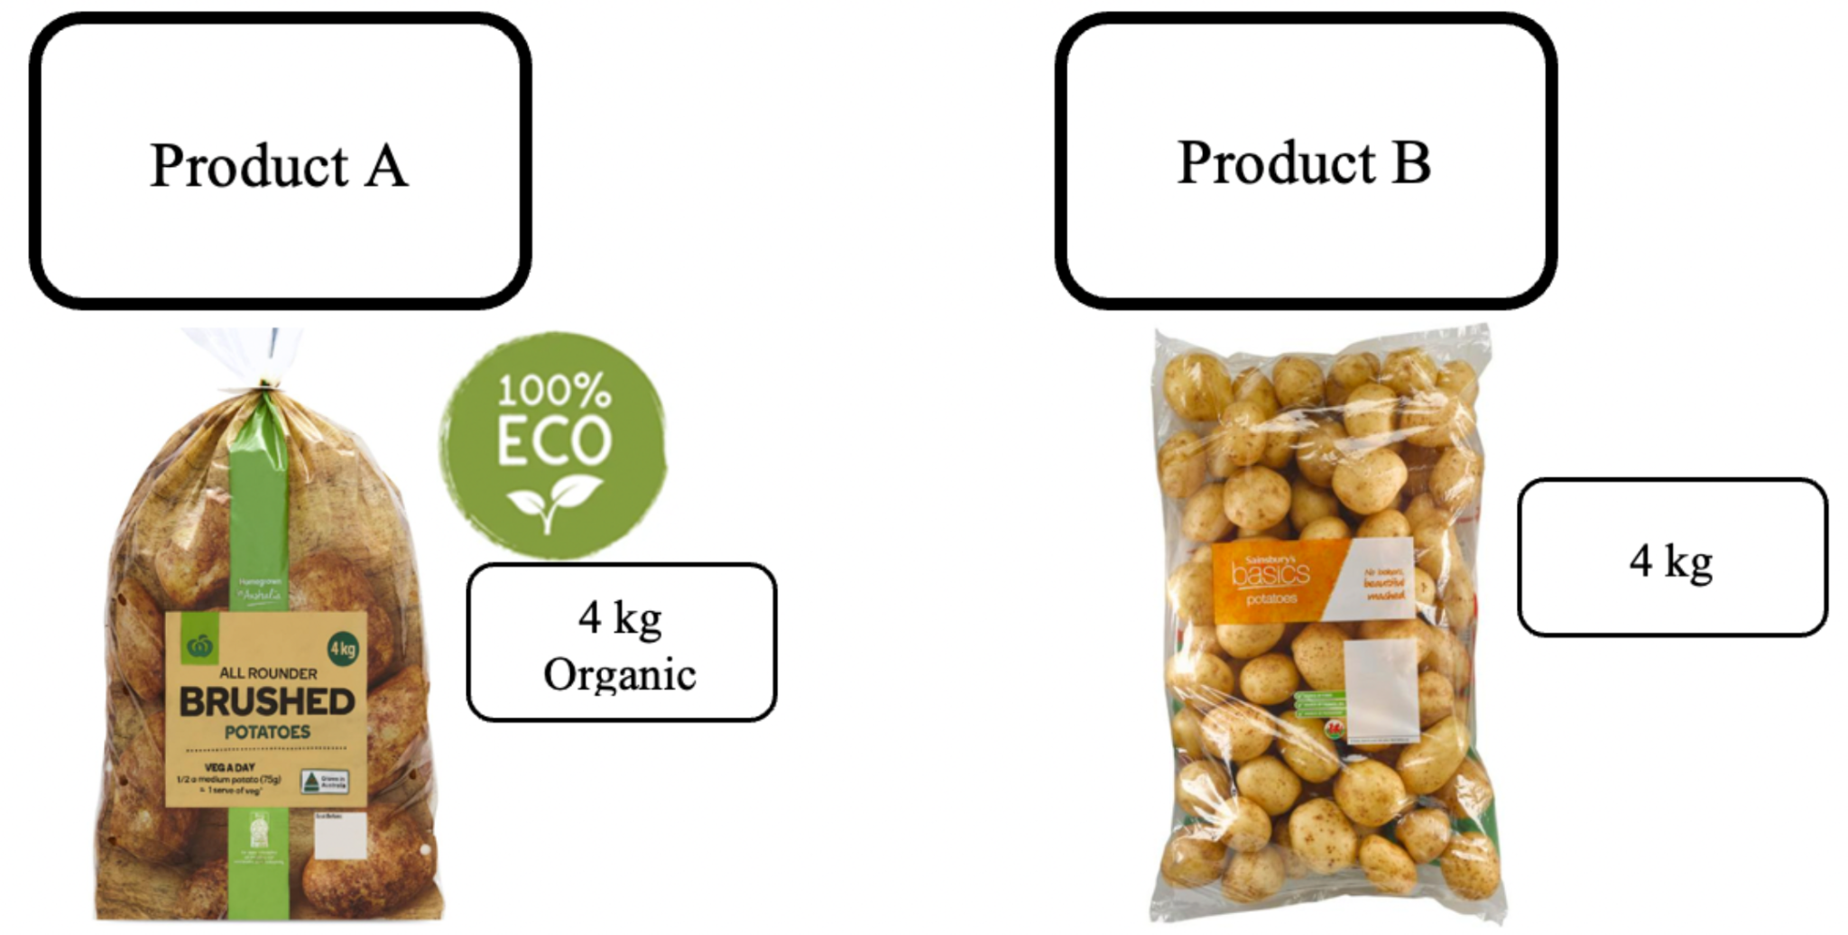

Price Product A: 4.00 Price product B: 4.00

The information on Product A was believable. (Johnson & Kaye’s, 2002)
1-2-3-4-5 (Not all believable – very believable)

The information on Product A was fair. (Johnson & Kaye’s, 2002)
1-2-3-4-5 (Not all believable – very believable)

Product A is trustworthy. (Everard & Galletta, 2006)
1-2-3-4-5-6-7 ( 1 = strongly disagree and 7 = strongly agree)

Product A is of high quality. (Everard & Galletta, 2006)
1-2-3-4-5-6-7 ( 1 = strongly disagree and 7 = strongly agree)

How likely are you to purchase product A? (J.G. Maxham III, 1999)
1-2-3-4-5-6-7 (Unlikely – likely)

Which product would you most likely buy? (J. Rokka & L. Uusitalo, 2008)
Product A
Reference product

Treatment 3
Imagine yourself being in a supermarket, you are presented with a shelf that has two products (laundry powder) on it. After reviewing the products, please respond to the statements below.

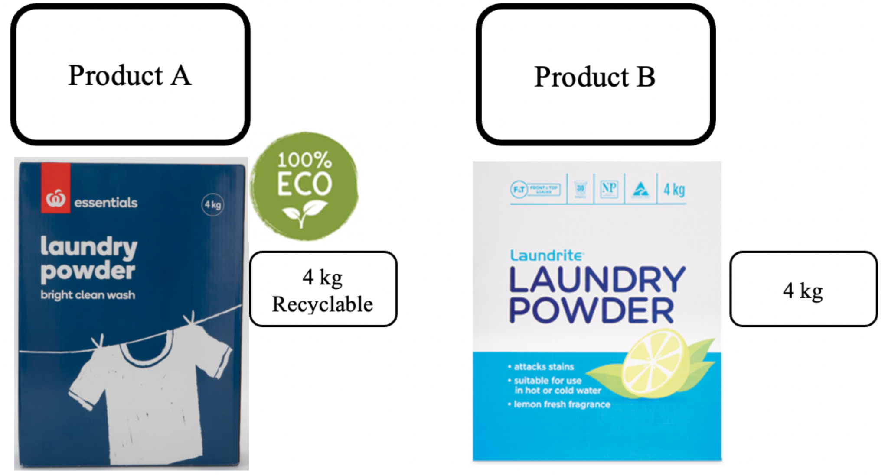

Price Product A: 4.50 Price product B: 6.00

The information on Product A was believable. (Johnson & Kaye’s, 2002)
1-2-3-4-5 (Not all believable – very believable)

The information on Product A was fair. (Johnson & Kaye’s, 2002)
1-2-3-4-5 (Not all believable – very believable)

Product A is trustworthy. (Everard & Galletta, 2006)
1-2-3-4-5-6-7 ( 1 = strongly disagree and 7 = strongly agree)

Product A is of high quality. (Everard & Galletta, 2006)
1-2-3-4-5-6-7 ( 1 = strongly disagree and 7 = strongly agree)

How likely are you to purchase product A? (J.G. Maxham III, 1999)
1-2-3-4-5-6-7 (Very unlikely – very likely)

Which product would you most likely buy? (J. Rokka & L. Uusitalo, 2008)
Product A
Product B

Examine the environmental concern of respondent

Please consider your own environmental awareness and respond to the following four statements:
(Melody E. Schuhwerk & Roxanne Lefkoff-Hagiu, 1995)

I am concerned about the environment.
1-2-3-4-5-6-7 (strongly disagree – strongly agree)

The condition of the environment affects the quality of my life
1-2-3-4-5-6-7 (strongly disagree – strongly agree)

I am willing to make sacrifices to protect the environment
1-2-3-4-5-6-7 (strongly disagree – strongly agree)

My actions impact the environment
1-2-3-4-5-6-7 (strongly disagree – strongly agree)

Part 3 – Simulation checks
CHECKPRODUCT
Which of these products was shown to you?
a. Avocado
b. Television

I ask you for some minor personal information. This information will remain anonymous.

Part 4 - Demographics

NATIONALITY
What is your nationality?
a. Dutch
b. Non-Dutch

GENDER
What is the highest degree or level of school you have completed?
a. Male
b. Female
c. Non-binary
d. Prefer not to say

AGE
What is your age?
… years

EDUCATION
What is the highest degree or level of school you have completed?
a. University (academic)
b. University of Applied Sciences (HBO)
c. College (MBO)
d. High school diploma
e. Other
Appendix B
Output model 4, complex samples: general linear model
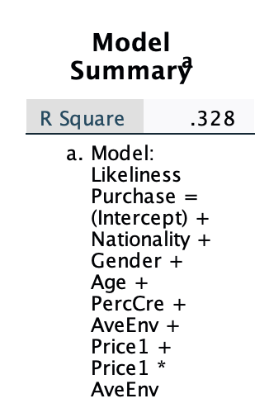
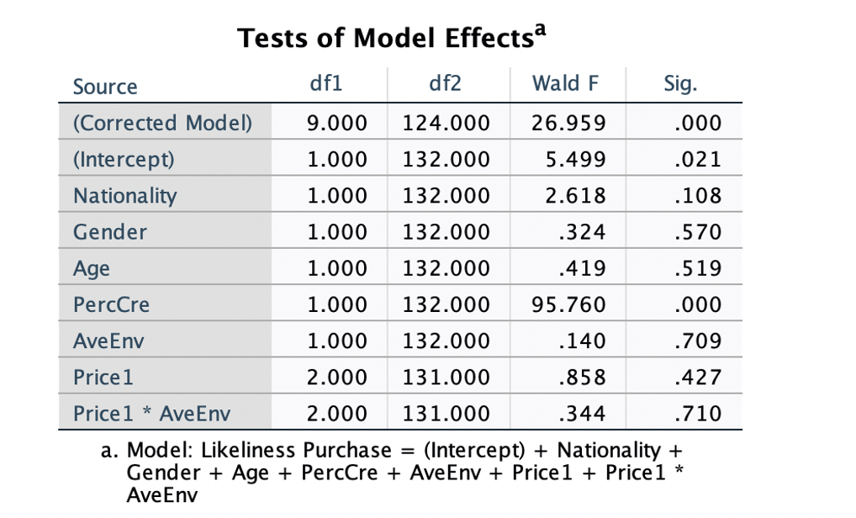
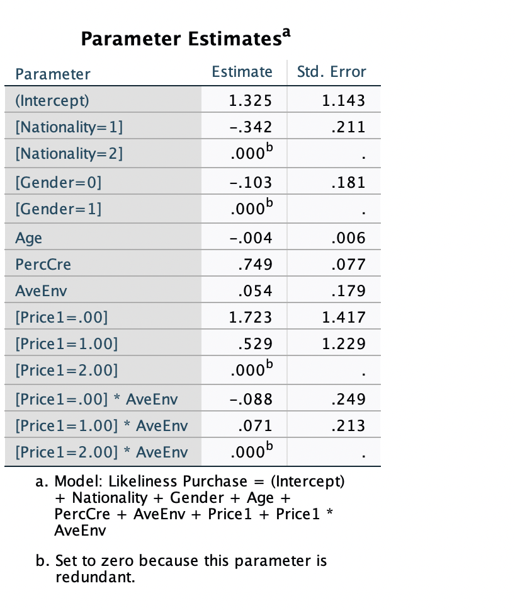

Output model 7, complex samples: general linear model
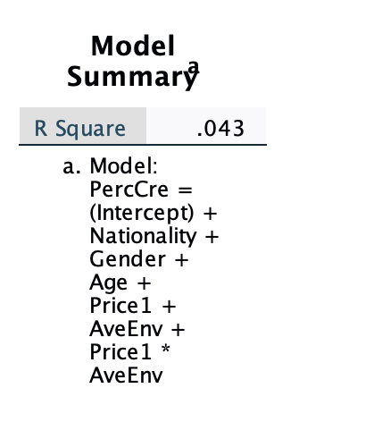
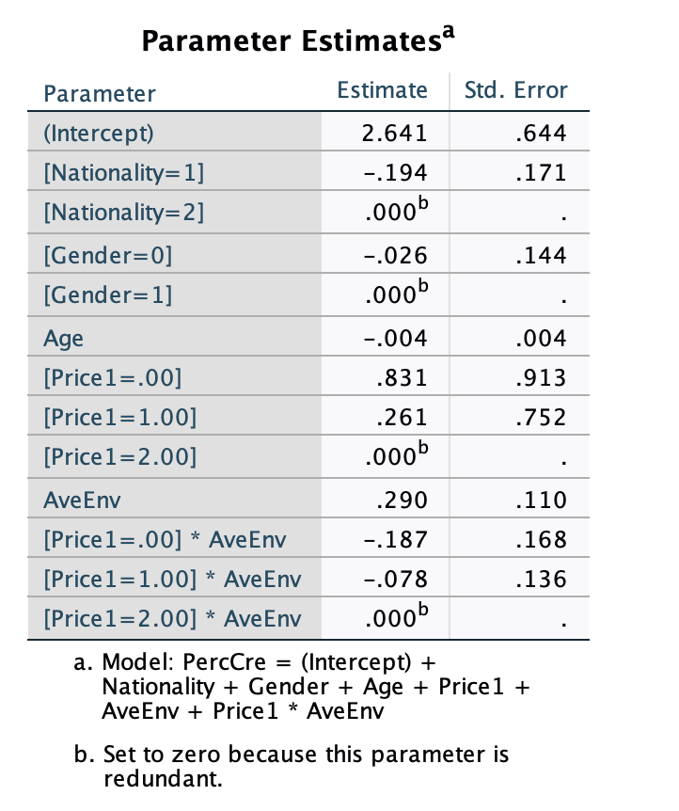
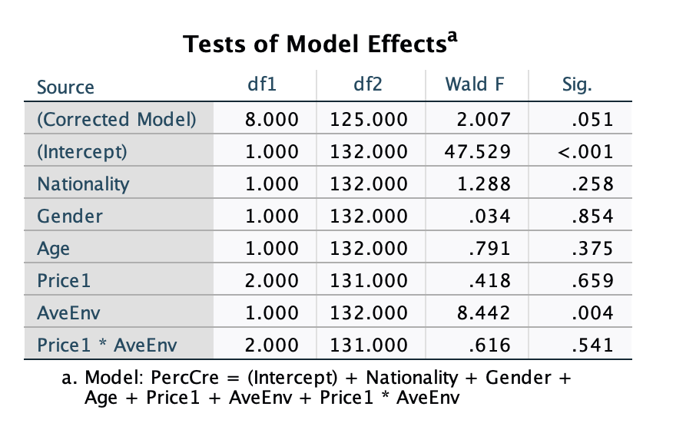

Appendix C

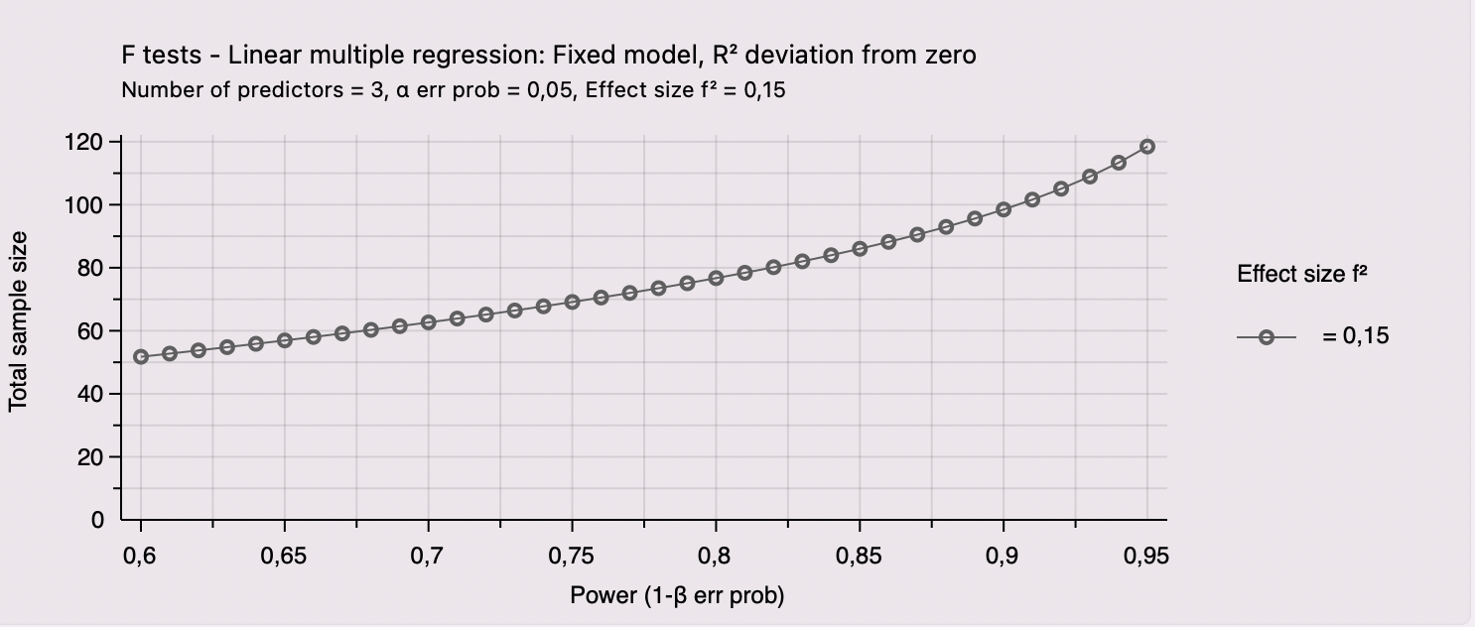
Appendix D
Internal reliability values product construct

Reliability Statistics
Cronbach's Alpha | Cronbach's Alpha Based on Standardized Items | N of Items
.837 | .856 | 5

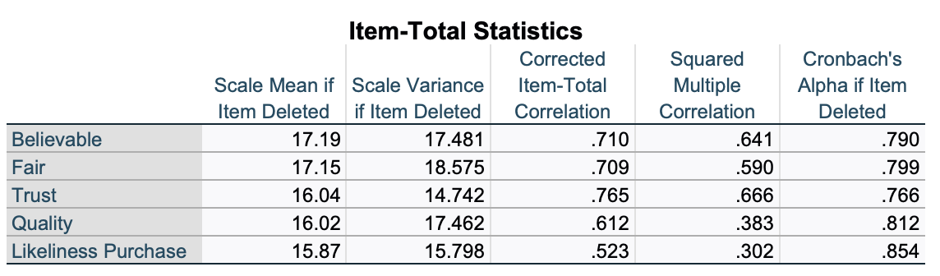

Appendix E
Internal reliability values environmental concern construct

Reliability Statistics
Cronbach's Alpha | Cronbach's Alpha Based on Standardized Items | N of Items
.740 | .751 | 4

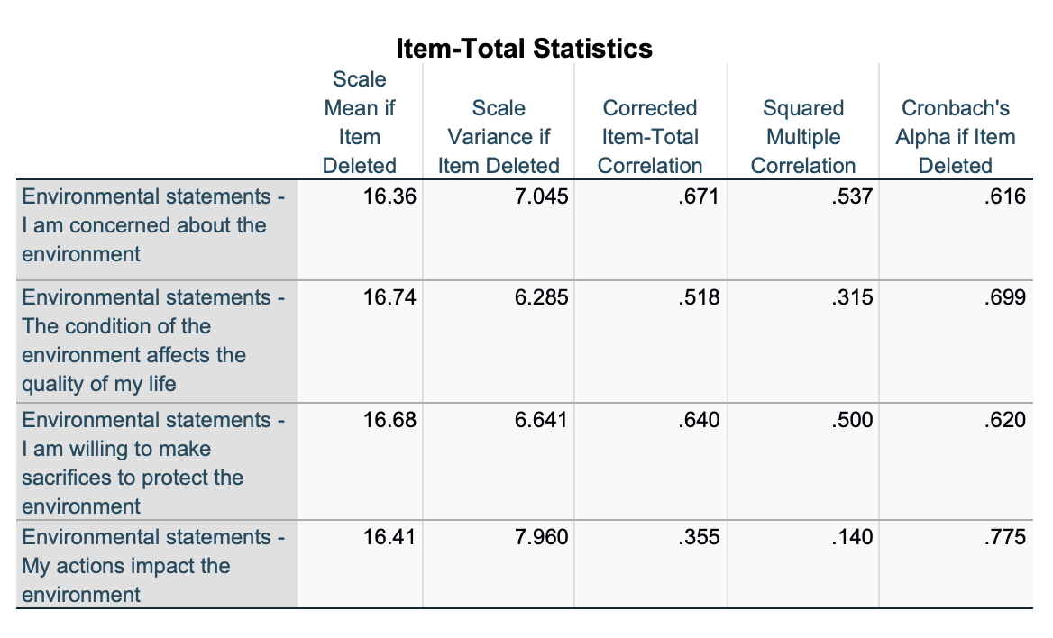

Appendix F

Statistics
What is your age? (Use numbers please)
N | Valid | 133
 | Missing | 0
Mean |  | 37.6992
Std. Deviation |  | 14.13248
Skewness |  | .497
Std. Error of Skewness |  | .210
Minimum |  | 21.00
Maximum |  | 67.00

What is your gender?
 | N | %
Male | 92 | 69.2%
Female | 41 | 30.8%

What is your nationality?
 | N | %
Dutch | 108 | 81.2%
Non-Dutch | 25 | 18.8%

