Layman’s summary
Regular exercise helps to prevent and treat several diseases. It is favourable for mental health, general well-being, and benefits the heart. As you may know, physical activity elevates heart rhythm, which causes an increase in blood flow to transfer oxygen and nutrients to your muscles. Incidentally, this can be experienced during sports as a fluttering feeling in the chest or an increased awareness of the heartbeat. In most of the cases, such apparent heartbeats are completely innocent. However, the heart can incidentally have issues with coordinating heartbeats correctly, which is called heart rhythm disease or arrythmia. Most arrythmias are innocent and do not directly affect the quality of life. However, in very rare cases, arrythmias can lead to abrupt loss of heart function when not managed carefully. Recent studies found that in very rare cases, practicing intensive endurance sports can be dangerous for individuals with underlying heart disease. Your heart needs to work harder when doing intense exercise, which might be a problem if your heart is damaged. When people engaged in intensive endurance sports are not aware of possible heart rhythm problems, it can put them at higher risk for a cardiac arrest during sports activity. Therefore, it is important to inform a physician if any warranting signals regarding the heart rhythm occur. Physicians can investigate the nature of the deviating heart rhythm and assess whether it is needed to make any adaptations in lifestyle, such as imposing sport restrictions. Luckily, in most cases, a divergent heart rhythm is innocent and does not require individuals to downscale the intensity or frequency of their training ritual. However, in rare cases intense sports activity worsens prognosis of the cardiovascular health of an athlete, or even worse contributes to fatal outcome. Therefore, interference by physicians is in some cases required. Nowadays, hhysicians have several tools to determine whether athletes are at higher risk if they continue with their sport ritual. Physicians map amongst others deviating heart beats, which are also called premature ventricular beats (PVCs). These beats origin from the ventricles rather than the sinoatrial node. PVCs can be recognized on an electrocardiogram, which is a record of a person’s heartbeat. PVCs might be an indicator to determine whether a patient is at risk for SCD-related arrythmia.
But how does a physician assess which PVC is innocent and which is harmful? This article provides a proposal for a tool to help physicians answering this important question. I investigated which characteristics of PVCs play an important role for this assessment. Is there a correlation between number of PVCs in 24h on a patient’s electrocardiogram and possible risk? Or is it more important how a single PVC is patterned? I also elaborate on the value of several clinical tools, such as the electrocardiography, a maximal exercise test, and cardiac magnetic resonance in case further investigation in athletes with PVCs is needed. To conclude, I summarized my findings in a flowchart, which can serve as a guideline for physicians to evaluate PVCs in athletes. This proposal might help physicians to evaluate PVCs and separate athletes which cardiovascular health is at risk because of their sport activities.
Name: Dirk Oerlemans
Study program: MSc Biology of Disease
Course: Writing Assignment
Student number: 9049894
Daily supervisor: M.D./PhD D.A.J.P. van de Sande
Examiner: dr. M.J.M Cramer
Second Reviewer: dr. A.S.J.M. te Riele
Date: 11-11-2022

Interpretation of premature ventricular contractions in athletes: a proposal for a diagnostic tool

Abstract
Premature ventricular contractions (PVCs) in athletes are usually benign, however they may rarely signal for underlying heart disease and risk of sudden cardiac death during intense sports activity. This literature review examines the clinical meaning of PVCs in the athlete. The article focuses on PVCs in the athletes covers the prognostic value of determinants, such as the absolute burden, the morphological pattern of the PVC, and the response to exercise. Furthermore, this article elaborates on the prognostic value of these elements for accurate risk stratification. A diagnostic tool is proposed at the end to help physicians manage the PVCs in the athlete. Diagnostic tools are differentiated in initial screening, first line investigation, and second line investigation to exclude underlying heart disease and provides a recommendation at which stage eligibility for athletes to participate in competitive sports should be reconsidered.

Introduction
Sudden cardiac death (SCD), presumably largely related to ventricular tachy-arrhythmia (VTA), is the leading cause of mortality in athletes during sport and exercise¹. Exercise-induced ventricular arrhythmia’s (VAs), such as non-sustained ventricular tachycardia (nsVT) or ventricular fibrillation (VF) can be a trigger for SCD in athletes with underlying heart disease^{2,3}. However, VAs are also regularly observed in athletes without cardiovascular abnormalities⁴. An ECG demonstrating a VA in the athlete are in most cases considered benign and reflect physiological adaptations of the heart in response to frequent exercise^{5,6}. Nonetheless, the diagnostic tool to assess risk for SCD through sports activity of athletes, with and without structural heart abnormalities, is still under debate². At present, physicians frequently use premature ventricular beats (PVCs) as a diagnostic tool to identify possible underlying arrhythmogenic substrates in athletes⁷. PVCs are spontaneous ectopic heartbeats that origin from the ventricles⁸. PVCs are extremely common and are measured in up to 75% of the athletes that undergo electrocardiogram (ECG) 24h ambulatory monitoring. Frequent PVCs (>60 per hour) or complex PVCs, which are more closely related to nsVT, or VF are observed in 1-4% of the cases. It is unknown whether the prevalence of PVCs is higher in athletes compared to their sedentary counterparts⁹. The majority of the PVCs are benign and disappear spontaneously¹⁰. However, PVCs may incidentally be an indicator for underlying heart disease which can trigger SCD ¹¹. Early recognition and management of malignant PVCs in these individuals may prevent for a fatal outcome⁹. Therefore, there is a clinical need for clear guidelines on how to evaluate PVCs in athletes without diagnosed cardiac disease with the purpose of risk stratification and to assess whether these athletes are still eligible for sports.

Initial screening
In case of suspicion of PVCs in the athletes, physicians need to establish whether the athlete has any underlying structural or functional cardiac abnormalities and need to examine the history of the athlete. If warranting signals of the athlete’s history or diagnosis are detected, a different protocol should be followed. This falls outside the scope of this article. This article focuses solely on the systematic approach to evaluate PVCs in athletes that are not diagnosed with any structural cardiac abnormalities yet and do not have a positive family history. Rest ECG at the clinic and 24h ECG ambulatory monitoring can be used to confirm the presence of PVCs in this initial stage.

PVC burden
The absolute burden of PVCs is historically used as the main criterium for PVC risk stratification in athletes¹⁰. A study found underlying heart disease, mainly cardiomyopathy and valve pathology, in up to 30% percent of the athletes with ≥2000 PVCs in 24h¹. A significantly smaller burden, ≥500 PVCs per 24 hours on a resting ECG, is roughly considered as a threshold to assume reasonable risk on arrhythmogenic cardiomyopathy (ACM)². The international criteria for electrocardiographic interpretation in athletes states that two or more PVCs on a resting ECG are required to initiate further investigation⁵. However, a retrospective study of the ECG recordings of SCD victims demonstrated that even a single PVC may be a warning sign for underlying heart disease patients at risk of SCD¹³. On the other hand, the prevalence of PVCs in athletes is similar to their sedentary counterparts, which makes the decision for in-depth investigation only based on absolute numbers debatable¹². Significant variation was found in PVC burden between individuals that underwent fourteen-day monitoring by a Holter¹⁴. It is commonly recognized that PVC occurrence depends on the activity of the autonomic nervous system which fluctuates throughout the day. Specifically, PVC occurrence is heart rate dependent and is also affected by blood pressure¹⁴. The latter supports the argument that it is not reliable to stratify risk for athletes to develop future ventricular arrhythmogenic burden solely based on absolute PVC numbers in 24h. On top of this, lifestyle factors, such as dysregulated sleep, dietary patterns, psychological stress, and physical activity are some of the determinants that either under- or overestimate PVC burden¹⁵. Therefore, other risk stratifiers should preferably be examined as well to guide diagnostic evaluation of PVCs in athletes¹⁰. And if absolute PVC burden is maintained as the main criterium for potential clinical follow-up, it should be considered to monitor the athlete for a period of fourteen days rather than 24h for a more accurate reflection of the absolute PVC burden¹⁴.

PVC morphology
Additional to determining the absolute PVC burden, the morphology of PVCs helps physicians to unravel the site of origin of VA. PVCs can be divided into two categories, idiopathic and malignant arrhythmogenic patterns.

Idiopathic PVCs
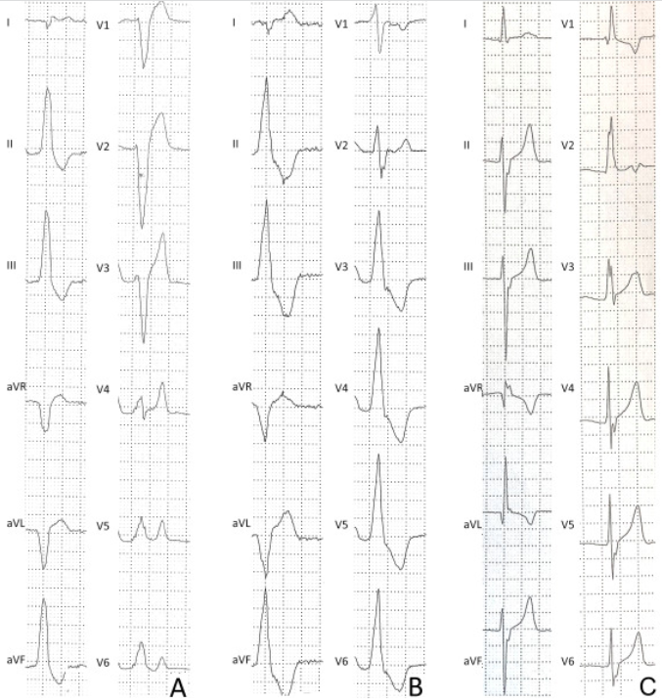
Benign PVCs, also called idiopathic PVCs, are the most common PVCs and have a well-defined site of origin¹⁶. Idiopathic PVCs have a favourable prognosis because of the absence of a myocardial substrate. Idiopathic PVCs origin in most cases from the right ventricular outflow tract (RVOT) or the left ventricular outflow tract (LVOT). PVCs originating from the LVOT are characterized by a left bundle branch block (LBBB) with an inferior axis and are also known as infundibular PVCs (Fig 1). A LBBB represents delayed activation of the left ventricle and is denoted by a negative QRS-complex in V1. The inferior axis denotes that the wave of depolarization occurs downwards in a frontal plan. This is indicated in an ECG by a negative aVL lead and positive II, III and aVF leads. Whether the PVC is sourced from either the LVOT or the RVOT depends on the morphology that is displayed by the precordial leads. These precordial leads show a turnover from a negative QRS complex to a positive QRS complex somewhere between V2 and V6, commonly referred to as the QRS transition. A positive QRS complex in V2 or V3 already indicates that the arrythmia origins in the RVOT (Fig 1A), whereas a positive QRS complex beyond V3 points out that the arrythmia starts in the LVOT (Fig 1B)¹⁰. PVCs with a fascicular morphology are also considered benign when the QRS complex has a short duration (<130ms). ‘Fascicular’ refers to the origin site of these PVCs, which is the left fascicle of the left bundle branch. A fascicular PVC is characterized by a right bundle branch block (RBBB). This can be recognized on an ECG by a deviating QRS-complex, which is displayed with a so called rSR pattern in V1 and a widened S wave in V6 (Fig 1C). An rSR pattern is a variation of the QRS complex with subsequently a small s wave followed by a big S wave and a big R wave. The left posterior fascicle is most likely the arrhythmogenic origin site when the RBBB has a superior axis. However, if the RBBB has an inferior axis, it is more plausible that the left anterior axis is the source of the idiopathic PVC¹² ¹⁰.

Figure 1 Morphologies of common premature ventricular beats in healthy athletes. Premature ventricular beat with negative QRS complex in V1 and inferior QRS axis, consistent with origin from the right ventricular outflow tract (A). Premature ventricular beat with negative QRS complex in V1 (left bundle branch block- like pattern) and inferior QRS axis in the limb leads, suggestive of the origin from the left ventricular outflow tract (B). Premature ventricular beat with a narrow QRS (120–130 ms) and typical right bundle branch block/superior axis configuration, suggestive of the origin from the posterior fascicle of the left bundle branch (C) Adopted from Corrado et al. 2020 ⁷.

Malignant PVCs
Malignant PVC morphologies are characterized by highly uncommon patterns (Fig 2). For example, a LBBB/RBBB morphology with an intermediate/superior axis or an atypical RBBB morphology that slightly differs from an archetypal RBBB and a wide QRS complex (130ms). These arrhythmogenic patterns seemingly originate from the interventricular septum and the mitral valve annulus, respectively. These patterns are associated with structural heart disease and should be evaluated further by a physician¹⁰. Patterns that are only characterized by an axis deviation without a bundle branch block are not associated with any major structural or functional abnormalities¹⁷. Also, uncommon morphologies are regularly observed consecutively, which is defined as a complex PVC. Complex PVCs can appear in multiple morphologies such as a couplet, a triplet, or a nsVT. It is characterized by a short coupling interval (<300ms) with a short QRS complex duration and a normal QT interval ¹⁸. Athletes should visit a specialist in case of complex VAs because these warrant for VF¹⁰. Some studies on cardiac arrest survivors or patients with VF suggested that early repolarization also enhances the risk on VF^{19,20}. However, based on current evidence, all patterns of early repolarization in athletes, without any clinical complications, should be considered benign²¹.
﻿
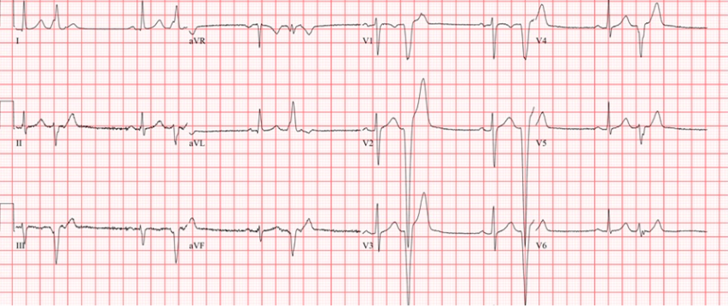
Figure 2. Right ventricular apical PVCs in a patient with early ARVC. PVC morphology in this case is a LBBB with a superior axis. Adopted from Darden & Prutkin 2022¹⁰.
The morphology of a PVC is of value to physicians to gain insight into the nature of the PVC and possible correlation with structural heart disease. However, like the absolute burden, studying the ECG patterns of a PVC is not completely trustworthy. ECG has its limitations in sensitivity and specificity. In some cases, the ECG of an athlete with structural heart disease might demonstrates an ECG without any deviations⁵. Furthermore, patterns that are considered benign incidentally turn out to be malignant and vice versa. Also, PVCs can still have an impact on the wellbeing of athletes, even when occurring in small numbers with apparent benign morphology. This can be experienced as a fluttering feeling in the chest or an increased awareness of the heartbeat, which might raise concern in athletes about their cardiovascular health¹⁰. Therefore, symptomatic athletes with apparent PVCs should also be considered for further investigation, depending on the specific symptoms.

First line investigation
Further non-invasive first line evaluation in athletes is needed in the occurrence of a high burden of PVCs, when uncommon morphological patterns/complex PVCs are perceived or occasionally in the presence of worrying symptoms. In this case, a physician should evaluate the in-depth medical history of the athlete such as family history or map possible lifestyle-interference by factors, such as the use of performance enhancing drugs, and lifestyle factors including sleep and dietary habits. Furthermore, a maximal exercise test with an echocardiography should be added to the diagnostic strategy to enlarge sensitivity and specificity. These tools are relatively wide available, inexpensive and feasible compared to second line investigation tools¹⁰.

Maximal Exercise Testing
The nature of PVCs can be further specified into two different categories: exercise-supressed PVCs (ES-PVCs) and exercise-induced PVCs (EI-PVCs)¹². ES-PVCs are in most cases benign. These arrhythmic patterns do usually have an infundibular origin, although robust data is missing⁵. In contrast, EI-PVCs may be an indicator of the presence of a myocardial substrate, such as ischaemic heart disease or ACM ^{22,23}. These cardiac syndromes can cause VAs that are stimulated by the adrenergic system through exercise. If this is the case, then VA can degenerate into VF which is the most frequent cause of SCD. Especially EI-PVCs with varied morphologies and beat-to-beat-alternation are related to an elevated risk on exercise-related SCD¹². The nature of PVCs can be unravelled by means of non-invasive exercise training¹²
Maximal exercise testing is an important tool to evaluate athletes with suspected ischaemic heart disease. While exercising, coronary blood flow must increase to meet the higher metabolic need of the myocardial cells. If the coronary blood flow is limited, abnormalities will most likely become apparent on an echocardiography²⁴. A possibility for such an exercise stress test (EST) would be the cardiopulmonary exercise test (CPET), which allows for thorough investigation of the cardiovascular system during exercise-induced stress. This type of ramp test, which is usually performed on a bike or a treadmill, can reveal ischaemic heart anomalies that are not demonstrated at rest. A CPET starts at a low work rate and progressively increases until indications for termination or exhaustion by the athlete and typically takes eight to twelve minutes²⁵. However, EST is less reliable as diagnostic tool to produce circumstances that elicit VTAs, which are strongly associated with ACM²³. VTAs typically occur during sudden catecholamine driven surges (e.g., a sprint), which cause a prompt heart rate increase during gradual increments. Therefore, a novel test strategy was used, a method which is referred to as the burst protocol. Burst EST, characterized by abrupt high-intensity workload rates at the immediate onset of testing, better mimics a typical VTA-triggering event and could improve diagnostic sensitivity or contribute to therapeutic decision-making²⁶

Echocardiography
First line testing with maximal exercise should be combined with echocardiography to identify possible structural cardiac abnormalities in athletes with a high burden of PVCs, complex PVCs and/or severe symptoms. Echocardiography is a common imaging technique to examine amongst others systolic and diastolic function, ventricular wall thickness, and chamber size. This ultrasound of the heart also points out potential wall motion abnormalities which raise the suspicion for ischaemic heart disease, valvular abnormalities, or cardiomyopathies¹². Echocardiography is also able to point out congenital coronary artery abnormalities, which are the main cause of ischaemia induced VA and SCD²⁷. It was demonstrated that echocardiography is a very feasible manner to exhibit coronary arteries of young athletes who mostly have a clear ultrasound with high image quality²⁸. Current state-of-the-art points out two techniques including transthoracic echocardiography (TTE) and speckle tracking echocardiography (STE).
Nowadays, TTE is recommended in first line evaluation of PVCs to exclude underlying structural heart disease. Throughout the years this widespread method is known for its ability to detect cardiac pathology. Furthermore, this technique is available and relatively inexpensive²⁹. Nonetheless, this conventional imaging technique has recently been doubted for its competence as a diagnostic tool to detect arrhythmogenic myocardial substrates in response to abundant/complex PVC findings³⁰. This technique primarily uses left ventricle ejection fraction (LVEF) as a parameter to assess left ventricle function. However, the TTE of an athlete can still manifest an immutable LVEF in the presence of more subtle LV dysfunction³¹. Two-dimensional STE is considered as an alternative imaging technique. STE analyses the motion of speckles, which are natural acoustic markers that appear as bright and dark spots within the LV wall. These speckles result from interactions, such as reflections, scattering, or interference of an ultrasound beam with myocardial tissue. STE assumes that the acoustic markers stick to the tissue and do not alternate their pattern in consecutive frames³². In contrary to TTE, STE also recognizes electromechanical changes, such as deviations in radial, longitudinal and/or circumferential strain (Fig 3)³³. Therefore, it has more possibilities to detect subtle myocardial dysfunction, in some cases already in subclinical state³⁴. It has already demonstrated its prognostic significance in hypertrophic cardiomyopathy³⁵. However, according to an editorial in response to this study, a downside from this technique is the limited accuracy to determine RV strain, due to relatively small RV wall thickness compared to LV. This consistently results in reported cases of poor-quality strain image when this technique is applied³⁶. The same editorial also disputes that the additional value of subtle change, such as slightly attenuated strain properties, are caused by PVCs or an independent condition³⁶.
General constrains of echocardiography are its inability to detect intramyocardial course of coronary arteries, atherosclerotic coronary artery stenosis and apical hypertrophy. Therefore, it should be considered to proceed to second line investigation in case of high-risk PVC morphologies and a warranting exercise test result.
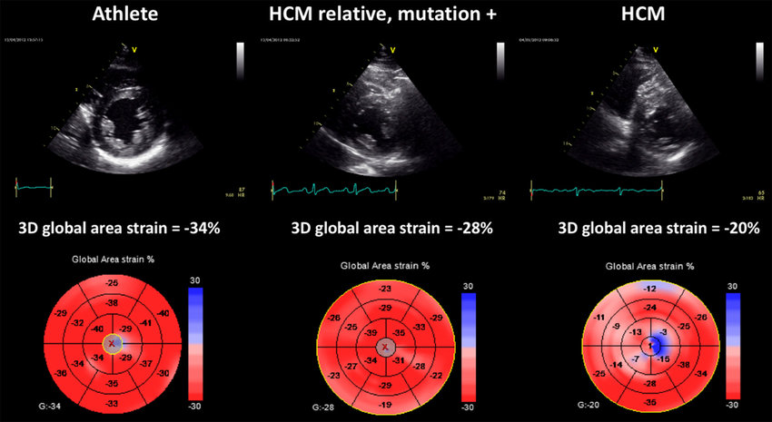
Figure 3. Three-dimensional speckle tracking analysis of global area strain in three subjects: an athlete having normal area strain values (left); a HCM-mutation carrier having mildly reduced global area strain values (middle); a HCM patient with severe reduction in global area strain due to impaired deformation of myocardial segments. Adapted from Muraru et al. 2017

Detraining
Unfortunately, the prognostic value of detraining athletes with PVCs is debatable regarding several conflicting studies. For instance, there is a study that demonstrates that the arrhythmogenic burden of Olympic athletes diminishes or completely disappears with detraining³⁷. However, in subsequent studies was found that retraining did not cause reappearance of PVCs and that there is no correlation between the PVC burden and the degree of LV hypertrophy caused by training³⁸. Furthermore, no differences were found in VA burden during a follow-up in a group of athletes that continued with training compared to a group that paused their sports activities³⁹. Therefore, it is unlikely that detraining resolves PVC occurrence in athletes.

Second line Investigation
If there is still concern for underlying cardiac pathology at this stage, more thorough in-depth investigation should be executed¹². The golden standard for in-depth investigation is a cardiac magnetic resonance with late gadolinium enhancement (CMR with LGE). It should be considered to impose sport restrictions in the meantime, and to advise on possible identified triggers, such as illicit drug or stimulant use, sleep deprivation or poor recovery ¹⁰.

Cardiac Magnetic Imaging with Late Gadolinium Enhancement
CMR (Fig 4) provides additional information to echocardiography in athletes with PVCs ⁴⁰ ⁴¹. It stands out from echocardiography because of its unique competence to detect and quantify abnormalities, such as oedema and fatty penetration. This more costly and time consuming technique is also able to discover the possible presence of non-ischaemic LV scar formation through LGE¹². The latter would be missed in a significant proportion of athletes in echocardiography with apparent undefined PVCs because of its subepicardial location. An isolated non-ischaemic LV scar is associated with life-threatening VAs and SCD in the athlete⁷. Therefore, it has become a key test as a follow-up for complex PVCs or exercise-induced PVCs in athletes⁴².
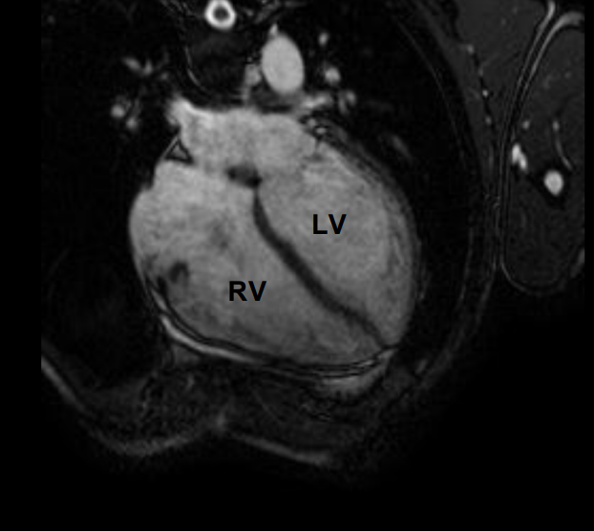
Figure 4. Cardiac magnetic resonance in an endurance athlete (long-distance swimmer). A symmetric dilatation of both right and left ventricular chambers is depicted in a four -chamber view. Adapted from D’andrea et al, 2021 ⁴¹.

Summary of the evaluation of athlete’s PVCs
Table 1 summarizes the PVC characteristics that seem to have the highest prognostic value. ﻿The decision for more thorough investigations should be mainly determined by the assessment of morphology, exercise inducibility of PVBs and an echocardiography rather than by the absolute burden of PVC by 24-h ambulatory monitoring. The golden standard for further investigation is by means of CMR with LGE, which can exclude a pathological myocardial tissue anomalies that would be missed by echocardiography.
Table 1. Overview of major determinants for risk stratification of premature ventricular beats in athletes
PVC Characteristic | Usually benign | May be associated with myocardial substrate
PVC morphology | Infundibular PVC or fascicular PVC | LBBB with intermediate or superior axis, atypical RBBB pattern
Response to exercise | Suppression | Inducement
Imaging abnormalities | No | Yes
Fig. 4 represents a practical diagnostic tool for physicians for the clinical evaluation of PVCs in athletes. In conclusion, Initial screening includes evaluating the anamneses of the athlete, measure ECG of the athlete at rest in the clinic and using ECG 24h ambulatory monitoring. The latter can be used to determine PVC burden and the morphology of the PVCs. If there are still warranting signals, such as a high burden (>500 PVCs) or the presence of complex PVCs, further investigation is needed by means of a maximal exercise test with an echocardiography. This can be used to exclude the presence of EI-PVCs and to map echocardiography abnormalities that require further investigation. If there are still warranting signals after first line investigation, temporary sport restrictions and the use of CMR with LGE should be considered to exclude reasonable risk on malignant VAs due to their sport activities. In this case, sports eligibility should be dependent on the outcome of this final second line investigation.
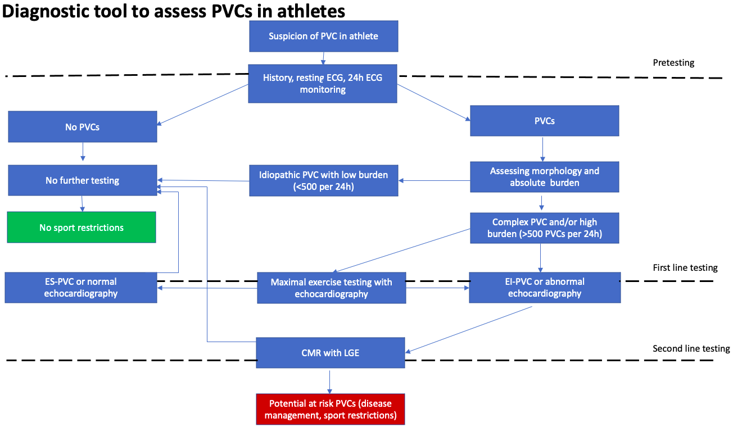
Figure 6. Proposed diagnostic tool for evaluation of athletes with premature ventricular contractions

References
1. Biffi, A. et al. Long-term clinical significance of frequent and complex ventricular tachyarrhythmias in trained athletes. J. Am. Coll. Cardiol. 40, 446–452 (2002).
2. Verdile, L. et al. Clinical significance of exercise-induced ventricular tachyarrhythmias in trained athletes without cardiovascular abnormalities. Hear. Rhythm 12, 78–85 (2015).
3. Mont, L. et al. Pre-participation cardiovascular evaluation for athletic participants to prevent sudden death: Position paper from the EHRA and the EACPR, branches of the ESC. Endorsed by APHRS, HRS, and SOLAECE. Eur. J. Prev. Cardiol. 24, 41–69 (2017).
4. Pilcher, G. F., Cook, A. J., Johnston, B. L. & Fletcher, G. F. Twenty-four-hour continuous electrocardiography during exercise and free activity in 80 apparently healthy runners. Am. J. Cardiol. 52, 859–861 (1983).
5. Sharma, S. et al. International recommendations for electrocardiographic interpretation in athletes. Eur. Heart J. 39, 1466–1480 (2018).
6. Zorzi, A. et al. Burden of ventricular arrhythmias at 12-lead 24-hour ambulatory ECG monitoring in middle-aged endurance athletes versus sedentary controls. Eur. J. Prev. Cardiol. 25, 2003–2011 (2018).
7. Zorzi, A. et al. Ventricular arrhythmias in young competitive athletes: Prevalence, determinants, and underlying substrate. J. Am. Heart Assoc. 7, (2018).
8. Koester, C., Ibrahim, A. M., Cancel, M. & Labedi, M. R. The Ubiquitous Premature Ventricular Complex. Cureus 12, 1–10 (2020).
9. D’Ascenzi, F. et al. The prevalence and clinical significance of premature ventricular beats in the athlete. Scand. J. Med. Sci. Sport. 27, 140–151 (2017).
10. Darden, D. & Prutkin, J. M. Premature Ventricular Contractions in Athletes : Insight into Evaluation and Management. Am. Coll. Cardiol. 1–10 (2022).
11. Ben Halima, A. et al. Assessment of premature ventricular beats in athletes. Ann. Cardiol. Angeiol. (Paris). 68, 175–180 (2019).
12. Corrado, D., Drezner, J. A., D’Ascenzi, F. & Zorzi, A. How to evaluate premature ventricular beats in the athlete: Critical review and proposal of a diagnostic algorithm. Br. J. Sports Med. 54, 1142–1148 (2020).
13. Corrado, D., Basso, C., Schiavon, M. & Thiene, C. Screening for hypertrophic cardiomyopathy in young athletes. N. Engl. J. Med. 339, 364–369 (1998).
14. Mullis, A. H. et al. Fluctuations in premature ventricular contraction burden can affect medical assessment and management. Hear. Rhythm 16, 1570–1574 (2019).
15. Reginato, E. et al. Dietary and lifestyle patterns are associated with heart rate variability. J. Clin. Med. 9, 1–17 (2020).
16. Eugenio, P. L. Frequent Premature Ventricular Contractions: An Electrical Link to Cardiomyopathy. Cardiol. Rev. 23, 168–172 (2015).
17. Gati, S. et al. Should axis deviation or atrial enlargement be categorised as abnormal in young athletes? the athlete’s electrocardiogram: Time for re-appraisal of markers of pathology. Eur. Heart J. 34, 3641–3648 (2013).
18. von Alvensleben, J. C., Etheridge, S. P., Viskin, S. & Collins, K. K. Short-coupled premature ventricular beats leading to ventricular fibrillation in a young patient: A Sudden Arrhythmia Death Syndrome case report and literature review. HeartRhythm Case Reports vol. 6 815–818 (2020).
19. Rosso, R. et al. J-Point Elevation in Survivors of Primary Ventricular Fibrillation and Matched Control Subjects. Incidence and Clinical Significance. J. Am. Coll. Cardiol. 52, 1231–1238 (2008).
20. Antzelevitch, C. et al. J-Wave syndromes expert consensus conference report: Emerging concepts and gaps in knowledge. Hear. Rhythm 13, e295–e324 (2016).
21. Quattrini, F. M. et al. Benign clinical significance of J-wave pattern (early repolarization) in highly trained athletes. Hear. Rhythm 11, 1974–1982 (2014).
22. Dzikowicz, D. J. & Carey, M. G. Exercise-Induced Premature Ventricular Contractions Are Associated With Myocardial Ischemia Among Asymptomatic Adult Male Firefighters: Implications for Enhanced Risk Stratification. Biol. Res. Nurs. 22, 369–377 (2020).
23. Assis, F. R. & Tandri, H. Epicardial Ablation of Ventricular Tachycardia in Arrhythmogenic Right Ventricular Cardiomyopathy. Card. Electrophysiol. Clin. 12, 329–343 (2020).
24. Hill, J. et al. Clinical review ABC of clinical electrocardiograph ^ Exercise tolerance testing. 324, 1084–1087 (2017).
25. Tran, D. Methods in Molecular Biology. (2018).
26. Roston, T. M. et al. Burst Exercise Testing Can Unmask Arrhythmias in Patients With Incompletely Penetrant Catecholaminergic Polymorphic Ventricular Tachycardia. JACC Clin. Electrophysiol. 7, 437–441 (2021).
27. Prakken, N. H. et al. Screening for proximal coronary artery anomalies with 3-dimensional MR coronary angiography. Int. J. Cardiovasc. Imaging 26, 701–710 (2010).
28. Zeppilli, P. et al. In vivo detection of coronary artery anomalies in asymptomatic athletes by echocardiographic screening. Chest 114, 89–93 (1998).
29. Latchamsetty, R. & Bogun, F. Premature Ventricular Complex-induced Cardiomyopathy. Rev. Española Cardiol. 69, 365–369 (2016).
30. Scorza, R., Shahgaldi, K., Rosenqvist, M. & Frykman, V. Evaluation of patients with high burden of premature ventricular contractions by comprehensive transthoracic echocardiography. IJC Hear. Vasc. 42, 101124 (2022).
31. Wijnmaalen, A. P. et al. Beneficial effects of catheter ablation on left ventricular and right ventricular function in patients with frequent premature ventricular contractions and preserved ejection fraction. Heart 96, 1275–1280 (2010).
32. Mondillo, S. et al. Speckle-Tracking Echocardiography. 71–83 (2011).
33. Muraru, D., Niero, A., Rodriguez-Zanella, H., Cherata, D. & Badano, L. Three-dimensional speckle-tracking echocardiography: Benefits and limitations of integrating myocardial mechanics with three-dimensional imaging. Cardiovasc. Diagn. Ther. 8, 101–117 (2018).
34. Fonseca, M. et al. Premature ventricular contractions of the right ventricular outflow tract: is there an incipient underlying disease? New insights from a speckle tracking echocardiography study. Indian Pacing Electrophysiol. J. 21, 147–152 (2021).
35. Smiseth, O. A., Torp, H., Opdahl, A., Haugaa, K. H. & Urheim, S. Myocardial strain imaging: How useful is it in clinical decision making? Eur. Heart J. 37, 1196-1207b (2016).
36. Roukoz, H. Speckle tracking echocardiography for management of patients with PVCs and normal ejection fraction. Indian Pacing Electrophysiol. J. 21, 153–155 (2021).
37. Biffi, A. et al. Impact of physical deconditioning on ventricular tachyarrhythmias in trained athletes. J. Am. Coll. Cardiol. 44, 1053–1058 (2004).
38. Biffi, A. et al. Relation Between Training-Induced Left Ventricular Hypertrophy and Risk for Ventricular Tachyarrhythmias in Elite Athletes. Am. J. Cardiol. 101, 1792–1795 (2008).
39. Delise, P. et al. Influence of training on the number and complexity of frequent VPBs in healthy athletes. J. Cardiovasc. Med. 12, 157–161 (2011).
40. Nucifora, G. et al. Prevalence and prognostic value of concealed structural abnormalities in patients with apparently idiopathic ventricular arrhythmias of left versus right ventricular origin: A magnetic resonance imaging study. Circ. Arrhythmia Electrophysiol. 7, 456–462 (2014).
41. D’andrea, A. et al. The role of multimodality imaging in athlete’s heart diagnosis: Current status and future directions. J. Clin. Med. 10, (2021).
42. Cipriani, A. et al. Predictive value of exercise testing in athletes with ventricular ectopy evaluated by cardiac magnetic resonance. Hear. Rhythm 16, 239–248 (2019).

