Decreasing Teenage Readership Rates in Lithuania: Exploring Causes and Suggesting Solutions

Laurynas Petrauskas
6544908
MA Thesis
15 August 2022
Supervisor: Dr. Jeroen Salman
Second accessor: Dr. Mia You

Contents
1. Abstract 3
2. Introduction 4
3. Overview of the most recent teenage and children readership tendencies 6
4. Benefits of reading 8
5. Theoretical Framework 11
5.1 Hans-Robert Jauss and the ‘horizon of expectations’ 11
5.2 Hans-Georg Gadamer and the ‘fusion of horizon’ 14
5.3 Wolfgang Iser and ‘the implied reader’ 15
6. Methodology 18
7. Results 21
7.1 Quantitative 21
7.1.1 Part one: General perception of reading 21
7.1.2 Part two: External influences on the importance and interest in reading 35
7.1.3 Part three: Reading habits and preferences 53
7.2 Qualitative 74
8. Conclusion 84
9. Discussion 87
Works Cited 88
Appendix 91

Abstract

Over the past years, Lithuania has faced a dramatic decrease in teenage readership rates, urging a circumstantial investigation of the causes. Previous research has explored the issue only by interviewing teenagers themselves and has thus overlooked the potential of an objective evaluation of the situation from a professional vantage, for example, that of teachers. This thesis conducts both quantitative and qualitative research. It examines the main causes of such high lack of interest in reading amongst Lithuanian teenagers through a questionnaire distributed amongst students and a set of open-ended questions for teachers. In contrast to what has been assumed in the hypothesis, the stringent curriculum is not the main cause of the decline in readership numbers. The main causes of the decline in teenage readership rates, this thesis shows, depend on other factors, such as poor concentration, low text comprehension skills, and the severe impact of modern technologies.

Introduction

Research on the reading habits of Lithuanian children conducted by the National Library of Lithuania in 2021 is an invaluable source, which shows the most recent readership tendencies among children. However, it only interviewed students from 1st to 10th grades and did not involve teachers. If one is to determine the reasons children are spending less and less time reading, it is crucial to interview students’ teachers, too. Insights from a professional background, especially that of education, cannot be overlooked. Therefore, in this thesis, my goal is to identify the latest readership tendencies of Lithuanian teenagers whilst also including the critical opinion of teachers. By asking both students and teachers to participate, I have sought to find ways of encouraging teenage readership. The main question I aim to answer is the following: What are the predominant reasons for decreasing numbers of teenage readers in Lithuania, and by what means can these numbers be increased?
In this thesis, I first introduce a brief overview of the most recent reading tendencies amongst teenagers in Lithuania to show that their number is indeed decreasing. Secondly, I outline the benefits of reading for children and teenagers in order to establish the foundational importance of the practice. In what follows, I present the methodology and provide the theoretical framework, namely Hans-Robert Jauss’s the ‘horizon of expectations’, Hans-Georg Gadamer’s the ‘fusion of horizon’, and Wolfgang Iser’s concept of ‘the implied reader’. All three notions argue for placing emphasis on the reader rather than the text, and thereby serve as an academic framework for this thesis regarding the influence over teenage readership numbers in Lithuania. The hypothesis set forth in this thesis is based on the premise that teenagers are constrained by the school curriculum, and do not have much freedom to choose literature of their own accord. As a consequence, they lose interest in reading, and teachers who are bound to be strictly following the curriculum are not able to help their students to explore literature outside of the programme. Finally, I present the findings gathered from both quantitative and qualitative parts of this research and discuss them through the lens of the theoretical framework outlined above.

Overview of the most recent teenage and children readership tendencies

According to the data gathered by the Central Intelligence Agency, in 2011 Lithuania’s literacy rate was 99,82%. Globally, therefore, Lithuania is one of the most literate countries in the entire world. However, this number does not seem to reflect itself in the reading habits of Lithuanian youths. Even though more than half of the students answered that they enjoy reading, research on children readership of Lithuania conducted by the National Library of Lithuania shows that in 2021 the readership rates among kids at schools are not as exceptional as one might expect. While more than half of the 10 — 11-year-old children responded that they love reading very much, only 10% of the 13 — 14-year-old students did. Fortunately, enthusiasm for reading seems to revive in high-school as 10th graders take up the notion of reading more seriously (“Vaikų ir paauglių skaitybos tyrimo 2021” rezultatai” 20). In contrast, a graph representing the frequency of how often students read as opposed to how much they enjoy it shows that the numbers are dramatically declining, and that they are spending less and less time reading. For example, according to the data, the percentage of 1st year students who read daily or almost daily is 76% as opposed to only 16% of 9th graders, hence 14 — 15-year-old students, who do the same. Besides, as much as 25% of the children in the 9th grade either barely ever read, or do not read at all.
An interesting dimension opens up when one looks at the results in response to the question of whether they believe that reading is important. At least 80% of students from each year answered that they believe it is. Hence, the absolute majority of teenagers recognize the importance of reading. It is clearly observable that benefits that come from reading. Students gave a variety of answers with “expanding knowledge” (35) being the most common one. Unfortunately, at the same time, these teenagers cannot seem to reap those benefits, even if they are aware of them. As research shows, most of the students merely do not find time to read or cannot find literature that they like. For both of these issues the percentage of students is 30% and 31% respectively (29).

Benefits of reading

One of the prerequisites for this thesis to be relevant is to show the importance of reading which in this research is mainly concerned with (non-)fiction and poetry but does not exclude other means, for instance, reading that takes place during interactive story video games. This is achieved through reviewing pre-existing scholarly literature on reading benefits. In her article, a professor at the Department of English and Communication Arts at Ignatius Ajuru University of Education, Peace Ibala Amala divides the benefits of reading for children into four main segments. The first section pivots around academic benefits. According to her, reading exposes one to different words, sentences, and grammatical structures. By “seeing how words are used in diverse contexts”, one gets “a better understanding of the word usage and its definitions rather than just the basic fact of a dictionary” (86). This allows children to comprehend texts and express their thoughts in a more fluent, cohesive manner more easily. At the same time, such comprehension leads to better writing skills (Amala 86). Secondly, Amala outlines the cognitive benefits. She argues that reading improves one’s concentration and focus, ability in reasoning, and argumentation. This is also argued for by Kassotakis and Flouris, who show that reading is vital for concentration and decision-making improvements (“Learning and teaching”). As it will be shown later, one of the major reasons teenagers are reading less and less has to do with their lack of concentration. Motivating teenage readership, then, is crucial as it could benefit both their reading habits and concentration skills. Thirdly, reading offers social benefits. According to Amala, “exposure to diverse culture”, amongst other social perquisites, “can help children in empathy for others, tolerance for difference and development of emotional sensitivity” (Amala 88). This aligns with Timothy du Sautoy’s point of view, who suggests that “there is . . . evidence that reading may improve understanding of minority groups” (326) – an implication of extreme importance in the world of ever-growing globalisation. Finally, by reading literature, children experience feelings and emotions they have not necessarily experienced before. Amala argues that this is one of the emotional benefits offered by literature. She believes that reading provides children not only with new perspectives on the world they live in, but also prepares them for possible unforeseen situations (89).
Reading is also important for one’s mental and physical health. Several research projects demonstrate that reading is an extremely helpful stress-reliever. Research by Denize Rizzolo et al. shows that “the students may have found the neutral reading material to be relaxing, thereby decreasing the sympathetic nervous system arousal and resulting in a reduction of stress” (85). In today’s world, extensive usage of a number of different technological gadgets results in a deteriorating attention span and causes concentration issues. Besides, electronic devices are often confused with perfect tools for rest. In contrast to that, reading offers a mentally engaging relaxation. Activities such as watching television, as opposed to reading, pertain to passive relaxation, which only helps people to ‘switch-off’ (“Reading Between the Lines: The Benefits of Reading for Pleasure” 6). As research by Yara Fleury Molen et al. exemplifies, reading before sleep can reduce pre-sleep arousal responsible for both mental and psychological processes that make it difficult to fall asleep (211). Replacing the usage of electronic devices with reading could immensely improve one’s focus and concentration skills in the same way it could contribute to a better quality of sleep – an extremely important factor contributing to better academic performance by students. Finally, the results of qualitative research by Gökmen Arslan et al. make it clear that “story reading can be an effective approach for the promotion of mental health and well-being in a school context” (3). That is, by working within the frame of positive psychology, a field that focuses on one’s strengths and positiveness in order to improve their quality of life, researchers found that this approach to childrens’ mental health can prevent depression, anxiety, pessimism, and negative emotions. In addition, it could potentially enhance one’s well-being, mindfulness, happiness, and stimulate positive emotions (10). As a more general implication, this insight shows that reading could contribute to a more positive and healthier environment at schools.

Theoretical Framework

5.1 Hans-Robert Jauss and the ‘horizon of expectations’

By 1933, Louise M. Rosenblatt had already begun investigating literary education at schools, and had argued for placing greater emphasis on the student rather than the text. In her book Literature as Exploration, she writes: “Traditional teaching - and testing - methods often confuse the student by implicitly fostering a non-literary, efferent approach when the actual purpose is presumably an aesthetic reading” (14). What Rosenblatt means by aesthetic reading is that the reader is a performer, too. In contrast to reading medical reports or sociological essays, where one has to focus on somewhat descriptive aspects of the text, in order to ‘produce’ plays and poems, “the reader must broaden the scope of attention to include the personal, affective aura and associations surrounding the words evoked and must focus on—experience, live through—the moods, scenes, situations being created during the transaction” (14). In such a way, the process of meaning creation is led by the reader who not only shifts attention to different aspects of a certain text but brings in a personal background of interest, knowledge, and even mood.
However, only in the 1960’s, the two founding figures - Hans-Robert Jauss and Wolfgang Iser – developed a literary theory, namely “reception theory,” and began adamantly arguing that the meaning of a text is established by the reader and that it can never become definitive. In her article “Review of Wolfgang Iser and His Reception Theory”, Yanling Shi appraises Jauss’s and Iser’s approaches to reception theory as follows: “If Jauss is thought of as dealing with the macrocosm of reception, then Iser concerns with the microcosm of response” (982). Jauss is very much concerned with the interplay between the past and the presence, and the reader’s role between the two. In the Literary History as a Challenge to Literary Theory, Jauss proposes a new approach to literary criticism which challenges positivistic readings and bases itself on both Formalist and Marxist approaches to the aesthetics of literature. According to him, “reader, listener and spectator - in short, the audience - play an extremely limited role in both literary theories” (7). He envisions a triangular relationship between the author, the text, and the reader, with the latter creating the historical life of the text which would not be possible without the active participation of the audience otherwise (8).
Jauss bridges meaning creation and the notion of history, hence the macrocosm of reception, and proposes the concept of the ‘Horizon of expectations.’ According to him, any reading is dynamic and therefore cannot be bound to a specific historical era. On the contrary, texts are given a different meaning in each historical period as each generation brings in its own qualities and interpretations. The way Jauss sees this is as a process in constant flux and suggests that “a literary work must be understood as creating a dialogue” (10). That is, new texts evoke the horizon of expectations “and rules familiar from earlier texts, which are then varied, corrected, changed or just reproduced” (13). It follows, then, that even though texts are bound to be heavily influenced by the past, every period in time proposes its own horizon of expectation as “the new literary work is received and judged against the background of other art forms as well as the background of everyday experience of life” (34).
Jauss’s theory suffices this research in at least three ways. First, at schools, students are very much constrained by the curriculum. In order to graduate, students must be knowledgeable about the majority of the mandatory readings. Controversially, the literary canon read throughout the course from 10th to 12th leaves no space for modern, relevant literature for teenagers, and literature in general is taught in a formalist way. That is, it does engage with students’ interpretations in the sense that it emphasizes textual and visual aspects of the text but dismisses any influences outside of the text. Consequentially, teenagers cannot expand their horizon of expectations but rather must stay within the established paradigms of literary analysis. Their interpretations are deemed valid as long as they comply with the requirements, which means that modes of literary analysis driven by, for example, application of certain frameworks, let alone deconstructivism, simply do not exist. Second, the most modern text in the mandatory list of readings – Marius Ivaškevičius’s Madagaskaras – dates back to 2004. Most of the previous year’s graduates were born in either 2002 or 2003. Hence, such ‘modern’ readings do not reflect their notion of modernity, leaving students somewhat unable to engage in a dialogue with the text. Finally, the mandatory reading list pertains to only four foreign authors. Students read William Shakespeare, Johann Wolfgang von Goethe, Franz Kafka, and Albert Camus. The rest of the canon – that is, 32 texts – are Lithuanian. As a consequence, students graduate with a very local and narrow understanding of literature. In other words, the scope of their horizon of expectations, once again, is restricted. It is true that there is a major difference between reading for educational purposes and as a form of leisure, the latter one supposedly providing the needed space for one’s literary explorations. However, given the intensity of the workload at schools and the fact that leisure reading does not necessarily pertain to literary analysis in the same way educational reading does, it is naïve to assume that students, especially those of younger age, will invest their time and energy to comprehend texts that they are reading to their fullest extent. Guidance, which is arguably very much absent at schools, is a crucial tool which prepares teenagers for further literary explorations. It is important to understand that this thesis does not argue against literary education at schools in general but rather stands as a critique for both the narrowness of the programme and its strict directives. Leisure reading and critical thinking are not mutually exclusive, yet it is precisely the latter one that allows students to freely interpret and analyse literature.

5.2 Hans-Georg Gadamer and the ‘fusion of horizon’

Expanding on the notion of the horizon of expectation, Hans-Georg Gadamer proposes the “Fusion of horizons”. He defines it as follows:
Every finite present has its limitations. We define the concept of “situation” by saying that it represents a standpoint that limits the possibility of vision. Hence essential to the concept of situation is the concept of “horizon”. The horizon is the range of vision that includes everything that can be seen from a particular vantage point. Applying this to the thinking mind, we speak of narrowness of horizon, of the possible expansion of horizon, of the opening up of new horizons, and so forth (261).
In other words, no horizon is definite or absolute due to its integral issues of a limited point of view. During processes of reading and listening, different representations of gender, race, age, sexuality, amongst other components expose themselves and come into play. Every reader brings in a particular background which inevitably affects the way the text is being perceived. Gadamer suggests that it is precisely through such processes that one expands or opens up a new horizon. It is important to note that the text also inevitably influences one’s horizon as the two horizons fuse eventually. However, the meaning of the text is dependent on the horizon of the reader.
As mentioned previously, the way in which most Lithuanian schools approach the literary canon is very conventional. As a result, students are not able to create their own meaning of the text as the fusion of horizons is limited to a point where many notions such as gender, sexuality, etc., are merely absent. Such texts do not correspond with the needs of modern teenagers and the fusion of horizons happens only in so far as the conventional approach to literature allows it.

5.3 Wolfgang Iser and ‘the implied reader’

If Jauss is dealing with the macrocosm of reception and incorporates history, Iser is more invested in explaining the relationship between the reader and the text alone. It must be taken into account that Iser’s macrocosmic approach to reception is also concerned with both “the intersection between the text and the context and between the text and the reader” (312 “Do I Write for an Audience?”). However, unlike Jauss, Iser puts more emphasis on the relationship between the reader and the process of reading itself rather than the historical life of texts and collective impact on that. That is, by reading a certain text, the reader does not only bring in a particular horizon that eventually fuses but also ‘realises’ the text. In order for students to be more interested in reading, they have to understand that they are in charge of the reading and the creation of meanings. Unfortunately, most of the current literary teaching approaches at schools in Lithuania focus on the text rather than the reader. It follows, then, that it is the text that leads the formation of students’ interpretations and thereby limits the potential of both the text and the reader.
Jauss argues that the historical life of a certain text could not exist without the reader. Iser, in a similar way, supposes that “the work is more than the text, for the text only takes on life when it is realized, and furthermore the realization is by no means independent of the individual disposition of the reader—though this in turn is acted upon by the different patterns of the text (274-275). In The Implied Reader, Iser talks about the process of reading as a creative endeavour. He argues: “The fact that completely different readers can be differently affected by the ‘reality’ of a particular text is ample evidence of the degree to which literary texts transform reading into a creative process that is far above mere perception of what is written” (279). This insight shows that literary texts are anything but manuals with clear instructions that have to be read in a particular way. It is the reader who allows the text to be realised.
Iser also argues for the implied reader that “embodies all those predispositions necessary for a literary work to exercise its effect—predispositions laid down, not by an empirical outside reality, but by the text itself”. He believes that “the implied reader as a concept has his roots firmly planted in the structure of the text; he is a construct and in no way to be identified with any real reader” (34). Hence, the implied reader is someone between the author and the reader that has sufficient knowledge to grasp the text. The actual reader, on the contrary, cannot grasp the full potential of the text as was imagined by the author. For this reason, the reader is bound to be constantly filling in gaps encountered throughout the reading. It follows that the reader constructs a singular interpretation with a cluster of gaps that had to be filled in due to the lack of knowledge and comprehension. Shi summarizes the role of the active reader and says the following: “The actual reader . . . with his own personal experiences accumulated little by little, his responses actually are continuously and inevitably changed and reconstructed. Consequently, literary texts always take on a range of possible meanings according to Iser’s analysis” (985). Unfortunately, literary teaching at schools in Lithuania is developed in a way that prevents students from filling the gaps of knowledge with personal insights and interpretations but rather with certain preconceived notions. Considering the ideas of Jauss and Iser, it can be argued that such literary education simply cannot exist since the meaning of the text essentially depends on the reader. However, at schools, the programme and textbooks provide extensive guidelines on how texts, their narratives, ideas, problems, etc. have to be understood. Eventually, the requirements for the Matura exam and its evaluation forms are most often based on those aforementioned guidelines, meaning that students’ interpretations are only feasible in so far as they comply with the specifications of the General Education Programme. Interestingly, the role of a teacher, in this respect, gains a problematic undertone too. Given that the curriculum must be followed thoroughly, teachers are bound to teach literature with previously mentioned preconceived notions. This makes literary teaching a vicious cycle whereby both teachers and students must follow the programme as otherwise the risk of a student failing the Matura exam becomes inevitable.

Methodology

This thesis performed both quantitative and qualitative research in order to identify the causes of decreasing teenage readership numbers in Lithuania. The former was carried out in the form of a questionnaire distributed through gymnasiums and vocational schools across the country. 450 students took part in the questionnaire with 302 of them being girls, 145 – boys, and 3 either non-binary or gender fluid. Even though it is of the utmost importance to raise awareness on issues regarding sexual minorities, the last one, unfortunately, is not investigated as a separate group. This has to do with the insufficient number of participants who identify as non-binary or gender fluid. Another clarification must be made in terms of the definition of teenagers. Although the notion of teenager has many definitions – as defined by law in different countries, as seen by sociologists, etc. – in this research teenagers are considered those from 14 to 19 years old.
The questionnaire was divided into three main parts. The first one was concerned with the interviewees and their relationships with reading in a broad sense. Students were asked to identify their favourite genres, think of the importance of literature, etc. The second part asked questions regarding external influences on one’s perception of reading. There, students had to think whether teachers, family, and friends affect their understanding of the importance of reading, and whether their domestic surroundings limit or expand their choice of literature. Finally, the third part of the questionnaire was interested in students’ reading habits. It asked questions with regard to how often teenagers read, whether or not different ways of reading influence their reading experiences, if access to local libraries is of any help when it comes to finding literature students enjoy. Most of the data from the questionnaire is analysed and compared in light of two main aspects: students’ sex and the type of school they attend. The latter idea is mainly motivated and informed by Pierre Bourdieu’s distinction between the forms of capital – economic, cultural, and social – and the effect cultural capital has on “the unequal scholastic achievement of children originating from the different social classes by relating academic success, i.e., the specific profits which children from the different classes and class fractions can obtain in the academic market, to the distribution of cultural capital between the classes and class fractions” (“The Forms of Capital” 17). In other words, this thesis is aware of the inevitable impact that social economic background has on one’s access to culture. Therefore, this research investigates the accessibility and richness of local libraries which supposedly narrow this gap down.
In terms of the qualitative part, three teachers from both state and private schools in Vilnius or its outskirts were interviewed. This choice was motivated by the assumption that private schools offer better education and are more invested in improving their students’ reading habits. There also seems to be a correlation between the school’s location and the quality of education on offer, as most of the best-achieving schools are situated in the largest cities in Lithuania. As 2019 data gathered by Statistics Lithuania shows, on average, a working person in Vilnius, the largest city in the country, earned 766 euros per month. In comparison, the income of a resident living in Alytus, the 6th biggest city in Lithuania, reached only 567 euros for the same period of time, let alone its suburban areas and the towns nearby. Following this data, it is reasonable to believe that education outside the major cities of Lithuania is less developed due to lower income levels and investment.
The questionnaire for the teachers consisted of nine open questions that were sent online. The questions were answered in Lithuanian and translated to English by me. The majority of the questions pivoted around their motivation in stimulating their students’ keenness on reading, inquired about current teenage readership tendencies as seen from a professional vantage point, and asked to comment on the curriculum. A couple of questions touched upon their relationships with their students. They aimed to investigate whether there were gaps between the ways in which both the student and the teacher perceive the process of reading. For instance, the students were asked to answer to what degree they are confident in sharing their reading ideas with their teachers. A similar question whether they believe students are comfortable with sharing their thoughts with them was asked for the teachers too. Finally, the teachers were asked to comment on the libraries and their accessibility.

Results

In this chapter, the results from quantitative and qualitative research are presented. The quantitative part is subdivided into three parts. In the first one, students share their general perception of reading. In the second part they identify the extent of the influence that their environment had or has on the way they perceive reading now. The last part analyses their reading habits and preferences. All of this is followed by the qualitative part where the teachers’ answers are demonstrated and therefore discussed.

Quantitative

7.1.1 Part one: General perception of reading

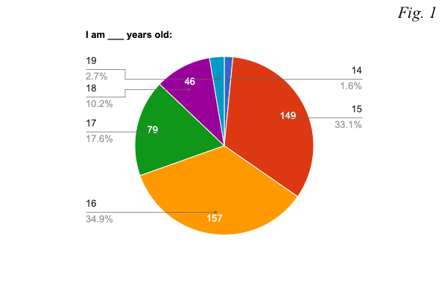
The first section introduces the most important findings regarding the students’ insights on reading in general. It was interested in how teenagers perceive their reading skills, asked questions about the most appealing genres of literature, whether or not they find reading interesting, if reading is important or insignificant, and what would make them more invested in the habit of reading. Given the fact that the research compares the data in light of two main criteria – gender and the type of educational institution the student attends – the first part was also keen to discover which age groups, genders, and types of schools were the most active ones in this project.
The two most active age groups in this research were 15- and 16-year-old teenagers, with each group constituting 33.1% and 34.9% of the whole respectively (see figure 1). Almost half as active were 17 years old students, making up 17.6% of those who took part in the questionnaire. The last distinctive group was that of 18-year-olds. Slightly more than 10% of the students were of this age. One of the possible reasons as to why older age cohorts did not participate to a similar degree as other younger students is that the last two years of school are focused on preparation for the state exams, suggesting that many students did not have time to participate, or had other priorities.
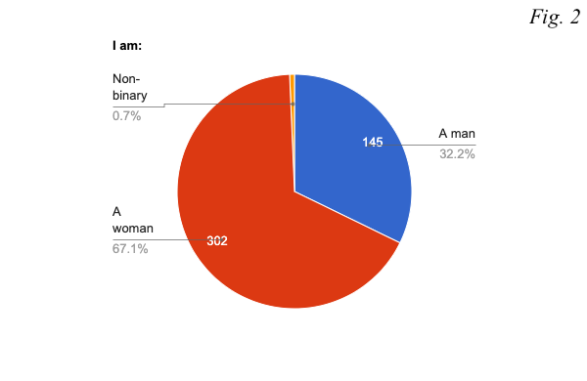
As mentioned previously, 302 girls took part in this research in contrast to 145 boys and 3 non-binary or gender fluid people (see figure 2). These numbers, unfortunately, only represent a small fraction of the demographics of Lithuania. That is, in the beginning of 2022, 1.306.599 (46.6%) men and 1.499.399 (54.4%) women were registered as permanent residents of Lithuania (https://osp.stat.gov.lt). In this research, girls stand for 67.1% of the whole whereas boy represent 32.2%. General tendencies of participation when it comes to sex, however, are similar to the ones from the previous year. In the research on the reading habits of Lithuanian children conducted by the National Library of Lithuania in 2021, 58.84% of the respondents were girls and 37.29% were boys (compared to 67.1% and 32.2% respectively in this research).
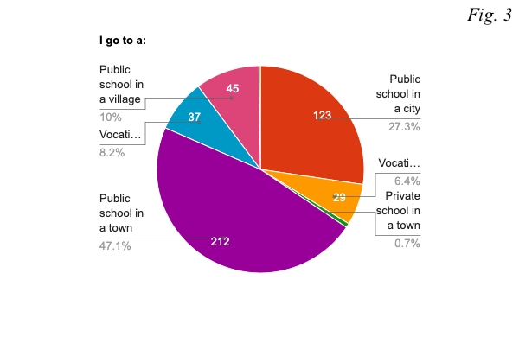
In terms of participation from state, private, or vocational schools in cities, towns, and villages, students from state schools in towns make up almost half of the whole number of the respondents (see figure 3). In comparison to the second largest group, that is, 123 students from state schools in cities, 212 teenagers attending state schools in towns took part in the questionnaire. Looking at the graph, it can be seen that a surprising number of teenagers from vocational schools, 29 students from cities, and 37 students from towns participated in this research. Shockingly, only 3 students from any type of private school answered the questions, thereby severely limiting the scope of this research. Besides, only one person from a vocational school in a village took part in the questionnaire. For this reason, the data gathered on private schools and vocational schools in villages will not be analysed in detail. However, the answers from individual students will be used for comparisons on a large scale.
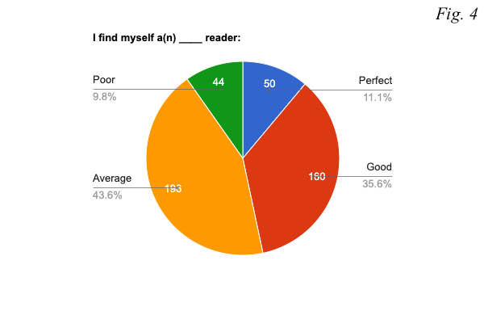
When asked to identify what kind of reader – perfect, good, poor, or average – they are, 43.6% of the students believe that they are average readers, 35.6% of them see themselves as good, 11.1% as perfect, and 9.8% as bad readers (see figure 4). These numbers imply that the majority of Lithuanian teenagers have the required assets for text comprehension. However, almost one in ten teenagers finds themselves struggling with understanding texts.
Whilst looking at the differences based on gender, girls deem themselves better readers (see figure 4.1). Slightly more than 41% of girls believe that they are good readers in comparison to 22.8% boys who think the same. On the contrary, around 60% of boys as opposed to only 35.4% of girls see themselves as average readers. 28 girls and 16 boys think that they are poor readers – in response to question 7, the majority of them answered that they do not like reading in general.
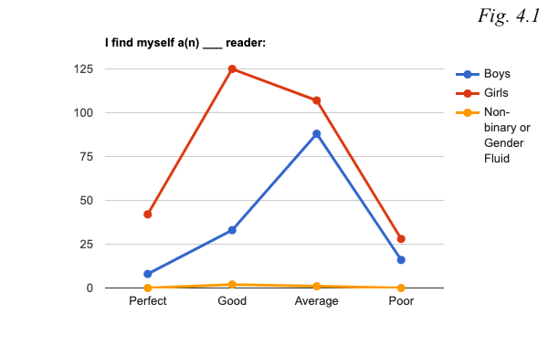
The most confident appear to be students from state schools in cities where 47.2% of students believe that they are good readers and only 6.6% identified themselves as poor readers (see figure 4.2). In fact, in any type of state school there are more self-identified average than good readers. Both vocational schools in cities and towns share a similar pattern: barely any or no perfect readers, a dozen good readers, the largest number of average readers, and a few poor readers.
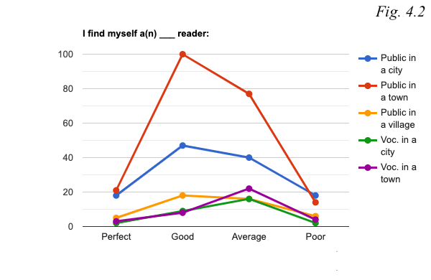
The most appealing type of literature is fiction. 292 (226 girls, 64, boys, and 2 non-binary or gender fluid) students indicated that they like it the most (see figure 5). This number is followed by 132 teenagers who said that their preferred type of reading is all types of articles online
An interesting dimension reveals itself when looking at the third most popular answer, which shows that there are more teenagers who like comics, specifically, than those who like non-fiction: 123 teenagers find comics to be the most, or one of the most, interesting types of literature, in contrast to 109 who said that they like non-fiction. 26 students answered that they like reading both.
An equal number of students, 79, answered that they like poetry and books that give information. A similar pattern appears when it comes to newspapers and magazines. That is, 64 and 65 students respectively indicated that these are one of the most appealing types of literature to them.
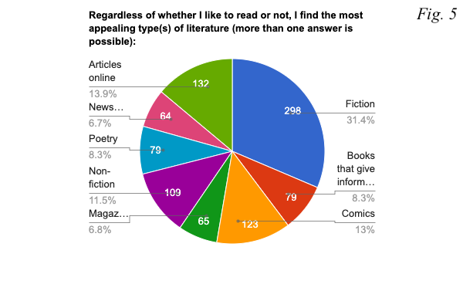
In response to the question of whether students find reading important or not, 59.1% of them indicated that they do (see figure 6). 35.3% of teenagers believe that reading is neither significant nor insignificant, and 5.6% of them deem reading entirely insignificant. This is a crucial finding as it clearly exposes the decline in teenage readership. The 2021 research on the reading habits of Lithuanian children conducted by the National Library of Lithuania shows that 89% of youths from all age groups found reading important in contrast to the 3% of them who did not. In this research, slightly more than half the students deem reading important. This dramatic decline implies that the problem might lie not at the heart of issues such as lack of concentration, or lack of time, but at the fact that teenagers merely find reading less and less important.
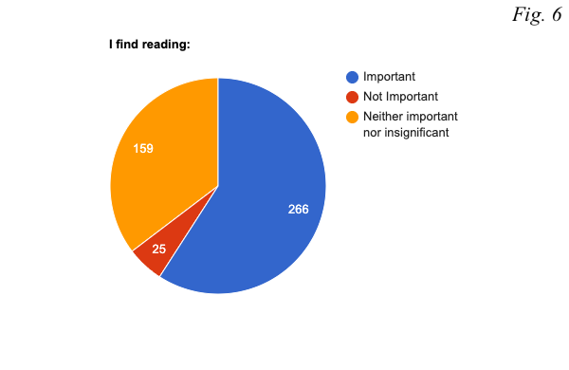
Similar to the previous year, girls found reading more important than boys did (see figure 6.1). 66.5% of girls said that reading is important, 32.1% said that they find it neither important nor not important, and 1.4% do not deem reading important. Opposed to that, 44.1% of boys see reading as important, 41.3% - neither significant nor insignificant, and a surprising percentage of them - 14.6% - do not deem reading important.
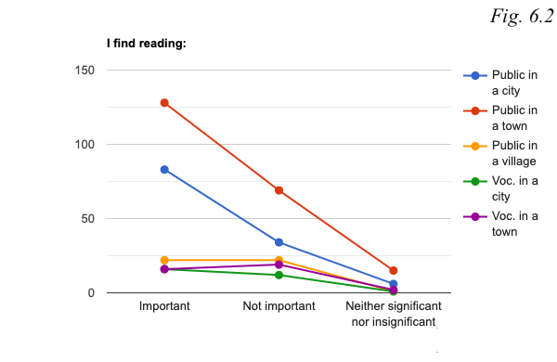
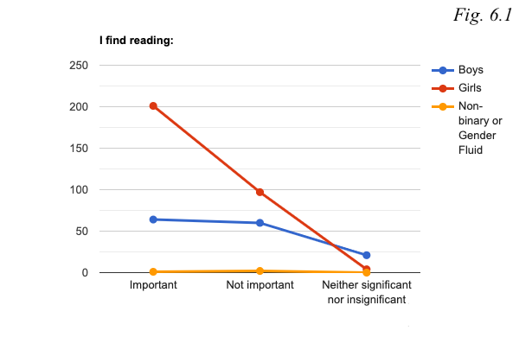
Both state schools in cities and towns pertain to the largest percentage of students that believe that reading is important (see figure 6.2). That is, 67.4% of teenagers from state schools in cities and 60.4% of students from state schools in towns answered that they think it is important to read in contrast to, for example, 43.2% of the students from vocational schools in towns. Controversially, the largest percentage of those who do not find reading in any way significant is also found in state schools in towns. There, 7.1% of students do not think that it is important to read.
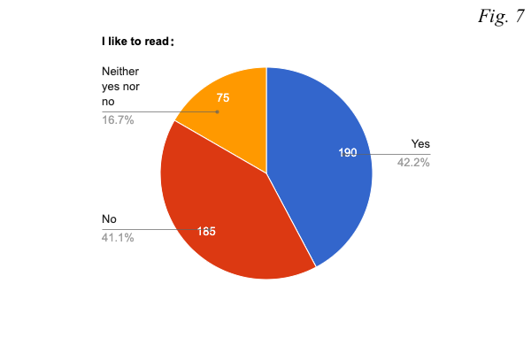
Question 7 asked students whether they like to read in general. An almost equal number of answers is shared between those who indicated that they like to read (190) and those who do not (185) (see figure 7). Almost one fifth of the teenagers (75) answered that they neither like nor do not like to read. Similar to the responses to question 6, these numbers show that decreasing teenage readership numbers are not necessarily linked to external issues that in one way or another prevent teenagers from reading. These results indicate that there is a general lack of interest in reading and that in addition to not finding reading important, students simply do not like to read.
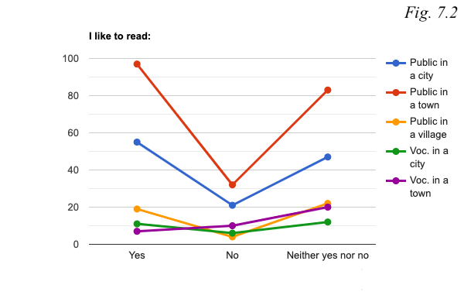
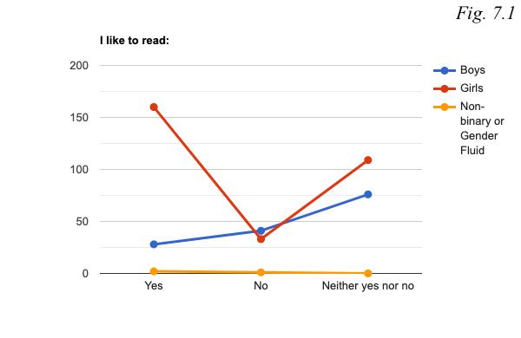
In relation to differences based on sex, girls like to read more than boys do. 53% of girls indicated that they like to read, only 10.9% that they do not, and 36.1% that they neither like it nor do not (see figure 7.1). Boys, in comparison, are less interested in reading. That is, only 19.3% of boys said that they like to read whereas 52.4% of them do not. The last part – 28.3% - are neither keen nor not keen on reading.
Once again, state schools in cities and towns show the biggest interest in reading (see figure 7.2). 44.7% of teenagers from state schools in cities and 45.8% teenagers from state schools in towns indicated that they like reading in contrast to 37.9% of students from vocational schools in cities and 18.9% of students in vocational schools in towns. Teenagers from state schools in villages and like reading constitute 42.2% of all the students there.
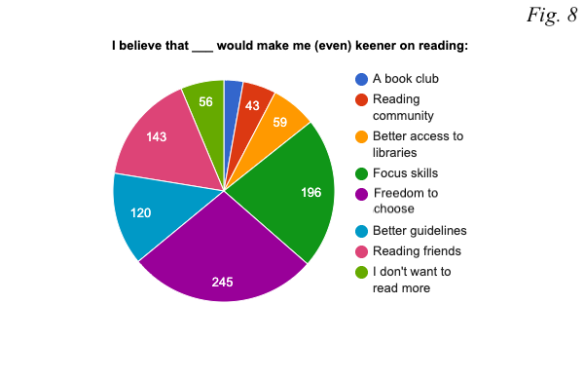
When asked to identify what would make them become keener on reading, the largest number of teenagers, that is, 245 students, said that it would be more freedom in choosing literature they themselves want to read (see figure 8). This finding is of extreme importance as it correlates to the premise of this thesis which supposes that teenagers at schools are very much limited by the curriculum.
The second most popular answer was that of lack of concentration and focus. 196 students indicated that they are struggling with this issue. Following that, the third most common answer was reading friends. Apparently, 143 teenagers would be inspired to take up reading more seriously if they had reading friends. In terms of the rest of the answers, 120 teenagers would like to have more guidance and recommendations when choosing their literature, 59 – better access to libraries, 43 students need a reading community, and 26 believe that becoming a member of a book club would make them more interested in reading. 56 respondents indicated that they do not want to read more.
To sum up the first part, the implications regarding teenagers’ perception on reading are not very different from those identified in the previous year’s research. That is, in contrast to boys, girls are more likely to identify themselves as good readers. Besides, on average, they tend to like reading as well as finding the habit of reading more important more often than boys do. In relation to educational institutions, students from state schools in cities and towns are the most confident about their reading capabilities. They also engage with the activity of reading more often than teenagers from other types of schools do, suggesting that the highest levels of apathy towards reading are found in villages and vocational schools.
When it comes to the most appealing types of literature, most of the teenagers prefer reading fiction. This does not mean that other types of literature should receive less attention. On the contrary, given the variety of options and the division between the answers, it is important to realise that in order to motivate teenage readership, the curriculum should not focus only on one or two specific genres but rather cater to the needs of every individual student. From this research it becomes clear that a large number of teenagers like comics – a genre often deemed to be of low literary value in elitist literary circles. Instead of promoting ‘valuable’ literature, school curriculums should aim to show students that any reading, in fact, is a valuable experience in itself. By the same token, schools should focus on transgressing the conventional manners of literary analysis and allow students instead to investigate literature that accords with their own interests in a multitude of ways.
Finally, the results show that teenagers are indeed limited by the curriculum. Most of them indicated that they would read more if they had had more freedom in their choice of literature. This is an important implication which yet again exposes an urgent need for changes in the General Education programme. Schools that are supposed to teach and motivate students to read, in fact, have the opposite effect. The second largest issue has to do with lack of concentration while reading. Even though this problem is not directly responsible for decreasing teenage readership rates as students can be interested in reading, engage with it, yet struggle to focus, it is crucial to understand that better focus skills could potentially contribute to wider teenage readership. Interestingly, there are a lot of students who need guidelines for literature. It is reasonable to assume that this has to do with the mandatory reading list at schools, which presents a very narrow ‘horizon’ of what literature has to offer. This results in teenagers not being able to find literature of their own interest as they are swamped with massive novels required to be read and analysed for Matura exams.

7.1.2 Part two: External influences on the importance and interest in reading

The second part of the questionnaire was concerned with the environment the students grew up in and whether or not it had any impact on the students’ current perception of the activity of reading. It was keen on finding out whether or not student’s current environment encourages them to read and to what extent they are comfortable with sharing their reading reflections with their family members, teachers, and friends. These questions, in contrast to the first part, seek to understand if it is possible to motivate teenage readership through students’ surroundings.
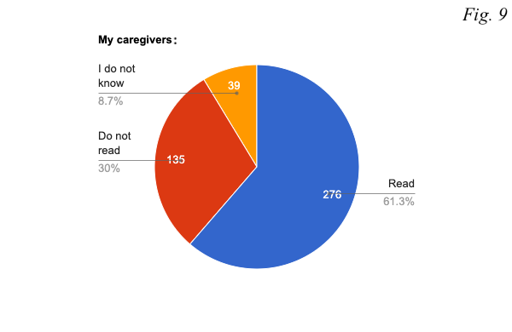
The first question of the second segment was keen to find out whether caregivers of the teenagers read or not. According to the data, 61.3% of the students’ caregivers do read as opposed to 30% of those who do not (see figure 9). 8.7% of students could not answer the question.
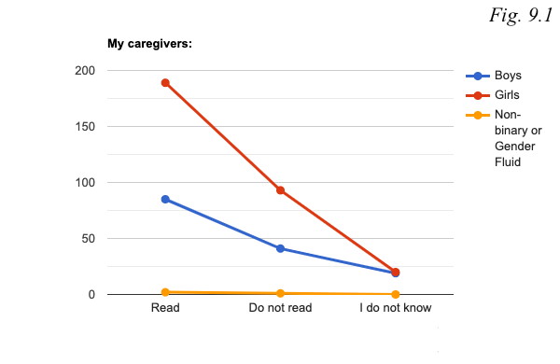
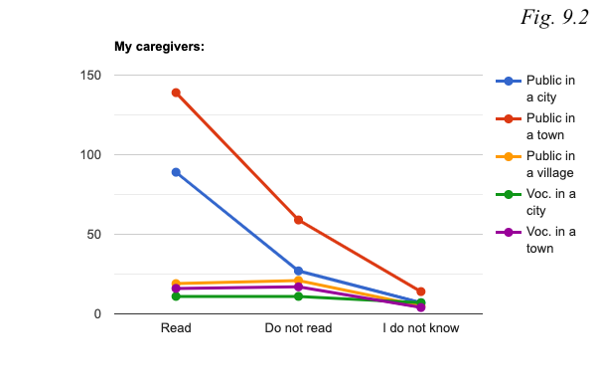
There are no large variations when it comes to sex, 65.6% of caregivers of girls read in comparison to reading caregivers of boys who make up 58.6% of the whole (see figure 9.1). However, there are quite significant differences based on the type of school teenagers go to (see figure 9.2). 72.4% of caregivers of students from state schools read in contrast to only 40.7% of caregivers whose children attend vocational schools. A similar pattern is to be found in towns. 65.6% of caregivers of students from state schools, according to the teenagers, read. On the contrary, only 43.2% of caregivers of students from vocational schools in towns do the same.
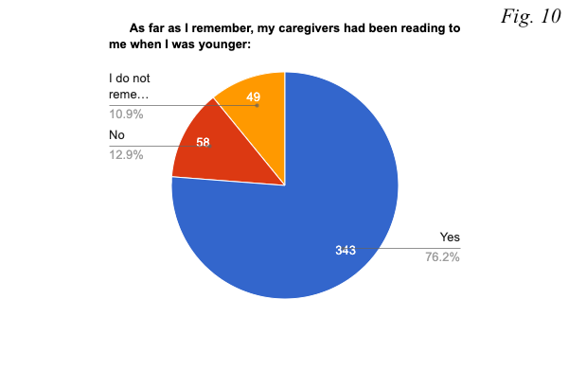
When asked whether their caregivers had been reading to them when they were younger, a large number, that is, slightly more than three quarters (76.2%) of teenagers answered that they did (see figure 10). Only 12.9% of caregivers did not read to their young kids and 10.9% of teenagers merely could not remember whether their caregivers were reading to them.
Once again, no major differences were found when it comes to sex (see figure 10.1). In response to the question, 71.7% of boys and 78.5% of girls said that their parents had been reading to them when they were young.
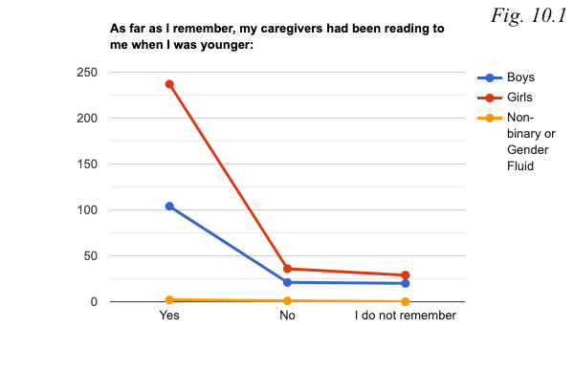
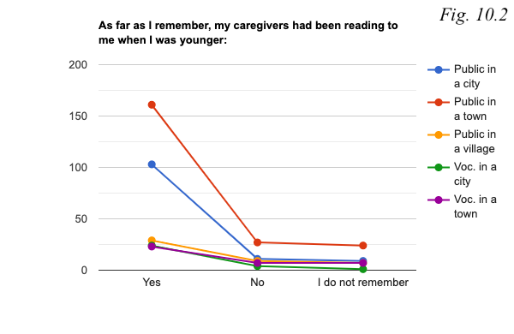
Regarding the type of school one goes to, no disparities were found either (see figure 10.2). 88.6% of students from state schools in cities, 75. 9% of students from state schools in towns, and 82.8% of students at vocational schools in towns indicated that their parents did read to them when they were kids. Slightly smaller percentages are found only when looking at teenagers attending state schools in villages and students from vocational schools in towns. For them, the numbers are 64.4% and 61.1% respectively.
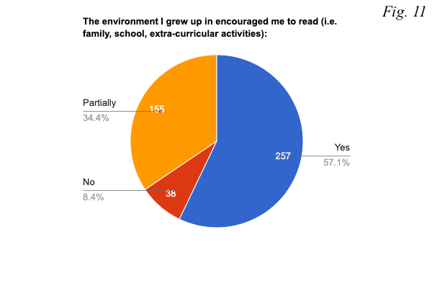
An impressive number of teenagers, 257, said that the environment they grew up in encouraged them to read, 155 students indicated that their environment did that only partially, and 38 – that it did not (see figure 11).
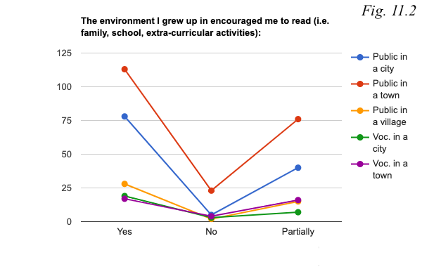
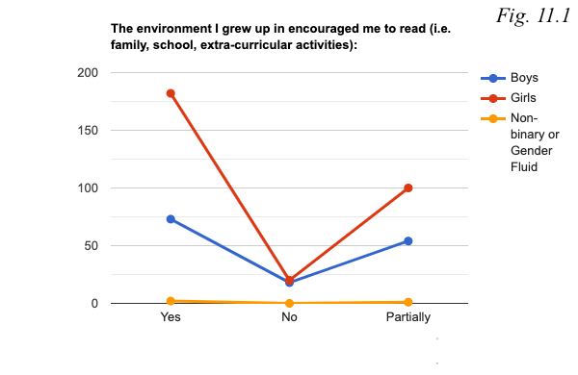
When it comes to sex, in contrast to 59.6% of girls, 50.3% of boys indicated that in the past their environment motivated them to read (see figure 11.1). The highest percentage of positive responses come from vocational schools in cities (see figure 11.2). There, 79.3% of the students answered ‘Yes’ to the question. Another distinctive number was found in state schools in villages where 62.2% of the teenagers said that they were encouraged to read when they were younger.
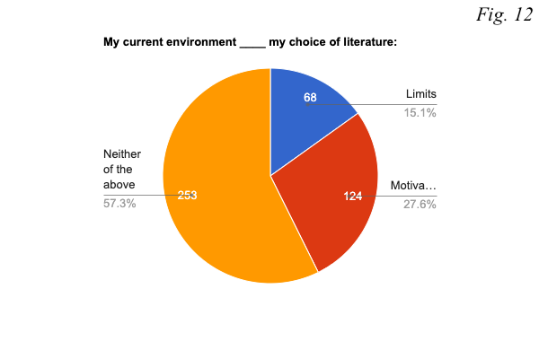
Building on Question 11, Question 12 asked students whether their current environment (school, friends, extra-curricular activities, etc.) limits or motivates their choice of literature. Surprisingly, only 15.1% of the students said that it limits (see figure 12). The result contradicts the number of responses to question 8 where 245 teenagers indicated that they would be keener on reading if they had more freedom while choosing their literature. Perhaps, the problem lies at the phrasing of this question since friends and extra-curricular activities were put together with school. This confusion is seen in 253 responses which said that their current environment neither limits nor motivates their choice of literature. Nevertheless, as many as 124 students said that their environment motivates their literature choice which implies that one fourth of the students oppose the premise of this research.
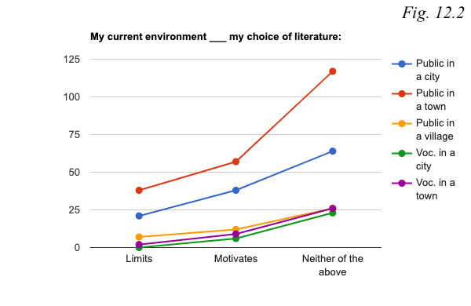
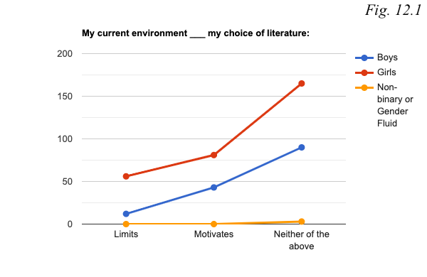
Given the fact that the question itself is confusing, it is not surprising that only a small number of teenagers believe that their current environment limits their choice of literature. However, there is an interesting difference when it comes sex (see figure 12.1). That is, only 8.3% of boys in contrast to 18.5% girls think that their choice of literature is limited by their environment.
When it comes to schools, state schools share a similar percentage of those who believe that the environment limits their choice of literature: 17.1% of teenagers from state schools in cities, 17.9% from state schools in towns, and 15.5% from state schools in villages think so (see figure 12.2). In a very sharp contrast, no students from vocational schools from cities and only 5.4% of teenagers from vocational schools in towns found their choice of literature limited. This finding raises a lot of questions, one of them being as follows: How do vocational schools cater to the needs of their students in a way that motivates them to read more?
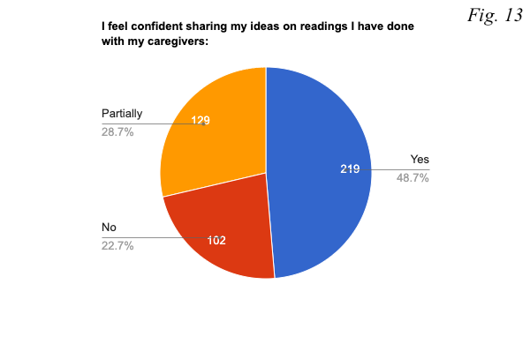
The following three questions were concerned with the extent to which teenagers feel comfortable with sharing their ideas on readings they have done with people within their environments. The first pie chart shows the results regarding students’ caregivers (see figure 13). Only slightly less than a half (48.7%) of the teenagers responded that they are comfortable with talking about books and their ideas with their caregivers, 28.7% of them responded that they are partially comfortable, and 22.7% of the students indicated that they are not.
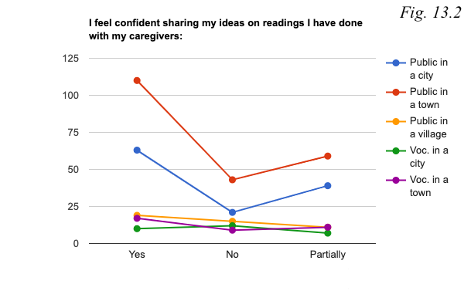
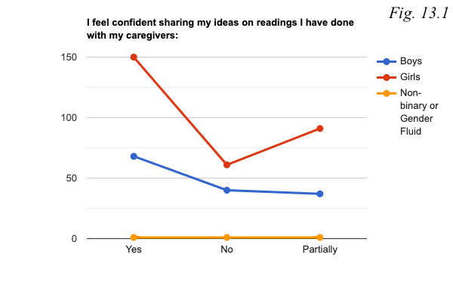
When looking at the differences based on sex, the percentages are almost the same: 46.9% of boys, 49.6% and girls feel comfortable when talking to their caregivers about books (see figure 13.1).
Most comfortable with sharing their ideas about books with their caregivers are students from state schools in both cities and towns (see figure 13.2). Their percentages constitute 51.2% and 51.9% respectively. The least comfortable appear to be teenagers from vocational schools in cities. There, only 34.5% of students responded ‘Yes’ to the question. The second least comfortable group was that of teenagers from state schools in villages where only 42.2% are not reserved when talking about books with their caregivers.
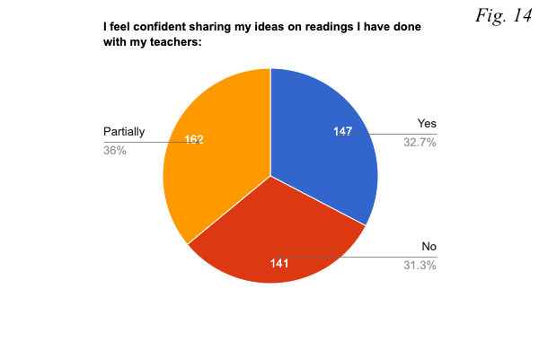
The next pie chart concerns their teachers. Here, the teenagers are less confident when sharing their ideas on books (see figure 14). Only 32.7% of them said ‘Yes’, 36% - ‘Partially’, and 31.3% of the teenagers indicated that they are not comfortable doing that.
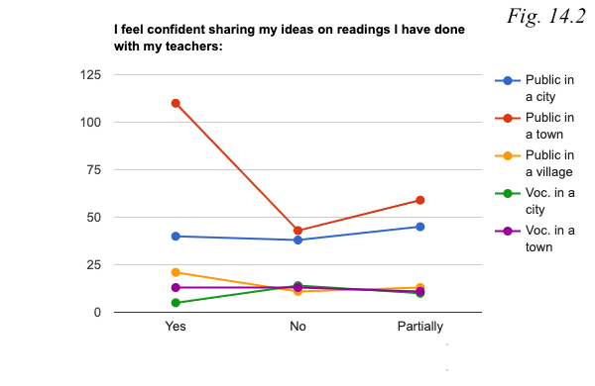
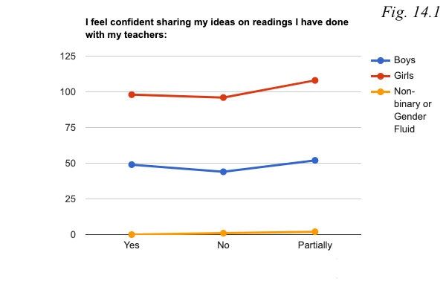
Both boys and girls share a very similar percentage on this issue (see figure 14.1). That is, 33.8% boys and 32.5% girls answered that they are not comfortable with sharing their reading thoughts with their teachers.
The lowest percentage indicating how confident students feel when sharing their ideas on readings with their teachers is found in vocational schools, where only 17.2% of the students said ‘Yes’ (see figure 14.2). On the contrary, the most confident appear to be teenagers from state schools in towns. There, 51.9% of them responded to the question positively. Another interesting dimension opens up when looking at the results from state schools in cities. In contrast to state schools in towns, only 32.5% of the students there are comfortable with sharing their reading ideas with teachers.
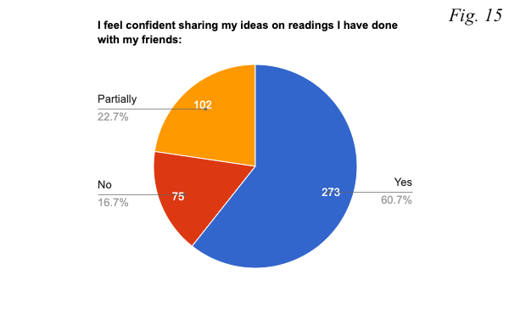
The last question regarding students’ confidence when talking to people from their environment about their reading experiences concerns students’ friends (see figure 15). The majority, that is, 60.7% of the teenagers indicated that they feel comfortable to share their thoughts on readings with their friends and only 16.7% of them chose to respond to the question by saying ‘No’. The last group of those who feel partially comfortable makes up 22.7% of the whole.
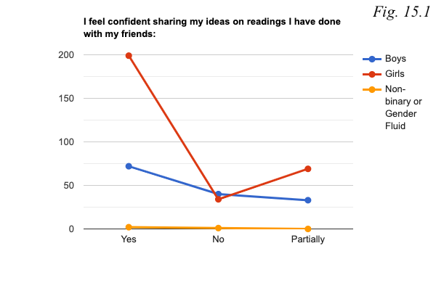
Interestingly, boys appear to be less comfortable talking about their reading experiences with their friends than girls (see figure 15.1). In contrast to 49.7% of boys, a substantially larger percentage of girls, that is, 65.9%, willingly share their reading ideas with friends.
When looking at the responses from different types of schools, a surprisingly small number of teenagers from vocational schools in comparison to other types of educational institutions indicated that they feel comfortable when talking about reading they have done with their friends (see figure 15.2). That is, only 40.5% of students from vocational schools in towns and 48.3% of students from vocational schools in cities confidently talk to their friends about books. Most comfortable are teenagers from state schools in both cities and towns. There, the percentages are 66.7% and 63.2% respectively.
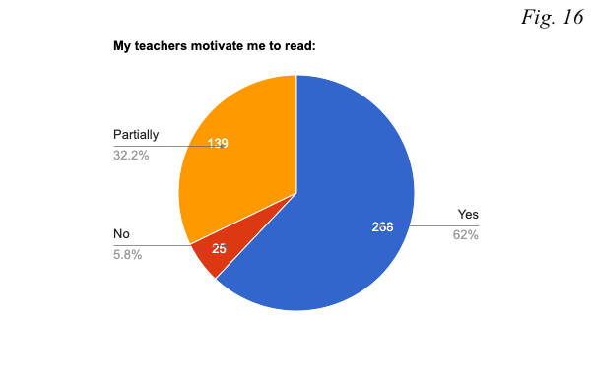
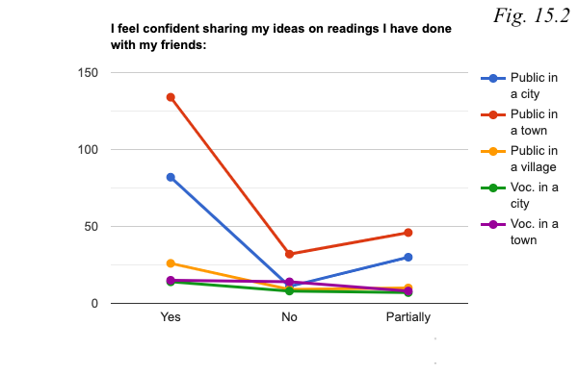
The last question of the second part of the questionnaire was interested in whether teenagers themselves think that their teachers motivate teenage readership (see figure 16). In fact, 62% of the students responded that their teachers motivate them and only 5.8% of them indicated that they do not. The last group that thinks that their teachers motivate them only partially makers up 32.3% of the whole.
These implications raise a question regarding the relationship between teacher and student. In other words, if the majority of teachers are indeed motivating their students to read, how can they create a safe space in order for students to feel comfortable when sharing their reading thoughts with them?
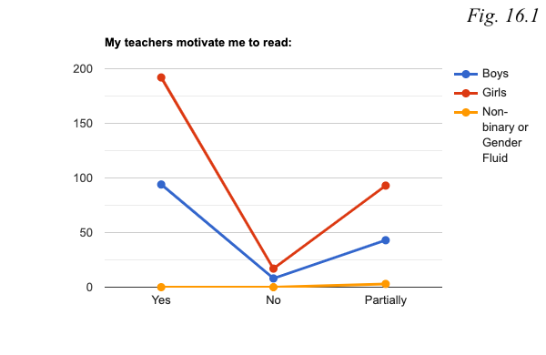
The majorities of both boys and girls believe their teachers motivate them to read (see figure 16.1). For boys, the percentage is 64.8% and for girls, 63.6%.
It appears that teachers in state schools motivate their students to read the most (see figure 16.2). There, the percentages are as follows: in cities it is 61%, in towns 68.4%, and in villages as much as 68.9%. Unfortunately, students in vocational schools in both cities and towns are not as motivated. In cities the percentage is only 48.3%, in towns, 51.4%.
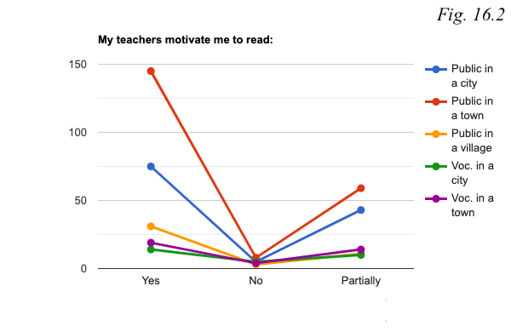
To conclude part two, one of the most interesting findings relates to the fact that when it comes to one’s environment and its influence on students’ perceptions of reading, there are dramatically fewer differences based on gender than on school types. This implies that issues regarding one’s environment and its impact on their motivation to read mostly lie at the heart of the differences between educational institutions and the student’s background in general, but not sex. For instance, most of the students whose parents read in their free time attend state schools either in cities or towns. It is also teenagers from state schools in cities who are most comfortable talking to their caregivers, teachers, and friends about their readings in comparison to students from other types of schools. These findings pose a potential direction for a more in-depth investigation of the impact that teenagers’ caregivers, their social status, their cultural capital, and their approach to literature have on teenagers’ perceptions of reading.
The vast majority of the respondents indicated that they are mostly keen on talking about their reading experiences with their friends as opposed to their caregivers or teachers. This is a crucial finding which stands as a gateway for a possible solution for decreasing readership rates. That is, in response to Question 8, 143 of the teenagers indicated that reading friends would make them more interested in reading. It follows, then, that friends not only motivate each other, but also provide a comfortable and safe space for discussions. Activities that encourage cooperation between teenagers themselves with as little supervision as possible could stimulate their interest in reading.

7.1.3 Part three: Reading habits and preferences

The last part of the questionnaire was focused on determining the most common reading habits of Lithuanian teenagers. Teenagers were asked to indicate their preferred ways of reading, identify how often they read, how often they choose literature independently, and the nature of their relationship with their local libraries. The third part of the questionnaire looked for ways through which teenage readership numbers could be increased by taking into account students’ reading preferences.
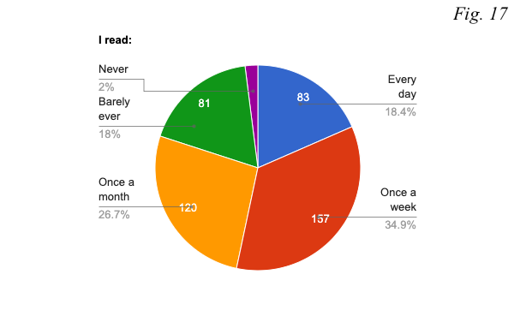
In response to question 17 which asked teenagers to indicate how often they read, the most common answer was ‘Once a week’ with 137 responses. 120 students said that they read only once a month, 83 – that they read every day, and 81 that they barely ever read. Only 9 people answered that they never read (see figure 17).
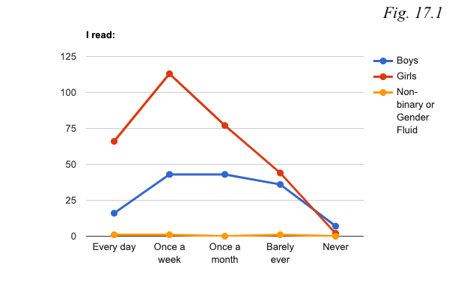
From this questionnaire it becomes clear that girls read more often than boys do (see figure 17.1). That is, 21.9% of girls, and only 11% of boys read every day. Additionally, 37.4% of the girls answered that they read once a week whereas only 29.7% of boys stated the same. However, boys pertain to a larger percentage of those who read once a month. 29.7% of them as opposed to 25.5% of girls take up reading only once a month.
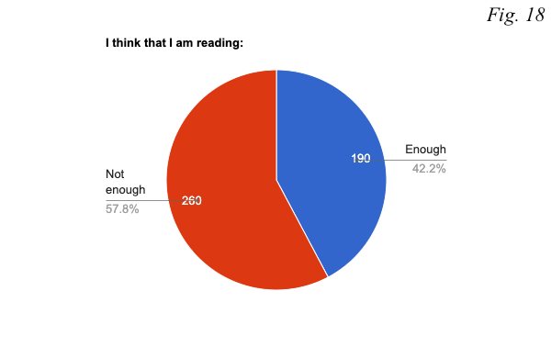
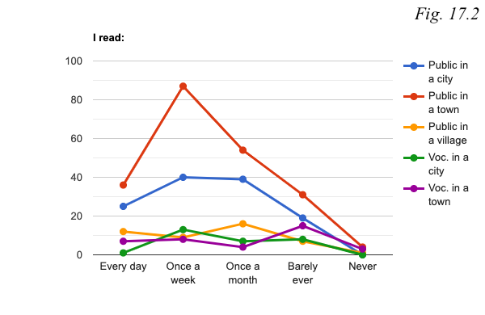
When it comes to schools, teenagers from state schools in villages pertain to the largest percentage of those who read every day (see figure 17.2). There, 26.7% of students engage in reading every day compared to, for instance, only 3.4% of the students from vocational schools in cities. In relation to those who read once a week, students from state schools in towns (41%) and vocational schools in cities (44.8%) are the ones who read most often weekly. In relation to teenagers who read once a month, the largest number of such readers is found in state schools in villages (35.6%) and the smallest in vocational schools in towns (10.8%). Students from vocational schools make up the largest proportion of those who barely ever read as the percentages in cities and towns are 27.6% and 40.5% respectively.
When asked whether they believe they are reading enough or not, the majority of the teenagers think the latter (see figure 18). That is, 57.8% of them suppose they should read more.
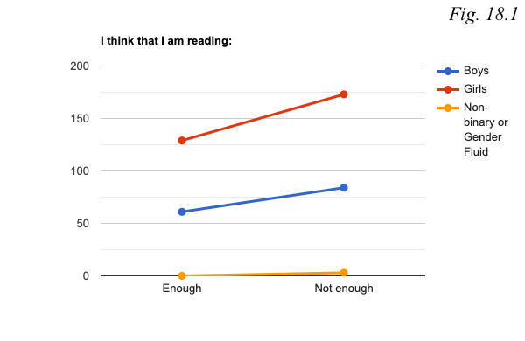
In terms of differences based on gender, both boys and girls are almost equally critical of how often they read. 42% of the boys and 42.7% of girls indicated that they are not reading enough (see figure 18.1).
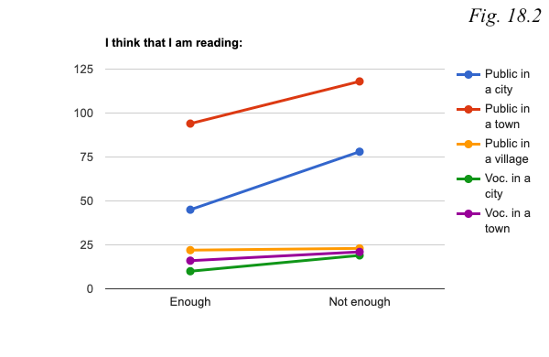
The teenagers from vocational schools in cities are the least satisfied with their reading frequency as 64.5% of them do not think that they are reading enough (see figure 18.2). The second largest group of teenagers is from state schools in cities. There, 63.4% of the students believe that they should be reading more often. In comparison, the most comfortable with the amount of reading they are doing appears to be teenagers from state schools in villages where almost half (48.9%) of the participants do not think that they should read more often.
In Question 19, in which students could choose multiple answers, the majority - 354 out of 450 students – said that they like reading physical books (see figure 19). 195 of the teenagers indicated that they like reading on their electronic devices, such as their computers or phones, and 39 on E-reading devices. Due to human error, audiobooks were not presented as an option. Given that, only a few people noted down that they also like listening to audiobooks in the field ‘Other’. It is important to mention that some of the students wrote down that they simply do not read. Their answers are not included in the charts as they are not relevant to the aim of the question which seeks to find out what ways of reading could potentially motivate teenage readership.
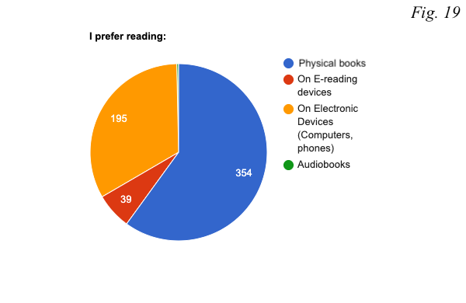
Both boys (63.4%) and girls (86%) enjoy reading physical books the most (see figure 19.1). All types of schools except for vocational in both cities and towns selected physical books as their preferred way of reading (see figure 19.2). There, teenagers like to read on their electronic devices more (in cities the percentage is 65.5% and in towns - 62.2%). On the contrary, the absolute majority of the students from state schools in cities, towns, and villages, that is, 85.4%, 84.9%, and 77.8% respectively, prefer physical books. These numbers open up a crucial dimension that supposes a different approach when it comes to motivating teenage readership in state schools and vocational schools.
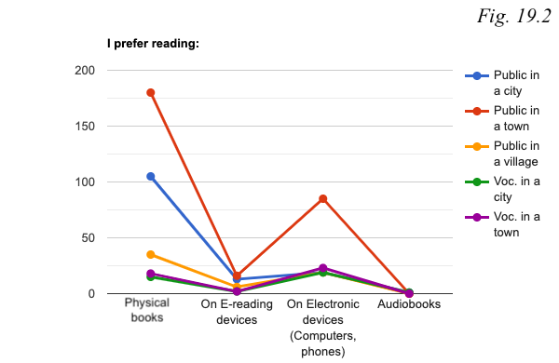
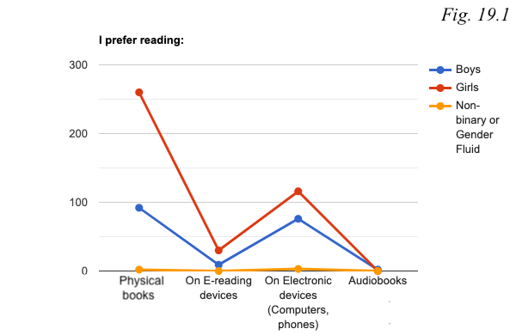
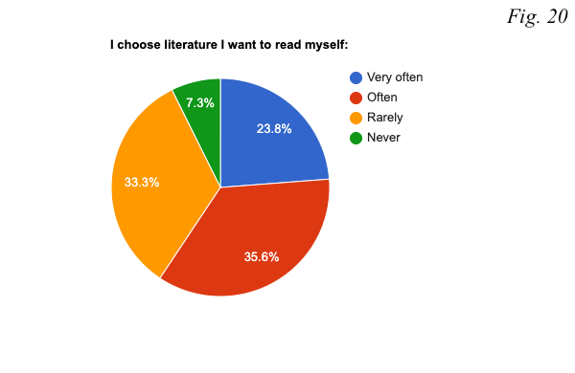
Question 20 was concerned with the freedom of teenagers when it comes to choosing literature that they themselves want to read (see figure 20). From the questionnaire it becomes clear that as much as 23.8% of the students do that very often, and 35.6% do it often. One third of the teenagers (33.3%) indicated that they rarely choose books they want to read themselves, and 7.3% answered that they never do that. These numbers demonstrate that almost half of the students rarely ever or never read literature of their own choosing, yet again confirming the premise of this research. If more than 40% of the teenagers mostly read what they are told to, it is unrealistic to have them both expanding or fusing their horizon with something that corresponds with their identity and investing in exploring literature.
In terms of differences based on gender, 28.1% of the girls responded that they choose their literature very often whereas 15.2% of the boys said the same (see figure 20.1). Besides, more boys than girls never do this at all. That is, 14.4% of the boys indicated that they never choose their own literature in contrast to only 4% of the girls who selected the same answer.
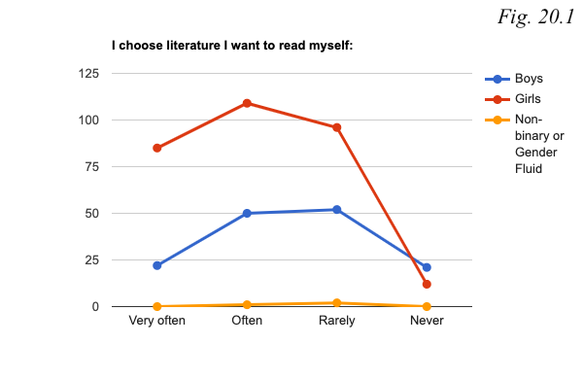
When looking at the type of school teenagers attend, the results do not differ drastically (see figure 20.2). For example, the lowest percentage of those who choose their own literature very often is found in state schools in cities where 20.3% of the students chose this answer opposed to 28.9% of the teenagers in state schools in villages who do the same. However, there are disparities in relation to those who selected ‘Often’ as their answer (see figure 20.2). 41.4% of the students who attend vocational schools in cities as opposed to only 13.5% of those in vocational schools in towns indicated that they choose literature they want to read themselves often. State schools in cities and towns pertain to 39% and 38.2% respectively. The least freedom, it seems, is exercised by teenagers from vocational schools in towns where 40.5% of the students said that they rarely, and 19% that they never choose their own literature.
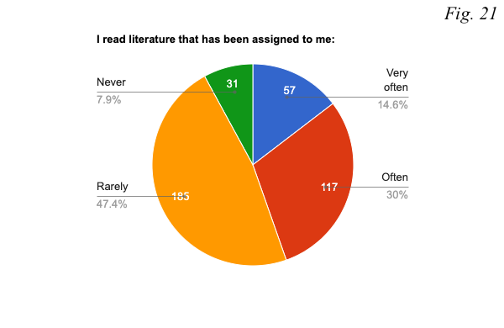
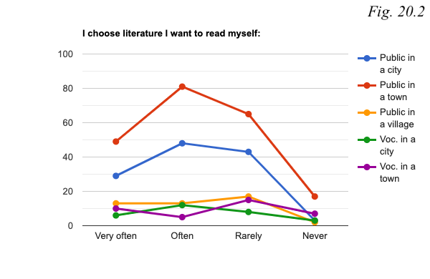
In contrast to the previous question, Question 21 asked how often students read literature that has been assigned to them at their educational institutions (see figure 21). According to the data, 12.7% of the students read it very often, 39.3% do it often, 41.1% rarely read what has been assigned to them, and 6.9% of the teenagers never do that.
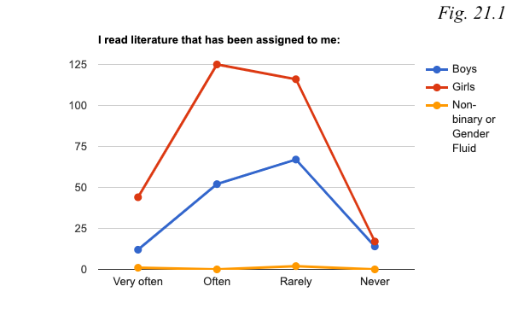
For boys, the two most popular answers were ‘Often’ (35.9%) and ‘Rarely’ (46.2%) (see figure 21.1). In comparison, 41.3% of the girls said that they do often read literature assigned to them and 38.4% of them said that they rarely do that. Additionally, the percentage of the girls who indicated that they read assigned literature very often is 14.6% as opposed to only 8.3% of the boys. It follows, then, that girls are slightly more invested in following the curriculum.
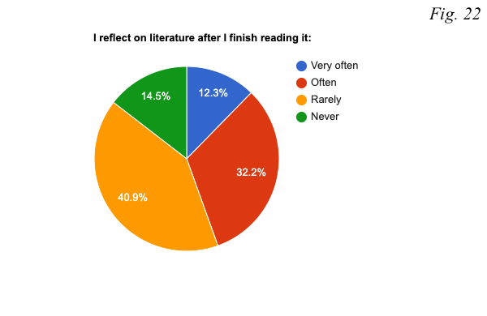
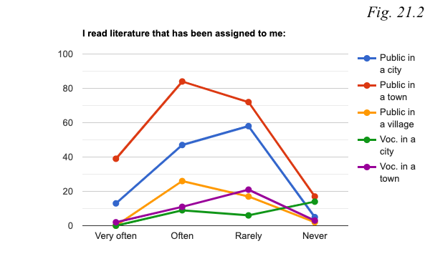
In response to Question 21, the worst numbers are found in vocational schools in cities (see figure 21.2). There, 48.3% of the students never read literature that their schools have assigned to them, and none of the students read it very often either. On the contrary, the students from state schools in towns are the most invested in reading such literature, as 18.3% do it very often and 39.6% do so often. However, as much as 8% of them reported that they never read the assigned literature. The last distinctive number has to do with vocational schools in towns which pertain to the largest number of those who do that rarely (56.8%)
Question 22 was interested in discerning how often teenagers reflect on their readings (see figure 22). As it turns out, 12.3% of them do it very often and 32.2% often. The largest percentage of the students - 40.9% – responded that they rarely ever do it. 14.5% of the teenagers indicated that they never reflect on their readings.
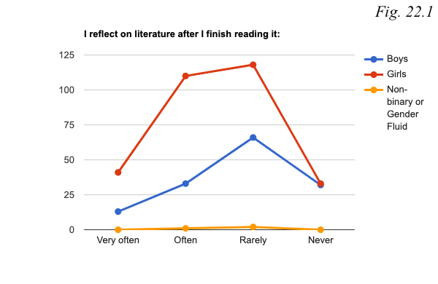
The responses show that girls reflect on their readings more often than boys do (see figure 22.1). That is, 36.4% of the girls chose ‘Often’ as their answer in contrast to 22.8% of boys who did the same. Moreover, 13.6% of the girls reflect on literature very often whereas only 9% of the boys do. Lastly, 10.9% of the girls and 22.1% of the boys indicated that they never do this.
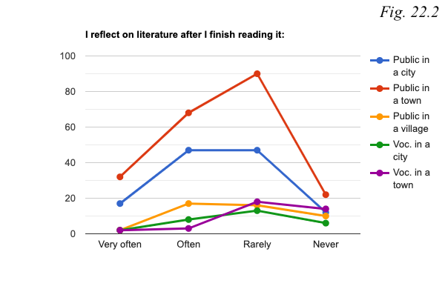
Teenagers from state schools in both cities and towns seemingly reflect on literature after finishing it more often than students from other types of schools (see figure 22.2). For instance, whilst answering the question, 13.8% of the teenagers from cities and 15.1% from towns said that they do that very often. In comparison, the third largest group that reflects on literature very often is that of vocational schools in cities which pertains to 6.9% of the students there. State schools have the largest numbers of those who chose ‘Often’ as their answer. In cities the number is 38.2%, in towns it is 32.1%, and in villages 37.8%. In this respect, teenagers from vocational schools in cities and towns rarely reflect on their readings, with the percentages being 44.8% and 48.6% respectively. Surprisingly, 37.5% of the students from vocational schools in towns never do that.
The last three questions of the third segment were focused on finding out how often teenagers go to their local libraries, whether they are accessible, and whether they cater to the needs of these teenagers. From the pie chart it becomes clear that not that many of the teenagers actually use libraries (see figure 23). That is, only 2.4% of the students go there very often, 17.6% of them go there often, 60.9% said that they rarely go to their libraries, and 19.1% of them never do so.
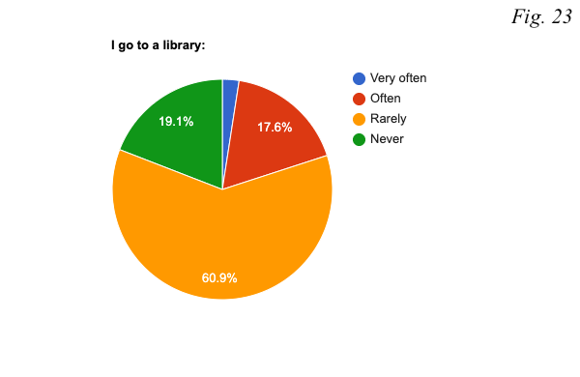
Only 1.4% of the boys and 3% of the girls said that they use libraries very often (see figure 23.1). In contrast to 22.2% of the girls, only 8.3% of the boys indicated that they go to libraries often. The largest numbers, however, are found when looking at the percentages of those who chose ‘Rarely’ as their option. That is, for the boys and the girls the numbers are 57.2% and 62.3% respectively. Surprisingly, as much as 33.1% of the boys as opposed to 12.6% of the girls never go there.
In all schools, most of the students rarely use their local libraries: 55.2% of the teenagers from state schools in cities, 62.7% from state schools in towns, 60% from state schools in villages, 48.3% from vocational schools in cities, and 51.4% from vocational schools in towns (see figure 23.2).
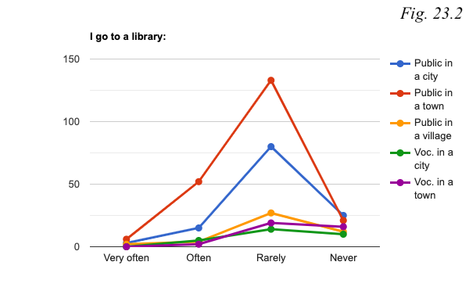
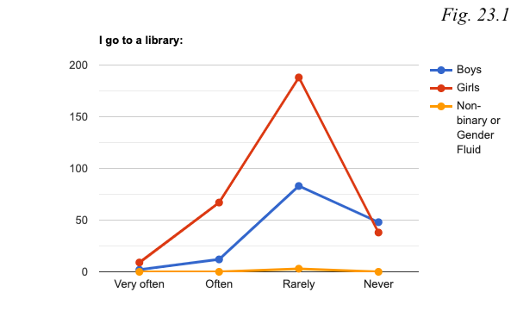

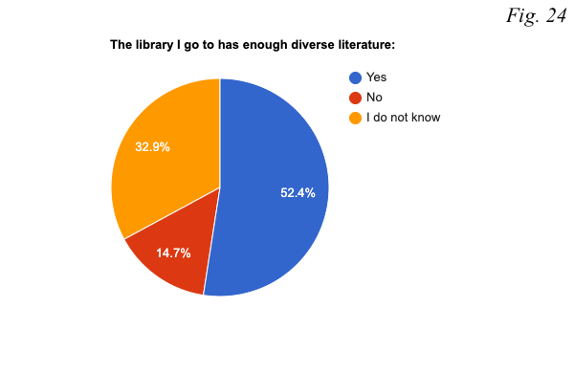
When asked to identify whether their local library has enough diverse literature, 52.4% of the teenagers answered positively, only 14.7% of them said that it does not, and 32.9% of the students could not answer the question, presumably because they do not go to the library often enough to know (see figure 24).
From the following chart, it appears that for girls the libraries they go to have enough diverse literature that caters to their needs: 58.3% of them chose ‘Yes’ as their answer (see figure 24.1). On the contrary, boys are less certain about this. In other words, the majority of them (44.8%) indicated simply that they do not know. This can be explained by the fact that boys go to their libraries less often than girls do. Due to this fact, their knowledge on the variety of literature in their local libraries is limited.

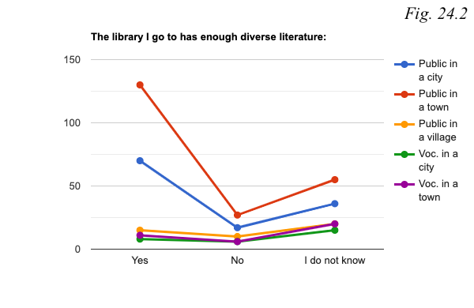
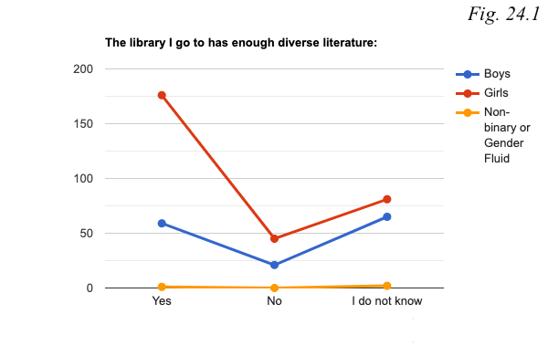
Teenagers from state schools in both cities (56.9%) and towns (61.3%) are satisfied with the diversity of literature in their libraries (see figure 24.2). Other types of schools, that is, state schools in villages and vocational schools in cities and towns, pertain to the largest numbers of those who could not answer the question. Once again, such uncertainty can be explained by the fact that teenagers do not use their libraries very often and therefore do not know what they have to offer.
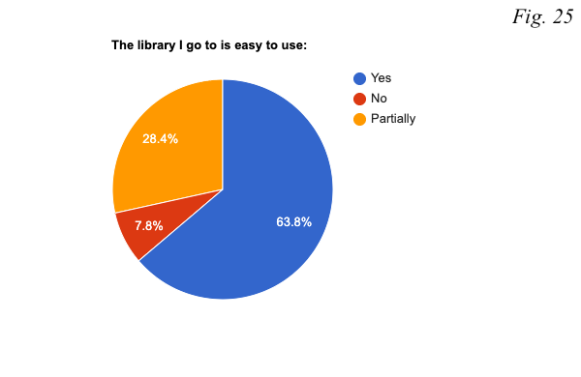
The last question of the questionnaire asked whether the local libraries students go to are easy to use. 63.% of the teenagers believe that their local libraries are indeed easy to use, 28.4% of them indicated that it is partially easy to use them, and 7.8% of the responses said that it is not.
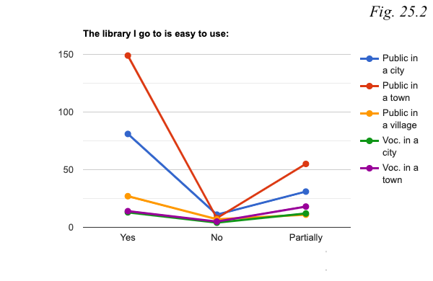
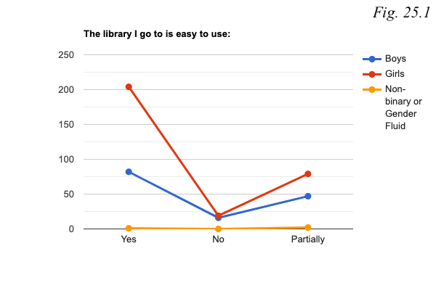
56.6% of the boys believe that their libraries are easy to use and as much as 67.5% of the girls think the same (see figure 25.1). On the contrary, boys are less content with the accessibility of their libraries as 32.4% of the boys in comparison to 26.1% of the girls said that their libraries are partially easy to use. Besides, only 6.3% of the girls believe that their libraries are not easy to use in contrast to 11% of the boys.
In each type of schools, besides vocational schools in towns, the majority of the students believe that their libraries are easy to use (see figure 25.2). Teenagers from vocational schools in towns are less certain about this as almost half (48.6%) chose ‘Partially’ as their answer.
In conclusion, similarly to the first part of the questionnaire, the last part of the questionnaire pertains to both factors, that is, gender and school type. For instance, girls choose their literature, reflect on it, attend libraries, and are satisfied with the diversity of books offered at their local libraries more than boys do. A similar pattern is found when considering school types. Teenagers from state schools in cities are some of the most avid readers, they believe that they should read more, they reflect on their readings more often than students from other types of schools do, and they are mostly satisfied with the diversity of their local libraries.
Other findings show that one fifth of Lithuanian teenagers either do not or barely ever read, urging for an investigation of this specific target group in order to find out what the reasons for their reluctance in reading may be. From this part it also becomes clear that teenagers still prefer physical books even though “improvements in e-reader technology and the convenience of smartphone reading have made digital books a mainstream phenomenon” (Tanner 1). Finally, a lot of students could not identify whether or not their local libraries have enough and/or sufficiently diverse literature, exposing the fact that few of them attend libraries.

Qualitative

The qualitative part of this research interviewed teachers’ in order to find out the most current teenage readership tendencies and to look at the ways in which they motivate their own students to read. It also asked them to reflect on the curriculum and the diversity of their school libraries. Most of the questions were designed to demonstrate whether there are any differences between how the teachers and the students understand the curriculum and perceive reading in general. An example of that, for instance, can be found when comparing Question 14 from the questionnaire and Question 6 from the interview. Only 32.7% of the students feel comfortable when sharing their reading thoughts with their teachers. In contrast, all three teachers indicated that they have managed to create a safe space for them to freely discuss their readings. Such discrepancies expose fundamental differences between how students and their teachers perceive the situation.
The importance of the first question is mainly to show the expertise of the interviewees (see appendix 2). As part of this research, I interviewed three teachers: Teacher A (private school in a city), Teacher B (private school in a town), and Teacher C (state school in a city). Teacher A “earned their BA in philology in 2014 from Lithuania's University of Educational Sciences (now Vytautas Magnus University), and an MA in literature in 2017 from Vilnius University”. Teacher B got their bachelor's and master's degrees in Pedagogical studies. Teacher C graduated from Vilnius Pedagogical University (bachelor's and master’s degrees) and is currently a teacher-methodologist working at a school in Vilnius for more than 20 years.
Question 2 asked the teachers to reflect on their own relationship with literature. From the interview it becomes clear that all of the teachers engage with it as often as possible and seek to be role models for their students. Interestingly, while answering the question, each of them emphasised a different matter. For instance, Teacher A’s relationship with literature pivots around the fact that they are an active member of the Lithuanian literary community, participating in the country's largest literary events. Therefore, they invite their students “to those events since it is important for the student to understand the pulse of today’s literature”. As shown previously, the most modern novel in the mandatory reading list was written in 2004. By inviting the students to contemporary literary events, Teacher A expands the students’ ‘horizons’ and supposedly helps them find literature that reflects their times and identity.
Teacher B reads constantly and does that actively in front of the students at school. They said the following: “Students see me reading, they ask for recommendations, and borrow my personal books.” It is difficult to draw any comparative conclusions based on this answer since only a few students from private schools answered the questionnaire. However, it is interesting to note the confidence that Teacher B expresses. They do not doubt that they stand as a great example for the teenagers. As their answer suggests, the students feel comfortable approaching them and therefore trust them, which is a crucial element for teenage readership motivation, since examples like this inspire students to look up to them and take up reading.
Lastly, Teacher C, who has loved reading since early childhood, emphasised the workload: “Now I have to read books from the mandatory list once a year, since in this kind of work it is a necessity... For my own pleasure, I cannot find time to read books every day, but I attempt to read a book within two or three weeks”. This response raises a critical question. That is, if teachers who have gained professional training in literary analysis have to spend vast amounts of time re-reading texts from the curriculum, which results in them not having enough time to read literature of their own interest, how is a teenager who studies at least a few school subjects in general supposed to keep up with the mandatory reading list? This finding sheds a different light on this research. That is, this thesis did not take into consideration the fact that the curriculum limits teachers, too.
In response to Question 3, which asked the teachers to comment on the current teenage readership tendencies, all of the teachers agreed: the numbers are indeed declining. Teachers A and C believe that the reason fewer and fewer students read books has to do with rapid technological developments. Teacher C said that students’ approach to literature can be summarized as follows: “Quick results with as little effort as possible”. According to them, “they [students] tend to read the text in passing, without delving into it, without paying attention to details or the conversations between the characters. Often, they do not want to work (read) since they know they can find any information online”. In other words, teenagers rely on the Internet for information and therefore do not put enough effort into understanding the novels they are reading. Teacher C noted that they can easily identify students who do not or barely read, as they have a poor vocabulary, their writing style is very basic, they have a lack of imagination, literacy gaps, and less developed memory.
Similarly, Teacher A said that students “are discovering easier alternatives, faster pleasures. Reading a big novel gets harder and harder for them, unless the book that they read happens to be a page-turner”. This issue has to do with the decreasing attention span of an average teenager. In other words, constant passive scrolling on social media results in humans not being able to focus on videos that do not draw attention within the very first seconds, or that are too long. Research by Carstens et al. shows that “participants with shorter attention spans have more social media accounts, prefer episodic social media applications and have a high frequency of use of their social media accounts from a mobile device or computer” (20). A very great example of that is TikTok platform. There, the average length of a video is 7 to 15 seconds. Given that most of the teenagers’ social media feeds are designed in such a way, it is not surprising that they have concentration difficulties. As the results from the quantitative section of this thesis show, the students themselves identify this issue as one of the main contributors to the decline of teenage readership. It is wrong to assume that all students are facing such consequences of extensive social media usage. However, in this research, this issue is recognized by both the teachers and the students and therefore urges for solutions.
Teacher B, in contrast, indicated a slightly different issue. According to them, most of the students “have only technical reading skills but no visuals appear when reading”. That is, for them reading is an automatic endeavour – they can read any text, but it must provide answers immediately. Given that, “they do not understand the conditions, are not able to work with large texts, and are not able to study independently”. Interestingly, this can also be linked to one’s reliance on the Internet as outlined by Teacher C. Since students can find almost any type of information online, they do not necessarily think of it as an imperative to comprehend all encountered texts. Consequently, their technical reading skills remain but comprehension skills decrease.
Building on Question 3, Question 4 asked if the teachers recognized any changes over the past decade when it comes to these readership tendencies. Yet again, every teacher highlighted a different aspect of the issue. Teacher A said that teenagers have always struggled with understanding that there is more literature available than merely that offered at schools, thereby confirming the premise of this thesis which argues that teenagers are presented with a very limited horizon of literature. As a consequence, they are not able to unfold their reading interests to their full potential and lose interest in reading. Teacher B adamantly stated the following: “No, they have not. 10 years ago and now students face the exact same problems. It is just that nowadays there are more audio-visual alternatives, children are more proficient in English, they have vast access to material from YouTube and other platforms”. Here, Teacher B means that there are many alternatives which stimulate teenagers’ brains in different and more entertaining ways. Finally, Teacher C also agrees that current teenagers face similar problems to people of their age 10 years ago. However, they drew attention the fact that more and more students realise the importance of reading yet still do not read. As mentioned previously, the 2021 research by the National Library of Lithuania exposed a very similar issue whereby students understand that reading has a lot of benefits but due to personal reasons cannot claim them.
In order to motivate teenage readership, teachers must also understand the crucial role that they play themselves. For this reason, Question 5 was interested in the ways through which the teachers motivate their students to read. Teacher A, for example, attempts to transgress the curriculum by introducing and recommending books outside of it, as well as bringing cultural magazines and newspapers to their classes. Teacher B motivates their students by teaching them how to read and comprehend texts. They said: “I have prepared special reading courses for all students regardless of their age. In our school, reading for pleasure is mandatory, as opposed to reading books from the curriculum. Until a sufficient reading habit is formed, there should be not a word about the mandatory literature list”. Hence, unlike Teacher A who introduces their students to literature other than solely the texts offered by the curriculum, Teacher B is invested in providing teenagers with a set of foundational skills required to comprehend and therefore enjoy literature. Finally, Teacher C motivates teenage readership through literary events and activities. For example, in the beginning of each academic year they organise and take part in a discussion called “Why is it beneficial/not beneficial to read books?”. Another interesting initiative is that of students’ exhibition “The oldest book I own at home” which asked students to look through their libraries at home and find the oldest book they own. However, Teacher B said that they are disappointed with the results: “Given the fact that a very large number of the students were surprised by the variety of books they own implies that conversations on books and reading, unfortunately, are not that frequent at home”. As Question 5 shows, each teacher implements different methods through which they seek to spark interest in reading among their students. It is impossible to evaluate each of the initiatives and compare them in light of their effectiveness. However, from the question it becomes clear that teachers are indeed trying to motivate their students in ways they deem best.
The following question was posed to learn the teachers’ opinions on whether or not their students feel comfortable talking to them about their reading experiences. Teacher A was certain that they managed to create a safe space for that: “Without any doubt. We talk about books - only if children want - during lessons, after school, during breaks. It is necessary to ask students for their opinions, accept and respect them”. This answer introduces an important insight, which emphasises how crucial it is to ensure that teenagers do not feel pressured to share their ideas at schools. Instead, teachers should look for ways of encouragement rather than forcing them to reflect on the reading they have done. Forcing students to do so might result in traumatic aftermaths whereby sharing their ideas in their future lives will be associated with coercion and stress.
In order to maintain a safe space, Teacher B and Teacher C apply very similar approaches. Teacher B organises a monthly book club. Even though it is mandatory to participate in it, it is up to the student to decide on the form of the presentation and whether or not the student wants to get graded. She said: “Once a month, the entire school community participates in a book club where students can present a book either in a free format or by choosing one of the 3 specified methods”. Afterwards, both teachers and peers give feedback. This method can be encouraging, as it gives a lot of liberty in terms of how the student wants to present the book and, accordingly, if they are to be graded. However, given that it is mandatory, it would be interesting to interview students and ask for their opinions on the book club as there is a high probability that some students do not feel comfortable being there, yet must give presentations regardless.
Likewise, Teacher C organises a similar event, though based on voluntary attendance. There, students select their own formats for a presentation on a book of their choosing. Teacher C said the following: “The way in which students present these books is completely up to them: Some of them present slides, some read excerpts, present online reviews and either agree or disagree with them. They reflect on their choice, on whether or not the book fulfilled their expectations, define problems, themes, main ideas, comment on the most important sections, explain how they deem the characters and their actions, and how would they behave in their shoes”. All of the interviewed teachers emphasised the role of the reader and not the text, be it by imparting skills to their students that set the foundation for them to be able to explore literature individually, introducing them to the contemporary literature, or providing students with spaces where they can analyse books that they have chosen themselves. All of these initiatives contribute to the expansion of teenagers’ horizons as well as giving more agency to the reader.
One of the most important questions for the teachers was the Question 7. It read as follows: How much freedom do you have when assigning readings to students? How thoroughly are you supposed to follow the curriculum? As indicated previously, this thesis overlooked the fact that teachers can be equally limited by the curriculum not only within the education system but also in their private lives. However, the issue seems to pertain only to teachers from state schools. For instance, both Teacher A and Teacher B said that they must follow the curriculum thoroughly. Even though Waldorf schools have more freedom than state schools, according to Teacher A who works in one of them, “those teaching 11-12 grades are quite constrained by the programme.” She continued: “I follow the programme because the final exam is focused on those authors from the list”. A very similar point is raised by Teacher C who said that they “have to follow the mandatory reading list which relies on the General Education programme in Lithuania and is rather large and vague. As a consequence, we do not have much freedom for literature outside of it”. In complete contrast to that, Teacher C has a lot of liberty in the sense that they do not assign reading to students. In the private school where Teacher C is teaching, both compulsory and optional works are selected by the students. They said that “there is a complete list of compulsory readings that one must complete in order to graduate. But that is that. As an educator, I have complete freedom to create an authentic educational programme that does not blindly follow, but rather consults the General Education Programme”. It would add a significant value to compare the results from the questionnaire and the interview with the teachers. However, the quantitative part did not receive enough answers from teenagers attending private schools. Nonetheless, this question presents quite a straightforward conclusion that teachers from private schools are more flexible with the curriculum and therefore are able to alter it according to the students’ needs.
When asked about what changes they would implement when it comes to the curriculum, once again, Teacher A and Teacher C shared very similar ideas as opposed to Teacher B. For instance, both state school teachers would like to have more World literature in the programme, and expressed hope for greater space for students to be able to analyse literature of their own choice. Teacher C also added that they wish for more freedom within the curriculum since currently there is barely any freedom for individual corrections. According to them, “at the moment, the curriculum is being reformed and, hopefully, after it has been changed the teacher will have more freedom for individual choices”. On the contrary, given that Teacher B has more freedom to manoeuvre within the General Education Programme, they have merely adjusted the requirements of it according to their needs. They said: “I have made changes that I needed in order for my students to be able to leave school without doing any grammatical errors; to be able to read and experience pleasure in it”. Despite the fact that Teacher B did not suggest any changes – they alter the programme in a way that caters the needs of their students - these findings show that the curriculum indeed urges for a change. Teachers either find it difficult to keep up with the programme or they change it since it does not satisfy their teaching methods.
Finally, the last question of the qualitative part inquired about the state of school libraries, about the diversity of texts in them, and whether or not they believe that students use them. In terms of the diversity, Teachers A and C said that their school libraries are up-to-date and literature there is indeed diverse enough. In contrast, Teacher B was more critical of their school library and said that “the library is certainly not diverse enough”. In order to solve the lack of books, the school in which Teacher B works asks students and adults to donate their personal books that they have finished reading. A similar practice is maintained by Teacher C too. Every year in celebration of the founding day of the school, each class gifts a book outside of the curriculum – unless there is a need for a certain publication – to the school’s library.
Not surprisingly, all of the teachers noted that fewer and fewer students attend their school libraries, but Teacher C was the only one to elaborate on the issue. They see this as a result of an increasing interest in E-Books, suggesting that decreasing numbers of students at libraries do not necessarily presuppose decreasing numbers in readership. In fact, Teacher C said their school provides its students with both options – “to read traditionally or in a modern way” - as every student is provided with a license that allows them to use a digital library.
In conclusion of this part, a few major aspects become clear. The first one is that the General Education Programme is out-dated and not only students but also some teachers - mostly from state schools - struggle to keep up with it. The second finding has to do with decreasing teenage readership numbers. Unfortunately, all of the teachers confirmed that fewer and fewer of their students read. Given the variety of opinions on the problem, it is logical to assume that the issue is multi-layered. However, all teachers in one way or another touched upon technologies and their impact on teenagers’ reading capabilities. According to them, a modern student has a short attention span, is easily distracted, and does not have well-developed text comprehension skills. Third, teachers are trying to motivate teenage readership in ways they consider the best. As the interviews show, they organise events, curate discussions, invite famous authors to share their experiences. Yet, it seems that teachers do not have any guidelines which would suggest paths they could potentially take in order to motivate their students to read. Four, the three teachers believe that the students trust them and that they have created a comfortable space for them to discuss books. Interestingly, only 32.7% of the teenagers who answered the questionnaire feel the same way. And lastly, teachers agree that students are not very keen on using local libraries, suggesting either that they have become less appealing, or that more and more teenagers have become interested in E-books.

Conclusion

If the beginning of this research suggested that one of the main reasons for teenage reluctance in reading had to do with the curriculum and its stringent directives, the results have shown that it constitutes only a small part of the whole. This thesis had shown how difficult it is to solve the problem by assuming that there is one over-arching issue that impinges on teenage readership rates. Nevertheless, given the variety of implications, this thesis puts forth a cluster of general insights dealing with the decline in teenage readership and serves as a starting point for more circumstantial research projects.
This thesis has explored potential ways of motivating teenagers to read by looking at three different factors. The first one analysed the relationship between the students and their perception of reading in general. As the results show, girls tend to deem reading important, like it, and actually engage with it more often than boys do. The same pattern is applicable when looking at school types, as state schools in cities and towns pertain to the largest number of students who enjoy reading and believe that reading is a crucial activity. It follows, then, that it is of extreme importance to investigate what leads, in most cases, male students and students outside of state schools in cities and towns to dislike reading literature. The first part had also shown that students would read more if they felt less limited by the curriculum. However, amongst other answers, almost as many students indicated that they lack concentration skills, meaning that the theoretical framework used in this thesis is sufficient only in so far as it touches upon the topic of the curriculum.
The second part of the quantitative research has shown the extent to which their environment impacts teenagers’ keenness on reading. In this part, gender did not play a significant role. On the contrary, most of the differences were found when comparing school types. It suggests that social class and/or access to culture and education can have as severe - if not more severe - impact on one’s perception of reading as the curriculum and its impositions. It is important to realise that changes within the curriculum will only suffice the needs of those who want to or are at least interested in reading, in most cases these people being female students from state schools in cities and towns. Therefore, outside of the curriculum, alternatives which inspire teenagers to read must be developed.
The last part of the questionnaire has demonstrated that it is by far the most difficult to collectively stimulate teenage readership through students’ reading habits as the only common point for the majority of the teenagers was that they prefer reading physical books above all. For the rest of the questions, gender and school type played significant roles yet without any specific exceptions. This implies that unlike general perceptions of reading, or environments in which students grew up, reading habits are indeed very personal and not necessarily bound to anything but preferences. Therefore it is a complex task to identify by what means one can motivate teenagers to read when it comes to this aspect.
Lastly, the qualitative part of this thesis has aimed to interview teachers in order to understand the situation from a professional vantage point. The most interesting finding had to do with the fact that, like the majority of the students, one of the teachers also feels limited by the curriculum. According to them, the programme is dense and leaves only a small amount of time for the teacher to explore literature of their own interest. As mentioned before, this thesis overlooked any possibility of that, urging for a more in-depth investigation of the relationship between the curriculum and teachers in Lithuania. Furthermore, all of the teachers agreed that the number of reading teenagers is decreasing and that in one way or another it has to do with technologies and their impact on students’ lives.
It is important to acknowledge that despite its significant contribution to the field, this thesis lacks depth on some levels. Instead of focusing on specific aspects of the issue, it had aimed to identify the culprit and consequently either did not properly analyse certain problems in detail or overlooked them. The theoretical framework sufficed the research only until the point when it became clear that the issue does not pivot exclusively around the curriculum. Hence, the main weakness of this thesis is that it presupposed a homogenous solution for an extremely intricate and delicate problem. Instead of speaking of expanding the horizon or emphasising the reader rather than the text, future research should take into consideration that such an approach does not work if the student is not able to concentrate or does not have a developed text comprehension asset. Furthermore, future research projects should also develop theoretical frameworks aware of the immense multimedia impact on contemporary teenagers’ concentration skills as well as provide more background on the role of the teacher.
The methodology of this research is sufficient yet not ideal. Due to human error, some parts of the questionnaire were omitted. For instance, Question 19 did not include audio books as an option. Besides, some questions had to be presented as closed-ended, thereby limiting the potential of more elaborate student answers. If this research had focused on more specific aspects of the issue, this could have been avoided.

Discussion

This thesis has confirmed that teenage readership rates are indeed decreasing. It was underlined by the students’ answers and acknowledged by the teachers who interact with them on a professional basis, looking for incentives to inspire them to read. What I discovered is that the issue is multi-faceted and much more complicated than was envisioned before. It was assumed that outdated contents and strict directives of the General Education Program for literature in Lithuania are the main causes for the decline in teenage readership rates. Revising the curriculum and granting more freedom for students to manoeuvre within it whilst exploring literature of their interest, this thesis argued, is a crucial step in order for teenagers to become interested in reading. However, as the research has shown, the main reasons for the decline in teenage readership rates have to do with more than the lack of freedom within the curriculum. In Lithuania, a large number of students struggle from poor concentration or text comprehension skills, or face detrimental impact of modern technologies. Besides, students from smaller and poorer towns and villages show generally less interest in reading than teenagers from the major cities and towns in the country do. In order to solve the issue, teachers are looking for alternative and curious ways to motivate their students to read. However, data shows this is not enough. The Ministry of Education, Science and Sport of Lithuania must not only re-develop the curriculum but also invest more resources in researching the causes in a more circumstantial manner. Otherwise, teachers will continue to struggle with looking for ways of potentially increasing constantly deteriorating teenage readership rates.

Works Cited
Amala, Peace Ibala. “Benefits of Reading Literature and the Promoting of Children’s Interest in Literature in this Age of Distraction.” Australian Research Journal of Humanities, Management and Social Sciences, vol. 11, no. 1, 2019, pp. 82-93.
---. Modes of Literary Studies. Amphibious School Accessories, 2011.
Arslan, Gökmen et al. “Benefits of Positive Psychology‑Based Story Reading on Adolescent Mental Health and Well‑Being.” Child Indicators Research, 2022, pp, 1-13, https://doi.org/10.1007/s12187-021-09891-4.
Baliutavičiūtė, Eglė. “7–12 klasių moksleivių skaitymo įpročiai ir pomėgiai: ką, kada ir kaip skaito paaugliai.” In Šiandien Aktualu: Straipsnių Rinkinys Bibliotekininkams, 2017, pp. 148-159.
Bourdieu, Pierre. “The Forms of Capital.” Handbook of Theory and Research for the Sociology of Education, Edited by John Richardson, 2011, pp. 15-29.
Carstens, Deborah S, et al. “Social Media Impact on Attention Span.” The Journal of Management and Engineering Integration, vol. 11, no. 1, 2018, pp. 20-27.
Denise, Rizzolo. “Stress Management Strategies for Students: The Immediate Effects of Yoga, Humor, And Reading on Stress.” Journal of College Teaching & Learning, vol. 6, no. 8, 2009, pp. 79-88.
du Sautoy, Timothy. “The benefits of reading for pleasure.” InnovAiT, vol. 14, no. 5, 2021, pp. 325-330.
Central Intelligence Agency, https://www.cia.gov/the-world-factbook/field/literacy/.
Gadamer, Hans-Georg. “Elements of a Theory of Hermeneutic Experience.” Truth and Method, Bloomsbury Publishing, 2013, pp. 236-324. ProQuest Ebook Central, http://ebookcentral.proquest.com/lib/uunl/detail.action?docID=1224251. Created from uunl on 2022-03-17 14:29:44.
Galaxy Quick Reads. “Reading Between the Lines: the Benefits of Reading for Pleasure.” 2015, pp. 1-13. https://www.letterpressproject.co.uk/media/file/The_Benefits_of_Reading_for_Pleasure.pdf.
Iser, Wolfgang. “Do I Write for an Audience?” PMLA, vol. 115, no. 3, 2000, pp. 310-314, Modern Language Association. https://www.jstor.org/stable/463451.
---. “The Reading Process.” The Implied Reader: Patterns of Communication in Prose Fiction from Bunyan to Beckett, The Johns Hopkins University Press, 1975, pp. 274-294.
---. The Act of Reading: A Theory of Aesthetic Response, The Johns Hopkins University Press, 1978.
Jauss, Robert Hans. “Literary History as a Challenge to Literary Theory.” New Literary History, vol. 2, no. 1, 1970, pp. 7-37.
Kučinskaitė, Jonė and Kairienė, Rasa. “2022 M. LIETUVOS GIMNAZIJŲ REITINGAS.” Reitingai, May, no. 1 (17), pp. 10-29.
Kassotakis, M., and G. Flouris. “Learning and teaching.” 2006.
Kourkouta, L., et al. “Reading and health benefits.” J. Healthc. Commun 3, vol. 3, no. 4:39, 2018, pp. 1-4.
Molen, Yara Fleury et al. “Pre-sleep worry decrease by adding reading and guided imagery to insomnia treatment.” Abstracts/Sleep Medicine, 2013, pp. 165–238. http://dx.doi.org/10.1016/j.sleep.2013.11.504.
Nacionalinės Martyno Mažvydo bibliotekos Vaikų ir jaunimo literatūros departamento Tyrimų ir sklaidos skyrius & IBBY Lietuvos skyrius. “Vaikų ir paauglių skaitybos tyrimo 2021 rezultatai.”, 2021, pp. 1-83. (https://www.lnb.lt/media/public/documents/skaitybostyrimas_galutinis.pdf.
“Resident Population at the Beginning of the Year 2022.” Rodiklių Duomenų Bazė - Oficialiosios Statistikos Portalas, https://osp.stat.gov.lt/statistiniu-rodikliu-analize?hash=63982249-6d32-4963-b5e9-9f5444b23de7#/.
Rosenblatt, Louise M. Literature As Exploration, 5h edition, The Modern Language Association of America, 1995.
Shi, Yanling. “Review of Wolfgang Iser and His Reception Theory.” Theory and Practice in Language Studies, vol. 3, no. 6, 2013, pp. 982-986.
Tanner, M. Julee. “Digital vs. Print: Reading Comprehension and the Future of the Book.” School of Information Student Research Journal, 2014, vol. 4, no. 2, pp. 1-12. https://doi.org/10.31979/2575-2499.040206.
“Viešosios Duomenų Rinkmenos.” Viešosios Duomenų Rinkmenos. https://open-data-ls-osp-sdg.hub.arcgis.com/pages/Metinis%20pajam%C5%B3%20ir%20gyvenimo%20s%C4%85lyg%C5%B3%20statistinis%20tyrimas.

Appendix
Appendix 1: Research questions for the students

Questions regarding reading and one’s approach to it in general

- I am _____ years old.
- I am a:
  - Male
  - Female
  - Other
- I go to a:
  - Private school in a city
  - State school in a city
  - Private school in a town
  - State school in a town
  - Private school in a village
  - State school in a village
  - Other _________
- I like to read:
  - Yes
  - Neither yes nor no
  - No
- I find myself a(n) _________ reader:
  - Perfect
  - Good
  - Average
  - Poor
- Regardless of whether I like to read or not, I find _________ the most appealing type(s) of literature (more than one answer is possible):
  - Books that give information (e.g., encyclopaedia, do it yourself, facts)
  - Comics
  - Fiction
  - Magazines
  - Newspapers
  - Non-fiction
  - Poetry books
  - The Internet (articles, online news)
  - Other: _________
- I find reading:
  - Important
  - Neither important nor insignificant
  - Insignificant
- I believe that ____ would make me (even) keener on reading:
  - Becoming part of a book club
  - Belonging to a community/environment that encourages reading
  - Better access to libraries and other local facilities
  - Being able to concentrate better
  - Being able to choose a text I want to read more freely
  - Better guidelines / recommendations when choosing a text I want to read
  - My friends who read
  - Having more free-time
  - Other _________
  - I do not want to read more
Questions regarding one’s environment and its influence on the perception on reading

- My caregivers:
  - Read
  - Do not read
  - I do not know
- As far as I remember, my caregivers had been reading to me when I was younger:
  - Yes
  - No
  - I do not remember
- The environment I grew up in encourages me to read (i.e. family, school, extra-curricular activities):
  - Yes
  - No
  - Partially
- My current environment _________ my choice of literature:
  - Limits
  - Motivates
  - Neither of the above
- I feel confident sharing my ideas on readings I have done with my caregivers:
  - Yes
  - No
  - Partially
- I feel confident sharing my ideas on readings I have done with my teachers:
  - Yes
  - No
  - Partially
- I feel confident sharing my ideas on readings I have done with my friends:
  - Yes
  - No
  - Partially
- My teachers motivate me to read:
  - Yes
  - No
  - Partially

Questions regarding reading habits

- I read:
  - Every day
  - Once a week
  - Once a month
  - Barely ever
  - Never
- I think that I am reading:
  - Enough
  - Not enough
- I prefer reading:
  - On electronic devices (i.e., my phone, computer)
  - On E-Readers (i.e., kindle)
  - Physical books
  - Other _________
- I choose literature I want to read myself:
  - Very often
  - Often
  - Rarely
  - Never
- I read assigned literature that has been assigned to me:
  - Very often
  - Often
  - Rarely
  - Never
- I reflect on literature after I finish reading it:
  - Yes
  - No
  - Rarely
- I go to a library:
  - Very often
  - Often
  - Rarely
  - Never
- The library I go to has enough of diverse and legally accessible literature:
  - Yes
  - No
  - I do not know
- The library I go to is easy to use:
  - Yes
  - No
  - Partially

Appendix 2: Research questions for the teachers

- What is your professional background? What is your field of expertise?
- What is your own relationship with reading (i.e., frequency of reading, interests of reading)? Do students see you reading / carrying your leisure readings? (Apparently, students who notice their teachers reading in their free time are more encouraged to do so themselves).
- What are your professional insights on current reading tendencies regarding teenagers?
  - If numbers of reading teenagers are increasing: How come? What can be done to maintain or increase them even more?
  - If decreasing: What are the reasons?
- Have these tendencies changed over the last decade or more (keeping in mind the amount of time the interviewee has been teaching so far)?
- Are you yourself motivating students to read? In what ways? Does this motivation pivot only around the curriculum, or does it also include leisure reading?
- Do you think students are comfortable sharing their ideas on readings they have done with you?
  - If yes: What are your practices in maintaining this safe and comfortable space for such discussions?
  - If not: In your opinion, what are the reasons for such reluctance?
- How much freedom do you have when assigning readings to students? How thoroughly are you supposed to follow the curriculum?
- If you could implement any changes in the curriculum, canon, teaching processes, etc. in order to motivate teenage readership, what would they be? Why?
- Could you reflect on your school’s library? Is there enough and diverse literature for students? Do you think students use it?

See: Nacionalinės Martyno Mažvydo bibliotekos Vaikų ir jaunimo literatūros departamento Tyrimų ir sklaidos skyrius & IBBY Lietuvos skyrius. “Vaikų ir paauglių skaitybos tyrimo 2021” rezultatai.” https://www.lnb.lt/media/public/documents/skaitybostyrimas_galutinis.pdf.
See: https://www.cia.gov/the-world-factbook/field/literacy/ [date of consultation?]
In contrast, in 2017, almost 90% of students from 7th to 12th grades answered that they like to read. See Eglė Balutavičiūtė: “7–12 klasių moksleivių skaitymo įpročiai ir pomėgiai: ką, kada ir kaip skaito paaugliai.”
The question allowed four possible answers: I love reading very much, I like reading, I somewhat like reading, and I do not like reading at all. The example touches upon the first group of students who love reading a lot.
Children are referred to as “all potential or actual young literates (that is, children able to read and write), from the moment they can with joy leaf through a picture book or listen to a story read aloud, to the age of say fourteen or fifteen” (Modes of Literary Studies 91). Although the age cohort of the target group in the article only slightly overlaps with the definition of teenagers in this research, insights on the benefits of reading are understood as universal and thereby applicable here too.
Hans-Georg Gadamer did not contribute to reception theory to such an extent as to be deemed equally important as Jauss or Iser for this thesis. For this reason he is not mentioned as one of the important figures for the theory.
For detailed information see Reitingai magazine published in 2022 May.
For more see “Viešosios Duomenų Rinkmenos.” https://open-data-ls-osp-sdg.hub.arcgis.com/pages/Metinis%20pajam%C5%B3%20ir%20gyvenimo%20s%C4%85lyg%C5%B3%20statistinis%20tyrimas.
All teachers were found either through recommendations received from my internship supervisor at the Lithuanian Publishers Association or were suggested by other teachers working in the field.

