Master Thesis U.S.E.
International Management, Master of Science

Investment decisions and post-deal performance of High Technology acquisitions

Student Name: Michail Tyllianakis
Student Number: 9564799
Supervisor Name: Riccardo Valboni
2nd reader Name: Luigi Pinna

Keywords:” Mergers and Acquisitions”, “High Technology”, “Performance”

Acknowledgments

I would like to thank first and foremost my supervisor Riccardo Valboni for his unconditional help and assistance throughout this paper. From the data collection up until the data analysis my supervisor was always willing to help me no matter what and made me believe in myself. Because of his guidance I was able to delve in the context of this research paper and produce this result. I would also like to thank my family, my mother Anna, my father Nicolas, my grandma Ninon and my uncle Stavros who were with me through thick and thin during this experience and helped get myself out of the deepest and darkest moments. This paper is for you.

Copyright statement
‘The copyright of this thesis rests with the author. I Michail Tyllianakis is responsible for its contents and opinions expressed in the thesis. U.S.E. is only responsible for the academic coaching and supervision and cannot be held liable for the content’.

Abstract

As the result of an impressive increasing number of High technology acquisitions, there has been growing interest in the topic due to its relevance but foremost its importance in the general Mergers and Acquisitions market. High tech acquisitions are more important than ever, as the constant rapid pace of change and evolvement in technology seems to increase the frequency of likewise transactions. This research paper is going to test the direct effects of key strategic variables, named intensities in this context, on the post-acquisition period of High Technology companies. A selected sample of 219 High technology acquisitions was obtained with relevant filters about deal characteristics that will be analyzed in detail further on this paper. The research question answered by this paper will be: “What are the effects of classical strategic factors in the post-acquisition process of High Technology companies?”. In order to approach this research question, two different multiple linear regression models were used in order to showcase the time difference of the 3-year average Return on assets and the 6-year average. Moreover, hypothesis testing with a one-sided t test will be used to test the significance of the independent variables on the dependent variable. Findings reveal that R&D intensity and Capital intensity were insignificant to our model and we failed to reject the null hypotheses, whereas Debt intensity and Administrative Intensity were significant, and we rejected the null. These results were not expected, and they were surprising. Nonetheless, because this is a research paper, these results can be used as indicators for future research, as more than ever it remains the most important sub species of Mergers and Acquisitions and the research shows that this topic has not been reviewed as thoroughly as it should have.

Table of Contents
Acknowledgments 2
Copyright statement 2
Abstract 3
1)Introduction 5
2)Literature review and Theoretical background 9
2.1)Categorization of acquisition literature 9
2.2) Acquisitions and Synergy creation 9
2.3)Acquisitions and use of Accounting measures for performance 10
2.4.1) High technology Acquisitions 11
3)Hypotheses Development 13
3.1)R&D Intensity 13
3.2)Capital Intensity 14
3.3)Debt Intensity 14
3.4)Administrative Intensity 15
4)Methods 15
4.1)Data collection and sample 15
4.2) Dependent variable 16
4.3)Controls 16
4.4)Independent variables 17
4.5)Dummy variables 18
4.6) Descriptive Statistics ,correlations and assumptions check 19
4.7) Analysis and Interpretation of results 22
6) Discussion 25
7)Limitations 26
7) Conclusion 26
7) Bibliography 28
8) Appendix 31
8.1)Heteroskedasticity test results 32
8.2)Variables Descriptions 32
8.3) Variance inflation factor 32
8.4) Skewness and Kurtosis 33

1)Introduction
This research paper will be delving in the effect of four different strategic variables (intensities) in the post-acquisition process of High technology firms. Post-acquisition process and performance have been studied by scholars and the effect of different intensities on them has been crucial for the advancement of research in the field of Mergers and Acquisitions. Intensities can be defined as a specific variable divided by size measure; we will get more into detail later on the paper. Total dollar volume (or transaction value) of domestic mergers and acquisitions increased from $200 billion in 1990 to a staggering $1.83 trillion in 2000(Cornett, Adair & Nofsinger, 2015). The high tech sector has experienced record breaking numbers in terms of acquisitions for the year 2021 ("Technology M&A continues record run | White & Case LLP", 2022) , with the total M&A value doubling from US$339Billion in 2020 to US$790billion in 2021.
According to PWC, “Dealmakers are optimistic that global technology, media and telecommunications (TMT) mergers and acquisitions (M&A) activity will continue in 2022 amidst continued growth in the sector and a rapid pace of change” ("Global M&A Trends in Technology", 2022). The technology field is constantly erupting and evolving at a really fast pace, with new fields such as data management, Artificial Intelligence , Health-tech and energy being some of the really important new technologies that there is high demand about. Not only that, “dealmakers remain optimistic that the rapid speed of change will create significant M&A opportunities, particularly in the technology sector” ("Global M&A Trends in Technology", 2022). One can say that Mergers and Acquisitions is a way for a company to grow faster than organic growth or a vehicle to increase their competitiveness and to strengthen their global market position. The fast pace of innovation that our world is facing on a daily basis can be one of the reasons that high tech companies are the ones that tend to acquire or merge with other companies. More specifically one company can use M&A in order to diversify in a new sector/market, also known as a conglomerate, or acquire a new technology or patent from the target firm. Technology acquisition can be used also for accelerating in house technology development by having knowledge sharing and exchange during the integration process of the acquisition. The importance of high-tech acquisitions is often disregarded. This research is unique because even though a number of researchers have looked into the determinants of post deal M&A performance, no one has studied the effect and the importance that these classic determinants have on a sample of specific high-tech acquisitions. A really important thing to mention is that from the high technology perspective, literature can be considered kind of scarce and by doing this analysis not only this paper can be used as reference for future research, but it will also show which determinants are more important into this particular acquisitive setting and give us a hint on how these companies continue to stay upfront on innovation. What personally amazes me the most is the fact that a lot of these companies, like Facebook and Google, in their early stages at least were free and had no subscription base income. This really shows how companies like that which 25 years ago were not that big, used acquisitions as a tool to not only facilitate knowledge, skills and technology exchange, but at the same time stay on top of their competition and become market leaders in the fields of High Technology.
Statistically speaking, the United States of America has been by far the capital of not only high tech acquisitions but acquisitions as a whole. More specifically I created this pie chart in order to graphically depict my statement above.

In this specific pie chart I used data from Eikon from the M&A deals screener tool. The data is filtered, with a minimum deal value of one billion US$ and a time frame of 15 years (2003-2018), same time frame as our sample used for the main analysis later in this paper. The platform generated 7508 deals in total , and as we can see from the pie chart above 46% of these occurred in the United States of America, making it by far the country with the most acquisition activity and buying power. This specific pie chart was used just to showcase just how many of the total Billion-dollar valued acquisitions occur in the United States, and 46% is a really remarkable number.

Investments in Mergers and Acquisitions have reached unprecedented levels in recent years (BARKEMA and SCHIJVEN, 2008) . But one can ask, just how important can someone consider high technology acquisitions are? In order to answer this question , I formulated two bar graphs containing data collected from the Eikon database. The data collected were on Merger and Acquisition deals plus I selected a specific time frame of 15 years (2003-2018) and a minimum deal value of 100 million USD$. Also, both acquiror and target were public companies, with a completed acquisition status and the acquiror nation based where else but the Unites States of America, the M&A capital of the world. These graphs showcase the frequency of probably the most important sub species of acquisitions, High technology acquisitions in context of a more general acquisition perspective. For the purpose of showing a more interesting and full perspective I created two graphs, one from the Acquiror and one from the Target perspective respectively.

So, what does the data show in these two really modest bar graphs? In the acquiror table, which is the first graph, we can see that 2537 of all completed acquisitions were High technology , being slightly higher and almost equal to the financials sector. This result without taking into consideration telecommunication and media and entertainment, which a lot of people would argue that they also belong in the High Technology category. Something that really showcases the importance of this type of acquisitions, this is a considerable high percentage, almost ¼ of all acquisitions that occurred during this 15 year time span the acquiror was a high technology firm. Other than that , from the target side we can see a 2998 value, representing the target companies bought in completed M&A transactions were also High tech. In the target graph, we can clearly see that by far high technology acquisitions dominate in terms of being selected as acquisition targets. I used both perspectives to show that from either the side of acquiror or target, High Technology acquisitions cover a substantial number for acquisitions as a whole. From both sides of the coin, technology acquisitions dominate, which really makes the numbers speak for themselves. This does not only illustrate the importance of these type of acquisitions but also makes it really interesting for research purposes. Most available research on the topic really shows the side of the acquiring company while a very few show the side of the target company. Moreover, the second (2) part of this paper will be the literature review, which is separated into four different parts: a) Categorization of acquisition literature , b)Acquisitions and synergy creation , c) Acquisitions and use of accounting measures for performance and d) High technology acquisitions. Then the hypotheses development will follow (3) , followed by methods (4) , discussion (5) , limitations (6) and conclusion (7).

2)Literature review and Theoretical background

2.1)Categorization of acquisition literature
One can say that the literature on Mergers and acquisitions can be separated into different categories and topics. It has been researched from different aspects and perspectives.
According to (Haleblian, Devers, McNamara, Carpenter & Davison, 2009) , the M&A literature can be separated into Antecedents or motives on why firms decide to acquire, Moderators or internal and external factors that moderate acquisition performance and lastly other acquisition outcomes. Another view of the literature by (Schipper, Weston, Chung & Hoag, 1990) classify the M&A theories as , mergers that are value creating , mergers that value diminishing and mergers that have no effect on value at all. Some parts of the literature, showcase the link between acquisitions and value creation or even categorize it like the authors above, according to value . So one can say that value creation and acquisitions has been a topic heavily linked by researchers.Although there is a lot of literature available to analyze and debate on , this specific research paper will be focusing on synergy creation and the effect of four key strategic variables on post-acquisition performance ,so accordingly I will continue this literature review in direction to the topics mentioned.

2.2) Acquisitions and Synergy creation
A lot of scholars look on the creation of synergy which can be associated with value creation. More specifically a number of scholars argue that the success in an M&A transaction can be defined as the creation of synergies, which can be defined as: that the merged company has greater value than the two companies in separate, in which the synergy creation occurs through economies of scales or scope and a way of skill transfer or knowledge transfer(Ansoff,1965).Economies of scale can be defined as cost advantages when fixed costs are spread over a large number of units, and can be considered an incentive for a merger or acquisition(Cornett, Adair & Nofsinger, 2015). A company that has merged , has a potential advantage over smaller firms because of the increase in size will allow for the decrease or elimination of overlapping resources. Economies of scope can be defined as a merged firms ability to generate synergistic cost savings through the joint use of inputs during production(Cornett, Adair & Nofsinger, 2015). According to (Stanwick & Stanwick, 2001) M&As should lead into synergy creation , growth stimulation increasing supply chain power and eliminating competition. Other scholars argue that synergy creation is one of the main motives for acquisitions or takeovers (Berkovitch & Narayanan, 1993). Synergy can also be defined as , “the concept that the sum of merging two firms is greater than their individual parts ” (King, Dalton, Daily & Covin, 2004) . A more formal way to (Ansoffs 1965) view above is through the synergy gain theory , which makes the main motives of the acquisition , “to achieve economies of scale and scope though operating synergy and also that financial synergy can potentially reduce the cost of capital , benefit from coinsurance effect and lower flotation and transaction costs “(Leepsa & Mishra, 2016). Not only that but according to (Seth,1990) except from economies of scale and scope, there are 3 more areas that value is created through acquisitions. These areas are Market power , financial diversification and coinsurance. So one can say that acquisitions can be used as a tool for external growth for a company. According to (Salter & Weinhold, 1979) one of the reasons that “acquisitions are used is in order to maximize the firm’s value”. Though there have been some cases where this was not the case and value creation was not achieved. Unsuccessful value creation in merger or acquisition transactions according to (Lubatkin 1983) was due to the fact that there were methodical problems in quantifying synergies. Moreover, he suggests that mergers do not provide any benefits due to administrative problems. We will now move forward to the review of literature on accounting measures used for performance in acquisitions.

2.3)Acquisitions and use of Accounting measures for performance
Accounting based measures has been one of the most used ways of measuring performance in the mergers and acquisitions research context. One of the ongoing debates in the M&A literature is, what type of variable is more appropriate to be used as a measure of performance and there are vast differences in the potential approaches in in order to define and measure performance in the context of M&A. More specifically we can broad them into two categories: Accounting measures and Market related measures. For this specific literature review it is irrelevant to elaborate on the market related measures, so I will make a small breakdown of the main accounting based measures used in similar research, as measures of M&A performance, thus as the dependent variable. Examples can be a number of ratios such as Return on Sales (ROS), which was studied by (Markides, 1995) who uncovered a negative significance with his independent variable which was the Debt to Equity ratio in a sample size of 200. Return on sales can be defined as the measure of how efficient a company is in turning sales into profits .(Kumar and Rajib, 2007) used the Return on Equity(ROE) ratio and found a positive connotation .An important ratio , as ROE is a profitability ratio that measures the return on the common stockholder’s investments in the assets of the firm (Cornett, Adair & Nofsinger, 2015).
. Moreover Return on Investments(ROI) can also be seen in research by (Simerly and Lee , 2000) who found a positive significance between ROI and the independent variable size of acquiror in a sample size of 700 .ROI can be defined as the benefit or return that the investor will receive in relation to their investment cost.Though the availability in accounting measures to be used in order to measure performance in M&As one can say the the ratio of Return on Assets (ROA) was the one that a lot of researchers preferred to incorporate in their studies (Uhlenbruck and Castro,2000) (Harrison, Hitt, Hoskisson & Ireland, 1991) , as it can be considered as a measure of profitability, which can be related to performance as a whole. ROA can be defined as a measure of the overall return on the firms assets including financial leverage and taxes ,and it is also a profitability ratio(Cornett, Adair & Nofsinger, 2015).It has been widely used by other researchers due to it’s reduced sensitivity on estimation bias (Ellis, 2011). Other scholars also like (Meeks & Meeks, 1981) compare the Return on Assets measure to Return on equity and also support the use of Return on Assets , also , due to the fact that It reflects less bias if it is used as a performance measurement. In finance and accounting ratio analysis is a major part of understanding a company and its state through different metrics of liquidity, asset management, debt management and profitability. In the Mergers and Acquisitions literature profitability ratios seem to be preferred by researchers are measures of performance, as profitability can be a way to show how successful a company is. Though (Meglio, 2009), puts an interesting take and separates performance into three categories, Financial , Innovative and Subjective. Next part will be the relevant literature review on high technology acquisitions.

2.4.1) High technology Acquisitions

One of the main characteristics in high technology or technology driven sectors can be the fact that there is high level of growth and high uncertainty.
According to (Desyllas & Hughes, 2010 ) there are two categories that relevant research on high technology M&As can be separated into, first is the drivers under which M&AS are preferred as the external technology sourcing strategy and the second one is , the impact of M&As on firm performance and their effective strategies. In another categorization by (Meglio, 2009), high technology driven acquisitions can be separated into three categories: strategic decision making , integration process and acquisition performance. This paper falls into the third category due to the fact that we will be studying post acquisition performance. One can say that technology M&A can refer to the acquisition of a high tech company or acquisitions in which one of the components of the acquired firm is technology. More specifically acquisition activity in this specific sectors is motivated by the need of acquiring firms to obtain new skills , knowledge and technology. According to (Cloodt et al. 2006) who authored a research based on a number of high tech companies , suggest that acquiring companies should target firms that are neither too unrelated nor too similar in knowledge of that of the acquiring firm. They also made a really important distinction on the effects of high tech vs non high tech acquisitions on post M&A innovative performance of the acquiror. They concluded that non technological M&As create no additional technological learning and also they do not have any contribution of significant effect on the post M&A innovative performance. This can be an indicator of just how important technology M&As and companies in general are for innovation. Moreover , high technology firms embrace M&A as an effective tool in order to be able to enhance resources and capabilities(Makri, M., Hitt, M. A., & Lane, P. J. 2010), not only this but they state that “the relatedness of the buyer’s and target’s technological knowledge can be considered a really important predictor of post acquisition innovation performance”. Furthermore, they state that absorptive capacity can be the reason that there is a positive effect on innovation performance. Absorptive capacity can be defined the “firms ability to be able to recognize value, assimilate and apply new external knowledge to benefit the firm “(Cohen and Levinthal 1990). A really important theoretical perspective on high technology M&A research , (Cohen and Levinthal 1990) concluded in their research that absorptive capacity appears to be a part of the acquiring firms decision calculus in the case of resource allocation or innovative capacity. Another really important contribution by , (Makri, M., Hitt, M. A., & Lane, P. J. 2010), is that acquisitions can actually contribute to higher quality inventions, if the appropriate knowledge is acquired and used accordingly.
Another view on the high technology firms market is that these companies are pressured to innovate , due to the increasing competitive pressure , declining technology life cycles and the constantly increasing investments in Research and Development (De Man and Duysters, 2005). They concluded though that M&As have a neutral or negative effect on innovation and that acquisitions may potentially lead to the creation of economies of scale which will lead to a decrease in the cost of innovation. One can say that there has been some positive inputs in research of high technology M&As, though to be precise nobody has studied the direct effect of a number of classic strategic factors on the post acquisition performance. In this specific part the literature can be considered fragmented, and this is the gap that I will be filling with my addition of this paper. The intensities used by (Harrison,1991) are really fascinating and revolutionary which makes it even more interesting if they were applied to a high technology context , and the results of this paper could create an interesting reference for future research.
So the Research question answered by this paper will be: What are the effects of classical strategic factors in the post-acquisition process of High Technology companies?

3)Hypotheses Development

I will be examining the following hypotheses by testing the effects that the four key strategic variables have on the post acquisition performance.The following intensities have been used by (Harrison, Hitt, Hoskisson & Ireland, 1991) ,but tested simultaneously while on my paper I will be testing their individual effects on the post acquisition performance .So in total I will be testing four different hypotheses.
3.1)R&D Intensity
What effect does Research and Development intensity have to performance in the post acquisition period of High Technology firms ?
As said above probably the most important of all independent variables in this research due to the context of this paper. According to (Ahuja & Katila, 2001) funding for the purpose of Research and Development by acquirers could result in superior innovation outcomes and not only that but also create absorptive capacity and enable successful utilization of external knowledge sources. R&D intensity has also been used by (Hall, 1987) and due to the fact that my topic focuses around high technology acquisitions, one can say that this variable is of mass importance for this research. Moreover the High technology sector is evolving on a rapid pace and there is uncertainty , so one can say that it would be beneficial for a company to invest in it’s R&D, but with this uncertainty and unpredictability it could be argued. In more formal words , (Kohers and Kohers , 2000) state that the high technology industry is high risk and high growth nature, something that shows the importance of this independent variable in this research context. And also one can say that there is tremendous potential if the High Technology companies implement and utilize their R&D power , knowledge and facilities in a right manner.
H1: Research and Development Intensity is positively related to post acquisition performance.

3.2)Capital Intensity
What is the effect of Capital Intensity to performance in the post acquisition period of High Technology firms?
To begin with capital in this paper refers to expenses that the company has in order to upgrade and maintain physical assets. I believe that the measure found in the financial statements that represents capital the best is , Property Plant and equipment(PPE). This variable can be considered important as I believe that a company is comprised of tangible and intangible assets , employees and knowledge. So the importance of physical capital cannot be overstated , especially in technology or science based companies, due to the fact that it can be the base of operations (e.g. labs ) and where all the innovation occurs.
H2:Capital Intensity is positively related to performance in the post acquisition period.

3.3)Debt Intensity
What is the effect of Debt Intensity on performance in the post acquisition period of High Technology Firms?
Public firms or corporations use debt financing in order to meet their capital needs. There are two different ways to use debt as financing: commercial paper and corporate bonds (Cornett, Adair & Nofsinger, 2015).A number of firms uses debt in order to leverage their spending , something that can lead to higher pace of growth . Moreover, when a firm performs well, financial leverage creates more available cash flows to share with stockholders and it will “magnify” the return to stockholders of the firm. Something that shows that stockholders encourage or support the use of debt financing(Cornett, Adair & Nofsinger, 2015).
In the case that a merger will lead to an increase in debt, tax savings will arise . This will occur due to the fact that because interest on debt is tax deductible firms experience a tax gain with the increased leverage after a merger (Cornett, Adair & Nofsinger, 2015). This specific intensity was used by (Harrison, Hitt, Hoskisson & Ireland, 1991) and can also be named interest intensity. Most companies use a combination of debt and equity Another reason to use debt to finance a potential investment on in our context an acquisition would be to be able to take advantage of the tax benefits that can arise from this action. According to (Fisher & Donaldson, 1962) the use of debt and unused debt capacity can be regarded as a resource.
H3:Debt Intensity is positively related to performance in the post acquisition period

3.4)Administrative Intensity
What is the effect of Administrative intensity on performance in the post acquisition period of High Technology Firms?
I used Selling General and Administrative expense (SG&A) ,because in my opinion it’s the best way to depict administrative expenses through the financial statements. Administrative costs would reflect costs related to personnel such as salaries , bonuses and other fees directed towards workforces. In acquisition context, this value could translate into costs that are directed towards searching and evaluating a potential target firm to acquire , negotiating a price , or even integration(Harrison, Hitt, Hoskisson & Ireland, 1991). My view is that in a general Mergers and acquisitions context (Not in high technology specifically), this intensity could be the most important one, due to the fact that the expenses mentioned above would also include the due diligence of a potential target firm, which many would argue that it is the basis of a good acquisition. Because a good due diligence, would result in a better target selection and thus most probably a smoother integration process and a better exchange of knowledge and information which would lead to a successful merger or acquisition.
H4:Administrative intensity is positively related to performance in the post acquisition period

4)Methods

4.1)Data collection and sample
I used Thomson One SDC and the Eikon databases in order to do my data collection . More specifically I downloaded the deals from the Thomson One Sdc and I used Eikon in order to download the relevant balance sheets and income statements of the acquiring companies in order to measure performance and compute the ROA . I then used the financial statements to compute my independent variables , and I manually collected the relevant values in order to construct my independent variables. To be exact I collected the values of: Total assets, Total revenues, Net income, Net Debt, Selling general and administrative, Research and Development expenditure and Property plant and equipment. My initial sample from Thomson one SDC, is based on 277 deals and a timespan of 15 years from 2003 to 2018. Though the final sample was reduced to 219 due to the fact that some of the companies used were either acquired , delisted from the databases or there was insufficient data in one or both the Balance sheet or income statement . Furthermore, I used the TF Macro filter option in order to classify both acquiring and target companies as High Technology and I applied a minimum deal value of 100million US$. Afterwards, I applied 51 to 100 % of shares acquired after the transaction and both the acquirer and target to be public companies in order to have better data availability. Lastly, I decided for the acquiring companies to be based in the United States of America, as said above due to its high acquisition activity and power.

4.2) Dependent variable
In this research the dependent variable will be the ratio of ROA or Return on Assets. I have chosen to use this specific accounting measure to showcase post acquisition performance. According to (Meeks and Meeks, 1981) ROA can be considered as the best accounting measure to use for post acquisition performance, due to the fact that it suggests less bias than the return on equity. More specifically (Ellis, Reus, Lamont and Ranft, 2011) state that ROA is used frequently to evaluate strategic actions , and it its less sensitive to estimation bias due to changes in leverage and/or bargaining power after completing an M&A transaction. In this paper I will use two types of ROAs to showcase two different results , First for the short run post acquisition results I will use the ROA (T+3), a 3 year average of the first 3 years post acquisition. Secondly in order to showcase medium/long run results I will use the ROA (T+6) a 6 year average of the 6 years post acquisition. I will compare both Stata outputs and the relevant hypotheses to determine the significance of my independent variables to the sample at both time frames. I chose to do this due to the fact that the acquisition should mature and both companies integrate better and this would be a way to show this.

4.3)Controls
The first control variable that I will be using in this paper will be the Return on assets of the acquiror but 1 year prior the acquisition occurred , so named ROA(T-1). I will use this specific variable in order to control for prior performance of the acquiror before the acquisition in order to eliminate any possible estimation bias. Moreover, the second control variable that will be used in this paper will be acquiror size (during the acquisition). In order to measure this variable I will be using the acquiring firms total assets at the time that each deal occurred. The third and final control variable that I will use will be the Deal Value or transaction value of the acquisitions at the time that the deal occurred , this control variable was used by ( Ellis, Reus, Lamont and Ranft, 2011).

4.4)Independent variables
“To begin with , intensity for my variables will be measured similarly , from dividing all the related expenditures by total revenues” (Harrison, Hitt, Hoskisson and Ireland, 1991). Though I will be slightly changing the variables used by Harrison, in this part of the paper I will be presenting my independent variables and how to calculate them .The first independent variable or intensity that will be used in this study will be R&D / Technological Intensity. To begin with (Jones & Williams, 1998) define technology intensity as a ratio of Research and development costs divided by the total sales figure of the company. Furthermore, this variable is one of the most important ones in the context of this research paper , due to the fact that the sample will be focused on high tech M&A deals.
M&A can be used as a form of R&D in order to grow in an existing market or as a vehicle in order to expand in a new one. Innovation and technology can be acquired, if the target firm owns some valuable technology or knowledge the main target for the buying firm would be to successfully integrate it . The value of R&D Expenditure was found on the Income statements of the acquiring company. The formula in order to calculate this specific variable will be : $R\&D Intensity=\frac{R\&D Expenditure }{Total Revenues}$

The second independent variable used in this study will be Capital Intensity. In order to calculate this variable we will use the capital intensity ratio , which is defined as a metric that shows how effective and efficient a company is in utilizing it’s capital assets in order to generate revenue. Another definition by (Schoenberg & Reeves, 1999),is that “capital intensity captures the ratio of capital employed in an industry to the total sales of this industry”. Both of the definitions are different on how capital intensity is measured. In our case , capital is defined as physical assets and it is constructed by the value of Property Plant and Equipment from the acquiring company’s balance sheet. In order to calculate the ratio we will use the following formula : $Capital Intensity=\frac{Property plant and equipment}{Total assets}$
The difference with Harrison’s paper will be that the variable capital intensity will be calculated by using the total assets instead of the total revenues . I chose to make this change as both parts of the fraction are part of the balance sheet and could bring more accuracy to the results of the analysis. Not only that but also total revenues can sometimes be misleading due to the fact that they have been manipulated by accounting departments in order to present a false image of higher performance to potential investors or shareholders.

The third independent variable in this study will be Debt/ Interest Intensity. As mentioned in the competing hypotheses section , according to (Fisher & Donaldson, 1962) the use of debt and unused debt capacity can be regarded as a resource. More specifically , debt capacity is really important for the cash flow of the firm, and is mainly depended on the cost of debt. A really important hypothesis and variable due to the fact that sometimes debt is used in order to finance an acquisition. More precisely when a firm issued debt in order to finance its assets or investments it gives the debt holders first claim to a fixed amount of its cash flows(Cornett, Adair & Nofsinger, 2015).
For this specific variable I collected the item Net Debt from the balance sheet of the acquiring firm. Net debt can be defined as financial liquidity metric the that measures the ability of the firm to pay its debts as if they were due to be paid today("Net Debt", 2022) . In order to calculate this variable the following formula will be used: $Debt Intensity=\frac{ Net debt}{Total Assets}$
Same goes for this specific variable, the small change I decided to do was change the total revenues for the total assets metric. The fourth independent variable in this study will be Administrative intensity. According to (Harrison, Hitt, Hoskisson and Ireland, 1991) , one of the “most critical variables for acquisitions if the amount of resources that is expected to be spent during the process of observing and evaluating a potential target firm , negotiating for the acquisition and integrating the acquired firm into the acquiring firm”. The best fit that depicts administrative costs better in the relevant financial statements was Selling General and Administrative , which can be found in the income statement of the acquiring firm. One can say that these resources are part of the administrative intensity variable. So we will use the following formula to calculate it: $Administrative Intensity:\frac{Selling General and Administrative }{Total Revenues}$

4.5)Dummy variables
In order to make the analysis more complete I decided to implement and add two dummy variables in my sample . First dummy variable is for the date of acquisitions. More specifically this dummy will be named datedummy and it will be coded 1 if the acquisitions occurred after 2008 and 0 if they did before. But why 2008 specifically ? I will be using this date of reference due to the fact that this was the time that the last (up until now ) financial crisis occurred but also when the 6th merger wave finished. Second dummy variable to be used will be the crossborder dummy , created specifically to showcase when an acquisition is local so the target will be based in the United states or cross border . In order to make this possible I initially coded the data from Eikon as follows: United states was replaced with the number 2 and every other nation with the number 1. After that on stata I used the generate command for crossdummy=0 , and then replace crossdumy=1 if <2. So the dummy will take the value 1 when the deal is crossborder and the value 0 when it is US based.

4.6) Descriptive Statistics ,correlations and assumptions check
Before we run the multiple regression , it is important to get an initial view of our dataset , by using the summarize function in STATA we get the following output. A correlation matrix graph will be used of the main dependent and independent variables to get a visual representation of the relationships between them.

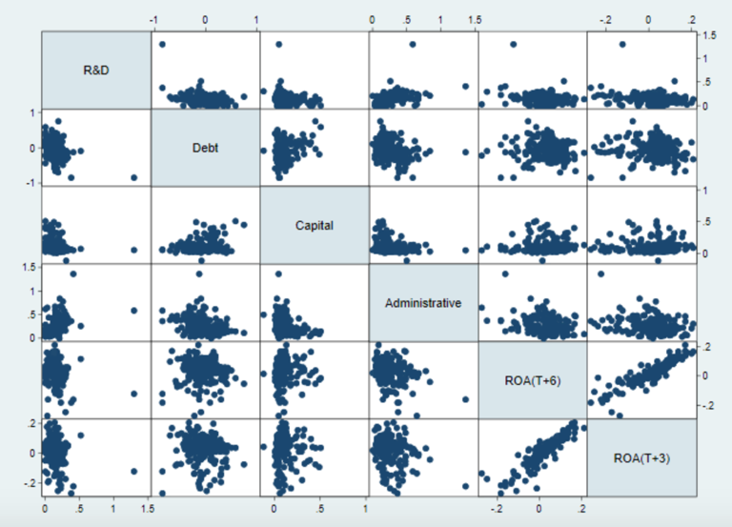
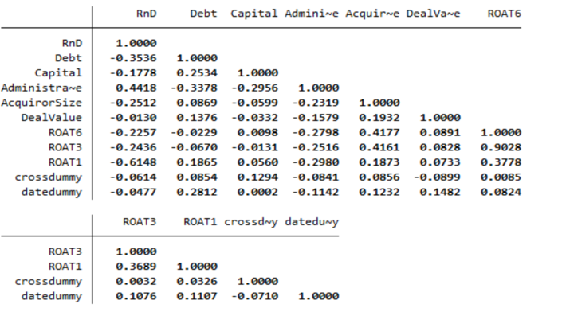
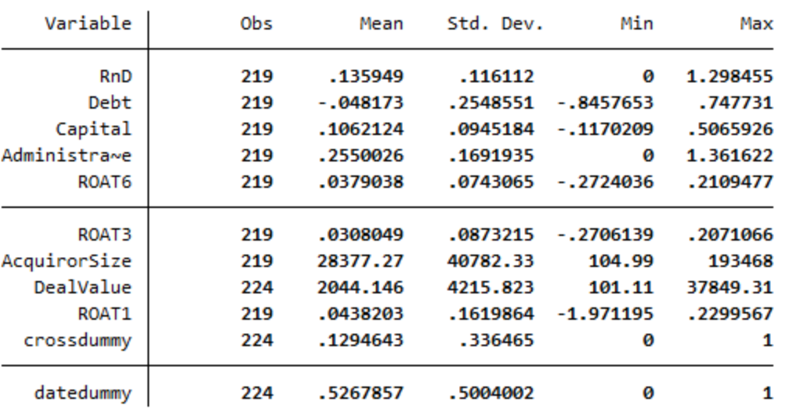

The first variable in line will be the R&D intensity, and it’s strongest relation that we can see in the table tends to be with ROAT-1, but due to the fact that this is one of our control variables , the next the next strongest relationship we observe is with Administrative Intensity with (r=0,44) which is a moderate positive relationship with R&D Intensity . Next we can see that R&D intensity has a weak negative correlation with both the dependent variables ROAT+3 and ROAT+6. Debt intensity and administrative intensity seem to have a moderate negative correlation of (r=-0.34). Moreover , administrative intensity has moderate negative correlation of( r=-0.3) with capital intensity. Capital intensity is also weakly positively corelated with debt intensity. Most of the variables have a negative correlation with the dependent variables so there is an inverse relationship between them. Only one that has a positive correlation but a weak one is the Capital intensity with the ROA T+6 which supports the relevant hypothesis (H2).

Right before the multiple regression analysis starts, we will need to check if the Linear assumptions stand in order to confirm that OLS is unbiased . In order to not go out of topic I will keep this part brief and all relevant tests and results should be found in the appendix. I will briefly interpret the results.
Assumption 1 of linearity in parameters is already true, for both of our models as we saw from the correlation screenshot above there is some linear relationship between all the data. Moreover our models can be written in mathematical terms like this :
$$ROA\left(T+3\right)=β0+β1R\&D+β2Capital+β3debt+β4Adm+e$$
$$ROA\left(T+6\right)=β0+β1R\&D+β2Capital+β3debt+β4Adm+e$$
A way to check for linearity would be with the Ramsay Reset test, but It is not needed in this case.
Assumption 2 this assumption stands , as our sample was selected was from the general context of M&As(population) , in a systematic random sampling selection .
Assumption 3 of no multicollinearity is true as a variance inflation factor (VIF) test was conducted and no results exceeded the value of 2. Test results are located in the appendix.
Assumption 4 of zero conditional mean is never violated as long as there is a regression intercept (Brooks , 2002).
Assumption 5 for homoskedasticity is violated, as the relevant Breusch pagan tests showed heteroskedasticity present for both the models. In order to correct for heteroskedasticity we will run the model using robust standard errors (regress, robust in STATA).
Assumption 6 of normality holds due to the fact that economic data tend to not be normally distributed (Brooks,2002) , so no further test for normality was used, due to the fact that our sample of N=219 can be considered large enough. Skewness and kurtosis graphs for each of the 4 independent and 2 dependent variables have been included in the appendix. (twoway(histogram x )(kdensity x), in STATA)
Assumption | Rule
MLR1 | Linear in parameters | √
MLR2 | Random samplng | √
MLR3 | No multicolinearity | √
MLR4 | Zero conditional mean | √
MLR5 | Homoskedasticty | Corrected
MLR6 | Normality | √

4.7) Analysis and Interpretation of results
For the analysis part I run two different multiple regressions in order to showcase the direct effect of my independent variables towards the Return on assets variable. For the first regression used the 3-year post acquisition average ROA as my dependent variable. I will now interpret the relevant STATA output. By looking at the value of Rsquared, we can translate it as: The amount of variation in the dependent variable (ROAT+3) that is explained by the Independent variables is 31%. Our model can be written as follows :
$$ROA\left(T+3\right)=0.0109+0.022R\&D+0.0053Capital+(-0.074debt)+(-0.082Adm)+e$$
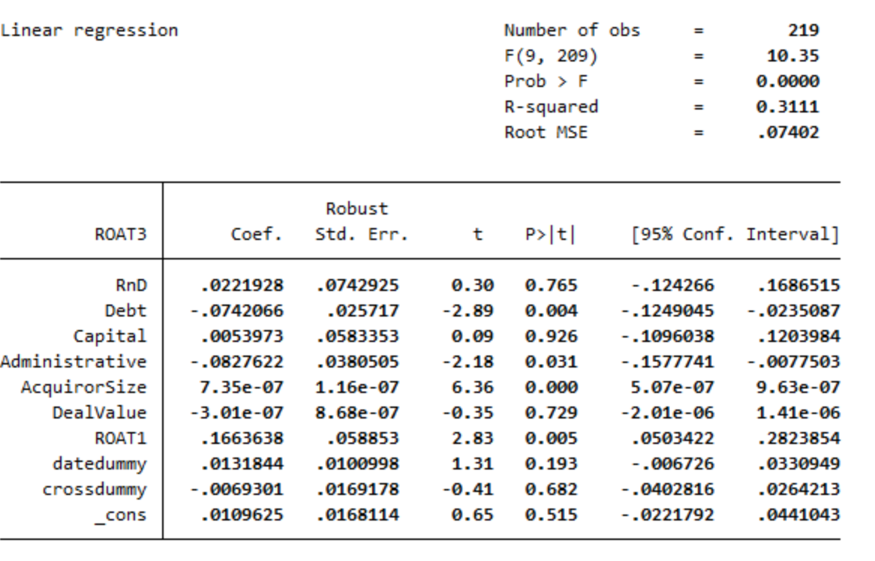

R&D intensity has a positive coefficient of 0.022, which translates as: holding all other variables constant for every increase in investment on R&D by 1 dollar , the value of ROA(T+3) will increase by 0.022 on average. We conduct a t test in order to test the hypothesis that : Research and Development Intensity is positively related to post acquisition performance. I will test this hypothesis , and all the upcoming ones at the 1 % , 5% and 10% levels of significance. As this is a one tailed test the relevant critical values are 10%=1.29 , 5%=1.65, 1%=2.35. So according to the results of the table , the t statistic is equal to 0.30 , which means that it is smaller than all three critical values and that we will fail to reject the null hypothesis at the 1% 5% and 10% level of significance , so we will conclude that there is no significant relationship between R&D intensity and ROA(T+3). Moreover another indicator that would tell us to not reject the null would be the high p value.
Capital intensity has a positive coefficient of 0.005, which translates as: holding all other variables constant for every increase in investment on Capital (Property plant and equipment) by 1 dollar, the value of ROA(T+3) will increase by 0.005 on average .For the second hypothesis that: Capital Intensity is positively related to performance in the post-acquisition period. We will follow the exact same procedure and compare the t value to all three relevant critical values. T value is equal to 0.09, which means that it is not greater than any of the critical values at any level of significance, so we will reject the null hypothesis at the 1% 5% and 10% level of significance and conclude that there is no significant relationship between Capital intensity and ROA(T+3). Similar to the previous Hypothesis the relevant high p value was an indicator to not reject the null.
Debt intensity has a negative coefficient of -0.07, which translates as: holding all other variables constant for every increase in investment on Debt by 1 dollar, the value of ROA(T+3) will decrease by 0.07 on average. For the third hypothesis that: Debt Intensity is positively related to performance in the post-acquisition period. In this case the relevant p value is equal to 0.004. So we can observe that it is smaller than all three levels of significance, so in this case we will reject the null hypothesis and conclude that there is a significant relationship between Debt intensity and ROA(T+3) at the 1% 5% and 10% levels of significance.
Administrative intensity has a negative coefficient of -0.083, which translates as: holding all other variables constant for every increase in investment on Administration (Selling general and administrative) by 1 dollar, the value of ROA(T+3) will decrease by 0.083 on average
For the fourth hypothesis that: Administrative intensity is positively related to performance in the post-acquisition period. In this case I will be using the relevant p value to compare and conclude the statistical significance of this hypothesis. So the relevant p value is equal to p=0.031. We determine that we will reject the null hypothesis at the 5% and 10% levels of significance and we will fail to reject at the 1% level of significance. We conclude that there is a significant relationship between Administrative Intensity and ROA(T+3).
So, we can conclude that at ROA(T+3) Debt intensity and administrative intensity where the independent variables that were significant to our sample.
Next I will be interpreting the t test results on ROA(T+6).Similarly to the previous STATA output we can say that the amount of variation in the dependent variable ROA(T+6) that is explained by out independent variables is 31%. Our model can be written as follows:
$$ROA\left(T+6\right)=0.020+0.071R\&D+0.012Capital+(-0.044debt)+(-0.084Adm)+e$$
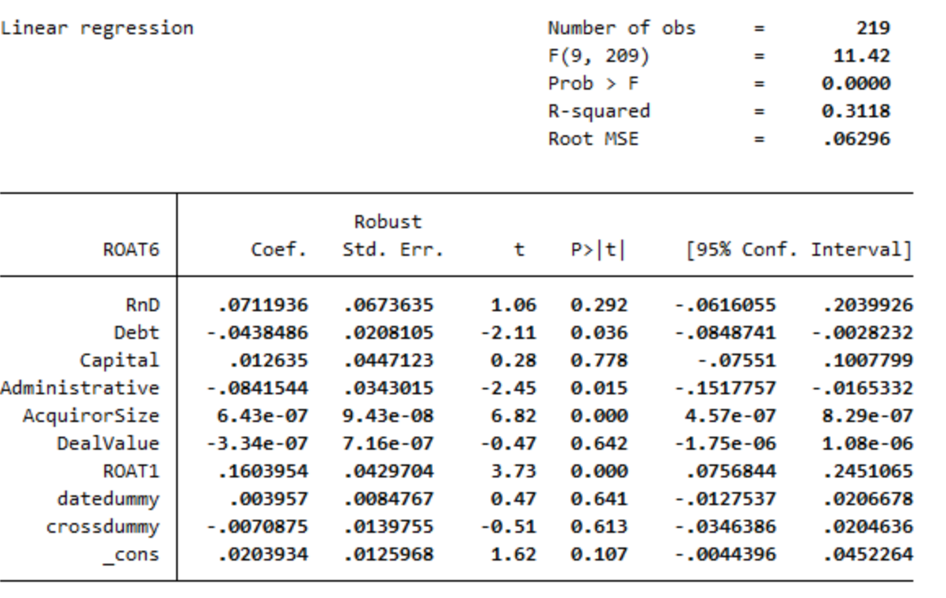

Again, I will be following the same techniques as I did regarding the table above, I will be testing on a one tailed t test due to its statistical power in 3 different levels of significance, 1% 5% and 10%.
R&D intensity has a positive coefficient of 0.071, which translates as: holding all other variables constant for every increase in investment on R&D by 1 dollar, the value of ROA(T+6) will increase by 0.071 on average. We conduct a t test in order to test the hypothesis that: Research and Development Intensity is positively related to post acquisition performance. The t statistic is equal to 1.06, so again we will fail to reject the null hypothesis at the 1% 5% and 10% level of significance and we will conclude that there is no significant relationship between R&D Intensity and ROA(T+6) , we could have also used the p value which is really large as well and it could also be an indicator to not reject the null.
Capital intensity has a positive coefficient of 0.012, which translates as: holding all other variables constant for every increase in investment on Capital (Property plant and equipment) by 1 dollar, the value of ROA(T+6) will increase by 0.012 on average. For the second hypothesis that: Capital Intensity is positively related to performance in the post-acquisition period. The t value is equal to 0.28 which is not greater than any of the critical values, so we will fail to reject the null hypothesis at the 1% 5% and 10% levels of significance, and we will again conclude that there is no significant relationship between Capital Intensity and ROA(T+6). As above, the relatively large p value could have also given us a hint of the result.
Debt intensity has a negative coefficient of -0.043, which translates as: holding all other variables constant for every increase in investment on Debt by 1 dollar, the value of ROA(T+6) will decrease by -0.043 on average and vice versa. For the third hypothesis that: Debt Intensity is positively related to performance in the post-acquisition period.
As we did earlier the relevant p value is equal to 0.036. So, by comparing with the levels of significance we can conclude that we will reject the null hypothesis there is a significant relationship between Debt intensity at ROA(T+6) at the 5% and 10% levels of significance while we will fail to reject at the 1%.
Administrative intensity has a negative coefficient of -0.084, which translates as: holding all other variables constant for every increase in investment on Administration (Selling general and administrative) by 1 dollar, the value of ROA(T+6) will decrease by 0.084 on average
For the fourth hypothesis that: Administrative intensity is positively related to performance in the post-acquisition period. The relevant p value is equal to 0.015. By comparing it to the levels of significance, we can conclude that we will reject the null hypothesis and there is a significant relationship between Administrative Intensity and ROA(T+6) at the 5% and 10% significance levels , and we will fail to reject the null at the 1%.So we can conclude that at ROA(T+6) Debt intensity and administrative intensity where again the independent variables that were significant to our sample.

6) Discussion
We spotted some differences in the coefficients from the 3 year average ROA , to the 6 year average ROA , with the biggest one being in R&D intensity from 0.022 to 0,071. The t value of the same intensity as relatively greater also from 0.30 to 1.06 though not big enough to be significant to our sample. The p values though indicated to us from the beginning that there was not much hope in terms of rejecting the null and supporting the relevant hypothesis.
Out of the independent variables chosen more than half of them ended up being insignificant. The results were surprising but also interesting not only on how many of the independent variables were insignificant but also due to the fact that R&D Intensity and Capital Intensity were the ones. I expected R&D intensity to have a significant effect on performance in the post acquisition period , but the data showed otherwise.
I used three different levels of significance because according to (Brooks,2008) a smaller level of significance is considered more appropriate for large samples. So, one can also say that for smaller datasets it would be better to use a higher level of significance to yield more statistically significant results. The results are still unexpected as due to being in the context of High Technology M&A one would expect a better result for R&D intensity, a result which depicts the actual impact of this variable on the post-merger effect.

7)Limitations
One of the limitations of this study was the use of accounting-based measures as measures of performance. Indeed many researchers have used them in order to measure performance , but one negative about their use is that they do not depict every action in the firm. Moreover , as mentioned earlier sometimes the 10ks , especially the income statements can be biased or the numbers altered . Firms artificially try to influence their earnings by manipulating accounting rules (Cornett, Adair & Nofsinger, 2015). More specifically companies sometimes will try to over or understate their earnings. Managers will try to “smooth” their earnings in order to show to potential or current investors that the assets of the firm are growing on a steady pace . One of the reasons to do this might be that the company is trying to do an IPO and would like to look attractive to investors. So one can say that accounting based measures even though they can be accurate, at times they can be biased and unreliable. Especially the profit and loss or income statement, due to the fact that it depicts the revenues of the company. Out of the widely used accounting measures ROA is considered to be the most accurate, but that doesn’t mean that the ROE ,ROI and ROS measures can’t be used and applied on a good manner to generate accurate results. It would be really interesting if these intensities and hypotheses were tested and another measure of performance was used like the Cummulative Abnormal returns that was used by (Doukas and Lang,1993) or Tobins q that was used by (Agrawal and Knoeber 1996) .Another limitation in the study was the number of intensities used. The initial expectations were that the number of intensities would be enough and all if not most , to be significant. Though the relevant rsquared statistic showed that only 31% of the variation in the dependent variable was explained by our chosen independent variables. So, one can say that if we added more intensities to the sample there would be more explanation by the independent variables.

7) Conclusion

This can lead to many assumptions and conclusions, one of which is that maybe after all R&D and Capital may be not as important as we thought of them to be , even in High Technology intensive firms. Unexpectedly, from what the results indicate Debt and Administrative intensities were the ones that had a statistical significance both on short term and medium/long term ROA. These results were not expected and , debt intensity to be statistically significant to our model , as mentioned above being in a High technology environment I expected Research and development to be a more statistically significant to our sample. The result for the debt intensity can indicate that financial leverage can be as important to a high technology firm as any other firm. Financial leverage refers to the extent that a company chooses to finance its ventures of assets by issuing debt securities. The more amount of debt is issued by the firm as a % of its total assets, the bigger the financial leverage is . When a firm performs well financial leverage will increase the returns or rewards towards shareholders, due to the fact that the share of the firms profits that is promised to its debt holders is set and unpredictable (Cornett, Adair & Nofsinger, 2015). One can say that this maybe will show that high technology companies should take finance their operations more on debt and leverage their investments in another manner.
Moreover , the administrative intensity was unexpected to yield these results. Though this study can be used in order to showcase the hidden weight of the administrative expenses (S,G&A) and their effect and statistical significance and importance for the post acquisition process. The data from this study show that it was statistically significant to have a positive effect in the post-acquisition , something that can show that this can be a really important part of the acquisition process. Perhaps target selection, due diligence and integration team, for the integration process are even more important than we ever thought. Possibly, only for High technology firms this can be the case, as their operations in high growth/high risk markets may need more attention to the administrative parts of the process rather than Research and development and Capital. After all a conclusion to be made is that post acquisition performance can be measured in a number of different ways and high technology companies and their determinants and factors that affect them need to be researched more, due to their importance in the mergers and acquisitions literature. This research showed an interesting result of some factors that were expected to yield different results, but surprisingly showed us another aspect of important factors regarding high technology acquisitions and their implications for future research.

7) Bibliography

- Agrawal, A., & Knoeber, C. (1996). Firm Performance and Mechanisms to Control Agency Problems between Managers and Shareholders. The Journal Of Financial And Quantitative Analysis, 31(3), 377. doi: 10.2307/2331397
- Ahuja, G., & Katila, R. (2001). Technological acquisitions and the innovation performance of acquiring firms: a longitudinal study. Strategic Management Journal, 22(3), 197-220. doi: 10.1002/smj.157
- Ansoff, H. I. (1965). Corporate Strategy: An Analytic Approach to Business Policy for Growth and Expansion. New York: McGraw-Hill.
- BARKEMA, H., & SCHIJVEN, M. (2008). TOWARD UNLOCKING THE FULL POTENTIAL OF ACQUISITIONS: THE ROLE OF ORGANIZATIONAL RESTRUCTURING. Academy Of Management Journal, 51(4), 696-722. doi: 10.5465/amj.2008.33665204
- Berkovitch, E., & Narayanan, M. (1993). Motives for Takeovers: An Empirical Investigation.
- Brooks (2002), Introductory Econometrics for Finance
- Brooks, C. (2008). Introductory Econometrics for Finance (2nd ed.). New York: Cambridge University Press
- Busija, E.C., O’Neill, H.M. and Zeithaml, C.P. (1997), “Diversification strategy, entry mode, and performance: evidence of choice and constraints”, Strategic Management Journal, Vol. 18 No. 4, pp. 321-7.
- Cloodt, M., Hagedoorn, J. and Van Kranenburg, H. (2006), “Mergers and acquisitions: their effect on the innovative performance of companies in high-tech industries”, Research Policy, Vol. 35, pp. 642-654.
- Cohen, W., & Levinthal, D. (1990). Absorptive Capacity: A New Perspective on Learning and Innovation. Administrative Science Quarterly, 35(1), 128. doi: 10.2307/2393553
- Cornett, M., Adair, T., & Nofsinger, J. (2015). Finance. New York: McGraw-Hill Education.
- De Man, A.-P., & Duysters, G. (2005). Collaboration and innovation: a review of the effects of mergers, acquisitions and alliances on innovation. Technovation, 25(12), 1377–1387.
- Desyllas, P., & Hughes, A. (2010). Do high technology acquirers become more innovative? Research Policy, 39(8), 1105–1121. doi:10.1016/j.respol.2010.05.005
- Doukas, J., & Lang, L. (2003). Foreign direct investment, diversification and firm performance. Journal Of International Business Studies, 34(2), 153-172. doi: 10.1057/palgrave.jibs.8400014
- Ellis, K., Reus, T., Lamont, B., & Ranft, A. (2011). Transfer Effects in Large Acquisitions: How Size-Specific Experience Matters. Academy Of Management Journal, 54(6), 1261-1276. doi: 10.5465/amj.2009.0122
- Fisher, A., & Donaldson, G. (1962). Corporate Debt Capacity: A Study of Corporate Debt Policy and the Determination of Corporate Debt Capacity. The Journal Of Finance, 17(3), 554. doi: 10.2307/2977084
- Global M&A Trends in Technology. (2022). Retrieved from https://www.pwc.com/gx/en/services/deals/trends/2022/telecommunications-media-technology.html#:~:text=Dealmakers%20are%20optimistic%20that%20global,current%20TMT%20deals%20landscape%20globally.
- Haleblian, J., Devers, C., McNamara, G., Carpenter, M., & Davison, R. (2009). Taking Stock of What We Know About Mergers and Acquisitions: A Review and Research Agenda. Journal Of Management, 35(3), 469-502. doi: 10.1177/0149206308330554
- Hall, B. (1987). The Effect of Takeover Activity on Corporate Research and Development. doi: 10.3386/w2191
- Harrison, J., Hitt, M., Hoskisson, R., & Ireland, R. (1991). Synergies and Post-Acquisition Performance: Differences versus Similarities in Resource Allocations. Journal Of Management, 17(1), 173-190. doi: 10.1177/014920639101700111
- Jones, C., & Williams, J. (1998). Measuring the Social Return to R&amp;D. The Quarterly Journal Of Economics, 113(4), 1119-1135. doi: 10.1162/003355398555856
- Journal Of Financial And Quantitative Analysis, 28(3), 347. doi: 10.2307/2331418
- King, D., Dalton, D., Daily, C., & Covin, J. (2004). Meta-analyses of post-acquisition performance: indications of unidentified moderators. Strategic Management Journal, 25(2), 187-200. doi: 10.1002/smj.371
- Kohers, N., & Kohers, T. (2000). The Value Creation Potential of High-Tech Mergers. Financial Analysts Journal, 56(3), 40-51. doi: 10.2469/faj.v56.n3.2359
- Kumar, B.R. and Rajib, P. (2007), “Mergers and corporate performance in India: an empirical study”, Decision, Vol. 34 No. 1, pp. 121-47.
- Leepsa, N., & Mishra, C. (2016). Theory and Practice of Mergers and Acquisitions: Empirical Evidence from Indian Cases. IIMS Journal Of Management Science, 7(2), 179. doi: 10.5958/0976-173x.2016.00016.6
- Lubatkin, M. (1983). Mergers and the performance of the acquiring firm. Academy of Management Review, 8: 219-225
- Makri, M., Hitt, M. A., & Lane, P. J. (2010). Complementary technologies, knowledge relatedness, and invention outcomes in high technology mergers and acquisitions. Strategic management journal, 31(6), 602–628.
- Markides, C.C. (1995), “Diversification, restructuring and economic performance”, Strategic Management Journal, Vol. 16 No. 2, pp. 101-18.
- Meeks, G., & Meeks, J. (1981). Profitability Measures as Indicators of Post-Merger Efficiency. The Journal Of Industrial Economics, 29(4), 335. doi: 10.2307/2098249
- Meglio, O. (2009). Measuring performance in technology-driven M&amp;AS: Insights from a literature review. Advances In Mergers &Amp; Acquisitions, 103-118. doi: 10.1108/s1479-361x(2009)0000008008
- Net Debt. (2022). Retrieved from https://corporatefinanceinstitute.com/resources/knowledge/finance/net-debt/
- Salter, M. S., & Weinhold, W. A. (1979). Diversification through Acquisition: Strategies for Creating Economic Value. New York: Free Press.
- Schipper, K., Weston, J., Chung, K., & Hoag, S. (1990). Mergers, Restructuring, and Corporate Control. The Journal Of Finance, 45(5), 1723. doi: 10.2307/2328765
- Schoenberg, R., & Reeves, R. (1999). What determines acquisition activity within an industry?. European Management Journal, 17(1), 93-98. doi: 10.1016/s0263-2373(98)00066-8
- Seth, A. (1990a), “Value Creation in Acquisitions: A Re-Examination of Performance Issues”, Strategic Management Journal, Vol. 11, Nr. 2, pp. 99-115
- Simerly, R.L. and Li, M. (2000), “Environmental dynamism, capital structure and performance: a theoretical integration and an empirical test”, Strategic Management Journal, Vol. 21 No. 1, pp. 31-49.
- Technology M&A continues record run | White & Case LLP. (2022). Retrieved 6 August 2022, from https://www.whitecase.com/publications/insight/record-breaker-us-ma-2021/technology
- Uhlenbruck, K. and Castro, J.O. (2000), “Foreign acquisitions in central and Eastern Europe: outcomes of privatization in transitional economies”, The Academy of Management Journal, Vol. 43 No. 3, pp. 381-402.

8) Appendix

8.1)Heteroskedasticity test results
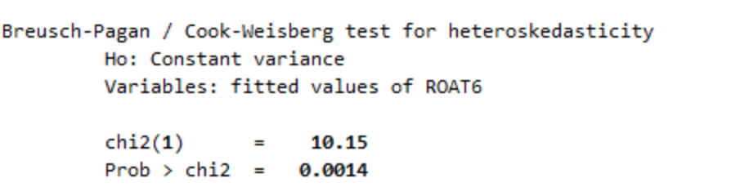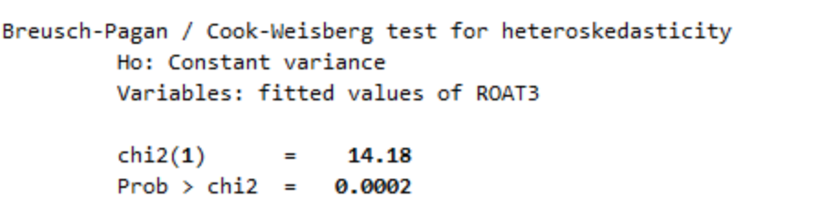

8.2)Variables Descriptions
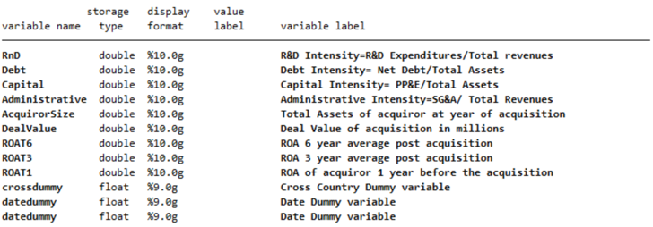

8.3) Variance inflation factor
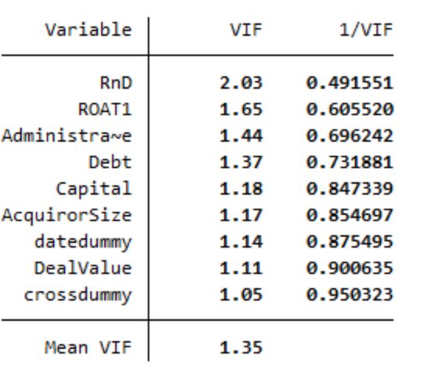

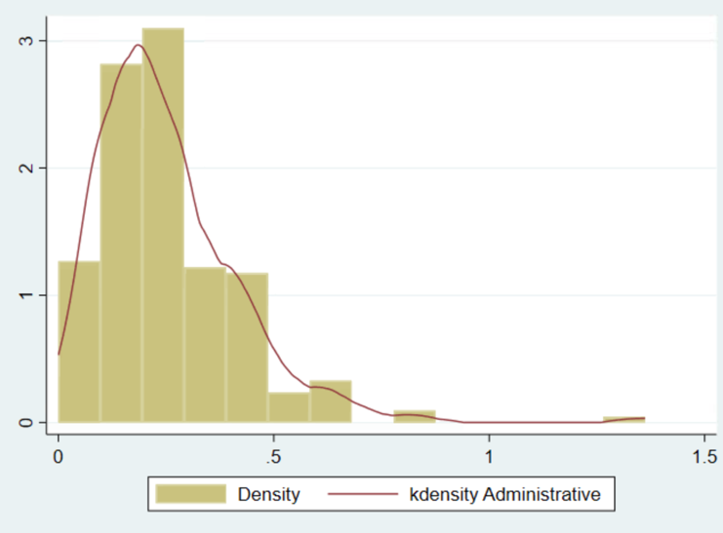
8.4) Skewness and Kurtosis
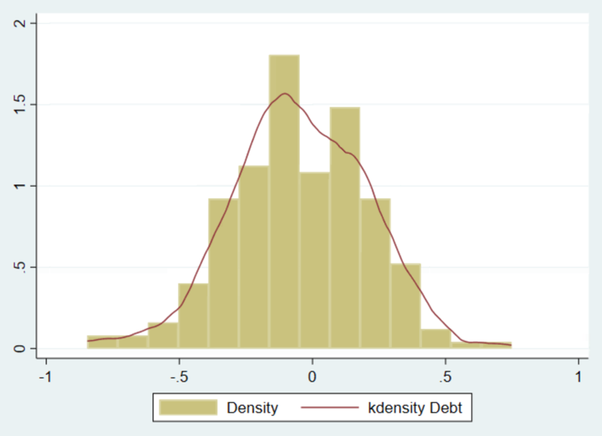

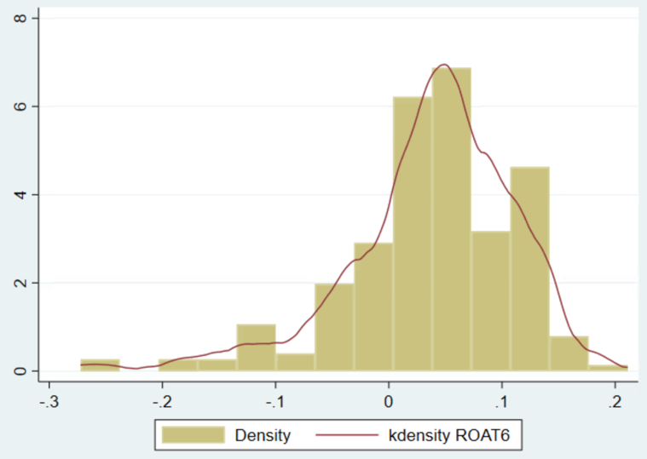
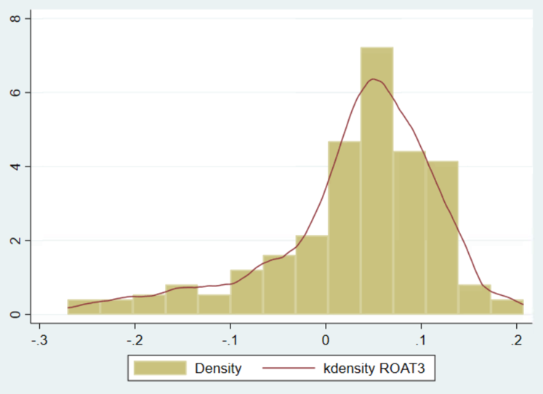
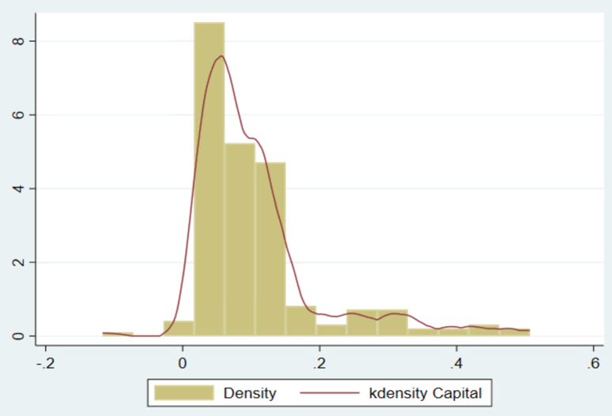
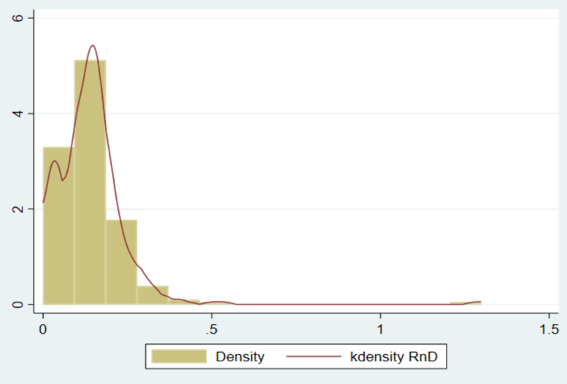

Return on sales: https://www.investopedia.com/terms/r/ros.asp
Return on Investment: https://corporatefinanceinstitute.com/resources/knowledge/finance/return-on-investment-roi-formula/
https://efinancemanagement.com/financial-analysis/capital-intensity-ratio#:~:text=Capital%20Intensity%20Ratio%20is%20a,or%20assets%20to%20generate%20revenue.

