Shoreface morphology changes on Ameland due to natural gas extraction

M.C. Swaving Dijkstra
5971918

m.c.swavingdijkstra@students.uu.nl
March 4th, 2022

Supervision
dr. ir. R.J.A. van Lammeren (WUR)
Responsible professor
dr. ir. L. Kooistra

Abstract

Due to the planned closure of the Groningen gas field, there is a need for gas extraction from other smaller gas reserves in the Netherlands. However, due to the continuing earthquakes and increasing public restraint onshore gas fields will no longer be made eligible for natural gas extraction. This leaves the offshore fields as the last solution to compensate for the gas deficit. However, extraction of gas from offshore fields is not without any consequences either. This study aims to quantify one of the negative effects of the gas extraction for a gas field located under the eastern part of the island of Ameland. The negative effect measured is the surface subsidence, which is especially important for locations that act as a protection against the rise sea-levels. When gas is extracted from fields the pore pressure is being reduced, which causes the sedimental layer to collapse under its own weight, which leads to a decrease in the height of the surface. For the Ameland-East region the surface monitoring committee measured a decrease in surface height as much as 38 cm using field measurements. For this research the surface height decrease is quantified using JARKUS data, which is a yearly measured dataset of the Dutch coast from which data is available since 1965. From this data the average height is measured for smaller areas located in the shallow zone of the north coast of Ameland, Terschelling and Schiermonnikoog through time. Moreover, a coastal transect that is on top of the Ameland-East gas field is measured to locate where the largest decrease in surface height occurs since the start of the natural gas extraction in 1986. The results show that the research areas located east on the islands have the largest decrease in surface height, with an average decrease of 27 centimeters found for the location Ameland-East since the start of the gas extraction in 1986 until 2021. The individual transect shows that this decrease in surface height is predominantly visible onshore in the dune valleys with decreases as much as 1 meter. The dunes themselves show hardly any change in surface height or even an increase in surface height linked to sand suppletion events. Offshore, average surface height in the shallow zone remained roughly the same but did show the disappearance of a second sandbar in 2021 compared to the situation when the gas extraction started in 1986. Lastly, the surface height further offshore also shows a larger decrease in surface height with a maximum decrease of 1 meter. The surface subsidence results found in this research are much larger compared to the found results of the monitoring committee.

Acronyms

DEM Digital Elevation Model
GPS Global Positioning System
JARKUS Jaarlijkse Kustmetingen
Lidar Light Detection and Ranging
NAM Nederlandse Aardolie Maatschappij
NAP Normaal Amsterdams Peil
PCS Projected Coordinate System
RD New Rijksdriehoek Coördinaten

Contents

Abstract 3
Acronyms 3
1 Introduction 6
1.1 Research questions 8
2. Context 9
2.1 Research area 9
2.2 Gas extraction activity Ameland-East 10
2.3 Literature review 11
2.3.1 Natural seabed height changes 11
2.3.2 Anthropogenic seabed height changes 12
2.3.3 Bathymetric measuring methods 13
2.3.4 JARKUS applications in other research projects 14
2.3.5 Effects of gas extraction on surface height in other research 15
3. Methodology 16
3.1 General methodology 16
3.2 JARKUS data 16
3.3 Seabed subsidence studied in other literature 16
3.4 Methods used to detect seabed subsidence 17
3.5 What signs of seabed subsidence are present at the shoreface of the Wadden isles 18
3.6 How to put the found results into perspective 19
3.6.1 Accounting for eastward movement of morphological features 19
3.6.2 Comparing found results with measurements in the field 19
4. Results 21
4.1 Difference maps between different raster DEM’s 21
4.2 Signs of seabed subsidence present in the shoreface of the Wadden Isles 23
4.3 Changes in standard deviation 25
4.4 Accounting for eastward motion of morphological features 27
4.5 Comparison JARKUS transect with field and GPS measurements 29
5. Discussion 32
5.1 Limitations of the JARKUS data 32
5.2 Evaluation of the performed method 32
5.3 Evaluation of the results 32
6. Conclusion 34
7. Recommendation 35
8. References 36
9. Appendices 39
9.1 Appendix A – Pre-processing JARKUS data 39

1 Introduction
The Netherlands still is heavily reliant on the extraction of natural gas from fields onshore and offshore. Extensive onshore gas extraction from the large Slochteren gas field has led to repeated earthquakes in the Dutch province of Groningen, leading to a policy shifting away from the extraction of natural gasses from the Dutch mainland (Vlek, 2019). However, alternative green energy sources are still too limited to compensate for the reduction of gas extraction from the fields in Groningen. Alternatively, the gas could be imported from other countries such as Russia. Besides this being an expensive solution, it would also make the Netherlands heavily reliant on Russia’s gas reserves, which can lead to complicated geo-political issues (Henderson & Mitrova, 2015). The other alternative to compensate for the deficit of energy resources is the extraction of gas from smaller gas fields. However, the newly formed Dutch government has banned the permits for further exploration of smaller onshore fields due to local safety issues, public restraint and set climate goals (Hess & Renner, 2019). Now, only small offshore gas fields are eligible to obtain permits for the extraction of gas. The Netherlands has already many different offshore platforms in use, the extraction of gas from these offshore fields is not without any consequences either.
Extraction from offshore gas fields usually results in local subsidence of the seabed (Vonhögen-Peeters, van Heteren, Wiersma, de Kleine & Marges, 2013; Wachler, Steiffert, Rasquin & Kösters, 2020). Even though this local subsidence may seem harmless there can be substantial negative side-effects. This is especially true for gas fields close to the shoreline. The first reason is that this subsidence can be noticeable several kilometres from the gas well causing substantial onshore subsidence as well (Jayeoba, Mathias, Nielsen, Vilarrasa & Bjørnarå, 2019), which increases the risk of flooding events. Moreover, dune volume changes are directly correlated with the beach slope. If the beach slope becomes steeper due to the extraction of natural gas, the dune volume is expected to reduce (De Vries, 2012). Since gas extraction is expected to cause substantial subsidence of the seabed, the beach slope angle becomes larger if this subsidence is relatively close to the mainland. Thus, gas field extractions that are close to the shore are expected to have the greatest influence on the dune volume on the shore. A decrease in dune volume also enhances coastal safety issues.
In the early 1990s the Dutch government launched a new coastal defence method called ‘Dynamic Coastal Management’. This meant that the primary coastal line of 1990 would be preserved, meaning that erosive trends would be stopped at all costs (Verhagen, 1990). Stopping these erosive trends was to be done with ‘dynamic’ solutions. This meant that no longer rigid structures should be used to preserve the primary coastline, solutions should come from ‘soft’ defence barriers. Even though dynamic coastal management is considered a success, it has led to an increase in sand suppletion all along the Dutch coastal zone (De Ruig & Hillen, 1997). Besides the increase in sand suppletion, the importance of soft defence structures such as dunes and beaches became increasingly important (Poortinga, Keijsers, Visser, Riksen & Baas, 2015). Thus, a decrease in sediment volumes on the coast and dunes has a large effect on the protection of the Dutch coastal zone.
Sediment volume changes over time are influenced by many different parameters, making determining the cause of the volume changes difficult. Sediment shows temporal variability in volume even under normal conditions (Poortinga, Keijsers, Visser, Riksen & Baas, 2015). Large erosive events can be linked during high seawater storms, showing slow accretion of sand between these storms. This variability masks the potential influence of natural gas extraction. Moreover, as previously mentioned sand suppletion has become a common method to ensure coastal safety. The time or the exact volumes of this sand suppletion are sometimes difficult to determine. Lastly, the bathymetry along the Dutch coast is a complex system that is constantly evolving, changes in this system sometimes lead to the disappearance of sediment, that cannot always be linked to certain events (Mai & Bartholomä, 2000).
Therefore, it is difficult for research to isolate the effects of the natural gas extraction on the height of the bathymetry as these other parameters that influence differences in bathymetry height must be considered.
This research will be limited to three different locations: (1) Terschelling, (2) Ameland and (3) Schiermonnikoog. The focus will be on the north side of the islands as that side contains most of the dunes and beaches due to the wave dominated influence of the North Sea. These beaches and dunes form the main protection from the North Sea and are therefore vital for the entire system of the island. The three islands are successively located in the centre of the Dutch barrier islands called the ‘Waddeneilanden’ and share a similar shoreface morphology. However, in front of the coast of Ameland there are several gas platforms that have been active since the 1986 pumping from a natural gas reservoir. Gas platforms are located approximately 2 kilometres offshore as well as on the eastern mainland of Ameland (Figure. 1). Terschelling and Schiermonnikoog will be used as control samples as there is no gas extraction active surrounding these barrier islands.
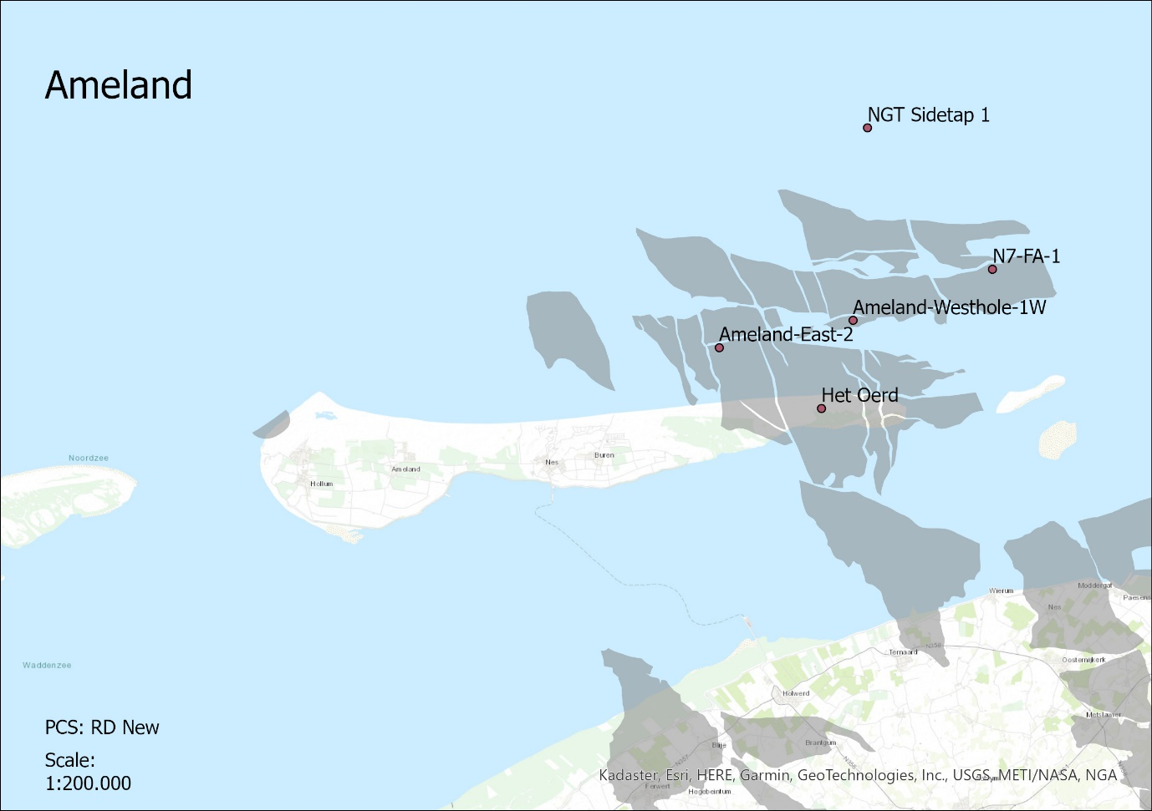
Figure 1: Gas extraction activity displayed red markers with gas fields displayed in grey.

1.1 Research questions
The research quantifies the impact of natural gas extraction on the shoreface of Ameland-East. Four research questions are drawn up to conduct this quantification:

- In what way is (sea)bed or surface subsidence studied in other research projects?
- What methodology could be used to detect seabed subsidence in relation to natural gas extraction?
- What signs of seabed subsidence are present at the shoreface of the Wadden Isles?
- How could these signs of seabed subsidence be evaluated?

As briefly stated earlier the shoreface morphology of the Wadden Isles is dynamic and complex, making it impossible to attribute all the shoreface changes to certain specific causes. Due to the complexity of the task the research area is limited to these three islands. The effects of the natural gas extraction on the entire Wadden Isles system is beyond the scope of this research. Therefore, changes that are found in this research might not be true for all the places where there is natural gas extraction close to the shore.

2. Context

2.1 Research area
Wadden isles are barrier islands and are part of a sequence of barrier islands from the Netherlands in the West all the way to the coast of Germany and Denmark in the East. The research area contains three of the Dutch Wadden Isles, (1) Terschelling, (2) Ameland and (3) Schiermonnikoog (Figure. 2a). The Wadden sea which is behind these islands forms one of the major intertidal areas on earth. During low tide large parts of the Wadden Sea fall dry. Besides that, the intertidal area of the Wadden Sea is one of the largest nature reserves in Western Europe. Most of the developments in the system are controlled by tidal forces, creating ebb deltas, gullies, sand banks and other morphological features (van Veen, van der Spek, Stive & Zitman, 2005).
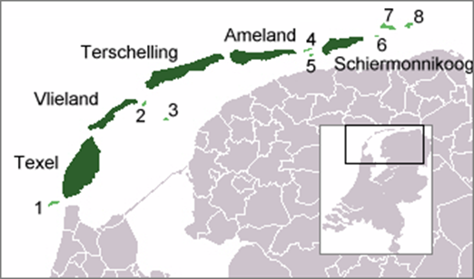
Figure 2a: Map of the Wadden Sea and the barrier islands.
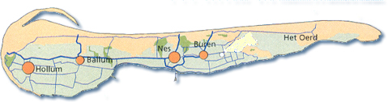
Figure 2b: Topographic map of Ameland
It is estimated that the barrier islands developed 6000 years ago after the most recent ice age (Oost, 1995). Due to the subsequent sea level rise the islands retreated to the shore over several kilometres. It is estimated that the current barrier islands are approximately 2000 years old. The islands form protection of the seaside for the Wadden Sea, making the Wadden Sea hardly influenced by waves. Due to dominant wind from the west and an eastward residual tidal current the barrier islands tend to shift in the eastern direction (Wang, Hoekstra, Burchard, Ridderinkhof, De Swart & Stive, 2012). Despite the closure of the Zuider Sea and later the Lauwers Sea the Wadden Sea largely contained the same character as it did before these major morphological changes.
The area of interest for this research is Ameland (Figure. 2b), which is the fourth Dutch island (counting from West to East) populated with approximately 3750 people across four different villages. The soil of Ameland predominantly consists of sandy dunes. Het Oerd is situated in the east of Ameland, which is a nature reserve containing a complex of dunes surrounded by wet valleys where seawater occasionally penetrates the soil. Due to these conditions, there is a wide variety of plant and bird species that are very susceptible to changes is conditions present in the nature reserve.

2.2 Gas extraction activity Ameland-East
In the 1960s the Dutch government allowed the search for potential gas reserves on multiple locations on Ameland. The NAM (Nederlandse Aardolie Maatschappij) ultimately got permission to extract gas from the Ameland-East gas field, with a gas well in the nature reserve ‘het Oerd’ and three wells several kilometres north of the island extracting gas from the Ameland-East gas field and two other gas fields called Ameland-Westgat and Ameland-N07FA (Figure. 3). Table 1 shows the potential production volume and the already produced volume from these gas fields until January 2021 for the three gas fields in Nm³.
Table 1: Production volumes Ameland gas fields
Name Gas field | Maximum production volume (Nm) | Produced volume until January 2021
Ameland-East | 52972 | 43167
Ameland-Westhole | 7018 | 5861
Ameland-N07FA | 1417 | 957

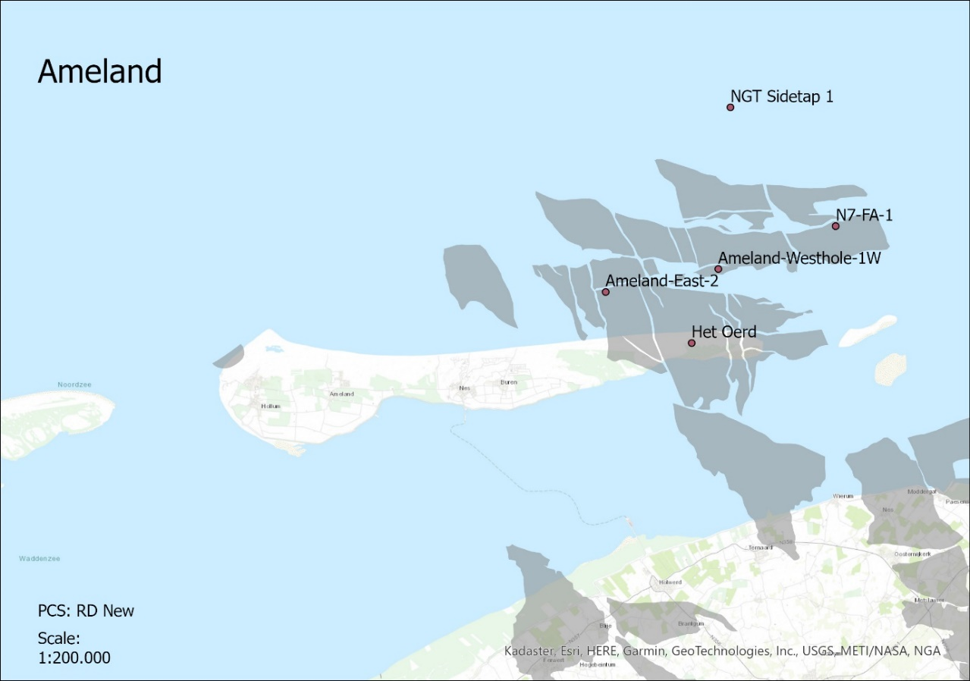
Figure 3, Locations of different gas wells and gas fields Ameland
From this table it becomes clear that most of the potential gas volume is already extracted from these three gas fields. The gas pressure of the Ameland-East field dropped from 570 bar in 1986 to 50 bar in 2017 (Piening, van de Veen & van Eijs, 2017). The total production value on Ameland is approximately 400 m³/year and is expected to slowly decrease over time. In 2035 it is expected that the gas extraction ends, however this date has been moved further in the future several times as well.
The decrease in pressure causes the grains in the soil to collapse under their own weight, which leads to a decrease in the height of the surface (Kou, Li, Wang, Zhang & Chen, 2020). On Ameland, this height decrease is monitored using ground measurements and GPS. The measured maximum decrease in height is 34 mm. If the height decrease is larger than the threshold level for the system to replenish itself with sediment human interference is necessary. This is often done by suppletion of sediment on the foreshore or on the beach and dunes.

2.3 Literature review
Keywords:
Bathymetry
JARKUS
Gas extraction
North Sea
Seabed Subsidence
There are constantly vertical changes in seabed height in the North Sea. These changes are influencing the dynamics and are shaping the future state of the North Sea region. Differences in seabed height result differences in sediment transport, deposition, and erosion (Fokker, Van Leijen, Orlic, Van Der Marel & Hanssen, 2018). The seabed height is therefore the important parameter that influences the dynamics of the North Sea. This seabed height is measured compared to NAP (Normaal Amsterdams Peil). NAP is the reference height used in the Netherlands to compare differences in height changes of the surface. As NAP increases along with the rising sea level, the relative height of the surface is decreasing slowly without interference of any other causes. There can be two different groups of causes distinguished that change the seabed height, natural and anthropogenic causes.

2.3.1 Natural seabed height changes
There are several different natural causes that influence the seabed height in the North Sea. Most of these natural causes act on a long timescale, showing minor but evident differences over longer periods of time. The three most important natural causes that influence the seabed height over a longer period are (1) compaction, (2) isostacy and (3) tectonics (van der Spek, 2018).
As the Netherlands lie at the inlet/estuarium? of some of the major rivers in Europe, much river sediment is accumulating in the Wadden Sea and the North Sea. The lower lying sediment layers start to compact under the pressure of the top layers, causing natural subsidence of the seabed (Karle, Bungenstock & Whermann, 2021). This compaction is often faster than the accommodation space created by the sea level rise which is caused by the increase in global temperature. This may enhance the sedimentation rate in the North Sea (Long, Waller, Stupples, 2006). Therefore, the actual influence of compaction on the seabed height is difficult to quantify.
Postglacial isostacy is the response of the earth its surface by the reduction of gravitational load by the melting of land ice. After the last glacial maximum land ice started to retreat further northward reducing the gravitational load on the surface. This causes an upward bouncing effect of the surface that is still observable today, increasing the height of the seabed. However, the effect of the postglacial isostacy has been gradually reduced over the last 10.000 years (Lambeck & Chappell, 2001).
Lastly plate tectonics can be responsible for sudden changes in vertical land movement. In the Netherlands, most of the tectonic activity occurs in the southern part of the country. However, it is estimated that this tectonic activity has negligible effect on the seabed height of the North Sea (Fokker, Van Leijen, Orlic, Van Der Marel & Hanssen, 2018). It is estimated that the combination of the natural processes that influence the seabed height in the North Sea cause a small subsidence of the seabed with velocities of less than 1 mm/year (Vermeersen et al., 2018).
Besides long-term processes that influence the seabed height of the North Sea, there are also processes that act on a shorter time scale, namely (1) wave and (2) tidal influences. The temporal and spatial evolution of bathymetry is dominated by the migration of tidal channels (Jacob, Stanev & Zhang, 2016). Due to the dynamic nature of the North Sea system traces of changes are found far away from the regions of origin because tidal waves propagate the local disturbances basin-wide. The tidal distortion resulting from the relatively small bathymetric changes is substantial, particularly in coastal zones. These changes are non-linear and are crucial for the sediment budget and morphological feedback to the system (Jacob, Stanev & Zhang, 2016). The influences of waves and tides act over a smaller period than the beforementioned causes. Thus, distinguished large changes in local seabed height that act over a period of a few years are predominantly caused by tidal and wave influence and not by other natural causes such as the Lundial cycle. This tidal influence acts over a period of 12 hours and 25 minutes. Moreover, depending on the position of the sun compared to the moon the strength of the tides can differ. During new moon and full moon, the sun contributes additional gravitational force to increase the tidal influences, which is called spring tide.

2.3.2 Anthropogenic seabed height changes
There are several activities in the Netherlands that influence the seabed height, these are (1) oil/gas extraction, (2) salt mining, (3) sand extraction, (4) coal mining, (5) gas storage and (6) geothermal exploitation. Only gas extraction, salt mining and sand extraction are relevant for the North Sea.
The gas that is extracted in the North Sea is often stored in the pores of sandstone formations. The extraction of gas from such a reservoir causes the pressure to decrease from the sandstone formation, leading to compaction of the sandstone formation. This leads to a decrease in the local seabed height as pores of the sandstone formation collapse under the weight of the top layers, which can often lead to earthquakes. The amount of pressure decrease is usually an accurate parameter to estimate the potential decrease of the soil, this pressure decrease is significant for the gas reservoirs surrounding Ameland. The subsidence of the seafloor is increased when the extraction of gas is from a deeper reservoir (Candela, Koster, Stafleu, Visser & Fokker, 2020). It is also important to consider that the decrease in surface height continues long after the last gas is extracted from a reservoir, thus stopping the extraction of gas has a delayed effect on the decrease of the surface height (Zander, Choi, Vanneste, Berndt, Dannowski, Carlton, & Bialas, 2018).
Salt solution mining produces salt from deep rock salt layers. The extraction of salt from this deep layer is done by pumping fresh water into a well that dissolves the salt from the layer. The salty water is brought back up and the salt is separated from the water. Because much salt can be extracted from a relatively small solution cavern the effects on the local seabed height are small compared to the extraction of gas (Fokker, Van Leijen, Orlic, Van Der Marel & Hanssen, 2018).
The Dutch government has been extracting sea sand for a long time. However, in recent decades the volumes of sea sand extracted compared to the total amount of sand extraction has drastically increased. This is caused as a result from the 1990 policy to preserve all coastal shores which is often done by suppletion of sand on beaches that need additional protection. Moreover, with the development of the second Maasvlakte and the sand motor there have been project that demanded enormous volumes of sand. The Netherlands has a designated area for sea sand extraction purposes approximately 20 kilometres of the coast, except for locations where there are underground pipelines or platforms (de Vrees, 2021).
The combination of natural and anthropogenic sources that influence the seabed height result in a relatively small subsidence of the seafloor. Combined with rising a rising sea level this results in extra accommodation space for sediment, which in the current situation can be easily filled with sediment that is transported into the North Sea system and from sand suppletion (Vönhogen-Peeters, van Heteren, Wiersma, de Kleine & Marges, 2013). Thus, the current situation there is no additional suppletion of sand necessary to balance out the North Sea subsidence.

2.3.3 Bathymetric measuring methods
There are several different methods to determine the changes in bathymetry in the North Sea besides based upon the field measurements like the JARKUS data. Four different remote sensing methods are (1) Aerial photography, (2) lidar scanning, (3) marine multibeam bathymetry and (4) GPS.
With the technological development of cameras in the 21st century aerial photographs can be used to create a digital terrain model. Aerial photogrammetry uses a multitude of photographs to accurately determine the shape of the earth its surface by cross-referencing between the different photographs. When using aerial photographs for determining the bathymetry of the sea there must be a correction done due to the refracting effect of the air-water boundary (Hodúl, Bird, Knudby & Chénier, 2018).
Bathymetric lidar uses laser beams and return rates to determine the depth of shallow coastal areas up to depths of 70 meters. However, the lidar method can be costly and inaccurate with heavy wave activity. Moreover, it is often difficult to determine the base water level from the lidar point clouds (Wang, Li, Liu, Wu, Liu & Ding, 2015).
Marine multibeam bathymetry uses sound waves to determine the depth of the bathymetry. This is done by recording the time it takes for the sound waves to be transported back to the receiver. The device is often carried by ships, making the mapping of large surface areas difficult. Moreover, multibeam bathymetry does not work well in shallow waters. Since 1990 every three years there is multibeam bathymetry data available from the Dutch coastal zone.
With improved satellites launched in recent years determining the surface height on the land can be very accurately done using GPS. As the method is relatively cheap many locations are continuously monitored using GPS measurements. However, GPS has still limited offshore applications available, making the measuring technique only eligible for on land measurements.
The demand for new methods to determine seabed height changes has increased over the last decade, this is mainly due to the continuing extraction of oil and gasses leading to seabed subsidence as well as predicting underwater seismic activity. Recent research has used a Micro-Electral-Mechinical-Systems accelerometer that senses changes in tilt angels to predict seabed height changes (Xu et al., 2018). Measuring the exact water pressure at the seabed floor has reached accuracies of 2-5 mm, this method can be applied relatively wide being capable of surveying entire underground oil/gas reservoirs. This led to finding differences is seabed height far from the locations where the gas reservoir was being extracted (Eiken & Stenvold, 2021).
Due to the shortcomings of the remote sensing methods accurate marine data in the Netherlands is still measured using JARKUS transects. JARKUS data results transects made up of points with a certain height/depth value. The data on the shore was prior to 1990 being measured using GPS, but now uses lidar technology. The offshore data is measured using marine multibeam surveying techniques (Giardino, Diamantidou, Pearson, Santinelli & Den Heijer, 2019). However, to distinguish the bathymetry from this point data can be done using several different processing methods.

2.3.4 JARKUS applications in other research projects
Vermaas (2012) conducted a pilot study which was focussed on combining different elevation datasets from the Dutch coast. One of these datasets was the JARKUS dataset. As the research was limited to a small part of the Dutch coast the dataset was clipped for the specific research area. There was a brief interpolation comparison conducted between kriging, natural neighbour, spline and IDW. The resulting DEM showed minor differences between the interpolation methods; therefore, the fast natural neighbour method was ultimately chosen. The chosen grid size was 20x20 meter, which was later decreased using the additional datasets. Because the JARKUS data consists of seaward transects sometimes several hundred meters apart the surface area created in between these transects is inaccurate. These inaccurate areas were removed using convex hulls. Convex hulls limit the raster output area by using the outer data points as boundaries for the resulting raster.
The JARKUS dataset is not as extensive for each year, meaning the comparing the resulting DEM’s is not straightforward. Comparing the DEM’s was done using four reference years that had a relatively extensive spatial coverage of measurement points. Subtracting the DEM of a particular year with a reference year results in a difference map. Difference maps were also created based over a certain period (1 or 5 years). Lastly, these difference maps were also accumulated over a longer period, these periods were 1965-1990, 1990-2000 and 2000-present. The increments between these years were chosen based on the coastal protection policy that was leading during these periods.
Van Rijn (1997) had a different purpose for his research, namely quantifying and visualizing sediment transport along the Dutch coast of North-Holland. Therefore, the shoreline was divided into three different compartments (3/-3, -3/-8 and -8/-20) in which -3 NAP is taken as the boundary between the inner and outer surf zone. The volume changes were determined using the JARKUS data for each of the different compartments. The resulting cross-shore transport rates were calculated using a coastal profile model, showing the quantity and direction of the transported sediment over the years. This resulted in a map visualizing the sediment transport behavior alongside the North-Holland coast.
Southgate (2011) used the JARKUS dataset to determine changes to the so-called momentary coastline. The JARKUS transects that reach several hundred meters offshore were used to determine this coastline. There often were gaps in the data, for example no measured bed level of a transect for a particular year or the transect is not measured extensive enough to accurately determine the momentary coastline. Approximately 60% of the initial data of the transects was considered complete. Since there are so many gaps in transect data especially during the early years of the JARKUS data collection it was decided that there was a maximum limit of 4 transect gaps over the years allowed for the data to be considered valid, resulting in a use of 904 transects to ultimately determine the momentary coastline.
Bitenc (2010) argued that the JARKUS data collection interval is too long for the use of coastal safety purposes. Large morphological changes in the seabed are caused during storm and sea flood events. These events can act on a very small timescale while the monitoring of bathymetric changes is done once a year. Thus, changes in the JARKUS data over a few years cannot always give reliable results. The strength of the JARKUS data is that the collection started in 1965, meaning that the coast has been monitored for the past 65 years, which is a timescale that smooths out most of these storm events.
Van Heerwaarden (2021) noticed that in the seaward side of the JARKUS transects certain inconsistencies in the data occur. Volume calculations are sensitive for these inconsistencies. Alternating or missing values within the profile were filled using linear interpolation to counteract the inconsistencies in the seaward data. As the length of the transects varies over the years the extrapolation was selected for a maximum depth of -20 meters. Large manmade changes were excluded from the JARKUS datasets.

2.3.5 Effects of gas extraction on surface height in other research
There is a general understanding among scientist on how gas extraction from offshore fields influences the height of the seabed. GPS receivers on offshore platforms show a decrease in platform height that can reach up to 10 meters (Zaradkiewicz, Eriksson, Christian, Klemm, & Hickman, 2018). The subsidence of the platforms is generally larger when the maturity of the hydrocarbon fields is higher. Thus, when the extraction of gas is done over a longer period more subsidence is expected (Levenberg & Orozova-Bekkevold, 2020). The reason for this subsidence is generally due a decrease in pressure of the reservoir from which the gas is extracted coupled with a decrease in pore volume (Eiken & Stenvold, 2021). To limit the compaction and subsidence of the gas fields water is injected into the reservoir, this causes the reservoir to maintain reasonable pore pressure which counteracts the subsequent subsidence. However, the Ekofisk field in the North Sea showed that even though water was injected into the gas reservoir and pore pressure maintained its initial level, the seabed continued to subside significantly (Keszthelyi, Dysthe & Jamtveit, 2016). The subsidence of the seabed is not only present directly above the reservoir from which gas is extracted. Significant decrease is seabed height (+/- 1 meter) can be observed several kilometres away from the platform that is used to extract gas from the reservoir (Borges, Landrø & Duffaut, 2020).
Since the gas extraction on Ameland started in 1986 the surface height of eastern part of the island is being monitored commissioned by the NAM with field measurements every 3 years. Since 2006 GPS measurements are also performed to monitor the average surface height every 3 years. The latest report of the commission surface subsidence (2017) showed that the maximum decrease on the Ameland mainland is 38 centimetres. The diameter of the area that is susceptible to decrease in surface height is approximately 17 kilometres (Piening, van der Veen & van Eijs, 2017).

3. Methodology
This section describes the performed methodology for each of the four different research questions that form the backbone of this research.

3.1 General methodology
This report will be structured in line with the four research questions that were mentioned earlier. These research questions have been answered individually and chronologically. This means that first research question 1 was answered after continuing to research question 2. When all the research questions are answered the main research question will be answered as well. There is a flow diagram made that shows a summarization of the performed methodology in this research (Figure. 4).
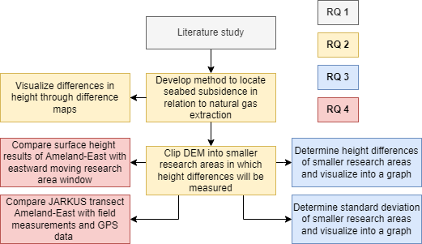
Figure 4, flow diagram of general methodology

3.2 JARKUS data
The data that will be used for this research is called JARKUS, which is a yearly measurement of the Dutch coast lead by Rijkswaterstaat. This JARKUS data contains transects of the sandy shore across the Dutch coast from the first coastal dunes to roughly 1 kilometre into the sea, the location of these transects is roughly the same each year. Data collection started back in 1926. There is yearly data available since 1965, complete data of 1463 different transects is present since 1992. The data contains x and y coordinates in the RD_New coordinate system and a height/depth z in meters relative to NAP (Normaal Amsterdams Peil). The data have a horizontal accuracy of approximately 15-30 centimetres. The original goal of the JARKUS data was morphological management, it was used to detect locations that needed suppletion of sand to ensure coastline safety. This is often the case due to the policy of the Netherlands to keep the virtual coastline in place. However, the data is also used for hydrological purposes as well as biological and chemical research (IJzendoorn, de Vries, Hallin, & Hesp, 2021).

3.3 Seabed subsidence studied in other literature
To develop a method to detect seabed subsidence on Ameland first a literature review was performed. This literature review consists of several different subjects that are necessary to understand to develop a method for this research. First, the natural and anthropogenic changes in seabed subsidence in the North Sea are listed. Then different surveying techniques that are used to detect seabed subsidence are discussed. The different applications of JARKUS data in other research will be listed. Lastly, the found results in other literature regarding seabed height changes linked to gas extraction are mentioned. Since the knowledge over the effects of natural gas extraction on the seabed height has increased over time it is decided that articles after 2010 are prioritised. To ensure results from literature are not outdated it is decided that literature older than 1990 is neglected. Keywords used to find the literature are ‘Bathymetry’, ‘Gas extraction’, ‘North Sea’ and ‘Seabed Subsidence’.

3.4 Methods used to detect seabed subsidence
The pre-processing procedure that is used to create the DEM’s is shown in Appendix A. Vermaas (2012) pointed out that different interpolation methods hardly make any difference in DEM results, therefore it is decided that a simple IDW interpolation of the JARKUS transect points sufficed. For Ameland, prior to the extraction of gas which started in 1986 DEM’s are created every 5 years. This is because there is no need to show increments of one year as changes that act on a temporal timescale of 1 year are not of interest for this research. However, from 1986 onwards the DEM’s are made with increments of 1 year. This is done to identify abrupt changes in surface height which in turn can be linked to sand suppletion or storm events as these events need to be considered to quantify the actual effects of the gas extraction. For Terschelling and Schiermonnikoog DEM’s are created with increments of five years for the entire period of 1966-2021, as these islands are not influenced by the extraction of natural gas.
As Bitenc (2010) pointed out,
the differences in data collection points between the different measurement years is visible in the spatial extend and density of the data. To illustrate this, two resulting DEM’s from Ameland are shown below, one for 1966 that has a relatively few data measuring points and extend and one for 2021 which has a relatively high number of measuring points and a wide extend (Figure. 5 a & b)
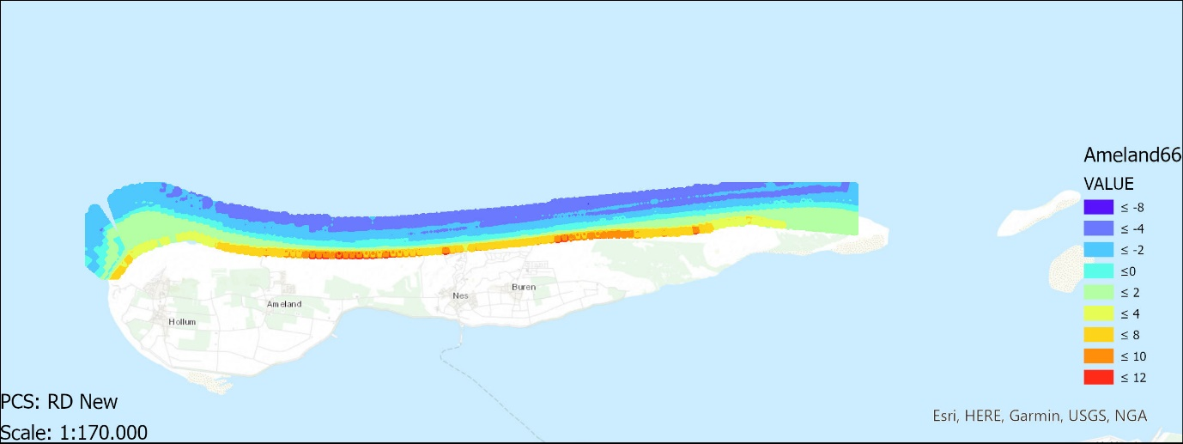
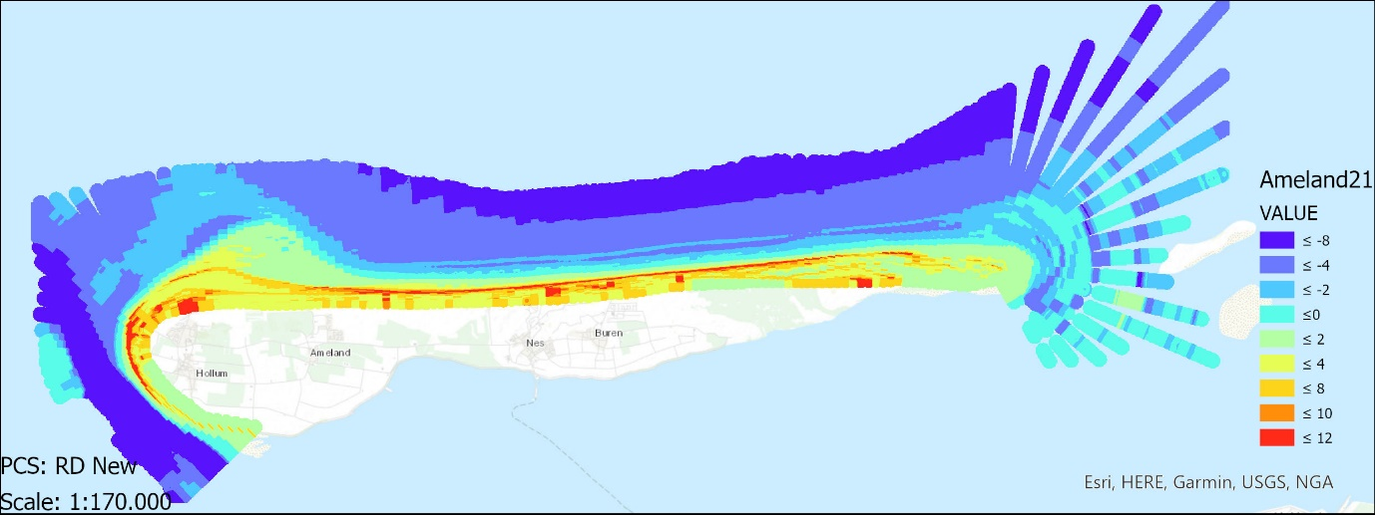
Figure 5 a & b, raster DEM’s of 1966 and 2021 with height in meters.
Van Rijn (1997) divided the raster DEM’s into different coastal zones to distinguish sediment volume changes depending on distance from the shoreline. In this research the raster DEM’s are clipped to specific smaller areas are used to detect changes in average seabed height (Figure. 6). These areas start in the shallow shoreface of the northern coast of the three different islands and stretch 750 meters into the sea. This distance was chosen because the minimum distance of the measured transects for years older than 2010 is 800 meters into the sea. Thus, data further into the sea would be incomplete for older measurement years. As Wang et al. (2012) stated, the morphological processes that act on the western part of a Wadden Isle are often very different from the morphological processes that act on the eastern part of the island. This is linked to the dominant western winds combined with a stronger eastward tidal flow. Therefore, these smaller research areas are divided into locations west, middle, and east. They all contain the same length of 2600 meters. Thus, each smaller area has a surface of approximately 2 km². The area Ameland-East is situated above a gas reservoir from where gas has been extracted since 1986, Ameland-East is therefore the main area of interest for detecting the effects of gas extraction on the surface height (Figure. 7).
Lastly, a row of dunes close to research area Ameland-East will be monitored on average surface height as well, with increments of 5 years for the period 1966-2021. This is because De Vries (2012) states that an increase in the beach angle results in a decrease in dune volume. Thus, a decrease in seabed height which results in a steeper beach angle usually results in less dune height, which will be measured using this smaller research area.
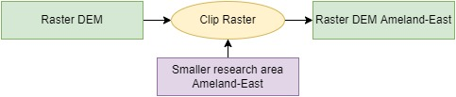
Figure 6, Flow diagram of Raster Clip
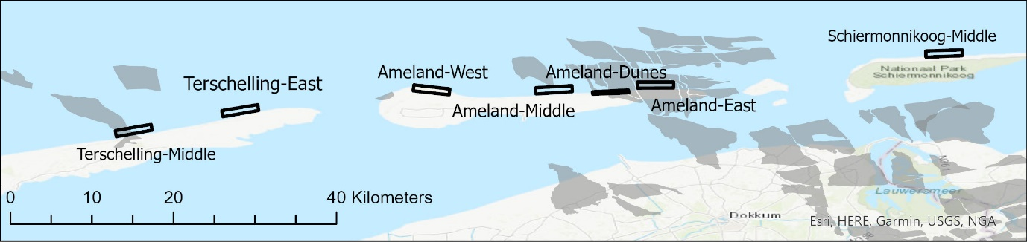
Figure 7, locations of smaller research areas combined with hydrocarbon fields
It is assumed that short term changes that influence the surface height on the island are the same for each of the different islands. This not only means that the natural morphological processes are assumed the same, also human influences from sand suppletion are assumed the same. Described long term differences such as sediment compaction unrelated to natural gas extraction as well as tectonic influences are assumed the same for locations on Terschelling and Schiermonnikoog compared to Ameland. Note that the gas reservoir on the area Terschelling-Middle has not been used for extraction and therefore the area is not influenced by gas extraction activity.

3.5 What signs of seabed subsidence are present at the shoreface of the Wadden isles
The average surface height within the smaller research areas acts as the parameter that quantifies the changes in the seabed height. The average surface height of the areas through time will be displayed in a graph. If the average height of the research area is going down, it is assumed that the seabed is subsiding. It is assumed that locations on Terschelling and Schiermonnikoog are not influenced by the effects of the natural gas extraction while locations on Ameland are influenced by the extraction of gas. Thus, additional subsidence found on locations on Ameland are linked to the influences of the natural gas extraction as the other parameters are assumed to be the same for each of the three islands. The standard deviation of the smaller research areas will also be monitored. Even though the standard deviation does not say anything on the accuracy of the DEM data, it does show if the data within the research areas is scattered. If the standard deviation for a particular year is exceptionally high, this might indicate a sudden erosive or accretion event. These large short-term changes can be most likely linked to human interference by sand suppletion or natural causes such as a storm event. Other natural causes that influence the height of the surface should not be neglected, as the migration of sandbars or ebb deltas can cause large differences in surface height over a short period as well.

3.6 How to put the found results into perspective
The found results can be put in perspective using the results found in other literature. This is done through two different methods, (1) accounting for eastward movement of morphological features and (2) comparing the results with measurements in the field and GPS measurements of the Ameland-East surface subsidence monitoring report.

3.6.1 Accounting for eastward movement of morphological features
Due to prevailing western winds combined with a dominant eastward flow of the tidal current the Wadden Isles are known to slowly move in an eastward direction (Wang, Hoekstra, Burchard, Ridderinkhof, De Swart & Stive, 2012). Even though the movement of the islands is in the order of centimetres over the period 1966-2021, morphological features offshore can move relatively large distances. This can be significant over a period of 50 years and is therefore relevant for this research. To determine the speed of this eastward movement, morphological features that are found in DEM’s of different years are measured in distance travelled. This distance is divided through the differences in years of the DEM’s which results in the velocity of the eastward motion of the morphological features, with units in meters/year. The research area which measures the surface height should be moving according to this eastward motion. This method does assume that the eastward motion of the morphology is the same for each morphological feature and is not dependent on the location relative to the island.

3.6.2 Comparing found results with measurements in the field
As mentioned before most of the gas has already been extracted from the fields in the Ameland-East region. The subsequent drop in pressure level of the gas fields from 570 to 80 bar is known to influence the surface height since the lack of pressure causes the grains in the soil to collapse (Kou, Li, Wang, Zhang & Chen, 2020). Therefore, the soil is monitored extensively in the Ameland-East region. Two methods that are used to measure the changes in surface height are (1) field measurements with measuring equipment on designated locations and (2) GPS measurements. Field measurements have been done on Ameland since 1986 with increments of 3 years (Piening, van der Veen & van Eijs, 2017). GPS measurements are conducted on the Ameland mainland as well as the coastal zone north of the island every 3 years since 2006. Combined results of these measurement techniques show distinctive signs of surface subsidence for the Ameland-East region. The surface height decrease pattern outline for the Ameland-East region over the period 1986-2017 (Figure. 8). These results will be compared with subsidence found of a JARKUS transect that crosses the Ameland-East region in a N-S direction (Figure. 9). If the found results of the JARKUS data coincide with the measurements found in the field and using GPS it shows that the JARKUS data is capable to distinguish decrease in surface height due to natural gas extraction.
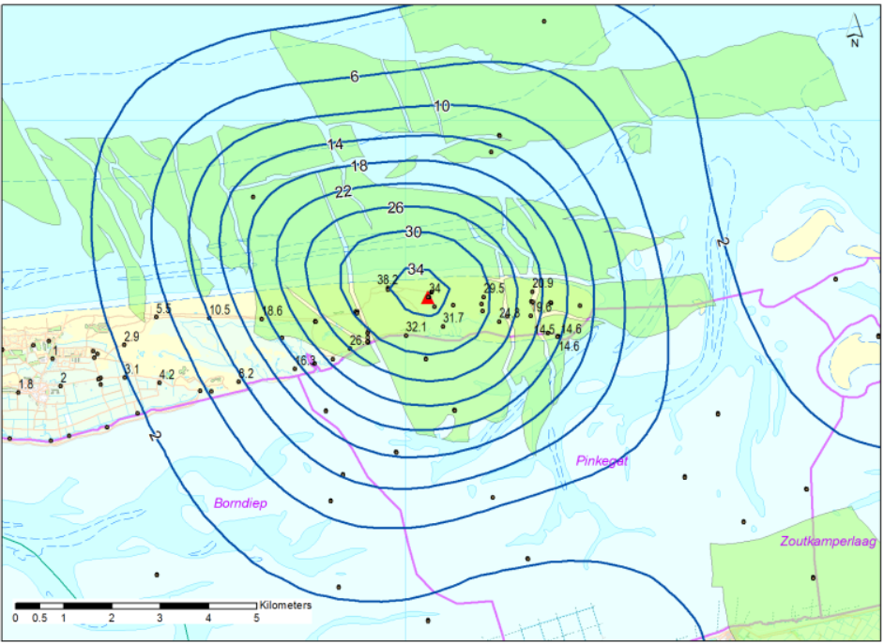
Figure 8, Total surface height decrease (cm) due to natural gas extraction on Ameland-East (Research Report Bodemdaling, 2017)
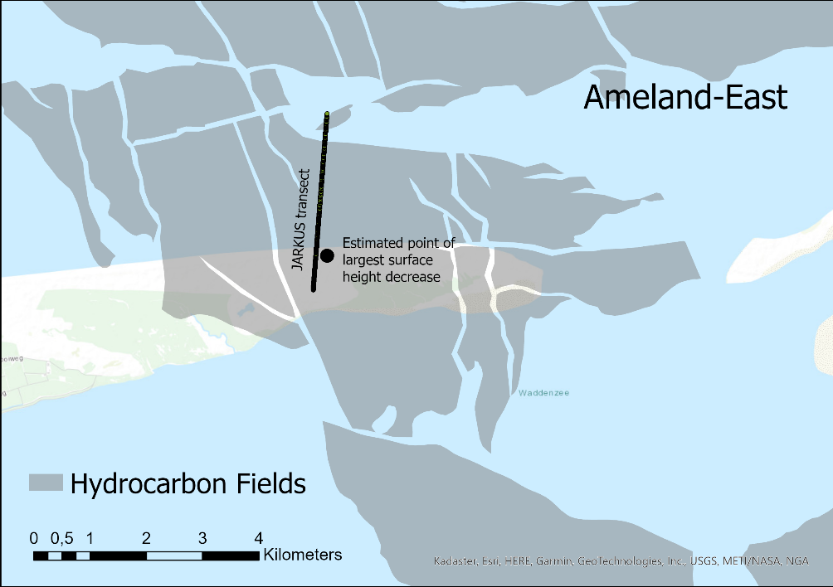
Figure 9, location JARKUS transect on Ameland-East
The workflow to select and export the data into a graph is displayed below (Figure. 10). The datasets are made for the period 1986-2021 with increments of five years. These transects will then be divide into two different parts, (1) the onshore dune part and (2) the shallow offshore part. According to the field and GPS measurements the decrease in surface height will be larger on the shore compared to offshore.
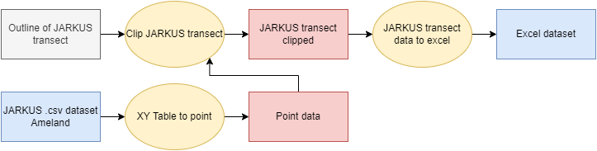
Figure 10, flow diagram of extracting JARKUS transect data

4. Results

4.1 Difference maps between different raster DEM’s

Differences between two DEM’s can be calculated and result into difference maps. Difference maps have a relatively limited spatial coverage, since the differences between the maps is dependent on the minimum extend of the DEM’s that are used as input. Difference maps between two successive years show spatial differences that can be linked to processes that act on a relatively short temporal timescale. The standard deviation of these difference maps is between 0.5 and 0.8. The spatial differences appear to happen perpendicular to the coast. These horizonal differences can be linked to the morphological process known as sandbar migration (Ruessink, Kuriyama, Reniers, Roelvink & Walstra, 2007). These sandbars can move in either direction up to 100 meters per year. Exceptionally large differences shown within a difference map are most likely due to local digging or suppletion of sand, traces of these activities were not found. The difference map between 2020 and 2019 is shown below for the Ameland-East region to illustrate the horizontal changes ins surface height linked to sandbar migration (Figure. 11).
Difference maps that are created between years over a larger period show accumulative changes of the surface height. Since these difference maps are accumulated over a larger period the outliers in the data become larger, resulting in an increase of the standard deviation from 0.5-0.8 for difference maps with successive years to on average 0.9-1.1 for the difference maps over a larger period. Dune volume changes also become more apparent using accumulated results over a longer period. These dune volume changes are shown for the difference map between 2021 and 1996 below, where the decrease in height is as large as 2 meters (Figure. 12). The 3 reference years chosen to distinguish the long timescale changes are 1966, 1986 and 2021. 1966 and 2021 are chosen based upon the fact that these years represent the oldest and newest complete datasets and thus represent the longest possible timescale that can be created with the JARKUS dataset. The year 1986 is chosen because this is the year in which the extraction of natural gas on Ameland started. Thus, differences in height prior to 1986 are not influenced by gas extraction activity, while after 1986 there is an influence present from the extraction of natural gas.
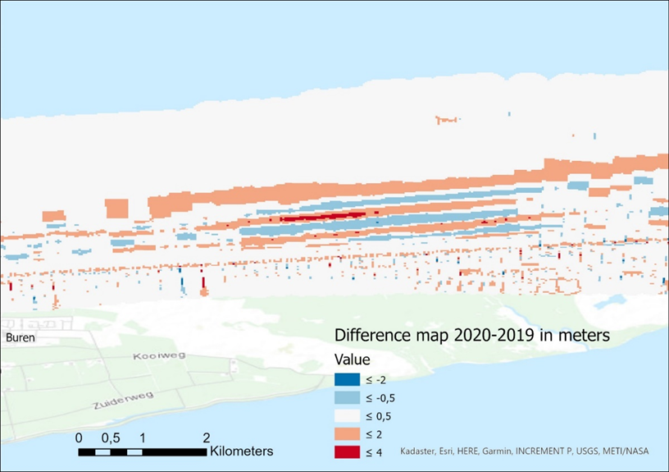
Figure 11, Horizontal erosion/accretion pattern related to sandbar migration
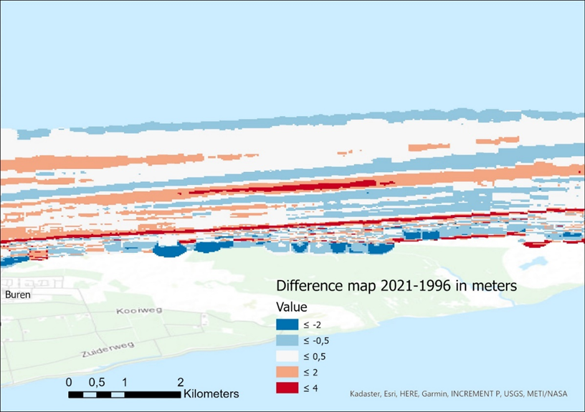
Figure 12, Large erosion in dunes when period between reverence years becomes larger
Changes to Ameland surface height over the entire period between 1966 and 2021 (Figure. 13a) makes apparent that the surface height of the far western part of Ameland has strongly decreased followed by a considerable increase slightly further east. From there the surface height starts to change from net sedimentation to net erosion approximately on the halfway point of the island. Areas where gas fields are present are present show a dominant erosive pattern, with a net decrease of approximately 1 meter.
The difference map of 2021-1986 (Figure. 13b) shows a somewhat similar pattern, indicating that since the gas extraction started the surface has decreased over time. The difference map of 1986-1966 (Figure. 13c) shows a similar pattern to that of 2021-1986, indicating that prior to the gas extraction on the eastern part of Ameland there has already been a local decrease in surface height.

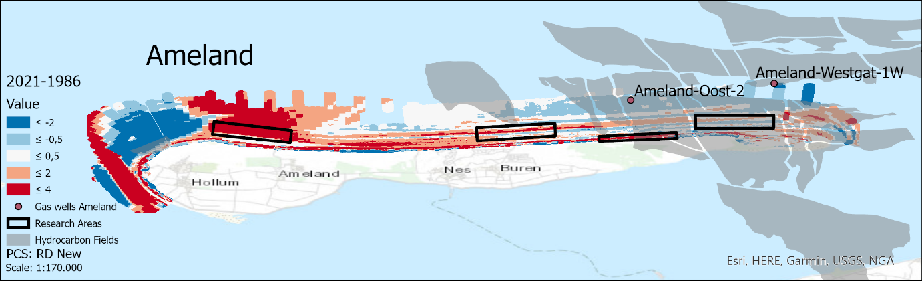
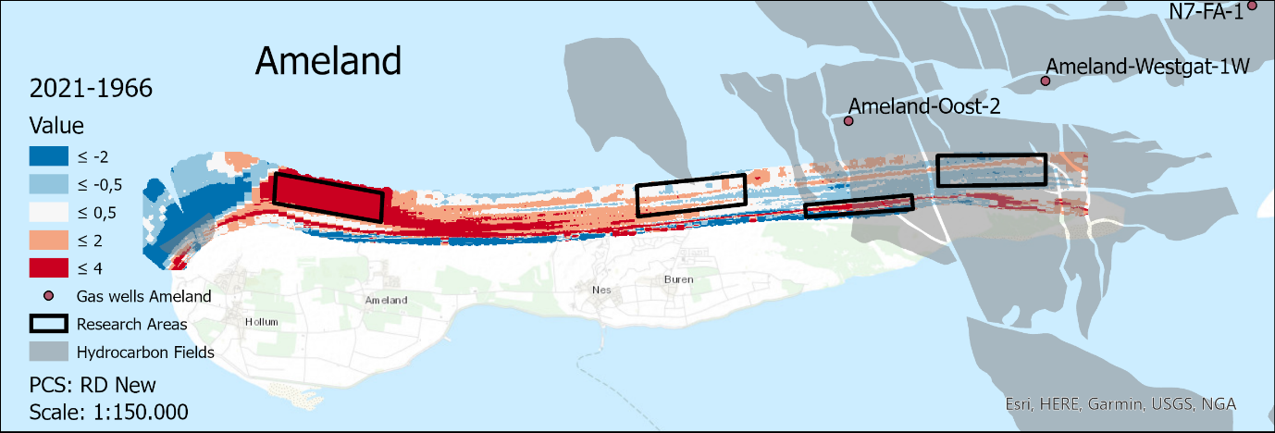
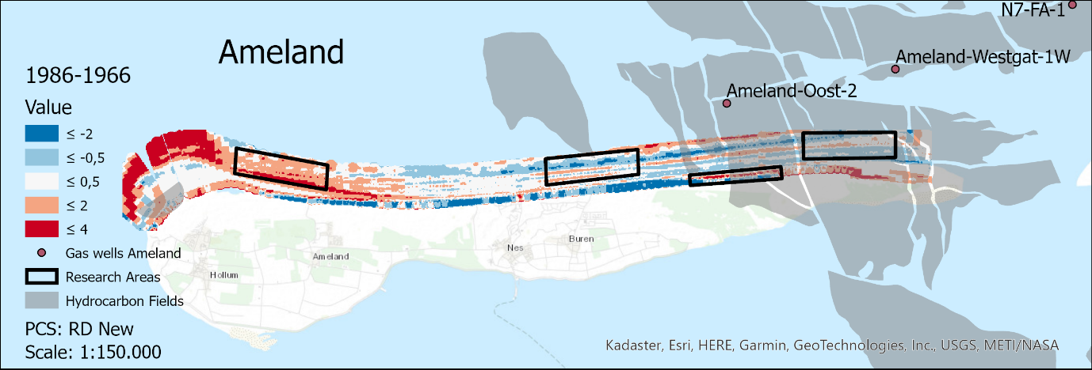
Figure 13 a,b,c, difference maps Ameland 2021-1966, 2021-1986 & 1986-1966

4.2 Signs of seabed subsidence present in the shoreface of the Wadden Isles

The found changes in surface height through the years for Ameland are displayed in the graph below (Figure. 14). This graph shows that the area Ameland-West massively increased in height from 1993 until 2003, the average height increased 3 meters over this period. This height increase is due to the eastward movement of a large shoal that slowly moves east into the area Ameland-West. From 2004 onward, the height remains roughly the same showing a net 4.5-meter increase in 2021 compared to 1966. Ameland-East is the only area that has a net decrease over the period 1966-2021. From 1966-1971 the area had its first drop of average height from 40 centimeters, stabilizing until 1990. From 1990 onwards there is a slow but significant decrease in height up and until 2021, in which the average height dropped 50 centimeters. Ameland-Middle shows roughly the same pattern as Ameland-East, but from the period 1990-1999 the average height increased approximately 20 centimeters, dropping sharply in 2003 with 20 centimeters in one year. After 2003, the height seems to slowly increase resulting in a net increase of 15 centimeters over the period 1966-2021. Lastly the surface height of the dunes below the Ameland-East area was measured. Remarkably, from 1966 to 2001 the behavior of the dunes is quite like that of the areas in the shallow zone, showing a low point in 1986. Between 2001 and 2006 the average height increased on average 2 meters; two thirds of this sudden growth disappeared in 2011 after which the average height seemed to stabilize. This indicates that the sediment has been transported away from the shoreface, and that the effectiveness of the sand suppletion is limited (Brown, Phelps, Barkwith, Hurst, Ellis & Plater, 2016).

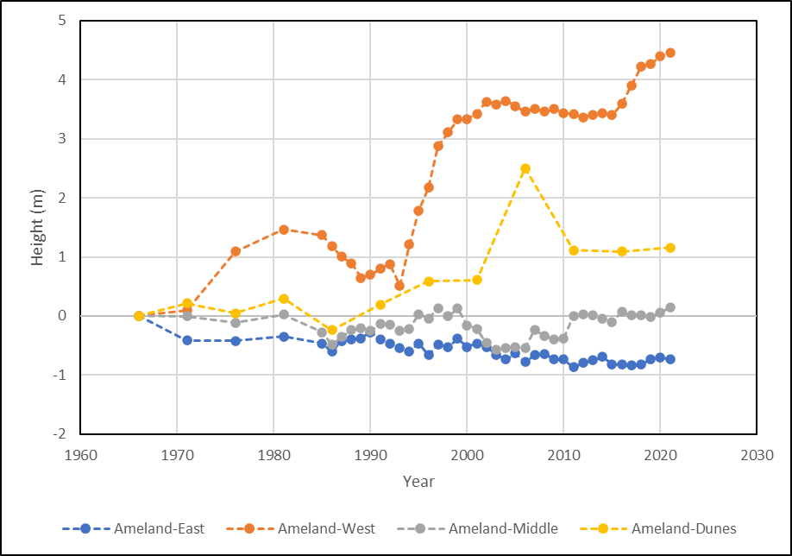

Figure 14, surface height changes on Ameland from 1966-2021
The results of Ameland-East and Ameland-Middle are put in perspective with locations on the islands of Terschelling and Schiermonnikoog in the graph below (Figure. 15). In this graph is it apparent that the research area on Schiermonnikoog shows a very different pattern compared to the areas on Ameland. From 1966-1981 the average height in the Schiermonnikoog area decreased with 50 centimeters. From 1986-2011 the height almost linearly 30 increased centimeters each year. Between 2011 and 2021 the average height decreases 85 centimeters.
As was the case on Ameland, the most eastern area on Terschelling is the only area that shows a decrease in average height over the period 1966-2021 (Figure. 16). Considering that between 1976 and 1981 the average height increased 80 centimeters, Terschelling-East is the area that had the largest drop in average height since gas extraction activities began in 1986. In 2001, the average height of Terschelling-East decreases 70 centimeters compared to 1996. Between 2001 and 2021 the average height decreases a further 30 centimeters. Terschelling-Middle shows a very large increase in average surface height. From 1976-2021 the height increased with more than two meters, with an approximately linear increase over the years 1986-2021.
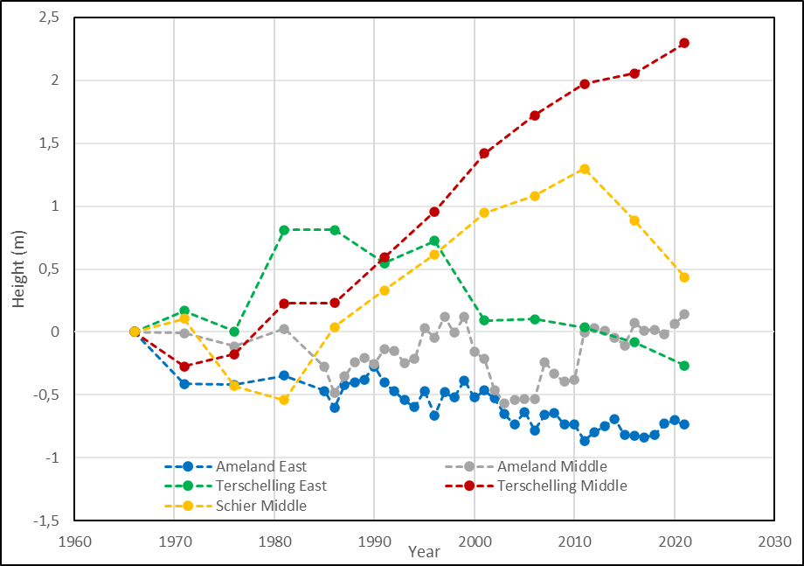

Figure 15, surface height changes for smaller research areas 1966-2021

Table 2 shows the change in average surface height of the research areas for the period 1986-2021. These results show that since the start of the gas extraction in 1986 the average height of all the research areas has increased, except for Terschelling-East and Ameland-East. Remarkably, the surface of Terschelling-East has decreased more than the surface of Ameland-East while there is no gas extraction activity present on Terschelling.
Table 2 | Average surface height changes 1986-2021 (cm)
Ameland-East | -27
Ameland-Middle | 42
Ameland-West | 334
Terschelling-East | -108
Terschelling-Middle | 206
Schiermonnikoog-Middle | 40

4.3 Changes in standard deviation
Figure 16 shows the change of the standard deviation for all the DEM’s. The standard deviation pattern for Ameland-East and Ameland-Middle show roughly the same behaviour, the standard deviation for these DEM’s is between the 1 and 1.8. Ameland-West shows a different behaviour, with a maximum standard deviation of 2.1 in 1993. After 1993, the standard deviation drops to 0.7 in 2002. The average surface height increased during this period. Thus, a decrease in standard deviation is correlated with an increase in surface height for the Ameland-West research area.
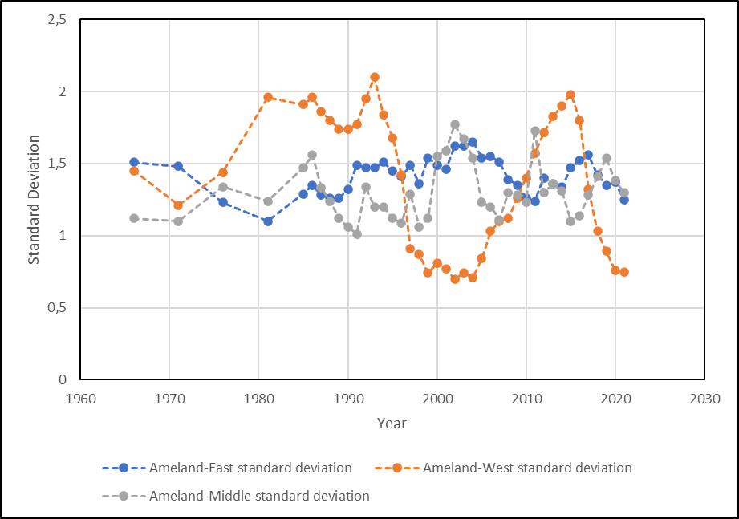
Figure 16, standard deviation research areas Ameland 1966-2021
When the standard deviation of the Ameland-East region is compared with research areas on other islands, it becomes clear that the standard deviation of Ameland-East is lower than these regions for almost every year. Remarkably, the standard deviation for all the areas in 1966 is roughly 1.5, showing more variance in the data after this year. Terschelling-Middle has the highest standard deviation, with a maximum of 2.45 in 2021. Schiermonnikoog-Middle and Terschelling-East also show a net increase in standard deviation over the years (Figure. 17).

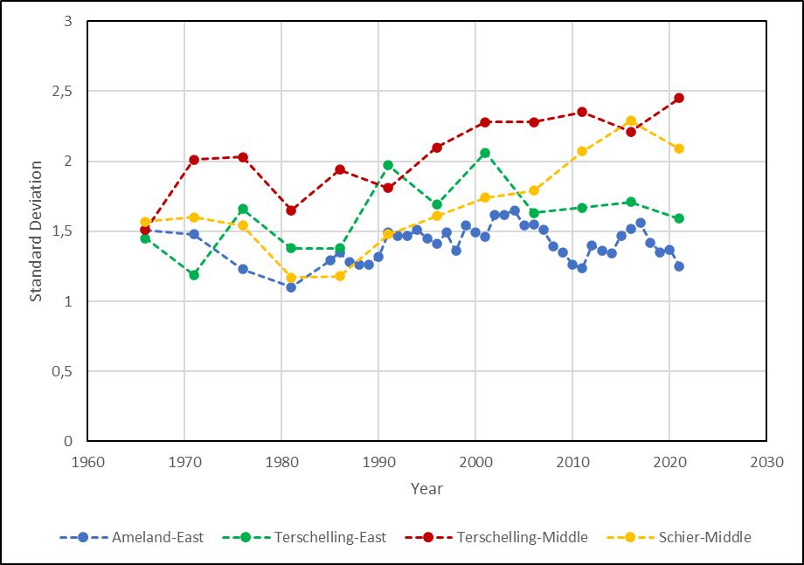
Figure 17, standard deviation research area Ameland-East compared with research areas on other islands

4.4 Accounting for eastward motion of morphological features
Due to prevailing western winds combined with a dominant eastward flow of the tidal current the Wadden Isles are known to slowly move in an eastward direction (Wang, Hoekstra, Burchard, Ridderinkhof, De Swart & Stive, 2012). When taking a close look at the 1986-1966 and 2021-1966 difference maps, there can be a seen distinctive eastward movement of a large shoal on the far west of the island. A few kilometres east a smaller sandbar moves roughly the same distance east as well. This movement is indicated with two blue arrows in the picture below (Figure. 18 a & b).

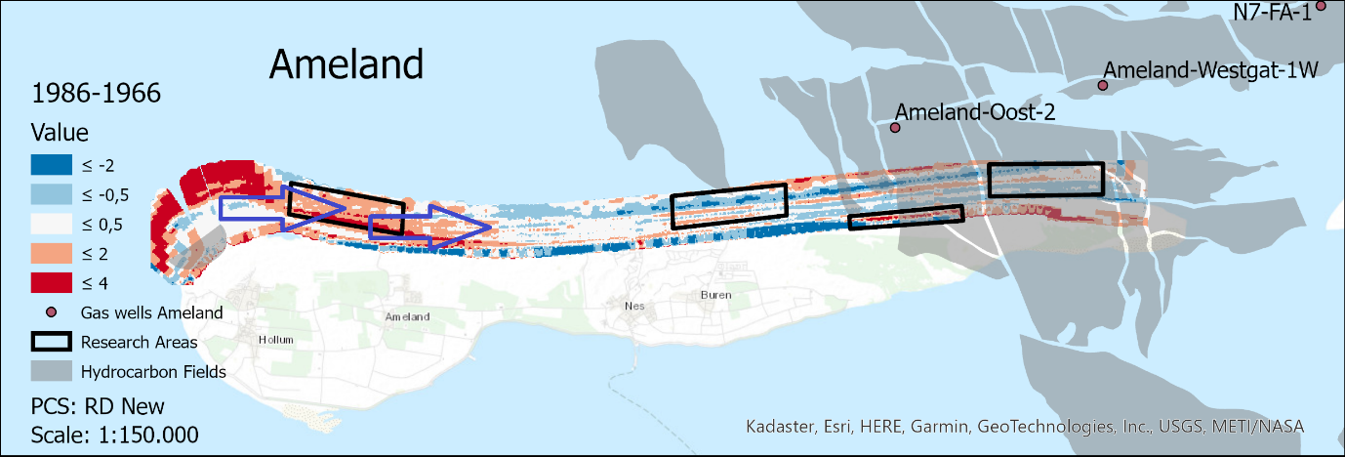
Figure 18 a & b, eastward motion of morphological features on the shoreface of Ameland indicated with blue arrows

The distance that these morphological features cover over the period between 1986 and 2021 is measured to be approximately 2500 meters. It is assumed that the coastal processes that occur on the foreshore in the western part of Ameland are the same as the processes that occur further east. Therefore, if a true comparison of surface height must be performed, this eastward shift in processes must be accounted for (see also section 3.6.1). The total distance of 2500 meters in 35 years comes down to roughly 70 meters per year. Thus, every 5 years the research area should be moved 350 meters east, as the speed of this movement is assumed to be the same over time. It is also assumed that the eastward shift is perpendicular to the coastline. Lastly, this eastward movement is assumed to occur with the same speed in the years before 1986. Thus, over the period between 1966 and 2021 the research area will cover 55x70=3850 meters. The location of the Ameland-East research area is used for 2021, thus 3850 westward lies the location for this research area for measuring the year 1966. Moving the research area according to the parameters described above, a new graph of the average surface height is developed for the Ameland-East research area with measurements every 5 years.
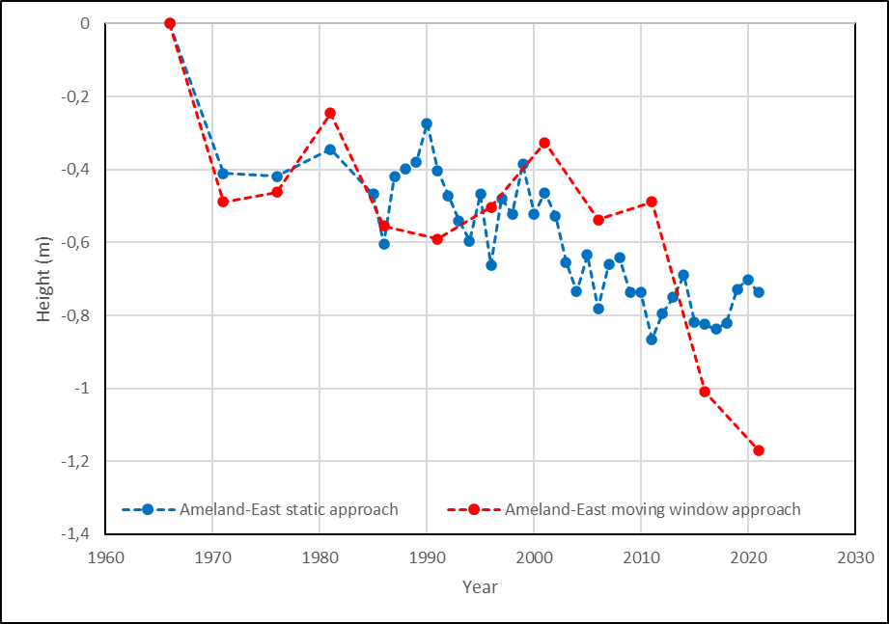
Figure 19, surface height changes static approach vs moving window approach
Incorporating the eastward movement of the Ameland-East research area through the years shows similar patterns in the average surface height compared to having one static location of the research area (Figure. 19). However, it is clearly visible that the total decrease in 2021 in surface is considerably larger, with a decrease of -1.17 meters for the moving research area compared to -0.74 meters for the static research area approach over the total period between 1966 and 2021. When looking at the decrease in average surface height from 1986 to 2021, the differences between the methods is also visible. For the static approach the decrease in height from 1986-2021 was 27 centimeters while with the incorporated eastward movement this decrease is 62 centimeters. Considering that the decrease over the period of 1966-1986 the average decrease in surface height is 55 centimeters for eastward moving approach, this decrease can still not be entirely linked to the extraction of gas.

4.5 Comparison JARKUS transect with field and GPS measurements
The JARKUS transect that crosses the Ameland-East area S-N is compared with measured surface height decrease using field measurements. In this transect x=0 is situated approximately 800 meters from the shoreline on the mainland. The transect is reaching approximately 1.7 kilometres north into the sea at x=2500 meters (Figure. 20). Field measurement data showed that the decrease in surface height was larger onshore compared to offshore. The maximum surface height decrease measured was 38 centimetres over the period 1986-2017, as 2017 is the year the latest report came out. Figure 21 shows the surface height onshore for the years of 1991, 1996 and 2016 of the Ameland-East regions. In this graph the x-axis starts 800 meters onshore (x=0) and after approximately 800 meters it reaches the shoreline (x=800).
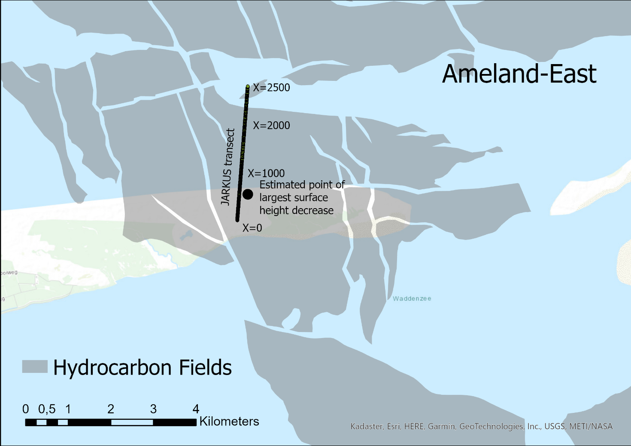
Figure 20, position JARKUS transect Ameland-East
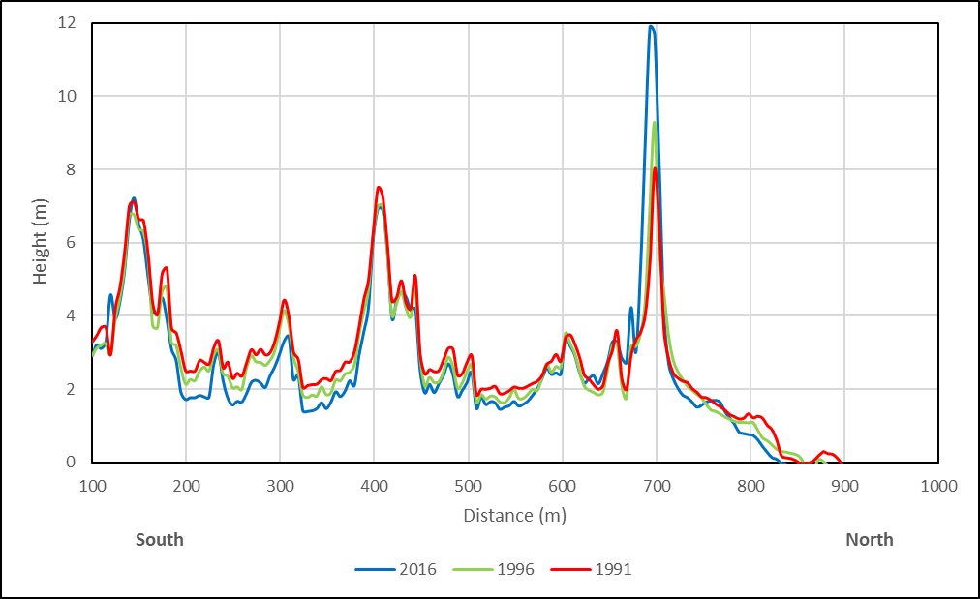
Figure 21, surface height changes onshore of JARKUS transect Ameland-East for 1991, 1996 & 2016
The JARKUS data shows a clear pattern of subsequent decrease in surface elevation for Ameland-East between the years 2016, 1996 and 1991. Especially the valleys between the dunes are affected by this decrease in surface height. The maximum decrease in surface height is 1 meter at distance x=200, which is 600 meters into the mainland of Ameland from the shoreline. The decrease is much larger compared to the field measurements, however there is a strong variability in surface height decrease based on location. Remarkably, the coastal dunes next to the shoreline at x=690 meters show a large increase in surface height of approximately 4 meters. This presumably is due to the repeated suppletion of sand to counteract the surface height decrease in the area. The surface height of the dunes further inland show hardly any differences in elevation.
Figure 22 shows the differences in height from the shallow water zone in the south up to a few kilometres north into the North Sea. This graph shows the elevation for the years 2021, 2011 and 1986, as these years contained the highest data density (most measurement points) and extend for this part of the transect. The differences in height up to x=2500 meter can be attributed to sand migration, showing slightly different locations for peaks that can be related to the location of a sandbar. Remarkably, 1986 shows 2 sandbars and 3 gullies, 2011 shows 2 sandbars and only 2 gullies and 2021 shows 1 sandbar and 1 gully. The fainting of the sandbar in 2021 can be an indication of a lack of sediment to feed the morphological feature. However, this phenomenon can also be explained by the sandbar lifecycle (Ruessink, Kuriyama, Reniers, Roelvink & Walstra, 2007), however there is no sign of the development of a new sandbar. Another explanation might be the occurrence of a storm that complete eroded oe of the sandbars. Further north into the sea the 1986 elevation is substantially higher compared to the elevation in 2021. The difference in height is approximately 1 meter. Not only is the significantly higher than the field measurements predict, but the decrease is also far larger compared to research area Ameland-East, which showed an average decrease of 27 centimetres. Ameland-East is in the shallow water zone, which shows more limited differences in elevation decrease compared to areas deeper into the sea. This might be the reason why the found decrease in surface elevation is small compared to the JARKUS transects of 1986 and 2021 that reach deeper into the North Sea.
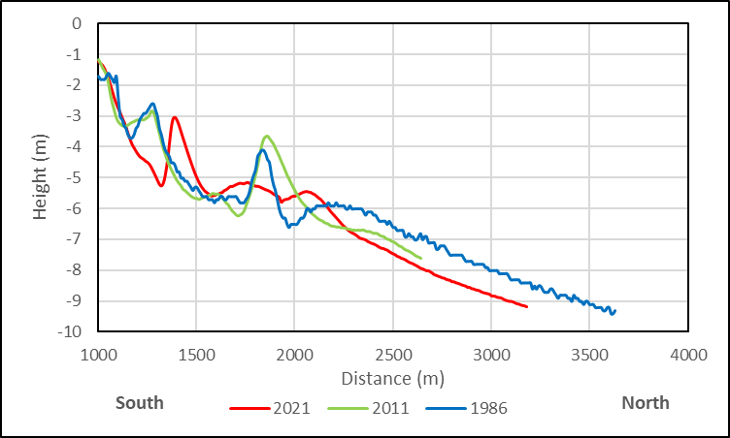
Figure 22, surface height changes offshore of JARKUS transect Ameland-East for 1986, 2011 & 2021

5. Discussion
This chapter discusses the limitations of the performed methodology and its subsequent results. First the limitations of the data will be discussed. Secondly the performed methodology is discussed and lastly the results are interpreted. The found results are compared with results from literature.

5.1 Limitations of the JARKUS data
The JARKUS data stretches from 1966 up to 2021, which makes it one of the most extensive coastal datasets in the world. However, due to the extensive period over which the data is collected certain weaknesses in the data are inevitable. Firstly, the data extend is highly variable over the years, making the JARKUS dataset only contain full coverage of the beach zone and the shallow offshore zone roughly 300 meters. This is a relatively small part of the coastline which results in limited applications of the data for the entire period 1966-2021. Secondly, the transects, of which the JARKUS data consist of, show irregularities in position and extend, making interpretations of spatial differences difficult to perform. Lastly, within transects certain data collection points are often missing, resulting in gaps in the transects that can be as large as several hundred meters. Therefore, the raster DEM’s that were created after interpolation often showed gaps in the data which limited the usability due to the impact of these gaps on the overall numbers such as average surface height and standard deviation.

5.2 Evaluation of the performed method
The performed method in this research assumed that besides the extraction of natural gas, the morphological behaviour surrounding the different Wadden Islands are assumed the same. However, due to the location of the islands in the system as well as their own spatial extent the dominant morphological processes that act on the islands can be very different from each other (Lodder, Huismans, Elias, de Looff & Wang, 2022). The smaller research areas were chosen based upon the extend of the JARKUS data into the North Sea, which is only a very limited part of the coast. Because of the large morphological differences that occur on the western side of the other parameters that influence the surface height were masked. This made several chosen research areas not eligible for the purpose of this research. Moreover, the JARKUS transect showed that especially the shallow shoreface which is heavily influenced by the dynamics of the waves form the sea and the behaviour of sandbars show the smallest differences in surface height changes of any location along the coast. Thus, in hindsight these locations are not ideal for identification of surface height changes. Considered the eastward motion of shoreface morphology due to prevailing western winds and eastward tidal currents showed larger rates of surface height decrease through the years and is therefore a phenomenon that should be considered in research along the Dutch coast. Using an individual transect makes detecting where along the coast the largest height differences occur easier. However, due to inconsistencies in the JARKUS data only a few different measurement years showed a transect without any large gaps in the data, which limits the usability of the transects. Moreover, only using a single transect shows only information of a very small area along the coast. If there is a larger area of interest which is often the case, more transects are needed which means that there are more potential locations for gaps in the data.

5.3 Evaluation of the results
Since the Wadden Islands system is a very complex one, changes in surface height are continuously happening which often cannot be linked to a certain cause. Usually very tiny changes to the system ultimately result in much larger changes over time (Becherer, Hofstede, Gräwe, Purkiani, Schultz & Burchard, 2018). This makes linking the effects of gas extraction particularly difficult to do. The results showed that Ameland-East research area was susceptible for erosion (-27 cm), but the same is true for the research area on the eastern coast of Terschelling (-108 cm). Thus, linking all the decrease in surface height to the extraction of natural gas is not valid.

However, the decline of the gas pressure from 570 to 80 bar or the Ameland-Oost gas field results in a decrease in surface height in the order of tens of meters, which is a decrease that is found on the Norwegian gas platform Ekofisk situated in the North Sea. Here, the system hardly compensates for the decrease in surface height with extra replenishment of new sediment and human interference to prevent the surface height to drop is not necessary as the platform is situated in the middle of the North Sea. Thus, it can be stated that the coastal system of the Wadden Isles prevents most of the decrease in surface height itself. However, since the start of the gas extraction in 1986, the volumes of sand that yearly are supplemented on Ameland have increased linearly. In the past decade the need of sand suppletion to prevent critical surface height changes to the system has become larger than was initially estimated based on model results (Slim, Wegman, Sanders, Huiskes & Van Dobben, 2011). This need of sediment is accelerated due to the continuing rise of the sea-level as well. The increase in sand suppletion over the years could have masked the actual surface height decrease that occurs on Ameland.
The eastward moving research area method, that assumes all morphological processes to shift in an eastward direction over time, causes additional sediment to be transported from the western part of Ameland to the east. This transport of sediment also masks the actual decrease in surface height that would occur.
From the JARKUS transect it becomes clear that the decrease in surface height is not evenly distributed along the coast. It is hypothesised that due to an increase of beach slope the volumes of the dunes would be reduced (De Vries, Southgate, Kanning & Ranasinghe, 2012). However, especially the dunes valleys are showing a decrease in surface height (max -1 meter, 1991-2021). This is larger than the monitoring committee of Ameland measured using field measurements. The dune valleys on Ameland have struggled with repeated flooding events which led to the surface floor to become wetter, which puts pressure on the local ecosystem as well as jeopardizes coastal safety (van Dobben, Slim, Wamelink & Dirkse, 2011). The dunes close to the shoreline showed a massive increase in height (max 4 meters) over the period 1991-2021. This is probably the result of the sand suppletion. The priority for the suppletion of sand is the maintenance of the coastline, therefore the first line of defence is usually the location where most of the sediment is dropped (van de Sluis & Bos, 2016).
In the shallow zone offshore the differences in surface height through the years are limited due to additional influences from waves, which is also evident from the measured surface height decrease by the committee of surface height control on Ameland (Piening, van der Veen & van Eijs, 2017). However, the disappearance of 1 of the sandbars might indicate that there are also influences from the gas extraction possible that are not directly visible hen only looking at the average surface height. Deeper into the sea the differences in surface height are just a visible as on the shore (-1 meter) which stretches over a horizontal area of approximately 3 kilometres. This behaviour of the surface floor is not described in monitoring reports, usually because the focus of these reports is on the decrease of surface height on the mainland.

6. Conclusion
This research provided an insight in the effects of the natural gas extraction on Ameland on the height of the surface. The research was conducted according to 4 different research questions that ultimately provide the backbone to answer the main research question.
The first research question is: “How is (sea)bed or surface subsidence studied in other research projects?”
As there are many different reasons why seabed subsidence must be monitored, there are many different approaches that fit best to a particular research area or system. What is also evident is that research typically is dependent on the data that is present, which is why there are vastly different approaches among research using different types of data and techniques while quantifying the same parameter, the heigh of the seabed. As for research that uses JARKUS data, most of the research is done in the shallow coastal zone. This is because this part of the shoreline is a very dynamic showing interesting changes in surface height as well as that the JARKUS dataset is usually complete for this part of the shoreface.
The second research question is: “What method could be used to detect seabed subsidence in relation to natural gas extraction?”
For the Ameland-East region the JARKUS data is sufficient to study surface height changes on the foredune, beach and shallow coastal zone. However, further in land or deeper into the sea the JARKUS data lacks completeness throughout the years, making studying changes related to natural gas extraction that act on a moderate time scale difficult.
The third research question is: “What signs of seabed subsidence are present at the shoreface of the Wadden Isles?”
There is a clear subsidence found for the Ameland-East research area (-27 cm) since the extraction of gas started in 1986. Further west the effects of seabed subsidence are not visible. However, Terschelling showed similar behaviour of the seabed height with a decrease of -107 centimetres in the east while showing an increase in seabed height further west. Thus, linking the seabed subsidence solely on the extraction of natural gas is not valid, as the subsidence also occurs on Terschelling.
The fourth research question is: “How could these signs of seabed subsidence be evaluated?”
The decrease in seabed height is more visible in the deeper coastal zone (-1 m) compared to the shallow coastal zone (-27 cm) as here other morphological processes mask the subsidence of the seabed in the shallow zone. On the shore the clearest signs of subsidence are present in the dune valleys (max -1 m, 1991-2021), which is also evident due to reports of the local soil of the dune valleys to become wetter. The dunes themselves are hardly affected by surface subsidence. The foredunes showed an enormous increase in height (max 4 m) due to repeated sand suppletion activity to ensure coastal safety.
The main research question is: “How to quantify the impact of natural gas extraction on the shoreface of Ameland-East?”
Quantification of the impact of the gas extraction on the surface height can be done using JARKUS data, with interpolated DEM’s for large areas while small areas individual transects suffice. This quantification is based on morphology expressed in absolute surface height differences, standard deviations, areas sizes and directions. The most visible seabed subsidence can be found far in the deeper coastal zones (2 km offshore) and in the dune valleys, since on the dunes themselves the repeated suppletion activity masks the potential effects while in the shallow coastal zone the seabed subsidence is masked by other natural morphological dynamics.

7. Recommendation
To quantify the effects of the natural gas extraction on Ameland many different other parameters must be considered. Natural causes such as a continuing eastward transport of sediment, sediment behaviour in the shallow coastal zone and large erosive events linked to storm all can cause changes in average surface height that are larger than the effect of the natural gas extraction. On top of that human intervention by suppletion of sand further mask the actual effect of the natural gas extraction.
The decrease in surface height is not evenly distributed over the area but highly dependent on location. Depending on the location of these measurement points large difference in surface height decrease can be found, for instance a measurement point in the dune valley will show much larger values compared to measurement points on top of the dunes themselves. It is therefore not recommended that the decrease in surface area should be averaged out by connecting individual field measurements no accounting for their location. Because this ultimately shows averaged results, which is done in the 5 yearly monitoring reports that measure the surface subsidence in the Ameland-East region.
It is recommended that using the JARKUS data should be based on the size of the area of interest. As for small research areas individual transects are sufficient to study surface subsidence while for larger areas of interest interpolation of the data points should be conducted. Moreover, transects can help identify potential location along the shore that are influenced by changes in the surface height, which can enhance the use of smaller research areas by using interpolation to detect changes in the seabed height. This is important as the decrease in surface height is heavily dependent on the research location.

8. References

Becherer, J., Hofstede, J., Gräwe, U., Purkiani, K., Schulz, E., & Burchard, H. (2018). The Wadden Sea in transition-consequences of sea level rise. Ocean Dynamics, 68(1), 131-151.
Bitenc, M. (2010). Evaluation of a laser Land-based Mobile Mapping System for measuring sandy coast morphology.
Borges, F., Landrø, M., & Duffaut, K. (2020). Time-lapse seismic analysis of overburden water injection at the Ekofisk field, southern North Sea. Geophysics, 85(1), B9-B21.
Brown, J. M., Phelps, J. J., Barkwith, A., Hurst, M. D., Ellis, M. A., & Plater, A. J. (2016). The effectiveness of beach mega-nourishment, assessed over three management epochs. Journal of environmental management, 184, 400-408.
Candela, T., Koster, K., Stafleu, J., Visser, W., & Fokker, P. (2020). Towards regionally forecasting shallow subsidence in the Netherlands. Proceedings of the International Association of Hydrological Sciences, 382, 427-431.
Do, A. T., Vries, S. D., & Stive, M. J. (2019). The estimation and evaluation of shoreline locations, shoreline-change rates, and coastal volume changes derived from Landsat images. Journal of Coastal Research, 35(1), 56-71.
van Dobben, H. F., Slim, P. A., Wamelink, G. W. W., & Dirkse, G. M. (2011). Vegetatieveranderingen in de duinen en hoge kwelder op Oost-Ameland. In Monitoring effecten van bodemdaling op Ameland-Oost (pp. 323-364). Begeleidingscommissie Monitoring Bodemdaling Ameland.
Eiken, O., & Stenvold, T. (2021). Accurate Measurements of Seabed Subsidence above North Sea fields. In EAGE GeoTech 2021 Third EAGE Workshop on Practical Reservoir Monitoring (Vol. 2021, No. 1, pp. 1-3). European Association of Geoscientists & Engineers.
Elias, E., & Bruens, A. (2012). Morfologische Analyse Boschplaat (Terschelling). Quickscan, Deltares.
Fokker, P. A., Van Leijen, F. J., Orlic, B., Van Der Marel, H., & Hanssen, R. F. (2018). Subsidence in the Dutch North Sea. Netherlands Journal of Geosciences, 97(3), 129-181.
Giardino, A., Diamantidou, E., Pearson, S., Santinelli, G., & Den Heijer, K. (2019). A regional application of bayesian modeling for coastal erosion and sand nourishment management. Water, 11(1), 61.
van Heerwaarden, E. J. M. (2021). Shoreface response of the Holland coast to sea-level rise (Master's thesis).
Henderson, J., & Mitrova, T. (2015). The political and commercial dynamics of Russia’s gas export strategy.
Hess, D. J., & Renner, M. (2019). Conservative political parties and energy transitions in Europe: Opposition to climate mitigation policies. Renewable and Sustainable Energy Reviews, 104, 419-428.
Hodúl, M., Bird, S., Knudby, A., & Chénier, R. (2018). Satellite derived photogrammetric bathymetry. ISPRS Journal of Photogrammetry and Remote Sensing, 142, 268-277.
van IJzendoorn, C. O., de Vries, S., Hallin, C., & Hesp, P. A. (2021). Sea level rise outpaced by vertical dune toe translation on prograding coasts. Scientific reports, 11(1), 1-8.
Jacob, B., Stanev, E. V., & Zhang, Y. J. (2016). Local and remote response of the North Sea dynamics to morphodynamic changes in the Wadden Sea. Ocean Dynamics, 66(5), 671-690.
Jayeoba, A., Mathias, S. A., Nielsen, S., Vilarrasa, V., & Bjørnarå, T. I. (2019). Closed-form equation for subsidence due to fluid production from a cylindrical confined aquifer. Journal of Hydrology, 573, 964-969.
Karle, M., Bungenstock, F., & Wehrmann, A. (2021). Holocene coastal landscape development in response to rising sea level in the Central North Sea coastal region. Netherlands Journal of Geosciences, 100.
Keszthelyi, D., Dysthe, D. K., & Jamtveit, B. (2016). Compaction of North-sea chalk by pore-failure and pressure solution in a producing reservoir. Frontiers in Physics, 4, 4.
Kou, X., Li, X. S., Wang, Y., Zhang, Y., & Chen, Z. Y. (2020). Distribution and reformation characteristics of gas hydrate during hydrate dissociation by thermal stimulation and depressurization methods. Applied Energy, 277, 115575.
Lambeck, K., & Chappell, J. (2001). Sea level change through the last glacial cycle. Science, 292(5517), 679-686.

Levenberg, E., & Orozova-Bekkevold, I. (2020). An offshore reservoir monitoring system based on fibre-optic distributed sensing of seabed strains. First Break, 38(3), 35-41.
Lodder, Q., Huismans, Y., Elias, E., de Looff, H., & Wang, Z. B. (2022). Future sediment exchange between the Dutch Wadden Sea and North Sea Coast-Insights based on ASMITA modelling. Ocean & Coastal Management, 219, 106067.
Long, A. J., Waller, M. P., & Stupples, P. (2006). Driving mechanisms of coastal change: Peat compaction and the destruction of late Holocene coastal wetlands. Marine Geology, 225(1-4), 63-84.
Mai, S., & Bartholomä, A. (2000). The missing mud flats of the Wadden Sea: a reconstruction of sediments and accommodation space lost in the wake of land reclamation. In Proceedings in Marine Science (Vol. 2, pp. 257-272). Elsevier.
Oost, A. P. (1995). Dynamics and sedimentary developments of the Dutch Wadden Sea with a special emphasis on the Frisian Inlet: a study of the barrier islands, ebb-tidal deltas, inlets and drainage basins. Faculteit Aardwetenschappen.
Piening, H., van der Veen, W., & van Eijs, R. (2017). Rapport monitoring effecten op bodemdaling van Ameland-Oost.
Poortinga, A., Keijsers, J. G. S., Visser, S. M., Riksen, M. J. P. M., & Baas, A. C. W. (2015). Temporal and spatial variability in event scale aeolian transport on Ameland, The Netherlands. GeoResJ, 5, 23-35.
Van Rijn, L. C. (1997). Sediment transport and budget of the central coastal zone of Holland. Coastal Engineering, 32(1), 61-90.
Ruessink, B. G., Kuriyama, Y., Reniers, A. J. H. M., Roelvink, J. A., & Walstra, D. J. R. (2007). Modeling cross‐shore sandbar behavior on the timescale of weeks. Journal of Geophysical Research: Earth Surface, 112(F3).
De Ruig, J.H.M.; Hillen, R. (1997). Developments in Dutch coastline management: Conclusions from the second governmental coastal report. J. Coast. Cons. 3, 203–210
Slim, P. A., Wegman, R. M. A., Sanders, M. E., Huiskes, H. P. J., & Van Dobben, H. F. (2011). Monitoring kwelderrand Oerderduinen: onderzoek naar de effecten van bodemdaling door gaswinning op de morfologie en vegetatie van de kuststrook ten zuiden van Het Oerd en de Oerderduinen op Oost-Ameland. In Monitoring effecten van bodemdaling op Ameland-Oost (pp. 125-176). Begeleidingscommissie Monitoring Bodemdaling Ameland.
van der Sluis, M. T., & Bos, O. G. (2016). Inventarisatie van ecologische monitoring en onderzoek met relevantie voor zandsuppletie (KPP-B&O Kust) (No. C035/16). IMARES.
Southgate, H. N. (2011). Data-based yearly forecasting of beach volumes along the Dutch North Sea coast. Coastal Engineering, 58(8), 749-760.
van der Spek, A. J. (2018). The development of the tidal basins in the Dutch Wadden Sea until 2100: the impact of accelerated sea-level rise and subsidence on their sediment budget–a synthesis. Netherlands Journal of Geosciences, 97(3), 71-78.
van Thienen-Visser, K., Pruiksma, J. P., & Breunese, J. N. (2015). Compaction and subsidence of the Groningen gas field in the Netherlands. Proceedings of the International Association of Hydrological Sciences, 372, 367-373.
van Veen, J., van der Spek, A. J., Stive, M. J., & Zitman, T. (2005). Ebb and flood channel systems in the Netherlands tidal waters. Journal of Coastal Research, 21(6), 1107-1120.
Verhagen, H.J. (1990). Definitie van waitering en de kustlijn; “De basiskustlijn”; Nota WBA-N-89125(7), Ministerie van Verkeer en Waterstaat/DWW, [Delft], pp. 1-12.
Vermaas, T. (2012). Analyse bruikbaarheid gecombineerde hoogtedata Hollandse kust: pilotstudie naar het combineren van hoogtedata uit verschillende bronnen (No. 2378). Alterra, Wageningen-UR.
Vermeersen, B. L., Slangen, A. B., Gerkema, T., Baart, F., Cohen, K. M., Dangendorf, S. & Van Der Wegen, M. (2018). Sea-level change in the Dutch North Sea. Netherlands Journal of Geosciences, 97(3), 79-127.
De Vlas, J. (2011). Monitoring effecten van bodemdaling op Ameland-Oost. Evaluatie na, 23.
Vlek, C. (2019). Rise and reduction of induced earthquakes in the Groningen gas field, 1991–2018: statistical trends, social impacts, and policy change. Environmental earth sciences, 78(3), 59.
Vonhögen-Peeters, L. M., van Heteren, S., Wiersma, A. P., de Kleine, M. P., & Marges, V. C. (2013). Quantifying sediment dynamics within the Dutch Wadden Sea using bathymetric monitoring series. Journal of Coastal Research, (65 (10065)), 1611-1616.
de Vrees, L. (2021). Adaptive marine spatial planning in the Netherlands sector of the North Sea. Marine Policy, 132, 103418.
De Vries, S., Southgate, H. N., Kanning, W., & Ranasinghe, R. W. M. R. J. B. (2012). Dune behaviour and aeolian transport on decadal timescales. Coastal engineering, 67, 41-53.
Wachler, B., Seiffert, R., Rasquin, C., & Kösters, F. (2020). Tidal response to sea level rise and bathymetric changes in the German Wadden Sea. Ocean Dynamics, 70, 1033-1052.
Wang, Z. B., Hoekstra, P., Burchard, H., Ridderinkhof, H., De Swart, H. E., & Stive, M. J. F. (2012). Morphodynamics of the Wadden Sea and its barrier island system. Ocean & coastal management, 68, 39-57.
Wang, C., Li, Q., Liu, Y., Wu, G., Liu, P., & Ding, X. (2015). A comparison of waveform processing algorithms for single-wavelength LiDAR bathymetry. ISPRS Journal of Photogrammetry and Remote Sensing, 101, 22-35.
Xu, C., Chen, J., Zhu, H., Zhang, P., Ren, Z., Zhu, H., & Lin, Y. (2018). Design and laboratory testing of a MEMS accelerometer array for subsidence monitoring. Review of Scientific Instruments, 89(8), 085103.
Zander, T., Choi, J. C., Vanneste, M., Berndt, C., Dannowski, A., Carlton, B., & Bialas, J. (2018). Potential impacts of gas hydrate exploitation on slope stability in the Danube deep-sea fan, Black Sea. Marine and Petroleum Geology, 92, 1056-1068.
Zaradkiewicz, P., Eriksson, E., Christian, P., Klemm, H., & Hickman, P. (2018). Time-Lapse Bathymetry Processing for Seabed Subsidence Monitoring. In 80th EAGE Conference and Exhibition 2018 (Vol. 2018, No. 1, pp. 1-5). European Association of Geoscientists & Engineers.

9. Appendices

9.1 Appendix A – Pre-processing JARKUS data
The JARKUS data is available from 1965-2021 in ASCII format. After converting the data into .csv it is imported into ArcPro as point data assigned with a depth/height value referenced to NAP. The data is clipped to the islands of Ameland, Terschelling and Schiermonnikoog. From the point datasets an interpolation is performed to create raster DEM’s.
Figure X, Flow diagram of raster DEM creation

