Sustainability Transitions for Digital Platform Companies in E-commerce

A Case Study on Helloprint

By Megi Kass

Utrecht University
MSc Science and Business Management

Academic Supervisor: Leendert Bell
Company Supervisor: Lennaert Koch

Content
Acknowledgements 4
Executive Summary 5
1. Introduction 7
2. Literature Review 9
2.1. Relevant Frameworks on Sustainability Transitions 9
2.2. Barriers to Sustainability Transitions 13
2.3. E-commerce and Sustainability 14
2.4. Digital Platforms and Sustainability 16
2.5. Constructed framework 18
3. Methodology 20
3.1. Data collection 20
3.2. Sample Selection 21
3.3. Data Analysis 22
4. Results 23
5. Discussion 27
5.1. Sustainability Transitions - Drivers, Barriers and Success Factors 27
5.2. Sustainability Transitions 31
5.2. Transitioning as a Digital Platform in E-commerce 34
5.4. Adaptations to the constructed framework on sustainability transitions 36
6. Conclusion & Recommendations 38
7. Limitations & Future Directions 40
8. Personal Reflection 41
9. References 43
9. Appendix 49

Figures
Figure 1. Transition management framework according to Loorbach and Wijsman, 2012.
Figure 2. Business model activity system for sustainability transitions
Figure 3. Summary of the literature review on e-commerce sustainability dimensions.
Figure 4. Constructed framework on sustainability transitions from unsustainable businesses towards sustainability.
Figure 5. Analysis of the semi-structured interviews in the form of a code tree, put against the transition management and SBM activity system framework.
Figure 6. Results on the semi-structured interviews on digital platform / ecommerce specific attributes to the transitioning process of sustainability.

Tables
Table 1. Helloprint’s company activities related to the constructed framework at the strategic long-term level.
Table 2. Helloprint’s company activities related to the constructed framework at the tacticall medium-term level.
Table 3. Helloprint’s company activities related to the constructed framework at the operational short-term level.
Table 4. Summary of Helloprint’s view on barriers to sustainability transition

Appendix
Table 1. Semi-structured interview questions in relationship to the theoretical frameworks on sustainability transitions.
Table 2. Coding of interview transcripts in form quotations.

Acknowledgements

I would like to express my gratitude and appreciation to my academic supervisor Leendert Bell for his valuable help and guidance throughout the process of completing this thesis. His dedication and supervision during my work has been a great motivating force and of invaluable academic advice, which has assisted me to a great extent to accomplish this research. I would have not been more pleased with his supervision and consider his continuous support during this process and important guidance for the successful completion of this last challenge of my academic career.

Furthermore, I would like to give my special thanks to my company supervisor Lennaert Koch for this great support and guidance throughout my internship and thesis. While this experience has been a great challenge for me, he has provided me with all the resources and responsibilities to develop myself further not only professionally but also personally. I consider myself truly lucky to have had the opportunity to thrive under his supervision and not only gain confidence in my own skills and knowledge but also acquire new hard and soft skills to become a T-shaped person.

Next, I need to give my special thanks to all the amazing colleagues that I have met during this last hurdle of my studies. It was truly a pleasure working together with such open-minded and kind people, struggling together though projects like the most sustainable choice, getting excited about the sustainability committee or sharing views on the flaws of society and our economy. It has been empowering and energizing being surrounded by such great energy and passion.

Last but not least, I would especially like to once again thank all my amazing friends, my family and my boyfriend for their presence in my life and their unconditional love and support. Despite the tough times everybody went through, whether it is depression triggered through the pandemic, despair due to the political situation or exhaustion from university or work, it is of enormous help to know that we will always have each other's back, continuous support and friendship even when at times the communication is falling short. Thank you all for going through another thesis with me and for all the positivity and love you give.

Executive Summary
The increasing urgency of the environmental challenges associated with the emergence of stricter regulations has focused the attention towards accelerating the sustainability transition in the public and in the private sector. The rapid pace of digitalization of our world is putting digital platforms and e-commerce more and more at the center of modern consumerism and fundamentally shifting consumption patterns towards online consumption. With the exponential growth of the digital economy and the growing importance of digital platforms in our society, the online sector has the potential to be a bridge towards sustainable development. While a body of literature has already been established around the theme of business sustainability, no articles were found that analyze or describe sustainability transitions specifically in the context of digital platforms in e-commerce.

This research aims to contribute towards accelerating the global transition towards sustainability in the business sector by investigating the sustainability transition in digital platforms in e-commerce, by using the online marketplace Helloprint as a case study, and offering a conceptualization in the form of a transition framework tailored to digital platforms in e-commerce. This report combines a literature review on various frameworks on sustainability transitions from literature with qualitative research in the form of semi-structured interviews in order to shed more light into the process of sustainability transitions within digital platforms in e-commerce. The literature review specifically looked into the transition management framework and the sustainable business model (SBM) activity system to conceptualize a framework for sustainability transitions encompassing both macro and micro perspectives.

The results of this study find that for the general transition process, most elements of the constructed sustainability transitions have been adopted, encompassing activities at the strategic, tactical, operational and reflexive level to a certain degree. Specific challenges to the transition have been found to be attributed to the lack of control over the supply chain, a specific attribute to digital platforms. While the case study indicated that the focus was heavily oriented towards the supporting industry of the platform, there has been found a lack of acknowledgment of the company as an operator within wider e-commerce and neglected within the transition process. Based on the analysis of the results in relation to the findings of the literature review, we came up with an adaptation of the conceptualized framework, encompassing dimensions of digital platforms and factors of e-commerce. Specifically, we added the role of digital platforms within the transition management framework, as the two-sided market dynamics of digital platforms have shown to be relevant for barriers and opportunities within the transitioning for the case study. Moreover, internal and external barriers to the transition process have been completed by including the dimensions of the supporting industry and the e-commerce industry as relevant factors during the sustainability transition process.

In general, this research concluded that transitioning towards sustainability for digital platforms in e-commerce includes all levels of the transition management framework and the SBM activity system for the general transition process. Here, companies focus on the supporting industry when approaching the transition and the role of digital platforms rather than the position as an e-commerce company. Being a platform and facilitator between two parties, the focus is very much on customer demand as a driver for the transition. In effect, we conclude that e-commerce and its impact on sustainability areas should be included as a factor when approaching the transition towards sustainability, as demonstrated in the adapted framework for sustainability transitions.

Introduction
The rapid digitalization of our society is leading to unprecedented growth in the digital e-commerce sector, disrupting traditional brick and mortar business towards online marketplaces. This fundamental shift towards adopting digital commerce solutions has thoroughly transformed our society’s consumption and production patterns (Pouri & Hilti, 2018). With the rise of e-commerce, digital platforms are gaining importance in today’s digital economy. E-commerce is governed by digital platforms that enable the exchange of goods and services of two or more parties in a digital space. Some of the world’s fastest growing and most valued companies in the world operate on platform business models (Hagiu & Altman, 2017; Parker et al., 2016). Today, digital platforms are transforming almost every industry and are omnipresent in our daily lives (Hein et al., 2019). The exponential growth of e-commerce is increasingly raising concern on the environmental and social impacts of the sector. With estimations that online shopping is becoming the standard shopping practice in the future, it is imperative to mitigate the negative impacts of the industry on the environment and society. While current consumption and production patterns are unsustainable, demonstrated by the major environmental crisis of our time (Kolk & Ciulli, 2020), sustainability is becoming a growing concern (Revinova, 2021) for the e-commerce sector and digital platforms alike. The rapid pace of development and evolution within this sector, shaped by the emergence of new technologies, ambitions and demands can act as a catalyst of spearheading sustainable solutions. Hence, the digital sector can form a bridge between the digitalization of our society and the transition towards a more sustainable economy (ECommerce Europe, 2021).

The transition to sustainability is gaining in momentum as sustainability is becoming a strategic concern (Hoffmann, 2018) and businesses are becoming increasingly aware of the risks associated with the depletion of natural resources and environmental degradation on their operations and systems. More and more businesses are changing their business models to become more sustainable. However, any transition process is complex. Academic literature has increasingly focused on the concepts of corporate social responsibility, sustainable business model innovation and business sustainability with the intent of creating conceptual frameworks or guidelines to facilitate or elaborate on the corporate transition towards sustainability in multiple dimensions. Where a body of literature has already been established in regards to business and sustainability, the exponential growth of the e-commerce sector and the thereby growing importance of digital platforms in our society makes it critical to analyze the sustainability impact of these actors and accelerate the sustainability transition within an ever-growing industry. Considering the development of the market demand for more sustainability and the rapid pace of adopting platforms such as online marketplaces for consumption, it is important to research sustainability transitions at the level of digital platforms in the e-commerce sector.
This research explores key academic frameworks on corporate transitioning towards sustainability in order to develop a thorough understanding of the main elements on sustainability transitions. This involves focusing on barriers faced by digital platforms in e-commerce when transitioning towards sustainability. The company Helloprint will be used as a case study for this research, being representative of digital platforms operating in e-commerce. Helloprint is an online marketplace for customized printed products for the small B2B customers which has recently started transitioning towards sustainability. The aim of this research is to use qualitative research methods in the form of semi-structured interviews in order to comprehend the approach towards sustainability transitions in digital platforms operating within the e-commerce industry by looking at the challenges faced by such businesses. The outcome should provide a comprehensive approach for addressing key sustainability challenges and obstacles in this sector while contributing to the academic discussion. The main research question this study aims to answer is: “How do digital platforms in e-commerce approach the transition towards sustainability”.
In the next chapter, we will elaborate on the theoretical background of sustainability transition frameworks, barriers to sustainability transitions, the connection of digital platforms and e-commerce to sustainability and elaborate on the constructed framework for sustainability transitions in the literature review . Furthermore, we will discuss the methods of data collection and analysis in the methodology. Elaborations on the data analyzed will be discussed in the discussions section. In the conclusion section, we summarize and reflect back on our findings and provide recommendations for the company Helloprint. Lastly, the research paper is finished off by a personal reflection, where I will reflect back my personal experience on writing this research.

Literature Review
The literature review focuses on the identification of key models for sustainability transition frameworks. The body of literature reviewed is related to the theoretical sustainability frameworks with the focus on transitions and themes of sustainability in the platform economy and e-commerce industry. The goal of this literature review is to create a comprehensive overview of analyzing available literature relevant to the theme of sustainability in the sector of e-commerce, specifically applied to digital platform companies.

2.1. Relevant Frameworks on Sustainability Transitions
The increasing urgency of the environmental challenges associated with the emergence of stricter regulations has focused the attention towards accelerating the sustainability transition within the wider system (Geels, 2019). Sustainability transitions refer to the long-term shift in a system’s structure, culture, institutions and networks from unsustainable to sustainable modes of production and consumption patterns (Rotmans & Loorbach, 2009). This complex change entails involving a web of multiple actors that act on multiple levels of a system to change technology, business, value chains and distribution, practices, values and culture in order to ensure a sustainable society (Köhler et al., 2019; Loorbach, 2010; Geels, 2011). For businesses, transitioning towards sustainability entails long-term transformation of current practices, strategies and models into sustainable ones.

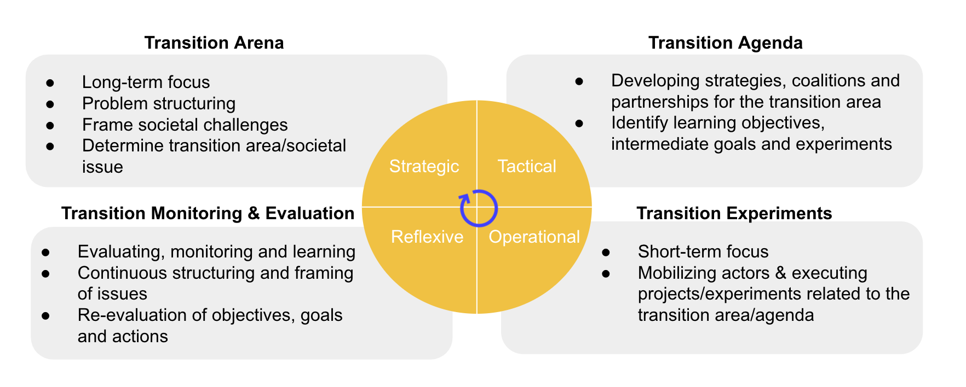
The process of transitioning is a complex one. Adding to the already existing complexity of system wide transformations, the issue of sustainability is too complex and interconnected to be solved in isolation. For business to achieve real transformational change in the field of sustainability, they have to shift the focus from defensive sustainability strategies, which entail reducing unsustainable firm-level behavior, towards proactive engagement on increasing the sustainability of the system via radical change across all levels an actors (Schaltegger et al., 2012; Ehrenfeld, 2005; Korhonen & Seager, 2008). Literature suggests that pro-active business strategies, that focus on innovating at the business model level by integrating environmental and societal concerns into the core business of the company, show the highest transformational potential to develop competitive advantage on sustainability (Schaltegger et al., 2012; Boons, 2009). In general, the academic discussion around sustainability transitions on the corporate level focus dominantly on the transition management approach (Loorbach, 2010). Loorbach and Wijsman (2012) suggest a framework for corporate sustainability transitions based on the transition management perspective that advocates for effective governance of a transition towards sustainability based on four dimensions; strategic, tactical, operational and reflexive (Figure 1) (Loorbach, 2007).
Figure 1. Transition management framework according to Loorbach and Wijsman, 2012. For simplification purposes, the image has been recreated by the author

The strategic level relates to activities that consider long-term horizons, problem structuring, creating alternative futures through visioning, politics and opinion making. In this dimension, actors are required to embrace change in order to achieve joint ambitions and open discussions to reflect on how to contribute to the desired change. From the business perspective, this entails determining which particular societal issues or transitions the firm can or aims at contributing. This strategic choice needs to be based on certain characteristics based on the systems it operates in, the business itself and its area of impact within the wider scope. The tactical level considers activities relating to the build-up and break-down of system structures through negotiation and collaboration. For the firm, this entails engaging in the development of strategies and coalitions around sustainability challenges by identifying learning objectives, intermediate goals and experiments. At the operational level, activities are focused on short-term decisions and actions, where actors decide on either re-creating, restructuring or changing systems. This entails for the business creating pilots, experiments and icons around specific business cases relating to sustainability challenges. Finally, the reflexive level describes activities relating to the continuous evaluation of the existing situation through debates, structure evaluation, assessment and research. For businesses, this means developing flexible and cross-business debates about societal and sustainability challenges and identifying the role of the business in this.

This framework takes on the perspective that sustainable development of our society can only be achieved through structural systemic changes in technology, economy, culture, ecology, institutions and organizations (Loorbach & Wijsman, 2012). It analyzes corporate change at the macro level by taking into account the wider context of effective transitions. This governance typology serves to develop specific process strategies and systemic instruments that play a crucial role in accelerating and structuring the process of change in the business environment. The framework of transition management is widely used as an analytical and normative approach to assess for effective governance of transitions through four basic types of activities a firm can undertake to influence their transition (Loorbach et al., 2015). While the transition management approach developed by Loorbach has been shown to be applicable for sustainability transitions for corporations, it serves as a tool outlining four distinct types of activities that firms can undertake to influence their sustainability transition.
Current literature suggests that business models can act as a vital force to facilitate system-wide transformations towards sustainability (Bidmon & Knab, 2018; Sarasini, 2018; Hillman et al., 2018). Hence, innovation at the business model level has received increasing attention in literature for its potential to act as a catalyst for systemic sustainability changes (García-Muiña et al., 2020). The business model is defined as a “rationale of how an organization creates, delivers and captures value” (Osterwalder & Pigneur, 2010) and representative of an organization’s strategic and operational activities that assist in creating a competitive advantage (Pateli & Giaglis, 2016). In line with this, sustainable business models (SBMs) are business models that incorporate pro-active multi-stakeholder management (Geissdoerfer et al., 2018) by taking into account ecological, financial and social concerns into business activities and integrating sustainability into their value proposition, creation, delivery and capture (Bocken, 2014). SBMs can serve as an important vehicle in achieving global sustainable development goals and serve as a strong accelerator for sustainability transitions. Hernández-Chea et al. (2021) investigate how business activities in SBMs contribute to dynamic system-level sustainability transitions by focusing on the role of SBMs activity system. The authors have conceptualized firm activities for sustainability transitions in a conceptual framework (Figure 2). Within the strategic, tactical and operational levels of the transition management framework, the authors identified that (1) long-term development of value propositions and leveraging of business opportunities for sustainability are dependent on a strategic dialogue and a shared vision among cross-sectoral firms; (2) medium-term sustainable value creation and delivery are established through the development of an interdependent network of the green supply chain and stakeholder collaboration; (3) short-term value delivery is ensured by the adoption of sustainable practices, control of daily operation, conduction of awareness campaigns and experimentations with collaborations (Hernández-Cha et al., 2012).
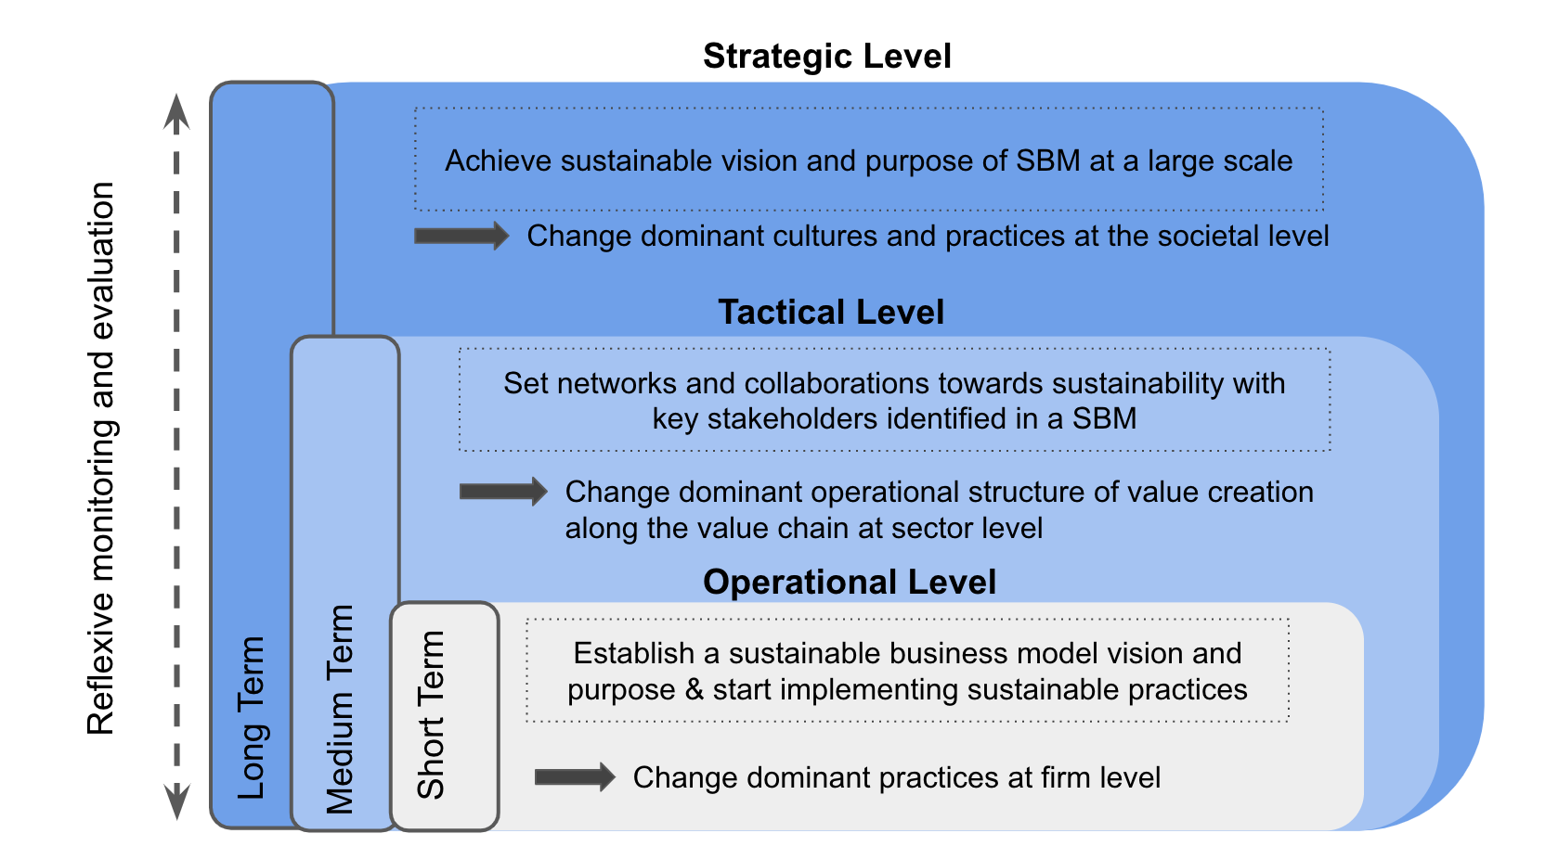

Figure 2. Business model activity system for sustainability transitions adapted by the author from Hernández-Cha et al. (2012). Sustainable Business Model (SBM). Image adjusted by the author.

Hernández-Cha et al. (2012) add on the business model activity system to comprehend the firm at the micro-level and looks deeply into the role of the business model, defining how firms can transition towards sustainability by directing and realigning activities through a holistic change in the business model towards a sustainable business model by pursuing sustainability through means of value proposition, creation and capture. The authors dive deeper into the radical changes a firm can accomplish systems-wide transformation.

In general, both frameworks argue that a leading role in sustainability can only be realized if and only when sustainability becomes part of the core business. This entails for traditional companies switching towards a sustainable business model, which entails organizational transitioning towards sustainability. Changes in firm’s practices can trigger sustainability transitions by diffusing through internal and external organizational structures, reaching industry and societal changes in systems both from a short and long term perspective. The developed theoretical sustainability frameworks by the two authors provide an overall theoretical guidelines for the practitioners and managers to accelerate the transition towards sustainability. While each framework can be employed for a wide range of sectors and firms across the globe, the frameworks fail at delivering firm or industry specific insight on how to tackle the firm-level transition towards sustainability. The following sections of the literature review will dive deeper into e-commerce at the industry level and digital platforms at the company level, in order to elaborate on the current academic literature on sustainability related to these fields.

2.2. Barriers to Sustainability Transitions
As does with every initiation of organizational change, sustainability transitions come with enormous practical and conceptual challenges. Post and Altmann (1994) have categorized two main sub-group of barriers faced by businesses when eliciting sustainable change, (1) industry barriers and (2) organizational barriers. Industry barriers are related to capital costs, community concern, regulatory constraints, information and technological knowledge that pose as obstructions to the achievement of sustainable development within the outside business environment while organizational barriers are attributed to the attitude of the personnel, top management, quality of communication and administrative heritage that hinder internal change towards sustainability. When further diving into internal firm barriers to sustainable transitions, businesses are often challenged by the lack of financial resources, time constraints, lack of knowledge, skills and awareness, current policies and regulations, existing organizational culture and risk of sustainable practice implementation in their transition towards sustainability (Caldera et al., 2014).

Both internal and external forces can be main blockers when initiating transitions towards sustainability. Indeed, organizational resistance to change combined with formidable industry barriers are attributes that block the achievement of sustainable development goals (Post & Altman, 1994). It is fundamental for the successful transition to sustainability to overcome these barriers by being responsive to organizational change in combination with low industry barriers. Only in case of both, the potential to achieve sustainable development goals is maximized and the transition towards sustainability is the most successful.

2.3. E-commerce and Sustainability
As the access to the Internet overgrows worldwide and the digital economy is increasingly gaining in momentum, e-commerce is becoming the dominant medium of consumption. With the current pace of digitalization, more and more businesses are using online marketplaces as a way to boost their sales and reach consumers globally. The rapid and continuous growth of the e-commerce sector has raised important considerations regarding its effect on sustainability (Dabija et al., 2016).

Fichter was among the first to analyze the potential environmental impact of e-commerce, distinguishing between three main order categories of environmental effects of e-commerce. The three levels of order effects are seen as the main drivers of environmental impact of the industry and are concerned with the results of changing consumption patterns, effects of IT infrastructure and transformation of markets and processes on the environment (Fichter, 2002). The main areas of impact identified were based on either direct or indirect effects of e-commerce such as technological waste, energy usage, production and manufacturing of goods, transport, changing consumption patterns, digitalization, resource productivity and land usage. Within Fichter’s categorization of environmental consequences of the e-commerce market, a common theme of current standardized practices of today’s categorization of environmental impact areas can be observed. Essentially, Fichter’s order-effects seem synonymous to the modern environmental impact assessment tool, GHG emissions protocol, a consumption based accounting system that quantifies environmental impact through production of emissions based on three scopes:

- Scope 1 - emissions from owned and controlled sources
- Scope 2 - indirect emissions from owned and controlled sources
- Scope 3 - indirect emissions outside of direct control areas

Indeed, recent research has continued analyzing the effects of e-commerce across all emission scopes. The dominant factor of emissions related to e-commerce has been described predominantly in e-commerce logistics, such as transportation planning and management, warehousing, packaging and distribution network designs (Mangiaracina, Marchet, Perotti & Tumino, 2015; Edwards et al., 2010; Sui & Rejeski, 2002). Interestingly, the available literature on e-commerce sustainability is mainly focused on Scope 2 and Scope 3 emissions, relating to the logistics and packaging aspect of e-commerce. In fact, most of the emissions in the e-commerce sector are a result of transport, packaging and returns (Coppola, 2021; Escursell, Llorach & Roncero, 2021) and considered the main challenges regarding sustainability in this industry. Additionally, the European Collaborative Report on Sustainability and Ecommerce highlights the importance of encouraging sustainable consumption behavior in consumers, innovating sustainable and efficient packaging and introducing sustainable e-logistics solutions to the industry (ECommerce Europe, 2021). While many academic papers focus on the environmental impacts of e-commerce when assessing the sustainability of the industry, some authors have challenged all three spheres of sustainability, namely the environmental, social and economic dimensions of e-commerce. Oláh et al. elaborate on the economic, environmental and social sustainability of e-commerce. Economic prosperity of e-commerce is a direct result of its high efficiency and effectiveness which has led to economic growth and increased profitability through exploitation of low costs, convenience, and high sales (Anvari & Norouzi, 2016). From a social capital perspective, e-commerce has encouraged the access of local businesses globally, increased the marketing of their local produce and decreased poverty (Phills, Deiglmeier & Miller, 2008). Hence, Oláh et al. (2018) argue of increased positive socio-economic effects of virtual markets (Oláh et al. 2018). However, sustainability of e-commerce within environmental impacts is divided. Both positive and negative environmental consequences as a result of digitalization and access to virtual markets have been reported (Carrillo, Vakharia & Wang, 2014). Environmental benefits are linked to the highly efficient and organized global logistics systems put in place (Oláh et al. 2018). However, studies revealed a greater net negative impact of logistics associated with e-commerce, resulting from an increase in pollution due to non-recyclable packaging, transportation and increased returns (Oláh et al. 2018). Based on the reviewed literature of the impact of e-commerce on environmental and social dimensions of sustainability, an overview of the e-commerce emissions spectrum has been constructed (Figure 3), in order to provide a summary of the main emission factors of the industry.

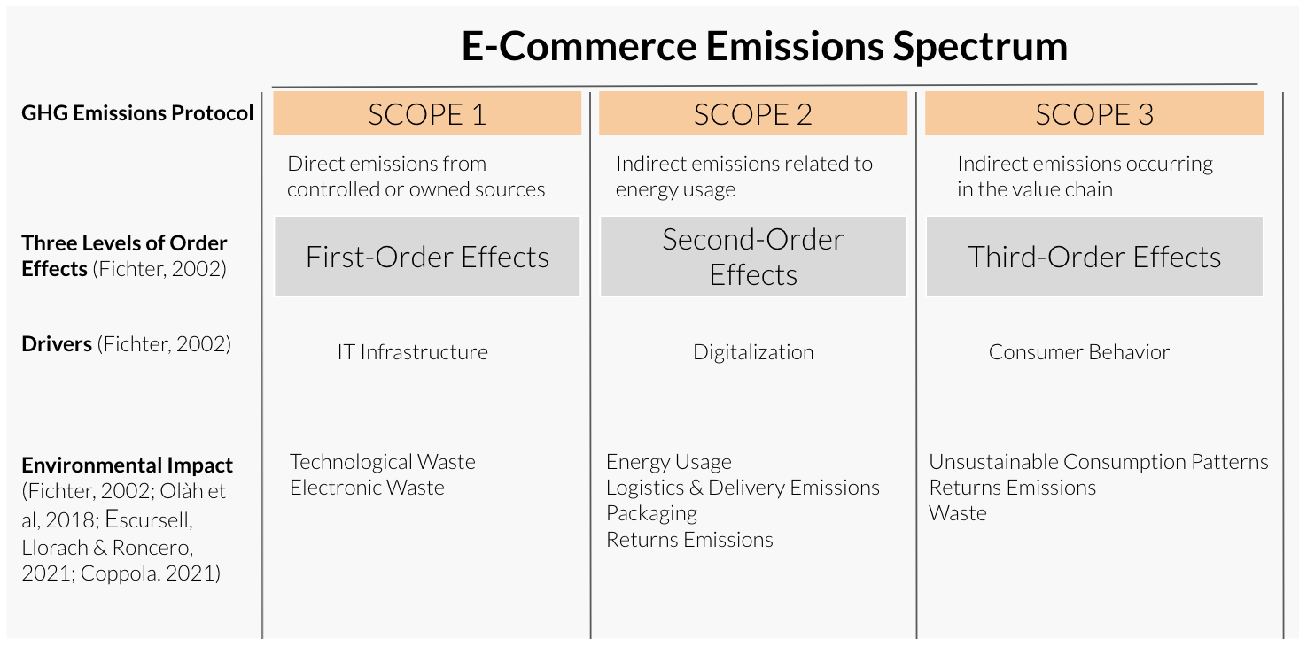
Figure 3. Summary of the literature review on e-commerce sustainability dimensions. Table constructed by the author.

2.4. Digital Platforms and Sustainability
E-commerce is enabled through the use of online marketplaces or digital platforms. Digital platforms are systems and interfaces that form a commercial network or marketplace facilitating the exchange and connection between two or more parties, connecting consumers and providers (IGI Global, 2021). A platform creates value by harnessing digital technology to connect people, resources and organizations within an interactive ecosystem thereby unleashing the network effect (Parker et al. 2016; Hagel, 2015). In this understanding, competition no longer resolves around the control of scarce, inimitable and valuable resources as with traditional pipeline businesses, but resides from intangible assets that facilitate the interaction between the participants of its network and the exchange of information between these parties through platform technology and the network effect (van Astyne et al. 2016; Ye et al., 2012; Rohn et al., 2021). The core functionality of digital platforms is provided by the software-based system in which companies are competing on multiple dimensions of technical architecture (Pon et al., 2014). Platform technology is the driving force behind facilitating and matching the interaction between distinct participants of the network in such a way that the participation of one side of the platform can raise the value on the other side through positive externalities (Roson, 2005; Parker et al., 2016). The network effect describes the phenomenon whereby an increase in numbers of participants (installed base) of the platform improves the value of the good or service (Gawer & Cusumano, 2014). Hence, the value of the platform is not solemnly derived from the features and functionality of the platform technology but interdependent of the network size and the interactions among them (Rohn et al., 2021). Ultimately, the network effects enable the fast scaling of digital platforms with winner-take-all dynamics, leading to the dominance of a few key platforms in the market (Chen et al., 2019).

Zarra et al. were among the only relevant that provided an overview on the matter of sustainability of digital platforms focusing on Asian firms. Here, specifically the three pillars of sustainability were analyzed in relation to the contributions of digital platforms in online marketplaces (Zarra et al., 2019). The argument is that macroeconomic conditions add to the uncertainty of economic sustainability of digital platforms due to the complexity of organizing a two-sided market, winner-take-all dynamics and market power of sellers and consumers because of the network effect (Daniel et al., 2014). Contributions of digital platforms towards social sustainability seems to be divided. On the one hand, digital platforms can offer flexibility to workers to decide on their own working hours and wage, encouraging market participation and have the potential to alleviate discrimination and promote social mobility (Zarra et al., 2019; Luca, 2016). On the other hand, digital platforms have been subject to criticisms because of poor treatment of workers and no guaranteed social protection and labour regulations (Zarra et al., 2019; Cunningham-Parmeter, 2018; World Bank, 2019). The main question still remains within the environmental impact of digital platforms in the age of the climate crisis. Environmental sustainability of digital platforms is estimated to lead both to positive and negative effects. One perspective elaborates on the potential of generating a new form of sustainable consumption pattern through platforms such as car-sharing services, which lower GHG emissions (Martin, 2016; Martin & Shaheen, 2010). Resource efficiency enabled through platforms is argued to have a positive impact on energy efficiency, use of natural resources and sustainable consumption due to digitalization (Auvinen, 2017). However, comorbidities of digital platforms are electronic waste through increased use of technological devices and their short life cycle, high energy consumption due to the need for massive data centers and computing power to maintain the platforms and their global outreach and logistics, leading to high emissions through global transport (Auvinen, 2017).

2.5. Constructed framework
Based on the reviewed frameworks from literature on sustainability transitions, a framework was constructed encompassing the findings from the transition management framework and the SBM activity system framework by Loorbach and Wijsman (2012) and Hernández-Chea et al. (2021). The constructed framework (Figure 4) shows that transitioning towards sustainability from an unsustainable business model requires four distinct types of activities that are crucial in guiding, accelerating and structuring the process of change towards sustainability, demonstrated by the transition management framework. Bridging this framework together with the SBM activity system, we achieve a comprehensive overview on the business activities supporting each branch of the transition management framework. Additionally, this framework indicates both internal and external barriers as inhibitors to the transformation of a sustainable business, which need to be taken into account and dealt with when transitioning towards sustainability. Hence, the constructed framework provides a holistic view on the mechanics behind business transformation, which will be used as a guiding framework for answering the main research question of this study.
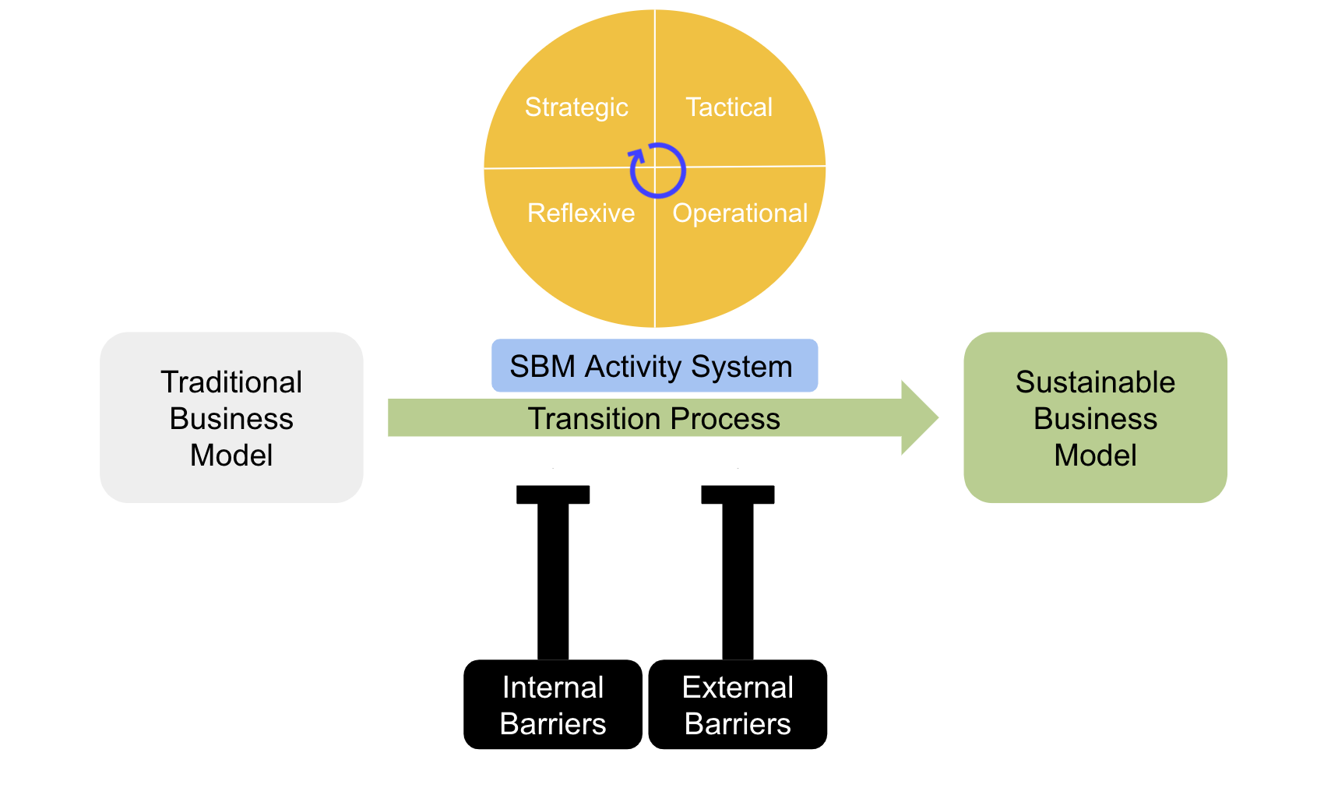
Figure 4. Constructed framework on sustainability transitions from unsustainable businesses towards sustainability. Framework established by the author.

Methodology
The environmental and societal urgency combined with the necessity of the market to move from traditional unsustainable business patterns towards sustainable solutions in a digitalized world. The ever increasing shift towards consumption on online marketplaces governed by digital platforms makes it essential to investigate the approach of sustainability transitions within this sector in order to provide a holistic framework and accelerate the sustainability movement across the entire industry. Hence, this has led to the research question: “How do digital platforms in e-commerce approach the transition towards sustainability?”. In order to answer the main research question, it is necessary to first answer the following sub question, which will assist in adding value to answering the main research question of this study. Hence, this paper will try to anwer: “What are the barriers for digital platforms in e-commerce when it comes to sustainability?”

3.1. Data collection
Answering the main research question and the related sub-question requires an exploratory approach by using qualitative research in the form of semi-structured interviews. Here, Helloprint, a platform company that serves as an online marketplace for customized printed products is being used as a case study and a representative for digital platforms in e-commerce. More specifically, the company operates within the print industry, where it differentiates itself by not owning print facilities but employing a network of print suppliers that sell through its channel to customers. The company has just recently started its transition to sustainability, and therefore makes a good case in analyzing it’s approach and considerations when insignating the transition process.
Semi-structured interviews of 30 min with members from the management board and relevant stakeholders have been conducted to identify key challenges faced by digital platforms in e-commerce on sustainability and the company’s approach to sustainability in this industry. The semi-structured interview questions will focus on the challenges faced by e-commerce and digital platforms in regards to sustainability, the transition management approach regarding this subject as well as the assessment of activities supporting the transition. The questions will focus on including all aspects of the analyzed theoretical frameworks in the literature review and complement the review on sustainability regarding e-commerce and digital platforms (Appendix Table 1). The interviews with the respondents have been performed both in person at the company headquarters and online. All interviews were recorded and transcribed via Otter.ai, a free online transcription software that uses artificial intelligence to transcribe audio recordings in real-time.

3.2. Sample Selection
For this, the interviewed members have been chosen based on their involvement considering the sustainability transition of the company, the decision making unit involved in its initiation and experts in the development of the e-commerce platform of the business. Hence, two members of the management board as well as other stakeholders have been chosen as suitable candidates having the relevant knowledge on the company’s overall direction and it’s sustainability transition. In total, five member have be interviewed:

- Lennaert Koch (CFO and CSO)
- Hans Scheffner (CEO)
- Sebastiaan Ram (E-commerce and Expansion Manager)
- Isabelle de Wolf (Sustainability Business Officer)
- Andrew Charnley (Supply Chain Manager)

Here the CFO/CSO and the CEO of the company were chosen in order to achieve an overall strategic point of view related back to the transition process towards sustainability. These actors are expected to give more insight into the management process and strategic drivers of the transition. Additionally, the Sustainability Business Officer has been selected as a respondent from the company in order to gain more awareness into the sustainability process at the tactical and operational level. Furthermore, this actor has been selected based on getting a differentiated view than from top management and receiving a view more explicit on the subject of sustainability. It is important for the answering of the research question to include the position and view of a respondent more involved and experienced explicitly in the e-commerce side of the business, therefore, the e-commerce and expansion manager has been selected as a suitable candidate for this research. Lastly, the supply chain manager has been chosen as a suitable respondent to get more insights within the supply chain management of the business and how sustainability transitions reflects on this part of the business. The lack of control of the supply chain is a characteristic very indicative of digital platforms, as they bear a role of mediator between the sellers and customers of the online platform. Here, the respondent is expected to give very interesting insights into the challenges of transitions from a supply chain perspective.

All respondents have been chosen based on their position and knowledge about different levels and aspects of the company and their involvement or impact regarding the sustainability transition. Additionally, it was important to get actors involved in the interview process that are not involved in the initiation and development of the sustainability transition process to receive an unbiased and holistic view of the transition process within the company.

3.3. Data Analysis
The interview questions were based on the variables and constructs of the theoretical framework reviewed in the literature review. The data was acquired through recording of the semi-structured interviews and transcripts. The raw data from the interview transcripts first went through a filtration process where responses of each respondent were scanned and reorganized or restructuring into the relevant question section. This was done due to the fact that the semi-structured interview process leaves open-ended questions with the motivation to have the respondents talk freely, which resulted in the coverage of multiple questions in one section. After the filtration process of the raw data, the transcripts were scanned and relevant quotations that were judged to be of importance for this research question and the sub-question. The relevant quotations for each question were summarized in a table giving an overview of the significant answers of each respondent (Appendix Table 2). The quotations of the interviewees were compared against the matrix constructed that connects the questions of the semi-structured interviews against the theoretical frameworks (Appendix Table 1) in order to facilitate the connection of the data to different elements of the framework and improved analyses of the results. The findings of the semi-structured interviews were grouped based on different overlapping themes in a tree code specific to the sustainability transition process and its relationship to the constructed theoretical framework on sustainability transitions (Figure 4) and the involvement or relevance in regards to digital platforms and the e-commerce industry (Figure 6). The classification of the code trees was based on a deductive approach where each interview question was simplified or grouped based on the main findings it would generate.

4. Results
The results of the semi-structured interviews have been summarized and put against the constructed sustainability transitions framework (Figure 3). The assessment of the interviews revealed that the four areas of transition management, the transition area, transition agenda, transition experiments and the transition monitoring and evaluation have been identified within the company’s behavior or intentions towards transitioning to sustainability. At the transition area level, company activities take into account the long-term horizon by developing a sustainability vision, mission and strategy. “It really starts with the strategy and embedding within all [...] processes and systems [of the company].” The respondents have all shared an aligned view on the importance of incorporating sustainability with all levels of the firm, but stating that the pressure needs to come from a top down approach in order to fully integrate sustainability into a ‘unsustainable’ company, which puts the focus on the management board and the CEO. When looking into the main drivers behind the transition towards sustainability for the company, all respondents have shown consensus on the importance of customer demand and market forces towards sustainability as being the key driver in the transition with the exception of the CEO of the company, who defined the main driver being additionally the duty towards society in ensuring a long term future for the generations to come. A summary of the main findings in regards to the strategic level has been established. (Table 1).
Table 1. Helloprint’s company activities related to the constructed framework at the strategic long-term level.
Constructed Framework | Company Activities
Transition Area - Strategic Level | Development of a corporate sustainability vision, mission and strategy
SBM Activity System
- Development of a sustainable value | Customer demand / market forces / societal challenges
- Leverage on sustainable business opportunities | Customer demand / market forces

At the medium-term tactical level, the findings demonstrated that one of the most important steps in transitioning towards sustainability was the development or integration of sustainability into the strategy. The CFO of the company elaborated that for the transition from a unsustainable business towards sustainability to be successful, the company needs to incorporate all levels of change management “We need to change our behavior, our DNA, our way of thinking, [...] you need to go through [eight steps], starting with sense of urgency, form powerful alliances, create a vision for change, invest in communication, empower the entire base, set short term goals, don’t slow down and make change a part of the culture.” x
Table 2. Helloprint’s company activities related to the constructed framework at the tacticall medium-term level.
Constructed Framework | Company Activities
Transition Agenda - Tactical Level | Sustainability strategy, projects, goals
SBM Activity System
- Building networks | Right partnerships
- Collaborations with stakeholders | /

The findings revealed that from an operational perspective (Table 3), which is about the implementation and experimentation of projects that add value to the sustainability vision of the company, the main activities performed by the business relate to increasing internal awareness and communication around the subject of sustainability itself through the establishment of the sustainability committee, integrate it into the company’s core technology driven through projects in collaboration with third parties, educating customers, suppliers and employees on sustainability and increasing the offerings and visibility of eco-friendly products on the website.

Table 3. Helloprint’s company activities related to the constructed framework at the operational short-term level.
Constructed Framework | Company Activities
Transition Experiments - Operational Level | Projects supporting the sustainability strategy
SBM Activity System
- Experimentation | Projects supporting the sustainability strategy
- Create value through implementing a shared vision | Sustainability Committee

Looking into the monitoring and transition level, the respondents have mentioned the establishment of measurable goals, key performance indicators and employee and customer satisfaction as attributes on how to measure the success of the transition process. Interestingly, the respondents not directly involved within establishing and implementing the sustainability transition have given a more customer oriented perspective for assessing the success of the transition, meaning that when sustainability oriented customers choose the company for its consumption, it is defined as a success.
Lastly, the challenges regarding sustainability transitions, both from an internal and external perspective have been found to be on an employee engagement level, the integration of sustainability within the existing corporate culture, the alignment and integration within the current ‘unsustainable’ business model of the company, the lack of control over the supply chain and sector specific attributes, relating to the inherent unsustainable nature of the offerings of the company, as the CFO of the company elaborated: “The printing industry [...] has a very unsustainable perspective, [...] the big challenge for us as an industry is to make sure that we break from that perspective [...]” (Table 4).

Table 4. Summary of Helloprint’s view on barriers to sustainability transition
Constructed Framework | Company Views
Internal Barriers | - Employee engagement  - Integration into company culture  - Alignment with current business model
External Barriers | - Lack of control over supply chain  - Unsustainable nature of the print industry

5. Discussion
This research investigates the sustainability transitions within digital platforms in e-commerce in response to the increasing importance of digital platforms in our society due to rapid digitalization of our world and the shift from traditional shopping behavior towards online consumption. Specifically, the paper addresses the research question: How do digital platforms in e-commerce approach the transition towards sustainability? To answer the main question of this research, it is important to understand the challenges of sustainability transitions within this industry. Therefore the main research question is supported by the sub-question: What are the barriers for digital platforms in e-commerce when it comes to sustainability?
The constructed framework on sustainability transitions (Figure 4) contributes to the understanding of critical factors necessary for a successful transition from a unsustainable business model to a sustainable one, taking into account internal and external barriers that need to be overcome to achieve this. The outcome of this research should shed more light into the attributes specific to digital platforms in e-commerce in order to (1) evaluate the transition approach of the company case in regards to the elements necessary for a successful transition and (2) complete or adapt the constructed framework in order to accommodate it specifically to the case of digital platforms in the e-commerce sector. The discussion will first examine the theme of sustainability transitions and move on to elaborate on the findings of the research that specifically refer to digital platforms and e-commerce. Finally, the constructed framework will be adapted based on the analysis of the results.

5.1. Sustainability Transitions - Drivers, Barriers and Success Factors
The interview analysis (Appendix Table 2) resulted in the construction of a code tree (Figure 5) categorizing the attributes of sustainability transitions within a platform company in e-commerce, such as Helloprint.
First, the analysis revealed that the main drivers for the transitioning towards sustainability are based on consumer demand and sector specific attributes. In the case of Helloprint, the specific market attributes related to their offerings as an online marketplace, which is based on customized printed products for small businesses. Surprisingly, drivers of the sustainability transition were not related to any factors to the position within the e-commerce sector. While the company has demonstrated an accommodative approach to sustainability, which implies sustainability adaptations of the current business model and the integration environmental or social objectives in the majority of business processes and product range (Schaltegger, Lüdeke-Freund & Hansen, 2012), the main driver of sustainability is still consumer demand for most respondents. Additionally, in the case of Helloprint, it was management that elaborated more on the desire to make a shift towards sustainability based on the inherent unsustainable nature of their business, specifically referring here to the print industry by adapting a role of advocates for change through their position as a platform. Surprisingly, the CEO of the company, was the only respondent that mentioned one of the drivers of the transition being driven by societal challenges and the obligation to ensure long-term viability for both future generation and the business itself. Interestingly, the leader of the company showed to consider at the strategic level the long-term horizon and relate to a societal challenge as motivators behind the sustainability transition process. While the contribution to society as a driver has been mentioned, there was no further elaboration on the particular societal issue it wants to contribute. It can only be estimated that this ‘contribution to society’ is reflective of the global issue in regards to climate change, as mentions of reduction of carbon footprint have been specified. In general, no considerations were given regarding the environmental and social implications of being actors within the e-commerce industry and the technological energy needs for operating as a digital platform in e-commerce.
Barriers to the transition process have been identified as being both of internal and external nature, with a core focus on employee engagement and motivation, integration of sustainability into corporate culture and the balance between economic gain, growth and revenue versus sustainability practices. External factors acting as inhibitors have been related to the lack of control over the supply chain, this is in the case of Helloprint related to the fact that they don’t have ownership over the products they offer on their marketplace. Additionally, industry characteristics specific to the offerings of the digital platform limit the transitioning process. For Helloprint, this is restricted to the speed of innovation within the print industry and the sustainability transition of their producers. Here, both organizational and industry barriers have been identified by the respondents for the transition to sustainability. While common internal barriers to transitions as identified in the literature, such as the attitude of top management, communication and time constraints have been dealt with already by the company and therefore pose no barriers to the transition process, employee engagement and the allocation of resources pose challenges to the sustainability process. This is specifically relevant as the company is still growing and majorly focused on gaining market share and establishing a position in the competitive landscape. Here, the clash between driving growth versus investing in long-term viability can become a conflict during the transition phase. While the company was very aware of internal challenges that could become inhibitors of its sustainability vision and mission, the perceived external challenges have not been all addressed. Specifically, regulatory concerns, capital costs and community concern have not been mentioned, despite the importance of dealing with these issues for a successful transition (Post & Altmann, 1994).
Furthermore, success factors in integrating sustainability into the core business have been attributed towards ensuring the integration of sustainability into the business model and the formation of coalitions, more specifically this entails the essentiality of alignment on the role of sustainability with the CEO and the management board in addition to integrating sustainability into the company’s vision, mission, strategy and culture. Indeed, the starting point of adopting sustainability into organizations and achieve the desired impact is based on integration sustainability into the business’s vision (Hernández-Chea et al., 2021). Here, the main internal barriers to the integration of sustainability have been neutralized, enabling the ability to achieve change in dominant operational structures for sustainable value creation. Additionally, partnerships have been noted as being an important success factor in supporting the transition. Here, the approach to sustainability is focused on the diffusion throughout the entire organization and value chain through the formation of a sustainability committee and sustainability department to increase exposure of sustainability within the business and engage employees. These parties will have a role of continuously communicating the values of sustainability to increase employee engagement and awareness. Diffusion of sustainability within the organization also entails the first step of integrating it into the business model.
Lastly, measuring and evaluating the sustainability transition has been implemented using both quantitative and qualitative methods, such as goal and target setting, setting key performance indicators (KPIs) for sustainability and measuring it both in terms of customer and employee satisfaction. While the company has set out objectives, goals and actions, there has been no process established into how these metrics can be brought together and re-evaluated in order to strengthen the sustainability proposition. For the success of the sustainability transition, the firm needs to find a process of re-evaluated the set metrics, gain insight into the process of the transition and how it relates back to the desired direction of the process in regards to the main change it tends to implement (Loorbach& Wijsman, 2012).
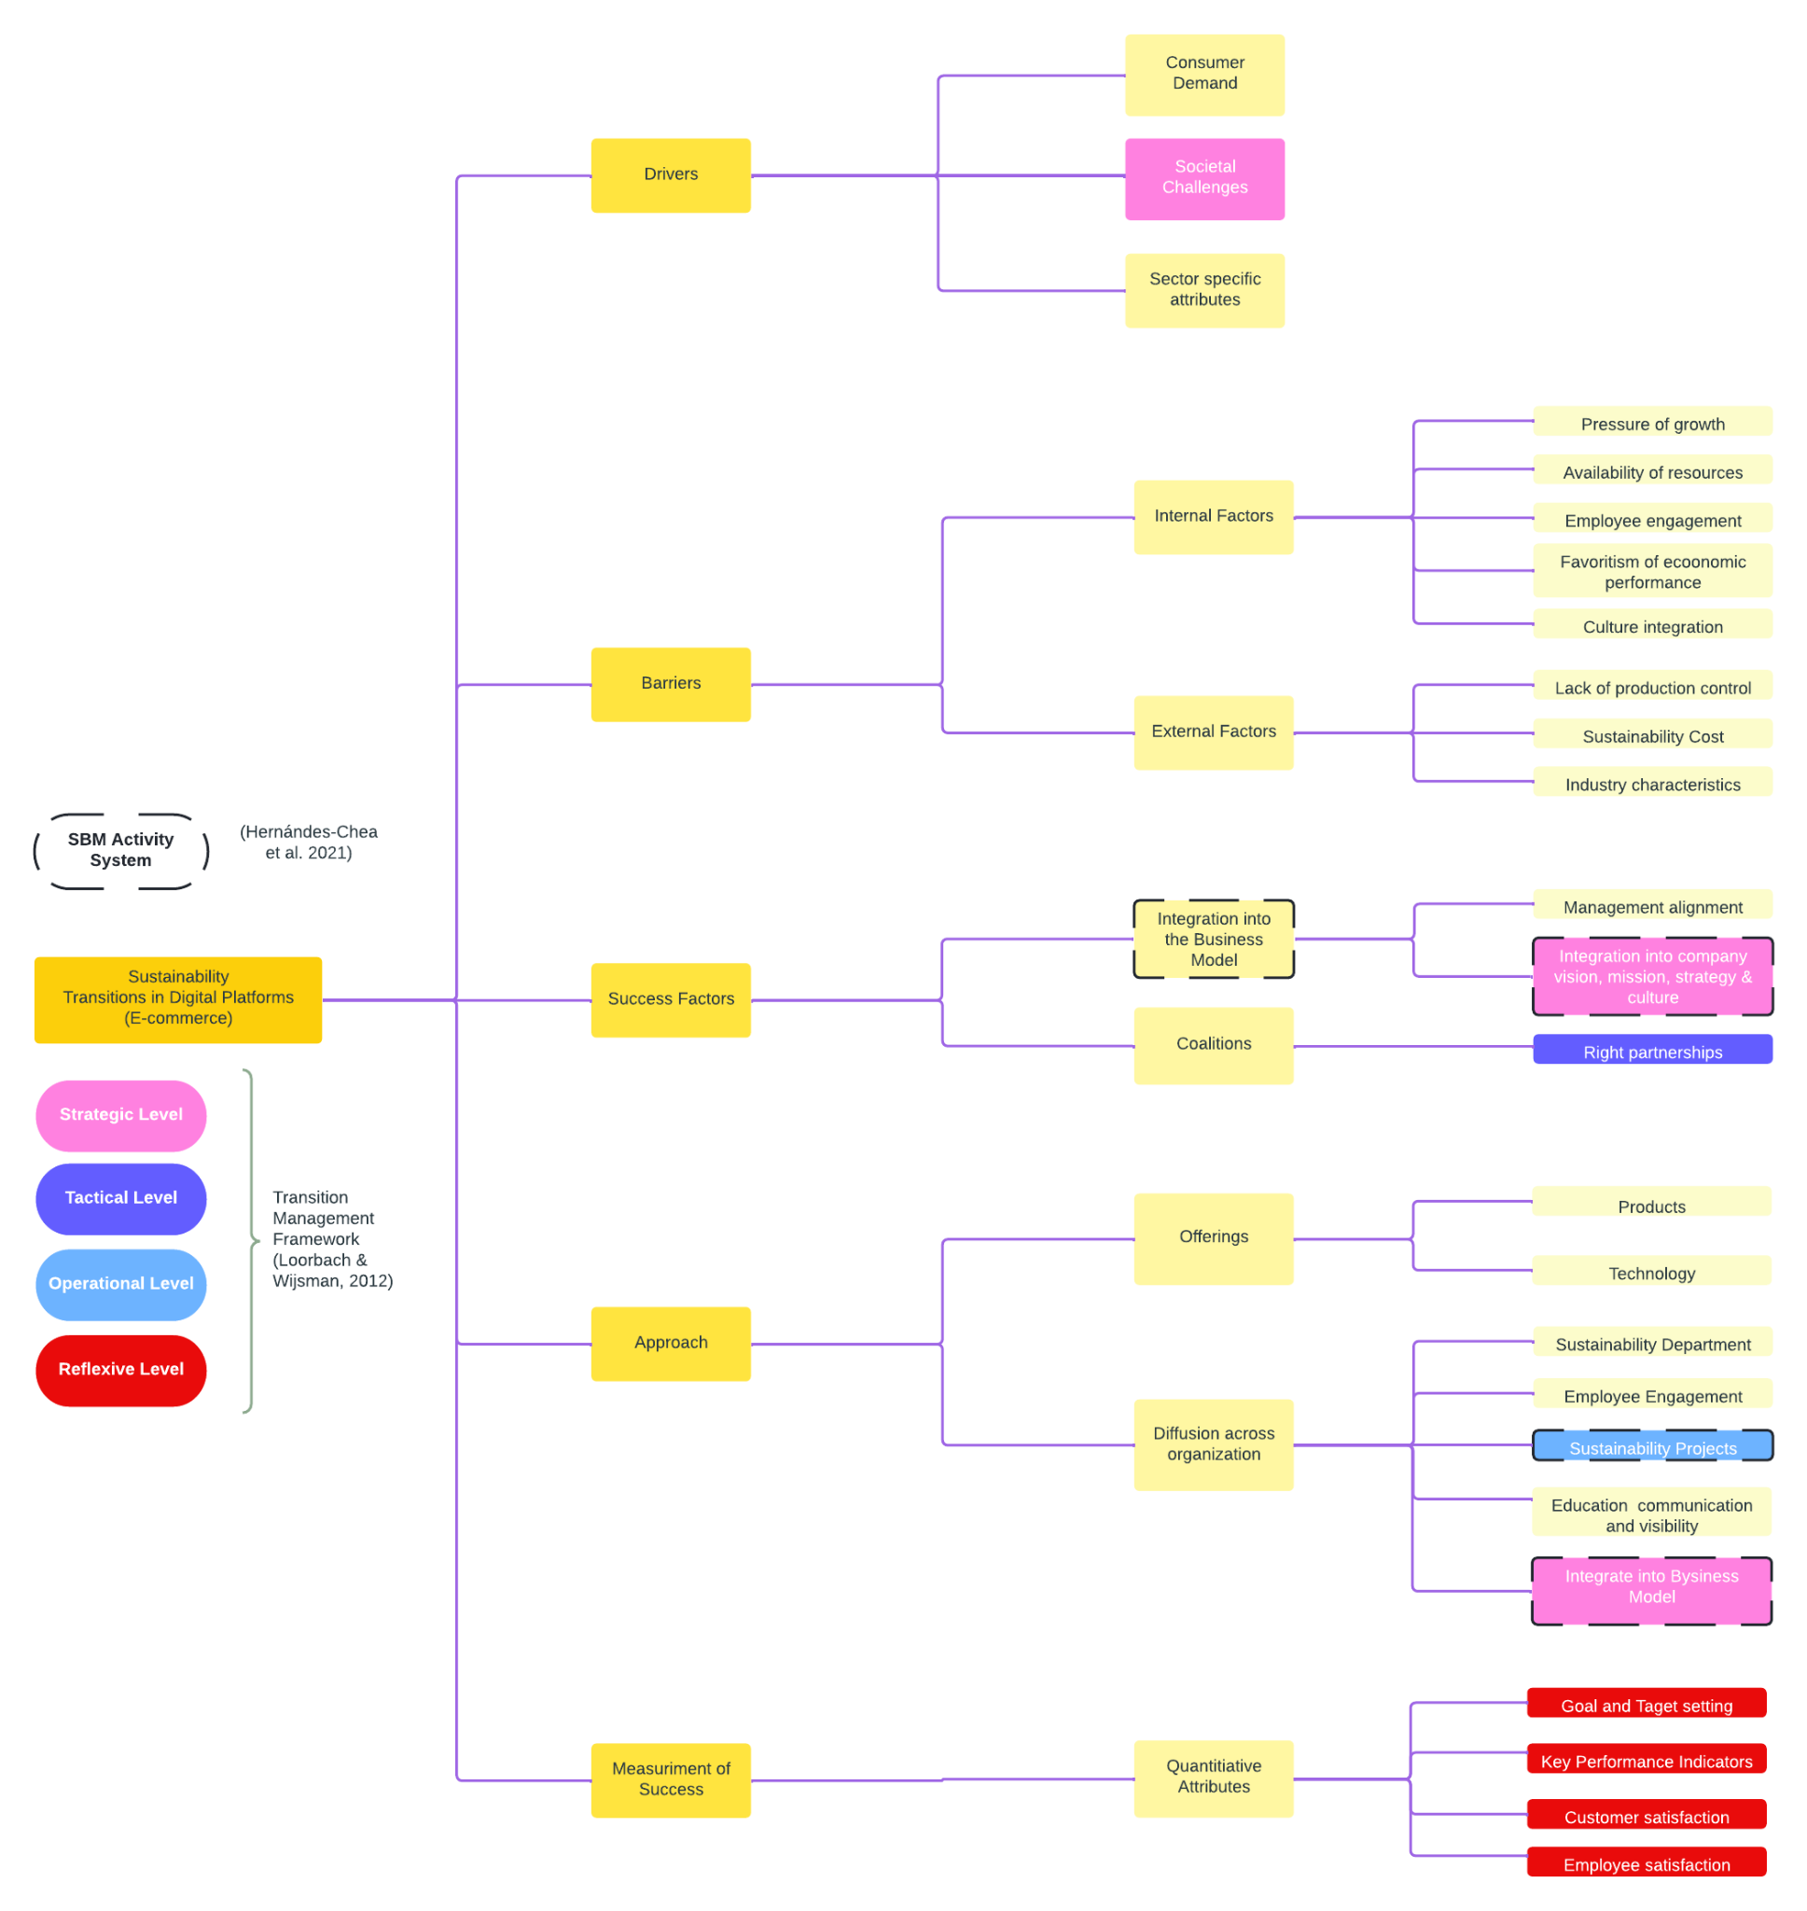
Figure 5. Analysis of the semi-structured interviews in the form of a code tree, put against the transition management and SBM activity system framework.

5.2. Sustainability Transitions
Based on the construction of the code tree for sustainability transitions, the analysis of the semi-structured surveys showed an overlap of factors within the sustainability transition of Helloprint compared to the academic sustainability transition frameworks analyzed in the literature review (Figure 4). Comparing these frameworks to the outcome of the code tree (Figure 5) demonstrated that all four areas of the transition management framework were included to a certain degree of the company’s approach towards sustainability. While the company has included sustainability into its vision, which is reflecting back on establishing a transition area, the respondents did not explicitly mention which particular border societa/environmental issue it can and aims to contribute to. It is important that before establishing a transition agenda, that the business considers questions related to the impact of its business and value chain within a wider societal and environmental context and identifies trends influencing its operating system. At this stage, problem structuring, envisioning and the establishment of a transition area needs to be discussed with selected stakeholders from within the company, other stakeholders and the wider societal context in order to frame the particular societal or environmental challenge they aim at contributing to (Loorbach & Wijsman, 2012). In the case of Helloprint, the vision related to sustainability has been an important step in establishing the transition area, however, only internal stakeholders have been included in the discussion without taking into account the wider context. This being said, the company is aware of the unsustainable nature of the business they operate in and are aware of the environmental challenges faced by this sector, however, the transition area has been established without feedback from external stakeholders.
On the tactical level, the company has already established a sustainability strategy and is looking to establish the right partnerships to support its sustainability agenda. Developing strategies and coalitions around the vision or transition area of the company is an important step in setting up the transition agenda. Additionally, the respondents have mentioned the establishment of goals, targets and projects, which project on the medium-term activities and strategies that align with the long-term strategic envisioning of the company.
At the operational level of the transition management framework, the analysis revealed that multiple projects have been implemented, in progress or are planned to be implemented in relation to the established transition agenda, which reflects on the business’s sustainability strategy. When comparing the company’s activities to the transition framework, the activities of the organization’s approach to short-term activities and projects are within the context of the company's vision and transition agenda, providing the right playing field for the implementation of new practices related to the new vision of sustainability.
Lastly, at the reflexive level, which encompasses the monitoring or evaluation of the transition process, the analysis revealed that the company case has not yet established a process of joint-reflection on the above mentioned transition levels. Here, evaluation of the sustainability vision and strategy is being reflected back on the success of the supporting projects and activities in terms of key performance indicators, customer and employee satisfaction and the achievement of company goals and targets. Interestingly, the respondents identify the success of the transition based on quantitative metrics that measure the success of the projects related to the sustainability vision, providing a fragmented approach to the sustainability vision, whereas a mechanistic paradigm seems to be employed, whereas the success of individual parts result in the success of the whole. However, the complexity of sustainability transitions requires a holistic approach in evaluating the transition process, it requires developing flexible and cross-business debate about the societal and/or environmental challenge addressed in the transition area and the role of the business in this. Here, the transition area, agenda and projects need to be linked through a joint process of reflection and monitoring, evaluating the progress, the feasibility and teh changing societal and environment context.
Looking at the company’s transition from an SBM activity system perspective, the analysis demonstrated that the company has established the first important step in adopting the SBM, which is the development of a viable vision and purpose. The importance of the vision lies within the fact that it should embed the desired sustainable impact the company wants to achieve in the long-term and thereby acts as a motivating force and inspiration (Hernández-Chea et al, 2021). Here, the focus is to achieve a sustainable vision and purpose by challenging and trying to influence dominant cultures. For Helloprint specifically, this reflects on the unsustainable nature of the supporting industry, the print industry, and the ability of the platform to influence unsustainable practices and trends. While the vision and purpose of the company in regards to sustainability and their supporting industry are well established, the company did not yet show any intention of completely substituting unsustainable products or processes for sustainable ones. However, they are leveraging on market forces and consumer demand for business opportunities for sustainability.
At the tactical level, the SBM activity system is all about building and setting networks and collaborations with various stakeholders in order to change dominant operational structures for value creation within the entire value chain. While the activities related to this level are about creating and maintaining interdependencies with the customer, the suppliers and stakeholders, the analysis revealed that the company has engaged already or is planning in interacting with various stakeholders of it’s value chain, namely the employee and supplier.
At the operational level, the SBM activity system focuses on short-term experimentation and implementation of sustainability related practices with the focus on engaging and influencing change in dominant practices. Here, the analysis revealed that the company is engaging in activities, under the form of projects, related to its sustainability strategy, supporting the overall sustainability vision, which have potential to discover and leverage on sustainable business opportunities. While the projects related to the overarching sustainability purpose of the company adds value, the analysis revealed that the scope of the projects or planned activities were not seeking out the substitution of unsustainable practices or products with sustainable ones. Here specifically, the focus seemed to be directed at adding offerings in order to expand the current range of products or services to include sustainable ones.
Adopting sustainable business models (SBM) has shown to facilitate sustainable business offerings, processes and operations, thereby facilitating sustainable transition pathways (Bidmon & Knab, 2018; Sarasini, 2018; Bolton & Hannon, 2016). Activities at the business model level, have the potential to initiate large-scale systemic change within the company, which supported by long-term strategic actions, such as the development of a sustainable vision, encourages the company to strive for positive change and influences all downstream activities (Hernández-Chea et al., 2021). By establishing the sustainability vision and integrating sustainability into its business model, the company has demonstrated the first steps in the transformation of the business model to a sustainable one. While all areas of the SBM activity system were to some degree applied or incorporated, there is still room for development into ensuring that the company’s sustainability transition and transformation at the business model level to fully harness the potential of sustainable value creation and capture.

5.2. Transitioning as a Digital Platform in E-commerce
Research into the semi-structured interviews identified elements specifically attributed to the role as a digital platform or online marketplace in the ecommerce sector have been portrayed (Figure 6). The analysis revealed that especially the lack of control on the supply chain and the fact of not having ownership over the products is a main barrier to sustainability transitions, specifically attributed to the role of the company as a digital platform. Interestingly, this function of an online marketplace renders a higher sense of responsibility towards influencing and educating two parties, in this case the customer and supplier, on sustainability.
In general, when asking about the transition process towards sustainability specifically in regards to the role of the company as a digital platform in e-commerce, the respondents viewed the process through the lens of the industry related to the products they offer on their platform. Here, mentions of e-commerce did not resonate with the business as much as the print industry in this case. It seems that regarding the sustainability transition process, the focus should not be held at the perspective of e-commerce specifically, but take a closer insight into the nature of the products or services sold on the digital platform, here called the ‘serving industry’.
Lastly, as a digital platform, the digital infrastructure and software is at the core of the business, which implies that the integration of sustainability into the core business, entails making it part of the algorithm. While technology is at the core of being an ‘enabler’ of e-commerce, meaning the digital platform, as it creates value by offering a place of exchange between two parties (IGI Global, 2021), is reliant on the dimensions of its technological architecture to drive value (Pon et al., 2014; Rohn et al., 2021). Hence, integrating sustainability into the technological side of the business is specific to the role of a digital platform.

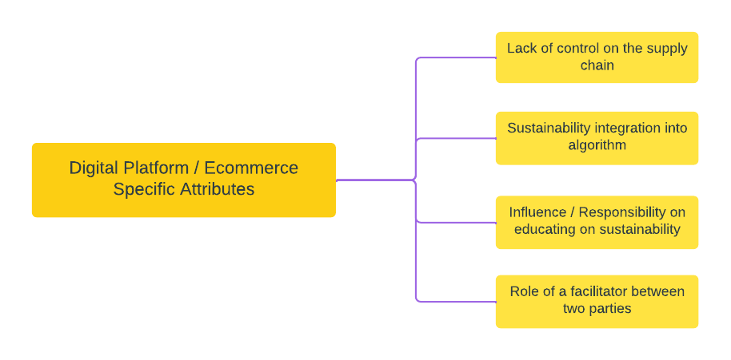
Figure 6. Results on the semi-structured interviews on digital platform / ecommerce specific attributes to the transitioning process of sustainability.

5.4. Adaptations to the constructed framework on sustainability transitions
Based on the findings and analysis of the results from the semi-structured interviews, the constructed framework (Figure 4) from the literature review has been adapted to include components specific to the case of digital platforms and the e-commerce industry (Figure 7). This framework contributes to the understanding of important factors related to the transition towards sustainability for digital platforms in e-commerce from a transition management and SBM activity system perspective using the company Helloprint as a case study. Here, adaptations were made on two different dimensions. First, the barriers to the transition process, identified being of an internal and external nature, have been adjusted to include elements of the supporting industry of the business and e-commerce. It was found that internal and external challenges of the transition process for digital platforms were specifically related to the supporting industry they serve. For Helloprint specifically, this meant looking at the challenges from their transition process through the lens of the print industry rather than through the wider industry they fit in, such as e-commerce, and their role as a digital platform. When looking at the transition process, it is important to determine challenges faced both from a supporting industry perspective while not forgetting to take into consideration the obstacles from the e-commerce perspective. While the company acknowledged it’s lack of control over the suppliers and the barriers faced by operating within a traditional and unsustainable industry, it did not take into consideration wider obstacles within e-commerce itself. The environmental impact of e-commerce, related specifically to e-commerce logistics, packaging and pollution have been reported to have negative impact on the biosphere (Oláh et al. 2018). These factors are important to consider when looking at external challenges faced by the company and can serve as an opportunity for innovation and development of sustainable value.
Second, the four levels of the transition management governance framework need to be specifically looked at from the perspective of the complexity of serving a two sided market and having the role of a facilitator between two parties. The transition process, through the strategic, tactical, operational and reflexive activities should include the position of the company as a digital platform and its role as a modulator between buyers and sellers. These elements should reflect on the position of the company as a digital platform by taking into consideration the integration of sustainability within the company’s technological landscape as well as its role of a modulator between two parties. Hence, all dimensions should be reflected within the company’s transition management approach.

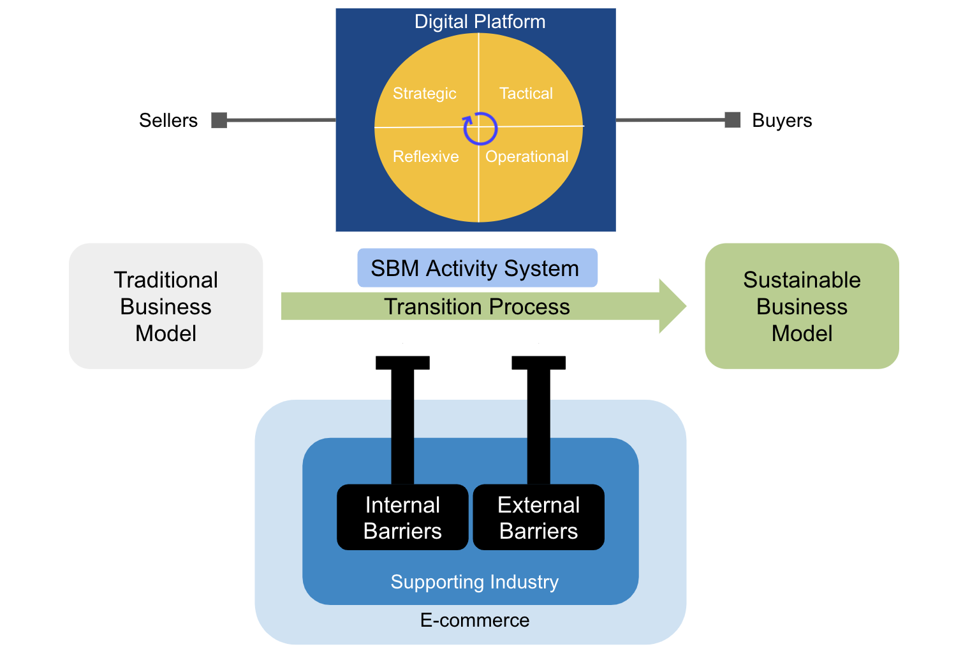
Figure 7. Adapted constructed framework on sustainability transitions for digital platforms in e-commerce. Framework designed by the author.

6. Conclusion & Recommendations
This research provides a conceptualization of how digital platforms in e-commerce approach the transition to sustainability while looking deeper into the different barriers and challenges faced by this sector in regards to their transition process. Frameworks from literature, specifically the transition management framework and SBM activity system, have been used in order to conceptualize a framework on sustainability transitions in order to understand at the macro and micro level the approach for a successful transition towards sustainability. In order to make the study specific for platform companies in e-commerce, the company Helloprint has been used as a case study to gain valuable insights on the transition process and approach of moving from an unsustainable business towards sustainability. Qualitative research in the form of semi-structured interviews allowed for a profound analysis of the approach to sustainability transitions at the company and compared to the conceptualized framework of the literature review. The outcome of this research revealed that the case company did not show major considerations regarding its role within th e-commerce during the transition process. Alternatively, the supporting industry, which reflects on the industry the offering of the platform fall under, are a major point of focus during the transition process. Additionally, the position as a digital platform brings about a great sense of responsibility to drive sustainable change and thus the transformation towards sustainability. When transitioning towards sustainability, the research found that the aspect of being a digital platform means that the transition management steps need to reflect on the two-sided dynamics of a digital platform and encompass or consider these actors when transitioning. Here, important barriers that need to be considered and overcome are based on the lack of control of the network of suppliers, supporting industry characteristics and the cost to transition towards sustainability in the supporting industry. Additionally, employee engagement, availability of resources and culture integration have been elaborated as major challenges. While these factors can relate to any company, the lack of control over the network is a special characteristic for digital platforms. This study concludes that transitioning towards sustainability for digital platforms in e-commerce includes all levels of the transition management framework and the SBM activity system for the general transition process. Here, companies focus on the supporting industry when approaching the transition and the role of digital platforms rather than the position as an e-commerce company. Being a platform and facilitator between two parties, the focus is very much on customer demand as a driver for the transition. In effect, we conclude that the e-commerce and its impact on sustainability areas should be included as a factor when approaching the transition towards sustainability, as demonstrated in the adapted framework for sustainability transitions.

While the company has shown to include elements of each of the levels of the transition process and already establishing the most important steps in the sense of developing a sustainability vision, mission and strategy and focusing on support from top management and diffusion across the organization through clear communication and employee engagement, certain aspects have not been developed thoroughly. In this section we will elaborate on some characteristics and actions the case company can adopt to make the sustainability transition more efficient and holistic based on the adapted framework for sustainability transitions (Figure 4). We recommend that the company goes through each level of the transition management framework and the SBM activity system framework in order to redefine and complete its transition process. Here specifically attention should be paid to precisely define the societal challenges it wants to contribute to. Additionally, more specifications are needed on how the company capture’s value from its sustainability proposition and how this can be made profitable in the long-term, as these dimensions have yet mostly been defined and driven through customer demand for sustainability. Moreover, we suggest that the company takes within consideration the e-commerce sector when going through the transition process and not only the supporting industry, as sustainability challenges and solutions may lay within this industry and raise potential opportunities in terms of sustainability. Lastly, the company should rethink its approach to monitoring and evaluating it’s sustainability transition, not only in terms of goals, targets and results but also from the perspective of the transition process itself. Here, the company should focus more on the alignment on the feasibility of the strategic envisioning and changing social context. As a next step, the objectives, goals and actions need to be re-evaluated and realigned depending on changing context and circumstances. This will facilitate the revision of the goals, visions and strategy whenever it is necessary.

7. Limitations & Future Directions
The main limitations of this paper are reflected based on several factors. The first limitation is reflected in the low number of interviewees (n = 5) that have been interviewed for the purpose of this research. In order to get a more holistic view of sustainability transitions within Helloprint, it would have been beneficial to have interviewed a broader range of participants, preferably two respondents from each department or team. This would have been beneficial in creating a better understanding of the perception of the company’s sustainability transitions throughout the entire business and reduce the bias in the findings. Second, the case chosen for this study might have not been the ideal case for this research. This is due to the fact that the company has just started it’s transition to sustainability a few months ago and the entire process is not yet established or fully integrated within the company. Despite the fact that this gives invaluable insights into the first steps of the transition and the mechanisms behind it, it might have been beneficial to interview the company at least a year after the start of the transition, in order to get a fuller picture of the different transition elements and get a better understanding of the process, as employees will have an improved understanding and engagement with the topic, which would increase the insights gained from this research. Lastly, the research design itself could have been more elaborated, integrating more interview questions to the semi-structured interviews and guiding the respondents better to get a more profound understanding of the effect or relationship of sustainability specifically for digital platforms and e-commerce. This might have led to more digital platform/e-commerce specific related answers which would have further enriched the constructed framework on sustainability transitions.
Future research may focus on expanding the research by integrating a higher number of cases operating as digital platforms in e-commerce to get a more complete understanding of the dynamics of these attributes in relation to sustainability transitions. In order to diversify and reduce the bias of the research, it is suggested to include start-ups, scale-ups and big international companies as case studies for this research. Here, companies should be selected that do not offer the same products or services on their platform, in order to filter out attributes specific to the role of a digital platform and e-commerce.

8. Personal Reflection
I would like to use this space of the research paper to elaborate on my personal reflection during the process of writing this thesis while in parallel working as an intern in sustainability at Helloprint. First, writing this thesis has been an enormous personal challenge for multiple reasons. First of all, coming from a background in natural sciences, this was a completely new experience in terms of the topic of the research and the research methods. This has led to some difficulties at the start as it required me to completely re-adjust my way of writing (thesis structure) and thinking. However, I am proud that despite the challenges at the beginning, I have managed to finalize this research, despite my own worries and uncertainties at the start of this journey. The support of my academic advisor was crucial in helping and challenging me in regards to approaching this research.
Furthermore, this experience, specifically having to write a thesis in parallel to working has been quite challenging. It was crucial to find the right balance and come up with a concrete plan in order to not be overwhelmed by stress, which I had struggled with at the beginning. For me, this meant becoming comfortable in a completely new environment, integrating with a new group of people, learning the processes and flows of the company while having to think about my research. In the first months this is extremely challenging, and I would suggest the University of Utrecht to rethink the structure of the Masters (SBM), in such a way that there would be a 1-2 month company internship required in the first year, and deduct these months of the major research internship, so that students can already get more familiar to the business environment. However, once I was more confident in the direction of the thesis and completely established within the company, the process was more smoothly for me personally.
Finally, I would like to come to the positive achievements during this thesis and internship. When I look back at where I started in October 2021, I can hardly recognize myself from back then. This internship has been incredible in my personal and professional growth and skills developed during this short period. I have noticed my transformation from a not-so-confident student towards establishing myself as a young professional adult. It was great for me to see how well I absorb new information and that I can understand even technical components of the company now, which I always thought I was inherently bad at. This has given me the confidence to take on any challenge and know that I will manage somehow. Moreover, the writing and finishing of this research paper marks a milestone in my personal life. I have managed to get over this last hurdle and graduate with a Master’s degree. From a teenager on, it was clear for me that the expectations laid upon me would be to get such a degree, which I will now achieve. From now onwards, I am free to develop and grow in any direction I see fit more myself and do my best in order to make the world a better place, at least with what is within my reach and power. There is a lot of work to do, and it will be me, my generation and the generations following that will shape this world. We have a lot of challenges ahead of us, but I believe that we can make this world a better place together.

9. References
Anvari, R.D.; Norouzi, D. The impact of e-commerce and R&D on economic development in some selected countries. Procedia-Soc. Behav. Sci. 2016, 229, 354–362.
Auvinen, H. (2017), “The environmental footprint of the platform economy”, Platform Value Now.
Bidmon, C.M.; Knab, S.F. The Three Roles of Business Models in Societal Transitions: New Linkages between Business Model and Transition Research. J. Clean. Prod. 2018, 178, 903–916.
Bocken, N. M., Short, S. W., Rana, P., & Evans, S. (2014). A literature and practice review to develop sustainable business model archetypes. Journal of cleaner production, 65, 42-56.
Bolton, R.; Hannon, M. Governing Sustainability Transitions through Business Model Innovation: Towards a Systems Understanding. Resà Policy 2016, 45, 1731–1742. [CrossRef]
Boons, F.A.A., 2009. Creating Ecological Value. An Evolutionary Approach to Busi- ness Strategies and the Natural Environment. Edward Elgar, Cheltenham.
Caldera, H. T. S., Desha, C., & Dawes, L. (2019). Evaluating the enablers and barriers for successful implementation of sustainable business practice in ‘lean’SMEs. Journal of Cleaner Production, 218, 575-590.
Carrillo, J.E.; Vakharia, A.J.; Wang, R. Environmental implications for online retailing. Eur. J. Oper. Res. 2014, 239, 744–755.
Chen, Y., Pereira, I., & Patel, P. C. (2021). Decentralized Governance of Digital Platforms. Journal of Management, 47(5), 1305–1337.
Coppola, D., 2021. Topic: Sustainability in e-commerce. [online] Statista. Available at: <https://www.statista.com/topics/8200/sustainability-in-e-commerce/#dossierKeyfigures> [Accessed 1 February 2022].
Cunningham-Parmeter, K. (2016), “From Amazon to Uber: Defining employment in the modern economy”, BUL Rev., 96.
Dabija, D.C., Pop, N.A. & Săniuță, A. (2016), ‘Innovation in Do-It-Yourself Retail – An Empirical Study of Generation X Professional Craftsmen and Consumers’, Economic Research-Ekonomska Istraživanja
Daniel, E.M.; Hoxmeier, J.; White, A. and A. Smart (2004), “A framework for the sustainability of e- marketplaces”, Business Process Management Journal, Vol. 10, No 3, pp. 277-289.
Edwards, J. B., McKinnon, A. C., & Cullinane, S. L. (2010). Comparative analysis of the carbon footprints of conventional and online retailing: A “last mile” perspective. International Journal of Physical Distribution & Logistics Management.
Ehrenfeld, D., 2005. Sustainability: living with imperfection. Conservation Biology 1,33e35.
Escursell, S., Llorach-Massana, P., & Roncero, M. B. (2021). Sustainability in e-commerce packaging: A review. Journal of cleaner production, 280, 124314.
Fichter, K. (2002). E‐commerce: Sorting out the environmental consequences. Journal of Industrial Ecology, 6(2), 25-41
García-Muiña, F.E.; Medina-Salgado, M.S.; Ferrari, A.M.; Cucchi, M. Sustainability transition in Industry 4.0 and Smart Manufac- turing with the triple-layered business model canvas. Sustainability 2020, 12, 2364.
Gawer, A., & Cusumano, M. A. (2014). Industry platforms and ecosystem innovation. Journal of product innovation management, 31(3), 417-433.
Geels, F. W. (2011). The multi-level perspective on sustainability transitions: Responses to seven criticisms. Environmental innovation and societal transitions, 1(1), 24-40.
Geels, F.W. (2019) Socio-Technical Transitions to Sustainability: A Review of Criticisms and Elaborations of the Multi-Level Perspective. Curr. Opin. Environ. Sustain, 39, 187–201.
Geissdoerfer, M., Vladimirova, D., & Evans, S. (2018). Sustainable business model innovation: A review. Journal of cleaner production, 198, 401-416.
Hagiu, A., Altman, E.J., 2017. Finding the Platform in your Product: four Strategies that can reveal hidden value. Harv. Bus. Rev. 95 (4), 94–100.
Hein, A., Schreieck, M., Riasanow, T., Setzke, D. S., Wiesche, M., Böhm, M., & Krcmar, H. (2020). Digital platform ecosystems. Electronic Markets, 30(1), 87-98.
Hernández-Chea, R., Jain, A., Bocken, N. M., & Gurtoo, A. (2021). The Business Model in Sustainability Transitions: A Conceptualization. Sustainability, 13(11), 5763.
Hillman, J.; Axon, S.; Morrissey, J. Social Enterprise as a Potential Niche Innovation Breakout for Low Carbon Transition. Energy Policy 2018, 117, 445–456.
Hoffman, A. J. (2018). The next phase of business sustainability. Stanford Social Innovation Review, 16(2), 34-39.
IGI Global, 2022. What is Digital Platform | IGI Global. [online] Igi-global.com. Available at: <https://www.igi-global.com/dictionary/beusin/55829> [Accessed 5 January 2022].
John Hagel, The Power of Platforms – Deloitte University Press, 2015
Köhler, J., Geels, F. W., Kern, F., Markard, J., Onsongo, E., Wieczorek, A., ... & Wells, P. (2019). An agenda for sustainability transitions research: State of the art and future directions. Environmental innovation and societal transitions, 31, 1-32.
Kolk, A., & Ciulli, F. (2020). The potential of sustainability-oriented digital platform multinationals: A comment on the transitions research agenda. Environmental Innovation and Societal Transitions, 34, 355-358
Korhonen, J., & Seager, T. P. (2008). Beyond eco‐efficiency: a resilience perspective. Business Strategy and the Environment, 17(7), 411-419.
Loorbach, D. (2007). Transition management. New mode of governance for sustainable development. Utrecht: International Books.
Loorbach, D. (2010). Transition management for sustainable development: a prescriptive, complexity‐based governance framework. Governance, 23(1), 161-183.
Loorbach, D., & Wijsman, K. (2013). Business transition management: exploring a new role for business in sustainability transitions. Journal of cleaner production, 45, 20-28.
Loorbach, D.; Frantzeskaki, N.; Huffenreuter, R.L. (2015).Transition Management: Taking Stock from Governance Experimentation. J. Corp. Citizsh. 2015, 48–66. [CrossRef]
Luca, M. (2016), “Designing Online Marketplaces: Trust and Reputation Mechanisms”, Harvard Business School, Working Paper No. 17-017.
Mangiaracina, R., Marchet, G., Perotti, S., & Tumino, A. (2015). A review of the environmental implications of B2C e-commerce: a logistics perspective. International Journal of Physical Distribution & Logistics Management.
Martin, C.J. (2016), “The sharing economy: A pathway to sustainability or a nightmarish form of neoliberal capitalism?”, Ecological Economics, Vol. 121, pp. 149–159.
Martin, E., & Shaheen, S., (2010), “Greenhouse Gas Impacts of CarSharing in North America.”, San Jose, CA: Mineta Transportation Institute Report 09-11.
Oláh, J., Kitukutha, N., Haddad, H., Pakurár, M., Máté, D., & Popp, J. (2018). Achieving Sustainable E-Commerce in Environmental, Social and Economic Dimensions by Taking Possible Trade-Offs. Sustainability, 11(1), 89. MDPI AG. Retrieved from http://dx.doi.org/10.3390/su11010089
Osterwalder, A.; Pigneur, Y. Business Model Generation: A Handbook for Visionaries, Game Changers, and Challengers; John Wiley & Sons: Hoboken, NJ, USA, 2010; ISBN 978-0-470-87641-1.
Parker, G.G., van Alstyne, M.W., Choudary, S.P., 2016. Platform Revolution: How Networked Markets Are Transforming the Economy - and How to Make Them Work for You, 1st edn. W.W. Norton & Company, New York, London.
Parker, G.G., van Alstyne, M.W., Choudary, S.P., 2016. Platform Revolution: How Networked Markets Are Transforming the Economy - and How to Make Them Work for You, 1st edn. W.W. Norton & Company, New York, London.
Pateli, A.G.; Giaglis, G.M. A research framework for analysing eBusiness models. Eur. J. Inf. Syst. 2004, 13, 302–314
Phills, J.A.; Deiglmeier, K.; Miller, D.T. Rediscovering social innovation. Stanf. Soc. Innov. Rev. 2008, 6, 34–43.
Pon, B., Seppa ̈la ̈, T., and Kenney, M. (2014). Android and the Demise of Operating System-Based Power: Firm Strategy and Platform Control in the Post-PC World, Telecommunications Policy 38: 979–991.
Post, J. E., & Altma, B. W. (1994). Managing the environmental change process: barriers and opportunities. Journal of Organizational Change Management.
Pouri, M. J., & Hilty, L. M. (2018). Conceptualizing the digital sharing economy in the context of sustainability. Sustainability, 10(12), 4453.
Revinova, S. (2021). E-commerce effects for the sustainable development goals. In SHS Web of Conferences (Vol. 114, p. 01013). EDP Sciences.
Rohn, D., Bican, P. M., Brem, A., Kraus, S., & Clauss, T. (2021). Digital platform-based business models–An exploration of critical success factors. Journal of Engineering and Technology Management, 60, 101625.
Roson, R., 2005. Two-sided markets: a tentative survey. Rev. Netw. Econ. 4 (2).
Rotmans, J., & Loorbach, D. (2009). Complexity and transition management. Journal of industrial ecology, 13(2), 184-196.
Sarasini, L. Integrating a Business Model Perspective into Transition Theory: The Example of New Mobility Services. Environ. Innov. Soc. Transit. 2018, 27, 16–31.
Schaltegger, S., Lüdeke-Freund, F., & Hansen, E. G. (2012). Business cases for sustainability: the role of business model innovation for corporate sustainability. International journal of innovation and sustainable development, 6(2), 95-119.
Statista, 2021. E-commerce average emissions by source 2020 | Statista. [online] Statista. Available at: <https://www.statista.com/statistics/1254302/e-commerce-average-emissions-by-source/> [Accessed 5 January 2022].
Sui, D. Z., & Rejeski, D. W. (2002). Environmental impacts of the emerging digital economy: the e-for-environment e-commerce?. Environmental Management, 29(2), 155-163.
van Alstyne, M.W., Parker, G.G., Choudary, S.P., 2016b. Pipelines, platforms, and the new rules of strategy. Harv. Bus. Rev. 94 (4), 54–62.
Ye, G., Priem, R.L., Alshwer, A.A., 2012. Achieving demand-side synergy from strategic diversification: how combining mundane assets can leverage consumer utilities. Organ. Sci. 23 (1), 207–224.
Zarra, A., Simonelli, F., Lenaerts, K., Luo, M., Baiocco, S., Shenglin, B., ... & Kilhoffer, Z. (2019). Sustainability in the Age of Platforms. EMSD Challenge Fund-Final Report.

9. Appendix
Table 1. Semi-structured interview questions in relationship to the theoretical frameworks on sustainability transitions.
Topic | Model | Construct | Questions
Sustainability Transition | TM Framework | Strategic Activity | What are the main drivers for a transition towards sustainability?
 |  | Tactic Activity | How are you engaging in integration sustainability into your core business?
 |  | Operational Activity | What do you believe are the most important actions or activities to be taken in order to ensure the successful transition towards sustainability for your company?
 |  | Reflexive | How do you measure and monitor the effectiveness of your sustainability transition?
 | SBM Activity System | Sustainable value proposition | What are the main drivers for a transition towards sustainability?
 |  | Sustainable value creation + delivery | How did you approach your company’s transition towards sustainability?
 |  | Sustainable value capture | What do you believe are the most important actions or activities to be taken in order to ensure the successful transition towards sustainability for your company?
 | Industry/Model | E-commerce | What are the main challenges/barriers operating as a digital platform in e-commerce regarding your transition towards sustainability?
 |  | Digital Platforms

Table 2. Coding of interview transcripts in form quotations.

Questions | Interviewee 1 | Interviewee 2 | Interviewee 3 | Interviewee 4 | Interviewee 5
What are the main drivers for a transition towards sustainability? | “[...] one big driver is consumer demand. I think that they see that people find it more and more important[...]”  “[...] there is more and more focus on brand reputation/value around sustainability.” | “The printing industry [...] has a very unsustainable perspective.”  “And I think the big challenge for us as an industry is to make sure that we create a break from that perspective, because in the end, that’s not a long term solution.” | “[...] we need to fulfill demand [...]our main goal is to unlock maximum demands, and that's pretty much what I think should drive sustainability. Ecommerce could in itself be a solution for a sustainable solution for a problem.” | “Is it something which starts from the customer [...]” | “So it is really a combined effort, I would say so it's our obligation to society, and will also bring us based on the demands of our customers closer to achieving the sustainability goals.”
What are the main challenges operating as a digital platform in e-commerce regarding your transition towards sustainability? | I think the biggest barrier or challenges that mainly products are in aren't actually made by the platform itself [...] you have less control over the manufacturing [...] and which natural resources are being used.”  “You as a platform you can change, but it doesn't mean that your whole supply chain changes automatically [...] it really needs cooperation with suppliers and carriers. [...] it is hard to change someone else's business model.”  “The biggest internal challenges are employees.” | “So I think the biggest internal challenge is to make sustainability part of that open DNA so that it really should be top of mind of everything we are doing what we're doing and how we're we're doing it. “  “[...] the challenge is to get things up and running.” | “We are in the printing industry. It's lagging compared to other industries in regards to sustainability and we are behind a little bit.“  “So at the end of the day, you know, agreeing with shareholders on certain growth, I would say like, if if the sustainability transition does not lead to growth for other brands, then there is a conflict between is that the real reason for offering more sustainable options is that too, to have a long term strategic advantage, and I think the extreme focus on performance could be a barrier for the transition to sustainability. “ | “We have a very wide range of products and also a depth of variations of products. I think it really starts with Yeah, going through your range of products and really differentiating, okay, which ones are sustainable”  “We don't own the production process.” | “because if it's not top of mind, when there's no real awareness in the team, and there's no anchoring in the strategic objectives, this is always the thing that's that, that comes last, because especially in the scaler, always have way too less resources. And also always need to grow faster. [...] So the challenge and the struggle is always how do I divide my resources.”  “It's always very difficult to change a industry, [...] they have their policies in place, and changing them costs time.”
What do you believe are the most important actions or activities to be taken in order to ensure the successful transition towards sustainability for your company? | “ [...]alignment from CEO and the board are willing to change [...] that's the first step to real transition.”  “ [...] making it a big part of the, of the company's vision.”  it starts with motivation and willingness to change from top to down [...] integrating it into your strategy [...] communicating it with the rest of the organization.”  “ It only works if you have the whole value chain in control”  “I think a lot of companies actually really need to partner up with suppliers in in any form to achieve the maximum output.” | “We need to change our behavior, our DNA, our way of thinking. So then you have in the end, the eight steps you need to go through which starts with sense of urgency, form powerful alliances, create a vision for change, invest in communication, empower the entire base, set short term goals, don’t slow down and make change a part of the culture.” | “ If we are moving more up in the marketing funnel, you're really still able to guide customers and inspire customers yet to probably take a different choice. “ | “ Have the right systems to basically measure the sustainability impact to track it [...] and communicate it consistently.”  “Identifying the right suppliers [...]” | “: Data, it starts most foremost with the products we sell and the technologies that we use for that, on itself, the market for the products is not the most sustainable one. “  “We have quite a dominating place as a marketplace.”  “I think we can make a direct call to the producing network to change the way they offer products and the technology that they use to a much more sustainable alternative to the products and technologies they currently use. I think it's most and foremost starts there because you can try to diminish your personal carbon footprint, that's also important. “
How did you approach your company’s transition towards sustainability? | Answered in the question: How are you engaging in integration sustainability into your core business? | I think we have a position to really disrupt the total value chain, as a platform, I think we have two options; we have really role and possibility to educate them from a sustainability perspective of choosing eco friendly products [...]. I think the reaction we tried to trigger one hand making sure that our end customers get educated, choose to make our products upset their footprints and choose for the most sustainable partner. And on the other side, making sure that value chain gets more sustainable by making our partners aware of their footprint and the impact on customers.” | “ It immediately is very visible. We are really trying to make it part of the culture so I really liked how you know how we're marketing it internally.”  “It was inspiring for this transition with the inception or the creation of the sustainability committee, so I really think that it's already top of minds.” | “It's part of the strategy now [...] taking the small steps in the right direction [...] communicating your intention, really embedding it in all the bar departments across the organization and really putting it top of mind.” | See above.
How are you engaging in integration sustainability into your core business? | “The Sustainability Committee has been developed [...] you have some sustainability cheerleaders within your organization, and they are able to trigger and stimulate other other employees to engage in sustainability and to motivate people and to engage into integrated into the team.”  “[...] make it more fun and educate our employees in a way that they can actually use.” | “Making it top of the agenda of of the management team [...] free resources for it, to create a team around it and make it part of the strategy [...] and the vision, the mission, the total setup of their organizational structure”  “[...] make it part in general the algorithm of the platform.” | “ It comes to getting everyone on board. The next thing is to guide customers towards more sustainable choices. And I think the final step is really making it part of our proposition.” | “It really starts with the strategy and embedding it with all the people that processes and systems your communication [...] onboarding [...] and recruiting.”  “every process or key process within the organization needs to be have some sustainable topic involved, and maybe also a KPI so that people are also starting to measure sustainability within their area.” | See above.
How do you measure and monitor the effectiveness of your sustainability transition? | “ I think based on the strategic initiatives that have been identified for 2022 and with at least a measurable and attainable, attainable goals, we can measure it based on that. So I think it's about setting the right goals.” | “Try to to really make it visible and transparent how our quantitative performance is a main KPIs.”  “Make it part of our customer satisfaction and employee satisfaction.” | “ The ultimate way to see if it's successful is to to find the customers that are looking for this and that are willing to that are basically choosing us because of that.” | “You start also measuring the NPS, the lifetime value of those particular types of customers to really understand.” | “[...] incorporating the sustainability goals in our strategic objectives.”

Table 3. Interview transcripts from Helloprint employees.
INTERVIEW TRANSCRIPTS

Isabelle - Sustainable Business Officer

Megi: Just for the record, can you briefly tell me a bit about yourself, your background and what you do?
Isabelle: I'm Isabelle I am currently sustainability Sustainable Business Officer, I was, say sustainability but it's sustainable. And I work here now for a little bit more than a month. Previously, I worked at Coca Cola, which was more in operational excellence, type of role. And before that, I pursued a master's degree in Strategic sustainable business.
Megi: For this interview, I mainly focus on the process of a let’s say unsustainable business towards sustainability. Concerning this, taking into account your role as a digital platform and your industry, e-commerce, what were the main drivers to take action towards a transition towards sustainability?
Isabelle: So I think one big driver is consumer demand. I think that they see that people find it more and more important, even though that that even though it doesn't always translate into consumer behavior, but I do think that brands How do you say is how people perceive your brand or reputation, that it's super important and that people find it more and more important that an organization works towards sustainable initiatives. So I think it's also so it has to be with I think, trends as well ecommerce. Besides that, ecommerce. Most of them have a lot of stakeholders, so the carriers and dependent on the business model but also for example to suppliers. So I think they, they want or they need to kind of work together with their surroundings to improve sustainability because as a platform, they're actually it is not much. It's not that you have a big carbon emission, or whatever, but you do have a large outreach to your suppliers and carriers to make a difference and to work differently. Yeah, and also adapt your products to the customer demand. So I think it shakes it really it is driven by customer demand action, and also innovation and ecommerce is mostly linked to innovation. So it also might be that they don't want to stay behind on innovation and solutions for sustainability.
Megi: In general, what did you perceive as being the main challenges or barriers as a digital platform in e-commerce regarding your transition towards sustainability?
Isabelle: Yeah, so I think it relates a little bit to what I said earlier. I think the the biggest barrier or challenges that mainly product are in aren't actually made by the platform itself. So it means that you have less control over the manufacturing way of manufacturing your product and which natural resources are being used or what kind of resources in general. So it's really so we use you as a platform you can change, but it doesn't mean that your whole supply chain changes automatically. So it really needs cooperation with suppliers and carriers. Yeah, so it's also kind of about changing someone else's business model. And I think that's super hard for an organization to do. And looking more specifically into this. I think the printing industry is weird. So the manufacturing things so but they buy a printing machine, for example, once in 20 years. So when something's just bought, it's not like easy to replace as well. So it also sometimes I think, changing to newer resources, for example, different kinds of papers may be what some somewhat older machines are not able to process it as well as newer machines because they are not built upon recycled paper or something. I think yes. I think one of the biggest internal challenges are employees because other people also find this very important. The question is really about what project has is more important. And since sustainability is new, I think a lot of people don't give priority to it yet. And it also doesn't have any tangible results sometimes or like, it's more about what's the financial outcome. And then there are some, some projects which are financially well, the positive but also you can actually kind of measure the outcome. And sometimes with sustainability, it's it's really long term. So people need to understand kind of the theory of sustainability and also want to apply it. So it really is about intrinsic motivation from an organization, but it means it kind of means that you really need to change the way your organization behaves. And I think behavior is super difficult thing.
Megi: How did you approach your company's transition towards sustainability? (Considering the fact you are a platform in e-commerce)
Isabelle: I think alignment from CEO I think that's very important that well, the CEO and the board are willing to change although they maybe don't even know yet, really on how to do it. But I think that's the first step to real transition. And really about making it a big part of the, of the company's vision at this point. So looking more in that, I think it starts with motivation and willingness to change from top to down as well. And then integrating it into your strategy. And then also really about communicating it with the rest of the organization. And ensuring that sustainability isn't just a short department, but it's really kind of this red thread through the organization. So it's not just a sustainability team. Taking up projects, but sustainability projects are being managed by other departments as well. I think, in general sustainability is really about working together to achieve a bigger goal than just yourself. Sustainability doesn't stop at your doorstep. So even though I think the effect on having less control is an ecommerce hire, I think in other also in other sectors, you can also find organizations who mainly make their own product but still are dependent on kind of the upstream materials from other organizations. So looking for example at Coca Cola what they did is they actually make the products themselves but they are actually dependent on what kind of plastics are used for the materials of the boat, the bottles, right?. So but depending on what the supplier gives you it can be virgin vesting material, but it can also be recycled material. So in that way. So even though Yeah, it only works if you have the whole value chain in control, and I think it's a different approach. But I so I do think but I think a lot of companies actually really need to partner up with suppliers in in any form to achieve the maximum output.
Megi: And how are you engaging in really incorporating sustainability in your core business?
Isabelle: The Sustainability Committee has been developed, of course, which I think is a great initiative. I'm also really a fan of such a way to integrate it, meaning that you have multiple kinds of you have more you have some sustainability cheerleaders within your organization, and they are able to trigger and stimulate other other employees to engage in sustainability and to motivate people and to engage into integrated into the team. So it definitely is possible to kind of spread it out. I think it's really also about looking, how can we make it more fun and educate our employees in a way that they can actually use? It? Because I think sustainability has been only over maybe the last two to three years. It's a big thing at universities as well. So a lot of people have been educated based on kind of capitalism idea, and I think a lot of people don't know how to apply sustainability within their job. So it's also really about to you like, hey, where can we close that gap? Yeah, and also making it fun and educating them on like how to be more sustainably in your personal life. Okay. So maybe then by that they can come up with other ideas or get inspired by using alternative brands. Yeah, I think it's kind of a shirt boy which you if people are more interested in it. Also maybe think of near more alternatives for their own business.
Megi: How do you plan on approaching monitoring/evaluating the effectiveness of your sustainability strategy, projects and partnerships?
Isabelle: I think it's a really good question. I think that's something that still needs to be developed. I think based on the strategic initiatives that have been identified for 2022 and with at least a measurable and attainable, attainable goals, we can measure it based on that. So I think it's about setting the right goals for for example a year and seeing if you achieve that, as what's been done for Strategic Initiatives for 2022 I think it's also we've currently done in a week work assessment, I think measuring it against that, and also taking the SDG framework in into account. And I think it's just choosing a few, not too much and also maybe not just only one way to measure your progress against it. But besides that, I think it's also always good to understand what competitors are doing and see if we really want to become the most sustainable if we are actually there. But I think you don't want to start with our own goals and seeing if we are able to achieve it.
Megi: Summing up, from your experience, what do you believe are the most important actions or activities to be taken in order to ensure the successful transition towards sustainability in your company?
Isabelle: I think then it really starts again about the goals. And I think, for example, our annual report would be a very good evaluation method to see where we stand at the end of each year. I hink in that way, it would be good to see the progress that we've booked and if we need to change something in the strategy. I think it’s good to inquire about like how do people perceive sustainability at this point, and do that also once a year, so you have your internal and I think externally we should measure on different levels, as in, do they have certain suppliers with certain certifications, but also looking into our product range? It's really, depends on our overall goals and see how far we've gone. So it might be that we maybe need to identify what does success mean actually, to really make it complete the strategy. So we can also assess and see if what we are doing actually helps you achieve the the overall goal.
____________________________________________________________________________
Lennaert - CFO

Megi: Just for the record, can you briefly tell me a bit about yourself, your background and what you do?
Lennaert: My name is Lennaert Koch, CFO, and besides my responsibilities as a CFO I’m also responsible for sustainability. working here for four years and my previous career work at KPN and before that at KPMG.
Megi: For this interview, I mainly focus on the process of a let’s say unsustainable business towards sustainability. Concerning this, taking into account your role as a digital platform and your industry, e-commerce, what were the main drivers to take action towards a transition towards sustainability?
Lennaert: So I think the starting point is more the industry we're in right so if you take a look at printing, then printing is really about producing items, four or more marketing related products with a logo on it. And it can be a brochure and it can be a flyer that can be water model, anything you can think of, but I think what you see within those products is that it's mainly one time use. So I think the combination of lots of paper, one time use ink I think that's what gives the industry a very unsustainable perspective. And I think the big challenge for us as an industry is to make sure that we create a break from that perspective, because in the end, there's not a long term simulation. And from our perspective, as a as a platform, I think we have two options. I think we have a position to really disrupt the total value chain from two perspectives. One is it like educating our customers so our customers are mainly b2b customers. The small businesses order a few times a year sometimes flyers sometimes promotion product but I think we have really role and possibility to educate them from a sustainability perspective of choosing eco friendly products, choosing eco friendly options. Choosing choosing a partner, was the most sustainable so that their carbon footprint is minimized where possible, so we will there always be footprints, but let's try to minimize it. And the other thing, I think is to educate the customers that even if you have the footprint that there is an option to compensate, compensate your carbon footprints. So we should give and we're giving our customers the option to to get to compensate their footprint by adding an additional service to their to the product where we are passing food money to the to the first machine to compensate their quarter from a delivery perspective, but also from a product. So that's more like the end customer perspective. So educating them and I think the that goes hand in hand with educating our partners from the perspective that okay, it's not all about price, and then about turnarounds, but going forward and will be about where's the most sustainable product so it's really also essential for our, for our partners to to go through that transition and to take a look at our own footprints. So that we can estimate it to monitor it, calculate it and make it part in general the algorithm of the platform. So what you will see over time is that I think an increasing percentage of the volume will no longer be driven by the quickest arounds or lowest price, but by which partner has the most sustainable option for us. Yeah, and I think the big difference we've been a really big print manufacturer is that you can only have one partner and that's yourself. But I think we have the option to teach our customers and to show our customers what will the impact be if you as the calculation of, let's say, 30 partners, because then there will be wrong the highest and one the lowest, and probably the one who is the lowest is not the cheapest. So in our current algorithm, the number of orders our ex partner will be getting can be quite limited. And by giving the customers the option to also choose the most sustainable, we'll probably see that that partner will increase the number of workers so he will increase his steroid practice and store revenue, his earnings and the partners who are more focused on cheap and quick loser partners. So they will debt I think over time will trigger them to say hey, why am I losing a part of that? The pilot because in the end, you're not sustainable? Yeah. So that's I think the reaction we tried to trigger one hand making sure that our end customers get educated, choose to make our products upset their footprints and choose for the most sustainable partner. And on the other side, making sure that value chain gets more sustainable by making our partners aware of their footprint and the impact on customers.
Megi: In general, what did you perceive as being thel challenges or barriers as a digital platform in e-commerce regarding your transition towards sustainability?
Lennaert: Internally, I think it starts with making it top of the agenda of of the management team. So if I take a look at from my own personal perspective, one year ago, it was not top of my agenda. And due to own awareness, I came to the conclusion that it shouldn't be very important and it should be part of the agenda. And then it's aligning with your yet with the rest of the company to make it that important to put it on the agenda, to free resources for it, to create a team around it and to make make it part of the strategy. So really showing that we find it that important that impacts falgoby saying okay, we're gonna build a sustainability team. So that's really internal and external, I think it's more to challenges is to, to get things up and running. And I think also to make partners aware. So I think what you see is that we send inquiries through our partners and the fact that not everybody's responding within the deadline. Exactly says the current situation that it's not top of mind for a big part of our partners. So I think the biggest internal challenge is to make sustainability part of that open DNA so that it really should be top of mind of everything we are doing what we're doing and how we're we're doing it. And then, from there on, I think try to make it part of the scope over customers. I think we cannot influence their DNA, but we can. We can educate them. We can make them aware, and then hopefully they will change their customer behavior. And I think we already saw that we were adding the possibility to make your order carbon neutral. That's, yeah, around somewhere between seven and 10% of our customers are choosing the option and we're not even doing marketing. So there is like the natural demands of offsetting, but also of the enormous growth we see in our Eco products scattered. It's our most most category which is growing the fastest, which means there's a very big amount of it because it's not that we're making it very visible on the right side yet or really pushing on it. So I think what you see is a lot of natural developments. Which will help to accelerate the ego perspective, from a product perspective from a cost perspective from a company perspective. So the demand is there. And we just need to give our customers the options to fill in decades.
Megi: How do you plan on approaching monitoring/evaluating the effectiveness of your sustainability strategy, projects and partnerships?
Lennaert: that's a very good, good question. So I think what we need to do is make our tactics and red tape last resort so didn't get mentioned earlier. So for instance, what is our percentage of revenue generated? What is the percentage of orders which are chosen to be carbon neutral? What is the percentage of most sample choice on a total mix? So really try to to really make it visible and transparent how our quantitative performance is a main KPIs. And I think from from the perspective of how to make it part of the DNA, you maybe we should make it part of our customer satisfaction and employee satisfaction to really ask our employees if they think it's already part of the DNA kind of print, because in the end, it's all about their perspective of what we are. And I can say yes, it's part of my DNA, but in the end, we all shoot as a question with Yes. And if I think if we all genuinely say yes sustainability is part of the DNA ofHelloprint, and I think you filled in the target and that ambition.
Megi: Summing up, from your experience, what do you believe are the most important actions or activities to be taken in order to ensure the successful transition towards sustainability in your company?
Lennaert: Well, I think I think in the end, if you were make it really academic, then you then in the end, our transition to sustainability is like any achievement. So we need to change our behavior, our DNA, our way of thinking. So then you have in the end, the eight steps you need to go through which starts with sense of urgency. Surely you have like a burning platform, then come to the coalition, go through the steps and I think we were now doing that. And we should follow all those steps. And we're now in the first phase of making sure that there is a baseline we need to make sure that everybody gets the top of mind and then we should go to to execution mode. The most important thing for change management is that 80% of the total population is willing to change.
____________________________________________________________________________
Sebastiaan: E-commerce manager

Megi: Just for the record, can you briefly tell me a bit about yourself, your background and what you do?
Sebastiaan: My name is Sebastian RAM. I've been another brain since pretty much the start. I'm now responsible for all ecommerce within our brain. So that is the development of our features on our on our ecommerce platforms in all 13 countries, as well as the contents, SEO performance. So basically anything that happens online My background is basically always been in E commerce and performance. I used to do it internationally at Heineken first, and then moved into real estates, but always the online performance, which started with a website for the World Cup in Africa and now 10 years later responsible for pretty much everything online at Helloprint.
Megi: For this interview, I mainly focus on the process of a let’s say unsustainable business towards sustainability. Concerning this, taking into account your role as a digital platform and your industry, e-commerce, what were the main drivers to take action towards a transition towards sustainability?
Sebastiaan: Yeah, so maybe this is a cheesy answer from ecommerce guy, but for me, I'm really commercial minded. So anything that is a demand for it is something that you need to, to provide, and I really think that the demand is changing a bit, but my motivation for that is maybe not so much ideological, but commercial. So I would answer this the same if you asked about what products should we launch? My answer would be we need to fulfill demand. And our our main goal is to unlock maximum demands, and that's pretty much what, what I think should drive sustainability. Ecommerce could in itself be a solution for a sustainable solution for a problem. So something that might in the past not happen through ecommerce might be a more sustainable choice if it's, if it happens. Online, but specifically towards the printing industry. I think that there is a demand that's currently not being serviced. Which I think if the first one that's able to properly fulfill this, as a has a big advantage in the market, which is how I think about our sustainability strategy is if we're the first one, to have to set the sets the standards it's actually a commercial use case for us.
Megi: In general, what did you perceive as being the challenges or barriers as a digital platform in e-commerce regarding your transition towards sustainability?
Sebastiaan: Oh, well, I think the printing industry is quite slow moving industry. I think by its its nature, it's a little bit of an old fashioned industry, I would, I would say, and it's very much whilst a way of offering has really changed. All my landscape has really changed. The supply chain of the head is not really changing that fast, I would say so there are really nice ways to markets but at the end of the day, you're still selling the same relevance and I think that the speed at which that is changing is too slow, I think to really be Yeah, really be leading this transition. I think we're in the printing industry. It's lagging and we're just behind a little bit and once everyone is all about stable products, and the printing industry catches up, okay, in my opinion. So at the end of the day, you know, agreeing with shareholders on certain growth, I would say like, if if the sustainability transition does not lead to growth for other brands, then there is a conflict between is that the real reason or is the real reason for offering more sustainable options is that too, to have a long term strategic advantage, and I think the extreme focus on performance could be a barrier for the transition to sustainability. Unless, yeah, this this transition leads immediately also to growth, then, then it's just a way to reach our growth ambitions.
Megi: How did you approach your company's transition towards sustainability? (Considering the fact you are a platform in e-commerce)
Sebastiaan: Yeah, so I think what's good is that it immediately is very visible. We are really trying to make it part of the culture so I really liked how you know how we're marketing it internally. Very recently with the sustainability themed keynotes that we had at a location and it was inspiring for this transition with the inception or the creation of the sustainability committee, so I really think that it's already top of minds also with you. You starting as an elebrate it became a thing. But I also wonder when does it come? When is it completely lifted? Through the organization? Yeah, when I when I see my day to day steering I still steer on you know, conversion rates whether or not these are sustainable products. I just man to fulfill the customer's demand and right now yeah, that's not always in the same direction is what you would take if sustainability was your main goal.
Megi: And how are you engaging in really incorporating sustainability in your core business?
Sebastiaan: The first initiative was the ecocart implementation. I think because it was the first one. It was part of a challenge that we did. I think making it part of the challenge was really a good idea. We really managed to get something live within this 100 day time periods. So I think you know, considering male team considering, yeah, pretty much going up the stream, I would say, when it comes to getting everyone on board. It was done quite efficiently. I would say. I'm very curious to see what the next steps are. So I think those were good steps but also the most obvious, once offsetting first. The next thing is to guide customers towards more sustainable choices. And I think the final step is really making it part of our proposition. And right now they feel more like add ons to our business model instead of the business model itself.

Megi: How do you plan on approaching monitoring/evaluating the effectiveness of your sustainability strategy, projects and partnerships?
Sebastiaan: Yeah, that completely depends on what the project is. So if we're, you know, take, for example, adding features like offsetting, but also integrating the most sustainable choice into our product offering, then, in my opinion, the ultimate goal to the ultimate measure to gauge success is the usage of it. So the percentage of customers choosing that's, you know, versus your expectations. I don't think that the goal is to go to which 100% But it's really to, to give customers that choice. You see already this offsetting being chosen, so there is a demand for for it. So I think the ultimate way to see if it's successful is to to find the customers that are looking for this and that are willing to that are basically choosing us because of that.
Megi: Summing up, from your experience, what do you believe are the most important actions or activities to be taken in order to ensure the successful transition towards sustainability in your company?
Sebastiaan: Okay, that's indeed a very broad one. So if I may enter in more from an ecommerce, yeah, effective is what you see on minus, it really depends on what kind of customers you're reaching your websites are right now. That is mostly customers that are specifically looking for printed products. So on Google, they might type in flyer printing. And I think if you're in that kind of ballgame, and that's very close to the conversions very late in the marketing funnel, it's, in my opinion, quite hard to steer customers to other options because they, they came to us because they were looking for flyer printing. I think if we are moving more up in the marketing funnel, you're really still able to guide customers and inspire customers yet to probably take a different choice than printing flyers, but really, you know, identify what they are need, what they need it for, and you know, how to maybe fulfill that in a more sustainable way. And how can we be part of that? That journey with them as well? I think right now, that's quite difficult because we're really converting customers on the product that they're looking for. How we can more be more leading in this, I think, also acquiring other customers. With more sustainable options for their marketing needs.
____________________________________________________________________________
Hans Scheffer - CEO
Megi: Just for the record, can you briefly tell me a bit about yourself, your background and what you do?
Hans: 39 years old, CEO and founder of Helloprint, I'm an entrepreneur for almost 20 years. So I've been there from the early rise of E commerce. And I saw the markets changing accordingly. always tried to be ahead of market developments. And now we're very interesting space where we as a marketplace model, in a in the market for customized print products.
Megi: For this interview, I mainly focus on the process of a let’s say unsustainable business towards sustainability. Concerning this, taking into account your role as a digital platform and your industry, e-commerce, what were the main drivers to take action towards a transition towards sustainability?
Hans: Most and foremost, it's our obligation to society to do so. Because if we continue in this space, and that's more generic comment, obviously, there will be no world to live in 100 years from now, so our children and grandchildren will not have a world to live in. So that's on itself.our customers are also becoming way more conscious about what they buy, who's producing it, and how we act towards society, to the environment and to the global population. And on the virtue of the changing demands of the customer. It's always much easier to make impactful decisions in your business model. So it is really a combined effort, I would say so it's our obligation to society, and will also bring us based on the demands of our customers closer to achieving the sustainability goals.
Megi: In general, what did you perceive as being the main challenges or barriers as a digital platform in e-commerce regarding your transition towards sustainability?
Hans: Sure, because if it's not top of mind, when there's no real awareness in the team, and there's no anchoring in the strategic objectives, this is always the thing that's that, that comes last, because especially in the scaler, always have way too less resources. And also always need to grow faster. And that gives us the triggers, prefers actions, that you skip the thing that on the short term has the least impact. And with sustainability, it's a long term game, and you will not see the results instantly. But you need to keep investing in it. So that it becomes a long term goal, and that you see long term results on it as well. So the challenge and the struggle is always how do I divide my resources. But if you train and teach your people well, and and really embrace this sustainability transition as a whole, they will see that the team slowly but steady, is becoming will be a work, we'll make more stable choices in their little habits. And I think that's the best way of doing it and keep continuing with explaining why we do it and repeating that, I think that's essential on every layer of the company. So, it's always very difficult to change a industry, right. So many producers are used to a way of working, they have their machinery, they have their policies in place, and changing them costs time. And it also costs a lot of investment. And it's our obligation as a marketplace to help them with that, to make that change to make them aware, but also to help them thrive on this and make choices and develop a roadmap and we want to become that partner for them as a marketplace. That really helps them and guides them in that process. And we have we have a large impact there. We have 300 other producers. Yeah, let's help them develop programs for them so that they will become more sustainable as well.
Megi: And how are you engaging in really incorporating sustainability in your core business? How did you approach your company's transition towards sustainability? (Considering the fact you are a platform in e-commerce)
Hans: Data, it starts most foremost with the products we sell and the technologies that we use for that, on itself, the market for the products is not the most sustainable one. But it's also at the other end, one of the biggest and largest industries worldwide. And because the fact that we are, we have quite a dominating place as a marketplace, especially in Europe, where we have attached over 300 local producers and carriers. Because of that position, I think we can make a direct call to the producing network to change the way they offer products and the technology that they use to a much more sustainable alternative to the products and technologies they currently use. I think it's most and foremost starts there because you can try to diminish your personal carbon footprint, that's also important. But the impact is much, much higher when you also try to change the supply chain. And that's the reason that we are investing quite significantly in that particular topic.
Megi: How do you plan on approaching monitoring/evaluating the effectiveness of your sustainability strategy, projects and partnerships?
Hans: That starts with awareness and incorporating the goals that we have as the first part of the strategy, so if a company only shouts that they want to do something in sustainability, that's totally not enough. So what we did it elebrate this incorporating the sustainability goals in our strategic objectives. But in our vision, where we change the vision of becoming the largest platform or largest marketplace for customized products, we've added the largest and most sustainable marketplace for customized print products. And by doing that the organization is aware of the fact that this is what much more than only some some loose phrases, but it also has a significant strategic objective behind it.

Megi: Summing up, from your experience, what do you believe are the most important actions or activities to be taken in order to ensure the successful transition towards sustainability in your company?
Hans: So difficult question, I would say. I think I will repeat myself. Okay, that's fine. I think that I think that starts with incorporating it into strategy. And if you do that, then you need to reach those rights. If you miss the revenue goals, or employee goals, or MBS goals, if you don't achieve them, they are going to ensure that you will find a way to do so. And in that, that it's just a logic business transition. Same as incorporating a company or starting a new country or introducing new products. And I think that if you really want to make a transition successful, it needs to be a fast parts of the business, not only ethics, but also the business goals. And that transition will go much smoother. And I think what's what's essential is that it's actually speak speak louder than words. That's that's an easy phrase to say. But it starts from the top in here. So so we, as leaders of the companies, should not only state this, but also really applied to it. And if you do that, then the transition is a possibility.
____________________________________________________________________________
Andrew Churney - Supply Chain Manager
Megi: Just for the record, can you briefly tell me a bit about yourself, your background and what you do?
Andrew: So my name is Andrew Charnley. I'm at hella print since August, I responsible for the supply chain, which covers the suppliers, the production and the printing quality, but also making sure that the suppliers produce on time so that also the carriers can pick up the products and deliver the products to the customers on time. So that's basically that little scope I'm responsible for. And we look at different KPIs with regards to on time dispatch rates on time, delivery rates, the quality, but also the carrier costs, and also the carrier coverage or carriers. So basically, into remote areas into residential areas. And then yeah, how can we keep that as local as possible. I've been mainly focusing on actually optimizing processes and making them scalable from from a global perspective.
Megi: For this interview, I mainly focus on the process of a let’s say unsustainable business towards sustainability. Concerning this, taking into account your role as a digital platform and your industry, e-commerce, what were the main drivers to take action towards a transition towards sustainability?
Andrew: Is it something which starts from the customer and then I think it's next step okay. How does that translate into a value proposition for the customer online? And then and then how can you translate that into your products, the processes and eventually also all the way your into your production and delivery.
Megi: In general, what did you perceive as being the main challenges or barriers as a digital platform in e-commerce regarding your transition towards sustainability?
Andrew: Barriers are is that of course yeah, depends per if you focus on helloprint. Of course yeah, we have a very wide range of products and also a depth of variations of products. I think it really starts with Yeah, going through your range of products and really differentiating, okay, which ones are sustainable, which ones are non sustainable? And then I think you need to be quite decisive as a as a company to say okay, if we want to choose products for the sustainable transition, I think we should be quite firm and decisive enough to say okay, these products don't fit this particular sustainability value proposition and therefore we need to get rid of them or Yeah, off bore them in in a way, so that you towards the customer, you are either 100% focused or you are very clear in how you communicate sustainable products on your website. And of course, if You're also quite clear with your communication. You can also, then also, of course you have because we don't own the production of Yeah, of the printed goods or products. I think we should also be quite selective in which suppliers we should onboard onto our supplier network. Do they fulfill certain needs? Like, for example, like a supplier scorecard as an example? Did they use sustainable materials to produce the products? And then eventually, of course, yeah, do we have sustainable carriers? What's the definition of those to deliver the goods? And I think it's really defining what's the definition of sustainability? And then how does it translate into a value proposition? And, of course, it's quite challenging as well, because of course, you need to keep the business running effectively, and most desirable, profit profitable. But of course, in making certain decisions, they also probably affect revenue when other cost prices will go up probably.
Megi: How did you approach your company's transition towards sustainability? (Considering the fact you are a platform in e-commerce)/How do you plan on approaching monitoring/evaluating the effectiveness of your sustainability strategy, projects and partnerships?
Andrew: So now that sustainability, I think it's part of the strategy now. I think that's good, because then it definitely gets some recognition into why it's important, and it also resonates across the organization. I think that's how it starts by embracing sustainability. I think that's good. And I think now it's really up to the organization, really, from really from a customer point of view. Is it really something our customers desire, like this really, also fit the needs of the customers? Because I think we can organize those organize, like, organize ourselves to be fully 100%. Sustainable. But is it something that our customers really desire? I mean, that's still very unclear, actually. I can definitely see that of course, here. You have the conscious, sustainable consumer, you see that everywhere. But um, I think as a company, the model is still very much focused on price. I think he's taking the small steps in the right direction, which is good. I think it starts by communicating your intention, right, which I think they're now doing, which is great. And the recognizing it in the strategy. And now, of course, I think it's really embedding it in all the bar departments across the organization and really putting it top of mind. So that everyone works on it. And I think it's just, I think, yeah, I think we also need to really understand. So for example, from a supply chain perspective, I'm in touch with a number of suppliers with regards to you know, we're using certain FSC certified paper, for example. And, you know, initially, what we're seeing is that some suppliers are a little bit hesitant to use certified paper, because it creates additional costs, it creates additional workarounds on their side. So therefore, you you see some limitations already arising in going to into a certain direction with regards to sustainability. And that's, of course, because we you don't own the production process. I think there are some challenges there. So the question then is, of course, yeah, how can you still make that transition, I believe then goes to Okay, identifying the right suppliers, which are willing to make that shift. And then, of course, yeah, organizing yourself. In that particular particular way that you are creating a sustained, sustainable offering for your customers, the customer will to search sustainability on the website or particular FFC term. What are the types of products which will, will show up related to sustainability on the website? Where you make that transition? Then, of course, you start also measuring the NPS, the lifetime value of those particular types of customers to really understand. It doesn't make sense, from a business point of view. To, to continue to offer that.
Megi: And how are you engaging in really incorporating sustainability in your core business?
Andrew: It starts everywhere. I think at first, like I figure I've mentioned a few times during it really starts with the strategy and betting it with all the people that processes and systems your communication. Yeah, also onboarding or you may be even also during recruiting. Every literally every process or key process within the organization needs to be have some sustainable topic involved, and maybe also a KPI so that people are also starting to measure sustainability within their area. Maybe, then they'll have to be initially accountable for it. But I think if you were to, like from from my side, if I were to find a way of measuring how many kilometers we would are sending are, yeah, initially producing but also delivering our goods. And that's X number. And they of course, yeah, how can we reduce that? By maybe our type of transport? I reckon I'll be right, very, like just a cool metric. But also, like quite a quite a cool want to share with the organization from a sustainability point of view.
Megi: Summing up, from your experience, what do you believe are the most important actions or activities to be taken in order to ensure the successful transition towards sustainability in your company?
Andrew: Your system so your persistence as well? Do we have the right systems to to basically measure the sustainability impact to track it? So from a KPI perspective, your branding and your brand? Yeah, are we communicating it consistently across all the marketing channels? from a brand perspective, but also from a product perspective? I think those are the key ones, actually, from a very critical point of view.

