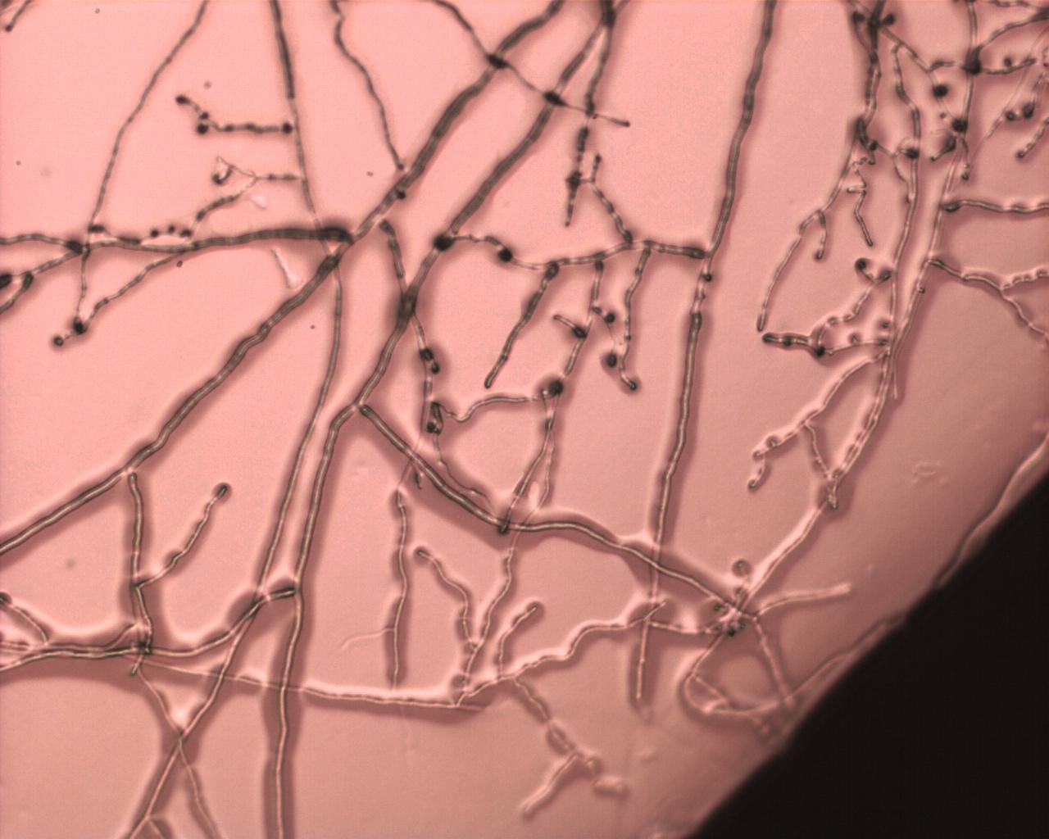
Cooperation and Conflict
How Fungi Shape our World

Environmental Biology Writing Assignment
Pim van de Noort
Supervisor: prof. dr. Han Wosten
Second reviewer: dr. Luis Lugones

Abstract
The kingdom of fungi is gaining more attention as new research sheds light on their mysterious ways. Their ability to express some of the most cooperative, as well as some of the most antagonistic behaviours, makes them an indispensable key of life. They helped plants to coonize land and with it, lay the foundation for new structures of ecological balance. Researchers are trying to find ways to utilize fungi’s cooperative nature, while simultaneously battling fungal pathogens that rival against that what humans have domesticated. Either with or against plants, bacteria and animals, including our own bodies, fungi are everywhere. This review summarizes some of the most important relationships that fungi have established with all the other kingdoms. Moreover, some of the challenges that humans face as fungi keep shaping our world are discussed.
Lekensamenvatting
De wereld van schimmels omvat vele soorten. Het is een wereld die voornamelijk ongezien zijn gang gaat, omdat veel schimmels onder de grond groeien. Echter onze levens en die van dieren en planten worden enorm gevormd door deze organismen. De eerste planten kwamen voor in het water, maar met behulp van schimmels konden deze op het land groeien. Een moment uit de geschiedenis die de wereld veranderde. Inmiddels zijn vele planten, bomen, dieren en ook mensen afhankelijk van schimmels. Ze sluiten de koolstofcyclus door dood biologisch materiaal af te breken en geven deze energie terug aan de natuur. Dieren voeden zich aan paddenstoelen of vormen symbioses met specifieke schimmel soorten. De mens maakt veel gebruik van schimmels voor de productie van eiwitten en andere stoffen. Er wordt onderzoek gedaan naar toepassingen voor schimmels bijvoorbeeld als materiaal voor kleding, isolatie en ook is er meer aandacht voor eetbare paddenstoelen. Maar niet alle schimmels zijn coöperatief. Sommige soorten staan bekend om hun venijnige infecties. In de landbouw worden antischimmelmiddelen gebruikt om gewassen te beschermen. Ook mens en dier lopen gevaar voor ziektes. Sommige soorten zijn zo dodelijk dat plant- en diersoorten wereldwijd uitsterven. Dit is met name verontrustend omdat door het overmatig gebruik van antischimmelmiddelen schimmels muteren en resistent worden waardoor deze middelen niet meer werken. Daarom zijn onderzoekers druk bezig om in kaart te brengen hoe deze ziektes ontstaan en of er nieuwe antischimmelmiddelen ontwikkeld kunnen worden. Deze literatuurstudie beschrijft hoe schimmels de wereld gevormd hebben tot hoe we die nu kennen. Het spectrum van coöperatieve tot parasitaire schimmels wordt behandeld in zowel planten, bacteriën en dieren. Ook wordt de rol van de mens in de mogelijke verspreiding van schimmelziekten en de impact hiervan op de landbouw en de natuur belicht. De huidige uitdagingen in het onderzoeksveld en daarbuiten worden ook beschreven.

Introduction
Fungi are scientifically underrated compared to other kingdoms of life. However, they have been and still are the key to life as we know it. Fungi made it possible for plants to colonize land. The consequences of this event have triggered more ecological changes than many other evolutionary phenomena. However, the field of mycology can be a struggle from the perspective of taxonomy. There are so many species that taxonomists keep bending their heads over updating phylogeny. As Hibett reflected on previous literature concerning kingdom classification of fungi, “These publications represented major advances toward a phylogenetic classification of Fungi, but they are already out of date”. Nonetheless, with the expansion of online taxonomies and research communities growing, this will make fungal taxonomy as comprehensive as ever (Hibbett 2007).
Since fungi are all around and represent a cornucopia of innovative potential, they should be of interest to any biologist and layman with an eye for an optimistic future. Indeed, the field of mycology is visibly expanding as it is not limited anymore to biology alone. Designers from fields like construction, fashion and food turn their heads to fungi for innovative solutions (Jones et al. 2020; 2021; Dupont et al. 2017) (Figure 1).
Yet, fungal research poses some
knowledge gaps between different fields
In mycology but multidisciplinary approaches to research are getting more common. This review is meant to put fungi in the spotlight in contrast to their unobtrusive nature. Some of their major cooperative and parasitic behaviours in nature are described. These examples of fungal diversity shall when possible be linked to other fields that include (but are not limited to) molecular biology, rhizosphere ecology, evolutionary symbiosis and phylogenetics. In doing so, the state of the art of different fields of mycology are put into perspective. Some of the challenges that are caused by human intervention with fungal nature or challenges that are ahead of fungal research are discussed.
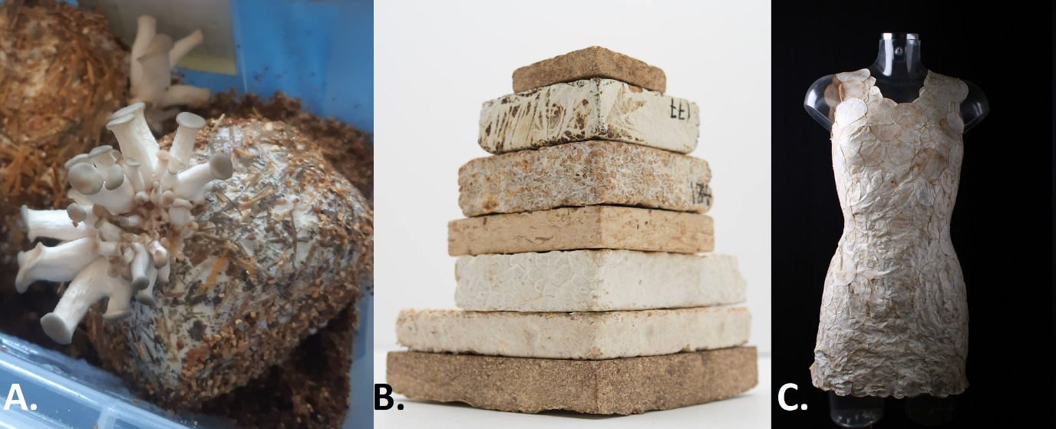
1.1 Fungal plant cooperators
Fungi proved to be a protagonist for life on earth when they formed a symbiosis with plants to be able to grow on land. Their first appearance in the fossil records came with plants during the Silurian period which was from 443.3 to 419.2 million years ago (Mya). Environments were marked by either warm and shallow seas or arid lands, exposed to high radiation and extreme varying temperatures as plants had yet to cover the soil (Leclerq, 1954). Waters were rich in plants as well as the plants’ ancestors, algae. It used to be thought that early plants or fungi were not equipped to go terrestrial at first. However, Delaux and colleagues did a
thorough phylogenetic analysis on the
Figure 1. Expanding fields of fungi. A. DIY growing setup of oyster mushrooms at home. B. Mycelial bricks. Courtesy of MycoWorks. C. A dress made with fungal sheets. Courtesy of Aniela Hoitink, MycoTEX.
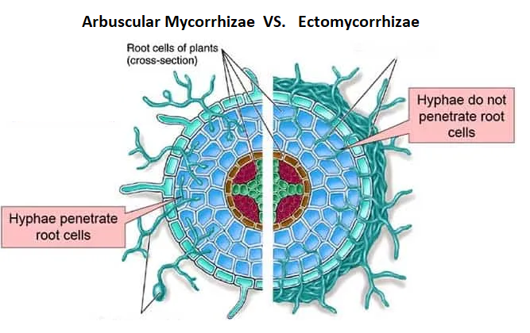
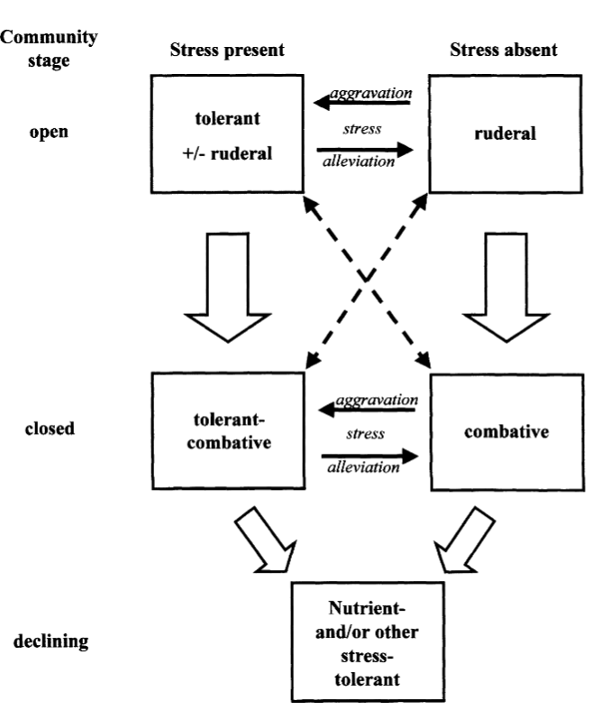
fungal and plant genes that are essential in the symbiotic signalling pathway. They found that a number of these genes were already present in some algal ancestors of early land plants. Among these genes were a LysM receptor-like kinase, playing a crucial general role in plant signalling and a calcium and calmodulin-dependent protein kinase, important for transduction of calcium spikes during mycorrhizal symbiosis (Delaux et al. 2015). This coincides with a much bigger fundamental idea of evolutionary biology, where the transition from uni- to multicellular organisms was also considered a relatively easy one, given that unicellular ancestors similarly owned the molecular tools to organize multicellularity before it became a reality (Michod and Roze 2001). And this form of physiological and morphological adaptivity is where fungi excel at. Their symbiosis formation with plants is a striking example. Evolution of the kingdoms has consistently evolved from simple unicellular ancestors where plants arose from green algae and animals from single-celled flagellated protists. Such a phylogenetic hypothesis came about later for fungi since mycology has been relatively fractured compared to other research fields. But a crucial part in the transition from water to land was the loss of the flagella. An event that separated the chytridiomycetes from the other phyla, as they are the only fungi left to reproduce by forming flagellated zoospores (Y. J. Liu, Hodson, and Hall 2006). To complicate matters for taxonomists, this event presumably happened at least four times independently (Lang et al. 2002; James et al. 2006). Before that, fungi were assumed to live in water as oomycetes of which the most primitive order is that of the Lagenidiales and occur generally as parasites (Kortekamp 2005). However, new research has unravelled that oomycete species are actually closer to algae than fungi and are now sometimes referred to as “pseudofungi” (Beakes, Glockling, and Sekimoto 2012). Diving into the fossil records, researchers show that the earliest vascular plants established associations with fungi, which share the appearance of endomycorrhizal (EM) fungi, ascertaining the hypothesis of a symbiosis (Pirozynski and Malloch 1975). This hypothesis found its way into the literature in the 1970’s. Researchers now have the resources to model ancient climates. And so, Humphreys et al conducted a simulation of a Palaeozoic environment with a CO₂-rich atmosphere. They grew an ancient liverwort with an arbuscular mycorrhizal (AM) fungus, the most common type of endomycorrhizal fungi, and showed that these conditions pressured selection for symbiosis. Since this liverwort is rootless as all early land plants were, this provides strong evidence for the terrestrialization of plants with the help of fungi (Humphreys et al. 2010). Fast forward 200 million years and ectomycorrhizal (EcM) fungi formed. They established their interactions with trees on land when organic material started to accumulate (Cairney 2000).
The difference between EcM and AM fungi is their occurrence and interaction with the plant host but both types can sometimes be found colonizing the same host, with the ratio between them dependent on abiotic factors (Lodge 1989). AM fungi are found everywhere in the world, growing in biomes ranging from deserts, savannas to tundras, largely found in the tropics and their abundance has been mapped in great detail (Treseder and Cross 2006). They form hyphae that grow intracellularly in the plant cortex cells and form structures at the tip of these hyphae called arbuscules, which branch out to maximize the internal surface contact within the plant cells. This way nutrients are shared in the most direct way between the cell membranes of the hyphae and cortex cells. Furthermore, the mycelial network spreads out externally into the soil.
EcM fungi occur mainly in the northern hemisphere as their preferable hosts are woody perennials. Still, they are also found in tropical climates (Smith and Read 2008a; Alexander and Hogberg 1986). In its relationship with the plant host, a network of hyphae will grow a fungal sheet or mantle around the roots of the plant. Some hyphae will colonize the intercellular space of the cortex cells but will never penetrate them. The exchange of nutrients must occur between the cell walls of both hyphae and plant cortex cells and is therefore less direct compared to AM fungi (Smith and Read 2008b).
Mycorrhizal fungi generally supply the plant with nitrogen and phosphorus as well as other micronutrients like ammonium and zinc and receive in return carbohydrates as sugars (Parniske 2008). However, it is fungi that are in control of the “market”. The AM fungi Rhizophagus irregularis was found to change its exchange rate of carbon to phosphorus when the fungal network was either restricted from resources or when phosphorus was added to the fungal network thereby compensating for its own supply as well as for the demand from the roots (Van’t Padje, Werner, and Kiers 2021).
Fungi continued to adapt to even metabolize inorganic nutrients. In 1997, the term rock-eating fungi was coined when weatherable minerals were found to contain pores made by fungi-excreted-acids (Jongmans et al. 1997). The hypothesis that these fungi helped plants in the uptake of such minerals seemed plausible since such fungi occur in forests where decomposition and mineralisation rates are low (Read, Leake, and Perez-Moreno 2004). Pot experiments showed that the uptake of tree seedlings of mineral nutrients such as calcium, potassium and magnesium was increased when grown together with EcM fungi (Ahonen-Jonnarth et al. 2000). As plants turned into trees, changing the molecular composition of both the atmosphere and the soil, some fungi in turn adapted their physiology to break down wood, as this was an accumulating energy source. The survival strategies include breaking down lignin, the molecule that coats the carbon rich cellulose in plant matter, as well as nitrogen-preserving methods. These species became known as wood decaying fungi (Rayner & Boddy, 1988). There are three main wood decaying fungi, brown rot (BRF), white rot (WRF) and soft rot fungi (SRF). Even though these types of fungi have their optimally preferred climates and substrates, the decay of wood comes in different stages where different fungi, sometimes simultaneously, profit from the available nutrients. Occasionally, a tree carries dormant fungi, endophytes, of which some become the initial decomposers after the tree dies (Parfitt et al. 2010). When wood is let to decay in an isolated lab environment, dominantly BRF start the decomposition process with metabolizing the cellulose and hemi-cellulose, generally (but not always) avoiding the lignin. These are primary colonizers (PCs). Then there are also secondary (SCs) and tertiary colonizers (TCs). PCs have evolved to be quick in their spore germination and fast resource capture and commit to rapid reproduction as they are not persistent during stress. SCs are more stress tolerant than PCs and exhibit a wider enzymatic capability (Boddy and Hiscox 2016). This is why in the second stage of decay, SCs outcompete PCs and continue the decaying process by extensively breaking down lignin (Coates and Rayner 1985). Competition peaks in the latest stage as TCs compete for the final recalcitrant substrates in decomposition but as the resource capture eventually completes, so does the species richness decrease (Boddy. 2001) (Figure 3).
Since fungi are so essential in maintaining a thriving forest ecology, efforts should be made to incorporate them in monitoring forest health. Some suggestions have been proposed such as measuring dead wood volume as an index of species richness or measuring soil mycelium mass (Lassauce et al. 2011; Parladé et al. 2017).
The cooperative spectrum of fungi with plants is versatile and extremely adaptive. The pathogenic spectrum is equally versatile, and the development of human society has indirectly set the ground for some of these species to adapt.
Figure 2. The difference in morphology between AM and EcM fungi. Hyphae of AM fungi will penetrate plant cortex cells, forming arbuscules. Hyphae of EcM fungi will colonize intercellular space but not penetrate the cortex cells.
Figure 3. The transients of species richness through fungal wood decay communities upon the availability of new substrate. Accumulating stress translates into the left side of the diagram whereas a decline in stress pushes it to the right. In the first stage, the substrate is open to colonization. Species richness increases and eventually reaches a closed stage where all substrate is colonized. As the nutrients are taken up and deplete, so does the species richness decline. (Adapted from Boddy 2001).
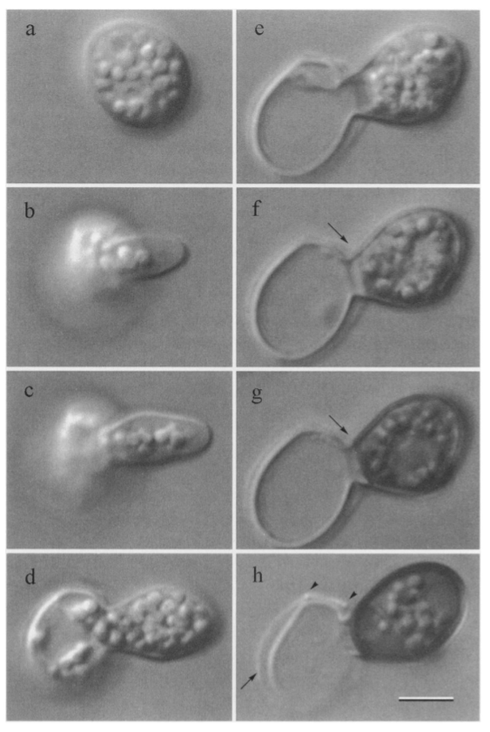
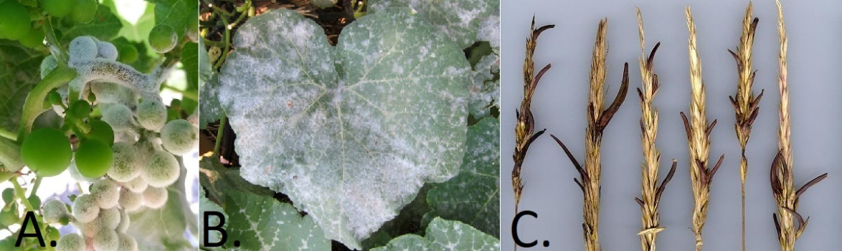
1.2 Fungal plant pathogens
Even though fungi have proved themselves as great cooperators in nature, essentially supporting life of many species in the process, some exhibit quite the opposite physiology. Fungi are feared pathogens, especially by humans, for the parasitic properties many species carry. Below, some of the most impactful parasitic fungi for plants are reviewed. The main focus here are crops, since these examples illustrate how human intervention with nature generally backfires ecological balance. However, as the population is ever growing, farmers and critics of the current food industry cope with difficult ethical questions. Reported in 2006, an estimated 14% of global crop harvest was spoiled by fungi (Oerke 2006). The extensive monocultures have helped humanity to feed as many people as ever. Such systems lack biodiversity and make the crop vulnerable. This has paved the way for parasitic fungi to flourish. As a result, humans battle a seemingly endless fight against fungi using fungicides to protect crops. This in turn has backfired with fungi becoming resistant and researchers describing the health risks of food treated with fungi- and pesticides (Gupta 2018).
The first step to infection for many fungal pathogens is the spores landing on the leaf or stem surface followed by germination. Appressoria are specialized cells at the tip of germ tubes that adhere to the surface and breach the plants cell walls by secreting cell wall degrading enzymes and accumulating cytoskeleton components (Mendgen, Hahn, and Deising 1996)(Figure 4). From there the species-specific pathogenicity pathways will kick off, as well as the immune response of the plant.
One of the main fungal crop diseases are the powdery (PM) and downy (DM) mildews. Mildews are obligate biotrophic fungi, so they need a living host in order to grow (Zhang et al. 2005). They grow optimally in humid places with moderate temperatures and are one of the most damaging diseases to crops like wheat, grapes, cucumber and apples. Greenhouses inconveniently conform very much to these growth conditions (Huang et al. 2000). Interestingly, looking into the evolutionary history of PM, it seems as if some of these fungi have prevailed in a successful parasite-host association long before their plant hosts were domesticated by humans. The strategy here was to utilize asexual reproduction rather then sexual, even though both reproductive cycles can be expressed. This approach of switching from a sexual to asexual cycle is more common in pathogenic fungi (Hacquard et al. 2013; Wicker et al. 2013).
Another major disease caused by fungi in crops is smut disease of which the largest group of pathogens are in the family of Ustilaginacea. Smut disease affects mainly grasses like corn, sugarcane and wheat. Like mildews, they grow as obligate biotrophs. Since their host must be living, they adapted to form a host-parasite relationship where the fungus leaches nutrients from the plant, but only enough for the plant to stay alive (Xia, Yu, and Ye 2020). The infection strategy of smut fungi is also similar to mildews, breaking into the host by forming an appressorium and secreting cell wall degrading enzymes. These enzymes, together with species specific effector proteins then counteract the plants immune response, which consists of cell wall reinforcement, reactive oxygen species and programmed cell death (Xia, Yu, and Ye 2020).
Another fungal crop parasite that should be mentioned are ergot fungi, since they are the oldest known mycotoxin producers, of which alkaloids are the main toxins. The earliest grass ever found in an amber fossil dates back to roughly 100 Mya. The fossil also contained an early ergot fungus. Nowadays, ergot alkaloids are used in drug manufacturing, of which LSD is well known. This provoked the imagination of researchers thinking of dinosaurs eating hallucinogenic grass (Oregon State University, 2015). There are stories of the Middle Ages where epidemics occurred in humans and animals as they ate ergot-infected grass or grains, sometimes referred to as ‘psychedelic bread’ (Liu and Jia 2017). The species that dominate the disease-causing behaviour are in the genus Claviceps that infect more than 600 plant species including grasses and cereal crops such as rye, sorghum, millet, corn and rice (Bové 1970; Baum, Lagudah, and Appels 1992). The lifecycle starts with airborne spores that germinate once landed on their host. Hyphae will invade the plant ovary and grow partly down the shoot. Here, the production of new asexual spores takes place that are secreted in a sappy liquid. This fluid may again be dispersed by physical contact with neighbouring plants, by rainfall or insects (Tenberge, 1999). In roughly five weeks, the ergot fungi will form sclerotia. This serves sexual reproduction or as a bet-hedging strategy to overcome disadvantageous conditions. The sclerotia will germinate once the right conditions are met (Luttrell 1977).
Despite the fact that humans have known many epidemics caused by ergot, it has become much more uncommon though case reports are still published (Mullins 2018). Interestingly, regardless of all the people once intoxicated by ergot, some people early on found out about the pharmaceutical potential of these mycotoxins. There are descriptions of ergot sclerotia being used in obstetrics in 1582 which occasionally went wrong due to inaccurate dosage. Yet, nowadays many medical advancements have been achieved in unravelling the biochemical properties (van Dongen and de Groot 1995).
Figure 4. Germination and appressorium formation of a Phyllosticta ampelicida asexual spore. a. The spore adheres to the substrate surface. b. A germ tube forms. c. The swelling of the germ tube coincides with appressorium development. d. Lipid-like bodies move into the appressorium. e. The appressorium almost reaches maturity. f. At the arrow, a septum between the appressorium and the emptied spore. g. The appressorium darkens due to melanisation. h. Arrows depict “scars” of where the spore was connected to the conidiogenous cell. (Adapted from Shaw et al 1998)
Figure 5. Fungal pathogens in common crops. A. Downy mildew growing on grapes. B. Powdery mildew colonizing the leaf of a cucumber plant. C. Ergot in wheat. The black structures are the sclerotia.
The final fungal crop parasite discussed in this chapter is Fusarium oxysporum f. sp. cubense (Foc). This fungus is a great example of how monocultures have jeopardized a whole market of a single crop. The fungus has earned a reputation by causing rot of various banana species, as it completely eradicated the Gros Michel banana, which was the dominant variety until the 1950s. The variety was soon to be replaced by a new cultivar, the Cavendish, which was resistant to this fungus. However, a mutated Foc strain has started the cycle all over as it appeared in Asia in the 1990s and in 2013 it was found to have spread in Africa. Experts expressed huge concerns, warning for if it manages to reach Latin-America, where the biggest banana farms are located (Butler 2013). It seems plausible that with globalization, as we carry our germs with us everywhere we go, we impose such a pathogenic crisis upon ourselves. This is strengthened by well known historical events such as the Spanish transmitting European flu to native Americans in the 15th century to current day examples of viral pandemics.
Additionally, in the light of fungi, we shall see later in this review that also animals are not safe from the fungal pathogens we unconsciously take with us around the world. These examples of pathogenic fungi underline that the standardized way of conducting agriculture on bigger scales but also smaller scale horticulture are in need of new strategies for a more balanced and controlled environment. Given the size of the human population, reorganizing the agricultural sector is one of the major challenges humans face. With the population growing, researchers are trying to optimize the amount of arable land. Globally, 800 million hectares of land have salt concentrations that induce plant stress and disturb yields (FOA, 2008). Due to the scale of this problem, researchers are looking to overcome this salt stress for crops. AM fungi and earthworms have been studied in the aid of maize salt tolerance. Maize was grown in combination with fungus and earthworm, both individually or neither and exposed to high salt soil. The combination of both fungus and earthworm revealed that both occupied different behaviours that supported the salt tolerance for the maize (Zhang et al. 2018). The earthworms would boost sodium uptake in the roots as well as nutrient uptake in the shoots. The fungus increased potassium transport from the roots to the shoots. It also reduced the content of oxidative stress compounds thereby promoting photosynthesis and transpiration, counteracting the salt stress. Researchers are simply domesticating new species to aid in crop productivity. This innovative potential of trying to establish a healthy soil microbiome, where fungi, bacteria and perhaps also animals (in the previous example worms) work together to aid in a plant's health, rather than to target the pathogen. Moreover, we shall see in the next chapter that the mixing of fungi and bacteria produces promising cocktails for a variety of applications.
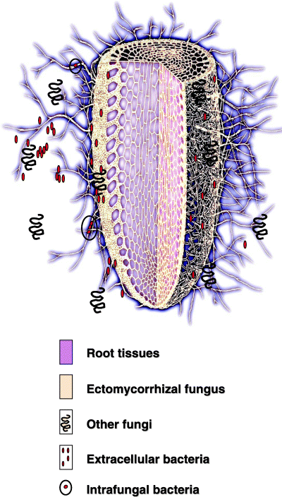
2.1 Fungi and bacterial cooperators
As depicted with fungi and plants, fungi can interact with their environment exhibiting all types of behaviour ranging from cooperating, acting highly competitive or parasitic. The problem with plants is that doing research on these interactions is time and resource consuming, since you either must go out and do fieldwork in the forest or grow plants in the lab. Research of fungal interactions with bacteria in the lab is more convenient since cultures can be grown on small scales. The downside is that it translates less easily back to the natural environment. Particularly the extrapolation of fungal lab research to the scale of nature is a peril. Therefore, more fundamental research is needed. Since mixed microbial communities are the archetype of communities in nature, more attention has been redirected to using polymicrobial cultivation methods. Researchers have found that mixed cultures, once stable, can lead to the expression of a wider range of active enzymes, stronger defence responses to external stress or a higher metabolic capacity, compared to monocultures (Briones and Raskin 2003). This chapter will mostly describe examples of cooperative fungal and bacterial cultures. These mainly come from applied research, as this type of research breaks down the components of nature to elucidate smaller systems. Field studies of natural fungal and bacterial interactions pose different challenges with even bigger questions. However, some natural interactions will also be reviewed, of which the most extensively studied are present in the soil. The soil, particularly that of forests, are extremely complex environments regarding mixed microbial communities (Figure 6). As mentioned in the previous chapter, mycorrhizal fungi are beneficial to the productivity and immunity of plants. But enthralling here is that the rhizosphere, the part of soil that is subject to plant root influences, is the most colonized and variegated in microbial communities dominated by bacteria. They are termed mycorrhization helper bacteria (MHB). It turns out that these bacteria are generally synergistic and aid in the establishment of mycorrhizas (Garbaye 1994; Smith and Read 2010). Many MBH strains have been characterized and belong to a variety of culturable species. Nonetheless, it remains to be seen how many species have yet to be identified due to their non-easily culturable physiology. This in turn could have implications on the phylogeny of MBH. Besides the rhizosphere, MBH have also been found on the fruiting bodies of EcM fungi and on the spores of AM fungi (Frey‐Klett, Garbaye, and Tarkka 2007). Because MBH were discovered after mycorrhizal fungi, there are still many questions concerning their detailed interactions. For instance, some MBH have been found to form biofilms on the EcM hyphae. Yet, why the biofilm forms at specific places like the mycorrhizosphere is still unknown (Sarand et al, 1998). One explanation that is offered is that biofilms form where fungal trehalose is exuded. Frey et al found that trehalose plays an important role in the selection of microbial communities. They reported that Pseudomonas isolates found in Douglas fir-Laccaria bicolor mycorrhizas take up trehalose, which is the most accumulated carbohydrate in the mycelium (Frey et al. 1997). Interestingly, 30% of the total carbon fixed by plants is received by fungi. It comes in the form of trehalose and is regarded as an important sink (Finlay and Söderström, 1992;Wiemken 2007). This way, fungi give back the carbon from plants directly to the soil and act as the mediator of this phenomenon. This is a beautiful example of a natural interaction of fungi cooperating with several organisms simultaneously that includes bacteria. But there are other instances where specific bacteria help the growth of specific fungi and this has been researched more extensively in fungi forming edible mushrooms. Agaricus bisporus (A. bisporus) grown in co-culture with Pseudomonas putida (P. putida), shows increased hyphal growth and primordia formation (Rainey, 1991). Similar results were reported for Pseudomonas spp with Pleurotus ostreatus (P. ostreatus) (Cho et al. 2003). If we now focus on the applied research of fungal-bacterial co-cultures, we can see that there is a strong aim to utilize this approach in biological degradation. For instance, a fungal-bacterial system has been proposed for the biodegradation of chlorobenzene. This molecule is a volatile organic pollutant that is used in the production of different pesticides (Cheng et al. 2017). It is hard to break down and can cause much harm to the human body. These are good developments, yet it seems ambiguous to use a fungal-bacterial system to break down waste products that are used in agricultural products which ruin the fungal-bacterial soil community in the first place. The strategy of fungal-bacterial systems in biodegradation is to find a synergy in metabolic capacities. A fungus might initiate the degradation pathway allowing the co-cultured bacteria to break down the intermediate molecules into small degradation products. This order can also be inverted. As an example, the fungus Aspergillus niger can be co-cultured with the bacterium Bacillus subtilis to break down 2-naphthol. In the 2-step process, A. niger breaks down 2-naphthol into 2 metabolites which B. subtilis can easily break down (Zang et al. 2010). Another example is the degradation of benzo[a]pyrene by the fungus P. ostreatus mixed with the bacterium Pseudomonas aeruginosa. Ligninolytic enzymes degrade the molecule into polar intermediates, ready to be broken down further by P. aeruginosa (Bhattacharya et al. 2017). Now that the utilization of fungal-bacterial systems is slowly taking shape, the next major obstacle will be to find the optimal state of running them. Most of these studies are performed in batch reactors where the medium remains in near homogenic conditions. For industrial settings, it is a guess how such a system will behave on a big and long-term scale. There’s for instance the risk that the initial inoculum does not remain in balance and that one of the species starts outgrowing its ally (David et al. 2018; Badia-Fabregat et al. 2017).
Another point of research concerning fungal-bacterial communities is their relation to human and animal health. For more than a decade, the microbiota has been regarded as an important regulator of our health and the credits were generally reserved for bacteria (Stiemsma et al. 2015). Since fungi were found to also play a small but very important role in a healthy gut biome, it is now sometimes referred to as the mycobiota (Underhill and Iliev 2014). As with plants, we can make an analogy for fungi in the human body in that they serve the host and other bacterial species simultaneously. Fungi are resistant to antibiotics and it was shown that during antibiotic treatment, the fungus Candida albicans would increase its colonization in the gut, to counter for the decrease of commensal bacteria due to nonspecific targeting by the drug (Erb Downward et al. 2013; Mason et al. 2012).
Figure 6. Soil micro community. At the tips of plant roots where exudates accumulate, a mix of fungi and bacteria colonize this rhizosphere. Here, an EcM fungus grows a mantle around the root tip and is surrounded, sometimes intracellularly by other bacteria and fungi. (Adapted from Frey-Klett, P. and Garbaye, J. 2005)
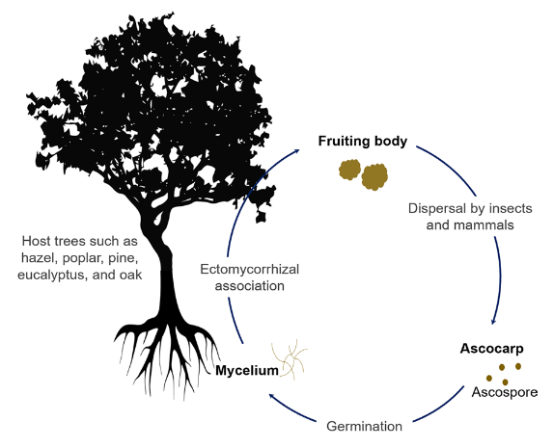
2.2 Fungal bacterial cooperators becoming pathogens
To my knowledge, there are no reports in literature that describe fungal bacteria interactions in which a fungus is particularly parasitic to a specific bacterium. However, there are instances in which fungal bacterial interactions, once commensal, become parasitic to its host. This can be problematic for instance in the case of dysbiosis. This condition occurs during an imbalance in the gut microbiota and can be caused by antibiotic treatment or microbial transplants (Kim et al. 2014). Here, a mixed community of fungi and bacteria commence a nasty infection that can result in biofilm formation. In such a community in the gut, Escherichia coli (E. coli) and C. albicans form a polymicrobial biofilm which the β-1,3-glucan from the cell walls of C. albicans supporting the resistance of E. coli to the quinolone antibiotic ofloxacin (Brucker et al. 2015). This is followed by the secretion of toxins and enzymes that harm the host (Ghannoum 2016). Thus, while still cooperative towards the bacteria, the fungus can become pathogenic to its host. Moreover, another issue is that the same species of fungi can exhibit phylogenetic instability, resulting in different morphologies or physiologies that make it difficult to classify them. This problem has arisen also in the research on the mycobiota where sometimes the sexual and asexual form of a species gets a different taxa classification (Underhill and Iliev 2014).
However, since fungal-bacterial interactions are important to many different fields of biology, ranging from agriculture to ecology and medicine, it is vital to collect this knowledge from experiments to get a deeper understanding of our environment. This will help to predict, manipulate or exploit such interactions (Frey-Klett et al. 2011). With the surface of fungal human (e.g animal) interactions scratched, we shall now dive deeper into this third kingdom, where fungi have established the most extraordinary relations. Some very gruesome parasitic interactions are described, of which some might have been introduced by humans.
Figure 7. The life cycle of the truffle. (Adapted from Lee et al 2020)
3.1 Fungi and animals
The most common relationship fungi have with animals is to use them for the distribution of its spores. Mushrooms are very nutritious, and many spores remain viable for germination after passing through the animal's digestive tract (Trappe and Maser 1976; Ori et al. 2018; Wallis, Claridge, and Trappe 2012). The fungal species that form truffles have most likely adapted the best strategy for this life cycle (Figure 7). Truffles are the fruiting bodies of some fungi and the most well-known species come from Ecm fungi. They have developed complex aroma compositions. This mix of aroma’s is different for each species and is irresistible to many animals, including humans (Bellesia et al. 1998). As truffles grow underground, they are dependent on the animals that dig up the truffles and eat them so that their spores may disperse through their faeces. Sometimes the spores may even germinate in the faeces before establishing a mycorrhiza with the trees (Ori et al. 2018). Stephens et al, reported that rodents preferred to dig up deeper rooted truffles despite the access to more shallow fruiting ones. Apparently, the deeper-rooted truffles produced a stronger scenting mix of volatile organic compounds (Stephens et al. 2020). Using these chemical signals to attract the animals, the rodents in turn pressure selection for the fruits producing stronger chemical cocktails since they in turn disperse the spores. Another selective trait that has been selected for in truffles is the gut-retention time of the spores. A longer retention time means a higher variation of distances that the spores can be dispersed by their animal hosts (Danks 2012). This adaptation of truffles to utilize animal faeces as the carrier of their spores has made these animals an important link in maintaining a healthy fungal diversity in the environments, they occur in (Maser, Claridge, and Trappe 2008). As humans are trying to develop ways to increase natural truffle production, research is pointed towards the soil as this is an indicator of the health of microbial communities and thus the fungus producing the truffle. This is also applied to bigger scales of agriculture. By now, research has unravelled the possibility of cultivating truffles commercially. However, humans are not the only animal to domesticate other species. Roughly 30 Mya, fungus-growing termites in Africa adapted an evolutionary strategy to domesticate a fungus to use as a food source (Wisselink, Aanen, and van ’t Padje 2020). The fungus is fed with dead plant material and in doing so, the termites have become an important link in biomass decomposition (Jones 1990). The termites set up a three-stage cycle for complete plant degradation. Each stage involves the mutualistic fungus at different maturity levels (fresh, mature and old). In the first stage, dead plant material is digested by ants together with fungal spores produced by the mature fungal comb. The spores germinate in the termite faeces and metabolize the lignocellulosic compounds. This matures into the so-called old fungal comb and the fungus starts to form nodules that the termites use as a food source (Schalk et al. 2021). However, additional research has now reported that the transformation of a specific bacterial community present in the termite gut was necessary for its establishment (Poulsen et al. 2014). But ants are far from the only animals to carry fungi in their intestines. As mentioned, humans carry a mycobiome and also ruminants are highly dependent on anaerobic fungi that help with cellulolysis (Theodorou et al 1992). Sadly, from a termite’s perspective, not all termites live symbiotic lives with fungi. One fungal parasite that targets insects including some termite species has baffled biologists for their remarkable behaviour altering physiology and will be discussed in the next paragraph.
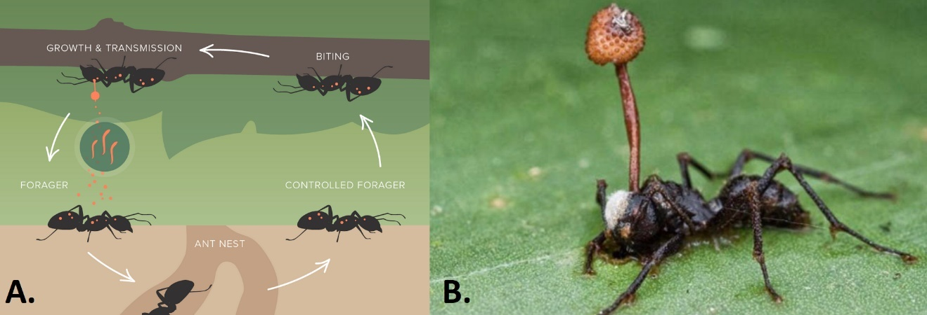
3.2 Fungal animal pathogens
Despite its old medicinal use in eastern countries, due to recent studies and even covered in BBC’s Planet Earth, the fungi belonging to the genus of Cordyceps and Ophiocordyceps have become one of the better-known exotic fungal animal parasites. They parasitize many insects including ant species but also caterpillars, moths, beetles or termites. The life cycle of the Ophiocordyceps fungus is rather unusual as it uses different bioactive compounds to establish an extended phenotype, the so-called “zombie” behaviour in infected ants. Different fungal species have specific hosts which exhibit slightly different parasitic behaviour. In general, ants will get infected with spores. The fungus germinates and starts releasing entomopathogen- related proteins. These proteins induce altering behaviour that make the ants climb up the tree canopy where they express “death grip” behaviour. The ants' mandibles bite into plant leaves or stems right before they’re killed by the fungus. The grip remains after death and the ant now serves as the spore distribution location for the fungus. A mushroom will now grow out of the body of the ant and the spores will rain down onto new unfortunate hosts (Andersen et al. 2009). The location of where an ant put its “death grip” may be quasi-random in some species but sometimes may be specific. The fungus Ophiocordyceps unilateralis has been found to infect ants that leave their nest to die in concentrated areas that are termed graveyards (Pontoppidan et al. 2009). Not all cordyceps are regarded parasitic. There is some debate on species being rather symbiotic to their host. Cordyceps sinensis only pairs with a specific moth species and is thought to support the insect in its metabolism. Therefore, the death of the insect might be the trigger for mushroom formation rather than the cause of death (Holliday and Cleaver 2008). Other yeast-like endosymbionts of the genus Cordyceps in insects have been described but their symbiotic nature is still indecisive as their phylogeny lies within entomopathogenic lineages and the molecular mechanisms have not been characterized (Suh et al, 2001).
Figure 8. The life cycle of Ophiocordyceps (A.) and its mushrooms (B.).
Besides insects, some fungi have specialized to parasitize aquatic animals. Some Fusarium sp. which are known for their pathogenicity in plants are also found to infect crustaceans such as lobster, crayfish and shrimp (Alderman and Polglase 1985). There are also reports of Exophalia sp. that specifically infect salmon. Similar to agriculture on land, outbreaks of these pathogenic fungi are common in captive fish farms (Langvad 1991). Even though amphibians have adapted to live on land, they are not resistant to drought and must remain partially aquatic. Therefore, they are also prone to be infected by fungus-like protists that also parasitize on fish (Romansic et al. 2009). Yet, the most infamous fungal parasites that have been responsible for the world’s biggest decline in amphibian species are the chytrid fungi in the genus of Batrachochytrium. Berger et al, was the first to report in 1998 the decrease of amphibians in Australian and central American rainforests by chytrid fungi yet its origin of spread was highly speculative (Berger et al. 1998). Quantitation of this abnormality was delivered two years later which revealed that this decline in populations was already going on for decades (Houlahan et al. 2000). A global assessment of amphibian populations presented in 2004 found that overextension and reduced habitat by human exploration had been the cause of major declines in populations. Still the decrease for another 200 species was obscure. The fungus Batrachochytrium dendrobatidis (Bd) was targeted as the potential culprit (Stuart et al. 2004). Bd causes the skin of its host to deteriorate. Since amphibians are highly dependent on their water-permeable skin for osmoregulation, mortality rates with infected individuals is high (Fisher and Garner 2020). In Australia alone, this fungus has been responsible for the extinction of 14 frog species (Retallick, McCallum, and Speare 2004). The origin of Bd has two hypotheses. One states that humans have introduced the pathogen to vulnerable ecosystems as a result of globalization. The second argues that the pathogen used to be a commensal organism to the amphibians but has become virulent due to the changing climate. The details for both arguments are discussed in multidisciplinary detail by Fisher and Garner (Fisher and Garner 2020), which represents the importance of bridging different fields for unravelling a disease's life cycle, its origin and to discuss prospects for the future. To top off this fungal pathogen chapter, we shall turn to one saprotrophic fungus that afflicts human health. Particularly humans that are immunocompromised and/ or have lung problems such as asthma are susceptible for diseases caused by Aspergillus fumigatus. The fungus is found to grow in the soil or decaying vegetation all around the world and does not generally invade the human respiratory tract (Kwon-Chung and Sugui 2013). Growing vegetatively, it plays an important role in nitrogen and carbon cycling. Once substrates deplete, A. fumigatus unleashes fast numbers of conidia that are dispersed by the slightest breeze. The efficiency of its spore production and dispersal are shown by a study that measured A. fumigatus spores as the most abundant fungal component in air sampling, including inside of hospitals (Abdel Hameed, Yasser, and Khoder 2004). Besides its spore production, A. fumigatus has found intricate ways to modify its own cell wall structure when exposed to anti-fungal stimuli. For instance, drugs will initiate the cell wall integrity pathway, a general cell wall maintenance pathway. Furthermore, there is the high-osmolarity glycerol pathway, reacting to osmotic and cell wall stress. In addition to other pathways such as the target of rapamycin signal transduction pathway and calcium signalling, there is a strong core from mitogen-activated protein kinase (MAPK) pathway that ties all of the mentioned pathways together. This complex mix of pathways makes that A. fumigatus is adapted to finetune its protein content and composition to fend off drugs and initiate infection (van de Veerdonk et al. 2017; Manfiolli et al. 2019). At this moment azoles are wide range agents used against several types of Aspergillus spp and have contributed to higher survival rates in immunocompromised patients (Walsh et al. 2008). Since azoles are the only drugs that are available against Aspergillus spp, their dependence on long-term treatments such as for chronic pulmonary aspergillosis cannot be underestimated (Walsh et al. 2008; Schweer et al. 2014). However, an ever-growing concern in the medical research field is the emerging resistance of A. fumigatus to azole class drugs. The awkward situation here is that azoles are also used in agriculture as fungicide. These might be slightly different agents, but their structures are similar to the ones used for medical conditions. The conditioned use of azole fungicides allows A. fumigatus to become resistant but also induces cross-resistance, lowering the effectiveness of medically used azoles. Since there is a very limited number of azoles, there lies responsibility in both the farmers and the researchers. An effective way for the farmers would be to explore the possibilities of reorganizing the amount of arable land. More crop diversity lowers the risk of disease compared to monocultures. Biological control and a healthier soil biome can support the plants. This would allow the use of azoles to be restricted to medical use and terminate the occurrence of environmental resistance of A. fumigatus (Verweij et al. 2015; Snelders et al. 2012). Yet, given the scale in which azoles are applied both medically and agriculturally, to abandon the use of the agents in one of these sectors is not feasible at this moment. To map the spread of resistance globally and bring to light the mechanisms on how resistance develops in nature should be set as priority. Summarizing all examples of major fungal pathogens, there is the recurring event of human introduction of these pathogens. Either directly by our own physical distribution globally, or indirectly by altering the environment. This ought to raise questions of how well we manage our lands and waters.
4. Discussion and conclusion
This review has described how fungi influence life on all levels of nature ranging from the smallest molecular interactions to connecting a whole ecosystem.
Unfortunately, research in mycology is much younger and more fractured compared to bacterial or plant research. However, the importance of fungi is something that is starting to win more attention as their crucial functions in nature get better understood. Depending on the species being researched, overlap of field work and lab work on a single species occasionally happens. Yet, within the research of mycology there is quite a distinction between those that research fungi in nature and those who research fungi in the lab. Fungi that are researched for uncovering innovative industrial applications follow a different path than research on fungal preservation in relation to its ecosystems. However, if we wish to deepen our understanding of fungi, more fundamental research is needed to identify species, to characterize further the once we have identified and to extend the spectrum of categories. As mycorrhizal and pathogenic fungi have been researched extensively, saprophytes and commensals have always been less studied (Parbery 1996).
Fungi are, compared to species from other kingdoms, the most cooperative in relation to species other than themselves. By closing the carbon cycle, they monopolize the highest accomplishment of a species by the act of increasing entropy. Ironically, the kingdom of fungi bears some of the highest adaptive pathogenic species. Explanations for this ambiguity are debatable to this day, as the spectrum of cooperation and antagonism is boundless. In this regard, the Fusarium genus covers most of this spectrum since it comprises, as described in earlier chapters, animal and plant pathogens but also plant endosymbiont species (Skiada et al. 2020). However, It is hard to predict whether fungi evolved first as pathogens or cooperators in nature. Growing hyphae is not only reserved for fungi but are found back among algae, cyanobacteria and Oomycetes. Mushrooms are easily degradable and leave no traces in the fossil record. (Kenrick and Crane 1997; Redecker, Kodner, and Graham 2000). It seems plausible that the extreme difference in fungal morphology and physiology is influenced by its phenotypic instability, causing mutations that make fungi very adaptive to its environment, but comes with the cost of within organism conflict (Silar 2019; Shilovsky, Putyatina, and Markov 2021). Their adaptability makes them hard pathogens to battle. This is supported by examples like Foc strains mutating to get around drug resistance in bananas or A. fumigatus that can actively change its cell wall structure depending on anti-fungal stimuli. Yet, there seems to be some human factor involved in, not always the origins, but certainly the continuation and spread of such mutant pathogens.
The examples of fungal pathogens in this review described how our own ignorance contributed to the spread of disease. This has caused the extinction of plants and animal species across the globe. In 2019, 1882 new fungal species were reported. Yet only 3,5% of them were linked to fungal animal relations, which implies how understudied these interactions are (Cheek et al. 2020). Now that these causations are getting mapped increasingly better, perhaps this should start the discussion of our own interactions with nature. Humans are relatively inflexible in changing their behaviour to changing environments compared to other species. Future generations are burdened with the price humans will have to pay for this behaviour as. As Clark modelled in the early 1970s, the exploitation of animal species tends to result in increased harvesting pressure, increased costs of production and a decrease of populations. The extermination of a population may be the consequence of a profit driven policy (Clark 1973). This questions whether we should interfere with nature at all, though to refrain from interacting with nature and to leave it be is an unrealistic utopia. Perhaps new solutions should come from a literal “bottom-up” approach, meaning the soil. Why not replace pesticides and fungicides for biological control applications in agriculture. Instead of trying to directly battle pathogens, we should increase the health of the crop and the abundance of healthy microbes that naturally support it. The use of biofertilizers have been reported to increase the number of beneficial microbes growing with bananas and helped in the suppression of Fusarium wilt disease (Shen et al 2018). Perhaps a purist idea of natural conservation would be to only interact on the fungal level. If we could manipulate fungi to establish preferred interactions, while maintaining their basal level of natural importance, as they have done since the beginning of terrestrialization, we could look forward to a much more balanced and sustainable world. Though one could wonder if and when such systems could be actually a reality, as the number of questions around fungi increase with each answer that researchers present.

References
Abdel Hameed, A. A., I. H. Yasser, and I. M. Khoder. 2004. “Indoor Air Quality during Renovation Actions: A Case Study.” Journal of Environmental Monitoring: JEM 6 (9): 740–44.
Ahonen-Jonnarth, U., van Hees, P. A. W., Lundström, U. & Finlay (2000). Production of organic acids by mycorrhizal and non-mycohrrizal Pinus sylvestris seedlings exposed to elevated concentrations of aluminium and heavy metals. New Phytologist, 146, 557-67.
Alderman, D. J., and Jane L. Polglase. 1985. “Fusarium Tabacinum (Beyma) Gams, as a Gill Parasite in the Crayfish, Austropotamobius Pallipes Lereboullet.” Journal of Fish Diseases. https://doi.org/10.1111/j.1365-2761.1985.tb01222.x.
Alexander, I. J., and P. Hogberg. 1986. “ECTOMYCORRHIZAS OF TROPICAL ANGIOSPERMOUS TREES.” New Phytologist. https://doi.org/10.1111/j.1469-8137.1986.tb00830.x.
Andersen, Andersen, Gerritsma, Yusah, Mayntz, Hywel-Jones, Billen, Boomsma, and Hughes. 2009. “The Life of a Dead Ant: The Expression of an Adaptive Extended Phenotype.” The American Naturalist. https://doi.org/10.2307/40306069.
Amber fossil links earliest grasses, dinosaurs and fungus used to produce LSD (2015, February 9) retrieved 17 February 2022 from https://phys.org/news/2015-02-amber-fossil-links-earliest-grasses.html
Badia-Fabregat, Marina, Daniel Lucas, Tero Tuomivirta, Hannu Fritze, Taina Pennanen, Sara Rodríguez-Mozaz, Damià Barceló, Glòria Caminal, and Teresa Vicent. 2017. “Study of the Effect of the Bacterial and Fungal Communities Present in Real Wastewater Effluents on the Performance of Fungal Treatments.” The Science of the Total Environment 579 (February): 366–77.
Baum, M., E. S. Lagudah, and R. Appels. 1992. “Wide Crosses in Cereals.” Annual Review of Plant Physiology and Plant Molecular Biology. https://doi.org/10.1146/annurev.pp.43.060192.001001.
Beakes, Gordon W., Sally L. Glockling, and Satoshi Sekimoto. 2012. “The Evolutionary Phylogeny of the Oomycete ‘Fungi.’” Protoplasma 249 (1): 3–19.
Bellesia, Franco, Adriano Pinetti, Alberto Bianchi, and Bruno Tirillini. 1998. “The Volatile Organic Compounds of Black Truffle (Tuber Melanosporum Vitt.) from Middle Italy.” Flavour and Fragrance Journal. https://doi.org/10.1002/(sici)1099-1026(199801/02)13:1<56::aid-ffj692>3.0.co;2-x.
Berger, L., R. Speare, P. Daszak, D. E. Green, A. A. Cunningham, C. L. Goggin, R. Slocombe, et al. 1998. “Chytridiomycosis Causes Amphibian Mortality Associated with Population Declines in the Rain Forests of Australia and Central America.” Proceedings of the National Academy of Sciences of the United States of America 95 (15): 9031–36.
Bhattacharya, Sourav, Arijit Das, Muthusamy Palaniswamy, and Jayaraman Angayarkanni. 2017. “Degradation of Benzo[a]pyrene by Pleurotus Ostreatus PO-3 in the Presence of Defined Fungal and Bacterial Co-Cultures.” Journal of Basic Microbiology 57 (2): 95–103.
Boddy, L. Fungal community ecology and wood decomposition process in angiosperms: From standing tree to complete decay of coarse woody debris. Ecol. Bull. 49, 43–56 (2001).
Boddy, Lynne, and Jennifer Hiscox. 2016. “Fungal Ecology: Principles and Mechanisms of Colonization and Competition by Saprotrophic Fungi.” Microbiology Spectrum 4 (6). https://doi.org/10.1128/microbiolspec.FUNK-0019-2016.
Bové, Frank James. 1970. The Story of Ergot: For Physicians, Pharmacists, Nurses, Biochemists, Biologists and Others Interested in the Life Sciences.
Briones, Aurelio, and Lutgarde Raskin. 2003. “Diversity and Dynamics of Microbial Communities in Engineered Environments and Their Implications for Process Stability.” Current Opinion in Biotechnology 14 (3): 270–76.
Brucker, Katrijn De, Katrijn De Brucker, Yulong Tan, Katlijn Vints, Kaat De Cremer, Annabel Braem, Natalie Verstraeten, et al. 2015. “Fungal β-1,3-Glucan Increases Ofloxacin Tolerance of Escherichia Coli in a Polymicrobial E. coli/Candida Albicans Biofilm.” Antimicrobial Agents and Chemotherapy. https://doi.org/10.1128/aac.04650-14.
Butler, Declan. 2013. “Fungus Threatens Top Banana.” Nature 504 (7479): 195–96.
Cairney, J. W. 2000. “Evolution of Mycorrhiza Systems.” Die Naturwissenschaften 87 (11): 467–75.
Cheek, Martin, Eimear Nic Lughadha, Paul Kirk, Heather Lindon, Julia Carretero, Brian Looney, Brian Douglas, et al. 2020. “New Scientific Discoveries: Plants and Fungi.” PLANTS, PEOPLE, PLANET 2 (5): 371–88.
Cheng, Zhuowei, Chao Li, Christian Kennes, Jiexu Ye, Dongzhi Chen, Shihan Zhang, Jianmeng Chen, and Jianming Yu. 2017. “Improved Biodegradation Potential of Chlorobenzene by a Mixed Fungal-Bacterial Consortium.” International Biodeterioration & Biodegradation. https://doi.org/10.1016/j.ibiod.2017.07.008.
Cho, Yong Sup, Jong Shik Kim, David E. Crowley, and Bong Gum Cho. 2003. “Growth Promotion of the Edible Fungus Pleurotus Ostreatus by Fluorescent Pseudomonads.” FEMS Microbiology Letters 218 (2): 271–76.
Clark, C. W. (1973). Profit maximization and the extinction of animal species. Journal of Political Economy, 81(4), 950-961.
Coates, D., and A. D. M. Rayner. 1985. “FUNGAL POPULATION AND COMMUNITY DEVELOPMENT IN CUT BEECH LOGS: III. SPATIAL DYNAMICS, INTERACTIONS AND STRATEGIES.” The New Phytologist 101 (1): 183–98.
Danks, Melissa A. 2012. “Gut-Retention Time in Mycophagous Mammals: A Review and a Study of Truffle-like Fungal Spore Retention in the Swamp Wallaby.” Fungal Ecology 5 (2): 200–210.
David, Pedroza-Camacho Lucas, Lores-Acosta Juan Camilo, Rojas-Enríquez Johans Farid, Mateus-Maldonado Juan Felipe, Puentes Cindy Stephanie, Ramírez-Rodríguez Julio, Mendez-Casallas Francy Janeth, et al. 2018. “Effect of Domestic Wastewater as Co-Substrate on Biological Stain Wastewater Treatment Using Fungal/Bacterial Consortia in Pilot Plant and Greenhouse Reuse.” Journal of Water Resource and Protection. https://doi.org/10.4236/jwarp.2018.103020.
Delaux, Pierre-Marc, Guru V. Radhakrishnan, Dhileepkumar Jayaraman, Jitender Cheema, Mathilde Malbreil, Jeremy D. Volkening, Hiroyuki Sekimoto, et al. 2015. “Algal Ancestor of Land Plants Was Preadapted for Symbiosis.” Proceedings of the National Academy of Sciences of the United States of America 112 (43): 13390–95.
Dongen, P. W. van, and A. N. de Groot. 1995. “History of Ergot Alkaloids from Ergotism to Ergometrine.” European Journal of Obstetrics, Gynecology, and Reproductive Biology 60 (2): 109–16.
Dupont, Joëlle, Sylvie Dequin, Tatiana Giraud, François Le Tacon, Souhir Marsit, Jeanne Ropars, Franck Richard, and Marc-André Selosse. 2017. “Fungi as a Source of Food.” Microbiology Spectrum 5 (3). https://doi.org/10.1128/microbiolspec.FUNK-0030-2016.
Erb Downward, John R., Nicole R. Falkowski, Katie L. Mason, Ryan Muraglia, and Gary B. Huffnagle. 2013. “Modulation of Post-Antibiotic Bacterial Community Reassembly and Host Response by Candida Albicans.” Scientific Reports 3: 2191.
FAO 2008. FAO Land and Plant Nutrition Management Service. Retrieved 19 feb 2022. http://www.fao.org/ag/agl/agll/spush
Finlay RD, Söderström B. 1992. Mycorrhiza and carbon flow to the soil. In: Allen M, ed. Mycorrhiza Functioning. London UK: Chapman & Hall, 134–160.
Fisher, Matthew C., and Trenton W. J. Garner. 2020. “Chytrid Fungi and Global Amphibian Declines.” Nature Reviews. Microbiology 18 (6): 332–43.
Frey-Klett, P., P. Burlinson, A. Deveau, M. Barret, M. Tarkka, and A. Sarniguet. 2011. “Bacterial-Fungal Interactions: Hyphens between Agricultural, Clinical, Environmental, and Food Microbiologists.” Microbiology and Molecular Biology Reviews: MMBR 75 (4): 583–609.
Frey-Klett, P. and Garbaye, J. (2005), Mycorrhiza helper bacteria: a promising model for the genomic analysis of fungal–bacterial interactions. New Phytologist, 168: 4-8. https://doi.org/10.1111/j.1469-8137.2005.01553.x
Frey‐Klett, P., Garbaye, J. and M. Tarkka. 2007. “The Mycorrhiza Helper Bacteria Revisited.” New Phytologist. https://doi.org/10.1111/j.1469-8137.2007.02191.x.
Frey-Klett, P., Garbaye, J., Berge, O and Heulin, T. 1997. “Metabolic and Genotypic Fingerprinting of Fluorescent Pseudomonads Associated with the Douglas Fir-Laccaria Bicolor Mycorrhizosphere.” Applied and Environmental Microbiology 63 (5): 1852–60.
Garbaye, J. 1994. “Tansley Review No. 76 Helper Bacteria: A New Dimension to the Mycorrhizal Symbiosis.” New Phytologist. https://doi.org/10.1111/j.1469-8137.1994.tb04003.x.
Ghannoum, M. 2016. “Cooperative Evolutionary Strategy between the Bacteriome and Mycobiome.” mBio. https://doi.org/10.1128/mBio.01951-16.
Gupta, R, C. 2018. Veterinary Toxicology: Basic and Clinical Principles. Academic Press.
Hacquard, Stéphane, Barbara Kracher, Takaki Maekawa, Saskia Vernaldi, Paul Schulze-Lefert, and Emiel Ver Loren van Themaat. 2013. “Mosaic Genome Structure of the Barley Powdery Mildew Pathogen and Conservation of Transcriptional Programs in Divergent Hosts.” Proceedings of the National Academy of Sciences of the United States of America 110 (24): E2219–28.
Hibbett, David S. 2007. A Higher-Level Phylogenetic Classification of the Fungi.
Holliday, John C., and Matt P. Cleaver. 2008. “Medicinal Value of the Caterpillar Fungi Species of the Genus Cordyceps (Fr.) Link (Ascomycetes). A Review.” International Journal of Medicinal Mushrooms. https://doi.org/10.1615/intjmedmushr.v10.i3.30.
Houlahan, J. E., C. S. Findlay, B. R. Schmidt, A. H. Meyer, and S. L. Kuzmin. 2000. “Quantitative Evidence for Global Amphibian Population Declines.” Nature 404 (6779): 752–55.
Huang, X. Q., S. L. K. Hsam, F. J. Zeller, G. Wenzel, and V. Mohler. 2000. “Molecular Mapping of the Wheat Powdery Mildew Resistance Gene Pm24 and Marker Validation for Molecular Breeding.” Theoretical and Applied Genetics. https://doi.org/10.1007/s001220051497.
Humphreys, Claire P., Peter J. Franks, Mark Rees, Martin I. Bidartondo, Jonathan R. Leake, and David J. Beerling. 2010. “Mutualistic Mycorrhiza-like Symbiosis in the Most Ancient Group of Land Plants.” Nature Communications 1 (November): 103.
Inuma, Takashi, Seyed Akbar Khodaparast, and Susumu Takamatsu. 2007. “Multilocus Phylogenetic Analyses within Blumeria Graminis, a Powdery Mildew Fungus of Cereals.” Molecular Phylogenetics and Evolution 44 (2): 741–51.
James, Timothy Y., Frank Kauff, Conrad L. Schoch, P. Brandon Matheny, Valérie Hofstetter, Cymon J. Cox, Gail Celio, et al. 2006. “Reconstructing the Early Evolution of Fungi Using a Six-Gene Phylogeny.” Nature 443 (7113): 818–22.
Jones, Julia Allen. 1990. “Termites, Soil Fertility and Carbon Cycling in Dry Tropical Africa: A Hypothesis.” Journal of Tropical Ecology 6 (3): 291–305.
Jones, Mitchell, Antoni Gandia, Sabu John, and Alexander Bismarck. 2021. “Leather-like Material Biofabrication Using Fungi.” Nature Sustainability. https://doi.org/10.1038/s41893-020-00606-1.
Jones, Mitchell, Andreas Mautner, Stefano Luenco, Alexander Bismarck, and Sabu John. 2020. “Engineered Mycelium Composite Construction Materials from Fungal Biorefineries: A Critical Review.” Materials & Design. https://doi.org/10.1016/j.matdes.2019.108397.
Jongmans, A. G., N. van Breemen, U. Lundström, P. A. W. van Hees, R. D. Finlay, M. Srinivasan, T. Unestam, R. Giesler, P-A Melkerud, and M. Olsson. 1997. “Rock-Eating Fungi.” Nature. https://doi.org/10.1038/39493.
Kenrick, P., and P. R. Crane. 1997. The Origin and Early Evolution of Plants on Land.
Kim, Yun-Gi, Kankanam Gamage Sanath Udayanga, Naoya Totsuka, Jason B. Weinberg, Gabriel Núñez, and Akira Shibuya. 2014. “Gut Dysbiosis Promotes M2 Macrophage Polarization and Allergic Airway Inflammation via Fungi-Induced PGE2.” Cell Host & Microbe. https://doi.org/10.1016/j.chom.2013.12.010.
Kortekamp, Andreas. 2005. “Growth, Occurrence and Development of Septa in Plasmopara Viticola and Other Members of the Peronosporaceae Using Light- and Epifluorescence-Microscopy.” Mycological Research 109 (Pt 5): 640–48.
Kwon-Chung, Kyung J., and Janyce A. Sugui. 2013. “Aspergillus Fumigatus--What Makes the Species a Ubiquitous Human Fungal Pathogen?” PLoS Pathogens 9 (12): e1003743.
Lang, B. F., C. O’Kelly, T. Nerad, M. W. Gray, and G. Burger. 2002. “The Closest Unicellular Relatives of Animals.” Current Biology: CB 12 (20): 1773–78.
Langvad, F. 1991. Exophiala Spp., Maladie Fungique Generalisée Des Poissons: Exophiala Spp., a Systemic Fungal Disease of Fish.
Lassauce, A., Paillet, Y., Jactel, H., Bouget, C. 2011. Deadwood as asurrogate for forest biodiversity: meta-analysis of correlations between deadwood volume and species richness of saproxylic organisms. Ecological Indicators.11(5): 1027–1039
Leclercq, S., 1954, Are the Psilophytales a starting or a resuiting point? Svensk Botanisk Tidskrift : Volym 48: Häfte 2
Lee, H., Nam, K., Zahra, Z. et al. Potentials of truffles in nutritional and medicinal applications: a review. Fungal Biol Biotechnol 7, 9 (2020). https://doi.org/10.1186/s40694-020-00097-x
Liu, Haichao, and Yanxing Jia. 2017. “Ergot Alkaloids: Synthetic Approaches to Lysergic Acid and Clavine Alkaloids.” Natural Product Reports 34 (4): 411–32.
Lodge, D. J. 1989. “The Influence of Soil Moisture and Flooding on Formation of VA-Endo- and Ectomycorrhizae in Populus and Salix.” Plant and Soil. https://doi.org/10.1007/bf02220718.
Luttrell, E. S. 1977. “The Disease Cycle and Fungus-Host Relationships in Dallisgrass Ergot.” Phytopathology. https://doi.org/10.1094/phyto-67-1461.
Manfiolli, Adriana Oliveira, Eliciane Cevolani Mattos, Leandro José de Assis, Lilian Pereira Silva, Mevlüt Ulaş, Neil Andrew Brown, Rafael Silva-Rocha, Özgür Bayram, and Gustavo H. Goldman. 2019. “Aspergillus Fumigatus High Osmolarity Glycerol Mitogen Activated Protein Kinases SakA and MpkC Physically Interact During Osmotic and Cell Wall Stresses.” Frontiers in Microbiology. https://doi.org/10.3389/fmicb.2019.00918.
Maser, Chris, Andrew W. Claridge, and James M. Trappe. 2008. Trees, Truffles, and Beasts: How Forests Function. Rutgers University Press.
Mason, Katie L., John R. Erb Downward, Kelly D. Mason, Nicole R. Falkowski, Kathryn A. Eaton, John Y. Kao, Vincent B. Young, and Gary B. Huffnagle. 2012. “Candida Albicans and Bacterial Microbiota Interactions in the Cecum during Recolonization Following Broad-Spectrum Antibiotic Therapy.” Infection and Immunity 80 (10): 3371–80.
Mendgen, K., M. Hahn, and H. Deising. 1996. “Morphogenesis and Mechanisms of Penetration by Plant Pathogenic Fungi.” Annual Review of Phytopathology 34: 367–86.
Michod, R. E., and D. Roze. 2001. “Cooperation and Conflict in the Evolution of Multicellularity.” Heredity 86 (Pt 1): 1–7.
Mullins, Michael E. 2018. “Ergot Toxicity from High-Dose Dihydroergotamine for Intractable Migraine Headache.” Toxicology Communications. https://doi.org/10.1080/24734306.2017.1415666.
Oregon State University. "Amber fossil links earliest grasses, dinosaurs and fungus used to produce LSD." ScienceDaily. www.sciencedaily.com/releases/2015/02/150209130730.htm (accessed February 20, 2022).
Oerke, E-C. 2006. “Crop Losses to Pests.” The Journal of Agricultural Science. https://doi.org/10.1017/s0021859605005708.
Ori, Francesca, James Trappe, Marco Leonardi, Mirco Iotti, and Giovanni Pacioni. 2018. “Crested Porcupines (Hystrix Cristata): Mycophagist Spore Dispersers of the Ectomycorrhizal Truffle Tuber Aestivum.” Mycorrhiza 28 (5-6): 561–65.
Parbery, D. G. 1996. “Trophism and the Ecology of Fungi Associated with Plants.” Biological Reviews of the Cambridge Philosophical Society 71 (3): 473–527.
Parfitt, David, Julie Hunt, David Dockrell, Hilary J. Rogers, and Lynne Boddy. 2010. “Do All Trees Carry the Seeds of Their Own Destruction? PCR Reveals Numerous Wood Decay Fungi Latently Present in Sapwood of a Wide Range of Angiosperm Trees.” Fungal Ecology. https://doi.org/10.1016/j.funeco.2010.02.001.
Parladé, J., Martínez-Peña, F., Pera, J. (2017). Effects of forest management and climatic variables on the mycelium dynamics and sporocarp production of the ectomycorrhizal fungus Boletus edulis. Forest Ecology and Management, 390(), 73–79. doi:10.1016/j.foreco.2017.01.025
Parniske, Martin. 2008. “Arbuscular Mycorrhiza: The Mother of Plant Root Endosymbioses.” Nature Reviews. Microbiology 6 (10): 763–75.
Pirozynski, K. A., and D. W. Malloch. 1975. “The Origin of Land Plants: A Matter of Mycotrophism.” Bio Systems 6 (3): 153–64.
Pontoppidan, Maj-Britt, Winanda Himaman, Nigel L. Hywel-Jones, Jacobus J. Boomsma, and David P. Hughes. 2009. “Graveyards on the Move: The Spatio-Temporal Distribution of Dead Ophiocordyceps-Infected Ants.” PloS One 4 (3): e4835.
Poulsen, Michael, Haofu Hu, Cai Li, Zhensheng Chen, Luohao Xu, Saria Otani, Sanne Nygaard, et al. 2014. “Complementary Symbiont Contributions to Plant Decomposition in a Fungus-Farming Termite.” Proceedings of the National Academy of Sciences of the United States of America 111 (40): 14500–505.
Rainey, P.B. 1991.”Effect of Pseudomonas putida on hyphal growth of Agaricus bisporus”. Mycol. Res. 95, 699.704
Rayner, A. D. M. & Boddy, L. (1988). Fungal Decomposition of Wood: its Biology and Ecology. Chichester: John Wiley International.
Read, David J., Jonathan R. L eake, and Jesus Perez-Moreno. 2004. “Mycorrhizal Fungi as Drivers of Ecosystem Processes in Heathland and Boreal Forest Biomes.” Canadian Journal of Botany. https://doi.org/10.1139/b04-123.
Redecker, D., R. Kodner, and L. E. Graham. 2000. “Glomalean Fungi from the Ordovician.” Science 289 (5486): 1920–21.
Retallick, Richard W. R., Hamish McCallum, and Rick Speare. 2004. “Endemic Infection of the Amphibian Chytrid Fungus in a Frog Community Post-Decline.” PLoS Biology 2 (11): e351.
Romansic, John M., Kristin A. Diez, Elise M. Higashi, James E. Johnson, and Andrew R. Blaustein. 2009. “Effects of the Pathogenic Water Mold Saprolegnia Ferax on Survival of Amphibian Larvae.” Diseases of Aquatic Organisms 83 (3): 187–93.
Sarand, I., Timonen, S., Nurmiaho-Lassila, E, L., Koivula, T., Haahtela, K., Romantschuk, M., Sen, R (1998). Microbial biofilms and catabolic plasmid harbouring degradative fluorescent pseudomonads in Scots pine mycorrhizospheres developed on petroleum contaminated soil, 27(2), 115–126. doi:10.1016/s0168-6496(98)00055-5
Shaw, B, D., Kuo, K., Hoch, H, C (1998). Germination and Appressorium Development of Phyllosticta ampelicida Pycnidiospores. Mycologia, 90(2), 258–268. doi:10.2307/3761301
Shen, Zongzhuan., Xue, C; Penton, C., Thomashow, R., Linda, S., Zhang, N., Beibei, W., Yunze, R., Rong, L., Qirong, S (2018). Suppression of banana Panama disease induced by soil microbiome reconstruction through an integrated agricultural strategy. Soil Biology and Biochemistry, (), S0038071718303705–. doi:10.1016/j.soilbio.2018.10.016
Schalk, Felix, Cene Gostinčar, Nina B. Kreuzenbeck, Benjamin H. Conlon, Elisabeth Sommerwerk, Patrick Rabe, Immo Burkhardt, et al. 2021. “The Termite Fungal Cultivar Combines Diverse Enzymes and Oxidative Reactions for Plant Biomass Conversion.” mBio 12 (3): e0355120.
Schweer, K. E., C. Bangard, K. Hekmat, and O. A. Cornely. 2014. “Chronic Pulmonary Aspergillosis.” Mycoses 57 (5): 257–70.
Shilovsky, Gregory A., Tatyana S. Putyatina, and Alexander V. Markov. 2021. “Altruism and Phenoptosis as Programs Supported by Evolution.” Biochemistry. Biokhimiia 86 (12): 1540–52.
Silar, Philippe. 2019. “Phenotypic Instability in Fungi.” Advances in Applied Microbiology. https://doi.org/10.1016/bs.aambs.2019.03.002.
Skiada, Vasiliki, Marianna Avramidou, Paola Bonfante, Andrea Genre, and Kalliope K. Papadopoulou. 2020. “An Endophytic Fusarium-Legume Association Is Partially Dependent on the Common Symbiotic Signalling Pathway.” The New Phytologist 226 (5): 1429–44.
Smith, Sally E., and David Read. 2008a. “Structure and Development of Ectomycorrhizal Roots.” Mycorrhizal Symbiosis. https://doi.org/10.1016/b978-012370526-6.50008-8. 2008b. “The Symbionts Forming Arbuscular Mycorrhizas.” Mycorrhizal Symbiosis. https://doi.org/10.1016/b978-012370526-6.50003-9.
Smith, Sally E., and David J. Read. 2010. Mycorrhizal Symbiosis. Academic Press.
Song, Zewei, Peter G. Kennedy, Feng J. Liew, and Jonathan S. Schilling. 2017. “Fungal Endophytes as Priority Colonizers Initiating Wood Decomposition.” Functional Ecology. https://doi.org/10.1111/1365-2435.12735.
Snelders, Eveline, Simone M. T. Camps, Anna Karawajczyk, Gijs Schaftenaar, Gert H. J. Kema, Henrich A. van der Lee, Corné H. Klaassen, Willem J. G. Melchers, and Paul E. Verweij. 2012. “Triazole Fungicides Can Induce Cross-Resistance to Medical Triazoles in Aspergillus Fumigatus.” PloS One 7 (3): e31801.
Stephens, Ryan B., Amy M. Trowbridge, Andrew P. Ouimette, W. Berk Knighton, Erik A. Hobbie, Paul C. Stoy, and Rebecca J. Rowe. 2020. “Signaling from below: Rodents Select for Deeper Fruiting Truffles with Stronger Volatile Emissions.” Ecology 101 (3): e02964.
Stiemsma, Leah T., Lisa A. Reynolds, Stuart E. Turvey, and B. Brett Finlay. 2015. “The Hygiene Hypothesis: Current Perspectives and Future Therapies.” ImmunoTargets and Therapy 4 (July): 143–57.
Stuart, Simon N., Janice S. Chanson, Neil A. Cox, Bruce E. Young, Ana S. L. Rodrigues, Debra L. Fischman, and Robert W. Waller. 2004. “Status and Trends of Amphibian Declines and Extinctions Worldwide.” Science 306 (5702): 1783–86.
Tenberge, Klaus Bernhard. “BIOLOGY AND LIFE STRATEGY OF THE ERGOT FUNGI.” (1999).
Suh, S. O., H. Noda, and M. Blackwell. 2001. “Insect Symbiosis: Derivation of Yeast-like Endosymbionts within an Entomopathogenic Filamentous Lineage.” Molecular Biology and Evolution 18 (6): 995–1000.
Theodorou ,M. K., L o w , S. E. & Trincia ,A. P. J. 1992. Anaerobic fungi and the rumen ecosystem. In The Fungal
Community: It’s Organisation and Role in the Ecosystem, 2nd edn, pp. 43-72.
Trappe, James M., and Chris Maser. 1976. “Germination of Spores of Glomus Macrocarpus (Endogonaceae) after Passage through a Rodent Digestive Tract.” Mycologia. https://doi.org/10.2307/3759016.
Treseder, Kathleen K., and Alison Cross. 2006. “Global Distributions of Arbuscular Mycorrhizal Fungi.” Ecosystems. https://doi.org/10.1007/s10021-005-0110-x.
Underhill, David M., and Iliyan D. Iliev. 2014. “The Mycobiota: Interactions between Commensal Fungi and the Host Immune System.” Nature Reviews. Immunology 14 (6): 405–16.
Van’t Padje, Anouk, Gijsbert D. A. Werner, and E. Toby Kiers. 2021. “Mycorrhizal Fungi Control Phosphorus Value in Trade Symbiosis with Host Roots When Exposed to Abrupt ‘Crashes’ and ‘Booms’ of Resource Availability.” The New Phytologist 229 (5): 2933–44.
Veerdonk, Frank L. van de, Mark S. Gresnigt, Luigina Romani, Mihai G. Netea, and Jean-Paul Latgé. 2017. “Aspergillus Fumigatus Morphology and Dynamic Host Interactions.” Nature Reviews. Microbiology 15 (11): 661–74.
Verweij, Paul E., Anuradha Chowdhary, Willem J. G. Melchers, and Jacques F. Meis. 2015. “Azole Resistance in Aspergillus Fumigatus: Can We Retain the Clinical Use of Mold-Active Antifungal Azoles?” Clinical Infectious Diseases: An Official Publication of the Infectious Diseases Society of America 62 (3): 362–68.
Wallis, Ian R., Andrew W. Claridge, and James M. Trappe. 2012. “Nitrogen Content, Amino Acid Composition and Digestibility of Fungi from a Nutritional Perspective in Animal Mycophagy.” Fungal Biology 116 (5): 590–602.
Walsh, Thomas J., Elias J. Anaissie, David W. Denning, Raoul Herbrecht, Dimitrios P. Kontoyiannis, Kieren A. Marr, Vicki A. Morrison, et al. 2008. “Treatment of Aspergillosis: Clinical Practice Guidelines of the Infectious Diseases Society of America.” Clinical Infectious Diseases: An Official Publication of the Infectious Diseases Society of America 46 (3): 327–60.
Wicker, Thomas, Simone Oberhaensli, Francis Parlange, Jan P. Buchmann, Margarita Shatalina, Stefan Roffler, Roi Ben-David, et al. 2013. “The Wheat Powdery Mildew Genome Shows the Unique Evolution of an Obligate Biotroph.” Nature Genetics 45 (9): 1092–96.
Wiemken, Verena. 2007. “Trehalose Synthesis in Ectomycorrhizas--a Driving Force of Carbon Gain for Fungi?” The New Phytologist.
Wisselink, Margo, Duur K. Aanen, and Anouk van ’t Padje. 2020. “The Longevity of Colonies of Fungus-Growing Termites and the Stability of the Symbiosis.” Insects 11 (8). https://doi.org/10.3390/insects11080527.
Xia, Wenqiang, Xiaoping Yu, and Zihong Ye. 2020. “Smut Fungal Strategies for the Successful Infection.” Microbial Pathogenesis 142 (February): 104039.
Zang, Shuyan, Bin Lian, Juan Wang, and Yanjie Yang. 2010. “Biodegradation of 2-Naphthol and Its Metabolites by Coupling Aspergillus Niger with Bacillus Subtilis.” Journal of Environmental Sciences 22 (5): 669–74.
Zhang, Wenwen, Chong Wang, Tianyi Lu, and Yanjia Zheng. 2018. “Cooperation between Arbuscular Mycorrhizal Fungi and Earthworms Promotes the Physiological Adaptation of Maize under a High Salt Stress.” Plant and Soil. https://doi.org/10.1007/s11104-017-3481-9.
Zhang, Z., C. Henderson, E. Perfect, T. L. W. Carver, B. J. Thomas, P. Skamnioti, and S. J. Gurr. 2005. “Of Genes and Genomes, Needles and Haystacks: Blumeria Graminis and Functionality.” Molecular Plant Pathology 6 (5): 561–75.

