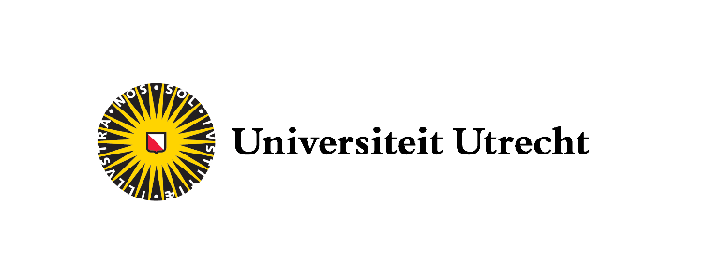

Interlocking directors of healthcare companies in the Netherlands and fraud practices

Master Sociology: Contemporary Social Problems
Author: Viradj Ramlochan Tewarie (6940757)
Supervisor: Rense Corton
Second reader: Matthias Kern
Date: 09-07-2021

Abstract

For municipalities, healthcare fraud in their region is a point of concern since the introduction of the Wmo 2015 and Jeudgzorg in 2015. In this research, we analyzed the connection between fraudulent healthcare companies and their directors and looked at the spread of fraud in the network. Counter the expectations; there was no significant difference in the connections between the fraudulent healthcare companies with directors before 2015 and after 2015. However, according to our investigation, fraudulent healthcare companies who share a director with a healthcare company are often also fraudulent. We have proposed using network analyses as a detection method that municipalities can implement as a viable analysis approach to detect potential fraudulent healthcare companies via their shared directors.

Preface

Writing a master thesis is a challenge for every student, and, in my experience, starting with writing is almost as hard as finishing. My thesis, Interlocking directors of healthcare companies in the Netherlands and fraud practices, marks the end for my master Sociology: Contemporary Social Problems at the University Utrecht. I wanted to thank my supervisor at the University, Rense Corten, for his guidance during my internship. I also wanted to thank my internship supervisor, Wolter van Dam, and the Kurtosis team, which allowed me to design my research, experiment during my internship and, most importantly, learn from my mistakes.
Finishing this Master is not the end of my academic development but instead a (short) pause in a longer process; at this junction of my life, I believe a brief reflection in my thesis is fitting. I was one of the students who loved to learn and experiment at school and later at university but always had trouble enjoying it thoroughly. Because you are often required to read and write everything at school, it was sometimes impossible to keep up with other students in my class because of my dyslexia. All the exciting things to learn were coded in a way I did not understand, and what others took minutes to understand sometimes took me hours. I write this to others who might struggle with this to tell them that it does not become easier; with time, you become better, but the moment you get lazy or stop, you will fall quickly and lose all your progress. When you struggle to swim against the current, you will become tired and might want to quit, don't, keep working, and arrive late; you will still finish and always be proud of your achievements.
At the end of my academic career, I learned not to hide this weakness but to show it instead. You might experience some ridicule, but ask for help; people are more willing to help than you sometimes think. When you hide it, you often lose more than you expect; asking for help should never be your default, but don't be scared of it. Always work hard, be honest, be kind, willing to experiment, and learn from your mistakes. I write this down not only for those who read it but for myself to never forget.
Have a great day,
Viradj Ramlochan-Tewarie
07-07-2021

Table of content

1. Introduction 4
2. Theoretical background 7
2.1 Fraud definition 7
2.2 Principal-agent model 10
2.3 Interlocking directorates 11
3. Methods section 12
3.1 Research design 12
3.2 Data 13
3.3 Operationalization 13
3.4 Analysis 15
3.5 Ethical considerations 16
4. Results 16
5. Conclusion 19
5.1 Limitations & recommendations of future research 21
6. Policy advice 22
References 23
APPENDIX A 30
APPENDIX B 33

Introduction

In 2015, the Dutch Government changed the healthcare laws for assisted living, protected living, district nursing, and youth care services, named the Wmo 2015 (social support act) and the Jeugdwet (youth law). The changes made municipalities less dependent on the central government for their local healthcare needs. The goal was to create more flexibility in healthcare options and to reduce costs by letting municipalities buy care that meets the regions' needs. With the decentralization of the government, municipalities have the responsibility to ensure that they can deliver the care needed in their region following the Wmo 2015 and Jeudgwet (den Draak & van der Ham, 2018). They also have to inspect the quality, legality, and continuity of the healthcare companies they contract before these companies can operate in their region (KluwerSchulinck, 2015). In this new system, municipalities became responsible for the costs of care in their region while ensuring that healthcare companies were keeping the standard expected in the past. However, the changes in the law did not come without opposition. There were concerns that this new system could lead to fraud by healthcare companies because of changes in the reimbursement process and the lowered entry barriers for healthcare companies (Bruggeman, Stijnen, & de Wit, 2017; van Ark, 2020b).
In 2019, news articles started coming out from the journalistic research platform Pointer and Follow the Money (FTM) who pointed at Zorgcowboys (healthcare cowboys); these were companies that used the new law to increase profits and for their self-enrichment (Mostert & Vermanen, 2019). The directors of these healthcare companies have funneled profits through organizational structures to earn more than the legal standard for top incomes in the Netherlands for the public sector, which in 2019 was a maximum of 194,000 euros per year (Vermanen, 2021; Wet normering topinkomens - BWBR0032249, 2021).
An illustration of the healthcare fraud was in the television broadcast of Pointer on September 25, 2019 (Pointer – kro-ncrv, 2019). 'Thuiszorg Naborgh,' a small company with about 25 employees that provided district nursing, was caught committing fraud. The care that they and similar companies deliver is often home care, for example, cleaning or other home-related tasks that their clients cannot do themselves because of health problems. Thuiszorg Naborgh has many clients and, as the directors of the company stated, works very efficiently. As such, they claimed to help more clients with fewer employees than other companies that provide the same services. However, Pointer showed that they did not work more efficiently, and the truth was that they were committing fraud. For example, the company charged for care that was not delivered or was of low quality. There were also cases where the 'Thuiszorg Naborgh' employees did not even go to the clients. One of their clients even saw that she receive care, according to Thuiszorg Naborg, while they were not even in the country (Mostert, 2019b).
After further investigations by the authorities and a court ruling, the company had to pay a fine because of the fraudulent practices (Mostert, 2020). When looking at healthcare fraud in the Netherlands, a challenge is to investigate how much healthcare companies have defrauded. Fraud, by its very nature, is hidden and hard to measure (e.g., van Geldrop & de Vries, 2012). Nevertheless, the best guess can be made by the director of the health insurance DSW, Aad de Groot, who states that healthcare companies with district nursing alone have defrauded between 100 to 200 million euros since 2015 (van Ark, 2020a).
In 2019, informatie knoppunt zorgfraude (IKZ), the organization that keeps track of healthcare fraud in the Netherlands, received 613 signals of healthcare fraud from municipalities, ten percent more than in the previous year. Often the municipalities give healthcare companies time to make sure there were no mistakes during the investigation and give them time to clear up mistakes before giving a signal to the IKZ (van der Laan, 2019). This extra time was often needed because of the new rules and the mistakes arising from inexperienced healthcare companies. Their behavior looked fraudulent, while it was not in some cases (den Draak & van der Ham, 2018).
Pointer and FTM have investigated healthcare companies in the Netherlands and have found that 97 besloten vernoodschap (private companies) were making profits over ten percent annually, using financial records of 2018. The healthcare insurance company DSW and other experts point that a profit of three precent annually is expected for companies that provided services within the Wmo 2015 and Jeudgzorg (Pointer – kro-ncrv, 2019). Their findings are limited since they could only look at private companies, which limited their investigating because they only looked at profit. Companies can have other forms; in the healthcare market, often vernoodschap onder firma (companies under company) and eenmanszaak (sole proprietorships). What is different in these two other forms compared to a private company is that the directors of these companies can take their salaries from the profit instead of having a fixed salary; thus, their profits are inflated and higher than ten percent (Mostert, 2019a).
In research requested by the Vereniging van Nederlandse Gemeenten (Association of Dutch Municipalities), healthcare fraud was differentiated as network fraud and organizational fraud (van der Torre & Heijkoop, 2020). In their research, network fraud is when clients and healthcare companies together defraud the healthcare system. For example, clients of these healthcare companies used a personal budget for self-enrichment and said they received care from the healthcare company when this was not the case. On the other hand, organizational fraud is when a healthcare company intended to operate as a regular healthcare company but gradually started to commit fraud over the years by charging for unprovided services. Here there is no direct involvement with the clients, and this often happens without their knowledge. Van der Torre and Heijkoop (2020) expect that a crossroad fraudster, an actor connected to multiple healthcare companies, influences healthcare companies to commit fraud. Because of the change in the healthcare law, for these crossroad fraudsters, this should be easier to do, compared to previous years. Fraudsters try to operate their company as a regular healthcare company by providing services not to get detected by the government, like in the example from 'Thuiszorg Naborgh.'
As shown above, it is complex to research the scale and how healthcare fraud is committed. Most earlier research only focused on the micro-level and only a few municipalities (e.g., Bommeljé, 2017; Fenger, Chin-A-Fat, Frankowski, & van der Torre, 2016; Torre & Heijkoop, 2020). In the case that there is an actor who instigated the fraud, these are often the directors of healthcare companies because they are the primary beneficiary of the fraudulent gains. Directors have a central role in healthcare companies and influence the decision-making of healthcare companies. To commit fraud, they create new companies or influence existing companies into committing fraud. There is also an expectation that they have a central position with other healthcare companies and, as such, can spread their health care fraud practices (van der Torre & Heijkoop, 2020). The clustering of fraud companies around a single actor is not a novel idea. For example, earlier investigations of car insurance fraud in the United States and investigations in fraud about the Italian mafia found that there are often a few actors that influence the fraud behavior and spreads through the network. A few actors that work together can influence the decisions of other actors in the network (Fronzetti Colladon & Remondi, 2017; Chang, Lai, Chou, Chiang, & Lin, 2020; McIllwain, 1999; Šubelj, Furlan & Bajec, 2011; Vlasselaer, Eliassi-Rad, Akoglu, Snoeck & Baesens, 2017).
This thesis uses the latest publicly available financial records of healthcare companies in the Netherlands made available by the Dutch Ministry of Health, Welfare and Sport (VWS) of 2019. This research does not have the goal to look at the validity of financial statements of the healthcare companies nor the accuracy of the annual reports as in journalistic research. Instead, this research looks at directors of healthcare companies and their relationship with other healthcare companies from a sociological-economic point of view. Thus, our research differs from past research that primarily focused on the individuals committing fraud or analyzing the implementation of a new policy since introducing the Wmo 2015 and Jeudgwet. Instead, we conducted descriptive research that uses this lens to investigate the current problems in healthcare fraud and give new insights for municipalities by adding to existing, policy-based research.
The societal goal of the research is to give contract managers of municipalities more insights into the healthcare companies they contract for their services. In addition, Kurtosis, the research firm for the internship, will use the results and the resulting product to support municipalities in their services to select healthcare companies with the creation of a new application.
The problem for municipalities at the moment is to make a well-informed selection to whom they want to extend a healthcare contract to operate in their region. In order to achieve this goal, we will discuss three research questions in this thesis. First, the descriptive question is: How big was the problem of Wmo 2015 and Jeugzorg fraud in the Netherlands in 2019? Second, the explanatory question in this thesis is: To what extent does the fraudulent behavior of healthcare companies spread to other healthcare companies via the directors these companies share? Finally, the policy question aims to explore the usefulness and application of this research by municipalities and reads: How can the use of network analyses of directors of healthcare companies support the supervisory task of municipalities in preventing fraud?

Theoretical background

Fraud definition

The Wmo 2015 and Jeugdwet, compared to the laws of 2007, have a greater emphasis on the decentralization of the government. As a result, municipalities have a more significant responsibility in purchasing healthcare for their regions (den Draak & van der Ham, 2018). They must ensure that the healthcare company meets the legality, continuity, and quality expectations following the Wmo 2015 and Jeugdwet law (KluwerSchulinck, 2015). Before the change, municipalities had a more passive role. Afterward, they became gatekeepers for their regions and ensured that companies met the demands required. For quality, most municipalities rely on the GGD, the public healthcare organization of that region (Mein, 2014). The GGD has the expertise and experience in inspecting whether care facilities meet the quality needs. Nevertheless, legality and continuity are inspected by the municipalities themselves.
When discussing the continuity of healthcare companies, municipalities look at the financial security by inspecting companies' spending practices and ensuring that they do not overspend their funds. When a healthcare company is spending more than they receive annually, in the long term, they could go bankrupt. For the regions they operate in, this could mean that healthcare options would disappear without the municipality having a proper replacement. Municipalities also investigate legality by looking at the healthcare company's spending and seeing if this is done in a non-fraudulent way. As discussed at the beginning of the thesis, this is a point of concern with municipalities, policymakers, and other healthcare companies like insurance companies that see that money is defrauded from the healthcare system (Bruggeman et al., 2017). While the terms continuity and legality are mentioned in the law and municipalities state that they inspect them, there is no single standard across municipalities to do these audits.

When discussing fraud, it is important to differentiate what type of fraud is being committed. Based on previous research in the Netherlands (van der Torre & Heijkoop, 2020; van Erp & Mein, 2013), there are two distinct but similar types of healthcare fraud. The first is Phantom billing: charging for care while the client has not received it. The second type is improper coding or upcoding: this is when reimbursement is requested for a different service that is more expensive. For both types of fraud, the client did not receive or got less than paid for, and the benefits are only for the healthcare company that committed the fraud (Thornton, Brinkhuis, Amrit, & Aly, 2015). In this research, we treat it as the same type of fraud because the outcome is the same - a benefit for the healthcare company via overcharging the government who pays in both cases.
During the first two years of the Wmo 2015 and Jeugdwet, the Dutch municipalities had trouble with improperly submitted claims by health care companies; they looked fraudulent but were not. In these two years, the municipalities and healthcare companies learned the new way of working and made fewer mistakes in filling out claims. Nevertheless, this still meant that something looked like fraudulent behavior while it was not, and labeling a company as fraudulent is troublesome. At the same time, it might only be inexperience with working in the healthcare system (den Draak & van der Ham, 2018). In the research of Sparrow over twenty years ago, a similar problem to the Dutch situation was happening in the healthcare system of the United States (Miller, Asher & Bayless, 1997; van Geldrop & de Vries, 2012). They started working with computers that accelerated handling healthcare companies' reimbursement claims but unintentionally made the process easier to defraud. That was because a computer cannot judge if a claim was valid, but interestingly this did not mean that every invalid claim was an attempt at fraud.
We are interested in healthcare fraud; the government inspects this by looking at legality and how companies operate. As mentioned, mistakes of healthcare companies could be seen as fraudulent, and to have a clear understanding, this distinction has to be made first. The general definition of fraud used here is: a violation of rules for obtaining benefits in which there is also a deliberate act by the person (or company) concerned (Boonstra-Verhaert, 2021). Table 2.1 shows the distinction between a mistake and fraud used for this thesis, based on findings of Fenger et al. (2016), van der Kooij (2016) and the classifications used by the Nederlandse Zorgautoriteit, the Dutch health authority who also investigated fraud (Ministerie van Volksgezondheid, Welzijn en Sport, 2018) in making these definitions.

Table 2.1 Type of problem, fraud definition.
Type of problem | Meaning
(unintentional) Mistake | The unintentional violation of a rule because of ambiguity or mistakes made in their interpretation of the rule.
Fraud | A violation of rules for obtaining benefits is also a deliberate act by the person (or company) concerned. Often for a financial benefit.

In fraud investigation, most research looks at three points of interest, pressure, opportunity, and rationalization of fraud behavior, popularized by the criminologist Donald Cressey. Together, these three points form Cressey's fraud triangle. This model, or iterations of it, has been used over the years by policymakers and social scientists to investigate fraud behavior (Kassem & Higson, 2012). With the introduction of the Wmo 2015 and Jeugdwet, the change in law created opportunities for fraudsters to defraud the healthcare system. The controls became less strict, and even years later, after introducing the law, municipalities have trouble preventing healthcare fraud. The driving factor was that the barrier to enter the healthcare market was lowered, and as long as a healthcare company had the proper permit, they could enter the market. Municipalities do not have the task of looking at the work experiences of the worker or the background of the owners of these healthcare companies in making their decisions (van der Kooij, 2016).
However, not every healthcare company started committing fraud. This is because every actor also rationalizes their choices and has pressures on them, such as environmental factors that influence these choices. While factors that increase opportunity can be observed, Kassem and Higson (2012) argue that rationalization and pressure are complex because they need a more in-depth knowledge of a fraudster, their lives, and their reasoning. According to Van der Torre and Heijkoop (2020), healthcare companies were less likely to commit fraud before the change in law than companies that entered the healthcare market after the change. These actors were motivated by the opportunity and had the pressure of making high profits as their goal. However, they also rationalized this choice. In this thesis, the principal-agent framework was used to build on this idea of rationalization.

Principal-agent model

The principal-agent model, in its simplest form, is built on the view that social life is a series of contracts between actors. Mitnick (1975) argues that principals give instructions or have expectations of their agents who have the executive responsibility to fulfill a task. However, Mitnick noted that agents could have motivations that cause them to make other choices for their benefit that are not in line with the principals' goals.
An example that illustrates the challenges with this relationship is a car repair at a garage. In this relationship, we have the car owner who wants their repairs as inexpensive as possible. On the other hand, we have an auto garage that wants to maximize profits when fixing a car. The principal-agent model states that two assumptions have to be met. The first implies that the principal's goals and the agents do not align with each other, making reaching the same goals complicated. There is also a second assumption of the principal-agent model, namely the information asymmetry between the two actors. The agent who repairs the car has all the information to see what causes the problems with the car and the cost, conversely, principals do not have this information. Thus, if the agents choose, they can overcharge the principal without their knowledge.
The primary way that principals try to mitigate this problem is by employing monitoring. Municipalities use monitoring and auditing of health care companies to ensure that they do not defraud the health care system (e.g., checking agreements and healthcare plans before signing the contracts and inspecting financial records) (Bommeljé, 2017). However, according to van der Torre and Heijkoop (2020), the municipalities with this responsibility mainly lacked this ability and could not inspect every company to the extent needed. Moreover, because of the financial restraints of municipalities for these tasks, there is a lack of employees who can carry out the inspections and have the required knowledge to do these analyses.
While municipalities monitor healthcare companies, as we discussed, there are fraudulent actors who, after 2015, started to infiltrate the healthcare market with the goal of committing fraud. This is behavior that the principals do not want from the agents. Only a few actors are fraudsters and infect as many other companies as possible around them in a network (e.g., de Koster, 2015); Torre and Heijkoop (2020) discuss the concept of crossroad fraudsters who are fraudsters connected to many other healthcare companies. These fraudsters should be the primary beneficiary of these practices, within healthcare companies, these are the directors. With these assumptions, we derived our first hypotheses: (H1) Fraudulent directors who joined the healthcare market after 2015 are more connected with fraudulent healthcare companies than fraudulent directors before 2015.

Interlocking directorates

Early findings from the domain of organizational sociology found that interlocking boards of directors are essential for transferring practices, norms, values, and policies (Mariolis and Jones, 1982; Mizruchi, 1996). Interlocking directors sit on more than one board and have a foundational role as decision-makers in companies as they connect other companies via their board seats. This means that the choices and views in one firm could spill over in other firms, and via this influence the choices that these firms make. Companies choose interlocking directors because this is an attempt to control the uncertain environment they operate in. The goal is that directors have a positive spillover effect and help reach the business goals; this idea builds on the mechanism of co-optation (Davis & Greve, 1997). The expectation is that these directors influence the network and, as such, can influence decision-making elsewhere in the network. In addition, companies want to show to the network they operate in that they have a healthy company with a good reputation; via these directors, they want to signal this.
Nevertheless, next to the relational capital of these directors, the human capital is also essential for companies and is a point of considerations when choosing a director (Wincent, Anokhin & Örtqvist, 2010). Interlocking directors are important for what they know and whom they know.
However, having a director on multiple boards can also be harmful if the director is connected with a company (suspected) of committing fraud since this negatively affects all companies' reputations (Kang, 2008; Fich & Shivdasani, 2007). As a result, companies distance these directors from the board and the company to signal that they are not associated with this behavior (Westphal & Khanna, 2003) (e.g., Cai, Dhaliwal, Kim, & Pan, 2014). There is the expectation that directors at the board of companies are the only actors that could instigate and prevent fraudulent practices because of their influence (Lai, Lei, & Song, 2018). When a company can distance itself from such directors, it can ensure that its stock price will not decrease because of the negative attention.
Kuang and Lee (2017) have argued that detecting fraud practices is more likely with interlocking directors, who use their board position to commit fraud, compared to independent directors who use their private network to commit fraud. Interlocking directors who commit fraud at one company are more significantly involved in fraud at other companies and are often a focus for investigations by auditors. This interest is also because when controlling for the private network of independent directors, interlocks are still more associated with fraud detected in auditors' work (Shropshire, 2010).
The influence of directors has not been uncontested, as far back as in the 1950s, there is the idea that directors were more seen as a representative role instead of a leading role; officers took this leading role (e.g., Chief executive officer), and managers, who take the decision making role (Zajac & Westphal, 1996). While companies still have directors partially for their knowledge and experience, the main goal was a signaling mechanism to show that a company successful. Because if a director is connected to a successful company, this gave the signal that all other companies they are connected to are also successful (Certo, 2003). For Dutch healthcare companies, this criticism is limited, and as such, can only be applied in a few rare cases. Most healthcare companies have directors involved in the decision-making. This criticism is based on the fact that most interlock research focuses on inter- or transnational companies, where most companies have many employees and managers that spread the company's control (e.g., Nicholson, Alexander, and Kiel, 2004). Based on the research above and acknowledging the criticisms of interlocking directors, we form our second hypothesis: (H2) An interlocking director connected to a company committing fraud is likely to be connected to another company engaged in fraud.

Methods

Research design

The use of network analyses offers the opportunity to create novel insights in auditing data used by municipalities and auditors in inspecting healthcare companies in the Netherlands. Our goal is to analyze interlocking directors and their influence on healthcare fraud. For our research, we will be answering our two hypotheses using financial statements of all healthcare companies in the Netherlands in 2019.
The dataset we use, DESAN 2019 (also named Zorgjaarverantwoording 2019), consists of the financial records and company information of healthcare companies in the Netherlands, collected by the Dutch Ministry of Health, Welfare and Sport in 2019 (Ministerie van Volksgezondheid, Welzijn en Sport, 2019). All healthcare companies in the Netherlands have to provide their financial statements each year via the DigiMV system. The Dutch Government uses this system to collect this data and release this publicly. The healthcare companies themself do not fill out the forms, but an external partner the healthcare company hires; in most cases, often an accounting firm, must ensure that these records are accurate.

Data

The dataset we use consists of the financial rapports and company information of 4608 healthcare companies from 2019 (Ministerie van Volksgezondheid, Welzijn en Sport, 2019). This dataset does not consist of all healthcare companies in the Netherlands but does have most healthcare companies under the Wmo 2015 and Jeudgwet, available publicly and includes financial records. As discussed throughout the thesis, the company structure is important to consider when interpreting financial records. Healthcare companies can have subsidiaries that operate separately from the leading company while being owned by that company. Because of the company structure, the government receives their financial statements in this way, and these subsidiaries with their parent company will treat it as one company. We have removed five University Hospitals from the dataset for our analysis because, as discussed earlier, these bigger companies are more complex to analyze their interlocking directors for our analyses.

Operationalization

The concerncode is a unique identifier every healthcare company in the data set has. We use this identifier for healthcare companies in our analyses because healthcare companies can have similar names; to not confuse them, we use this identifier. A fictitious example is that we used the unique concern code, 7PRZMQ7FQT, instead of "Adems Thuiszorg B.V." in our analyses.
The directors variable is the variable that contains the names of directors on the healthcare companies' board. This variable is constructed using four other variables to make up this individual variable. At the beginning of the name, the pronoun used implies if the director is male or female, in the data set Dhr., for males and Mw., for females. Then the initials of every person, the part between the first name and the last name, for example, 'de' or 'van de,' and the last name of every director, were used. These combined formed the full name of every director used in the analysis. In 17 cases, the pronoun was not present, this could be a mistake, or these people do not identify with these pronouns and choose not to use them. These names were inspected for similarity to other full names, this was not the case, and these were without pronouns included in the analysis.
A few challenges arose while constructing this variable that reduced the number of entries included in the analysis. The first initials or last name was missing in some cases, or the full first name was spelled out. In the former case, these directors were not included in the analysis because it was unsure who someone is without these values. In the latter case, the name(s) was constructed to only the initials and were included in the analysis.
Some other challenges were that some directors have entries that did not use the same format to fill out the form or made mistakes in their formating. As a fictitious example, "Mw. Joanne K ROwling" was changed to "Mw. J.K. Rowling" and included in the analysis. To ensure that the names were machine searchable, spaces in the name were limited to one (these were 852 spaces removed). The analysis aims to find interlocking directors; there are directors on the board of multiple companies. The assumption was that these were the same people and not people with the same full name as constructed. A sample of five pairs, a total of ten names were drawn whom we reviewed. In our sample, these were the same people; as such, we assume for our analyses that this is the case for all our directors. Lastly, there were 64 names removed from the directors of healthcare companies because they used a non-alphabetical name, for example, "%%~$%€" instead of a name where fill in; these were excluded from the analysis. After our exclusion criteria, we have 7308 director entries, 6915 unique directory entries, and 407 interlocking directors.
The year that a director joined the board of directors is used in our analyses. We are only interested in the year directors have joined; as such, we transformed the whole date to only the year. For example, 01-01-2015 was changed to 2015 and included in the analysis. In 486 cases, there was no year filled in; in these cases, we used a dummy variable, 1905, and included them in the analyses.
For legality, as we have mentioned, municipalities have no standard method of how they inspect this. However, drawing on lessons from past research, we found the use of expert constructs best fitting for our analyses (van Capelleveen, Poel, Mueller, Thornton & van Hillegersberg, 2016). The other method often used in fraud analysis (in the healthcare space) is data mining or machine learning (e.g., Bauder, Khoshgoftaar, & Seliya, 2016; Matloob, Khan and Rahman, 2020; Thornton, Mueller, Schoutsen, & van Hillegersberg, 2013) to find data patterns showing fraudulent behavior. The problem with this and other black-box approaches is that it is unknown why something is labeled fraudulent. Because for this reason, we found the use of a black-box method ill-considered when inspecting fraud because understanding why something is fraudulent is important in fraud investigations. We also found that other methods as inspecting one variable, such as used by Pointer and FTM, were too limited, as mentioned in the introduction (e.g., Mostert, 2020).
The internship company Kurtosis developed such an expert construct and created a single metric that indicates fraud. Municipalities are using this metric to identify fraudulent healthcare companies in their region. This metric is a trade-secret of Kurtosis, and per our agreement, we cannot explain what variables, thresholds, and weights are used.
The legality variable uses 11 other metrics that are on their turn, calculated with 34 other variables from the dataset. Because we use financial data, depending on the company structure, data could be missing, and the calculation takes missing variables into account. All eleven metrics have thresholds and weights that influence the individual score, and when combined, they give a single score between positive one and negative one to a healthcare company. Also, for example, the profit of a healthcare company is used, the weights are adjusted to take different company structures into account to prevent false positives. When the score is equal to or above zero, then the healthcare company is not committing fraud. When this is under zero, we say that the company is committing fraud. The threshold used for this metric is less strict than mentioned by other experts; this is because there is a preference for false negatives instead of false-positive when labeling a company as fraudulent by municipalities. By employing this metric, we can include all healthcare companies instead, as in previous research, only specific types of healthcare companies.

Analysis

Our network is an undirected two-mode network with two sets of nodes, the healthcare companies, and the directors. The challenge with two-mode networks is that there are limited methods to analyze the network; because of this, we projected our two-mode network as a one-mode network (Opsahl, 2014). Projections link nodes from the same set to each other when connected to the same node from the other set. For testing all our hypotheses, we use the one-mode projection of healthcare companies.
In the network diagrams, we use the same visual language in our graphs unless otherwise specified. Healthcare companies are squares, and directors are black circles. Healthcare companies depicted with a red square have a legality score lower than zero (for fraudulent), green squares are for healthcare companies with a score equal to or higher than zero (for non-fraudulent).
To test our first hypotheses, we compared the mean degree of two groups with fraudulent healthcare companies with directors from before 2015 in the first group and after 2015 in the second group. Our first group consists of 778 directors (and 553 healthcare companies), and our second group has 922 directors (and 656 healthcare companies). There is an overlap in the two groups of 66 healthcare companies that have directors in both groups. We have treated them as different healthcare companies and included them in the analyses. To compare the mean degree, we use a two-pair independent T-test to test our first hypotheses.
To test our second hypothesis, we have 407 directors connected to more than one healthcare company (622 healthcare companies). We use a segregation measure to test our hypotheses to see to what extent fraudulent and non-fraudulent healthcare companies cluster with themselves and not with each other. We also have analyzed the structure of communities in our network via visual investigations and describe these. We use the freeman segregation index, which compares the mean degree within nodes and between nodes of the network with the network if there was random mixing of the degrees (Bojanowski and Corten, 2014). We use this index because it can interpret undirected networks. In this index, a score of one means perfect segregation; this means that fraudulent and non-fraudulent healthcare companies are only connected with themselves. A zero score implies no clustering of fraudsters and non-fraudsters; the distribution of degrees is the same as random mixing.
For our analysis, we used R version 4.0.3 with Rstudio version 1.3.1093 (Borgatti, 2009; Heo, Veen, and van de Schoot, 2020; Murphy and Knapp, 2017; Ognyanaova, 2016). The igraph, netseg, car, and psych libraries were used in R for the analysis. We use Microsoft Excel to clean the data we use in our analyses and the CSV format (comma separated values) to use in R.

Ethical considerations

We choose to anonymize the names and directors in the final analysis for our study. Our consideration in making this decision is that the goal of this research is a meso analysis into what fraud looks like in the network of healthcare companies and their directors. Thus, we will not focus on individuals, and this data is not needed to interpret our results. We removed all data from the dataset we do not use for analyses to avoid unnecessary data and ensure the privacy of the directors in our network. The data is stored in the digital environment of the University Utrecht and the researcher's computer, which were both password and two-factor authentication protected to ensure that only they have access to the data. The internship had access to the edge list, a part of the data we provided per our agreement, which consists of cleaned data for their application based on this research. All other data used in this research will be deleted in one month after completing the thesis. For this research, ethical approval is given by the FETC, with the registration code: 21-0957, by Utrecht University.

Results

In 2019 there were 6915 directors and 4557 healthcare companies operating in the Netherlands. Of these healthcare companies, 1143 were fraudulent, and 3465 were not involved with fraud (see table 4.1). In figure 4.1, we see the distribution of directors; most healthcare companies have one director. There are 407 directors on multiple boards; most are on the board of two healthcare companies, see figure 4.2. The network is mainly disconnected; there is a mean degree of 1.303 for the complete two-mode network, a mean degree of 1.195 for the one-mode director projection, and a 0.258 for the healthcare companies projection. We can have zero degrees in our projections because there could be a single connection between two nodes from two different sets of nodes.

Figure 4.1. The number of healthcare companies per director Figure 4.2. The number of healthcare companies per director with at least two healthcare companies.
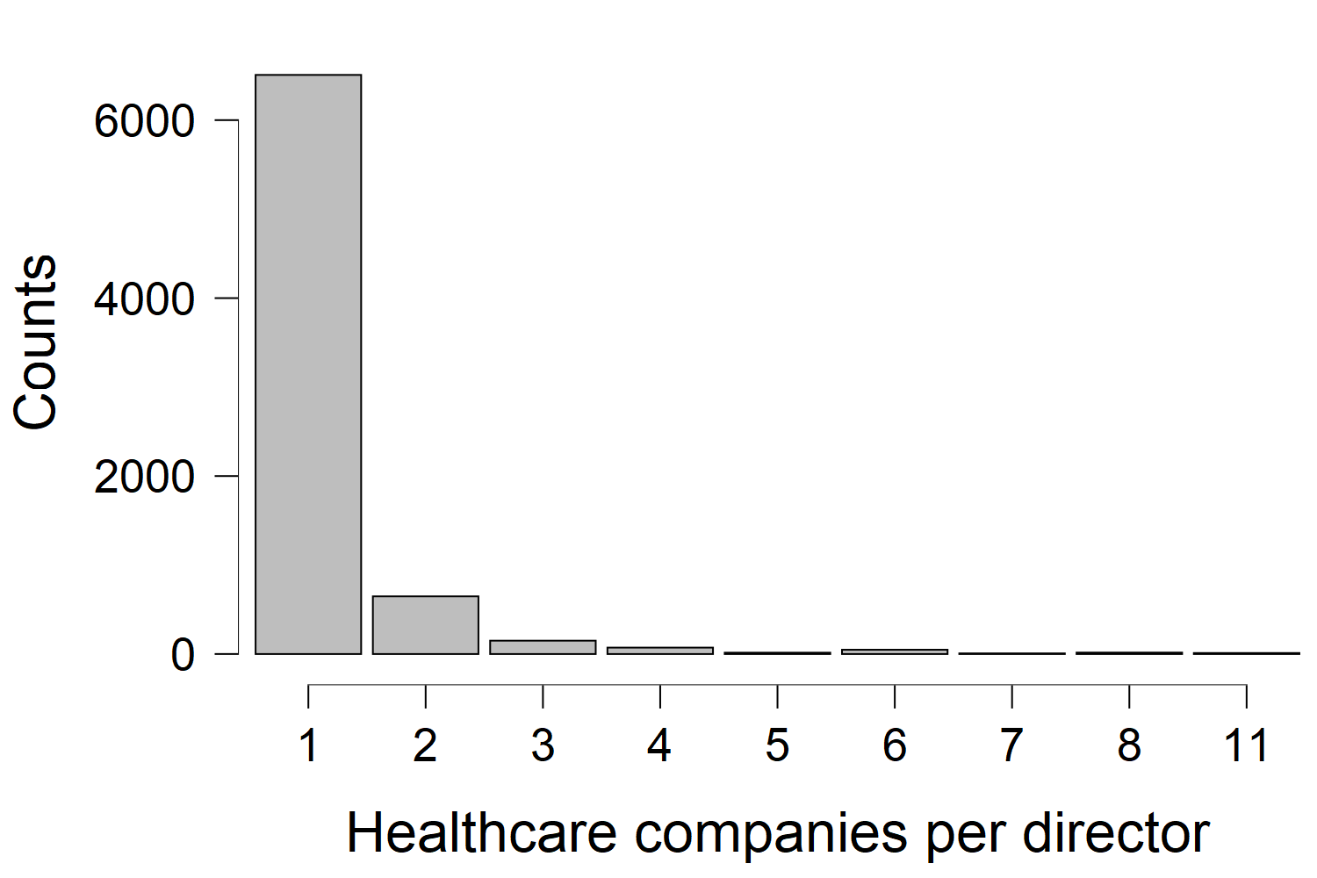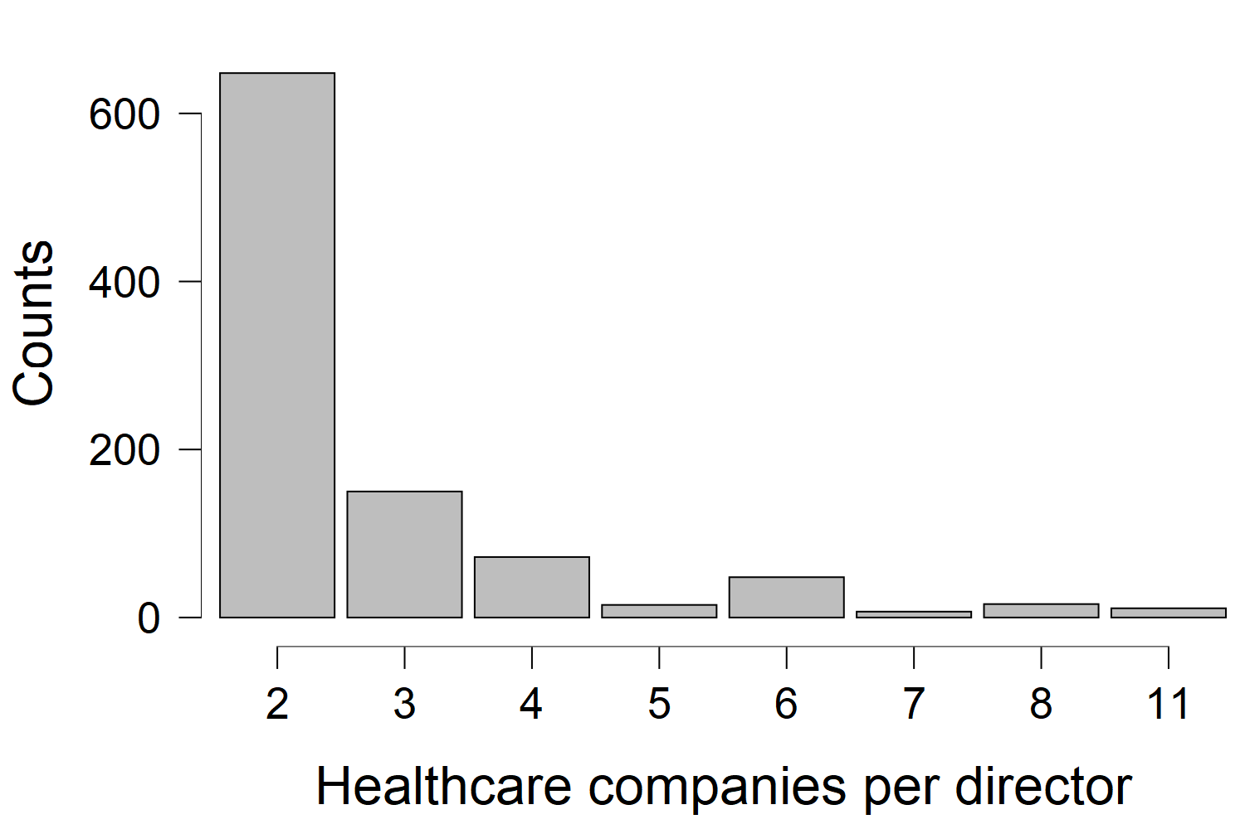
The fraudster network before 2015 has 778 directors and 553 healthcare companies with a mean degree of 1.214, and the network after 2015, 922 directors and 656 healthcare companies who were committing fraud, with a mean degree of 1.237. Our last network has 662 healthcare companies with 407 directors on the board of directors of at least two healthcare companies. The mean degree of 1.809, the director's projection is 0.904, and the healthcare company projection has a mean degree of 1.776. In this network, every healthcare company is connected with one other healthcare company via their director; because of this, the mean degree is higher than in the previous networks. All network diagrams are included in Appendix A, with corresponding figure numbers expanded for better readability.
Table 4.1. Descriptive statistics of the complete network, network before 2015, network after 2015, and interlock network
 | Complete network | Network before 2015 | Network after 2015 | Interlock network
Number of nodes | 11.472 | 1331 | 1578 | 1069
Number of directors | 6915 | 778 | 922 | 407
Number of healthcare companies | 4557 | 553 | 656 | 662
Number of fraudulent healthcare companies | 1143 | 553 | 656 | 186
Number of non-fraudulent healthcare companies | 3465 | 0 | 0 | 476
Mean degree | 1.303 | 1.214 | 1.237 | 1.809
Max degree | 16 | 16 | 16 | 11
Min degree | 1 | 1 | 1 | 1
Mean degree of director projection | 1.195 | 1.278 | 0.957 | 0.904
Max degree of director projection | 15 | 15 | 8 | 7
Min degree of directors projection | 0 | 0 | 0 | 0
Mean degree of healthcare companies projection | 0.258 | 0.123 | 0.299 | 1.776
Max degree of healthcare companies projection | 10 | 4 | 8 | 10
Min degree of healthcare companies projection | 0 | 0 | 0 | 0

Figure 4.3 Fraudulent healthcare companies before 2015 Figure 4.4 Fraudulent healthcare companies after 2015
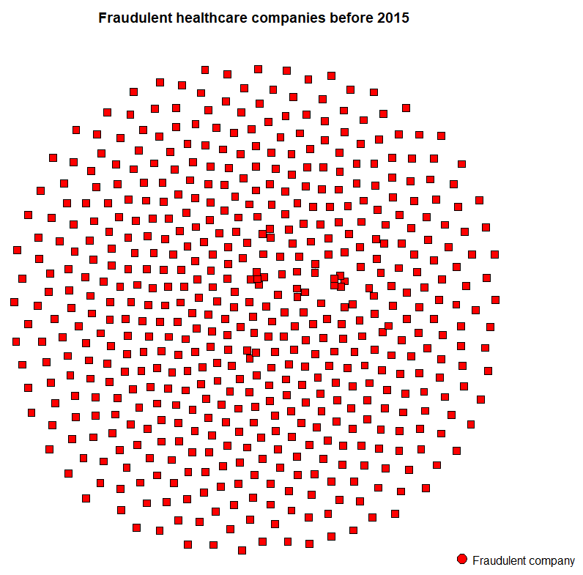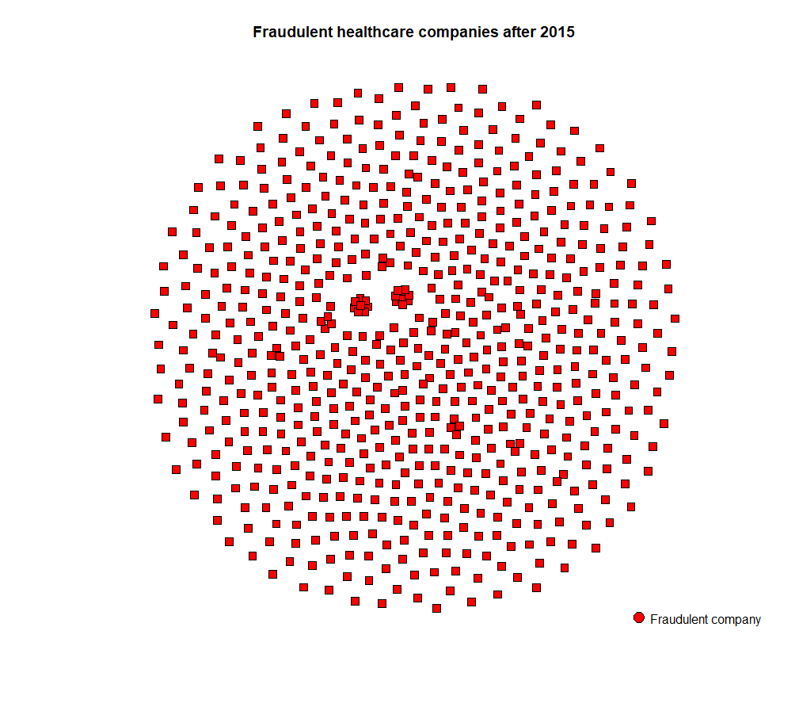

Our first hypothesis is (H1) Fraudulent directors who joined the healthcare market after 2015 are more connected with fraudulent healthcare companies than fraudulent directors before 2015. We used the one-mode projection (company-company), figure 4.3 and 4.4, to test this hypothesis, with a mean degree of 0.123 before 2015 and 0.299 after 2015. Our Levene test (F(1)=0.757, p=0.384) was not significant; we did not reject the null hypothesis and assume that the groups are equal; we continued the independent T-test. When comparing the degree of the group before and after 2015, this is not significant (t(2638.9)= -0.859, p = 0.390). We rejected our first hypothesis.
The second hypothesis that we have tested is (H2) An interlocking director connected to a company committing fraud is likely to be connected to another company engaged in fraud. When investigating the network, figure 4.5 in appendix A, we have 279 communities. We see three community structures we want to highlight and present what these look like in figure 4.6; the squares are healthcare companies, and circles are directors; the color is to differentiate the communities. The first is on the right, a single director connected to two (or three) healthcare companies, the most prevalent form in our network. The second is on the bottom, two or three directors associated with two or more healthcare companies; all the directors are connected to the healthcare companies in this community. The third is the top one and is star-shaped, with one director connected to more than six healthcare companies. When we inspect the latter type of communities, we observe that there are, in all cases, all fraudulent healthcare companies.

Figure 4.6 Communities render for hypotheses 2 Figure 4.7 Healthcare companies that share at least one director
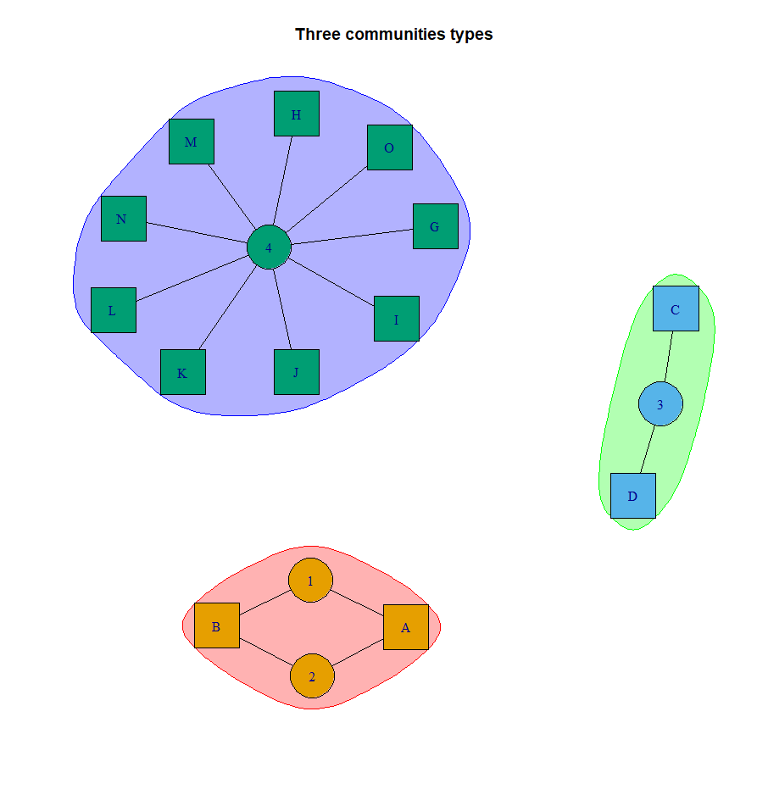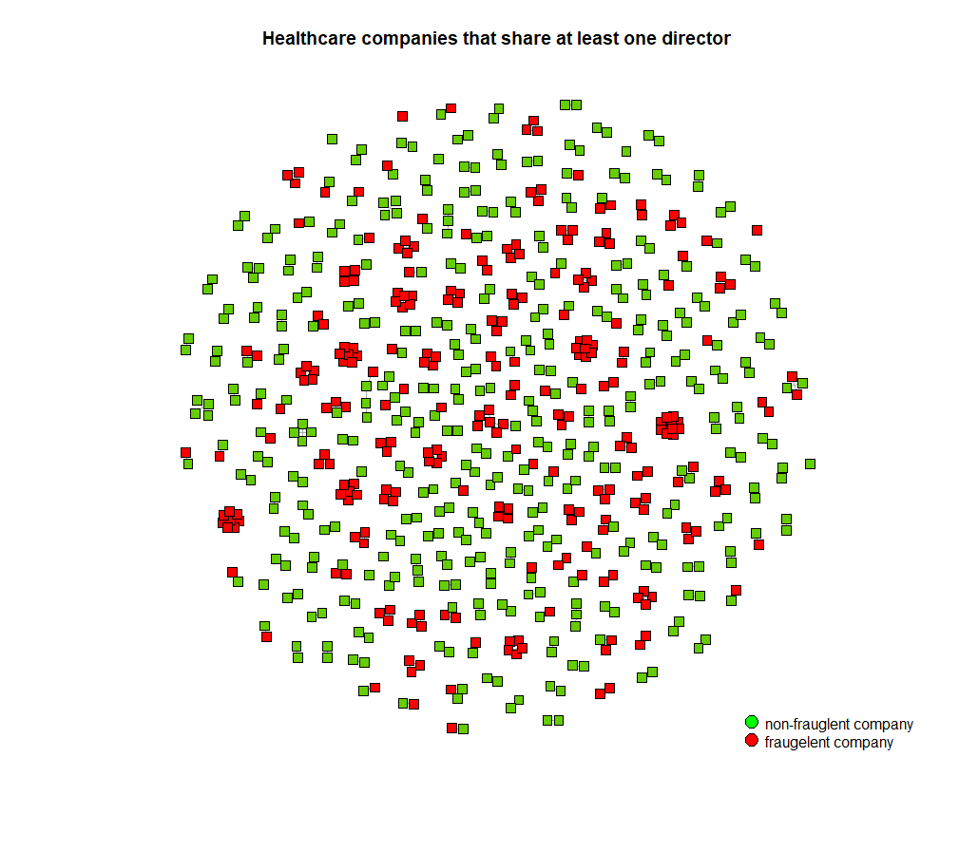
To test the hypotheses, we used the one-mode projection of healthcare companies, figure 4.7, and looked at segregation in the network; our freeman segregation index (S = 0.828) was close to perfect segregation. Fraudulent and non-fraudulent healthcare companies are more connected with themselves than with each other, compared to if the connections were random. We have confirmed our second hypothesis.

Conclusion

Our investigation has looked into healthcare fraud in the Netherlands and the influence of directors in this process. Until now, we have investigated two of our research questions; our descriptive question was: How big was the problem of Wmo 2015 and Jeugzorg fraud in the Netherlands in 2019? Our second question was: To what extent does the fraudulent behavior of healthcare companies spread to other healthcare companies via the directors these companies share?
In answering our first research question, we used our legality metric; 25.08% (or 1143 companies) of the entire network of healthcare companies is committing healthcare fraud. In our literary research, the only researched findings related to healthcare fraud were the 97 healthcare companies designated by Pointer and FTM in 2018 (Mostert, 2019a), which only looked at a subsection of the available data. Furthermore, other insights like that of Informatie Knoppunt Zorgfraude (IKZ) in 2019 stated that there were 613 signals of fraud (van der Laan, 2019). While our focus, as mentioned in the introduction, was not to evaluate the accuracy of our metric, we did find the glass box approach a benefit because we had an understanding of why a company was fraudulent, which is a severe charge for a company and should be understood before claiming a company is committing fraud. Moreover, having clear definitions and indications of a fraudulent healthcare company is essential for future research
We expected that after 2015 there was an insurgent of fraud networks, with directors as crossroad fraudsters (Torre and Heijkoop, 2020). The group of fraudulent healthcare companies and their directors after 2015 was more extensive than before 2015. However, there was no significant increase in the degree between the two groups of fraudulent healthcare companies, and thus, we rejected our first hypothesis. While we see that the degree between companies with new directors did not increase, we see that the number of fraudulent healthcare companies with new directors after 2015 is more than all fraudulent healthcare companies before 2015. While we cannot confirm a fraud network after 2015, we can state an increase of fraudulent healthcare companies that entered the healthcare market. While this could be because of the inexperience of directors, like at the beginning when the law change, we expect this is not the case because government and municipalities ensure that healthcare companies can navigate the healthcare market and help in the prevention of making mistakes (e.g., den Draak & van der Ham, 2018; van der Kooij, 2016)
For our second hypothesis, we inspected the connections between companies of directors in our network. While other research has suggested that the role of directors is often a signaling function in corporations (Certo, 2003; Zajac & Westphal, 1996), for healthcare companies, directors are influential in the day-to-day operation and responsible for fraud (e.g., Mostert, 2020). We found a high degree of segregation in our network between fraudulent and non-fraudulent healthcare companies. When directors are connected to one fraudulent healthcare company, they are likely to be connected to other fraudulent healthcare companies. Healthcare companies committing fraud are connected with these directors, and if these healthcare companies do not want to commit fraud, they would have distanced themselves from fraudulent directors (Fich and Shivdasani, 2007). We will include this finding in our policy advice on how municipalities and, in particular, contract managers could include this in their investigations for preventing healthcare fraud.
Our descriptive research into healthcare fraud made the first effort into mapping out the structures between healthcare companies and directors in the Netherlands. We found that directors of health care companies are important actors that could instigate fraud behavior and influence other healthcare companies into committing fraud. We made suggestions on how future research could expand on our research in the future.

Limitations & recommendations of future research

The first limitation of our research could be found in the dataset we used. We used cross-sectional data, which does not give us insights into how the network of healthcare companies evolved over the years. For example, we had directors in hypothesis 2 with a mix of fraudulent and non-fraudulent healthcare companies connected to them. We expect that this could mean that these directors are transitioning non-fraudulent healthcare companies to a fraudulent one or the other way around. This was not possible to investigate with our dataset, and we advise future research to look into this. We also advise to include general information about healthcare companies such as mergers of healthcare companies, all directors' who were hired over the years, and the year of establishment of the healthcare company in the analysis; these were missing in our dataset, which limited the extent of our research.
Our second limitation was the use of the legality metric; the proprietary nature of this metric has limited the reproducibility of this research by outside entities. As discussed in our conclusion, we find that using the glass box approach is invaluable because we could include more healthcare companies in our analyses and, most importantly, insights into why a company is fraudulent. We advise future research to develop a similar metric with experts (e.g., van Capelleveen et al., 2016).
Our third limitation might have been our primary interest in directors; we have seen the influence of directors on the clustering of small communities of fraudsters and non-fraudsters in the network, but we want to suggest looking beyond this for future research. Our weak findings into crossroad fraudsters might suggest that other actors, such as healthcare companies' supervisors, who also could be connected to multiple healthcare companies, could be interesting for future research to investigate. Previous research suggests that fraud clusters in the network around a few actors responsible for committing fraud (e.g., Chang, Lai, Chou, Chiang, & Lin, 2020).
Also, a further investigation of Mostert and Vermanen (2019) claims that directors choose company structures or companies outside the healthcare market to commit fraud via organizational structures. Future research can investigate the types of schemes used by healthcare companies to defraud the government. As Mitnick (1975) had discussed, the extend of influence over a director also reaches in the private environment, and future research could include this, which could explain the choice to commit fraud. We advise having the fraud triangle as a starting point when focusing on influence from the private environment of directors (Fenger et al., 2016; Kassem & Higson, 2012). By investigating pressures, opportunities, and rationalization that leads to fraud, we can increase our insights into healthcare fraud and better prevent this behavior.
The last unexplored avenue we suggest future research could investigate is searching for fraud patterns within fraudulent healthcare companies by inspecting the transactional data between the healthcare companies and the health insurance companies that handle the reimbursements (e.g., Thornton et al., 2015; Matloob et al., 2020). Because we have insights into which healthcare companies commit fraud, future research can investigate directors connected to more than one healthcare company to see the extend of fraudulent healthcare claims. These findings could help to prevent fraudulent transactions in the future.

Policy advice

This thesis has looked at directors of healthcare companies, fraudsters, and clusters of fraudsters of healthcare companies in the Netherlands. Our findings point to actionable recommendations for municipalities to employ in their efforts to prevent fraudsters from further infecting healthcare companies with fraud behavior and monitor existing healthcare companies that might display fraudulent behavior in the future. We will answer our final research question: how can the use of network analyses of directors of healthcare companies support the supervisory task of municipalities in preventing fraud?
We propose using network analyses not as a replacement for existing monitoring methods but by giving insights into the extent of fraud behavior in the healthcare market. We found that directors connected to multiple healthcare companies segregated these companies in fraudulent or non-fraudulent communities, respectively. When there is an indication of fraud, and this is being investigated, municipalities using the proprietary legality metric (alternatively a comparable metric) or using a signal like that of the Informatie Knoppunt Zorgfraude (IKZ) (Van der Laan, 2019), municipalities can use these indicators and look into the other healthcare companies connected to the directors as a preventive fraud measure. We do not suggest that all these healthcare companies should be treated as fraudulent by municipalities; instead, they should use this as a starting point in their fraud investigation.
Using this preventative measure does not only help municipalities find fraudulent healthcare companies; it also saves time and money. When fraudsters operate, this costs money for the government, and starting separate investigations is also costly for the government. As an illustration of how we see it being implemented as a utility for municipalities to use, we have included a render of the dashboard (see appendix B) we have created for Kurtosis as a part of the internship.
We also propose that municipalities should look into the directors during their investigations; building on our findings, we can assume the active role of directors in committing fraud of healthcare companies. By making directors more accountable for the committed fraud, municipalities prevent future fraud behavior by removing the incentives for fraud behavior (Mitnick, 1975). What this intervention should look like should be investigated by municipalities who have insights into the fraud investigations. Based on our findings, we propose that directors connected to more than one healthcare company should be the starting point of their research.

References

Bauder, R., Khoshgoftaar, T. M., & Seliya, N. (2016). A survey on the state of healthcare upcoding fraud analysis and detection. Health Services and Outcomes Research Methodology, 17(1), 31–55. https://doi.org/10.1007/s10742-016-0154-8
Bojanowski, M., & Corten, R. (2014). Measuring segregation in social networks. Social Networks, 39, 14–32. https://doi.org/10.1016/j.socnet.2014.04.001
Bommeljé, Y. (2017). Effectieve aanpak op basis van praktijkcasus in twente. Sociaal Bestek, 79(2), 9–11. https://doi.org/10.1007/s41196-017-0027-x
Boonstra-Verhaert, J. (2021, January 24). Column: Fraudeonderzoeken door zorgverzekeraars. BijzonderStrafrecht.nl. https://www.bijzonderstrafrecht.nl/home/column-fraudeonderzoeken-door-zorgverzekeraars
Borgatti, S. P. (2009). -mode concepts in social network analysis. Encyclopedia of Complexity and System Science, 6, 8279–8291. https://www.researchgate.net/profile/Stephen-Borgatti/publication/255386102_Social_Network_Analysis_Two-Mode_Concepts_in/links/53f9f6260cf27c365ceae063/Social-Network-Analysis-Two-Mode-Concepts-in.pdf
Bruggeman, C. W. C. A., Stijnen, R., & de Wit, J. C. (2017, April). Kroniek van het gemeentelijk sociaal domein (deel 2). Wolters Kluwer. https://www.navigator.nl/document/ida03bed20ec7d4865b236797586818ab7?cpid=WKNL-LTR-Nav2&cip=hybrid
Cai, Y., Dhaliwal, D. S., Kim, Y., & Pan, C. (2014). Board interlocks and the diffusion of disclosure policy. Review of Accounting Studies, 19(3), 1086–1119. https://doi.org/10.1007/s11142-014-9280-0
Certo, S. T. (2003). Influencing initial public offering investors with prestige: Signaling with board structures. Academy of Management Review, 28(3), 432–446. https://doi.org/10.5465/amr.2003.10196754
Chang, Y. C., Lai, K. T., Chou, S. C. T., Chiang, W. C., & Lin, Y. C. (2020). Who is the boss? Identifying key roles in telecom fraud network via centrality-guided deep random walk. Data Technologies and Applications, 55(1), 1–18. https://doi.org/10.1108/dta-05-2020-0103
Davis, G. F., & Greve, H. R. (1997). Corporate elite networks and governance changes in the 1980s. American Journal of Sociology, 103(1), 1–37. https://doi.org/10.1086/231170
de Koster, Y. (2015, March 19). Risico’s fraude gemeenten in de zorg in kaart gebracht. Binnenlands Bestuur. https://www.binnenlandsbestuur.nl/sociaal/nieuws/risico-s-fraude-in-de-zorg-gemeenten-onder-de.9466559.lynkx
den Draak, M., & van der Ham, L. (2018). Gemeenten over de uitvoering van de wmo 2015: Het glas is halfvol én halfleeg. Tijdschrift voor gezondheidswetenschappen, 96(8), 348–353. https://doi.org/10.1007/s12508-018-0207-1
Fenger, M., Chin-A-Fat, N., Frankowski, A., & van der Torre, L. (2016). Naar rechtmatige zorg in het gemeentelijke sociale domein. Faculteit der Sociale Wetenschappen. https://vng.nl/files/vng/publicatie_bijlagen/2016/eur-onderzoek-naar-rechtmatige-zorg-gemeentelijke-sociale-domein.pdf
Fich, E. M., & Shivdasani, A. (2007). Financial fraud, director reputation, and shareholder wealth. Journal of Financial Economics, 86(2), 306–336. https://doi.org/10.1016/j.jfineco.2006.05.012
Fronzetti Colladon, A., & Remondi, E. (2017). Using social network analysis to prevent money laundering. Expert Systems with Applications, 67, 49–58. https://doi.org/10.1016/j.eswa.2016.09.029
Graaf, D. N. D., & Wiertz, D. (2019). Analytical framework. In Societal problems as public bads (1st ed., pp. 28–29). Routledge.
Heo, I., Veen, D., & van de Schoot, R. (2020, May 15). Tutorial: R for beginners. Zenodo. https://zenodo.org/record/3963825
Informatie knooppunt zorgfraude. (2020, June). Jaarbeeld 2019. Ikz. https://www.ikz.nl/documenten/publicaties/2020/06/18/jaarbeeld-2019
Kang, E. (2008). Director interlocks and spillover effects of reputational penalties from financial reporting fraud. Academy of Management Journal, 51(3), 537–555. https://doi.org/10.5465/amj.2008.32626007
Kassem, R., & Higson, A. W. (2012). The new fraud triangle model. Journal of Emerging Trends in Economics and Management Sciences, 3(3), 191–195. https://hdl.handle.net/2134/10100
KluwerSchulinck. (2015). Belangrijkste wijzingingen wmo 2015. http://pdf.kluwerschulinck.nl/Belangrijkste%20wijzigingen%20Wmo%202015.pdf
Kuang, Y. F., & Lee, G. (2017). Corporate fraud and external social connectedness of independent directors. Journal of Corporate Finance, 45, 401–427. https://doi.org/10.1016/j.jcorpfin.2017.05.014
Lai, T. K., Lei, A. C., & Song, F. M. (2018). The impact of corporate fraud on director-interlocked firms: Evidence from bank loans. Journal of Business Finance & Accounting, 46(1–2), 32–67. https://doi.org/10.1111/jbfa.12362
Mariolis, P., & Jones, M. H. (1982). Centrality in corporate interlock networks: Reliability and stability. Administrative Science Quarterly, 27(4), 571–585. https://doi.org/10.2307/2392531
Matloob, I., Khan, S. A., & Rahman, H. U. (2020). Sequence mining and Prediction-Based healthcare fraud detection methodology. IEEE Access, 8, 143256–143273. https://doi.org/10.1109/access.2020.3013962
McIllwain, J. S. (1999). Organized crime: A social network approach. Crime, Law and Social Change, 32(4), 301–323. https://doi.org/10.1023/a:1008354713842
Mein, A. (2014, January). Handreiking toezicht wmo. Verwey-Jonker Instituut. https://www.verwey-jonker.nl/publicatie/handreiking-toezicht-wmo/
Miller, R., Asher, A., & Bayless, C. (1997). Sometimes bad guys wear white. Health Affairs, 16(1), 222–223. https://doi.org/10.1377/hlthaff.16.1.222
Ministerie van Volksgezondheid, Welzijn en Sport. (2018, April). Rechtmatige zorg aanpak van fouten en fraude 2018–2021. https://www.rijksoverheid.nl/binaries/rijksoverheid/documenten/publicaties/2018/04/19/programma-rechtmatige-zorg/Rechtmatige-Zorg.pdf
Ministerie van Volksgezondheid, Welzijn en Sport. (2019, June 15). Verantwoordingsgegevens per verslagjaar (datasets) [De Jaarverantwoording Zorg, Jeugd en Veilig Thuis is een jaarlijks terugkerende verplichting.]. https://www.jaarverantwoordingzorg.nl/gegevens-bekijken/verantwoordingsgegevens-per-verslagjaar-datasets
Mitnick, B. M. (1975). The theory of agency: The policing "paradox" and regulatory behavior. Public Choice, 24(1), 27–42. https://link.springer.com/content/pdf/10.1007/BF01718413.pdf
Mizruchi, M. S. (1996). What do interlocks do? An analysis, critique, and assessment of research on interlocking directorates. Annual Review of Sociology, 22(1), 271–298. https://doi.org/10.1146/annurev.soc.22.1.271
Mostert, D. (2019a, July 11). Onderzoek naar “zorgcowboys”: Veel woede, herkenning en nieuwe tips! KRO-NCRV. https://pointer.kro-ncrv.nl/onderzoek-naar-zorgcowboys-veel-woede-herkenning-en-nieuwe-tips
Mostert, D. (2019b, October 8). Inspectie dwingt thuiszorg naborgh te stoppen. KRO-NCRV. https://pointer.kro-ncrv.nl/inspectie-dwingt-thuiszorg-naborgh-te-stoppen
Mostert, D. (2020, July 22). Thuiszorg naborgh aansprakelijk voor te hoge declaraties. KRO-NCRV. https://pointer.kro-ncrv.nl/thuiszorg-naborgh-aansprakelijk-voor-te-hoge-declaraties
Mostert, D., & Vermanen, J. (2019, September 25). Zo vind je minstens 85 zorgbedrijven die structureel hoge winst maken. KRO-NCRV. https://pointer.kro-ncrv.nl/zo-vind-je-minstens-85-zorgbedrijven-die-structureel-hoge-winst-maken
Murphy, P., & Knapp, B. (2017, October 12). RPubs - Bipartite/Two-Mode networks in igraph. Rpubs. https://www.rpubs.com/pjmurphy/317838
Nicholson, G. J., Alexander, M., & Kiel, G. C. (2004). Defining the social capital of the board of directors: An exploratory study. Journal of the Australian and New Zealand Academy of Management, 10(1), 54–72. https://doi.org/10.5172/jmo.2004.10.1.54
Ognyanaova, K. (2016). Network analysis and visualization with r and igraph. Kateto. http://www.kateto.net/netscix2016
Pointer - kro-ncrv. (2019, September 25). Zorgcowboys (2/3): De directeuren van deze zorgbedrijven worden rijk van zorggeld Afl. 3. www.npostart.nl. https://www.npostart.nl/pointer/KN_1706350
Shropshire, C. (2010). The role of the interlocking director and board receptivity in the diffusion of practices. Academy of Management Review, 35(2), 246–264. https://doi.org/10.5465/amr.35.2.zok246
ŠUbelj, L., Furlan, Š., & Bajec, M. (2011). An expert system for detecting automobile insurance fraud using social network analysis. Expert Systems with Applications: An International Journal, 38(1), 1039–1052. https://doi.org/10.1016/j.eswa.2010.07.143
Thornton, D., Brinkhuis, M., Amrit, C., & Aly, R. (2015). Categorizing and describing the types of fraud in healthcare. Procedia Computer Science, 64, 713–720. https://doi.org/10.1016/j.procs.2015.08.594
Thornton, D., Mueller, R. M., Schoutsen, P., & van Hillegersberg, J. (2013). Predicting healthcare fraud in medicaid: A multidimensional data model and analysis techniques for fraud detection. Procedia Technology, 9, 1252–1264. https://doi.org/10.1016/j.protcy.2013.12.140
van Ark, E. (2020a, September 4). Binnen twee jaar miljonair in de thuiszorg. Follow the Money - Platform voor onderzoeksjournalistiek. https://www.ftm.nl/artikelen/zorgcowboys-megawinsten-bedrijven
van Ark, T. (2020b, November 4). Stand van zaken (aanpassingswet) wet toetreding zorgaanbieders en wetsvoorstel integere bedrijfsvoering zorgaanbieders. https://www.tweedekamer.nl/. https://www.tweedekamer.nl/kamerstukken/brieven_regering/detail?id=2020Z20496&did=2020D43985
van Capelleveen, G., Poel, M., Mueller, R. M., Thornton, D., & van Hillegersberg, J. (2016). Outlier detection in healthcare fraud: A case study in the Medicaid dental domain. International Journal of Accounting Information Systems, 21, 18–31. https://doi.org/10.1016/j.accinf.2016.04.001
van der Kooij, L. (2016, April). Handreiking voor gemeenten: Fraudepreventie en naleving wmo 2015 en jeugdwet. Vereniging van Nederlandse Gemeenten. https://vng.nl/files/vng/publicaties/2016/20160414-handreiking-fraudepreventie-en-naleving-wmo-jeugdwet.pdf
van der Laan, A. (2019). Rapport signalen fraude in de zorg 2019. informatie knooppunt zorgfraude (ikz). https://www.rijksoverheid.nl/documenten/rapporten/2020/06/17/signalen-fraude-in-de-zorg-2019
van der Torre, E., & Heijkoop, M. (2020, June). Een wereld te winnen over zorgfraude (wmo 2015 en jeugdwet). VNG Naleving. https://vng.nl/sites/default/files/2020-09/200630-onderzoek-zorgfraude-publieksversie.pdf
van Erp, J., & Mein, A. (2013, January). Doelgroepenanalyse declaratiepraktijk medisch specialistische zorg. Verwey-Jonker Instituut. https://www.verwey-jonker.nl/publicatie/doelgroepenanalyse-declaratiepraktijk-medisch-specialistische-zorg/
van Geldrop, A., & de Vries, T. (2012). Fraude loont de toekomst van fraude en ict. SST Academy. https://ris.utwente.nl/ws/portalfiles/portal/5143775/STT-ICT_en_Fraude-publicatie_fraude_loont.pdf
van Vlasselaer, V., Eliassi-Rad, T., Akoglu, L., Snoeck, M., & Baesens, B. (2017). GOTCHA! Network-Based fraud detection for social security fraud. Management Science, 63(9), 3090–3110. https://doi.org/10.1287/mnsc.2016.2489
Vermanen, J. (2021, February 10). Zorgbestuurders keren zichzelf 25,1 miljoen euro winst uit. Follow the Money. https://www.ftm.nl/artikelen/zorgbestuurders-keren-zichzelf-27-miljoen-winst-uit
Westphal, J. D., & Khanna, P. (2003). Keeping directors in line: Social distancing as a control mechanism in the corporate elite. Administrative Science Quarterly, 48(3), 361–398. https://doi.org/10.2307/3556678
Wet normering topinkomens - BWBR0032249. (2021, January 1). wetten.overheid.nl. https://wetten.overheid.nl/BWBR0032249/2021-01-01/
Wincent, J., Anokhin, S., & ÖRtqvist, D. (2010). Does network board capital matter? A study of innovative performance in strategic SME networks. Journal of Business Research, 63(3), 265–275. https://doi.org/10.1016/j.jbusres.2009.03.012
Zajac, E. J., & Westphal, J. D. (1996). DIRECTOR REPUTATION, CEO/BOARD POWER, AND THE DYNAMICS OF BOARD INTERLOCKS. Academy of Management Proceedings, 1996(1), 254–258. https://doi.org/10.5465/ambpp.1996.4980568

APPENDIX A
Figure 4.3 Fraudulent healthcare companies before 2015
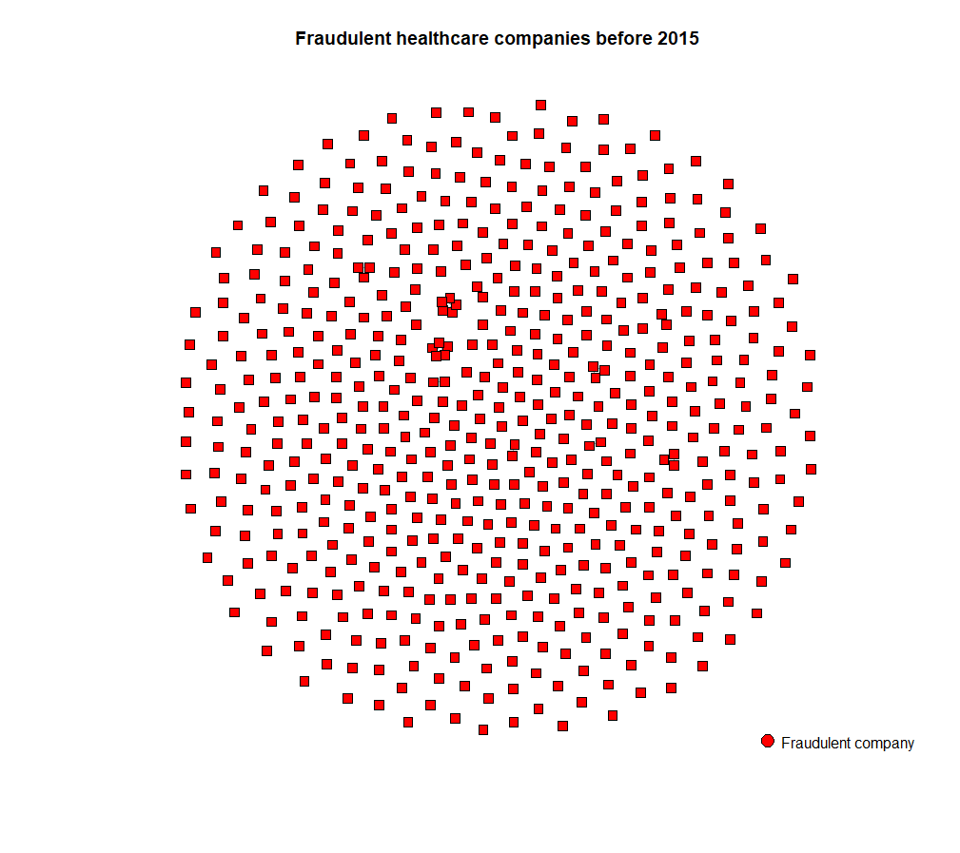
Figure 4.4 Fraudulent healthcare companies after 2015

Figure 4.5 Directors with more than one healthcare companies
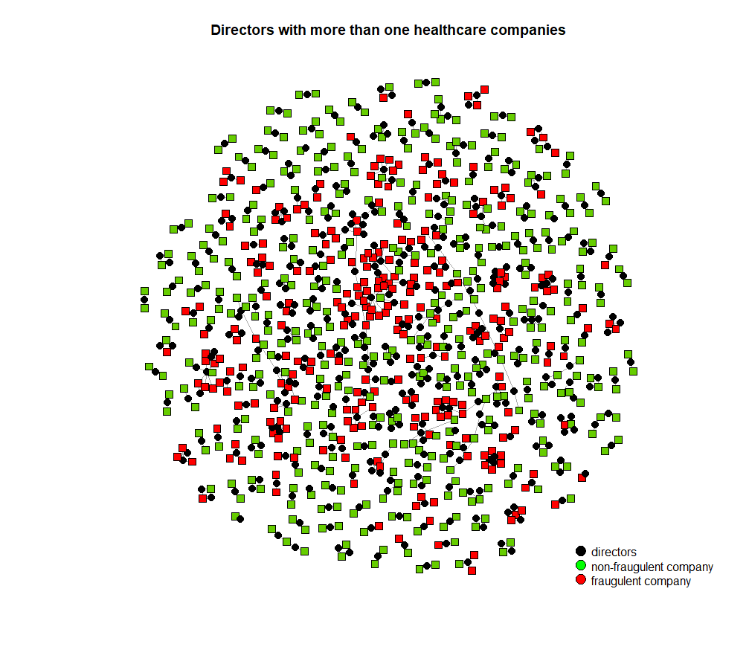
Figure 4.6 Communities render for hypotheses 2

Figure 4.7 Healthcare companies that share at least one director

APPENDIX B

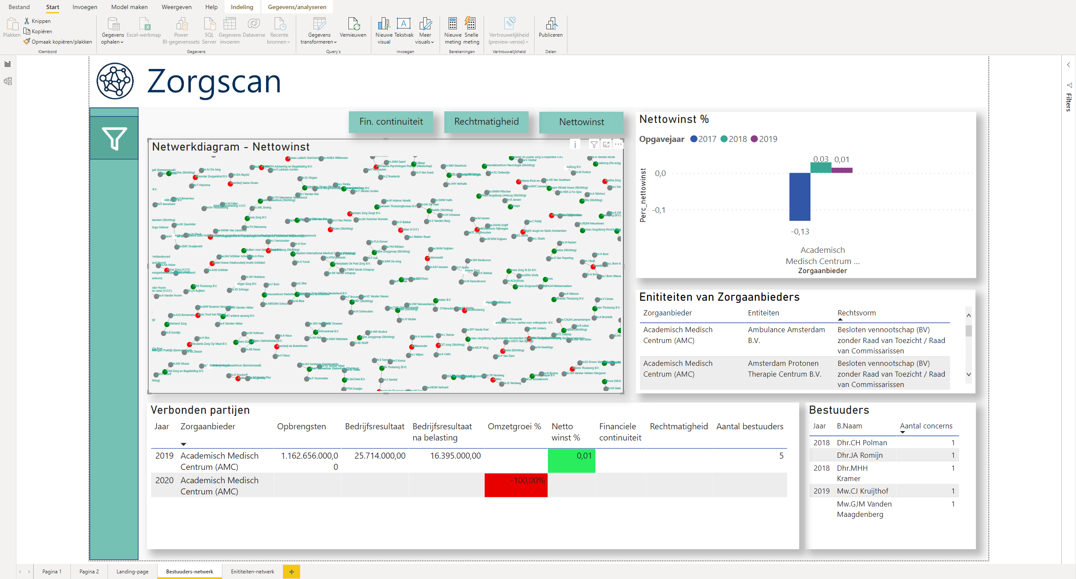
The network diagram used here is based on the thesis results, but all other indicators used were requested by Kurtosis, which were based on requirements that are expected to be useful for municipalities.

Also known as pgb, it is a budget for people in need of healthcare services but cannot afford it themselves given by the government.
With pressure is meant, what point of influence is there in a person's life that leads them to commit fraud, this could be financial (e.g., gambling addiction) or non-financial pressure (e.g., employment pressure when not committing the fraud).
When we talk about the opportunity, we talk about what allows an actor to commit fraud (often) with a reduced chance of getting caught).
Rationalization is the process of reasoning with arguments to justify an actors own actions of committing fraud. When rationalizing, this can mean that choices in the public bad, like healthcare fraud, can be rationalized to be seen as a good choice by an individual who is committing them (Graaf & Wiertz, 2019).

