How Facebook frames social interaction on virtual reality platform Facebook Horizon

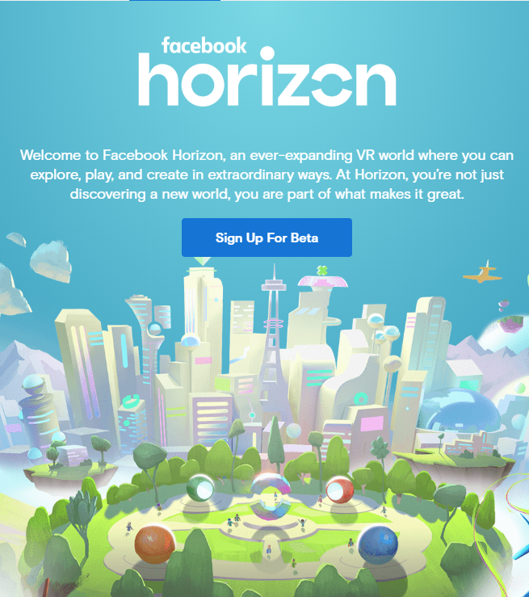

Timo Meilof, 6019471
Media & Culture Studies 2019-2020, Block 4
Utrecht University
Supervisor: Dr. Stefan Werning
June 11, 2020
Word Count: 7697
Table of Contents
Summary 2
Introduction 3
Academic Relevance 4
Theoretical Framework 5
Social Virtual Reality 6
Platforms 6
Digital framing and rhetoric 7
Citizenship 8
Play and games 9
Methodology 10
Analysis 12
Corpus 12
Metaphors of exploration and world-building 13
Play and Games 14
Metaphors of creativity 17
Citizenship 18
Conclusion 21
Bibliography 22

Summary
In this thesis, I explain my research on Facebook Horizon and I give an answer to the following research question: How does Facebook frame social interaction in virtual reality between users of Facebook Horizon? To answer this question, I have performed a framing analysis of Horizon’s public communication. To do this, I studied the language and images they used to rhetorically frame their users, and I studied the rhetorical affordances of the platform. From my research it became clear that Horizon uses four main themes a lot in the framing of their users. According to Horizon’s public communication, a Horizon user is eager to explore and build worlds, plays games with friends, is creative, and is a citizen of the virtual world. All four of the categories are also heavily interlinked and play off each other in various ways. First, according to Horizon’s framing, a Horizon user can “explore” the endless stream of content supplied by its users, in the form of games, experiences, worlds and art. Second, Horizon users can “play” many different games on the platform, some of which are developed by third parties using code, while others are made by casual Horizon users using built in creator tools. Third, Horizon users can “create” many kinds of things on the platform and share them with friends. Users can build their own spaces, but also their own games or art pieces. Finally, a Horizon user is a “citizen” of the platform who partakes in all Horizon has to offer like the things mentioned in the other three categories. Also, a Horizon citizen is a responsible person who is eager to create a respectful and comfortable culture, and after spending enough time in Horizon, the user could even become a local. This fourth category of citizenship is also somewhat of a synthesis of the other categories, because they all contribute to making a Horizon user into a citizen. Therefore, this thesis concludes that a Horizon user is a responsible citizen of the platform who, through exploring, playing, and creating, makes sure that Horizon has a respectful and comfortable culture.
Introduction
With virtual reality increasing in quality at a fast pace, and with the current desire for shared virtual workspaces and meeting spaces, Facebook Horizon could attract a mass audience and persuade people to get into virtual reality. Horizon is a virtual reality platform, announced in September 2019, which is to be released this year. It will be a virtual reality social network centred around playing games with friends, exploring the virtual world and being creative in virtual reality environments. Horizon seems poised to become a centrepiece in Facebook’s “platformization” strategy as two of their social virtual reality apps, Facebook Spaces and Oculus Rooms, have already been shut down to make way for Horizon. This shows that Horizon defines Facebook’s vision for social VR from now on, which is why it is an important platform to study.
There is an ongoing arms race between Facebook and Microsoft to create the best virtual reality platform, as Microsoft bought AltspaceVR, a similar platform, in 2017. Eric Romo, the co-founder of AltspaceVR joined the competing Facebook Horizon team only a few months later. With major tech companies investing in virtual reality platforms, the future possibilities have to be promising.
Facebook Horizon could be understood as a step to further the idea of the “Facebook nation,” which is a term used to describe Facebook, implying that it needs to be understood as a nation rather than a platform. Facebook states that Horizon users will become citizens of the virtual reality platform, which is quite literally in line with the idea of the Facebook nation. This type of framing could impact the “social imaginary” in such a way that people might start to see a future in which they would be a Horizon citizen and therefore abide by its laws and conventions. Horizon raises some important questions about privacy, especially because it is a platform from Facebook, which is notorious for its privacy scandals. To be able to exist in virtual reality and interact with the virtual world, headsets are used which generate a lot more user data than a web browser or a phone application can right now.
In my research I try to answer the following research question: How does Facebook frame social interaction in virtual reality between users of Facebook Horizon? I will also answer the following sub questions: First, what are Facebook Horizons defining affordances? Second, how does Facebook Horizon frame its users as citizens? Third, how does Facebook Horizon incorporate aspects of play? To be able to answer these questions, I have done a framing analysis. I have studied Horizon’s public communication, like the website, trailers and footage from conference talks as well as press reports on its early design affordances to be able to deduce how Facebook frames social interaction between future Horizon users as part of their platformization strategy. In doing so, this research will add to four ongoing academic discourses.

Academic Relevance
First of all, there currently is no research on Facebook horizon yet, most likely because it has only been announced since September, and because it has not been released yet. I, however, will use the already available online material to be able to answer specific research questions which don’t require access to the platform. This means that I will likely be one of the first to write about this case specifically, even though social virtual reality is already an established academic discourse. In this discourse, Fiachra O’Brolcháin et al. wrote about some of the threats virtual reality social networks might pose to privacy and autonomy and this is a great motivation for doing my research. In the paper, the authors discuss the possibility that a large social networking company, like Facebook, would develop a virtual reality social network and they argue that this could lead to large societal problems. The framing which is used by the company could contribute to the concerns regarding privacy and autonomy. My research will add a case study to this conceptual theoretical study on the convergence of virtual reality and social networks and next to that, it will expand on research on social VR by Simon Gunkel et al. They mention gaming and video conferencing as some of the key use cases for social VR, and my research will go into these uses in Facebook Horizon.
My research will also add to the study of citizenship in relation to digital media. It will expand on Joke Hermes’s research on citizenship in the age of the internet by also including virtual reality as a space in which citizenship can be practiced and as a space which can be discursively claimed as being for citizen engagement. My research also expands on Devan Bisonette’s research on DIY citizenship in which he discusses citizenship in virtual spaces. He mainly focusses on the internet, rather than on virtual reality, which is a new angle my research provides. My research will focus more on the rhetoric of citizenship as well, which is mostly left out in these studies.
My research will also add to the discourse on platforms. Research has been conducted on Facebook and other social media platforms by scholars like van Dijck, Bucher and Helmond and Hoffmann et al. My research will expand on their research by providing a case study of what could be a major new cornerstone of Facebook’s platformization strategy, and also by focussing on how the rhetoric of citizenship and games works in platformization strategies.
Finally, my research will expand on the study of the role of play in online social interaction. Espen Aarseth discussed the “implied player” as the player who is enforced to play how the game wants him to because of certain design choices, and with Horizon including games, this concept will allow me to talk about the way in which Horizon frames the players of its games. Also, Frans Mäyrä discussed key criteria for playfulness in mobile communication and he briefly touched upon Facebook’s social games. My research will add a new case to his theory, as well as focus on the role of play in growing a platform.

Theoretical Framework
In this theoretical framework I will be discussing the theories which most are important for my analysis of Facebook Horizon. I will start by discussing theories on social VR, because those form the basis for the rest of the theory. I will then move on to discussing theory on platforms, to be able to understand Horizon as a platform with the desire to grow. From there, I will move on to theory on digital language and rhetoric for the construction of meaning, which will allow me to say how Horizon frames its users through its digital rhetoric. I will then discuss literature on citizenship, with a focus on virtual and online citizenship, to be able to understand how Horizon rhetorically frames its users as citizens. Finally, I will discuss the role play and games can have for online social interaction, which will allow me to study the games and playfulness of Horizon.
Social Virtual Reality
To be able to discuss Facebook Horizon, it is important to clarify exactly what it is and how people have been studying social virtual reality up until now. In a paper by O’Brolcháin et al. the threats to privacy and autonomy of virtual reality social networks are explained. According to them, a virtual reality social network is something which could form when large social networks and virtual reality technology converge. The authors state that people in virtual reality social networks “would be represented by avatars and be able to interact in real-time in virtual environments.” According to them, some of the privacy threats include the vulnerability and misuse of data, the prevalence of recording devices and the loss of anonymity. These privacy issues might by themselves be a threat to autonomy because people could get used to living life under surveillance, but there were other threats as well like the problem of the filter bubble, problems with manipulation, addiction and quite a few more.
To be able to see how Horizon might be used, it is important to have some background knowledge on the current state of research into social virtual reality. Simon Gunkel et al. discuss some of the types of applications which users could find relevant for a social virtual reality experience. They mention video conferencing and gaming as some of the key use cases for social VR, which are both prevalent in Horizon as well.
One of the results of our increased use of online platforms for communication, is the fact that online communication is taking on a different form. According to Vincent Miller, “the notion of ‘phatic communion’ has become an increasingly significant part of digital media culture.” What is meant by phatic communion is communication with a purely social intent and without any informational or dialogic intents. This means that people communicate online only to express a mutual token of connectedness, rather than for the exchange of meaningful information. This theory will be used to analyse the types of communication which are visible in Horizon’s framing of its users.
Platforms
When discussing a platform like Horizon, it is important to have a clear idea of what a platform is, and to know how platforms try to expand their userbase. Therefore, it is good to analyse what a platform allows its users to do with it. In a paper on the affordances of social media platforms, T. Bucher and A. Helmond define “affordances” as the perceived range of possible actions linked to the features of a platform. The term allows me to talk about the embedded sociotechnical mechanisms which allow users to do certain things, and exclude other things from the platform. I will use this notion to discuss Horizon’s framing of its possible uses.
When talking about the affordances of social networks, it is important to analyse what interests these affordances serve and what this results in for the users. This is something José van Dijck argues as well in a paper on Facebook as a tool for producing sociality and connectivity. She argues that “social media platforms are manifestations of a culture wherein networked publicity strategies mediate the norms for sociality and connectivity.” What this means is that platforms, like Facebook, are at work to challenge the norms we have as a society for connectivity and sociality. This is also why some people have been referring to Facebook as a “Facebook Nation” which threatens society’s norms and conventions. By introducing a new platform like Horizon, Facebook could in theory alter societal norms in a major way, because it introduces a new way to interface with people, through the use of virtual reality.
The fact that Horizon is called a platform is not neutral, according to Tarleton Gillespie. He pointed out some of the reasoning behind the platformization of large platforms which exist today like Facebook and YouTube. According to Gillespie, the term platform “emerges not simply as indicating a functional shape: it suggests a progressive and egalitarian arrangement, promising to support those who stand upon it.” What this means is that platforms today are the supporting entities for our communication and online social interaction, but because they are designed in a particular way, they can exert control over the way they are used. Gillespie also discusses the political implications of the term, and he mentions that platforms like YouTube are using the word platform to lean on its connotations. He says that this “fits neatly with the long-standing rhetoric about the democratizing potential of the Internet, and with the more recent enthusiasm for user-generated content.” It is this democratizing potential which is worrying, because platforms could be taking over certain tasks which used to belong to governments.
Digital framing and rhetoric
To frame communication and interaction between users, Horizon employs certain types of images, language and other forms of public communication. This together makes up their digital rhetoric. According to James P. Zappen “studies of digital rhetoric help to explain how traditional rhetorical strategies of persuasion function and how they are being reconfigured in digital spaces.” According to this statement, the spaces in which people are rhetorically persuaded of things are increasingly digital. Zappen also mentions that this transformation into a new digital rhetoric “encourages self-expression, participation, and creative collaboration.” These characteristics are prevalent in a lot of digital rhetoric and it will therefore be interesting to see how they are used in Horizon’s rhetoric.
When analysing this rhetoric, it is good to understand how Facebook uses it to discursively construct their users. For this purpose, I will use a text by Anna Lauren Hoffmann, Nicholas Proferes and Michael Zimmer, in which they discuss the discursive construction of Facebook and its users. According to them “Zuckerberg’s discursive construction of user identity offers a mold within which users can be cast.” This shows how important the discursive construction and framing of a platform’s users can be. By using a certain digital rhetoric to frame a platform’s users, the platform already somewhat shapes how its users can behave.
This type of framing could alter the social imaginary, which is the way in which people can imagine the future possibilities of something, according to Bendor. This social imaginary is very reliant on the rhetorical framing of a technology, because that is what creates an image in users’ minds.
Citizenship
One of the terms Facebook Horizon uses to frame its users on their website is citizenship, which is why I will use this term as a metaphor in my analysis. For this purpose, a text by Joke Hermes about citizenship in the age of the internet is very useful. In the text, Hermes discusses how new information and communication technologies have impacted practices of citizenship. She argues that “new internet communication technologies are not necessarily producing ‘new’ citizens but they do provide for new citizen practices.” This means that people are still citizens of their own country, but they also practice new forms of citizenship online.
This is in line with Mark Poster’s idea of the netizen, which is a citizen of the internet. According to him “certain structural features of the Internet encourage, promote, or at least allow exchanges across national borders.” This means that, according to Poster, the internet, and virtual worlds as well, have properties which make sure that people will exchange information with foreigners. According to him “new media offer possibilities for the construction of planetary political subjects, netizens who will be multiple, dispersed, and virtual, nodes of a network of collective intelligence.” With Horizon rhetorically constructing its users as citizens, this could be the first step towards the creation of these netizens and concretizing what the utopian “netizen” could look like in practice. They would then be in a constant binary of states between being a citizen of a country and being a citizen of Horizon.
Play and games
Finally, I will be discussing the role of play and games in online social interaction. Frans Mäyrä came up with three criteria for playfulness in communication, namely “support for free and spontaneous user activity, the sharing of surprising contents and humorous signals for non-serious uses.” It will be interesting to see how these three criteria can be seen in Horizon. Mäyrä also mentioned that “communication and sharing has a key role in Facebook game play, and these kinds of games have gained the genre moniker ‘social games’.” Games in which communication and sharing play a key role are most likely the types of games Horizon will have as well.
According to S. Craig Watkins, “social gaming occurs in various styles and subgenres of games but refers primarily to those games in which social interaction with others is a key component of the gaming experience.” What is meant here is that social gaming needs to be understood as a form of gaming which stimulates, and usually also requires, people to interact with each other. Facebook Horizon seems to be including games in which you have to interact with friends, so studying these social games will be important.
According to Dong-Hee Shin and Youn-Joo Shin, “users accept social network games as a new way to entertain and bond with others, escape from reality, and communicate with others.” With Horizon making similar games but for virtual reality, people might again see these games as a new way to communicate with people and to escape from reality, to which the technology lends itself perfectly.
These types of games, and Horizon as a whole, can be open-ended and allow for freedom, which means that they can be called “possibility spaces”. According to Kurt D. Squire, “people enter and participate in virtual worlds which function as possibility spaces for their participants, opening and expanding new horizons, particularly new ways of thinking, doing, and being.” This means that Horizon can be seen as a space in which anything is possible and because of it, users could feel that they can expand their horizons and find new ways of thinking.
By playing social network games, users can create data and content for the owners of the game as well. This concept of working by playing is usually referred to as “playbour.” This is a term which, according to Julian Kücklich, denotes “the fact that in the entertainment industries, the relationship between work and play is changing, leading, as it were, to a hybrid form of ‘playbour’.” What is meant is that people are increasingly led to believe they are just playing games for fun while really the game owners are generating value from this play. Because of this, players can be seen as people who are not only playing, but doing labour as well, through play.
In my analysis I will also be using the notion of the implied player, which is a player who follows the implied game path which has been put in by the creators, according to Espen Aarseth. This means that there could be certain game rules or mechanics which make players behave in a particular way. The implied player could also be discursively constructed by Horizon in their public communication in the way in which Hoffman et al. described as mentioned earlier.
Finally, it is important to realize what the relationship between technology and playfulness is, especially focussing on user interfaces and platforms. Technology is, according to Miguel Sicart, increasingly appealing to our senses and feelings. He says that “a typical rhetoric of this postfunctional design makes technologies look and feel more playful.” This means that companies are increasingly designing their platforms and user interfaces to be playful, even when these quirks serve no actual use other than to entertain the user.

Methodology
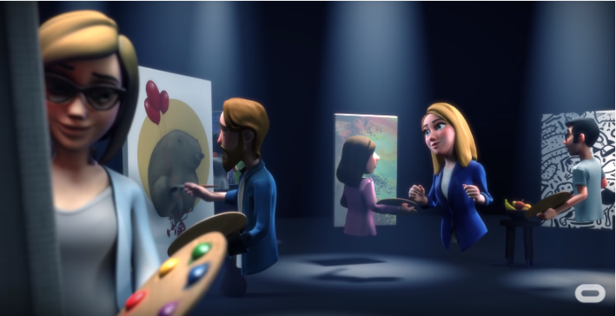
To be able to answer my questions, I performed a framing analysis of Facebook Horizon’s public communication and of journalist reviews of Horizon. George Lakoff has written a paper on the framing of the environment, which is unrelated to Facebook, but it provides good background on the methodology of a framing analysis. According to Lakoff “frames include semantic roles, relations between roles, and relations to other frames.” What this means is that by looking at framing, I can say something about the meaning Facebook Horizon conveys. Whenever they use a certain word or image, they activate the frame which comes with it. For example, if Horizon uses the word local on their website, this would activate the frame of the word, which are associations people have with locals, things locals do, and where they should be. In this case people might have the association that the locals are permanent residents of Horizon, who know everything about the virtual city. By studying the frames they use to construct an idea of their future users, I can say something about the way in which Horizon frames the interaction between its users.
I will start out by collecting information on the “affordances” of Horizon from the website, trailers and from journalist reviews. The affordances contribute to the framing of future use as part of Horizon’s “digital rhetoric” because they show what users can do in the platform. I would, for example, study the website of Facebook Horizon and analyse what it says users of Facebook Horizon will be able to do with the platform. To be able to analyse the website, I will borrow from Mel Stanfill’s interface analysis method, in which she analyses website interfaces to determine what a website’s ideal user should do. The site states, for example, that you can defy physical limits and “Push the boundaries of reality and yourself. Fly to the moon or create a masterpiece; connect with a friend across the planet; swim in the ocean without losing your breath.” This shows some of the affordances which Facebook implies are part of Horizon. Another example could be a still from the trailer, shown in Figure 1. In this image, you can see that it will be possible to be in a shared space with other people’s avatars and paint together, which are also affordances of the platform.
I will then be studying the way in which Facebook Horizon frames its users, mainly by studying public communication on the website. I will be looking for examples of framing by looking for references to users and to types of use. I will in this regard also be studying the references to citizenship, including the inherent rights and duties of users, of which I will include an example in Figure 2.
Figure 1: A Still from the trailer showing avatars painting.
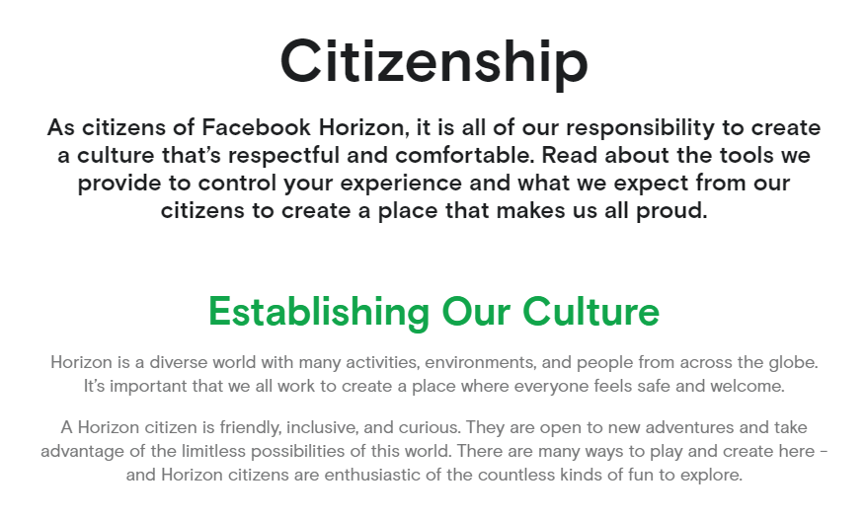
Figure 2: A Screenshot from the citizenship page on Horizon's website.
As can be seen in the image, Facebook frames their users as citizens, and they also mention that this comes with certain responsibilities. I plan to do a framing analysis of these types of pieces of text. This, together with the analysis of the affordances and games, will allow me to conclude how Facebook frames the social interaction of Facebook Horizon users.

Analysis
The analysis will be structured by the patterns which could be found across my corpus, including the concepts playfulness and games in social VR, citizenship, metaphors of creativity, and metaphors of exploration and world building. These concepts can be linked to the Horizon website very easily. This is because the three main selling points on the overview page on the Horizon website are explore, play, and create. I will therefore use these concepts and their cultural connotations to structure my analysis. The term citizenship has a separate, prominent page on the website, and so I will conclude my analysis by focussing on the metaphor of citizenship, which acts a sort of umbrella term for the other three concepts as explained below.

Corpus
In my analysis section, I will mainly focus on Facebook Horizon’s website. This is where most of the information on the platform is located and therefore it contributes to framing a lot. Another part of my corpus will consist of video footage, for example the trailer for Horizon, which shows the product in use and therefore also participates in framing. Apart from that footage, I will use footage from Oculus Connect 6, the conference at which Horizon was announced. In this conference, some demo footage of the platform in its early stages is shown and this will allow me to talk about some affordances a little more in depth. The third, and last part of my corpus consists of reviews from people who have had early access to the platform, mainly journalists. In their reviews they elaborate on the possibilities of the platform, which will allow me to deduce some more affordances and social uses of Horizon which might not be in Facebook’s trailers or public communication.

Metaphors of exploration and world-building
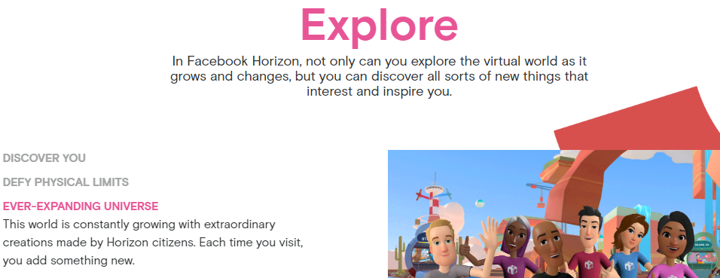
Facebook emphasises that there are near endless things you can explore in Horizon, both on their website and in the trailer. On the website, “Explore” is the first main header which can be seen when scrolling down the overview page. This is interesting because, according to Mel Stanfill, “to understand the norms sites produce, analysis must consider which responses become the path of least resistance and how.” A visitor of Horizon’s website would come across the word “explore” first, potentially priming the user to not only think of Horizon as a place to explore but also to explore the website further. However, to have things to explore, they first need to be created.
This is a problem for which Facebook found a solution in 2007, when it made its API public so that third parties could develop apps and widgets for Facebook. This resulted in the creation of content for Facebook, for which they did not have to pay anything. They seem to be taking a similar approach in Horizon by allowing users and third party developers to create worlds and experiences which can be explored by others.
On the Horizon website, under the “Explore” header, it states that you can explore an “ever-expanding universe.” This ties in well with Gillespie’s platform metaphor. A platform is boundless by definition and is therefore predicated on constant expansion. Following this logic, Horizon seems to be trying to become the starting point for all social virtual reality interaction in the future. They are trying to create the backbone and social infrastructure which will allow users and third parties to easily create and share content on Facebook’s behalf. This interplay is what creates their “ever-expanding universe” for its users to explore.
Facebook Horizon seems to be emphasising the fact that it is an open-ended game, to which Kurt Squire refers to as a “possibility space.” Horizon is framing itself as a possibility space in which anything is possible, showing how closely interrelated the four topics of my analysis are because together, they encompass the endless possibilities of a digital world. On their website, they mention the wide range of possible options for exploration: “Push the boundaries of reality and yourself. Fly to the moon or create a masterpiece; connect with a friend across the planet; swim in the ocean without losing your breath.” According to their framing, anything is possible, as long as you can think of it. This could also impact people’s “social imaginary” on the topic of virtual reality by reframing it as a technology with endless potential.
One other thing mentioned on Horizon’s website under the “Explore” header is that it is not only about discovering the virtual world as it grows and changes but apparently also about discovering yourself and finding inspiration. According to them “You build it how you see it,” which shows that Horizon is framing the experience of the platform as not only being about exploring things other people made but also about exploring your own imagination and creativity, which again links to another one of my main concepts, creativity, which will be discussed later on.
Figure 3: A Screenshot from the overview page of Horizon's website.

Play and Games
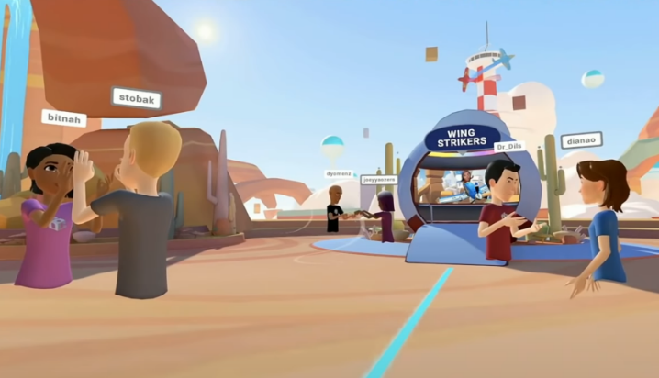
Judging from the website and the trailer, Horizon seems to include a lot of games as its main attractions, especially in its early stages. This is similar to Facebook as a platform, which also used games for expanding its userbase relatively early on, allowing people to request extra game currency from their Facebook friends for example. “Play” is the second major header on the overview page of Horizon’s website, and games have been a part of other public communication as well, like the trailer and oculus connect conference talks.
One interesting angle to view Horizon’s framing of its users as gamers is that of the implied player. Espen Aarseth says that the implied player “can be seen as a role made for the player by the game, a set of expectations that the player must fulfill.” What this means for Horizon is that by emphasising a certain type of player in their public communication, they already show the expectations they have for their users.
Horizon seems to focus on social gaming, with the website emphasizing “Friendly competition” and “Teamwork” as two of the three headers under “Play.” This emphasis is also present in the trailer, which shows the main character playing a flying game and a shooting game, with some of her friends. The types of games which are shown are good examples of “social gaming” because interaction with others is a key part of the experience. This can be seen in one of the talks given at Oculus Connect 6 as well in which Mike Howard, product manager at Oculus, mentioned that they were focussing on a party system in Horizon which would streamline joining friends in their experiences as much as possible. With this system, Horizon seems to emphasise playing together as an important part of the experience.
To be able to play together, Facebook has developed a few games themselves, but it seems as though they are hoping for third party developers to create “social network games” for Horizon. According to Dong-Hee Shin and Youn-Joo Shin, “users accept SNGs as a new way to entertain and bond with others, escape from reality, and communicate with others.” Horizon plays into all these aspects very well. It allows users to bond with other users by having them play in a shared space. It also allows users to escape from reality, not only by playing a game, but by being in virtual reality as well. Finally, it also allows users to communicate with others through the use of spatialized VoIP audio, which was also named as a key functionality by Mike Howard in his talk. This implies that users will be able to feel as though they are in a coherent three dimensional space, with sound coming from different angles and distances. This is a major change in virtual group communication, as one of the major issues of current group meeting programs is the fact that all speakers are heard by everyone at the same level of loudness, meaning that only one person can realistically talk at a time. In Horizon, this would be solved by allowing users to talk to those close to them in a virtual space like the one in Figure 4, which implies that users are able to work in groups more effectively and also strengthens the sense of place. This could also lead to a culture in which people would have more in depth online communication because of the possibility for virtual face to face talking, rather than the “phatic” kind of communication to which people resort to through mobile communication devices.
With regards to games, Facebook mainly shows the game with the airplanes, called Wing Strikers, which seems to be a major selling point. Scott Stein, a journalist for Cnet.com, described it as “a dogfighting mini-plane sports game that's as fun as most VR games I'd pay for.” This shows how Horizon’s users might assess the platform, in terms of how much “fun” it provides. By developing a game which can compete with other paid VR titles, Horizon might draw in VR gaming enthusiasts with the game alone. According to Stein, this game has been developed by Facebook specifically for Horizon and it was built without using Horizon’s in-platform creative tools unlike some of the other games shown like Robo Rumble, which is probably why it is so impressive. Wing Strikers is a game which plays into the freedom of movement which virtual reality promises. Being able to fly a plane around and at the same time playing a game of capture the flag with friends frames the Horizon user as someone with the freedom to do what they want. Flying around in a plane signifies freedom, which is most likely the connotation Facebook wanted to emphasise, showing that even in gaming Horizon users are free to do anything they can think of.
In Horizon players are free to play how they want and free to create games the way they want them. They seem to adhere to Mäyrä’s criteria for social games which were “support for free and spontaneous user activity, the sharing of surprising contents and humorous signals for non-serious uses.” Sharing surprising content seems possible for sure, but the other two criteria are relatively limited. First, free and spontaneous user activity is limited by the “affordances” of the creator tools. When something is embedded into the tool it can be done, however when someone wants to express his freedom by building a revolutionary game, this is not necessarily possible in Horizon. Second, the creator tools could limit the way in which users can be “playful” with the games they want to create, because the tools most likely only allow for the creation of very simple games. This also raises questions regarding the distribution of creative power because a programmer would be able to create much more intricate games than a casual Horizon user using the built-in creator tools.
Figure 4: A still from the Day 1 Keynote showing a virtual space from which users can enter games.
Figure 5: A still from the Day 1 Keynote showing gameplay footage in Wing Strikers.

Metaphors of creativity
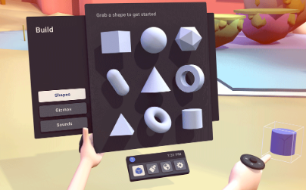
Creating your own experiences, places and objects seem to be some of Horizon’s key features. According to Helen Thornham, “the pervasive features of creativity that seem to have stood the test of time are the notion that creativity is productive and that it is located at the site of the individual.” This means that creativity is an individual productive process and Horizon seems to be focussing on letting the individual produce as well. According to Mark Zuckerberg, in his Oculus Connect keynote, “The best part is that the creator experience is built right into VR.” This implies that a creator experience is something which can be built in to allow people to be productive by themselves. Apparently, you do not need experience with coding, and you can, according to Zuckerberg, “create something neat in a couple of hours and then invite your friends in to come and check it out.” To be able to do this, Facebook Horizon seems to be using a tool similar to Google’s tilt brush VR. The tool, as depicted in figure 6, consists of a menu with shapes, colours, effects and even sounds and “gizmo’s” which are probably interactable gadgets. Horizon seems to frame its users as creatives who can build anything they want “from simple or complex 3D objects using a library of shapes and tools, all the way to building complex multiplayer games and experiences with visual scripting.”
This ties in with their platformization strategy and it allows them to generate content without putting in the work themselves. By letting users create content, Horizon generates a lot of free surplus value through user labour. Similar relations between the owner of a platform or product and users who generate extra content for it, have previously been referred to as instances of “playbour.” Playbour is a term which, according to Julian Kücklich, denotes “the fact that in the entertainment industries, the relationship between work and play is changing, leading, as it were, to a hybrid form of "playbour".” By providing tools for people to create, and emphasising the fact that this should be fun, Horizon frames its users as content creators as well.
A trend towards letting users create content, and also “claiming” this creativity as a key aspect of online social interaction, can be seen in the slogans of some other upcoming new platforms. For example TikTok’s mission is “to inspire creativity and bring joy,” while Triller’s mission is “Create, Share, Connect,” and lastly Byte’s mission is “Creativity first.” Following this trend it is no surprise that Horizon also emphasizes the fact that users can create and share. Under the “Create” header, the website states that “Our content discovery and distribution tools help surface your creations for everyone to enjoy.” This means that the content which you create will be easy to share with others and it might even have the possibility to go viral if the content discovery and distribution tools are anything like Facebook’s.
With horizon emphasizing the possibility of creating your own experiences and spaces, they seem to be going along with the trend in new media described by Watkins: “In the new media regime, users expect to be able to create and control their own content and increasingly create their own stories.” Horizon actively frames its users as being able to create and control their own content and games, with them emphasising the fact that users can do anything on the platform.
Figure 6: A still from the Day 1 Keynote showing Horizon's built in creator tool.

Citizenship
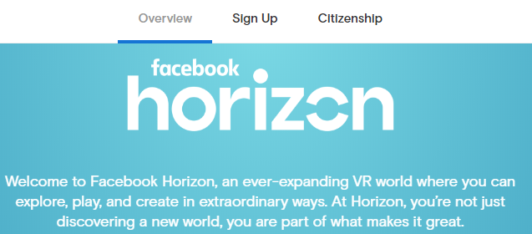
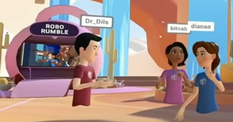
The Horizon website has a few different pages, the “Overview” page, the “Sign Up” page and the “Citizenship” page. The fact that citizenship has its own dedicated page already shows how important Facebook thinks it is that Horizon users will see themselves as citizens, rather than as just users. The “ideal user” of the website clicks on citizenship after having read the overview page, and maybe even after having signed up for the beta.
When having clicked on the page, the first sentence on there reads “as citizens of Facebook Horizon, it is all of our responsibility to create a culture that’s respectful and comfortable.” By mentioning that this statement applies to citizens, and by stressing “our responsibility,” Facebook constructs its users as citizens who have a responsibility to act in a certain way. As Hoffman et al. mentioned “Zuckerberg’s discursive construction of user identity offers a mold within which users can be cast.” This mould within which users can be cast is in this case a responsible citizen who cares about a respectful and comfortable culture in Horizon. Interesting is their use of the word culture, because this is a very hard to define term, according to Sandra L. Faulkner. In her chapter on redefining culture, she brings together some of the general themes which can be linked to the word culture. Culture seems to be, according to Faulkner, mostly referring to social structures and processes following certain group values, with a possible element of power or ideology. A shared culture is often created through a shared history, experience, norms, and values. This means that for Horizon, by framing the culture they envision, they are already letting its future users get accustomed to the type of culture they will be a part of, which can impact the way they will use the platform. This shows how Horizon is already creating some of the norms for sociality and connectivity by making use of publicity strategies, like van Dijck described as mentioned earlier.
A little below the main statement on the citizenship page on Horizon’s website is the section “establishing our culture” in which the following is stated about Horizon citizens: “They are open to new adventures and take advantage of the limitless possibilities of this world. There are many ways to play and create here - and Horizon citizens are enthusiastic of the countless kinds of fun to explore.” This piece of text seems to be referring back to all of the previously discussed main topics, which were also mentioned on the overview page of the website: explore, play and create. This piece of text frames a Horizon citizen as someone who likes to do all the things which they frame as being possible on the platform. This shows that the page about citizenship is partly a synthesis of the previous topics, which means that a good Horizon citizen is framed as someone who uses the platform in the way in which Facebook has discursively constructed its possible uses.
When you use Horizon as a citizen, you can apparently become a Horizon local, a community guide. According to the website, locals are “welcoming, supportive, and have a deep knowledge of Horizon.” This function could be similar to Google Maps’s local guides, which is a gamified function of maps in which you get points for adding things to the map, writing reviews, and therefore helping out foreigners. Horizon could employ a similar tactic, in which they would give people points, or other virtual rewards, for helping out newcomers. In this piece of text, Horizon frames its locals as welcoming, supportive and having deep knowledge of Horizon, a virtual environment. These characteristics are very similar to locals in the real world, who also have deep knowledge of their environment. By stressing the fact that locals can exist in Horizon, Facebook frames it as being a place where you can spend enough time, and feel well enough at home, that you become a citizen of Horizon, next to being a citizen of your home country. This also shows how, like Joke Hermes theorized, new practices of citizenship can emerge from digital media, in this case being a local of Horizon. This concept of the local also links well to Poster’s idea of the “netizen.” When users of Horizon would identify as locals, they would be netizens of Horizon. This would, however, go against the idea of the netizen being a planetary political subject because they would reside on Horizon, instead of in an online network of collective intelligence. When users would be citizens of Horizon in this way, Horizon would effectively be a legitimate system of governance.
At the bottom of the page, they show they are planning on providing tools which can control your experience, by for example only allowing people within a certain distance of your avatar and having a sort of panic button which takes you out of the experience in case other Horizon users are being annoying. Here, a Horizon citizen is framed as in control of the experience at all time, meaning that at any moment in which you would rather not be a Horizon citizen, you can jump straight out of the experience.
When looking at the demo footage from OC6, it becomes clear that it will be possible to create your own avatar, which will have its own username. Some of the names included numbers, and none of them included last names. This would seemingly allow users to create an avatar to their liking. However, the only way to log in to Horizon is with a Facebook account. According to Watkins, “whereas users of Facebook engage in identity management and self-representation, users of synthetic worlds engage in identity play and self-experimentation.” In Horizon’s case you are free to make your avatar an alternative self, but it will still be linked to your Facebook account, which means that your friends will most likely be able to recognize the fact that you are behind the avatar. This means that there is a loss of anonymity which usually did exist in virtual worlds in which users could create their own avatars because it will be possible to trace back to your real self.
Figure 7: The top of Horizon's website on the overview page.
Figure 8: A still from the Day 1 Keynote showing an example of avatars and their names.

Conclusion
According to my analysis, the following things about Facebook Horizon become clear. Horizon frames its users as exploring, creating and playing citizens of a virtual world. The ideal horizon user is one who explores its endless possibilities, who tries his luck at creating some places and experiences himself, and who uses it to meet friends and play games together. Games can be created by users and third-party developers, and Horizon will make it fast and easy to launch into one of these games and experiences. There is a focus on social interaction to be seen here as well, where people can be in a shared space together before they hop into a game, so that they can interact before and after the experience. A Horizon user also takes the time to explore things, either alone or with friends. There will be an endless stream of content for people to enjoy and find inspiration in. The ideal horizon user also adds content to this stream, either by using the built-in tools or by developing an experience if the user has coding skills. A Horizon user is also framed as a responsible citizen who is actively trying to create a respectful and comfortable culture and he or she is friendly, inclusive and curious. Doing all this is what, according to Horizon’s framing, makes a user into a Horizon citizen.
One interesting recent development is that in the end of May 2020, a very similar platform to Horizon has been announced by the former CEO of HTC. It is called Manova and can only be played on the Mova VR headset, which will be released with it. Judging from the website it looks like very similar remake of Horizon aimed more at the Asian market, where Facebook is not as prevalent. The other social VR platforms currently in existence, like altspaceVR and Rec Room VR could suffer from Horizon’s launch, because they are most likely not as perfected and are struggling with a smaller budget. With the current pandemic, it seems like a great time for Facebook to release Horizon because everyone is forced to work at home using video calling apps like Microsoft Teams and Zoom. Facebook Horizon could be a great solution, since it allows its users to be in a shared space together in which they could work, and through the use of spatialized audio people would be able to have more streamlined conversations with people who are closer to them.
My research is unfortunately not without limitations, some of which I will now address. My research has only focussed on the information which was available before the platform’s launch, and is therefore only able to say how Horizon framed its users, and not anything about the platform in use. My research should be seen as a first step towards understanding the direction Facebook seems to be taking with Horizon. This research can be expanded on by studying the platform itself upon release and seeing how, for example, the interface and affordances of the platform will shape user behaviour. It would also be good to study how the platform generates data, and on what exactly, because the impact of gathering detailed data on a large scale would warrant further research, with Facebook already appearing in a lot of data related scandals and with VR being a technology which inherently creates more data than mobile phones and computers. My research focussed on only one social VR platform, while there are others to study. Studying the framing of users in Horizon, and in Manova as well when it gets released, would be able to tell us a lot about how the creators of these platforms envision our virtual reality future, and whether that should worry us or whether it should excite us. For now, Horizon seems to warrant a little bit of both.

Bibliography
Aarseth, Espen. “I Fought the Law: Transgressive Play and the Implied Player.” In From Literature to Cultural Literacy, edited by Naomi Segal and Daniela Koleva, 180-188. London: Palgrave Macmillan, 2014.
Baldwin, John R., Sandra L. Faulkner, Michael L. Hecht, and Sheryl L. Lindsley. “Redefining Culture: Perspectives Across the Disciplines.” In Redefining culture: Perspectives across the disciplines, edited by John R. Baldwin, Sandra L. Faulkner, Michael L. Hecht, and Sheryl L. Lindsley, 27-52. Mahwah, N.J. : Lawrence Erlbaum Associates, 2006.
Bendor, Roy. Interactive Media for Sustainability. Cham: Palgrave Macmillan, 2018.
Bissonette, Devan. “A Digital Democracy or Twenty-First-Century Tyranny? CNN’s iReport and the Future of Citizenship in Virtual Spaces.” In DIY Citizenship : Critical Making and Social Media, edited by Matt Ratto and Megan Boler, 385-402. Cambridge: MIT Press, 2014.
Bucher, T. and A. Helmond. “The Affordances of Social Media Platforms.” In The SAGE Handbook of Social Media, edited by J. Burgess, A. Marwick and T. Poell, 233–253. London and New York: Sage Publications, 2018.
Dijck, José van. “Facebook as a Tool for Producing Sociality and Connectivity.” Television & New Media 13, no. 2 (March 2012): 160–76.
Gillespie, Tarleton. “The Politics of ‘Platforms’.” New Media & Society 12, no. 3 (May 2010): 347- 364.
Google Maps. “Local Guides.” Accessed June 11, 2019. https://maps.google.com/localguides.
Gunkel, Simon, Hans Stokking, Martin Prins, Omar Niamut, Ernestasia Siahaan, and Pablo Cesar. “Experiencing Virtual Reality Together: Social VR Use Case Study.” Proceedings of the 2018 ACM International Conference on Interactive Experiences for TV and Online Video (TVX ’18), (June 2018): 233–238. https://doi.org/10.1145/3210825.3213566.
Hermes, Joke. “Citizenship in the Age of the Internet.” European Journal of Communication 21, no. 3 (September 2006): 295–309.
Hoffmann, Anna Lauren, Nicholas Proferes, and Michael Zimmer. “‘Making the World More Open and Connected’: Mark Zuckerberg and the Discursive Construction of Facebook and Its Users.” New Media & Society 20, no. 1 (January 2018): 199–218.
Holt, Kris. “Social VR world 'Facebook Horizon' comes to Oculus in 2020.” Engadget, September 25, 2019. https://www.engadget.com/2019/09/25/oculus-social-vr-world-facebook- horizon/.
Kharpal, Arjun. “Mark Zuckerberg is 'Dictator' of Facebook 'Nation,' Says the Pirate Bay Founder.” Entrepreneur, May 31, 2016. https://www.entrepreneur.com/article/276711.
Kücklich, Julian. “Precarious Playbour: Modders and the Digital Games Industry.” Fibreculture 5, no. 1 (September 2005): 1-5.
Lakoff, George. “Why it Matters How We Frame the Environment.” Environmental Communication 4, no. 1 (March 2010): 70-81.
Matney, Lucas. “AltspaceVR CEO joins Facebook months after selling his startup to Microsoft.” Techcrunch, January 22, 2018. https://techcrunch.com/2018/01/22/altspacevr-ceo- joins-facebook-months-after-selling-his-startup-to-microsoft/.
Matney, Lucas. “Microsoft acquires social virtual reality app AltspaceVR.” Techcrunch, October 3, 2017. https://techcrunch.com/2017/10/03/microsoft-acquires-social-virtual-reality- app-altspacevr/.
Mäyrä, Frans. “Playful mobile communication: Services supporting the culture of play.” Interactions: Studies in Communication & Culture 3, No. 1 (October 2012): 55-70.
Miller, Vincent. “New Media, Networking and Phatic Culture.” Convergence 14, no. 4 (November 2008): 387–400.
O’Brolcháin, Fiachra, Tim Jacquemard, David Monaghan, Noel O’Connor, Peter Novitzky And Bert Gordijn. “The Convergence of Virtual Reality and Social Networks: Threats to Privacy and Autonomy.” Science and Engineering Ethics 22, no. 1 (January 2015): 1-29.
Oculus. “Citizenship.” Accessed June 5, 2020. https://www.oculus.com/facebookhorizon/citizenship/.
Oculus. “Day 1 Keynote | Oculus Connect 6.” YouTube, September 25, 2019. https://www.youtube.com/watch?v=RCB_mfGmh9w.
Oculus. “Facebook Horizon Overview.” Accessed June 10, 2020. https://www.oculus.com/facebookhorizon/.
Oculus. “Oculus Connected: Building Social Experiences and Connecting People at Scale.” YouTube, September 26, 2019. https://www.youtube.com/watch?v=oPVsmDd51Lk.
Oculus. “Welcome to Facebook Horizon.” YouTube, September 25, 2019. https://www.youtube.com/watch?v=Is8eXZco46Q.
Poster, Mark. "Digital networks and citizenship." pmla 117, no. 1 (2002): 98-103.
Shin, Dong-Hee and Youn-Joo Shin. “Why do people play social network games?” Computers in Human Behavior 27, no. 2 (March 2011): 852-861.
Sicart, Miguel. Play Matters. Cambridge: The MIT Press, 2014.
Squire, Kurt D. "Video Games and Education: Designing Learning Systems for an Interactive Age." Educational Technology 48, no. 2 (March-April 2008): 17-26.
Stanfill, Mel. “The Interface as Discourse: The Production of Norms through Web Design.” New Media & Society 17, no. 7 (2015): 1059–74.
Stein, Scott. “I tried Facebook’s vision for the social future of VR, and it’s full of question marks.” Cnet.com, accessed May 21, 2020, https://www.cnet.com/news/i-tried-facebooks- vision-for-the-social-future-of-vr-full-of-question-marks/.
Thornham, Helen. “Claiming ‘creativity’: discouse, ‘doctrine’ or participatory practice?” International Journal of Cultural Policy 20, no. 5 (2014): 536-552.
Viner, Josh. “Building Social Media Platforms of the Future Using Psychology Principles.” Medium.com, Accessed May 21, 2020, https://medium.com/the-dopamine- effect/building-social-media-of-the-future-using-psychology-principles-782688387e3d.
Watkins, S. Craig. The young and the digital: what the migration to social-network sites, games, and anytime, anywhere media means for our future. Boston: Beacon Press, 2009.
Zappen, James P. “Digital Rhetoric: Toward an Integrated Theory.” Technical Communication Quarterly 14, no. 3 (November 2009): 319-325.

Tarleton Gillespie, “The Politics of ‘Platforms’,” New Media & Society 12, no. 3 (May 2010): 347-364.
Kris Holt, “Social VR world 'Facebook Horizon' comes to Oculus in 2020,” Engadget, September 25, 2019, https://www.engadget.com/2019/09/25/oculus-social-vr-world-facebook-horizon/.
Lucas Matney, “Microsoft acquires social virtual reality app AltspaceVR,” Techcrunch, October 3, 2017, https://techcrunch.com/2017/10/03/microsoft-acquires-social-virtual-reality-app-altspacevr/.
Lucas Matney, “AltspaceVR CEO joins Facebook months after selling his startup to Microsoft,” Techcrunch, January 22, 2018, https://techcrunch.com/2018/01/22/altspacevr-ceo-joins-facebook-months-after-selling-his-startup-to-microsoft/.
Arjun Kharpal, “Mark Zuckerberg is 'Dictator' of Facebook 'Nation,' Says the Pirate Bay Founder,” Entrepreneur, May 31, 2016, https://www.entrepreneur.com/article/276711.
Roy Bendor, Interactive Media for Sustainability (Cham: Palgrave Macmillan, 2018), 133.
Fiachra O’Brolcháin, Tim Jacquemard, David Monaghan, Noel O’Connor, Peter Novitzky And Bert Gordijn, “The Convergence of Virtual Reality and Social Networks: Threats to Privacy and Autonomy,” Science and Engineering Ethics 22, no. 1 (January 2015): 1-29.
Simon Gunkel, Hans Stokking, Martin Prins, Omar Niamut, Ernestasia Siahaan, and Pablo Cesar, “Experiencing Virtual Reality Together: Social VR Use Case Study,” Proceedings of the 2018 ACM International Conference on Interactive Experiences for TV and Online Video (TVX ’18), (June 2018): 233–238.
Joke Hermes, “Citizenship in the Age of the Internet,” European Journal of Communication 21, no. 3 (September 2006): 295–309.
Devan Bissonette, “A Digital Democracy or Twenty-First-Century Tyranny? CNN’s iReport and the Future of Citizenship in Virtual Spaces,” in DIY Citizenship : Critical Making and Social Media, ed. Matt Ratto and Megan Boler (Cambridge: MIT Press, 2014), 385-402.
José van Dijck, “Facebook as a Tool for Producing Sociality and Connectivity,” Television & New Media 13, no. 2 (March 2012): 160–76.
T. Bucher and A. Helmond, “The Affordances of Social Media Platforms,” in The SAGE Handbook of Social Media, ed. J. Burgess, A. Marwick and T. Poell (London and New York: Sage Publications, 2018), 233-253.
Anna Lauren Hoffmann, Nicholas Proferes, and Michael Zimmer, “‘Making the World More Open and Connected’: Mark Zuckerberg and the Discursive Construction of Facebook and Its Users,” New Media & Society 20, no. 1 (January 2018): 199–218.
Espen Aarseth, “I Fought the Law: Transgressive Play and the Implied Player,” in From Literature to Cultural Literacy, ed. Naomi Segal and Daniela Koleva (London: Palgrave Macmillan, 2014), 180-188.
Frans Mäyrä, “Playful mobile communication: Services supporting the culture of play,” Interactions: Studies in Communication & Culture 3, No. 1 (October 2012): 55-70.
O’Brolcháin, Jacquemard, Monaghan, O’Connor, Novitzky and Gordijn, “The Convergence of Virtual Reality,” 1-29.
O’Brolcháin, Jacquemard, Monaghan, O’Connor, Novitzky and Gordijn, “The Convergence of Virtual Reality,” 3.
Gunkel, Stokking, Prins, Niamut, Siahaan, and Cesar, “Experiencing Virtual Reality,” 233–238.
Vincent Miller, “New Media, Networking and Phatic Culture,” Convergence 14, no. 4 (November 2008): 387.
Bucher and Helmond, “The Affordances of Social Media Platforms,” 3.
Van Dijck, “Facebook as a Tool,” 160–76.
Kharpal, “Mark Zuckerberg.'
Gillespie, “The Politics of ‘Platforms’,” 350.
Gillespie, “The Politics of ‘Platforms’,” 352.
James P. Zappen, “Digital Rhetoric: Toward an Integrated Theory,” Technical Communication Quarterly 14, no. 3 (November 2009): 319.
Zappen, “Digital Rhetoric,” 321.
Hoffmann, Proferes and Zimmer, “Making the World,” 199–218.
Bendor, Interactive Media, 133.
Hermes, “Citizenship in the Age of the Internet,” 306.
Mark Poster, "Digital networks and citizenship," pmla 117, no. 1 (2002): 101.
Poster, "Digital networks," 103.
Mäyrä, “Playful mobile communication,” 64.
Mäyrä, “Playful mobile communication,” 63.
S. Craig Watkins, The young and the digital: what the migration to social-network sites, games, and anytime, anywhere media means for our future (Boston: Beacon Press, 2009), 107.
Dong-Hee Shin and Youn-Joo Shin, “Why do people play social network games?,” Computers in Human Behavior 27, no. 2 (March 2011): 852.
Kurt D. Squire, "Video Games and Education: Designing Learning Systems for an Interactive Age," Educational Technology 48, no. 2 (March-April 2008): 24.
Julian Kücklich, “Precarious Playbour: Modders and the Digital Games Industry,” Fibreculture 5, no. 1 (September 2005): 1.
Aarseth, “I Fought the Law,”180-188.
Hoffmann, Proferes and Zimmer, “Making the World,” 199–218.
Miguel Sicart, Play Matters (Cambridge: The MIT Press, 2014), 33.
George Lakoff, “Why it Matters How We Frame the Environment,” Environmental Communication 4, no. 1 (March 2010): 71.
Bucher and Helmond, “The Affordances of Social Media Platforms,” 3.
Zappen, “Digital Rhetoric,” 319.
Mel Stanfill, “The Interface as Discourse: The Production of Norms through Web Design,” New Media & Society 17, no. 7 (2015): 1059–74.
“Facebook Horizon Overview,” Oculus, accessed March 24, 2020, https://www.oculus.com/facebookhorizon/.
Oculus, “Facebook Horizon Overview.”
Stanfill, “The Interface as Discourse,” 1061.
Gillespie, “The Politics of ‘Platforms’,” 349.
Oculus, “Facebook Horizon Overview.”
Gillespie, “The Politics of ‘Platforms’,” 350.
Oculus, “Facebook Horizon Overview.”
Squire, "Video Games," 24.
Oculus, “Facebook Horizon Overview.”
Bendor, Interactive Media, 133.
Oculus, “Facebook Horizon Overview.”
Oculus, “Facebook Horizon Overview.”
Aarseth, “I Fought the Law,”180-188.
Oculus, “Facebook Horizon Overview.”
Oculus, “Welcome to Facebook Horizon,” YouTube, September 25, 2019, https://www.youtube.com/watch?v=Is8eXZco46Q.
Watkins, The young and the digital, 107.
Oculus, “Oculus Connected: Building Social Experiences and Connecting People at Scale,” YouTube, September 26, 2019, https://www.youtube.com/watch?v=oPVsmDd51Lk.
Shin and Shin, “Why do people,” 859.
Shin and Shin, “Why do people,” 852.
Oculus, “Oculus Connected.”
Miller, “New Media,” 387.
Scott Stein, “I tried Facebook’s vision for the social future of VR, and it’s full of question marks,” Cnet, accessed May 21, 2020, https://www.cnet.com/news/i-tried-facebooks-vision-for-the-social-future-of-vr-full-of-question-marks/.
Frans Mäyrä, “Playful mobile communication,” 64.
Bucher and Helmond, “The Affordances of Social Media Platforms,” 3.
Sicart, Play Matters, 33.
Helen Thornham, “Claiming ‘creativity’: discouse, ‘doctrine’ or participatory practice?,” International Journal of Cultural Policy 20, no. 5 (2014): 536.
Oculus, “Day 1 Keynote | Oculus Connect 6,” YouTube, September 25, 2019, https://www.youtube.com/watch?v=RCB_mfGmh9w.
Oculus, “Day 1 Keynote.”
Oculus, “Day 1 Keynote.”
Kücklich, “Precarious Playbour,” 1.
Thornham, “Claiming ‘creativity’,” 536-552.
Josh Viner, “Building Social Media Platforms of the Future Using Psychology Principles,” Medium.com, Accessed May 21, 2020, https://medium.com/the-dopamine-effect/building-social-media-of-the-future-using-psychology-principles-782688387e3d.
Oculus, “Facebook Horizon Overview.”
Watkins, The young and the digital, 115.
Oculus, “Facebook Horizon Overview.”
Stanfill, “The Interface as Discourse,” 1061.
“Citizenship,” Oculus, accessed June 5, 2020, https://www.oculus.com/facebookhorizon/citizenship/.
Hoffmann, Proferes and Zimmer, “Making the World More Open and Connected,” 199–218.
Sandra L. Faulkner, John R. Baldwin, Michael L. Hecht, and Sheryl L. Lindsley, “Redefining Culture: Perspectives Across the Disciplines,” in Redefining culture: Perspectives across the disciplines, ed. John R. Baldwin, Sandra L. Faulkner, Michael L. Hecht, and Sheryl L. Lindsley (Mahwah, N.J. : Lawrence Erlbaum Associates, 2006), 27-52.
Faulkner, Baldwin, Hecht and Lindsley, “Redefining Culture,” 27-52.
Van Dijck, “Facebook as a Tool,” 160–76.
Oculus, “Citizenship.”
Oculus, “Citizenship.”
“Local Guides,” Google Maps, Accessed June 11, 2019, https://maps.google.com/localguides.
Hermes, “Citizenship in the Age of the Internet,” 306.
Poster, "Digital networks," 101.
Poster, "Digital networks," 103.
Oculus, “Citizenship.”
Watkins, The young and the digital, 118-119.

