The lonely world of Fallout 76:

An analysis of the role of NPCs in identity performance

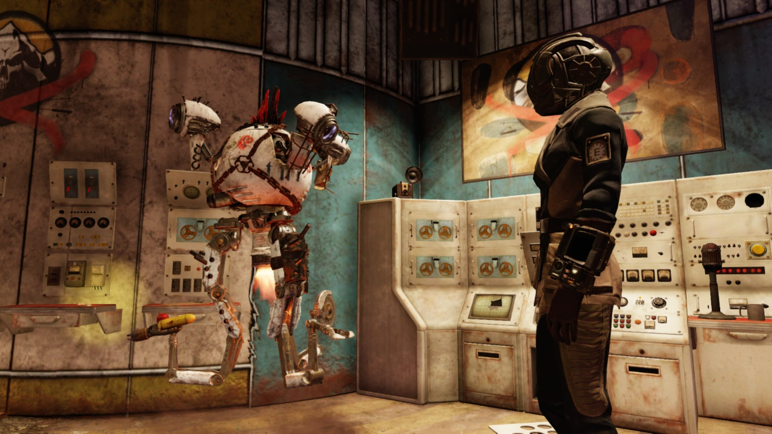

Suzanne Peeters

6167063

BA Media en Cultuur

2019-2020 03 + 04

BA Eindwerkstuk

ME3V15026

Supervisor: Jasper van Vught

Chicago Notes and Bibliography

11-6-2020

Word count: 7383

Table of contents
Abstract 2
Introduction 3
Theoretical framework 5
Identifying online 5
Non-Player Characters 7
Method 10
Analysis 12
Performing through actions: functional characters 12
Performing through choices: Narrative NPCs 15
Conclusion 18
Ludography 20
References 20
Appendix I: Fieldnotes 22
Pre-Wastelanders gameplay 22
Traveling to and Interacting with vendors: The Raider Vendor Bot 22
Playing ‘Tea Time’ and Strange Brew: Sweetwater 22
The main questline: Bandit leader Rose 23
Wastelanders gameplay 23
Duchess 23
The new Bandit Leader Rose 23
Paige 24

List of figures
Figure 1: The Raider Vendor Bot (screenshot made in Fallout 76) 12
Figure 2: Bandit Leader Rose (screenshot made in Fallout 76) 13
Figure 3: Sweetwater during the Strange Brew quest (screenshot made in Fallout 76) 13
Figure 4: The new interactions with Bandit Leader Rose (screenshot made in Fallout 76) 16
Figure 5: Paige (screenshot made in Fallout 76) 16
Figure 6: Dialogue screens show dialogue based on perks as can be seen here in red (screenshot made in Fallout 76) 17

All images used are screenshots taken by me while playing Fallout 76 on the Xbox One

Abstract
This Bachelor thesis shows an analysis of the Pre-Wastelanders and Wastelanders version of Bethesda Game Studios’ online role-playing game Fallout 76 that was released in 2018. By using a mixture of textual analysis and autoethnography, I analyze the role that the presence of non-player characters plays in the ability of a player to perform an identity. Using concepts from the discourse surrounding non-player characters and identity, such as the performance of the self and James Paul Gee’s different identity types, I argue that allowing the player to actually interact with a more ‘narrative’ NPC also allows the player to form a more rounded identity in the gameworld. The two different versions of Fallout 76 are inhabited by two types of NPCs that vastly differ in their interactability, namely the functional and the narrative NPCs. Starting with an analysis of the functional NPCs I conclude that the main function of these characters is allowing the player to access the user interface of the game. Players can only perform actions and listen to these characters. This causes players to use their character as something resembling a vehicle instead of an embodiment of their real self in the virtual world. It causes a clear divide between the ‘real’ and the ‘virtual self.’ The narrative characters with their more developed dialogue systems, reputation system and characteristics that change while talking to the player show quite the opposite. The social situations that are created by narrative NPCs within quests offer the player the opportunity to play their role and form an identity. This means that the gap between the ‘virtual’ and the ‘real-life identity’ can be bridged by the ‘projective identity.’ Trough the analysis of the interactions with narrative and functional NPCs this thesis shows that NPCs can be more than just ludic type of entity. They could also be seen as stage builders. NPCs ground the player’s self to the gameworld and allow them to play their role in it. They create social situations and thus a stage on which the player can perform a self.

Keywords: Fallout 76, Non-player characters, functional NPC, narrative NPC, virtual identity, real-life identity, projective identity, performance of the self.

Introduction
Fallout 76 (Bethesda Game Studios, 2018) tells the story of the inhabitants of the first vault that opens after a nuclear apocalypse in the United States. The player is part of the first group of people released back into the post-apocalyptic wasteland of Appalachia and tasked with repopulating the place. The game starts when you, the player, wake up in Vault 76 on reclamation day. This is also the place where you, as is common in role-playing games, will probably spend quite a large amount of time in the character creator to choose the exact way you want your character to look and maybe even create your mirror image to roam the world of Appalachia. After choosing your character’s name, you also get your first encounter with the perk system in this game that lets you choose between different characteristics that will affect the way your character can act in the world. Lastly, you put on your party hat and head out into West Virginia on your way to becoming the character you want to be. But will you really be able to actually perform this identity when there is almost no one else to truly interact with?
Generally role-playing games such as the Fallout series are filled with non-player characters, from here on referred to as “NPCs.” Scholars such as Hendrik Warpefelt have written about them and have often described NPCs as mainly having ludic functionalities within the gameworld. However, as negative reviews after Fallout 76’s release in late 2018 would suggest, NPCs play a bigger part. Many reviews described a feeling of emptiness that the game emitted. When looking at Fallout 76 one could argue that this was due to the lack of NPCs to actually interact with in the game and the decision to position the players very far apart. This experience, however, has changed after an update called “Wastelanders” on the 14th of April 2020 that added new NPCs to the world. Based on ideas such as the performance of the self by Goffman, in which he suggests that individuals ‘perform’ in order to project a desirable image of themselves, I suggest that NPCs play a bigger role in a players’ playing experience than previous research would suggest. In the gameworld your identity is constructed through interaction with other entities, but what happens to you when there are no others to perform to? Based on these observations I ask the question: “What role does the presence of interactable Non-player characters play in the performance of identity in a game?”
In order to answer my main question, I will ask three sub-questions to create a broader image of how the game functions in relation to the player. The first sub-question will be “What type of interactions do functional NPCs allow in Fallout 76?” The second sub-question will be “What type of interactions do narrative NPCs allow in Fallout 76?” Both of these sub-questions will focus on the general functionalities of the two groups of NPCs that can be recognized in the two versions of the game. Fallout 76’s different versions offer an excellent case for examining the role that NPCs play in identity performance because of the change in the interactability of NPCs that happens in the update. I refer to the Pre-Wastelanders game’s inhabitants as functional characters due to their more ludic functionalities and less interactable nature. In contrast, the Wastelanders game’s more interactable NPCs play a different role, namely a more narrative one both in relation to the player and the game. They will be referred to as narrative NPCs. By analyzing the two different types of NPCs I will try to create a clear image of how the NPCs in this world perform and what they allow.
The analysis of these NPCs leads to the answer of the last the last sub-question: “How do the interactions with these characters allow for different types of identity performance?” This question combines the NPCs analyzed in the two previous sub-questions, in an attempt to determine the role of NPCs in the performance of identity. The answer to this sub-question will be merged into the conclusions of both the discussion of functional as well as the discussion of narrative NPCs.
This research fits into the general debate surrounding the functionality of NPCs in games. This research aims to question the existing typologies of NPCs. A lot of those typologies seem to focus on the ludic qualities of NPCs and I would like to add that NPCs might harbor more potential than that. This case would add an example of a game that fits within these discussions and, due to the update, gives an exceptional opportunity to truly see how NPCs change a game.

Theoretical framework

Identifying online
While discussing identity in games, we should start from a broader perspective and discuss the performance and the creation of it in general. A concept to use for this is the performance of the self as explained by Erving Goffman. Goffman explains social processes of identity construction. In the Presentation of Self in Everyday Life he claims that individuals ‘perform’ in order to project a desirable image of themselves. In this book Goffman focuses on face-to-face communication, something that is not exactly applicable to interaction with computer-generated entities. The specifics of the communication of Goffman’s desirable self are not particularly important for this analysis, but the idea of needing others to perform your identity to is. When there are no other entities to interact with, there is no identity to create. To an extent both face-to-face communication and the performance of the self can be used as a base to examine interactions in the almost NPC-less world of pre-Wastelanders Fallout 76.
However, as Goffman’s book was published in 1954, a more recent revision of his work might help when applying Goffman’s concepts to games. Bernie Hogan writes about this in his article “The Presentation of Self in the Age of Social Media: Distinguishing Performances and Exhibitions Online.” In this article he argues that self-presentation can be split into performances which take place in synchronous situations and exhibitions which take place in asynchronous situations. Hogan states that one of the main differences between the two is the fact that in performances the performance of self is bound to the specific audience that is there at that point in time. This is not true for exhibitions, as on the internet things can be taken out of a situation and be replayed in a different context. These exhibitions can be explained as a form of presentation of the self where data is shown for others to interpret at a later point in time. The main element that can be used from this article is the idea that in new media, contrary to Goffman’s theory, a performance is never synchronous. It can always be changed. When playing a game, users can save their data and start over if they do not like the outcome of the way they have decided to act as their character.
This theory is not a perfect match to games, as I would argue that they are not fully applicable to either the concept of exhibition or performance due to the fact that the player is actually performing tasks as a character in an asynchronous environment. However, a mixture of Goffman’s and Hogan’s concept of the ‘performance of the self’ helps to understand how one needs others in Fallout 76 to perform and create an identity with the added nuance that they are performing in an asynchronous environment.
These ‘others’ that we need to perform a self in this research are, as becomes clear from the corpus, not human entities but computer-generated ones. A big part of this research is thus based on the idea that a personal connection between human actors and computers is possible. I see the possibility that players can have a psychological connection to computer generated characters and through that connection can create an identity. This is discussed by Sherry Turkle in Second Self. In this book she states that computional objects are experienced as both part of the self and of the external world. She sees the computer as subjective, as something that makes us think about ourselves. She gives computers a role in defining how we think about ourselves. This connects to the general ideas that plays a role in this research. NPCs are an example of a connection between human and technology that make us question the way we perform our identity.
As shown in Second Self, Turkle sees that humans can see computers as being part of their self. She acknowledges that in a way we identify with computers and thus also computer-generated characters. Related to this idea we can also look further into how players could identify themselves within a game. Starting with a broader idea of what it means to identify online. Sherry Turkle writes about this in Life on the Screen. She states that identity on the internet can be related to the idea of ‘windows.’ Turkle suggests that through computers a person is able to perform multiple different identities trough different media. She states that the life practice of ‘windows’ is that of a decentered self that exists in many worlds and plays many roles at the same time. Online life can be one more window of the self. While this concept is not directly connected to games, it still shows that your character in Fallout 76 could also be considered as a new ‘window’ to your self. The idea of your self being connected to what happens on screen is also something that is discussed in relation to games. R.V. Kelly explains in “The Psychology of MMORPG Players” that there can indeed be a personal relation between the avatar and player. Players often choose to create a character that is very similar to their real selves. Kelly mentions that for some players the creation of an identical self actually enhances the verisimilitude of the game for the players. The character becomes part of the player’s self, rather than something outside of it. Kelly states that most players see MMORPG characters as extensions or representatives of their real selves. He states that a character is not just a thing that gets pushed around on screen. It is the player instantiated into the computer.
Where Turkle’s concept of ‘windows’ does not directly apply to videogames, Kelly’s description of MMORPG helps show a similar sentiment in games. Both the works of Turkle and Kelly explain that the character and identity we perform in Fallout 76 are connected to our real-world self. They show that the player is connected to their character on the screen and is in fact performing a part of their own identity in this world. We connect with our computer-generated selves and through those also with the other characters in the world.
Turkle and Kelly’s ideas however only scratch the surface of what these identities are and, perhaps more importantly in relation to this analysis, what they look like and how they are created. The sources mentioned before offer a broader discussion of identities in games and show that one’s self can really be connected to a computer. Kelly and Turkle offer a more psychological view of connections between computers, the self and characters. They, however, do not explain how this identity could be created, this is where the concept of ‘ludic identities’ applies. This concept is explained in “Homo ludens 2.0: Play, media, and identity.” Frissen et al. explain the construction of ‘ludic identities’ in threefold. ‘Play1’ refers to the play that is programmed into our everyday life. It consists of our lived experiences of the natural and human world as playful and our more or less casual playing. ‘Play2’ refers to how the expression of this playfulness is articulated in games. Lastly, ‘Play3’ refers to how the player understands her or himself from the perspective of this playground of possible identities and internalizes this insight. According to Frissen et al. with ‘ludic identity’ we identify ourselves with the multimediality, interactivity, virtuality and connectivity of ludic technologies. The identities are seen as an active appropriation by the player that comes as a result of use of these technologies. One could thus still connect this to Turkle’s idea of seeing one’s self trough the computer. Trough playing with these ludic technologies you are also creating the ‘windows’ Turkle talks about. Thus, games such as Fallout 76 offer us the opportunity to create identities through play. This concept acts as a general, and still very broad, idea of how playing with media actually allows people to create identities.
The previous sources also do not explain what an identity looks like when playing games. In the book “What Video Games Have to Teach Us About Learning and Literacy” James Paul Gee discusses Identity in more detail. In this he writes about three different types of identities: ‘The virtual,’ the ‘real-life’ and the ‘projective identity.’ The ‘virtual identity’ is the character that is actually living in the world of the game and the ‘real-life identity’ is the identity of non-virtual player holding the controller. Especially the last type of identity is interesting when looking at role-playing games such as Fallout 76. Gee describes ‘projective identity’ as being the identity we project onto our virtual character. He bases it both on the meaning of project as projecting one’s values on a character and seeing the character as a project in the making. It concerns the characteristics we want this character to posses and the way we want it to act. It is the real-world self as the virtual self. The focus lies on the interactions between these two. Generally Role-playing games offer players choices in how they want their character to act. This is the identity you inhabit when worrying about how you want your character to act. When playing Fallout 76 you also try to build a character that acts and looks a certain way. While choosing their character perks or the way you look, you are already using the projective identity to decide how you want to act in the world. These identities again can only be formed trough interacting with others in a world and thus rely on the performances Goffman imagines when discussing the ‘performed self.’ Without performing these identities, they would be concepts that could never take actual shape in the world. Thus, performing to other entities in a world, be it the real or the virtual one, is key to brining the way you see yourself into existence.

Non-Player Characters
As Turkle stated in Second Self and suggested in the previous paragraph, a connection between the self and computers is possible. In the case of games these computers can either get the form of player characters or non-player characters. While discussing identity, I already focused on the players in the game, but a closer look at these non-player computer generated entities is also useful. When discussing the role of NPCs in games for this research the work by Henrik Warpefelt and Harko Verhagen is a good starting point for discussing these characters. They propose an updated typology of NPCs in “Towards an updated typology of non-player character roles.” They add categories to already existing research. Their categories consist of: Buy, sell and make stuff, provide services, provide combat challenges, provide mechanical challenges, provide loot, give or advance quests, provide narrative exposition, assist the player, act as an ally in combat, accompany the player and make the place look busy. They distinct them by measuring ‘characterhood.’
The categories that are discussed in this article are, however, not incredibly useful when distinguishing very specific character types as they only discuss the general functions that the NPCs perform without actually naming them and specifying their actions within a gameworld. This is solved when looking at Warpefelt’s PHD dissertation. In this he adds to the research on the functionalities of NPCs by assigning them to different character types. He divides them into four different categories:
Firstly, the functions category. The NPCs in this category provide the player access to the user interface of the game through diegetic means and offer services that make the game playable. Warpefelt states that Players expect to encounter them in shops or other visible areas, preferably behind counters. Within this category are three different kinds of NPCs: vendors, services characters and questgivers. Most of the interactable characters that exist within both versions of Fallout 76 fall within this category.
The second category is adversaries. These are the hostile or opposing NPCs in games. This category consists of enemies and opponents. The enemy characters provide the player performative challenges and will often drop loot when killed. According to Warpefelt they are often not actually fully realized characters and essentially nameless soldiers or monsters. Opponents offer the player mechanical challenges. They feature in games where combat is not the main mode of conflict.
The third category is friends. These types of NPCs represent the various companions a player can acquire in the game. They help the player with various tasks and act as the general allies in the world. This category consists of sidekicks, allies, companions, pets and minions.
Lastly Warpefelt mentions the providers. Warpefelt states that this category consists of storytellers and loot providers. Storytellers perform the active role of providing the player with key snippets of narrative. This type can be assigned to just about any character that offers narrative exposition. They fulfill the function of supplying background information but is more aimed at giving clues to the scripted narrative in the game. Warpefelt states that the loot provider type can be described as characters that offer loot. In many cases, this only happens after they die. That is also why there is a large co-occurrence between loot providers and the enemy type.
In relation to Fallout 76 the typology and functions of NPCs are important to apply to the way the performance and functions of NPCs change in the two versions of the game. These character types also apply to the ‘performance of the self.’ When analyzing a character in Fallout 76 one could use these categories to see to what extent these NPCs are performing their role. This then helps in determining their role in the ‘performance of the self’ as well. Furthermore, this typology also helps on a methodologic level. With this typology the types and functions of NPCs can be determined and then used to categorize some of the characters and their functions in my analysis.

Method
I will conduct my research by performing a textual analysis of a game, as explained by Clara Fernández-Vara in An introduction to game analysis. She explains analyzing a game as applying a textual analysis to understand in which way a text, a game, would be understood by a player. I will use some of the methods that Fernández-Vara describes in order to question the current academic view on NPC functions and identity in games. While analyzing I will approach the game as a process, as is explained by van Vught and Glas. This means that I will look at the subjective play process rather than at the game as an object that can be analyzed. I will focus on what my activities in the game are like and what they mean in relation to my research question.
Aside from using a textual analysis, I will also add elements of an autoethnography to document my own experiences of the gameworld. As I specifically look into the experience of one’s self in the game, I would deem my personal experience an important factor to include when analyzing. Leon Anderson describes an analytic autoethnography as ethnographic work in which the researcher is a full member in the research group or setting, visible as such a member in the researcher’s published texts and committed to an analytic research agenda focused on improving theoretical understandings of broader social phenomena . He describes five key features when talking about autoethnographies. However, as I will not actually be doing an autoethnography to research a social situation but use elements of it to enhance my textual analysis, I will only use three of the features he describes. The first is the complete member researcher status, which he describes as the researcher being a complete member of the world that is researched. In this case this is the world of Fallout 76. The second feature is analytic reflexivity. With this Anderson refers to the researcher’s awareness of their necessary connection to the research situation and hence their effect upon it. Lastly, the third feature is narrative visibility of the researcher’s self. This means that the researcher should be visible in the research by recounting their own experiences to help illustrate analytic insights. In order to incorporate this autoethnography I will use Fieldnotes as explained by Wolfinger. I will use the strategy he describes as ‘comprehensive note taking.’ This means that I will systematically record observations based on various questions I ask while playing. In relation to the NPCs I will ask what role characters are performing, how I can interact with them and how I can perform an identity to them.
More specifically, I will apply these methods to Fallout 76 as it is both before and after the Wastelanders update. I will look at to what extent a player can interact with NPCs both before and after the update. As mentioned before, I will focus on the different types of NPCs that can be found in the pre-Wastelanders game and the Wastelanders game. During the analysis I will use different NPCs from each version of the game to analyze their actions. The NPCs that will be chosen for my corpus are mainly from Warpefelt’s vendor, questgiver and storyteller type. Within both the functional NPCs as well as the narrative NPCs of Fallout 76 this is the most common type of NPC that can be found. I will mainly use Warpefelt’s typology as a guideline though, as I am not looking for the ludic functionalities of NPCs but for the role they play in interactions and identity creation. The different types of NPCs are there to show different kinds of interactions with functional and narrative NPCs. Aside from this, I will also only focus on NPCs that are friendly to the player and not the enemy types. These types of NPCs can be found in a larger amount but can not be interacted with apart from fighting them. In regard to the research question, I will start with a general analysis of the NPCs in the game from both the functions and narrative categories. These will be researched by analyzing which roles they fulfill and to what extent the player can actually make choices in how they interact with these characters. At the end of both of the analysis of the interactions with these NPCs I will conclude how an identity can be performed and answer the third research question. In order to answer these questions, I will use data gathered through fieldnotes while playing some of the quests in the game both before and after the update.

Analysis

Performing through actions: functional characters
Both the Pre-Wastelanders and Wastelanders world of Fallout 76 contain NPCs. The amount differs quite a bit though. Where in the pre-Wastelanders world it is rare to actually encounter an entity that one is able to interact, the Wastelanders version of the game offers a large range of different friendly characters that add to the narrative. Aside from the quantity of NPCs, the two versions thus also differ in how they allow the player to interact with them. In order to get a general understanding of these different types of NPCs, I will start with looking at inhabitants from the pre-Wastelanders game that I refer to as the functional NPCs to see what type of interactions they allow.
The pre-Wastelanders world of Appalachia is an empty one. When wandering through it there is a small chance of encountering actual non-player characters, unless you go looking for them. The best chance of finding any of them is walking into places with vendors. Robots are placed at a few points over the map to fulfill what Warpefelt calls the functionality of “buying and selling.” When interacting with vendors it becomes clear that NPCs in this world mainly function as a way of access to the user interface for the player, which places them in Warpefelt’s functions category. Warpefelt describes the functions category as NPCs that provide the player with access to the user interface of the game through diegetic means and offer services that make the game playable. These functional NPCs are thus added to the gameworld to work as a gateway to allowing players to fulfill different actions. Warpefelt states that Players expect to encounter them in shops or other visible areas, preferably behind counters. The characters that fit into this category are described as: vendors, services and questgivers.
An example of this can be seen when interacting with an NPC called the Raider Vendor Bot (figure 1). Interacting with this NPC is very similar to interacting with all other vendors in this version of the game. Their only function is providing a place to trade your items. When interacting with them they offer two options: trade or interact. If the player chooses to interact, they randomly say one of their ‘catchphrases’ to the player.

“I get two options on my screen: Interact or trade. I press interact. The vendor gives me one of his catchphrases: “Stick’em up. Ha. Just kidding. Want to buy or sell?”
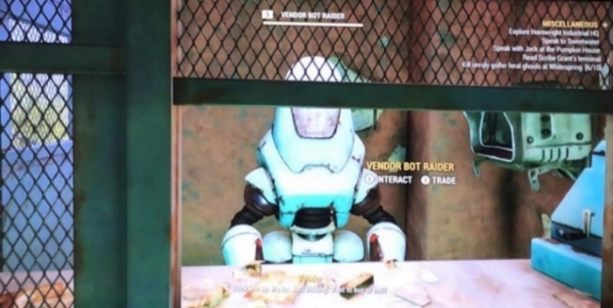
Figure 1: The Raider Vendor Bot (screenshot made in Fallout 76)

The interaction with this NPC is very similar tot the functions that Warpefelt assigns to this type. He states that vendors rarely provide any type of narrative connection. The bots that offer trading in this version of Fallout 76 offer no narrative connection and are only there to fulfill the function of gateway to the barter menus. These interactions are almost similar to pressing a button or using a computer in the game, only now performed by a moving entity. The functions that these characters allow are purely ludic. This can even be recognized in Raider Vendor Bot’s quote. They immediately refer to their functionality. This bot is there for actions, not for talking. They allow the player to continue with their plans such as buying the strongest weapons in the game or selling junk. They allow ‘play’ and the most basic performance of identity. They allow the player to perform the actions through a virtual persona, but do not allow them to build a deeper connection to them or the world.
These same observations can be applied to other NPC types that can be found in the Pre-Wastelanders version of the game. When playing through questlines, the player might encounter some other bots both in the main quests and the daily quests. Even though these characters do offer the player some narrative connection to the world, their core functionalities are still to offer the player a way of access to the user interface of the game. Bots like the characters Bandit leader Rose (figure 2) and Sweetwater (figure 3) roam a small plot of land and operate as a button that can be pressed to gain diegetic access to the quest UI.

“Interacting with Sweetwater consists of hitting interact and listening to what he has to say. He always tells the same story when starting the quest. He tells the player he is missing ingredients for the tea that need to be found.”

As stated in the fieldnotes, the character Sweetwater only offers the player the ludic functionalities of the questgiver. They are there to interact with to start and end a quest, but throughout it they do not offer anything novel to the player. Their personality remains static as they offer the same exact lines of dialogue, no matter the player or time of day. The same goes for Rose, whose dialogue happens only once instead of daily and whose role is bigger in the questline but when summarizing her functionalities comes down to almost the exact same role as Sweetwater. Rose also remains a static character that drones up a monologue without allowing input from the player.
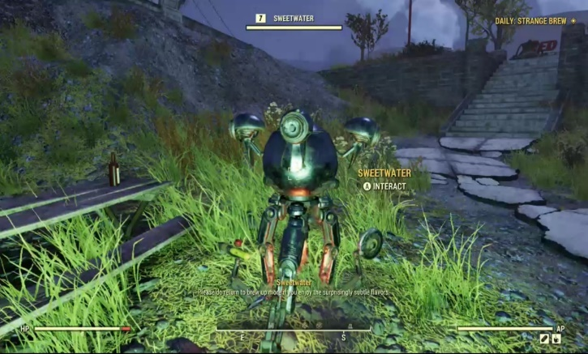
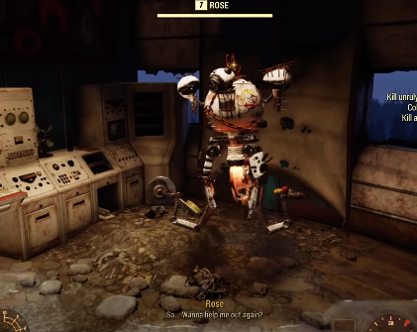
Figure 2: Bandit Leader Rose (screenshot made in Fallout 76)
Figure 3: Sweetwater during the Strange Brew quest (screenshot made in Fallout 76)
Looking at the examples mentioned here, one could state that the interactions with these functional characters turn out to be very superficial. There are not a lot of opportunities in this version of the game to actually interact with the characters. The functionalities of the robot NPCs are fairly limited and mainly consist of repeatedly droning up the same lines of dialogue. Interacting with them, thus does not require a lot of effort from the player. They offer the basics that are needed for playing the game, which leaves the player to perform the actions and listen. These interactions result in the player functioning like a game piece in the world. The characters in the pre-Wastelanders game only offer actions to be performed and little to no input. Which leads to the player controlling their character almost like a game piece or piece of equipment as James Newman puts it in “The Myth of Ergodic Videogame.” The player-characters work as vehicles to take the player from the request of the functional character, to the answer in the world and back to the functional character to receive their reward. Because of the lack of narrative connection, the world almost functions as a boardgame on which the player moves their piece between functional NPC boxes, landmarks and enemies to reach the finish line.
Directly connected to the fact that the functional characters ‘allow’ the player access to the user interface, these superficial interactions also lead to a player character that only ‘allows’ the player to perform actions and no personality. This is also directly noticeable in the identity that can be performed by the player. I would state that although the players are performing like Newman’s game pieces it does not necessarily mean that they are not performing an identity at all, as the player is still performing actions as a character. However, this identity is not a very elaborate one. The functional NPCs allow only one identity, namely that of the vehicle that fits on the tracks created by the game. The way in which the functional NPCs approach the player affects the way the player character is experienced by the player, as the NPCs do not allow any personal connection or input. This shows a large divide between character and player and thus, between what James Paul Gee calls the ‘virtual’ and the ‘real’ identity. This divide is mainly caused by the fact that there is no opportunity for the ‘projective identity’ to be applied. Gee describes this as being the identity we project onto our virtual character. He bases it both on the meaning of project as projecting one’s values on a character and seeing the character as a project in the making. It’s the real-world values of the player implemented and executed by the virtual player character. While interacting with the functional characters in this pre-Wastelanders version of the game, there are no actual opportunities for the player to really set this projected identity into motion because of the one-sided dialogues and a lack of player input.
The identity that is thus created when interacting with the functional characters in the pre-Wastelanders game is merely a virtual one, that of a character living in a virtual world, and the identity of the player stays separate from that. You are still fulfilling a role but have not reached the full potential of participating in this world. It is an identity, but not a rounded one. While playing this version of the game the player is constantly reminded of the fact that their character only functions as a vehicle to carry them trough the world and because of a lack of deeper interactions they can never truly immerse into their ‘virtual identity.’

Performing through choices: Narrative NPCs
These functional characters are still part of the Wastelanders version of Fallout 76. The Vendor bots, Sweetwater and many similar characters can still be found throughout the world and still offer the same interactions and experience to the player. They are, however, no longer the only type of NPC one encounters in the gameworld. As mentioned before, the updated game has added a large number of new NPCs. Aside from the number of NPCs that wanders the world a change can also be found within their functionalities.
The added NPCs in this new version of Appalachia still harbor some of the functions of the functionalities category. They still allow the user to access the user interfaces that their type applies to, but they offer narrative connections as well. As I will discuss in this paragraph, the vendors are no longer just vendors, but they can also be questgivers, storytellers and allies at the same time. The types of characters that are seen in the pre-Wastelanders version of the game are rather black and white in their functionalities. They are either a vendor, an enemy or a questgiver. In contrast the characters in this version of the game are gray. They are a mixture of different categories and offer the player a different kind of interaction because of it. Most of these characters are a mixture of questgivers and storytellers. Warpefelt assigns the functionality of narrative exposition to these roles, because of this I will call them ‘narrative NPCs’ as I will look into the type of interactions these NPCs allow in Fallout 76.
The difference between functional and narrative characters is perhaps most visible in the character Duchess, the first NPC the player encounters in the main quest. She is many different character types at once but most importantly offers the player a narrative choice. She offers the player both functions such as quests and bartering, but also allows the player to go deeper than that and choose dialogue and playstyles. The dialogue system that is triggered when talking to Duchess gives the player the opportunity of approaching her in many different ways:

“I can also choose dialogue when introducing myself that shows her the type of character I am. I can use my low charisma to let her pity me.”

While interacting with Duchess the player gets the possibility to choose multiple different ways of approaching a problem and use some of the characteristics assigned to the player-character. Aside from that it also gives Duchess the opportunity to tell the player more about the world or themselves. This shows the narrative NPC building a world and the player at the same time as they are performing their identity through interactions.
Aside from Duchess, who functions as a vendor after completing her questline, there are other NPCs with a more prominent narrative function. These characters are primarily questgivers and storytellers and can be found in the main questline that is added to the Wastelanders game. One of these characters has been discussed as a functional character before: Bandit leader Rose (figure 4). Similar to Duchess, Rose now offers the player a deeper sort of dialogue. The player is no longer just a game piece after interacting with Rose, but can now receive information based on the way they acted in a conversation. The interactions with Rose are no longer one-sided and repetitive, but offer the possibility to actively participate, instead of passively waiting to use their game piece.
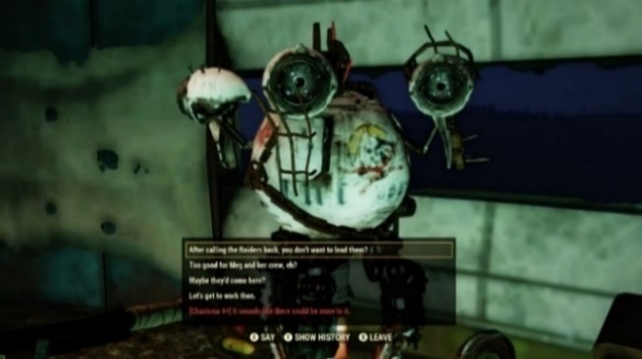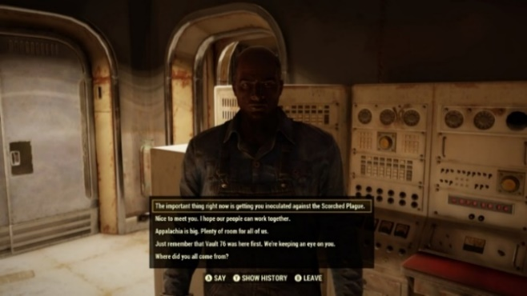
Figure 4: The new interactions with Bandit Leader Rose (screenshot made in Fallout 76)
Figure 5: Paige (screenshot made in Fallout 76)

Another narrative character is Paige (figure 5), the leader of one of the factions in the game. He functions in a way very similar to both Rose and Duchess as his main role is very similar to theirs, namely being part of a quest. Similar to other interactions mentioned before, while talking to Paige the player can choose multiple different ways of approaching a subject. The player can for example choose to introduce themself formally, get straight to the point and give him the information, get a little hostile or ask questions when first meeting him. This will lead to different answers from Paige. One thing that sets Paige apart though is his connection to a reputation system. Being nice to him means a more positive reputation status and makes the faction nicer to you. Paige, and other characters connected to a reputation system, plays a role in the way the world acts towards the player and the opportunities the player has in this world. Aside from offering narrative he thus also offers a way of changing your social experience of the game.
These narrative characters in Fallout 76 are similar to what Espen Aarseth describes as deep characters, in comparison to the functional characters being flat characters. Aarseth describes deep characters as characters who change and develop as the story progresses, rather than staying the same no matter what happens. These flat characters do have individual appearances, but little personality. The narrative NPCs in Fallout 76 are deeper and change according to how the player interacts with them. One can conclude that this is the main difference that can be recognized in the interactions between the two different games. The pre-Wastelanders game is filled with shallow functional NPCs, while the Wastelanders game adds deep narrative NPCs that change along with the choices of the player. These choices allow for the player to perform another role than a game piece.
All in all, these narrative characters are a mixture of different categories. Most importantly, they allow for the player to have a deeper and more developed kind of interaction. Which allows for a broader type of playful identity creation and performance. The narrative characters allow for actual interaction through dialogue screens but are also notably deeper characters that change through those interactions. The narrative NPCs in the Wastelanders game allow the player to truly interact as their character. The social situations that are created within quests offer the player the opportunity to play their role and form an identity. This means that the gap between what Gee calls the ‘virtual’ and the ‘real-life identity’ can be bridged by the ‘projective identity.’ This is because the values of the player can be projected on the character through the dialogue options and actions (figure 6). The characteristics that the player gives to their character can be used in interactions. The player can project their values on the character and get to play their real-world self as the virtual self.
Figure 6: Dialogue screens show dialogue based on perks as can be seen here in red (screenshot made in Fallout 76)
Aside from this, the NPCs in this world also ground and immerse the player to the gameworld. This also directly applies to the shift of a divide between the player and the character to them merging a bit more. Gordon Calleja’s concept of ‘cohabitation’ applies here. He describes this as something that looks into the presence of actors in an environment and is important in anchoring the player to the location both spatially and socially. Calleja explains that ‘cohabitation’ plays a role in the immersion in a game. The feeling of NPCs cohabiting alongside the player helps to add a feeling of presence. The presence of other characters thus grounds the player to the gameworld and adds to immersing them, rather than separating them from it.
Thus, aside from giving the players an opportunity to create a rounded identity, the increased number of narrative NPCs in the Wastelanders game also ground the player to it. These NPCs thus show that they hold the ability to be more than a simple ludic tool, but also play an important role in letting the player perform their identity and grounding them to the game.

Conclusion
The switch from Fallout 76 being an empty Wasteland with very few interactable NPCs to a world that is quite the opposite, is an interesting tool to show the role that the presence of NPCs actually plays in allowing players to identify themselves in a gameworld. Trough a use of textual analysis and autoethnography this research shows that the characters in the pre-Wastelanders world function as tools. While this does not necessarily have to be a negative thing for a game, I would argue that it is in a role-playing game. In these games you are often encouraged to build and perform a role, which can only happen through interactions and actions. A world with NPCs that are mainly functional flat characters, as is the case in pre-Wastelanders Fallout 76, only offers actions that can be fulfilled but no actual performance of your values or characteristics. This has a direct connection to the way a player experiences their self in this world: they are a game piece and a tool through which the real-world self can perform their actions but this real-world self cannot create a rounded identity because there are no values to project in interactions. In contrast, the Wastelanders version’s narrative characters do allow this projection of identity. The narrative characters show what the presence of interactable NPCs can do for identity creation. It allows for Gee’s different identity types to come together and through that allows a more rounded self to be performed. I would thus argue that this role in identity creation shows that NPCs can be more than just ludic type of entity but could also be seen as stage builders. They ground the player’s self to the gameworld and allow them to play their role in it. They create social situations and thus a stage on which the player can perform a self. Performing in a game can thus only be done with the help from others, be they Goffman’s real humans or Fallout 76’s narrative bots.
This research has shown that NPCs hold the potential to play a bigger role in games than simply being there to allow access to user interfaces, die and drop loot or provide narratives. While reading the works on player identity in games and NPCs by scholars some of the scholars mentioned in my theoretical framework, one could notice that the focus is often either on the ludic functionalities of the NPCs or the way a player identifies with their player-character. The role of NPCs in identity creation and thus their more social connection to the player is not as prominent as I would argue it should be. My research would thus function as an addition to the debate in the form of an example of a game that shows two very different ways in which an NPC plays a role in the identity creation of a player. While far reached, I also hope that this example could perhaps spark some questions around both the current debate about NPC typologies and the possible addition of the social role of NPCs alongside their ludic ones.
There are, however, also some limitations to this research that could be looked into in future research. First of all, my choice to perform a textual analysis that heavily relies on an autoethnography and my personal observations means that the observations made in this analysis are based on one experience of Fallout 76. The observations and conclusions of another player might thus differ from my own and could lead to a different conclusion. This also connects to one of the more prominent aspects of Fallout 76 I chose not to focus on during this research. Fallout 76 is not an offline game but rather a multiplayer online role-playing game. Its functionalities specifically allow for players to group up, complete quests and interact with each other. It would thus, also be very interesting to look into the creation of identity through a lens of the game’s online participatory culture by using methods focused on researching players instead of limiting oneself to the NPCs in the world. One could analyze the identities created trough talking to your fellow players and, for example, compare those to the more limited interactions that the functional NPCs allowed to see if the feeling of being a vehicle in this game decreases or is cancelled-out trough role-playing with other player characters. One could thus analyze what kind of identity the addition of interactions with real players alongside more shallow NPCs allows. Fallout 76 shows both in future and in this current research an ample opportunity to research identity and self in a gameworld.

Ludography
Bethesda Game Studios (2018). Fallout 76 [Xbox One]. Bethesda Softworks.

References
Aarseth, Espen. “A narrative theory of games.” Proceedings of the International Conference on the Foundations of Digital Games (2012): 129-133.

Anderson, Leon. “Analytical Autoethnography,” Journal of Contemporary Ethnography, Vol. 35, nr. 4 (2006): 373-395.

Calleja, Gordon. “Shared Involvement.” In In-game: From immersion to incorporation, 93-112. MIT Press, 2011.

Fernández-Vara, Clara. An introduction to game analysis. New York: Routledge, 2014.

Frissen, Valerie, Sybille Lammes, Michiel De Lange, Jos De Mul and Joost Raessens. "Homo Ludens 2.0: Play, Media, and Identity." In Playful Identities: The Ludification of Digital Media Cultures, edited by Frissen Valerie, Lammes Sybille, De Lange Michiel, De Mul Jos and Raessens Joost, 9-50. Amsterdam: Amsterdam University Press, 2015.

Gee, James Paul. “Learning and Identity: What does it mean to be a Half-Elf.” In What Video Games Have to Teach Us About Learning and Literacy, 51-72. New York: St. Martins Press, 2003.

Goffman, Erving. The presentation of self in everyday life. London: Penguin, 1990.

Kelly, R. V. “The Psychology of MMORPG Players.” In Massively Multiplayer Online Role-Playing Games: The People, the Addiction and the Playing Experience, 46-61. Jefferson, N.C.: McFarland, 2004.

Newman, James. "The myth of the ergodic videogame: Some thoughts on player-character relationships in videogames" Game studies 2, no. 1 (2002): 1-17.

Turkle, Sherry. “Introduction: Identity in the Age of the Internet.” In Life on the Screen, pp. 9-50. Simon and Schuster, 2011.

Turkle, Sherry. The Second Self: Computers and the Human Spirit. Cambridge: MIT Press, 2005.

Van Vught, Jasper and René Glas. “Considering play: from method to analysis.” Transactions of the Digital Games Research Association Journal 4.1 (2017): 1-19.

Warpefelt, Henrik and Harko Verhagen. “Towards an updated typology of non-player character roles.” Proceedings of the International Conference on Game and Entertainment Technologies (2015): 1-9.

Warpefelt, Henrik. "The Non-Player Character: Exploring the believability of NPC presentation and behavior." PhD dissertation, Department of Computer and Systems Sciences, Stockholm University, 2016.

Wolfinger, Nicholas H. “On writing fieldnotes: collection strategies and background expectancies.” Qualitative Research, Vol. 2, nr.1 (2002): 85-95.

Appendix I: Fieldnotes

Pre-Wastelanders gameplay

Traveling to and Interacting with vendors: The Raider Vendor Bot
I decide to run off to one of the train stations that is placed near my camp, the place where I store most of my character’s supplies. While walking there it is, as it is most of the time in this game, a lonesome journey. I encounter no other players while walking on the tracks towards this particular train station. When I look at the map, I see that there are eight other players on this server, none of which are in the region I am in at the moment. While continuing my journey I also take notice of the fact that there are no enemy entities on this road either, it is just me. Though this may also be due to the fact that I am travelling through The Forest, which is the region on the map for low-level players. However, I do feel like there should be some entity here after ten minutes of walking. The fact that there have been no other characters around me for quite some time does make me feel quite detached from the game. It feels lonely when it is just your character walking for minutes on end trough nature with nothing to encounter. I notice that I usually put on the radio that is offered in this game to make it feel a little more alive. It’s actually quite enjoyable to walk while listening to Anything Goes, but as soon as I turn it off, I am once again confronted by how eerie the world feels without distractions in the form of songs from the 1930’s.
When I arrive at the train station, I notice that, again, there are no enemies for me to fight off and no other players that are currently bartering with the raider vendor bot that is assigned to this shop. When I walk into the building and up to the vendor bot, I get two options on my screen: Interact or trade. I press interact. The vendor gives me one of his catchphrases: “Stick’em up. Ha. Just kidding. Want to buy or sell?”
I press trade and sell some of my meds. After this whole experience I conclude that this may very well be a good example of how most of the interactions between non-hostile NPCs and player go. You go up to them, if they are not a quest character, they say a catch phrase and they allow you to trade. There is no room for choice or your own input. It is what it is.

Playing ‘Tea Time’ and Strange Brew: Sweetwater
While playing the daily quest ‘Tea Time’ and the event Strange Brew I encounter the NPC Sweetwater. A bot NPC with a questgiver functionality during the daily quest. What surprises me, however, is that during the ‘Tea Time’ event he is not needed directly to start the event. ‘Tea time’ just starts and ends without interacting with the NPC and he can then only be heard over your radio a few times during the quest. The daily quest does start and end after interacting with the robot. This NPC is needed directly to start and complete this daily quest.
The interactions with Sweetwater consist of hitting interact and listening to what he has to say. He always tells the same story when starting the quest. He tells the player he is missing ingredients for the tea that need to be found. The player themselves cannot interact with him other than listening to his directions. In relation to the event he can be heard over de radio giving directions about which boiler should be defended. No personal choices can be made aside from completing the quest or walking away and even then, the quest will still appear as available. After completing the quest multiple times, the player always gets the same reaction and reward from the NPC. The reaction to completing or failing the event also stays the same every time. Outside of quests Sweetwater only has a few catchphrases that he repeats.
These interactions also show that Sweetwater does not allow me to make choices in relation to my character aside from failing or completing the event. Though this could be considered more related to skill rather than to character identity.

The main questline: Bandit leader Rose
During the main quest I encounter Bandit leader Rose. All in all, the interactions with her are actually quite similar to my interactions with Sweetwater. This NPC also functions as a questgiver in the game and allows them to start a quest. The one addition though is that she can be heard over the radio during the main quest offering commentary and tasks. The interactions with Rose are also very similar to the other NPCs in this game. She cannot be interacted with besides hitting the interact button. After this she will start the programmed dialogue to the player and a new quest will start while the former ends. She will offer sarcastic commentary, personal stories and actually makes some threats to me as well, but never actually allows me to interfere. I would thus also conclude that no identity can be performed here. Aside from dying multiple times during a quest, which does actually unlock a few comments that Rose makes over the radio. I do not think that choosing to be bad at the game is a performance of identity though.

Wastelanders gameplay

Duchess
One of the first characters I encounter in the new version of the game is an NPC named Duchess. After being told about her bar by two NPCs standing outside the vault, I head down there for more information regarding the mystery that is part of the main quest. The main role of Duchess is questgiver in the beginning of the game. Apart from that she also functions as a storyteller. After finishing the first few quests she will open her shop and function as a vendor. Due to the fact that she is not a character that is purely focused on functionalities, I will also categorize her as narrative.
I can interact with Duchess to a great extent. While playing through the main questline I can choose multiple different ways of approaching a problem and use some of the characteristics I assigned to my character. I, for example, am playing a character with high intelligence and can therefor solve problems with knowledge about robotics when their robot breaks down. This is a more functional option though. I can also choose dialogue when introducing myself that shows her the type of character I am. I can use my low charisma to let her pity me. As became clear, I can use characteristics that are personal to my character while talking. I can choose between multiple different versions of the dialogue when playing the main quest and through that perform an identity more directly.

The new Bandit Leader Rose
To my surprise, during the main quest I also encounter Bandit Leader Rose again. Though her roles stayed pretty much the same when compared to her old version, namely being a questgiver, her intractability has changed a lot. Aside form becoming a deep character with more personality and change during conversations, this version of Rose allows me to interact with her. I can now choose different dialogue options. In the questline I can for example make her listen to a recording that leads to her becoming a little depressed or to have her never listen to it because it was blocked from her memory for a reason. These choices are locked by perk points and thus depend on how I built my character. The interactions can thus be personalized and a self can be performed.

Paige
While playing the main questline and other quests regarding the settlers faction, I encounter Paige. This character could be categorized as a questgiver and a storyteller. Similar to the other NPCs in this version of the game I will categorize him as a narrative NPC, because of his intractability. While talking to this character I can choose multiple different ways of approaching a subject. I can for example choose to introduce myself formally, get straight to the point and give him the information, get a little hostile or ask questions when first meeting him. This will lead to different answers from Paige. As he is related to a reputation system the nicer I am, the higher my reputation will be. This will make the faction nicer to me as well. These smaller choices in dialogue, while not having an enormous effect, allow me to personalize my conversation and perform an identity.

Bethesda Game Studios (2018), Fallout 76 [Xbox One], Bethesda Softworks.
Take for example a reviewer from IGN who states that a lack of NPCs and the amount of players on the map cause the world to feel empty and lonely when you play alone; Brandin Tyrrel, “Fallout 76 Review: A Wasted Wasteland,” IGN, November 26, 2018. https://www.ign.com/articles/2018/11/22/fallout-76-review
Erving Goffman, The presentation of self in everyday life (London: Penguin, 1990).
Take for example articles and books by the following scholars that have all mentioned several ludic qualities and types of NPCs: Henrik Warpefelt, "The Non-Player Character: Exploring the believability of NPC presentation and behavior." PhD dissertation, Department of Computer and Systems Sciences, Stockholm University (2016): 27-123; Henrik Warpefelt and Harko Verhagen. “Towards an updated typology of non-player character roles,” Proceedings of the International Conference on Game and Entertainment Technologies (2015): 1-9.; R. Bartle, Designing Virtual Worlds (New Riders Publishing, Indianapolis, IN, USA: 2004).
Erving Goffman, The presentation of self in everyday life (London: Penguin, 1990).
Bernie Hogan, “The Presentation of Self in the Age of Social Media: Distinguishing Performances and Exhibitions Online,” Bulletin of Science, Technology & Society 30.6 (2010), 377-386.
Hogan, “The Presentation of Self in the Age of Social Media,” 377.
Hogan, “The Presentation of Self in the Age of Social Media,” 380.
Hogan, “The Presentation of Self in the Age of Social Media,” 381.
Sherry Turkle, The Second Self: Computers and the Human Spirit (Cambridge: MIT Press, 2005).
Sherry Turkle, “Introduction to the MIT Press Edition (2004),” in The Second Self: Computers and the Human Spirit (Cambridge: MIT Press, 2005), 5.
Sherry Turkle, “Introduction (1984): The Evocative Object,” in The Second Self: Computers and the Human Spirit (Cambridge: MIT Press, 2005), 19.
Sherry Turkle, “Introduction: Identity in the Age of the Internet,” in Life on the Screen (Simon and Schuster, 2011).
Turkle, “Introduction,” 14.
Turkle, “Introduction,” 14.
R. V. Kelly, “The Psychology of MMORPG Players,” in Massively Multiplayer Online Role-Playing Games: The People, the Addiction and the Playing Experience (Jefferson, N.C.: McFarland, 2004), 53.
R.V. Kelly, “The Psychology of MMORPG Players,” 58.
R.V. Kelly, “The Psychology of MMORPG Players,” 58.
Valerie Frissen, Sybille Lammes, Michiel de Lange, Jos de Mul and Joost Raessens, “Homo Ludens 2.0: Play, media, and identity” in Playful Identities: The Ludification of Digital Media Cultures, eds. Valerie Frissen, Sybille Lammes, Michiel de Lange, Jos de Mul and Joost Raessens (Amsterdam: Amsterdam University Press, 2015), 9-50.
Frissen et al, “Homo Ludens 2.0,” 35.
Frissen et al, “Homo Ludens 2.0,” 36.
Frissen et al, “Homo Ludens 2.0,” 38.
Frissen et al, “Homo Ludens 2.0,” 38-39.
James Paul Gee, “Learning and Identity: What does it mean to be a Half-Elf” in What Video Games Have to Teach Us About Learning and Literacy (New York: St. Martins Press, 2003), 51-72.
Gee, “Learning and Identity,” 54-55.
Gee, “Learning and Identity,” 55.
Gee, “Learning and Identity,” 56.
Henrik Warpefelt and Harko Verhagen. “Towards an updated typology of non-player character roles,” Proceedings of the International Conference on Game and Entertainment Technologies (2015): 1-9.
Warpefelt, “Towards an updated typology of non-player character roles,” 7-8.
Henrik Warpefelt, "The Non-Player Character: Exploring the believability of NPC presentation and behavior." PhD dissertation, Department of Computer and Systems Sciences, Stockholm University (2016): 27-123.
Warpefelt, "The Non-Player Character,” 83.
Warpefelt, "The Non-Player Character,” 83.
Warpefelt, "The Non-Player Character,” 84.
Warpefelt, "The Non-Player Character,” 87.
Warpefelt, "The Non-Player Character,” 88.
Warpefelt, "The Non-Player Character,” 89.
Warpefelt, "The Non-Player Character,” 90.
Warpefelt, "The Non-Player Character,” 95.
Warpefelt, "The Non-Player Character,” 95.
Warpefelt, "The Non-Player Character,” 96.
Clara Fernández-Vara, An introduction to game analysis (New York: Routledge, 2014), 1-269.
Clara Fernández-Vara, “The Whys and Wherefores of Game Analysis,” in an Introduction to Game Analysis, 11.
Clara Fernández-Vara, “Writing the analysis,” in an Introduction to Game Analysis, 234.
Jasper van Vught and René Glas, “Considering play: from method to analysis,” Transactions of the Digital Games Research Association Journal, Vol. 4, nr. 1 (2017): 4.
Leon Anderson, “Analytical Autoethnography,” Journal of Contemporary Ethnography, Vol. 35, nr. 4 (2006): 375.
Leon Anderson, “Analytical Autoethnography,” 379.
Leon Anderson, “Analytical Autoethnography,” 382.
Leon Anderson, “Analytical Autoethnography,” 384.
Nicholas H. Wolfinger, “On writing fieldnotes: collection strategies and background expectancies,” Qualitative Research, Vol. 2, nr.1 (2002): 85-95.
Wolfinger, “On writing fieldnotes,” 90.
Warpefelt, "The Non-Player Character,” 83.
Warpefelt, "The Non-Player Character,” 83.
Warpefelt, "The Non-Player Character,” 83.
Fieldnotes in appendix I, page 22.
Warpefelt, "The Non-Player Character,” 84.
Fieldnotes in appendix I, page 22.
James Newman, "The myth of the ergodic videogame: Some thoughts on player-character relationships in videogames," Game studies 2, no. 1 (2002): 1-17.
Gee, “Learning and Identity,” 55.
Fieldnotes in appendix I, page 23.
Fieldnotes in appendix I, page 24.
Espen Aarseth, “A narrative theory of games,” Proceedings of the International Conference on the Foundations of Digital Games (2012): 132.
Aarseth, “A narrative theory of games,” 132.
Gee, “Learning and Identity,” 54-55.
Calleja, “Shared Involvement,” in In-game: From immersion to incorporation (MIT Press, 2011), 102.

