Longitudinal development of hoof balance in the foal focusing on the center of pressure pattern of the hoof.

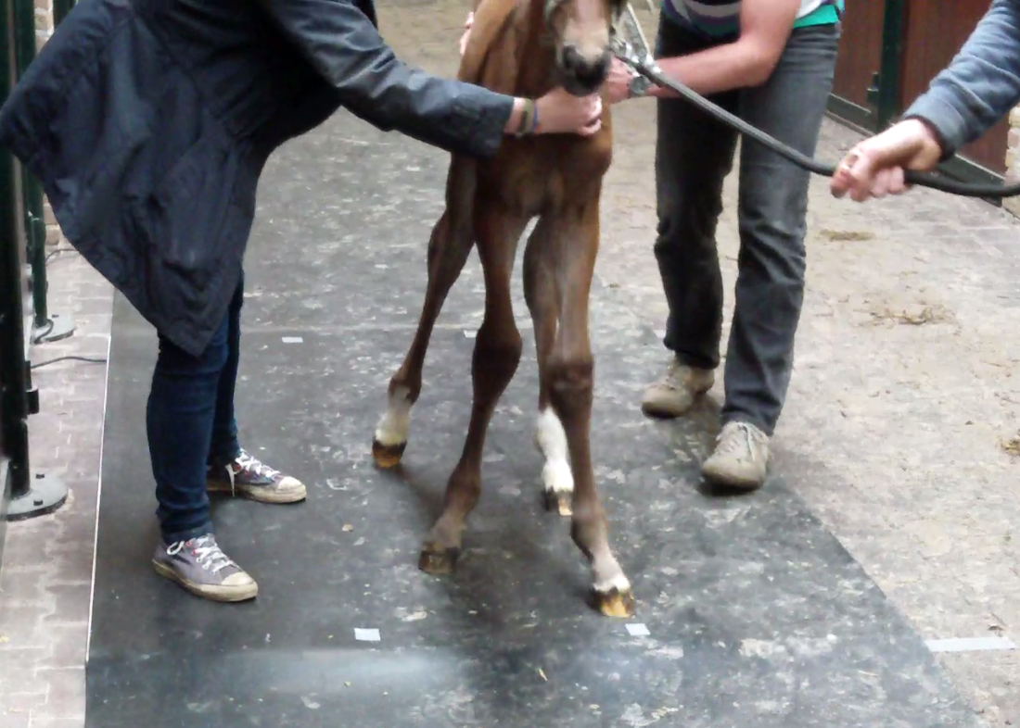

Research Project Veterinary Medicine University Utrecht

S.P. Kooij
3994848
December 2019

Project Tutors:
F. M. Serra Braganca
Drs. B.M.C. Gorissen
Dr. W. Back
Department of Equine Sciences and Pathobiology

Abstract
Horses are precocial animals, which means their foals are able to stand and walk after birth, but their balance still needs to develop more during the first months. The aim of this study was to obtain more knowledge on the development of hoof balance of foals and the development of the center of pressure (COP) at the stance phase during the first 6 months after birth. Pressure plate measurements from 11 Dutch warmblood foals during walk and trot were used during the first 24 weeks of their lives. This was used to calculate an asymmetry index(ASI) to determine the center of pressure(COP) during the entire stance phase.
It was found that dynamic hoof balance of foals at birth is not the same as the hoof balance of an adult horse, but some patterns can already be seen from this young age. During the first weeks the landing is already lateral but develops further towards a lateral landing over time. Landing is also a bit more on the toe. COP at midstance variates a bit over time but stays close to the center. Balance during the hoof-off is entirely on the toe and mostly lateral. Additional research is required to confirm these findings. Knowledge on development of hoof balance could be helpful for veterinarians to manage any problems and early intervention when needed.
Keywords: horse, foal, kinetics, gait development, center of pressure, dynamic hoof balance

Introduction
Hoof balance is a concept that involves not only the static geometry of the hoof, but also the dynamic interaction of the hoof with the surface throughout the stance phase and is influenced by conformation, movement, trimming, shoeing and equestrian discipline(1,2). Hoof balance can be divided in two parts: the toe-heel balance and the medio-lateral balance(2). Hoof imbalance can be linked to equine distal limb lameness.(3) The determination of static and dynamic hoof balance is therefore essential during lameness examinations(2). Knowledge on development of hoof balance could be helpful for veterinarians to manage any problems and early intervention when needed.
In this so called ‘new economy’, the development of new technologies will provide the equine clinician and farrier with new biomechanical tools for a more objective evaluation of equine locomotion(5). Modern portable pressure plate systems would become one of these new possibilities. Pressure plates (with/without calibrating force plates) provide information about the symmetry in pressure/force distribution between limbs as well as the pressure distribution in different regions of the hoof during a complete stance phase of the hoof. This may allow us to differentiate between toe and heel landing in specific causes of lameness(5,6). This could also be used to determine center of pressure (COP) patterns, supplying extra value to gait analysis and improving our understanding of the effects of different interventions on hoof balance(7). The center of pressure path quantifies the dynamic load distribution under the hoof in a moving horse.(8)

Van Heel et al. 2004 used the pressure plate system to measure the trajectory of the COP under dynamic conditions and studied the effect of trimming on hoof balance. The preferred way of landing appeared to be lateral in both fore and hind feet. Horses showed a distinct pattern; the center of pressure travelled towards a maximum lateral deviation and returned towards the dorsopalmar/plantar axis of the hoof(7). Other studies have also used the pressure plate successfully(2,5,8,9). Oosterlink et al. 2013 provides insight into the force distribution underneath the hoof during the entire stance phase. The results demonstrate higher loading of the lateral part of the hoof, not only at impact, but also during the midstance and hoof-off(2). Pressure plates can even be used to study toe-heel and medio-lateral balance on a hard and soft surface. At impact, there was more even load distribution between lateral and medial on the soft vs. hard surface at walk. At mid-stance a significantly higher toe loading was found on the soft surface compared to the hard surface at a walk and a trot(5). These studies show that pressure plate systems can objectively quantify pressure distribution underneath the hoof during the stance phase(7).

Horses are precocial, which means that their young are relatively mobile at birth. At first sight their gait looks the like that of an adult horse but little is known about the development and maturation of balance in foals(10). Recent work using stabilographic measurements has indicated that foals have relatively poor postural control after birth, which gradually improves during early life(10). While in adult horses studies have provided some insight on normal hoof balance(2,5,7), little research has been published on the development of hoof balance in foals(10–12).The few studies on the development of gait in foals were mostly kinematic of nature(13–15). Looking at the static balance of foals from birth to 5 months of age it was found that COP movements of newborn foals had a high amplitude and velocity, especially in the craniocaudal direction. These values decreased rapidly during the first week of life and then more slowly until 2–3 months of age(10). The development of the dynamic balance during stance phase will probably show a similar rapid development during this period. This requires further investigation(12).
The aim of this study was to describe the development of hoof balance of foals and the development of the center of pressure (COP) throughout the stance phase in particular during the first 6 months after birth.

It can be expected that static COP in the standing foal can be compared to dynamic COP. So during the first few weeks there will be a more uncoordinated balance(10), showing a relatively high variation in COP pattern during walk and trot. This will improve over time, gradually stabilizing in the patterns observed in adult horses. It is expected that lateral landing will be most common in the fore and the hind feet, and that at an age of 3 months the COP will match up to that of a matured, adult horse. At a younger age than 3 months, the foals find it more difficult to keep their balance so they are more straddled, which means COP will be more in a medial direction. Nonetheless, a difference in balance between fore and hind limbs is still to be expected, as the hind limbs show more variability for a longer time and thus will mature more slowly(7).

Material and methods
Foals
Pressure plate data of 11 different Dutch Warmblood foals had already been collected for this study. The dataset from the experiment of Gorissen et al. 2017(11) was used. In short, eleven privately owned Royal Dutch Sport Horse foals (5 female, 6 male) bred for showjumping were used in this study. They were all born and housed at the same stud farm and raised according to usual standards in the Dutch horse breeding industry. One colt was excluded from this study due to asymmetrical front feet. Before each measurement session, foals were examined by an experienced equine veterinarian (B.M.C.G) and only included if they were considered clinically sound. There were also radiographs taken of the knee and hock joints at 4-6 weeks of age and after 6 months to determine whether a foal had developed osteochondrosis (OC). OC positive foals are separated from the analysis to ensure that the results are not influenced by OC status. Hoof trimming was not performed during the study period because this could have induced more variation unrelated to the development and could have induced a bias in the data(12).

Pressure plate
A pressure plate with a measuring surface of 1.95 × 0.32 m (Footscan 3D, 2 m system)ª, connected to a computer with appropriate software (Gait Scientific, version 7.99–27.05.2014)ª was used. These pressure plates are equipped with 16,384 sensors (sensitivity 0.27–127 N/cm²; 2.06 sensors/cm²), measuring at 125 Hz. Before each session, the system was calibrated according to the manufacturer's instructions and offset was manually adjusted to avoid saturation of the sensors. The pressure plate was embedded in a custom made, wooden frame to create a 1.5 m wide and 2.3 m long level measuring area with a small ramp in front and behind to prevent stumbling. To protect the pressure plate, the runway including the plate was covered with a 10 m long, 1.5 m wide and 5 mm thick rubber mat^{b} (natural rubber/styrene-butadiene rubber, shore hardness 65 ± 5).

Data collection
All measurements took place in an empty stable building at the stud farm. After a 5 min warm-up period, foals were led over the pressure plate at their preferred speed by an experienced handler. Before weaning the foals followed their dams, led by another person next to the pressure plate; after weaning foals were handled alone. A trial was considered valid if the foal moved over the pressure plate in a consistent manner, looking straight ahead and with the hooves making full ground contact within the measuring area. When the foals were small, all limbs could be measured during one run, but with increasing size left and right limb data needed to be recorded in separate trials.
The foals have been followed from 3 days till 24 weeks of age. Pressure plate measurements have been taken from 3 days after birth (week 0), to 1, 2, 4, 6, 8, 10, 12, 16, 20 and 24 weeks after birth. All the measurements were done on the same day until at least 5 valid measurements for each hoof were collected. The measurements are done during walk and trot, excluding trot measurements of the first two moments. Video recordings were used to determine if the foals walked properly over the pressure plate or if the foals were moving abnormally due to excitement or other abnormal behavior that may have disturbed its movement or balance.

Data processing
Collected footprints were manually assigned to left fore (LF), right fore (RF), left hind (LH) or right hind (RH) based on the video images. The collected data was processed by manually dividing a recorded hoof pressure plot in toe/heel by a horizontal line through the maximal hoof width and in lateral/medial by a vertical line through the central part of the toe and midway between the heels, as described by Oosterlinck et al. (2013)(2) (Figure 1). For this purpose, the Footscan® software (Gait Scientificª, version 7.99–27.05.2014) associated with the RsScan pressure plate was used. Hoofprints that were rotated too much, were excluded based on a visual assessment. Also the cases where the foal didn’t walk over the pressure plate properly were excluded by using the video recordings. After that, the data was processed using Excel and custom-written Matlab scripts (Matlab r2015b^{c}). The results of each set of 5 measurements per limb were averaged and considered representative for that limb at that measuring moment.

Figure .1 Screen capture of an example of the Footscan® software window where the hoof toe/heel and medial/lateral zones are manually divided.

Toe-heel and medial-lateral hoof balance ASI of each data frame was calculated using the vertical forces obtained for the four hoof zones by the following formulas(2):

$$ASI\left(toe-heel\right)=\frac{VF\left(toe\right)-VF\left(heel\right)}{0,5*\left(VF\left(toe\right)+VF\left(heel\right)\right)}*100$$

$$ASI\left(medial-lateral\right)=\frac{VF\left(medial\right)-VF\left(lateral\right)}{0,5*\left(VF\left(medial\right)+VF(lateral\right)}*100$$

The ASI of force distribution was calculated and the average of all data at each point in time is shown in the results. This was done separately for the front and hind legs, for the OC- and OC+ foals and for walk and trot. For each stance phase the hoof-on, midstance and hoof-off are determined. For the toe-heel ASI, a positive value indicates higher loading towards the toe zone and a negative value indicates higher loading towards the heel zone. For the medial-lateral ASI, a positive value indicates higher loading towards the medial zone and a negative value higher loading towards the lateral zone.

For visual interpretation of the dynamic ASI, the timeseries data was plotted in a 2D plot, where the toe-heel ASI was plotted in the y-axis and the medial-lateral ASI was plotted in the x-axis. Each data point was connected with a vector indicating the direction of COP thought the measurement during stance.

The longitudinal development of COP during the hoof-on, midstance and hoof-off was determined based on the force distribution over the four zones at impact with the plate. For each separate phase of stance( hoof-on, midstance, hoof-off) another plot was made using Excel to get a better visual impression of the development over 6 months time. These graphics were also used to visually determine differences between front vs. hindlegs, walk vs trot and OC negative vs OC positive. A percentage of landing types during hoof-on, midstance an hoof-off was also calculated.

Results
All foals were considered clinically sound at visual inspection before each measurement session, except for two foals at 24 weeks. One week later these animals were considered sound and pressure plate measurements were taken and included in the dataset as being representative for week 24.

Five out of the ten foals were negative for OC at the first radiographic screening, whereas in the other six at least one lesion was found. Three foals showed unilateral and three others had bilateral signs of osteochondrosis (Table 1). At 6 months at the second screening moment, two out of the five foals were still positive for OC. All osteochondrosis lesions were detected in the tarsal joints, none in the stifle joints. Accurate evaluation of the stifle joints was not possible during the first radiographic examination due to the physiological irregular contour and granular subchondral bone opacity of the femoral trochlear ridges. At the second examination, no radiographic signs of osteochondrosis in the stifles were found.

Foal number | Sex | OC status 6 weeks | OC status 6 months
1 | Male | 2 | 0
2 | Male | 0 | 0
3 | Male | 1 | 0
4 | Female | 2 | 2
5 | Female | 0 | 0
6 | Female | 1 | 0
7 | Female | 0 | 0
8 | Male | 2 | 1
9 | Female | 0 | 0
10 | Male | 0 | 0
Table 1. Sex and osteochondrosis status (at 6 and 24 weeks) of the foals, 1 = unilateral, 2 = bilateral
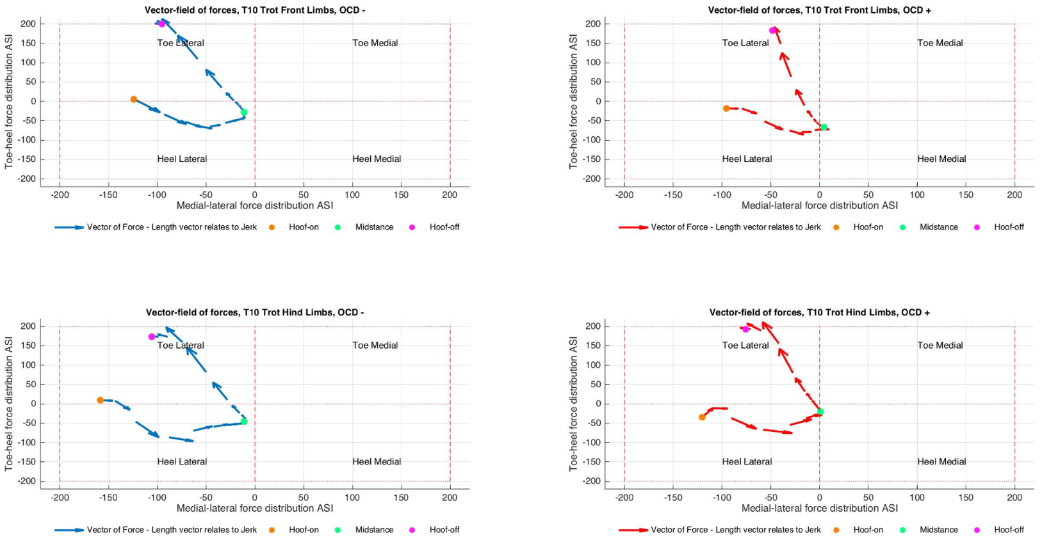
Figure 2. One example of the calculated COP results based on the four zone division during hoof-on, midstance and hoof-off.

Figure 3. An example of the longitudinal development of the COP of the hoof-on phase of the front limb in walk of the OC negative group

Figure 2 presents an example of one of the results showing the calculated COP pattern during hoof-on, midstance and hoof-off. This was done for all the measurements over time in walk and trot. Front and hind limbs are presented separately as well as OC negative and OC positive results. The results are the average of the 5 OC negative and the 5 OC positive foals. Details of the mean force distribution ASI for toe-heel(TH) and medio-lateral(ML) balance over time can be found in Appendix 1. Using the numbers in Appendix 1 another plot could be made. In this plot the development of hoof-on, midstance and hoof-ff can be visualized over 6 months time. An example of this is shown in figure 3.

Development of the COP during hoof-on over 6 months time
Mean ASI values during the hoof-on are presented in Appendix 1, table 1 and 2.
Medial-lateral
It is shown that the hoof-on phase is in general more lateral for both gaits and for all limbs. In 100% of the cases the front legs are loaded more lateral(table 2). For the hindlegs almost all measurements were laterally loaded except for the first measurement in the OC- and the first in the OC+ group, those were more medial loaded. Over time the development of the COP shifted more lateral than at T0.

Toe-Heel
Concerning toe-heel balance during hoof-on there is a less obvious loading pattern than the ML balance, especially during walk. Over time there isn’t a clear preference, there are some shifts in toe-heel loading in both gaits, especially in walk. Overall the landing is more loaded towards the toe region.
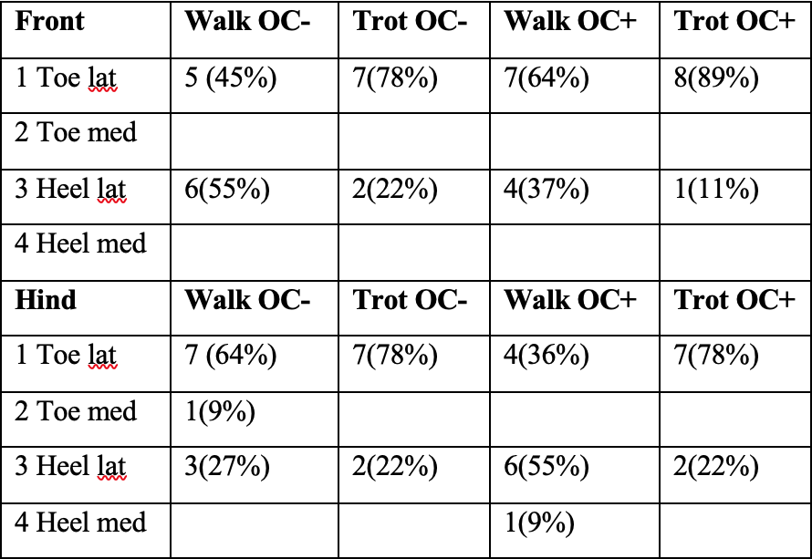
In comparison the loading of the front feet during trot is more towards the toe than during walk for the OC- group. Looking at the hind legs and comparing walk vs trot, the loading during walk is more towards the medial region for the first 4 measurements, where measurements in trot already start more lateral. This goes for both OC- as OC+ groups. When looking at the front limbs during trot compared to the hind limbs, the hind limbs load more lateral than the front limbs. There are no remarkable results when looking at OC- vs OC+.
Table 2. Percentage of total landing types during hoof-on

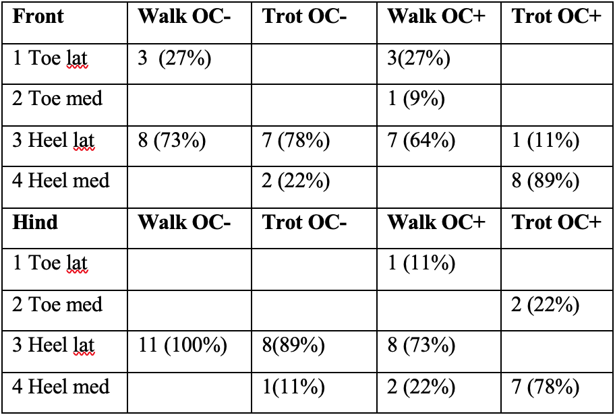
Development of the COP during midstance over 6 months time
Mean ASI values during midstance are presented in Appendix 1, table 3 and 4.
Medial-lateral
The results during midstance show a minimal shift, with almost all results being between 50 to -50 for both ML as TH loading. Overall the COP during midstance is more lateral, excluding the OC+ group during trot(table 3). The OC+ group during trot is loaded medial. Over time there is a slight shift towards lateral. COP during midstance appears to be loaded around the center.
Table 3. Percentage of total landing types during midstance
Toe-Heel
In the front limb during walk in the OC- group the first 3 measurements were in the toe region and all 8 following measurements were more loaded towards the heel. This is consistent with the majority of the other groups, where the heel region is more loaded during midstance. Over time there are no obvious changes. COP during midstance appears to be loaded around the center.

When comparing the results it was found that loading during trot was more around the center than all the measurements in walk.

Development of the COP during hoof-off over 6 months time
Mean ASI values during the hoof-off are presented in Appendix 1, table 5 and 6.
Medial-lateral
As seen in table 4 COP during hoof-off for the front limbs during walk was mostly medial loaded, where in trot loading was more lateral. For the hind legs pressure during walk was also more lateral, where in trot 100% of the hind legs were loaded lateral. Over time the development of the ML balance shifts more towards lateral.
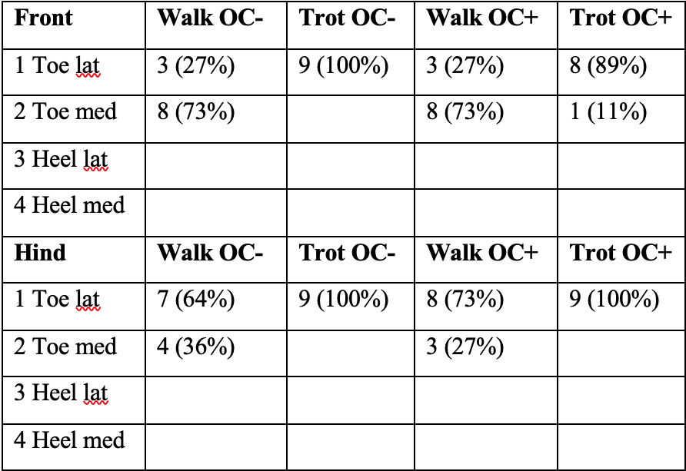
Toe-Heel
It is clear that the COP of the hoof-off is in the toe region, since 100% of the results are towards the toe. Over time there is not a clear shift towards the toe, since from T0 all results are already near the max toe region.

Comparing results there are not many differences between OC- vs OC+. During walk of the OC+ group the front legs compared to the hind legs loaded more medial. Also in the OC- group during walk the hind legs were compared to trot, the trot appeared to be more lateral during loading.
Table 3. Percentage of total landing types during hoof-off
Discussion
Dynamic hoof balance of foals at birth is not the same as the hoof balance of an adult horse, but some patterns can already be seen from this young age. During the first weeks the landing is already lateral but develops more towards a more lateral landing over time. Landing is also a bit more on the toe, which is different from adult horses(2,5). COP at midstance variates a bit over time but stays close to the center. Balance during the hoof-off is entirely on the toe and mostly lateral. These findings are consistent with LM balance seen previous studies, but not when it comes to TH balance(2,5,8).
It was hypothesized that COP pattern during the stance phase would compare to those of mature horses around 3 months of age, since most rapid changes in static balance of foals showed to be during the first few weeks and were almost the same at 3 months(10). However during the entire study of 6 months the hoof balance still showed more variation than adult horses. This could possibly be because dynamic balance is more difficult to achieve than static balance.
During the first weeks the landing is already lateral but developed more towards a more lateral landing over time. Almost al measurements are more lateral, the 2 measurements that are more medial are the measurements of T0, so some imbalance could be expected. Landing was also a bit more on the toe. This was consistent to previous findings when looking at ML balance in adult horses and ponies(2,5,8,9). This suggests foals already have a similar adult like pattern from a young age when it comes to medio-lateral balance.
In the first few weeks the medial-lateral balance is more medial during hoof-on and hoof-off than expected and this develops to be more lateral later. Newborn foals splay their limbs to increase the base of support and maintain balance(10). Splayed limbs have increased pressure on the medial part of the hooves. When the foal gets older and the musculoskeletal system matures the foal will gain more balance and place his limbs straighter and the hoof loading becomes more lateral.
In midstance the variation during measurements was small, with most of the loading to be particularly more lateral. During trot the hoof balance seemed more stable than at walk. Over time there weren’t any obvious changes in the COP, suggesting that the foals already have a normal balance early after birth when it comes to the midstance and that the midstance is most stable from birth than hoof-on and hoof-off.
Longitudinal COP balance during hoof-off stayed constant. 100 % of the measurements were in the toe region. Over time there is not a clear shift towards the toe, since from T0 all results are already near the max toe region. During walk the ML balance was not that consistent and was mostly medial in the front limbs. For the hind legs this was more lateral. During trot it was almost consistent towards the lateral region. Over time the development of the ML balance shifts more towards lateral.

The prevalence of osteochondrosis in young foals can be very high(16,17), although the majority of the lesions present at an early age will heal(18). OC lesions might influence the gait, that’s why OC status was measured and included in this study on longitudinal development of hoof balance. Hoof balance in foals that were OC positive did not show major differences in their COP pattern. This was not statistically found, but based on visual findings. The most outstanding difference was during midstance. Only in the OC positive group during trot both limbs were loaded medial, while at walk both limbs loaded more lateral. Also during walk in the hoof-off phase the front legs of the OC positive group compared to the hind legs loaded more medial. An explanation for these differences could be that OC could lead to pain and therefore can cause a change in loading pattern. The radiographs were taken joints at 4-6 weeks of age and after 6 months to determine whether a foal had developed osteochondrosis. In 6 out of 10 foals at least one OC lesion was found. At 6 months at the second screening moment, two out of the five foals were still positive for OC. In between these moments no radiographs were taken, so it is unknown when the foals became OC negative. This could therefor have influenced the results of the OC positive group. Since accurate evaluation of the stifle joints was not possible during the first radiographic examination due to the physiological irregular contour and granular subchondral bone opacity of the femoral trochlear ridges. It can not be said that all the stifles were clear for OC. They were clear at the second examination, but those could have healed. So the OC negative group could have had some false negatives, influencing the results.

The number of animals used for this study is more than usually used for pressure plate studies. For example: Oosterlinck at al. (2014) used five ponies(5), Oosterlinck at al. (2013) used seven Royal Dutch Sport Horses(2). The foals used during this study were young and untrained, but learned to walk over the pressure plate along the way. Some foals were difficult to handle and needed to be embraced to walk correctly over the plate, since they did not accept to be lead by a rope. This made it difficult to make them move in the same way for all the trials. Measurements in which the foals were very difficult were excluded. The number of valid runs is based on studies in mature horses(2,6) and ponies(5,9), where the same system was used. Measurements took as long as it needed to collect 5 valid measurements for each hoof at each gait. Thus, tiredness played a role, some foals found it very difficult to trot and instead of trotting they galloped, so more measurements were needed and the foals got more tired. Therefore, and also because the foals were too small, it was decided to let the foals trot over the plate starting at week 2.

Conformation of the hooves and legs influences the way pressure is distributed over the foot(19). Though prevalence of congenital limb deformities is high most defects improve spontaneously during the first months of life(20). This could affect the development of hoof balance over time and it is even possible there could be a correlation between them, but this needs further investigation. When the foals where walked straight over the pressure plate, due to the conformation of the hoof or limb not all the hooves were placed in the same direction as the pressure plate, resulting in rotated hoofprints. Hoofprints that were extremely rotated were excluded. Also the cases where the foal didn’t walk over the pressure plate properly were excluded by using the video recordings. One weakness of the Footscan® software is that the rotated hoofprints could not be turned in a correct way. Whether the hoofprints were too much rotated or not, was estimated by eye and is not measured objectively. Some foals consequently produced this type of hoof prints, so those could not all be excluded and were therefor still used. This might influence the results.

Trimming of the hooves was not performed during the entire study period because this could have induced more variation unrelated to the development(12). From the first few days of the foal’s life, the hoof adapts to loading, and even slight deviations of the distal limb are reflected in the form of the hoof. Therefor it would be desirable to start trimming from an early age(4 weeks) and to follow every month to maintain correct conformation(1). So it would be interesting for future studies to see if there are any differences between trimming and no trimming in hoof balance development.

Conclusion
Dynamic hoof balance of foals at birth is not the same as the hoof balance of an adult horse, but some patterns can already be seen from this young age. During the first weeks the landing is already lateral but develops more towards a lateral landing over time. Landing is also a bit more on the toe. COP at midstance variates a bit over time but stays close to the center. Balance during the hoof-off is entirely on the toe and mostly lateral. These findings are consistent with previous studies.
Additional research is required to confirm these findings. Knowledge on development of hoof balance could be helpful for veterinarians to manage any problems and early intervention when needed.

Acknowledgements
The author wishes to thank Filipe Serra Bragança, Ben Gorissen, Willem Back and for their support.

Manufacturers’ addresses
ª RsScan International N.V., Paal, Belgium.
^{b} De Mulder Rubber and Plastics, Gent, Belgium
^{c} MathWorks, Natick, Massachusetts, USA.

References
1. Johnston C, Back W. Hoof ground interaction: when biomechanical stimuli challenge the tissues of the distal limb. Equine Vet J. 2006;38(7):634–41.
2. Oosterlinck M, Hardeman LC, van der Meij BR, Veraa S, van der Kolk JH, Wijnberg ID, et al. Pressure plate analysis of toe–heel and medio-lateral hoof balance at the walk and trot in sound sport horses. Vet J. 2013 Dec;198:e9–13.
3. Trotter GW. Hoof balance in equine lameness. J Equine Vet Sci. 2004 Nov;24(11):494–5.
4. Oosterlinck M, Pille F, Back W, Dewulf J, Gasthuys F. A pressure plate study on fore and hindlimb loading and the association with hoof contact area in sound ponies at the walk and trot. Vet J. 2011 Oct 1;190(1):71–6.
5. Oosterlinck M, Royaux E, Back W, Pille F. A preliminary study on pressure-plate evaluation of forelimb toe–heel and mediolateral hoof balance on a hard vs. a soft surface in sound ponies at the walk and trot. Equine Vet J. 2014;46(6):751–5.
6. Oosterlinck M, Pille F, Huppes T, Gasthuys F, Back W. Comparison of pressure plate and force plate gait kinetics in sound Warmbloods at walk and trot. Vet J. 2010 Dec 1;186(3):347–51.
7. Heel MCV van, Moleman M, Barneveld A, Weeren PR van, Back W. Changes in location of centre of pressure and hoof-unrollment pattern in relation to an 8-week shoeing interval in the horse. Equine Vet J. 2005;37(6):536–40.
8. Nauwelaerts S, Hobbs SJ, Back W. A horse’s locomotor signature: COP path determined by the individual limb. PLoS ONE [Internet]. 2017 Feb 14 [cited 2020 Feb 24];12(2). Available from: https://www.ncbi.nlm.nih.gov/pmc/articles/PMC5308775/
9. Oosterlinck M, Pille F, Back W, Dewulf J, Gasthuys F. Use of a stand-alone pressure plate for the objective evaluation of forelimb symmetry in sound ponies at walk and trot. Vet J. 2010 Mar;183(3):305–9.
10. Nauwelaerts S, Malone SR, Clayton HM. Development of postural balance in foals. Vet J. 2013 Dec 1;198:e70–4.
11. Gorissen BMC, Wolschrijn CF, Serra Bragança FM, Geerts A a. J, Leenders WOJL, Back W, et al. The development of locomotor kinetics in the foal and the effect of osteochondrosis. Equine Vet J. 2017 Jul 1;49(4):467–74.
12. Gorissen BMC, Bragança FMS, Wolschrijn CF, Back W, Weeren PR van. The development of hoof balance and landing preference in the post-natal period. Equine Vet J. 2018;50(6):809–17.
13. Back W, Barneveld A, Schamhardt HC, Bruin G, Hartman W. Longitudinal development of the kinematics of 4-, 10-, 18- and 26-month-old Dutch Warmblood horses. Equine Vet J. 1994;26(S17):3–6.
14. Denham SF, Staniar WB, Dascanio JJ, Phillips AB, Splan RK. Linear and Temporal Kinematics of the Walk in Warmblood Foals. J Equine Vet Sci. 2012 Feb;32(2):112–5.
15. Drevemo S, Fredricson I, Hjertén G, McMIKEN D. Early development of gait asymmetries in trotting Standardbred colts. Equine Vet J. 1987;19(3):189–91.
16. Grevenhof EMV, Ducro BJ, Weeren PRV, Tartwijk JMFMV, Belt AJVD, Bijma P. Prevalence of various radiographic manifestations of osteochondrosis and their correlations between and within joints in Dutch Warmblood horses. Equine Vet J. 2009;41(1):11–6.
17. Weeren PR van, Olstad K. Pathogenesis of osteochondrosis dissecans: How does this translate to management of the clinical case? Equine Vet Educ. 2016;28(3):155–66.
18. Dik KJ, Enzerink E, Weeren PR van. Radiographic development of osteochondral abnormalities, in the hock and stifle of Dutch Warmblood foals, from age 1 to 11 months. Equine Vet J. 1999;31(S31):9–15.
19. Wiggers N, Nauwelaerts SLP, Hobbs SJ, Bool S, Wolschrijn CF, Back W. Functional Locomotor Consequences of Uneven Forefeet for Trot Symmetry in Individual Riding Horses. PLoS ONE [Internet]. 2015 Feb 3 [cited 2020 Mar 16];10(2). Available from: https://www.ncbi.nlm.nih.gov/pmc/articles/PMC4315574/
20. Robert C, Valette J-P, Denoix J-M. Longitudinal development of equine forelimb conformation from birth to weaning in three different horse breeds. Vet J. 2013 Dec 1;198:e75–80.

Appendix 1.
Table 1 Mean force distribution ASI for the toe-heel (TH) and medio-lateral (ML) balance over time (weeks) for the hoof-on at walk.

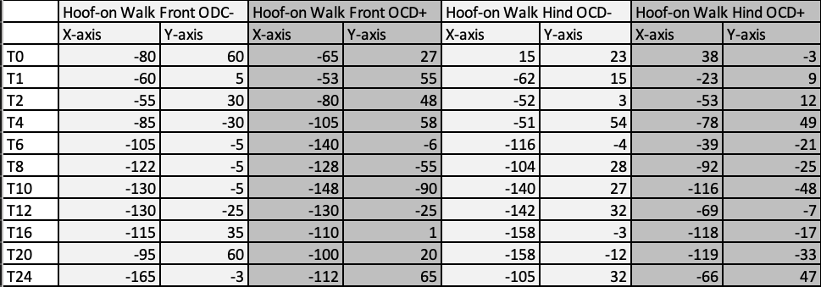
Table 2 Mean force distribution ASI for the toe-heel (TH) and medio-lateral (ML) balance over time (weeks) for the hoof-on at trot.
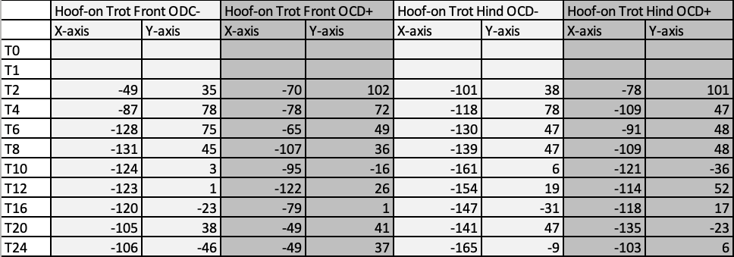

Table 3 Mean force distribution ASI for the toe-heel (TH) and medio-lateral (ML) balance over time (weeks) for the midstance at walk.
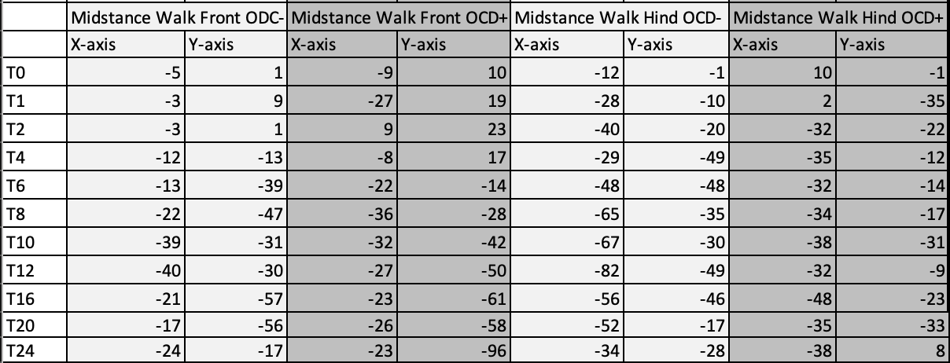

Table 4 Mean force distribution ASI for the toe-heel (TH) and medio-lateral (ML) balance over time (weeks) for the midstance at trot.
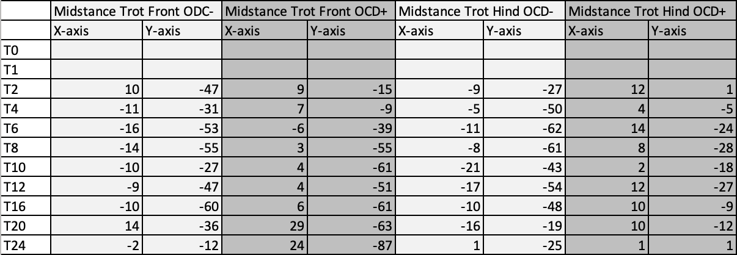

Table 5 Mean force distribution ASI for the toe-heel (TH) and medio-lateral (ML) balance over time (weeks) for the hoof-off at walk.
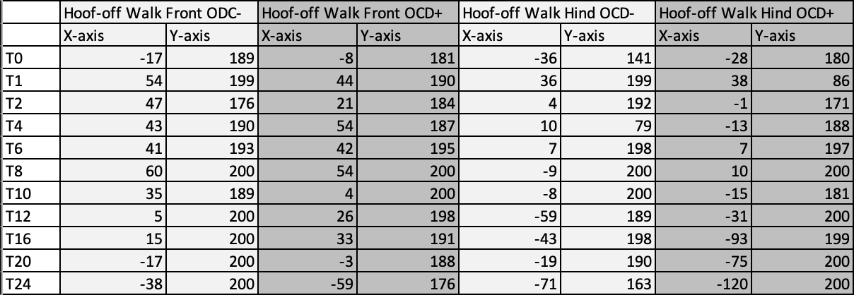

Table 6 Mean force distribution ASI for the toe-heel (TH) and medio-lateral (ML) balance over time (weeks) for the hoof-off at trot.
