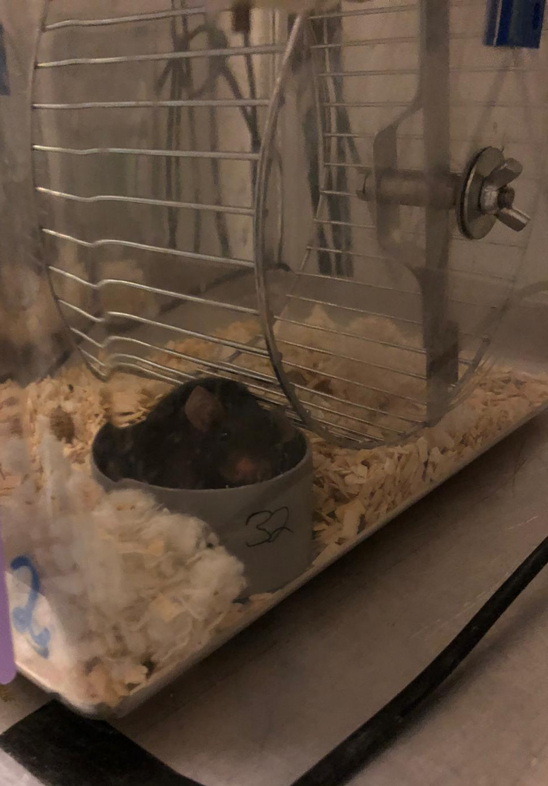
Special winter issue by Nine Gerrits
Neuron

Activity-based anorexia

How does a negative energy balance influences the NAc
Impact of the activity-based anorexia model on D1 medium spiny neurons in the nucleus accumbens of female mice
December 2021
Research report

Graphical abstract
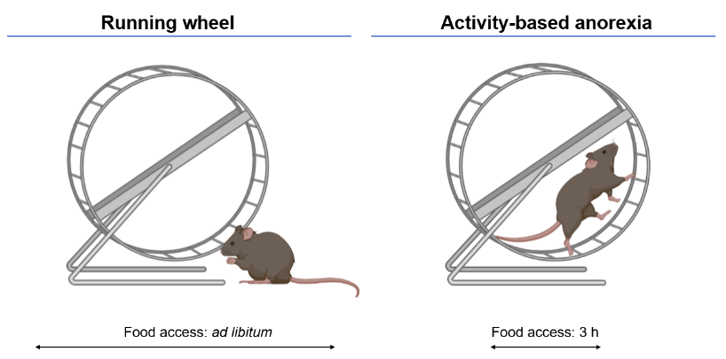
Author
Nine Gerrits (5911516)

Supervisor
Fabien Ducrocq
Examiners
Roger Adan
Frank Meye
Correspondence
n.j.m.gerrits@students.uu.nl,
f.y.c.ducrocq@umcutrecht.nl

=

Highlights
- ABA animals display increased running performances and decreased food intake leading to a negative energy balance
- Adult female mice exhibit ABA resistant and vulnerable subtypes
- Electrical intrinsic D1-MSN properties are unaltered after ABA exposure
- Pre-synaptic glutamatergic transmission onto D1-MSN is not significantly modified by the ABA model
- Overall, D1-MSN excitability remains unaltered after ABA exposure, independently of ABA subtype

Impact of the activity-based anorexia model on D1 medium spiny neurons in the nucleus accumbens of female mice
December 2021
Research report
N.J.M. Gerrits (n.j.m.gerrits@students.uu.nl)
Dept. of Translational Neuroscience, Brain division, University Medical Center Utrecht
Abstract
Anorexia nervosa (AN) is a metabo-psychiatric eating disorder that predominantly develops in adolescent women. AN is characterized by self-induced loss of body weight and hyperactivity leading to a severe negative energy balance. Moreover, AN individuals experience a lack of pleasure and reduced motivation. In accordance, previous research indicates an impaired dopamine reward system in patients. Interestingly, the nucleus accumbens (NAc), a critical brain area in reward processing, is also involved in energy balance regulation. However, NAc involvement in negative energy balance development with respect to AN has not been fully investigated and underlying mechanisms remain unknown. Herein, we hypothesised that medium spiny neurons (MSN), the dopaminoceptive neurons present in the NAc, are impacted by an AN animal model. More precisely, we aim to investigate if the activity-based anorexia (ABA) model impacts the excitability of MSNs in the NAc. To test this hypothesis we exposed DrD1-Cre/TdTomato female mice to the ABA paradigm at adulthood. The ABA model consists of a 3h feeding period, combined with unlimited running wheel access, inducing hyperactivity and self-starvation. We performed whole-cell patch clamp recordings after ABA exposure on acute NAc brain slices to assess electrical intrinsic properties and pre- and post-synaptic transmission of MSNs. We found that ABA exposed adult mice exhibit vulnerable and resistant subtypes. D1-MSN electrical intrinsic properties and pre- and post- glutamatergic transmission were found spared in both ABA subtypes when compared to running wheel control mice. We therefore conclude that ABA exposure has no effect on D1-MSN excitability in the NAc. Although our study did not reveal any correlation between AN like symptoms and D1-MSN excitability, this fundamental work brought us a step closer to unravel the contribution of the NAc towards ABA exposure and eventually AN susceptibility.
Keywords: Activity-based anorexia model, nucleus accumbens, medium spiny neurons, neuronal excitability
Laymans summary
Anorexia nervosa is a common eating disorder in adolescent women. The lifetime prevalence is estimated to be 1.0-2.9% among the Dutch population. The most notorious symptoms are reduced food intake and hyperactivity due to patients experiencing an intensive fear of becoming fat. As a result individuals with anorexia nervosa become severely underweight. At this moment behavioral therapy, sometimes combined with antipsychotic medicine, is used for treatment. Nonetheless, still half of the patients do not fully recover or remain chronically ill. Various scientific studies performed in anorexia nervosa patients suggest the presence of alterations in a brain area called the nucleus accumbens, amongst others. The nucleus accumbens is critical for both energy regulation and integrating rewarding information. Although it is demonstrated that the nucleus accumbens is important in anorexia nervosa, it is unknown how these alterations arise. To understand how anorexia nervosa develops and eventually construct new efficient medicine or treatments it is necessary to investigate this in more depth. Since it is not possible to investigate in humans how a negative energy balance influences neurons in the nucleus accumbens, we used an animal model. In this project an activity-based anorexia mouse model was used where mice are exposed to unlimited running wheel access and a 3h feeding period. A negative energy balance arises, resulting in body weight loss. Interestingly, mice exhibited vulnerable and resistant subtypes in line with clinical observations where humans show individual differences in anorexia nervosa susceptibility. After establishing the negative energy balance, we made brain slices to measure neuronal currents in the nucleus accumbens. Neurons integrate information and if this integration has been altered due to a negative energy balance this can eventually lead to a modified behavioral outcome. Different neurons are present in the nucleus accumbens and we found so far that one specific population of neurons was unaltered compared to a normal situation. This means that these neurons still function properly after a negative energy balance induction and future research should focus on other neuronal populations. This fundamental scientific research brings us a step closer to unravel the contribution of the nucleus accumbens in anorexia nervosa and supports the journey of finding efficient treatments.
Introduction

Anorexia nervosa (AN) is an eating disorder that predominantly develops in young/adolescent women but is also observed in adulthood and men¹. The lifetime prevalence of AN for adolescent women has been estimated to be 1.0-2.9% among the Dutch population ². Core features of AN are self-induced loss of bodyweight and hyperactivity leading to a severe negative energy balance ³. Consequently, patients drop their BMI below 17 kg/m2 and are more at risk for cardiovascular diseases and gastrointestinal disturbances amongst others ^{4,5}. In addition, psychiatric comorbidities, such as mood disorders, anxiety and obsessive compulsive disorders are very common in AN individuals ⁵. Overall, these complications are partly responsible for AN patients having the highest death rate of all psychiatric disorders. The annual mortality rate is 5,34 per 1000 AN patients and 20% can be explained by suicides ⁶. Behavioral therapy, sometimes combined with anti-psychotics, is used as a treatment for AN. Nonetheless, this treatment is not fully efficient, since only 47% of surviving patients recover from AN, 34% recovers marginally and 20% remains chronically ill ⁷. This treatment inefficiency is partly due to the unknown mechanisms underlying AN and despite existing knowledge more fundamental research is needed to decipher these mechanism.
It has been shown that AN patients experience a lack of pleasure and reduced motivation. In accordance, previous research indicates a dysfunction of the dopamine reward system in patients. This reward system is mainly composed of the so-called mesolimbic system, where dopaminergic neurons in the ventral tegmental area (VTA) project to the nucleus accumbens (NAc), the ventral part of the striatum. As a response to rewarding stimuli, dopamine is released by the VTA, where it modulates activity of the NAc by binding specific dopaminergic receptors ⁸. It has been shown that women with an AN history have reduced neuronal activity in the dorsal and ventral striatum in response to sucrose compared to healthy controls ⁹. Additionally, AN patients show increased Dopamine2/Dopamine3 (D2/D3) receptor binding in the ventral striatum ¹⁰. To visualize D2/D3 receptor binding via positron emission tomography (PET) a radioisotope attached D2/D3 receptor antagonist was used, replacing the endogenous dopamine. Increased binding levels of this D2/D3 receptor ligand can be explained by decreased dopamine levels and/or an increased density of D2/D3 receptors. Interestingly, a decrease of homovanillic acid (HVA), an important metabolite of dopamine, was seen in cerebrospinal fluid of AN patients ¹¹. Providing that decreased HVA levels indirectly reflect decreased dopamine levels, it could explain the increased antagonist receptor binding seen in AN patients. However, there is also evidence for a negative association between BMI and D2 receptor availability ¹². This indirectly suggests that the increased D2/D3 receptor binding described earlier can be explained by an increased D2/D3 receptor density. Altogether, these data point to a disturbance in the dopamine reward pathway in AN patients. Nonetheless, these clinical results are indirect measurements and exact alterations of the dopamine system as well as the neuronal mechanisms underlying them remain unknown.
Considering the mesolimbic reward system is conserved in mammals, rodents represent an effective in vivo model to study these neuronal mechanisms more precisely. In order to mimic AN in rodents an environmental model was developed and originally proposed in 1954 ¹³. In this activity-based anorexia (ABA) model, the animal is exposed to a combination of voluntary running wheel access and time-restricted feeding, as they induce most AN features when combined together. These features include reduced food intake and increased physical activity levels leading to a negative energy balance ¹⁴. Indeed, compulsive wheel running, mainly expressed by food anticipatory activity (FAA) will develop over time, despite extreme weight loss. More precisely, FAA is the running wheel (hyper)activity seen preceding access of food and is generally observed during the last 6 hours before food admission ¹⁵. Notably, adolescent female mice are highly vulnerable to the ABA model in contrast to adult female mice where ABA exposed mice can be divided in vulnerable and resistant subtypes ¹⁶. This is in line with clinical observations where adolescent women are more prone to develop AN ¹.
As previously stated, the NAc is known for being a critical brain area in reward processing. In addition, more recent studies showed that the NAc is also involved in energy regulation by modulating both feeding and exercise. As food and exercise are both rewarding, behavioral responses depend on both the reward value and internal energy state of the animal. Ultimately, the NAc contributes to cost/benefit-based decision making ¹⁷. These latest observations together with alterations found in AN patients suggest that the NAc is involved in AN-related dysregulation of the energy balance. Anatomically, the most abundant neurons in the NAc are medium spiny neurons (MSN), since they represent ≈ 90% of all ventral striatal neurons¹⁸. MSNs are GABAergic, dopaminoceptive and are characterised by their low excitability. These neurons can be divided in dopamine receptor 1 (D1) and D2 expressing MSNs. Notably, activation of D1 receptors enhance firing rate of D1-MSNs, whereas activation of D2 receptors decrease D2-MSN firing ¹⁹. Furthermore, as has been mentioned, the NAc is important in energy regulation and this is reflected by D1- and D2-MSN activity ²⁰. In brief, Zhu and colleagues showed that activation and inactivation of D1-MSN significantly and bidirectionally modified food intake, whereas food intake wasn’t altered by (in)activation of D2-MSN. Additionally, wheel running distance is increased during either activation of D1-MSN or inactivation of D2-MSN. Not to mention, a study done in the NAc shell showed that D1-MSN projections to the lateral hypothalamus are involved in a rapid control over feeding ²¹. Little is known yet about MSNs in the context of AN but interestingly female mice with virally overexpressed D2 receptors in D2R-expressing neurons of the NAc core showed more vulnerability to the ABA model compared to controls ²². Altogether, these data suggest that both D1 and D2 MSNs are important in energy regulation and may play a role in the development/ maintenance of AN-like symptoms observed in the ABA model.
However, besides the data previously described, the involvement of NAc MSNs in ABA-related behavioral alterations have not been fully investigated and underlying mechanisms remain unknown. The overall project aims to investigate the impact of the ABA model on NAc MSN excitability. In the present study, we focused on D1-MSN in the NAc core, since no sufficient data of D2-MSN was present due to technical issues and a lack of time. We hypothesised that if D1-MSNs are impacted by ABA exposure, excitability will be increased, since activation of D1-MSN increased physical activity in mice²⁰. To test this hypothesis we exposed DrD1-Cre/TdTomato female mice to the ABA paradigm and compared them to wheel running control mice at adulthood. After ABA exposure, brains were harvested and sliced for electrophysiological purposes. We performed whole-cell patch clamp recordings on acute NAc brain slices to assess basic electrical intrinsic properties and excitability of MSNs. This fundamental work contributes to a better understanding on how the NAc responds to a severe negative energy balance and provides a link between AN symptoms and dysregulation of the reward system observed in AN patients.
Materials and Methods

Animals and housing
DrD1-Cre (Dopamine 1 receptor) mice (JAX: #028298; 129S genetic background) and Ai14 receptor (TdTomato) mice (JAX: #007914, C57BL/6J genetic background) were purchased from the Jackson Laboratory. Female D1-Cre and male Ai14 were bred in house (Department of translational Neuroscience, Utrecht). Adult heterozygous female DrD1-Cre/TdTomato offspring (2-5 months old) were used for all studies. Prior to experiments, mice were group housed on a 12 h light/dark cycle in a temperature (21 +- 2 °C) and humidity (60-70%) controlled room with wood shavings as bedding and tissue and shelter for enrichment. Mice were fed with ad libitum standard mice chow (Special Diets Services, CRM (E), #801730) and tap water unless otherwise stated. Microbiological status of all animals was conventional. The discomfort of the protocol was estimated to be moderate and all experiments were approved by the animal welfare authority (IvD) Utrecht.
Activity-based anorexia paradigm (ABA)
Adult DrD1Cre/tdTomato female mice were distributed in two groups: ABA (5 days of 3 hour/day food access; unlimited wheel access) (n=11) and running wheel (RW) control (ad libitum food access, unlimited wheel access) (n=11). Mice were randomized in these groups based on their litter of origin and baseline bodyweight with RandoMize. Three weeks before wheel running habituation, animals were transferred to the experimental room (24 °C) with a reversed 12h light/dark cycle in their classical home cages for acclimation. Mice were group housed until the start of habituation. To decrease stress, mice were handled for 7 days by the experimenter prior to habituation. Starting from habituation onwards mice were singly housed in a cage (17x15x26cm) with wood shavings as bedding, cotton nestlets for enrichment and a running wheel (1 revolution = 44 cm). Cages were located in close proximity of each other to provide visual, acoustic and odor contact. ABA and RW cages were equally distributed over the top and bottom racks, to prevent confounding factors such as light and noise. During habituation, standard mice chow was given in plastic round cups on the cage floor and tap water was ad libitum available. Animals were acclimated to their cage and running wheels for 10 days to stabilize wheel running performances before experimental onset. As illustrated in Fig. 1, mice enter the acute (food restriction) phase after habituation. In ABA mice, food access was limited from 12.00 – 15.00 (onset of dark phase), in RW controls food was ad libitum available. After 5 days of the acute phase, both ABA as RW mice were sacrificed at dark onset to harvest the brain for electrophysiological purposes. Mice reached their humane end point (HEP) if they experienced hypothermia and lost more than 20% of their baseline body weight. If mice almost reached their HEP before the end of the experiment, +- 0.5 g of standard chow was given with an additional heating pad below the cage during the restrictive phase for one day to improve body weight and general health. Daily body weight, food intake, water intake and wheel running were recorded during habituation and acute phase. During ABA exposure FAA develops and this was calculated as the distance traveled during the last 6h of the light phase (i.e. prior food exposure). Running wheel activity was measured by homemade mechanical wheels (Department of Translational Neuroscience, Utrecht) connected to a monitoring software (CageReg, cage registration program version 5.5). Data were recorded in 60 min bins. An individual mouse represents the experimental unit while analyzing this behavioral dataset.
Slice preparation
For electrophysiological recordings of MSNs, acute sagittal brain slices with NAc were made from adult (2-5 month old) female mice. Mice were gas anesthetized with 200 μL isoflurane and decapitated. The brain was then dissected within a minute and glued to the stage of a LEICA VT 1000 S vibratome. Oxygenated ice-cold artificial cerebrospinal fluid (aCSF) (containing in mM; 92 Choline Chloride, 2.5 KCl, 1.2 NaH2PO4, 25 NaHCO3, 20 HEPES, 25 Glucose, 20 NMDG, 10 sodium ascorbate, 2 thiourea, 3 Na-pyruvate, 3.05 N-Acetyl L Cysteine, 7 MgCl2, 0.5 CaCl2.2H2O) was administered to the stage. Slices of 350 µm thickness were cut and transferred to 37 °C oxygenated aCSF. After 5 minutes, slices were put in oxygenated incubation solution (containing in mM: 92 NaCl, 2.5 KCl, 1.2 NaH2PO4, NaHCO3, 20 HEPES, 25 Glucose, 3 sodium ascorbate, 2 thiourea, 3 Na-pyruvate, 2 MgCl2, 2 CaCl2.2H2O) at room temperature for at least 60 minutes and for the rest of the day until recording. Slices recovered at room temperature were transferred into the recording chamber bath of a Scientifica electrophysiological set-up. Oxygenated recording solution (containing in mM: 124 NaCl, 2.5 KCl, 1 NaH2PO4, 26.2 NaHCO3, 5 HEPES, 11 Glucose, 1.3 MgCl2, 2.5 CaCl2.2H2O) was circulated through the bath at approximately 31°C with a speed of 1.5-2 ml/min. All solutions used were continuously bubbled with 95% O2 and 5% CO2, and had a pH and osmolarity of 7.3-7.4 and 300-310 mOSM, respectively.
Whole-cell patch-clamp recordings
To determine electrophysiological properties of MSNs in the NAc, neurons were whole-cell patch clamped. To visualize cells, an upright microscope with infrared light (Q imaging, scientific cmos, Scientifica) was used and digitalized with QCapture software. D1-MSNs were identified by red fluorescence (DrD1Cre/Tdtomato mice), this is illustrated in Fig. 3. A green light (550 nm) was emitted to detect the excitation of the red fluorescence (Cool led pE-2). Voltage clamp (VC) and current clamp (CC) recordings were amplified (Axon Instruments, Axopatch 200B), digitized (Axon Instruments, DigiData 1550A) and analyzed with pClamp 10.6/11.1 software. Polished pipettes were pulled from glass capillaries with a flaming/brown micropipette puller model p-97. Pipette resistance when filled with internal solution (containing in mM: 139 potassium-D-gluconate, 5 KCl, 2 MgCl2, 0.2 EGTA, 10 HEPES, 10 creatine phosphate, 4 Na2-ATP, 0.3 Na3-GTP ; pH: 7.3-7.4, mOsm: 300-305) was 2.5-5.5 MΩ. Internal solution was always kept on ice before entering the pipettes. Whole-cell access was obtained after opening the neurons. Membrane resistance, membrane capacitance and access resistance were measured with a -5 mV step in VC at -65 mV. Spontaneous excitatory postsynaptic currents were recorded with a gap free protocol for 5 minutes in VC at -65 mV. Hereafter a switch to CC was made to measure the input/output curves. An initial current of -150 pA was injected for 600 ms and with an interval of 5 seconds the current injected increased with a +10 pA step. Finally, hyperpolarization-activated currents were measured in VC with voltage steps of -10 mV going from a membrane potential of -50 to -140 mV. Recordings with a series resistance higher than 30 MΩ, monitored throughout the whole recording time, were excluded from further analysis due to bad patch quality. An individual cell represents the experimental unit while analysing this electrophysiological dataset.

Statistical analysis
Behavioral data were collected in individual mice. Mean bodyweight, food intake and wheel running during habituation were analyzed with an unpaired t-test or Mann Whitney U test if not normally distributed. A two-way repeated measures ANOVA followed by Bonferroni’s multiple comparison test, when applicable, was conducted to analyze the trajectory of bodyweight and food intake during the acute phase. A stop in the running wheel count due to technical problems accounts for some random missing values and therefore a mixed-effects model ANOVA was conducted to analyze FAA. Electrophysiological data were collected in individual neurons. Resting membrane potential, rheobase and membrane resistance were analyzed with a one-way ANOVA or Kruskal-Wallis test if not normally distributed. The current/voltage (I/V) , input/output (I-O) and hyperpolarization-activated currents curve were analyzed with a two-way repeated measures ANOVA followed by Bonferroni’s multiple comparison test when applicable. sEPSC amplitude and sEPSC frequency were analyzed with a one-way ANOVA or Kruskal-Wallis test if not normally distributed and the Kruskal-Wallis test was followed by Dun’s multiple comparison test. A Pearson correlation test was used for correlation analysis and the mean habituation running activity was analyzed with a one-way ANOVA followed by Bonferroni’s multiple comparison test. The experimenter was blind to groups during analysis. Data are presented as mean ± SEM (standard error of the mean). Graphpad Prism 7 was used to perform statistical analyses. Differences were considered significant at p < 0.05 (*), p < 0.01 (**), p < 0.001(***) and as a trend at p<0.1 (#).
Results
Decreased body weight and food intake and increased running performances during the acute phase is observed in adult ABA female mice.
Adult female mice were exposed to the ABA paradigm (acute phase) after habituation to the cage and running wheel and euthanized after ABA day 5 to harvest brains for electrophysiological purposes (Fig. 1A). During 10 days of habituation body weight, food intake and wheel running performaces were measured. There were no mean habituation differences between ABA and RW mice in body weight (Mann whitney U; p=0.7969) (Fig. 1B) or food intake (Unpaired t-test; p=0.7191) (Fig. 1C). In addition, no difference between ABA and RW mice was found in mean running wheel performance during the last 2 days of habituation (Unpaired t-test; p=0.1899) (Fig. 1D), where performances were found stable over days. To determine if the ABA paradigm has an effect on adult female mice, body weight was assessed everyday before food exposure. As expected, a decreased body weight was found in ABA mice, worsening day by day (Fig. 1E)., Indeed post hoc tests revealed that ABA mice lost weight significanlty when compared to RW controls on all 5 days of the acute phase (Interaction; p<0.001, all post hoc; p<0.001). The longer the mice were exposed to ABA the lower the body weight (Time effect, p<0.001) ultimately reaching 14% ± 1.20 of body weight loss on day 5. Similarly, post hoc tests indicated a decreased food intake in ABA mice when compared to RW controls on all 4 days of the acute phase (Interaction; p<0.001, all post hoc; p<0.001) (Fig. 1F). Day A1 of food intake is not presented since this value does not represent a relevant outcome. Before the first food removal mice are not starving and therefore the values are artificially low. Although learning abilities were seen in food intake over time (Time effect, p<0.01), there still is a highly significant difference during the last day of ABA between both groups (post hoc; p<0.01). Furthermore, FAA increases and becomes more evident over time in ABA mice (Fig. 1G). A significant increase on day 4 and day 5 was seen during the acute phase (Interaction; p<0.05, post hoc; p<0.05 and p<0.01, respectively). This is reflected by the circadian distribution (Fig. 1H), where an abrupt increase in light phase running was displayed by ABA mice, whereas RW mice only show running activity during the dark phase. Altogether, increased activity and decreased food intake is displayed by ABA mice leading to a negative energy balance (i.e. decreased body weight).
Resistant and vulnerable subtypes are exhibited in adult female mice exposed to ABA
Individual values of FAA showed the high variability that exists between different ABA mice (Fig. 2A). Interestingly, the same heterogeneity in FAA expression has recently been described by an article and they concluded that adult female mice can exhibit either resistant or vulnerable subtypes while being exposed to the ABA paradigm. A body weight loss of more than 20% over 10 days was characterized as vulnerable. It appeared that these vulnerable mice also showed significant more FAA compared to resistant mice, linking hyperactivity and sensitivity to the ABA protocol ¹⁶. Therefore, in our study ABA mice will be subdivided
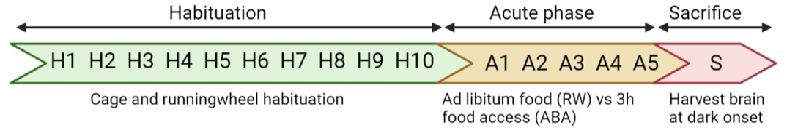
A

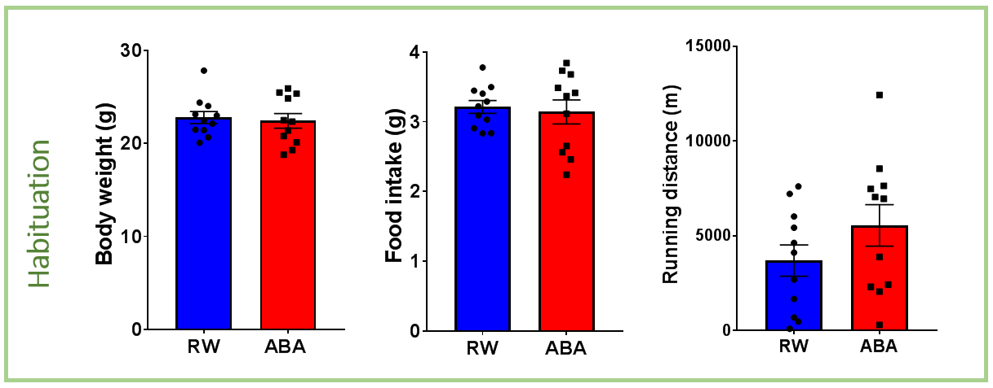
D
C
B

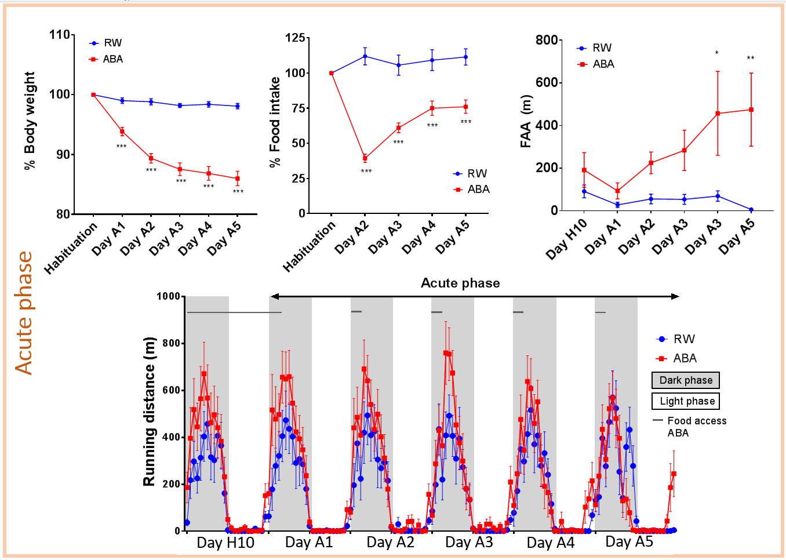
G
E
F

H

Figure 1. Habituation and acute phase in running wheel (RW) and activity-based anorexia (ABA) mice. (A) Timeline of experimental model, with habituation (H) in green and the acute ABA phase (A) in orange. (B) Mean body weight (g) over 10 days of habituation in RW and ABA mice. (C) Mean food intake (g) over 10 days of habituation in RW and ABA mice. (D) Mean running wheel distance (m) over last 2 days of habituation in RW and ABA mice. (E) Body weight loss trajectory (%) in RW and ABA mice during acute phase. Mean weight during habituation is set at 100%. (F) Percentage of daily food intake across last four days of acute phase in RW and ABA mice. Mean food intake during habituation is set at 100%. (G) Food anticipatory activity (FAA) (m), measured during 6h prior food access, in RW and ABA mice during acute phase. (H) Wheel running revolutions during the last day of habituation and the acute phase in RW and ABA mice. Grey and white box represent dark- and light phase, respectively. RW; n=11, ABA; n=11. Data are presented as mean ± SEM (*p<0.05, **p< 0.01, ***p<0.001).
based on their FAA levels. More precisely, mice that travelled over 400 meters at least once in the 5 ABA days during the 6h period prior food access (FAA) were considered as part of the vulnerable subtype (ABA-V). RW controls never reached these FAA running performances and therefore all ABA animals that similarly did not achieve higher running performances than 400 m were considered as part of the resistant subtype (ABA-R). The establishment of ABA subtypes, results in an even more drastic expression of FAA in ABA-V mice (Fig. 2B). Increased FAA was seen in ABA-V mice compared to RW control (Interaction; p<0.001, post hoc A3-A5; p<0.001) and ABA-R on days A3, A4 and A5 (Interaction; p<0.001, post hoc; A3 p<0.01, A4/A5 p<0.001). In order to confirm that increased FAA expression contributes to the development of a more severe negative energy balance, we next compared body weights of RW, ABA-R and ABA-V. First, both ABA subtypes were different from the RW control but more importantly, a significant difference between ABA-R and ABA-V was found. ABA-V mice dropped faster in body weight when compared to ABA-R mice on day A2, A3 and A4 (Interaction; p<0.001, post hoc A2-A4; p<0.05) (Fig. 2C). Interestingly, no difference in food intake was seen between ABA-V and ABA-R mice (Fig. 2D). These data suggest that increased FAA is an important factor in accelerating the development of a negative energy balance in ABA animals.
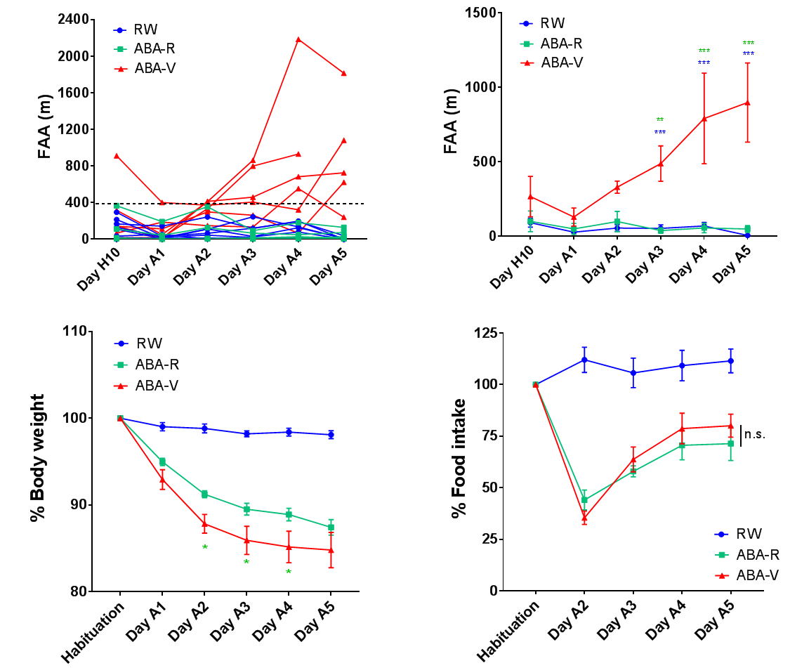
A
B

D
C

Figure 2. Adult female mice exposed to ABA exhibit resistant and vulnerable subtypes. (A) Individual values of FAA (m) show that animals display a high variability in running distance. These values were used to subdivide ABA mice in resistant (ABA-R) and vulnerable (ABA-V) groups. To be included in the ABA-V subtype a threshold needs to be overcome once, as indicated by the dotted line. (B) FAA (m) in RW, ABA-R and ABA-V mice during acute phase. (C) Body weight loss trajectory during acute phase (%) in RW, ABA-R and ABA-V mice. Mean weight during habituation is set at 100%. (D) Percentage of daily food intake across last four days of acute phase in RW, ABA-R and ABA-V mice. Mean food intake during habituation is set on 100%. RW; n=11, ABA-R; n=5, ABA-V; n=6. Data are presented as mean ± SEM (n.s.= not significant, *p<0.05, **p< 0.01, ***p<0.001).

ABA exposure does not alter NAc D1-MSN intrinsic electrical properties
In order to assess the impact of ABA on excitability of NAc MSNs, we performed whole-cell patch clamp electrophysiology. To distinguish D1-MSNs from other cells and be able to study their electrophysiological properties, selective labeling is necessary. In the present study D1-MSN were selectively labeled in a Cre-dependent fashion. Ai14 mice were crossed with DrD1-Cre mice and heterozygous female progeny (DrD1Cre/TdTomato mice) were used for further experiments (Fig. 3A). Ai14 mice carried a red fluorescent protein (TdTomato), which was prevented from transcription by a loxP-flanked STOP cassette. When crossed with DrD1-Cre mice, progeny expressed Cre-recombinase specifically in DrD1- expressing neurons. In presence of the Cre-recombinase the stop cassette was removed from the gene and TdTomato was expressed. DrD1 negative neurons did not express Cre-recombinase and therefore were not labeled with TdTomato (Fig. 3B). Consequently, in the NAc D1-MSN were identified by fluorescence in acute brain slices as illustrated in figure 3C.
Next, to determine if NAc D1-MSN excitability was changed when exposed to ABA, whole-cell patch clamp recordings of D1-MSNs were made. Intrinsic electrical properties and excitability of a neuron can be determined by measuring different parameters. First, intrinsic properties were measured in current clamp mode, such as the relationship between injected currents and voltage responses (I-V Curve) and injected currents and number of action potentials (AP) (I-O curve) (Fig. 4A-C). No differences were observed in the I-V curve (Interaction; p=0.4731, Group factor; p=0.4013) and action potential patterns were similar between groups (Interaction; p=0.9938, Group factor; p=0.5653). Additionally, the minimum amount of current necessary to initiate an action potential, the so-called rheobase, was not changed after ABA exposure (one-way ANOVA; p=0.7980) (Fig. 4D). In accordance, membrane properties such as resting membrane potential (RMP) (one-way ANOVA; p=0.6283) and membrane resistance (Kruskal-Wallis, p=0,5189) were similar in RW, ABA-R and ABA-V mice (Fig. 4E-F). Furthermore, it is well known that MSNs have robust hyperpolarization-activated inwardly rectifying potassium (KIR) currents contributing to maintain a hyperpolarized “down state” ¹⁹. Alterations in these currents can contribute to a modified excitability.
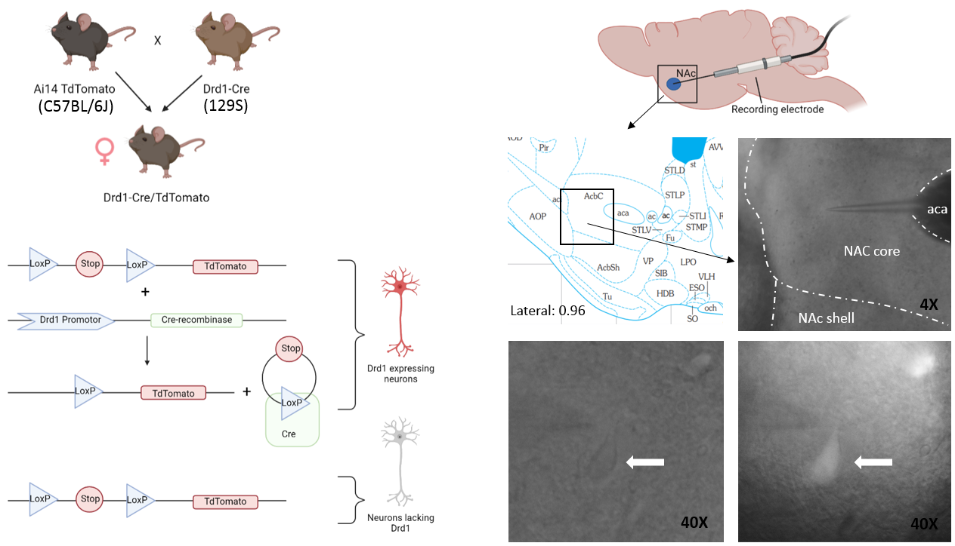
A
C

B

Figure 3. Selective labeling of Drd1 expressing neurons (A) Heterozygous female progeny of Ai14 and DrD1-Cre mice were used for experimental purposes. (B) Labeling D1-MSN with fluorescence in Cre-dependent fashion. (C) (Top) Schematic of sagittal brain slices containing the NAc core. (Middle) Brain atlas at lateral 0.96 mm with the corresponding microscope bright field picture of NAc core (4x magnification). (Bottom) D1-MSN in bright field mode and fluorescent mode, respectively (40x magnification).
Interestingly, it has been shown that KIR currents represent most of the hyperpolarization-activated currents in MSNs ²³. Thus in this study hyperpolarization-activated currents were measured to preliminarily estimate a potential effect of ABA exposure on these KIR currents. Currents were measured in voltage clamp by using ramps from -50 to -140 mV (Fig. 4G-H). Results showed no alteration in hyperpolarization-activated currents between groups (Interaction; p=0.8939, Group factor; p=0.5537) (Fig. 4I). Altogether these data suggest that ABA exposure doesn’t affect NAc D1-MSN intrinsic electrical properties and neuronal excitability.
ABA exposure does not induce alterations in spontaneous glutamatergic transmission received by D1-MSN in the NAc
Considering that glutamate is the main excitatory neurotransmitter in the brain that contributes to increase neuronal activity, the glutamatergic transmission received by D1-MSN in the NAc was assessed. To do so, spontaneous post synaptic currents were recorded in all experimental groups. This measurement allows to investigate both pre- and post-synaptic transmission. More precisely, potassium gluconate internal solution was used and voltage was maintained at -65 mV, allowing only excitatory currents through the membrane. As a result, only glutamatergic transmission was recorded. After a few minutes of recording spontaneous excitatory post synaptic currents (sEPSC), an average of sEPSC amplitude as well as sEPSC frequency was determined. The amplitude of sEPSC is dependent upon activation of post-synaptic receptors and therefore reflects post-synaptic receptor density (Fig. 5A). D1-MSN sEPSC amplitude was found unaltered in both subtypes of ABA exposed mice (one-way ANOVA; p=0.3750) (Fig. 5B). This data suggests that ABA exposure has no effect on glutamatergic post-synaptic transmission. Additionally, sEPSC frequency was measured (Fig. 5C) sEPSC frequency dependents on pre-synaptic vesicular release and therefore reflects pre-synaptic glutamatergic transmission. It was observed that ABA exposure did not induce modifications in sEPSC frequency (Kruskal-Wallis; p=0.1056) (Fig. 5D), suggesting that pre-synaptic glutamatergic transmission remains unaltered after ABA exposure. Altogether, these data demonstrate that neither post-synaptic nor pre-synaptic glutamatergic transmission is significantly impacted by the ABA protocol resulting in unchanged excitability patterns.
Discussion
It has been shown that the dopamine reward pathway is disturbed in AN patients. However, these findings are mostly indirect measurements and underlying mechanisms are not fully understood yet. A few recent preclinical studies suggest that MSNs in the nucleus accumbens are involved in energy balance regulation and alterations in these neurons can induce AN associated symptoms such as hyperactivity and body weight loss^{20,22}. Therefore in our study we investigated if ABA exposed mice, a validated AN in vivo model inducing a severe negative energy balance, display alterations in D1-MSN excitability in the NAc. This fundamental work provides insights into the link between AN symptoms and the dysregulation of the dopamine reward system observed in AN patients. As expected our present findings showed that ABA exposed adult female mice displayed increased running performances and decreased food intake leading to a negative energy balance. Additionally, in line with previous research¹⁶ we observed that adult female mice exhibited vulnerable and resistant subtypes. Strikingly, our findings revealed that in both ABA-R and ABA-V mice no significant alterations in intrinsic properties were present. In addition, we demonstrated that synaptic glutamatergic transmission onto D1-MSN was not significantly modified by the ABA model. Taken together, our data indicates that D1-MSN excitability remains unaltered after ABA exposure.
The ABA paradigm is a widely used animal model in AN research. It is thought to be the best environmental model available, since it reproduces many endophenotypes seen in the disorder itself. Not only does this model show a decrease in food intake and an increase in hyperactivity resulting in a severe negative energy balance, it also mimics peripheral complications such as cardiovascular and gonadal dysfunctions as well as severe hypoglycemia ²⁴. Nevertheless, symptoms such as psychosocial factors, weight phobia and long-term effects observed in AN patients are not reflected in this model ^{24,25}. Interestingly, within AN patients a variability in symptoms is shown and therefore AN subtypes have been created. To be diagnosed with AN via DSM-5 criteria, individuals must show a restrictive energy intake leading to a significant low body weight (BMI<17 kg/m2), carry an intense fear of becoming fat and have a distorted body image. Additionally, patients are subtyped in either binge-eating type AN or restricting type AN. Binge-eating type AN patients engage in binge eating behavior and self-induced vomiting in contrast with restricting type AN
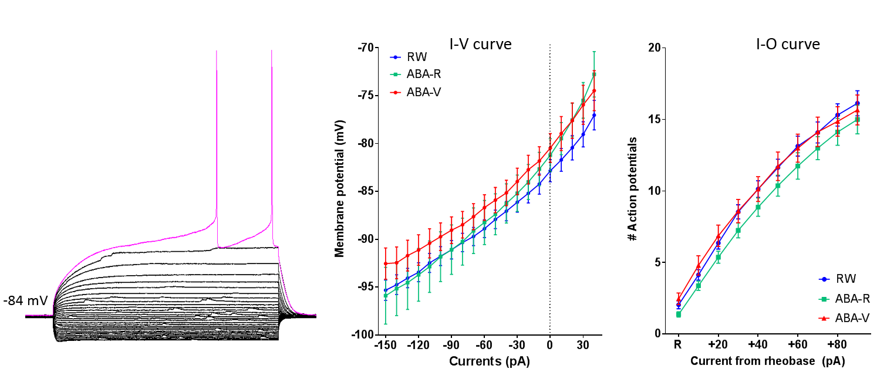
A
B
C

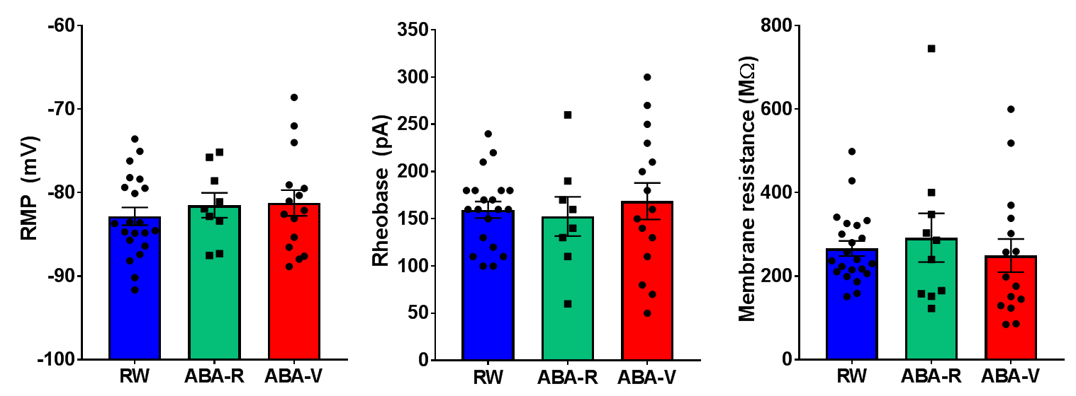
F
E
D

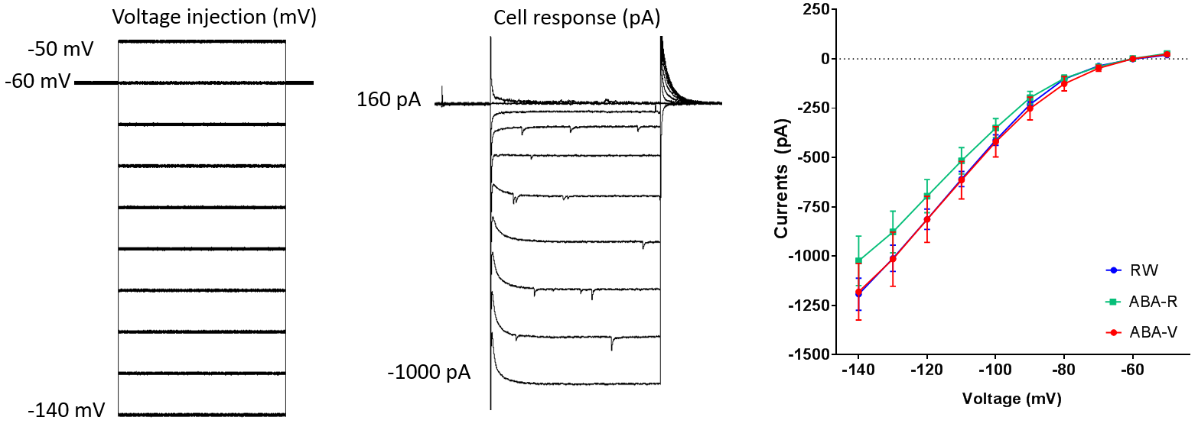
I
H
G

Figure 4. Intrinsic properties of NAc D1-MSNs are not altered after ABA exposure. (A) Representative traces of voltage responses in D1-MSNs. (B) I-V curve (current-voltage curve). RW; n=20 (9), ABA-R; n=8 (4), ABA-V; n=14 (5). (C) I-O curve (input- output curve with currents as input and number (#) of action potential as output). RW; n=20 (9), ABA-R; n=8 (4), ABA-V; n=15 (5). (D) Resting membrane potential (RMP) in mV. RW; n=22 (9), ABA-R; n=9 (4), ABA-V; n=15 (5). (E) Rheobase in pA. RW; n=20 (9), ABA-R; n=8 (4), ABA-V; n=15 (5). (F) Membrane resistance in MΩ. RW; n=22 (10), ABA-R; n=10 (4), ABA-V; n=15 (5). (G) Trace of voltage ramps applied to the cell and (H) a representative trace of current responses from D1-MSN to voltage ramps. (I) Measure of hyperpolarization-activated currents. RW; n=19 (9), ABA-R; n=10 (4), ABA-V; n=11 (5). Data are presented as mean +- SEM. All data shown are not significant.
where these behaviors are not exhibited but weight loss is accomplished by dieting, fasting and/or excessive exercise²⁶. It is known that certain traits and risk factors result in a less favorable prognosis and rehospitalization ^{27,28}. Patients expressing periodic hyperactivity, especially seen in restricting type AN, have increased chances for rehospitalization and strikingly, 31 to 80% of AN patients express this hyperactivity ^{27,29}. Although not all AN features are displayed by the ABA paradigm, it covers the very common and important risk factor hyperactivity. Therefore, the ABA model is a valid animal model to study underlying mechanisms of AN, specifically alterations in neuronal mechanisms induced by a severe negative energy balance.
In accordance with a previous published study¹⁶, our research showed that ABA exposed adult female mice exhibit ABA vulnerable and ABA resistant subtypes. The vulnerability of the previously described study was characterized by a body weight loss of more than 20% within 10 days¹⁶. However, since for our study electrophysiological recordings were performed following ABA exposure, it was not possible to wait for the HEP (20% of bodyweight loss) to be reached. A cut off of 5 ABA days was chosen, since this was sufficient to create ABA symptoms such as FAA but still a 100% of mice could be kept until the end of the experiment. Interestingly, ABA-V mice in the previous described study displayed increased FAA¹⁶. Therefore, in our study FAA was used to characterize vulnerability. Unfortunately, technical problems occurred during the experimental period accounting for some missing values in the wheel running monitoring of day 5 of one ABA-V mice. Nonetheless, the threshold for being characterized as an ABA-V mice was already met and therefore we expect that this event brings no alterations to the results. Accelerated body weight loss in ABA-V compared to ABA-R was observed, but strikingly both subtypes showed similar food intake when vulnerability was characterized based on FAA. These results indicate that food intake is necessary to establish the negative energy balance since RW control mice do not display increased FAA and body weight loss. However, FAA rather than food intake is critical for ABA vulnerability since no difference in food intake was seen between ABA-R and ABA-V mice while FAA was increased.
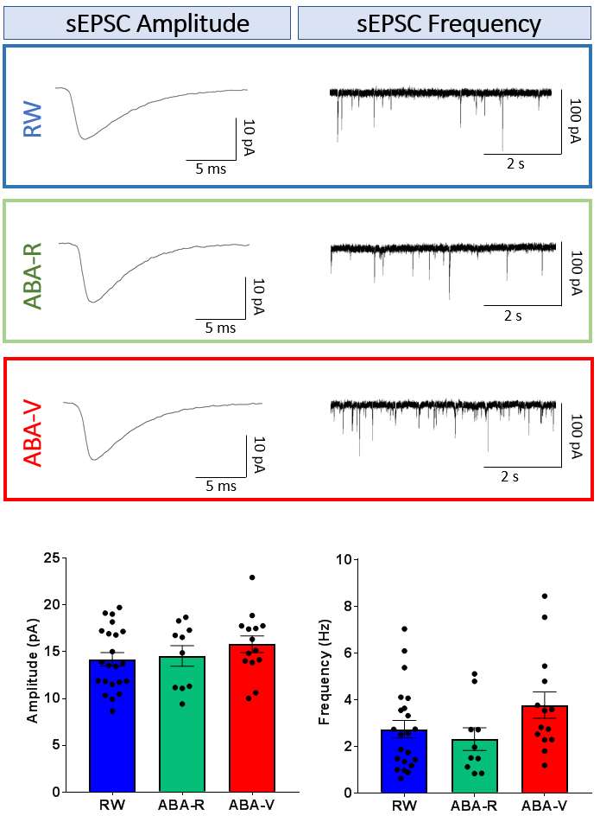
Figure 5. Spontaneous excitatory post-synaptic currents (sEPSC) are not altered in D1-MSNs after ABA exposure. (A) Traces of averaged events over 2 minute sEPSC recording allowing to measure mean amplitude in (A1) RW, (A2) ABA-R,and (A3) ABA-V mice. (B) Averaged amplitude in pA. (C) Traces showing sEPSC recording over time in (C1) RW, (C2) ABA-R and (C3) ABA-V mice. (D) Calculated sEPSC Frequency (Hz). RW; n=22 (10), ABA-R; n=10 (4) ABA-V; n=14 (5). Data are presented as mean +- SEM. All data shown are not significant
C2

C1

A2
A1
C3
A3

D
B

There are several ways to interpret the hyperactivity characterized as FAA and some studies suggest that FAA can be explained by stress relieve. It is demonstrated that severe stressful events can negatively impact the dopamine reward pathway ¹⁸. A food restriction stressor can cause a 50% decrease in basal extracellular dopamine levels in the NAc ³⁰. It is thought that hyperactivity acts as a compensatory behavior and increases dopamine levels resulting in a anxiolytic and rewarding effect ³¹. On the other hand, it could also be explained by evolutionary behavior where it is beneficial to increase activity levels for a higher chance of finding food. Not to mention, hypothesis exist about FAA being necessary for maintaining body temperature, since this is decreased following food restriction in ABA mice ³². Interestingly, a study by Wu et al., showed in rats that postprandial activities, but not FAA, were directly related to weight loss ³³. Moreover, rats fed at irregular times during ABA performed increased running activity in both dark and light phase compared to rats fed at fixed times during an ABA protocol³⁴. This indicates that FAA alone might not be enough to predict model severity and characterize vulnerability, since hyperactivity is not only presented prior food access. Therefore I suggest that FAA in ABA is a behavioral disturbance amongst others that participates in altering the day / night rhythm and general activity patterns ultimately leading to increased vulnerability to the ABA model. However, it remains debatable what drives these disturbances in day / night rhythm.
This argument goes well together with the question on how variability emerges in ABA vulnerability. Multiple arguments on the question have been raised. First of all it is thought that the mouse strain is of importance ^{35,36}. Interestingly, preliminary results showed increased activity levels resulting in increased vulnerability in DrD1Cre/TdTomato (129S/BL6 genetic background) mice backcrossed with C57BL/6J mice. Strains vary in genetic background resulting in phenotypical differences such as variations of body weight, activity and other behavioral dimensions that can possibly cause mice to be more or less vulnerable. It has been demonstrated that leaner animals show increased activity during ABA and are therefore more vulnerable ²⁴. Nonetheless, in contrast to previous research our data showed no correlation between body weight and ABA vulnerability (R² =0.07844, p=0.4042) (Fig. 6A1). Additionally, we showed that there is no correlation between age and ABA vulnerability when mice have already reached adulthood (R²=0.00906, p=0.7807) (Fig. 6A2). Interestingly, anxiety is the most common comorbidity in AN patients. Consistent with these clinical results, it is shown that mice exposed to post weaning isolation stress were more susceptible to body weight loss and showed increased light phase activity during ABA exposure ³⁷. In accordance, rats with higher anxiety levels, measured by spending more time in closed arms of the elevated plus maze, showed increased running activity during the ABA paradigm resulting in severe body weight loss. Interestingly, high anxious rats already showed increased activity performances prior to food restriction compared to low anxious mice³⁸ and additionally mice and rats with high baseline running activity strongly predicted ABA vulnerability³⁵. These preclinical data suggest that anxiety could be a risk factor for developing a negative energy balance. Consistently, we found a slight positive correlation between baseline running wheel performances and food anticipatory during ABA (R²=0.2806, p=0.0938) (Fig. 6A3). This baseline running wheel performance is also portrayed in figure 6B where a trend in increased wheel running was observed during habituation between ABA-V and RW mice (One-way ANOVA; p=0.0538, post hoc; p=0.0551), while ABA-R and RW mice have similar running performances (One-way ANOVA; p=0.0538, post hoc; p=0.9999).
A1
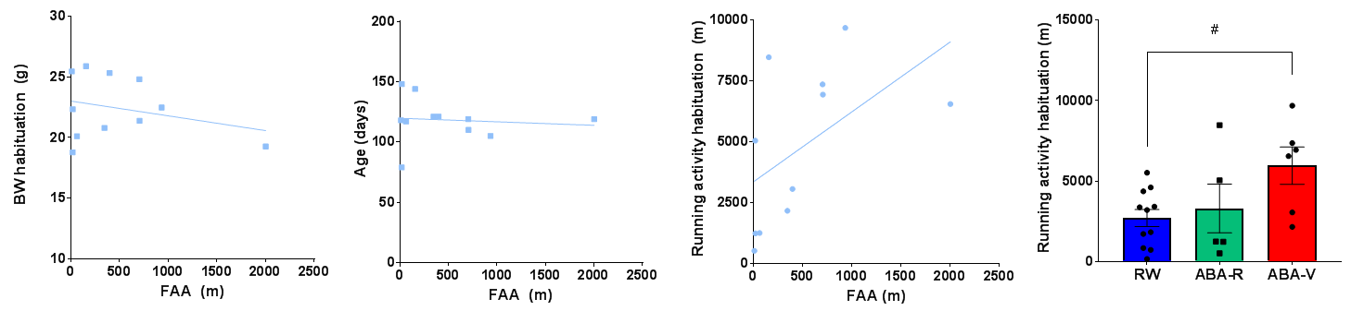
B
A3
A2

Figure 6. Running wheel activity before ABA slightly correlates with FAA at day 5 of ABA. (A) Correlations from ABA-V and ABA-R mice combined (n=11) between (A1) bodyweight (g) during habituation and FAA (m) (A2) age (days) and FAA (m) (A3) running activity during habituation (m) and FAA (m). (B) Mean running wheel distance (m) during habituation in RW, ABA-R and ABA-V mice. RW; n=11, ABA-R; n=5, ABA-V; n=6. Data in B is presented as mean +- SEM (#p<0.01).
Considering these data, I suggest that hyperactivity either expressed as FAA or postprandial activity is a compensatory behavior to increase dopamine levels resulting in an anxiolytic and rewarding effect.
The aim of our research was to investigate the impact of the activity-based anorexia model, described in detail above, on neuronal excitability in the NAc. Specifically MSN excitability, since these neurons are dopaminoceptive. Data on D2-MSN were incomplete due to technical issues and lack of time and therefore only D1-MSN excitability was assessed. Excitability is a cell property, allowing the cell to respond with an electrical signal or action potential to incoming stimuli. Alterations in excitability in one neuronal population can eventually lead to modified behavioral patterns, such as hyperactivity seen in ABA mice or AN patients and is therefore interesting to study. Different properties participate in determining a cells excitability such as intrinsic electrical properties and pre and post-synaptic transmission. We expected that a negative energy balance would increase D1-MSN excitability. However, no differences were observed in intrinsic electrical properties of D1-MSNs after ABA exposure in mice. Membrane properties such as RMP and membrane resistance were similar in RW, ABA-R and ABA-V mice. Additionally, hyperpolarization-activated currents (critical in modulating MSN excitability) and input-output curves remain unchanged. Additionally, no modification was observed in both pre- and post-synaptic glutamatergic transmission suggesting that D1-MSN excitability and glutamatergic transmission they receive remain unmodified after ABA exposure.
However, since ABA-R and ABA-V mice were split based on their vulnerability, the sample size decreased. Strikingly, a slight but nonsignificant difference was measured between ABA-R and ABA-V mice in sEPSC frequency (Kruskal-Wallis; p=0.1056, post hoc; p=0.1403). This sEPSC frequency indirectly reflects the pre-synaptic glutamatergic transmission, since the frequency is dependent upon pre-synaptic vesicular release. This suggests that a potential increased glutamatergic transmission may develop after ABA exposure. However, the sample size needs to be increased in order to conclude on this. Moreover, correlation analysis showed no significant correlation between sEPSC frequency and behavioral FAA in ABA mice (R²=0.1096, p=0.3841). If future research with an increased power finds a significant increase in sEPSC frequency, it could be therefore an on-off switch rather than a gradual situation, where a threshold needs to be reached for ABA susceptibility. Of course, other parameters can also be involved. Notably, besides the already mentioned glutamatergic transmission, inhibitory GABAergic transmission too influences neuronal excitability. Although, a slight but nonsignificant increase in sEPSC frequency was observed, significant disturbances in the excitatory / inhibitory balance can arise if this is combined with decreased inhibitory PSC (IPSC) frequency. Therefore, it would be interesting for future research to investigate this balance in more depth.
Interestingly, previous research demonstrated modified glutamatergic transmission in the NAc of ABA exposed rats. Increased calcium permeable AMPA receptor formations were observed, which could lead to excitotoxicity and redirect the synapse functionality towards an immature synapse ³⁹. In contrast with this study we did not find any modifications in sEPSC amplitude, reflecting post-synaptic glutamatergic transmission since the amplitude is dependent on activation of post-synaptic receptors. Moreover, all electrical intrinsic properties remained unchanged in ABA exposed mice compared to RW controls, suggesting that there was no alteration in receptor formation and excitotoxicity. Notably, the study described above, investigates the general NAc in adolescent rats. In contrast with this study, we selectively investigated the D1-MSN population in the NAc core. Therefore, it could be possible that this altered glutamatergic transmission seen in the previously described paper arises in other neuronal populations of the NAc core such as D2-MSN.
Strikingly, mice that were virally overexpressed with D2 in the NAc core, showed increased ABA vulnerability. They demonstrated accelerated body weight loss, decreased food intake and increased running wheel performances compared with mice who were exposed to a control virus²². However, it is still unknown if ABA exposure influences D2-MSN excitability in the NAc core resulting in hyperactivity and this would therefore be interesting to study. Since, dopamine modulates D2-MSN by decreasing its firing rate and hyperactivity is induced by decreased D2-MSN activity ^{19,20}, it is suspected that ABA exposure would decrease D2-MSN excitability. So far previous research focused on the impact of manipulated MSN activity on behavioral outcomes. Similarly, to what we have done with D1-MSN it would be interesting to look at D2-MSN integrity after exposing mice to the ABA model. Interestingly, adolescent mice display a sensitive period during development where D1- and D2-MSN decrease their intrinsic excitability. Between the 5 and 10 week old time point, inward currents, predominantly composed of KIR currents, increase. Consequently, both D1 and D2-MSN decrease their excitability ⁴⁰. It is possible that disturbances in dopamine levels during this sensitive time window will accelerate the decreasing excitability in D2-MSN, making adolescent mice more vulnerable to the ABA model.
There are however some shortcomings in our study. It is sometimes argued against performing AN studies in adult mice, since the disorder is predominantly seen during adolescence¹. In accordance, adolescent mice are more vulnerable to the ABA paradigm compared to adult mice¹⁶. However, adult female mice exhibit resistant and vulnerable subtypes which facilitates investigating ABA susceptibility and is therefore of importance. To study the cause of ABA susceptibility, I suggest to split control mice in high running and low running groups. This would allow us to investigate if there are preexisting biological traits prior ABA exposure (e.g. a difference in D2-MSN excitability in ABA vulnerable mice). Another shortcoming is that it was assumed that fluorescent neurons in DrD1Cre/TdTomato mice were D1-MSNs since they express the DrD1 gene and therefore TdTomato. However, very few non-fluorescent neurons were found in the NAc core, while it has been demonstrated by previous research that D1- and D2- MSN in the NAc core should occur equally and be homogeneously distributed. Moreover, it has been demonstrated that 6% of neurons in the NAc core co-express D1 and D2 receptors ⁴¹. This could mean that in our research also DrD2 expressing neurons were patched due to a possible high background fluorescence and co-expressing neurons. If ABA exposure influences both populations individually (and in an opposite way) it could be that an important effect was missed since both D1 as D2-MSN were patched. However, during patch clamping, neurons with the most robust fluorescence were carefully picked and therefore I think that our results still reflect the D1-MSN population. However, additionally to validate this study, confocal analysis combined with immunostainings of D2 neurons should be done on brain slices of DrD1Cre/TdTomato mice to check if there is a colocalization present.
In summary, our study shows that adult female mice exhibit vulnerable and resistant subtypes when exposed to the ABA model. Moreover, the electrical intrinsic properties of D1-MSNs in the NAc core as well as pre- and post- synaptic glutamatergic transmission onto D1-MSNs were found to be unmodified in both ABA-R and ABA-V mice. Altogether, we demonstrate that, in contrast with our hypothesis, no alterations were induced in D1-MSN excitability after ABA exposure. Future research should therefore focus on investigating the contribution of other neuronal populations, such as the D2-MSNs in the NAc core. The present study provides insight into the response of the NAc to ABA-related behavioral alterations and contributes to unravelling the link between alterations in the dopamine reward pathway seen in AN patients and AN symptoms such as hyperactivity.
Acknowledgements
I especially thank Fabien Ducrocq for being my supervisor and teaching me the ins and outs of electrophysiology and general research. Additionally, I would like to thank Roger Adan and Frank Meye for inviting me into their laboratory team. I acknowledge the use of facilities at the department of translational Neuroscience and this work has been funded by Fyssen Foundation and NWO.

References
1. Nagl, M. et al. Prevalence, incidence, and natural course of anorexia and bulimia nervosa among adolescents and young adults. Eur. Child Adolesc. Psychiatry 25, 903–918 (2016).
2. Smink, F. R. E., van Hoeken, D., Oldehinkel, A. J. & Hoek, H. W. Prevalence and severity of DSM-5 eating disorders in a community cohort of adolescents. Int. J. Eat. Disord. 47, 610–619 (2014).
3. Treasure, J. et al. Anorexia nervosa. Nat. Rev. Dis. Primer 1, 15074 (2015).
4. Chidiac, C. W. An update on the medical consequences of anorexia nervosa. Curr. Opin. Pediatr. 31, 448–453 (2019).
5. Westmoreland, P., Krantz, M. J. & Mehler, P. S. Medical Complications of Anorexia Nervosa and Bulimia. Am. J. Med. 129, 30–37 (2016).
6. Arcelus, J., Mitchell, A. J., Wales, J. & Nielsen, S. Mortality Rates in Patients With Anorexia Nervosa and Other Eating Disorders: A Meta-analysis of 36 Studies. Arch. Gen. Psychiatry 68, 724–731 (2011).
7. Steinhausen, H.-C. Outcome of Eating Disorders. Child Adolesc. Psychiatr. Clin. N. Am. 18, 225–242 (2009).
8. Russo, S. J. & Nestler, E. J. The brain reward circuitry in mood disorders. Nat. Rev. Neurosci. 14, 609–625 (2013).
9. Wagner, A. et al. Altered Insula Response to Taste Stimuli in Individuals Recovered from Restricting-Type Anorexia Nervosa. Neuropsychopharmacology 33, 513–523 (2008).
10. Frank, G. K. et al. Increased Dopamine D2/D3 Receptor Binding After Recovery from Anorexia Nervosa Measured by Positron Emission Tomography and [11C]Raclopride. Biol. Psychiatry 58, 908–912 (2005).
11. Kaye, W. H., Frank, G. K. & McConaha, C. Altered Dopamine Activity after Recovery from Restricting-Type Anorexia Nervosa. Neuropsychopharmacology 21, 503–506 (1999).
12. Wang, X. et al. Altered mGluR5-Homer scaffolds and corticostriatal connectivity in a Shank3 complete knockout model of autism. Nat. Commun. 7, 11459 (2016).
13. Hall, J. F. & Hanford, P. V. Activity as a function of a restricted feeding schedule. J. Comp. Physiol. Psychol. 47, 362–363 (1954).
14. Schalla, M. A. & Stengel, A. Activity Based Anorexia as an Animal Model for Anorexia Nervosa–A Systematic Review. Front. Nutr. 6, 69 (2019).
15. Merkestein, M., Verhagen, L. A. W. & Adan, R. A. H. Food-Anticipatory Activity: Rat Models and Underlying Mechanisms. in Animal Models of Eating Disorders (ed. Avena, N. M.) vol. 74 291–317 (Humana Press, 2013).
16. Beeler, J. A. et al. Vulnerable and Resilient Phenotypes in a Mouse Model of Anorexia Nervosa. Biol. Psychiatry 90, 829–842 (2021).
17. Day, J. J., Jones, J. L. & Carelli, R. M. Nucleus accumbens neurons encode predicted and ongoing reward costs in rats. Eur. J. Neurosci. 33, 308–321 (2011).
18. Baik, J.-H. Stress and the dopaminergic reward system. Exp. Mol. Med. 52, 1879–1890 (2020).
19. Kreitzer, A. C. Physiology and Pharmacology of Striatal Neurons. Annu. Rev. Neurosci. 32, 127–147 (2009).
20. Zhu, X., Ottenheimer, D. & DiLeone, R. J. Activity of D1/2 Receptor Expressing Neurons in the Nucleus Accumbens Regulates Running, Locomotion, and Food Intake. Front. Behav. Neurosci. 10, 66 (2016).
21. O’Connor, E. C. et al. Accumbal D1R Neurons Projecting to Lateral Hypothalamus Authorize Feeding. Neuron 88, 553–564 (2015).
22. Welch, A. C. et al. Dopamine D2 receptor overexpression in the nucleus accumbens core induces robust weight loss during scheduled fasting selectively in female mice. Mol. Psychiatry 26, 3765–3777 (2021).
23. Cazorla, M., Shegda, M., Ramesh, B., Harrison, N. L. & Kellendonk, C. Striatal D2 Receptors Regulate Dendritic Morphology of Medium Spiny Neurons via Kir2 Channels. J. Neurosci. 32, 2398–2409 (2012).
24. Skowron, K. et al. Is the Activity-Based Anorexia Model a Reliable Method of Presenting Peripheral Clinical Features of Anorexia Nervosa? Nutrients 13, 2876 (2021).
25. Scharner, S. & Stengel, A. Animal Models for Anorexia Nervosa—A Systematic Review. Front. Hum. Neurosci. 14, 606 (2021).
26. DSM-5 Diagnostic Classification. in Diagnostic and Statistical Manual of Mental Disorders (American Psychiatric Association, 2013). doi:10.1176/appi.books.9780890425596.x00DiagnosticClassification.
27. Steinhausen, H.-C., Grigoroiu-Serbanescu, M., Boyadjieva, S., Neumärker, K.-J. & Winkler Metzke, C. Course and predictors of rehospitalization in adolescent anorexia nervosa in a multisite study. Int. J. Eat. Disord. 41, 29–36 (2008).
28. Finfgeld, D. L. Anorexia nervosa: Analysis of long-term outcomes and clinical implications. Arch. Psychiatr. Nurs. 16, 176–186 (2002).
29. Hebebrand, J. et al. Hyperactivity in patients with anorexia nervosa and in semistarved rats: evidence for a pivotal role of hypoleptinemia. Physiol. Behav. 79, 25–37 (2003).
30. Pothos, E., Creese, I. & Hoebel, B. Restricted eating with weight loss selectively decreases extracellular dopamine in the nucleus accumbens and alters dopamine response to amphetamine, morphine, and food intake. J. Neurosci. 15, 6640–6650 (1995).
31. Davis, C. & Woodside, D. B. Sensitivity to the rewarding effects of food and exercise in the eating disorders. Compr. Psychiatry 43, 189–194 (2002).
32. Fraga, A. et al. Activity-Based Anorexia Induces Browning of Adipose Tissue Independent of Hypothalamic AMPK. Front. Endocrinol. 12, 319 (2021).
33. Wu, H. et al. Rethinking food anticipatory activity in the activity-based anorexia rat model. Sci. Rep. 4, 3929 (2014).
34. Pérez-Padilla, A., Magalhães, P. & Pellón, R. The effects of food presentation at regular or irregular times on the development of activity-based anorexia in rats. Behav. Processes 84, 541–545 (2010).
35. Pjetri, E. et al. Identifying Predictors of Activity Based Anorexia Susceptibility in Diverse Genetic Rodent Populations. PLOS ONE 7, e50453 (2012).
36. Gelegen, C. et al. Difference in susceptibility to activity-based anorexia in two inbred strains of mice. Eur. Neuropsychopharmacol. 17, 199–205 (2007).
37. Hurel, I. et al. Beyond the Activity-Based Anorexia Model: Reinforcing Values of Exercise and Feeding Examined in Stressed Adolescent Male and Female Mice. Front. Pharmacol. 10, 587 (2019).
38. Schwenzer, C. et al. Fear and food: Anxiety-like behavior and the susceptibility to weight loss in an activity-based anorexia rat model. Clin. Transl. Sci. n/a,.
39. Mottarlini, F. et al. Activity-Based Anorexia Dynamically Dysregulates the Glutamatergic Synapse in the Nucleus Accumbens of Female Adolescent Rats. Nutrients 12, 3661 (2020).
40. Gertler, T. S., Chan, C. S. & Surmeier, D. J. Dichotomous Anatomical Properties of Adult Striatal Medium Spiny Neurons. J. Neurosci. 28, 10814–10824 (2008).
41. Gangarossa, G. et al. Distribution and compartmental organization of GABAergic medium-sized spiny neurons in the mouse nucleus accumbens. Front. Neural Circuits 7, 22 (2013).

