September-December 2021
Supervisors: A. (Anne) Kummeling, E.A. (Esther) Winter

Medical treatment of male dogs with vesico-urethral reflex dyssynergia (VURD)

M. Brinkman BSc
Master year 3, Faculty Veterinary Medicine, Utrecht University, Utrecht, The Netherlands

Abstract

The aim of this study was to retrospectively evaluate the use, effectiveness and possible side effects of terazosin, alfuzosin and tamsulosin in dogs with VURD. With the results, the medical treatment protocol of dogs with VURD treated at the veterinary clinic of Utrecht University and other veterinary clinics in the Netherlands could be enhanced.
This study included 32 male dogs presented from 1-1-2016 until 31-10-2021 with a median age of 6.2 years (1.2-13 years) and body weight of 38.8 kg (17.5-58.3 kg). Diagnosis of VURD was made based on history and physical examination (100%), urinalysis with urine culture and antibiogram (97%), blood examination (50%), repeatedly easy catheterization (91%), ultrasound (94%), x-ray (69%), of which retrograde urethrocystography (34%), urethrocystoscopy (16%) and cytology (28%). Follow up ranged from 28 days to 5.1 years, with a median of 7 months.
Outcome: Terazosin, with a median effective dose of 0.49 mg/kg per day (0.26-0.76 mg/kg), was given in 28 dogs (82%). Alfuzosin, with a median effective dose of 0.48 mg/kg per day (0.25-0.59 mg/kg), was given in 5 dogs (15%). Only one dog was given tamsulosin, with poor effects of treatment. All 5 dogs treated with alfuzosin had good results, however the group was too small to make definite conclusions. Of the 28 dogs receiving terazosin 9 had good results, 13 moderate and 6 poor. The most often noted side effect was lethargy, in both the terazosin and alfuzosin group (15 of 32 dogs), incontinence was seen in 2 dogs and other side effects were sporadic. Effect of castration was most notably in dogs castrated surgically prior to treatment with an α1-blocker, as this group showed the best results. Dogs that were not castrated only had poor or moderate results.
Conclusion: Terazosin is most often used in veterinary practice (82%) and tamsulosin the least. As only descriptive statistics were used in this study, it is not possible to draw significant conclusions about differences in effectiveness of treatment or side effects between the different types of α1-blockers. Alfuzosin did show promising results, yet further research is needed. As only one patient received tamsulosin, evaluation of use of this drug in dogs with VURD could not be established yet.

Content

Introduction 3
α-adrenergic receptors 4
Dosages 5
Terazosin 5
Alfuzosin 5
Tamsulosin 5
Aim & Hypothesis 6
Abbreviations 6
Material and Methods 6
Materials 6
Methods 7
Results 7
Clinical signs 7
Treatment 9
Effect of the α1-blockers 10
Terazosin 10
Alfuzosin 12
Tamsulosin 13
Antibiotics 14
Castration 14
Discussion 15
Conclusion 19
Acknowledgements 19
References 19
Appendix 22
1. The questionnaire for the owners 22
2. Treatment protocol of VURD 23
a. Current version 23
b. Updated version 24
3. Assessments 25
Severity of dysuria 25
Effect classification 25
Severity of side effects 25

Introduction
Vesico-urethral reflex dyssynergia (VURD), also known as detrusor urethral dyssynergia (DUD) is a condition most often seen in middle aged male dogs that are of large breed (Diaz Espineira, 1998; Haagsman, 2013; Stilwell, 2020). In VURD the urethral sphincter relaxes insufficiently when the musculus detrusor contracts during the voiding phase of the micturition. The insufficient relaxation can be caused by either the internal or the external urethral sphincter. Often insufficient relaxation of the internal urethral sphincter is the cause (Rosin, 1981; Wein, 2021). Relaxation of the external urethral sphincter is established by inhibition of somatic innervation. The internal urethral sphincter relaxes by parasympatic innervation. More precisely, the parasympatic innervation leads to negative feedback on the hypogastric nerve (sympatic nerve). This in turn leads to inhibition of the α-adrenergic receptors located in the internal sphincter causing relaxation of the internal urethral sphincter (Clemens, 2010).

The insufficient relaxation in VURD causes a divergent micturition pattern of the dog (dysuria), expressed as stranguria with a less powerful jet (with dribbling) instead of normal urination, often leaving the patient unable to empty its bladder completely (Diaz Espineira, 1998).
Dysuria in dogs is a condition also caused by several other illnesses, located in either the urethra, the bladder and the prostate in male dogs, or affecting innervation of the urinary tract.
Differential diagnosis of dysuria in male dogs (Holt, 1990; Nelson, 2020):
- Inflammation
  - Urinary tract infection (can be due to an urachal diverticulum)
  - Chemically induced inflammation
  - Polypoid cystitis
  - Proliferative urethritis
  - Prostatitis
- Urolithiasis
- Neoplasia
  - Prostatic neoplasia
  - Neoplasia of the urethra or bladder (such as transitional cell carcinoma)
- Trauma
  - Bladder contusion and/or rupture
  - Bladder displacement or entrapment
  - Urethral rupture or stricture
  - Perineal hernia with displacement of bladder, prostate and/or urethra
- Innervation
  - VURD/DUD
  - Detrusor atony
  - Other neurological diseases affecting the innervation of the urinary tract (e.g. peripheral neuropathies, trauma cauda equina and/or spinal cord)

For the diagnosis of VURD in dogs, and thus dyssynergia, the diagnostic tools are limited. Therefore, diagnosis of VURD is made by exclusion of the other conditions as described above (Diaz Espineira, 1998; Holt, 1990). Exclusion can be made based on physical examination (including rectal examination), urinalysis and urine culture, and diagnostic imaging with ultrasonography, retrograde urethrocystography or urethrocystoscopy (Gookin, 1996; Stillwell, 2020).

When VURD is left untreated, bladder overload can occur, which in time can lead to dysfunction of the musculus detrusor (bladder atony). The musculus detrusor is then unable to contract sufficiently and this can lead to persistent bacterial infections and urinary incontinence (Goldstein, 2005; Noël, 2010).
Treatment of VURD is aimed at relaxing the urethral sphincter, either the external or internal, during the voiding phase of the bladder. Most often, treatment is aimed at relaxing the internal sphincter. For internal urethral sphincter relaxation, α-adrenergic receptor blockers can be used. For the external sphincter, drugs aimed at relaxation of somatic muscles are prescribed, such as diazepam (Andersson, 2007; Diaz Espineira, 1998). Castration is also described as therapeutic intervention for reducing the risk of recurrent dysuria or stranguria, as sexual excitement can be a risk factor for functional urethral obstruction (Diaz Espineira, 1998). Earlier research showed that with chemical castration, signs of dysuria recurred, whereas with surgical castration they did not. Therefore, surgical castration was associated with significantly longer survival times compared to chemical castration (Haagsman, 2013).

α-adrenergic receptors
Stimulation of α-adrenergic receptors leads to vasoconstriction and contraction of smooth muscle. The α-adrenergic receptors can be divided into α1 and α2 receptors, based on their location, as α1-receptors are postsynaptic and α2 are (mostly) presynaptic receptors. Of these two, the α1-receptors have a function in the urinary tract. The α1-receptors can be divided in the α1A, α1B, and α1D-subtypes based upon their pharmacological differences. All three subtypes are present in blood vessels. In smooth muscle contraction the role of α1B-receptors is uncertain. The α1A and α1D-receptors are of more importance in contraction of smooth muscle cells in the urinary tract, with the α1A-receptor as the main subtype in the urethra and the prostate (Andersson, 2007; Clemens, 2010; Franco-Salinas, 2010; Proudman, 2020).

There are no veterinary drugs registered for blocking the α1-adrenergic receptors. Therefore, drugs registered for humans are used. Initially prazosin has been used for treatment. This drug is no longer available in the Netherlands (Haagsman, 2013). This might be, as prazosin was not as selective as the newer α1-blockers (SFK). The α1-blockers now used are terazosin, alfuzosin and tamsulosin, of which tamsulosin is the latest used drug. However, there is little experience with tamsulosin in veterinary patients (Baaren, 2014; Rol, 2015).

In humans, α1-blockers/antagonists are used in treatment of benign prostate hyperplasia (BPH), providing smooth muscle relaxation of the prostate and lower urinary tract. Initially, non-selective α1-antagonists were used, such as doxazosin, terazosin, indoramin and prazosin. However, the hypotension resulting from the effect on the blood vessels was a problematic side effect. Therefore, newer α1-antagonists have been developed as more selective for the α1A receptor. These newer antagonists are tamsulosin, alfuzosin and silodosin (Clemens, 2010; Proudman, 2020). The effect and selectivity of these drugs have been evaluated in the study of Proudman, 2020. It was shown that alfuzosin was not selective for a subtype of the α1-receptors, tamsulosin was just as selective for the α1A as the α1D receptor and silodosin showed best selectivity for the α1A-receptor, as did a few other α1-antagonists that are not available yet (Proudman, 2020). Adverse effects have been evaluated as well. The hypotensic effect on blood pressure in humans was higher when treated with terazosin, compared to tamsulosin and alfuzosin (Andersson, 2007). Thus, even though the newer antagonists were not as selective for the α1A receptor as initially planned, they did show fewer side effects.

In dogs, clinical effects and side effects have only been investigated for terazosin and alfuzosin administered orally. Two small studies (with respectively 19 and 26 dogs) compared the efficacy and side effects of both drugs in dogs with VURD (Baaren, 2014; Rol, 2015). For estimating the clinical effect, the study of Baaren, 2014 described the improvement in voiding to be good, when the voiding pattern returned to normal after the six weeks treatment period. In the study of Rol, 2015 the dogs were divided into dogs with mild and severe dysuria. Improvement in voiding pattern in dogs with mild dysuria was considered good when the voiding pattern was normal after the six weeks treatment period and good for dogs with severe dysuria when there was a huge improvement. Though good response percentages in both studies were higher in the alfuzosin group compared to the terazosin group (respectively 50% and 58% vs 29% and 14%), they were not significantly different.
The side effects noted in the dogs consisted of lethargy, ataxia, paresis and weakness of the limbs and gastrointestinal signs such as anorexia and vomiting. Other side effects seen were anuria or incontinence and hyperventilation. The frequency of side effects per medication group was not significantly different in these studies (Baaren, 2014; Rol, 2015).

Dosages

Terazosin
Dosages used in dogs are based upon clinical studies. There are no advised dosages available in Plumb’s Veterinary Drug Handbook. The dosages published in clinical studies are administered orally, and therefore clinically applicable. In an older previous study dosages were advised of 0.5 mg/kg twice daily, or 0.25 mg/kg when side effects were seen (Haagsman, 2013). In the latest studies terazosin was started with 0.25 mg/kg twice daily (Baaren, 2014; Rol, 2015). Pharmacokinetics after oral administration in dogs have been investigated for dosages of 0.1, 0.3 and 1 mg/kg. The elimination half-life of terazosin in the experiment ranged from 6 to 15 hours, with a mean of respectively 8.5, 8.6 and 8.4 for the different dosages (Witte, 1997). The average maximal effect on the intraurethral pressure in all dogs was respectively around 20%, 65% and 95%. However, the mean hypotension was around 100% at a dosage of 1.0 mg/kg (Witte, 1997). Therefore, the dosage of 0.25 to 0.5 mg/kg twice daily seems to give a good balance between effect and hypotension.

Alfuzosin
Dosages used for oral administration of alfuzosin are similar to terazosin. In the studies of Baaren and Rol a dosage of 0.25 mg/kg twice a day was used. Pharmacokinetics for oral use of alfuzosin have not been well investigated in dogs. In humans, the elimination half-life of alfuzosin is 3 to 5 hours for immediate release formulations and 7 to 9 hours for slow-release preparations (cbg-meb).

Tamsulosin
The effect of tamsulosin has been investigated in anesthetized dogs as a model for urethra relaxation in humans (Akiyama, 2001; Noguchi, 2008; Tatemichi, 2006). These articles showed that single dosages of 10 mcg/kg intravenous (IV) initially gave almost total reduction in intra-urethral pressure. At these dosages, the mean arterial blood pressure dropped to around 50%. Anecdotal dosages for oral administration are found in Plumb’s Veterinary Drug Handbook: 0.01 mg/kg, once or twice daily or 0.4 mg total once daily and administered orally. The 0.4 mg per dog was also used in 3 dogs (body weight unknown) in a recent study regarding treatment of VURD in dogs (Stillwell, 2020). The only noted side effect for tamsulosin was mild lethargy, which was transitory. The effect of tamsulosin as monotherapy was not assessed.

Aim & Hypothesis
The aim of this study is to retrospectively evaluate the use, effectiveness and possible side effects of terazosin, alfuzosin and tamsulosin in dogs with VURD. The results may enhance the medical treatment protocol of dogs with VURD treated at the veterinary clinic of Utrecht University and other veterinary clinics in the Netherlands.

H0: There is no significant difference in the effectiveness of terazosin, alfuzosin or tamsulosin in dogs with VURD.
H1: There is a significant difference in the effectiveness of terazosin, alfuzosin or tamsulosin in dogs with VURD.

H0: There is no significant difference in side effects of terazosin, alfuzosin or tamsulosin in dogs with VURD.
H1: There is a significant difference in side effects of terazosin, alfuzosin or tamsulosin in dogs with VURD.

Abbreviations
BPH Benign prostate hyperplasia
DUD Detrusor urethral dyssynergia
FNAB Fine needle aspiration biopsy
HPF High power field
IV Intravenous
LPF Low power field
NSAID Non-Steroidal Anti-Inflammatory Drugs
UVDL Universitair Veterinair Diagnostisch Laboratorium
VURD Vesico-urethral reflex dyssynergia
WBC White blood cell count

Material and Methods

Materials
For this study, a collection of dogs with (presumptive) VURD presented at the veterinary clinic of Utrecht University or other veterinary clinics from 1-1-2016 until 31-10-2021 has been made. For each dog included in the study, data were collected regarding breed, age at the onset of clinical signs, diagnostic approach, castration and treatment (dosage, time, effects, side effects, co-medication, catheterization). A questionnaire in Dutch assessing the effectiveness of the treatment was made and owners were contacted to further analyze the outcome of treatment.

Methods
For the collection of dogs of the veterinary clinic of Utrecht University, data from the pharmacy of dogs with prescription of α1-blockers has been retrieved. This data was compared to the files of the patients in Vetware to find out which dogs had gotten the prescription for VURD. Other veterinary clinics in the Netherlands have been contacted by mail and/or phone to obtain more dogs (presumptively) diagnosed with VURD for this study. Therefore, the clinics needed to contact the owner to ask if they wanted to take part in this study. If so, the patient file was sent and a phone number to contact the owner. To obtain the data from the questionnaire, owners were contacted by phone. If they preferred to fill in the questionnaire on paper or if the owners could not be reached by phone, the questionnaire was sent by email. Owners of whom the dogs were known to have passed away were not contacted. The questionnaire is attached as Appendix 1.

Results have been described using descriptive statistics. The current treatment protocol of VURD used at the veterinary clinic of Utrecht University has been evaluated and updated according to the results of this study. The current treatment protocol and the updated version are attached as Appendix 2.

Results
A total of 64 dogs were retrieved from the pharmacy by selecting on prescription of either alfuzosin or terazosin (no prescriptions of tamsulosin were made at the veterinary clinic of Utrecht University). For 33 of these dogs, the medication had been prescribed for VURD according to the patient information in Vetware. Six of these dogs did not meet the criteria of the patient selection as they had another primary problem (such as a mechanical urethra or ureter obstruction) and one dog died due to a progressive pneumonia before effect of treatment could be evaluated. A total of 6 dogs from other veterinary clinics were allowed into the study by their owners.
In total, this study consisted of 32 male dogs. The age at onset of clinical signs ranged from 1.2 to 13 years, with a median of 6.2 years. Their body weight ranged from 17.5 to 58.3 kg with a median of 38.8 kg. The most frequently seen breed was the Labrador Retriever (16 dogs, 50%), followed by the German Shepherd (5 dogs, 16%). There were 2 cross breed dogs included. Only one dog was included from the following breeds: Basset Fauve de Bretagne, Shepherd of unknown type, Staffordshire bull terrier, Hovawart, Dobermann, Icelandic dog, Rottweiler, Rhodesian Ridgeback and the Dutch Shepherd.

The questionnaire was answered by phone by 21 dog owners and by mail by 6 owners.
Three dog owners were not approached due to the known death of the dogs and 2 owners were not interested in taking part.

Clinical signs
The clinical signs with which the dogs presented are enumerated in Table 1. All dogs were presented with dysuria, of which 17 dogs had a more severe form and 15 dogs a mild form (the grading of severity has been described in Appendix 3 and is similar to previous studies (Haagsman, 2013; Rol, 2015).

Clinical signs | Number | %
Dysuria | 32 | 100
Subtypes
Stranguria | 24 | 73
Dripping/altered urine stream | 23 | 70
Pollakisuria | 7 | 21
Incomplete urine voiding | 5 | 15
Anuria | 14 | 42
Other signs
Incontinence | 12 | 36
Lethargy | 3 | 9
Difficult defecation | 1 | 3
Excessive licking of genital area | 1 | 3
Table 1: Clinical signs in 32 male dogs with VURD

The difficult defecation reported in one dog occurred 3 months after surgical castration. The dog received a laxative. A control ultrasound was made after 2 days. No abnormalities were found on ultrasound and the problems were gone. The difficulty in defecation did not recur.

The diagnostic approach performed in the 32 dogs is described in Table 2. Urinalysis (results of the most recent prior to start of treatment with an α1-blocker) was performed in 31 dogs. Of the 31 samples taken from the dogs, 25 samples were assessed at the diagnostic laboratory of the UVDL and 6 samples were examined with a dipstick and microscopic evaluation of the sediment by the practitioner.
The urinalysis results of the 25 dogs (81%) included haematuria/haemoglobinuria, with an erythrocyte count of >30/HPF in 8 dogs (26%), in 2 dogs 5-15/HPF and in 2 dogs there was a trace of erythrocytes noted. Alkalinuria (pH >7) was seen in 10 dogs (32%). Pyuria with white blood cell count (WBC) >30/HPF was seen in 3 dogs, WBC 15-30/HPF in 3 dogs and WBC 5-15/HPF in one dog. Cylindruria (1-3 casts/LPF) was seen in 3 dogs. Proteinuria (with an increased protein/creat-ratio) was seen in 2 dogs. One dog had cystine crystals, one dog more than 100/HPF bacteria.
Of the 6 dogs (19%) in which dipstick and microscopic evaluation of the sediment was performed, 3 had + on proteins, and one had ++. In 2 dogs, alkalinuria (pH >7) was seen and in one dog, blood had a result of +++.
In 6 of the 31 dogs (19%), urine cultures were positive. The blood examinations done showed no relevant abnormalities.

Imaging with x-ray without contrast was performed in 23 dogs (69%). A total of 16 dogs had either retrograde urethrocystography or urethrocystoscopy (50%). In one dog both retrograde urethrocystography and urethrocystoscopy were performed.

Of the 32, 19 dogs (59%) did not have an enlarged prostate. Benign prostate hyperplasia was suspected via imaging in 12 dogs (38%), none of which caused urethral obstruction. In one dog the prostate was not examined.
Cytology after fine needle aspiration biopsies (FNAB) of the prostate when enlarged (in 6 dogs) showed only signs of BPH. Other FNABs for cytology (in 3 dogs) were taken from the bladder or the urethra when the tissue seemed abnormal, neoplasia was excluded in 2 dogs and cystitis confirmed in one dog.

In 22 of the 32 dogs (69%) there was no obstruction found. In 9 dogs (28%), the possibility of a mechanical obstruction was not definitely excluded by means of diagnostic examinations. A mechanical obstruction was found in one dog and was caused by a remaining piece of a catheter.

Diagnostic approach | Number | %
History & physical examination (including digital rectal examination) | 32 | 100
Urinalysis with urine culture and antibiogram | 31 | 97
Blood examination (urea, creatinine, liver values) | 16 | 50
Repeatedly easy to catheterise | 29 | 91
Ultrasound | 30 | 94
X-ray (without contrast) | 23 | 69
of which retrograde urethrocystography | 11 | 34
Urethrocystoscopy | 5 | 16
Cytology of urogenital system | 9 | 28
Table 2: Diagnostic approach of 32 male dogs with VURD (In only one dog, a neurological examination was performed as well, revealing no abnormalities).

Treatment
The treatment of VURD patients consisted of α1-blockers and castration.

Days between onset of clinical signs and start of the therapy with an α1-blocker ranged from 0 days to 3.9 years, with a median of 26 days.

The α1-blockers used to treat VURD are shown in Table 3. One dog started with terazosin and switched to alfuzosin. Another dog was given terazosin and switched for a short period of time to tamsulosin. All drugs were given orally and the owners mentioned administration of the drugs was easy.

Given α1-blocker | Number * | %
Terazosin | 28 | 82
Alfuzosin | 5 | 15
Tamsulosin | 1 | 3
Table 3: Number of dogs receiving a specific α1-blocker
* 2 dogs received two different α1-blockers, one after the other

Of the 32 dogs, 17 dogs (53%) were castrated prior to α1-blocker treatment, 11 (34%) during the treatment period and 4 (13%) were not castrated. Of the 17 dogs castrated prior to treatment, 7 (41%) were chemically castrated (with either Ypozane® or Suprelorin®) and 10 (59%) surgically. Of the 11 dogs castrated during treatment 3 (27%) were chemically and 8 (73%) surgically castrated.

The follow-up period was determined as starting when clinical signs of VURD started up to the moment the dog died or the questionnaire was taken. The follow-up period ranged from 28 days to 5.1 years, with a median of 7 months. Of the 32 dogs, 12 (38%) died during the follow-up period. Of those 12 dogs, 8 (67%) were euthanized due to progressive signs of VURD. So, mortality due to VURD in this study was 8 of 32 (25%).

Effect of the α1-blockers

Terazosin
An overview of the dosages and effect of terazosin is shown in Table 4. Effective dose has not been mentioned, when there was no improvement after starting treatment with terazosin. The dosages were divided into gifts twice (or three times in 2 dogs) a day.

Nr | Max daily dose | Eff daily dose | Period | Dysuria | Effect | Side-effects | Co-meds | AB
1 | 1.00 | 0.50 | 35 d | S | M | Severe | - | Y
2 | 0.57 | 0.57 | 8.5 mth | S | G | - | - | Y
3 | 0.84 | 0.84 | 1.5 yr | S | M | Transient | - | Y
4 | 0.37 | 0.37 | 2.9 mth | M | M | - | Diaz | N
5 | 0.60 | 0.60 | 6 wk | M | M | Mild | - | N
6 | 0.51 | 0.51 | 4 mth | M | G | - | Diaz | N
7 | 0.76 | 0.76 | 46 d | S | G | - | - | N
8 | 0.80 | 0.27 | 2.8 mth | M | G | Dose-dep | Diaz | Y
9 | 1.00 | - | 31 d | M | P | Severe | - | N
10 | 0.98 | 0.98 | 6.6 mth | S | M | - | Diaz | Y
11 | 0.19 | 0.19 | 2.8 mth | S | M | - | - | Y
12 | 0.55 | - | 9 d | S | P | NA | - | N
13 | 0.86 | - | NA | S | M | Dose-dep | Diaz | N
14 | 0.47 | 0.47 | 1.2 y | M | G | - | Diaz | N
15 | 0.49 | 0.49 | 1.4 y | M | M | - | - | Y
16 | 0.30 | 0.30 | 1.0 y | M | P | Severe | - | N
17 | 0.53 | 0.53 | 2 mth | M | M | Severe | - | N
18 | 0.52 | - | 48 d | M | P | Transient | - | N
19 | 0.51 | 0.34 | 27 d | S | P | Severe | Diaz | Y
20 | 0.97 | 0.65 | 3.4 y | S | M | - | Diaz, Oxy | Y
21 | 0.48 | 0.48 | 2.1 y | M | G | - | - | Y
22 | 0.52 | - | 4 d | S | P | Mild | - | N
23 | 0.73 | 0.49 | 2.3 y | S | G | Dose-dep | Carb | Y
24 | 1.13 | 1.13 | 2.7 y | M | M | Transient | - | N
25 | 0.26 | 0.26 | 44 d | S | G | Transient | Diaz | N
26 | 0.77 | 0.14 | 4.5 y | S | M | - | Diaz | N
27 | 0.53 | 0.53 | 1.1 y | M | G | - | - | N
28 | 0.51 | 0.51 | 7.8 mth | S | M | - | - | Y
Table 4: Effects of Terazosin in 28 male dogs with VURD. Max daily dose = highest dose given per day in mg/kg; Eff daily dose per day in mg/kg = effective dose; Period = the longest uninterrupted time terazosin was given; Severity of dysuria M = mild, S = severe; Effect is considered G = good, M = moderate or P = poor; Side effects were absent (-), dose-dependent, transient, mild or severe (assessments of severity of dysuria, effect and severity of side effects are described in Appendix 3); Co-meds = medication given during treatment with terazosin, also indicated for VURD, Diaz = diazepam, Oxy = oxybutynin, Carb = carbachol; AB = antibiotics given Y = yes or N = no.

In Table 4, only co-medication for VURD has been mentioned. Of the 10 dogs (36%) treated with diazepam, 6 were only given diazepam at the start of treatment. They either stopped with diazepam because of side effects or absence of beneficial effects. In 3 dogs, diazepam was given during the entire treatment period with terazosin and one dog received diazepam longer than terazosin. The carbachol in one dog was only given at the start of treatment and stopped as there were no beneficial effects. The dog receiving oxybutynin had moderate results on terazosin, but good results with addition of oxybutynin. The oxybutynin was started later and given for a longer period.
Other co-medications were NSAIDs (meloxicam, carprofen), gabapentin, gastro-intestinal medication (cisapride, omeprazole, maropitant, sucralfate, metoclopramide, isogel), phenobarbital and skin-related medications (prednisolone, cyclosporine, oclacitinib, Surolan®*, enilconazole). No interaction effects have been observed.
Another finding in this study was improvement in one dog with poor response to treatment with terazosin after the owner started with water restriction and walking the dog more often. Another owner, whose dog had a good response to treatment, mentioned doing this as well. One owner of a dog with moderate response to terazosin mentioned dysuria was only seen when the dog had a full bladder.
Use of antibiotics is described in more detail on page 14.
* Surolan consists of miconazole, polymyxin B and prednisolone.

The treatment period with terazosin ranged from 4 days to 4.5 years, with a median of 4 months. If treatments with poor effect are left out (as these sometimes stopped earlier), the period ranges from 35 days to 4.5 years, with a median of 7.8 months. Lowering the dose of terazosin was tried in 6 patients during this treatment period, yet dysuria then recurred. Therefore, the dose was increased again.

The terazosin side-effects seen were lethargy in 13 dogs (46%; severe lethargy in 5 dogs, transient mild lethargy in 4 dogs, mild lethargy in 2 dogs and dose-dependent lethargy in 2 dogs), dose-dependent incontinence in one dog and dose-dependent ataxia in one dog.

An overview of the effect of treatment with terazosin is shown in Diagram 1.
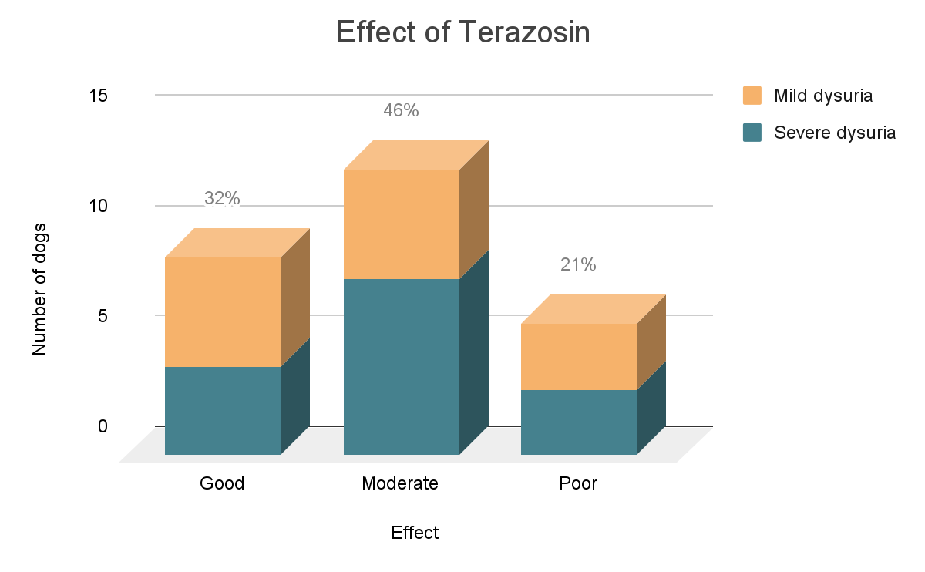
Diagram 1: Effect of treatment with terazosin in 28 male dogs with VURD. (The number of dogs per effect is shown in percentages)

Effective dose of terazosin, which resulted in a good effect of treatment, ranged from 0.26 to 0.76 mg/kg per day with a median of 0.49 mg/kg per day. With these dosages, only transient or no side effects were seen.

Alfuzosin
An overview of dosages and the effect of alfuzosin is shown in Table 5. Dogs receiving treatment with alfuzosin did not receive other medication for VURD. Other medication given during treatment with alfuzosin included an NSAID in 2 dogs. Use of antibiotics is described in more detail on page 14. Alfuzosin dosages were divided into two gifts per day.

Nr | Max daily dose | Eff daily dose | Period | Dysuria | Effect | Side-effects | Co-meds | AB
1 | 0.50 | 0.25 | 4 wk | M | G | Dose-dep | - | Y
2 | 0.52 | 0.46 | 1.8 yr | S | G | - | - | Y
3 | 0.48 | 0.48 | 1.7 yr | S | G | - | - | N
4 | 0.54 | 0.54 | 1.7 mth | M | G | Mild | - | Y
5 | 0.70 | 0.59 | 1.1 yr | S | G | Dose-dep | - | Y
Table 5: Effects of Alfuzosin in 5 male dogs with VURD. Max daily dose = highest dose given per day in mg/kg; Eff daily dose = effective dose per day in mg/kg; Period = the longest uninterrupted time alfuzosin was given; Severity of dysuria M = mild, S = severe; Effect is considered G = good, M = moderate or P = poor; Side effects were absent (-), dose-dependent, transient, mild or severe (assessment of dysuria, effect and severity of side effects are described in Appendix 3); Co-meds = medication given during treatment with alfuzosin, also indicated for VURD; AB = antibiotics given Y = yes or N = no.

The treatment period with alfuzosin ranged from 4 weeks to 1.8 years, with a median of 1.1 year. One dog started with terazosin and switched to alfuzosin. With terazosin, this dog had a moderate effect of treatment, after switching to alfuzosin it improved to good effect.

Side effects that were seen included lethargy in 2 dogs (dose dependent lethargy in one dog and mild lethargy in one dog), yellow discoloration of feces in one dog (this has been left out of Table 5) and dose-dependent mild incontinence in one dog.

An overview of the effect of alfuzosin is shown in Diagram 2.
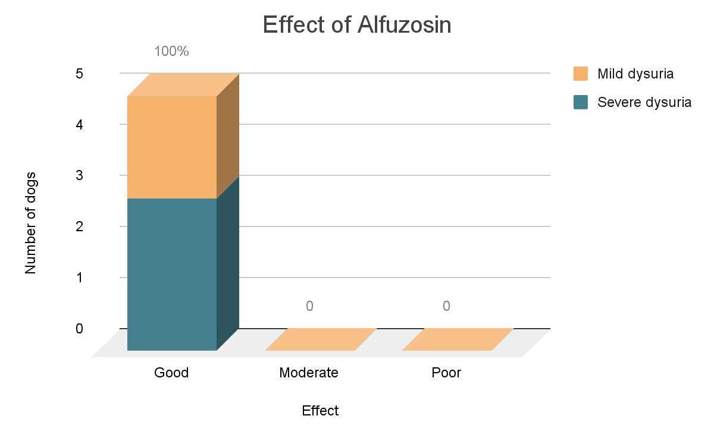
Diagram 2: Effect of treatment with alfuzosin in 5 male dogs with VURD. (The number of dogs per effect are given in percentages)

Effective dose of alfuzosin, which resulted in a good effect of treatment, ranged from 0.25 to 0.59 mg/kg per day with a median of 0.48 mg/kg per day. With these dosages there were only mild side effects seen in one dog (possibly a little slower/mild lethargy).

Tamsulosin
Only one dog included in this study received tamsulosin. This dog with severe dysuria started with terazosin, which gave a moderate effect. He then switched to tamsulosin for three months, which did not improve the effect. The dosage tamsulosin given is unknown. There were no side-effects seen. Co-medication consisted of carprofen, of which no interaction or side effects were observed.

Antibiotics
Antibiotics were prescribed in 15 dogs (32%). An overview of the indication is shown in Diagram 3. Of the 9 dogs given antibiotics for bacterial cystitis, one dog turned out not to have bacterial cystitis (urine culture came back negative). In 4 dogs, antibiotics were prescribed preventively, as these dogs were frequently catheterized. Other sporadic indications were prostatitis in one dog and anal sac disease in one dog.

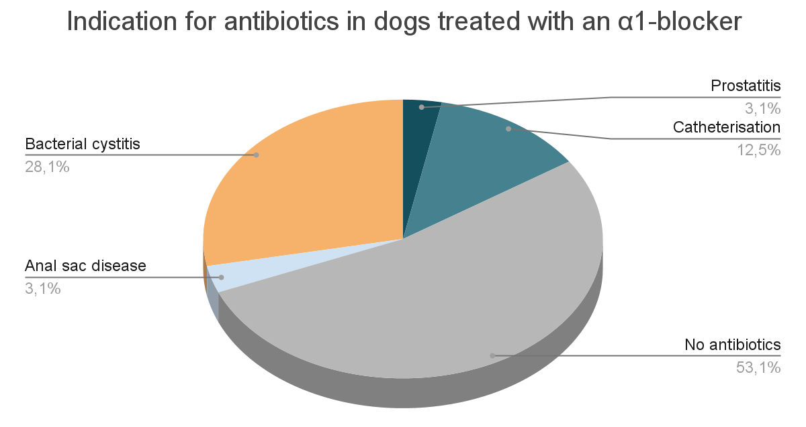
Diagram 3: Indication for use of antibiotics in 32 dogs with VURD treated with an α1-blocker

Castration
To evaluate if castration may have had a positive effect on the outcome of treatment, the effect of treatment with an α1-blocker has been plotted against the moment of castration in Diagram 5.
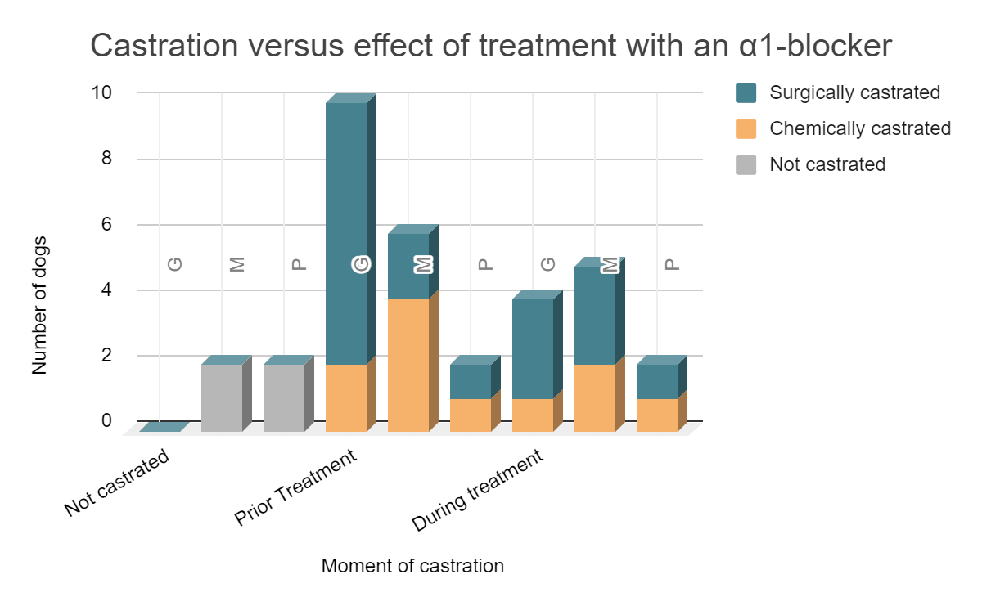
Diagram 5: Effect of treatment with an α1-blocker in relation to castration in 31 dogs with VURD. One dog received two different α1-blockers, one after the other. The effect of tamsulosin has not been included. G = good, M = moderate, P = poor.

Discussion
In this retrospective study the clinical approach and treatment of 32 dogs with VURD presented from 1-1-2016 to 31-10-2021 has been analyzed. The patients' descriptions were in line with findings in previous studies. They were all middle-sized to large males, mostly Labrador Retrievers, German Shepherds and cross breeds (Baaren, 2014; Diaz Espineara, 1998; Haagsman, 2013; Rol, 2015; Stilwell, 2020). Only the Basset Fauve de Bretagne in this study was a smaller breed, though small breeds were also reported in the study of Stilwell, 2020. The age ranges from 1.2 to 13 years, with a median age of 6.2 years at which signs of VURD started. This is consistent with the description in previous articles (often middle-aged, with similar range in age). The clinical signs reported in the 32 dogs in this study were similar to previous studies as well (Baaren, 2014; Diaz Espineara, 1998; Haagsman, 2013; Rol, 2015; Stilwell, 2020). The lethargy seen in the clinical signs of three dogs has not been mentioned previously, it seems likely that this was a response to the lesser wellbeing as this was reported in dogs with severe dysuria. The difficult defecation seen in one dog seemed to be a coincidental finding and the excessive licking of the genital area reported in one dog might have been a sign of discomfort.
For diagnosis of VURD, physical examination (including rectal examination) was performed in all dogs. Urinalysis was performed in all but one dog, therefore presence of cystitis was not excluded in this dog. However, because no abnormalities were found after biopsy of the urethra and urethrocystoscopy were performed in this dog, cystitis seems unlikely.
Using urinalysis for differentiation in the diagnosis of VURD has little value according to Holt, 1990. However, urinalysis can reveal white blood cells, casts or crystals. Diagnosing these abnormalities can help in addressing secondary problems of the patient.
Blood examination was not mentioned as a diagnostic tool in previous studies. Obstruction or severe trauma of the urogenital system could lead to abnormalities in electrolytes and for such, blood examination can be helpful. Though urinalysis and diagnostic imaging could help differentiate such conditions as well. In this study, blood examination was performed in 16 of the 32 dogs and did in our dogs not help in differentiation or diagnosis of secondary problems, as there were no abnormalities revealed.
For ruling out mechanical obstruction, repeated catheterization, imaging with ultrasonography, radiology or endoscopy of the urinary tract can help. In all 32 dogs, at least one of these diagnostic tools was used. Of these techniques, both contrast radiography and endoscopy can give a direct answer and could be used as only diagnostic for ruling out a mechanical obstruction. When the other techniques are used, a combination would be best. Based on the technique used, the sustainability of the presumptive diagnosis can differ. In this study 16 dogs did not get retrograde urethrocystography or urethrocystoscopy. Thus, in these dogs, detailed assessment of the urethra is missing.
A neurological exam was performed in only one dog in this study. Yet, for excluding other abnormalities in innervation, this is an easy diagnostic tool, and therefore it is surprising this was not performed more often (Stilwell, 2020).
In humans the diagnosis of VURD is not made by excluding other differential diagnoses but by using electromyography with or without fluoroscopy, voiding cystourethrography or urethral pressure profiles, sometimes combined with ureteroscopy to exclude strictures. Yet the criteria for each of these tools differ and research showed not every VURD patient to be positive with each tool (Stoffel, 2015). Therefore, in humans, diagnosis of VURD, though more advanced, can be difficult as well. In veterinary clinics, such tools are not commonly available. For pressure profiling and electromyography, the dog would have to be anesthetized, which can influence and thus make it difficult interpreting the findings. As for the voiding cystourethrography: in this technic the patient is told to void his or her bladder after it is filled (Stoffel, 2015). This method cannot be used in dogs.
In humans VURD is not treated with α1-blockers or castration. When the patient has mild dysuria, managing the dysuria by self-catheterization is favored, as this is least invasive. Surgical treatment by performing a urinary sphincterotomy, is one of the most successful treatments. Injecting botulinum A toxin into the external urethral sphincter has been reported as effective treatment as well. The effect could last up to 2 to 13 months, but standardization of this treatment is lacking (Stoffel, 2015). In dogs, sphincterotomy is not a used therapy, as incontinence is an unfavorable complication often seen in dogs after the surgery (Hu, 2016). Injecting botulinum A toxin has not been investigated for this indication in dogs yet.
This study showed VURD is often treated with terazosin in veterinary clinics in the Netherlands. In humans the more specific α1-blockers alfuzosin or tamsulosin are prescribed for males with BPH and terazosin is no longer used due to the difference in side-effects (Andersson, 2007; Nederlands Huisartsen Genootschap). Latest research showed promising results for newer medication in humans with BPH. One of which is the more selective α1A-blocker silodosin (Proudman, 2020). This drug is available in capsules of 4 mg or 8 mg (cbg-meb). Next to α1-blockers, the botulinum neurotoxin A injected into the prostate has been investigated for use in patients with BPH as well. The toxin affects the α1A receptor, leading to downregulation for at least 12 weeks (Lokeshwar, 2019; Moussa, 2019). As the targeted effect is the same as for the current medical treatment in dogs with VURD, this might have potential in the future, when the effect and use of the botulinum A toxin has been further investigated. Unlike the botulinum A toxin, the use of silodosin has already been studied in dogs. One study compared the IV use of silodosin and tamsulosin, both in dosages of 0.3 to 10 mcg/kg, in dogs with BPH. Though the effect on urethral pressure was similar in both drugs, tamsulosin caused a significant greater hypotension compared to silodosin. Thus, silodosin is expected to cause less side-effects in dogs compared to tamsulosin (Kobayashi, 2009). Currently there are no effective dosages of these drugs known for oral use in dogs. Therefore, in dogs with VURD, we are still relying on the α1-blockers used in this study. The results of treatment with these seem variable (mostly in the terazosin group, yet this was also the largest group of patients). No clear relation between severity of dysuria and effect has been seen, nor a dose-dependent effect. Alfuzosin showed the best effect and little side effects compared to the other drugs. Yet, alfuzosin was used in a small patient group, which might have biased the effect. One dog received consecutively terazosin and alfuzosin, with best effect on alfuzosin. The comparison of both drugs in the same patients has not been studied yet. The effect of tamsulosin in this study was poor, yet as this drug was administered to only one patient (that also showed a moderate result on terazosin before) the outcome is too biased and more research should evaluate the use of this drug in dogs with VURD.
When a choice is made between alfuzosin and tamsulosin, which are the currently used drugs in humans, alfuzosin seems most substantiated for use in dogs. This advice is given for two reasons. Alfuzosin appears to be very effective in this study, as it also did in the studies of Baaren, 2014 and Rol, 2015 (Baaren, 2014; Rol, 2015). The second reason is a better scientific support for the dosage of alfuzosin in dogs compared to the suggested dosage of tamsulosin. The dosage for oral administration of 0.01 mg/kg once a day of tamsulosin in dogs as described in Plumb’s Veterinary Drug Handbook is retrieved from Kirk’s Current Veterinary Therapy. Here it was listed as an empirical dosage.
The used dosage of tamsulosin in the one dog in this study is unknown. Therefore, it is unclear if the poor effect of treatment is caused by an inappropriate dosage or by a poor effect of tamsulosin in that dog.
The dosages for terazosin and alfuzosin from previous studies were identical and ranged from 0.25 to 0.5 mg/kg twice a day orally, adding up to 0.5 to 1 mg/kg per day (Baaren, 2014; Rol, 2015). In this study the median effective daily dose for terazosin was 0.49 mg/kg and therefore similar to the lowest dose from previous studies. Yet lower and higher doses of terazosin were effective as well (0.26 to 0.76 mg/kg per day), with only transient or no side effects. It seems the appearance of side-effects is dose-dependent as well as patient bound. Therefore, starting with oral terazosin 0.25 mg/kg twice daily seems like a good starting dose, with adjusting of the dosage based on evaluation of effect and side effect. In this study, there was a broad range in treatment periods of terazosin with moderate or good effect. In earlier studies, treatment was continued for 6 weeks. The results from this study show that effect can improve when the treatment is prolonged. Dysuria recurred in 6 patients when they tried tapering off the medication after 6 weeks. The 6 weeks could be used initially when starting up a patient on terazosin, yet warning the owners the duration of treatment might be prolonged, sometimes even for years, seems advisable.
The median effective dose of oral alfuzosin of 0.48 mg/kg per day was similar to the low dose used in previous studies. The range of 0.25 to 0.59 mg/kg per day, however, was lower than the maximal dose in earlier studies (0.5 to 1 mg/kg per day) (Baaren, 2014; Rol, 2015). Starting off with oral alfuzosin 0.25 mg/kg twice a day seems advisable based on the findings in this study. It seems less likely (compared to terazosin) a raise in dose would be necessary. As with terazosin, the appearance of side effects seems dose-dependent and patient related in alfuzosin. In one patient a discoloration of the feces was seen after starting with the treatment with alfuzosin, yet the relation with the treatment is unclear. Therefore, it was not mentioned in Table 5. The median treatment period with alfuzosin in this study was longer than 6 weeks, apart from one dog that received alfuzosin for 4 weeks. Warning the owners of a VURD patient the treatment with alfuzosin can last longer: up to a year or even 2 years, could be helpful in managing expectations.
When prescribing drugs in patients, the available formulations of these drugs can play a role in choosing the best treatment. The formulations of the drugs used in this study are designed for human use. Terazosin is available in tablets of 2 mg, 5 mg and 10 mg for oral use. Alfuzosin is available as 10 mg slow-release tablets, and 2.5 mg film-coated tablets for oral use. The summary of product specifications states the slow-release tablets (of 10 mg) may not be broken to preserve the retard effect (cbg-meb). Yet, some of the patients in this study did get half tablets as well. It might be that the halving of the tablets did not play a role in the effect during the whole 12 hours (based on a twice a day gift). Tamsulosin is only available in slow-release 0.4 mg (film-coated) tablets or capsules for oral use. Breaking the tablets or opening the capsules would disrupt the retard function of the formulations (cbg-meb). If we look at the typical VURD dog, with a median weight of 39 kg, terazosin could be prescribed as two tablets of 5 mg twice a day or one tablet of 10mg twice a day (9.7 mg twice daily). As alfuzosin dosage is similar, a prescription of one tablet of 10 mg twice a day is applicable. One tablet or capsule of tamsulosin 0.4 mg could be given once daily. Dogs weighing around the minimum found in this study (17.5 kg) could receive 2 tablets of 2 mg terazosin or one tablet of 5 mg twice a day. Alternatively, alfuzosin 2 tablets of 2.5 mg tablets twice daily could be prescribed (4.4 mg twice daily). As tamsulosin can only be given in a dose of 0.4 mg, this drug might not be suitable for dogs with this weight. For a dog weighing the maximum found in this study (58.3 kg) 3 tablets of 5 mg terazosin twice a day could be prescribed or one tablet of 10 mg and 2 tablets of 2.5 mg alfuzosin. As the maximal advised dosage of tamsulosin is 0.4 mg a day (Plumb’s), the dog could receive one tablet or capsule of 0.4 mg once a day. Overall, both terazosin and alfuzosin seem equal in applicability. Tamsulosin might not be suitable in dogs weighing less than about 40 kg, as the slow-release formulations may not be broken. In dogs weighing more, it might be preferred, as a slow-release formulation could have less side-effects (i.e. hypotension). Yet, more research on oral use of tamsulosin in dogs with VURD is needed to see if this is the case in dogs.
In most patients an α1-blocker was used as monotherapy. During the treatment with an α1-blocker, few patients received diazepam for a longer period as they seemed to have supplementary effects. This indicates those patients might have had problems with their external sphincter (Andersson, 2007; Diaz Espineira, 1998). Oxybutynin was given to one patient. Oxybutynin is a parasympaticolyticum, used in the urinary tract as bladder relaxant by blocking contractility of the detrusor muscle (farmacotherapeutisch kompas; uu). In humans, oxybutynin has been investigated for treatment of VURD, as it theoretically would decrease not well-regulated contraction and thus reflexes of VURD. Yet data to substantiate this theory is lacking (Stoffel, 2015).
Interactions or side effects of one of the α1-blockers with co-medications, such as NSAIDs, have not been reported in this study. When prescribing medication, it is good practice to check if interaction between the drugs is known. Most dogs receiving antibiotics either received them for a bacterial cystitis or to prevent a bacterial cystitis. It is more likely the cystitis was secondary to VURD as the problems with which the patients presented were more similar to those of patients with VURD (a less powerful jet) compared to patients with cystitis (i.e., pollakiuria and stranguria). Frequent catheterization can provide a porte d'entrée for bacteria. Yet, with the current advice on use of antibiotics, it seems unfounded to start antibacterial treatment as a prophylaxis for urinary tract infections (knmvd).
In a few patients it was reported that frequent walking the dog and water restriction improved signs of dysuria. This form of (supplementary) treatment has not been described before. One can conclude, this would at least prevent bladder overload. How this treatment reduces signs of dysuria is unknown, as it has not been studied (yet).
Earlier studies suggested castration as part of the therapy for improving dysuria (Diaz Espinieara, 1998; Holt, 1990; Haagsman, 2013). Significantly longer survival times were seen in surgically castrated dogs compared to chemically castrated dogs (Haagsman, 2013). To evaluate the difference in this study, chemical and surgical castration have been plotted separately. The most pronounced results in Diagram 5 are the moderate to poor effect in dogs that were not castrated and the good effect of treatment in dogs surgically castrated prior to start of treatment with an α1-blocker. It seems castration, especially surgical prior to start of treatment, does positively affect the outcome of treatment and thus the improvement of dysuria. Yet, definite conclusions cannot be drawn based on the results of this study.

Conclusion
It is clear that terazosin is most often used in Dutch veterinary practice to treat VURD, as 28 of the 32 dogs (82%) received this α1-blocker. As there was a small number of dogs in this study, only descriptive statistics were used and it is not possible to give a significant difference in effectiveness of treatment or side effects between the different types of α1-blockers. This study did, as did the studies of Baaren, 2014 and Rol, 2015, show promising results in treatment with alfuzosin, though the alfuzosin group was too small (5 dogs) to be confirmative. As only one patient received tamsulosin, evaluation of use of this drug in dogs with VURD could not be established yet. The results of this study suggest castration as part of the treatment to be effective, especially when performed prior to start with treatment with an α1-blocker.

Acknowledgements
For their support and feedback, I would like to thank both of my supervisors. I would also like to thank the veterinary clinics and the dog owners willing to take part in this study.

References
- Akiyama, K., Noto, H., Nishizawa, O., Sugaya, K., Yamagishi, R., Kitazawa, M., Tsuchida, S. (2001). Effect of KMD-3213, an a1A-adrenoceptor antagonist, on the prostatic urethral pressure and blood pressure in male decerebrate dogs. International journal of Urology, 8(4), 177-183
- Andersson, K-E and Gratzke, C. (2007). Pharmacology of alfa1-adrenoceptor antagonists in the lower urinary tract and central nervous system. Nature Clinical Practice, 4(7), 368-378
- Apotheek faculteit Diergeneeskunde. (2014, November 27). Oxybutynine tabletten en capsules. UU, https://www.uu.nl/sites/default/files/bs-024_-_oxybutynine_tabletten_en_capsules_-_v-003.pdf
- Baaren, C.N. (2014). A prospective, randomized, double-blinded study comparing the efficacy and side effects of terazosin and alfuzosin for treatment of vesico-urethral reflex dyssynergia in dogs. Master Research Project Veterinary Medicine, Department of Clinical Sciences of Companion Animals. Utrecht University.
- Clemens, J.C. (2010). Basic bladder neurophysiology. Urologic Clinics of North America, 37, 487–494
- College ter beoordeling van geneesmiddelen. (Consulted 2021, September 21). Geneesmiddeleninformatiebank > alfuzosine. Cbg-meb,
https://www.geneesmiddeleninformatiebank.nl/
- Diaz Espineira, M.M., Viehoff, F.W., Nickel, R.F. (1998). Idiopathic detrusor-urethral dyssynergia in dogs: a retrospective analysis of 22 cases. Journal of Small Animal Practice, 39, 264-270
- Educational Concepts LLC, dba Brief Media. (Consulted 2021, September 21). Plumb’s Veterinary Drug Handbook > Tamsulosin. Plumb’s, https://academic-plumbs-com.proxy.library.uu.nl/
- Franco-Salinas, G., de la Rosette, J.J.M.C.H., Michel, M.C. (2010). Pharmacokinetics and pharmacodynamics of tamsulosin in its modified-release and oral controlled absorption system formulations. Clinical Pharmacokinetics, 49(3), 177-188
- Goldstein, R.E., Westropp, J.L. (2005). Urodynamic testing in the diagnosis of small animal micturition disorders. Clinical Technical Small Animal Practice, 20, 65-72
- Gookin, J.L., Bunch, S.E. (1996). Detrusor-striated sphincter dyssynergia in a dog. Journal of Veterinary Internal Medicine, 10(5), 339-344
- Haagsman, A.N., Kummeling, A., Moes, M.E., Mesu, S.J., Kirpensteijn, J. (2013). Comparison of terazosin and prazosin for treatment of vesico-urethral reflex dyssynergia in dogs. Veterinary Record, 173(2),41
- Holt P. (1990). Companion Animal Practice: Dysuria in the dog Part 1: Management of the dysuric animal. In Practice, 12,121-125
- Hu, H.Z., Granger, N., Jeffery, N.D. (2016). Pathophysiology, clinical importance, and management of neurogenic lower urinary tract dysfunction caused by suprasacral spinal cord injury. Journal of Veterinary Internal Medicine, 30(5), 1575-1588
- Kobayashi, S., Tomiyama, Y., Tatemichi, S., Hoyano, Y., Kobayashi, M., Yamazaki, Y. (2009). Effects of silodosin and tamsulosin on the urethra and cardiovascular system in young and old dogs with benign prostatic hyperplasia. European Journal of Pharmacology, 613, 135-140
- Koninklijke Nederlandse Maatschappij voor Diergeneeskunde. (2013, November 4). Richtlijn bacteriële urineweginfecties hond en kat Versie 1.1. Knmvd, https://www.knmvd.nl/richtlijn-bacteriele-urineweg-infecties-bij-hond-en-kat/
- Lane, I.F., Westropp, J.L. (2009). Urinary incontinence and micturition disorders: pharmacologic management. Kirk’s Current Veterinary Therapy, 14th edition (pp.955-959). St Louis (MO): Elsevier.
- Lokeshwar, S.D., Harper, B.T., Webb, E., Jordan, A., Dykes, T.A., Neal Jr, D.E., Terris, M.K., Klaassen, Z. (2019). Epidemiology and treatment modalities for the management of benign prostatic hyperplasia. Translational Andrology and Urology, 8(5), 529-539
- Moussa, A.M., Ragheb, A.M., Abdelbary, A.M., Ibrahim, R.M., El Edawy, M.S., Aref, A., Assem, A., Elfayoumy, H., Elzawy, F. (2019). Outcome of Botulinum Toxin-A intraprostatic injection for benign prostatic hyperplasia induced lower urinary tract symptoms: A prospective multicenter study. Prostate, 79(11), 1221-1225
- Nelson, R.W., Couto, C.G. (2020). Small animal internal medicine, 6th edition. https://elsevierelibrary-co-uk.proxy.library.uu.nl/product/small-animal-internal-medicine-ebook
- NHG-Richtlijnen. (Consulted 2021, November 18). Mictieklachten bij mannen. Nederlands Huisartsen Genootschap, https://richtlijnen.nhg.org/standaarden/mictieklachten-bij-mannen
- Noël, S., Claeys, S., Hamaide, A. (2010). Acquired urinary incontinence in the bitch: update and perspectives from human medicine. Part 1: the bladder component, pathophysiology and medical treatment. The Veterinary Journal, 186, 10-17
- Noguchi, Y., Ohtake, A., Suzuki, M., Sasamata, M. (2008). In vivo study on the effects of α1-adrenoceptor antagonists on intraurethral pressure in the prostatic urethra and intraluminal pressure in the vas deferens in male dogs. European Journal of Pharmacology, 580(1–2), 256-261
- Rol, I. (2015). A prospective, randomized, double-blinded study comparing the efficacy and side effects of alfuzosin and terazosin for treatment of vesico-urethral reflex dyssynergia in dogs. Master Research Project Veterinary Medicine, Department of Clinical Sciences of Companion Animals. Utrecht University.
- Rosin, A.E., Barsantj, I.A. (1981). Diagnosis of urinary incontinence in dogs: role of the urethral pressure profile. Journal of the American Veterinary Medical Association, 178, 814-822
- Stichting farmaceutische kerngetallen. (2008, November 13). Plasproblemen bij 50+ mannen. SFK, https://www.sfk.nl/publicaties/PW/2008/2008-46.html
- Stillwell, C., Bazelle, J., Walker, D., Stanzani, G., Florey, J. (2020). Detrusor urethral dyssynergy in dogs:35 cases (2007-2019). Journal of Small Animal Practice, 62(6), 468-477
- Stoffel, J.T. (2015). Detrusor sphincter dyssynergia: a review of physiology, diagnosis, and treatment strategies. Translational Andrology and Urology, 5(1), 127-135
- Tatemichi, S., Tomiyama, Y., Maruyama, I., Kobayashi, S., Kobayashi, K., Maezawa, A., Kobayashi, M., Yamazaki, Y., Shibata, N. (2006). Uroselectivity in Male Dogs of Silodosin (KMD-3213), A Novel Drug for the Obstructive Component of Benign Prostatic Hyperplasia. Neurourology and Urodynamics, 25(7), 792-799
- Wein A.J., (2021). Neuromuscular dysfunction of the lower urinary tract. In: Campbell-Walsh-Wein Urology, 12th edition. https://www-clinicalkey-com.proxy.library.uu.nl/#!/content/book/3-s2.0-B9780323546423001178
- Witte, D.G., Brune, M.E., Katwala, S.P., Milicic, I., Kerwin, J.F., Hancock, A.A. (1997). Relationships between pharmacokinetics and blockade of agonist-induced prostatic intraurethral pressure and mean arterial pressure in the conscious dog after single and repeated daily oral administration of terazosin. Journal of Pharmacology and Experimental Therapeutics August, 282(2), 891-898

Appendix

1. The questionnaire for the owners
Vragen voor eigenaren (duur ong 5-10 minuten)

Betreffend het geven van de medicatie (terazosine, alfuzosine of tamsulosine):
- Was de medicatie makkelijk toe te dienen?
- Hoeveel tabletjes heeft u gegeven? En hoe vaak per dag?
  - Heeft u de medicatie afgebouwd? In welke stapjes (bv 1/2 tabletje) en na hoeveel tijd/dagen?
  - En zo ja, op basis waarvan?
  - Hoe lang (aantal dagen) heeft u de medicatie uiteindelijk gegeven?
- Werden er andere medicatie gegeven ten tijde van? En voor welke indicatie?

Zijn de klachten met het plassen na of tijdens het gebruik van de medicatie teruggekomen of gebleven?
Heeft u iets aan bijwerkingen gemerkt bij u huisdier?
- En in hoeverre had uw hond of u daar last van?
- Werden er ook andere medicatie gegeven op het moment van de bijwerkingen?

2. Treatment protocol of VURD

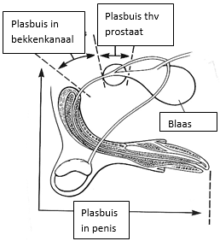
a. Current version
Geachte meneer/mevrouw,

Bij uw hond is vastgesteld dat er sprake is van een slechte werking van de plasbuis. Dit komt door een overactieve plasbuis, die zich niet opent als de blaas een seintje geeft dat deze vol is en zich wil leegmaken door te plassen. Doordat de blaas zich niet kan leegmaken, blijft uw hond het gevoel houden dat hij moet plassen en zal dan continue proberen te plassen zonder of met minimaal resultaat. Natuurlijk is het erg belangrijk, dat hij gaat plassen, omdat de blaas anders overvuld en dan zelfs overrekt kan raken. Bij overrekking kan er veel schade plaatsvinden aan de blaas met kans op blaasverlamming. Dit laatste is zeer ernstig.
Door middel van medicijnen willen we de overmatige werking van de plasbuis stilleggen. Dat doen we meestal met 2 medicijnen:
1. De werking van testosteron of mannelijke geslachtshormonen blokkeren door een eenmalige injectie met Tardak® of Vetadinon®, een bepaald hormoon. Dit wordt ook wel chemische castratie genoemd. Dit middel zal gaan werken na 2-4 dagen en heeft een werkingsduur van 6 weken. Het is nodig om bij intacte reuen de geslachtshormonen weg te nemen, omdat deze mogelijk een rol spelen bij de problemen van een overactieve plasbuis. Een andere optie is chemische castratie door middel van een implantaat (GnRH-agonist). De implantaat is te verkrijgen met een werkingsduur van 6 of 12 maanden. De implantaat wordt tussen de schouderbladen onder de huid aangebracht en lost vanzelf op (binnen 6 of 12 maanden). Echter het beste effect wordt verkregen met chirurgische castratie.
2. De zenuwvoorziening van de plasbuis remmen door het middel terazosine. Dit middel zorgt ervoor dat een deel van het zenuwstelsel wordt uitgeschakeld, namelijk het deel dat zorgt voor een verhoogde spanning op bloedvaten én de plasbuis. Bij de mens wordt dit middel gebruikt voor hoge bloeddruk, maar ook voor mannen met een vergrote prostaat en plasproblemen.
In het geval van ………………………………….., wordt er gestart met :
- terazosine (ontspant de sluitspier van de blaas)
- diazepam (ontspant de plasbuis zelf)
- Tardak/Vetadinon (kortdurende chemische castratie per injectie)
- Suprelorin implantaat (langdurige chemische castratie per onderhuids implantaat)
Om herhaling van deze klachten te voorkomen, adviseren wij om te overwegen om uw hond chemisch of chirurgisch te castreren.

b. Updated version
Geachte meneer/mevrouw,
Bij uw hond is vastgesteld dat er sprake is van een slechte werking van de plasbuis. Dit komt door een overactieve plasbuis, die zich niet opent als de blaas een seintje geeft dat deze vol is en zich wil leegmaken door te plassen. Doordat de blaas zich niet kan leegmaken, blijft uw hond het gevoel houden dat hij moet plassen en zal dan continue proberen te plassen zonder of met minimaal resultaat. Natuurlijk is het erg belangrijk, dat hij gaat plassen, omdat de blaas anders overvuld en dan zelfs overrekt kan raken. Bij overrekking kan er veel schade plaatsvinden aan de blaas met kans op blaasverlamming. Dit laatste is zeer ernstig.
Door middel van medicijnen willen we de overmatige werking van de plasbuis stilleggen. Dat doen we meestal met 2 soorten medicijnen:
1. De werking van testosteron of mannelijke geslachtshormonen blokkeren door een 7-daagse kuur met Ypozane® tabletjes, een bepaald hormoon. Dit wordt ook wel chemische castratie genoemd. Dit middel zal gaan werken binnen 2 weken en heeft een werkingsduur van tenminste 5 maanden. Het is nodig om bij intacte reuen de geslachtshormonen weg te nemen, omdat deze mogelijk een rol spelen bij de problemen van een overactieve plasbuis. Een andere optie is chemische castratie door middel van een Suprelorin implantaat (GnRH-agonist). Het implantaat is te verkrijgen met een werkingsduur van 6 of 12 maanden. Het implantaat wordt tussen de schouderbladen onder de huid aangebracht en lost vanzelf op (binnen 6 of 12 maanden). Echter het beste effect wordt verkregen met chirurgische castratie in een vroeg stadium van de behandeling.
2. De zenuwvoorziening van de plasbuis remmen door het middel terazosine of alfuzosine. Deze middelen zorgen ervoor dat een deel van het zenuwstelsel wordt uitgeschakeld, namelijk het deel dat zorgt voor een verhoogde spanning op bloedvaten én de plasbuis. Bij de mens worden deze middelen gebruikt voor hoge bloeddruk, maar ook voor mannen met een vergrote prostaat en plasproblemen.
In het geval van ………………………………….., wordt er gestart met :
- terazosine (ontspant de sluitspier van de blaas)
- alfuzosine (ontspant de sluitspier van de blaas)
- diazepam (ontspant de plasbuis zelf)
- Ypozane (kortdurende chemische castratie per tablet)
- Suprelorin implantaat (langdurige chemische castratie per onderhuids implantaat)
Om herhaling van deze klachten te voorkomen, adviseren wij om uw hond chirurgisch te castreren.

3. Assessments

Severity of dysuria
The severity of dysuria was grouped in mild or severe. Dogs with mild dysuria the quality of urine voiding was less than normal, with intermittent periods of dysuria. Dysuria was considered severe when there were signs of bladder overload (seriously enlarged bladder, incontinence) or more than 50 ml of urine present after micturation. (Where 50 ml already is more than the residual volume found in healthy male dogs (Inge en Baaren)).

Effect classification
The effect classification is based on a combination of severity of dysuria and the frequency of catheterisation needed. A scale of good, moderate or poor has been made.
- The effect of treatment was considered good, when the miction pattern returned to the way it was before the clinical signs of dysuria started and when catheterisation was no longer needed or only incidentally in patients with severe dysuria.
- A moderate effect is classified as some improvement in the miction pattern after starting the treatment, yet with periods of dysuria remaining. Catheterisation was needed less or equal in patients with severe dysuria or in patients whose miction pattern returned to the way it was before the clinical signs of dysuria started.
- The effect was considered poor, when there was no improvement in the dysuria after starting the treatment.

Severity of side effects
Severe when it was a reason to quit the treatment.
Dose-dependent when a lowering of the dosage made the side effects disappear.
Transient when they disappeared after a few days without a change in treatment.

Mild when the side effects were mild and did not cause the owners or vets to change or stop the treatment.

