Age- and sex-specific mortality rates of owned, free-roaming dogs enrolled in a health and demographic surveillance system in South Africa.
B.F.M.Leenders

Summary
Canine rabies is still a problem in developing countries in Africa and Asia. Domestic dogs are, in the most parts of Africa and Asia, the main reservoir. Rabies in dogs and humans can be controlled through mass vaccination, this is based on the concept of herd immunity. The herd immunity depends on a number of factors, including the mortality rates. The aim of this study was to investigate the age- and sex-specific mortality rates of owned, free-roaming dogs enrolled in a health and demographic surveillance system in South Africa.

Introduction
Infection with the rabies virus causes an acute encephalitis. The virus is transmitted through saliva on broken skin. (3) Canine rabies has been eliminated from domestic dog populations in Western Europe and North America, but is still a problem in developing countries.(5) Throughout most of Africa and Asia, domestic dogs are the main reservoir of rabies.(3) Every year an estimated 55.000 people die from rabies, over 99% of these deaths occur in developing countries (4)
In South Africa two biotypes of Rabies exist; the mongoose- and the canid biotype. (6) From 1976 Canine Rabies is found in South Africa. Since then the disease has been endemic in the coastal provinces of KwaZulu-Natal and the Eastern Cape. In 2005, a marked increase in the number of canine rabies was reported in the Limpopo Province. Since 2008 it also re-emerged in Mpumalanga Province. From then on rabies is also radiating northwards and affecting previous controlled areas. Also, Rabies has occasionally been reported in the Gauteng Province during the past decade. (7)
Canine rabies in dogs and humans can be controlled and in certain instances eradicated by the mass vaccination of dogs. The control of infectious diseases in populations through mass vaccination is based on the concept of herd immunity.(2)
The proportion of the population that has to be vaccinated to achieve effective herd immunity is determined by how infectious the disease is in the given population. This is captured by the parameter R₀, the basic reproduction number of the disease in a population. When R₀ is lower then 1, it means that on average an infectious case will pass the infection on to less than one other individual. So when R₀ <1 the infection will die out in the population. R₀ for rabies has been estimated to be between 1 and 2 for dog populations around the world.(4) Using the standard formula to relate required vaccination coverage to R₀, a estimated target vaccination coverage of 20-40% is needed to control rabies in Tanzania where R₀ is ±1.2.(4) Herd immunity declines rapidly in the interval between vaccination campaigns because of births and deaths in the domestic dog population. The mortality- and birth rates in dog populations in developing countries are generally high, and so, as vaccinated dogs die and new, susceptible dogs are born into the population, the level of vaccination coverage declines below the target threshold of 20-40%. When the vaccination coverage declines below the target threshold outbreaks occur. By incorporating demographic parameters, the estimated proportion of the dog population that has to be vaccinated during annual campaigns is around 60% in Tanzania.(4)
For this reason it is important to know the demographics (in particular, rates of birth, death, in- and out-migration) of the dog population in endemic areas. With the formula: P_{crit} = 1 – 1/R₀ the minimal vaccination coverage is calculated. To maintain herd immunity above P_{crit} between campaigns, a larger proportion of the dog population, P_{target}, should be vaccinated. P_{target} = e^{(v+d+r))T} P_{crit}, where r is the rate of dog population growth, d is the death rate, 1/v is the duration of vaccine induced immunity, and T is the interval between campaigns.(4)
Reduction of the population growth rate or death rate could be an option to reduce P_{target}. This could be achieved by birth control. To find out the impact of birth control on P_{target} is, it is important to know how many puppies of the born litters die before they become adults. Therefore this research project is about the age-and sex-specific mortality rates in puppies.
Materials and methods
Material
The research took place in Hluvukani, South Africa. The mother dogs used in this research were enrolled through a Health and Demographic Surveillance System. This system collects vital data on rates of birth, mortality and migration in a population of owned, free roaming dogs in a rabies-affected, resource-constrained community in Bushbuckridge local municipality, Mpumalanga Province, South Africa. A total of 166 female dogs were part of this study. We included all litters born between 24/05/2014 and 03/07/2014 which were 20 litters, with a total of 128 puppies (52 males, 54 females, 22 unknown). The enrolled dogs were AfriCanis Landrace.
Methods
The study took place from June till November 2014. The first 6 weeks were fieldwork, in which 20 new born litters were enrolled. Later the Environmental Monitors took over, to monitor the mortality rates. Environmental Monitors are local people, part of a program resulting of the collaboration between University of Pretoria, South African Nation Park, Kruger2Canyon and the Department of Environmental Affairs. They work at the Hluvukani veterinary office and they also helped with translation.
Dog owners were encouraged to report births to the study team, who visited the litter as soon as possible, to ascertain the litter size and sex of the puppies. Litters were followed from birth up to 120 days old, to determine age- and sex-specific mortality rates. All households that were enrolled in the health and demographic surveillance system have been visited a couple of times. To make them aware to call if they have a dead dog or if a new litter is born. Households with live born puppies were revisited every week, and mortalities will be recorded (Follow up litter form, Appendix).
Calculation of the survival fraction (S) The number of puppies that died in each week post-partum (i), was indicated by d_{i}. The number of puppies that begins the week alive, was indicated by r_{i}, those were the puppies “at risk”.
Then the hazard rate for week i is estimated as: h(i)= d_{i} / r_{i.}
The estimated probability for a puppy to survive week i (survival fraction) is equal to the probability that week i-1 is survived × the estimated probability that the animal does not die in the next week: S(i)= S(i-1)×(1-h(i))
These calculations results in a Kaplan Meier survival curve.(1)
Results
After 120 days there were 51 dead puppies; 12 males, 19 females and 20 unknown. A total of 42 puppies were lost during the study (censored). The probability that a puppy will be 120days old is 50% (Table 1). See the results in the survival curve (figure 1).
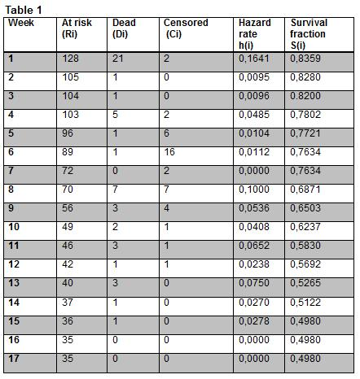The standard error is calculated with the Greenwood formula because there was censoring (Table 2).
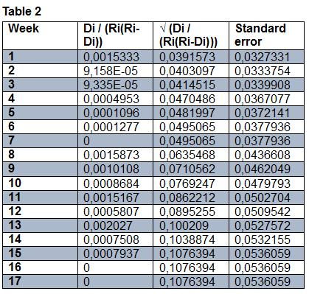
Discussion/Conclusion
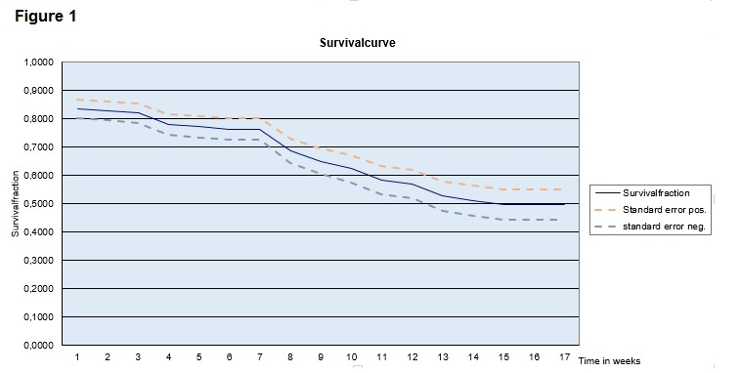For the period end of May till the beginning of July we now know how many puppies were born and how likely it is that they will be 120 days or older. So we can partially say something about the population growth. But to calculate P_{target} more things should be examined. The population growth we calculated is for unvaccinated puppies, but we still don’t know anything about de death rate in adults (vaccinated dogs). This is important to know, because new unvaccinated dogs and mortality of vaccinated dogs can ensure that you get below the P_{target} threshold and then the herd immunity is too low. So it is better to also follow adult dogs and to know how many vaccinated dogs die and to follow the puppies till they get older and get vaccinated. A Mortality rate of 50% is quite high. There is not one critical period where the mortality rate is high. In the first week there were 20 dead puppies, but that’s probably because there was a litter with 20 puppies and 17 of them died the first week. The problem is that we never saw the 17 dead puppies by ourselves. So in that case we have to trust the owners. About one third of the puppies have been lost (censored) during the study. Causes for this censoring are: euthanasia, puppies disappeared or are stolen and most of the time they were given away or sold to other households before the end of the study. Of the 42 censored puppies 31 were sold or given away. So there is a chance that they’re still alive. Thus these puppies could have had an influence on the survival curve, if they could have been persecuted for a longer time. Therefore the mortality rate is maybe lower then 50%. So it is difficult to say if reduction of the mortality rate will have an influence on the P_{target}.
Approximately 7% of the country’s population lives in the Mpumalanga province. The population is unevenly distributed with, approximately half of the population living in communal lands. The distribution of the dog population correlates with that of human settlements. This results in large dog populations in densely populated communal lands.(6) The study took place in Hluvukani. This village was very similar to the surrounding villages, in terms of infrastructure, houses, and also in how the people handle and live together with the dogs. Thus this village was representative for that area.
During the fieldwork there were a couple of problems. Most of the time the owners didn’t call when there was a new litter or a dead puppy. So not every litter is followed from day 1 till day 120, sometimes the puppies were already a couple of weeks old when they were visited for the first time. Or there were already dead puppies the first time the litter was visited and then the owners didn’t know how long ago the puppy died or the sex of the dead puppy. The owners didn’t know the exact date of birth. For example, sometimes the owners said that the puppies were a few days old, but they already had their eyes open, so the puppies had to be older. When the owners estimated the date of birth we calculated with the youngest date. The puppies were not always visible and then we were not able to check the size of the litter and the sex of the puppies. In one case there were two litters in one household, but the owners didn’t know which puppy belongs to which mom. In this case we counted both litters as one litter. The original plan was to visit the litters every week, but through to circumstances this did not happen. This may cause some of the data to be unreliable. Better monitoring would contribute to more reliable results. It is also important to motivate the owners more so they report new litters and dead puppies earlier and if it is possible to follow the puppies that are sold or given away. So puppies really can be followed from day 1 till 120.
References
(1) A. Petrie, P. Watson. Statistics for Veterinary and Animal Science. second ed.: Blackwell Publishing; 2006.
(2) Cleaveland S, Kaare M, Knobel D, Laurenson MK. Canine vaccination-Providing broader benefits for disease control. Vet Microbiol 2006;117(1):43-50.
(3) Gsell AS, Knobel DL, Kazwala RR, Vounatsou P, Zinsstag J. Domestic dog demographic structure and dynamics relevant to rabies control planning in urban areas in Africa: The case of Iringa, Tanzania. BMC Vet Res 2012;8.
(4) Hampson K, Dushoff J, Cleaveland S, Haydon DT, Kaare M, Packer C, et al. Transmission dynamics and prospects for the elimination of canine Rabies. PloS Biol 2009;7(3):0462-0471.
(5) Knobel DL, Cleaveland S, Coleman PG, Fèvre EM, Meltzer MI, Miranda MEG, et al. Re-evaluating the burden of rabies in Africa and Asia. Bull WHO 2005;83(5):360-368.
(6) Mkhize GC, Ngoepe EC, Du Plessis BJA, Reininghaus B, Sabeta CT. Re-emergence of dog rabies in Mpumalanga Province, South Africa. Vector Borne Zoonotic Dis 2010;10(9):921-926.
(7) Sabeta CT, Weyer J, Geertsma P, Mohale D, Miyen J, Blumberg LH, et al. Emergence of rabies in the gauteng province, South Africa: 2010-2011. J S Afr Vet Assoc 2013;84(1).

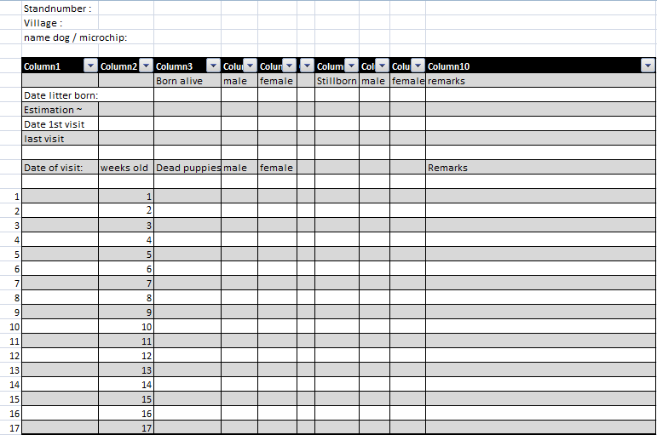Appendix

