Innate lymphoid cells
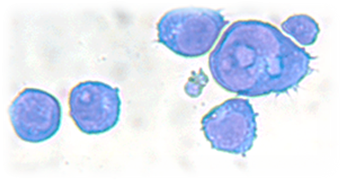

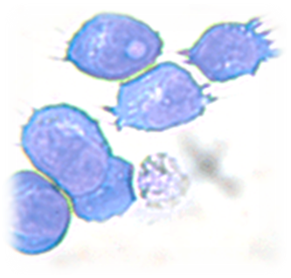in atopic dermatitis

Sophie van Tol

Masterthesis
Master Biology of Disease
Utrecht University
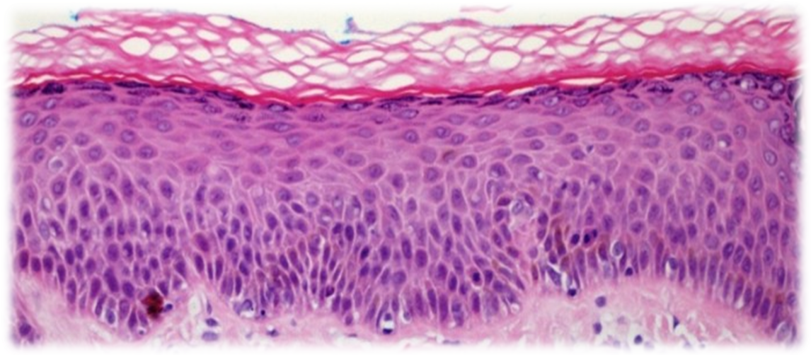
References front page images: http://tissupath.com.au/medical-student-subjects-skin/ and Crossover immune cells blur the boundaries. Science 2012:336;1228-1229.

Index

Index 2
Abstract 3
Introduction 4
Th2 immunity 5
Epithelial cells 5
Antigen presenting cells 6
Effector cells 7
Innate lymphoid cells 8
Group 1 ILCs 9
Group 3 ILCs 10
Group 2 ILCs 11
Physiological function 13
Th2 immunity 13
Other functions 15
Atopic dermatitis 16
Pathogenesis 16
Group 2 Innate lymphoid cells 19
Conclusion 23
References 24

Abstract
Th2 immunity was evolved for the immune response against parasites. Basophils, eosinophils, mast cells and Th2 cells are characteristic cell types in Th2 immunity. Furthermore Th2 immunity is characterized by IgE antibody production by B cells. Recently a new innate cell type was identified and found to be involved in Th2 immunity. These cells were called group 2 innate lymphoid cells (ILC2s). Group 1 and 3 ILCs are other ILC subsets derived from the same progenitor cells, but with different functions in the immune system.
ILC2s contribute to the immune response against parasites, but also to allergic diseases. Their role in allergic asthma and chronic rhinitis has already been described. Very recently, ILC2s were found to contribute to the inflammatory response in atopic dermatitis (AD).
AD is characterized by skin lesions with a thickened epidermis and lymphocyte infiltration. Various factors contribute to the pathogenesis: skin barrier dysfunction, IgE sensitization and both Th2 and Th1 immune responses. Acute lesions are mediated by a Th2 immune response, while chronic lesions are mediated by a Th1 immune response.
It was shown that depletion of ILC2s reduced the inflammatory response in mice eczema lesions. However the importance of ILC2s in the development of AD remains to be examined. It is suggested that ILC2s cause the initial Th2 response in acute lesions. More research on ILC2s and their role in AD could lead to a better understanding of the pathogenesis of AD and might improve treatment of AD.

Introduction
The immune system is developed to remove pathogens, dysfunctional cells and other damaging components from the body. An immune response is initiated when pattern recognition receptors on immune cells recognize pathogen associated molecular patterns (PAMPs) or damage associated molecular patterns (DAMPs). After recognition several mechanisms are activated, resulting in phagocytosis of the pathogen or the dysfunctional cell¹. The adaptive immune system is activated via antigen presenting cells (APCs) such as dendritic cells and macrophages, which enhances removal of the pathogen².
The adaptive immune system is regulated by CD4⁺ T helper cells (Th cells), which activate B cells and CD8⁺ cytotoxic T cells. Th cells can differentiate into several subsets, depending on the activating cell type and the microenvironment. The conventional subsets are Th1 and Th2 cells, associated with ‘type I immunity’ and ‘type II immunity’ respectively. However additional T helper subsets have been identified recently, such as regulatory T cells, T follicular helper cells, Th17 and Th9 cells^{1;3}.
Intracellular microorganisms such as bacteria, viruses and fungi drive type I immunity⁴. Naïve T cells differentiate into Th1 cells in the presence of the cytokines interferon γ (IFNγ) and IL-2. Abnormal activation of type I immunity can lead to autoimmune diseases. Beside Th1 cells neutrophils, macrophages and natural killer cells are implicated in type I immunity^{3;5}.
Type II immunity is involved in infections of extracellular pathogens, mainly parasites⁴. It is predominantly induced by cytokines IL-4 and IL-13 and mast cells, eosinophils and basophils are generally involved in these immune responses. When abnormally activated, Th2 responses can lead to allergic inflammatory diseases³.

The differentiation of naïve T cells into Th2 cells and the effector mechanisms of Th2 cells are well defined. However, less is known about the initiation of the Th2 immune response^{1;6}. Recently a lot of research has been performed on a newly described innate immune cell type; the innate lymphoid cell (ILC). A subset of these ILCs, ILC2s, is suggested to play an important role in the initiation of Th2 immune responses.
This review focuses on the role of ILC2s in Th2 associated responses. First, the mechanisms of Th2 responses are described, before going into detail about the identification and the physiological function of ILC2s. In addition to parasite-driven Th2 immunity, ILC2s are found to play a role in the pathology of allergic diseases. In the last part of this review the suggested role for ILC2s in the development of AD is described.

Th2 immunity
Th2 immunity has been evolved due to the lack of a specialized mechanism for clearance of multicellular pathogens such as parasites. Parasites are eukaryotic organisms and share more homology with humans compared to unicellular pathogens. Therefore the recognition of parasite proteins is more difficult for the human immune system⁷. In allergic patients, harmless antigens (allergens) are recognized by the immune system resulting in allergic inflammatory disease¹.
Recognition of parasite products and allergens is probably based on enzymatic activity. Both parasitic organisms and certain allergens, such as trypsin and papain, were found to show protease activity, which could explain their similar effect on the immune system^{1;7;8}.
However, other mechanisms are suggested to be involved in the recognition by the immune system. DerP2, the most common house-dust-mite allergen, was reported to activate TLR4 on lung epithelial cells⁹. Furthermore, the glycoprotein Omega-1 of the parasite Schistosoma mansoni egg was found to be able to induce a Th2 response¹. The exact characteristics of parasite proteins and allergens inducing activation of epithelial cells remain to be elucidated.

Epithelial cells
Parasites and allergens often enter the body via the lung, skin or intestines, where epithelial cells are the first cell type that is encountered. Epithelial cells are able to get activated upon parasite products and allergens, leading to production of thymic stromal lymphopoietin (TSLP), IL-25, IL-33 and various chemokines^{1;6}. TSLP, IL-25 and IL-33 activate antigen presenting cells present in the concerning tissue, which leads to activation of Th cells. The effects of epithelial-derived TSLP, IL-25 and IL-33 are described below.

TSLP is important for the development of lymphocytes in the thymus, but when produced by epithelial cells it induces Th2 immune responses^{7;10;11}. TSLP binds to a heterodimeric receptor that is composed of an IL-7Rα chain and TSLPR chain and which is present on dendritic cells, mast cells, basophils and Th2 cells¹⁰.
TSLP acts on dendritic cells by priming them to promote Th2 differentiation and it inhibits production of Th1 associated cytokines IFNγ and IL-12^{1;11;12}. Furthermore, TSLP production leads to recruitment of Th2 cells to the tissue site via dendritic cells¹³. TSLP can act directly on Th2 cells by regulation of their cytokine production and it is involved in the regulation of regulatory T cells¹⁰. TSLP can also activate mast cells and basophils¹. Increased levels of TSLP are associated with atopic diseases and with rheumatoid arthritis^{10-12;14}.

IL-25 (also called IL-17E) is not only expressed by epithelial cells, but also by eosinophils, basophils, mast cells, macrophages and Th2 cells^{1;2;15}. IL-25 interacts with its receptor IL-17Rb, which exists in soluble and membrane bound form and is widely expressed throughout the immune system.
IL-25 is suggested to be involved in modulation of the Th2 immune response¹⁵. The cytokine causes further differentiation into Th2 cells and Th2 associated cytokine production^{15;16}. A positive feedback loop promoting the Th2 response is initiated, because IL-25 causes upregulation of its receptor on memory Th2 cells^{2;17}. Furthermore, IL-25 promotes survival and mobilization of eosinophils and cytokine production by eosinophils^{2;10;18}. Increased IL-25 expression is associated with asthma and allergic airway inflammation. It can induce airway hyperreactivity independent of other Th2 associated cytokines¹⁰. IL-25 levels were also found to be elevated in patients with atopic dermatitis¹⁵.

IL-33 is a cytokine of the IL-1 family and its receptor ST2 is present in a membrane bound and soluble form¹⁹. IL-33 is constitutively expressed by epithelial cells and released in case of necrotic cell death. It functions as an alarmin to activate other cells. In case of apoptosis, IL-33 is inactivated by caspases, to prevent inflammatory responses^{11;20}.
IL-33 is also produced by fibroblasts, smooth muscle cells, dendritic cells, macrophages and Th2 cells, although in general the levels are low²¹. The ST2 receptor is present on mast cells, basophils, eosinophils and macrophages¹⁰. IL-33 stimulates basophil activation and TSLP production by mast cells¹⁹. Furthermore, IL-33 in the lung induces differentiation into alternatively activated macrophages. These macrophages play an important role in Th2 immunity and they enhance degranulation and promote eosinophil survival and tissue repair²². IL-33 is found to be associated with airway inflammation and the induction of airway hyperreactivity. Surprisingly, IL-33 is also implicated in atherosclerosis¹⁰.

Collectively, TSLP, IL-25 and IL-33 induce the production of Th2 associated cytokines via different cell types (figure 1). Amplification of the Th2 response is accomplished by upregulation of TSLPR, IL-17Rb and ST2 receptor in response to TSLP, IL-25 and IL-33 production. The soluble forms of IL-17Rb and ST2 receptor can regulate levels of IL-25 and IL-33¹⁰. IL-25 and IL-33 can enhance TSLP production, via epithelial cells¹⁶ and mast cells¹⁹ respectively. IL-33 in combination with TSLP enhances the production of Th2 associated cytokines and chemokines by mast cells²³. Increased levels of TSLP, IL-25 or IL-33 are all associated with allergic inflammatory diseases such as allergic asthma and atopic dermatitis¹⁰.
Figure 1: effects of cytokines TSLP, IL-25 and IL-33 produced by epithelial cells. All three cytokines induce production of Th2 associated cytokines, by targeting innate immune cells or Th2 cells directly. TSLP and IL-25 both promote the differentiation of naive T cells into Th2 cells¹⁰.

Antigen presenting cells
Although epithelial cell-derived cytokines can stimulate Th2 immunity, antigen presenting cells (APCs) are necessary for the initiation of the adaptive immune response. Upon recognition of parasite products or allergens, APCs are activated and migrate to the lymph node to activate naïve CD4⁺ T cells and B cells^{24;25}. Differentiation of naive CD4⁺ T cells into Th1 or Th2 cells depends on the APC subset, the cytokines in the microenvironment and interaction with other cell types²⁴.
Dendritic cells and basophils are the relevant APCs in Th2 immunity. Dendritic cells expose TLRs involved in the recognition of antigens, but can also take up antigens via their FcεRI receptor associated with IgE. After activation dendritic cells migrate to the lymph node. Maturation then takes place, which enhances their ability to stimulate T cell differentiation and decreases the efficiency of antigen uptake²⁶. In general dendritic cells promote Th1 immunity by production of IL-12. However in the presence of TSLP IL-12 production is inhibited and thereby differentiation into Th2 cells is induced^{1;15}.
Basophils are present in very low concentrations, but they expand and recruit to the tissue site in case of parasitic infections or in allergic disease. This indicates basophils are specific for Th2 immune responses^{7;27}. Beside antigen presentation, basophils were reported to produce cytokines TSLP, IL-25, IL-4 and IL-10^{1;7}. IL-4 and IL-10 produced by basophils induce differentiation of naive T cells into Th2 cells^{25;27}.

Effector cells
Once naive T cells are differentiated into Th2 cells, effector and memory Th2 cells are directed to the infected tissue site. Th2 cells produce a broad range of cytokines such as IL-2, IL-4, IL-13 and IL-25, which promotes the Th2 inflammatory response^{1;25}. IL-2 in combination with IL-4 causes proliferation of Th2 cells via autocrine signaling, while IL-4 and IL-13 can cause a positive feedback loop via epithelial cells¹. The inflammatory response is amplified by production of IL-25, which promotes further differentiation into Th2 cells and upregulating their receptor on memory Th2 cells¹⁵.
IL-13 is an essential cytokine for the expulsion of parasites from the body. IL-13 induces goblet cell hyperplasia and increases mucus production, which blocks the attachment of parasites to the epithelium^{1;28}. IL-13 together with IL-4 produced by Th2 cells stimulates class switching of B cells to produce IgE antibodies^{1;29}. IL-13 can also upregulate MHC class II expression on B cells and other APCs²⁹.
IL-9 and IL-4 induce proliferation and degranulation of mast cells. This leads to release of histamine, chemokines and cytokines, which causes recruitment of eosinophils and neutrophils to the tissue site^{1;30}. Eosinophils are also recruited to the tissue site by eotaxin, whose expression is increased by IL-13³¹.
Eosinophils at the tissue site proliferate upon stimulation with IL-5¹. They express Fc receptors for IgE and IgG and binding of IgE or IgG causes degranulation of eosinophils. Neutrophil degranulation can be induced by mast cell-derived cytokines such as IL-8. Degranulation of these granulocytes causes release of cytokines, lytic enzymes and platelet-activating factors, which protect against parasites. However in allergic diseases this release results in massive tissue damage³⁰.

Innate lymphoid cells
Innate lymphoid cells (ILCs) are a recently identified cell lineage, involved in innate immunity. Based on function and surface markers, ILCs are classified in three different groups: group 1, group 2 and group 3 ILCs. The three different groups produce Th1, Th2 and Th17 associated cytokines respectively³²⁻³⁴. All types of ILCs are derived from a common precursor cell, the common lymphoid precursor^{3;34}.
One of the common characteristics of ILCs is their expression of the transcriptional repressor inhibitor of DNA binding 2 (id2), which prevents transcription of genes associated with B cell development³⁵. The development of ILCs is also dependent on the common IL-2R γ-chain^{32;33}. Furthermore, ILCs can be distinguished from other immune cell types, because they lack myeloid and lymphocyte specific markers and they lack the recombination activating gene (RAG)-dependent rearranged antigen receptors. This lack of cell type-specific markers is termed lineage negative^{32;36}.
Group 1 ILCs include natural killer (NK) cells and ILC1s and they are characterized by IFNγ production. Group 2 ILCs or ILC2s are characterized by their production of Th2 associated cytokines. Group 3 ILCs consist of lymphoid tissue inducer (LTi) cells, NCR⁺ ILC3s and NCR⁻ ILC3s and are characterized by their production of IL-17 and/or IL-22 (figure 2)^{32;36}. The basic characteristics of group 1 and group 3 ILCs are shortly described below. The rest of this chapter and the next focus on the identification of group 2 ILCs and their role in Th2 immunity.

Figure 2: classification of ILC types by Spits et al.³². ILCs are divided into three different subsets. Group 1 ILCs include NK cells and ILC1s. Group 2 are the ILC2s. Group 3 ILCs comprise lymphoid tissue inducer (LTi) cells and NCR⁺ and NCR⁻ ILC3s³².

Group 1 ILCs
Table 1: group 1 ILCs including NK cells and ILC1s.
 | Transcription factors | Surface markers | Activating cytokines | Cytokine production
NK cells^{37;38} | T-bet | NKp46, CD16, CD94, (CD56) | IL-12, IL-18  Viral IFNα and IFNβ | IFNγ, TNFα, GM-CSF, RANTES, MIP1α, MIP1β
ILC1s³³ | T-bet | Unknown | IL-12, IL-18 | IFNγ, TNFα, GM-CSF

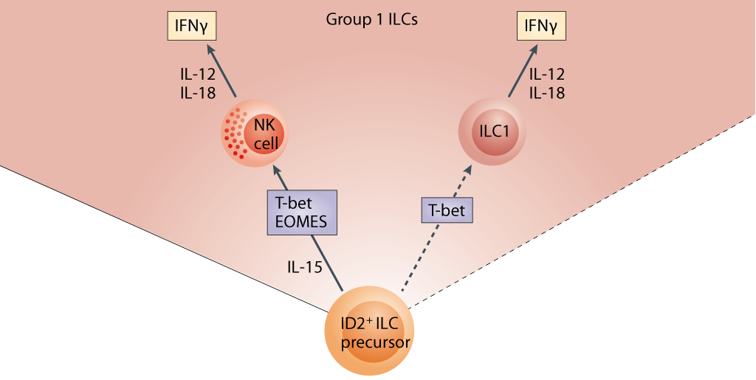
Figure 3: group 1 ILCs consist of NK cells and ILC1s. Both are dependent on the transcription factor T-bet and produce IFNγ among other cytokines upon stimulation with IL-12 and IL-18 (adapted from Spits et al.³²).

The first identified type of ILCs were natural killer (NK) cells, an innate cell type with cytotoxic activity, involved in early defense against viral infections³⁷. Just recently another cell type has been identified, which resembles NK cells, but shows no cytotoxic activity. This new ILC type was termed ILC1³³. The characteristics of NK cells and ILC1s are summarized in table 1 and figure 3.
NK cells can be divided into classical NK cells and NK T cells. Only the classical NK cell belongs to the ILC population, because NK T cells express the rearranged antigen receptors TCRs. CD56 expressing NK cells were found to be associated with cytokine production, while NK cells that did not express CD56 were found to be associated with cytotoxic activity^{37;38}.
NK cells recognize MHCI lacking cells and are cytotoxic by release of perforin and granzyme into the target cell. The cytotoxic activity of NK cells can be enhanced by virus-induced IFNα and IFNβ^{37;38}. In response to IL-12 and IL-18, NK cells produce antimicrobial peptides and a wide range of cytokines and chemokines, mainly IFNγ^{3;32;37}.
In contrast to NK cells, ILC1s are non-cytotoxic and do not express NK cell markers CD16, CD94, CD56 and NKp46. Activation and cytokine production of ILC1s seems to be similar to NK cells^{33;39}. A high number of ILC1s was found in the lamina propria of patients with Crohn’s disease and IFNγ producing cells were found to contribute to the inflammation of the intestine in these patients³³. Up to now only one article has been published about ILC1s.

Group 3 ILCs
Table 2: group 3 ILCs including LTi cells, NCR⁺ ILC3s and NCR⁻ ILC3s.
 | Transcription factors | Surface markers | Activating cytokines | Cytokine production
LTi cells^{40;41} | RORγt, AHR | CCR6 | IL-23, IL-1β | IL-17, IL-22
NCR⁺ ILC3s⁴²⁻⁴⁴ | RORγt, AHR, T-bet | NKp44, NKp46 | IL-23, IL-1β | IL-22
NCR⁻ ILC3s⁴⁵ | RORγt | NKp44 | IL-23, IL-1β | IL-17, IL-22, IFNγ
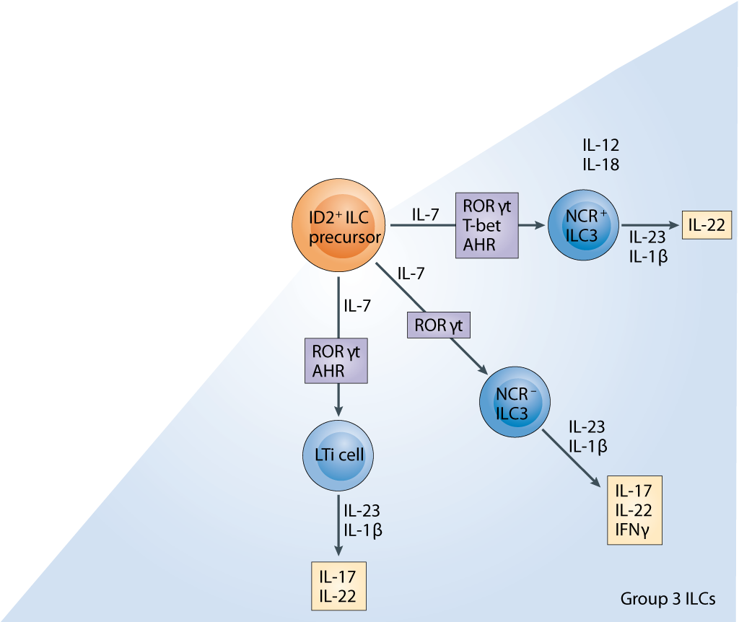

Figure 4: group 3 ILCs consist of LTi cells, NCR⁺ and NCR⁻ ILC3s. Development is dependent on IL-7 and transcription factor RORγt. They produce IL-17 and/or IL-22 upon stimulation with IL-23 and IL-1β (adapted from Spits et al.³²).

In 1992 Kelly et al.⁴⁰ reported about a new cell type involved in the formation of lymph nodes during embryogenesis. These cells were termed lymphoid tissue inducer cells (LTi cells) and later classified as group 3 ILCs⁴⁰. The additional cell types in group 3 ILCs are NCR⁺ and NCR⁻ ILC3s, which were first observed by Cupedo et al.⁴³. They described a natural killer-like cell that produced IL-17 and IL-22, which turned out to be related to LTi cells rather than NK cells^{42;43}. Further characteristics of group 3 ILCs are summarized in table 2 and figure 4.
LTi cells are involved in the formation of lymph nodes during fetal development and after birth involved in pathogen induced formation of secondary lymphoid tissue³⁸. The production of lymphotoxin β by LTi cells induces mesenchymal cells to attract more LTi cells and hematopoietic cells, which will form the lymph node^{3;38;43}.
NCR⁺ ILC3s were identified as a subset of NK cells, because of their expression of receptors NKp44 and NKp46, the cytotoxic receptor on NK cells^{44;46}. However, NCR⁺ ILC3s are not cytotoxic, because they lack killer inhibitory receptors and perforin. Furthermore they are distinct from NK cells because they produce IL-22 instead of IFNγ^{38;46}. NCR⁺ ILC3s are present in mucosal tissues and are found to protect against the pathogen Citrobacter rodentium^{32;38;44;46;47}. However it is suggested that they cannot completely clear pathogens from the intestine as this might require IL-17⁴⁶.
The third cell type that belongs to group 3 ILCs is the NCR⁻ ILC3s, which are similar to NCR⁺ ILC3s but do not express the NKp46 receptor. NCR⁻ ILC3s were identified by Buonocore et al.⁴⁵ and found to contribute to bacteria-induced colitis and inflammatory bowel disease^{32;46;45}. The exact role of NCR⁻ ILC3s and the functional differences with NCR⁺ ILC3s in intestinal immunity remains to be examined.

It seems that there is plasticity between group 1 and group 3 ILCs. IL-12 stimulation on ILC3s causes transition into an ILC1-like phenotype. On the other hand, NCR⁺ ILC3s cultured in the presence of IL-2 were able produce IFNγ and express NK cell associated cytotoxic receptors^{3;33;48}. The degree of plasticity between these two types remains to be further examined.

Group 2 ILCs
Table 3 : group 2 ILCs or ILC2s.
 | Transcription factors | Surface markers | Activating cytokines | Cytokine production
ILC2s^{18;28;49-51} | GATA3, RORα | CRTH2, CD16, CD7, ICOS | TSLP, IL-25, IL-33 | IL-5, IL-6, IL-9, IL-13
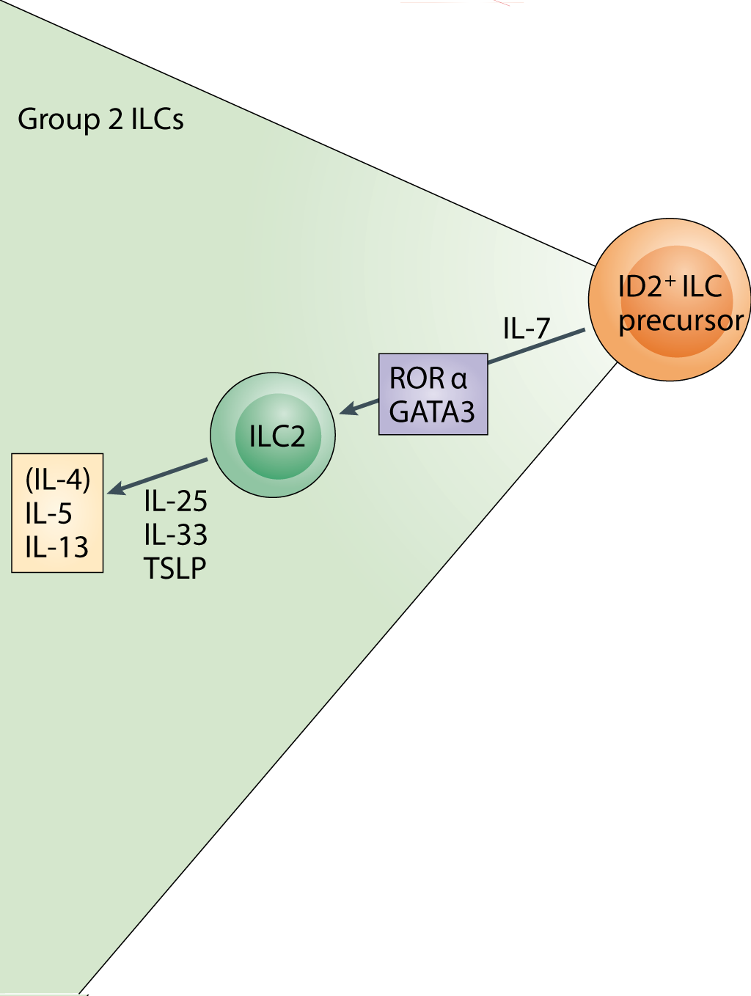

Figure 5 : development of group 2 ILCs is dependent on IL-7 and the transcription factors RORα and GATA3. Upon stimulation with TSLP, IL-25 and IL-33 ILC2s produce IL-5 and IL-13 (adapted from Spits et al.³²).

In 2001 Fort et al.¹⁸ published an article that described an unidentified cellular source of Th2 associated cytokines. These cells expressed IL-5 and IL-13 upon stimulation with IL-25 and were termed non-B non-T cells¹⁸. After almost a decade, four articles independently reported the identification of this cell type.
Moro et al.⁴⁹ described the presence of ‘natural helper cells’ in lymphoid structures within adipose tissues in the peritoneal cavity. After infection with Nippostrongylus brasiliensis these cells produced cytokines IL-5 and IL-13. These Th2 associated cytokines were also produced by stimulation with IL-33 in RAG2^{-/-} mice, in vivo models that lack mature lymphocytes. The ‘natural helper cells’ were lineage negative and expressed Sca-1 and c-Kit (figure 6)⁴⁹.
Neill et al.²⁸ used IL-13-eGFP reporter mice, a model that allows live imaging of IL-13 gene expression, to identify the presence of ‘nuocytes’. IL-13 producing cells were found in the intestines upon stimulation with IL-25 and IL-33. This was confirmed in experiments Nippostrongylus brasiliensis infection. ‘Nuocytes’ were found to be lineage negative and expressed the ST2 receptor, IL-17Rb receptor and the IL-7Rα receptor (figure 6)²⁸.
Price et al.⁵⁰ identified the ‘innate type 2 helper cell’ by using IL4-eGFP and IL13-eGFP reporter mice. Cells that expressed IL-13 were lineage-negative and found in particular in the mesenteric lymph nodes, the spleen and the liver. These cells were responsive to IL-25 and IL-33, which was also confirmed by experiments with Nippostrongylus brasiliensis infection⁵⁰.
Saenz et al.⁵¹ reported about a lineage-negative multipotent progenitor cell population termed ‘MPP^{type2} cells’. Upon IL-25 stimulation, these cells were found to accumulate in lymphoid tissue within the intestines. Adoptive transfer of IL-25 stimulated ‘MPP^{type2} cells’ to IL-25^{-/-} mice lead to IL-4, IL-5 and IL-13 production⁵¹.
The identified cell types by Moro et al., Neill et al., Price et al. and Saenz et al. all responded to IL-25 and/or IL-33, produced Th2 associated cytokines, were lineage negative and expressed Sca-1 and c-Kit. MPP^{type2} cells were found to differ from the other identified cell types, because they did not express the ST2 receptor and they had variable expression of IL-7Rα. Furthermore MPP^{type2} cells show multi-potent potential and can differentiate into other cell types^{6;51}. Therefore the ‘natural helper cells’, ‘nuocytes’ and ‘innate type 2 helper cells’ were defined as group 2 ILC2s³².

The presence of ILC2s in human was identified by Mjösberg et al.⁵². ILC2s were found in both fetal and adult tissues and were distributed in the lung, gut and nasal tissues. Similar to mouse ILC2s these cells were lineage negative and expressed IL-7Rα. Furthermore they produced IL-5 and IL-13 upon stimulation with IL-25 and IL-33. These cells also express CRTH2, a Th2 associated chemoattrractant receptor, and the T cell associated surface markers CD161 and CD127⁵². The characteristics of ILC2s are summarized in table 3 and figure 5.

Figure 6: histology of group 2 innate lymphoid cells. These cells were observed in mouse lymphoid tissue in the peritoneal cavity. They were lineage negative and expressed surface markers Sca-1 and c-Kit. A: Giemsa staining; 100x magnification²⁸. B: Giemsa staining; scale bar 20μm. C: electron micrograph; scale bar: 2μm⁴⁹.

Physiological function
Human ILC2s have been observed in the circulation, lungs, skin and gut^{3;53}. In mice ILC2s were found to be present in the circulation, lung, spleen, liver, intestines, mesenteric lymph nodes and mesenteric fat associated lymphoid clusters³. The amount of ILC2s in healthy individuals is very low. ILC2s are also present in fetal tissues, where the amount is slightly higher³⁶. In parasitic infections the number of ILC2s greatly expands³. Various studies revealed that ILC2s are essential in Th2 immunity and for parasite expulsion^{28;49-51}. ILC2s are a major source of Th2 associated cytokines and are able to produce these cytokines rapidly after stimulation³. ILC2s are therefore suggested to be important in the initiation of the immune response.

Th2 immunity
Table 4: surface marker expression on ILC2s in mice and human (NT: not tested. Adaptation from Spits et al.³⁶).
 | Natural helper cells (mouse) |  | Nuocytes (mouse) | Ih2 cells (mouse) | ILC2s (human)
Sca1 | + | + |  | - | NT
CD117 (cKit) | + | +/- |  | +/- | +/-
CD127 (IL-7Rα) | + | + |  | NT | +
CD25 (IL-2Rα) | + | NT |  | + | +
ST2 (IL-33R) | + | + |  | NT | +
IL-17Rb (IL-25R) | NT | + |  | NT | +
ICOS | NT | + |  | NT | NT
Β7 | NT | + |  | NT | NT
CRTH2 | NT | NT |  | NT | +

ILC2s express several surface markers, including various cytokine and chemokine receptors (see table 4). The expression of CD117 on the surface of ILC2s is heterogeneous and depends on the tissue location of the ILC³⁶. IL-7 and IL-2 are necessary for the development of ILC2s, so the presence of surface molecules IL-7Rα and IL-2Rα on ILC2s was expected^{32;36} ILC2s do not express the IgE receptor FcεRI, so they are not responsive to IgE⁵⁴.
ILC2s were found to express the ST2 receptor and IL-17Rb, which are receptors for IL-33 and IL-25 respectively³⁶. TSLP has been found to enhance GATA-3 expression in ILC2s, so ILC2s probably also express TSLPR⁵⁵. TSLP, IL-25 and IL-33 are produced by epithelial cells when activated by parasitic products or allergens. Expression of these cytokines has been found to lead to the initiation of Th2 associated responses, possibly via ILC2s^{1;10;56}. It is unknown if ILC2s can also respond directly to parasitic antigens or allergens²⁰.
Stimulation with IL-25 causes production of IL-4, IL-5 and IL-13 in mice experiments. In an experiment with RAG^{-/-} mice, which lack T and B lymphocytes, stimulation with IL-25 still led to the production of IL-5 and IL-13. ILC2s were found to be responsible for this cytokine production upon IL-25 stimulation. IL-4 was not produced by RAG^{-/-} mice, so ILC2s probably do not produce this cytokine¹⁸. IL-25 deficient mice could not clear infection with N Brasiliensis or T Muris, suggesting that IL-25 is important for the activation of ILC2s⁵⁴. IL-25 stimulates ILC2s, but suppresses ILC3s by inhibiting the production of IL-22. On the other hand, IL-22 from ILC3s was found to be able to inhibit ILC2 activation (figure 7)³.
IL-33 was found to induce proliferation of ILC2s and production of IL-5 and IL-13 by ILC2s. IL-33 also induces IL-5 and IL-13 production by other cell types such as mast cells and basophils^{5;6;57}.

Β7, ICOS and CRTH2 are adhesion molecules that were observed to be expressed on the surface of ILC2s in mice experiments. β7 associates with MADCAM-1 which is present on high endothelial venules, Peyer’s patches and mesenteric lymph nodes. This interaction probably results in migration of ILC2s to the intestinal lymphoid tissues. ICOS interacts with ICOS ligand which is observed at mucosal surfaces. This interaction is suggested to play a role in homing of ILC2s to mucosal surfaces⁵. CRTH2 is a Th2 associated chemoattractant receptor, involved in recruitment to the skin⁵².
ILC2s also express the chemokine receptors CXCR4, CXCR6 and CCR9. CXCR6 interacts with CXCL16 and is essential for T cell distribution and NK cell migration. Although the role for ILC2s is unknown, it might be involved in recruitment of ILC2s to the tissue site. CXCR4 interacts with CXCL12, which is known as a pre-B cell growth factor. Its function on ILC2s is unknown, but it could play a role in the development of ILC2s. CCR9 contributes to homing of intraepithelial lymphoid cells, which includes B and T cells, but possibly also ILC2s⁵.

Figure 7: the role of ILC2s in parasitic infection. ILC2s produce IL-5, IL-6 and IL-13. IL-5 induces eosinophilia and IL-6 induces IgA production by B cells. IL-13 has various effects such as globlet cell hyperplasia and smooth muscle contraction³.

ILC2s have been shown to produce IL-5, IL-6, and IL-13 (figure 7) and some articles report the production of IL-9, IL-10 and GM-CSF by ILC2s. Although these cytokines are produced by various cells in the immune system, ILC2s were found to be the major source³.
IL-5 is constitutively expressed by ILC2s and causes eosinophilia in the inflamed tissue. Furthermore IL-5 and IL-6 cause antibody production by B cells. In mice experiments by Moro et al.⁴⁹ ‘natural helper cells’, present in fat associated lymphoid clusters, were found to induce IgA production by B cells^{49;58}. IgA is often produced in immune responses in the gut, although Th2 immunity is characterized by IgE production^{29;59}. Although not shown in figure 7, ILC2s were found to produce IL-9, which leads to the proliferation of mast cells and basophils⁴.
IL-13 is only produced by Th2 cells and ILC2s, but is very important for the clearance of parasitic infections as IL-13 alone can induce parasite expulsion^{1;28}. IL-13 induces various mechanisms leading to parasite expulsion, such as goblet cell hyperplasia, smooth muscle cell contraction, recruitment of eosinophils and IgE class switching by B cells^{3;29;31;49}.
IL-4 was long thought to be the key cytokine for Th2 differentiation, until it was shown that naïve CD4⁺ T cells are able to differentiate into Th2 cells in the absence of IL-4. Moreover, IL-4 was not among the cytokines produced by ILC2s¹¹. Th2 cells promote proliferation of ILC2s, which is suggested to be stimulated by IL-25 production by Th2 cells. It is unknown how ILC2s are involved in the activation of Th2 cells^{1;3}.

Expression of MHC class II has been described on nuocytes, which suggests that ILC2s can also function as antigen presenting cells. On the other hand, no expression of MHC class II was found on natural helper cells²⁰. However this could be due to the activation state of the cell or it may be tissue dependent. IL-13 upregulates MHC class II expression on B cells and monocytes²⁹, which could also be the case for ILC2s.

Other functions
Beside Th2 immunity, ILC2s are suggested to have various other functions. They might play a role in the regulation of tissue formation as they are found to be present during embryogenesis. They might have a similar function as the group 3 ILC subset LTi cells in the fetal stage. However this hypothesis needs to be examined⁵².
Monticelli et al.⁶⁰ were the first to describe the presence of ILC2s in human lung tissue and also reported that ILC2s are involved in tissue repair in the lung. ILC2s were found to produce high levels of amphiregulin, which is involved in proliferation of epithelial cells and fibroblasts. Maintenance of tissue homeostasis by ILC2 derived amphiregulin could be important for restoration of infection or allergy-induced tissue damage⁶⁰. IL-33 promotes differentiation into alternatively activated macrophages, which can also promote tissue repair²³.
ILC2s are found to be present in certain adipose tissues and may play a role in adipose tissue homeostasis. IL-33 can stimulate alternatively activated macrophages, while Th2 associated cytokines can stimulate M1 macrophages in adipose tissues. The role of ILC2s in this process remains to be elucidated^{20;61}.

Atopic dermatitis
The incidence of atopic dermatitis (AD) in Western countries has increased enormously over the last decades. 10-20% of the children develop AD, which persists in adulthood in 1-3% of the Western population. The increasing incidence is suggested to be due to the absence of exposure to a wide range of pathogens, which may impair regulatory control on the immune system. The ‘hygiene hypothesis’ refers to this explanation for the increase in autoimmune diseases and allergic diseases^{4;62;63}.
Together with allergic asthma and allergic rhinitis, AD forms the atopy syndrome. In atopic diseases, patients are prone to form IgE antibodies against harmless environmental products (IgE sensitization)⁶⁴. Patients with AD have a higher risk of developing allergic asthma or rhinitis and also have a higher risk on food allergies⁶².
Two forms of AD exist: the extrinsic and the intrinsic form, which are IgE mediated and non-IgE mediated respectively. 70-80% of the AD patients suffer from the extrinsic form. However this classification is debatable and it might be that the intrinsic form can pass into the extrinsic form. Moreover, atopic diseases are characterized by IgE sensitization, but the importance of IgE in the development of AD is unclear^{25;62;65}.
The clinical features of AD are dry skin (xerosis) and itching of the skin. Attacks of severe itching (pruritus) and complications by bacterial or viral infections can occur^{62;66}. AD can be diagnosed based on clinical phenotype⁶². Serum levels of TARC can be measured to assess the severity of AD⁶⁷. Treatment of AD is focused on improvement of barrier function and reduction of inflammation⁶².
AD lesions can be acute and chronic. Acute lesions are crusted eroded vesicles, while chronic lesions are described as lichenified and excoriated plaques⁶². Furthermore acute AD lesions are characterized by the presence of Th2 associated cytokines, while Th1 associated cytokines are present in chronic AD lesions²⁵.
Various genes are associated with an increased risk of AD. Linkage and association studies have been performed and revealed that AD patients often have a mutation in the gene encoding filaggrin, a protein involved in skin barrier integrity⁶⁸. Other mutations are found in genes encoding skin barrier integrity proteins⁶⁹. Furthermore, mutations are found in the genes encoding IL-18, IL-13 and the β-chain of FcεRI. IL-18 can induce IFNγ production, favouring a Th1 mediated immune response, while IL-13 is involved in the effects of Th2 responses. FcεRI is the high affinity receptor for IgE, present on various immune cells^{25;67}.

Pathogenesis
Various factors contribute to the pathogenesis of AD, such as skin barrier dysfunction, IgE sensitization and both Th2 and Th1 mediated immune responses. However, the initiating factor in the development of AD is unclear. Two hypotheses are proposed: the inside-out and the outside-in hypothesis. The first suggests that a defect in immunological regulation results in IgE sensitization and development of AD. The outside-in hypothesis suggests that a genetic defect or environmental cause leads to skin barrier dysfunction, IgE sensitization and AD development^{69;70}.

Skin barrier dysfunction
The skin barrier is formed by the stratum corneum, tight junctions and Langerhans cells. The stratum corneum is the outermost layer of the epidermis (figure 8). It is formed by terminally differentiated and cornified keratinocytes, which lack nuclei, intracellular organelles and cell membranes. The cells are encapsulated in the cornified envelope, which consists of cross-linked proteins. Furthermore, nonpolar lipids, antimicrobial peptides, and ceramides are present in the stratum corneum, which contributes to the skin barrier function⁷¹.
In the stratum granulosum cells are connected by tight junctions, forming a physical barrier. In the stratum spinosum Langerhans cells are present for activation of the adaptive immune response in case of infection or tissue damage. The stratum basale contains melanocytes and proliferating keratinocytes^{69;71}.
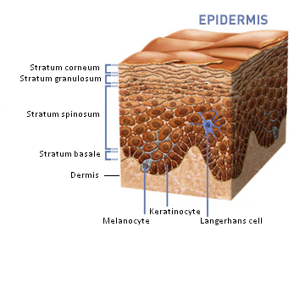

Figure 8: schematic overview of the epidermis, which consists of four layers: the stratum corneum, stratum granulosum, stratum spinosum and stratum basale. Keratinocytes are the main cell type in the epidermis. Melanocytes reside in the basal layer and Langerhans cells are present in the stratum spinosum⁶⁹. Picture adapted from http://myskinhealth.co.za.

In one third of the AD patients the filaggrin gene is mutated, which causes skin barrier dysfunction. Filaggrin is produced by keratinocytes and can be incorporated in the lipid layer in the stratum corneum. This lipid layer is involved in water retention and alterations cause aberrant hydration of the skin. When the filaggrin gene is mutated, there is a higher chance of penetration of environmental allergens or pathogens into the skin^{25;66;69;72;73}.
The skin barrier can also be impaired by other mutations in genes encoding proteins important for the cornification of keratinocytes. Mutations in tight junction genes were also related to skin barrier dysfunction. Furthermore, it has been found that the skin barrier function can be reduced by mechanical factors⁷¹.
Secondary infections often occur in AD. In 90% of the AD patients the skin is colonized by Staphylococcus aureus⁷⁴. This can be due to the impaired skin barrier, increased expression of adhesion molecules, lack of antimicrobial peptide production and aberrant TLR2 function⁷⁴⁻⁷⁶. S. Aureus produces enterotoxin A and B which contributes to AD severity by stimulating the immune response in the skin^{25;62}. Furthermore, the present inflammatory response causes insufficient clearance of the infection⁷⁴.

The histology of AD lesions is characterized by hyperplasia of the epidermis and leukocyte infiltration in both the epidermis and the dermis (figure 9)⁷⁰. There is intracellular edema (spongiosis) in the epidermis (figure 9). Moreover, histology shows accelerated renewal of keratinocytes and thickening of the stratum corneum^{25;62;70}. Also in non-lesional skin of AD patients there is lymphocyte infiltration, decreased hydration of the skin and decreased differentiation of cells in the epidermis^{62;65;70}.

Figure 9: skin of a healthy individual (NS) and skin of an AD lesion (AD). Compared to the normal skin there is thickening of the epidermis and the dermis with leukocyte infiltration and spongiosis⁷⁰.

IgE sensitization
The majority of AD patients suffer from extrinsic AD, which is characterized by IgE sensitization²⁵. The IgE antibodies can be directed against allergens, autoantigens or antigens derived from micro organisms such as S. Aureus. Autoantigens might be recognized because they share epitopes with exogenous allergens⁷⁷.
Mast cells, dendritic cells and many other cell types express the IgE receptors FcεRI or FcεRII^{77;78}. Dendritic cells are sensitized by binding of IgE to the high affinity receptor FcεRI. However, dendritic cells can also cause T cell activation independent from IgE^{25;77}.
Binding of IgE to the FcεRI receptor on mast cells leads to sensitization of the mast cells. If the antigen binds IgE on mast cells they become activated, leading to degranulation and release of histamine and cytokines. Mast cell products affect the function of keratinocytes and dendritic cells. Furthermore these products stimulate IgE synthesis by B cells and induce a Th2 associated immune response. In AD lesions massive degranulation has been observed and in chronic lesions this was combined with an increased amount of mast cells. Mast cells can also be activated independent from IgE, by complement or by certain cytokines⁷⁷.
IgE can contribute to the development of AD by stimulating inflammation. The expression of the FcεRI receptor was found to be increased in AD. However IgE sensitization is not essential for AD development^{69;77}. Approximately 20% of the AD patients suffers from intrinsic AD, which is non-IgE mediated. In the lesions of these patients more Th1 associated cytokines are found compared to lesions of extrinsic AD patients. Furthermore, non-IgE mediated AD often goes together with a normal skin barrier function. The importance of IgE in the development of AD remains unclear⁷⁸.

Th2 immune response
The presence of Th2 cytokines such as IL-4, IL-5 and IL-13 are characteristic for acute AD lesions⁶². Allergen patch tests with AD patients showed an increased IL-4 expression within 24 hours after allergen exposure, which was decreased again before 48 hours⁶². IL-4 and IL-13 establish the inflammatory response in the tissue, induce class switching of B cells to IgE synthesis and upregulate adhesion molecules on endothelial cells to increase migration to the tissue site. IL-5 promotes eosinophilia, one of the characteristics of AD^{62;69}.
Allergen exposure or mechanical injury such as scratching leads to rapid release of TSLP, IL-25 and IL-33 by keratinocytes. Keratinocytes express TSLP constitutively and expression is greatly increased in AD lesions. The release of TSLP can be enhanced by Th2 associated cytokines and TNFα and is reduced by Th1 associated cytokines IFNγ and TGFβ^{65;69;80}.
TSLP primes LCs in the epidermis and it can activate Th2 cells to produce cytokines¹³. TSLP overexpression in the skin, without affecting the skin barrier, results in an AD-like phenotype^{79;81}. Furthermore, in contrast to IL-25 and IL-33, the production of TSLP was found to be required for the development of AD⁷⁹.

A dysfunctional skin barrier facilitates penetration of allergens and pathogens. LCs can take up antigens on the outside of the tight junction barrier (figure 10)⁷¹. Subsequently they activate T cells and induce differentiation into Th2 cells. T cell migration to the epidermis is stimulated by CCL22 and TARC chemokine production by epithelial cells^{10;62;70}.
In AD the number of natural killer cells is reduced, probably due to an increase in apoptosis of NK cells. This is suggested to contribute to the Th2 response in the acute AD lesions. Cytotoxic CD8⁺ T cells have been found to be recruited to the skin in an early phase, augmenting the inflammatory response⁶⁹.

Figure 10: activation of the adaptive immune response by Langerhans cells. Langerhans cells take up allergens or bacterial molecules outside of the tight junction barrier. Allergens or bacterial products can penetrate the stratum corneum in case of skin barrier dysfunction⁷¹.

Th1 immune response
Chronic AD lesions are characterized by the presence of Th1 associated cytokines²⁵. IFNγ and IL-12 are mainly present and are involved in the induction of the Th1 response. The Th1 response is maintained by IL-12, IL-18, IL-11, IL-17 and TGF-β. Furthermore IL-5 and GM-CSF were detected. In chronic lesions the epidermis is damaged by increased apoptosis of skin cells. The expression of Th1 associated cytokines was found to be increased 48 hours after allergen exposure⁶².
What factors induce the switch from Th2 immunity into Th1 immunity is unclear. Inflammatory dendritic epidermal cells (IDECs) are thought to be involved. These cells are antigen presenting cells that migrate to the skin upon inflammatory stimuli. Their infiltration into the skin is suggested to induce the switch into Th1 immunity, because these cells produce proinflammatory cytokines such as IL-12²⁵. However, it was observed that IDECs migrate rapidly to the skin, which suggests they are already present in the acute lesions.
Another cell type that might contribute to the switch into a Th1 associated response are regulatory T cells. Regulatory T cells can suppress the function of both Th1 and Th2 cells. Furthermore mutations in the FoxP3 gene of regulatory T cells are associated with high IgE levels and development of food allergies and AD⁶². Some bacterial infections such as S. Aureus have the properties to inhibit regulatory T cell function, which increased inflammation⁸².

Group 2 Innate lymphoid cells
ILC2s have been described to contribute to gut immunity and atopic diseases such as allergic asthma and allergic rhinitis^{52;55;76}. Until recently, nothing was known about the presence of ILC2s in the skin. One article by Kim et al.⁵³ has been published which shows ILC2s are present in both healthy skin and AD lesional skin and that ILC2s contribute to the inflammatory response in AD⁵³.

The article by Kim et al.⁵³ describes that flow cytometry was performed with isolated cells from human healthy skin and human AD lesions. ILC2s were found to be present in both sample types. However, the number of ILC2s in the AD skin lesions was greatly increased (figure 11). ILC2s could isolated from the other cells, because they do not express lineage markers and the FcεRI receptor. Furthermore they express CD25, the IL-2 receptor α-chain, and the receptor for IL-33. ILC2s can be distinguished from ILC3s, because ILC2s do not express surface markers specific for ILC3s, such as CD4, Nkp44 and RORγt⁵³.
The ILC2s in AD lesional skin were found to express CRTH2 and CD161, while ILC2s in the healthy skin did not. This could indicate a different population of ILC2s or an activated state of the cells⁵³.
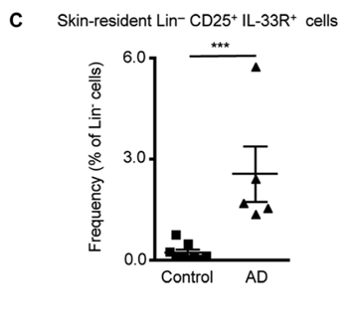
Figure 11: FACS analysis of healthy skin (A) and AD skin lesions (B). ILC2s were selected because they are negative lineage, lack expression of the FcεRI receptor and show expression of CD25 (IL-2 receptor α-chain) and the IL-33 receptor (ST2). There was a significant increase in ILC2s in AD skin lesions compared to the healthy skin (C)⁵³.

The role of ILC2s in the development of AD was studied with the MC903 mouse model, which is a C57BL/6 wild-type mouse that received topical treatment with the vitamin D analog calcipotriol. This treatment results in AD-like inflammation and AD-like histology of the skin. In this mouse model increased numbers of ILC2s were detected in the skin. Depletion of ILC2s caused a reduction in inflammation in the AD mouse model (figure 12). Furthermore, depletion of ILC2s reduced IL-5 and IL-13 levels and epidermal thickness^{53;79}.
The effects of ILC2s on Th2 immune responses were found to be mediated by TSLP only. In IL-33^{-/-} or IL-17Rb^{-/-} mice the development of AD was not altered compared to the MC903 mouse model. TLSPR deficient mice showed reduced ILC2 associated immune responses. IL-33 was found to be able to support the effect of TSLP on AD development⁵³.

The study by Kim et al. is yet the only published article on the role of ILC2s in AD and their results have to be confirmed by other studies. However, here we assume ILC2s are present in the skin and involved in the inflammatory response in AD.

Figure 12: the role of ILC2s in the development of AD in a mouse model. MC903 treatment causes an AD-like phenotype (middle) compared to the control (left). Depletion of ILC2s by anti-CD25 causes reduced inflammation and skin thickness in the mouse model (right)⁵³.

The mice experiments by Kim et al. showed that depletion of ILC2s results in reduced inflammation and a decreased epidermal thickness in the skin (figure 12)⁵³. MC903 mice show histological features of AD lesions, however it is unclear if these lesions are acute or chronic lesions⁷⁹. However, the finding that ILC2 induces Th2 immune responses and ILC2 depletion decreases inflammation, suggests that the mouse model shows lesions with an acute phenotype⁵³. For further research about the role of ILC2s in acute and chronic AD lesions this animal model may not be suitable.
Although the study of Kim et al. did not distinguish between acute and chronic AD lesions, it seems likely that ILC2s are involved in the immune response in acute lesions. This means the ILC2s respond rapidly after allergen exposure by production of Th2 associated cytokines. Therefore, it is likely that ILC2s reside in the tissue. This is supported by the finding that ILC2s are present in human healthy skin tissue⁵³. It is not known if ILC2s are also present in non-lesional AD skin.
It was found that in human AD lesional skin the number of ILC2s was greatly increased. This could be due to proliferation of ILC2s in the tissue or recruitment of other ILC2s to the tissue site. ILC2s in human AD skin were found to express CRTH2, which is a skin homing receptor present on T cells, keratinocytes, basophils and eosinophils⁶⁹. ILC2s expressing this marker might be recruited to the skin from peripheral tissues.

Kim et al. found that TSLP contributes to the development of AD, while IL-25 and IL-33 did not influence the inflammatory response in the AD mouse model. On the other hand, Hvid et al.⁸³ described that IL-25 contributes to AD progress. They observed increased levels of IL-25 and IL-17Rb in AD lesions⁸³. Despite the findings of Kim et al. it seems likely that IL-25 contributes to AD inflammation via IL-17Rb on ILC2s⁵³. TSLP could activate ILC2s and initiate the Th2 cytokine production in AD, while IL-25 could be involved in modulation of the Th2 immune response¹⁵.
Moreover, IL-25 is thought to be involved in the impairment of the skin barrier function by down regulating filaggrin synthesis. Thereby, IL-25 provides a link between immune responses in AD and dysfunction of the skin barrier^{65;83}.
IL-33 was reported to be present in AD skin lesions, but not in healthy skin⁸⁴. This suggests it contributes to the development of AD. It seems likely that IL-33 stimulates the inflammatory response in AD via ILC2s, because they express the ST2 receptor. This is in contrast with the findings of Kim et al., who showed no decrease in inflammation in IL-33 knockout mice⁵³.
IL-33 is known to promote fibrosis and might also play a role in tissue repair in AD. IL-13 was found to cause cutaneous fibrosis in mice upon stimulation with IL-33. Eosinophils were responsible for the IL-13 production and subsequent tissue repair. However, ILC2s could have a similar effect in AD lesions⁸⁵.

In mice, depletion of ILC2s leads to a decreased inflammatory response, but not to total inhibition of inflammation. This suggests other cell types contribute to the Th2 immune response as well. The relative contribution of ILC2s and Th2 cells to the Th2 response remains to be examined. Furthermore, Th1 cells are also present in small amounts in acute AD lesions.
ILC2s are suggested to be essential for the initiation of the immune response in AD. ILC2s are an innate cell type and they can be activated by specific patterns or cytokines, although the exact mechanism of activation of ILC2s is unclear. ILC2s can produce Th2 associated cytokines directly after activation and cause a rapid inflammatory response. T cells have to be activated first by APCs in the lymph node and subsequently migrate to the tissue site before they can induce an inflammatory response.

Beside the ILC2s, the presence of ILC3s in the AD lesional skin has also been described. However it was also reported that ILC3s do not contribute to the pathogenesis of AD⁵³. Elevated levels of IL-17 and IL-22 are observed in AD lesions, which have been suggested to be due to the presence of Th17 and Th22 cells⁷⁶. Cua et al.⁸⁶ reported that IL-17 is only present in acute AD, while Th17 infiltrate the skin in a later stage⁸⁶. This indicates that ILC3s could be involved in early phases of the development of AD, although this remains to be examined.
Furthermore, ILC3s have been described to play a role in psoriasis, another inflammatory skin disease. If the role of IL-22 producing ILC3s in AD could be confirmed, this also provides another link between inflammation and skin barrier dysfunction next to IL-25. IL-22 is able to down regulate filaggrin expression and inhibit keratinocyte differentiation^{65;87}.

Conclusion
ILC2s are a recently identified innate cell type. They are involved in immunity against parasites and in allergic diseases by production of Th2 associated cytokines. ILC2s are present in various tissues and play a role in the pathology of allergic asthma and chronic rhinitis. Very recently, an article was published that described the presence of ILC2s in the skin and their contribution to AD⁵³. ILC2s play a role in the Th2 immune response in AD lesional skin, however the exact mechanism and the importance of ILC2 for the development of AD are unclear.
Here the following role for ILC2s in the development of AD is suggested. Keratinocytes in the skin are activated upon allergen exposure or mechanical factors, which leads to the production of TSLP, IL-25 and IL-33. LCs are also activated upon recognition of allergens and migrate to the lymph node to activate the adaptive immune system. TSLP (in combination with IL-25 and IL-33) from keratinocytes activates ILC2s and initiate production of Th2 associated cytokines such as IL-5, IL-9 and IL-13. These cytokines cause the initial inflammatory response in the AD skin, leading to the development of acute eczema lesions.
Upon stimulation with TSLP, LCs promote differentiation of naïve T cells into Th2 cells. The Th2 cells migrate to the tissue where they contribute to the Th2 immune response. The response is enhanced by mutual stimulation of ILC2s and Th2 cells. Due to an unknown trigger, IL-12-induced dendritic cells promote differentiation into Th1 cells. Th1 cytokines inhibit the Th2 response and cause chronic AD lesions.
As suggested above and by other articles, ILC2s might be essential for the initiation of Th2 immune responses. More research should be performed on the role of ILC2s in AD to examine the importance of ILC2s in AD. Furthermore, the relative contribution of TSLP, IL-25 and IL-33 needs to be studied. This could improve the understanding of the pathogenesis of AD, which may lead to better treatment.

References

1. Paul WE, Zhu J. How are T(H)2-type immune responses initiated and amplified? Nat.Rev.Immunol. 2010; 10: 225-35.
2. Kim HY, DeKruyff RH, Umetsu DT. The many paths to asthma: phenotype shaped by innate and adaptive immunity. Nat.Immunol. 2010; 11: 577-84.
3. Walker JA, Barlow JL, McKenzie AN. Innate lymphoid cells - how did we miss them? Nat.Rev.Immunol. 2013; 13: 75-87.
4. Allen JE, Maizels RM. Diversity and dialogue in immunity to helminths. Nat.Rev.Immunol. 2011; 11: 375-88.
5. Barlow JL, McKenzie AN. Nuocytes: expanding the innate cell repertoire in type-2 immunity. J.Leukoc.Biol. 2011; 90: 867-74.
6. Saenz SA, Noti M, Artis D. Innate immune cell populations function as initiators and effectors in Th2 cytokine responses. Trends Immunol. 2010; 31: 407-13.
7. Sokol CL, Barton GM, Farr AG et al. A mechanism for the initiation of allergen-induced T helper type 2 responses. Nat.Immunol. 2008; 9: 310-8.
8. Finkelman FD, Urban JF, Jr. Cytokines: making the right choice. Parasitol.Today 1992; 8: 311-4.
9. Hammad H, Chieppa M, Perros F et al. House dust mite allergen induces asthma via Toll-like receptor 4 triggering of airway structural cells. Nat.Med. 2009; 15: 410-6.
10. Saenz SA, Taylor BC, Artis D. Welcome to the neighborhood: epithelial cell-derived cytokines license innate and adaptive immune responses at mucosal sites. Immunol.Rev. 2008; 226: 172-90.
11. Oliphant CJ, Barlow JL, McKenzie AN. Insights into the initiation of type 2 immune responses. Immunology 2011; 134: 378-85.
12. Mjosberg J, Spits H. Type 2 innate lymphoid cells-new members of the "type 2 franchise" that mediate allergic airway inflammation. Eur.J.Immunol. 2012; 42: 1093-6.
13. Soumelis V, Reche PA, Kanzler H et al. Human epithelial cells trigger dendritic cell mediated allergic inflammation by producing TSLP. Nat.Immunol. 2002; 3: 673-80.
14. Zhou B, Comeau MR, De ST et al. Thymic stromal lymphopoietin as a key initiator of allergic airway inflammation in mice. Nat.Immunol. 2005; 6: 1047-53.
15. Wang YH, Angkasekwinai P, Lu N et al. IL-25 augments type 2 immune responses by enhancing the expansion and functions of TSLP-DC-activated Th2 memory cells. J.Exp.Med. 2007; 204: 1837-47.
16. Angkasekwinai P, Park H, Wang YH et al. Interleukin 25 promotes the initiation of proallergic type 2 responses. J.Exp.Med. 2007; 204: 1509-17.
17. Wang YH, Ito T, Wang YH et al. Maintenance and polarization of human TH2 central memory T cells by thymic stromal lymphopoietin-activated dendritic cells. Immunity. 2006; 24: 827-38.
18. Fort MM, Cheung J, Yen D et al. IL-25 induces IL-4, IL-5, and IL-13 and Th2-associated pathologies in vivo. Immunity. 2001; 15: 985-95.
19. Humphreys NE, Xu D, Hepworth MR et al. IL-33, a potent inducer of adaptive immunity to intestinal nematodes. J.Immunol. 2008; 180: 2443-9.
20. Koyasu S, Moro K. Innate Th2-type immune responses and the natural helper cell, a newly identified lymphocyte population. Curr.Opin.Allergy Clin.Immunol. 2011; 11: 109-14.
21. Schmitz J, Owyang A, Oldham E et al. IL-33, an interleukin-1-like cytokine that signals via the IL-1 receptor-related protein ST2 and induces T helper type 2-associated cytokines. Immunity. 2005; 23: 479-90.
22. Kurowska-Stolarska M, Stolarski B, Kewin P et al. IL-33 amplifies the polarization of alternatively activated macrophages that contribute to airway inflammation. J.Immunol. 2009; 183: 6469-77.
23. Allakhverdi Z, Smith DE, Comeau MR et al. Cutting edge: The ST2 ligand IL-33 potently activates and drives maturation of human mast cells. J.Immunol. 2007; 179: 2051-4.
24. Gros E, Novak N. Cutaneous dendritic cells in allergic inflammation. Clin.Exp.Allergy 2012; 42: 1161-75.
25. Novak N, Bieber T, Leung DY. Immune mechanisms leading to atopic dermatitis. J.Allergy Clin.Immunol. 2003; 112: S128-S139.
26. Novak N, Bieber T. 2. Dendritic cells as regulators of immunity and tolerance. J.Allergy Clin.Immunol. 2008; 121: S370-S374.
27. Yoshimoto T, Yasuda K, Tanaka H et al. Basophils contribute to T(H)2-IgE responses in vivo via IL-4 production and presentation of peptide-MHC class II complexes to CD4+ T cells. Nat.Immunol. 2009; 10: 706-12.
28. Neill DR, Wong SH, Bellosi A et al. Nuocytes represent a new innate effector leukocyte that mediates type-2 immunity. Nature 2010; 464: 1367-70.
29. Wynn TA. IL-13 effector functions. Annu.Rev.Immunol. 2003; 21: 425-56.
30. Kindt TJ, Osborne BA, Goldsby RA. Kuby Immunology, 6th edn. W.H. Freeman & Company, 2006.
31. Mannon P, Reinisch W. Interleukin 13 and its role in gut defence and inflammation. Gut 2012; 61: 1765-73.
32. Spits H, Artis D, Colonna M et al. Innate lymphoid cells - a proposal for uniform nomenclature. Nat.Rev.Immunol. 2013; 13: 145-9.
33. Bernink JH, Peters CP, Munneke M et al. Human type 1 innate lymphoid cells accumulate in inflamed mucosal tissues. Nat.Immunol. 2013; 14: 221-9.
34. Hoyler T, Connor CA, Kiss EA et al. T-bet and Gata3 in controlling type 1 and type 2 immunity mediated by innate lymphoid cells. Curr.Opin.Immunol. 2013.
35. Boos MD, Yokota Y, Eberl G et al. Mature natural killer cell and lymphoid tissue-inducing cell development requires Id2-mediated suppression of E protein activity. J.Exp.Med. 2007; 204: 1119-30.
36. Spits H, Cupedo T. Innate lymphoid cells: emerging insights in development, lineage relationships, and function. Annu.Rev.Immunol. 2012; 30: 647-75.
37. Biron CA, Nguyen KB, Pien GC et al. Natural killer cells in antiviral defense: function and regulation by innate cytokines. Annu.Rev.Immunol. 1999; 17: 189-220.
38. Spits H, Di Santo JP. The expanding family of innate lymphoid cells: regulators and effectors of immunity and tissue remodeling. Nat.Immunol. 2011; 12: 21-7.
39. Gordon SM, Chaix J, Rupp LJ et al. The transcription factors T-bet and Eomes control key checkpoints of natural killer cell maturation. Immunity. 2012; 36: 55-67.
40. Kelly KA, Scollay R. Seeding of neonatal lymph nodes by T cells and identification of a novel population of CD3-CD4+ cells. Eur.J.Immunol. 1992; 22: 329-34.
41. Scandella E, Bolinger B, Lattmann E et al. Restoration of lymphoid organ integrity through the interaction of lymphoid tissue-inducer cells with stroma of the T cell zone. Nat.Immunol. 2008; 9: 667-75.
42. Crellin NK, Trifari S, Kaplan CD et al. Human NKp44+IL-22+ cells and LTi-like cells constitute a stable RORC+ lineage distinct from conventional natural killer cells. J.Exp.Med. 2010; 207: 281-90.
43. Cupedo T, Crellin NK, Papazian N et al. Human fetal lymphoid tissue-inducer cells are interleukin 17-producing precursors to RORC+ CD127+ natural killer-like cells. Nat.Immunol. 2009; 10: 66-74.
44. Cella M, Fuchs A, Vermi W et al. A human natural killer cell subset provides an innate source of IL-22 for mucosal immunity. Nature 2009; 457: 722-5.
45. Buonocore S, Ahern PP, Uhlig HH et al. Innate lymphoid cells drive interleukin-23-dependent innate intestinal pathology. Nature 2010; 464: 1371-5.
46. Satoh-Takayama N, Vosshenrich CA, Lesjean-Pottier S et al. Microbial flora drives interleukin 22 production in intestinal NKp46+ cells that provide innate mucosal immune defense. Immunity. 2008; 29: 958-70.
47. Koyasu S, Moro K. Role of innate lymphocytes in infection and inflammation. Front Immunol. 2012; 3: 101.
48. Cella M, Otero K, Colonna M. Expansion of human NK-22 cells with IL-7, IL-2, and IL-1beta reveals intrinsic functional plasticity. Proc.Natl.Acad.Sci.U.S.A 2010; 107: 10961-6.
49. Moro K, Yamada T, Tanabe M et al. Innate production of T(H)2 cytokines by adipose tissue-associated c-Kit(+)Sca-1(+) lymphoid cells. Nature 2010; 463: 540-4.
50. Price AE, Liang HE, Sullivan BM et al. Systemically dispersed innate IL-13-expressing cells in type 2 immunity. Proc.Natl.Acad.Sci.U.S.A 2010; 107: 11489-94.
51. Saenz SA, Siracusa MC, Perrigoue JG et al. IL25 elicits a multipotent progenitor cell population that promotes T(H)2 cytokine responses. Nature 2010; 464: 1362-6.
52. Mjosberg JM, Trifari S, Crellin NK et al. Human IL-25- and IL-33-responsive type 2 innate lymphoid cells are defined by expression of CRTH2 and CD161. Nat.Immunol. 2011; 12: 1055-62.
53. Kim BS, Siracusa MC, Saenz SA et al. TSLP Elicits IL-33-Independent Innate Lymphoid Cell Responses to Promote Skin Inflammation. Sci.Transl.Med. 2013; 5: 170ra16.
54. Fallon PG, Ballantyne SJ, Mangan NE et al. Identification of an interleukin (IL)-25-dependent cell population that provides IL-4, IL-5, and IL-13 at the onset of helminth expulsion. J.Exp.Med. 2006; 203: 1105-16.
55. Mjosberg J, Bernink J, Golebski K et al. The transcription factor GATA3 is essential for the function of human type 2 innate lymphoid cells. Immunity. 2012; 37: 649-59.
56. Halim TY, Krauss RH, Sun AC et al. Lung natural helper cells are a critical source of Th2 cell-type cytokines in protease allergen-induced airway inflammation. Immunity. 2012; 36: 451-63.
57. Koyasu S, Moro K. Type 2 innate immune responses and the natural helper cell. Immunology 2011; 132: 475-81.
58. Okoye IS, Wilson MS. CD4+ T helper 2 cells--microbial triggers, differentiation requirements and effector functions. Immunology 2011; 134: 368-77.
59. Nairn R, Helbert M. Immunology for medical students, 2nd edn. Mosby, 2007.
60. Monticelli LA, Sonnenberg GF, Abt MC et al. Innate lymphoid cells promote lung-tissue homeostasis after infection with influenza virus. Nat.Immunol. 2011; 12: 1045-54.
61. Suganami T, Ogawa Y. Adipose tissue macrophages: their role in adipose tissue remodeling. J.Leukoc.Biol. 2010; 88: 33-9.
62. Bieber T. Atopic dermatitis. Ann.Dermatol. 2010; 22: 125-37.
63. Schultz LF. Atopic dermatitis: an increasing problem. Pediatr.Allergy Immunol. 1996; 7: 51-3.
64. Bieber T. Atopic dermatitis. N.Engl.J.Med. 2008; 358: 1483-94.
65. Novak N, Leung DY. Advances in atopic dermatitis. Curr.Opin.Immunol. 2011; 23: 778-83.
66. Proksch E, Folster-Holst R, Jensen JM. Skin barrier function, epidermal proliferation and differentiation in eczema. J.Dermatol.Sci. 2006; 43: 159-69.
67. Kou K, Aihara M, Matsunaga T et al. Association of serum interleukin-18 and other biomarkers with disease severity in adults with atopic dermatitis. Arch.Dermatol.Res. 2012; 304: 305-12.
68. Jakasa I, Koster ES, Calkoen F et al. Skin barrier function in healthy subjects and patients with atopic dermatitis in relation to filaggrin loss-of-function mutations. J.Invest Dermatol. 2011; 131: 540-2.
69. Brandt EB, Sivaprasad U. Th2 Cytokines and Atopic Dermatitis. J.Clin.Cell Immunol. 2011; 2.
70. Wollenberg A, Klein E. Current aspects of innate and adaptive immunity in atopic dermatitis. Clin.Rev.Allergy Immunol. 2007; 33: 35-44.
71. Kubo A, Nagao K, Amagai M. Epidermal barrier dysfunction and cutaneous sensitization in atopic diseases. J.Clin.Invest 2012; 122: 440-7.
72. Palmer CN, Irvine AD, Terron-Kwiatkowski A et al. Common loss-of-function variants of the epidermal barrier protein filaggrin are a major predisposing factor for atopic dermatitis. Nat.Genet. 2006; 38: 441-6.
73. Ovaere P, Lippens S, Vandenabeele P et al. The emerging roles of serine protease cascades in the epidermis. Trends Biochem.Sci. 2009; 34: 453-63.
74. Baker BS. The role of microorganisms in atopic dermatitis. Clin.Exp.Immunol. 2006; 144: 1-9.
75. Savinko T, Matikainen S, Saarialho-Kere U et al. IL-33 and ST2 in atopic dermatitis: expression profiles and modulation by triggering factors. J.Invest Dermatol. 2012; 132: 1392-400.
76. Park CO, Noh S, Jin S et al. Insight into newly discovered innate immune modulation in atopic dermatitis. Exp.Dermatol. 2013; 22: 6-9.
77. Liu FT, Goodarzi H, Chen HY. IgE, mast cells, and eosinophils in atopic dermatitis. Clin.Rev.Allergy Immunol. 2011; 41: 298-310.
78. Roguedas-Contios AM, Misery L. What is intrinsic atopic dermatitis? Clin.Rev.Allergy Immunol. 2011; 41: 233-6.
79. Li M, Hener P, Zhang Z et al. Induction of thymic stromal lymphopoietin expression in keratinocytes is necessary for generating an atopic dermatitis upon application of the active vitamin D3 analogue MC903 on mouse skin. J.Invest Dermatol. 2009; 129: 498-502.
80. Giustizieri ML, Mascia F, Frezzolini A et al. Keratinocytes from patients with atopic dermatitis and psoriasis show a distinct chemokine production profile in response to T cell-derived cytokines. J.Allergy Clin.Immunol. 2001; 107: 871-7.
81. Yoo J, Omori M, Gyarmati D et al. Spontaneous atopic dermatitis in mice expressing an inducible thymic stromal lymphopoietin transgene specifically in the skin. J.Exp.Med. 2005; 202: 541-9.
82. Cardona ID, Goleva E, Ou LS et al. Staphylococcal enterotoxin B inhibits regulatory T cells by inducing glucocorticoid-induced TNF receptor-related protein ligand on monocytes. J.Allergy Clin.Immunol. 2006; 117: 688-95.
83. Hvid M, Vestergaard C, Kemp K et al. IL-25 in atopic dermatitis: a possible link between inflammation and skin barrier dysfunction? J.Invest Dermatol. 2011; 131: 150-7.
84. Pushparaj PN, Tay HK, H'ng SC et al. The cytokine interleukin-33 mediates anaphylactic shock. Proc.Natl.Acad.Sci.U.S.A 2009; 106: 9773-8.
85. Rankin AL, Mumm JB, Murphy E et al. IL-33 induces IL-13-dependent cutaneous fibrosis. J.Immunol. 2010; 184: 1526-35.
86. Cua DJ, Tato CM. Innate IL-17-producing cells: the sentinels of the immune system. Nat.Rev.Immunol. 2010; 10: 479-89.
87. Gutowska-Owsiak D, Schaupp AL, Salimi M et al. Interleukin-22 downregulates filaggrin expression and affects expression of profilaggrin processing enzymes. Br.J.Dermatol. 2011; 165: 492-8.

