**Plasticity in cancer stem cells: the role of stochasticity, genetic instability, epigenetics and the microenvironment.**

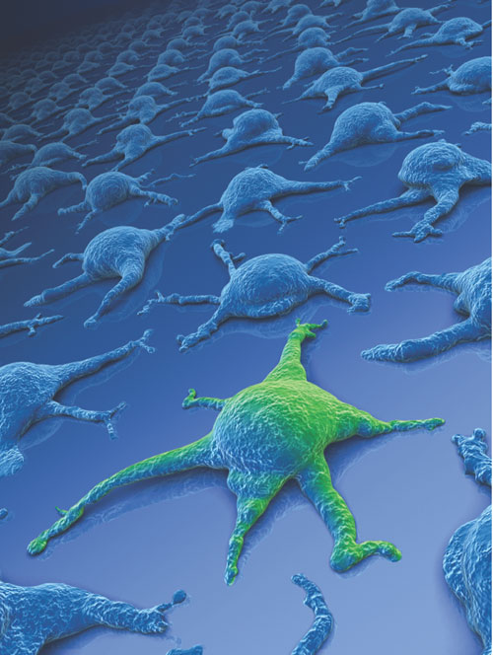



**S. C. Steenbeek**

**Master thesis**

**January-February 2014**

**Publish date: Februari 28th 2014**

**Author: S. C. Steenbeek**

**Contact: s.c.steenbeek@students.uu.nl**

**Master program: Cancer, Genomics and developmental Biology**

**Utrecht University, The Netherlands**

**Direct Supervisor: Anoek Zomer**

**Principal Investigator: Jacco van Rheenen**

**Institute: Hubrecht Institute, Developmental Biology and Stem Cell Research**

Front page illustration represents a rare cancer stem cell in green among thousands of more differentiated cancer cells which are represented in blue. Image credits go to Ken Brown, Mondolithic Studios.   **Contents**

4

5

6

8

11

13

14

19

22

24

28

28

29

Abstract ____________________________________________

Laymen summary ____________________________________________

Chapter 1. Introduction

* 1. Cancer and tumor heterogeneity. ____________________________________________
  2. Cancer stem cell (CSC) hypothesis. __________________________________________

Chapter 2. Challenges in studying CSCs and their plasticity. _______________

Chapter 3. Evidence for CSC plasticity.

* 1. Stochastic drift in CSC plasticity. __________________
  2. The role of genetic instability and epigenetics on CSC plasticity. _______________
  3. The role of the microenvironment in CSC plasticity. ________________

Chapter 4. Lineage tracing as a novel way to study tumor heterogeneity and CSC plasticity _____

Chapter 5. Discussion ________________________________________

Supplemental

Used abbreviations __________________________________________

Acknowledgements ___________________________________________

References _________________________________________

**Abstract**

The cancer stem cell (CSC) theory proposes that a tumor is maintained and propagated by a cancer cell with stem cell-like properties. CSCs have been implicated to be the main driver for tumor initiation, propagation, metastasis and recurrence. Although a lot of work has been performed on identifying and characterizing CSCs, no unifiable markers for, and characteristics of CSCs, have been established to date. More recently, a rising number of studies provide evidence that stemness characteristics can be acquired by more differentiated cancer cells, giving rise to *de novo* CSCs. Therefore, the CSC theory shifts towards a model in which the CSC characteristics can be acquired by stochastic mechanisms, genetic and epigenetic changes and extrinsic factors from the microenvironment, which could also be defined as the CSC niche. Most studies on CSC plasticity have been performed using *in vitro* studies, serial transplants or xenograft assays. These methods represent another environment than the unperturbed tumor and are static models, making it challenging to study *in vivo* CSC dynamics. Intravital imaging techniques in combination with genetic lineage tracing will enable researchers to study CSCs over time and in the unperturbed and will most likely prove to be essential in studying CSC dynamics *in vivo*. To summarize, this thesis reviews current challenges in CSC identification and reviews mechanisms which have been found to induce *de novo* CSC generation. Additionally, future experimental setups and the therapeutic consequences of *de novo* generation of CSCs will be discussed.

D:\University Master\CSCs\Figures\graphical abstract1.tif

Graphical abstract. The CSC phenotype is a reversible fate and can be acquired by stochastic drift, genetic instability, epigenetic changes and extrinsic factors from the microenvironment

**Laymen summary**

Cancer ranks in the top disease-related deaths. As a disease, it has is very high variety among subtypes and patients in the leading causes, disease progression and therapy response. Even within one tumor from one patient there is a high variety between the different cells. For example, some cells maintain the tumor growth, other cells form the tumor bulk and some cells have a tumor-supportive role. Even though many years of research have been performed on improving therapeutics and treatment strategies, the gain in disease free or overall survival is minimal for some types of cancer.

One theory that explains the variety in tumor cell properties within a tumor and explains the minimal gain in treatment improvements is the cancer stem cell (CSC) theory. The CSC theory is based on a small population of cells, the CSCs, maintaining the tumor, causing the tumor to metastasize and re-growing the tumor upon therapy relapse. These CSCs are thought to be able to self-renew as a stem cell, adopt other fates of the tumor bulk and to be more resistant to therapies. As a result, remaining resistant CSCs after therapy can regrow the whole tumor with the presence of all different cell types. The classical CSC theory sees the CSC as the top cell in the tumor hierarchy and if this cell could be killed, the tumor will not grow further, reduce in size and relapse after therapy will not occur anymore.

More recent experiments however, show that the CSCs are not a defined set of cells within the tumor, but other cells could acquire CSC characteristics as well. Different causes leading to this reversible CSC property are random changes relying on chance, mutational changes to the genes, changes to how the genes are transcribed and input from the environment of the cell. These different factors are not independent, as mutations and the cells environment also influence gene transcription. Currently, evidence for CSC plasticity is provided by studies that sort tumor cells on their properties and next analyze how efficiently they grow out “in a dish” or when transplanted into a mouse. Although very informative, a major limitation is that the cancer cells are taken out of their own tumor environment and could undergo changes, thereby not growing out in a dish or a transplant assay as they would in the tumor. A new technique that will likely prove to be essential in studying tumor development and the CSCs is live microscopy. Using life microscopy, the tumor and cells can be followed in the same mouse for an extended amount of time and most importantly, in their own tumor with the support of other tumor cells. One study already showed that CSCs play a role in mouse breast tumors, revealing that different cancer cells have a different outgrowth potential.

As more information on CSCs plasticity becomes available, this also changes the view on how cancer should be treated. The more traditional theory that targeting the CSC alone would stop disease progression would not hold true if other cancer cells can adopt CSC properties. Therefore, it may be essential to target both the tumor bulk and CSCs at the same time, or making sure that cancer cells cannot develop into new CSCs.

**Chapter 1.1. Cancer initiation and tumor heterogeneity.**

Cancer arises as the result of the accumulation of harmful mutations that lead to uncontrolled cellular proliferation and tumor formation. Tumorigenesis is a multistep process during which a healthy cell undergoes progressive conversion into a premalignant, invasive and metastasizing cancer cell. As a whole, cancer is a very complex disease due to the high variability between patients. This variation is represented in the different inducers of the founder mutations, mutational landscape, disease phenotype and therapy response. Even though cancer is perceived as a very complex disease, the first edition of the hallmarks of cancer published in 2000 suggests that cells need to undergo six common modifications to become malignant1. These hallmarks include self-sufficiency in growth signals, insensitivity to growth-inhibitory signals, evasion of apoptosis, limitless replicative potential, sustained angiogenesis, and tissue invasion and metastasis (Figure 1). In 2011 a follow-up review by the same authors added two emerging hallmarks of cancer: the deregulation of cellular epigenetics and avoidance of the immune system2. In addition, the hallmarks of cancer were updated by two enabling characteristics. These enabling characteristics allow the acquisition of the main drivers of tumor progression as defined by the other eight hallmarks. These enabling hallmarks are genome instability and mutation and tumor-promoting inflammation and like the other hallmarks, they are commonly shared among the different types of cancer.

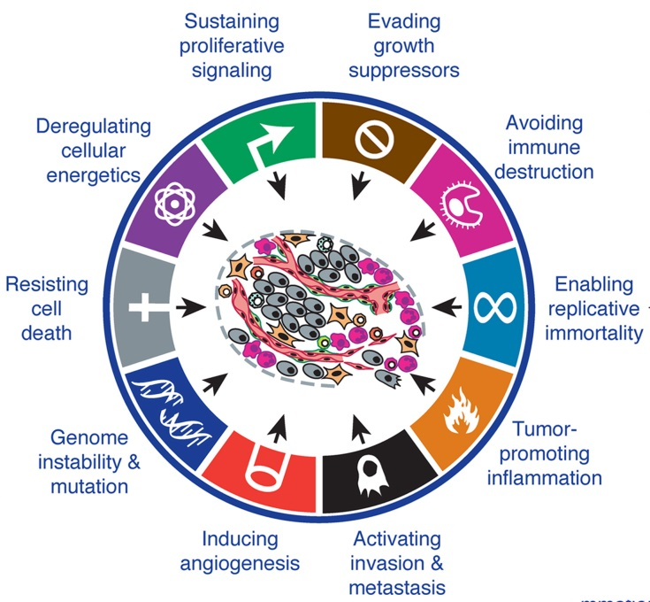

Figure 1. The hallmarks of cancer. The common modifications a cell needs to undergo to become malignant are defined in the hallmarks of cancer, including the six common modifications proposed in 2000 and the additional emerging and enabling hallmarks as of 20112.

In addition to the high patient to patient variability in cancer, another layer of complexity is present within the tumor. In contrast to the classical reductionist view, which perceives the tumor as a uniform mass of cells possessing unregulated growth, tumors display a high level of intratumor heterogeneity (Figure 2). This heterogeneity is present in differences in microenvironment within the tumor and on the level of genetic and epigenetic variation among the cancer cells. Tumor heterogeneity was first identified in 1963 as the variability in the ability of different regions of a lymphoma to form colonies *in vitro* or initiate carcinomas *in vivo* upon transplantation3. This study and many subsequent findings have changed the view on tumor biology and how cancer should be studied and therapeutically targeted.

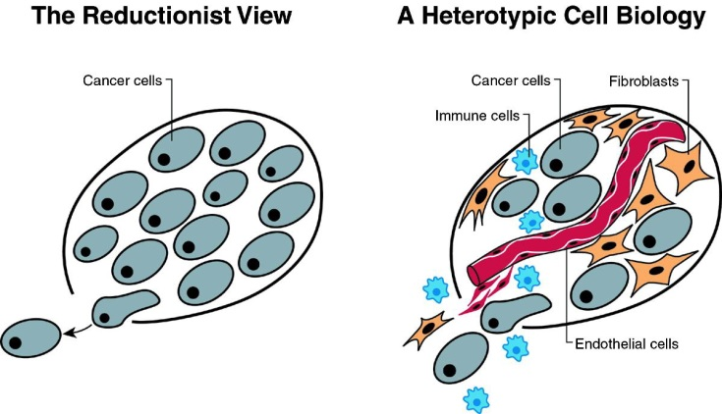Figure 2. The tumor as a complex tissue. In the classical reductionist view, the tumor was perceived as a body of cells with genetic aberrations leading to tumor formation. Currently, the tumor is perceived as a complex tissue environment, in which cancer cells work together with immune cells, fibroblasts and endothelial cells1.

The heterogeneity in tumor microenvironment plays a big role in tumor physiology by varying oxygen and nutrient levels and a wide variety of stromal interactions between cancer cells and tumor-supporting cells4. Microdissection of tumors and subsequent in-depth sequencing of different regions within one tumor revealed that clones with diverse genetic aberrations are present5. In addition, tumor cells with the same genetic status can have differentiation or proliferative states due to epigenetic variation, for instance by variation in promotor hypermethylation6. This epigenetical heterogeneity results in different clones within a tumor that have higher proliferative capacities or chances of survival. In addition to differences in proliferative capacity, cancer cells with a different epigenetic status may adopt alternative cell fates to support tumor growth, thereby affecting tumor survival as a whole. For example, in glioblastoma it is found that tumor cells transdifferentiate into endothelial-like cells for tumor-associated neovasculature7.

To summarize, the tumor is very heterogeneous in its microenvironment and individual cancer cells. Individual tumor cells are heterogeneous in their genetic aberrations and epigenetical landscape, leading to differences in proliferative capacities, differentiation and clone survival.

**Chapter 1.2. The cancer stem cell (CSC) hypothesis.**

Intratumor heterogeneity can be explained by hierarchical growth and clonal evolution of cancer cells by Darwinian mechanisms of evolution8, leading to differences in proliferation and clone survival. This may be achieved through stochastic oncogenic events leading to clonal diversity (Figure 3A). An alternative to the stochastic model for tumor growth is the stem cell model that explains tumor progression by hierarchical growth (Figure 3B).

1. Stochastic model: Clonal diversity B. Cancer stem cell model: Hierarchical growth



Figure 3. Comparison of the stochastic model and the CSC model. In the stochastic model for tumor growth, oncogenic events (represented by lightning bolts) in one or multiple clones gives these cells a growth advantage, represented as yellow (A). In the CSC model one or multiple CSCs (red) maintain the tumor and the tumor bulk consists of transit-amplifying (blue) and more differentiated cancer cells (green) (B). Figure modified from9.

The cancer stem cell (CSC) model proposes the existence of a rare tumor-initiating and propagating cancer stem cell and a bulk of non-tumorigenic cancer cells. CSCs are named by characteristics of stem cells; they self-renew, are immortal and are necessary to maintain the population of more differentiated cancer cells. The first experimental evidence for CSCs was provided for acute myeloid leukemia, showing that only cancer cells expressing stem cell markers of the hematopoietic system could propagate tumors in xenografts10. In the following years, CSC-like populations have been identified in many other types of cancer and reviewed elsewhere11-13.

Cancer ranks in the top disease-related deaths14 and for certain cancers such as uterine corpus, cervical, larynx, lung, and pancreatic cancer, the improvements in disease-free or overall survival have been minimal for the past 25 years14, 15. This may be explained by CSCs resistant to traditional therapies and as a result, the CSC hypothesis received increased interest by physicians seeing lack of effect in the drugs they prescribed. It is important to note that CSCs do not have to originate from somatic stem cells (SSCs). This may be true for some types of cancer but this is not required since stemness-related oncogenes can also be reactivated in more differentiated cell types as reviewed elsewhere16, 17 and as illustrated by possible cells of origin for the different types of breast cancer (Figure 4).

In healthy tissue organization the capacities to self-renew and proliferate are tightly regulated. To prevent unregulated growth, the self-renewal potential of SSCs and fast proliferation by transit amplifying cells are separated between different cell types. This is illustrated by SSCs that proliferate slowly, are immortal and express telomerase and the fast-replicating transit amplifying cells that have a limited number of cell divisions before entering quiescence18. One organ developing by this hierarchy is the mammary epithelium, where all different lineages can arise from one common mammary stem cell19 (Figure 4). However, the hierarchy and cellular functions that apply for healthy tissue development and maintenance may not be that well-defined for tumors maintained by CSCs. Properties of SSCs that have been ascribed to CSCs over time are that SSCs are rare, controlled by a defined niche and have a fixed marker expression, but this may not hold true for CSCs. Therefore, the working definition of a CSC should be a cancer-maintaining cell that can recapitulate a similar tumor at a distant site or after therapy, instead of focusing on traits used to define SSCs.

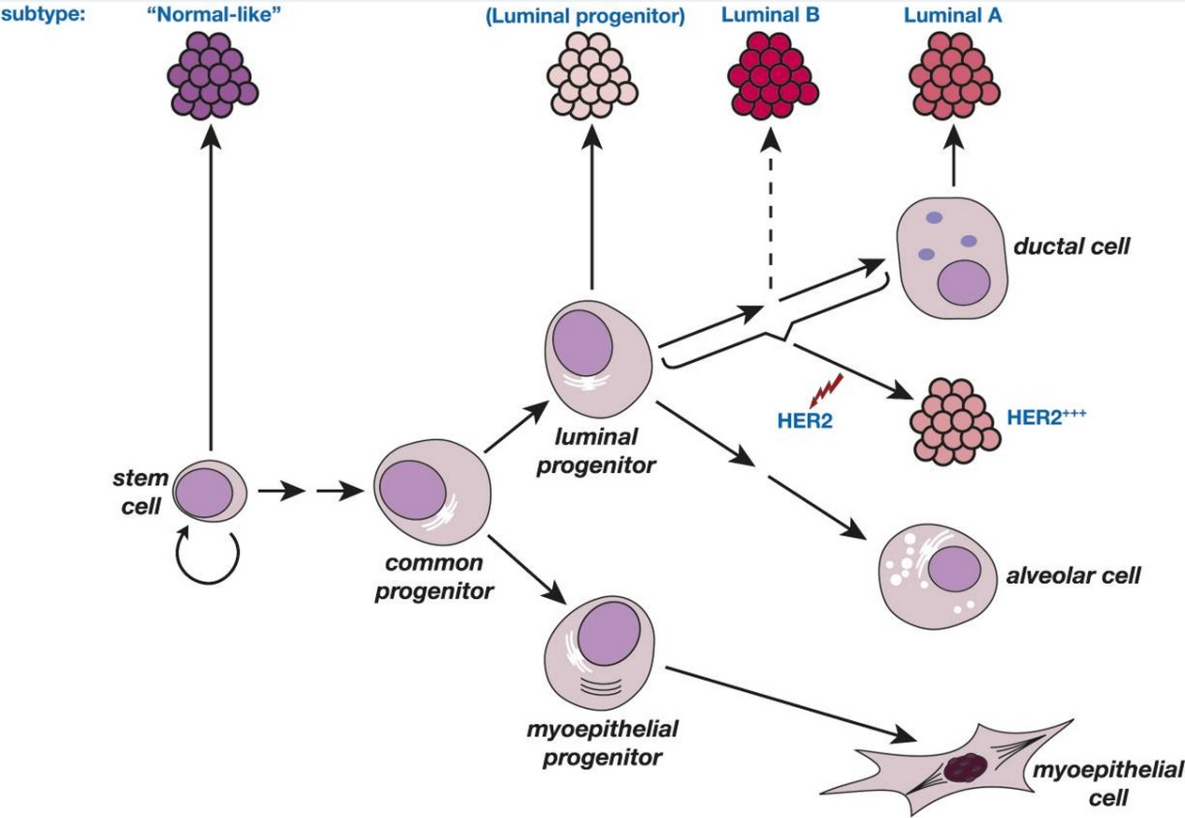

Figure 4. Cellular hierarchy in mammary epithelium. One common stem cell gives rise to all differentiated cell types in the mammary epithelium via a common progenitor and subsequent luminal and myoepithelial progenitors. This also shows the different subtypes of breast cancer to their closest related healthy counterparts, as based on gene expression analysis19.

CSCs are proposed to be linked to all steps in cancer occurrence and evolution: tumor-initiation and development by affecting tumorigenicity of the dominant clone, metastasis by a tumor-initiating cell20 and recurrence after therapy resistance21. As previously mentioned, physicians had increased interest in the CSC hypothesis after seeing a minimal effect of some of the cancer therapeutics they prescribed to their patients. During therapy, it would be of vital importance to hit the CSCs as they are the immortal cells and responsible for tumor growth and propagation. CSCs are believed to be more resistant to conventional therapies, for example because most therapeutics target the fast dividing cells, whereas CSCs are theoretically quiescent or divide at a low pace.

In addition, altered DNA damage and DNA repair mechanisms in CSCs suppress apoptosis in these cells22, 23. New therapy to target the CSCs could target surface markers, the ABC cassette membrane transporters, tumor microenvironment and signal cascades including Hedgehog, Notch, and Wnt signaling, whose expression has been related to the (re)activation of stem cell properties21. As CSCs are more resistant to apoptosis, a combination of chemo- or radio-sensitizing drugs or drugs inducing differentiation of CSCs in combination with more classical therapies may prove to be most successful. However, care has to be taken in selecting novel drug targets, as certain CSC traits may be very similar to those of SSCs. The unintentional targeting of SSCs can lead to severe side effects as seen with common traditional chemotherapeutics24.

The general theory of the CSC relies on stemness and maturation/differentiation being mutually exclusive properties as in SSCs. However, stemness of a cell could vary over time and from cell to cell, for example as a result of genetic instability and epigenetic variability. As a result, a CSC may lose its stemness traits over time but a more differentiated cancer cell may be able to gain or regain the CSC characteristics. Therefore, the concept of CSCs has evolved from the classical “stem-cell-like” idea with an irreversible differentiation to a more plastic and reversible property of cancer cells (Figure 5). Multiple studies in different systems have shown that stemness may be more of a dynamic and reversible cell state than an actual constant population within the tumor. In melanoma for example, CSC plasticity may be readily reversible25 whereas CSC plasticity in other tumors may be more inefficient. In this thesis the evidence and mechanisms underlying CSC plasticity will be discussed.

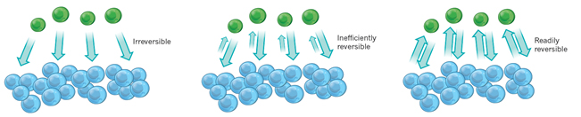

Figure 5. Potential plasticity of the CSC fate. The CSC differentiation and CSC plasticity schematically modelled as irreversible, inefficiently reversible and readily reversible. Green represents the CSCs whereas blue represents more differentiated cells26.

**Chapter 2. Challenges in studying CSCs and their plasticity.**

The original CSC concept describes a cancer cell arising from a SSC that subsequently irreversibly differentiates into a more differentiated phenotype. This version of the CSC hypothesis has been hotly debated over the past years and evolved from its original concept, as modern views of the CSC are not based on SSCs as the cell of origin and does include plasticity of CSCs. Even though the concept of the CSC has evolved in the past years, there is no consensus yet regarding the existence and properties of CSCs. This can be ascribed to the variation in what is defined as a CSC as described above and the high variation in the experimental approaches used to identify and characterize CSCs. Most studies rely on [fluorescence-activated cell sorting](http://en.wikipedia.org/wiki/Fluorescence-activated_cell_sorting) (FACS) to isolate the CSC-containing population subsequently followed by an *in vitro* or *in vivo* outgrowth assay to test tumorigenicity of defined cell populations. However, the variety in potential CSC markers, sphere forming and transplantation assays, and the study of different types and subtypes of cancer, affects the view on the CSC theory.

**Isolation and sorting of CSCs**

The isolation of CSCs is faced by multiple technical issues and challenges27. Live cell recovery may be bad and raises the question how representative the recovered fraction is for the tumor. The breakage of cell-cell interactions and other microenvironmental factors changes cellular properties and could lead to changes in gene expression. Next, changes in gene expression could affect expression of extracellular markers and could potentially change the state of differentiation and stemness of a cell. Additionally, the enzymatic treatment necessary to acquire single cells may modify the cell surface marker phenotype. Even in the case that all or most extracellular markers are maintained during cell preparation from the tumor, representable CSC markers which could be used for sorting may be difficult to identify. For instance, the markers representing the CSCs may be similar to SSCs or the CSC may be represented in a population with markers unrelated to stemness trades. In addition, extracellular markers defined for the CSC-containing population in one patient may not be useable to identify the proposed population in other patients, as is the case in pancreatic cancer28. Despite all these challenges, potential CSC markers and CSC-containing populations have been identified for a wide variety of cancers and reviewed elsewhere13, 21. Although it is of high interest to identify a unifiable CSC marker for all CSCs or disease-specific CSCs, this is beyond the scope of this thesis.

**Test of tumorigenicity**

The golden standard to determine CSC potential is outgrowth of a tumor in serial xenograft transplants from a single cell or a defined subpopulation of tumor cells. However, permissiveness of the outgrowth assay affects the assumed CSC presence since an *ex vivo* sphere assay, xenograft or serial transplants results in different outcome of observed outgrowth potential27. As a result, the outgrowth potential scored may be linked to the assay used for analysis rather than reflecting the tumorigenic potential of the original cancer cell population. SSCs, for example in the gut, are very dependent on their niche for their stemness and pluripotency potential, indicating the importance of a supporting niche, which may hold true for CSCs as well. As a result, the rate of underestimation of the number of CSCs by an unpermissive niche is unknown in transplantation assays. A variety of studies have shown methods to improve the outgrowth potential of transplanted cells. First, transplanted cells must physically remain at the site of injection and Matrigel can provide cells with an extracellular matrix and growth factors facilitating outgrowth.

In many transplant assays, high numbers of cells are necessary, which may indicate that these cells create their own niche by using strong autocrine loops. With a low number of transplanted cells, the autocrine growth loop has to be even stronger as the created niche is smaller. That not all cells have to be dividing cancer cells to create a permissive niche was indicated by studies using transplants including feeder cells29. Such a study using breast cancer cells showed that transplantation with feeder cells lowered the number of cancer cells necessary for successful transplantation30. Important to note is that with the use of xenotransplants into immunodeficient mice, there is limited support for self-renewal of human CSCs as an effect of the species barrier31. The species barrier is thereby likely selecting for the more aggressive types. Another indication of the importance of the niche is the presence of endocrine signals, as implantation of an estrogen pellet can enhance efficiency for hormone-responsive cancers32.

To conclude, the current methods for CSC isolation and test of tumorigenicity by transplantation has revealed very useful insights in tumor and CSC biology. Important to keep in mind however, is that current transplantation assays reveal the tumorigenic capacity in the assay conditions but does not reveal the potential of that same cell in its original tumor33.

**Chapter 3. Evidence for CSC plasticity.**

Recent work has shown that the stemness trait of the CSCs may be an acquirable cell fate rather than a defined cell population. Underlying mechanisms involved in gaining or regaining of stemness properties could be related to cell intrinsic factors and extrinsic influences from the microenvironment. A wide variety of studies discussed in this chapter show that stemness traits in cancer cells can be acquired through stochastic drift, genetic instability, epigenetic changes and cues from the microenvironment. These influences are not fully separable and research has shown interplay between these drivers of acquirable stemness in cancer cells.

**Chapter 3.1. Stochastic drift in CSC plasticity.**

Stochastic drift describes random changes within the population of cancer cells in a tumor and may explain the gaining of stemness properties. Multiple breast cancer cell lines have defined phenotypically different subpopulations of stem-like, basal and luminal cells30. When these populations are isolated by FACS and cultured afterwards, each population has the ability to reconstitute all other phenotypic cell types in the same proportion of the original unsorted population (Figure 6). Importantly, these observations are in line with a computer model for stochastic cell state changes the authors developed. This model explains that the recovery of population equilibrium can be explained by probabilities for random cell state transitions alone. Not only does this study show that any cell population will return to the original phenotypic equilibrium, it also shows that cells can acquire a *de novo* stem-like state from more differentiated cells *in vitro*. On a molecular level, this stochasticity in differentiation state might be explained by the stochastic interactions of soluble factors and binomial distributing of biological molecules during mitosis34. Even though pure stochastic changes may explain the acquired stemness traits in *de novo* CSCs, molecular mechanisms leading to this stochasticity have not yet been experimentally proven. Additionally, it has to be taken into account that cell fate is commonly believed to be very strictly regulated and likely stochastic changes alone not a sole driver of newly acquired stemness traits. Indeed, other factors as genetic and epigenetic changes and defined microenvironments and microenvironmental factors have shown to induce stem cell and CSC traits.

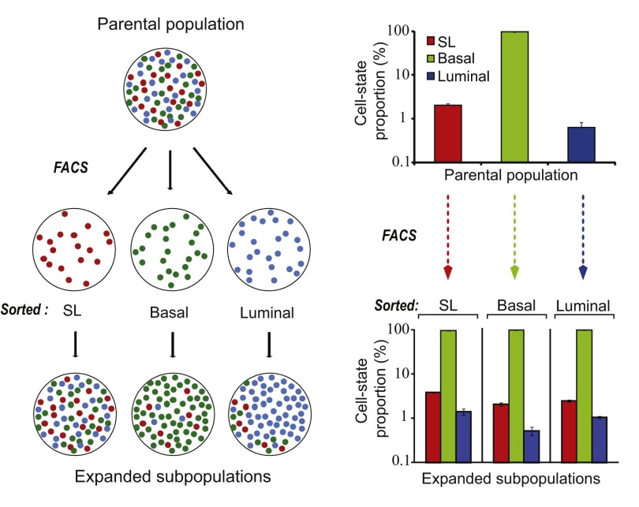

Figure 6. Different subpopulations of breast cancer cell lines return to the same equilibrium irrespective of original sorted population. The breast cancer cell line SUM159 parental population is sorted by FACS into stem like (SL), basal and luminal populations. After these populations are expanded for six days, each population returns to the same equilibrium as the parental population as represented schematically (left panel) and by bar graphs (right panel)30.

**Chapter 3.2 The role of genetic instability and epigenetics on CSC plasticity**

Genome instability and mutation is an enabling characteristic of cancer progression, as is described in the second edition of the hallmarks of cancer2. This hallmark may very well be a driver of the stemness fate, but direct evidence is limited due to difficulty in distinguishing driver from passenger mutations and as a result, it is challenging to link the loss of genes to acquired stemness traits. For some genes and genetic mechanisms however, evidence for a direct link to CSC function is found.

**Genetic instability**

The genomic instability and high mutation rate in cancer cells is a main driver of tumor progression. Therefore, it is not unlikely that genomic changes can lead to the acquiring of stem cell properties. One major contributor to genomic instability is whole-chromosomal instability (W-CIN), which is the unequal chromosome distribution during cell divisions and leads to aneuploidy, heterogeneity in karyotypes and a further increase in DNA damage35. Another way in which genomic changes can occur is by retrotransposon mobilization. Retrotransposons are mobile genetic elements which can lead to insertional mutagenesis and the change in gene function and expression. Epithelial tumors have been demonstrated to accommodate L1 retrotransposon mobilization and L1 activation correlates to a higher rate of metastasis and a poorer cancer prognosis36, 37. In healthy tissue, various stem cells such as embryonic stem cells or neural progenitors are more permissive to L1 mobilization38, 39. Even though direct evidence is still limited at the moment, it has been hypothesized that epithelial tumors can drive their tumorigenicity by activating the L1 retrotransposons and possibly adopting the CSC fate40. One gene of which the loss has been directly linked to stemness is TP53. Loss of the tumor suppressor p53 is extensively linked to cancer progression and is also one of the founder mutations in many cancers41. More recent work shows that loss of p53 leads to enhanced self-renewal of mammary stem cells and symmetric CSC divisions leading to enhanced tumor growth42. Additionally, another study showed that loss of p53 can induce transcription patterns that resemble those of embryonic stem cells (ESCs) and induced pluripotent stem (iPS) cells, thereby acquiring the CSC phenotype43. Important to note is that the loss of gene expression, in this case p53, could be due to direct genomic alterations affecting integrity of the p53 gene or by silencing of gene expression through epigenetic mechanisms. To conclude, these results show that loss of one gene can induce a more stem cell- or CSC-like phenotype and those drivers are present in cancer cells. Direct evidence that mutations in genes result in *de novo* CSC formation is still limited. More direct evidence is present for a link between epigenetic changes and pluripotency.

**Epigenetical factors**

Stem cells in normal development and tissue homeostasis are regulated by gene expression and imprinted epigenetic patterns. Similarly, the CSC fate can be controlled by epigenetic heterogeneity and changes among cancer cells. Importantly, the relatively recent field of iPS cells shows that by overexpression of Oct4, Sox2, Klf4 and c-Myc a fully differentiated cell can be reprogrammed into an embryonic-like iPS cell. The generation of iPS cells shows thatthe transient change in expression of only 4 genes induces full pluripotency. This was first achieved in mouse fibroblasts in 200644 and in human cells in 2007 by two independent groups45, 46.

These iPS cells are functionally pluripotent and have a reprogrammed epigenome with a higher resemblance to ES cell-associated genes than their fully differentiated cell of origin. This is illustrated by the loss of cell of origin-specific enhancers and a gain of ES cell-specific enhancers over time in the iPS cells, as shown by Histone3K4 methylation-2 (H3K4me2) patterns47 (Figure 7A). This means that iPS cells have a gene expression profile enriched for pluripotency-associated genes and a high expression for chromatin modifiers48 (Figure 7B). Most important is that the iPS cells can be generated by a (transient) change in gene expression which shows that no differentiation state is fully determined and can be changed or reverted to full pluripotency.

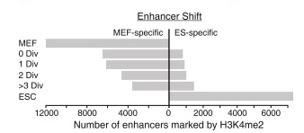

A

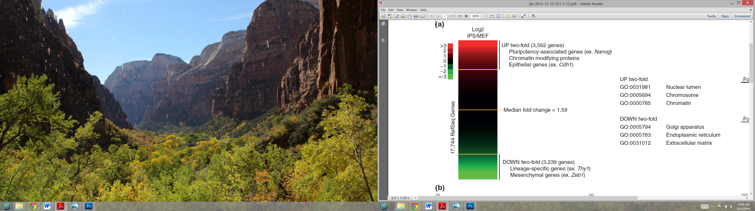Figure 7. Shift in enhancers and gene expression profiles in iPS cells. Enhancer H3K4me2 patterns of iPS cells shift from the cell of origin to ES specific methylation patterns. iPS cells from 0 divisions (div) to over 3 division or more lose expression of many MEF-specific H3K4me2 patterns and gain patterns associated with ESCs, the ES-specific enhancers (A)47. Gene expression data showing changes in gene expression for iPS cells in comparison to their cell of origin, mouse embryonic fibroblasts. Specifically represented are groups of genes with a higher than 2 fold change in expression levels (B)48.

B

**Epigenome reprogramming** **in iPS and cancer**

As with the production of iPS cells, expression of oncogenes in cancer have been shown to reprogram the epigenome, thereby reactivating developmental, stem cell and self-renewal pathways. Important to note is that, just like in iPS cells, prolonged activity of these reprogramming genes is not necessary49, which imposes that identifying these drivers in already developed CSCs is challenging. *In vivo* evidence shows that the fusion oncogenes BCR-ABL in leukemia49, EWS-FL-1 in Ewing sarcoma50 and SYT-SSX2 in synovial sarcoma51 are genes that are capable of reprogramming differentiation gene networks in cancer and can activate stem cell-associated genes. These fusion genes are the result of recurrent translocations in patients and can thereby facilitate *de novo* CSC generation in patient tumors. Oct4, Sox2, Klf4 and c-Myc, the genes that can be used for iPS cell generation, could play a role as well in plasticity of the CSC fate. In ovarian carcinomas, Sox2 expression increases the expression of CSC markers and enhances the capacity to form tumorspheres and to grow tumors *in vivo*52.

In melanoma, the H3K4 demethylase JARID1B is established as a factor required for CSC maintenance and *de novo* acquisition of the CSC fate in differentiated melanoma cells25. JARID1B is a transcriptional regulator and only expressed in a small population of slow cycling cells within the tumor. A full knockdown of JARID1B leads to tumor regression indicating the necessity of JARID1B+ cells for tumor maintenance (Figure 8, bottom panel). Interestingly, JARID1B- cells can gain JARID1B expression and function as CSCs (Figure 8, top panel). These findings confirm the existence of a plastic CSC phenotype in melanoma which is necessary for tumor maintenance. However, since every melanoma cell can adopt this JARID1B-regulated CSC fate it is debated if this reflects the actual plasticity of the CSC fate. Alternatively, melanoma may not be organized in differentiated subpopulations as previously thought, but may only shift towards a bipotent CSC or non-CSC fate, regulated by JARID1B.

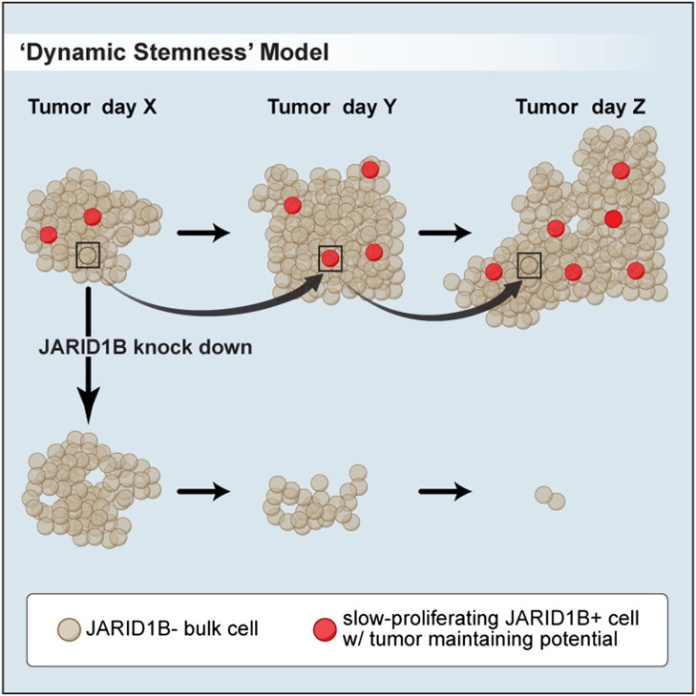

Figure 8. The dynamic stemness model of JARID1B+ cells in melanoma. JARID1B- bulk melanoma cells can acquire JARID1B expression and thereby become a slow-proliferating melanoma cell with tumor-maintaining potential (top panel). Knockdown of JARID1B in melanoma cells leads to loss of CSCs and regression of the tumor bulk (lower panel)25.

Not all changes in gene expression are regulated by cell-intrinsic processes but the microenvironment also plays a major role in controlling the differentiation state and epigenetic landscape of a cell. A study in ovarian clear cell carcinoma (OCCC) shows that different subpopulations of tumor cells, clonally derived from one single cancer cell, can adopt different CSC fates and differentiation capabilities depending on their location and the microenvironment within the tumor53. For their outgrowth potential in subsequent transplantations these clones have a different dependency on supportive niche. For example, one clone displayed a very aggressive CSC pattern, where a more differentiated clone was only capable of tumor propagation when co-transplanted with hESC cells. Again, this demonstrates the importance of the permissiveness of the outgrowth assay and its link to what would be perceived as a CSC, as already discussed in chapter 2. Importantly, tumors originating from one clone but propagated in a different niche, the regular xenotransplant versus hESC-supported transplants, show major differences in epigenetic profile. Additionally, the expression of key genes involved in proliferation and self-renewal such as Wnt, Notch and Hedgehog were expressed at higher levels in the tumor cells transplanted using the hESC-supporting niche54. This highlights that the microenvironment can induce expression of stem cell-associated genes and can thereby enhance the CSC capabilities of populations of tumor cells which are not capable of this tumor formation in models that lack this microenvironment.

Another example of microenvironment-regulated cell fate is epithelial to mesenchymal transition (EMT), a developmental program that has been associated with acquisition of CSC characteristics. EMT is a reversible embryonic program, underlining its transient nature, and its activation has been linked to cancer cell motility and metastasis of the primary tumor55. During EMT, epithelial cells generally lose their E-cadherin function, cell adhesion, apical to basal polarity and display an increased motility. Many microenvironmental factors have been linked to the induction of EMT, like TGF-β, Notch, FGF and Wnt, which induce EMT by changing the expression or post transcriptional regulation of EMT genes (for a review, see 56).

A direct link between EMT and the acquisition of *de novo* stem cell characteristics was first described in human mammary epithelial cells and carcinomas. In these cell types, the ectopic expression of either Twist or Snail induced EMT and most, if not all of these cells, acquired a CD44high/CD24low expression status associated with normal mammary stem cells and human breast CSCs57. In addition, cells that did undergo EMT had a higher ability to form mammospheres and tumorspheres, a widely accepted *in vitro* stem cell test. Additionally, cells in which EMT was induced by Twist or Snail resulted in significantly more tumors in mice in comparison to untransformed cancer cells. In breast cancer, often overexpressed proto-oncogenes HER2 and ER are linked to poor prognosis58. HER2 overexpression in ER-positive cancer cells leads to activation of the transcriptional regulator STAT3, inducing EMT59. This leads to a larger CD44high/CD24low population, which expresses Oct-4 and Sox-2, stem cell markers which are also used for the generation of iPS cells. Functionally, cancer cells with activated HER2-ER-STAT3 displayed a higher tumorsphere forming capacity. Therapeutic targeting of both HER2 and STAT3 by combined treatment with Herceptin and Stattic decreases the expression of EMT and stem cell markers and negatively affects *in vitro* growth. Together, this data shows that the poorer disease prognosis associated with HER2 overexpression might be explained by activation of EMT, thereby promoting CSC formation.

To summarize, EMT has long been seen as a driver of disease progression by promoting tissue invasion and metastasis. Additionally, it can also be considered as a prime suspect of promoting disease progression by inducing the CSC fate. Chapter 3.3 will discuss microenvironmental factors that can induce EMT and stem cell characteristics more extensively.

Besides the effect of gene expression on the plasticity of the CSC phenotype, post-transcriptional regulation of protein levels can affect the CSC state, for example through miRNAs. The miR-290 family is specifically expressed in embryonic stem cells, functionally enhancing the stem cell cycle and downregulated upon differentiation60. Three of these miRNAs, miR-291-3p, miR-294 and miR-295 have been used in iPS cell generation together with Oct4, Sox2, and Klf4, thereby replacing the necessity for c-Myc61. The miR-290 cluster likely functions downstream of c-Myc and has been shown to induce methyltransferases, thereby changing the epigenetic profile and potentially silencing the expression of tumor suppressors or genes linked to differentiation, although direct evidence is not available at the moment62. As these miRNAs are linked to enhancing the stem cell cycle and can be used as a tool for the generation of iPS cells, it can be hypothesized that they could play a role in the generation of *de novo* CSCs. Indeed, expression of the miR-200 family has been linked to the CSC phenotype in breast, pancreatic and ovarian cancer. Downregulation of one of the members of this family, miR-200a, induces EMT and CSC features, as indicated by increased CSC markers, activation of the Wnt/β-catenin pathway and resistance to chemotherapeutic drugs63. In a xenograft assay using hepatic stem-like cells, only miR-200a expressing cells were able to induce tumor growth, showing the functional importance of this pathway in tumorigenicity.

Taken together, the studies discussed in this chapter indicate that the acquired stemness traits in cancer cells can be attributed to genetic and epigenetic changes. Important to stress is that accumulation of mutations also affects epigenetic regulators, thereby changing the epigenetic landscape2. Additionally, it has already been brought to light that the changes in gene expression and epigenetic profile leading to acquired stemness are not a fully cell-intrinsic property but can also be induced by the microenvironment of the cancer cell. In the next chapter, the role of the microenvironment on CSC plasticity will be discussed further.

**Chapter 3.3 The role of the microenvironment in CSC plasticity**

As has been described in chapter 2, the microenvironment plays a major role in determining the tumorigenic capabilities of a single cell or a population of cells. Especially in stem cell biology in healthy tissues, the role of the stem cell niche during development and tissue homeostasis has been defined.

**The stem cell niche**

SSCs are maintained and regulated by cells directly surrounding the stem cells, called the stem cell niche. In healthy tissues these niches are spatially dispersed and can have a fixed location in the organ structure, such as the stem cell crypt in the mouse small intestine64 or the niche in the *C. elegans* germline that consists of a single distal tip cell65. In most epithelial structures however, such as lung, mammary gland, prostate gland, esophagus and bladder there is no distinct location for the stem cell niche and the niche is comprised of the surrounding cells and signals that compose the microenvironment66. After tissue damage or tissue resizing, stem cells and their niche can be recapitulated and stem cells arise *de novo,* but mechanisms underlying these processes are yet to be discovered66. One study showed *de novo* production of stem cells after radiation-induced apoptosis of the Lgr5+ stem cells in the colon67. Another study showed that after specific ablation of the Lgr5+ stem cells in the small intestine, the stem cells are recovered by clonal expansion of the transit-amplifying cells, forming *de novo* Lgr5+ stem cells68. In the hair follicle a similar establishment of stem cells was observed, as ablated hair follicle stem cells can be repopulated by epithelial cells. These epithelial cells do normally not contribute to hair growth but upon injury migrate to the stem cell niche that subsequently determines their stem cell fate69. Taken together, these studies show that more differentiated cells can be reprogrammed into SSCs after injury or specific ablation of the original stem cells. Therefore, it is not unimaginable that differentiated cancer cells would be able to acquire a CSC fate similarly.

**Role of the microenvironment in CSC outgrowth potential**

The microenvironment has a major role in the outgrowth potential of healthy and cancer cells in transplantation assays. For example, the outgrowth potential and cell fate of mammary epithelial lineages is different in a mammary transplantation model in comparison to the same lineage-traced subpopulation in unperturbed tissues*,* which shows that permissiveness of the model affects the outgrowth potential of cells70.

**Co-injection boosts the outgrowth potential of tumor subpopulations**

Even though individual CSCs have not been traced *in vivo,* multiple studies have shown that co-injection with other cells in a xenograft model increases the outgrowth potential of the CSCs. A previously discussed study in chapter 3.1 showed that CSC, basal and luminal cancer cell populations from a breast cancer cell line can recapitulate the full tumor heterogeneity *in vitro*30. However, when injected in a traditional xenograft transplantation assay, only the CSC fraction was capable of inducing tumor growth. When co-injected with non-dividing irradiated feeder cells, thereby providing a niche to sustain outgrowth, all populations were able to regenerate CSC-like cells and formed tumors with equal proportions of luminal, basal and CSCs30.

Another study previously discussed in chapter 3.2 showed how co-injection provides a supporting niche for outgrowth of ovarian clear cell carcinoma (OCCC) upon transplantation. Here, 6 OCCC subpopulations originating from the same primary tumor were transplanted with the support of two different microenvironments: a traditional xenograft transplant and a co-transplant assay with hESCs53. In the traditional transplantation assay, only some clones had the ability to propagate a new tumor, whereas if transplanted with a hESC based microenvironment all clones could recapitulate the heterogeneous tumor. Taken together, these studies show that the outgrowth potential increases when tumor cells are co-injected with feeder cells or hESCs that provide a suitable niche. In addition, this shows that there may be distinct CSC populations or populations capable of acquiring the CSC fate, requiring a different microenvironmental niche to exert their tumorigenic potential. It is tempting to assume that the enhanced capacity of these transplantation experiments to propagate tumors reflects *de novo* CSC generation. However, it may also illustrate an underestimation of CSC capacity in studies using the xenotransplant assay, as discussed in chapter 2. Where mechanisms underlying *de novo* stemness traits in SSCs are unknown at the moment, multiple microenvironmental factors have been identified that induce cancer cells to acquire *de novo* CSC characteristics.

**Wnt**

One of the well-known players in stem cell regulation which has also been linked to cancer is the family of Wnt proteins71. They are excreted by the stromal cells or by enhanced autocrine signaling and usually signal over short distances. In an adenoma cancer spheroid system, the forced overexpression of a stable recombinant Wnt promotes the CSC fate. This is indicated by spheres with a higher proliferation, a higher capacity for self-renewal and higher expression of CSC markers Cd44 and Cd13372. This effect of Wnt signaling was found to be inhibited by BMP, which counteracts the acquired CSC state by inducing differentiation, showing that stemness in adenoma CSCs is an acquirable property. In colon cancer, high Wnt activity functionally defines the CSC population *in vitro* and *in vivo*73. When more differentiated colon cancer cells are co-cultured with myofibroblasts, or even with myofibroblast conditioned medium, the Wnt/β-catenin response greatly increased, differentiation was prevented, CSC markers were acquired and clonogenic potential was restored. In addition, xenograft models showed that colon CSCs were preferentially located in close proximity to myofibroblasts, indicating that myofibroblasts excrete factors that provide a niche for CSCs. HGF secreted from these myofibroblasts promotes Wnt/β-catenin nuclear activity through c-MET, thereby inducing dedifferentiation of cancer cells into a CSC fate.

**HGF**

As discussed above, HGF is excreted from myofibroblasts and induces CSC phenotypes in colon cancer. Additional studies show that other sources of HGF in tumors are cancer associated-fibroblasts74 and adipose-derived mesenchymal stem cells75. In colorectal cancer cells, HGF enhanced CSC potential and tumor-initiating properties *in vitro* and *in vivo* by co-culturing tumor cells with myofibroblasts excreting HGF74. In glioblastoma, activation of the HGF receptor c-Met enhanced the glioblastoma CSC population76. This is demonstrated by enhanced stem cell marker expression, enhanced neurosphere forming capacity and neutralization of forced differentiation upon c-Met activation. Importantly, c-MET activation in glioblastoma-derived neurospheres induced expression of Oct4, Sox2, Klf4, c-Myc and Nanog, all genes used for the generation of iPS cells from differentiated cells76. Together, these studies show that HGF can induce *de novo* acquiring of the CSC fate in more differentiated cancer cells. Importantly, activation of the HGF receptor c-Met can induce expression of reprogramming factors similarly to iPS cell generation, stressing the importance of reprogramming in CSC plasticity.

**IL-6**

CSCs can induce more differentiated cancer cells to acquire the CSC fate by direct cell-cell contact or by CSC conditioned media77. This media has a high concentration of the inflammatory-associated cytokine Interleukin 6 (IL-6) which was proven to be sufficient for breast CSC formation. This suggests that tumor heterogeneity maintains a dynamic induction between CSCs and more differentiated cancer cells, which is regulated by IL-6. Responsiveness of differentiated cells to IL-6 depends on microenvironmental levels of IL-6, IL-6 receptor expression and the intracellular response to IL-6, thereby preventing all cancer cells from adopting the CSC fate77. Another study shows that IL-6 signals through the JAK1-STAT3 pathway, followed by Oct4 gene expression and thereby converting differentiated cancer cells into CSCs78. Mechanistically, HER-2 expression induces a transcriptional inflammatory profile, also including the upregulation of IL-6 in HER-2 positive breast cancers58. In this study, secreted IL-6 was essential for HER-2-mediated tumor formation and Stat3 activation in tumor cells. Potentially, this exposes an essential role for CSCs in breast tumor progression.

**Microenvironmental signals relate to EMT and CSC function**

As has already been discussed in chapter 3.2, the process of EMT has been linked to cancer progression and acquiring *de novo* stemness traits in healthy tissue and cancer cells (Figure 9). Multiple signals from the microenvironment have been shown to induce EMT and may result in the generation of *de novo* CSCs. One study showed that cancer-associated fibroblasts induce EMT in prostate cancer and is accompanied by an enhanced expression of stem cell markers, as well as an increased ability to form tumorspheres and to self-renew79. Hence, the paracrine interplay between cancer-associated fibroblasts and cancer cells leads to an EMT-driven gain of CSC properties associated with aggressiveness and metastatic spread79.

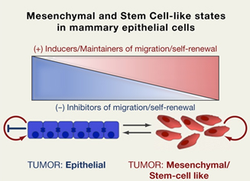Figure 9. The link between EMT and stem cell-like traits. Epithelial tumors that undergo EMT acquire a mesenchymal, stem cell-like phenotype. This process is accompanied by a loss of inhibitors of migration and self-renewal and a gain in inducers and maintainers of migration and self-renewal80.

Multiple microenvironmental factors such as TGF-β, Notch, FGF and Wnt, can induce EMT. However, direct evidence linking EMT induced by these factors and acquisition of stemness in cancer cells remains limited. To date, the role of TGF-β in EMT-induced CSC characteristics is understood best. As was already discussed in chapter 3.2, EMT has been linked to a gain in stemness and more recent data has shown that TGF-β-induced EMT is accompanied by an increase in stem cell-like properties. In mammary epithelial cells, TGF-β induces EMT and CSC-like properties with intrinsic epigenetic changes dependent on continued presence of TGF-β81. On the other hand, a study in mammary epithelial cells showed that TGF-β, together with canonical and non-canonical Wnts coordinates EMT after which autocrine signaling replaces the need for external factors80. This data shows that a TGF-β-induced EMT does induce stem cell characteristics which, if other enabling factors are present as well, could induce a stable CSC fate.

**Chapter 4. Lineage tracing as a novel way to study tumor heterogeneity and CSC plasticity**

Challenges of current models that provide evidence for CSC plasticity are centered on the question how *in vitro* growth, xenografts and serial transplants of CSCs relate to their outgrowth potential in native, unaltered microenvironments. Additionally, CSCs are currently not fully distinguishable from more differentiated cancer cells based on extracellular marker expression and cell sorting errors. Based on this, the imperfect marker theory was established, which states it would not be impossible to experimentally distinguish between the phenotypic switching of CSCs and present-day imperfect sorting82. Based on the imperfect marker theory, studies showing a phenotypic switch in populations of cells after sorting may actually not indicate *de novo* CSC generation. *In vivo* tracing of CSC fate and determining their kinetics will be very useful tools to verify if the current *in vitro* studies and xenograft assays do mimic the actual CSC potential in unmanipulated tumors.

By combining genetic lineage tracing in an inducible confetti model and advanced 2-photon microscopy, tumors can be imaged intravitally for an extended amount of time. To date, genetic lineage tracing has given extraordinary insights in stem cell biology and cellular hierarchy in multiple organs under unperturbed growth conditions. These studies show how lineage tracing in healthy tissue is used to define the cell of origin and developmental hierarchy in epidermis83, 84, intestinal85, prostate86 and mammary gland epithelium70. For a better understanding of tumor biology, lineage tracing studies will be important to identify the cell of origin16 and have already proven to be an important tool in providing evidence for CSC existence and understanding the dynamics of the CSC fate. For instance, lineage tracing over time can indicate if all cells contribute similarly to tumor growth, if only a minority of CSCs is responsible for tumor outgrowth, or if the CSC model in combination with neutral drift applies to tumor growth87(Figure 10A). To date, intravital microscopy has provided evidence for CSCs in squamous skin tumors, glioblastoma and mammary tumors, and will be discussed next.

In glioblastoma, a competitive tumor outgrowth model used co-transplantation of CSCs with more differentiated cancer cells. Using intravital microscopy, it was assessed that the CSCs drove tumor formation, even when they only comprised a small minority of the transplanted cells88. Although providing valuable information on CSC outgrowth *in vivo*, this study used a xenograft transplant model and therefore the microenvironment in this setting does not reflect the environment and heterogeneity of the original tumor. To fully study endogenous tumors in an unperturbed microenvironment the use of chemical tumor induction or genetically induced tumors will be more useful. One study on squamous skin tumors used a combination of carcinogen tumor initiation by DMBA and TPA treatment, followed by lineage tracing. This strategy showed that most tumor cells have a limited potential for proliferation and only a fraction of the tumor cells has the capacity for long term self-renewal, thereby giving rise to the main bulk of the tumor89. In genetically induced PyMT mammary tumors, intravital microscopy also showed that only a small fraction of the tumor cells clonally expand over the course of 15 days90. In contrast to the other studies, this approach shows the plasticity of the outgrowth from different clones. In this tumor model, different clones grow continuously, regress, disappear or have a delayed onset of growth, showing that the CSC fate can be acquired or inactivated90.

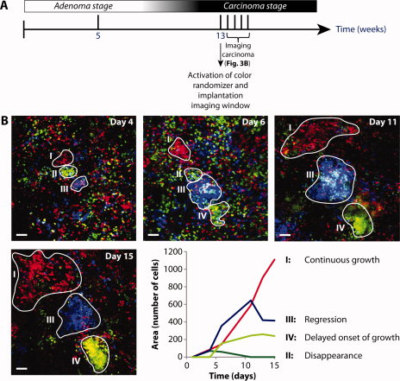

A

B



Figure10. The role of intravital imaging in CSC studies. A schematic representation of three models for clonal tumor growth (A). In A’ each clone has the same proliferative potential, in A’’ only a small subpopulation of CSCs has the ability for long-term self-renewal or a combination of both as represented in A’’’, where a subset of CSCs undergoes neutral competition for outgrowth87. Evidence for CSCs and CSC plasticity *in vivo*, as determined by intravital imaging in a mouse mammary tumor (B). Four different outgrowth patterns are observed over a 15 day period, namely continuous growth (I), clone disappearance (II), regression (III) and delayed onset of growth (IV)90.

These studies have provided evidence for the CSC hypothesis *in vivo* in unperturbed tumors. In addition, the CSC state can be a dynamic and acquirable property, as is shown for mammary tumors. Therefore, it is likely that the current stem cell model describes a subset of CSCs that maintains the tumor, combined with neutral competition for clonal dominance as not all tumor growth-supporting clones proliferate at the same rate90 (Figure 10A’’’).

**Chapter 5. Discussion**

The cancer stem cell theory is a currently accepted model which has undergone many changes through time. Contradictory to previously assumed, not all cancers and CSCs arise from SSCs. Additionally, the latest evidence discussed in this thesis suggests that stemness in cancer cells is a plastic property, meaning that differentiated cancer cells can acquire *de novo* stem cell characteristics.

**Mechanisms inducing *de novo* CSC generation**

Multiple mechanisms have been proposed to be involved in CSC plasticity and acquisition of CSC characteristics in more differentiated cancer cells. Implicated underlying mechanisms include stochastic changes, genetic and epigenetic modifications, and microenvironmental factors. Important to note is that these are not fully separable inducers of acquisition of stem cell characteristics. For example, genetic loss of epigenetic regulators can lead to major changes in the epigenetical landscape, potentially activating stem cell-associated pathways. The microenvironment can also induce epigenetic changes leading to CSC plasticity, as observed in single OCCC clones that are transplanted with different supporting microenvironments, leading to differential epigenetic profiles and stemness-related gene expression.

Genetic and stochastic changes may be drivers of CSC plasticity, but important to point out is that experimental evidence is limited. Concerning genetic changes, proof is limited because driver and passenger mutations are currently difficult to distinguish in developed tumors91. In some studies, it has been shown that loss of a single gene, for example p53, can induce a stem cell-like transcription pattern. However, a direct link between gene loss and generation of *de novo* CSCs in an *in vitro* setting does not necessarily mean that this is a driver of CSC plasticity in unperturbed tumors. Additionally, if the CSC fate is perceived as a plastic and reversible property, it may be more likely induced by stochastic, epigenetic or microenvironmental changes than by genetic changes. Stochastic changes as a player in acquisition of *de novo* CSC characteristics have been verified using computer models representing observations made in *in vitro* experiments. However, differentiation status has long been perceived as a stable cell property which does not change by stochastic changes alone. Although cancer cells are more plastic than cells in healthy tissues, stochastic changes are not likely to be the main driver of CSC plasticity.

More robust evidence for CSC plasticity has been found for epigenetical changes and regulation by the microenvironment. As the generation of iPS cells shows, healthy fully differentiated cells can be reprogrammed to ES-like states, displaying full developmental pluripotency. Additionally, iPS cells acquire epigenetical landscapes and gene expression profiles similar to ES cells. Indeed, fusion genes acquired by genetic instability, which are present in patient tumors, do reprogram differentiation gene networks and can activate stem cell-associated genes as is shown for BCR-ABL, EWS-FL-1 and SYT-SSX2. Additionally, transient re-activation of stem cell-associated genes, similarly to iPS cell generation, can reprogram differentiated cancer cells into CSCs. This is shown for Sox2 expression in ovarian carcinomas, miR-290 family expression in hepatic cancer cells and the role of HGF/c-Met signaling in activating Oct4, Sox2, Klf4, c-Myc and Nanog expression.

SSCs are maintained by their respective niche, which is often located at a defined location within the tissue. Microenvironmental factors present in this niche maintain SSCs and can induce more differentiated cells to acquire the SSC fate after stem cell ablation, as has been shown in the mouse colon, small intestine and hair follicle cells. Therefore, it is easy to make an analogy that, with the correct environmental cues, differentiated cancer cells could acquire CSC traits. Indeed, co-transplantation of differentiated cancer cells in a hESC-supported niche did boost stem cell-related gene expression and enhanced tumor initiation. However, these results should be interpreted with care as they could also represent the presence of a more permissive environment that supports tumor growth. Other studies on the other hand, have specifically shown that stemness can be an acquirable trait in more differentiated cancer cells. For example, myofibroblasts, tumor-associated fibroblasts and CSCs themselves have been identified to enhance *de novo* CSC formation. Multiple factors from the microenvironment have specifically been identified to induce *de novo* CSC characteristics, including Wnt, HGF, IL6 and TGF-β. Taken together, these results indicate that a CSC niche similarly to the SSC niche may exist, given that the permissive factors are represented in the tumor cells’ microenvironment.

**EMT as a main player of CSC plasticity**

Recently, EMT has been linked to acquisition of CSC-like characteristics as enhanced self-renewal, CSC-gene expression and increased tumorigenicity. Functionally, both changes in gene expression of Twist or Snail and microenvironmental factors as TGF-β and Wnts can drive EMT in cancer cells, thereby inducing CSC characteristics. Earlier work already identified EMT as a process enabling metastasis of epithelial tumors, thereby contributing to poor disease prognosis. The more recently discovered role of EMT in *de novo* CSC generation adds another mechanism how EMT leads to poorer prognosis, namely by resistance to classical therapies and their ability for tumor initiation and propagation.

Taken together, these studies on CSC plasticity show a wide variety in mechanisms that drive CSC plasticity (Figure 11). Since these mechanisms have been elucidated in different types and subtypes of tumors, it can be hypothesized that these drivers of CSC plasticity are not unifiable mechanisms among tumors. For example, where reactivation of JARID1B in certain melanomas is sufficient to drive CSC characteristics, it is likely that this does not apply to all types of cancer. As has already been discussed in chapter 1, the hallmarks of cancer describe that even though cancer is a very heterogeneous disease, cancer cells have to undergo common modifications to become malignant. In line with this theory, it can be proposed that more differentiated cancer cells need to undergo common changes to acquire CSC properties. Based on the knowledge of iPS cells, it can be suggested that irrespective of the drivers of CSC plasticity, the cancer cells need to undergo transcriptional changes in pluripotency-associated genes, likely preceded or followed by epigenetical changes.

**Current models to test the CSC and the role of lineage tracing**

Important in studying the acquirable CSC fate is that it should be indisputably determined if an actual switch in cell fate and stemness occurs. Based on studies highlighting the importance of a permissive outgrowth model, a larger population of cells than previously thought may have tumor-propagating and -initiating capabilities. This is shown by xenografts supported with feeder cells, hESC supported transplants, and mice that have a higher level of immunodeficiency, all enhancing the permissiveness of the xenograft model. Without this permissive environment, it may be that individual or small numbers of cancer cells do not survive long enough to acquire CSC capabilities. Another possibility for the underestimation of the tumorigenic potential by some studies is that the autocrine loop of a sorted population of cancer cells is not strong enough. Therefore, these tumor cells or CSCs may not have the same outgrowth potential in the transplant model as they would have in an unperturbed tumor containing a more permissive microenvironment.

Another key technique to address outgrowth potential and CSC plasticity is lineage tracing during cancer development. By using intravital microscopy in combination with genetic lineage tracing, the tumor can be imaged *in vivo* in its unaltered microenvironment. Using this strategy, the actual heterogeneity and plasticity in tumor outgrowth, evolution and effects of therapy can be visualized in one mouse over time, instead of only visualizing an intermediate or end stage in tumor development. If reliable markers are identified for CSCs, future experiments could ablate these CSCs with inducible toxin and intravital imaging could be used to visualize if CSCs expressing the same marker arise *de novo*. This strategy has already proven to be successful in identifying plasticity in the Lgr5+ stem cells in the mouse intestine. One type of cancer for which this strategy could already be tested is melanoma relying on JARID1B+ CSCs for tumor maintenance and may be used as a proof of principle. Next, *in vivo* visualization of CSC plasticity could prove to be an essential tool in visualization of the effect of therapies on tumors. For example, it could be assessed how different combinations of therapeutics affect different clones within the tumor and how they affect CSCs and CSC plasticity.

D:\University Master\CSCs\Figures\graphical discussion 2.tif

Figure 11. Mechanisms underlying CSC plasticity. CSCs are characterized as self-renewing cells that give rise to more differentiated tumor cells, represented here as the non-stem tumor bulk. CSC plasticity can be induced by stochastic drift, genetic instability, epigenetic changes and microenvironmental factors. These are not fully independent mechanisms, as epigenetic changes can be induced by both genetic instability and the microenvironment. Changes in gene expression that lead to CSC plasticity are the pluripotency related genes Oct4, Sox2, Klf4, c-Myc, fusion genes BCR-ABL, EWS-FL-1, SYT-SSX2, the miR-290 cluster and JARID1B. EMT leading to acquired stemness can be induced by expression of Twist, Snail, and activation of HER2-ER-STAT3 or by the microenvironment through TGF-β and Wnt. Direct microenvironment-induced CSC plasticity can be induced by Wnt, HGF and IL-6, providing evidence for existence of the CSC niche. These inducers of CSC plasticity have been identified in a variety of different tumor cells. Therefore, these factors are probably not unifiable factors among different tumor types.

**Patient variability**

The main developmental pathways and mechanisms controlling the behavior of SSCs are very conserved and are unifiable among different individuals of one species. Cancer on the other hand is a very heterogenic disease with a high inter-patient heterogeneity in the cell of origin, genetic and epigenetic variability, and response to therapy. As a result, it is possible that markers currently used to identify CSCs, CSC plasticity and even the CSC model may not translate from patient to patient. Therefore, key questions in current CSC biology are if tumors of the same type express unifiable CSC markers and if they follow the same stem cell model and tumor hierarchy. As the number of studies on CSC plasticity increases and already proven drivers of CSC plasticity are tested on other types and subtypes of cancer, this question will hopefully be answered in the near future.

**Effect of therapy on CSC population**

Although limited experimental data on CSCs is based on tumor progression in human patients, CSCs have been linked to therapy resistance and cancer recurrence. This view is mostly based on the ability of human cancer cells expressing CSC markers to recapitulate similar tumors in xenograft assays. In addition, CSC-like cells have been shown to be more resistant to certain therapies than more differentiated cancer cells, similarly to stem cells in the gut which have a higher resistance to apoptosis67. Therefore, another key question in CSC biology is if there is a difference in tumor composition before and after therapy, and disease relapse. One study in human colorectal tumors shows a higher ratio of CSCs and increased tumorigenic potential after therapy with a classical therapeutic92, but further studies on CSC proportion and properties after therapy are currently not available.

**Implications of stemness as an acquirable cell trait for cancer treatments**

Increasing evidence shows that CSCs can arise *de novo* from more differentiated cancer cells, which is a view that will have large implications for existing therapies and therapies currently under design. After the CSC theory gained popularity, it has been proposed that only targeting the CSCs would stop the tumor from progressing and metastasizing. However, the existence of an acquirable CSC state implies that for successful therapy, both the tumor bulk and the CSCs have to be targeted simultaneously. Another strategy would be to target the CSCs in combination with agents preventing differentiated cancer cells to acquire the CSC fate. If the stemness is a more acquirable trait through epigenetical changes, CSCs may be eradicated by forced differentiation of CSCs. This could be achieved by using drugs targeting the epigenetic profile, thereby reprogramming and differentiating the CSCs49. For instance in melanoma, the JARID1B+ CSCs could be targeted by inhibiting H3K4 demethylase activity. Together with classical tumor resection, forced differentiation of CSCs could help to eliminate all cancer cells by sensitizing them to therapy.

To conclude, an increasing number of studies provide evidence for CSC plasticity in a variety of cancers. As a result, CSCs are not represented by a fixed population of cells but instead, CSC characteristics can also be acquired by more differentiated tumor cells. Current evidence for CSC plasticity in human tumors is mostly based on sorting of CSC-containing populations and subsequent xenotransplantation. Though these studies have provided compelling evidence for CSC existence and their plasticity, CSC plasticity in unperturbed tumors has currently only been shown in one study on mammary tumors. For future research on CSC plasticity *in vivo*, intravital microscopy in combination with genetic lineage tracing will likely prove to be an essential tool. As novel therapies have been proposed to target the CSCs, plasticity in CSCs will have major impact on cancer treatment outcome in tumors that rely on CSCs for survival and propagation. Therefore, both the tumor bulk and CSCs should be targeted simultaneously or in combination with CSC differentiation-inducing therapy.

**Supplemental: Used abbreviations**

CSC Cancer stem cell

ESC Embryonic stem cell

FACS [Fluorescence-activated cell sorting](http://en.wikipedia.org/wiki/Fluorescence-activated_cell_sorting)

hESC Human embryonic stem cell

iPS cell Induced pluripotent stem cell

SSC Somatic Stem Cell

**Acknowledgements**

To start, I would like to thank Jacco van Rheenen for giving me the opportunity to write my master’s thesis in his group. Additionally, I would like to thank Jacco for the initial brainstorm session we had on the selection of a topic and strategies for thesis writing. Most of all, I would like to thank my daily supervisor Anoek Zomer for the inspiring discussions, encouraging words and her critical reviews on the different versions of this thesis. Without Anoek, this thesis would have never come near to this final version and I am very thankful for her help. Lastly, I would like to thank my former group leader Niels Geijsen for taking some of his precious time to be the second examiner for this thesis.

**References**

1. Hanahan, D. & Weinberg, R. A. The hallmarks of cancer. *Cell* **100**, 57-70 (2000).

2. Hanahan, D. & Weinberg, R. A. Hallmarks of cancer: The next generation. *Cell* **144**, 646-674 (2011).

3. BRUCE, W. R. & VAN DER GAAG, H. A Quantitative Assay for the Number of Murine Lymphoma Cells Capable of Proliferation in Vivo. *Nature* **199**, 79-80 (1963).

4. Junttila, M. R. & de Sauvage, F. J. Influence of tumour micro-environment heterogeneity on therapeutic response. *Nature* **501**, 346-354 (2013).

5. Russnes, H. G., Navin, N., Hicks, J. & Borresen-Dale, A. L. Insight into the heterogeneity of breast cancer through next-generation sequencing. *J. Clin. Invest.* **121**, 3810-3818 (2011).

6. Moelans, C. B., de Groot, J. S., Pan, X., van der Wall, E. & van Diest, P. J. Clonal intratumor heterogeneity of promoter hypermethylation in breast cancer by MS-MLPA. *Mod. Pathol.* (2013).

7. Dong, J. *et al*. Glioma stem/progenitor cells contribute to neovascularization via transdifferentiation. *Stem Cell. Rev.* **7**, 141-152 (2011).

8. Greaves, M. & Maley, C. C. Clonal Evolution in Cancer. *Nature* **481**, 306-313.

9. Antoniou, A., Hebrant, A., Dom, G., Dumont, J. E. & Maenhaut, C. Cancer stem cells, a fuzzy evolving concept: A cell population or a cell property? *Cell. Cycle* **12**, 3743-3748 (2013).

10. Lapidot, T. *et al*. A cell initiating human acute myeloid leukaemia after transplantation into SCID mice. *Nature* **367**, 645-648 (1994).

11. Nguyen, L. V., Vanner, R., Dirks, P. & Eaves, C. J. Cancer stem cells: an evolving concept. *Nat. Rev. Cancer.* **12**, 133-143 (2012).

12. Baccelli, I. & Trumpp, A. The evolving concept of cancer and metastasis stem cells. *J. Cell Biol.* **198**, 281-293 (2012).

13. Medema, J. P. Cancer stem cells: the challenges ahead. *Nat. Cell Biol.* **15**, 338-344 (2013).

14. Jemal, A., Siegel, R., Xu, J. & Ward, E. Cancer Statistics, 2010. *CA: A Cancer Journal for Clinicians* **60**, 277-300 (2010).

15. Deorah, S., Lynch, C. F., Sibenaller, Z. A. & Ryken, T. C. Trends in brain cancer incidence and survival in the United States: Surveillance, Epidemiology, and End Results Program, 1973 to 2001. *Neurosurg. Focus.* **20**, E1 (2006).

16. Blanpain, C. Tracing the cellular origin of cancer. *Nat. Cell Biol.* **15**, 126-134 (2013).

17. Visvader, J. E. Cells of origin in cancer. *Nature* **469**, 314-322 (2011).

18. Pazianos, G., Uqoezwa, M. & Reya, T. The elements of stem cell self-renewal: a genetic perspective. *BioTechniques* **35**, 1240-1247 (2003).

19. Visvader, J. E. Keeping abreast of the mammary epithelial hierarchy and breast tumorigenesis. *Genes and Development* **23**, 2563-2577 (2009).

20. Fessler, E., Dijkgraaf, F. E., De Sousa E Melo, F. & Medema, J. P. Cancer stem cell dynamics in tumor progression and metastasis: is the microenvironment to blame? *Cancer Lett.* **341**, 97-104 (2013).

21. Chen, K., Huang, Y. -. & Chen, J. -. Understanding and targeting cancer stem cells: Therapeutic implications and challenges. *Acta Pharmacol. Sin.* **34**, 732-740 (2013).

22. Singh, A. & Settleman, J. EMT, cancer stem cells and drug resistance: an emerging axis of evil in the war on cancer. *Oncogene* **29**, 4741-4751 (2010).

23. Eyler, C. E. & Rich, J. N. Survival of the Fittest: Cancer Stem Cells in Therapeutic Resistance and Angiogenesis. *Journal of Clinical Oncology* **26**, 2839-2845 (2008).

24. Love, R. R., Leventhal, H., Easterling, D. V. & Nerenz, D. R. Side effects and emotional distress during cancer chemotherapy. *Cancer* **63**, 604-612 (1989).

25. Roesch, A. *et al*. A Temporarily Distinct Subpopulation of Slow-Cycling Melanoma Cells Is Required for Continuous Tumor Growth. *Cell* **141**, 583-594 (2010).

26. Meacham, C. E. & Morrison, S. J. Tumour heterogeneity and cancer cell plasticity. *Nature* **501**, 328-337 (2013).

27. Hill, R. P. Identifying cancer stem cells in solid tumors: Case not proven. *Cancer Res.* **66**, 1891-1896 (2006).

28. Bunger, S. *et al*. Pancreatic carcinoma cell lines reflect frequency and variability of cancer stem cell markers in clinical tissue. *Eur. Surg. Res.* **49**, 88-98 (2012).

29. Hewitt, H. B., Blake, E. & Proter, E. H. The effect of lethally irradiated cells on the transplantability of murine tumours. *Br. J. Cancer* **28**, 123-135 (1973).

30. Gupta, P. B. *et al*. Stochastic state transitions give rise to phenotypic equilibrium in populations of cancer cells. *Cell* **146**, 633-644 (2011).

31. Clevers, H. The cancer stem cell: premises, promises and challenges. *Nat. Med.* **17**, 313-319 (2011).

32. White, A. C., Levy, J. A. & McGrath, C. M. Site-selective growth of a hormone-responsive human breast carcinoma in athymic mice. *Cancer Res.* **42**, 906-912 (1982).

33. Shackleton, M., Quintana, E., Fearon, E. R. & Morrison, S. J. Heterogeneity in cancer: cancer stem cells versus clonal evolution. *Cell* **138**, 822-829 (2009).

34. Liao, D., Estévez-Salmerón, L. & Tlsty, T. D. Generalized principles of stochasticity can be used to control dynamic heterogeneity. *Physical Biology* **9** (2012).

35. Roschke, A. V. & Rozenblum, E. Multi-Layered Cancer Chromosomal Instability Phenotype. *Front. Oncol.* **3**, 302 (2013).

36. Pattamadilok, J. *et al*. LINE-1 hypomethylation level as a potential prognostic factor for epithelial ovarian cancer. *Int. J. Gynecol. Cancer* **18**, 711-717 (2008).

37. Chen, L., Dahlstrom, J. E., Chandra, A., Board, P. & Rangasamy, D. Prognostic value of LINE-1 retrotransposon expression and its subcellular localization in breast cancer. *Breast Cancer Res. Treat.* **136**, 129-142 (2012).

38. Garcia-Perez, J. L. *et al*. LINE-1 retrotransposition in human embryonic stem cells. *Hum. Mol. Genet.* **16**, 1569-1577 (2007).

39. Coufal, N. G. *et al*. L1 retrotransposition in human neural progenitor cells. *Nature* **460**, 1127-1131 (2009).

40. Carreira, P. E., Richardson, S. R. & Faulkner, G. J. L1 retrotransposons, cancer stem cells and oncogenesis. *FEBS Journal* (2013).

41. Hainaut, P. & Wiman, K. G. 30 Years and a Long Way into P53 Research. *Lancet Oncol.* **10**, 913-919 (2009).

42. Cicalese, A. *et al*. The Tumor Suppressor p53 Regulates Polarity of Self-Renewing Divisions in Mammary Stem Cells. *Cell* **138**, 1083-1095 (2009).

43. Mizuno, H., Spike, B. T., Wahl, G. M. & Levine, A. J. Inactivation of p53 in breast cancers correlates with stem cell transcriptional signatures. *Proc. Natl. Acad. Sci. U. S. A.* **107**, 22745-22750 (2010).

44. Takahashi, K. & Yamanaka, S. Induction of Pluripotent Stem Cells from Mouse Embryonic and Adult Fibroblast Cultures by Defined Factors. *Cell* **126**, 663-676 (2006).

45. Yu, J. *et al*. Induced pluripotent stem cell lines derived from human somatic cells. *Science* **318**, 1917-1920 (2007).

46. Takahashi, K. *et al*. Induction of Pluripotent Stem Cells from Adult Human Fibroblasts by Defined Factors. *Cell* **131**, 861-872 (2007).

47. Koche, R. P. *et al*. Reprogramming factor expression initiates widespread targeted chromatin remodeling. *Cell. Stem Cell.* **8**, 96-105 (2011).

48. Schmidt, R. & Plath, K. The roles of the reprogramming factors Oct4, Sox2 and Klf4 in resetting the somatic cell epigenome during induced pluripotent stem cell generation. *Genome Biol.* **13**, 251 (2012).

49. Vicente-Dueñas, C., Romero-Camarero, I., Cobaleda, C. & Sánchez-García, I. Function of oncogenes in cancer development: A changing paradigm. *EMBO J.* **32**, 1502-1513 (2013).

50. Riggi, N. *et al*. EWS-FLI-1 modulates miRNA145 and SOX2 expression to initiate mesenchymal stem cell reprogramming toward Ewing sarcoma cancer stem cells. *Genes Dev.* **24**, 916-932 (2010).

51. Garcia, C. B. *et al*. Reprogramming of mesenchymal stem cells by the synovial sarcoma-associated oncogene SYT-SSX2. *Oncogene* **31**, 2323-2334 (2012).

52. Bareiss, P. M. *et al*. SOX2 expression associates with stem cell state in human ovarian carcinoma. *Cancer Res.* **73**, 5544-5555 (2013).

53. Katz, E., Skorecki, K. & Tzukerman, M. Niche-dependent tumorigenic capacity of malignant ovarian ascites-derived cancer ceil subpopulations. *Clinical Cancer Research* **15**, 70-80 (2009).

54. Abelson, S., Shamai, Y., Berger, L., Skorecki, K. & Tzukerman, M. Niche-dependent gene expression profile of intratumoral heterogeneous ovarian cancer stem cell populations. *PLoS One* **8**, e83651 (2013).

55. Thiery, J. P. Epithelial-mesenchymal transitions in development and pathologies. *Curr. Opin. Cell Biol.* **15**, 740-746 (2003).

56. Moreno-Bueno, G., Portillo, F. & Cano, A. Transcriptional regulation of cell polarity in EMT and cancer. *Oncogene* **27**, 6958-6969 (2008).

57. Mani, S. A. *et al*. The epithelial-mesenchymal transition generates cells with properties of stem cells. *Cell* **133**, 704-715 (2008).

58. Hartman, Z. C. *et al*. HER2 overexpression elicits a proinflammatory IL-6 autocrine signaling loop that is critical for tumorigenesis. *Cancer Res.* **71**, 4380-4391 (2011).

59. Chung, S. S., Giehl, N., Wu, Y. & Vadgama, J. V. STAT3 activation in HER2-overexpressing breast cancer promotes epithelial-mesenchymal transition and cancer stem cell traits. *Int. J. Oncol.* **44**, 403-411 (2014).

60. Houbaviy, H. B., Murray, M. F. & Sharp, P. A. Embryonic stem cell-specific MicroRNAs. *Dev. Cell.* **5**, 351-358 (2003).

61. Judson, R. L., Babiarz, J. E., Venere, M. & Blelloch, R. Embryonic stem cell-specific microRNAs promote induced pluripotency. *Nat. Biotechnol.* **27**, 459-461 (2009).

62. Sinkkonen, L. *et al*. MicroRNAs control de novo DNA methylation through regulation of transcriptional repressors in mouse embryonic stem cells. *Nat. Struct. Mol. Biol.* **15**, 259-267 (2008).

63. Liu, J. *et al*. Downregulation of miR-200a induces EMT phenotypes and CSC-like signatures through targeting the beta-catenin pathway in hepatic oval cells. *PLoS One* **8**, e79409 (2013).

64. Barker, N. *et al*. Identification of stem cells in small intestine and colon by marker gene Lgr5. *Nature* **449**, 1003-1007 (2007).

65. Byrd, D. T. & Kimble, J. Scratching the niche that controls Caenorhabditis elegans germline stem cells. *Semin. Cell Dev. Biol.* **20**, 1107-1113 (2009).

66. O'Brien, L. E. & Bilder, D. Beyond the niche: tissue-level coordination of stem cell dynamics. *Annu. Rev. Cell Dev. Biol.* **29**, 107-136 (2013).

67. Otsuka, K. *et al*. Ionizing radiation leads to the replacement and de novo production of colonic Lgr5(+) stem cells. *Radiat. Res.* **179**, 637-646 (2013).

68. Ritsma, L. *et al*. Intestinal crypt homeostasis revealed at single-stem-cell level by in vivo live imaging. *Nature* (2014).

69. Rompolas, P., Mesa, K. R. & Greco, V. Spatial organization within a niche as a determinant of stem-cell fate. *Nature* **502**, 513-518 (2013).

70. Van Keymeulen, A. *et al*. Distinct stem cells contribute to mammary gland development and maintenance. *Nature* **479**, 189-193 (2011).

71. Clevers, H. & Nusse, R. Wnt/ß-catenin signaling and disease. *Cell* **149**, 1192-1205 (2012).

72. Farrall, A. L. *et al*. Wnt and BMP signals control intestinal adenoma cell fates. *Int. J. Cancer* **131**, 2242-2252 (2012).

73. Vermeulen, L. *et al*. Wnt activity defines colon cancer stem cells and is regulated by the microenvironment. *Nat. Cell Biol.* **12**, 468-476 (2010).

74. Wu, X. *et al*. Hepatocyte growth factor activates tumor stromal fibroblasts to promote tumorigenesis in gastric cancer. *Cancer Lett.* **335**, 128-135 (2013).

75. Eterno, V. *et al*. Adipose-derived Mesenchymal Stem Cells (ASCs) may favour breast cancer recurrence via HGF/c-Met signaling. *Oncotarget* (2013).

76. Li, Y. *et al*. c-Met signaling induces a reprogramming network and supports the glioblastoma stem-like phenotype. *Proc. Natl. Acad. Sci. U. S. A.* **108**, 9951-9956 (2011).

77. Iliopoulos, D., Hirsch, H. A., Wang, G. & Struhl, K. Inducible formation of breast cancer stem cells and their dynamic equilibrium with non-stem cancer cells via IL6 secretion. *Proc. Natl. Acad. Sci. U. S. A.* **108**, 1397-1402 (2011).

78. Kim, S. Y. *et al*. Role of the IL-6-JAK1-STAT3-Oct-4 pathway in the conversion of non-stem cancer cells into cancer stem-like cells. *Cell. Signal.* **25**, 961-969 (2013).

79. Giannoni, E. *et al*. Reciprocal activation of prostate cancer cells and cancer-associated fibroblasts stimulates epithelial-mesenchymal transition and cancer stemness. *Cancer Res.* **70**, 6945-6956 (2010).

80. Scheel, C. *et al*. Paracrine and autocrine signals induce and maintain mesenchymal and stem cell states in the breast. *Cell* **145**, 926-940 (2011).

81. Junk, D. J., Cipriano, R., Bryson, B. L., Gilmore, H. L. & Jackson, M. W. Tumor microenvironmental signaling elicits epithelialmesenchymal plasticity through cooperation with transforming genetic events. *Neoplasia (United States)* **15**, 1086-1095 (2013).

82. Zapperi, S. & La Porta, C. A. Do cancer cells undergo phenotypic switching? The case for imperfect cancer stem cell markers. *Sci. Rep.* **2**, 441 (2012).

83. Doupe, D. P., Klein, A. M., Simons, B. D. & Jones, P. H. The ordered architecture of murine ear epidermis is maintained by progenitor cells with random fate. *Dev. Cell.* **18**, 317-323 (2010).

84. Mascre, G. *et al*. Distinct contribution of stem and progenitor cells to epidermal maintenance. *Nature* **489**, 257-262 (2012).

85. Schepers, A. G. *et al*. Lineage tracing reveals Lgr5+ stem cell activity in mouse intestinal adenomas. *Science* **337**, 730-735 (2012).

86. Ousset, M. *et al*. Multipotent and unipotent progenitors contribute to prostate postnatal development. *Nat. Cell Biol.* **14**, 1131-1138 (2012).

87. Blanpain, C. & Simons, B. D. Unravelling stem cell dynamics by lineage tracing. *Nature Reviews Molecular Cell Biology* **14**, 489-502 (2013).

88. Lathia, J. D. *et al*. Direct in vivo evidence for tumor propagation by glioblastoma cancer stem cells. *PLoS One* **6**, e24807 (2011).

89. Driessens, G., Beck, B., Caauwe, A., Simons, B. D. & Blanpain, C. Defining the mode of tumour growth by clonal analysis. *Nature* **488**, 527-530 (2012).

90. Zomer, A. *et al*. Brief report: Intravital imaging of cancer stem cell plasticity in mammary tumors. *Stem Cells* **31**, 602-606 (2013).

91. Raphael, B. J., Dobson, J. R., Oesper, L. & Vandin, F. Identifying driver mutations in sequenced cancer genomes: computational approaches to enable precision medicine. *Genome Med.* **6**, 5 (2014).

92. Dylla, S. J. *et al*. Colorectal cancer stem cells are enriched in xenogeneic tumors following chemotherapy. *PLoS One* **3**, e2428 (2008).