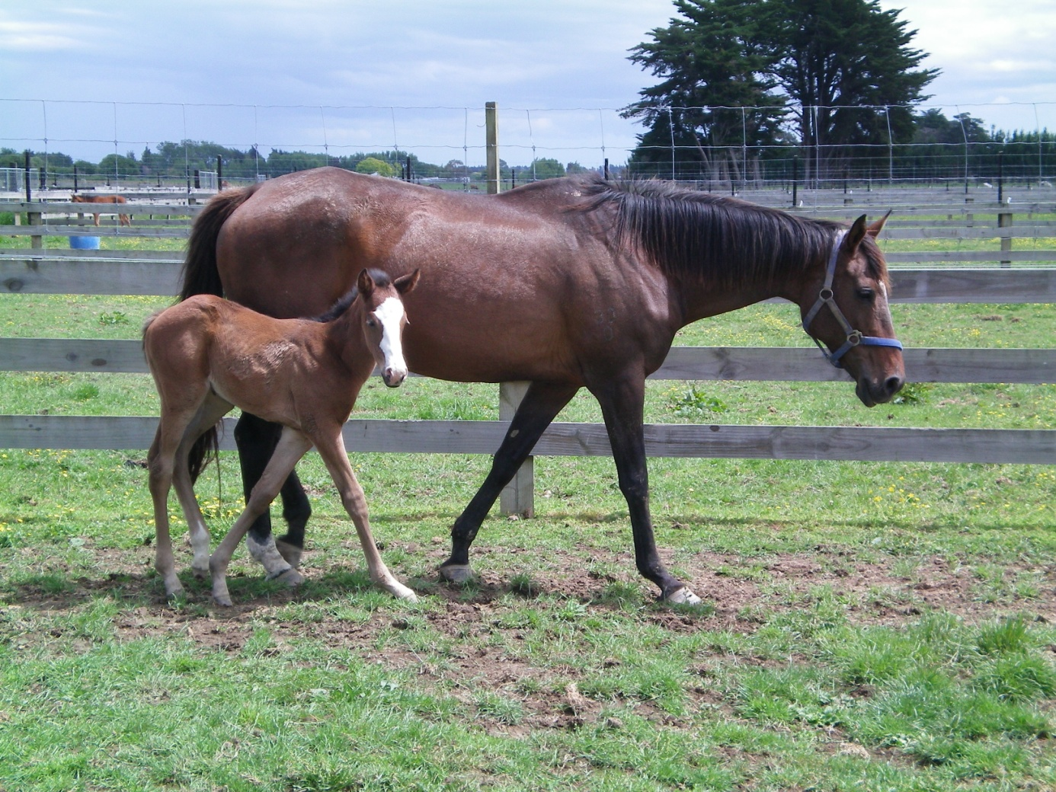

Research Project Institute of Veterinary, Animal and Biomedical Sciences
Massey University, New Zealand
Drs. M.M.G. van der Drift (0351679)
December 2010

Project supervisors:
Dr. C.W. Rogers (NZ)
Prof. Dr. P.R. van Weeren (NLD)

1. Abstract
Thoroughbred breeders in New Zealand are under continuous pressure from the racing industry. For breeders it is important to produce early born colts, as buyers believe early colts are more likely to be able to race successfully as two year olds, when potential earnings are high. In order to do so, breeders believe that it is important to have mares on a rising plane of nutrition after foaling.
The hypothesis of this research project is: mares with a high body condition score (BCS) will have (1) shorter gestation lengths, (2) a shorter interval from parturition till first ovulation, (3) will need fewer oestrous cycles till conception and (4) will produce more colts than fillies compared to mares with low BCS.
We went to two stud farms in Palmerston North, New Zealand: Goodwood Stud and Wellfield Lodge. In total we used 69 mares. We measured their BCS at the moment of foaling and conception. We retrieved data about these mares from both stud farms and the New Zealand Thoroughbred Racing studbook, including the dates of service, dates of parturition and sex of the foals. These data gave us the possibility to test our hypothesis.
We found no significant relationship between the BCS at time of conception in 2009 and the gestation lengths (n=24). On the other hand, we did find a significant relationship (P=0.001) between the moment of covering in the season and the gestation length. The gestation length shortens when length of the photoperiod increases at the moment of covering.
We found a significant (P=0.003) linear relationship between BCS at time of conception and the interval from parturition to date of first service (n=45). We also found a significant (P=0.002) linear relationship between BCS at time of first service and the interval from parturition to date of first service (n=45). The result was contradictory to our hypothesis: a high BCS at first service of conception will lead to a prolonged interval between parturition to first service.
We found no significant correlation between the BCS at time of conception and the interval between parturition and conception (n=54). Like the gestation length, this interval is under influence of photoperiod as well. We found a significant (P=0.001) relationship between the moment in season of conception and the length of the interval from parturition to conception (n=56).
We found a significant (P=0.004) difference between the mean BCS of mares that gave birth to a colt (n=14) and the mean BCS of mares that gave birth to a filly (n=10). The mean BCS of mares that gave birth to a filly was 5.63 ± 0.29. The mean BCS of mares that gave birth to a colt was 6,84 ± 0,25. In order to produce colts, the mare should have a BCS between 6.3-7.3. In order to produce fillies, the mare should have a BCS between 5.0 and 6.2.
We conclude that the ideal BCS of a mare at the moment of covering is around 6.5. This is the BCS at which mares will produce more colts than fillies. Breeders should not attempt to have their mares on a higher BCS at the moment of covering than 6.5-7, because the interval from parturition to first date of service will prolong when mares gain weight. Breeders should not attempt to have their mares on a BCS under 6.2 since their mares will then produce more fillies than colts. Then the intervals from parturition to first date of service will decrease, but this will only be a few days per point BCS the mare loses. It is more important to breed colts. In order to reach short gestation lengths, breeders should breed late in the season. In order to reduce the interval from parturition to last date of service, breeders should breed early in the season. The BCS has no significant influence on these variables.

Content
- Abstract p. 2
- Introduction p. 4
  - The Thoroughbred industry of New Zealand p. 4
  - Equine cyclicity p. 5
  - Reproductive efficiency p. 5
  - Reproduction parameters and body condition score p. 6
  - Body condition scoring system p. 7
  - Body condition score and nutrient uptake p. 8
  - Body condition score of the mare in relation to sex ratios p. 8
- Materials and methods p. 10
- Results p. 11
  - Hypothesis 1 p. 11
  - Hypothesis 2 p. 12
  - Hypothesis 3 p. 13
  - Hypothesis 4 p. 15
- Conclusion p. 16
  - Hypothesis 1 p. 16
  - Hypothesis 2 p. 16
  - Hypothesis 3 p. 16
  - Hypothesis 4 p. 16
- Discussion p. 17
- References p. 18
- Appendix p. 20

2. Introduction
Thoroughbreds in New Zealand are generally sold as yearlings (16 months) at auction. Premium prices are paid for well-grown colts that are born early in the season, as buyers believe early colts are more likely to be able to race successfully as two year olds when potential earnings are high. The Thoroughbred breeder is therefore under considerable pressure to reduce the time from parturition to conception to try to ensure foals are born early in the breeding season.³⁸
Many breeders believe that it is important to have the mare on a rising plane of nutrition after foaling to improve conception rates. However, there is a paucity of hard data to support this belief. Data indicate that mares that are thin, or losing weight around the time of conception, have a higher risk of early embryonic loss compared to mares in moderate condition or those gaining weight.³⁶
It also seems that mares in good condition or on a rising plane of nutrition more often give birth to male offspring. An investigation by Cameron et al. showed that Kaimanawa mares in poor condition at time of conception will more often give birth to fillies whereas mares in good condition will more often give birth to colts. Breeders could use this phenomenon to adjust their management by having mares on a good condition at time of conception.¹¹
This study aims to determine the association between mare body condition score (BCS) and number of cycles per conception, parturition to conception interval and gestation length. We also aimed to determine if there is a correlation between the BCS of the mare at the time of conception and the sex of the foal. Colts make money for breeders because they have a future in the racing industry, while fillies don’t. Therefore it is important for breeders to breed more colts than fillies.
Hypothesis: Mares with a high BCS will have (1) shorter gestation lengths, (2) a shorter interval from parturition till first ovulation, (3) will need less oestrous cycles till conception and (4) will produce more colts than fillies compared to mares with low BCS.
2.1 The Thoroughbred industry of New Zealand
The first New Zealand Thoroughbreds were imported in 1840 in Wellington from South Wales. National yearling sales started in 1927. During the second half of the twentieth century, Thoroughbred racing became more than just a sport and the industry as we know it today started to take formation.²⁶
Internationally New Zealand is the fifth largest Thoroughbred racing industry and produces 4% of the global Thoroughbred foal crop. Domestically the racing industry contributes annually $1,082 million (0,95%) of the New Zealand’s gross domestic product. The export of Thoroughbred racing horses generates $120 million per year.
In 2008/2009 6483 broodmares were covered by 166 stallions, producing 4224 foals. There are 71 Thoroughbred racing clubs and about 300 race meetings arranged per year. Approximately 5500 horses started at least once per year and the total number of starts per year is close to 32000. Export of young Thoroughbreds is increasing. Asian countries are the most important countries to export to. The main export product are male horses under five years old.^{2,26,27,30}
The NZTR holds its headquarters in Wellington and represents the interests of the racing clubs. Their responsibilities include administration of the codes and rules of racing, keeping of the New Zealand Stud Book, maintaining the official Thoroughbred database, registration of all racing animals, handicapping, licensing of trainers and jockeys, production and publication of codes and rules for the New Zealand racing industry, collection of fees and payment of stakes and the taking of nominations and withdrawals for all race days.^{1,26}
The racing season starts at August the first and ends on July the 31th the following year. Races are run on grass (turf) track surfaces. The production and racing of two year olds is a major focus of the New Zealand industry. Horses are broken in and trained between the age of 15 to 24 months and are able to race after August 1 of their second year. Two year olds may participate in races between 800 and 1400m, which are restricted to two year old horses only. After December the first in the year the horse turned two years old, they may participate in 1000-1200 meter races. Foals born early in September are older at the time of yearling sales and therefore they will have size and maturity advantages over younger yearlings. Therefore, breeders try to produce foals close to August the first. This means that the New Zealand breeding season is limited to the period between September the first and half of December.^{26,30,37}
In addition to all of this, Thoroughbred foals may only be produced by natural service. If a foal is produced differently, it cannot be registered. This requires a lot of management concerning the stallions and guidance of the broodmare. To increase the gene pool and access to high quality genetics, shuttle-stallions are imported from the Northern Hemisphere, since their breeding season is in a different time of the year. After the Southern Hemisphere breeding season, the stallions will be returned.^{26,30}
2.2 Equine cyclicity
Mares start ovulating for the first time during late summer as yearlings. In their second year they enter puberty under influence of the increasing photoperiod in spring. Their age, their nutritional status and training influence the exact time of the first ovulation as two year old. Training will delay the onset of puberty, while a good body condition and being born early in the year will advance the onset of puberty.¹⁴
During winter most mares will enter anoestrus. Melatonin is secreted by the pineal gland and suppresses GnRH secretion and thus LH and FSH secretion. The ovaries are small, firm and inactive. When the photoperiod in spring increases, GnRH becomes less suppressed and LH and FSH will be produced in rising amounts. Follicle growth follows but they do not yet ovulate. This transitional phase may last up to six weeks. The ovulatory phase follows. The first part is the oestrus, in which the animal is sexually receptive. The second part is the luteal phase after ovulation. FSH increases and leads to follicle growth. Oestrogen concentrations rise. Ovulation occurs about 24 hours before the end of the oestrus. LH peaks right after ovulation. Progesterone will start rising soon after ovulation produced by the new corpus luteum. Without conception, prostaglandin from the endometrial causes lysis of the corpus luteum and progesterone will no longer be produced, thereby inducing a new oestrous cycle. The oestrous cycle will repeat itself until the autumn transitional phase. The photoperiod decreases and the mare will have a transition into the anovulatory phase. Some mares will have a decrease in follicle magnitude; others enter prolonged intervals between ovulations until they stop ovulating completely.¹⁴
2.3 Reproductive efficiency
The reproductive efficiency of the mare depends on three factors: the fertilization rate (the frequency with which an ovum will be fertilized), the pregnancy rate (the number of mares that become pregnant per covering) and the foaling rate (the number of live foals being born per covering).¹⁶
Several factors may influence these rates. In this investigation we expect to see a relationship between the BCS and reproductive efficiency. Other factors are the reproductive status, the parity and the age of the mare. Brück et al. examined the reproductive efficiency of six Australian commercial Thoroughbred stud farms (n= 1368 mares). The overall pregnancy rate was 83,9% (1368 mares/1630 pregnancies). The pregnancy rate per served oestrous period was 54,7% (1433 pregnancies/2618 oestrous periods). ⁶
Age was of major influence on the parameters. Mares of 3 to 10 years old had significantly higher pregnancy rates and foaling rates (86,7% and 73,6% respectively) than mares over 11 years old (77,6% and 59,3% respectively). Mares over 15 years had higher abortion rates (p <0.05).⁶ The embryo viability was reduced in mares with an average age of 17,4 years, compared to mares with an average age of 4,9 years. Reasons for this phenomenon are possibly the abnormalities of the uterine environment, failure of oviductal transport or abnormalities of the oviductal environment and embryonic defects.³
Brück et al also found significant differences in reproduction parameters between maiden, foaling and barren mares. The number of oestrous cycles to result in pregnancy was lower for foaling mares, than it was for maiden of barren mares. The foaling rate was significantly higher (p <0.05) in maiden mares than in foaling or barren mares (76,6%, 68,6% and 67,6% respectively). Foaling rate decreased when mares need multiple cycles to reach pregnancy. Mares that need one or two cycles had a higher foaling rate than mares that need 3 or more cycles (77,8%, 65,4% and 42,9% respectively). There were no significant differences in pregnancy rate or pregnancy loss between maiden, foaling or barren mares.^{6,37}
To promote reproductive efficiency by enhancing the onset of estrus, 68% of the stud farms in New Zealand use hormone therapy (progesterone and/or oestradiol).³⁰
In this project we will examine if there is a relationship between the BCS of a mare and her reproduction efficiency, taking into account other influencing factors such as age and reproductive status of the mare and the use of hormones.
The gestation length is another important factor influencing the reproductive efficiency of a mare. It is generally accepted as 335 to 342 days, with a variation of 300 to 400 days and a mean of 351 ± 10.4 days. Van Rijssen et al. (2010) showed that gestation length was significantly longer for colt foals than for filly foals (353 ± 0,6 days and 351 ± 0,5 days respectively). Conception early in the year (September) leads to longer gestation lengths. Barren mares have longer gestation lengths than maiden or barren mares.³⁷
2.4 Reproduction parameters and body condition score
Mares are often stimulated to lose or gain weight during their life. Many stud masters aim to have dry mares at a lower BCS than wet mares at the start of the breeding season. The dry mares are then placed on a rising plane of nutrition in an attempt to stimulate an early start to oestrus. This management applies only for about 27% of the wet mares prior to breeding. A body condition scoring system was used on 86% of the stud farms in New Zealand’s North Island. The stud masters tried to have the foaling and lactating mares on a median score (3 out of 5) and a 2,5 out of 5 at the time of breeding.³⁰
Henneke et al. (1984) showed that the group of mares that lose BCS 90 days ante partum to foaling and have a low BCS at time of foaling to 90 days postpartum, have significant lower pregnancy rates for the second and third cycles and a reduced maintenance of pregnancy to 90 days, than mares in other groups. These groups include mares with a high BCS during these 180 days, mares that lose BCS ante partum and gain BCS postpartum and mares with a high BCS ante partum, but lose BCS postpartum. The mean interval between parturition to first ovulation tends to be longer for these mares as well (p <0.15). The mean interval between first to second ovulation is significantly longer. It appears that gestation length is not under influence of BCS.¹⁸
Pregnancy rates and the number of cycles per conception increase when mares enter the breeding season with a low BCS (<3). Barren and maiden mares that enter the breeding season with a low BCS will have a delayed onset of oestrus and ovulation. An irregular oestrus, increased early embryonic resorption and possibly early abortion are also associated with a low BCS. Whether there is a correlation between a low BCS and late abortion;, or between a low BCS and mares that do not become pregnant at all is unclear. Increasing nutrient intake several weeks before conception in case of mares with a low BCS increases conception rates. Reducing nutrient intake before conception in case of mares with a high BCS decreases conception rates. A BCS of 5 at foaling appears to be optimal.^{18,31}
Spring-born fillies, which were grown with deprived nutrient intake during winter, started cycling two to seven months later in their life than fillies that had the ability to grow during the winter. Both groups were fed ad lib after the winter period. Normally fillies start cycling when they are 12 to 15 months of age.³¹
Leptin is a hormone produced by adipocytes. An increase in rump fatness is associated with an increase in leptin concentration in the blood. So, leptin is positively correlated to fat percentage and fat mass. High leptin concentrations stimulate GnRH secretion.^{4,12,21}
Gastal et al. did a study comparing diameters of ovulatory follicles and BCS. Mares with a high BCS have a high amount of medium (11-19 mm) and large (>20 mm) follicles. It also showed that mares with low BCS had smaller diameters of the ovulatory follicle for the first and second ovulation and that these mares have fewer medium follicles per day preceding the first ovulation and fewer large follicles preceding the second ovulation. This indicates that low BCS is associated with reduced follicle development, including the diameter of the ovulatory follicle during the transition between anovulatory and ovulatory seasons and during the first interovulatory interval of the ovulatory season. These results are not attributable to altered circulating FSH and LH.¹⁵
2.5 Body condition scoring system
In the past there have been many studies to determine the best way to measure horses’ body condition and fat percentage. Horses are not all the same breed or size and there is a lot of variety in body conformation during life, for example when the horse grows from foal to mature horse or when a mare is in gestation or with different levels of training. Therefore it is difficult to capture the condition of a horse as objective data.
The body condition scoring system invented by Henneke et al. is often used to determine horse condition. Henneke et al. showed that this system, including a visual appraisal and palpation of the fat cover at six areas of body, is a more accurate way to measure BCS in Quarter Horses than other systems like measuring weight and height. These areas include the neck, withers, back, tail head, ribs and the area behind the shoulders. It proved to be independent of size or conformation of the horse.
The system is adjusted when there are conformation changes during late pregnancy in which the weight of the conceptus stretches the skin and musculature of the back ribs and tail head. These adjustments include placing more emphasis on fat deposition behind the shoulders and along the withers. Also, maiden mares have more fat stored over their ribs than older mares. The system is adjusted to maiden mares by placing less emphasis on fat deposition on the ribs.¹⁹
The system was first tested on Quarter Horses. The system can also be used for Thoroughbreds, though Thoroughbreds tend to store more fat on the neck, whereas the withers and loin store a lesser amount of fat. Thoroughbreds have a great deal of variation in conformation of the withers and that is probably the reason for the withers to be difficult to score accurately. The loin is difficult to judge due to a variety in musculature across the back. These muscles are filling the area beneath the subcutaneous fat and should not be included in the scoring. Judges of BCS in Thoroughbreds should keep in mind to pay more attention to the other areas, the neck, ribs, tail head and the area behind the shoulders.³³
The reliability of the body condition scoring system depends on three aspects. The scoring will have to be repeatable, so that a person will give an animal that has not changed in time the same score over time. The scoring will have to be reproducible, so that two different persons will give an animal the same score. And last, the scoring will have to be predictable. This is the ability of the system to reflect actual body fat of the animal.⁷
2.6 Body condition score and nutrient uptake
In contrast to many other countries, New Zealand has pastures that grow grass all year round. Breeders can keep all their horses in these pastures all year round. The feeding value of the pasture is therefore the main source of nutrition. Feeding value of ryegrass pastures with sufficient grass heights appears high and sufficient for pregnant or lactating Thoroughbred mares and unlikely to limit feeding value. Mares should therefore be able to maintain their body condition when supplied in adequate quality and quantity. Since mares on stud farms sometimes graze pastures with insufficient grass heights, some of them will may not be able to maintain their body condition.²⁰
2.7 Body condition score of the mare in relation to sex ratio’s
The Trivers-Willard hypothesis by TRIVERS, R. L. and WILLARD, D. (1973) ³⁵ suggests that where one sex has more variable reproductive success, such as males in polygynous species, mothers in good condition will be benefited by producing more of that sex, whereas mothers in poor condition would be benefited by producing more of the reproductive stable sex. In this way the mean sex ratio will be held 50/50. This theory is only applicable to species with small litter size.
Male reproductive success is easily influenced by changes in condition, since they have to compete with other males over a female to reproduce themselves. For a female, the reproductive success is much less dependent on change in condition. She will still reproduce herself when she is in poor condition.
The Trivers-Willard hypothesis depends on three premises: 1) that the condition of the mother during the parental investment is correlated to the condition of the young at the end of the parental investment; 2) that the condition of the young at the end of the parental investment will influence the condition during adulthood; 3) that the reproductive success in males is influenced by relatively small changes in condition. ^{11,35}
The Trivers-Willard hypothesis appears to apply to horses including domesticated horses, even though the third premise does not apply to them. Cameron (2004) investigated the studies about the hypothesis. She noted that 34% of the past investigations significantly support the Trivers-Willard hypothesis. Another 5% showed non-significant support, 8,5% though showed a significant outcome against the Trivers-Willard hypothesis. These results depend on the type of measurement taken.⁸
Altogether it seems that mares in good condition at the time of conception more often give birth to colts and mares in poor condition at time of conception more often give birth to fillies. Change of condition is supposed to have more influence on sex ratio than the actual BCS at the moment of conception. Mares losing condition at time of conception give birth to a filly (3% was a colt). Mares that gain weight at time of conception give birth to a colt (80% was a colt) according to Cameron etal. (2007). This correlation has also been determined for cows. Furthermore, parental investment, from conception to weaning, differs for mares who give birth to colts and mares who give birth to fillies: mares in poor condition invest more in fillies, whereas mares in rich condition invest more in colts.^{10,11,29}
Whether the hypothesis applies or not depends on the moment on which the measurements are taken and on inconsistencies in measures themselves. The BCS of the mare should be taken just before or at conception to reveal a relationship between the mares’ condition and sex ratios. When BCS, nutrition or weight around time of conception are compared to sex rates 74% of the research significantly support the hypothesis according to Cameron, E.Z. (2004). Measurements taken during gestation or around parturition show little correlation to sex ratios. Weight is the least strong measurement method, since weight is under influence of size. A large animal can be heavy and still be in poor condition. ^{8,10,32}
Another factor that influences sex ratio is the change in circulating plasma glucose level. High levels of circulating glucose are thought to lead to the birth of more males. The following studies support this hypothesis. When female mice were treated with dexamethasone glucose levels decrease. Dexamethasone treatment around the time of conception leads to a higher rate of the birth of female mice.⁹ Mice pre-Sertoli cells are the most sensitive cells of the reproduction tract to glucose starvation. The result is failure of testis development.²⁵ In vitro, glucose seems to accelerate development of bovine male embryos and blastocysts and slow down development of bovine female embryos and blastocysts.^{17,22,24,27} Furthermore, in bovine and human embryos glucose metabolism is twofold higher in male blastocysts compared to female blastocysts. The pentose phosphate pathway is fourfold higher in female blastocysts compared to male blastocysts.^{28,34} When animals are stressed, cortisol concentrations rise and circulating plasma glucose concentrations rise. Stressed females produce more male offspring.⁸ Glucose also influences a range of reproductive hormones. One of these is the expression of growth hormone receptor.⁵ The timing of the luteinizing hormone pulse and expression of the gonadothropin-releasing hormone receptor are other such factors.¹³ By influencing reproductive hormones blastocyst development can be slowed down or accelerated.
The moment of covering of horses on stud farms is usually managed. Timing of conception can induce differences in sex ratio since circulating plasma glucose levels fluctuate during the oestrous cycle. Plasma levels of glucose changes under influence of cortisol. Cortisol is high in dioestrus and low during oestrus. The lowest level of cortisol is reached two days before ovulation.^{16,23}
Following these earlier studies this study will try to detect a correlation between mares BCS and the sex ratio of the foals born.

3. Materials and methods
Data were collected from two Thoroughbred stud farms, Goodwood Stud and Wellfield Lodge, which are both located in Palmerston North, New Zealand. Other data were collected from the NZTR studbook. All data originate from the years 2009 and 2010. Data were collected from a total of 69 mares. Not all horses were suited for testing of all hypotheses.
Body condition scores were measured according to the Body Condition Scoring System created by Henneke et al. in 1984 as has been described in the introduction. The system contains the visual appraisal and palpation of the fat cover at six areas of body. These areas include the neck, withers, back, tail head, ribs and the area behind the shoulders, see figure 1. The information retrieved was evaluated according to the table ‘Description of individual body condition scores’ as can be found in the Appendix. This way, mares could retrieve a BCS of 1 to 9, respectively low to high.
Areas used for the BCS
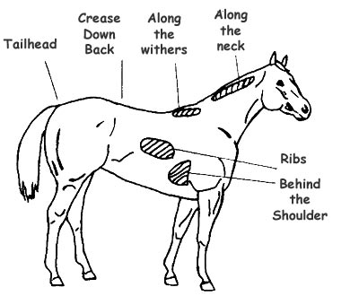
Fig. 1 Diagram of areas palpated to estimate body fat and condition¹⁹
Measurement of BCS took place shortly after foaling in 2009, around conception in 2009, prior to foaling in 2010 and shortly after foaling in 2010.
Data retrieved from the stud farms included the parturition dates in 2009 and 2010, the sex of the foals, the date of first and last service in 2009, the number of coverings and their plane of nutrition. These data helped us to calculate the interval of parturition to first date of service and to last date of service in 2009, the gestation length.
All data were processed with MS Excel and statistically analyzed with PASW Statistics 18.

4. Results
4.1 Hypothesis 1: Mares with a high BCS at time of conception will have shorter gestation lengths compared to mares with low BCS
BCS at time of conception and gestation length
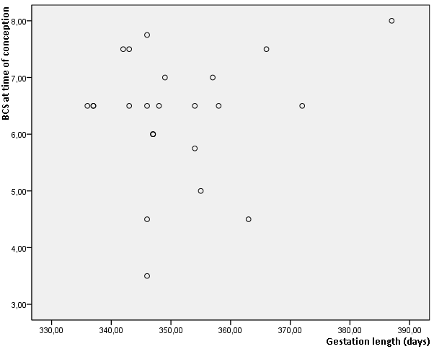

Fig. 2a Relationship of the mares BCS at time of conception and gestation length, n=24

Moment of covering and gestation length
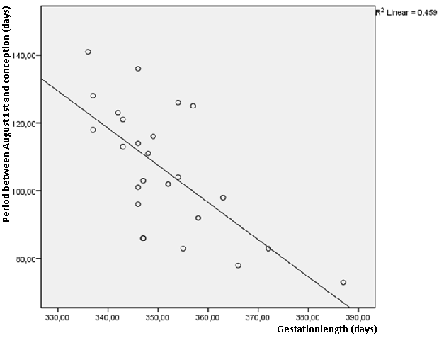
Fig. 2b Relationship of the moment of covering and gestation length, n=24
Figure 2a shows the relationship between the BCS of 24 mares at time of conception in 2009 and their gestation lengths in days. We found no significant relationship between these two variables. We realised that the variation in gestation length may be under strong influence of variation in length of the photoperiod at time of covering. Van Rijssen et al. (2010) showed that mares covered later in the season will have significantly shorter gestation lengths.³⁷ Therefore we calculated the number of days between August the first and date of covering of the mares. These calculations can be found on the y-axe in figure 2b. We encountered that the gestation length will significantly (P=0.001) shorten when mares are covered later in the season, when length of the photoperiod increases.
4.2 Hypothesis 2: Mares with a high BCS will have a shorter interval from parturition till first ovulation compared to mares with low BCS
BCS at conception and the interval of parturition to first date of service
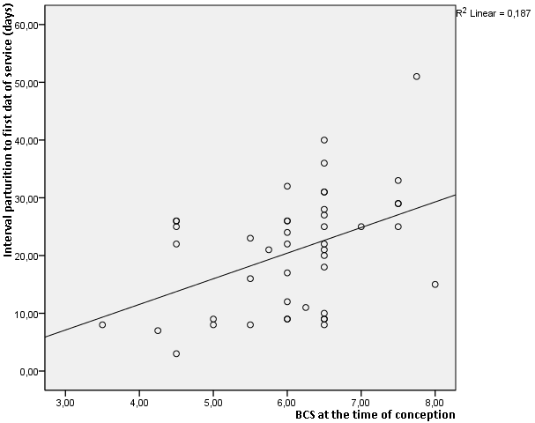
Fig. 3a Relationship between the mares BCS at time of conception and the interval of parturition to first date of service, n=45
Figure 3a shows the relationship between the BCS at time of conception of 45 mares and their interval from parturition to date of first service. We found a significant linear relationship between these variables (P=0.003)

BCS at time of first service and the interval of parturition to first date of service
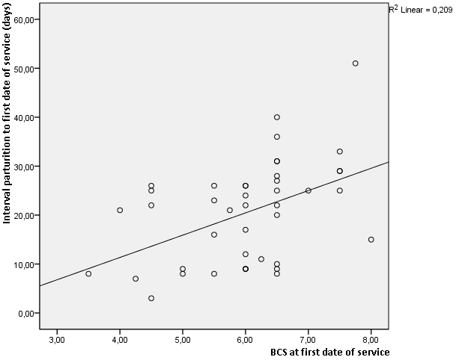
Fig. 3b Relationship between the mares BCS at date of first service and the interval of parturition to first date of service, n=45
Figure 3b shows the relationship between the BCS at time of first service of 45 mares and their interval from parturition to date of first service. We found a significant linear relationship between these variables (P=0.002)
These two figures show that mares should have a low BCS in order to shorten the interval from parturition to first time of service.
4.3 Hypothesis 3: Mares with a high BCS will need will need less oestrous cycles till conception compared to mares with low BCS
The period between parturition and conception and its relationship with BCS at time of conception
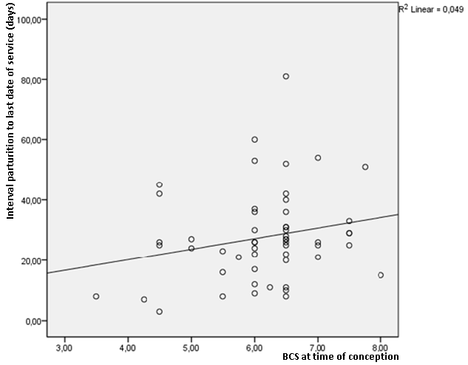
Fig. 4a The relationship between the period between parturition and conception and the BCS at time of conception, n=54
To test this hypothesis we compared the BCS of 54 mares at time of conception with the interval between parturition and conception in 2009. The results can be found in figure 4a. We could not find a significant relationship between these two variables. There seems to be a linear relationship between them but this is not significant (P=0.055).
We figured that there may be a relationship between the change in BCS from the moment of foaling to the moment of conception and the interval from parturition and the last date of service. However, we could not find such a correlation.
The interval of parturition to conception and its relationship to moment of covering
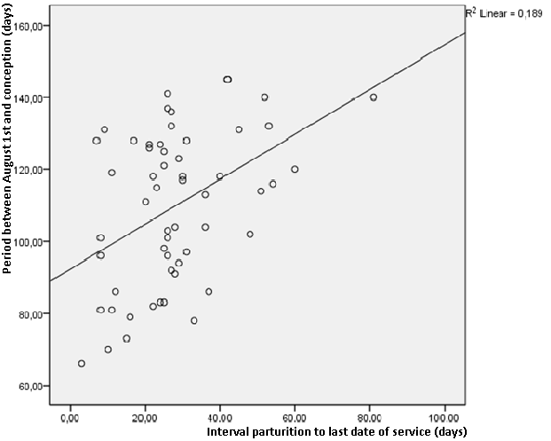
Fig. 4b The relationship between the period between parturition and conception and the moment of covering, n=56
Although the length of the interval between parturition and conception seems to have no significant relationship with the BCS of the mare at time of conception, the moment of covering does have its influence. Fig 4b shows a significant (P=0.001) relationship between the moment in season of conception of 56 mares and the length of the interval from parturition to conception. This indicates that a variation in day length is the main factor in determination of the length of the interval. When a mare is covered later in the season, when the photoperiod is long, the interval extends. Therefore, mares covered early in the season will have shorter intervals.

4.4 Hypothesis 4: Mares with a high BCS at time of conception will produce more colts than fillies compared to mares with low BCS
Relationship between the BCS of the mare at time of conception and the sex of the foal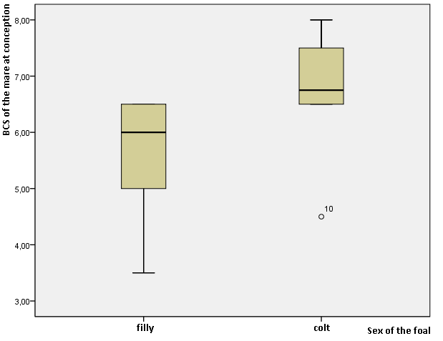
Fig. 5 Relationship between the BCS of the mare at time of conception and the sex of the foal, n=24
For this hypothesis we looked at the sex of foals of 24 mares. The mare had a BCS between 3,5 and 8. In total they gave birth to 10 fillies and 14 colts. Figure 5 shows the significant (P=0.004) difference between the mean BCS of mares that gave birth to a colt and the mean BCS of mares that gave birth to a filly. The mean BCS of mares that gave birth to a filly was 5,63 ± 0.29. The mean BCS of mares that gave birth to a colt was 6,84 ± 0.25. In order to produce colts, the mare should have a BCS between 6,3-7,3. In order to produce fillies, the mare should have a BCS between 5,0 and 6,2.

5. Conclusion
5.1 Hypothesis 1: Mares with a high BCS at time of conception will have shorter gestation lengths compared to mares with low BCS
Mares with a high BCS compared to mares with a low BCS will not have shorter gestation lengths. There is no significant correlation between these variables. The gestation length is greatly influenced by variation in photoperiod. Whether BCS has any influence at all cannot be concluded based on this investigation. To shorten the gestation length, mares should be covered later in the season.
5.2 Hypothesis 2: Mares with a high BCS will have a shorter interval from parturition till first ovulation compared to mares with low BCS
Mares with a high BCS compared to mares with a low BCS at time of conception and at time of first service will have longer intervals from parturition to first service. To restrict this interval it is thus important that mares will not be obese.
5.3 Hypothesis 3: Mares with a high BCS will need will need less oestrous cycles till conception compared to mares with low BCS
The interval from parturition to conception is not significantly related to the BCS at time of conception or to change of BCS during the period from foaling to conception. The length of the interval is under influence of the moment of covering in the season. Mares that are covered early in the season when day length is short will have a shorter interval from parturition to conception.
5.4 Hypothesis 4: Mares with a high BCS at time of conception will produce more colts than fillies compared to mares with low BCS
This hypothesis is not confirmed. In order to produce colts, the mare should have a BCS between 6,3-7,3 with a mean BCS of 6,8. In order to produce fillies, the mare should have a BCS between 5,0 and 6,2, with a mean BCS of 5,6.
5.5 Final conclusion
The ideal BCS of a mare at the moment of covering is around 6,5. This is the BCS at which mares will produce more colts than fillies. Breeders should not attempt to have their mares on a higher BCS at the moment of covering than 6,5-7, because the interval from parturition to first date of service will get longer when mares gain weight. Breeders should not attempt to have their mares on a BCS under 6,2 since their mares will then produce more fillies than colts. Then the intervals from parturition to first date of service will decrease, but this will only be a few days per point BCS the mare loses. It is more important to breed colts.
In order to realise short gestation lengths, breeders should breed late in the season. In order to reduce the interval from parturition to last date of service, breeders should breed early in the season. The BCS has no significant influence on these variables.

6. Discussion
As method for this research we used the Body Condition Scoring system invented by Henneke et al. which was adjusted for use in Thoroughbreds. The system has been proven to be accurate and the score given by one person will not differ more than half a point from the score given by another person. We did not explore whether this accuracy applied to the different people who measured the BCS of the mares. There may be a larger variety in scores given by separate persons. This would make the BCS data less reliable.
The mares did not all belong to the stud farm. Some mares were only there for foaling and covering by the stud farm’s stallion. This introduced variation in management policy. We do not know whether these mares were fed and grazed in the same way as the stud farm mares.
To test the hypotheses we could not use many mares. Mares in the two stud farms, Goodwood Stud and Wellfield Lodge, were not always on the stud farms and therefore we missed some data. This reduced the number of mares available for data analysis. Further, we had to do our statistical analysis before all foals were born. This also diminished the total amount of data available for analysis.
We did no power analysis to determine the needed sample size. Because we do not know the power it could be that the non-significant results would still become significant if we would use the right sample size. On the other hand, the significant results we did find can also be false because we do not know the required sample size. Over all, we had only small numbers of data to our availability. It would be interesting to do a power analysis and determine how big het population will have to be to have enough power and continue the collection of data the next years.
For testing the second hypothesis (mares with a high BCS will have a shorter interval from parturition till first ovulation compared to mares with low BCS) we used the first date of service as moment of first ovulation. This is not always correct. For some mares this first date of service was their foal heat, others were not covered on their foal heat but during the oestrus after their foal heat. Whether the covering takes place during foal heat depends on the stud farm’s management. A criterion not to use the foal heat is for example the occurrence of a difficulty during pregnancy of parturition and has nothing to do with whether or not the mare can be covered or will conceive.
When we tested the third hypothesis (mares with a high BCS will need less oestrous cycles till conception compared to mares with low BCS) we used the interval from parturition to last date of service. Hereby we did not test the actual amount of oestrous cycles, but the time that was necessary for conception. This was due to the limited data available on the actual number of oestrous cycles used for covering.

7. References
- Anonymous (2009) ‘Anual Report 2008/2009’ In: www.nzracing.co.nz
- Anonymous (2009) ‘New Zealand Thoroughbred Racing Fact Book 2009’ In: www.nzracing.co.nz
- BALL, B.A., LITTLE, T.V., WEBER, J.A. and WOODS, G.L. (1989) ‘Survival of day-4 embryos from young, normal mares and aged, subfertile mares after transfer to normal recipient mares’ In: Journals of Reproduction and Fertility Ltd – 85, pp. 187-194
- BERNE, R.M., LEVY, M.N., KOEPPEN, B.M., STANTON, B.A. (2004) ‘Age-related changes is gonadothropin secretion’ In: Physiology – 5th edition, Elsevier, Inc. USA, pp. 928-932
- BRAMELD, J.M., GILMOUR, R.S., and BUTTERY, P.J. (1999) ‘Glucose and amino acids interact with hormones to control expression of insulin-like growth factor-I and growth hormone receptor mRNA in cultured pig hepatocytes’ In: American Society for Nutritional Sciences – 129, pp. 1298–1306
- BRÜCK, I., ANDERSON, G.A. and HYLAND, J.H. (1993) ‘Reproductive performance of Thoroughbred mares on six commercial stud farms’ In: Australian Veterinary Journal – 70(8), pp.299-303
- BURKHOLDER, W.J. (2000) ‘Use of body condition scores in clinical assessment of the provision of optimal nutrition’ In: Veterinary Medicine Today: Timely Topics in Nutrition – 217(5), 650-654
- CAMERON, E.Z., (2004) ‘Facultative adjustment of mammalian sex ratios in support of the Trivers-Willard hypothesis: evidence for a mechanism’ In: Proceedings of the Royal Society B – 271, pp. 1723-1728
- CAMERON, E.Z., LEMONS, P.R., BATEMAN, P.W. and BENNETT, N.C. (2008) ‘Experimental alteration of litter sex ratios in a mammal’ In: Proceedings of The Royal Society B – 273, pp 323-327
- CAMERON, E.Z. and WAYNE, L.L. (2007) ‘Extreme sex ratio variation in relation to change in condition around conception’ In: Biology Letters – 3, pp. 395-397
- CAMERON, E.Z., WAYNE, L.L., STAFFORD, K.J. and VELTMAN, C.J. (1999) ‘Birth sex ratios relate to mare condition at conception in Kaimanawa horses’ In: Behavioural Ecology – 10(5), pp. 472-475
- CUBITT, T., CARTER, R., STANIAR, W.B., HARRIS, P. and GEOR, R. (2007) ‘Adiposity and leptin concentrations in Thoroughbred mare’ In: The FASEB Journal – 21(830.4)
- DISKIN, M.G., MACKEY, D.R., ROCHE, J.F. and SREENAN, J.M. (2003) ‘Effects of nutrition metabolic status on circulating hormones and ovarian follicle development in cattle’ In: Animal Reproductive Science – 78, pp. 345–370
- ENGLAND, G.C.W. (2005) ‘Endocrinology of the oestrous cycle and puberty’ In: Fertility and Obstetrics in the horse – 3th edition, Blackwell Science Ltd, Oxford, UK, pp. 10-19
- GASTAL, M.O., GASTAL, E.L., SPINELLI, V., GINTHER, O.J. (2004) ‘Relationships between body condition and follicle development in mares’ In: Animal Reproduction - 1(1) p.115-121
- GINTHER, G.J. (1992) ‘Reproductive efficiency’ In: Reproductive Biology of the mare – 2nd edition, Equiservices, Wisconsin, USA, pp. 499-562
- GUTIERREZ-ADAN, A., GRANADOS, J., PINTADO, B. and De La FUENTE, J. (2001) ‘Influence of glucose on the sex ratio of bovine IVM/IVF embryos cultured in vitro’ In: Reproduction, Fertility and Development – 13, pp. 361-365
- HENNEKE, D.R., POTTER, G.D. and KREIDER, J.L. (1984) ‘Body condition during pregnancy and lactation and reproductive efficiency of mares’ In: Theriogenology – 21(6), pp. 897-909
- HENNEKE, D.R., POTTER, G.D., KREIDER, J.L. and YEATES, B.F., (1983) ‘Relationship between condition score, physical measurements and body fat percentage in mares’ In: Equine veterinary journal - 15(4), 371-372.
- HOSKIN, S.O. and GEE, E.K. (2004) ‘Feeding value of pastures for horses’ In: New Zealand Veterinary Journal – 52(6), pp. 332-341
- KEARNS, C.F., McKEEVER, K.H., ROEGNER, V., BRADY, S.M., and MALINOWSKI, K. (2006) ‘Adiponectin and leptin are related to fat mass in horses’ In: The Veterinary Journal – 172, pp. 460-465
- KOCHLAR, H.P., PEIPPA, J. and KING, W.A. (2001) ‘Sex related embryo development’ In: Theriogenology – 55, pp. 3–14
- KRACKOW, S. and HOECK, H.N. (1989) ‘Sex ratio manipulation, maternal investment and behaviour during concurrent pregnancy and lactation in house mice’ In: Animal Behaviour – 37, pp. 177–186
- LARSON, M.A., KIMURA, K., KUBISCH, H.M. and ROBERTS, R.M. (2001) ‘Sexual dimorphism among bovine embryos in their ability to make the transition to expanded blastocyst and in the expression of the signalling molecule IFN-tau’ In: Proceedings of the National Academy of Science of the United States of America – 98, pp. 9677-9682
- MATOBA, S., HIRAMATSU, R., KANAI-AZUMA, M., TSUNEKAWA, N., HARIKAE, K.,, KAWAKAMI, H., KUROHMARU, M. and KANAI, Y. (2008) ‘Establishment of testis-specific SOX9 activation requires high-glucose metabolism in mouse sex differentiation’ In: Developmental Biology – 324, pp. 76-87
- PERKINS, N.R. (2005) ‘Epidemiology of health and performance in New Zealand racehorses’ In: Massey Epicentre - pp. 1-271
- PERKINS, N.R., REID, S.W.J. and MORRIS, R.S. (2004) ‘Profiling the New Zealand thoroughbred racing industry: 1 Training, racing and general health patterns’ In: New Zealand Veterinary Journal – 53(1), pp 59-68
- RAY, P.F., CONAGHAN, J. WINSTON, R.M. and HANDYSIDE, A.H. (1995) ‘Increased number of cells and metabolic activity in male human pre-implantation embryos following in vitro fertilization’ In: Journal of Reproduction and Fertility – 104, pp. 165-171
- ROCHE, J.R., LEE, J.M. and BERRY, D.P. (2006) ‘Pre-conception energy balance and secondary sex ratio- partial support for the Trivers-Willard Hypothesis in dairy cows’ In: Journal of Dairy Science – 89(6), pp. 2119-2125
- ROGERS, C.W., GEE, E.K. and FIRTH, E.C. (2007) ‘A cross-sectional survey of Thoroughbred stud farm management in the North Island of New Zealand’ In: New Zealand Veterinary Journal – 55(6), pp. 302-307
- ROSE, R., OFFORD, M., (1997) 'Proceedings of the equine nutrition and pastures for horses workshops' - 97/3. DPIE Copyshop
- SHELDON, B.C. and WEST, S.A. (2004) ‘Maternal dominance, maternal condition, and offspring sex ratio in ungulate mammals’ In: The American Naturalist – 163(1), pp. 40-54
- SUAGEE, K.S., BURK, A.O., QUINN, R.W., PETERSEN, E.D., HARTSOCK, T.G. and DOUGLASS, L.W. (2008) ‘Effects of diet and weight gain on body condition scoring in thoroughbred geldings’ In: Journal of Equine Veterinary Science – 28(3), 156-166
- TIFFIN, G.J., RIEGER, D., BETTERIDGE, K.J., YADAV, B.R. and KING, W.A. (1991) ‘Glucose and glutamine metabolism in pre-attachment cattle embryos in relation to sex and stage of development’ In: Journal of Reproduction and Fertility – 93, pp. 125-132
- TRIVERS, R. L. and WILLARD, D. (1973) ‘Natural selection of parental ability to vary the sex ratio of offspring’ In: Science – 179, pp. 90–92
- VAN NIEKERK, F.E. and VAN NIEKERK, C.H. (1998) ‘The effect of dietary protein on reproduction in the mare. VII. Embryonic development, early embryonic death, foetal losses and their relationship with serum progestagen’ In: Journal of the South African Veterinary Association – 69(4), pp. 150-155
- VAN RIJSSEN, J.D., GEE, E.K., ROGERS, C.W. and O’BRIEN, J.R. (2010) ‘Factors influencing gestation length and interval from foaling to conception in mares managed on a commercial Thoroughbred stud farm’ In: Proceedings of the New Zealand Society of Animal Reproduction – 70, pp. 146-148
- WALDRON, K., ROGERS, C.W., GEE, E.K. and BOLWELL, C. (2011) ‘Production variables influencing the auction sales price of New Zealand Thoroughbred yearlings’ - not published yet

- Appendix
Description of individual body condition scores
Score |  | Description
1. | Poor | Animal extremely emaciated. Spinous processes, ribs, tail head, tuber coxae and ischii projecting prominently. Bone structure of withers, shoulders and neck easily noticeable. No fatty tissue can be felt
2. | Very thin | Animal emaciated. Slight fat covering over base of spinous processes, transverse processes of lumbar vertebrae feel rounded. Spinous processes, ribs, tail head, tuber coxae and ischii prominent. Withers, shoulders and neck structures faintly discernable
3. | Thin | Fat build up about halfway on spinous processes, transverse processes cannot be felt. Slight fat cover over ribs. Spinous processes and ribs easily discernable. Tail head prominent, but individual vertebrae cannot be visually identified. Tuber coxae appear rounded, but easily discernable. Tuber ischii not distinguishable. Withers, shoulders and neck accentuated
4. | Moderately thin | Negative crease along back. Faint outline of ribs discernable. Tail head prominence depends on conformation; fat can be felt around it. Tuber coxae not discernable. Withers, shoulders and neck not obviously thin
5. | Moderate | Back level. Ribs cannot be visually distinguished but can be easily felt. Fat around tail head beginning to feel spongy. Withers appear rounded over spinous processes. Shoulders and neck blend smoothly into body
6. | Moderately fleshy | May have slight crease down back. Fat over ribs fleshy feels spongy. Fat around tail head feels soft. Fat beginning to be deposited along the side of the withers, behind the shoulders and along the sides of the neck
7. | Fleshy | May have crease down back. Individual ribs can be felt, but noticeable filling between ribs with fat. Fat around tail head is soft. Fat deposited along withers, behind shoulders and along the neck
8. | Fat | Crease down back. Difficult to feel ribs. Fat around tail head very soft. Area along withers filled with fat. Area behind shoulder filled with fat. Noticeable thickening of neck. Fat deposited along inner thighs
9. | Extremely fat | Obvious crease down back. Patchy fat appearing over ribs. Bulging fat around tail head, along withers, behind shoulders and along neck. Fat along inner thighs may rub together. Flank filled with fat
Fig 6. BCS according to Henneke et al. ²⁰

