The Transitional Period
of Hitchcock

Dieke van de Steeg
3709299
Eindwerkstuk
Film genres
Docent: Jim Hurley
Blok 4/2013
21-06-2013
Contents

Introduction 2
Hitchcock and Britain in the 1930’s 4
Making British films between 1934-1939 4
Control in Britain 5
Hitchcock and Hollywood in the 1940’s 8
Making Hollywood films between 1939-1942 8
Control in Hollywood 9
Cinematography 11
Montage 12
Conclusion 14
Appendix 1: Banned films in the US 15
Appendix 2: Cinematric results of The 39 Steps, The Lady Vanishes, Rebecca and Suspicion. 16
Bibliography 18

Introduction

“I’m a typed director. If I made Cinderella, the audience would immediately be looking for a body in the coach.”

This quote of Alfred Hitchcock doesn’t surprises anyone that saw at least one of his films. Hitchcock is known as the Master of Suspense and famous because of his thriller genre films. His Hollywood films Rear Window (1954), Vertigo (1958) and Psycho (1960) are mostly known, but he also made a lot of British films before he came to Hollywood. Hitchcock was born in Britain and he started to develop his own style of making films that formed a basis for his whole career. Tom Ryall mentions in his book Alfred Hitchcock and the British Cinema that the European cinema was at that time forming its own way of filmmaking, in reaction to the overpowering classical cinema of Hollywood. But Ryall also mentions that from the beginning of his career Hitchcock is very influenced by the classical Hollywood film and that this is reflected in his films. But how could Hitchcock make such films while he was still attached to the British way of filmmaking? And in what way are his films then American? And why did he, if he was already making ‘Hollywood’ films, go to Hollywood anyway? Was he given more freedom in Hollywood and could he there turn his creative ideas into better and bigger motion pictures? These questions all revolve around the transition Hitchcock made being director in Britain and moving to Hollywood in 1939. But this paper is not going to be about a historical outline of how both studio systems worked and how Hitchcock was being part of each system. The thing I’m interested in is how this transition from Britain to America is visible in his films. Of course I need to make an outline what the circumstances were when Hitchcock was dealing with both Britain and Hollywood, but the main focus will be in what way his British and Hollywood films differ from one another and how those differences can be brought back to the context he was working in. My main thesis thus will be: In what way did the British studio system and the Hollywood studio system influenced Hitchcock’s work? These side questions will help to answer my main thesis: What were the circumstances inside the British studio system that Hitchcock had to deal with? With what kind of aspects of the Hollywood studio system was Hitchcock confronted after moving to America? How are those two approaches of film making in Britain and Hollywood visible in Hitchcock’s films?
In order to answer the main question I’m going to analyze four of Hitchcock’s films, both two British and two American. This will give an overall view on how Hitchcock approached filmmaking in his late Britain and early Hollywood period. Thus the focus will be on a small period in Hitchcock’s career from 1934 up until 1942. The films that I will discuss in this period are his British films The 39 Steps (1935) and The Lady Vanishes (1938). The American films I will use are Rebecca (1940) and Suspicion (1941). My approach on answering my question is explaining the social context that Hitchcock was working in. With that I will highlight certain relevant aspects or scenes from his films that are being analyzed with a formalistic approach to give examples in what way Hitchcock had to change certain ideas or contents. A part of the formalistic approach will be supported with a shot analysis made by the Cinematrics measurement tool created by Yuri Tsivian. The start of this paper will be around the context of Hitchcock’s British films. It will contain a short overview of the British studio system that Hitchcock worked within. A side focus will be on the possible restrictions the British government imposed. After this I want to discuss the context around the beginning of his Hollywood career and also their possible limitations and consequences for Hitchcock. Throughout these descriptions of both contexts, I will highlight and discuss certain aspects or scenes from the films that give an example of how the contexts had their grip on Hitchcock as director. The main keys here will be their cinematography and montage. Besides that I want to make a formalistic analysis of the films by highlighting the most important aspects to compare with one another to what extent the two periods of filmmaking differ or are alike to one another.

Hitchcock and Britain in the 1930’s

Making British films between 1934-1939

The 1930s British popular cinema is probably the least known and least respected, although its film industry was the largest outside America at that time. The case was that it had been continually ridiculed as being artistically inconsequential. Several film historians describe the 1930s British features as muddled, cheap and artless, or trivial and without contemporary emphasis. And still in this period Alfred Hitchcock made himself known as a good director in Britain, while the studio system was trying to change this low standard of filmmaking. Hitchcock was working on his most successful films during this period within a film industry that was demanding more British films. The Cinematograph Films Act created in 1927 was still valid and at the end of the thirties the British film industry became more booming than ever, although Hollywood financed most of the films. This Act was created by the Parliament and acted out by the Board of Trade. The government urged the film industry to achieve a certain quota of British films because before 1927 they were pretty overshadowed by Hollywood that produced and screened their films in the Britain. The audience seemed to love the Hollywood films and Britain’s own industry was at a point of bleeding to death. With this Act the British film industry got a new boost, however later it was seen as a failure because with the quota the British film industry expanded in a fast rate, but the production increased so much that the quota was consistently exceeded. Most films financed with American money became known as quota quickies, because of their low budgets, a poor quality, made with great haste and the British audience loathed them. This control on the film industry, acted out by the government, was regulated by a whole different institution as it was conducted America. As will be discussed in the next chapter, its own film industry was responsible for acting out the control on films and not the government.
In 1934 Hitchcock’s new career was about to begin when he was re-united with producer Michael Balcon. This same producer gave him in the early 1920s the opportunity to become a director after which several films flourished out of their good relationship and collaboration. But the years before the mid-thirties his career had a downfall and he got entangled with making some quota quickies. But then in 1934 he joined the Gaumont-British Production and with Michael Balcon besides him, Hitchcock was now able to produce the series of thrillers, which for most people constitute the ‘essential British Hitchcock’.
The silent force behind the quotas could be seen as strive for a British authentically national identity. This had been the case since the 1920s for all the European film producing countries. It ended up with the interpretation from film directors of an artistic divergence from the Hollywood classical model of narrative cinema. The interesting thing here is that Hitchcock didn’t wanted to strive to a British national identity but thought that Hollywood had much more to offer. That could be explained from the beginning of his career when he was already influenced and interested in the classical narrative style of Hollywood. Ryall writes in Alfred Hitchcock and the British Cinema that Hitchcock saw a lot of American films before he became a director. Also when he started working in the film industry he worked with experienced American writers and directors who taught him the principles of classical narrative style. This of course influenced Hitchcock in the way he made his British films. How this is styled in his films will be discussed

Control in Britain

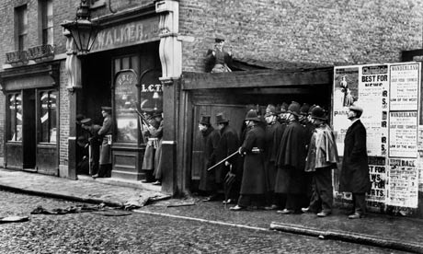
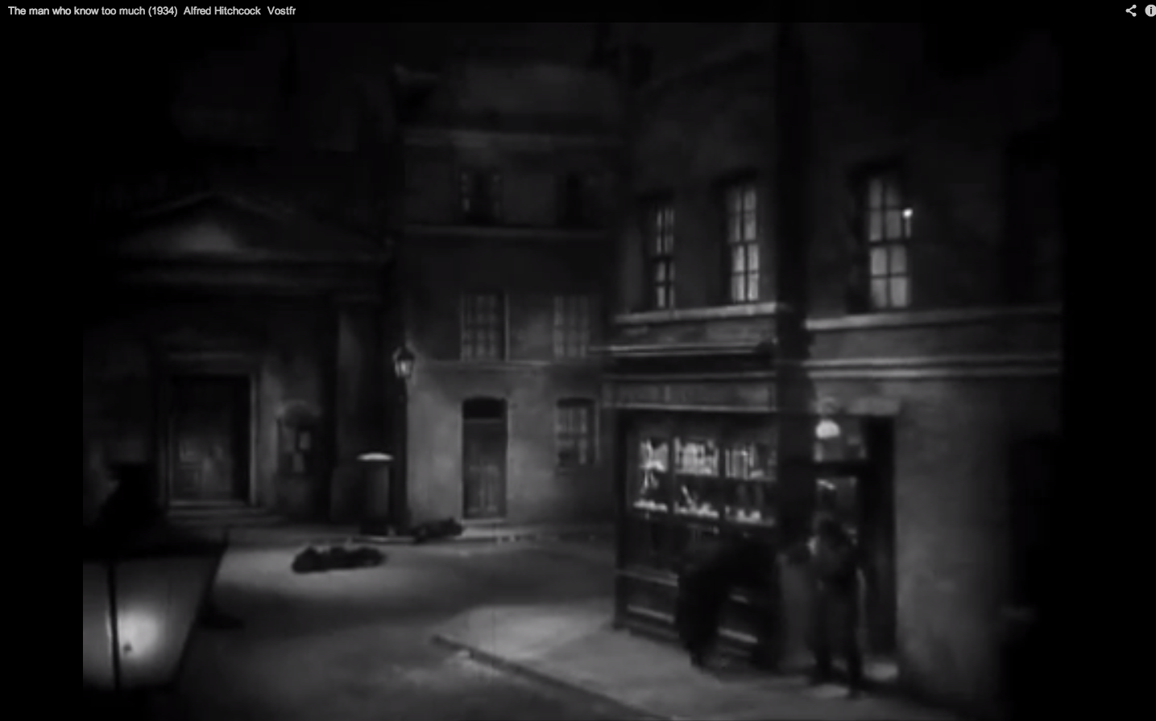
Besides these quota legislations Hitchcock also had to deal with a British censorship of feature films. During the 1930s patriotic values were a main output in the British cinema, whether this theme had a subtle and implicit or more explicit and open expression. These values provided an optimistic point of view at a time of national economic crisis. A table in the book British Popular Films 1929-1939: The Cinema of Reassurance (1997) shows how many films released in a period of four years, from 1935-1939, consisted the patriotism as a primary theme of the feature. It indicates an increasing amount of films where this is the primary focus of the production, from 8.6% in 1935 ascending to 18,4% in 1939. This rise of almost one out of five films released in 1939 reflects on the more openly patriotic features caused by the just announced declaration of war. Nationalistic films emphasized the Britain past triumphs and the problems that the nation had overcome to achieve her success. So during the 1930’s Depression, Britain held on to the same idea like the historical subjects implicated. The suffering that was caused by the Depression would lead to a greater and better future. Patriotism functioned as a form of comfort and a reassurance and reminded the audiences of a unified society. As a director, Hitchcock did indeed also feel the pressure of the use of patriotism. He wasn’t allowed to put Britain into disrepute and was at some point really restricted in making films about his own choices of interest. In the interview ‘The Censor Wouldn’t Pass It’ with J. Danvers Williams originally published in Film Weekly Hitchcock told Williams while working in Britain he experienced some form of censorship against social importance and dramatizing real events. At some point he wanted to make a film about the General Strike of 1926 because Hitchcock loved dynamic situations turning into a motion picture. While presenting the idea to the British Board of Film censors, they vetoed it immediately because of all the authentic drama of the situation like fistfights that Hitchcock wanted to show. Also with the ending of his film The Man Who Knew Too Much he experienced censorship in wanting to situate the Sydney Street siege with militia and machine guns and had to find other methods. The siege that took place on a house in Sydney Street east London was seen as a mistake and lack of judgment authorized by Winston Churchill. There were three men, supposed to be Jewish anarchists, hiding in the house after a robbery attempt. Churchill ordered 74 policemen, 35 artillerymen and 15 engineers to blow up the house. They surrounded the place and both sides exchanged fire for six hours. In the end a fire started from inside the house and with the policemen Churchill stood and just watched the house go up in flames, which swallowed the criminals. The men turned out to be Polish petty criminals and all the police learned from the siege was not that they had overreacted, but that they needed better weapons. While Hitchcock was not allowed to show the whole situation accurate, he managed to put several visual aspects like copying the set in the ending so the British audience knew that it was referring to the siege. The following two images are an example of this, the left is a press photo of the real situation in 1911, and the right is a screenshot of the film The Man Who Knew Too Much depicting the siege.

Throughout the whole article of Williams and this example of the Sidney Street siege it becomes clear that Hitchcock was fascinated by the law and politics but was not fully allowed to put this in his films, but still we saw he found his own ways. Hitchcock states in the article that he didn’t have any freedom when it comes to doing what he wanted to most: “Circumstances have forced me into the realms of fiction. I have always wanted to make films with some sociological importance – but I have never been allowed to do so.” Still besides of these patriotic morals, other limitations like referring to sex are the case in Britain and did have strain on Hitchcock. The film industry had a particular sexual moral standard that carried out a real British message. Leach writes in British Film that sexuality was presented primarily through the chivalrous gentleman and ladylike behavior of the characters. According to him, this was because the British film was bound up with the class system. Sex was presented in films, but with certain discretion, implication and insinuations.
Chapter 2 will explain that a whole different approach can be seen in America. Hitchcock was really fond of making sexual jokes, what is implicitly reflected in The Lady Vanishes and The 39 Steps. In the first thirty minutes of The 39 Steps at least three times there is a referring to sex. The first time when Mr. Hannay and the woman Smith meet, she asks him if she may come to his home. Hannay almost agrees instantly to that, which implies that he has no problem whatsoever in taking a woman home with him late at night. Also when Hannay wants to disguise himself while escaping his building and asks the milkman to swap clothes with him, by explaining the truth the milkman doesn’t cooperate until Hannay makes up a story about him visiting a married lady upstairs and didn’t want her husband to come after him. In The Lady Vanishes several lines, dialogues and showing of body parts give the same idea. At the beginning of the film, the hotel manager tells his maid that the two British men are taking her room for one night. He talks to her in a foreign language, but somehow it seems that he ends his sentence with the word ‘puta’, the word for prostitute in Spanish. While following the maid upstairs the two men say:

“Pity he couldn’t have given us one each.”
“Eh?”
“I mean, uh, a room apiece.”
“Oh.”

The reaction and look of the maid towards the two men indeed does imply that the manager said something like the word prostitute. The two men’s reaction to the whole situation makes it even more likely. Also when the waiter enters the room of the three supposedly American girls, they stand all in their underdress, and one is first shown from her bare legs up standing on a table at eyelevel of the waiter who barely dared to watch. The most obvious sexual reference are the persons Mr and Ms Todhunter who are pretending to be married couple on a holiday but their dialogue reveals their secret of being in a relation with someone else. One can discuss of all these examples in both films are discreet in the way the British films would like to see it. Anyhow, it seems that Hitchcock could make enough insinuations to sex in his films that it makes this topic look more explicit than implicit. Still he holds onto the codes of gentlemanly and ladylike behavior. When comparing these sexual insinuations to the standards of Hollywood, one might conclude that Hollywood was much stricter and focused on different morals then Britain. Appendix 1 gives examples of which parts of the discussed British films were deleted before screen approval in America. Chapter 2 will continue on this difference.
Another restriction besides patriotic morals, or maybe I should say limitation, in making films was the fact that the British film industry wasn’t that much of a good organized system compared to Hollywood. Hitchcock pleaded in the article ‘If I Were Head of a Production Company’ for a better workplace and more studio space. According to Hitchcock the British studio system had a shortage on money, or rather the inability of using the money in the right way. In the next chapter new techniques in Hollywood will be discussed, techniques Britain had no money for. Hitchcock saw also that Hollywood had a better functional system with the re-usage of sets and high-tech material. Hitchcock told a reporter: “I made The Lady Vanishes in a studio ninety feet long and I was forced to build sets in perspective.”

Hitchcock and Hollywood in the 1940’s

Making Hollywood films between 1939-1942

To understand where Hitchcock went after Britain I have to explain in a short version how Hollywood was constructed. During the silent era, the Hollywood film industry had formed an oligopoly with a small numbers of companies that cooperated to close the film market to competition from other countries. By 1930, the Hollywood oligopoly was a structure that would last for nearly twenty years. There were eight companies in that oligopoly that dominated the film industry. The Big Five, also called the Majors, were vertically integrated with owning a theater chain and having an international distribution operation. There were also smaller companies with few or no theaters called the Little Three and beside those two groups were also several independent firms and some of them made expensive ‘A’ films compared to the Majors. David O’ Selznick, the producer of Hitchcock’s first American film Rebecca, made such ‘A’ films. During the 1930s in Britain some, for British standards, expensive films were made with the idea of hitting box offices in America. But the British films that were most successful in America tended to be films that were not particularly directed towards America at all. The most successful classic thrillers of Alfred Hitchcock are an example of those. Hitchcock had to adjust to the Hollywood way of filmmaking, what provided him some advantage and at the same time disadvantage to the British film production system. In the 1930s Hollywood established filmmaking as a system, becoming a sort of business industry. The Hollywood studio’s wanted to be filmmaking like a whole constitute, one group style. For example, this included a continuity system for narrative smoothly flowing and constructing a unified space for a scene, for it was necessary to made such a system for laying some ground rules. All elements in the film, from lighting and cinematography to editing are meant to serve the story continuity and this was developing since the silent era. Besides these rules Hitchcock also came to work with new techniques in Hollywood. To enhance the productivity studios became larger and invested in new cameras and other techniques like Technicolor and special effects. At the end of the 1930s most studios had invested in camera movement techniques, what made a great contribution to the continuity smoothness. The new hydraulic control of panning and tilting made an end to the jerky reframing. Also around the 1936s most production companies had flexible dollies or they rented large cranes. These camera techniques were new to Hitchcock for the British film industry didn’t have that much money to keep up with the new developments in Hollywood.

Control in Hollywood

There have been several occasions throughout the American film history with struggle for control or influence on the process of producing and showing. The reason for the urge to control on cinema was because film was the first visual and aural mass entertainment form of the twentieth century and it seemed to have an overwhelming power. Also film was the most popular mass medium during its first fifty years. Censorship was justified on a 1915 claim that movies were not covered by the First Amendment protection and this provided a legal motivation to impose the prior restraint on movie exhibition. Around the 1940s Hollywood’s trade organization the Motion Picture Producers and Distributors of America, Inc. (MPPDA) observed film production closely to narrow representations about sex, crime, violence, the professions, and morality. They became known as the notorious Production Code (PC) and then revised by executives from Hollywood from 1930 to 1966. The task of the PC was to indicate what might and what would not provoke local censorship, which would take control of a particular movie in their own hands, and trying to shape films to avoid these effects. The primary reason for Hollywood’s self-regulation was the urgent necessity that movies would not disturb the political and social current situation of American society, or that they interrupt the box office hits and income with controversial material. The deleted scenes, dialogues and acts shown in Appendix 1 are a great example of how this self-regulation control on films was applied on Hitchcock’s British films. Where in Britain sexual implications were sort of decent as long it was done in a gentlemanly or ladylike manner, in Hollywood this was not decent at all and did not stroke with the Production Code values. However some of these scenes I described, were apparently not that much of a big problem, such as the dialogue of the two men reacting on the offer of the maids room in The Lady Vanishes. I find this quite remarkable because it is still an implicit sexual reference, but maybe the verdict of the Production Code was that it wasn’t obvious for all the audience to notice at once. But still, most of all implicit or suggestive dialogues and acts from the actors were inappropriate. Hitchcock had to adjust to this way of filming in Hollywood and couldn’t go on the way he did all those years. However there are some sexual undertones to find in Rebecca that aren’t that obvious to recognize. Looking at Mrs. Danvers, she adored and loved the former lady of the house Rebecca. But is seems as if it is more than just loving friendship. She holds on to Rebecca’s image so tight, that she still pretends that she lives in the house. She tells the new Mrs. De Winter that she can here Rebecca walk around the house. In the end her love for Rebecca becomes her death. She can’t bare the idea that Rebecca held back a secret from her and can’t go on living with this fact. She dies with her beloved memories the room of Rebecca, what could stand of a symbol that she would be reunited again with her beloved Rebecca.
While Hitchcock began to work in Hollywood he needed to adjust to a new film industry and one of a great difference was the way the studio and producers had much control on the production process. His first contract was with the famous producer Selznick, who was probably the most extreme control freak producer in Hollywood. Selznick made himself a superior bargaining position and later Hitchcock would come to regard it as a collar that rubbed and choked. The struggle between the two is seen in the shaping of the script for Rebecca what resulted in adapting it over and over again to please Selznick for he wanted to make the film according to the novel. Hitchcock had very clear ideas about how the film would supposed to look like and had already gained experience in adapting the novel The 39 Steps into a successful film. He had been given all freedom in Britain with that, but now Selznick was breathing down his neck watching every word. With making Suspicion Hitchcock didn’t had Selznick as a demanding producer, but here the restrictions of the film industry are clearly seen. Hitchcock originally had a different ending envisioned where Gary Grant as Johnny did murdered his best friend and killed his wife also in the end, but gets caught by a letter she writes before her death to her mother. The new boss of RKO, the production company where Hitchcock made Suspicion, was lord high censor of the Production Code and insisted on a different ending where Johnny wasn’t a villain but just a scamp who thought of ending his own life.

Cinematography

Looking at camera movement between his British and his Hollywood films the difference in using dollies is interesting. In The 39 Steps there is not the same smooth camera movement seen as in Suspicion. For example taking the first dolly right at the beginning of the film, the one in the theatre centering from back to front the people who yell their question to Mr. Memory. The camera rides only for a short distance, while reframing in a rough and hard way to get the right person at the right time within the frame. Also I noticed that there aren’t any dolly shots on location in Scotland, what could mean that or the surface was too bad, or the equipment was not capable of using on uneven grounds. In Suspicion dollies look much smoother and the running distance of the camera is much larger. Looking at the shot where Johnny and Lina walk to church accompanied by the Barhams family, the camera rides along with them for several meters with no rough movements. Because of the space Hollywood had in the studios, the most of this film is shot within the studio. Therefore the terrain could be modified to the standards a moving camera needed to have. A great difference thus between working in Hollywood and Britain is the location of filming. In Britain there wasn’t money to make larger studios to contain larger sets. Therefore a lot of scenes were filmed outside on location, where in Hollywood this was not an issue and all scenes where shot in studios.
Also a circularly dolly shot in Suspicion is used in the scene where Lina and Johnny are kissing in the study of her father. The camera circles from their right to the left side. This is a great example of the new rules Hitchcock had to follow in Hollywood. He wanted to change the axis of action as it is called and he had to stick to the continuity system they were using not crossing the 180º line to keep a consistent screen direction of the two relative positions of Johnnie and Lina. To continue the smooth way of story continuity, probably the best way according to the producers is to use a circularly shot. Also in the film Rebecca the openings shot is a tracking shot showing the drive Mrs. de Winter used to walk before Manderlay burnt down. The tracking shot is followed by a crane shot, which isn’t used in Hitchcock’s British films. Besides the notice of a moving camera also a difference in use of angles could be seen. In Rebecca a whole new camera angle is used that has also not been seen in his British films. One of the scenes at the end, where the maid Mrs. Danvers has set the house on fire, a remarkable low angle framed shot reveals the collapsing roof and the beams fall towards the camera. In his British films no divergent camera angles are to be seen, but that doesn’t mean necessarily that Hitchcock didn’t knew such camera frames or just the claim that the British film industry lacked such technique. In my opinion the main reason could be that there just wasn’t enough space in the British studios to perform such framed shots.
But not only the camera work differs between Hitchcock’s British films and his Hollywood films. Kay Brown, Selznick’s trustworthy agent en talent scout, told him before Selznick even saw one of Hitchcock’s films that these films were lacking its technical aspect and that the miniatures look as they had been done by a child. And this is clearly seen in The 39 Steps with the shots on the Scottish highlands. When Hannay arrives at a farmer’s cottage, we see for a moment a miniature of the house on a hill with a car leaving on the drive. The moving car looks like a sort of stop motion and the whole scenery doesn’t really match with the actual scenery. Also the shot of the helicopter that would represent the mobile police chasing after Hannay is really just a toy and you can really almost see the thread its hanging onto. The same use of miniatures is seen in The Lady Vanishes for instance the first shot of the film where the camera moves from an overview of the village towards the hotel. The whole scenery looks not real and the moving car toy makes it even worse. These represents the poor quality of technique the British film industry had at that time. In both the Hollywood films the appearance is that no miniatures were used. However in Rebecca it is quite plausible that a miniature is used to visualize Monte Carlo from a high angle, or eagle eye perspective. But after looking closely at the shot, I noticed down on the right two spots, what seems to be persons, moving in the frame. Still this part could have been placed within the frame of the miniature. In any case if this would be a miniature, it is made by skillful artists and does look rather real and not at all the same as the childish miniatures of the British films.

Montage

We have seen that David O. Selznick had the last word about the whole production process. Bordwell says in Poetics of Cinema that with the editing Selznick always thought that Hitchcock’s film tended to be ‘cutty’. Sometimes he tried to slow down the editing pace by taking charge of the montage process, which was the case in The Paradine Case (1947) by making a final cut. The first thing I noticed about the editing in Hitchcock’s Hollywood films is an abundant use of dissolves. In Suspicion almost every scene ends with a dissolve into the next scene. The dissolve seems to have three functions here; first it links the one scene to the other. They connect in a certain way with each other like for instance the scene where Lina is walking around town and discovers the two chairs in the window of an antiques shop, a dissolve follows and the next scene she walks up towards Mr. Thwaite to apologize that she didn’t believe him when he said that Johnnie sold those chairs some days earlier. The second function is to insinuate a time-lapse, a shorting of the action at that moment. When Lina hears that Johnnie on Tuesday was seen at the races instead of working at Melbeck, her walking down the street dissolves into the shot where she enters Melbeck’s office. The third function is that of showing the thoughts of a character. When Lina is playing a word game, she suddenly suspects that Johnnie is going to murder Beaky and with four shots dissolving in each other it shows how she thinks Johnnie pushes Beaky from the cliff.
In The 39 Steps the opposite is the case with the frequent use of dissolves. At the end of a scene a fade out is mostly used. The amount of dissolves is easily to count and the use varies in different functions. It functions as a sort of zoom at the beginning of the train scene. The first shot is the traveling train, having a dissolve into the shot where Hannay sits with two other men in a compartment. Another function is to link two shots together, as seen with the medium shot of the policeman wiping his sweating forehead dissolving into a long hot of the policemen arriving on the horizon spotting Hannay running away. It seems that while Hitchcock was working in Britain, the dissolve used in connecting scenes to each other in the way Hollywood did, was not a standard editing technique. The following example will substantiate this assumption. Beginning with the scene where Hannay takes the bullet out of the hymnbook until three scenes later where Hannay is sitting in the car with the girl Pamela next to him, only cuts connect all the shots and scenes to each other. Even so no fade out is used, because that would interrupt the continuity of storytelling. A Hollywood film would use probably dissolves to connect the three scenes together as Hitchcock shows later in Suspicion. This example makes it clearer why Selznick found Hitchcock’s work most of the times too ‘cutty’. Yes of course Selznick meant with this the high pace of shot after shot, but the use of dissolves between scenes create also a pause and a respite between those, in Selznick eyes, too rapid shot change.
Also I looked at the average shot length of both his British and Hollywood films. Those results from the program Cinematrics can be found at appendix 2. There is a clear distinction seen between two British films and the first film Rebecca, made with the collaboration of Selznick. The ASL of Rebecca is 9.4 while The 39 Steps is 8.8 and The Lady Vanishes 7.5. With Rebecca having a longer shot duration it looks obvious that Selznick was the reason behind this slowing down. However Suspicion is a bit faster in relation to Rebecca with an ASL of 8.8 and equals in some way Hitchcock’s British films. It is quite likely to think that Hitchcock did have more freedom in the editing process while making Suspicion because RKO and not Selznick produced it. But as I already mentioned in the part ‘Control in Hollywood’, other limitations were disturbing the production process by a RKO imposing a new ending.

Conclusion

Throughout this paper it has become clear that the social context is a great influence on the process of filmmaking in general. When the contexts change, the contents of films also do change. Hitchcock had to taken in account the changes that caused the switch from Britain to America. In both Britain and Hollywood he was subjected to a form of censorship. Still it looks that in Britain Hitchcock had more freedom to handle certain topics in his films. The only main thing Britain was focused on was to display their country in the best way possible. Besides that, other topics were allowed to discuss in films and Hitchcock used that freedom to humor sexuality, which he loved to highlight in his films. And this is certainly reflected in his film The Lady Vanishes. But this kind of freedom was gone when Hitchcock came to work in Hollywood. He couldn’t depict sexuality freely in for instance dialogues and had to do it in a non-obvious way. The character of Mrs. Danvers in Rebecca is an example of that. Also a great difference is to be seen in cinematography. The cinematographic form seems to be highly influenced by the technique that was available in both the British and Hollywood studios. Britain hadn’t that much money in comparison with Hollywood so the studios were much smaller and didn’t have the latest technical gadgets. There isn’t any use of crane shots for instance and dolly shots aren’t that long and smooth than we can seen in Hitchcock’s Hollywood films. Also the way of using miniatures in Britain seems to be not quite the standard in Hollywood. The most logically explanation for this would be that in Hollywood there was enough money to hire skillful artists who could make those miniatures look as real as possible. Hollywood had a great restriction on Hitchcock. The interference of the producer and the studio decisions is very noticeable in comparison with Hitchcock’s British films. Besides that he had to follow the rules the American film industry had set out with their continuity system. But I guess all this wasn’t that bad, because Hitchcock new what opportunities he could get in Hollywood. He could work with new technologies that benefited his films, like the crane shot in Rebecca and have huge studio spaces to build large decors. Overall the two studio systems vary in a lot of ways and this had a great impact on Hitchcock’s way of making his films. Still he was a smart man and sometimes he found ways to surpass the rules he had to follow. But the freedom he had in Britain was the price he was willing to pay for a short time to become the biggest director of suspense.

Appendix 1: Banned films in the US

Following some Hitchcock’s British films and their deleted scenes and dialogues due to the Production Code in the United States.

The Man Who Knew Too Much: It was established policy to withhold approval of all kidnapping stories, unless the kidnapping was the central theme of the story, the person kidnapped was not a child, there were no details o the crime, no profit accrued to the kidnappers, and the kidnappers were punished. The film met all the above requirements, except that a child was involved. Further the final two reels presented ‘slaughter the like of which had not been seen since Scarface’. There was too much gunplay and killing to make the film acceptable. In order to bring the film into conformity with the Code, in the first part, the close shot of the girl being kidnapped with a hand held over het mouth was deleted. In the last two reels, the gunfight was severely cut, removing scenes of the police being shot, the street strewn with dead policemen, the policeman dying on a mattress, gangers firing at the police entering the house, and the scene where the ‘gangster with a mustache’ was shot.

The 39 Steps: After viewing Gaumont-British was asked to delete the close shot of the girl taking off het stockings wile handcuffed to Hammond; Hammond’s line, ‘Now for the operating table’; two shots of Hammond rolling over and placing his hand on the girls leg; and all profanity.

The Lady Vanishes: at first the film was basically in conformity with the Production Code, subject to deletion of all dialogue indicating that the characters of Mr and Mrs Todhunter were not married and travelling on an illicit holiday. Other items: the lines of Gilbert to Iris: ‘Now which side do you like to sleep’ and ‘In that case I’ll sleep in the middle’; the phrase, ‘a private thingummy’; expressions of profanity; Gilbert’s line, ‘Kick him – see if he’s got a false bottom’; and the hotel maid looking under the bed and pulling out a hatbox to the accompaniment of facial expression by the man present (a suggestive toilet gag).

Appendix 2: Cinematric results of The 39 Steps, The Lady Vanishes, Rebecca and Suspicion.

The 39 Steps
ASL: 8.8 MSL: 4.1 MSL/ASL: 0.47 LEN: 84:44.3 NoS: 577 MAX: 111.6 MIN: 0.4 Range: 111.2 StDev: 13.6 CV: 1.54

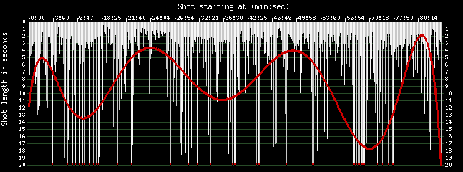

The Lady Vanishes
ASL: 7.5 MSL: 4.4 MSL/ASL: 0.59 LEN: 93:57.7 NoS: 751 MAX: 73.2 MIN: 0.3 Range: 72.9 StDev: 8.6 CV: 1.14

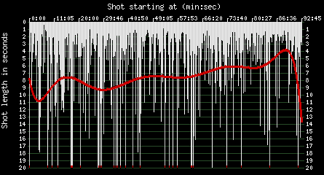

Rebecca
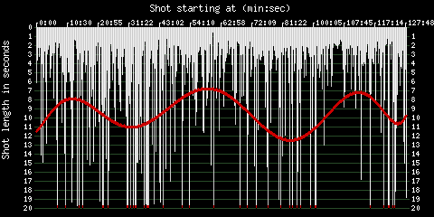
ASL: 9.4 MSL: 4.8 MSL/ASL: 0.51 LEN: 128:32.2 NoS: 820 MAX: 163 MIN: 0.5 Range: 162.5 StDev: 14 CV: 1.49

Suspicion
ASL: 8.8 MSL: 5 MSL/ASL: 0.57 LEN: 98:9.5 NoS: 672 MAX: 73.7 MIN: 0.1 Range: 73.6 StDev: 10.4 CV: 1.18

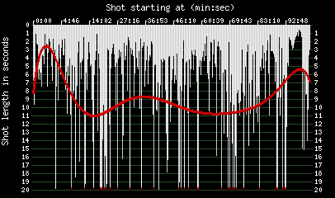
Bibliography

Balio, Tino, Grand Design: Hollywood As a Modern Business Enterprise 1930-1939 (Berkeley and Los Angeles: University of California Press, 1993), 109-113.
Bates, Stephen. “Sidney Street Siege Resonates Even 100 Years On.” The Guardian, January 2, 2011. Accessed June 17, 2013. http://www.guardian.co.uk/uk/2011/jan/02/sidney-street-siege-100-years.
Bernstein, Matthew. “Introduction” in Controlling Hollywood: Censorship and Regulation in the Studio Era. Edited by Matthew Bernstein. New Brunswick, New Jersey: Rutgers University Press, 1999.
Bordwell, David. Poetics of Cinema. New York, London: Routledge, 2008.
Bordwell, David and Kristin Thompson. Film History: An Introduction. New York: McGraw-Hill, 2010.
Glancy, H. Mark. “Hollywood and Britain: MGM and the British ‘Quota” Legislation.’ In The Unknown 1930s: an Alternative History of the British Cinema, 1929-1939. Edited by Jeffrey Richards. London: I.B. Tauris & Co Ltd, 1998.
Hitchcock, Alfred. Newsweek, 11 June. 1956.
“If I Were Head of a Production Company.” Originally published in Picturegoer, January 5, 1935, 15. In Hitchcock on Hitchcock: Selected Writings and Interviews. Edited by Sidney Gottlieb. Berkeley, Los Angeles and London: University of California Press, 1995.
Leach, Jim. British Film. Cambridge: University Press, 2004.
Leff, Leonard J.. Hitchcock and Selznick: the Rich and Strange Collaboration of Alfred Hitchcock and David O. Selznick in Hollywood. Berkeley, Los Angeles and London: University of California Press, 1987.
McGilligan, Patrick. Alfred Hitchcock: A Life in Darkness and Light. New York: HarperCollins Publishers, 2003.
Ryall, Tom. Alfred Hitchcock and the British Cinema. London: The Athlone Press Ltd., 1996.
Shafer, Stephen C.. British Popular Films 1929-1939: The Cinema of Reassurance. London: Routledge, 1997.
Slide, Anthony. ‘Banned in the USA’: British Films in the United States and Their Censorship, 1933-1960. London, New York: I.B. Tauris & Co Ltd, 1998.
Taylor, John Russell. Strangers in Paradise: The Hollywood Émigrés 1933-1950. London: Faber and Faber Limited, 1983.
Williams, J. Danvers. “The Censor Wouldn’t Pass It.” Originally published in Film Weekly, November 5, 1938, 6-7. In Hitchcock on Hitchcock: Selected Writings and Interviews. Edited by Sidney Gottlieb. Berkeley, Los Angeles and London: University of California Press, 1995.

Hitchcock, Alfred, Newsweek, 11 June 1956.
Tom Ryall, Alfred Hitchcock and the British Cinema (London: The Athlone Press Ltd.: 1996), 59, 146.
Stephen C. Shafer, British Popular Films 1929-1939: The Cinema of Reassurance (London: Routledge, 1997), 10.
H. Mark Glancy, “Hollywood and Britain: MGM and the British ‘Quota” Legislation,’ in The Unknown 1930s: an Alternative History of the British Cinema, 1929-1939, ed. by Jeffrey Richards (London: I.B. Tauris & Co Ltd, 1998), 57-58.
David Bordwell and Kristin Thompson, Film History: An Introduction (New York: McGraw-Hill, 2010), 220.
Glancy, Hollywood and Britain, 60.
Ryall, Alfred Hitchcock, 86, 102-103.
Ryall, Alfred Hitchcock, 59, 146.
Shafer, British Popular Films, 220.
Shafer, British Popular Films, 220-221, 224-226.
J. Danvers Williams, “The Censor Wouldn’t Pass It,” originally published in Film Weekly, November 5, 1938, 6-7, in Hitchcock on Hitchcock: Selected Writings and Interviews, ed. by Sidney Gottlieb (Berkeley, Los Angeles, London: University of California Press, 1995), 196-197.
Williams, “Censor Wouldn’t Pass”, 197-198.
Bates, Stephen, “Sidney Street Siege Resonates Even 100 Years On,” The Guardian, January 2, 2011, accessed June 17, 2013, http://www.guardian.co.uk/uk/2011/jan/02/sidney-street-siege-100-years.
Williams, “Censor Wouldn’t Pass”, 197.
Jim Leach, British Film (Cambridge: University Press, 2004), 124.
“If I Were Head of a Production Company,” originally published in Picturegoer, January 5, 1935, 15, in Hitchcock on Hitchcock: Selected Writings and Interviews, ed. by Sidney Gottlieb (Berkeley, Los Angeles, London: University of California Press, 1995), 172-175.
Leonard J. Leff, Hitchcock and Selznick: the Rich and Strange Collaboration of Alfred Hitchcock and David O. Selznick in Hollywood (Berkeley, Los Angeles and London: University of California Press, 1987), 30.
Bordwell and Thompson, Film History, 196-199.
John Russell Taylor, Strangers in Paradise: The Hollywood Émigrés 1933-1950 (London: Faber and Faber Limited, 1983), 123-126.
Tino Balio, Grand Design: Hollywood As a Modern Business Enterprise 1930-1939 (Berkeley and Los Angeles: University of California Press, 1993), 109-113.
Balio, Hollywood As a Modern Business, 126 – 128.
Matthew Bernstein, “Introduction” in Controlling Hollywood: Censorship and Regulation in the Studio Era, ed. by Matthew Bernstein (New Brunswick, New Jersey: Rutgers University Press, 1999), 1.
Bernstein, Controlling Hollywood, 2-3.
Leff, Hitchcock and Selznick, 33, 42-45.
Patrick, McGilligan, Alfred Hitchcock: A Life in Darkness and Light (New York: HarperCollins Publishers, 2003), 285-289.
Leff, Hitchcock and Selznick, 26.
David Bordwell, Poetics of Cinema (New York, London: Routledge, 2008), 37.
Slide, Anthony, ‘Banned in the USA’: British Films in the United States and Their Censorship, 1933-1960 (London, New York: I.B. Tauris & Co Ltd, 1998), 136.
Slide, ‘Banned in the USA’, 102.
Slide, ‘Banned in the USA’, 95.

