From Dracula to Buffy: A Study on the Original Vampire and His Descendants.

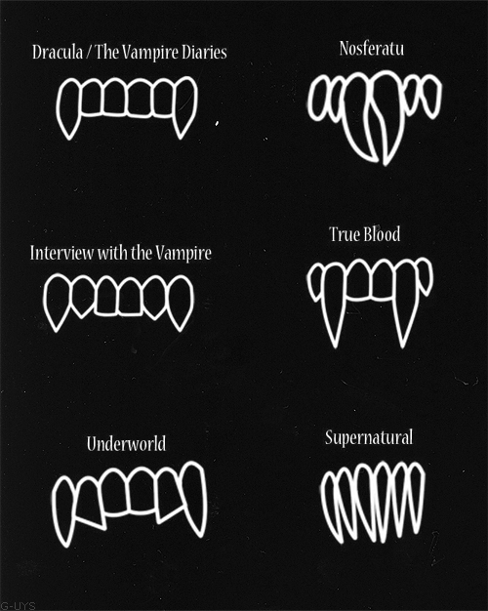

BA Thesis English Language and Culture, Utrecht University
Rowan Verstelle
3686183
David Pascoe
19-06-2013
Word count excluding quotes: 10,071

Table of Contents
Introduction………………………………………………………………………………….3
- The Vampire’s Origins: the Vampire throughout history and Dracula…………6
- The Vampire in Current Works of Fiction in the Medium of Television………..12
- Comparing the original and the new: characterisation, metaphor and myth…...33
- The Female Character in the Original and the New Vampire Stories…………...41
Conclusion……………………………………………………………………………………48
Bibliography…………………………………………………………………………………50

From Dracula to Buffy: An Introduction
Bram Stoker’s Dracula is what springs to most people’s minds when they hear the word “Vampire”. His novel and his vampire have traveled all the way from 1897 to 2013 by way of various adaptations, making Dracula one of the most iconic fictional characters and one of the most popular Halloween costumes. Before and since Dracula, vampires have been an interesting topic for fiction because vampires are perfect for the use of analogy and metaphor. This use of analogy and metaphor in vampire fiction will be touched upon in each chapter and most in depth in chapter 3.
The first chapter will focus on the origins of the vampire in history and the starting point of this BA Thesis: Dracula. As said in the above paragraph, Dracula is one of the most iconic vampires and one of the first that was introduced in the world of fiction. Stoker’s novel sparked the interest in vampires and created a popular myth from which most modern vampire fictions derive their own vampire myths, which will be explained in chapter 2.The first chapter will also explore the metaphor of the vampire before and within Dracula, which will be compared later with the metaphor in modern vampire fiction in chapter 3. Chapter 1 will also look at historical views of the vampire in general and how the idea of the vampire came to be.
In the novel, Dracula, the old-fashioned aristocrat, represent ultimate evil in one neat little package. His face changes from young to old and back again during the course of the novel, just as his personality seems to alter between pleasant and creepy. The film adaptation from 1992 “Bram Stoker’s Dracula” by Francis Ford Coppola, offers the viewer a back-story, which immediately makes the count more sympathetic and seem like he deserves to take Mina. Of course, this may have something to do with the charismatic portrayal by Gary Oldman, yet this is a trend that can be seen after this film adaptation in other works of vampire fiction, such as the novels and then later television shows The Vampire Diaries and The Southern Vampire Mysteries/ True Blood, which have multiple ‘good’ vampires with a murky past, on the path of redemption. This shift from the view of a vampire being pure evil to a view of a vampire as a complex being with the capability of being good or human-like is an important factor in differentiating between the original and modern vampire and can be attributed to the reality of the vampire in society. As people started disbelieving in vampires, their mythos started changing from the vampire as an outsider of society, to an insider of society. One thing remained unchanged: vampirism is a curse and most of the vampires had a violent past from the moment they were turned. This turning from human to vampire also usually occurs with violence, as one of the most important steps of becoming a vampire is, after all, dying. These differences in the view of the vampire will be largely explored in chapter 3, where I will be comparing the original vampire with the modern vampire, and also in chapter 4, which will focus on the female vampire in vampire fiction as a whole.
The third chapter will compare and contrast the original vampire and society’s view of the vampire with that of the modern world. It will give an analysis of three television shows: Buffy the Vampire Slayer, The Vampire Diaries and Trueblood. The novels and their adaptation from The Twilight Saga will also briefly be discussed, because their popularity caused The Vampire Diaries to be adapted for screen in the first place. These television series, novels and films will be discussed in great detail in chapter 2. Chapter three will look at the difference in characterisation, myths and use of metaphor.
The female vampire is a strange creature. In Dracula, women were made vampire to be Dracula’s bride and are portrayed as sexual deviants, who only wish to feed and have sex. This is also the case with Lucy, Mina’s friend, who is made vampire by Dracula over the course of the novel. She is a modern woman, like Mina, and her sexuality is heavily emphasised. This emphasis on sexuality is innate in all vampire fiction, as there is a clear link between sex and the vampire, and especially female sexuality. Female sexuality has always been a hot topic of discussion and many men in history published their own opinion of female sexuality. Female vampire characters are still shown as overly sexualised, even in the works of self-proclaimed feminist Joss Whedon, whose most iconic female vampires are Drusilla and Darla, two sides of the same coin when they were human: Drusilla was a nun and Darla was a prostitute dying of syphilis. When made vampire, even the pious Drusilla becomes a sexual deviant, accompanied by her insanity inflicted upon her by her Sire Angel. There are not a lot of pre-pubescent vampires in general, so I will use Let the Right One In to discuss the implications of a young female vampire in chapter four, where the female vampire will be further explored.

Chapter 1: The Vampire’s Origins: the Vampire throughout history and Dracula
This chapter will explore the vampire’s origins and the novel and character Dracula. These origins and Dracula will be seen as the starting point for vampire fiction. As Greg Forster notes in his chapter “ Faith and Plato: ‘You’re Nothing! Disgusting, Murderous Bitch!’” in Buffy the Vampire Slayer and Philosophy: “ Traditional vampire fiction has been heavily shaped by the worldview of Christianity, whose strict metaphysical separation between good and evil gives rise to images of vampires as demonic creatures with seductive and corrupting power.” (Forster, 25) This is certainly the case with the vampire pre-Buffy the Vampire Slayer and is a fitting description for Dracula.
In his first chapter, Rickels notes that “In medieval Europe- at the time of the Middle-Ages crisis- a working definition of vampirism was already current, the one, you know the one, that the Christian church came up with to put down sinners. This medieval take first fixed the focus on the vampire. The vampire was by definition a dead person who, since not eligible for proper Christian burial in hallowed ground, was on the rebound.” (Rickels, 2) This may also be where the myth about a vampire’s aversion to the cross comes from. He goes on to explain that in different times, it was different people being suspected of being a vampire. “But just the same, the selection criteria for going vampiric tended to revolve each time around the hostilities of the in-group against whatever was already on the outside.” As cited within Rickels’ The Vampire Lectures, “People who are different, unpopular or great sinners are apt to return from the dead.” (Barber, 29) There is one group of people, Rickels says, who are most often seen as most likely to return as vampires; people who commit suicide.
“The suicide was refused proper burial service in local churchyards: not only to double (antibody-style) the impropriety of the suicidal act but also to keep the suicide, who was bound to come back, confused and out of it. They didn’t want him finding his way back to the family setting. That is why the suicide was buried at the crossroads outside town: faced with a four-way choice, chances were the zombie wouldn’t make the right one.” (Rickels, 3)
He notes that also “robbers, arsonists, prostitutes and treacherous bar maids” were likely to return as vampires from Bulgarian accounts, and people with birth defects were also high on the list. He concludes that “If we look at this wide spread of possibilities, we can conclude that vampirism not only serves the exclusion of the different […], but that is also always covers the need to mourn. That the vampire is someone who was buried improperly also meant, still to the point, that this special someone was not mourned properly.” (Rickels, 4)
This idea of mourning comes back in several aspects of the vampire, old or new. In most myths, the dead human must be buried in order to be reborn as a vampire. In dying, the human loses a part of himself that must be mourned, whether it be his soul, his family or his personality. The burial signifies the loss of that part of the human and the transition to his new vampire self. As the vampire has been mourned by being buried, he essentially remains dead: his family and loved ones no longer see him as alive. Thus, the vampire cannot enter a residence with a living owner. He or she is not part of the living world anymore and must live a half-existence, separated from his old life by the sun, that which nurtures life.

The Oxford English Dictionary gives the following definition of ‘vampire’: “A preternatural being of a malignant nature (in the original and usual form of the belief, a reanimated corpse), supposed to seek nourishment, or do harm, by sucking the blood of sleeping persons; a man or woman abnormally endowed with similar habits.” (OED: Vampire) This stems from the mythological incubus and succubus: the incubus visits female sleepers, the succubus male sleepers, has intercourse with them and sucks the life-force from their bodies. This is also where the word “nightmare” comes from. (Rickels) Blood and life have had a longstanding relationship. Blood, of course, carries the oxygen to our brains, enables us to move and think. In Greek mythology, spirits in the underworld could only speak after drinking blood and the blood of Christ is “one of the all-time great guarantees of eternal life” (Rickels)and features heavily in the Catholic church. As Renfield says in Dracula: “The doctor here will bear me out that on one occasion I tried to kill him for the purpose of strengthening my vital powers by assimilation with my own body of his life through the medium of his blood- relying, of course, upon the Scriptural phrase, ‘for the blood is the life’.” (Stoker,280) Greek mythology also has more literal vampires: the Lamiae , who, along with the Empusae and Mormolyceae, seduced young men with their fake beauty, while they actually had serpertine tails or flaming hair and brass and donkey legs. Later these Lamiae are called ghosts, with the same purpose, companions of Hekate. (theoi.com)

The vampire can thus be found even in ancient mythology, in various forms. The vampire as we know it, however, traces back to Stoker’s Dracula. Stoker did a great deal of research and “charted Dracula’s lineage all the way back to the fifteenth-century Prince of Walachia, nicknamed “Vlad the Impaler” because his favorite means of taking no prisoners was to, press the pause button, round up the losers and then, press play, have them all impaled on larger-than-life stakes. […] Vlad, who was also known as Dracula, “son of Dracul”, a real son of a name that means “dragon” (Rickels, 11), was kept busy defending his territory against Saxon traders who had been moving in on the wide open spaces of Eastern Europe. “Vlad and his impaling tactics scared the Saxon’s so much that they started portraying him in some kind of early comic books, called chapbooks. Vlad’s atrocities were also spread across Germany via printing press, which brings us to one aspect of most vampire legends: it coincides with the invention of something technological.”(Rickels, 11) This comes back in Dracula, where typewriters and gramophones are the new rage.

Dracula, then, represents the old-fashioned East, whereas Jonathan Harker and Mina represent the forward-thinking West. Dracula, in his age, is outside of what was then modern British society and his very existence is a threat to that blooming and growing society. It was a time of innovation and invention, which Dracula continuously contradicts in the novel. His castle is extremely old, as becomes clear when Jonathan Harker describes it in his journal: “The curtains and upholstery of the chairs and sofas and the hangings of my bed are of the costliest and most beautiful fabrics, and must have been of fabulous value when they were made, for they are centuries old, though in excellent condition.” Dracula even calls himself old-fashioned, when he and Jonathan are discussing his house in England:

”I am glad that it is old and big. I myself am of an old family, and to live in a new house would kill me. A house cannot be made habitable in a day; and, after all, how few days go to make up a century. I rejoice also that there is a chapel of old times. We Transylvanian nobles love not to think that our bones may be amongst the common dead. I seek not gaiety nor mirth, not the bright voluptuousness of much sunshine and sparkling waters which please the young and gay. I am no longer young.” (Stoker, 35)
Dracula introduces its vampire by the same name very gradually, as the story is more plot-driven than the modern character-driven stories. The reader experiences the first sense of dread quite early on, however, as Jonathan Harker describes his harrowing journey from England to Romania. While on his way to Castle Dracula, Jonathan Harker notes his journal that people start crossing themselves and look frightened whenever he mentions the Count: “When I asked him if he knew Count Dracula, and could tell me anything of his castle, both he and his wife crossed themselves, and, saying that they knew nothing at all, simply refused to speak further.” (Stoker, 13) A little further along, he hears people talking about strange things: “I must say they were not cheering to me, for amongst them were ‘Ordog’- Satan, ‘pokol’- hell, ‘stregoica’- witch, ‘vrolok’ and ‘vlkoslak’- both of which mean the same thing, one being Slovak and the other Servian for something that is either were-wolf or vampire. Mem., I must ask the Count about these superstitions.” (Stoker, 15) Clearly, people are afraid of the Count, but Jonathan Harker does not realise this yet, chalking it up to cultural differences.
As Dracula is only revealed to be a vampire at the last third of the novel, we rarely see him perform any vampiric acts in person. The reader hears his legend and skills through the words of Van Helsing, as he educates the other men and Mina about what this vampire is. It becomes quite clear from Van Helsing’s description that the vampire is a thing of the old world and as such has no place in this new age of technology: “For, let me tell you, he is known everywhere that men have been. In old Greece, in old Rome; he flourish in Germany all over, in France, in India, even in the Chersonese; and in China, so far from us in all ways, there even is he, and the peoples fear him at this day.” (Stoker, 286) Both physically and culturally, the vampire is far removed from England and seems to not have found a home there until Dracula decided to move to England.
Lastly, there is quite a bit of travelling going on in Dracula, making the world seem quite big, although most of the story takes place in England. Jonathan Harker describes his journey from England to Romania in minute detail, travelling through various countries and languages. Later, Dracula performs the same journey, although by ship instead of train. Later still, Dracula flees back to Romania, as Van Helsing and his men have destroyed all but one of his boxes of dirt, which he needs to remain strong. Van Helsing travels back and forth between Amsterdam and Whitby, Mina travels to Budapest to marry Jonathan and Dr. Seward travels from London to Whitby. Their travels are what make the characters and the plot go forward, as each time someone travels an important event takes place, whether it be marriage, death or illness.

Chapter 2: The Vampire in Current Works of Fiction in the Medium of Television

Before comparing the original and new vampire, the new vampire must first be explored and discussed. As the vampire is new in this age, so is the medium in which it is presented: television and film. I have therefore taken three television shows, which will serve as my main examples of the modern vampires, as well as some popular vampire films, keeping, if present, the novels they were based on at the back of my mind. The most important television series with regards to representation and mythos of vampires is Buffy the Vampire Slayer. It had the longest run on television of the three and has some classic as well as original interpretations of the vampire, and includes an episode about Dracula. The other two vampire-focussed television series are True Blood and The Vampire Diaries. Buffy the Vampire Slayer’s spin-off Angel will also be consulted in the discussion of the four main vampires in the Buffy-verse. The Twilight Saga is included as well, because of its enormous social and cultural impact and Bram Stoker’s Dracula by Francis Ford Coppola will also be briefly discussed.
Modern vampire fiction has three main ingredients: the female (super) human protagonist, the male brooding, tortured vampire and an antagonistic vampire who initially thwarts the protagonist and the first vampire. Apart from Buffy the Vampire Slayer, most of the fiction is based solely on the romance between the female protagonist and brooding vampire, which is interrupted constantly by the second vampire. The vampires themselves have gone through a remarkable transformation since Dracula, as Karen Backstein notes in her article “ (Un)safe Sex: Romancing the Vampire” : “ No bats, no capes, and perhaps just a touch of white pallor to provide a whiff of the grave.” (Blackstein, 38) They have become more human and thus more loveable, as they are meant to fit the role of love-interest. The stories are largely character driven and stay mostly in one place, including several locations in their town where all of the characters regularly meet up.
Firstly the female protagonist: she is an innocent virgin just going about her daily life, dealing with some internal issues, oftentimes caused by vampires. Initially, she wants nothing to do with vampires, but is helplessly intrigued. The female protagonist introduces the audience to the vampire and the lore that accompanies him. Through her, we figure out what this mysterious man is and what his troubles are. She is introduced to the viewer as an average girl, but is revealed to have special powers or serve some magical purpose. Her blood is special, somehow, and often more attractive to vampires, contributing even more to the forbidden love image. The parental figures are always absent, regardless of their living-or-dead status. She has to be lonely and sad in order to fall for the lonely and sad vampire, whose quiet danger makes her feel alive.
Secondly, the male ‘good’ vampire. He is ‘damaged goods’ and refrains from killing humans, because of some horrific past experience. As Karen Blackstein notes, the vampire has changed from the monstrous Dracula into a soft-hearted guilt-filled hero: “ Across every medium, from books to films to television, today’s vampire- at least, that particular type of vampire who serves as the narrative’s male lead and the heroine’s love interest- has transformed into an alluring combination of danger and sensitivity, a handsome romantic hero haunted by his lust for blood and his guilt for the humans he killed in the past.” (Blackstein, 38) He is ‘new’ in town, but often we find out that he lived there when he was human, or is drawn to the town for its specific properties. Angel, from Buffy the Vampire Slayer, appears to be the model on which his descendants are based: he is broody, socially inept, despises himself and his past behaviour and carries a big secret because of said past. He has a soul and a trigger that makes him go evil and lose that soul. Stefan (The Vampire Diaries) and Bill (True Blood) each have their own weaknesses that makes them go evil- or revert to their old ways. His dark mood is reflected in his looks: primarily dark colours and a ‘hero-haircut’.
Thirdly, the antagonistic vampire who threatens the relationship of the two main characters. He is funny, sardonic and charming, but ultimately evil, compared to the other vampire, because they enjoy their life as a vampire, while the other vampire appears to wish they were still human and are basically ‘bad at being a vampire’. They often have some sort of relation to the first vampire: Angel is Spike’s Grandsire, Stefan is Damon’s younger brother and Eric and Bill knew each other in 1905, when Bill still drank human blood. He, too, is attracted to the female protagonist because of her special qualities. Our villain is not all he seems, though, and slowly transforms into one of the “good guys”, without losing the evil charm that makes him so attractive to the audience. This takes a bit longer for Spike, originally to be killed off by Buffy in season two. The audience liked him so much that Joss Whedon, writer and creator of Buffy the Vampire Slayer, decided to keep him on in the role of “truth-teller”. As Rhonda Wilcox notes in her book Why Buffy Matters, the vampires in the Buffy-verse often play “ the ego-to-id relationship of the human-vampire elements of the personality” (Wilcox, 80) When we are introduced to vampire-Willow from another universe, Willow’s lesbian leanings are hinted at. When Willow remarks on her vampire counterpart, she says: “ That’s me as a vampire? I’m so evil and skanky. And…I think I’m kinda gay.” Buffy tries to reassure her: “ Willow, just remember a vampire’s personality has nothing to do with the person that was.” Angel then says: “Well, actually…” (after seeing Willow and Buffy’s desperate looks) “That’s a good point.” (3. 16 “Doppelgangland”) What Angel starts to say, though, is that a human’s personality and sexual identity does not change that much when they become a vampire.

In order to better explore the vampires of the television series, and in a lesser extent the films, I will first explain the concept of each show, which determines the type of vampires that are present in that show and how they are portrayed.
Buffy the Vampire Slayer is where it arguably all started. Named after the film also written by Joss Whedon, it takes up where the film left off: Buffy has been expelled for burning down the school and has had it with her Slayer destiny. She has to move from hip Los Angeles to the small town of Sunnydale, where, according to Cordelia the bad part of town is “about half a block from the good part of town. We don’t have a whole lot of town here.” (1.1 “Welcome to the Hellmouth”) and start over. Sunnydale, however, is situated on top of a ‘hellmouth’. “centre of mystical convergence” (1.1 “Welcome to the Hellmouth”), which attracts and feeds all of the evil that the show brings in. This is confirmed later in the episode by Angel, “You’re standing at the mouth of Hell and it’s about to open. Don’t turn your back on this. You’ve gotta be ready.” (1.1 “Welcome to the Hellmouth”)
The first few seasons are basically an allegorical description of high school and its horrors, as Joss Whedon explains in his audio commentary on the episode “Innocence”: “We pitched it as the ultimate high school horror show, very basically taking the pain, humiliation, alienation, and all the problems of high school and ballooning them into horrific proportions. The show only works if it resonates.” (Joss Whedon audio commentary on 2.16 “Innocence”)
The opening scene of the pilot immediately sets the tone for the show. An older boy and a young girl in a Catholic school uniform break into the school at night, accompanied by ominous music. She is nervous, he seems to have bad intentions: playing out the classic horror-film scene.
“ “I heard a noise.” “It’s nothing.”
“Well, maybe it’s something.” “Or maybe it’s something” the boy teases.
“That’s not funny,” The boy turns around and calls around the corner. “Helloooo…There’s nobody here,” he reassures her.
“Are you sure?” she asks. “Yes, I’m sure.” The girl is looking around and whispers “Okay,” before turning around and revealing her demonic face as she attacks the boy. (1.1 “Welcome to the Hellmouth”)
A first-time viewer would expect it to be the other way around. As Joss Whedon explains in his audio commentary of the episode: “The first thing I ever thought of when I thought of Buffy the movie was the little girl, the little blonde girl who goes into a dark alley and gets killed in every horror movie. The idea of Buffy was to subvert that idea, that image and create someone who was a hero where she had always been a victim. That element of surprise, that element of genre busting is very much at the heart of both the movie and the series.” And of the reveal of the girl being the monster: “The mission statement of the show: nothing is as it seems” (Audio commentary on 1.1 “Welcome to the Hellmouth”) The scary thing about vampires is that they appear human and normal, as writer and creator Joss Whedon explains:
“The decision to make “vamp face” for the vampires was very conscious and thought-out, the idea that they would look normal and then change into vampires was done because we wanted a) to have normal high school students who you could interact with, then they would turn out to be evil and you would never be sure which was which and also because when Buffy is fighting them it was important to me that they looked like demons, like monsters. I didn’t think I really wanted to put a show on the air about a high school girl who was stabbing normal-looking people in the heart. I thought somehow that might send the wrong message but when they are clearly monsters it takes it to a level of fantasy that is safer.” (Audio-commentary by Joss Whedon on 1.1 “Welcome to the Hellmouth”)
Below is a picture of Darla in her season 1 vamp-face, the make-up more ghoulish than in later seasons.
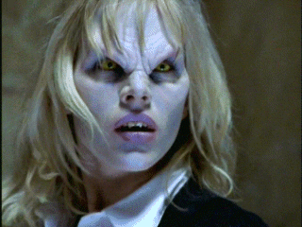
The way that vampires die is specific to Buffy the Vampire Slayer. They turn into dust, clothes and all, because it would be impractical to have Buffy have to clean up every vampire she staked and also, people cannot know that Sunnydale is crawling with vampires. The accompanying sound of the “going poof”, as it is described in the show, is some sort of animalistic scream. “Going poof” is seen below.
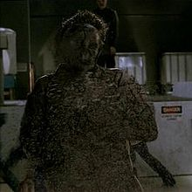
The next episode offers more mythology, not just about vampires. It also tells us that in the Buffy-verse, only villains believe in God, and in fact do their evil in his name. “When Giles lays out the history of the world according to the Buffyverse, he dismissively refers to the biblical story of Genesis as “ popular mythology”. (Foster, 28)
“This world is older than any of you know. Contrary to popular mythology, it did not begin as a paradise. For untold eons, demons walked the earth. They made it their home, their Hell. But in time they lost their purchase on reality, the way it was made for mortal animals, for man. All that remains of the old ones, are vestiges, certain magics, certain creatures.”
And as to how vampires came to be:
“ The books tell the last demon to leave this reality fed off a human, mixed their blood. He was a human form possessed, infected by the demon’s soul. He bit another, and another and so they walked the earth. Feeding. Killing some, mixing their blood with others to make more of their kind. Waiting for their animals to die out and the old ones to return.” (1.2 “The Harvest”)
In season seven of Buffy the Vampire Slayer, the original vampires are introduced: Turok-Han (or über-vamps). They are to vampires what Neanderthals are to humans. They are primordial beings, unthinking killing machines. Whereas the modern vampires are capable of thought and feelings, the Turok-Han simply want to destruct under the command of the First Evil. Unlike the normal vampires, they can enter a residence without an invitation and have no weakness for the cross. They existed before humans and thus have no concept of human life and religion. They are still vulnerable to sunlight and decapitation, as well as staking and holy water, which possibly effective because it was actually blessed by a priest with a ritual, rather than being a symbol of religion, like the cross.
The Turok-Han’s look is similar to that of the Master, also known as Heinrich Joseph Nest, leader of the Order of Aurelius, who worship the Old Ones, and referred to as King of the Vampires. He has lived past “the curse” of human features, which makes him resemble a Turok-Han, or Count Orlok from Nosferatu, more than an ordinary vampire. Like Dracula, he possesses the ability to hypnotise his victims. It is unknown how old he actually was, but he is generally considered the oldest vampire in his time. 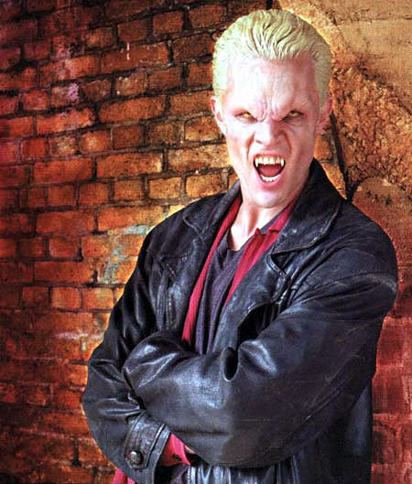
an ordinary vampire’s face (Spike)
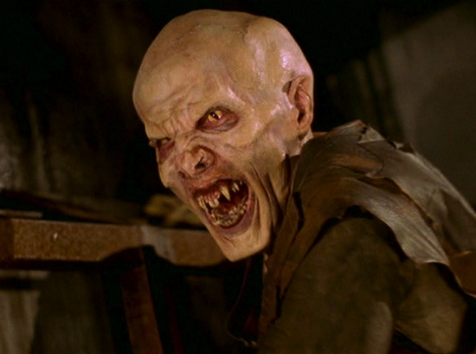 A Turok-Han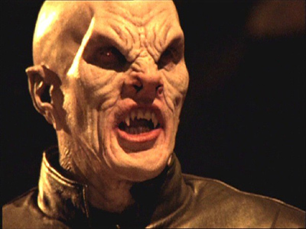 The Master
The vampires in Buffy the Vampire Slayer are seen as parasites, as is made clear for a dialogue in the season two episode “Lie to Me”. Buffy’s old friend wants to be a vampire, as he is dying of a brain tumor. “I’m in. I will become immortal.”
Buffy responds: “Well, I’ve got a news flash for you, brain trust. That’s not how it works. You die, and a demon sets up shop in your old house, and it walks, and it talks, and it remembers your life, but it’s not you.” (2.7 “Lie to Me”) Rickels confirms that the view of vampires as parasites is a common one: “By the eighteenth century vampirism had become synonymous with contagious disease. Circulation was the newly discovered order of the day. With it came notions of contagion and quarantine that would in time set up passport controls between states but led right away to the more to segregate what was dead from the living.”( Rickels, 18)
Onto the second modern vampire tale: The Vampire Diaries‘ entire premise is based on the concept of two vampire brothers loving the same girl, twice. Elena Gilbert is a normal high school teenager who lost her parents in a car crash the previous year. She has detached herself from the world; broken up with her boyfriend Matt Donavan and quit being a cheerleader. On the first day back at school after summer break, she meets the mysterious Stefan Salvatore, who has just moved to Mystic Falls to live with his uncle Zach at the Boarding House. It is immediately obvious that Stefan is a tortured, old soul, which is attractive to Elena because she at the moment is not her bright and bubbly self. They both write about their life in their diaries, as the title of the show suggests.
After hanging out with Stefan for a while, Elena starts noticing that Stefan is stronger and faster than most people and heals incredibly fast. An older man in town recognises him from fifty years ago and his name appears on the list of the founders of Mystic Falls. Strange murders start taking place and she meets Damon Salvatore, Stefan’s older, charismatic but sketchy brother. The audience is shown that he feeds on Caroline, one of Elena’s best friends, by Compelling her to let him drink from her and spy on Elena and Stefan for him. What Damon is doing to Caroline has serious implications; he is essentially raping her, both physically and mentally, without her knowledge. After Caroline becomes a vampire, she regains the memories that were hidden by the Compulsion and she confronts Damon about his actions. Damon’s behaviour is a good example of how vampires continue to be viewed as sexual deviants and corruptors of good.
Elena finds out that both brothers are vampires and used to live in Mystic Falls in its founder-days. She gradually accepts this, but after sleeping with Stefan for the first time, discovers a picture of herself, dressed in the style of the 1800s. The woman in the photograph is Katherine, Damon and Stefan’s sire. Damon is in Mystic Falls to open the tomb, where all of Mystic Falls’ vampires were put to die in 1864, so that he can get Katherine out, but they discover that she has been alive all along.
In 1864, Katherine used to fool around with both Salvatore brothers and is actually the main reason for their conflict. Once Damon starts falling in love with Elena as well, the relationship with Katherine appears to be happening all over again, except for the fact that Elena loves Stefan only. This, of course, changes over the course of the series, as Damon first has to redeem himself in order to be viewed as a worthy love interest for Elena. Katherine and Elena turn out to be Doppelgangers and are part of a ritual that will release Klaus’ werewolf side, making him the first hybrid.
Klaus is part of a family of original vampires, turned by a spell, but his mother cursed his werewolf side to be dormant so that his father would not find out Klaus was not his son. The Originals are vulnerable only to the White Oak stake, but can be kept dormant by covering a dagger in the ash of the White Oak tree and plunging that into their heart. They are faster and stronger than other vampires, partly because of their age and partly because they were the first vampires. They also have the power to Compel other vampires. Klaus’s blood, as a hybrid, can cure a werewolf bite, which is fatal to vampires. When one of the Originals is killed, it is revealed that killing an Original means killing their entire bloodline: every vampire an Original Sired, as well as the vampires they have Sired. Without knowing which Original Sired them (all of the Mystic Falls vampires stem from the same vampire: Katherine) they cannot kill any of them. They eventually figure out it is Klaus that Sired them and he thus turns into their undefeatable enemy.
The idea of balance is an important theme in The Vampire Diaries, as seen when a witch loses her powers when she has been turned, and too much magic exhausts the teenage witch Bonnie, giving her nosebleeds or causing her to faint. Klaus turning into a hybrid upset that balance. The balance is also seen in the case of life and death. In order for Elena to survive the ritual, someone of her blood must die- in this case, her biological father offered himself up for the life of his daughter. In the season four finale, Bonnie successfully brought back Jeremy from the dead for the second time- but she died in his place.
The Vampire Diaries replaces the concept of a soul with that of a humanity switch. Vampires can “switch” their humanity on and off, if they are still young vampires, as Rose explains:“It’s a lie you know. There’s no switch you can turn off. Sure, when you’re a newbie. But after a couple of hundred years you just have to pretend.”
(2.9 “Katerina”) With the switch off, they feel no emotions and turn into evil, sadistic killing machines. Particularly Stefan suffers from this humanity switch, as he feels incredibly guilty for everything he has done while his switch was off. He is incapable of drinking human blood without becoming addicted to it and turning into the “Ripper”, as Klaus lovingly calls this alter-ego.
Vampires in The Vampire Diaries die differently from Buffy the Vampire Slayer, instead of turning to dust, they desiccate until they are completely dead, as shown in the picture below.
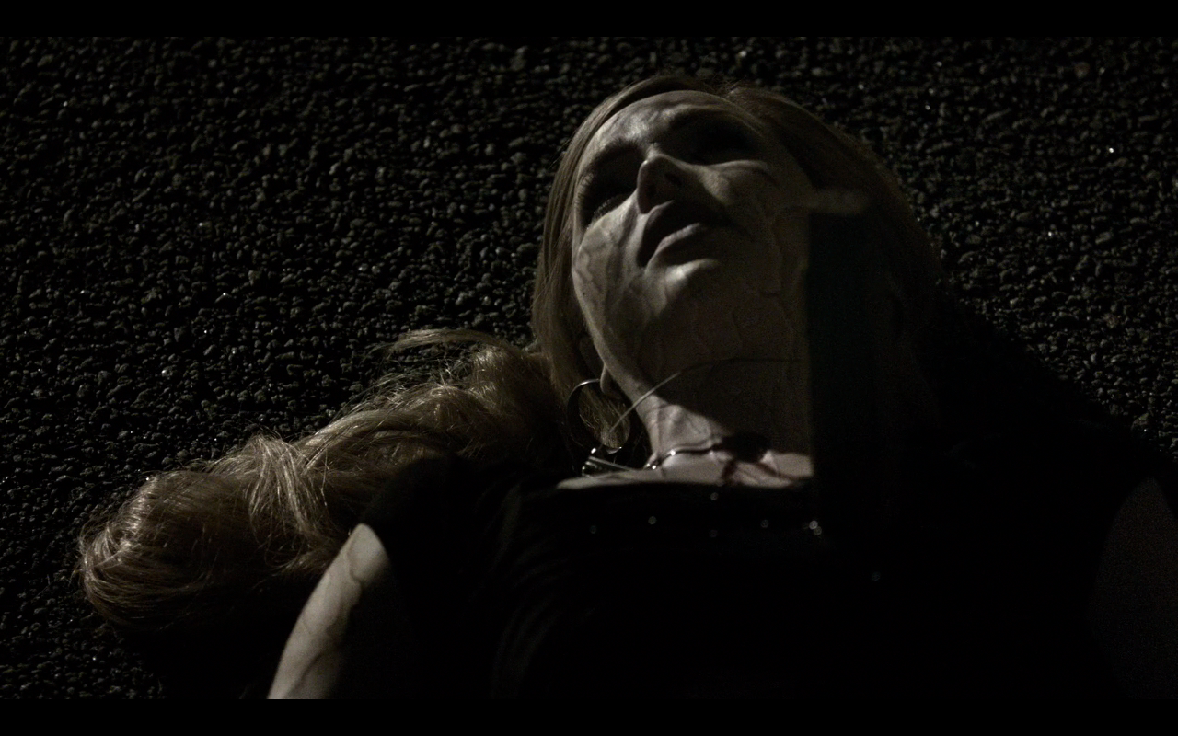
They are vulnerable to the same killing methods as in Buffy the Vampire Slayer: decapitation, staking, sunlight and fire. The Vampire Diaries does not make use of crosses, holy water or garlic and adds a method of killing vampires: ripping out the heart.
The physiology of vampires in The Vampire Diaries is also different: they breathe and have a heartbeat, adding to their human-like appearance and thus acceptance into society. Their “vamp-face” involves blood red eyes, with dark veins around their eyes and protruding fangs. The rest of their face, or teeth, does not change as it does in Buffy the Vampire Slayer. The Vampire Diaries’ vampires are thus a lot more human and less the stuff of myths than they are in Buffy the Vampire Slayer. At heart, The Vampire Diaries is a love-story that just happens to have vampires and other supernatural creatures in it. The vampires are meant to be seen as potential love-interests and thus have to look very pretty, both in vamp-face and normal-face. As is usual with American teen-oriented television, all of their actors are conventionally beautiful or handsome. This could also be because The Twilight Saga heavily influenced the show, which was at its most popular when The Vampire Diaries started airing.
Below are pictures of Damon in vamp-face and Klaus in his hybric-vamp-face. 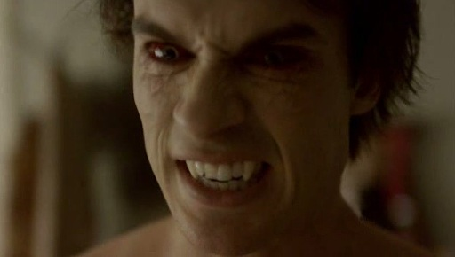
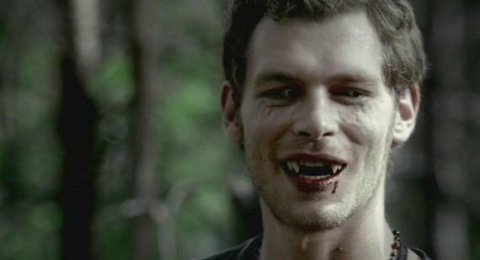
Klaus’s hybrid vamp-face shows some clear differences from that of an ordinary vampire’s: his eyes are yellow, rather than red, and he has four protruding fangs, instead of the usual two.
True Blood revolves around a special human girl named Sookie Stackhouse, a chipper, blonde, telepathic waitress in Bon Temps, a fictional town in north-western Louisiana. She is later revealed to be half-faerie, which is where she gets her telepathy from. Unlike in the other fictions, the regular people of the world are aware of the existence of vampires, as they “came out of the coffin” (1.1 “Strange Love”) two years prior to the start of the show, when Japanese scientists created a synthetic substitute for blood called “Tru Blood.” This has made the vampires split into two groups: those who wish to go “mainstream” and feed on “Tru Blood” and argue for equal rights for vampires, and those who feel vampires cannot co-exist peacefully with humans and see them as food, as their vampire instinct, as well as the Vampire Bible, tells them. The blood of vampires has the ability to heal humans and also works as a powerful drug. The story later introduces other supernatural creatures such as shape shifters, werewolves, witches, fairies and a maenad. There are several love triangles going on in the show, which change per season, always involving Sookie and a supernatural creature.
Besides the love story, the show also addresses several contemporary issues such as equal rights, discrimination, violence against minorities and homosexuals, drug addiction as well as the power of religion and the media. The vampires in this particular story are a more obvious metaphor for what is currently happening in the United States with regards towards gay marriage and equal rights for men and women and discrimination of minorities. The vampires are often spoken about with fear, disgust and misunderstanding and are called “unnatural”. The vampires are vulnerable to the sun, decapitation and staking and need to be invited into a residence. As said, their blood has healing properties as well as being a drug for humans. Unlike other vampires, they are also vulnerable to silver, which burns them and can render them unable to move. There is no mention of a soul or some other kind of restraint on a vampire’s natural instincts and they appear to make the decision to go “mainstream” for a variety of reasons. Their vamp-face consists simply of protruding fangs, which they snap in and out of their gums with ease. When they cry, blood runs out of their tear ducts, instead of tears, which makes for a ghastly image. Like in Buffy the Vampire Slayer, a vampire explodes when he dies, but not in dust. Instead, they explode in a gooey mass of blood and organs. When they meet the sun, they simply burn up. Both deaths , referred to as the True Death, are seen below.

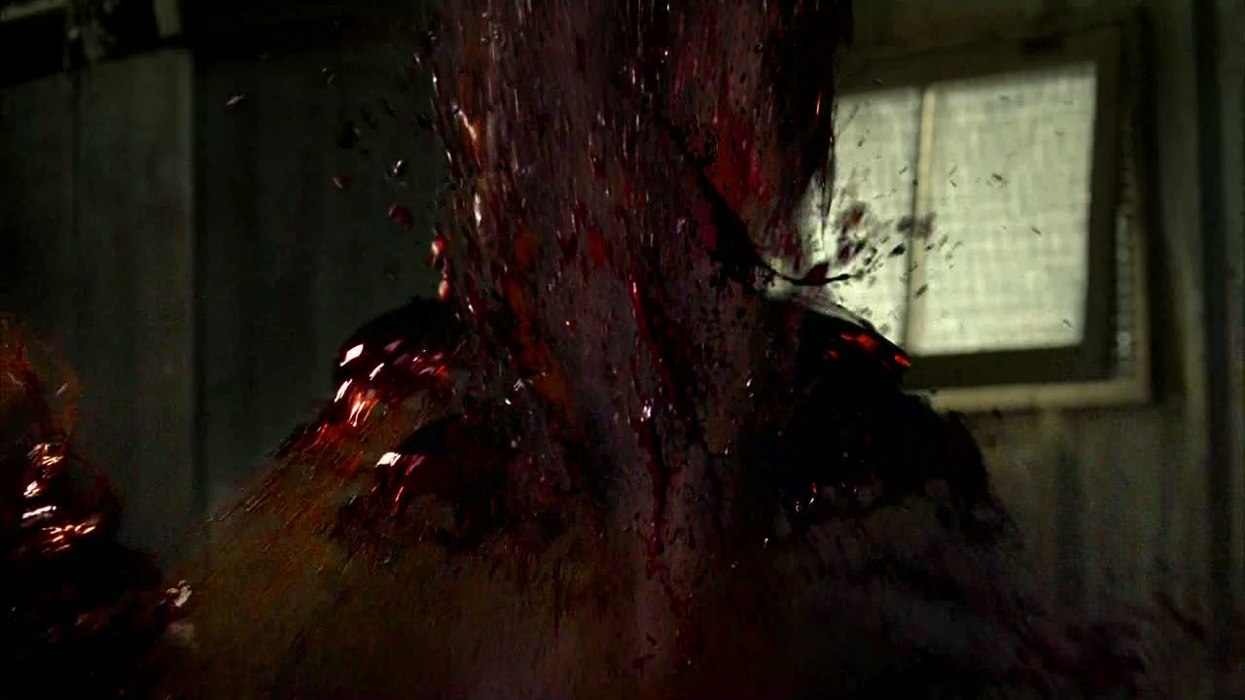
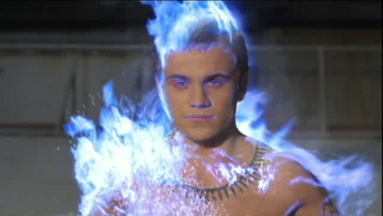
Eric’s maker Godric meeting the sun.

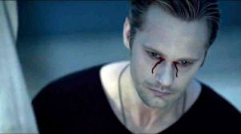
Tears of a vampire in True Blood.
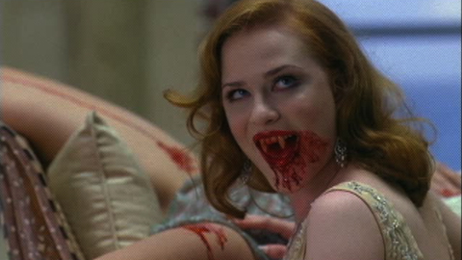
Fangs in True Blood.

Show/Film | Fangs | Eyes | Face | Vulnerabilities | Other features
Buffy the Vampire Slayer | Fangs protrude in canine position | Yellow | Ridged and dipped brow, shortened nose (bat-like) | The sun unless wearing the Gem of Amara, which renders the vampire wearing it invulnerable to the sun as well as other methods of killing.  The cross, stake, holy water and decapitation. | Increased strength, speed. Invisible in the mirror.  Do not require oxygen. Body heat is at room temperature.  No soul, but capable of feelings.
The Vampire Diaries | Fangs protrude from the canine position. | Blood red. | Dark veins protruding from eyes towards the cheeks. | The sun unless wearing a Daylight ring/bracelet/necklace which can be made by a witch with a lapis lazuli stone.  Stake, decapitation, removal of the heart.  Werewolf venom.  The herb vervain weakens them considerably. | Increased strength, incredible speed. Visible in mirrors. Breathe and have a heartbeat. Body heat at room temperature, warm up with coffee.  Increased emotions/ humanity switch.
True Blood | Fangs protrude in the lateral incisor position | Normal | Normal | The sun, unless high on faerie-blood.  Silver, stake and decapitation. | Increased strength, incredible speed. Visible in mirrors. Can fly.
The Twilight Saga | No fangs (their teeth are strong enough on their own) | Red if they drink human blood, amber after having fed on animals, normal when hungry | Normal. | Decapitation, ripping apart and fire. | Increased strength and speed. Special powers: reading minds, having visions, increased empathy. Skin is hard like marble.
Let the right one in | Does not show fangs, but does show puncture marks made by fangs | Normal | Normal, but transforms into an older, warped face | The sun, burst into flames almost immediately. | Can enter a residence without an invitation, but will start bleeding from every orifice and the pores. Increased strength and speed.

Chapter 3: Comparing the original and the new: characterisation, metaphor and myth
As the vampire jumps medium from novel to film, his characterisation changes. The monstrous Dracula transforms into a handsome Angel, Stefan or Bill. Along with the vampire’s physical and mental transformation, there is a change in their mythology and the way vampires are used as a metaphor for current social issues. The vampires in True Blood have taken over the role of minorities such as homosexuals and ethnic minorities in the United States today. They fight for their right to marry, for example, which is eventually granted in some states. This chapter will explore the differences between the classic vampire and the modern vampire by looking at characterisation, metaphor and myth.
Dracula, as portrayed in the novel and its various adaptations, is a horrible creature. His description, whether in his old or young form, make him seem intimidating and dangerous, and ultimately Other:
“ a tall, thin man, with a beaky nose and black moustache and pointed beard, […] His face was not a good face; it was hard, and cruel, and sensual, and his big white teeth, that looked all the whiter because his lips were so red, were pointed like an animal’s.” (Stoker, 207)
It is clear that the Count is a peculiar man, despite all of his charms. Unlike in the 1992 film adaptation by Francis Ford Coppola, he does not attempt to get to know Mina, in order to seduce her. Instead, he first turns her best friend Lucy into a vampire and then attacks her and Jonathan at night. He makes Mina drink his blood, making her, as she says: “Unclean! Unclean! Even the Almighty shuns my polluted flesh!”(Stoker, 353) after Van Helsing places a piece of Sacred Wafer on her forehead to guard her and it burns into her skin. In Dracula, the vampire is clearly immoral in the eyes of Christianity and a product of the devil. The line between good, Van Helsing and his men, and evil, Dracula, is clear and represented in what both sides embody.
Van Helsing is a scientist, a “philosopher and a metaphysician, an one of the most advanced scientists of his day; and he has, I believe, an absolutely open mind.” (Stoker, 137) He embraces the unknown as well as the new. Dracula, on the other hand, is old-fashioned and a part of the Old World. Furthermore, he has renounced God and God has renounced him back. “But by this time the Professor had gained his feet, and was holding towards him the envelope which contained the Sacred Wafer. The Count suddenly stopped, just as poor Lucy had done outside the tomb, and cowered back. Further and further back he cowered, as we, lifting our crucifixes, advanced.” (Stoker, 336) Symbols of Christianity have the power to subdue Dracula, making him an evil beast, because God does not accept him.
Christian symbols continue to be used in popular vampire myth, as well as the aversion to garlic. Despite the non-Christian moral outlook in the Buffyverse, vampires still have a weakness for the cross and holy water- although the cross sometimes varies in its effects. In one scene in season seven, Spike drapes himself over a cross in a church, burning himself on purpose, asking: “ Can we rest now? Buffy, can we rest?” (7.2 “Beneath You”) The viewer discovers Spike has won his soul back and is feeling so guilty that he can bring himself to touch a cross on purpose, creating the powerful image seen on the next page. It burns him, similar to how the soul inside him burns. “They put the spark in me…And now all it does is burn.” (7.2 “Beneath You”)
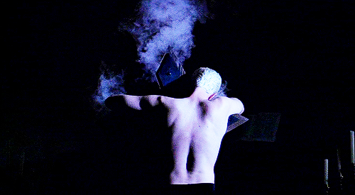
It seems that Spike, in general, diffuses most of the vampire’s myths. He eats and drinks like a human being, taking great pleasure in the Bronx’s fried union flowers and a good bottle of whiskey. Dracula, on the other hand, is never seen eating by Jonathan: “Even friend Jonathan, who lived with him for weeks, did never see him eat, never!” (Stoker, 286) Dracula has more particularities than the modern vampire: he can control the elements, change into and command “ all the meaner things: the rat and the owl, and the bat- the moth and the fox, and the wolf” (Stoker, 283) The pilot episode of The Vampire Diaries has Damon transformed as a crow and sending a bank of mist over the cemetery, but this is never seen again. The Dracula we see in the Buffyverse is capable of such feats, as he is no ordinary vampire, but he is terribly old-fashioned, like the original Dracula, and eventually Buffy is able to slay him. It seems that, in order to survive, the vampire has had to lose some of its mythical elements.
When Buffy first meets Dracula, she is surprised to find out he is real. “ I am Dracula,” he says, with great flair. “ Get out!” Buffy exclaims (5.1 “Buffy v.s Dracula”) Dracula starts out as what we have seen in the novel and the film adaptations: tall, dark and handsome. He has a big forehead, a beaky nose and bushy eyebrows. His eyes are described as “ penetrating” and he is revealed to be able to control and read minds. He differs from ordinary vampires in his special powers, such as emerging from a cloud of mist and being able to disappear the same way, transforming into a bat and a wolf and he makes Xander his bug-eating minion, like Renfield in the novel. His looks are also different from the ordinary vampire: he wears a long black cloak with a red lining, his nails are long and pointy like claws, his eyes are bright blue and his fangs appear to be longer than a normal vampire’s. This is also evident in his bite-mark: whereas Angel’s scar resembles that of an entire row of teeth, Dracula leaves two neat puncture marks behind, as the picture below shows.
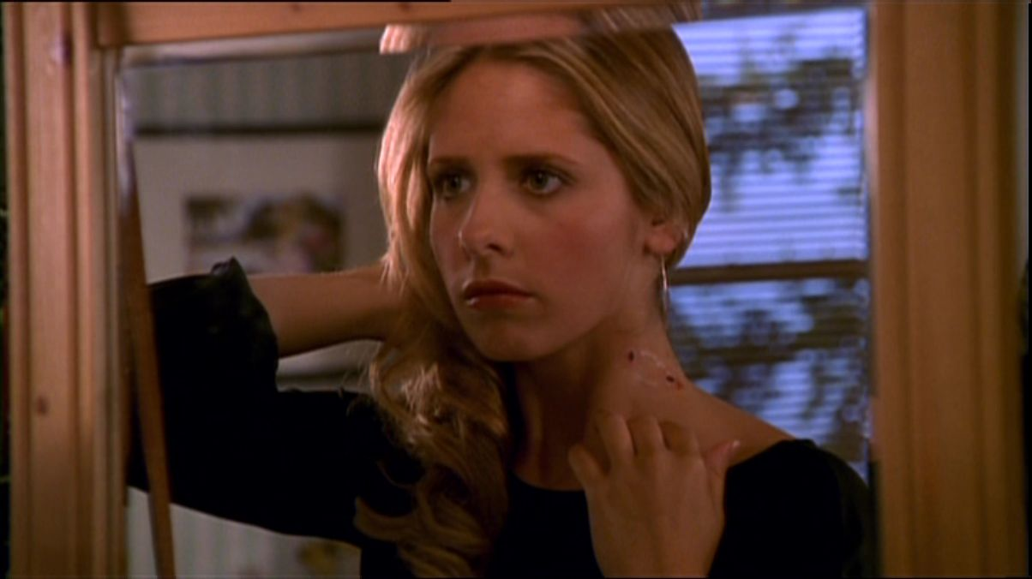
After Buffy’s encounters with Dracula, the Scooby Gang is rightfully shaken and concerned. As Giles puts it: “The trick in defeating him lies in separating the fact from the fiction.” The fiction, as we know it from the novel, is what Dracula created himself, according to Spike, who knew Dracula before he got famous. Buffy’s Dracula is given the role of truth-teller. He informs her that her power “is rooted in darkness”
(5.1 “Buffy v.s Dracula”) Buffy, in turn, informs him that “a guy like you should think about going electric. Seriously.” (5.1 “Buffy v.s Dracula) after she nearly hits him with a lit torch.
The relationship with technology is the next change in vampires in today’s vampire fiction. Dracula was designed as a metaphor for the changing world during the Industrial Revolution, after items such as typewriters and the gramophone and electricity were invented. Dracula remained behind in Eastern Europe, in his stately but dilapidated castle. The modern vampire, however, embraces technology. Spike uses a computer to track down Buffy’s dorm room in season four, and has managed to hook up a television in a crypt, on which he watches the soap Passions, and a vampire in True Blood boasts about how fast he can text. In The Vampire Diaries, the modern vampires attend high school and blend in with normal society because of their Daylight rings, but the vampires from 1864 did have problems with new technology. John Gilbert, an inventor, fashioned a vampire-detector out of a pocket-watch, which is what ultimately led to nearly all of the vampires in Mystic Falls in 1864 to be trapped in the church. After they were released from the tomb, however, they quickly adapted to a modern way of life, using cell phones and a remote control without much difficulty. The majority of modern vampire fiction, thus, has no problem with modern technology. Technology is everywhere these days, so vampires as a metaphor for the sense of technology is no longer as relevant as it was in Dracula. What does remain, however, is the view of the vampire as the Other.
Vampires as a metaphor for the Other in society is a theme most obviously present in True Blood, where vampire sympathisers are called “Fangbangers” and the first season shows a serial killer going after women who have slept with vampires, reflective of racial murders and gay bashing. The show has vampires go into discussion with Christian politicians and preachers on news programmes, often using real-life hosts, advocating for vampire rights, as is happening in real life with people advocating for gay marriage and equal rights for women and ethnic minorities. The show points out these analogies quite obviously in the pun “coming out of the coffin” (1.1 “Strange Love”) Despite the metaphor, the show also addresses homophobia and racism more directly; sassy fry-cook/ drugs dealer/ prostitute Lafayette is both black, gay and a cross-dresser and at one point has to deal with some homophobic customers sending his burger back because “the burger might have aids” (1.5 “Sparks Fly Out”)
The show’s main movement against vampires is a church called “Fellowship of the Sun”, where people are trained to kill vampires, justifying their actions with Bible scriptures. At one point, a suicide bomber sent by “The Fellowship of the Sun” attacks a vampire meeting and blows himself up, covered in silver. Many vampires die or are harmed significantly in the attack, along with the human companions of some of the vampires. Suicide bombing is something we see in the news fairly regularly, mostly with Islamic extremists.
Addiction is a new element in vampire fiction. As the focus shifts from the human perspective towards the perspective of the vampire, or at least to one sympathetic towards vampires, social issues besides seduction and corruption may be addressed. As addiction is a very real and very prevalent affliction in today’s consumption society, it is no wonder it features in modern vampire fiction. One obvious case is True Blood , where a vampire’s blood has healing properties and can also give humans a powerful high. Jason Stackhouse, Sookie’s oblivious and somewhat idiotic brother, turns to “V”, short for vampire blood, in order to be able to perform better sexually. He accidently downs an entire vial and develops an addiction for “V”, which causes him to kidnap a vampire with his new girlfriend Amy, so that they have a steady supply of blood. The topic of addiction is also dealt with in The Vampire Diaries with Stefan, who regularly falls off the bandwagon when it comes to drinking human blood. He is unable to control his bloodlust because he usually drinks animal blood, so when he is forced to drink Elena’s blood, he becomes addicted again. He steals blood bags from the hospital and hides his destructive behaviour from his friends, who have to dose him with vervain and lock him up in order to wean him off of the human blood: essentially vampire rehab.
As said in the previous chapter, the modern vampire has become more assimilated to humans, both in looks and personality. After Buffy the Vampire Slayer, vampires lost most of their demonic visage and inherent evilness. The Vampire Diaries at least has changing eyes and fangs, but their vamp-face looks remarkably pretty compared to that of Buffy the Vampire Slayer, and their characters are only considered evil when they have their humanity switch off. True Blood’s vampires are left only with fangs and are so assimilated in the human society that they have actually come out and are trying to integrate into that society by petitioning for vampire marriage and by opening vampire-owned businesses. The Twilight Saga has changed the mythology of the vampire (among other supernatural beings) so much that their vampires do not remotely resemble Dracula anymore; lacking fangs and sparkling in the sunlight is one of the most critiqued features of The Twilight Saga’s vampires.
All of these changes in vampire fiction are due to the romantic view literature has given us. Vampire fiction is no longer purely about the mystery of the vampire; it is a case of been there, done that. Readers and viewers are familiar with the vampire and usually want to see the impossible love story between a human girl and a vampire boy, essentially a rewriting of the classic Romeo & Juliet story. In today’s society, the vampire has become common, a fictional creature seen so many often that it has to get its attraction elsewhere; namely the interaction with our own species.

Chapter 4: The Female Character in the Original and the New Vampire Stories
One aspect of fiction is that it often reflects the time in which it was written. Even in the year 2013, strong, well-written female characters are a rarity, seemingly even more so in vampire fiction. Dracula was told in the form of letters and diary entries, mostly in the male perspective. Mina and Lucy, the two main female characters, are essentially faceless instruments for the male voice. The male vampire then literally weakens them even more, both mentally and physically. This is true for female vampires and female characters in vampire fiction in general, as I will show in this chapter.
Most modern vampire fiction is directed at teenage girls, so most of the fiction is written from the perspective of a teenage girl. As Backstein explains: “They are female-centered narratives that strive for audience identification with the heroine- with her strength, her extraordinary capabilities, her status as an object of desire, or a combination of all these traits.” (Backstein, 38) The problem with female characters is pointed out quite clearly: “an object of desire”. Women are still seen as objects, existing purely for male entertainment. Most of the girls narrating the vampire fiction are faceless, voiceless and superficial, as is the case in the novels of The Vampire Diaries. The Elena in the novel is incredibly arrogant, yet sweet, incredibly pretty, and yet insecure and everyone seems to love her immediately. Luckily, the television series gave Elena a better personality; she has her own opinion and states it, yet she still relies on the men to do the battle for her, until she has been made a vampire, contrasting strongly with the independent, survivalist vampire Katherine. Becoming a vampire often improves the lives of the female characters; they become strong, independent people, as in the case of Caroline, Katherine, Elena, Darla and Jessica. Unfortunately, becoming a vampire also means that the characters become hypersexual creatures.

Vampirism and sexuality are naturally entwined because of the first principle of vampirism: in order to survive, the vampire must feed on humans by sucking their blood. Both the act of sucking and blood-drawing have sexual implications. Sex, at its most basic, is about sharing bodily fluids; with heterosexual sex, sperm enters the vagina, which also releases its own liquids. The sucking of blood can reflect the act of fellatio, as it also involves taking in bodily fluids through the mouth, and sperm, like blood, contains life. All of these sexual elements of the vampire seem to reflect the female role (if we are excluding homosexual sex) of sexual intercourse and as such it comes as no surprise that female characters in vampire fiction, whether vampire or not (yet, it nearly always appears inevitable) are divided into either being hypersexual and overtly virginal.
The idea of women being sexually deviant creatures stems from the early ideas about female sexuality. Women were considered to have more interest in sex than men, who were able to think with their heads instead of their reproductive organs, because women have a womb, which made them into wanton sex-slaves. Men were seen as the bringers of sanity through the act of sex; it was believed that menstrual blood pooled around the heart, which could only be relieved by having sex. The womb, as mentioned above, was responsible for all sorts of undesirable behaviour, which is where the term ‘hysteria’ comes from. The Greek word for womb was ‘hystera’ and Greco-Roman medical writers believed that hysteria was caused by violent movements of the womb- the so-called “Wandering Womb” and thus pertained solely to women. (www.hsl.virginia.edu) Slightly later on, with the circulation of the Bible, women were again deemed unequal and subservient to men. Eve, the first woman in the New Testament, born from Adam’s rib, caused her and Adam to be thrown out of Eden by listening to the snake and eating the forbidden fruit. All women were seen as “daughters of Eve” and thus deviant by nature.
The intense sexuality and insanity ascribed to women is heavily personified in the character of Drusilla in Buffy the Vampire Slayer, despite the fact that Joss Whedon is a self-proclaimed feminist. Drusilla represents both the sexual deviant and the virgin; as a human, Drusilla was a devout believer, her religious zeal amplified by her visions, which society deemed evil. Angelus, who took deep pleasure in mental and physical torture, murdered Drusilla’s entire family, torturing her into insanity. To escape him, she fled to a convent, but on the day she was to take her Holy Orders- becoming a bride of Christ- Angelus turned her into a vampire, a creature of pure evil. Her insanity, her visions and powers of hypnosis are what make her a dangerous vampire. In the season two episode “Halloween”, Drusilla has a vision of a spell coming over Sunnydale’s Halloween-ers: “Everything is switching. Outside to inside. She [Buffy] will be weak.” (2.6 “Halloween”)
Due to her insanity, Drusilla often seems childlike, especially in the first few episodes when she is physically weak. She has a collection of porcelain dolls that she speaks to, as seen in the episode “School Hard”, when she is scolding one her dolls, who is not allowed to watch her feed on a girl: “You see, Miss Edith, if you’d been good you could’ve watched with the rest”. (2.3 “School Hard”) She calls her Sire Angel “Daddy” in a deeply perverse way, as she also has sex with him, and her Grandsire Darla “Grandmummy” and is very dependent on them, a role Spike fulfils after they split from Angel and Darla. When the viewer is first introduced to Spike and Drusilla, she is wearing a long white dress, accompanied by eerie, twinkling music playing on the background, contrasting sharply with Spike’s Billy Idol look. Her childishness is set off by her hyper sexuality. In one scene of “School Hard”, Drusilla slices open Spike’s face with her nail and then licks the blood off his cheek. When she first meets the human William, she rubs her belly and starts winding her hips against the air in some sort of sensual dance. (5.7 “Fool For Love”) She appears to be quite sweet to the nervous William, up until the moment she turns into a monster and bites him. This change happens quite often in the Buffy-verse, as we have already seen in the pilot’s opening scene with Darla.
Darla, both as a human and a vampire, is another good example of the sexualised female character in vampire fiction. When the viewer is introduced to her in the pilot, she is wearing a catholic school uniform, accompanied by her sweet voice, she seems quite the innocent virgin, making it quite a shock when she is revealed to be a monster. In flashback episodes, like “Fool For Love”, the viewer learns Darla’s back-story. Darla was born in the late sixteenth century in the British Isles and emigrates to the Virginia Colony as a young prostitute. Darla is not her real name, given to her by the Master instead and the viewer is never given it, as Darla has forgotten it over time. The name is short for Darlene, derived from the word “darling” or “dear one”, and it certainly fits her sugary voice and personality and the affection the Master shows for her. (www.behindthename.com) As a prostitute, and one dying of syphilis at that, Darla is certainly hypersexual as a human, which only amplifies once she was turned by the Master, who ironically visited her in the disguise of a priest.
As a vampire, Darla uses her feminine charms to attract men, as she did Angel, so that she can suck their blood. Darla’s Siring of Angel is shown in “Becoming, Pt.1”, the season two finale. Angel is drunkenly stumbling into an alley, where Darla is waiting for him, dressed to the nines as always. He comes onto her and she is deceptively coy. She promises to show Angel the world, things that he has never seen or heard of. “Close your eyes”, (2.21 “Becoming, Pt.1”) she says, and once he obeys, she is in vamp-face, biting his neck. She brings him down to his knees and scratches right above her breasts, from which he sucks her blood. Her Siring of Angel is heavily sexual and through many other flashbacks we see bits and pieces of her journey with Angelus, Drusilla and Spike, including her sexual escapades, which include threesomes with Angel and Drusilla.
The sexuality of these two vampires is in contrast with Buffy, the protagonist. At sixteen, she is a virgin, inexperienced at both dating and sex. When she and Angel sleep together on her birthday, he loses his soul. As Joss Whedon says in his audio commentary of “Innocence”: “What we basically wanted to show was a horror movie version of the idea of ‘I sleep with my boyfriend and now he doesn’t call me and also he’s killing hookers in alleys’”(Joss Whedon audio commentary on 2.16 “Innocence”) What he is essentially doing, however, is punishing the girl for having sex, which was exactly what he did not want when he created the series. “The blonde girl in the alley who was attacked and killed- she always had sex and was punished for it. I thought that wasn’t fair.”(Joss Whedon audio commentary on 2.16 “Innocence”) However, Buffy is in high school and the issue of sex had to come up some time. He reflects on the decision to punish Buffy, saying that what she and Angel did was not bad, but this was a horror show and in horror, people get punished for everything they do. By making that punishment emotional, Whedon defends, was that it let her “grow from it, let her be stronger, let it resonate on a stronger emotional level.” (Joss Whedon audio commentary on 2.16 “Innocence”) Still, Buffy is continuously punished for having sex. In college, she has a fling with Parker Abrams, who pretended to be kind and vulnerable so that he could get her into bed. She sleeps with Riley Finn and sets off a group of poltergeists, nearly killing them. Buffy’s sexual relationship is borderline dysfunctional, as she uses him purely for sexual pleasure and is abusive of him before, during and after sex. After she breaks it off, he tries to rape her to show her that she does love him. In short, for Buffy sex equals bad.
Let the Right One In is one of very few vampire fictions that show a prepubescent vampire and one who appears to be a girl, as well. For most of the film, Eli is dependent and child-like and has nothing sexual about her at all. However, on closer inspection, Eli does have sexuality. She lives with a man named Hakan, who she refers to as her father, but what remains fairly implicit in the film is that he is actually a pedophile, killing people for her so that she does not have to do it herself, in exchange for letting him touch her. He takes care of her and in return she must take care of him. It is a highly dysfunctional relationship and when she kills him, she shows no remorse.
The film does not explicitly state how old Eli actually is, only that she has been twelve “for a long time” (Let the Right One In) Her relationship with Oskar, while seemingly innocent, has a darker undertone. Someone who has been twelve for perhaps decades has a different mindset from someone who actually is only twelve years old. We see this when she crawls into bed with him; his childlike request that they go steady is met with her questions about what them going steady will entail. Only when he assures her that nothing will change, does she consent. Eli continuously hints that she may not be a girl; the audience assumes she means that she is a vampire. What Eli actually means is that she is a castrated boy, revealed when Oskar spies on her when she is changing into his mother’s dress. A shot of her genitals shows a mangled scar, but Oskar looks away so quickly that it does not register completely with the audience, or Oskar himself. Implicitly, even a young vampire has sexual connotations.
As seen from the given examples, of which there are many more, the vampire and the female character are still heavily sexualised, making the female characters into either saints or sinners. The attitude reflects the one that modern Western society still has of the female in connection with sex. If a girl does not have sex, she is a prude. If she does have sex, she is a slut and is punished for her behaviour. Before we see a change in female fictional characters, there needs to be a change in how society in general views women: looking at current United States politics, things are not going very well.

From Dracula to Buffy: Conclusion.
Having discussed the vampire in history, the classic vampire Dracula and his modern descendants, what can be concluded about the changes the vampire has gone through? He has transformed from a hideous monster shunned by God to an attractive, mysterious hero welcomed by society. His role is no longer to be the hunter, the outsider of society; representing what society fears at the moment. The vampire instead has become a highly desirable love-interest, with many teenage girls swooning and wanting to be bitten by their favourite onscreen vampire. In order to become a love interest, the vampire has had to change his ways, regretting his evil past and on the road to redemption. He has lost most of his demonic visage and most of his extraordinary powers. In short, he has become more human.
Some aspects of the vampire have remained the same; the creature is still used to comment on current social issues, such as homosexuality, equal rights and discrimination. True Blood in particular uses the vampire to reflect current United States politics, by inviting real news-programme hosts on the show and having them go into discussions they often do in real life, between vampires and humans. Vampires are advocating for the right to marry and are opening their own business all over America. Violence against minority groups is also portrayed, by having humans kidnap and torture vampires. The Vampire Diaries addresses the issue of addiction, as Stefan is unable to control his bloodlust, which makes him go on horrific, fatal benders.
One issue that the vampire fiction mostly fails to address is the inequality of women. Female characters, whether vampire or human, are split into virgins and sexual deviants, punished for having sex. The female vampires are turned into hypersexual objects of desire, by having their modus operandi be seduction followed by murder. Even the prepubescent vampire Eli in Let the Right One In shows implicit sexual elements. If literature reflects society, than society still has a very objectifying view of women, even in 2013.
The most notable change, then, is how vampires have shifted from being viewed as subhuman, to being assimilated to humans. They look more human, even in their vamp-face, and are much more in touch with human society: they are perfectly capable of using technology and usually have human lovers. Most people no longer believe that vampires are real, so it has become safe for the vampire to lose some of its demonic elements, becoming more human in the process.

Works cited:
admin. “Joseph-Morgan-Klaus-vamp” Screen capture. Joseph and Phoebe Tonkin Talk The Shocking Twist. Josephmorgan.org, 29 April 2013. WEB. 28 June 2013.
AngelusB. “Buffy vs Dracula” Screen capture. Buffy Summers. Fanpop.com, over a year ago. WEB. 28 June 2013.
“Becoming, Pt.1” Buffy the Vampire Slayer: The Complete Collection. 20th Century Fox Home Entertainment, 2011. DVD
“Beneath You.” Buffy the Vampire Slayer: The Complete Collection. 20th Century Fox Home Entertainment, 2011. DVD
Beneath You. “Spike on the Cross” www.tumblr.com. N.d. WEB. 28 June 2013.
Blackstein, Karen. “(Un)Safe Sex: Romancing the Vampire.” Cineaste 35.1 (2009): 38-41. Academic Search Elite. Web. 28 June 2013.
Bram Stoker’s Dracula. Dir. Francis Ford Coppola. Perf. Gary Oldman. DVD.
“Buffy v.s Dracula” Buffy the Vampire Slayer: The Complete Collection. 20th Century Fox Home Entertainment, 2011. DVD
Campbell, Mike. “Darla” www.behindthename.com. 1996. WEB. 28 June 2013.
Cheryl, Shanka. “Alexander-Skarsgard-Eric-On-TrueBlood-Crying-Ggnoads.” Screen capture. All About Crying for ‘True Blood’ Season 5. www.bestmoviesevernews.com, 21 May 2012. WEB. 28 June 2013.
Delahaye, Gabe. “evan-rachel-wood.jpg- vampire queen” Screen capture. True Blood: This Show Would be Off the Rails, If It’d Had Any in the First Place. www.videogum.com, 31 August 2009. WEB. 28 June 2013.
“Doppelgangland” Buffy the Vampire Slayer: The Complete Collection. 20th Century Fox Home Entertainment, 2011. DVD
Fanpire. “Godric Meets the Sun” Screen capture. I Will Rise Up- True Blood episode 209. www.fanpirediaries.com , 19 August 2009. WEB. 28 June 2013.
Forster, Greg. “Faith and Plato: ‘You’re Nothing! Disgusting, Murderious Bitch.’” Buffy the Vampire Slayer and Philosophy: Fear and Trembling in Sunnydale. Ed. James B. South. Open Court. Chicago, 2003. PRINT
“Fool For Love” Buffy the Vampire Slayer: The Complete Collection. 20th Century Fox Home Entertainment, 2011. DVD
“Halloween” Buffy the Vampire Slayer: The Complete Collection. 20th Century Fox Home Entertainment, 2011. DVD
Heroine_Tv. “A Closer Look at Darla, Part 1.” Screen capture. Darla. Buffyfest.blogspot.nl, November 28 2009. WEB. 28 June 2013.
“Innocence” Buffy the Vampire Slayer: The Complete Collection. Audio commentary by Joss Whedon. 20th Century Fox Home Entertainment, 2011. DVD
“Katerina” The Vampire Diaries. The CW. 11 November 2009. Television.
Let The Right One In. Dir. Tomas Alfredson. DVD.
“Lie to Me” Buffy the Vampire Slayer: The Complete Collection. 20th Century Fox Home Entertainment, 2011. DVD
Mac0drum, Lee. “Vamped Out Damon.” Screen capture. Head over Heels for a Homicidal Hottie. www.frommysideofthemoon.wordpress.com , 2 May 2010. WEB. 28 June 2013.
mimivilee. “ The Master” Screen capture. www.fanpop.com, over a year ago. WEB. 28 June 2013.
Neil93 “Lexi Staked.png” Screen capture. Season One Body Count. www.vampirediaries.wikia.com , n.d. WEB. 28 June 2009.
n.p. “Phasma/ Empousai.” www.theoi.com. n.d. WEB. 28 June 2013.
n.p “Chersonese.” www.merriam-webster.com. n.d. WEB. 28 June 2013.
n.p “Spike vamp face 3.jpg” Photograph. www.buffy-wikia.com. n.d WEB. 28 June 2013.
n.p “Turok-Han” Screen capture. www.screenused.com, 2001. WEB. 28 June 2013.
n.p “Different Vampire Teeth for Different Movies/ Shows.” Drawing. www.funnyelf.com. n.d. WEB. 28 June 2013.
n.p “True Death: Goo.” Screen capture. Best Vamp Series: True Blood v.s Vampire Diaries; Nr. 7 The True Death. www.worf.dailypix.me , n.d. WEB. 28 June 2009.
n.p “Ancient Gynacology.” www.hsl.virginia.edu, n.d. WEB. 28 June 2009.
n.p “Vampire”. www.oxfordenglishdictionary.com , n.d. WEB. 28 June 2009.
Rickels, Laurence A. The Vampire Lectures. University of Minnesota Press. Minneapolis, 1999. PRINT.
“Sparks Fly Out” True Blood. HBO. 5 October 2008. Television.
Stoker, Bram. Dracula. Penguin Group. London, 1994. PRINT.
“Strange Love” True Blood. HBO. 7 September 2008. Television.
Wilcox, Rhonda. Why Buffy Matters. I.B. Tauris & Co Ltd. London, 2010. PRINT.

VERKLARING: INTELLECTUEEL EIGENDOM
De Universiteit Utrecht definieert het verschijnsel “plagiaat” als volgt:
Van plagiaat is sprake bij het in een scriptie of ander werkstuk gegevens of tekstgedeelten van
anderen overnemen zonder bronvermelding. Onder plagiaat valt onder meer:
het knippen en plakken van tekst van digitale bronnen zoals encyclopedieën of digitale
tijdschriften zonder aanhalingstekens en verwijzing;
het knippen en plakken van teksten van het internet zonder aanhalingstekens en verwijzing;
het overnemen van gedrukt materiaal zoals boeken, tijdschriften of encyclopedieën zonder
aanhalingstekens of verwijzing;
het opnemen van een vertaling van bovengenoemde teksten zonder aanhalingstekens en
verwijzing;
het parafraseren van bovengenoemde teksten zonder verwijzing. Een parafrase mag nooit
bestaan uit louter vervangen van enkele woorden door synoniemen;
het overnemen van beeld-, geluids- of testmateriaal van anderen zonder verwijzing en
zodoende laten doorgaan voor eigen werk;
het overnemen van werk van andere studenten en dit laten doorgaan voor eigen werk. Indien
dit gebeurt met toestemming van de andere student is de laatste medeplichtig aan plagiaat;
ook wanneer in een gezamenlijk werkstuk door een van de auteurs plagiaat wordt gepleegd,
zijn de andere auteurs medeplichtig aan plagiaat, indien zij hadden kunnen of moeten weten
dat de ander plagiaat pleegde;
het indienen van werkstukken die verworven zijn van een commerciële instelling (zoals een
internetsite met uittreksels of papers) of die tegen betaling door iemand anders zijn
geschreven.

Ik heb de bovenstaande definitie van het verschijnsel “plagiaat” zorgvuldig gelezen, en
verklaar hierbij dat ik mij in het aangehechte essay / werkstuk niet schuldig heb gemaakt aan
plagiaat.

Naam: Rowan Verstelle
Studentnummer: 3686183
Plaats: Utrecht
Datum: 28 Juni 2013
Handtekening:

Dracula cannot be seen in mirrors, has sharp teeth, pointy ears, hairy palms, long pointy nails, can climb walls like a lizard, is extremely pale, does not eat normal food and sleeps during the day.
Which has its own sexual and vampiric implications.
Merriam- Webster: “any of several peninsulas: as (1) Jutland; (2) The Malay Peninsula ; (3) Crimea; (4) Gallipoli/ The Thracian Chersonese” (Merriam-Webster- Chersonese)
After murdering a gypsy princess, Angel was cursed by her clan with a soul, which he would only lose once he experienced a moment of pure happiness. Because his soul made him feel so guilty, this moment was almost sure to never come. Buffy, however, was the one thing that made him happy, and after the first time she and Angel slept together, he lost his soul. This was used as a metaphor for teenage boys and men suddenly changing after sex.
Seen in an earlier episode called “The Wish”, where Cordelia made a wish to a Vengeance demon (or Justice demon, as they prefer to call it) that Buffy never came to Sunnydale. As a result, the alternative universe created by that wish is a Sunnydale overrun with vampires, with season one Big Bad the Master still alive and Xander and Willow as his top two vampires. As a result of a spell, Vampire-Willow is transported to the ‘real’ universe.
The script was changed substantially, causing Whedon to resent the project and wanting a do-over where he could write and create it as it was intended: a commentary on the horror film and the dumb Valley girl that always dies. By making the Slayer this tiny blonde teenager, he rejects the image of the weak woman and gives her power instead, kicking the ass of men twice her size.
An ironic image, we later find out, as Darla was prostitute dying of syphilis in the New World when she was human and hated the clergy and religion in general. She was said to have a thing for religious wars, exemplified by her showing up in China during the Boxer Rebellion in 1900.
Staking a Turok-Han is more difficult because of their denser sternums. Holy water causes only minor burns.
I will be using the television series, rather than the books by the same name by L.J Smith, on which it is based, because for once, the adaptation is much better than the original.
Who, it turns out, is more like Stefan’s nephew a dozen times removed.
Explained as animal attacks by the police, who are actually part of a secret society that watches out for vampires and knows how to kill them.
Compelling is similar to Dracula’s thrall: the vampire can control the mind of a human with eye-contact. True Blood calls this “Glamouring”. This mind-control includes erasing memories, but they return if the human is turned into a vampire.
Katherine was the second Doppelganger and had a baby out of wedlock while she was human. Once she learnt what Klaus wanted with her, she fled and turned herself by tricking Rose into giving her blood to heal herself and then committing suicide so that she would die with vampire blood in her system. A Doppelgangers blood is only useful for the ritual and the turning of hybrids as long as that blood is human.
In his bloodlust, Stefan tears his victims apart and in his guilt tries to piece them back together like a horrific puzzle.
Based on The Southern Vampire Mysteries by Charlaine Harris. I will be sticking to the television show, as it is the most popular medium today.
The Vampire Bible says that God created Lilith in his image- a vampire- and created Adam and Eve for her to feed on. Thus, vampires are superior creatures, blessed by God himself. Because of the presence of Lilith, this seems to refer back to the Old Testament, rather than the New Testament.
In Greek mythology, maenads were the female worshippers of Dionysus, driven mad by a constant state of frenzy. Mary-Ann is the maenad on the show and wants to sacrifice shape shifter Sam Merlotte in order to summon her God. She has the power to send the people of Bon Temps into a state of frenzy and ecstasy, from which she appears to gain power.
On the 26th June, DOMA (“Defense of Marriage Act”) was ruled unconstitutional, meaning that gay marriage is now recognised on a federal level and that same-sex married couples receive the same federal marriage benefits that straight couples do. States that recognise same-sex marriage now also recognise same-sex marriage from other States and California has re-legalised gay marriage.
Traditionally the weapon of choice against werewolves, according to most popular fiction.
Liking humans, not wanting to kill or feeling guilty for their past misdeeds.
Riley, Buffy’s boyfriend visits Spike’s crypt to find out more about Dracula. Spike has this to say about the Count: “Dracula? Poncy bugger owes me eleven pounds for one thing. Know him? We’re old rivals. But then, he got famous. Forgot all about his foes. I’ll tell you what, that glory hound has done more harm to vampires than any Slayer. His story gets out, and suddenly, everybody knows how to kill us- the mirror bit!” (5.1 “ Buffy v.s Dracula”)
English does not actually have a word for this liquid.
Shadowing the Seer Cassandra of the Iliad, whose visions nobody believed and who was driven mad in the end.
Referring to the fact that there are many politicians wanting to govern a woman’s body by not allowing abortion, birth-control and saying that there is just a thing as ‘legal rape’.

