The value of palaeoecological tools in
Maya archaeology

2013
Utrecht University
Master Thesis

by
Benjamin van der Veen

supervised by
Timme Donders

Abastract
In this report the value of palaeoecological tools, pollen assemblages and stable oxygen isotope records, in Maya archaeology is examined. A detailed description is given of several of the most detailed palaeoecological records. These records were retrieved from lakes in the Maya lowlands, and shed light on what role environmental change had on the collapse of Maya civilization. Pollen records give insight into the change of vegetation in the area, and stable isotopic records give information on past hydrology of the lake. Analysis of these records point to the deterioration of the environment by the Maya, which lowered their resilience as a society. It is therefore likely that sustained dry periods during the Terminal Classic period were a contributing factor in the collapse of the Maya civilization.

Introduction

 | Period |  | Timespan
 | Early Preclassic |  | 2000 - 1000 B.C.
 | Middle Preclassic |  | 1000 - 600 B.C.
 | Late Precassic |  | 600 B.C. - 250 A.D.
 | Classic |  | 250 - 800 A.D.
 | Terminal Classic |  | 800 - 900 A.D.
 | Postclassic |  | 900 - 1520 A.D.

Historic overview Maya culture

Ever since the settlement of Mesoamerica explorers have been interested in the former civilization of the Mayas. The cities that were found made it clear that this culture was advanced and had a widespread influence in the region. However, all the previously occupied sites were deserted and reclaimed by the forest, which implied a long-passed decline. Classical archaeological work has shed a light on much of Maya culture, and how its society developed over the millennia. The Early Preclassic period (2000 - 1000 B.C.) is characterized by the settlement and the expansion of population centres. Large trade networks developed, spanning entire Mesoamerica. The Middle Preclassic period (1000 - 600 B.C.) saw the stratification of society; the religious and political classes become increasingly important. These changes in social stratification spread throughout the area during the Late Preclassic period (600 B.C. - 250 A.D.). Before the end of this period, around 150 - 200 A.D., a decline in population is observed, which is known as the Preclassic abandonment. As urban centres continued to grow after this event, social, intellectual and artistic development increased. The civilization was at its peak of development in the Classic Period (250 - 800 A.D.) (Folan et al. 2000). All throughout these periods increasingly grandiose temples are erected and advances were made in mathematics and astronomy. Seemingly at the top of development did the Classical Maya civilization collapse, differing from place to place between 750 A.D and 900 A.D.. In 830A.D. all construction of monuments had practically ceased and the last Maya dated monument was completed in 909 A.D. (deMenocal 2001). Archaeologists divide the Maya lowlands along cultural and environmental lines, see figure 1. The northern Maya lowlands are located on the semi-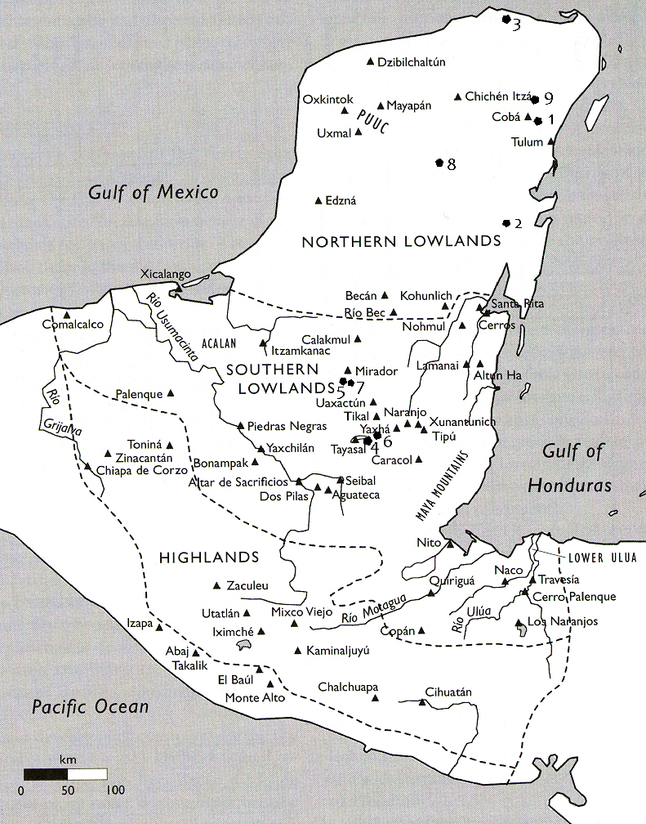arid plains of the Mexican Yucatán Peninsula, which is made up of limestone and shows little relief. The southern Maya lowlands are situated in the wetter, tropical forests of northern Guatemala, Belize and Honduras (Johnston 2003). The, more developed, southern lowlands were hit hardest by the collapse. While many of the northern lowland sites retained some level of habitation during the Postclassic period (900 - 1520 A.D.) until the colonization of the Spanish (Folan et al. 2000).
Table 1: Maya cultural periods and corresponding dates.

Figure 1: Map of the Maya area, the northern and southern lowlands and the highlands are demarcated by the dotted lines. The triangles indicate Maya archeological sites. Hexagons mark sites that are discussed in this report: 1 Lake Cobá, 2 Lake Tzib, 3 Ria Lagartos mangroves, 4 Lake Petén-Itzá, 5 Lake Puerto Arturo, 6 Lake Salpetén, 7 Reservoir Aguado Zacatal, 8 Lake Chichancanab, 9 Lake Punta Laguna
The onset of agriculture was of key importance to the rise of the Maya culture. Recent studies have show that maize, Zea mays, was first cultivated in the present-day pacific region of central Mexico (Blake 2006). Maize was adopted as staple food and its cultivation, in addition to other plants like beans and squashes, spread throughout Mesoamerica. Active agricultural practices like burning the vegetation have been recorded in Mesoamerica from 10000 yr. B.P. onwards (Zizumbo-Villarreal, Colunga-GarcíaMarín 2010). From this original place of cultivation its presence spread east, past the Maya lowlands, towards the pacific coast of present-day Colombia and Ecuador in South-America (Blake 2006). The first actual pollen of maize in the Maya lowlands has been dated to 5400 yr. B.P. (Zizumbo-Villarreal, Colunga-GarcíaMarín 2010).
There have been many speculations on the reason of this collapse, ranging from overpopulation, deforestation, soil erosion, war, disease and climate change. The collapse did not happen at the same time everywhere, which implies that it cannot be attributed to a single cause. It is clear though that the impact was real as many places saw a reduction of 90 per cent of its population (Johnston 2003). It has become apparent that the entire region was engaged in war leading up to the Terminal Classic period (Marcus 2003).
In the late 1950s scientists started to implement palaeoenvironmental techniques to get an insight into the relationship between the Maya and their environment. As the technique showed potential in reconstructing several environmental conditions the number of studies increased. During the 1970s it became clear that the climate of Mesoamerica had not remained stable, as was assumed before. Not so much temperature but the moisture availability was shown to have varied considerably. This insight combined with previous observation at Maya sites, which were located proximately to water, indicated that this change of climate might have had considerable effect. In places where no natural source of water was available large storage facilities were constructed. Furthermore, the mythology and art, as depicted in their temples, shows the importance of water to Maya civilization (Brenner et al. 2003).

Scientific relevance and selection criteria

Scientists have taken a special interest in Maya climate history and how they reacted to the associated vegetation changes, in the light of present and future climate change. Insight into how the Maya reacted to the vegetation changes, that were associated with climate change, can give us insights in how to respond to future climate change. Especially now the region is again becoming heavily populated.
In this report an overview will be given of the best-dated and most-detailed sedimentary records from the Maya lowlands. All these sights contain a record that spans the Maya period completely or gives a high-resolution overview of the Maya collapse. The first part will discuss what contribution the pollen data has given to archaeology. The second part of this report will discuss the isotopic records from lakes in the Maya lowlands, and its contribution to Maya archaeology. Pollen records were chosen because these give a good indication how vegetation has changed, whether due to human or natural impact. The isotopic records give insight into the hydrological budget of lakes, effectively indicating wet/dry conditions of an area. The combination of these two records should give a good insight into what the impact of the Maya was on their environment, and what the influence of the environment was on the Maya. The conclusion of the report will contain an overview of the most important insights and some of recommendations for future research.

Methodological overview

There is a wide array of possible analyses that can be used to reconstruct environmental conditions. All of these analyses rely on sediments retrieved from lacustrine environments. These lake sediments accumulate over time and are deposited in a more-or-less ordered manner, from old to young. The sediment contains a range of natural materials, ranging from pollen grains to diatoms and animal microfossils. The abundance of specific species depends on environmental conditions. Therefore, analysis of the microfossils can give an indication of past environmental conditions. Furthermore, aquatic organisms are influenced by the chemical conditions of the water in which they live. Traces of this chemical environment get preserved in the remains of these organisms, which can be used to reconstruct past conditions. In effect can the sediment be considered as an archive of past environmental conditions.
One of the most used techniques is the stratigraphic analysis of pollen grains. The change over time of pollen grains, which in many cases are identifiable down to the species or genus level, gives a good indication how the plant community in the catchment area of the lake has changed (Lentz 2000). However, it has become clear that human deforestation in the area has removed the potential to infer any climate signal from pollen assemblages (Curtis et al. 1998, Leyden 1987). It rather gives information on how the vegetation in the area directly around the lake has changed. Although climate cannot be inferred from pollen assemblages in the Maya lowlands, they are useful for reconstructing the impact human practices had on the environment. Present-day analysis of pollen assemblages from eight different types of ecosystems, in the Maya lowlands, has increased the insight into the relation between pollen assemblages and actual vegetation. It appears that an accurate distinction can be made between different ecosystems based on pollen assemblage (Bhattacharya et al. 2011). It can therefore be assumed that the reconstructed pollen-assemblages give a good representation of the vegetation in the catchment area.
Another important analysis technique is based on the ratio of stable oxygen isotopes, ¹⁸O and ¹⁶O, which is measured on the carbonate (CaCO³) shells of organisms. The two isotopes have a different mass that causes fractionation during physical, chemical and biological reactions. In a closed lacustrine environment when water is evaporated the bicarbonate ions (HCO³⁻) become enriched with the heavier ¹⁸O isotope. Depending on the ratio of evaporation with regard to precipitation (E/P), the lake gets enriched in ¹⁸O. The organisms that live in these lakes incorporate the bicarbonate into there shells as calcium carbonate (CaCO₃). When these organisms are short-lived their shells are a perfect registration of the lake's evaporation budget during its lifetime (Covich, Stuiver 1974). The ratio of oxygen isotopes, in a piece of shell, can be measured and set against a standard. This gives a value that shows the departure of the sample’s ratio from the standard, Vienna Peedee Belemnite (VPDB), and is expressed like δ¹⁸O. In this case increased E/P would result in increased values of δ¹⁸O, as the lake get enriched with heavy isotopes. Especially shells of gastropods and ostracods are used for analysis.
However, not all lakes are suitable for such an analysis and therefore they must meet several criteria. First, the lake must be hydrologically closed, loosing most of its water through evaporation. Second, it must be large enough that it still contains water during dry periods, to obtain a continuous record. The lake cannot be too large, however, because this would suppress the isotopic signal caused by evaporation. Lakes no deeper than 15m or 25m, depending on the overall size, generally contain the best records (Brenner et al. 2003). Evaporation and precipitation and runoff are the main drivers of the hydrological budget. Deforestation can also alter the entire hydrology of an area, through altering the transpiration and storage characteristics of the soil. Furthermore, this might increase the delivery of ¹⁸O-depleted water to the lake (Rosenmeier et al. 2002).
These paleoenvironmental analyses have provided an environmental context to the archaeological studies of the Maya civilization. Although both techniques have their strong and weak points it is clear that they provide high-resolution records of environmental change. In addition, further geochemical analysis of the sediment can give information on soil erosion in the area surrounding a lake. For all these techniques present day insight into the sedimentation processes at these places is crucial. Present day sedimentary conditions, once measured, can form the basis for proxy analyses of sediments. In order to come to a good environmental reconstruction several sedimentary proxy records will need to show coherent results (Brenner et al. 2003). In order to get a reliable age-model for these sedimentary records radiocarbon dating can be used on preferably terrestrial fossil remains. The lakes in the Maya lowlands contain hard-water, which will influence the reconstructed dates if aquatic material is used. Hard-water contains an amount of carbon that is derived from the surrounding rock, which is depleted in its radioactive isotope, ¹⁴C. Therefore, preferably no fossil derived from the water should be used for the age-model, because this would result in an older age (Brenner et al. 2002).

Pollen records from the Maya lowlands

The first research into the vegetation history of Maya area was done on sediments from Laguna de Petenxil, in the southern lowlands (Cowgill et al. 1966). This is a lake of 0.6km² and a maximum depth of 4m. The pollen assemblage showed interesting changes in vegetation, and could be divided into three distinct pollen zones. Although maize (Zea) pollen were found throughout the core, other pollen gave further information on land use changes. The oldest section of the core showed that the landscape was dominated by herbaceous plants, especially grasses, which implies that the landscape was less forested than today. Younger sediments show a period of more agricultural activity that is inferred from the abundance of Ambrosia pollen, a weed that is associated with agriculture. Furthermore did this section show an increase in grasses (Poaceae) and a reduction of high-forest pollen (Moraceae). The youngest section of the sediment core showed high numbers of forest pollen and low numbers of pollen associated with agriculture. From this information the authors concluded that the last part of the sediment core shows that the grasslands became forested. Further conclusions were that humans had practiced agriculture for at least 4000 years and that the climate had stayed stable over this period. Neither did their analysis indicate that the population reached such numbers that would have caused serious environmental damage, so no disastrous soil erosion was observed. This initial analysis showed the potential for environmental reconstruction using stratigraphic investigation.
This part will discuss the results of similar analysis on three sediment cores from the northern lowlands and four from the southern lowlands. In some of the cores signs of soil erosion were observed, ranging from increased sedimentation rates to distinct clay sediment layers and geochemical indicators of increased clay deposition.

Lake Cobá (Leyden 1998) Figure 2
Lake Cobá is located in the northern lowlands near to the centre of the Maya city Cobá, and was diked in order to serve as a reservoir. For pollen analysis an 8.8m core was collected in the middle of the lake from a water depth of 4.6m. The base of the core was dated at 7600 yr. B.P. (5650 B.C.). The bottom part of the core does not contain any pollen, and the first assemblage at a depth of 7.8m indicates a wetland environment, surrounded by a forest environment expressed in Piscidia pollen. The second zone in the core show a decline of wetland species and a diversification of the upland forest. Already in this zone is it apparent that weeds and grasses start to replace the forest from around 3600 yr. B.P. (1650 B.C.) and remain dominant throughout the rest of the core. In zone 3 the first presence of Zea (maize) becomes apparent around 2800 yr. B.P. (850 B.C.) and is present up until the top of the core, but high numbers are only present until 1230 yr. B.P. (720 A.D.). Zone 3 is further characterised by the highest number of disturbance-related species. Zone 4 shows a decline in disturbance-related species and an expansion of secondary forest pollen. This trend of forest regeneration continues throughout zone 4 and 5.
Leyden (1998) concludes that human impact in the catchment area is apparent from the Early Preclassic (1650B.C.) period onward, as indicated by the disturbance-related pollen. From the Middle Preclassic period maize agriculture becomes apparent and is sustained intensely until it declines sharply during the Late Classic period 720 (A.D.). During the habitation of the area the amount of arboreal pollen is reduced, but the species diversity is not. This might indicate that orchards were maintained, containing economically important trees, it might also reflect proximate patches of forest. This is probably an indication of the relocation of agriculture away from the direct proximity of the lake. The Classic Collapse is represented in the pollen record as the decline of disturbance-related species and the increase of forest species, like Trema. During the Postclassic period the forest expansion intensifies, indicating permanent reduction of agriculture.

Lake Tzib (Carrillo-Bastos et al. 2010) Figure 3
In more recent years sediment from another lake from the northern lowlands has been used to reconstruct a paleoclimate record, namely Lake Tzib (19°17' N, 88°04' W). The lake is basically a shallow depression roughly 600m across with an average depth of 0.5m. The sediment was cored to a depth of 2.5m in a water depth of 0.25m. Every 10 cm a sample was taken for pollen analysis, adding up to a total of twenty-six data points. The lake is prone to seasonal flooding during the wet season, which enables salt intrusion from the nearby estuary system.
Four different zones were identified on the basis of the pollen assemblages. Zone 1, dating from 7900 yr. B.P. (5950 B.C.) to 7000 yr. B.P. (5050 B.C.), is dominated by medium stature forest taxa, like Moraveae and Ficus. Also present are grasses and Chenopodiaceae, but make up only a minor part of the assemblage. Pollen zone 2, dating from 7000 yr. B.P. (5050 B.C.) to 4600 yr. B.P.(2650 B.C.), shows a decrease of forest taxa and a decline in mangrove abundance. Around 5200 yr. B.P. (3150 B.C.) this decline is most pronounced and disturbance species, like grasses increase. Zone 3, 4600 yr. B.P.(2650 B.C.) to 3000 yr. B.P. (1050 B.C.), shows an increase of mediate stature forest species and, to a lesser extent, also wetland species. The first occurrence of Zea pollen is dated to around 3500 yr. B.P. (1550 B.C.). Pollen zone 4, dating from 3000 yr. B.P. (1050 B.C.) to 500 yr. B.P. (1450 A.D.), shows a decrease of wetland taxa, but the medium stature forest species show a slight sustained increase.
The pollen from zone 1 indicate that the site was prone to seasonal flooding during this period, as represented by the mangrove and wetland species. The forest taxa indicate overall humid conditions. The decrease of forest and mangrove taxa in pollen zone 2 indicates drier conditions. This can also be inferred from the slight increase in more drought resistant forest species, like Acacia sp., Randia sp. and Aponcynaceae. Around 5000 yr. B.P. (3050 B.C.) the lowest number of the flood-associated species is observed. The disturbance-related species that co-occur with the introduction of Zea, around 3500 yr. B.P. (1550 B.C.), indicate human influence in the region. Pollen zone 4 is shows the impact of sustained dry conditions, between 1000 yr. B.P. (950 A.D.) and 850 yr. B.P. (1100 A.D.), expressed in the decrease of Zea and and an increase of forest species. This event can be correlated to the Terminal Classic drought event.

Ria Lagartos mangroves (Aragón-Moreno et al. 2012) Figure 4
This sediment core was recovered from a pond, 3.6km from the coast, which is susceptible to flooding. This pond (21°34' N, 88°04' W) is located in the Ría Lagartos Biosphere Reserve at the northern fringe of the Yucatán Peninsula. A 1.9m core was retrieved from the pond for pollen analysis. The base of the core was dated to 3800 yr. B.P. and 64 samples were taken, giving the record a temporal resolution of roughly 60 years.
As the core was obtained from a mangrove area, species specific to this type of vegetation are abundant throughout the core, of which Rhizophora mangle L. and Conocarpus erecta are most abundant. Also present but in less abundance are Aveicennia germinans and Laguncularia racemosa. Pollen from tropical forest species are also abundant throughout the core, of which Ficus sp. and Moraceae are most abundant. Of the species that are related to disturbance grasses, Poaceae and Asteraceae are most abundant. Cyperaceae pollen appear in large abundances in some parts of the core. Pollen zone 1, dating from 3780 yr. B.P. to 3450 yr. B.P., is dominated by tropical forest pollen and also a also great abundance of disturbance species is observed. Of the mangrove species R. mangle is most abundant. Zea is present in virtually all samples of this zone. Pollen zone 2a, 3450 yr. B.P. until 1570 yr. B.P., shows several peaks of mangrove pollen abundance and an overall increase in abundance. Furthermore, the disturbance species diversity increases and Zea is present in most samples. Towards the top of zone 2b, 1570 yr. B.P. until 770 yr. B.P., mangrove and tropical forest abundance declines greatly. This is mainly due to the increase of disturbance related species; Zea is also present throughout this section. Pollen zone 3, 770 yr. B.P. until present, shows a general increase of mangrove abundance, but values fluctuate. The tropical forest taxa also increase in abundance, and the disturbance species show a sharp reduction in presence. Zea has only one occurrence in this section, besides the contemporary presence of pollen in the core. Also very apparent is the increase of Cyperaceae at the lower part of the pollen zone.
The high number of mangrove and forest species in zone 1 implies that wet conditions prevailed during this time. The presence of Zea and charcoal indicate agriculture was already taking place during this time.
It can be inferred from the pollen assemblages that humid conditions prevailed until 3450 yr. B.P. as mangrove species were dominant in the assemblage. From this time, until 1700 yr. B.P., a drying trend set in, and some extreme dry events might be related to the Late Preclassic abandonment. There seems to be a wet period between 1700 yr. B.P. and 1300 yr. B.P.. However, the driest period is inferred at 950 yr. B.P., correlation to the demise of the Classic Maya. From 900 yr. B.P. wet conditions return to the area, stimulating forest growth.

Lake Petén-Itzá (Curtis et al. 1998) Figure 5
One of the largest lakes in the southern lowlands is Lake Petén-Itzá in Guatemala. It has a surface area of over 99km2 and a measured depth of 36m. The lake consists of two basins, from which the smaller of the two has been cored (16°55' N, 89°50' W). A 5.45m core was retrieved from a 7.6m water dept. The oldest reconstructed age, from nearly the bottom of the core, gave an age of 8840 yr. B.P. (7930 B.C.). The core was sampled every 10cm for analysis of pollen.
The pollen assemblage of the oldest part of the record is characterized by high forest taxa, indicating moist climate conditions from 8500 yr. B.P. (6550 B.C.) until 5500 yr. B.P. (3550 B.C.). In addition to the pollen the presence of aquatic microfossils indicate moist conditions during this period. From 4200 yr. B.P. the amount of disturbance taxa and pine pollen increase. The disturbance-related taxa reached their maximum around 1186 yr. B.P. (880 A.D.), corresponding to the Classic collapse. From this time onward an increase of arboreal pollen can be observed, and the abundance of disturbance taxa decreases. The amount of arboreal pollen, however, never reached the numbers of the early Holocene.
The "Maya clay" cannot visually be detected in this sediment core, but the geochemical analysis indicates the increased erosion took place. Increased magnetic susceptibility in addition to higher levels of Fe and K, after 2800 yr. B.P., indicate that the sediment contains more clay. These indicators of erosion show a decline after 1100 yr. B.P. (925 A.D.). Forest regeneration is visible in the pollen record from 1000 yr. B.P. (1025 A.D.).

Lake Puerto Arturo (Wahl et al. 2006) Figure 6
Lago Puerto Arturo (17°32' N, 90°11' W) is a lake, in the northern part of the southern lowlands, with a surface area of 1,5km2 and a maximum depth of 12m. A 7.3m sediment core was recovered from a water depth of 7.8m, in addition a replicate core was retrieved. Fifty samples were taken and processed for pollen analysis. The basal age of the core was dated over 55000 yr. B.P., indicating the Pleistocene sediments and a subsequent hiatus, on which the Holocene sediments were deposited. The oldest Holocene date in the core was around 8400 yr. B.P. (7550 B.C.). The record was divided into four zones based on the pollen assemblages. The oldest part, zone 4, ranges from 8400 yr. B.P. (6450 B.C.) until 4700 yr. B.P. (2750 B.C.). The two arboreal types Moraceae/Urticaceae and Melastomataceae/Combretaceae dominate this pollen zone. There is one distinct peak of disturbance-related pollen. Pollen zone 3, 4700 yr. B.P. (2750 B.C.) until 3400 yr. B.P. (1450 B.C.), shows a significant increase of herbaceous pollen, and the Melastomataceae/Combretaceae type trees decrease in number. At the base of this zone a single Zea pollen was found. The same trends as seen in zone 3 continue in zone 2, 3400 yr. B.P. (1450 B.C.) until 1000 yr. B.P. (950 A.D.), but are even more pronounced. The pollen of herbaceous species, like grasses, increase and Zea pollen are most frequent in this section. In addition to Melastomataceae/Combretaceae, as observed in zone 3, Moraceae/Urticaceae also starts to decline. Pollen zone 1 is characterized by a sharp increase of all arboreal pollen and a decrease of herbaceous species; no Zea pollen were found in this zone.
The bottom part of the core contains a part Pleistocene soil, overlain with Holocene sediments. The bottom part of this sediment contains high concentrations of gypsum indicating warm and dry conditions, just like those analysed by Rosenmeier et al. (2002) and Hodell et al. (1995). Form around 8000 yr. B.P onward high arboreal pollen-count indicate lowland tropical forest vegetation. There are, however, also pollen of grasses and herbs in the core, indicating that some areas proximate to the lake were open wetland areas. From around 4600 yr. B.P. (2850 B.C.), in zone 3, pollen indicate the start of settlement and agriculture by showing an increase of disturbance species like grasses. The Zea pollen at the base of the section implies that the decrease of forest pollen is associated with agriculture. In other places, where no direct indication for agriculture is found at the onset of forest decline it is less clear if this is the result of a changing climate or agriculture. Zone 2 shows the most signs of dense population and disturbance related species. One distinct episode shows all disturbance related species at pre-settlement levels, and can be correlated to the Late Preclassic abandonment of 1810 yr. B.P. (140 A.D.). This decline in Ambrosia is seen in all vegetation reconstructions of the Petén area. The decline in disturbance-relate species at the onset of zone 1 probably coincides with the Late Classic collapse. Arboreal pollen, like Moraceae/Urticaceae, increase rapidly. The herbaceous pollen of this zone indicates that the overall vegetation was different during this period compared to the pre-settlement.

Lake Salpetén (Leyden 1987) Figure 7
Lake Salpetén (16°58' N, 89°40' W) lies just to the east of Lake Petén-Itzá, and is considerably smaller, with an area on only 2,6km2 and a maximum depth of 32m. A 15m core was retrieved from a water depth of 26m, the base of which has been dated at the onset of the Holocene. No age-model has been used because of the hard water error. The gyspum layer between 12m and 10.5m likely correlates to the observed gypsum layers in other lakes. After this layer pollen counts increase for all species. It is clear that from 10.5 m to 8.5m arboreal species, Moraceae, are dominant, after which they decline. From a depth of 8.5m to 6m, disturbance related species increase and Zea is first observed. Between 6m to 2m the highest abundance of Zea and disturbance related species is observed. Above 2m there is an apparent decrease in disturbance related species as well as Zea. From this time onward do the arboreal species increase in numbers.

Reservoir Aguada Zacatal (Wahl et al. 2007) Figure 8
The circular reservoir Aguada Zacatal (17°41' N, 89°52' W) is located 4km west of Nakbe, in the southern Maya lowlands. It was used by the adjacent small site of Zacatal to preserve water during the dry season. The reservoir is 100m in diameter and is surrounded by a am high berm. The water preservation and prevention of desiccation enhances the preservation of microfossil. A 1,1m core, the base of which dates to 695 A.D., was retrieved and sampled every 2cm for pollen analysis. Based on the pollen assemblages the core was divided into two pollen zones. Pollen zone 2, ranging from 695A.D. to 840A.D., is dominated by grasses, Poaceae, and other herbaceous taxa like Asteraceae. Only small number of forest pollen are encountered throughout this part of the core, Zea is present throughout though. The transition to pollen zone 1, 840 A.D. to present, shows a sharp decline in grasses, disturbance taxa and Zea, some of which disappear completely. Pollen zone 1 is dominated by Cyperaceae and fern spores, but also shows a slight increase of forest taxa abundances.
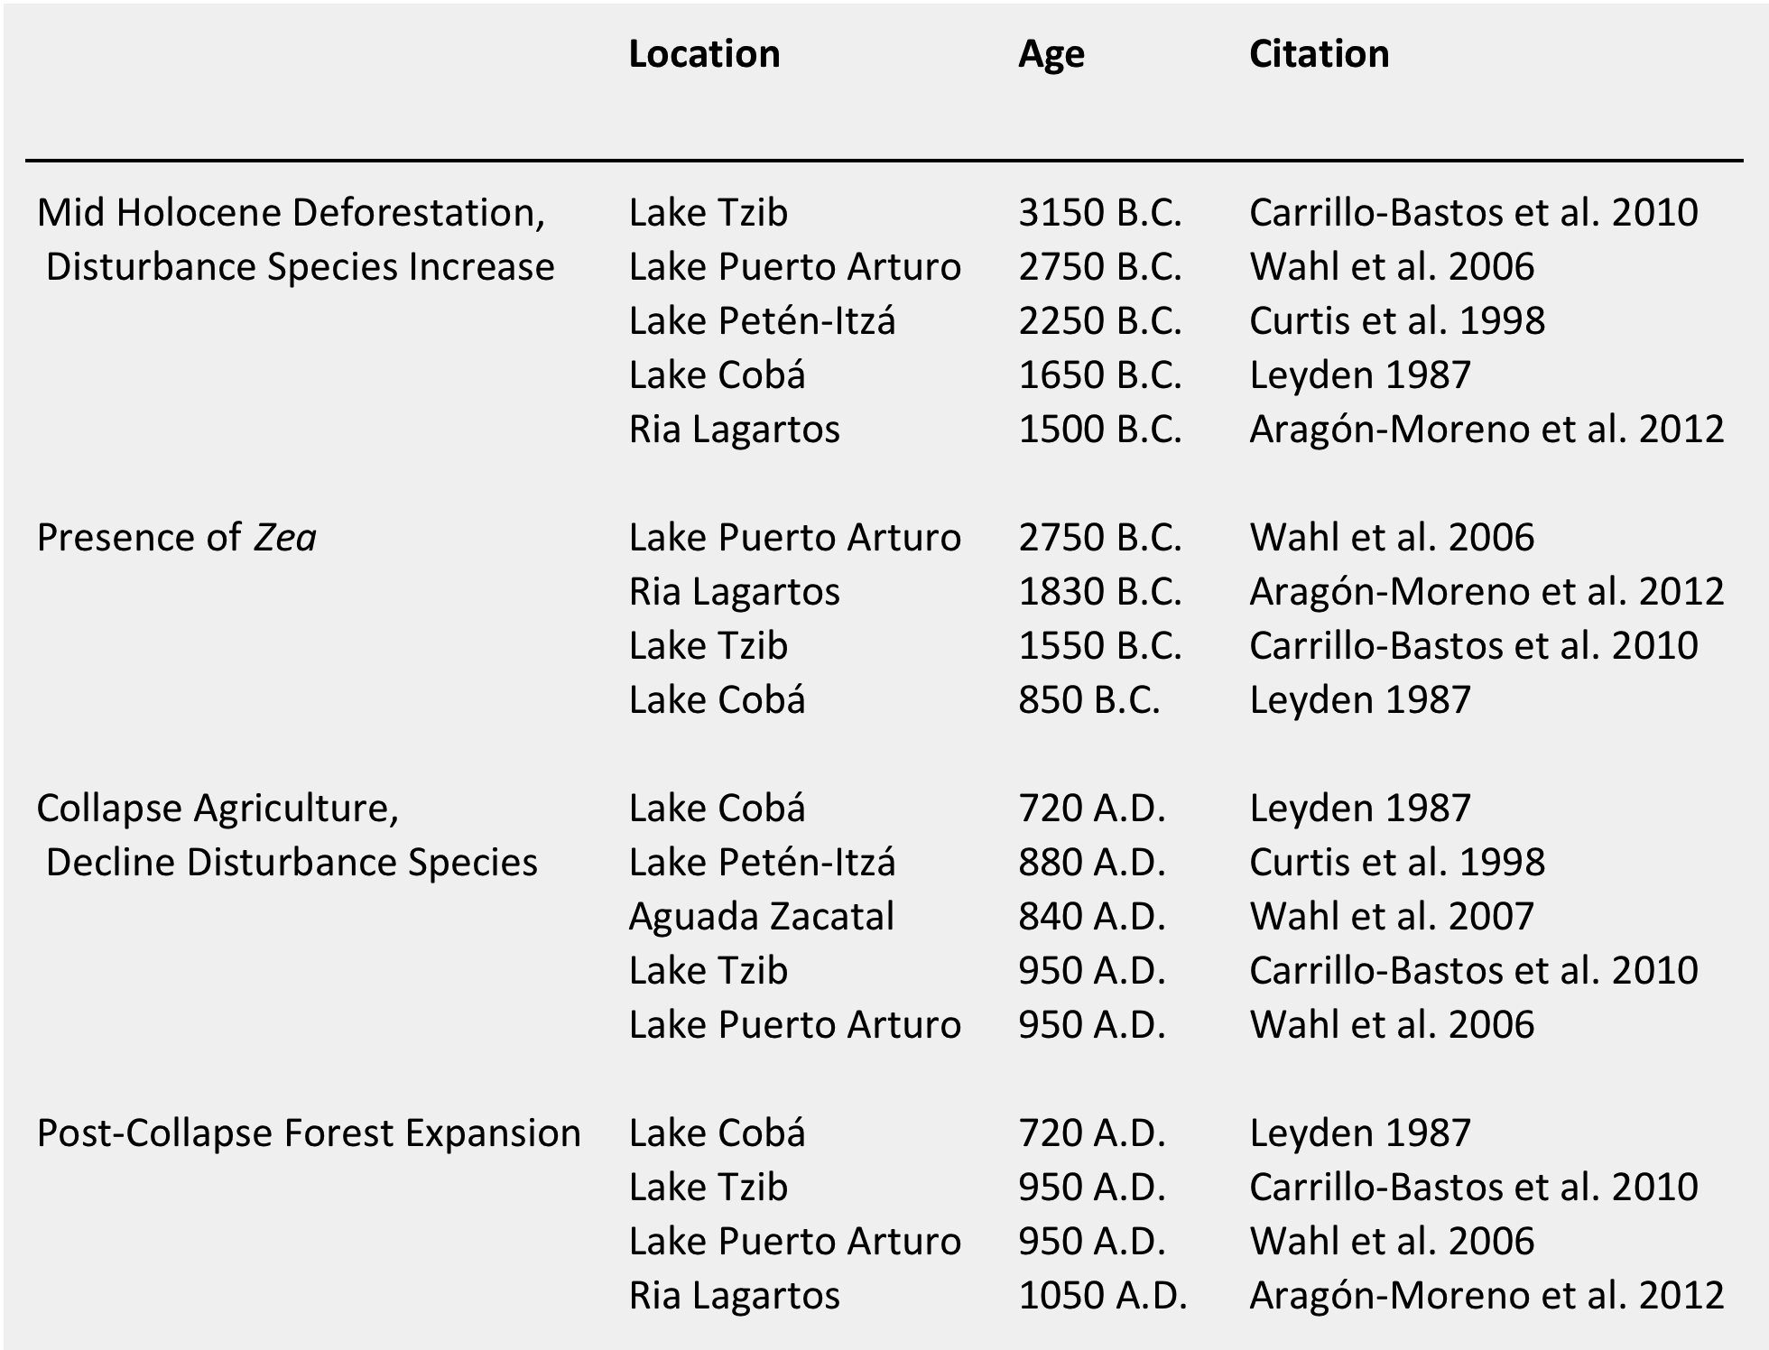
The pollen assemblage of this core shows the abandonment of the Late Classic collapse (840 A.D.). As the direct surroundings of this site were completely dominated by human activities this abandonment is accurately recorded.

Table 2: Overview of pollen data. The given dates are the onset of the aforementioned event.
Discussion Pollen Records

It is clear that during the early Holocene the Maya lowlands were covered by forests, which has been interpreted as indicating wet conditions (Curtis et al. 1998, Leyden 1987, Carrillo-Bastos et al. 2010, Aragón-Moreno et al. 2012, Wahl et al. 2006). Deforestation of the southern lowlands seems to precede deforestation on the northern lowlands. This onset seems to take place in the southern area around 4500 yr. B.P. (Curtis et al. 1998, Wahl et al. 2006), and in the northern area around 3500 yr. B.P. (Curtis et al. 1998, Aragón-Moreno et al. 2012). This period of deforestation also sees an increase of disturbance related species like grasses and Aseraceae and in many cases the presence of Zea is also seen. This indicates that from this time the area started to be heavily influenced by human presence in the area. Around this time an increase of clay particles in the sediment is also observed indicating erosion (Curtis et al. 1998). The northern lowland lakes do not contain "Maya clay" layer, which can be explained by the absence of much topographic relief. In the south, where the hillsides are steep and soil erosion is much more pronounced these “Maya clays” are visible in the sediment. Furthermore, the Petén area receives more rainfall that enables more soil development, which can be eroded by the intense rainfall (Leyden 1987). Much more evidence of soil erosion is derived from geomorphological research in the entire Maya lowlands. This has shown that around the first major erosional event started around 3000 yr. B.P. (Beach et al. 2006, Beach et al. 2008). Although the extent of deforestation and erosion varies from place to place and in exact timing, it is clear that in general the entire area underwent the same pattern.
After this initial event of deforestation pollen diagrams show a stable period of sustained human activity. The return to a more forested area began after the Classic Maya collapse, between 840-950 A.D.. It is clear, though, from geomorphological data that prior to the collapse erosion intensified once more, between 55-900 A.D., despite this not observed in the sediment records (Beach et al. 2006).
Archaeological research has shown that Maya developed a range of methods to limit the negative effects of this erosion, like damming certain areas and constructing terraces to reduce erosion. What specific method was used depended on the terrain, vegetation and soil type (Neff et al. 2006). It has been proposed that terraces developed as side effect of farming on hillsides. As the stones were transferred to one side of a field, over time they formed a ridge against which soil would accumulate. At the bottom of slopes terraces have been found, and it is hypothesized that these were constructed to collect the soil that washed down from the hillsides. Dams were constructed in order to collect water during the rainy season and limit soil transportation. These dams function to slow the flow rate trough a channel that results in the sedimentation of soil, on which farming would be practiced (Beach et al. 2002).
Besides the negative effects of soil erosion as a result of deforestation, archaeological research has shown that this also resulted in the reduction of high-quality timber use. The use of timber in Maya society ranged from use as a construction material to the use of fuel in the use of lime plaster production.
The city of Tikal was one of the major urban centres of the southern lowlands. Analysis of the timbers that were used in the construction of temples and palaces indicate that the used species varied greatly over time. Initial preference for construction was given to upland tree species that grow very tall; over time the use shifted to smaller trees from the seasonal wetlands. This change of timber preference is also reflected in the maximum size of the beams that were used in construction, which reduced with time (Lentz, Hockaday 2009). This indicates that availability of high-quality timber species declined as much of the Maya area was deforested for agriculture.
The same trend is seen on the outskirts of the Maya lowlands, at two small Maya sites. The sites are located in Paynes Creek National Park, the Early Classic Chan B'i and the Late Classic Atz'aam Na. Both were salt producing communities, supplying the large urban Maya areas in their ever-increasing demand. Analysis of the types of wood that were used in the construction of buildings has shown that the quality of timber reduced with time. This decline in use of preferred timber indicated that natural resources became overexploited (Robinson, McKillop 2013). In addition to using timber as a construction material it was also used as fuel in the salt production process. As the demand for salt increased from the large urban areas, so did the strain on the vegetation surrounding smaller sites increase. These changes of resource use, in addition to the paleoecological evidence, indicate that the constant strain of the environment caused the Maya to exceed the carrying capacity of their natural system. Once this point is crossed yields from the natural environment start to diminish, as is its resilience.

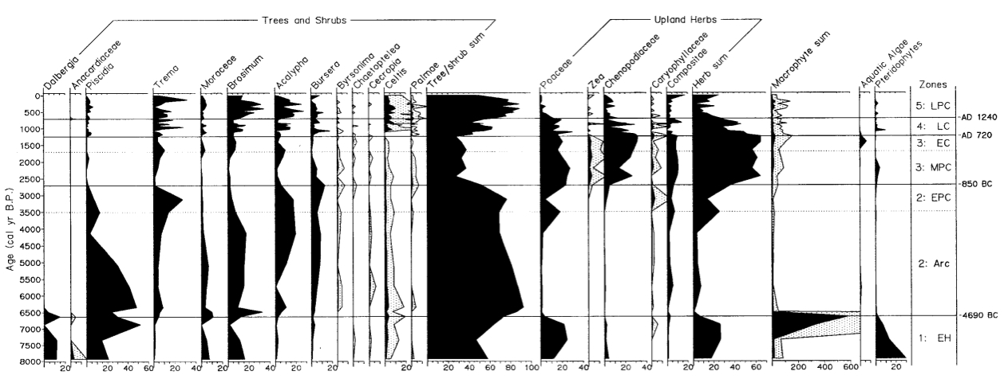
Figure 2: Pollen assemblage Lake Coba (Leyden 1987)

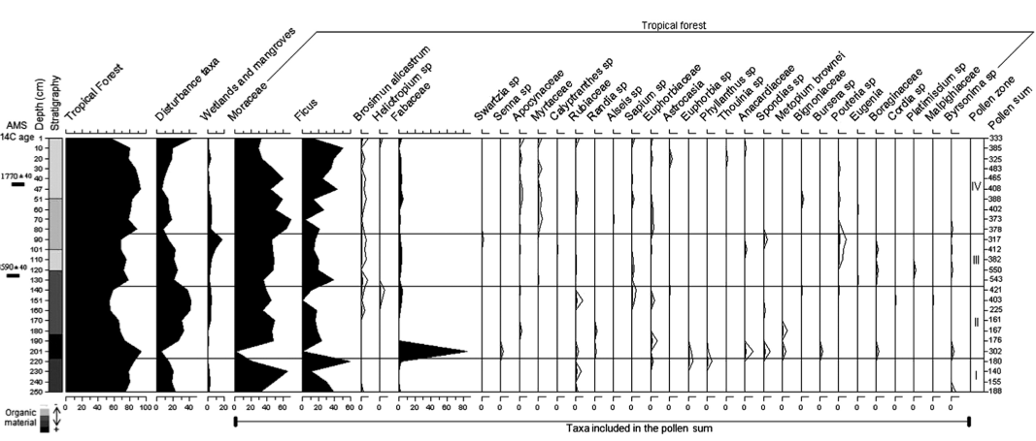
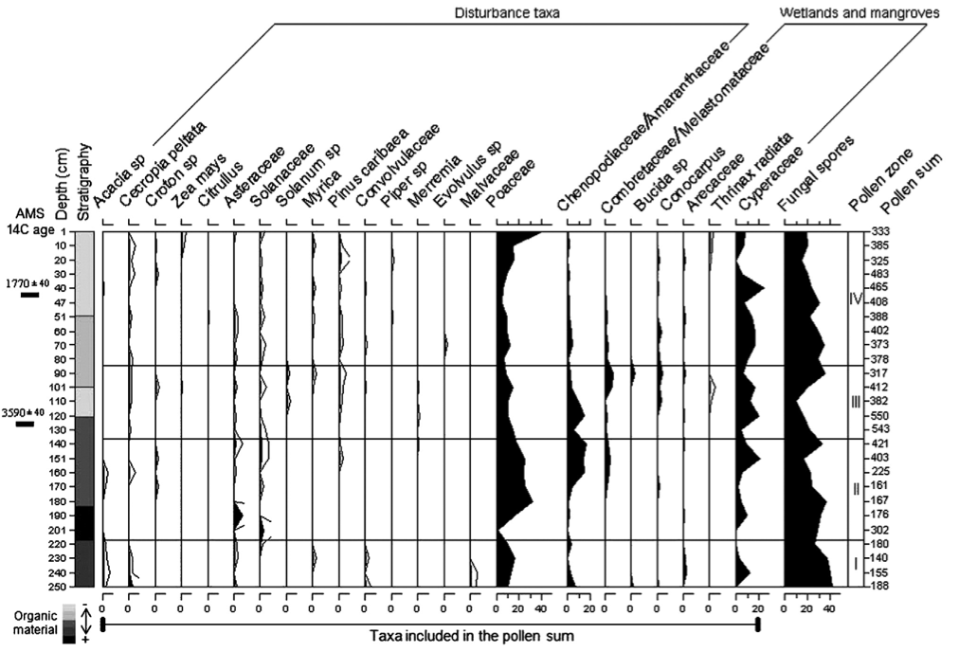
Figure 3: Pollen assemblage Lake Tzib (Carrillo-Bastos et al. 2010)
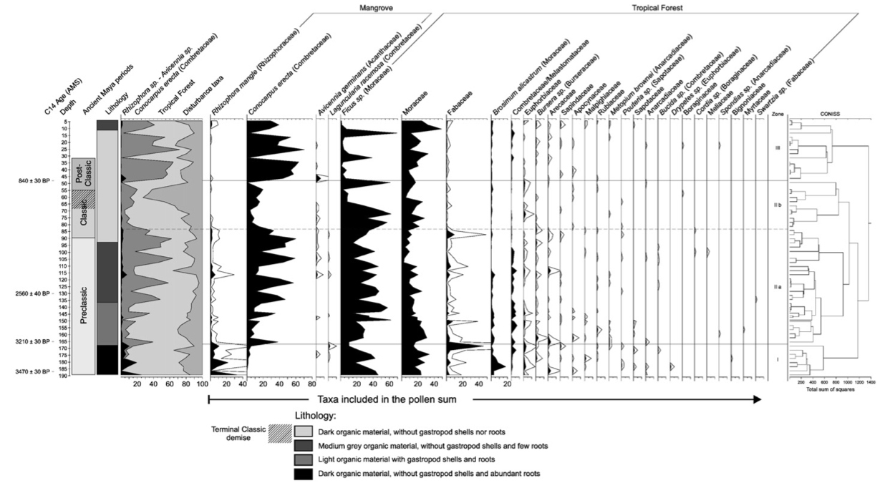

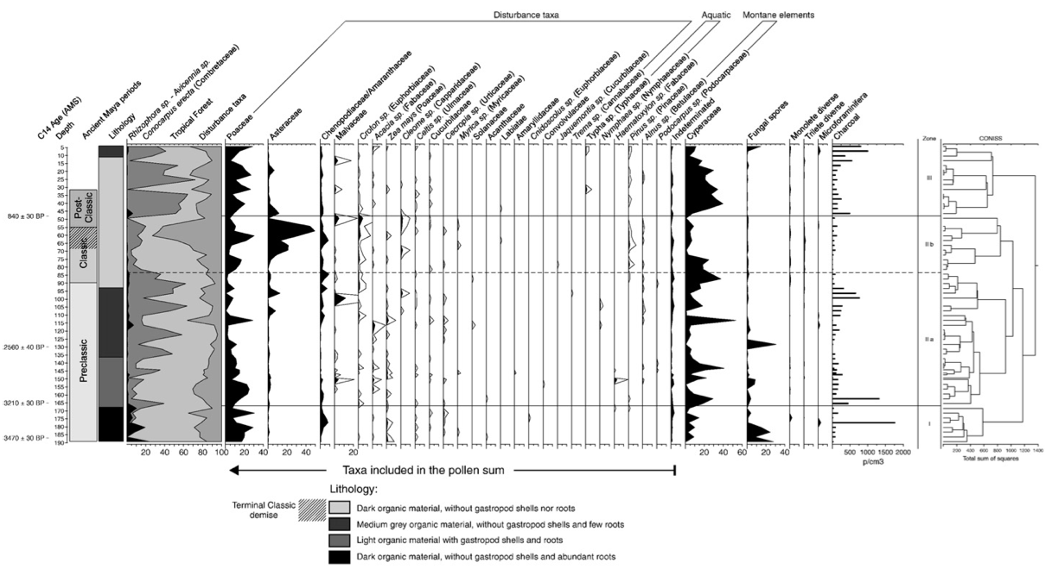

Figure 4: Pollen assemblage Ria Lagartos mangroves (Aragón-Moreno et al. 2012)

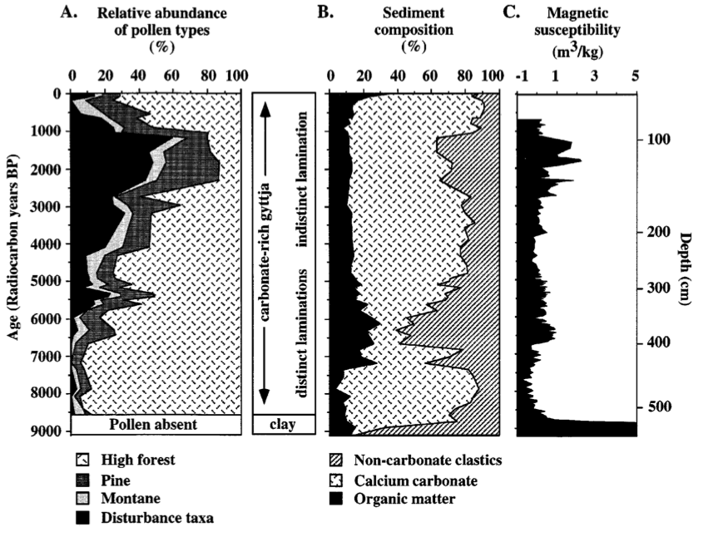

Figure 5: Pollen assemblage Lake Peten-Itza (Curtis et al. 1998)

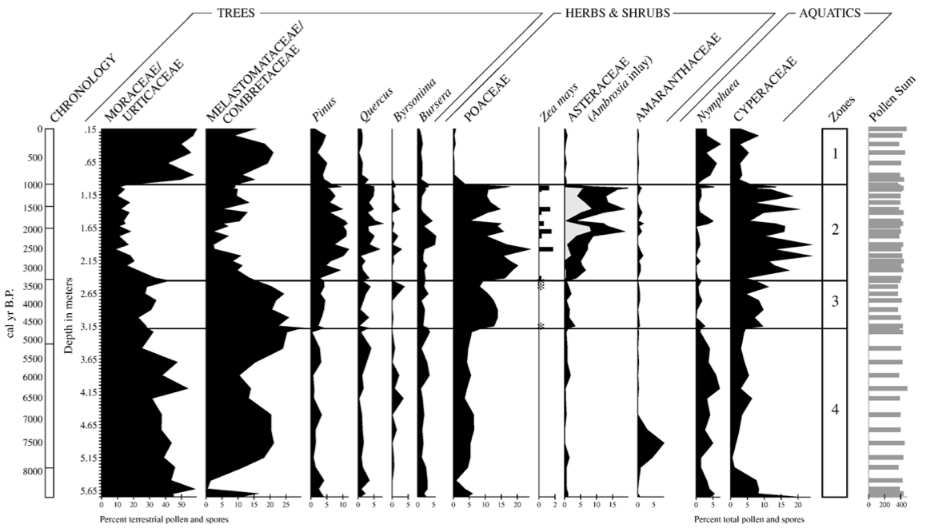

Figure 6: Pollen assemblage Lake Puerto Arturo (Wahl et al. 2006)

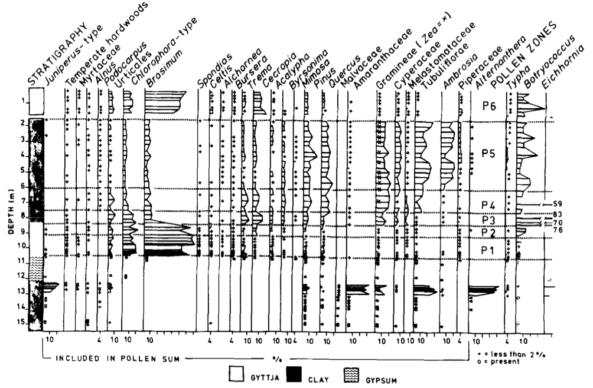

Figure 7: Pollen assemblage Lake Salpetén (Leyden 1987)

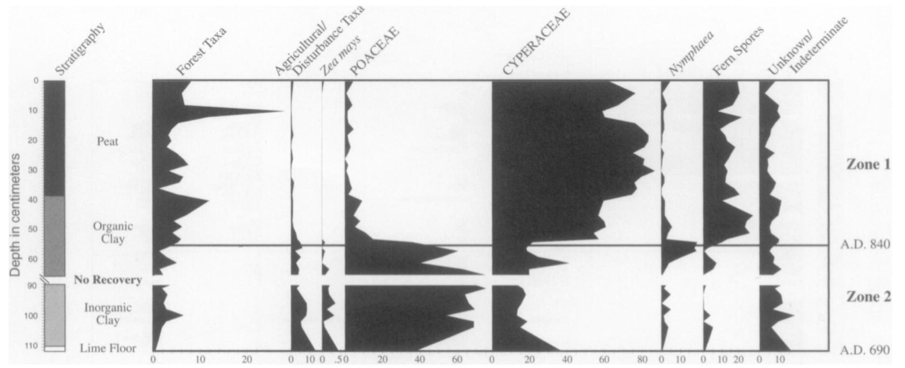

Figure 8: Pollen assemblage Reservoir Aguada Zacatal (Wahl et al. 2007)

Isotope records from the Maya Lowlands

The pollen records give much insight into the ecological history of the Maya lowlands. Unfortunately, they cannot provide information on past climate, as the human influence on the vegetation was too great to infer any climate signal from it. As described above, shells from gastropods and ostracods can be used to reconstruct the hydrological budget of lakes. In the following part three records from the northern lowlands will be discussed and two from the southern lowlands. The isotope records from lake Tzib from lake Petén-Itza were derived from the same sediment core as on which the pollen analysis was performed.

Lake Chichancanab (Hodell et al. 1995) Figure 9
One of the first places that cored to construct a high-resolution paleoclimate record was Lake Chinchancanab (19°50' N, 88°45'W) in the northern Yucatán Peninsula. The most reliable record for this location, so far, is a 4.9m core collected from 6.9m water depth. The core was sampled every 1cm, which resulted in a temporal resolution of about nineteen years. The lacustrine deposits terminate on a paleosol and the lake seems to have filled 8200 yr. B.P. (7250 B.C.). The early deposits contain gastropod and ostracod shells with relatively high δ¹⁸O values. The benthic foraminifer, Ammonia beccarii that only reproduces in salt conditions, was also present in this section of the core in addition to high gypsum concentrations. These factors indicate a high E/P ratio pointing to low lake levels and a high salinity, as a result of dry early Holocene conditions. From 7200 yr. B.P. (6000 B.C.) A. beccarii is no longer present and carbonates are precipitated rather than gypsum. These indicators, in combination with declining shell δ¹⁸O values indicate a rapid filling of the lake, as a result of moist conditions. Around 3000 yr. B.P. (1250 B.C.) a drying trend is observed, as shell δ¹⁸O values increase again and gypsum is again being deposited. This dry period seems to further intensify around 2500 yr. B.P. (750 B.C.). This trend continues up until the onset of a extremely dry period at 1140 yr. B.P. (920 A.D.), which can be inferred from the high shell δ¹⁸O values and high concentrations of gypsum. The Classic Maya Collapse coincides closely with the onset of this dry period.

Lake Punta Laguna (Curtis et al. 1996) Figure 10
Another lake from the northern Yucatán Peninsula that was cored to reconstruct a paleoclimate record is Lake Punta Laguna (20°38' N, 87°37' W). From a water depth of 6.3m a 6.3m core was collected, the base of the section was dated at 3310 yr. B.P. (1090 B.C.). Samples were taken every 1cm, giving the record a temporal resolution of around six years. Isotopic analysis, of the shells of the ostracod Cytheridella ilosvayi and gastropod Pyrgophorus coronatus, gave two highly fluctuating paleoclimate records. Despite these fluctuations it is evident that δ¹⁸O values have varied over the long-term, three periods can be distinguished. The first ranging from 3310 yr. B.P. (1360 B.C.) until 1785 yr. B.P. (165 A.D.), the second period from 1785 yr. B.P. (165 A.D.) until 930 yr. B.P. (1020 A.D.) and the third period between 930 yr. B.P. (1090 B.C.) and present. The second period is characterized by drier conditions that the other two periods, inferred from higher δ¹⁸O values. Within his period there are three peaks that indicate extreme drought events, they occur at 1171, 1019 and 943 yr. B.P. (or 862, 986 and 1051 A.D.), respectively. These dry events in Punta Laguna closely correspond to the observed drought at Chichancanab.

Lake Tzib (Carrillo-Bastos et al. 2010) Figure 11
The sediment core from lake Tzib was sampled at 5cm intervals for the isotope reconstruction. In order to construct two separate the δ¹⁸O isotope records the shells of the gastropods Pyrgophus sp. and Assiminea sp. were analysed. The base of the core was dated at 7900 yr. B.P. (5950 B.C.), the isotope record ranges from 5300 yr. B.P. (3350 B.C.) to 600 yr. B.P. (1350 A.D.). The driest conditions, as inferred from the isotopic values, are observed at 3500 yr. B.P. (1550 B.C.) There are two clear peaks of elevated isotopic values, indicating dry conditions, at 1750 yr. B.P. (200 A.D.) and 1200 yr. B.P. (750 A.D.). These two dry-spells can be associated to the Preclassic abandonment and the Terminal Classic period. An increase in precipitation is observed at 750 yr. B.P. (1200 A.D.), which falls in the medieval climate optimum.

Lake Petén-Itzá (Curtis et al. 1998) Figure 12
For the isotope record the core was sampled every 1cm, which gave a temporal resolution of roughly 19years per data point. Two species of gastropod, Cochliopina sp. and Pyrgophorus sp. were used to construct two isotopic profiles. A third composite record was constructed from two species of ostracod, Cytheridella ilosvayi and Candona sp.. The oldest part of the record shows high δ¹⁸O values, indicating sustained dry conditions. From around 6800 yr. B.P. (5700 B.C.) moist conditions increase for around two thousand years until 4800 yr. B.P. (3700 B.C.), based on the steady decline of δ¹⁸O values. From this time onward isotopic values stabilized and showed little variation. Although both isotopic profiles from the northern highlands indicate a drying event in the late Holocene, this is not reflected in the Petén-Itzá core. This apparent stasis in this record might reflect climatic conditions, but this does not have to be the case. As Lake Petén-Itzá covers such a large area its volume is immense, possibly making it unresponsive to smaller E/P changes.

Lake Salpetén (Rosenmeier et al. 2002) Figure 13
Lake Salpetén (16°58' N, 89°40' W) lies just to the eats of Lake Petén-Itzá, and is considerably smaller, with an area on only 2,6km2 and a maximum depth of 32m. The water chemistry is similar to that of Lake Chinchancanab, being saturated with sulfate. Several different cores were taken along a transect at water depths of 9.2m, 14m, 16.3m and 23,2m. The δ¹⁸O isotope profiles from the different cores show similar results.
However, due to its small size and human alteration of the watershed changes of the δ¹⁸O values might indicate something different than only E/P variations. For example human-induced deforestation can also skew the δ¹⁸O record towards low values in addition to wetter climate conditions. Between 3050 yr. B.P. (1300 B.C.) and 2340 yr. B.P. (390 B.C.) δ¹⁸O values decrease. During this period pollen data shows that there is widespread deforestation taking place, possibly increasing inflow and causing the isotopic values to drop. Minimum values in the δ¹⁸O record occur between 2340 yr. B.P. (390 B.C.) and 1860 yr. B.P. (90 A.D.), during the Middle and Late Preclassical Period. Following this minimum is the step-wise increase of values at 1860 yr. B.P. (150 A.D.), 1540 yr. B.P. (550 A.D.), 1190 yr. B.P. (850 A.D.) and 660 yr. B.P. (1300 A.D.). This stepwise increase might indicate an increase of aridity or changes in the hydrology by forest recovery due to population decline, or a combination of both. The increase in values at 1190 yr. B.P. (850 A.D.) might well be associated with the Terminal Classic Collapse. It is unclear though whether this increase of values is the result of a cultural response to climate change or a response of the environment to disturbance, induced by humans.

Discussion Isotope Records

The records from Lake Chinchancanab and Petén-Itza shows a decrease of δ¹⁸O values indicating the onset of wetter conditions in the early Holocene, around 7000 yr. B.P. (Curtis et al. 1998, Hodell et al. 1995). This is in accordance with the pollen data, which shows densely forested conditions in the early Holocene.
In general the different sediment cores have yielded consistent results, namely a decrease of δ¹⁸O values around 3000 yr. B.P., as is observed in lake Chinchancanab,Tzib and Salpetén. This might indicate wetter conditions or may reflect a change in hydrology of the area, as deforestation is recorded during this period (Rosenmeier et al. 2002, Hodell et al. 1995).
The onset of increased δ¹⁸O values in Punta Laguna, at 165 A.D., can be correlated to Preclassic Maya abandonment (Curtis et al. 1996). This same event is observed in lake Tzib as a clear peak of high δ¹⁸O values at 200 A.D. (Carrillo-Bastos et al. 2010). A stepwise increase of δ¹⁸O values is also observed at lake Salpetén (Rosenmeier et al. 2002).
The Record from Lake Punta Laguna shows sustained dry conditions between 1785 yr. B.P. (165 A.D.) until 930 yr. B.P. (1020 A.D.) (Curtis et al. 1996). In addition, the records from lake Salpetén and Chinchancanab shows a drying trend with an onset around 2000 yr. B.P. (Rosenmeier et al. 2002, Hodell et al. 1995)
The records from the northern Maya lowlands, Lake Chichancanab, Lake Punta Laguna and Lake Tzib, show a sustained dry period around the Classic Maya collapse. These are recorded at 920A.D., 862 A.D. and 750 A.D. respectively (Carrillo-Bastos et al. 2010, Hodell et al. 1995, Curtis et al. 1996). The difference in timing between the sites is probably the result of dating uncertainty. Lake Tzib, as seen in the description above, is subject to seasonal flooding and subsequently very wet. This might have delayed the peak in drought a century with respect to the other sites. This same dry period can be observed in the southern lowlands, Lake Salpetén, at 850 A.D. (Rosenmeier et al. 2002).
Although some of the results are ambiguous, it is clear that increases in δ¹⁸O values correspond to cultural events. The first is the Preclassic Maya abandonment, 165-200 A.D., the second is the Terminal Classic period, 750-986 A.D.. Although these events are reflected in the isotope record it could also be the case that they reflect the change of hydrology as the area reforest recovered due to declined population pressure.
The records from the southern lowlands show conflicting results. The δ¹⁸O isotope record from Lake Petén-Itzá does not show much variation over the last five thousand years. The records from Lake Salpetén, on the other hand, show a step-wise increase of δ¹⁸O values. Human-induced hydrology changes might have played a larger role in the southern lowlands and influenced the δ¹⁸O records of Lake Petén-Itzá. As this region receives more rainfall, deforestation might be expressed more extremely in these areas, as the soil loses water-retaining properties.
As the records from the northern lowlands show similar δ¹⁸O profiles, it can be inferred that these lakes do reflect changes in precipitation (E/P).
In addition to the types of analysis that are discussed in this report new insights from recent years underscribe that a drying of the environment was a factor in the collapse of the Maya. The Preclassic abandonment and the Classic Maya collapse have been shown to correlate with a southward shift of the Intertropical Convergence Zone (Haug et al. 2003). This would have resulted in the decline of precipitation in the Maya lowlands. Analyses of stalactites, from the Yucatán Peninsula, have in recent years increased as it has shown to be a promising method for the reconstruction of precipitation changes. The principle on which this is based is similar to that of the discussed isotope records. One such record from Belize has shown that indeed precipitation decline occurred at the Classic Maya collapse (Kennett et al. 2012). These stalactite records have such a high temporal resolution that a reconstruction over the Terminal Maya period could be made, and it was found that eight drought events over 150 years, ranging from 3 to 15 years in duration, attributed to the demise of the Maya civilization (Medina-Elizalde et al. 2010). Using two of the described lake-records, in addition to two others, recent modelling has shown that the increase of δ¹⁸O values can actually be attributed to a reduction in precipitation. This modelling showed that the two most severe droughts occurred at 830 and 928 A.D., which saw a reduction of precipitation between 30 and 50 per cent (Medina-Elizalde, Rohling 2012).
Although the northern lowlands are drier than the southern lowlands population decline was worst in the south. As the south is wetter it might be expected that drought impacts the north to a greater extent, but this area is also characterized by easy accessible ground water, which the south does not have. Therefore, the north might have been more resilient to drought, even if it was already drier to start off with. The southern lowlands were more dependent on surface waters like lakes and artificial reservoirs. As drought caused small lakes and reservoirs to disappear more people became dependent on the larger bodies of water in the area. This is expressed in a sharp decline of population during the Classic Maya collapse, and subsequently many watersheds were completely abandoned during the Late Postclassic period. Once the population pressure was gone the forest were able to regrow. As the exact timing and intensity of the collapse varied over the Maya lowlands it is likely that additional factors played a role. As mentioned above archaeological studies have shown that the entire area engaged in war during the period leading up to the collapse. This, and maybe other circumstances, might have had additional effects of destabilizing the society in the pre-collapse years. The sustained droughts over a prolonged period were probably too much that, the already instable, society could take.

Conclusion

It is clear that the Maya had great impact on their environment through deforestation. The onset of this deforestation was in many cases accompanied by the first observation of Zea, or other herbs that indicate agricultural practices. Increased soil erosion and diminished timber-quality for construction implies that the Maya impacted their environment in a negative way, and that natural resources availability declined. The combination of this with their geographical setting, which made them dependant on surface water, decreased the resilience of the civilization as a whole. The isotopic records show the occurrence of dry periods around the time of the collapse of Maya civilization. As their resilience was probably lowered, due to its impact on the environment, it is therefore very likely that the droughts played a mayor role in the collapse. The collapse did, however, not occur at all places at the same time, and northern sites were least impacted. This implies that other factors such, such as warfare, might have played a role. After the collapse much of the lowlands is gradually covered by forests, but not reaching levels of pre-Maya settlement, indicating dryer conditions.
Especially in the southern lowlands, where the collapse was greatest and human environmental impact seems most pronounced, additional records can greatly contribute to further insight. The best record would come from lakes, which are not too large and had minimal human impact. For this collaboration between archaeologists and palaeoecologists is needed, as archaeologist can identify such lakes. In addition other records like stalactites can be used to give a higher spatial and temporal resolution on the hydrological budget of the area. Further analysis of geochemical proxies can shed more light on erosion in the Maya lowlands, which might show a relation to deforestation.
Increased understanding of the relationship between the Maya and their environment can also be of great help for the present, as the area is again getting densely populated. Contemporary inhabitants of the region might learn from the mistakes the Maya made, especially in the light of climate change.

Acknowledgment
I would like to thank Timme for the good supervision during the initial part of the research. He enabled me to pursue my own interest and offer good guidance in this process.

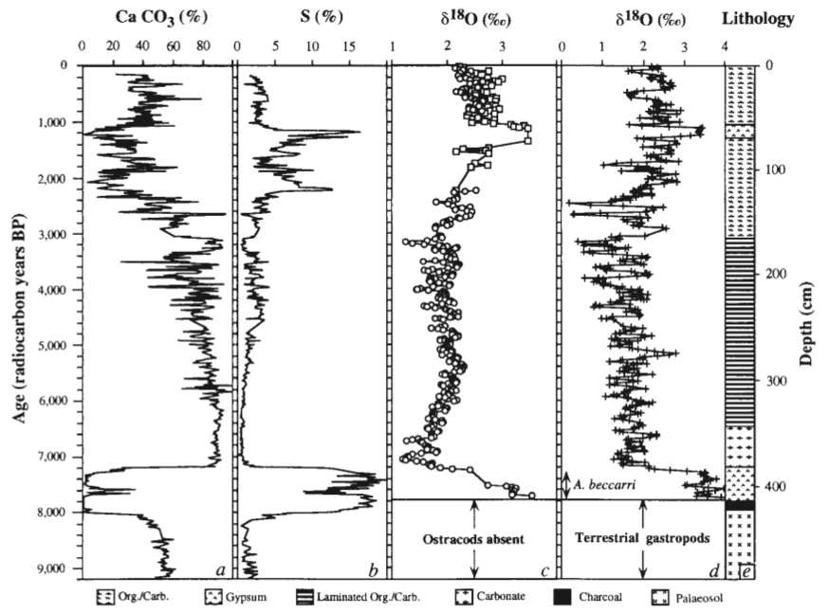

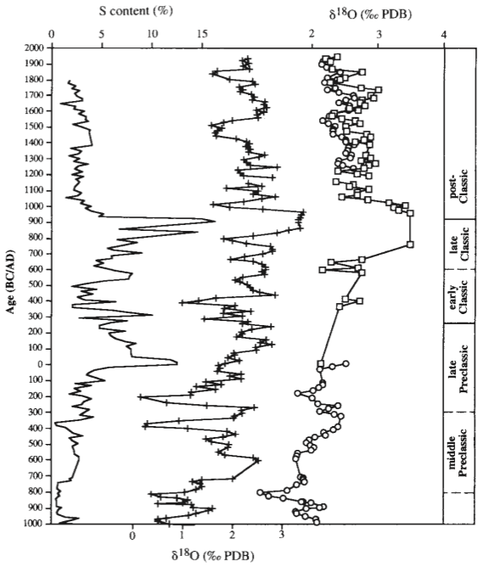

Figure 9: Oxygen isotope record Lake Chichancanab (Hodell et al. 1995)

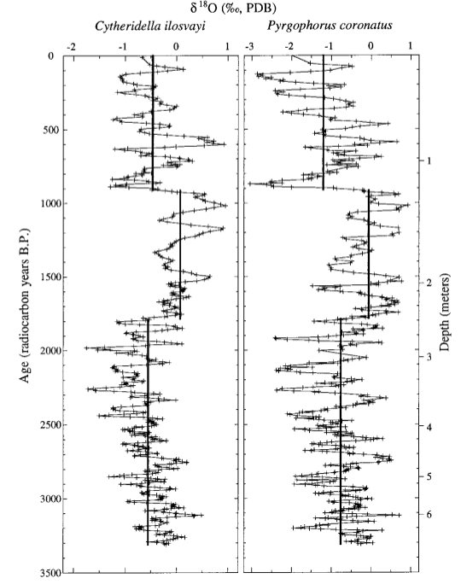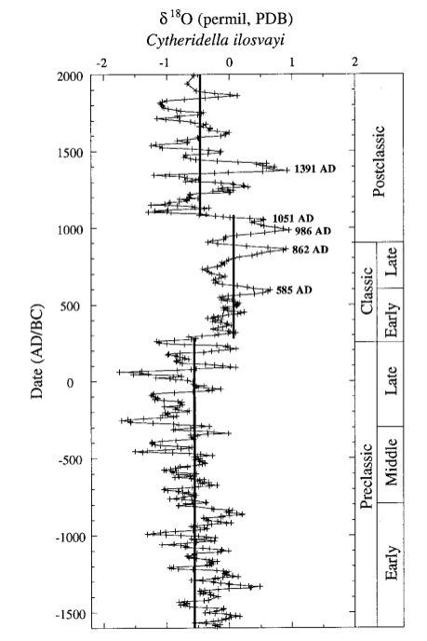

Figure 10: Oxygen isotope record Lake Punta Laguna (Curtis et al. 1996)

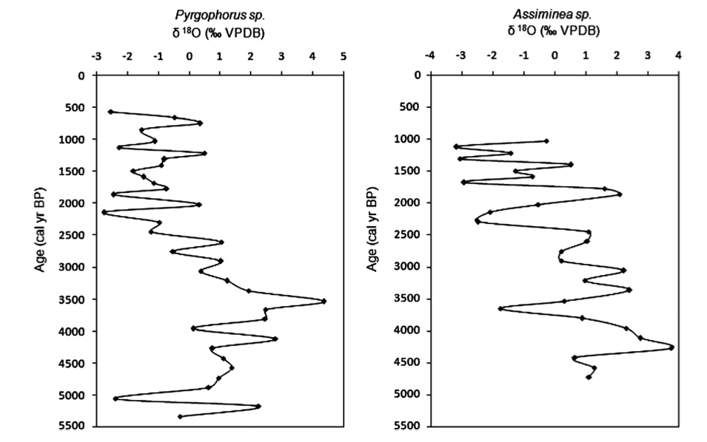

Figure 11: Oxygen isotope record Lake Tzib (Carrillo-Bastos et al. 2010)

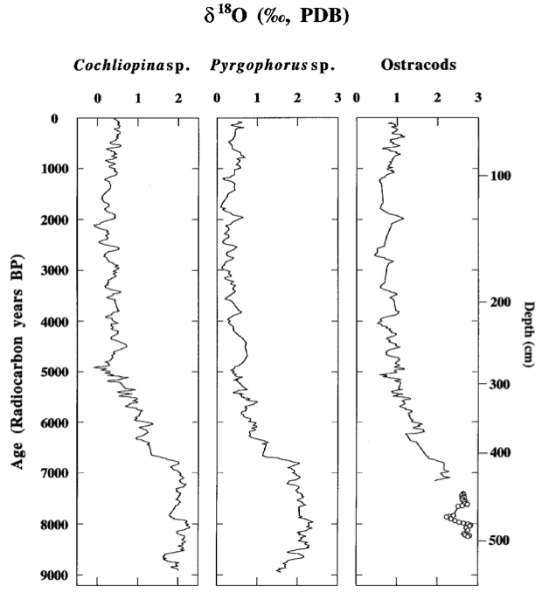

Figure 12: Oxygen isotope record Lake Peten-Itza (Curtis et al. 1998)
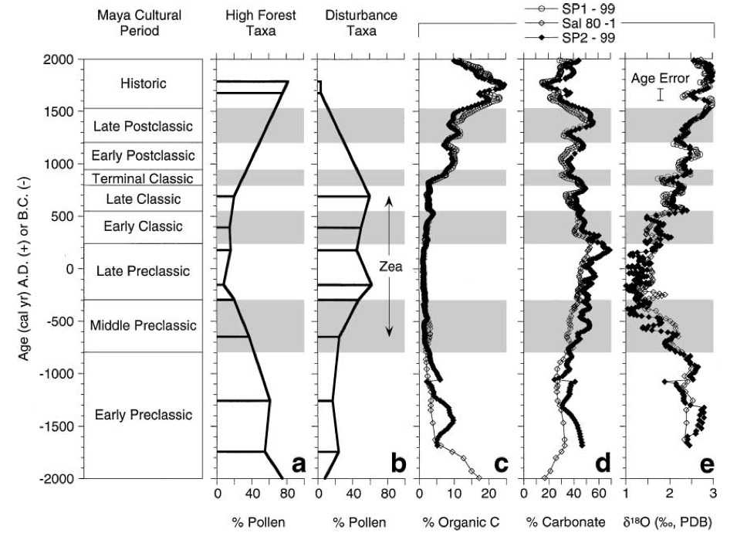

Figure 13: Oxygen isotope record Lake Salpetén (Rosenmeier et al. 2002)

References

Aragón-Moreno, A.A., Islebe, G.A. & Torrescano-Valle, N. 2012, "A ~ 3800-yr, high-resolution record of vegetation and climate change on the north coast of the Yucatan Peninsula", Review of palaeobotany and palynology, vol. 178, no. 0, pp. 35-42.
Beach, T., Dunning, N., Luzzadder-Beach, S., Cook, D.E. & Lohse, J. 2006, "Impacts of the ancient Maya on soils and soil erosion in the central Maya Lowlands", Catena, vol. 65, no. 2, pp. 166-178.
Beach, T., Luzzadder-Beach, S., Dunning, N. & Cook, D. 2008, "Human and natural impacts on fluvial and karst depressions of the Maya Lowlands", Geomorphology, vol. 101, no. 1â€“2, pp. 308-331.
BEACH, T., LUZZADDER-BEACH, S., DUNNING, N., HAGEMAN, J. & LOHSE, J. 2002, "UPLAND AGRICULTURE IN THE MAYA LOWLANDS: ANCIENT MAYA SOIL CONSERVATION IN NORTHWESTERN BELIZE*", Geographical Review, vol. 92, no. 3, pp. 372-397.
Bhattacharya, T., Beach, T. & Wahl, D. 2011, "An analysis of modern pollen rain from the Maya lowlands of northern Belize", Review of palaeobotany and palynology, vol. 164, no. 1â€“2, pp. 109-120.
Blake, M. 2006, "Dating the initial spread of Zea mays", Histories of maize: multidisciplinary approaches to the prehistory, linguistics, biogeography, domestication and evolution of maize.Amsterdam: Elsevier, , pp. 55-72.
Brenner, M., Hodell, D.A., Curtis, J.H., Rosenmeier, M.F., Anselmetti, F.S. & Ariztegui, D. 2003, "Paleolimnological approaches for inferring past climate change in the Maya Region: recent advances and methodological limitations." in The Lowland Maya area: three millennia at the human-wildland interface, eds. A. Gómez-Pompa, M.F. Allen, S.L. Fedick & J.J. Jiménez-Osornio, The Haworth Press, Binghamton, NY, pp. 45-75.
Brenner, M., Rosenmeier, M.F., Hodell, D.A. & Curtis, J.H. 2002, "PALEOLIMNOLOGY OF THE MAYA LOWLANDS", Ancient Mesoamerica, vol. 13, no. 01, pp. 141-157.
Carrillo-Bastos, A., Islebe, G.A., Torrescano-Valle, N. & González, N.E. 2010, "Holocene vegetation and climate history of central Quintana Roo, Yucatán Península, Mexico", Review of palaeobotany and palynology, vol. 160, no. 3, pp. 189-196.
Covich, A. & Stuiver, M. 1974, "Changes in oxygen 18 as a measure of long-term fluctuations in tropical lake levels and molluscan populations", Limnology and Oceanography, vol. 19, no. 4, pp. 682-691.
Cowgill, Ursula M., G. Evelyn Hutchinson, A.A. Racek, Clyde E. Goul- den, Ruth Patrick, and Matsuo Tsukada
1966 The History of Laguna de Petenxil, a Small Lake in Northern Guatemala. Memoirs of the Connecticut Academy of Arts and Sci- ences 17:1–126.
Curtis, J.H., Hodell, D.A. & Brenner, M. 1996, "Climate Variability on the Yucatan Peninsula (Mexico) during the Past 3500 Years, and Implications for Maya Cultural Evolution", Quaternary Research, vol. 46, no. 1, pp. 37-47.
Curtis, J., Brenner, M., Hodell, D., Balser, R., Islebe, G. & Hooghiemstra, H. 1998, "A multi-proxy study of Holocene environmental change in the Maya Lowlands of Peten, Guatemala", Journal of Paleolimnology, vol. 19, no. 2, pp. 139-159.
deMenocal, P.B. 2001, "Cultural Responses to Climate Change During the Late Holocene", Science, vol. 292, no. 5517, pp. 667-673.
Folan, W.J., Faust, B., Lutz, W. & Gunn, J.D. 2000, "Social and environmental factors in the classic Maya collapse", RESEARCH REPORT-INTERNATIONAL INSTITUTE FOR APPLIED SYSTEMS ANALYSIS IIASA RR, , no. 14, pp. 2-32.
Haug, G.H., Günther, D., Peterson, L.C., Sigman, D.M., Hughen, K.A. & Aeschlimann, B. 2003, "Climate and the collapse of Maya civilization", Science, vol. 299, no. 5613, pp. 1731-1735.
Hodell, D.A., Curtis, J.H. & Brenner, M. 1995, "Possible role of climate in the collapse of Classic Maya civilization", Nature, vol. 375, no. 6530, pp. 391-394.
Johnston, K.J. 2003, "The intensification of pre-industrial cereal agriculture in the tropics: Boserup, cultivation lengthening, and the Classic Maya", Journal of Anthropological Archaeology, vol. 22, no. 2, pp. 126-161.
Kennett, D.J., Breitenbach, S.F.M., Aquino, V.V., Asmerom, Y., Awe, J., Baldini, J.U.L., Bartlein, P., Culleton, B.J., Ebert, C., Jazwa, C., Macri, M.J., Marwan, N., Polyak, V., Prufer, K.M., Ridley, H.E., Sodemann, H., Winterhalder, B. & Haug, G.H. 2012, "Development and Disintegration of Maya Political Systems in Response to Climate Change", Science, vol. 338, no. 6108, pp. 788-791.
Lentz, D.L. 2000, An imperfect balance: Landscape transformations in the Precolumbian Americas, Columbia University Press.
Lentz, D.L. & Hockaday, B. 2009, "Tikal timbers and temples: ancient Maya agroforestry and the end of time", Journal of Archaeological Science, vol. 36, no. 7, pp. 1342-1353.
Leyden, B.W. 1987, "Man and climate in the Maya lowlands", Quaternary Research, vol. 28, no. 3, pp. 407-414.
Marcus, J. 2003, "Recent Advances in Maya Archaeology", Journal of Archaeological Research, vol. 11, no. 2, pp. 71-148.
Medina-Elizalde, M., Burns, S.J., Lea, D.W., Asmerom, Y., von Gunten, L., Polyak, V., Vuille, M. & Karmalkar, A. 2010, "High resolution stalagmite climate record from the Yucatán Peninsula spanning the Maya terminal classic period", Earth and Planetary Science Letters, vol. 298, no. 1, pp. 255-262.
Medina-Elizalde, M. & Rohling, E.J. 2012, "Collapse of Classic Maya civilization related to modest reduction in precipitation", Science, vol. 335, no. 6071, pp. 956-959.
Neff, H., Pearsall, D.M., Jones, J.G., Arroyo, B., Collins, S.K. & Freidel, D.E. 2006, "Early Maya Adaptive Patterns: Mid-Late Holocene Paleoenvironmental Evidence from Pacific Guatemala", Latin American Antiquity, vol. 17, no. 3, pp. 287-315.
Robinson, M.E. & McKillop, H.I. 2013, "Ancient Maya wood selection and forest exploitation: a view from the Paynes Creek salt works, Belize", Journal of Archaeological Science, vol. 40, no. 10, pp. 3584-3595.
Rosenmeier, M.F., Hodell, D.A., Brenner, M., Curtis, J.H. & Guilderson, T.P. 2002, "A 4000-Year Lacustrine Record of Environmental Change in the Southern Maya Lowlands, PetÃ©n, Guatemala", Quaternary Research, vol. 57, no. 2, pp. 183-190.
Wahl, D., Byrne, R., Schreiner, T. & Hansen, R. 2006, "Holocene vegetation change in the northern Peten and its implications for Maya prehistory", Quaternary Research, vol. 65, no. 3, pp. 380-389.
Wahl, D., Schreiner, T., Byrne, R. & Hansen, R. 2007, "A Paleoecological Record from a Late Classic Maya Reservoir in the North PetÃ©n", Latin American Antiquity, vol. 18, no. 2, pp. 212-222.
Zizumbo-Villarreal, D. & Colunga-GarcíaMarín, P. 2010, "Origin of agriculture and plant domestication in West Mesoamerica", Genetic Resources and Crop Evolution, vol. 57, no. 6, pp. 813-825.

