Fate of phosphorus in the flower bulb area, the Netherlands

Modeling the contribution of the hydrological sources seepage and agriculture to the PO₄ concentration in the Leidse Vaart, using the modeling program SOBEK-Delwaq, and taking into account advection and adsorption.

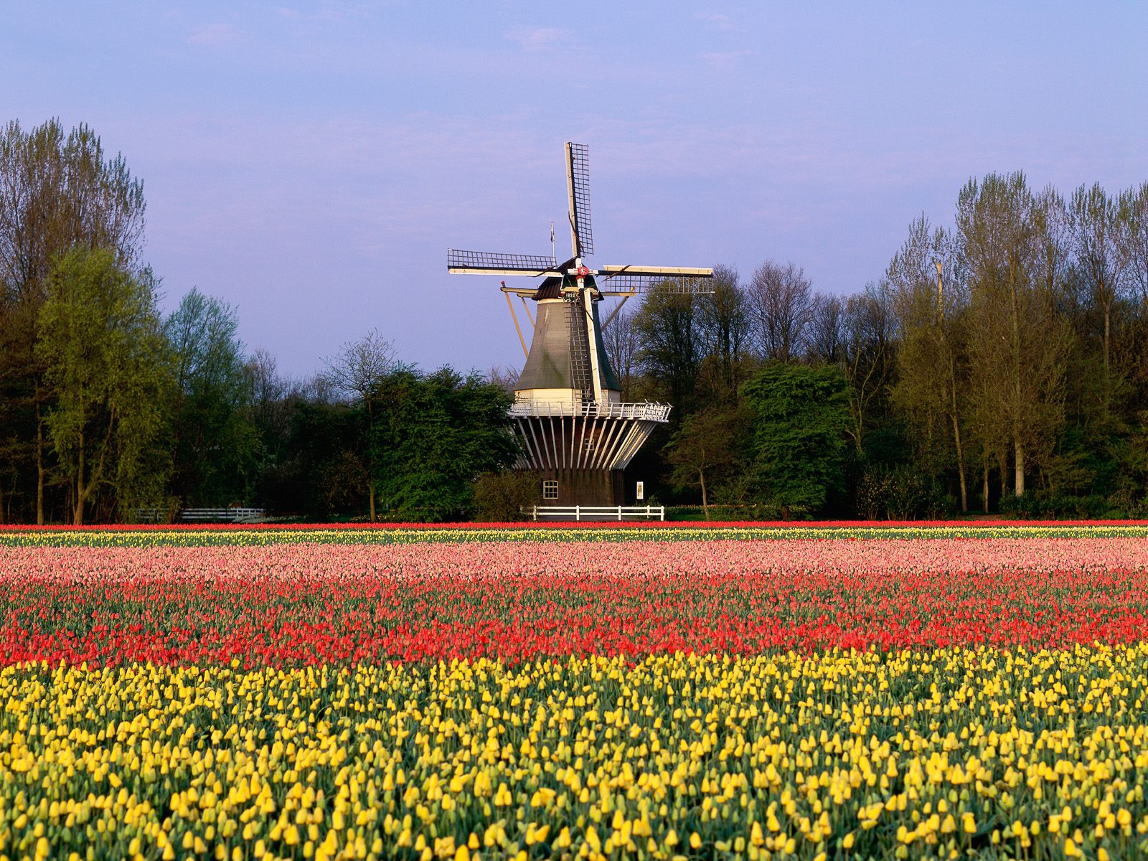

February 15, 2013
Author: Pauline Beerens
Master Earth Surface and Water, Hydrology track

Fate of phosphorus in the flower bulb area, the Netherlands

Modeling the contribution of the hydrological sources seepage and agriculture to the PO₄ concentration in the Leidse Vaart, using the modeling program SOBEK-Delwaq, and taking into account advection and adsorption.

February 15, 2013

Author: Pauline Beerens
Studentnumber: 3404609
Master Earth Surface and Water, Hydrology track

Illustration on the cover: Copyright © 2013 HD Wallpapers.

Abstract

This research was commissioned by the Water Board of Rijnland and was supervised by S. Jansen (Deltares) and Prof. Dr. Ir. S. M. Hassanizadeh (Utrecht University).

In the flower bulb area, phosphorus leaching from agricultural soils poses an important barrier for reaching water quality goals. In this research project, a model was built to estimate the contributions of the hydrological sources seepage and agriculture to the phosphorus load of the surface water, in particular the Leidse Vaart. This should ultimately help to estimate the potential effects of measures on surface water quality. Main question answered is:

How is the phosphorus concentration in the Leidse Vaart influenced by the sources seepage and agriculture?

The start model was the already existing SOBEK model from the Water Board of Rijnland, which models the contribution by agriculture with the rainfall runoff (RR) module and the main waterways (Dutch: ‘boezemkanalen’) with the channel flow (CF) module. Chosen was to change and extend this model to a SOBEK-Delwaq model. Delwaq is the water quality module of SOBEK that makes it possible to model different substances (e.g. nitrogen, phosphorus) and different processes (e.g. adsorption, mineralization, biological activity). Besides that, Delwaq makes it possible to distinguish between sources of these substances (e.g. seepage, sewage treatment plants).

Chosen was to only model the sources seepage and agriculture, only model the substance ortho-phosphate (PO₄), and only model the processes advection (by mass balance equation) and adsorption (by Langmuir isotherm).

For 2 polders (that were actually not located in the flower bulb area), of which one experiences seepage and one experiences infiltration, a sensitivity analysis was done with a reference scenario that has a PO₄ concentration of 3 g PO₄/m³ for the source seepage or agriculture. The influence of changes in initial concentration, source concentration, water volume in the polder, and residence time of the substances was tested. As check for adsorption, also the conservative tracer chloride was modeled. From this sensitivity analysis it is concluded that the concentration in the main waterways is especially influenced by the source agriculture: a lot of PO₄ is added to the polder channels at the same time in combination with a fast discharge to the main waterways. Therefore PO₄ at the top of the water column does not come in contact with the sediment, disallowing adsorption to take place. Because seepage is a continuous source with low concentrations, there is much more mixing in the water column and more interaction of PO₄ with the sediment.

For the Leidse Vaart, every polder in the flower bulb area (consisting of 69 polders) was modeled with the reference scenario to get an indication of the contributions of seepage and agriculture. A polder was assigned to belong to the flower bulb area when flower bulbs were included in the agricultural crop list, and the polder was located in the west of Rijnland. The results are only meant as a basis for future modeling because of the limited processes included in the model. The results indicate that seepage potentially is a big contributor. However, additional research and modeling is necessary to give definite numbers of its contribution.

List of abbreviations

GEP: good ecological potential. WFD-norm for artificial water bodies. For phosphorus in the Leidse Vaart, this norm is 0.15 mg/L P (summer average).
GES: good ecological status. WFD-norm for natural water bodies.
NAP: in Dutch ‘Nieuw Amsterdams Peil’.
P: phosphorus.
PO₄: ortho-phosphate.
SOBEK 1DFLOW or SOBEK CF: the channel flow schematization is the modeling program SOBEK.
SOBEK RR: the rainfall-runoff schematization in SOBEK.
SOBEK 1DWAQ or Delwaq: the water quality module (DELWAQ) in SOBEK.
WFD: Water Framework Directive.
Polder channel: all ditches in a polder are in the SOBEK-Delwaq model united in one long channel called polder channel.
Main waterways: in Dutch ‘boezemkanalen’.

List of symbols

Symbol | Explanation
α | Angle river bed (-), in small river sin alpha ≈ tan alpha = S_{b}
β | Reaction factor (1/s), calculated by eq. 5.11
ϒ | Drainage resistance (s), data
µ | Storage coefficient (m/m), calculated by eq. 5.12
φ | Volumetric porosity (-), parameter
ρ | Density (kg/m³), parameter
ρ^{b} | Bulk density (kg DM/m³ DM), parameter
ρ^{s} | Particle density (kg/m³), parameter
$$τ$$ | Shear stress (N/m²), calculated by eq. 5.7
A | Average cross sectional area (m²), calculated by eq. 5.2
b | Channel width (m), data
B | Bottom width channel (m), data
c | Chézy coefficient (m^{1/2}/s), calculated by eq. 5.6
C | Concentration of a substance in the water (kg/m³), calculated by equation 5.15
C_{ads} | Concentration adsorbed phosphate (kg P/m³ DM), calculated by equation 5.33
C_{Fe} | Concentration iron in dry matter (kg Fe/kg DM), parameter
D | Average channel depth (m), calculated by eq. 5.3
D_{isp} | Dispersion coefficient (m²/s), parameter
d | Depth groundwater table (m), data
dH | Difference between groundwater level and drainage basis (m)
D_{isp} | Dispersion coefficient (m²/s), parameter
E | Evaporation (m/s), data
f | Drainage factor depending on the groundwater table (-). In SOBEK it is necessary to incorporate this parameter into the drainage resistance.
F | Transport flux (kg/s), calculated by equation 5.17
$$\vec{F}$$ | Sum of forces (N), calculated by eq. 6.9
F_{adv} | Advective transport flux of a substance (kg/s), calculated by eq. 9.1 and 9.2
F_{disp} | Dispersive transport flux of a substance (kg/s), calculated by eq. 9.3 and 9.4
g | Gravitational acceleration (m/s²), parameter
h | Flow depth (m above ground level), subscript 0 means bed level, 1 means upstream water level, 2 means downstream water level
h_{f} | Water depth (m) at the location of the interaction zone, calculated by eq. 6.23
I | Infiltration (m/s), data
k²⁰ | Rate constant at reference temperature 20°C (s⁻¹), parameter
k_{L} | Coefficient related to sorption energy (m³/kg), parameter
k_{n} | Nikuradse equivalent roughness (m), parameter
k_{sorp} | Sorption reaction rate (s⁻¹), calculated by equation 5.34
k_{T} | Temperature coefficient (-), parameter
L | Channel length (m), data
m | Mass (kg), calculated by eq. 6.9
O | Wetted perimeter (m), calculated by eq. 5.9
p | Momentum (N/s), calculated by p = mv
P_{n} | Net precipitation (m/s), data
Q | Discharge (m³/s), calculated by eq. 5.5
q | Specific discharge (m/s)
$\overline{q}$ | Lateral flow (m²/s), data
R | Hydraulic radius (m), calculated by eq. 5.8
R | Retardation coefficient (-), calculated by equation 5.31
R_{ads} | Rate of adsorption (kg/m³s), calculated by equation 5.32
R_{netto} | Netto source/sink (kg/m³s)
R_{s} | Source/sink (kg/m³s), calculated by eq. 5.16 and 5.19
s | Adsorbed fraction (kg P/kg Fe), calculated by eq. 5.25
S | Seepage (m/s), data
S_{b} | Slope river bed (-), data
S_{f} | Friction slope (-), calculated by eq. 6.22
S_{max} | Maximal adsorbed fraction (kg P/kg Fe), parameter
t | Unit time (s)
T | Ambient water temperature (°C), parameter
v | Velocity (m/s), calculated by v = Q/A
V | Soil moisture storage in the root zone (m), calculated by eq. 8.1
Volume | Volume (m³), calculated by V = L*A
V_{eq} | Storage capacity at equilibrium (m), data
W | Average channel width (m), calculated by eq. 5.4
x | Unit length (m)
$\overline{y}$ | Water depth above centroid of flow (m), is virtually the same as h

Table of Contents
Abstract 5
List of abbreviations 6
List of symbols 7
1. Introduction 12
1.1 Problem description 12
1.2 Policy 12
1.3 Goal of the research 13
1.4 Main question and sub questions 13
1.5 Reading guide 13
2. Area information 14
2.1 Location 14
2.2 Soil 14
2.3 Hydrology 15
3. Phosphorus 16
3.1 Phosphorus concentrations Rijnland 16
3.2 Sources of phosphorus in the flower bulb area 16
3.3 Forms of phosphorus 17
3.4 Phosphorus cycle 18
4. Model choice 21
5. Model description 22
5.1 SOBEK 1DFLOW / CF 22
5.2 SOBEK-RR, unpaved node 24
5.2.1 Precipitation and evaporation 24
5.2.2 Surface runoff 24
5.2.3 Drainage 25
5.2.4 Seepage 25
5.2.5 Infiltration 25
5.2.6 Percolation 26
5.3 SOBEK 1DWAQ 26
6. Method 31
6.1 Recap of choices 31
6.2 Water quantity start model 32
6.3 Water quality start model 32
6.4 Schematization start model 32
6.5 New model 35
6.6 Schematization of the new model 35
6.7 Water quantity new model 38
6.8 Water quality new model 40
6.9 Sensitivity analysis 41
6.9.1 Scenarios and hypotheses 41
6.9.2 Data and parameters 43
7. Results and discussion of the results 45
7.1 Results water quantity 45
7.2 Discussion water quantity 47
7.3 Results water quality sensitivity analysis 48
7.4 Discussion about the shape of the reference runs 52
7.5 Discussion of the scenarios results 53
7.6 Results water quality Leidse Vaart 55
7.7 Discussion about the results for the Leidse Vaart 59
8. Discussion 60
8.1 Benefits of the new model 60
8.2 Schematization of the model 60
8.3 Choices 60
8.3.1 Ortho-phosphate versus colloidal P 60
8.3.2 Seepage and agriculture versus other sources 60
8.3.3 Advection and adsorption versus other processes 60
8.3 Scenarios 61
8.4 Data and parameters 61
9. Conclusion 63
10. Recommendations 64
11. Bibliography 65
12. List of figures 69
13. List of tables 71
14. Appendices 72
Appendix 1: Land use flower bulb area 73
Appendix 2: Soil types Rijnland 74
Appendix 3: Seepage and infiltration Rijnland 75
Appendix 4: The quantity area of Rijnland with the main waterways, beach, dunes and the former water boards of Groot Haarlemmermeer, the Oude Rijnstromen and Wilck and Wiericke 76
Appendix 5: Derivation of the continuity equation (conservation of mass) 1D 77
Appendix 6: Derivation of the momentum equation 1D 79
Appendix 7: Derivation of the De Zeeuw-Hellinga equation for the runoff 83
Appendix 8: Derivation of the equation for percolation 84
Appendix 9: Derivation of the advection-dispersion equation in DELWAQ 85
Appendix 10: List of polder numbers and names in model 87
Appendix 11: Precipitation and evaporation for polder 200 and polder 88 90
Appendix 12: Flow from agricultural area to polder ditches for polder 200 and 88 91
Appendix 13: Water pumped from the main waterway into the polder channel 92
Appendix 14: Test run desorption polder 200 93

1. Introduction

1.1 Problem description
The flower bulb area is an economically important area for the Netherlands, but it is also is one of the areas with the most intensive agricultural activities resulting in high environmental pressure. Problem substances are related to the fertilizer application and include pesticides as well as nutrients. Problem pesticides are carbendazim and imidacloprid and nutrients that exceed the limits for water quality are phosphorus and nitrogen (Loeffen 2007). Because of the sandy soil in the area, these substances leach quite easily into the surface waters. More and more attention is paid to these substances: the Water Framework Directive (WFD) obliges European Union member states to realize a good ecological status (GES) of their water systems by 2015, which can be prolonged to 2027. For many water bodies this can only be reached when the nutrient levels decrease further, especially phosphorus levels (de Boorder 2011). With phosphate concentrations up to 4 mg/L measured in the ditches the flower bulb area has one of the highest phosphate concentrations of the Netherlands (de Boorder 2011). Therefore it is essential to pay attention to phosphorus.

Phosphorus is added by fertilizer application. Because there is a low organic matter content present in the flower bulb area, adding fertilizer is essential to grow flower bulbs, but this contributes enormously to the phosphorus content in the topsoil and the emissions to surface water. Historical use together with the current adding of phosphorus by fertilizer use has resulted in phosphate accumulation in the soil profile. These high phosphate concentrations can leach into the ground- or surface water which increases the environmental pressure, especially because phosphorus in freshwaters is a limiting element (de Boorder 2011). Examples of pressures are eutrophication, which is the excessive production of algae and cyanobacteria, and oxygen depletion in water, which can kill fish (Koopmans 2010).

1.2 Policy
The European Nitrates Directive was adopted in 1991 and aims to protect groundwater quality across Europe (European_Union 2010). The Dutch fertilizer policy is based on this directive. The manure policy tries to reduce the nitrogen and phosphorus coming from the agriculture and entering the surface- and groundwaters (Rijksoverheid 2012). However, this policy focuses on reducing the current load of phosphate and not on the mitigation of historical accumulated load (de Boorder 2011). Large quality improvements have been reached for nitrogen and phosphorus in main waterways by emission reduction of sewage treatment plants (a. Rijnland 2012). Also agricultural emissions have reduced, but strong bounds of phosphorus to the adsorption sites have resulted in a phosphorus accumulation in the soil that results in a slow phosphate drain-off (van den Broek 2005).

In 2000, the European Water Framework Directive (WFD) was adopted. The environmental objectives are set for surface waters, groundwaters and protected areas. WFD-goals include the achievement of good ecological status (GES) by 2015 which can be prolonged to 2027, no deterioration, progressive reduction of pollution of priority substances, reversal of any significant, upward trend of pollutants in groundwaters and the achievement of standards and objectives set for protected areas (European_Communities 2009). However, heavily modified and artificial water bodies only have to reach their good ecological potential (GEP) by 2027, which is the good ecological status adjusted for the changes that were made and cannot be undone.

The criteria for water bodies in Rijnland set by the Water Board of Rijnland are that the water body has to have a minimal surface of 50 hectares, the catchment area is larger than 10 square kilometers, it has more than 15% open waters and/or it has a Natura 2000 status (d. Rijnland 2012). In the flower bulb area there is therefore only one WFD water body, the Leidse Vaart (Krol 2012). The Leidse Vaart is an artificial water body and thus has a GEP, which is a summer average for phosphorus of 0.15 mg/L (Krol 2012). In comparison, most canals and ditches have a GEP between 0.15 and 0.22 mg P/L, and streams have a GES of 0.14 mg P/L (CBS 2012).

1.3 Goal of the research
The Water Board of Rijnland has commissioned a research to find out what the contribution of different sources is to the surface water system and predominantly to the Leidse Vaart (Krol 2012). They want to separate the agricultural sources from the other sources.

Two main goals are identified: First, it is important to know what the focal point of a measure should be, because measures are expensive. Second, some sources, like seepage, do not count for the WFD-norm because it is impossible to improve the quality of these sources. When it is possible to show that these sources contribute to the P concentration in the Leidse Vaart, a more lenient WFD-norm could be applied which perhaps makes less measures necessary. Therefore in this research attention is paid to the sources Agriculture and Seepage.

1.4 Main question and sub questions
We chose a model to achieve these goals. This model will be used to determine the water quantity and quality in Rijnland. A model makes it possible to vary input from various sources and test the effect in water quality. Main and sub questions are formulated as follows:

The main question of this research is: How is the phosphorus concentration in the Leidse Vaart influenced by the sources Seepage and Agriculture?

The sub questions are:
- How sensitive is the P concentration in the main waterways to the adding of P by seepage?
- How sensitive is the P concentration in the main waterways to the adding of P as result of fertilizer application in agricultural areas?
- What are the possibilities of the model for scenario modeling?

Finally, the model should help the Water Board of Rijnland in making a choice for measures or for norm adaptation.

1.5 Reading guide
The next section starts with some information about the flower bulb area: location, soil and hydrology. This is followed with chapter 3 that is about phosphorus. This chapter among other things explains which sources of phosphorus and which types of phosphorus are regarded in this research. After that, chapter 4 explains why the SOBEK-Delwaq model is chosen. This is followed in chapter 5 by the model equations, with the focus on the chosen processes (advection and adsorption). Chapter 6 starts with a recap of choices and then explains the method used in this research to model the area of Rijnland. It is chosen to do a sensitivity analysis and the scenarios used to do this, as well as the formulated hypotheses and the chosen parameters are also explained in chapter 6. Chapter 7 shows the results and the discussion of the results, subdivided into the categories water quantity, water quality of the sensitivity analysis and the water quality of the Leidse Vaart. Chapter 8 is the discussion which is followed in chapter 9 by the conclusion. The final section contains the recommendations.

2. Area information
This chapter starts with a section showing the location of Rijnland and the flower bulb area. This is followed by sections about the soil types and hydrology in Rijnland.

2.1 Location
Rijnlands management area is located between the municipalities of Wassenaar, IJmuiden, Amsterdam and Gouda, in the west of the Netherlands. This area is about 1113 km² (b. Rijnland 2012). Of Rijnlands area, about 3% is used to grow flower bulbs. The flower bulbs grow mainly in the western part of Rijnland and this area is therefore called the flower bulb area (b. Rijnland 2012). The flower bulb cultivation is a small scale business with on average 8 hectares per company (Groenendijk 2009), which results in about 625 flower bulb companies (a. Rijnland 2012). In figure 1, the management area of Rijnland is shown, with the flower bulb area surrounded by a red line. A map of the land use in the flower bulb area of Rijnland can be found in appendix 1.

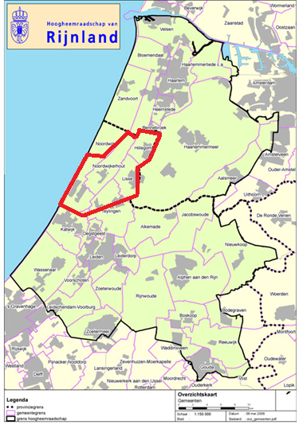
Figure 1: Management area of Rijnland, with the flower bulb area surrounded by a red line (e. Rijnland 2005).

2.2 Soil
A map with the different types of soil present in Rijnland can be found in appendix 2. The soil in the flower bulb area consists of calcareous rich entisols with moderate fine sand and calcareous dune-entisols with fine sand (Groenendijk 2009). The organic matter content in the first 50 centimeters is ranging from 0.5-1.5% (Dijkstra 1997).

2.3 Hydrology
The annual rainfall for the period 1981 – 2010 was on average 892 mm (b. Rijnland 2012). For the owners of the flower bulbs, high groundwater levels are a bigger problem than low water levels. Therefore they try to let the water level be lower than -0.60 m NAP (e. Rijnland 2005), by level management, dewatering and the adding of water. About 30% of the flower bulb area is dewatered by open drainage, 15% by closed drainage, 50% by pumped drainage and about 5% is dewatered by a combination of source drainage and open drainage (Chardon et al., 2008 in (Groenendijk 2009)).

In the flower bulb area there is in general seepage in the western part with values up to 0.5 mm/day. In the eastern part there is infiltration (Groenendijk 2009). However, in the northern part of Rijnland there is more or less equilibrium between seepage and infiltration (Dijkstra 1997). This is caused by a poorly permeable clay layer that is present at circa 1 meter below ground level (Groenendijk et al., 1996 in (Dijkstra 1997)). In a large part of the flower bulb area is infiltration and no seepage, although there is some uncertainty (van Dam 2012). A map of the seepage and infiltration is shown in appendix 3.

The surface of the main waterways in Rijnland is circa 15 000 hectares. The surface of the main waters is about 4500 hectares (e. Rijnland 2005). The water level of the main waters varies between -0.62 m NAP in the winter and -0.59 m NAP in the summer. Rijnland has circa 170 polders of about 70,000 hectares in total and 40 water treatment plants that dewater at the main waterways, but also the polders of Amsterdam-west and a sluice by Bodegraven (both outside Rijnlands management area) dewater on the main waterways of Rijnland. In appendix 4, the four main pumping stations of Rijnland, Spaarndam, Halfweg, Katwijk and Gouda are shown. Also the original Water Boards that are now incorporated into the Water Board of Rijnland are indicated: Groot Haarlemmermeer, de Oude Rijnstromen and Wilck and Wiericke. Spaarndam and Halfweg dewater in the Noordzeekanaal, Katwijk in the Noordzee, and Gouda in the Hollandsche IJssel (e. Rijnland 2005). Gouda has a different regime, because the cities channels are separated from the other channels by a sluice and the water level is kept at -0.70 m NAP. In dry periods, water from the Hollandsche IJssel can enter Rijnland via Gouda. The dunes in the west of Rijnland have a higher water level and the water of this area infiltrates and dewaters in the main waterways.

3. Phosphorus
In this chapter, first the current phosphorus concentrations in Rijnland are shown. After that, the sources of these current phosphorus concentrations are shown, with focus on agriculture as a source. Then there is a section about the types of phosphorus, starting with the difference between organic and inorganic P. This is followed by a description of the three phases of P: particulate, colloidal and dissolved. The final section shows the phosphorus cycle and the processes that this cycle includes with focus on dissolved phosphorus.

3.1 Phosphorus concentrations Rijnland
The GEP for phosphorus in the Leidse Vaart is a summer average of 0.15 mg/L (c. Rijnland 2009). However, in the flower bulb area the phosphorus concentrations lie between 0.10 mg/L and 4.3 mg/L (de Boorder 2011), thereby exceeding the norm (figure 2). The concentrations are the highest in the western part of Rijnland, because of the low capacity of sandy soils to bind phosphorus in combination with the adding of a lot of phosphorus by using fertilizer (f. Rijnland 2002). For this area, phosphorus concentrations measured in the groundwater lie between 1 and 4 mg/L (Groenendijk 2009). The historical use of phosphorus has also led to phosphorus saturation of the soil. Although there have been large reductions in the adding of nutrients, still more phosphorus enters than leaves the area and is added to the soil (Groenendijk 2009). Saturation is a problem because it turns the soil into a potential source for phosphorus (van de Weerd 2008). In addition, the risk of P loss increases with a higher degree of P saturation (Koopmans 2010).

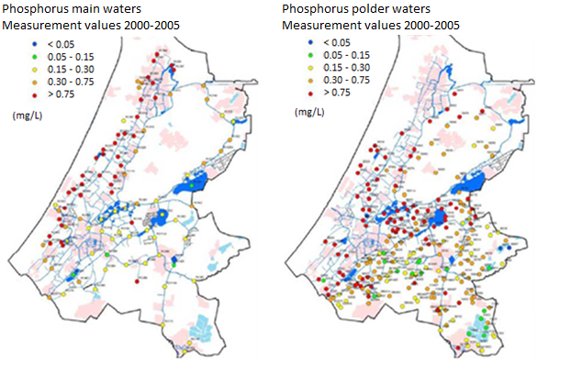
Figure 2: Long-term summer averages of phosphorus in the period 2000-2005. The norm of phosphorus (0.15 mg P/L) is not exceeded in the green and blue dots, but it is exceeded in all other cases (Hoogheemraadschap van Rijnland, 2006 in (Groenendijk 2009)).

3.2 Sources of phosphorus in the flower bulb area
The flower bulb area contributes about 24% to the total phosphate load in Rijnland, which is about 152 ton/year (Rijnland, 2010 in (van Dam 2012)). In the surface water of the flower bulb area, fertilizers used in agriculture count for 98% of the P load, as shown in table 1 (de Jonge 2011). In this table, the seepage is not taken into account.

Table 1: Sources of P load in the surface waters of the flower bulb area (de Jonge 2011).
Source | P-load
Atmospheric deposition | 1%
Fertilizers other agriculture | 33%
Fertilizers flower bulb area | 65%
Other | 1%
Total | 100%

There is 2,700 hectare soil suitable to cultivate flower bulbs, but every year 500 hectare is used for other crops, because of crop rotation. To grow flower bulbs, adding organic matter is essential. This is because organic matter is important for a good soil quality and there is only around 1% naturally present in this area (Groenendijk 2009). The soil needs 3,600-5,400 kg/ha*year organic matter to be able to grow the bulbs (van Dam 2012). Therefore, animal manure, artificial fertilizer and compost are used to increase the organic matter content. By doing this, also extra phosphorus is added, which the soil does not really need because of historical accumulation of phosphorus. In table 2, the amount of organic matter and P₂O₅ is shown that you typically get from each type of fertilizer. As can be seen, animal manure adds a lot of P₂O₅. The total P in manure is 6.0-8.6 g/kg (Kleinman et al., 2005b in (Chardon 2007)). The effect of animal manure on the P concentration in the environment is twofold: large amounts of phosphorus are added and plants cannot directly take up this phosphorus. The latter is because in animal manure phosphorus and nitrogen are fixated in complex organic bonds, making mineralization essential before plants can use the nutrients (van de Weerd 2008). Maintaining the organic matter content of the soil and staying within the phosphorus norm thus seems impossible when animal manure is used (van Dam 2012).

Table 2: Amount of organic matter and P₂O₄ you get from 1000 kg fertilizer, per type of fertilizer (van Dam 2012).
Type fertilizer (1000 kg) | Organic matter (kg) | P₂O₅ (kg)
Animal manure | 75 | 4.1
Compost | 158 | 3.7
Straw | 210 | 2.2

3.3 Forms of phosphorus
In the environment, P occurs as organic or inorganic P. Organic P is for example found as part of living or dead organic materials (van der Perk 2006). The organic forms of P in aquatic systems include phosphate esters, phosphonates and phosphinates (van Moorleghem 2011). P in its inorganic forms occurs as orthophosphates, for example as phosphoric acid (H₃PO₄) and its dissociation products, the orthophosphate ions: H₂PO₄⁻, HPO₄²⁻ and PO₄³⁻ (Fetter 2008).

Three phases of phosphorus are distinguished: particulate phase – a hardly mobile solid phase; colloidal phase – a mobile solid phase; and dissolved phase – a mobile aqueous phase (Liu 2011); (Sims et al., 2000 in (Heathwaite 2005)). The distinction between the dissolved and the particulate phase is an arbitrary one of 0.45 µm, with fractions of P that are able to pass through a 0.45 µm membrane identified as dissolved and the rest identified as particulate (Heathwaite 2005). When using this distinction, colloids with sizes in the range of 1 nm to 1 µm (Liu 2011), fall in no category. A schematic overview of the sizes is shown in figure 3.

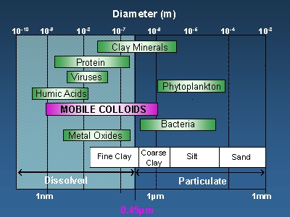
Figure 3: Schematic overview showing the size range of colloids and the 0.45 micron divide commonly used to distinguish dissolved from particulate phosphorus (LEC 2012).

The classical view has always been that P moves in soils as ortho-phosphate (Dolfing 1999), however, nowadays more attention is paid to mobile colloidal P in subsurface drainage samples and soil solutions (Ilg 2008). This is the case because colloidal P is thought to be a significant component of P loss via leaching (Heathwaite 2005). In addition, colloids differ in their mobility from particulate phosphorus: colloids are small which makes Brownian forces more important than gravitation. Therefore, they can remain in water for a longer time and travel longer distances (Liu 2011).

However, research to colloidal P is new and very difficult because colloid movement is dependent on many variables; it is for example largely influenced by preferential flow (Chardon 2007). This research therefore focusses on dissolved P, more specific on ortho-phosphate (PO₄).

3.4 Phosphorus cycle
The phosphorus cycle is shown in figure 4. As discussed before, phosphorus enters the flower bulb area mainly because it is added by fertilizer. Part of this phosphorus leaves the area by runoff or erosion attached to sediment or as soluble phosphorus and discharges directly in surface waters, part of this phosphorus leaves the area by leaching, and a part interacts with the soil.

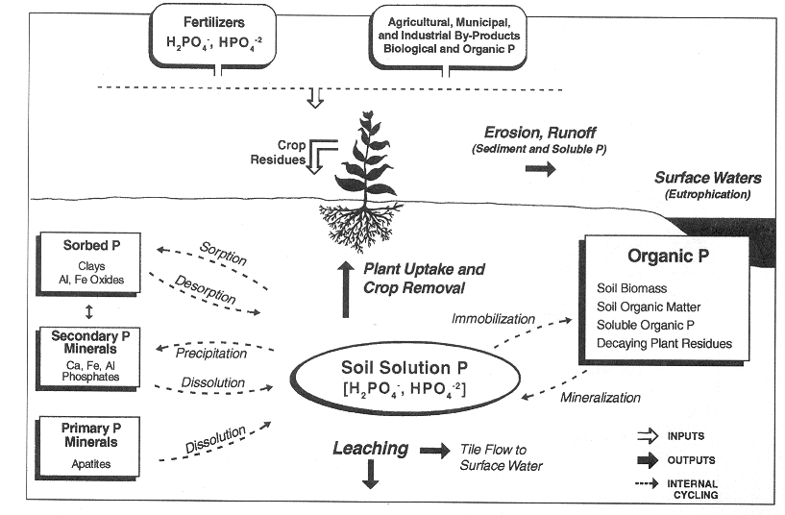
Figure 4: Phosphorus cycle (Koopmans 2010).

As shown in figure 4, the interaction processes in the soil can be divided into three categories:

- Adsorption – desorption
- Precipitation – dissolution
- Immobilization – mineralization

For inorganic phosphorus, like ortho-phosphate, controlling reactions are sorption-desorption and precipitation-dissolution.

Sorption comprises the following processes:

- Adsorption: the attachment of substances to the surface of soil particles.
- Absorption: the diffusion of adsorbed substances into the solid soil particles.
- Desorption: the detachment of substances to the surface of soil particles.

The adsorption reaction is a fast reversible reaction, which is followed by the slow absorption (Cornforth 2012). P may become available again by slow desorption. Adsorption is a ligand exchange reaction between phosphate ions and OH⁻ or H₂O groups. Bridging complexes are formed between the HPO₄²⁻ ions and metal oxide surfaces (Cornforth 2012). The pH determines the H₂O and OH⁻ proportions and thus the reactions that take place.

Precipitation and dissolution is controlled by the pH value and the redox potential (van der Perk 2006). It depends on the pH what the speciation of the dissolved phosphorus species is. Under acid conditions (pH < 4.5), phosphate ions react with dissolved iron and aluminium ions and precipitate as ferric iron and aluminium phosphates (van der Perk 2006). In equation 3.1, the reaction of phosphate ion with dissolved iron is shown and in equation 3.2 the reaction of a phosphate ion with dissolved aluminium ion (Lenntech 2011). In alkaline soils (pH > 7), P can react with calcium carbonate to precipitate as hydroxyapatite (equation 3.3) (Fetter 2008). Because calcium phosphates are poorly soluble, the reverse dissolution reaction occurs less often.

$Fe^{3+}+H_{n}PO_{4}^{3-n}→FePO_{4 }(s)+nH^{+}$ eq. 3.1

$Al^{3+}+H_{n}PO_{4}^{3-n}→AlPO_{4}(s)+nH^{+}$ eq. 3.2

$3 HPO_{4}^{2-}+5 CaCO_{3}+2 H_{2}O→Ca_{5}{\left(PO_{4}\right)}_{3}\left(OH\right)(s)+5HCO_{3}^{-}+OH^{-}$ eq. 3.3

Although the redox potential has no major effect on the environmental behavior of P itself, it does influence the iron hydroxides that react with P. Under reducing conditions, ferric phosphate is reduced to ferrous phosphate, which is much more soluble (equation 3.4) (van der Perk 2006). Because ferrous phosphate is more soluble, it does not stay in the solid state. Therefore the precipitated phosphorus gets dissolved again resulting in increased dissolved P concentrations.

$FePO_{4}\left(s\right)·2H_{2}O→Fe_{3}{\left(PO_{4}\right)}_{2}(s)·8H_{2}O$ eq. 3.4

4. Model choice
The Water Board of Rijnland has shown interest in finding out what the contribution of different sources is to the surface water system and predominantly to the Leidse Vaart (Krol 2012). They want to separate the agricultural sources from the other sources. In this research a model is used to achieve this and to be able to advise them on which source they have to focus and whether or not they should choose for norm adaptation or taking measures.

The model used is SOBEK-Delwaq. SOBEK is an integrated model that has multiple modules able to model urban, rural or river flows and thereby helping water management (a. Deltares 2012). Relevant in relation to this research are the Rural 1DFLOW, the RR and the 1DWAQ module. The SOBEK-Rural 1DFLOW can simulate one-dimensional flow in irrigation and drainage systems, RR is the rainfall-runoff module which is often used to model polders, and 1DWAQ is the water quality module called Delwaq (a. Deltares 2012). The Delwaq module calculates the substances- and sediment transport in water systems and incorporates the dynamics of the water system in its calculations (a. Deltares 2012). In figure 5, the flow diagram of the simulation with RR, Rural 1DFLOW and 1DWAQ is shown.

Figure 5: Flow diagram of the simulation with RR, Rural 1DFLOW and 1DWAQ in SOBEK (a. Deltares 2012).

In this research SOBEK-Delwaq is used as model. This model is chosen because of multiple reasons:

- The Water Board of Rijnland already has a SOBEK model of the Rijnland area at polder scale. This is an advantage because a lot of information about the area is incorporated in this model and is thus readily available. Besides that, Rijnland is a large area and it would be very time consuming and difficult to model the whole area from scratch.
- It is possible to model quantity of water and quality of water. SOBEK-Delwaq enables direct use of water quality modules. It can model multiple types of P: adsorbed orthophosphate, detritus phosphorus, other organic phosphorus and ortho-phosphate (PO₄).
- It is easy to make a distinction between sources like seepage and agriculture. Therefore it is for example possible to turn only one source on and see its influence on the whole area.
- It is possible to see changes in P concentrations at multiple locations, like in an individual polder or anywhere in a main waterway. This makes it possible to see the influence of a source at a specific location.
- It is easy to adapt SOBEK-Delwaq to run a different scenario.
- The output of the model is shown in graphs and the data can easily be exported to Excel.

5. Model description
SOBEK has multiple modules, the three relevant for this research are the 1DFLOW module, also called channel flow (CF) module, Rainfall-Runoff (RR) module, and SOBEK 1DWAQ module, the water quality module of SOBEK called Delwaq. In this section, the underlying formulas of these three modules are shown, taking into account that only advection and adsorption are modeled.

5.1 SOBEK 1DFLOW / CF
SOBEK 1DFLOW / CF is used to model the water flow in main waterways. To do this, the complete Saint Venant equations for one-dimensional problems are solved. The Saint Venant equations are derived from the integration of the Navier-Stokes equations (van Nooyen 2005), with the most important assumption that the horizontal length is much larger than the vertical depth, as is the case in shallow waters like ditches and channels. All assumptions are (van Nooyen 2005):

- It is a shallow fluid (the horizontal length is much larger than the vertical depth).
- The fluid is incompressible (constant density).
- There is a constant symmetrical cross section.
- There is a constant soil slope.
- The pressure locally is equal to the pressure in uniform flow.

The 1D continuity equation is shown in equation 5.1, and the 1D momentum equation in equation 5.5 (b. Deltares 2012). The derivations are shown in appendix 5 and 6 respectively.

Continuity equation: $\frac{δQ}{δx}+\frac{δA}{δt}=\overline{q}$ eq. 5.1

In which:
Q = Discharge (m³/s), calculated by equation 5.5
x = Unit length (m)
A = Average cross sectional area (m²), calculated by equation 5.2
t = Unit time (s)
q = Lateral flow (m²/s)

$A=DW$ eq. 5.2

In which:
D = average depth (m), calculated by equation 5.3
W = average width (m), calculated by equation 5.4

$D=\frac{1}{2}\left(h_{1}-h_{2}\right)-h_{0}$ eq. 5.3

In which:
h₁ = upstream water level (m above ground level)
h₂ = downstream water level (m above ground level)
h₀ = bed level (m above ground level)

$W=B+S_{b}*D$ eq. 5.4

In which:
B = bottom width (m)
α = angle river bed (-)
D = average depth (m)

Momentum equation: $\frac{δQ}{δt}+\frac{δ}{δx}\left(\frac{Q^{2}}{A}\right)+gA\frac{δh}{δx}+\frac{gQ\left|Q\right|}{c^{2}RA}-b\frac{τ}{ρ}=0$ eq. 5.5

In which:
Q = Discharge (m³/s)
t = Unit time (s)
A = Average cross sectional area (m²), calculated by equation 5.2
x = Unit length (m)
g = Gravitational acceleration (m/s²)
h = Flow depth (m)
c = Chézy coefficient (m^{1/2}/s), calculated by equation 5.6
b = Channel width (m)
$τ$ = Shear stress (N/m²), calculated by equation 5.7
R = hydraulic radius (m), calculated by equation 5.8
ρ = Density (kg/m³)

The Chézy coefficient is calculated with a simplification of the White-Colebrook formula that specifies an equivalent roughness according to Nikuradse (b. Deltares 2012). This simplified formula is shown in equation 5.6.

$c=18*\log\left(\frac{12*R}{k_{n}}\right)$ eq. 5.6

In which:
c = Chézy coefficient (m^{1/2}/s)
R = Hydraulic radius (m)
k_{n} = Nikuradse equivalent roughness (m)

$τ=ρghS_{b}$ eq. 5.7

In which:
ρ = Density (kg/m³)
g = Gravitational acceleration (m/s²)
h = Flow depth (m)
S_{b} = slope river bed (-)

$R=\frac{A}{O}$ eq. 5.8

In which:
A = Average cross sectional area (m²), calculated by equation 5.2
O = wetted perimeter, calculated by equation 5.9

$O=B+2D\sqrt{1+\tan^{2}{α}}$ eq. 5.9

In which:
B = bottom width (m)
α = angle river bed (-)
D = average depth (m)

5.2 SOBEK-RR, unpaved node
SOBEK-RR is the rainfall-runoff module. This module is in general used to model water in polders. SOBEK-RR models precipitation, evaporation, surface runoff, groundwater drainage, infiltration, seepage and percolation (b. Deltares 2012). The unpaved node, that is used to model the agriculture, models with this information the storage on the land, the unsaturated zone and the shallow groundwater (figure 6).

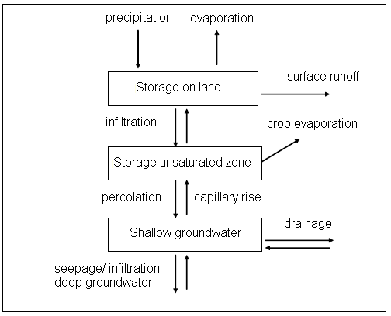
Figure 6: Concept RR-unpaved (Prinsen 2009).

5.2.1 Precipitation and evaporation
Precipitation and evaporation data can be added using a user-defined file, or as pre-defined file. The pre-defined options include the KNMI-series from De Bilt, the long term average values, values according to Guideline Sewer systems and daily values for the selected precipitation period (b. Deltares 2012).

5.2.2 Surface runoff
The surface runoff to open water in unpaved areas can occur when the ‘storage on land’ reservoir is filled by the precipitation minus evapotranspiration minus infiltration into the soil, or when the groundwater level has reached the soil surface level (b. Deltares 2012). The surface runoff thus starts when or the infiltration capacity is exceeded, or when the groundwater level reaches the surface level.

The runoff is modeled by the De Zeeuw-Hellinga equation (equation 5.10). The derivation of the De Zeeuw-Hellinga equation is shown in appendix 7.

$q(t)=q(t-1)*e^{-βdt}+\left(I+S\right)\left(1-e^{-βdt}\right)$ eq. 5.10

In which:
q = specific discharge (m/s)
β = reaction factor (1/s), calculated by equation 5.11
t = time unit (s)
I = infiltration (m/s)
S = seepage (m/s)
The De Zeeuw-Hellinga equation is pre-defined in SOBEK-RR, the only value that has to be defined is the surface runoff reaction factor β (b. Deltares 2012). This reaction factor is calculated by equation 5.11:

$β=\frac{1}{γμ}$ eq. 5.11

In which:
ϒ = drainage resistance (s)
µ = the storage coefficient (m/m), calculated by equation 5.12

$μ=\frac{V_{eq}}{d}$ eq. 5.12

In which:
V_{eq} = storage capacity at equilibrium condition (m)
d = depth groundwater table (m)

5.2.3 Drainage
Drainage is modeled with the Ernst formulation. This makes it possible to use CAPSIM: a model code for the unsaturated zone, allowing RR to model also non-drained areas (Prinsen 2009). CAPSIM determines the equilibrium soil moisture content per time step as a function of ground water level, crop type and soil type. In wet periods excess water percolates directly to the shallow groundwater and in dry periods there is capillary rise and possible evaporation reduction (Prinsen 2009). The Ernst principle is shown in figure 7, and the Ernst equation is shown in equation 5.13 (b. Deltares 2012).

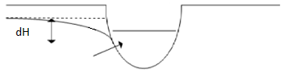
Figure 7: The Ernst principle (b. Deltares 2012).

$q=\frac{dH}{γf}$ eq. 5.13

In which:
q = specific discharge (m/s)
dH = difference between groundwater level and drainage basis (m)
ϒ = drainage resistance (s)
f = factor between 0.65 and 0.85, depending on the shape of the groundwater table (-). In SOBEK it is not possible to use this parameter. You should incorporate this parameter in ϒ (Prinsen 2009).

5.2.4 Seepage
It is possible to model the deep groundwater by adding seepage as constant value, a time series or as a time series that depend on a function of hydraulic head of the deep groundwater (Prinsen 2009).

5.2.5 Infiltration
Besides the surface runoff also the infiltration is calculated with the De Zeeuw-Hellinga equation as defined in equation 5.10 (b. Deltares 2012), although the model requires a user defined infiltration capacity. The infiltration occurs when the groundwater level is lower than the open water level.

5.2.6 Percolation
Percolation from the root zone to the groundwater occurs when the soil moisture storage in the root zone exceeds the equilibrium soil moisture content (b. Deltares 2012). The derivation of the percolation equation as modeled in SOBEK-RR is shown in appendix 8. The percolation equation is shown in equation 5.14.

$q=\frac{V_{eq}-V(t)}{dt}$ eq. 5.14

In which:
q = specific discharge (m/s)
V_{eq} = storage capacity at equilibrium condition (m)
V = soil moisture storage in the root zone (m)
t = time unit (s)

SOBEK uses the equilibrium storage V_{eq} as initial soil moisture storage.

5.3 SOBEK 1DWAQ
SOBEK 1DWAQ is the water quality module of SOBEK. DELWAQ can model processes in surface water and sediment, like physical processes as reaeration and settling, (bio)chemical processes as adsorption and denitrification, and biological processes as primary production and predation on phytoplankton (Hydraulics 2003).

In figure 8, an overview of substances included in DELWAQ is given. In this figure, the substances are subdivided into functional groups and the substances not taken into account are colored black. As shown, the substances list of DELWAQ includes conservative tracers. These are only subject to transport. This makes it possible to determine which part of the migration of a substance can be attributed to solely transport processes (Hydraulics 2003).

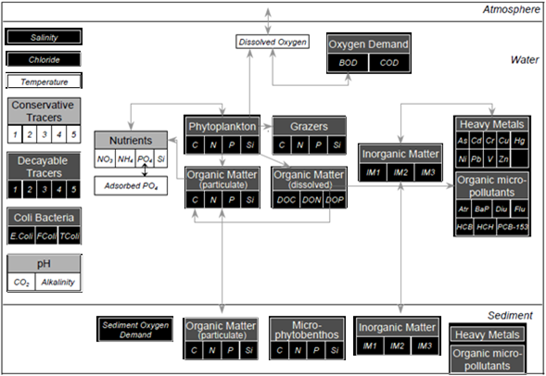
Figure 8: Overview of substances included in DELWAQ, subdivided into functional groups. Major links between substances are indicated by the arrows. Processes not discussed in the following sections are made black (Hydraulics 2003).

The mass balance of ortho-phosphate is as follows (equation 5.15) (Hydraulics 2003):

$\frac{ΔPO_{4}}{Δt}=loads+transport±sorption+mineralisation±precipitation|dissolution-primary production+autolyses+atmospheric deposition±sediment flux$
eq. 5.15

In this research, only the loads, transport and sorption are modeled. The loads are assigned per scenario and this is described in section 6.9.1. The underlying transport equation is the advection-dispersion equation. The derivation of the advection-dispersion equation as used in Delwaq is shown in appendix 9. In this research the choice was made to model only advection, because dispersion in surface waters is negligible. This is not a problem because Delwaq models substances in such a way that when it enters at a location, it immediately is diluted over the whole channel.

Regarding phosphorus, SOBEK can model adsorbed orthophosphate, detritus phosphorus, other organic phosphorus and ortho-phosphate. In this research the choice was made to only model ortho-phosphate. The only process taken into account is adsorption, because of limited information on the other processes in the water column. The equations used to solve the advection-adsorption problems are shown in the following section. The explanation of symbols is listed in table 3.

Table 3: Explanation of symbols.
Symbol | Explanation
ρ^{b} | Bulk density (kg DM/m³ DM), parameter
ρ^{s} | Particle density (kg/m³), parameter
φ | Volumetric porosity (-), parameter
A | Average cross sectional area (m²), calculated by eq. 5.2
C | Concentration of a substance in the water (kg/m³), calculated by equation 5.15
C_{ads} | Concentration adsorbed phosphate (kg P/m³ DM), calculated by equation 5.33
C_{Fe} | Concentration iron in dry matter (kg Fe/kg DM), parameter
D_{isp} | Dispersion coefficient (m²/s), parameter
f | Function (-)
F | Transport flux (kg/s), calculated by equation 5.17
k²⁰ | Rate constant at reference temperature 20°C (s⁻¹), parameter
k_{L} | Coefficient related to sorption energy (m³/kg), parameter
k_{sorp} | Sorption reaction rate (s⁻¹), calculated by equation 5.34
k_{T} | Temperature coefficient (-), parameter
q | Specific discharge (m/s)
R | Retardation coefficient (-), calculated by equation 5.31
R_{ads} | Rate of adsorption (kg/m³s), calculated by equation 5.32
R_{s} | Source/sink (kg/m³s), calculated by eq. 5.16 and 5.19
s | Adsorbed fraction (kg P/kg Fe), calculated by eq. 5.25
S_{max} | Maximal adsorbed fraction (kg P/kg Fe), parameter
t | Unit time (s)
T | Ambient water temperature (°C), parameter
v | Velocity (m/s), calculated by v = Q/A
x | Unit length (m)

The mass balance of a dissolved solute is described by equation 5.16:

$\frac{δϕC}{δt}+\frac{δF}{δx}=-R_{s}$ eq. 5.16

When advection and dispersion are taken into account the flux F is defined by equation 5.17:

$F=Cq-ϕD_{isp}\frac{δC}{δt}$ eq. 5.17

When equation 5.17 is inserted into equation 5.16, the mass balance becomes equation 5.18:

$\frac{δϕC}{δt}+\frac{δCq}{δx}-\frac{δ}{δx}\left(ϕD_{isp}\frac{δC}{δt}\right)=-R_{s}$ eq. 5.18

The mass balance of an adsorbed solute is described by equation 5.19:

$\frac{δ\left(1-ϕ\right)ρ^{s}s}{δt}=+R_{s}$ eq. 5.19

Because of equation 5.20, equation 5.19 is converted into equation 5.21:

$ρ^{b}=\left(1-ϕ\right)ρ^{s}$ eq. 5.20

$\frac{δρ^{b}s}{δt}=+R_{s}$ eq. 5.21

The mass balance of the dissolved solute is added to the mass balance of the adsorbed solute, to get the total mass balance as shown in equation 5.22:

$\frac{δ\left(ϕC-ρ^{b}s\right)}{δt}+\frac{δCq}{δx}-\frac{δ}{δx}\left(ϕD_{isp}\frac{δC}{δx}\right)=0$ eq. 5.22

All terms in the total mass balance are divided by φ and because v = q/φ equation 5.22 can be rewritten to equation 5.23:

$\frac{δ\left(C+\frac{ρ^{b}s}{ϕ}\right)}{δt}+\frac{δCv}{δx}-\frac{δ}{δx}\left(D_{isp}\frac{δC}{δx}\right)=0$ eq. 5.23

The adsorption s is a function of concentration C as shown in eq. 5.24:

$s=f(C)$ eq. 5.24

The adsorption of P is highly non-linear. This is the case because energy levels of binding sites vary: high-energy sites are more attractive for substances than low-energy sites (McGechan 2002). This non-linearity can be approximated by alternative equations, like isotherms, to make linear approximations (McGechan 2002). In Delwaq it is possible to choose between three options (Hydraulics 2003):

- Linear sorption that ignores dependency on pH, temperature and redox potential.
- Langmuir isotherm that ignores dependency on pH, temperature and redox potential.
- Langmuir isotherm that includes the dependency on pH, temperature and redox potential.

In this research, the second option is used: a Langmuir isotherm that ignores the dependencies. The equation for the Langmuir isotherm is shown in equation 5.25 (Fetter 2008):

$s=\frac{k_{L}S_{max}C}{1+k_{L}C}$ eq. 5.25

Adsorption as function of concentration is therefore represented by equation 5.26:

$\frac{ds}{dC}=\frac{K_{L}S_{max}}{{\left(1+K_{L}C\right)}^{2}}$ eq. 5.26

The new total mass balance then becomes equation 5.27:

$\frac{δ\left(C+\frac{ρ^{b}ds}{ϕdC}\right)}{δt}+\frac{δCv}{δx}-\frac{δ}{δx}\left(D_{isp}\frac{δC}{δx}\right)=0$ eq. 5.27

Now a new term called retardation coefficient R is introduced and all terms in the total mass balance are multiplied with A and because Q = vA equation 5.27 can be rewritten (equation 5.28-5.31):

$\frac{δ\left(CR\right)}{δt}+\frac{δCv}{δx}-\frac{δ}{δx}\left(D_{isp}\frac{δC}{δx}\right)=0$ eq. 5.28

$R\frac{δC}{δt}+\frac{δCv}{δx}-\frac{δ}{δx}\left(D_{isp}\frac{δC}{δt}\right)=0$ eq. 5.29

$R\frac{δAC}{δt}+\frac{δQC}{δx}-\frac{δ}{δx}\left({AD}_{isp}\frac{δC}{δt}\right)=0$ eq. 5.30

$R=1+\frac{ρ^{b}ds}{ϕdC}$ eq. 5.31

In Delwaq, the rate of adsorption is modeled as defined by equation 5.32:

$R_{ads}=k_{sorp}*\left(C_{ads}\left(t\right)-C_{ads}\left(t-dt\right)\right)$ eq. 5.32

The concentration adsorbed phosphate is related to the adsorption via the Langmuir isotherm and is calculated by equation 5.33:

$C_{ads}=s*C_{Fe}*ρ^{b}$ eq. 5.33

The sorption reaction rate depends on the water temperature. The water temperature influences the rate at which the water quality processes take place and is modeled with a uniform exponential equation (equation 5.34) (Hydraulics 2003).

$k_{sorp}=k^{20}*k_{T}^{T-20}$ eq. 5.34

6. Method
In this section first a recap of the modeling choices is made. Then it is explained for the start model how the water quantity, water quality and the schematization was done. After that, first the schematization of the new model is explained. This is followed by the water quantity part of the new model including how the water quantity is compared to the start model. This is followed by the water quality part of the new model explaining which scenarios will be used for the sensitivity analysis, what the hypotheses are and the parameters chosen.

In this research, SOBEK version 2.12.003 is used. This is currently the newest version (a. Deltares 2012). Also, in this research the fully implicit iterative method (numerical scheme 15) is used to solve differential equations. This scheme has as features (Hydraulics 2003):

- It is implicit, in both the vertical and horizontal direction. This means the scheme is always stable which makes it possible to use large computational time-steps (RIZA 2005). The stability criteria is defined as the Courant number, which reads (equation 6.0.1) (RIZA 2005):

$Courant number=\frac{ΔtU}{Δx}≤1$ eq. 6.0.1

In which:
t = time (s)
U = velocity in the longitudinal direction (m/s)
x = longitudinal co-ordinate (m)

- It has iterative solvers of the matrix. This means that it guesses the concentration of a vector, that preferably is the concentration of the previous time-step and checks if this guess was correct or not and will continue to guess better until the squared sum of differences of all concentrations, the residual, is below a threshold value of 1.0E-5 or if 50 guesses have occurred. It is possible to adapt the threshold value or the amount of guesses (Hydraulics 2003).

- It has an upwind scheme. This means that positivity is guaranteed, as long as there is stability (RIZA 2005).

6.1 Recap of choices
In recap, the choices made regarding the modeling were the following:

- The sources of PO₄ that are modeled are agriculture and seepage. This because agriculture is the largest source of P in the surface waters of the flower bulb area (de Jonge 2011). Seepage is modeled because the Water Board of Rijnland suspects that seepage has a major contribution to the phosphorus load in the area (Krol 2012). If this would be the case, the WFD-norm could become more lenient because seepage does not count for the WFD-norm. Phosphorus that enters the flower bulb area as precipitation or as result of the water treatment plants is neglected because these additions are not significant (de Jonge 2011). The uptake of phosphorus by plants can be modeled by subtracting the PO₄ the plant uses from the PO₄ that is added by the fertilizer application. However, in this research this uptake is not taken into account.
- It was chosen to model only ortho-phosphate, because dissolved P is a major component of P movement in the soil (Dolfing 1999). It is thought that colloidal P also attributes a lot, but colloidal P movement is dependent on a lot of variables (Vendelboe 2011) (Chardon 2007) what makes it very difficult to model.
- It is chosen to model with SOBEK-Delwaq, because the Water Board of Rijnland already has a SOBEK model, it is possible to model water quantity and quality, it is easy to make distinction between sources, it is possible to see changes in P concentrations at multiple locations, it is easy to run different scenarios, and the output can easily be used.
- Only advection and adsorption are modeled. It is assumed that there is no dispersion.

6.2 Water quantity start model
The start model is gained from the Water Board of Rijnland. It is their SOBEK model in which they have used a Rainfall-Runoff (RR) schematization to represent the individual polders and they used a Channel Flow (CF) schematization to represent the main waterways. Their version is valid for the years 2000-2008 and it takes the discharges of the main pumping stations as well as the meteorological input on daily basis. Furthermore, for the water supply of water treatment plants an average value is used (g. Rijnland 2011). The main waterway system of Rijnland is able to discharge through the 4 main pumping stations, Katwijk, Halfweg, Spaarndam, and Gouda. The management of these pumping stations influences the flow direction in the channels.

6.3 Water quality start model
In the past, the start model was used by the Water Board of Rijnland in combination with mass fraction sums based on water quality measurements to calculate the nitrogen and phosphorus fractions solely in the main waters of Rijnland as result of the discharge policy regarding the water treatment plants. Note that this model is thus not able to model phosphorus; the phosphorus concentration that leaves every polder is specified by using data from water quality samples (g. Rijnland 2011). By using this way to model water quality it is possible to assign the phosphorus concentration of every polder at the point where the polder connects to the channel. This makes it however impossible to see the influence of different hydrological sources to the phosphorus concentration in a channel (Meijers 2012).

6.4 Schematization start model
In figure 9, the SOBEK schematization of the start model is shown on the left, and the schematization of one individual polder in the start model is shown on the right.

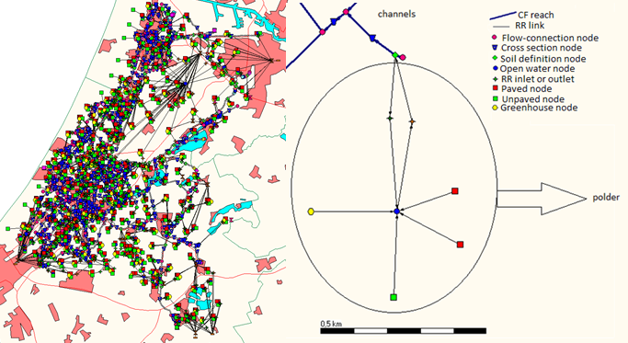
Figure 9: SOBEK schematization start model for the whole of Rijnland, the background map shows in light blue waters and in red cities (left). Schematization of one individual polder in the start model (right).

The individual polders are schematized in the RR module and the channels in the CF module. Every polder has a total area that is divided over an open water node and multiple paved- and/or unpaved- and/or greenhouse nodes. For each of these nodes, the input for precipitation and evaporation are average daily values that are in the case of precipitation gained from the closest meteorological station and in the case of evaporation standard values for the area of Rijnland. For each of these nodes the seepage or infiltration is added as a constant value throughout the year with a positive value when there is seepage and a negative value when there is infiltration.

These paved-, unpaved- and greenhouse nodes all discharge water into the polder. Water enters and leaves the polder (thus the open water node) through a pump, weir or orifice and enters the channel. In the open water node a seasonal target level is defined that specifies the water level of the polder below ground level. This target level determines the pumping regime.

The input information for these nodes as well as the input information for the nodes in the new model is summarized in table 4.

Table 4: Input information for the nodes.
Name | Input
CF waterway | The length of the main waterway.
RR link | The length of the link.
Flow-connection node | This node is a boundary node with as boundary condition Q = 0. No input is needed.
Cross-section node | The cross-section node describes the cross-section of the channel and therefore determines together with the length of the CF reach the water volume in a channel. The node also contains information about the friction of the bed. If there is only one cross-section defined in a reach, this cross-section is applied over the whole reach at all calculation points. If there are multiple cross-sections within a reach there is interpolation between these cross-sections.
Soil definition node | Contains information about the soil type and the level above ground level.
Open water node | The open water node contains information about the volume of water in the polder, the precipitation, evaporation and seepage or infiltration. In the open water node is also the seasonal target level specified.
RR inlet or outlet | The water can leave and enter the polder via pumps, weirs or orifices. The input for pumping stations is the switch-on and switch-off level above target level and the pumping capacity. For orifices and weirs the most important input information is the width of the crest and the crest level above ground level.
Paved node | The paved nodes contain information about the paved area, precipitation and evaporation. Furthermore, it describes the sewer type used (mixed system, separate system, improved separate system), the capacity of the sewer pump, and the storage on the street and/or sewer.
Unpaved node | The unpaved nodes contain information about the area per crop type, precipitation, evaporation and seepage or infiltration. Furthermore, it contains information about the soil type, the thickness of the groundwater layer, the storage of water on land, and the infiltration and drainage capacity of the area.
Greenhouse node | The greenhouse nodes contain information about the greenhouse area, precipitation and evaporation. Furthermore, it contains information about the storage of water on roofs.
CF polder channel | The length of the polder channel.
Boundary node | Constant water level. SOBEK models this by removing the excess amount of water at that point.
CF inlet or outlet | The water can leave and enter the polder via pumps or weirs. The input for pumping stations is switch-on and switch-off level and the pumping capacity. For weirs the input is the crest level and the crest width. In the new model there are no orifices.
CF-RR connection node | Contains information about the level above ground level of the paved, unpaved or greenhouse nodes. This value is the target level of the start model.
Precipitation node | Contains information about the area the precipitation falls on, which is the area at the depth of the target level in the open water node in the start model. This is combined with the meteorological data from the closest meteorological station.
Evaporation node | Contains information about the area that experiences evaporation, which is the area at the depth of the target level in the open water node in the start model. This is combined with the meteorological data for evaporation.
Seepage/infiltration node | For polders in the flower bulb area: the area that experiences seepage/infiltration is the area at the depth of the target level in the open water node plus the area of the unpaved node. The seepage/infiltration in the unpaved node is set to 0. All other polders: the area is only the area at the depth of the target level in the open water node. There is seepage when this node has a positive value and infiltration when it has a negative value.
Measurement station | The measurement station measures the water level at the location it is positioned. By using a measurement station the pump is able to use an interval dependent controller that can create a seasonal dependent target level.

6.5 New model
In this research the water quality module of SOBEK, called Delwaq, is used to model phosphorus. This has a major advantage: with Delwaq it is possible to make distinction between different phosphorus sources by assigning different concentrations to every source (Meijers 2012). This makes it for example possible to assign only a phosphorus concentration to seepage in one polder or in multiple polders and allows you to see how this influences the concentration of a channel in the polder or a channel further away from the polder(s).

To use the Delwaq module, it is necessary to schematize every polder in CF, because Delwaq can only be used in channels. Therefore the start model will be converted into a complete Channel Flow model. Thus, every individual polder is converted into CF schematization. Then, the Delwaq schematization is added in such a way that it is possible to make a distinction between the polders and channels. By doing this, every polder is considered as an entity, so every phosphorus concentration that enters the waters in the polder is immediately diluted over the whole volume of water in the polder (Meijers 2012). The main differences between the start model and the new model are shown in table 5.

Table 5: Main differences between the start model and new model.
Start model | New model
Polders in RR schematization. | Polders in CF schematization.
Valid for the years 2000-2008. | The choice was made to only model one year, the year 2002, but this can easily be extended.
Mass fraction sums used to calculate water quality. | Delwaq used to model water quality.
No distinction between sources. | Distinction between sources.
All water is represented as a box of water. | All water is represented as one long channel.
Open water node includes water volume, target level, precipitation, evaporation and seepage/infiltration. | Water volume is modeled by defining a cross-section in combination with channel length. Precipitation, evaporation and seepage/infiltration are all separated into individual nodes. The target level is included in the CF outlet in combination with a measurement station.
RR inlets and/or outlets. | CF inlets and/or outlets. The CF inlet gets an enforced regime by using a time controller. The data is obtained from the start model. The CF outlet includes the target level in combination with a measurement station. All orifices are replaced by pumping stations.
Unpaved-, paved-, and greenhouse-nodes all enter the open water node. | Unpaved-, paved-, and greenhouse-nodes all enter the polder channel in separate CF-RR connection nodes to be able to assign different phosphorus concentrations to them.

6.6 Schematization of the new model
The schematization of the new model is shown in figure 10. The polder in the start model is now schematized as a polder channel. The flow-connection node at the end of the polder is used as boundary node with the boundary condition that discharge Q = 0. This node is given the name of the original open water node that was present in the start model, and becomes OPWA_number open water node, followed by the name of the polder, e.g. OPWA_200, Polder Achthoven (1.1). The boundary node on the left is only temporarily present because this individual polder was cut out the start model and needs a boundary with constant water level of -0.60 above ground level is added to let some water out the system.

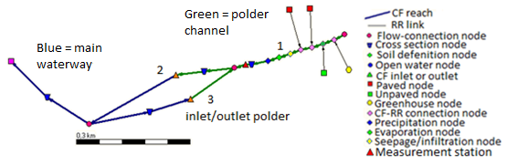
Figure 10: Schematization of one individual polder in the new model.

The information that was present in the open water node of the start model is separated:

- Precipitation, evaporation and seepage/infiltration are all separated into individual nodes.
- The target level is included in the CF outlet in combination with a measurement station.
- Water volume is modeled by defining a cross-section in combination with channel length.

The information about precipitation, evaporation and seepage/infiltration is combined with the area it acts on into the precipitation-, evaporation-, and seepage-node.

The seasonal dependent target level is used as input for the CF outlet (a pump or weir) by defining an interval controller. To do this, a measurement station is needed to tell the pump or weir what the current water level is and then the pump or weir decides whether or not it has to discharge water from the polder into the main waterway. In every polder a measurement station and seasonal dependent target level is added, even if the polder does have the same target level throughout the year, only the seasonality is left out. This is done because it is easier to adjust if it changes in the future. The CF inlet is changed into a pumping station if it was not already a pumping station and gets an enforced regime for the year 2002 gained from the results of the start model. The enforced regime is applied by using a time controller and making sure that the pump is always on. This means that for every day the amount of discharge in the polder is pre-defined.

The volume of water in the polder was schematized as a box of water and this is replaced by defining an area in a cross-section in combination with a cannel length. Figure 10 shows the position of reach 1, 2 and 3. Reach 2 and 3 are partly polder channel and partly main waterway. Approximately 95% of the water volume will be modeled in reach 1, and approximately 5% in reach 2 and 3. Reach 2 and 3 are modeled with a small volume, because in reality there is no channel there. Assigning the water volumes is done by making a Y-Z-profile, assuming the total reach that represents the polder has a length of 2000 m. The Y-Z profile is calculated by using the level-area relation of the open water node in the start model. Figure 11 shows an example of the level-area relation. In the Y-Z profile, Y represents the radius of the channel, which means it is half the width of the channel. Y is calculated by equation 6.6.1. It assumed that the length of channel 1, 2 and 3 is together is 2000 m, so length branch is 2000 m.

$Y=\frac{1}{2}Width branch (m)=\frac{1}{2}\frac{surface (m^{2})}{length branch (m)}$ eq. 6.6.1

Figure 11: Example of a level-area relation in an open water node.

The Z of the Y-Z profile represents the depth of the channel. This depth has to be added in relative values instead of level above datum that is used in throughout the rest of the model. The bed level of the open water node is taken as 0 m, when the next (higher) level is positioned 10 cm above the bed level this Z is taken as 0.1 m, etc. The model asks for a bed level to adjust the values to level above datum. An example of the Y-Z profile is shown in figure 12.

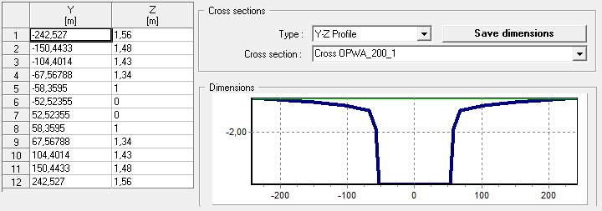
Figure 12: Example of a Y-Z Profile for a cross-section.

Then reach 1 is assigned 95% of the volume by making this reach 1900 m long. The other 5% of the water volume is for reach 2 and 3 together, dividing the volume equally. This is done by taking 2.5% of every Y in the Y-profile of reach 1 as input for the Y-profile in reach 2 and 2.5% of every Y in the Y-profile of reach 1 as input for the Y-profile in reach 3. The Z-profile stays the same and the channel length becomes 2000 m. The cross section in channel 1 is called Cross OPWA_(open water node number)_1, in this case Cross OPWA_200_1. The cross sections in channel 2 and 3 will be the same, and end at 2, e.g. Cross OPWA_200_2.

In some cases, also an extra cross-section in the original channel has to be added. This is the case when a polder enters the main waterway halfway meaning an extra flow-connection node is added. In this case it is necessary to add an extra cross section node. This extra node is given the same cross section as the cross section node that was already in the original channel. This is the right way because SOBEK assumes that the profile used between 2 flow-connection nodes is valid for the whole reach, so when the reach is split both parts will have the same cross-section.
Some exceptions were made (the names of the polders that belong to the polder numbers can be found in appendix 10):
- Polders that have only an outlet and no inlet were assigned 97.5% of the volume by making this channel 1950 m long. This is the case for polder 129, 130, 131, 157, 166, 235, 258, 259, 296, 400, 401, 402, 404, 408, 409, 410, 411, 417, 418, 419, 423, 425, 426, 428.
- For some polders, the length of their channel inlets and outlets were increased to 16000 m. This because SOBEK obligates you to maintain a certain minimum length depending on how you draw the channels. This was for example the case in the Haarlemmermeerpolder. Polders that are adapted like this are: 101, 102, 103, 104, 105, 106, 107, 108, 109, 110, 111, 112, 113, 114, 115, 116, 117, 118, 119, 120, 121, 122, 123, 124, 125, 174, 198, 204, 216, 222, 227, 228, 229, 232, 235, 264, 310, 400, 403, 408, 413, 414, 415, 418, 420, 421, 422, 424, 425, 427.
- Polder 240 has in total 3 inlets/outlets. Still 95% of the volume was modeled in the polder, but every inlet/outlet was modeled with only 1.666% instead of 2.5% by adjusting the cross-section.
- Polder 100 has in total 4 inlets/outlets. Here, the channel length of the inlets/outlets was increased to 16000 m. The polder was modeled with 95% of the water volume, but every inlet/outlet was modeled with only 1.25% instead of 2.5% by adjusting the cross-section.

6.7 Water quantity new model
To start the new schematization in CF, the start model was classified into 4 main types of polders, depending on the types of inlet and outlet they have. After that the results of the cumulative discharges of four example polders that were randomly chosen to represent each group are checked against the results of the same example polders in the start model. The classification is as follows:

Type 1: Polders that discharge water to the channel via a pump and gain water from the channel via an orifice. This type covers about 75.8% of the total amount of polders. An example is polder 200: Polder Achthoven (1.1). The schematization of this polder in the old model and in the new model is shown in figure 13.

Type 2: Polders that discharge water to the channel via a pump and gain water from the channel via a pump. This type covers about 4.7% of the total amount of polders. An example is polder 413, the schematization in the old model and the new model is shown in figure 13.

Type 3: Polders that discharge water to the channel via a weir and do not gain water from the channel. This type covers about 6.7% of the total amount of polders. An example is polder 129: Het Vinkenveld (4A). The schematization of this polder in the old model and in the new model is shown in figure 13.

Type 4: Polders that discharge water to the channel via a weir and gain water from the channel via a pump. This type covers about 9.4% of the total amount of polders. An example is polder 88: Gebied Wittenburgerweg. The schematization of this polder in the old model and in the new model is shown in figure 13.

This classification, the polders a class includes, the main location and the schematization of these groups in the old and new model are shown in table 6. The polder names that belong to each number can be found in appendix 10.

Table 6: Classification of the polders.
Type polder | Polders that belong to type | Where located? | Schematization in old model | Schematization in new model | % polders
Type 1 | All other polders, e.g. 200. | Throughout the model. | Inlet is an orifice, outlet is a pump. | Pump in with time controller, pump out with interval controller. | 75.5
Type 2 | 101; 102; 103; 104; 105; 107; 108; 110; 111; 114; 115; 413; 414; 415 | Haarlemmer-meerpolder and the south of Rijnland. | Inlet is a pump, outlet is a pump. | Pump in with time controller, pump out with interval controller. | 4.7
Type 3 | 129; 130; 131; 157; 235; 258; 259; 296; 401; 402; 404; 408; 409; 410; 417; 418; 419; 423; 425; 426; 428 | In the west and the south of Rijnland. | No inlet, outlet is a weir. | Weir out with interval controller. | 7.0
Type 4 | 87; 88; 109; 112; 113; 116; 117; 118; 119; 120; 121; 122; 123; 124; 125; 141; 163; 180; 181; 210; 277; 403; 412; 420; 421; 422; 424; 427 | Near Wassenaar, Haarlemmer-meerpolder and the south of Rijnland. | Inlet is a pump, outlet is a weir. | Pump in with time controller, weir out with interval controller. | 9.4
Remaining | 74; 149; 204; 236 | Throughout the model. | Inlet is an orifice, outlet is a weir. | Pump in with time controller, weir out with interval controller (resembles type 3). | 3.4
 | 166; 400; 411 | Throughout the model. | No inlet, outlet is a pump. | Pump out with interval controller.
 | 416 | Near Am-bachtspolder. | No inlet, outlets are a pump and a weir. | Pumps out with interval controller.
 | 240 | Riekerpolder. | Inlet is an orifice, outlets are 2 pumps. | Pump in with time controller, pumps out with interval controller.
 | 100 | Haarlemmer-meerpolder. | Inlet is a pump, outlets are 3 pumps. | Pump in with time controller, pumps out with interval controller.

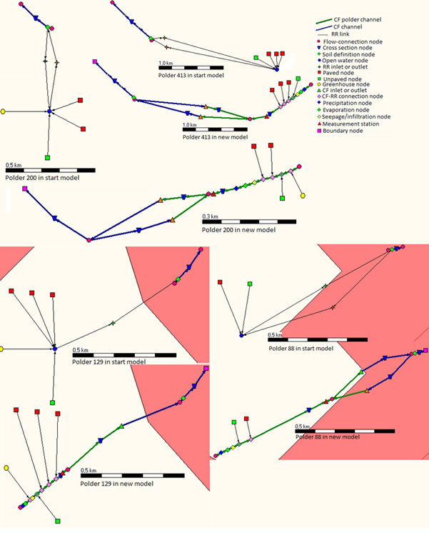
Figure 13: Schematization of the 4 different main types of polders in the old and the new model.

6.8 Water quality new model
The new schematization in Delwaq was only implemented for the flower bulb area. The demands for a polder to be included in the flower bulb area are 1) that they contain flower bulbs as one of the crop types of their agricultural area, and 2) that the polder is situated in the west part of Rijnland. The polders that are included in the flower bulb area are shown in table 7. The polder names that belong to each number can be found in appendix 10.

Table 7: Polders that belong to the flower bulb area.
Polders that belong to the flower bulb area and were in the start model schematized in the RR module. | Polders that belong to the flower bulb area and were in the start model schematized in the CF module.
3; 4; 7; 63; 64; 65; 66; 67; 68; 69; 80; 81; 82; 83; 84; 100; 107; 108; 112; 113; 127; 129; 130; 133; 134; 136; 148; 154; 158; 159; 160; 161; 163; 164; 170; 180; 181; 189; 205; 206; 210; 244; 245; 246; 247; 252; 277; 282; 290; 292; 299; 301; 315. | Boezemgebied_9; Boezemgebied_10; Boezemgebied_11; Boezemgebied_12; Boezemgebied_13; Boezemgebied_14; Boezemgebied_15; Boezemgebied_16; Boezemgebied_17; Boezemgebied_18; Boezemgebied_19; Boezemgebied_20; Boezemgebied_21; Boezemgebied_22; Boezemgebied_23; Boezemgebied_32.

The Delwaq schematization means that every polder that belongs to the flower bulb area is schematized with Delwaq channels (CF polder channels). These channels are colored dark green. Also, a new CF-RR connection node is made where seepage/infiltration as well as agriculture in the flower bulb area enters the polder channel. The agricultural node is colored dark green, and the seepage/infiltration node is colored yellow. By using this new connection node, concentrations of the substances modeled can be changed for the whole flower bulb area at once instead of adapting the concentrations for every individual polder in the flower bulb area.

In this research only the substance PO₄ is modeled. Processes that are taken into account are advection and adsorption. Phosphorus that enters the flower bulb area as precipitation or as result of the water treatment plants is neglected because these additions are insignificant (de Jonge 2011). The uptake of phosphorus by plants can be modeled by subtracting the PO₄ the plant uses from the PO₄ that is added by the fertilizer application. To do this, a time dependent PO₄ concentration can be added. However, in this research the PO₄ uptake of plants is not taken into account.

6.9 Sensitivity analysis
A sensitivity analysis is done for two individual polders: polder 200 that has infiltration and polder 88 that has seepage. These two polders were chosen randomly from the model so that is why they are not located in the flower bulb area. In this sensitivity analysis, the initial PO₄ concentration in all channels is varied as well as the PO₄ concentration of two phosphorus sources: seepage and agriculture. In SOBEK these sources are modeled in such a way that every source has an assigned PO₄ concentration in g/m³ and a flow in m³/s. The absolute quantity of PO₄ that enters the polder channel therefore depends on the volume water that enters the polder channel. However, in the case of infiltration the concentration of PO₄ is not assigned. SOBEK models the water that infiltrates with the same concentration as the water in the polder channel at that moment.

6.9.1 Scenarios and hypotheses
The reference scenarios are modeled with no initial PO₄ concentration and a start PO₄ concentration for seepage respectively agriculture of 3 g/m³. All other sources are modeled with no PO₄ concentration. Only advection and adsorption are modeled. Dispersion is assumed to be 0, because by using Delwaq it is assumed that every concentration that enters the polder channel is immediately evenly mixed through the whole polder channel. In the reference scenario, the water volume is modeled in such a way that storage is taken into account and the water volume is assumed to be present as a giant box. Five different scenarios are tested:

- Adding of an initial PO₄ concentration. It is expected that when there is an initial concentration, less adsorption spots are available for the PO₄ that enters with the sources seepage or agriculture. The PO₄ concentration in the channels will therefore be higher than in the reference scenario.
- Decreasing the PO₄ concentration of the sources by a factor two. It is expected that this will result in a more than two times decrease in concentration of the channels because the Langmuir isotherm determines a decreasing adsorption when concentration increases.
- Removing the storage from the cross-sections to change the water volume. In the reference scenario, storage is modeled. The storage in the cross-sections is an amount of water that is in reality only present in the polder when there is a water surplus, as is the case in the winter. When this storage is used to model the whole year, there is an overestimation of the water quantity in the dry months like the summer. Therefore the PO₄ concentration in the dry months will be underestimated. Because the WFD-norm is a summer average, it is important to model the summer correctly. Thus, for the wet months it is better to run the model with storage, but for the dry months it is better to run the model without storage. It is expected that in comparison with the reference scenario the PO₄ concentration is higher in this run, but this will only be a better estimation for the dry months.
- Removing the storage from the cross-sections and adapting the polder channels to change the residence time of the substances. For polder 200 the adaptation means that the polder channel becomes 60 times longer and 60 times smaller as in the reference scenario. In the case of polder 88 the polder channel becomes 3 times longer and 3 times smaller as in the reference scenario. In the reference scenario, all water in the polder is modeled as a giant box. In this scenario however, the polder channels are adapted in such a way that they are more realistic: the channel width becomes about 2 meters. The channel length is additionally changed in such a way that the volume of water does not change compared to scenario 3. It is expected that because the channel length increases, the time a particle PO₄ stays in the channel increases. Therefore there is more time to interact with the sediment. There thus is more adsorption time and the concentrations are therefore expected to be lower than in scenario 3 and lower than the reference scenario.
- Instead of PO₄ a run with a conservative tracer (chloride). In this run there is storage and the polder channels are not adapted. Chloride is a conservative tracer that does not interact with the sediment. Therefore there is not adsorption. The concentrations are expected to be higher than in the reference scenario.

The inputs for the different scenarios are summarized in table 8 and the visualization of these scenarios is shown in figure 14.

Table 8: Input scenarios sensitivity analysis.
 | Seepage polder 200 | Agriculture polder 200 | Seepage polder 88 | Agriculture polder 88
Reference scenario | PO₄ initial = 0 g/m³  PO₄ seepage = 3 g/m³ | PO₄ initial = 0 g/m³  PO₄ agriculture = 3 g/m³ | PO₄ initial = 0 g/m³  PO₄ seepage = 3 g/m³ | PO₄ initial = 0 g/m³  PO₄ agriculture = 3 g/m³
1. Initial concentration | PO₄ initial = 0.5 g/m³  PO₄ seepage = 3 g/m³ | PO₄ initial = 0.5 g/m³  PO₄ agriculture = 3 g/m³ | PO₄ initial = 0.5 g/m³  PO₄ seepage = 3 g/m³ | PO₄ initial = 0.5 g/m³  PO₄ agriculture = 3 g/m³
2. Source concentration | PO₄ initial = 0 g/m³  PO₄ seepage = 1.5 g/m³ | PO₄ initial = 0 g/m³  PO₄ agriculture = 1.5 g/m³ | PO₄ initial = 0 g/m³  PO₄ seepage = 1.5 g/m³ | PO₄ initial = 0 g/m³  PO₄ agriculture = 1.5 g/m³
3. Storage | PO₄ initial = 0 g/m³  PO₄ seepage = 3 g/m³ | PO₄ initial = 0 g/m³  PO₄ agriculture = 3 g/m³ | PO₄ initial = 0 g/m³  PO₄ seepage = 3 g/m³ | PO₄ initial = 0 g/m³  PO₄ agriculture = 3 g/m³
4. Adapted channels | PO₄ initial = 0 g/m³  PO₄ seepage = 3 g/m³ | PO₄ initial = 0 g/m³  PO₄ agriculture = 3 g/m³ | PO₄ initial = 0 g/m³  PO₄ seepage = 3 g/m³ | PO₄ initial = 0 g/m³  PO₄ agriculture = 3 g/m³
5. Conservative tracer (chloride) | Cl initial = 0 g/m³  Cl seepage = 3 g/m³ | Cl initial = 0 g/m³  Cl agriculture = 3 g/m³ | Cl initial = 0 g/m³  Cl seepage = 3 g/m³ | Cl initial = 0 g/m³  Cl agriculture = 3 g/m³
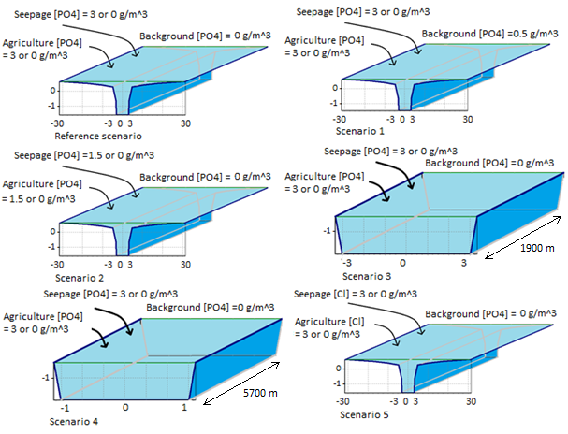
Figure 14: Visualization of the scenarios. These scenarios are scaled for the polder channels of polder 88.

6.9.2 Data and parameters
To model these processes, data for precipitation, evaporation, and seepage/infiltration was gathered from the start model gained from the Water Board of Rijnland and this was taken as input for the new model. For precipitation this data are the daily values from the precipitation stations of the KNMI. The station used differs per polder and depends on which station is closest. For evaporation, also daily values are used, but for every polder the evaporation station used is the same. Seepage/infiltration data are user-defined constant values. As discussed before, other input is the channel length and the cross section for every polder. All symbols in the equations of which the values are derived from data provided in the start model of Rijnland are shown in table 9.

Table 9: All symbols in the equations of which the values are derived from data.
Symbol | Explanation
ϒ | Drainage resistance (s)
b | Channel width (m)
B | Bottom width channel (m)
d | Depth groundwater table (m)
E | Evaporation (m/s)
I | Infiltration (m/s)
L | Channel length (m)
P_{n} | Net precipitation (m/s)
$\overline{q}$ | Lateral flow (m²/s)
S | Seepage (m/s)
S_{b} | Slope river bed (-)
V_{eq} | Storage capacity at equilibrium condition (m).
The values chosen for the parameters are shown in table 10.

Table 10: Parameters used in the model.
Symbol | Value | Explanation
φ | 1 (-) | Volumetric porosity of fresh water (-).
ρ | 1000 kg/m³ | Density of fresh water (kg/m³).
ρ^{b} | 2650 kg/m³ | Bulk density of sediment (kg DM/m³ DM).
C_{Fe} | 0.02 kg Fe/kg DM | Concentration iron in dry matter (kg Fe/kg DM). Research of Del Bubba et al. (2003) shows values of 0.008 kg Fe/kg DM (Del Bubba 2003), research of Dunne et al. (2005) gives values in the range of 0.003 – 0.009 kg Fe/kg DM (Dunne 2005). The chosen parameter value is thus about 2.5 times higher than research shows.
D50 | 0.0005 m | Median grain size. The value of 0.0005 m is taken from the start model and corresponds to values between fine grain sediments (D50 is 0.15 to 0.30 mm) and coarse sands (D50 around 1.0 mm) (King 2005).
D_{isp} | 0 m²/s | Dispersion coefficient (m²/s), assumed.
g | 9.81 m/s² | Gravitational acceleration (m/s²).
k²⁰ |  | Rate constant at reference temperature 20°C (s⁻¹)
k_{L} | 100 m³/g P | Coefficient related to sorption energy (m³/kg). This value falls in the range of 0.02 – 0.4 L/mg for k_{L}-values found in research of Reddy et al 1998 (Reddy 1998).
k_{n} | 0.003 m | Nikuradse equivalent roughness (m). The Nikuradse equivalent roughness is especially useful for problems that deal only with surface friction caused by the bed grains (Mariott 2005). The k_{n} for flat sand beds can be calculated by k_{n} = (1 – 10)*D50 (Liu, 2001 in (Engineering 2010).
k_{T} | 1 (-) | Temperature coefficient (-). A temperature coefficient of 1 means that there are no physical changes due to the temperature (b. Deltares 2012).
pH | 7 (-) | Acidity. The normal acidity of water is 7.
S_{max} | 0.15 kg P/kg Fe | Maximal adsorbed fraction (kg P/kg Fe). This value falls in the range of 700 – 1700 mg/kg for S_{max} values found in research of Dunne et al, 2005 (Dunne 2005).
T | 15 °C | Ambient water temperature (°C).

7. Results and discussion of the results
In this chapter, the results are combined with the discussion of the results and this is subdivided into three categories: the water quantity, the water quality for the sensitivity analysis of polder 200 and 88, and the water quality for the Leidse Vaart.

7.1 Results water quantity
In figure 15, 16, 17 and 18, the cumulative discharge from the polder to the channel is shown for respectively polder 200, 129, 88 and 413. For polder 200 and 413 this discharge is via a pump, for polder 129 and 88 this discharge is via a weir. Furthermore, polders 200 and 129 have infiltration; polders 88 and 413 have seepage. To get these graphs, the results of the new model had to be adjusted by deleting the peak that the model creates at the start of the modulation time. SOBEK shows this start peak because in the new model a boundary node with constant water level is added which requires SOBEK to discharge the excess water at that point. Therefore some calculations are needed to get the actual situation.

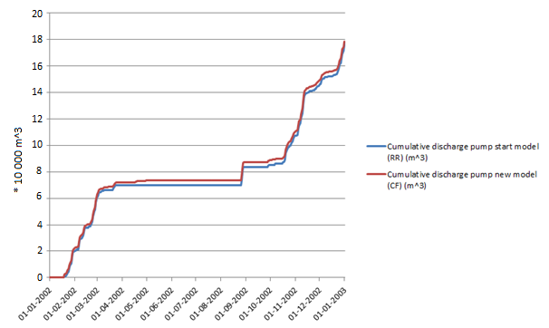
Figure 15: The cumulative discharges via the pump of polder 200 to the channel of the start model and the new model.

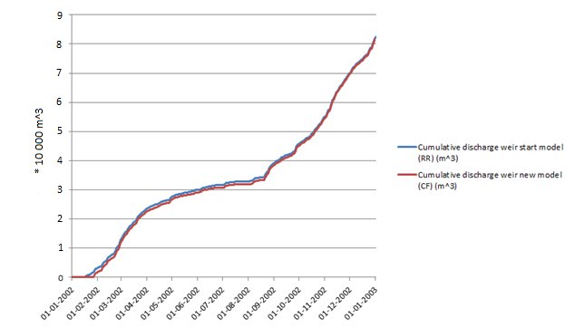
Figure 16: The cumulative discharges via the weir of polder 129 to the channel of the start model and the new model.

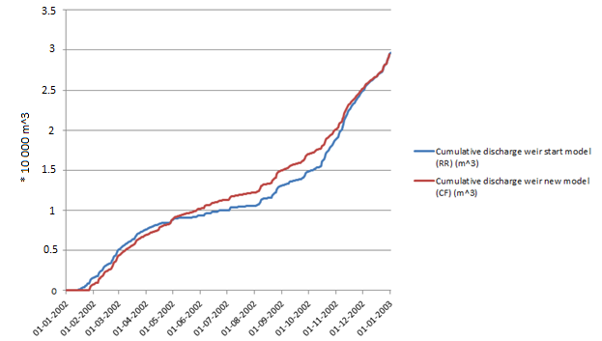
Figure 17: The cumulative discharges via the weir of polder 88 to the channel of the start model and the new model.

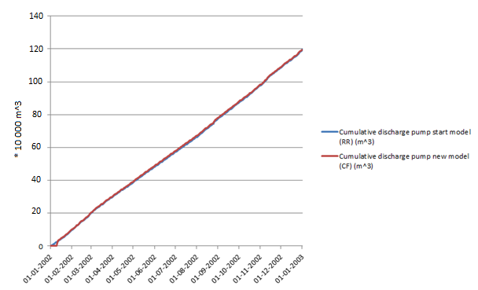
Figure 18: The cumulative discharges via the pump of polder 413 to the channel of the start model and the new model.

7.2 Discussion water quantity
As shown in figure 15, polder 200 shows no discharge in summer. Most logical explanation is that the target water level is never exceeded in summer because in summer the water level of the polder is allowed to be higher than in winter allowing more water in the polder and because the evaporation rate is higher in summer. Polder 129 (figure 16) has the same target water level the whole year round. In summer there apparently is still more water in the polder than allowed resulting in discharge, although this discharge is a lot less than in winter due to the higher evaporation rate. Polder 88 (figure 17) acts the same as polder 200, although polder 88 shows a little discharge during the summer. In this case apparently the target water level is sometimes exceeded, resulting in discharge. Polder 413 (figure 18) acts the same as polder 200 but actively receives a lot of water by the inlet pumping station during the summer, resulting in approximately the same discharge all year round.

As shown in figure 15-18, the cumulative discharge matches quite well for all four polder types. For polder 200, the quantitative difference at the end of the year is about +10,000 m³. Because the volume of water that is discharged at the end of the year for the start model is about 1,800,000 m³, the deviation is about 0.56%. For polder 129, the quantitative difference is about -10,000 m³, but because the volume of water discharged at the end of the year for the start model is only about 825,000 m³, this deviation is about 1.3%. For polder 88 the quantitative difference is about -2,000 m³ for a volume of about 297,000 m³, which gives a deviation about 0.7%. Polder 413 has a quantitative difference that is about -6,200 m³ and a total volume of about 11,960,000 m³ resulting in a deviation of about 0.05%. Because these deviations are not significant, the water quantity for all four types is assumed to be modeled correctly in the new schematization.

Together these 4 types cover 96.6% of the total amount of polders. The other 3.4% of polders were not separately tested because they only cover a small part of the total amount of polders, and they have similar characteristics as the 4 major groups. The deviations in discharges are assumed to be in the same ranges.

7.3 Results water quality sensitivity analysis
Polder 200 (Achthoven 1.1) is a peat meadow with grass and polder 88 (Gebied Wittenburgerweg) a sandy polder. They are both not located in the flower bulb area because they were randomly chosen to represent their polder type. This is however not a problem because this sensitivity analysis was done to see the differences between agriculture and seepage and relatively these differences are expected to be the same in all areas. The exact values presented in these results do not say that much because of the assumptions that were made. But this also does not matter because the sensitivity analysis is about relative differences.

Polder 200 experiences a constant seepage of -0.12 mm/day the whole year round. This means that there is infiltration. The target level in the polder is a constant water level of -1.95 m above ground level, but in the summer this water level is raised to -1.85 m above ground level. In the reference scenario, the water volume is modeled in such a way that storage is taken into account and the water volume is assumed to be present as a giant box. The agricultural area has a surface of about 368 ha; the seepage area is the agricultural area plus the surface water area and has therefore an area of about 392 ha. The PO₄ concentration for the seepage as well as the agricultural area is kept constant the whole year round with a value in g/m³. SOBEK combines this with the flow of the agricultural area or seepage to the polder channel (m³/s) to get the PO₄ added to the polder ditches. In appendix 11 the precipitation and evaporation (m³/s) of polder 200 is shown. In appendix 12 the flow of the agricultural area to the polder ditches (m³/s) is shown. These figures show no flow from the agricultural area to the polder ditches during the summer, with the exception of an enormous precipitation event on the first of September.

Polder 88 experiences a constant seepage of 0.05 mm/day the whole year round. The target level in the polder is a constant water level of -0.60 m above ground level, but in summer this water level is raised to -0.40 m above ground level. Also here, the reference scenario models the water volume in such a way that storage is taken into account and the water volume is assumed to be present as a giant box. The agricultural area has a surface of about 56 ha; the seepage area is about 58 ha. In appendix 11 the precipitation and evaporation (m³/s) of polder 88 is shown. In appendix 12 the flow of the agricultural area to the polder ditches (m³/s) is shown. Because the surface area of polder 88 is so much smaller than the area of polder 200, the precipitation and evaporation are much lower. Also the flow of the agricultural area to the polder ditches is lower. However, polder 200 still shows flow from the agricultural area to the polder ditches in summer, although this flow is lower than in winter.

The results of the scenarios are shown in figure 19-22. Distinction is made between polder channels (scenarios that end with A) and main waterways (scenarios that end with B). For polder 200 only scenario 1 is modeled when seepage is the source, because polder 200 has no seepage but infiltration.

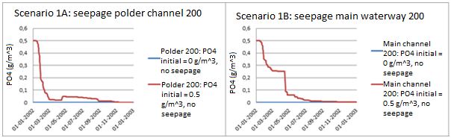
Figure 19: Results sensitivity analysis polder 200, run with seepage.
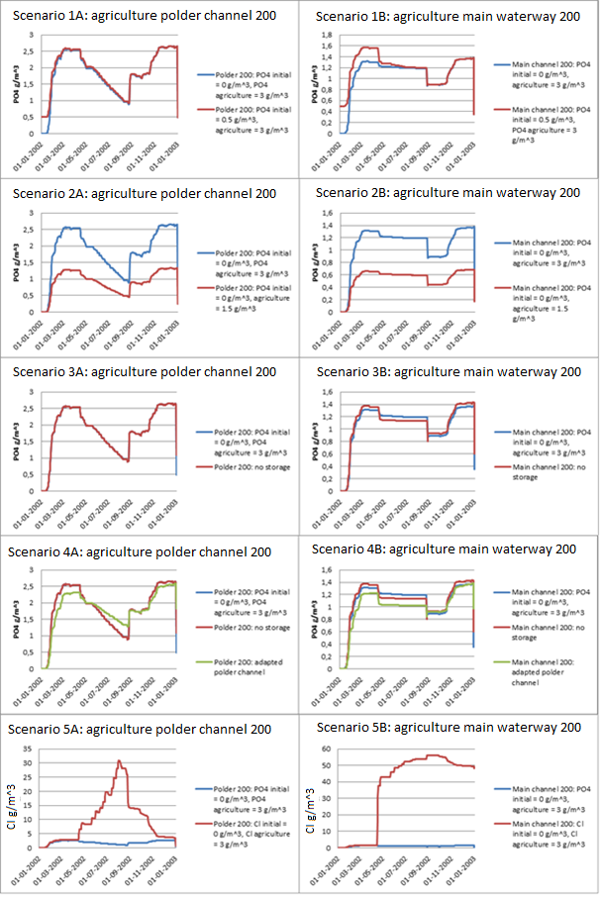
Figure 20: Results sensitivity analysis polder 200, run with agriculture.
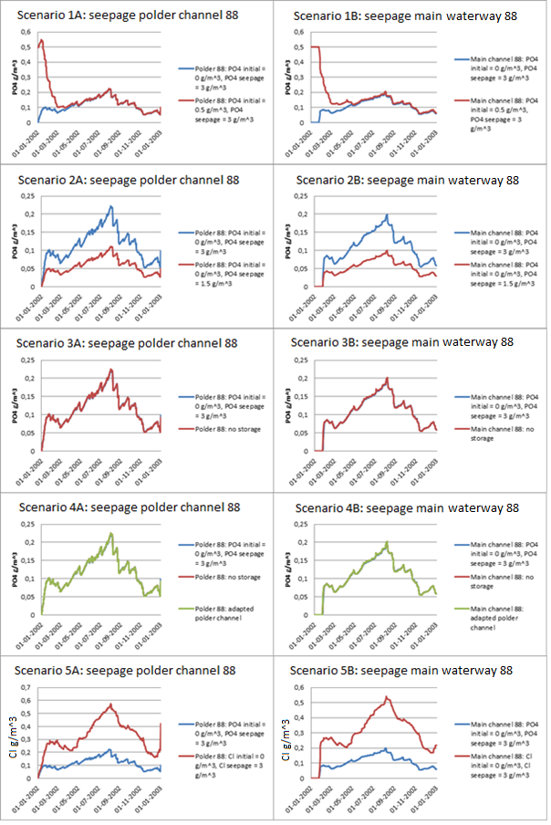
Figure 21: Results sensitivity analysis polder 88, run with seepage.
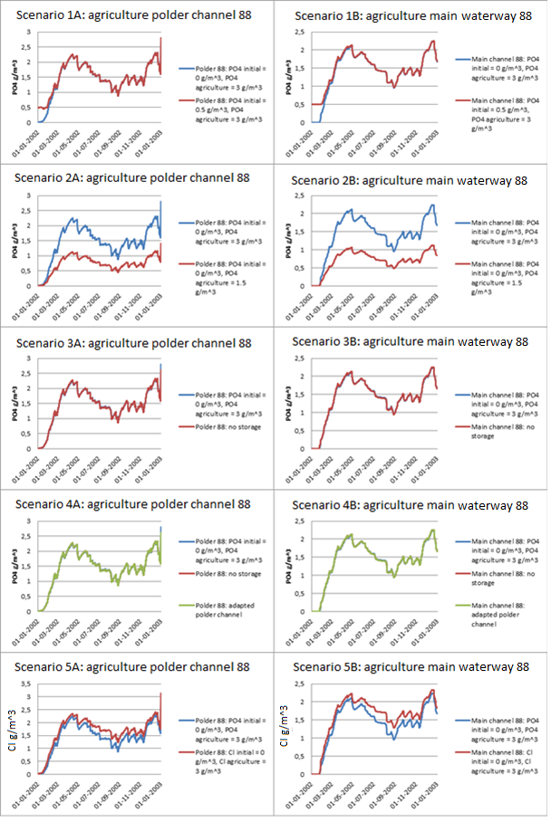
Figure 22: Results sensitivity analysis polder 88, run with agriculture.

7.4 Discussion about the shape of the reference runs

Seepage polder 200: There is a little bit of PO₄ in the polder channel in summer as a result of seepage, but this is probably artificial because there is no seepage in polder 200.

Agriculture polder 200: The polder channel shows an increase in concentration in the winter. This is most logically the case because in the winter there is more precipitation which results in more discharge of PO₄ containing water from the agricultural land to the polder channels. The summer (half April to half October) coincides with a decreasing trend of the concentration. This is most logical the result of three reasons:

- The decrease in precipitation results in no discharge from the agricultural area into the polder channel so there is no PO₄ entering the polder channel. An exception is a small discharge in the beginning of May resulting in small concentration increase in the polder channel.
- The PO₄ in the channel is decreasing as result of adsorption.
- In the polder, a higher water level is allowed during summer. To increase the water level in the polder at the beginning of the summer water gets pumped from the main waterway into the polder channel as shown in appendix 13. By doing this, water with relative low PO₄ concentrations gets pumped into the polder channel that has a relative high PO₄ concentration resulting in dilution. The rest of the summer the polder water level is kept constant by precipitation and by pumping water from the main waterway into the polder channel. However, in the course of the summer, the pumping results in decreasing dilution effects because the concentration in the polder channel is decreasing to values equal to the main waterway.

The results show a sudden increase in concentration at the first of September that coincides with the enormous precipitation event enables a lot of PO₄ to enter the polder channel. Then the concentration starts to decrease again during the remaining of the summer for the same reasons it decreased in the first part of the summer.

The main waterway shows increases in PO₄ concentration during the winter, most logically the result of the higher discharge of the PO₄ containing polder water to the main waterway during winter. In the summer, the decrease in PO₄ is relatively small compared to the decrease of PO₄ in the polder channel during the summer. This is most logically the case because water from the main waterway gets evaporated and no extra water is added to the main waterway, while the volume of water in the polder channel increases because more water is allowed in the polder during the summer. At the first of September, the results show a sudden drop in PO₄ concentration in the main waterway. This is most logically the result of the fact that a large precipitation event at the first of September flushes polder water with relative low PO₄ concentrations into the main waterway resulting in dilution in the main waterway. Later on the concentrations increase relatively fast again because now polder water with a relative high PO₄ concentration as result of the precipitation event has reached the main waterway. The main waterway thus shows some delay in its concentration profile compared to the polder channel.

Seepage polder 88: The polder channel and the main waterway show close resemblance in their concentration pattern although there is some delay. This resemblance is most logically there because polder 88 still has discharge from the polder channel into the main waterway during summer and thus PO₄ keeps entering the main waterway whole year round.

Both the polder channel as well as the main waterway show decreases in the PO₄ concentration during the winter. This most logically is the case because its concentration is diluted by precipitation. During the summer, there is adsorption, but still the concentration of PO₄ increases so the adsorption must be relatively small. Most logically the PO₄ concentration increases because of the combined effect of two reasons:

- The seepage is modeled as continues source which means that PO₄ keeps entering the polder channel during the summer.
- In summer there is less precipitation and more evaporation resulting in higher concentrations.

Agriculture polder 88: Also these results show close resemblance between the PO₄ concentrations in the polder channel and the main waterway and also here there is some delay. This resemblance is most logically there because there is still discharge from the polder channel to the main waterway. Another observation is that the PO₄ concentrations as result of agriculture are a lot higher than the concentrations as result of seepage.

Both the polder channel and the main waterway show increases in PO₄ concentrations during the winter. This is most logically the case because in the winter there is more precipitation which results in more discharge of PO₄ containing water from the agricultural land to the polder channels. During the summer the concentration of PO₄ drops because of multiple reasons:

- The decrease in precipitation results in no discharge from the agricultural area into the polder channel so there is no PO₄ entering the polder channel.
- The PO₄ in the channel is decreasing as result of adsorption.
- In the polder, a higher water level is allowed during the summer. At the beginning of the summer when the target level switches this higher water level is reached by pumping water from the main waterway into the polder channel as shown in appendix 13. Because the main waterway has a slightly smaller concentration, this results in a small drop in concentration in the polder channel. The rest of the summer the water level in the polder is kept at constant water level by precipitation and discharging excess water.

7.5 Discussion of the scenarios results

Scenario 1: Adding of an initial PO₄ concentration.
The model runs with initial concentration show a higher start concentration than the reference run. However, after a while the reference run and the run with initial concentration show the same result. This is most logically the case because the initial concentration is not a constant source, which means that besides the first time step, no initial concentration enters the system. This adjustment time is largest for the seepage run of polder 88, most logically because the PO₄ added by seepage is small compared to the initial PO₄ concentration in the channels.

Although there is no seepage in polder 200, the results of scenario 1 are shown because they illustrate how the initial concentration changes throughout the year. The results for the polder channel show a fast decrease in PO₄ concentration, most logically the result of adsorption and discharge of water from the polder channel into the main waterway. This is visible in the main waterway by a slower decrease in the concentrations. Then there is a small increase in concentration during the summer which is most logically the result of the decrease in water volume due to the decrease in precipitation and the increase in evaporation. Also the decrease of the concentration is smaller because there is no discharge to the main waterway, only adsorption. The fact that there is no discharge to the main waterway results in a fast decrease in concentration in the main waterway due to adsorption. At the end of the summer there is a sudden concentration drop. This drop coincides with the change in target level. This means that there is less water allowed in the polder compared to the summer period, and the excess water with a certain PO₄ concentration discharges in the main waterway. This effect is not visible in the main waterway because it gets diluted.

Scenario 2: Decreasing the PO₄ concentration of the sources by a factor two.
When the concentration is divided by two, the concentrations in the polder channel as well as the main waterway are also divided by exactly two. It was however expected that this would result in a more than two times decrease in concentration because of the decreasing adsorption determined by the Langmuir isotherm.

A reason why the results do not show a more than two times decrease, might be that the concentration of PO₄ is still in the linear part of the Langmuir isotherm. To test this, a conservative calculation with the Langmuir isotherm was done with k_{L} = 0.1 m³/gP and S_{max} = 0.15 gP/gFe and a concentration of respectively 3 gP/m³ and 1.5 gP/m³. This concentration is conservative, because it does not take into account the dilution that occurs when this concentration enters the polder channel. The results are shown in equation 7.5.1 and 7.5.2. Furthermore the plot of the Langmuir isotherm with k_{L} = 0.1 m³/gP and S_{max} = 0.15 gP/gFe is shown in figure 23. The results of both the calculations and the plotted isotherm show that indeed the concentration of PO₄ is still in the linear part of the Langmuir isotherm.

$s=\frac{k_{L}S_{max }C}{1+k_{L}C}=\frac{0.1*0.15*3 }{1+0.1*3}=0.034615 gP/gFe$ eq. 7.5.1

$s=\frac{k_{L}S_{max }C}{1+k_{L}C}=\frac{0.1*0.15*1.5 }{1+0.1*1.5}=0.019565 gP/gFe$ eq. 7.5.2

Figure 23: Plot of the Langmuir isotherm with k_{L} = 0.1 m³/gP and S_{max} = 0.15 gP/gFe.

Scenario 3: Removing the storage from the cross-sections to change the water volume.
There is hardly any difference between the run with and without storage. This most logically is the case because SOBEK models the storage in time, making the distinction between summer and winter automatically.

Scenario 4: Removing the storage from the cross-sections and adapting the polder channels to change the residence time of the substances.
Because the storage removal was already discussed in scenario 3, the focus here lies on the adaptation of the channels.

For polder 88, the polder channel adaptation results in hardly any difference with the reference run, which is most logically the result from the fact that the adaptation of the polder channel is a relatively small one (only a factor 3 longer and smaller compared to a factor 60 for polder 200).

For polder 200, in the case of agriculture the polder channel shows lower concentrations in winter and higher concentrations in summer than the reference run. The results show these higher summer concentrations most logically because the ortho-phosphate took so long to reach the main waterway that it was trapped in the polder when the summer started which is supported by the data of the main waterway where concentrations in summer are lower than in the reference run.

Scenario 5: Instead of PO₄ a run with a conservative tracer (chloride).
For polder 200, in the case of agriculture the run with chloride instead of ortho-phosphate shows for the polder channel a peak in the summer and lower concentrations in winter. The main waterway shows up to the start of the summer about the same concentrations for chloride as the polder channel. Then there is a sudden increase in concentration at the beginning of the summer. The reason for this is most logically the following: during the summer a higher water level is allowed in the polder channel. Therefore at the start of the summer water is pumped from the main waterway into the polder (appendix 13). The polder channel and the main waterway have at that moment about the same PO₄ concentration so this pumping hardly changes the concentrations in the polder. The main waterway however, has now lost a lot of water volume to the polder while no water is discharging in the main waterway. Besides that, the main waterway already was smaller than the polder channel. For these reasons the concentration in the main waterway increases a lot. In total ten times water gets pumped into the polder channel, which results in step by step increases in the PO₄ concentration in the main waterway, but also in the polder channel because the pumped water has a higher and higher concentration. At the end of the summer the concentrations in the polder channel decrease again because water from the agricultural land that has lower concentrations enters the polder channel. It takes however some time before this is visible in the main waterway because it takes some time before this water enters the main waterway.

For polder 88, the concentration of chloride shows the same shape as the reference run. However, in the case of seepage the concentrations of chloride are almost three times higher than those of ortho-phosphate, while in the case of agriculture the concentrations of chloride are not more than 1.25 times higher than those of ortho-phosphate. Apparently, there is much more interaction with the soil of PO₄ that enters the polder with seepage than for PO₄ that enters from the agricultural land. This is most logically the case because the agriculture adds a lot of PO₄ to the polder channels at the same time in combination with a fast discharge to the main waterways. Therefore PO₄ at the top of the water column does not come in contact with the sediment, disallowing adsorption to take place. Because seepage is a continuous source with low concentrations, there is much more mixing in the water column and more interaction of PO₄ with the sediment.

7.6 Results water quality Leidse Vaart
To model the influences of the sources seepage and agriculture on the PO₄ concentration in the Leidse Vaart, the whole model was runned. However, the model gives an error as result of a schematization mistake. This can occur because of many reasons like an unintended soil jump, a mistake in a cross-section, etc. A structural solution is the adaptation of the locations SOBEK assigns as wrong, however SOBEK is only able to assign one wrong location at a time, which makes that repairing the model is very time consuming.

Note that although it is not yet possible to run the whole model, the model is not useless because it is still possible to make simulations for every individual polder. Therefore an alternative calculation was made to see the influence of the sources seepage and agriculture on the concentration PO₄ in the Leidse Vaart. The results of this calculation are indicative and only to use as basis for future modeling.

For this calculation, every polder in the flower bulb area (as shown in table 7 in the previous chapter) was cut from the model and runned with a concentration of 3 gP/m³ for seepage or agriculture. This means that 69 polders were modeled of which 34 experience seepage and 35 infiltration. The concentrations in the polder channel were multiplied with the discharge of the polder channel to the main waterway. In this way, it is possible to calculate the amount of PO₄ discharging to the main waterway in a year. The discharge was corrected for the initial peak that SOBEK models to adjust to the boundary condition of -0.6 m above ground level.

Als het mogelijk is het volume van de Leidse Vaart te krijgen kan ik hier nog een concentratie profile maken voor de concentratie in de Leidse Vaart per maand.

Assumptions made for this calculation are:

- Seepage and agriculture have the same PO₄ concentration.
- There is only adsorption of PO₄.
- All polders in the flower bulb area directly influence the concentration of PO₄ in the Leidse Vaart.
- All water volume that leaves the polders is modeled via a pump or a weir. Different routes like a water treatment plant are not taken into account.

For every polder in the flower bulb area, the seepage in mm/day, the area of seepage and agriculture in hectare, the cumulative PO₄ load added by seepage and by agriculture, and the cumulative PO₄ load added by seepage and agriculture per area are shown in table 11. The main waterways (‘boezemgebieden’) are abbreviated (a B_ before the waterway number).

Table 11: Indicative amount of PO₄ in the Leidse Vaart resulting from seepage and agriculture (only to use as basis for future modeling).
Polder nr. | Seepage (mm/day) | area seepage (ha) | area agriculture (ha) | PO₄ seepage (g/year) | PO₄ agriculture (g/year) | PO₄ seepage (g/ha*year) | PO₄ agriculture (g/ha*year)
3 | 0.00E+00 | 83.32 | 80.90 | 0 | 9.18 | 0.00E+00 | 1.13E-01
4 | 0.00E+00 | 6.75 | 6.62 | 0 | 0.98 | 0.00E+00 | 1.48E-01
7 | 9.89E-03 | 124.70 | 121.78 | 0.11 | 15.89 | 8.82E-04 | 1.30E-01
63 | 0.00E+00 | 124.01 | 114.68 | 0 | 11.29 | 0.00E+00 | 9.84E-02
64 | 0.00E+00 | 76.59 | 69.65 | 0 | 4.35 | 0.00E+00 | 6.25E-02
65 | 6.86E-01 | 17.07 | 15.42 | 1.2 | 1.86 | 7.03E-02 | 1.21E-01
66 | 1.16E+00 | 203.62 | 191.92 | 26.81 | 23.57 | 1.32E-01 | 1.23E-01
67 | 5.26E-01 | 84.03 | 80.23 | 0.04 | 0.06 | 4.76E-04 | 7.48E-04
68 | 3.86E-01 | 9.46 | 9.25 | 0.42 | 1.23 | 4.44E-02 | 1.33E-01
69 | 8.33E-01 | 42.29 | 40.48 | 4 | 5.5 | 9.46E-02 | 1.36E-01
80 | 0.00E+00 | 100.25 | 96.13 | 0 | 5.83 | 0.00E+00 | 6.06E-02
81 | 0.00E+00 | 57.76 | 54.78 | 0 | 4.37 | 0.00E+00 | 7.98E-02
82 | 0.00E+00 | 91.37 | 87.20 | 0 | 9.79 | 0.00E+00 | 1.12E-01
83 | 1.49E-02 | 234.13 | 223.07 | 0.34 | 31.03 | 1.45E-03 | 1.39E-01
84 | 0.00E+00 | 212.22 | 201.14 | 0 | 14.27 | 0.00E+00 | 7.09E-02
100 | 4.63E-01 | 4316.04 | 4072.31 | 418.72 | 870.53 | 9.70E-02 | 2.14E-01
107 | 3.53E-01 | 934.34 | 907.46 | 27.54 | 59.81 | 2.95E-02 | 6.59E-02
108 | 3.07E-01 | 1009.28 | 990.12 | 24.83 | 63.02 | 2.46E-02 | 6.36E-02
112 | 2.12E+00 | 432.45 | 420.66 | 105.16 | 47.73 | 2.43E-01 | 1.13E-01
113 | 9.89E-01 | 226.60 | 194.59 | 21.99 | 13.3 | 9.70E-02 | 6.83E-02
127 | 8.83E-02 | 137.33 | 131.32 | 0.78 | 12.92 | 5.68E-03 | 9.84E-02
129 | 0.00E+00 | 176.49 | 173.66 | 0 | 18.92 | 0.00E+00 | 1.09E-01
130 | 0.00E+00 | 117.16 | 114.04 | 0 | 9.45 | 0.00E+00 | 8.29E-02
133 | 5.01E-01 | 107.17 | 102.98 | 6.07 | 10.59 | 5.66E-02 | 1.03E-01
134 | 3.46E-01 | 355.82 | 338.40 | 13 | 45.93 | 3.65E-02 | 1.36E-01
136 | 1.62E-01 | 201.03 | 193.16 | 3.14 | 28.81 | 1.56E-02 | 1.49E-01
148 | 0.00E+00 | 122.28 | 116.00 | 0 | 15.35 | 0.00E+00 | 1.32E-01
154 | 1.46E-01 | 181.90 | 170.17 | 1.87 | 17.4 | 1.03E-02 | 1.02E-01
158 | 2.46E-01 | 233.48 | 223.96 | 4.31 | 15.2 | 1.85E-02 | 6.79E-02
159 | 1.86E-01 | 120.80 | 114.87 | 2.42 | 8.41 | 2.00E-02 | 7.32E-02
160 | 0.00E+00 | 100.10 | 93.26 | 0 | 4.74 | 0.00E+00 | 5.08E-02
161 | 0.00E+00 | 8.54 | 8.39 | 0 | 1.01 | 0.00E+00 | 1.20E-01
163 | 0.00E+00 | 130.18 | 125.95 | 0 | 7 | 0.00E+00 | 5.56E-02
164 | 0.00E+00 | 106.81 | 103.26 | 0 | 6.49 | 0.00E+00 | 6.29E-02
170 | 0.00E+00 | 69.73 | 67.45 | 0 | 8.71 | 0.00E+00 | 1.29E-01
180 | 8.21E-02 | 28.03 | 272.82 | 0.26 | 26.55 | 9.28E-03 | 9.73E-02
181 | 3.58E-02 | 504.07 | 490.50 | 2.01 | 46.97 | 3.99E-03 | 9.58E-02
Polder nr. | Seepage (mm/day) | area seepage (ha) | area agriculture (ha) | PO₄ seepage (g/year) | PO₄ agriculture (g/year) | PO₄ seepage (g/ha*year) | PO₄ agriculture (g/ha*year)
189 | 0.00E+00 | 98.87 | 91.49 | 0 | 7.81 | 0.00E+00 | 8.54E-02
205 | 8.58E-02 | 242.51 | 230.10 | 1.87 | 20.07 | 7.71E-03 | 8.72E-02
206 | 0.00E+00 | 26.14 | 25.00 | 0 | 2.09 | 0.00E+00 | 8.36E-02
210 | 0.00E+00 | 209.75 | 203.52 | 0 | 17.66 | 0.00E+00 | 8.68E-02
244 | 0.00E+00 | 138.81 | 128.30 | 0 | 10.42 | 0.00E+00 | 8.12E-02
245 | 0.00E+00 | 78.72 | 69.23 | 0 | 4.93 | 0.00E+00 | 7.12E-02
246 | 4.03E-01 | 6.87 | 6.44 | 0.25 | 0.95 | 3.64E-02 | 1.48E-01
247 | 3.90E-02 | 34.00 | 32.17 | 0.11 | 5.15 | 3.24E-03 | 1.60E-01
252 | 0.00E+00 | 99.32 | 93.66 | 0 | 8.88 | 0.00E+00 | 9.48E-02
277 | 2.62E-01 | 261.29 | 249.58 | 7.22 | 18.46 | 2.76E-02 | 7.40E-02
282 | 1.70E-01 | 156.59 | 145.03 | 2.33 | 8.58 | 1.49E-02 | 5.92E-02
290 | 0.00E+00 | 36.79 | 34.62 | 0 | 3.76 | 0.00E+00 | 1.09E-01
292 | 0.00E+00 | 15.21 | 14.96 | 0 | 2.17 | 0.00E+00 | 1.45E-01
299 | 0.00E+00 | 33.20 | 31.39 | 0 | 2.24 | 0.00E+00 | 7.14E-02
301 | 5.64E-01 | 176.52 | 170.51 | 10.96 | 24.11 | 6.21E-02 | 1.41E-01
315 | 1.58E-01 | 160.91 | 154.23 | 2.53 | 20.06 | 1.57E-02 | 1.30E-01
B_9 | 7.95E-01 | 434.01 | 1004.01 | 58.58 | 73.64 | 1.35E-01 | 7.33E-02
B_10 | 0.00E+00 | 631.89 | 631.89 | 0 | 40.69 | 0.00E+00 | 6.44E-02
B_11 | 0.00E+00 | 832.69 | 832.69 | 0 | 97.71 | 0.00E+00 | 1.17E-01
B_12 | 0.00E+00 | 104.21 | 104.21 | 0 | 3.29 | 0.00E+00 | 3.16E-02
B_13 | 8.93E-01 | 169.81 | 169.81 | 16.41 | 21.58 | 9.66E-02 | 1.27E-01
B_14 | 0.00E+00 | 358.58 | 358.58 | 0 | 21.12 | 0.00E+00 | 5.89E-02
B_15 | 1.69E-01 | 537.57 | 537.57 | 10.74 | 52.63 | 2.00E-02 | 9.79E-02
B_16 | 0.00E+00 | 426.47 | 426.47 | 0 | 39.82 | 0.00E+00 | 9.34E-02
B_17 | 0.00E+00 | 215.71 | 215.71 | 0 | 21.75 | 0.00E+00 | 1.01E-01
B_18 | 1.07E-01 | 389.74 | 389.74 | 7.41 | 39.74 | 1.90E-02 | 1.02E-01
B_19 | 0.00E+00 | 78.12 | 78.12 | 0 | 7 | 0.00E+00 | 8.96E-02
B_20 | 0.00E+00 | 179.63 | 179.63 | 0 | 9.29 | 0.00E+00 | 5.17E-02
B_21 | 9.66E-02 | 249.54 | 249.54 | 28.32 | 199.89 | 1.13E-01 | 8.01E-01
B_22 | 2.84E-02 | 222.97 | 222.97 | 0.65 | 16.28 | 2.92E-03 | 7.30E-02
B_23 | 0.00E+00 | 15.82 | 15.82 | 0 | 6.96 | 0.00E+00 | 4.40E-01
B_32 | 0.00E+00 | 496.18 | 496.18 | 0 | 39.1 | 0.00E+00 | 7.88E-02

 | Seepage (g/year) | Seepage (g/ha*year) | Agriculture (g/year) | Agriculture (g/ha*year)
Cumulative | 812.40 | 0.0446 | 2325.87 | 0.1263
Average | 11.77 | 0.000647 | 33.71 | 0.001831
Average normal polders | 13.02 | 0.001013 | 30.86 | 0.002469
Average boezemgebieden | 7.63 | 0.001428 | 43.16 | 0.007299

7.7 Discussion about the results for the Leidse Vaart
The results of the Leidse Vaart (table 11) show the cumulative amount of PO₄ added to the Leidse Vaart in a year per individual polder as well as the total input. As shown, the cumulative amount of PO₄ added by seepage in a year is 812.40 gP/year and for agriculture this is 2325.86 gP/year. If the area is taken into account, seepage contributes 0.0446 g/ha*year, and agriculture 0.1263 g/ha*year. This means that when seepage and agriculture have the same PO₄ concentration of 3 gP/m³, seepage adds about 25.9% and agriculture about 74.1% of the yearly PO₄ amount to the Leidse Vaart. If the areas are taken into account seepage even contributes more: 26.1% versus 73.9% for agriculture. However, the concentrations of seepage and agriculture are in reality not the same and it would be worthwhile to see what their real concentrations are.

The only process modeled is adsorption while other processes are not taken into account. It would be worthwhile to add other processes to the model, because it is expected that for example biological activity will decrease the PO₄ concentration a lot during the summer.

Another assumption was that all the polders in the flower bulb area directly influence the concentration of PO₄ in the Leidse Vaart. However, only 18 of the 69 polders are identified that discharge directly into the Leidse Vaart as shown in table 12. Thus it could be that the PO₄ of the other 51 polders never reaches the Leidse Vaart which results in an overestimation of the amount of PO₄ in the Leidse Vaart. It would therefore be worthwhile to check if all the water that discharges from the polder actually enters the Leidse Vaart. The same effect can occur from the fact that no other routes for PO₄ to leave the area are modeled, like via a water treatment plant or via plant uptake. For future modeling it would be worthwhile to take into account these other routes.

Table 12: Polders that discharge directly into the Leidse Vaart.
Polders that discharge directly into the Leidse Vaart (derived from the start model gained from the Water Board of Rijnland) | 65; 66; 67; 68; 69; 82; 83; 134; 136; 154; 163; 247; 277; 301; 315; Boezemgebied_9; Boezemgebied_11; Boezemgebied_19.

The results show that the amount of PO₄ that every polder contributes to the Leidse Vaart is almost always higher for agriculture than for seepage. The exceptions are polder 66, 112 and 113. The reason for this is most logically that these polders are the polders with the most seepage. The seepage values for every polder in the flower bulb area are shown in table 11. These polders are located close to the Haarlemmermeerpolder, where the largest seepage values are found as shown in appendix 3.

The results also show that the boezemgebieden contribute less than average to the amount of PO₄ in the Leidse Vaart by seepage than the normal polders. This most logically is the case because the average seepage of the normal polders is about 1.6 times as large as the average seepage of the boezemgebieden as shown in table 11. This results from the fact that the percentage of polders experiencing seepage is higher for the normal polders than for the boezemgebieden.

The results also show that the boezemgebieden contribute more than average to the amount of PO₄ in the Leidse Vaart by agriculture than the other polders. This most logically originates from the fact that the discharge from the boezemgebieden is higher. This higher discharge is there because the average agricultural area of the boezemgebieden is about 1.5 times larger than the agricultural area of the normal polders as shown in table 11. This means that there is more area where precipitation can fall on which results in more discharge.

8. Discussion

8.1 Benefits of the new model
By using the new model, it is possible to use the water quantity module of SOBEK. This gives insight in the different sources to the PO₄ concentration at a certain place. This is beneficial because it is then possible to see what sources are the main contributors and thus need the focus of the measures.

8.2 Schematization of the model
All sources enter at different places in the polder channel. However, this is not a problem because Delwaq schematizes the polder as a control volume, which means that the polder is one entity. When a substance with a certain concentration enters at a certain location, this substance is immediately diluted over the whole polder.

It is preferred that all the water volume of the open water node in the start model to be modeled in the polder, and no water volume in channels of the inlet or outlet from the polder to the main waterway because in reality there is no inlet or outlet channel. However, in this schematization 5% of the water volume is divided over the inlet and outlet channel, which is partly polder channel and partly main waterway. Therefore, the volume of water in the polder is underestimated, and the volume in the channel overestimated. Because this water volume is relatively small (5% of the total water volume), the fault this creates will be limited.

8.3 Choices

8.3.1 Ortho-phosphate versus colloidal P
The choice was made to only model ortho-phosphate. Colloidal P is not modeled because it is not yet possible to incorporate colloidal P in a flow model of this size. This because colloidal P flow is influenced by a lot of area-dependent characteristics that are prone to high variability (see e.g. research of (Vendelboe 2011) or (Chardon 2007)). Research of (Heathwaite 2005) highlights the potential for drainage water to mobilize colloids and associated phosphorus during rainfall events. This means that the real concentrations in the main waterways after rainfall events are underestimated with this model.

8.3.2 Seepage and agriculture versus other sources
Only the sources seepage and agriculture were modeled. This because agriculture is expected to be the largest source of P, and the Water Board of Rijnland has interest in seepage as a source. Phosphorus that enters the flower bulb area as precipitation or as result of the water treatment plants is neglected. Not taking into account these sources will not influence the results for the flower bulb area that much because of their low contribution to the phosphorus concentration in surface waters compared to fertilizer use. The phosphorus that leaves the area because it is taken up by plants is also neglected. This might influence the results a lot in the growing season of the flower bulbs. It is advised to overcome this problem in the future by using time-series for PO₄ added by agriculture.

8.3.3 Advection and adsorption versus other processes
Only advection and adsorption are modeled. It is assumed that there is no dispersion. This is a reasonable assumption because by using Delwaq it is assumed that every concentration that enters the polder channel is immediately evenly mixed through the whole polder channel. It is also assumed that there is no desorption. Desorption is a slow reaction that is of much less importance than adsorption. Therefore it will not be a significant process. This is underpinned by the fact that some test runs with desorption for the polders 200 and 88 did not give significant differences from the runs without desorption. The results for agriculture in polder 200 for no desorption and desorption for the polder channel as well as the main waterway are shown in appendix 14.

Normally, the increased biological activity during summer would decrease the PO₄ concentration a lot. However, in this research biological activity was not taken into account. This probably gives a large overestimation of the concentration in summer. For future modeling it is advised to at least also take into account biological activity. It would be best to model all processes available in Delwaq, but this would be a long term goal because it will take some time before all necessary information is assembled.

8.3 Scenarios
Modeling the polders with adapted channels gives is the most realistic scenario. However, the reference scenarios are without adapted channels. This is done because in the start model, the polder channels were modeled as large reservoirs instead of channels. This was copied. In terms of percentage difference between scenarios it does not matter if adapted channels are taken as reference for the sensitivity analysis or not, as long as all the scenarios are also runned with adapted channels. However, for a better estimation of PO₄ concentrations in the Leidse Vaart in summer it is advised to do other runs with and adapted channels.

By modeling the PO₄ concentration on the CF-RR connection node instead of on the unpaved node that represents the agricultural area, no fertilizer application is modeled when there is no discharge from the agricultural land to the polder channels. This is e.g. the case in summer. Therefore also PO₄ build-up on the land and the associated flush with extreme PO₄ concentrations at the end of a dry period is not modeled. To overcome this problem, it is advised to model in the future seasonal dependent PO₄ concentrations by using time-series. In this way, fertilizer application is modeled when there is really fertilizer application. Additional advantage is that by using time-series also PO₄ uptake by plants can be taken into account.

8.4 Data and parameters
Mistakes could have occurred when the data was exported from the start model to the new model. However, because the data was checked, the chance of such a mistake is very low. Data gained from the Water Board of Rijnland is assumed to be the best data available at the moment. However, especially seepage values are uncertain. This is the case because of several reasons:

- Seepage values can only be modeled at regional scale because of limitations to the grid cell size. In addition, small scale infiltration- and seepage processes cannot be modeled (G. a. Oude Essink 2011).
- It is not possible to see the distinction between seepage to parcels or ditches (G. a. Oude Essink 2011).
- The seepage is modeled as an average constant value, while in reality this value varies throughout the year.

The parameters that were used were the default parameters in SOBEK-Delwaq. These values were checked against parameter values found in literature. All default values matched the values found in literature, except the value for the concentration of iron in dry matter. Del Bubba et al. (2003) give for the concentration of iron in dry matter values of 0.008 kg Fe/kg DM (Del Bubba 2003), Dunne et al. (2005) give values in the range of 0.003 – 0.009 kg Fe/kg DM (Dunne 2005). The chosen parameter value is thus about 2.5 times higher than research shows. According to this, the amount of PO₄ that adsorbs is overestimated and thus the concentrations in the polder channels, main waterways and Leidse Vaart are underestimated. For future modeling it is advised to decrease the value of the iron concentration in dry matter.

9. Conclusion

The numbers found in the sensitivity analysis do not say that much because of the assumptions made. Besides that the polders used (200 and 88) are not located in the flower bulb area. However, this sensitivity analyses was done to get a notion of the relative difference between the sources seepage and agriculture. In the case of polder 200, there is no seepage so only agriculture contributes to the PO₄ concentration in the main waterways. For polder 88, the results also show that agriculture contributes more to the PO₄ concentration in the main waterways, but the contribution of seepage is 10% of that of agriculture. This indicates that the contribution of seepage is significant, but further investigation is necessary because of the assumptions made.

The results of the sensitivity analysis also show that the concentration in the main waterways is especially influenced by the source agriculture: a lot of PO₄ is added to the polder channels at the same time in combination with a fast discharge to the main waterways. Therefore PO₄ at the top of the water column does not come in contact with the sediment, disallowing adsorption to take place. Because seepage is a continuous source with low concentrations, there is much more mixing in the water and more interaction of PO₄ with the sediment.

At this moment, the model does not work. However, individual polders can be cut from the model to further investigate. It is easy to run scenarios because it is possible to adapt only the PO₄ concentration of one agricultural connection node or seepage connection node that enters the channel and this is taken over for every polder belonging to the flower bulb area. It is also very easy to run the scenario for a longer time period by adapting the simulation settings. Furthermore it is easy to check concentrations at certain locations in channels and at certain nodes.

Individual polders were further investigated in order to find the contributions of seepage and agriculture to the PO₄ concentration in the Leidse Vaart, to answer the main question:

How is the phosphorus concentration in the Leidse Vaart influenced by the sources seepage and agriculture?

The results show that seepage adds about 25.9% and agriculture about 74.1% of the yearly PO₄ amount to the Leidse Vaart when seepage and agriculture have the same PO₄ concentration. If the areas are taken into account seepage even contributes more: 26.1% versus 73.9% for agriculture. Agriculture is always a bigger PO₄ source than seepage, except near the Haarlemmermeerpolder where very high seepage values are found. Boezemgebieden show low contributions to the PO₄ concentration in the Leidse Vaart by seepage and high contributions by agriculture compared to polders.

10. Recommendations
The results for the Leidse Vaart show that seepage thus is a significant contributor of the PO₄ concentration in the Leidse Vaart. However, the assumptions made could have influenced the results. Therefore the following is recommended for future modeling:

- The PO₄ concentrations in seepage and agriculture are in this research both modeled as 3 g/m³. However, in reality these concentrations are not the same. It is therefore advised to check what the real PO₄ concentrations are and adjust the model accordingly.

- In this research, the only process taken into account was adsorption. For future modeling it is advised to at least also take into account biological activity. It would be best to model all processes available in Delwaq, but this would be a long term goal because it will take some time before all necessary information is assembled.

- The current research probably overestimated the adsorption because the iron concentration in dry matter used was chosen about 2.5 times higher than the values found in literature. It is therefore advised to decrease the iron concentration in dry matter.

- In this research it was assumed that all polders in the flower bulb area directly influence the concentration of PO₄ in the Leidse Vaart. However, only 18 polders directly discharge into the Leidse Vaart, the other polders discharge into other channels that later on enter the Leidse Vaart. Therefore there is dilution of PO₄ and more interaction time with the sediment before the water enters the Leidse Vaart. For future modeling it is advised to take this dilution and interaction time into account.

- No other routes (e.g. via water treatment plants) were taken into account. It is advised to check how much water leaves the flower bulb area via other routes and adjust the model accordingly.

- It is advised to model the PO₄ concentration added by agriculture by using time-series of the soil column. In this way, fertilizer application is modeled when there is really fertilizer application. Additional advantage is that by using time-series also PO₄ uptake by plants can be taken into account.

- In this research, the water quantity of the polders was modeled more as a big box than as small channels. It is therefore advised to adapt the channels in the polders in such a way that they are more realistic for a polder (e.g. making them 1 à 2 meters in width). Also, polders were modeled as one long channel, while in reality there are maybe more channels in one polder or curved channels. This would influence the residence time of water and thus PO₄ in the polder and thus the interaction time of PO₄ with the sediment.

- In the model only water is pumped into the polders to keep the groundwater level constant, while in reality also water is pumped into the polder to flush the polder. It is advised to look into the influences of this flushing on residence time and water quality.

11. Bibliography
CBS, PBL, Wageningen UR. Vermesting in regionaal water, 1990-2010 (indicator 0552, versie 04, 12 september 2012). 2012. http://www.compendiumvoordeleefomgeving.nl/indicatoren/nl0552-Vermesting-regionale-wateren.html?i=11-60 (viewed 2012).
Chardon, W.J., Aaldering, G.H., and van der Salm, C. Phosphorus Leaching from Cow Manure Patches on Soil Columns. Journal of Environmental Quality 36 (2007), pp. 17-23, 2007.
Cornforth, I.S. „The fate of phosphate fertilizers in soil.” 2012. http://nzic.org.nz/ChemProcesses/soils/2D.pdf (viewed 01-22 2013).
de Boorder, N., Griffioen, J., Twisk, W. 2011. „De haalbaarheid van waterzuivering bij poldergemalen.” H2O / 01, 2011: pp. 14-15.
de Jonge, M., Leerlooijer, C., Schaafsma, R. Nutriëntenonderzoek Bloembollen. Literatuurinventarisatie ten behoeve van 'Rijn-West KRW Bloembollen'. Grontmij, projectnumber 311109, referencenumber GM-0041808, 2011.
Del Bubba, M., Arias, C.A., Brix, H. „Phosphorus adsorption maximum of sands for use as media in subsurface flow constructed reed beds as measured by the Langmuir isotherm.” Water research 37 (2003) (Water Research 37 (2003)), 2003: pp. 3390-3400.
Deltares, a. Deltares. 2012. www.deltares.nl (viewed 08-25 2012).
Deltares, b. „SOBEK. Hydrodynamics, Rainfall Runoff and Real Time Control. User Manual. Version 0.00.23705.” Deltares, 2012.
Dijkstra, J.P., Groenendijk, P., Boesten, J.J.T.I., and Roelsma, J. Emissies van bestrijdingsmiddelen en nutriënten in de bloembollenteelt. Modelonderzoek naar de uitspoeling van bestrijdingsmiddelen en nutriënten. Report 387.5, Wageningen: DLO-Staring Centrum, 1997.
Dolfing, J., Chardon, W.J., Japenga, J. Association between colloidal iron, aluminum, phosphorus and humic acids. Soil Science 164 (1999), pp. 171-179, 1999.
Dunne, E., Culleton, N., O'Donovan, G., and Harrington, R. Phosphorus retention and sorption by constructed wetland soils. Oak Park, Carlow: Teagasc (The Irish Agriculture and Food Development Authority), 2005.
Engineering, Department of Civil and Environmental. „Original material by Tuomo Karvonen (2002). Chapter 6.3 Velocity distribution, bed roughness and friction factors in unvegetated channels.” Helsinki: University of Technology, 2010.
European_Communities. „Common implementation strategy for the Water Framework Directive (2000/60/EC).” Technical report 2009-027. ISBN 978-92-79, 2009.
European_Union. The EU Nitrates Directive. 2010. http://ec.europa.eu/environment/pubs/pdf/factsheets/nitrates.pdf (viewed 09-14 2012).
Fetter, C.W. Contaminant hydrogeology. Second edition. Illinois, USA: Waveland Press, Inc., 2008.
Goodwill, I.M., and Sleigh, P.A. „Full notes: Fluid Mechanics. CIVE 2400. Section 2: Open Channel Hydraulics.” University of Leeds, United Kingdom, 2002.
Groenendijk, P., de Kool, S.A.M., van der Grift, B., Stuurman, R.J., Janssen, G.M.C.M. Onderzoeksproject KRW-pilot bollensector. Vooronderzoek en plan van aanpak. Wageningen: Alterra report 1947, 2009.
Heathwaite, L., Haygarth, P., Matthews, R., Preedy, N., and Butler, P. Evaluating Colloidal Phosphorus Delivery to Surface Waters from Diffuse Agricultural Sources. Journal of Environmental Quality 34 (2005), pp. 287-298, 2005.
Hydraulics, WL|Delft. „User Manual. Delft3D-WAQ. Versatile water quality modelling in 1D, 2D or 3D systems including physical, (bio)chemical and biological processes.” Delft: WL|Delft Hydraulics, March 2003.
Ilg, K., Dominik, P., Kaupenjohann, M., and Siemens, J. Phosphorus-induced mobilization of colloids: model systems and soils. European Journal of Soil Science 59 (2008), pp. 233-246, 2008.
King, D.B. Jr. „Influence of Grain Size on Sediment Transport Rates with Emphasis on the Total Longshore Rate.” US Army Corps of Engineers, 2005.
Koopmans, G.F. „Alterra. College: Phosphorus Cycle in Soil: Loss to Surface Waters and Measures in the Schuitenbeek Area.” Utrecht, 02-17 2010.
Krol, A. and van Dokkum, H. „Personal communication.” Leiden, 08-27 2012.
LEC. Colloidal Organic Matter & Phosphorus Transfer in Grassland Hydrological Pathways. 2012. http://www.lec.lancs.ac.uk/cswm/colloids/po.php (viewed 09-14 2012).
Lenntech. Phosphorus removal from wastewater. 2011. http://www.lenntech.com/phosphorus-removal.htm (viewed 09-20 2012).
Liu, J., Liang, X., Yang, J., Ye, Y., Su, M., Nie, Z., and Chen, Y. Size distribution and composition of phosphorus in the East Tiao River, China: The significant role of colloids. Journal of Environmental Monitoring 13 (2011), pp. 2844-2850, 2011.
Loeffen, V. „Hoogheemraadschap Rijnland. Presentation: Waterkwaliteit en de bollensector. Presentatie stand van zaken overleg tbv de gebiedscommissie Noord op 13 november 2007.” 2007.
Mariott, M.J. and Jayaratne, R. „Hydraulic roughness - links between Manning's coefficient, Nikuradse's equivalent sand roughness and bed grain size.” Proceedings of Advances in Computing and Technology (AC&T), 2005: pp. 27-32.
McGechan, M.B., Lewis, D.R. „Transport of Particulate and Colloid-sorbed Contaminants through Soil, Part 1: General Principles.” Biosystems Engineering 83, 2002: 255-273.
Meijers, E. „Deltares. Personal communication.” Utrecht, 2012.
Mujumdar, P.P. „Flood Wave Propagation. The Saint Venant equations.” Resonance (2001), 2001: pp. 66-73.
Oude Essink, G., and Hunink, J. Kwel- en isohypsenkaarten Provincie Zuid-Holland. Utrecht: Deltares. Report 1201950-000-BGS-0001-m, 2011.
Oude Essink, G., van Baaren, E., van Vliet, M. Verkennende studie klimaatverandering en verzilting grondwater in Zuid-Holland. Report 092-81111, Utrecht: Deltares, 2008.
Prinsen, G., Hakvoort, H., Dahm, R. „Neerslag-afvoermodellering met SOBEK-RR.” Stromingen 15 (2009), 2009: pp. 6-22.
Reddy, K.R., O'Connor, G.A., and Gale, P.M. „Phosphorus Sorption Capacities of Wetland Soils and Stream Sediments Impacted by Dairy Effluent.” Journal of Environmental Quality 27 (1998) (Journal of Environmental Quality 27 (1998)), 1998: pp. 438-447.
Rijksoverheid. Europese Nitraatrichtlijn. 2012. http://www.rijksoverheid.nl/onderwerpen/mest/europese-nitraatrichtlijn (viewed 09-14 2012).
Rijnland, a. Hoogheemraadschap van Rijnland. 2012. www.rijnland.net (viewed 07-08 2012).
Rijnland, b. Water in cijfers 2011 klein. 2012. www.rijnland.net (viewed 08-25 2012).
Rijnland, c. „Factsheet KRW per oppervlaktewaterlichaam.” NL 13_43, 2009.
Rijnland, d. Kader Richtlijn Water. Resultaten 2011. Utrecht: Rijnland, CORSA number 12.18473 version 2, 2012.
Rijnland, e. Handboek boezembeheer. Leiden: Rijnland, 2005.
Rijnland, f. Roulerend Meetnet De Boezem. Leiden: Rijnland, 2002.
Rijnland, g. Lozingenbeleid SOBEK-sommen. Leiden: Hoogheemraadschap van Rijnland, 2011.
RIZA. „Technical Reference Manual Water Quality.” RIZA, August 2005.
van Beek, L.P.H. „University of Utrecht. College: Routing.” Utrecht, 10-18 2011.
van Dam, A. „Bodemdienst Van Dam. Presentation: Bemesting bollenteelt westelijk zand.” 2012.
van de Weerd, H. and Torenbeek, R. Uitspoeling van meststoffen uit grasland. Emissieroutes onder de loep. Utrecht: STOWA, rapportnumber 2007-14, ISBN 978.90.5773.364.2, 2008.
van den Broek, J.A. Sturing van stikstof- en fosforverliezen in de Nederlandse landbouw: een nieuw mestbeleid voor 2030. WOT-rapport 2, Wageningen: Wettelijke Onderzoekstaken Natuur & Milieu, 2005.
van der Perk, M. Soil and Water Contamination. From molecular to catchment scale. London, UK: Taylor & Francis Group plc, 2006.
van Moorleghem, C., Six, L., Degryse, F., Smolders, E., and Merckx, R. „Effect of Organic P Forms and P Present in Inorganic Colloids on the Determination of Dissolved P in Environmental Samples by the Diffuse Gradient in Thin Films Technique, Ion Chromatography and Colorimetry.” Analytical Chemistry 83 (2011) , 2011: pp. 5317-5323.
van Nooyen, R. „Van behoudswetten via Navier-Stokes naar St. Venant.” 2005. van Nooyen, R. (2005). Van behoudswetten via Navier-Stokes naar St. Venant. (viewed 01-22 2013).
Vendelboe, A.L., Moldrup, P., Heckrath, G., Jin, Y., and Wollesen de Jonge, L.W. Colloid and Phosphorus Leaching From Undisturbed Soil Cores Sampled Along a Natural Clay Gradient. Soil Science 176 (2011), pp. 399-406, 2011.

12. List of figures
Figure 1: Management area of Rijnland, with the flower bulb area surrounded by a red line (e. Rijnland 2005). 14
Figure 2: Long-term summer averages of phosphorus in the period 2000-2005. The norm of phosphorus (0.15 mg P/L) is not exceeded in the green and blue dots, but it is exceeded in all other cases (Hoogheemraadschap van Rijnland, 2006 in (Groenendijk 2009)). 16
Figure 3: Schematic overview showing the size range of colloids and the 0.45 micron divide commonly used to distinguish dissolved from particulate phosphorus (LEC 2012). 18
Figure 4: Phosphorus cycle (Koopmans 2010). 19
Figure 5: Flow diagram of the simulation with RR, Rural 1DFLOW and 1DWAQ in SOBEK (a. Deltares 2012). 21
Figure 6: Concept RR-unpaved (Prinsen 2009). 24
Figure 7: The Ernst principle (b. Deltares 2012). 25
Figure 8: Overview of substances included in DELWAQ, subdivided into functional groups. Major links between substances are indicated by the arrows. Processes not discussed in the following sections are made black (Hydraulics 2003). 27
Figure 9: SOBEK schematization start model for the whole of Rijnland, the background map shows in light blue waters and in red cities (left). Schematization of one individual polder in the start model (right). 33
Figure 10: Schematization of one individual polder in the new model. 36
Figure 11: Example of a level-area relation in an open water node. 37
Figure 12: Example of a Y-Z Profile for a cross-section. 37
Figure 13: Schematization of the 4 different main types of polders in the old and the new model. 40
Figure 14: Visualization of the scenarios. These scenarios are scaled for the polder channels of polder 88. 43
Figure 15: The cumulative discharges via the pump of polder 200 to the channel of the start model and the new model. 45
Figure 16: The cumulative discharges via the weir of polder 129 to the channel of the start model and the new model. 46
Figure 17: The cumulative discharges via the weir of polder 88 to the channel of the start model and the new model. 46
Figure 18: The cumulative discharges via the pump of polder 413 to the channel of the start model and the new model. 47
Figure 19: Results sensitivity analysis polder 200, run with seepage. 48
Figure 20: Results sensitivity analysis polder 200, run with agriculture. 49
Figure 21: Results sensitivity analysis polder 88, run with seepage. 50
Figure 22: Results sensitivity analysis polder 88, run with agriculture. 51
Figure 23: Plot of the Langmuir isotherm with k_{L} = 0.1 m³/gP and S_{max} = 0.15 gP/gFe. 54
Figure 24: Land use in the flower bulb area (PIRIREIS in (G. v. Oude Essink 2008)). 73
Figure 25: Soil types Rijnland (Baggelaar 2011). 74
Figure 26: Seepage and infiltration Rijnland (Hoogheemraadschap van Rijnland, 2009 in (Baggelaar 2011)). 75
Figure 27: The quantity area of Rijnland with the main waterways, beach, dunes and the former Water Boards of Groot Haarlemmermeer, the Oude Rijnstromen and Wilck and Wiericke (e. Rijnland 2005). 76
Figure 28: Flow in a channel (van Beek 2011). 77
Figure 29: The forces considered in a channel in the momentum equation (van Beek 2011). 79
Figure 30: Forces on a channel length in uniform flow (Goodwill 2002). 81
Figure 31: Schematic overview of the flow through a slice of a water body (RIZA 2005). 85
Figure 32: Precipitation and evaporation polder 200. 90
Figure 33: Precipitation and evaporation polder 88. 90
Figure 34: Flow from agricultural area to polder ditches (m^3/s) for polder 200 (above) and polder 88 (below). 91
Figure 35: Water pumped from main waterway into the polder channel (Polder 200). 92
Figure 36: Water pumped from main waterway into the polder channel (Polder 88). 92
Figure 37: Results test run with desorption for the polder channels of polder 200. 93
Figure 38: Results test run with desorption for the main waterway polder 200. 93

13. List of tables
Table 1: Sources of P load in the surface waters of the flower bulb area (de Jonge 2011). 17
Table 2: Amount of organic matter and P₂O₄ you get from 1000 kg fertilizer, per type of fertilizer (van Dam 2012). 17
Table 3: Explanation of symbols. 28
Table 4: Input information for the nodes. 34
Table 5: Main differences between the start model and new model. 35
Table 6: Classification of the polders. 39
Table 7: Polders that belong to the flower bulb area. 41
Table 8: Input scenarios sensitivity analysis. 42
Table 9: All symbols in the equations of which the values are derived from data. 43
Table 10: Parameters used in the model. 44
Table 11: Indicative amount of PO₄ in the Leidse Vaart resulting from seepage and agriculture (only to use as basis for future modeling). 57
Table 12: Polders that discharge directly into the Leidse Vaart. 59
Table 13: The forces considered in the momentum equation 1D. 79

14. Appendices

Appendix 1: Land use flower bulb area.
Appendix 2: Soil types Rijnland.
Appendix 3: Seepage and infiltration Rijnland.
Appendix 4: The quantity area of Rijnland with the main waterways, beach, dunes and the former water boards of Groot Haarlemmermeer, the Oude Rijnstromen and Wilck and Wiericke.
Appendix 5: Derivation of the continuity equation (conservation of mass) 1D.
Appendix 6: Derivation of the momentum equation 1D.
Appendix 7: Derivation of the De Zeeuw-Hellinga equation for the runoff.
Appendix 8: Derivation of the equation for percolation.
Appendix 9: Derivation of the advection-dispersion equation in DELWAQ.
Appendix 10: List of polder numbers and names in model.
Appendix 11: Precipitation and evaporation for polder 200 and polder 88.
Appendix 12: Flow from agricultural area to polder ditches for polder 200 and 88.
Appendix 13: Water pumped from the main waterway into the polder channel.
Appendix 14: Test run desorption polder 200.

Appendix 1: Land use flower bulb area

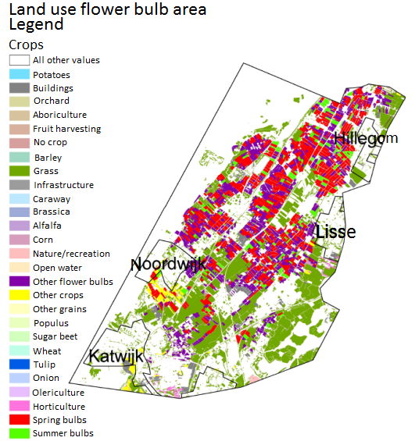
Figure 24: Land use in the flower bulb area (PIRIREIS in (G. v. Oude Essink 2008)).

Appendix 2: Soil types Rijnland

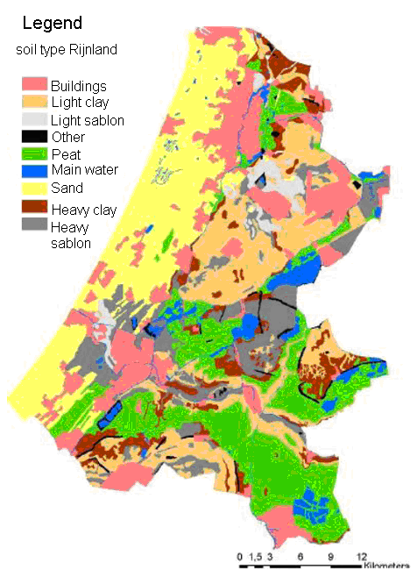
Figure 25: Soil types Rijnland (Baggelaar 2011).

Appendix 3: Seepage and infiltration Rijnland

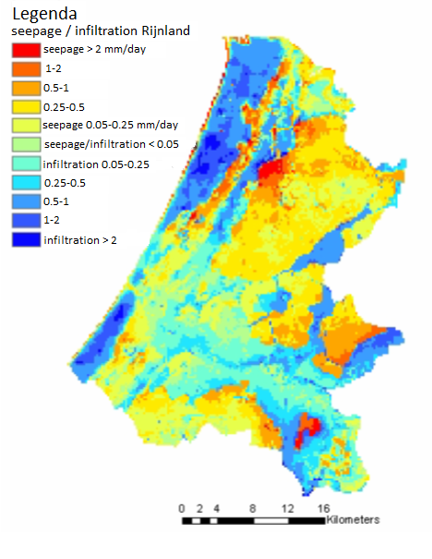
Figure 26: Seepage and infiltration Rijnland (Hoogheemraadschap van Rijnland, 2009 in (Baggelaar 2011)).

Appendix 4: The quantity area of Rijnland with the main waterways, beach, dunes and the former water boards of Groot Haarlemmermeer, the Oude Rijnstromen and Wilck and Wiericke

Figure 27: The quantity area of Rijnland with the main waterways, beach, dunes and the former Water Boards of Groot Haarlemmermeer, the Oude Rijnstromen and Wilck and Wiericke (e. Rijnland 2005).

Appendix 5: Derivation of the continuity equation (conservation of mass) 1D

Figure 28 shows mass flow in a channel. The continuity equation means that there is conservation of mass, so no mass can appear or disappear. This means that the water entering the channel must be the same as the water leaving the channel ± the change in mass storage (equation 5.1.1) (van Beek, 2011):

$Mass inflow=Mass outflow+Change in mass storage$ eq. 5.1.1

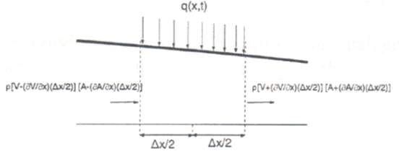
Figure 28: Flow in a channel (van Beek 2011).

When a control volume of length dx in a channel is considered, figure 28 shows that the mass inflow is calculated by adding the longitudinal mass flow to the lateral mass flow. This is expressed in equation 5.1.2 (van Beek 2011):

$Mass inflow=ρ\left(v-\frac{δv}{δx}\frac{Δx}{2}\right)\left(A-\frac{δA}{δx}\frac{Δx}{2}\right)+ρ\int_{x}^{x+Δx}{\overline{q}\left(x,t\right)dx}$ eq. 5.1.2

The mass outflow is shown in equation 5.1.3 and the storage change in equation 5.1.4 (van Beek 2011):

$Mass outflow=ρ\left(v+\frac{δv}{δx}\frac{Δx}{2}\right)\left(A+\frac{δA}{δx}\frac{Δx}{2}\right)$ eq. 5.1.3

$Change in mass storage=ρ\frac{δA}{δt}x$ eq. 5.1.4

Equation 5.1.2, 5.1.3 and 5.1.4 are inserted into equation 5.1.1 to get the continuity equation (equation 6.5):

$ρ\left(v-\frac{δv}{δx}\frac{Δx}{2}\right)\left(A-\frac{δA}{δx}\frac{Δx}{2}\right)+ρ\int_{x}^{x+Δx}{q\left(x,t\right)dx}=ρ\left(v+\frac{δv}{δx}\frac{Δx}{2}\right)\left(A+\frac{δA}{δx}\frac{Δx}{2}\right)+ρ\frac{δA}{δt}x$ eq. 5.1.5

This can be simplified and rearranged to get equation 5.1.6:

$-ρ\left(A\frac{δv}{δx}Δx+v\frac{δA}{δx}Δx\right)+ρ\overline{q}Δx-ρ\frac{δA}{δt}Δx=0$ eq. 5.1.6

The density of water is assumed to be constant. Equation 5.1.6 can then be divided by ρdx to get equation 5.1.7 (van Beek 2011).

$A\frac{δv}{δx}+v\frac{δA}{δx}+\frac{δA}{δt}=\overline{q}$ eq. 5.1.7

Because Q = vA, equation 5.1.7 can be rewritten to get equation 5.1.8, which is known as the 1D continuity equation.

$\frac{δQ}{δx}+\frac{δA}{δt}=\overline{q}$ eq. 5.1.8

The first term describes the amount of water leaving the control volume, the second term describes the change in storage of the control volume, and the last term describes the lateral flow which is entering the control volume.

Appendix 6: Derivation of the momentum equation 1D

The momentum equation is derived from Newton’s second law: the sum of forces is equal to the sum in momentum (equation 6.1) (van Beek 2011):

$\vec{F}=\frac{d\vec{p}}{dt}=\frac{d(mv)}{dt}=\frac{mdv}{dt}+\frac{vdm}{dt}$ eq. 6.1

The forces considered in a channel are shown in figure 29 and explained in table 13.

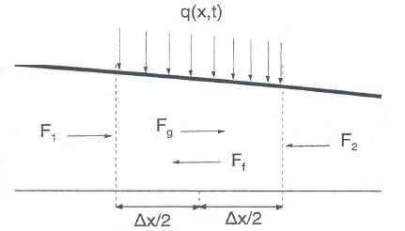
Figure 29: The forces considered in a channel in the momentum equation (van Beek 2011).

Table 13: The forces considered in the momentum equation 1D.
Force | Explanation
F_{g} | Gravity force due to weight of water in the control volume.
F_{f} | Friction force due to shear stress along the bottom and sides of the control volume.
F₁ and F₂ | Pressure forces due to hydrostatic forces on the left and right hand side of the control volume.

The equations for the different forces are shown in equation 6.2, 6.3, 6.4, 6.5 and 6.6. The sum of forces is shown in equation 6.7 (van Beek 2011).

$F_{g}=ρgAΔxsinα=ρgAS_{b}Δx$ eq. 6.2

$F_{f}=ρgAS_{f}Δx$ eq. 6.3

$F_{1}=ρg\left(\overline{y}A-\frac{δ\left(\overline{y}A\right)}{δx}\frac{Δx}{2}\right)$ eq. 6.4

$F_{2}=ρg\left(\overline{y}A+\frac{δ\left(\overline{y}A\right)}{δx}\frac{Δx}{2}\right)$ eq. 6.5

$F_{1}-F_{2}=-ρg\frac{δ\left(\overline{y}A\right)}{δx}Δx$ eq. 6.6

$Sum of forces=-ρg\frac{δ\left(\overline{y}A\right)}{δx}Δx+ρgAS_{b}Δx-ρgAS_{f}Δx$ eq. 6.7

The change in momentum is shown in equation 6.8 (van Beek 2011).

$Change in momentum=\frac{d\left(mv\right)}{dt}=\frac{mdv}{dt}+\frac{vdm}{dt}$ eq. 6.8

Because of equation 6.9 and 6.10, and because $\overline{q}$ is the area over time, the change of momentum becomes equation 6.11:

$mass m=ρ*Volume=ρ*A*Δx$ eq. 6.9

$\frac{dv}{dt}=\frac{δv}{δt}+v\frac{δv}{δx}$ eq. 6.10

$Change in momentum=\frac{d\left(mv\right)}{dt}=\frac{mdv}{dt}+\frac{vdm}{dt}=ρAΔx\frac{dv}{dt}+v\frac{dρAΔx}{dt}=ρAΔx\left(\frac{δv}{δt}+v\frac{δv}{δx}\right)+ρv\overline{q}Δx$ eq. 6.11

Equation 6.7 and 6.11 are inserted in equation 6.1: the sum of forces is equal to the change in momentum. The equation becomes (equation 6.12):

$-ρg\frac{δ\left(\overline{y}A\right)}{δx}Δx+ρgAS_{b}Δx-ρgAS_{f}Δx=ρAΔx\left(\frac{δv}{δt}+v\frac{δv}{δx}\right)+ρv\overline{q}Δx$ eq. 6.12

This is divided by ρΔx, to become equation 6.13. Then the equation is rewritten with Q = vA, resulting in equation 6.14. Furthermore, the lateral flow is neglected and y is changed into h, because these two are virtually the same. After rearranging, this gives equation 6.15, which is known as the 1D momentum equation (van Beek 2011).

$-g\frac{δ\left(\overline{y}A\right)}{δx}+gAS_{b}-gAS_{f}=A\left(\frac{δv}{δt}+\frac{δv}{δx}\right)+v\overline{q}$ eq. 6.13

$-g\frac{δ\left(\overline{y}A\right)}{δx}+gAS_{b}-gAS_{f}=\frac{δQ}{δt}+\frac{δ}{δx}\left(\frac{Q^{2}}{A}\right)+v\overline{q}$ eq. 6.14

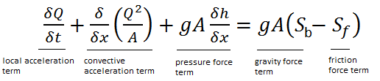 eq. 6.15

In the momentum equation, the first term is the local acceleration term. This term describes the change in momentum due to change in velocity over time. The second term is the convective acceleration term, which describes the change in momentum due to change in velocity along the channel. The third term is the pressure force term which describes a force proportional to the change in water depth along the channel. The last term is build up from two parts: the first part is a gravity force term and the second part a friction force term that describes the friction of the bed. The gravity force term describes a force proportional to the bed slope, while the friction force term describes a force proportional to the friction slope (Mujumdar 2001).

The S-S_{f} in SOBEK 1DFLOW is adapted to become equation 6.16 (b. Deltares 2012):

$b\frac{τ}{ρ}-\frac{gQ\left|Q\right|}{c^{2}RA}$ eq. 6.16

This is derived as follows: in uniform flow, the gravity force and shear force balance (Goodwill 2002). From figure 30 it can be seen that the gravity force and the shear force are represented by equation 7.17 and 7.18 (Goodwill 2002).

Figure 30: Forces on a channel length in uniform flow (Goodwill 2002).

$Gravity force=ρgALsin\left(α\right)$ eq. 6.17

$Shear force=τOL$ eq. 6.18

In balance this becomes (equation 6.19) (Goodwill 2002):

$ρgALsin\left(α\right)=τOL→τ=\frac{ρgALsin\left(α\right)}{OL}$ eq. 6.19

And because A/O = R (as in eq. 5.8), R = bh/b = h, and when a channel of small slope is considered sin alpha ≈ tan alpha = S_{b}, equation 6.19 can be simplified to equation 6.20 (Goodwill 2002):

$τ=\frac{ρgALsin\left(α\right)}{OL}$

$τ=\frac{ρgAsin\left(α\right)}{O}$

$τ=ρgRsin\left(α\right)$
$$τ=ρghsin\left(α\right)$$
$$τ=ρghS_{b}$$
$$S_{b}=\frac{τ}{ρgh}$$ eq. 6.20

Because A = bh, the equation gAS_{b} as in equation 6.15, can be rewritten to become equation 6.21:

$gAS_{b}=gbhS_{b}=gbh\frac{τ}{ρgh}=b\frac{τ}{ρ}$ eq. 6.21

The equation gAS_{f} as in equation 6.15 is rewritten as follows to become equation 6.24:

$S_{f}=\frac{dh_{f}}{dx}$ (Engineering 2010). eq. 6.22

$h_{f}=\frac{1}{c^{2}}\left(\frac{Lv^{2}}{R}\right)$(Engineering 2010). eq. 6.23

$Q=vA$

$gAS_{f}=gA\frac{dh_{f}}{dx}=gA\frac{d}{dx}\frac{1}{c^{2}}\frac{Lv^{2}}{R}=\frac{gv^{2}A}{c^{2}R}\frac{d}{dx}L$

$\frac{d}{dx}L=1$

$gAS_{f}=\frac{gv^{2}A}{c^{2}R}=\frac{gv^{2}A}{c^{2}R}\frac{A}{A}=\frac{gQQ}{c^{2}RA}=\frac{gQ\left|Q\right|}{c^{2}RA}$ eq. 6.24

The absolute value of the discharge is used to guarantee that the roughness always works opposite the flow direction (b. Deltares 2012).

The total momentum equation then becomes equation 6.25:

Momentum equation = $\frac{δQ}{δt}+\frac{δ}{δx}\left(\frac{Q^{2}}{A}\right)+gA\frac{δh}{δx}+\frac{gQ\left|Q\right|}{c^{2}RA}-b\frac{τ}{ρ}=0$ eq. 6.25

Appendix 7: Derivation of the De Zeeuw-Hellinga equation for the runoff

The De Zeeuw-Hellinga equation assumes a linear relationship between discharge and the difference between ground water level and open water level. This is shown in equation 7.1 (Prinsen 2009).

$q=β*μ*dh$ eq. 7.1

The water balance for time step dt states that the storage of water is the sum of infiltration and seepage minus the specific discharge (equation 7.2) (Prinsen 2009).

$μ*dh=\left(I+S-q\right)dt$ eq. 7.2

The combination of equation 7.1 and 7.2 result in the De Zeeuw-Hellinga equation (eq. 7.3) (b. Deltares 2012).

$q_{t}=q_{t-1}*e^{-βdt}+\left(I+S\right)\left(1-e^{-βdt}\right)$ eq. 7.3

Appendix 8: Derivation of the equation for percolation

To determine whether there is percolation or capillary rise, the equilibrium moisture storage needs to be determined. If the water content in the root zone exceeds this equilibrium, there is percolation to the groundwater, when it does not exceed equilibrium there is capillary rise. The potential root zone volume minus the equilibrium soil moisture content will give the amount of water that percolates to the groundwater (b. Deltares 2012).

The potential root zone volume is calculated by adding the net precipitation minus evaporation of a time step to the previous soil moisture storage in the root zone (equation 8.1) (b. Deltares 2012).

$V(t)=V(t-dt)+\left(P_{n}-E\right)dt$ eq. 8.1

The equilibrium soil moisture content is calculated with equation 8.2 (b. Deltares 2012).

$V_{eq}=f\left(soil physical unit, thickness root zone, depth groundwater level\right)$ eq. 8.2

The percolation is then calculated by subtracting the moisture storage in the root zone from the equilibrium soil moisture content, as shown in equation 8.3 (b. Deltares 2012).

$q=\frac{V_{eq}-V(t)}{dt}$ eq. 8.3

Appendix 9: Derivation of the advection-dispersion equation in DELWAQ

Figure 31 shows a schematic overview of the flow through a slice of a water body. The upstream slice has position x and its surface is A at position x. The downstream slice has position x+dx with surface A(x+dx). The water flow is in the positive x direction (RIZA 2005).

Advection is the flow of a substance due to its host fluid. This advection is modeled as the flow through a surface, multiplied by the concentration at the surface (equation 9.1 and 9.2) (RIZA 2005). There is outflow though the downstream slice which results in a minus sign in the second equation.

$F_{adv}\left(x\right)=Q\left(x\right)C(x)$ eq. 9.1

$F_{adv}\left(x+dx\right)=-Q\left(x+dx\right)C(x+dx)$ eq. 9.2

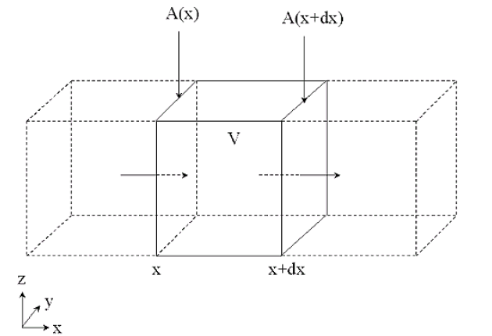
Figure 31: Schematic overview of the flow through a slice of a water body (RIZA 2005).

Dispersion is based on Fick’s law: it is inverse proportional to the concentration gradient perpendicular to the surface. In DELWAQ dispersion stands for all transport that is not described by advection. It is calculated as in equation 9.3 and 9.4 (Hydraulics 2003). Dispersion is in the opposite direction of the concentration gradient; therefore dispersion causes net transport from higher to lower concentrations resulting in a minus sign in the first equation.

$F_{disp}(x)=-D_{isp}\left(x\right)A\left(x\right)\left(\frac{δC}{δx}\right)$ eq. 9.3

$F_{disp}\left(x+dx\right)=D_{isp}\left(x+dx\right)A\left(x+dx\right){\left(\frac{δC}{δx}\right)}_{x+dx}$ eq. 9.4

The mass balance for a substance in a slice becomes equation 9.5. When it is assumed that the slice has a thickness that approaches zero, the mass balance for the substance becomes equation 9.6 (RIZA 2005).

$\frac{δm}{δt}=Q\left(x\right)C\left(x\right)-Q\left(x+dx\right)C\left(x+dx\right)-D_{isp}\left(x\right)A\left(x\right)\left(\frac{δC}{δx}\right)+D_{isp}\left(x+dx\right)A\left(x+dx\right){\left(\frac{δC}{δx}\right)}_{x+dx}+R_{netto}*Volume$ eq. 9.5

$\frac{δ\left(AC\right)}{δt}=-\frac{δ\left(QC\right)}{δx}+\frac{δ}{δx}\left(D_{isp}A\frac{δC}{δx}\right)+R_{netto}A$ eq. 9.6

The source term is a zero order term that is independent of the concentration. It is added to account for substance loads and substance dependent water quality processes (RIZA 2005).

Appendix 10: List of polder numbers and names in model

Nr. | Name | Nr. | Name | Nr. | Name
1 | Aderpolder | 76 | Drooggemaakte Veender- en Lijkerpolder | 111 | Haarlemmermeerpolder (12)
2 | Ambachtspolder | 77 | Duivenvoordse-Veenzijdsepolder (1.2) | 112 | Haarlemmermeerpolder (15)
3 | Beekpolder (1.1) | 78 | Duivenvoordse-Veenzijdsepolder (1.6) | 113 | Haarlemmermeerpolder (21)
4 | Beekpolder (2.1) | 79 | Duivenvoordse-Veenzijdsepolder (2.1) | 114 | Haarlemmermeerpolder (25)
5 | Bennebroekerpolder | 80 | Elsbroekerpolder (1.1) | 115 | Haarlemmermeerpolder (26)
6 | Bennebroekerpolder (noord) | 81 | Elsbroekerpolder (2.1) | 116 | Haarlemmermeerpolder (28)
7 | Berg- en Daalpolder | 82 | Elsgeesterpolder (1.1) | 117 | Haarlemmermeerpolder (31A)
8 | Binnenpolder (OR-2.13.1.1) | 83 | Elsgeesterpolder (2.1) | 118 | Haarlemmermeerpolder (32)
9 | Binnenpolder (OR-2.13.2.1) | 84 | Floris Schouten Vrouwenpolder (1.1) | 119 | Haarlemmermeerpolder (33)
10 | Binnenpolder (WW-27A) | 85 | Floris Schouten Vrouwenpolder (2.1) | 120 | Haarlemmermeerpolder (34)
11 | Blauwepolder (1.1) | 86 | Frederikspolder | 121 | Haarlemmermeerpolder (48)
12 | Blauwepolder (2.1) | 87 | Gebied Groot Haesebroek/ De Kieviet | 122 | Haarlemmermeerpolder (49)
53 | Bosch- en Gasthuispolder (1.1) | 88 | Gebied Wittenburgerweg | 123 | Haarlemmermeerpolder (50)
54 | Bosch- en Gasthuispolder (2.1) | 89 | Gecombineerde Starrevaart- en Damhouderpolder | 124 | Haarlemmermeerpolder (51)
55 | Bospolder (1.1) | 90 | Geer- en Buurtpolder – Polder Oostgeer | 125 | Haarlemmermeerpolder (HW11)
56 | Bospolder (2.1) | 91 | Gnephoek | 126 | Hellegatspolder
57 | Boterhuispolder | 92 | Gogerpolder (1.1) | 127 | Hemmeerpolder
58 | Broek- en Simontjespolder | 93 | Gogerpolder (3.1) | 128 | Het Amsterdamse Bos
59 | Buitendijksche Buitenveldersche polder | 94 | Gouwepolder | 129 | Het Vinkenveld (4A)
60 | Buurterpolder | 95 | Grietpolder | 130 | Het Vinkenveld (4F)
61 | Coupépolder | 96 | Groote en Kleine Heilige Geestpolder | 131 | Het Vinkenveld (4H)
62 | De Lange Bretten | 97 | Grote Polder | 132 | Hogenwaardse Polder
63 | De Zilk 10.1 | 98 | Grote Polder – Industrieterrein | 133 | Hogeveensepolder (1.1)
64 | De Zilk 10.2 | 99 | Grote Westeindse Polder | 134 | Hogeveensepolder (2.2)
65 | De Zilk 4 | 100 | Haarlemmermeerpolder (00) | 135 | Hondsdijksepolder
66 | De Zilk 5b/5c | 101 | Haarlemmermeerpolder (01) | 136 | Hoogewegpolder
67 | De Zilk 6.2 | 102 | Haarlemmermeerpolder (02) | 137 | Hoogmadesepolder (1.1)
68 | De Zilk 6.3 | 103 | Haarlemmermeerpolder (03) | 138 | Hoogmadesepolder (2.1)
69 | De Zilk 8 | 104 | Haarlemmermeerpolder (04) | 139 | Horn- en Stommeerpolder
70 | Doespolder | 105 | Haarlemmermeerpolder (05) | 140 | Inlaagpolder
71 | De Akkersloot-, Hertogs- en Blijverpolder | 106 | Haarlemmermeerpolder (07) | 141 | Inmaling Duinrel
72 | Dr. Polder Aan de Westzijde te Aarlanderveen | 107 | Haarlemmermeerpolder (08) | 142 | Kaagerpolder
73 | Drooggemaakte Geer- en Kleine Blankaardpolder | 108 | Haarlemmermeerpolder (09) | 143 | Kadebuurt
74 | Drooggemaakte Grote Polder | 109 | Haarlemmermeerpolder (10) | 144 | Kalkpolder
75 | Drooggemaakte Hoef- en Schoutenpolder | 110 | Haarlemmermeerpolder (11) | 145 | Kikkerpolder
Nr. | Name | Nr. | Name | Nr. | Name
146 | Klaas Hennepoelpolder | 181 | Noordzijderpolder-Zuid | 219 | Polder Middelburg en Tempelpolder
147 | Kleine Cronesteinse- of Knotterpolder | 182 | Ommedijksepolder | 220 | Polder Morsebel
148 | Klinkenberger- en Voorhofpolder (1.1) | 183 | Ontpolderd 5 | 221 | Polder Nieuwkoop
149 | Klinkenberger- en Voorhofpolder (2.1) | 184 | Ontpolderd 6 | 222 | Polder Nieuwkoop en Noorden
150 | Knippolder (1.1) | 185 | Oostboschpolder (1.1) | 223 | Polder Oudendijk
151 | Knippolder (2.1) | 186 | Oostboschpolder (2.1) | 224 | Polder Oudenhof (Noord)
152 | Kokshoornpolder | 187 | Oostbroekpolder – zuidelijk deel | 225 | Polder Oudshoorn (Noord)
153 | Lagenwaardsepolder | 188 | Oosteinderpoelpolder | 226 | Polder Oudshoorn-Zuid
154 | Lageveensepolder | 189 | Oosteinderpolder | 227 | Polder Oukoop en Negenviertel
155 | Lakerpolder | 190 | Oostvliet-, Hof- en Spekpolder | 228 | Polder Reeuwijk en Sluipwijk
156 | Leendert de Boerspolder | 191 | Oranjepolder | 229 | Polder Reeuwijk en Sluipwijk (Abessinië)
157 | Lentevreugd | 192 | Osdorper Binnenpolder | 230 | Polder Spruit
158 | Lisserpoelpolder (1.1) | 193 | Osdorper Bovenpolder | 231 | Polder Steekt
159 | Lisserpoelpolder (2.1) | 194 | Oude Spaarndammerpolder | 232 | Polder Stein
160 | Luizenmarktpolder (1.1) | 195 | Overbraker Binnenpolder | 233 | Polder Vierambacht
161 | Luizenmarktpolder (2.1) | 196 | Overveerpolder | 234 | Polder Willens
162 | Lutkemeerpolder | 197 | Papenwegsepolder | 235 | Polder Willens (Goudse Hout)
163 | Mariënduin | 198 | Plas Broekvelden/ Vettenbroek | 236 | Polder Willens (Goverwelle Oost)
164 | Meer- en Duinpolder (2.1) | 199 | Poelpolder | 237 | Polder Zuidwijk
165 | Meer- en Duinpolder (3.1) | 200 | Polder Achthoven (1.1) | 238 | Rhijnenburgerpolder
166 | Meerwijkplas | 201 | Polder Achthoven (2.1) | 239 | Ridderveld en de Bijlen
167 | Meeslouwerpolder | 202 | Polder Alpherhoorn (Kerk & Zanen+Molenwetering) | 240 | Riekerpolder
168 | Merenwijk | 203 | Polder Bloemendaal (32A) | 241 | Rietvinkpolder (1.1)
169 | Middelveldse Akerpolder | 204 | Polder Bloemendaal (32B) | 242 | Rietvinkpolder (2.1)
170 | Mottigerpolder | 205 | Polder Boekhorst | 243 | Rijnsaterwoudschepolder
171 | Munniken-, Zijllaan- en Meijepolder | 206 | Polder de Bonte Kriel | 244 | RL-Zilk-7A
172 | Nieuwe Driemanspolder 17A | 209 | Polder Groenendijk | 245 | RL-Zilk-7B
173 | Nieuwe Driemanspolder 17B | 210 | Polder Het Langeveld | 246 | RL-Zilk-9A
174 | Nieuwe Driemanspolder 17C | 211 | Polder Het Noordveen | 247 | RL-Zilk-9B
175 | Noord-Hoflandschepolder (1.1) | 212 | Polder Het Zaanse Rietveld (22A) | 248 | Rodenburger- en Cronesteinschepolder (west)
176 | Noord-Hoflandschepolder (3.1) | 214 | Polder Kamphuizen | 249 | Rodepolder
177 | Noord-Hoflandschepolder (4.1) | 215 | Polder Klein Starrevaart | 250 | Romolenpolder (04A)
178 | Noordeind- en Geerpolder (1.1) | 216 | Polder Kort Haarlem | 251 | Romolenpolder (04B)
179 | Noordeind- en Geerpolder (2.1) | 217 | Polder Korte Akkeren | 252 | Roodemolenpolder
180 | Noordzijderpolder-Noord | 218 | Polder Laag Boskoop | 253 | Room- of Meerburgerpolder (OOST)

Nr. | Name | Nr. | Name | Nr. | Name
254 | Room- of Meerburgerpolder (WEST) | 289 | Warmonderarm- en Alkemaderpolder (1.1) | 412 | -
255 | Rottepolder | 290 | Warmonderarm- en Alkemaderpolder (2.1) | 413 | -
256 | Ruijgelaansepolder (1.1) | 291 | Warmonderarm- en Alkemaderpolder (3.1) | 414 | -
257 | Ruijgelaansepolder (2.1) | 292 | Warmonderarm- en Alkemaderpolder (4.1) | 415 | -
258 | Schapenduinen (07N) | 293 | Wassenaarschepolder | 416 | -
259 | Schapenduinen (07Z) | 294 | Waterloospolder | 417 | -
260 | Schinkelpolder | 295 | Westbroekpolder | 418 | -
261 | Slaaghpolder (Oost) | 296 | Zanderij | 419 | -
262 | Slaaghpolder (West) | 297 | Zegersloot | 420 | -
263 | Sloterbinnen en Middelveldsepolder | 298 | Zemelpolder (1.1) | 421 | -
264 | Stadsboezem Gouda | 299 | Zemelpolder (2.1) | 422 | -
265 | Starrenburgerpolder | 300 | Zijdepolder | 423 | -
266 | Stevenshofjespolder | 301 | Zilkerpolder | 424 | -
267 | Tuinder- of Kogjespolder | 302 | Zoetermeerse Meerpolder | 425 | -
268 | Veender en Lijkerpolder Buiten de Bedijking | 304 | Zonneveldspolder | 426 | -
269 | Veenderpolder | 305 | Zuid- en Noordeinderpolder (1.1) | 427 | -
270 | Veenpolder | 306 | Zuid- en Noordeinderpolder (3.1) | 428 | -
271 | Veerpolder | 307 | Zuid-Hoflandschepolder (1.1) |  | Boezemgebied_9
272 | Venniperpolder | 308 | Zuid-Hoflandschepolder (1.3) |  | Boezemgebied_10
273 | Verenigde Binnenpolder | 309 | Zuiderpolder |  | Boezemgebied_11
274 | Verenigde Bloklandse- en Korteraarsepolder | 310 | Zuidzijderpolder |  | Boezemgebied_12
275 | Verenigde Groote en Kleine Polders | 311 | Zwanburgerpolder |  | Boezemgebied_13
276 | Vlietpolder | 312 | Zweilanderpolder |  | Boezemgebied_14
277 | Vogelenzang | 313 | Zwet- en Grote Blankaartpolder |  | Boezemgebied_15
278 | Voormalig Marinevliegkamp Valkenburg | 314 | Zwetpolder |  | Boezemgebied_16
279 | Voorofschepolder | 315 | Zwetterpolder |  | Boezemgebied_17
280 | Voorofse Polder (25F) | 400 | - |  | Boezemgebied_18
281 | Voorofse Polder (25G) | 401 | - |  | Boezemgebied_19
282 | Vosse- en Weerlanerpolder | 402 | - |  | Boezemgebied_20
283 | Vriesekoopschepolder | 403 | - |  | Boezemgebied_21
284 | Vrouw Vennepolder (1.1) | 404 | - |  | Boezemgebied_22
285 | Vrouw Vennepolder (2.1) | 408 | - |  | Boezemgebied_23
286 | Vrouwgeestpolder | 409 | - |  | Boezemgebied_32
287 | Waarder- en Schoteroog | 410 | -
288 | Waarder- en Veerpolder | 411 | -

Appendix 11: Precipitation and evaporation for polder 200 and polder 88

Figure 32: Precipitation and evaporation polder 200.

Figure 33: Precipitation and evaporation polder 88.

Appendix 12: Flow from agricultural area to polder ditches for polder 200 and 88
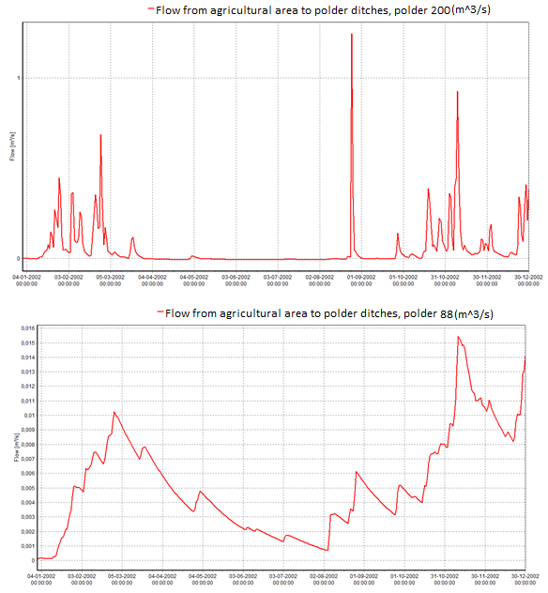
Figure 34: Flow from agricultural area to polder ditches (m^3/s) for polder 200 (above) and polder 88 (below).

Appendix 13: Water pumped from the main waterway into the polder channel

Figure 35: Water pumped from main waterway into the polder channel (Polder 200).

Figure 36: Water pumped from main waterway into the polder channel (Polder 88).

Appendix 14: Test run desorption polder 200

Figure 37: Results test run with desorption for the polder channels of polder 200.

Figure 38: Results test run with desorption for the main waterway polder 200.

