Research Project
Veterinary Medicine University Utrecht
Department of farm animal health

A.S.E. Tieben

Supervisors:
S.W.F. Eisenberg
W. Gruenberg

June – October 2011

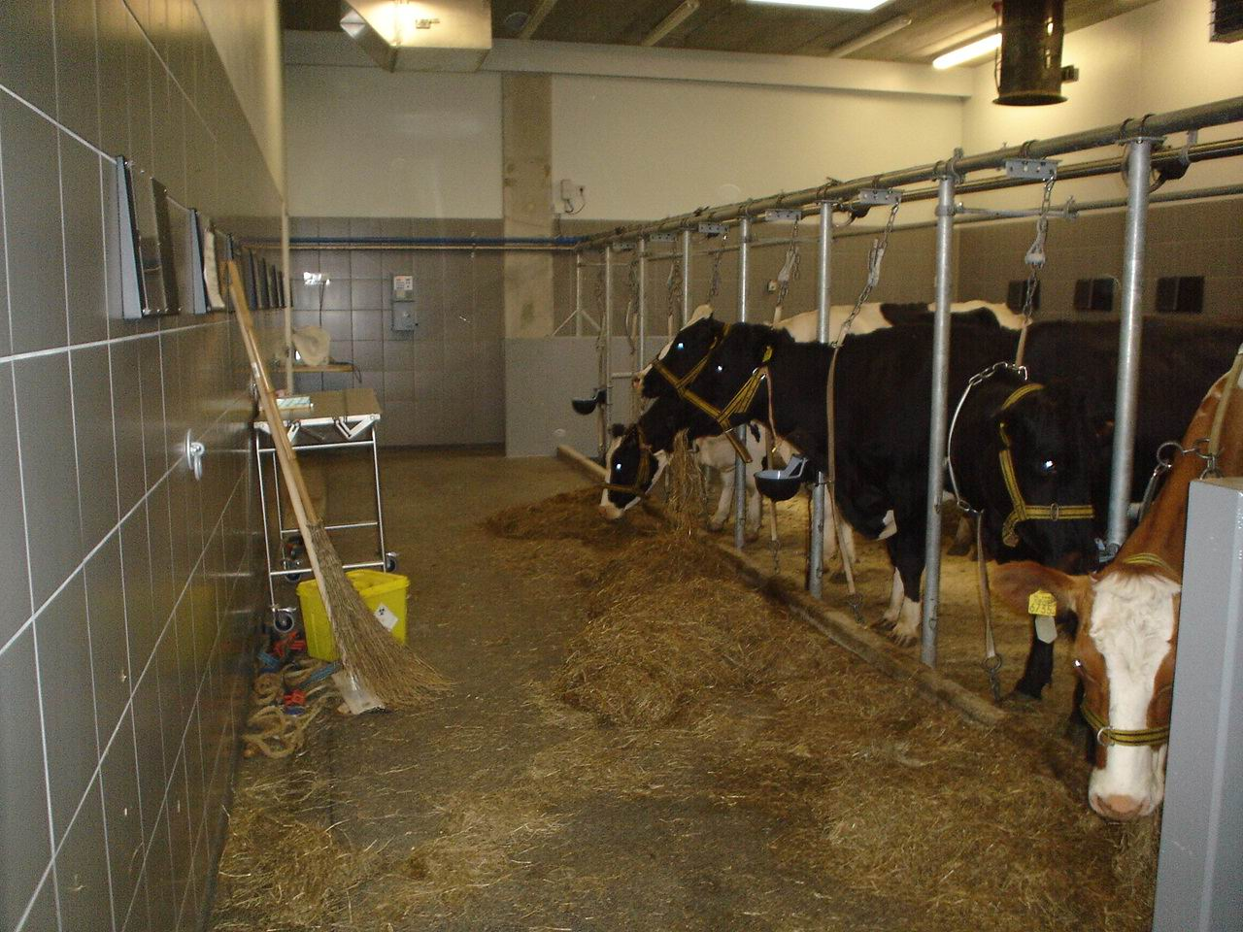
Abstract
The effects of 48 hours fasting on cardio- respiratory patterns and rectal temperature in dairy cattle
Objective
This research was executed to examine what is happening with heart rhythm, heart rate, rectal
temperature and respiration rate in dairy cattle who are fasting for 48 hours. This is one of two papers wrote about this research. The other paper gives some more information about the acid- bace balance and the electrolytes.

Method
Five healthy Holstein Frisian dairy cows (mean age 2, 9 years and mean days in lactation 274, 2) were followed for one week. Monday was adaptation day, on Tuesday the normal values were measured and on Wednesday and Thursday the cows were fasting. At Friday, the cows were eating again. Five times every day clinical examination was done: heart rate, respiration rate and rectal temperature were measured. One time a day urine was taken and also one time a day an ECG was made. The ECG was made to detect cardiac dysrhythmia’s. In urine was measured: pH, net acid excretion, S.G., creatinine and potassium. Three times a day blood was taken. In blood was measured: blood- gas values, electrolytes, hematocrit, total protein, BHBZ, creatinine and NEFA’s.

Results
Heart rate and respiration rate were significantly decreased during fasting. This returns very quickly to normal when the cows were eating again. Rectal temperature decreases also somewhat but this was not significant.
At the ECG a prolonged ST segment, a prolonged TQ interval and a prolonged TP interval were seen.

Conclusion
The decreased heart rate was due to the increased influence of the parasymphatetic nervous system. And the increase of the parasymphatetic nervous system can have many reasons which are not become clear in this study.
The abnormalities on the ECG’s were possibly due to a hypokalemia and/or a dysfunction of the potassium channels.
The decrease in respiration rate was possibly due to a decrease in stomach filling.

Contents
- Introduction
  - Fasting cattle …………………………………………………. 4
  - Bradycardia and sinus arrhythmia …………………………… 5
  - Electrocardiogram (ECG) ……………………………………. 9
  - Body temperature ……………………………………………. 10
  - Respiration …………………………………………………… 11
- Aim of the study ………………………………………………… 13
- Materials and methods
  - Animals ……………………………………………………… 14
  - Study design …………………………………………………. 14
  - Blood analysis ……………………………………………….. 15
  - Urine analysis ………………………………………………... 15
  - Clinical parameters …………………………………………... 16
  - ECG’s ………………………………………………………... 16
  - Statistical analysis …………………………………………… 17
- Results
  - Fasting ……………………………………………………….. 18
  - Heart rate …………………………………………………….. 18
  - ECG’s ………………………………………………………... 20
  - Body temperature ……………………………………………. 22
  - Respiration rate ………………………………………………. 22
  - Other facts ……………………………………………………. 25
- Discussion
  - Heart rate …………………………………………………….. 26
  - ECG’s ………………………………………………………... 27
  - Body temperature ……………………………………………. 28
  - Respiration rate ………………………………………………. 29
- Conclusion ………………………………………………………. 30
- Acknowledgements ………………………………………………30
- References ………………………………………………………. 31

Attachments
Appendix 1: ECG’s
1. Introduction

During the study of Veterinary Medicine at the University of Utrecht all students
have to fulfill a research project. This paper is the report of my research on the effects of 48 hours fasting at cardio- respiratory patterns and rectal temperature in dairy cattle.
This research was executed because there is less information what is happen with a clinically healthy cow who is fasting. Information about fasting cows is often very old, have done with (beef) steers and other breeds than those that are common in the Dutch livestock farming. In addition, many studies have been done with cows that had other disease such as milk fever and mostly these cows were already treated for the disease. Therefore, we do not know exactly what is happing with a clinically healthy cow who is fasting and it is important to know this so we can treat sick animals, which are suffering from diseases as milk fever possibly in a better way. This paper is one of two papers that are written about this research. This paper focus on what is happening with heart rhythm, heart rate, rectal temperature and respiration rate at 48 hours of fasting. The other paper focus on what is happening with the acid-base balance.

1.1 Fasting cattle
A hypochloremic, hypokalemic metabolic alkalosis is showed in several diseases in dairy cattle. For example by cattle with coliform mastitis, cows with a right displacement of the abomasum and cows with a pyloric stenosis (Kuiper, 1980; Ohtsuka et al, 1997; Sahinduran et al, 2006). Generally, these cows have lost their appetite and/ or have a depression in digestive tract motility, and sometimes an obstruction. This has many agreements with fasting so that is why animals who are fasting are frequently getting a hypocholemic, hypokalemic metabolic alkalosis. More details about the metabolic alkalosis you can find in the other paper wrote about this study (The effects of 48 hours fasting on acid-base balance and electrolytes in dairy cow, Annelous Kist).

Rumsey et al, have done a study like this with clinically healthy cows that are fasting. They found a reduced rectal temperature, heart rate and respiratory rate. Also they found increased P and R ECG amplitudes. Serum sodium and potassium were increased but this was not significant. The results were more significant with 96 hours of fasting. The cattle returned very quickly to a physiologically normal state (Rumsey et al, 1976).
Also mature Hereford steers fasted for 32 hours were getting some abnormalities. The serum calcium decreased and the phosphor increased, but these changes were within the normal ranges. Serum sodium was not changed but the chloride was increased. Potassium and iron were both decreased (Galyean et al, 1981).
Another study with fasting steers found also an increased serum phosphorus, total protein and billirubin. The magnesium and potassium decreased. These changes were mainly seen in the first 24 hours of fasting of the total 92 hours of fasting (Smith et al, 1984).
Cole, have done a crossover study with Mature Hampshire cows (n = 8). Animals that were fed had lower PCV and higher glucose levels than animals that were deprived. Plasma magnesium and sodium were not affected but plasma potassium decreased. In whole blood sodium, magnesium and potassium did not differ in the fed and deprived animals (Cole, 2000).

Many times a hypokalemia is reported in studies with fasting cattle. Hypokalemia can occur due to reduced feed intake, intracellular shifting of potassium due to a metabolic alkalosis and hyperglycemia, an increased potassium loss due the mineralcorticoid effects of the administered corticosteroids and a kaluresis due to the hyperglycemic osmotic diuresis. It is worth remembering that plasma shows only 0, 4% of total potassium and there is about 10% of the total potassium extracellular.
Potassium is so important because it is the most important intracellular cation because it determines the resting membrane potential due to its concentration gradient between intra- and extracellular (Peek et al, 2003).
The typical diets of cattle are high in potassium and thus the potassium excretion with the urine is high. This adaptation contributes to the development of hypokalemia when feed intake is reduced because the excretion with urine cannot be reduced rapidly enough to maintain a normal potassium level (Sattler et al, 1998).
Many different symptoms are described due to hypokalemia. In a report of 14 cows with a hypokalemia they found an abnormal position of head and neck, weakness, rumen atony, abnormal feces, tachycardia, anorexia, cardiac dysrhythmia, acid- base imbalance (alkalosis) and a hyperglycemia. The hyperglycemia and tachycardia were due to transport stress and some cows were very ill (Sattler et al, 1998).
Another study done with 17 hypokalemic cows showed also muscle weakness and recumbence. 10 cows had a hypochloremic metabolic alkalosis and 7 cows had a metabolic acidosis (Peek et al, 2003).

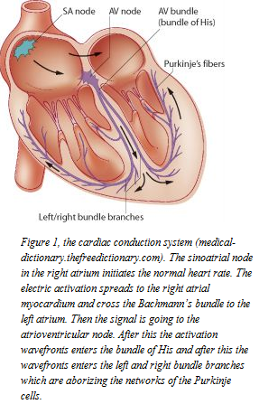1.2 Bradycardia and sinus arrhythmia

The sinoatrial node in the right atrium initiates the normal heart rate with a spontaneously generalized action potential and is often called the pacemaker of the heart. The electric activation spreads to the right atrial myocardium and cross the Bachmann’s bundle to the left atrium. Then the signal is going to the atrioventricular node, this is the only connection for the signal for going from atria to ventricles. After the atrioventricular node the activation wavefronts enters a specialized conduction system called the bundle of His and after this the wavefronts enters the left and right bundle branches which are aborizing the network of the Purkinje cells. The bundle of His and the Purkinje cells distributes the action potential widely trough the ventricular myocardium (Reece, 2004). In figure one the cardiac conduction system is reviewed.

A normal sinus rhythm is regular and originates from the sinoatrial node. Sinus bradycardia is a regular sinus rhythm but it is slower than expected. On the ECG you will see normal P waves and the PQ interval is constant.

Sinus arrhythmia is an irregular sinus rhythm. The distance between the P waves and between the PQ interval is not constant on the ECG (Merck veterinary manual, 2011).

There are two groups of underlying mechanisms for cardiac arrhythmias: abnormalities of impulse formation and abnormalities of impulse propagation. Abnormalities of impulse formation are changes in normal pacemaker activity of the sinoatrial node or other secondary pacemakers who will compete with the sinoatrial node. Abnormalities of impulse propagation include blocks of the impulse at several places of the heart, mostly this occur in the atrioventricular node (Reece, 2004).

The autonomic nervous system plays an immense role in the behavior of the cardiovascular system, also in regulating the heart rate.

When the parasympathetic nervous system is activated (at rest), the nerve fibers release acetylcholine within the myocardium. Cardiac cells have muscarine receptors and they activate G-proteins if acetylcholine binds. Activation occurs when a bound GDP molecule is replaced for a GTP molecule. The altered protein can now bind to potassium channels in the membrane en open them, thus potassium permeability is increased. As a result, heart rate will decrease due to an efflux of potassium ions because the cellular membrane becomes more polarized. This hyperpolarization makes the generation of action potential more difficult, and thus slowing the rate of the sinoatrial node. Also indirect opening of potassium channels occurs after acetylcholine binding at the muscarine receptor. Furthermore, the G-proteins also increase the release of arachidonic acid that also increases potassium permeability.

Sympathetic fibers release norepinephrine and receptors within the cell bind this and stimulate β1 adrenergic receptors. Also G-proteins replace GDP for GTP molecules upon activation by the β1 adrenergic receptors. This cause an increase in the release of cAMP, this cAMP causes molecules of protein kinase A to phosphorylate large numbers of calcium channels. This makes that calcium channels are longer open and also a greater number of calcium channels are going open. Thus, calcium is going into the cells, so the threshold for depolarization will be more easily attained.

The atrioventricular node is the place where the parasympathetic and the sympathetic systems will act the most when they will increase or decrease the heart rate (Iaizzo et al, 2009).

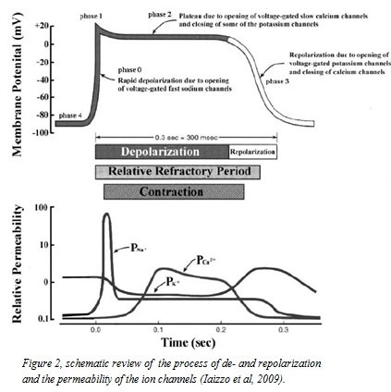

A normal myocardial cell has a resting membrane potential of -90 mV. In this myocyte the membrane potential is dominated by the potassium ions. The action potential is initiated when the resting potential is becoming more positive to -60 to -70 mV. At this point, called the threshold potential the sodium channels open and begin a cascade also involving other ion channels. The myocyte is brought to his threshold potential via a neighboring cell. At the threshold potential the fast voltage- gated sodium channels open, the permeability of the cell for sodium ions increase and sodium flows into the cell (phase 0). This happens very easily because in the cell it is more negative than the extracellular fluid and the sodium concentration is higher in the extracellular fluid. Within a few milliseconds the fast sodium channels are inactivated automatically. The depolarization due to the sodium ions activates the opening of voltage- gated slow calcium channels so the permeability increases and the concentration of calcium increases into the cell. At the same time the membrane permeability decreases for potassium due to closing of the potassium channels. For 200-250 ms the membrane potential is staying close to 0 mV, as a small inflow of calcium balances the small outflow of potassium (phase two). After this the voltage- gated potassium channels are opening and the repolarization is initiated and potassium flows out of the cell. At the same time calcium channels are closing and thus the efflux of potassium ions restore the negative resting potential (phase three). In Figure two this process of the membrane potential and the permeability of the ion channels are schematic reviewed.

The principle of conduction is the same in the sinoatrial node and the atrioventricular node, but these nodes are slow responding. The resting membrane potential (phase 4) is more positive and the slope of the upstroke (phase 0), the amplitude of the action potential and the overshoot are smaller than in myocytes with a fast response (Iaizzo et al, 2009; Berne et al, 2004).

Bradycardia and sinus arrhythmia consistently develop in cows that are fasting for 48 hours. When cows are eating again the heart rate returns very quickly to normal and the sinus arrhythmia disappears (McGuirk et al, 1990).
Bradycardia occurs also in cattle with several diseases. There is also a bradycardia or a normal heart rate observed by cattle that are suffering from dehydration, sepsis, abdominal distention or other diseases in which tachycardia is expected. Also sinus arrhythmia has been seen under such conditions.
The bradycardia can be caused by anatomic changes in the sinus node, increased vagal tone and a decreased sympathetic tone. Changes in the sinus node are not likely to occur with fasting because heart rate returns to normal after feeding. In clinically normal cattle the heart rate at rest is influenced by parasympathetic tone. The increase in parasympathetic tone with fasting may be attributable to increased vagal tone. This can be due to increased activity in vagal afferent fibers because of: changes in ph, stretch or other chemical mediators in the gastro-enteritic channel. Also changes in concentrations of ketone bodies, billirubin, glucose, free fatty acids, electrolytes and acid- base balance can cause this increased activity in vagal afferent fibers. The changes in heart rhythm and heart rate are seen by different diseases and also by fasting, therefore it is possible that these symptoms are not a clinical sign of disease but a clinical sign with lack of food intake. In addition, bradycardia can occur because this is an energy saving system and the basal metabolism of the cow will decrease (McGuirk et al, 1990).
The fasting bradycardia may be a result from an increase in parasympathetic tone due to changes in forestomach stretch or fill. Changes in blood parameters or electrolyte parameters may also influence the autonomic activity. Heart rate was significantly decreased in cattle after 48 hours of fasting. Administration of atropine sulfate resulted in a significant increase in heart rate in fasted cattle but not in fed cattle. Atropine is a parasympatholytic agent and act by competitive blockage of muscarinic receptors. This observation supports the hypothesis that fasting bradycardia is associated with a marked increase in parasympathetic tone. Also an increase in HI-FR fluctuations was seen with fasting and the administratration of atropine which indicate that the parasympathetic influence increase. Also a significant increase in total protein was observed. Potassium was decreased.
In steers after rumen evacuation the heart rate was also significantly decreased compared with a full rumen. There are tension receptors located around the reticular groove; they will send a tonic afferent input to the medullary gastric center via the nervus vagus. A decrease in rumen fill would reduce tension in the receptors and might result in a slowing of heart rate. This reflex slowing appears to be primarily due to increased parasympathetic nervous activity, presumably mediated by the nervus vagus (Clabough et al, 1989).

Also in clinically healthy cows sometimes dysrhythmias appear. In 952 normal and clinically healthy cows in three different age groups, 202 cows showed one or two types of dysrhythmias. Sinus arrhythmia and sinus tachycardia did occur most. The incidence of dysrhythmias does not differ between different age groups, breeds and lactation versus non- lactation. Cows older than six years showed a significant lower heart rate. The cases with sinus arrhythmia showed significant lower heart rate. Thus, maybe the high vagal tone can cause the bradycardia and also the sinus arrhythmia. No one of the cows with a dysrhythmia showed any clinical sign of heart disease (Rezakhani et al, 2004A).

Also in human who does not eat bradycardia and sinus arrhythmia are reported. In human there is also hypotension and a prolonged QT interval described. The bradycardia is probably caused by vagal hypertonia, this is reflected by an increase in pulse variability. The prolonged QT interval can be caused by probably a decrease in ventricular mass by people who do not eat for a longer time. But can also be caused by changes in the ion concentrations. Especially hypokalemia, hypomagnesemia and hypocalemia are well known causes in human (Macías-Robles et al, 2009).
More studies describe a prolonged QT interval in human with an electrolyte imbalance. Again the electrolyte imbalances that disturb the QT interval are hypokalemia, hypomagnesemia and hypocalcemia. The prolonged QT interval was seen on the ECG but also T and U wave abnormalities were seen. The QT interval was not only prolonged but also variable. Alternant in T waves is a sign of enhanced electrical instability (Khan, 2002).
The QT interval is measured in the ECG from the beginning of the QRS complex to the end of the T wave. This interval reflects the cardiac de- and repolarization time in one heart cycle. The QT interval has a close relation to the duration of the action potential in the myocyte. The number and function of the ion pumps and channels in the cell membrane determine the duration and size of the action potential. There are at least seventeen different kinds. Blockage, dysfunction or inhibition of the channels leads to prolongation of the cardiac de- or repolarization. The function and also the number of the ion channels are influenced by some drugs but also by the actual electrolyte status, the tonus of the autonomic nerve system and the oxygen supply (Elming et al, 2003).

Another study done in humans with eating disorders found besides the bradycardia, sinus arrhythmia, the hypotension and prolonged QT interval also hypothermia, salivary gland swelling, anemia, dehydration and an hypochloremic, hypokalemic metabolic alkalosis (Tsuboi, 2005).

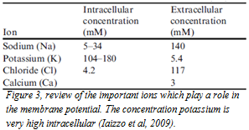Often hypokalemia is mentioned as the cause of the bradycardia and the arrhythmia’s, because potassium ions play an important role in maintaining the electrical potential across the cellular membrane and also in depolarization and repolarization of the myocytes. The intracellular concentration of potassium is great. In figure three the concentrations of the important ions are reviewed.
As the potassium levels decrease there is an elevation in the negative resting membrane potential and a prolongation of the action potential. Particularly the phase 3 repolarization and the refractory periods are prolonged. So the muscles do not react as fast as they normally will. Due to the increased duration of the action potential and the refractory period, the patients with a hypokalemia are at increased risk for dysrhythmias. In human with hypokalemia there is noted that besides the prolonged QT interval also an decrease in T wave amplitude, a ST segment depression, a PR interval prolongation and the development of U waves were seen (Maffé et al, 2009).
Animal studies have showed that arrhythmia’s induced by hypokalemia are causing: prolonged ventricular repolarization, slowed conduction and abnormal pacemaker activity.
- Prolonged ventricular repolarization. This effect is seen on the ECG as the prolonged QT interval and the patient shows increased ventricular action potential duration (ADP). The prolonged ADP is due to the inhibition of outward potassium currents that contribute in the ventricular repolarization. Hypokalemia suppress the conductance of Ikr (rapid component of delayed rectifier). And thus the Ikr channels are going faster in the inactivated state. Therefore, action potential takes longer. Also hypokalemia inhibits Ik1, which is the inward rectifier. This is contributing in setting the resting membrane potential and the late phase of ventricular repolarization. The action potential gets a long tail and this is resulting in an increase in the relative refractory period (RRP) and a decrease in the difference of the resting membrane potential from the threshold potential.
So there is more chance at early afterdepolarizations (EAD). EAD’s represent positive deflections interrupting the smooth course of repolarization. Prolongation of ventricular repolarization increase the time spent over voltage window for reactivation of inward sodium and calcium currents. The prolongation of ventricular repolarization is not accompanied by prolongation of the effective refractory period (ERP). These two changes make the patient more vulnerable to ventricular tachyarrhythmias. Also there are substantial heterogeneities in distribution of potassium channels. Therefore, at some places of the heart the hypokalemia produces a longer ADP and at other sites is does not. So this may produces a conduction block.
- Conduction abnormalities. The hypokalemia slows conduction in the atrioventricular node. Because of reduced cardiac excitability because of the membrane hyperpolarization. Thus, depolarization begins in incomplete repolarized fibers.
- 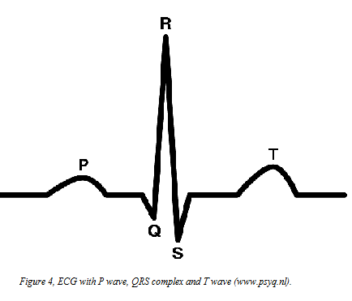Abnormal automaticity. The abnormal pacemaker activity has been attributed to the increase of the slope of diastolic depolarization in Purkinje fibers and also by delayed EAD’s caused by calcium overload secondary to inhibition of the Na-K pump and stimulation of the reverse mode of the Na-Ca exchange. Thus, hypokalemia prolongs the plateau in Purkinje fibers but decrease it in the ventricular fibers. The action potential tail prolongs more in the conducting system than in the ventricles thus increasing the dispersion of repolarization. It increases the diastolic depolarization in the Purkinje fibers and so increases the automaticity (El- Sherif et al, 2011; Osadchii, 2010).

1.3 Electrocardiogram (ECG)
Changes in cardiac electrical activity can be detected with an ECG. No deflection from the discharge of the sinoatrial node is seen on the ECG because the voltage generate by the relatively small number of cells is too small to detect trough the body surface. Discharge of the sinoatrial node is assumed to occur just prior to the p wave. The P wave is representing the depolarization of the atrial muscle. After the P wave there is a return to the baseline during this segment of the ECG the signal is traversing through the atrioventricular node and also in this node the number of cells are too small to detect on the ECG. As the impulses emerges from the atrioventricular node they activates the bundle of his and the Purkinje system and thus the ventricular muscle, this is represented by the QRS complex. This is followed by the repolarization of the ventricles and this is represented by the T wave. Repolarization of the atrial muscle occurs simultaneously with depolarization of the ventricles and is therefore masked by the QRS complex (Reece, 2004). In figure four the wave’s and the complexes of the ECG are reviewed.
ECG waveforms that are of clinical importance are:
- PR interval: this represents the time it takes for an impulse to travel from sinoatrial node through the atria and atrioventricular node to the onset of ventricular depolarization. When this interval is prolonged, a patient is suffering of some kind of heart block.
- QRS complex: this shows how long the overall ventricular depolarization takes. A wide QRS complex can indicate a conduction block or delay in the bundle branches or Purkinje fibers. This can alter the ventricular contraction.
- ST segment: this is the period when ventricles are depolarized and contracting. Depression of this segment can be caused by ischemia of the ventricles, infarction, pericarditis and electrolyte imbalances.
- QT interval: this reflects the time that ventricles begin their depolarization to the time they have completely repolarized (to their resting potential). When this interval is prolonged it is an indication of delayed repolarization of the myocytes, maybe caused by irregular opening or closing of potassium or sodium channels (Iaizzo et al, 2009).

At 600 normal and healthy dairy cows an ECG was made, the cows were in age from one to fourteen years. Mean heart rate was 75, 73 beats per minute (Rezakhani et al, 2004B). Also another study had found a mean heart rate of 75 beats per minute; this study used 32 cows (Deroth et al, 1980).

See table one for the mean values of the ECG components in normal healthy cows. In this study, they also found that values of P wave amplitude and the duration of the QRS complex were significantly higher in older animals; this could be due to the size of the heart in older cows. In pregnant cows the amplitude of P wave was also higher. This can be because in pregnant cows the abdominal cavity may push the diaphragm forward and place the heart in a more vertical position. The QT intervals and the T waves were higher in non- pregnant cows. This could be due to the higher heart rate in pregnant cows.

Base apex lead has been used in this study. Several studies have showed that base apex lead is the best option for an ECG. It gives clear large waves and complexes and animal movement has a minimum effect on the outcome (Rezakhani et al, 2004B).

Both studies found a large variation in the amplitude of P wave and T wave between the different cows (Rezakhani et al, 2004B; Deroth et al, 1980).

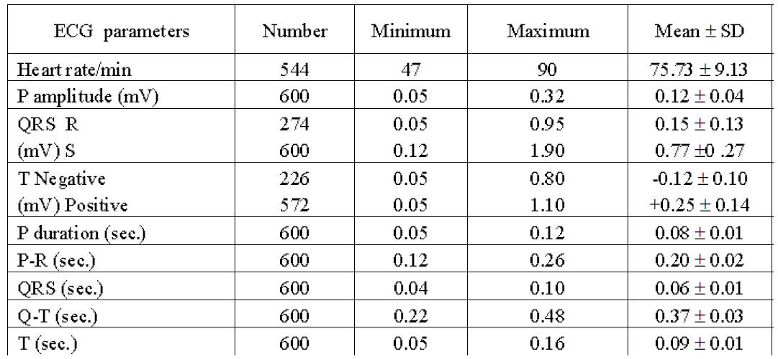
Table 1, normal ECG values in clinically healthy cows (Rezakhani et al, 2004B).

1.4 Body temperature

There is a constant balance in the regulation of energy intake and energy expenditure in an animal’s life. Under thermoneutral conditions, the metabolic rate is remarkably constant in each species. However, when feed intake is greatly increased or restricted the metabolic rate is correspondingly elevated or reduced to correct the energy balance. This process is called the diet- induced thermogenesis. A reduction in energy expenditure in response to fasting has been seen in birds and mammals. There is a reliance of homeothermy on tachymetabolism so reduction in metabolic rate is accompanied by a lowering in the body temperature. It is a passive result of the decreased metabolism. The hypothermia is the greatest when the animal is non- active thus during the night (Piccione et al, 2002).

It is showed in human that body temperature is higher in people that are eating than people that are fasting for 24 hours (Martineaud et al, 2000). Also fasting for ten hours resulted in a significant lower rectal temperature (Driver et al, 1999).
Also in sheep and goats the rectal temperature decreases with fasting. Food deprivation for four days in sheep and goats caused a significant fall in rectal temperature. In goats the body temperature decreased from day two of fasting and the circadian rhythm was going away. In sheep the daily oscillation in body temperature persists but the body temperature gradually fell. When the animals were fed again the body temperature was normal again within one day (Piccione et al, 2002). Also cows can have a body temperature rhythm with a decrease during the night and the lowest temperature at 7.00 AM and a increase during the day with the highest temperature at 3.00 PM. But this pattern can be altered when cows are prolonged exposed to heat stress (Shehab-El-Deen et al, 2010).
In steers there are some contradictory outcomes of the study results. Some studies have found that with 32 hours of fasting the rectal temperature did not differ between the fasted steers and the control group (Galyean et al, 1981; Suzuki et al, 1997). However, other studies have found a decrease in temperature at steers that were fasted (Schaefer et al, 1988).

Otherwise when cows are housed in open stalls the rectal temperature is higher in the summer months and lower in the winter at extreme hot or cold temperatures. So when temperatures increases or decreases extremely there is some change in rectal temperature. Holstein Frisian cows do have a higher rectal temperature of 0, 47 degrees when they are exposed to heat stress (Strikandakumar et al, 2004).

1.5 Respiration
The regulation center of the respiration in mammals is located in the brain stem and is called the respiratory center. It is not one center but it consists of different regions within the medulla and pons. Four regions have been identified:

1. The dorsal respiratory group in the dorsal medulla. This is responsible for inspiration and the rhythm of breathing. Output is generated by the nervus phrenicus and the input is generated by the nervus vagus and the nervus glossopharyngeal. There are mechanoreceptors in the lung that relay impulses via the nervus vagus and play an important role in the ventilation.

2. The ventral respiratory group. This is primarily responsible for expiration. When there is a normal breathing the expiration is passive, than these neurons are not active. With exercise these neurons become active.

3. The pneumotaxic center. This inhibits inspiration and thus regulates inspiratory volume and respiration rate.

4. The apneustic center. This center is not very well understood. This center is associated with deep inspirations.

So the basic rhythm, depth or both can be changed due to the body needs. The most important afferent impulses come from the Hering- Breuer reflexes. The receptors for these reflexes are located in the lung, bronchi and bronchioles. The impulses are transmitted via the nervus vagus to the respiratory center. When the vagus nerve afferent impulses are lost then dogs will get an increased tidal volume and a slower respiration frequency. Nevertheless, there are more receptors for modifying the rhythm of respiration. For example in the skin (rubbing the skin starts breathing cycles in newborns or deeper inspiration), there are also receptors in the tendons and joints and these are stimulated when muscle contraction initiates movement. In addition, when the mucous membrane of the upper air passages is stimulated the inspiration is inhibited to prevent the lungs for harmful gasses.

Also the afferent impulses form the baroreceptors in the carotid and aortic sinuses have their function in regulation of the respiration. Their principal function is the role in the circulation. The receptors constantly generate impulses and these increase in frequency as the blood pressure increase. These impulses to the respiratory center are inhibitory and so the respiratory frequency decrease. The function of this response is to modify the return of blood to the heart. So when blood pressure is decreased, respiration increases an flow of blood to the heart is better possible. Because of the increased respiratory there is a greater negativity of intrapleural pressure. This is transmitted to the mediastinal space and so the vena cave can expand. The larger pressure difference between the vena cave and the veins assist for more flow of blood through the heart (Reece, 2004).

The respiratory mechanism is also sensitive for changes in blood pH and pCO2. When a metabolic acidosis occur the bicarbonate ion concentration falls because of reaction with the added acid or because of direct losses of bicarbonate. As a result plasma CO2 will increase. The respiration reaction is very fast and increasing alveolar ventilation occurs and so pCO2 will decrease. This compensation will bring ratio conjugate base to weak acid back to the normal value but the hypobasemia will persist until the loss of bicarbonate is replaced. This requires renal action: excretion of hydrogen ions and restore of bicarbonate. In case of a metabolic alkalosis there is an increase in bicarbonate. The rise in pH will depress ventilation and pCO2 will rise so pH is going to its normal level. The hyperbasemia persist and renal correction must occur with decreased secretion of hydrogen ions en increased secretion of bicarbonate ions (Reece, 2004; Hubble, 2007).

Respiration frequency may be affected by body size, age, exercise, excitement, environmental temperature, pregnancy, filling of digestive tract and state of health.

Digestive tract filling and pregnancy increase the respiration frequency because they limit the excursion of the diaphragm during inspiration. Because the expansion is restricted there will not be adequate ventilation so adequate ventilation is maintained by increased frequency (Reece, 2004).

When cows are exposed to heat stress then sweating and panting are important mechanisms to regulate the body temperature. The respiration rate will increase to evaporate water (Strikandakumar et al, 2004). It is seen when cattle have a body temperature rhythm that respiration rate will follow this rhythm. So when the body temperature increases at the afternoon also the respiration rate will increase (Shehab-El-Deen et al, 2010).
Otherwise human who do not eat for a longer time (months or years) have hypercapnia and a normal respiration rate but they have decreased peak expiratory flow rates. This can be due to an increased vagal tone and/ or a decrease in muscle strength. When the people were eating again the hypercapnia disappears. Therefore, the decrease in expiratory flow rates is the most reasonable due to the increased vagal tone (Kerem et al, 2011).

2. Aim of the study
The aim of this study is to study what happens with heart rate, heart rhythm, rectal temperature and respiratory rate when a cow is fasting for 48 hours.
The hypotheses of this study are:
- The cows develop a bradycardia due to an increase in parasympathetic influence.
- The cows develop ECG abnormalities due to hypokalemia.
- The temperature of the cows will decrease due to a decrease in basal metabolism.
- The respiration frequency will decrease because the cows will compensate the metabolic alkalosis they will get from the fasting.
3. Materials and methods
3.1 Animals
This experiment was conducted with cows from the University of Utrecht. For this study we selected five mature and healthy HF cows from the dairy herd at the University of Utrecht. Mean age was 2, 9 years (Std deviation: 7, 8 months), mean days in lactation were 274, 2 days (Std deviation: 8, 9 days) and mean body weight was 528, 8 kg (Std deviation: 45, 5 kg). See table two for information about the cows. The laboratory animal committee approved all the experimental procedures (dec. number: 2010.III.11.133).
The cows were fasted for 48 hours and were housed at tie-stalls with a rubber floor.

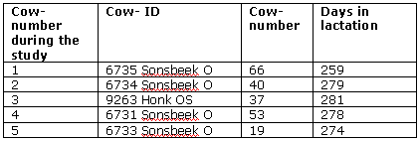
Table 2, information about the cows.

3.2 Study design
At day one the cows were housed apart from the other cows and were fitted with
jugular catheters (Discofix® C 3-way Stopcock Connection Tubing, Braun). Heart rate, respiration rate and the body temperature were measured five times this day. At day two the same things as day one were measured but also blood and urine was taken and an ECG was made. At days three and four the cows were fasted and the same things as day two were measured. At day five the cows were fed again and we measured the same things as day two. See table three for the overview of the measurements during the study.

Before and after the study the cows were fed with the feed they are used to. This is:

- 10 kg maize.
- Ad libitum grass or silage.
- 2 kg concentrate (because the cows are a few hours a day on pasture).
- 60 gram of minerals.
At day five when cows were allowed to eat again we started with silage, in the afternoon the cows got also maize and in the evening they got there concentrate.

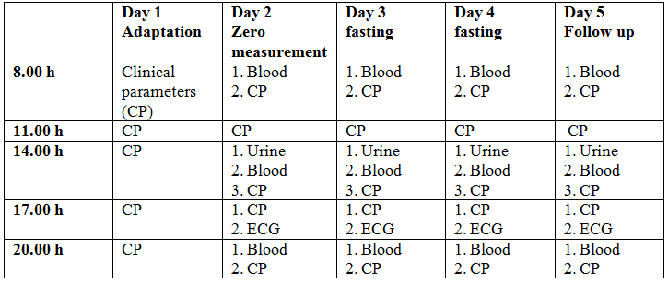
Table 3, overview of measurements during the study.

3.3 Blood analyses
A serum tube (only at 2.00 PM), heparin tube and a pH tube were taken from the catheter when we took blood. The blood from the pH tube was analyzed directly for blood-gas values and electrolytes with the Rapidlab 1260 blood- gas analyzer (Siemens healthcare diagnostics, Deerfield, United States). We measured: pH, pCO2, pO2, sodium, potassium, chloride and the base excess.
The blood from the heparin tube was used for analyzing BHBZ and creatinine by the UVDL and was centrifuged (Eppendorf centrifuge 5804R). The plasma was directly frozen at -20. A micronic tube with plasma was filled as a backup and also frozen. We also took a capillary with blood from the heparin tube. This was centrifuged (Heraeus Pico 17 Haematokrit) and hematocrit was measured, with the plasma of this capillary the total protein was measured with a refractometer (ATC portable refractometer – protein).
One time a day at 2.00 PM we measured the glucose value with the precision Xceed (Abbott Precision Xceed Pro System).
Also at 2.00 PM we took a serum tube which was centrifuged and plasma was used for analyzing of NEFA’s by the UVDL and was frozen. Also from this we filled a micronic tube for backup.

3.4 Urine analyses
At 2.00 PM the urine was taken. We measured the pH and the specific gravity. Urine was put into a water bath (Julabo TW12) for 10 minutes and then the pH was measured with a pH meter (inoLab® pH 740). The specific gravity was determined with a refractometer. Also we put urine in two tubes with a pipette and those were frozen. One tube was used for analyzing potassium and creatinine by the UVDL and one tube was used for analyzing chloride in a laboratory in Germany. The main urine was also frozen and was send at the end of the proof to a laboratory in Germany for determining the net acid excretion.
See table four for blood and urine measurements.

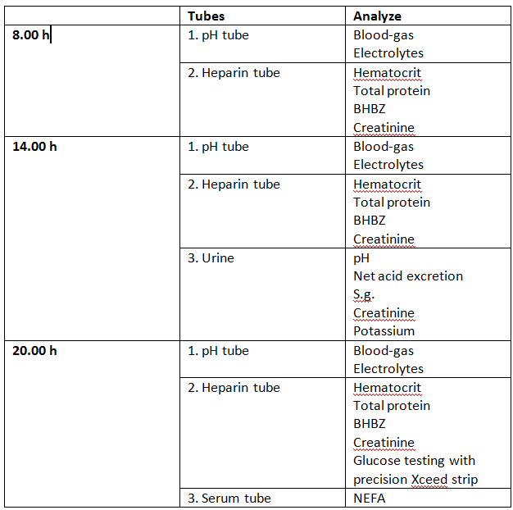
Table 4, blood and urine measurements.

3.5 Clinical parameters
- Heart rate was analyzed with a Littmann stethoscope during 1 minute. Rectal temperature was measured with a digital thermometer and we looked at the respiration rate and count this for half a minute. See table five for the normal values of the clinical parameters.
Also at Saturday morning a clinical examination was executed and respiration rate, heart rate and rectal temperature were examined. So also only the morning measurements were compared to each other.

Respiration rate | 10-30 beats per minute
Heart rate | 50-80 beats per minute
Rectal temperature | 39-39 degrees
Table 5, normal values of clinical parameters (Kuiper et al, 2008).
3.6 ECG

Heart rhythm was detected with an ECG (Mindray Beneview T5) at 5.00 PM. The ECG was recorded with a bipolar base apex lead. Animals were kept at their tie-stalls and no sedative was used. The ECG was recorded when the animals were in a quiet state. Alligator- type electrodes were used and before the attachment of the electrodes the places for the electrodes were shaved and cleaned with alcohol.

The positive electrode of lead one was attached on the skin of the fifth intercostal space just caudal to the olecranon at the left side. The negative electrode was placed on the jugular furrow about the lower part of the right side of the neck. The earth electrode was attached away from these two electrodes at the left side of the neck.

The ECG’s that were made were stored and after the study the intervals, segments and amplitudes of each ECG were measured with the c

omputer program: patient data management and review. All the measurements were made ten times per ECG, see figure five how measurements were made.
- Wave: a wave begins and ends on the baseline and is a graphic representation of an electrical event.
- Segment: this is an electrically quiet area in the cycle.

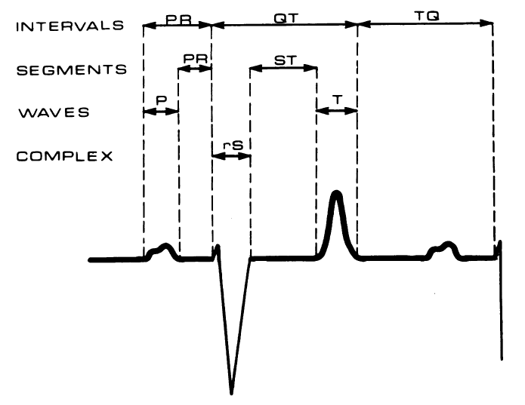

Figure 5, measurements of the ECG components (Deroth et al, 1980). Also the TP interval was measured and the amplitudes of the P, R and T waves. The TP interval was measured from the beginning of the T wave till the beginning of the P wave.

3.7 Statistical analysis
All the statistic analysis made in this study was done with the program SPSS17.
The ANOVA for repeated measurements was used for comparing the different data of the days with each other.
The ANOVA test is a parametric method. Therefore, this test is only meaningful for numerical data which is sampled from a population with an underlying normal distribution or whose distribution can be rendered normal by mathematical transformation. In this study the data that were not normally distributed were transformed with a log- transformation.
At the test of normality the Shapiro-Wilk test results were used because sample size is between 3 and 2000. If p> 0.05 the test of normality is non- significant and so the data are normally distributed.

After this the ANOVA test can be executed. First Mauchly’s test (the relationship between pairs of groups is equal) was done. If Mauchly’s test was significant Huynh- Feldt or Greenhouse- Geisser correction was used. Also a bonferroni correction was put in at the beginning.
When p< 0, 05 the difference was significant.

The correlation was measured with the Pearson correlation.
4. Results

4.1 Fasting
During this study the cows did not get a hypokalemic, hypochloremic metabolic alkalosis as expected but even a metabolic acidosis. The potassium excretion in the urine was extremely decreased during the days of fasting and also the pH of the urine was lower during fasting. Moreover, the cows were dehydrated. More information you can find in the paper of Annelous Kist (The effects of 48 hours fasting on acid-base balance and electrolytes in dairy cow).

4.2 Heart rate
The heart rate during this study was significant lower when the cows were fasting (Wednesday and Thursday). At Friday the cows were already recovering so there was no significant decrease anymore.
At Saturday morning the mean heart rate was already 63, 6 beats per minute.
Normal heart rate during this study of the cows was 65 (+/- 5, 2) beats per minute.
There was no correlation between serum potassium level and the decreased heart rate (Pearson Correlation: -0.147, Sig: 0.648).
Mean serum potassium level was: 3.62 mmol/L (+/- 0.36) during this study.
At Friday the standard deviation was greater than the other days, this was not due to one cow in special. Maybe some cows were more excited when they were being fed again than others and maybe the heart rate from some cows was increasing faster than others. In figure six mean heart rate during the trial is reviewed.
Mean heart rate at the acclimatization days was 64,4 and 65 beats per minute. The mean heart rate at Wednesday and Thursday when the cows were fasting were 45,7 and 41,1 beats per minute. The heart rate at Friday when the cows where eating again was 55,8 beats per minute.

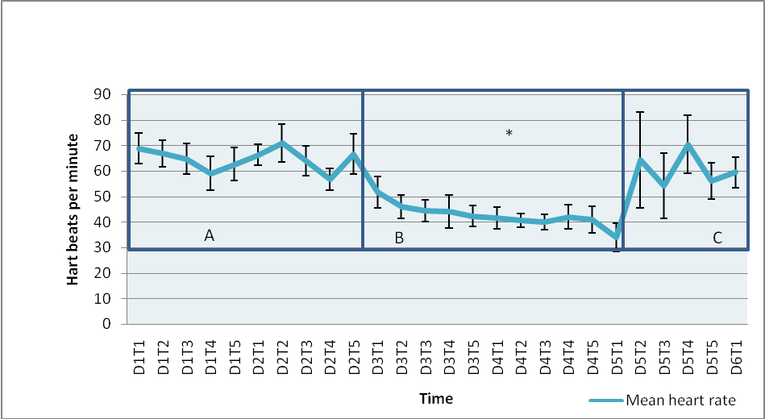
Figure 6, changes in mean heart rate during the trial. A = acclimatization period, B= Fasting period, C= re- feeding period. During the days of fasting there was a significant decrease in heart rate compared with the acclimatization period and this is reviewed with *. At Friday when the cows were eating again the heart rate was going the normal.

The cows were fed at Friday again at 8.30 AM. Therefore, at the morning clinical examination the cows were still fasting and so heart rate at Friday morning was still significantly lower. There was a large standard deviation at Saturday morning; this was due to cow five who had diarrhea. When this cow was not taken into account with the statistical analysis the heart rate at Saturday is still not significantly decreased compared with Monday and Tuesday, so heart rate was going back to normal. In figure seven the morning measurements are reviewed with and without the measurements of cow five. The morning measurements of Monday and Tuesday were 68,8 and 66,4 beats per minute. At the fasting days at Wednesday, Thursday and Friday morning the mean heart rate was 51,6; 41,6 and 34 beats per minute. At Saturday morning the mean heart rate was 63,6 beats per minute and the heart beats per minute at Saturday morning minus cow five was 59,5.

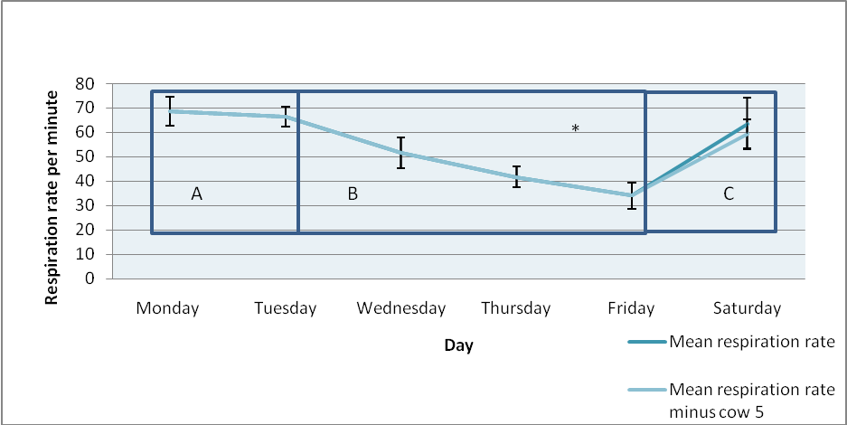
Figure 7, mean heart rate of the morning clinical examination at 8.00 AM. Now it is seen that heart rate decreases even further at the Friday morning. At 8.30 AM the cows were eating again. The cows were fasting at Tuesday and Wednesday. Cow five was responsible for the great standard deviation at Saturday morning because of his extensive diarrhea, so also the measurement of Saturday morning minus cow five are reviewed. *= significant decrease in heart rate compared to the acclimatization period. A = acclimatization period, B= Fasting period, C= re- feeding period.

Heart rate decreases very fast because at Wednesday morning the heart rate was already decreased to 51, 6 beats per minute.
Heart rate also increases very fast after feeding because at Saturday morning heart was already 63, 6 heart beats per minute. Below the heart rate at Friday is showed so the increase in heart rate at Friday in special is seen. Heart rate increases immediately after feeding again. At times 11.00 AM, 2.00 AM and 5.00 PM the standard deviation is great but this was not due to one cow or the same cows or to a special cause. Maybe the heart rate of some cows is recovering faster than others. Also at that day just before the clinical examination at 11.00 AM and 5.00 PM the cows were fed. Maybe some cows were more excited about this than others. In figure eight the measurements of only Friday and the Saturday morning are reviewed.

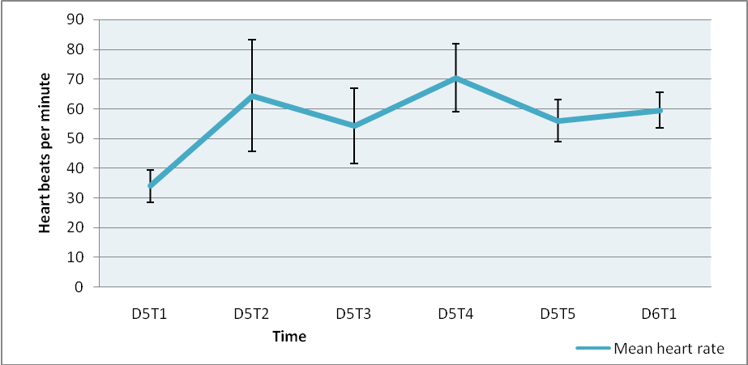
Figure 8, mean heart rate at the different times of clinical examination at Friday and the Saturday morning are showed. At 8.00 AM (D5T1) the cows were still fasting and at 8.30 AM the cows were eating again. The heart rate increases very fast after eating again. In the measurement of Saturday morning cow five is executed because of the extensive diarrhea. At times 11.00 AM, 2.00 PM and 5.00 PM the standard deviation is great but this was not due to one cow or the same cows or to a special cause.

4.3 ECG’s
During fasting the ST segment was significantly prolonged. It was directly seen at the first day of fasting. At Friday when the cows were eating again the ST segment was immediately going back to normal. Therefore, there was no significant prolongation anymore between Tuesday and Friday but the length of the ST segment was not yet totally normal.
Also the TQ interval was significantly prolonged. At Friday the length of the TQ interval was almost back to normal. There was no significant prolongation anymore.
At least the TP interval was significantly prolonged and at Friday the length of the interval was almost back to normal. There was no significant prolongation anymore. This results are reviewed in figure nine and ten.

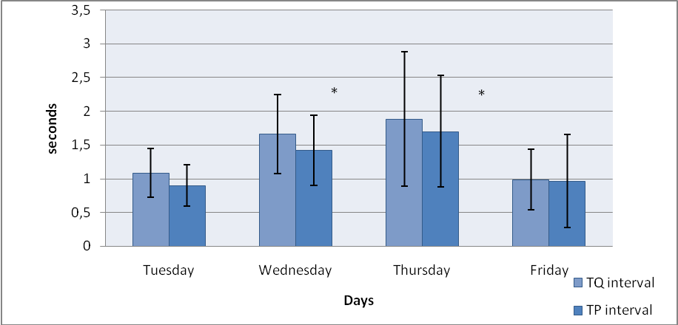
Figure 9, changes in TQ interval and TP interval during the trial. During fasting at Wednesday and Thursday the intervals are prolonged and at Friday when the cows are eating again the intervals are going back to the normal values.* = fasting and a significant prolongation compared to Tuesday. Probably the prolongation of the TQ interval is caused by the prolongation of the TP interval.

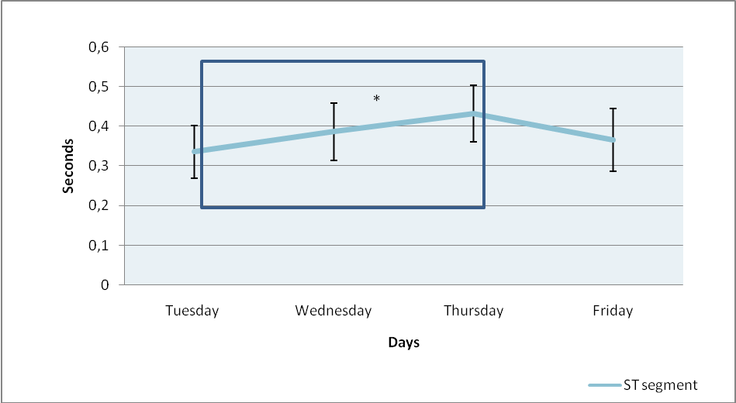
Figure 10, changes in ST segment during the study. * = cows are fasting and ST segment is significantly prolonged compared to Tuesday. At Friday the cows were eating again. The ST segment is prolonged during the days that the cows are fasting. At Friday the ST segment is going back to the normal value.

There were some more changes seen in the ECG’s during fasting. But these were not significant. The P wave and T wave prolonged a little. Also the RS segment and the QT interval prolonged somewhat. And the R wave and T wave amplitudes were elevated but the P wave amplitude decreased during fasting. Maybe these results have become significant if the cows were fasting for a longer time or the trial was executed with more cows. All results are shown in table six to nine.

 | P wave | T wave
Tuesday | ,17 (,03674) | ,18 (,02828)
Wednesday | ,19 (,03082) | ,19 (,02915)
Thursday | ,2060 (,04827) | ,1960 (,03362)
Friday | ,2080 (,01304) | ,2160 (,05771)
Table 6, mean values and standard deviation of ECG waves. At Wednesday and Thursday the cows were fasting. There was no significant change in the ECG waves during fasting.

 | RS segment | PR segment | ST segment
Tuesday | ,1680 (,02168) | ,1660 (,03912) | ,3360 (,06427)
Wednesday | ,1620 (,02168) | ,2020 (,02490) | ,3860 (,06768) *
Thursday | ,1720 (,01924) | ,1980 (,01789) | ,4320 (,06301) *
Friday | ,1840 (,02608) | ,1980 (,02490) | ,3660 (,08234)
Table 7, mean values and standard deviation of ECG segments. At Wednesday and Thursday the cows were fasting. There were no significant changes in the RS segment and the PR segment but only in the ST segment. * = cows are fasting and ST segment is significantly prolonged compared to Tuesday.

 | PR interval | QT interval | TQ interval | TP interval
Tuesday | ,4100 (,17436) | ,7860 (,47611) | 1,0840 (,39766) | ,8980 (,33199)
Wednesday | ,3960 (,25314) | ,8700 (,56666) | 1,6600 (,64637)* | 1,4180 (,55845)*
Thursday | ,4560 (,26931) | ,9300 (,63052) | 1,8860 (1,09100)* | 1,7000 (,89964)*
Friday | ,4600 (,25278) | ,7960 (,46785) | ,9840 (,49232) | ,9620 (,76090)
Table 8, mean values and standard deviation of ECG intervals. There were only significant changes in the TQ interval and the TP interval. * = cows are fasting and ST segment is significantly prolonged compared to Tuesday.

 | R wave | T wave | P wave
Tuesday | 2,7600 (,64560) | 2,2880 (,45202) | ,7040 (,21279)
Wednesday | 3,2880 (,73343) | 2,5680 (,64150) | ,5960 (,22909)
Thursday | 3,2800 (1,06320) | 3,2400 (1,00598) | ,6960 (,23298)
Friday | 3,6760 (,56823) | 3,3400 (1,00817) | ,7000 (,34000)
Table 9, mean values and standard deviation of ECG wave amplitudes. There were no significant changes in ECG wave amplitudes during the days of fasting at Wednesday and Thursday.

Thus it is seen that the ECG intervals and segments recover when cows are eating again, because at Friday a normal value or a recovery is seen. The length of the waves and the amplitudes of the waves increased even more at Friday and thus are not immediately recovering after eating again.

4.4 Body temperature
During fasting the body temperature decreases but this was not significant.
Mean non- fasting body temperature of the cows was 38, 1 (+/- 0.13) degrees.
At Saturday morning mean body temperature was 38, 2 degrees.
Also when only morning measurements were compared no significant decrease was found. The mean body temperatures per day are reviewed in table ten.

 | Mean | Standard deviation
Monday | 38,2480 | ,20130
Tuesday | 38,1840 | ,12522
Wednesday | 37,9080 | ,10545
Thursday | 37,9920 | ,10060
Friday | 38,0880 | ,22521
Saturday | 38,16 | 0,320936
Tabel 10, mean body temperature with standard deviation per day. At Wednesday and Thursday the cows were fasting but no significant decrease in body temperature was found. The results of Saturday are only the morning measurements.

4.5 Respiration rate
During fasting the respiration rate decreased significantly. But there was no significant difference between Tuesday (normal value) and Wednesday (first day of fasting). So the decrease in respiration rate started already at Wednesday but became substantial at Thursday. Between Friday (eating again) and Tuesday there is still a significant decrease in respiration rate. So the effects on respiration rate do not come immediately after eating again. See figure eleven for these results.
Mean respiration rate (non- fasting) of these cows was 29.1 (+/- 1.9) per minute.
At Saturday morning mean respiration rate was: 32.4 per minute. The mean respiration rate at the acclimatization period at Monday and Tuesday was 28,4 and 29,7 per minute. At Wednesday and Thursday the mean respiration rate per minute was 26,7 and 25,2 and the mean respiration rate per minute at Friday was 24,4.
At blood- gas analysis the difference between bicarbonate actual and standard was not more than 2-3 mmol so respiratory compensation was not seen.

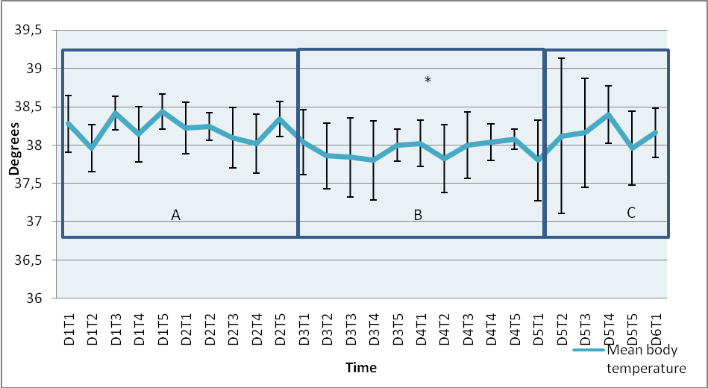
Figure 11, changes in mean respiration rate during the trial. At Wednesday and Thursday the cows were fasting and at Friday the cows were eating again. *= significantly decrease in respiration rate compared to the normal values of the eating period. A= eating, B= fasting, C= eating again. It is shown that respiration rate is mostly at the lowest level in the morning. But not always at the same time. At Monday, Tuesday, Thursday and Friday this is at 8.00 AM but at Wednesday this is at 11.00 AM.

Also the respiration rates of only the morning measurements are reviewed. See figure twelve for these results. It is shown that respiration rate is mostly at the lowest level in the morning. But not always at the same time. At Monday (25,6), Tuesday (27,6), Thursday (22,4) and Friday (21,2) this is at 8.00 AM but at Wednesday (28,4) this is at 11.00 AM.
At Saturday morning (32,4) the respiration rate was back to normal, it was even higher than the normal value. As with heart rate there is a further decrease in respiration rate at Friday morning because cows are still fasting then.

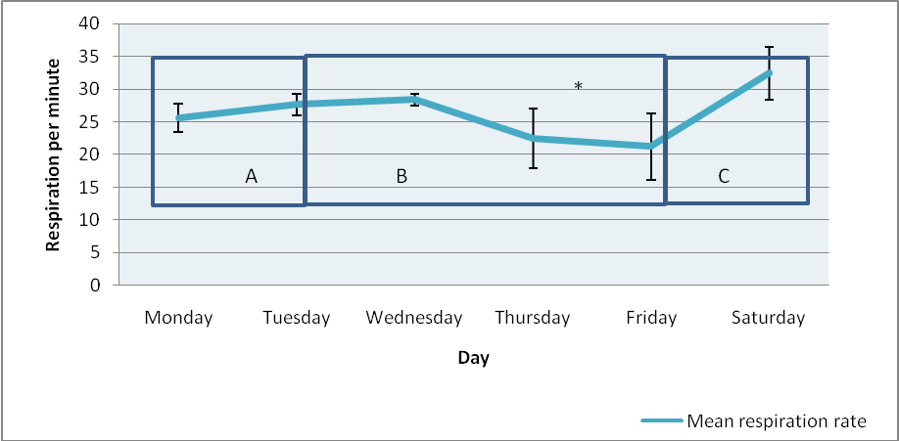
Figure 12, mean respiration rate of the morning measurements. At Friday morning the cows were still fasting and respiration rate decreased even more. When cows were feeding again the respiration rate increases fast and at Saturday morning respiration rate was back to normal values. A = acclimatization period, B= Fasting period, C= re- feeding period. *= the cows are fasting and have a significant decrease in respiration rate compared to the values of the acclimatization period.

Thus, respiration rate is recovered at Saturday morning. In figure thirteen the respiration rate is reviewed of only Friday and the Saturday morning. Respiration rate is increasing immediately after feeding the cows again.

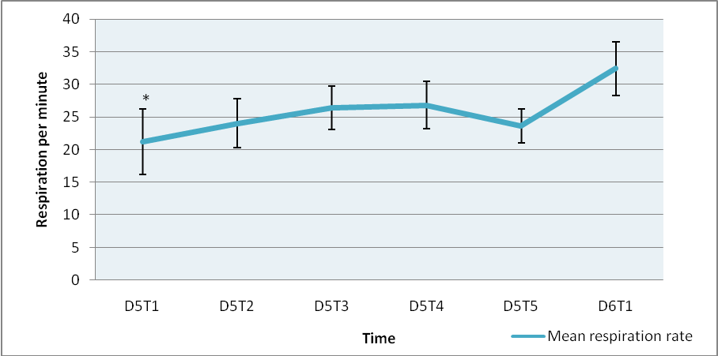
Figure 13, respiration rate at Friday and the Saturday morning. At 8.00 hour the cows were still fasting, but at 8.30 hour the cows were eating again and respiration rate increases.* = the cows where still fasting.

4.6 Other facts
We noticed a large (significant) decrease in milk production. This was seen in the milking round in the afternoon at the first day of fasting. See figure fourteen.
At day four in the afternoon we noticed at two cows cold extremities. At day five in the evening the temperature of the extremities of this two cows were back to normal.
Also at day three around 2.00 PM the cows had extreme dry and compact feces. At day five in the evening this was not yet completely recovered.
Furthermore the cows lost many weight in the two days of fasting. Before fasting the bodyconditionscore (BCS) was 2,5 out 5 and one cow had a BCS of 3- 3,5 out 5 (cow 5). After fasting the BCS was 1,5-2 and the cow who had an BCS of 3- 3,5 had an BCS of 2-2,5 after fasting.
The hairs at the back of the cows were erect and two of the cows were having a lot of saliva.

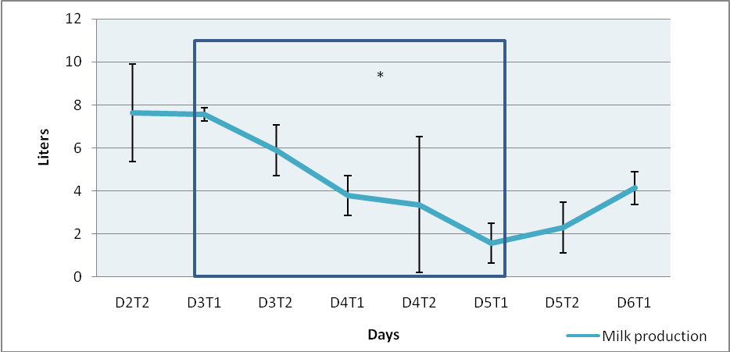
Figure 14, changes in mean milk production during the trial. *= fasting period.
5. Discussion

5.1 Heart rate
In this study the cows had a significant bradycardia during the 48 hours of fasting. This bradycardia appeared very quickly because at the first round of clinical examination at 8.00 AM (12 hours after the last feeding) the cows had already a bradycardia and this persisted the whole time during fasting. Also the recovery to a normal heart rate was very quick. Cows were fed at 8.30 AM again and the heart rate was significantly increased at the clinically examination round at 11.00 AM that same day again. Thus after fasting heart rate returned very fast (within 2, 5 hours) to normal ranges. All five cows had a bradycardia.
This is in agreement with the studies of McGuirk and Clabough (McGuirk et al, 1990; Clabough et al, 1989).
Mean heart rate in our study was: 65 (+/- 5, 2) beats per minute. This is in contrast with the studies of Rezakhani and Deroth were mean heart rate was 75 beats per minute (Rezakhani et al, 2004B; Deroth et al, 1980). This difference in heart rate is maybe possible because the cows in our study were already used to their environment and they were already used to clinical examination and people around them.

No significant correlation between serum potassium and the decrease in heart rate was detected. Also the magnitude of the decrease in serum potassium was small and values remained within normal reference ranges. In our study the cows were not only fasted but also appeared to be dehydrated (hematocrit and total protein increased) so it is possible that the cows had a hypokalemia but this did not show in the serum samples because of the dehydration. In addition, cows had a metabolic acidosis during the fasting period during which the potassium flows out of the cell causing a decrease in intracellular potassium However, intracellular levels were not measured and would be more critical in cardiac electrical events. Potassium excretion decreased enormously in the urine, indicating that a lack of potassium occurred.
If there is an (intracellular or extracellular) hypokalemia the negative resting membrane potential is elevated so the myocytes do not react as fast as they normally do. This occurs also in the pacemaker cells of the sinoatrial node, and thus a bradycardia can occur (El- sheriff et al, 2011; Osadchii, 2010).
Another possible reason is that the bradycardia is caused by an increase in parasympathetic tone. We did not administered atropine to the fasting cows so in our study we could not distinguish if the bradycardia was due to an increase in parasympathetic tone or due to an elevated resting membrane potential. This in contrast with the study of Clabough who found that after administration of atropine the heart rate increased in fasted cattle, also the fluctuations in heart rate were increased in fasted cattle (Clabough et al, 1989).
The increase in parasympathetic tone with fasting may be attributable to increased vagal tone. This can be due to increased activity in vagal afferent fibers because of: changes in ph, stretch or other chemical mediators in the gastro-enteritic channel. Also changes in concentrations of ketone bodies, billirubin, total protein, glucose, free fatty acids, electrolytes and acid- base balance can cause this increase activity in vagal afferent fibers (McGuirk et al, 1990).
In steers after rumen evacuation the heart rate was also significantly decreased compared with a full rumen. There are tension receptors located around the reticular groove, they will send a tonic afferent input to the medullary gastric center via the nervus vagus. A decrease in rumen fill would reduce tension in the receptors and might result in a slowing of heart rate. This reflex slowing appears to be primarily due to increased parasympathetic nervous activity, presumably mediated by the nervus vagus (Clabough et al, 1989).

5.2 ECG’s
The duration of the different ECG components in our study were somewhat different to the study done by Rezakhani (Rezakhani et al, 2004B). But there were some differences between this study and our study. Rezakhani used 600 Iran cows, the age varied from 1-14 years (mean age 4, 9 years), the places where the electrodes were placed were not shaved and the ECG components were measured with a magnifying glass and (Rezakhani et al, 2004B). The study by Deroth used a three- channel portable electrocardiograph and used 12 electrodes and 32 cows. The mean age was 4, 7 years (Deroth et al, 1980). In our study the mean age was 2, 8 years, we used five Holstein Frisian cows, a base apex lead ECG was used and ECG components were measured with a computer program. In spite of the difference in study design our results are in agreement with the study of Deroth but in our study the ECG components were measured at exactly the same manner (Deroth et al, 1980).
We did not found a higher P wave amplitude in older animals because the cows used in this study were around the same age and younger. Nevertheless, we found a higher P wave amplitude compared to literature (Deroth et al, 1980). This can be due to the great variation between animals in P wave amplitude.

- During fasting the ST segment was significantly prolonged. It was directly seen at the first day of fasting. At Friday when the cows were eating again the ST segment was normal again. So recovery was very quick. The ST segment reflects the ventricular repolarization period indicating the period when ventricles are depolarized and contracting. Thus when the ST segment is prolonged the ventricles are prolonged depolarized en it takes some more time till they are repolarizing.
There is no literature about the prolongation of the ST segment, because this parameter is commonly not used in ECG interpretation. In literature only the elevation or depression of the ST segment is taken into account. In human medicine the main cause of ST segment elevation is acute myocardial infarction/ hypoxia. But also many other problems can cause a ST elevation such as: left ventricular hypertrophy, left bundle-branch block, early repolarization, ventricular aneurysm (old infarction with persistent ST- segment elevation) and conduction defect (Wang et al, 2003).
Also anti-arrhythmic agents and electrolyte abnormalities can cause an ST segment elevation such as hyperkalemia and hypercalcemia. But also a hypokalemia can cause a ST segment elevation. It is also seen by hypomagnesaemia and thiamine deficiency and hyponatremia (Francis et al, 2004; Yorgun et al, 2010; Alvarez et al, 2011; Daly et al, 2004).
However, in our study sometimes it looked like the ST segments were elevated but this was not in all the cows and definitely not significant. So the ST segment is only prolonged. Our hypothesis about this is that during the ST segment the ventricles are in the plateau phase of the action potential. This means that when the ST segment is prolonged the plateau phase is prolonged. At the plateau phase calcium ions enters the cell via voltage regulated channels and this inward is balanced with the outward of potassium. As long as the inward of calcium is balanced by the outward of potassium the action potential plateau persists. When calcium channel antagonists (diltiazem) are used the plateau becomes less positive and the duration of the plateau decreases. When potassium channel antagonists are administrated the plateau prolongs. Also the acetylcholine of the parasympathetic nervous system can decrease the plateau phase. The acetylcholine interacts with muscarinic receptors and so inhibits the adenyl cyclase and thus the cAMP decreases and so the calcium channels are not activated in the cell membrane. Than the plateau is decrease and the contractile strength of the heart is also decreased. At the end of the plateau the potassium must exceed the calcium and then the repolarization will start. When a cow is suffering from a hypokalemia the potassium currents are inhibited this means that it takes longer before the potassium exceeds the inward of calcium and so the plateau of the action potential and thus the beginning of repolarization increases.

In addition, the TQ interval was significantly prolonged. At Friday the length of the TQ interval was almost back to normal. Also the TP interval was significantly prolonged and at Friday the length of the interval was back to normal. The TP interval is a component of the TQ interval. So probably the prolongation of the TQ interval is due to the prolonged TP interval. The TQ interval reflects the diastole and the TP interval represents the pure diastole. Also about this interval there is no literature available. This is because these distances are totally depended on the heart rate. In this study the cows have a bradycardia so it is logically that the TQ interval in prolonged.
The only interval that is many times mentioned in human that are fasting or have electrolyte imbalances is a prolongation of the QT interval (Macías- Robles et al, 2009; Khan, 2002; Tsuboi, 2005). But also other abnormalities which are mentioned in these studies such as variability’s in T wave and a U wave are not seen in our study (Khan, 2002). In this study the QT interval is also prolonged but this was not significant. Especially hypokalemia, hypomagnesemia and hypocalcemia are mentioned as causes for the prolonged QT interval (Macías- Robles et al, 2009).

We did found increased R wave amplitudes (but this was not significant) this is in agreement with the study done by Rumsey et al, but in this study the increase was significant. Also Rumsey et al, found an increase in P wave amplitude this is in contrast with our study because in our study the P wave amplitude decreased during the 48 hours of fasting (Rumsey et al, 1976).

If all the abnormalities in the ECG’s and the duration of the action potentials of the cows in general are taken into account it is possible that this abnormalities are caused by a hypokalemia. It is not that important if this is an intracellular or an extracellular hypokalemia because both can cause these abnormalities in the ECG’s. An intracellular hypokalemia causes an elevation of the negative resting membrane and causes a prolongation of the action potential, so myocytes do not react as fast as they will normally do. In addition, because of the prolonged refractory period the patients have an increase risk at cardiac dysrhythmia’s. Extracellular hypokalemia produces these abnormalities also because hypokalemia suppresses the potassium channels in the mycoyte (El- sheriff et al, 2011; Osadchii, 2010).

5.3 Body temperature
Body temperature was slightly decreased in this study during fasting but this decrease was not significant. This is in contrast with the study done by Galyean and Suzuki but in agreement with the study of Schaefer (galyean et al, 1981; Suzuki et al, 1997; Schaefer et al, 1988). This is also in contrast with studies done in human and in sheep and goats (Martineaud et al, 2000; Driver et al, 1999; Piccione et al, 2002). We did not detect a circadian change in body temperature as has been described before (Shehab- El- Deen et al, 2010).
This can be due to the warm housing circumstances in the research stall. The ambient air temperature was 21, 3 degrees constantly. Before the study the cows came from an open stall in the fresh air. So the cows were not used to the warm circumstances, the cows were sometimes even sweating. Maybe when the cows were housed at their open stall the temperature would have decreased more but during this study the housing circumstances were too hot. Also rectal temperature at night was not measured maybe this had given us some other results because the hypothermia is described to be maximal when the animals are not active, thus during the night (Piccione et al, 2002).

5.4 Respiration rate
The respiration rate decreased significantly during fasting. This decrease was not seen before the last day of fasting and stayed until the first day of eating again.
The decrease of respiration rate is not a consequence of the acid-bace balance. The cows did not get a metabolic alkalosis as expected but even a metabolic acidosis. In addition, the bicarbonate actual and bicarbonate standard did not differ more than 2-3 mmol/L during blood- gas analyses, indicating that the cows did not compensate via respiration. Due to the metabolic acidosis and the warm circumstances in the stall there was an increase in respiration rate expected but this did not happen (Reece, 2004; Hubble, 2007; Strikandakumar et al, 2004).
The respiration rate can also be affected by the baroreceptors in the carotid and aortic sinuses. When blood pressure is decreased the respiration rate will increase (Reece, 2004). This is also in contrast with our study: because when cows are dehydrated and have a bradycardia a low blood pressure in expected.
The observed decrease in respiration rate might be due to the decrease of stomach filling (especially the rumen), which has been described in the introduction. Due to the decrease of rumen filling the excursion of the diaphragm is no longer limited and thus the ventilation is more adequate (Reece, 2004).
The extreme increase in respiration frequency at Saturday was maybe due to the increased stomach filling, the cows were hungry and did ate a lot, but can also caused by the fact that the respiration rate at Saturday morning was counted by different researchers.

6. Conclusion

The question of this study was what happened with cardio- respiratory patterns and rectal temperature in clinically healthy cows who were fasted for 48 hours.
The outcome of this study was that hart rate and respiratory rate decreased and that the cows get some abnormalities on their ECG’s. Also the rectal temperature decreased but this was not significant.
The decreased heart rate was due to the increased influence of the parasymphatetic nervous system. This increase of the parasymphatetic nervous system can have many reasons which are not become clear in this study.
The abnormalities on the ECG’s were possibly due to a hypokalemia and/or a dysfunction of the potassium channels.
The decrease in respiration rate was possibly due to a decrease in stomach filling.

So we have some answers but more research is needed. A next study can possibly use atropine and needs to measure the intracellular potassium concentrations.

7. Acknowledgements

I want to thank Susanne Eisenberg, Walter Gruenberg and Saskia van der Drift for their effort and the opportunity to fulfil my research project at the departement of farm animal health at the University of Utrecht.

8. References
Alvarez, P.A., M.V. Blanco, J. Lerman (2011) Brugada Type 1 Electrocardiographic Pattern Induced by Severe Hyponatremia. Cardiology 2011;118:97–100

Berne, R.M., M.N. Levy, B.M. Koeppen, B.A. Stanton (2004) Physiology. Fifth edition. Elsevier. ISBN: 0323022251.

Clabough, D.B., C.R. Swanson (1989) Heart rhythm spectral analysis of fasting- induced bradycardia of cattle. Am J Physiol Regulatory Integrative Comp Physiol 257:1303-1306, 1989

Cole, N.A. (2000) Changes in postprandial plasma and extracellular and ruminal fluid volumes in wethers fed or unfed for 72 hours. J ANIM SCI 2000, 78:216-223

Daly, M.J., L.J. DIXON (2009) A case of ST-elevation and nystagmus when coronary thrombosis is not to blame. Q J Med 2009; 102:737–739

Deroth, L. (1980) Electrocardiographic Parameters in the Normal Lactating Holstein Cow. The Canadian veterinary journal Volume 21 October-octobre 1980 No. 10

Driver, H.S., (1999) Energy content of the evening meal alters nocturnal body temperature but not sleep. Physiology & Behavior 68 (1999) 17-23

Elming H., J. Sonne, H.K.F. Lublin (2003) The importance of the QT interval: a review of the literature. Acta Psychiatr Scand 2003: 107: 96–101

El- Sherif, N., G. Turitto (2011) Electrolyte disorders and arrhythmogenesis. Cardiology journal, 2011, Vol.18, No.3, pp.233-245.

Francis, J., C. Antzelevitch (2004) Brugada syndrome. International Journal of Cardiology 101 (2005) 173– 178

Galyean, M.L., R. W. Lee and M. E. Hubbert (1981) Influence of Fasting and Transit on Ruminal and Blood metabolites in beef steers. J ANIM SCI 1981, 53:7-18.

Hubble, S.M.A. (2007) Acid-base and blood gas analysis. Anaesthesia and Intensive Care Medicine 8 (11), pp. 471-473

Iaizzo, P.A. (2009) Handbook of Cardiac Anatomy, Physiology, and Devices. Second edition. Totowa, NJ : Humana Press, a part of Springer Science+Business Media, LLC. ISBN: 9781603273725.

Kerem N.C., E. Averin, A. Riskin, N. Tov, I. Srugo, A. Kugelman (2011) Respiratory Functions in Adolescents Hospitalized for Anorexia Nervosa: A Prospective Study. (Int J Eat Disord 2011; 00:000–000)

Khan, I.A., (2002) Clinical and therapeutic aspects of congenital and acquired long QT- syndrome. The American Journal of medicine, January 2002, volume 112

Kuiper, R., (1980) Reflux van lebmaaginhoud bij het rund. Oorzaken; gevolgen, in het bijzonder de metabole alkalose. Proefschrift ter verkrijging van doctor in de diergeneeskunde.

Kuiper, R., R.A. van Nieuwstadt (2008) Het klinisch onderzoek van paard en landbouwhuisdieren. Elsevier gezondheidszorg, Maarssen. ISBN 9789035229914.

Macías-Robles, M.D., A.M. Perez-Clemente, C. Maciá-Bobes, M.A. Alvarez-Rued, S. Pozo-Nuevo (2009) Prolonged QT interval in a man with anorexia nervosa. International Archives of Medicine 2009, 2:23 doi:10.1186/1755-7682-2-23

Maffé, S., F. Signorottia, A. Perucca, M. Bielli, U. Hladnik, E. Ragazzoni, E. Maduli, P. Paffoni, P. Dellavesa, A.Paino, F. Zenone, U. Parravicini, N. Franchetti Pardo, L. Cucchi, M. Zanetta (2009) Atypical arrhythmic complications in familial hypokalemic periodic paralysis. J Cardiovasc Med 10:68–71 Q 2009 Italian Federation of Cardiology

Martineaud J.P., F. Cisse , A. Samb (2000) Circadian variability of temperature in fasting subjects. Scripta Medica (BRNO) – 73 (1): 15–24, January 2000

McGuirk, S.M., R.M. Bednarski, M.K. Clayton (1990) Bradycardia in cattle deprived of food. J Am Vet Med Assoc. 1990 Mar 15;196(6):894-6

Merck veterinary manual (2011) http://www.merckvetmanual.com/mvm/index.jsp?cfile=htm/bc/11205.htm&word=sinus%2crhythm

Ohtsuka, H., K. Mori, a. Hatsugaya, M. Koiwa, H. Sato, T. Yoshino, K. Takahashi (1997) metabolic alkalosis in coliform mastitis. J. Vet. Med. Sci. 59(6):471-472, 1997

Osadchii, O.E. (2010) Mechanisms of hypokalemia- induced ventricular arrhythmogenicity. Fundamental & Clinical Pharmacology 24 (2010) 547–559

Peek, S.F., T.J. Divers, C. Guard, A. Rath, W.C. Rebhun (2003) Hypokalemia, Muscle Weakness and recumbency in Dairy Cattle (17 cases 1991-1998). Preconvention Seminar 7: Dairy Herd Problem Investigation Strhythmgies. American association of bovine practioners. September 15-17 2003 – Columbus, OH

Piccione G., Caola, R. Refinetti (2002) Circadian modulation of starvation induced hypothermia in sheep and goats. Chronobiology international, 19(3), 531–541 (2002)

Reece, W.O. (2004) Dukes physiology of domestic animals, twelfth edition. Cornell university press. ISBN 0-8014-4238-9

Rezakhani, A., A.A. Paphan, H.R. Gheisari (2004A) Cardiac dysrhythmias in clinically healthy heifers and cows. Revue Méd. Vét., 2004, 155, 159-162

Rezakhani, A., A.A. Paphan, S. Shekarfroush (2004B) Analysis of base apex lead electrocardiograms of normal dairy cows. Veterinarski arhiv 74 (5), 351-358, 2004

Rumsey, T.S., J. Bond (1976) Cardiorespiratory patterns, rectal temperature, serum electrolytes and packed cell volume in beef cattle deprived of feed and water. Journal of animal science, vol. 42, No. 5, 1976

Sahinduran, S., M. Koray Albay (2006) Haematological and biochemical profiles in right displacement of abomasum in cattle. Revue Méd. Vét., 2006, 157, 7, 352-356

Sattler, N., G. Fecteau, C. Girard, Y. Couture. (1998) Description of 14 cases of bovine hypokalaemia syndrome. The Veterinary Record (1998) 143, 503-507

Schaefer, A.L., S.D.M. Jones, A.K.W. Tong, W.C. Vincent (1988) The effects of fasting and transportation on beef cattle. 1. Acid-base- electrolyte balance and infrared heat loss of beef cattle. Livestock production science, 20 (1988) 15-24. Elsevier science publishers B.V., Amsterdam

Shehab-El-Deen M. A. M. M., M.S. Fadel, A Van Soom, S.Y. Saleh, D. Maes, J.L.M.R. Leroy (2010) Circadian rhythm of metabolic changes associated with summer heat stress in high-producing dairy cattle. Trop Anim Health Prod (2010) 42:1119–1125

Smith, S.B., Prior, R.L. (1984) Metabolic responses to fasting and alloxan-induced diabetes mellitus in steers. American Journal of Veterinary Research 45 (9), pp. 1829-1834

Strikandakumar, A., E.H Johnson (2004) Effect of heat stress on milk production, rectal temperature, respiratory rate and blood chemistry in Holstein, Jersey and Australian milking zebu cows. Tropical animal health and production, 36 (2004) 685- 692

Suzuki, K., T. Ajito, E. Kadota, S. Ohashi, S. Iwabuchi (1997) Comparison of commercial isotonic fluids intravenously administered to rehydrhythm fasted bullocks. J. vet. Med. Sci. 59(8):689-694, 1997

Tsuboi, K., (2005) Eating disorders in adolescence and their implications. JMAJ 48(3): 123–129, 2005

Wang, K., R.W. Asinger, H.J.L. Marriott (2003) ST-Segment Elevation in Conditions Other Than Acute Myocardial Infarction. N Engl J Med 2003; 349:2128-2135

Yorgun, H., H. Aksoy, M. A. Şendur, A. H. Ateş, E. B. Kaya, K. Aytemir, A.Oto (2010) Brugada Syndrome with Aborted Sudden Cardiac Death Related to Liquorice-Induced Hypokalemia. Med Princ Pract 2010;19:485–489

Appendix 1, ECG’s
Koe 6731

Day two (Tuesday), normal value
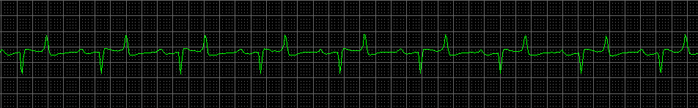
Day three, fasting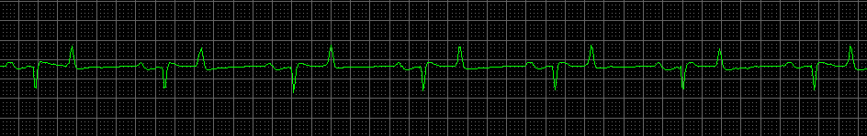
Day four, fasting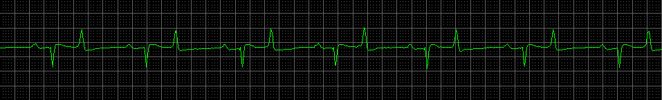
Day five, eating again
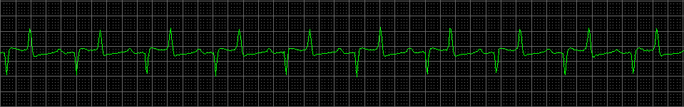

Koe 6734
Day two (Tuesday), normal value
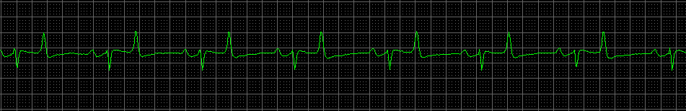
Day three, fasting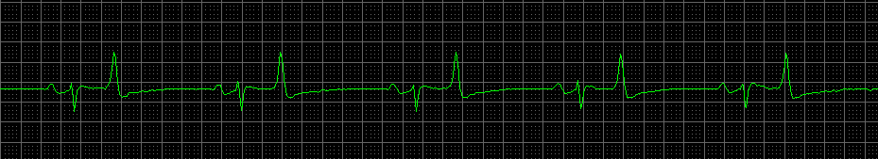
Day four, fasting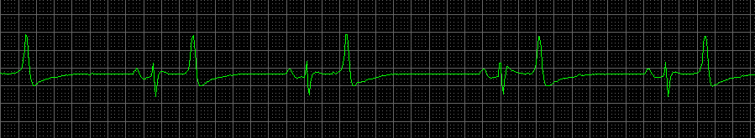
Day five, eating again
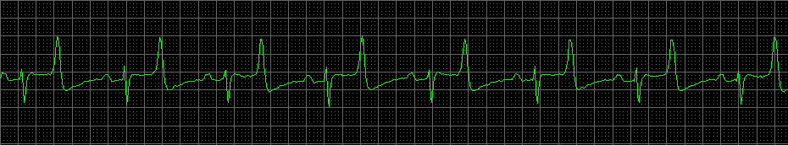
Koe 6735
Day two (Tuesday), normal value
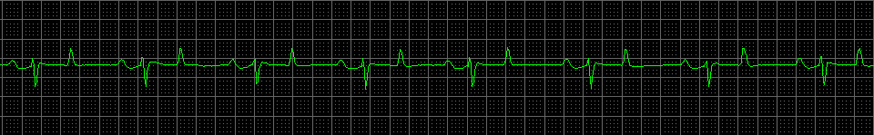
Day three, fasting 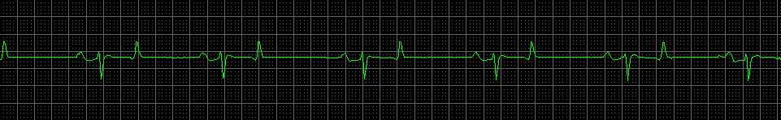
Day four, fasting 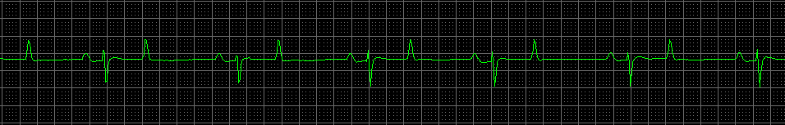
Day five, eating again
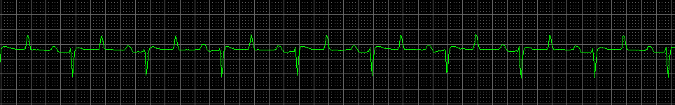
Koe 9263
Day two (Tuesday), normal value
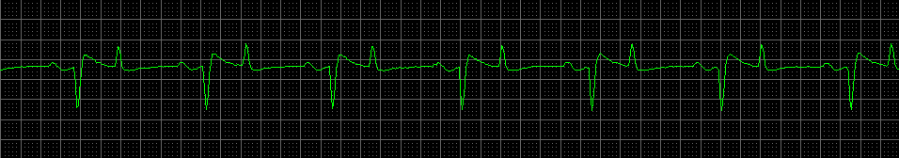
Day three, fasting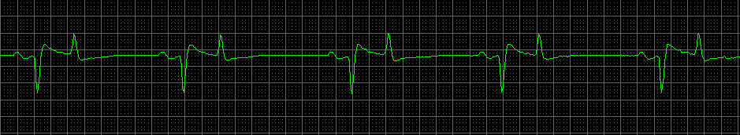
Day four, fasting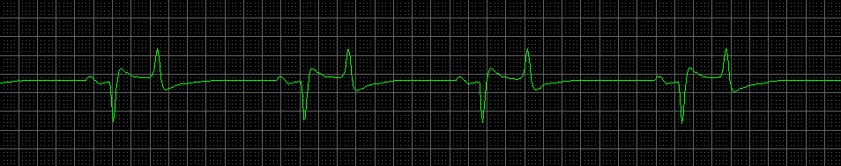
Day five, eating again
