Bram Stoker’s Dracula Adapted In Modern Times:
Theories on Characterisation, Themes and Historiographic Metafiction

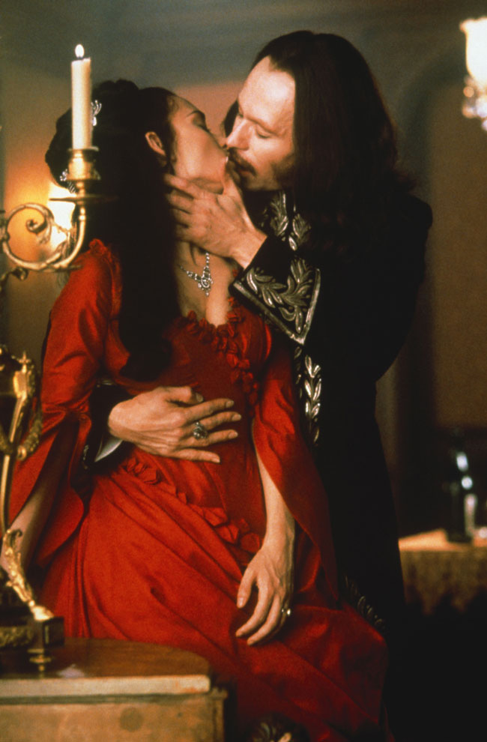

"Time is on my side, your girls that you all love are mine already; and through them
you and others shall yet be mine" (Stoker 365)

BA Thesis English Language and Culture, Utrecht University.
Maria C. van Harselaar
3495833
Roselinde Supheert
15 February 2013

Table of Contents

Introduction 3
1. Themes and Characterisation in Dracula and Classic Adaptations 7
2. Themes and Characterisation in Modern Draculas 12
3. The Contemporary Dracula’s in comparison to the original: modern 18
takes on Characterisation & Themes
4. The Contemporary Dracula and Historiographic Metafiction 24
Conclusion 30
Bibliography 31

Dracula Adapted to Modern Age, An Introduction
Bram Stoker’s Dracula from 1897 is a Victorian gothic novel that has intrigued people since it was first published. The story contains a number of elements that are specific to the genre and to the time in which it was written. The Victorian gothic novel is in a number of aspects different from the modern novel. One of these differences is that the story is plot-driven, whereas contemporary literature is often character-driven. Secondly, Victorian gothic novels feed what would be called a pleasing sort of terror, and suspense in which certain characters descend into madness. The Victorian gothic novel furthermore places emphasis on aristocratic decay, a topic on which Chapter 1 will elaborate further. For now, it suffices to say that the novel’s main character and antagonist Dracula, who is an aristocrat, represents ultimate innate evil in this novel. Another example of Stoker making use of the gothic formula can be found in the exploration of good and evil which commonly ends in good prevailing over evil. Something which is out of the ordinary for the gothic novel, but which does feed the terror, is Stoker’s usage of diary entries, newspaper snippets and letters written from the different points of view from some of the important characters.
The elements briefly discussed in the above paragraph and the story’s visual nature make for a story which is very interesting to adaptors. Unsurprisingly, the first stage adaptations of Dracula went into production before Bram Stoker passed away in 1912. It was not until Nosferatu was released in 1922, however, that a film version (albeit a silent one) saw the light of day. This adaptation and other early renditions of Dracula remained relatively faithful to the novel.
Because modern requirements for film and literature differ from Victorian requirements, and because elements like gender roles and colonisation play a different role in society nowadays, there has been a shift in attention when it comes to adapting Dracula in the past years. One of the most striking differences is that Dracula in Dracula 2000 (2000) and Bram Stoker’s Dracula (from 1992) is presented as a relatively humane character with a background story added to the original piece of fiction. This concept will be further explored in Chapter 4 which deals with how modern Dracula adaptations tie in with the concept of historiographic metafiction.
There is a larger than life appeal to Dracula’s character, and interestingly enough the novel already alludes to that with the foreboding words of the Count himself, “Time is on my side, your girls that you all love are mine already; and through them you and others shall yet be mine” (Stoker 365). While Dracula is ultimately evil, this quotation suggest that the sensual power he has over others is what makes him appealing and envy worthy to the other characters in the novel, and to readers throughout history. He has become an image of self-empowerment as he takes what he wants throughout the novel. Carter-Stephenson, who has done extensive research on Dracula in modern culture, posits the following:

One reason for [his popularity] is that we have taken the character of the Count, made him our own, and perhaps even made him into an image of what we ourselves are. Dracula explores the central themes of gothic fantasy and […] we accept the figure of the Count as a figure of power and a clear reflection of something that is inside of us. [He] may well be evil, but he is also an empowering vision of the Self as Other. (Carter-Stephenson)

Another reason for Dracula’s popularity is rooted in its themes. This novel was ground breaking when it was first published because it explored the sexual conventions of its time, as Chapter 1 will point out. While there was never a direct sexual link between Dracula and his victims, the fact that they were all female and that contamination happened through the drinking of blood from the neck’s arteries was enough of a euphemistic reference. All modern adaptations that will be discussed take the exploration of the theme of lust further. Sex and its dark side has intrigued people throughout time. Furthermore, the mythical creature of the vampire has often been related to sex. Even in ancient folklore there were creatures known as the succubus and incubus. These entities, related to vampires, visited unfortunate men and women in the night and left them in a state of sexual ecstasy after having stolen their energy. Essentially, people’s infidelity made them create stories about sexual monsters forcing them into immoral deed; these stories gave them peace of mind as the article “Folklore Vampires and Sex” argues. Because infidelity, unfortunately, just like sex is a timeless theme, these vampires have withstood the hand of time better than many other mythical creatures, and in a society which is bent on outward appearances and sex it is unsurprising that the vampire is making a grand re-entrance with ongoing television series like True Blood (2008) and with novel series like Anne Rice’s The Vampire Chronicles (mid 1980s to the early 2000s). These contemporary pieces of work tend to emphasise the beauty and sensuality of the vampiric protagonists, as well as their humanity.
While there are numerous papers on Dracula and on a variety of adaptations too, the way in which modern adaptations of this particular novel tie in with modern theories on film is largely unexplored. Because there is a revival of sorts of the vampire in modern media, this paper means to take a look at three contemporary adaptations of Dracula which fit in with this modern tradition, namely Bram Stoker’s Dracula (1992), Dracula 2000 (2000) and the BBC Dracula (2006). This paper will shed light on the reasons why these three modern adaptations use historiographic metafiction, and why they differ so much from the original novel with regard to narrative, themes and the characterisation, whereas two classic adaptations stay much closer to the novel in this regard. These particular discrepancies have sprung from the requirements and interests of modern filmography, literature and society.
Chapter 1 will describe the themes and means of characterisation in both the novel and Nosferatu (1922) and Dracula (1931), the two classic adaptations. Chapter 2 then means to establish how the aforementioned elements, themes and characterisation, are prevalent in the three mentioned modern adaptations. Chapter 3 and 4 form the heart of the paper. Chapter 3 is a comparative in-depth analysis of how and why the original novel and classic adaptations differ from the contemporary adaptations. Chapter 4 explains how the contemporary Dracula films tie in with the concept of historiographic metafiction.

1. Themes and Characterisation in Dracula and Classic Adaptations
In terms of formula, Dracula for the larger part adheres to elements specific to the classic Victorian gothic novel. As mentioned in the introduction, a subtle and ominous sense of terror is one of the main ingredients of this particular genre and Dracula is no exception in this respect. However, although the novel largely adheres to the formula, it also transcends it. The novel touches upon a number of different genres, the obvious being vampire fiction, horror and Victorian fiction. Invasion-ism (albeit on a small scale) and colonialism as well as post-colonialism are also touched upon in the novel.
The genres mentioned above can be traced back to the major themes which play a role in Dracula. Most of these themes reflect the zeitgeist of the period in which the novel was written. Three main themes can be specified: aristocratic decay, sexual conventions and immigration. Apart from these themes, the concept of female beauty is also thoroughly explored in the novel, as this chapter will show.
Firstly, aristocratic decay is perhaps the most prominent theme within the novel, as its antagonist, Count Dracula, is based on this concept. Donna Loftus states in “The Rise of the Victorian Middle Class” that because of the industrial revolution, the urban middle-class managed to establish a society based on merit rather than on birth. This kind of society is the exact opposite of gentry and reduced the importance of the aristocratic class. Unsurprisingly, aristocratic decay became prevalent within the traditional Victorian gothic novel; it also played a large role in Dracula. One example which underlines this is the description of Dracula’s castle. Jonathan Harker observes the following with regard to the castle as he is driven towards it: “Suddenly, I became conscious of the fact that the driver was in the act of pulling up the horses in the courtyard of a vast ruined castle, from whose tall black windows came no ray of light, and whose broken battlements showed a jagged line against the sky” (Stoker 36). The ruined castle is symbolic of the status of the gentry in Victorian England at the time of writing. James Craig Holte suggests in Dracula in the Dark that, “The decay of Dracula’s castle suggests the […] belief in the failure of European aristocracy and recalls the gothic roots of the vampire narrative. The religious icons that appear throughout […] associate[s] the evil of vampirism with the satanic” (54). The fact that vampirism in the novel is associated with the satanic and the fact that the antagonist, Count Dracula, is both an aristocrat and a vampire clearly show the negative stance that Stoker took towards aristocracy in his novel. Stoker’s Catholic Irish roots underline this, as there is often a clear division between good and evil in a religious context, and by making his antagonist a vampire, a satanic being, Stoker clearly condemns both anti-Christian sentiments and the gentry.
Second of all, in Dracula sexual conventions are explored. Although there is no explicit mention of sexual intercourse in the novel, the interaction between Dracula and his female victims is exemplary to the exploration of the conventions as it is highly sensual. The scene in which the reader silently observes Mina drinking from Dracula’s blood is an excellent example, because it is so intimate: “With his left hand he held both of Mrs. Harker’s hands, keeping them away with her arms at full tension; his right hand gripped her by the back of the neck, forcing her face down on his bosom” (Stoker 336). Dracula forces Mina’s entire body close to his while making her yield completely. While this is not necessarily a sexual act, the intimacy of it and Mina’s complete yielding to Dracula’s desire to have her drink his blood makes it highly erotic.
Immigration literature is another key element in the novel. In the nineteenth century, immigration to the United Kingdom and United States of America was prominent. Reasons for immigration differed, but its prominence in society made for a popular topic in Victorian literature. In Dracula the vampire is turned into what could be considered a citizen of the world, not a citizen of a certain country. There is no description of his having difficulty with gaining entrance to the United Kingdom, even though in reality this would have been the case for an Eastern-European individual. By making Count Dracula an immigrant as well as a vampire, the novel points out the dangers of letting an alien wander among indigenous British society.
The ideal of female beauty and character that was prevalent in Victorian society plays a large role in the novel, and both Dracula’s men and antagonist’s attention centre around it. All women in Dracula are portrayed as intuitive beings and their outward appearance conforms to the Victorian ideal:

On the surface, Lucy displays all the features of the sweetly languid Victorian lady, thus exhibiting the conventional image of femininity required of her: she is extremely sensitive to influences, walks in her sleep, and has an “anemic look” (Stoker 94). […] both Lucy’s sleepwalking and Mina’s somnambulism indeed reinforce the views on femininity that the novel reveals. These traits are connected to the unconscious and thus to instinct, unacknowledged desires and lack of control over impulses, features that can be associated with unrestrained appetite as well. (Domínquez-Rue 302)

Emma Domínguez-Rue underlines this in the above quotation. The female vampires are all described as extremely skinny and exceedingly beautiful because of it, thus creating an anorexic image of perfection. Indeed, upon her death even Lucy is described as “A beautiful corpse” (Stoker 175), because of her hollow eyes, clearly defined cheekbones and long thin limbs. While Mina is not described as beautiful but intelligent instead, she displays the same traits as Lucy and it is because of Mina’s superficial behaviour that she becomes the centre of Count Dracula’s attention after Lucy’s death. Domínguez-Rue continues to argue in her article “Sins of the Flesh” that, “[Mina] mimics her friend in her hypnoid conditions, hallucinations, amnesia, somnambulism and ‘morbid’ appetite. Mina’s behaviour clearly evokes Lucy’s and thus hints at her propensity towards vampirism and the monstrous appetite it unravels” (305). Because of Mina’s behaviour and her feminine inclination towards intuitive behaviour rather than rationalism, she is more prone to become a vampire than a man would be.

Themes and Characterisation in Classic Adaptations
Two of the earliest known adaptations of Dracula, Nosferatu and Dracula (1931) are fairly faithful to the novel. While Nosferatu had to change names of its characters because of copyright reasons, it is considered to this very day to be one of the most faithful adaptations of the novel, and the same goes for the relationship of fidelity between the 1931 Dracula and the novel. Both films introduce Dracula (Count Orlok in Nosferatu) as their antagonist. He is a devil-like creature and murderer, and neither film provides an insight into his mind. Moreover, the concept of terror is brought to life by means of strong suspense and by making use of the power of suggestion rather than by special effects as is often the case in contemporary adaptations. An example to this is the fact that Dracula (1931) never actually shows the Count to be drinking blood, instead it is suggested through conversation. In the novel this same kind of suspense is also achieved by the power of suggestions, and by the various diary entries and newspaper clippings that are ambiguous. For instance, “It almost seems as though the captain had been seized with some kind of mania before he had got well into blue water, and that this had developed persistently throughout the voyage” (Stoker 182). This is part of a newspaper item about the Demeter, the ship that carried Dracula to the United Kingdom in the novel. While it is not made explicit what the cause of the mania is, the suggestion that it is Dracula adds to the suspense.
Immigration is an important theme in both classic adaptations. The vampire counts are both alien in the way they look, and the way they dress. In Nosferatu the difference between Orlok and the humans is the most obvious: his vampire teeth are visible at all times, his hands with exceedingly long fingers and nails look monstrous and his large bald head gives him a surreal look too, as opposed to the humans in the film. The antagonist in Dracula (1931), Bela Lugosi, is an actor with Italian roots. He looks remarkably different from the other men in the film and his demeanour is far more dramatic with grand hand gestures than that of the Englishmen.
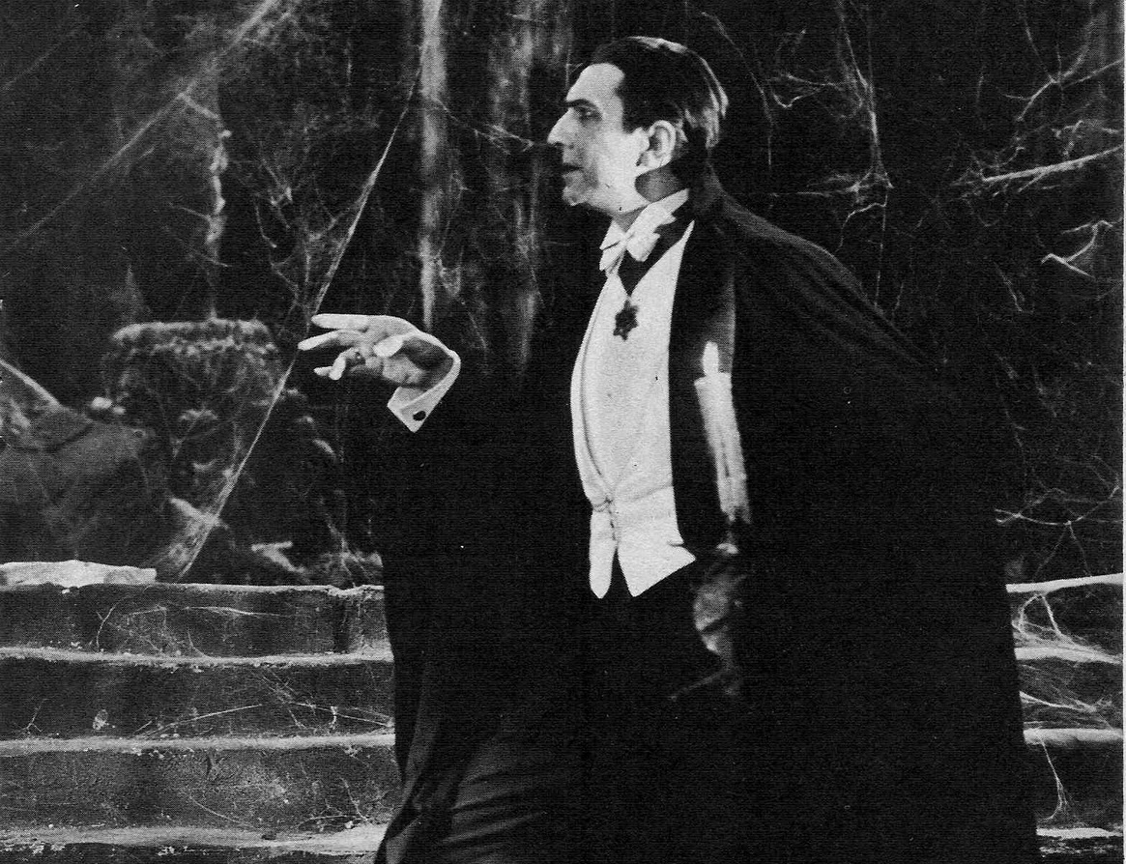Fig 1. Bela Lugosi in Dracula (1931) as he shows Jonathan Harker to his room in one of the first
scenes of the film.
He is also treated differently, and his remark about death below does not only forebode him being a vampire, but also his coming from a different culture than the English characters:

Count Dracula: To die, to be *really* dead, that must be glorious!
Mina Seward: Why, Count Dracula!
Count Dracula: There are far worse things awaiting man than death. (Scene 6)

While the audience reads this as a death wish coming from an undead fiend weary of his undead life, for the characters his words must sound alien because of potential cultural differences as talking about death is not something one usually discusses over tea. Yet, Count Dracula blurts these words out without any problems, causing Mina, who in the adaptation displays the same traits she has in the novel, to jump. Interestingly enough, while the female beauty and behaviouristic ideal was a prominent theme in the novel, Mina’s jumpiness is the only link to that. For the rest of the film, this theme remains unexplored.

2. Themes and Characterisation in Modern Draculas.
Dracula 2000, Bram Stoker’s Dracula and the 2006 Dracula (a direct-to-tv film) are all contemporary adaptations. The two major themes that are explored in these films are religion and sexuality. The female beauty ideal as a theme is largely abandoned. In terms of fidelity, immigration is the one of the few themes which is faithful to the novel, as Dracula is still an outsider, a foreigner coming to the United Kingdom. It is however not as prominent as the themes of religion and sexuality are. As such, this chapter will not deal with these two topics, as they posit less interesting points than religion and sexuality. In terms of characterisation and narrative there is a shift to be found as well. Where neither the novel nor the early adaptations only had a main antagonist, Dracula, and no clear protagonists, these adaptations do have one or multiple protagonists. This makes for a more clearly defined storyline which is character driven, as opposed to the plot driven novel.

Religion in Modern Draculas
Religion, interestingly enough, plays a larger role in modern adaptations than it does in classic ones or in the novel. In a society which has become increasingly secularized and sceptical towards the church, resentment has become more prominent. This resentment towards religion as a theme is firmly rooted into the modern adaptations too. Chapter 4 will clarify the background stories (which all have a religious aspect) that are inserted into modern Dracula films further by linking them to historiographic metafiction. For now it suffices to realise that these background stories in all three adaptations add to their religious, or anti-religious tone.
In Bram Stoker’s Dracula, Dracula is actually Vlad Tepes and unlike the setting of the novel, which is set in the Victorian era, the opening scene of Bram Stoker’s Dracula takes place in 1462. Vlad is, at this point, depicted as a medieval god-fearing orthodox Christian. His wife, Elisabetha, is “fooled into believing he has died, unable to cope with her grief she flung to her death” (scene 1). Because of her suicide, the film suggests that she is not allowed into heaven. This causes Vlad Dracula to renounce his religion: he is unable to come to terms with the fact that his being a god-fearing man, and leading people into battle under God’s banner cannot save his wife from eternal damnation. Out of resentment towards the God he has served all of his life, he pierces a stone crucifix in the chapel with a sword. As blood starts pouring from it he drinks from the bleeding cross stating “Blood is the life, and it will be mine,” the first half of that sentence being a direct quotation from the novel. He feels God has betrayed him, and so he performs a blasphemous deed by drinking from the crucifix’ blood. This is the cause for him becoming a vampire: he renounces his God through blasphemy and transcended death. This could be viewed as a piece of criticism aimed at Jesus’ rise from the grave. Jesus overcame death in order to offer salvation to all living beings on earth whereas Dracula overcame death through renouncing God and that he is able to turn people into vampires, and by doing so keep them turned away from God’s salvation.
In Dracula 2000 Dracula is initially displayed as a monstrous fiend, quite similar to the novel. However, right before his death scene it is revealed that he was shaped by his personal history: he turns out to be Judas Iscariot incarnated, the man who betrayed Jesus Christ and the one responsible for his death. In Matthew 27:5 it is described that after Christ’s death Judas hung himself from a tree. Dracula 2000 suggests that after this, Judas was not allowed either into hell or into heaven because his sin was so great that neither would have him. Thus he became immortal and turned into a blood-sucking fiend who had superhuman powers. He was further capable of preventing mortals from either going to heaven or hell after their death by turning them into vampires. Dracula’s anti-Christian powers give him allure in his film; they are the reason he is admired and feared at the same time. This too shows a vision on religion which is less than positive.
Finally, in the 2006 Dracula a rather different approach is taken. Religion plays an equally large role, but its roots are different. Just like in the novel, Dracula has no background story to speak of. However, he appears to stand at the head of an occult society which worships him for his dark power over others, and his blood which is revered for its supernatural powers. In this film Dracula is brought to England by Arthur Holmwood, the films’ protagonist. Holmwood comes into contact with this satanic cult that worships Dracula after he finds out that he has syphilis. The bishop of the cult fools him into believing that Dracula’s blood has healing powers that will help him, and so Holmwood decided to pay for Dracula’s trip to the United Kingdom. This trip is only supposed to be temporary, and so Dracula is initially presented as a traveller, but not necessarily an immigrant. The idea that Holmwood’s initiation into this diabolical cult will heal him ties in with the fact that religion’s leading and safeguarding role is on a decline. Arguably, most people no longer believe that the church is able to help them on all fronts as God is no longer considered a puppet-master who heals people as he sees fit, and will seek alternative ways to treat their ailments, even if that means resorting to less than holy means. Dracula, in this film, is described by the cult as a deity with powers in the Biblical tradition ascribed to God: his blood is able to heal illnesses, sexually transmittable diseases in particular. Only later on in the film does it become apparent that by healing these illnesses, the people drinking his blood are doomed an undead state of being.

Lust and Sexuality in modern Draculas
The exploration of sexual conventions in the novel has been taken to a higher level in
all three contemporary adaptations because the theme of lust and sexuality plays a large role in these films. It is, however, most apparent in the 2006 Dracula where lust and the diseases caused by it are the main ingredient. As mentioned before, they are the reason Dracula is able to come to Britain. Arthur Holmwood wishes to marry Lucy because she appeals to him physically. It becomes apparent from the very first scene that he is not attracted by her intellect, nor that he considers her thoughts important. When he finds out he has syphilis, he wishes to postpone the marriage until Dracula has cured him of his disease; he also chooses to not tell Lucy of his ailment. In fact, without getting her input first Arthur publicly announces that the wedding is to be postponed until the next summer. This underlines the fact that Lucy is more of a trophy wife than an equal partner in their relationship. The fact that their marriage is still unconsummated when Dracula visits Lucy as she is lying in bed next to her husband makes the scene where Dracula infects her with his blood all the more erotic. In this scene, Lucy is lying in bed next to her husband when Dracula creeps up on her from under the sheets. She is dressed in only her nightgown while he appears to be nude. Before he approaches her for the bite, he is fondling her inappropriately, he moans and rocks his abdomen back and forth in a sexually suggestive manner.
In Bram Stoker’s Dracula the theme of lust is also vividly explored, although it goes hand in hand with love in this film. The theme is most important in the relationship between Mina and Dracula. This film shows Dracula as a tragic romantic anti-hero. Mina turns out to be Elisabetha re-incarnated and so Dracula and Mina share a soul connection which transcends time and even death. The sexual tension between Dracula and Mina is apparent from their very first meeting, where he almost turns her into a vampire when they visit “The Amazing Cinematograph” (scene 4). It then reaches an ultimate high as Mina begs him to turn her into a vampire by saying “take me away from all this death”. In this particular scene, Mina’s devotion to Dracula becomes apparent because she declares to not care about condemning her immortal soul; her only wish is to spend a deathless eternity with her love, Vlad Dracula. During this scene both are scarcely dressed and in bed. This sensuous retelling of how Mina drinks Dracula’s blood greatly differs from the novel. As pointed out earlier, in the novel Count Dracula forced her against his chest and made her drink, whereas Mina was the one who insisted in the film. Furthermore, in the film adaptation Dracula actually did not want her to drink, because he loved her to much to condemn her to the “Darkness in which [he] walk[s]”.

3. Characterisation and Themes in Dracula, a Comparison
As was indicated in the previous two chapters, it would be safe to say that the original novel, as well as the two discussed classics, differs in a number of ways from the three contemporary chosen adaptations. The most obvious reason for this is that contemporary society is very different from the Victorian era. Moreover, requirements for literature have changed with time, and finally, the film is a different kind of medium than the book. With the advancement of technology, modern film is capable of bringing much grander imagery to life than what was possible with classic cinematography, and subsequently it is no surprise that the visuals of old adaptations are unable to match the special effects that modern films can offer. However, since this paper deals with the content of the story of Dracula and not so much the visual elements of it, this latter aspect will not be taken into further consideration.

The Diminishing Position of Religion in Context
In the Victorian era religion played an important role in life, being interwoven with everyday routine and morals. Religion has always had a large influence on laying out what was appropriate, and what was not. In the strongly Catholic Victorian Irish society in which Stoker lived, as well as the Anglican Victorian England, this Christian morality had found renewed interest and prominence as the following citation by W.J. Reader points out: “The nineteenth century revolved around a revival of religious activity unmatched since Puritan times. The bible was taken as the literal truth and was the foundation of moral [behaviour] which became known as “Victorianism”.” Decadence and deviation from traditional Christian values was unappreciated, as the unfortunate life of Oscar Wilde demonstrates for instance. In such a society religion would not be openly criticised. Conversely, Count Dracula himself who opposes everything that religion stands for with his decadence, immortal state of being and lust for human blood, is a manifestation of anti-Christianity. The fact that daylight strongly weakens him shows a moral conviction of his decadent and flamboyant being. In the late twentieth century adaptations of the novel, like in contemporary society, take a critical approach with regard to religion. Within the media for instance, the church is no longer above judgement, but instead often subjected to heavy criticism. As elaborated upon in Chapter 2, in the 1992 Bram Stoker’s Dracula, Dracula is the immortal incarnation of Vlad Tepes who has fallen from grace because his wife had committed suicide. As mentioned, he renounces God, drinks his blood from the bleeding Cross and by becoming a vampire he becomes immortal and is able to shape others in his likeliness, just like God. This would have fitted in within a Victorian setting too, had Dracula been an ultimately evil fiend; however, he is not. Instead, he is portrayed as a tragic romantic anti-hero. He is a man who made one fatal mistake after another and thus condemned himself. However, the love that Mina feels for him redeems him from the fact that his disregard for God has damned him. At the end of the film it is implied that he finds peace and joins God in heaven; this would have been unthought of in a Victorian setting. The background story of Dracula in this film challenges the biblical concept of good and evil. This biblical way of thinking is evident in the novel Dracula and was prevalent in the Victorian gothic novel too where it pertained antagonists. Count Dracula was ultimately evil in the novel, but the division between good and evil is blurred in the 1992 film. This firmly ties in with the fact that the boundaries between good and evil have gradually blurred within literature since the Victorian society: even characters that appear to be ultimately bad will nowadays often also show characteristics that could redeem them.

Explicit Eroticism in Dracula Adaptations
One of the main reasons why the modern Draculas are more explicitly erotic than the original novel is because in contemporary society the taboo on sex has seen a great decline. Eroticism has found its way into mainstream film in increasing numbers since the 1960s. The civil rights era also added to this trend, as did a newfound sense of freedom following the end of World War II. “Throughout the late 1960s and early 1970s the combination of student protests, counter culture movements and medically prescribed contraceptives ushered in a decisive break with the preceding values which prescribed confinement of women’s sexual pleasure within the suburban walls of heterosexual marriage and the regulation of man’s sexuality in the public.” (Ridgway) This indicates that the break with traditional values allowed for a much broader sense of sexuality, and this offers an opening for public displays of (near) pornographic material in the mainstream media. Interestingly enough, some of the earliest cinematic endeavours in the Victorian age were also pornographic; the boundaries of the sexual taboo were at that time already explored to a certain degree, but not in mainstream media (Kilmarnock). Furthermore, in comparison to the modern era, Victorian pornography was relatively tame and was not as graphic. This shows quite a contrast to, for instance, a scene in which Count Dracula comes to Lucy in the 2006 made-for-tv Dracula. This scene, which is discussed in detail in Chapter 2 on page 16, portrays Dracula as a sexually aroused character and as such explicit sexuality becomes central to his character as opposed to implicit sexuality, which was the case in both older films and the novel. The difference between the novel and this film in this particular scene is astounding. In the novel, it is only implied that Dracula bit Lucy, as she begins to “waste away suspiciously” (Stoker 85) after Dracula appears in England, and later becomes a vampire as observed by Van Helsing and the other male protagonists of the novel. There is nothing erotic about the exchange of blood between Lucy and the Count because the act itself is entirely omitted in the novel, whereas this scene is incredibly drawn out and erotic in the 2006 Dracula.
Because religion’s role has been marginalised it seems only logical that morals that were once an intricate part of everyday life have deteriorated, and that society is now capable of fostering more open displays of sexuality. Over time this has influenced the media. They started to use sexuality as a mechanism to captivate people’s imagination. Sex sells and this is evident in all media that are used these days; it is not restricted to film or advertisements, but also prominent in modern literature. This might be why the modern Dracula adaptations have interwoven sexuality in the everyday interactions that take place between characters. One example of a casual conversation about the topic can be found in Bram Stoker’s Dracula. In the second scene of that film Mina is sitting at her typewriter; she is writing a diary entry while taking a look at the book lying next to her. It is the Kama Sutra. As she is looking at the images she appears to be disgusted and intrigued at the same time, shifting awkwardly in her seat and uttering small words. When her friend Lucy enters the room she tries to hide the because it is inappropriate for a young unmarried woman to indulge in anything carnal, but the book falls to the ground before she can hide it and it results in her and Lucy taking a look at it and engaging in a conversation about various sexual positions displayed in the book. The stereotypical image of Victorian Society is an image of prudency and high morality; in such a society a conversation like this would have been highly unthought of. Young women did not indulge or even know much, if anything, about sexuality, whereas they grow up seeing it everywhere nowadays with media fostering open sexuality.

Plot in Modern Adaptations
Finally, one of the main difficulties with a novel like Dracula from a modern literary point of view is that it is plot driven. This plot driven story line is commonly used in Gothic novels during the Victorian era, because it was the plot which created the suspense. Most contemporary literary works, on the other hand, are usually not plot driven, but character driven. In the twentieth century literary text story progression is directly linked to character growth (Elizabeth Stockley-French) Out of the three films discussed, this is most evident in Bram Stoker’s Dracula. While the film is based on a plot driven story, this film turns the concept around and focuses the story on Dracula’s motivations and his character’s development, using these elements for the story’s progression. The film suggests that a Romanian aristocrat named Dracula turns into a monster due to an influence that is beyond his power, namely his wife’s unfortunate suicide as discussed in Chapter 2. It is implied that he becomes a soulless blood hungry demon and lives that way for hundreds of years. Then hundreds of years later, he is subjected to a transformation of sorts which turns him into a flawed person capable of feeling human emotions. By becoming capable of feeling love and grief once again, both emotions he had lost in his transformation into a vampire, he regains his humanity. To underline this, one of his vampire mistresses in scene 6 mentions “You… you who has never loved before,” which he counters with “Yes, I too can love – and I shall love again” (Scene 5). Although he offers the vampire brides a baby to feast on after this exchange of words, the conversation does foreshadow Dracula’s development as a character and leaves him rounder, instead of flat like the antagaonist Count Dracula in the novel. Soon thereafter he travels to the United Kingdom, introduces himself to Mina and as their relationship begins to take shape, he gradually becomes less monstrous. An early example of regained humanity can be found in scene 7, where Dracula and Mina are alone in a corridor of the Cinematograph. He initially grabs a hold of her and almost turns her into a vampire, but then changes his mind as he gazes down upon her because she looks so fragile and because he realises that although they have just met, she is his Elisabetha re-incarnated. Essentially, while most of the story line in this film is comparable to the novel, the fact that it is character driven (by Dracula’s motivations) and the fact that Dracula’s love for Mina dictates his every move is a crucial difference and ties in with modern thoughts on literature as the development of the plot itself is secondary to the development of the characters.

4. The Contemporary Dracula and Historiographic Metafiction
To shed light on the ways contemporary Dracula adaptations tie in with historiographic metafiction, it is first important to establish what historiographic metafiction is and how it is found in films. Linda Hutcheon coined the term in her article “Historiographic Metafiction: Parody and the Intertextuality of History.” She argues that it is a genre which belongs to the postmodern tradition and is connected to historical fiction because it makes use of a historical intertextuality-based frame but is not truly historical fiction. Essentially, it pushes the boundaries of historical fiction for two reasons: first, it inserts fiction within fiction, and secondly, it has a self-reflexive intertextual nature (4). This explains the link with postmodernism as postmodernism too is known for pushing boundaries one way or another. Hutcheon points out in her article that,

Today, there is a return to the idea of a common discursive "property" in the embedding of both literary and historical texts in fiction, but it is a return made problematic by overtly metafictional assertions of both history and literature as human constructs, indeed, as human illusions necessary, but none the less illusory for all that. The intertextual parody of historiographic metafiction en-acts, in a way, the views of certain contemporary historiographers: it offers a sense of the presence of the past, but this is a past that can only be known from its texts, its traces [are] literary or historical. (4)

In essence, historical metafictional texts consider any piece of fiction and history fair play, and implement them into their texts as they see fit to progress their stories and offer a historical context, which may or may not be factual. In the three Dracula adaptations that are discussed in this paper, historical fact and myth are used to create a historiographic context or backdrop for Dracula, which thus adds another dimension to an otherwise flat literary character.
In two adaptations, the inserting of a background story for Dracula into the original story changes the audience’s perspective of Count Dracula. These two films, Dracula 2000 and Bram Stoker’s Dracula, give him such depth that they leave the original Count Dracula as presented by Bram Stoker almost a farce in his lack of background. In that sense they fit right in with, but also surpass the boundaries of historiographic metafiction by becoming more than just self-reflexive: they almost become pieces of criticism aimed at the flatness of Count Dracula in the novel.
While the reviews of Dracula 2000 scrutinised the literary importance of this film by heavily criticising the story and actor’s performances, the fact that this film gives Dracula’s motives a religious twist relates to the concept of historiographic metafiction. Initially, Dracula is presented as an immortal, sexually appealing but otherwise flat antagonist and as a result the viewer feels only very little sympathy for his character. As is pointed out in Chapter 2 on page 14, at the end of the film he turns out to be Judas Iscariot who, because of his sins, became a vampire. This is a piece of myth making. The film adaptation takes the story of Judas Iscariot hanging himself after betraying Jesus Christ and inserts it into the original story and uses it as a backdrop for the film’s antagonist. By doing so the scriptwriters manipulated a historic-religious myth, discarding any potential religious opposition to make a biblical story public property, and a “prop” (Hutcheon 4) for their film. Another important element which belongs to the concept of historiographic metafiction is the film’s setting. It is set in contemporary New Orleans, instead of Victorian London. This is another acknowledgement of intertextuality on behalf of the film, because Anne Rice’s The Vampire Chronicles, one of the most critically acclaimed series of vampire novels in the second half of the twentieth century is set in New Orleans and has made this city the home-base of arguably the most influential vampire(s) of the land in her stories. Moreover, by including key elements from the novel while not directly following the original plot in its entirety, the film again uses intertextuality rather than being a one-on-one adaptation like the other two films discussed. Exemplary to this is the main protagonist, Matthew van Helsing, who is introduced as a descendant of Abraham van Helsing. In this film he is initially shown to be the protector of the coffin in which Dracula is trapped before his resurrection. After the resurrection it is revealed that Matthew is actually Abraham van Helsing himself, and he dies attempting to kill Dracula. Van Helsing is modelled after the Van Helsing of the novel: he is a static, righteous and religiously committed character, and one of Dracula’s main enemies. Although his characteristics are the same, the film’s plot deviates from the novel’s plot, where Van Helsing helps to kill Count Dracula once and for all and survives. However, the way that van Helsing leaves the set of the film the way he entered, righteous and religiously committed, is still very much in keeping with the novel’s Van Helsing. This change of life course can be attributed to the concept of metafiction. While he is not given a background the fact that he dies for his life’s cause (protecting the world from Dracula) makes him all the more interesting, and that is the purpose of the metafiction here: his death is introduced as a new story element into the original piece of fiction.
The most notable and evident example of historiographic metafiction can be found in Bram Stoker’s Dracula. The addition of his background as the Transylvanian prince Vlad Tepes is a logical choice, because Stoker did choose this man’s name and social status as the basis for his novel’s antagonist. Interestingly enough, while numerous academic articles have already been written on the link between Vlad Tepes and Count Dracula, the 1992 adaptation was the first film to combine the two and merge them into one character.
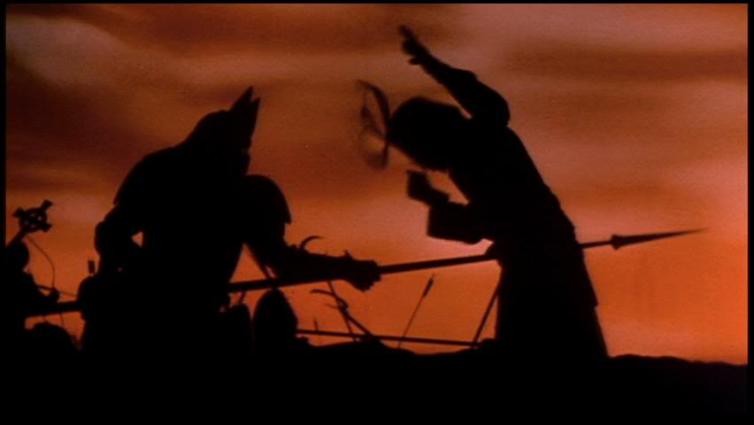
Fig 2. Vlad Dracula impaling a Turkish enemy, Bram Stoker’s Dracula (1992).

The opening scene of this film shows us why Dracula has become who he is. In the tradition of historiographic metafiction, this film has inserted a piece of historical information on Vlad Tepes into the character of Count Dracula and renamed him Prince Vlad Dracula of Transylvania. In a silhouette-based shot during a battle scene the concept of Vlad the Impaler, one of Tepes’ nicknames, is also brought to life as Vlad Dracula impales every enemy he comes across as Figure 2 shows. The link between Vlad Tepes and Count Dracula is made at the end of scene 1, which has already been elaborated on in Chapter 2. Essentially, Dracula returns from battle, enters the family chapel, finds his wife dead after having committed suicide, renounces God and becomes a vampire. This particular piece of information sets the scene for a very different kind of antagonist, and actually makes him more of a Byronic hero than an actual antagonist. Instead of being an evil entity, Dracula in this film is a man who is desperate because he feels his religion as well as his love has forsaken him and so this backdrop created by merging Stoker’s Dracula and Vlad Tepes into one character in this film causes the audience to take a completely different stance towards him, which does not only show a different kind of characterisation, but also is the purpose of historiographic metafiction here.
The adaptations discussed here do not only make use of intertextuality with regard to the historical and religious characters Vlad Tepes and Judas Iscariot; they also make allusions to adaptations that appeared before them, most notably Nosferatu and the 1931 Dracula. The 1931 portrayal of Count Dracula by Bela Lugosi has proven to be especially iconic as it establishes the count as a charismatic aristocratic monster, an image that remained prevalent until the 1992 Bram Stoker’s Dracula. Nosferatu initially almost disappeared into oblivion. Prana Film, the production company which made Nosferatu, was sued by Bram Stoker’s estate because of copyright infringement. Jonathan Bailey writes that when Stoker’s estate won this court case, all copies of the film were to be destroyed. According to popular belief, all copies but one were burned and this one copy, while it was damaged, became the source for later small-scaled releases (Saravia). The DVD release, according to film critic Jerry Saravia, sparked new interest in Nosferatu, and the unsettling atmosphere in this movie as well as its bombastic classical soundtrack modelled for scenes in the 2006 Dracula. Thus, there is a direct link of intertextuality between the classic and contemporary adaptations.
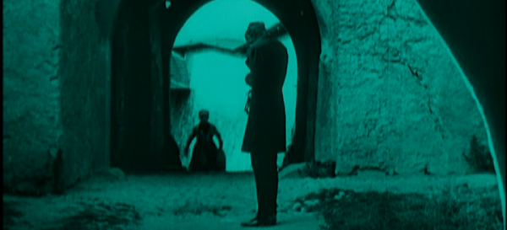
Fig 3. Noferatu, 1922, Count Orlok awaits Thomas Hutter
An excellent example to illustrate this is the scene from which the screen capture on the last page is taken. The colour of this scene is green on the 2001 DVD release, and while this is likely due to damage to the original tape it does contribute to an unsettling atmosphere, just like the ominous soundtrack does. The castle entrance appears to be in ruins. The image below shows Max Schreck, the iconic actor who played Count Orlok, to be waiting for his guest Thomas Hutter (pseudonym for Jonathan Harker). After they are introduced, Orlok invites Hutter in, and over dinner Hutter gets frightened by Orlok and he jumps as Orlok reveals part of his vampiric nature. In the 2006 Dracula, a similar atmosphere is evoked. Interestingly, all scenes that are shot within Dracula’s castle are colourised in green and the greeting scene between Dracula and Harker, too, is directly derived from Nosferatu. Harker enters the castle and finds the courtyard in ruins and then over dinner Count Dracula frightens Harker just moments after he introduces himself (Scene 2); Nosferatu is the direct inspiration source for both shots in Dracula (2006). Robert Stam points out in his article “Beyond Fidelity: The Dialogics of Adaptation” that an adaptation is not only influenced by the original work or the spirits of the original work and the time in which the adaptations were made; any potential adaptations that preceded it are bound to influence it as well. The example above illustrates this. The notion of influence of preceding adaptations on any film version of a novel also ties in with the concept of self-reflexiveness, one of the elements of historiographic metafiction. By shooting scenes that are directly derived from, or at the very least heavily inspired by classic scenes, these adaptations show themselves to be aware of their own position in time, and their own stance with regard to other adaptations.

Conclusion
The relationship between Dracula, the iconic novel that Bram Stoker wrote in the mid-nineteenth century, and three prominent contemporary adaptations is problematic. The concept of fidelity which was prevalent in earlier adaptations has moved to the back and given way to artistic liberties. This firmly ties in with the fact that viewpoints on religion and sexuality for instance have significantly changed over time. It also shows clear links to the concept of historiographic metafiction, a postmodern genre which suggests that in certain works existing pieces of fiction, history and religion are added to the original piece of work without necessarily maintaining a relationship of historical accuracy. Instead, a highly self-reflexive and intertextual approach is taken.
All three modern adaptations and the two classic adaptations discussed in this paper have brought something new to the universe of Bram Stoker’s Dracula. By doing so they keep the tradition and the interest alive in the most famous Victorian antagonist, and in the most famous of all vampires. Dracula remains immortal not only because contemporary adaptations have brought him into the twentieth and twenty-first century, but because each adaptation redefines him in accordance with the viewpoints of their respective era.

Bibliography
Bailey, Jonathan. “Nosferatu vs Dracula: A True Copyright Horror Story”. PlagiarismToday.
7 Oct. 2007. Web. 26 Jan. 2013. < http://www.plagiarismtoday.com/2011/10/17/
dracula-vs-nosferatu-a-true-copyright-horror-story/ >

Bram Stoker’s Dracula. Dir. Francis Ford Coppola . Perf. Gary Oldman, Winona Ryder,
Anthony Hopkins and Keanu Reeves. Colombia Pictures, 1992. Film.

Corigan, Timothy et al. eds. “Beyond Fidelity: The Dialogics of Adaptation”. Stam, Robert.

Critical Visions in Film Theory. Boston: Bedford St. Martin’s, 2011. Print.

Holte, James Craige. Dracula in the Dark. Westport: Praeger Publishing,1997. Print.

Dominguez-Rue, Emma. “Sins of the flesh: anorexia, eroticism and the female vampire in
Bram Stoker’s Dracula”. Journal of Gender Studies 19.3, 2010: 297-308. Print.

Dracula. Dir. Bil Eagles. Perf. David Suchet, Mark Warren and Sophia Myles. British
Broadcasting Coorporation, 2006. Film.

Dracula. Dir. Tod Browning. Perf. Bela Lugosi, Helen Chandler and David Manners.
Universal Pictures, 1931. Film.

Dracula 2000. Dir. Patrick Lussier. Perf. Gerard Butler, Christopher Plummer, Jonny Lee
Miller, and Justine Waddell. Wes Craven Films, 2000. Film.

“Folklore Vampires and Sex”. By Light Unseen. Web. 28 Nov. 2012.
< http://bylightunseen.net/vampsex.htm >

Hutcheon, Linda. Historiographic Metafiction: Parody and the Intertextuality of History.
Ed. P. O'Donnell and Robert Con Davis. Baltimore: Johns Hopkins UP, 1989. Print.

Kilmarnock. “Dr. Kilmarnock’s Obscure world of Victorian Pornography”. Sotissier. Web. 10
Feb. 2013. < http://www.sottisier.co.uk/victoriana/index.html >

Lufton, Donna. “The Rise of the Victorian Middle Class”. BBC History. BBC, 17 Feb. 2011.
Web. 28 Nov 2012. < http://www.bbc.co.uk/history/british/victorians/middle_classes_
01.shtml >

Nosferatu.Dir. F.W. Murnau. Perf. Max Schreck, Greta Schröder and Ruth Landshoff. Prana-
Film GmbH, 1922. Film.

Reader, W.J. Life in Victorian England. New York, Capricorn Books, 1967. Print.

Ridgway, Steven. “The Sexual Revolution of the 60s”. Sex & Modernity, 2007. Web. 1 Feb.
2013. < http://www.isis.aust.com/stephan/writings/sexuality/revo.htm >

Saravia, Jerry. Nosferatu: The Plague Carrier. Jerry Saravia on Cinema and Pop Culture.
Web. 7 Jan 2012. < http://jerrysaravia.blogspot.nl/2011/02/plague-carrier.html >

Stockley-French, Elizabeth. Writing Fiction. New York: Pearson, 2010. Print.

Stoker, Bram. Dracula. New York: Vintage Classics, 1897 Print.

Stephenson, C.J. Cart. Dracula and Modern Culture. O Tempora, Castle of the Night. Web.
25 Nov 2012. < http://www.carter-stephenson.co.uk/dracula.htm >

While this terror is, without a doubt, a tool used to scare the reader, it is often portrayed as seductive and attractive to the reader.
While he is the main character, the fact that he is evil and needs to be exterminated makes him an antagonist, not a protagonist.
Interestingly enough, unlike in Dracula, the vampires in these modern series often are given the role of protagonist, as they are considered dark but not ultimately evil.
Professor of History at the University of Portsmouth, who has focussed most of her research on Victorian society and British industrialisation.
Professor at the East Caroline University, whose research focuses on literature and film studies.
Professor in English literature at University of Lleida, Catalunya, Spain.
The only truly significant difference between novel and adaptation in this case is the way that Nosferatu treats sunlight. It is not described as fatal in the novel, nor considered as such in Dracula (1931), but in Nosferatu it kills the vampire.
Vlad Tepes was three-times Voivode (Medieval title for a Prince of Romania), and he was notorious for his monstrous ways of butchering his enemies.
Quite unlike the Biblical God who heals people when they are deserving or have repented, as so many Biblical stories show.
This can be linked to the Victorian image of beauty as described in chapter 1. Beauty is not a central theme to the 2006 film, but it is central to Holmwood’s desire to marry Lucy.
This is interesting, because all other adaptations in this paper, as well as the novel, treat Dracula as their antagonist.
He can turn a mortal being into what he is: a vampire. This is similar to God’s creation of man in his own image.
There is a grey area where it concerns the romantic byronic heroes that also have part in the Gothic novel and who display traits of antagonists but are not antagonists. Mr Heathcliff of Wuthering Heights (1847is an example of this Byronic hero; his cruelty makes him a strong antagonist-like character, but the novels also shows that the tragic turns of his life have condemned him to who he has become, quite unlike the ultimately evil creature without a background that Count Dracula is.
The hippie-movement was an enormous influence in tearin down taboos around sex. In a society that was tired of war and being lied to by governments, escapism through lmusic and free love became rather prominent.
Professor of comparative literature at the University of Toronto, who is known for her contributions to literary theory and criticism
Author for the website PlagiarismToday, who specialises in historical cases of plagiarism

