A review of longitudinal fMRI studies on age-related changes in functional brain activity

By Pieter van de Vijver

# Abstract

In the past two decades neuroimaging studies have tried to unveil the neural mechanisms behind age-related changes in cognitive strategies and performance. Structural imaging studies have shown that brain volume changes throughout the complete life-span and functional imaging studies have reported age-related differences in brain activation and connectivity.

The aim of this thesis was to provide an overview of studies that report age-related changes in brain activation as measured with functional MRI in a longitudinal design in healthy subjects. We found 16 studies of which 11 reported changes in activity over time. The majority of studies was performed in children. fMRI task used varied between attention, language, memory, working memory and sensory processing tasks.

We found increases and decreases in activation in children between 5 and 20 and adults above age 50. A trend of left-hemispheric increases were shown for children around age 8, adults around age 66 and in language studies. Adolescents between ages 10 and 14 seemed to primarily increase activity in regions in the right hemisphere.

We conclude that due to the small number of studies, wide variety of fMRI tasks used across studies and the wide age-range of participants, a meta-analysis is not yet feasible and findings should be interpreted with caution. Furthermore, we suggest that changes in brain volume, performance and BOLD characteristics should be controlled for when studying age-related changes in brain activation using the BOLD signal. Also, we stress the importance of including information about the nature of a longitudinal activation change and to make a clear distinction whether longitudinal activation differences refer to changes in BOLD signal between two task conditions or between task and rest activation.

# Introduction

Human life-span is accompanied by changes in cognitive function. The most prominent changes in cognitive function include the development of language, emotional regulation and executive functions during the first two decades of the human life. In young adult life cognitive functioning appears to be largely stable. However, in adulthood age differences in cognitive function exist between young and older adults. Older adults show a decline in episodic memory and various executive functions such as working memory, attention and task switching compared to young adults, while other functions such as semantic memory and emotional regulation are unaffected by age (Grady, 2012).

In search of the neural mechanisms that underlie these changes studies using MRI have correlated brain changes to age and age-related differences in cognitive function. Structural imaging revealed that during childhood and adolescence sensorimotor regions mature fist, followed by temporal and parietal association cortices after which the prefrontal and lateral temporal cortices mature (Giedd, 2004; Gogtay et al., 2004; Sowell et al., 2003; Sowell et al., 2004). These maturation processes correlate with the development of sensorimotor skills, development of language skills and spatial attention and development of executive functions respectively (Casey et al., 2005). Functional brain imaging has indicated that during maturation a shift in brain activity from subcortical and posterior bottom-up regions to higher cortical top-down processing takes place (Rubia, 2012). In this view the maturation of cognitive skills is accompanied by increased activation of task-relevant frontal and parieto-temporal regions that are involved in higher order processing (Rubia, 2012).

Also during adulthood changes in brain volume (Hedman et al., 2011) and shifts in activation (Spreng et al., 2010) have been reported. After a growth period of grey matter volume during childhood, a decline sets in from 13 to 20, after which there is a decade with relatively small changes followed by an increasing decline with age (Hedman et al., 2011). White matter volume changes, associated with the connectivity between regions, increase well into adulthood and starts to decline around age 40 years (Hedman et al., 2011). In functional imaging studies these structural changes are accompanied by an age-related shift in activity from the occipital to the prefrontal region, among other changes in brain activation in regions that are more specific to the domain or task that is being investigated (Spreng et al., 2010).

Most studies compare age groups to investigate age-related brain changes. Although they are easier to implement than longitudinal studies, the use of a cross-sectional design is confounded by a high between-subject variability that can interfere with actual aging effects (Ronnlund et al., 2005). For instance, opposite aging effects were found in the prefrontal cortex between a cross-sectional and longitudinal approach (Nyberg et al., 2010). In longitudinal studies subject serve as their own controls, thereby partially eliminating these between-subject effects and providing the opportunity to study subtle changes in brain activation (Poldrack, 2000).

Because longitudinal studies are more difficult to perform due to drop-outs, technological innovation of magnetic resonance imaging scanners and cost considerations, there is little literature on the longitudinal changes in brain activation. In this paper we performed a search through peer-reviewed literature to give a review on all longitudinal studies that use blood-oxygen-level-dependent (BOLD) functional magnetic resonance imaging to investigate age-related activation changes in healthy subjects. The BOLD signal is a commonly used, but indirect, measure of brain activity by detecting changes in the level of oxygenated blood resulting from a vascular reaction to the activation of neural tissue (Logothetis et al., 2001).

# Methods

## Data sources

A systematic search was conducted to identify functional MRI studies that examined longitudinal changes in blood-oxygenated-level-dependent (BOLD) signal in healthy individuals with at least two MRI scans at different time points. The search was conducted using the computerized database PUBMED using the following keyword combination: *“longitudinal AND (functional mri OR fmri OR functional mri OR functional magnetic resonance imaging) Filters: Humans****”***. As a result 340 papers were found that were examined to investigate whether the papers reached inclusion criteria. Additional studies were obtained through cross-references in selected papers, which resulted in an additional modified search using the following keyword combination: *“Longitudinal [Title/Abstract] AND (activation [Title/abstract] OR function [Title/abstract] OR functional [Title/abstract]) AND (age [Title/abstract] OR aging [Title/abstract] OR age-related [Title/abstract] OR maturation [Title/abstract]) AND brain [Title/abstract] Filters: Humans”*. The secondary search resulted in 452 papers.

## Study selection

Studies were included that had a longitudinal design with at least two fMRI scans at different time points and reported longitudinal changes in the BOLD signal of healthy individuals. Papers that used healthy subjects as a control group were only included when longitudinal changes were reported for the healthy group separately. Also, because we were only looking for age-related activation changes, intervention studies that investigated the effects of training or medical intervention on brain activation were excluded.

# Results

We found sixteen studies that met the inclusion criteria, published between 2004 and 2012. The magnetic field of the MRI-scanners varied from 1.5 Tesla to 4 Tesla. In total 426 healthy subjects were included varying between 7 and 65 subjects per study and ranging between 5 and over 80 years of age. Time between the first and last MRI scan varied between 4 weeks and 6 years.

The majority (i.e. 11) of the studies was performed in children and adolescents, two studied adults in the age-range between 20 and 50 and three investigated adults above 50 years of age. In total, 11 out of the 16 studies reported changes in BOLD activity over time in large variety of cortical and subcortical regions. Unfortunately, a meta-analysis was not feasible due to the small number of studies considering the wide variety of ages that were studied. Instead, we decided to provide a qualitative review of the longitudinal fMRI studies that have been published so far.

Out of the 11 studies that reported longitudinal activation changes, 7 reported longitudinal changes of task-related activity compared to a rest period, 3 studies reported changes over time of the difference in brain activation between two task conditions and one study reported changes of both task-related activity versus rest as well as changes in the difference between activation related to different task conditions. For the five studies that did not report changes in activation over time, 4 compared task-related activation against baseline and one compared activity between two task conditions.

In one of the three studies that we defined as reporting longitudinal activation change between two task conditions, one of the task conditions consisted of finger tapping as a control condition instead of rest (Szaflarski et al., 2006). During the other task condition subjects had to perform the task of interest while still tapping their fingers. They indicated that the difference in brain activation between the two conditions showed a similar activation pattern as studies that used the task without finger tapping and used rest as a control measure. Therefore, we chose to interpret findings from this study as a comparison of task-related activation to rest in the following tables, figures and qualitative analyses.

Based on the task that was being presented in the scanner we divided the studies into five domains: Attention, language, emotion, memory, working memory and sensory studies. Areas that showed differences in BOLD response over time were divided based upon their location in the 1) frontal, 2) temporal, 3) parietal and 4) occipital lobe and 5) other subcortical regions. An overview of the results is presented in Table 1 and Figure 1. Figure 2 shows the same data broken down by left and right hemisphere. A full overview of the number of subjects, time between scans, scanner field-strength and the task and statistical methods that were used is given in supplementary table S1.

Three out of four studies on attention in children ranging from 8 to 18 years reported changes in cortical activity. Three studies that examined the development of language during childhood found changes mainly in the left hemisphere, one study did not find time-related changes. Two studies investigated changes in emotion-related activation around the age of 11. One study reported right-lateralized decreases and a left cortical increase in activation between conditions, whereas the second study only reported increases in both hemispheres and subcortical regions when comparing task activity to rest. Of the three studies on memory in adults above 50 one reported no differences, one reported a hippocampal decrease in the difference between task conditions and another showed a trend of an activation shift from right to left over time. A working memory study in adolescents reported a decrease in bilateral temporal and subcortical regions, increases in right hemispheric posterior cortical regions and bilateral increases and decreases in the frontal lobe. Two studies in adults between 20 and 50 on working memory and visual sensory processing found no differences in changes in the BOLD response over time.

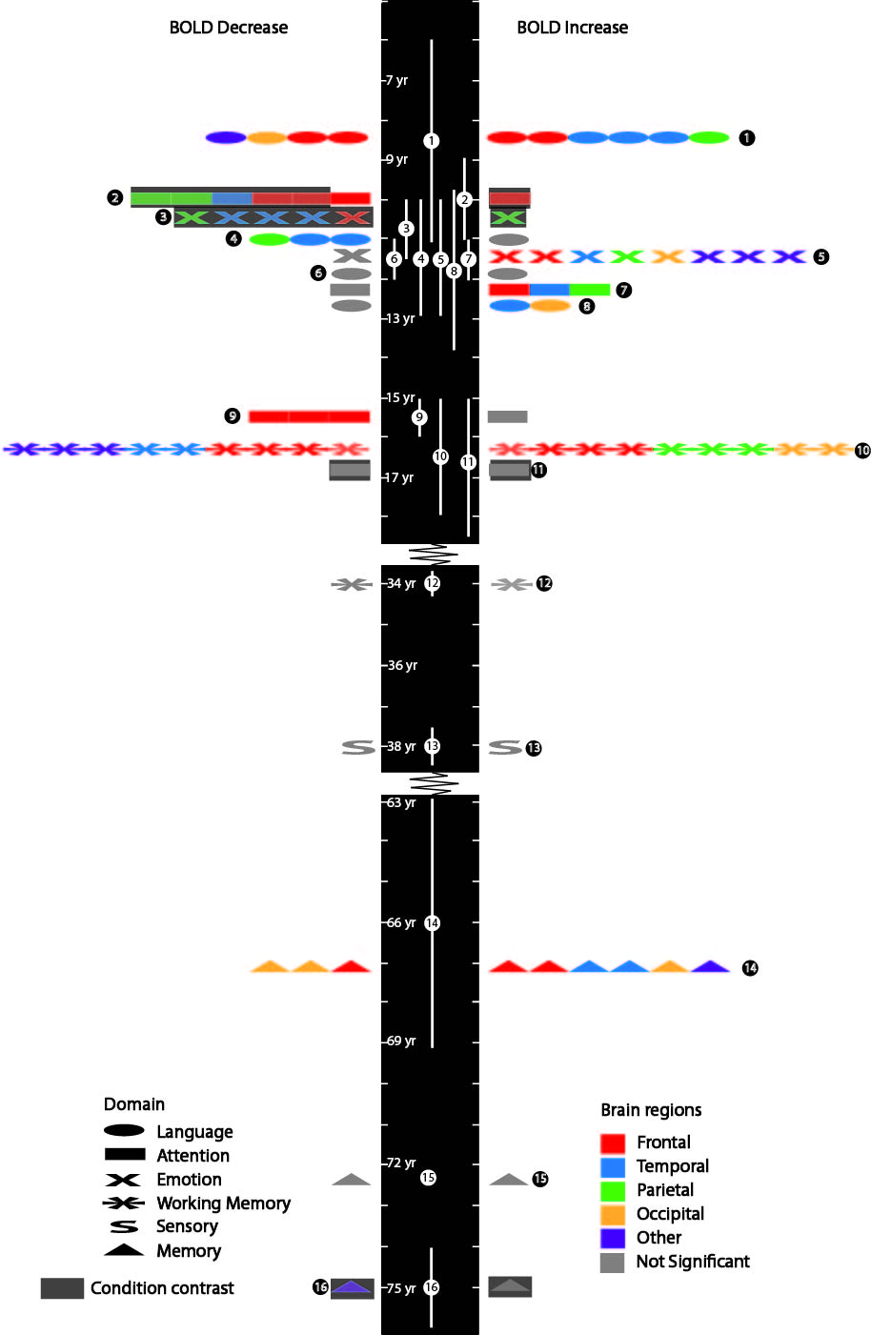Figure 1. Timeline representing all regions that show longitudinal BOLD signal changes horizontally per study. Left side represents regions that show a decrease in BOLD signal, right side an increase. Average subject age halfway the inter session interval per study is indicated by the position of the white numbered circles on the vertical timeline with error bars representing the time between first and last scan session. Numbers in the white and black circles refer to the study number as indicated in Table 1 and S1. Colors indicate region of change, with light grey representing ‘no significant change’. Shapes represent the domain of the fMRI task used. Regions that didn’t compare activity to rest (i.e. contrasted activity between task conditions) are depicted on a dark grey background.

Table 1. Decreses (red) and increases (green) in BOLD signal over time are presented per study. Age is average subject age or age-range at time 1; ISI Inter session interval (i.e time between first and last scan); N refers to number of healthy subjects included; Numbered studies refer to numbers in Figure 1 and 2. Black underlined regions indicate longitudinal changes between task conditions instead of task to rest differences. First letter indicates hemisphere: L left; R right; After which the region is indicated by: Mi middle; Me medial; I inferior; S superior; F frontal; T temporal; P parietal; O occipital; CC (double) cingulate cortex; C cortex; L lobe; J Junction; PFC prefrontal cortex; SMG supramarginal gyrus; Postcentr Postcentral Gyrus; Precentr Precentral Gyrus; Hip hippocampus; LOTS left occipital temporal sulcus; Thal thalamus; Parahip parahippocampal gyrus; Cerebel cerebellum; pre(cun) pre(cuneus); Vent str Ventral Striatum; Sup mot superior motor cortex; Oper. Rol Operculum Rolandicus; XS extrastriate;

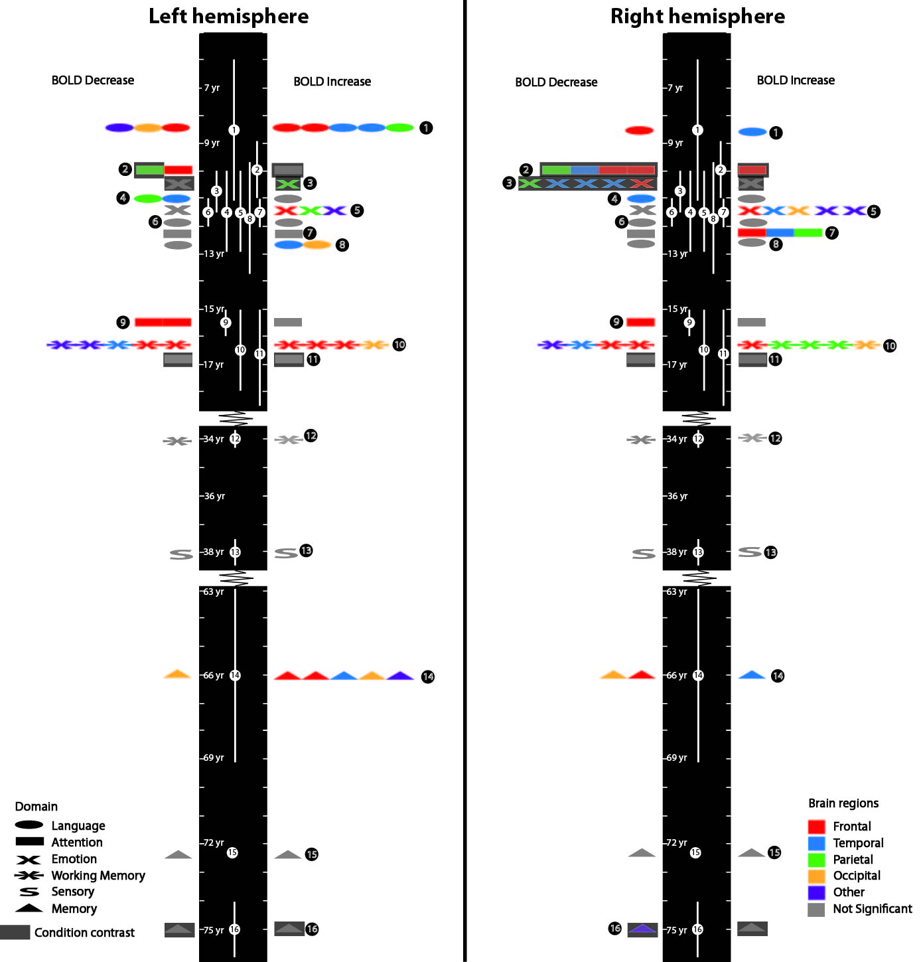Figure 2. Same as Figure 1, but broken down in BOLD response changes for the left and right hemisphere separately.

# Discussion

We conducted a systematic search using PUBMED to provide a review of all studies that report changes in BOLD signal over time in healthy subjects using longitudinal fMRI. Our main findings is that we find increases and decreases in brain activity over time across all domains and all brain regions during childhood and adolescence as well as in adults above 50. No longitudinal differences were found in adults between 20 and 50. However, not enough longitudinal fMRI studies were found to conduct a meta-analysis. Because of the limited amount of data and large variety in methodology between studies, findings should be interpreted with caution.

Within the reported longitudinal changes, there is a qualitative difference in interpretation of changes that are based on comparing task-related activity to rest and changes that are based on the difference between two task-related conditions. The former is an indication of changes in the extend or magnitude of brain activation compared to the brain at rest. Longitudinal changes of activation differences between two task conditions however, only provide information about changes in activation relative to each other. Information about the BOLD signal change relative to rest cannot be derived from this measure. Therefore, longitudinal changes of task-related activation relative to rest cannot be compared to those reported between task-conditions when comparing studies in related to age-related changes in brain activation.

Also, changes in BOLD signal between two task conditions, or a condition and rest, are usually determined for every time point separately. The longitudinal change then represents the difference in the change in BOLD signal between different time points. These longitudinal changes in activity as measured by fMRI can be interpreted in several ways. For example, in an experiment where task activity is compared to rest an longitudinal increase in activity can represent the activation of a region at time 2 that did not show activity at the first scanning session (Figure 3A) or an increase of activity of a region that at time 1 already showed an increase (Figure 3B) or a reduced decrease in activation compared to time 1 (Figure 3C) or no activation in a region that deactivated at time 1 (Figure 3D) or a region that showed no significant increase nor decrease at times 1 and 2, but still differs significantly when the two time points are compared (Figure 3E).

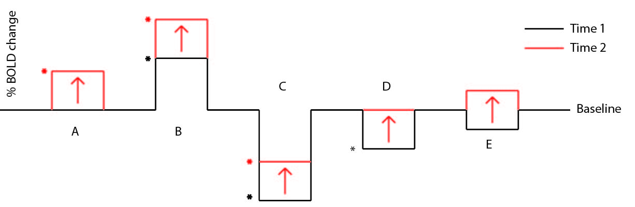

Figure 3. Possible interpretation of longitudinal increase in BOLD response. A) Increase B) Increasing increase C) decreasing decrease D) Decrease returning to baseline E) Decrease to increase in which both effects can be non-significant separately, but longitudinal increase is significant. Variations to the presented situation are also possible. * indicates significant effect

Most studies deal with this issue by only including ROI’s that show a task-related increases at time 1 or adapt them from other studies using the same task (Durston et al., 2006; Epstein et al., 2009; Pfeifer et al., 2011). However, this method limits finding of activity changes to areas that are already known to show task-related activation. Others mention the nature of the effect in the text (Ben-Shachar et al., 2011; McNealy et al., 2011). Some report percentage signal change for both time points (Konrad et al., 2007; O'Brien et al., 2010). Shaw (Shaw et al., 2012) performed a repeated measures ANOVA on percentage change between conditions averaged over an ROI and reported beta-values for the intercept and time predictor. Szaflarski (Szaflarski et al., 2006) chose for a modified regression method that excluded in- and decreasing deactivations. Except for the studies by Nyberg (Nyberg et al., 2010) and Finn (Finn et al., 2010), none of the studies reported significant activation increases and decreases for both time points separately. However, of those two studies, coordinates indicating significant activation task-related change within the sessions don’t match the coordinates that show changes in BOLD response between sessions. Therefore, it is unclear whether regions that show longitudinal change showed an in- or decrease at either time point.

When examining the reported effect with these methodological constraints in mind it can be said that longitudinal changes for most studies are changes in regions that show a task-related increase in activity compared to rest. Increases reported by Konrad are changes from a BOLD signal decrease to BOLD signal increase. Change regions reported by Nyberg and Finn seem to show task-related increases at the first session based on activation figures, although this is not explicitly mentioned per region of change. Regions that show changes reported by Shaw and O’Brien and the ROI analysis by Durston compare within task differences and therefore provide no information about the change in activation compared to rest.

Based on studies that compare task activity to rest, there seems to be an increase in task-related activity in left temporal-parietal regions between 7 and 9 years old. Interestingly, this correlates with the maturation of the parietal and temporal association cortex (Thompson and Nelson, 2001). Between 10 and 14 the left hemisphere shows decreases and increases in a variety of cortical regions. The right hemisphere however, shows mainly an increase in activation in cortical and subcortical areas. The trend of increasing left hemispheric activation in young children followed by right hemispheric increases during early adolescence might indicate a difference in the rate of development between hemispheres. More studies are required to confirm whether these lateralization differences represent a general trend of cortical development or are related to task- or domain-related developmental differences.

Adolescents older than 15 show bilateral in- and decreases in frontal regions, increased activity in right sided parietal regions and a decrease in bilateral subcortical regions. The changes of frontal and parietal activation could represent a neural reorganization in favor of task-related areas (Casey et al., 2005), while decreases in subcortical areas support the sub-cortical to cortical shift suggest by Rubia (Rubia, 2012)which will be discussed below. Between the ages 20 and 50 no changes in activation were found. Around 65 there seems to be an increase in cortical and subcortical regions in the left hemisphere, which in older adults is often interpreted as compensation for functional decline (Cabeza et al., 2002; Grady et al., 1994). In older adults again no changes were reported. However we must stress that, especially in ages 15 and older, these observations are based on very few studies and must be interpreted as a liberal impression of the results.

Changes in activity in studies using an attention task seem to be mainly right lateralized. However, the study by Durston et al. (Durston et al., 2006) reports a decrease only in the left dorsolateral prefrontal cortex (DLPFC) in the whole brain analysis of task-related activation compared to rest. Other, mostly right-hemispheric, activation changes were the result of a ROI analysis that compared activity changes between target and non-target trials. The study by Konrad (Konrad et al., 2007) also shows activation increases in the right hemisphere. But here, they chose for peak voxel analysis in the right-hemispheric region based on a significant group by time effect between ADHD patients an healthy subjects. It is not possible to determine whether similar changes occur in other, possibly left-hemispheric, regions using a peak voxel comparison. Therefore, although in the results more right-hemispheric regions show differences in activation over time compared to left, due to the differences in analytic approach no generalizations about lateralization in attention-related activity can be derived from these results.

Inspection of longitudinal activity changes in language studies shows activity changes, predominantly increases, in the left hemisphere. This fits well with cross-sectional results on language development (Holland et al., 2001) . Since speech-related language functions, which both McNealy (McNealy et al., 2011) and Szaflarski’s (Szaflarski et al., 2006) study appeal to, are mostly left-lateralized (Friederici, 2011; Hickok and Poeppel, 2007) it gives further support to the maturation theory that defines maturation as an increase of task-related areas in favor of non-related areas (Casey et al., 2005).

We find little support for a sub-cortical to (anterior) cortical shift in children (Rubia, 2012), since both increases and decreases in sub-cortical and cortical areas are reported across studies. One study in young children does indicate such a shift in the left hemisphere (Szaflarski et al., 2006), suggesting that such a shift only occurs during early childhood. One study in late adolescents reports decreases in subcortical regions, but increases in the occipital lobe, which is not considered a brain region involved in higher cognition. No posterior to anterior shift in activity in adults (Spreng et al., 2010) can be deducted from this analysis.

A shift from sub-cortical and posterior regions to more anterior cortical regions is associated with a shift from bottom-up processing, which refers to perception driven activation, to top-down processing, which is defined as processes related to cognitive control (Rubia et al., 2010; Smith et al., 2011). Therefore, we find some support for an age-related shift from bottom-up processing to more top-down activation in the left hemisphere of young children (<10) but not for older children and adults.

In cross-sectional studies it is critical to examine performance in development studies because cohort effects of performance can influence age-effects (Casey et al., 2005). Also in longitudinal studies performance provides important information about the nature of changes in activity. Changes in reaction time or accuracy can reflect changes in neural architecture that result in more efficient processing such as inhibition of task-irrelevant areas in favor of task-related ones(Durston et al., 2006). Repeated task exposure can induce a practice effect or habituation to stimuli resulting in better performance and a reduction of task-related activity correlated to habituation or task-difficulty (Barch et al., 1997; Meltzer et al., 2009; Wright et al., 2001). In our analysis only one study found a inverse correlation between activation change and decreased reaction times (Konrad et al., 2007). Another found a trend of increasing activity of task-related areas correlated with task accuracy (Durston et al., 2006). Since both studies show higher activation correlated with performance, this most likely represents a neural reorganization that favors task-related regions. Prefrontal regions that correlated with increased performance at separate time points were found for time 1 in a study by Nyberg (Nyberg et al., 2010) and time 2 in a study by Finn (Finn et al., 2010), but they represent between-subject and not within-subject changes. Surprisingly, a working memory study that tested adults on a delayed match to sample task every three weeks for a half year, did not find any changes in performance or neural activity (Wei et al., 2004). These results suggest that all regions that showed change in activity, represent changes in neural architecture related to aging, instead of methodological or habituation effects.

Studies have shown that structural brain changes can cause changes in neural activity (Lu et al., 2009). Therefore, in order to determine whether changes in activity result from organization shifts in activity or structural alterations, it is useful to include structural alterations when analyzing longitudinal functional changes.

Although all studies obtained an anatomical scan at both time points, only two studies investigated whether functional changes correlated with structural changes. In one study hippocampal volumes were measured, but found no correlation with function or performance was found (O'Brien et al., 2010). Interestingly, in another study a correlation between grey matter atrophy and functional decline was found in the right middle frontal cortex, but not other regions that showed either atrophy or functional decline (Nyberg et al., 2010). This indicates that changes in brain volume can, but not necessarily do, correlate with functional changes. Because only two out of eleven studies that report changes in brain activation over time provided data on changes in brain volume, the extend in which structural alterations influence changes in functional activity over time cannot be determined.

Using the characteristics of the BOLD signal as a measure of brain activation is considered to be a reliable (Logothetis et al., 2001; Mukamel et al., 2005). However, the characteristics of BOLD signal in relation to neural activation, i.e. the hemodynamic response function (HRF), have been shown to vary in early development (Arichi et al., 2012), between young and older adults (Handwerker et al., 2004a), in neurogenerative diseases (Rombouts et al., 2007) and even between healthy age-matched subjects (Handwerker et al., 2004b). These differences in HRF can affect the identification of functional activation in statistical analysis (Handwerker et al., 2004b), because in most studies a standard canonical HRF is used to relate BOLD signal to brain activation. Also, other studies have correlated differences in other vascular properties, such as changes in cerebral blood flow, to differences in cognitive performance (Bangen et al., 2009). The mechanisms behind the neural and vascular contributions to the BOLD signal remain to be unveiled (Kannurpatti et al., 2010), but these studies show that when investigating changes in neural activation that are accompanied with aging, measures of neurovascular coupling should be included in the study. All studies included in this analysis did not control for such effects.

Methodologically, we propose that studies that report age-related changes in activity should control for effects of brain volume and performance changes on brain activation over time. Also, since characteristics of the BOLD response are known change over time, we question the usability of using BOLD for detecting age-related changes in activity when changes in BOLD characteristics are not included in the study. Furthermore, when comparing longitudinal studies, a clear distinction has to be made between changes in the difference between a task condition and rest and the changes in the difference between two task conditions, since the latter does not provide information about the absolute neural activation compared to the brain at rest. Finally, when reporting changes in activity over time in a region, information about in- or decrease of activation at the fist MRI session, and preferably following sessions, should be reported to determine the nature of the activation change.

In conclusion, we reviewed findings of 16 studies investigating longitudinal changes in BOLD signal as measured with functional magnetic resonance imaging. The results showed a pattern of increases and decreases in cortical and subcortical regions during childhood, adolescence and in adults older than 50. No changes were found between age 20 and 50. Results indicate trends of increase in activity in the left hemisphere around the age of 8 followed by an increase in right-sided activity around 14. Language studies in children mainly showed an increase in activity in the left hemisphere over time. Adults around age 66 seem also seem to increase activity in the left hemisphere. However, not enough longitudinal fMRI studies were found to conduct a meta-analysis. Because of the limited amount of data and large variety in methodology between studies, more studies in all age ranges, but especially in adults, are needed to confirm these findings.

# Reference List

Aguirregomozcorta, M., Mancini, L., Jenkins, T.M., Hickman, S.J., Ciccarelli, O., Plant, G.T., Thompson, A.J., Toosy, A.T., 2011. A longitudinal functional MRI study of non-arteritic anterior ischaemic optic neuropathy patients. J Neurol.Neurosurg.Psychiatry 82, 905-913.

Arichi, T., Fagiolo, G., Varela, M., Melendez-Calderon, A., Allievi, A., Merchant, N., Tusor, N., Counsell, S.J., Burdet, E., Beckmann, C.F., Edwards, A.D., 2012. Development of BOLD signal hemodynamic responses in the human brain. Neuroimage.

Bangen, K.J., Restom, K., Liu, T.T., Jak, A.J., Wierenga, C.E., Salmon, D.P., Bondi, M.W., 2009. Differential age effects on cerebral blood flow and BOLD response to encoding: associations with cognition and stroke risk. Neurobiol.Aging 30, 1276-1287.

Barch, D.M., Braver, T.S., Nystrom, L.E., Forman, S.D., Noll, D.C., Cohen, J.D., 1997. Dissociating working memory from task difficulty in human prefrontal cortex. Neuropsychologia 35, 1373-1380.

Ben-Shachar, M., Dougherty, R.F., Deutsch, G.K., Wandell, B.A., 2011. The development of cortical sensitivity to visual word forms. J Cogn Neurosci 23, 2387-2399.

Cabeza, R., Anderson, N.D., Locantore, J.K., McIntosh, A.R., 2002. Aging gracefully: compensatory brain activity in high-performing older adults. Neuroimage. 17, 1394-1402.

Casey, B.J., Tottenham, N., Liston, C., Durston, S., 2005. Imaging the developing brain: what have we learned about cognitive development? Trends Cogn Sci. 9, 104-110.

Durston, S., Davidson, M.C., Tottenham, N., Galvan, A., Spicer, J., Fossella, J.A., Casey, B.J., 2006. A shift from diffuse to focal cortical activity with development. Dev.Sci. 9, 1-8.

Epstein, J.N., Delbello, M.P., Adler, C.M., Altaye, M., Kramer, M., Mills, N.P., Strakowski, S.M., Holland, S., 2009. Differential patterns of brain activation over time in adolescents with and without attention deficit hyperactivity disorder (ADHD) during performance of a sustained attention task. Neuropediatrics 40, 1-5.

Finn, A.S., Sheridan, M.A., Kam, C.L., Hinshaw, S., D'Esposito, M., 2010. Longitudinal evidence for functional specialization of the neural circuit supporting working memory in the human brain. J Neurosci 30, 11062-11067.

Friederici, A.D., 2011. The brain basis of language processing: from structure to function. Physiol Rev. 91, 1357-1392.

Giedd, J.N., 2004. Structural magnetic resonance imaging of the adolescent brain. Ann.N.Y.Acad.Sci. 1021, 77-85.

Gogtay, N., Giedd, J.N., Lusk, L., Hayashi, K.M., Greenstein, D., Vaituzis, A.C., Nugent, T.F., III, Herman, D.H., Clasen, L.S., Toga, A.W., Rapoport, J.L., Thompson, P.M., 2004. Dynamic mapping of human cortical development during childhood through early adulthood. Proc.Natl.Acad.Sci.U.S.A 101, 8174-8179.

Grady, C., 2012. The cognitive neuroscience of ageing. Nat.Rev.Neurosci 13, 491-505.

Grady, C.L., Maisog, J.M., Horwitz, B., Ungerleider, L.G., Mentis, M.J., Salerno, J.A., Pietrini, P., Wagner, E., Haxby, J.V., 1994. Age-related changes in cortical blood flow activation during visual processing of faces and location. J Neurosci 14, 1450-1462.

Handwerker, D.A., Ollinger, J.M., D'Esposito, M., 2004a. Variation of BOLD hemodynamic responses across subjects and brain regions and their effects on statistical analyses. Neuroimage. 21, 1639-1651.

Handwerker, D.A., Ollinger, J.M., D'Esposito, M., 2004b. Variation of BOLD hemodynamic responses across subjects and brain regions and their effects on statistical analyses. Neuroimage. 21, 1639-1651.

Hedman, A.M., van Haren, N.E., Schnack, H.G., Kahn, R.S., Hulshoff Pol, H.E., 2011. Human brain changes across the life span: A review of 56 longitudinal magnetic resonance imaging studies. Hum.Brain Mapp.

Hickok, G., Poeppel, D., 2007. The cortical organization of speech processing. Nat.Rev.Neurosci 8, 393-402.

Holland, S.K., Plante, E., Weber, B.A., Strawsburg, R.H., Schmithorst, V.J., Ball, W.S., Jr., 2001. Normal fMRI brain activation patterns in children performing a verb generation task. Neuroimage. 14, 837-843.

Kannurpatti, S.S., Motes, M.A., Rypma, B., Biswal, B.B., 2010. Neural and vascular variability and the fMRI-BOLD response in normal aging. Magn Reson.Imaging 28, 466-476.

Konrad, K., Neufang, S., Fink, G.R., Herpertz-Dahlmann, B., 2007. Long-term effects of methylphenidate on neural networks associated with executive attention in children with ADHD: results from a longitudinal functional MRI study. J Am.Acad.Child Adolesc.Psychiatry 46, 1633-1641.

Koolschijn, P.C., Schel, M.A., de, R.M., Rombouts, S.A., Crone, E.A., 2011. A three-year longitudinal functional magnetic resonance imaging study of performance monitoring and test-retest reliability from childhood to early adulthood. J Neurosci 31, 4204-4212.

Logothetis, N.K., Pauls, J., Augath, M., Trinath, T., Oeltermann, A., 2001. Neurophysiological investigation of the basis of the fMRI signal. Nature 412, 150-157.

Lu, L.H., Dapretto, M., O'Hare, E.D., Kan, E., McCourt, S.T., Thompson, P.M., Toga, A.W., Bookheimer, S.Y., Sowell, E.R., 2009. Relationships between brain activation and brain structure in normally developing children. Cereb.Cortex 19, 2595-2604.

McNealy, K., Mazziotta, J.C., Dapretto, M., 2011. Age and experience shape developmental changes in the neural basis of language-related learning. Dev.Sci. 14, 1261-1282.

Meltzer, J.A., Postman-Caucheteux, W.A., McArdle, J.J., Braun, A.R., 2009. Strategies for longitudinal neuroimaging studies of overt language production. Neuroimage. 47, 745-755.

Meyler, A., Keller, T.A., Cherkassky, V.L., Gabrieli, J.D., Just, M.A., 2008. Modifying the brain activation of poor readers during sentence comprehension with extended remedial instruction: a longitudinal study of neuroplasticity. Neuropsychologia 46, 2580-2592.

Mukamel, R., Gelbard, H., Arieli, A., Hasson, U., Fried, I., Malach, R., 2005. Coupling between neuronal firing, field potentials, and FMRI in human auditory cortex. Science 309, 951-954.

Nyberg, L., Salami, A., Andersson, M., Eriksson, J., Kalpouzos, G., Kauppi, K., Lind, J., Pudas, S., Persson, J., Nilsson, L.G., 2010. Longitudinal evidence for diminished frontal cortex function in aging. Proc.Natl.Acad.Sci.U.S.A 107, 22682-22686.

O'Brien, J.L., O'Keefe, K.M., LaViolette, P.S., DeLuca, A.N., Blacker, D., Dickerson, B.C., Sperling, R.A., 2010. Longitudinal fMRI in elderly reveals loss of hippocampal activation with clinical decline. Neurology 74, 1969-1976.

Pfeifer, J.H., Masten, C.L., Moore, W.E., III, Oswald, T.M., Mazziotta, J.C., Iacoboni, M., Dapretto, M., 2011. Entering adolescence: resistance to peer influence, risky behavior, and neural changes in emotion reactivity. Neuron 69, 1029-1036.

Poldrack, R.A., 2000. Imaging brain plasticity: conceptual and methodological issues--a theoretical review. Neuroimage. 12, 1-13.

Putcha, D., O'Keefe, K., LaViolette, P., O'Brien, J., Greve, D., Rentz, D.M., Locascio, J., Atri, A., Sperling, R., 2011. Reliability of functional magnetic resonance imaging associative encoding memory paradigms in non-demented elderly adults. Hum.Brain Mapp. 32, 2027-2044.

Rombouts, S.A., Scheltens, P., Kuijer, J.P., Barkhof, F., 2007. Whole brain analysis of T2* weighted baseline FMRI signal in dementia. Hum.Brain Mapp. 28, 1313-1317.

Ronnlund, M., Nyberg, L., Backman, L., Nilsson, L.G., 2005. Stability, growth, and decline in adult life span development of declarative memory: cross-sectional and longitudinal data from a population-based study. Psychol.Aging 20, 3-18.

Rubia, K., 2012. Functional brain imaging across development. Eur.Child Adolesc.Psychiatry.

Rubia, K., Hyde, Z., Halari, R., Giampietro, V., Smith, A., 2010. Effects of age and sex on developmental neural networks of visual-spatial attention allocation. Neuroimage. 51, 817-827.

Shaw, D.J., Grosbras, M.H., Leonard, G., Pike, G.B., Paus, T., 2012. Development of the action observation network during early adolescence: a longitudinal study. Soc.Cogn Affect.Neurosci 7, 64-80.

Smith, A.B., Halari, R., Giampetro, V., Brammer, M., Rubia, K., 2011. Developmental effects of reward on sustained attention networks. Neuroimage. 56, 1693-1704.

Sowell, E.R., Peterson, B.S., Thompson, P.M., Welcome, S.E., Henkenius, A.L., Toga, A.W., 2003. Mapping cortical change across the human life span. Nat.Neurosci 6, 309-315.

Sowell, E.R., Thompson, P.M., Leonard, C.M., Welcome, S.E., Kan, E., Toga, A.W., 2004. Longitudinal mapping of cortical thickness and brain growth in normal children. J Neurosci 24, 8223-8231.

Spreng, R.N., Wojtowicz, M., Grady, C.L., 2010. Reliable differences in brain activity between young and old adults: a quantitative meta-analysis across multiple cognitive domains. Neurosci Biobehav.Rev. 34, 1178-1194.

Szaflarski, J.P., Schmithorst, V.J., Altaye, M., Byars, A.W., Ret, J., Plante, E., Holland, S.K., 2006. A longitudinal functional magnetic resonance imaging study of language development in children 5 to 11 years old. Ann.Neurol. 59, 796-807.

Thompson, R.A., Nelson, C.A., 2001. Developmental science and the media. Early brain development. Am.Psychol. 56, 5-15.

Wei, X., Yoo, S.S., Dickey, C.C., Zou, K.H., Guttmann, C.R., Panych, L.P., 2004. Functional MRI of auditory verbal working memory: long-term reproducibility analysis. Neuroimage. 21, 1000-1008.

Wright, C.I., Fischer, H., Whalen, P.J., McInerney, S.C., Shin, L.M., Rauch, S.L., 2001. Differential prefrontal cortex and amygdala habituation to repeatedly presented emotional stimuli. NeuroReport 12, 379-383.

# Supplementary data

S1

| # | Author | Task | Tesla | Healthy  Subjects | Age @  Time1 | Inter  Session  Interval | FOV | ROI | Contrast | Threshold | domain | Comment |
| --- | --- | --- | --- | --- | --- | --- | --- | --- | --- | --- | --- | --- |
| 1 | (Szaflarski et al., 2006) | Covert verb generation | ? | 30 | 5-7 | 5x 1yr | WB | x | Task+fingertapping vs fingertapping | Modified voxelwise GLM | Language |  |
| 2 | (Durston et al., 2006) | Target detection: don’t respond to non-target | 1.5T | 7 | 9±1 | 2.1+-0.6 | WB | ROI: Target vs nontarget contrast at Time1: max vox > 3 (p<.01) defined as roi | WB: task vs baseline  ROI: target vs non-target | WB: p<0.0001  Max vox>3  ROI: Fixed effects ANOVA p<0.05 | Language |  |
| 3 | (Shaw et al., 2012) | Passive viewing of video clips: neutral & angry hand/face action and non biological | 1.5T | 65 | 10±0.4 | 1,5yr | WB | 20 ROI’s based on meta-analysis: table included in paper | Hand/face action vs non-biological | P<0.05 in mixed model regression from SPM | Emotion |  |
| 4 | (McNealy et al., 2011) | Listening to random syllables: unstressed, stressed and random | 3T | 39 | 9.5-10.5 | 3yr | WB |  | Baseline vs random syllables and normal language (stressed and unstressed) | p<0.001  Multiple com parison corrected @Cluster level p<0,05 | Language |  |
| 5 | (Pfeifer et al., 2011) | Viewing emotional expressions (including neutral) | 3T | 38 | 10±0.5 | 1,5yr | WB |  | Faces vs baseline | WB: p<0.005 uncorr (20 vox minimum) | Emotion |  |
| 6 | (Meyler et al., 2008) | Sentence reading: sense or nonsense response. | 3T | 10 | 10.8±0.5 | Pre & post training (100 hrs training) and  1 yr follow -up | WB (missing some Orbitol and temporal) | ROI of only increasing activation at both time points | Reading vs baseline | P<.002 with 10 vox, uncorrected | Language | Only T1 -> T3 reported. T1->2 is intervention study |
| 7 | (Konrad et al., 2007) | Indicate direction of middle of 5 arrows. Varying in cue an flanking arrow directions.  Attention study | 1.5T | 11 | 11. 2±1.3 | 1yr | WB | Peak voxel from significant group x time interaction (ADHD vs control) | Task vs baseline  ROI:  Invalid cue: valid trial vs invalid trial (TPJ)  Executive:  Incongruent trial vs congruent trial (ACC) | WB: P<.001 unc  Voxel >10  ROI: ANOVA % signal change in peak voxel p<0.05 | Attention |  |
| 8 | (Ben-Shachar et al., 2011) | Implicit reading: four visibility levels. Indicate color of fixation cross | 3T | 28 | 7-12 | 4x1y | PB(occipital and temporal + ventral parietal and frontal) | ROI based on words vs baseline p<.03 for all years | Words vs baseline | half maximum BOLD change on word sensitivity curve | Language |  |
| 9 | (Epstein et al., 2009) | Serial single digit presentation: React to same digit twice. Varying levels of visibility/clarity | 3T | 14 | 12-18 | 1 yr | WB | Active according to Literature: Bilateral frontal, acc, pcc, striatum, parahipo, hippo, inf par lobe | Task vs rest | ROI analysis:  P<.005  Cluster: >5 vox | Attention |  |
| 10 | (Finn et al., 2010) | Delayed match-to-sample: high and low load | 4T | 10 | 15.1±1.6 | 3 | WB |  | Task vs baseline | * <p.001 minimum cluster 10  &  **<p.0001  Minimum cluster 3/ multiple comparison corrrected | Attention | *chose to exclude p<.05 uncorrected  Only hippocampus survived ** |
| 11 | (Koolschijn et al., 2011) | Feedbacked rule switching | 3T | 10  12  10 | 20.7  15.0  10.4 | 3.4  4.0  3.6 | WB | ROI: 1st warning > positive feedback.  preSMA/ACC, IPC/SPC, B S/MiFG, B IFG, G insula | First warning > positive feedback | Repeated ANOVA  P<0.001 FDR corr and >10 vox | Attention | Groups separately and combined n.s.  First warning indicates ruleswitch |
| 12 | (Wei et al., 2004) | Auditory n-back | 1.5T | 8 | 21-49 | 8x 3wk | WB | Table 1:  ROI: p<.05 corrected  Group map anatomically reorganized labels:  DLPFC  SMA  PMA  ACC  BA44/45 - 7 - 40  Insula | Task vs baseline | ANOVA on Activation index (median Z * number of vox) per ROI. | Working memory |  |
| 13 | (Aguirregomozcorta et al., 2011) | Red 8Hz whole field stimulation per eye | 1.5T | 23 | 38 ± 16 | dy/wk/yr | WB |  | Stimulation vs baseline | Cluster level  -Peak: <.01  -Spatial extent: <.05 | Sensory | Only |
| 14 | (Nyberg et al., 2010) | Familiar unfamilair choise for abstract and contrete words | 1.5T | 38 | 49-79  (66±8) | 6yr | WB | x | Task vs baseline | P<0.0001 uncorrected  max vox >20 | Memory |  |
| 15 | (Putcha et al., 2011) | Face/name associative encoding | 3T | 27 | 72±10.1  (61-83) | 4-6w | WB |  | All contrasts vs fixation cross | P<0.001  Max vox >5 | Memory | Do report small cluster of increased deactivation for CDR=0, but don’t report location |
| 16 | (O'Brien et al., 2010) | Face-name association: contrast between novel and repeated faces | 3T | 51 | 74.8±5.4 | 2 yr | WB | Hippocampus:funtiional activation in structural template | Novel vs repeated | P<0.001  Vox >20 | Memory |  |